FILE: CNMI_Lidar_ros.doc
UPDATED: 17 May 2006
BY: Bill Elenbaas

NAVAL OCEANOGRAPHIC OFFICE
Stennis Space Center, Mississippi

Report of Survey

Commonwealth of the Northern Mariana Islands (CNMI)

Vessel: CHARTS Aircraft
Detachment: CHARTS Team
Dates of Survey 20-24 March 2006
Technical Specifications: TS-06-CHARTS-02
Archive Number: 06H3A02
Hydrographic Area: Approaches to Saipan Harbor
Topographic Areas: Tinian: NMUA, International Airport; port facilities
Saipan: Port facilities, International Airport
Rota: International Airport
Personnel:

SURVOP | SURVOP Dates | Senior NAVOCEANO  Representative | Data Manager | N4 Lead
02-CHARTS-06 | 20-24 Mar 2006 | Bill Elenbaas | Bill Elenbaas | Bill Elenbaas

UNCLASSIFIED

DISTRIBUTION STATEMENT A: Approved for public release; distribution is unlimited.

Table of Contents

1.0 General Information 5
1.1 Scope of Report 5
1.2 Requirements 5
1.3 Technical Specifications 5
1.4 Survey Standards 6
1.4.1 International Hydrographic Organization (IHO) 6
1.4.2 United States Army Corps of Engineers (USACE) 6
1.5 Survey Areas 6
1.5.1 Hydrography. 6
1.5.2 Topography. 6
1.6 Extraneous Activities Affecting the Survey 7
1.7 Flight History 7
2.0 Geodetic Control 8
2.1 Time 8
2.2 Horizontal Datum 8
2.3 Vertical Datum 8
2.4 Station Descriptions 8
2.4.1 Saipan Harbor Base Station Information 8
2.4.2 Rota International Airport Base Station Information 10
2.4.3 New Geodetic Control 12
2.5 Datum Shifts 12
2.6 Kinematic GPS Data Collection and Processing 12
3.0 Digital Survey System 12
3.1 System Components 12
3.1.1 Aircraft 12
3.1.2 Laser / Transceiver 13
3.1.3 GPS Receiver 13
3.1.4 GPS Antenna 13
3.1.5 Primary GPS Receiver (in POS/AV) 13
3.1.6 Primary GPS Antenna 13
3.1.7 POS/AV 14
3.1.8 Digital Camera 14
3.1.9 Hyperspectral Imager 14
3.1.10 Field Processing Software 14
4.0 Calibrations 15
4.1 Positioning Systems 15
4.2 CHARTS Positioning Quality Control 15
4.3 CHARTS System Calibration 15
4.3.1 Hard Target Test 15
4.3.2 In Flight Calibration 15
4.4 Survey System Offsets/Alignment 16
5. 0 Tides and Tide Gages 16
5.1 Saipan 16
5.2 Preliminary Tidal Zoning 16
5.3 Final Tidal Zoning 17
5.4 Tidal Data Collection 17
5.5 Tidal Corrections 17
5.6 Application of Tides 17
5.7 Currents and Tidal Streams 17
6. 0 Data Collection and Processing 17
6.1 Hydrography 17
6.1.1 Units 18
6.1.2 Sounding Development and Coverage 18
6.1.3 Cross Check and Swath Overlap Agreements 19
6.1.4 Field Data Processing 19
6.1.5 Corrections to Soundings 19
6.1.6 Agreement with Prior Surveys 19
6.1.7 Agreement with Existing Charts 19
6.1.8 Aids to Navigation 19
6.1.9 Obstructions 19
6.2 Topography 19
6.2.1 Survey Areas 19
6.2.1 Units 19
6.2.2 Elevation Development and Coverage 19
6.2.3 Cross Check and Swath Overlap Agreements 19
6.2.4 Processing Software 19
6.2.5 Field Processing 19
6.2.6 Corrections to Elevations 19
6.2.7 Agreement with Prior Surveys 19
7.0 Accuracy and Resolution of Soundings (Hydrographic Mode) 19
7. 1 Horizontal Accuracy 19
7. 2 Vertical Accuracy 19
7. 3 Tide Corrections 19
7.4 IHO Standards 19
7.5 CHARTS Lidar Target Detection 19
8.0 Accuracy and Resolution of Elevations (Topographic Mode) 19
8.1 Horizontal Accuracy 19
8.2 Vertical Accuracy 19
8.3 USACE Standards 19
10.0 Changes to Sailing Directions 19
10.1 General 19
10.2 Landmarks 19
10.3 Cautions 19
10.4 Warnings 19
10.5 Anchorages and Moorings 19
10.6 Coastal Pollution 19
11.0 Ancillary Observations 19
11.1 Tidal Streams and Currents 19
11.2 Meteorology 19
11.3 Sound Velocity Measurements 19
11.4 Water Clarity Observations 19
11.5 Biological Observations 19
11.6 Seabed Sampling 19
12.0 Photography 19
13.0 References 19
14.0 Appendices 19
Appendix A. Data sheets for KGPS base station locations 19
A.1.1 National Ocean Service Tidal Benchmark 1633227 UHC-2C Datasheet 19
A.1.2 National Geodetic Service DG3988 Datasheet 19
A.2. National Geodetic Service DG3991 Datasheet 19
Appendix B. CHARTS System Calibration 19
B.1. Timing Calibration 19
B.2. Angular Calibration 19
B.3. Camera Calibration 19
B.4. Deep Bias Calibration 19
Appendix C. GPS Processing Summaries 19
Appendix D. System 2 Parameter File 19

1.0 General Information

1.1 Scope of Report

NAVOCEANO personnel and, contracted surveyors and representatives of the Commonwealth of the Northern Mariana Islands (CNMI) conducted survey operations within CNMI. This report specifically addresses the Compact Hydrographic Airborne Rapid Total Survey (CHARTS) survey and should be considered complimentary to any other reports such as the CNMI Technical Specifications and the CNMI Report of Data Processing.

1.2 Requirements

This survey was conducted in support of specific validated requirements of NGA and COMPACFLT. Data collection included the acquisition of the following types of information: Hydrographic and topographic lidar data, digital imagery, navigation data, investigation of hazards and aids to navigation. The collected data will support the production of updated high-resolution nautical charts, high and medium density Digital Terrain Elevation Databases (DTED), and safe navigation of U.S. and coalition forces operating in the area, humanitarian assistance, disaster relief, coastal zone development and harbor expansion projects.

1.3 Technical Specifications

Technical Specifications TS-06-CHARTS-02 applies.

1.4 Survey Standards

1.4.1 International Hydrographic Organization (IHO)

This survey was planned and conducted to meet IHO Order 1 standards (see IHO Special Publication 44, IHO Standards for Hydrographic Surveys).

1.4.2 United States Army Corps of Engineers (USACE)

The topographic portion of this survey was conducted according to guidance used by USACE including:

- USACE publication EM-1110-1-1003, NAVSTAR Global Positioning System Surveying.
- USACE EM -1110-1-1005, Topographic Surveying.
- USACE publication EM-1110-1-1000, Engineering and Design - Photogrammetric Mapping.

Some of the significant requirements include:

- Topographic spot density at a maximum of 2.0 by 2.0 meters.
- Vertical elevation accurate to +/- 30 cm (2 sigma).
- Horizontal positioning accurate to +/- 3 m (2 sigma).
- The topographic lidar data of sufficient density to produce 1 meter contours.
- Topographic data collected with 200% coverage by flying lines at 60% overlap.
- Topographic data collected at or near the land water interface.

1.5 Survey Areas

1.5.1 Hydrography.

The hydrographic survey was conducted over the approaches to Saipan Harbor, CNMI. A picture the hydrographic survey area is located in Section 6.1.

1.5.2 Topography.

Topographic data was collected over the following areas:

- Saipan: Saipan International Airport
Saipan Port Facilities
- Tinian: Tinian International Airport
Tinian Port Facilities
Northern Exclusive Military Use Area
- Rota: Rota International Airport

Pictures of the topographic survey areas are located in Section 6.2.1.

Additional hydrographic and topographic data collection over the islands of Sarigan and Farallon de Medinilla was specified in the Technical Specifications however these surveys were not conducted for the following reasons:

- The survey areas were too far from the KGPS base station located on Saipan to use kinematic positioning methods.
- It was logistically unfeasible to establish KGPS base stations on the islands.
- System 2 uses the Omnistar DGPS service, which has insufficient coverage in this region of the world.

1.6 Extraneous Activities Affecting the Survey

The survey was affected by numerous extraneous activities including:

- CHARTS System 3 failure resulted in the use of CHARTS System 2
- Weather (wind, rain, low cloud ceilings)
- GPS week rollover (every Sunday, 1000 local)

1.7 Flight History

A total of seven flights were conducted between 20 and 24 March 2006. A summary of these flights are listed in Table 1.7.

Start Date  (Local) | Flight Number | Area | Type
20 March | 1 | Saipan Int. Apt. (200%)  Saipan Harbor | T  H
21 March | 2 | Saipan Harbor (100%)  Saipan Port Facilities (200%)  Tinian Port Facilities (200%) | H  T  T
21 March | 3 | Tinian NMUA | T
22 March | 4 | Saipan Harbor  Tinian NMUA | H  T
23 March | 5 | Tinian NMUA | T
23 March | 6 | Rota Airport (200%)  Saipan Harbor (200%) | T  H
24 March | 7 | Tinian NMUA (200%)  Saipan Harbor (300%) | T  H

Table 1.7. Summary of CHARTS hydrographic and topographic flights. “Type” refers to hydrographic (H) or topographic (T) lines.

2.0 Geodetic Control

2.1 Time

All data was initially collected using GPS time. Times were converted to Universal Time Coordinated (UTC) after processing the GPS data. UTC was used thereafter for the reference time for all data.

2.2 Horizontal Datum

North American Datum 1983 (1986) (NAD83(1986)) was used for all data collection. See CNMI Data Processing Report for conversion from NAD83(1986) to WGS1984 coordinates.

2.3 Vertical Datum

All soundings and elevations were collected using Northern Mariana Vertical Datum 2003 (NMVD03). See CNMI Data Processing Report for reduction to Chart Datum (hydrographic data, MLLW) and Map Datum (topographic data, MSL).

2.4 Station Descriptions

Control established by GPS satellite surveying techniques was completed in accordance with geometric (three-dimensional) geodetic survey standards set by the Federal Geodetic Control Committee in "Geometric Geodetic Accuracy Standards and Specifications for Using GPS Relative Positioning Techniques, 1 August 1989.

The station description and data sheet for Saipan Harbor is found in Appendices A.1.1 and A.1.2. The station description and data sheet for Rota Airport is found in Appendix A.2.

2.4.1 Saipan Harbor Base Station

The Saipan harbor base station was established over NGS benchmark DG3988. This base station was used for hydrographic surveys in Saipan Harbor and topographic surveys of Saipan and Tinian. Datasheets for the DG3988 are found in Appendices A.1.1 and A.1.2. There were potential multipath issues due to the close proximity of a chain link fence, two utility poles and an overhead wire. However, GPS data processing showed excellent solutions for base station positions, with RMS errors no greater than 6 cm (see Appendix C. GPS Processing Summaries). Photographs of DG3988 are shown in figures C.1.1 and C.1.2.

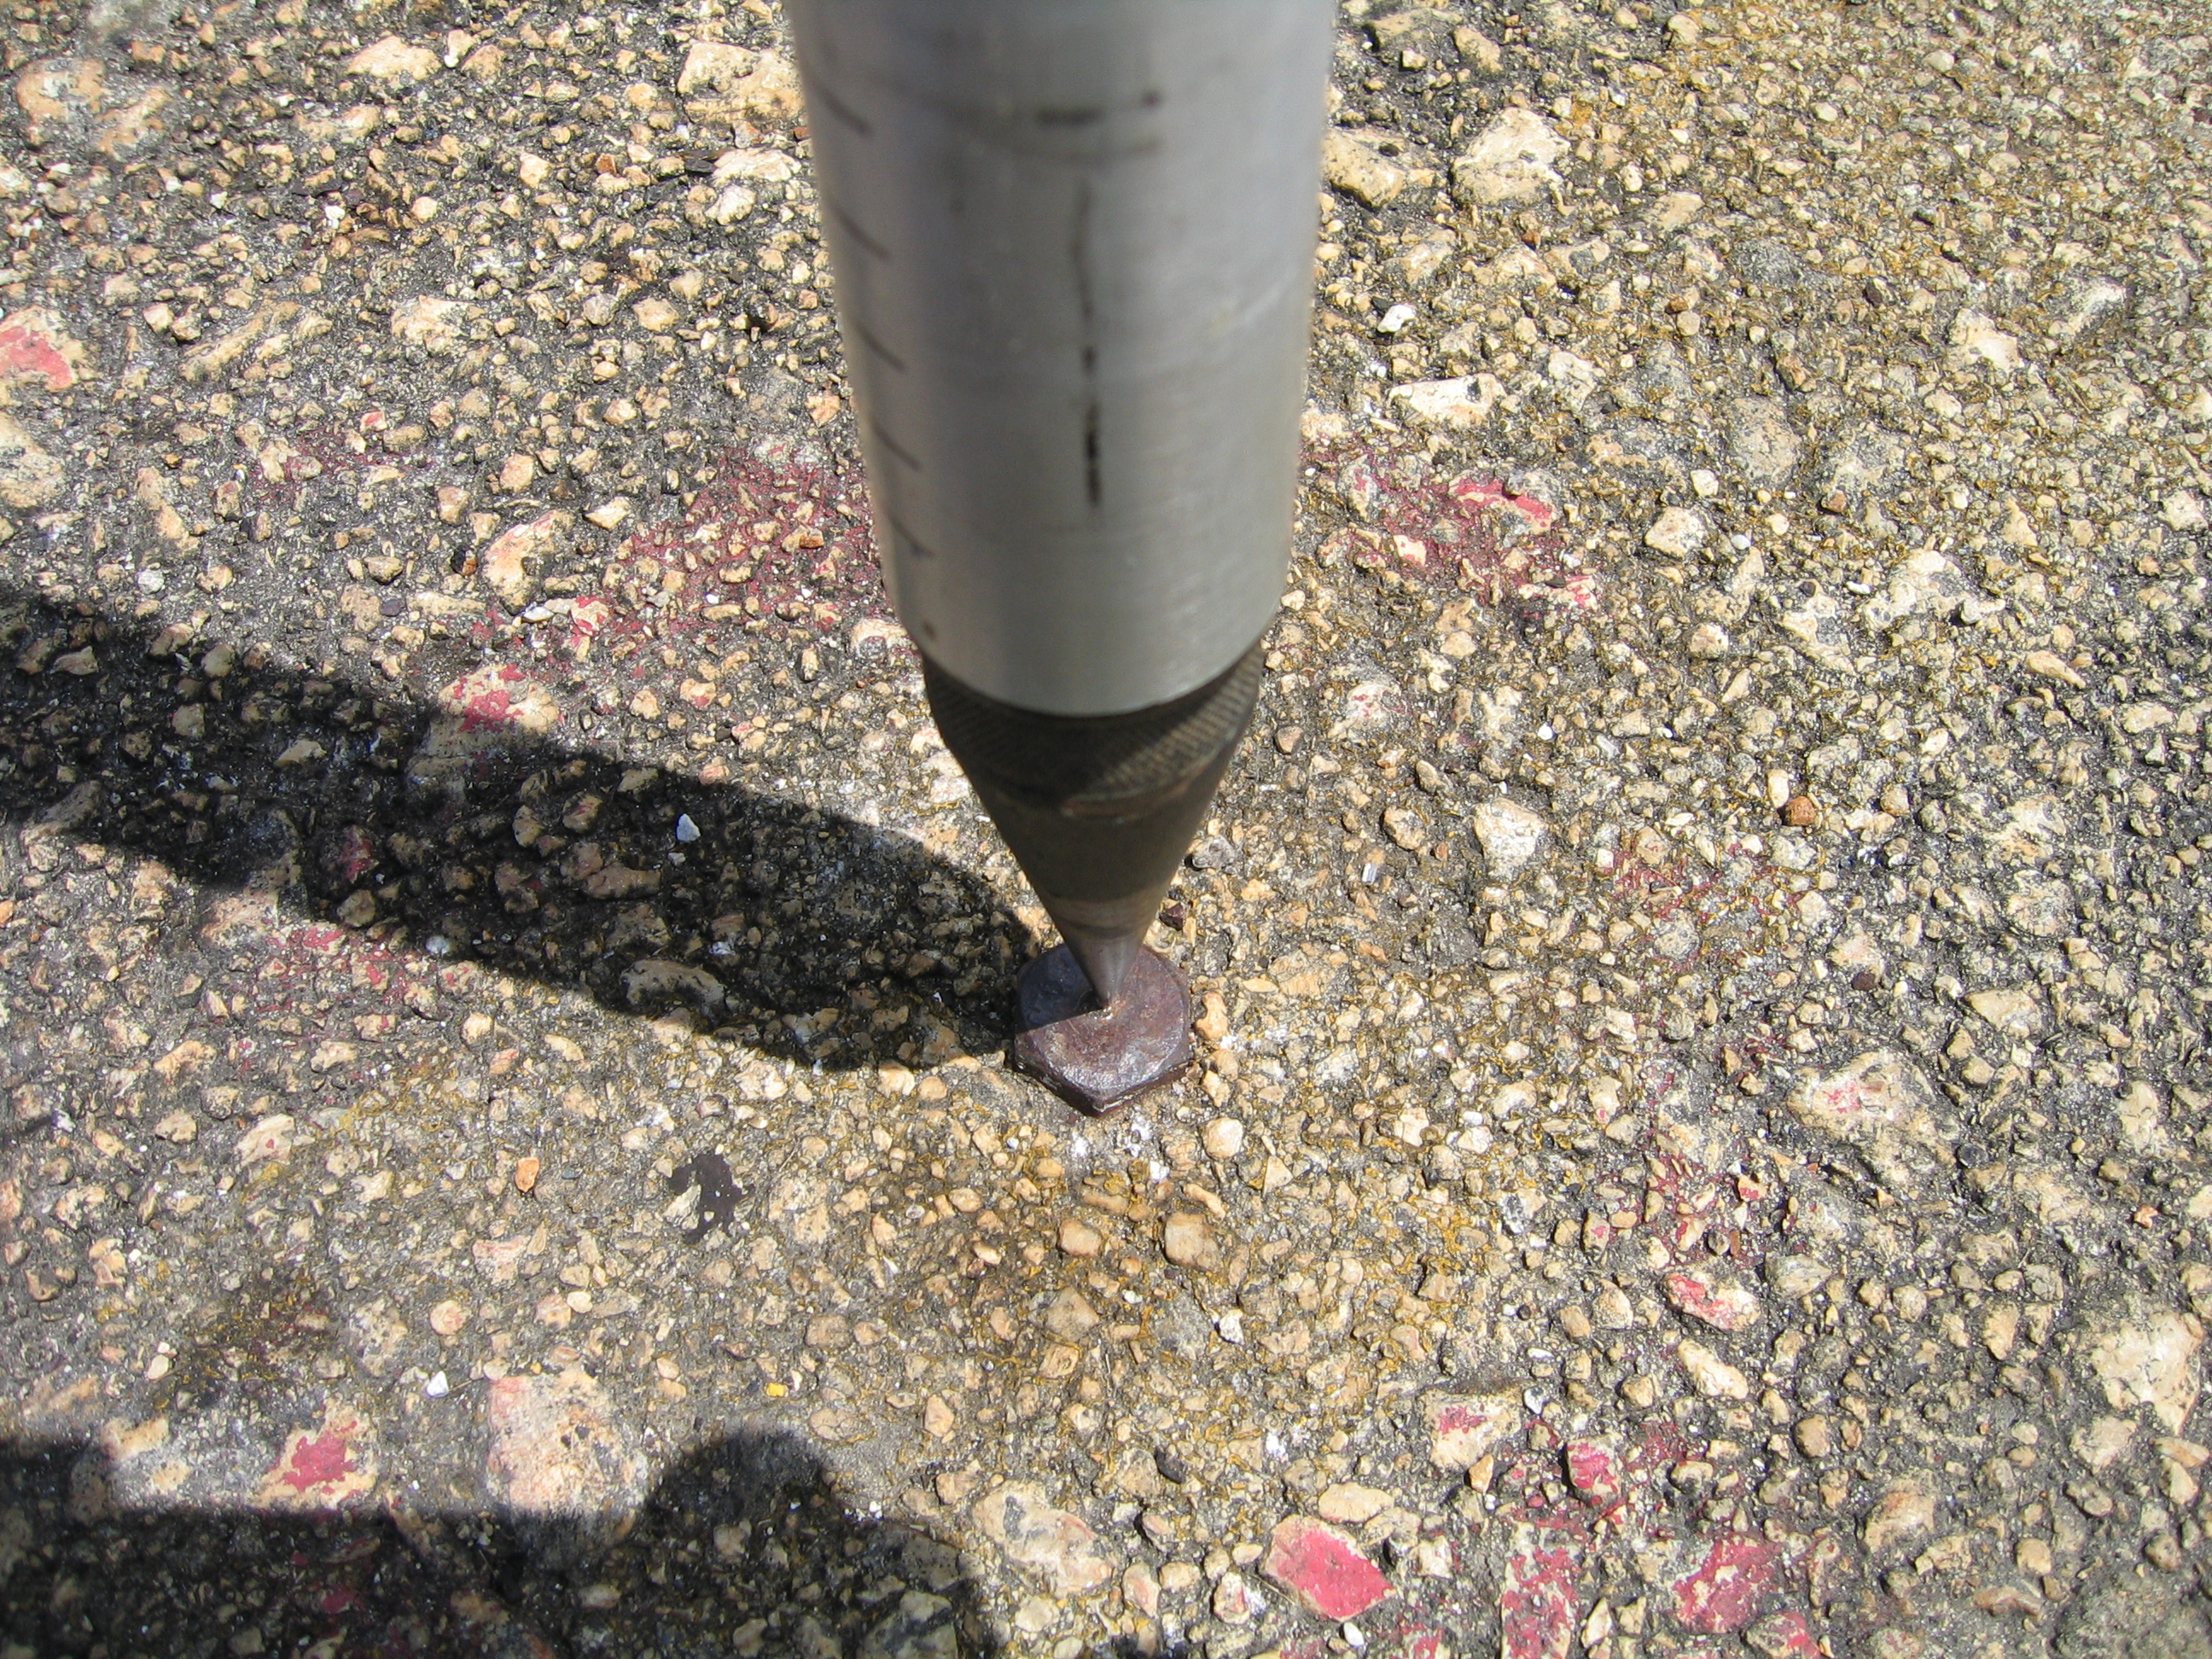

Figure C1.1. Saipan Harbor base station DG3988. The benchmark is a bolt set in the Saipan Port Authority parking lot at the base of Delta Pier, Saipan Harbor. There are faint remains of a red circle painted around the bolt.

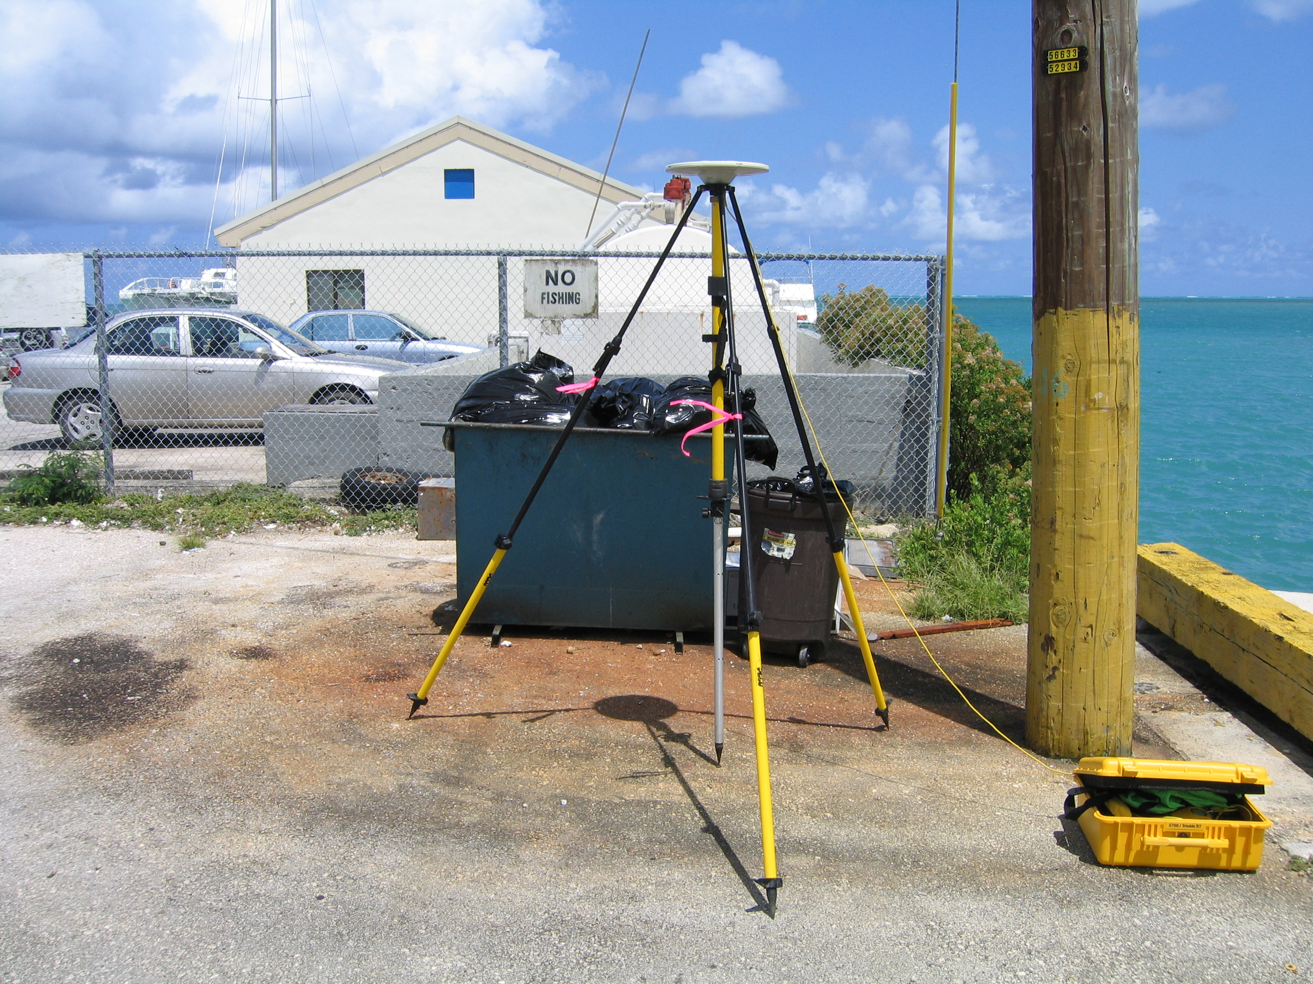

Figure C.1.2. Temporary base station DG3998, view to the North.

Date (Local) | Receiver Type, S/N | Antenna Type, S/N
20 March | Trimble 5700  0220240177 | Trimble Zephyr Geodetic  12482193
21 March | Trimble 5700  0220240177 | Trimble Zephyr Geodetic  12482193
22 March | Trimble 5700  0220240177 | Trimble Zephyr Geodetic  12482193
23 March | Trimble 5700 | Trimble Zephyr Geodetic
24 March | Trimble 5700  0220240177 | Trimble Zephyr Geodetic  12482193

Table C.1. Saipan GPS base station information.

2.4.2 Rota International Airport Base Station

The base station used for the survey of Rota International Airport was established over NGS benchmark DG3991. The datasheet for DG3991 is found in Appendix A.2.1. There were potential multipath issues due to the proximity of a concrete cell phone tower approximately 30 meters to the SW. This tower was supported by four steel cables. However, multipath did not appear to be a problem, since processing of the GPS data resulted in an RMS error of 6 cm (See Appendix C. GPS Processing Summaries). Information on the GPS setup used at DG3991 is provided in Table 2.4.2 below.

GPS Receiver Type | Trimble 5700
GPS Receiver S/N | 0220340177
Antenna Type | Trimble Zephyr Geodetic
Antenna S/N | 12482193
Ellipsoid* | WGS84
Latitude* | 14 10 39.58943 N
Longitude* | 145 15 52.51147 E  (given as 214 44 09 W)
Ellipsoid Height (m)* | 191.322

Table 2.4.2. Information for the Rota Airport GPS base station. Position and elevation were provided by the NGS datasheet (see Appendices A.2.1 and A.2.2). * Data from network adjustment.

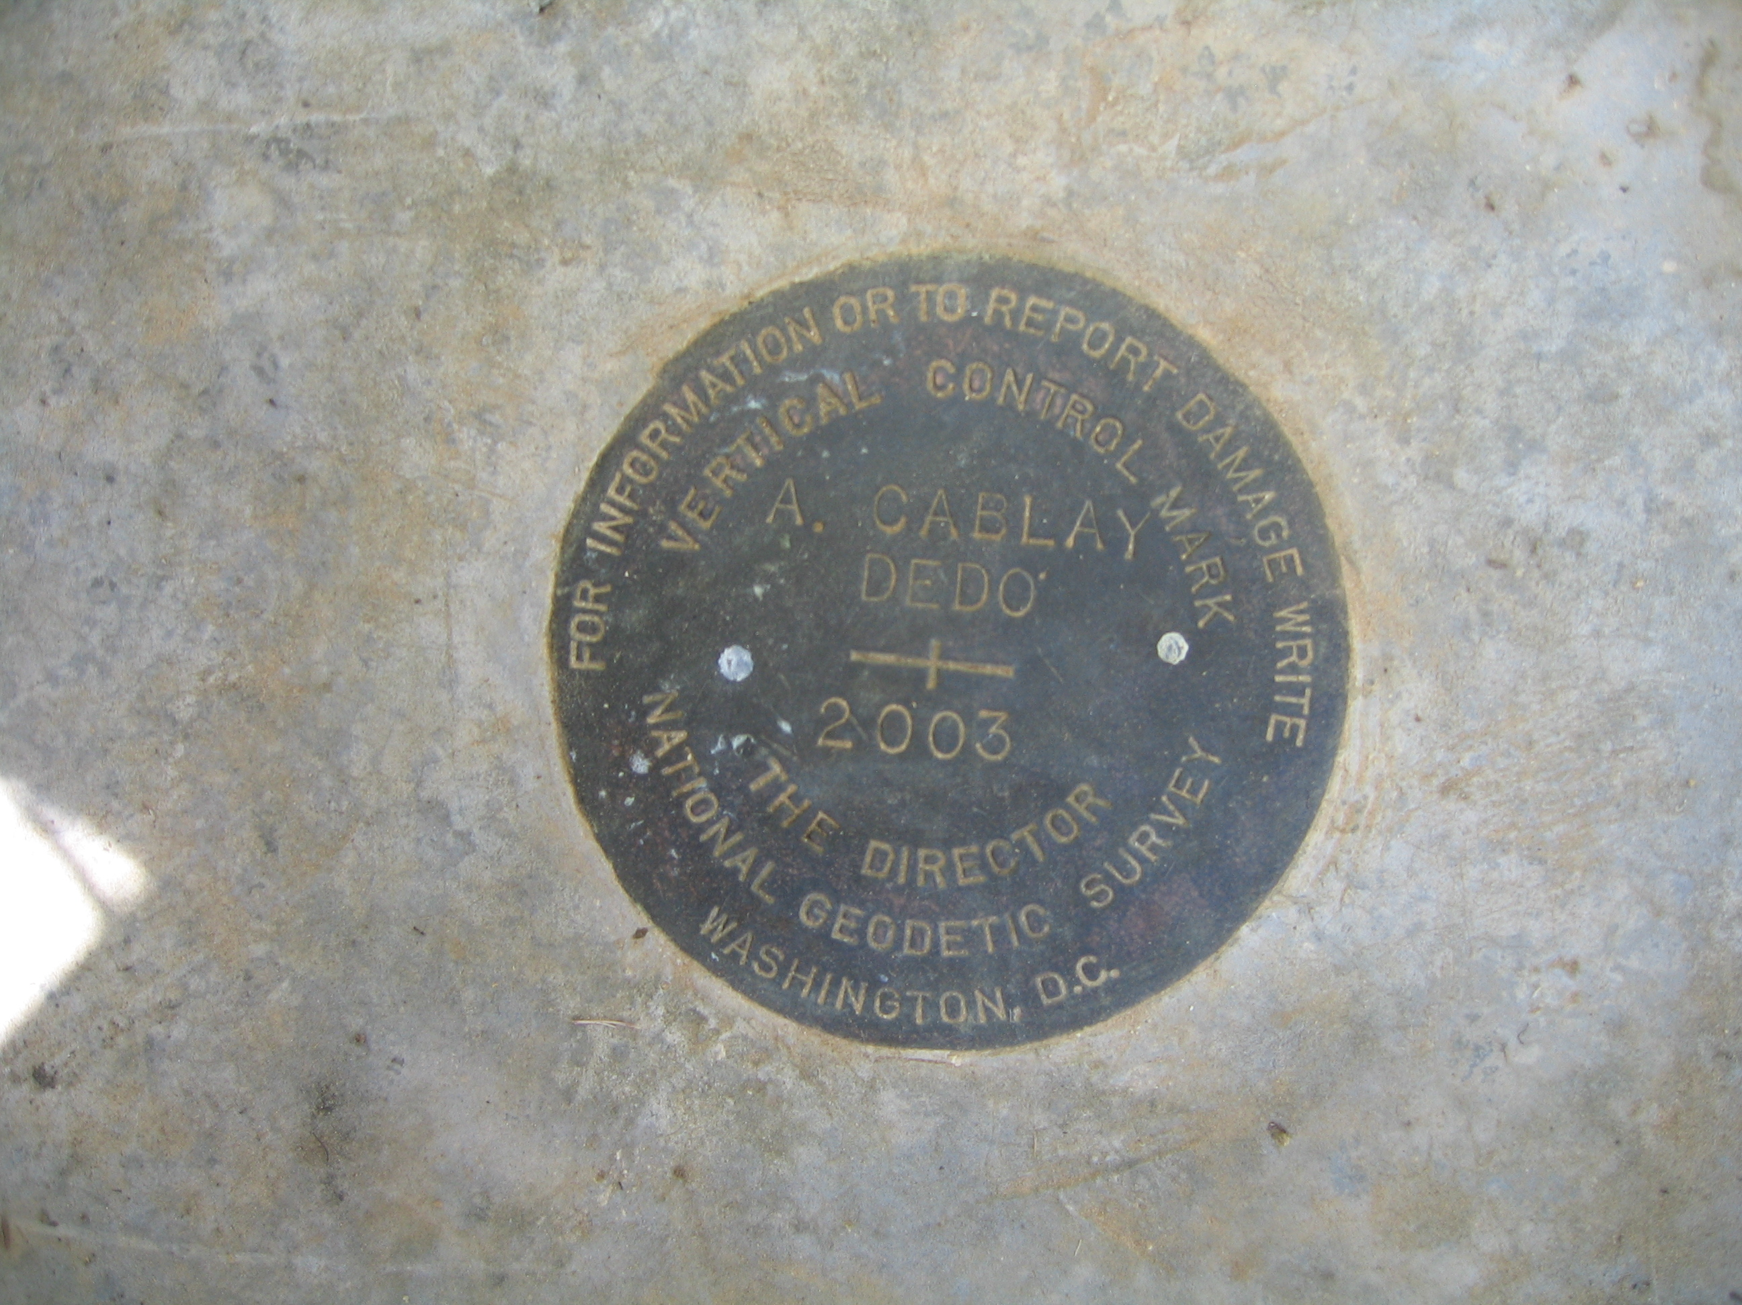

Figure C.2.1. Rota Airport base station DG3991. The benchmark is a standard NGS benchmark marked “A. CABLAY” and “DEDO” set in a concrete post.

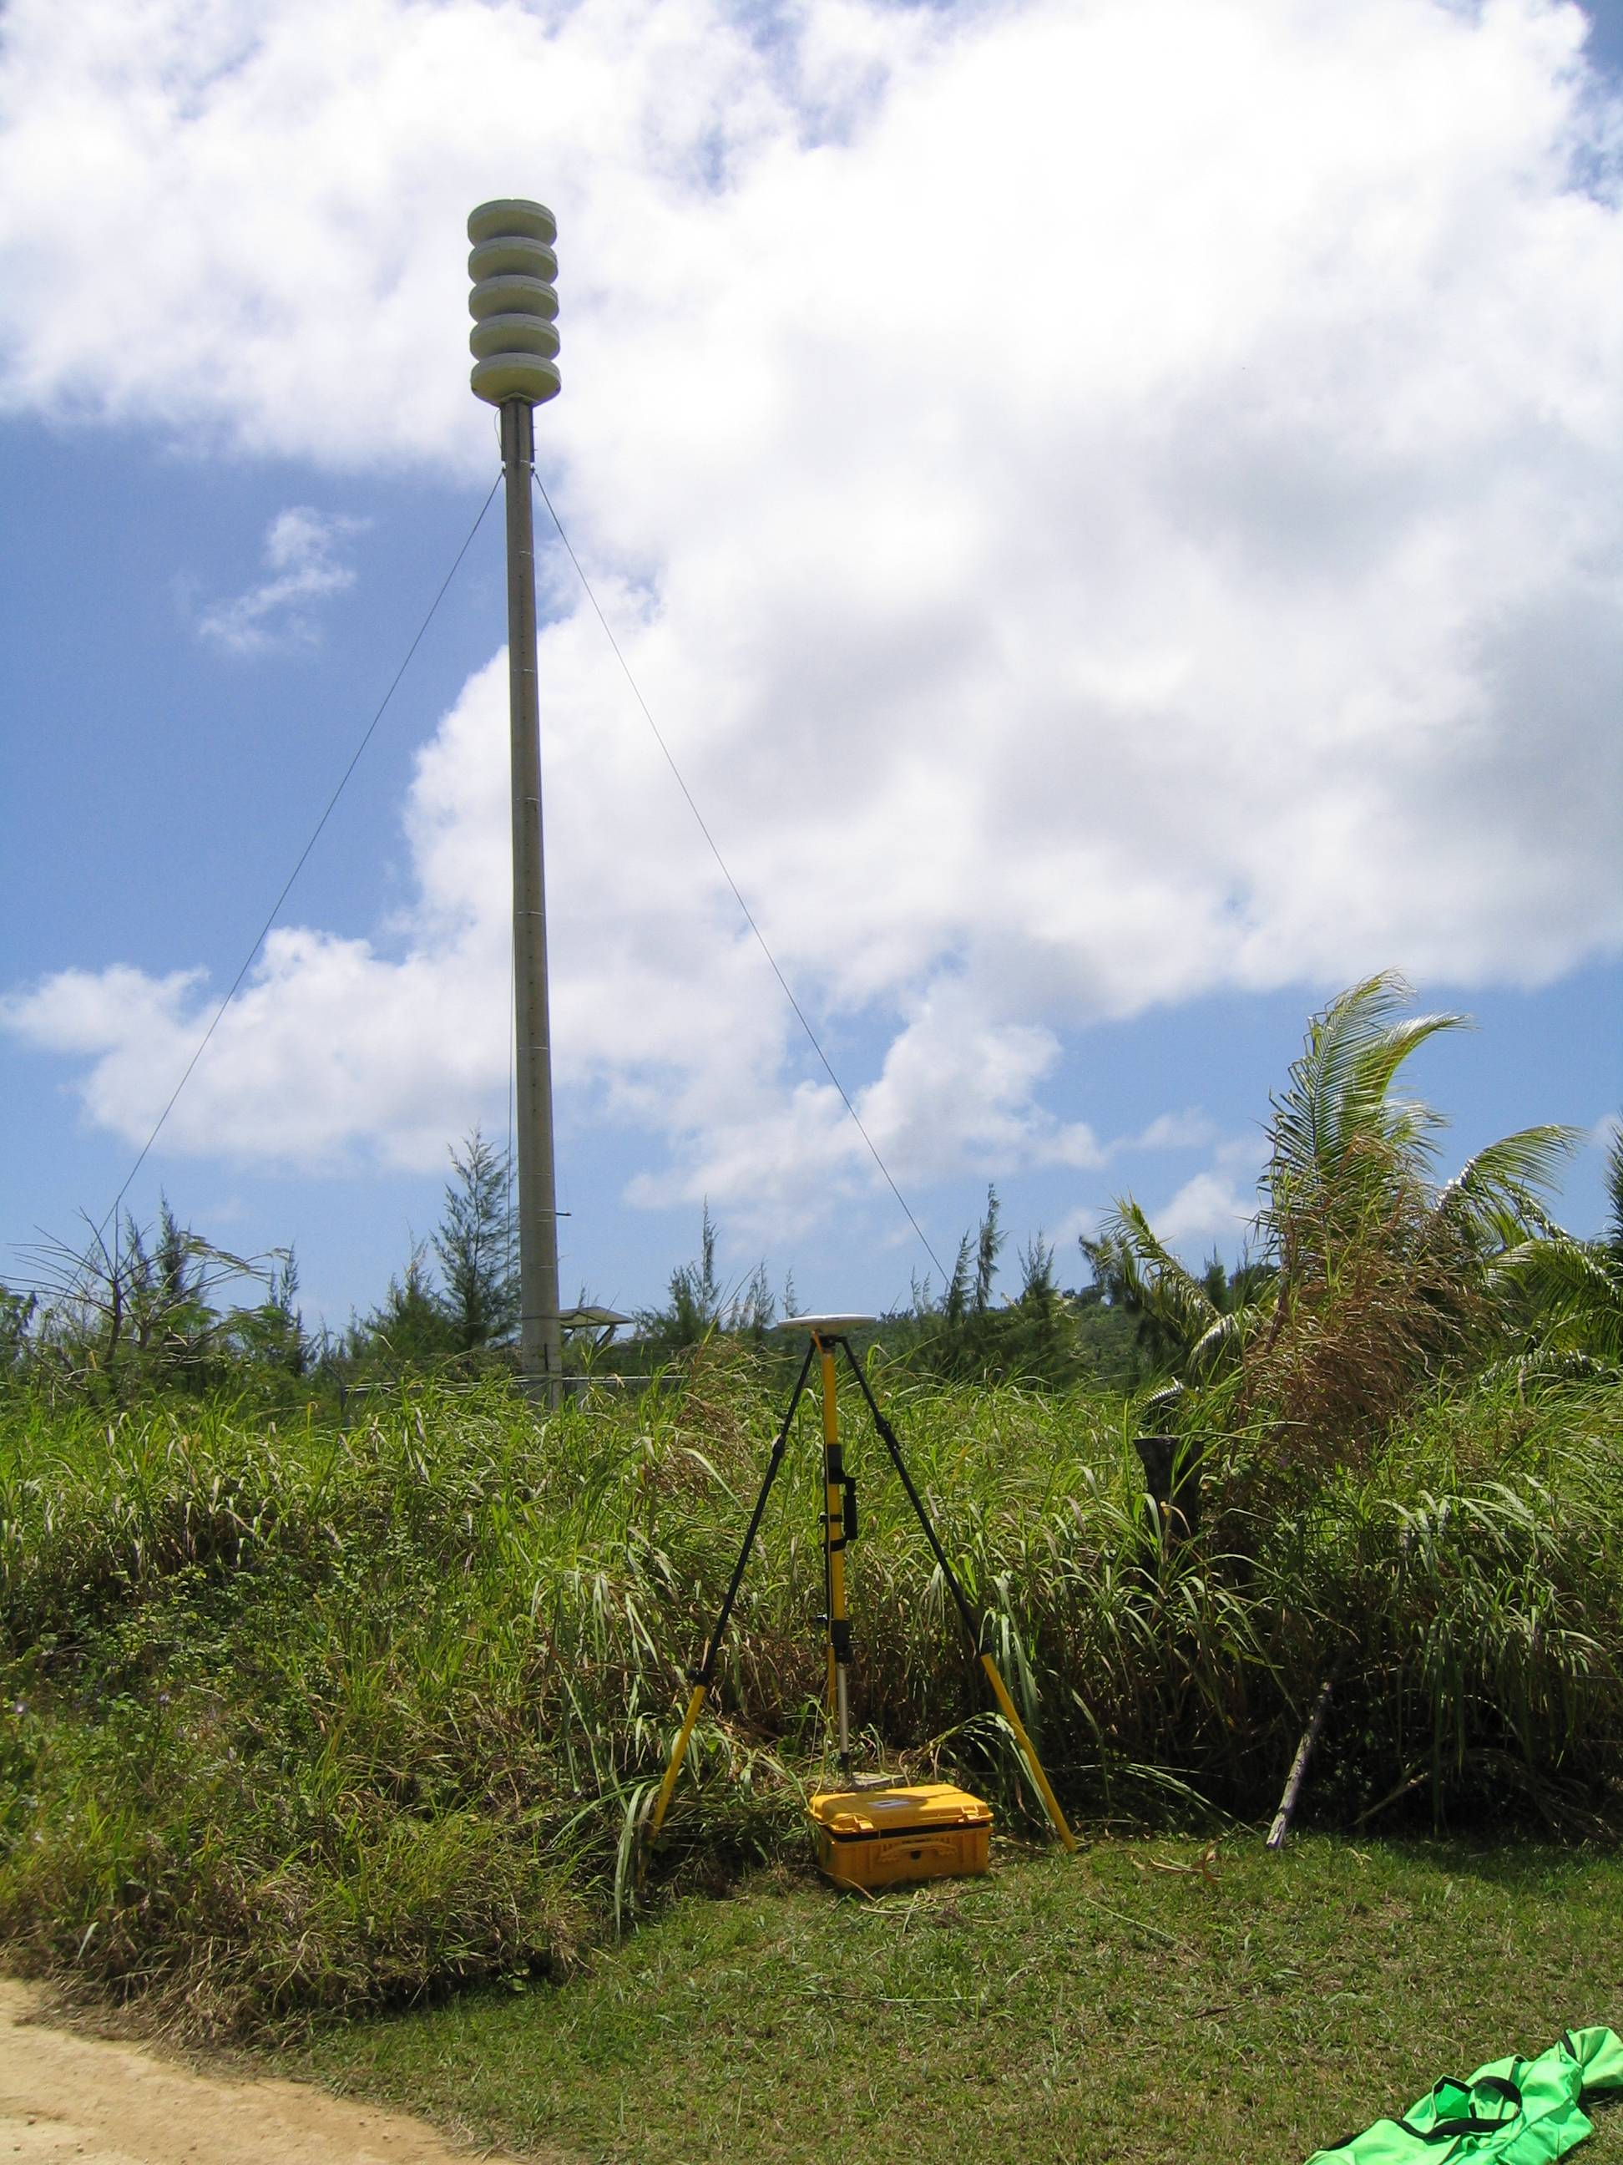

Figure C.2. Rota Airport base station DG3991, view to the North. The reference point is an NGS benchmark located on a concrete post just behind the GPS receiver case. Potential source of multipath errors is the cell phone tower and guy wires located approximately 10 meters to the North of the benchmark. However, GPS data processing showed excellent solutions for base station positions, with RMS errors no greater than 9 cm (see Appendix C. GPS Processing Summaries).

Date (Local) | Receiver Type, S/N | Antenna Type, S/N
23 March | Trimble 5700  0220240177 | Trimble Zephyr Geodetic  12482193

Table C.2. Rota Airport GPS base station information.

The GPS data collected at DG3991 was submitted to NOAA’s Online Positioning Users Service for a network adjustment of it’s position.

2.4.3 New Geodetic Control

No new geodetic control was established during this survey.

2.5 Datum Shifts

No vertical or horizontal datum shifts were made in the field. See the CNMI data processing report for detail on the reduction of data to Chart and Map Datum.

2.6 Kinematic GPS Data Collection and Processing

The aircraft was positioned using post-processed kinematic GPS methods. The aircraft was positioned in flight using a combination of a Novatel GPS receiver and an Applanix POS/AV-410. During each flight, GPS data was simultaneously recorded on board the aircraft and at a GPS base station. The frequency of recording was two records per second on the aircraft and one record per second at the GPS base station. Corrections from the KGPS base stations were applied to GPS positions and inertial data collected on the aircraft. Simultaneous GPS fixes from the base station and the aircraft were processed by Applanix POSPac V4.1. POSPac calculated a corrected aircraft position for each one-second epoch by the post-processed kinematic GPS method. In flight, the POS/AV measured aircraft accelerations in three dimensions at 200 Hz. This data was combined with the post-processed GPS solution using POSPac by calculating the aircraft attitude and position between GPS fixes. The final kinematic aircraft positions were then applied to the laser shot data in SHOALS GCS.

3.0 Digital Survey System

3.1 System Components

3.1.1 Aircraft

Manufacturer: Beachcraft
Model: King Air 200
Serial Number: BB007
Tail Number: C-FBCN

3.1.2 Laser / Transceiver

Manufacturer: Optech Incorporated
Model: SHOALS 1000T
Serial Number: 002

Topographic laser
Manufacturer: Northrop Grumman Component Technologies
Model: Unknown
Serial Number: Unknown
Wavelength: 1064 nm
Pulse repetition rate: 10 kHz

Hydrographic Laser
Manufacturer: Cutting Edge Optronics, Inc.
Model: Unknown
Serial Number: Unknown
Wavelength: 532 nm
Pulse repetition rate: 1 kHz

3.1.3 GPS Receiver

Manufacturer: Novatel
Model: Unknown
Serial Number: Unknown

3.1.4 GPS Antenna

Manufacturer: NavCom
Model: NavCom AT2775
Serial Number: Unknown

3.1.5 Primary GPS Receiver (in POS/AV)

Manufacturer: NovAtel
Model: Millennium GPS Card
Serial Number: Unknown

3.1.6 Primary GPS Antenna

Manufacturer: NovAtel
Model: 512
Serial Number: Unknown

3.1.7 POS/AV

Manufacturer: Applanix Corporation
Model: 410
Serial Number: Unknown

POS AV Absolute Accuracy Specifications (RMS):

Navigation Mode | DGPS | Real Time Kinematic | Post-Processed Kinematic
Position (m) | 0.5 - 2 | 0.1 - 0.3 | 0.05
Velocity (m/s) | 0.05 | 0.01 | 0.005
Roll & Pitch (deg) | 0.015 | 0.015 | 0.008
True Heading (deg) | 0.05 | 0.04 | 0.015

3.1.8 Digital Camera

Manufacturer: Duncan Tech
Model: DT4000
Serial Number: Unknown

3.1.9 Hyperspectral Imager

Manufacturer: Itres Research Limited
Model: CASI-1500
Serial Number: Unknown

3.1.10 Field Processing Software

Software used during field processing is listed in Table 6.1.4.

POSPac V4.2
Optech Shoals GCS V6.02
Fledermaus V6.1.5 Professional
Area Based Editor V4.3.1-1

Table 6.1.4. Field topographic data processing software.

4.0 Calibrations

4.1 Positioning Systems

No formal calibrations of the Novatel receivers were conducted in the field. However, the consistency of sequential GPS positions were verified during the application of kinematic corrections from the base station to the aircraft data. Bathymetric data associated with invalid fixes was not processed. Cross check lines orthogonal to production lines and sixty percent overlap on production lines were used to monitor the repeatability (precision) of the navigation and laser systems. Gross differences in horizontal or vertical positioning of the aircraft were obvious in the three-dimensional renderings (Fledermaus and Area Based Editor) of the data. In such cases the navigation methods used on the suspect flight lines were investigated and corrected.

4.2 CHARTS Positioning Quality Control

During survey operations the operator continuously monitored position quality in the air. Flight lines were re-flown if any of the following specifications are exceeded:

- Position Dilution of Precision exceeds 3.
- The semi-major axis of the positional error ellipse exceeds 3.5 m at the 95% confidence level.
- The minimum number of satellites being tracked for continued sounding is less than 4 healthy SV’s.
- The minimum elevation for SV is less than 100 from the horizontal.

4.3 CHARTS System Calibration

Optech installed CHARTS System 2 prior to the CNMI survey. A discussion of system calibration methods is found in the “SHOALS Calibration Summary”. System 2 was calibrated immediately prior to the installation, and the calibration report is found in the “System 2 Calibration Report”.

4.3.1 Hard Target Test

A “hard target” test is accomplished by firing the lasers against a known baseline distance using a calibrated jig. The test is performed for each receiver of the surface and bottom channels. Any observed error is eliminated through adjustment of appropriate parameters. The hard target test is described in the Timing Calibration section of Appendix B.

4.3.2 In Flight Calibration

Prior to the survey (and after any equipment changes) CHARTS system undergoes an in-flight calibration to determine small system offsets. These offsets include the position of the scanner mirror frame relative to the optical axes of the system and aircraft attitude (roll, pitch and heading) as defined by the Inertial Navigation System. The in-flight calibration is accomplished by flying over a calm, flat area in the field. An average of the water surface is derived by the system, and then a calibration program developed by the National Ocean Service derives the angular offsets assuming that the sea surface is flat. The offsets are applied to the collected data, and successful plotting of a flat-water surface indicates that the angles were correctly derived. In flight calibration procedures are described in the Angular Calibration section of Appendix B.

4.4 Survey System Offsets/Alignment

The survey system offsets are listed in Appendix D. System 2 Parameter File. During each installation of the laser system and motion sensors are optically aligned, and the offsets measured with respect to the phase center of the GPS antenna. The measured offsets are contained in the “STATIC” file that is written to the survey plan. During initialization of the data collection system the STATIC file is written to the daily data tape. During processing the offset values are extracted from the tape along with the navigation data applied during post processing.

5. 0 Tides and Tide Gages

5.1 Saipan

The NOAA tide gage installed in Saipan Harbor (see http://co-ops.nos.noaa.gov/cgi-bin/station_info.cgi?stn=1633227+TANAPAG+HARBOR,+SAIPAN,+N+MARIANAS+IS) has been removed. This did not present a problem for the survey since we used the tidal datums and benchmark-datum offsets previously established for this gage.

For surveys of Saipan and Tinian the KGPS base station receiver was placed over the NOAA tidal benchmark designated 1633227 UH-2C (also listed as NGS PID DG3988) in Saipan Harbor (see Appendices A.1.1 and A.1.2).

For the survey of Rota International Airport the KGPS base station was established over NGS benchmark DG3991 (see Appendices A.2.1 and A.2.2).

5.2 Preliminary Tidal Zoning

Not applicable.

5.3 Final Tidal Zoning

Not applicable.

5.4 Tidal Data Collection

Not applicable.

5.5 Tidal Corrections

Not applicable.

5.6 Application of Tides

The offsets between chart datum and the NMVD03 in each of the survey areas were unknown at the time of the survey, therefore the lidar data was collected with respect to the ellipsoid (i.e. the “soundings” and “elevations” are really distances between the ellipsoid and the measurement). Depths and elevations for this project will eventually be referred to chart datum (Mean Lower Low Water) and map datum (MSL) when a final “datum-to-ellipsoid” zoning scheme is determined (see CNMI Data Processing Report).

5.7 Currents and Tidal Streams

No tidal currents or streams were measured.

6. 0 Data Collection and Processing

6.1 Hydrography

The survey area for the approaches to Saipan Harbor is shown in Figure 6.1.

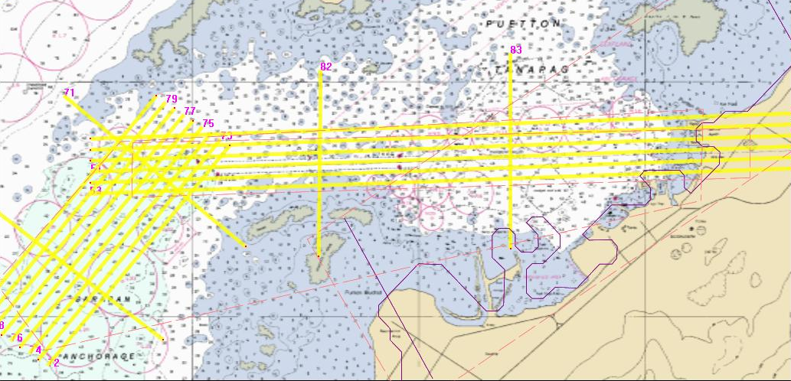

Figure 6. Survey Area, approaches to Saipan Harbor.

6.1.1 Units

All depths and elevations were reported as distance from the NMVD03 ellipsoid in meters.

6.1.2 Sounding Development and Coverage

Characteristics of the hydrographic cross check and production lines are shown in table 6.1.2.

Line type | Altitude | Speed | Shot Spacing | Line Spacing | Swath Width | Overlap
Hydro  Cross-check | 300 m  (AGL) | 128 kts | 3 X 3 m | 340 m | 125 m | NONE
Hydro  Production | 300 m (AGL) | 128 kts | 3 X 3 m | 60 m | 125 m | 30%

Table 6.1.2. System 2 hydrographic crosscheck and development line characteristics. Once an area was flown to 100% the lines were split and the area was re-flown to 200% on a different flight.

Crosscheck and production lines were planned using hardcopy NOAA chart 81076, 8th Edition, May 1993. To ensure the survey covered obstructions previously noted in the Saipan Channel, positions from NOAA’s “items” list (W00113_submarinefeatures.xls) were imported into the GCS flight planning module and overlaid on the BSB chart. Line spacing and overlap ensured each area was surveyed to a minimum of 200%. Percentage of coverage was checked using Fledermaus and Area Based Editor. Any holidays were re-flown to achieve a minimum of 200% coverage.

6.1.3 Cross Check and Swath Overlap Agreements

Two cross check lines were flown approximately SE-NW over the outer channel. Two cross check lines were flown approximately N-S over the inner channel. The crosscheck lines for the harbor were flown prior to development lines. Comparisons of depths from overlapping development and crosscheck lines as well as from swath overlaps show the datasets are indistinguishable.

1.4 Field Data Processing

Field processing of hydrographic data included applying precise navigation to the laser shots, automatically extracting depths from the laser return waveforms and manual data editing. POSPac was used to apply kinematic GPS corrections derived from the base station to the POS-AV and GPS data collected on the aircraft. Once the laser shots were precisely navigated depths were extracted from the raw laser wave forms using Optech’s SHOALS GCS software. The output of this process is the Hydrographic Output File (HOF), consisting of the position, depth and status (i.e. accepted, rejected, questionable, depth-swapped, etc.) of each laser shot. SHOALS GCS software was then used to create a “Pure File Magic” (PFM) file. Fledermaus software was used to visualize the data and to change the status of the flags in the HOF file. Fledermaus was also used to recover rejected soundings from very shallow (~1.5 to 2.0 meters) water (Shoreline Depth Swap), to extract rejected soundings from near shore areas that were flown in a land-to-water direction (Reverse Processing), and to accept or reject suspect soundings. Once the data was processed using SHOALS GCS software a second PFM file was created using Area Based Editor (ABE) software. ABE was used to search for known targets (wrecks, shoals, rocks and aids to navigation) in the data, to compare the data with Geo-Tiff images of NOAA charts and to view the data in slices. It should be noted that during the entire processing sequence no sounding data was deleted; only the status flags were changed in the HOF file.

6.1.5 Corrections to Soundings

Soundings were collected referenced to the WGS84 ellipsoid. See the CNMI Data Processing Report for more information on reduction of data to Chart Datum.

6.1.6 Agreement with Prior Surveys

During 3-6 September, 2003 the NOAA (NMFS) R/V AHI surveyed Saipan Harbor using unknown multibeam and side scan sonar systems. Ninety two obstructions in the approaches Saipan Harbor were observed (see “W00113_submarinefeatures.pdf”) and forty eight of these obstructions were listed in NOAA’s Dangers to Navigation report (see “W00113_Saipan_DTON.pdf”). Soundings, shaded bathymetry and the obstructions listed in NOAA’s DTON W0013 report are shown graphically overlaid on large scale sections of NOAA chart 81076 (see “RV_AHI_Survey_1.jpg”, “RV_AHI_Survey_2.jpg” and “RV_AHI_Survey_3.jpg”).

Using Fledermaus software, a color-shaded bathymetric surface was prepared using data from the CHARTS survey. The positions of the obstructions listed in NOAA’s “W00113_Saipan_Submarine_Features.pdf” (i.e. all the observed obstructions, including those from “W00113_Saipan_DTON.pdf”) were overlaid on this surface.

6.1.7 Agreement with Existing Charts

Charts affected by this survey include:

NOAA Chart 81076, Saipan Harbor
Date: August, 2003
Edition: 10, corrected through NTM XX
UTM grid zone: 55N
Horizontal datum: NAD83 (WGS84)
Chart Datum: MLLW

NOAA Chart 81067, Saipan and Tinian
Date: August, 2003
Edition: 6th, corrected through NTM XX
UTM grid zone: 55N
Horizontal datum: NAD83 (WGS84)
Chart Datum: MLLW

Note: NOAA chart 81067 does not show soundings in the survey area. The user is referred to NOAA chart 81076.

NOAA Chart 81076.

Dredged areas. The survey area covered a dredged channel on NOAA chart 81076. As is the case in maintained channels, soundings, obstructions and contours are not shown within the channel. The E-W channel is marked “35 FT FOR A WIDTH OF 400 FT 1997”. Soundings from this survey indicate this channel generally varies from 37 to 42 ft (11.3 to 12.8 m). A few obstructions were noted within the channel. The survey also covered a NE-SW oriented, wedge-shaped area leading up to the seaward end of the channel. This area was dredged and marked “35 FT FOR A WIDTH OF 400 TO 900 FT 1997”. Soundings from this survey indicate this channel generally varies from 13 to 15 m ( 42.6 to 49.2 ft.). Several hundred obstructions (using IHO obstruction criteria) were noted within this area.
Turning Basin. The survey covered a substantial portion of the turning basin off the Port of Saipan. Numerous obstructions were identified in this area, however only two were shown on the chart. Water clarity in some areas of the turning basin precluded lidar data collection.
Cross Check Lines. The survey was focused on the dredged areas of Saipan Harbor, however cross check lines extended past these areas. Soundings were recorded as deep as 51 m (167 ft) and numerous features were detected, however the data is provided with the caveat that there was only 100% coverage outside the main development lines.
Aids to Navigation. The lidar system detected returns from every floating aid to navigation in the survey area. See Section 6.1.8 Aids to Navigation for further details.
Shoreline. Topographic data was collected over the facilities of the Port of Saipan. Some areas of the shoreline have been filled, and minor changes to the NOAA chart 81076 will be required.
Obstructions. Main development lines covered the dredged channel to a minimum of 300%. Information on obstructions in Saipan harbor were provided by NOAA (see W00113_DTON_report.pdf, W00113_submarinefeatures.pdf). Information on the obstruction investigations can be found in Section 6.1.9 Obstructions.

6.1.8 Aids to Navigation

Aids to navigation (ATON) for Saipan Harbor were extracted from NGA website (see USCG Light List, Vol. VI, 2005, corrected through U.S. Notice to Mariners No. 10/2006 (11 March 2006)). The positions of the ATONs were converted to .shp files, imported into Fledermaus software and displayed as crosses overlaid on the lidar bathymetry data. Each ATON was shown to be verified (listed position correct), not verified (not seen in the digital down-look imagery or in the lidar data) or observed (seen in down-look imagery but not positioned with lidar data). A summary of the ATON investigation is found in “NAVOCEANO_Investigations_of_Saipan_ATONS.xls”.

6.1.9 Obstructions

A list of obstructions positioned by the R/V AHI in September, 2003 was provided by NOAA (see “W00113_submarinefeatures.pdf” and “W00113_submarinefeatures.xls”). The positions of the obstructions were converted to .shp files, imported into Fledermaus software and displayed as crosses overlaid on the lidar bathymetry data. The disposition (existence and location) of each obstruction in the survey area was investigated. A summary of the obstruction investigation is found in “W00113_submarinefeatures_navo_investigation.xls”.

6.2 Topography

6.2.1 Survey Areas

Topographic survey areas are shown in figures 6.2.1.A through 6.2.1.E.
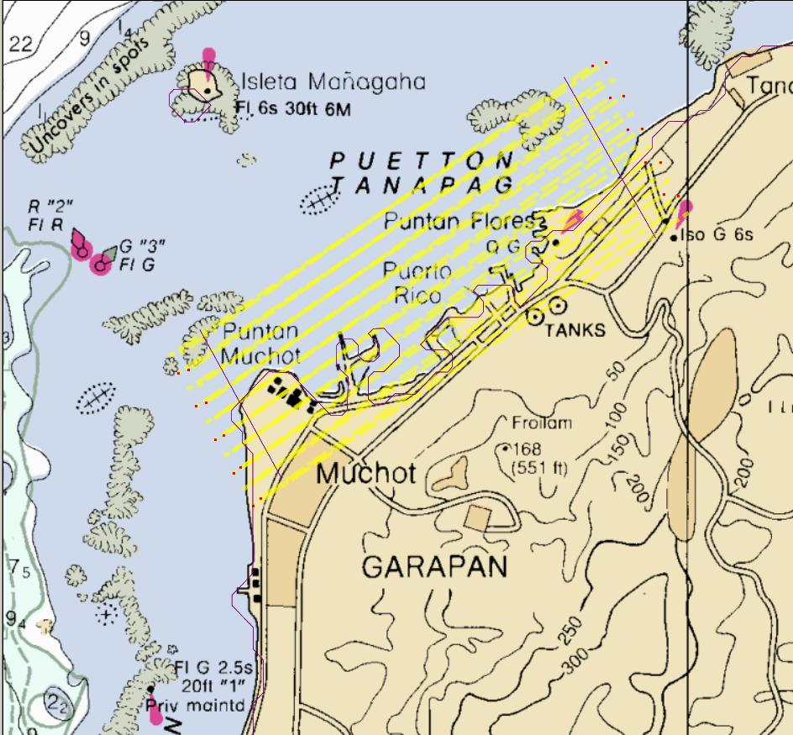

Figure 6.2.1.A. Saipan Harbor topographic survey area (cross check lines not shown).
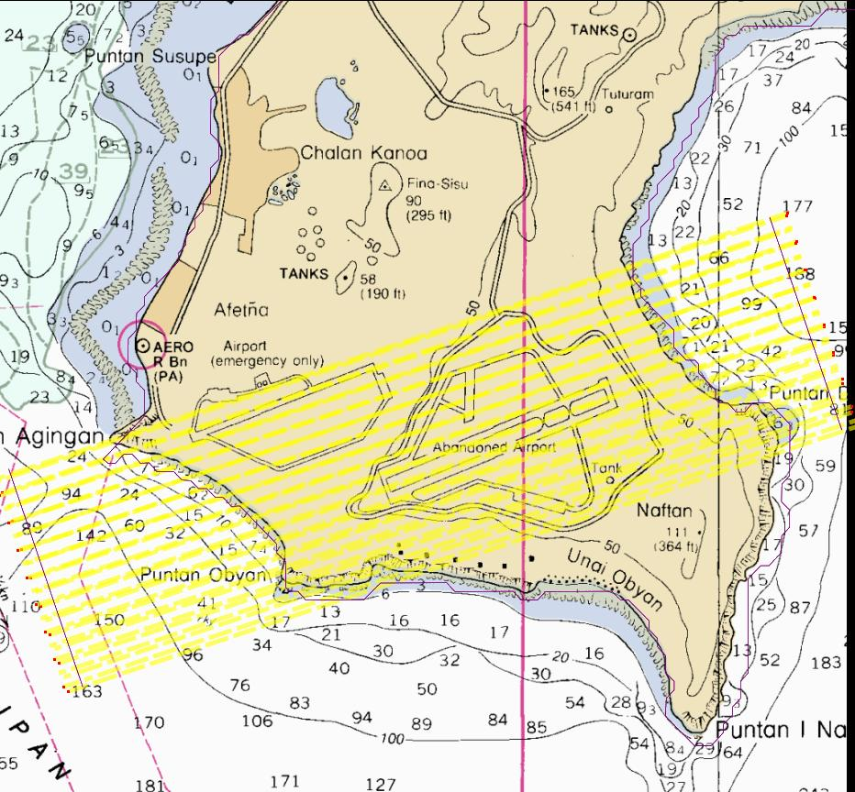

Figure 6.2.1.B. Saipan International Airport topographic survey area (cross check lines not shown).

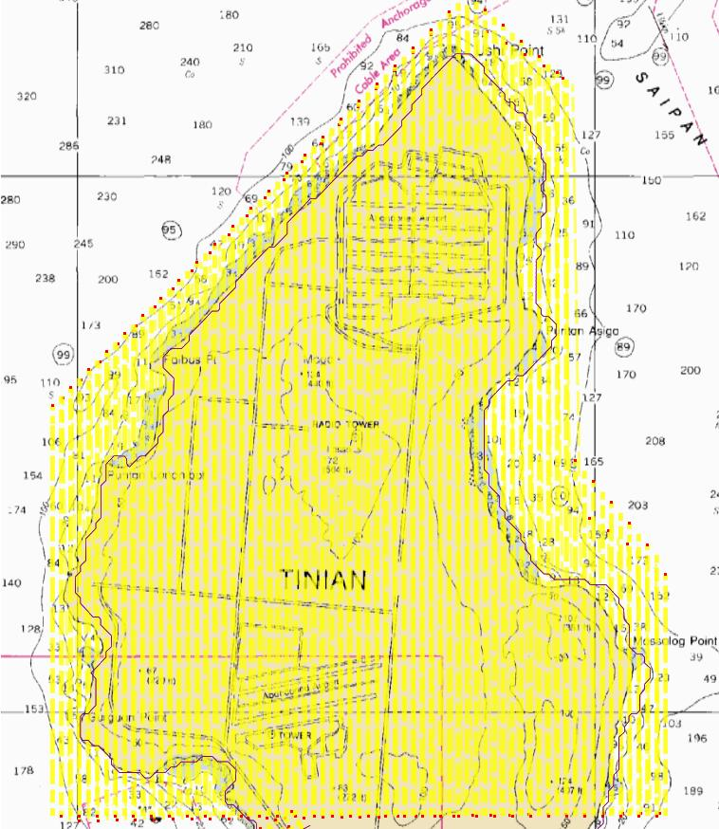

Figure 6.2.1.C. Tinian Northern Military Use Area (NMUA) topographic survey area (cross check lines not shown).

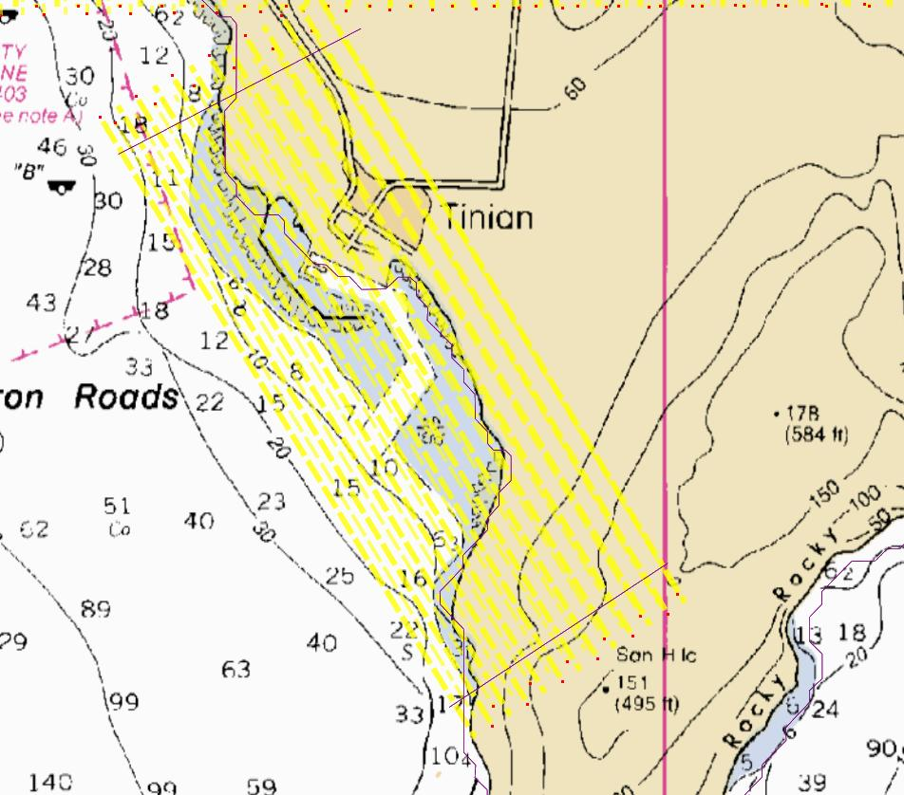

Figure 6.2.1.D. Tinian International Airport topographic survey area (cross check lines not shown).

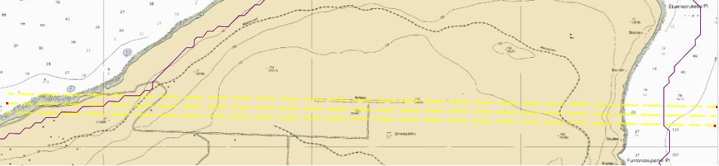

Figure 6.2.1.D. Rota International Airport topographic survey area (cross check lines not shown).

6.2.1 Units

All elevations are reported as distance from the NMVD03 ellipsoid in meters.

6.2.2 Elevation Development and Coverage

Topographic flights were conducted during 20-24 March 2006. Details of these flights are listed in Section 1.7. Characteristics of the topographic and development lines are shown in table 6.2.2. To reduce flight time 60% overlap on each line was used. Line spacing and overlap ensured each area was surveyed to a minimum of 200%. Percentage of coverage was checked using Fledermaus and Area Based Editor, and any holidays were re-flown.

Line Type | Altitude | Speed | Shot Spacing  (along X cross track) | Line  Spacing | Swath  Width | Overlap
Topo  Cross-check | 600 m  (AGL) | 125 kts | 0.8 m X 1.9 m | 5 km | 390 m | NONE
Topo  Production | 600 m  (AGL) | 125 kts | 0.8 m X 1.9 m | ~150 m | 390 m | 60 %

Table 6.2.2. System2 topographic development line characteristics. Adjacent lines were flown in opposite directions.

- Topographic and hydrographic survey lines over Saipan were planned using BSB (raster chart format) chart 81076_1, 8th edition, May 1993.
- Topographic survey flights over Tinian were planned using BSB chart 81067_1, 5th edition, May 1990.
- Topographic survey flights over Rota were planned using BSB chart 81063_1, 5th edition, May 1990.

6.2.3 Cross Check and Swath Overlap Agreements

Each topographic survey project included cross check lines perpendicular to the development lines. The crosscheck lines were flown prior to development lines. Comparison of elevations from overlapping development and crosscheck lines as well as from swath overlaps shows the datasets are indistinguishable.

6.2.4 Processing Software

Software used during field processing is listed in Table 6.2.4.

POSPac V4.1
Optech Shoals GCS V6.01
Fledermaus V6.1.4.b Professional
Area Based Editor V

Table 6.2.4. Field topographic data processing software.

6.2.5 Field Processing

Field processing of topographic data included applying precise navigation to the laser shots, automatically extracting elevations from the laser return waveforms and manual data editing. POSPac was used to apply kinematic GPS corrections derived from the base station to the POS-AV and GPS data collected on the aircraft. Once the laser shots were precisely navigated, elevations were extracted from the raw laser wave forms using Optech’s SHOALS GCS software. The output of this process is the Topographic Output File (TOF), consisting of the position, elevation and status (i.e. accepted, rejected, questionable, etc.) of each laser shot. SHOALS GCS software was then used to create a “Pure File Magic” (PFM) file. Fledermaus software was used to visualize the data and to change the status of the flags in the TOF file. Fledermaus was also used to reject elevations from water returns and to edit obvious spurious data. Once the data was processed using SHOALS GCS software a second PFM file was created using Area Based Editor (ABE) software. ABE was used to view the data in slices. It should be noted that during the entire processing sequence no elevation data was deleted; only the status flags were changed in the TOF file.

6.2.6 Corrections to Elevations

Elevations were measured by the aircraft as distances from the NMVD03 ellipsoid. Elevations for this project will eventually be referred to the map (vertical) datum (Mean Sea Level) when the distance between the ellipsoid and the vertical datum is established. Reduction of elevations to Map Datum is discussed in the CNMI Data Processing Report.

Topographic data collected with airborne lidar includes both “first” and “last” returns. First returns are reflections from objects above the earth’s surface (vegetation, power lines); second returns are ground reflections. Due to the density of vegetation surrounding the topographic survey areas very few second returns were recorded over the jungle. It should be noted that the .pfm elevation files are composed of returns from trees and vegetation as well as returns from hard surfaces (true earth or structures).

6.2.7 Agreement with Prior Surveys

Information from prior topographic surveys was not available.

7.0 Accuracy and Resolution of Soundings (Hydrographic Mode)

Optech (personal communications, November-December 2004) provided horizontal and vertical error budget information. The error budgets discussed below pertain to depths referenced to the NMVD03 ellipsoid, the positioning system operating in KGPS mode and with flight parameters shown in Table 6.1.2.

7. 1 Horizontal Accuracy

An example of the horizontal error budget for the CHARTS system operating with KGPS for soundings in 50 meters of water is shown in Table 7.1.

Error Source | Error | Resultant horizontal error (m)
Height (m, 1 sigma) | 0.10 | 0.04
Roll (deg, 1 sigma) | 0.008 | 0.06
Pitch (deg, 1 sigma) | 0.008 | 0.06
Heading (deg, 1 sigma) | 0.015 | 0.04
Scan angle encoder (deg, 1 sigma)1 | 0.02 | 0.22
Antenna lever arm (m, 1 sigma) | 0.05 | 0.07
Calibration (deg, 1 sigma) | 0.010 | 0.11
Laser pointing (deg, 1 sigma) | 0.02 | 0.16
IHO allowable depth error (1 sigma) at 50 m (m)2 | 0.41 | 0.11
Propagation error (factor)3 | 0.015 | 0.75
Surface beam steering(m, 1 sigma)4 | 0.23 | 0.06
KGPS position (m, 1 sigma) | 0.15 | 0.29
CHARTS total RMS horizontal error (m, 1 sigma) | -- | 0.81
CHARTS total RMS horizontal error (m, 95% confidence) | -- | 1.60
IHO allowable horizontal error  (m, 95% confidence) | -- | 7.50

Table 7.1. Horizontal error budget for hydrographic data collection in 50 meters of water using flight parameters shown in Table 6.1.2. Notes: 1. The scan angle of the two steering mirrors is digitized with an error of 0.02 degrees. 2. This is the horizontal error that may be present if the depth error was at the IHO 1-sigma maximum (0.41 meters) for a 50 meter sounding. 3. The propagation error factor is caused by beam spreading in the water column. As it is a “factor” it is multiplied by the depth—i.e. 50 m x 0.015 = 0.75 m. 4. This uncertainty is due to random steering of the pulse by surface waves. The horizontal error budget for the CHARTS system for all depths up to 50 meters is shown in Figure 7.1.

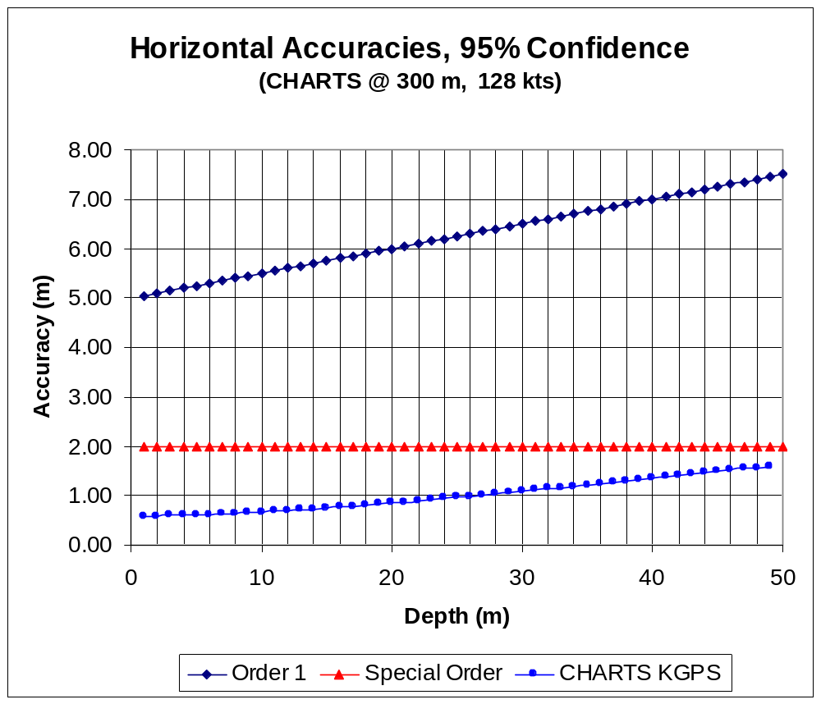

Figure 7.1. CHARTS system horizontal error budget for hydrographic data collection between 0 and 50 meters of water using flight parameters shown in Table 6.1.2.

7. 2 Vertical Accuracy

An example of the vertical error budget for the CHARTS system operating with KGPS for soundings in 50 meters of water is shown in Table 7.2. The 95% confidence level for depth is calculated as:

|Σ(Bias Errors)-(Constant Bias)| + 1.96(ΣRandom Errors)^{1,2}

Note:
¹Errors in the determination of the tidal datum are not included in this error budget.
²10 cm used for the error in the KGPS trajectory. If the trajectory vertical accuracy is better than this, then the overall error would be lower. For example, a 5 cm error in the trajectory would lower the total error for shallow water (less than 5 m) from 29 cm in the table to 24 cm. This meets the USACE General Survey standard but, Optech cannot guarantee this for all cases.
Table 7.2. Vertical error budget for hydrographic data collection in 50 meters of water using flight parameters shown in Table 6.1.2.

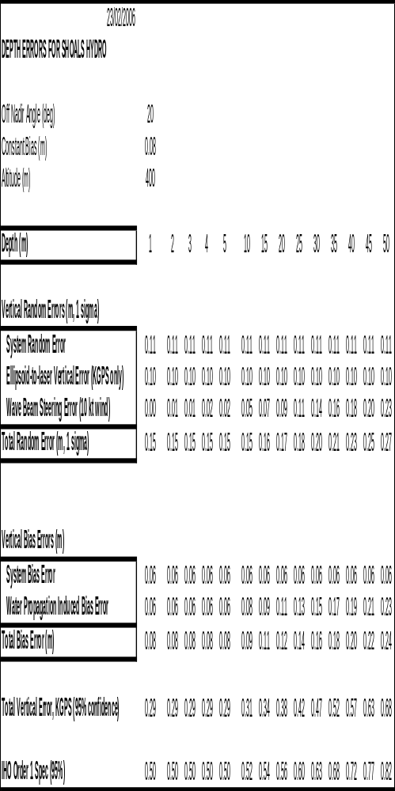

The System Random error in Table 7.2 includes such factors as the range measurement, the amplifiers, wave heights, pulse location calculation and also the vertical error associated with the pointing of the laser beam. The two random errors of the KGPS trajectory (10 cm) and the vertical component were kept separate due to the steering of the beam from the wave surface.

The System Bias error includes thermal effects, range calibration, and the error in detecting the air water interface. The major bias for a hydrographic laser is the bias induced by the water propagation which depends on many factors. We have kept this error minimized in the SHOALS design by using a constant off nadir angle for the beam. The algorithm also attempts to correct for this bias with the use of a depth dependent parameter. However, there still remains an uncertainty and this is the bias shown in Table 7.2.

The vertical error budget for the CHARTS system for all depths up to 50 meters is shown in Figure 7.2.

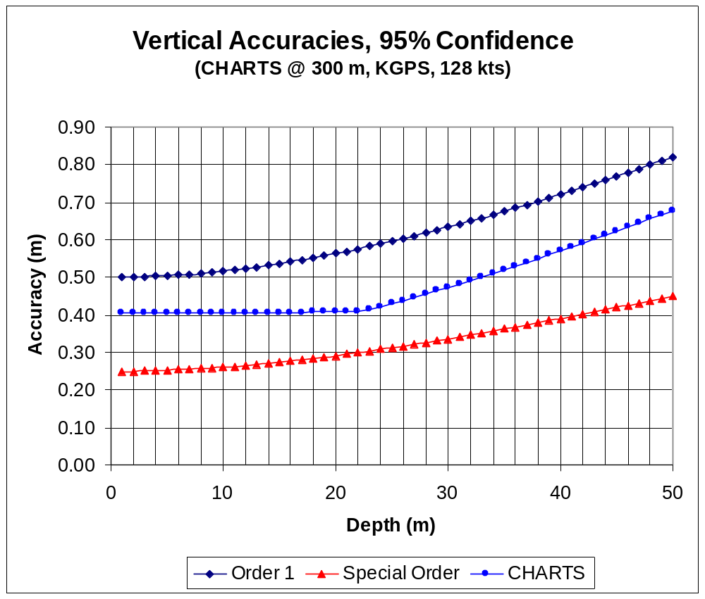
Figure 7.2. CHARTS system vertical error budget for hydrographic data collection between 0 and 50 meters of water using flight parameters shown in Table 6.1.2.

7. 3 Tide Corrections

No tide corrections were applied to the data. Soundings were collected referenced to the NMVD03 ellipsoid. Depths for this project will eventually be referred to the chart datum (Mean Lower Low Water feet) when the distance between the ellipsoid and the chart datum is established. See the CNMI Data Processing Report for more information.

7.4 IHO Standards

It can be seen from Table 7.1 and Figure 7.1 that CHARTS data meets IHO horizontal accuracy requirements for all depths up to 50 meters. Vertical error budgets discussed in section 7.2 pertain to depths referred to the NMVD03 ellipsoid. While the absolute accuracy (with respect to the NMVD03 ellipsoid) is high, whether the data meets IHO standards can only be determined after the distance from the NMVD03 ellipsoid to chart datum is applied to the data (see CNMI Data Processing Report).

7.5 CHARTS Lidar Target Detection

Based on target detection probability curves produced by NOAA, all areas meet IHO Order 1 target/object detection requirements at the 95% confidence level for depths from 7 m to 20 m with single-flight coverage. At depths deeper than 20 m, signal-to-noise ratio limitations greatly reduce target detection capability, particularly for small objects less than 2 meters. During testing of the CHARTS system targets of 2 meters and larger were detected 100% of the time in depths between 5 and 30 meters. Based on these tests the lidar system meets IHO Order 1 target detection requirements and multiple coverage greatly reinforces this capability.

8.0 Accuracy and Resolution of Elevations (Topographic Mode)

Optech (personal communications, 28-30 November 2004) provided horizontal and vertical error budget information. The error budgets discussed below pertain to depths referenced to the NMVD03 ellipsoid, the positioning system operating in kinematic mode and with flight parameters from Table 6.2.2.

8.1 Horizontal Accuracy

An example of the horizontal error budget for the CHARTS system in topographic mode is shown in Table 8.1.

Error Source | Error | Resultant horizontal error (m, 1 sigma)
Height (m, 1 sigma) | 0.10 | 0.04
Roll (deg, 1 sigma) | 0.008 | 0.07
Pitch (deg, 1 sigma) | 0.008 | 0.07
Heading (deg, 1 sigma) | 0.015 | 0.04
Scan angle encoder (deg, 1 sigma)1 | 0.02 | 0.24
Antenna lever arm (m, 1 sigma) | 0.05 | 0.07
Calibration (deg, 1 sigma) | 0.010 | 0.12
Laser pointing (deg, 1 sigma) | 0.02 | 0.17
KGPS position (m, 1 sigma) | 0.15 | 0.29
CHARTS total RMS horizontal error (m, 1 sigma) | -- | 0.38
CHARTS total RMS horizontal error (m, 95% confidence) | -- | 0.74
USACE allowable horizontal error (m, 95% confidence) | -- | 3.00

1. The scan angle of the two steering mirrors is digitized with an error of 0.02 degrees.

Table 8.1. Horizontal error budget for topographic data collection in 50 meters of water using flight parameters in Table 6.2.2.

8.2 Vertical Accuracy

The vertical error budget for the CHARTS system operating in topographic mode is shown in Table 8.2. The 95% confidence level for elevation is calculated as:

|Σ(Bias Errors)-(Constant Bias)| + 1.96(ΣRandom Errors)^{1,2}

Note:
¹The error in the determination of the vertical datum (MSL) is not included in this error budget.
²10 cm used for the error in the KGPS trajectory. If the trajectory vertical accuracy is better than this, then the overall error would be lower. For example, a 5 cm error in the trajectory would lower the total error for shallow water (less than 5 m) from 29 cm in the table to 24 cm. This meets the USACE General Survey standard but, Optech cannot guarantee this for all cases.
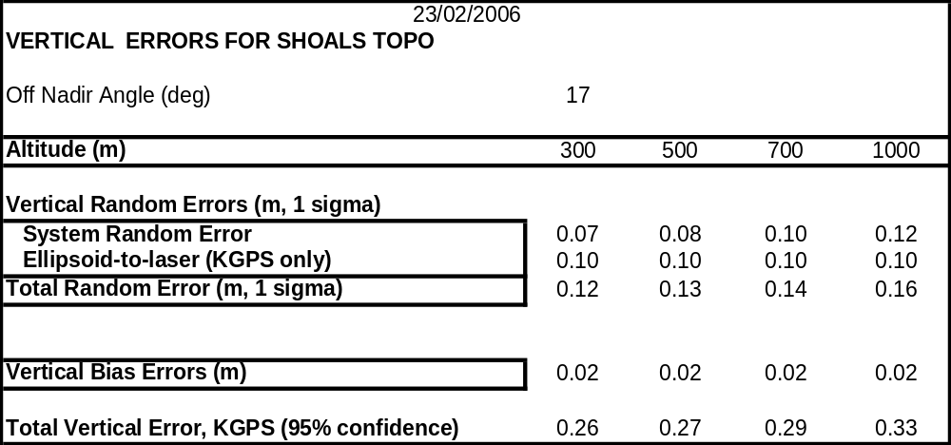

Table 8.2. Vertical error budget for topographic data collection in using flight parameters in Table 6.1.2.

The Vertical Bias errors in Table 8.2 for the topographic laser subsystem include thermal and calibration terms.

The System Random Errors in Table 8.2 comprise such factors as the range measurement, the amplifiers, and the vertical component error due to the error in the laser beam pointing.

8.3 USACE Standards

Topographic elevations use Mean Sea Level (MSL) for the vertical datum. While the absolute accuracy (with respect to the NMVD03 ellipsoid) is high, whether the data meets USACE standards can only be determined after the distance from the NMVD03 ellipsoid to vertical datum is applied when the CNMI Data Processing Report is available.

10.0 Changes to Sailing Directions

10.1 General

Not applicable.

10.2 Landmarks

Not applicable.

10.3 Cautions

Not applicable.

10.4 Warnings

Not applicable.

10.5 Anchorages and Moorings

Not applicable.

10.6 Coastal Pollution

Not applicable.

11.0 Ancillary Observations

Not applicable.

11.1 Tidal Streams and Currents

Not applicable.

11.2 Meteorology

Not applicable.

11.3 Sound Velocity Measurements

Not applicable.

11.4 Water Clarity Observations

Not applicable.

11.5 Biological Observations

Not applicable.

11.6 Seabed Sampling

Not applicable.

12.0 Photography

Digital overlapping, down-look images were taken at a rate of one per second, providing at least one image per laser shot. While not of photogrametric quality (neither orthometric nor orthorectified) these images were used to identify features observed in the lidar data. On the completion of the project these images were mosaiced (see CNMI Data Processing Report). Individual images and the final mosaic have been submitted to NAVOCEANO along with other hydrographic data.

13.0 References

14.1 U.S. Department of Commerce. National Oceanic and Atmospheric Administration, National Ocean Survey. "National Ocean Survey Hydrographic Survey Specifications and Deliverables,” Apr. 1999.

14.2 U.S. Federal Geodetic Control Committee. "Geometric Geodetic Accuracy Standards and Specifications for Using GPS Relative Positioning Techniques, Version 5.0 (Preliminary)", National Oceanic and Atmospheric Administration, Rockville, MD, National Geodetic Survey, May 1988. (Reprinted and corrected Aug 1989).

14.3 Naval Oceanographic Office. “Hydrographic Smooth Sheet Specification,” Ver. 2.2. Bay St. Louis, Stennis Space Center, MS.

14.4 Naval Oceanographic Office. “Hydrographic Field Chart Specification,” Ver. 2.0. Bay St. Louis, Stennis Space Center, MS.

14.5 Naval Oceanographic Office. "Hydrographic Procedures". Bay St. Louis, Stennis Space Center, MS, 1990.

14.6 United States. Oceanographer of the Navy. "Guide to Marine Observing and Reporting", N.O. Publication 606, Washington, DC, Defense Mapping Agency Hydrographic/Topographic Center, 1983.

14.7 Naval Oceanographic Office. "Guide to Common Shipboard Expendable Bathythermograph (SXBT) Recording Malfunctions", by Barry P. Blumenthal and Stephen M. Kroner, Bay St. Louis, Stennis Space Center, MS, Aug 1978 (Revised Feb 1981).

14.8 Monaco. International Hydrographic Bureau. "IHO Standards For Hydrographic Surveys, Classification Criteria For Deep Sea Soundings, and Procedures For Elimination of Doubtful Data", Special Publication No. 44, 4th Edition, 1998.

14.9 U.S. Department of Commerce. National Oceanic and Atmospheric Administration, National Ocean Survey "Side Scan Sonar Manual", by LCDR D.H. Peterson, NOAA and LCDR A.A. Armstrong III, NOAA, Charting and Geodetic Services, 1988.

14.10 IHO Standards for Hydrographic Surveys Special Publication No.44, Fourth Edition, Monaco, 1998.

14.11 “Maritime Claims Reference Manual,” DOD 2005.1-M January 1996.

14.12 “The Commander’s Handbook on The Law of Naval Operations,” NWP 1-14M, Formerly NWP 9 (Rev. A), October 1995.

14.13 “Department of the Navy (DON) Information Security Program (ISP) Regulation,” SECNAVINST 5510.36, Exhibit 8A, 17 March 1999.

14.14 Naval Oceanographic Office. “Responsibility and Authority of the Senior NAVOCEANO Representative,” NAVOCEANOINST 3120.2B, 10 October 1994.

14.15 Naval Oceanographic Office. “Survey Operations Reporting Procedures,” NAVOCEANOINST 3140.5C, 17 June 1995.

14.16 Naval Oceanographic Office . “Administrative Procedures,” Chapter 4, Mail Procedures, NAVOCEANOINST 5218.3B, 16 May 1996.

14.17 United States Army Corps of Engineers. “Engineering and Design – Photogrammetric Mapping,” USACE publications EM
1110-1-1000, 01 July 2002.

14.18 United States Army Corps of Engineers. “NAVSTAR Global Positioning System Surveying,” USACE publication EM 1110-1-1003, 01 July 2003.

14.19 United States Army Corps of Engineers. “Topographic Surveying,” USACE publication EM 1110-1-1005, 31 August 1995.

14.20 National Oceanic and Atmospheric Administration. “Coast Pilot 7 - 37th Edition”. Chapter 15 Pacific Islands. 2005.

14.21 National Geospatial Intelligence Agency. “Sailing Directions Enroute – Publication 126 – Pacific Islands.” 2005.

14.22 Naval Oceanographic Office. “Outside Source Data Evaluation - Descriptive Report: Micronesia – Northern Mariana Islands, Guam, Apra Inner Harbor”. NAVOCEANO. Register No. W00006. 2001.

14.0 Appendices

Appendix A. Data sheets for KGPS base station locations

A.1.1 National Ocean Service Tidal Benchmark 1633227 UHC-2C Datasheet

The data sheet for tidal benchmark UHC-2 used for the Saipan Harbor GPS base station can be found on NOAA’s website at http://140.90.121.76/benchmarks/1633227.html. The pertinent information is reproduced below. (Note: NOAA’s primary benchmark 1633227 UH-2C is given PID DG3988 by the National Geodetic Service. See Appendix C.1.2, National Geodetic Survey DG3988 Datasheet)

U.S. DEPARTMENT OF COMMERCE
National Oceanic and Atmospheric Administration
National Ocean Service

Station ID: 1633227
Publication Date: 04/21/2003
Name: TANAPAG HARBOR, SAIPAN, N MARIANAS IS
NOAA Chart: 81067 Latitude: 15° 13.6' N
USGS Quad: ISLAND OF SAIPAN Longitude: 145° 44.2' E

To reach tidal bench marks from Saipan International Airport, proceed 3.4 km
(2.1 mi) north along an unnamed road. As the road terminates, turn left (west)
onto Cross Island Road (Note: there are no road signs in Saipan). Turn right
(north) on Middle Road (first large intersection with traffic light) and proceed
for 8 km (5 mi). Turn left (west) immediately after the WESTPAC building
(located on the west side of Middle Road). The unnamed road will bend to the
south, turn right (west) just past the Port of Saipan Building (two story
concrete building painted beige). Proceed through the parking toll booth and
turn right toward the NNE side of the port facility. The bench marks were
located on the Port of Saipan facility. The tide gauge was located where east
parking lot meets with the east face of Delta Dock.

T I D A L B E N C H M A R K

PRIMARY BENCH MARK STAMPING: None.
DESIGNATION: 1633227 UH-2C

MONUMENTATION: Bolt VM#: 16316
AGENCY: University of Hawaii (UH) PID:
SETTING CLASSIFICATION: Concrete deck

The primary bench mark is a 9/16" SS hex head bolt set in the concrete deck
where the east face of Delta Dock (Delta -3) meets the east face of the parking
lot (CPA-2) fronting the port building, located at the Commonwealth Port
Authority (CPA) facility in Saipan Harbor (aka Tanapag Harbor), 2.83 m (9.3 ft)
SSE of the SE corner of a diesel containment wall, 2.56 m (8.4 ft) NNE of
utility pole #7, and 1.13 m (3.7 ft) west of the east pier face (CPA-2).

T I D A L D A T U M S

Tidal datums at TANAPAG HARBOR, SAIPAN, N MARIANAS IS based on:

LENGTH OF SERIES: 5 Months
TIME PERIOD: October 2000 - February 2001
TIDAL EPOCH: 1983-2001
CONTROL TIDE STATION: 1630000 GUAM, APRA HARBOR

Elevations of tidal datums referred to Mean Lower Low Water (MLLW), in METERS:

MEAN HIGHER HIGH WATER (MHHW) = 0.669
MEAN HIGH WATER (MHW) = 0.629
MEAN TIDE LEVEL (MTL) = 0.407
MEAN SEA LEVEL (MSL) = 0.392
MEAN LOW WATER (MLW) = 0.185
MEAN LOWER LOW WATER (MLLW) = 0.000

National Geodetic Vertical Datum (NGVD 29)

Bench Mark Elevation Information

In METERS above:

Stamping or Designation MLLW MHW
163 3227 UH-2C 2.049 1.420

D E F I N I T I O N S

Mean Sea Level (MSL) is a tidal datum determined over a 19-year National Tidal
Datum Epoch. It pertains to local mean sea level and should not be confused
with the fixed datums of North American Vertical Datum of 1988 (NAVD 88).

NGVD 29 is a fixed datum adopted as a national standard geodetic reference for
heights but is now considered superseded. NGVD 29 is sometimes referred to as
Sea Level Datum of 1929 or as Mean Sea Level on some early issues of Geological
Survey Topographic Quads. NGVD 29 was originally derived from a general
adjustment of the first-order leveling networks of the U.S. and Canada after
holding mean sea level observed at 26 long term tide stations as fixed.
Numerous local and wide-spread adjustments have been made since establishment in
1929. Bench mark elevations relative to NGVD 29 are available from the National
Geodetic Survey (NGS) data base via the World Wide Web at
National Geodetic Survey.

NAVD 88 is a fixed datum derived from a simultaneous, least squares, minimum
constraint adjustment of Canadian/Mexican/United States leveling observations.
Local mean sea level observed at Father Point/Rimouski, Canada was held fixed as
the single initial constraint. NAVD 88 replaces NGVD 29 as the national
standard geodetic reference for heights. Bench mark elevations relative to
NAVD 88 are available from NGS through the World Wide Web at
National Geodetic Survey.

NGVD 29 and NAVD 88 are fixed geodetic datums whose elevation relationships to
local MSL and other tidal datums may not be consistent from one location to
another.

The Vertical Mark Number (VM#) and PID# shown on the bench mark sheet are unique
identifiers for bench marks in the tidal and geodetic databases, respectively.
Each bench mark in either database has a single, unique VM# and/or PID# assigned.
Where both VM# and PID# are indicated, both tidal and geodetic elevations are
available for the bench mark listed.

The NAVD 88 elevation is shown on the Elevations of Tidal Datums Table Referred
to MLLW only when two or more of the bench marks listed have NAVD 88 elevations.
The NAVD 88 elevation relationship shown in the table is derived from an average
of several bench mark elevations relative to tide station datum. As a result of
this averaging, NAVD 88 bench mark elevations computed indirectly from the tidal
datums elevation table may differ slightly from NAVD 88 elevations listed for
each bench mark in the NGS database.

A.1.2 National Geodetic Service DG3988 Datasheet

Information on this benchmark was found on the NGS website, starting at:
http://www.ngs.noaa.gov/cgi-bin/ds_county.prl and is reproduced below. (Note: NGS PID DG3988 is given tidal benchmark identifier 1633227 UH-2C by the National Ocean Service. See Appendix C.1.1, National Ocean Service Tidal Benchmark1633227 UH-2C Datasheet.)

The NGS Data Sheet
See file dsdata.txt for more information about the datasheet.
DATABASE = Sybase
PROGRAM = datasheet
VERSION = 7.33
1 National Geodetic Survey, Retrieval Date = MARCH 25, 2006
***********************************************************************
DESIGNATION - 163 3227 TIDAL UH 2C
PID - DG3988
STATE/COUNTY- CQ/NORTHERN MARIANA ISLANDS
USGS QUAD -

*CURRENT SURVEY CONTROL
___________________________________________________________________
* NAD 83(2002)- 15 13 34.73150(N) 214 15 45.39433(W) ADJUSTED
* NMVD03 - 1.657 (meters) 5.44 (feet) ADJUSTED ___________________________________________________________________
EPOCH DATE - 2002.00
X - -5,087,487.659 (meters) COMP
Y - 3,465,585.998 (meters) COMP
Z - 1,664,290.360 (meters) COMP
ELLIP HEIGHT- 56.06 (meters) (06/14/04) GPS OBS
GEOID HEIGHT- 53.14 (meters) EGM96

HORZ ORDER - A
VERT ORDER - FIRST CLASS II
ELLP ORDER - SECOND CLASS I

The horizontal coordinates were established by GPS observations and adjusted by the National Geodetic Survey in June 2004. This is a SPECIAL STATUS position. See SPECIAL STATUS under the DATUM ITEM on the data sheet items page. The horizontal coordinates are valid at the epoch date displayed above. The epoch date for horizontal control is a decimal equivalence of Year/Month/Day.

The orthometric height was determined by differential leveling and adjusted by the National Geodetic Survey in April 2003.

The X, Y, and Z were computed from the position and the ellipsoidal ht.

The ellipsoidal height was determined by GPS observations and is referenced to NAD 83.

The geoid height was determined by EARTH GRAVITY MODEL 96.
The EGM96 model is referenced to the WGS84 ellipsoid.

North East Units Scale Factor Converg.
UTM 55 1,683,750.068 364,394.340 MT 0.99982743 -0 19 54.0

Elev Factor x Scale Factor = Combined Factor
UTM 55 0.99999119 x 0.99982743 = 0.99981862

SUPERSEDED SURVEY CONTROL

No superseded survey control is available for this station.

U.S. NATIONAL GRID SPATIAL ADDRESS: 55PCS6439483750(NAD 83)
MARKER: B = BOLT
SETTING: 35 = SET IN A MAT FOUNDATION OR CONCRETE SLAB OTHER THAN
WITH SETTING: PAVEMENT
SP_SET: DECK
MARK LOGO: NONE
MAGNETIC: N = NO MAGNETIC MATERIAL
STABILITY: C = MAY HOLD, BUT OF TYPE COMMONLY SUBJECT TO
STABILITY: SURFACE MOTION

HISTORY - Date Condition Report By
HISTORY - UNK MONUMENTED UHI
HISTORY - 20030530 GOOD CNMI
HISTORY - 20040304 GOOD CO-OPS

STATION DESCRIPTION

DESCRIBED BY COMMONWEALTH NORTHN MARIANA IS 2003 (PPC)
THE STATION IS LOCATED IN COMMONWEALTH PORT AUTHORITY (CPA) FACILITY IN SAIPAN HARBOR AKA TANAPAG HARBOR. TO REACH THE STATION FROM THE INTERSECTION OF CORSS ISLAND ROAD AND MIDDLE ROAD PROCEED NORTH APPROXIMATELY 5.0 MILES. (8.0 KM) TURN LEFT (WEST) IMMEDIATELY AFTER THE WESTPAC BUILDING (WHICH IS LOCATED ON THE WEST SIDE OF MIDDLE ROAD) THE UNNAMED ROAD WILL BEND TO THE SOUTH. TURN RIGHT (WEST) JUST PAST THE PORT OF SAIPAN BUILDING AND PROCEED THROUGH THE PARKING TOLL BOOTH AND TURN RIGHT TOWARD THE NORTH NORTHEAST SIDE OF THE PORT FACILITY. THE STATION IS EMBEDDED IN CONCRETE DECK WHERE THE EAST FACE OF DELTA DOCK (DELTA -3) MEETS THE EAST FACE OF THE PARKING LOT FRONTING THE PORT BUILDING. THE BOLT IS 2.82 M (9.25 FT) SSE OF THE SE CORNER OF A DIESEL CONTAINMENT WALL, 2.55 M (8.37 FT) NNE OF UTILITY POLE NO 7, AND 1.14 M (3.74 FT) WEST OF THE PIER FACE. THE BENCH MARK IS UN-STAMPED UNIVERSITY OF HAWAII 9/16 INCH SS HEX HEAD BOLT.

STATION RECOVERY (2004)

RECOVERY NOTE BY CEN OPER OCEANOG PROD+SVCS 2004 (JRH)
ADJUSTMENT ID=00000434 (NORTHERN MARIANAS VERTICAL DATUM=NM), SPECIFICALLY FOR THE ISLAND OF SAIPAN, IN 2004 -

COMPUTATION OF HEIGHT FOR CONSTRAINT FOLLOWS...

USING DATA WITH A PUBLICATION DATE OF 04/21/2003 FOR
TANAPAG HARBOR, SAIPAN, N MARIANAS IS, TIDE STATION 163 3227 BASED ON THE FOLLOWING--

LENGTH OF SERIES = 5 MONTHS
TIME PERIOD = OCTOBER 2000 - FEBRUARY 2001
TIDAL EPOCH = 1983-2001
CONTROL TIDE STATION = 1630000 GUAM, APRA HARBOR
BENCH MARK ELEVATION INFORMATION IN METERS ABOVE

STAMPING OR DESIGNATION MLLW MHW

163 3227 UH-2C 2.049 1.420

USING ELEVATIONS OF MEAN HIGH WATER (MHW) AND MEAN SEA LEVEL (MSL) TIDAL DATUMS REFERRED TO MEAN LOWER LOW WATER (MLLW), IN METERS -

(MHW - MSL) = 0.629 - 0.392 = 0.237 METER

(MHW - MSL) + MHW FOR 163 3227 UH-2C = 0.237 + 1.420 = 1.657 METERS

THE ORTHOMETRIC HEIGHTS, RESULTING FROM THE 2004 ADJUSTMENT OF THE 2003 LEVELING OBSERVATIONS DONE ON THE ISLAND OF SAIPAN, WERE COMPUTED BASED ON NORMAL GRAVITY (SEE USC+GS SPECIAL PUBLICATION 240). NOTE--IF ACTUAL GRAVITY VALUES BECOME AVAILABLE IN THE NORTHERN MARIANAS, 'TRUE' ORTHOMETRIC HEIGHTS MAY BE RECOMPUTED LATER.

A.2.1 National Geodetic Service DG3991 Datasheet

Information on this benchmark was found on the NGS website, starting at: http://www.ngs.noaa.gov/cgi-bin/ds_county.prl and is reproduced below.

NGS Data Sheet
DATABASE = Sybase
PROGRAM = datasheet
VERSION = 7.33

1 National Geodetic Survey, Retrieval Date = MARCH 25, 2006
***********************************************************************
DESIGNATION - A CABLAY DEDO
PID - DG3991
STATE/COUNTY - CQ/NORTHERN MARIANA ISLANDS
USGS QUAD -

*CURRENT SURVEY CONTROL
___________________________________________________________________
NAD 83(1986)- 14 10 39. (N) 214 44 09. (W) SCALED
NMVD03 - 135.294 (meters) 443.88 (feet) ADJUSTED
___________________________________________________________________
GEOID HEIGHT- 53.79 (meters) EGM96

VERT ORDER - FIRST CLASS II

The horizontal coordinates were scaled from a topographic map and have an estimated accuracy of +/- 6 seconds.

The orthometric height was determined by differential leveling and adjusted by the National Geodetic Survey in October 2004. No vertical observational check was made to the station.

The geoid height was determined by EARTH GRAVITY MODEL 96.
The EGM96 model is referenced to the WGS84 ellipsoid.

SUPERSEDED SURVEY CONTROL

No superseded survey control is available for this station.

U.S. NATIONAL GRID SPATIAL ADDRESS: 55PCR126680(NAD 83)
MARKER: DV = VERTICAL CONTROL DISK
SETTING: 7 = SET IN TOP OF CONCRETE MONUMENT
STAMPING: A CABLAY DEDO 2003
MARK LOGO: NGS
MAGNETIC: N = NO MAGNETIC MATERIAL
STABILITY: C = MAY HOLD, BUT OF TYPE COMMONLY SUBJECT TO
STABILITY: SURFACE MOTION

HISTORY - Date Condition Report By
HISTORY - 2003 MONUMENTED CNMI

STATION DESCRIPTION

DESCRIBED BY COMMONWEALTH NORTHN MARIANA IS 2003 (JJR)
THE STATION IS LOCATED IN CHENCHON AREA ON THE ISLAND OF ROTA IN THE COMMONWEALTH OF THE NORTHERN MARIANA ISLANDS. TO REACH THE STATION FROM THE ROTA INTERNATIONAL AIRPORT PROCEED SOUTH ON THE AIRPORT ROAD FOR 0.1 MILE (0.2 KM) TO THE MAIN INTERSECTION OF THE AIRPORT ROAD AND THE MAIN ROAD KNOWN AS SAN FRANCISCO ROAD, PROCEED EAST FOR 1.7 MILES
(2.7 KM) TO THE MARK. THE STATION IS A STANDARD NGS BENCH MARK DISK SET IN A 14 INCH SQUARE CONCRETE PROJECTION 0.6 METERS (2.0 FT) ABOVE THE GROUND AT THE NORTH END OF THE FENCE. IT IS 0.8 METERS (2.6 FT) NORTHWEST OF A PROPERTY CORNER, 5.3 METERS (17.4 FT) SOUTHEAST OF THE CENTERLINE OF A DIRT ROAD, AND 1.4 METERS (4.6 FT) NORTHWEST OF A FENCE CORNER.

A.2.2 Network Adjustment of DG3991

The GPS data from the base station established at DG3991 (Rota Airport) was submitted to NOAA’s Online Positioning User Service (OPUS, http://www.ngs.noaa.gov/OPUS/) for a network adjustment of it’s position. The results of this adjustment are shown below

-----------------------------------------------------

FILE: DG3991_01770820.dat 000457259

NGS OPUS SOLUTION REPORT
========================

USER: chris_macon@hotmail.com
DATE: April 01, 2006
RINEX FILE: dg39082b.06o
TIME: 00:22:06 UTC
SOFTWARE: page5 0601.10 master31.pl
START: 2006/03/23 01:19:00
EPHEMERIS: igr13674.eph [rapid]
STOP: 2006/03/23 04:44:00
NAV FILE: brdc0820.06n
OBS USED: 7484 / 7662 : 98%
ANT NAME: TRM41249.00 NONE
# FIXED AMB: 37 / 42 : 88%
ARP HEIGHT: 1.5
OVERALL RMS: 0.017(m)

REF FRAME: ITRF00 (EPOCH:2006.2223)

X: -5083023.885(m) 0.137(m)
Y: 3524302.661(m) 0.091(m)
Z: 1552094.131(m) 0.023(m)

LAT: 14 10 39.58943 0.037(m)
E LON: 145 15 52.51147 0.153(m)
W LON: 214 44 7.48853 0.153(m)
EL HGT: 191.322(m) 0.057(m)

UTM COORDINATES
UTM (Zone 55)
Northing (Y) [meters] 1568070.043
Easting (X) [meters] 312710.847
Convergence [degrees] -0.42517840
Point Scale 1.00003389
Combined Factor 1.00015919

BASE STATIONS USED

PID DESIGNATION LAT LON DIST(m)
CCJM 1462376.0
DF7984 GUUG U OF GUAM CORS ARP N132559.519 E1444809.793 96323.4
AF9627 GUAM USGS GUAM OBSERV N133521.556 E1445206.126 77919.6

Appendix B. CHARTS System Calibration

B.1. Timing Calibration

Timing calibration utilized by the CHARTS program had developed a symptom termed “double banding”, whereby the absolute timing of the system separated itself into distinct populations --- one level offset to longer timing from the correct value, and one offset to shorter timing values. Various attempts were made to characterize this problem, and indeed to work around its effects, but these were largely unsuccessful because this is a fundamental problem internal to the digitizer and there appears to be no robust method to recover data which exhibits the double banding problem.

The following table presents the hardware changes which are critical to the timing calibration of the system, the delta_time values (“hardware” timing constants) used during data collection within this time period, and the delta_t_soft values (“software” timing constants) used to compensate collected data whenever the modification of delta_time values lagged behind.

During the hard target testing, subsequent analysis showed that the target times for the laser power/timing test mode should be:

System 03 version 1.84
timing_cal_primary: 89.43
timing_cal_secondary: 89.13
timing_cal_ir: 90.30
timing_cal_raman: 89.33

System 02 version 1.107
timing_cal_primary: 88.82
timing_cal_secondary: 88.35
timing_cal_ir: 89.61
timing_cal_raman: 88.55

All tests performed subsequently, in order to re-calibrate the system timing following the replacement of timing-critical hardware, were done by reference only. That is only the “hardware” timing parameters, or delta_time values, were changed to bring the system timing into agreement with the hard target tests. Since the physical timing path for the laser power/timing test did not change, the system timing could be adjusted merely to maintain these target values by comparative laser power/timing tests performed just prior to and just subsequent to any hardware changes. Therefore the target numbers for the laser power/timing test mode have been preserved throughout the time period listed in the table above.

B.2. Angular Calibration

Initial indications were that the existing angular calibration values did not flatten the water surface to the extent required for the highest quality data production. There was a slight “crown” to the average water surface, and a very slight tilt across the swath. While the existing calibration values could be used with a fair degree of success, it was decided to revise the angular calibration parameters to yield a truly flat average water surface.

These data were analyzed to yield values of the pitch, vertical and horizontal misalignment angles which would preserve the sum of (pitch + vertical) misalignment values at +0.111 degrees, in order that the absolute elevations derived by the hydro system would be maintained between the existing and new calibration sets.

reference the calibration contained within, are written as below:

System 03 version 1.84
IMU_sensor_pitch_offset: -1.500
rcvr_horiz_misalign_angle: -0.068
rcvr_vert_misalign_angle: 1.418
scan_x_yaw_misalign_angle: -1.095

System 02 version 1.107
IMU_sensor_pitch_offset: -1.249
rcvr_horiz_misalign_angle: -0.069
rcvr_vert_misalign_angle: 1.302
scan_x_yaw_misalign_angle: -0.315

B.3. Camera Calibration

System 03 version 1.84
camera_boresight_roll: 0.21
camera_boresight_pitch: 0.31
camera_boresight_heading: -1.28

System 02 version 1.107
camera_boresight_roll: -0.175
camera_boresight_pitch: 0.766
camera_boresight_heading: -1.398

B.4. Deep Bias Calibration

The deep bias parameters are used to ensure agreement between the deep and shallow channels for derived depths in the so-called “overlap” region between 8 and 13 meters. The GCS processor performs an automatic calculation to determine the deep bias parameters, given appropriate input data

“system_parameters_03.txt”, version 1.84, are as follows:
deep_bias_200: 0.0, 0.0
deep_bias_300: 0.044, 0.036
deep_bias_400: 0.026, 0.013

System 02 version 1.107
primary_bias_200: 0.0, 0.0
primary_bias_300: -0.004, 0.016
primary_bias_400: 0.009, 0.026

Appendix C. GPS Processing Summaries

GPS Start Date_Time: 060320_0058
Date: 20 March (local)
Flight: 1
Program: POSGPS
Version: 4.10
Project: N:\CNMI\gps\060320_079\060320_0058\GPS\060320_0058.gnv
Solution Type: Combined Fwd/Rev

Number of Epochs:
Total in GPB file: 31837
No processed position: 15918
Missing Fwd or Rev: 3
With bad C/A code: 0
With bad L1 Phase: 0

Measurement RMS Values:
L1 Phase: 0.0279 (m)
C/A Code: 0.70 (m)
L1 Doppler: 0.032 (m/s)

Fwd/Rev Separation RMS Values:
East: 0.026 (m)
North: 0.030 (m)
Height: 0.061 (m)

Fwd/Rev Sep. RMS for 25%-75% weighting (15911 occurrences):
East: 0.026 (m)
North: 0.030 (m)
Height: 0.061 (m)

Quality Number Percentages:
Q 1: 99.6 %
Q 2: 0.4 %
Q 3: 0.0 %
Q 4: 0.0 %
Q 5: 0.0 %
Q 6: 0.0 %

Position Standard Deviation Percentages:
0.00 - 0.10 m: 100.0 %
0.10 - 0.30 m: 0.0 %
0.30 - 1.00 m: 0.0 %
1.00 - 5.00 m: 0.0 %
5.00 m + over: 0.0 %

Percentages of epochs with DD_DOP over 10.00:
DOP over Tol: 0.6 %

Baseline Distances:
Maximum: 21.904 (km)
Minimum: 0.310 (km)
Average: 11.476 (km)
First Epoch: 11.548 (km)
Last Epoch: 11.610 (km)

-------------------------------------------------------------------------------------------------

GPS Start Date_Time: 060320_2225
Date: 21 March (local)
Flight: 2
Program: POSGPS
Version: 4.10
Project: N:\CNMI\gps\060320_079\060320_2225\GPS\060320_2225.gnv
Solution Type: Combined Fwd/Rev

Number of Epochs:
Total in GPB file: 33693
No processed position: 16846
Missing Fwd or Rev: 3
With bad C/A code: 0
With bad L1 Phase: 0

Measurement RMS Values:
L1 Phase: 0.0267 (m)
C/A Code: 0.76 (m)
L1 Doppler: 0.033 (m/s)

Fwd/Rev Separation RMS Values:
East: 0.022 (m)
North: 0.014 (m)
Height: 0.032 (m)

Fwd/Rev Sep. RMS for 25%-75% weighting (16839 occurrences):
East: 0.022 (m)
North: 0.014 (m)
Height: 0.032 (m)

Quality Number Percentages:
Q 1: 99.3 %
Q 2: 0.7 %
Q 3: 0.0 %
Q 4: 0.0 %
Q 5: 0.0 %
Q 6: 0.0 %

Position Standard Deviation Percentages:
0.00 - 0.10 m: 100.0 %
0.10 - 0.30 m: 0.0 %
0.30 - 1.00 m: 0.0 %
1.00 - 5.00 m: 0.0 %
5.00 m + over: 0.0 %

Percentages of epochs with DD_DOP over 10.00:
DOP over Tol: 0.0 %

Baseline Distances:
Maximum: 42.222 (km)
Minimum: 0.274 (km)
Average: 18.514 (km)
First Epoch: 11.558 (km)
Last Epoch: 11.605 (km)

-------------------------------------------------------------------------------------------------

Date:
Flight: 3
GPS Start Date_Time: 060321_0411
Program: POSGPS
Version: 4.10
Project: N:\CNMI\gps\060321_080\060321_0411\GPS\060321_0411.gnv
Solution Type: Combined Fwd/Rev

Number of Epochs:
Total in GPB file: 26845
No processed position: 13423
Missing Fwd or Rev: 3
With bad C/A code: 0
With bad L1 Phase: 0

Measurement RMS Values:
L1 Phase: 0.0249 (m)
C/A Code: 0.68 (m)
L1 Doppler: 0.031 (m/s)

Fwd/Rev Separation RMS Values:
East: 0.020 (m)
North: 0.022 (m)
Height: 0.068 (m)

Fwd/Rev Sep. RMS for 25%-75% weighting (13416 occurrences):
East: 0.020 (m)
North: 0.022 (m)
Height: 0.068 (m)

Quality Number Percentages:
Q 1: 99.9 %
Q 2: 0.1 %
Q 3: 0.0 %
Q 4: 0.0 %
Q 5: 0.0 %
Q 6: 0.0 %

Position Standard Deviation Percentages:
0.00 - 0.10 m: 100.0 %
0.10 - 0.30 m: 0.0 %
0.30 - 1.00 m: 0.0 %
1.00 - 5.00 m: 0.0 %
5.00 m + over: 0.0 %

Percentages of epochs with DD_DOP over 10.00:
DOP over Tol: 0.0 %

Baseline Distances:

-------------------------------------------------------------------------------------------------

GPS Start Date_Time: 060321_2054
Date:
Flight: 4
Program: POSGPS
Version: 4.10
Project: N:\CNMI\gps\060321_080\060321_2054\GPS\060321_2054.gnv
Solution Type: Combined Fwd/Rev

Number of Epochs:
Total in GPB file: 35486
No processed position: 19308
Missing Fwd or Rev: 1
With bad C/A code: 0
With bad L1 Phase: 0

Measurement RMS Values:
L1 Phase: 0.0259 (m)
C/A Code: 0.82 (m)
L1 Doppler: 0.034 (m/s)

Fwd/Rev Separation RMS Values:
East: 0.017 (m)
North: 0.038 (m)
Height: 0.051 (m)

Fwd/Rev Sep. RMS for 25%-75% weighting (16174 occurrences):
East: 0.017 (m)
North: 0.038 (m)
Height: 0.051 (m)

Quality Number Percentages:
Q 1: 99.0 %
Q 2: 1.0 %
Q 3: 0.0 %
Q 4: 0.0 %
Q 5: 0.0 %
Q 6: 0.0 %

Position Standard Deviation Percentages:
0.00 - 0.10 m: 100.0 %
0.10 - 0.30 m: 0.0 %
0.30 - 1.00 m: 0.0 %
1.00 - 5.00 m: 0.0 %
5.00 m + over: 0.0 %

Percentages of epochs with DD_DOP over 10.00:
DOP over Tol: 0.0 %

Baseline Distances:
Maximum: 38.168 (km)
Minimum: 0.289 (km)
Average: 19.409 (km)
First Epoch: 2.824 (km)
Last Epoch: 18.658 (km)

-------------------------------------------------------------------------------------------------

GPS Start Date_Time: 060322_2104
Date:
Flight: 5
Program: POSGPS
Version: 4.10
Project: N:\CNMI\gps\060322_081\060322_2104\GPS\060322_2104.gnv

Solution Type: Combined Fwd/Rev

Number of Epochs:
Total in GPB file: 36141
No processed position: 18232
Missing Fwd or Rev: 1
With bad C/A code: 0
With bad L1 Phase: 0

Measurement RMS Values:
L1 Phase: 0.0281 (m)
C/A Code: 0.78 (m)
L1 Doppler: 0.394 (m/s)

Fwd/Rev Separation RMS Values:
East: 0.030 (m)
North: 0.048 (m)
Height: 0.105 (m)

Fwd/Rev Sep. RMS for 25%-75% weighting (13871 occurrences):
East: 0.029 (m)
North: 0.052 (m)
Height: 0.096 (m)

Quality Number Percentages:
Q 1: 98.4 %
Q 2: 1.6 %
Q 3: 0.0 %
Q 4: 0.0 %
Q 5: 0.0 %
Q 6: 0.0 %

Position Standard Deviation Percentages:
0.00 - 0.10 m: 100.0 %
0.10 - 0.30 m: 0.0 %
0.30 - 1.00 m: 0.0 %
1.00 - 5.00 m: 0.0 %
5.00 m + over: 0.0 %

Percentages of epochs with DD_DOP over 10.00:
DOP over Tol: 7.6 %

Baseline Distances:
Maximum: 37.441 (km)
Minimum: 0.638 (km)
Average: 21.712 (km)
First Epoch: 11.560 (km)
Last Epoch: 11.608 (km)

-------------------------------------------------------------------------------------------------

Processing Summary Information

Program: POSGPS
Version: 4.20
Project: N:\CNMI\gps\060323_082\060323_0306\GPS\060323_0306.gnv
Solution Type: Combined Fwd/Rev

Number of Epochs:
Total in GPB file: 15890
No processed position: 11631
Missing Fwd or Rev: 3
With bad C/A code: 0
With bad L1 Phase: 0

Measurement RMS Values:
L1 Phase: 0.0264 (m)
C/A Code: 0.59 (m)
L1 Doppler: 0.036 (m/s)

Fwd/Rev Separation RMS Values:
East: 0.013 (m)
North: 0.013 (m)
Height: 0.013 (m)

Fwd/Rev Sep. RMS for 25%-75% weighting (4253 occurances):
East: 0.013 (m)
North: 0.013 (m)
Height: 0.013 (m)

Quality Number Percentages:
Q 1: 99.7 %
Q 2: 0.3 %
Q 3: 0.0 %
Q 4: 0.0 %
Q 5: 0.0 %
Q 6: 0.0 %

Position Standard Deviation Percentages:
0.00 - 0.10 m: 100.0 %
0.10 - 0.30 m: 0.0 %
0.30 - 1.00 m: 0.0 %
1.00 - 5.00 m: 0.0 %
5.00 m + over: 0.0 %

Percentages of epochs with DD_DOP over 10.00:
DOP over Tol: 0.0 %

Baseline Distances:
Maximum: 28.943 (km)
Minimum: 0.535 (km)
Average: 8.356 (km)
First Epoch: 28.806 (km)
Last Epoch: 28.943 (km)

-------------------------------------------------------------------------------------------------

GPS Start Date_Time: 060323_0604
Date:
Flight: 7
Program: POSGPS
Version: 4.10
Project: N:\CNMI\gps\060323_082\060323_0604\GPS\060323_0604.gnv
Solution Type: Combined Fwd/Rev

Number of Epochs:
Total in GPB file: 5981
No processed position: 2990
Missing Fwd or Rev: 2
With bad C/A code: 0
With bad L1 Phase: 0

Measurement RMS Values:
L1 Phase: 0.0257 (m)
C/A Code: 0.73 (m)
L1 Doppler: 0.281 (m/s)

Fwd/Rev Separation RMS Values:
East: 0.011 (m)
North: 0.025 (m)
Height: 0.065 (m)

Fwd/Rev Sep. RMS for 25%-75% weighting (2985 occurrences):
East: 0.011 (m)
North: 0.025 (m)
Height: 0.065 (m)

Quality Number Percentages:
Q 1: 99.8 %
Q 2: 0.2 %
Q 3: 0.0 %
Q 4: 0.0 %
Q 5: 0.0 %
Q 6: 0.0 %

Position Standard Deviation Percentages:
0.00 - 0.10 m: 100.0 %
0.10 - 0.30 m: 0.0 %
0.30 - 1.00 m: 0.0 %
1.00 - 5.00 m: 0.0 %
5.00 m + over: 0.0 %

Percentages of epochs with DD_DOP over 10.00:
DOP over Tol: 0.0 %

Baseline Distances:
Maximum: 24.074 (km)
Minimum: 0.620 (km)
Average: 10.785 (km)
First Epoch: 6.877 (km)
Last Epoch: 11.603 (km)

-------------------------------------------------------------------------------------------------

GPS Start Date_Time: 060323_2200
Date:
GPS Flight:
Program: POSGPS
Version: 4.10
Project: N:\CNMI\gps\060324_083\060323_2200\GPS\060323_2200.gnv
Solution Type: Combined Fwd/Rev

Number of Epochs:
Total in GPB file: 28010
No processed position: 14006
Missing Fwd or Rev: 3
With bad C/A code: 0
With bad L1 Phase: 0

Measurement RMS Values:
L1 Phase: 0.0281 (m)
C/A Code: 0.80 (m)
L1 Doppler: 0.037 (m/s)

Fwd/Rev Separation RMS Values:
East: 0.045 (m)
North: 0.028 (m)
Height: 0.069 (m)

Fwd/Rev Sep. RMS for 25%-75% weighting (13996 occurrences):
East: 0.045 (m)
North: 0.027 (m)
Height: 0.066 (m)

Quality Number Percentages:
Q 1: 99.4 %
Q 2: 0.6 %
Q 3: 0.0 %
Q 4: 0.0 %
Q 5: 0.0 %
Q 6: 0.0 %

Position Standard Deviation Percentages:
0.00 - 0.10 m: 100.0 %
0.10 - 0.30 m: 0.0 %
0.30 - 1.00 m: 0.0 %
1.00 - 5.00 m: 0.0 %
5.00 m + over: 0.0 %

Percentages of epochs with DD_DOP over 10.00:
DOP over Tol: 0.0 %

Baseline Distances:
Maximum: 35.804 (km)
Minimum: 0.301 (km)
Average: 15.667 (km)
First Epoch: 11.559 (km)
Last Epoch: 11.577 (km)

Appendix D. System 2 Parameter File

Parameter file version 1.108 was provided by Optech on 18 March, 2006. All data collected in CNMI used this parameter file for data processing.

sys_param_version: 1.108

[OI_PR_MISSION_DATA]

global_scale: 12500
local_scale: 2500
change_scale_distance: 2000

[LASER_SECTION]

hydro_rep_rate: 1000
532_laser_energy_cal: 0.001214, -0.135
1064_laser_energy_cal: 0.000499, 1.50
altitude_range_divergence_product: 1510
pulse_width: 125
pulse_delay: 0
laser_min_encoder_setting: 14
laser_max_encoder_setting: 54
laser_min_mrad_setting: 3.5
laser_max_mrad_setting: 10.7

[SCANNER_SECTION]

scan_x_scale: 1.00000
scan_x_offset: 0.00000
scan_x_error_thresh: 0.5
scan_y_scale: 1.00000
scan_y_offset: 0.00000
scan_y_error_thresh: 0.5
nadir_angle: -9.89, -1.37
pos_x_scale: 1.000
pos_x_offset: 0.000
pos_y_scale: 1.000
pos_y_offset: 0.000
scanner_latch_delay: 17

[RX_ELECT_SECTION]

altitude_averaging_value: 400
range_gate_offset: 50
tzero_discriminator_threshold: 75
secondary_discriminator_threshold: 80
ir_discriminator_threshold: 60
raman_discriminator_threshold: 100
CFD_threshold_type: 0
receiver_t0_source: 0
PMT_gate: 1
PMT_gate_source: 1
radio_beacon: 0

[DIGITIZER_SECTION]

primary_delta_time: 60.00
secondary_delta_time: 25.75
ir_delta_time: 24.83
raman_delta_time: 26.79
digitizer_adjust_bins: 34

[ALGORITHM_SECTION]

air_bfom_thresh: 6,7
data_length: 500, 200, 200, 80
ac_zero_offset: 51, 13, 13, 13
above_surface_time: 20, 20, 100, 20
air_surface_bias_time: 2.0
bot_run_required: 6, 5
bot_risetime_thresh: 30, 25
safety_margin: 85, 10
log_amp_noise: 78.0, 123.0
digitizer_noise: 1.8
green_laser_pulsewidth: 5.5
eff_pulse_risetime: 8.0, 8.0, 8.0, 7.0
preamp_gain: 1, 18, 9, 24
bandwidth: 57, 76, 76, 64
detector_gain: 5000, 60, 75, 119
detector_noise: 0.0, 2.2, 2.2, 2.2
sec_bkgnd_ratio: 0.056
prim_bkgnd_ratio: 3.66
mirror_posref_lever_arm: 0.228, -0.060, -0.106
logamp_gain_array:

208.125, 208.125, 208.125, 208.125, 208.125, 208.125, 208.125, 208.125,
208.125, 208.125, 208.125, 208.125, 208.125, 208.125, 208.125, 207.525,
206.811, 206.098, 205.384, 204.670, 203.956, 203.242, 202.528, 201.814,
201.100, 200.198, 199.200, 198.201, 197.202, 196.203, 195.204, 194.205,
193.206, 192.207, 191.209, 190.210, 189.211, 188.212, 187.213, 186.214,
184.991, 181.979, 178.966, 175.953, 172.941, 169.928, 166.916, 163.903,
160.891, 157.878, 154.866, 151.853, 148.841, 145.828, 142.816, 139.870,
136.955, 134.041, 131.126, 128.212, 125.298, 122.383, 119.469, 116.554,
113.640, 110.725, 107.811, 104.897, 101.982, 99.536, 97.533, 95.530,
93.527, 91.524, 89.521, 87.518, 85.515, 83.512, 81.509, 79.506,
77.503, 75.500, 73.497, 71.494, 69.491, 67.759, 66.037, 64.314,
62.591, 60.869, 59.146, 57.424, 55.701, 53.979, 52.256, 50.534,
48.811, 47.088, 45.423, 44.387, 43.352, 42.316, 41.281, 40.245,
39.210, 38.174, 37.139, 36.103, 35.068, 34.032, 32.997, 31.961,
30.925, 29.890, 28.986, 28.133, 27.281, 26.428, 25.576, 24.723,
23.870, 23.018, 22.165, 21.313, 20.460, 19.607, 18.755, 18.212,
17.766, 17.320, 16.874, 16.428, 15.982, 15.536, 15.090, 14.644,
14.198, 13.752, 13.306, 12.860, 12.414, 11.968, 11.603, 11.360,
11.117, 10.874, 10.630, 10.387, 10.144, 9.901, 9.658, 9.415,
9.171, 8.928, 8.685, 8.442, 8.199, 7.956, 7.712, 7.469,
7.255, 7.053, 6.850, 6.647, 6.445, 6.242, 6.039, 5.837,
5.634, 5.432, 5.229, 5.026, 4.824, 4.621, 4.478, 4.381,
4.284, 4.187, 4.090, 3.993, 3.896, 3.799, 3.702, 3.605,
3.508, 3.411, 3.314, 3.217, 3.120, 3.023, 2.926, 2.829,
2.752, 2.680, 2.608, 2.535, 2.463, 2.391, 2.319, 2.246,
2.174, 2.102, 2.030, 1.958, 1.885, 1.813, 1.741, 1.681,
1.633, 1.585, 1.537, 1.489, 1.441, 1.393, 1.344, 1.296,
1.248, 1.200, 1.152, 1.104, 1.056, 1.015, 0.989, 0.962,
0.936, 0.909, 0.882, 0.856, 0.829, 0.803, 0.776, 0.750,
0.723, 0.697, 0.670, 0.644, 0.617, 0.617, 0.617, 0.617,
0.617, 0.617, 0.617, 0.617, 0.617, 0.617, 0.617, 0.617,
0.617, 0.617, 0.617, 0.617, 0.617, 0.617, 0.617, 0.617

[HAPS_FLOW_THRU]

apriori_k: 0.15
apriori_depth_limit: 50
apriori_depth_bias: -0.152, -0.152
bathy_topo_bias: 0.152, 0.109, 0.067
bottom_horizontal_bias: 33
bfom_thresh_primary: 5
bfom_thresh_secondary: 7
sfc_run_required: 9, 8, 8
sfc_fom_threshold: 10.0, 15.0, 3.7
sfc_risetime_threshold: 22, 20, 19
early_sfc_tracker_threshold: 3
late_sfc_tracker_threshold: 4
sfc_tracker_boxcar_size: 100
bad_data_pulse_limit: 75
height_std_dev_threshold: 0.5
land_flag_sw: 1
sfc_dif_thresh: 5
nadir_angle_error_thresh: 5
max_bot_risetime_sw: 0
soft_sfc_coding: 0, 4
bottom_logic_sw: 2
wave_cor_sw: 1
window_size: 10
max_rms_wave_ht: 0.6
index_of_refraction: F
min_water_fraction: 0.3
ir_land_thresh: 245,235,225
glint_thresh: 200
gain_ramp_fom_thresh: 50.0
primary_bias_200: 0.0, 0.0
primary_bias_300: -0.004, 0.016
primary_bias_400: 0.009, 0.026
surfing_conf_level: 9.0
delta_t_soft: 0, 0, 0, 0
roll_slope_400: 0.0
pitch_slope_400: 0.0
otf_alt_conf_th: 70
op_cal_output_sw: 0
force_utm_zone:0
cs_land_sw: 0
auto_bfom_sw: 1
auto_run_sw: 1
spatial_analysis_sw: 1
bfom_multi_stdev: 6.0, 6.0
run_multi_stdev: 0.4
outlier_multi_stdev: 1.5
min_outlier_thresh: 1.5
suspect_multi_stdev: 1.5
shallow_slope_sw: 0
turbidity_layer_switch: 0
raman_noise_filter_sw: 0
inland_water_sw: 0

[HARDWARE_FLOW_THRU]

sensor_subsystem: 002
laser_head: 001
planned_laser_current: 48
laser_chiller: 004
rec_logic_module: 002
timing_cal_primary: 88.82
timing_cal_secondary: 88.35
timing_cal_ir: 89.61
timing_cal_raman: 88.55
sec_nd_filter: 0.5
ir_nd_filter: 0.0
raman_nd_filter: 0.0
gnd_bkgnd_ratio: 0.18, 1
ir_amp_noise: 77.0
raman_amp_noise: 258.0
raman_logamp_factor: 1.0
scanner_id_number: 002
scan_pattern: 1
rcvr_horiz_misalign_angle: -0.036
rcvr_vert_misalign_angle: 1.261
scan_x_yaw_misalign_angle: -0.315
scan_y_yaw_misalign_angle: 0.0000
scan_x_roll_misalign_angle: 0.0000
scan_x_mirror_bend_angle: 0.0000
scan_y_roll_misalign_angle: 0.0000
scan_y_mirror_bend_angle: 0.0000
sensorref_antenna_lever_arm: 2.114, 0.135, -0.899
mirror_IMU_lever_arm: 0.228, -0.060, -0.106
mirror_sensorref_lever_arm: 0.301, -0.290, -0.521
IMU_sensorref_lever_arm: 0.073, -0.230, -0.415
IMU_antenna_lever_arm: 2.187, -0.095, -1.314
IMU_sensor_roll_offset: 0.000
IMU_sensor_pitch_offset: -1.209
IMU_sensor_head_offset: 0.150
shot_time_shift: 0.0

[DIGITAL_CAMERA_SECTION]

digital_camera:534
lateral_pixels: 1600
forward_pixels: 1200
pixel_size: 7.4
focal_length: 16.065
radial_distortion_K0: 0.0
radial_distortion_K1: 0.000687854
radial_distortion_K2: -0.00000575118
radial_distortion_K3: 0.0000000432508
radial_distortion_K4: -0.0000000000187
radial_distortion_K5: 0.0
radial_distortion_K6: 0.0
radial_distortion_K7: 0.0
principal_point_offsets: 30.11, -11.68
camera_boresight_roll: -0.175
camera_boresight_pitch: 0.766
camera_boresight_heading: -1.398
camera_trig_delay: 0.00
posref_camera_lever_arm: -0.364, 0.06, 0.131

[AMP_DELAY_SECTION]

prim_amp_delay_table:
-1.14, -1.15, -1.25, -1.17, -1.05, -1.02, -1.04, -1.09,
-1.12, -1.13, -1.15, -1.19, -1.17, -1.19, -1.18, -1.15,
-1.13, -1.14, -1.10, -1.10, -1.11, -1.09, -1.07, -1.05,
-1.02, -0.98, -0.95, -0.97, -0.95, -0.94, -0.93, -0.93,
-0.89, -0.89, -0.89, -0.88, -0.90, -0.92, -0.92, -0.92,
-0.94, -0.97, -0.97, -1.00, -1.01, -1.01, -1.05, -1.03,
-1.06, -1.06, -1.04, -1.04, -1.06, -1.05, -1.05, -1.04,
-1.05, -1.05, -1.04, -1.01, -1.01, -0.99, -1.00, -0.99,
-1.00, -0.99, -1.01, -1.01, -1.04, -1.05, -1.06, -1.08,
-1.10, -1.11, -1.12, -1.13, -1.16, -1.17, -1.18, -1.19,
-1.21, -1.22, -1.27, -1.30, -1.32, -1.35, -1.39, -1.38,
-1.40, -1.41, -1.42, -1.45, -1.47, -1.48, -1.47, -1.49,
-1.50, -1.51, -1.50, -1.50, -1.51, -1.51, -1.49, -1.51,
-1.50, -1.47, -1.47, -1.46, -1.46, -1.44, -1.45, -1.50,
-1.56, -1.62, -1.69, -1.71, -1.77, -1.80, -1.83, -1.86,
-1.89, -1.90, -1.89, -1.90, -1.92, -1.94, -1.96, -2.01,
-2.01, -2.04, -2.06, -2.09, -2.11, -2.13, -2.17, -2.18,
-2.21, -2.22, -2.24, -2.25, -2.27, -2.31, -2.33, -2.35,
-2.30, -2.32, -2.31, -2.29, -2.27, -2.28, -2.22, -2.17,
-2.12, -2.11, -2.00, -1.92, -1.89, -1.89, -1.89, -1.89,
-1.87, -1.87, -1.88, -1.91, -1.93, -1.96, -2.01, -2.07,
-2.11, -2.15, -2.19, -2.21, -2.24, -2.28, -2.30, -2.29,
-2.30, -2.29, -2.27, -2.27, -2.25, -2.21, -2.19, -2.15,
-2.15, -2.09, -2.06, -2.06, -2.10, -2.22, -2.23, -2.31,
-2.37, -2.45, -2.47, -2.53, -2.61, -2.70, -2.81, -2.89,
-3.04, -3.10, -3.12, -3.24, -3.55, -3.51, -3.43, -3.44,
-3.45, -3.46, -3.48, -3.51, -3.54, -3.57, -3.61, -3.66,
-3.71, -3.76, -3.82, -3.89, -3.96, -4.03, -4.11, -4.20,
-4.29, -4.38, -4.48, -4.59, -4.70, -4.81, -4.93, -5.06,
-5.19, -5.32, -5.46, -5.61, -5.76, -5.91, -6.07, -6.24,
-6.41, -6.58, -6.76, -6.95, -7.14, -7.33, -7.53, -7.74,
-7.95, -8.16, -8.38, -8.61, -8.84, -9.07, -9.31, -9.56

sec_amp_delay_table:
-3.42, -3.25, -3.20, -3.15, -3.00, -2.99, -2.91, -2.84,
-2.79, -2.75, -2.74, -2.70, -2.69, -2.65, -2.62, -2.63,
-2.62, -2.60, -2.62, -2.63, -2.62, -2.59, -2.58, -2.56,
-2.53, -2.49, -2.49, -2.47, -2.44, -2.43, -2.41, -2.42,
-2.38, -2.38, -2.37, -2.38, -2.37, -2.38, -2.38, -2.39,
-2.36, -2.38, -2.38, -2.38, -2.38, -2.37, -2.36, -2.35,
-2.33, -2.31, -2.29, -2.26, -2.26, -2.24, -2.21, -2.20,
-2.19, -2.17, -2.16, -2.13, -2.12, -2.13, -2.10, -2.09,
-2.09, -2.08, -2.09, -2.11, -2.10, -2.12, -2.11, -2.13,
-2.13, -2.12, -2.12, -2.12, -2.13, -2.10, -2.12, -2.10,
-2.09, -2.11, -2.12, -2.12, -2.13, -2.13, -2.15, -2.14,
-2.13, -2.14, -2.12, -2.13, -2.14, -2.13, -2.13, -2.11,
-2.11, -2.10, -2.09, -2.08, -2.08, -2.09, -2.09, -2.08,
-2.07, -2.05, -2.06, -2.02, -2.02, -2.02, -2.02, -2.05,
-2.08, -2.10, -2.12, -2.15, -2.14, -2.15, -2.15, -2.16,
-2.17, -2.14, -2.14, -2.15, -2.16, -2.18, -2.21, -2.22,
-2.22, -2.23, -2.24, -2.23, -2.24, -2.25, -2.26, -2.25,
-2.24, -2.24, -2.23, -2.22, -2.22, -2.22, -2.20, -2.18,
-2.19, -2.18, -2.17, -2.16, -2.14, -2.11, -2.11, -2.09,
-2.06, -2.04, -1.99, -1.97, -1.94, -1.97, -1.94, -1.96,
-1.97, -1.96, -1.95, -1.95, -1.97, -1.98, -1.97, -2.00,
-2.01, -2.03, -2.04, -2.06, -2.08, -2.10, -2.12, -2.12,
-2.13, -2.13, -2.13, -2.14, -2.13, -2.12, -2.11, -2.09,
-2.07, -2.07, -2.03, -2.01, -2.00, -2.00, -2.00, -2.00,
-1.99, -2.00, -2.00, -2.01, -2.02, -2.04, -2.06, -2.07,
-2.07, -2.07, -2.05, -2.07, -2.08, -2.10, -2.11, -2.13,
-2.12, -2.12, -2.11, -2.12, -2.10, -2.08, -2.06, -2.05,
-2.01, -2.03, -2.03, -2.05, -2.05, -2.05, -2.05, -2.04,
-2.04, -2.04, -2.04, -2.04, -2.04, -2.04, -2.03, -2.03,
-2.03, -2.03, -2.03, -2.03, -2.03, -2.02, -2.02, -2.02,
-2.02, -2.02, -2.02, -2.02, -2.01, -2.01, -2.01, -2.01,
-2.01, -2.01, -2.01, -2.00, -2.00, -2.00, -2.00, -2.00

ir_amp_delay_table:
-5.08, -4.98, -4.88, -4.78, -4.69, -4.59, -4.47, -4.33,
-4.21, -4.14, -4.09, -4.11, -4.07, -4.02, -4.04, -4.01,
-4.00, -4.01, -4.01, -4.01, -4.03, -4.00, -3.98, -3.97,
-3.96, -3.94, -3.92, -3.86, -3.76, -3.72, -3.71, -3.68,
-3.65, -3.62, -3.62, -3.61, -3.60, -3.61, -3.60, -3.63,
-3.66, -3.66, -3.69, -3.70, -3.72, -3.74, -3.75, -3.77,
-3.77, -3.77, -3.77, -3.75, -3.73, -3.74, -3.73, -3.71,
-3.71, -3.69, -3.67, -3.66, -3.64, -3.62, -3.60, -3.56,
-3.55, -3.54, -3.51, -3.50, -3.52, -3.50, -3.50, -3.51,
-3.52, -3.51, -3.53, -3.54, -3.57, -3.59, -3.61, -3.62,
-3.61, -3.63, -3.67, -3.68, -3.69, -3.69, -3.69, -3.68,
-3.69, -3.66, -3.65, -3.64, -3.65, -3.62, -3.62, -3.59,
-3.57, -3.57, -3.55, -3.53, -3.54, -3.51, -3.49, -3.47,
-3.48, -3.45, -3.43, -3.40, -3.38, -3.38, -3.35, -3.38,
-3.39, -3.45, -3.50, -3.52, -3.55, -3.58, -3.58, -3.64,
-3.70, -3.70, -3.69, -3.69, -3.69, -3.76, -3.79, -3.83,
-3.80, -3.82, -3.82, -3.82, -3.81, -3.82, -3.82, -3.82,
-3.81, -3.80, -3.77, -3.78, -3.74, -3.75, -3.74, -3.73,
-3.70, -3.70, -3.68, -3.66, -3.66, -3.63, -3.63, -3.61,
-3.59, -3.57, -3.54, -3.53, -3.55, -3.58, -3.61, -3.61,
-3.64, -3.63, -3.63, -3.63, -3.61, -3.62, -3.64, -3.63,
-3.63, -3.61, -3.62, -3.60, -3.59, -3.60, -3.62, -3.61,
-3.61, -3.62, -3.62, -3.63, -3.63, -3.64, -3.63, -3.63,
-3.62, -3.62, -3.58, -3.57, -3.57, -3.56, -3.56, -3.55,
-3.54, -3.51, -3.50, -3.48, -3.46, -3.46, -3.44, -3.43,
-3.44, -3.45, -3.45, -3.45, -3.51, -3.57, -3.65, -3.71,
-3.75, -3.78, -3.81, -3.81, -3.84, -3.86, -3.86, -3.85,
-3.85, -3.94, -3.95, -4.05, -4.05, -4.05, -4.05, -4.06,
-4.06, -4.06, -4.07, -4.07, -4.07, -4.08, -4.08, -4.08,
-4.09, -4.09, -4.09, -4.09, -4.10, -4.10, -4.10, -4.11,
-4.11, -4.11, -4.12, -4.12, -4.12, -4.13, -4.13, -4.13,
-4.13, -4.14, -4.14, -4.14, -4.15, -4.15, -4.15, -4.16

ram_amp_delay_table:
-3.08, -3.07, -3.06, -3.05, -2.95, -2.76, -2.64, -2.59,
-2.60, -2.61, -2.61, -2.62, -2.64, -2.64, -2.60, -2.58,
-2.57, -2.54, -2.52, -2.52, -2.50, -2.48, -2.46, -2.43,
-2.41, -2.40, -2.39, -2.36, -2.33, -2.34, -2.32, -2.30,
-2.28, -2.31, -2.35, -2.33, -2.33, -2.31, -2.33, -2.32,
-2.32, -2.33, -2.32, -2.34, -2.32, -2.33, -2.32, -2.32,
-2.29, -2.27, -2.23, -2.21, -2.22, -2.16, -2.15, -2.12,
-2.12, -2.12, -2.08, -2.05, -2.05, -2.06, -2.04, -2.04,
-2.04, -2.03, -2.06, -2.06, -2.10, -2.09, -2.12, -2.13,
-2.14, -2.16, -2.15, -2.15, -2.15, -2.18, -2.15, -2.13,
-2.14, -2.14, -2.16, -2.17, -2.19, -2.18, -2.19, -2.17,
-2.19, -2.18, -2.14, -2.14, -2.12, -2.09, -2.09, -2.08,
-2.07, -2.06, -2.03, -2.04, -2.01, -1.99, -1.99, -1.98,
-1.97, -1.96, -1.93, -1.93, -1.93, -1.95, -1.94, -1.98,
-2.04, -2.09, -2.12, -2.16, -2.17, -2.20, -2.20, -2.20,
-2.20, -2.22, -2.19, -2.17, -2.19, -2.20, -2.22, -2.25,
-2.25, -2.28, -2.29, -2.28, -2.29, -2.29, -2.29, -2.29,
-2.31, -2.29, -2.30, -2.29, -2.28, -2.30, -2.27, -2.28,
-2.23, -2.23, -2.22, -2.20, -2.17, -2.14, -2.12, -2.11,
-2.06, -2.05, -2.01, -1.95, -1.94, -1.95, -1.97, -1.97,
-1.97, -1.96, -1.98, -1.97, -1.96, -1.98, -1.99, -1.99,
-1.99, -2.02, -2.04, -2.06, -2.08, -2.10, -2.13, -2.15,
-2.15, -2.14, -2.13, -2.10, -2.09, -2.11, -2.09, -2.07,
-2.03, -1.99, -2.00, -1.94, -1.93, -1.94, -1.93, -1.94,
-1.92, -1.90, -1.91, -1.93, -1.95, -1.99, -2.01, -2.04,
-2.07, -2.10, -2.11, -2.11, -2.14, -2.18, -2.22, -2.22,
-2.23, -2.24, -2.25, -2.22, -2.26, -2.26, -2.19, -2.24,
-2.14, -2.05, -2.08, -2.08, -2.08, -2.07, -2.07, -2.07,
-2.07, -2.07, -2.06, -2.06, -2.06, -2.06, -2.06, -2.05,
-2.05, -2.05, -2.05, -2.05, -2.04, -2.04, -2.04, -2.04,
-2.04, -2.03, -2.03, -2.03, -2.03, -2.03, -2.02, -2.02,
-2.02, -2.02, -2.02, -2.01, -2.01, -2.01, -2.01, -2.01

[TOPO_SECTION]

topo_rep_rate: 10000
last_pulse_offset: 0.0
first_pulse_offset: 0.0
topo_roll_offset: 0.00
topo_pitch_offset: -0.775
topo_heading_offset: 0.230
topo_first_deltatime: 17.47
topo_last_deltatime: 17.47
topo_CFD_threshold: 40
topo_range_gate_distance: 60
topo_scanner_latch_delay: 11

[TOPO_FLOW_THRU]

topo_outlier_multiplier: 2.0
short_range_filter_value: 100
long_range_filter_value: 200
dual_elevation_filter_value: 0.5
dual_elevation_filter_sw: 0
topo_cal_output_sw: 0
topo_elevation_bias: -0.055, -0.038
topo_horiz_misalign_angle: 0.188
topo_vert_misalign_angle: 0.922
topo_scan_x_yaw_misalign_angle: 0.0
topo_nadir_cor_left: 0.0
topo_nadir_cor_right: 0.0
topo_intensity_table:
0 20 -0.218
20 40 -0.257
40 60 -0.325
60 80 -0.374
80 100 -0.240
100 120 -0.149
120 140 -0.180
140 160 -0.181
160 180 -0.213
180 200 -0.365
200 220 -0.382
220 240 -0.369
240 255 -0.358

