
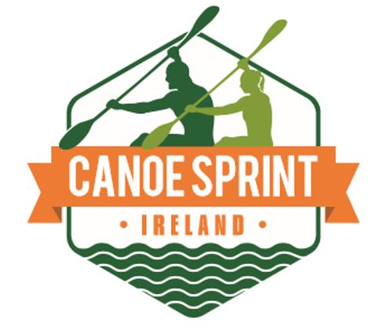

Canoe Sprint Ireland and CANI

All Ireland Sprint Championships 2015

Date: Saturday 29th August 2015.

Venue: Lough Rinn Canoeing/Rowing Regatta Centre, Mohill, Co.Leitrim
(Salmon Leap Canoe Club hold LD ranking race on Sunday 30th August at the venue)

Events: K1/C1 1000m&200m K2/C2 200m&500m K4 1000m

Classes:
Senior Men/Women, ParaCanoe, Masters (35+),U-23 M&F,U-18 M&F,U-15 M&F
U-14 Open Guppies/Lightning’s (or other kayaks max. length 4.2m) over 200/500m
K4 Open mixed with 1 Senior/U23, Junior, Master, and Female per crew to provide equal crews where possible. Clubs may enter as many crews as possible and combine clubs.

Entry Fee: Unlimited event entry all in fee: Juniors €15, Seniors €25 to be paid with entry. Late entry fee €5 per person
Payment by PayPal: https://www.paypal.com/ie/webapps/mpp/home click send from drop down menu. Enter canoesprintireland@gmail.com and enter amount. Pay by credit card or PayPal account, make sure you use a reference.

Event Details: ICF standard Canoe Sprint 9 lane regatta course.
K1 heats will be open and may be seeded for all classes (males, females, juniors) combined based on past history, performance, etc., at the organiser’s discretion.
Times will determine qualification to Finals.

Closing date for entries is Tuesday 25th August

Complete Google Docs entry form at : http://goo.gl/forms/kVkqr4giYf

Accommodation and additional info:
Lough Rynn Castle Self Catering houses special rate of 40€ per person per night BB with four person occupancy contact 071 9632700 and quote canoesprintireland.
B&B’s in area: Lough Rynn View 087 277 8942 & Lough Rynn Gatehouse 086 856 8284.
Camping for Campervan and Caravans at the centre.

We are also looking for volunteers and more sponsors to help out on the day.

Please contact canoesprintireland@gmail, performance@cani.org.uk, or David Pringle 0872480055 if you are willing to help.



Racing Notes for Clubs:

- All K boats must comply with ICF rules regarding boat weight standards ie 12 kg for K1 and 18 kg for K2.
- Clubs should nominate a Team Leader for the regatta who can liaise with the race organisers. There will be a team leaders meeting at 9:30am on Saturday at the regatta course. All paddlers should be on site by 10.00.
- The timetable is very tight so please make sure that all paddlers and crews arrive at the start line in good time (at least 5 minutes) before their race is due to start.
The starter will not wait if paddlers are not in the start area when called.
- All athletes should wear their club colours and all boats should have race numbers
- Closing date for entries is Tuesday 25th August – please make sure that your club entries arrive in good time.
- National Sprint Championship titles will be awarded to the first Irish paddler both male and female in the K1 class 1000m, 200m and K2/K4 Class finals – see below.
- Entries will also be accepted in the K boat classes from paddlers who wish to paddle other types of boats eg sea-boats, down river or wild water boats, provided they do not exceed maximum length for K1 of 5.2m or for K2 of 6.5m and exceed the minimum weight.
- Lightnings/Guppies will be used by multiple paddlers and must be returned immediately after use.
- Please wear club colours/tracksuits for medal ceremony’s which will take place throughout the day.

Please obey the instructions of the Race Starter and other Race Officials at all times. Failure to do so will result in disqualification.
Location Details
Lough Rinn Regional Canoeing/Rowing Centre is located 2km out the L1053 from Mohill.
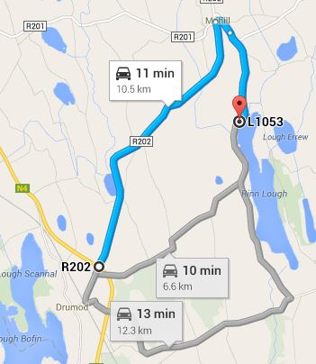

National Championships K1 1000m, 200m, K2 500m,200m
Male | Senior
Female | Senior
Male | U23
Female | U23
Male | Junior U 18
Female | Junior U 18
Male | Junior U 15
Female | Junior U 15
Open Club K4 | Mixed and Elite
Open Guppie/Lightning | U14 & U12

Provisional Timetable |  |  |  | Event | Time
Race | 1 | Heat | 1 | K1 1000 | 11.00
Race | 2 | Heat | 2 | K1 1000 | 11.05
Race | 3 | Heat | 3 | K1 1000 | 11.10
Race | 4 | Heat | 4 | K1 1000 | 11.15
Race | 5 | Heat | 5 | K1 1000 | 11.20
Race | 6 | Heat | 6 | K1 1000 | 11.25
Race | 7 | Heat | 7 | K1 1000 | 11.30
Race | 8 | Heat | 8 | K1 1000 | 11.35
Race | 9 | Heat | 9 | K1 1000 | 11.40
Race | 10 | Heat | 1 | U-14 500 | 11.45
Race | 11 | Heat | 2 | U-14 500 | 11.55
Race | 12 | Heat | 3 | U-14 500 | 12.05
Race | 13 | Final | A | K1 1000 | 12.15
Race | 14 | Final | B | K1 1000 | 12.20
Race | 15 | Final | C | K1 1000 | 12.25
Race | 16 | Final | D | K1 1000 | 12.30
Race | 17 | Final | E | K1 1000 | 12.35
Race | 18 | Final | F | K1 1000 | 12.40
Race | 19 | Final | G | K1 1000 | 12.45
Race | 20 | Final | H | K1 1000 | 12.50
Race | 21 | Final | I | K1 1000 | 12.55
Race | 22 | Finals | 1 | U-14 500 | 13.00
Officials Lunch Break
Race | 23 | Final | A | K2 500 | 13.30
Race | 24 | Final | B | K2 500 | 13.40
Race | 25 | Final | C | K2 500 | 13.50
Race | 26 | Final | D | K2 500 | 14.00
Medal Ceremony
Race | 27 | Heat | 1 | U-14 200 | 14.05
Race | 28 | Heat | 2 | U-14 200 | 14.15
Race | 29 | Heat | 3 | U-14 200 | 14.25
Race | 30 | Heat | 1 | K1 200 | 14.30
Race | 31 | Heat | 2 | K1 200 | 14.33
Race | 32 | Heat | 3 | K1 200 | 14.36
Race | 33 | Heat | 4 | K1 200 | 14.39
Race | 34 | Heat | 5 | K1 200 | 14.42
Race | 35 | Heat | 6 | K1 200 | 14.45
Race | 36 | Heat | 7 | K1 200 | 14.48
Race | 37 | Heat | 8 | K1 200 | 14.51
Race | 38 | Heat | 9 | K1 200 | 14.54
Race | 39 | Finals |  | U-14 200 | 14.57
Race | 40 | Final | A | K1 200 | 15.30
Race | 41 | Final | B | K1 200 | 15.33
Race | 42 | Final | C | K1 200 | 15.36
Race | 43 | Final | D | K1 200 | 15.39
Race | 44 | Final | E | K1 200 | 15.42
Race | 45 | Final | F | K1 200 | 15.45
Race | 46 | Final | G | K1 200 | 15.48
Race | 47 | Final | H | K1 200 | 15.51
Race | 48 | Final | I | K1 200 | 15.54
Race | 49 | Final | A | K2 200 | 16.20
Race | 50 | Final | B | K2 200 | 16.30
Race | 51 | Final | C | K2 200 | 16.40
Race | 52 | Final | D | K2 200 | 16.50
Race | 53 | Final | A | K4 1000 | 17.15
Race | 54 | Final | B | K4 1000 | 17.35
Race | 55 | Final | C | K4 1000 | 18:00
Medal Ceremony

