CXCOMMERCE
User Guide

Table of Contents

1.0 Introduction 4
1.1 Absolute Basics 5
1.1.1 Uploading Your Main Company Details 5
1.1.2 Upload Logo 6
1.1.3 Company Details Shown On Site 7
1.1.4 Credit Cards and Delivery Charges 8
1.1.5 Updating basic pricing within the default price plan 9
1.1.6 Adding Users 10
1.2 More Advanced Settings 11
1.2.1 Updating Theme and Colour 11
1.2.2 Credit Card Processing 11
1.3 General Pricing Overview 12
2.0 Accessing the system 14
2.1 As a dealer 14
2.2 As an Epro administrator 16
2.2 As an Epro customer 18
3.0 Dealer Home 19
3.1 Account Login / Password 20
3.2 Company Details 21
3.3 Create a new eprocurement website 23
3.4 Edit existing website 24
3.5 Site Configuration 25
3.5.1 Company logo 25
3.6.2 Company Details 26
3.6.3 Website Colour 28
3.6.4 Website Theme 29
3.6.5 General Settings 30
3.6.6 Home Page 33
3.6.7 Contact Us 34
3.6.8 About Us 35
3.6.9 T&C’s 36
3.6.10 Delivery 37
3.6.11 Returns and Backorders 38
3.6.12 Credit Application 39
3.6.13 Help 40
3.6.14 Catalogues 41
3.6.15 Custom Products 42
3.6.16 Restricted Catalogue 46
3.6.17 Home Page Promotions 48
3.6.18 Default core list / site specific price file 50
3.6.19 Pricing 53
3.6.20 Price Files 54
3.6.21 Price Plans 59
3.6.22 Thumbnails and brands 60
3.6.23 Add User 62
3.6.24 Edit User 63
3.6.25 User Grouping 76
3.6.26 Order Sign Off Groups 77
3.6.27 Cost Centres 78
3.6.28 Invoice Points 79
3.6.29 Delivery Points 81
3.6.30 Email Users 83
3.6.31 Price Comparison 84
3.6.32 Reports: Orders 86
3.6.33 Reports: Sales Summary 88
3.6.34 Reports: Product Usage 90
3.6.35 Reports: Financial Summary 91
3.7 Order Monitor 92
3.8 Search Orders 94
3.9 Search Users 97
3.10 Protx Refunds 99
3.11 Download Manuals 100
4.0 Using the HTML editor 101
4.1 Background Colour 103
4.2 Adding tables 103
4.3 Adding text 103
4.4 Formatting text 103
4.5 Formatting bullet points 103
4.6 Adding images 103
4.7 Adding hyperlinks 103
4.8 Save 103
5.0 Authorisations 104
6.0 Clic2mail 105
7.0 Order Pad 105
8.0 Dealer Mode Ordering 106
9.0 Web forwarding/masking 107
Appendix A - Help 108
A.1 FAQ’s 108
A.1.1 How do I handle credit card orders? 108
A.1.2 How to I change my delivery charges, or offer free delivery? 108
A.1.4 I don’t want to accept credit card orders. How do I set this up? 108
A.1.5 Can I set it so users have to log in to their account before they browse? 108
A.1.6 Can I set it so users can browse but to have to log in before they purchase? 108
A.1.7 Can I set individual users a credit limit or specified payment method? 108
A.1.8 I’ve forgotten my password – How do I find out what it is? 108
A.1.9 What is an Order Pad? 108
A.1.10 Can I set up web masking/web forwarding, so you can see the site is www.cxcommerce.com? 108
A.1.11 How do I set up Protx? 109
A.2 Trouble Shooting 110
A.2.1 The store design is pushed out of shape and the logo is surrounded with white space 110
A.2.2 The logo is too large 110
A.2.3 The logo has been uploaded, but isn’t showing 110
A.2.4 There are no products showing on the store 110
A.2.5 My pricing is showing incorrectly 110
A.2.5 I haven’t received my email order confirmation. 110
A.3 CSV file Overview 111
Appendix B – Related Documentation 112

1.0 Introduction

This documentation explains how to administer the ecommerce solution by using step-by-step instructions and visual aids.

It is intended to be read by any customer whom requires instructions on how to do this.

Some sections and screen shots may vary depending on the platform, site type, and catalogue in use.

Please note that this guide my also include references to EPRO. EPRO is additional functionality to the standard and restricted versions.

1.1 Absolute Basics

This section advises you of the absolute minimum you need to do in order to get up and running. For full details, please visit the relevant dedicated section within the main user guide.

1.1.1 Uploading Your Main Company Details

- Log in to the dealer admin area.
- Click on ‘Company Details’
- Check the contact details are correct.
- Enter your VAT Number.
- Enter your Company Registration Number.
- Click on ‘update’.

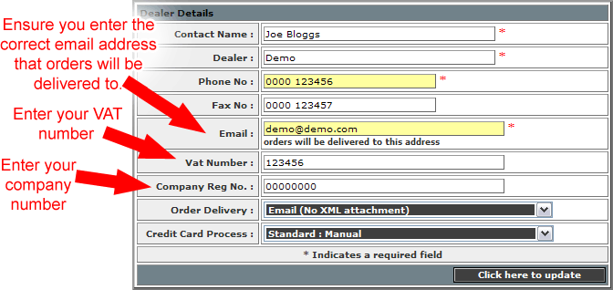

1.1.2 Upload Logo

- Log in to the dealer admin area.
- Click on ‘edit existing websites’
- Select the relevant site.
- Click on ‘Company Logo’
- Browse to the saved logo.
- Click on ‘update’.

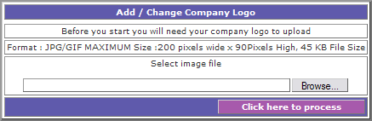

1.1.3 Company Details Shown On Site

- Log in to the dealer admin area.
- Click on ‘edit existing websites’
- Select the relevant site.
- Click on ‘Company Details’
- Add, edit or amend the details as required.
- Click on ‘update’.

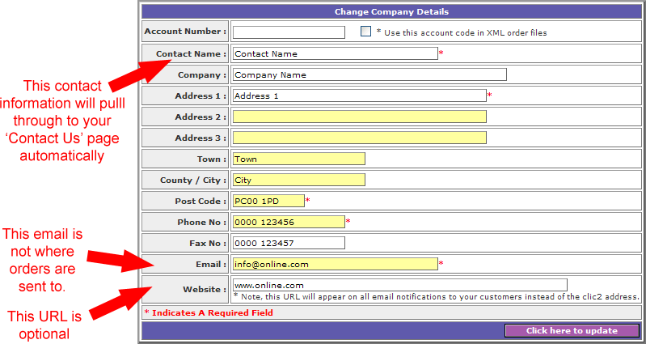
1.1.4 Credit Cards and Delivery Charges

- Log in to the dealer admin area.
- Click on ‘edit existing websites’
- Select the relevant site.
- Click on ‘General Settings’
- At the top of the page you will see checkboxes, allowing you to choose which credit cards you accept.
- At the bottom of the page you will have the option to enter your delivery charge, and any free delivery setting.
- Click on ‘update’.

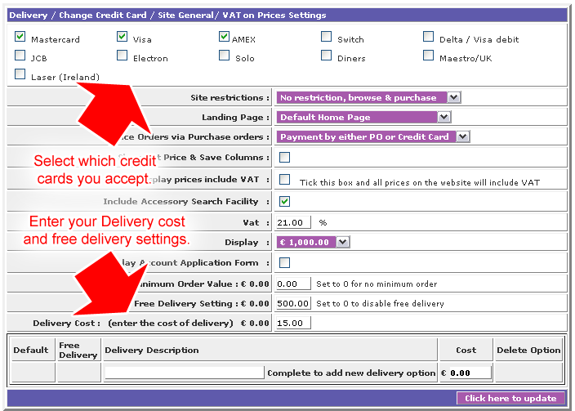

1.1.5 Updating basic pricing within the default price plan

Please note this will only be effective if you have not already set up other price plans.

- Log in to the dealer admin area.
- Click on ‘edit existing websites’
- Select the relevant site.
- Click on ‘Price Files’
- If you have more than one catalogue available, you may be asked to choose which one you wish to update.
- From the drop down list select ‘Dynamic Prices’.
- For the default price file, click on the words ‘Edit margins for Dynamic Prices’.
- A new window will open. You will see the catalogue broken down by category, and you can amend the margins accordingly.
- Click on ‘update’.

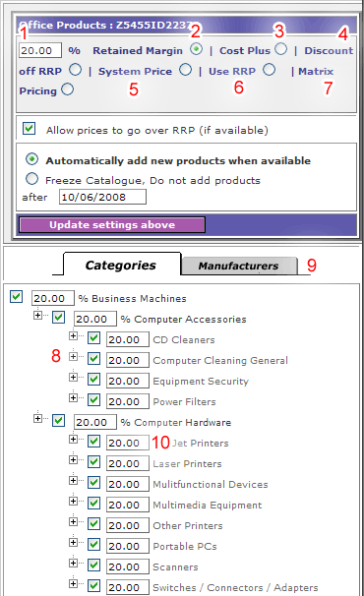
- This percentage will be applied to the whole file, unless a margin has been applied to a particular category (as in point 10).

- By selecting this option, your prices are worked out using a retained margin. 'Retained Margin' means how much profit gained in a sale price.

- By selecting this option, your prices are worked out using a cost plus margin. 'Cost Plus' is simply the cost price plus the percentage of the cost price.

- By selecting this option, your prices are worked out by discounting down from the rrp prices (if available).

- By selecting this option, your prices are shown as the system prices (if available).

- By selecting this option, your prices are shown as the rrp prices (if available).

- By selecting this option, you are provided new options, consisting of ‘Discount’ and ‘Guaranteed Margin’, allowing you to choose setting against each Matrix category. The ‘discount’ column discounts down from the RRP, and the ‘guaranteed margin’ column means that you will always make that specified margin, and therefore not sell below cost.

E.G: If a cost price is £10, and the items RRP is £12.99, a 40% discount and 0% guaranteed margin would generate a sale price of £7.79, selling at less than cost. By applying a 5% guaranteed margin, the sale price would be £10.50, readjusting the discount to be 19%.

- By selecting or de-selecting these check-boxes, you can switch the corresponding category.

- By clicking on the Manufacturer tab, you can switch on and off manufacturer ranges.

- By changing the percentage here, you can choose which mark up you would like for a particular category.

1.1.6 Adding Users

- Log in to the dealer admin area.
- Click on ‘edit existing websites’
- Select the relevant site.
- Click on ‘Add Users’
- Add the details as required. Options will vary depending on site type.
- Click on ‘update’.

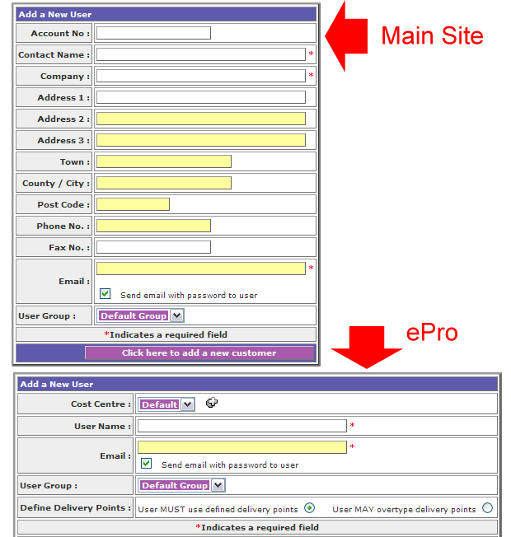

1.2 More Advanced Settings

1.2.1 Updating Theme and Colour

- Log in to the dealer admin area.
- Click on ‘edit existing websites’
- Select the relevant site.
- Click on ‘Website Theme’
- Select the required them.
- Click on ‘update’
- A new page showing the available colours will be produced.
- Select the colour you require.
- Click on ‘update’.

1.2.2 Credit Card Processing

If you have chosen to accept credit cards within general settings you will receive any credit card order details via a secure site email. You will then need to process it as you would any other order, such as one received over the phone. This works fine for many dealers, but it does leave you open to fraud.

We recommend you set up a Protx account, and link it into your store. Protx is a third party company who process credit card details online automatically, which protects you from fraud and poor credit history, etc.

Firstly, you need to contact Protx and register an account with them. The contact information for Protx is available here: http://www.protx.com/aboutus/contactus.asp

- To set up Protx, log into your store administration area, and on the grey section click on 'Company details'.
- Under 'Credit card process', select the Protx server required.
- Select update.
- Enter your Protx Vendor code (this is usually your company name, but if you are unsure please contact Protx) and update again.
- Please ensure that you have these IP address set in your Protx admin account
79.99.68.053
79.99.68.060
subnet mask for both 255.255.255.128
- You will also need to check that your Protx account is the correct one for this process.

1.3 General Pricing Overview
There are three steps to pricing:
- Set up Price files – you can have several different price files set up.
- Incorporate those price files into a price plan.
- Apply the file to a user or site.
HOW TO DO IT:
- To set up a new dynamic (margin based) price list, go to the ‘price files’ option
- From the drop down menu, select ‘dynamic prices’
- Enter a new price file name where prompted, and click on the plus symbol (if you wish to edit an existing file, skip this step).
- Next to the file you wish to edit margins for, click the line of text which says ‘Edit margins for Dynamic Prices’
- A new window will open, where you can select the required catalogues/mailers. Select which you require and submit. You will now see a screen similar to the below:

- This percentage will be applied to the whole file, unless a margin has been applied to a particular category (as in point 10).

- By selecting this option, your prices are worked out using a retained margin. 'Retained Margin' means how much profit gained in a sale price.

- By selecting this option, your prices are worked out using a cost plus margin. 'Cost Plus' is simply the cost price plus the percentage of the cost price.

- By selecting this option, your prices are worked out by discounting down from the rrp prices (if available).

- By selecting this option, your prices are shown as the system prices (if available).

- By selecting this option, your prices are shown as the rrp prices (if available).

- By selecting this option, you areprovided new options, consisting of ‘Discount’ and ‘Guaranteed Margin’, allowing you to choose setting against each Matrix category. The ‘discount’ column discounts down from the RRP, and the ‘guaranteed margin’ column means that you will always make that specified margin, and therefore not sell below cost.

E.G: If a cost price is £10, and the items RRP is £12.99, a 40% discount and 0% guaranteed margin would generate a sale price of £7.79, selling at less than cost. By applying a 5% guaranteed margin, the sale price would be £10.50, readjusting the discount to be 19%.

- By selecting or de-selecting these check-boxes, you can switch the corresponding category.

- By clicking on the Manufacturer tab, you can switch on and off manufacturer ranges.

- By changing the percentage here, you can choose which mark up you would like for a particular category.
  - Once completed, ensure you update the file.
  - Within the price file section, you can also save ‘static sale prices’ by selecting this option from the list. The file needs to be one column with codes, and another with prices (no currency symbols or thousands separators), and saved as a csv or tab file.
  - Now you need to create your price plan.
  - Come out of Price Files and go into ‘Price Plans’
  - Select ‘Sale Price Plans’.
  - Either create a new or edit an existing plan by clicking on the plus symbol next to the name.
  - You will see a screen similar to the below:
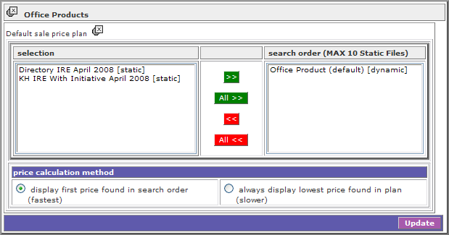
  - On the left you can add as many static files as you wish – there will be both those you have uploaded and those available with your catalogue selections. Add them into the right hand column.
  - Always finish of with your dynamic price file so that it appears at the bottom of the list.
  - Choose if you want to display the first price found in the price file order, or lowest price first.
  - Update.
  - Your plan is now ready. All you need to do now is apply it.
  - To apply your plan to an entire site, go to the ‘Catalogues’ option and select the required file under ‘sale price plan’
  - To apply your plan to a user (only possible under a main store, not ePro), go to the ‘edit users’ option and select the required file under ‘price plan’
  - To edit anything in the future, only that particular component needs to be changes, so if you need to upload a static price file, all you need to do is overwrite the existing, and all plans which that file is included within will automatically update.

2.0 Accessing the system

2.1 As a dealer
ALL SITES (ALL VERSIONS)

Go to http://www.cxcommerce.com/admin

A screen should be produced similar to the following, containing a login and password free text field.

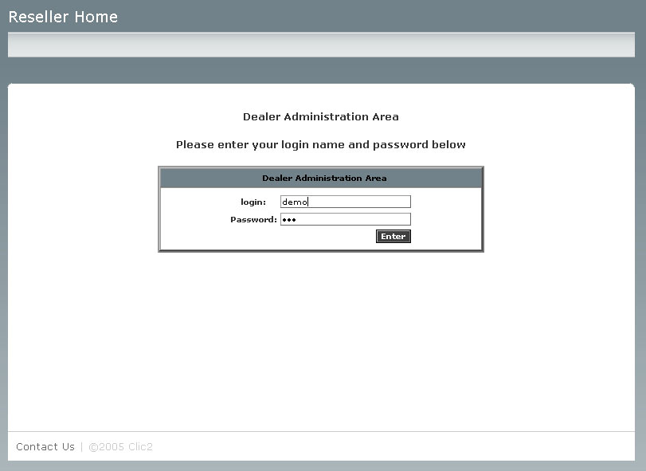

The login field should display what is actually entered.

The password field should hide (encrypt) what is entered, as displayed above.

If the login and password are incorrect, the following should be displayed, stating the highlighted red message “No record found, please try again”:

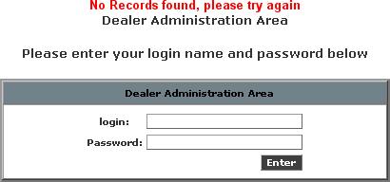

If the login and password are correct, the page should be redirected to http://www.cxcommerce.com/admin/pgSuseradmin.cfm, the ‘Dealer Home’ menu (section 3.0).

2.2 As an Epro administrator
EPRO (STANDARD)

Go to http://www.cxcommerce.com.

A screen should be produced similar to the following:

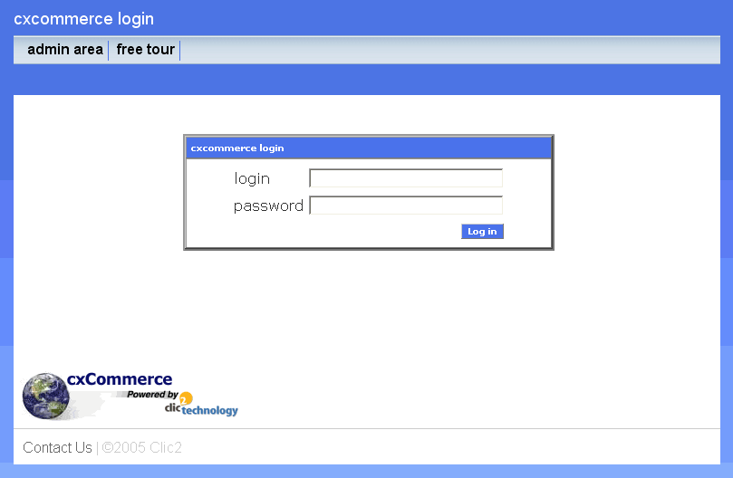

The admin area option should be selected.

This should be directed to http://www.cxcommerce.com/Admin/Pglogin.cfm.

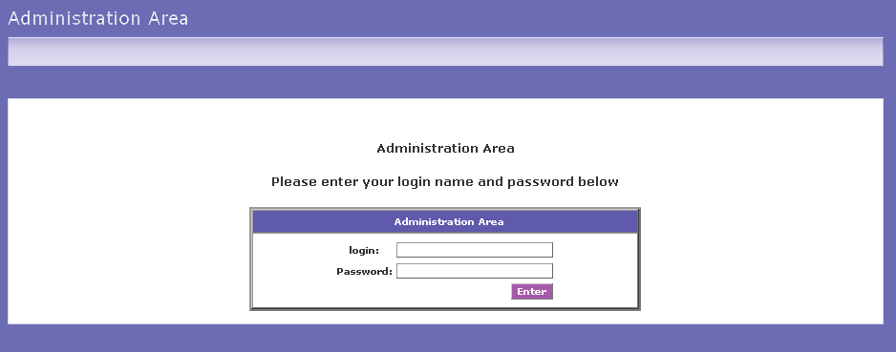

The login field should display what is actually entered.

The password field should hide (encrypt) what is entered.

If the login and password are incorrect, the following should be displayed, stating the highlighted red message “No record found, please try again”:

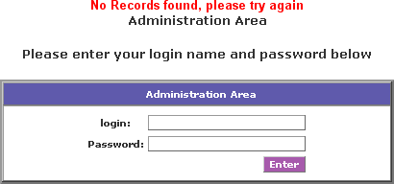

If the login and password are correct, the page should be redirected to http://www.cxcommerce.com/Admin/pgAdmin.cfm, the ‘Site Configuration’ menu (section 4.0).

2.2 As an Epro customer
EPRO (STANDARD)

Go to http://www.cxcommerce.com.

A screen should be produced similar to the following:

The login field should display what is actually entered.

The password field should hide (encrypt) what is entered.

If the login and password are incorrect, the following should be displayed, stating the highlighted red message “Incorrect Login or Password”:

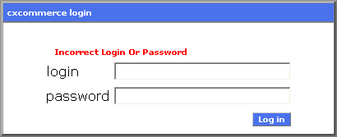

If the login and password are correct, the page should be redirected to their eprocurement solution, which is not covered in this documentation.

3.0 Dealer Home
The Dealer Home menu has the following options available:

- Account – ALL SITES (ALL VERSIONS)
  - Account login / password – ALL SITES (ALL VERSIONS)
  - Company Details – ALL SITES (ALL VERSIONS)
- Websites – ALL SITES (ALL VERSIONS)
  - Create a new website – EPRO (STANDARD)
  - Edit existing website – ALL SITES (ALL VERSIONS)
- Order Monitor – ALL SITES (ALL VERSIONS)
  - Order Monitor – ALL SITES (ALL VERSIONS)
  - Search Users – ALL SITES (ALL VERSIONS)
  - Search Orders – ALL SITES (ALL VERSIONS)
- Protx Refunds – ALL SITES (ALL VERSIONS)
  - Protx refunds – ALL SITES (ALL VERSIONS) (IF PROTX SET UP)
- Download Manuals – ALL SITES (ALL VERSIONS)
  - Dealer user guide – ALL SITES (ALL VERSIONS)
- “Click here to leave dealer area” and Logout

3.1 Account Login / Password
1

This option allows you to change the login and password for your account.

Should you change this, please remember to inform all who may need to access the system.

2
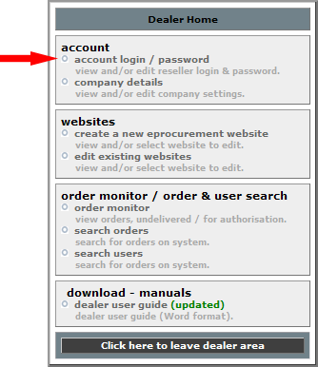 | Select the ‘account log in / password’ option from the menu.
3
You will be presented with the screen on the right.  Amend your details as required and select the ‘Click here to update’ button.  The login field should display what is actually entered.  The password field should hide (encrypt) what is entered.  You will receive the highlighted confirmation message ‘Record Updated’.  To return to the main menu, select ‘Dealer Home’. | 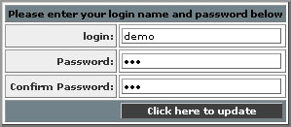

3.2 Company Details
1

This option allows you to change the company for your account.

You must ensure this data is always correct and up to date.

2
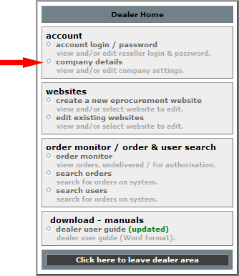 | Select the ‘company details’ option from the menu.

3
You will be presented with the screen on the right. Amend your details as required and select the ‘Click here to update’ button.  You will receive confirmation of the change. To return to the main menu, select ‘Reseller Home’. | 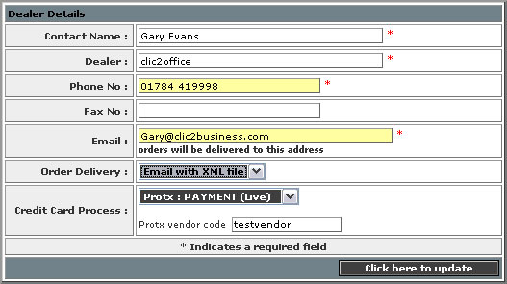
4
There are several variables within the dealer details section. These are:

Contact Name:
This should be a free text field, which is mandatory.

Dealer:
This should be a free text field, which is mandatory.

Phone Number:
This should be a free text field, which is mandatory.

Email:
This should be a free text field, which is mandatory, and MUST be a valid email address.
Any orders generated within the eprocurement solution will be sent to this email address.

Order Delivery:
This should be a selectable drop-down menu. The choices are:
Email – This is a simple email with a link to a secure server. The dealer receives the email and clicks on the link, and is prompted to enter their password.
If the password is incorrect, the message ‘incorrect password entered will be displayed’.
If the password is correct, the order in full will be displayed.

Email with XML file:
As for with email delivery, with an attached XML file of the order.

The order displays are defined within section X.X

Credit card process
This should be a selectable drop-down menu. The choices are:

Protx: TEST SERVER
Protx: DEFERRED (live)
Protx: PREAUTH (live)
Protx: PAYMENT (live)
Standard: MANUAL

If Standard: MANUAL is selected, the credit card details will be passed to the dealer for them to process manually.

If any Protx option is selected, an additional option will be produced called Protx Vendor code. The dealer’s code must be entered. The Protx account set up must be complete (www.protx.co.uk).

3.3 Create a new eProcurement website

EPRO (STANDARD)

1

This option allows you to create a new Epro site.

2

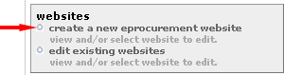 |  | Select the ‘edit existing website’ option from the menu.
3
You will be presented with the screen on the right.  You will need to complete the following fields:  Account Number  Contact Name*  Company*  Administrator Email*  (* Denotes a mandatory field)  A check box will also be available. | 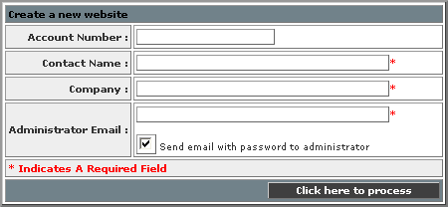
By ticking this checkbox, upon clicking the ‘Click here to process’ button, an email will be automatically sent to the email specified within the ‘Administrator Email’ field, with their log in and password.
4
Upon selecting ‘Click here to process’, an Epro site is created.

You will receive the highlighted confirmation message ‘Website created’.

IMPORTANT: The Epro site will not function until catalogues are selected and pricing is set up – See section 3.4 for site set-up instructions.

3.4 Edit existing website

ALL SITES (ALL VERSIONS)
1

This option allows you to edit your online store and/or your Epro sites.

2

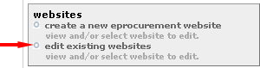 |  | Select the ‘edit existing website’ option from the menu.
3
You will be presented with a screen similar to that on the right.  The information displayed for each site is:  Site ID  Created date  Number of users  Site type  Delete option  Select the website you wish to amend by clicking on the appropriate company name. | 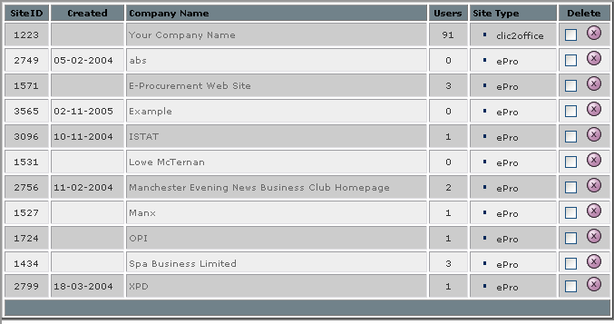

3.5 Site Configuration
Different options are available depending on the version in question.
These will be annotated.

3.5.1 Company logo

ALL SITES (ALL VERSIONS)

1

This option allows you to upload or change the company logo, which appears on the site.

Select the ‘company logo’ option.
2
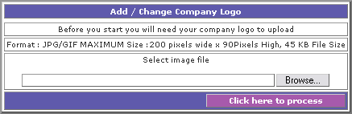 | Click on the browse button to browse to where you have your company logo saved.  Please note your logo must be in a JPG or GIF format, and must be 200 pixels wide x 90 pixels high (roughly 7cm’s wide by 3cms high). The maximum file size is 50 KB.  If your logo is in the incorrect format, it will not be displayed. If it is larger than the dimensions specified above it may corrupt the layout of your store.  Click on the ‘Click here to process’.
3
You will see a confirmation message that this has been updated successfully.

The uploaded logo will appear on the specified website.

3.6.2 Company Details

ALL SITES (ALL VERSIONS)

1

These details will appear on the website.

Select the ‘company details’ option.

2

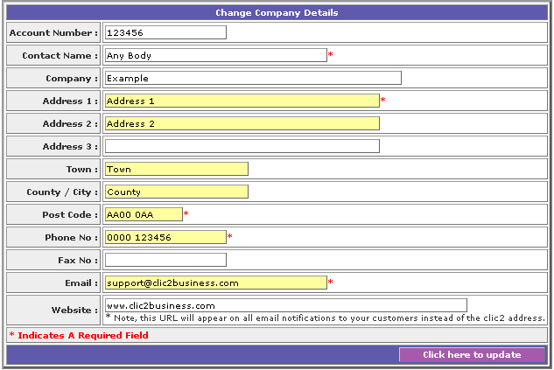 | You will be presented with a screen similar to that on the left.
The fields available are:

Account number:
This should be a free text field, which is not mandatory.

Contact Name:
This should be a free text field, which is mandatory.

Company
This should be a free text field, which is mandatory.

Address 1:
This should be a free text field, which is mandatory.

Address 2:
This should be a free text field, which is not mandatory.

Address 3:
This should be a free text field, which is not mandatory.

Town:
This should be a free text field, which is not mandatory.

County / City:
This should be a free text field, which is not mandatory.

Phone:
This should be a free text field, which is mandatory.

Fax:
This should be a free text field, which is not mandatory.

Email:
This should be a free text field, which is mandatory.

Website:
This should be a free text field, which is not mandatory.

3
When selecting the ‘Click here to process’ button, the information entered will be entered onto the website.

If any contents are entered into the website field, this will be inserted into the email notifications generated by the system. If nothing is entered the standard Clic2 address will be used.

If, within the dealer home ‘Company details’ option, the order notification has been set to include an XML file, there will be an additional checkbox. If checked, this will use the account number specified within the XML file.
4
Upon selecting the ‘Click here to update button’, you will receive the highlighted confirmation message ‘Record Updated’, and the information input will be inserted into the store.

3.6.3 Website Colour

ALL SITES (ALL VERSIONS)

1

You can choose your website colour scheme.

Select the ‘Website colour’ option.

If the template (store design) selected has a colour variable, you will be presented with a list of colours.

Select the appropriate one, and click on the ‘Click here to update’ button.

You will receive the highlighted confirmation message ‘Updated’, and the chosen colour will be reflected on the website.

The page will automatically redirect to the ‘Website Theme’ menu (see section 3.6.4).

3.6.4 Website Theme

1

Select the ‘Website Theme’ option.

2

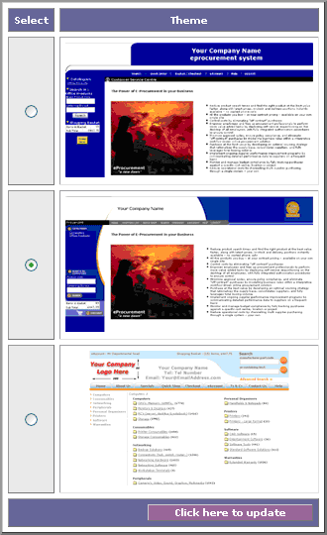 | You will be presented with a screen similar to that on the left.  A theme is essentially is a design for the website.  Choose the theme you want by clicking on one of the radio buttons.  Once completed, click on the ‘Click here to update’ button.  You will receive the highlighted confirmation message ‘Updated’, and the chosen theme will be applied to the website.  The page will automatically redirect to the ‘Website Colour’ menu (see section 3.6.3).

3.6.5 General Settings

ALL SITES (ALL VERSIONS)
1

This section allows you to select your settings that will be used on the website.

Select the ‘general settings’ option.
2
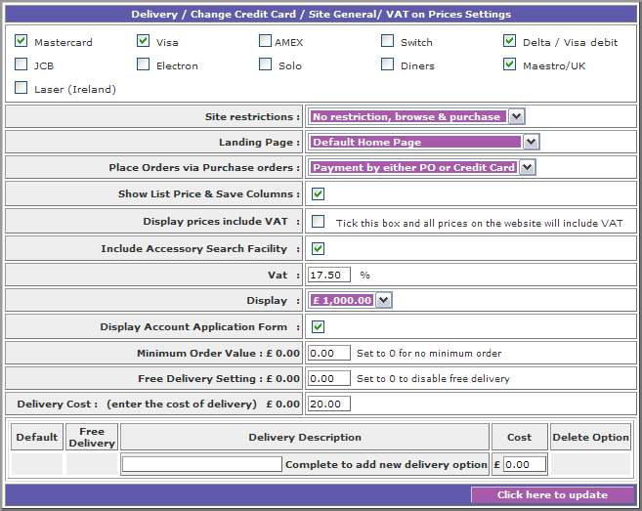
You will be presented with a screen similar to that above. Details of these options are overleaf:
Credit cards – ALL SITES (ALL VERSIONS)
There are several options available. To set your site to give the option to select credit cards, and display which credit cards you accept, place a tick in the checkbox for each card you accept.

Upon updating, the system will automatically update the site to accept the specified credit cards.

Site Restrictions - ALL SITES (ALL VERSIONS) EXCLUDES EPRO
This is a selecting drop down menu, with the following options available:

No restriction, browse & purchase – selecting this option sets the site to allow the user to browse and place items within the basket before login on or register an account to complete the purchase.

Login before accessing site – selecting this option sets the site to force the user to login before they can browse and place items within the basket.

Browse site, login before purchase – selecting this option sets the site to allow the user to browse, but is unable to place items within the basket before login on or register an account.

Landing Page - ALL SITES (ALL VERSIONS)
This is a selecting drop down menu, with the following options available:

Default home page – selecting this option sets the site to display the default home page for the site type.

Custom home page – selecting this option sets the site to display the administrator created custom home page.

About us – selecting this option sets the site to display the administrator created About Us page.

Contact us – selecting this option sets the site to display the administrator created Contact Us page.

Login page – selecting this option sets the site to display the account login page.

Index for catalogue – selecting this option sets the site to display the index page for the specified catalogue.

Promotions for catalogue – selecting this option sets the site to display the home page promotions for the specified catalogue.

Special Offers for catalogue – selecting this option sets the site to display the administrator created special offers for the specified catalogue.

Select the landing page you require from the drop down menu, and upon updating the site will display the chosen landing page within the centre of the store.

Place orders by purchase orders - ALL SITES (ALL VERSIONS)
This is a selectable drop down menu, with the following options available:

Payment by either PO or Credit Card – selecting this option will set the site to allow both purchase order payments and credit card payments.

Payment by purchase order only – selecting this option will set the site to allow purchase order payments only.

Payment by credit cards only – selecting this option will set the site to allow credit card payments only.

Show list price and save columns – ALL SITES (ALL VERSIONS)
This is a check box. By clicking this checkbox and updating, the site will display the recommended retail price (if available) and the saving made calculated using the actual the sale price. If no saving is made, this field will not be displayed.

If the box is left unchecked, only the sale price will be shown.
Display prices include VAT – ALL SITES (ALL VERSIONS)
This is a check box. By clicking this checkbox and updating, the site will display all prices including VAT. In brackets beneath the price will also be shown excluding VAT.

If the box is left unchecked, the site will display all prices excluding VAT. In brackets beneath the price will also be shown including VAT.

Set VAT rate – ALL SITES (ALL VERSIONS)
This is a numerical text field, which will default to 17.5%, but can be changed if required by entering the new figure and updating.

Display – ALL SITES (ALL VERSIONS)
This is a selectable drop down menu, with the following options available:

£1,000.00 - selecting this option will set the site the currency symbol to pounds.
€1,000.00 - selecting this option will set the site the currency symbol to euros.

This option does not change the prices, only the currency symbol; so a price set to 100 will either £100 or €100.

Display Account Application form - ALL SITES (ALL VERSIONS) EXCLUDE EPRO
This is a check box. By clicking this checkbox and updating, the site will display show an account application form on the site. An end customer can fill in this account application form, and the dealer will receive notification of this via email. Should they wish to choose to allow the applicant an account, the must create it using the ‘add user’ functionality.

If the box is left unchecked, the site will not display this functionality.

Minimum order value - ALL SITES (STANDARD)
This is a numerical text field. You can set a minimum order value, that suits you by entering the numerical value, and upon updating this will automatically not allow an order to be sent under that value

Free delivery setting - ALL SITES (ALL VERSIONS)
This is a numerical text field. You can set the site to allow free delivery when orders are over a given total cost. Entering the numerical value of the order figure, and updating this will automatically show no cost for deliveries of order over that given number.

Should you wish to disable free delivery, type in ‘0’. This will be the default setting.

Delivery cost - EPRO (STANDARD)
This is a numerical text field. You can set a standard delivery cost that suits you by entering the numerical value, and upon updating this will automatically add this figure onto the total of any given order, unless the free delivery setting is enabled.

Dealer specified delivery cost - ALL SITES (STANDARD)
You can also set a number of specified delivery charges, which allows the customer to choose what rate they pay, for example, 24 hour deliver and 48 hour delivery. As many specified delivery costs could be set up as requirement dictates.

The fields which need completing/editing to create a dealer specified delivery cost are:

Default – this is a radio button, which if selected will become the default delivery setting.

Free Delivery – this is a radio button, which if selected allows the free delivery figure to be used (i.e. allows free delivery for orders over the set figure).

Delivery Description – This is a free text field, within which the delivery description (such as ’48 hour delivery’) must be entered.

Cost – This is a numerical value field, within which the cost of the delivery must be entered.

There is also a delete option. If you wish to delete a delivery option, place a tick within the checkbox and update.

Upon selecting the ‘Click here to update button’, you will receive the highlighted confirmation message ‘Updated’, and the information input will be updated on the store. You will remain on the same page.

3.6.6 Home Page

ALL SITES (ALL VERSIONS)

This HTML Editor featured in this section is an externally provided tool; therefore we cannot in good faith provide a functional specification, however, there is a guide for usage in section 7.0.

1

You can create a specific homepage for the site.

If you do not create a custom page, the space for it within the site will be populated with standard text.

Select the ‘home page’ option.
2
You will be presented with a screen similar to that below.

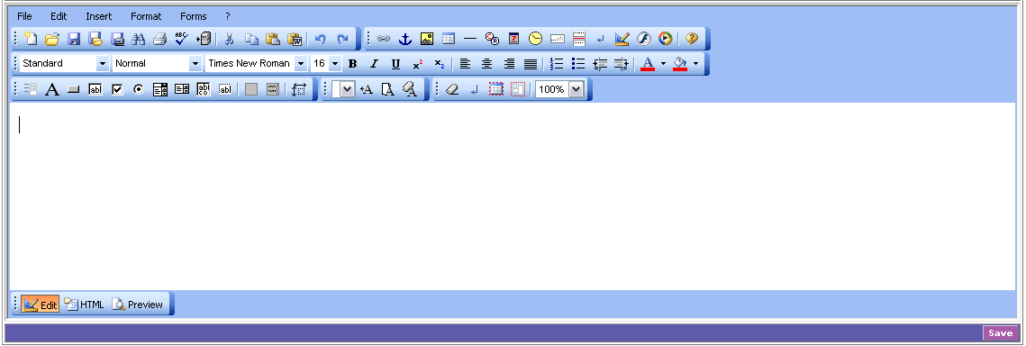
3
Create the page using the HTML editor (full instructions in section HTML Editor section).

When complete, select the ‘Save button’.

Upon saving you will receive the highlighted confirmation message ‘Updated’, and will remain on the same page.

3.6.7 Contact Us

ALL SITES (ALL VERSIONS)

This HTML Editor featured in this section is an externally provided tool; therefore we cannot in good faith provide a functional specification, however, there is a guide for usage in section 7.0.

1

You can create a specific Contact Us for the site.

If you do not create a custom page, the space for it within the site will be populated the information specified within the Site Configuration ‘Company Details’ section, and will also automatically add a ‘Google map’.

Select the ‘home page’ option.
2
You will be presented with a screen similar to that below.

3
Create the page using the HTML editor (full instructions in section HTML Editor section).

When complete, select the ‘Save button’.

Upon saving you will receive the highlighted confirmation message ‘Updated’, and will remain on the same page. The Google map option will no longer be available.

3.6.8 About Us

ALL SITES (ALL VERSIONS)

This HTML Editor featured in this section is an externally provided tool; therefore we cannot in good faith provide a functional specification, however, there is a guide for usage in section 7.0.

1

You can create a specific ‘About Us’ page for the site.

If you do not create a custom page, the space for it within the site will be populated with standard text.

Select the ‘About Us’ option.
2
You will be presented with a screen similar to that below.

3
Create the page using the HTML editor (full instructions in section 9).

When complete, select the ‘Save button’.

Upon saving you will receive the highlighted confirmation message ‘Updated’, and will remain on the same page.

3.6.9 T&C’s

ALL SITES (ALL VERSIONS)

This HTML Editor featured in this section is an externally provided tool; therefore we cannot in good faith provide a functional specification, however, there is a guide for usage in section 7.0.

1

You can create a specific ‘T&C’s’ page for the site.

If you do not create a custom page, the space for it within the site will be populated with standard text.

Select the ‘T&C’s’ option.
2
You will be presented with a screen similar to that below.

3
Create the page using the HTML editor (full instructions in section 9).

When complete, select the ‘Save button’.

Upon saving you will receive the highlighted confirmation message ‘Updated’, and will remain on the same page.

3.6.10 Delivery

ALL SITES (ALL VERSIONS)

This HTML Editor featured in this section is an externally provided tool; therefore we cannot in good faith provide a functional specification, however, there is a guide for usage in section 7.0.

1

You can create a specific ‘Delivery’ page for the site.

If you do not create a custom page, the space for it within the site will be populated with standard text.

Select the ‘Delivery’ option.
2
You will be presented with a screen similar to that below.

3

Create the page using the HTML editor (full instructions in section 9).

When complete, select the ‘Save button’.

Upon saving you will receive the highlighted confirmation message ‘Updated’, and will remain on the same page.

3.6.11 Returns and Backorders

ALL SITES (ALL VERSIONS)

This HTML Editor featured in this section is an externally provided tool; therefore we cannot in good faith provide a functional specification, however, there is a guide for usage in section 7.0.

1

You can create a specific ‘Returns and Backorders’ page for the site.

If you do not create a custom page, the space for it within the site will be populated with standard text.

Select the ‘Returns and Backorders’ option.
2
You will be presented with a screen similar to that below.

3
Create the page using the HTML editor (full instructions in section 9).

When complete, select the ‘Save button’.

Upon saving you will receive the highlighted confirmation message ‘Updated’, and will remain on the same page.

3.6.12 Credit Application

ALL SITES (ALL VERSIONS)

This HTML Editor featured in this section is an externally provided tool; therefore we cannot in good faith provide a functional specification, however, there is a guide for usage in section 7.0.

1

You can create a specific ‘Credit Application’ page for the site.

If you do not create a custom page, the space for it within the site will be populated with standard text.

Select the ‘Credit Application’ option.
2
You will be presented with a screen similar to that below.

3
Create the page using the HTML editor (full instructions in section 9).

When complete, select the ‘Save button’.

Upon saving you will receive the highlighted confirmation message ‘Updated’, and will remain on the same page.

3.6.13 Help

ALL SITES (ALL VERSIONS)

This HTML Editor featured in this section is an externally provided tool; therefore we cannot in good faith provide a functional specification, however, there is a guide for usage in section 7.0.

1

You can create a specific ‘Help’ page for the site.

If you do not create a custom page, the space for it within the site will be populated with standard text.

Select the ‘Help’ option.
2
You will be presented with a screen similar to that below.

3
Create the page using the HTML editor (full instructions in section 10).

When complete, select the ‘Save button’.

Upon saving you will receive the highlighted confirmation message ‘Updated’, and will remain on the same page.

3.6.14 Catalogues

ALL SITES (ALL VERSIONS)
1

Select the ‘catalogues/price plan’ option.

2
You will be shown a list of available catalogues.  This list varies depending on the programme being run, and is set centrally.  Select the ones you wish to make available on your store and select the ‘Click here to update’ button. | 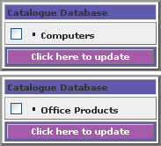
2
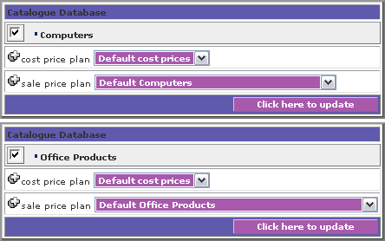 | Once you have switched on the catalogues you want, the option to select the cost price and sale price plans appears.  Details of price plans can be found in section x.x.  To select a price plan for either cost or sale, use the drop down menus.  The drop down menus are already populated by those price plans created by the user.  Once the correct price plan has been selected, select the ‘Click here to update’ button.  Upon saving you will receive the highlighted confirmation message ‘Updated’, and will remain on the same page.  If no price plan is selected the system will automatically use the ‘Default’ plan.

3.6.15 Custom Products

ALL SITES (ALL VERSIONS)

1

Select the ‘custom products’ option.

2
You will be asked to select the catalogue you wish your custom product to appear within.  The option is given to you in a drop down menu format, the contents of which vary depending on site type.  There is also a check box to ‘Include central products’. Ticking this box means that the custom products you upload will be included across the entire store. Un-checking this box means they will only be included within those accounts you set specific price files for.  Select the catalogue you wish to insert you custom products into. |  | 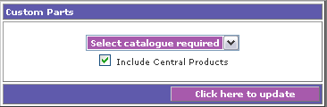
3
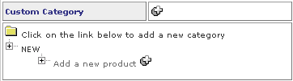 | You will then be provided with a further sub menu.  You have two options within this sub-menu:  Add a ‘Custom Category’ and ‘Add a new product’  Add a custom category by clicking on the plus symbol next to the option.
Select the ‘Add a new product option’ by clicking on the plus symbol.  An additional sub-menu will be produced.  You need to select the two high level options, Category and Group, from the drop down menu.  The contents of these drop down menu’s vary depending on the catalogue selected, and are set by the catalogue structure within the database.  It is not possible to add your own categories at this level. | 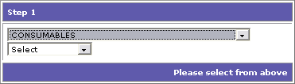

4
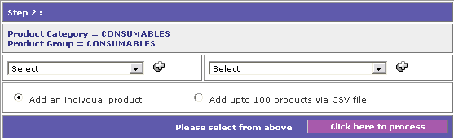 | You will then automatically be taken to the next submenu, within which you specify sub-category and manufacturer.  You can add you own sub category and manufacturer by clicking on the plus sign and updating.  Then select the sub-category and group from the drop down menu.  There are two additional radio button options to upload individual products, or upload up to 100 products using a CSV.  Select which is required and click on ‘Click here to process’.  Individual product addition is continued in point 5, multiple uploads in point 6.

5
You will be taken to a screen similar to that on the right, which contains the following fields:  Part code:  This is a free text field and is mandatory. Maximum 50 characters.  Description:  This is a free text field and is mandatory. Maximum 255 characters  List price:  This is a numerical field and is mandatory. It is used to specify the RRP.  Part Cost:  This is a free text field and is mandatory. It is used to specify the Dealers cost price. | 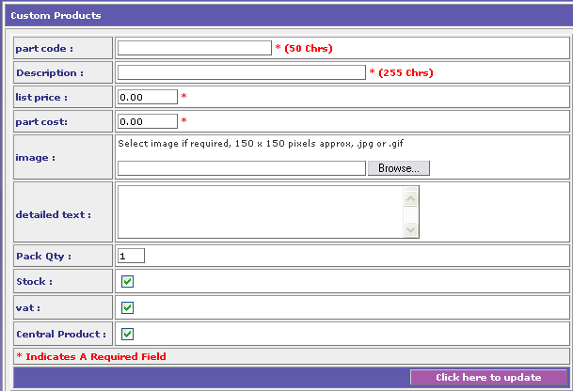
Image:
This is a browsable option, allowing the administrator to browse to a saved image of the product. This image must be in a jpg or gif format, and needs to be 150 x 150 pixels in size. It is not mandatory.

Detailed text:
This is a free text field and is not mandatory.

Pack Qty:
This is a numerical field and is not mandatory. It is used to specify the how many items per pack

Stock:
This is a checkbox, and if checked will show on the site to be in stock. If left unchecked it will be shown out of stock.

VAT:
This is a checkbox, and if checked will show on the site to be VAT applicable. If unchecked it will show to be VAT exempt.

Central products:
This is a checkbox, and if checked will be included as a central product.

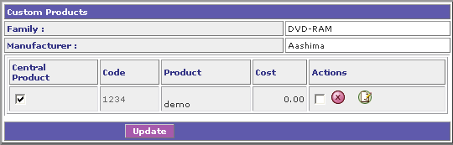 |  | Upon selecting update, a confirmation screen will appear, and the product will be inserted into the store. If you wish to edit the custom product, select the green notepad icon, and you will be able to edit the same fields described above  To delete the item, enter a check within the check box and select the red x icon. The item will be deleted from the site.

6
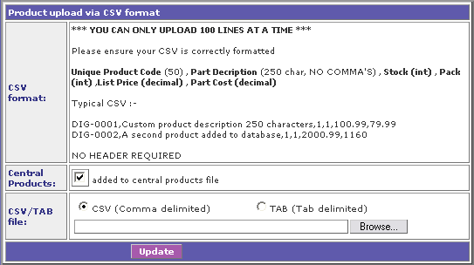 |  | You will be taken to a screen similar to that on the left.  You must have a csv file or a tab delimited file.  The ‘columns’ in this file must be completed for each item. No headers should be entered within the file.  The ‘columns’ are:  Part code:  This is a free text field. Maximum 50 characters.
Description:
This is a free text field. Maximum 255 characters, and must contain NO COMMAS.

Stock:
This is a numeric field, to show the item in stock, enter 1, and to show out of stock enter 0.

Pack Qty:
This is a numeric field, and specifies the number of units in a pack.

List price:
This is a numerical field and is mandatory. It is used to specify the RRP.

Part Cost:
This is a free text field and is mandatory. It is used to specify the Dealers cost price.

Check the ‘added to central products file checkbox if you require the products uploaded to the central file.

There are two radio buttons. Select the required one from the options ‘CSV’ or ‘TAB’ depending on the type of file you wish to upload.

Browse to the file.

By selecting the ‘Update’ button, the products are inserted into the site, and you will be shown a screen similar to that on the left, listing all the products uploaded.  If you wish to edit the custom product, or add an image or detailed description, select the green notepad icon, and you will be able to edit the same fields described in point 5. | 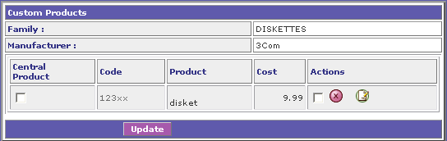
To delete the item, enter a check within the check box and select the red x icon. The item will be deleted from the site.

Upon saving you will receive the highlighted confirmation message ‘Updated’, and will remain on the same page.

For custom products to appear you MUST have a SALE price assigned, either in a static file, or by ticking the ‘include central custom products’ box within the appropriate dynamic Pricefile.

3.6.16 Restricted Catalogue

ALL SITES (STANDARD)

1

You have the ability to select a restricted catalogue for certain users.
To do this, select the ‘restricted catalogue’ option.

2
You will be provided with a list of catalogues available.  Select the catalogue that you wish to restrict by clicking on it. |  | 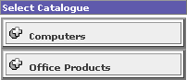
3
You will be taken to a screen similar to that on the right.  The option available to you is ‘enter new list name’.  This is a free text field.  Enter the name for the restricted catalogue and select the ‘Update’ button. | 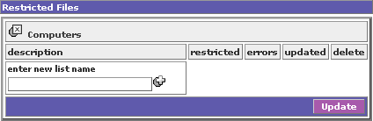
4

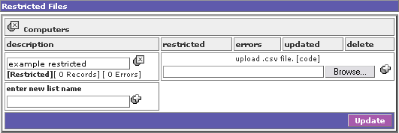 |  |  | You will automatically be given the option to browse to a saved file.  This file must be a list of part codes only, and saved as a CSV file  ‘Update button’.

5

If the incorrect file format is uploaded, or the ‘columns’ are incomplete, the highlighted message ‘incorrect file format’ will be displayed, and you will be prompted to retry.  If the correct file format has been uploaded, the screen will automatically update, and will now show the following options/information:  Description  This is an editable free text field, which can be saved. | 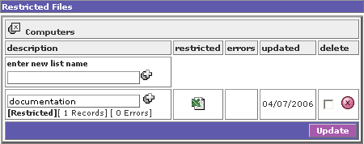
Plus Symbol
By selecting this symbol, the system will allow you to overwrite the file uploaded with a new one – see point 4.

Restricted
By selecting the excel icon under the ‘restricted’ heading, you will see all the codes successfully inserted.

Errors
By selecting the excel icon under the ‘errors’ heading, you will see all the codes which have not been inserted, and the reason why, such as ‘Invalid code’ or ‘Duplicate entry’.

Updated
This is a system-generated field, stating when the file was last updated.

Delete
To delete the restricted file, place a tick in the checkbox, and click on the red X icon.

Upon saving you will receive the highlighted confirmation message ‘Updated’, and will remain on the same page.
To apply this restriction, either go into the ‘catalogues’ option, and apply it to the entire site, or go to ‘user maintenance’ and select the ‘extended options’ icon for the appropriate user, and apply it just for them.

3.6.17 Home Page Promotions

ALL SITES (ALL VERSIONS)

1

You have the ability to add your own promotions into the section on the front page of the webstore. The front page can display up to six offers, but more than this number can be added, and the offers will rotate upon refreshing the page.

To add an offer, click on ‘Home page Promotions’

2
You will be provided with a list of catalogues available.  Select the catalogue that you wish to restrict by choosing it from the drop down menu. |  | 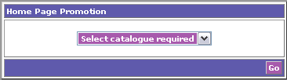
3
You will be taken to a screen similar to that on the right.  The option available to you is ‘add a new offer’.  This is a free text field.  Enter the product code for the item you wish to promote, and select the ‘plus’ button. | 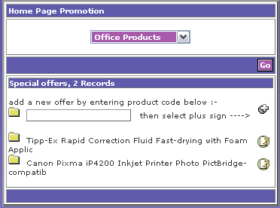
4

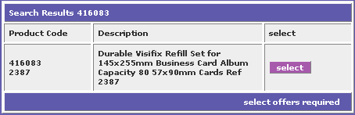 |  |  | A list of possible products will be produced. Select the correct one by clicking on ‘Select’.  If there are no possible products for the code entered, a response message ‘NO PRODUCT CODES’ will be produced.

5

A new box will now appear.  The fields available within are:  Product Code  This is automaticallt populated and is not editable.  Offer Heading  This is an automatically populated, yeat editable free text field, with a maximum of 60 characters.  Image  If there is an image in the database for the product, this will be automatically populated.  Upload image  This allows you to upload your own image by broesing to it. This will overwrite the database or any previously loaded images for the homepage promotions only.  Detailed text  This is a free text field which is formattable using HTML code.  Save by clicking on ‘Create Offer’ | 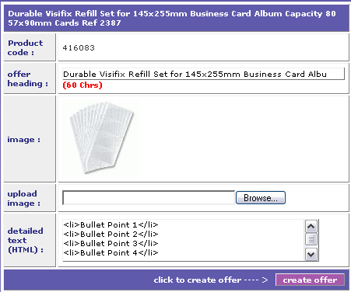
To make these offers show, depending on what your settings already are, you may need to go into the ‘general settings’ option, and under landing site, select ‘promotions for xxx’ (where xxx is the catalogue name).

3.6.18 Default core list / site specific price file

EPRO (STANDARD)

1

You have the ability to upload a price file for a specific EPRO site, and a core list for that EPRO site.

Select the ‘Default core list / site specific price file’ option from the menu.

2

You will be taken to a screen with the two options. These are:

- Price file for X (where X is the Epro site name)
- Core list for X (where X is the Epro site name)

3
Price file for X  You will be taken to a screen similar to that on the right.  The first option available to you is ‘create site price file’ by clicking on the plus symbol. | 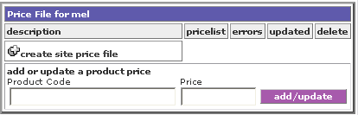
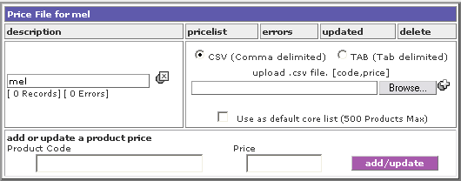 |  | The name will automatically default to the site name, but this can be amended, and the following options will appear.  CSV and TAB  These are radio buttons, and you need to choose the correct option depending on if you are uploading a csv or tab delimited file.
You also have a checkbox option, which if ticked will use this core list as the default core list.

The browse option allows you to browse to a saved file. The file needs to be a csv or tab delimited file, and need no headers for the ‘columns’. The columns within the file need to be the product code and the sale price.

This product codes must be exactly as they appear on the store, and the price must exclude the currency symbol.

Click on the plus symbol to upload the file.

You can also add individual products by entering the product code into the ‘product code’ field. This code must be exactly as it appears on the store. Then add the price into the price field, excluding the currency symbol.

Selecting the ‘add/update’ button will insert you price file into the site, and if the ‘use as default core list’ checkbox was ticked, the first 500 products will be inserted into the core list.

If the incorrect file format is uploaded, or the ‘columns’ are incomplete, the highlighted message ‘incorrect file format’ will be displayed, and you will be prompted to retry.
If a correct file format is entered, the screen will automatically update, and will now show the following options/information:

Description
This is an editable free text field, which can be saved.

Plus Symbol
By selecting this symbol, the system will allow you to overwrite the file uploaded with a new one – see point 4.

Pricelist
By selecting the excel icon under the ‘pricelist’ heading, you will see all the codes successfully inserted.

Errors
By selecting the excel icon under the ‘errors’ heading, you will see all the codes which have not been inserted, and the reason why, such as ‘Invalid code’ or ‘Duplicate entry’.

Updated
This is a system-generated field, stating when the file was last updated.

Delete
To delete the restricted file, place a tick in the checkbox, and click on the red X icon.

Upon saving you will receive the highlighted confirmation message ‘Updated’, and will remain on the same page.

4

Core list for X  You will be taken to a screen similar to that on the right.  The first option available to you is ‘create site price file’ by clicking on the plus symbol. | 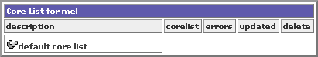
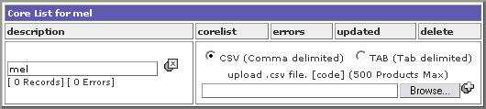 |  | The name will automatically default to the site name, but this can be amended, and the following options will appear.  CSV and TAB  These are radio buttons, and you need to choose the correct option depending on if you are uploading a csv or tab delimited file.
The browse option allows you to browse to a saved file. The file needs to be a csv or tab delimited file, and need no headers for the ‘columns’. The only column required the product code.

This product codes must be exactly as they appear on the store.

The core list must contain a maximum of 500 products

Click on the plus symbol to upload the file.

If the incorrect file format is uploaded, or the ‘columns’ are incomplete, the highlighted message ‘incorrect file format’ will be displayed, and you will be prompted to retry.
If a correct file format is entered, the screen will automatically update, and will now show the following options/information:

Description
This is an editable free text field, which can be saved.

Plus Symbol
By selecting this symbol, the system will allow you to overwrite the file uploaded with a new one – see point 4.

Corelist
By selecting the excel icon under the ‘corelist’ heading, you will see all the codes successfully inserted.

Errors
By selecting the excel icon under the ‘errors’ heading, you will see all the codes which have not been inserted, and the reason why, such as ‘Invalid code’ or ‘Duplicate entry’.

Updated
This is a system-generated field, stating when the file was last updated.

Delete
To delete the restricted file, place a tick in the checkbox, and click on the red X icon.

Upon saving you will receive the highlighted confirmation message ‘Updated’, and will remain on the same page.

3.6.19 Pricing
Pricing is imperative to an ecommerce solution.

The Clic2 eProcurement system allows you to set up a variety of different pricing structures across multiple catalogues.

For example, you can apply specified pricing structures to one, many or all of your customers, which allows you the flexibility to tailor pricing around specific accounts as well as giving you a variety of generic structures for others:

- ‘Cost’ price file – an uploadable price file stating at what cost items are brought for by the dealer.
- ‘Sale: Static’ price file – a resellers uploadable sell price file.
- ‘Sale: dynamic’ price file – a sale price based on margin.

How this works? By setting up as many price files as you like, you can chop and choose from these to apply a price plan for your customer – meeting their every need!

3.6.20 Price Files

ALL SITES – ALL VERSIONS EXCEPT EPRO
RESTRICTED VERSIONS DO NOT ALLOW YOU TO UPLOAD STATIC FILES

Before beginning with your price file, please note that if you are editing the file in Excel, Excel may automatically remove any ‘0’s at the beginning of product codes. To prevent this from occurring, open the file with Notepad or Wordpad.

1

Upon selecting the price file option, you will have a choice of your available catalogues.

This selection of catalogues is set centrally and varies on the SITE TYPE.

Select the catalogue you wish to apply a price file to.
2

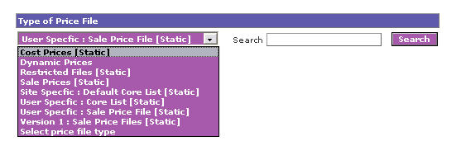
You will be taken to a screen similar to the above, consisting of a selectable drop down menu and a free text search field.

Selectable drop down menu
The options available depend on what is already loaded on the site, and consist of:
- Dynamic Prices – file based on margins
- Restricted Files [static] – file of set prices uploaded within the ‘restricted catalogue’ option
- Sale Prices [static] – file of set prices
- Site Specific: Default Core List [static] - file of set prices uploaded within the ‘special offers/site specific price file’ option
- User Specific: Core List [static] - file of set prices uploaded within the ‘edit user – core list’ option
- User Specific: Sale Price File [static] - file of set prices uploaded within the ‘edit user – pricing’ option
- Version 1: Sale Price Files [static] - file of prices migrated from the old version of the system.

Upon selecting you required option, and clicking the ‘Search’ button, the search results will be displayed.

Free text field
By typing in the name of the price file you require to locate, and clicking the ‘Search’ button, the search results will be displayed.

3.6.20.1 Static Price Files results

ALL SITES – STANDARD

Continued from 6.6.18

1

The search results will be displayed similar to that on the right.  The following options are available.  Search:  See ‘price files option’ for details  Enter new price file name:  This is a free text field used to create a new file within the selected category. | 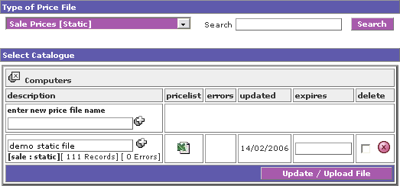
Plus Symbol
By selecting this symbol after adding a new file name, you a new price file entry. Two new options will be displayed.

Browse
The browse option allows you to browse to a saved file. The file needs to be a csv or tab delimited file, and need no headers for the ‘columns’. The columns within the file need to be the product code and the sale price.

CSV and TAB
These are radio buttons, and you need to choose the correct option depending on if you are uploading a csv or tab delimited file.

Description
This is an editable free text field, which can be saved by clicking on the update button.

Plus Symbol
By selecting this symbol, the system will allow you to overwrite the file uploaded with a new one.

Pricelist
By selecting the excel icon under the ‘pricelist’ heading, you will see all the codes successfully inserted.

Errors
By selecting the excel icon under the ‘errors’ heading, you will see all the codes which have not been inserted, and the reason why, such as ‘Invalid code’ or ‘Duplicate entry’.

Updated
This is a system-generated field, stating when the file was last updated.

Delete
To delete the restricted file, place a tick in the checkbox, and click on the red X icon

Upon saving you will receive the highlighted confirmation message ‘Updated’, and will remain on the same page.

If the incorrect file format is uploaded, or the ‘columns’ are incomplete, the highlighted message ‘incorrect file format’ will be displayed, and you will be prompted to retry.

3.6.20.2 Dynamic Price Files Results

ALL SITES – STANDARD

The dynamic file will always be the last price file in the price plan and will create a sale price for any products not found in the preceding static price files. The dynamic price file will also allow the filtering of the product sections and manufacturers.

Continued from 6.6.18

1

The search results will be displayed similar to that on the right.  The following options are available.  Search:  See ‘price files’ option for details  Enter new price file name:  This is a free text field used to create a new file within the selected category. | 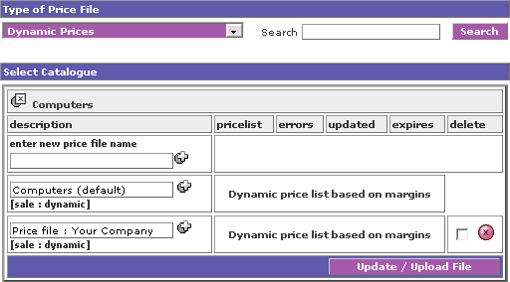
Plus Symbol
By selecting this symbol after adding a new file name, you a new price file entry.

Description
This is an editable free text field, which can be saved by clicking on the update button.

Plus Symbol
By selecting this symbol, a new screen will be opened allowing you create or edit a price file based on margins. See ‘Setting up a dynamic file’ section for details.

Dynamic price list based on margins
By selecting this symbol, a new screen will be opened allowing you create or edit a price file based on margins. See ‘Setting up a dynamic file’ section for details.

Delete
To delete the restricted file, place a tick in the checkbox, and click on the red X icon. You are unable to delete default files.

Upon saving you will receive the highlighted confirmation message ‘Updated’, and will remain on the same page.

If the incorrect file format is uploaded, or the ‘columns’ are incomplete, the highlighted message ‘incorrect file format’ will be displayed, and you will be prompted to retry.

3.6.20.3 Setting up a dynamic file

ALL SITES – STANDARD
1

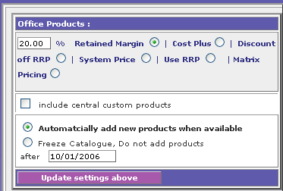 | When the Dynamic price list based on margins is selected a new window will be opened containing The following options:  RADIO BUTTONS  Retained Margin (specifiable using free text fields)  Cost Plus (specifiable using free text fields)  Discount off RRP (specifiable using free text fields)  System Price  Use RRP  Matrix Pricing (SIMPLY AND OFFICEPOINT ONLY)  Based on which option you choose, you can specify the margin
Include Central Products
This is a check box, upon which selecting, custom central products will be included based on the margins set.

Radio Buttons
You can also specify at this point if you would like to automatically add new products, or freeze the catalogue at a certain point.

Clicking on the update savings above button, the lower part of the page will be amended.
2
Checkbox  By selecting the relevant checkboxes, you can switch on or off the categories.  % field  Typing in the relevant percentage will amend the price on the store.  Series name  This is a clickable link. By clicking here you will be taken to a list of products within that series, which also allows a static price to be set per product.  Clicking on the ‘select here to update’ button will save these settings | 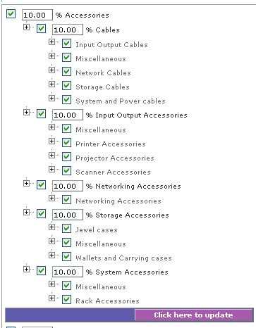

3

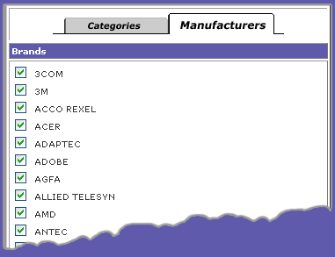 |  | You can also set which manufacturers you wish to stock, by selecting the ‘Manufacturers’ tab, check or uncheck as appropriate, and select ‘Update’.
4

Matrix pricing allows you to set margins according to the ‘band’ set by the distributors.

This generally only applies to products within the Office Products range.

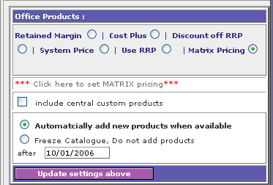 |  |  | Select ‘Matrix Pricing’. And click on the ‘Update settings above’ button.  Then select the ‘Click here to set MATRIX pricing’ option.
5
You will be presented with a screen similar to the one on the right.  For each band, apply the percentage discount, as well as any retained margin you want.  Select ‘Click here to update’ to save. | 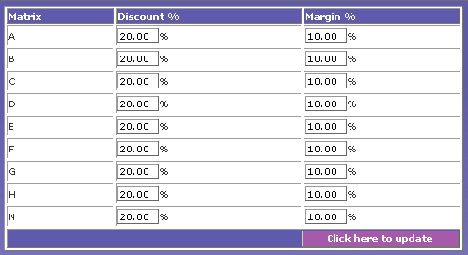

3.6.21 Price Plans

ALL SITES ALL VERSIONS

1

When it comes to setting price plans, you can do this on two levels: Cost Price and Sale Price.

Cost price plans are essential for using ‘dynamic’ price files – for the times that a margin based profit scheme is applied.

To set up a cost price plan is the same as a sales price plan, which is documented here.
2
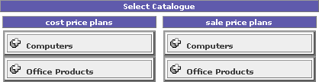 |  |  | Select the catalogue you require at either the cost price level or sale price level.
3
You will be presented with a screen similar to that on the right. Give your price plan a name and select the ‘Update’ button. | 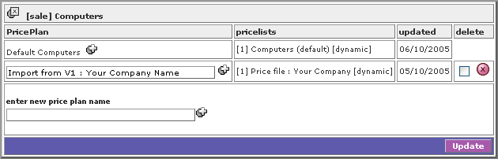
3

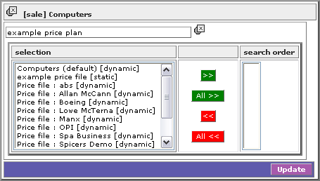 |  | Select the price file/s you wish to apply to this particular plan.  You can use as many as you like, however, if there are duplicate products with different prices in the price files, the system will select the price from the earliest price file in the selected order, so make sure you put things in the correct search order.  Should a product not be available in any price file, the system will go back to the default dynamic pricing.

3.6.22 Thumbnails and brands

ALL SITES - STANDARD

1

Users on the standard version have the ability to allow thumbnails to be shown on the front of the online store, similar to the image shown below.
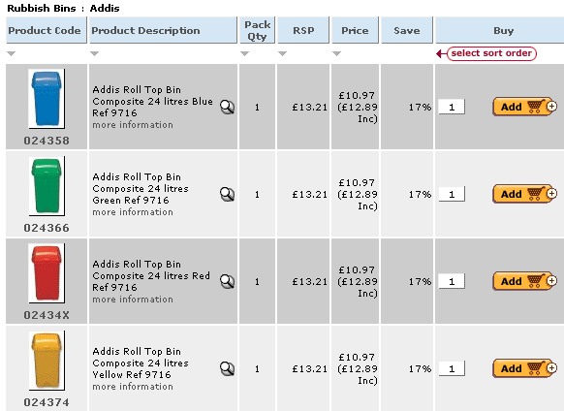
This facility can be switched on or off per category and for individual users or sites (such as ePro users), simply by setting up a different dynamic price file for the user.

This facility also allows users to miss out the manufacturer (Brands) stage of browsing through the index structure.

The thumbnails and brands stage will automatically be switched on by default.
2
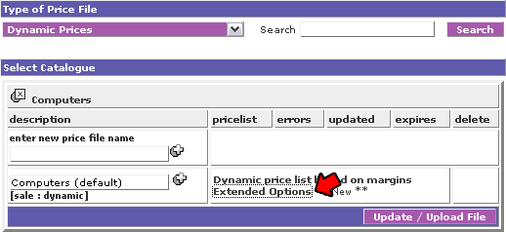 | To change these settings, browse to or create the dynamic price file in question.  You will then see the ‘Extended Options’, which is a clickable link.  Selecting this link will take the user through to a new window.

3
A series of options will become available for each category within the catalogue.

These are:
Display Images
Images on
All On – This is a checkbox. By selecting this check box all the categories will have the thumbnail images displayed.
Images off
All Off – This is a checkbox. By selecting this check box none of the categories will have the thumbnail images displayed.

Individual categories – These are radio buttons, allowing the user to switch the thumbnails on or off for individual categories.

Skip Brands During Indexing
Include Brand Page
All On – This is a checkbox. By selecting this check box all the categories will have the brands indexing displayed.
Skip Brand Page
All Off – This is a checkbox. By selecting this check box none of the categories will have the brands indexing displayed.

Individual categories – These are radio buttons, allowing the user to switch the brands indexing on or off for individual categories.

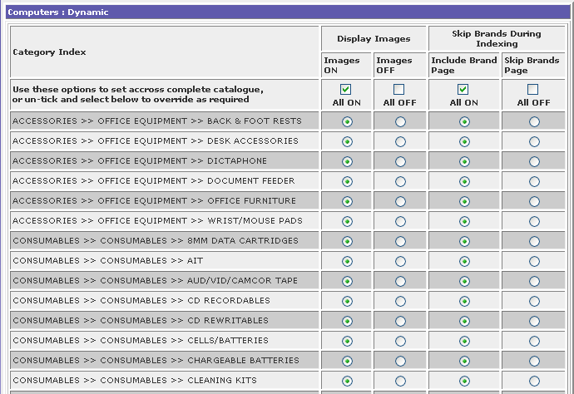
When the correct selections have been made, select the ‘Click here to update’ button at the bottom of the page.

3.6.23 Add User

ALL SITES (ALL VERSIONS)

1

PLEASE NOTE: For EPRO enabled sites; this section only applies to the store within which you are viewing. You can change the store you are viewing by selecting from the drop down menu at the top of the site configuration menu.

By adding a user, you are giving a customer an account login and password, which allows you to apply specific pricing structures, cost centres (EPRO) and user groups.

Select the ‘add user’ option.
2
You will be presented with a screen similar to that on the right.  The options are:  Cost Centre – ALL SITES (EPRO)  Select the appropriate cost centre from the drop down menu. The options are administrator specified. If no Cost Centres have created by the user, this will use the ‘Default’ setting.  User Name – ALL SITES (ALL VERSIONS)  Free text field, which is mandatory.  Email – ALL SITES (ALL VERSIONS)  Free text field, which is mandatory.  Send email checkbox  If checked, the system will automatically send an email to the specified email address advising them of the username and password.  User Group  Select the appropriate User Group from the drop down menu. The options are administrator specified. If no Default Groups have created by the user, this will use the ‘Default’ setting.  Select the ‘Click here to add a new customer’ button. | 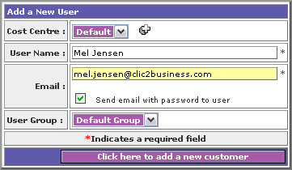
3
You will receive a highlighted confirmation message ‘User Added’ and will remain on the same page.

3.6.24 Edit User

ALL SITES (ALL VERSIONS)

1

PLEASE NOTE: For EPRO enabled sites; this section only applies to the store within which you are viewing. You can change the store you are viewing by selecting from the drop down menu at the top of the site configuration menu.

Select the ‘edit user’ option.
2
You will be presented a search facility screen.

You have the choice to enter the following search criteria.

Contact name – ALL SITES (ALL VERSIONS)
This is a free text field. If left blank it will search all contact names.

User group – ALL SITES (ALL VERSIONS)
This is a drop down menu, populated with administrator specified user groups. If no group is selected, it will search all user groups.

Company Name – ALL SITES (ALL VERSIONS) EXCLUDES EPRO
This is a free text field. If left blank it will search all company names.

Cost Centre – EPRO (STANDARD)
This is a drop down menu, populated with administrator specified cost centres. If no group is selected, it will search all cost centres.

Post Code – ALL SITES (ALL VERSIONS) EXCLUDES EPRO
This is a free text field. If left blank it will search all postcodes.

Account Active – ALL SITES (ALL VERSIONS)
This is a drop down menu, where the choices are:
- Yes. Selecting Yes will search those account, which are set to active.
- No. Selecting No will search all those account, which are not set to active.

This option defaults to ‘Yes’

Select the ‘Click here to search’ button.

The search will be run according to the specified criteria, and you will be taken to the result page.

3
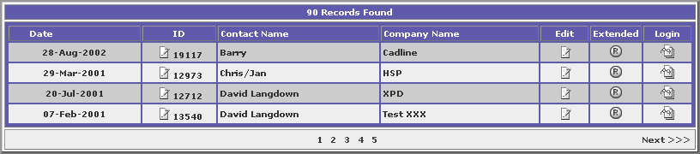
The results will tell you how many records have been found, and if more results have been found than can fit on one page, clickable ‘page numbers’, along with relevant next and back buttons will be displayed.

You have three options, which can be accessed via the three icons on the right of the page.

These are:
- Edit
- Extended
- Login

3.6.24.1 Edit User – edit customer details

ALL SITES (ALL VERSIONS)

1

You have the ability to amend the following fields:  Account number - ALL SITES (ALL VERSIONS)  This is a free text field, which is not mandatory.  Account name - ALL SITES (ALL VERSIONS)  This is a free text field, which is not mandatory.  Company name - ALL SITES (ALL VERSIONS)  This is a free text field, which is not mandatory.  Address - ALL SITES (ALL VERSIONS)  This is a free text field, which is not mandatory.  Address 1 - ALL SITES (ALL VERSIONS)  This is a free text field, which is not mandatory.  Address 2 - ALL SITES (ALL VERSIONS)  This is a free text field, which is not mandatory.  Address 3 - ALL SITES (ALL VERSIONS)  This is a free text field, which is not mandatory. | 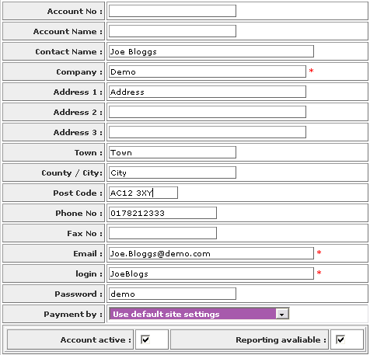
Town - ALL SITES (ALL VERSIONS)
This is a free text field, which is not mandatory.

City/County - ALL SITES (ALL VERSIONS)
This is a free text field, which is not mandatory.

Post Code - ALL SITES (ALL VERSIONS)
This is a free text field, which is not mandatory.

Phone number - ALL SITES (ALL VERSIONS)
This is a free text field, which is not mandatory.

Fax number - ALL SITES (ALL VERSIONS)
This is a free text field, which is not mandatory.

Email - ALL SITES (ALL VERSIONS)
This is a free text field, which is mandatory.

Password - ALL SITES (ALL VERSIONS)
This is a free text field, which is mandatory

Payment by - ALL SITES (ALL VERSIONS)
This is a drop down menu, with the options:
Use default site settings.
Payment via PO or credit card.
Payment via PO only.
Payment via credit card only.
If ‘default site settings’ are selected, the system will use the setting selected within the ‘general settings’ option.

Account active checkbox - ALL SITES (ALL VERSIONS)
If checked, the account is set to ‘active’

Account active checkbox - ALL SITES (ALL VERSIONS)
If checked, reporting is available for the user.
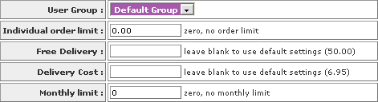
User Group - ALL SITES (ALL VERSIONS)
This is a drop down menu, the option ‘Default Group’, and any administrator specified ‘User Groups’.

If no administrator specified ‘User Group’ is selected the system will use the ‘Default Group’ setting.

Individual order limit - ALL SITES (STANDARD)
This option allows you to specify a cap on the maximum value for a single order by this customer. Leaving this value set to 0 sets no order limit

Free Delivery - ALL SITES (STANDARD) EXCLUDES EPRO
This option allows you to specify a free delivery over order of the given value for this customer.
Leaving this blank will mean the site uses the default setting specified within ‘general settings’.

Delivery Cost - ALL SITES (STANDARD) EXCLUDES EPRO
This option allows you to specify a free delivery over order of the given value this customer.
Leaving this blank will mean the site uses the default setting specified within ‘general settings’.

Monthly limit - ALL SITES (STANDARD)
This option allows you to specify a cap on the maximum value for the monthly orders by this customer. Leaving this value set to 0 sets no order limit

Authorise Orders - EPRO (STANDARD)
This is a drop down menu, the options are ‘No authoriser’, and a list of other customers with user accounts.

Selecting another customers contact name will mean that they must authorise the order prior to the dealer receiving the order.

Details on how this functions are available within the ‘Authorisation section’.

If no authoriser is selected, authorisations will not be required, and the order will be sent directly to the dealer.

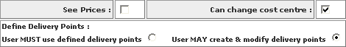
See Prices - EPRO (STANDARD)
This is a checkbox. To be defined

Can change cost centre - EPRO (STANDARD)
This is a checkbox, which when checked will allow the customer to change the cost centre specified on their confirmation/invoice.

Define Delivery Points - EPRO (STANDARD)

There is a choice of two radio buttons available:

User MUST use defined delivery points
Upon selecting this, the customer can only choose from delivery points specified by the administrator.

User MAY create and modify delivery points
Upon selecting this, the customer may amend delivery points specified by the administrator, and add their own.

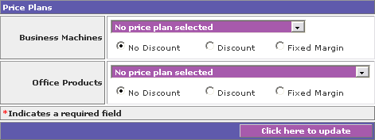

Price plans - ALL SITES (STANDARD) EXCLUDES EPRO
You can select the price plan for this customer per catalogue.

The options are provided within a drop down menu, and these are all user created price plans, with the additional option ‘No price plan selected’.

If no user created price plan is selected, the ‘No price plan selected’ option will be used, and the price plan will use be one specified with the ‘Catalogues’ section

Once selected and updated, the selected price plan will be applied for this customer on the appropriate catalogue once they have logged into their account.
Radio Buttons - ALL SITES (STANDARD) EXCLUDES EPRO

There are an additional three radio buttons for each catalogue. These are:

No Discount (default)
No discount is applied, and the specified price plan settings are used

Discount
Selecting the discount radio button and updating will produce two new fields.

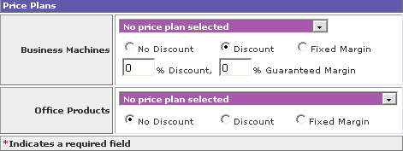

% Discount is a numerical free text field, allowing you to specify a percentage discount off the price plan selected.

% Guaranteed Margin is a numerical free text field, allowing you to specify a guaranteed margin percentage despite the discount.

Discount
Selecting the discount radio button and updating will produce two new fields.

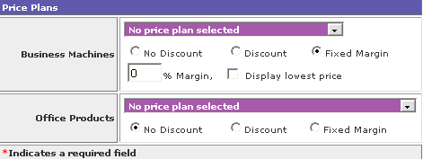

% Margin is a numerical free text field, allowing you to specify a fixed margin.

Display lowest price is a checkbox, which if checked will display the lowest price on the site.

Upon saving you will receive the highlighted confirmation message ‘Updated’, and will remain on the same page.

3.6.24.2 Edit User – edit core / restricted plan

ALL SITES (ALL VERSIONS)

1

You have the ability to upload a price file for a specific customer, and a core list for that customer.

Select the ‘Default core list / site specific price file’ option from the menu.

2
Upon selecting the option, you may have a choice of your available catalogues. Select the catalogue you wish to apply a price file to.

If there is only one catalogue, you will be taken to step 3.
3

You will be taken to a screen with the four options. These are:

Restricted product plan for X (where X is the Customer name)
Price file for X (where X is the Customer name) – NOT AVAILABLE FOR EPRO SITE CUSTOMERS
Core list for X (where X is the Customer name)
Requisition pad for X (where X is the Customer name)

4 - Restricted Product Plan

For the restricted product plan option, there is a drop down menu with the options ‘No restriction’ and any administrator specified restricted product plans.

The site defaults to ‘No restriction’.

5 - Price file for X
You will be taken to a screen similar to that on the right.

The first option available to you is ‘create site price file’ by clicking on the plus symbol.

The name will automatically default to the customer name, but this can be amended, and the following options will appear.

CSV and TAB
These are radio buttons, and you need to choose the correct option depending on if you are uploading a csv or tab delimited file.
You also have a checkbox option, which if ticked will use this core list as the default core list.

The browse option allows you to browse to a saved file. The file needs to be a csv or tab delimited file, and need no headers for the ‘columns’. The columns within the file need to be the product code and the sale price.

This product codes must be exactly as they appear on the store, and the price must exclude the currency symbol.

Click on the plus symbol to upload the file.

You can also add individual products by entering the product code into the ‘product code’ field. This code must be exactly as it appears on the store. Then add the price into the price field, excluding the currency symbol.

Selecting the ‘add/update’ button will insert you price file into the site, and if the ‘use as default core list’ checkbox was ticked, the first 500 products will be inserted into the core list.

If the incorrect file format is uploaded, or the ‘columns’ are incomplete, the highlighted message ‘incorrect file format’ will be displayed, and you will be prompted to retry.
If a correct file format is entered, the screen will automatically update, and will now show the following options/information:

Description
This is an editable free text field, which can be saved.

Plus Symbol
By selecting this symbol, the system will allow you to overwrite the file uploaded with a new one – see point 4.

Pricelist
By selecting the excel icon under the ‘pricelist’ heading, you will see all the codes successfully inserted.

Errors
By selecting the excel icon under the ‘errors’ heading, you will see all the codes which have not been inserted, and the reason why, such as ‘Invalid code’ or ‘Duplicate entry’.

Updated
This is a system-generated field, stating when the file was last updated.

Delete
To delete the restricted file, place a tick in the checkbox, and click on the red X icon.

Upon saving you will receive the highlighted confirmation message ‘Updated’, and will remain on the same page.

6 - Core list for X
You will be taken to a screen similar to that on the right.

The first option available to you is ‘create default core list’ by clicking on the plus symbol.

The name will automatically default to the customer name, but this can be amended, and the following options will appear.

CSV and TAB
These are radio buttons, and you need to choose the correct option depending on if you are uploading a csv or tab delimited file.
The browse option allows you to browse to a saved file. The file needs to be a csv or tab delimited file, and need no headers for the ‘columns’. The only column required the product code.

This product codes must be exactly as they appear on the store.

The core list must contain a maximum of 500 products

Click on the plus symbol to upload the file.

If the incorrect file format is uploaded, or the ‘columns’ are incomplete, the highlighted message ‘incorrect file format’ will be displayed, and you will be prompted to retry.
If a correct file format is entered, the screen will automatically update, and will now show the following options/information:

Description
This is an editable free text field, which can be saved.

Plus Symbol
By selecting this symbol, the system will allow you to overwrite the file uploaded with a new one – see point 4.

Corelist
By selecting the excel icon under the ‘corelist’ heading, you will see all the codes successfully inserted.

Errors
By selecting the excel icon under the ‘errors’ heading, you will see all the codes which have not been inserted, and the reason why, such as ‘Invalid code’ or ‘Duplicate entry’.

Updated
This is a system-generated field, stating when the file was last updated.

Delete
To delete the restricted file, place a tick in the checkbox, and click on the red X icon.

Upon saving you will receive the highlighted confirmation message ‘Updated’, and will remain on the same page.

7 – Requisition Pad for X
You will see a screen similar to that on the right.  The first option available to you is ‘create requisition pad’ by clicking on the plus symbol. | 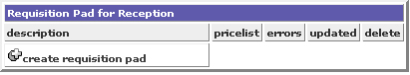
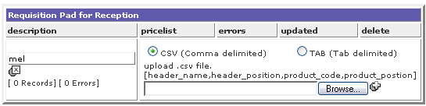 |  |  | The name will automatically default to the customer name, but this can be amended, and the following options will appear.  CSV and TAB  These are radio buttons, and you need to choose the correct option depending on if you are uploading a csv or tab delimited file.
The browse option allows you to browse to a saved file. The file needs to be a csv or tab delimited file, and need no headers for the ‘columns’.  The columns should be:  - Column A = Grouping header  - Column B = Grouping order  - Column C = Part code  - Column D = Part order  To the right is a sample of how a csv file would look like:  This product codes must be exactly as they appear on the store. |  | 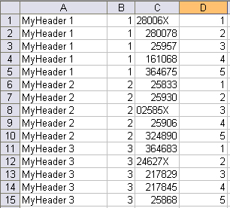
Click on the plus symbol to upload the file.

If the incorrect file format is uploaded, or the ‘columns’ are incomplete, the highlighted message ‘incorrect file format’ will be displayed, and you will be prompted to retry.
If a correct file format is entered, the screen will automatically update, and will now show the following options/information:

Description
This is an editable free text field, which can be saved.

Plus Symbol
By selecting this symbol, the system will allow you to overwrite the file uploaded with a new one – see point 4.

Pricelist
By selecting the excel icon under the ‘pricelist’ heading, you will see all the codes successfully inserted.

Errors
By selecting the excel icon under the ‘errors’ heading, you will see all the codes which have not been inserted, and the reason why, such as ‘Invalid code’ or ‘Duplicate entry’.

Updated
This is a system-generated field, stating when the file was last updated.

Delete
To delete the restricted file, place a tick in the checkbox, and click on the red X icon.

Upon saving you will receive the highlighted confirmation message ‘Updated’, and will remain on the same page.
The user may then go to eAccount on the store, and select ‘Requisition Pad’ from the menu. Something similar to the below will appear:

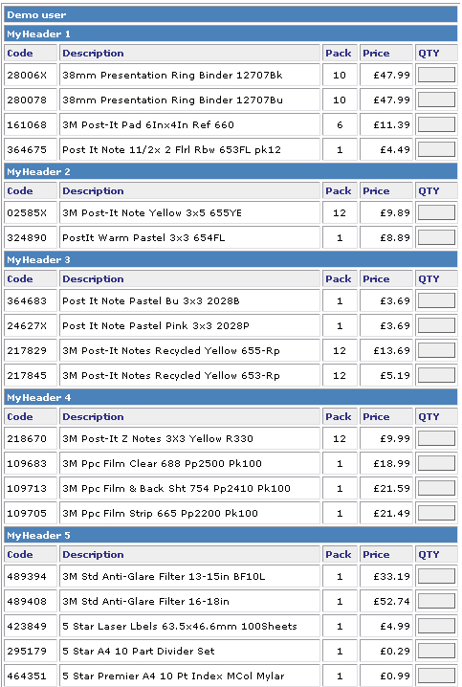

The user may then simply add in the quantities they require and click on ‘Add to shopping basket’

3.6.24.3 Edit User – Login

ALL SITES (ALL VERSIONS)

1

There is also an option, which allows you to log into your customers account, so you see exactly what your customer sees, with the extra functionality of viewing how their pricing is calculated.

Select the login icon.

2
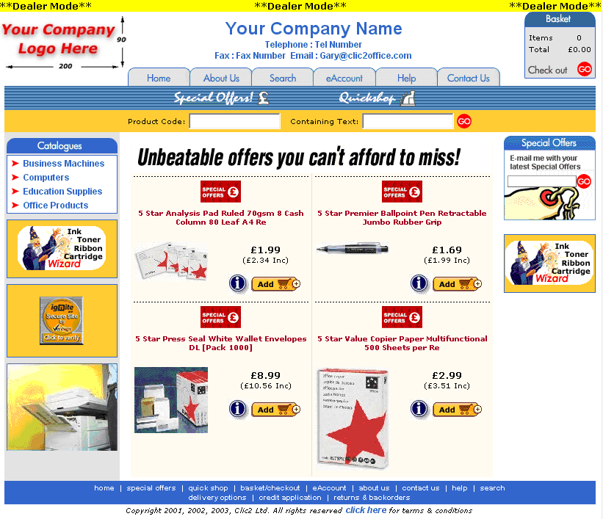 |  | A new window will automatically open, which will log directly onto the site as the user selected.  There will be an additional yellow bar shown across the site at all times, displaying the message ‘dealer mode’. This will only be displayed when you log in directly from the administration area, and will not be displayed when your customer logs into the site.
3
When browsing to, or searching for, a particular product, you will be able to view how the price is calculated for that product for the customer account you are logged into.  This will only be displayed when you log in directly from the administration area, and will not be displayed when your customer logs into the site. | 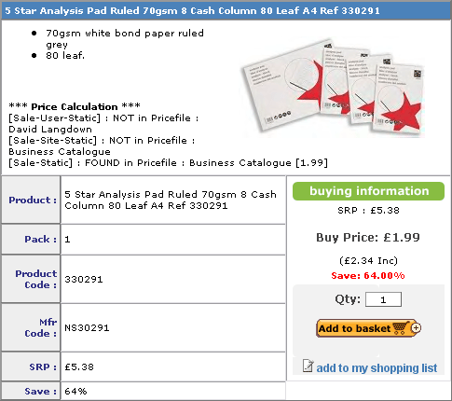

3.6.25 User Grouping

ALL SITES (ALL VERSIONS)

1

PLEASE NOTE: This section only applies to the store within which you are viewing. You can change the store you are viewing by selecting from the drop down menu at the top of the site configuration main menu.

You can set up user groups, to which you can send information.

Select the ‘user grouping’ option.
2
You will be presented with a screen similar to that on the right.  You have the following fields and information available:  Group name:  This lists the names of existing groups. There will automatically be a ‘Default Group’ to which all registered customers will be automatically inserted (unless otherwise specified within ‘user details’).  Users:  This is a numerical figure, and shows the number of users within the group.  Delete:  To delete the item, enter a check within the check box and select the red x icon. The group will be deleted from the site.  Complete to add a new user group:  This is a free text field. Add in the name of your new user group and select the ‘Click here to update’ button.  You will see the group added to the list, and will now be available within the drop down menu in ‘user details’.  To add group members, go back to ‘edit user’ and select the appropriate group for each user.  Upon saving you will remain on the same page. | 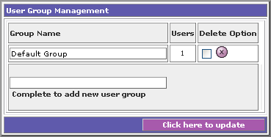

3.6.26 Order Sign Off Groups

EPRO (STANDARD)

1

PLEASE NOTE: This section only applies to the store within which you are viewing. You can change the store you are viewing by selecting from the drop down menu at the top of the site configuration main menu.

You can set up multiple authorisation levels, or ‘order sign off groups’, up to a maximum of 5.

This sets a requirement, so orders of £50 to be authorised by user A, orders over £100 need to be authorised by user B and orders over £500 need to be authorised by user C.

Select the ‘order sign off group’ option.
2
You will be presented with a screen similar to that on the right.  You have the following fields and information available:  Authorisation Group name:  This lists the names of existing authorisation groups, and is a free text field, which can be edited at any time. | 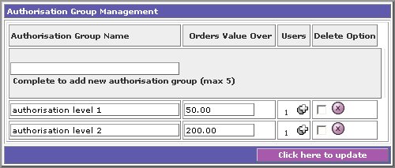
Orders Value Over:
This is a numerical text field, within which the value amount shows the number of users within the group.

Users Plus Icon:
This is a numerical figure, and shows the number of users within the group. Selecting the plus icon allows you to add more. The users within this are the ‘Authorisers’

Delete:
To delete the item, enter a check within the check box and select the red x icon. The group will be deleted from the site.

Complete to add a new authorisation group:
This is a free text field. Add in the name of your new authorisation group and select the ‘Click here to update’ button.

You will see the group added to the list.

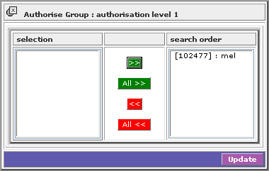 |  | To add users, click on the ‘plus button’.  You will see a screen similar to that on the left. Available users will be displayed in the left hand column, and selected users will be in the right.  Move these back and forth using the arrow keys.  Upon saving you will return to the original page.  When selecting ‘click here to update’ on the original page, you will remain on that page.

3.6.27 Cost Centres

EPRO (STANDARD)

1

PLEASE NOTE: This section only applies to the store within which you are viewing. You can change the store you are viewing by selecting from the drop down menu at the top of the site configuration main menu.

You can set up cost centres, which you can group you orders, users and invoices by.

Select the ‘cost centres’ option.
2

You will be presented with a screen similar to that on the right.  You have the following fields and information available:  Cost centre description:  This lists the names of existing groups.  There will automatically be a ‘Default’ cost centre, within which all registered customers will be automatically inserted (unless otherwise specified within ‘user details’). | 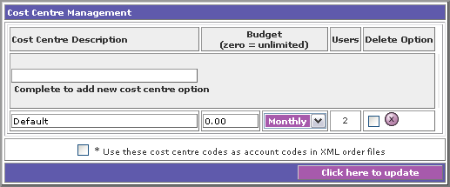
Budget:
This is a currency field. Entering a figure will set the site to allow orders for that cost centre up to the given monthly budget. If no budget is required, leave set to 0.

Users:
This is a numerical figure, and shows the number of users within the group.

Delete:
To delete the item, enter a check within the check box and select the red x icon. The group will be deleted from the site.

Complete to add a new cost centre option:
This is a free text field. Add in the name of your new cost centre and select the ‘Click here to update’ button.

You will see the group added to the list, and will now be available within the drop down menu in ‘user details’.

To assign customers to this cost centre, go back to ‘edit user’ and select the appropriate cost centre for each user.

Upon saving you will remain on the same page.

3.6.28 Invoice Points

EPRO (STANDARD)

1

PLEASE NOTE: This section only applies to the store within which you are viewing. You can change the store you are viewing by selecting from the drop down menu at the top of the site configuration main menu.

You can set up invoice points, which allows your customers to specify where they would like to have the invoice delivered to.

Select the ‘delivery points’ option.
2

You will be presented with a screen similar to that on the right.  You have the following fields and information available:  Short Name:  This lists the names of existing delivery points.  There will automatically be a ‘Default’ delivery point, which will automatically use the address entered in ‘company details’. | 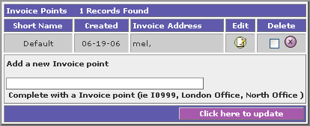
Created:
This is a system-generated date, and displayed the date the delivery point was created.

Invoice Address:
This is a system-generated field, displaying the address set up for this delivery point...

Edit:
Selecting this item will allow you to edit the address entered, as detailed in point 3.

Delete:
To delete the item, enter a check within the check box and select the red x icon. The group will be deleted from the site.

Complete to add a new delivery point:
This is a free text field. Add in the name of your new cost centre and select the ‘Click here to update’ button.

3

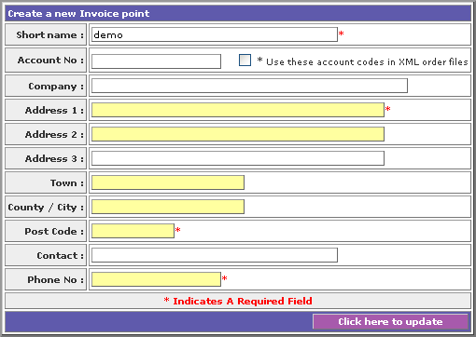 | You will be taken to a screen similar to that on the left.  The following fields are available:  Short name:  This is a free text field and is mandatory.  Account No:  This is a free text field and is not mandatory.  Account Checkbox:  This is a checkbox, which, upon ticking, will use the specified account code in the XML order files.
Company:
This is a free text field and is not mandatory.

Address 1:
This is a free text field and is mandatory.

Address 2:
This is a free text field and is not mandatory.

Address 3:
This is a free text field and is not mandatory.

Town:
This is a free text field and is not mandatory.

County / City:
This is a free text field and is not mandatory.

Post Code:
This is a free text field and is mandatory.

Contact:
This is a free text field and is not mandatory.

Phone No:
This is a free text field and is mandatory.

Selecting the click here to update button will insert the changes made, and take you back to the initial invoice point screen, where the changes will be reflected.

3.6.29 Delivery Points

EPRO (STANDARD)

1

PLEASE NOTE: This section only applies to the store within which you are viewing. You can change the store you are viewing by selecting from the drop down menu at the top of the site configuration main menu.

You can set up delivery points, which allows your customers to specify where they would like to have the item delivered.

Select the ‘delivery points’ option.
2

You will be presented with a screen similar to that on the right.  You have the following fields and information available:  Short Name:  This lists the names of existing delivery points.  There will automatically be a ‘Default’ delivery point, which will automatically use the address entered in ‘company details’. | 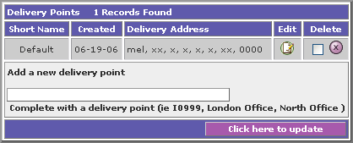
Created:
This is a system-generated date, and displayed the date the delivery point was created.

Delivery Address:
This is a system-generated field, displaying the address set up for this delivery point...

Edit:
Selecting this item will allow you to edit the address entered, as detailed in point 3.

Delete:
To delete the item, enter a check within the check box and select the red x icon. The group will be deleted from the site.

Complete to add a new delivery point:
This is a free text field. Add in the name of your new cost centre and select the ‘Click here to update’ button.

3

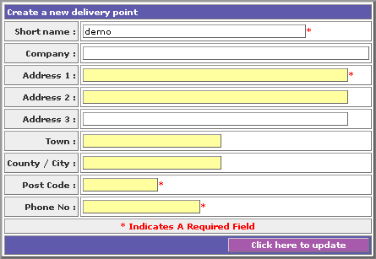 | You will be taken to a screen similar to that on the left.  The following fields are available:  Short name:  This is a free text field and is mandatory.  Company:  This is a free text field and is not mandatory.  Address 1:  This is a free text field and is mandatory.
Address 2:
This is a free text field and is not mandatory.

Address 3:
This is a free text field and is not mandatory.

Town:
This is a free text field and is not mandatory.

County / City:
This is a free text field and is not mandatory.

Post Code:
This is a free text field and is mandatory.

Phone No:
This is a free text field and is mandatory.

Selecting the click here to update button will insert the changes made, and take you back to the initial delivery point screen, where the changes will be reflected.

3.6.30 Email Users

ALL SITES (ALL VERSIONS)

1

PLEASE NOTE: This section only applies to the store within which you are viewing. You can change the store you are viewing by selecting from the drop down menu at the top of the site configuration main menu.

You can send your registered users an email, and you can select which groups you wish to communicate to.
Select the ‘email users’ option.
2
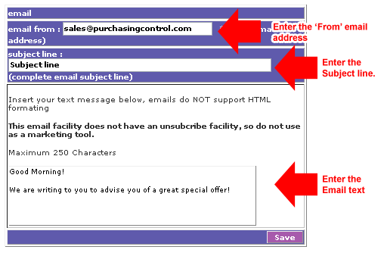 |  | You will be shown a screen similar to that below.  Check, and if necessary change the ‘email from’ field.  Add a subject line.  Create the body of your email using the Text Editor.  When complete, select the ‘Save button’.
3
You will be presented with a page similar to the one on the right.  There will be a list of administrator specified groups, and the ‘Default Group’ shown.  The number of users in each group will also be displayed.  Select the group you wish to transmit to and select the ‘transmit’ button by ticking on the relevant checkbox.  The mail will be previewed in a window below this button.  Selecting the ‘click here to transmit message button, the messages will be transmitted from the system.  You will receive a confirmation message upon completion. | 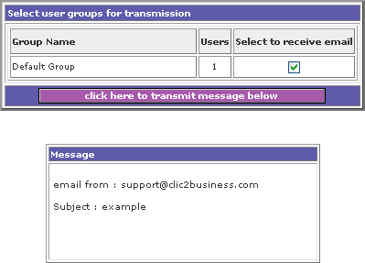

3.6.31 Price Comparison

ALL SITES (STANDARD - ON REQUEST)

1
By selecting this option, you will be taken into a new screen. |  | 
2
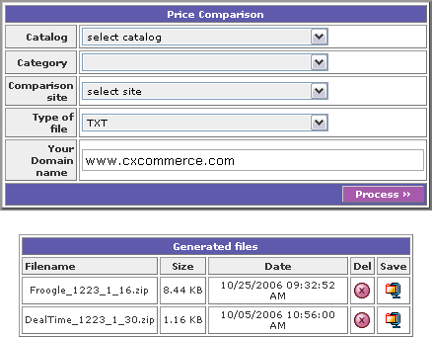
TOP SECTION:

The fields available are:

Catalogue:
This is a drop down menu, within which the fields available match the catalogues available.

Category:
This is a drop down menu, within which the fields available match the catalogue selected.

Comparison:
This is a drop down menu, within which the fields available include:
- Dealtime
- Froogle
- Kelkoo
- PriceRunner
- Shopzilla

Type of file:
This is a drop down menu, within which the fields available are:
- Csv
- Text

Your Domain Name:
This is a free text, optional field.

Process Button
Once all the other fields are populated, clicking on the ‘Process Key’, upon which the report will be processed and the green confirmation message ‘Price Comparison was successfully generated’ will be displayed.

LOWER SECTION:  The fields available are:  Filename:  This is the name of the file.  Size:  This is the size of the file. | 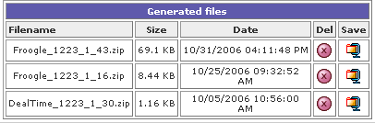
Date:
This is the date and time that the file was created.

Delete:
This is a clickable icon, which allows you to delete the file.

Save:
This is a clickable icon. By clicking it you will have the option to save or open the file.

3.6.32 Reports: Orders

ALL SITES (ALL VERSIONS)

1
Select the ‘Orders’ option.  You will be taken to a page similar to that on the right, with search criteria fields, allowing you to search for the orders.  The search criteria available is: | 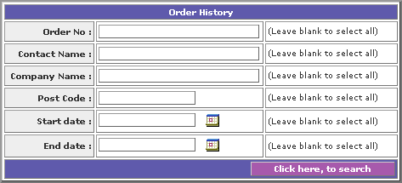
Order No:
This is a free text field, but if anything is entered it does need to match an existing order number within the system.

If part of the order number is entered, the search will run, and produce all results containing the partial entry.

If left blank, the search will run on all order numbers.

Contact Name:
This is a free text field, but if anything is entered it does need to match an existing contact name within the system.

If part of the contact name is entered, the search will run, and produce all results containing the partial entry.

If left blank, the search will run on all contact names.

Company Name:
This is a free text field, but if anything is entered it does need to match an existing company name within the system.

If part of the company name is entered, the search will run, and produce all results containing the partial entry.

If left blank, the search will run on all company names.

Post Code:
This is a free text field, but if anything is entered it does need to match an existing postcode within the system.

If part of the postcode is entered, the search will run, and produce all results containing the partial entry.

If left blank, the search will run on all postcodes.

Start Date:
This is a date field, and needs to be in the format DD/MM/YYYY. There is also a calendar icon. By selecting this icon a pop-up calendar will be produced. You can select the appropriate date by clicking on it. The pop-up calendar will close automatically.

If left blank, the search will run on all dates.

End Date:
This is a date field, and needs to be in the format DD/MM/YYYY. There is also a calendar icon. By selecting this icon a pop-up calendar will be produced. You can select the appropriate date by clicking on it. The pop-up calendar will close automatically.

If left blank, the search will run on all dates

Click on the ‘Click here to search’ button to search.

2
If no results can be found based on the search criteria entered the highlighted message ‘No records found’ will be displayed. You will remain on the search criteria page and your specified criteria will remain on in the fields.

If you search was successful, the result will be returned as follows:
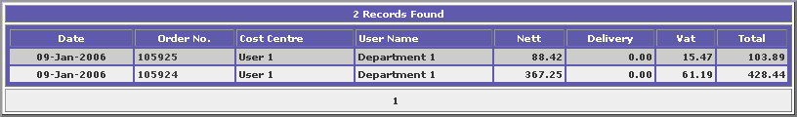
The fields available are:

Date:
This is the date the order was placed.

Order No:
This is the unique order number, and the number is also a clickable link.

Selecting this link, you will be prompted to enter your password. Upon correct entry of the password, you will be taken to a display of the order.

4
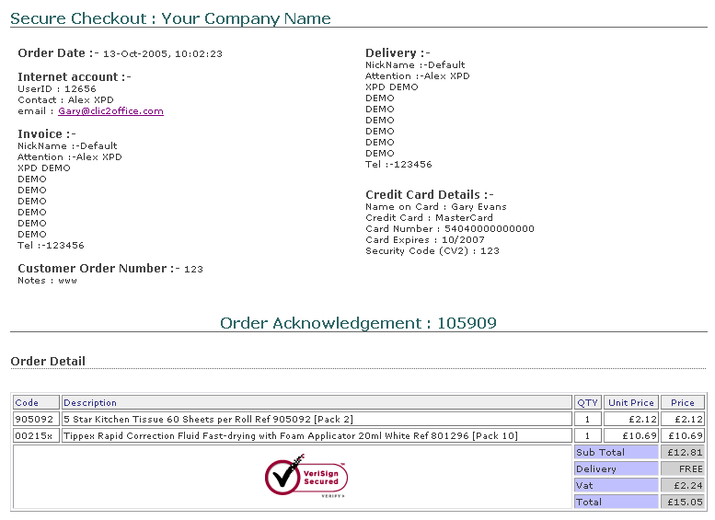 | The order will look similar to the example on the left.  You will need to process the order as normal.

3.6.33 Reports: Sales Summary

ALL SITES (ALL VERSIONS)

1
Select the ‘Sales Summary’ option.  You will be taken to a page similar to that on the right, with search criteria fields, allowing you to search for the orders.  The search criteria available is: | 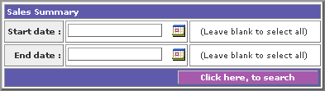
Start Date:
This is a date field, and needs to be in the format DD/MM/YYYY. There is also a calendar icon. By selecting this icon a pop-up calendar will be produced. You can select the appropriate date by clicking on it. The pop-up calendar will close automatically.

If left blank, the search will run on all dates.

End Date:
This is a date field, and needs to be in the format DD/MM/YYYY. There is also a calendar icon. By selecting this icon a pop-up calendar will be produced. You can select the appropriate date by clicking on it. The pop-up calendar will close automatically.

If left blank, the search will run on all dates

Click on the ‘Click here to search’ button to search.

2
If no results can be found based on the search criteria entered the highlighted message ‘No records found’ will be displayed. You will remain on the search criteria page and your specified criteria will remain on in the fields.

If you search was successful, the result will be returned as follows:
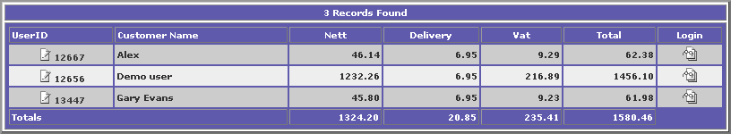
The fields available are:

User ID:
This is the unique User ID for the registered customer. This is automatically displayed by the system, and is a clickable link though to that customers ‘edit user’ details.

Customer Name:
This is the customer name as specified with the ‘edit details’ section.

Nett:
This is the Nett taking for this customer within the dates specified.

Delivery:
This is the Delivery taking for this customer within the dates specified.

VAT:
This is the VAT taking for this customer within the dates specified.

Total:
This is the Total taking for this customer within the dates specified.

Login:
This login icon logs you into the customer’s account, as described in the ‘edit user’ section.

Totals:
This is the Total takings for all customers within the dates specified.

3.6.34 Reports: Product Usage

ALL SITES (ALL VERSIONS)

1
Select the ‘Product Usage’ option.  You will be taken to a page similar to that on the right, with search criteria fields, allowing you to search for the products ordered.  The search criteria available is: | 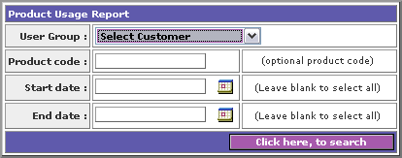
User Group:
This is a selectable drop down menu, within which user groups and registered customer names are selectable.

If nothing is selected, the search will run on all customers.

Product Code:
This is a free text field, but if anything is entered it does need to match an existing product code within the system.

If part of the product code is entered, the search will run, and produce all results containing the partial entry.

If left blank, the search will run on all product codes

Start Date:
This is a date field, and needs to be in the format DD/MM/YYYY. There is also a calendar icon. By selecting this icon a pop-up calendar will be produced. You can select the appropriate date by clicking on it. The pop-up calendar will close automatically.

If left blank, the search will run on all dates.

End Date:
This is a date field, and needs to be in the format DD/MM/YYYY. There is also a calendar icon. By selecting this icon a pop-up calendar will be produced. You can select the appropriate date by clicking on it. The pop-up calendar will close automatically.

If left blank, the search will run on all dates

Click on the ‘Click here to search’ button to search.

2
If no results can be found based on the search criteria entered the highlighted message ‘No records found’ will be displayed. You will remain on the search criteria page and your specified criteria will remain on in the fields.

If you search was successful, the result will be returned as follows:

Grouped by Customer Name:
Product Code
Product Description
Quantity
Total

3.6.35 Reports: Financial Summary

ALL SITES (ALL VERSIONS)

1
Select the ‘Financial Summary’ option.  You will be taken to a page similar to that on the right, with search criteria fields, allowing you to search for the orders.  The search criteria available is: | 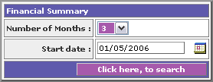
Number of Months:
This is a selectable drop down menu, from which the following options are available:
- 3
- 6
- 9
- 12

If no selection is made, the system will default to 3 months.

Start Date:
This is a date field, and needs to be in the format DD/MM/YYYY. There is also a calendar icon. By selecting this icon a pop-up calendar will be produced. You can select the appropriate date by clicking on it. The pop-up calendar will close automatically.

If no date is specified, the system will default to 01/05/2006.

Click on the ‘Click here to search’ button to search.

2
If no results can be found based on the search criteria entered the highlighted message ‘No records found’ will be displayed. You will remain on the search criteria page and your specified criteria will remain on in the fields.

If you search was successful, the result will be returned as follows:
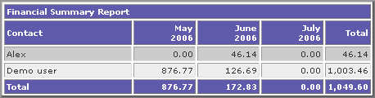
The fields available are:

Contact Name:
This is the customer name as specified with the ‘edit details’ section.

Months:
This is the total figure of takings from the specified customer within that month.

Total:
This is the total figure of takings from the specified customer within the 3, 6, 9 or 12 months.

3.7 Order Monitor
ALL SITES (ALL VERSIONS)
1

This option allows you to view and authorise any orders.

2
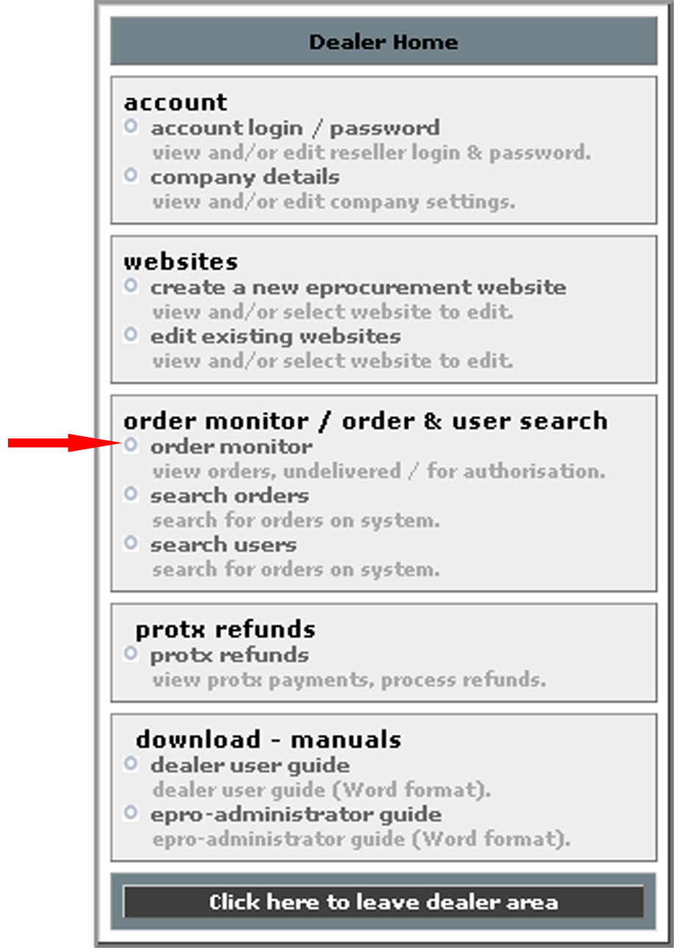 | Select the ‘order monitor’ option from the menu.  You will be provided with a list of orders, which have been received but not viewed by the dealer.  The items shown are:  Order Date & Time  Order ID  Link/Comments  XML file copy (If order with XML is selected within ‘Dealer Home: Company details’ Section 3.2).  By selecting a link, you will be prompted to enter your password to gain access to the secure server, and are able to view the order.

4
The order will look similar to the example on the left.

You will need to process the order as normal.

3.8 Search Orders
ALL SITES (ALL VERSIONS)
1

This option allows you to view and authorise any orders.

2
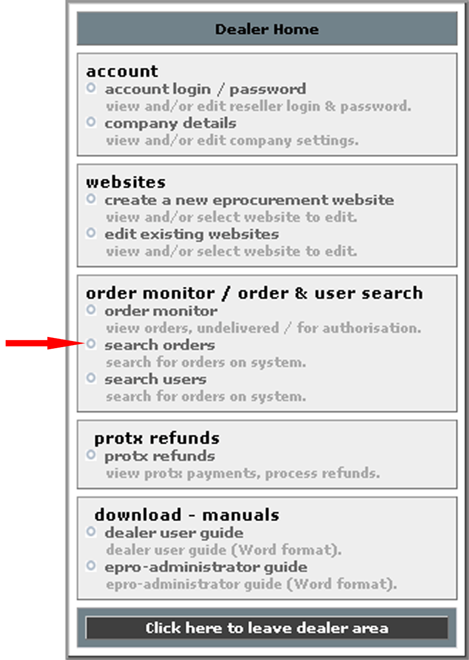 | Select the ‘search orders’ option.

2
You will be taken to a page similar to that on the right, with search criteria fields, allowing you to search for the orders.

The search criteria available is:
Order No:
This is a free text field, but if anything is entered it does need to match an existing order number within the system.

If part of the order number is entered, the search will run, and produce all results containing the partial entry.

If left blank, the search will run on all order numbers.

Contact Name:
This is a free text field, but if anything is entered it does need to match an existing contact name within the system.

If part of the contact name is entered, the search will run, and produce all results containing the partial entry.

If left blank, the search will run on all contact names.

Company Name:
This is a free text field, but if anything is entered it does need to match an existing company name within the system.

If part of the company name is entered, the search will run, and produce all results containing the partial entry.

If left blank, the search will run on all company names.

Post Code:
This is a free text field, but if anything is entered it does need to match an existing post code within the system.

If part of the post code is entered, the search will run, and produce all results containing the partial entry.

If left blank, the search will run on all post codes.

Start Date:
This is a date field, and needs to be in the format DD/MM/YYYY. There is also a calendar icon. By selecting this icon a pop-up calendar will be produced. You can select the appropriate date by clicking on it. The pop-up calendar will close automatically.

If left blank, the search will run on all dates.

End Date:
This is a date field, and needs to be in the format DD/MM/YYYY. There is also a calendar icon. By selecting this icon a pop-up calendar will be produced. You can select the appropriate date by clicking on it. The pop-up calendar will close automatically.

If left blank, the search will run on all dates

Click on the ‘Click here to search’ button to search.

3
If no results can be found based on the search criteria entered the highlighted message ‘No records found’ will be displayed. You will remain on the search criteria page and your specified criteria will remain on in the fields.

If you search was successful, the result will be returned as follows:
The fields available are:

Date:
This is the date the order was placed.

Order No:
This is the unique order number, and the number is also a clickable link.

Selecting this link, you will be prompted to enter your password. Upon correct entry of the password, you will be taken to a display of the order.

4
The order will look similar to the example on the left.

You will need to process the order as normal.

3.9 Search Users
ALL SITES (ALL VERSIONS)
1

This option allows you to view and authorise any orders.

2
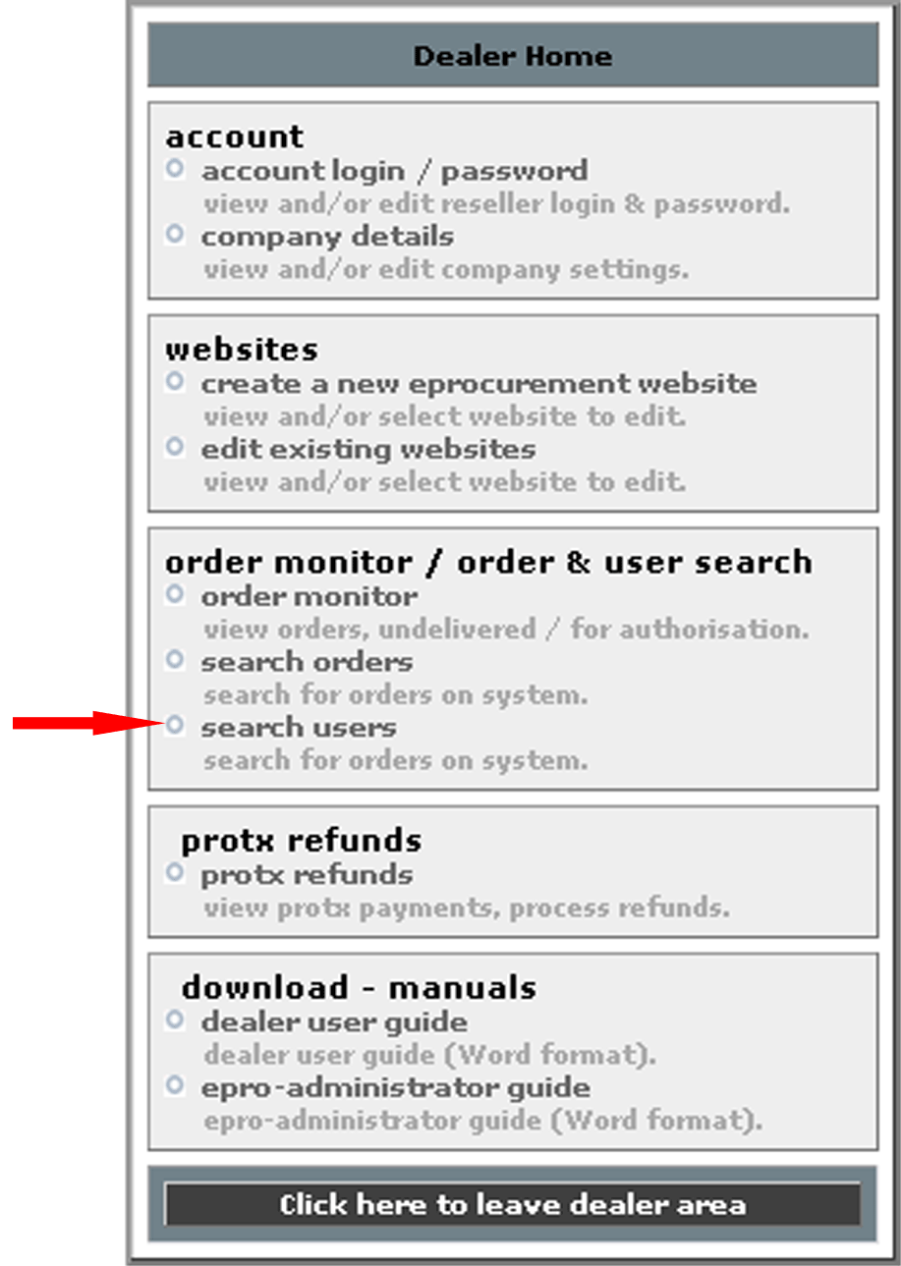 | Select the ‘search users’ option.

3

You will be presented a search facility screen.

You have the choice to enter the following search criteria.

Contact name – ALL SITES (ALL VERSIONS)
This is a free text field. If left blank it will search all contact names.

User group – ALL SITES (ALL VERSIONS)
This is a drop down menu, populated with administrator specified user groups. If no group is selected, it will search all user groups.

Company Name – ALL SITES (ALL VERSIONS) EXCLUDES EPRO
This is a free text field. If left blank it will search all company names.

Cost Centre – EPRO (STANDARD)
This is a drop down menu, populated with administrator specified cost centres. If no group is selected, it will search all cost centres.

Post Code – ALL SITES (ALL VERSIONS) EXCLUDES EPRO
This is a free text field. If left blank it will search all postcodes.

Account Active – ALL SITES (ALL VERSIONS)
This is a drop down menu, where the choices are:
- Yes. Selecting Yes will search those account, which are set to active.
- No. Selecting No will search all those account, which are not set to active.

This option defaults to ‘Yes’

Select the ‘Click here to search’ button.

The search will be run according to the specified criteria, and you will be taken to the result page.

3
The results will tell you how many records have been found, and if more results have been found than can fit on one page, clickable ‘page numbers’, along with relevant next and back buttons will be displayed.

You have three options, which can be accessed via the three icons on the right of the page.

These are:
- Edit
- Extended
- Login

Details of these can be found within the relevant sections earlier within this document.

3.10 Protx Refunds

ALL SITES (ALL VERSIONS)

This option will always be available, but will only contain any of the following if the site is set up to use PROTX.
1

This option allows you to refund any payments made via Protx, the online credit card payment, as well as view any payments in general.

2
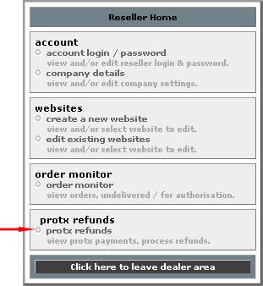 | Select the ‘Protx refunds’ option from the menu.  You will be provided with a list of orders, which have been processed via Protx.  The items shown are:  Order Date  Order ID  Link/Comments  XML file copy (If order with XML is selected within ‘Dealer Home: Company detains’ Section 3.2).  By selecting a link, you will be prompted to enter your password to gain access to the secure server, and are able to view an order.  To action a refund, log into your Protx account (www.protx.co.uk).

3.11 Download Manuals

ALL SITES (ALL VERSIONS)

The following option will be available:

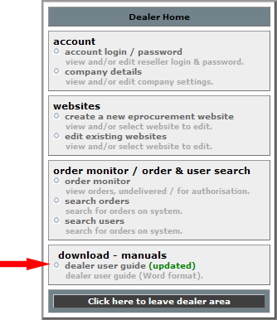

- Dealer user guide ALL SITES (ALL VERSIONS)

Both options will open or be downloadable in MS Word, depending on the users Internet settings.

4.0 Using the HTML editor

ALL SITES (ALL VERSIONS)

This is an externally provided tool; therefore we cannot in good faith provide a functional specification, however, below is a brief guide.

1
You can type, edit, copy and paste into the HTML editor. Below is an overview (although not an exhaustive guide) of the functionalities available.
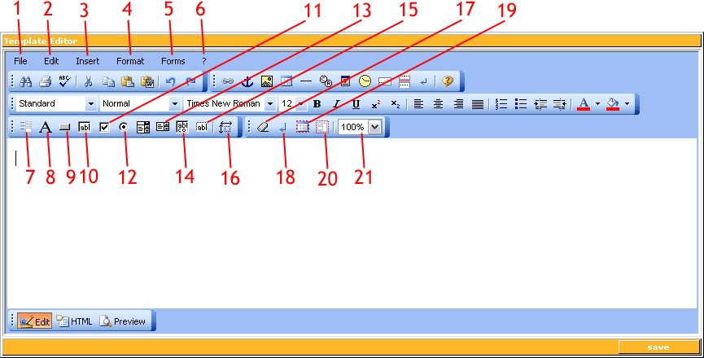
1 File  Preview or print  2 Edit (options repeated below)  3 Insert (options repeated below)  4 Format (options repeated below)  5 Forms (options repeated below)  6 Help  7 Insert Form  8 Insert Label (on form)  9 Insert Button (on form)  10 Insert Input (on form)  11 Insert Checkbox (on form)  12 Insert Radio button (on form)  13 Insert Combo box (on form) | 14 Insert text area (on form)  15 Insert Hidden field (on form)  16 Absolute Position (on form)  17 Remove Format  18 Set RETURN mode  This button can tab between either starting a new paragraph, or just a line break, when pressing the return key.  19 Table Highlight  20 Select all  By clicking this, everything would be selected.  21 Zoom options

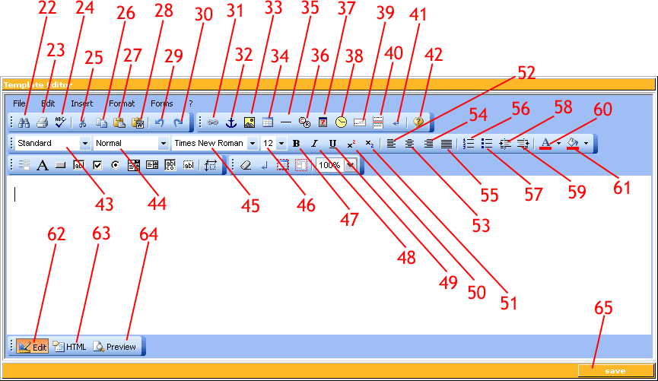

22 Search  This functionality allows you to search for, and if required, replace, items of text.  23 Print  24 Spell Checker  25 Cut  26 Copy  27 Paste  28 Paste from MS Word  29 Undo  30 Redo  31 Insert Link  32 Insert Anchor  33 Insert Image  34 Insert Table  35 Insert Rule (line)  36 Insert Special Characters (e.g. ©)  37 Insert Date  38 Insert Time  39 Marquee  Adds a scrolling message of text  40 Page Break  41 Insert Paragraph  42 Help  43 Select Style Sheet  44 Select Text Format  45 Select Text Font | 46 Select Text Size  47 Bold  48 Italic  49 Underline  50 Superscript  51 Subscript  52 Align Left  53 Align Centre  54 Align Right  55 Justify Full  56 Ordered List  Adds numerical bullet points  57 Unordered List  Adds plain bullet points  58 Indent  59 Outdent  60 Select Text Colour  61 Set Background Colour  62 Edit  This is the standard for editing your creative.  63 HTML  You can see the HTML code by clicking on this option. Click ‘Edit’ to return.  64 Preview  65 Save  You can save the file at any time and re-edit earlier.

4.1 Background Colour
To create your basic page, you may wish to select a background colour. To do this, select the background fill option (number 61 within the ‘Buttons’ section). By selecting the arrow to the right hand side of this button you can select the colour you want. Please note that by using this tool only the area behind any text will be coloured.

If you don’t choose a background cover, it will remain white.

4.2 Adding tables
To add a table, click on button 34. You will be prompted to choose how many columns and rows you would like.

You can centralise or align the table by highlighting the whole thing and choosing the appropriate button.

Populate the table by clicking in the different cells and adding text or images as you would normally.

4.3 Adding text
To add text, just type in the text you want. It will appear in blocks and can only be broken up by images you insert later unless you use tables.

4.4 Formatting text
To format the text, highlight the text you wish to change and amend it using the editing buttons, outlined here:

- Font – button 45
- Size – button 46
- Make bold – button 47
- Make italic – button 48
- Underline – button 49
- Left align – button 52
- Centrally align – button 53
- Right align – button 54
- Justify – button 55
- Colour – button 60

4.5 Formatting bullet points
To add bullet points, highlight the text if you have already added it, and click on the bullet point button. If you haven’t added the bullet point text, move the cursor to where you want the bullet points to be, click on the bullet button and type your text. Each time you press return a new line containing a bullet point will be started.

For the bullet points to be numbered (i.e. 1, 2, 3) use button 56.
For the bullet points to be plain (i.e. dots) use button 57.

4.6 Adding images
To add images, click on button 33. You will be given an option to either use a local image (i.e. saved file on your computer) or a web image. If you select local image, you will be asked to browse to it.

If you choose to use a web-based image, you will need to type in a full URL, such as http://www.Clic2mail.com/Clic2mail/companylogo.gif.

You can move and resize your image by dragging and dropping where required.

4.7 Adding hyperlinks
To add a hyperlink, type the text you want to show, such as ‘click here’ or ‘visit the website’. Highlight this text and click on button 31. You will be asked to type in the full URL.

4.8 Save
Always be sure to save your work before exiting.

5.0 Authorisations

EPRO (STANDARD)
1

On an Epro site, if an authoriser has been set for a customer within the ‘edit user’ section, when that customer purchases an item, the highlighted message ‘your order will be sent to x for authorisation’ (where x is the specified authorisers name), and instead of an ‘order’ button, the button ‘send for authorisation’ is displayed.

Upon selecting this button, the standard order process is continued.

The order is displayed on the ‘order monitor’ for the dealer to see, but the actual details are hidden until authorisation is completed.

2
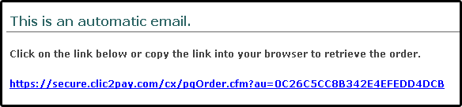 |  | Upon the order finally being submitted for authorisation, the authoriser will be sent an email similar to that on the left.  Clicking on this link will take the authoriser to the order.
3
Details of the order, cost centre and budget spent will be provided, with the following options:  Accept:  This is a button labelled ‘click here to ACCEPT order for processing. Selecting this button will accept the order. The order will be sent to the dealer.  The order is made fully viewable within the ‘order monitor’.  Reject:  This is a button labelled ‘click here to REJECT order for processing. Selecting this button will reject the order. The order will not be sent to the dealer, and the customer will receive a notification email stating their order was rejected, along with any rejection comments.  The order is removed from ‘order monitor’.  Rejection comments:  This is a free text field within which the authoriser can specify the reasons for the rejection. | 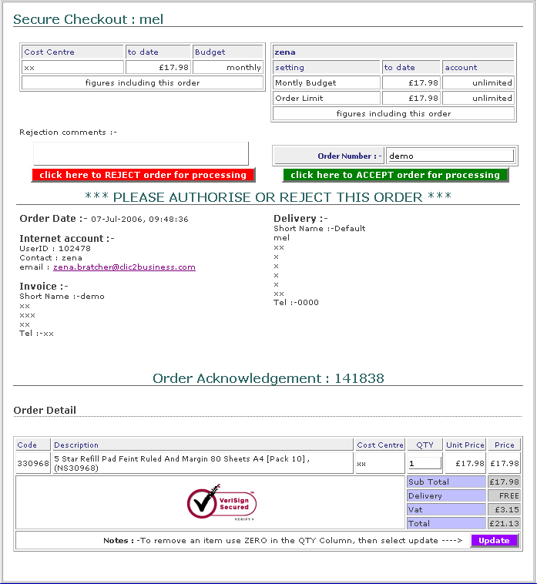

6.0 Clic2mail
1

 | Within your stores configuration page, you will see the clic2mail option.  Clic2mail allows you to send out ebulletins to your customer email lists. There is additional documentation available for this system.

7.0 Order Pad

Order pad gives the customer the ability to save a list of products they may want to purchase regularly. This saves them the hassle of browsing and searching for products.

To do this, they just need to add items into their shopping basket, and instead of checking out, they can simply ‘save as order pad’, and giving it a name.

Once saved, the customer can open the order pad by clicking on ‘eaccount’ and selecting ‘order pads’. A list of the customers order pads will be produced, and by clicking on the desired one it will open.

The Order Pad will then display the items within it, and the user can just put the quantities they wish to purchase next to the appropriate product, and then click on ‘Add to shopping basket’. They can also shop as they would normally.

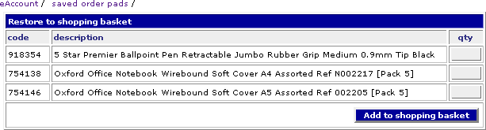

You can save multiple order pads. The user can utilise this for each category of products they buy, for example they can save an order pad for ‘janitorial supplies’ then a separate one for ‘stationary equipment’.

8.0 Dealer Mode Ordering

You have the facility to order products on behalf of your customer.
- To do this, log into your dealer admin area and:
- Select ‘edit existing website’.
- Select the site you require.
- Select ‘edit user’
- Enter your search criteria and submit.
- Click on the icon login for the appropriate user (last icon on the right).

Shop as required, but within the basket, and when ready, click on ‘Checkout’ or ‘View Basket’, and you will now be presented with the following

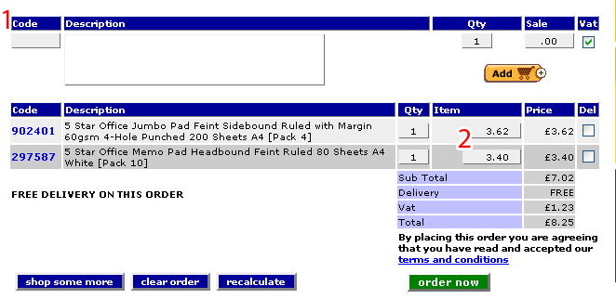

At the area labelled ‘1’ you now have the facility to add items which are not part of the catalogue.

Add a code, description, quantity and price, ensure there is a tick in the box if you wish this product to have VAT applied (untick this box if the product is VAT exempt) and click on ‘add’.

At the area labelled ‘2’ you may edit the item price per product. Please ensure you click on ‘Recalculate’ after amending the price, or you may find it reverting to the old price after clicking ‘order now’.

9.0 Web forwarding/masking
In order to mask the domain name www.cxcommerce.com, you will need to obtain a new domain name, such as www.yourdomain.co.uk, or if you already have a domain name for you main website, you may wish to add a subdomain to this, such as http://store.yourdomain.co.uk.

Once you have this, you will need to point the A record to the IP Address 79.99.68.3
If you are unsure how to do any of this, your ISP or Domain Hosting Provider (or whomever maintains your domain addresses) should be able to assist.

Once this has been done, send an email to support@clic2.co.uk advising that you have pointed you A record to us and would like us to add your domain. Please ensure you include the domain name you wish to use.

Appendix A - Help

Should you require assistance, contact the helpline on: 0800 496 4455

A.1 FAQ’s

A.1.1 How do I handle credit card orders?
Unless you are signed up to Protx where credit card orders are processed and paid automatically, you will receive any credit card order details via a secure site email. You will then need to process it as you would any other order, such as one received over the phone.

A.1.2 How to I change my delivery charges, or offer free delivery?
See the section for ‘general settings’

A.1.4 I don’t want to accept credit card orders. How do I set this up?
You can select which credits cards you accept, if any, by going to the ‘general settings’ option and ticking or unticking the relevant boxes. Further information is available within section.

A.1.5 Can I set it so users have to log in to their account before they browse?
Yes – simply go into the ‘general settings’ section and you will see an option stating ‘Site restrictions’. Select ‘Login before accessing site’, and save by selecting the ‘Click here to update’ button.

A.1.6 Can I set it so users can browse but to have to log in before they purchase?
Yes – simply go into the ‘general settings’ section and you will see an option stating ‘Site restrictions’. Select ‘Browse site, login before purchase’, and save by selecting the ‘Click here to update’ button.

A.1.7 Can I set individual users a credit limit or specified payment method?
Yes – go to the ‘edit users’ option (see the ‘edit user’ section), and search for the user in question.
Go into ‘edit customer details’, you can set the following:
- Individual order limit
- Monthly credit limit
- Delivery cost
- Payment by method

Save by selecting the ‘Click here to update’ button. See the ‘edit user’ section for more details.

A.1.8 I’ve forgotten my password – How do I find out what it is?
Contact the helpline on 0800 496 4455, and we will obtain your password for you. Please note that you may be asked some security questions before the password is given.

A.1.9 What is an Order Pad?
Please see the ‘Order Pad’ section.

A.1.10 Can I set up web masking/web forwarding, so you can see the site is www.cxcommerce.com?
Yes - In order to mask the domain name, we need to point the A record of your domain to 79.99.68.3. If you are unsure how to do this, your ISP (or whomever maintains your domain addresses) should be able to assist. Once this has been done, contact us and let us know what the exact domain name is, and we will do the rest.

A.1.11 How do I set up Protx?
- To set up Protx, log into your store administration area, and on the grey section click on 'Company details'.
- Under 'Credit card process', select the Protx server required.
- Select update.
- Enter your Protx Vendor code (this is usually your company name, but if you are unsure please contact Protx) and update again.
- Please ensure that you have these IP address set in your Protx admin account
79.99.68.053
79.99.68.060
subnet mask for both 255.255.255.128
- You will also need to check that your Protx account is the correct one for this process.

The contact information for Protx is available here: http://www.protx.com/aboutus/contactus.asp

A.2 Trouble Shooting

A.2.1 The store design is pushed out of shape and the logo is surrounded with white space
This may be caused by the logo itself having white space around it prior to the logo being uploaded. To correct this, trim the white space from the logo and re-upload it.

If you need any assistance with this, please contact the helpline on 0800 496 4455.

A.2.2 The logo is too large
This may be caused by the logo itself being too large prior to the logo being uploaded. To correct this, resize the logo to a maximum of 200 pixels wide by 90 pixels high and re-upload it.

If you need any assistance with this, please contact the helpline on 0800 496 4455.

A.2.3 The logo has been uploaded, but isn’t showing
This may be caused by the logo being saved in the wrong format prior to it being uploaded. To correct this, save the logo in either a .jpg or .gif format and re-upload it.

If you need any assistance with this, please contact the helpline on 0800 496 4455.

A.2.4 There are no products showing on the store
This may be caused by the products being switched off in the administration area of the store. To correct this, see section 6.4

If you need any assistance with this, please contact the helpline on 0800 496 4455.

A.2.5 My pricing is showing incorrectly
Please see the online guide at: http://www.cxcommerce.com/pricing_guide/index.html

A.2.5 I haven’t received my email order confirmation.
Unfortunately we can not guarantee that all emails are delivered across the world wide web as we do not control this.

Firstly, check that the email address you have saved within ‘company details’ (on the first grey login screen) is correct and working OK.

If this seems to be in working order, try the following:
- Check that this email has not gone into your junk email folder (if you have one)
- Check with your IT person that these mails are not stuck on your server
- Add the email address webmaster@clic2business.com to your whitelist/safe senders list
- Contact your ISP and ask them to do the same.

Failing this, speak to your ISP and IT person to see if they have any further ideas to see what might be causing this, and contact us on 0800 496 4455 so we can investigate further.

So that you don’t miss any orders, we suggest you log into your admin area at the end of each day, and go into the order monitor. This will show any orders which have not been viewed yet. A downloadable XML file will also be shown if you have this option selected, so you can save this and put it into your backend system.

A.3 CSV file Overview

A common text file format that contains comma-delimited values – essentially a flat file where each column of data is separated by a column.

You can use WordPad, Notepad or MS Excel to view and create csv files. MS Excel does the work for you, but if creating in Word or Notepad, you must ensure to use commas for columns and returns for rows.

Appendix B – Related Documentation

Clic2mail User Guide.

