E-COMMERCE BUSINESS MODELS
A business model is a set of planned activities (business process) designed to result in a profit in a marketplace.
A business plan is a document that describes a firm’s business model.
An e-commerce business model aims to use and leverage the unique qualities of the Internet and web.
EIGHT KEY ELEMENTS OF A E-Commerce BUSINESS MODEL
If you hope to develop a successful business model in any arena, not just e-commerce, you must make sure that the model effectively addresses the eight elements.
- Customer Value Proposition | - Revenue Model
- Market Opportunity | - Competitive Environment
- Competitive Advantage | - Market Strategy
- Organizational Development | - Management Team
- CUSTOMER VALUE PROPOSITION(Why should customer buy from you?)
A value proposition defines how a company’s product or service fulfills the needs of customers. To develop and analyze a firm’s a firm’s value proposition, you need to understand why customers will choose to business with the firm instead of another company and what the firm provides that other firms do not and cannot. From the consumer point of view, successful e-commerce value propositions include
- Personalization of Products | - Customization of Products | - Reduction of Product Search Costs
- Reduction of Price Discovery Cost | - Facilitation of transactions by Managing Product Delivery
Examples: Pizzahut Value Proposition - delivery of Pizza within 17 and half min.
Fresh Direct Value Proposition (Convenience and save time) – Offering customers the freshest food in New York, direct from the growers and manufacturers, at the lowest price, delivered to their homes at day/night.
Amazon Value Proposition – (Unparalleled Selection and Convenience) Amazon makes it possible for book lovers to shop for virtually any book in print from the comfort of their home or office, 24 hours a day and to know immediately whether a book is in stock or not.
- REVENUE MODEL (How will you earn money?)
A firms revenue model describes how the firm will earn revenue, generate profits and produce a superior return on invested capital we use the terms revenue model and financial model interchangeable. The function of business organizations is both to generate profits and to produce returns on invested capital that exceed alternative investments.
Profits alone are not sufficient to make a company successful. In order to be considered successful, a firm must produce returns greater than alternative investments. Firms that fail this test go out of existence.
Retailers, for example, sell a product, such as a personal computer, to a customer who pays for the computer using cash or a credit card. This produces revenue. The merchants typically charge more for the computer than it pays out in operating expenses, producing a profit.
But in order to go into business, the computer merchant had to invest capital – either by borrowing or by dipping into personal savings. The profits from the business constitute the return on invested capital, and these returns must be greater than the merchant could obtain elsewhere, say, by investing (alternative investments) in real estate or just putting the money into a savings account.
Although there are many different e-commerce revenue models that have been developed, most companies rely on one, or some combination, of the following major revenue models:
- Advertising Revenue Model | - Subscription Revenue Model | - Transaction Fee Revenue Model
- Sales Revenue Model | - Affiliate Revenue Model
- Advertising Revenue Model: A Web site that offers its users content, services, and /or products also provides a forum for advertisements and receives fees from advertisers. Those web sites that are able to attract the greatest viewership or that have a highly specialized and are able to retain user attention are able to charge higher advertising rates. Yahoo, AOL, MSN for instance, derives a significant amount of revenue from search engine and other forms of online advertising.
- Subscription Revenue Model: A website that offers its users content or services charges a subscription fee for access to some or all of its offerings. For instance, the online version of consumer reports and WSJ.com provides access to its content only to subscribers, who have a choice of paying a $5.95 monthly subscription fee or a $26.00 annual fee. The content offered must be perceived as a high-value-added that is not readily available elsewhere nor easily replicated. Yahoo, for instance, has broadened its business model to include a number of different types of premium subscription services, such as yahoo! Real Time Quote, and Yahoo! Finance.
- Transaction Fee Revenue Model: A company receives a fee for enabling or executing a transaction. For example, eBay provides an online auction marketplace and receives a small transaction fee from a seller if the seller is successful in selling the item. E* Trade, an online stockbroker, receives transaction fees each time it executes a stock transaction on behalf of a customer.
- Sales Revenue Model: companies derive revenue by selling goods, information, or services to customers. Companies such as amazon (which sells books, music, and other products), LLBean.com, and Gap.com all have sales revenue models. Other examples are: Dell.com, Acer.com, Sony.com, Freshdirect.com, Webvan.com etc.
- Affiliate Revenue Model: Sites that steer business to an “affiliate” receive a referral fee or percentage of the revenue from any resulting sales. For example, Mypoints.com makes money by connecting companies with potential customers by offering special deals to its members. When they take advantage of an offer and make a purchase, members earn “points” they can redeem for freebies, and MyPoints.com receives a fee. Community feedback sites such as Epinions and About.com receive much of their revenue from steering (guiding) potential customers to web sites where they make a purchase.
- Market Opportunity (What marketspace do you intend to serve, and what is its size?)
The term market opportunity refers to the company’s intended marketspace(i.e. an area of actual or potential commercial value) and the overall potential financial/revenue opportunities available to the firm in that marketspace. The market opportunity is usually divided into smaller market niches(segments) The realistic market opportunity is defined by the revenue potential in each of the market segments where you hope to compete.
For instance, let’s assume you are analyzing a software training company that creates software- learning systems for sale to corporations over the Internet.
The overall size of the software training market for all market segments is approximately $70 billion. The overall market can be broken down, however, into two major market segments: instructor-led training products, which comprise about 70% of the market ($49 billion in revenue), and computer-based training, which accounts for 30% ($21 billion ).
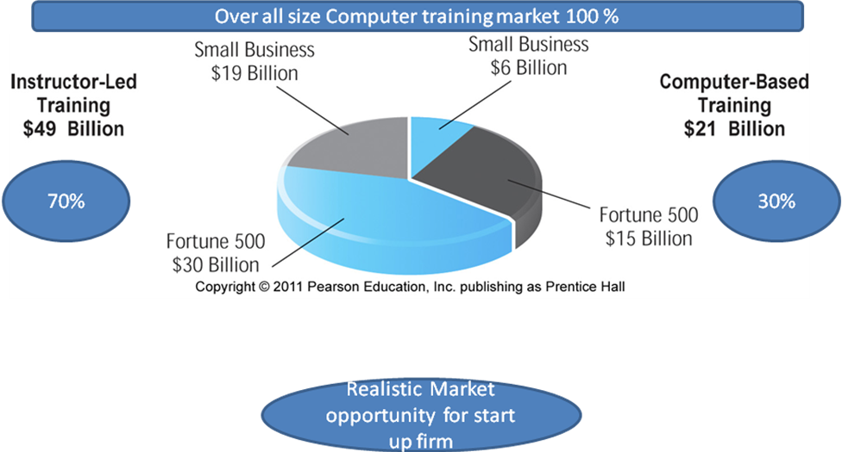
$6billion + $15billion
$21 Billion
$19billion + $30billion
$49 Billion
Start up firm simply ignore this Segment
70 Billion
There are further market niches within each of those major market segments, such as the Fortune 500 computer-based training market and the small business computer-based training market. Because the firm is a startup firm, it cannot compete effectively in the large business; computer based training market (about $15 billion.) Large brand-name training firms dominate this niche(Segment). The Startup firm’s real market opportunity is to sell to the thousands of small business firms who spend about $6 billion on computer-based software training and who desperately need a cost-effective training solution. This is the size of the firm’s realistic market opportunity.
- COMPETITIVE ENVIRONMENT(Who else occupies your intended marketspace)
A firm’s competitive environment refers to the other companies selling similar products and operating in the same marketspace. It also refers to the presence of substitute products and potential new entrants to the market, as well as the power of customers and suppliers over your business. The competitive environment for a company is influenced by several factors:
- how many competitors are active | - how large their operations are
- competitor how profitable these firms are | - how they price their products
- the market share of each competitor
Firms typically have both direct and indirect competitors. Direct competitors are those companies that sell products and services that are very similar and into the same market segment. For example, Priceline and Travelociy, both of whom sell discount airline tickets online, are direct competitors because both companies sell identical products – cheap tickets. Indirect competitors are companies that may be in different industries but still compete indirectly because their products can substitute for one another. For instance, automobile manufacturers and airline companies operate in different industries, but they still compete indirectly because they offer consumers alternative means of transportation. CNN.com, a news outlet, is an indirect competitor of ESPN.com not because they sell identical products, but because they both compete for consumers’ time online.
The existence of a large number of competitors in may one segment may be a sign that the market is saturated and that it may be difficult to become profitable. On the other hand, a lack of competitors could either signal an untapped(untouched) market niche(segment) ripe (ready) for the picking or a market that has already been tried without success because there is no money to be made.
- COMPETITIVE ADVANTAGE (What special advantages does your firm bring to the marketplace?)
Firms achieve a competitive advantage when they can produce a superior product and / or bring the product to market at a lower price than most, or all, of their competitors. Firms also compete on scope(Regional/National/Global). Some firms can develop global market, while other firms can only develop a national or regional market . Firms that can provide superior products at lowest cost on a global basis are truly advantaged.
Firms achieve competitive advantages because they have somehow been able to obtain differential access to the factors of production that are denied to their competitors – at least in the short term. Perhaps the firm has been able to obtain very favorable terms from suppliers, shippers, or sources of labor. Or perhaps the firm has more experienced, knowledgeable, and loyal employees than any competitors. Maybe the firm has a patent on a product that others cannot imitate, or access to investment capital through a network of former business colleagues or a brand name and popular image that other firms cannot duplicate.
An asymmetry exists whenever one participant in a market has more resources – financial backing, knowledge, information, and / or power – than other participants. Asymmetries lead to some firms having an edge over others, permitting them to come to market with better products, faster than competitors, and sometimes at lower cost.
One rather unique competitive advantage derives from being first mover. A first mover advantage is a competitive market advantage for a firm that results from being the first into a marketplace with a serviceable product or service. If first movers develop a loyal following or a unique interface that is difficult to imitate, they can sustain their first – mover advantage for long periods. Amazon provides a good example. However, in the history of technology-driven business innovation, most first movers lack the complimentary resources(resources and assets not directly involved in the production of the product but required for success, such as marketing, management, financial assets, and reputation) needed to sustain their advantages, and often follower firms reap(gain) the largest rewards.
Some competitive advantages are called “unfair.” An unfair competitive advantage occurs when one firm develops an advantage based on a factor that other firms cannot purchase. For instance, a brand name cannot be purchased and is in that sense an “unfair” advantage. Brands are built upon loyalty, trust, reliability, and quality. Once obtained(brand) they are difficult to copy or imitate, and they permit firms to charge premium prices for their products.
In perfect markets, there are no competitive advantages or asymmetries because all firms have access to all the factors of production(including information and knowledge) equally. However, real markets are imperfect, and asymmetries leading to competitive advantages do exist, at least in the short term. Most competitive advantages are short term, although some – such as the competitive advantage enjoyed by coca-cola because of the Coke brand name – can be sustained for very long periods. But not forever: Coke is increasingly being challenged by fruit, health, and unique flavor drinks.
Companies are said to leverage their competitive assets when they use their competitive advantages to achieve more advantage in surrounding markets. For instance Amazon’s move into the online grocery business leverages the company’s huge customer database and years of e-commerce experience.
- MARKET STRATEGY (How do you plan to promote your products or services to attract your target audience?)
No matter how tremendous a firm’s qualities, its marketing strategy and execution are often just as important. The best business concept, or idea, will fail if it is not properly marketed to potential customers .
Everything you do to promote your company’s products and services to potential customers is known as marketing. Market strategy is the plan you put together that details exactly how you intend to enter a new market and attract new customers.
Part of FreshDirect’s strategy , for instance, is to develop close supply chain partnerships with growers and manufacturers so it purchases goods at lower prices directly from the source . This helps FreshDirect lower its prices for consumers. By partnering with suppliers that could benefit from FreshDirect’s access to consumers, FreshDirect is attempting to extend its competitive advantage.
Other companies, such as Yahoo, have used a different marketing strategy. They invest heavily in advertising(on tv, Newspaper etc.) to get the word out about their site. AOL used sampling of millions of free cd-roms to attract new users. AOL enclosed cd with free trail offers in magazines and newspapers across the country.
- ORGANIZATIONAL DEVELOPMENT (What types of organizational structures within the firm are necessary to Cary out the business plan)
Although any entrepreneurial ventures are started by one visionary individual, it is rare that one person alone can grow an idea into a multi-million dollar company. In most cases, fast-growth companies – especially e-commerce businesses – need employees and a set of business procedures. In short, all firms–new ones in particular – need an organization to efficiently implement their business plans and strategies. Many e-commerce firms and many traditional firms who attempt an e-commerce strategy have failed because they lacked the organizational structures and supportive cultural values required to support new forms of commerce.
Companies that hope to grow and succeed need to have a plan for organizational development that describes how the company will organize the work that needs to be accomplished. Typically, work is divided into functional departments, such as production, shipping, marketing, customer support, and finance. Jobs within these functional areas are defined, and then recruitment begins for specific job titles and responsibilities. Typically, in the beginning, generalists who can perform multiple tasks are hired. As the company grows, recruiting becomes more specialized. For instance, at the outset, a business may have one marketing manager. But after two or three years of steady growth, that one marketing position may be broken down into seven separate jobs done by seven individuals.
For instance, eBay founder Pierre Omidyar started an online auction site, according to some sources, to help his friend trade PEZ dispensers with other collectors, but within a few months the volume of business had far exceeded what he alone could handle. So he began hiring people with more business experience to help out. Soon the company had many employees, departments, and managers who were responsible for overseeing the various aspects of the organization.
- MANAGEMENT TEAM (What kinds of experiences and background are important for the company’s leaders to have?)
The single most important element of a business model is the management team responsible for making the model work. A strong management team gives a model instant credibility to outside investors, market – specific knowledge, and experience in implementing business plan. A strong management team may not be able to save a weak business model, but the team should be able to change the model and redefine the business as it becomes necessary.
Eventually, most companies get to the point of having several senior executives or managers.. The challenge is to find people who have both the experience and the ability to apply that experience to new situations.
To be able to identify good managers for a business startup, first consider the kinds of experiences that would be helpful to manager joining your company. What kind of technical background is desirable? What kind of supervisory experience is necessary? How many years in a particular function should be required?
What job functions should be fulfilled first: marketing, production, finance, or operations? Especially in situations where financing will be needed to get a company off the ground, do prospective senior managers have experience and contacts for raising financing from outside investors?
MAJOR BUSINESS-TO-CONSUMER(B2C) BUSINESS MODELS
Business-to-consumer (B2C) e-commerce, in which online business seek to reach individual consumers, is the most well-known and familiar type of e-commerce.
- Portal | - E-Tailers
- Content Provider | - Transaction Broker
- Market Creator | - Service Provider
- Community Provider
- PORTAL
Portals such as Yahoo, MSN/Windows Live , and AOL offer users powerful web search tools as well as an integrated package of content and services, such as news, email, instant messaging, calendars, shopping, music downloads, video streaming and more, all in one place. Initially, portals sought to be viewed as “gateways” to the Internet. Today, however, the portal business model is to be a destination site. They are marketed as places where consumers will want to start their web searching and hopefully stay a long time to read news, find entertainment, and meet other people. Portals do not sell anything directly. The market opportunity is very large. Portals generate revenue primarily by charging advertisers for ad placement, collecting referral fees for steering customers to other sites and charging for premium services. AOL, MSN(in conjunction with Verizon ), and yahoo (in conjunction with AT & T) – which in addition to being portals are also Internet Service Providers (ISP’s) that provide access to the Internet and the Web – add an additional revenue stream: monthly subscription fees for access.
Although there are numerous portal/search engine sites, the top five sites (Google, Yahoo, MSN, AOL, and ASK.COM) gather more than 92% of the search engine traffic because of their superior brand recognition. Many of the top sites were among the first to appear on the web and therefore had first-mover advantages.
Yahoo, AOL, MSN, and others like them are considered to be horizontal portals because they define their marketspace to include all users of the Internet. Vertical Portals (some times called vortals) attempt to provide similar services as horizontal portals, but are focused around a particular subject matter or market segment. For instance, Sailnet specializes in the consumer sailboat market that contains about 8 million Americans who own or rent sailboats. Although the total number of vortal users may be much lower than the number of portal users, if the market segment is attractive enough, advertisers are willing to pay a premium in order to reach a targeted audience. Also, visitors to specialized niche(segment) vortals spend more money than the average yahoo visitor. Google and Ask.com can also be considered portals of a sort, but currently focus primarily on offering search services. They generate revenues primarily from search engine advertising sales and also from affiliate referral fees.
- E-Tailer
Online retail stores, often called e-tailers, come in all sizes, from giant Amazon to tiny local stores that have web sites. E-tailers are similar to the typical bricks- and – mortar storefront except that customers only have to connect to the Internet to check their inventory and place an order. Some e-tailers, which are referred to as “bricks-and-clicks,” are subsidiaries or divisions of existing physical stores and carry the same products. JSPenney, Barnes & Noble, Wal-Mart, and Staples are four examples of companies with complementary online stores. Others, however, operate only in the virtual(Click - and-Click) world, without any ties to physical locations. Amazon, BlueNile.com, and Drugstore.com are examples of this type of e-tailers. Several other variations of e-tailers – such as online versions of direct mail catalogs, online malls, and manufacturer-direct online sales also exist.
Given that the overall retail market in the United States in 2007 is estimated to be around $4 trillion, the market opportunity for e-tailers is very large. Every internet user is a potential customers. Customers who feel time-starved are even better prospects, since they want shopping solutions that will eliminate the need to drive to the mall or store. The e-tail revenue model is product-based, with customers paying for the purchase of a particular item.
This sector is extremely competitive, however. Since barriers to entry (the total cost of entering a new marketplace) into the web e-tail market are low, tens of thousands of small e-tail shops have sprung up on the web. Becoming profitable and surviving is very difficult, however, for e-tailers with no prior brand name or experience. Companies that try to reach every online consumer are likely to deplete their resources quickly. Those that develop a niche strategy, clearly identifying their target market and its needs, are best prepared to make a profit. Keeping expenses low, selection broad, and inventory controlled are keys to success in e-tailing, with inventory being the most difficult to gauge.
- CONTENT PROVIDER
Although there are many different ways the internet can be useful, “information content,” which can be defined broadly to include all forms of intellectual property, is one of the largest types of internet usage. Intellectual property refers to all forms of human expression that can be put into a tangible medium such as text, CD’S or the web. Content Providers distribute information content, such as digital video, music, photos, text, and artwork, over the web.
Content providers make money by charging a subscription fee. For instance in the case of WSJ.COM , Harvard Business Review, and many others, charge customers for content downloads in addition to or in place of a subscription fee. Micropayment systems technology provides content providers with a cost-effective method for processing high volumes of very small monetary transactions (anywhere from $.25 to $5.00 per transaction). Micropayment systems have greatly enhanced the revenue model prospects of content providers who wish to charge by the download.
Of course, not all online content providers charge for their information: just look at sportsline.com, CIO.com , CNN.com and the online versions of many newspapers and magazines. Users can access news and information at these sites without paying a cent. These popular sites make money in other ways, such as through advertising and partner promotions on the site. Increasingly, however, “free content” is limited to headlines and text, whereas premium content – in – depth articles or video delivery is sold for a fee.
Some content providers, however, do not own content, but syndicate (aggregate) and then distribute content produced by others. Syndication is a major variation of the standard content provider model. Another variation here is web aggregators, who collect information from a wide variety of sources and then add value to that information through post-aggregation services. For instance, shopping.com collects information on the prices of thousands of goods online, analyzes the information and presents users with tables showing the range of prices and web locations. Shopping.com adds value to content it aggregates, and re-sells this value to advertisers who advertise on its site.
- TRANSACTION BROKER
Sites that process transitions for consumers normally handled in person, by phone, or by mail are transition brokers. The largest industries using this model are financial services, travel services, and job placement services. The online transaction broker’s primary value propositions are savings of money and time. In addition, most transaction brokers provide timely information and opinions. Sites such as Monster.com offer job searchers a national marketplace for their talents and employers a national resource for that talent. Both employers and job seekers are attracted by the convenience and currency of information. Online stock brokers charge commissions that are considerably less than traditional brokers, with many offering substantial deals, such as cash and a certain number of free trades, to lure new customers.
Given rising consumer interest in financial planning and the stock market, the market opportunity for online transaction brokers appears to be large. However, while millions of customers have shifted to online brokers, many have been wary about switching from their traditional broker who provides personal advice and a brand name. Fears of privacy invasion and the loss of control over personal financial information also contribute to market resistance. Consequently, the challenge for online brokers is to overcome consumer fears by emphasizing the security and privacy measures in place, and, like physical banks and brokerage firms, providing a broad range of financial services and not just stock trading.
- MARKET CREATOR
Market creators build a digital environment in which buyers and sellers can meet, display products, search for products, and establish prices. A prime example is Priceline, which allows consumers to set the price they are willing to pay for various travel accommodations and other products (some times referred to as a reverse auction) and eBay, the online auction site utilized by both businesses and consumers.
For example, eBay’s auction business model is to create a digital electronic environment for buyers and sellers to meet, agree on a price, and transact. This is different from transaction brokers who actually carry out the transaction for their customers, acting as agents in larger markets. At ebay the buyers and sellers are their own agents. Each sale on eBay nets the company a commission based on the percentage of the item’s sales price, in addition to a listing fee. eBay is one of the few web sites that has been profitable virtually from the beginning. Why ? one answer is that eBay has no inventory or production costs. Its simply a middleman.
The market opportunity for market creators is potentially vast , but only if the firm has the financial resources and marketing plan to attract sufficient sellers and active users, and this makes for an efficient market. There are many sellers and buyers for each type of product, sometimes for the same product, for example, laptop computer models. Some very large web based firms such as amazon have leveraged their large customer data base and started auctions.
In addition to marketing and branding, a company’s management team and organization can make a difference in creating new markets, especially if some managers have had experience in similar businesses . Speed is often the key in such situations. They ability to become operational quickly can make the difference between success and failure.
- SERVICE PROVIDER
While e-tailers sell products online, service providers offer services online. There’s been an explosion in online services that is often unrecognized. Web 2.0 applications such as photo sharing, video sharing, and user-generated content (in blogs and social networking sites ) are all services provided to customers. Google has led the way in developing online applications such as Google Maps, Google Docs and Spreadsheets and Gmail. ThinkFree and Buzzword are online alternatives to Microsoft Word provided as services (rather than boxed software – a product). More personal services such as online medical bill management, financial and pension planning , and travel recommender sites are showing strong growth.
Service providers use a variety of revenue models. Some charge a fee, or monthly subscriptions, while others generate revenue from other sources, such as through advertising and by collecting personal information that is useful in direct marketing.
Some services are free but are not complete. For instance, Google app basic edition is free, but a “Premier” model with virtual conference rooms and advanced tools costs $50 per employee a year. Much like retailers who trade products for cash, service, providers trade knowledge, expertise, and capabilities, for revenue.
Obviously, some services cannot be provided online. For example , dentistry, medical services, pluming, and car repair cannot be completed via the Internet. However, online arrangements can be made for these services. Online service providers may offer computer services, such as information storage, provide legal services, such as at BlueFlag.com, or offer advice and services to high-net worth individuals, such as at MyCFO.com. Grocery shopping sites such as FreshDirect and Peapod are also providing services. To complicate matters a bit, most financial transaction brokers provide services such as college tuition and pension planning. Travel brokers also provide vacation-planning services, not just transactions with airlines and hotels. Indeed, mixing services with your products is a powerful business strategy pursued by many hard-goods companies (for example, warranties are services).
The basic value proposition of service providers is that they offer consumers valuable, convenient, time-saving, and low-cost alternatives to traditional service providers or in the case of search engines and most web 2.0 applications – they provide services that are truly unique to the web. Where else can you search 50 billion web pages, or share photos with as many other people instantly? Research has found, for instance, that a major factor in predicting online buying behavior is time saving. Time-starved people tend to be busy professionals who work long hours and simply do not have the time to pick up packages, buy groceries, send photos, or visits with financial planners. The market opportunity for service providers is as large as the variety of services that can be provided and potentially is much larger than the market opportunity for physical goods. We live in a service-based economy and society; witness the growth of fast food restaurants, package delivery services and wireless cellular phone services. Consumers increasing demand for convenience products and services bodes well for current and future online service providers.
Marketing of service providers must allay consumer fears about hiring a vendor online, as well as build confidence and familiarity among current and potential customers. Building confidence and trust is critical for service providers just as it is for retail product merchants. Kodak, for instance, has a powerful brand name over a century old, and has translated that brand into a trusted online provider of photo services. In the process, Kodak is transforming itself from a products-only company (cameras and paper) into a more contemporary digital services company.
- COMMUNITY PROVIDER
Although community providers are not a new entity , the internet has made such sites for like-minded individuals to meet and converse much easier, without the limitations of geography and time to hinder participation Community providers are sites that create a digital online environment where people with similar interests can transact (buy and sell goods); share interests, photos, videos; communicate with like-minded people; receive interest-related information; and even play out fantasies by adopting online personalities called avatars. The social networking sites myspace, facebook, friendster, and hundreds of other smaller, niche sites such as doostang, twitter, and google buzz, all offer users community building tools and services.
The basic value proposition of community providers is to create a fast, convenient, one-stop site where users can focus on their most important concerns and interests, share the experience with friends, and learn more about their own interests community providers typically rely on a hybrid revenue model that includes subscription fees, sales revenues, transaction fees, affiliate fees, and advertising fees from other firms that are attracted by a tightly focused audience.
For instance, a parent might visit Babystyle.com for tips on diapering a baby and be presented with a link to Huggies.com; if the parent clicks the link and then makes a purchase from Huggies.com , Babystyle gets a commission. Likewise, banner ads also generate revenue . at about.com , visitors can share tips and buy recommended books from Amazon, giving about.com a commission on every purchase. Some of the oldest communities on the web are well.com , which provides a forum for technology and internet – related discussions, and fool.com which providers financial advice, news, and opinions. The well offers various membership plans ranging from $10 to $15 a month. Fool.com supports itself through ads and selling products that start out “free” but turn into annual subscriptions.
Facebook is rapidly gaining on its rival MySpace by encouraging users to build their own revenue producing applications that run on their profiles and even take in advertising and affiliate revenues.
Online communities tend to reflect offline relationships when your friends say they have a profile on Facebook and ask you to visit; you are encouraged to build your own online profile.

MAJOR BUSINESS-TO-BUSINESS(B2B) BUSINESS MODELS
Business to Business e-commerce , in which businesses sell to other businesses, is more than ten times the size of Business to Customer e-commerce, even through most of the public attention has focused on B2C.
- E-Distributor | - E-Procurement
- Exchange | - Industry Consortium
- Private Industrial Networks
- E-Distributor
Companies that supply products and services directly to individual businesses are e-distributors. W.w.Grainger, for example, is the largest distributor of maintenance, repair, and operations (MRO) supplies are thought of as indirect input to the production process – as opposed to direct inputs. In the past, Grainger relied on catalog sales and physical distribution centers in metropolitan areas. Its catalog of equipment went online in 1995 at Grainger.com, giving businesses access to more than 220,000 items. Company purchasing agents can search by type of product, such as motors, HVAC, or fluids, or by specific brand name.
E-distributors are owned by one company seeking to serve many customers. However, as with exchanges, critical mass is a factor . With e-distributors, the more products and services a company makes available on its site, the more attractive that site is to potential customers. One stop shopping is always preferable to having to visit numerous sites to locate a particular part or products.
- E-Procurement
Just as e-distributors provide products to other companies , e-procurement firms create and sell access to digital electronic markets. Firms such as Ariba, for instance, have created software that helps large firms organize their procurement process by creating mini-digital markets for a single firm. Ariba creates custom integrated online catalogs (where supplier firms can list their offerings) for purchasing firms. On the sell side, Ariba helps vendors sell to large purchasers by providing software to handle catalog creation shipping, insurance, and finance. Both the buy and sell side software is referred to generically as “value chain management” software.
B2B service providers make money through transaction fees, fees based on the number of workstations using the service, or annual licensing fees. They offer purchasing firms a sophisticated set of sourcing and supply chain management tools that permit firms to reduce supply chain costs. In the software world, firms such as Ariba are sometimes also called application service providers (ASPs); they are able to offer firms much lower costs of software b achieving scale economies. Scale economies are efficiencies that result from increasing the size of a business, for instance, when large, fixed-cost production systems (such as factories or software systems) can be operated at full capacity with no idle time. In the case of software, the marginal cost of a digital copy of a software program is nearly zero, and finding additional buyers for an expensive software program is exceptionally profitable. This is much more efficient than having every firm build its own supply chain management system, and it permits firms such as Ariba to specialize and offer their software to firms at a cost far less than the cost of developing it.
- Exchange
Exchanges have garnered most of the B2B attention and early funding because of their potential market size even through today they are a small part of the overall B2B picture. An exchange is an independent digital electronic marketplace where hundreds of suppliers meet a smaller number of very large commercial purchasers. Exchangers are owned by independent, usually entrepreneurial startup firms whose business is making a market, and they generate revenue by charging a commission or fee based on the size of the transactions conducted among trading parties. They usually serve a single vertical industry such as steel, polymers or aluminum, and focus on the exchange of direct inputs to production and short-term contracts or spot purchasing. For buyers, B2B exchanges make it possible to gather information, check out suppliers, collect prices, and keep up to date on the latest happenings all in one place. Sellers, on the other hand, benefit from expanded access to buyers. The greater the number of sellers and buyers, the lower the sales cost and the higher the chances of making a sale. The ease, speed, and volume of transactions are summarily referred to as market liquidity.
In theory, exchanges make it significantly less expensive and time-consuming to identify potential suppliers, customers and partners, and to do business with each other. As a result, they can lower transaction costs – the cost of making a sale or purchase. Exchanges can also lower product costs and inventory carrying costs (the cost of keeping a product on hand in a warehouse.). In reality B2B exchanges have had a difficult time convincing thousands of suppliers to move into singular digital markets where they face powerful price competition, and an equally difficult time convincing businesses to change their purchasing behavior away from trusted long-term trading partners. As a result, the number of exchanges has fallen to less than 200, down from over 1500 in 2002 , although the surviving have experienced some success.
- Industry Consortium
Industry consortia are industry – owned vertical marketplaces that serve specific industries, such as the automobile, aerospace, chemical, floral, or logging industries. In contrast, horizontal marketplaces sell specific products and services to a wide range of companies. Vertical marketplaces supply a smaller number of companies with products and services of specific interest to their industry, while horizontal marketplaces supply companies in different industries with a particular type of product and service, such as marketing-related, financial, or computing services . for example , EXOSTAR is an online trading exchange for the aerospace and defense industry, founded by BAE Systems, Boeing , Lockheed Martin, Raytheon, and Rolls-Royce in 2000. Exostar connects with over 300 procurement systems in 20 different countries and has registered more than 24, 000 trading partners worldwide.
Industry consortia have tended to be more successful than independent exchanges in part because they are sponsored by powerful, deep – pocketed industry players and also because they strengthen traditional purchasing behavior rather than seek to transform it.
- Private Industrial Networks
Private industrial networks (some times referred to as private trading exchanges or PTXs) constitute about 75% of all B2B expenditures by large firms and far exceed the expenditures for all forms of net marketplaces. Private industrial networks are digital networks(often but not always internet-based networks) designed to coordinate the flow of communications among firms engaged in business together. For instance Wal-Mart operates one of the largest private industrial networks in the world for its suppliers, who on a daily bases use Wal-Mart’s network to monitor the sales of their goods, the status of shipments and the actual inventory level of their goods. B2B e-commerce relies overwhelmingly on a technology called electronic data interchange (EDI). EDI is useful for one to one relationship between a single supplier and a single purchaser and originally was designed for proprietary networks, although it is migrating rapidly to the internet. Many firms have begun to supplement their EDI systems, however, with more powerful web technologies that can enable many – to – one and many to many market relationships where there are many suppliers selling to a single or small group of very large purchasers, or, in the case of independent exchanges, there may be many sellers and many buyers simultaneously in the marketplace. EDI is not designed for these types of relationships. There are two types of private industrial networks:
  - Single Firm
Single firm private industrial networks are the most common form of private industrial network . These single – firm networks are owned by a single large purchasing firm, such as Wal-Mart or Proter & Gamble. Participation is by invitation only to trusted long-term suppliers of direct inputs. Single-firm networks typically evolve out of a firm’s own enterprise resource planning system(ERP), and they are an effort to include key suppliers in the firm’s own business decision making .
  - Industry-wide
Industry wide private industrial networks often evolve out of industry associations. These networks are usually owned by a consortium of the large firms in an industry and have the following goals: providing a neutral set of standards ofor commercial communications over the internet ; having shared and open technology platforms for solving industry problems; and in some cases, providing operating networks that allow members of an entire industry to closely collaborate. To some extent, these industry wide networks are a response to the success of single – fimr private industrial networks. For instance, wal-mart has refused to open its very successful network to other members of the retail industry, in effect to become an industry standard, for fear it will be sharing technology secrets with other retailers like Sears.
In response, Sears and other retailers around the world have created their own set of organizations and networks that are open to all in the industry. For instance, Agentrics is an industry-wide private industrial network for retailers and suppliers designed to facilitate and simplify trading among retailers, suppliers, partners and distributors. Agentrics’ members currently include 17 of the worlds top 30 retailers and over 200 suppliers from Africa, asia, Europe, north America and south America, with combined sales of approximately $ 1 trillion . Agentrics provides collaborative design tools; planning and management; negotiations and auctions; order execution; demand aggregations; worldwide item management; worldwide logistics and a global catalog in English, French, German, and Spanish containing trading relationship data for member sponsored suppliers totaling more than 30,000 items. From this list of service and capabilities, it is clear that industry wide private industrial networks offer much more functionality than industry consortia, although the tow models appear to moving closer together.
BUSINESS MODELS IN EMERGING E-COMMERCE AREAS
When we think about a business, we typically think of a business firm that produces a product or good and then sells it to a customer. But the web has forced us to recognize new forms of business, such as
- Consumer to Consumer (C2C) Business Models | - Peer – to – Peer(P2P) Business Model
- M-Commerce(Mobile Commerce) Business Models

- CONSUMER TO CONSUMER (C2C) BUSINESS MODELS
C2C ventures provide a way for consumers to sell to each other, with the help of an online business. The first and best example of this type of business is eBay, utilizing a market creator business model.
Before eBay, individual consumers used garage sales, flea markets, and thrift shops to both dispose of and acquire used merchandise. With the introduction of online auctions, consumers no longer had to venture out of their homes or offices in order to bid on items of interest, and sellers could relinquish expensive retail space that was no longer needed in order to reach buyers. In return for linking like-minded buyers and sellers, eBay takes a small commission. The more auctions, the more money eBay makes. In fact, it is one of the few Web companies that has been profitable from day one – and has stayed so for several years.
Consumers who don’t like auctions but still want to find used merchandise can visit Half.com(also owned by eBay), which enables consumers to sell unwanted books, movie , music, and games to other consumers at a fixed price. In return for facilitating the transaction, Half.com takes a commission on the sale, ranging from 5% - 15% depending on the sale price, plus a fraction of the shipping fee it charges.
- PEER – TO – PEER(P2P) BUSINESS MODEL
Like the C2C models, P2P business models link users, enabling them to share files and computer resources without a common server. The focus in P2P companies is on helping individuals make information available for anyone’s use by connecting users on the web. Historically, peer-to-peer software technology has been used to allow the sharing of copyrighted music files in violation of digital copyright law. The challenge for P2P ventures is to develop viable , legal business models that will enable them to make money. Difficulties faced by Kazaa, one of the most prominent examples of a P2P business model in action. To date , there are few if any examples of successful p2P e-commerce business models outside of the music and content file swapping sites. However, one company that has successfully used this model outside those two arenas is Cloudmark, which offers a P2P anti-spam solution called Cloudmark Desktop. Cloudmark currently protects over 180 million e-mailboxes in 163 countries.
- M-COMMERCE(MOBILE COMMERCE) BUSINESS MODELS
M-commerce, short for mobile commerce, takes traditional e-commerce models and leverages emerging new wireless technologies to permit mobile access to the web. Wireless web technology will be used to enable the extension of existing web business models to service the mobile work force and consumer of the future. Wireless networks utilize newly available bandwidth and communication protocols to connect mobile users to the internet. These technologies have already taken off in Asia and Europe, and will expand greatly in the United States in a few years. The major advantage of m-commerce is that it provides Internet access to anyone, anytime, and anywhere, using wireless devices. The key technologies here are cell phone based 3G (third – generation wireless ) Wi-Fi(wireless local area networks), and Bluetooth (short-range radio frequency web devices).
There are many more cell phone subscribers than there are Internet users. Cell phone usage is still considerably higher in Asia and Europe than it is in the United States, However, in the United States, the introduction of the iPhone in June 2007 has brought about a resurgence of interest in 3G technologies and their potential role in e-commerce. The standards implementing Wi-Fi were first introduced in 1997 , and since then it has exploded in the United States and elsewhere. Analysts estimate that there are around 180,000 wireless hot spots (locations that enable device to connect to a nearby wireless LAN and access the Internet) worldwide in 2007. Likewise, the number of Bluetooth-enabled cell phones is also expanding exponentially. For instance, over half of all the cell phones sold the fourth quarter of 2006 in the United states supported Bluetooth. Two new wireless technologies that may have an impact are Ultra wideband(wireless USB technology), which will be able to transfer large files such as movies over short distances, and Zigbee, which like Bluetooth, will connect devices to each other but at a longer range and with lower power requirements.
Despite all of the technological advancements in the last server years, mobile commerce in the United States hass been a disappointment to date . According to a recent report, only 2% of the retail brands in the top 1,000 U.S. brands currently operate a mobile web site, and in many instances, they are used purely as a marketing and branding vehicle. However, industry observers believe that with the introduction of the iPhone and other phones with similar capabilities, this may soon begin to change. The server-side hardware and software platform is nearly in place and the basic bandwidth is ready. As with all areas of e-commerce, the challenge for businesses will be finding ways to use m-commerce to make money while serving customer needs. Currently, demand is highest for digital content such as customized ring tones, games and wallpaper. With the introduction of the iPhone, mobile search applications are likely to become more popular. Consumer applications are also beginning to appear in high volume personal transaction areas, such as eBay’s anywhere system, and mobile payment platforms such as Paypal’s Mobile checkout.
M-commerce business models that hope to rely on push advertising.
E-COMMERCE ENABLERS
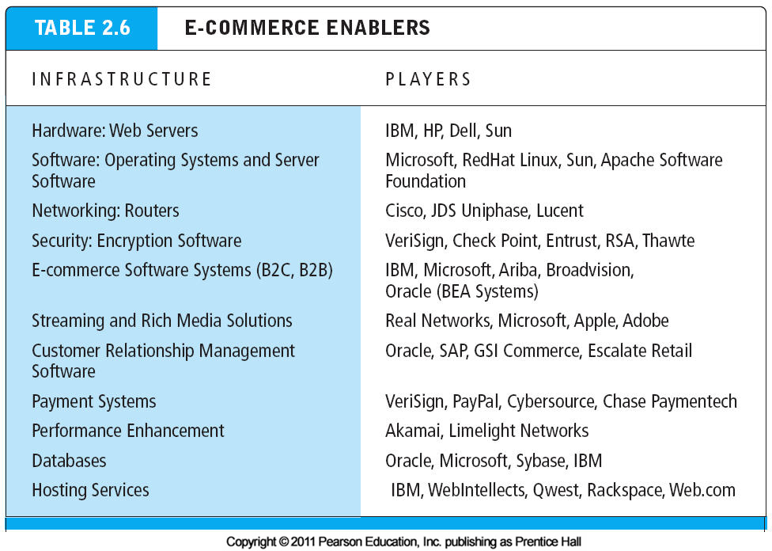
The banking firms, shipping companies, hardware companies, real estate speculators, and clothing companies such as Levi Strauss built long-lasting fortunes. Likewise in e-commerce. No discussion of e-commerce business models would be complete without mention of a group of companies whose business model is focused on providing the infrastructure necessary for e-commerce companies to exist, grow and prosper. These are the e-commerce enablers: the Internet infrastructure companies. They provide the hardware, operating system software, networks and communications technology, applications software, web designs, consulting services, and other tools that make e-commerce over the web possible. While these firms may not be conducting e-commerce per se (although in many instances, e-commerce in its traditional sense is in fact one of their sales channels), they as a group have perhaps profited the most from the development of e-commerce.

HOW THE INTERNET AND THE WEB CHANGE BUSINESS: STRATEGY, STRUCTURE, AND PROCESS
Now that you have a clear grasp of the variety of business models used by e-commerce firms, you also need to understand how the Internet and the web have changed the business environment in the last decade, including industry structures, business strategies, and industry and firm operations (business processes and value chains). In general , the internet is an open standards system available to all players, and this fact inherently makes it easy for new competitors to enter the marketspace and offer substitute products or channels of delivery. The internet tends to intensify competition. Because information becomes available to everyone, the internet inherently shifts power to buyers who can quickly discover the lowest-cost provider on the web. On the other hand the internet presents many new opportunities for creating value, for branding products and charging premium prices, and for enlarging an already powerful offline physical business such as wal-mart or Sears.
- INDUSTRY STRUCTURE | - INDUSTRY VALUE CHAINS
- FIRM VALUE CHAINS | - FIRM VALUE WEBS
- BUSINESS STRATEGY
- INDUSTRY STRUCTURE
E-Commerce changes industry structure, in some industries more than others. Industry structure refers to the nature of the players in an industry and their relative bargaining power. An industry’s structure is characterized by five forces: rivalry among existing competitors, the threat of substitute products, barriers to entry into the industry, the bargaining power of suppliers, and the bargaining power of buyers. When you describe an industry’s structure, you are describing the general business environment in an industry and the overall profitability of doing business in that environment. E-commerce has the potential to change the relative strength of these competitive forces.
When you consider a business model and its potential long-term profitability, you should always perform an industry structural analysis. An industry structural analysis is an effort to understand and describe the nature of competition in an industry, the nature of substitute products, the barriers to entry, and the relative strength of consumers and suppliers.
E-commerce can affect the structure and dynamics of industries in very different ways. Consider the recorded music industry, and industry that has experienced significant change because of the internet and e-commerce. Historically, the major record label firms owned the exclusive rights to the recorded music of various artists. With the entrance into the marketplace of substitute providers such as Kazaa, millions of consumers began to use the Internet to bypass traditional music labels and their distributors entirely. In the travel industry, entirely new middlemen such as Travelocity have entered the market to compete with traditional travel agents. After Travelocity, Expedia, CheapTickets, and other travel services demonstrated the power of e-commerce marketing for airline tickets, the actual owners of the airline seats – the major airlines – banded together to form their own Internet outlet for tickets, Orbitz, for direct sales to consumers, potentially eliminating the middlemen entirely Clearly, e-commerce and the Internet create new industry dynamic that can best be described as the give and take of the marketplace, the changing fortunes of competitors.
Yet in other industries, the Internet and e-commerce have strengthened existing players. In the chemical and automobile industries, e-commerce is being used effectively by manufacturers to strengthen their traditional distributors. In these industries, e-commerce technology has not fundamentally altered the competitive forces – bargaining power of suppliers, barriers to entry, bargaining power of buyers,
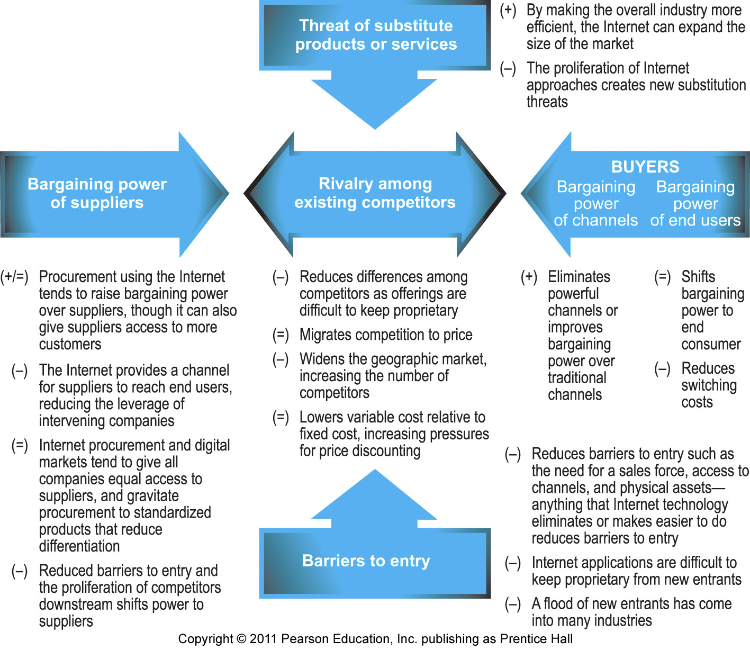
Threat of substitutes, or rivalry among competitors – within the industry Hence, each industry is different and you need to examine each one carefully to understand the impacts of e-commerce on competition and strategy.
New forms of distribution created by new market entrants can completely change the competitive forces in an industry for instance, if a software firm such as Microsoft discovers that consumers will gladly substitute a $50 or even free encyclopedia on a CD-ROM(a digital information product) for a $2,500 set of Britannica encyclopedias (a physical information product), then the competitive forces in the encyclopedia industry are radically changed. Even if the substitute is an inferior product, consumers are able to satisfy their anxieties about their children’s education at a much lower cost.
Inter-firm rivalry(competition) is one area of the business environment where e-commerce technologies have had an impact on most industries. In general, the Internet has increased price competition in nearly all markets. It has been relatively easy for existing firms to adopt e-commerce technology and attempt to use it to achieve competitive advantage vis-à-vis rivals. For instance, the Internet inherently changes the scope of competition from local and regional to national and global. Because consumers have access to global price information, the Internet produces pressures on firms to compete by lowering prices (and lowering profits) On the other hand, the Internet has made it possible for some firms to differentiate their product or services from others. Amazon has patented one-click purchasing for instance, while eBay has created a unique, easy to use interface and a differentiating brand name. REI, Inc, - a specialty mountain climbing-oriented sporting goods company has been able to use its web site to maintain its strong niche focus on outdoor gear therefore, although the Internet has increased emphasis on price competition, it has also enabled businesses to create new strategies for differentiation and branding so that they can retain higher prices.
It is impossible to determine if e-commerce technologies have had an overall positive or negative impact on firm profitability in general. Each industry is unique, so it is necessary to perform a separate analysis for each one. Clearly, in some industries, in particular, information product industries such as the music, newspaper, book, and software industries, as well as other information-intense industries such as financial services, e-commerce has shaken the foundations of the industry. in these industries, the power of consumers has grown relative to providers prices have fallen, and overall profitability has been challenged. In other industries, especially manufacturing, the Internet has not greatly changed relationships with buyers, but has changed relationships with suppliers. Increasingly, manufacturing firm in entire industries have banded together to aggregate purchases, create industry digital exchanges or marketplaces, and outsource industrial processes in order to obtain better prices from suppliers. Throughout this book, we will document these changes in industry structure and market dynamics introduced by e-commerce and the Internet.
- INDUSTRY VALUE CHAINS
While an industry structural analysis helps us understand the impact of e-commerce technology on the overall business environment in an industry, a more detailed industry value chain analysis can help identify more precisely just how e-commerce may change business operations at the industry level. One of the basic tools for understanding the impact of information technology on industry and firm operations is the value chain the concept is quite simple. A value chain is the set of activities performed in an industry or in a firm that transforms raw inputs into final products and services. Each of these activities adds economic value to the final product; hence, the term value chain as an interconnected set of value-adding activities. Figure illustrates the six generic players in an industry value chain: suppliers, manufacturers, transporters, distributors, retailers, and customers.
By reducing the cost of information, the Internet offers each of the key players in an industry value chain new opportunities to maximize their positions by

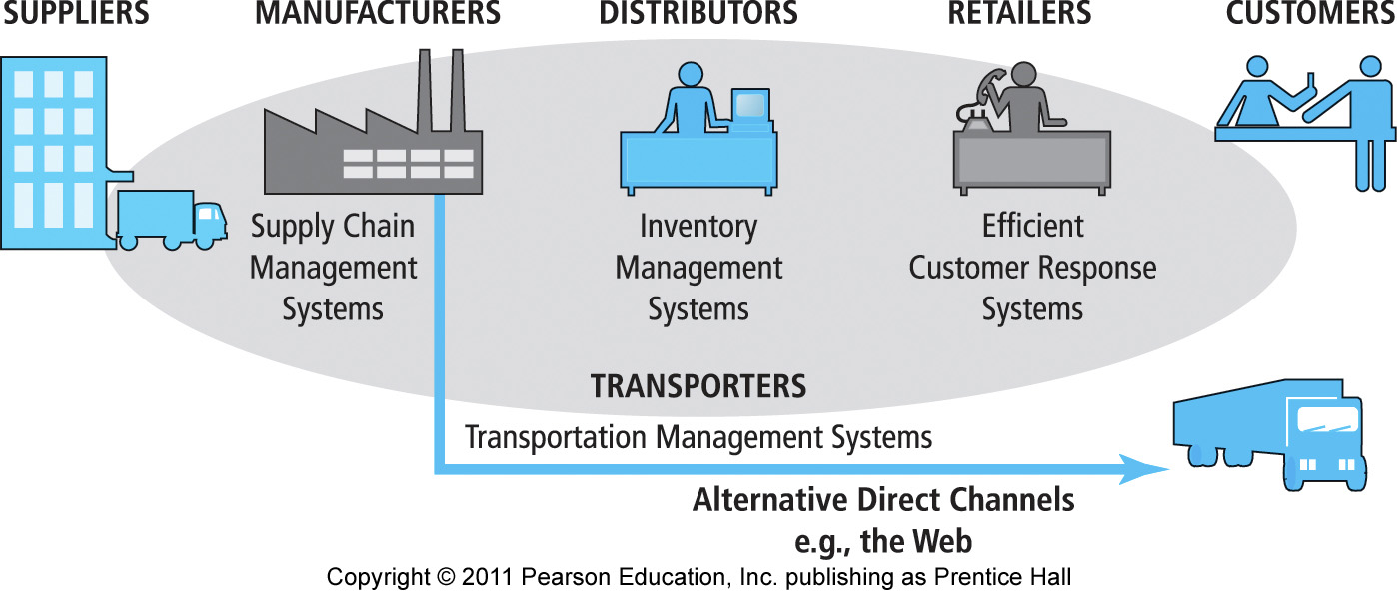
Lowering costs and /or raising prices. For instance, manufacturers can reduce the costs they pay for goods by developing web-based B2B exchanges with their suppliers. Manufacturers can develop direct relationships with their customers through their own web sites, bypassing the costs of distributors and retailers. Distributors can develop highly efficient inventory management systems to reduce their cost, and retailers can develop highly efficient customer relationship management systems to strengthen their service to customers. Customers in turn can use the web to search for the best quality, fastest delivery, and lowest prices, there by lowering their transaction costs and reducing prices they pay for final goods. Finally, the operational efficiency of the entire industry can increase, lowering prices and adding value to consumers, and helping the industry to compete with alternative industries. Dell Inc., for instance, employs a number of these stratagems, most notably a sales model for personal computers that bypasses traditional retail distribution channels by selling directly to consumers over the web. Dell also has developed a highly efficient supply chain management system to reduce its costs, and an equally efficient customer relationship management system to support customers and add to the value of its products.
- FIRM VALUE CHAINS
The concept of value chain can be used to analyze a single firm’s operational efficiency as well. The question here is : How does e-commerce technology potentially affect the value chains of firms within an industry? A firm value chain is the set of activities a firm engages in to create final products from raw inputs. Each step in the process of production adds value to the final product. In addition, firms develop support activities that coordinate the production process and

Fig 2.6
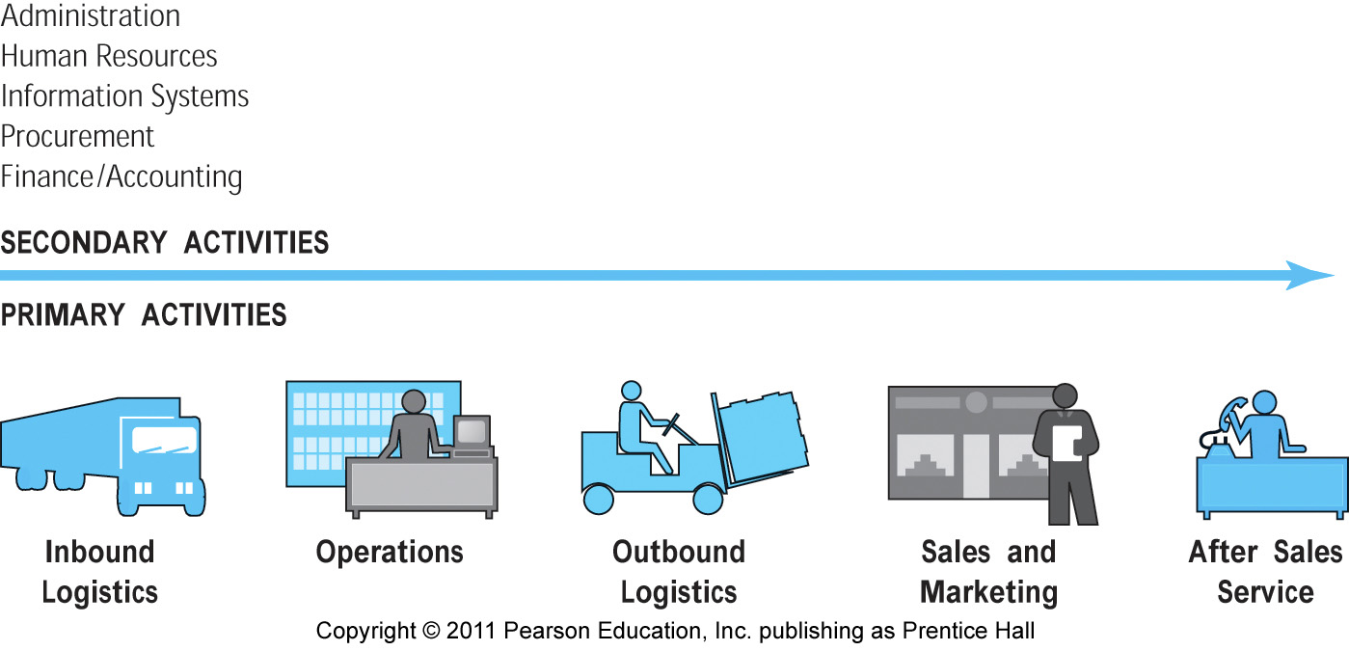
contribute to overall operational efficiency. Figure illustrates the key steps and support activities in a firm’s value chain the internet offers firms many opportunities to increase their operational efficiency and differentiate their products. For instance, firms can use the Internet’s communications efficiency to outsource some primary and secondary activities to specialized, more efficient providers without such outsourcing being visible to the consumer. In addition, firms, can use the Internet to more precisely coordinate the steps in the value chains and reduce their costs. Finally, firms can use the Internet to provide users with more differentiated and high-value products. For instance, Amazon uses the Internet to provide consumers with a much larger inventory of books to choose from , at a lower cost, than traditional book stores. It also provides many services – such as instantly available professional and consumer reviews, and information on buying patterns of other consumers- that traditional bookstores cannot.
- FIRM VALUE WEBS
While firms produce value through their value chains, they also rely on the value chains of their partners – their suppliers, distributors, and delivery firms. The Internet creates new opportunities for firms to cooperate and create a value web. A value web is a networked business ecosystem that uses Internet technology to coordinate the value chains of business partners within an industry, or at the first level, to coordinate the value chains of a group of firms. Figure illustrates a value web.

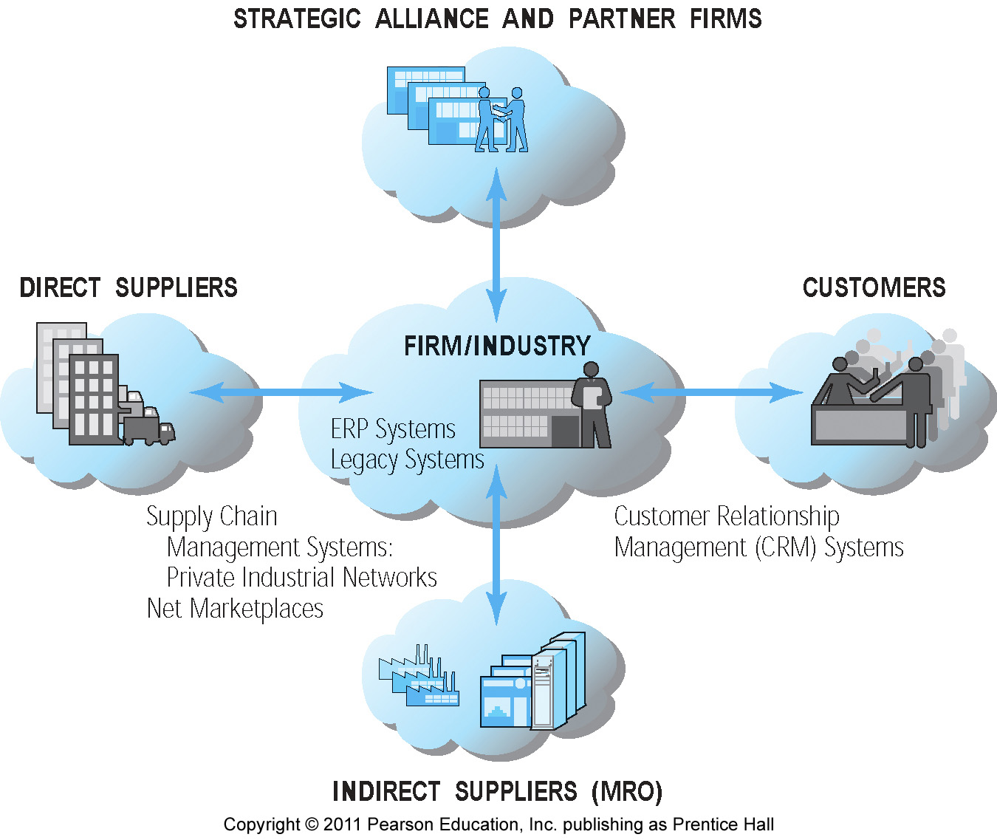
A value web coordinates a firm’s suppliers with its own production needs using an Internet-based supply chain management system. Firms also use the Internet to develop close relationships with their logistics partners. For instance, Amazon relies on UPS tracking systems to provide its customers with online package tracking, and it relies on the U.S. Postal Service systems to insert packages directly into the mail stream. Amazon has partnership relations with hundreds of firms to generate customers and to manage relationships relations with hundreds of firms to generate customers and to manage relationships with customers. In fact, when you examine Amazon closely, you realize that the value it delivers to customers is in large part the result of coordination with other firms and not simply the result of activities internal to Amazon. The value of Amazon is, in large part, the value delivered by its value web partners. This is difficult for other firms to imitate in the short run.
- BUSINESS STRATEGY
A business strategy is a set of plans for achieving superior long-term returns on the capital invested in a business firm. A business strategy is therefore a plan for making profits in a competitive environment over the long term. Profit is simply the difference between the price a firm is able to charge for its products and the cost of producing and distributing goods. Profit represents economic value. Economic value is created anytime customers are willing to pay more for a product than it costs to produce. Why would anyone pay more for a product than it costs to produce? There are multiple answers. The product may be unique (there are no other suppliers), it may be the least costly product of its type available, consumers may be able to purchase the product anywhere in the world, or it may satisfy some unique needs that other products do not. Each of these sources of economic value defines a firm’s strategy for positioning its products in the marketplace. There are four generic strategies for achieving a profitable business: differentiation, cost, scope, and focus. We describe each of these below. The specific strategies that a firm follows will depend on the product, the industry, and the marketplace where competition is encountered.
Although the Internet is a unique marketplace, the same principles of strategy and business apply. Successful e-commerce strategies involve using the Internet to leverage and strengthen existing business ( rather than destroy your business), and to use the Internet to provide products and services your competitors cannot copy (in the short term anyway) and that means developing unique products, proprietary content, distinguishing processes (like Amazon’s one-click shopping), and personalized or customized services and products. Let’s examine these ideas more closely.
Differentiation refers to all the ways producers can make their products unique and distinguish them from those of competitors. The opposite of differentiation is commoditization – a situation where there are no differences among products or services, and the only basis of choosing a product is price. As economists tell us, when price alone becomes the basis of competition and there are many suppliers and many customers, eventually the price of the good falls to the cost to produce it (marginal revenues from the nth unit equal marginal costs). And then profits are zero! This is an unacceptable situation for any business person. The solution is to differentiate your product and to create a monopoly-like situation where you are the only supplier.
There are many ways businesses differentiate their products. A business may start with a core generic product, but then create expectations among users about the “experience” of consuming the product – “Nothing refreshes like a Cake!” or “Nothing equals the experience of driving a BMW.” Businesses may also augment products by adding features to make them different from those of competitors. And businesses can differentiate their products further by enhancing the products’ abilities to solve related consumer problems. For instance, tax programs such as TurboTax can import data from spreadsheet programs, as well as be used to electronically file tax return. These capabilities are enhancements to the product that solve a customer’s problems. The purpose of marketing is to create these differentiation features and to make the consumer aware of the unique qualities of products, creating in the process a “brand” that stands for these features.
In their totality, the differentiation features of a product constitute the customer value proposition. The Internet and the web offer some unique ways to differentiate products. The ability of the web to personalize the shopping experience and to customize the product or service to the particular demands of each consumer are perhaps the most significant ways in which the web can be used to differentiate products. E-commerce businesses can also differentiate products by leveraging the ubiquitous nature of the web( by making it possible to purchase the product from home, work, or on the road); the global reach of the web(by making it possible to purchase the product anywhere in the world); richness and interactivity (by creating web-based experiences for people who use the product, such as unique interactive content, videos, stories about users, and reviews by users); and information density (by storing and processing information for consumers of the product , such ass warranty information on all products purchased through a site or income tax information online).
Adopting a strategy of cost competition means a business has discovered some unique set of business processes or resources that other firms cannot obtain in the marketplace. Business processes are the atomic units of the value chain. For instance, the set of value-creating activities called Inbound Logistics in Figure 2.6 is in reality composed of many different collections of activities performed by people on the loading docks and in the warehouses. These different collections of activities are called business processes – the set of steps or procedures required to perform the various elements of the value chain.
When a firm discovers a new, more efficient set of business processes, it can obtain a cost advantage over competitors. Then it can attract customers by charging a lower price, while still making a handsome profit. Eventually, its competitors go out of business as the market decisively tilts toward the lowest-cost supplier, it can also compete effectively on cost. For instance, switching production to low-wage-cost areas of the world is one way to lower costs.
Competing on cost can be a short-lived affair and very tricky. Competitors can also discover the same or different efficiencies in production. And competitors can also move production to low-cost areas of the world. Also, competitors may decide to lose money for a period as they compete on cost.
The Internet offers some new ways to compete on cost, at least in the short term. Firms can leverage the Internet’s ubiquity by lowering the costs of order entry ( the customer fills out all the forms, so there is no order entry department); leverage global reach and universal standards by having a single order entry system worldwide; and leverage richness, interactivity, and personalization by creating customer profiles online and treating each individual consumer differently without the use of an expensive sales force that performed these functions in the past. Finally, firms can leverage the information intensity of the web by providing consumers with detailed information on products, without maintaining either expensive catalogs or a sales force.
While the Internet offers powerful capabilities for intensifying cost competition , making cost competition appear to be a viable strategy, the danger is that competitors have access to the same technology. The factor markets – where producers buy their supplies – are open to all. Assuming they have the skills and organizational will to use the technology, competitors can buy many of the same cost – reducing techniques in the marketplace. Even a skilled labor force can be purchased, ultimately However, self – knowledge, proprietary tacit knowledge (knowledge that is not published or codified), and a loyal, skilled workforce are in the short term difficult to purchase in factor markets. Therefore, cost competition remains a viable strategy.
Two other generic business strategies are scope and focus. A scope strategy is a strategy to compete in all markets around the globe, rather than merely in local, regional, or national markets. The Internet’s global reach, universal standards and ubiquity can certainly be leveraged to assist businesses in becoming global competitors. Yahoo, for instance, along with all of the other top 20 e-commerce sites, has readily attained a global presence using the Internet.
A focus strategy is a strategy to compete within a narrow market segment or product segment. This is a specialization strategy with the goal of becoming the premier provider in a narrow market. For instance, L.L.Bean users the web to continue its historic focus on outdoor sports apparel; and w.w.Grainger – the web’s most frequently visited B2Bsite – focuses on a narrow market segment called MRO: maintenance, repair, and operations of commercial buildings. The Internet offers some obvious capabilities that enable a focus strategy. Firms can leverage the Web’s rich interactive features to create highly focused messages to different market segments; the information intensity of the Web makes it possible to focus e-mail and other marketing campaigns on small market segments; personalization – and related customization – means the same product can be customized and personalized to fulfill the very focused needs of specific market segments and consumers.
###

