TAXES

I paid my taxes, I’m proud to say,
And I bought some civilization today.
I helped build a bridge and a highway, too;
I bought my three children a park and a zoo
When I paid my taxes.

I helped build a library, paid for more books;
Paid for having the streets cleaned, improving their looks.
Paid for drinking founts street corners to crown,
And paid for new street lights in the old town
When I paid my taxes.

I helped hire a free doctor and a firemen’s crew;
I paid for a free nurse and some policemen, too.
I helped buy a young man a very fine job,
At a bathing beach for my Dorothy and Bob.
When I paid my taxes.

I helped build a school and hired teachers, too;
I helped buy a golf course for my son to play through.
I helped build a museum of music and art;
Now, friends, don’t you think I really was smart
When I paid my taxes?

V. PROCESSING PAYMENTS

APPLICATION OF TAX PAYMENTS

The subject of applying tax payments to the oldest bill can be a confusing issue for some Tax Collectors. There is no RSA which directs us on what to do. However, the New Hampshire Supreme Court decision of the case Olson vs. Town of Fitzwilliam clarifies this issue. The court case was Elaine A. Olson, Executrix of the Estate of Michael C. Olson & a. vs Town of Fitzwilliam. The Tax Collector in this case was found to have refused to apply tax payments as instructed by the taxpayer. This resulted in an eventual tax deeding of the property. RSA 80 does not give the Tax Collector the authority to direct payment as he/she sees fit. The statute states only that an interested party may redeem the tax lien in order to avoid the issuance of a tax deed to the Town. RSA 80:76 does not direct the Tax Collector to apply funds to the oldest tax liability first when there are multiple outstanding liens on the property. Therefore, a taxpayer may direct payments as they see fit.

Policies (written or unwritten) which mandate the Tax Collector to apply all monies received to the oldest taxes due are not valid under law. The collector must apply the taxes in the fashion requested by the taxpayer. The collector can point out earlier unpaid taxes, but if the money comes in with a direction as to how they should be applied (for example, from a bank/mortgage company escrow check), they should be applied as directed.

Another issue addressed in this case involved multiple owners (tenants in common) where one tax bill was issued.

The names and addresses of both owners were listed on the deed to the property. Only one property owner received a notice of timber yield tax which was statutorily insufficient so the timber tax lien was invalid against him. While the statute directs that notices must be sent to the “current owner”, the purpose of this statute is to notice all named owners of an impending lien that may adversely affect their ownership rights. The statutory directive was not fulfilled when the Tax Collector sent notice to only one property owner at his home address.

This decision means that if you are aware that a property is co-owned by co-owners at different addresses, notices must go to both parties at the separate addresses. This may be critical in situations such as divorced/separated couples where one party has moved out. If you are aware of this situation, separate notices of bills, delinquencies, tax lien notices and tax deed notices must be sent to all owners of record.

TAX COLLECTOR
Town of Goffstown
16 Main Street
Goffstown, NH 03045

I instruct the Tax Collector to apply this payment to my current taxes. I do not wish for this payment to be applied to any prior property taxes or tax liens that I presently have with regard to this property.

----------------------------------------
Property Address

------------------------------------------
Signature of Property Owner -------------------------------
Date

***** Gail Lavallee, CTC, Goffstown uses this form when a taxpayer owes prior year taxes and they want the payment applied to the current taxes.
Types of Payments
Quick RSA References

80:52-b Checks Tendered in Payment of Taxes. – If any person tenders a check for the payment of any taxes levied by the tax collector and the check is returned to the tax collector as uncollectible for any reason, such taxes shall be deemed not paid and the person tendering such check shall be subject to applicable tax delinquency penalties, protest and collection charges.

Source. 1977, 26:1, eff. April 1, 1977.

80:52-c Electronic Payment. – The governing body may authorize the municipality's treasurer or other appropriate municipal official to accept payment of local taxes, charges generated by the sale of utility services, or other fees or charges by use of a credit card, debit card, or such other means of electronic transaction as approved by the governing body. Any municipality may add to the amount due, in addition to any penalties and interest payable, a service charge for the acceptance of the credit card, debit card, or such other means of electronic transaction as approved by the governing body. The municipality, at the time of billing, shall disclose the amount of the service charge.

Source. 1994, 2:2. 1995, 137:4, eff. May 24, 1995. 2001, 78:2, eff. Aug. 18, 2001. 2009, 37:1, eff. July 14, 2009.

80:71 Partial Payments in Redemption. – Any person with a legal interest in real estate upon which a real estate tax lien has been executed may make partial payments in redemption to the collector of taxes who shall receive the same and give a receipt therefor. The collector shall pay over such sums to the town treasurer. If complete redemption is not made before a deed of the real estate is given to the lienholder, the collector of taxes shall within 10 days direct the selectmen to issue an order upon the town treasurer to refund to the person making such partial payments or his heirs or assigns the sum so paid. The selectmen shall promptly issue such order. If the order is not issued within 30 days of the time the collector directs that the order be issued, the sum to be refunded shall draw interest at the rate of 6 percent per annum from the date the sum was directed to be paid to the date of actual payment.

Source. 1987, 322:1. 1991, 54:7, eff. April 1, 1992.

76:13 Interest. – Interest at 12 percent per annum shall be charged upon all taxes except resident taxes, except as otherwise provided by statute, not paid on or before December 1 after their assessment, which shall be collected from that date with the taxes as incident thereto, except in the case where a tax bill sent to the taxpayer on or after November 2 and before April 1 of the following year interest shall not be charged until 30 days after the bills are mailed. Interest due in an amount up to $25 may be waived by the collector, with the approval and consent of the board of selectmen and the board of assessors, if in the collector's judgment the administrative and collection costs involved do not warrant collection of the amount due. The tax collector shall state on the tax bill the date from which interest will be charged and such date shall be determined by the day the collector sends out the last tax bill on the list. The collector shall notify the board of tax and land appeals in writing of the date on which the last tax bill was sent.
Source. 1860, 2373. 1861, 2491. GS 53:9. 1872, 42:1. GL 57:9. PS 59:8. PL 64:11. RL 77:11. 1943, 55:1. 1949, 61:1. RSA 76:13. 1965, 81:1. 1969, 206:1. 1970, 30:1. 1973, 486:4; 544:8. 1977, 354:1. 1981, 465:14. 1989, 39:1. 1991, 54:1; 306:9. 2001, 63:1, eff. April 1, 2001.
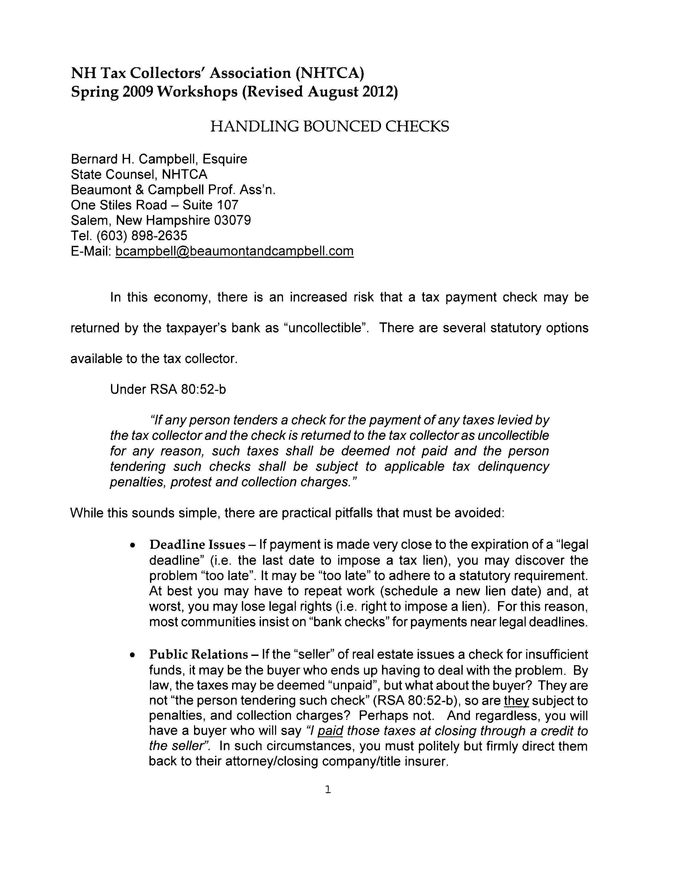
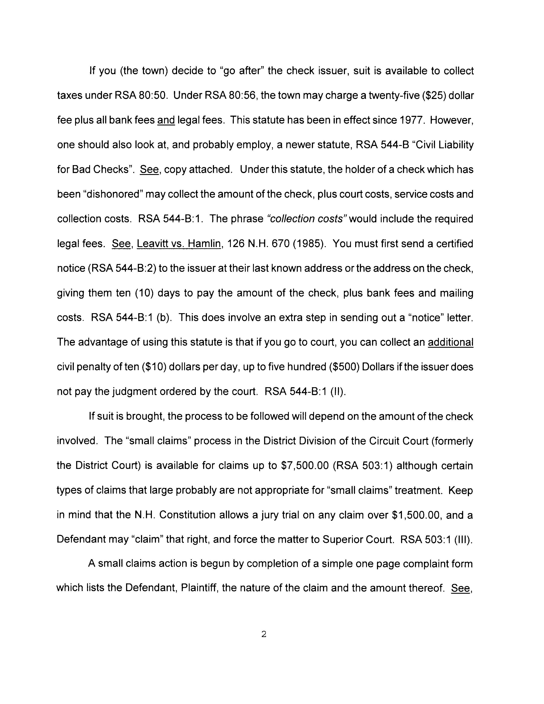
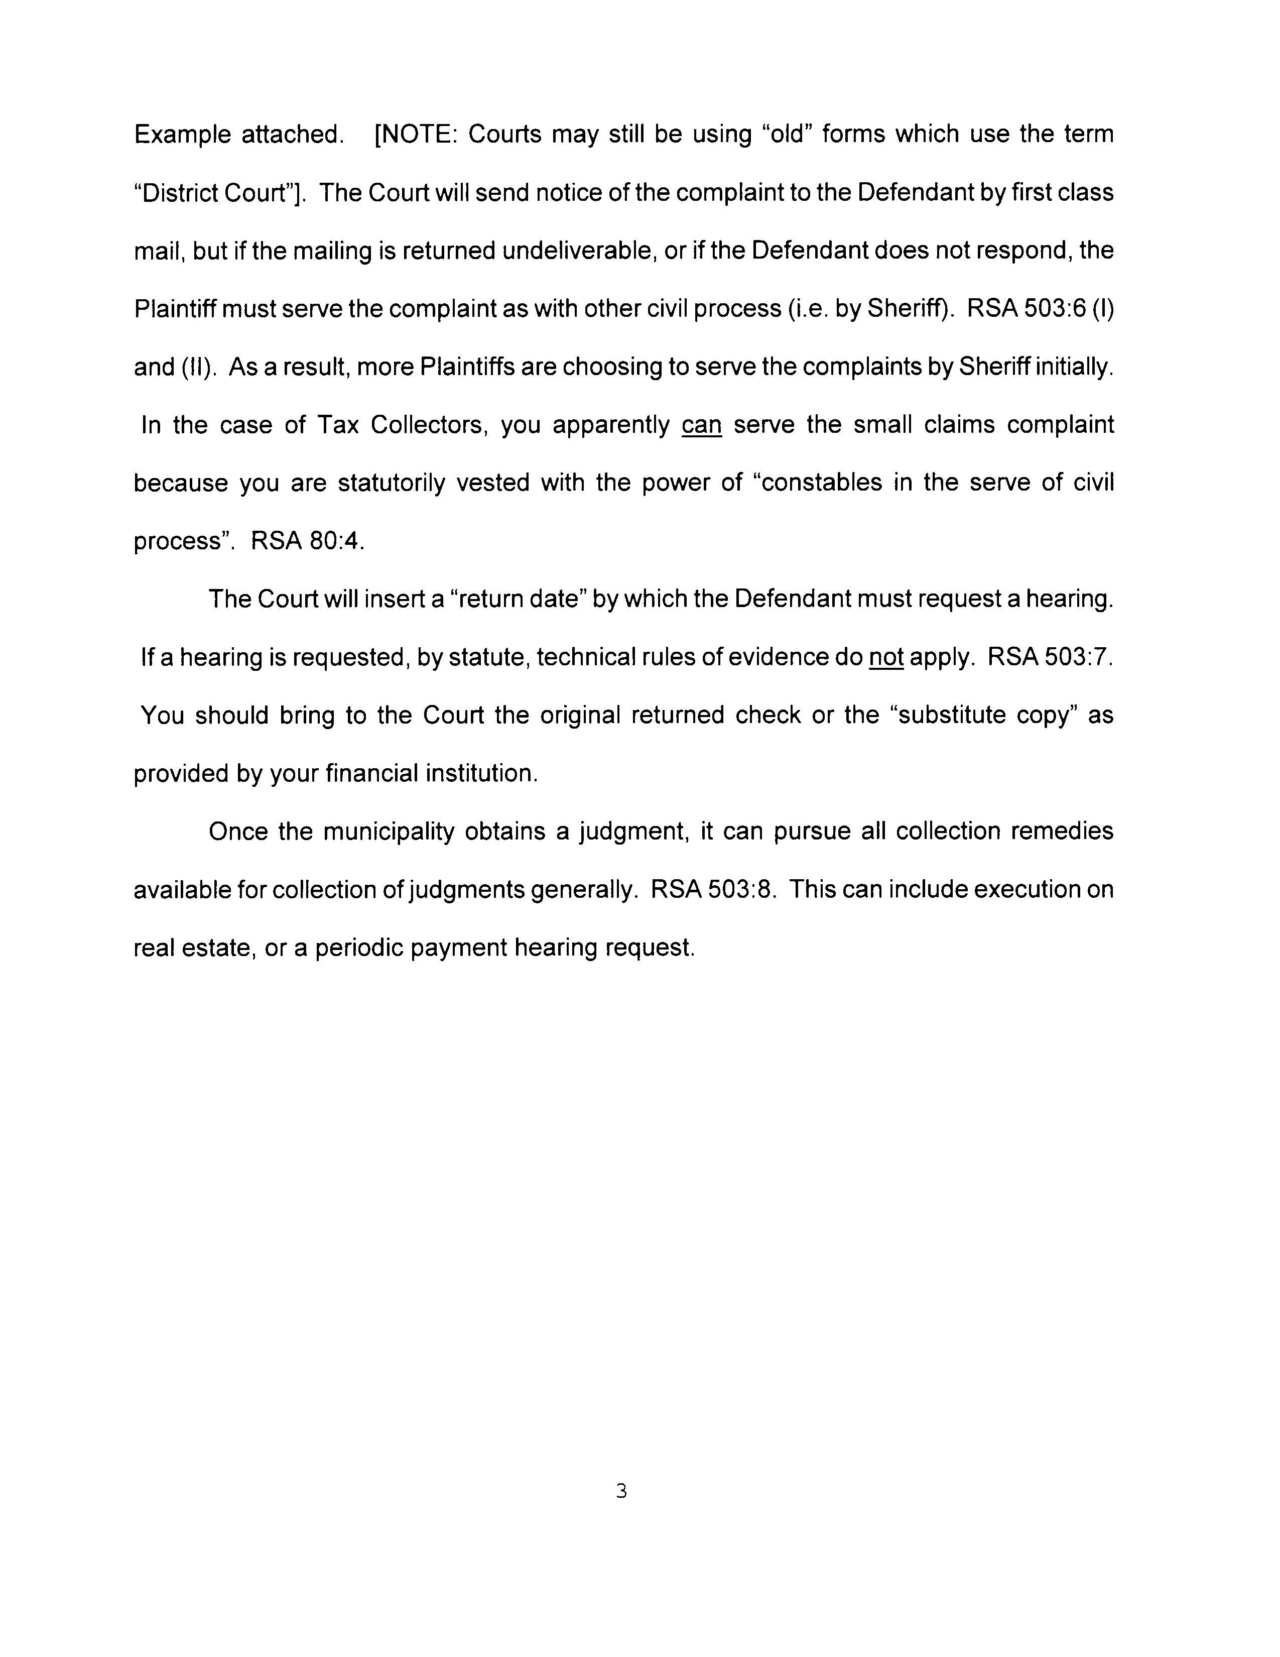

TOWN OF MOULTONBOROUGH
RETURNED CHECK POLICY

RETURNED CHECKS

Payments (RSA 80:52-b): If any person tenders a check for the payment of any taxes levied by the tax collector and the check is returned to the tax collector as uncollectible for any reason, such taxes shall be deemed not paid and the person tendering such check shall be subject to applicable tax delinquency penalties, protest and collection charges.

Uncollectible Checks (RSA 80:56): Whenever any check issued to a city or town for the payment of taxes, permit fees, licenses, special assessments, water or sewer bills, or any combination of these or for any other municipal services is returned to the city or town official as uncollectible, the city or town shall charge a fee of $25.00 plus all protest, ban and legal fees in addition to the amount of said check to the person who issued such check to cover the cost of collecting the debt that the check was issued to pay. The $25 fee together with any protest or legal fees collected shall be for the use of the city or town.

The payment is reversed from the property tax account and a letter is sent to the owner regarding the returned check and the fees associated with it.

Note: Every software system is different so reversing the payment from the account varies in each municipality.

Office of Tax Collector
P.O. Box 152
Moultonborough, NH 03254

Office: 603-476-2347 Office Hours: M - F 9-4
Fax: 603-476-5835
E-mail: taxcollector@moultonboroughnh.gov

July 6, 2012

Taxpayer

Re: Tax Account #

Dear :

Please be advised that our Treasurer has informed me that check #102 drawn on the Chase Bank for $2,700 has been returned and marked “Insufficient Funds”. There is a $25.00 charge for the returned check in accordance with RSA 80:56.

Enclosed please find a Parcel Balance Report. The Report includes all balances due through July 13, 2012. Interest is accruing at the rate of $.89 per day.

Please feel free to contact me if you have any questions.

Sincerely,

Susette M. Remson
Certified Tax Collector

Enc.

PROPERTY TAX PREPAYMENTS

A prepayment is any amount of money that is collected in advance of a property tax bill.

RSA 80:52-a Prepayment states: “ Any town by vote at a town meeting under a proper article in the warrant or by vote of the board of selectmen or the town council and any city by vote of its governing body may authorize the prepayment of taxes and authorize the collector of taxes to accept payments in prepayment of taxes. If a town or city so votes, any person, firm or corporation owning taxable property may, at any time before notice of the amount of taxes assessed against said property has been received, make payments on account of such taxes as will be due and the collector shall receive such payments and give a receipt therefor and credit the amounts paid toward the amount of the taxes eventually assessed against said property. In any town or city which shall vote to authorize the prepayment of taxes the collector of taxes shall give such bond in the form and amount which the commissioner of revenue administration shall require, and the collector shall pay over all sums so received to the town treasurer under the provisions of RSA 41:35. No taxpayer shall be allowed to prepay taxes more than 2 years in advance of the due date of taxes. No interest shall accrue to the taxpayer on any prepayment, nor shall any interest be paid to the taxpayer on any prepayment which is later subject to rebate or refund.”

Sample Prepayment Policy…
TO: Board of Selectmen
FROM: , Tax Collector
DATE:
RE: Pre-payment Policy for Property Taxes

I am requesting that the Board of Selectmen adopt the following policy regarding the acceptance of tax prepayments pursuant to RSA 80:52-a.

Taxpayers shall be allowed to prepay taxes no more than 2 years in advance of the due date of the taxes. No interest shall accrue to the taxpayer on any prepayment, nor shall any interest be paid to the taxpayer on any prepayment which is later subject to rebate or refund.

This policy is adopted with the approval and consent of the Board of Selectmen.

SIGNED:

___________________________________

___________________________________

___________________________________

OVERPAYMENTS vs. PREPAYMENTS
2011 NHTCA – Fall Education Conference

Presented by: Cindy Torsey, CTC-Town of New Hampton and Diane Trippett, CTC- Town of Merrimack

Prepayments: Prepayments are authorized under RSA 80:52-a.

RSA 80:52-a Prepayment
Any town by vote at a town meeting under a proper article in the warrant or by vote of the board of selectmen or the town council and any city by vote of its governing board may authorize the prepayment of taxes and authorize the collector of taxes to accept payments in prepayment of taxes. If a town or city so votes, any person, firm or corporation owning taxable property may, at any time before notice of the amount of taxes assessed against said property has been received, make payments on account of such taxes as will be due and the collector shall receive such payments and give a receipt therefore and credit the amounts paid toward the amount of the taxes eventually assessed against said property. In any town or city which shall vote to authorize the prepayment of taxes the collector of taxes shall give such bond in the form and amount which the commissioner of revenue administration shall require, and the collector shall pay over all sums so received to the town treasurer under the provisions of RSA 41:35. No taxpayer shall be allowed to prepay taxes more than 2 years in advance of the due date of the taxes. No interest shall accrue to the taxpayer on any prepayment, nor shall any interest be paid to the taxpayer on any prepayment which is later subject to rebate or refund.
Source. 1963, 36:1. 1973, 544:8. 1989, 155:1, eff. July 16, 1989. 1998, 241:1, eff. Aug. 4, 1998.
Overpayments are not automatically kept as “prepayments” or “credits” to the next billing cycle.
If an overpayment is received and the customer wants it to be applied to their next bill as a pre-payment/credit, it is advised that you get the authorization in writing before posting any overpayment as credit/prepayment.

Overpayments:

RSA 80:57 Refund of Overpayments
If any person tenders a payment for any taxes and/or interest, in excess of the taxes levied and interest incident thereto, the collector of taxes shall direct the selectmen to issue an order upon the town treasurer to refund to the person making such payment or his heirs or assigns the excess sum so paid; provided, however, that if the sum overpaid is $ 5.00 or less, no refund shall be required unless the taxpayer in such case shall apply in writing to the tax collector for said refund within 60 days of actual payment.

Source. 1983, 285:9, eff. Aug. 17, 1983.

Refunds on overpayments:
The following is recommended when issuing a refund of an overpayment:
If a payment is received which creates an overpayment and there is no instruction as to what to do with the overpayment, the overpayment is refunded to the person/entity that created the overpayment. As noted above in the “prepayment” section, the overage is not automatically applied to the next bill. If the amount overpaid is less than the $ 5.00, the amount is written off to interest and not refunded unless the customer requests a refund in writing.
If two parties make payment on an account, the second party making payment (creating an overpayment) should be refunded, unless they authorize the tax collector, in writing, to refund the first party.

It is recognized that these processes may vary from municipality to municipality, and advice of your legal counsel should always be taken in to consideration.

ABATEMENTS VERSUS ABATEMENT REFUNDS

An abatement is a reduction in a property tax bill which has not yet been paid by the taxpayer. An abatement refund is a reduction in the tax obligation of a taxpayer who has already paid their tax bill.

RSA 76:16 By Selectmen or Assessors states in part that “Selectmen or assessors, for good cause shown, may abate any tax assessed by them or their predecessors, including any portion of interest accrued on such tax.”

RSA 76:17-d Abatement Refund states that “the Selectmen or assessors may apply all or a portion of the amount of any taxes abated, along with interest computed according to this chapter, to any outstanding taxes owed by the taxpayer to the municipality. Taxes shall be considered outstanding if they are subject to interest pursuant to RSA 76:13. The selectmen or assessors shall send notice to the taxpayer of the amount credited against outstanding taxes and the date the credit was recorded.”

Usually, the abatement refunds are not recorded on the MS-61 form because the taxes have been cleared off the books once the initial payment was made. This may be an issue between the selectmen’s office and the taxpayer. The treasurer/bookkeeper would credit cash rather than the tax commitment. Some collectors want to show the complete history of the taxpayer’s account so they post the abatement refund to the account and it results in a credit balance (or overpayment) to the account. In order to remove the overpayment from the account, a refund transaction has to be applied to the taxpayer’s account to show a zero balance. Deciding whether or not to post the abatement refunds is a personal preference.

ABATEMENT
TOWN OF MERRIMACK, NH

To the Collector of Taxes,

Sir: By vote of the Board of {Councilors, Assessors}, upon the application of:

Name:

Mailing Address:

We have abated the amount of $
We have abated interest in the amount of $
On (Map/Parcel No.): located at (Street & No.):
For Tax Year 2011 . . . . .

Pursuant to RSA 76:17-d:
Any Outstanding Taxes Due? Yes . . . . . No . . . . .
Any Outstanding Taxes Due on other property owned in Town? Yes . . . . . . No . . . . . .
Cause of abatement:

NOTICE OF ABATEMENT REFUND & CREDIT APPLIED (RSA 76:17-d)
The abatement refund will be applied to your outstanding taxes pursuant to RDA 76:17-d as follows:
Amount of Payment Applied: $_____________________
Type & Year of Tax Credited: $_____________________
For Property Located at: ______________________
Remaining Amount For Refund $_____________________
Please contact the tax collector’s office to determine any remaining outstanding balances of taxes due.

Per Order,
MERRIMACK TOWN COUNCIL

_____________________________________________________
Finlay C. Rothhaus, Chairman (Sign in black ink) (Date)
_____________________________________________________
William W. Boyd III, vice Chair (Sign in black ink) (Date)
_____________________________________________________
Thomas P. Koenig (Sign in black ink) (Date)
_____________________________________________________
Thomas Mahon (Sign in black ink) (Date)
______________________________________________________
Daniel Dwyer (Sign in black ink) (Date)
______________________________________________________
Jacqueline J. Flood (Sign in black ink) (Date)
______________________________________________________
Nancy Harrington (Sign in black ink) (Date)

Assessor reviewed date:_______________________________

Reporting Tax Abatement Interest to the IRS

Judy A. Silva
Deputy Director for Legal Services and Government Affairs
Barbara T. Reid
Government Finance Advisor
New Hampshire Municipal Association/Local Government Center

Q: When a taxpayer receives a property tax abatement, must the municipality report the interest paid on that abatement to the Internal Revenue Service (IRS)?

A: Municipalities must report to the IRS interest of $600 (six hundred dollars) or more paid on a property tax abatement. When a municipality abates taxes, New Hampshire law requires that interest at the rate of 6% per year must be paid on the amount abated from the date the taxes were paid to the date of the refund. RSA 76:17-a. This is true whether the municipality makes the abatement on its own decision or is ordered to do so by the Board of Tax and Land Appeals (BTLA) or the superior court.

The question of reporting that interest to the IRS is highlighted by the statute prescribing the BTLA abatement form, RSA 76:16, III which requires that the following statement be added to the abatement form:

If an abatement is granted and taxes have been paid, interest on the abatement shall be paid in accordance with RSA 76:17-a. Any interest paid to the applicant must be reported by the municipality to the United States Internal Revenue Service, in accordance with federal law. Prior to the payment of an abatement with interest, the taxpayer shall provide the municipality with the applicant’s social security number or federal tax identification number. Municipalities shall treat the social security or federal tax identification information as confidential and exempt from a public information request under RSA 91-A. (Emphasis added.)

Q: Does that mean a municipality must report all interest paid on an abatement, regardless of the amount?

A: No. Note that the statute says “in accordance with federal law.” This raises the question of what federal law requires. Some municipalities report interest of $10 or more, but I believe that threshold applies only to interest paid by financial institutions and interest on publicly traded bonds and other securities. See IRC § 6049. You can report the payment of interest of less than $600, but you are not required to do so.

The interest you pay on an abatement is considered income to the recipient. Section 6041 of the Internal Revenue Code states, in pertinent part, that “all persons engaged in a trade or business and making payment in the course of such trade or business to another person of…income…of $600 or more in any taxable year” shall report it to the IRS. (Note that the IRS interprets the term “trade or business” very broadly to include charitable organizations, the federal government, states, and “any political subdivision thereof,” so this requirement applies to municipalities. See 26 CFR §1.6041-1(b) & (i).)

Q: Who is responsible for reporting the payment?

A: The federal regulations provide that the report of interest paid (called an “information return”) made by a political subdivision of a state shall be made by the officer or employee of the subdivision having control of such payments or who is designated to make such returns.

Q: How is the payment reported?

A: The information return is to be made on a Form 1099-INT; a separate Form 1099-INT is created for each interest payment that must be reported for the calendar year. The Internal Revenue Code requires that the municipality provide the 1099-INT information (either a copy of the actual form or, with IRS approval, in a different format) to the individual taxpayer on or before January 31 of the year following the calendar year in which the interest was paid.

All Form 1099-INTs issued by the municipality must be filed with the IRS. For 2012, the instructions for the payer state that the form must be filed with the IRS by February 28, 2013, or by April 1, 2013 if filing electronically. Electronic filing is required as of January 1, 2012. See IRS Publication 1220 – Revenue Procedure 2011-40 for specifications on the IRS Filing Information Returns Electronically (FIRE) system and procedures.

Q. What other information does the municipality need to file the report?

A. You need the taxpayer’s social security number or taxpayer identification number in order to report the interest paid. If you don’t have that number, there is an IRS form you can use to obtain it—Form W-9. If the interest on the abatement will be $600 or more, you can provide a W-9 to the taxpayer when the abatement is granted, but before the check is sent. If you cannot get the taxpayer’s social security or tax ID number, then you will be required to do “backup withholding” of the federal tax on the interest payment at the rate of 28%. The new provision in RSA 76:16, III, however, provides that “prior to the payment of an abatement with interest,” the taxpayer must provide a social security or tax ID number. Given that language, the preferable route would be to simply refund the taxes abated as required and delay the payment of interest until you receive the necessary reporting numbers.

* * * *

Having said all that, keep in mind that you would have to abate taxes in the amount of $10,000 and have held those taxes for one year in order to meet the $600 interest requirement. It will hopefully be a rare event when you pay interest in excess of $600 so that you will have to file an information return with the IRS.

ALSO NOTE: This information is good as of the date below. IRS regulations and other laws can and do change, so it is imperative that the latest version of each is consulted.

March 15, 2012

DAILY & MONTHLY BALANCING PROCEDURES

END OF DAY:

Deposit daily or weekly per RSA 41:35

Balance the receipts on a daily basis to the work for the corresponding day as follows:

The steps are:

1. Total all of the receipts (actual tax bills or computer printouts of receipts). It is beneficial to make notes on the bills (or in the computer) if the bill was paid by cash or check. It is also helpful to note who paid the taxes; for example, the property owner or the mortgage company.

2. Total all of the checks and cash collected.

3. Verify that the deposit (cash and checks received) and the receipts equal the total payments collected.

4. If the records are computerized, print out the computer totals of the day’s work and compare it with the total receipts and money collected.

5. If all three items (the receipts, cash & check total and computer printout) are identical, prepare the deposit for the day. (This can be done the next day since the office may close after the banks are closed. However, make sure that the date used for the deposit corresponds to the actual date of the work so the receipt can be matched accordingly).

6. Prepare and sign the remittance slips to be given to the treasurer. (This may need to be done prior to making the deposit if the treasurer or treasurer’s designee personally makes the deposit). If the tax collector makes the deposit, make a copy of the bank deposit ticket for the records and give the original deposit ticket to the treasurer along with the remittance slip.

7. File the following in the appropriate places: Receipts or computer printouts of receipts; computer totals of the day’s work; copies of the deposit slips; copies of the signed remittance documents. It is critical to make sure that the money deposited equals the amount of money remitted to the treasurer. If there was an abatement or a refund issued, make sure that they are filed accordingly.

END OF MONTH:

Monthly reconciliation of the deposits/remittances made to the treasurer is an important responsibility of the tax collector. This needs to be done on a monthly basis and at the end of the year. At the end of every month, the total of all cash receipts collected for the month, summarized by tax levy type and year must equal the amount remitted to the treasurer.

Hint: When performing the monthly reconciliation of accounts, it is easier to focus on one type of tax levy at a time in order to easily identify any potential problem.

The following items will be needed in order to balance at the end of the month:

1. Prior month reconciliation; ending balance for the previous month and the beginning balance for the current month should be identical.
2. All signed warrants issued during the month.
3. A list of all the abatements granted and the corresponding abatement slips which have been approved (signed) by the Board of Selectmen or the Board of Assessors.
4. All refunds processed during the month.
5. A list of overpayments which occurred during the month, not yet refunded, with the corresponding payment request form used to apply for the refund.
6. A listing of payment transactions for the month, including principal, cost and interest which have already been reconciled and confirmed with the treasurer.
7. A listing of any credit balances as of the end of the month.
8. A listing of property taken by tax deed, if applicable.
9. A listing of discounts issued during the month, if applicable.
10. A listing of uncollected/unredeemed property, yield, land use, excavation and resident tax (if applicable) owed as of the last day of the month. Please note that this amount should not include the credit balance mentioned above.
11. If the records are computerized, a trial balance report will provide most of the information listed above.

Once this information has been compiled, complete an MS-61 for the month.

If a monthly MS-61 prints off your system compare the figures to the General Ledger and/or Treasurer to make sure that you both balance. This should be done on a monthly basis or more often if so desired. Put the totals from the reports onto an Excel spreadsheet or a manual form for balancing purposes. If you need to compile the figures manually or on a spreadsheet, proceed with the completion of the form. Once you have the totals for the month, compare these figures to the Treasurer or Finance office to make sure that the totals are the same. If a variance exists it needs to be identified because these amounts need to be in agreement. An example could be that a returned check has not been properly accounted for at the end of the month. Once everything is completed and you are in balance with the Treasurer or Finance office, open the next month by carrying forward the balances from the previous month.

A LITTLE BIT OF HUMOR
…..JUST WHEN YOU THINK YOU’VE HEARD IT ALL…
I DIDN’T PAY MY BILL BECAUSE…….

- My Mother, Father & Sister were in the hospital.
- My house was robbed; they took all my money.
- I thought my mortgage company would pay you!
- I never got the bill; I shouldn’t have to pay it now!
- The dog ate the bill.
- I get all my other bills, but for some reason I never get these green bills.
- It is not my bill; it’s the previous owner’s bill.
- I go to Florida for the winter.
- I went out of the Country.
- The letter said on or about.
- I paid what the bill/letter said.
- The letter is a bit much, couldn’t you have called me instead?
- I had surgery.
- There was a death in the family.
- I bought another house and the taxes are lower; I feel I am entitled to a rebate from Nashua.
- Sorry I’m behind 2 years; I thought those property tax bills were water bills.
- I didn’t know I was supposed to notify you when I moved, I send my on-line payments to the same account- the old owner must have my payments.
- What can ya do for me regarding the interest; can you get rid of it?
- I’m late and I know it, but hey whaddya say “Let’s make a Deal!!!”

compiled by Ruth Raswyck, CDTC, Nashua:

