
October 25 – 27, 2013 – Heritage Park, Chilliwack, BC

Phone (250) 578-7518 Website www.maneeventexpo.com
Fax (250) 578-7559 Non-Profit or Association Booth Space Agreement Email sales@maneeventexpo.com
Breed/ Association: (No sharing of space permitted) |  | Contact Name: |  | Phone Number Will be published
Fax Number: |  | Cell or Alternate Number:
Email: | Website: Will be linked on maneeventexpo.com  www.
Mailing Address: |  |  | City |  | Prov. | Postal Code
Please list the name of your Breed or Equine Association as you wish to be listed in the Show Guide and on the Website. Please note that there is no selling of horses, breeding or products from the booth as these booths are for the information of a particular Breed or equine association only, if you wish to sell horses, breeding or products please complete a Commercial Booth Agreement.

Non-Profit 10’ x 10’ Booths Include: 8’ (high) back & 4’ (high) side draped walls; 750 watts of power; listing in Show Guide & on our website with link to your website. Please see Terms & Conditions below. Everyone Handling Horses or working your booth will require a wristband. |  |  |  | NOT INCLUDED:  Carpet, Tables or Chairs
Non-Profit 10’x 10’ Booth (indicate below if you require Weekend or Day Passes) |  |  | ____ x $ 425.00 |  |  | $ ___________
Weekend Stalls (if required) Stalls must be booked in advance as stabling is limited. Weekend Stalls are for Friday from 8:00 am thru Sunday 8:00 pm. |  |  | ____ x $ 90.00 |  |  | $____________
Day Stalls (if required) Stalls for day only from 8:00 am – 10:00 pm or any portion thereof not overnight |  |  | ____ x $ 45.00 |  |  | $____________
ADD GST (5%) |  |  |  |  |  | $ _________
Extra Weekend wristbands required for volunteers/riders (GST Included) |  |  | _____ x $ 40.00 |  |  | $____________
Extra Day wristbands required for volunteers/riders (GST Included) |  |  | _____ x $ 15.00 |  |  | $____________
Stall Deposit (Required it Weekend or Day stalls reserved) Deposit cheques will be returned once stalls have been cleaned and inspected. (If payment is made by credit card and stalls are left dirty your credit card will be charged $25.00 per stall) otherwise please send Separate Stall Deposit cheque dated October 27, 2013 |  |  | _____ x $ 25.00 |  |  | $____________
Wristbands Each 10 x 10 Booth comes with either 4 weekend or 10 single day wristbands for workers/riders (wristbands are non-transferrable), please indicate which you require. |  |  | 4 Weekend Passes |  | 10 Single Day Passes
Payment - Please note for Booths to be reserved payment must accompany this Booth Agreement. (NSF Cheques are subject to a $25.00 fee) |  |  |  | Total Payable $ ________
Payment Method: (Please √ applicable box) Cheque (Payable to Mane Event) Visa Master Card

Credit Card Number: _____________________________________________ Expiration Date: ___________________

Name on the Credit Card: _________________________ Authorized Credit Card Signature: _________________________

Booth Cancellations - If a written cancellation is received 91 days or more from the date of the show the exhibitor is liable for 50% of the contracted amount, if less than 90 days the exhibitor is liable for 100% of the contracted amount.
TERMS AND CONDITIONS
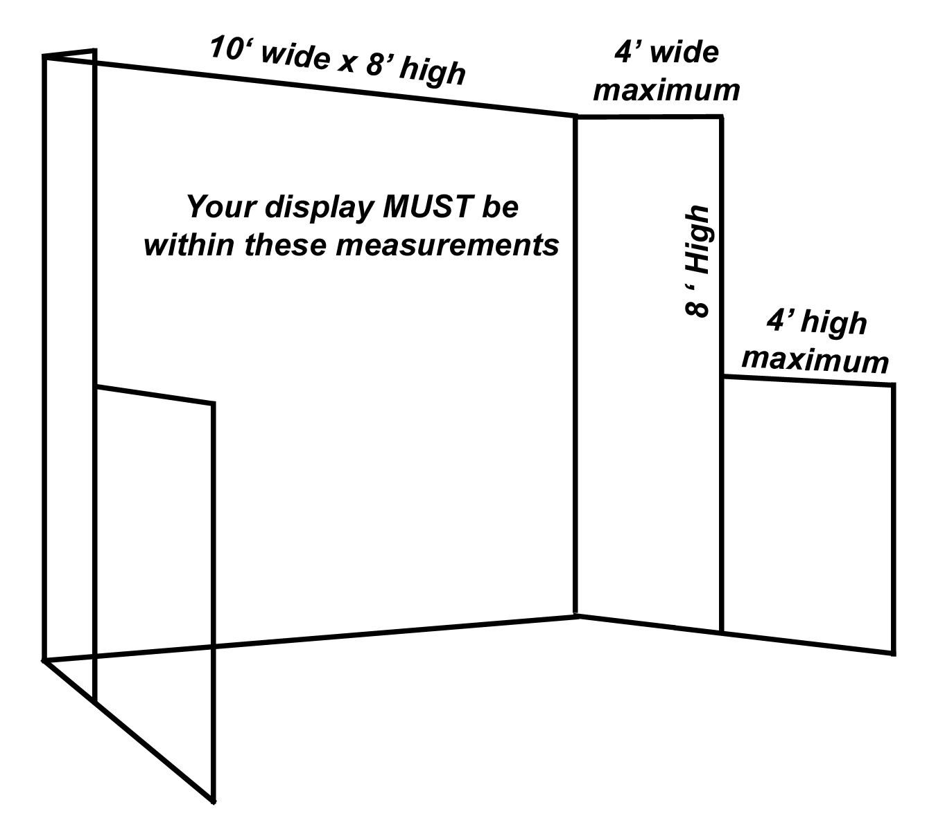
- Liability- Exhibitor agrees to indemnify and hold harmless The Mane Event also referred to as management, principles, agents, officers and employees from all claims, losses, costs, damages or expenses resulting or arising from any and all injuries to or death of any person or damage to any property caused by an act, omission or neglect of Exhibitor’s agent, employees, invites, contractors or guests which occur in or about the Exhibit Space. Exhibitor agrees to use and occupy the Exhibit Space at Exhibitor’s own risk, and hereby releases The Mane Event, its agents, officers, employees and invites from all claims for any damage, loss or injury to persons or property to the full extent permitted by law occurring in or about the Exhibit Space, including, but not limited to damages, resulting from the acts of other Exhibitors, theft, vandalism, fire and other casualty damage or damage arising from any defects in the premises.
- Booth Detail - Each booth will contain 4 ft. high curtain side dividers, 8 ft curtained backdrop, 750 watts power, Exhibitor passes are dependent on the size of the booth, a listing in the Show Guide and The Mane Event website.
- Booth Size - You must stay within your space booked and maintain the line of sight down the sides of your exhibit (maximum on sides 48” unless approved by The Mane Event prior to show) to make sure all exhibitors can be seen.
- Noise Control- Any electronic equipment or machinery which is determined to be detracting from other exhibits will not be permitted.
- Exhibit Installation - Exhibitors may initiate booth construction, after checking in at the show office. See below for hours.
- Exhibit Staffing - All exhibits must be staffed during show hours by at least one person. Exhibitors are requested to arrive at least 20 minutes prior to show opening.
- Wristbands – Each staff must have a wristband on to enter the building. These are non transferable and for one staff member only.
- Removal of Exhibits- No part of an exhibit will be allowed to leave the exhibit hall before 5:30 pm, Sunday, October 27, 2013.
- Booth Assignment- While initial booth reservation is mutually agreed to by Exhibitor and Management, final assignment is the proprietary right of Management. Every attempt will be made to locate the Exhibitor in the booth he or she has reserved but, in extenuating circumstances, the booth can be reassigned without approval of Exhibitor. The exhibitor shall not assign, sublet or apportion the whole or any part of the space assigned or have representatives, equipment or materials from firms other than its own in the exhibit space.
- Security- Security will be provided to patrol from Thursday to Sunday until close of show 24 hours a day. Management is not responsible for theft or damage of property.
- Booth Contract - The exhibit space contract upon receipt by management shall constitute a valid and binding contract.
- Cancellation - If a written cancellation is received 91 days or more from the date of the show the exhibitor is liable for 50% of the contracted amount, if less than 90 days the exhibitor is liable for 100% of the contracted amount.
- Right to Refuse- Management reserves the right to review and reject any application for exhibit space without prejudice.
- Dogs - Please note that dogs that are in booths must be caged, we recommend that you leave your dogs at home for the comfort of the dog.

We, the undersigned do hereby agree to exhibit at The Mane Event, and agree with the Terms and Conditions outlined above.

Signed this __________ day of ____________________, 20 ____ x ________________________________________________________
(Exhibitor – Signature Required)
Make Sure: (√ Boxes)

Booth Agreement has been signed & dated Fax to: (250) 578-7559 or Mail to: The Mane Event
Deposit or Credit Card Number Enclosed Unit 468, 230–1210 Summit Drive
Terms & Conditions have been read & understood KAMLOOPS, BC V2C 6M1

Business Office
The Mane Event
Unit 468, 230-1210 Summit Drive
Kamloops, BC V2C 6M1
(250) 578-7518 • (250) 578-7559 Fax
sales@maneeventexpo.com • www.maneeventexpo.com

Show Grounds
Heritage Park
44140 Luckakuck Way • Chilliwack, BC V2R 4A7

Exhibitor Move-In Dates and Hours (Subject to Change):
Wednesday, October 23 8:00 am - 8:00 pm
Thursday, October 24 8:00 am - 8:00 pm

Show Hours
Friday, October 25 9:00 am - 8:00 pm (8:15 Equine Experience)
Saturday, October 26 9:00 am - 8:00 pm (8:15 Equine Experience)
Sunday, October 27 9:00 am - 5:30 pm

Fax To: (250) 578-7559 or Mail To: The Mane Event
230-1210 Summit Drive, Unit 468
KAMLOOPS, BC V2C 6M1

