The Idiot Guide
to
CoA
within
DIRECT LENDING

Sean McNally

Table of Contents
Contents are interactive. Scroll down to find what you want. Hold down the Ctrl key and click on the contents line. It will automatically take you straight there.

A.1 Cost of Attendance (CoA) 2
A.1.1 Exchange Rate 4
A.1.1.1 The rate for the CoA 4
A.1.2 The range of what schools do for exchange rates 6
A.1.3 Actual Received Cash exchange rate 6
A.1.3.1 US Ed Dept - exchange rates Foreign Schools Handbook 7
A.1.3.2 USDE Dear Colleague letter on exchange and early payments 7
A.1.3.3 Other Considerations for CoA planning 11
A.1.4 Sean’s CoA Sheet 12
A.1.5 How to drive CoA Spreadsheet 13
A.1.5.1 Student Checklist 15
A.1.5.2 CoA spreadsheet - technical info 16
A.1.6 CoA and Dependents 21
A.2 CoA Change after 1st Disbursement 23
A.2.1 Calculate what needs to change – new CoA & compare 23

This guide an extract from Sean’s Idiot Guide which is available at
www.sean-usloans.co.uk

Cost of Attendance (CoA)
The CoA is your best estimate of how much money is needed in order to study the course at your university.
You compile this in your currency, as that is the currency in which costs are calculated and in which it will be spent.
You will also make a best guess at how many dollars will be needed to meet that need in your own currency. It is not how many dollars today will meet that need because the dollars are not being collected and converted today but some time in the future.
These are the elements which make up the CoA
Tuition Fees | Round dollars, no cents
Room | It means rent, in round dollars, no cents
Board | power, utilities and food
Books | Books and pens and writing pads etc
Travel | 2 flights to/from USA plus weekly/daily travel
Personal | Pocket money, beer, lunches, pizzas etc
Other Essential Costs | PC, health insurance, on-going medication (diabetes, epilepsy, , visa related costs, Origination Fees, etc.  Even childcare costs if junior is in UK with the student (Parent).  But NOT (these are not exhaustive but are ones I’ve declined)  - costs of spouse (if spouse chooses to come with the student for a holiday then spouse funds it)  - mortgage in USA or other loan repayments  - moving house (study abroad is not permanent)  - cosmetic medical treatment - tucks, boobs, spa teeth-white, hair removal/replacement, weight watchers, sauna/massage  - holidays (sightseeing in Paris while in UK) – but if they budget well and cook instead of living on KFC or Pizza Hut they will have enough money left for graduation ball and cheap trip to France/Spain etc.
Total Cost of Attendance | All the above
Adjust down for Sponsorship, Awards or other Aid | Any other aid given to student to be deducted from costs
Total Requested Cost of The cost of attendance is your best estimate of all the costs required Attendance | Full costs minus any scholarships etc

You – the school – must set your CoA. It must be in this format -
The USA assume that this is simple because all your courses cost the same; all your students are in your own university dormitory therefore all cost the same; they all eat in your own cafeteria where the cost of burger/pizza/salad is the same; and all stationary and books and CDs come from the university bookshop at a fixed price; and everyone has a haircut every two weeks in the university hairdresser which costs the same for boys and girls; and nobody drinks alcohol because there are no bars (can’t drink until aged 21); and who would possibly want to do anything which is not on-campus, so all their pocket money is loaded on their campus ID card as you give them their pocket money each week. Easy-peasy.
You would send the student the Costs and ask if they want a loan, they say yes, you then send them how much loan they could have, then they tell you how much they want, then you …[constant bat and ball between school and student] … until you know what they want and have all the required documents.
But, to get real –
The version I produce shows the loan entitlement and allows the student to adjust it for how much they wits to borrow and it produces a visa letter – it’s not actually a visa letter, it’s a notification of how much loan and when but it is required as proof of funding for their visa application, so most people call it the visa latter.
- the CoA changes with the
- tuition fee and where to live
- Travel to campus or not,
- etc
BUT you already have
- a broad idea of worst [highest] tuition fee
- a rough idea of school/external room rates [local newspaper]
- a rough idea of power/utility costs
- a reasonable idea of local travel costs
- a rough idea of what would be reasonable pocket money per week – not more than you have yourself
So you could either
- use the hours of spare time you have each day (ho-ho) to calculate the individual CoA for each student by calculating all their particular variables
- or use the broad costs you easily know to make a worst case scenario and let the student do all the work to insert their own variables
I chose the latter and built the spreadsheet to make that scenario transparent, and to allow the student to make their own variations up to a figure I guessed to be absolute worst case increased by 10%.
The spreadsheet I produced
- cuts out having to search through the hard-code areas to personalise school data and so keeps all the individual school information in one place and be easy and comprehensive
- cuts out risk of confusion or omission
- cuts out the risk of the calculating fields and subfields being accidentally changed
- issues red comments at the end of the sheet to warn if a student is asking for the moon

Exchange Rate
There are no regulations concerning exchange rates. We are the ones daft enough to choose not to be born in the USA and play with funny money - USA only works in dollars. So if you choose to work in another currency, then you set [or fall by] your rules.

Unless you are a time traveler returning from the future, you don’t know what the exchange rate will be over a whole year which has yet to start - you set it in Feb/March ahead of an autumn start, so realistically you are guessing a rate about18 months in advance of the final use of the funds. I always set a ‘worst case’ one based on a strict formula which ensures that the student should be able borrow more than absolutely necessary and should not need to come back to me for more. If they have some left over for graduation ball or an interview suit, then so be it, or they can always choose to reduce their loan during the year and/or make an early repayment when they finish.

The rate for the CoA
is your guess at how many dollars a student needs to meet your £sterling needs.
Unless you have a time machine to be able to go into the future to see what money you will actually receive in our currency, the rate you use can only be a guess.
If you estimate low,
- it could make your university look either more economically favourable or just plain cheap
- you have to decide whether you want to appear cheap or re-assuringly expensive
- students may run out of money
- you have to decide whether or not you want to throw staff time at increasing loans during the year as money runs out
If you estimate high
- it makes your university look either top quality cost or just plain too expensive
- you have to decide whether you want to appear expensive or top-drawer quality
- student should not run out of money
When you've decided on those policies you should stick to whatever rate you set and it should apply equally to all loan applications - if not, then you are open to accusations of favouriticism/discrimination
If you don’t like my exchange rate, or the formula/method used, then plan your own but be consistent and give strong consideration to how it will affect your applicants as in
- Angry customers where their friends have a different rate
- Angry customers if you “cut their money”
- Repeat customers where you have to keep making changes
- Do you have spare staff time to handle repeat customers which would be repeaters if you got it right the first time
- Students blog and tweet – what will your reputation be on their social media
I pick a date in Feb, walk down a high street, call into every bank and write down their rate and their commission rate. Then select the worst high street rate and multiply it by the worst of any commission charged by any bank.
Here’s my planning for 2015/16
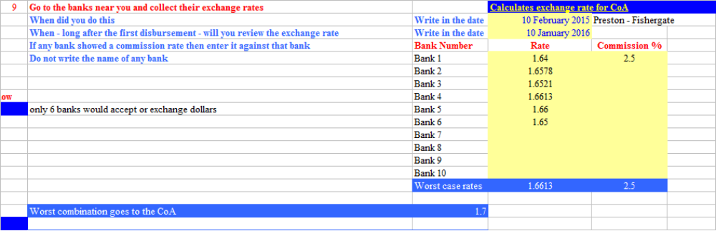
You have to see the exchange rate in the same way as the other elements which make up the CoA. If you’ve also been reasonably generous with the other elements of the CoA, then you should have covered the likely worst case of exchange and/or inflation. At the end of the day, it’s a best guess which you have to balance between being
- affordable or “too cheap to be any good”
- unaffordable or “reassuringly expensive”
Remember
- The exchange rate does not affect your (£) pound costs, it only affects the number of ($) dollars to achieve the same (£) pound value.
- You need a decent buffer against the risk of adverse $:£ change.
If you have problems with the rate
- Is it the fear of the total value or outcome in CoA
- Is this Marks & Spencer marketing
- £10 is too expensive but £9.99 will sell.
- Is your problem with the exchange rate or the original £ costs?
Also consider the difference in the final numbers - when costs are high anyway, another couple of thousand makes little difference. ie. once you've passed, say, £80k, then whether the overall is $85k or $86.5k makes little difference in choice of school, but makes a difference in having rent/food for the last month or being able to buy an interview suit.
Or you could just get a TARDIS and your plans would be wholly accurate.

The range of what schools do for exchange rates
What almost everyone does is
- on the CoA, fix a best guess at the worst rate [unfavourable to the student] and stick to it for setting the CoA for all student for that year
- give the student the actual exchange rate as received at the point of exchange of each disbursement
The advantage of this practice is that every borrower will get at least all the £sterling they were expecting and usually more than expected.
Methods used by most schools for best guessing a rate are one of
- select the worst rate from the worst bank, multiply it by the worst commission deducted by the worst bank, raise it by 10% - that's my method - and I found that most years the very worst rate during the year was very close to, or matched, my estimate. For most disbursements, students received a better rate.
- On a fixed date annually use the worst rate from the previous 12 months
- On a fixed date annually use the worst rate from the previous 12 months and raise it by the same fixed %
- On a fixed date annually use the median rate from the previous 12 months and raise it by the maximum % variance from the mean in that same 12 months

Actual Received Cash exchange rate
At the time of disbursement, you will receive money in your currency at the rate it converted at the time.
Students must receive their money at this rate – if not, you are effectively making a charge for loan processing which is absolutely forbidden
As students will get their actual cash at the rate you actually received it at the point of real exchange – your CoA rate should make them either about right or slightly better off.

US Ed Dept - exchange rates Foreign Schools Handbook
From the 14/15 Foreign FSA Handbook page 17 and available at
http://ifap.ed.gov/ForeignSchoolInfo/ForeignSchoolsHandbook.html
COST OF ATTENDANCE AND FLUCTUATING CURRENCY RATES
Unless a foreign institution has entered into an enrollment agreement with a student to provide a program or a portion of a program for a set amount expressed in U.S. dollars, the foreign institution may adjust the cost of attendance to reflect changes in exchange rates. Say, for example, that in June, an institution’s yearly cost of attendance of 30,000 British pounds is the equivalent of 45,000 U.S. dollars based on an exchange rate of 1.5 U.S. dollars to 1 British pound. However, when the student arrives in September, the exchange rate is 2 U.S. dollars to 1 British pound for a cost of attendance of 60,000 U.S. dollars. Provided the institution did not enter into an enrollment agreement with the student for $45,000 U.S. dollars, the institution may use $60,000 U.S. dollars for the student’s cost of attendance.
If recalculations of costs of attendance on this basis are to be performed, the institution should have a policy it applies consistently, resulting in both upward and downward adjustments, with respect to all Direct Loan borrowers.
The recalculation should not include costs incurred in a different payment period. In the recalculation, the general rules as to costs of attendance continue to apply (e.g., costs of attendance for tuition and fees should include only those normally assessed a student carrying the same academic workload as determined by the institution, and can include costs for rental or purchase of any equipment, materials, or supplies required of all students in the same course of study). These recalculations are not an exercise of professional judgment but instead reflect changes in costs as expressed in U.S. dollars resulting from fluctuations in currency exchange rates.

USDE Dear Colleague letter on exchange and early payments
Publication Date: December 2, 2010
DCL ID: | GEN-10-18
Subject: Guidance to foreign institutions on various Title IV requirements
Summary: This letter provides foreign institutions that participate in the William D. Ford Federal Direct Loan (Direct Loan) Program with guidance on Title IV, Higher Education Act (HEA) program requirements.
Dear Colleague:
An institution of higher education’s participation in the Direct Loan Program is governed by United States laws and regulations. In this letter, we provide guidance to assist institutions located outside of the United States with the proper administration of various “cash management” requirements for maintaining, disbursing, and accounting for Direct Loan Program funds, as well as information on institutional discretion for adjusting a student’s cost of attendance to account for fluctuating currency exchange rates. This guidance is intended to supplement, and, where necessary, clarify and correct, training previously provided to foreign schools in workshop sessions as part of their transition to the Direct Loan Program. Recordings of Foreign School Direct Loan Training Webinars are available at http://www2.ed.gov/offices/OSFAP/training/specific.html. Additional information on the participation of foreign institutions in the Direct Loan Program is available on the Foreign Schools Information Web site at http://ifap.ed.gov/ForeignSchoolInfo/ForeignSchoolInfo.html. During reviews of an institution’s compliance, we take into account any written guidance that had been provided by the Department during the period under review. In all cases, statutory and regulatory requirements are controlling.
Early Disbursements to Students
Q1. Under the Federal Family Education Loan (FFEL) Program, under certain circumstances, lenders were allowed to disburse FFEL Program funds directly to a student, or a parent for a Parent PLUS Loan, up to 30 days prior to the first day of classes for a payment period. Does this same policy apply to direct disbursements of Direct Loan funds by foreign schools?
A1. No. The earliest an institution may disburse Direct Loan Program funds to a student, or parent for a Parent PLUS Loan, for any payment period is 10 days before the first day of classes for the payment period. For credit-hour non-term programs, credit hour programs with non-standard terms that are not substantially equal in length, and clock hour programs, a student may not be paid for a second or subsequent payment period until he or she has completed the previous payment period. Therefore, if a student completes the previous payment period for which he or she received Direct Loan Program funds later than 10 days before the first day of classes of the subsequent payment period, the institution may not disburse Direct Loan Program funds until the date the student completes the previous payment period. As with FFEL Program funds, the earliest an institution may disburse the initial installment of a loan under the Direct Loan Program to a first-year, first-time borrower in an undergraduate program of study is 30 days after the first day of the student’s program of study. An institution is exempt from the 30-day delayed disbursement requirement for loans disbursed before October 1, 2011, if the institution has a cohort default rate of less than 10 percent for each of the three most recent fiscal years for which data are available. An institution is exempt from the 30-day delayed disbursement requirement for loans disbursed on or after October 1, 2011, if the institution has a cohort default rate of less than 15 percent for each of the three most recent fiscal years for which data are available. (34 CFR 668.164(f)). This is a correction to guidance provided to foreign institutions earlier this year in training workshop sessions as part of the transition to the Direct Loan Program.
Payment of a Direct Loan Credit Balance to a Student or Parent
Q2. Are foreign institutions required to pay a credit balance of Direct Loan Program funds in a specific currency (e.g., U.S. dollars or local currency)?
A2. We expect that in most cases foreign institutions will pay Direct Loan Program credit balances to students or parents in the local currency. However, a foreign institution may pay a Direct Loan Program credit balance in U.S. dollars if it chooses to do so, either to accommodate a request from a U.S. student or otherwise. Whenever an institution disburses Title IV, HEA program funds by crediting a student’s account and the total amount of all Title IV, HEA program funds credited exceeds the amount of tuition and fees, room and board, and other authorized charges the institution assessed the student, the institution must pay the resulting credit balance directly to the student, or parent for a Parent PLUS Loan, as soon as possible, but no later than: (1) 14 calendar days after the balance occurred if the credit balance occurred after the first day of class of a payment period; or (2) 14 calendar days after the first day of class of a payment period if the credit balance occurred on or before the first day of class of that payment period (34 CFR 668.164(e)).
Student’s/Parent’s Cancellation of a Loan
Q3. If a student, or parent for Parent PLUS Loan funds, requests that an institution cancel all or a portion of his or her Direct Loan, is a foreign institution required to comply with the cancellation request if the loan funds have already been drawn down by the institution? If an institution is required to return the funds, and it results in the institution returning more than the original amount received due to fluctuating exchange rates and any fee the bank charges for making the exchange, must the institution still comply?
A3. Yes, an institution must comply with a borrower’s request to cancel all or a portion of a loan that was credited to a student’s account if the institution receives the cancellation request within certain time frames, as described below. The institution must return the original U.S. dollar amount of cancelled loan funds, even if the institution incurs additional costs due to fluctuating exchange rates and/or exchange fees.
Any time an institution credits a student account with Title IV loan funds, the institution must notify the student, or parent for a Parent PLUS Loan, of the anticipated date and amount of the disbursement, the student’s or parent’s right to cancel all or a portion of the loan, and the procedures and time by which the student or parent must notify the institution that he or she wishes to cancel the loan or loan disbursement.
The student or parent must inform the institution if he or she wishes to cancel all or a portion of a loan. If the institution, prior to crediting the student’s account, obtains from the student a written confirmation of the type and amount of Direct Loans that the student wants to receive for the award year, the institution is required to return the loan proceeds, cancel the loan, or do both, only if it receives the cancellation request by the later of the first day of the payment period or 14 days after it notified the student or parent of the right to cancel all or a portion of the loan. If the institution did not obtain such a written confirmation prior to crediting the student’s account, the institution is required to return the loan proceeds, cancel the loan, or do both, only if it receives the cancellation request within 30 days of the date the institution notified the student or parent of the right to cancel all or a portion of the loan. If an institution receives a student’s or parent’s request for cancellation after the periods specified, the institution may, but is not required to, honor the cancellation request (34 CFR 668.165(a)).
If an institution is required to return Direct Loan funds in response to a student’s or parent’s loan cancellation request, the institution is not responsible for returning any portion of the loan disbursed directly to the student or parent. However, institutions are encouraged to take an active role in advising borrowers to return Direct Loan funds that were disbursed directly, if the borrower wants to cancel the loan. For additional information on Title IV loan cancellation requirements, see Chapter 1 of Volume 4 of the 2010-2011 Federal Student Aid Handbook at http://ifap.ed.gov/fsahandbook/attachments/1011FSAHbkVol4Ch1.pdf. For information on the procedures for returning Direct Loan funds to the Department, see the electronic announcement posted to the Department’s Information for Financial Aid Professionals (IFAP) Web site at: http://ifap.ed.gov/eannouncements/072310FSDL10RefundsCashGuid.html.
Changes to Cost of Attendance Due to Fluctuating Currency Rates
Q4. May an institution adjust a student’s cost of attendance to recognize fluctuations in currency rates? For example, in June, our institution’s yearly cost of attendance of 30,000 British pounds is the equivalent of 45,000 U.S. dollars based on an exchange rate of 1.5 U.S. dollars to 1 British pound. However, when the student arrives in September, the exchange rate is 2 U.S. dollars to 1 British pound for a cost of attendance of 60,000 U.S. dollars.
A4. Unless a foreign institution has entered into an enrollment agreement with the student to provide a program or a portion of a program for a set amount expressed in U.S. dollars, the foreign institution may adjust the cost of attendance to reflect changes in exchange rates. If recalculations of costs of attendance on this basis are to be performed, the institution should have a policy it applies consistently, resulting in both upward and downward adjustments, with respect to all Direct Loan borrowers. The recalculation should not include costs incurred in a different payment period. In the recalculation, the general rules as to costs of attendance continue to apply (e.g., costs of attendance for tuition and fees should include only those normally assessed a student carrying the same academic workload as determined by the institution, and can include costs for rental or purchase of any equipment, materials, or supplies required of all students in the same course of study). These recalculations are not an exercise of professional judgment but instead reflect changes in costs as expressed in U.S. dollars resulting from fluctuations in currency exchange rates.
Thank you for your continued participation in the Direct Loan Program. If you have any questions regarding this letter, please contact the Office of Federal Student Aid’s Foreign Schools Team at fsa.foreign.schools@ed.gov or (202) 377-3168.
Sincerely,
Eduardo M. Ochoa, Assistant Secretary forPostsecondary Education
Attachments/Enclosures:
Guidance to foreign institutions on various Title IV requirements in PDF Format, 20KB, 4 Pages

Other Considerations for CoA planning
The following lines help to guide discussion and decisions on exchange/CoA
FIRST - the exchange rate does not affect your (£) pound costs,
- it only affects the number of ($) dollars to achieve the same (£) pound value.
- It is only a decent buffer against the risk of adverse $:£ change.
SECOND - the fear of the total value or outcome in CoA/exchange
- Is this Marks & Spencer marketing
- £10 is too expensive but £9.99 will sell.
- Is your problem with the exchange rate or the original £ costs?

Both the (£) CoA and the ($) rate need to be considered together, and then policies set, remembering that ...

If the CoA and/or the exchange is set high, junior may have more money to
- cover the higher [deposits etc] costs of term 1,
- absorb higher costs where your estimates may have been frugal [rent, lunches, pocket money]
- pay for graduation ball
- later reduce or repay their loan as things change
- stay away from you and your staff
If the CoA and/or the exchange is set low, junior may
- be constantly running out, or short, of money
- keep coming back to you for a short-term loan until next disbursement
- keep trying to increase their loan
- use financial worry as a mitigating circumstance for poor academic/exam performance or progress
- be a constant high-demand and repeat customer for you and your staff

Also consider the difference in the numbers - when costs are high anyway, another couple of thousand makes little difference. ie. once you've passed, say, £80k, then whether the overall is $85k or $87k makes very little difference.
Whilst these seem common sense, it is important to have clear aims for the final considerations of
- Are your costs actually realistic.
- is your exchange rate sufficient to buffer adverse movement so that junior gets sufficient £s for your estimated costs

Sean’s CoA Sheet
This sheet does everything for you
You can get it from http://www.sean-usloans.co.uk/flow.html

How to drive CoA Spreadsheet
- Don’t touch the blue boxes, only the yellow
- Add school logo and/or coat or arms to the letter (bottom) and CoA pages (top)
- Protect the page WARNING – use a password you won’t forget
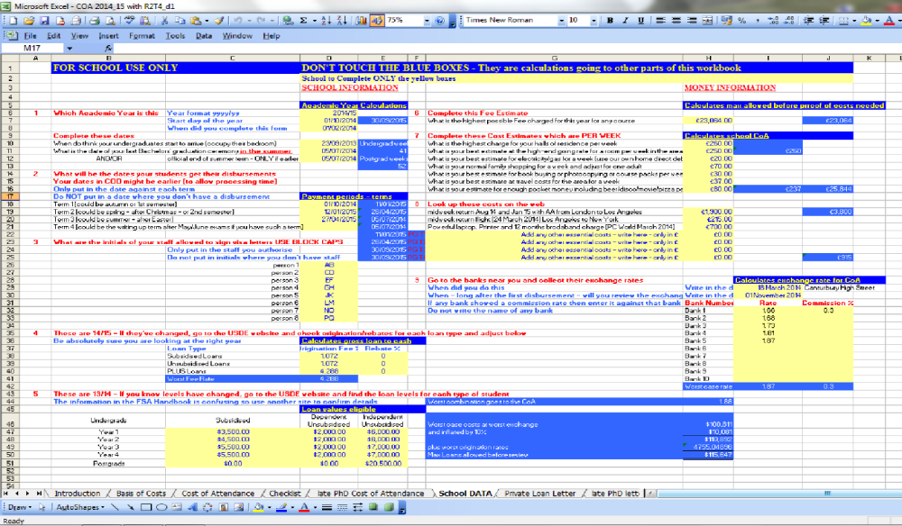
Go to the “school data” tab and complete the yellow boxes only in sections

- 1 define your school’s year for UGs and PGs
- 2 define your school terms/semesters
- 3 initials of authorised staff
- 6 highest tuition fee
- 7 weekly costs of living
- 8 be happy or adjust the values I have set
- The other costs are done for 15/16
- The bank data is already done for 15/16 – you might not like the exchange rate and may chose to simply change it.
- The loan values are already done for 15/16
- The origination/rebate rates are already done for 15/16
- Put any other info collected on the spreadsheet
- Protect the page WARNING – use a password you won’t forget
Want School data kept secret?
Some schools don’t want students to see the “school data” page, if this is you, then …
- Highlight the columns B to L
- Click right mouse
- Click hide
- Protect the page WARNING – use a password you won’t forget

Publish to school web pages along with instructions for application
The CoA is in sections
- Student personal information – will be used as the address label
- Course/year info – calculates loan entitlement
- Weekly costs – suggested school values which students may alter
- Annual charges - suggested school values which students may alter
- Requested CoA in US Format in US Dollars
- Student loan entitlement towards their CoA
- Entitlement increased up to take loan fees into account
- Student request
- School statement
There is also a late start PhD sheet with alterations specific to any late starters
- Because people asked for it
- Calculates values based on the number of weeks planned to be in attendance
- Can also be used for people returning after a break
- Sets the disbursement dates, adjusting for actual start date by using normal dates where possible, and including the term mid-point for Easter starters.
- Has its own visa letter
Passwords
- This whole workbook is unprotected so you can instantly start using it
- Nothing is currently protected. You should protect each sheet separately
- When protected, only the yellow cells with blue writing will remain unlocked
- This will lock all cells except the yellow cells with blue writing for filling in by the student
- You need an easy password you can easily remember like “yanks”

Student Checklist
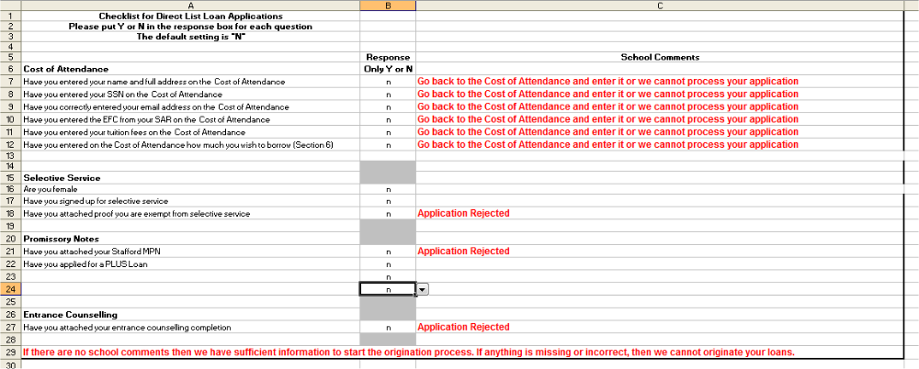
A tab of the spreadsheet which students should use as a check they have completed everything for their loan application.
The aim of the checklist is to re-inforce to the applicant, just like the application flowchart, that if they think they can skip something their application will fail.
Again, if the student has supplied everything you need, you can complete the whole checking and input within a minute or two, if not, you will waste many hours spread over many days looking up different systems for stuff which probably isn’t there because the applicant hasn’t done it, then chasing the applicant for each item they need to do

CoA spreadsheet - technical info
This section is only of interest if you have a good understanding of XL formulae including “iif” [“iif” is used in sql, but “=if” is used in XL as in (=if (if, then,else)) statements.
School Data tab
An easier format to give to school unfamiliar with handling the formulae in the hidden columns in the CoA and the PhD-late-start CoA.
- annual dates feed to CoA sheet; end of final term and year feed to CoA, Visa and R2T4 calculations
- disburse dates feed to COA and visa and R2T4 sheets
- staff initials feed to visa letter
- origination fees feed the calculations used in the CoA to reduce the loans to their cash value and also to calculate the fee which needs to be grossed back into the PLUS loan including the fee for the plus loan
- max loan limits feed the CoA sheet
- the highest known tuition fee is used within the same sheet in the J column to create a worst possible CoA
- feed the CoA sheet
- ditto
- calculates a worst case exchange rate by taking the worst rate from those offered, gross it by the worst commission fee noted and that combination inflated again by 10%
blue section below 9 uses column J to compile a worst case CoA applied to a worst case tuition fee converted to dollars using a worst case FX rate and inflated again by 10% to give the max allowable loan [not showing on the CoA] above which the warning messages are triggered in the CoA and checklist sheets
CoA Sheet -
Is this course for BSc or BA or BLL? Only answer Y or N | y
Are you taking a profesional course but at undergraduate level? Only answer Y or N | N
Do not adjust this line | Y
What will be your year of study only answer one of 1 2 3 | 1

When the student enters whether they are undergrad or not, their year and their dependency, it triggers movements in hidden tables covering the loan values available, the number of weeks of weekly costs, and the end date of the year.
The hidden tables are between columns F and Q, and the data in the cells is printed white on white, son that when the page is locked, applicants can’t access the formulae to corrupt them.
Hidden columns
In both the CoA and thre late PhD CoA, columns G-P are hidden; the calculations in those columns are printed white on white.
The purpose of the hidden columns is to keep all the formulae off the main viewable section so students cannot adjust the formulae or corrupt the spreadsheet.
To see the data
- Highlight columns F-Q
- Then click on a decent text colour
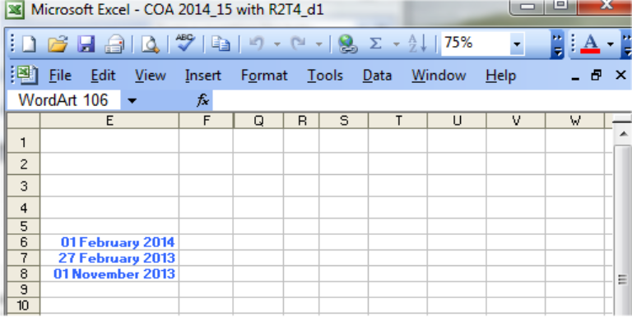
- Then right mouse in F:Q and “unhide”

Here’s the overall look
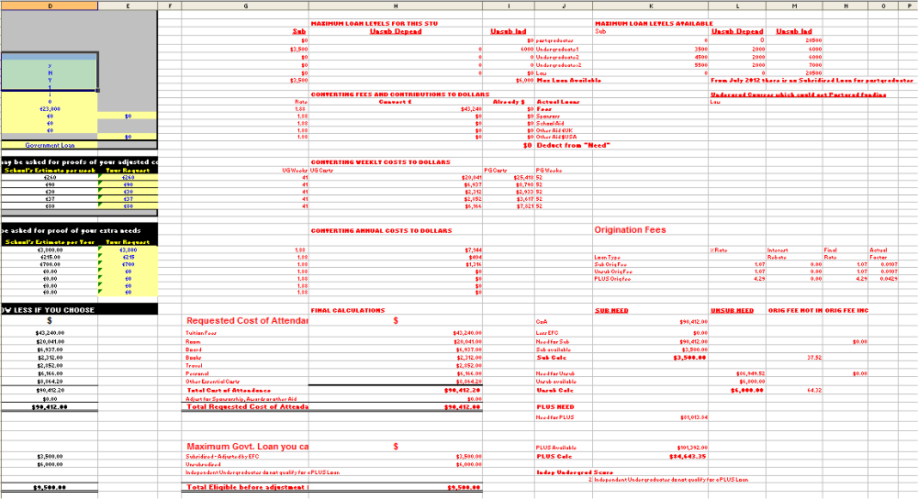
main data calculations of dates and disbursements
max loans allowed and copying them into max avail for this student
Converting to dollars for $CoA
Calculate the actual loans, and the fees deducted to add the fees back into the PLUS loan so the cash value for the students equals the CoA
Top art of this table is to ensure that he correct terms (drop boxes) are used to match the values used all over the rest of the spreadsheet. Bottom part selects the course length and the end dates for the visa letter based on whther stu answers Y or N to whether their course is undergrad
 | Depend | Choice | Year
 | I | N | 1
 | D | Y | 2
 |  |  | 3 or above
 | Private Loan | STANDING DATA | Loan Dates
 | Government Loan | Undergrads | Start | 01-Oct-14
 |  |  | End | 05-Jul-14
 |  | Postgrads | Start | 01-Oct-14
 |  |  | End | 30-Sep-15

The table beside it breaks the disbursements from the final total into instalments for the visa letter. The dates are fed from the school data tab. The divisor is the count of dates, and formats empty cells from School Data tab to count as null and not as zero.
 | ONLY ENTER DATES
DISBURSEMENTS | Disburse Dates | VALUES ARE AUTOMATIC
3 | 01/10/2014 | $18,779.67
put 2nd date | 12/01/2015 | $18,779.67
put 3rd date or blank | 28/04/2015 | $18,779.67
put 4th date or blank
When the student inserts their year of study, the next tables are adjusted. Max loan value combinations are fed from School data tab. Values move from the right to left columns based on a full set of combination variables such as this where undergard=Y and depend=D and yr=1 returns the max as in this formula from cell H24 …
=IF((AND(D26="Y",D30="D",D29=1)),L24,0)
 | MAXIMUM LOAN FOR THIS STU |  |  | MAXIMUM LOAN LEVELS AVAILABLE
Sub | Unsub Depend | Unsub Ind |  | Sub | Unsub Depend | Unsub Ind
$0 |  | $20,500 | postgraduates | 0 | 0 | 20500
$0 | 0 | 0 | Undergraduate1 | 3500 | 2000 | 6000
$0 | 0 | 0 | Undergraduate2 | 4500 | 2000 | 6000
$0 | 0 | 0 | Undergraduate>2 | 5500 | 2000 | 7000
$0 | 0 | $0 | Law | 0 | 0 | 20500
$0 |  | $20,500 | Max Loan Available
The max available bottom line is the max of each column copied from right to left columns

This table reduces the tuition on the CoA by the value of any other funding an converts everything to $US
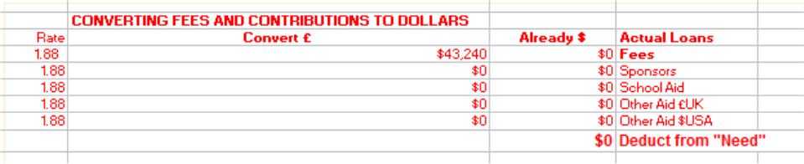
Below it the next two tables converts the other annual and weekly costs into $US.
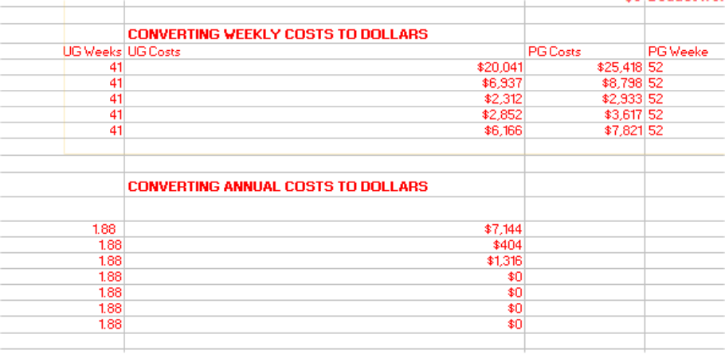
All the above table feed into the table below. Whther the 52 weeks or the 41 (UG) weeks is decided by either Y or N based on the Y or N to is your course BA/BSc
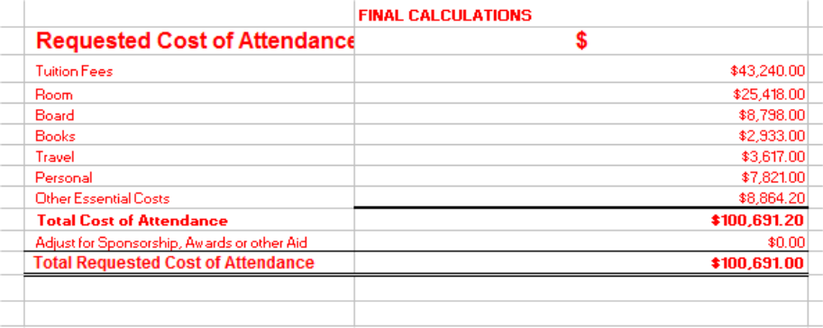
The formula used in all cases is if BA/BSc answer is N use the PG figures otherwise use the UG figures. Actual formula is =ROUND((IF(D26="N",I41,H41)),0)

There are then two final tables, one which calculates how much of each type of loan the student can have based on their “need” and calculate the fee associated with that loan, then carry forward the remaining “need” plus the fee from the first (sub) loan to perform the same again on the unsub and plus loan.
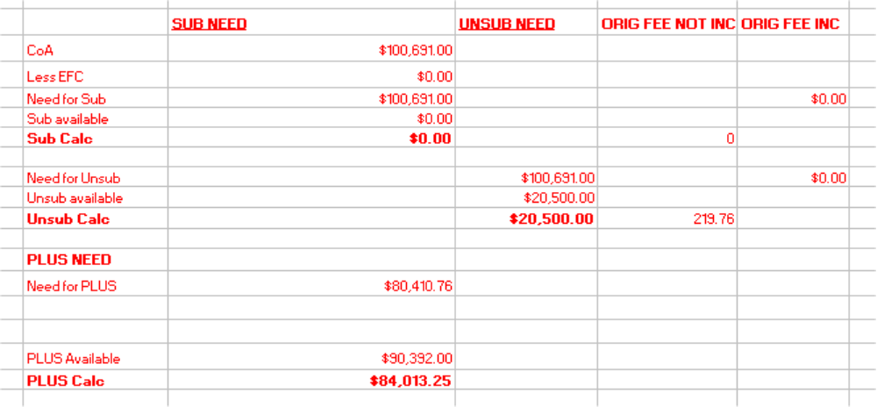
Note the “need” values being carried on down and the origination fees being added back into the need. The final step of the PLUS calc is to gross the PLUS up to include its own fees.
These final loan values, their fees and their cash values go to the final table
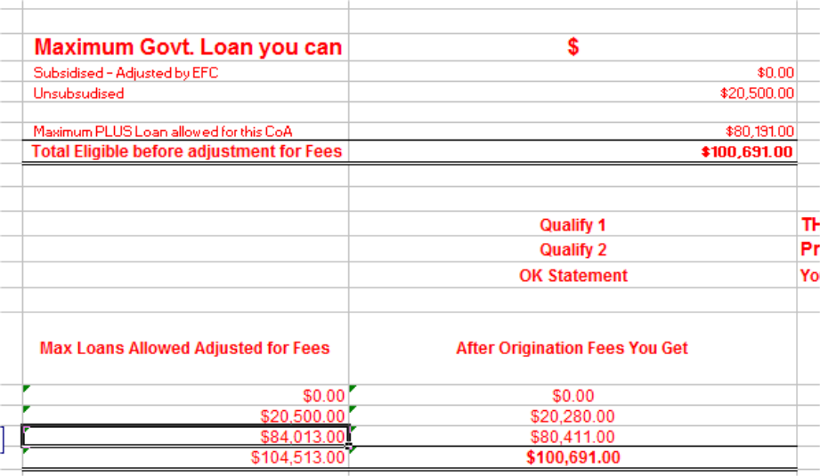
Which feeds the main viewable part of the sheet.
Re-hide the columns and protect the sheet.
Highlight columns G to P and click on the text colour and set to white, then right mouse in the highlighted columns and click “hide”
When the sheet is protected, the students cannot get to the hidden columns or see anything in the cells.

CoA and Dependents
Federal Regulations are that Educational loans are purely for the education of the student and may only be extended to cover dependent children for any costs directly related to the course. That is, the dependent child(ren) present in this country with the student for the duration of their course.
A partner/spouse may not come into the CoA but much of their costs could be covered by other means
Child costs may cover
- Nursery education
- Childcare to cover the time between child school start/end and student classes start/end
- Housing, clothing, food, medical care
- Spouse/Partner, if coming to this country, are responsible for themselves and may not be a cost to the student.
The partner could be broadly accommodated within these costs for student and child(ren) but must NOT be costed into the CoA as the partner
My advice is
RENT:
Bedrooms, one for adult, plus one for each gender of child(ren) allow a max of 2 children per room, such that dad and 2 boys would be 2 bedrooms, dad and 3 boys would be 3 rooms, dad and 1 boy + 1 girl would be 3 rooms.
If parent bedroom happens to be big enough to sleep 2 people, then I don’t question it. Check the 'going' rent for renting a room/bedsit on www.loot.co.uk for the area where the student says they are living.
BOARD:
Similarly food etc is only allowable for the student and dependent child(ren). My estimates are based on my weekly shopping bills averaged over a month, divided by 2 as I shop for a family of 3 adults, and rounded up to the nearest £10.
Allow 50% extra per child.
If shopping and cooking is done well, and this provides sufficient food for another adult, then that just happens to be handy for the spouse.
PERSONAL:
is based on my pocket money for a week excluding luxuries but including two nights in the pub which would probably make 4 nights in a student bar.
Allow another 30% per child for similar expenses. If this happens to provide enough cash to support the spouse, then that’s handy but not deliberate.
TRAVEL: based on the cost of a travelcard valid for all public transport for 2 Inner London 'zones'.
Allow the same for each child at the cost of a travelcard. Someone may have to accompany the child(ren) to/from school - read the ‘childcare’ bit.
BOOKS:
based on the cost of a 'course pack' every week, not just term weeks. Nothing different or extra, unless the school has ‘requirements’ for the children – which comes under ‘childcare’
OTHER:
- FLIGHTS:
- allow two return flights from LA, for parent and per child, and extend if required to include essential fieldwork (listed to prove necessity with costs) and any compulsory conferences.
- medical expenses.
- CHILDCARE: allow for
- Government/Council [low cost or free] must be the first choice – not private education.
- Supervision between school hours and student class hours, including supervisor’s transport fares taking children to/from school/creche
- Creche costs for each child below school age
- Full childcare for any child not able to go to crèche/school
- A spouse/partner could be paid by the student to fulfill these roles if required
- Any requirements of the school.
- CHILD CLOTHES
- School uniforms, and reasonable replenishes for growth
- Ditto casual wear

This gives some idea of the spare capacity can be built into the Cost of Attendance .
The ‘carer’ costs should show, but under no circumstances must any indication of ‘spouse’ show.
The childcare costs should also be reasonable for the place and number of children - check local websites for an indication of what the ‘going’ rates are.

CoA Change after 1st Disbursement
Read this through before attempting anything – you first need to understand the concepts by following through the simple examples – then you can attempt the real thing.
There are several reasons to increase or decrease the loan money which the student needs
- Tuition reduction
- Re-assessed as a home student
- Another award received
- Such as scholarship or research grant
- Change in living cost circumstances
- Pregnancy
- Rent increase
- Medication/physiotherapy following an accident
- Student doesn’t need that much any more
- Received an inheritance
- Parental salary bonus better than expected
- Student originally borrowed less than full CoA but now needs more
- Parental salary bonus worse than expected
- Sale of property/land – to be used to fund studies – hasn’t sold. This is common for students coming from farming states where parents have an asset to sell which they don’t need such as an unfarmed field, or fishing/water rights to a creek on their land

Calculate what needs to change – new CoA & compare
The process is the same whether the change requires an increase or decrease in the amount of loan money needed.
- calculate a full new CoA
- on the old CoA in the student loan folder write in a bright colour (ideally red) the word “old” and today’s date
- on the new CoA in the student loan folder write in a bright colour (ideally red) the word “new” and today’s date. This might seem stupid but believe me, months later when you’re sitting with the auditor, you will wish you had done it.
- compare new to old CoA to work out what has to change; write it down
- If it’s an increase, go straight to the Idiot Guide on increasing a loan and follow those instructions – remember adjust the award first then the disbursements
- If it’s a decrease, it can be messy so write it down - here’s a simple table to demonstrate reduction – always start with the PLUS loan
Loan | Old CoA | New CoA | Hope to reduce by | Undisbursed left to reduce | Real change value
Plus | 60,000 | 51,000 | -9000 | 40,000 | - 9,000
Unsub | 2,000 | 2,000 | 0 | 2,666 | 0
Sub | 5,500 | 5,500 | 0 | 3,666 | 0
Total | 67,500 | 58,500 |  |  | - 9,000
There could be more than one loan to adjust, so, for each loan which has to be changed, you have to work out the precise adjustment.
- REMEMBER – the value already disbursed will not be changed
- You can only reduce the value left to disburse
- Work out what’s left to disburse
- If there’s not enough left to reduce by the value you hoped, then anything further has to come off the next loan down
- work out what has to change; write it down so you can see what you’re going to do
- here’s a simple table to demonstrate
Loan | Old CoA | New CoA | Hope to reduce by | Undisbursed left to reduce | Real change value | Notes
Plus | 60,000 | 19,000 | 41,000 | 40,000 | -40,000 | 1,000 short to reduce
Unsub | 2,000 | 1,000 | 1,000 | 2,666 | -2,000 | Actual reduction includes 1,000 left from plus loan
Sub | 5,500 | 5,500 | 0 | 3,666 | 0
Total | 67,500 | 25,500 |  |  | -42,000

Then use the Adjust a loan section of the idiot guide.
Remember that to decrease, you have to decrease the disbursements first before adjusting the award value.

