Somerset Community Banking Study
An appraisal of existing services and options for the future

Niall Alexander
10/10/2009

Contents

1.0 | Background | Page 3
2.0 | Summary | Page 5
3.0 | The current context | Page 8
4.0 | The impact of the recession and credit crunch in Somerset | Page 11
5.0 | Debt advice in Somerset | Page 24
6.0 | The role of social landlords in Somerset | Page 33
7.0 | Home collected credit in Somerset | Page 40
8.0 | Credit unions in Somerset | Page 45
9.0 | A new credit provider and the role of other partners | Page 58
10.0 | Somerset focus group and the impact on health | Page 64
11.0 | Alternative models | Page 66
12.0 | Options appraisal: Do a little, do more, do a lot! | Page 75

1.0 Background
This report was commissioned by the Somerset Community Banking Steering Group to “review in general terms the possible demand for community banking and related services, the current capacity of the sector in Somerset and how possible partners may contribute to the future development of services.” Specifically the brief asked for:
- A survey of users and potential users of community banking services – e.g. clients / customers of current providers – to establish need from the perspective of user rather than supplier.
- A clearer locality based map of current service provision in the county, broken down by district areas and by the four types of organisation identified above. This mapping should be achieved by direct contact rather than purely desk research.
- A sensitive consultation with credit union volunteers and potential credit union local support agencies to identify an acceptable support and development programme to enable credit unions to be able to participate in a wider financial inclusion strategy.
- An options appraisal which sets out practical ways forward to achieve the objective of financial inclusion in the county through a community banking or related approach. These options should be based on maximising existing capacity, and on a recognition of the likely limitation of availability of public and charitable foundation finance in the immediate and medium term future.
Over a 12 week period:
- 22 organisations were visited;
- 41 people were interviewed face-to-face;
- two focus groups, with 10 participants, were conducted;
- two roundtable meetings (with 15 attendees) were held with representatives of the four credit unions; and
- three meetings of the steering group were attended where presentations on progress were given, and further discussion ensued or direction given on the next part of the study.

The following organisations were interviewed:
- Somerset County Council (4)
- NHS Somerset (1)
- Somerset Community Foundation (1)
- Somerset Voluntary Sector Network (1)
- Sedgemoor District Council (1)
- Mendip District Council (1)
- Homes In Sedgemoor (3)
- Magna West Somerset Housing Association (1)
- Mendip Housing Association (1)
- Yarlington Housing Group (2)
- Mendip Credit Union (3)
- Moorvale Credit Union (3)
- Camelot Credit Union (3)
- Sedgemoor Savers Credit Union (4)
- DWP Financial Inclusion Champions (2)
- Sedgemoor CAB (1)
- Taunton CAB (3)
- South Somerset CAB (1)
- Mendip CAB (1)
- West Somerset Advice Bureau (1)
- Wessex Re-Investment Trust (2)
- JobCentre Plus (1)
2.0 Summary
The report covers the impact on Somerset of the current recession and ongoing credit crunch, the rising numbers of Job Seekers Allowance (JSA) claimants, up 137% in two years, and the likelihood of increased demands on already busy debt advice services. The report describes the impact of debt in terms of its attrition on an individual’s physical and mental health and details the amounts and locations of affordable credit within Somerset, plotting the loans made by Somerset’s four credit unions by both number and volume and, for the first time, assessing the impact of the credit union loans within the most disadvantaged neighbourhoods, where demand for affordable credit is likely to be highest.
Around ten credit union loans are written every week across Somerset between the four current providers, half of these are in Somerset’s most disadvantaged postcodes. This is insufficient to meet the affordable credit demands of significant numbers of people in Somerset and even the possible injection of loan capital from housing associations will still be insufficient when set against the estimates of the number of higher-cost home collected credit (HCC) customers at 20,000 people.
Focus group participants, all of whom were renters, on low-incomes, helped shape the options appraisal, through their candidness on debts, credit, insurance, access to and opinion on services and their assessment on their needs including pricing and travel-time to access services. The report puts forward fifteen options on a way forward for the steering group. Mindful of the restrictions on funding highlighted in the brief, these suggestions can be characterized as “do a little” which will be immediate work often at low or no cost through “do more” to “do a lot” which has the greatest draw on potentially limited or scarce resources. The imminent budgetary cuts and restrictions over the coming years will make the demand for resources increasingly challenging.
The broad assessment is that those initiatives delivering a Somerset-wide service will be the most likely to succeed. The funding environment will make it difficult to achieve all of the options, although some are likely to be deliverable at a low cost:

Do a little  (short term) | Do more  (medium term) | Do a lot  (longer term)
Sector connector events | Utilise leverage with High Street Banks to develop trusted partner status | Seek DWP Growth Fund capital to deliver more affordable credit in Somerset
Bulbs, Benefits, Banking & Business events

Promote NDL on all correspondence | Investigate philanthropy capital alongside Housing Association loan guarantees | Open 1, 2 or 3 CDFIs offering affordable credit (priced for risk) in Taunton, Bridgwater and / or Yeovil, either by franchising from existing successful CDFI or by replication. Backed by DWP, Somerset Community Foundation, Housing Associations, Local Authorities with embedded CAB staff, linked savings to Somerset’s credit unions and trusted partner bank accounts, linked micro business lending to WRT.
Volunteer recruitment campaign | Somerset wide HCI product & promotion
Housing Association annual survey (baseline) | Utilise HA and CAB outlets as Credit Union collection points
“Credit Cruncher” packs | Develop a “safe & Sound in Somerset” marketing campaign
Fund a central Credit Union resource | Seek funding to develop Gateway triage
The thrust of the report, the direction of travel, for the local authorities, housing associations, debt advice agencies, credit unions and other newly gained partners is to work more co-operatively, to overcome mutual misunderstandings and to ensure that the “perfect does not get in the way of the good” to achieve a more concentrated, and inter-connected delivery of service of affordable credit, debt advice, bank accounts and access to savings than is currently the case across Somerset.
The recommendations will need leadership and will to drive them forward. Housing associations, advice agencies and credit unions were clear that they are prepared to engage in the process, but their own pressures and workloads meant they were unlikely to be the principal drivers of any developments. Somerset County Council will probably be facing the challenge to “do more with less” in the coming months, and despite their county-wide responsibility may not be in the best position to lead the developments. Other potential roles might be taken forward by NHS Somerset and Somerset Community Foundation although they too have workplans and challenges that might limit their abilities to lead the process. It is really an essential pre-requisite that the currently configured Steering Group establishes who will lead the initiative both within the steering group itself and within its component parts.
At a meeting of the Somerset Community Banking Steering group held to discuss the draft report in October 2009 the following four underlying principles were agreed as the basis for taking forward the report:
- The group were keen that any services and activities should be Somerset wide.
- The group agreed that although access to cheaper loans was an important element in tackling financial exclusion, any activities should also find ways of supporting greater access to bank accounts, access to savings schemes and access to financial education.
- The group agreed that any activities should be as sustainable as possible (i.e. have the minimum level of public subsidy) and should try and more towards greater sustainability over the next 3/5 years. This has clear implications for the customer groups that might be targeted, levels of interest charged and bad debt rates.
- Finally, the group agreed that as far as possible, services and activities should be built on existing organisations in the County, but that this would not preclude working with outside organisations who could add value by bringing in expertise.

3.0 The current context
The banking system has just been through its worst crisis since the Second World War, the global recession that has accompanied it has seen plunging house prices, a freezing of credit as banks hoard cash to repair their balance sheets, massive quantitative easing, the lowest interest rates on record, rising unemployment, and an agreement amongst all commentators, now accepted by politicians, that hard choices and a reining in of public spending will follow from 2010 as the UK taxpayer will need to foot the bill for the bail out of the UK’s financial institutions.
The estimated losses as a result of the subprime crisis have risen from around the $100bn originally forecast in August 2007 to $1000bn (or $1trillion) forecast by the IMF on 9th April 2008, to $4.1trillion their revised forecast just over a year later. The current crisis is different from previous ones according to George Magnus, Senior Economic advisor at UBS Bank who presciently told the Financial Times in February 2008 that “I think this is different: a) because it’s big; b) because it’s widespread; and c) because it is about solvencies, not just about liquidity. And solvency requires a totally different policy approach than just a liquidity problem”.
A number of economists like Nouriel Roubini, and other commentators had predicted the catastrophe both in the UK and worldwide. In March 2005 the Griffiths Commission on personal Debt stated:
“At the end of the day there are two sharply differing views of the likely consequences of the present scale of consumer borrowing.
One is that the trillion pounds of consumer debt is a time bomb ticking away. At some date an explosion will occur – a collapse in house prices, higher interest rates, recession in the economy, growing unemployment, debtors unable to pay off their loans, repossessions and increasing insolvencies.
The other view is more sanguine and represented by the Bank of England and the Government…The Commission believes that the Bank of England is too sanguine in its outlook. Debt is a time bomb which could be triggered by any number of shocks to the economy at any time.”
The epicentre of the shock that ignited the time bomb may have been the US subprime mortgage sector but the contagion has spread to other sectors such as commercial property, consumer credit and commercial loans. The International Monetary Fund (IMF) wrote that there had been a "collective failure" to understand the dangerous levels of debt built up in the financial system with increased risks of financial instability forcing them to further tighten credit.
"It is now clear that the current turmoil is more than simply a liquidity event, reflecting deep-seated balance sheet fragilities and weak capital bases, which means its effects are likely to be broader, deeper and more protracted,"
Or to put it another way:
“It is interesting that the industry has invented new ways to lose money when the old ways seemed to work just fine.”
The pressure on banks had a catastrophic impact on institutions where business modeling relied on borrowing “short” from the wholesale markets to lend “long” to the mortgage markets without using deposits as the primary source of finance. Unprecedented images of a “run” on a UK bank were transmitted around the world in September 2007 when around 8% or £2bn was withdrawn over the counters as queues snaked around street corners with hundreds of people withdrawing their savings.
Estimates suggest that as much as 75% of Northern Rock’s business was built using this model. Hence, Northern Rock which had written 20% of UK mortgages in 2007 needed UK tax payer intervention to prop it up. It was nationalised in February 2008 with around £100bn added to the national debt. Confidence in many financial institutions evaporated
“Once you have a run on the bank you are in a death spiral and your assets become worthless, Banks and brokerages are a house of cards built on the confidence of clients, creditors and counterparties. If you take chunks out of that confidence, things can go awry pretty quickly. It could happen to any one of the brokers”
The global crisis reached its peak when Lehman Brothers was allowed to fail, one year after the run on Northern Rock, on September 15th 2008 filing for bankruptcy protection, the fear that subsequently spread throughout the markets caused a “who’s next” scenario. HBOS was taken over by Lloyds, Bradford & Bingley was nationalised with the savings business sold to Santander who also bought up Alliance & Leicester, and RBS was saved by the UK taxpayer. The behaviour of certain banks and bankers led to the former Chief Executives and Chairmen of HBOS and RBS “profoundly and unreservedly” apologising to the Treasury Select Committee in February 2009. Subsequently, debates on bankers remuneration and broader discussions on our use of credit and lifestyle have dominated news media.
Warren Buffett noted the behaviour of US financial institutions in his annual shareholder letter when he said “You only learn who has been swimming naked when the tide goes out – and what we are witnessing at some of our largest institutions is an ugly sight!”
The rocking of the financial system led to the perfect storm of a freeze in credit as banks hoarded cash, and the consequential impact on world economies, the President of the World Bank, not noted for exaggerated talk, said:
“I think 2009 is going to be a dangerous year. We’ve gone from financial crisis to economic crisis, now we’re in the midst of an unemployment crisis, and there is the danger that this could spread to a social, political & human crisis”
The crisis is upon us, its impact is felt across the globe, across the UK in both urban and rural settings, no-one is exempt. In Somerset, the pressures for individuals, families and communities is real through job losses, pay freezes, rising debts and repossessions, a loss of confidence both literally and figuratively, and a corresponding impact on health and prosperity.
4.0 The impact of the recession and credit crunch in Somerset
The estimated 2009 population of Somerset is 534,100 within which the number of people under 18 years old is just over 22%. This gives an adult population estimated at 418,300. The population mix is shown below:
Chart 1: Somerset population
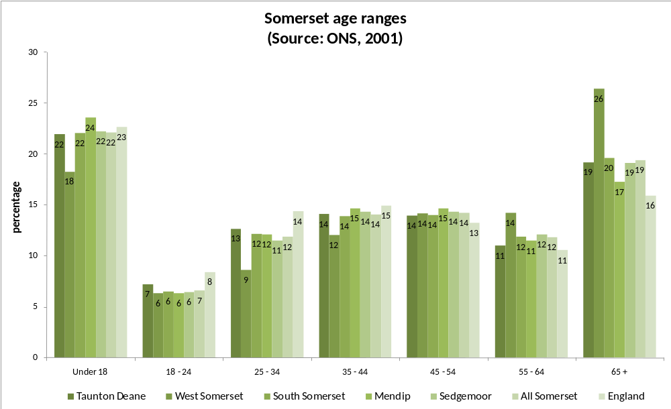
Chart 2: Somerset age profile
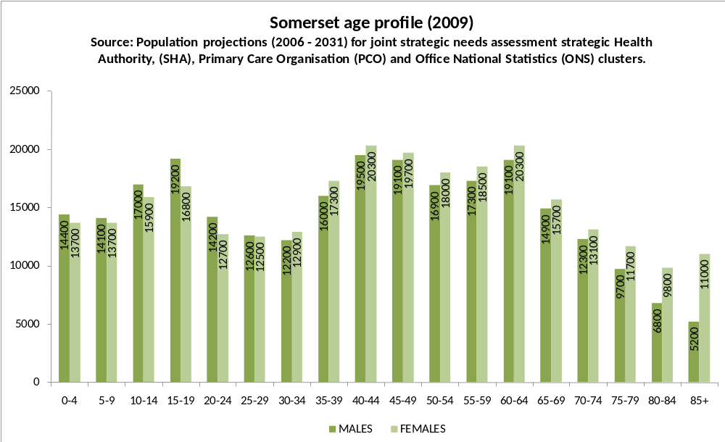
Somerset has 5% more owner-occupiers than England as a whole, and fewer people residing within social housing tenure. Social classification broadly mirrors the UK. Average earnings are below both the South West and England as a whole. Whilst pockets of poverty are noticeable in the disadvantaged wards and communities, much of it is hidden as research undertaken by Somerset Community Foundation identified 77% of all Income Support (IS) Attendance Allowance (AA) and Disability Living Allowance (DLA) benefit recipients resided outwith the urban areas of Bridgwater, Taunton and Yeovil.
Chart 3: Somerset tenure profile
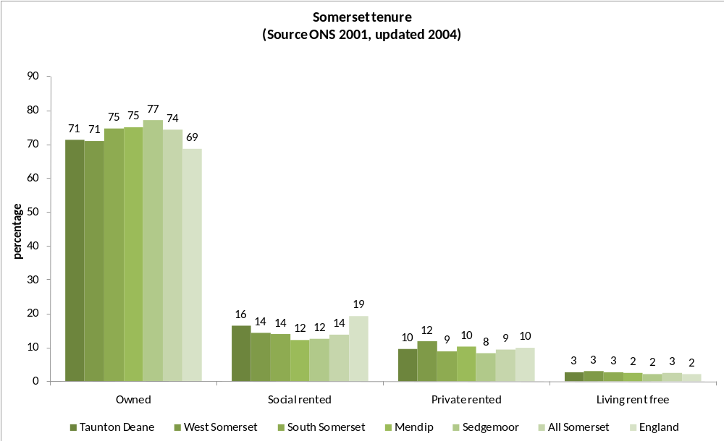
Chart 4: Somerset average earnings
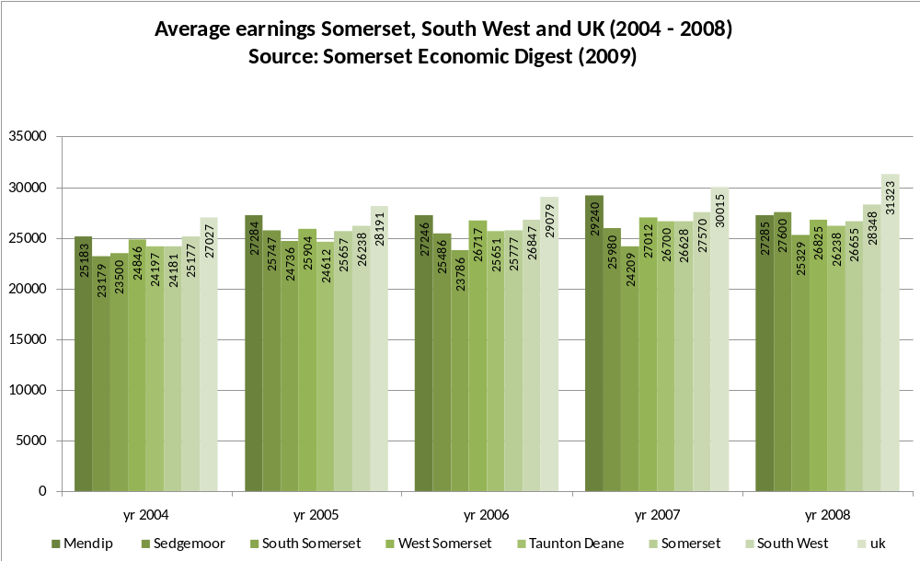

Chart 5: Somerset split of benefit claimants (urban v rural)
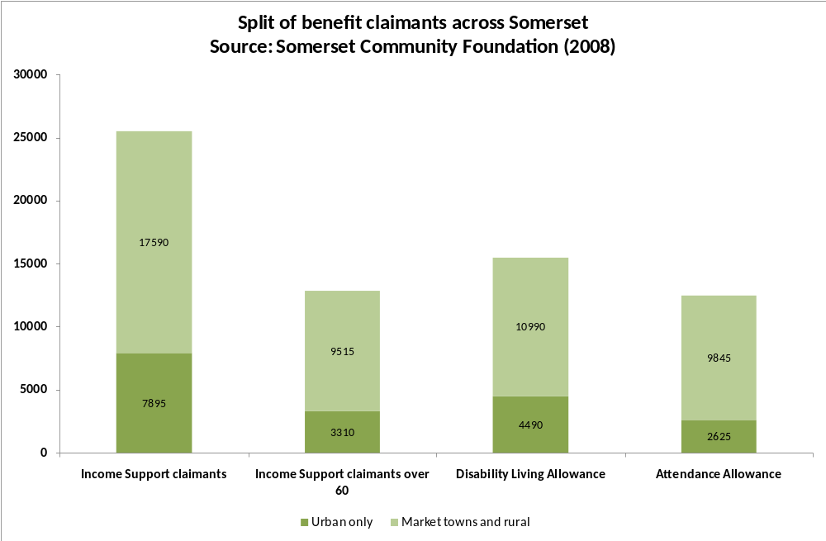
Chart 6: Somerset Social classification
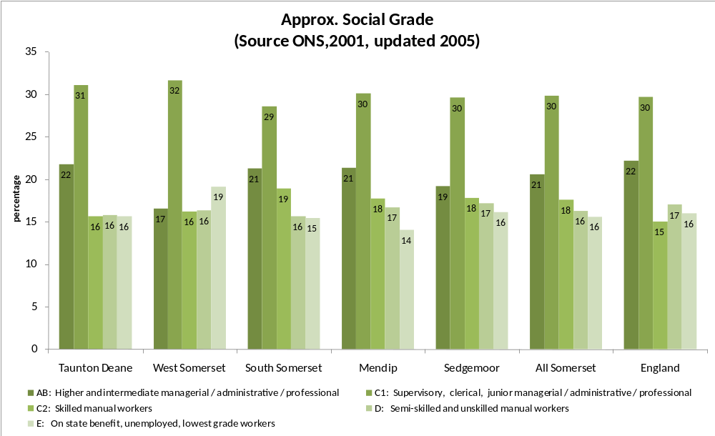

According to Somerset’s Economic Digest, 4% of Somerset features within the most disadvantaged 20% of England. About 20,000 people in 14 wards fall within the super output areas most disadvantaged 20%.
Chart 7: Somerset Lower Level Super Output areas
 | Top 20% SOAs | Total SOAs | % of population
England | 6,496 | 32,482 | 20.0%
South West | 300 | 3,226 | 9.3%
Somerset | 14 | 327 | 4,3%
Mendip | 2 | 67 | 3.0%
Sedgemoor | 5 | 68 | 7.4%
South Somerset | 3 | 103 | 2.9%
Taunton Deane | 3 | 66 | 4.5%
West Somerset | 1 | 23 | 4.3%
Nationally, unemployment reached 2.435m people in June 2009 (the highest number out of work since 1995, Professor David (Danny) Blanchflower the former MPC member and expert on unemployment has described youth unemployment as a “national disaster” and predicts “another huge jump” Somerset has not been immune to the impact of the recession, the Somerset economic recovery plan noted that “In 2008 there were 1,241 job losses from 34 companies, but only 372 jobs created in 8 companies. 67.6% of these job losses occurred during October- December 2008.”
Chart 8: UK unemployment
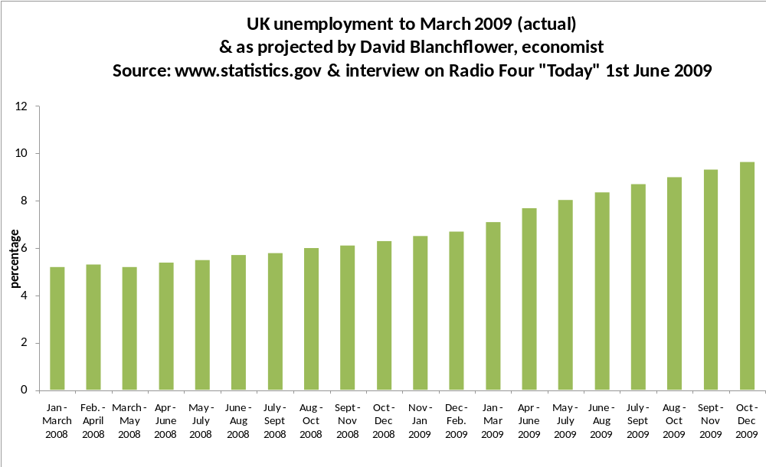
Across Somerset there has been a 137% rise in JSA numbers over the two-year period June 2007 to June 2009, alongside a 48% decrease in Jobcentre Plus vacancies. Debt advice agencies additionally recognised the impact not just from job losses but from the reduction in hours where there has still been the same travel costs to work but take home pay has been reduced. “It’s a huge problem, Hours being cut is a big problem, hours cut, but you have to keep your car, expenditure associated with the job remains the same, travel, petrol. It’s an issue in a rural area.” (CAB Manager).
Chart 9: Somerset JSA claimants
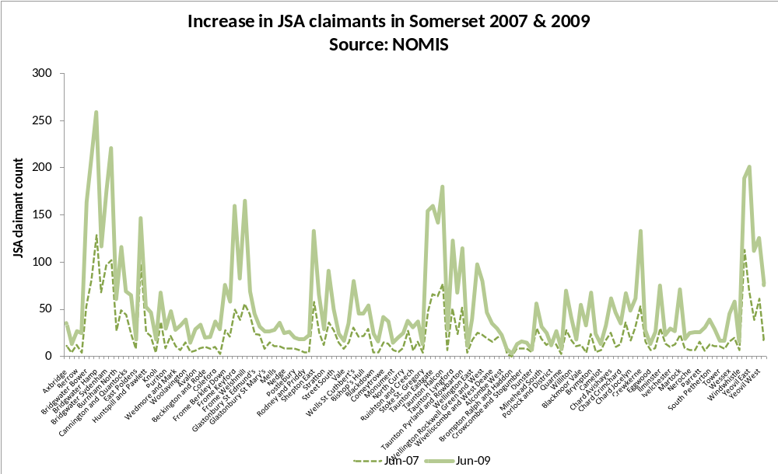
Chart 10: Somerset JSA claimants (deprived wards only)
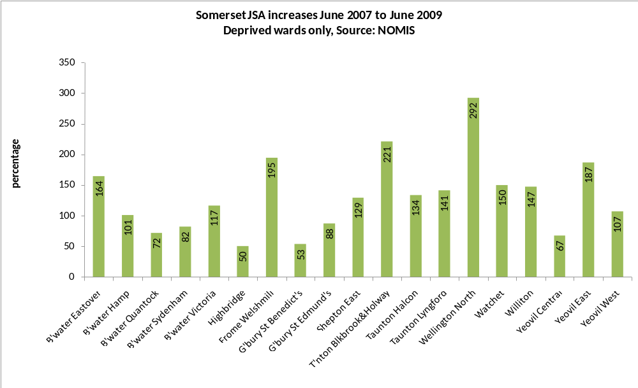

Chart 11: Somerset unfilled Job vacancies
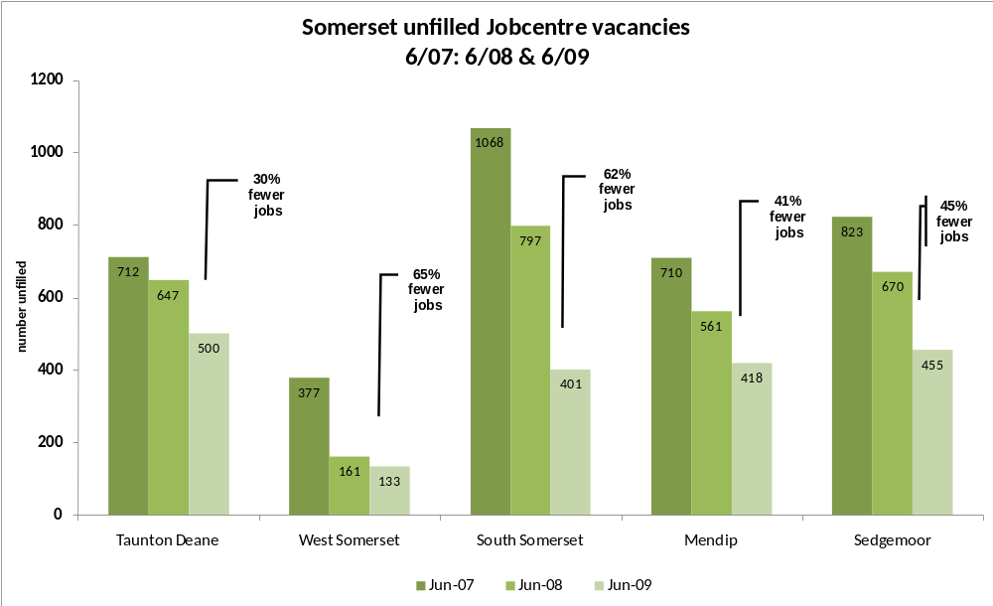
Alongside rising unemployment figures, are county court judgements, bankruptcy and repossessions. These tend to lag behind unemployment as people can be cushioned by a redundancy cheque or “get by” for a few months.
Chart 12: Somerset CCJs
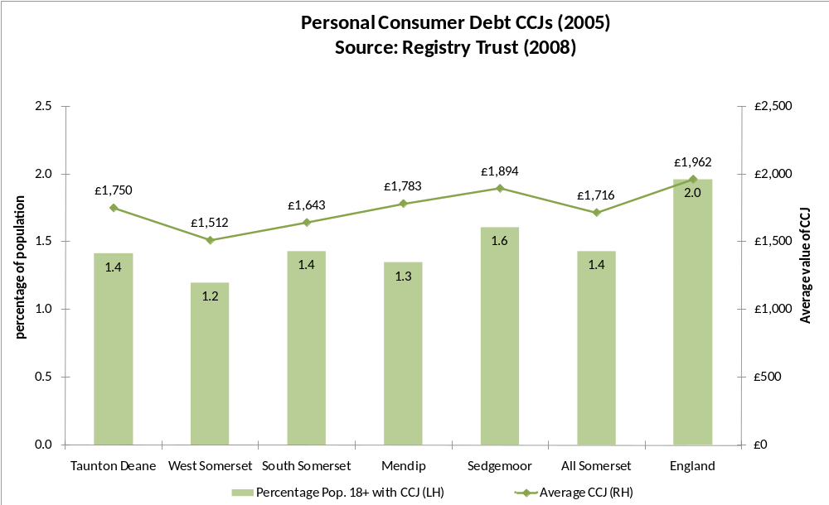
The Government’s narrative to the white paper “A Better Deal for Consumers” released by BIS in July 2009 stated starkly:
“The immediate backdrop to this narrative is the recession. An acute international financial crisis has fed into the wider economy, causing world recession. This recession affects people across the UK economy, but it may cause particular hardship for some consumers in low-income groups or those who have difficulty in managing their financial affairs.”
The report continued:
“As a result of a change in economic circumstances due to the credit crunch availability of credit has reduced. This will have an impact on both middle-income highly-geared households that may rely on the ability to refinance their obligations in order to keep up with repayments, and low-income families who have come to rely on credit on a regular basis to make up any shortfall.”
The Institute for Fiscal Studies (IFS) had little doubt who would be worst affected by the recession and credit crunch, stating in March 2009 that the current recession will hit the poorest, the oldest and those in social housing hardest as price rises on food and energy are disproportionate. For example, a reduction in bank base rate assists homeowners but has no impact on renters. Food prices which have risen by 11.3% over the past year and electricity and gas have risen 22.3% traditionally representing a bigger budget item for the poorest and the oldest.
Mortgage approvals are – despite a slight upswing in recent months – still down by 63% in May 2009 from June 2007. Secured lending, as demonstrated by the graph (below) has fallen sharply, but, there has not been anything like the same percentage drop in unsecured lending as people still use their credit cards and access unsecured loans. The market leading home-collected-credit company, Provident Financial Service (Provident) saw their profits rise, their customer numbers rise, and became the only FTSE 250 financial company to return a positive dividend for their shareholders in 2008.
Chart 13: UK Secured and unsecured lending
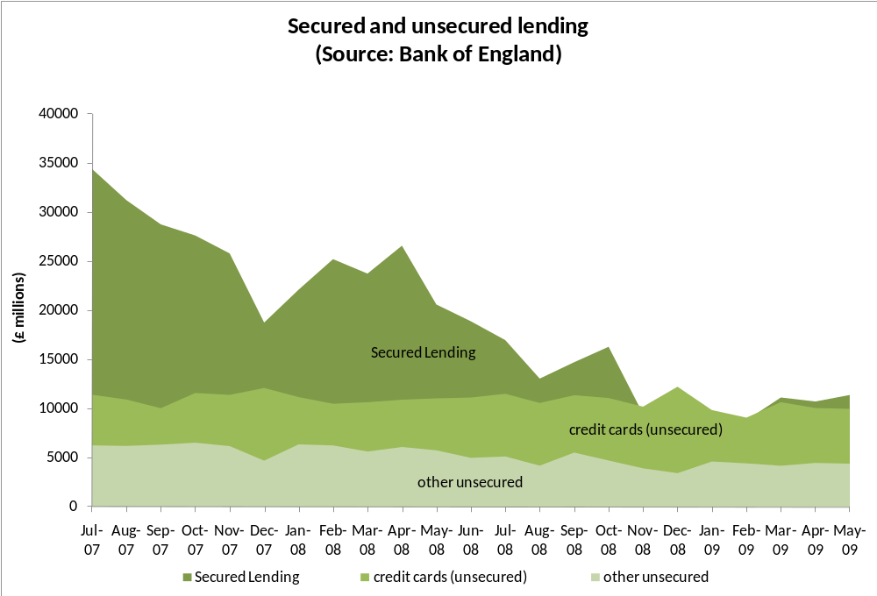
Chart 14: Unsecured lending (credit cards & non credit cards)
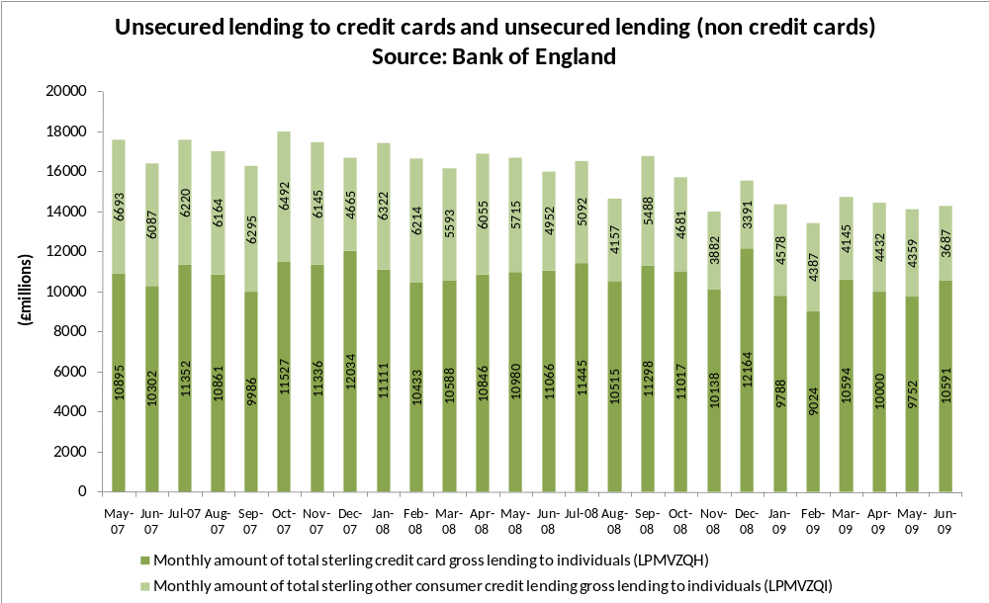

Chart 15: Summary Provident Financial 2008 results
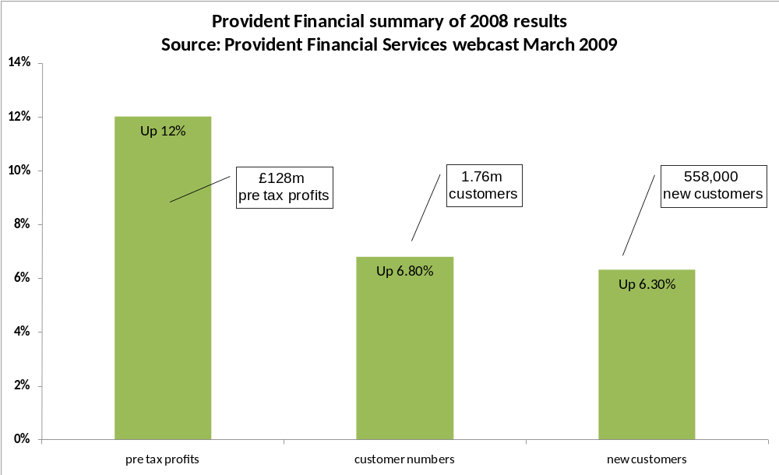
A major difference for consumers now is their inability to securitise. Before the credit crunch customers might have securitised their unsecured debts against rising house prices. This is no longer possible. Falling house prices and a rise in negative equity are part of the current storm. Statistics taken from the Somerset County Council economic recovery plan identify:
- A 23% increase between 2007 and 2008 in housing repossession orders at Taunton County Court;
- Average Somerset house price in Q4 2008 was 11% down on Q4 2007 (per BBC);
- A 2% increase in Somerset repossessions over past year;a
- Repossession order claims up 29% on previous quarter.
The ratings agency, Fitch, identified Taunton amongst the 100 cities in the worst negative equity trap in the UK with 6.9% of borrowers already in negative equity:

Chart 16: Fitch UK negative equity
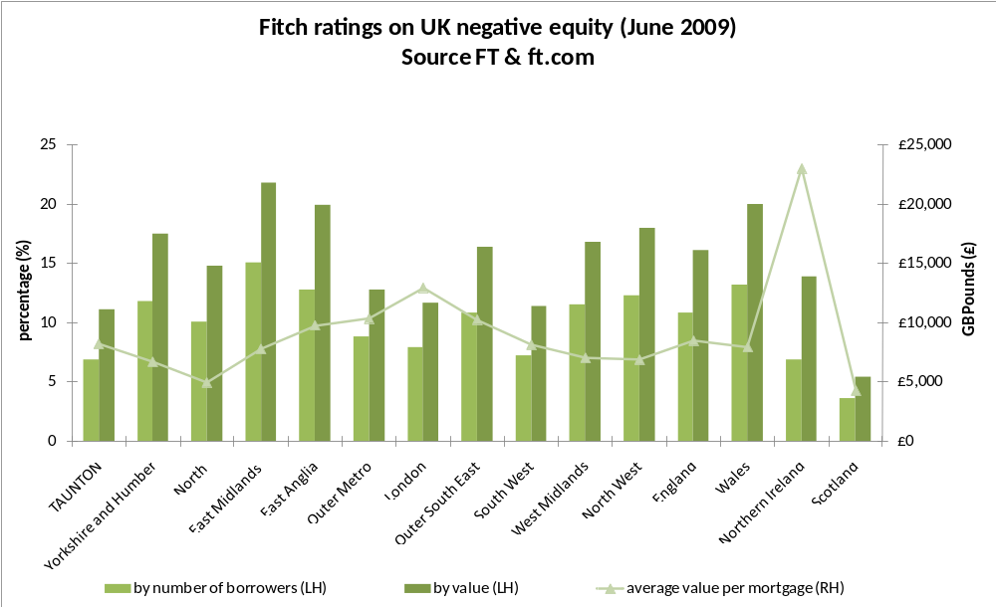
The position is pretty bleak for many individuals and families; the traditionally poor have been joined by a new poor - as unemployment, increased food and fuel bills, an inability to securitise existing debts, rising repossessions, a freezing or withdrawal of credit, more people seeking assistance and advice from front line services and more people seeking out the limited unsecured credit, at whatever price, available to them for their everyday needs makes life tougher for many families - previously unaffected. The subsequent impact on confidence and physical and mental health results in more people being diagnosed by GPs for stress, depression and anxiety.
“Health tends to get worse in a recession; the most obvious way is the effect of unemployment on health. At the extreme, it doubles the risk of suicide, depression and attempted suicide.” “Unemployment is bad for your health, It is not just that people in poor health are more likely to be unemployed, the evidence from studies looking at the closure of factories is that everybody who lost their job saw their health go down regardless of how healthy they were to start with.”
5.0 Debt Advice in Somerset
Part of the response of government to the current crisis is to seek ways to further support debt advice charities, like Citizens Advice Bureaux (CAB), National Debtline (NDL) and the Consumer Credit Counselling Service (CCCS). The economic narrative to the Government’s white paper picks up on the increase in enquiries to money advice agencies noting that CAB, NDL, and the CCCS all saw substantial rises in customer numbers in 2008 of respectively 9%, 12% and 5%. However, the picture is even worse if we go back to the beginning of the current crisis in August 2007. The following chart shows the increased number of callers to NDL increased by 191% between January 2007 and January 2009 both nationally and across Somerset where calls are higher than average.
Chart 17: Calls to NDL
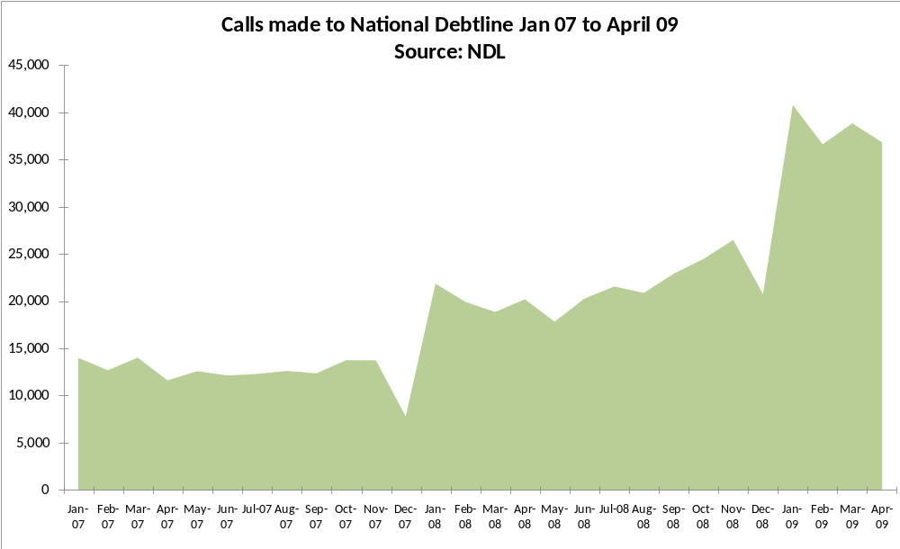

Chart 18: Calls to NDL from Somerset
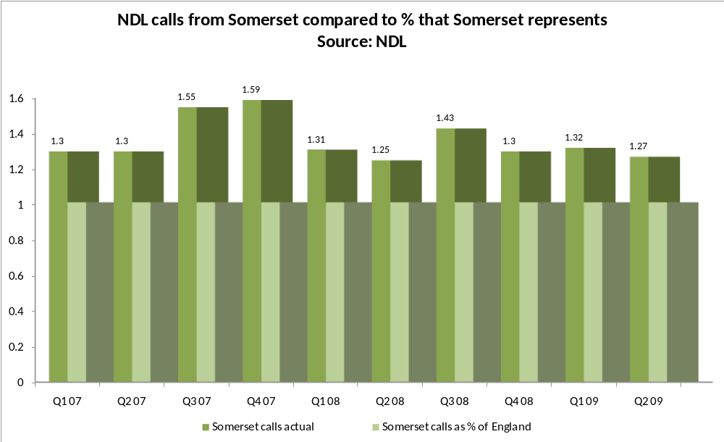
The government expects the rise in demand to continue. Across Somerset the four CAB and the independent West Somerset Advice Bureau provided statistics on their footfall and debt advice issues seen. Anecdotally, all the debt advice agencies reported that they were inundated with clients. Between Q3 and Q4 (2008/09) there was a 13% rise in clients seen by all four CAB.
Over 60,000 issues were dealt with in the financial year 2008/09, and around 26,000 of those issues were debt related. Managers reported a difference in their client’s characteristics:
”Our clients are changing; our debt clients are changing, over-indebted because they’ve lost their income, more home-owners.” (CAB Manager)
“We’ve seen better off clients since last September / October, (2008) and saw a shift in increasing numbers of unemployed clients, this is gradually having an effect on the debt work, the redundancy running out and things getting tougher” (CAB Manager)

Chart 19: Somerset debt issues 2008/09
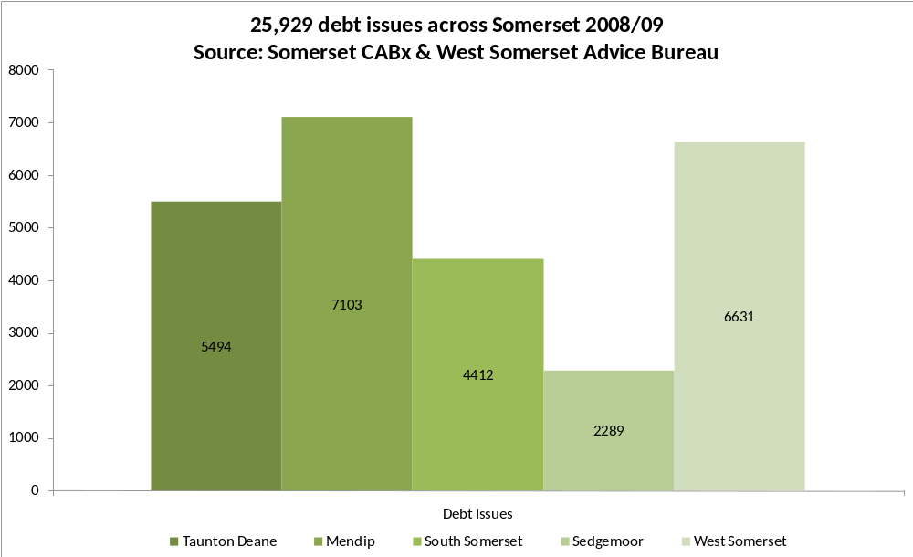
Drilling into the debt issues data the common themes remained consistent: bank & building society overdrafts, credit & store cards, and other unsecured loans. However, there has been a marked increase in debt issues under other headings. Significantly, bankruptcy, and mortgage arrears are creeping higher as a percentage of all debt issues seen.
Chart 20: Somerset top debt issues
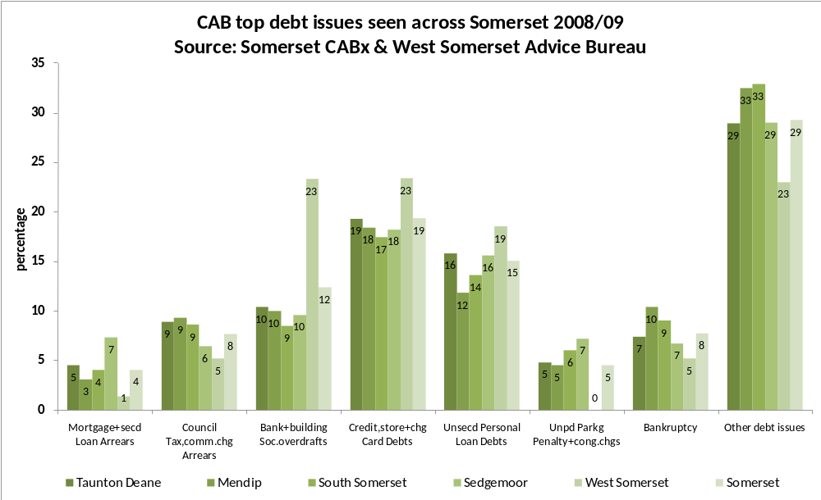
Bureau managers reported that the introduction of the “Gateway” system had been helpful in quickly identifying - through a triage service staffed by specialist advice staff - the root of the client’s debt problem. This ten-minute service allows for a quick overview to be undertaken with the client then filtered into the most appropriate staff member. Gateway does though draw away the most skilled staff to undertake the triage analysis, and they are often reluctant to do this as their preference is to deal with the case from start to finish rather than simply acting as the analyst for the case.
Additional specialist training is required to bring through additional Gateway staff, it is a rapid response service (that can be as attractive to some volunteers as it is unattractive to others) to ensure a streamlined quality of service for the client. CAB managers also reported on their hopes for the recently introduced Advice Link service involving a multiplicity of agencies to provide a better awareness and delivery of service.
Overall, and perhaps surprisingly, debt advice issues were marginally down in the second half of 2008/09 from the first half. There was no obvious pattern to the debts seen by each advice bureau.

Chart 21: Somerset increase in debt issues seen
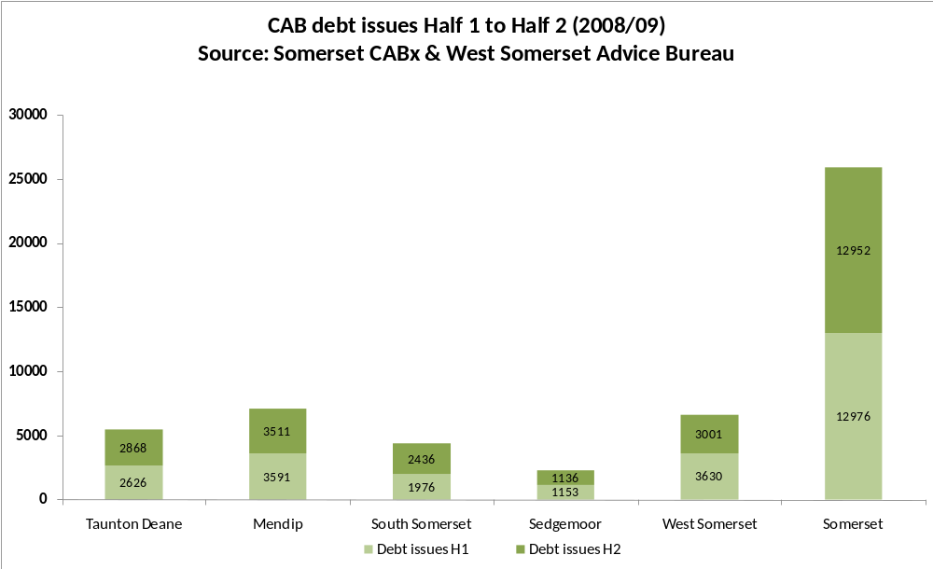
Chart 22: Somerset selective debt issues increase & decrease
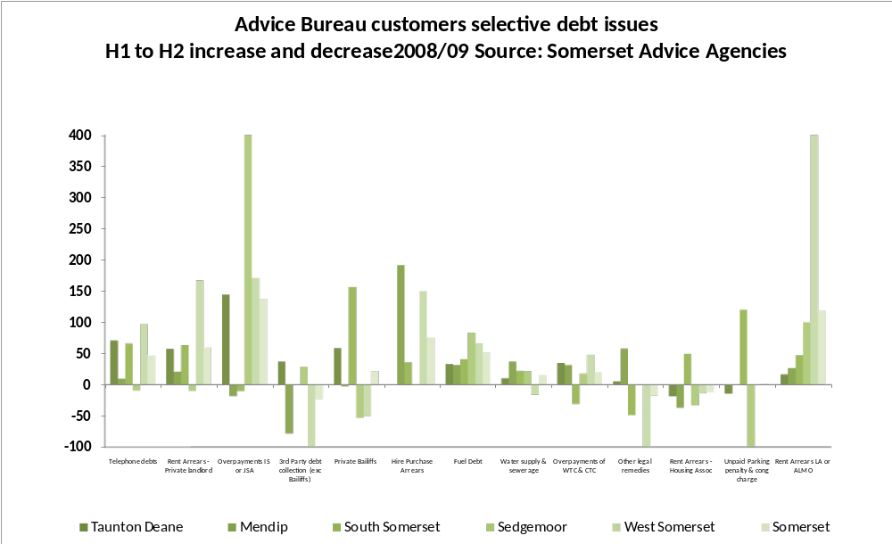
All Bureaus operate outreach services, often a half-day or day per week service. In total there are 29 potential venues to receive face-to-face advice from Somerset’s five advice organisations.
Chart 23: Somerset advice locations
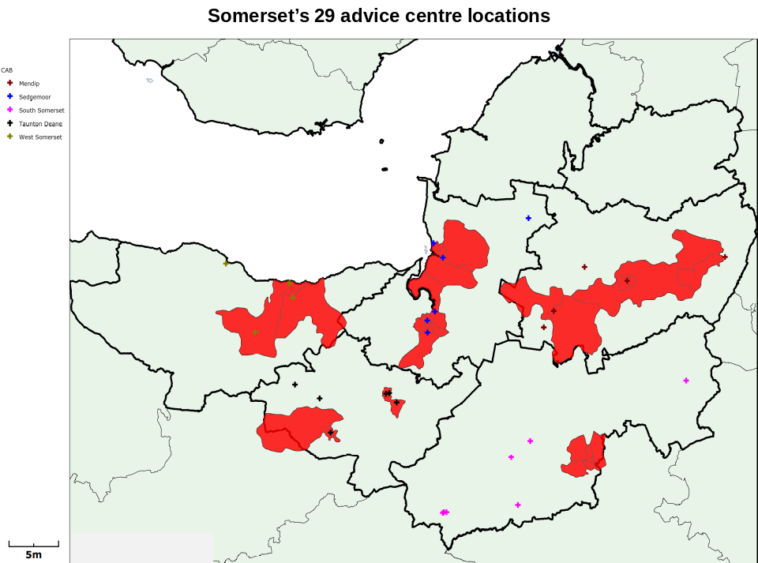

The funding of debt advice posts by Wessex Water was highlighted by a number of CAB Managers as a good example of the type of funding, with no strings attached, that they valued. So too was the funding from NHS Somerset to deliver CAB services in GPs surgeries. Often, CAB Managers spend their time devising new projects to attract short-term funds when the reality is that they simply need greater resources to support the traditional face-to-face service.
Managers recognised the value of telephone and website channels for a proportion of customers. Some already offered telephone advice. There may be further merit in promoting the free telephone helpline services offered by NDL across Somerset. Better marketing of these freephone numbers, highlighting the free, confidential, impartial nature of the service is important and for a proportion of attendees to CAB their issue may be resolved over the telephone thereby notionally freeing up space for face-to-face services.
In the focus groups undertaken during the research no-one had heard of NDL, CCCS or Payplan despite six of the ten participants acknowledging debt as an issue. Furthermore, a number of participants wrongly believed that simply visiting a CAB or telephoning a helpline would somehow adversely affect other parts of their life, either by informing some government department or preventing future abilities to secure credit or a mortgage. The only participant using a telephone helpline to discuss bankruptcy was using a fee-paying service.
When asked about their role in signposting or promoting credit unions a number of Advice Bureau managers accepted that they could do more to promote the services of their local credit union. They all recognised the value of ethical savings and loans organisations but some were concerned at the real or perceived service that their clients might receive if they approached their local credit union. This “mutual misunderstanding” of the work of credit unions was reciprocated in other agencies and within the credit unions movement about the work of other agencies:
- “We do probably underestimate what the CU can do” (CAB Manager).
- “We need some capacity building for the CU movement in Somerset” (CAB Manager)
- “I see them (Credit Unions) as the ideal solution for clients with very little money, we have all their leaflets in the waiting room, staff will quite happily suggest to people that they join the Credit Union” (CAB Manager)
- “I have concerns over equity of (Credit Union) service” (Somerset County Council official)
- “We (housing association) need to be satisfied about the Credit unions abilities” (Housing Association)
A major difficulty between credit unions and advice agencies has often been the distinction of priority and non-priority debts. This relationship has often resulted in jarring experiences where advice agencies and credit unions have sought to work together. The report into the SCU-MAP project in London where an initiative was established to join up the services of an advice bureau and a credit union failed. No-one was recommended to join the credit union from the advice bureau over the term of the SCU-MAP pilot. In a separate piece of work in Scotland where this type of relationship was also being encouraged a credit union manager said “I have a selfish head and a holistic heart, my selfish head says that someone with a debt to me needs to repay me, the holistic heart recognises their need for debt management advice but if I refer to the local CAB, their debt to me will be non-priority and I’ll be lucky to get £1 a week”
Nationally, CAB do not view credit union debt as “priority debt.” There is no likelihood of the individual losing their home or having their utility cut off, it is a non-priority debt. Locally, some CAB displayed an open-mind to a level of flexibility depending on the nature of the debt:
- “They are not a priority debt but adjustments can be made in financial statements – there is a little more flexibility in CAB approach” (CAB Manager)
Broadly, credit unions were not regarded as just another creditor. Credit unions see themselves as pathways to financial inclusion, encouraging saving and frugality and responsible borrowing, this was largely verified by CAB, and other agencies. The credit unions greatest difficulty as far as the CAB, and other organisations interviewed were concerned was a lack of consistency of service:
- “Somerset wide is the way to go (on service delivery) you have to be able to access the same services wherever you are and you cannot do that at the moment with the credit unions – it’s not a level playing field through the county” (CAB Manager);
- “I think the Credit Union is the one organisation that we could work very well with, in the same building, I think ours (the credit union) is very tired here” (CAB Manager)
The volunteer set up operated by Credit Unions in Somerset mean that service opening times or the quality of service received could not be guaranteed and this led to some of the reservations expressed about them by CAB and other agencies. CAB managers want to address debt prevention as well as debt management:
- “What we really need is to get the clients earlier – we spend so much time fire-fighting, it would be wonderful to do a lot more preventative work, financial capability work” (CAB Manager)
Advice Bureau managers were amenable to working alongside both credit unions and housing associations, many pointed out their existing relationships with both, although some scepticism was expressed toward those housing associations that employed their own debt advisors on the level of training or their level of independence.
- “I do have reservations because it is (the housing association debt advice) not independent” (CAB Manager)
- “…we have concerns about the threats of repossessions, there’s a cultural difference (in the way organisations work)” (CAB Manager)
- “they cannot be as “independent” and they cannot deal with DROs or encourage people to go bankrupt they have to hand them off to us” (CAB Manager)
- “Housing Associations cannot be impartial in (the) delivery of money and debt advice” (CAB Manager)
That said, the housing associations were also seen as playing a valued additional service alongside CAB:
- “There’s plenty (workload) to go round” (CAB Manager).
Somerset’s debt advice services, already busy, are getting busier. A wider range of the public is attending. This trend will continue. Advice Bureaus were willing to work closely with credit unions seeing them as sensible options for people to save and borrow small sums of money. The demands of the day-to-day advice work and their commitment to Advice Link and Gateway meant little time was left to develop new partnerships. There was an acknowledgment that they could work with credit unions but Advice Bureau managers were unlikely to “make the running” to develop the relationship.
6.0 The role of social landlords in Somerset
The government has identified housing associations as key bulwarks in the fight to combat financial exclusion. The housing association tenant is amongst the most vulnerable to financial exclusion; they earn the least, yet pay the most for their small-sum credit. Social renters are the least likely to have savings, will be less likely to have Home Contents Insurance (HCI) yet more likely to suffer fire, theft, or flood. They will be the most likely to be using prepayment meters and pay-as-you-go mobiles and consequently not benefit from the direct debit discounts that are otherwise available. The cost of being poor is estimated to be an additional £1,000 annually, the poverty premium.
Chart 24: Annual income by tenure
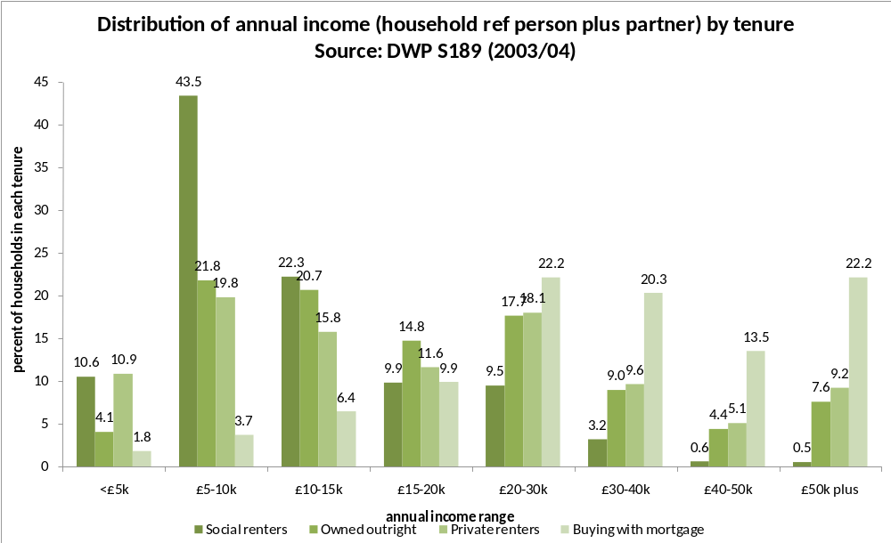
Four of Somerset’s major housing associations expressed a willingness to support the work of both credit unions and debt advice agencies. Between them they house almost 20,000 people throughout Somerset:

Housing  Association | Number of units | Housing  Association | Number of units
 | 2074 |  | 8521
 | 4200 |  | 4190
Source: Housing.Net
Some associations already support their own welfare rights and debt advice staff, some have bespoke home contents schemes, and some have already committed to underwriting credit union loans for their tenants. Mendip Housing offers a four times a year doctor surgery across their community. Yarlington Housing Group, like Mendip Housing, have their own welfare benefits officer and courts service. (Yarlington Housing Group estimates the cost of eviction at £7,000 and therefore recognises the business case of investing in preventative services). If they could support further initiatives that would help reduce these numbers then they, and their fellow housing associations, would do so. Mendip Housing has their own benefits officer who operates in five areas throughout Mendip with significant attendees and results:
Chart 25: Numbers attending Mendip HA advice surgeries
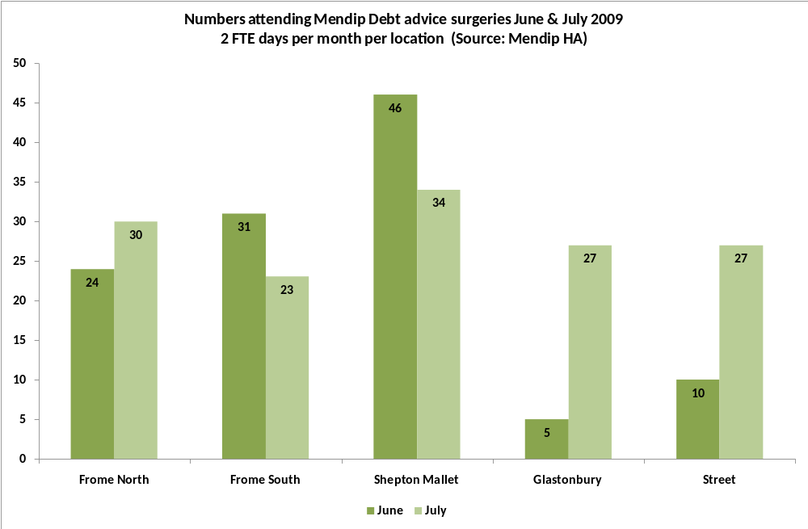
Scaling up these numbers (116 in June, 141 in July) would mean potentially 1,392 to 1,692 people assisted annually. Mendip Housing already shares their outreach offices with the local credit union. A consistently delivered credit union presence alongside the Mendip Housing debt advisors, allied to a consistent and well marketed message through other channels could help raise the profile and the membership with a key demographic.
The business case for Mendip Housing (and by implication all housing associations) engagement in financial exclusion activity is revealed when the income raised for tenants by the debt advice in these five areas reveals the following sums:
April: | £6,760 | May: | £4,750 | June: | £4,096 | July: | £44,089
Homes In Sedgemoor have launched a financial inclusion strategy, they are committed to supporting the work of the community banking study although they made an important distinction around “supporting” rather than “leading”. This raises important questions about leadership and who will drive forward the initiatives suggested in this report. If housing associations, advice bureaus and credit unions cannot lead the steering group then who will?
A CAB advisory service operates weekly in the lobby of Sedgemoor Council; the credit union if volunteers could be found could do the same. Magna West Somerset Housing Association identified over a dozen community flats as potential outlets, free-of-charge, for credit union collection points around their stock and were keen to see how they could support other community banking ideas.
The housing associations are busy with both activity and action. Their support for underwriting loan guarantee schemes is admirable, although the amounts are small and the mechanisms for underwriting the loans should be loosened or entrusted to the credit union to deliver. Ensuring tenants have access to affordable credit is important, especially for new tenancies who will otherwise furnish their unfurnished home from no-credit-check retailers or rent-to-own stores like BrightHouse. Encouraging the take-up of Home Contents Insurance (HCI) is vital too; some associations operate their own bespoke scheme but take-up is low. A report for the DWP undertaken by NHF identified 45% of social landlords offered a bespoke HCI policy, taken up by 12% of tenants.
Research by the ABI identified that 35% of people in very low-income households (less than £10,000 a year) have no insurance of any kind, compared to only 5% of households with an average income (£15,000-£30,000). Under half of low-income households hold home contents insurance compared to over 80% of those with average incomes, and of those with a low- income and no insurance, a third borrow funds to replace stolen or damaged household items, increasing their indebtedness.
The alternative for tenants to low-cost HCI is often the cross-selling of an expensive warranty with a television, settee or cooker that could otherwise be easily covered by HCI. Housing Officers have a key, front-line role to play in both noticing what is needed at pre and post-tenancy visits and building the link to low-cost provision. Tenants often say it is affordability that causes them to forego HCI, however, the Financial Inclusion Taskforce identified that:
“Affordability as a label often hides the impact of other barriers. The true barrier may well be a perception of lack of affordability, which can be overturned once products and prices are discussed in greater detail. Indeed, the Taskforce’s qualitative research found that some of the participants’ estimates of the cost of HCI premiums were vastly inflated, indicating there is a gap between the actual and perceived cost of insurance for some.”
Analysis of one of the better HCI take-up schemes at Glasgow Housing Association (GHA) (they have 20% take up amongst their 65,209 units) identified almost as many people over the age of 85 years old (692) as under the age of 35 (681) held a GHA HCI policy. In Somerset the housing associations confirmed that low take-up of insurance was an issue. The youngest three focus group participants were all women, all under 35 years old. None had HCI.
The Financial Inclusion Taskforce’s response to the poor take-up is correct, “For social tenants, the key intermediary is clearly the landlord. It is important that front- line social housing staff are able to highlight the benefits of HCI and actively promote schemes that are supported by landlords, both with existing and new tenants. They also need training to deal competently with enquiries about their scheme.”
HCI policies can be easily set up with insurance brokers; policies are good value and can be purchased for less than £1 per week. Training for housing officers as introducers (not sellers) of the HCI policy needs to be undertaken to ensure that they are aware of the policy benefits, the costs and the implications of not having HCI. As a minimum, the NHF’s My Home Insurance should be offered although a lower cost bespoke Somerset-wide policy might be cheaper and offer more benefits.
Somerset’s Housing Associations have premises, staff and, to an extent, resources to support some of the work of the community banking initiative. Their leverage with banks is potentially a significant lure to attract so-called “trusted partner” status where new or even retained business within a bank with a major housing association or council or health trust might be enough to persuade a bank to confer trusted partner status on a housing association.
In other parts of the UK banks have allowed housing associations or CDFIs to open basic bank accounts on their behalf. For example, in Glasgow RBS has conferred trusted partner status on the Scotcash CDFI allowing them to take the identification and address verification requirements to open accounts. This has resulted in over 600 accounts being opened in two years. Bank of Scotland (now part of Lloyds Group) permitted staff at Mercian Housing Association in Birmingham to open bank accounts on their behalf. The ebb and flow within the banking sector toward their commitment to halving the number of people unbanked in the UK needs partners to make it happen. Partly as a result of the impact of part-nationalisation the appetite amongst banks has increased again to work co-operatively with partner organisations. The (financial) attractiveness of a number of Somerset’s community banking partners could be utilised here. The aggregate deposits, current accounts, loans, asset finance and insurance that banks seek to gain or retain are significant in Somerset. A collective will amongst a number of partners to be supportive on a quid pro quo basis with a bank willing to confer trusted partner status, or to support affordable credit should not to be underestimated.
Housing associations have gathered significant amount of information on their customers yet were not able to assess the banking, insurance or credit needs of their tenants. An annual survey across all tenures will allow a baseline of data to be collected. The information gathered will inform the future delivery or targeting of services and could include information alongside household income, employment and number of dependents, on:
- banked and unbanked customers;
- credit availability and use amongst customers;
- savings held;
- HCI policyholders;
- interest in self-employment / micro-business loans;
- credit union membership;
Housing associations represent the route to market for potential savers and borrowers. There are potential customers within social housing and a common marketing strategy, perhaps along the lines of “Safe savings: Sound borrowings” or “Safe & Sound in Somerset” can be used to describe the activity of all credit unions. A common message, compellingly delivered by a range of customer facing individuals in housing associations and other organisations can begin to raise the profile of the credit union movement and its products and services.
Alongside this housing associations can potentially deliver a range of other products and services for their customers specifically HCI and bank accounts by utilising their leverage with banks.
Somerset’s leading housing associations recognise the role that they can play. Some of their activity like the take-up of HCI has not delivered significant results but their commitment to delivery is not in question. There has been a significant impact from the work of debt and welfare benefits advisors. Housing associations, like the advice sector, are unlikely to lead the process of joining up the parts to deliver a concentrated Somerset-wide delivery, but they are willing to play their part. They provide a significant route to market for the proposed products and services; they have leverage with High Street banks and frontline information on the impact of financial exclusion on their customers. They are a vital partner in any community banking development.

7.0 Home collected credit in Somerset

Across the UK 2.3m people rely on home collected credit (HCC) for their small sum needs. One in twenty doors in the UK is familiar with the knock on the door from the home credit agent seeking repayment. Over a 52 week loan a typical charge of about £3.50 per week is collected for every £100 borrowed, so if you borrow £500 you will typically repay £17.50, the critical factor for the borrower is flexibility, affordability and convenience; and for the lender, time. The typical home collected credit loan was estimated in 2005 at £555 usually taken over 43 weeks.
Provident Financial Services (Provident) are the leading home collected credit company in the UK, with an estimated 60% + market share. Their nearest competitors Cattles and London Scottish have both withdrawn their lending from the market leaving Provident alone as the market-leading company. Provident’s website in September 2009 advertised a £500 loan taken over 52 weeks at £17.50 per week, a total repaid of £910, an APR of 272.2%, the same amount borrowed over a shorter term, of 23 weeks will see a smaller amount repaid in total (£747.50 the total cost of credit) with higher weekly repayments of £32.50 and an APR of 545.2%
The socio-demographic indicators of the social renting tenant appear to mirror the seven principal characteristics of home collected credit identified by the British Market Research Bureau (BMRB) analysis of over 24,000 people for the Competition Commission enquiry into home collected credit in 2006, these criteria are:
• of working age but not working;
• women aged under 34 years old;
• with children;
• socio-economic grades D & E;
• at least 50% with an income under £13,000;
• renting from social landlord; and
• living within the most disadvantaged neighbourhoods.
Chart 26: Home collected credit criteria
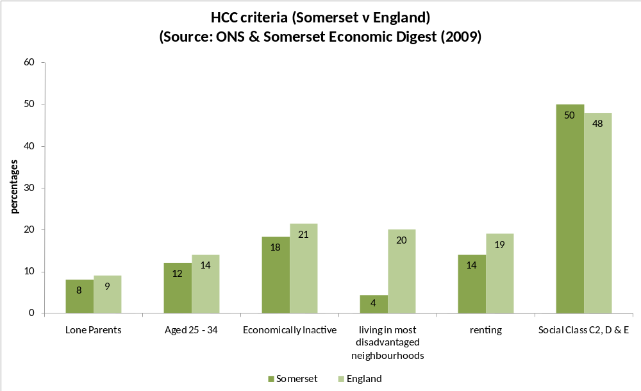
Provident’s army of 11,500 self-employed agents sells cash, and they are very good at it. Their presence and operation across Somerset was anecdotally recognised by all debt advice organisations, and by the focus group participants four of whom admitted to being recent or current home credit users. It is likely that Somerset will be on the low end of HCC, the rural dimension makes it difficult for self-employed collectors to generate a “round” of 120 – 150 customers within a reasonable radius. However, the lack of alternative provision and the population density of some of the urban areas of Taunton, Bridgwater, Frome and Yeovil amongst other parts make it likely that the average of 4.7% of the adult population using home credit will be reached. 4.7% of Somerset’s adult population is 19,660.
There is a tendency for politicians, commentators and the general public who are not part of the 1 in 20 doors that Provident visit to be angered and outraged by them. MPs regularly decry them from public platforms. People wrongly attribute the pejorative term “loan shark” to Provident and other legal HCC providers. Campaigns to cap interest levels often illustrate their case with examples drawn from HCC loans. This approach is misguided and misunderstands the nature of the HCC market and their customer. Indeed Tony Quigley, Head of the Illegal Money-Lending Team (IML) at Birmingham City Council said in a presentation to the National Housing Federation (NHF) in March 2009 “…there is a massive divide between home credit and illegal money lenders; home credit providers are not loan sharks.”
The role of credit unions is often highlighted as the solution to the affordable credit needs of millions of people. A report into illegal money lending in the UK concluded that “credit unions appear to be serving a different universe, with borrowers from credit unions even in these very deprived estates being significantly more up market than borrowers from either the high cost lenders or the illegal lenders. Credit union borrowers had higher average incomes and were more likely to be in work than either home credit borrowers or illegal lender users”
Unless the government introduce a cap on interest rates, which appears unlikely, then home credit is likely to remain and flourish in the UK as credit dries up from mainstream sources. Provident has already seen a new customer seeking their product during the recession, their CEO announcing in March 2009 that “We think that (the home credit) market is growing, at the moment quite nicely, principally from people moving down into that market from higher up the credit curve.”
Supporting affordable credit alternatives is vital in Somerset, although it is not a panacea, even a best case scenario would see only around 5% of home credit customers making a choice based on a lower cost alternative. Nevertheless, 5% of almost 20,000 potential home credit customers would be 1000 additional people saving around £343 per typical loan.
Provident and other home collected credit companies, provide a service, admittedly not a service that everyone would want to take, but a service nonetheless. Provident lend money to people who often (but not always) cannot borrow from elsewhere (26% have credit / store cards). Their customer regards affordability (small, regular weekly collected payments with flexibility and no additional penalties for missed payments) as more important that price. They have a 93% satisfaction rating amongst their customer base and are extremely good at delivering a product that their customer seeks.
As already stated, HCC companies are expensive, a 52 week loan of £500 advertised on Provident’s website attracts an APR of 272.2% and interest of £410, but the reader needs to understand pricing and risk before making a judgment on lenders. Provident understand their customers’ needs, they correctly point out that APRs are an extremely poor way of comparing loan rates when short-term, small-sum credit is concerned (something that many organisations including CAB agree with), and they also correctly point out that they have no hidden costs.
Other lenders can hide the true cost of credit in penalty charges or by over-inflating the price of goods in the first place. Provident continue to be the market leader because they know their market. They are close to their customers, allowing occasional missed payments and showing the type of flexibility that is missing from other credit providers. What, after all, is their agent going to do if the customer does not answer the door to the agent on a Friday evening or seeks to make a smaller payment because something else has taken priority?
HCC remains a logical, indeed, arguably a sensible choice for some people. Banks may offer cheaper rates, but they don’t offer short-term, small-sum loans, particularly to a credit impaired or risky customer. If a payment is sought by direct debit and the cash is not in the account then the customer is charged. To a bank the money is either “in” or “not in” your account; it’s not acceptable for it to be “nearly in.” Until October 2009 when RBS led the way by reducing their bank charges (from 338 to £5) the typical unpaid DD charges ranged from £25 to £39.
The following table indicates the amounts potentially being lost to high-cost home collected credit companies within Somerset. Using Provident’s illustration on their website of a £500 loan over 52 weeks and comparing it to a £500 loan from other affordable credit suppliers such as a credit union or CDFI over one year, the potential savings in interest payments alone are enormous.

Chart 27: Comparing the cost of home credit with alternative Somerset providers:
The  credit  supplier | The  amount borrowed | How long to repay the amount borrowed | The  Annual Percentage Rate (APR) | The total cost of credit  (the original amount plus interest) | The difference (between Provident’s price and other lenders)
Provident Financial | £500 | 1 year (weekly) | 272.2% | £910 | ----
Somerset  Credit Union | £500 | 1 year (monthly) | 12.7% | £533 | £377
Somerset  Credit Union | £500 | 1 year (monthly) | 26.8% | £567 | £343
Somerset CDFI  (potentially) | £500 | 1 year (monthly) | 41.2% | £600 | £310
Somerset CDFI (potentially) | £500 | 1 year (monthly) | 46.1% | £610 | £300
In Somerset there are potentially 20,000 adults who will use home collected credit. Scaling up the sum illustrated above a conservative figure of around £343,000 could be retained within low-income communities (in excess interest payments annually) almost certainly within Somerset’s poorest communities if 1,000 people could be persuaded to borrow from the credit union rather than home collected credit. The sum would be less is the borrower was persuaded to take out their credit needs with a higher cost CDFI but 1,000 people borrowing £500 would still see a collective saving of £300,000.
Whilst these sums are massive it is also unrealistic to suggest that simply offering an alternative supplier of small-sum credit will be a panacea to a low-income communities’ credit needs. Alternatives already exist and are either unused or underused by the market they are trying to attract and serve. Only about 500 people borrow annually from Somerset’s four credit unions. The product offering needs to be right for the customer, even then only a small proportion of existing home collected credit customers will use affordable credit alternatives.
8.0 Credit unions in Somerset
There are four credit unions in Somerset. Each is entirely volunteer run, with a handful of dedicated and able personnel within each. The credit unions are all members of ACE - a small trade body - and each has a number of collection points throughout their respective common bond areas, all staffed by volunteers. The collection points are often driven by the proximity of volunteers rather than the location of likely beneficiaries, so, for example, many low income, disadvantaged communities do not have collection points because volunteers have not been identified in some of the locations, in this sense they are demand led rather than service driven.
It will be beneficial to introduce and implement a volunteer recruitment strategy across Somerset. Rising unemployment in Somerset could provide an opportunity to recruit able volunteers looking to hone their skills for a return to the job market. Utilising volunteers as a way of both serving the community and as a driver to return to employment is essential to allow Somerset’s credit unions to tap into the goodwill displayed toward them by a range of agencies and services. Without increased capacity to deliver the service the credit union movement in Somerset will remain hidden in plain sight. Ironically, the best way to deliver increased volunteers is probably through the appointment of some paid staff to take forward specific responsibility for this role.
Membership of the credit unions in Somerset is low, around 0.4% of the adult population, below the national average which is just under 1%.
Chart 28: Somerset Credit union membership
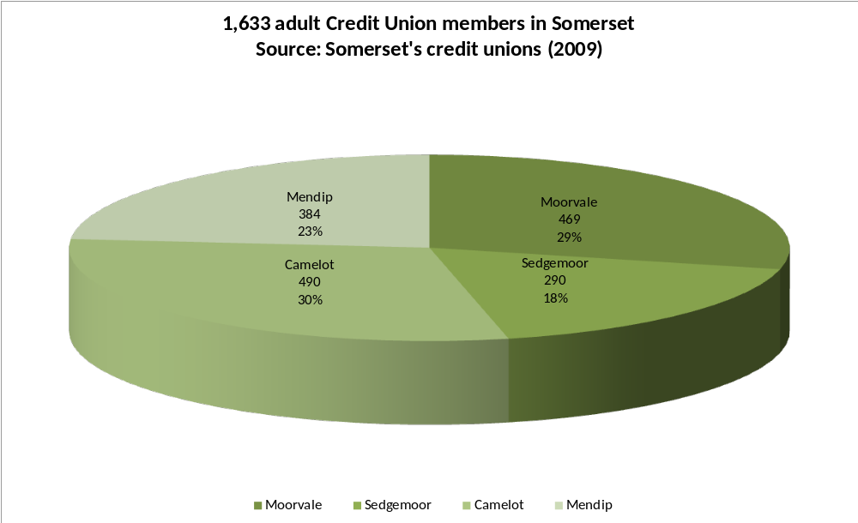
The volunteers within Somerset’s four Credit Unions have ebbed and flowed over the years with the occasional and unavoidable departures of certain individuals taking with them often an irreplaceable knowledge of systems or record-keeping, in two of the credit unions this is an immediate or very recent happening.
The credit unions do as well as they can within the constraints often associated with volunteer driven organisations. The current volunteers have a breadth of experience and skills and demonstrate a significant commitment to their community and to the ethos of co-operative, mutual organisations. One described their credit union as “A transformative experience of non-materialistic, mutually supportive, non-mercenary, honestly brokered credit”
There was division within the four on the merits of a Somerset-wide credit union with a common bond potentially stretching from Porlock to Wincanton. Many existing volunteers indicated that their reason for getting involved was the local presence and the sense of community, some pointed to a difference between the four credit unions “we are operationally different; the culture of the four Credit Unions is not the same” Another comment was more pointed “we’ll do what suits us – not what suits someone else.”
Some were positive about the potential benefits of coming together, seeing the economies of scale, and the opportunity to professionalise the set-up with paid staff. At a roundtable meeting with all credit unions present one who spoke in favour of a Somerset-wide credit union stated “Paid staff are essential for our (credit union) development, we need a more professional set-up.” Others expressed a different view that “Bigger is not necessarily better” indicating that a Somerset-wide credit union would not have their blessing or involvement.
People did not want to feel corralled into doing someone else’s bidding one view which appeared to represent the strength of feeling “We are interested in creative, practical, pragmatic, workable solutions, and trying not to be run over by their (funders and potential funders) solutions.”
Generally, the dominant sense presented by the credit unions in Somerset was of a willingness to work not only with other agencies, but also to more co-operatively together.
Some credit unions remain skeptical about what paid staff could add to the proposition in Somerset, “wary of staff who are chasing their next grant for their wages.” Others reserved their scepticism for the reported willingness of other agencies to work co-operatively with the credit unions feeling that similar overtures had been made by the credit unions to potential partners in the past and had not been well received.
Whilst the credit unions expressed a commitment to work co-operatively it was on their terms. They receive modest amounts of financial support from Somerset County Council and are operationally able to continue as standalone organisations should they determine that any arrangement is not to their liking. Their commitment to work co-operatively needs to be followed through; embedded beyond the commitment of current individuals. If additional support in cash and kind is to be forthcoming then this needs to be harnessed to agreed outcomes such as more members, more loans, more opening times and so on.
The over-riding aim of many partners is to support a vehicle that can deliver savings and loans products. The most obvious way is to work with what is already there, but should that arrangement prove unsatisfactory then alternatives including a scaled-up Somerset-wide credit union could be considered; an approach which two of the credit union members appeared amenable (although not tied) to. Increased access to affordable credit and transformative savings needs to be delivered by a consistent and professional service able to meet the needs day-in and day-out of all of the community and delivering this through volunteers alone is extremely challenging, undertaking the tasks required will probably require two paid staff – it cannot be delivered by volunteers alone.
All four credit unions paid a dividend in the past year. In Mendip the introduction of an initiative entitled Dividends Make a Difference saw several hundred pounds re-invested into Mendip Credit Union for general use. This philanthropic giving allows Mendip CU to underwrite loan funds to higher risk customers. The possibility of extending a Dividends Make a Difference scheme throughout Somerset should be explored.
Chart 29: Somerset credit union dividend
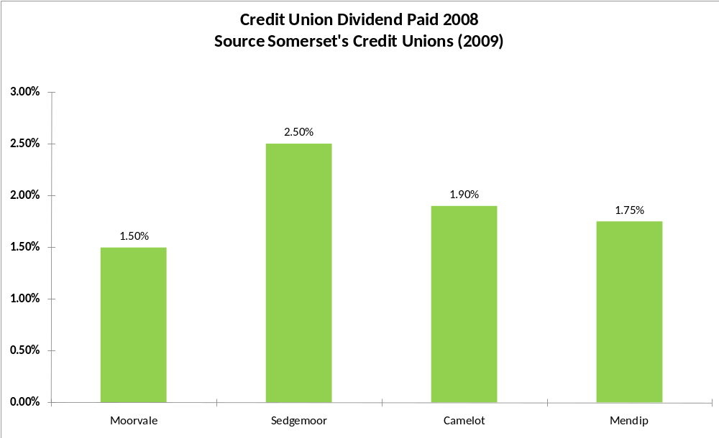
Building the capacity of the credit unions is a key aspect of any centrally funded resource. Their product is good although largely unknown; their outlets are hidden or unseen; their message largely unheard. Their profile needs to be raised and alongside it there needs to be a consistency of delivery. Membership must grow to survive and income from lending must grow to provide operational sustainability and growth.
The credit unions in Somerset contend that they want to deliver more loans and more services to a wider group of people. However, their ability to service more people is extremely limited and their plans to expand seem sketchy, based on securing additional volunteers. A focused, agreed strategy to share certain functions, embrace common services and employ the services of one, but more probably two skilled, paid professionals to build relationship and advocate on their behalf is needed to work toward specific set goals and targets around volunteers, members, outlets, partners, loans and default rates. A funded central resource function should be established and tasked to deliver:
- a common information hub, telephony and (potentially) appointment book;
- consistent marketing & promotional message along the lines of “safe savings : sound borrowing;”
- loan administration using 1 x back office;
- training in loan underwriting;
- volunteer development and recruitment;
- building partnerships and collection points with:
  - Citizens Advice Bureau;
  - Housing Associations;
  - Local Authorities;
  - Wessex Re-Investment Trust;
  - NHS Somerset;
  - Somerset Voluntary Sector Network;
  - Somerset Community Foundation;
  - Supporting People.
- distribute membership forms;
- common reporting to potential funders.
Whilst determined to put forward their position as independent, sustainable, volunteer-driven organisations that despite reservations from some quarters run effective small businesses, the overwhelming view was that the status quo was not an option. At the very least a new spur was needed and the idea of the common central resource recognising local credit union’s position and dynamic - but working harmoniously to develop volunteers and undertake other tasks which would allow the movement to make strides forward in terms of membership and reach - appeared acceptable.
The membership is low for a reason. People are unaware of the credit union product offering. Nine of the ten participants in the two focus groups were not members of a credit union and the vast majority had not even heard of its existence or understood what it offered. Literature is low-impact and low-key. Premises are in poor locations and inadequate to scale-up the membership numbers. Somerset County Council has 17,000 employees but no concerted effort is made by the Council to advertise the benefits of credit union membership through a payroll deduction scheme or promotional campaign to advertise the benefits. Somerset’s housing related supporting people services work with 26 accredited organisations dealing with 4,000 separate individuals – each of whom should be advised about the benefits of credit union membership by a team of staff willing - and able - to help. Housing associations like Magna West Somerset Housing Association has over a dozen community buildings near the stock that they will allow free use of. Homes in Sedgemoor have developed a financial inclusion strategy that confirms their support or the local credit union, in their case, Bridgwater to:
- Develop and agree a partnership protocol with the Credit Union;
- Provide a financial bond in partnership with the Council to support the security of the Credit Union for the benefit of our customers;
- Work with the Credit Union to develop an access route to low interest loans specifically for our customers;
- Work with the Credit Union to expand and develop the membership of the Credit Union;
- Set and publish formal targets in agreement with partners for the development of the Credit Union and take-up of membership;
- Investigate the potential of Community Banking to assist our customers;
- Promote the benefits of regular savings with the Credit Union using direct debits.
Mendip Housing has underwritten 25 loans within Mendip credit union (£20,000 has been confirmed). Yarlington Housing Group were considering the same offer for Camelot credit union, Magna West were prepared to take a paper to their board to consider a similar request for Moorvale, and Homes in Sedgemoor are in discussions with Sedgemoor Savers as their financial inclusion strategy confirms.
The opportunity to build relationships with Advice Bureau or housing associations or other organisations like NHS Somerset or SCVN is personality driven and needs a greater intensity of focus and consistency of message. Credit unions acknowledged that they have not always had the time to build relationships due to other more pressing commitments. Part of the common central resource idea would be to deliver a simple, consistent message along the line of “safe savings: sound borrowing” or “Safe & Sound in Somerset” to a public already looking for alternatives to the major banks.
The mutual misunderstandings, apparent within other interviews of what the credit union did or could do, were apparent too within the credit unions of their potential partners.
Demystifying the movement and speaking with clarity needs the buy-in of every credit union in Somerset. They need to work alongside housing associations, local authorities, community enablers and a whole range of front-line staff to deliver a consistent message, and then to be available when the phone rings or the potential member turns up, to service the needs professionally and quickly. Those who have been won over by the credit union movement are evangelical about its benefits; there is no escaping the value of safe, simple, savings products and low-cost borrowing but the movement – nationally, not just in Somerset - has not been able to tap into the mainstream to persuade people from all social classifications and tenures to join, save and borrow. The message needs to be simple and compelling.
The savings held in 2008/09 amounted to £621,000, fairly evenly split across the four organisations.
Chart 30: Somerset credit union savings held
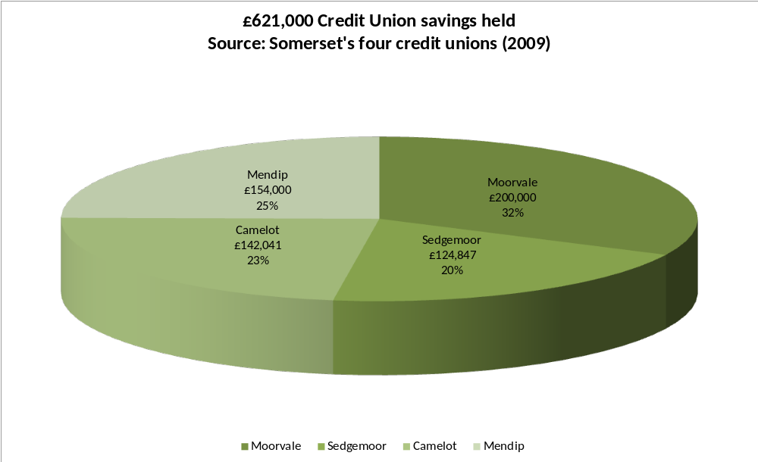
In terms of loans issued the Somerset Credit unions provided information detailing £450,000 loaned in a 12 month period. This included the only DWP Growth Fund lending undertaken (with acknowledged difficulty) by Moorvale, hence their higher percentage of loans issued. Just over ten people a week across Somerset borrow money from one of the four credit unions.
Chart 31: Somerset credit union loans issued
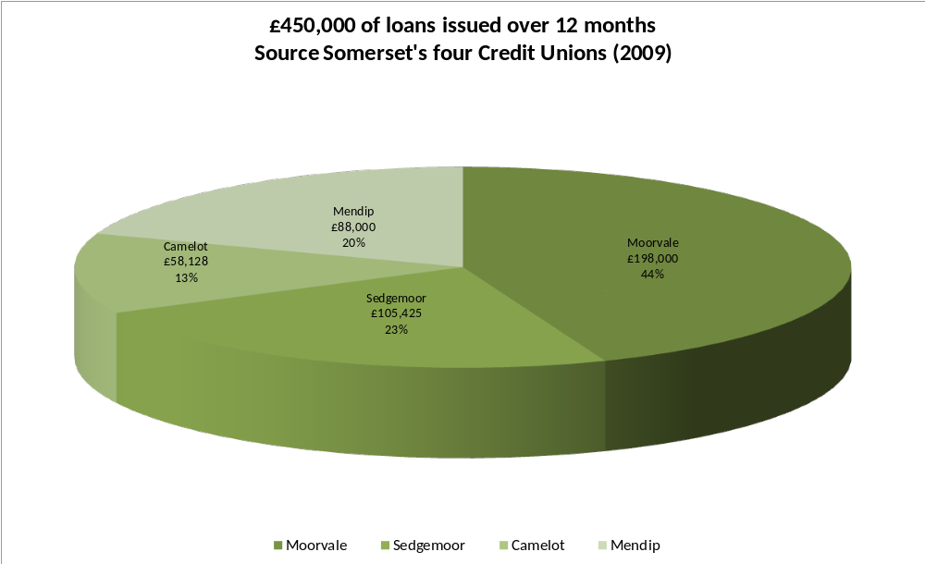
The credit unions were able to provide information on their lending over a three-month period April, May and June 2009. This snapshot of lending is helpful in illustrating where the loans are made and their value. The majority of loans by customer number and by volume are issued to people residing within the most disadvantaged postcodes throughout Somerset. The majority of loans are clustered at or near to the hubs of Somerset’s credit unions, for example, very few loans are issued in West Somerset. (Detailed individual maps for each credit union are available).
Chart 32: Somerset credit union loans issued (April – June 2009)
Chart 33: Somerset credit union loans issued (April – June 2009)
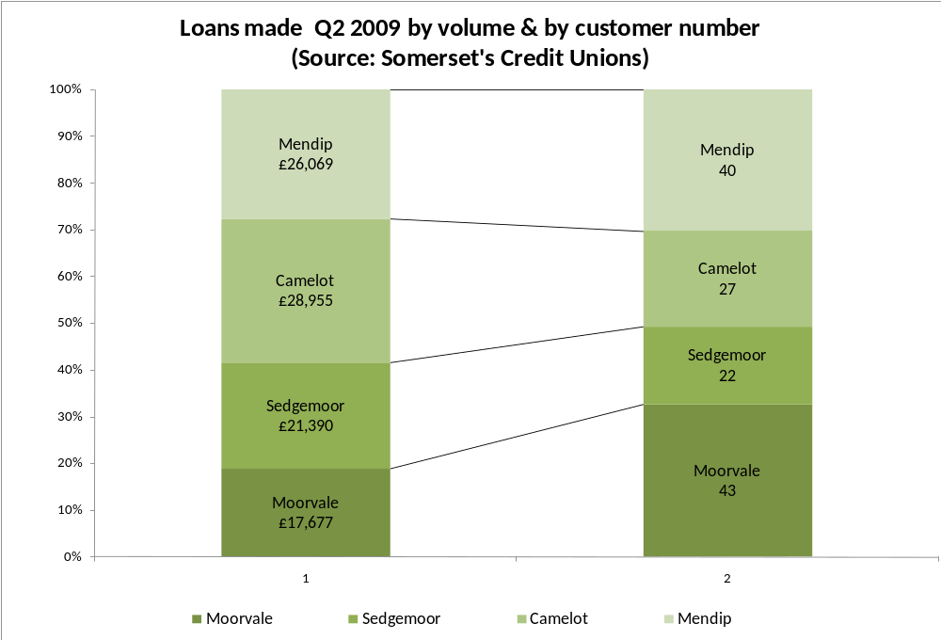
Lending money is the easy part of any loan operation, it is getting it back that is difficult, and credit unions recognise the difficulty. Moorvale articulated the particular problem of issuing DWP growth fund loans to a different customer from the one that they had been familiar in serving, culminating in the Moorvale committee imposing a £150 limit on the loans as they were so concerned about the rising bad debt rate and the apparent message that had circulated by word-of-mouth that the vigorous pursuance of the loans by Moorvale was unlikely.
The majority of loans issued are share-based, with the borrower known to the credit union through their shares held and regular savings pattern. Mendip are moving to lower their interest rate to 6% for members with more that 50% of a loan request held in shares, competitive with High Street banks current rates. This form of lending is safer as the credit union hold a proportion of the loan in shares which cannot be accessed whilst the loan is being repaid. The potential loss is therefore mitigated although it is not unknown for people to save and then not repay the subsequent loan.
There was insufficient information on the credit union customer to draw any specific conclusion of how close a fit the Somerset credit union member was to the member identified by the 2006 ABCUL research. The person most in need of affordable credit is often living in the most disadvantaged neighbourhood, social renting, housing income under £200, social class C2, D and E, female, with children.
Moorvale’s experience with the DWP growth fund customer identifies the difficulty of lending capacity based loans to a high risk customer. It is particularly difficult to do so when lending is capped at a maximum of 2% per month (26.8% APR). Whilst it will be desirable to take an increased level of risk, perhaps with the loan guarantee fund it is unfair on the movement to ask them to build their loan book, and sustainability, around lending to such a high risk group.
Credit union loans across Somerset are very small by number in comparison to the likely home collected credit loans. Around ten loans are made per month across Somerset, and just over five of these will be made in the most disadvantaged neighbourhoods.
Chart 34: Somerset credit union Home credit v credit union loans issued by month
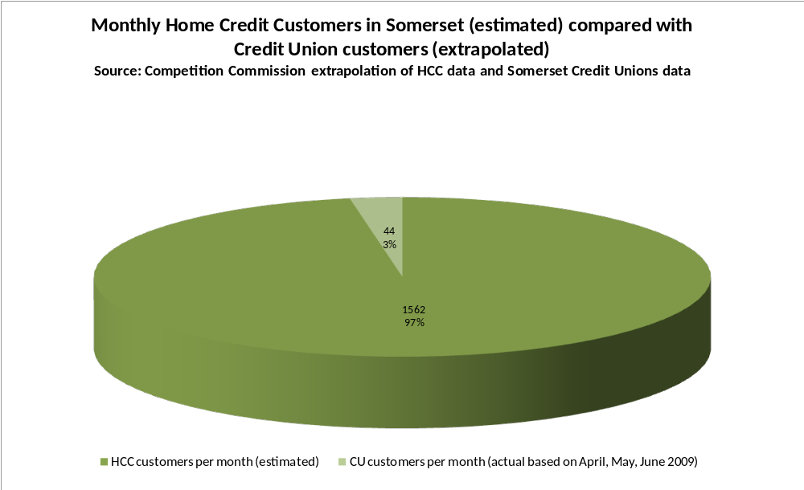
Chart 35: Somerset loans advanced by home credit and credit union
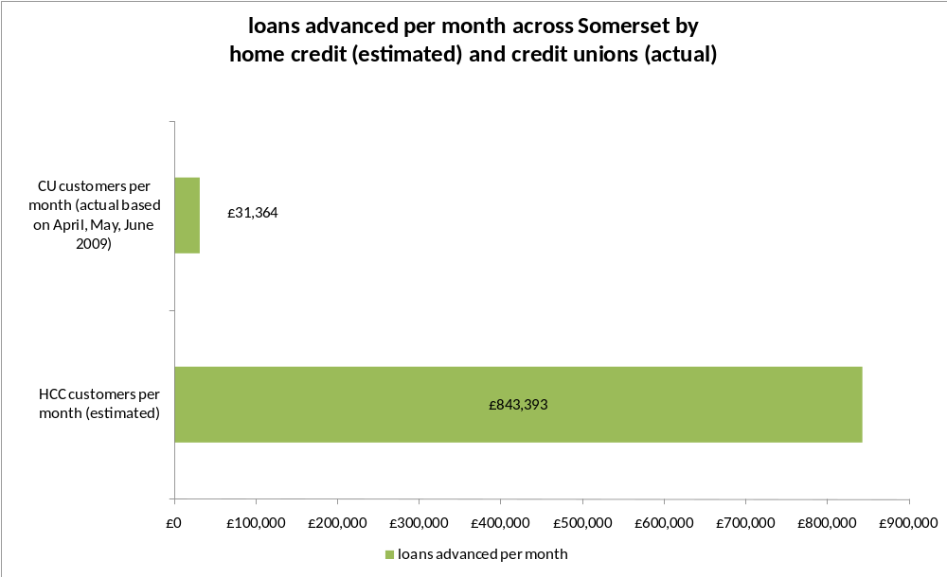
Understanding pricing is the key to lending; the higher the risk that the customer presents, the greater the need to price for that risk. Somerset’s credit unions cannot risk capacity-based lending with their current members money, it would be foolish to do so. To tackle the needs of affordable credit through capacity-based lending needs a specialist vehicle.
The credit unions in Somerset are:
- Small but with a committed volunteer base;
- reliant on handful of key people;
- Community led, co-operatives, committed to the ethos of a savings culture;
- Demand led, not service driven;
- Working from low-key and inadequate premises;
- Facing a challenge to engage and retain volunteers;
- Not collectively committed to a Somerset-wide credit union;
- Predominantly issuing share-based loans with only a minimal appetite for capacity based lending;
- All paying a dividend (1.5% to 2.5%);
- Serving a membership of 1,633 adult members (0.4% of Somerset);
- Holding £621,000 in shares / savings;
- Writing £450,000 in loans in past year;
- In one case contracted with the DWP Growth Fund with significant (& continuing) difficulties;
- 132 loans in Q2 (09); 53% in disadvantaged postcodes;
- Not convincing partners about their stability and ability to provide a consistent level of service.

9.0 A new credit provider and the role of other partners
Community Development Finance Institutions (CDFIs) are social businesses that are often associated with small business micro lending to near bankable businesses. In Somerset, Wessex Re-Investment Trust (WRT) provide the micro loans to small, near bankable businesses. In a recession, with 137% rise in JSA claimants over the past two years many people will use this trigger point to seek the finance to establish their own businesses. WRT’s micro lending can be included within any Safe & Sound marketing strategy to promote small business lending.
Research undertaken by the FSB in the South West in June 2009 asked small business owners in both rural and urban locations three questions:
- Whether they had seen a rise in the overall cost of new credit in the past two months?
- Whether they had seen an increase in the cost of existing finance in the past two months?
- Whether their bank had refused their request for a loan or overdraft facility in the past two months?
Their responses indicate that further advertising of the micro credit available through WRT would be valuable across Somerset to provide the facilities that banks appear unable or unwilling to meet.
Chart 36: FSB credit survey (urban)
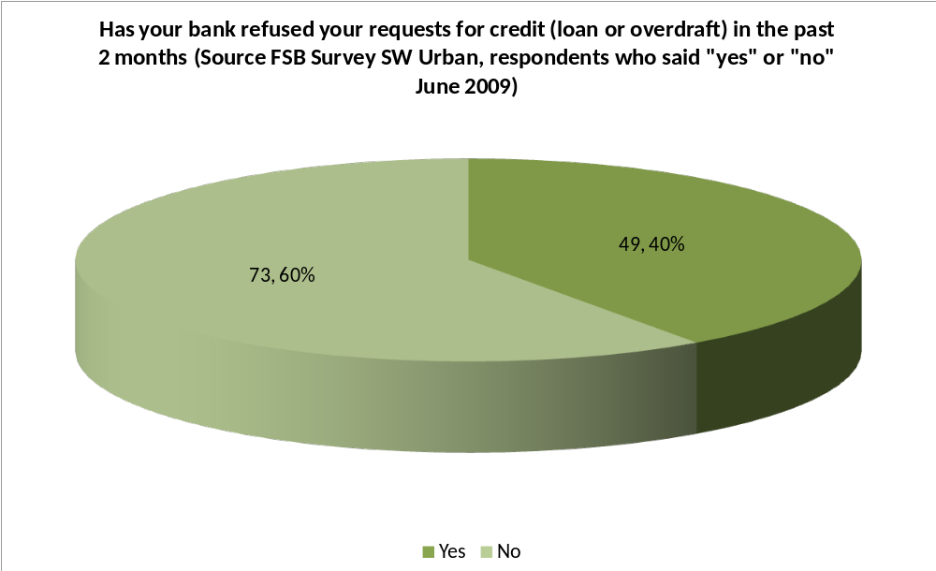
Chart 37: FSB credit survey 2 (urban)
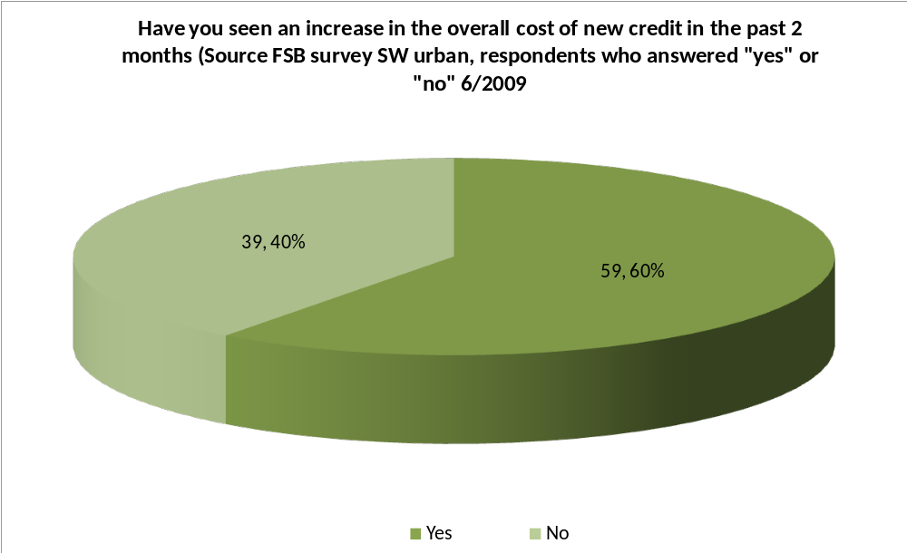

Chart 38: FSB credit survey 3 (urban)
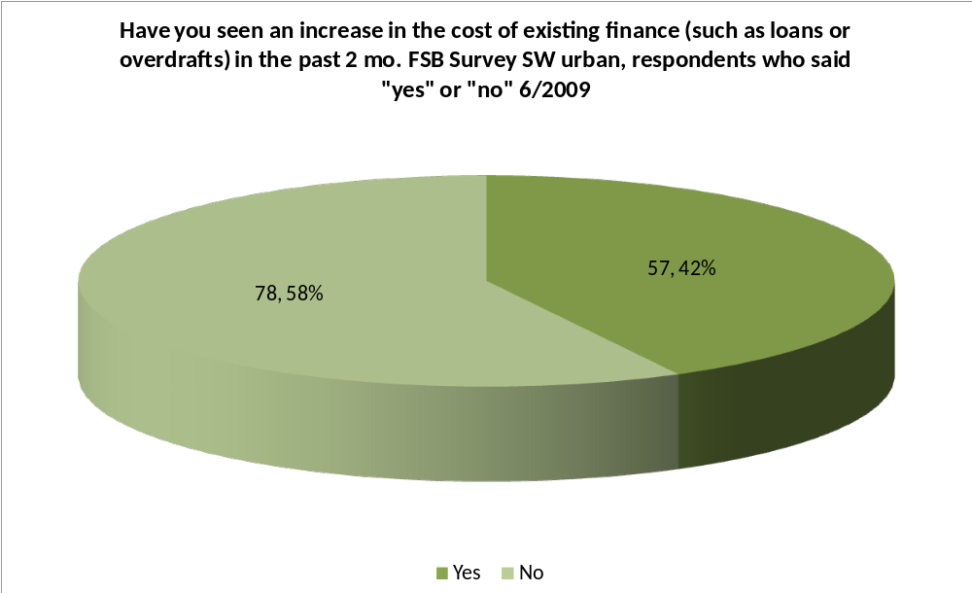
Chart 39: FSB credit survey (rural)
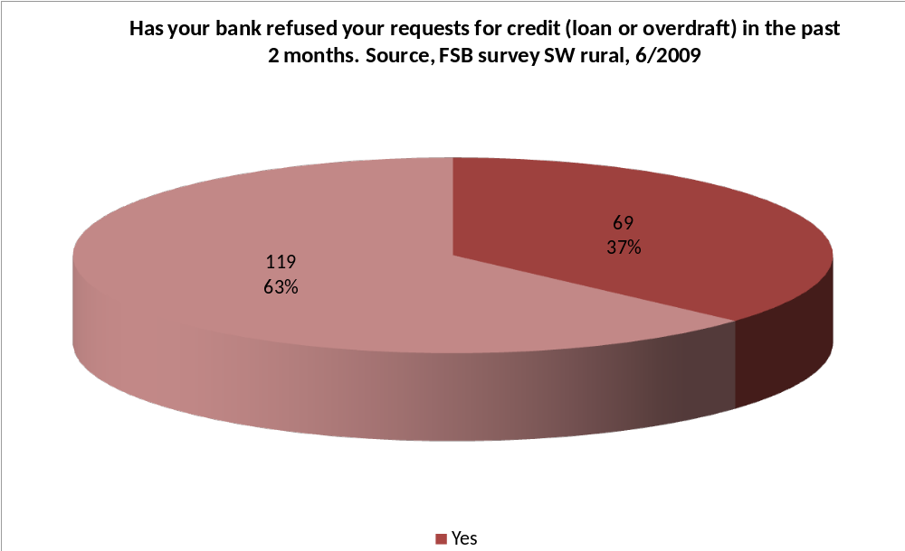

Chart 40: FSB credit survey 2 (rural)
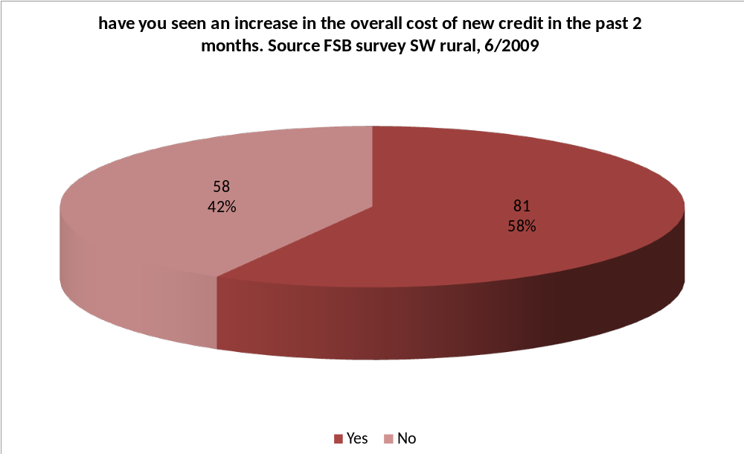
Chart 41: FSB credit survey 3 (rural)
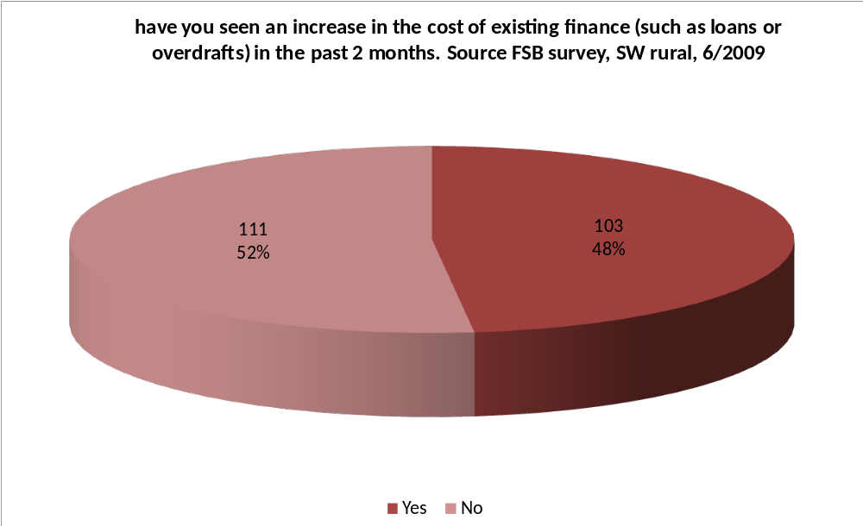
In addition to micro-lending some CDFIs have specialised in capacity-based personal loans to the most vulnerable customer seeking small-sum credit and often reliant on high-cost home collected credit.
It is feasible that an existing personal-lending CDFI might be prepared to open an outlet in some of the larger urban areas of Somerset to offer loans, linked (credit union) savings, bank accounts and money advice to a customer in a separate (but related) development to the proposed credit union development.
CDFIs price for risk, a typical £500 loan from a personal lending CDFI will cost around £20 per £100 borrowed. Typical APRs are around 41%. The cost of bringing an existing operation to parts of Somerset would incur running costs for a small loan outlet in, say, Bridgwater, Taunton Frome or Yeovil of around £50,000 per annum, which would need to cover:
- Loans Officer salary @ £18,000
- Administrator salary (part time) @ £8,000
- Management fee @ £7,000
- Running costs @ £12,000
On top of these costs there would need to be sufficient capital of approximately £200,000 to lend. It is possible that until the year 2011 the DWP Growth Fund, who already contract with CDFIs in other parts of the UK might be willing to contract with them to deliver affordable credit in the most disadvantaged parts of Somerset. Conversations with DWP Financial Inclusion Champions revealed that under 7% of growth fund lending has been committed to rural parts of the UK (their benchmark ought to be 20%) and whilst there can be no guarantees that an established credit provider and contractor could be able to access growth fund money it was clear from DWP GF champions that their role to work with the Somerset Community Banking Partnership could only be beneficial in supporting the notion if the steering group were to commit to that route.
DWP also made it clear that any proposals to seek GF capital in Somerset needed to be Somerset-wide and include a range of other partners.
Two of the potential partners in any steering group development could be the NHS Somerset and the Somerset Community Foundation. Both organisations would welcome the delivery of affordable credit and other products on a Somerset wide basis with clear outcomes and outputs.
NHS Somerset advised that the role of the 17 newly created “community enablers” might be helpful in supporting the clear and consistent product delivery message to a range of people as their role will be to support vulnerable individuals in the widest health sense. They were also prepared to act as a host for any events designed to bring together the range of partners in a sector connector event to allow each to better understand the others work.
Somerset Community Foundation have a Somerset-wide remit and their work with high net worth individuals throughout Somerset could potentially see them playing a role in the development of further philanthropy capital or supporting the creation of a Somerset wide lending vehicle. Their Chief Executive considered that there was “considerable potential for a new approach to community philanthropy in Somerset” and he saw potential to develop this idea with the community banking steering group.
Other discussions with SVNS, JobCentre Plus, Community Council for Somerset and local authorities equally demonstrated the goodwill and determination to work in partnership and offer assistance where possible to build the momentum to take forward the work of the community banking steering group.

9.0 Somerset focus groups and the impact on health
Two focus groups were held with ten individuals in Yeovil and Taunton, set up with the assistance of Yarlington Housing Group and Taunton CAB.
Ten people attended. All were social renters; one had been a home-owner until only a few weeks previous, but had been caught in negative equity and owed £20,000 having seen her house sold at auction.
Three of the ten were women under 34 years old. All were parents, all had partners. All three admitted to debts, none possessed home contents insurance. One used a cheque casher as their overdraft limit had been exceeded on their bank account and she did not want to deposit funds as it would go toward her overdraft.
Six of the ten had multiple debts, four of them had taken CAB advice, and one had found CAB unhelpful and was now taking advice on bankruptcy from a telephone helpline. The person using the telephone advice was being charged a fee to consolidate their loans.
No-one had heard of NDL, CCCS or Payplan, of the six who were in debt, four had used CAB in the past 12 – 18 months. Three were positive about their experience, one recounting how she was prepared to travel to a CAB location further away from her home than the nearby CAB to see a particular advisor whom she trusted. All focus group participants said they would travel to access advice or other credit services, a radius of 45 minutes was thought reasonable.
One person was a credit union member, the majority had not heard of a credit union. An exercise was undertaken in determining attitude to, and understanding of pricing. A long list of percentages was put up and people were asked to say what percentage or PAR was excessive. Eight of the ten said anything above 20% was too high, the remaining two said anything above 30% was too high. When asked what they thought of repaying £595 for a £500 loan over a year there was widespread agreement that this was acceptable. The group were surprised to hear that this sum represented 40% APR.
Credit union lending between 12 and 26% APR was seen as “too good to be true” one participant waited behind at Taunton CAB to find out the contact details of the credit union. The group would welcome an outlet that would provide a range of services under one roof including savings, lending, bank accounts, money advice and insurance.
Every participant was concerned about the impact of the recession, old and young alike were worried about the effect on their children, either through an inability to get on the housing ladder, or difficulty getting work, or being unable to provide them with the goods and services that others take for granted.
People were worried about the impact on their health, people used terms like worrying and fearful and challenging to describe their emotions. Some admitted to attendance at GPs for treatment for depression and anxiety and admitted to constant worries; others while acknowledging their circumstances had an “out of sight out of mind approach” to their debts, refusing to acknowledge it, or open letters from creditors.
The impact of debt on an individual’s mental and physical health is well documented MIND report than 1 in 4 people have a mental health problem, and 1 in 2 people in debt have a mental health problem.
As reported earlier the link between recession and depression (in the mental not the economic sense) is well known to medical professionals:
'The recession is clearly having a detrimental impact on the nation's mental health but men in particular are struggling with the emotional impact. Being a breadwinner is something that is still crucial to the male psyche so if a man loses his job he loses a large part of his identity putting his mental wellbeing in jeopardy. The problem is that too many men wrongly believe that admitting mental distress makes them weak and this kind of self stigma can cost lives. At this time, it's really important that it's as easy as possible for men to find the help they need”.
“Much publicity surrounds the economic costs of the recession but these unmet psychological needs, such as loneliness, stress, frustration, feeling out of control, helpless, insecure and fearful are at least as widespread and corrosive in the UK as unmet material needs.

10.0 Alternative models

A number of alternative models were put forward by interviewees. These were investigated and a summary of findings is reported below:
South West Pound
The Devon Community Banking Partnership also known as South West Pound (formerly known as D£VON POUND) was established in 2006. It was originally established to address rural financial exclusion with seedcorn support from Friends Provident Foundation, a local authority and three housing associations.
After three years of operation Devon CBP has supported almost 4,000 people. Their services include information, money advice and financial services support to individuals in sessions lasting up to three hours. They run financial capability workshops and training for credit unions, housing associations and adult learners. They run this through an accredited Open College network (OCN) Money Matters course. Finally, with their connections to local affordable credit providers they offer low cost loans through their partner credit unions.
In its first 3 years Devon CBP:
- Supported over 4000 financially excluded people with their debt, money advice or credit needs;
- Assisted 2316 people who presented with collective debt of £6.560m;
- Introduced 1388 new credit union members (an increase of 110% on membership from 2006 levels) in the first 20 months;
- Advanced 1073 people £542,000 in loans from credit union partners;
- Saved the borrowers over £558,000 on the interest that they would have paid to home collected credit companies.
Devon CBP is a collaboration of different organisations. It receives financial support from ten housing partners, Devon County Council and the Friends Provident Foundation. Housing associations are the largest supporter as their tenants are the likeliest beneficiaries as the following table illustrates.
Chart 42: South West Pound tenure of users
 | Year of Initial Contact
Residential Status | 2006/2007 | 2007/2008 | 2008/2009 | Total All years
Local Authority /Housing Association | 51.82% | 52.51% | 36.56% | 45.57%
Privately Renting | 35.64% | 27.95% | 33.75% | 31.00%
Temporary / Supported (i.e. hostel, B&B, etc) | 6.60% | 14.14% | 19.85% | 16.07%
No Fixed Abode | 2.64% | 3.05% | 6.76% | 4.63%
Owner / Occupier | 3.30% | 2.35% | 3.03% | 2.71%
Shared Owner | 0.00% | 0.00% | 0.05% | 0.02%
Grand Total | 100% | 100% | 100% | 100%
It their project report in 2008 they acknowledge candidly their strengths and weaknesses, such as the considerable advances of new credit union membership, tackling high cost credit, resolving debt crisis and undertaking debt prevention work alongside the challenges of holding together a partnership where income generation to address sustainability is still difficult.
“it has reached a crossroads in its vision of sustainability and as such is beginning to examine ways in which a “project” can genuinely convert into an ethical “business” which is less reliant on grant aid and more driven by sales and this has led to an interesting divide and dilemma regarding “independence and impartiality” V’s “long-term survival”.
Devon CBP has successfully accessed the current financial support from government departments and has made significant strides in persuading housing associations throughout the South West region that the delivery of arms length services to their tenants is a better use of HA resources than an in-house service. They estimate that they can deliver their case work service of support to individuals at £125 per case, and estimate that a similar delivery delivered in-house by a housing association would cost £50 more.
Effectively Devon CBP as a social business is generating income from housing associations to deliver a service of financial support to tenants. However, delivering money advice, case work support and financial capability training is expensive. Credit Unions, as standalone businesses have seen an increase in their loan book which might potentially allow individual credit unions to strengthen their own business model, they are under no legal obligation to recycle interest earned to support Devon CBP. Indeed, given the level of bad debt it is still likely that the sustainability of individual credit unions remains precarious.
In 2006, the loan book of five Devon credit unions was £200,000, generating an income from lending (before bad debt) of around £16,000. The increase in lending has seen the collective loan book rise to around £650,000, generating earned income of just under £50,000 per year. The increased loan book has thrown up new challenges for volunteer based credit unions and ensuring credit quality is maintained is always difficult. Write offs on lending in 2008 ran at 30% on DWP Growth Fund loans and 6% on member loans. This makes sustainability impossible.
Devon CBP is an excellent example of collaborative working. Bringing together the myriad organisations that offer credit and money advice is a significant achievement in itself, given the different challenges of debt prevention and debt management. They have increased their income stream from Housing Association contracts substantially, yet they acknowledge that this needs to be on a firmer footing.
Their challenge now is to generate sufficient income from those parts of the operation that can deliver “sales” at a profit in order to support the business, but not at a price that prevents the service reaching the financially vulnerable people who most need it. It is effective but it is costly and the delivery of credit appears slightly unwieldy.
Money Advice Centre (MAC) Bourneville estate, Weston-Super-Mare
In 2006 key personnel with a background in welfare rights / money advice within North Somerset Housing (NSH), raised within the recently stock transferred North Somerset HA the idea of supporting financially excluded tenants from both a social policy perspective and as a business case to address issues of growing arrears and evictions.
Many NSH tenants were located within the isolated Bourneville Housing Estate containing over 2,500 houses (1400 owned by NSH). A relatively long bus journey is required to access financial and advice services in Weston-Super-Mare and the estate had been in decline for many years with classic indicators of financial and social exclusion including low income and high benefit dependency. Only one quarter of the Bourneville estate is in full-time employment.
The stock transfer had released regeneration funds for NSH and £100,000 was committed each year for three years to fund a Money Advice Centre, converting a derelict property owned by NSH in a parade of shops in the heart of the estate. Importantly, The MAC is run jointly by both the CAB and the credit union under one roof.
A grant of £50,000 was secured from Barclays Bank and a contribution from another, smaller HA, Raglan, for £30,000. Over time further funding was secured, the chart depicts the funding after three years of operation.
Chart 43: Money Advice centre (MAC) funding
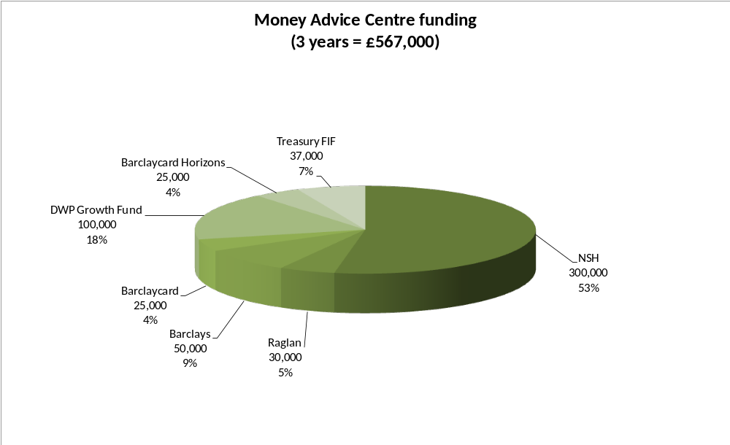
The location in the heart of the estate has seen significant footfall traffic. In 18 months almost 15,000 people have visited the office, an average of 41 per day. Many customers have valued the third party, impartial and confidential nature of the service. A report on the impact of the MAC after seven months identified improved physical and mental health and 96% satisfaction with the third party service delivered by the CAB in resolving problems.
The location, near customers, is seen as vital, as is the impartial and independent nature of the advice including advice relating to housing arrears owed to the landlords who support the project. In a survey of service users 88% said that the location of the MAC had made a difference in their decision to seek advice, and 64% said they had difficulty in travelling into town to reach the main CAB office in Weston.
Clients access the service for a whole range of reasons, the top three being
- Debt, 58% of clients.
- Benefits (including council tax and housing benefit) 27%, and
- Housing 4%.
Steve Zebedee, Head of Corporate Support at NSH and the driving force behind their role in the project acknowledges the reduction in arrears (at the end of its first year, arrears had dropped by over 10% and cases of arrears over £1,000 had dropped from 148 to 104, a decrease of 30%) but is cautious over attributing all of the drop to the MAC. However their role alongside the alterations undertaken within NSH have been definite factors in the reduction.
Whilst debt management is being delivered for residents by the CAB aspect of the MAC, debt prevention is addressed alongside affordable credit by the credit union which shares the premises. Many collaborations and partnerships between CAB and credit unions have been unsuccessful with a jarring relationship sometimes apparent as issues of non priority debt and recommending one specific financial provider can cause difficulties and tensions. MAC appears to have successfully overcome these challenges.
In 27 months of operation a total of 544 loans (of which 459 or 84% have been by NSH tenants) have been taken out, with the average loan advanced being £350. The credit union also now has 445 additional saving accounts opened over the same period.
NSH can clearly identify, and it is assumed price the value of the MAC interventions with their tenants to their Board. Reductions in arrears, savings against equivalent home collected credit, these can be measured. The benefits to a community’s health and well being is harder to record although there are undoubted personal and societal benefits to communities as a result of interventions addressing debt prevention and debt management.
The success of the MAC has also attracted additional investment such as a free to use ATM machine supplied by the Nationwide Building Society. This machine is used on average 1,700 times a week, saving many residents £1.75 per withdrawal which was charged by the only other ATM within 1 mile of the estate, an annual saving in excess of £150,000.
The MAC is a very successful, local service. It will continue to attract support from NSH recognising the undoubted benefits to their tenants. It will need ongoing financial support as the income from loans will be both relatively small and the credit union as a standalone independent operation is responsible for the future use of the income. For example, in 2007/08, 242 loans were advanced from the credit union. Before bad debt is taken into account the return on 242 loans, averaging £350 per loan at 24% interest (26.8% APR) will be £11,410.
The MAC is an excellent example of a housing association recognising the benefits to their tenants of third party service delivery. Their investment has seen both a social and financial return to NSH alongside enormous benefits to thousands of Bourneville residents.
Scotcash CDFI
Scotcash opened its doors to Glaswegians seeking small loans, money advice, savings and bank accounts in January 2007. It’s designed to look like many of the loan operations that pepper Glasgow’s streets offering high cost credit and payday advances. Scotcash, however, is different.
In just over two years Scotcash has issued £1.2m to almost 2200 people, 99% of whom rent their home. Interest rates are higher than mainstream loans, about £20 is repaid in interest for every £100 borrowed, but they are substantially cheaper than those alternative non mainstream providers. In 2008, Scotcash was the overall winner of the prestigious Guardian Public Service award.
Scotcash does more than loans. For many people coming through the door, debt advice is a more appropriate option. Two CAB money advisors based in-house provide this service. Their advice has helped customers manage more than £3m in debt, secure over £1.2m in unclaimed benefits, and has prevented over 100 evictions.
Scotcash is also a route to mainstream financial products. Through an arrangement with the Royal Bank of Scotland (RBS), 600 customers have opened basic bank accounts. Another 200 have opened savings accounts (£30,000 + saved) with Glasgow Credit Union, meaning that in future they will have access to money saved or be able to borrow at lower cost through the Credit Union.
Scotcash was born from discussions between Glasgow Housing Association and Glasgow City Council which identified a number of joint concerns around financial exclusion amongst their tenants and residents. Further development support came from Communities Scotland and RBS.
Scotcash is now the second largest CDFI in the UK, a social business backed by significant investment exceeding £2m from GHA, Communities Scotland, Glasgow City Council, NHS Greater Glasgow and Clyde, the Department for Work and Pension and RBS amongst others. It is intended to be sustainable in the longer term, with no need for ongoing public subsidy, and large enough to make a real impact on the home credit lending market in Glasgow.
Chart 4: Scotcash funding
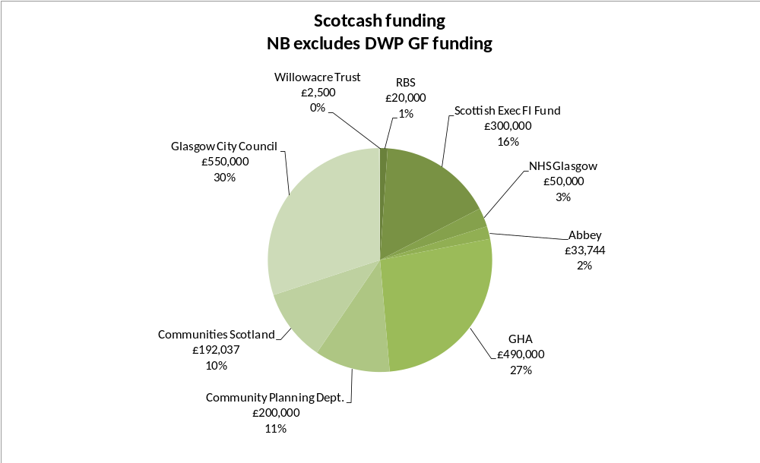
GHA’s Assistant Director of Regeneration David Fletcher says of Scotcash,
‘We have made a significant commitment in Scotcash, and got a significant return. We know many customers have been using high cost credit or are experiencing some financial distress. Scotcash treats people with dignity and respect, and from the information we get back from the organization, we know it is making a real contribution to the lives of our tenants across the city”
Summary of all three case studies
All three projects highlighted have many plus points. They have all seen increase in either loans made or money advice clients seen. Their difficulty is cost and sustainability. South West Pound has 18 staff, and a turnover of £500,000, income from lending generated by the credit unions is acknowledged at just under £50,000 per year, and the relationship between South West Pound and the credit unions means that the income is credit union income not South West Pound income. MAC costs £567,000 over 3 years, and at the end of the 3 years a decision will need to be taken on how to continue funding the project. In 2007/08 The credit union made 242 loans, assuming they were at £500 each over one year this would generate income from lending before bad debt of just over £16,000. Scotcash generates income before bad debt of around £8,000 per month, currently insufficient to meet its running costs. In Somerset there is unlikely to be the resources available to deliver a South West Pound or MAC model, a smaller version of Scotcash (perhaps delivered by an English-based CDFI) might be possible, if capital can be secured from DWP Growth Fund, revenue from housing associations or other sources and salary costs are kept as low as possible with loan rates being properly priced for risk (and return).
12.0 Options appraisal: Do a little, do more, do a lot!
It was clear at the outset that the brief could not simply provide a wish list of new ideas and initiatives, the backdrop of pressure on resources means that it will be extremely difficult to secure the funding required to support a wide range of impressive sounding but hard to deliver proposals.
The following options are put forward in terms of those that can be undertaken quickly, and will take little or limited amount of resource to make them happen. As a minimum the greatest issue facing Somerset’s credit unions are around volunteer development. The commitment of partners has been repeatedly expressed in interviews and there will be ways to increase the credit union message to an increased audience. The danger is that capacity cannot be met, people interested in joining or borrowing will find phones ringing, or emails unanswered, or collection points unstaffed.
As a starting point the members of the community banking steering group should meet with a wide range of partners to deploy resources and agree which are the key elements to proceed with from the options list. Thereafter an action plan and timeline should be prepared with key tasks agreed and lead officers identified. It is vital that everyone is clear on leadership, both within the steering group and within the respective parts of the steering group. So, identifying key personnel or organisations who will take discrete elements connected to say, housing associations or advice bureaus will be required.
Critically outcomes will need to be set and agreed. The interdependence of many of the options may it difficult to propose outcomes at this time, for example, setting a target for the number of bank accounts or HCI policies is difficult until the baseline number of unbanked and uninsured is known. However, outcomes should be Somerset wide, and could encompass increases in volunteer numbers, increases in credit union membership or borrowers; greater awareness and use of advice bureaus or calls to NDL, increased take-up of HCI, attendance at housing outreach and CAB surgeries, attendance at events to promote Somerset-wide services and so on.
Much is being done to address the needs of the people of Somerset; individually and collectively great efforts are being made and results realised. There will be a greater demand on services addressing debt management and debt prevention in the coming months, and working collectively more can be achieved.
Option | Description | Partners | Cost
Sector Connector | A half day seminar to allow key partners to explain their own work and better understand their partners work | Credit Unions. / Housing Associations.  NHS Somerset. / Somerset Community Foundation. / CAB & West Somerset Advice Bureau. / Somerset Voluntary Sector Network. / Local Authorities. / Wessex Re-Investment Trust. / DWP Financial inclusion Champions. / JobCentre Plus / Community Council for Somerset | Low (under £1,000)
Promote NDL | Advertise National DebtLine (NDL) on all correspondence to increase awareness and monitor caller numbers from Somerset | Credit Unions. / Housing Associations.  NHS Somerset. / Somerset Community Foundation. / CAB & West Somerset Advice Bureau. / Somerset Voluntary Sector Network. / Local Authorities. / Wessex re-Investment Trust. / DWP Financial inclusion Champions. / JobCentre Plus / Community Council for Somerset | Low
Bulbs, benefits, Banking & Business events | High profile customer focused event featuring Energy Saving Trust, Money & Debt Advice, Pension Credit advisors. JobCentre Plus, Banks, Wessex Re-Investment Trust, Credit Unions, advertised via radio and local media to promote the services available to people throughout Somerset to combat the recession and credit crunch. | Credit Unions. / Housing Associations.  NHS Somerset. / Somerset Community Foundation. / CAB & West Somerset Advice Bureau. / Somerset Voluntary Sector Network. / Local Authorities. / Wessex re-Investment Trust. / DWP Financial inclusion Champions. / JobCentre Plus / Community Council for Somerset / Energy Saving Trust. / High Street Banks / Furniture re-Cycling Outlets. | Low (under £2500)
Tenants Baseline Study | Gather information on all housing association residents through an annual baseline survey including information on bank accounts held, credit use, savings, interest in self employment, HCI, etc | Housing Associations | Low (under £1000)
Credit Buster information Packs | User friendly brochure detailing summary benefits of Credit Union membership, loan comparison, CAB, NDL, | Credit Unions. / Housing Associations.  NHS Somerset. / Somerset Community Foundation. / CAB & West Somerset Advice Bureau. / Somerset Voluntary Sector Network. / Local Authorities.  Wessex re-Investment Trust. / DWP Financial inclusion Champions. / JobCentre Plus. / Community Council for Somerset | Medium (under £5000)
Central Credit Union Resource | Funding two posts within a common central resource serving all four credit unions. To include:  - A common information hub, telephony and (potentially) appointment book;  - Consistent marketing & promotional message along the lines of “safe savings : sound borrowing;”  - Loan administration using 1 x back office;  - Training in loan underwriting;  - Volunteer development and recruitment;  - Building partnerships and collection points with:  - Citizens Advice Bureau;  - Housing Associations;  - Local Authorities;  - Wessex Re-Investment Trust;  - Primary Care Trust;  - Somerset Voluntary Support Network;  - Somerset Community Foundation;  - Supporting People.  - Distribute membership forms;  - Common reporting to potential funders. | Application to one or more of the following organisations to fund central resource:  - Community Builders  - Esmee Fairbairn Foundation  - Transact Barclays Community Finance Fund  - Friends Provident Foundation | High (£50,000 per year)
Leverage with High Street Banks to secure trusted partner status | High Street Banks can confer “trusted partner” status with housing associations thereby allowing them to accept the ID and address verification to open basic bank accounts. Often this status is granted on a quid pro quo basis with banks securing or retaining business from partner organisations. | Housing Associations / Local Authorities / NHS Somerset | Low
Develop Gateway triage system | Each CAB offers a ten minute assessment process utilising their most experienced staff. Training for staff is required to increase effectiveness of the Gateway either through additional, specialist volunteers, or potentially paid Gateway personnel | CAB | Low (volunteer based) to High (paid staff)
Further investigation of philanthropy capital | Somerset’s liquid millionaires and other high net worth individuals approached to support percentage of giving to use as capital for future capacity based lending or other community banking developments | Somerset Community Foundation / Local Authorities | Low
New Credit Union collection points | Utilise Housing Association and CAB outreach offices to develop new credit union collection points | Housing Associations / CAB / credit unions | Low
Recruit new volunteers | Volunteer promotion strategy to encourage new credit union volunteers within locations that have a clear need for credit | Credit Unions / SVSN / Local Authorities / Housing Associations / CAB / Community Council for Somerset | Low
Develop a Safe & Sound marketing strategy | Utilise marketing personnel to develop a marketing strategy that can encompass the benefits of all credit unions. Promote strategy throughout media outlets in Somerset | Credit unions / Local Authorities | Medium (under £10,000)
Enhance face to face contact & promotion | Harness the personnel already seeing vulnerable adults to promote the credit buster packs, safe & sound strategy, and other credit union and CAB benefits. | Supporting People / Housing Officers / JC Plus / Community Enablers / CAB / Childcare centres / Health Visitors / GPs | Low (training and info. raising through central credit union resource)
HCI strategy | Develop HCI policy costing under £1 / week across Somerset to be promoted in credit buster and Safe & Sound strategy. | Housing Associations | Low (training Housing Officers in the benefits of HCI)
Seek DWP Growth Fund support for CDFI development | Investigate the location of (up to) 4 CDFIs in urban parts of Somerset (Frome, Bridgwater, Yeovil, Taunton). Approach existing DWP contracted CDFIs to establish their interest in managing and operating a CDFI. Develop a funding package with DWP GF, Somerset County Council, NHS Somerset, Housing Associations & Somerset Community Foundation. Secure commitment from CAB to embed money advisor. Secure commitment from Credit Unions to offer linked saving accounts. | Somerset County Council / Housing Associations / NHS Somerset / DWP Growth Fund / Transact Barclays Community Finance Fund / Social Capital / CAB / Somerset Community Foundation / High Street Bank | High (around £50,000 per outlet per year)

“IMF puts losses at $4,100bn” article by Sarah O’Connor quoting IMF Global Stability Report, Financial Times 21 April 2009
IMF Global Financial Stability Report, April 2008
John Stumpf, CEO, Wells Fargo, quoted in Warren Buffet’s letter to Berkshire Hathaway shareholders, February 2008
David Trone, Wall St analyst quoted in New York Times 16th March 2008 www.nytimes.com/2008/03/16/business/worldbusiness/16iht-bailout.5.11152401.html
Warren Buffett is a U.S. investor, businessman, and philanthropist. He is one of the most successful investors in history, the largest shareholder and CEO of Berkshire Hathaway. In 2008 he was ranked by Forbes as the richest person in the world with an estimated net worth of approximately $62 billion. He is known for his frugality despite his massive wealth and for his scepticism of certain accountancy practices and financial instruments
Robert Zoellick, President, World Bank 17th Feb 2009
Population projections (2006 – 2031) for Joint Strategic Needs Assessment Strategic Health Authorities and Primary Care Organisations
Communities and Local Government areas falling within the most disadvantaged 29% quoted in Somerset Economic Digest (March 2009)
ONS
Monetary Policy Committee (MPC) the committee of nine economist chaired by the Governor of the Bank of England that amongst other duties sets Bank of England base rate
Professor David Blanchflower quoted in http://perspicacious.co.uk/all-the-news/national-disaster-looms-as-one-in-five-young-britons-are-now-unemployed/14847/
“A Better deal for Consumers: Delivering real help now and help for the future” HM Government Business Innovation & Skills (BIS) (July 2009)
IFS report quoted in “Life becomes cheaper for many richer families” article in Financial Times 25/3/09
“Somerset Economic Recovery Plan” Somerset County Council (March 2009)
Danny Dorling, Professor of Human geography at the University of Sheffield quoted in “public health in a recession” article in Nursing Times (November 2008)
Professor Richard Wilkinson, emeritus Professor of Social Epidemiology at the University of Nottingham quoted in “public health in a recession” article in Nursing Times (November 2008)
Customer footfall in Q3 (08/09) was 5560 rising to 6299 in Q4 (08/09) an increase of 13%. All four CAB reported increases in that period ranging from 4% to 22% of customers. Source: Somerset CAB
Linking Credit Unions & Money Advice:A research report on the Blackfriars Advice Centre, Southwark Credit Union and Twinpier. Paul A Jones, financial inclusion partnership Project, Liverpool JMU, (2006)
“How poor households pay more for essential goods and services”, Family Welfare Association (Save the Children) (2007) http://www.savethechildren.org.uk/en/docs/poverty_briefing.pdf
BrightHouse is a rent-to-buy store with 177 stores in the UK serving 125,000 predominantly low income customers. It does not undertake any credit check on its customers, instead asking for five character references. Its customer base is 75% female. BrightHouse charges an APR of 29.9%. They often establish their outlets within poorer neighbourhoods and shopping centres. Many commentators believe they over inflate the price of goods initially and then cross sell an expensive warranty to the customer if the customer cannot demonstrate accidental damage on HP goods on their HCI policy.
HCI: A puzzle or a mystery: National Housing Federation (DWP) November 2008 limited publication
ABI, Access for All: Extending the reach of insurance protection (Oct 2007)
Financial Inclusion Taskforce, Report on findings into insurance and financial inclusion, IWG, June 2008
Financial Inclusion Taskforce, Report on findings into insurance and financial inclusion, IWG, June 2008
Peter Crook, CEO, Provident Financial Services remarks made to city analysts announcing Provident’s 2008 results on 3rd March 2009, Source: Provident webcast.
A £500 loan repaid over 12 month at 26.8% APR (the maximum a credit union can impose) would incur interest of £67, compared to a £500 cash loan from Provident advertised on their website on 27th September 2008 repaid weekly over 52 weeks which incurs interest of £410 (total repayable £910 at 272.2% APR) http://www.providentpersonalcredit.com/home-credit/loan-calculator/
At the end of 2007 there were 607,400 members within 501 UK credit unions. (Source: Breaking through to the future: The strategic development of credit unions in Britain, 1998 – 2008, Paul A Jones Research Unit for Financial Inclusion, Liverpool John Moore’s University, (Dec 2008)) and 61.4m people estimated to live in the UK July 2008 (source: ONS)
Membership Counts: Who uses credit unions Smith, Nick & Collard, Sharon (PFRC) (2006) identified the credit union customer as 67% female, average age 47 years, without dependent children 52%, white 79%, owns home outright or with mortgage 48%, employed full time 48%, net household income over £200 per week 63%.
Paul Farmer, CEO, MIND, quoted in Daily Mail “men are twice as likely to suffer stress in silence” 11 May 2009
The Receding Tide: Understanding unmet needs in a harsher economic climate The interim findings of the Mapping Needs Project Dan Vale, Beth Watt s & Jane Franklin (Young Foundation) (2009)
Case study reproduced from ONE report on affordable credit in North East (Rocket Science, April 2009) approved by Kevin Osborne, South West Pound.
Case study reproduced from ONE report on affordable credit in North East (Rocket Science, April 2009) approved by Steve Zebedee, North Somerset Homes
Making Advice Count measure of the impact of the money advice centre
MAC statistics supplied by Steve Zebedee, North Somerset Homes (April 2009)
Making Advice Count. A Measure of the impact of the Money Advice Centre, Nov 2007 (CAB)
Making Advice Count. A Measure of the impact of the Money Advice Centre, Nov 2007 (CAB)
Making Advice Count. A Measure of the impact of the Money Advice Centre, Nov 2007 (CAB)
Scotcash case study reproduced from forthcoming SFHA brochure (to be published October 2009)

