
Operating Instructions
Contador
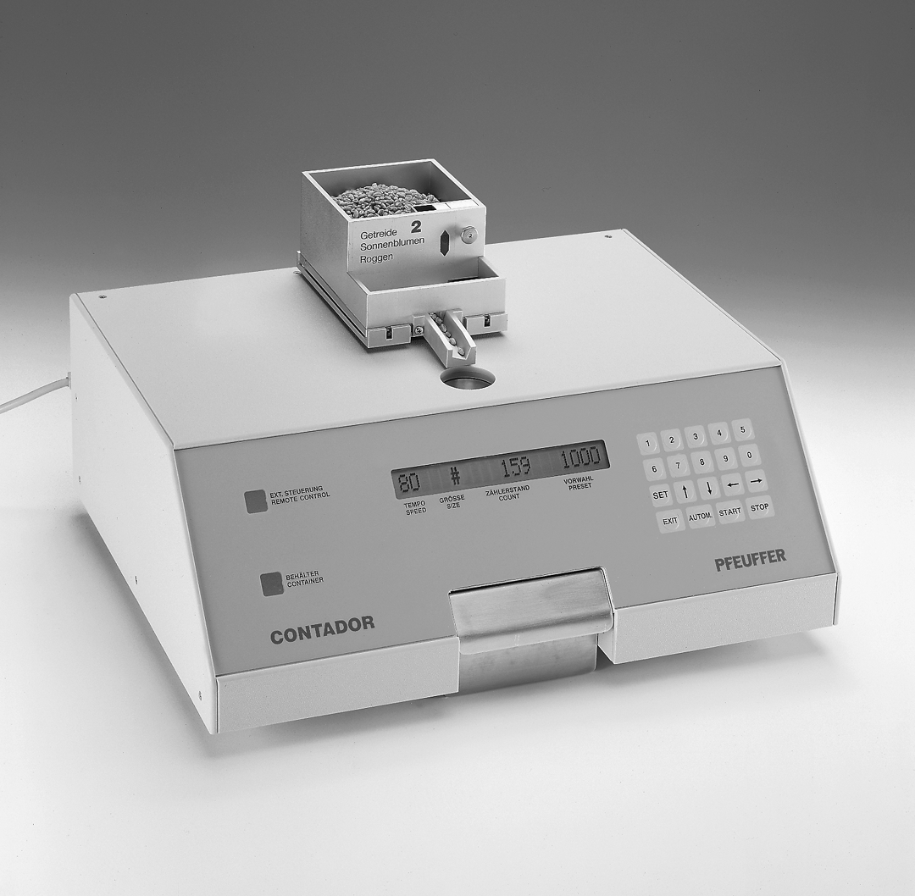

Serial no.: _____________
Pfeuffer GmbH
Distributed by:
Hoffman Manufacturing,Inc.
16541 Green Bridge RD SE
Jefferson, OR 97352 USA

Tel. (541)327-2242
Fax (541)327-2255

www.hoffmanmfg.com
sales@hoffmanmfg.com

Contents:
1. Introduction
1.1 General
1.2 Function
1.3 Notice - application as directed
2. Safety
2.1 Symbol and notice explanation
2.2 Operator safety-instructions
2.3 Working with electric components
3. Packing, transport
3.1 Transport and storage
3.2 Equipment supplied:
3.3 Assembly
3.4 Connections
4. Function / operation
4.1 Switching on
4.2 Display
4.3 Filling of the sample
4.4 Counting of yarrow and camomile
4.5 Settings
4.6 Counting speed (TEMPO/SPEED)
4.7 Speed reduction
4.8 Grain size (GRÖSSE/SIZE)
4.9 Counting modes
4.10 Feed acceleration
4.11 Audible signal
4.12 Changing the RS232 parameter
4.13 Transmission of count via RS 232
4.14 Discharging of the sample
4.15 Switching off
5. Trouble shooting
What to do, if?
6. Cleaning and maintenance
6.1 Cleaning
6.2 Cleaning the light barrier
6.3 Fuse Replacement
7. Spare parts and service
7.1 Spare parts
7.2 Service
8. Technical data
9. Test certificate
10. Index

Read these operating instructions very carefully before starting the operation and always keep them close to the instrument. We do not assume any liability for errors and damages which are due to the disregarding of these operating instructions.
Only if you have knowledge of these operating instructions can errors be avoided and a trouble-free operation can be guaranteed. It is therefore very important that all persons concerned take note of these operating instructions. If there are any difficulties please contact our customer service or one of our representatives. © 1999, Pfeuffer GmbH, D-97318 Kitzingen.

These operating instructions should be read in full by the operator. They include instructions, technical drawings which must not be copied, neither completely nor in part, distributed, used or passed to third parties without our written permission. We reserve the right to make technical modifications which may be necessary for the continued improvement and development of the CONTADOR.

1. Introduction

1.1 General
The seed counter CONTADOR is used for the rapid determination of precise counting results, e. g. for the thousand corn weight of grain, small seeds, legumes, maize, etc.

The Contador consists of a photoelectric counting device, keypad, well-legible, illuminated LCD dot-matrix display, programme for normal, summation and differential counting, automatic or manual speed regulation and setting of grain size.

Besides the feed containers and collection container the CONTADOR can be equipped optionally with a semi-automatic filling station CONTAFILL for the filling of the counted grains into bags respectively bottles.

The Contador is delivered completely ready for operation. The instrument is suitable for remote control via RS232 interface.

1.2 Function
A feed container is placed onto the instrument. During the counting process the feed container is kept in place and vibrating by means of an electromagnet. The product to be counted reaches the outlet and falls through the photoelectric counting device into the collection container. As soon as the preset quantity is reached, the seed counter CONTADOR switches off automatically.

1.3 Notice - application as directed
The Contador is exclusively designated for the counting of grains, small seeds, legumes, maize and similar products.

Objects made of static plastic or similar foreign parts must not be counted with the Contador. We draw your attention to the fact that the feed counter is not suitable for the control of liquids. This leads to a destruction of the CONTADOR. Unauthorized modifications are not allowed. The indications of these operating instructions regarding operation and maintenance must be considered.

Any application other than that stated herein is forbidden. The manufacturer assumes no liability for damage caused by incorrect or unauthorized use. Any damage or risk caused by improper use is the responsibility of the operator. Before using the CONTADOR for applications outside the guidelines contained herein contact the customer service department of Pfeuffer GmbH, Kitzingen.

2. Safety

2.1 Symbol and notice explanation

2.1.1 Operator safety symbol:
You find this symbol in connection with all notices regarding operator safety in these operating instructions (OI), which refer to dangers to life and limb of persons. Pay attention to these notices and be very careful in these cases. Pass all notices regarding operator safety on to other operators. Besides the notices of these operating instructions the general rules for safety and prevention of accidents must be considered.


2.1.2 Attention-notice
Attention! You find Attention! at points in these operating instructions, which must be complied with particularly in order to maintain the directives, rules, notices and correct operation and to prevent damage or destruction of the machine.

2.2 Operator safety-instructions
The CONTADOR is manufactured according to the latest technological standards, especially with regard to the rules for prevention of accidents (RPA) and is operationally reliable. This machine can be dangerous if it is used improperly by untrained persons or if it is not used in accordance with the directions. We draw your attention especially to the fact that all safety precautions of the machine serve for accident prevention, i.e. the protection of the operating and maintenance personnel and for the machine itself.
During all works that are related to mounting, dismounting, conversion, adjustment and maintenance the machine must be disconnected from the mains in order to avoid electrocutions or short circuits.

The following notices regarding operator safety must be particularly considered.
- Each person, who is concerned with mounting, dismounting, remounting, commissioning, operation and maintenance (inspection, maintenance and overhaul) of the CONTADOR in the company of the operator must have read and understood the complete operating instructions and especially the chapter regarding safety.
- The operator is obliged to use the CONTADOR only in perfect condition.
- The operator of the CONTADOR is responsible to ensure that the safety devices are not changed, that they are working and that they are not blocked. It is not allowed to remove, make unusable or bridge over safety devices from the machine, such as locks, covers and housing switches.
- Remove protection devices only during standstill or with disconnected plug.
- Principally all work on the CONTADOR must be carried out during still stand.
- Before starting the machine after repair works it is necessary to check whether all protection devices have been fixed.
- The local rules for safety and prevention of accidents must be considered in every case before starting the operation of the CONTADOR.

2.3 Working with electric components
All repair and maintenance works regarding electric components of the CONTADOR must be carried out by an electric specialist in accordance with the VDE (Association of German Electric Engineers)-regulations as well as the requirements of the local electric supply companies. Attention must be paid to ensure that the connection to the mains is equipped with a protective conductor (earth).

3. Packing, transport

3.1 Transport and storage

3.1.1 Notices and protective measures for the transport
- use the supplied original packing for despatch
- treat with usual care
- keep instrument in original packing and prevented from moisture
- do not keep in the open
- do not put heavy objects on the packing

3.1.2 Information regarding damages in transit
Damages in transit must be reported and documented in written form (preferably by means of a photograph).

3.1.3 Checks during the acceptance through the consignee:
 Are there any loose parts inside the housing?
 Are there any scratches, dents or other damages on the housing?

3.2 Equipment supplied:
Check the equipment supplied with regard to completeness. Compare the following list to the delivered parts. If something is not clear look up the delivery note first. It contains all parts delivered by us. Missing parts must be reported to us immediately in written form.

3.2.1 Standard equipment
article-no. | description | quantity
1410 0009 | Seed counter CONTADOR | 1
2410 1062 | mains cable for power supply | 1
3110 0040 | collection container | 1
2410 010_ | feed container at your option (refer to 3.2.2) | 1
3190 0020 | bristle brush | 1
2410 0090 | operating instructions (English) | 1

3.2.2 Accessories / Options For further spare parts refer to chapter 8.
article-no. | description |  | quantity
2410 0101 | feed container no.1 for rape, seeds, small seeds | 1
2410 0102 | feed container no. 2 for grain, sunflower seeds, rye | 1
2410 0103 | feed container no. 3 for legumes, beans, peas and maize | 1
2410 0104 | outlet for maize for feed container no. 3 | 1
 | feed container for costume jewellery | 1
 | feed container no. 1 with additional slide (for yarrow and camomile | 1
 | smooth collection container for yarrow and camomile | 1

3.3 Assembly
Place the Contador horizontally onto a solid table. Pay attention to an ergonomic arrangement and to the consideration of the safety regulations described under chapter 2.
In the supplied original position the feed container and the collection are not mounted to the instrument. The corresponding feed container must be placed on the receiver of the feed container of the instrument. The collection container is placed under the outlet opening.

3.4 Connections

3.4.1 Power supply

Main connection of 230 V/50 Hz alternating current with protection conductor earth is required. Use the supplied main cable for this purpose.
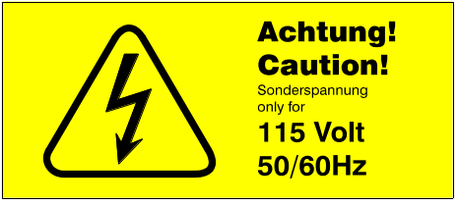sticker „special voltage“

Before starting the initial operation, check whether the indications of the type plate correspond to the available supply voltage respectively main frequency. If the source of current has a different voltage (e.g. 115 V) pay attention to the yellow label attached at the rear side. Only if the opposite label is fixed to the rear side is the machine really suitable for the indicated special voltage! If there is not any label at the rear side the machine is 230 V/50 Hz.

3.4.2 Remote control
RS232-interface (25poles D Sub-socket at the rear panel) for the control of the instrument by means of an external PC. For this purpose the programme extension „CONTWA“ can be supplied on request (must be indicated on your CONTADOR order!) The control is done by means of commands in single ASCII-characters.

Configuration of the 25 poles D Sub-socket at the rear panel of the CONTADOR:
Pin 2 - TxD
Pin 3 - RxD
Pin 7 - GND

- Special interface (15poles D Sub-socket at the rear panel)
for simple external controlling device

4. Function / operation

Attention! Before starting the initial operation please read chapter 2 of these operating instructions regarding safety in any case! Cleaned and undressed samples reduce the cleaning work and the cleaning interval (refer to 6.2)!

4.1 Switching on
After switching on the instrument the system message " *** CONTADOR *** " appears on the LCD-display for 2 seconds and then the status indication " # # 0 0 "(refer to illustration under 4.2) with the values for speed, size, count and preset appears. The "#"-sign indicates that speed and size regulation are set automatically.

4.2 Display elements
- Single-space, 20-digits LCD-display (Display);
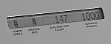
LCD-Display
for the simultaneous indication of the following parameters in normal mode
- counting speed (Tempo/Speed)
- grain size (Größe/Size)
- count (Zählerstand/Count)
- count preset (Vorwahl/Preset).

- Luminous array "Ext. Steuerung/Remote Control" is active, if
- remote control of the instrument via RS232-interface or special interface is carried out, operation by means of the keypad is not possible in this case
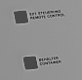
radiant fields
- semi-automatic filling station CONTAFILL is connected.

- Luminous array "Behälter/Container"
is active, if the feed container and/or the collection container are missing.
In this case the instrument stops counting.

4.3 Filling of the sample
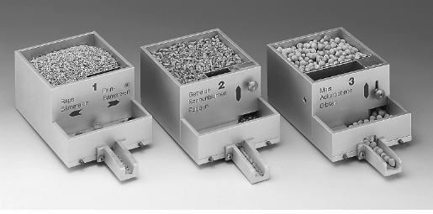
feed container
- Place the suitable feed container (1,2 or 3) onto the receiver of the container
- Fill the sample into the feed container
- Adjust the slide of the feed container according to the grain size
Note:
The instrument is equipped with a safety circuit. If the collection container is missing, the Contador does not start to count (LCD-display: „collection container missing“).

4.4 Counting of yarrow and camomile
For the counting of yarrow and camomile the following points must be considered:
- A special feed container (feed container no. 1 with additional slide, option) must be used. The position of the two slides no. 1 and no. 2 must be adjusted in order to guarantee the passing of single seeds through the light barrier.
- A special collection container (option) without insert must be used.
- The feed container must be cleaned carefully after each counting (blow out with air). The outlet must be cleaned with alcohol, otherwise it can be jammed and due to this a counting will not be possible anymore.
During the counting of other products (e.g. rape) the right slide no. 2 of the feed container no. 1 must be replaced by the supplied slide no. 3.

4.5 Settings
In order to improve the counting speed or counting accuracy the Contador offers various settings. In order to start a counting process only the preset must be set. For the other parameters, the standard settings can be maintained.

- The selection of the parameters must be done while not in thecounting mode and the display is not flashing (switching on-condition). The setting mode is started by pressing the key "SET" (preset starts to flash). By means of the keys „0“ up to „9“ the preset value can be adjusted (for further information please refer to the lower paragraph). By means of the arrow keys „⬅" respectively „➔" or the key combination „SET“, „SET“, „5“ or „6“ the various input arrays can be selected. At the same time the input array is flashing on the display.
- The following diagram represents the configuration of the arrays. In order to reach e.g. the „counting mode“, press „SET“ and „➔“. For the setting of the language press „SET“, „SET“, „5“ and „➔“ successively. A detailed description follows!
- The input arrays on the right of the „preset“ appear on display only after having been selected. The requested parameter is set by means of the arrow keys "⬆„ respectively "⬇„.
- The setting mode is stopped by pressing the key "STOP" (input is no longer flashing).

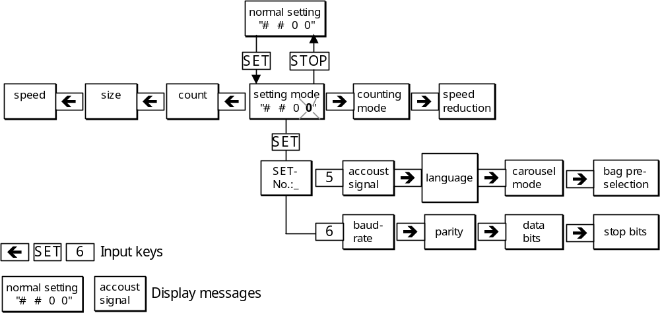
diagram „input levels Contador“
The requested values can be set by means of the indicated keys:

Parameter | keys | possible settings | presetting
preset | 0...9 | 1 ... 99950 | 0
count | 0...9 | 0 ... 99950 | 0
size | 0...9, AUTOM. | 3 ... 150 or „#“ for auto mode |  | #
speed | 0...9, AUTOM. | 0 ... 99 or „#“ for auto mode | #
counting mode | [⬆] [⬇] | counting normal, sums, differences | normal
speed reduction | [⬆] [⬇] | YES, NO | YES
acoustic signal | [⬆] [⬇] | YES, NO | YES
language | [⬆] [⬇] | German, English, French | German
baud rate | [⬆] [⬇] | 150, 300, 600, 1200, 2400, 4800, 9600 | 9600
parity | [⬆] [⬇] | none, even, odd | NONE
data bits | [⬆] [⬇] | 7, 8 | 8
Stop bits | [⬆] [⬇] | 1, 2 | 1
Input stop by pressing STOP.

4.6 Counting speed (Tempo/Speed)
The CONTADOR selects the counting speed automatically in accordance with the placed feed container and the measured counting impulse. At the same time the counting period and the counting accuracy is optimised. Speed („#”) means, that the setting of the counting speed is adjusted automatically by the Contador.
The operator can also set a fix speed value manually in the range between „0“ up to „99“, i.e. 99 % of the maximum possible speed. In this case, however, an optimal time and size regulation is not possible.
The counting accuracy can be increased e.g. by reducing the speed. The manual setting does not allow a speed reduction at the end of the counting (refer to 4.7).

4.7 Speed reduction
Shortly before the counting process is finished the counting speed is reduced in automatic mode („#“), in order to prevent the falling of additional grains. The CONTADOR reduces the speed and counts only the preset quantity of grains. The tempo reduction can be switched off by means of the corresponding selection array. In this case there will be a „ ! “ in front of the automatic sign „ # “ for speed on the display.

4.8 Grain size (GRÖSSE/SIZE)
Note: Do not forget the regulation of the slide of the feed container according to the product to be counted!
4.8.1 Automatic mode
Automatic mode for size („#“) means, that the instrument partly disregards foreign elements (dust, additions of a smaller diameter), i.e. grains, which are considerably smaller than the product to be counted are not considered. A rape seed among a peas sample would not be counted.
4.8.2 Manual mode
Setting the size of the grains to be counted effects that all grains of maximally half of the preset size are disregarded. The range for the setting of the grain size is from „3“ for 0.3 mm up to „150“ for 15,0 mm, considering as scale the smallest grains to be counted. Problems may occur with long grains, which cannot always be distinguished from round grains of similar diameter.
Note: size regulations exceeding the range between 3 ... 150 (=0,3 ... 15,0 mm) are limited automatically. This is indicated by an acoustic warning signal (beep tone).

4.9 Counting modes

4.9.1 Normal counting (simple)
(= standard counting beginning from 0). After switching on the CONTADOR, the standard setting is normal counting. There is not symbol between count and preset on the display. After pressing the key "START" the instrument starts counting beginning from count „0“ (automatic setting to 0 before starting the counting process). The counting mode is indicated by means of the symbol "➔" between count and preset. When reaching the preset value the feeder is switched off and grains, which are falling through afterwards, are still counted for a period of two seconds. Then the symbol "➔" disappears in the display.
If the normal counting process is interrupted, it can be continued by pressing the key "WEITER/CONTIN.", without resetting the count to zero.

4.9.3 Counting sums
(= to be added to the already existing counted quantity). This counting mode is indicated by means of the symbol "+" between the count and the preset. After pressing the key "START" the instrument continues to count from the existing count value (no automatic reset to zero at counting start). As preset value the sum of the count plus the preset value appear as new value and "➔" instead of „+“ appears on the display.
As soon as the calculated preset value is reached the feeder stops and the symbol „+“ instead of "➔" appears in the display. As preset value the originally set value appears..
Example: counting of beans (very big), in case of bigger quantities the volume of the feed
container is not sufficient.

4.9.4 Counting differences
(= to be detracted from the already existing counted quantity).
This counting mode is indicated by means of the symbol „-„ between the count and preset. After pressing the key "START" the count quantity entered as preset value is detracted from the quantity already counted. As preset value the difference between count minus set preset appears as new value and "➔" instead of „-„ is indicated on the display. As preset value the originally set value appears on the display. As soon as the calculated preset value is reached the feeder stops and the symbol „-“ instead of "➔" appears in the display. As preset value the originally set value appears..
Example: division into different bags

4.10 Feed acceleration
When pressing the key "⬆“ after starting the counting process, the feeding speed is increased as long as the key is pressed respectively as long as the instrument has not yet started the counting process.
Thereby the product to be counted reaches the outlet faster (the product to be counted is vibrated faster, e.g. if the feed container is full).

4.11 Acoustic signal
Counting and other operational errors can be indicated by means of an internal beep tone.
The acoustic signal can be selected by pressing the keys "SET", "SET", "5". By means of the keys "⬆" or "⬇" the operation with beep tone is switched on or off, by pressing the key „STOP“ the selection mode can be left.

4.12 Change of the RS232 parameter
For the control of the CONTADOR by means of the serial interface the baud rate, parity, data bits and stop bits can be changed. The selection can be done by pressing the keys "SET", "SET", "6". By means of the arrow keys "⬅" respectively "➔" the parameters can be selected, by means of the keys or the arrow key "⬇" the values can be changed, by means of the key "STOP" the selection mode can be left.

Possible settings:
baud rate = 150, 300, 600, 1200, 2400, 4800, 9600
parity = non, even odd
data bits = 7, 8
stop bits = 1, 2

4.13 Transmission of count via RS 232
During the standstill of the instrument (no counting and no flashing display) the count can be transmitted via RS232-interface by pressing the keys "⬅" or "➔":

<cr> <lf>
*** CONTADOR ***
<cr> <lf>
count: 54321

4.14 Discharging of the sample
Empty the collection container (collection container respectively bags or bottles of the CONTAFILL). It is important, that the collection container, the bags and the bottles are completely empty, otherwise the result of the next counting is falsified.

4.15 Switching off
Switch off the instrument by means of the flip switch (0 / I); the display is extinguished..

Attention! When changing the place first of all the flip switch must be switched off and only then the instrument must be separated from the mains. Otherwise there may occur problems, when switching on the instrument!

5. Trouble shooting
Independent of the following notices the local safety regulations must be considered during the operation of the CONTADOR in any case. As for the rest we refer to the relevant rules for prevention of accidents of the employers liability insurance associations.

Fault finding , what to do, if?
Symptoms | Cause | Measure(s)
display not illuminated after switching on | fuse blown | replace fuse (positioned directly at the mains supply)
 | mains cable not connected properly | Check the plug at the instrument and inside the socket. Does the socket lead current?
„*** Contador ***“ appears on the display for a longer period after having switched on the instrument | instrument was not switched on properly | switch off, wait for about 5 seconds, switch on again
instrument does not start the operation after having pressed the key „START“ | feed container missing | place feed container
 | collection container missing | place the collection container or send instrument for repair
 | electronics faulty | send instrument for repair
message „preset wrong“ („no sample) appears on the display; instrument stops counting during the counting process. | instruments stopped feeding, because for a period of 1 minute no sample was counted | fill in sample, eliminate jamming (by shaking)
 | mains voltage fluctuations | check mains voltage
 | electronics faulty | send instrument for repair
instrument does not switch off automatically | mains voltage fluctuations,  electronics faulty | check mains voltage,  send instrument for repair
wrong counting result | speed too high | reduce speed
 | improper regulation of slide at feed container | adjust the slide according to the grain size
 | incorrect manual data input (speed, size) | correct data
 | instrument does not count correctly | carry out a test by means of a reference sample
 | electronics faulty or dirty | send instrument for repair
flashing display | display still in setting mode (Set-mode) | press key „STOP“
display message " preset wrong" | preset is 0 (must be at least 1); | enter bigger preset
 | preset > 99950 (max. preset during normal counting:  99950); | enter smaller preset
 | during counting differences: preset > than count; during counting sums: preset plus count > than 99950; | change preset respectively count accordingly
display message  "feed container missing";  "collection container missing" | the corresponding container is missing | place corresponding container
beep-tone and display „grain size 150“ is illuminated | grain size > 150 was selected | enter grain size < 150
table 6.1

All error messages must be confirmed by pressing the key „STOP", to continue the working process of the instrument.

6. Cleaning and maintenance

Unauthorized conversions are not allowed!
This can cause avoidable dangers to life and limb. The manufacturer does not accept any liability..

Pay attention, that the instrument is separated from the mains before opening the housing of the Contador in order to avoid electrocution and short circuits.

Besides the following points the Contador is not subject to warranty.

6.1 Cleaning
In case of dusty and dressed seeds the feed container and the collection container must be cleaned by means of a pencil from time to time.

Attention! The rubber insert inside the collection container must not be removed! This will lead to incorrect counting results and impurities inside the light barrier.

After switching off the Contador must be cleaned with a cloth from time to time.
Do not use acids or aggressive cleaning agents.
We recommend to clean respectively to cover the complete instrument before longer periods of standstill. This guarantees a proper function of the instrument.

6.2 Cleaning of the light barrier
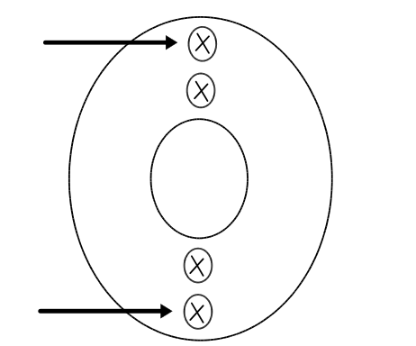
Befestigungsschrauben Auslauftrichter
Depending on the frequency of use especially in case of dusty and dressed products the light barrier must be cleaned from time to time:
- Remove the collection container
- Loosen the fixing screws at the bottom side of the discharging hopper (refer to opposite diagram).
Note: the two internal screws should not be loosened, otherwise the setting of the discharging hopper can be misadjusted.
- Remove the discharging hopper
- Clean the light barrier with a dry cloth.
- Assemble in reversed order.
- Check the counting accuracy (refer to chapter 9).

6.3 Replacement of the fuse

Do not replace the fuse, except the display is not illuminated after having switched on the instrument, even if the mains voltage is available.

Pay attention, that the instrument is separated from the mains before opening the housing of the Contador in order to avoid electrocution and short circuits.

The fuse is located inside the fuse holder below the connector plug. In case of malfunctions, please check, whether the fuse is ok (visual check). Use the type T 800 m A, 250 V.

7. Spare parts and service

7.1 Spare parts
Please refer to the spare part lists for your spare part orders.
It is most important to keep spare parts and wearing parts on site to maintain the constant function and readiness for operation of the CONTADOR.

Pos. | Part-No. | description
1 | 2410 0101 | feed container for small seeds, size 1
2 | 2410 0102 | feed container for cereals, size 2
3 | 2410 0103 | feed container for legumes and maize, size 3
4 | 3299 5060 | main cable
5 | 3253 0214 | fuse, type 0,8 A; 250 V, time-lag
6 | 3135 0085 |  | rubber feet
7 | 2410 0036 |  | collection container
8 |  |  | smooth collection container for yarrow and camomile
9 |  |  | slide no. 3 for feed container no. 1 (for yarrow and camomile)

For your spare parts orders we need the following information:
- part no.:
- description:
- machine type:
- serial no.:
- year of construction:
- quantity:

Original spare parts can be obtained from us directly or through our authorised dealer. We can only guarantee original spare parts. Of course, we carry out service work as well. If you have any doubts, as to whether you are in a position to carry out conversion work by yourself please contact us:

Hoffman Manufacturing, Inc

16541 Green Bridge RD SE
Jefferson, OR 97352 USA

Phone: 001(541)327-2242
Telefax: 001(541)327-2255

7.2 Service
In case of claims we need the following information:
- customer address
- description of instrument / -type
- serial-no.
- year of construction
- problem description, claimed errors

8. Technical data

8.1 Ratings (please enter data):
Company/place:
Description of machine: Seed counter
Type of machine: Contador
Serial no.:
Year of construction: 200__

8.2 Machine data
voltage: 115 V or 230 V ~ AC
frequency: 50 / 60 Hz
Other voltages can be supplied on request!
size: 430 x 355 x 230 mm (including feed container)
weight: 16 kg
ambient temperature: 5 °C up to 40°C
display: LCD, 20 digits, illuminated

CE-marking

By means of the CE marking of the machine and the EC Declaration of Conformity the supplied Contador is in accordance to the relevant elementary safety and health standards of the EC Directives machines 89/392/EC electromagnetic compatibility 89/336/EC.

9. Test certificate
For routine checks of the counting accuracy of the instrument each operator should prepare his own test certificate (=reference sample, e.g. 1000 grains of wheat) immediately after receipt of the CONTADOR.
In case of high deviations, please contact the customer service of Pfeuffer GmbH.

This protocol serves as documentation of the test condition of the seed counter Contador by the operator. Please copy this page for your tests.

Company, city
stamp:
Year of construction:
Serial no.

Test with reference sample

Standard sample: __________________________

Quantity: __________________________

Allowed tolerance: __________________________

Temperature: __________________________

date of test: | counted quantity | result/remark

The person who carried out the test confirms the proper performance of the measurements as described in the operation instructions under chapter 4.

The Contador meets the requested requirements.

City, date name, position signature

10. Index

A
application as directed 3
Assembly 6
C
cleaning 13
counting differences 11
counting speed 10
counting sums 10
D
Display elements 7
F
fault finding 12
feed acceleration 11
feed container 5
Function 7
fuse 13
G
grain size 10
I
interface 6; 11
N
normal counting 10
O
Operation 7
P
Parameter 9
R
RS232 11
S
Safety 4
safety circuit 7
service 14
Signal 11
spare parts 14
T
technical data 15
tempo reduction 10
test certificate 16

EC-Declaration of Conformity
as defined by EC directives
Machinery 89/392/EEC, Annex II A and
Electro-magnetic compatibility 89/336/EEC

We herewith declare that the machine described below as well as the version put into circulation by us corresponds to the relevant elementary safety and health standards of the EC machinery directive because of its design.

In case of modification of the machine not in coordination with us this declaration expires.

Description of the instrument: seed counter

instrument type: CONTADOR

serial no.:

Relevant EC directives:
EC machinery directive 89/392/EEC
EC directive electro-magnetic compatibility 89/336/EEC

Applied harmonized :
DIN EN 292-1, DIN EN 292-2, DIN EN 60204-1 (VDE 0113, Part 1),
DIN EN 50081-1 (VDE 0839, Part 81-1), DIN EN 50082-1 (VDE 0839, Part 82-1),
DIN EN 61010-1 (VDE 0411, Part 1)

Applied national standards:
DIN 57106-1 (DIN VDE 0106, Part 1), DIN 57106-100 (DIN VDE 0106, Part 100)

