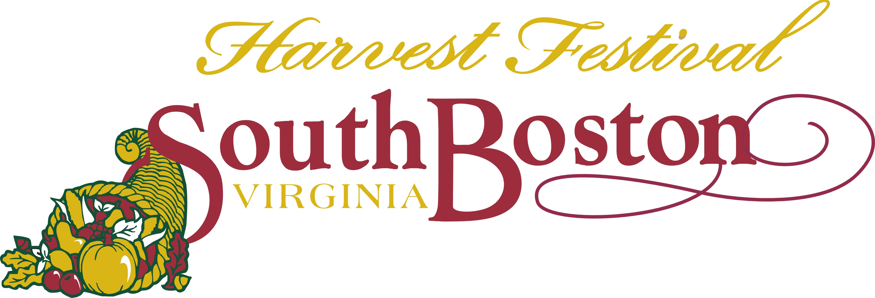
27th Annual in Downtown South Boston
432 Main Street, South Boston, VA 24592
Telephone: (434)-575-4208 Fax: (434) 575-4275
E-mail: sdavis@southbostonva.us Website: www.soboharvestfest.com

Saturday, September 29, 2018
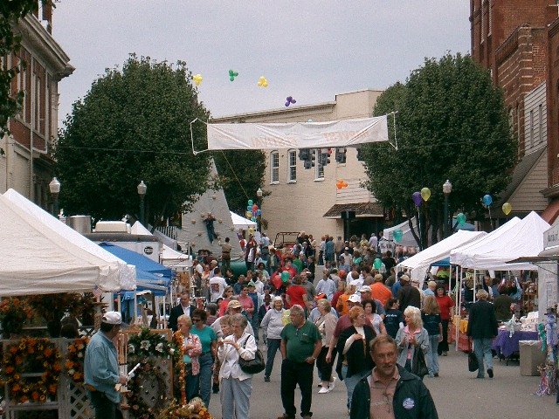
CRAFT VENDOR APPLICATION

ENTRY FEE:

$60.00 make payable to South Boston Harvest Festival (fee is non-refundable) All applications received after Aug. 31, 2018, the entry fee will be $10.00 more--$70.00
Send completed application and check, money order or credit card information to:
South Boston Harvest Festival 432 Main Street South Boston, VA 24592
Service Charge for all returned checks $25.00
Final Deadline ---Thursday, September 27, 2018 12:00 noon

REQUIREMENTS TO APPLY:

*MUST be handmade. If selling both handmade and non-handmade in the same booth you must use the commercial application, no toy guns allowed
*At least one photo of what your display will resemble must accompany this application. Application will not be considered without photo.

INFORMATION:

*This is an outdoor festival held in the streets of downtown South Boston.
*Booth space is 10 by 10. The space may be on the street or on the sidewalk area between the trees. You may purchase two spaces if needed, $60.00 per space.
*Vendors provide their own tables, chairs, tents, shelves, racks, extension cords etc.
*Exhibit hours are 9:00 a.m. to 5:00 p.m. Be ready to sell at 9:00 a.m. and sell until 5:00 p.m. Vendors leaving before 5:00 pm may not be invited back. No selling is permitted after 5:00 p.m.
*Fee is non-refundable due to cancellation on your part or inclement weather. This is a “rain or shine event”---no rain date.
*Exhibit spaces will be arranged by the Harvest Festival organizers according to the order of application received, paid application fee, and what works best for the flow of the festival.
*All vendors must sell to the street side of the festival.
*Confirmation will be sent prior to the festival, along with all check-in information.
*As the festival is a family event, all items displayed or sold must be in “good taste”. This is up to the discretion of the Harvest Festival organizers.
*Estimated attendance of previous festivals was around 8,000.

For Office Use Only:

App#___________ Date Rec._______________ Conf. Sent__________________ Fee Paid__________

CRAFT VENDOR APPLICATION 2018
$60.00 application fee---must accompany this application

Organization Name: Phone:________________________
____________________________________
Cell Phone:____________________
Contact Person:
_______________________________________________________________________

Email: (PRINT CLEARLY, you will receive festival information by email

______________________________________________________________________________________________

Full Mailing Address:
________________________________________________________________________

City/State/Zip____________________________________________________________

Items to be exhibited or sold: (be specific, no toy guns allowed to be sold)___________

_______________________________________________________________________

Will you be bringing a tent? Yes__________________ No_________________
If yes, state size of tent (required) _____________________________________
Are you purchasing two or more spaces? Yes _____How many?_____ No, just one ____

NOTE: Please state if you are bringing a tent. Not all vendor spaces are tent friendly. Your
space cannot be altered to fit a tent if you do not indicate that you will be using one.

Electrical Needs: (check the one that applies to you)

Option #1 none _________

Option #2 yes __________(120v/20amps)
If yes, state what you will be using the electricity for. For example---cash register,
lamps etc.________________________________________________________________

Extra electricity, Option #3 yes _________ (the volts/amps you require ____________)
If yes, state what you will be using the electricity for. For example---cash register,
lamps etc.________________________________________________________________

Our extra electricity is limited. If your electrical needs are above 120v/20 amps, please call and discuss this with the festival coordinator for approval, before mailing in application.
There is an additional charge for extra electricity. (434-575-4208)

Do you have handicapped needs? Yes _____________No _____________

Have you been here before as a vendor? Yes ____________No _________

How did you hear about this festival? _______________________________

Payment Information
(Payment is due with the application to secure your spot)

Payment: Please make check or money order payable to South Boston Harvest Festival

Payment by credit card: (fill out below or call the office 434-575-4208)

Name as it appears on card: ____________________________________________________

Full Address: _______________________________________________________________

Type of Card (circle one) VISA MASTERCARD DISCOVER

Card Number: _ _ _ _ - _ _ _ _ - _ _ _ _ - _ _ _ _ Security Code: ___ ___ ___

Expiration Date: ___________ Amount to be charged: _____________________________

Signature: _________________________________________________________________

By submitting this form, I understand that my Credit Card will be charged the fee for my
application to the South Boston Harvest Festival of 2018 upon the Festival’s receipt of this application form. Your receipt will be emailed back to you. Your statement will show a charge
made to Destination Downtown South Boston (DDSB).

Agreement Information
(signature required---this page must accompany your application)

PLEASE PRINT OUT ALL PAGES, FILL OUT COMPLETELY AND MAIL BACK TO THE FESTIVAL. KEEP COVER PAGE FOR YOUR FILES

Any questions call Sara Davis, Festival Coordinator at 434-575-4208, fax 434-575-4275
or email sdavis@southbostonva.us .
For more information visit, www.soboharvestfest.com

By signing this application, each vendor is fully responsible for their own entries, including loss by breakage, theft, fire, rain, or any other cause of damage to inventory or self. Vendors are responsible for any insurance they deem necessary. Also, the vendor hereby expressly releases Destination Downtown South Boston and the Town of South Boston from any and all liability for damage, loss or injury to any person or goods from any cause whatsoever. Destination Downtown South Boston and the Town of South Boston assume no responsibility or liability for fire, theft, rain, or other loss or damage or for injuries to person or property.

Signature (required) _______________________________________________________

Today’s Date ____________________________________________________________

27th Annual in Downtown South Boston
432 Main Street, South Boston, VA 24592
Telephone: (434)-575-4208 Fax: (434) 575-4275
E-mail: sdavis@southbostonva.us Website: www.soboharvestfest.com

NO SOLICITATION AGREEMENT

Organization Name ______________________________________________________

Contact Name __________________________________________________________

Address _______________________________________________________________

City, State, Zip __________________________________________________________

The South Boston Harvest Festival allows all vendors to operate their booth space within the allotted dimensions as stated on all applications, each paid space being 10 ft by 10 ft. All vendors will agree to use their 10 by 10 booth space to display their wares in that area. At no time during festival hours (9:00 am to 5:00 pm) will vendors or any of their associates be allowed to go up and down the festival streets and solicit the visitors. Any vendor or their associates who do not abide by this agreement will be asked to leave the festival immediately and will not be allowed to return to the festival in future years.

Signature of Contact Name ____________________________________________________

Today’s Date _______________________________________________________________

Please read, sign, date and return to the
South Boston Harvest Festival, with your application.

