
Error: Reference source not found
Error: Reference source not foundGuide

SACS 102 – Creating and Maintaining the Schedule
Instructor Training Guide

APPROPRIATE USE AND SECURITY OF CONFIDENTIAL AND SENSITIVE INFORMATION
Due to the integrated nature of the various Human Resources, Finance, and Student modules in Banner and the reporting information in the Enterprise Data Warehouse (EDW), you may have access to information beyond what you need to perform your assigned duties. Your access to Banner and the EDW has been granted based on business need, and it is your responsibility to ensure the information you access is used appropriately.
Here are some reminders of good data stewardship to help you carry out your responsibility:
Do not share your passwords or store them in an unsecured manner. Do not leave your workstation unattended while logged on to administrative information systems. You are responsible for any activity that occurs using your logon ID.
Do not share confidential and sensitive information with anyone, including colleagues, unless there is a business reason.
Retrieve printed reports quickly, and do not leave the reports lying around in plain view.
Secure reports containing confidential and sensitive information (e.g., FERPA, EEO, or HIPAA protected data).
Regarding FERPA, the University of Illinois maintains individual records and information about students for the purpose of providing educational, vocational, and personal services to its students. It is University policy to comply fully with federal statutes and regulations regarding the confidentiality of student educational records. As required by the Family Educational Rights and Privacy Act (FERPA) of 1974, as amended, University policy outlines procedures covering the privacy rights of students. The policy is intended to ensure the confidentiality of student education records, to establish the right of students to inspect and review their education records, and to provide guidelines for the correction of inaccurate or misleading data.
When disposing of reports containing confidential or sensitive information, shred the documents in a timely manner.
Your responsibilities regarding the protection and security of administrative information are outlined in the University of Illinois Information Security Policy for Administrative Information and Guidelines posted at http://www.aits.uillinois.edu/security/securestandards.html and http://www.aits.uillinois.edu/security/guidelines.html. Any violation could subject you to disciplinary action, which could include dismissal or, in those cases where laws have been broken, legal action. You should have signed a compliance form that indicates you have read, understand and agree to comply with the University's Information Security Policy for Administrative Information. If you have not already signed the compliance form, please see your Unit Security Contact, who is responsible for maintaining these forms.
Acknowledgements
This manual is based on SCT Banner2000 System, Release 6.1.
Copyright
Copyright © 2004 University of Illinois – UI-Integrate Project. All rights reserved. No part of this publication may be reproduced or used in any form or by any means⎯graphic, electronic, or mechanical, including photocopying, recording, taping or in information storage and retrieval systems⎯without written permission of University of Illinois – UI-Integrate Project.
Trademarks
Banner2000 ® is a registered trademark of SCT, Corporation.
Prerequisites
The following are prerequisites for this course:
SARR 201 – General Person Records
Course Information
Course ID: SACS 102
Revision Date: 12/15/2005
Version: 2.5

Table of Contents
How to Use this Guide ix
About this Guide ix
Organization of this Guide ix
Conventions Used in this Guide ix
Agenda x
Course Overview 1
Course Objectives 1
Lesson 1: Creating Sections 2
Lesson Length 2
Lesson Objectives 2
Process Flow Diagrams 2
Topic 1.1: Relationship of Catalog Level Course Forms to Schedule Level Section Forms 3
Task 1.1.A—The Basic Course Information (SCACRSE) and Schedule (SSASECT) Forms 3
Task 1.1.B—Building a New Section 4
Task 1.1.B Learning Activity 5
Task 1.1.C—Viewing Course Changes from Term to Term 6
Topic 1.2: Creating Sections 6
Process Examples 6
Topic 1.2 Learning Activity 8
Topic 1.3: Copying Sections 8
Process Examples 8
Lesson Summary 10
Lesson Review 11
Lesson 2: Editing Sections 12
Lesson Length 12
Lesson Objectives 12
Topic 2.1: Field Defaults 12
Task 2.1.A: Fields That Default Directly 12
Task 2.1.B: Fields That Limit the Choices Available at the Section 13
Topic 2.1 Learning Activity 13
Topic 2.2: Querying Sections in Banner 14
Process Examples 14
Topic 2.2 Learning Activity 15
Topic 2.3: Editing the Schedule Form (SSASECT) 15
Process Examples 15
Topic 2.3 Learning Activity 16
Lesson Summary 16
Lesson Review 17
Lesson 3: Managing Enrollment and Dropping Sections 18
Lesson Length 18
Lesson Objectives 18
Topic 3.1: The Enrollment Data Block 18
Process Examples 18
Topic 3.2: The Projected Field 19
Process Examples 20
Topic 3.2 Learning Activity 20
Topic 3.3: Waitlists 21
Process Examples 21
Topic 3.3 Learning Activity 22
Topic 3.4: Reserving Seats 22
Process Examples 23
Topic 3.4 Learning Activity 24
Topic 3.5: Removing the Section Record 24
Topic 3.5 Learning Activity 25
Topic 3.6: The Inactive/Cancelled Status 25
Process Examples 25
Topic 3.6 Learning Activity 27
Lesson Summary 27
Lesson Review 28
Lesson 4: Assigning Resources 29
Lesson Length 29
Lesson Objectives 29
Topic 4.1: Assigning Times from the Meeting Time Code Validation Form (STVMEET) 29
Process Examples 29
Topic 4.2: Allocating Rooms For Sections 31
Process Examples 31
Topic 4.2 Learning Activity 32
Topic 4.3: Customizing the Meeting Times/Places 32
Process Examples 33
Topic 4.3 Learning Activity 33
Topic 4.4: Creating, Locating and Assigning Instructors 34
Task 4.4.A Creating an Instructor 35
Task 4.4.B Instructor Records Maintenance 37
Task 4.4.C Assigning Instructors 37
Task 4.4.C Learning Activity 39
Task 4.4.D Assigning Instructors to Sessions 40
Topic 4.4 Learning Activity 41
Lesson Summary 42
Lesson Review 42
Lesson 5: Cross-Listing Courses 43
Lesson Length 43
Lesson Objectives 43
Topic 5.1: Cross-Listing 43
Topic 5.2: Catalog Level Requirements for Cross-Lists 44
Topic 5.3: Schedule Level Requirements for Cross-Lists 44
Process Example 45
Topic 5.3 Learning Activity 47
Topic 5.4: Editing Time/Place Information after Cross-Lists Creation 47
Topic 5.4 Learning Activity 49
Lesson Summary 49
Lesson Learning Activity 49
Lesson 6: Creating Independent Study Sections 50
Lesson Length 50
Lesson Objectives 50
Topic 6.1: Appropriate Schedule Codes/Approval Types as Enrollment Controls 50
Process Examples 51
Topic 6.1 Learning Activity 52
Topic 6.2: Non-printed ISSs 53
Process Examples 53
Topic 6.2 Learning Activity 55
Lesson Summary 56
Lesson Review 56
Lesson 7: Co-Requisites and Block Scheduling 57
Lesson Length 57
Lesson Objectives 57
Topic 7.1: Co-Requisites 57
Process Examples 58
Topic 7.1 Learning Activity 60
Topic 7.2: One-Way Co-Requisites Practice 61
Process Examples 61
Topic 7.3: Block Scheduling 62
Lesson Summary 63
Lesson 8: Section Fees and Restrictions 64
Lesson Length 64
Lesson Objectives 64
Topic 8.1: Schedule Level Section Fees 64
Process Examples 65
Topic 8.1 Learning Activity 66
Topic 8.2: Possible Section Restrictions 66
Task 8.2.A Include Versus Exclude 67
Task 8.2.B Viewing Default Catalog Level Restrictions 68
Task 8.2.B Learning Activity 69
Topic 8.3: Editing Schedule Level Restrictions 69
Process Examples 70
Topic 8.3 Learning Activity 70
Topic 8.4: Editing Section Comments 71
Topic 8.5: CAPP Area Pre-requisites and Restricting Registration 71
Process Examples 72
Topic 8.6: Adding a Degree Program Attribute to a Section 73
Topic 8.7: Schedule Types 73
Lesson Summary 75
Lesson Review 75
Appendix A 77
Course Field Definitions 77
Section Field Definitions 87
Appendix B 1177
Validation Table Values 117
Section Status Code Validation (STVSSTS) 117
Session Code Validation (STVSESS) 117
Approval Code Validation (STVSAPR) 118
Part of Term Validation (STVPTRM) 118
Appendix C 117
Glossary 119
Appendix D 120
Answers to Questions 120

How to Use this Guide
This guide is intended to supplement instructor-led training for the UI-Integrate System. It is meant for you to use as a learning guide during class and as a reference on the job.

About this Guide
Each lesson is organized into process descriptions and step-by-step activities. Lesson topics provide the background and concepts for the new processes, while the activities allow you to apply these concepts to hands-on examples.

Organization of this Guide
Each lesson includes a brief introduction to the lesson, along with the objectives of that lesson. In addition, each lesson includes the following information, when applicable:
- Topics relating to each lesson objective
- Process description relating to each topic
- Process flow diagrams
- Field-by-Field description of every Form
- Menu paths and Form names for the Banner application
- Step-by-step process explanations
- Topic Exercises
- Lesson Exercises
- Lesson Review
This guide also includes a Course Summary, and an Appendix with reference information.

Conventions Used in this Guide
Throughout this guide, you will find icons representing various types of information. These icons serve as reminders of their associated text.
 | Indicates an Activity where you can test your skills. |  | Indicates a Hint such as a tip, shortcut, or additional way to do something.
 | Indicates a Note or additional information that might be helpful to you. |  | Indicates a Glossary Term, which is also defined in the Glossary section of the Appendix.
*  (asterisk) | Indicates a required field on a Banner form. |  | Indicates a Warning of an action that you should not perform or that might cause problems in Banner.

Agenda
Agenda Item | Length
Day One
Welcome and Introductions | 15 minutes
Lesson One: Creating Sections | 1 hour
Break | 15 minutes
Lesson Two: Editing Sections | 1 hour
Lunch | 1 hour
Lesson Three: Managing Enrollment and Dropping Sections | 1 hour 30 minutes
Break | 15 minutes
Lesson Four: Assigning Resources | 1 hour 15 minutes
Lesson Five: Cross-Listing Courses | 1 hour
Day Two
Lesson Six: Creating Independent Study Sections | 45 minutes
Break | 15 minutes
Lesson Seven: Co-Requisites and Block Scheduling | 30 minutes
Lesson Eight: Section Fees and Restrictions | 45 minutes
TOTAL COURSE TIME | 10 hours

Course Overview
During this course you will both build and change course sections in the variety of ways that you regularly do during normal business processes.

Course Objectives
When you have completed the materials presented in this course you will be able to:
- Describe the relationship between the catalog and the schedule levels in Banner.
- Identify the key forms in Banner that are used in the section creation process.
- Copy and/or create a section in Banner.
- Delete a section in Banner.
- Manage enrollment for sections using Banner.
- Assign resources (room and instructor) to sections in Banner.
- Describe the appropriate instances when you use each of the two ways to create independent study sections in Banner.
- Manage fees and/or course attributes at the section-level using Banner.
- Manage restrictions at the section level.

Lesson 1: Creating Sections
Although a good deal of time and effort are placed into the creation of the Course Catalog, when students register, they do not register for courses but rather they register for specific sections of those courses. For example, a course such as ENG 100 might have dozens of different sections during a given term meeting at various times and locations; a student can register for any one of them.
In this lesson we will begin to explore how specific sections of courses are created in Banner.

Lesson Length
This lesson takes approximately one hour to complete.

Lesson Objectives
When you have completed the materials presented in this lesson, you will be able to:
- Identify which section parameters default from the catalog level in Banner
- Create a baseline section in Banner
- Create sections in Banner by copying the baseline section

Process Flow Diagrams
Schedule Level
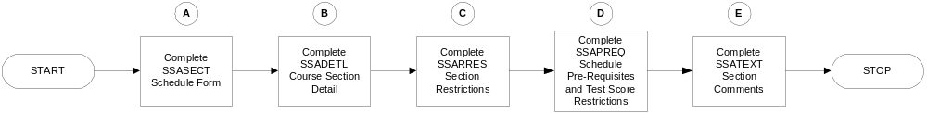
Beginning SSASECT
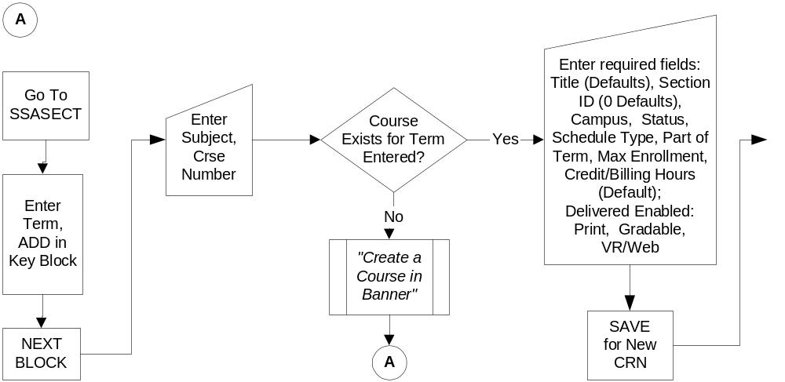

Topic 1.1: Relationship of Catalog Level Course Forms to Schedule Level Section Forms
Before you can create sections of a course, you must have those courses built into the catalog. In this topic, we will look at what course data needs to be in Banner at the catalog level. We will also begin to explore how that data defaults to the schedule level.
When sections of courses need to be built into the university schedule (sometimes called the “timetable”), selected individuals go into Banner and create the needed sections. If this is not done, or if it is done incorrectly, student registration is adversely affected—or even prevented.

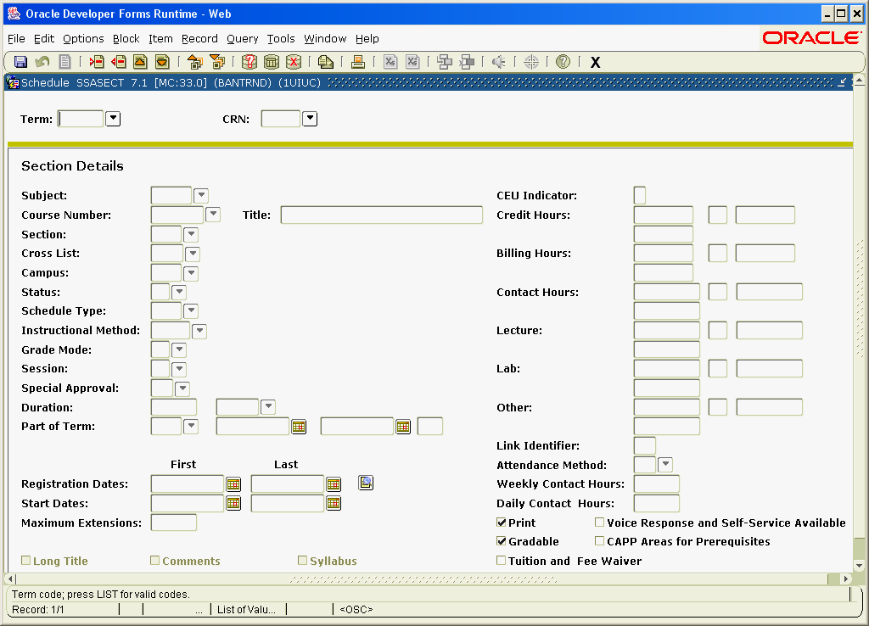
Even though it’s called a “Course Reference Number” this value is actually Banner’s tracking number for specific sections of a course!
The Schedule (SSASECT) form

Task 1.1.A—The Basic Course Information (SCACRSE) and Schedule (SSASECT) Forms
Let’s introduce the Basic Course Information (SCACRSE) form and see how it relates to the Schedule (SSASECT) form.
Step | Action | Results/Decisions
 | Using the Menu or the Direct Access field, display the Basic Course Information (SCACRSE) form:  SCT Banner »  Student Menu»  Course Catalog Menu »  Basic Course Information Form | The Basic Course Information (SCACRSE) form displays.
 | Type XXXX in the Subject field and press ENTER. | Use your Subject code.
 | Type 1XX in the Course field and press ENTER. | Select a 100-level course in your department.
 | Type 1200XX in the Term field and press ENTER.
 | Click Next Block seven times to navigate through SCACRSE in its entirety, and return to the SCACRSE Course Information block.
 | Click the Exit button to exit back to the Main Menu.
Instructor Note  The CRNs for this exercise are in the form of a handout labeled Topic 1.1A | Using the Menu or the Direct Access field display the Schedule (SSASECT) form.  SCT Banner »  Student Menu»  Class Schedule Menu »  Schedule Form | The Schedule (SSASECT) form displays.  The term that you were looking in before in SCACRSE defaults into the Term field here.
 | Type 1200XX in the Term field and press ENTER.
 | Press TAB to reach the Course Ref. Number field.
 | Type XXXXX in the Course Ref. Number field. | Your instructor will give you this value.
 | Click Next Block to access the Section Information block.
 | Press TAB to navigate through the form and press F9 on each List of Values (LOV) field to explore each field and the validation table behind it.

Task 1.1.B—Building a New Section
Now we will build a new section of that course.
Keep in mind, a section is built at the “schedule level”; the course that it is based on was made at the “catalog level.”

Step-by-Step Procedures
Step | Action | Results/Decisions
 | Click the Rollback button or press Control + F7 to rollback to the Key block. | Now you will make a new section of this course for this same term.
 | Press TAB to reach the Course Ref. Number field.
 | Type ADD in the Course Ref. Number field.
 | Click Next Block to go to the Section Information block.
 | Type XXXX in the Subject field and press TAB.
 | Type 1XX in the Crse Number field.
 | Press TAB twice. | Now you are in the Section field where you may define the number of this new section.  Notice how the Course Title has defaulted from what was created at the catalog level.
 | Type 100 in the Section field and press TAB twice.
 | Type 100 in the Campus field and press TAB. | Instructor Note  It’s a good practice to jot down the Course Reference Number whenever you create a new section!!
 | Type A in the Status field and press TAB to reach the next field. | This sets the section to Active status; registration is allowed.
 | Type LEC in the Schd Type field. Or select LEC from the LOV.
 | Press TAB seven times to reach the Part/Term field.
 | Type 1 and press TAB. | Notice how the Start and End dates default.
 | Click the Save button or press F10 to save this record | Now your new section has been saved. Transaction complete: 1 records applied and saved displays in the auto-help line.

Task 1.1.B Learning Activity
Develop Your Skills
- Please fill in the blanks with the proper form names to finish this sentence:
Much of the information entered into __________________defaults, or otherwise control, what data you can enter into __________________.

Task 1.1.C—Viewing Course Changes from Term to Term
Over time, revisions to course information will need to be done. In order to view changes in course information, for an effective term, simply change the term code to reflect the different term and select a Course Reference Number for the course in question.
When a change is made on SCACRSE, it generally affects sections that will be built. Credit hour changes will affect sections that have already been created. However, other changes will need to be edited to reflect that change at the schedule level.

Topic 1.2: Creating Sections
In this topic, we will enter a section with some more comprehensive data.

Finishing SSASECT
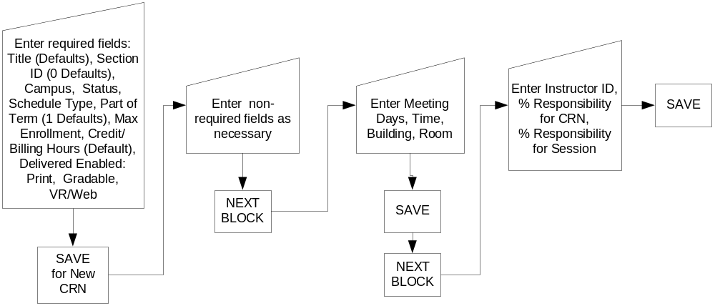

Process Examples
One of your courses needs another section. It will meet on Saturday afternoons from 12:30-4:00 pm for half of the term and use S for its grading mode. If S is its default grading mode, you do not have to fill that field in at the schedule level. We will not assign an instructor at this time (we’ll do that during a later topic).

Step-by-Step Procedures
Step | Action | Results/Decisions
 | Using the Menu or the Direct Access field display the Schedule (SSASECT) form.  SCT Banner»  Student Menu»  Class Schedule Menu»  Schedule Form | The Schedule (SSASECT) form displays.
 | Type 1200XX in the Term field and press TAB.
 | Type ADD in the Course Ref. Number field.
 | Click the Next Block button to go to the Section Information block.
 | Type XXXX in the Subject field and press TAB. | A subject in your department.
 | Type 3XX in the Crse Number field and press TAB twice. | The name of the course displays in the course title field.
 | Type 100 in the Section field and press TAB twice.
 | Type 100 in the Campus field and press TAB.
 | Type A in the Status field and press TAB to access the next field.
 | Type LEC in the Schd Type field and press TAB seven times.
 | Type A in the Part/Term field and press TAB. | The Registration From Date and To Date display.
 | Click the Save button or press F10 to save this record. | Now your new section has been saved. Transaction complete: 1 records applied and saved displays in the auto-help line.
 | Click Next Block. | The Meeting Time block displays.
 | Press TAB twice. | Dates display in the Start Date and End Date fields.
 | Press TAB through the day of the week fields until you reach the S check box.
 | Press the spacebar or mouse to select the S check box. | This class meets on eight consecutive Saturdays.
 | Press TAB twice to reach the Start- field.
 | Type 1230 in the Start field. | The Start Time is 12:30 pm.
 | Type 1550 in the End Time field. | The End Time is 3:50 pm. (All classes must end at least 10 minutes prior to the hour or half-hour.)
 | Click the Save button or press F10 to save this record. | Now your new section has been saved. Transaction complete: 1 records applied and saved displays in the auto-help line.
 | Click Rollback to the Key Block.

Apply Your Knowledge

Topic 1.2 Learning Activity
- In this topic’s exercise you created a lecture section for one of your courses. Now please make a “zero section” (use section id = 0) for the same Subject/Course Number, which will be a lab section. You can give it the same characteristics as the section that you just made, but do not recreate the meeting times. We will use the special section ID of zero because we will be using this section for a special purpose in the next topic.
NOTE: Don’t forget to make a note of the Course Reference Number that your new section received.

Topic 1.3: Copying Sections
Banner offers many ways to relieve the amount of manual data entry that is needed: copy buttons, maintenance buttons, and the duplicate record option for example.
When making multiple sections of a course, the preferred method is to always create a “section 0” section (zero being the value put in the Section ID field). Any section with a Section ID of zero can be used to copy the Section Information block fields directly into new sections. You will practice this in the following exercise using the section that you just made.

Process Examples
We will now copy an existing section’s information to a new section using the “zero section” method.

Step-by-Step Procedures
Step | Action | Results/Decisions
 | Display the Schedule (SSASECT) form  SCT Banner »  Student Menu»  Class Schedule Menu »  Schedule Form | The Schedule (SSASECT) form displays.
 | Type 1200XX in the Term field and press TAB.
 | Type ADD in the Course Ref. Number field.
 | Press ENTER or TAB. | This is a departure from what you normally do, which is to click Next Block to access the form. When you press ENTER or TAB at this point, the Default Section Information form displays. This is what you use to copy sections.
 | Press TAB and type XXXXX (this is the CRN of the section that you created in the last “Learning Activity”) and press ENTER or TAB. | The Process Default Maintenance button is no longer grayed out if you have entered a CRN with a section ID of zero.  Please be aware that you are copying only the first block of SSASECT and that other information needs to be added separately.
 | Click the Maintenance button labeled Process Default. | You are back on the The Schedule (SSASECT) form now.  Even though this looks just like the section that you created before, please note that the CRN has changed. This is actually a new section.  You may now go in and edit it to make it fit your needs—for example, giving it a new section id and meeting time, etc.
 | Press TAB three times to access the Section field.
 | Type 200 in the Section field.
 | Click the Save button or press F10 to save this record. | Now your new section has been saved. Transaction complete: 1 records applied and saved displays in the auto-help line.
 | Click Rollback to the Key Block.

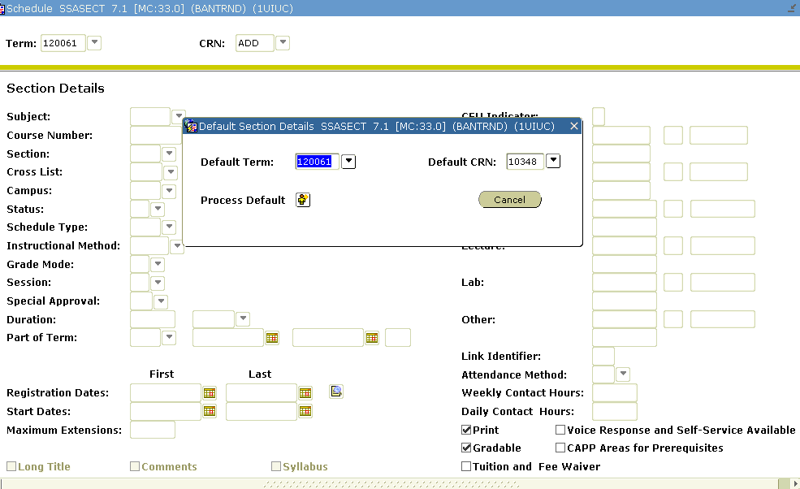
Copying a Zero Section
Please note: The course reference number that you must enter will vary! In this figure, the CRN was “10348.” That means CRN 10348 was the “Zero Section” or it had a Section ID = 0.

Lesson Summary
In this lesson we:
- Identified how SCACRSE relates to its counterpart form at the “Schedule Level”, SSASECT
- Explored how edits at the various levels affect one another
- Learned how to create sections in Banner
- Learned how to create and copy “Zero sections” in Banner

Lesson Review
- Can a section of ENG 100 be set up as a Lab if that was not one of the Schedule types listed for ENG 100 in SCACRSE?

- What is the difference between the “Course Reference Number” and the “Section ID” of a given course offering? How is each created?

- What does the Section ID have to be if you want to copy all of a section’s information into a new section record?

- What does the Voice Response and Self Service Available check box affect?

- What does the Gradable check box affect?

Lesson 2: Editing Sections
After the initial Schedule build, there will be a need to revise and edit various aspects of course sections. This lesson explores ongoing maintenance issues with the Schedule as it further reinforces our understanding of how catalog level processes relate to schedule level processes.

Lesson Length
This lesson takes approximately one hour and 30 minutes to complete.

Lesson Objectives
When you have completed the materials presented in this lesson, you will be able to:
- Explain which values on Schedule (SSASECT) form default from catalog level to schedule level and various ways in which they do so.
- Explain the ways in which information can be edited on SSASECT.
- Explain how edits at the various levels (catalog level and schedule) affect each other.

Topic 2.1: Field Defaults
In this topic we will review, in a more comprehensive fashion, which fields default from catalog to schedule level between the Basic Course Information (SCACRSE) form and the Schedule (SSASECT) form.

Task 2.1.A: Fields That Default Directly
The following fields default directly to Schedule (SSASECT) form:
- Course title
- CAPP Areas for Pre-requisites Designator
- Tuition waiver designator
These fields can be changed in SSASECT when you build the actual section. Changing the title of a section is generally a serious matter that can be done only with University approval. The Tuition Waiver check box can be selected or cleared on SSASECT regardless of how it defaulted.
Again, a reminder: changes on SSASECT only affect that section. Changes to the Basic Course Information (SCACRSE) form generally only affect sections created after that point. An exception to this rule is title: if the course title is changed after sections have already been built but the section titles have not been updated, the new course title will be used for those sections.
Finally, the term roll is not affected directly by changes in SCACRSE. The term roll process in Banner rolls section level information directly from one term to the next like term.

Task 2.1.B: Fields That Limit the Choices Available at the Section
The following catalog-level fields control what can be entered on the Schedule (SSASECT) form:
- Credit Hours
- Billing Hours
- Schedule Types
- Grading Modes
If Credit and Billing Hours are not defined as a range on the course, there is no need to enter a value for the section on SSASECT; the value from the course will be used. If the course is defined with a range, then you may pick a value in that range displayed on SSASECT. Examples of ranges that you can put into the Course Information (SCACRSE) form are “either 2 OR 4 hours” and “2 TO 4 hours.” In the former case, you could use two or four hours when you create section. In the latter case, you could specify two, three, or four hours. If you do not specify a value, then the range defined for the course will be available to the section; initially, the lowest value from the range will default to the student’s registration but can then be changed.
If only one Schedule Type value is listed in SCACRSE, then that is what you must use when you build the section. If more than one is listed on SCACRSE, then you may choose one of those when you build the section. The Grading Mode value can be left null on SSASECT. This means that, at registration time, the default Grading Mode from SCACRSE will be assigned to registrations, but it can be changed. If a Grading Mode is to be assigned on SSASECT, you are limited to the values defined on SCACRSE and the value assigned on SSASECT cannot be changed at registration.

Topic 2.1 Learning Activity
Develop Your Skills

Go back and look at BIOL 599, Section 0, for the current term. Please answer the following questions for that term:
- What schedule type(s) can the above course have for each of its sections?

- What grading mode(s) can the above course have for each of its sections?

- What other form could you look at to verify the answers to these questions?

Topic 2.2: Querying Sections in Banner
When you are searching for or verifying information, the Schedule Section Query (SSASECQ) form is very useful. This form can be used to query sections based upon several criteria, check enrollments for sections of a course, and find inactive/cancelled sections in order to reactivate them.
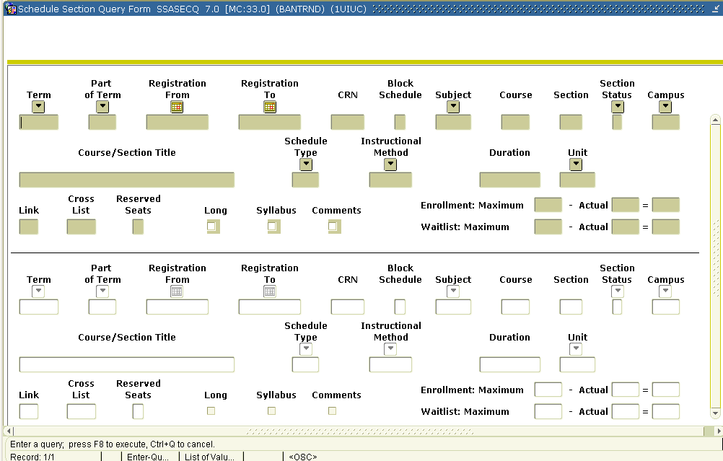

Process Examples
Checking your work with a query can help you to verify that you have entered the data correctly.

Step-by-Step Procedures
Step | Action | Results/Decisions
 | Double clicking in the Course Reference Number (CRN) field on SSASECT, will display the Schedule Query (SSASECQ) form:  SCT Banner»  Student Menu»  Class Schedule Menu »  Schedule Form »  Schedule Section Query Form | The Schedule Query (SSASECQ) form displays.
 | Type 1200XX in the Term field.
 | Press TAB six times to reach to the Subj field.
- E | Type XXXX in the Subj field. | You search for all sections in the subject that have been built for that term.
 | Press F8 or click the Execute Query button. | All of the sections for that subject in the effective term display, including the ones that you created.
 | Press Exit to return to SSASECT.

Topic 2.2 Learning Activity
Instructor Note  Do not skip this activity or you will not be able to do the step tables in the next lesson. | Apply Your Knowledge
- As you’ve seen, it’s easy to find out what sections have already been created. Please make a list of all of the Course Reference Numbers for HIST 100 and ZULU 403 in the 1200XX term.

- Next, clear the query form and this time search for sections of those two courses in the previous term. Please list those.

Topic 2.3: Editing the Schedule Form (SSASECT)
You will edit SSASECT fields that you haven’t yet had the chance to work with.

Process Examples
A section of your Special Topics course has been approved for a section specific title.

Step-by-Step Procedures
Instructor Note
Demonstrate this step chart. Do not have students complete this. Also demonstrate how to use the Session Indicator value of 0 on the query form to find the CRN for NAST 1XX, Section 001.
Step | Action | Results/Decisions
 | Display the Schedule (SSASECT) form  SCT Banner»  Student Menu»  Class Schedule Menu »  Schedule Form | The Schedule (SSASECT) form displays.
 | Type 1200XX on the Term field and press TAB.
 | Double Click on the Course Ref. Number field.
 | Tab to Subj field and enter XXXX; tab to Crse field and enter 290
 | Press F8 or Execute Query button
 | Select a record and double click in CRN field. | This will take the section information for that CRN back to SSASECT
 | Click the Next Block button to go to the Section Information block.
 | Press TAB twice to go to the Course Title field (which is unlabelled).
 | Type History of Banner in that field. | This should only be done if it is a course that is approved for Section Specific Titles.
 | Click the Save button or press F10 to save these records. | Transcactions Complete: 1 records applied and saved. displays in the auto-hint line.

Topic 2.3 Learning Activity
Develop Your Skills
Instructor Note
Hint – Look at the field descriptions.
Also, this is a good point at which to introduce the bookmark job aid.

- When are Course Titles able to be changed from the default in SCACRSE for a section?

Lesson Summary
In this lesson, you have
- Explored what fields in the Basic Course Information (SCACRSE) form default to the schedule level and can be changed or edited and how.
- Used the Schedule Query (SSASECQ) form.
- Practiced editing the Schedule (SSASECT) form.

Lesson Review
Instructor Note
At this point, we’ve explored the two basic forms, the Basic Course Information (SCACRSE) form and the Schedule (SSASECT) form, in some depth. However, before we move on to the other forms that you will be using, we will spend Lesson 3 looking at how to manage enrollment using the Enrollment Data Information block of the Schedule form.
- If some sections of ENG 100 will be Lecture and some will be Lab schedule type, what value(s) must be in SCACRSE?

- Can a section of ENG 100 have three credits attached if it was set up in SCACRSE as having “0 OR 4 credits”? List all the values that can be applied.

- If some sections will be two credit hours and some will be four credit hours, what value(s) must be entered for Credit Hours in SCACRSE?

- Can you leave Grade Mode empty on SSASECT? What happens if you do and there is only one grading mode specified on SCACRSE? What if there are many grading modes listed in SCACRSE?

Lesson 3: Managing Enrollment and Dropping Sections
Over time, it becomes necessary to drop sections that have been built. We will explore how that is done in Banner. We will also explore how the timing of the dropped section affects the exact manner in which we will perform the process.
Reserved seating, waitlists, and over-enrollment strategies are also covered in this lesson. It is possible to control, or even prevent, registration just by altering the value in one field in the Enrollment Data block of the Schedule (SSASECT) form. Although you can press TAB to access this block, it is often quicker to use the Option menu or F3 to navigate there.

Lesson Length
This lesson takes approximately one hour and 30 minutes to complete.

Lesson Objectives
When you have completed the materials presented in this lesson you will be able to:
- Demonstrate ways to navigate to Enrollment Data block of SSASECT
- Use the enrollment form to create a waitlist
- Use the enrollment form to reserve seats by given criteria
- Explain the necessary steps to drop/cancel/inactivate a section, depending on when it is done

Topic 3.1: The Enrollment Data Block
The Enrollment Data block is a normal part of a section’s build. It is customary not only to set a maximum enrollment during the build, but also to control registration at various key times in the future by altering the value in that “maximum” field. First we will introduce the block and the preferred methods of getting there.

Process Examples
First, we’ll demonstrate how to navigate to and use the Enrollment Data block during normal section builds.

Step-by-Step Procedures
Step | Action | Results/Decisions
 | Display the Schedule (SSASECT) form either by using Direct Access field or the Main Menu path  SCT Banner»  Student Menu »  Class Schedule Menu »  Schedule Form | The Schedule (SSASECT) form displays.
 | Type 1200XX in the Term field and press TAB.
 | Type the appropriate Course Reference Number in the Course Ref. Number field for the section created in Topic 1.1.b (Subj, 1XX, Section 100). | Do a CRN query on SSASECQ if you are unclear as to which CRN to type here!
 | Click Next Block. | Instructor Note  Normally, pressing TAB is the recommended method of navigating through forms in Banner. In this instance, however, using the option menu is preferred.
 | Press F3 or under the Options: select Section Enrollment Info | You can also tab 26 times through the Section Information block. The Attendance Method Information will display; tab once more.  If you click Next Block from the Section Information block through all of the additional blocks, you are never shown this block. In terms of exiting this block, however, it “exists” as the “last” additional block; and so you click Next Block to return to the Section Information block.
 | Type 40 in the Maximum field. | This is the maximum expected enrollment.
 | Click the Save button or press F10 to save this record. Do not exit from the Section Enrollment Info as it will be used in the next exercise. | Now your new section has been saved. Transaction complete: 1 records applied and saved displays in the auto-help line.

Topic 3.2: The Projected Field
Earlier we said that the Maximum Enrollment field is sometimes adjusted upwards or downward to control registration. This strategy is usually helpful only after the building and room assignments have been made.
Since the maximum enrollment isn’t the reliable indicator of what you eventually project the enrollment maximum to be, we need to use another field for that: the Projected field. This field is necessary to indicate your intended maximum for the section. There isn’t any functionality in banner with this field, but it is necessary for the scheduling software program we will be using. If the Projected field is zero, we cannot assign a room.

Process Examples
We’ll set the Projected field value for section above. We will change the maximum down to 25 since we want to save seats for later in the registration period; therefore we’ll set projected to 40 as a reminder of what our maximum is.

Step-by-Step Procedures
Step | Action | Results/Decisions
 | In the same section as above | Do a CRN query on SSASECQ if you are unclear as to which CRN to type here!
 | Type 25 in the Maximum field and press TAB twice.
 | Type 40 in the Projected field. | This is the actual maximum enrollment for the course. This can be set to equal the room capacity, for example (although Banner does no automated checks along those lines). This field is informational only, but it is going to be used by the University.
 | Click the Save button or press F10 to save this record. Do not exit from the Section Enrollment Info as it will be used in the next exercise. | Now your new section has been saved. Transaction complete: 1 records applied and saved displays in the auto-help line.

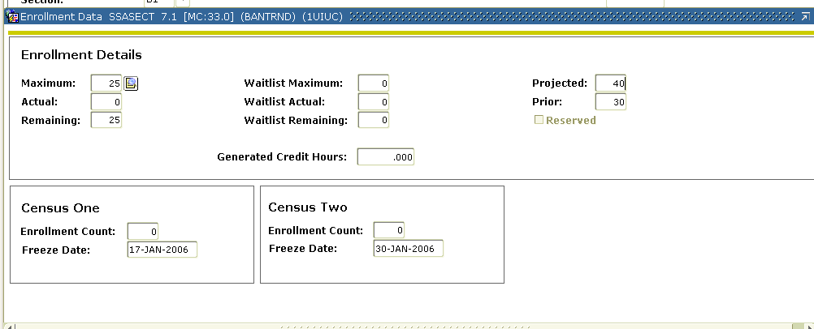
The Enrollment Data Block is a regular part of the section build. Note the Projected value of 40 as a reminder of the total number of seats available.

Topic 3.2 Learning Activity
Develop Your Skills
- As a review, please list all of the fields for which you normally enter values when you build sections.
NOTE: There are other fields used on a case-by-case basis, but these need to be addressed on all sections.

2. When we say a field is “informational only” (like the Projected field, for example), what do we mean by that?

Topic 3.3: Waitlists
When you are creating sections, some individual sections may be set up with waitlists. It is important to note that the management of waitlists is a manual process. Be aware that students can put themselves on more than one waitlisted section of a course and only the student can remove themselves from the waitlist. This is not automatically done once a student gets into a section.
Waitlists are maintained as a separate transaction within Banner. That is, once a section’s enrollment is full and registration is closed, if a waitlist has been defined, students can choose to be on the waitlist. Once the waitlist is established and a student is added to the waitlist, the section remains closed, even if students drop and regular seats open up. This is demonstrated in the table that follows.

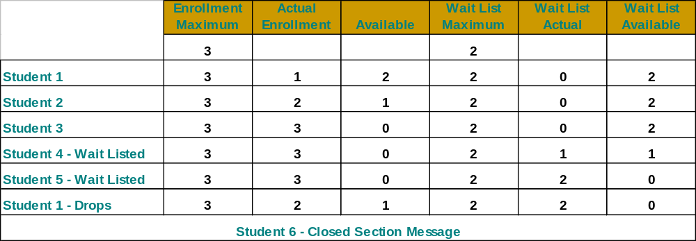
Instructor Note
Can do a query here using waitlist as criteria.

Process Examples
We will set up the section from the previous exercise with a waitlist of five students.

Step-by-Step Procedures
Step | Action | Results/Decisions
 | Press TAB to reach the Waitlist Maximum field.
 | Type 5 in the Waitlist Maximum field. | Now, once enrollment is full for this section, five more students are able to register as “waitlisted” status for this course.  If seats open up, registration personnel have to give the student a permit override in order for them to change the waitlisted status to registered.
 | Click the Save button or press F10 to save this record. Do not exit from the Section Enrollment Info as it will be used in the next exercise. | Now your new section has been saved. Transaction complete: 1 records applied and saved displays in the auto-help line.

Topic 3.3 Learning Activity
Develop Your Skills
Instructor Note
The important point here is the manual nature of waitlist management
- Does a course with a maximum of 20 and a waitlist of five have 25 seats to fill?

- Why or why not?

Topic 3.4: Reserving Seats
Reserving seats is another function that can be used to manage enrollment in sections by Level, Major, or Class. The first record of the Reserved Seat block is understood to indicate unreserved seats (Open to Any). It indicates seats that are available to all students except those who qualify for a reserved seat. Therefore, reserving a number of seats for a level/major/class not only saves those seats for the group indicated; it also limits that same group to the number of seats indicated. It is important to note that you cannot override reserved seats.

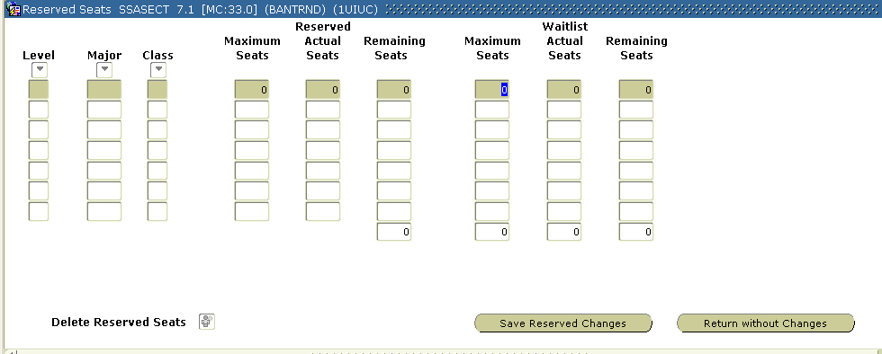
Reserved Seats block of SSASECT form
Once reserved seating is defined and a student registration is applied to one of the reserved seats, the reserved seat data cannot be deleted. For example, if a 30 seat Accounting section reserves 15 seats for majors, once the first accounting major registers, the reservation of seats for accounting majors cannot be removed. While the number of reserved seats can be changed, the seat reservation will continue to restrict enrollment for accounting majors: if only 10 accounting majors had registered in the above section by the first day of class, the number of reserved seats could be reduced from 15 to 10 to open the remaining seats to non-accounting majors; however, that prevents any more accounting majors from registering for the section.

Process Examples
We will return to our section and set aside 15 seats for undergraduates with a specific major.

Step-by-Step Procedures
Step | Action | Results/Decisions
 | Click the Detail button next to the Maximum field. | The Reserved Seats Detail block displays.  The record that represents “not reserved” seating has already been completed and your cursor rests in the Maximum Seats field.  Instructor Note  Major and Level are just two of many way to restrict this. You can also restrict by Class or by a combination of these
 | Type 10 in the Maximum Seats field. | What we are doing is leaving the difference between our original maximum value and the reserved seats that we will enter in the next record.
 | Press the DOWN ARROW to the next record. | You must use the ARROW key here. Your cursor displays again in the Level field on the next line.
 | Type 1U in the Level field and tab. | The cursor moves to the Major field.
 | Double-click or press F9 to bring up the “All Major Codes” Validation table.
 | Press DOWN ARROW to select XXXX; click OK. | Go ahead and select any value for this.
 | Press TAB to reach the Maximum Seats field.
 | Type 15 in the Maximum Seats field and tab. | Notice how the totals display in the bottom of the block.
 | Click the Save Reserved Changes button. | You are now back in the Enrollment Data block. Notice how the maximum value hasn’t changed.

Topic 3.4 Learning Activity
Apply Your Knowledge
- In what order do you normally access the following blocks? (Please number them one for first, and so forth in the blanks provided).
Enrollment Data block _____
Section Information block of SSASECT _____
Reserved Seats block _____

Topic 3.5: Removing the Section Record
Roll (as in “term roll” or “rolling the term”)

An automated process of copying all of the sections and their information from one term to the next
How you remove a section record from the registration process depends on a number of factors: Do you want the section to be in the term roll for next like term? Has the section been included in the published schedule yet? Have any students enrolled for the section yet?
The only time you might remove a section record from Banner outright is if a course is supposed to be dropped and the section should not roll to the next like term. Below is a screen shot of how this is done.

Removing a Section
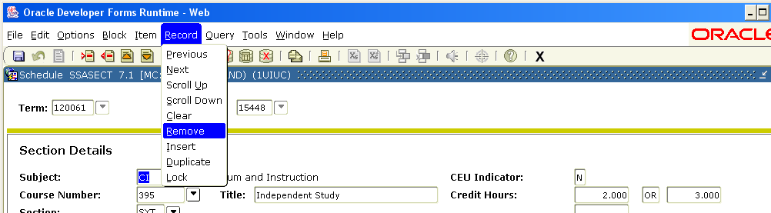

HINT: Do not do this unless prior approval has been given! Also, you cannot re-use the CRN.

Topic 3.5 Learning Activity
Apply Your Knowledge

- Under what circumstances do you completely remove a record from Banner?

Topic 3.6: The Inactive/Cancelled Status
After the term roll, any sections that will not be offered for the term need to be removed from the schedule. To do this, you need to change the status to “I” for inactive. If the section has been published, then you use the “cancelled” status (C). If students are enrolled and the section is cancelled, departments must contact the students to let them know of the cancellation. Students will need to drop the section from their registration, or a department may contact Facility Management & Scheduling and we can mass drop them.

NOTE: Assigning instructors to sections will be covered in Lesson 4. At this point, it is worth noting that if a section has a C: Cancelled or I: Inactive status and has instructors assigned, the instructor will still see the CRN on his or her schedule when he or she logs into Web for Faculty (even though the detailed schedule information will note the section status). To avoid confusion, you might want to remove the instructor from the section when setting a section status value of C: Cancelled or I: Inactive.

Process Examples
Let’s say that we have received instructions to drop a section due to low enrollment. But when we look at it, it has students registered for it. What do we do?
The example that follows takes us through the steps.

Step-by-Step Procedures
Step | Action | Results/Decisions
 | Display the Schedule (SSASECT) form either by using Direct Access field or the Main Menu path:  SCT Banner»  Student Menu »  Class Schedule Menu »  Schedule Form | The Schedule (SSASECT) form displays.
 | Type 1200XX in the Term field and press TAB.
 | Double click in the Course Ref. Number field to query for a section.
 | Tab to the SUBJ field and enter XXXX. | Use your department Subject.
 | Tab to CRSE field and enter 1XX. | Select a 100-level course in your department.
 | Press F8 or Execute Query button.
 | Double click in one CRN. | This will return to SSASECT.
 | Click Next Block. | Fields in the Section Information block are populated.
 | Now access the Enrollment Data block via the Options menu or by clicking F3:  Options »  Section Enrollment Info | The Enrollment Data block displays.  While here, look at the Actual field under the Maximum field. This value is anything other than zero, then students have registered for the section.
 | Click Next Block. | The Section Information block displays.
 | Press TAB six times to reach the Status field.
 | Type C in the Status field. | Giving the course the “cancelled” status immediately
 | Click Save. | Technically, Cancelled means “active, but no registration allowed.” Active/Inactive refers to whether it is retained in the term roll.  At this point, you contact FMS to have them manually drop all enrolled students.
 | Rollback to the Key Block

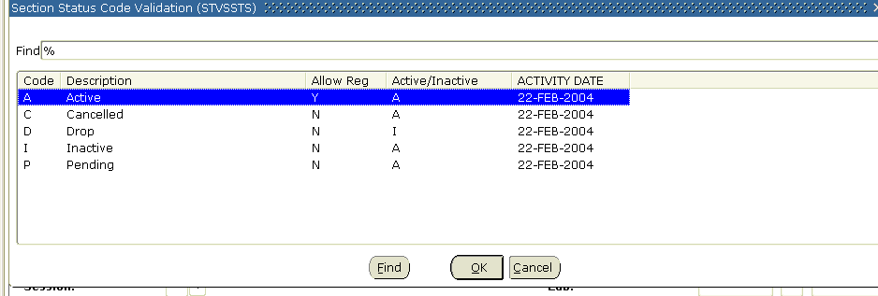
The Section Status Code Validation (STVSSTS) form, notice how only dropped courses are not rolled to the next term
HINT: Section status is one of the fields you can query by on SSASECQ. To monitor when students have been dropped from Cancelled sections, query by term, the subject code(s) for your department, Status of “C” and actual enrollment = 0.

Topic 3.6 Learning Activity
Develop Your Skills
- What is the first consideration that you take when you find out about the decision to “drop” a section?

- What other considerations do you need to make?

Lesson Summary
In this lesson, we:
- Demonstrated ways to navigate to Enrollment Data block of the Schedule (SSASECT) form.
- Used the Enrollment Data block to create a waitlist.
- Used the Enrollment Data block to reserve seats by given criteria.
- Went through the necessary steps to drop a section, depending on when it needs to be done vis-à-vis the published Schedule.
- Went through the considerations that need to be taken in account when you “drop” a section.

Lesson Review
- What is the difference between a waitlist and reserved seating?
Instructor Note
An important part of the Schedule is assigning resources, for example, instructors and locations. Although third-party room-scheduling software will be utilized to schedule classes and assign rooms, it is useful to know how it is done in Banner. We will look at how to custom edit meeting times and locations in the next lesson, as well.

- Why does it matter when you drop a course in Banner?

- What is the difference between dropping a course and canceling it in Banner?

Lesson 4: Assigning Resources
An important part of creating a section is to assign the needed resources (rooms, times, and instructors).
Although third-party software will be used to query and allocate rooms, we will cover how that is done in Banner. We will also cover how to query for instructors and how to change a general person into what Banner will recognize as an instructor so that individual may be selected for the record.

Lesson Length
This lesson takes approximately one hour and 30 minutes to complete.

Lesson Objectives
When you have completed the materials presented in this lesson, you will be able to:
- Schedule the meeting time/place.
- Query to find appropriate rooms.
- Edit meeting time/place fields to match appropriate contact hours.
- Designate general persons as instructors and appoint instructors to appropriate sections.

Topic 4.1: Assigning Times from the Meeting Time Code Validation Form (STVMEET)
Many meeting times are preloaded into Banner and can be called upon by entering the appropriate code from the Meeting Time Code Validation (STVMEET) form. Once the code is entered, however, the meeting times can be edited.

Process Examples
In this exercise, we will schedule a section for only the first twelve weeks of the term.

Step-by-Step Procedures
Step | Action | Results/Decisions
 | Display the Schedule (SSASECT) form either by using Direct Access field or the Main Menu path  SCT Banner»  Student Menu »  Class Schedule Menu »  Schedule Form | The Schedule (SSASECT) form displays.
 | Type 1200XX in the Term field and press TAB.
 | Type the appropriate Course Reference Number in the Course Ref. Number field for the section created in topic 1.2 (SUBJ 3XX). | Do a CRN query on SSASECQ if you are unclear as to which CRN to type here!
 | Click Next Block twice. | The Section Information block displays after the first Next Block.  The Meeting Time block displays.

Notice how most of the Meeting Time block of the Schedule (SSASECT) form is a windowpane. You must scroll to the right to perform the procedures in this step chart and the next one.
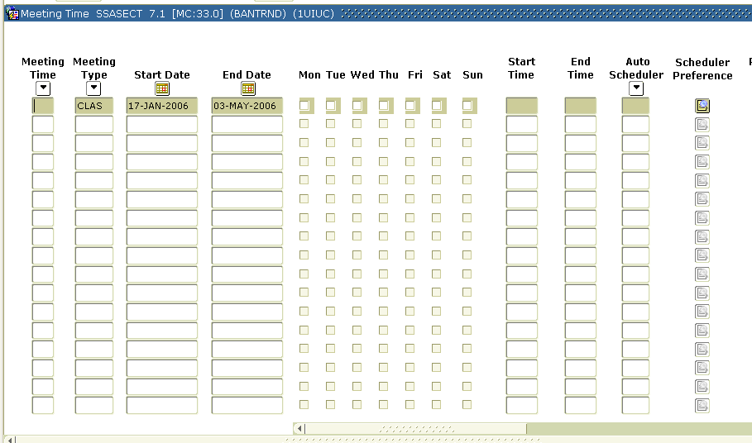
The windowpane of the meeting time block, scrollbar positioned on the far left
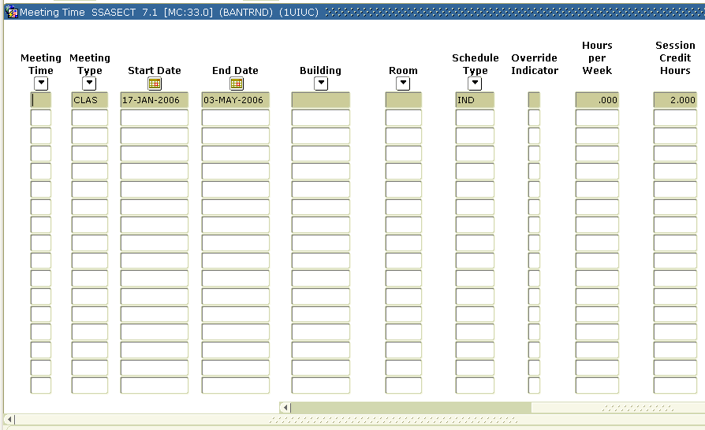
The windowpane of the Meeting Time block, as you scroll across
Step | Action | Results/Decisions
 | Click Delete Record button to remove the existing meeting time.
 | Tab twice to display start and end dates. | The Meeting Time Code Validation (STVMEET) pop-up displays.
 | Press SHIFT+TAB key combination once to navigate backwards to reach the End Date field.
 | Type XXXXXXXX (instructor will give you the date to use) in the End Date field and press ENTER. | DD-MTH-YEAR displays.  We are doing this since this is a twelve week course and we selected the Full Term Part-of-Term on the first block of SSASECT.
 | Click the M, W, and F check boxes. | Use the space bar to check boxes and tab; or click using your mouse.
 | Tab 3 times to the Start field and type 1400; then type 1450 | Do not tab after entering the start time. It will automatically take you to the End time field.
 | Click the Save button. | Transaction complete: 2 records applied and saved displays in the auto-help line.  We will continue this process in the next step chart.

Topic 4.2: Allocating Rooms For Sections
In order for rooms to be allocated for a section build, a number of things must have already been set up in Banner:
- Buildings must have been defined in the Building Definition (SLABLDG) form using codes that are set up in the Building Code Validation (STVBLDG) form
- Rooms in those buildings must have been defined as “classrooms” in the Room Definition (SLARDEF) form and must be active.
NOTE: This is regardless of whether they are actually classrooms or not. All rooms used for scheduling must have this “classroom” designation.

Process Examples
Now we will query to find what rooms are available within a given building.

Step-by-Step Procedures
Step | Action | Results/Decisions
 | Press TAB 12 times to reach the Build field.
 | Type 1BNR (Instructor will give you the building code) into the Build field
 | From the Options menu, select Query Available Class Room (SLQMEET). Your meeting information should be displayed. | The Available Classroom Query (SLQMEET) form displays.
 | Click Options»Available Rooms. | From this query, you can see all rooms.
 | Press DOWN ARROW to the record with 1XX in the Room field and double-click that record to select it. | This defaults Room 1XX into the Meeting Time block of SSASECT.
 | Click Save. | Transaction complete: 1 records applied and saved displays in the auto-help line.

NOTE: If you were entering a section in its entirety, you would be asked to save the record at this point before you could proceed to the next block

If you know your building and room, you can type it directly into the Meeting Time block.

Topic 4.2 Learning Activity
Apply Your Knowledge

- Go into the record for a section of one of your courses and assign it a meeting time of Tuesday nights, from 6:00 to 9:30pm. (Remember, you must enter times in Military Times since there isn’t a designation for AM and PM.)

Topic 4.3: Customizing the Meeting Times/Places
As we indicated at the beginning of this lesson, the times and places for individual sessions can be manually created or edited to reflect actual circumstances. In Topic 4.1, we adjusted the end date to indicate the twelve-week length of time for the section. But even more complicated arrangements may occur.
For example, it is possible that more than one meeting arrangement needs to be created for a section. In addition to the regular class meetings, a section may need to reserve a time and place for a discussion.

Process Examples
As practice, we will enter an additional meeting for the section in exercise 4.1. In addition to M, W, F 2:00-2:50pm, it will meet Saturday from noon to 3:20pm.

Step-by-Step Procedures
Step | Action | Results/Decisions
 | Display the Schedule (SSASECT) form
 | Type 1200XX in the Term field and press TAB.
 | Type the appropriate Course Reference Number in the Course Ref. Number field for the section in exercise 4.1. | Do a CRN query on SSASECQ if you are unclear as to which CRN to type here!
 | Click Next Block twice. | The Section Information block displays after the first Next Block.  The Meeting Time block displays.
 | Press the DOWN ARROW to access a new row.
 | Press TAB to access the S field and select it.
 | Press TAB to reach the Start- field and type 1200.
 | Type 1520 in the End- field.
 | Press TAB to reach the Build field.
 | Type 1BNR in the Build field.
 | Press TAB once to reach the Room field.
 | Type 2XX in the Room field.
 | Press TAB four times to reach the Sess Cred field.
 | Type 0 and press TAB. | If this is not done, you will receive an error message:  *ERROR* Sum of SESSION hours exceed SECTION hours of X.
 | Press Save | Transaction Complete: X records applied and saved displays in the auto-help line.

Topic 4.3 Learning Activity
Develop Your Skills
Consider the following scenario and then please answer the questions below: Next Fall, Students can register for one of two VP 150 Veterinary Pathobiology II sections. One option for students is to register for the section that meets every Tuesday evening for sixteen weeks. Or they can register for the day section-- which meets Monday and Wednesday afternoon in one building the first eight weeks, but in another building the second eight weeks.
- How many sections of VP 150 are there next fall?

- How many Course Reference Numbers will be listed in the Class Schedule under Veterinary Pathobiology II?

- How many meeting records does the section record for the evening VP 150 listing have in Banner?

- How many meeting records does the section record for the afternoon VP 150 listing have in Banner?

Topic 4.4: Creating, Locating and Assigning Instructors
In order for instructors to be created in Banner, the individual must first have a general person record in Banner. Human Resources creates the person records for regular faculty; the person records for graduate assistants are created through the admissions process.
Faculty records (that is, the record that designates a general person as one who can be assigned as an instructor for a section) are created on the Faculty Information (SIAINST) form. This is done for faculty as well as graduate students who will be teaching assistants.

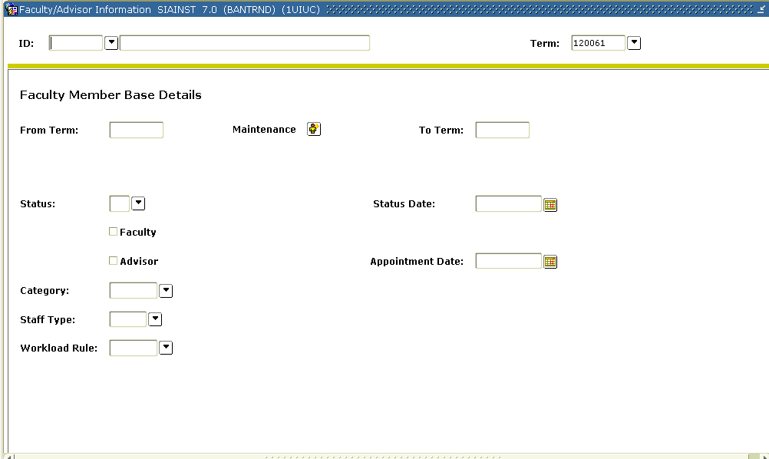
The Faculty Information (SIAINST) form

Task 4.4.A Creating an Instructor
When instructors are brought on to the University, they need to be listed in the schedule as an instructor. They are in Banner as “general persons” but not as “instructors.” In this process we will demonstrate how to designate a general person record as an instructor.

Process Examples
We will designate a faculty member as an instructor.

Step-by-Step Procedures
Step | Action | Results/Decisions
 | Display the Faculty/Advisor Information (SIAINST) form either by using Direct Access or the Main Menu path:  SCT Banner»  Student System Menu »  Faculty Load Menu »  Faculty/Advisor Information  Form | The Faculty/Advisor Information (SIAINST) form displays with the cursor in the ID field.
 | Click the ID button to find a faculty member. | An Option List displays with a choice of Person Search or Faculty/Advisor Search.
 | Select Person Search to access general person records. | The Person Search (SOAIDEN) form displays.
 | Press TAB to access the Last Name field. | The cursor moves to the Last Name field.
 | Type Smith in the Last Name field and press F8 to execute the search. | The record for that person displays.
 | Double-click the ID field for one of the records. | This displays the faculty’s record in The Faculty/Advisor Information (SIAINST) form.
 | Press TAB to access the Term field.
 | Type 1200XX in the Term field.
 | Click Next Block to reach the Faculty Member Base Information block. | This moves the cursor to the Status field in the Faculty Member Base Information block. The From Term and To Term fields display.
 | Type A in the Status field. | If faculty is already active, just verify the next steps.
 | Press TAB twice to reach the Faculty field.
 | Use the spacebar to select the Faculty field.
 | Click the Save button to save the faculty record. | Transaction complete: 1 records applied and saved displays in the auto-help line.
 | Click Next Block twice to access the Faculty College and Department block. | Entering the department information will assist in searching for your instructors when assigning them on SSASECT.
 | Select the Home check box.
 | Press TAB to access the Coll field.
 | Type XX - your college code.
 | Click OK.
 | Press F9 or double-click the Dept field to access the Department Validation (STVDEPT) form.
 | Select XXXX – your department code.
 | Click OK.
 | Click Save to save the record.
 | Click Rollback.

Task 4.4.B Instructor Records Maintenance
Like students records, instructor records are effective-term driven for a campus, allowing the user to maintain faculty information over time. When information that is stored in any of the blocks changes, the user enters the effective term of the change in the Key block. The user then navigates to the block that stores the information to be updated, and clicks the maintenance button to create a new record, which can then be updated and saved. By creating new records to reflect updates for the terms in which they are effective, it is possible to maintain historically accurate records for each instructor. In addition the end term can be used to search for instructors. The instructors are not campus specific, so this is a way of restricting to campus by term. This also allows the instructors to only select the Urbana campus when viewing rosters via the Web for Faculty.

Process Examples
We will de-activate the above person as an instructor beyond the UIUC End of Time.
Step | Action | Results/Decisions
 | Display the Faculty/Advisor Information (SIAINST) form either by using Direct Access or the Main Menu path:  SCT Banner»  Student System Menu »  Faculty Load Menu »  Faculty/Advisor Information  Form | The Faculty/Advisor Information (SIAINST) form displays with the cursor in the ID field.
 | Press TAB to access the Term field in the Key block and type 199999. | 199999 is the value for UIUC End of Time. 299999 is used for UIC and 499999 is used for UIS. This way, when searching for instructors you can narrow the search by campus.
 | Click Next Block.
 | Click the Maintenance button, and the new Key Term will now be the From Term.
 | Type I in the Faculty Status field. | This will inactivate the faculty beginning the new From Term.
 | Click Save to save the record.
 | Click Exit to return to the Main Menu.

Task 4.4.C Assigning Instructors
Now we will enter instructors for this course as though it were team taught equally between two instructors.
We will once again use our section from Topic 4.3 to practice on.

Process Examples

Step-by-Step Procedures
Step |  | Action |  | Results/Decisions
 |  | Display the Schedule (SSASECT) form either by using Direct Access or the Main Menu path:  SCT Banner»  Student Menu »  Class Schedule Menu »  Schedule Form |  | The Schedule (SSASECT) form displays.
 |  | Type 1200XX in the Term field and press TAB.
 |  | Type the appropriate Course Reference Number in the Course Ref. Number field for the section from Topic 4.3. |  | Do a CRN query on SSASECQ if you are unclear as to which CRN to type here!
 |  | Click Next Block three times |  | The Section Information block displays after the first Next Block.  The Meeting Time block displays after the second Next Block.  The Instructor block displays after the third time you click Next Block.
 |  | Click the ID button (drop down arrow) that is above to the second column in the Instructor block. |  | This brings up the Faculty/Advisor Query (SIAIQRY) form.
 |  | Make sure that the value in the Term field is 1200XX and that the Faculty field is selected. |  | These values default into those fields.
 |  | Click Next Block.
 |  | Press TAB to reach the Last Name field.
 |  | Type Smith into the Last Name field.
 |  | Tab to the First Name field and type in the first name of the person you made a faculty in Task 4.4.A and press F8 to execute the query. |  | If you aren’t sure of the spelling, you should type the First Initial and % (wild card).  The record for the person displays (possibly among a list of records that match the search criteria).
 |  | Double-click that record (the cursor is already in the ID field). |  | The record defaults back in the Instructor block of SSASECT.
 |  | Click Save. |  | Transaction Comple: 1 Records Applied and Saved displays in the auto-help line.
NOTE: Notice how the Primary Instructor designator is selected (the P check box) for the first instructor assigned. To save yourself the step of updating the Primary Instructor designator after all instructional assignments for a section have been made, assign the primary instructor first.

If your campus allows students to search for sections based on instructor name, the list of instructors included in the pull-down menu that students see will be limited to the primary instructors assigned to sections.

Similarly, the list of sections returned from a search for classes to add would only list the primary instructor. However, if a student clicks on the CRN for one of the records to see detailed information on the section, the detailed information includes all instructors assigned to the sections.
Step |  | Action |  | Results/Decisions
 |  | Press DOWN ARROW so that you are ready to enter another record into the Instructor block.
 |  | Click the ID button that is below the ID field in the Instructor block. |  | This brings up the Faculty/Advisor Query (SIAIQRY) form.
 |  | Make sure that the value in the Term field is 1200XX and that the Faculty field is selected. |  | These values default into those fields.
 |  | Click Next Block.
- a |  | Press TAB to reach the Last Name field.
 |  | Type the instructor name in the Last Name field and press F8 to execute the query. |  | The instructor will give you the name to use.
 |  | Double-click the record for the person you want to assign (the cursor is already in the ID field). |  | The record defaults back in the Instructor block of SSASECT.
 |  | Press Save. |  | Transaction Comple: 2 Records Applied and Saved displays in the auto-help line.
 |  |  | WARNING: Even if the total percentages of all instructors exceed 100%, Banner lets you save the records—although it gives you a warning to let you know.

Task 4.4.C Learning Activity
Apply Your Knowledge
Please go into another section of a course and add a different faculty member as an instructor.

Task 4.4.D Assigning Instructors to Sessions
Meeting records can share a common session ID. If a section has multiple meeting records with multiple instructors, they can be grouped by session ID. The reason is to clarify the instructor assignment. If you have multiple instructors and need to indicate who is teaching when, it makes sense to group the meeting records by session ID and then assign instructors accordingly.
- Sections are the classes that students actually register for. Sections are represented in Banner by CRNs (Course Reference Numbers).
- Sessions, on the other hand, are centered around individual meeting times/places as indicated on the Meeting Time block of the Schedule (SSASECT) form. A section may have multiple sessions, as in the screen shot below.

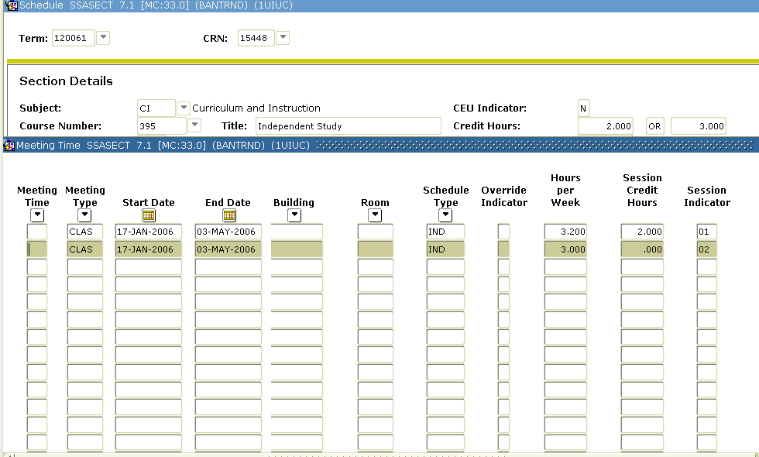
A section (CRN 15448- indicated with one star) with multiple sessions (indicated with two stars)

Process Examples
We will assign each instructor to separate meeting times of the same section in Task 4.4.C.

Step-by-Step Procedures
Step | Action | Results/Decisions
 | Display the Schedule (SSASECT) form either by using Direct Access or the Main Menu path:  SCT Banner»  Student Menu »  Class Schedule Menu »  Schedule Form | The Schedule (SSASECT) form displays.
 | Type 1200XX in the Term field and press TAB.
 | Type the appropriate Course Reference Number in the Course Ref. Number field for the section in Task 4.4.C. | Do a CRN query on SSASECQ if you are unclear as to which CRN to type here!
 | Click Next Block two times. | The Section Information block displays after the first Next Block.  The Meeting Time block displays after the second Next Block.
 | Press DOWN ARROW so that you are at the second record in the Meeting Time block.
 | Press TAB 18 times or use the mouse to advance to the Sess In field.
 | Type 02 in the Sess In field.
 | Click Save.
 | Click Next Block to advance to the Instructor block.
 | Press DOWN ARROW so that you are at the second record in the Instructor block.
 | Type 02 in the Sess In field. | Now the two instructors have separate sessions.
 | Click Save. | Transaction Comple: 1 Records Applied and Saved displays in the auto-help line.

Topic 4.4 Learning Activity
Develop Your Skills
- On what form are “general persons” made into “instructors” in Banner?

Lesson Summary
In this lesson we learned how to
- Assign multiple meeting times for a section
- Query and assign available rooms
- Convert a general person into an instructor
Instructor Note
Once you have created a section and assigned resources to that section, you have built a basic section. Lessons Five through Seven deal with the more complex considerations that often need to be taken into account.
- Query for existing instructors available for an effective term

Lesson Review
Please match the terms on the left with their definitions/examples/related concepts on the right by placing letters in the blanks given.
- ____ Session A. Has its own Course Ref. Number
- ____ Course B. PS 200
- ____ Section C. Necessary if an instructor is scheduled
- ____ Form to Create Instructors D. STVMEET
- ____ Primary Instructor E. A section may have more than one of these
- ____ Meeting Record F. SIAINST
G. Instructors are assigned to this

Lesson 5: Cross-Listing Courses
In Banner, cross-listed sections are two or more different sections that are taught in the same room at the same time by the same instructor. They may be different courses, such as EPSY 501 and PSYC 501, Cognition and Instruction. Or cross-lists may be different sections of the same course, e.g., a regular and an honors section, or a course that is taken for three credits by undergraduate and for four credits by graduate students. To cross-list sections in Banner, the course must exist in the Banner Catalog and be active for the term, and the sections must be created. An unlimited number of sections can be cross-listed in Banner.

Lesson Length
This lesson takes approximately one hour to complete.

Lesson Objectives
When you have completed the materials presented in this lesson you will be able to:
- Differentiate among cross-lists, co-requisites, and concurrent pre-requisites
- Identify what information at the catalog-level designates cross-list courses
- Identify what is necessary at the schedule-level to cross-list sections
- Cross-list sections using SSASECT
- Control enrollment using SSAXLST
- Copy meeting information from controlling courses to non-controlling courses
- Maintain section information for cross-listed sections

Topic 5.1: Cross-Listing
NOTE: We often refer to “cross-listed courses”. But, to be technically accurate, all cross-listing takes place at the “schedule-level” in Banner. A cross-list might be best understood as the same course taught as two or more sections.
Instructor Note
At this point, the instructor should go into the course records (SCACRSE and SCADETL) and show the participants how the Courses from which all the sections created thus far were set up
Do not confuse Cross-listing with other similar concepts such as co-requisites and pre-requisites (especially concurrent pre-requisites).
- Co-requisites are two or more courses that require students to take one section of each during the same term. For example, “you must take a section of PHYS 105 and PHYS 106 the same term.”
- A pre-requisite is a requirement for a student to have taken a section of a course during or before registering for a section of another course. For example, “you must take a section of ENG 100 prior to ENG 200.” A concurrent pre-requisite refers to a student being able to take a course and its pre-requisite course during the same term.
Neither of these is synonymous with cross-listing. The principal reasons for cross-listing sections of two courses are to control combined enrollment and to clarify that those sections meet in the same room, at the same time, and with the same instructor.
Even though we do not cover co-requisites and pre-requisites until later in this course, check the glossary at the back of this manual or ask your instructor if you are having trouble understanding the differences between these concepts at this point.

Topic 5.2: Catalog Level Requirements for Cross-Lists
When sections of approved cross-listed courses are to be cross-listed at the section level in Banner, the following characteristics will have been set up at the catalog level:
- The Approval field for all courses with cross-listed sections is either “C” or “N.”
- The Course Identifiers in Supplemental Data block of SCADETL match.
- The courses are listed as Equivalent Courses in the Equivalent Courses block of SCADETL with an end term of 999999.
- The Credit Category field in the Supplemental Data block of SCADETL for the non-controlling course contains the Subject of the Controlling course.
For all of the sections of cross-listed courses that we cross-list in this lesson, we will assume that these steps have already taken place.
In some cases, sections with the same subject/number combination are cross-listed. An example of this is an undergrad section and a grad section of the same course but have different credit. In other cases, sections of two different subject/number combination are offered at the same time with the same instructor but are not equivalent (meets with). An example would be a section of ECE and CHBE having the same topic and instructor. For these examples, there is no need for the above course fields to be completed.

Topic 5.3: Schedule Level Requirements for Cross-Lists
After the cross-list sections have been created on the Schedule (SSASECT) form, the SSAXLST Cross List Definition option is selected. Here the Cross-List Group Identifier is created, and the Cross-List maximum enrollment is set. Then the cross-list group can be set up in either of two ways: By entering the CRNs in the Cross List Section block of the Cross List Definition (SSAXLST) form, or by entering the Cross-List Group Identifier in the Cross List field at the top of SSASECT for each cross-listed section. These cross-list identifiers are created and maintained by Facility Management and Scheduling and you will not be able to create them. The following explains the difference between the cross-list ids:
A: ‘Meets with’ sections (i.e., CHBE 494 A and ECE 498 A are offered at the same time by the same instructor)
B: Differential Credit sections (Undergraduate credit vs. Graduate credit)
C: Approved equivalent courses (Same as . . .)
L: LAS Learning Communities (Sections where seats have been taken out of the regular section for a specific Learning Community)

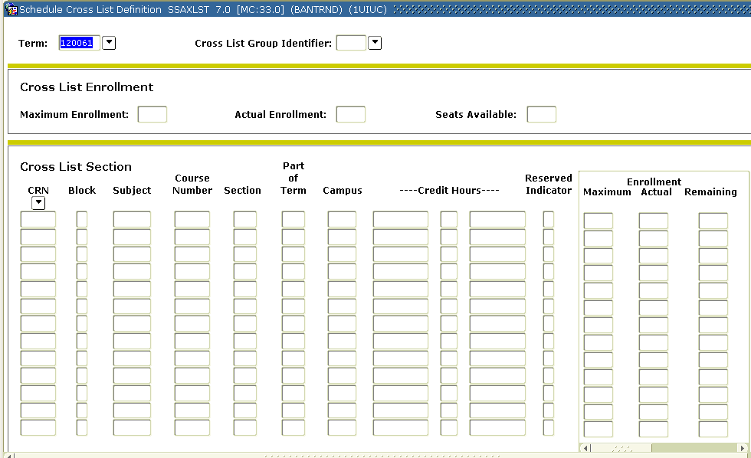
The Schedule Cross List Definition (SSAXLST) form.

Process Example
We will cross list sections of a course in your department and give the total cross-list an enrollment maximum of 20 students.

Step-by-Step Procedures
Step | Action | Results/Decisions
 | Display the Schedule (SSASECT) form  SCT Banner»  Student Menu »  Class Schedule Menu »  Schedule Form | The Schedule (SSASECT) form displays.
 | Type 1200XX in the Term field.
 | Press TAB to reach the Course Ref. Number field and type ADD. | Do a CRN query on SSASECQ if you are unclear as to which CRN to type here!  NOTE: Make sure you double-click the record in SSASECQ in order to default the CRN back into SSASECT.
 | Click the Next Block button to go to the Section Information block.
 | Type XXXX in the Subject field and press TAB.
 | Type XXX in the Crse Number field and press TAB twice. | Pick a course in your department that is crosslisted.
 | Type 100 in the Section field and press TAB.
 | Type A9XX in the Cross List field and press TAB.
 | Type 100 in the Campus field and press TAB.
 | Type A in the Status field and press TAB to access the next field.
 | Type LEC in the Schd Type field and press TAB seven times.
 | Type 1 in the Part/Term field and press TAB. | The Registration From Date and To Date display.
 | Click the Save button or press F10 to save this record. | Now your new section has been saved. Transaction complete: 1 records applied and saved displays in the auto-help line.
 | Click Rollback.
 | Type 1200XX in the Term field and press TAB.
 | Type ADD in the Course Ref. Number field.
 | Click the Next Block button to go to the Section Information block.
 | Type XXXX in the Subject field and press TAB. | This is the subject of the crosslisted course.
 | Type XXX in the Crse Number field and press TAB twice. | The name of the course displays in the course title field.
 | Type 100 in the Section field and press TAB.
 | Type A9XX in the Cross List field and press TAB.
 | Type 100 in the Campus field and press TAB.
 | Type A in the Status field and press TAB to access the next field.
 | Type LEC in the Schd Type field and press TAB seven times.
 | Type 1 in the Part/Term field and press TAB. | The Registration From Date and To Date display.
 | Click the Save button or press F10 to save this record. | Now your new section has been saved. Transaction complete: 1 records applied and saved displays in the auto-help line.
 | Using the Options menu, select Cross List Definition (SSAXLST). | The Schedule Cross List Definiton (SSAXLST) form displays.
 | Next Block and type 20 in the max enrollment field. | Max enrollment and CRNs that are crosslisted will display.  You will notice the sections added are listed in the next block.
 | Save.
 | Click Exit to return to SSASECT.

NOTE: You do not need to access the Schedule (SSASECT) form to create a cross-list. Cross-lists are created on the Cross List Definition (SSAXLST) form. You may access this form through Direct Access.

Topic 5.3 Learning Activity
Apply Your Knowledge
Please cross-list two PHIL 110, Section XXX and RLST 110, Section XXX. Give the cross-list a maximum enrollment of 25 students and give it a Cross List Identifier of A9XX + 30.

Topic 5.4: Editing Time/Place Information after Cross-Lists Creation
Once the cross-list sections have been created with meeting and instructor information, and the cross-list group is set up, any change made on the controlling section must be made on each of the non-controlling sections as well.

Step-by-Step Procedures
Step | Action | Results/Decisions
 | Display the Schedule (SSASECT) form  SCT Banner»  Student Menu »  Class Schedule Menu »  Schedule Form | The Schedule (SSASECT) form displays.
 | Type 120061 in the Term field.
 | Press TAB to reach the Course Ref. Number field and type the appropriate value to bring up PHIL 110, Section XXX. | You can do a CRN query on SSASECQ! Use the same CRN you used in the previous Topic Learning Activity.
 | Click Next Block to move to the Section Information block. | Notice the cross-list indicator. It displays the number you entered in the previous Topic Learning Activity.
 | Click Next Block to bring up the Meeting Time block. | The Meeting Time block displays.
 | Click Delete Record to remove the existing meeting time. | If an instructor is assigned, the instructor record must be deleted before the meeting time.
 | Type 09 in the Meet field.
 | Press TAB three times to reach the Build field.
 | Type 1BNH into the Build field.
 | Press TAB to reach the Room field.
 | Double-click the Room field or press F9. | This brings up the Room Query (SLQROOM) form.
 | Press F8 to execute the query.
 | Press DOWN ARROW to the record with 3XX in the Room field and double-click that record to select it. | This displays Room 3XX from the 1BNH building into the Meeting Time block of the Schedule (SSASECT) form.
 | Press Save.
Since that was a course in a cross-list, we now need to go edit other sections that were involved, as well.
Step | Action | Results/Decisions
 | Select the Cross-List Definition Form (SSAXLST)” item in the Option menu. | The Cross-List Definition Form (SSAXLST) displays.
 | Click Next Block twice. | Now you can see all of the sections that are in this particular cross-list.  IMPORTANT: Note the CRN of the section that you still need to edit!!
 | Highlight the CRN for the section that still needs to be edited.
 | Select Course Section Information (SSASECT) from the Options menu. | This displays the SSASECT form for that CRN.
 | Click Next Block to move to the Section Information block. | Notice the cross-list indicator. It displays the number you entered in the previous Topic Learning Activity.
 | Click Next Block to bring up the Meeting Time block. | The Meeting Time block displays.
 | Select Item from the Menu Bar.
 | Select Duplicate Item from the Item menu. | Steps 21 and 22 can be accomplished by pressing F3.
 | Click Next Block.
 | Double-click the CRN with meeting records to insert the duplicate record. | This overrides the original meeting record and saves the corrections.
 | Click Save. | Transaction complete: 1 records applied and saved displays in the auto-help line.
 | Click Exit button to return to SSAXLST and repeat for additional CRNs.
 | Click Exit button to return to SSASECT when all CRNs have been changed.

Topic 5.4 Learning Activity
Develop Your Skills
Are the following statements true or false?
- Cross-listing is done at the catalog level.

- Once a Cross-list Identifier is set up, you can add a section to a cross-list by just putting Cross-list Group Identifiers in the Section information block of SSASECT for all affected sections.

- You have to manage enrollment in cross-lists manually—Banner won’t do it for you.

Lesson Summary
In this lesson, you learned to
- Differentiate among cross-listing, co-requisites, and concurrent pre-requisites.
- Identify what information should exist at the catalog-level for approved cross-list courses
- Identify what is necessary at the schedule-level to cross-list sections
- Cross-list sections using SSASECT
- Control enrollment using SSAXLST
- Maintain section information for cross-listed sections

Lesson Learning Activity
Apply Your Knowledge
Please go into cross-list A9XX and change the meeting times so that the class meets once a week on Saturday mornings from 8:30am -1pm.

Lesson 6: Creating Independent Study Sections
Creation of independent study and graduate thesis sections (Independent Study Sections or ISS, hereafter) differs from creating other sections in the scheduling of meeting times and meeting places. Also, for some campuses/departments, it differs in how the sections display in the Schedule.
The ISS sections that students end up registering for are all scheduled as “ARRANGED” sections. Since independent instruction involves one-on-one work between the student and the instructor, they are responsible for scheduling meeting times and places. Independent Study sections cannot be used for class settings and should never have times and places published.
This lesson explains the importance of enrollment controls and shows you how to create an ISS section that is not printed in the Schedule, and also shows you how to create an ISS section that is printed in the Schedule.

Lesson Length
This lesson takes approximately 45 minutes to complete.

Lesson Objectives
When you have completed the materials presented in this lesson, you will be able to:
- Explain importance of enrollment controls
- Create an Independent Study Section (ISS) that is not printed in the Schedule
- Create an ISS that is printed in the Schedule

Topic 6.1: Appropriate Schedule Codes/Approval Types as Enrollment Controls
At UIUC, ISS that display in the printed Schedule are not designed for students to actually register in them. To prevent students from enrolling in the display section and to direct them to contact an instructor, an enrollment maximum value of greater than zero is set and an approval code of IN (Instructor Consent Required) is entered in the Approval field. If a student attempts to register for the section, he or she is notified that the instructor needs to be contacted; once arrangements for the independent study are made, the instructor gives the student the proper CRN for registration.

Schedule (SSASECT) form.

Process Examples
In order to control enrollment in Independent Study Sections (ISS), you must enter an approval code in the Approval Code field. In the task below we will create an ISS with an approval code of IN (Instructor Consent Required).

Step-by-Step Procedure
Step | Action | Results/Decisions
 | Display the Schedule (SSASECT) form using  SCT Banner »  Student Menu »  Class Schedule Menu »  Schedule Form | The Schedule (SSASECT) form displays.
 | Type 1200XX in the Term field and press TAB.
 | Type ADD in the Course Ref. Number field.
 | Click Next Block to go to the Section Information block.
 | Type XXXX in the Subject field and press TAB.
 | Type 599 in the Crse Number field and press TAB to complete the course information. | The course title displays.
 | Press TAB to access the Section field.
 | Type 0 and press TAB twice.
 | Type 100 in the Campus field and press TAB.
 | Type A in the Status field and press TAB to access the next field.
 | Type IND in the Schd Type field and press TAB four times to access the Appr field. | Double-click for a LOV to select IND. Another type of TBA (ISS) course is conference. Depending on your campus, other codes could be used such as CNF, etc.
 | Type IN in the Appr field and press TAB three times to access the Part/Term field. | Instructor Approval Required to take this course.
 | Type 1 in the Part/Term field and press TAB. | The starting and ending dates are populated.
 | Press TAB thirteen times to open the Enrollment Data block. | The Attendance Method Information pop-up screen displays after pressing TAB the twelfth time. Press TAB again to reach the Enrollment block.  If you next block from the Section Information block through all of the additional blocks, you are never shown this block. You can access it by only pressing TAB or through the option menu. In terms of exiting this block, however, it “exists” as the “last” additional block; and so you ckick Next Block to return to the Section Information block.
 | Type 10 in the Maximum Enrollment field. Press TAB twice to reach the Projected field. | We are not really going to have students register in this section. This value must be greater than zero so that the appropriate error message displays when students attempt registration.
 | Type 10 in the Projected field.
 | Click the Save button or press F10 to save. | Transaction complete: 1 records applied and saved displays in the auto-help line.

Topic 6.1 Learning Activity
Develop Your Skills
- What happens if a student tries to register for a Display Section of an Independent Study Session via the Web?
Instructor Note
Revisiting the Bookmark Job Aid will be helpful here.

Topic 6.2: Non-printed ISSs
If the independent instruction section is set not to print in the Schedule or Web, then permission to enroll can be granted by the instructor giving the student the CRN. In this case, if the student were to enroll in more than one independent instruction section with the same subject/course number combination, the student needs a Registration Permit Override for duplicate registration entered on their record. Departmental units/instructors need to develop procedures for inquiring about duplicate registrations and entering registration permit overrides when necessary.
If the section does not print in the Schedule of classes and will not be displayed on the “Web For Students” Web Lookup, the Print and Voice Response and Self Service Available check boxes on the first block of SSASECT are cleared. As long as the section has an active status and the student knows the CRN (obtained, presumably, from the instructor as confirmation that arrangements for study were approved), the student is able to enter the CRN in Web registration, even though the section does not display in the Web registration module.

Process Examples
In this task we will create an ISS that is not displayed in the Schedule or on the Web.

Step-by-Step Procedure
Step | Action | Results/Decisions
 | Display the Schedule (SSASECT) form using  SCT Banner»  Student Menu »  Class Schedule Menu »  Schedule Form | The Schedule (SSASECT) form displays.
 | Type 1200XX in the Term field. Press TAB.
 | Type ADD in the Course Ref. Number field.
 | Click Next Block to go to the Section Information block.
 | Type XXXX in the Subject field. Press TAB.
 | Type 599 in the Crse Number field. Press TAB twice to access the Section field. | The course title displays.
 | Type XYZ and press TAB twice.
 | Type 100 in the Campus field and press TAB.
 | Type A in the Status field and press TAB to access the next field.
 | Type IND in the Schd Type field and press TAB seven times to access the Part/Term field. | Double-click for a LOV.
 | Type 1 in the Part/Term field and press TAB. | The starting and ending dates are populated.
 | Press TAB thirteen times to open the Enrollment Data block or press F3. | The Attendance Method Information pop-up screen displays after pressing TAB the twelfth time. Press TAB again to reach the Enrollment block.  If you next block from the Section Information block through all of the additional blocks, you are never shown this block. You can only access it by pressing TAB or through the option menu. In terms of exiting this block, however, it “exists” as the “last” additional block; and so you click Next Block to return to the Section Information block.
 | Set the Maximum Enrollment to 10. Press TAB twice to reach the Projected field.
 | Type 10 in the Projected field.
 | Press TAB three times to advance through the Enrollment block fields. | The Additional Credit Hour Information pop-up displays.
 | Press TAB three times to advance through the Additional Credit Hour Information fields. | You return to the Section Information block.
 | Press TAB until the cursor is at the Print check box. Clear the Print check box. | The check is removed from the box so this section does not print in the hardcopy Schedule of Classes or display on the Web.
 | Press TAB until the cursor is at the Voice Response and Self Service Available check box. Clear the Voice Response and Self Service Available check box.
 | Click the Save button or press F10 to save. | Transaction complete: 1 records applied and saved displays in the auto-help line.
 | Click Next Block to go to the Meeting Time block.
 | Press TAB twice to complete the start and end date for the section.
 | Press TAB 14 times until you reach the Hrs/ Wk field. Type 0 in the Hrs/Wk field. | This is necessary to assign an instructor in Banner to an ARRANGED section.
 | Click the Save button or press F10 to save this record. | Now your new section has been saved. Transaction complete: 1 records applied and saved displays in the auto-help line.
 | Click Next Block to go to the Instructor block.
 | Click the ID button. | The Faculty/Advisor Query (SIAIQRY) form displays.
 | Click Next Block.
 | Press TAB to reach the Last Name field.
 | Type the instructor name in the Last Name field and press F8 to execute the query. | The instructor will give you the name to use.
 | Double-click the record to complete the record into the Instructor block of the Schedule (SSASECT) form.
 | Click the Save button or press F10 to save this record. | Now your new section has been saved. Transaction complete: 1 records applied and saved displays in the auto-help line.

Topic 6.2 Learning Activity

Develop Your Skills

1. When creating an ISS what does clearing the print check box do?

2. What does clearing the Voice Response and Self Service Available check box do?

Lesson Summary
In this lesson, you have
- Discussed the importance of enrollment controls
- Created an Independent Study Section (ISS) with an approval code that prints in the schedule
- Created an ISS that does not print in the Schedule and added an instructor to this section
- Discussed an ISS that prints in the Schedule

Lesson Review
- Why is it important to control enrollment for an ISS?

- If the independent study section is set not to print in the Schedule or Web, then permission to enroll can be granted by the instructor giving what to the students?

Lesson 7: Co-Requisites and Block Scheduling
On occasion courses are required to be taken concurrently. In this lesson, we will cover how to set up co-requisites and block scheduling.

Lesson Length
This lesson takes approximately 25 minutes to complete.

Lesson Objectives
When you have completed the materials presented in this lesson, you will be able to:
- Differentiate between cross-listing, co-requisites, and concurrent pre-requisites
- Determine whether two courses have been set up as co-requisites at the catalog-level
- Differentiate between two different types of co-requisites (mutual and one-way) at the section-level
- Specify one-way section level co-requisite
- Describe how Block Scheduling works in Banner

Topic 7.1: Co-Requisites
As mentioned in Lesson 5, Co-requisites are courses that must be taken in the same term. They are not cross-listed because they do not meet at the same place and time; they are required to be taken concurrently during registration. For example, PHYS 105, Introduction to Physics Lecture, and PHYS 106, Introduction to Physics Laboratory, must be taken in the same term.
To create section-level co-requisites in Banner, the courses must exist in the Banner catalog and be active for the term, and the courses must be set up as co-requisites on the Course Detail Information (SCADETL) form.
The screenshot that follows shows the block where this takes place.
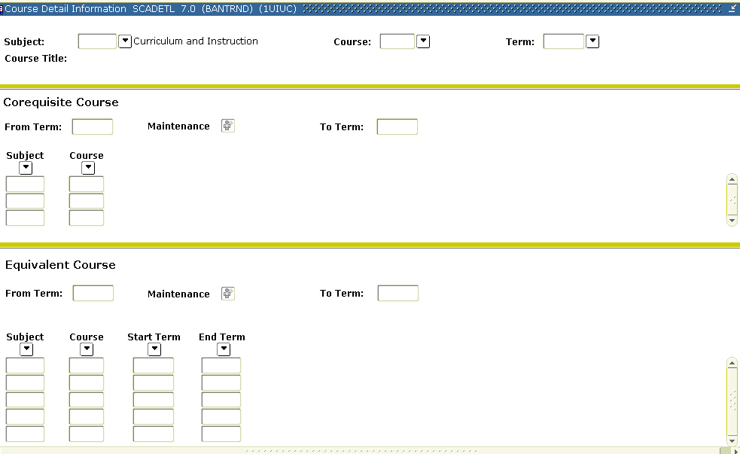
The Co-Requisite block of SCADETL
NOTE: Unlike most other section characteristics, even if no co-requisite is listed at the schedule level, Banner enforces the requirement by referring back to the catalog level. Co-requisites are defined at the catalog level and may or may not be further defined at the section level.
If specific sections of these courses that have been defined as co-requisites must be taken together, the sections are created and set up as co-requisites on the Schedule Detail (SSADETL) form.
So, when a student registers for a course section, Banner checks the SSADETL (section level form) to see if a specific section must be taken at the same time. Then, if there are none, it checks back on SCADETL (at the catalog level) to see if any courses are listed as co-requisites. If there are, Banner requires that the student take any one of the available sections for that course that was listed in SCADETL.

Process Examples
In this task we will create a Section of RHET 101 for which a particular section of RHET 100 is a co-requisite.

Step-by-Step Procedure
Step | Action | Results/Decisions
 | Display the Schedule (SSASECT) form using  SCT Banner»  Student Menu »  Class Schedule Menu »  Schedule Form | The Schedule (SSASECT) form displays.
 | Type 1200XX in the Term field.
 | Press TAB to reach the Course Ref. Number field.
 | Type ADD in the Course Ref. Number field.
 | Click Next Block to go to the Section Information block.
 | Type RHET in the Subject field and press TAB.
 | Type 101 in the Crse Number field.
 | Press TAB twice.
 | Type XX in the Section field and press TAB twice.
 | Type 100 in the Campus field and press TAB.
 | Type A in the Status field and press TAB to reach the next field. | This sets the section to Active status; registration is allowed.
 | Type LEC in the Schd Type field. Or select LEC from the LOV.
 | Press TAB seven times to reach the Part/Term field.
 | Type 1 and press TAB. | Notice how the Start and End dates default.
 | Click the Save button or press F10 to save this record | Now your new section has been saved. Transaction complete: 1 records applied and saved displays in the auto-help line.
 | Access the Course Section Detail (SSADETL) form from the options menu.
 | Click Next Block twice to access the Co-requisites block.
 | Double-click or press F9 in the Course Ref. Number field.
 | Select RHET 100 Section XX from the list of Co-requisites. Please note the CRN of the section that you are selecting. You will use it again. | NOTE: Notice how you may select any of the sections that have the appropriate subject/number combination. If you leave this blank, it enables the student who has registered for RHET 101 Section XX to select any of these sections during their registration process.  Any time you enter a co-requisite in SSADETL, you are specifying the section of the co-requisite course they must select.
 | Click Save.
 | Press Rollback to return to the Key block.
 | Press TAB to reach the Course Ref. Number field.
 | Type the appropriate Course Reference Number in the Course Ref. Number field for RHET 100, Section XX.
 | Click Next Block twice. | The Co-requisites block displays.
 | Press F9 to see the Co-requisite query LOV. | The Co-requisite Query displays.
 | Select RHET 101, Section XX from the list of values.
 | Click OK.
 | Click Save. | Transaction complete: 1 records applied and saved displays in the auto-help line.  NOTE: Now you have made the general relationship of “any section of RHET 101 must be taken with any section of RHET 100 and vice versa” into a specific relationship of “this section of RHET 101 must be taken with that section of RHET 100 and vice versa.”
 | Click Exit to return to the SSASECT.

Topic 7.1 Learning Activity
Develop Your Skills
Please answer the questions below:
- What form in Banner is used to indicate co-requisite courses?

- What form in Banner is used to indicate co-requisite relationships between specific sections?

- What happens if a student tries to register for a course with a co-requisite, but no specific co-requisite sections have been identified on SSADETL? What can students then do?

Topic 7.2: One-Way Co-Requisites Practice
A one-way co-requisite is where the relationship is only in one direction – that is, “if you take this you must take that, but the reverse is NOT true.” While this can be done at the catalog level, it is also possible the one-way co-requisite needs to be defined at the section level even though already defined as a two-way co-requisite at the catalog level.

Process Examples
In this exercise, we will make it so that students who take a section of RHET 101 need to take a section of RHET 100, but not vice versa.
Step | Action | Results/Decisions
 | Either by using Direct Access or the Main Menu path  SCT Banner»  Student Menu »  Class Schedule Menu »  Schedule Detail Form | The Schedule Detail (SSADETL) form displays.
 | Type 1200XX in the Term field and press TAB.
 | Type the appropriate Course Reference Number in the Course Ref. Number field for RHET 100, Section XX (the section from the exercise above). | Hint: Do a CRN query on SSASECQ for the CRN to type here!
 | Click Next Block twice. | The cursor displays in Co-requisites block.
 | Remove record the CRN listed.
 | Click Save.
 | Rollback to the key block
 | Type the Course Reference Number in the Course Ref. Number field for RHET 101, Section XX.
 | Click Next Block twice. | You will notice that the CRN for the RHET 100, Section XX still is listed for the section of RHET 101.  This means that any student taking a section of RHET 101 must take a section of RHET 100, but not vice versa.
 | Click Exit to return to the Main Menu.

Topic 7.3: Block Scheduling
NOTE: Most departments of the University of Illinois will not use Block Scheduling. It is included here for the sake of completeness.

The Block Schedule (SSABLCK) form can be used to define block schedule groups. Note that the codes must first be defined on the Block Validation (STVBLCK) form.
Students cannot register themselves for a Block Schedule. This must be done by College personnel. However, students may drop any section that is listed in a block.
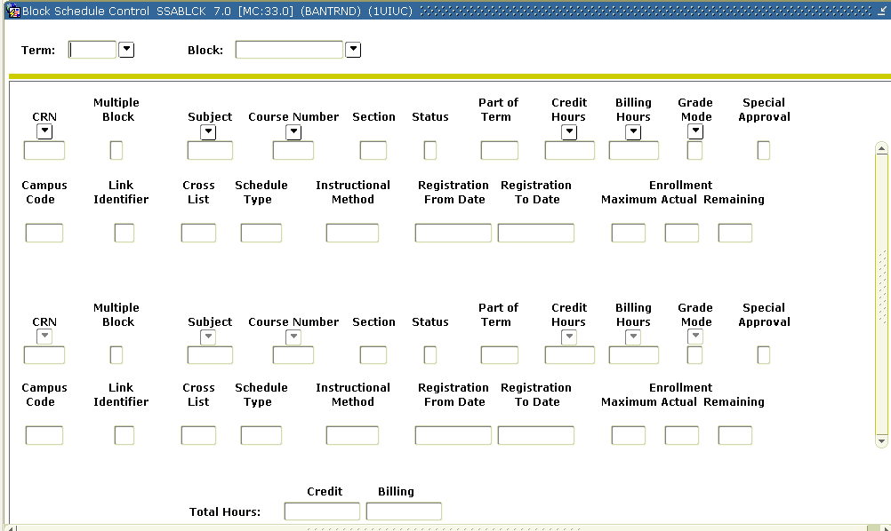
The Block Schedule (SSABLCK) form
Sections can be defined to the block group by CRN.
Sections can also be defined to block groups by entering the block code in the Block Schedule block of the SSADETL form.

Lesson Summary
In this lesson we learned how to:
- Differentiate among cross-listing, co-requisites, and concurrent pre-requisites
- Determine whether two courses have been set up as co-requisites at the catalog-level
- Differentiate between two different types of co-requisites (mutual and one-way) at the section-level
- Convert mutual co-requisites to one-way co-requisites
- Describe how Block Scheduling works in Banner

Lesson 8: Section Fees and Restrictions
Finally, there are a number of special characteristics that are added at the schedule level. In this lesson, we will cover how to set up section fees, registration restrictions, and CAPP area pre-requisites.

Lesson Length
This lesson takes approximately 45 minutes to complete.

Lesson Objectives
When you have completed the materials presented in this lesson you will be able to:
- Add section fees that were not defined at the catalog-level
- Identify how sections may be restricted
- Identify how section restrictions default from the catalog-level, but may be edited at the schedule level
- Describe when “include” or “exclude” restrictions are more appropriate
- Edit section-level restrictions based on: major, class, level, degree, college, program, and campus
- Describe how to edit section comments in Banner
- Describe how to use CAPP are pre-requisites to restrict registration
- Add a degree program attribute to a section
- Identify special Schedule Types used by the University of Illinois

Topic 8.1: Schedule Level Section Fees
Another complexity that occurs in many courses is the requirement of special fees.
Special fees can be entered in the Fee Codes block of SCADETL. This value may be entered as a flat fee, per-credit hour fee, or per billing hour fee.
NOTE: The detail code displayed on this block is controlled by Accounts Receivable, and automates the collection of money into the correct departmental accounts.
As with many other characteristics, fees default to the schedule level, but only to a new section that is built. Any new or changed fee at the catalog level does not change information on existing sections. An unlimited number of fees may be entered.
Fees are primarily entered at the schedule level. We will look at both how to create a new fee and how to edit an existing fee on the Schedule Detail (SSADETL) form.

Process Examples
Now we will edit an existing section fee and add a new section fee.

Step-by-Step Procedures
Step | Action | Results/Decisions
 | Display the Schedule Detail, (SSADETL) form either by using Direct Access or the Main Menu path  SCT Banner »  Student Menu »  Class Schedule Menu »  Schedule Detail Form | The Schedule Detail (SSADETL) form displays.
 | Type 120058 in the Term field and press TAB.
 | Type the appropriate Course Reference Number in the Course Ref. Number field for ARTS 310, Section XX. | Do a CRN query on SSASECQ if you are unclear as to which CRN to type here!
 | Click Next Block three times. | The Section Fees/Degree Program Attribute block displays.  Notice how the fee code and amount have defaulted from SCADETL at the catalog level.
 | Type 1G in the Level field and press TAB to reach the Amount field.
 | Type 50.00 in the Amount field. | We are changing the fee for this particular section. Note that the Fee Type field defaults to FLAT.
 | Press DOWN ARROW so that you can enter the next record.
 | Type 1U in the Level field.
 | Type UADH in the Details field and press TAB to reach the Amount field. | We are giving undergraduates their own fee for this section.
 | Type 25.00 in the Amount field. | Note that the Fee Type field defaults to FLAT.
 | Press Save. | An alert box displays that says: The section fees have been changed. This will cause an update fee assessment.
 | Click OK twice. | Transaction complete: 2 records applied and saved displays in the auto-help line.
 | Click Exit button to return to the Main Menu.

Topic 8.1 Learning Activity
Develop Your Skills

Please answer the following questions.
- Fees may be entered at the ___________________________ level.
  - catalog
  - section
  - both catalog and section
- The form used to enter fees at the section level is ________________________.

Topic 8.2: Possible Section Restrictions
Restrictions default from the catalog level to the schedule level, but may be changed at the schedule level. At UIUC, all restrictions are entered at the schedule level on SSARRES.

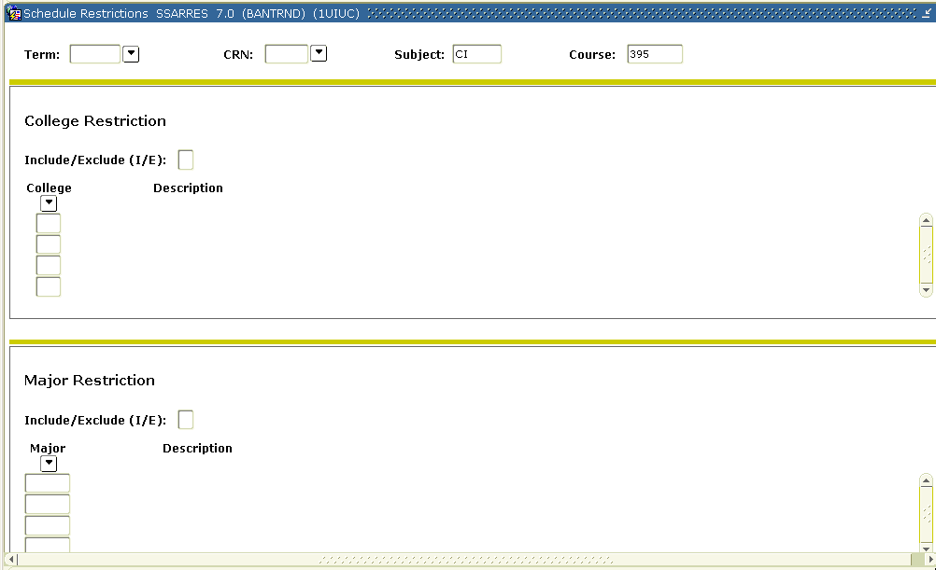
The Schedule Restrictions Form (SSARRES)

Task 8.2.A Include Versus Exclude
The purpose of the Section Registration Restriction (SSARRES) form is to control enrollment in a course by the assignment of course registration restrictions when the schedule is built. A section may be restricted (including or excluding students) by the student’s College, Major, Class, Level, Degree, Program, and Campus.
- Restrictions between blocks have an AND relationship.
- Restrictions within blocks have an OR relationship.

The "AND" relationship looks different when using exclude restrictions. In the below example, if both restrictions are include restrictions, then there is no difference:
Include students with major 0115 and include students with level 1G will leave you students who are (both) major 0115 and level 1G, excluding all others. The And relationship creates a smaller include group
When using exclude restrictions, then excluding students with a given major and excluding students with a given level does not only exclude students with the major and level, it excludes all students with the major and all students with the level. Instead of the "AND" creating a smaller group, the "AND" relationship in excluding creates a bigger group of excluded students.

NOTE: When Banner enforces Exclude Restrictions, it looks at the relevant program information on both the students’ Primary and Secondary curricula. It is possible that an exclude restriction on one population (e.g., BFA students -- degree restriction) could exclude some of the students you meant to include (e.g., BS students) where some students are part of one population based on the primary curriculum and part of the other population based on the secondary curriculum. To avoid inadvertently excluding students, try to restrict by including appropriate student populations rather than excluding inappropriate populations.

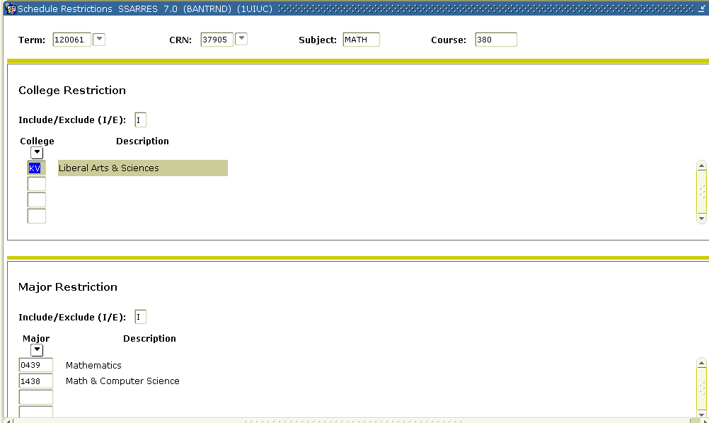
For example, the section displayed in these two screen shots would include students in the College of Liberal Arts & Sciences AND either majoring in Mathematics or Math & Computer Science AND either a Junior or Senior in standing.
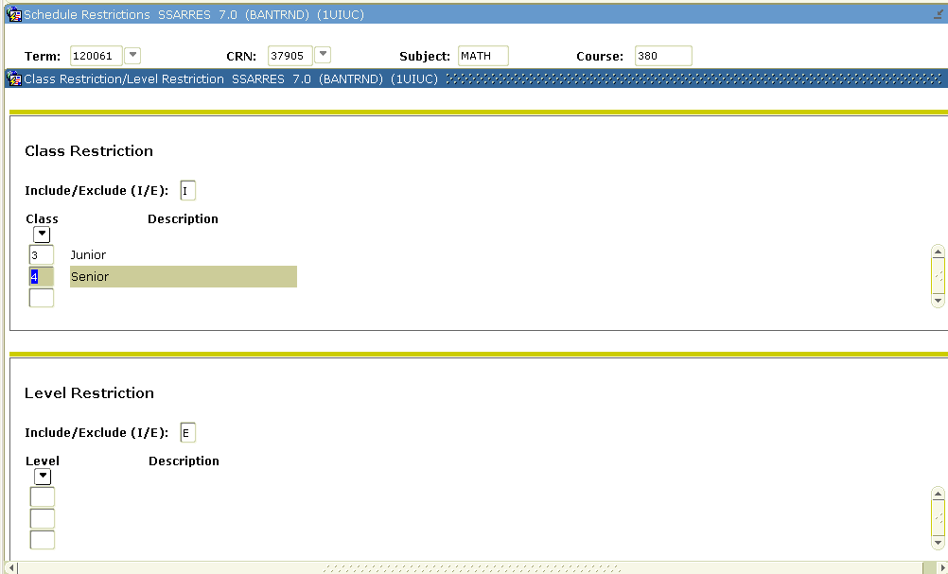

Task 8.2.B Viewing Default Catalog Level Restrictions
Let’s view this record in SSARRES to see what restrictions are on the section.

Step-by-Step Procedures
Step | Action | Results/Decisions
 | Display the Schedule Restrictions (SSARRES) form either by using Direct Access or the Main Menu path  SCT Banner »  Student Menu»  Class Schedule Menu»  Schedule Restrictions Form | The Schedule Restrictions (SSARRES) form displays.
 | Type 1200XX in the Term field and press TAB.
 | Type the appropriate Course Reference Number in the Course Ref. Number field for MATH 380, Section B1. | Do a CRN query on SSASECQ if you are unclear as to which CRN to type here!
 | Click Next Block eight times to navigate through the form in its entirety. | We will continue this step chart in the next process exercise.

Task 8.2.B Learning Activity
Apply Your Knowledge

- What is the menu path from the main menu to get to the Course Section Restriction (SSARRES) form?

- How do you describe the population of students that are currently restricted from MATH 380?

- Are they restricted just from the section that we looked at in the step chart, or from all sections of MATH 380?

Topic 8.3: Editing Schedule Level Restrictions
Because, for example, including all Chemistry majors is the same as excluding all non-Chemistry majors, there is more than one way to make edits to reflect any particular restrictions.
The key, of course, is to pick the way that makes the most sense from a data entry perspective. With the above example, listing a Chemistry major inclusion is easier than creating an exclusion that listed “all non-chemistry majors.”

Process Examples
In this process, we will change the section so that it only allows undergraduate students.

Step-by-Step Procedures
Step | Action | Results/Decisions
 | Click Next Block three times. | The Level Restrictions block displays.
 | Type I in the Include/Exclude (I/E) field.
 | Press TAB to reach the Level field.
 | Type 1U in the Level field.
 | Click Save. | Transaction complete: 1 records applied and saved saved displays in the auto-help line.

Topic 8.3 Learning Activity
Apply Your Knowledge
- Please restrict MATH 380, Section B1 so that only Chemistry majors may register for that section, removing all previous restrictions.

Topic 8.4: Editing Section Comments
For any text that needs to display in the class schedule that is specific to that one section, you may go to the Section Comment (SSATEXT) form and enter it there as shown in the following graphic.
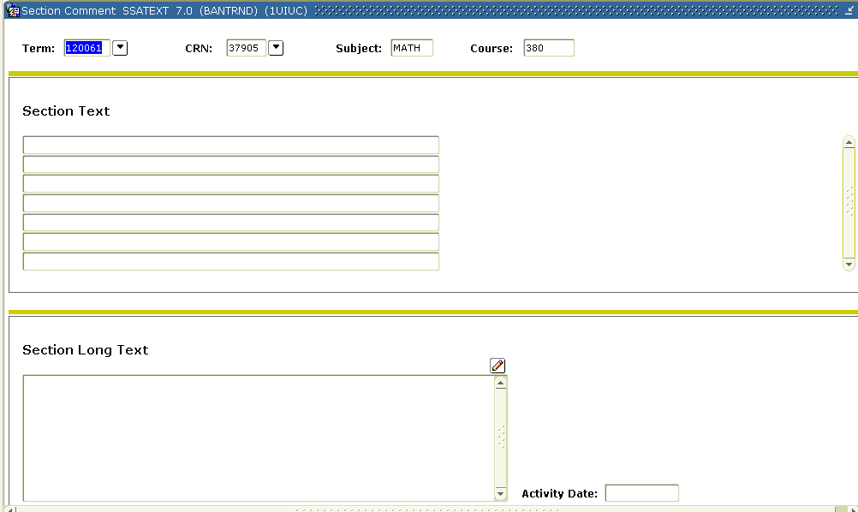

NOT USED
The Lined Section Text block of the Section Comment (SSATEXT) form will not be used. Next Block to navigate to the Long Comments block of the form. Since this block has word wrap, bypass the primary block and use the Long Comments option for all section specific comments.
NOTE: As with other “long” forms, if you have more text than what you can view at once in the Long Comments block, you can click the edit button and make your edits in an edit window that you can resize!

Topic 8.5: CAPP Area Pre-requisites and Restricting Registration
While SSARRES is limited to restricting registration based on characteristics of the students program or class, it is also possible to restrict registration by some student attributes. The Section Area Pre-requisite Restrictions block of SSAPREQ can be used to restrict registration to sections by CAPP areas that have been defined to require that students have a particular student attribute on their records. When students attempt to register for a section that has been given a CAPP Area student attribute restriction, the attribute defined to the CAPP area must be entered for the student for the term in which the section has been scheduled. The Additional Student Information (SGASADD) form is used to review which attributes have been assigned to students for a given term.
Instructor Note
Revisiting the Bookmark Job Aid will be helpful here.
While SSAPREQ can also be used to define test score and course prerequisites (typically defined in the upper block of the SSAPREQ form), that block will not be useful as prerequisites will not be entered until further testing can be done.

Process Examples
In this exercise, we will place a CAPP area attribute restriction on a section.

Step-by-Step Procedures
Step | Action | Results/Decisions
 | Display The Section Pre-requisite & Test Score Restriction (SSAPREQ) form using either Direct Access or the Main Menu  SCT Banner Menu » Student Menu » Schedule Menu | The Key block of SSAPREQ
 | Type 1200XX in the Term field
 | Tab to the CRN field and double click. | Do a query on SSASECQ to find a section to use.
 | Tab to the SUBJ field and type LAS
 | Tab to the CRSE field and type 199 and execute query.
 | Double click in the CRN field to take back to SSADETL.
 | Click Next Block | The Section Information block of SSAPREQ
 | Press TAB three times to reach the CAPP Areas for Pre-requisites check box. Select the check box with either the mouse or the spacebar.
 | Click Next Block twice | The Section Area Pre-requisite Restrictions block of SSAPREQ
 | Press F9 or double-click the Area field to see it’s List of values | The Area Library (SMAALIB) displays. Note the Print Indicator field and the LOV behind it.
 | Press down arrow to reach the record for “1DIS - Discovery”. Double-click that record. | The record’s area is populated back into SSAPREQ
 | Click Save | Transaction Complete: 2 Records applied and saved
 | Click Exit button to return to Main Menu.

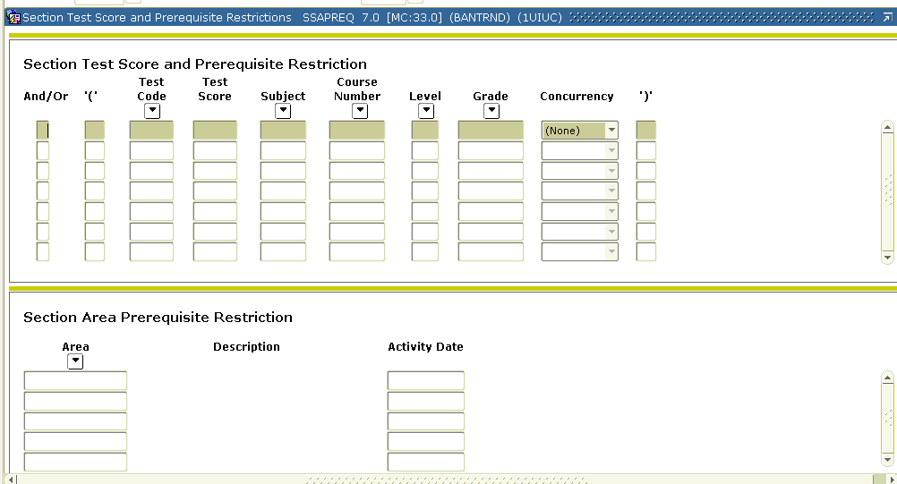
Section Area Prerequisite Restriction block of SSAPREQ form

Topic 8.6: Adding a Degree Program Attribute to a Section
Instructor Note
Demonstrate where this block is and the LOVs.
Degree attributes serve to label courses with specific characteristics. During web registration, a student may search for sections by degree attributes. Values default to the section, but only to any new section that is built. Any new or removed value in the catalog will not be reflected on existing sections. An unlimited number of degree attributes may be entered. Attributes that default from the catalog record but are not appropriate for a section can be removed using the Record Remove function.
Student attributes are characteristics of a student or students involved in certain groups such as Honors, Teacher Certification program, or Discovery program. During web registration, a student may search for sections by degree attributes.
As outline above, courses or sections can be restricted to specific students by the use of certain student attributes through the use of CAPP Area prerequisites.

Topic 8.7: Schedule Types
If a student attempts to register for two sections of the same course (subject/course number combination) in a term, the student will get a registration error; Banner terms this duplicate registration. While this duplicate error checking is necessary in many cases, some courses are approved to allow registration in multiple sections in the same term (e.g., variable topics courses).
To facilitate registration in multiple sections of approved courses, special schedule type codes are defined for the course on SCACRSE and then need to be used when creating sections of the course. Schedule type codes are used to facilitate registration in multiple sections of the same course because Banner does not prevent registration in multiple sections of the same course if the sections are created with different schedule types. This is the logic used for linked sections: a student is able to register for a lecture section of a course and a lab section of a course since the sections would be created with schedule types of LEC and LAB, respectively (Linked sections are covered in SACS 203). To adapt this feature to courses approved for duplicate registration in the same term, different codes that reference the same schedule type are assigned and can be used when creating these sections so that Banner will allow registration. For example, if a course is approved for Lecture format and can be repeated in the same semester, then the schedule types that should be defined at the course level include, in addition to LEC: Lecture, the following:
L1: Lecture
L2: Lecture
L3: Lecture
L4: Lecture
L5: Lecture
Since all of the above schedule types indicate a lecture, any could be used in creating a lecture section. To allow registration in multiple lecture sections of the same course where appropriate, each section would need to be set up with a different lecture schedule type code. As long as a student signing up for multiple sections of the same course selected sections with different schedule types, the registration would be allowed.
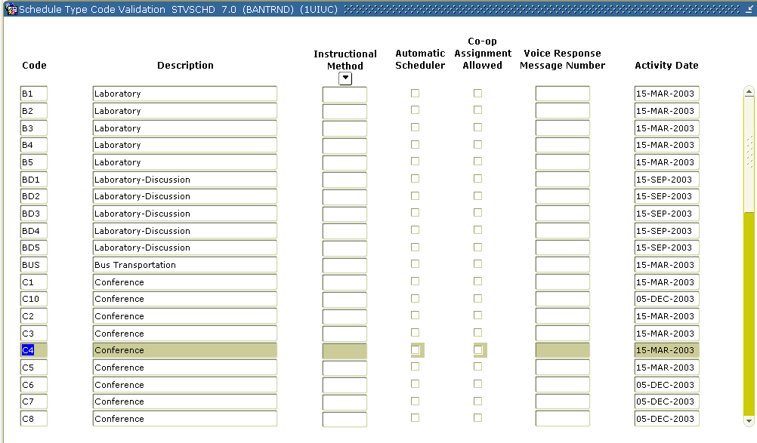
The Schedule Type Validation form. Note how you use the scroll bar to display all of the schedule type values.
WARNING: The use of different schedule type codes to bypass duplicate registration error checking relies on Banner considering sections of the same course not to be duplicates if the schedule types differ. Similarly, if a course that is not approved for repeats in the same term has, for example, one section scheduled using the LEC: Lecture schedule type and a second section scheduled using the LCD: Lecture-Discussion schedule type, Banner would NOT prevent a student from registering for both sections.

Lesson Summary
In this lesson we learned how to:
- Add section fees that were not defined at the catalog-level
- Identify how sections may be restricted
- Describe when “include” or “exclude” restrictions are more appropriate
- Edit section-level restrictions based on: major, class, level, degree, college, program, and campus
- Describe how to edit section comments in Banner
- Describe how to use CAPP are pre-requisites to restrict registration
- Add a degree program attribute to a section
- Identify Schedule Types used by the University of Illinois

Lesson Review
- Schedule type
- Grading Mode
- Section Fees
- Co-requisites
- Restrictions
- Course Title

- Which of the above section characteristics default from the catalog level to the schedule level directly and then may be changed at the schedule level?

- Which of the above section characteristics define a list of values that may be applied at the schedule level in particular fields?

- With which of the above does Banner go back and look at the catalog level if no value is listed at the schedule level and give the student the choice to make at the time of registration?

Appendix A

SCACRSE
Form Description | Form Name | Path
Basic Course Information form | SCACRSE | SCT Banner»  Student Menu»  Course Catalog

Key Block
Field Name | Input Data | Usage
Subject | The two-to-four-character Subject code (STVSUBJ). | Must be completed.  Used to group courses by subject matter. The values in the LOV are campus specific and separated by Virtual Private Databases (VPD) so that each campus can only view its own Subject codes.
Course | The three-digit course number. | Must be completed.
Course Title | Display only. | The title of the course.
Term | The six-digit term code. | Must be completed.  All terms are campus-specific.  All information in the associated blocks refers to this term.

Primary Block 1- Course Information
Field Name | Input Data | Output Data | Usage
Course Title | Up-to-30 character title of the course. | This defaults to the section level as the “Course Title” in SSASECT. | Must be completed. This is the approved title that will default to a section.
College | Two character college code (STVCOLL). | See usage. | Must be completed. This information assists with institutional reporting and security.
Division | Not used. | See usage. | Not used
Department | Four-digit department code (STVDEPT). | See usage. | This field needs to be completed in order to assist with institutional reporting and security.
Status | One character status code (STVCSTA).  A= Active  T= Temp  I= Inactive | See usage. | Must be completed. This affects whether sections may or may not be scheduled.  Allows or prevents creation of sections. Active and Temporary allow sections to be created in Schedule.  Inactive prevents sections from being created in Schedule.
Approval | C or N  C – Controlling course  N – Non-controlling course | See usage. | Information Only—used only for courses that are cross-listed. This field has been repurposed to indicate whether a course is “controlling” or “non-controlling.”
Prereq Waiver | Not used at the University. |  | Not used.
(Course) Duration |  | Values entered are defaulted to new section records as they are created. | Not used.
(Duration Unit Code) |  | Values entered are defaulted to new section records as they are created.  It is validated against the Duration Unit Validation (GTVDUNT) form. | Not used.
Continuing Ed | Selected or not. | See usage. | This is selected only if the course is offered for Continuing Education Units. Initially only credit-bearing courses are being created in Banner.
Tuition Waiver | Selected or not. | If selected, the credits for this course are not used in the normal tuition credits or range calculation. | This defaults to the sections, but may be changed there.
Fees | Not used. | See usage. | Not used.
CAPP Areas for Pre-requisites | Check box. | This defaults to the section level. It can be changed there.
Syllabus Exists? | Check box. | See usage. | When selected, shows that learning objectives, required materials, and/or technical requirements have been entered on the Course Syllabus (SCASYBL) form for this course.
Long Title Exists? | Check box. | See usage. | When selected, shows that a long course title has been entered on the Course Syllabus (SCASYBL) form for this course.
CEU/Credit: Low | Zero to 99.99. If only one credit value is defined for the course, it is entered in this field; if the course offered for a range of credit, the low value in the range is entered in this field. | Limits what can be assigned at the section level or at registration. | Must be completed.
CEU/Credit: Or/To | “OR” or “TO”; used to define a range of credit. | See usage. | OR defines two options for credit hours. TO defines a range of available credit including all numerical values (up to three decimal places) between the two values.
CEU/Credit: High | Zero to 99.99. If the course is offered for a range of credit, the high value in the range is entered in this field. | Limits what can be assigned at the section level or at registration. | Used for courses defined with a range of credit.
Billing: Low | Zero to 99.99. When tabbing through this field, the value for CEU/Credit defaults into this field. If only one billing hour value is defined for the course, it is entered in this field; if the course is offered for a range of billing hours, the low value in the range is entered in this field.  Note: Courses defined with a low credit hour value of 0 hours – where the 0 value is not intended for use in linked sections of the course – should have the low billing hour value set to .01. This is necessary to ensure that assessment and refunding function properly if students enroll sections of these courses with the intention of being assessed the Range IV tuition rate (Assessment for 0 credit). The low credit hour value should be set to zero. | Limits what can be assigned at the section level or at registration. Billing hours are used for assessment of tuition and fees. | Must be completed. Press TAB to bypass the billing and let that default to whatever value was entered for CEU/Credit.  If the value for CEU/Credit hours is changed at some point, the value(s) in the Billing field(s) may need to be changed to match it.
Billing: Or/To | “OR” or “TO”; used to define a range of billing hours. | See usage. | OR defines two options for billing hours. TO defines a range of available billing hours including all numerical values (up to three decimal places) between the two values.
Billing: High | Zero to 99.99. If a range of billing hours is defined for the course, the high value in the range is entered in this field. | Limits what can be assigned at the section level or at registration. | Used for courses defined with a range of billing hours.
Lab/Other Contact | Not used. | See usage. | Not used.
Limit | Up-to-two-digit integer  For example, 1= student may take the course once and repeat the course one time.  If repeats are not allowed, use “0” because Banner treats “0” and null differently. | See usage. | Informational only.
Max Hours | Up-to-four-digit number (with two decimal places to the right of the decimal).  Leave null if course is not repeated or if there is no limit to the maximum hours. | See usage. | This is the maximum number of credit hours allowed.  This field can be used instead of Limit or in conjunction with the Limit field. When both are used, an OR relationship is present; if repeat checking is used, the most restrictive value would be used.
Repeat Status | Up to 30 characters. | See usage. | This field is being used to trigger a “repeat information” message in the catalog print process.

Additional Blocks

Additional Block 1—Course Level
Field Name | Valid Input Data | Valid Output Data | Usage
Level | Two-character alphanumeric code (STVLEVL). | See usage. | Must be completed. This controls what credit level may be assigned at registration. If multiple levels are input here, registration tries to match the student level to the appropriate course credit level.

Additional Block 2—Grading Mode
Field Name | Valid Input Data | Valid Output Data | Usage
Mode | One-character grading mode code (STVGMOD). | See usage. | Must be completed. The values listed here represent the list of possible grading modes available to those building the sections and available at registration (if none defined at the section).  If multiple grading modes are available for a course, enter a record (row) for each mode.
Default | See usage. | D – Default  N – Not default | One grading mode must have a value of D entered.  N defaults in this field. If no grade mode is defined for a section, the default mode will be assigned at registration.

Additional Block 3—Schedule Type
Field Name | Valid Input Data | Valid Output Data | Usage
Schedule | Up-to-three -character designator for the delivery of instruction (STVSCHD). | See usage. | Must be completed. The values listed here represent the possible schedule types available to those building the sections.
Instructional Method | This field not used by the University. |  | Not Used.
Workload | Six-digit number (four before decimal, two after). | This field is used for faculty load tracking. See usage. | This value represents the number of contact hours for the instructor that this course normally represents. Each campus determines this value.  NOTE: Only UIC and UIS use this field.
Over Enroll | TBD | TBD | TBD
Adjusted Workload | TBD | TBD | TBD

SCADETL
Form Description | Form Name | Path
Course Detail Information form | SCADETL | SCT Banner»  Student»  Course Catalog

Key Block
Field Name | Input Data | Usage
Subject | Up-to-four-character Subject code (STVSUBJ). | Must be completed.  To group courses by subject matter. The values in the LOV are campus specific and separated by Virtual Private Databases (VPD) so that each campus can only view its own Subject codes.
Course | The three-digit course number. | Must be completed.
Term | The six-digit term code. | Must be completed. All terms campus-specific.  All information in the associated blocks refers to this term.
Course Title |  | A descriptive title of this course.

Block 1—Co-Requisite Course
Field Name | Valid Input Data | Valid Output Data | Usage
From Term | The six-digit term code. Display only. | See usage. | Indicates the first term for which the indicated information is effective.
To Term | The six-digit term code. Display only. | See usage. | Indicates the first term for which the indicated information is no longer effective. Defaults to 999999, which indicates the information if effective indefinitely.
Subject | Up-to-four-character alphanumeric code  (STVSUBJ). | See usage. | Subject code of the course that must be taken concurrently with the course identified in the Key block.
Course | Three-digit code. | See usage. | Course number of the course that must be taken concurrently with the course identified in Key block.

Block 2—Equivalent Course
Field Name | Input Data | Output Data | Usage
From Term | The six-digit term code. | See usage. | First term current equivalent course definition is effective.
To Term | The six-digit term code. | See usage. | Defaults to 999999 last term current equivalent is effective.
Subject | Up-to-four-character alphanumeric code  (STVSUBJ). | This data controls what course you can input in the next field | Subject code of the course that must be taken concurrently with the course identified in the Key block.
Course | Three digit code. | See above. | Course number of the course that must be taken concurrently with course identified in Key block.
Start Term | Six-digit term code. | See usage. | When Cross-listed and historical equivalent courses are entered in the Equivalent Course block, a range of terms must be entered to reflect the period of time for which these courses are/were considered equivalent.  Use the actual beginning and ending dates of terms for courses that are equivalent but no longer offered. Assign current course offerings that are NOT cross-listed a campus-specific “end of time” of 199999 (for Urbana), 299999, etc. to differentiate between these courses and those that ARE cross-listed (which are assigned Banner’s end of time of 999999).
End Term | Six-digit term code. | See usage. | See above.

Block 3—Fee Codes
Field Name | Valid Input Data | Valid Output Data | Usage
Detail | One of a pre-existing set of fee types (TSADETC)  Must use a fee type from TSADETC of “C.” | This defaults to the section level (SSADETL) but may be changed. This activates the Amount and Fee Type fields. | Fee codes that are assigned to every section of this course, even if different schedule types. This fee can be edited/removed or new fees may be added at the section level.
Amount | Dollar and cent amount, with decimal. | See usage. | Amount of fee. Se below.
Fee Type | F= flat  C= credit  B= billing  Additional values come from STVFTYP. | See usage. | Indicates how amount in previous field is assessed.

Block 4—Degree Attributes
Field Name | Valid Input Data | Valid Output Data | Usage
Attribute | Four-character alphanumeric code (STVATTR). | This defaults to the section level (SSADETL). | Degree attributes that are assigned to every section of this course. This may be edited at the section level. Displays in dynamic Web catalog at the section level. This data is used for search criteria on Web registration. For example, Honors or Discovery.

Block 5—Transfer Institutions
BLOCK IS NOT USED

Block 6—Supplemental Data
Field Name | Valid Input Data | Valid Output Data | Usage
Occupational Course | Two character alphanumeric code (STVCCSL) | See Usage | This field has been repurposed to indicate low-differential credit (Undergraduate) value on catalog print.
Classification | Two-character alphanumeric code (STVCCSL) | See usage. | This field has been repurposed to indicate high-differential credit (Graduate) value on catalog print.
Course Identifier | Seven-digit tracking number. | See usage. | This field records a tracking number for course content that remains with the course regardless of changes to title/subject/number, etc.  Cross-listed courses have the same course identifier.
Credit Category |  | See usage. | This field has been repurposed to indicate the controlling subject for cross-listed courses.
Element 1 | L or none  L= Language | See usage. | Institutional Reporting uses this field. Indicated course teaches a language.
Element 2 | R or none  R= Remedial | See usage. | Institutional Reporting uses this field. Indicates course is taken as remedial instruction.

Block 7 –Course Description
Field Name | Valid Input Data | Valid Output Data | Usage
Course Description | Up to 32K of data that can be used exclusively or as a supplement to the existing multiple 60-character records. |  | A long course description. This is where you enter information that will appear in either the catalog for this course or the schedule or both.

Block 8—Text
Field Name | Valid Input Data | Valid Output Data | Usage
Course Text | Not used. | Not used. | Not used.

SSASECT
Form Description | Form Name | Path
Schedule form | SSASECT | SCT Banner»  Student»  Class Schedule

Key Block
Field Name | Input Data | Output Data | Usage
Term | Six-digit term code. | See usage. | The term in which the section is being offered.
Course Ref. Number | Five-digit CRN number. | See usage. | When students register, they register for classes by Course Reference Number (CRN). CRNs are how individual sections of classes are actually tracked in Banner.

Primary Block 1—Section Information
Field Name | Input Data | Output Data | Usage
Subject | Up-to-four-character subject code (STVSUBJ). | See usage. | Must be completed.
Crse. Number | Three-digit course number code. This must be a proper number in combination with the Subject as per what has been set up at the catalog level. | Once this and Subject are entered and you press TAB, the Title, Credit/CEU Ind., and Billing fields display default information from their catalog level counterparts. | Must be completed.
Section Title | Up-to-30 character title of the course. Defaults from the Course Title field; can be updated here with approval from appropriate campus office. | This title displays in the Web for Student Look up Classes to Add feature and on the student’s schedule and rolls to academic history to display on the student transcript. | Must be completed.
Section | Three-character alphanumeric field. If a value other than the default value of “0” is entered, the ID must be unique for sections of the same course. When multiple sections of a course are created, the value can be left as “0” and that section can be duplicated to expedite creating the remaining sections. | See usage. | Must be completed.
Cross List | Four-character field. Identifies the section as part of a cross list. Cross lists must first be defined on the Schedule Cross List Definition (SSAXLST) form. | See usage. | Indicates section meets at the same time in the same room with the same instructor as other sections in the cross list; enrollment across all sections can be limited by the cross list maximum enrollment value. Sections can be defined to a Cross List by entering the cross-list ID in this field or by entering the CRN on SSAXLST.
Campus | 100 for UIUC, 200 for UIC, or 400 for UIS. |  | Must be completed.
Status | A (Active: allowing registration)  P (Pending: no registration allowed)  C (Cancelled: no registration allowed)  D (Drop: no registration allowed, section will not roll to next like term)  I (Inactive: no registration allowed) |  | See Appendix A.
Schd Type | One of the List of Values (LOV) that were set at the catalog level when the course was created. | See usage. | Must be completed.
Instruct Meth. | Field should be left unpopulated for sections scheduled in a part-of-term. | See usage. | USED FOR OPEN LEARNING SECTIONS ONLY. Type of instructional method and description for the section. Instructional Method must be defined on SOAORUL for the term.
Grade Mode | One of the LOV that were set at the catalog level when the course was created. | See usage. | This can be left blank. When this is left blank, the grade mode identified as the default in the course record defaults at registration. Should only be populated on SSASECT if no other grade mode is allowed for the section.
Session | These U of I codes are one-character codes that indicate non-traditional modes of instructional delivery (STVSESS). | If a code is selected, then a code should also be entered in the Attn. Meth field. | Used to indicate delivery method for class search in Web registration.
Appr | These U of I codes are two character codes that represent different types of approval codes (STVSAPR). | See usage. | This controls access to courses at the time of registration. Regardless of the approval needed, a manual “Registration Permit Override” is necessary in Banner at time of registration
Duration | Field will be unpopulated for sections scheduled in a part of term. | See usage. | USED FOR OPEN LEARNING SECTIONS ONLY.  Amount of time (number of units) the student is given to complete the section.
Duration Unit | Field will be unpopulated for sections scheduled in a part of term. |  | USED FOR OPEN LEARNING SECTIONS ONLY.  Unit of duration and its description (week, month, etc.) Used in set up of registration status codes and refunding.
Part/Term | Appropriate part-of-term value should be entered. | See usage. | One of the Parts of Term that are defined on SOATERM. Some may have start and end dates that can be edited (this is also set on SOATERM). Not used for Open Learning sections.  See Appendix A.
Reg Dates (Registration From Date) | Not used for sections scheduled in a part of term. Indicates the first date that registration is open to the learner for this section for an open learning course. | See usage. | FOR OPEN LEARNING SECTIONS ONLY. Defaults from SOAORUL, but may be changed here if the OVR indicator is selected for the corresponding rule on SOAORUL. This date cannot be changed after registration records have been processed for the section.
Reg Dates (Registration To Date) | Not used for sections scheduled in a part of term. Indicates the last date that registration is open to the learner for this section for an open learning course. | See usage. | FOR OPEN LEARNING SECTIONS ONLY. Defaults from SOAORUL, but may be changed here if the OVR indicator is selected for the corresponding rule on SOAORUL.  This date cannot be changed after registration records have been processed for the section.
Start Dates (Start From Date) | Not used for sections scheduled in a part of term. Indicates the earliest date that a student can start the open learning section. | See usage. | FOR OPEN LEARNING SECTIONS ONLY. Defaults from SOAORUL, but may be changed here if the OVR indicator is selected for the corresponding rule on SOAORUL.  This date cannot be changed after registration records have been processed for the section.
Start Dates (Start To Date) | Not used for sections scheduled in a part of term. Indicates the latest date that a student can start the open learning section. | See usage. | FOR OPEN LEARNING SECTIONS ONLY. Defaults from SOAORUL, but may be changed here if the OVR indicator is selected for the corresponding rule on SOAORUL.  This date cannot be changed after registration records have been processed for the section.
Extn Max (Maximum Allowable Extension) | When a new section is created, this field will be populated with a value of zero. |  | FOR OPEN LEARNING SECTIONS ONLY.  The maximum number of extensions permitted for an open learning section for a learner who is actively registered.  The value in this field cannot be changed after registration records have been processed for the section.
CEU/Credit | Zero to 99.99. For courses defined by a range of credit, a specific value from the range may be entered here. If the course is not defined as a range, this field may be left null. | Value defined here is assigned to all registrations for the section. | Available credit hour values from course definition are displayed above in gray. If the Credit field is left null, the values from the course limit what can be set at registration.
Billing | Zero to 99.99. For courses defined by a range of billing hours, a specific value from the range may be entered here. If the course is not defined as a range, this field may be left null.  Note: Sections defined with a credit hour value of 0 hours – where the 0 value is not intended for use in linked sections of the course – should have the billing hour value set to .01. This is necessary to ensure that assessment and refunding functions properly if students enroll in these sections with the intention of being assessed the Range IV tuition rate (Assessment for 0 credit). The low credit hour value should be set to zero. | Value defined here is assigned to all registrations for the section. | Available billing hour values from course definition are displayed above in gray; if the Billing Hour field is left null, the values from the course limit what can be set at registration.
Contact | Not used. | Not used. | Not used.
Link Ident | Two-character code. | See usage. | This field holds the two-digit link code identifier.  On linked courses (courses that require registration in more than one section of the course), the value in this field must match the value in the Link Connector field of SSADETL for the other section to ensure complete registration.
Attendance Method | One-character code that indicates the technology used in course delivery. (STVACCT). | See usage. | Repurposed field; information is used for Department of Education reporting.  Note you must click the Detail button to access this and the next two fields.
Weekly Contact Hours | Not used. | Not used. | Not used.
Daily Contact Hours | Not used. | Not used. | Not used.
Print | Check box. | See usage. | If box is selected, this section prints in the printed schedule and on the Web schedule.
Gradable | Check box. | See usage. | If box is selected, this section is graded and added to academic history.
Tuit/Fee Waiver | Check box. | If selected, the credits for this course are not used in the normal calculation based on SFARGFE rules. For example, a course-specific tuition may be assessed in lieu of the hours being applied to the range calculation. | Defaults from SCACRSE, but may be changed here.
Voice Response and Self Service Available | Check box. | See usage. | If selected, this course will display on the Web Class Search and is available for Web registration. If unselected, (i.e., Independent Study sections) the section does not display on the Web but can be added in Web registration by manually typing the CRN.
CAPP Areas for Pre-requisites | Check box. | Controls which block of the Schedule Pre-requisite and Test Score Restrictions (SSAPREQ) form is used for Pre-requisite checking. If selected, the bottom block is used and CAPP Area pre-requisite(s) must be entered on SSAPREQ. | Defaults from SCACRSE, but may be changed here. Value indicated here will also display in the same field on the first block of SSAPREQ.
Long Title | Check box.  Display only. | See usage. | If selected, a long title exists as part of the section syllabus information on SSASYLB. Not Used at the U of I.
Comments | Check box.  Display only. | See usage. | If selected, section comments exist in the Section Text block of SSATEXT. Not Used at the U of I.
Syllabus | Check box.  Display only. | See usage. | If selected, learning objectives, required materials, and/or technical requirements have been defined on SSASYLB. Not used at the U of I.

Additional Block 1—Meeting Time
Field Name | Valid Input Data | Valid Output Data | Usage
Meet | Two-character alphanumeric code (STVMEET). | When an existing code is selected, the appropriate M though U fields are selected and start/end time fields are populated. | This field is used to select pre-set meeting patterns.
Mtg (Meeting) Type | Defaults to CLAS. | See usage. | Defines the purpose of the meeting time.
Start Date | Defaults the dates from the section information block on SSASECT when the user tabs out of the Mtg Type field. | See usage. | Must be completed. May be changed even after it displays; may not be set earlier than Start date on section information block of SSASECT.
End Date | Defaults the dates from the section information block on SSASECT when the user tabs out of the Mtg Type field. | See usage. | Must be completed. May be changed even after it displays; may not be set later than End date on section information block of SSASECT.
M (Monday) | Check box. | See usage. | May be changed even after it displays.
T (Tuesday) | Check box. | See usage. | May be changed even after it displays.
W (Wednesday) | Check box. | See usage. | May be changed even after it displays.
R (Thursday) | Check box. | See usage. | May be changed even after it displays.
F (Friday) | Check box. | See usage. | May be changed even after it displays.
S (Saturday) | Check box. | See usage. | May be changed even after it displays.
U (Sunday) | Check box. | See usage. | May be changed even after it displays.
Start Time | Start time of class meeting (according to 24-hour clock). When using a code from STVMEET in the meet field, defaults from the data input into the specific meeting time related fields. | See usage. | May be entered manually if it does not default.
End Time | End time of class meeting (according to 24-hour clock). When using a code from STVMEET in the meet field, defaults from the data input into the specific meeting time related fields. | See usage. | May be entered manually if it does not default. Note: end times need to reflect when the class actually ends. For example, if sections meet every hour, a 9:00 section should have an end time of 09:50 instead of 10:00. Otherwise, Banner will not allow a student registered in the 9:00 to register for a 10:00 since it would read this as a time conflict.
Hrs/wk | Automatically calculated according to the data input into the specific meeting time related fields. Fifty minutes will calculate as one hour per week. | See usage. | Must be completed. Contact hours for the section are based on this.  To assign an instructor to a part-of-term section where no meeting pattern has yet been defined, a value must be entered into this field in order to save a meeting record and then assign an instructor. This value can be used to calculate faculty load. It is adjusted by the “% Resp” and the “% Sess” values in the next block.
Sess Cred | The lowest credit value from the first block defaults to this field. | See usage. | The total of session credit values for all meeting records cannot exceed the highest credit value defined for the section/course.  This value can be used to calculate faculty load. It is adjusted by the “% Resp” value in the next block.
Sess Ind | Up-to-two-character alphanumeric. |  | Defaults to “01.” This can be changed. Multiple meeting records can use the same Sess Ind value. Instructors are assigned to sessions of sections.

Additional Block 2—Instructor
Field Name | Valid Input Data | Valid Output Data | Usage
Session Ind | Up-to-two-digit number. Must have been assigned to at least one meeting record on the previous (Meeting) block. | See usage. | This block is where you assign instructors—although it can also be done using SIAASGN.
ID | The ID of any available instructor. Queries can be executed on SIAIQRY. | See usage. | Faculty must already exist in SPAIDEN and SIAINST to be assigned.
% Resp | Percentile. | This value affects such faculty load-related fields as: faculty workload, session credit, generated credit, weekly contact hours, and total contact hours. See usage. | If >1 instructor is assigned to a session, their relative workload can be represented here.
P | Check box. | See usage. | Required. If at least one instructor is assigned to a section, one of the instructors must have this selected (indicated “Primary Instructor”).
O | Check box. | See usage. | Selecting this overrides “instructor conflict errors.
% Sess | Percentile. | This further adjusts the weekly contact hours and total contact hours. See usage. | An indicator that can be used when multiple instructors teach the same session.

SSASECQ
Form Description | Form Name | Path
Schedule Section Query form | SSASECQ | SCT Banner»  Student»  Class Schedule

Field Name | Input Data |  | Output Data |  | Usage
Term | Six-digit term code. A wildcard character (%) can be entered in place of a digit or digits. |  | The term in which the section is being offered. |  | Used to restrict search to sections scheduled in the indicated term.
Part/Term | Appropriate part-of-term value can be entered. | The part of term in which the section is being offered. |  | Used to search for sections scheduled in the indicated part of term.
Reg From/Reg To | Registration date range for Open Learning Sections. | The Registration From and Registration To dates assigned to Open Learning Sections. |  | Used to search for Open Learning Sections by Registration date range.
Course Ref. Number | Five-digit CRN number. A wildcard character (%) can be entered in place of a digit or digits. |  | The CRN assigned to the section. |  | Used to search for sections by CRN.
BI | Y (Yes) or null. |  | Y indicates the section is part of a block. |  | Use to search for sections that are part of a block.
Subject | Up-to-four-character subject code (STVSUBJ). | Indicates Subject code of course section. |  | Used to search for sections by Subject code.
Crse. Number | Three-digit course number code. Can enter a specific course number, a greater than (<###) or less than (>###) operation, or a wildcard character (%) can be entered in place of a digit or digits. | The course number of the course section. |  | Used to search for sections by course number. If a greater than operation is used (>###), all sections of courses numbered higher than the indicated value (###) will be returned; if a less than operation is used (<###) all sections of course numbered lower than the indicated value will be retuned.
Section | Three-character alphanumeric field. A wildcard character (%) can be entered in place of a character or characters. | The section ID of the section. |  | Used to search for sections by section ID.
Status | A (Active)  P (Pending)  C (Cancelled)  D (Drop)  I (Inactive) | The status of section. |  | Used to search for sections with a specific section status.
Campus | 100 for UIUC, 200 for UIC, or 400 for UIS. |  |  | Must be completed.
Course/Section Title | Title of course/section. A wildcard character (%) can be entered in place of part of the title. |  | The title of the section. |  | Used to search for sections by title.
Schd Type | Schedule Type code (STVSCHD). | The Schedule Type code assigned to the section. |  | Used to search for sections by schedule type.
Instruct Meth. | Instructional Method code (GTVINSM).  Field should be left unpopulated for sections scheduled in a part-of-term. | The Instructional Method code assigned to the section. |  | Used to search for sections defined by Instructional method; only used with Open Learning sections.
Duration | Number of duration units (first field) and type of duration unit (GTVDUNT). A specific number of units or a greater than (>##) or less than <##) operation can be entered in the first field. | The duration (length) of the Open Learning section. |  | Used to search for Open Learning sections by length.
Link | Two-character Link Identifier code. A wildcard character (%) can be entered in place of one of the characters. | The Link Identifier assigned to the section. |  | Used to search for sections with the specified Link ID or pattern (e.g., “A%” would return all sections that were part of the first grouping (the “A” grouping) of linked sections.
Cross List | Four-character cross list ID. A wildcard character (%) can be used in place of one or more characters. | The cross list to which the section has been assigned. |  | Used to search for sections that have been assigned to the specified cross list.
Rsvd | Y (Yes) or null. |  | Y indicates that the section has seats reserved by level, major or class. |  | Used to search for sections that have reserved seats.
Long Title | Check box. | A check in the box indicates that a long section title has been entered on SSASYLB. |  | Used to search for sections that have had a long section title entered on SSASYLB.
Syllabus | Check box. | A check in the box indicates that learning objectives, required materials, and/or technical requirements have been entered on SSASYLB. |  | Used to search for sections that have had learning objectives, required materials, and/or technical requirements defined on SSASYLB.
Comments | Check box. | A check in the box indicates that section comments have been entered on the Section Text block of SSATEXT for the section. |  | Used to search for sections that have data entered in the Section Text block of SSATEXT (U of I uses the Section Description block of SSATEXT).
Maximum | Up-to-four-digit integer indicating the number of seats in the section. A specific value or a greater than (>###) or less than (<###) operation can be entered. |  | The seat maximum defined for the section. |  | Used to search for sections with a specified seat maximum.
Actual (under Maximum) | Up-to-four-digit integer indicating the number of students registered in the section. A specific value or a greater than (>###) or less than (<###) operation can be entered. |  | The number of students enrolled in the section. |  | Used to search for sections with a specified enrollment.
= (Remaining) | Up-to-four-digit integer indicating the number of seats remaining in the section. A specific value or a greater than (>###) or less than (<###) operation can be entered. |  | The number of seats remaining in the section. |  | Used to search for sections with a specified number of seats remaining.
Waitlist Maximum | Up-to-four-digit integer indicating the number of waitlist spots defined for the section. A specific value or a greater than (>###) or less than (<###) operation can be entered. |  | The number of waitlist spots defined for the section. |  | Used to search for sections with a specified number of waitlist spots.
Waitlist Actual | Up-to-four-digit integer indicating the number of students on the waitlist for the section. A specific value or a greater than (>###) or less than (<###) operation can be entered. |  | The number of students on the waitlist. |  | Used to search for sections with the specified number of students on the waitlist.
= (Remaining) | Up-to-four-digit integer indicating the number of students on spots remaining on the waitlist for the section. A specific value or a greater than (>###) or less than (<###) operation can be entered. |  | The number of spots remaining on the waitlist. |  | Used to search for sections with the specified number of spots remaining on the waitlist.

Faculty Information Form (SIAINST)
The Faculty Information (SIAINST) form can be accessed using Direct Access, or from the Banner main menu using the path provided.
Form Description | Form Name | Path
Faculty Information form | SIAINST | SCT Banner»  Student»  Faculty Load

Key Block
Field Name | Input Data | Output Data | Usage
ID | Valid Banner general person ID. |  | Required. Faculty member’s ID (UIN) from the general person record.
Term | Six-digit term code (STVTERM). |  | Required. This represents the effective term for the faculty information.

Primary Block – Faculty Base Information
Field Name | Input Data | Output Data | Usage
Status | One-character faculty status code  A = Active  E = Error: invalid faculty ID  I = Inactive | See usage. | Required. Must be “A” to assign faculty to sections.
Status Date | DD-MON-YY |  | Required. Effective date of faculty status—not actually used by HR. Defaults to the day that status is made “A.”
Faculty | Selected or not. |  | Required. Select to indicate the person is a faculty member in order to assign sections.
Advisor | Selected or not. |  | Select if the faculty person is also an advisor.
Appointment Date | Do not use. | Do not use. | This information is maintained in the Banner Human Resource module.
Category | Do not use. |  | Faculty type (professor, assistant professor, etc.). This information is maintained in the Banner Human Resource module.
Staff Type | Do not use. |  | Indicates full-time or part-time staff. This information is maintained in the Banner Human Resource module.
Workload Rule | Not used. |  | Not used.

Additional Block 1--Faculty Contract
THIS BLOCK IS NOT USED.

Additional Block 2--Faculty College and Department
Field Name | Valid Input Data | Valid Output Data | Usage
Home | Selected or not. | See usage. | Checking this field indicates that the department with which the faculty member is associated is the home, or primary, department. If multiple departments are listed, only one may be selected as Home.
Coll | Two-character College code (STVCOLL). | See usage. | College in which the instructor’s home department is housed.
Dept | Four-digit Department code (STVDEPT). | See usage. | Department with which the faculty member is associated.
Percentage | Numeric value from one to 100. | See usage. | If the faculty member is associated with more than one department, use this field to indicate the percentage of appointment for each department.

Additional Block 3--Faculty Attributes
THIS BLOCK IS NOT USED.

Additional Block 4--Faculty Comments
THIS BLOCK IS NOT USED.

SSAXLST
Form Description | Form Name | Path
Schedule Cross List Definition form | SSAXLST | SCT Banner»  Student»  Class Schedule»  Schedule Cross List  Definition form

Key Block
Field Name | Input Data | Output Data | Usage
Term | Term | The six-digit term code. | Must be completed.  All terms are campus-specific.  All information in the associated blocks refers to this term.
Cross List Group Identifier | Four-character alphanumeric. | This value also displays in the Cross List field on the Section information block of SSASECT for sections assigned to the ID. | This is a unique identifier given to each combination of sections that are cross-listed.

Primary Block 1- Cross List Enrollment
Field Name | Input Data | Output Data | Usage
Maximum Enrollment | Four-digit number. | See usage. | The value in this field represents the total number of students allowed to register across all of the sections that are cross-listed.
Actual Enrollment | This field displays. This field indicates the total number of students currently enrolled for all the cross-listed sections. This calculation is done in real time. | This field affects the calculation for the next field. | See Below (Seats Available).
Seats Available | This field displays. Its value is equal to the difference between the “Maximum” and “Actual” fields. This value represents how many more students may register for any of the cross-listed sections, provided the section has seats available. | See usage. | Once the value in this field is zero, registration for any section of this cross-list is prevented.

Primary Block 2 - Cross List Section
Field Name | Input Data | Output Data | Usage
CRN | Five-digit CRN number. | See usage.  This is the only field entered on this block. The remainder of the block displays default information. | When students register, they register for classes by CRN (course reference number). CRNs are how individual sections of classes are actually tracked in Banner.
Bl | Display only. | Y indicates section is part of a block.
Subj Code | This field displays default information according to its corresponding field in SSASECT. | See usage. | This field may not be updated on this form.
Crse | This field displays default information according to its corresponding field in SSASECT. | See usage. | This field may not be updated on this form.
Sec No. | This field displays default information according to its corresponding field in SSASECT. | See usage. | This field may not be updated on this form.
Part Term | This field displays default information according to its corresponding field in SSASECT. | See usage. | This field may not be updated on this form.
Camp | This field displays default information according to its corresponding field in SSASECT. | See usage. | This field may not be updated on this form.
Credits (Low) | This field displays default information according to its corresponding field in SSASECT. | See usage. | This field may not be updated on this form.
Credits (To/Or) | This field displays default information according to its corresponding field in SSASECT. | See usage. | This field may not be updated on this form.
Credits (High) | This field displays default information according to its corresponding field in SSASECT. | See usage. | This field may not be updated on this form.
Enrollment Max | This field displays default information according to its corresponding field in SSASECT. | See usage. | This field may not be updated on this form.
Enrollment Act | This field displays default information according to its corresponding field in SSASECT. | See usage. | This field may not be updated on this form.
Enrollment Rem | This field displays default information according to its corresponding field in SSASECT. | See usage. | This field may not be updated on this form.
Waitlist Max | This field displays default information according to its corresponding field in SSASECT. | See usage. | This field may not be updated on this form.
Waitlist Act | This field displays default information according to its corresponding field in SSASECT. | See usage. | This field may not be updated on this form.
Waitlist Rem | This field displays default information according to its corresponding field in SSASECT. | See usage. | This field may not be updated on this form.

SSADETL
Form Description | Form Name | Path
Schedule Detail form | SSADETL | SCT Banner»  Student»  Class Schedule

Key Block
Field Name | Input Data | Usage
Term | The five-digit term code. | Must be completed.
Course Ref. Number | Five-digit CRN number. | When students register, they register for classes by CRN (course reference number). CRNs are how individual sections of classes are actually tracked in Banner.
Subject | The Up-to-four-character Subject code (STVSUBJ). | This defaults when you select a CRN.
Course | The three-digit course number. | This defaults when you select a CRN.

Block 1—Section Links
Field Name | Input Data | Output Data | Usage
Section Links | Two-character alphanumeric. | See usage. | This code is what Banner uses to identify linked courses. Banner takes this code and look for sections with the same code in the “Link Ident.” field of SSASECT.  The first character of the code is an arbitrary alphabetical character, while the second character represents the schedule-type of the section to which it is linked.

Block 2—Co-requisites
Field Name | Valid Input Data | Valid Output Data | Usage
Course Ref. Number | Five-digit CRN number. | This completes the other fields in the block. | Specific CRN of section of co-requisite course required for registration.
Subject | Up-to-four-character alphanumeric code  (STVSUBJ). | See usage. | This defaults when you select a CRN. This is the Subject for the CRN that you selected above.
Course | Three digit code. | See usage. | This defaults when you select a CRN. This is the Course Number for the CRN that you selected above.
Section | Three character alphanumeric code. | See usage. | This defaults when you select a CRN. This is the Section ID for the CRN that you selected above.

Additional Block 1—Section Fees
Field Name | Valid Input Data | Valid Output Data | Usage
Level | Two-character level code. | See usage. | Can specify student level for which fee applies.
Details | One of a pre-existing set of fee types (TSADETC)  Must use a fee type from TSADETC of “C.” | This defaults from the catalog level (SCACRSE) but may be changed. This activates the Amount and Fee Type fields. | This fee can be edited/removed or new fees may be added at the section level.
Amount | Dollar and cent amount, with decimal. | See usage. | See above.  If “CRED” or “BILL” is chosen for Fee Type, then a calculation is made.
Fee Type | FLAT  CRED (per credit hour)  BILL (per billing hour)  Additional values come from STVFTYP. | See usage. | See above.
Duration Units | Display only. | Not used. | Not used.

Additional Block 2—Degree Attributes
Field Name | Valid Input Data | Valid Output Data | Usage
Attribute | Four-character alphanumeric code (STVATTR). | This defaults from the catalog level (SCADETL). | This defaults, but may be added or deleted at the section level.

Additional Block 3—Section Contracts
Field Name | Valid Input Data | Valid Output Data | Usage
Contract | Two-character code from the Schedule Contract Code Validation (STVSCCD) form. | See usage. | Used to indicate the contract or self-supporting program with which the section is associated.
Description | Display only. | See usage. | Displays the description of the contract type or self-supporting program name.
Percentage | Not used. | Not used. | Not used.
Primary | Not used. | Not used. | Not used.

Additional Block 4—Block Schedules
Field Name | Valid Input Data | Valid Output Data | Usage
Block | 10-character alphanumeric code (STVBLCK). | See usage. | This value associates this section with a registration block.  The user can then assign that same block code to students and activate the “Process Block” registration function on SFAREGS.  Block registration can only be done manually.

Additional Block 1—Section Fees
Field Name | Valid Input Data | Valid Output Data | Usage
Level | Two-character level code. | See usage. | Can specify student level for which fee applies.
Details | One of a pre-existing set of fee types (TSADETC)  Must use a fee type from TSADETC of “C.” | This defaults from the catalog level (SCACRSE) but may be changed. This activates the Amount and Fee Type fields. | This fee can be edited/removed or new fees may be added at the section level.
Amount | Dollar and cent amount, with decimal. | See usage. | See above.  If “CRED” or “BILL” is chosen for Fee Type, then a calculation is made.
Fee Type | FLAT  CRED (per credit hour)  BILL (per billing hour)  Additional values come from STVFTYP. | See usage. | See above.
Duration Units | Display only. | Not used. | Not used.

SSARRES
Form Description | Form Name | Path
Schedule Registration form | SSARRES | SCT Banner»  Student System»  Class Schedule

Key Block
Field Name | Input Data | Usage
Term | The six-digit term code. | Must be completed.
Course Ref. Number | Five-digit CRN number. | When students register, they register for classes by CRN (course reference number). CRNs are how individual sections of classes are actually tracked in Banner.
Subject | The two-to-four-character Subject code (STVSUBJ). | This displays when you select a CRN.
Course | The three-digit course number. | This displays when you select a CRN.

Block 1—College Restrictions
Field Name | Input Data | Output Data | Usage
I/E | I = include  or  E = exclude | See usage. | This determines whether the value given in the next field represents what is permitted (and everything else is restricted) or if it represents what is restricted (and everything else is allowed).
College | Two-character alphanumeric  For example, FN = College of Dentistry. | See usage. | See above.

Block 2—Major Restrictions
Field Name | Input Data | Output Data | Usage
I/E | I = include  or  E = exclude | See usage. | This determines whether the value given in the next field represents what is permitted (and everything else is restricted) or if it represents what is restricted (and everything else is allowed).
Major | Four-digit major code  For example, 0023 = Forestry Major. | See usage. | See above.

Block 1—Class Restrictions
Field Name | Valid Input Data | Valid Output Data | Usage
I/E | I = include  or  E = exclude | See usage. | This determines whether the value given in the Class field represents what is included (and everything else is restricted) or if it represents what is restricted (and everything else is allowed).
Class | Two-character numeric class code  For example, 02 = Sophomore. | See usage. | See above.  Please note: You may need to check with your campus to confirm this is the student’s current class at the time of registration – not the class that they are expected to attain at the end of the term for which they are registering.

Block 2—Level Restrictions
Field Name | Valid Input Data | Valid Output Data | Usage
I/E | I = include  or  E = exclude | See usage. | This determines whether the value given in the Level field represents what is included (and everything else is restricted) or if it represents what is restricted (and everything else is allowed).
Level | Two-character alphanumeric level code  For example, 1L = Law- Urbana | See usage. | See above.

Block 3—Degree Restrictions
Field Name | Valid Input Data | Valid Output Data | Usage
I/E | I = include  or  E = exclude | See usage. | This determines whether the value given in the Degree field represents what is included (and everything else is restricted) or if it represents what is restricted (and everything else is allowed).
Degree | Up-to-six-character degree code.  For example, BFA = Bachelor of Fine Arts. | See usage. | See above.

Block 4—Program Restrictions
Field Name | Valid Input Data | Valid Output Data | Usage
I/E | I = include  or  E = exclude | See usage. | This determines whether the value given in the Program field represents what is included (and everything else is restricted) or if it represents what is restricted (and everything else is allowed).
Program | Up-to-12-character alphanumeric Program code.  For example, 20FL0075BS = BS in Finance at UIC. | See usage. | See above.

Block 5—Campus Restrictions
Field Name | Valid Input Data | Valid Output Data | Usage
I/E | I = include  or  E = exclude | See usage. | This determines whether the value given in the Campus field represents what is included (and everything else is restricted) or if it represents what is restricted (and everything else is allowed).
Campus | Three-character numeric code.  For example, 400 = Springfield. | See usage. | See above.

SSAPREQ
Form Description | Form Name | Path
The Schedule Pre-requisite and Test Score Restrictions form | SSAPREQ | SCT Banner »  Student »  Class Schedule

Key Block
Field Name | Input Data | Output Data | Usage
Term | The six-digit term code. |  | Term.
Course Ref. Number | The five-digit course reference number. |  | This is the tracking number for the section that you want to view/edit.

Primary Block
Field Name | Input Data | Output Data | Usage
Subject | Auto-populates. | See usage. | This is the subject for the section selected in the key block.
Course Number | Auto-populates. | See usage. | This is the course number of the section selected in the key block.
Section Title | Auto-populates. | See usage. | This is the section title of the section selected in the key block.
CAPP Areas for Pre-requisites | Defaults from the catalog level, but you can edit. You may Select or Clear check box. | See usage. | Indicates whether the Section Test Score & Pre-requisite Restrictions block OR the section Area Pre-requisite Restriction block is to be used for controlling registration.  For any given section in any given term, both the top block and the bottom block cannot be enforced for registration.  If the check box is selected, the Section Area Pre-requisite Restrictions block (the bottom one) will be used and must be populated with a CAPP Area prerequisite.

Section Test Score & Pre-requisite Restriction
Field Name | Valid Input Data | Valid Output Data | Usage
A/O | A or O  This may not be entered for the first in a list of parameters. | A [and] or O [or] | And/or relationship for the subject/course/term restriction.
‘(‘ |  |  | Left parenthesis  Can be used to indicate that different parameters are being grouped together logically in the overall scenario.
NOTE:
Placement of parentheses will affect the meaning of the parameters. For example:
“An A in ENG 100 and (an A in PSY 100 or an A in PSY 200)”
…is different than…
“(An A in ENG 100 and an A in PSY 100) or an A in PSY 200”

Code | LOV from STVTESC. |  | Text code associated with restriction.
Score |  |  | Minimum score of test code.
Subj. | LOV from STVSUBJ. |  | Defines subject area for pre-requisite requirements.
Course | LOV from existing courses of the subject entered in the previous field; course number of pre-Banner course can also be entered here. |  | Defines course number for pre-requisite requirements.
Levl | Use Query button to determine possible values. | See usage. | Level code associated with grade definition.
Grade | Use Query button to determine possible values. | See usage. | Minimum grade required.
Concurrency | Selection of “YES/NO.” | See usage. | Specifies that pre-requisite course requirement can be completed at same time as Key block section.
‘)’ |  |  | Right parenthesis  Can be used to indicate that different parameters are being grouped together logically in the overall scenario.

Section Area Pre-requisite Restriction
Field Name | Valid Input Data | Valid Output Data | Usage
Area | 30-character alphanumeric code (SMAALIB). | See usage. | Defines area(s) for which restrictions exist. Examples include student attributes or, after Academic History records have been converted to Banner, course prerequisite rules used in conjunction with attribute restrictions or complicated course pre-requisites that cannot be properly defined in the upper block of SSAPREQ.

Appendix B

Validation Table Values

Section Status Code Validation (STVSSTS)
Value | Usage | Printed in Timetable | Displays on Web for Student
A (Active) | Status that allows registration activity to take place. | X | X
P (Pending) | Status for sections that might be offered for the current term if demand warrants it. Updating the status from Pending to Active makes the section available for registration. Pending section will not display on student Web registration; at UIUC, pending sections will print in the Timetable as Pending. | X  UIUC Only
C (Cancelled) | Status for a section that has been available for registration but will no longer allow registrations or be offered for the term. This status can be set to a section even if enrollments exist; however, cancelled status does not automatically drop the students who are enrolled. Students will need to be informed that the section has been cancelled – either they can drop themselves from the cancelled section or a registrar has to drop them.
D (Drop) | Status for sections that will not be offered in the current term and should not be rolled to the next like term. This status cannot be assigned to a section if enrollments exist.
I (Inactive) | Status for sections that will not be offered in the current term but should be rolled to the next like term. Particularly useful for departments who offer courses every other year.

Session Code Validation (STVSESS)
Value | Usage
B (UIS Broadcast Television) | Only used at UIS: Signals to students registering via the Web that the section is a telecourse offered via television; students can select this code when searching for sections.
I (UIS: Internet Intensive) | Only used at UIS: Signals to students registering via the Web that the section makes intensive use of the internet and the World Wide Web for course delivery (attendance at face-to-face class sessions required); students can select this code when searching for sections.
O (Online) | Signals to students registering via the Web that the section is offered online; students can select this code when searching for sections.
V (Interactive Video) | Signals to students registering via the Web that the section is offered via interactive video; section may be the source of the course delivery or it may be at a remote location; students can select this code when searching for sections.

Approval Code Validation (STVSAPR)
The associated descriptions display as error messages when students attempt to add sections that have been defined with an approval code. Regardless of the type of approval indicated, the same type of registration permission override value is needed to allow a student to register: “Approval Override.”
Value | Usage
AD | Advisor approval required
AO | Academic Outreach Approval required
DN | Dean approval required
DP | Departmental approval required
IN | Instructor approval required
SP | Approval required – see Class Schedule (UIC only)

Part of Term Validation (STVPTRM)
The list of values that display in the part-of-term field on SSASECT will be limited to those defined for the term on the Term Control (SOATERM) form. In most cases, a term will have a full term defined (part of term 1) and a first half and second half defined (part of term A and B). Depending on the campus, additional parts of term may defined for the indicated professional programs (e.g., Law, Dentistry) or Extramural offerings. The part of term C: Combined Sessions is not used for scheduling classes; the U: Urbana Calendar is used by College of Medicine (UIC terms). By selecting a part-of-term value on SSASECT, the section is defined by the start and end dates for the part of term (as defined on SOATERM; the dates will default to the section record) and registration for the section is controlled by rules established for the part of term on the Course Registration Status (SFARSTS) form.
Value | Usage
1 | Full Term
A | First Half
B | Second Half
C | Combined Sessions
XM | Extramural
L1 | Law I
L2 | Law II
LF | Law Full Term

Appendix C

Glossary
Term | Definition
Approval Code | A code in Banner that is attached to a section that prohibits registration for the section until the appropriate approval is granted.
Co-requisite courses | Courses that must be taken at the same time.
Course Level | Level applied to a course designating what credit level(s) may be assigned at registration.
Cross-listed course | The same course listed under multiple subject/number combinations.
Course | A class described in the catalog.
Equivalent courses | Courses that are considered the same for pre-requisite and degree requirements. These include cross-listed courses and historically equivalent courses.
Grading Mode | Authorization for the type of grading system attached to a course such as standard letter, pass/fail, etc.
Schedule Level | Anything that affects only a particular section of a course.
Schedule | Timetable of when courses (sections) are offered each term.  These are the possible classes offered for student registration for a given term.
Section | A particular meeting time/place (or group of meeting times and places) that represent one class for which a student may register. There may be more than one section for any given course.
(Term) Roll | An automated process of copying all of the sections and their information from one term to the next
Validation Table | Table used to define the values that can be entered in specific fields on Banner forms.
Virtual Private Database (VPD) | A way to segregate records in Banner. At the U of I, VPD is applied to catalog, schedule, and academic history records so that each campus can view and use only the course records for that campus.

Appendix D

Answers to Questions

Topic 1.1.B Learning Activity
Please fill in the blanks with the proper form names to finish this sentence:
Much of the information entered into _____defaults, or otherwise control, what data you can enter into _____.
SCACRSE, SSASECT

Lesson 1 Review
Can a section of ENG 100 be set up as a Lab if that was not one of the Schedule types listed for ENG 100 in SCACRSE?
No.
What is the difference between the “Course Reference Number” and the “Section ID” of a given course offering? How is each created?
The CRN is Banner’s tracking number for each section. The end user arbitrarily creates the Section ID (although, if you want the section to be copied, you use 0)
What does the Section ID have to be if you want to copy all of a section’s information into a new section record?
Zero
What does the Voice Response and Self Service Available check box affect?
Whether or not the section displays on the Web and is available for Web registration
What does the Gradable check box affect?
Whether or not the section is to be graded and added to academic history

Topic 2.1 Learning Activity
Go back and look at BIOL 599, Section 0 for the current term. Please answer the following questions:
What schedule type(s) can the above course have for each of its sections?
LEC or ONL
What grading mode(s) can the above course have for each of its sections?
C or S
What other forms could you look at to verify the answers to these questions?
SCACRSE

Topic 2.3 Learning Activity

When are Course Titles able to be changed from the default in SCACRSE for a section?
If they are Special Topics or approved sections that need to be listed on the transcript.

Lesson 2 Review
If some sections of ENG 100 will be Lecture and some will be Lab schedule type, what value must be in SCACRSE?
Both
Can a section of ENG 100 have 3 credits attached if it was set up in SCACRSE as having “0 OR 4 credits”? List all of the values that apply.
No. 0 credits, 4 credits.
If some sections will be two credit hours and some will be four credit hours, what values must be entered for Credit Hours in SCACRSE?
The low value is “2”, the high value is “4”, and remember it must be “OR”
Can you leave Grade Mode empty on SSASECT? What will happen if you do and there is only one grading mode specified on SCACRSE? What about if there are many grading modes listed in SCACRSE?
Yes. If that happens the default grade mode defined at the catalog level will default. This is true regardless of how many are listed on SCACRSE

Topic 3.2 Learning Activity
As a review, please list all of the fields that you will normally enter values for when you build sections
- Subject
- Course Number
- Section ID
- Campus
- Status
- Schedule Type
- Part of Term
- Grade Mode (only if not the default)
- Maximum Enrollment
When we say a field is “informational only” (like the Projected field, for example), what do we mean by that?
We mean that the field is not selected by Banner internally against any other fields nor used in processing in any way.

Topic 3.3 Learning Activity
Does a course with a maximum of 20 and a waitlist of five have 25 seats to fill? Why or why not?
No, the maximum reflects “seats to fill”. Although it would be accurate to say that up to 25 students could register for the course (20 as enrolled, five as “waitlisted” or waiting for one of those 20 seats to empty.)

Topic 3.4 Learning Activity
In what order do you normally access the following blocks? (Please number them one for first, and so forth in the blanks provided)
Enrollment Data block _____
Section information block of SSASECT _____
Reserved Seats block _____
2, 1, 3

Topic 3.5 Learning Activity
Under what circumstances do you completely remove a record from Banner?
Only before the timetable goes to print and if there is no desire to roll it to the next like term.

Topic 3.6 Learning Activity
What is the first consideration that you take when you find out about the decision to “drop” a section?
Whether or not the section has been published in the Timetable.
What other considerations do you need to make?
Whether or not the section has students registered for it. And whether or not the section needs to be available for the term roll.

Lesson 3 Review
What is the difference between a waitlist and reserved seating?
A waitlist is utilized only after the section’s seating is “full”. Reserved seats are taken out of the section’s “maximum” seating capacity during registration based on the student’s level, major and/or class.
Why does it matter when you drop a course in Banner?
If you make changes to a section (or remove it entirely) in Banner after the Schedule has been published, it could negatively affect student registration. Similarly, if you cancel a section with students enrolled in it, the students must be manually dropped from the section in Banner as well.
What is the difference between dropping a course and canceling it, in Banner?
We use the cancelled status to mean “no registration permitted, but will be rolled to the next term”. Dropped means there is “no registration permitted and will not roll to the next term”.

Topic 4.3 Learning Activity
How many sections of VP 150 are there next fall?
2
How many Course Reference Numbers will be listed in the Class Schedule under Veterinary Pathobiology II?
2
How many meeting records does the section record for evening VP 150 listing have in Banner?
1
How many meeting records does the section record for the afternoon VP 150 listing have in Banner?
2

Topics 4.4 Learning Activity
On what form are “general persons” made into “instructors” in Banner?
SIAINST

Lesson 4 Review
Please match the terms on the left with their definitions/examples/related concepts on the right by placing letters in the blanks given.
___G_ Session A. Has its own Course Ref. Number
___B_ Course B. PS 200
___A_ Section C. Necessary if an instructor is scheduled
___F_ Where to Create Instructors D. STVMEET
___C_ Primary Instructor E. A section may have more than one of these
___E_ Meeting Record F. SIAINST G. Instructors are assigned to this

Topic 5.4 Learning Activity
Are the following statements true or false?
Cross-listing is done at the catalog level.
F
You can create a cross-list by just putting Cross-list Group Identifiers in the Section information block of SSASECT for all affected sections.
F
You have to manage enrollment in cross-lists manually—Banner won’t do it for you.
F

Topic 6.1 Learning Activity
What happens if a student tries to register for a Display Section of an Independent Study Session via the Web?
They will see the error message: “Instructor Approval Required”. Then they will have to contact the instructor and the instructor will give them the correct CRN that will enable them to register correctly.

Topic 6.2 Learning Activity
When creating an ISS what does clearing the print box do?
The check is removed from the box so this section does not display in the Schedule of Classes.
What does clearing the Voice Response and Self Service Available check box do?
The check is removed from the box so this section does not display in the “Web For” Web lookup. Students may still register for a section by typing the CRN in manually.

Lesson 6 Review
Why is it important to control enrollment for an ISS?
There is a maximum number of student enrollment allowed for each ISS depending on the instructor's availability for meeting times; instructor and student need to determine content of ISS.

If the independent study section is set to not print in the Schedule or Web, then permission to enroll can be granted by the instructor giving what to the students?
The CRN

Topic 7.1 Learning Activity
Please answer the questions below:
What form in Banner is used to indicate co-requisite courses?
SCADETL
What form in Banner is used to indicate co-requisite relationships between specific sections?
SSADETL
What happens if a student tries to register for a course with a co-requisite, but no specific co-requisite sections have been identified on SSADETL? What can students then do?
Banner will refer back to what was listed as a co-requisite at the Catalog level and students may select any section of that listed co-requisite.

Topic 8.1 Learning Activity
Please answer the following questions.
Fees may be entered at the _____ level.
  - catalog
  - section
  - both catalog and section
C
The form used to enter fees at the section level is _____.
SSADETL

Topic 8.2.B Learning Activity
What is the menu path from the main menu to get to the Course Registration Restriction (SCARRES) form?
My Banner»Student»Course Catalog
How do you describe the population of students that are currently restricted from MATH 380?
Anyone not in the College of Education
Are they restricted just from the section that we looked at in the step chart, or from all sections of MATH 380?
All sections

Lesson 8 Review
Schedule type
Grading Mode
Section Fees
Co-requisites
Restrictions
Course Title

Which of the above section characteristics default from the catalog level to the schedule level directly and then may be changed at the schedule level?
Section Fees, Restrictions, Course Title
Which of the above section characteristics define a list of values that may be applied at the schedule level in particular fields?
Schedule Type, Grading Mode
With which of the above does Banner go back and look at the catalog level if no value is listed at the schedule level and give the student the choice to make at the time of registration?
Co-Requisites

