
Connecticut State Colleges and Universities

Request for Proposal (RFP) CSCU-1909

CREDIT AND COLLECTION SERVICES

Due date: May 17, 2019, by 2:00 PM EST

Table of Contents:
- Statement of Objectives
- Background
- Term
- Scope of Project
- Proposal Submission Requirements
- Format of Proposals
- Evaluation of Proposals
- Time Frames
- Conditions
- Insurance
XI. Freedom of Information

Attachments
Attachment A - Contract Proposal
Attachment B - Gift and Campaign Contribution Certification
Attachment C - Consulting Agreement Affidavit
Attachment D - Affirmation of Receipt of State Ethics Laws Summary
Attachment E - Iran Certification Form
Attachment F - Nondiscrimination Certification Affidavit Form C
Attachment G - Commission on Human Rights and Opportunities Form
Attachment H - SEEC Notice to Executive Branch State Contractors and Prospective State Contractors of Campaign Contribution and Solicitation Limitations
Attachment I - Sample Contract

I. STATEMENT OF OBJECTIVES

The Connecticut State Colleges and Universities (“CSCU”), is seeking proposals from qualified professional collection agencies that specialize in higher education, to perform collection services relative to the collection of tuition, student loans, Perkins loans, or other forms of debt, on behalf of the Connecticut State Universities. It is the objective of the CSCU to receive quality collection performance and service, allowing for a reduction in its default rate, and the proper and timely handling of debt. The delinquent debtors are primarily non-paying students, or former student recipients of federally funded loan programs or of other debt sources, non-federally funded. Please note that CSCU intends to receive 100% of the principal on tuition/fees debt. This applies to all loan collections referred under any subsequent contract with a collection agency as a result of this RFP.

II. BACKGROUND

In 2011, Public Acts 11-48 and 11-61 instituted consolidated governance of Connecticut higher education, creating the Connecticut State College and University (CSCU) system. The Board of Regents for Higher Education serves as the governing body for the Connecticut State University System, the regional community-technical college system, and Charter Oak State College. The specific powers and duties of the Board are prescribed in Title 10a of the Connecticut General Statutes and are further delineated in policies adopted by the Board from time to time. The CSCU System Office supports the seventeen colleges and universities under the direction of the Board of Regents for Higher Education.

Collectively known as CSCU, the Connecticut State Colleges and Universities maintain distinct mission statements to serve their constituents while collectively working to achieve a system-wide vision and mission.

The four comprehensive Connecticut State Universities serve over 32,000 students, and comprise the largest public university system in the state. The CSCU System Office and the Universities are located in urban areas of Connecticut:
- CSCU System Office Hartford
- Central Connecticut State University New Britain
- Eastern Connecticut State University Willimantic
- Southern Connecticut State University New Haven
- Western Connecticut State University Danbury

For additional information, please visit our website: www.ct.edu

Any contract(s) awarded as a result of this RFP may be extended to the Connecticut Community Colleges and Charter Oak State College. Use of this award is voluntary and is contingent upon acceptance by the awarded contractor(s).

Universities General Information:

 | Estimated 2018 annual total dollar value of accounts | Number of account placements for collection including Perkins loans | Average age of the accounts at time of collection placement | Average balance for the University debt | Average balance for Perkins Accounts
Central Connecticut State University | $4,405,777  Perkins -$1,386,480 | 1,654  828 | 4-6 months  Placement > $100 | $2,662 | $1,674
Eastern Connecticut State University | $2,391,652  Perkins -$168,807 | 866  86 | 60 days  Placement >$40  Perkins - 5 months | $2,761 | $1,963
Southern Connecticut State University | $1,999,817  Perkins -$903,538 | 652  134 | 7 months from due date | $3,067 | $6,742
Western Connecticut State University | $1,222,369  Perkins -$3,377,953 | 484  175 | 3 months | $2,526 | $2,651

III. TERM OF CONTRACT

The initial contract term will be for 5-years, with an option to extend for up to an additional five years.

IV. Scope of services

- For the purposes of this RFP, “University” or “CSCU” refers to the individual Connecticut State Universities and to the System Office, unless otherwise stated and “agency” refers to the collection agency. Proposer must comply with all state laws, federal laws and regulations regarding collection of federal student loans, to include but not limited to, Title 34 of the Code of Federal Regulations, and must meet the applicable licensing requirements of all 50 states. Proposals are to address whether or not your response is in compliance or agreement with each of the following requirements. Any and all exceptions are to be stated, referencing the appropriate Section number.

Services to be provided will include, but are not limited to the following:

- “Collections” on first and second referrals on student loans from Federal (Perkins/Direct), Nursing Student Loan (NSL), Health Professional Student Loan (HPSL), Loan for Disadvantaged Students (LDS), Primary Care Loan (PCL); any other Federal or State loan programs; litigation; judgment loans; along with general Accounts Receivable which are comprised of unpaid general student debt and Universities long-term loans. Collection services are when accounts actually being placed with an agency will be worked according to their normal business practice and the terms of this proposal.

Each proposer must demonstrate its ability to:

- Accept, process, and properly handle federally funded student loan debts, tuition debts, and miscellaneous education-related debts. The agency must include in its proposal its experience level with Perkins loans.
- Communicate with CSCU’s debtors in an approved fashion of communication, and show the effectiveness of these communications. The agency must demonstrate compliance of all activities with appropriate State and Federal regulatory commissions. The agency must be capable of providing due diligence reports to show the collection efforts taken.

- Provide traditional collections services, as well as the ability to accelerate the turnover of an account to attorney action. The agency must be capable of referring to credit bureau reporting at the earliest point allowed by law after at least 60 days after date of placement. The agency must provide a fee structure that provides the agency motivation for normal collection versus the use of litigation. The agency shall comply with Connecticut General Statutes including Section 36a-805.
- Provide live customer service between the hours of 8:00am and 5:00pm eastern standard time, Monday through Friday, excluding holidays.
- It is encouraged that proposers submit the lowest possible collection fee percentages that maximize the Institutions’ potential collection revenue. Please see evaluation criteria in section VII. All collections shall be in compliance with all federal laws and with Connecticut General Statutes Section 36a-805(a).
- CSCU’s current contingency fees or other fees currently being assessed or billed by Credit and Collection vendors is as low as 12.00%. Collection services are provided at zero dollar cost to CSCU.

General Contract Requirements

Any agency to which a contract is awarded will be required to agree to comply with the following requirements, which shall be set forth in the contract executed by the collection agency and CSCU:

- Throughout the term of the agreement, the agency shall possess a Connecticut license to operate as a collection agency, and will perform its services in accordance with Federal laws and regulations and with those of all states in which the agency makes collection efforts on behalf of CSCU.

- The agency shall comply with all state and federal laws and regulations, including, but not limited to, the banking laws of the State of Connecticut and Title IV of the Higher Education Act. In addition, proposers must familiarize themselves and fully comply with The Banking Laws of the State of Connecticut. Specifically C.G.S Sec. 36a-805. In addition, the agency must have, and maintain during the life of any agreement, a current valid collection agency license for the State of Connecticut. Please provide a copy of this license with your proposal.

- Throughout the term of the agreement, the agency shall carry Employee Surety Bond coverage in an amount not less than $100,000.00.

- The agency shall agree to indemnify and hold BOR, CSCU, its officers, employees and agents harmless from any and all claims, actions or demands, damage or property loss and liability including attorney's fees and costs arising from the acts or omissions of the agency, its employees or agents in the performance of its obligations under the agreement to be executed by the agency and CSCU. Throughout the period of this agreement, the agency shall retain Hold Harmless type of insurance coverage in an amount of at least one million dollars in accordance with Section X of this agreement.

- For delinquent accounts of the Perkins (National Defense/Direct) and Nursing Student Loan Programs, all related business shall be transacted through the appropriate university office and, with regard to accounts owing for tuition and other items, the agency shall deal directly with the appropriate University.

- The agency shall not assign any interest in the contract to be executed by the agency and CSCU, without prior written authorization from CSCU.

- The agency shall agree that CSCU will not assume liability or be responsible for taxes or legal expenses other than for its own defense or to bring an action to collect an account.

- The agency shall suspend collection action, either temporarily or permanently, and no fee will be paid, if a CSCU University determines at a later date that an amount legitimately qualifies, and it is authorized for, deferment or cancellation. (CSCU will make every effort to avoid the referral of accounts that qualify for Teaching, Service Employment, Military Service, Peace Corp. Service or any other kind of loan cancellation.)

- Any Perkins (National Defense/Direct) or Nursing Student Loan account returned by the agency to a CSCU university because of the apparent impossibility of affecting collection shall be accompanied by a statement acceptable to Federal authorities for the purpose of assignment of such account to the appropriate Federal office.

- Except in the case of bankruptcy, death of the debtor, or some other provable inability to pay, the agency will work each assigned referral account with diligence for not less than (12) months) months before returning uncollected accounts to CSCU, unless:

a. A payment agreement has been made for payment beginning within thirty (30) days from the conclusion of the six-month period, and the agency has provided CSCU with appropriate documentation on file to evidence this agreement; or

b. A dispute between the borrower and the agency exists.

- The agency shall review and return accounts with no current activity within ninety (90) days after reaching twelve (12) months of agency assignment.

- The agency shall submit to the appropriate CSCU University copies of correspondence and/or complaints received from the borrowers within (15) fifteen days of receipt of such information and/or documentation.

- The agency shall submit to the appropriate CSCU University a copy of any judgment received within (15) fifteen days of the rendering of said judgment.

- In the event the agency renegotiates a repayment agreement with a borrower, the agency shall notify CSCU of this action within fifteen (15) days of the renegotiation of said agreement.

- CSCU will not accept any settlement of debt less than 100% of debt.

- Each amount paid to a CSCU University by agency shall be made for the gross amount collected from the borrower net of any commission. Agency shall acknowledge and agree that up-front payments of attorney's fees will not be authorized by CSCU. The agency's fee invoices shall accompany the reports of collections.

- If the agency receives a bad check from a debtor, the agency shall not deduct the amount from the next statement but shall correspond directly with the client. The amount of the bad check and any charges incurred from the bad check should appear in a separate invoice or statement.

- For Perkins loans, payments shall be forwarded by agency directly to CSCU’s third party billing service, with notification to the agency made upon clearance of the payment. For all other debts, payments shall be forwarded to the agency

- Agency shall comply with the guidelines provided in Section 34 C.F.R. §§ 99.1 et seq. of the Federal Regulations adopted pursuant to the Family Educational Rights Privacy Act, 20 U.S.C. § 1232g (FERPA). Agreements executed by the agency and the CSCU shall contain the following provisions, at minimum. See Attachment I:

In all respects, Contractor shall comply with the provisions of the Family Educational Rights and Privacy Act (FERPA). For purposes of this contract, FERPA includes any amendments or other relevant provisions of federal law, as well as all requirements of Chapter 99 of Title 34 of the Code of Federal Regulations, as amended from time to time. Nothing in this agreement may be construed to allow Contractor to maintain, use, disclose or share student information in a manner not allowed by federal law or regulation or by this contract. Contractor agrees that it shall not provide any student information obtained under this contract to any party ineligible to receive data protected by FERPA. This section shall survive the termination, cancellation or expiration of the contract.

- Agency shall comply with the requirements of the Gramm-Leach-Bliley Act, 15 U.S.C. § 6801, et seq., and the rules and regulations promulgated thereunder (“GLB”), dealing with the confidentiality of customer data and information. Agreements executed by the agency and CSCU shall contain, at minimum, the provisions included in the Confidential Information Addendum appearing as part of Attachment I, the Sample Contract

- In addition, any agreement executed by CSCU and an agency to which a contract is awarded hereunder will expressly acknowledge that:

- CSCU holds the right to submit accounts to the agency that have previously been placed with other collection agencies despite the age of the debt

- The Universities may add fees to the accounts for the cost of collection.

- The Universities shall receive 100% of the principal of tuition/fees debt.

- The agency shall suspend collection action, either temporarily or permanently, and no fee will be paid, if a CSCU University determines at a later date that an amount legitimately qualifies, and is authorized for, deferment or cancellation.

- At the discretion of CSCU, the agency may be requested to remove a credit bureau listing for a debtor upon return of a paid account, in accordance with state and federal laws.

B. Reporting

Each proposer must detail its reporting package stating timeframes, goals, and deadlines as it relates to all reports and remittances. Each proposer must detail its ability to turn over accounts by electronic file and to provide payment files and returned accounts by electronic file. In addition, because the successful proposer(s) will have to provide online service access to debtor accounts, each proposer must describe its process for accessing the accounts, including security measures. Proposers should describe their ability to incorporate unique identification numbers, such as Banner ID Numbers, as searchable fields available to CSCU

Each University shall have a distinct set of records, and shall have access to accounts that are relevant to that university only (the agency shall not maintain one common database). If additional fees are to be incurred for this service, such fees must be outlined clearly in the proposal or will not be considered for payment.

The agency (or agencies) to which a contract is awarded will be required to agree to comply with the following requirements, which shall be set forth in the contract executed by the collection agency and CSCU:
- Universities Responsibilities:
- The proposer will receive an information sheet from billing service that will reflect the total outstanding balance, interest accrued to date, original balance, annual interest rate, collection fees and last known address on long term loans.

- Copies of promissory notes available for Federal Perkins Loan Master promissory note and other pertinent documentation are available upon written request. Note that some universities’ students electronically acknowledge the legal obligation at the time of class registration while other universities do not have promissory notes, or acknowledgment of debt in a defaulted payment plan.

- The general student account information will list name, social security number, student identification number (up to 10 digits) description of debt, due date, past due amount and last known address.

- With regard to Perkins loans, CSCU shall authorize its third party billing service to transmit via "Tape Exchange" to the agency the information necessary for the servicing of its delinquent accounts. The universities of CSCU have no obligation to submit any minimum number of accounts but will submit delinquent accounts that in its judgment it cannot itself collect.

- Each CSCU entity shall have a distinct set of records, and shall have access to accounts that are relevant to that university only (the agency shall not maintain one common database).

- Agencies Responsibilities:
- Each week's student loans gross collections shall be electronically reported to CSCU’s third party billing service by the agency, followed by a report to each university, sorted by debtor, via fax and/or regular mail. (NOTE: CSCU reserves the right to require monthly instead of weekly reporting and remittance at each of the University’s discretion.)
- Gross collections shall be reported by the agency to each University, by debtor, for tuition and other accounts, and each report shall be accompanied by a check in the total amount of collections reported with all applicable fees removed. Checks shall be made payable to each university by name. Remittance may be made electronically by EFT / ACH / Wire Transfer.

- The following reports shall be provided by the agency weekly to CSCU Universities and their third party billing service, unless experience leads both parties to agree that a greater or lesser frequency is preferable:
  - Collection/Remittance Report;

  - Debtor Status Report showing date and amount assigned, amount collected and remitted, unpaid balance due, fees earned, and action taken by the Agency; and Updated address and phone number information.

- The following reports shall be provided by the Agency monthly to CSCU unless experience leads both parties to agree that a greater or lesser frequency is preferable:

  - Acknowledgment Report (a listing of accounts and amounts assigned for collection); (Please break down principal amount and fees)

  - Due diligence reports to show credit collection efforts taken; and

  - Other reports, including, but not limited to, deletion lists and changes of address or other particulars, as the need arises.

- The following report shall be provided by the Agency annually to CSCU no later than July 30 each year for the most recent completed fiscal year ending June 30th:

  - Balance activity report to show the balance at July 1, university additions to the account balance that fiscal year, value of collections returned to the institutions, amount paid out to the institution and the ending balance as of June 30.

- The agency shall provide online service access to debtor accounts.

D. Litigation / Findings

Any agreement executed by the CSCU and the successful proposer(s) shall provide that:

- If and when the agency believes that the condition of an account is such that legal action is warranted, it shall so recommend to CSCU, giving the reasons therefore;

- The agency shall not proceed with the recommended legal action unless and until written authorization is received from CSCU;

- The agency shall provide CSCU with a clear, readable copy of Judgment and Executions granted; and,

- The agency shall absorb the cost of any litigation that is not recoverable from the debtor due to a settlement made without the Client's authorization.

- Upon out-side audit of the agency; the agency shall notify CSCU any findings that may affect the parties.

V. PROPOSAL Submission Requirments

Proposals must include the following components, in addition to meeting the requirements listed in Section V below:

- A description of how the agency proposes to meet the scope of services found in Section IV, including strategy for collections. The agency's definition of “not collectable” shall be included with proposal. The proposal should establish the ability of the agency to satisfactorily perform the required work, including demonstrated experience and competence performing work of a similar nature, strength and stability of the agency, reporting and staffing capability.

- The agency's rate of return for collections, tiered by either weeks or months.

- A proposed detailed list of fees and expenses.

- A proposed timeline for implementation.

- Reference information for five (5) higher education clients for which the agency provides services, relevant to the work proposed, to include:

- Organization name and location
- Starting date of service
- Relevant volume statistics
- Contact name, title, telephone number, and e-mail address

The references must be relevant to services performed in the last 36 months, and shall include their level of acceptance of those services. In addition to the above references, Proposer are required to provide a list of all colleges and universities for which insurance is provided, as well as a listing of all college and university clients that have not renewed with your firm within the last two years, including reason for non-renewal and contact information. These non-renewals shall not include the reason of merger or acquisition of a firm by another firm.

- CSCU locations, may at their discretion request 3rd placement of regular or Perkins loans despite the age of the debt. Please provide pricing for third placements in your bid response.

VI. FORMAT OF PROPOSALS:

The proposal must be submitted in the format outlined below:

    - Provide all the applicable information found in Section IV.

    - The proposal must be signed by an authorized official, and must provide the following information:
- The name and location of the bidding company;
- The name, title, telephone number, and e-mail address of the appropriate person to contact concerning the proposal
- The location of the office that will be serving the CSCU;
- The number of years the proposing company has been in business under this name;
- If the company is a subsidiary of another corporation, the name of the parent company;
- Financial rating of the company, or other indicator of financial strength and stability.

    - The proposal package must include:
  - Fully completed Contract Proposal form (Attachment A);
  - Fully completed OPM Ethics forms (Attachments B,C, D and E);
  - Fully completed Nondiscrimination Certification (Attachment F);
  - Fully completed Commission on Human Rights and Opportunities form
(Attachment G).

D. The System is exempt from payment of excise, transportation, and sales taxes imposed by the federal government and/or the state. Such taxes must not be included in the costs.

E. Bid must conform to all instructions and conditions outlined in this RFP.

BIDDERS MUST CERTIFY THAT THEIR BID WILL REMAIN VALID FOR A PERIOD OF 120 DAYS

FROM THE BID DUE DATE APPEARING IN SECTION VII.

VII. Evaluation of Proposals

Each proposal will be evaluated by a screening committee against the following criteria, to determine which vendor is most capable of implementing CSUS’s requirements.
- The competitiveness of the proposer’s proposed fee structure, and compliance with Connecticut General Statutes Section 36a-805(a);
- Proposer’s demonstrated rate of return, for debt collection and Perkins loans and ability to ensure security of account information;
- Demonstrated ability and past experience to perform the work described in this RFP;
- Proposer’s strategy for collection of debts and ability to provide state of the art processes;
- Proposer’s specialization in higher education.

Proposers that are chosen for an award resulting from this RFP must be willing to enter into a contract with the CSCU under the terms and conditions appearing in Attachment I, without exception, as well as modifications and additions the CSCU deems necessary prior to execution. Submission of a proposal in response to this RFP constitutes acceptance of State of Connecticut Contract Terms and Conditions as stated in Attachment I.

VIII. TIME FRAMES:

The proposal process will be governed by the following time lines:

- All questions and requests for clarification must be in writing and submitted by April 22, 2019, no later than 2:00 P.M. E.S.T. to Douglas Ginsberg (dinsberg@commnet.edu) and copy to Sharon Kromas (skromas@commnet.edu). Include the RFP number and title in the subject line. All questions will be answered as an addendum to this RFP only. No verbal questions will be accepted or answered.

Questions, with answers, will be posted on the Connecticut State Colleges and Universities website, www.ct.edu/about/rfp on or before May 3, 2019. It is the responsibility of the proposers to visit the website to retrieve the questions and answers. Proposers should visit this website frequently prior to the due date for possible addenda in addition to questions and answers.
One clearly marked original and five (5) copies of the proposal, along with a CD / DVD or USB flash drive containing the proposal must be submitted in a sealed envelope or package, labeled as follows:

Credit and Collection Services
RFP CSCU-1909
Bid due date and time: May 17, 2019 by 2:00 P.M, E.S.T.

NOTE: The outermost packaging must include this label in addition to any inner envelopes.

Proposals must be received by the Connecticut State Colleges and Universities, System Office Finance Department by May 17, 2019 no later than 2:00 P.M., E.S.T.
Send all proposals to:

Connecticut State Colleges and Universities
Attention: Douglas Ginsberg
Finance Department
61 Woodland Street, 3rd floor
Hartford, CT 06105

Late, E-Mailed or faxed proposals are not acceptable and will be rejected. The CSCU is not responsible for delivery delays or errors by any type of delivery carrier.

- A public bid opening will take place on May 17, 2019 at 2:30 P.M., E.S.T. at the office of the Connecticut State Colleges and Universities, 61 Woodland Street, Hartford, CT 06105. Attendance at this bid opening is not mandatory. There shall be no discussion of any proposal submitted.

- Meetings with Proposers. At its discretion, the CSCU may convene meetings with proposers in order to gain a fuller understanding of the proposals. The meetings may involve demonstrations, interviews, presentations, or site visits. If the CSCU determines that such meetings are warranted, the CSCU will contact proposers to make an appointment. The RFP Selection Committee may, at its option, elect to “short-list” the number of proposers brought in for meetings based on the evaluation criteria included in this RFP. Please note that any costs incurred to meet the requirements of this RFP are to be borne by the proposer.

IX. CONDITIONS

- The Connecticut State Colleges and Universities reserves the right to make an award in whole or in part, and to contract with one or more proposers for services
- Any contract awarded as a result of this RFP shall be in full compliance with the statutes and regulations of the State of Connecticut and include the Contract Provisions required by the State. Any portion of the contract determined to be in conflict with said statutes and/or regulations will be interpreted so as to be in compliance. Under no circumstances will CSCU enter into a contract that requires CSCU or the State to indemnify another party, or agree to binding arbitration.
- Proposals are subject to rejection in whole or part if they limit or modify any of the terms and conditions and/or specifications of the RFP.
- Proposals are binding commitments and may be incorporated into any contract awarded.

- As part of the evaluation process, the CSCU may require presentations from the highest ranked proposers. If a bidder is requested to make a presentation, the bidder will make the necessary arrangements and bear all costs associated with the presentation.
- The successful bidder shall comply with all applicable Connecticut State Colleges and Universities Policies including the Ethical Conduct Policy, which may be found by visiting: www.ct.edu/hr/policies. The successful bidder shall also comply with all federal and state statutes and regulations including, but not limited to, Gramm-Leach-Bliley Act and the Family Educational Rights and Privacy Act (“FERPA”) in the protection of all data.
- All proposals submitted in response to this RFP become the property of the State of Connecticut, and are subject to the provisions of section 1-210 of the Connecticut General Statutes (Freedom of Information). See Section X below.
- Any and all prices quoted in a proposal shall be valid for a period of 120 days from the due date of the Proposal.
- Any oral agreement between any agency or employee and a bidder shall be superseded by the written agreement.
- The CSCU reserves the right to:
- amend or cancel this RFP;
- award in part; reject any and all proposals, in whole or in part;
- contract with one or more proposers for services;
- correct any and all inaccuracies due to clerical error in any contract awarded.
- Proposer warrants that:
  - proposer did not participate in the RFP development process;
  - proposer had no knowledge of the contents of this RFP prior to its issuance;
  - no employee of the proposer participated, in any way, in the preparation of this RFP;
  - proposal was not made in connection with any competing vendor submitting a separate response to this RFP;
  - proposal is submitted without collusion or fraud of any kind.
- Proposer shall bear any and all cost incurred in responding to this RFP.
- Any subsequent contract(s) arising from this RFP may be extended to other constituent units of higher education. The use of this award is voluntary and is contingent upon acceptance by the contractor.
- Any contract awarded is subject to contract compliance requirements mandated by Section 4a-60, 4a-60a, and 46a-68j of the Connecticut General Statutes.
The CSCU may require the Contractor to supply the following data to comply with State requirements:
- The Contractor’s success in implementing an affirmative action plan;
- The Contractor’s success in developing an apprenticeship program complying with Section 46a-68(a) to 46a-68(k) of the Connecticut General Statutes, inclusive;
- The Contractors promise to develop and implement a successful affirmative action plan;
- The Contractor’s promise to set aside a portion of the contract for legitimate small contractors and minority business enterprises, where applicable. (See C.G.S. Section 40-60g – 4a-60j.)
P. Any contract awarded shall be subject to Executive Orders of the Governor, State of Connecticut:
- Executive Order No. 3 regarding nondiscrimination promulgated June 16, 1971, and to the guidelines and rules of the State Labor Commissioner implementing said Executive Order;
- Executive Order No. 17, promulgated February 15, 1973, requiring contractors and subcontractors to list employment openings with the Connecticut State Employment Service;
- Executive Order No. 16, promulgated August 4, 1999 regarding Violence in the Workplace Prevention Policy;
- Contract may also be subject to Executive Order No. 14 of Governor M. Jodi Rell, promulgated April 17, 2006, concerning procurement of cleaning products and services and to Executive Order No. 49 of Governor Dannel P. Malloy, promulgated May 22, 2015, mandating disclosure of certain gifts to public employees and contributions to certain candidates for office. If Executive Order 14 and/or Executive Order 49 are applicable, they are deemed to be incorporated into and are made a part of the Contract as if they had been fully set forth in it.
- Said Executive Orders are incorporated herein and made a part of this RFP, as though fully set forth herein.
- At the Contractor’s request, the Institution or CSCU shall provide a copy of these orders to the Contractor
.
- For all state contracts as defined in Connecticut General Statutes §9-612(g) the authorized signatory to this Agreement expressly acknowledges receipt of the State Election Enforcement Commission’s notice advising state contractors of state campaign contribution and solicitation prohibitions, and will inform its principals of the contents of the notice. See Attachment H, Notice to Executive Branch State Contractors and Prospective State Contractors of Campaign Contribution Solicitation Limitations.

X. INSURANCE

A Certificate of Insurance (“Certificate”), certifying that the vendor carries Commercial General Liability insurance. An original Certificate shall be submitted to the System prior to commencement of work. The Certificate shall provide evidence of coverage in the amount of $1,000,000 Combined Single Limit (CSL) per occurrence for bodily injury, personal injury and property damage. Coverage shall include Premises Liability, Operations, Independent Contractors, Products and Completed Operations, Contractual Liability and Broad Form Property Damage coverage. If an aggregate limit applies, said limit shall apply separately to the project, or the general aggregate limit shall be twice the occurrence limit. Worker’s Compensation and Employer’s Liability is required and must meet statutory coverage requirements prescribed by the Worker’s Compensation statutes of the State of Connecticut. The Employer’s Liability coverage must provide minimum limits of $100,000 each accident, $500,000 Policy Disease Limit, $100,000 each employee. Policies shall list the State of Connecticut, its officers, officials, employees, agents, Boards and Commissions as Additional Insured. The coverage shall contain no special limitations on the scope of protection afforded to the System and the State of Connecticut. The vendor shall assume liability for any and all deductibles in any and all insurance policies. Vendor warrants that he/she will maintain in force all insurance coverage cited in this section while providing services to the System.

- FREEDOM OF INFORMATION

CSCU treats proposals as confidential until after a contract is finalized. At that time, they become subject to disclosure under the Freedom of Information Act. CSCU is a public entity and its records including responses to this RFP, are public records. See Conn. Gen. Stat. §§1-200, et seq., and especially §1-210(b)(24). Due regard will be given for the protection of proprietary or confidential information contained in all proposals received. Conn. Gen. Stat. §1-210(b)(5). However, all materials associated with this RFP are subject to the terms of the Connecticut Freedom of Information Act (“FOIA”) and all applicable rules, regulations and administrative decisions. If a firm is interested in preserving the confidentiality of any part of its proposal, it will not be sufficient merely to state generally that the proposal is proprietary or confidential in nature and not, therefore, subject to release to third parties. Instead, those particular sentences, paragraphs, pages or sections that a firm believes to be exempt from disclosure under FOIA must be specifically identified as such. Convincing explanation and rationale sufficient to justify each exemption consistent with Section 1-210(b) of FOIA must accompany the proposal. The rationale and explanation must be stated in terms of the reasons the materials are legally exempt form release pursuant to FOIA. Firms should not require that their entire proposal, note the majority of the proposal, be confidential. Any submitted proposal, once execution of a contract is complete and any completed contract will be considered public information. CSCU has no obligation to initiate, prosecute or defend any legal proceeding or to seek a protective order or other similar relief to prevent disclosure of any information that is sought pursuant to a FOIA request. The contractor has the burden of establishing the availability of any FOIA exemption in any proceeding where it is an issue. In no event shall CSCU have any liability for the disclosure of any documents or information in its possession which CSCU believes are required to be disclosed pursuant to FOIA or other requirements of law.
Attachment A

CONTRACT PROPOSAL

Please read carefully
Connecticut State Colleges and Universities
Finance Department
61 Woodland Street
Hartford, CT 06105-2337

THIS FORM MUST BE RETURNED WITH PROPOSAL
RFP NUMBER  CSCU-1909 |  | DATE OF OPENING  May 17, 2019 | TIME OF OPENING  2:30 PM EST |  |  | AMOUNT OF SURETY (if required)  $100,000.00 |  |  |  |  |  |  |  |  | DATE ISSUED  April 8, 2019
COMMODITY CLASS/SUBCLASS AND DESCRIPTION  Credit and Collections Services |  |  |  |  |  |  |  | PRE-BID SITE VISIT:  None
CONTACT:  Douglas Ginsberg |  |  |  | E-MAIL:  dginsberg@commnet.edu
FOR |  |  |  |  |  | CONTRACT PERIOD:  5 years, with option to extend an additional 5 years.
REQUEST FOR PROPOSAL
Pursuant to the provisions of Sections 10a-151b and 4-217 of the General Statutes of Connecticut as amended. SEALED PROPOSALS WILL BE RECEIVED by the Finance Department of the Connecticut State Colleges and Universities, for furnishing the services herein listed.
AFFIRMATION OF PROPOSER
The undersigned affirms and declares:
- That this proposal is executed and signed with full knowledge and acceptance of the provisions of the laws of the State of Connecticut, and the terms and conditions listed herein.
- That should any part of this proposal be accepted in writing by CSCU within one hundred twenty (120) calendar days from the date of opening unless an earlier date for acceptance is specified in proposal schedule, said proposer will furnish and deliver the commodities and / or services for which this proposal is made, at the rates offered and fee schedule proposed, and in compliance with the provisions listed herein. Should award of any part of this proposal be delayed beyond the period of one hundred twenty (120) days or an earlier date specified in proposal schedule, such award shall be conditioned upon proposer’s acceptance.
PROPOSAL. The undersigned, accepting the conditions set forth herein, hereby agrees in strict accordance therewith, to furnish and deliver the services to the state agency or state agencies named in the proposal at the prices bid therein.
 | TYPE OR PRINT NAME OF INDIVIDUAL |  |  |  |  |  |  |  |  |  |  |  | DOING BUSINESS AS (Trade Name)
SIGNATURE  WHEN PROPOSER | BUSINESS ADDRESS STREET CITY STATE ZIP CODE
IS AN  INDIVIDUAL | WRITTEN SIGNATURE OF INDIVIDUAL SIGNING THIS PROPOSAL |  |  |  |  |  | SOCIAL SECURITY NUMBER |  |  |  |  |  |  |  |  |  | DATE EXECUTED
 | TYPEWRITTEN NAME |  |  |  |  |  |  |  |  |  |  |  |  | TELEPHONE NUMBER
 | NAME (Type or print names of all partners ) TITLE |  |  |  |  |  |  |  |  |  |  | NAME TITLE
 | NAME TITLE |  |  |  |  |  |  |  |  |  |  | NAME TITLE
SIGNATURE  WHEN PROPOSER  IS A FIRM | DOING BUSINESS AS (Trade Name) |  |  |  |  |  |  |  | BUSINESS ADDRESS STREET CITY STATE ZIP CODE
 | WRITTEN SIGNATURE OF PARTNER SIGNING THIS PROPOSAL |  |  |  |  |  |  |  |  | F.E.I. NUMBER |  |  |  |  |  | DATE EXECUTED
 | TYPEWRITTEN NAME |  |  |  |  |  |  |  |  |  |  |  |  | TELEPHONE NUMBER
 | FULL NAME OF CORPORATION |  |  |  |  |  |  |  |  |  |  |  |  | INCORPORATED IN WHAT STATE
SIGNATURE  WHEN PROPOSER | BUSINESS ADDRESS STREET CITY STATE ZIP CODE |  |  |  |  |  |  |  |  |  |  |  |  | F.E.I. NUMBER
IS A  CORPORATION | PRESIDENT |  |  |  | SECRETARY |  |  |  |  |  |  |  |  | TREASURER
 | WRITTEN SIGNATURE OF CORPORATE OFFICIAL OR PERSON DULY AUTHORIZED TO SIGN PROPOSALS ON BEHALF OF THE ABOVE CORPORATION |  |  |  |  |  |  |  |  |  |  |  |  |  |  |  |  | TITLE
 | TYPEWRITTEN NAME |  |  |  |  |  |  |  |  |  | TELEPHONE NUMBER |  |  |  |  |  |  | DATE EXECUTED
FOR ALL PROPOSERS | NAME AND TITLE OF INDIVIDUAL TO CONTACT CONCERING THE PROPOSAL |  |  |  |  |  |  |  |  |  | E-MAIL |  |  |  |  |  |  | TELEPHONE

OPM Ethics Form 1
 | STATE OF CONNECTICUT Attachment B  GIFT AND CAMPAIGN CONTRIBUTION CERTIFICATION
Written or electronic certification to accompany a State contract with a value of $50,000 or more
in a calendar or fiscal year, pursuant to C.G.S. §§ 4-250 and 4-252(c); Governor M. Jodi Rell’s Executive Orders No. 1, Para. 8, and No. 7C, Para. 10; and C.G.S. §9-612(g)(2)

INSTRUCTIONS:

Complete all sections of the form. Attach additional pages, if necessary, to provide full disclosure about any lawful campaign contributions made to campaigns of candidates for statewide public office or the General Assembly, as described herein. Sign and date the form, under oath, in the presence of a Commissioner of the Superior Court or Notary Public. Submit the completed form to the awarding State agency at the time of initial contract execution and if there is a change in the information contained in the most recently filed certification, such person shall submit an updated certification either (i) not later than thirty (30) days after the effective date of such change or (ii) upon the submittal of any new bid or proposal for a contract, whichever is earlier. Such person shall also submit an accurate, updated certification not later than fourteen days after the twelve-month anniversary of the most recently filed certification or updated certification.

CHECK ONE:  Initial Certification  12 Month Anniversary Update (Multi-year contracts only.)
 Updated Certification because of change of information contained in the most recently filed certification or twelve-month anniversary update.

GIFT CERTIFICATION:

As used in this certification, the following terms have the meaning set forth below:

- “Contract” means that contract between the State of Connecticut (and/or one or more of it agencies or instrumentalities) and the Contractor, attached hereto, or as otherwise described by the awarding State agency below;
- If this is an Initial Certification, “Execution Date” means the date the Contract is fully executed by, and becomes effective between, the parties; if this is a twelve-month anniversary update, “Execution Date” means the date this certification is signed by the Contractor;
- “Contractor” means the person, firm or corporation named as the contactor below;
- “Applicable Public Official or State Employee” means any public official or state employee described in C.G.S. §4-252(c)(1)(i) or (ii);
- “Gift” has the same meaning given that term in C.G.S. § 4-250(1);
- “Principals or Key Personnel” means and refers to those principals and key personnel of the Contractor, and its or their agents, as described in C.G.S. §§ 4-250(5) and 4-252(c)(1)(B) and (C).

I, the undersigned, am a Principal or Key Personnel of the person, firm or corporation authorized to execute this certification on behalf of the Contractor. I hereby certify that, no gifts were made by (A) such person, firm, corporation, (B) any principals and key personnel of the person firm or corporation who participate substantially in preparing bids, proposals or negotiating state contracts or (C) any agent of such, firm, corporation, or principals or key personnel who participates substantially in preparing bids, proposals or negotiating state contracts, to (i) any public official or state employee of the state agency or quasi-public agency soliciting bids or proposals for state contracts who participates substantially in the preparation of bid solicitations or request for proposals for state contracts or the negotiation or award of state contracts or (ii) any public official or state employee of any other state agency, who has supervisory or appointing authority over such state agency or quasi-public agency.

I further certify that no Principals or Key Personnel know of any action by the Contractor to circumvent (or which would result in the circumvention of) the above certification regarding Gifts by providing for any other Principals, Key Personnel, officials, or employees of the Contractor, or its or their agents, to make a Gift to any Applicable Public Official or State Employee. I further certify that the Contractor made the bid or proposal for the Contract without fraud or collusion with any person.

OPM Ethics Form 1

CAMPAIGN CONTRIBUTION CERTIFICATION:

I further certify that, on or after December 31, 2006, neither the Contractor nor any of its principals, as defined in C.G.S. § 9-612(g)(1), has made any campaign contributions to, or solicited any contributions on behalf of, any exploratory committee, candidate committee, political committee, or party committee established by, or supporting or authorized to support, any candidate for statewide public office, in violation of C.G.S. § 9-612(g)(2)(A). I further certify that all lawful campaign contributions that have been made on or after December 31, 2006 by the Contractor or any of its principals, as defined in C.G.S. § 9-612(g)(1), to, or solicited on behalf of, any exploratory committee, candidate committee, political committee, or party committee established by, or supporting or authorized to support any candidates for statewide public office or the General Assembly, are listed below:

Lawful Campaign Contributions to Candidates for Statewide Public Office:

Contribution Date Name of Contributor Recipient Value Description
______________________________________________________________________________________
______________________________________________________________________________________
______________________________________________________________________________________
______________________________________________________________________________________
______________________________________________________________________________________
______________________________________________________________________________________
______________________________________________________________________________________
______________________________________________________________________________________

Lawful Campaign Contributions to Candidates for the General Assembly:

Contribution Date Name of Contributor Recipient Value Description
______________________________________________________________________________________
______________________________________________________________________________________
______________________________________________________________________________________
______________________________________________________________________________________
______________________________________________________________________________________
______________________________________________________________________________________
______________________________________________________________________________________
______________________________________________________________________________________

Sworn as true to the best of my knowledge and belief, subject to the penalties of false statement.

__________________________________ _________________________________________
Printed Contractor Name Printed Name of Authorized Official

___________________________________
Signature of Authorized Official

Subscribed and acknowledged before me this ______ day of __________________, 20___.

__________________________________________
Commissioner of the Superior Court (or Notary Public)

______________________________
My Commission Expires
OPM Ethics Form 5

STATE OF CONNECTICUT Attachment C
CONSULTING AGREEMENT AFFIDAVIT
Affidavit to accompany a bid or proposal for the purchase of goods and services with a value of $50,000 or more in a calendar or fiscal year, pursuant to Connecticut General Statutes §§ 4a-81(a) and 4a-81(b). For sole source or no bid contracts the form is submitted at time of contract execution.

INSTRUCTIONS:

If the bidder or vendor has entered into a consulting agreement, as defined by Connecticut General Statutes § 4a-81(b)(1): Complete all sections of the form. If the bidder or contractor has entered into more than one such consulting agreement, use a separate form for each agreement. Sign and date the form in the presence of a Commissioner of the Superior Court or Notary Public. If the bidder or contractor has not entered into a consulting agreement, as defined by Connecticut General Statutes § 4a-81(b)(1): Complete only the shaded section of the form. Sign and date the form in the presence of a Commissioner of the Superior Court or Notary Public.

Submit completed form to the awarding State agency with bid or proposal. For a sole source award, submit completed form to the awarding State agency at the time of contract execution.

This affidavit must be amended if there is any change in the information contained in the most recently filed affidavit not later than (i) thirty days after the effective date of any such change or (ii) upon the submittal of any new bid or proposal, whichever is earlier.

AFFIDAVIT: [Number of Affidavits Sworn and Subscribed On This Day: _____]

I, the undersigned, hereby swear that I am a principal or key personnel of the bidder or contractor awarded a contract, as described in Connecticut General Statutes § 4a-81(b), or that I am the individual awarded such a contract who is authorized to execute such contract. I further swear that I have not entered into any consulting agreement in connection with such contract, except for the agreement listed below:

__________________________________________ _______________________________________
Consultant’s Name and Title Name of Firm (if applicable)

__________________ ___________________ ___________________
Start Date End Date Cost

Description of Services Provided: ___________________________________________________________

______________________________________________________________________________________

Is the consultant a former State employee or former public official?  YES  NO

If YES: ___________________________________ __________________________
Name of Former State Agency Termination Date of Employment

Sworn as true to the best of my knowledge and belief, subject to the penalties of false statement.

___________________________ _____________________________________________________
Printed Name of Bidder or Contractor Signature of Principal or Key Personnel Date

______________________________________________________
Printed Name (of above) Awarding State Agency

Sworn and subscribed before me on this _______ day of ____________, 20___.

___________________________________
Commissioner of the Superior Court
or Notary Public
OPM Ethics Form 6
Attachment D
STATE OF CONNECTICUT
AFFIRMATION OF RECEIPT OF STATE ETHICS LAWS SUMMARY

Written or electronic affirmation to accompany a large State construction or procurement
contract, having a cost of more than $500,000, pursuant to Connecticut General Statutes §§ 1-
101mm and 1-101qq

INSTRUCTIONS:

Complete all sections of the form. Submit completed form to the awarding State agency or contractor, as directed below.

CHECK ONE:

- I am a person seeking a large State construction or procurement contract. I am submitting this affirmation to the awarding State agency with my bid or proposal. [Check this box if the contract will be awarded through a competitive process.]

- I am a contractor who has been awarded a large State construction or procurement contract. I am submitting this affirmation to the awarding State agency at the time of contract execution. [Check this box if the contract was a sole source award.]

- I am a subcontractor or consultant of a contractor who has been awarded a large State construction or procurement contract. I am submitting this affirmation to the contractor.

- I am a contractor who has already filed an affirmation, but I am updating such affirmation either (i) no later than thirty (30) days after the effective date of any such change or (ii) upon the submittal of any new bid or proposal, whichever is earlier.

IMPORTANT NOTE:

Within fifteen (15) days after the request of such agency, institution or quasi-public agency for such affirmation contractors shall submit the affirmations of their subcontractors and consultants to the awarding State agency. Failure to submit such affirmations in a timely manner shall be cause for termination of the large State construction or procurement contract.

AFFIRMATION:

I, the undersigned person, contractor, subcontractor, consultant, or the duly authorized representative thereof, affirm (1) receipt of the summary of State ethics laws* developed by the Office of State Ethics pursuant to Connecticut General Statutes § 1-81b and (2) that key employees of such person, contractor, subcontractor, or consultant have read and understand the summary and agree to comply with its provisions.

* The summary of State ethics laws is available on the State of Connecticut’s Office of State Ethics website.

________________________________________________ ____________________
Signature Date

________________________________________________ ____________________________________
Printed Name Title

________________________________________________
Firm or Corporation (if applicable)

________________________________________________ ____________________ ____ ______
Street Address City State Zip

____________________________________
Awarding State Agency
OPM Iran Certification Form 7 (Rev. 3-28-14)
Attachment E
STATE OF CONNECTICUT
Written or electronic PDF copy of the written certification to accompany a large state contract pursuant to P.A.
No. 13-162 (Prohibiting State Contracts With Entities Making Certain Investments In Iran)
Respondent Name: __________________________________

INSTRUCTIONS:

CHECK ONE: Initial Certification.
Amendment or renewal.

A. Who must complete and submit this form. Effective October 1, 2013, this form must be submitted for any large state contract, as defined in section 4-250 of the Connecticut General Statutes. This form must always be submitted with the bid or proposal, or if there was no bid process, with the resulting contract, regardless of where the principal place of business is located.

Pursuant to P.A. No. 13-162, upon submission of a bid or prior to executing a large state contract, the certification portion of this form must be completed by any corporation, general partnership, limited partnership, limited liability partnership, joint venture, nonprofit organization or other business organization whose principal place of business is located outside of the United States. United States subsidiaries of foreign corporations are exempt. For purposes of this form, a “foreign corporation” is one that is organized and incorporated outside the United States of America.

Check applicable box:

 Respondent’s principal place of business is within the United States or Respondent is a United States subsidiary of a foreign corporation. Respondents who check this box are not required to complete the certification portion of this form, but must submit this form with its Invitation to Bid (“ITB”), Request for Proposal (“RFP”) or contract package if there was no bid process.

 Respondent’s principal place of business is outside the United States and it is not a United States subsidiary of a foreign corporation. CERTIFICATION required. Please complete the certification portion of this form and submit it with the ITB or RFP response or contract package if there was no bid process.

B. Additional definitions.

- “Large state contract” has the same meaning as defined in section 4–250 of the Connecticut General Statutes;
- “Respondent” means the person whose name is set forth at the beginning of this form; and
- “State agency” and “quasi-public agency” have the same meanings as provided in section 1–79 of the Connecticut General Statutes.

C. Certification requirements.

No state agency or quasi-public agency shall enter into any large state contract, or amend or renew any such contract with any Respondent whose principal place of business is located outside the United States and is not a United States subsidiary of a foreign corporation unless the Respondent has submitted this certification.

Complete all sections of this certification and sign and date it, under oath, in the presence of a Commissioner of the Superior Court, a Notary Public or a person authorized to take an oath in another state.

CERTIFICATION:

I, the undersigned, am the official authorized to execute contracts on behalf of the Respondent. I certify that:

 Respondent has made no direct investments of twenty million dollars or more in the energy sector of Iran on or after October 1, 2013, as described in Section 202 of the Comprehensive Iran Sanctions, Accountability and Divestment Act of 2010.

 Respondent has either made direct investments of twenty million dollars or more in the energy sector of Iran on or after October 1, 2013, as described in Section 202 of the Comprehensive Iran Sanctions, Accountability and Divestment Act of 2010, or Respondent made such an investment prior to October 1, 2013 and has now increased or renewed such an investment on or after said date, or both.

Sworn as true to the best of my knowledge and belief, subject to the penalties of false statement.

__________________________________ _________________________________________
Printed Respondent Name Printed Name of Authorized Official

___________________________________
Signature of Authorized Official

Subscribed and acknowledged before me this ______ day of __________________, 20___.

___________________________________________
Commissioner of the Superior Court (or Notary Public)

_____________________________
My Commission Expires

Nondiscrimination Certification Affidavit Form C Attachment F


STATE OF CONNECTICUT

NONDISCRIMINATION CERTIFICATION — Affidavit
By Entity
For Contracts Valued at $50,000 or More

Documentation in the form of an affidavit signed under penalty of false statement by a chief executive officer, president, chairperson, member, or other corporate officer duly authorized to adopt corporate, company, or partnership policy that certifies the contractor complies with the nondiscrimination agreements and warranties under Connecticut General Statutes §§ 4a-60(a)(1) and 4a-60a(a)(1), as amended

INSTRUCTIONS:

For use by an entity (corporation, limited liability company, or partnership) when entering into any contract type with the State of Connecticut valued at $50,000 or more for any year of the contract. Complete all sections of the form. Sign form in the presence of a Commissioner of Superior Court or Notary Public. Submit to the awarding State agency prior to contract execution.

AFFIDAVIT:

I, the undersigned, am over the age of eighteen (18) and understand and appreciate the obligations of

an oath. I am_________________________ of _______________________________ an entity
Signatory’s Title Name of Entity

duly formed and existing under the laws of ______________________________________
Name of State or Commonwealth I certify that I am authorized to execute and deliver this affidavit on behalf of

and that _______________________________ Name of Entity Name of Entity

has a policy in place that complies with the nondiscrimination agreements and warranties of Connecticut General Statutes §§ 4a-60(a)(1)and 4a-60a(a)(1), as amended.

Authorized Signatory

Printed Name

Sworn and subscribed to before me on this _______ day of____________, 20____.

Commissioner of the Superior Court/ Commission Expiration Date Notary Public

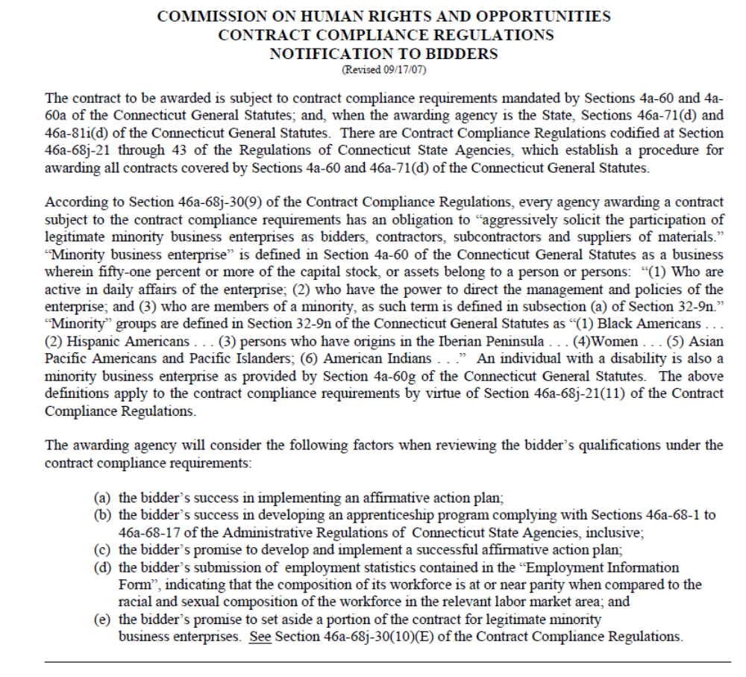
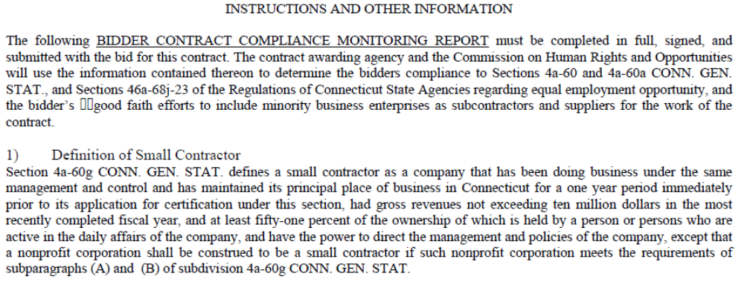
Attachment G
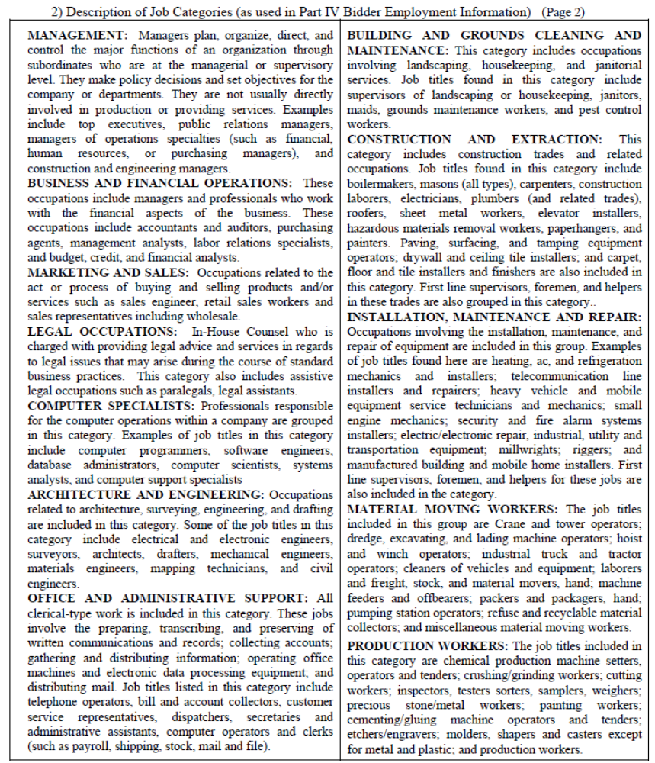

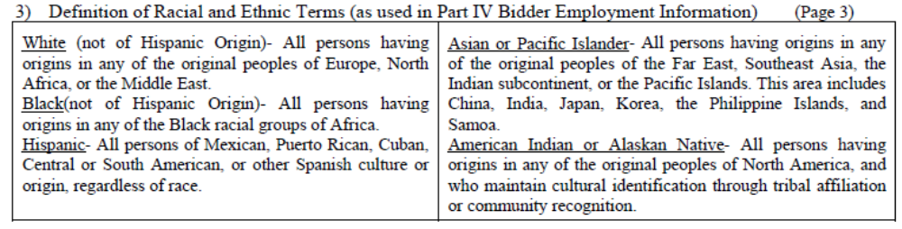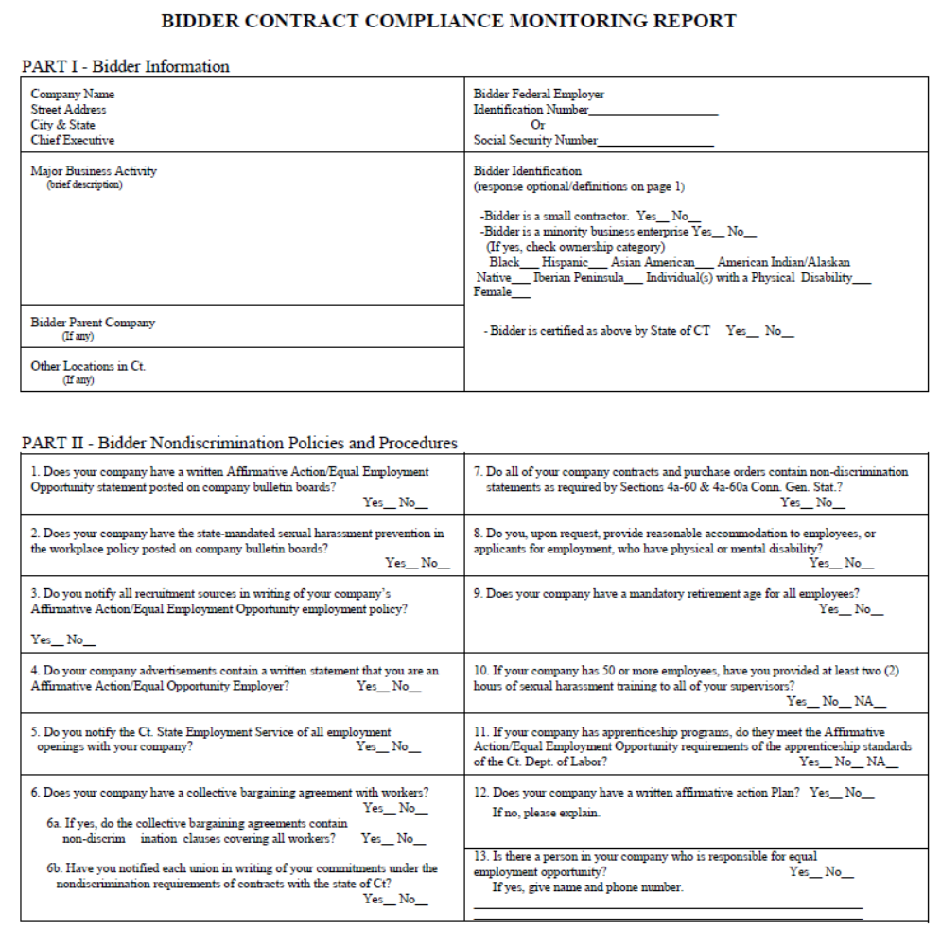

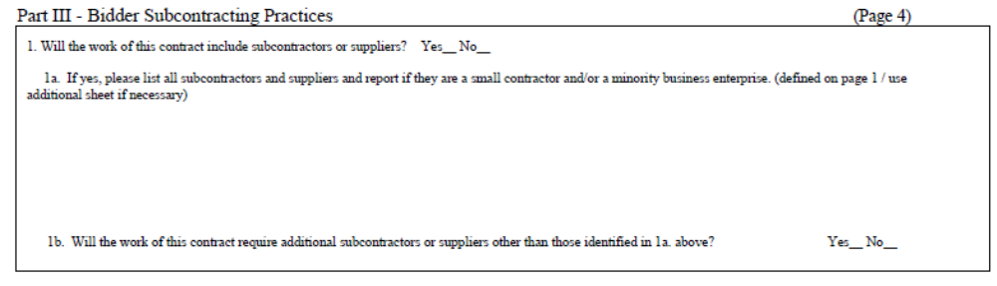

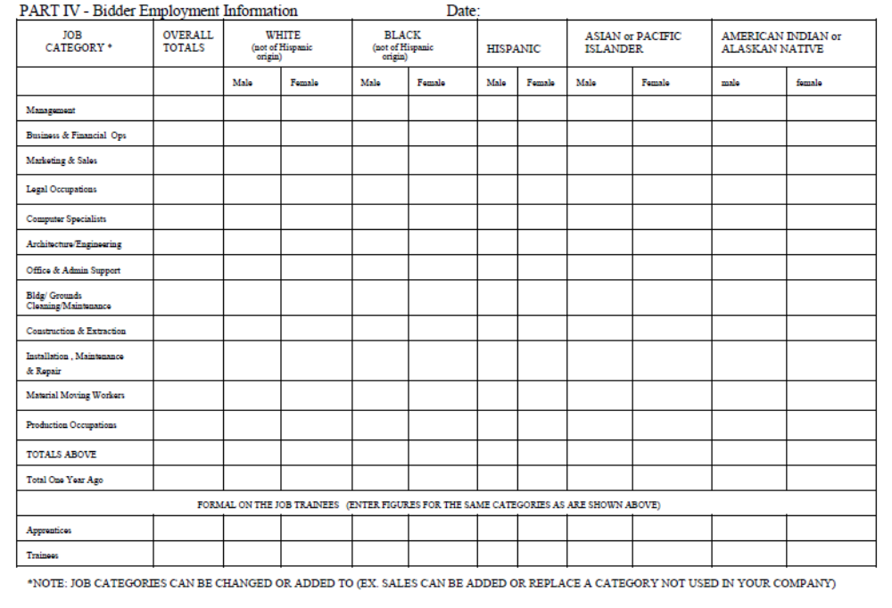

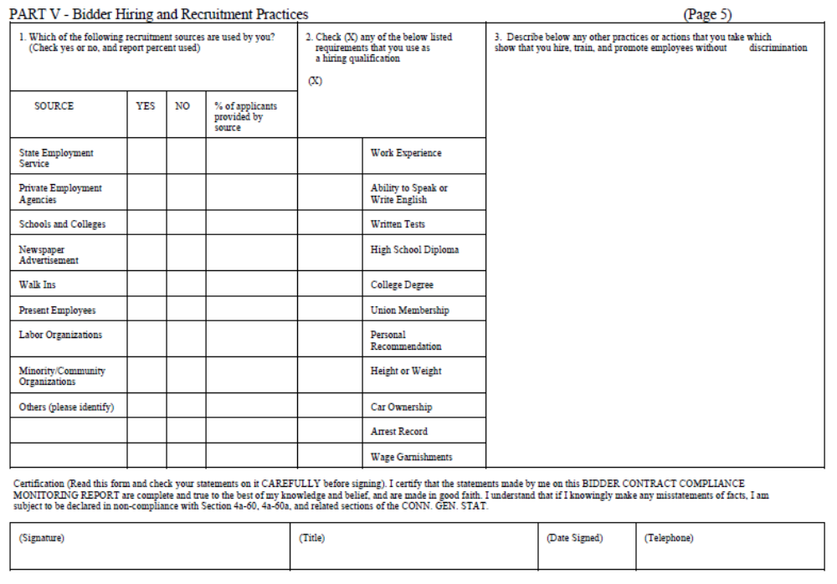


CONNECTICUT STATE ELECTIONS ENFORCEMENT COMMISSION Attachment H
Rev. 1/11
Page 1 of 2

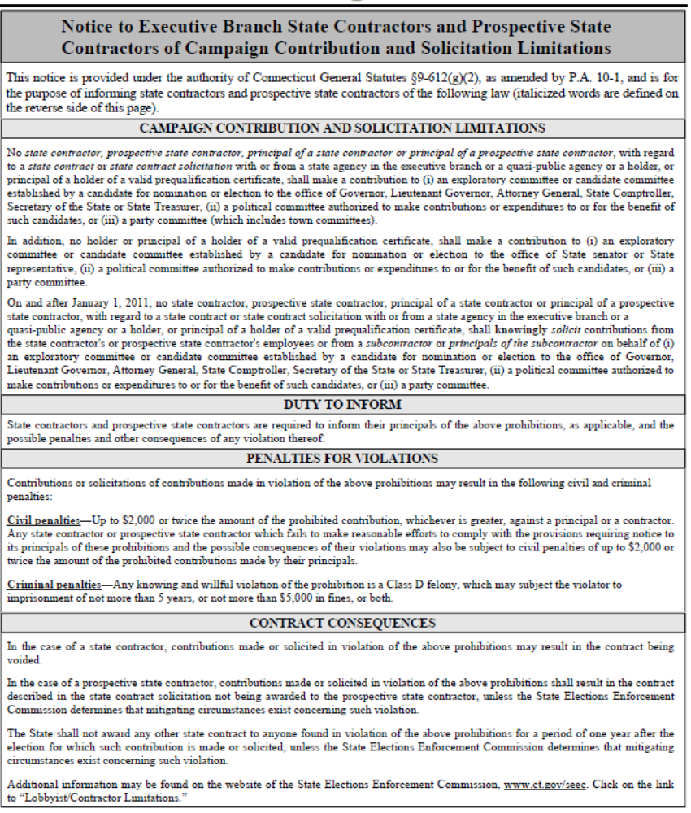

CONNECTICUT STATE ELECTIONS ENFORCEMENT COMMISSION
Rev. 1/11
Page 2 of 2
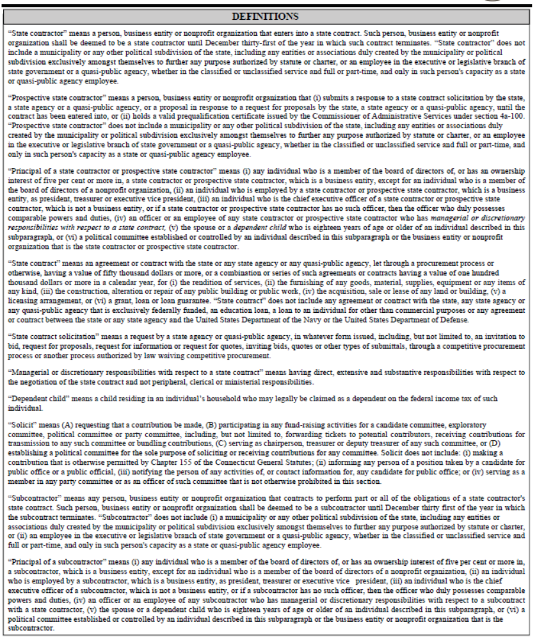

SAMPLE CONTRACT TO BE INSERTED AS ATTACHMENT I

SAMPLE CONTRACT

Agreement Between
_________________________
And
Connecticut State Colleges and Universities

This agreement is made the ___ day of _____, 2019 by and between (CONTRACTOR NAME) of (CONTRACTOR ADDRESS) (Hereinafter “Contractor”), and the Connecticut State Colleges and Universities on behalf of the Connecticut State University System (hereinafter “CSCU” or “State”) with a central / system office located at 61 Woodland Street, Hartford, Connecticut 06105.

- Agreement and Scope of Work

This Agreement, pursuant to an award made to the Contractor (RFP CSCU-1909) provides for credit and collection services relative to tuition, student loans, Perkins loans or other forms of educational related debts. The Contractor agrees to accept, process, and properly handle such educational related debts from Central Connecticut State University, Eastern Connecticut State University, Southern Connecticut State University, and Western Connecticut State University (each a “University” or collectively “Universities” or “CSCU”). This contract is also available for use by the Community Technical Colleges, Charter Oak State College, and the University of Connecticut, subject to the Contractor’s approval.

- The Contractor shall adhere to the following requirements throughout the term of the contract:

- Throughout the term of the agreement, the Contractor shall possess a State of Connecticut license to operate as a Collection Contractor, and shall perform its services in accordance with Federal laws and regulations and with those of all states in which the Contractor makes collection efforts on behalf of CSCU.

- The Contractor shall comply with all state and federal laws and regulations pertaining to collection agency practices, treatment of borrowers, and protection of individual privacy. Such laws and regulations include, but may not be limited to: the Banking Laws of the State of Connecticut; Connecticut General Statute Sec. 36a-805; Title IV of the Higher Education Act (as amended); Bankruptcy Code, as amended (11 USC Sec. 101, et. Seq.); Federal Fair Debt Collection Practices Act; Federal Trade Commission; Fair Credit Reporting Act; Gramm-Leach-Bliley Act; Health Insurance Portability and Accountability Act; and Federal Red Flags Rules regulations.

- Contractor shall provide ongoing training to provide its staff with an understanding of regulatory requirements and updates in the laws relative to collection techniques.

- Contractor shall not, under any circumstances, use any threats, intimidation, or harassment in the collection process or violate any applicable guidelines established by the Federal Trade Commission, the State of Connecticut, or any other state.

- The Contractor shall submit to CSCU copies of correspondence and/or complaints received from the borrowers within (15) fifteen days of receipt of such information and/or documentation.

- Throughout the term of the agreement, the Contractor shall carry Employee Surety Bond coverage in an amount not less than $100,000.00.

- The Contractor shall not assign any interest in this contract without the express prior written consent of CSCU.

- In performing the services described herein, the Contractor agrees to conduct all activities in accordance with the following:

- Accept accounts for collection on an as-needed basis from each University. The Universities have no obligation to submit any minimum number of accounts during the term of this Agreement

- Accept accounts for collection on an as-needed basis from CSCU’s contracted third party accounting and billing service, for federally funded Perkins loans. Each University shall authorize the third party accounting and billing service to transmit via "Tape Exchange" or electronic file, in a format approved by the University, to the Contractor the information necessary for the servicing of its delinquent accounts. Such accounts shall be collected by Contractor staff specializing in or specifically trained in the recovery of such accounts; University agrees to provide to Contractor any additional information and/or documentation requested in connection with the servicing of the accounts under this Agreement in a timely manner, not to exceed 30 days after the request of same.

- Begin collection activity on accounts within forty-eight (48) hours of assignment;

- Follow up on all accounts by telephone, with follow-up collection letter(s) to the debtor;

- Proceed with Skip Tracing, which is the process of locating a borrower’s current address and telephone number through a variety of sources, within ten (10) days after the unavailability of a valid address and / or telephone number occurs;

- Conduct all activities with confirmation letter(s) sent to the debtor;

- Encourage each debtor to pay the total amount due or if that is not possible, Contractor shall request a good faith payment of one-third (1/3) or one half (1/2) the total amount due. Contractor shall continue collection attempts on the remaining balance until the account is collected in full or returned to the University;

- Set up either a payment schedule with the debtor or arrange for any payment activity toward elimination of the debt. Copies of written payment agreements shall be submitted to the University;

- CSCU will not accept any settlement of debt less than 100% of debt. Except in the case of bankruptcy, death of the debtor, or some other provable inability to pay, the Contractor shall work each assigned referral account with diligence for not less than (12) months before returning uncollected accounts to the University, unless:

- A payment agreement has been made for payment beginning within thirty (30) days from the conclusion of the twelve-month period, and the contractor has provided the University with appropriate documentation on file to evidence this agreement;

- Return is requested by CSCU.

- The Contractor shall review and return accounts with no current activity within ninety (90) days after reaching twelve (12) months of contractor assignment.

- The Contractor shall suspend collection action, either temporarily or permanently, and no fee will be collected, if a University determines at a later date that an amount legitimately qualifies, and it is authorized for, deferment or cancellation.

- For Perkins loans, exhaust all normal collection efforts before offers of loan consolidation or debt rehabilitation are made, following federal regulations. Rehabilitation and consolidation are programs provided for by the federal government for Perkins loans.

- Any Perkins (National Defense/Direct) or Nursing Student Loan account returned by the Contractor to a University because of the apparent impossibility of affecting collection shall be accompanied by a statement acceptable to Federal authorities for the purpose of assignment of such account to the appropriate Federal office.

- For delinquent accounts of the Perkins (National Defense/Direct) and Nursing Student Loan Programs, all related business shall be transacted through the appropriate University office and, with regard to accounts owing for tuition and other items, the contractor shall deal directly with the appropriate University.

- If the Contractor receives a bad check from a debtor, the Contractor shall not deduct the amount from the next statement but shall correspond directly with the University. The amount of the bad check and any charges incurred from the bad check should appear in a subsequent report to the University.

- Contractor shall provide Credit Bureau Reporting service on behalf of each University, if requested. When requested, Contractor shall provide credit bureau reporting at the timeframe requested by the University, not to precede the earliest point allowed by law. Authorization in writing shall be given by the University for each account, or blanket authorization for all accounts the University elects to have reported to the credit bureaus.

- Upon request by a University, Contractor shall remove a credit bureau listing for a debtor upon return of a paid account, as allowed and in adherence to the Fair Credit Reporting Act (FCRA).

- Contractor expressly acknowledges and agrees that:

- CSCU reserves the right to enter into multiple contracts for credit and collections services.

- CSCU holds the right to submit accounts to Contractor that have previously been placed with other collection agencies, regardless of the age of the debt.

- Contractor fees shall be added to the balance wed by a debtor, prior to the placement of each account with Contractor; and

- Upon written request, accounts may be withdrawn by a University, if CSCU or a University makes the determination that withdrawal of an account would be in its own best interest, or upon notice of termination, or upon expiration of the Agreement. Contractor shall not be entitled to fees from monies subsequently collected on a withdrawn or recalled account.

- Litigation:

- Contractor shall recommend to a University legal action on an account only when the standard collection process has been exhausted or legal action is otherwise warranted, and Contractor shall give the reasons in writing to the University;

- Contractor shall not commence any litigation on accounts it has been assigned the right to collect without the express written consent of the University, and the written approval of the Connecticut Attorney General. Such approvals will include written approval of a schedule costs related to litigation;

- Provide the University with a clear, readable copy of any and all judgments and executions granted; and

- The contractor agrees that the Universities will not assume liability or be responsible for taxes or legal expenses other than for its own defense or to bring an action to collect an account.

- Fees and Remittance of Collections:

Collection services shall be provided at no cost to each University. Contractor’s fees shall be calculated as a percentage above the debt owed to the university, in accordance with the schedule set forth below, and subject to the conditions herein. Contractor is only entitled to a fee on that portion of the debt actually collected by Contractor. Each University reserves the right to add the fee prior to placing an account with the Contractor. This contract does not guarantee a specific amount of business or income.

- For tuition accounts and other forms of debt placed for collection by each University, amounts collected by contractor shall be remitted to the University for the gross amount collected from the borrower, net of the contractor’s fee. Checks shall be made payable to each University by name. Remittance may be made electronically by EFT (Electronic Funds Transfer), ACH (Automated Clearing House), or Wire Transfer. Contractor is only entitled to a fee on that portion of debt collected by Contractor.

- For Perkins student loan accounts, all amounts collected by Contractor shall be forwarded directly to CSCU’s third party billing service, inclusive of contractor’s fee, for deposit with the Office of the State Comptroller. Contractor shall submit an invoice for fees collected to the University, which shall be paid by the University after approval of invoice by the Perkins loan administrator at each University.

- Amounts paid to the contractor under this agreement shall not exceed $5,000,000.

- Records and Reporting:

Contractor shall provide online service access to debtor accounts. Contractor shall maintain a distinct set of records for each University, and each University shall have access to accounts that are relevant to that University only. Contractor shall not maintain one common database unless requested to do so in writing by CSCU. Contractor shall keep each University apprised of activities in regards to collection of their accounts and further agree that:

- Student loans gross collections shall be electronically reported to CSCU’s third party billing service by the Contractor, followed by a report to each university, sorted by debtor, via fax and/or regular mail. The Contractor shall provide the University offices for Perkins (National Defense/Direct) and Nursing Student Loan accounts with a hard copy of the detailed invoice in the total amount of the collections reported. Each University reserves the right to require weekly, bi-weekly, or monthly reporting and remittance at each of the University’s discretion.
- Gross collections shall be reported by the Contractor to each University, by debtor, for tuition and other accounts, and each report shall be accompanied by a check in the total amount of collections reported with all applicable fees removed. Checks shall be made payable to each university by name. Remittance may be made electronically by EFT (Electronic Funds Transfer), ACH (Automated Clearing House), or Wire Transfer.
- The following reports shall be provided by the Contractor weekly to each University and their third party billing service, unless experience leads both parties to agree that a greater or lesser frequency is preferable. Any reports that include personally identifiable information including, but not limited to social security numbers, shall only be transmitted using a secure medium and shall not be sent by e-mail.
a. Collection/Remittance Report;

b. Debtor Status Report showing date and amount assigned, amount collected and remitted, unpaid balance due, fees earned, and action taken by the Contractor; and

c. Updated address and phone number information.

- The following reports shall be provided by the Contractor monthly to each University unless experience leads both parties to agree that a greater or lesser frequency is preferable:

a. Acknowledgment Report (a listing of accounts and amounts assigned for collection, with break-down of principal amount and fees)

b. Due diligence reports to show credit collection efforts taken; and

c. Other reports, including, but not limited to, deletion lists and changes of address or other particulars, as the need arises.

- The following report shall be provided by the Agency annually to CSCU no later than July 30 each year for the most recent completed fiscal year ending June 30th:

- Balance activity report to show the balance at July 1, university additions to the account balance that fiscal year, value of collections returned to the institutions, amount paid out to the institution and the ending balance as of June 30.

- Contractor shall use its best efforts to create any other reports requested by the Universities, at the intervals requested by them.

- Customer Service: At minimum, contractor shall provide live customer service between the hours of 9:00am to 4:00pm eastern time, Monday through Friday, excluding holidays.

- Implementation:

Contractor agrees to provide account set up and implementation services to each University at no cost. Implementation Services may include, but may not be limited to: Implementation Kickoff Meetings at University offices, to be scheduled on dates and times determined by mutual agreement; Completion of technical set-up of accounts and reports; Training of Contractor personnel on procedures and timelines specific to each University; Training for University staff on the use of web based portals and reports.

- Family Educational Rights and Privacy Act (“FERPA”):

Contractor agrees that certain student information and education records, (“Education Records”), in whole or in part, that include personally identifiable information (PII) are subject to the guidelines provided in Section 34 C.F.R. §§ 99.1 et seq. of the Federal Regulations adopted pursuant to the Family Educational Rights and Privacy Act, 20 U.S.C. § 1232g (FERPA) and Contractor agrees that it will utilize such Education Records only to perform the services required by this Agreement and for no other purpose. To ensure that CSCU has direct control over Contractor’s use and maintenance of Education Records consistent with FERPA, the parties hereby agree as follows:

- CSCU agrees to allow Contractor access only to those portions of Education Records for which Contractor has a legitimate interest and solely for the purpose of completing the work outlined in the Contract. Specifically, access shall be limited to the following: Education Records collected and/or maintained in connection with student loan accounts and related financial and personal information.

- Contractor agrees and acknowledges that Education Records are protected by and subject to the requirements of FERPA. Contractor shall keep such Education Records strictly confidential and recognizes that it shall not re-disclose such Education Records without the express written consent of the CSCU. Further, Contractor agrees that it will remain current with applicable FERPA requirements.

- Contractor agrees to access and use the Education Records solely for the purpose of completing the tasks agreed to in the Agreement, and that all reports, data, studies, and analyses created by Contractor pursuant to the Agreement are the sole property of CSCU and will not be disclosed by Contractor to anyone but CSCU.

- Contractor agrees that CSCU must fully comply with the requirements of FERPA. Therefore, CSCU reserves the right to refuse to disclose records when CSCU deems such disclosure may violate the requirements of FERPA and its regulations. Contractor agrees that its use and access to Education Records is within the CSCU’s sole discretion and that CSCU shall completely control Contractor’s use of and access to such records;

Contractor expressly agrees to:
- Limit access to the Education Records to Contractor employees who have a legitimate interest in the information and identify those individuals.

- Prohibit disclosure of Education Records.

- Require all of its subcontractors and agents that receive, use or have access to the Education Records to implement reasonable and appropriate security safeguards to protect Education Records and make those subcontractors agreements available for review upon request.

- Return to CSCU all confidential information and destroy Education Records under its control at the termination or expiration of the contract.

- Contractor agrees to implement and maintain a comprehensive data-security program for the protection of Education Records disclosed pursuant to the Agreement. Contractor agrees that its data security program shall be consistent with and comply with standards no less rigorous than those set forth in all applicable federal and state laws, regulations, and business guidance issued by the Department of Education and Federal Trade Commission to protect data from unauthorized access, destruction, use, modification or disclosure. Such data security program shall include, but not be limited to the following:

- A security policy for employees related to the storage, access and transportation of data containing Education Records;

- Reasonable restrictions on access to records containing Education Records, including access to any locked storage where such records are kept;

- A process for reviewing policies and security measures at least annually;

- Creating secure access controls to Education Records, including but not limited to passwords and encryption techniques, to preserve the confidentiality and integrity of all Education Records; and,

- Prohibiting any downloading or storage of Education Records to individual user desktops, mobile or storage devices.

- Contractor names the following individual as the custodian of Education Records: _________

- Contractor agrees that it shall comply with the requirements of FERPA and its regulations regarding the destruction and disclosure of student information. Contractor agrees to destroy all Education Records obtained from the above-referenced education records as soon as all analysis has been performed, or when the information is no longer needed, whichever date comes first. Contractor agrees that all versions of such information and data, electronic, paper, or otherwise, will be destroyed pursuant to Department of Defense data destruction standards, not to include the physical destruction of the hard drives, and that Contractor will provide CSCU with written confirmation of the destruction of the data. Contractor agrees it will not share, sell, rent, use or disclose Education Records with or to any third parties without the express written consent of CSCU.

- In the event of a data breach, Contractor shall promptly notify CSCU of such breach. The parties agree that a data breach shall (i) have occurred upon any actual, probable, or reasonably suspected misuse, compromise or unauthorized access of Education Records; or (ii) presumably occurred upon discovery of a physical trespass of a secure area, electronic systems intrusion or hacking, loss or theft of notebook, desktop or other electronic mobile device, hard drive or information storage devise, loss or theft of printed materials, receipt of complaint of violation of privacy policies.
- CSCU reserves the right to immediately suspend data transmission between the parties in the event of a breach until Contractor can demonstrate that it has remedied the cause of the breach.
- CSCU reserves the right to investigate or require Contractor to conduct an investigation and report of the breach, at its own expense.
- CSCU reserves the right to manage and mitigate the impact of any breach; however, Contractor shall be solely responsible for any costs associated with a breach, including those related to managing and mitigating the impact of such breach.

- CSCU reserves the right to monitor Contractor to affirm that Contractor has the appropriate policies and practices in place to ensure the protection of Education Records. CSCU reserves the right to perform audits at its expense to the extent necessary to ensure compliance with the terms of this agreement. Contractor agrees to cooperate in the performance of such audits.

- If required to disclose Education Records by law, Contractor shall immediately provide CSCU notice so that CSCU may seek a protective order.

- These provisions shall survive the termination, cancellation or expiration of the contract.

- Confidentiality:

Contractor shall use all means possible to safeguard any and all data in its care. Contractor shall maintain a payment management system that insures that all payments are secured, properly recorded, and posted to the correct account. Contractor shall comply with the requirements of the Gramm-Leach-Bliley Act (“GLB”), 15 U.S.C. § 6801, et seq., and the rules and regulations promulgated thereunder, as detailed in Attachment 1, attached hereto and made a part hereof.
- Additional Services:

Contractor shall provide additional services to the CSCU Universities, the CSCU System Office, the Community Technical Colleges, or Charter Oak State University upon request, which may include but not be limited to: customized seminars or workshop presentations, creation of new or unique accounts, implementation of international collections, or other credit and collection services not already described herein. Any such services shall be based upon mutual agreement of the parties and a written, signed statement of work (“SOW”).

III – TERM AND TERMINATION

This Agreement shall commence on that date that the Agreement is approved by the Connecticut Office of the Attorney General and shall continue in effect until (DATE) unless terminated earlier in accordance with the provisions of Section IV.E. All accounts, and any documentation or information pertaining to all activities executed on each account shall be returned to CSCU within thirty (30) days from the date of termination, or expiration, of the Agreement. This Agreement may be extended for periods of time up to an additional five years by written agreement of the parties and approval of the Connecticut Office of the Attorney General.

IV - OTHER TERMS AND CONDITIONS

A. Claims Against The State:
The Contractor agrees that the sole and exclusive means for the presentation of any claim against the State arising from this Agreement shall be in accordance with Chapter 53 of the Connecticut General Statutes (Claims Against the State) and the Contractor further agrees not to initiate legal proceedings in any state or federal court in addition to, or in lieu of, said Chapter 53 proceedings.

B. Indemnification and Insurance:
- The Contractor shall indemnify, defend and hold harmless the State and its officers, representatives, agents, servants, employees, successors and assigns from and against any and all (1) claims arising, directly or indirectly, in connection with the Contract, including the acts of commission or omission (collectively, the “Acts”) of the Contractor or contractor parties; and (2) liabilities, damages, losses, costs and expenses, including but not limited to, attorneys’ and other professionals’ fees, arising, directly or indirectly, in connection with claims, Acts or the contract. The Contractor shall use counsel reasonably acceptable to the State in carrying out its obligations under this section. The Contractor’s obligations under this section to indemnify, defend and hold harmless against claims includes claims concerning confidentiality of any part of or all of the Contractor’s bid, proposal or any records, any intellectual property rights, other proprietary rights of any person or entity, copyrighted or uncopyrighted compositions, secret processes, patented or unpatented inventions, articles or appliances furnished or used in the performance.
- The Contractor shall not be responsible for indemnifying or holding the State harmless from any liability arising due to the negligence of the State or any third party acting under the direct control or supervision of the State.
- The Contractor shall reimburse the State for any and all damages to the real or personal property of the State caused by the Acts of the Contractor or any contractor parties. The State shall give the Contractor reasonable notice of any such claims.
- The Contractor’s duties under this section shall remain fully in effect and binding in accordance with the terms and conditions of the Contract, without being lessened or compromised in any way, even where the Contractor is alleged or is found to have merely contributed in part to the Acts giving rise to the claims and/or where the State is alleged or is found to have contributed to the Acts giving rise to the claims.
- The Contractor shall carry and maintain at all times during the term of the Contract, and during the time that any provisions survive the term of the Contract, sufficient general liability insurance to satisfy its obligations under this Contract. The Contractor shall cause the State to be named as an additional insured on the policy and shall provide (1) a certificate of insurance, (2) the declaration page and (3) the additional insured endorsement to the policy to the Client Agency prior to the Effective Date of the Contract evidencing that the State is an additional insured. The Contractor shall not begin Performance until the delivery of these 3 documents to the Client Agency. State shall be entitled to recover under the insurance policy even if a body of competent jurisdiction determines that State is contributorily negligent.
- This section shall survive the termination of the contract and shall not be limited by reason of any insurance coverage.

C. Sovereign Immunity:
The parties acknowledge and agree that nothing in this Contract shall be construed as a modification, compromise or waiver by the State of any rights or defenses of any immunities provided by Federal law or the laws of the State of Connecticut to the State or any of its officers and employees, which they may have had, now have or will have with respect to all matters arising out of this Contract. To the extent that this section conflicts with any other section, this section shall govern.
D. Forum and Choice of Law:
The parties deem the Contract to have been made in the City of Hartford, State of Connecticut. Both parties agree that it is fair and reasonable for the validity and construction of the contract to be, and it shall be, governed by the laws and court decisions of the State of Connecticut, without giving effect to its principles of conflicts of laws. To the extent that any immunities provided by Federal law or the laws of the State of Connecticut do not bar an action against the State, and to the extent that these courts are courts of competent jurisdiction, for the purpose of venue, the complaint shall be made returnable to the Judicial District of Hartford only or shall be brought in the United States District Court for the District of Connecticut only, and shall not be transferred to any other court, provided, however, that nothing here constitutes a waiver or compromise of the sovereign immunity of the State of Connecticut. The Contractor waives any objection which it may now have or will have to the laying of venue of any claims in any forum and further irrevocably submits to such jurisdiction in any suit, action or proceeding.

E. Termination:
      - Notwithstanding any provisions in this contract, the CSCU, through a duly authorized employee, may terminate the contract whenever the CSCU makes a written determination that such termination is in the best interests of the State. The CSCU shall notify the Contractor in writing of termination pursuant to this section, which notice shall specify the effective date of termination and the extent to which the Contractor must complete its performance under the contract prior to such date.
      - Notwithstanding any provisions in this contract, the CSCU, through a duly authorized employee, may, after making a written determination that the Contractor has breached the contract, terminate the contract in accordance with the following breach provision. Notwithstanding any provisions in this contract, Contractor, through a duly authorized employee, may, after making a written determination that the State, University, CSCU or College has breached the contract, terminate the contract in accordance with the following breach provision.
- Breach. If either party breaches the contract in any respect, the non-breaching party shall provide written notice of the breach to the breaching party and afford the breaching party an opportunity to cure within ten (10) days from the date that the breaching party receives the notice. In the case of a Contractor breach, any other time period which the CSCU sets forth in the notice shall trump the ten (10) days. The right to cure period shall be extended if the non-breaching party is satisfied that the breaching party is making a good faith effort to cure but the nature of the breach is such that it cannot be cured within the right to cure period. The notice may include an effective contract termination date if the breach is not cured by the stated date and, unless otherwise modified by the non-breaching party in writing prior to the termination date, no further action shall be required of any party to effect the termination as of the stated date. If the notice does not set forth an effective contract termination date, then the non-breaching party may terminate the contract by giving the breaching party no less than twenty four (24) hours’ prior written notice. If the CSCU believes that the Contractor has not performed according to the contract, the CSCU may withhold payment in whole or in part pending resolution of the performance issue, provided that the CSCU notifies the Contractor in writing prior to the date that the payment would have been due.
      - The Party Terminating shall send the notice of termination via certified mail, return receipt requested, to the breaching party at the most current address which the breaching party has furnished to the party terminating for purposes of correspondence, or by hand delivery. Upon receiving the notice from the terminating party, the breaching party shall immediately discontinue all services affected in accordance with the notice, undertake all commercially reasonable efforts to mitigate any losses or damages, and deliver to CSCU all records. The records are deemed to be the property of the CSCU and the Contractor shall deliver them to the CSCU no later than thirty (30) days after the termination of the contract or fifteen (15) days after the Contractor receives a written request from the CSCU for the records. The Contractor shall deliver those records that exist in electronic, magnetic or other intangible form in a non-proprietary format, such as, but not limited to, ASCII or .TXT.
      - In the event of termination by the CSCU and upon receipt of a written notice of termination from the CSCU, the Contractor shall cease operations as the CSCU directs in the notice, and take all actions that are necessary or appropriate, or that the CSCU may reasonably direct, for the protection, and preservation of the goods and any other property. Except for any work which the CSCU directs the Contractor to perform in the notice prior to the effective date of termination, and except as otherwise provided in the notice, the Contractor shall terminate or conclude all existing subcontracts and purchase orders and shall not enter into any further subcontracts, purchase orders or commitments.
      - The CSCU shall, within forty-five (45) days of the effective date of termination, reimburse the Contractor for its performance rendered and accepted by the CSCU in accordance with the terms of this contract, in addition to all actual and reasonable costs incurred after termination in completing those portions of the performance which the notice required the Contractor to complete. However, the Contractor is not entitled to receive and the CSCU is not obligated to tender to the Contractor any payments for anticipated or lost profits. Upon request by the CSCU, the Contractor shall assign to the CSCU, or any replacement Contractor which the CSCU designates, all subcontracts, purchase orders and other commitments, deliver to the CSCU all records and other information pertaining to its performance, and remove from State premises, whether leased or owned, all of Contractor’s property, equipment, waste material and rubbish related to its performance, all as the CSCU may request.
      - For breach or violation of any of the provisions in the section concerning representations and warranties, the CSCU may terminate the contract in accordance with its terms and revoke any consents to assignments given as if the assignments had never been requested or consented to, without liability to the Contractor or Contractor parties or any third party.
      - Upon termination of the contract, all rights and obligations shall be null and void, so that no party shall have any further rights or obligations to any other party, except with respect to the sections which survive termination. All representations, warranties, agreements and rights of the parties under the contract shall survive such termination to the extent not otherwise limited in the contract and without each one of them having to be specifically mentioned in the contract.
      - Termination of the contract pursuant to this section shall not be deemed to be a breach of contract by the terminating party.

F. Entire Agreement:
This written contract shall constitute the entire agreement between the parties and no other terms and conditions in any document, acceptance or acknowledgment shall be effective or binding unless expressly agreed to in writing by the CSCU. This contract may not be changed other than by a formal written contract amendment signed by the parties hereto and approved by the Connecticut Attorney General.

G. Nondiscrimination:
(a) For purposes of this Section, the following terms are defined as follows:
    - “Commission” means the Commission on Human Rights and Opportunities;
    - “Contract” and “contract” include any extension or modification of the Contract or contract;
    - “Contractor” and “contractor” include any successors or assigns of the Contractor or contractor;
    - “Gender identity or expression” means a person’s gender-related identity, appearance or behavior, whether or not that gender-related identity, appearance or behavior is different from that traditionally associated with the person’s physiology or assigned sex at birth, which gender-related identity can be shown by providing evidence including, but not limited to, medical history, care or treatment of the gender-related identity, consistent and uniform assertion of the gender-related identity or any other evidence that the gender-related identity is sincerely held, part of a person’s core identity or not being asserted for an improper purpose.
    - “good faith” means that degree of diligence which a reasonable person would exercise in the performance of legal duties and obligations;
    - “good faith efforts” shall include, but not be limited to, those reasonable initial efforts necessary to comply with statutory or regulatory requirements and additional or substituted efforts when it is determined that such initial efforts will not be sufficient to comply with such requirements;
    - “marital status” means being single, married as recognized by the State of Connecticut, widowed, separated or divorced;
    - “mental disability” means one or more mental disorders, as defined in the most recent edition of the American Psychiatric Association’s “Diagnostic and Statistical Manual of Mental Disorders”, or a record of or regarding a person as having one or more such disorders;
    - “minority business enterprise” means any small contractor or supplier of materials fifty-one percent or more of the capital stock, if any, or assets of which is owned by a person or persons: (1) who are active in the daily affairs of the enterprise, (2) who have the power to direct the management and policies of the enterprise, and (3) who are members of a minority, as such term is defined in subsection (a) of C.G.S. § 32-9n; and
    - “public works contract” means any agreement between any individual, firm or corporation and the State or any political subdivision of the State other than a municipality for construction, rehabilitation, conversion, extension, demolition or repair of a public building, highway or other changes or improvements in real property, or which is financed in whole or in part by the State, including, but not limited to, matching expenditures, grants, loans, insurance or guarantees.

For purposes of this Section, the terms “Contract” and “contract” do not include a contract where each contractor is (1) a political subdivision of the state, including, but not limited to, a municipality, unless the contract is a municipal public works contract or quasi-public agency project contract, (2) any other state, including but not limited to any federally recognized Indian tribal governments, as defined in C.G.S. § 1-267, (3) the federal government, (4) a foreign government, or (5) an agency of a subdivision, state or government described in the immediately preceding enumerated items (1), (2), (3),or (4).

(b) (1) The Contractor agrees and warrants that in the performance of the Contract such Contractor will not discriminate or permit discrimination against any person or group of persons on the grounds of race, color, religious creed, age, marital status, national origin, ancestry, sex, gender identity or expression, intellectual disability, mental disability or physical disability, including, but not limited to, blindness, unless it is shown by such Contractor that such disability prevents performance of the work involved, in any manner prohibited by the laws of the United States or of the State of Connecticut; and the Contractor further agrees to take affirmative action to insure that applicants with job-related qualifications are employed and that employees are treated when employed without regard to their race, color, religious creed, age, marital status, national origin, ancestry, sex, gender identity or expression, intellectual disability, mental disability or physical disability, including, but not limited to, blindness, unless it is shown by the Contractor that such disability prevents performance of the work involved; (2) the Contractor agrees, in all solicitations or advertisements for employees placed by or on behalf of the Contractor, to state that it is an “affirmative action-equal opportunity employer” in accordance with regulations adopted by the Commission; (3) the Contractor agrees to provide each labor union or representative of workers with which the Contractor has a collective bargaining Agreement or other contract or understanding and each vendor with which the Contractor has a contract or understanding, a notice to be provided by the Commission, advising the labor union or workers’ representative of the Contractor’s commitments under this section and to post copies of the notice in conspicuous places available to employees and applicants for employment; (4) the Contractor agrees to comply with each provision of this Section and C.G.S. §§ 46a-68e and 46a-68f and with each regulation or relevant order issued by said Commission pursuant to C.G.S. §§ 46a-56, 46a-68e, 46a-68f and 46a-86; and (5) the Contractor agrees to provide the Commission on Human Rights and Opportunities with such information requested by the Commission, and permit access to pertinent books, records and accounts, concerning the employment practices and procedures of the Contractor as relate to the provisions of this Section and C.G.S. § 46a-56. If the contract is a public works contract, municipal public works contract or contract for a quasi-public agency project, the Contractor agrees and warrants that he or she will make good faith efforts to employ minority business enterprises as subcontractors and suppliers of materials on such public works or quasi-public agency projects.

(c) Determination of the Contractor’s good faith efforts shall include, but shall not be limited to, the following factors: The Contractor’s employment and subcontracting policies, patterns and practices; affirmative advertising, recruitment and training; technical assistance activities and such other reasonable activities or efforts as the Commission may prescribe that are designed to ensure the participation of minority business enterprises in public works projects.

(d) The Contractor shall develop and maintain adequate documentation, in a manner prescribed by the Commission, of its good faith efforts.

(e) The Contractor shall include the provisions of subsection (b) of this Section in every subcontract or purchase order entered into in order to fulfill any obligation of a contract with the State and in every subcontract entered into in order to fulfill any obligation of a municipal public works contract for a quasi-public agency project, and such provisions shall be binding on a subcontractor, vendor or manufacturer unless exempted by regulations or orders of the Commission. The Contractor shall take such action with respect to any such subcontract or purchase order as the Commission may direct as a means of enforcing such provisions including sanctions for noncompliance in accordance with C.G.S. § 46a-56, as amended; provided if such Contractor becomes involved in, or is threatened with, litigation with a subcontractor or vendor as a result of such direction by the Commission regarding a State contract, the Contractor may request the State of Connecticut to enter into any such litigation or negotiation prior thereto to protect the interests of the State and the State may so enter.

(f) The Contractor agrees to comply with the regulations referred to in this Section as they exist on the date of this Contract and as they may be adopted or amended from time to time during the term of this Contract and any amendments thereto.

(g) (1) The Contractor agrees and warrants that in the performance of the Contract such Contractor will not discriminate or permit discrimination against any person or group of persons on the grounds of sexual orientation, in any manner prohibited by the laws of the United States or the State of Connecticut, and that employees are treated when employed without regard to their sexual orientation; (2) the Contractor agrees to provide each labor union or representative of workers with which such Contractor has a collective bargaining Agreement or other contract or understanding and each vendor with which such Contractor has a contract or understanding, a notice to be provided by the Commission on Human Rights and Opportunities advising the labor union or workers’ representative of the Contractor’s commitments under this section, and to post copies of the notice in conspicuous places available to employees and applicants for employment; (3) the Contractor agrees to comply with each provision of this section and with each regulation or relevant order issued by said Commission pursuant to C.G.S. § 46a-56; and (4) the Contractor agrees to provide the Commission on Human Rights and Opportunities with such information requested by the Commission, and permit access to pertinent books, records and accounts, concerning the employment practices and procedures of the Contractor which relate to the provisions of this Section and C.G.S. § 46a-56.

      - The Contractor shall include the provisions of the foregoing paragraph in every subcontract or purchase order entered into in order to fulfill any obligation of a contract with the State and such provisions shall be binding on a subcontractor, vendor or manufacturer unless exempted by regulations or orders of the Commission. The Contractor shall take such action with respect to any such subcontract or purchase order as the Commission may direct as a means of enforcing such provisions including sanctions for noncompliance in accordance with C.G.S. § 46a-56 as amended; provided, if such Contractor becomes involved in, or is threatened with, litigation with a subcontractor or vendor as a result of such direction by the Commission regarding a State contract, the Contractor may request the State of Connecticut to enter into any such litigation or negotiation prior thereto to protect the interests of the State and the State may so enter.

H. Executive Orders:
This Contract is subject to the provisions of Executive Order No. Three of Governor Thomas J. Meskill, promulgated June 16, 1971, concerning labor employment practices, Executive Order No. Seventeen of Governor Thomas J. Meskill, promulgated February 15, 1973, concerning the listing of employment openings and Executive Order No. Sixteen of Governor John G. Rowland promulgated August 4, 1999, concerning violence in the workplace, all of which are incorporated into and are made a part of the Contract as if they had been fully set forth in it. The Contract may also be subject to Executive Order No. 14 of Governor M. Jodi Rell, promulgated April 17, 2006, concerning procurement of cleaning products and services and to Executive Order No. 49 of Governor Dannel P. Malloy, promulgated May 22, 2015, mandating disclosure of certain gifts to public employees and contributions to certain candidates for office. If Executive Order 14 and/or Executive Order 49 are applicable, they are deemed to be incorporated into and are made a part of the Contract as if they had been fully set forth in it. At the Contractor's request, the Institution or DAS shall provide a copy of these orders to the Contractor.

I. Quality Surveillance, Examination of Records and Inspection of Work:
Pursuant to C.G.S. § 4e-29 and 4e-30, all services performed by the Contractor and all records pertaining to this contract shall be subject to the inspection and approval of the State and the State Contracting Agency at reasonable times.

J. Assignment:
This contract shall not be assigned by either party without the express prior written consent of the other.

K. Professional Standards:
In rendering services under this contract, the Contractor shall conform to high professional standards of work and business ethic. The Contractor warrants that the services shall be performed: 1) in a professional and workmanlike manner; and 2) in accordance with generally and currently accepted principles and practices. During the term of this contract, the Contractor agrees to provide to CSCU in a good and faithful manner, using its best efforts and in a manner that shall promote the interests of said CSCU, such services as the CSCU requests, provided in this contract.

L. SEEC:
For all state contracts as defined in Connecticut General Statutes §9-612(g)(2), having a value in a calendar year of $50,000 or more or a combination or series of such agreements or contracts having a value of $100,000 or more, the authorized signatory to this Agreement expressly acknowledges receipt of the State Election Enforcement Commission’s notice advising state contractors of state campaign contribution and solicitation prohibitions, and will inform its principals of the contents of the notice. See Notice below.

NOTICE TO EXECUTIVE BRANCH STATE CONTRACTORS AND PROSPECTIVE STATE
CONTRACTORS OF CAMPAIGN CONTRIBUTION AND SOLICITATION LIMITATIONS
This notice is provided under the authority of Connecticut General Statutes §9-612(g)(2), as amended by P.A. 10-1, and is for the purpose of informing state contractors and prospective state contractors of the following law (italicized words are defined below):

CAMPAIGN CONTRIBUTION AND SOLICITATION LIMITATIONS
No state contractor, prospective state contractor, principal of a state contractor or principal of a prospective state contractor, with regard to a state contract or state contract solicitation with or from a state agency in the executive branch or a quasi-public agency or a holder, or principal of a holder of a valid prequalification certificate, shall make a contribution to (i) an exploratory committee or candidate committee established by a candidate for nomination or election to the office of Governor, Lieutenant Governor, Attorney General, State Comptroller, Secretary of the State or State Treasurer, (ii) a political committee authorized to make contributions or expenditures to or for the benefit of such candidates, or (iii) a party committee (which includes town committees).

In addition, no holder or principal of a holder of a valid prequalification certificate, shall make a contribution to (i) an exploratory committee or candidate committee established by a candidate for nomination or election to the office of State senator or State representative, (ii) a political committee authorized to make contributions or expenditures to or for the benefit of such candidates, or (iii) a party committee.

On and after January 1, 2011, no state contractor, prospective state contractor, principal of a state contractor or principal of a prospective state contractor, with regard to a state contract or state contract solicitation with or from a state agency in the executive branch or a quasi-public agency or a holder, or principal of a holder of a valid prequalification certificate, shall knowingly solicit contributions from the state contractor's or prospective state contractor's employees or from a subcontractor or principals of the subcontractor on behalf of (i) an exploratory committee or candidate committee established by a candidate for nomination or election to the office of Governor, Lieutenant Governor, Attorney General, State Comptroller, Secretary of the State or State Treasurer, (ii) a political committee authorized to make contributions or expenditures to or for the benefit of such candidates, or (iii) a party committee.

DUTY TO INFORM
State contractors and prospective state contractors are required to inform their principals of the above prohibitions, as applicable, and the possible penalties and other consequences of any violation thereof.

PENALTIES FOR VIOLATIONS
Contributions or solicitations of contributions made in violation of the above prohibitions may result in the following civil and criminal penalties:

Civil penalties: Up to $2,000 or twice the amount of the prohibited contribution, whichever is greater, against a principal or a contractor. Any state contractor or prospective state contractor which fails to make reasonable efforts to comply with the provisions requiring notice to its principals of these prohibitions and the possible consequences of their violations may also be subject to civil penalties of up to $2,000 or twice the amount of the prohibited contributions made by their principals.

Criminal penalties: Any knowing and willful violation of the prohibition is a Class D felony, which may subject the violator to imprisonment of not more than 5 years, or not more than $5,000 in fines, or both.

CONTRACT CONSEQUENCES
In the case of a state contractor, contributions made or solicited in violation of the above prohibitions may result in the contract being voided.

In the case of a prospective state contractor, contributions made or solicited in violation of the above prohibitions shall result in the contract described in the state contract solicitation not being awarded to the prospective state contractor, unless the State Elections Enforcement Commission determines that mitigating circumstances exist concerning such violation.

The State shall not award any other state contract to anyone found in violation of the above prohibitions for a period of one year after the election for which such contribution is made or solicited, unless the State Elections Enforcement Commission determines that mitigating circumstances exist concerning such violation.

Additional information may be found on the website of the State Elections Enforcement Commission, www.ct.gov/seec. Click on the link to “Lobbyist/Contractor Limitations.”

DEFINITIONS

“State contractor” means a person, business entity or nonprofit organization that enters into a state contract. Such person, business entity or nonprofit organization shall be deemed to be a state contractor until December thirty-first of the year in which such contract terminates. “State contractor” does not include a municipality or any other political subdivision of the state, including any entities or associations duly created by the municipality or political subdivision exclusively amongst themselves to further any purpose authorized by statute or charter, or an employee in the executive or legislative branch of state government or a quasi-public agency, whether in the classified or unclassified service and full or part-time, and only in such person's capacity as a state or quasi-public agency employee.

“Prospective state contractor” means a person, business entity or nonprofit organization that (i) submits a response to a state contract solicitation by the state, a state agency or a quasi-public agency, or a proposal in response to a request for proposals by the state, a state agency or a quasi-public agency, until the contract has been entered into, or (ii) holds a valid prequalification certificate issued by the Commissioner of Administrative Services under section 4a-100. “Prospective state contractor” does not include a municipality or any other political subdivision of the state, including any entities or associations duly created by the municipality or political subdivision exclusively amongst themselves to further any purpose authorized by statute or charter, or an employee in the executive or legislative branch of state government or a quasi-public agency, whether in the classified or unclassified service and full or part-time, and only in such person's capacity as a state or quasi-public agency employee.

“Principal of a state contractor or prospective state contractor” means (i) any individual who is a member of the board of directors of, or has an ownership interest of five per cent or more in, a state contractor or prospective state contractor, which is a business entity, except for an individual who is a member of the board of directors of a nonprofit organization, (ii) an individual who is employed by a state contractor or prospective state contractor, which is a business entity, as president, treasurer or executive vice president, (iii) an individual who is the chief executive officer of a state contractor or prospective state contractor, which is not a business entity, or if a state contractor or prospective state contractor has no such officer, then the officer who duly possesses comparable powers and duties, (iv) an officer or an employee of any state contractor or prospective state contractor who has managerial or discretionary responsibilities with respect to a state contract, (v) the spouse or a dependent child who is eighteen years of age or older of an individual described in this subparagraph, or (vi) a political committee established or controlled by an individual described in this subparagraph or the business entity or nonprofit organization that is the state contractor or prospective state contractor.

“State contract” means an agreement or contract with the state or any state agency or any quasi-public agency, let through a procurement process or otherwise, having a value of fifty thousand dollars or more, or a combination or series of such agreements or contracts having a value of one hundred thousand dollars or more in a calendar year, for (i) the rendition of services, (ii) the furnishing of any goods, material, supplies, equipment or any items of any kind, (iii) the construction, alteration or repair of any public building or public work, (iv) the acquisition, sale or lease of any land or building, (v) a licensing arrangement, or (vi) a grant, loan or loan guarantee. “State contract” does not include any agreement or contract with the state, any state agency or any quasi-public agency that is exclusively federally funded, an education loan, a loan to an individual for other than commercial purposes or any agreement or contract between the state or any state agency and the United States Department of the Navy or the United States Department of Defense.

“State contract solicitation” means a request by a state agency or quasi-public agency, in whatever form issued, including, but not limited to, an invitation to bid, request for proposals, request for information or request for quotes, inviting bids, quotes or other types of submittals, through a competitive procurement process or another process authorized by law waiving competitive procurement.

“Managerial or discretionary responsibilities with respect to a state contract” means having direct, extensive and substantive responsibilities with respect to the negotiation of the state contract and not peripheral, clerical or ministerial responsibilities.

“Dependent child” means a child residing in an individual’s household who may legally be claimed as a dependent on the federal income tax of such individual.

“Solicit” means (A) requesting that a contribution be made, (B) participating in any fund-raising activities for a candidate committee, exploratory committee, political committee or party committee, including, but not limited to, forwarding tickets to potential contributors, receiving contributions for transmission to any such committee or bundling contributions, (C) serving as chairperson, treasurer or deputy treasurer of any such committee, or (D) establishing a political committee for the sole purpose of soliciting or receiving contributions for any committee. Solicit does not include: (i) making a contribution that is otherwise permitted by Chapter 155 of the Connecticut General Statutes; (ii) informing any person of a position taken by a candidate for public office or a public official, (iii) notifying the person of any activities of, or contact information for, any candidate for public office; or (iv) serving as a member in any party committee or as an officer of such committee that is not otherwise prohibited in this section.

“Subcontractor” means any person, business entity or nonprofit organization that contracts to perform part or all of the obligations of a state contractor's state contract. Such person, business entity or nonprofit organization shall be deemed to be a subcontractor until December thirty first of the year in which the subcontract terminates. “Subcontractor” does not include (i) a municipality or any other political subdivision of the state, including any entities or associations duly created by the municipality or political subdivision exclusively amongst themselves to further any purpose authorized by statute or charter, or (ii) an employee in the executive or legislative branch of state government or a quasi-public agency, whether in the classified or unclassified service and full or part-time, and only in such person's capacity as a state or quasi-public agency employee.

“Principal of a subcontractor” means (i) any individual who is a member of the board of directors of, or has an ownership interest of five per cent or more in, a subcontractor, which is a business entity, except for an individual who is a member of the board of directors of a nonprofit organization, (ii) an individual who is employed by a subcontractor, which is a business entity, as president, treasurer or executive vice president, (iii) an individual who is the chief executive officer of a subcontractor, which is not a business entity, or if a subcontractor has no such officer, then the officer who duly possesses comparable powers and duties, (iv) an officer or an employee of any subcontractor who has managerial or discretionary responsibilities with respect to a subcontract with a state contractor, (v) the spouse or a dependent child who is eighteen years of age or older of an individual described in this subparagraph, or (vi) a political committee established or controlled by an individual described in this subparagraph or the business entity or nonprofit organization that is the subcontractor.

M. Summary of State Ethics Laws:
Pursuant to the requirements of section 1-101qq of the Connecticut General Statutes, the summary of State ethic laws developed by the State Ethics Commission pursuant to section 1-81b of the Connecticut General Statutes is incorporated by reference into and made a part of the contract as if the summary had been fully set forth in the contract.

N. Whistleblower:
This contract may be subject to the provisions of Section 4-61dd of the Connecticut General Statutes. In accordance with this statute, if an officer, employee or appointing authority of the Contractor takes or threatens to take any personnel action against any employee of the Contractor in retaliation for such employee’s disclosure of information to any employee of the contracting state or quasi-public agency or the Auditors of Public Accounts or the Attorney General under the provisions of subsection (a) of such statute, the Contractor shall be liable for a civil penalty of not more than five thousand dollars for each offense, up to a maximum of twenty per cent of the value of this contract. Each violation shall be a separate and distinct offense and in the case of a continuing violation, each calendar day’s continuance of the violation shall be deemed to be a separate and distinct offense. The State may request that the Attorney General bring a civil action in the Superior Court for the Judicial District of Hartford to seek imposition and recovery of such civil penalty. In accordance with subsection (f) of such statute, each large state contractor, as defined in the statute, shall post a notice of the provisions of the statute relating to large state contractors in a conspicuous place which is readily available for viewing by the employees of the contractor.

ACCEPTANCES AND APPROVALS

By the Contractor
Contractor (Corporate/Legal Name of Contractor)

Signature (Authorized Official) Date

(Typed/Printed Name and Title of Authorized Official)

By the State Contracting Agency
Statutory Authority C.G.S. 10a-6, 4a-52a, 10a-151b

Contracting Agency Name

Signature (Authorized Official) Date

(Typed/Printed Name and Title of Authorized Official)

By the Connecticut Attorney General (approved as to form)

Signature Date

(Typed/Printed Name) Assistant / Associate Attorney General

ATTACHMENT 1
CONFIDENTIAL INFORMATION ADDENDUM

CSCU and Contractor mutually agree to modify the Agreement to incorporate the terms of this Addendum in order to comply with the requirements of the Gramm-Leach-Bliley Act, 15 U.S.C. § 6801, et seq., and the rules and regulations promulgated thereunder (“GLBAA”), dealing with the confidentiality of customer data and information.

- Definition of Covered Data and Information: “Covered data and information” means all customer data and information required to be protected under GLBAA, whether in paper, electronic or other form. “Covered data and information” also refers to financial information that CSCU has obtained from a customer in the process of offering a financial product or service, or such information provided to CSCU by another financial institution. “Offering a financial product or service” to a customer includes offering student loans, receiving income tax information from a current or prospective student or that student’s parent(s) or legal guardian(s) as part of a financial aid application, offering credit or interest bearing loans, and other miscellaneous financial services as defined in 12 C.F.R. §225.28. Examples of “covered data and information” relating to such products or services are names, addresses, phone numbers, bank and credit card account numbers, income and credit histories and social security numbers. “Covered data and information” shall also include any credit card information received in the course of business by CSCU, whether or not such credit card information is covered by GLBAA.

- Acknowledgment of Access to Covered Data and Information: Contractor acknowledges that the Agreement allows Contractor access to covered data and information. Specifically, access to the following categories of covered data and information is anticipated under the Agreement:

Data and information collected and/or maintained in connection with student loan accounts and related financial and personal information.

3. Prohibition on Unauthorized Use or Disclosure of Covered Data and Information: Contractor agrees to hold the covered data and information in strict confidence. Contractor shall not use or disclose, or permit the use or disclosure of, covered data and information received from or on behalf of CSCU except as permitted or required by the Agreement, as required by law, or as otherwise authorized in writing by CSCU.

- Safeguard Standard: Contractor expressly warrants and represents to CSCU that it has implemented and currently maintains safeguards for the protection of covered data and information that comply with the safeguarding requirements of GLBA.

- Return or Destruction of Covered Data and Information: Upon termination, cancellation, expiration or other conclusion of the Agreement, Contractor shall:

a. Return to CSCU or, if return is not feasible, destroy all covered data and information in whatever form or medium that data or information was received from, or created on behalf of, CSCU by Contractor. This provision shall also apply to all covered data and information that is in the possession of subcontractors or agents of Contractor. In such case, Contractor shall retain no copies of such information, including any compilations derived from and allowing identification of covered data and information. Contractor shall complete such return or destruction as promptly as possible, but not less than thirty (30) days after the effective date of the conclusion of this Agreement. Within such thirty (30) day period, Contractor shall certify in writing to CSCU that such return or destruction has been completed.

b. If Contractor believes that the return or destruction of covered data and information is not feasible, Contractor shall provide written notification of the conditions that make return or destruction infeasible. Upon mutual agreement of the parties that return or destruction is not feasible, Contractor shall extend the protections of this Agreement to covered data and information received from or created on behalf of CSCU, and limit further uses and disclosures of such covered data and information, for so long as Contractor maintains the covered data and information.

- Rights to Reports, Access and Inspection: Contractor shall, upon request from CSCU, provide to CSCU, within two (2) business days of receiving such request, access to and the right to inspect: (i) any assessment of internal and external risks to the security of covered data and information maintained by Contractor; (ii) Contractor’s information security plan or program; (iii) any record(s) of unauthorized use or disclosure of covered data and information maintained by Contractor and of the steps taken by Contractor in response to such unauthorized use or disclosure, provided, however, that Contractor shall not be obligated to afford CSCU access to any records, data or information the disclosure of which would violate the provisions of GLBA or any other applicable law or regulation.

7. Termination: Notwithstanding, and in addition to, any termination rights of the parties set forth in the Agreement, if CSCU reasonably determines in good faith that Contractor has materially breached any of its obligations under this Addendum, CSCU, in its sole discretion, shall have the right to:

(i) exercise any of its rights to reports, access and inspection under this Addendum; and/or

(ii) require Contractor to submit to a plan of monitoring and reporting, as CSCU may determine necessary to maintain compliance with the terms of this Addendum; and/or

(iii) provide Contractor with a fifteen (15) day period to cure the breach; and/or

(iv) terminate this Agreement immediately if Contractor has breached a material term of this Addendum and cure is not possible.

Before exercising any of these options, CSCU shall provide written notice to Contractor describing the violation and the action that CSCU intends to take.

8. Subcontractors and Agents: If Contractor intends to provide any covered data and information which was received from, or created for, CSCU to a subcontractor or agent, prior to the provision of such data and information to such subcontractor or agent, Contractor shall: (i) notify CSCU of its intent to provide covered data and information to such subcontractor or agent; (ii) require such subcontractor or agent to agree, in writing, to comply with the same restrictions and conditions as are imposed upon Contractor by this Addendum; and (iii) provide to CSCU a copy of the written agreement described in subsection (ii) hereof.

9. Maintenance of the Security of Electronic Information: Contractor shall develop, implement, maintain and use appropriate administrative, technical and physical security measures to preserve the confidentiality, integrity and availability of all electronically maintained or transmitted covered data and information received from, or on behalf of, CSCU.

10. Reporting of Unauthorized Disclosures or Misuse of Covered Data and Information: Contractor shall report to CSCU any use or disclosure of covered data and information not authorized by this Addendum or in writing by CSCU. Contractor shall make the report to CSCU as expeditiously as possible, but not later than twelve (12) hours after Contractor learns of such use or disclosure. Contractor’s report shall identify: (i) the nature of the unauthorized use or disclosure; (ii) the covered data and information used or disclosed; (iii) the identity of the person or entity who or which made the unauthorized use or received the unauthorized disclosure; (iv) the actions which Contractor has taken or will take to mitigate any deleterious effect of the unauthorized use or disclosure; and (v) the corrective action Contractor has taken or shall take to prevent future similar unauthorized use or disclosure. Contractor shall provide such other information, including a written report, as reasonably requested by CSCU.

11. Indemnity: Contractor shall defend and hold CSCU harmless from all claims, liabilities, damages, or judgments involving a third party, including CSCU’s costs and attorneys’ fees, which arise as a result of Contractor’s failure to meet any of its obligations under this Addendum or GLBA. Contractor shall also reimburse CSCU for any and all costs incurred by CSCU in connection with the notification of customers of loss, damage, or unauthorized access to covered data and information resulting from Contractor’s failure to meet any of its obligations under this Addendum or GLBA.

12. Survival: The respective rights and obligations of Contractor under Sections 5 and 9 of this Addendum shall survive the termination of this Agreement.

13. Conflict: If any conflict exists between the terms of the original Agreement and this Addendum, the terms of this Addendum shall govern.

