
a world bank country study

Czech Republic

Intergovernmental Fiscal
Relations in the Transition

May 2001

acronyms and abbreviations

CIT Corporate Income Tax
EMU European Monetary Union
EU European Union
GDP Gross Domestic Product
IMF International Monetary Fund
ISPA Structural Policy Instrument for Pre-Accession
MTEF Medium-Term Expenditure Framework
NUTS Territorial Statistical Unit Nomenclature
OECD Organization for Economic Cooperation and Development
PER Public Expenditure Review
PHARE Assistance for Economic Reconstruction
PIT Personal Income Tax
SAPARD Special Accession Program for Agriculture and Rural Development
USAID U.S. Agency for International Development
VAT Value Added Tax

Vice President : Johannes Linn, ECAVP
Country Director : Roger W. Grawe
Sector Director : Pradeep Mitra
Sector Managers : Kyle Peters and Helga Muller
Task Team Leader : João C. Oliveira

Contents
Acknowledgements v
Preface vi
Executive Summary viii

1. ADMINISTRATIVE STRUCTURE 1
a. profile of the current territorial administrative structure 1
b. decision-making power at the local level 4
c. the establishment of regions and the interim period 5
d. challenges ahead and reform issues 7

2. EXPENDITURE RESPONSIBILITIES 11
a. current expenditure assignments 11
b. the role of the new regions 13
c. expenditure patterns 16
d. regional disparities in local government spending 20
e. issues on expenditure assignments 21
f. options for reform in expenditure assignments 27

3. REVENUE ASSIGNMENTS 30
a. local revenue sources 30
b. patterns of local government revenues 36
c. the 2000 reform in revenue assignment 37
d. the unfinished reform agenda 42

4. FISCAL IMBALANCES AND THE SYSTEM OF TRANSFERS 48
a. the current system of transfers 48
b. vertical and horizontal imbalances 51
c. main issues concerning the system of transfers 55
d. options for reform 61

5. ACCESS TO BORROWING BY SUBNATIONAL GOVERNMENTS 64
a. public sector debt 64
b. local fiscal imbalances and debt accumulation 65
c. expansion and composition of municipal debt 67
d. access to borrowing by municipalities 68
e. local government indebtedness 69
f. management of local government debt 70
g. options for reform 75

6. SUBNATIONAL GOVERNMENT BUDGETING 78
a. autonomy, discretion, and accountability 78
b. budget preparation, predictability and transparency 80
c. local budget execution, monitoring, and reporting 81
d. control and performance evaluation 83
e. options for reform 84

Matrix of Main Issues and Options/Recommendations 86
Statistical Appendix 91

list of tables

Table 1 Czech Republic: Structure of Local Government Operations, 1995-2000 xi
Table 1.1 Czech Republic: Subnational Government Entities 2
Table 1.2 Czech Republic Municipalities 3
Table 1.3 Regions in the Czech Republic, 1999 6
Table 2.1 Czech Republic Expenditure Assignment 14
Table 2.2 Distribution of Expenditures Between Levels of Government, 1993-2001 16
Table 2.3 Composition of Subnational Expenditures-Function Category, 1993-1999 17
Table 2.4 Composition of Subnational Expenditures-Economic Type, 1993-2001 19
Table 3.1 Czech Republic: Tax Buoyancy 32
Table 3.2 Czech Republic: Tax Sharing System 34
Table 3.3 Czech Republic: Local Government Revenues, 1993-2000 37
Table 4.1 Transfers to Local Governments to Finance Delegated Functions 49
Table 4.2 Subsidies to Local Budgets for 1999-2000 (in millions of CZK) 50
Table 4.3 Subsidies to Local Governments Budgeted for 2001 51
Table 4.4 Aggregate Municipal Deficit (surplus), 1993-2000 54
Table 5.1 Czech Republic Outstanding Debt 65
Table 5.2 Municipal Bonds Issued, 1992-1999 69

List of figures

Figure 1 Czech Republic, Comparative Local Expenditure Share x
Figure 2.1: Local Government Expenditure Coefficient Variation (Av.’97-’99) 18
Figure 3.1 Czech Republic: State Tax Revenue (% GDP) 33
Figure 3.2 Czech Republic: Local Government Tax Revenue (% GDP) 33
Figure 3.3 Czech Republic: Evolution of Tax Revenue (% GDP) 35
Figure 3.4 Czech Republic: Local Government – Revenue Composition 35
Figure 3.5 Czech Republic Tax -Sharing Pool Distribution by Region 41
Figure 3.6 Czech Republic Tax-Sharing Pool Distribution by Size of Municipalities 42
Figure 3.7 Czech Republic Municipalities’ Tax-Sharing Losses and Gains, by Size 47
Figure 3.8 Czech Republic: Municipalities’ Per Capita Tax-Sharing Losses and Gains 47
Figure 3.9 Czech Republic: Municipal Tax-Sharing, Losses and Gains, by Region 47
Figure 3.10 Czech Republic: Per Capita Changes in Tax-Sharing, by Region 47
Figure 5.1 Czech Republic Municipal Debt Outstanding, 1993-99 66
Figure 5.2: Czech Republic Local Fiscal Deficits, 1993-2000 66
Figure 5.3 Czech Republic: Evolution of Debt Outstanding Composition, 1993-99 67
Figure 5.4 Czech Republic: Municipal Debt Outstanding Composition (1998-99) 68

List of Boxes

Box 2.1 Own Responsibilities for Municipalities 12
Box 2.2 Privatized Public Utilities and Services in the Czech Republic 24
Box 2.3 Interest-Free Loans to Municipalities 25
Box 3.1 Winners and Losers in the 2000 Tax Sharing Reform 47
Box 4.1 State Subsidies to Municipalities and Districts in 2000 52
Box 4.2 The Design of Categorical Transfers 57
Box 4.3 Basic Steps in the Design of an Equalization Mechanism 60

Statistical Appendix Tables

Table 1 Structure of Government Operations in the Czech Republic, 1995-2001
Consolidated Budgets 92
Table 2a Czech Republic: Per Capita Expenditure for Municipalities Aggregate at the District Level, 1997 93
Table 2b Czech Republic: Per Capita Expenditure for Municipalities Aggregate at the District Level, 1998 93
Table 2c Czech Republic: Per Capita Expenditure for Municipalities Aggregate at the District Level, 1999 94
Table 2d Czech Republic: Coefficient of Variation of Per Capita Expenditure for Municipalities Aggregate at the District Level, 1999 94

Acknowledgments

This World Bank report was prepared by Joao do Carmo Oliveira (World Bank) and Jorge Martinez-Vazquez (Georgia State University) on the request of the Czech Government. The authors are grateful for the support received from Mr. Dimitrij Lola, Ms. Drahomira Vaskova and many country’s authorities and officials (of the State, District and Municipal governments) for providing the information contained in the report. A special gratitude is expressed to Ms. Vera Kamenickova, who provided invaluable guidance since the beginning of this work.

The report was written under the general guidance of Mr. Roger W. Grawe (Country Director), Pradeep Mitra (Sector Director), Helga Muller and Kyle Peters (Sector Managers). Ms. Teresa Ter-Minassian (IMF/FAD Director) and Mr. Robert Ebel (World Bank Institute) were the peer reviewers. Valuable inputs and suggestions were also received from Bernard Funck, Carlos Silva-Jauregui, Peter Fallon (World Bank), Jana Matesova (World Bank-EDS), Rachel Van Elkian, Marco Cangiano, Teresa Daban and Luiz de Mello (IMF). The report was edited by Ms. Emily Evershed and processed by Nancy Davies-Cole.

PREFACE

Like in most countries in transition, the decentralization process in the Czech Republic needs to be understood as a process driven by both economic and political forces. From the economic perspective, decentralization aims to increase public sector efficiency and to improve allocation of resources in the economy as a whole. From a political perspective, decentralization tends to strengthen Czech Republic’s democratic institutions, bring public decisions closer to people’s needs and preferences, and tends to increase accountability of public officials.

The historical legacy and recent political events have conditioned the path of decentralization reform and set constraints, which for the time being, limit the options available to policy makers. One of the main challenges to successful decentralization in the Czech Republic is the fragmentation of municipalities into entities of inefficient sizes. The negative experience with forced amalgamation of local governments under the previous regime—owing to arbitrariness and lack of representation—created resistance and have made it difficult to consider non-voluntary solutions to this issue. The administrative reform of 2000, with the creation of new regions as an intermediate level government, addressed this problem only partially.

The Czech Government still faces a host of other constraints inherited from the previous regime, which limits the design of a decentralized public finance system. A culture of subsidies and free services—resulting from absence of a cost recovery tradition—still plays a role in the scope of local expenditure responsibilities, as is the case of housing and transportation. In addition, the lack of an active private market for housing has so far made any meaningful reform of the real estate tax more difficult, the argument offered being that increased property taxes would create negative incentives to private investment in this sector. Furthermore, a tradition of centralized government and weak grassroots demand for authentic local autonomy have had an impact on the revenue assignments between the central and local governments. Finally, efforts to equalize fiscal opportunities across the country in the face of enterprise restructuring and a low labor mobility have stressed government finances. Nevertheless, strong historical accountability to the center and a tradition of fiscal discipline have helped most local governments maintain balanced budgets and kept them away from indebtedness even when no explicit limitations to borrowing have been imposed.

The single most important political objective of the Czech Republic is to join the European Union. This in turn will place new challenges on intergovernmental finances. With EU membership will come an obligation for consolidate its public finances, including that of bringing down and maintaining general government deficit within the limits of the EU’s Stability and Growth Pact. The question then arises of the appropriate division of this responsibility between the national and subnational levels in meeting this aggregate fiscal objective

Consequently, the problem of developing new institutions for fiscal coordination among different levels of government has become critical for the Czech Republic. There is a need to establish legal and procedural frameworks for ensuring subnational governments fiscal behavior that is consistent with the obligation of EU membership. In this regard, the Czech Republic can learn from other European countries, which had to develop different institutions and procedures to conform themselves to the EU. For example, Belgium adopted a mechanism based on multilateral negotiations, which resembles the German approach, and created a High Financial Council to supervise the budgetary policies of regions and communities. Spain, in the context of the convergence program, has relied on bilateral negotiations leading to a set of agreements between the central government and each individual subnational government, where targets are set for deficit and debt. Austria and Italy have instead used a policy based on statutory rules, where the law fixes for a period of time the criteria for distributing the limit set in the Maastricht Treaty of European Monetary Union on public deficit among levels of government.

Furthermore, the EU regional policy, including a number of programs such as the structural funds, will impose constraints and set directions for the Czech Republic’s own regional policies. Interestingly enough, unlike in most other European countries, the new regions in the Czech Republic were not created along historical lines (e.g., Bohemia, Moravia), but instead following the EU’s Territorial Statistical Units Nomenclature (NUTS). This may facilitate the mobilization of EU pre-accession and structural funds, without sensitizing traditional regional sentiments.

This report covers the most important elements of intergovernmental fiscal relations in the Czech Republic, including administrative structure, expenditure and revenue assignments, fiscal imbalances and transfers, access to borrowing and indebtedness, and budgeting. While each of these aspects is discussed in separate Chapter, it is necessary to keep in mind that these elements are intimately related to each other, so that reform design needs to be conducted in a coordinated manner.

Executive Summary

- During the last decade, the Czech Republic has made progress in overcoming the legacy of the socialist past, the 1993 breakup of the Czech and Slovak Federal Republic, and the transition to a market economy. In recent years, an evolving intergovernmental fiscal relations agenda has had to address critical emerging issues, including the prospect of joining the European Union and the need for substantial improvement in the overall efficiency of the public sector.

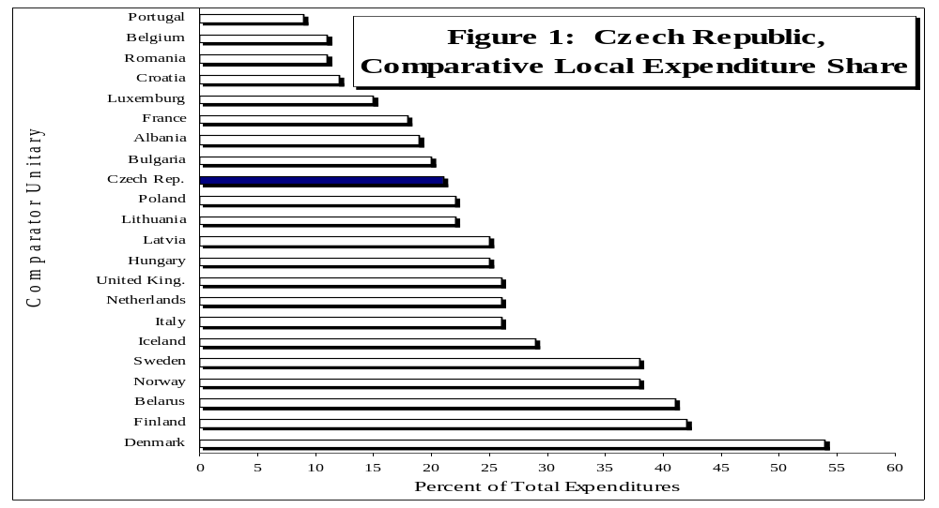
- Because of the Czech Republic’s cultural and political traditions, including its recent history of central planning, expenditure responsibilities assigned to local governments have not been as extensive as those in the Northern European countries, although they have been more extensive than in Southern European countries (Figure 1). Similar to the situation in other Eastern European countries in transition, the local government share in total public expenditures basically remained stable during the 1990s, at about 21 percent.

Sources: World Bank DEC sub-national database initiative, and GFS/IMF (most recent
years available—between 1994-98) .

- In addition, local government expenditures (and revenues) relative to GDP fluctuated little since 1993, around an average of 9.4 percent (Table 1), and one-third of expenditures were capital expenditures. About half of local government revenues were in the form of taxes, of which “own” taxes (including the real estate tax and other local taxes) represented only 11 percent, while the rest came from shared taxes with the central government—personal income tax (PIT) and corporate income tax (CIT). Privatization proceeds were another important source of revenues and were used by local governments during the 1990s to help finance their deficits.

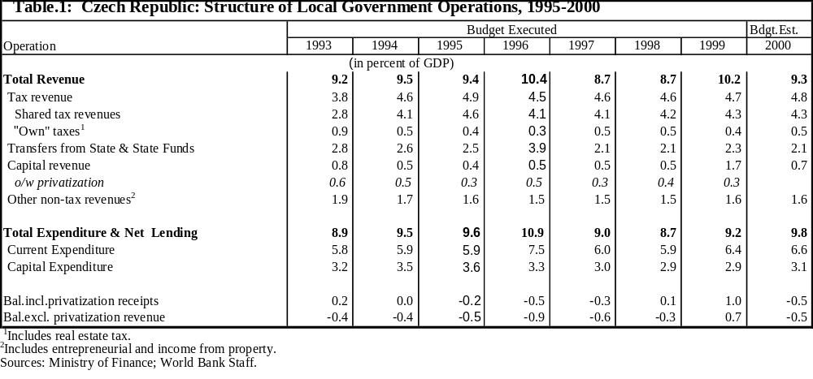

- This Summary presents an overview of the most relevant intergovernmental fiscal issues at the present time in the Czech Republic, with a focus on the available options for moving the policy agenda forward. A more extensive analysis of the main issues and options is presented in Chapters 1 to 6.

Background
- The 1993 Constitution established the Czech Republic as a sovereign unitary state and guaranteed two levels of territorial self-governments: the higher self-governing units (the regions), and the basic self-governing units (the municipalities). Until 2000, the regions did not exist as self-governing units. There were instead 77 district offices, which were deconcentrated units of the state territorial administration and which, to a certain extent, worked as surrogate regional governments.

- On the whole, the system of intergovernmental fiscal relations in the Czech Republic remains quite centralized. A fair assessment of the current system is that the Czech Republic may be considered as having a significantly deconcentrated state administration structure. This is because all of the activities of district offices and the bulk of the activities of municipalities have been aimed at implementing the central government’s policies at the local level. Most of the fiscal decision-making power emanates from the center and local level governments have only a marginal influence on local fiscal matters.

- Nevertheless, a degree of decentralization has evolved during the transition. On the expenditure side of the budget, local governments have been given some discretion to make decisions for their own expenditure responsibilities (for example, opening and closing schools). On the revenue side, the structure of financing has been transformed since the early 1990s, by reducing the previous heavy reliance on “transfers,” and by increasing the relative importance of tax-sharing. Local governments have also been provided with their “own revenues” since the beginning of the decade. But the most important of these revenues, the “real estate tax,” is not yet fully established. The assessment of the base for the real estate tax is still determined by the central government on the basis of a decree (which specifies values per type of use) rather than on the basis of market values.

- In the wake of the 1993 Constitutional precepts and in preparation for EU accession, but also bowing to internal political pressures, the territorial administration reform of 2000 (Act of Parliament # 129/2000) established 14 new regions with elected representatives (elections took place in November 2000). Accompanying these reforms, the government also revamped the revenue assignment to municipalities in 2000 by completely redesigning the tax-sharing system. With the creation of the regions, the district offices would be phased out from January 2001 up to the end of 2002, and there would be a phasing-in period for the full implementation of the regions’ responsibilities through the end of 2002. These changes will have a major impact on the Czech Republic’s system of intergovernmental fiscal relations.

- The 2000 reform package created, on the one hand, self-governing regions, intended to complete the decentralized administrative structure of the Czech Republic, which was long overdue. On the other hand, the reform changed the tax-sharing arrangements with the municipal governments in order to address certain important problems that had emerged during the last seven years of the transition. These problems included: (i) increasing vertical fiscal imbalances in favor of municipalities during the 1990s, as perceived by the central authorities; (ii) increasing horizontal fiscal disparities among municipalities, because of differential development experiences and incidence of industrial depression, unemployment, and rural poverty; (iii) tax-cutting predatory competition among jurisdictions for an increased tax base; and (iv) increasing administrative fragmentation due to a mixture of political liberalization, reaction to negative past experiences with forced amalgamation, and wrong incentives (Chapters 1, 2, and 4).

- The new tax-sharing system for the municipalities has positive as well as negative implications for fiscal decentralization in the Czech Republic. On the positive side, it has made the revenue system for municipalities: (i) more stable and predictable by moving away from a single tax base toward a pool of taxes; and (ii) more equitable by moving away from a derivation basis, in general, toward an adjusted per capita, size distribution of the tax-sharing pool.

- On the negative side, the reform has introduced some weaknesses into the revenue assignment system, which have, inter alia: (i) practically removed all tax-effort incentives; (ii) allowed for the continuation of incentives for negative interjurisdictional tax competition by retaining the residence-of-taxpayer criterion for the allocation of 30 percent of the unincorporated PIT; and (iii) introduced an adjustment coefficient for the per capita distribution of the tax-sharing pool that in its conception lacked both transparency and a sound economic rationale.

- The changes in revenue assignment in 2000 were not meant to be part of a tax reform, since new taxes were not introduced and existing ones were not eliminated, nor were tax rates or the tax base modified, nor was the overall tax burden affected. Specifically, the 2000 reform did not affect the attribution of fiscal decision-making powers among government levels. This latter aspect, in particular the granting of more tax autonomy to self-governing entities, is the crucial pending issue still to be addressed in the future re-design of intergovernmental fiscal relations in the Czech Republic.

- It is too early to tell how effective the reforms of 2000 will be in modernizing intergovernmental fiscal relations and in increasing the overall efficiency of public service delivery. It should be borne in mind that the functions of the new regions and their system of financing will still need to be defined over the next two years. Nonetheless, it should be noted that the reforms fell short of maximizing the potential benefits implied by a more complete reform agenda, which at a minimum should have included: (i) explicit incentives for local tax efforts, tax autonomy at the margin, and more accountability (particularly with the full implementation of a modern local property tax); (ii) explicit incentives for the voluntary amalgamation of small communities; (iii) a well-defined adjustment coefficient for the per capita distribution of the tax-sharing pool; and (iv) a separate fiscal equalization mechanism, to partially compensate the fiscally distressed areas of the country. These are among the most critical issues for the future intergovernmental fiscal reform agenda.

- On the basis of the analysis developed in the next Chapters of this work, the following discussion summarizes the pending issues and offers options for reform in the main areas of intergovernmental fiscal relations in the Czech Republic, including: administrative structure, expenditure responsibilities, revenue assignments, fiscal imbalances and the system of transfers, access to borrowing, and subnational governments budgeting.

Policy Issues and Reform Options

Administrative Structure

- The most striking feature of the Czech Republic’s administrative structure is its fragmentation at the lowest tier of government. The proliferation of municipalities during the earlier period of the transition led to a current administrative structure in which a majority of these local governments lack adequate technical and financial capacities. Despite their inefficient scale, smaller municipalities have not been inclined to enter into cooperation agreements or to associate among themselves, nor has there been enough outsourcing to improve the efficiency of public service delivery. Another distinguishing feature of the current administrative structure is the limited decision-making power attributed to the local governments. As deconcentrated territorial administration bodies of the state, the now-being-phased-out district offices were heavily dependent on and financed by the state budget. Roughly, half of the district offices’ revenue came from tax sharing, the remaining part essentially from state subsidies (Chapter 3). But municipalities, even as self-governing bodies, are still significantly dependent on state transfers and revenue sharing (Chapter 1).

- The 2000 reform of territorial administration was aimed at building up administrative capacity and democratic representation at the intermediate tier of government. The central authorities intend to implement this goal over a period of two years ending in December 2002. During the interim period the new regions will be fully funded by the state budget, while the definition of their responsibilities will be pending on each area ministry’s decision to decentralize. Such an approach to administrative reform does not augur well and may become a problem on its own, since there is little motivation for ministries to voluntarily relinquish their own current decision-making powers in support of decentralization.

- Another concern relates to the potential fiscal impact of the 2000 reform, because all indications are that the bureaucracies of the new regions will be created afresh, while the employees of the district offices will be mostly absorbed by the state and the municipalities. This is likely to entail an increase in overall public expenditures and to put at risk the overall fiscal balance of the public sector.

- Finally, although the Ministry of Interior is conducting the new territorial arrangements in the wake of the 2000 reforms, there is not as yet in place any multilevel government coordination mechanism which, with the leadership of the central government, would focus exclusively on the fiscal decentralization process, and which would ensure the continued credibility and sustainability of the reform process.

- Recommendations. The strategic direction for further administrative reforms is to sustain the fiscal decentralization process by empowering territorial self-governing units with a meaningful degree of autonomy and giving local representatives enough authority to perform their functions. Specifically, the government may consider:

- Formally establishing a multilevel government coordinating body, led by the central government, to proceed with the fiscal decentralization process. This would serve as a forum for initial conflict resolution as well as a mechanism for the central government to: (i) improve the design and gauge the direction, the pace, and the extent of decentralization: and (ii) disseminate information, provide training, and directly engage the local authorities in the decentralization process. This is a critical institutional aspect for the sustainability of fiscal decentralization.

- Urgently defining autonomous functions (on expenditures and revenues) for the new regions, in order to create the right sense of accountability from the beginning, rather than merely fully financing state deconcentrated functions (Chapters 1, 2, and 3).

- Reversing the municipal fragmentation by:
(i) Creating stronger incentives (financial and legal) that promote voluntary amalgamation of the small communities into economically and financially viable municipalities. For example, the central government might be involved in promoting cooperative arrangements among municipalities, such as the creation of joint stock companies for the delivery of services which require large infrastructures—or the formation of special associations of municipalities, or contracting among municipalities, for the same purposes. The government could also consider outsourcing public services delivery to the private sector as a means of overcoming the inefficiencies associated with the small scale of most municipalities. Also, special support could be designed to help small communities secure the matching funds needed for their access to the EU pre-accession funds, on a concessional basis, but conditional upon their voluntary, economically viable amalgamation (Chapter 4).

(ii) Adopting an approach of asymmetric assignment of revenue and expenditure responsibilities, using the new regional self-governing administrative structure (and acting in cooperation with larger municipalities) as a tool to facilitate the amalgamation process (Chapters 2 and 3).

Expenditure Responsibilities
- The current assignment of expenditure responsibilities between the center and municipalities broadly conforms with accepted principles, although coordination and cooperation among different levels of government in the case of concurrent responsibilities has been weak (Chapter 2).

- In the Czech Republic significant disparities still exist across jurisdictions (municipalities as well as regions) in both actual per capita expenditures and “expenditure needs” (as reflected by unemployment rates, poverty levels, infant mortality rates). There is also empirical evidence that smaller municipalities are less efficient in the delivery of basic services.

- House rents and tariffs on public utilities (such as water and gas) are still controlled by the central government and are far from full cost recovery levels. The salaries of local government employees are also controlled by the central government. In theory, municipalities are responsible for their own capital infrastructure. In practice, municipalities still depend significantly on the central government for the financing of capital expenditures, including the reconstruction and rehabilitation of infrastructure and housing. This financing takes the form of grants and highly subsidized loans.

- Recommendations. The strategic direction for expenditure assignments is to further clarify the responsibilities for each level of government and to make local authorities fully accountable before their respective constituencies for policy results — measured in terms of their effectiveness and efficiency in delivering quality public services. Specific policy actions should include:

- Developing institutions for intergovernmental cooperation and dialogue. This will be central to increasing local public expenditure efficiency in areas of concurrent expenditure responsibilities.

- Establishing a broad-based commission to make recommendations on the new regions’ expenditure responsibilities.

- Making provisions for the de facto capital expenditure responsibilities for local infrastructure that are currently at the central level to be, in due time, transferred back to the respective local governments (both regions and municipalities).

- Amending the Budget Rules Law to preempt unfunded mandates to local governments.

- Gradually lifting central government controls on utility prices at the local level.

- Increasing reliance on the private sector in both financing and the delivery of public services in order to increase the overall efficiency of local government expenditures. The role of local governments in the provision of housing services should be scaled back and ultimately eliminated. Alternative private provision of education and health services should also be promoted.

Revenue Assignments
- The 2000 reform of revenue assignment (i.e., the new tax-sharing arrangement) leaves important soft spots in the intergovernmental fiscal relations system. These include: (i) the risk borne by local governments of further discretionary changes in revenue assignments, which may affect predictability and reform credibility; (ii) the absence of an effective incentive mechanism to encourage tax effort, which may affect efficiency; (iii) the incentives for undesirable “tax-cutting” competition signaled by the present allocation criterion for the unincorporated personal income tax (PIT), based on taxpayer residence; (iv) the insignificant degree of autonomy of local authorities over their own revenue sources, which adversely affects efficiency and accountability; (v) the full dependence of the new regional administration on the state budget; and (vi) the absence of an economic rationale for the adopted coefficient that adjusts the per capita distribution of the tax-sharing pool according to population size (Chapter 3).

- Recommendations. In this area, the natural strategic direction of reforms is to boost revenue autonomy in order to improve budgetary predictability and the accountability of local authorities by: (i) clearly defining revenue assignments (both tax-sharing arrangements and own local taxes autonomy), respecting fairness in resource allocation and encouraging local tax efforts; and (ii) attributing adequate decision-making powers on tax rates and the determination of tax bases. In the short run, the government may consider developing an agenda for the reform of revenue assignments along the following lines:

- Increasing the predictability of local budgets by establishing all structural policy parameters of intergovernmental fiscal relations (e.g., coefficients of tax-sharing pooling and distribution, bandwidth of local tax rates, local tax base and exceptions) in the organic laws (instead of in the annual budget law, as is presently done).

- Providing more local autonomy and restoring tax-effort incentives by reassigning the personal income tax (PIT) as follows: (i) bring the totality of the unincorporated PIT into the shared tax pool; (ii) reduce the progressive rate of the “wage-tax” component of the PIT by a corresponding amount; and (iii) devolve to the municipalities the right to impose their own flat-rate (proportional) PIT local surcharge (piggybacking on the national adjusted progressive PIT rate) within a bandwidth of rates. Overall, these reforms should be fiscally neutral.

- Providing the new regions with adequate own funds, by assigning to them: (i) shared taxes (commensurate with their expenditure responsibilities); (ii) autonomous revenue sources, including surcharges that can piggyback on national taxes and/or a flat-rate PIT similar to that proposed for the municipalities.

- Strengthening local revenue autonomy by providing municipalities with the instrument of market value assessment of properties, and assisting them in building local government tax administration capacity for this tax.

- Reviewing the adopted adjustment coefficient for the tax-sharing distribution mechanism, in order to introduce a clear economic rationale to it—considering the convenience of a more transparent formula-based equalization transfer scheme separately (see next section).

Fiscal Imbalances and Transfers
- An outstanding characteristic of the Czech system of intergovernmental fiscal relations is that, despite the existence of significant horizontal fiscal disparities, there is no clear, separate policy instrument to deal with “fiscal equalization transfers”, which explicitly can take into account regional differences in both tax capacity and expenditure needs (Chapter 4).

- Regarding the system of conditional transfers (i.e., the specific subsidies), it may be considered vulnerable in several aspects: (i) the system is, at present, too complex and unwieldy; (ii) although there are numerous constraints and conditions for access, the system has little de facto control; (iii) access depends heavily on negotiation skills and political connections; (iv) the system presents little transparency as to how it actually works; (v) transfers have become an unstable source of local government revenue; and (vi) funding practices may lead to negative incentives if the central government is perceived as reducing transfers because local government revenue has increased. In addition, transfers from the EU pre-accession funds have not yet been used positively as an additional means of conditional leverage to reverse the fragmentation of municipalities nor to strengthen the fiscal decentralization policy.

- Recommendations. The strategy is to rationalize the transfer system so as to: (i) increase its transparency; (ii) make it a more effective instrument for the implementation of policies of national interest at the local level; (iii) reduce horizontal fiscal disparities; and (iv) help reverse the fragmentation process of municipalities. In the short run, in order to rationalize transfers and increase allocative efficiency, the government may consider reviewing the current system of specific subsidies by:

- Decreasing the number of specific subsidies and simplifying the system by having fewer transfers by programmatic goal, in order to be more effective and efficient (alternative block grant systems should also be examined).

- Using explicit rules or formulas for the allocation of grants, in order to boost the transparency and predictability of the transfer system.

- Carrying out systematic ex post performance evaluation of programs, to improve efficiency and planning.

- Prioritizing programs and stabilizing transfers within the context of the central government’s medium-term expenditure framework, aiming at improving the predictability of local budgets.

- Evaluating the establishment of a separate “Fiscal Equalization Fund” (independent from the tax-sharing mechanism) to specifically address the issue of reducing regional fiscal disparities owing to cross-regional differences in tax capacity and unmet expenditure needs arising, inter alia, from differences in unemployment rates, poverty, and health conditions.

- Reviewing the financial conditions for the matching funds that the local governments must contribute to access the EU pre-accession funds, and evaluating the potential effectiveness of increasing financial concessions to support the smallest and financially weakest municipalities — but conditional on voluntary (non-revertible and legally binding) amalgamation that could show a substantial increase in the efficiency of public service delivery.

Access to Borrowing
- Although it is apparently low in the aggregate, the “true” level of local debt is not entirely transparent in the Czech Republic owing to the existence of contingent liabilities and other forms of off-budget fiscal operations. Reading the true level of local debt is also complicated by the possibility of diverse interpretations of the standard national chart of accounts. In principle, municipalities can have free access to all forms of borrowing, but in practice access to borrowing by small municipalities has been limited by their low creditworthiness. The largest municipalities have had access to international financial markets, and the rest of the municipalities have mostly borrowed from domestic banks. It appears that many small and middle-size municipalities are already deeply in debt (Chapter 5).

- Municipal credit management is still in the development stage in the Czech Republic. Under the present conditions of market failures, the current sole reliance on market discipline as an approach to control and to guarantee responsible access of municipalities to capital markets is risky and is unlikely to effectively prevent financial crises. However, the adoption of an approach of direct control of every local credit operation would increase central bureaucracy undesirably and would run contrary to other decentralization objectives.

- The institutional framework that would enable the financial sector to operate with subnational governments is still being developed. For example, the Bankruptcy and Composition Act does not yet include municipalities as a subject, and this may have been a risk factor explaining the reluctance of the banking system to participate more actively in the municipal capital markets. In addition, there is no official monitoring and supervisory mechanism in place for subnational government indebtedness and credit operations as an assurance against systemic financial crises in the future.

- Recommendations. The strategic orientation of reforms is to put in place an institutional framework and prudential rules that would ensure fiscally responsible borrowing by subnational governments, and would encourage competitive behavior and market discipline in the financial system in its dealings with self-governing units. Institutional development is critical at this juncture to improve control and responsible access of subnational governments to the capital market in Czech Republic. The government might consider upgrading regulations and institutions related to municipal/regional credit markets by:

- Formally establishing basic parameters for subnational governments to access to capital markets by: (i) restricting medium- and long-term loans to investment projects only; (ii) limiting the debt service ratio to subnational governments to 0.1; and (iii) limiting their debt stock to revenue ratio to perhaps 0.8.

- Formally establishing prudential rules for the banking system to operate with subnational governments by limiting bank portfolio exposure to local/regional governments (individually) to a certain maximum limit recommended by good banking prudential rules.

- Approving and diligently implementing a “bankruptcy law” which clearly defines debt workout procedures in cases of municipal/regional government default.

- Adopting a “fiscal responsibilities law” to curb excessive deficits and imprudent buildups of public debt, including municipal and regional public debt.

- Encouraging the dissemination of “risk and credit rating analyses,” aimed at improving transparency and promoting market discipline.

- Establishing an official monitoring agency to keep records on and to monitor the overall development of the municipal/regional capital market and indebtedness, including contingent liabilities. The database organized by such an institution should be publicly accessible.

Local Budgeting
- Lack of budget predictability is a major problem for local budget formulation in the Czech Republic, because: (i) budget formulation is still a top-down process, with no participation by local authorities; and (ii) the budget cycles of the state budget and local budgets are not synchronized in practice. In budget execution, the lack of a single account approach for Treasury operations leaves the local budgetary process less effective and less transparent. The implementation of the standard accounting system seems to lack uniformity in respect to interpretation and coverage of each specific budget item. The external audit has focused exclusively on inputs and on financial and legal compliance. To date, there has been no evaluation of the performance of budget programs. Moreover, with the discontinuation of the district offices, a new solution for the external audit function, both for the new regions and for municipalities, is urgently called for (Chapter 6).

- Recommendations. The strategic direction of reforms of local budgeting is to strengthen the budgetary process by increasing the transparency and accountability of local budgets congruent with the objectives being pursued for the state budget on budget formulation, execution, and evaluation. The increased transparency and accountability of the decision-making process is highly dependent on how well the budgeting process works in its formulation, execution, and evaluation phases. Although many improvements have been carried out in the budgeting process at the central government level, there is ample room for strengthening the budget process at the local level. The most urgently needed reforms include:

- Upgrading the skills of local officials in the standard accounting system and control, especially in smaller municipalities.

- Introducing a Treasury function, including a single account approach for budget execution at the local level.

- Expanding the scope of the external audit beyond the evaluation of input content and legal and procedural compliance to include the performance evaluation of the outputs/outcomes of expenditure programs.

- Establishing new (external) audit authorities for the new regions and municipalities. One option is for the Supreme Audit Office to be charged with the responsibility of auditing the 14 newly-created regions, and for the new regional audit offices subordinated to the regional self-governing units to be charged with auditing the accounts of municipalities.

- Boosting the predictability of local budgets by synchronizing the de facto budget cycles (central and local/regional), by improving cooperation on budget preparation among government levels, and by encouraging the formulation of simplified multiyear expenditure frameworks for local/regional governments congruent with a central government Medium-Term Expenditure Framework (MTEF).

Conclusion
- The Czech Republic has adopted an evolutionary reform approach to the system of intergovernmental fiscal relations. This approach has been re-embraced with the creation of the new regions, which will be phased in during a transition period of two years. This is a promising effort which helps to put the intergovernmental fiscal reform in perspective as part of a process — rather than as a once-and-for-all policy event. Nevertheless, there still are significant gaps in the strategic direction of the current reform agenda. The future reform strategy needs to re-focus on the principles of budgetary autonomy, transparency, and accountability.

- The paramount objectives of the fiscal decentralization process are to increase the overall efficiency of public expenditures and to improve equity in access to public service. However, the Czech Republic still falls short of these goals and will need to overcome several key challenges, including: (i) inefficient local administration, reflected by the highly fragmented municipal administrative structure; (ii) lack of autonomy, evidenced by the very limited decision-making power of local authorities and their excessive dependence on the state budget transfers and tax-sharing system; (iii) increasing regional fiscal disparities, resulting from asymmetric economic developments and diverse needs among regions; and (iv) lack of transparency in the level and composition of local government expenditure and debt, owing to the presence of off-budget operations and contingent liabilities, reflecting the inconsistent implementation of budgeting and accounting rules, and the absence of ex post performance evaluation of policies and programs.

- The options and recommendations presented in this summary are aimed at enabling the Czech government to proceed in a timely way with administrative and institutional reforms toward consolidating the process of fiscal decentralization, but re-orienting the course of the current reform. This strategic re-orientation should include the following:

- The strengthening of financial and legal incentives for small municipalities to voluntarily amalgamate, including the leveraging of the EU pre-accession structural funds, enhanced cooperation among local governments and with regional governments, and greater participation of the private sector in service delivery and financing.

- The attribution to subnational governments of clearer responsibilities, decision-making powers, and autonomy to perform — most significantly by redefining their taxing powers, with more reliance on own tax revenues: local fees, property tax, and rights to impose piggyback surcharge rates on personal income taxes—so as to provide incentives for local fiscal effort and increased accountability.

- The improvement of equity in access to public services, without compromising incentives for local tax effort, by rationalizing the current system of earmarked transfers (mainly through simplification, increased transparency, and better prioritization), by revising the recently adopted tax-sharing mechanism (the per capita adjustment coefficient), and by considering the establishment of a separate “Fiscal Equalization Fund” at the regional and local levels.

- The reform of the regulatory framework for subnational credit, by: (i) restricting borrowing to investment projects; (ii) adopting maximum levels for debt stock and debt service ratios; (iii) enforcing stricter prudential rules on banks operating with self-governing units; (iv) adopting a “Bankruptcy Law” which includes municipalities as a subject; (v) adopting a “Fiscal Responsibility Law”; and (vi) officially monitoring the municipal credit market.

- The strengthening of uniformity, transparency, and predictability in self-government budget systems, by upgrading the skills of local officials, introducing local Treasury functions including a single account, reinforcing external audits (for both the new regions and the municipalities), including program performance evaluation practices.

- One risk in carrying out the recommended strategic re-direction is that the specific reforms to be adopted could become inconsistent with the Acquis Communautaire. This is to be avoided at all costs. On the other hand, not re-directing the current strategy could entail the risks of lowering the efficiency of public expenditures and lowering economic growth, increasing inequalities and deteriorating national cohesion, and encouraging uncontrolled local borrowing, thus bringing about a credible threat to macroeconomic stability.

Administrative Structure

A. Profile of the Current Territorial Administrative Structure
  - The Czech Republic is a democratic, unitary state. The Constitution establishes that the country shall be governed by a three-tier government structure, composed of the state (the central government), the higher level self-governing entities (the regions), and the basic self-governing entities (the municipalities). However, until 2000, only a two-tier self-government structure (with elected representatives and fiscal decision-making powers) operated in practice: the central government and the municipalities. In between the central government and the municipalities during this period the system relied on the districts, which essentially were deconcentrated units of the central government. The administrative reforms of 2000 (Act of Parliament # 129/2000) established the self-governing regions, to be phased in over a period of two years at the same time that the districts are phased out by end-2002. Through 2000, the implementation of a significant part of the central government’s fiscal policies was “delegated” to local authorities (both districts and municipalities). This authority will continue in the future to be delegated — to the new regions as well as to the municipalities.

Local Self-Governments: Municipalities
  - Until 2000, municipalities were the only self-governing territorial authorities, with a directly-elected Municipal Council exerting ultimate power within the municipal jurisdiction, as established by law. The Municipal Council, the legislative branch of the municipal government, indirectly elects the members of the Municipal Board, which is the municipal executive body. The head of the Municipal Board is the Mayor, who is chosen from among the Board’s representative members. The Chief Administrative Officer of the Municipal Board is appointed by the Mayor in consultation with the Municipal Council and (until 2000) the head of the District Office.

  - As the capital city, Prague enjoys a special status. In addition, Prague and the other largest municipalities (Brno, Plzen, and Ostrava) also have district status. Thirteen other municipalities of relatively large size, and of economic, social, and cultural importance, are the so-called “statutory” towns. There are also 383 “designated” municipalities which are authorized to perform some delegated state competencies, including some functions on behalf of smaller surrounding communities. The rest are small communities which have gained the legal status of municipality, a condition which qualifies them to have direct access to state subsidies. Since the late 1980s, with the end of the communist regime, the Czech Republic has experienced a wave of proliferation in the number of municipalities (Table 1.1). This trend has been attributed to historical reasons, including the repudiation by the local population of the previous socialist planning and central control system based on the “national committees,” and the generally unsuccessful experiences with imposed amalgamations of smaller communities that were tried during the 1960s and 1970s. In the early 1990s, when popular pressures for increased democracy were strong, it was especially difficult to discipline the fiscal decentralization process and to contain the creation of new municipalities.

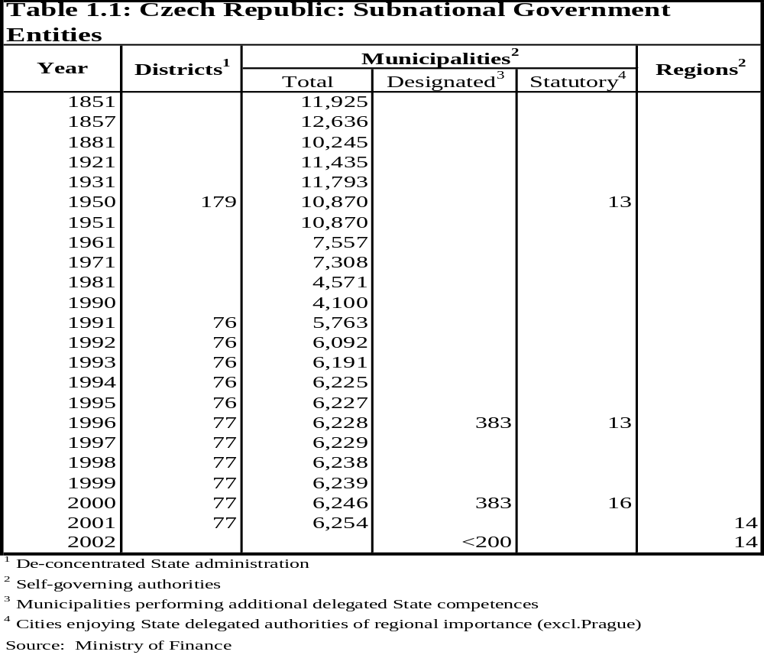
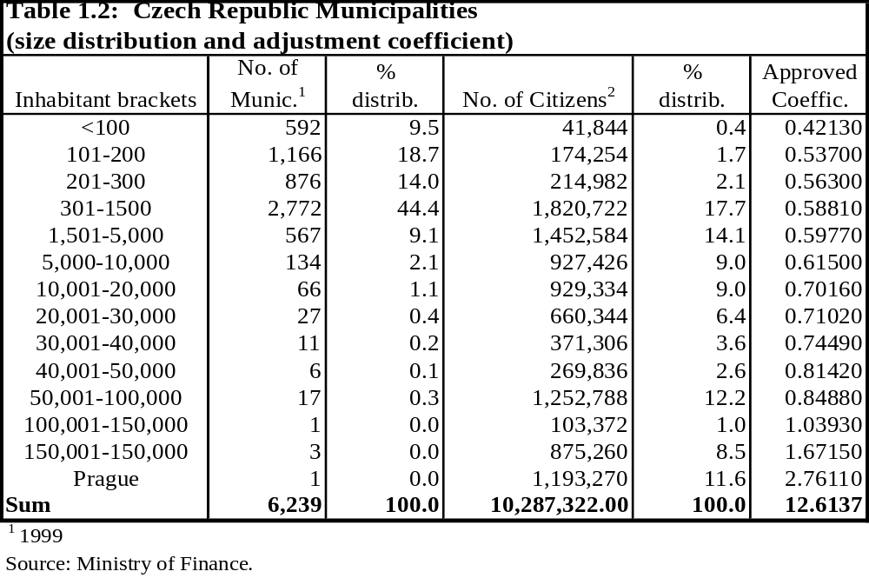
  - In 1999, the Czech Republic was again fragmented into 6,239 municipalities, close to the level reached in the 1960s. Currently, 86 percent of the municipalities have fewer than 1,500 inhabitants, and 42 percent have fewer than 300 inhabitants (Table 1.2). This has been a major problem for a rational local administration, since the smallest communities do not have sufficient tax revenue capacity and have been incapable of: (i) retaining qualified staff with the necessary expertise; and (ii) taking advantage of externalities in the consumption of, and economies of scale in the production of, public services (especially utilities). The lack of tax revenue capacity has deprived small municipalities of fiscal independence, leaving them highly dependent on transfers from the state (Chapter 4). The lack of qualified staff, the small population size, and the absence of an adequate scale for the production of public goods and services may have seriously jeopardized the efficacy of local public service delivery and the efficiency of local public expenditures in general. Moreover, small municipalities in the Czech Republic have not yet cooperated or associated among themselves sufficiently, or outsourced enough of the public service delivery to the private sector to overcome these problems (Chapter 2).

  - As a result of varying fiscal capacity and expenditure needs, increasing horizontal fiscal disparities have been observed among municipalities (Chapters 2 and 3). Dislocation of economic activity, worsening conditions in the labor market, and the nature of the tax-sharing system are the forces behind this trend. In particular, the industrial depression and the economic restructuring efforts since the mid-1990s have led to increased unemployment (for example, in Most, Karvina, Chomutov, Ostrava-mésto), with serious consequences for the respective local government budgets in the form of decreased tax revenues and increased social assistance needs. On the other hand, the most prosperous industrial and tourist areas (such as Plzen, Brno, and Prague) have enjoyed buoyant revenues, have gained more fiscal independence, and have even successfully accessed financial markets through bond issues to expand their opportunities for capital investments.

Deconcentrated State Administration: The Districts
  - The 73 districts, as territorial divisions of the state administration, were merely deconcentrated units of the central government. The head of the district office, who was appointed by and dismissed by, and reported to, the central government (Minister of Interior), had the attributions of assisting and following up the implementation of state policies at the local level and supervising the legality of the performance of local authorities (Municipal Council, Board, and Office) on “delegated” functions (Chapter 2). District offices also represented some ministerial departments. But many ministerial departments (including Education, Financial Affairs, Employment, and Environment) usually had their own field services not subordinated to the district offices. Although this policy had some operational advantages, it often made policy implementation and coordination more difficult, adding to the overall inefficiency of public service delivery.

  - The districts had an Assembly that deliberated and approved the budget and the policy agenda submitted by the district office. The members of the District Assembly were the Mayors (or their deputies) of municipalities in the district, which ordinarily convened twice a year to approve the district budget and the final accounts. Nevertheless, the District Assembly could also function as a forum in which municipalities could discuss issues of common interest. For example, state transfers to municipalities for the execution of delegated functions were made through the district budget. Also, to a certain extent, the District Assembly could function as an institution for conflict resolution and as a complement to the courts at the district level. In some ways, the District Assemblies functioned as surrogate regional governments for matters of local interest, but without self-governing powers.

B. Decision-making Power at the Local Level
  - As an integral part of the state administration, district offices, although enjoying some limited decision-making power on local resource allocation, had neither independent property rights nor total budgetary independence. In contrast, municipalities retain legal decision-making powers within their jurisdiction and run an independent budget. What is questionable is the degree of autonomy and decision-making power that municipalities actually enjoy, since they do not have sufficient tax autonomy, or capacity, and since most municipalities are highly dependent on transfers from the state (see Chapter 3).

  - Municipalities do have a considerable degree of autonomy with respect to own expenditures financed either by their own local revenues or by non-conditional transfers (i.e., revenue-sharing in state taxes). However, in the case of delegated functions, the decision-making power of municipalities is practically nonexistent, since “subsidies” are earmarked (see Chapter 4). But even in the case of own expenditures, effective local autonomy varies across municipalities because of considerable disparities in fiscal capacity. The largest, and industrially prosperous municipalities are those with some degree of revenue autonomy and some decision-making power on local expenditures. A myriad of small municipalities have practically no revenue autonomy or relevant decision-making powers on local expenditures.

C. The Establishment of Regions and the Interim Period
  - In April 2000, Parliament approved Law # 129/2000, establishing the regions (the higher self-governing entities). Two main motivations behind this change in territorial administration were to build up administrative capacity and to build democratic representation at the intermediate level of government. What is even more important is that this move resulted from both internal pressures for the fulfillment of the Constitutional precept and the urgent need to put in place a more consistent institutional framework for the implementation of the EU pre-accession and structural funds. This institutional framework would require strong regional implementation capacity, transparency, and accountability.

  - Law # 129/2000 established 14 regions, with elected representatives, to be effective from January 1, 2001. The 14 new regions have geographically consolidated the previous 77 districts basically around the “statutory towns” plus Prague. The 14 newly-created regions are: Prague City, Central Bohemia, Ceské Budejovice, Plzen, Karlovy Vary, Usti Nad Labem, Liberec, Hradec Kralove, Pardubice, Jihlava, Brno, Olomouc, Zlin, and Ostrava (Table 1.3).
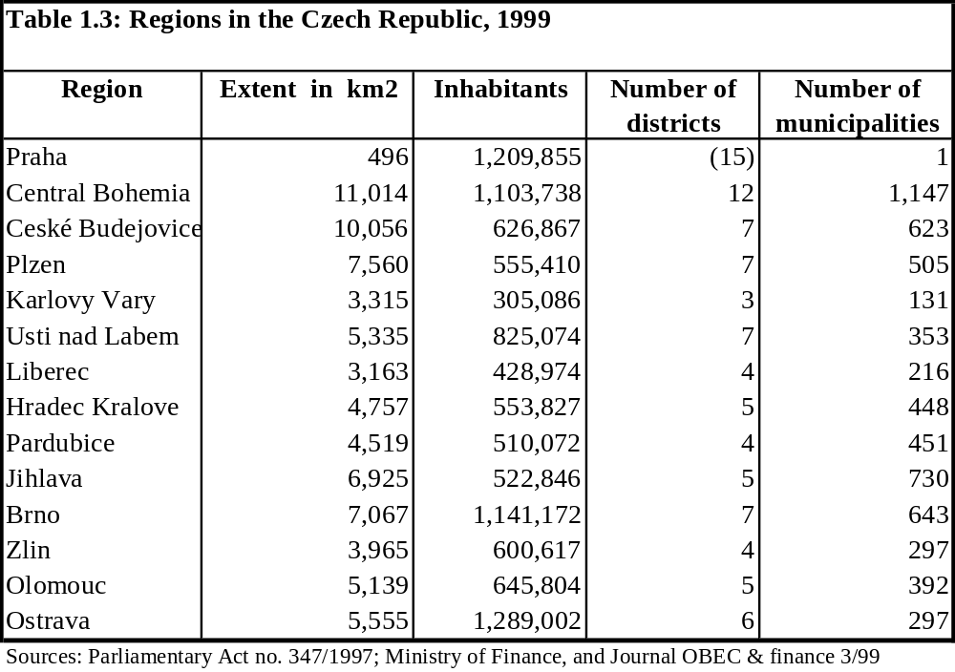

  - The Law on Regions establishes the basic administrative structure for regional self-government. This structure includes the Regional Assembly as the legislative body, the Regional Council as the executive body, and the Regional Office. The Assembly is composed of regional representatives directly elected by the regional population. The Regional Council and the President of the Assembly are both elected by the Assembly from within its members, while officers of the Regional Office are appointed by the Regional Council, and these officers appoint the staff. The Regional Office can carry out state-delegated functions. However, the central government can create regional special bodies to perform special delegated functions.

  - The new government structure will be phased in over a period of two years through December 2002. Districts will be formally dissolved and will cease to exist at the end of 2002, and from January 1, 2001 they will be financed through the state budget and will no longer provide grants to the municipalities. During this interim period, the new regions will be fully funded via transfers from the state budget. Although no concrete expenditure responsibilities have as yet been assigned to the regions, the general plans call for the regions to basically absorb some responsibilities of the state (e.g., secondary education, inter-city transport, environment, regional planning). Some of these functions were previously performed by the district offices (see Chapter 2). Some other state functions carried out by the districts, however, will be absorbed by “designated” municipalities, which the Minister of Interior intends to reduce to a smaller group of no more than 200. The method of financing the new regions beyond December 2002, including the assignment of autonomous revenue sources, has not yet been defined.

  - The two-year interim period adopted by Parliament to put in place the functions and responsibilities and the revenue sources of the new regional authorities represents a prudent approach. Such an approach may avoid major disruptions in service delivery in particular, since the phasing out of the old districts over the same period will be used as an administrative bridge. For strategic reasons, Parliament decided to initiate the decentralization reforms by allowing the election of regional representatives to take place first, and only then proceeding with further steps in the reform. In addition, the government’s initial move in the sequence of reforms was undertaken appropriately, by first shifting to the regions some major responsibilities (e.g., secondary education, inter-city transport, environment, regional planning)—which will be initially fully funded by the 2001 state budget—and only then proceeding with the definition of own sources of resources. Thus, an important general principle in the design of intergovernmental fiscal relations—that resources should follow responsibilities—has been adhered to in the government’s strategy. This procedure should help guarantee sufficient resources and adequate vertical fiscal balance from the beginning of the new intergovernmental structure.

  - Nevertheless, the government should minimize the period of keeping the new regions fully dependent on the state budget. As soon as possible, the government should assign equivalent autonomous revenue sources to the regions. Fiscal decentralization (as opposed to a mere deconcentration of state administration, as was the case until now) requires that regional and municipal authorities be given a degree of autonomous decision-making power in order to adequately perform their functions and deliver quality public services. The latter is a necessary incentive mechanism to make subnational self-governing authorities accountable for policy results to the residents in their jurisdictions.

  - A potential issue during the interim period, however, is a probable increase in public expenditures related to the implementation of the regional government administration. Apparently, it is the intention of the Ministry of Interior that part of the district offices’ staff and officers should be given the opportunity to join the municipal personnel structures where they are currently situated, while the remaining staff might well be accommodated in the state administration. This could mean that the bureaucracy of the new regions would be built afresh, thereby expanding public employment, the wage bill, social benefits, and possibly capital expenditures. If this situation is not properly equated and controlled in time, it could result in a large scale structural fiscal imbalance which might be difficult to reverse in the future. This should be a matter of concern for the central government.

D. Challenges Ahead and Reform Issues

  - If responsible local governments are to be developed, the right institutions and incentives should be in place. For this purpose, the attribution of clear responsibility, the delegation of specific decision-making powers, and the autonomy to perform are essential incentives to make local authorities accountable for results before their own constituencies.

  - With the new territorial administration, the potential for a more efficient delivery of public services will lie with: (i) meaningful decentralization of some relevant functions to the regions; (ii) optimization of the size of operation of basic self-governing units; (iii) provision of a minimal degree of revenue autonomy to new regional governments; (iv) promotion of private sector participation in financing as well as delivery of public services; and (v) proper coordination of decentralization policy.

(i) Decentralizing functions to the higher self-governing units: the regions. Apparently, some of the responsibilities transferred to the regions will be on a “delegated” basis, at least at the beginning of the reform—for example, secondary education. Although this means that a considerable share of these expenditures will be state-financed via specific or categorical transfers, several positive initiatives are under consideration. For example, giving school boards and school directors greater discretion to enhance their decision-making powers and to use transfers on a “capitation” basis in secondary education (as is now done for elementary education with municipalities) is a welcome step that should encourage operational efficiency. Further decentralization reform steps could significantly increase the efficiency of public expenditures by giving the regions direct responsibility for resource allocation for specific functions, and by allocating autonomous decision-making powers that are closer to the regional population’s interest, such as tertiary education, inter-city transport, environment, and regional planning (Chapter 2).

(ii) Rationalizing the size of basic self-governing units: the municipalities. The excessive fragmentation of municipalities has been a historical feature of the Czech Republic (Chapter 2). Because this fragmentation has brought about serious administrative, technical, and financial difficulties, this will probably be a recurrent issue in the agendas of both the government and the Parliament in the coming years. The main concern will be to rationalize the operations of the small municipalities to economically viable sizes while, at the same time, respecting the preferences of these municipalities.

One option is to put in place incentives (including financial incentives) that can help reverse the fragmentation process and can promote the merging of small communities wherever possible. The other option is to take advantage of the restructuring of the territorial administration and shift some responsibilities belonging to the small municipalities to the regions or to “designated towns.” The assignment of expenditure responsibilities does not need to be uniform across the basic self-governing units in such an extreme situation of varying local capacities. In any case, adherence to the reform should be voluntary, and the government should be able to articulate reform instruments so that: (i) the affected communities would realize that the changes would make them relatively better-off, in both the short and long terms (e.g., they would have a substantially higher “per capita” share in the tax-sharing system, an amplified tax base and revenue capacity, and better access to quality services); (ii) the provision of public services should be more effective and efficient, as a result of being able to internalize current externalities in consumption and economies of scale in the production of public services (e.g., water and sewage treatment, garbage collection); and (iii) the changes should visibly improve the affected communities’ chances of benefiting more directly from the EU pre-accession funds, as planned.

(iii) Providing self-governments with a minimum degree of revenue autonomy. Once the attribution of “independent” expenditure responsibilities has been established, it will be urgent to clearly define the regions’ own sources of revenue. The latter should comprehend predictable sources—including taxes, with discretion at the margin on rates, and non-tax revenues (fees, surcharges, rent on property, etc.) (Chapter 3). In addition, property rights (on social facilities—school and hospital buildings, etc.—and nonsocial facilities—energy generation and water treatment plants, roads, etc.) should be well established. For the latter, clear regulation should be adopted on the limits of property disposal for privatization and assets recycling programs or as collateral for responsible access to credit markets. This regulation should be aimed at expanding the capital investment capacities of self-governing units. Transfers out of the pool of tax-sharing systems should always be of a lump-sum, non-conditional grant nature.

It is most important that self-governing units (both regions and municipalities) be empowered with decision-making autonomy on their own revenue sources. This will enable subnational authorities to operate with a margin of resource predictability and flexibility, so that they can choose from a set of constrained policy options and can be directly accountable for their decisions.

(iv) Promoting private sector participation. Private sector participation in the provision and delivery of local services remains too low. Private sector participation (in financing and provision) could help to increase the efficiency of service delivery (through increased competition) and to release scarce financial resources for the local budgets so that they can provide other necessary services. On both efficiency and equity grounds, it is critical that local governments should be able to: (i) promote the increasing participation of the private sector in the social sectors; (ii) authorize public facilities to operate with user charges on some service delivery; and (iii) continue the privatization of utilities’ property, as well as promote the privatization of housing and some educational, health, and entertainment facilities, when it becomes clear that the private sector can deliver a better service.

While local governments in the Czech Republic have been making a considerable effort to attract private investment (Chapter 2), it is very much up to the central government to continue its policy of assuring the proper legal and regulatory framework to consolidate an enabling business environment for the development of private initiative, inclusive of the social sector. Such an environment will need the assurance of property rights, well-regulated financial and health insurance markets, well-designed school admission procedures and accreditation systems, and deregulated rents on commercial buildings, land, and housing.

(v) Coordinating the decentralization process. The government realizes that intergovernmental fiscal reform is a process and not a “once-and-for-all ” policy move. In this context, the government should be prepared to face evolving challenges in a process that is participatory—involving all stakeholders, in particular local governments (both the new regions and the municipalities) and their representative organizations. The creation and nurturing of multilevel institutions of intergovernmental dialogue and cooperation should improve the design of the system, its daily operations, and the necessary periodic adjustments. Specifically, an intergovernmental relations agency for cooperation and dialogue, led by the central government (but with representatives from the state, the regions, and the municipalities) and charged with monitoring the implementation of the decentralization process, should prove particularly useful. Such a multilevel agency could work as a technical intergovernmental body to coordinate intergovernmental relations and to promote communication, management of information, and dissemination of best practices in decentralized public administration. Such an institution would accommodate divergent interests and could serve as a first point for conflict resolution.

Expenditure Responsibilities

A. Current Expenditure Assignments
- By and large, intergovernmental expenditure assignments in the Czech Republic conform to conventional general principles. In particular, to a large extent they respect the principle of subsidiarity. Until 2000, the assignment of expenditure responsibilities at the local level included those responsibilities assigned to the municipalities and those assigned to the districts. There have not been any major changes in the expenditure responsibilities of municipal governments since the Municipal Act of the early 1990s.

- Currently, municipal expenditure responsibilities are divided into “delegated” responsibilities and “own” responsibilities. Delegated responsibilities are those transferred by the central administration to the municipalities only for the actual delivery of services while all decisions on regulations remain at the central level. The responsibility for financing delegated responsibilities also remain partially at the central level. Central government contributions to the financing of delegated responsibilities only cover a part of the costs of provision. Delegated responsibilities include activities in civil registry (birth, marriage, and death), building codes, regulation and enforcement of laws pertaining to the environment, transportation, sanitation, and so on. The largest 383 municipalities perform more delegated responsibilities than the rest of the municipalities. The larger municipalities may provide delegated services to the other municipalities (5,856 in number) under mutual agreements or under arrangements designed by the district offices. The district offices have been responsible for overseeing the performance of municipalities vis-à-vis the delegated responsibilities. The financial support from the state to the municipalities for the delegated services goes through the district offices.

- In the domain of own responsibilities, municipalities have in principle the discretion to make their own decisions on how to deliver the services, although in many cases they are subject to state regulations. Municipalities may also receive funding from the central government for the delivery of own responsibilities. Among own responsibilities, the Municipality Act further distinguishes between “mandatory” and “optional” responsibilities. Among the latter are cultural activities, including libraries, galleries, and recreational facilities. Within the mandatory responsibilities, a further distinction is made between “public services” which are financed from general revenues, and “technical services” which are financed by fees. The latter include water and sewerage services, waste collection, and public transport. While technical services can be denied if charges are not paid, public services are to be provided to all residents.

- No major changes are envisioned in the assignment of expenditure responsibilities at the municipal level other than the possible absorption of some functions that have until now been the responsibility of districts. The current division of expenditure responsibilities among different levels of government is summarized in Table 2.1. Own responsibilities for municipal governments are shown in Box 2.1.

Box 2.1: Own Responsibilities for Municipalities

a. Education, including operation and maintenance of buildings for kindergartens and basic education (up to 15 years of age).¹ Responsibility for basic education is concurrent with the central government, which is responsible for teacher salaries and social insurance contributions, textbooks, and school supplies.² Municipalities can open or close schools upon approval of the Ministry of Education. Responsibility for capital expenditures for rehabilitation or construction of new schools lies with municipal governments but in reality the central government has continued to provide most of the funding. Municipalities also receive a subsidy per student from the central government to help cover operating costs.
b. Social care, consisting mainly of the operation of nursing homes, orphanages, and facilities for the disabled.³ Municipalities receive a subsidy or grant from the central government to cover a share of these costs. These subsidies are calculated on a per bed basis and are set to cover a share of the operating costs of the facilities. Municipalities, funded by the central government, also provide payments to families in poverty or distress. Larger municipalities also pay recurrent benefits to supplement income up to a minimum subsistence on behalf of the state,⁴ and the central government covers the administration costs of these programs.
- Health care services, by partly financing small hospitals and clinics.⁵
- Culture and recreation, including libraries, theaters, local museums, and zoos, as well as sport complexes, stadiums, swimming pools, and so on. Cultural activities are supported in part by discretionary central government grants.
- Public safety (civil defense) and local traffic police. Fire brigades operate under the local government budget but they are mostly funded by central government grants to the districts and organized according to central government rules. However, the four largest cities have their own fire protection services.
- Sanitation, including solid waste disposal and street cleaning. Often these activities are contracted out to the private sector.
- Street lighting, cemetery, and park construction and maintenance.
- Water and sewerage treatment, often also contracted out to privatized companies, but rates are regulated by the central government.
- Urban planning and zoning.
- Local roads and intra-city transport by subsidizing private local transport companies.
k. Public housing services. Municipalities still own a substantial amount of housing.⁶ Rents are regulated by the central governments except for the newly built apartments. Municipalities continue to build apartments with central government subsidies.⁷

¹ Large cities may also run secondary schools. Some municipalities run specialized schools for handicapped children, which in general are the responsibility of the central government. In both cases, municipalities receive a subsidy per pupil from the central government.
² Teachers’ salaries do not go through the municipal budgets, and teachers are not municipal government employees.
³ Most of the institutional care for the elderly and the disabled is provided directly by the central government or the district offices. The most important social welfare services (including pensions, child and sickness benefits) are also the responsibility of the central government and are distributed through the district offices (World Bank, 1999).
⁴ Visek, Petr, “Czech Republic-National Survey (Social Assistance),” EC Phare Consensus Program, 1999.
⁵ Health services are financed through the national health insurance system and the majority of hospitals are run by the central government.
⁶ In 1999, 23 percent of the stock of apartments was still owned by municipalities. All housing built by the state before 1990 was transferred to the municipalities at the start of the transition and over time a sizable share of this housing was privatized or sold to long-term occupants.
⁷ Some of the subsidies are for the repair and maintenance of prefabricated houses and there are also subsidies for the construction of assisted-living facilities for the elderly.

- Expenditure responsibilities at the district level currently include: health services, with the registration of all types of health facilities and the operation of public hospitals with central government subsidies; the distribution of benefits to people with disabilities; the operation of nursing homes and orphanages; and the organization of fire protection services.

- As districts will be merged into the central government administration in 2001 and will be discontinued by the end of 2002, a decision has to be made on the allocation of district responsibilities to other levels of government. The Czech government is allowing itself a transition period of two years, during which the disposition of district responsibilities will be decided. Two main choices of strategy are being discussed. In the first, some responsibilities of the districts would be transferred to the regions and some to the municipalities. In the second strategy, the district responsibilities would be exclusively shifted to a group of 180 “designated” municipalities.

B. The Role of the New Regions
- The most significant aspect of the territorial administration reforms of 2000 has been the creation of 14 new regions, effective from January 2001. But both responsibilities and financing for the new regions will be provisional through December 2002. During this two-year transition period the new regions will be financed by direct transfers from the central government, after the costing out of the newly-transferred responsibilities (Chapter 1).

Table 2.1: Czech Republic Expenditure Assignment

Expenditure | Central Government | Districts/Regions¹ | Municipalities
Monetary Policy | 100 percent | --- | ---
Defense/Foreign Economic Relations | 100 percent | --- | ---
Justice/Internal Security | 100 percent | --- | ---
Delegated Responsibilities for Civil Registry and Enforcement of National Regulations | -Financing and regulation | -Supervision | -Delivery and implementation
Regional Development | Overall policy direction | Regional Development | ---
Education | -All university and research institute expenditures  -Teachers’ salaries at all levels  -Subsidies for school building | -Technical/vocational  -Secondary Schools  -Other (incl. Special care) | -Pre-primary²  -Basic 9-year schools²
Culture, Recreation and Parks | -National museum  -National theater | -Regional museums  -Theaters  -Zoos | -Recreational activities  -Sports park facilities
Health | -Primary healthcare  -Medical research institutes | Hospitals | -Secondary hospitals²  -Primary health²
Roads | National roads | Regional roads  Types II and III roads | Local roads
Public Transportation | -Highways, air, and rail transport | Regional transportation facilities | Local transport
Fire Protection | --- | Fire protection services | Several large cities also assume fire protection
Libraries |  | Regional libraries | Local library services
Police Services and Civil Defense | National police | Local police and civil defense | Local police²
Sanitation  (Garbage Collection) | --- | --- | -Collection and treatment of solid waste  -Street cleaning
Sewage treatment |  |  | Treatment plants and operation
Water and Public Utilities | --- | --- | -Water treatment and supply  -Natural gas supply  -Heating
Housing and Spatial/City Planning | Support for housing | Regional planning | -Maintenance of public housing and building  -City planning²
Social Safety Net and Welfare | Social security benefits | -Nursing homes  -Orphanages  -Handicapped facilities | -Pensioner residential homes²  -Orphanages  -Homes for the mentally handicapped  -Nursing homes for the elderly²
Environment and Tourism | -National environmental issues  -National tourism | -Regional environmental problems | -Local environmental issues²  -Local tourism
¹The assignments to the new regions are still tentative and are in italics.
²These are mandatory responsibilities for municipalities, although some are concurrent with other levels of government.

- The Law on the Establishment of Regions contains some references to the responsibilities and authority of the new regions, but on the whole no explicit expenditure assignment for these higher self-governing entities is provided. Paralleling the current arrangements that exist for municipalities, the Law on the Establishment of Regions mandates that the new regional governments will perform the duties of the state administration in matters delegated by law, and that the regions will receive financial compensation from the central government for the discharge of the delegated tasks. The Law also mentions several own expenditure responsibilities for the regions, including regional development, land-use planning, and transport network planning within the region. One important aspect of this Law is that the regions are not given any power to legislate, but they may initiate legislation by submitting proposals to Parliament. To a large extent, the determination of the expenditure responsibilities for the new regions has been left to the line ministries. This does not augur well for an effective process of decentralization of central government powers.

- Nevertheless, concrete plans do exist for the transfer of responsibilities from the central government to the regions:

- The Ministry for Regional Development plans to transfer to the new regions some responsibilities related to the regional development in their territories, including authority over spatial and zoning plans.

- The Ministry of Education will be phasing out the current School Board Offices at the district level and will transfer all their functions to the new regions. The Ministry will transfer to the regions the responsibilities for (upper) secondary education, which parallel those responsibilities which municipalities now have for basic education. The regions will have the authority to appoint school directors and to open and close secondary schools. The regions will also be responsible for the operation and maintenance, as well as the construction, of secondary schools, but the central government will continue to be financially responsible for teacher salaries and social insurance contributions, and for school supplies.

- The Ministry of Labor and Social Affairs has plans to transfer to the regions the responsibility for 11 social care facilities.

- The Ministry of Health has plans to rely on the new regional health departments to coordinate policies with the municipalities and approve the network of health facilities. The transfer of the ownership of hospitals now controlled by the

districts to the regions is expected to encounter difficulties because many of these hospitals are currently heavily indebted.

- The Ministry of Transport has plans to shift responsibilities of ownership and maintenance for roads of Category II and III to the new regions together with a proportional share of the State Transport Infrastructure Fund. The deconcentrated offices of the Ministry of Transport, now at the district level, will also be transferred to the regions.

- In addition to the decentralization of services from the central government, as mentioned above, the regions may assume other expenditure responsibilities from the districts, such as expenditure responsibilities for fire brigades, hospitals, nursing homes, orphanages, facilities for handicapped people, theaters, museums, and parks and zoos.

C. Expenditure Patterns
- Local government expenditures (comprehending districts and municipalities) as a percent of GDP have remained fairly stable but have followed a mild inverted U-shape over the transition period. In 1993, local budgets represented 9 percent of GDP and are projected at 8 percent of GDP for 2001 (Table 2.2). They reached their peak in 1996 at 11 percent of GDP. The share of local budgets in general government expenditures has exhibited a similar pattern. Local budgets represented 21 percent of general government expenditures in 1993 and are projected at 20 percent for 2001; they reached a peak at 27 percent in 1996.
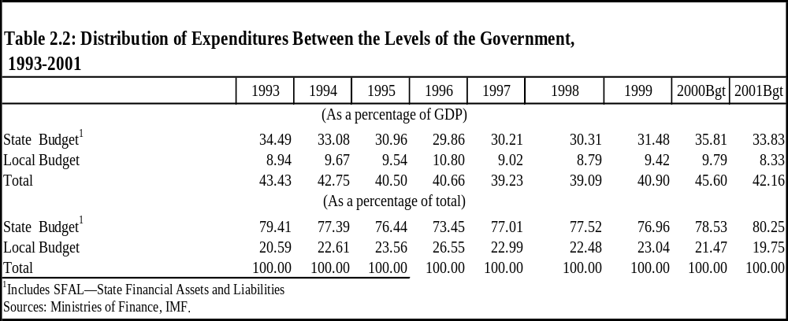

- Local expenditures by function have continued to evolve during the transition. Expenditures on Housing and Community Amenities have been the most important component of local expenditures throughout these years, representing 27 percent of total expenditures in 1999, down from 35 percent in 1993 (Table 2.3). Among other important expenditure categories, three items have increased over the transition years, with Economic Affairs and Services reaching 18 percent of the total in 1999, General Public Services 15 percent, and Social Security and Welfare 12 percent. On the other hand, the relative importance of expenditures on Education and Health has decreased systematically since 1993. In 1999, Education represented 8 percent of total expenditures and Health 4 percent, down from 13 percent and 7 percent, respectively, in 1993. This does not mean that the real provision of these services has decreased, since these are concurrent responsibilities of the central and local governments. For example, in the case of basic education and kindergartens, expenditures per pupil were practically unchanged from 1993 to 1999.
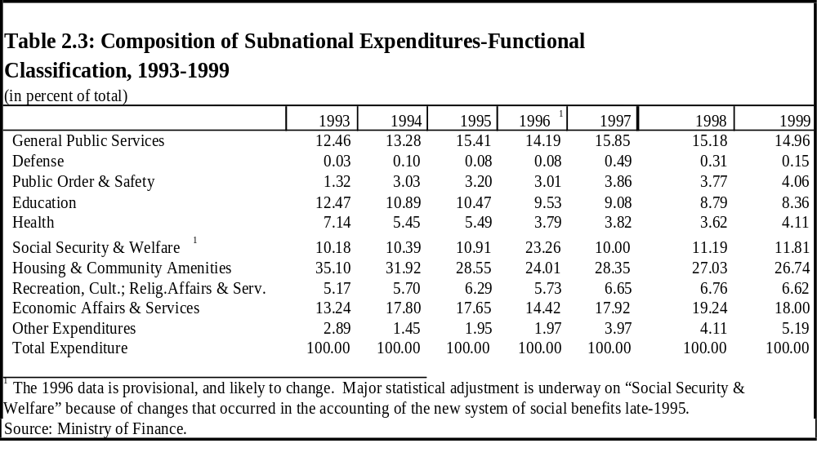
- A notable feature of local expenditures by function is their significant variation across municipalities. Tables 2a, 2b, and 2c in the Statistical Appendix show per capita expenditures for functional expenditure categories for all municipalities aggregated at the district level for 1997 to 1999, and the averages for the coefficients of variation over the three-year period are summarized in Figure 2.1. For example, the coefficient of variation for expenditures per capita on education is one of the lowest, but was still at 0.54 in 1999 and with a maximum expenditure per capita of 7,794 CZK and a minimum of 395 CZK.
Differences are more marked in some other expenditure items, such as social assistance, which had a coefficient of variation of 1.22 in 1999, and a maximum expenditure per capita of 9,181 CZK and a minimum of 164 CZK. Differences in expenditure per capita are more pronounced for less basic expenditures items, such as telecommunications (coefficient of variation of 2.21) or security and public order (coefficient of variation of 1.59). The largest expenditures per capita have been on housing and communal services, with a maximum in 1999 of 22,353 CZK and a minimum of 1,050 CZK. By and large, the average coefficients of variation (Figure 2.1, and also Table 2d in the Statistical Appendix) demonstrate that municipalities have followed a responsible expenditure pattern. The variations in expenditures per capita are the lowest for basic services, such as education, health, and welfare.
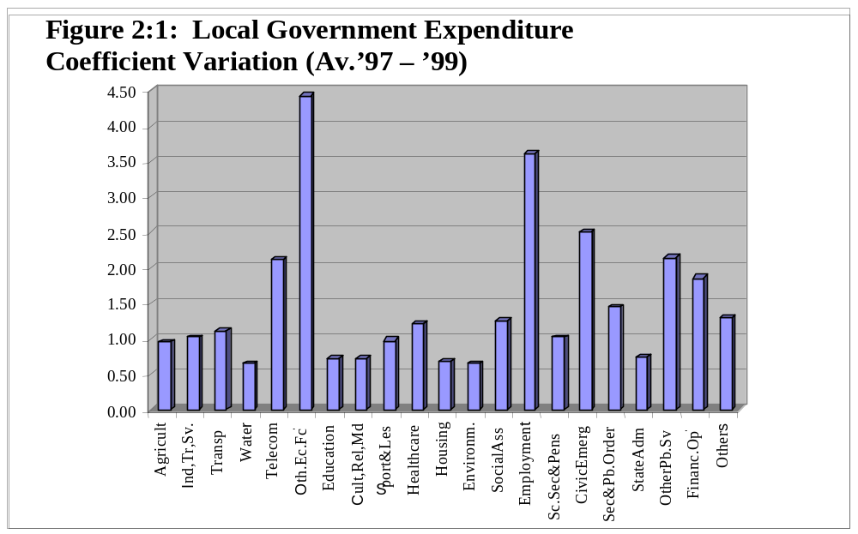

- The profile of the economic composition of local expenditures reveals a high but unstable share of capital expenditures in the budgets over the last seven years. Capital expenditures at their low represented 31 percent of total local expenditures in 1999, down from 35 percent in 1993 (Table 2.4). For 2000, capital expenditures were projected to represent 41 percent of total expenditures, which to a large extent may be reflecting the high capital revenues of local governments for this year. These high levels of capital expenditure are not expected to be sustainable, as capital revenues of local governments are expected to decrease significantly from the heights of the past several years. The relative importance of wages and salaries plus contributions has steadily increased from 10 percent in 1993 to a projected 15 percent in 2000. Subsidies and transfers have fluctuated widely over the past seven years, reaching a high of 35 percent in 1996, but they are projected to be at 20 percent in 2001, the same level they reached in 1993.

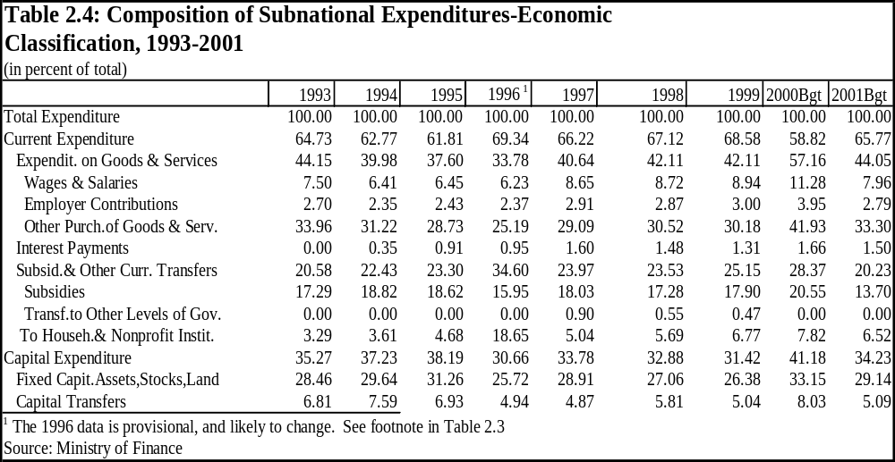

- While the aggregate data by economic and functional classifications reveal some information on expenditure priorities and on the input composition of the delivery of local services, they reveal little about the relative efficiency of different local governments. From this viewpoint, one of the most important issues is how the significant size variation of municipalities affects the composition and efficiency of local public expenditures. Size tends to affect the composition of expenditures because smaller municipalities are less able to afford and to spend, for example, on responsibilities involving culture and the arts and other “optional” sectors.

- One particular area of interest is whether there are disadvantages for smaller municipalities because of their inability to realize economies of scale in the production and delivery of services. The size distribution of municipal expenditures does provide some evidence of this phenomenon, but with the important caveat that expenditure shares do not necessarily represent differences in costs. For example, for 1995 municipalities with less than 200 inhabitants spent 35 percent of their funds on internal administration. This went down to 25 percent for slightly larger municipalities (those with 500 to 1,000 inhabitants) and continued to decline with the size of the municipality. For those municipalities with populations over 500,000, internal administration represented 11 percent of total expenditures.

- A similar pattern is present for services requiring heavy infrastructure, such as water and sewerage. These services represented 23 percent of total expenditures for the smallest municipalities and only 6 percent for municipalities of over 500,000 population. Thus, although in theory the disadvantages of small size for the delivery of services can be overcome by entering municipal associations or by contracting with private companies, these options (at least in 1995) were not sufficiently exercised by municipalities, or were not able to offset the diseconomies of scale inherent in small-size communities.

D. Regional Disparities in Local Government Spending
- Little information is available on fiscal and economic disparities at the municipal and/or district levels, although currently there are some disparities at the regional level. At the municipal level, there were significant disparities in 1995 in per capita expenditures across municipalities of different sizes. For municipalities with less than 500 inhabitants, public expenditures per capita were under 6,000 CZK, while for municipalities of over 500,000 population, expenditures per capita were slightly over 19,500 CZK. In terms of fiscal capacity, the worst off are municipalities with fewer than 200 inhabitants where the majority of the population works in agriculture and a smaller percentage of the population is economically active. It is not immediately obvious what effect these disparities have on uniformity in the provision of basic services. For example, the Ministry of Education considers that the existing disparities in the level of service or the quality of schools across local governments are not significant. However, the previous Chapter has indicated that, despite the relatively low coefficient of variation in the distribution of per capita expenditures in education across municipalities, education expenditures per capita in 1999 ranged from a maximum of 7,794 CZK to a minimum of 395 CZK.

- At the regional level, significant differences appear in GDP per capita, although these disparities arise from the differences between Prague and the rest of the country. For 1996, GDP per capita as a percent of the EU average was on the low side (49 percent in Stredocesky and 55 percent in Vychodocesky). At the high end was Prague, at 120 percent of the EU average. The next highest region was Zapadocesky, at 63 percent of the EU average. It would also appear that regional disparities have grown during the transition because of different unemployment rates associated with the decline of heavy industry in some regions and redundant labor from agricultural areas. These imbalances have not been helped by the low inter-regional mobility of the labor force in the Czech Republic.

- A similar picture of economic disparities is drawn in a recent report of the Ministry of Regional Development.The main conclusion is that there is a marked difference in economic base and available resources between Prague and the rest of the country. In 1995, GDP per capita in Prague was 182 percent of the national average. The disparities among other regions in the country were less pronounced. Only Plzen and Brno were at the national average, and the poorest region, Central Bohemia, had a per capita income of almost 22 percent under the national average. Disparities in personal income tax revenues per capita were more pronounced than those in GDP per capita. On average, between 1995 and 1997, Prague had PIT revenues per capita that were 2.5 times higher than the rest of the nation. At the other extreme, PIT revenues per capita for Jihlava were 40 percent below the national average. There are also differences in other socioeconomic indicators. For example, infant mortality rates were slightly over 10 per thousand in Ostrava and Trutnov and under 2 per thousand in Znojmo.

E. Issues on Expenditure Assignments
The New Regions and the Fragmented Local Governments

- The next step in decentralization will be the assignment of direct expenditure responsibilities (beyond “delegated” functions financed by the State) and associated decision-making power to the regions. These responsibilities should encompass areas of the interest of the regional population, including for instance inter-city transport, environment issues, and regional planning. Caution, however, should be exercised to avoid inter-jurisdictional conflict of power, unfunded mandates, and soft budget constraints. Clear definition of powers is critical, since concurrent mandates may emerge, leading to inefficiencies. Unfunded mandates can be an incentive for local governments to trigger a bailout and easily become a major source of soft budget constraints. To ensure local (regional as well as municipal) hard budget constraints, legally enforceable significant penalties to fiscally irresponsible behavior should include: (a) the loss of autonomy, with the central government taking over and restructuring the local activities; and/or (b) the establishment of standards of fiscal responsibility and holding local officials personally accountable for results.

- One of the most significant problems in the Czech system of intergovernmental fiscal relations is the small size of many municipalities, which does not allow for an efficient delivery of services. The amalgamation of these municipalities is a highly charged political issue for the near future. However, in theory most of the problems created by the small size of municipalities could be remedied by re-assigning current municipal responsibilities for services with economies of scale, such as water and sewage treatment, to the new regions. Because the inability to realize economies of scale in the delivery of services is confined to small-size municipalities, it would be worth considering the alternative of introducing asymmetric expenditure assignments at the municipal level, in conjunction with the creation of new regions. This strategy could take different forms, but it would basically give fewer responsibilities to smaller municipalities in some critical services that are negatively affected by small size and would give the new regional governments the responsibility for providing those critical services in the smaller municipalities. The responsibility for additional services, and the funding sources to accompany them, would devolve in the future to municipalities that reach a minimum prescribed scale through voluntary amalgamation. The year 2000 reform package of new laws appears to allow the voluntary upward delegation of municipal responsibilities to the regions. It is too early to tell whether this approach will work, but there is little evidence from international experience that this is an effective solution to the problem of the small scale of municipal governments.

- It would appear that the Czech government has not focused sufficiently on the potential of the new regions as a means of resolving municipal fragmentation in a politically acceptable manner. There may still be time for such a focus because the expenditure responsibilities of the new regional governments have not yet been determined. However, the government has already proceeded with the revenue assignments to the municipalities, and therefore, transferring some municipal responsibilities to the regions would entail a new change in revenue assignments. On the other hand, this route for addressing municipal fragmentation may have been pre-empted
by the political consensus that the assignment of responsibilities to the regions “should not be detrimental to the municipalities, except for voluntary assignments.

- Several other aspects of the small size of municipalities go beyond the failure to realize economies of scale. The first is that some municipalities provide services for residents of other municipalities without having a mechanism that explicitly allows for compensation among jurisdictions. In some cases, this compensation does seem to exist, as in the case of education and health or the connection to water services. But in other cases, such as cultural and recreational programs, no such compensation mechanism exists. A solution to this problem might be to shift to the regions some of these responsibilities with spillover effects across municipal boundaries for which it is hard to devise compensation mechanisms among municipalities. Another problem arising from small size is the inability of certain municipalities to finance critical responsibilities. For example, there have been questions about whether some municipalities are able to cover the difference between the real cost of social assistance programs and the funds actually transferred to them for this purpose by the central government.

- A final aspect of small size is the diminished administrative capacity of small municipalities. Although it is clear that the new regions will not be in a hierarchical position vis-à-vis the municipalities, one unresolved question is that of what limited power, if any, the new regions will have to exert control and supervision over the municipalities. Should the powers that district offices have had over the municipalities until now be kept, or should they be expanded, or narrowed? This raises highly-charged political issues in the Czech Republic which go well beyond the issues of efficiency and economic rationality. But from that viewpoint alone, given the very small size of most municipalities in the Czech Republic, it would seem reasonable to provide the regional governments with powers to supervise and assist public service delivery at the local level, at least in the case of municipalities under a certain critical size.

Privatization of Services
- A significant feature of local public service delivery is the increasing reliance by municipalities on contracting with private companies for the delivery of services or privatizing the service delivery completely. This is a positive trend which can provide an adequate answer to the problem of high costs of delivery that are due to the fragmentation of municipal governments. In some cases, these relationships are contractual and are the results of open bidding competitions. Services that have been contracted out include garbage collection, housing services for the elderly and the handicapped, and the management of municipal hospitals and clinics. In other cases, there are local government associations and partnerships between municipalities and private or semi-private companies. These are more common in particular service areas, such as water and sewerage, landfill waste sites, municipal transport, street cleaning, street and park maintenance, municipal lighting, and municipal housing. Some of the privatizations, for example in water and sewerage, had their origin in the process followed early in the transition of divesting state public enterprises (Box 2.2).

- The privatization of public services has brought important changes to tariff and cost recovery policies at the local level. Tariffs for public utilities are still regulated by the central government on the basis of “economically justified costs” plus “reasonable profit.” The increased tariffs have brought significant operational efficiencies, and have reduced “consumption” by significant levels, thereby alleviating the need for infrastructure expansion. The official policy has been to gradually increase tariffs to a level that covers all operational costs. Although at present there are no subsidies for operations purposes, in the case of water and sewerage services the central government still provides significant subsidies for infrastructure replacement and expansion. Although long-term plans are to eliminate these subsidies and replace them with loans, this strategy will work on a sustainable basis only if tariffs are set to a level of full cost recovery including the replacement costs for infrastructure. What stands in the way of a full cost recovery tariff structure is the perception that current charges may be on the verge of being “socially intolerable.” However, this can only be true for families in poverty and not for middle and high income families. Therefore, a preferred policy will be to raise tariffs at their full cost recovery level, including replacement costs for infrastructure, and to devise ways to target the subsidies only to poor households. Cost recovery in local transport appears to be at much lower levels. For example, the municipal transport company in Prague has a level of cost recovery of less than 30 percent. This is also a politically sensitive area, but a policy of gradual price increases now with the goal of significantly reducing (if not eliminating) subsidies will preempt budget-led crises in the future.

Box 2.2: Privatized Public Utilities and Services in the Czech Republic
Services for water and wastewater treatment are mostly privatized in the Czech Republic. Most of this privatization took place through the transfer of ownership rights of the regional branches of former state enterprises. A government decree declared that the new owners of water and sewerage treatment plants could only be municipalities, associations of municipalities, or joint-stock companies with majority ownership by municipalities. The latter two arrangements were used for the transfer of ownership for infrastructure that was serving more than one municipality. Ownership of assets was made proportional to population or water consumption. In some cases, the transfer of ownership of infrastructure and the operational property were made two separate entities. In these cases, the operational company leased the infrastructure or entered into an operational contract or concession. Operational companies can have foreign participation of up to 20 percent of the market value of the stock. British and French companies have participation in a number of Czech water and wastewater treatment companies.
Other privatized public utilities include city gas and electricity. During the privatization process, the central government provided the municipalities with a 34 percent ownership of the companies distributing gas and electricity. The rest of the gas and electric companies are owned either by private companies, domestic and foreign, or by the central government (National Property Fund). Buildings in the city centers are often linked to a local heating plant which is run by a corporation owned by the municipality.
Municipal solid waste and dump sites have also usually been privatized. Some of these corporations are jointly held by foreign companies and the municipality. For example, in the city of Otrokovice, the waste dump is administered by a corporation, 60 percent of which is owned by a Danish firm.
Intra-city public transportation is typically run by a municipal company, which may be jointly held by several municipalities. Such is the case in the cities of Otrokovice and Zlín. Municipalities typically provide the transport company with a yearly subsidy to cover its operating deficit. Municipalities also provide investment grants to the transport companies, often with support from the central government.

Capital Expenditure Responsibilities
- The assignment of responsibility for expenditures in capital infrastructure is murky. In theory, municipal governments are responsible for capital expenditures in certain areas of responsibility: for example, they are responsible for school buildings, for water and sewerage treatment plants, for local roads, and so on. In practice, the central government has continued to provide a considerable amount of funding to local governments for capital infrastructure. This help from the central government has taken different forms. For example, there is subsidized state lending to local governments (Box 2.3). In addition, a long list of capital transfers or subsidies is provided to municipalities by a number of central government agencies.
Box 2.3: Subsidized Loans to Municipalities
Many municipalities are able to get subsidized loans (including interest-free) from the Ministry of Finance, the Ministry of Agriculture, and the State Environmental Fund (SEF). These loans, which are known as “reimbursable financial assistance,” can be granted only for particular types of investments. The Ministry of Finance grants these loans for major water treatment projects, for the building of schools and hospitals, for housing construction, and for rural revitalization. The Ministry of Agriculture grants this type of loan for water treatment and distribution systems and sewerage treatment plants. The SEF provides this type of loan similarly for water and sewage treatment plants and distribution systems, solid waste disposal plants, and the conversion of heating systems.

Interest-free loans are a significant source of capital expenditure financing but by no means the most important. For example, in 1996, the financing of municipal expenditures in infrastructure was 25.5 percent from state capital subsidies, 17 percent from loans, 5.1 percent from zero-interest loans, and the rest from own resources.¹

¹ See Peterson et al. , (1997).

- Central government policy has been to concentrate state aid in the form of subsidies and interest free loans in certain areas, such as education and water and sewerage services, which may be justified because of public interest or the presence of externalities. The issue is whether these policies are helping to create a mentality of dependence and negative incentives for the proper maintenance of infrastructure. The latter could be the case if municipalities believe that they can divert funds from maintenance to other issues in the hope that the central government will provide the funds for the reconstruction or rehabilitation of the infrastructure. The criteria used by central government agencies may also have an impact on these incentives. For example, the Ministry of Education uses “emergency situation” (for schools that are in a serious state of disrepair) as the top priority.

- There is little information available on infrastructure maintenance practices and expenditures at the local level. Thus, it is not possible to make a judgment on the seriousness of any negative incentives stemming from the dichotomy between maintenance and capital expenditure responsibilities. What is known from international practice is that these negative incentives can be effectively neutralized by a variety of financing schemes which give ownership of the projects to local governments. One of these schemes is to always require cofinancing or matching funds for any capital transfers from the central government. Actually, the Czech government has been requiring or has plans to require matching funds for most capital subsidies to the municipalities. Maintaining and deepening this policy would be important.

- The use of subsidized lending (interest-free loans, discussed above) may be less transparent than capital transfers or even direct construction by the central government, but it serves the purpose of leading municipalities to take ownership of the projects and to create a fiscal culture that involves the necessity of borrowing and repaying loans for the development of municipal infrastructure. However, the danger with this type of financing is that municipal governments may become accustomed to this soft loan practice and not recognize the actual opportunity cost of public funds. It would be desirable over the medium term to shift these activities to the actual lending institutions and provide central government incentives exclusively through matching grants.

Expenditure Coordination among Levels of Government
- Expenditure assignments can never be sufficiently delineated in the law so as to eliminate the possibility of friction and misinterpretation among different levels of government. One significant feature of fiscal decentralization in the Czech Republic is the absence for the most part of mechanisms of coordination and cooperation among different levels of government. These institutions of cooperation and dialogue perform useful functions in countries such as Austria, Denmark, Estonia, Germany, and Latvia and involve regular and transparent exchanges of information and dialogue at the political and technical levels.

- In the Czech Republic, some coordination has taken place between the districts and the municipalities. For the most part, this relationship has been hierarchical with municipalities dependent on or responding to the districts. The lack of coordination and cooperation among institutions may be explained by the very large number of municipalities, which makes it difficult or impossible for the central government authorities to coordinate with local governments. The natural avenue for this coordination would have been the Union of Municipalities, which has been in existence since 1991. However, an open and regular dialogue with the Union has not been maintained, although this institution does comment on most of the draft laws that would have an impact on municipalities. In a conference in Brno in 1999, the central government accepted the European Charter of Self-Government’s recommendations on coordination among different levels of government. However, no arrangements have yet been specified.

(Un)funded Mandates
- Central government expenditure mandates to subnational governments are a challenge in most systems of decentralized finance. The assigment to subnational governments of expenditure responsibilities without the corresponding resources (unfunded mandates), among a host of other problems, tends to soften budget constraints. So far, fortunately, unlike many other countries in transition, the Czech Republic has, for several reasons, been able to generally avoid imposing open unfunded mandates on local governments. First, the central government has continued the wide use of specific grants for a number of activities which in other countries may be left unfunded. Second, there is a tradition of delegated functions which obligates the central government to guarantee full funding for the municipalities. Third, there appears to have been an open policy by the central government for transferring adequate resources for any new mandated increase in municipal expenditures. Despite these factors, there have been cases of unfunded mandates—the most recent involving the transfer to the municipalities of the responsibility for issuing personal identification cards and passports. In addition, many municipalities still argue that the past transfers of housing responsibilities to the municipalities had a strong component of unfunded mandates since not enough funds were made available for this responsibility. Moreover, it should be considered that, even when “funded”, subnational governments may not feel responsible if prices (of inputs and of services) are centrally determined. This policy tends to open the door for bailouts and soft budget constraints, since price controls may actually become a hidden form of unfunded mandates. On public sector pricing practices, the Czech Republic still has room for improvement in several areas, including the price of some utilities, and house rents.

- The best way to avoid unfunded mandates in the future will be to continue to strive for a clear and stable assignment of expenditure responsibilities. This assignment should be transparent as to which level of government has power to regulate the activity, to finance it, and to implement it. The outright prohibition of unfunded mandates should also be made part of the legal framework and the actual practice of the central government, especially Parliament. Developing institutions for dialogue and coordination among different levels of government is the best means of controlling unfunded mandates.

F. Options for Reform in Expenditure Assignments
(i) Establishing a broad-based commission to propose the new regions’ expenditure responsibilities. Providing the new regional governments with meaningful expenditure responsibilities is the critical step needed to ensure that the recent administrative reforms contribute to a more efficient and accountable public sector. Relying completely on the goodwill and wisdom of line ministries to select what current central government functions should be decentralized to the regions may not produce optimal results, given the vested interests of these agencies. The government should consider charging a special broad-based commission with this work. This commission could also be charged with providing recommendations as to which expenditure responsibilities now assigned to municipalities could be shifted to the regions (but only in the case of small municipalities). This would require the formal acceptance of asymmetric expenditure assignments at the local level, although, de facto, the Czech Republic has had asymmetric expenditure assignments for many years.

(ii) Transferring de facto responsibility for local infrastructure investment and fire protection to local governments. There are areas in the assignment of expenditure responsibilities to local governments that will require careful review, evaluation, and ultimately policy action. Realignment of the de facto and de jure capital expenditure responsibilities at the local level is needed. The central authorities must move more decisively to make municipalities the main providers (in the planning, financing, and implementation) of capital infrastructure, as is stated now in the law. In addition, there are some expenditure responsibilities that could be efficiently reassigned, such as fire protection services, which many larger municipalities could provide by themselves.

(iii) Strengthening privatization and the role of the private sector in the financing and delivery of public services. One of the strengths of fiscal decentralization in the Czech Republic is the growing privatization of public service delivery. This, no doubt, has helped to build a more efficient public sector and to provide better quality and cheaper services to citizens. Numerous central government policies have contributed to this trend, as in the case of the privatization of electricity, gas, heating, and water and sewage treatment. This is an important goal to keep in the front agenda of government sectoral policies, in particular in sectors such as housing, where continued reliance on public sector solutions is unwarranted. The municipal governments should give up the business of providing housing. Most, if not all, of the housing stock at the municipal level should be sold and privatized—with the possible exception of housing for the very poor. The central government needs to re-channel the funds for new municipal housing to help the local governments divest themselves of this responsibility. As the Czech Republic completes its transition to a market economy, the role of the private sector should also increase in the financing and delivery of services in traditionally socialized sectors, such as education and health.

(iv) Preempting unfunded mandates. Unfunded mandates from the center to decentralized governments have not been a serious problem to date. Nevertheless, international experience from developed and developing countries indicates that as decentralization progresses there are increased pressures on the central authorities to pass on different forms of legislation that are tantamount to unfunded mandates. Now is the time to include explicit amendments in the budget process laws, including, in particular, the Law on Budget Rules. It is also the time for Parliament and the central government agencies to adopt explicit protocols that make the occurrence of unfunded mandates less likely, including the formal review of all draft legislation for the existence of unfunded mandates.

(v) Developing institutions for cooperation and dialogue. Building a decentralized system of intergovernmental fiscal relations in the Czech Republic has been for the most part a one-way street, with the center dictating solutions. The overall performance, the quality of design, and the day-to-day operations of the intergovernmental system would be much improved by the creation of formal institutions for coordination and dialogue among different levels of government. The Czech Republic might look to the experiences of its neighbors in Germany and Austria to find good examples of how this can be done.

Revenue Assignments

- In the Czech Republic, tax policy (decision-making power on tax rates and bases) and tax administration have been a national prerogative. Local governments (districts and municipalities) cannot introduce new taxes, and have very limited revenue autonomy. Districts, as deconcentrated state territorial administrations, have been funded by state transfers, shared taxes, and some local service charges. Municipalities, as self-governing authorities, also have (besides the state transfers and shared taxes) independent property rights (which provide them with the corresponding capital/property incomes: interest revenues, privatization proceeds, and rents) as well as their local fees and “own” taxes (at the present time only the real estate tax, for which municipalities have some discretion in setting the tax rate).

- The present revenue assignment system evolved from the 1993 tax and budget reforms, which established the foundations for a fiscal decentralization process in the Czech Republic. The goal was to reduce local dependence on the state budget (transfers) and to foster local self-reliance on regular revenue flows (fundamentally on the basis of shared taxes) and some decision-making power (the ability to determine the rate of the real estate tax within some pre-established margins). The revenue reassignment component of the 2000 public sector reform represented only an ambivalent step in the context of the fiscal decentralization in the making, since it placed less emphasis on self-reliance and more on transfers and revenue-sharing.

A. Local Revenue Sources

Evolution of the Revenue Assignment System
- Before 1992, practically all local government expenditures were directly “subsidized” (by state grants), and practically all local government fiscal decisions were taken by the center. Act 337/92 marked the beginning of a new era by introducing several important innovations. This Act: (i) assigned, for the first time, a real estate tax as a “local” tax; and (ii) introduced the concept of stable tax-sharing arrangements, with a well-defined specific attribution of proceeds from the personal income tax (PIT) entirely to the municipalities. Since then, the PIT has been levied on “dependent income ” (i.e., the so-called “wage tax”) and on the incomes of the self-employed (i.e., unincorporated economic activities) at a progressive tax rate which varies between 15 percent and 40 percent. Dependent income PIT proceeds are allocated on a derivation basis (based on the place of work rather than the residence of workers), and PIT on the self-employed is allocated on a residence basis (rather than where the economic activity actually takes place). These reforms represented a meaningful departure from the ineffective “gap fill” intergovernmental budgetary approach inherited from the previous regime, which had prevailed until then.

- Despite the merits of the 1992 budgetary reforms, important weaknesses, which have affected the revenue assignment system to this day, were introduced by the reform itself. The first such weakness concerns the design of the real estate tax, which, although the most appropriate tax to be allocated to the local level, was left quite incomplete. Only minimal discretion of decision-making power was provided to the local authorities on the tax rate and none on the measurement of the tax base. Actually, property values since 1993 have been assessed at a fixed amount per square meter and the amount has been determined by decree. These limitations have led to a failure to create a relevant margin of local autonomy on this “local tax” and have ended up not attracting much interest. As a consequence, collections from the real estate tax have been fairly insignificant.

- The second weakness of the 1992 reforms was to assign 100 percent of the progressive rate PIT to local governments on a derivation basis. Four significant issues can be identified in this assignment:

(i) The assignment of the PIT on the self-employed (i.e., the unincorporated PIT) on a residence basis has promoted a negative “tax cutting” competition among jurisdictions, owing to their efforts to attract the right to receive the tax. From an economic perspective, competition usually tends to increase efficiency and these gains are also possible in a system of decentralized government. But in this case the goal became simply to move the declared residence of the self-employed. This represents an inefficient fiscal policy, since its incentives do not necessarily increase production and employment in the aggregate, and they certainly reduce public revenue.

(ii) The allocation of the wage PIT on a derivation or place-of-work basis instead of on a residence basis tends to be inefficient and unfair, given that workers and people in general consume more services in the place where they live than in the place where they work.

(iii) A progressive income tax rate embodies a national income redistribution purpose, and as such it should be assigned at the central level. If allocated to lower level governments, the progressive PIT becomes a powerful source of regional revenue disparity, instead of serving its original purpose of promoting equity. On the other hand, a proportional or flat rate PIT at the local level would better approximate the notion of a price for services—an important criterion for an efficient assignment of revenue sources at the local level.

(iv) The PIT is a potentially important buoyant source of revenue (i.e., it tends to be an income-elastic tax), which has the potential for creating major fiscal vertical imbalances when revenue sources assigned to the central government are less income elastic (Table 3.1) (see Chapter 4 on vertical imbalance issues).

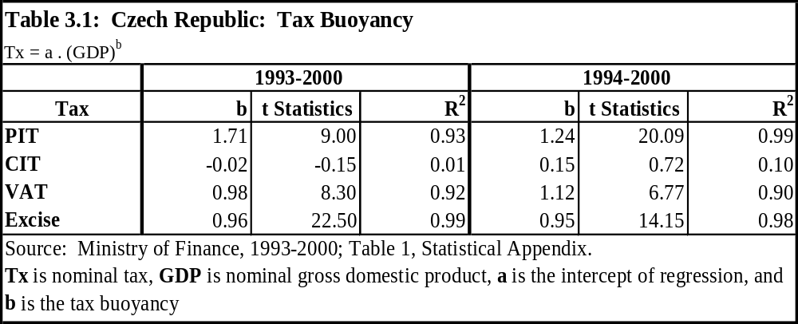

The Current System of Revenue Assignments
- In fact, the dynamics of the tax-sharing system during the 1990s revealed it to be unstable, because of the increasing vertical fiscal imbalance that it brought about. The buoyancy of the PIT, assigned to municipalities, contrasted with the lackluster performance of taxes assigned to the state, especially the corporate income tax (CIT)—the latter showing a dramatic decline in terms of GDP share (Figures 3.1 and 3.2) (see also Chapter 4 on this issue). These trends led the government to adjust the system in 1996 (Act # 154/96), by: (i) re-assigning the “wage tax” component of the PIT, with the attribution of 70 percent of it back to the state and 30 percent to municipalities; and (ii) to compensate for this revenue withdrawal, sharing 20 percent of the CIT, the so-called “profit tax,” with municipalities. Such an adjustment in the tax-sharing system, by mixing taxes with distinct income elasticity, was presented as a necessary move in order to stabilize the intergovernmental fiscal balance. In fact, it had essentially a once-and-for-all impact on the revenue trends, since the CIT decline continued affecting mainly state revenue. These trends eventually led to the reforms in 2000.

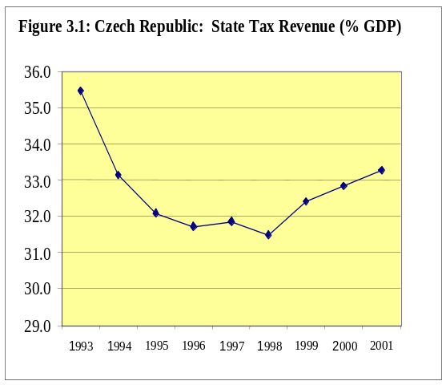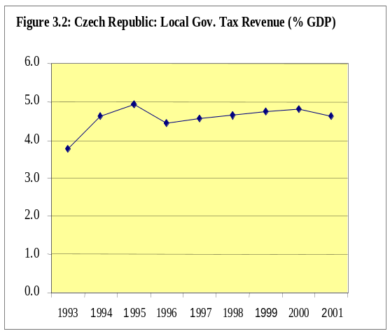
Source: Ministry of Finance.

Source: Ministry of Finance.

- Table 3.2 summarizes the statutory tax assignment before and after the 2000 reforms. Before the 2000 reforms, the tax assignment configuration was as follows.

- Central Government Taxes. One hundred percent of the collection of VAT, excise taxes, Customs duties, taxes on property transfers, road tax, and Social Security contributions have been assigned to the state budget. Among these taxes, VAT has been the most dynamic tax source, particularly since 1998. Excise tax collection has been stagnant as a percentage of GDP, while Customs duty collection steadily declined during the 1990s (Figure 3.3, and Statistical Appendix, Table 1). Social insurance contributions increased, particularly until 1997.

- Shared Taxes. PIT, CIT, and environmental levies were the only taxes shares between central and local governments prior to the 2000 reforms. A 40 percent share of PIT goes to the state, and 60 percent to local governments (district offices and municipalities), mainly distributed on a derivation basis. The sharing rates for the CIT since the 1996 reform have been 80 percent to the state and 20 percent to municipalities, with the municipal share being distributed nationally according to population size. The environmental levies (on withdrawal of land from forestry and from agriculture, waste deposits, and air pollution) are shared between the State Environmental Fund and the municipality, 60 percent and 40 percent, respectively, also on a derivation basis. Shared taxes, although quite unstable, have represented the most important, and an increasing, source of local government revenues (to 47 percent in 2000, from 31 percent in 1993).

Table 3.2:- Czech Republic Tax Sharing System

Tax¹ | Type and Rate | Levied on | Exemptions | Tax Sharing (until 2000) |  |  | New Tax-Sharing
 |  |  |  | Central | District | Munici-palities | Central | Munici-  palities
PIT | Progressive  15 to 40% | Indiv. wages | Some Capital income | 70-30%;  40% ª | 30% ª | 30% ª | 20.59% of the pool of PIT*, CIT, and VAT effectively collected is distributed to municipalities on an “adjusted” per capita basis.
PIT | Progressive  15 to 40% | Self-empl. incomes | Some Capital income |  |  | 100% ^{b}
CIT³ | Flat 35% | Profits,Legal entities | Charitable & non-profit | 80% |  | 20% ^{c}
VAT | On the Value Added Basic  rate 22% | Sales | 5% on food pharmac., books & newspaper | 100%
Excise Tax | 15% HST (wholesale) | Petroleum prod,tobacco,beverages | Heating gas oil | 100% |  |  | 100%
Property Tx^{d} (Real Estate Tax) | Area,quality, use.  0.3% to 4.5% of decree value | Land, buildings, structures | Extensive list of exemptions |  |  | 100% |  | 100%
Prop.Trnsf. (Gifts and Inheritance) | Real estate 5%  Inherit., gifts  1 to 12% | Real estate, inheritance and gifts | State organ. and privatization | 100% |  |  | 100%
Road Tax | Annual ths. CZK 1.2-50.4 | vehicles | Public trnsp. and low emissions | 100% |  |  | 80%**
Customs import duty | 15% HST | Imported goods | Exports | 100% |  |  | 100%
Fees,Levy, Fines,Serv.Rents ² | Miscellaneous | Utilities, housing | Charitable, disabled,  children,seniors |  |  | 100% |  | 100%
Social Sec.Contr. | Hlth. 13.5%⁴ Sc.In. 34%⁴ | Wage bill Self-emp.inc |  | 100% |  |  | 100%
Source: Ministry of Finance (Ref.no.111/1700/2000); Czech Taxation in 1999; new legislation 2000.

Remarks on the Table:

* Except 30% of PIT on self-employment income, which is collected in advance on a derivation basis (i.e., it remains in the payer’s domicile).
** Effective January 1, 2001, twenty percent (20%) of Road Tax is earmarked to the new extra-budgetary State Transport Infrastructure Fund (STIF).
ª on “dependent income”, i.e., the so-called wage tax. See text on distribution.
^{b} on self-employment income (unincorporated economic activities). Distributed according to the residence of tax-payer.
^{c} on corporate economic activities, shared with municipalities since the 1996 tax-sharing reform on a population size basis.
^{d} Introduced by the 1993 tax reform as “real estate tax” (on land and buildings).
¹ In principle, all taxes are State taxes, regulated by the Parliament and administered by Central Government bodies (under the Ministry of Finance).
² District State offices and Municipalities administer some levies (including environmental protection), fees, and fines. See text for sharing rates.
³ Flat rate of 35% applies, but pension fund investment profits are taxed 25%. CIT includes “tax withholding on interest and dividends”. Municipalities retain all CIT paid by their “own commercial activities”.
⁴ Employees and employers contributions are about one-fourth and three-fourths, respectively.

- Figure 3.4 shows the trends in the composition of local government revenues during the 1990s. An outstanding feature is that while the relative importance of shared taxes increased, state transfers to local governments decreased correspondingly (to 23 percent in 2000, from more than 30 percent in 1993), so that the joint contribution of shared taxes and state transfers remained at about 70 percent of local government revenue during the 1990s. One possible interpretation of these trends is that the central government has “regulated” transfers to local budgets in a sort of “gap-fill” fashion, in order to complement about 70 percent of finance of the budget. Another possible interpretation is that, because of decreasing state transfers, the local governments had to make significant efforts to attract economic activities and raise taxes. In any case, what is important is that during the 1990s a decentralization process took place, in the sense that municipalities started to become less dependent on state budget transfers and began to rely increasingly on shared tax revenues. Although this development represented a first important stage in the decentralization process, a meaningful degree of tax autonomy for local authorities was still missing.
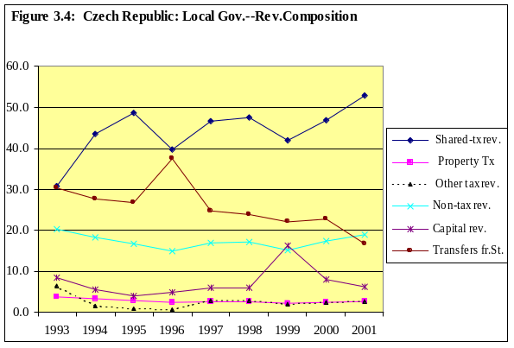
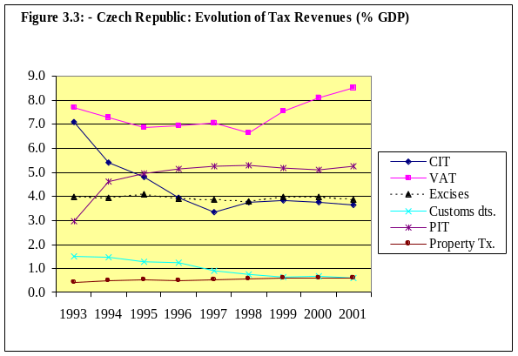

Source: Ministry of Finance

- Local Taxes. Local taxes include the real estate tax (or property tax), and local fees, fines, service charges, and levies. Regarding the real estate tax, municipalities can set tax rates within a bandwidth (0.3 percent to 4.5 percent), but the band itself and the value of the tax base are determined by the central government. In addition, the central government establishes provisions for a long list of exemptions. Municipalities do not have the discretion to give exemptions on the real estate tax. The most significant feature of the current property tax is that it is still assessed by the old system of fixing the amount per square meter, with its value determined by “decree,” without regular adjustments being made for either market price shifts or general inflation. As a result, the property tax has been ineffective, playing a minor role as a local government revenue source. In fact, its collection performance has shown a steady decline as a proportion of local total revenue.

- Regarding other local sources of revenues, municipalities are free—respecting the upper limits determined by the central government—to set rates, define bases, and give exemptions for permits to sell tobacco and alcoholic drinks and to operate gambling machines. Municipalities also charge for municipal motor vehicle permits, advertisement permits, hotel bed fees, recreation facility user fees, dog licenses, entrance tickets, fees for the use of public areas, fees on small air pollutants, and other licenses and permit fees. In addition, municipalities collect “rents” on housing and charge tariffs on water and other utilities owned by them. However, the prices (“rents” and “tariffs”) are still regulated by the central government. This has had a significant impact on local budgets, especially in the case of rents on housing.

B. Patterns of Local Government Revenues
- Since 1993, local government revenues have represented about 9 percent of GDP on average (corresponding to about 22 percent of the general government revenue) without showing significant variation or any clear trend. About half of local government revenues have been from shared taxes, particularly PIT and CIT. During the 1993-96 period, the PIT averaged 40 percent of total local revenues and the CIT 3 percent, and these shares shifted to 33 and 10 percent, respectively, during the 1997-2000 period (Table 3.3). “Own” local taxes (including the real estate tax, local and administrative fees, and “other taxes”) have contributed a smaller and declining share of total local revenues—8 percent on average during 1993-96 and only 5 percent on average during 1997-2000.

- With a slight declining trend, non-tax revenues have contributed around 15 percent to the total revenue of local governments during the entire 1993-2000 period. If “local revenues” are defined as the sum of non-tax revenues (contributions from budgetary and non-budgetary organizations, rent on properties, interest received, etc.) and own tax collections (excluding shared taxes), this figure adds up to no more than 2.2 percent of GDP during the period 1993-96 and falls to 1.7 percent during the period 1997-2000. The latter compares highly unfavorably with other European countries, such as Denmark and Sweden (17 percent), Norway (12 percent), Spain (5.9 percent), France (4.4), and Hungary (3.8 percent).

- Capital revenues (property sales and returns from capital investments) have increased in relative importance during the period. Mostly as the result of privatization policy, capital revenues more than doubled their relative importance as a source of local revenues from the first half to the second half of the 1990s. State transfers and transfers from state funds still represent about one-fourth of local government revenues, although their relative importance declined slightly during the decade.

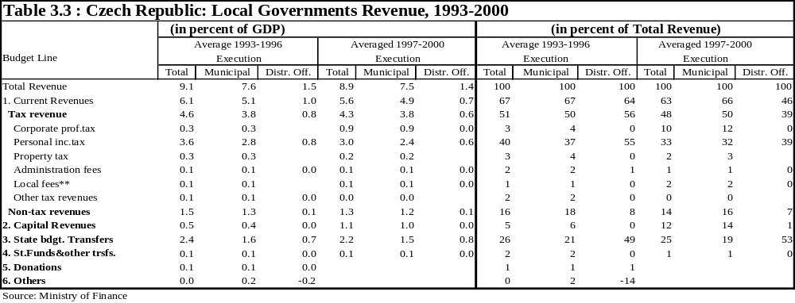
- District offices have not had access to the CIT and the property tax. Since 1997, districts offices have obtained about 19 percent of the shared PIT, and their collection of service fees have been insignificant. Corresponding to their local share of responsibilities, municipalities have obtained around 87 percent of total local government revenues, and have been the recipients of about two-thirds of total transfers from the state budget and state funds to local governments (including transfers received from the district offices).

- The pattern of local revenues during the 1990s, when summarized, shows two main features: (i) slightly declining transfers from the center being replaced by shared-tax and capital revenues, which may have brought some sense of autonomy to municipalities; and (ii) a low level and declining trend of “own revenues” (tax and non-tax), which are contrary to the desired attribution of accountability to local authorities. These trends, however, do not tend to be sustainable (because privatization proceeds are temporary), nor do they provide local authorities with the right incentives to increase efficiency and accountability (because of the lack of decision-making power over shared taxes and the insignificance of “own” sources of revenue—particularly the property tax).

C. The 2000 Reform in Revenue Assignment

- The 2000 public sector reforms, effective from January 1, 2001, essentially transformed the tax-sharing mechanism between the central government and local governments. In addition, the reform earmarked 20 percent of the road tax proceeds to a new extrabudgetary fund, the State Transport Infrastructure Fund. The elimination of district offices from the state territorial administrative structure has meant that for the first time the tax-sharing system will involve only central government and municipalities. The revenue assignment for the 14 new regions has not yet been determined, and it will be on hold for an interim period until December 2002 while the assignment of expenditure responsibilities is under consideration.

- The government’s 2000 reform of the tax-sharing system represents a major effort to address some of the most serious problems affecting intergovernmental fiscal relations. The new system moves away from the personal income tax on a derivation basis, toward a more egalitarian and sustainable revenue sharing mechanism. The system pools together a share of the total collection of the three main taxes (PIT, CIT, and VAT), and distributes the pool to municipalities on an adjusted per capita basis (Table 1.2). To avoid major disruptions in local government financing, the intention was to keep the initial size of the tax-sharing pool of the new system basically the same as the current one, but with the basis of the system and the allocation mechanism changed. Therefore, a share of 20.59 percent of the aggregate collection of the three main taxes was determined to be equivalent to the total amount of municipalities’ tax-sharing revenues in 1999 under the old system for revenue sharing.

- During the interim period (January 2001 through December 2002), the new regions will be fully funded from the state budget through transfers. This precautionary phased-in approach is quite adequate for the particular circumstances, since the size of the required resources is still to be determined and the necessary administrative capacity still needs to be built in the regions. However, it would be desirable to shorten the interim period, if at all possible, in order to avoid creating a mentality of dependence and to increase the efficiency of regional budgets from the beginning. In this sense, congruent and predictable sources of revenue (suitable tax-sharing arrangements and own revenue sources), with an appropriate margin of autonomy, should be clearly and quickly assigned to the regions.

The Objectives of the Reform
- The new mechanism of tax-sharing with municipalities was designed to basically address four major problems related to the previous revenue assignment system: (i) the perceived growing vertical fiscal imbalances between the center and the local governments, rendering the system macroeconomically unstable and fiscally unsustainable in the medium term; (ii) the widening horizontal disparities in terms of revenue capacity among distinct localities, which raise serious questions on the equitability of the system; (iii) tax-cutting competition among municipalities, which entails a reduction in the effective tax base and a misallocation of public resources; and (iv) the persistent fragmentation of municipalities, which is an obstacle to the implementation of the current fiscal policies, to economic integration in the EU, and to more effective decentralization.

(i) Perceived vertical fiscal imbalances between expenditure responsibilities and the resources of central and local governments have developed mostly as a result of the income-elasticity differentials of the respective assigned revenue sources. As observed above, the PIT assigned to local governments has been a relatively more dynamic source of revenue, as compared with the central government’s sources of revenue (VAT, CIT, excise tax, and import tax). By pooling VAT, CIT, and PIT, the new tax-sharing mechanism aims to average and homogenize the income elasticity of both local and central government revenues and thereby to freeze the vertical fiscal balance and bring more stability to the system.

(ii) Horizontal fiscal disparities have emerged from differences in economic base and also from the incidence of industrial depression, unemployment, and poverty that has stricken several areas of the country. In the absence of any explicit equalization transfer mechanism (see Chapter 4), the present revenue assignment of personal income taxes on a derivation basis has accentuated the fiscal disparities among local government. The new system aims to factor in equity considerations by redistributing the tax-sharing pool among municipalities, on the basis of national per capita average by population size. Moreover, the system will adjust it by a coefficient structure which was intended, inter alia, to take into account the level of unemployment so as to favor structurally depressed areas.

(iii) Tax-cutting competition among local governments to attract businesses has not been a good fiscal incentive mechanism, since it tends to lead to a reduction of the aggregate effective tax base and tax collection. Because the PIT on individual businesses is allocated on the basis of the declared residence of the entrepreneur, the current system may misallocate tax revenue in favor of jurisdictions other than those in which the economic activity takes place and in which the critical public service demand exists. The reform objective was apparently to reduce the effects of tax-cutting competition by adopting a more diversified tax-sharing pool, allocated on a national per capita basis by population size instead of on a derivation basis. However, the basic problem remains with the 30 percent of unincorporated PIT, which remains with the municipalities in which the taxpayers reside. This was intended as a marginal incentive to encourage tax effort and local economic development. However, this policy still retains a strong and perverse tax-cutting competition incentive, because municipalities will continue to compete simply to attract people to move their residences, thus shifting resources away from where the economic activity is taking place.

(iv) Administrative fragmentation is a result of the increase in the number of municipalities over the last decade (to more than 6,200 municipalities in 2,000, from about 4,000 ten years ago) (Table 1.1). This increased fragmentation is in part a response to legitimate demands for self-governance, but it is also a response to perverse incentives ingrained in the system. The system had a built-in bias toward local self-governing status, because municipalities became eligible for administrative independence (entailing new local authorities, new local public employment, etc.) and for access to state budget grants, regardless of the existence of administrative capacity and/or the minimum required scale for effectively producing and delivering public and technical services. By the adoption of an adjustment coefficient structure, the new revenue-sharing system aimed to create incentives for voluntary amalgamation of the very small municipalities.

The Implications of the Reform
- Through the new tax-sharing mechanism, the Czech government sought to resolve the four issues identified above with a single policy instrument, aimed at reaching: (i) a more broad-based pool of shared taxes, so as to bring more vertical balance to the system; (ii) a distribution of the tax-sharing pool to municipalities according to population size, in order to reduce revenue capacity disparities within the fiscal system; (ii) an environment less conducive to tax-cutting competition; and (iv) a per capita adjustment coefficient to population size, in order to promote voluntary amalgamation of small-size communities, but also apparently taking into account the specific problems of structurally distressed areas and the costs of service delivery.

- There is, however, no assurance that the reform in the revenue sharing system will be able to attain all four objectives. Rather it appears that some of the objectives have a better chance to be achieved than others. Nevertheless, through the pooling of a larger number of important taxes as a base for tax-sharing, more balance will be brought to the assigned revenues between the two levels of government over time, since the buoyancy of specific taxes on the revenue of each government layer will tend to be evened out.

- The per capita distribution of the new pool of taxes addresses the issue of horizontal equity, with population size of municipalities being used probably as a “proxy” for expenditure needs. The per capita distribution also tends to reduce tax-cutting competition (except for the remaining 30 percent of self-employed PIT that continues on a residence-of-payer basis). However, the new tax-sharing mechanism alone can effectively address neither the issue of differences in expenditure needs based on the demographic and socioeconomic characteristics of local jurisdictions, nor the issues of fiscal capacity and autonomy. Because of this, the government may need to put in place some compensatory fiscal equalization mechanism (see Chapter 4) and to promote incentives to encourage local tax efforts and economic development.

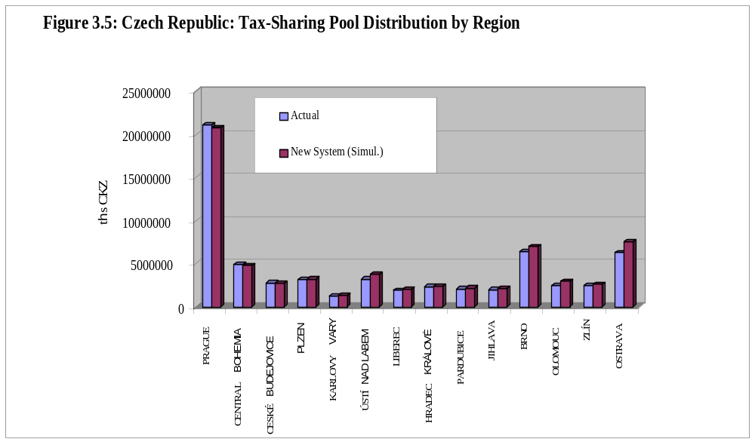
Data Source: Ministry of Finance.

- The government’s intention to use a coefficient structure to adjust the per capita distribution of shared taxes, aiming at considering cost and incentive elements, is commendable, but the rationale behind the adopted adjustment coefficient structure (Table 1.2) is not yet explicit. For example, it is not clear to what extent the disparities in expenditure needs arising from differences in the cost of provision are being adequately captured by the adjustment coefficients. Certainly, there was a de facto political rationale behind the adopted adjustment coefficients—namely, improving the financial flows of the majority of municipalities to facilitate the necessary political support for the approval of the reform (Figure 3.5). However, without a clear and explicit economic rationale, the adjustment coefficient that was finally adopted ended up merely mimicking the structure of the existing revenue-sharing system, with some variations only in a few brackets at both ends of the size distribution of municipalities (Figure 3.6). Although there were some winners and losers in the 2000 tax-sharing reform (Box 3.1), the overall distribution of resources among municipalities did not change significantly (Figure 3.6). The most important changes lie in the implications of the reform over time, because local resources are now likely to grow at a slower rate, and because there will be a de-linking of local revenues and local economic development (and government performance), since, with the new system, municipalities will receive their share of resources largely independent of any tax effort.

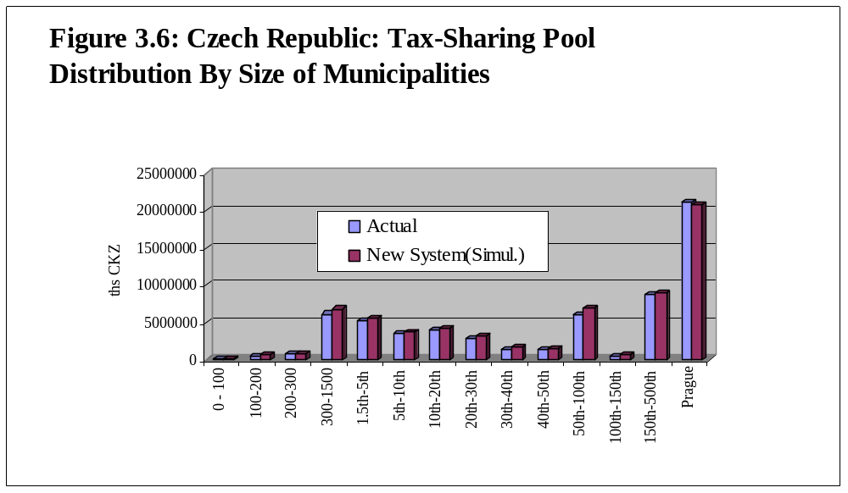

Source: Ministry of Finance.

D. The Unfinished Reform Agenda
- The 2000 reform of revenue assignments still leaves important unresolved issues in the Czech Republic’s system of intergovernmental fiscal relations. These issues include: (i) the risk of fundamental changes being conducted at the discretion of the Ministry of Finance simply through ordinary annual budget laws, which may affect the credibility and effectiveness of the new system; (ii) the absence of an effective incentive mechanism to encourage revenue mobilization and tax effort, which may perpetuate the dependence of local authorities on tax-sharing revenues and transfers from the center; (iii) the insignificant degree of autonomy provided to local authorities over their own revenue sources, which is not sufficient to make these authorities fully accountable before the local population; (iv) the full dependence of the new regional administration on the state budget, which could create a mentality of dependence and jeopardize budgetary efficiency; (v) insufficient economic incentives for the voluntary amalgamation of small municipalities, which are not adequate to resolve the current excessive fragmentation; and (vi) the lack of an economic rationale for the adopted adjustment coefficient for the tax-sharing pool distribution, which may jeopardize the sustainability of the new system. Possible means of addressing main issues and options related to each of these remaining weaknesses are presented in the following paragraphs.

(i) Establishing the structural policy parameters in the organic laws. The 2000 reform left to the discretion of the Ministry of Finance the right to propose, through Annual Budget Laws, modifications in the 20.59 percent coefficient of the collected taxes that will form the tax-sharing pool, and in the structure of the per capita adjustment coefficient itself. This gives the central government discretionary powers, for example, to claw back (in the aggregate) even the increased revenues that result from local governments’ tax efforts from their own sources. Such provisions create serious problems of instability and uncertainty for the administration of local budgets and represent a step backward in the process of designing a sustainable system of intergovernmental fiscal relations. Local authorities need a minimum level of predictability and stability if they are to conduct effective local budget management. Thus, to preserve a reasonable level of revenue predictability for local governments, many countries have instead operated with fixed rules of revenue assignment (including the coefficients of tax-sharing pooling and distribution, the bandwidth of local tax rates, the local tax base and exceptions) in their organic laws (e.g., Budget Rules Law), which are subject to less frequent changes. These organic laws tend to be changed only after extensive debate based on technical studies that can clearly justify the need for modifications. In order to bring predictability and sustainability to the new system of revenue assignment, the Czech government might consider revisiting this aspect of the 2000 reform package.

(ii) Restoring tax-effort incentives and fairness in tax assignment. With the exception of 30 percent of unincorporated PIT, the 2000 reform converted all shared tax distribution into a population size basis, which is commendable from the equity standpoint. The downside of eliminating the derivation basis as an allocation criterion, however, was that the tax-sharing system lost most of its tax-effort incentive. Actually, what was left in place was the most inefficient aspect of the previous tax-sharing system—namely, the unincorporated PIT allocated according to the place of residence of the taxpayer. The continued use of this criterion still threatens to cause destructive tax-cutting competition, whereby municipalities offer incentives to attract residents who are developing economic activities in other jurisdictions. To circumvent this lack of tax-effort incentive and the unfairness of the allocation criterion of the unincorporated PIT, the government could consider a two-step strategy. First, the totality of the unincorporated PIT could be brought into the shared-tax pool and submitted to the common rule of allocation based on population size distribution. Second, the “wage-tax” component of the PIT could be split into two taxes: (i) a progressive PIT similar to the existing one but with an overall lower structure for the progressive rates and which would equally enter the tax-sharing pool; and (ii) a proportional (or flat) rate PIT which would be assigned to local governments, with some discretion for setting the flat rate (between legislated minimum and maximum rates), and piggybacking the national progressive PIT. The first step would resolve the issue of the present unfair distribution of the unincorporated PIT, while the second step would represent a significant means of local revenue mobilization, would contribute to local tax autonomy, and would help make local authorities more accountable to their constituencies.

(iii) Strengthening local revenue autonomy. One of the most important elements of the unfinished agenda on revenue assignments at the local level lies in the small degree of revenue autonomy provided to municipalities. A significant degree of revenue autonomy and some tax effort incentives are critical to encouraging the accountability and increasing the efficiency of local government operations. Such autonomy and incentives are also the most effective means of addressing the vertical imbalance issues that inevitably arise with dynamic changes in revenue bases and demand for public services. Actually, the new system has neither provided municipalities with additional meaningful sources of revenues nor introduced the necessary reforms of the real estate tax (or a broader concept of the property tax). There is a need to provide municipalities with the ability to use market assessments of urban properties, while keeping, at the same time, their ability to decide on the tax rate within a legislated bandwidth. Market assessed values can make this tax a meaningful source of local revenues. Reforming the property tax would not only improve the level of autonomy and local accountability but it would also contribute to revenue mobilization at the subnational level and would improve equity in the current distribution of tax burdens.
(iv) Assigning shared taxes and autonomous revenue sources to the new regions. As observed above, the 2000 reform took a wise precautionary step by providing a two-year interim period to bridge and phase in the implementation of the new regional administrations by first attributing the regions’ expenditure responsibilities and only then defining the regions’ sources of revenue. During the interim period, the regions’ expenditure programs will be fully maintained by the state budget. It would be desirable, however, to shorten the interim period in order to avoid creating a mentality of dependence and to start with efficient regional budgets from the beginning. In this context, a congruent and predictable mix of sources of revenues, with an appropriate margin of autonomy, should be clearly and quickly assigned to the regions. To avoid vertical imbalances, the revenues to be assigned to the new regions should be congruent with and commensurate to the level of responsibilities attributed to them. Like the municipalities, the regions could have access to the tax-sharing pool and should also have some degree of autonomy on their own tax base. Several options exist. The rural property tax could possibly be assigned to the regions. Also the regions could be allowed to impose a surcharge piggybacking on some of the national tax rates. A clear and quick decision on these options would create a sense of budgetary independence, prevent vertical imbalances, and build up responsibility by making the new elected authorities accountable for their respective decisions at the regional level.

(v) Strengthening economic incentives for voluntary amalgamation. The new tax-sharing system intended to provide incentives for administrative consolidation for the very small municipalities, where economies of scale are most needed. It is not certain, however, that the incentives provided by the approved structure of the per capita adjusted coefficients are sufficient to stop, much less to reverse, the fragmentation process. And these incentives are not yet clearly structured. As the incentive structure presently stands, the adjustment coefficient provides larger municipalities (of 100,000 inhabitants and even larger) with similar incentives to merge. Incentives to merge, however, should cease when economies of scale tend to be internalized for most public services. This is an area which deserves more focused attention and stronger incentives if concrete results are to be obtained. For this, the government could consider using the new structure of territorial administration, with the creation of the new regions, and also the EU pre-accession funds, as leverages to promote stronger administrative consolidation. For example, many revenue/tax functions of municipalities below a certain size should be attributed to the regional governments or to larger municipalities (see also Chapter 2, for issues on expenditure assignment). As a complement, the government could use the financial mechanism of matching funds to the EU pre-accession funds to promote amalgamation (see Chapter 4). Adopting an approach of asymmetric revenue assignments, responsibilities, and financial support might be the best way of increasing overall administrative and technical efficiency in the current context of such a high level of municipal fragmentation.

(vi) Establishing an economic rationale for the adjustment coefficient. It is not as yet clear whether it has also been the intention of the reform introduce a fiscal equalization mechanism embodied in the distribution of the new tax-sharing system. The new system has some elements that resemble a fiscal equalization approach, but they are not explicit (see Box 3.1). Although a loose “per capita adjustment coefficient” has been adopted, no serious, transparent consideration was given either to the revenue capacity or to the expenditure needs of the regions/municipalities. The new tax-sharing pool distribution mechanism still calls for a clear economic rationale. This is a critical pending issue of current intergovernmental fiscal relations in the Czech Republic, which could evolve toward consideration of a more transparent, formula-based equalization transfer scheme. Chapter 4 addresses this issue and the options.

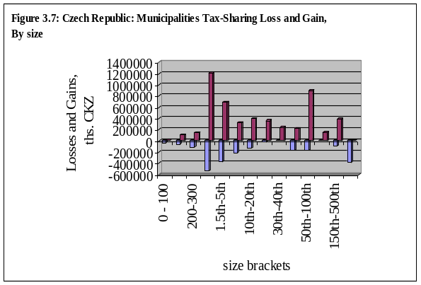
Box 3.1: Winners and Losers in the 2000 Tax-Sharing Reform

Simulations developed by the Ministry of Finance show that, in most of the size distribution spectrum, municipalities will end up having net gains from the change in the tax-sharing system (Figure 3.7). This was probably an important element in political negotiations to gain Parliamentary approval for reform. The only two exceptions are the city of Prague, which loses only 1.8 percent of its total receipts from the tax-sharing pool, and the very small municipalities (the ones in the 0-100 inhabitants bracket) which are penalized with a 17 percent loss in the total share of revenues. The latter was apparently intended as an incentive to help reversing the fragmentation trend of municipalities, also because municipalities of average size (particularly for those between 300 and 10,000 inhabitants) will still benefit from the reform.

In per capita terms, although the winners and losers in terms of population size distribution are basically the same, the profile of the new tax-sharing distribution tends to lean more in favor of “larger” municipalities (especially those above 20,000 inhabitants), confirming the remarks in the previous paragraph, but probably revealing the influence of regional factors not properly rationalized by the adjustment coefficient (Figure 3.8).

Certainly every new region (NUTS III) will have some municipalities which will be winning and some which will be losing with the new tax-sharing arrangement. Besides the city of Prague, the net losers are Central Bohemia and Ceske Budejovice regions, while the larger net winners are situated in the area of Northern Moravia (mainly Ostrava and Olomouc regions) and Northern Bohemia (Usti Nad Labem and Karlovy Vary regions) (Figures 3.9 and 3.10). These shifts may reflect political decisions of taking into account regional income disparities and unemployment considerations of the structurally distressed industrial large areas, including Ostrava-mesto and Usti nad Labem. This could indicate some equalization concerns behind the present arrangement, but they are neither explicit nor rationalized by the adopted adjustment coefficient.
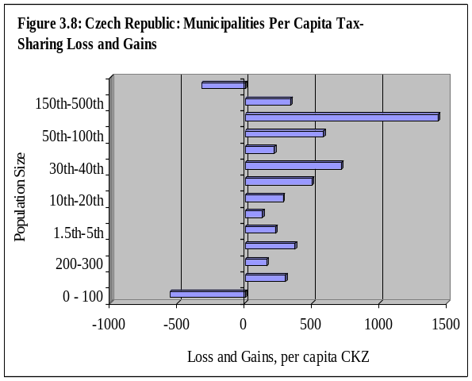
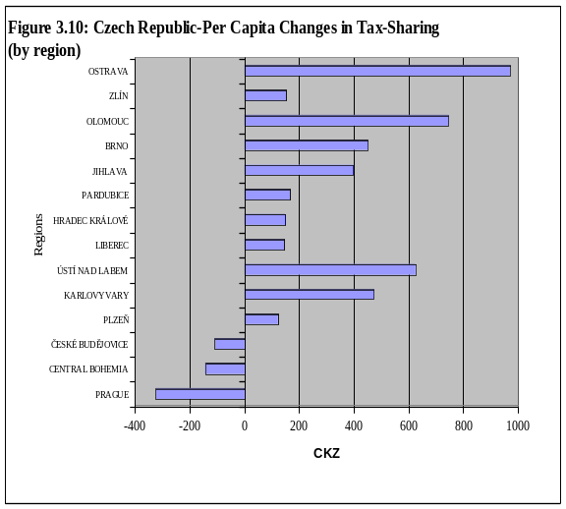
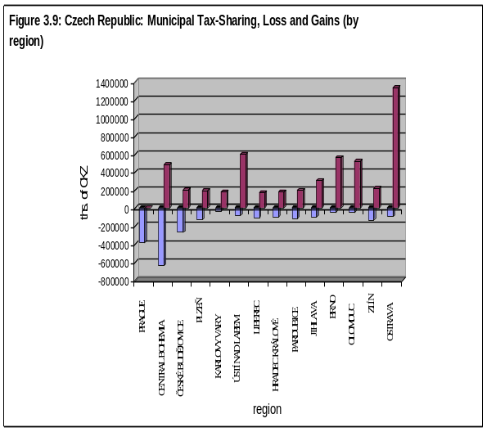

Fiscal Imbalances and the System of Transfers

A. The Current System of Transfers
- Two dominant characteristics of fiscal decentralization stand out in the Czech Republic vis-à-vis most other countries, including countries in transition. One of these characteristics is that there is no clearly defined system of equalization grants at the municipal or the district level, and the 2000 reforms have not put in place an explicit mechanism for such equalization grants. Nevertheless, as discussed in the previous Chapter, the new tax-sharing system with the municipalities (based on an adjusted per capita basis coefficient) has some built-in equalizing features. As regards the new regions, although at present there are also no government plans to introduce an explicit system of equalizing transfers at that level, the poorest regions in the Czech Republic will tend to benefit from EU structural funds in the near future.

- The other dominant characteristic of the current system of transfers is the existence of a complex system of subsidies (or conditional grants), which are used by the central government to pursue a variety of policy objectives at the local level. A common feature of these grants is that they are earmarked for specific purposes and that, in most cases, local governments have to provide separate accounts reporting on how these grants have been used.

- The relative importance of earmarked subsidies has continued to decline during the transition. Despite their complexity, earmarked subsidies accounted for only 24 percent of all local (district and municipality) revenues in 1999. For municipalities alone, earmarked subsidies accounted for about 19 percent of municipal total revenues, whereas in 1993 earmarked subsidies represented 31 percent of local government total revenues and 28 percent of municipal total revenues. Most of this decline has been at the municipal level, since earmarked subsidies have been a fairly stable source of district financing. On average, subsidies have represented about half of the districts’ total resources throughout the transition period (Table 1, Statistical Appendix).

- Central government earmarked subsidies to local governments are for both current and capital expenditure activities, with the subsidies for current expenditures being dominant. Although they have been losing importance vis-à-vis capital subsidies, subsidies for current expenditures still represent two-thirds of the total transfers budgeted for 2001.

- Two main types of earmarked grants exist for the current expenditure activities of local governments. The first type is for financing the central government’s legally delegated responsibilities to municipalities. These legally-mandated grants are categorical and are to be spent on well-defined specific programs; they do not require any matching funds from the municipalities. In general, these transfers are distributed on a “per client” or “per head” basis and cover expenditures in the areas of social assistance and benefits, kindergarten and primary education, selected hospital and assistance institutions, fire brigades, and the execution of general government services including registration and permits (Table 4.1).

Table 4.1: Transfers to Local Governments to Finance Delegated Functions

Type of Transfer | Criteria of Allocation
 | 1998 | 1999
Social assistance  a) asylums for social care  all-year, all-week stay  b) other centers | 63000 CZK/head  33900 CZK/head  50500 CZK/head | 63000 CZK/head  33900 CZK/head  50500 CZK/head
Social benefits | These are mandatory expenditures allocated for the social needy and the handicapped according to particular laws.
Education  (Primary and nursery schools) | 1110 CZK/head | 1221 CZK/head
Selected hospital institution  (Children and baby homes) | 63000 CZK/head | 63000 CZK/head
Execution of government service | Administration services provided by the municipal authority.  Contribution for 100 inhabitants:  1100 CZKm. with independent activity  2200 CZKm. with register activity  6550 CZKm. with building activity  10500 CZKm. w/ delegated authority  7550 CZKm. with activity of district authority. | Administration services provided by the municipal authority.  Contribution for 100 inhabitants:  1210 CZKm. with independent activity  2420 CZKm. with register activity  7205 CZKm. with building activity  11500 CZKm. w/ delegated authority  8305 CZKm. with activity of district authority.
Fire brigades | Grant for service of fire brigades in according to legal norms.
Source: Ministry of Finance..

- The second type of specific subsidies for current expenditure activities is discretionary (as opposed to being legally mandated). These subsidies require application by the municipalities according to established rules, and are awarded at the discretion of the granting central government agencies. Often, they may require conditional or matching financing arrangements by the municipalities. These subsidies cover a variety of areas, including crime and drug-addiction prevention, environmental issues, and employment and development policies. Table 4.2 provides a listing and the funding levels for these transfers to municipalities and districts for 1999 and 2000. A summary description of existing transfer programs is presented in Box 4.1.

- On the side of capital transfers, funds are also transferred for a variety of purposes, including schools, hospitals, social care facilities, gas distribution, equipment of fire brigades, development of industrial zones, public transport, water and sewerage treatment plants, and so on (Box 4.1). All subsidies for capital infrastructure require matching funds from the municipalities. The only exception is for building new institutions for the delivery of social care in those cases in which the municipality has had to restitute the property to its original owners. In such cases, the central government funds the cost of the facility in full, subject to specifications and norms. Ordinarily, for most other cases capital matching arrangements provide central government funds at established sharing rates up to a maximum amount, but in some cases capital grants are set to cover “standard costs” as opposed to the actual costs of the project.

Table 4.2: Subsidies to Local Budgets for 1999-2000

(in millions of CZK)
Item | Esti-mated  Actual 1999 | District  Offices | Municipal | Budget  2000 | District  Offices | Municipal
Subsidies to district offices and municipalities | 20,977.0 | 9,546.3 | 11,430.7 | 23,797.0 | 9,731.3 | 14,065.7
Including:  Social payments  Social-care institutions  Retirement homes  Education  Transportation services  Selected health care facilities  Provision of state administration services  Fightfighting and rescue corps including JPOs  Territorial balancing subsidy  Anti-radon measures  Resources to increase social-care payments  Contribution to district offices for provision of state admin. services  Land parcel modification  Administrative expenditures involved in the system of making social support payments  Comprehensive cooperative programs for crime prevention and prevention of drug dependency at local levels  Resources for implementing the amendment of law No.133/1985 on fire protection (severance pay and compensation for lost pay)  Reserves to strengthen transportation services  Other non-capital subsidies in the VPS chapter of the state budget  Non-capital subsidies in the VPS chapter of the state budget  Including: non-capital subsidies excluding social payments  Capital subsidies in the VPS chapter of the state budget  Subsidies in the VPS chapter of the state budget  Other subsidies accepted from state budget (in the chapters of state administration organs)  Including:  Non-capital  Capital  Total subsidies from the state budget  Capital subsidies from the State Environmental Fund | 6,920.0  1,047.6  1,721.3  1,696.6  1,114.1  128.9  2,477.3  3,121.0  2,750.2  70.1  2,480.0  120.0  847.0  240.0  110.0  50.0  100.0  4,017.1  24,994.1  15,594.1  3,008.4  28,002.5  8,666.3  882.7  7,783.6  36,668.8  1,396.0 | 1,303.5  821.0  1,028.6  1,100.9  96.4  2,445.7  2,750.2  70.1  377.2  120.0  820.8  219.0  50.0  100.0  1,757.1  11,303.4  9,622.7  1,550.8  12,854.2  Q1,981.5  459.6  1,521.9  14,835.7 | 5,616.5  226.6  692.7  1,696.6  13.2  32.5  2,477.3  675.3  2,102.8  26.2  21.0  110.0  2,260.0  13,690.7  5,971.4  1,457.6  15,148.3  6,684.8  423.1  6,261.7  21,833.1  1,396.0 | 9,500.0  1,068.5  1,769.6  1,687.6  1,214.1  128.7  2,477.1  3,148.2  2,803.2  56.1  139.8  652.2  184.8  84.7  38.5  1,156.1  24,953.1  15,453.1  2,249.9  27,303.0  8,593.0  1,702.9  6,890.1  35,796.0  1,200.0 | 1,300.0  856.1  1,042.5  1,167.2  96.2  2,466.1  2,803.2  56.1  139.8  632.0  168.6  38.5  1,035.0  10,766.3  9,466.3  1,347.7  12,141.0  1,859.1  430.6  1,428.5  14,000.1 | 8,200.0  212.4  727.1  1,687.6  46.9  32.5  2,477.1  682.1  20.2  16.2  84.7  121.1  14,186.8  5,986.8  875.2  15,062  6,733.9  1,272.3  5,461.6  21,795.9  1,200.0
CUMULATIVE TOTAL OF SUBSIDIES | 38,064.8 | 14,835.7 | 23,229.1 | 36,996.0 | 14,000.1 | 22,995.9
Source: Ministry of Finance.

- In addition to these capital transfers from the central government budget, municipalities also receive capital transfers from the State Environmental Fund. These grants are for environmental purposes, interpreted broadly to include water supply systems and the introduction of gas, flood control, the revitalization of the countryside, and energy conservation measures. The Environmental Fund favors project financing including loans with matching shares of the Fund going to the municipalities. The matching rate for grants to the municipalities is usually set by the State Environmental Fund at a minimum of 20 percent. Total transfers from the State Environmental Fund represent about 7 percent of all transfers budgeted for 2001 (Table 4.3).

Table 4.3: Subsidies to Local Governments Budgeted for 2001

 | Current  Transfers  (bi.CZK) | Capital  transfers  (bi.CZK) | All transfers (bi.CZK) | Share in  total (%)
Subsidies from Central Government  Subsidies from State Environmental Fund | 17.8  0.08 | 6.9  1.9 | 24.7  2.0 | 92.8  7.2
Total transfers | 17.9 | 8.8 | 26.7 | 100.0

Source: Ministry of Finance.

- Through 2000, district governments also received earmarked subsidies for social welfare, education, fire protection, and the administration of state services. In addition, some districts received capital subsidies for social care institutions, retirement homes, transport, and health facilities. The new regions will be entirely financed by transfers (or subsidies) on a cost-reimbursement basis through the transition period from January 2001 to December 2002.

B. Vertical and Horizontal Imbalances
- Government transfers can be used mainly to address vertical and horizontal imbalances among levels of government. Vertical imbalances exist when there is a mismatch between the expenditure responsibilities assigned and the resources made available to different levels of government. Horizontal imbalances exist when there are significant disparities among local governments because of differences in fiscal capacity to raise adequate revenues with a standard level of tax effort, or because of differences in expenditure needs caused by higher costs of the provision of services or particular features of the local government over which local authorities have no control.

Box 4.1: State Subsidies to Municipalities and Districts in 2000*

Total subsidies to districts and municipalities in 2000 were budgeted at 37 billion CZK. The subsidies came from three different sources: (i) 74 percent subsidies from the General Treasury Administration (VPS) Chapter of the State Budget; (ii) 23 percent subsidies from organizations of the state administration; and (iii) 3 percent from the State Environmental Fund. Of the total, 62 percent was assigned to the municipalities and the balance, 38 percent, to the districts. Close to three-fourths of the subsidies were for current expenditures, and 73 percent of all capital subsidies were allocated to the municipalities.

(i) Subsidies from the General Treasury Administration ("VPS")

Subsidies from the VPS were set at 27.2 billion CZK. Close to 92 percent of these subsidies were for current expenditures in services such as transportation, state administration activities delegated to the municipalities such as the civil registry, education, social benefits and services, and others. The VPS subsidies are divided into two basic blocks. The first block of subsidies are the “mandatory” subsidies represented by the financial relationship between the state budget and the municipalities and districts. These subsidies are determined by law according to explicit criteria and computation indicators. The main “mandatory” subsidies include the following:

Subsidy | Aimed at | Amount (in Billion CZK)
Social payments | Socially needy citizens, also handicapped and the sick | 5.5
Social-care Institut. | Operational expenditures of communities’ and district offices’ institutions | 1.1
Retirement homes | Operational expenditures of communities’ and district offices’ institutions | 1.8
Education | Operational expenditures of basic schools and kindergartens | 1.7
Transport services | Partially compensate losses of basic bus transportation services in the territory (does not include municipal mass transportation companies) | 1.2
Health care facilities | Selected child health care facilities (e.g., infant institutions, children’s homes) not covered by the health insurance system | 0.13
State admin.services | Compensate municipalities for the cost of execution of state administrative services | 2.5
Firefighting | Compensate firefighting and rescue organizations (including Community Volunteer Fire Dept.-JPOs II and III) at districts for non-capital expenditures | 3.2
Territorial Balancing | Compensate for uneven distribution of wage tax collection (districts with annual per capita tax collection below CZK 2,870.60 are eligible for the subsidy) – This is the only non-special purpose subsidy awarded by the State Budget to the districts. The territorial allocation of this subsidy is decided by the district assembly | 2.8

The second block of subsidies included in the VPS Chapter of the State Budget represents capital and current subsidies allocated to districts and municipalities for various purposes. Capital subsidies (CZK 2.2 billion) are paid for health and education purposes to organizations in the districts and municipalities. Non-capital subsidies (CZK 1.2billion) are for: anti-radon measures; state administrative activities; modification of lots (appraisal, identification, and surveying of land parcels subject to restitution); administration of state social support payments (including postage and remittance costs); prevention of criminality and drug dependence; implementation of the amendment to Law no. 133/1985 SB. on fire protection.

(ii) Subsidies from the budgets of Other State Administration Organizations

These subsidies are used to implement municipal infrastructure programs. They primarily involve an extensive housing construction program (including rental apartments and the technical infrastructure, houses to provide community care services, support for maintenance of the housing stock), a program for the construction and maintenance of water supply lines and water purification facilities, sewerage treatment, a program for construction and maintenance of the highway network of statutory cities, a program for rural renewal, among others. The total of these subsidies amounts to CZK 8.6 billion. Of this amount, 80 percent is set aside for capital subsidies, and 78 percent of the total amount goes to municipalities.

(iii) Subsidy from the State Environmental Fund

A further source of subsidies for municipalities is the State Environmental Fund with a total of CZK 1.2 billion. The subsidies are provided for construction of wastewater cleaning facilities, sewerage disposal, water supply lines, and the communities’ gas programs.
_______________________________
* Information in this box is drawn from “2000 State Budget”, Attachment G.

- Unlike horizontal imbalances, no precise ways of measuring vertical imbalances exist. The 2000 reform in revenue assignments may imply a perception held by the central level that a vertical imbalance gap had developed against the central government (and in favor of local governments) over the past decade. Essentially, the argument was that the imbalance was a result of differences in revenue elasticity with respect to the GDP of the assigned revenues at the central and local levels. These differences would have been more obvious for the personal income tax (PIT) assigned to local governments, and for other tax revenues, such as the VAT, the corporate income tax, and excise taxes assigned to the central government. Another aspect of the argument (not always fully developed) was that there had been a higher GDP elasticity of local spending on delegated functions and on certain components such as teacher salaries that have basically been financed from the center. These arguments led to the 2000 reform in revenue assignments to the municipalities, as reviewed in Chapter 3. However (as was also discussed in Chapter 3) the central government had de facto been addressing the perceived vertical imbalances vis-à-vis local budgets by controlling the rate of growth in the overall funds dedicated to financing the transfers (or earmarked subventions) to the local governments.

- It is worth noting that the actual tax revenue performance over time provides some support to the above-mentioned broad-based “perception” (Chapter 3, Table 3.1). The buoyancy coefficient for the PIT (which has been more heavily shared by local governments) is consistently over 1 (one) and exceeds the buoyancy of the other central government taxes. Other more conventional readings of vertical imbalance, although weaker measures, might not necessarily indicate an increasing vertical imbalance against the central government. A common way to measure vertical imbalances is to estimate the share of local government expenditures that is financed by revenue sources over which local governments have control. If only own local revenues are defined as controlled sources of revenue (that is, property tax, administration fees, and other fees and local revenues), then the coefficient is about 0.13 in 1999, down from 0.17 in 1994 (Table 1, Statistical Appendix). This would indicate a considerable worsening in the already bad vertical imbalance against local governments. However, if the definition of controlled revenues is enlarged to include local shared taxes with the central government, the measure of vertical imbalance (0.60) improves considerably and becomes closer in line with measures for other fiscally decentralized countries.

- Another of these conventional, weak measures for vertical imbalances is the aggregate budget performance of local budgets. The presence of a sustained deficit for local governments might be interpreted as evidence of unsatisfied expenditure needs. Table 4.4 shows the aggregate performance of local budgets between 1993 and 2000. Over the last seven years the table shows a predominance of budget deficits over budget surpluses. The most significant exception is a very high budget surplus for 1999, owing to an unprecedented inflow of capital revenues when the municipalities began selling stockholder rights in their shares in the electric and gas distribution companies. Also, these two measures of vertical imbalance, especially the first, highlight the absence of meaningful revenue autonomy at the local level. It is only through the ability to raise their own revenues in the margin that local governments can really close any vertical imbalances that may arise over time.

Table 4.4: Aggregate Municipal Deficit / Surplus, 1993-2000
(in billions of CZK)

 | 1993 | 1994 | 1995 | 1996 | 1997 | 1998 | 1999¹ | 2000¹
Budget Balance | 0.9 | -1.1 | -3.2 | -9.6 | -4.8 | 1.5 | 19.0 | -1.4
¹Projected
Source: Ministry of Finance.

- With respect to horizontal fiscal disparities, information is scarce regarding differences in fiscal capacity or expenditure needs at this time. Some of the available evidence was discussed in Chapter 2 on expenditure assignments. A priori, horizontal disparities should not be insignificant—given the differences in economic base across municipalities of different sizes and across different regions, particularly because of the emergence of industrial depression, unemployment, and poverty in some areas of the country. The aggregate evidence available at the level of NUTS II regions shows that in the period 1995-97 average revenues from the PIT in Prague were 219 percent of the national average, while all the other NUTS II regions were below the national average. The lowest standing was for Central Moravia at 79 percent of the national average. Excluding Prague, the other NUTS II regions ranged from 106 percent of the national average for the Southwest to 94 percent for Central Moravia. The differences are less marked for GDP per capita at the NUTS II regional level. For 1996, GDP per capita was 186 percent of the national average in Prague and 84 percent in Central Moravia. These implied fiscal disparities are not insignificant but they are not large by international standards, and in particular in reference to other transitional countries.

- Nevertheless, whatever these disparities have been, in the absence of any explicit equalization transfer mechanism, the revenue assignment prevalent through 2000 with the PIT assigned to the local level on a derivation basis may have accentuated fiscal disparities among local governments, in particular when Prague is considered. The new revenue assignments, with the distribution of tax revenues on an adjusted per capita basis, should reduce those fiscal disparities on the revenue side of the budget. However, it is not entirely clear what the impact of the adjustment on the per capita basis may be. Actually, as discussed below, the approved per capita adjustment coefficient is unlikely to properly address the disparities on the expenditure side of the budget owing to differences in expenditure needs.

C. Main Issues Concerning the System of Transfers
- This Chapter focuses on three main issues: (i) the current reliance on the system of conditional transfers and how to improve these transfers; (ii) the absence of an equalization transfer mechanism and whether there is justification for one; and (iii) the transfers related to the Czech Republic’s accession to the EU.

The Current Reliance on Specific Conditional Transfers
- The current system of conditional transfers (or specific subsidies) to local governments has many strong features but also several weaknesses. On the positive side, most of the specific subsidies to municipalities and district offices are designed to cover only partially recurrent expenditures on education, health care, etc. In fact, specific subsidies fully cover all operating costs only in the cases of social welfare and fire protection and rescue crews. Equally notable is that practically all specific subsidies for capital investment purposes require matching funds from local governments. These practices tend to increase the efficiency of public expenditures at the local level by increasing local ownership of the programs and setting a price (or opportunity cost) for the use of central government funds at the local level. Another positive feature of some of the specific subsidies is that the allocation mechanism induces positive or neutral incentives for good expenditure management at the local level. For example, the allocation of specific transfers for social assistance, health care, or education is on the basis of per head indicators. This approach tends to eliminate any incentive to accumulate idle physical capacity or to overstaff service delivery.

- On the downside, the current system of specific subsidies is vulnerable to criticism on the following grounds:

- The current system is complex and unwieldy.

- The numerous constraints and conditions placed on the transfers may be too restraining to local autonomy, while at the same time there is little de facto control by the central government over the final use of these funds.

- The actual allocation of many of these transfers, including the criteria for eligibility and award, remains murky. In particular, there is a sense that the award of many of these transfers still depends heavily on political connections and bargaining skills or the political power of municipalities.

- There is little transparency on how the system works. For example, the list of subsidy recipients was never published.

- The current system of specific subsidies has proven to be a rather unstable source of revenue for local governments, and this, in turn, has damaged the ability of local governments to plan and budget their expenditures in an efficient manner.

- The funding practices for specific transfers may have led to negative incentives for revenue mobilization at the local level if the central government was perceived as reducing the level of discretionary transfers at any time that local governments increased their own revenues.

- There is no easy way to design categorical or conditional grant programs, but there are some general rules that the government should keep in mind to streamline and simplify the current system as well as to make it more transparent (Box 4.2). An in-depth review of the current system of conditional grants should be instrumental in finding ways to decrease the number of transfer programs by consolidating existing similar programs. This should be possible, for example with the various existing programs supporting local investment in water and sewage treatment plants. Especially in the case of current grants, an alternative block grant system could be designed. In the latter case, transferred funds would be untied, as long as allocated within larger expenditure categories—e.g., education, health care. It would be desirable wherever possible to use formulas for the allocation of grants as opposed to discretion, and, when discretion is inevitable, the rules for application and the criteria for awards should always be made explicit and public—as should the list of awarded projects and their amounts. The review could also be used to explore ways of increasing funding stability and predictability.

Box 4.2: The Design of Categorical Transfers

International experience shows a considerable variation in the design of categorical transfers. Categorical transfers are used for many different objectives, including redistributing fiscal resources, addressing externalities, addressing vertical imbalances, addressing limitations with borrowing at the subnational level, and promoting subnational expenditure in areas of national importance or in support of national programs implemented locally. Several considerations enter the efficient design of transfers. Unconditional grants have the advantage of respecting decision- making autonomy at the local level. The use of earmarked grants exclusively means that the central authorities have identified all priorities at the local level, and that the central authorities possess better information on needs. Earmarking resources can also interfere with a more cost-effective provision of public services, including a common bias in favor of capital expenditures over recurrent expenditures. Earmarking also implies higher management and monitoring costs. However, matching arrangements enhance efficiency by increasing ownership and decreasing the chances of corruption and wastefulness. The design of conditional transfers must take into account the potential strategic behavior of subnational governments and the incentive signals provided to them.

Using conditional transfers for equalization purposes is fraught with difficulties. Significant resources need to be dedicated to measuring differences and care must be given to avoid rewarding voluntary decisions to spend resources in particular patterns. Matching arrangements can be used for equalization purposes by granting lower matching rates to jurisdictions with lower fiscal capacity and/or higher expenditure needs. The allocation of conditional grants through objective formulas tends to be more efficient and fair than the use of discretion by the central authorities. Discretional systems are subject to distortions brought about by lobbying pressures from local governments or by national representatives defending or lobbying for local interests. Formulas have the added benefit of simplicity and transparency. If formulas are not used, and they are not always feasible, the allocation of funds or the selection process of projects should be subject to legislated criteria and procedures.

An alternative to a project by project based “application” process may be to evaluate the entire local government expenditure plan and then selection of items for funding according to fund availability. In some countries, the criteria for the selection of subnational government capital projects include matching the priorities for infrastructure investment established in a multi-year national capital investment plan.

The advantage of a program-based approach for categorical grants is that it can help ensure that funds are used as intended. However, it tends to have higher administration costs, especially in countries with a more centralized and hierarchical tradition, and is likely to be more bureaucratic and inflexible. The project-based approach also has led in many countries to a myriad of central government programs with fragmented decision-making. As a reaction, it has become more common for countries to abolish all the fragmented ongoing programs and to pool the existing funds in just a handful of programs with the funds distributed according to a formula. A formula approach ensures a fair and consistent treatment of all local governments. However, a formula approach is not always possible. In such a case, funds should be allocated via a competition process. The discretion element in the latter approach can be reduced by requiring transfers to fit into a national policy and by requiring explicit selection and award rules. Nevertheless, the competitive approach rewards grantsmanship ability and skills, diverting public resources and focus from the direct provision of public services.

An Equalization Transfer Mechanism?
- One of the most significant peculiarities of the system of intergovernmental fiscal relations in the Czech Republic, as mentioned, is the absence of an explicit equalization mechanism at the local level. One reason for this situation may have been that fiscal disparities across local jurisdictions are not very pronounced, especially when Prague is not included. To date, the main source of disparities in the availability of revenues has been the relative size of per capita PIT revenues. Other taxes, such as the real estate property tax, also have the potential of introducing significant disparities, but only in the distant future. Less is known at this point in time about differences in expenditure needs and apparently not much attention has been paid to this issue. Perhaps to compensate for the absence of an equalization fund, revenue assignments to local governments have always had significant equalizing features. As was seen in the previous Chapter, municipalities already had a 20 percent share in the revenues from the corporate income tax distributed among all municipalities in the country on a per capita basis.

- The reforms in revenue assignments in 2000 strengthen this equalizing feature. Starting in January 2001, the lion’s share of revenue sharing for the municipalities (20.59 percent of corporate income tax, the VAT, and the wage-personal income tax) will be allocated on an adjusted per capita basis by size of municipality. Thus, to certain extent, the fundamental question of whether there is a need for a formula-driven equalization transfer system appears to have been answered by the 2000 reform itself, with the new revenue assignment. In particular, the new tax-sharing pool distribution system is using population size (instead of derivation basis) and the per capita adjustment coefficient as a “proxy” for local “needs.”

- However, the question arises of how well the proposed adjustment coefficient structure applied to the per capita basis criterion will be able to close fiscal disparities, because the government seems to be trying, with this single instrument of revenue sharing, to achieve other objectives besides a more equal satisfaction of needs—objectives such as: providing incentives for small local governments to amalgamate, supporting the structurally depressed areas where unemployment and poverty are more intense, etc.

- Pursuing several different aims with a single instrument may mean sacrificing some of the objectives. This would appear to be the case with the new revenue assignment approach. As the previous Chapters have shown, the adjustment coefficients to be applied to the per capita distribution are progressive, starting at 0.42 for municipalities under 100 inhabitants and reaching 2.76 for Prague. However, if this progressive scale on population size is to be equalizing, there should be a high inverse correlation between population size and fiscal capacity (or availability of local tax bases) per capita, and also a high positive correlation between population size and expenditure needs per capita caused by higher costs for the provision of public services and higher incidence of population groups with greater public service needs, such as the very young, the elderly, the unemployed, or the poor.

- It is unlikely, however, that either of the correlations mentioned above will hold in reality. It is much more likely that the availability of tax bases (such as for professional income or the relative value of real estate) in per capita terms will tend to increase with population size. It is also much more likely that expenditure needs from the relative incidence of population groups in need will be higher in smaller communities. In fact, it is the very young and the elderly who remain behind in the migration to larger urban areas from the countryside. The incidence of unemployment and poverty may also be higher in rural areas with small towns. Only the cost or price of services may increase with the size of the municipality because of congestion and higher input prices. Even in this case, however, small and remote communities may experience higher costs of provision in per capita terms for basic infrastructure services such as roads, heating, and water and sewage treatment.

- If the unequalizing effects of the adjustment coefficient prove to be sizable, two options are open to redress these disparities. The first would be to transform the adjustment coefficient scale of the new revenue sharing approach to better take into account differences in both fiscal capacity and expenditure needs. This option would, of course, affect other objectives now being pursued with the adjustment coefficient scale, such as providing incentives for the amalgamation of smaller municipalities. The second option would be to introduce an explicit and separate equalization mechanism to equalize fiscal capacity and expenditure needs across municipalities on a per capita basis. Box 4.3 provides the basic steps required in the construction of an effective equalization mechanism.

- Given the government’s plans to revise the revenue assignments for municipalities in the next two years in order to give more emphasis to incentives and to the development of local tax bases, the use of a separate and explicit equalization mechanism may prove instrumental in properly addressing the many conflicting objectives. Therefore, during the next two years, while the revenue and expenditure assignments of the new regions are being evaluated and finalized, the government may also find that the best way to deal with fiscal disparities across regions is through a centrally funded Equalization Fund, which would better serve the specific purpose of reducing horizontal disparities among regions.

Box 4.3: Basic Steps in the Design of an Equalization Mechanism

The first step is to decide how much equalization will be performed in light of its potential effects on the overall incentives for revenue mobilization and the impact on regional growth. A high degree of equalization may take away incentives for the development of tax bases.

The second step is to decide on the use of different instruments to pursue economic objectives other than equalization, such as categorical grants for sectoral policy objectives and revenue assignments and autonomy to address vertical imbalances. Equalization grants should be lump-sum, distributed with no conditions.

The third step is the determination of the overall funding level for equalization. The pool of funds can be formed by direct contributions from the richer local governments, as in the “fraternal” systems used in Scandinavian and some Central European countries, or through direct central government contributions. The level of funding can be determined on an ad hoc basis every year or using a rule, through providing a more stable basis, such as a percentage of central government revenues that is fixed for a number of years. A “grants commission” may also be charged with this and other implementation issues of the equalization mechanism.

The fourth step is the allocation of funds to local governments. This can be accomplished by using a formula or by using ad hoc rules. Formulas range from equal per capita basis to complex explicit formulas. More complete formulas attempt to capture existing fiscal disparities arising from differences in tax capacity and differences in expenditure needs. Formulas can take many shapes and forms but they should not create negative incentives for revenue mobilization and efficient expenditure choices, and should be relatively simple, transparent, and stable over time.

The EU Pre-Accession and Structural Funds
- The need for equalization transfers may decrease to the extent that EU funds will be available during the pre-accession period and that structural funds will also be available after the Czech Republic joins the EU. However, use of these funds will also require matching funds from the regions benefiting from the EU funds. Therefore, a mechanism must be in place to ensure that even the poorest regions have the capacity to contribute the necessary matching funds.

- During the pre-accession period of 2000-2006 the following EU funds will be available to the Czech Republic:

- PHARE funds for EUR 79 million per year for the preparation for accession to the EU, including preparation for the Structural Funds (i.e., institution building).

- SAPARD funds for approximately EUR 22 million per year for agricultural and rural development.

- ISPA funds for between EUR 57 million and 83 million per year for environmental and transport projects.

- After accession, EU aid will be provided through the individual structural funds and the Cohesion Fund with an amount limited to 4 percent of GDP. The structural funds for the Czech Republic will fit under the first EU criterion of GDP per capita being less than 75 percent of the EU per capita GDP, with the exception of Prague. The significance of the structural funds is that they will be implemented at the decentralized level, and this will provide the government with a convenient leverage to strengthen its fiscal decentralization policy. Therefore, if the policy is well designed, the central government could use the EU pre-accession and structural funds as a powerful instrument for promoting the amalgamation of small communities, by offering those communities attractive conditions for local matching funds, conditional on their voluntary decision to join alternative spatial and scale arrangements that could entail a more efficient delivery of public services.

- The Ministry of Regional Development has been in charge of steering the policy process to ensure that the structural funds are well utilized. The recent difficulties with the award of SAPARD and ISPA funds, however, have been due to the EU Commission’s lagging with its own legislation and also to the fact that the Czech line ministries were not timely in proposing the right financial instruments and presenting good quality projects.

D. Options for Reform
- The government may consider three major lines of reform actions to improve the current transfer system, namely: (i) revision of the current transfer system, aimed at rationalizing local expenditures; (ii) reconsideration of an equalization grant mechanism, separate from the tax-sharing system, aimed at reducing regional disparities; and (iii) use of the opportunity of the EU pre-accession and structural funds as leverage to rationalize the government’s decentralization policy, aimed at amalgamating the financially weak small municipalities.

(i) Reviewing the current system of specific subsidies to rationalize local expenditures. The continued reliance on categorical transfers to fund delegated functions and other central government programs will require finding ways to improve on the positive features of the transfer system and to correct some critical problems that these transfers present at this time. It is important for these transfers to be kept efficiently structured. In particular, it is important to retain a per capita or per client design and to avoid going back to using capacity-based criteria. Reaching for “additionality” in these programs will also be significant, in view of the requirement of matching funds for capital grants and the less-than-full funding of most recurrent expenditure programs.

The government should conduct an in-depth review of the current system of conditional grants with the objectives of decreasing their number and simplifying the system, and of examining the alternative of introducing block grants (untied funds within larger expenditure categories). It will also be important to improve the fairness and transparency of these grants by considering the use of formulas for their allocation whenever possible, or by using explicit rules for the selection and award of projects and by making public the recipients and the levels of the awards. Performance evaluations across municipalities and regions should be carried out on a periodic basis, and the results of these evaluations should be used to improve state budget resource allocations and to increase the efficiency of service delivery at the local levels.

Determining the level of funding for government transfers annually may be instrumental from the macroeconomic viewpoint, but it can create too much uncertainty in subnational government fiscal plans. There is, therefore, a need to find ways to stabilize transfer funds and to make them more predictable for local governments, at least for a period of two or three years within the context of a central government medium-term expenditure framework.

Funding rules for specific transfers may also have to be re-examined to ensure that there is no explicit or implicit claw-back of local revenues that have been raised by greater local tax efforts.

(ii) Reconsidering the role of equalization grants in reducing regional disparities. The introduction of revenue sharing on an adjusted per capita basis at the municipal level represents a resourceful solution to a complex set of objectives, including vertical balance, equalization across jurisdictions, and the provision of incentives for the amalgamation of small jurisdictions. Nevertheless, as is usually the case in economic policy, it will be more effective to pursue conflicting objectives with separate instruments. In this respect, the issue of reducing regional disparities by means of equalization transfers may require the introduction of a separate instrument. As an alternative (although perhaps a much less effective one), the government could consider modifying the adjustment coefficients to take into account differences in fiscal disparity and expenditure needs across municipalities. Either of these alternatives will be needed if the unequalizing effects of the adjustment coefficient prove to be sizable. The use of a separate equalization mechanism may prove additionally helpful during the next two years if the government plans to revise the revenue assignments for municipalities to give more emphasis to incentives for the development of local tax bases. The concept of an equalization mechanism at the regional level could also provide the government with additional freedom to design a revenue assignment for the new regions that contains greater revenue autonomy.

(iii) Leveraging EU regional funds to increase local efficiency. The smallest municipalities are not always in a financial condition to contribute their matching shares to the EU pre-accession and structural funds. The government may approach this problem as an opportunity to help reverse the fragmentation process of the municipalities. As a mechanism must be put in place to ensure that even the poorest communities have the capacity to participate in the structural programs, the use of strong “financial incentives” cum “conditionalities” may be the best approach.

The government may promote the use of EU funds as a convenient leverage to strengthen its fiscal decentralization policy and to increase administrative, technical, and allocative efficiencies at the local and regional levels. Therefore, the required matching funds could be made available by the central government on a highly concessional basis for small municipalities, conditional on voluntary arrangements that could ensure an effective and efficient amalgamation. The explicit financial incentives should be attractive enough to induce the local inhabitants to concede on amalgamation. In any case, the arrangements should be final, legally binding, and economically viable to ensure economies of scale in production and internalization of the externalities in consumption of local public services.

Access to Borrowing by Subnational Governments

A. Public Sector Debt
- Public debt outstanding in the Czech Republic during the 1990s fluctuated around 13.5 percent of GDP on average, with local governments’ debt—which is a relatively recent phenomenon in the country—increasing from 0.3 percent of GDP in 1993 to 2.2 percent in 1999 (Table 5.1). Thus, in terms of the Maastritch general criterion for fiscal discipline, the Czech Republic seems to fare well. Nevertheless, a more conclusive inference, on both local finance sustainability and macroeconomic stability, would require that all forms of contingent liabilities existing in the Czech Republic (in each level of government) also be taken into account. This Chapter is concerned with the local governments’ debt and access to borrowing.

- As in many other unitary countries, local governments in the Czech Republic have had only limited discretion to finance expenditure. Since local governments cannot print money and their tax autonomy is very limited (see Chapters 2, 3 and 4), the single most important alternative available for financing local fiscal imbalances has been to borrow from commercial sources (banking and non-banking loans and credit, including bond issuing) and non-commercial sources (interest-free or subsidized loans from the state, mainly the Ministry of Finance and the State Environmental Fund). In addition, municipalities have often provided guarantees and assumed contingent liabilities that may lead to expanding their effective financial exposure. Although this exposure has not as yet been excessive, it still represents a potential fiscal risk that the central government should watch, in order to prevent it from becoming a threat to macroeconomic stability. It is important for the government to bear in mind that local government debts may or may not become a macroeconomic threat, depending on how the economic system perceives these debts and whether indebted local governments are (explicitly or implicitly) backed by the central government.

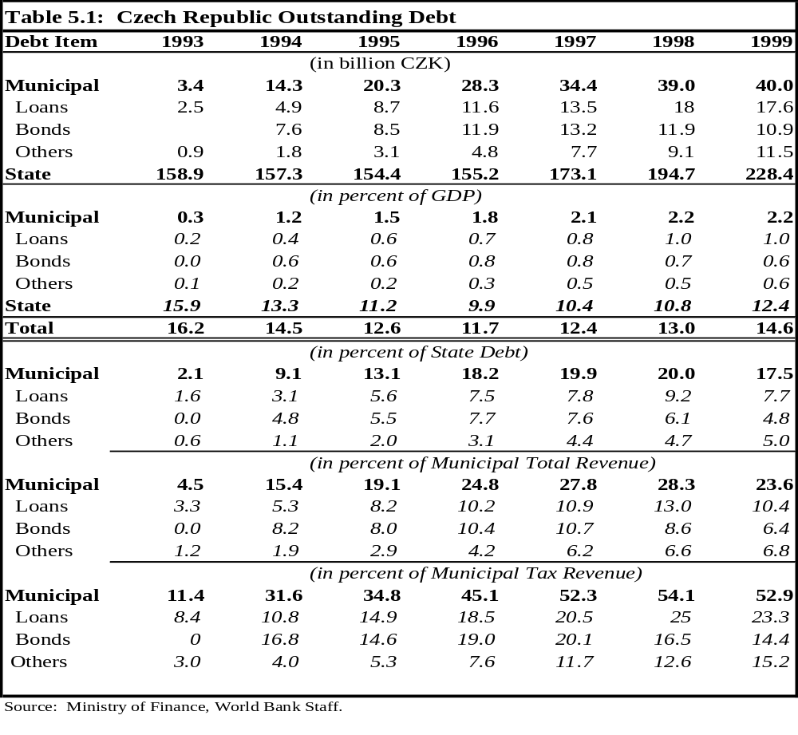

B. Local Fiscal Imbalances and Debt Accumulation
- In the Czech Republic, only municipalities, as self-governing entities, can have access to borrowing. District offices do not have the power to assume financial contractual obligations of their own because they are merely deconcentrated bodies of state territorial administration.

- The outstanding debt of Czech municipalities has shown a systematic increase over the period 1993-99, reaching 53 percent of municipal tax revenues in 1999 from 11 percent in 1993. This debt corresponds to 2.2 percent of GDP and about 20 percent of
the state debt in 1999. Although that municipal debt may still be considered too small to be an immediate threat to macroeconomic stability, it is worrisome that it grew rapidly — more than sixfold—during the period (Figure 5.1). The 1999 stabilization of municipal debt outstanding in relation to GDP (and even the slight drop in relation to municipal tax revenue) appears to have been a result of significant sales of financial assets during 1999, which allowed municipalities to cope with their entire financial needs for the year, including some debt amortization.

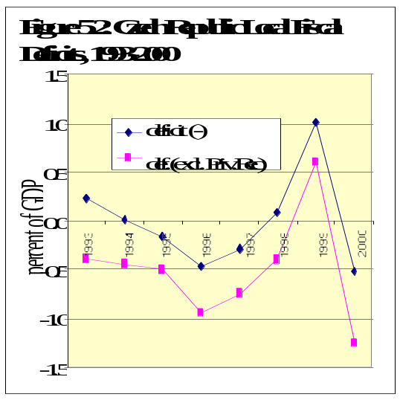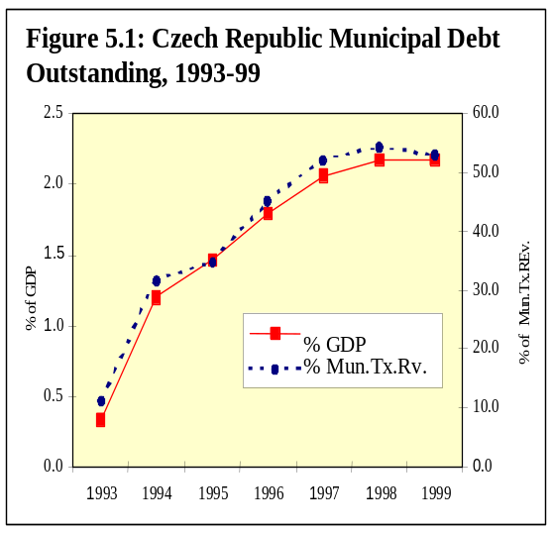

Source: Ministry of Finance.

- What is more worrisome, however, is the fact that, except for 1999, the reasons why municipal outstanding debt grew so rapidly during the decade are not entirely transparent. There is no evident correspondence between the imbalances of the fiscal accounting flows of municipalities (reflected in the deficit curves of Figure 5.2) and the municipalities’ debt accumulation (Figure 5.1). It should be noted that while fiscal flow statistics show the municipalities’ fiscal standing as reasonably stable during the 1990s (i.e., with rather small deficits alternating with small surpluses), aggregate municipal outstanding debt accumulated quite rapidly. This apparent statistical discrepancy may reflect lack of uniformity in accounting and lack of transparency, which could result from: (i) probable differing interpretations by municipalities of accounting procedures (see Chapter 6); (ii) off-budget financial operations, including reimbursable components of “grants” from the state budget and Extrabudgetary Funds inadequately recorded as revenue by some municipalities; and (iii) credit guarantees to budgetary and non-budgetary organizations (and other off-budget contingent liabilities) that have been effectively assumed by municipalities only when these guarantees were due.

- The lack of uniformity in accounting and the absence of full transparency in fiscal operations (including those affecting assets and liabilities of the public entities) may represent a major macroeconomic risk, because, in such situations, statistics tend to become unreliable and non-transparent contingent liabilities tend to show up as direct municipal liabilities only when the obligations are called upon. As non-transparent contingent liabilities have not been properly reflected in the flows of the fiscal accounts, there is no early warning system in place indicating the level of risk to which municipalities are exposed.

C. Expansion and Composition of Municipal Debt
- The expansion of municipal debt during the 1990s was broad-based. All forms of municipal debt expanded substantially: loans, bond issues, and “other” (the last including non-commercial loans, and, especially, “refundable transfers”). Bond debt expanded intensively in the mid-1990s (Table 5.1). Toward the end of the 1990s, the Exchange Commission actually prohibited new bond issues as part of the general fiscal adjustment policy. As a consequence of the regulations and prohibitions of the late 1990s, no municipal bond issuance occurred until early 2000, and the municipal bond debt outstanding has fallen slightly in nominal terms (Figure 5.3). Recently, only Prague has issued bonds in the foreign financial market (EUR 200 million in 1999 (Table 5.2).
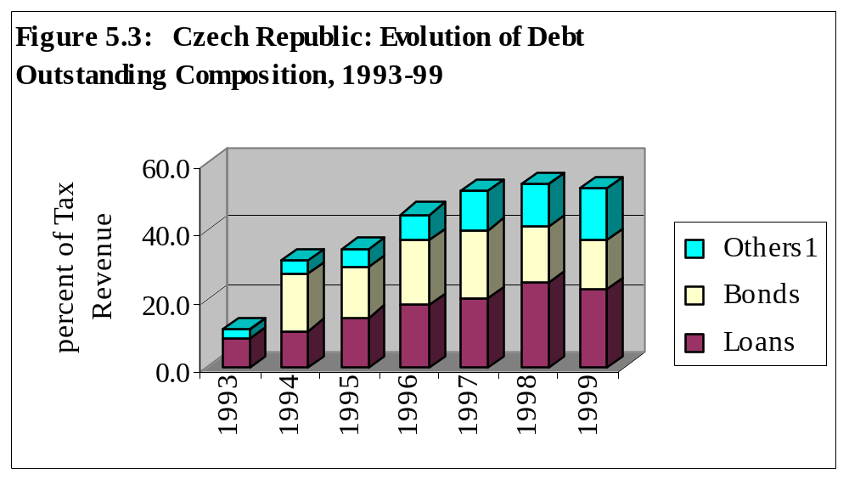

Source: Ministry of Finance.

- In the late 1990s, municipalities’ outstanding debt was composed of 45 percent loans, 29 percent issued bonds, and 26 percent “other” (Figure 5.4). While most local governments have had access to banking loans and credit, bond issuance (especially the placement of bonds in foreign financial markets) has been accessed only by the larger cities (Prague, Ostrava, Plzen, Brno, Liberec, Usti nad Labem, and a few others). Municipal bond issues (mainly by large cities in foreign capital markets) and municipal commercial loans (mainly domestic) have essentially been aimed at financing city public construction works and transportation systems. Concessional loans from the state have been on a programmed basis (e.g., to supplement the required counterpart funding for the EU pre-accession structural funds for investment projects) and on a discretionary ad hoc basis (as in the case of the State Environmental Fund and the state budget). Municipal borrowing from the State Environmental Fund has mainly financed gas and water supply systems, sewerage, and wastewater treatment plants. Municipal borrowing from the state budget has been mostly for housing. Arrears is another component of local government indebtedness (to wages and salaries, as well as to suppliers), although this item does not appear to be a significant component of local debt in the Czech Republic.

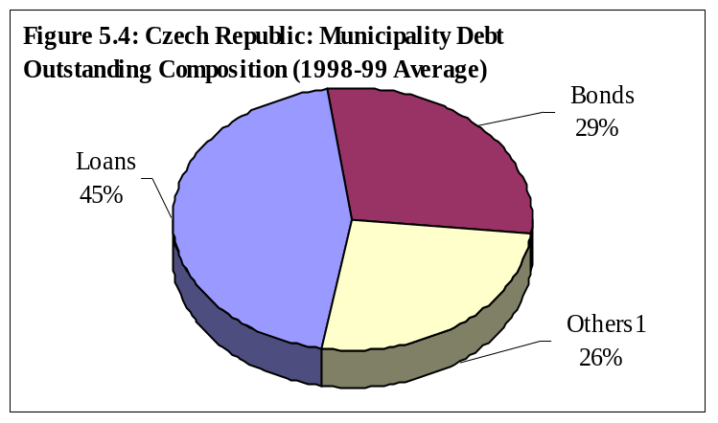

Source: Ministry of Finance.

D. Access to Borrowing by Municipalities
- While large Czech municipalities have had access to all financial markets and to the most sophisticated debt instruments for the financing of their investment projects, small municipalities have had access, if any, only to local banking and non-commercial credit sources. This difference is at least in part reflected in the vast contrast in creditworthiness between these two groups of municipalities. While larger municipalities have inherited substantial assets and have enjoyed buoyant tax bases (showing good performance of revenue from shared taxes, mainly the PIT and CIT), small municipalities do not have sufficient assets and have shown only a meager revenue/tax capacity, insufficient to support credit operations.

- Moreover, there has been the perception that the current Czech Commercial Code restricts collateral for credit operations to existing assets at the time of the debt agreement signature (in other words, that the Commercial Code does not recognize future revenue as collateral. This perception (though not confirmed by the current regulations) together with the limited tax autonomy of local governments, may be a factor in preventing small and medium-size municipalities from improving their access to financial markets.

- Banking sector representatives have seen these issues as major concerns when dealing with municipalities’ credit and have argued that banks would prefer municipalities to have more freedom on their own tax bases, rather than being heavily dependent on state transfers. In spite of this, it appears that most small and medium-size municipalities are indebted, and in these cases beyond their ability to service the debt. Indeed, it appears that some of the weaker municipalities are actually insolvent. The perception in the banking sector is that only a few of the small municipalities have shown good creditworthiness in the recent past, because of their potential development as tourist centers. In fact, some of these municipalities (e.g., Smrzovka, and Rokytnice nad Jizerou) are already borrowing heavily from the banking system (especially from Ceska Sporitelna—the Czech Savings Bank) and investing in tourism infrastructure.

Table 5.2: Municipal Bonds Issued, 1992-1999
Year of Issue | Municipality | Face Value (mil.CZK) | Maturity  (years) | Interest  Rate (%) | Underwriter
1992  1993  1994  1995  1996  1997  1999 | Ostrava  Sumperk  Smrzovka  Liberec  Prague  Pardubice  Usti nad Labem  Caslav  Rikytnice nad Jizerou  Veseli nad Moravou  Rychnov nad Kneznou  Plzen  Marianske Lazne  Brno  Frydek-Mistek  Decin  Kladno  Ostrava  Zidlochovice  Prague | 8.5  20  115  100  USD 250 mil (equivalent to CZK 7,3 bil.  50  150  90  120  10  100  500  200  1,200  150  250  250  DM 75 mil. (equivalent to CZK 1,318.2 mil)  40  EUR 200 mil. | 6  5  7  5  5  5  5  8  7  7  7  5  5  7  5  7  7  5  10  5 | D+1,5  18.00  14.25  14.25  7.25  12.70  12.70  15.50  12.00  14.10  13.10  11.50  11.50  11.10  11.80  12.50  12.50  LIBOR+0.2  25%  12.90  4.63 | City Hall  CSOB  CS  CS  Nomura International  KB  KB  Burzovni spolecnost pro  Kapitaloy trh  CS  Velkomoravska banka  KB  Bayerische Vereinsbank  Praha, ING CR, Capital  Markets, SCFB Praha,  KB  KB  IPB  CS  CSOB  CSOB  ING Barings  CMZRB  ING Barings
Source: Ministry of Finance.

E. Local Government Indebtedness
- Debt financing of capital expenditure is a common feature of decentralized subnational governments, which in general have (or should have) the responsibility for financing local public infrastructure. This has not always been the case in the Czech Republic, where the central government still participates heavily in the financing of local infrastructure, mainly through matching grants (Chapter 4). On the one hand, transferring this responsibility to subnational governments (especially the richest ones) is an important step in the direction of developing a sense of ownership at the local level, which tends to result in improved maintenance of the capital stock and an increased rationalization and efficiency in the use of facilities.

- On the other hand, full financing of local capital needs out of local current revenues (without borrowing) would be neither quantitatively feasible—even if the local authorities had the desired autonomy on local tax bases and rates—nor economically efficient (or equitable). It would not be efficient or equitable because in general the benefits of these investments persist for several years (or decades), and future generations should participate in expenditure financing as well.

- There is also a cash management argument to the effect that local government borrowing may also be justified by the need to match non-synchronized expenditure and tax flows within the same year. Moreover, borrowing may also provide an important independent mechanism for fostering political accountability, since financial markets may signal the performance quality (good or poor) of local governments through credit ratings and actual interest rates charged, or simply by blocking the governments’ access to credit.

- Overall, local government access to borrowing may be desirable as an instrument for optimizing inter-temporal allocation of resources and promoting economic growth and fiscal equity. However, in the absence of clear rules and accountability, financial market failures and soft budget constraints may lead to irresponsible excessive indebtedness on the part of local governments and can easily become another kind of problem. In particular, local officials can be tempted to overspend on popular programs by borrowing in excess now and leaving the bill to be paid by future taxpayers. Uncontrolled local borrowing may lead local governments to default on their debts, forcing the central government to assume these unpaid liabilities. This would pose major macroeconomic and stability risks, which would justify the Czech government’s adopting adequate regulations and monitoring mechanisms to ensure that local government access to borrowing and indebtedness is fiscally responsible.

F. Management of Local Government Debt
- The international experience offers several approaches to the management of local government debt from which the Czech Republic might profit when designing its own model. The most common approaches include: (i) leaving financial market discipline to operate freely; (ii) establishing strict administrative, case-by-case control; and (iii) establishing explicit, preemptive and legally binding general rules to prevent crises and encourage good market behavior. A combination of these options may prove more advantageous for the Czech Republic.

Market Discipline
- In principle, market discipline would set the most desirable benchmarks. However, governments realize at times that market discipline alone cannot be as effective as desired, because of prevailing market failures, such as the following

(i) Restricted financial markets. Market discipline will not be effective when financial markets are not free and open, as is the case in the Czech Republic. Inter alia, restricted access to foreign capital markets that limits options, and compulsory allocation of resources (including those of official financial agencies and parastatals) to facilitate the placement of government bonds, are common market failures. And market failures lead to suboptimal financial sector portfolio composition.

(ii) Lack of transparency. Without the adequate availability of and dissemination of information, and without full transparency on debt outstanding and capacity to pay, market discipline will fail. Obtaining reliable financial information in the Czech Republic—especially for the local governments (as observed above)—is not a trivial effort. Municipalities may not follow the same interpretation of the chart of accounting, or may not maintain clear and uniform registers of their assets and liabilities, or may not publish and disseminate information on debt and capacity to pay on a systematic and reliable basis. Moreover, extrabudgetary/contingent liabilities assumed by direct or indirect guarantees provided by local governments to their parastatals or funds are major areas in which considerable transparency improvement is needed.

(iii) Soft budget constraints and moral hazard incentives. When moral hazard incentives permeate the relationship of the public sector with the financial system, the efficacy of market discipline as an instrument for checking excessive local government indebtedness is jeopardized. Ad hoc, extraordinary, and off-budget financing, or the concession to municipalities of guarantees to certain loans by the Czech central government (either through grants or through lending operations), or by municipalities to municipal budgetary and non-budgetary organizations, are also “hidden” forms of soft budget constraints that may lead to moral hazard incentives.

(iv) Insensitivity to market signals. For market discipline to be effective, the borrower should evidence sensitivity to market signals by seeking financial policies consistent with full solvency. Increasing interest rates should stop or should at least make the borrower review its borrowing decision. It is unlikely, however, that municipal mayors and heads of regional executive boards, as elected politicians, will be concerned with market signals when deciding on their current expenditure programs.

- The international evidence is that even in mature financial markets, such as that of Canada, sole reliance on market discipline has not been satisfactory in checking the excessive indebtedness of subnational governments. In the mid-1990s, subnational government debt in Canada reached 23 percent of GDP. The subnational governments were forced by this to adopt fiscal adjustment programs, but only after they were excluded from the market, which entailed high social costs. In Brazil and Argentina, without the necessary market conditions in place, the experience in the 1980s proved disastrous and the central government had to intervene with large bailout operations to rescue the creditors and to avoid systemic crisis.

- Under the present market conditions in the Czech Republic, sole reliance on market discipline is unlikely to be sufficient to improve the responsible access of local governments (municipal and regional) to the capital market. A more viable alternative is to have regulation in place that is sufficiently adequate to prevent excessive local government indebtedness (as is discussed below). Nevertheless, to the extent possible, regulation should imitate desirable market discipline, in order to minimize distortions and encourage market practices in the future. In addition, the government should explicitly encourage market discipline, participation of the private sector, and development of independent institutions. Periodic monitoring reports by independent organizations on municipal and regional indebtedness and on the current and prospective financial situation of municipalities and regions also tend to have a major impact on the development of market institutions and should be encouraged by the government.

Administrative Controls
- Some countries exercise direct controls over the access of local governments to capital markets by: (i) requiring approval by central agencies for credit operations proposed by local governments; or (ii) prohibiting local governments from directly accessing capital markets. Requiring central agency approval means that credit operation contracts are individually evaluated on their financial terms and conditions. In such a case, central government micro-management, bureaucracy, and inefficiency are likely to crop up. India has used this approach because the central government is a major creditor of the states and because such approval is a Constitutional provision. Australia, during the 1980s, prohibited direct access to capital markets, centralized all loans, and then on-lent to the subnational governments. However, as direct control was not effective, Australian subnational governments have again been allowed free access to capital markets, but they are controlled ex ante from an aggregate perspective and more closely monitored ex post from an individual perspective.

- In general, central governments have realized that increasing direct control over local governments’ credit operations is inconvenient in that: (i) it increases the centralization of financial decisions, which runs counter to the fiscal decentralization goals of greater accountability on the part of local authorities and enhanced allocation efficiency; and (ii) it involves the central government in micro-managing every local government credit operation, which tends to increase central bureaucracy and administrative inefficiencies, and tends also to foster undesirable inefficiencies in the financial system. It is well understood why direct control of every credit operation has not been recommended for the Czech Republic: the country’s 6,239 municipalities and 14 regions would make direct control both costly and difficult.

- Regarding the indiscriminate prohibition of access to borrowing, such an option would seem incompatible with the Czech Constitution (Art. 101)—which allows self-governments to freely operate their own properties and budget—and with certain Parliamentary Acts establishing and regulating the regions (Act#129/2000) and municipalities (Act#128/2000). These Acts empower the respective Assembly of Representatives with the right to decide on credit/loan operations.

Rules-Based Approach
- Rules for access to capital markets can be effective only if they are legally binding, simple to follow, transparent, and applied across-the-board. Such rules should comprise clear quantitative limits and procedural norms, which respect and imitate, to the extent possible, good practices of financial market discipline and creditworthiness indicators. Many countries have adopted the rules-based approach as a preventive measure, or according to the needs of particular situations, to curb subnational government access to capital markets (examples include the United States, Spain, Japan, Korea, and Brazil).

- Some countries limit the credit operations of local governments in order to preempt systemic crises, by prohibiting the following: (i) central bank financing; (ii) non-investment expenditure financing; (iii) short-term liquidity assistance; and (iv) external (foreign) financing. These rules are, in many cases, well justified. Aiming at monetary stability, independent central banks should not provide any kind of direct finance to government, including local governments. Also, non-investment expenditure financing by the banking system should be banned, as a golden rule, to force local governments to stop postponing necessary adjustments in their recurrent expenditures. While the Czech Republic should pursue restrictions (i) and (ii), it may not be wise for it to follow restrictions (iii) and (iv). In fact, short-term loans for liquidity assistance purposes create an opportunity to smooth out local government cash flows during the year, and can optimize financial inflows with outflows. In many countries (including the United States and Brazil) short-term loans for liquidity assistance are quite common and appropriate. But for liquidity assistance to perform its function well, there must be a contract-binding proviso to the effect that local governments are obliged to liquidate their debt during the same fiscal year.

- The most compelling reasons for the prohibition of subnational government access to foreign capital markets have been macroeconomic: (i) that such operations may have an impact on stabilization; (ii) that a concerted negotiation approach could be beneficial for the country; (iii) that the default of one individual entity might spill over on the creditworthiness of the other entities and on sovereign risk rating; and (iv) that multilateral financial institutions usually require a sovereign guarantee. However, as market conditions in the Czech Republic are evolving at a fast pace, as the integration to the EU market is imminent, and as the fiscal decentralization process is in progress, this prohibition would be counterproductive in terms of promoting European market integration and in terms of opportunities lost through inability to access international capital markets. For the time being, instead of an outright prohibition or complete liberalization, it may be prudent to continue with the requirement for prior permission of the Exchange Commission for foreign loans to local governments.

The Practice in the Czech Republic
- In the Czech Republic, access of municipalities to capital markets has been controlled by a mix of market discipline and some implicit government control, exercised by moral suasion on the part of the central authorities on both the financial institutions and the municipal governments. Since 1997, the Ministry of Finance has suspended authorization by the Exchange Commission to local governments to place new bond issues in foreign markets and has recommended that financial institutions stop lending to those municipalities that have reached 15 percent debt service ratio. In addition, the Ministry of Finance has threatened to discontinue state “subsidies” (grants and loan transfers) to municipalities that do not obey these rules. Although banks apparently have followed the recommendations, these rules are not legally binding.

- The only formal instrument of local indebtedness monitoring and control is the Exchange Commission. However, this institution only decides on the authorization of bond issuance for a domestic borrower in foreign capital markets. It does not monitor the spectrum of municipal debt, including domestic indebtedness. Legally, there is no formal limitation for municipalities on borrowing, and they can borrow from whatever financing source, for whatever purpose (even to finance recurrent expenditures), and under any financial condition of time and rates. Some of the financial operations of municipalities are guaranteed by official institutions (including Ceska Sporitelna), but the majority of these operations are not explicitly guaranteed and it is not certain how creditors would recover their money in case of default. The current Bankruptcy and Composition Act does not include municipalities as a subject, and this may be a reason for the increasing reluctance of the banking system to continue financing most municipalities.

- On the other hand, municipalities themselves have been granting loans and guarantees to local businesses in support of local developmental activities. Although such financial activities of municipalities in the Czech Republic are subject to the approval of Municipal Assemblies, the procedures are not clear, and the lack of monitoring and supervisory mechanisms has left room for soft budget constraints and has also produced moral hazard incentives—both features of a high fiscal risk situation.

G. Options for Reform
- There is a clear need to develop a financial system that includes basic operational and supervisory rules specifically designed for the indebtedness of local governments (municipalities and regions) and is aimed at promoting responsible access to capital markets as a leverage for optimizing local capital investment financing but also keeping in place hard budget constraints. Also, institutional arrangements on the availability and reliability of local debt information need to be seriously considered in order to improve transparency and accountability in the whole system.

- Nevertheless, reform options should not preclude the continuation of the basic current legal structure that allows normal access to borrowing subject to Local Assembly approval—although submitted to reinforced supervision rules of the Exchange Commission, the Czech National Bank, and the Ministry of Finance. At the present juncture, the government may consider examining the implementation of the following reform options in relation to the municipal/local capital market.

(i) Restricting loans to high-return investment expenditures by banning medium-term and long-term loans for the recurrent expenditures of local governments and by enforcing full repayment in the same fiscal year of any short-term liquidity assistance.

(ii) Limiting the debt service ratio of local governments to a maximum of, for example, 0.1 (i.e., the flow of due interest and amortization to the flow of revenue should not surpass 10 percent). Above this limit further indebtedness should not be allowed, because debt service commitment would be likely to jeopardize the normal delivery of basic local public services (such as education, health, and social assistance).

(iii) Limiting the total indebtedness indicator of local government (i.e., the ratio of debt stock outstanding—including indirect and contingent liabilities—to the flow of total annual revenue excluding conditional grants) to a maximum of, for example, 0.8 in the long-run. For the time being, the central authorities should adopt a prudent approach by allowing only gradual increases in the total indebtedness indicator of individual subnational governments.

(iv) Limiting banks’ portfolio exposure to a certain maximum dictated by recommended banking prudential rules, enforced on a bank-by-bank assets basis, for each local government. The Central Bank should apply strict norms of supervision, especially to the official credit institutions (e.g., Ceska Sporitelna) .

(v) Passing and implementing a financial emergency or bankruptcy law for local governments that could clearly define debt workout procedures in case of local government default. This is a must in view of the current Czech capital market conditions. Once approved, this procedure for the settlement of local government debts should be implemented diligently. The Hungarian “Procedure for Settlement of Local Government Debts” may be a good practical case to be observed during the review of the Czech Republic’s own bankruptcy law. Nevertheless, putting in place a sound bankruptcy mechanism does not diminish the need for setting up a proper system of controls and incentives to harden the budget constraints of lower-tier governments in Czech Republic.

(vi) Adopting a Law on Fiscal Responsibility which would aim at limiting reiterated, excessive deficits and the imprudent buildup of (local) public debt. This type of law would create the conditions that would increase efficiency, fiscal transparency, and the accountability of public administration in general, and of local government in particular. Fiscal authorities and managers (including municipal/regional officials) would be personally legally accountable for their decisions, and financial guarantees by subnational governments (either to their enterprises or to local businesses) should be prohibited and central government guarantees to (and bailouts of) local government indebtedness should be explicitly banned by this law. New Zealand’s, and particularly Brazil’s, Fiscal Responsibility Acts may also provide some guidance for this reform.

(vii) Reviewing the Commercial Code financing rules, by clarifying the role and conditions of the future revenue of local governments as collateral for loans to local governments. Such clarification could interject a dynamic element in the process of financing public budgets by forcing local governments to be more transparent and accountable, and by encouraging lenders to evaluate risks more seriously. This reform would be effective only if sufficient marginal tax/revenue autonomy can be given to local authorities so that they can exercise flexibility on local own revenue possibilities.

(viii) Encouraging the dissemination of risk and credit rating analyses of local governments would also improve transparency, would impel the financial system to operate as closely as possible to market discipline, and would promote the practice of creditworthiness analysis. In the United States, Canada, and Australia this has been a common practice, with private risk rating companies playing a central role. This practice helps local governments to obtain the necessary financing from domestic and foreign capital markets, while at the same time it monitors the risks of excessive indebtedness. This practice of credit rating municipalities has just begun in the Czech Republic, and should be decisively encouraged. The government can help by making reliable information on municipalities’ fiscal/financial situation (including budgetary and indebtedness) regularly and openly available to the market.

(ix) Establishing an official monitoring agency to keep records and monitor the overall development of local government indebtedness, including all kinds of contingent liabilities. This agency, possibly under the Ministry of Finance, should exercise statistical, coordinating, and supervisory roles. The agency would be essential for the dissemination of reliable information on a systematic basis, as well as for enforcing the Fiscal Responsibility Law, for initiating financial emergency measures, and for supporting the development of market institutions and fostering market discipline. Such an agency would increase transparency and create a system of early warning for local government indebtedness.

Subnational Government Budgeting

- Until very recently, the budget process at the subnational level in the Czech Republic was regulated by the Budgetary Rules Act of 1990, which also applied to the state budget and the budgets of other public institutions. In July 2000, Parliament passed the Law on Budget Rules of Territorial Entities (Law no. 250/2000), which exclusively regulates the budget process of the municipalities and the new regions. This law also regulates the partnerships of municipalities for the joint provision of services.

- Although the new Law on Budget Rules of Territorial Entities contributes significantly to a more efficient and transparent budget process at the subnational level, important aspects of subnational budgets still require review and reform. This Chapter addresses the most important standing issues in the areas of: (i) local autonomy, budget discretion, and accountability; (ii) budget preparation, predictability, and transparency; (iii) budget execution, monitoring, and reporting; and (iv) budget control and performance evaluation.

A. Autonomy, Discretion, and Accountability
- At the beginning of the transition, municipalities had little autonomy or discretion in setting expenditure priorities and making budget decisions on the delivery of public services. Paralleling this lack of autonomy and discretion, local governments had little or no accountability to residents within their jurisdictions. Instead, accountability was vertical, to the central government administration apparatus.

- Local government autonomy, which was proclaimed in the Constitution, developed initially with the reforms of 1993 and has continued to evolve. Many features of the current system of intergovernmental relations also add to the autonomy and discretion of local governments. Municipalities have their own democratically elected governments and have independent administrations. In particular, municipal finance officials are not under any central authority but respond exclusively to municipal elected representatives. Also important is the fact that the budgets of local governments are not linked to the central government budget and local budgets do not, in principle, require approval by central authorities. As has been noted, of course financial links do exist between the budgets at the two levels through revenue sharing and transfers and limitations on the use of transfer funds when these are in the form of specific subsidies. For the most part, municipal governments are also free to make decisions on the most efficient way to deliver public services without intervention from central authorities. In this context, local governments are not subject to uniform standards of services (unless they are delegated responsibilities financed by specific subsidies from the center), nor are local governments subject to expenditure or capacity norms or to minimum expenditure requirements.

- In addition, each municipality has its own personnel services and has complete freedom to hire and fire. Municipalities are also completely free to contract with the private sector for the delivery of public services, and, in fact, many do so.

- Nevertheless, several features of the current budget system limit municipalities’ autonomy and discretion on both sides of the budget. These features include the following:

- Local governments have no flexibility in setting wages. Thus, even though they are free to hire and fire their employees, local governments cannot adapt to local labor market conditions.

- Several important fees and charges for government services are still regulated by central authorities. The budget consequences are particularly important in the case of housing—the highest expenditure item in municipal budgets—where the central government still controls rents.

- Municipalities have, as has been analyzed in previous Chapters, little autonomy over the revenue side of their budgets. In particular, municipalities have little discretion over the tax rates of meaningful tax instruments. This lack of tax autonomy undermines municipal government accountability to citizens.

- In addition, several other features of the system limit the autonomy of local governments in less precise, although no less important, ways. One form of restriction is brought about by the current norms used in education, social assistance, and health, pertaining to workloads, average class size, etc. Municipal discretion is also reduced by the matching fund requirements in many subsidies and by the increasing importance of mandatory expenditures for social assistance. These latter forms of restrictions on local autonomy are much harder to control, since in many ways they may be justified: for example, norms are needed to regulate the size of teacher payrolls in the education sector. Thus, there is a need to balance conflicting objectives without unduly sacrificing local autonomy.

B. Budget Preparation, Predictability and Transparency
- Several aspects of budget formulation practice at the local level contribute to the transparency of municipal budgets. Local governments are obliged by law to publish the draft budget. Legally, the budget structure for local governments is uniform and follows the structure of that used for all elements of the general government budget. The budget calendar is also uniform and follows the calendar year. The municipal budget and the new regional budgets as a rule need to be drafted as balanced budgets. A deficit is allowed only if it can be covered by accumulated financial assets or by loans, bonds, or financial aid.

- But other aspects of budget formulation detract from the predictability and certainty of the budget process. However, these features are essential for planning and expenditure efficiency at the local level. Currently, budget formulation in the Czech Republic is strictly top-down. Central authorities basically determine unilaterally the amount of transfers and other resources that the state budget will allocate to the local budgets in a specific year, and local governments are not involved sufficiently in the derivation of the budget envelope for subnational governments. The introduction of organizations for coordination and dialogue between the different levels of government (discussed in Chapter 2) could alleviate this problem.

- One difficulty affecting budget predictability at the local level is that the budget cycles of subnational governments and the central government are not synchronized. While local budgets are approved in November and December, the central government budget often may not be approved until well within the fiscal year. In the Czech Republic, this lack of synchronization is important because of the dependence of local governments on central government subsidies, transfers, and shared taxes. To date, local governments have coped with this uncertainty but it has nevertheless affected budget planning at the local level. Using formulas for the allocation of transfers and using stable rules for funding over the years should enable local governments to better cope with this situation.

- However, the state and municipal budgets will continue to be sequentially linked. This will apply also to the state and the regional budgets. It is clear that regional budgets will not be formulated and approved until the state budget is approved. Because of this time dependency, it will be worth reconsidering the time periods allowed in the law for the formulation and approval of both the state budget and the local budgets. The obvious solution would be to advance in time the deadline for approval of the state budget and provide the regions and municipalities with more time for a realistic formulation of the budgets and for thorough discussion by the respective elected councils.

- Another way of increasing predictability would be to widen the planning horizon for public expenditure programs. Although municipalities are only required to prepare annual budgets, it is recommended that they maintain multi-year projections for capital investment projects and loans. In particular, the Law on Budget Rules of Territorial Entities requires that municipal and regional governments produce a “budget overview” as a tool for medium-term financial planning and that they take into account all their contractual obligations. The “budget overview” must include data on revenues and expenditures and, especially, information on long-term obligations and outstanding debts, as well as financial resources. In addition, from 2001 the central government will be required to produce a medium-term budgetary outlook which will be prepared by the Ministry of Finance in cooperation, inter alia, with the territorial self-governments. In the future, these exercises may be instrumental in introducing the concept of a simple medium-term expenditure framework for local governments. A more formalized medium-term budgetary framework should help local governments to better cope with the dynamic aspects of public expenditures. For example, given the significant decline in fertility in the country, it is likely that excess capacity will develop in primary education. At the very least, there should be an increase in local budget predictability as a result of the multi-year budget framework required for the state budget.

- Another aspect of the budget process at the local level that adds to the overall uncertainty of municipal budgets is that local governments are allowed to offer guarantees to budgetary and non-budgetary organizations and appear to do so quite often (Chapter 5). Little information exists as to what the actual financial exposure of local governments is in relation to these guarantees and to other contingent liabilities. But the overall stability of subnational budgets hinges upon reining in these practices, if not eliminating them entirely. Transparency in this area needs to be significantly improved.

- Another factor contributing to local budget uncertainty is that budgeting for capital investment at the local level remains weak and there are no provisions for separate capital budgets. At the central government level, the process in support of local government investment is quite fragmented and often lacks transparency. For example, the lists of recipients and the amounts of funds granted by Parliament have not been made public until recently, and the selection of local investment projects by the executive branch is often not transparent.

C. Local Budget Execution, Monitoring, and Reporting
- The new Law on Budget Rules of Territorial Entities is sparse on the treatment of budget execution issues. Currently, no treasury function exists at the subnational level and consequently there is no comprehensive monitoring system for the performance of budget execution for local governments. While the recent reform of the budget system will introduce a single account approach at the central government level, there are no provisions in the Law on Budget Rules of Territorial Entities requiring local governments to adopt a similar approach.

- Despite this relatively lax budget execution environment, the actual performance of local budgets has apparently displayed no major disruption. In particular, there has been, at least in recent years, no sequestering of the budget or reported significant development of budget arrears to suppliers or wage arrears to employees. Local governments are required to send the Ministry of Finance a monthly report on a uniform basis. Although more in depth research is needed, the level of overall operational efficiency seems reasonable, given the current level of budgetary discretion. The widespread use of public bids for the procurement of services may have contributed to keeping delivery costs reasonably in check and may have reduced the opportunities for corruption in the public sector.

- As at the central level, most budget adjustments at the local level have been made through reductions in public investment. Although bureaucratically convenient, significant jumps or discontinuities in capital expenditure tend to be a less efficient way of cutting overall expenditures. It would be desirable for local governments to take a wider approach to budget adjustments and to prioritize expenditures by deciding on the desired outcomes in the preparation phase.

- Accounting principles are uniform for all local governments and are dictated by law. Nevertheless, incomplete accounting systems (lack of precise rules and instructions on how to apply them) remain one of the most serious problems at the local level. The current municipal accounts do not provide a full picture or a complete statement of the balance sheet of municipalities. In practice the implementation of the current accounting system can be weak, owing for the most part to the proliferation of very small municipalities with low administrative capacity. Although there is a uniform budget classification, interpretations of the accounts vary and budget items capture different information in different municipalities. One apparent reason for this is that municipalities do not have enough information on procedures. Another cause is the lack of skills of officials, especially in smaller municipalities.

- To a large extent, the acceptable budget execution performance of many municipalities may be attributed to the oversight and assistance provided to them, until now, by the district offices, particularly in the case of the smaller municipalities. The phasing out of the district offices since beginning-2001 raises the important issue of whether the new regions will be willing to provide the same service, and whether they will be able to do so, given that the load or number of municipalities will be much higher per region. Moreover, at least at this initial stage, it is understood that there will be no hierarchical relationship among the self-governing entities, which would make regional oversight difficult. This is an important issue requiring the immediate attention of the government. One option, then, would be to find an acceptable means of making the

regional governments responsible for oversight of and assistance to smaller municipalities in budget execution matters.

D. Control and Performance Evaluation
- Municipalities are required to make public the budget outturns, although no standard format is required for this final accounting result. The law also requires that the budgets of all municipalities be audited annually. The vast majority of the municipal external audits has been carried out by the district offices. However, the budgets of some municipalities are audited by private firms. There are concerns over the quality and accuracy of the external audits of municipal accounts in part because the district offices have had to perform on average the audits for over 80 municipalities in a very short period of time. There is some consensus among practitioners that the independent auditors tend to do a more thorough job. However, fewer municipalities have used them because they can be costly, and the audit by the district office was free.

- The 2000 Law on the Establishment of Regions (Act of Parliament # 129/2000) requires an external ex post audit of the regional government accounts every year either by an independent auditor or by the Ministry of Finance. In the case of the former, the regional government would have to pay for the cost of the audit. The results of the audit must be discussed by the Regional Assembly before June 30 of the following fiscal year. This puts budget oversight and audit at the regional level on the same footing as that for municipal governments.

- External audits of municipalities have concentrated exclusively on financial and legal compliance. Thus, the focus of the evaluation has been on the use of inputs, budget resources, and compliance with rules rather than on the outputs, the outcomes, and the performance of local expenditure programs. These concerns also apply to the future audits of regional budgets.

- Carrying out full-fledged performance audits at the local level is probably not feasible at the present time, especially for the smaller municipalities. However, improving the efficiency of public expenditures at the subnational level will require the introduction of budget evaluation programs in the near future, at least in Prague and the larger municipalities as well as at the new regional level.

E. Options for Reform
(i) Increasing budgetary autonomy. The realization of benefits from decentralization (i.e., increasing the efficiency of public expenditures) is not possible without an adequate degree of budgetary autonomy. Although local governments in the Czech Republic enjoy some degree of budgetary autonomy, there are three specific areas in which policy changes will be needed. First, local budget autonomy will require that local governments are able to increase (or decrease) the size of their budgets, at least at the margin, by setting the tax rates for some meaningful taxes. Second, rent and tariff controls by central government agencies at the local level should be gradually lifted over time, with the proper regulatory arrangements in place. Third, local budget autonomy will also require that local governments have not only the discretion to use their resources according to their own priorities but also the freedom to deliver public services using the production techniques and combinations of inputs they consider most cost efficient.

(ii) Increasing budget predictability. Budgetary predictability requires that local governments are able to prepare their budgets separately from the budget process of the central government. This means that local governments would be able to approve their budgets even when the central government failed to do so on time. For this to be the case, local governments must have certain and stable sources of financing. If some of the financing comes from the central government, as in the case of earmarked transfers, then predictability means that these transfers are determined by formula or other objective means, or that local governments have a different (lagged) budget schedule, or that local government budgets are amended once the exact level of transfers is known. Increasing the predictability of local budgets would also require that central government capital transfers are regrouped into a few well-defined sectoral programs and that more explicit and clearer guidelines are used for the eligibility of local governments. The new regions and large municipalities should be encouraged to adopt a more formalized medium-term budgetary framework, which should help local governments to better cope with dynamic aspects of public expenditures.

(iii) Increasing budget transparency. Budgetary transparency can be improved by facilitating a better use of the uniform budget classification at the local level. The Ministry of Finance should issue clear information and guidelines on procedures and should more effectively facilitate the training of local officials, especially in smaller municipalities. The new regional governments should be charged with assisting small municipal governments in budget preparation and execution, thus taking over the work carried out until now by the district offices. Accounting and reporting requirements should be enforced prior to attributing additional expenditure responsibilities to lower level governments.

(iv) Strengthening budget execution and internal control. Part of the solution to the problem of expenditure monitoring and control at the local level would be the adoption of a treasury function. The current reform at the central level, which adopts elements of a modern treasury function, such as a single account, should be extended to the new regional governments and to municipalities of at least a certain size. The advantages of adopting a modern treasury function at the local level are that it would strengthen internal expenditure control and would help with
such aspects of budget execution as cash and debt management, accounting, and procurement.

- Strengthening oversight and audit over budget performance. It will be necessary to maintain and to strengthen the current financial audits for local governments, with an emphasis on financial and legal compliance. Although external private auditors are likely to produce better quality audits, it is unlikely that the smallest municipalities could afford private auditing companies. Thus, an important task for the new regions will be to improve on the audit services rendered to the municipalities in the past by the district offices. The regional governments may find it more efficient to contract out these services with private accounting firms. While capacity is not likely to be in place soon, there will be a need in the medium-term for a new kind of audit that focuses on the evaluation of budget performance (i.e., on the outputs and outcomes from local expenditure programs). These evaluations may be carried out by the local governments themselves and discussed by local councils at the time of the presentation of the annual financial audits.
Matrix of Main Issues and Options/Recommendations
Issues | Main Findings | Options/Recommendations |  | Timing  (*)
 |  | Strategic Direction of Reforms | Specific Policy Actions
I-Administrative Structure | 1. Increasing fragmentation of municipalities, with most of them lacking adequate technical and financial capacities  2. Lack of cooperation/association among the small municipalities and insufficient outsourcing to improve efficiency in service delivery  3. Lack of decision-making power of local governments (especially the small ones), because: (i) they are mostly executing “delegated” functions; and (ii) they are highly dependent on transfers  4. Unclear responsibilities of the newly created regions because they are still pending on each area ministry decision  5. Risks of structural fiscal imbalances because of indications that new regions’ bureaucracies will be created afresh and expenditures will tend to increase  6. Lack of a multilevel government coordination mechanism to focus on the fiscal decentralization process. | Sustain fiscal decentralization by attributing meaningful decision-making power to territorial self-governing units (regions and municipalities), and amalgamating the smallest municipalities to reasonable size (e.g., smaller size boundary of 10,000 inhabitants). | a. Consider formally establishing a multilevel government coordinating body, led by the central government, to spearhead the fiscal decentralization process  b. Decentralize well defined spending functions to the newly created regions, together with the commensurate source of resources  c. Reverse the process of municipal fragmentation by: (i) providing stronger incentives to promote voluntary amalgamation of small communities into economically and financially viable municipalities; and (ii) adopting an approach of asymmetric assignment of revenue and expenditure responsibilities, and using the new regional self-governing administrative structure (and cooperation with the larger municipalities) as a tool to facilitate the amalgamation process. | Immediate  Short-term  Medium-term
II –Expenditure Responsibilities | 1. Weak coordination and cooperation among different levels of government, although current assignment broadly conforms with general principles  2. Significant disparities across jurisdictions on per capita effective expenditures and “needs” (reflected in the variations in the economic basis and the social indicators)  3. Inability of small municipalities to reach an efficient service delivery  4. Regulation of public utilities tariffs (e.g., water and housing) by the central government without considering total cost recovery basis. | Clarify expenditure responsibilities per government tier and make local authorities fully accountable for policy results (in terms of effectiveness and efficiency of quality public service delivery). | a. Develop institutions for intergovernmental cooperation and dialogue aiming to increase local public expenditure efficiency in areas of concurrent responsibilities  b. Establish a broad-based commission to propose definition of the newly created regions’ expenditure responsibilities  c. Transfer de facto capital expenditures responsibilities to self-governing entities  d. Amend the Budget Rules Law to preempt unfunded mandates  e. Gradually lift central government controls on public utilities prices at the local level  f. Scale back public provision of housing  g. Encourage private sector participation in both financing and delivery of public services, by promoting gradual privatization also of education and health care. | Medium-term  Immediate  Medium-term  Short-term  Medium-term  Short-term  Short-term
Issues | Main Findings | Options/Recommendations |  | Timing  (*)
 |  | Strategic Direction of Reforms | Specific Policy Actions
III – Revenue Assignments | 1. Insignificant degree of autonomy of local authorities over revenue sources  2. Absence of an effective incentive mechanism to encourage tax effort  3. Perverse incentives for tax-cutting competition signaled by the allocation of unincorporated personal income tax (PIT) on a residence of taxpayer basis  4. Full dependence of the new regional administration on the state budget  5. Absence of an economic rationale for the adopted coefficient that adjusts the per capita tax-sharing pool distribution according to population size  6. Risk of further discretionary changes in revenue assignments (and on regulation affecting the intergovernmental fiscal relations in general) | Boost local revenue autonomy to improve budget predictability and local authorities' accountability. | a. Establish all structural parameters of intergovernmental fiscal relations policy in the organic laws (e.g., Budget Rules Law), instead of annual budget laws, in order to increase predictability for the local budgets  b. Re-assign PIT to restore tax-effort incentives and fairness on tax-sharing allocation by: (i) bringing the totality of unincorporated PIT into the shared tax pool; (ii) reducing the progressive rate of the “wage-tax” component of the PIT in a corresponding amount; and (iii) devolving to municipal authorities the right to impose a flat-rate (proportional) PIT local surcharge (piggybacking the national adjusted progressive PIT rate)  c. Consider assigning the newly created regions with: (i) shared-taxes (commensurate with their responsibilities); (ii) autonomous revenue sources, including rural property and surcharges that could piggyback the rate of some national taxes (e.g., a flat-rate PIT similar to that proposed to the municipalities)  d. Strengthen local revenue autonomy by providing local governments with the instrument of market value assessment of properties, and help build local government tax administration capacity for this tax.  e. Review the adopted adjustment coefficient for the tax-sharing distribution mechanism in order to introduce a clear economic rationale to it—considering the convenience of a more transparent formula-based equalization transfer scheme separately. | Short-term  Medium-term  Medium-term  Short-term  Short-term

Issues | Main Findings | Options/Recommendations |  |  | Timing  (*)
 |  | Strategic Direction of Reforms | Specific Policy Actions
IV – Fiscal Imbalances and the Transfer System | 1. Absence of a separate instrument to deal with fiscal disparities across regions  2. Vulnerable system of specific subsidies because: (i)it is too complex and unwieldy; (ii) there is too little de facto control; (iii) access depends on negotiation skills and political connections; (iv) there is little transparency on how it really works; (v) it has become an unstable source of local budget revenue; (vi) total allocation may be perceived as being intentionally reduced as local revenues increases  3. Transfers from the EU pre-accession funds have not yet been positively used as a conditional leverage to rationalize the fragmented municipality structure and to strengthen the fiscal decentralization policy. | Rationalize the transfer system as an instrument to implement policies of national interest, to reduce regional disparities, and to help reverse the fragmentation process of municipalities. | a. Review the current system of specific transfers by: (i) decreasing the number of specific subsidies and simplifying the system; (ii) using explicit, transparent rules or formulas for the allocation of grants; (iii) carrying out systematic ex post performance evaluation of programs; (iv) prioritize programs and stabilize transfers within the context of central government medium-term expenditure framework, aiming at improving predictability for local budgets  b. Consider establishing a separate “Fiscal Equalization Fund” (independent of the tax-sharing mechanism) to specifically address regional fiscal disparities  c. Consider reviewing the financial conditions for the matching funds that the local governments have to contribute to access the EU pre-accession funds, aiming at increasing concessions to the smallest municipalities, but conditional to voluntary, economically efficient amalgamation. | Short-term  Medium-term  Medium-term

Issues | Main Findings | Options/Recommendations |  |  | Timing  (*)
 |  | Strategic Direction of Reforms | Specific Policy Actions
V – Access to Borrowing | 1. Official local debt (in the aggregate) is low, but the “true” level of local government indebtedness is not transparent because of contingent liabilities, off-budget operations, and diverse interpretations of the standard national chart of accounts  2. Municipalities can have free access to all forms of borrowing, but access by small and medium-size municipalities is highly limited by their low creditworthiness (owing to shortage of assets and lack of tax autonomy, as collateral)  3. Because of market failures in the financial system, sole reliance on market discipline is unlikely to provide an adequate guarantee of orderly and responsible fiscal behavior  4. Direct control of local credit operations would undesirably increase central bureaucracy and would run against the decentralization process  5. The Bankruptcy and Composition Act does not include municipalities as a subject, entailing credit to municipalities to be perceived as a high risk factor in the capital market  6. There is no official monitoring or supervisory mechanism in place for subnational government indebtedness that could help prevent irresponsible and destabilizing behavior constraints. | Create the institutional framework and prudential rules to ensure fiscally responsible borrowing by subnational governments and to encourage competitive behavior and market discipline in the financial system in its dealings with self-governing units. | a. Consider formally regulating the municipal capital market, by establishing basic parameters for the access of subnational governments, by: (i) restricting medium and long term loans to investment projects only; (ii) limiting debt service ratio to subnational governments to 0.1; (iii) limiting their debt stock to revenue ratio to 0.8  b. Consider formally establishing prudential rules for the banking system to operate with subnational governments by limiting bank portfolio exposition to local/ regional governments (individually) to certain maximum limits recommended by good banking prudential rules  c. Approve and diligently implement a “bankruptcy law” which clearly defines debt workout procedures in case of municipal/ regional government default  d. Adopt a “Law on Fiscal Responsibilities” to curb excessive deficits and imprudent buildups of public debt, including municipal and regional public debt;  e. Support institutions that promote the dissemination of “risk and credit rating analyses,” aiming at improving transparency, and promoting market discipline  f. Establish an official monitoring agency to keep records and to monitor the overall development of the municipal/ regional capital market and indebtedness, including contingent liabilities. The database of such an institution should be publicly accessible. | Immediate  Immediate  Short-term  Short-term  Immediate  Short-term

Issues | Main Findings | Options/Recommendations |  | Timing  (*)
 |  | Strategic Direction of Reforms | Specific Policy Actions
VI – Local Budgeting | 1. Local budget predictability is a major problem because: (i) budget formulation is still a top down process; (ii) budget cycles in practice are not synchronized  2. Transparency of local budget execution may be affected because a single account approach for the Treasury is not yet mandatory  3. Implementation of the standard accounting system seems to lack uniformity because of diverse interpretation and coverage of budget items  4. External audits have focused exclusively on financial and legal compliance and evaluation of program performance is absent  5. Discontinuation of district offices calls for urgent definition and the establishment of new external audit functions for the new regions as well as for municipalities. | Increase the transparency and accountability of local budgets congruent with the objectives being pursued for the state budget in the areas of budget formulation, execution, and evaluation. | a. Upgrade skills of local officials in the standard accounting system and control, especially for smaller municipalities  b. Make implementation of a single account approach mandatory for the Treasury operations in the self-governing units as well  c. Expand the scope of the external audit toward program performance evaluation, by focusing on output/outcomes besides the input content, and legal and procedural compliance  d. Establish new external audit authorities for the new regions and municipalities.  e. Synchronize the de facto budget cycles (central and local/regional), boost cooperation on budget preparation among government levels, and encourage formulation of simplified multiyear expenditure frameworks for local/regional governments congruent with the central government MTEF. | Medium-term  Medium-term  Medium-term  Short-term  Medium-term
(*) Immediate = to be implemented in the next three months
Short-Term = to be implemented during the next budget cycle
Medium-Term = to be implemented during the next two budget cycles

STATISTICAL APPENDIX
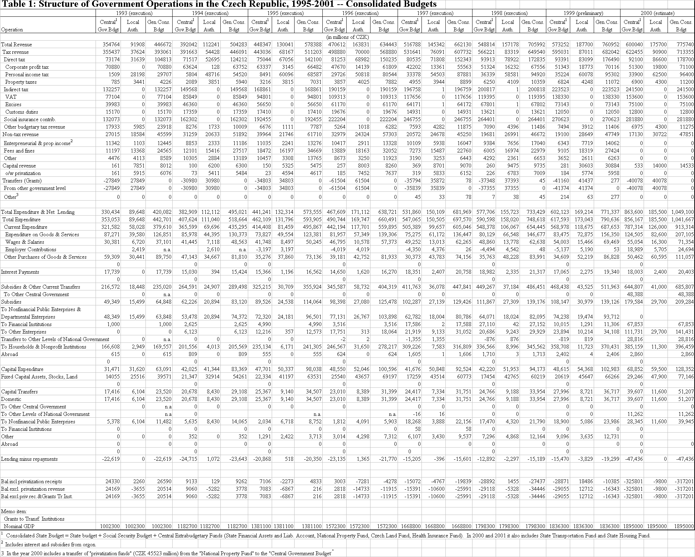

Table 2a: Czech Republic: Per Capita Expenditure for Municipalities Aggregate at the District Level, 1997

District¹ Expenditure (CZK/per capita) | Agriculture and Forestry | Industry, Construction, Trade and Services | Transportation | Water Industry | Telecommunications | General Issues and Other Economic Functions | Education² | Culture, Churches, and Media | Sports and Leisure Activities | Healthcare | Housing, Communal Services, and Territorial Development | Environment Protection | Social Assistance and Benefits | Employment Policy | Social Care and Assistance and Common Activities in Social Security and Pension Insurance | Civic Emergency Planning | Security and Public Order | State Administration, Territ. Self-Governments, Political Parties | Other Public Services and Activities | Financial Operations | Other Activities | Total Expenditure
Mean | 85 | 86 | 1214 | 979 | 10 | 2 | 1442 | 590 | 262 | 116 | 2769 | 624 | 398 | 1 | 435 | 41 | 233 | 1930 | 9 | 224 | 190 | 11639
Minimum | 1 | 1 | 324 | 85 | 0 | 0 | 568 | 78 | 25 | 0 | 814 | 88 | 74 | 0 | 5 | 0 | 55 | 583 | 0 | 0 | 0 | 3540
Maximum | 475 | 594 | 9401 | 2704 | 103 | 61 | 8586 | 4054 | 1937 | 795 | 15790 | 2909 | 4575 | 14 | 2265 | 364 | 2367 | 7891 | 158 | 2016 | 1400 | 57801
Coef of Var | 0.97 | 1.14 | 1.17 | 0.63 | 2.02 | 4.36 | 0.61 | 0.81 | 0.95 | 1.37 | 0.65 | 0.58 | 1.31 | 4.46 | 0.92 | 1.60 | 1.46 | 0.44 | 2.85 | 1.34 | 1.09 | 0.56

Table 2b: Czech Republic: Per Capita Expenditure for Municipalities Aggregate at the District Level, 1998

District Expenditure¹  (CZK/per capita) | Agriculture and Forestry | Industry, Construction, Trade and Services | Transportation | Water Industry | Telecommunications | General Issues and Other Economic Functions | Education² | Culture, Churches, and Media | Sports and Leisure Activities | Healthcare | Housing, Communal Services, and Territorial Development | Environment Protection | Social Assistance and Benefits | Employment Policy | Social Care and Assistance and Common Activities in Social Security and Pension Insurance | Civic Emergency Planning | Security and Public Order | State Administration, Territ. Self-Governments, Political Parties | Other Public Services and Activities | Financial Operations | Other Activities | Total Expenditure
Mean | 93 | 71 | 1375 | 889 | 11 | 3 | 1,463 | 612 | 299 | 105 | 3077 | 621 | 592 | 2 | 481 | 19 | 246 | 1909 | 5 | 235 | 248 | 12357
Minimum | 0 | 1 | 369 | 89 | 0 | 0 | 466 | 123 | 45 | 0 | 1160 | 162 | 101 | 0 | 6 | 0 | 45 | 529 | -2 | 0 | 1 | 4698
Maximum | 595 | 311 | 10548 | 3216 | 94 | 114 | 7,806 | 3290 | 2186 | 571 | 17076 | 3699 | 6294 | 46 | 2791 | 574 | 2282 | 10453 | 99 | 1416 | 2644 | 62359
Coef of Var | 0.98 | 0.97 | 1.08 | 0.66 | 2.10 | 4.81 | 1 | 0.67 | 0.94 | 1.14 | 0.63 | 0.67 | 1.20 | 3.46 | 1.03 | 3.69 | 1.30 | 0.59 | 2.97 | 0.99 | 1.50 | 0.56

Table 2c: Czech Republic: Per Capita Expenditure for Municipalities Aggregate at the District Level, 1999

District Expenditure¹  (CZK/per capita) | Agriculture and Forestry | Industry, Construction, Trade and Services | Transportation | Water Industry | Telecommunications | General Issues and Other Economic Functions | Education² | Culture, Churches, and Media | Sports and Leisure Activities | Healthcare | Housing, Communal Services, and Territorial Development | Environment Protection | Social Assistance and Benefits | Employment Policy | Social Care and Assistance and Common Activities in Social Security and Pension Insurance | Civic Emergency Planning | Security and Public Order | State Administration, Territ. Self-Governments, Political Parties | Other Public Services and Activities | Financial Operations | Other Activities | Total Expenditure
Mean | 98 | 78 | 1448 | 994 | 6 | 2 | 1536 | 636 | 346 | 129 | 3234 | 720 | 852 | 4 | 471 | 5 | 179 | 108 | 2102 | 7 | 399 | 13655
Minimum | 1 | 1 | 445 | 82 | 0 | 0 | 405 | 179 | 50 | 0 | 1050 | 207 | 164 | 0 | 11 | 0 | 3 | 22 | 547 | 0 | 25 | 4749
Maximum | 510 | 419 | 9954 | 3694 | 78 | 49 | 7798 | 3264 | 3138 | 700 | 22353 | 4446 | 9181 | 85 | 2987 | 64 | 2352 | 1007 | 12196 | 176 | 3651 | 75335
Coef of Var | 0.91 | 0.94 | 1.09 | 0.65 | 2.21 | 4.09 | 0.54 | 0.68 | 1.04 | 1.13 | 0.76 | 0.69 | 1.22 | 2.93 | 1.09 | 2.23 | 1.59 | 1.20 | 0.62 | 3.23 | 1.28 | 0.60

Table 2d: Czech Republic: Coefficient of Variation of Per Capita Expenditure for Municipalities Aggregate at the District Level, 1997-99

 | Agricult. | Ind,Tr,Sv. | Transp. | Water | Telecom | Oth.Ec.Fc. | Education | Cult,Rel,Md. | Sport&Les. | Healthcare | Housing | Environm. | SocialAss. | Employment | Sc.Sec&Pens. | CivicEmerg. | Sec&Pb.Order | StateAdm. | OtherPb.Sv. | Financ.Op. | Others | TotalExp.
CV97 | 0.97 | 1.14 | 1.17 | 0.63 | 2.02 | 4.36 | 0.61 | 0.81 | 0.95 | 1.37 | 0.65 | 0.58 | 1.31 | 4.46 | 0.92 | 1.60 | 1.46 | 0.44 | 2.85 | 1.34 | 1.09 | 0.56
CV98 | 0.98 | 0.97 | 1.08 | 0.66 | 2.10 | 4.81 | 1.00 | 0.67 | 0.94 | 1.14 | 0.63 | 0.67 | 1.20 | 3.46 | 1.03 | 3.69 | 1.30 | 0.59 | 2.97 | 0.99 | 1.50 | 0.56
CV99 | 0.91 | 0.94 | 1.09 | 0.65 | 2.21 | 4.09 | 0.54 | 0.68 | 1.04 | 1.13 | 0.76 | 0.69 | 1.22 | 2.93 | 1.09 | 2.23 | 1.59 | 1.20 | 0.62 | 3.23 | 1.28 | 0.60
AV.CV(97-99) | 0.95 | 1.02 | 1.11 | 0.65 | 2.11 | 4.42 | 0.72 | 0.72 | 0.98 | 1.21 | 0.68 | 0.65 | 1.24 | 3.62 | 1.01 | 2.51 | 1.45 | 0.74 | 2.15 | 1.85 | 1.29 | 0.57

¹ Since only three among all 75 districts have defense expenditure, this category has not been included.
² The column “Education” is added from two “Education” categories, No. 31 and No.32 in the original data.

The reported share of local governments in total expenditures can be a misleading indicator, as is the case with any other available single dimension indicator, of the true degree of decentralization across countries. A higher share of local expenditures does not necessarily mean that there is more expenditure or revenue autonomy at the local level.
Similarly to Hungary and Poland, the Czech Republic initiated reforms of its intergovernmental system in the first half of 1990s, but their implementation lagged behind until recently. Like Slovakia, only from late 1990s-early 2000 a major decentralization push took place in the Czech Republic with the creation of intermediate level governments (the regions) consistent with aspirations to access the EU. In terms of local expenditure share in public expenditure, Czech Republic is still less decentralized than Hungary and Poland, but significantly more decentralized than Slovakia (with about 7 percent—not shown in Figure 1).
In the Czech Republic, local government includes both municipalities and district offices, the latter representing the state deconcentrated territorial administration. See Chapter 1 for a separate analysis of municipalities.
The concept of geographic regions was first introduced by Law 347/97. However, regions, as self-governing entities, became actually effective only in January 1, 2001, after the Act # 129/2000 was approved and the elections for the regions’ representatives took place in November 2000.
Including Act # 129/2000 on the New Territorial State Administration and Establishment of the Regions, Act # 243/2000 on Tax Assignment, Act # 250/2000 on the Local Budget Rules, Act # 218/2000 on the State Budget Rules, and Act # 104/2000 on the Establishment of the Extrabudgetary State Transport Infrastructure Fund.
Since this adjustment coefficient depends on only one factor (population), it is easy to compute, but the approach may be considered as being unfair because it does not consider other factors (e.g., tax effort, poverty indicators).
However, the most important sources of capital financing for municipalities are own revenue and loans.
Constitution, Art. 1.
Constitution, Arts. 99 through 105. Art. 101 establishes “self-governing territorial divisions” as public-law entities with own property rights, operating according to their own independent budgets. The state may intervene in activities of self-governing territorial divisions only in accordance to and to protect the law.
Some non-members of the Municipal Council may be chosen to participate in special committees.
A statutory town may also be divided into town districts, and the head of a statutory town is the Lord Mayor.
The downside of municipality fragmentation (lack of administrative capacity, lack of fiscal resources, and lack of realization of scale economies) should be weighted against the result of increased political accountability. Smallness of communities and the proximity of voters to decision-makers facilitate the satisfaction of local preferences at the same time that they increase representation and political accountability(see also Chapter 2.)
The legal geographic concept for these regions existed since 1997. (See footnote 3)
Constitution, Art. 99.
In accordance with the Czech Republic formal commitments for the implementation of the Acquis Communautaire. The EU pre-accession funds for the Czech Republic are reflected in three programs: the PHARE programs for institution building; the ISPA programs for environment and transport; and the SAPARD for agriculture and rural development (Chapter 4).
The first elections for the Regional Assemblies’ representatives was held on November 12, 2000, together with the election for one-third of the Senate.
These new regions coincide geographically with the NUTS III regional classification of the “Territorial Units Statistical Nomenclature” adopted by the EU as a criterion for grants allocation. NUTS III regions are subdivisions of the EU “basic administrative units” (i.e. Czech Republic NUTS II eight regions, which are: Prague, Central-Bohemia, South-West, North-West, North-East, South-East, Central Moravia, and Ostrava).
Administrative and financial incentives related to the matching funds to EU pre-accession funds could be used in combination as suggested in Chapter 3.
This kind of incentive should explicitly represent a redistribution of the tax-sharing poll. A small reduction of the shares in the upper end (the municipalities situated in the highest two or three brackets) could have a large impact on the mid-lower range of the present tax-sharing distribution (the municipalities between 1,500 and 10,000 inhabitants). The 2000 tax-sharing reform approved by Parliament actually started providing some of incentives, but should go further (Chapters 3 and 4). Also, for macroeconomic reasons, it is important that the reform should be deficit-neutral. The premise of a hard budget constraint is essential in order to avoid moral hazard behavior and to keep the reform sustainable.
New Municipal Act of Parliament #128/2000; OECD (2000); and Kamenickova, Vera, “Fiscal Decentralization in the Czech Republic,” project 180-0034, The Urban Institute/USAID, Washington, D.C., 1999.
Given the elimination of district offices in the near future, it is not yet clear whether the central administration would delegate the oversight of the municipalities’ performance responsibilities to the regions.
District offices can suspend municipalities’ decisions, which can be overturned only by Parliament or the courts.
These types of services are more affordable and more common among larger municipalities.
In addition to the district offices, many line ministries have their own regional offices (Chapter 1). In the case of education, there are School Board Offices in all 86 school districts under direct subordination to the Ministry of Education. These offices are in charge of supervising the operation of the basic schools run by the municipalities and the allocation of central government funds for teacher salaries. The School Boards are also in charge of maintaining the network of upper secondary schools.
At present, the districts have responsibility for over 1,000 institutions including hospitals, home care facilities, libraries, museums, and so on. By 2003, all these institutions should have been transferred to the new regional governments or to the municipalities.
The municipalities in this group would be chosen according to population size (with a minimum of 15,000 inhabitants) and by geographical location (surrounded by other smaller municipalities at a distance not greater than 30 kilometers). The fate of some line ministry offices has not been decided. In the case of the Ministry of Education, the School Board Offices will probably be replaced by the new regional governments’ education departments, which will be part of the regional government and no longer subordinate to the Ministry of Education.
Hích, Jan, and Kristina Larischová, “Reforms of Public Administration and Establishment of Regional Self-Governments in the Czech Republic within the Framework of the EU-Accession,” in Eric von Breska and Martin Brusis (editors), Central and Eastern Europe on the Way into the European Union, Centrum fur Angewandte Politikforschung, Ludwig Maximilians-Universitat, Munich, 1999.
Act of Parliament # 129/2000, Articles 14, 29, 35, 36, and 59.
The strategy is to follow a two-step process. In the first phase, during 2001, the line ministries will decentralize responsibilities to the new regions. In the second phase, during 2002, some of the responsibilities of the disappearing districts may be shifted to the regions and the rest to the municipalities.
Usually, central administrations tend to be highly protective of their sphere of power and reluctant to give up a part of their budgets.
This passes on to the new regions the difficult decision on what schools to close or consolidate because of shifting demographics. The possible moral hazard of opening schools and passing up the teacher costs to the central government will apparently be controlled—as in the case of basic education—by the use of transfer mechanisms including, for example, teacher salaries derived on a per student accommodated basis.
Unlike the case of basic education, the central government does not pay for textbooks at the secondary level and the students have to buy them.
An important reason for this indebtedness is that hospitals are not being paid on a timely basis by the insurance companies. The new regions will also be facing the difficult decision of closing and consolidating tertiary health facilities.
World Bank, “Czech Republic: Towards EU Accession, Washington, 1999 (Table 6.8).
One factor affecting this pattern is the discretionary earmarked capital transfers and loan subsidies from the central government (Chapter 4).
See footnotes in Tables 2.3 and 2.4.
In addition to the proceeds from privatization, in 1999 the local governments also received a quite substantial amount of money by selling out voting rights of their shares of electricity companies. Some of these extraordinary receipts were used for paying debt, some were used for new investments (with a reflection in 2000), and some were kept as financial assets.
Lacina, Karel, and Zdean Vajdova, “Local Government in the Czech Republic,” in Tamás M. Harváth (editor), Decentralization: Experiments and Reforms, Local Government and Public Service Reform Initiative, Budapest, 2000, with provisional data for 1995 from Moderni obec (Modern Municipality), Prague, 1996.
Moderní obec.
The uniformity in provision standards is attributed to the concurrent central government funding of education and the uniform normative constraints imposed on local governments throughout the country.
Czech Statistical Office, Regionálni Hruby Domácí Produkt v Zemích Strední Evropy, Prague, 1999. Regional variation in GDP per capita was higher in the Czech Republic than in most other countries in Central Europe including the Baltics. These differences also increased from 1993 to 1996. But, as mentioned, most of this variation is directly related to the fact that Prague has done so much better than the rest of the country.
Some regions have historically had a weaker economic base as in the case of Jihlava and Olomuc Regions, and others have been more recently negatively affected by the economic restructuring of heavy industry leading to significantly higher unemployment, as has been the case of Ustí nad Labem and Ostrava.
See Regional Development Strategy of the Czech Republic, Ministry of Regional Development, Prague, July 2000.
Czech Statistical Office, Okresy Ceské Republiky v Roce 1998, Prague, 1998.
See sub-section on “(Un)funded Mandates” below.
Possible side effects of the asymmetric assignment of fiscal responsibilities to municipalities includes: (a) increasing differences in the political influence of the local governments in national policy; and (b) affecting the relative economic capacity of the less endowed local governments to provide public services.
Kamenickova, 1999.
For example, in the case of education, the municipality in which the child actually resides pays the other municipality for a share of the school costs.
World Bank, “Czech Republic Towards EU Accession”, (Chapter IV), 1999.
In essence, economies of scale in the delivery of services can be realized by private companies that provide the same services for a number of municipalities. These cost savings may be passed on to the municipal budgets if there is an adequate level of competition among potential providers.
The Czech Republic passed a Procurement Act in 1994, which applies to all public entities including local governments.
Chapter VII, Czech Republic PER, World Bank, 2000.
Subsidies for capital infrastructure are discussed in Chapter 4.
Early on in the transition, the Union of Municipalities did not help itself in gaining a seat at the table of policymaking because there were significant differences of opinion among municipalities and often open disagreement between larger and smaller municipalities.
Actually, Article 105 of the Constitution requires a law for the delegation of state responsibilities to local self-governments.
Kamenickova, 1999.
“Wage tax” in this case should be understood as “income tax” withholdings on the wage bill. Actually, a “payroll tax” does not exist in Czech Republic since its abolition in 1993.
Law no. 338/92 Coll. (latest amendment no. 248/1995 Coll.) regulates the “real estate tax” on land and buildings.
Actually, the competition has taken place not through reductions in the PIT tax rate, which are outside the legal powers of the municipalities, but through the granting of incentives such as free land, local taxes, and other subsidies. The current legislation allows the entrepreneur to pay the tax where the entrepreneur resides independently of where the economic activity actually takes place.
It certainly is less necessary to implement redistribution at the local level. Those localities with many high income taxpayers already have a higher tax base and are less in need of increased resources.
Social Security contributions are levied on the wage bill and self-employed incomes. They are levied at a rate of 13.5 percent for health insurance and 34 percent for the other social security items. The health care component of these contributions goes to the extrabudgetary Health Insurance Fund, the rest remains in the state budget to cover the expenditures with pension, sickness benefits, and employment policy.
The “wage taxes” collected from the largest municipalities (Prague, Ostrava, Brno, Plzen) are shared between the municipality (70 percent) and the central government (30 percent). The wage taxes collected in the other municipalities have been distributed as follows: 40 percent to the state, 30 percent to the municipalities (derivation basis), and 30 percent to the district offices (derivation basis). Thirty (30) percent of the latter has been distributed as follows: 10 percent also on a derivation basis, and only the remaining 20 percent according to the size of the population of each municipality in the district. The effective share of the “local” governments has been more than 47 percent of the “wage tax”(OECD, Eco/wkp(2000)18, working papers no. 245, 2000).
From 3.7 percent in 1993 to 2.4 percent in 2000, which corresponded to only 0.2 percent of GDP, compared to the 2 percent average of the OECD countries (OECD, op cit, 2000).
Including tax and non-tax current revenues, capital revenues, and transfers from both the state budget and state funds.
The real estate tax collection fell from 0.3 percent of GDP in the first period to 0.2 in the second.
See “Intergovernmental Finance in Hungary: Continuous Progress, Continuous Change and Options for Reform,” unpublished World Bank note (Draft May 7, 1999), and OECD Revenue Statistics, 1999.
Act # 129/2000 on the New Territorial State Administration and Establishment of the Regions, Act # 243/2000 on Tax Assignment, Act # 250/2000 on the Local Budget Rules, Act # 218/2000 on the State Budget Rules, and Act # 104/2000 on the Establishment of the Extrabudgetary State Transport Infrastructure Fund.
An adjustment coefficient structure is intended to correct the population distribution, by a total average public service cost element, which is supposed to be higher for larger cities. The adopted adjustment coefficient (see Table 1.2) tends to favor larger municipalities, by basically replicating, to a certain extent, the previous system’s effective shared-tax distribution by bracket-size of municipalities; with exceptions for the extremes of the size distribution, Prague’s share was slightly reduced, while the shares of municipalities with populations below 1,500 increased (with the exception of municipalities of less than 100 population).
These imbalances were more obvious in the higher buoyancy coefficient of the personal income tax (which had been assigned to local governments) with respect to GDP, in comparison to the buoyancy coefficient of other tax revenues, such as the VAT and the corporate income tax (which had been retained by the central government) (See Table 3.1 ). To some extent, the perceived vertical imbalances may also have developed as a result of the higher income elasticity of delegated and other local expenditures that are still largely financed from the center (such as teachers’ salaries, other education expenditures, and social assistance).
With the exception of 20 percent of the PIT wage tax that is redistributed by the District Assembly in accordance with the size of the municipal population in the district.
Another potential advantage of the new tax sharing system is that by not pooling the entire state tax revenues, but rather reserving some leeway for implementing discretionary fiscal policy, the government will still have the required flexibility to pursue macroeconomic stabilization objectives.
Although 30 percent of the income tax on the self-employed now remains in the municipality in which the taxpayer resides, this is an inadequate incentive to promote local tax effort. It should be noted that the need to consider an equalization transfer mechanism (see Chapter 4) will be increased if a significant degree of tax autonomy is introduced. This is because an effective encouragement of local tax effort would require that the tax proceeds remain where the economic activity that generates them takes place.
The computational mechanic of obtaining the adjusted shares (S_{i}) for each municipality out of the pool of shared taxes is the following: S_{i} = P x A, where P stands for the size of the tax-sharing pool and A for the distribution coefficient. In this case P = (tax collection of the taxes entering the pool, i.e., VAT, CIT, and PIT) x (.2059) , and A = (m_{i}/Z) x C, where m_{i} represents the population of municipality i, Z is the country population, and C is the approved per capita adjustment coefficient. For the approved coefficient (see Table 1.2) it is true that the cost of some services may increase with urban congestion in larger cities, for example, roads and bridges (as the adopted adjustment coefficient structure seems to imply), but it is also true that the cost of other services, such as school transportation and heating, may increase with the lower density of rural areas and small towns.
A separate issue related to the past, but which may also affect the credibility of the new system, is the need to work out compensatory mechanisms for those municipalities that were already engaged in capital investment projects based on previously planned revenue streams, and on which the 2000 reform may have inflicted a loss.
In the presence of asymmetric expenditure arrangements, as proposed in this report, the resources to be assigned to regional and municipal governments should be adequately balanced.
As a rule, the Annual Budget Laws should be stripped of matters strange to the annual “estimation of revenue” and “determination of expenditure limits.” Those matters should be addressed by the proper organic or specific laws.
An effort should be made to achieve a fiscal neutral result, in terms of overall tax burden and in terms of overall tax-sharing. Each municipality could impose its own flat (proportional) percentage rate of PIT on top of the uniform (progressive) national rate. The proceeds collected by each municipality would be complementing the tax-sharing amount (resulting from the same 20.59 percent PIT share) that it would receive according to the 2000 reform. Correspondingly, the uniform national rate should be reduced in such a proportion as to allow the municipal surcharge enough room so that the overall tax burden would not necessarily increase.
Following the principle of allocating PIT according to where the demand for services is, the proposed piggybacked flat-rate on the “wage-tax” should—at least at the beginning—be collected centrally and allocated according to the residence of the taxpayers (i.e., workers).
It should be borne in mind that, on the one hand, the highest the inter-municipal mobility of factors and goods, the highest the chances for local tax autonomy to affect tax competition and to distort location decision. On the other hand, it is unlikely that marginal local tax differentials would increase mobility when they are accompanied by improved service standards.
In general, difficulties with reforming the property tax lie in the vested interests (interests which keep substantial wealth in the form of valuable real estate for speculative purposes) which end up neutralizing the potential effects that this fiscal instrument can have on developing the real estate markets and as an adequate source of local government revenue. The following reasons are sometimes mentioned for the ineffectiveness of a property tax: (i) difficulties related to the estimation of the market value of land and buildings—mainly because of the relatively low level of market transactions, sometimes due to economic stagnation; (ii) problems with the incompleteness of registries and cadastres; and (iii) lack of local administrative capacities, especially in the small municipalities. In the case of the Czech Republic, however, these arguments are weak (except for the small municipalities), since the country is prepared to overcome these shortcomings, if any remain, very quickly.
Also, as the real estate tax is an important source of information on net wealth changes, the reforms should include an enforceable agreement between the central tax administration and subnational governments on the exchange of relevant information in order to avoid fraud.
The regions could possibly be allowed a flat piggyback PIT, similar to that discussed above for the municipalities. In any case, the general approach should be overall fiscal neutrality.
Although not directly applicable to the present context of Czech Republic, recent literature shows the possibility of attaining greater subnational government self-reliance through the introduction of subnational Value Added Taxes (VAT) levied on the basis of income (production). See Bird, Richard (1999), Rethinking Subnational Taxes: A New look at Tax Assignment, IMF Working Paper 99/165; and Keen, Michael (2000), VIVAT, CVAT and All That: New Forms of Value-Added Tax for Federal Systems, IMF Working Paper 00/83.
These subsidies to schools are exclusive of teacher salaries. The latter are paid directly by the central government to the School Boards at the district level.
This is the case for the building of apartments by municipalities, where the transfers are set at 370,000 CZK per regular apartment and 750,000 CZK per apartment for community care.
The Environmental Fund currently provides loans to municipalities at rates as low as 3 percent.
The 0.13 coefficient is considerably less than the coefficients for countries with significant levels of decentralization. Using the same definition, countries such as Denmark, Germany, and the Netherlands have coefficients between 0.2 and 0.3.
Municipalities had been given free of charge by the National Property Fund 34 percent of the shares of the 16 new electric and gas distribution corporations.
Regional Development Strategy of the Czech Republic, Ministry of Regional Development, Prague, July 2000.
This practice departs from old systems that, for example, compensated for health care or assistance facilities on a per bed basis, giving local governments an incentive to open new facilities or to oppose the consolidation of existing underutilized facilities. Instead, the current practice in the Czech Republic is that the allocation of funds for those services is on the basis of occupied beds. It should be noted, however, that even a criterion of occupied beds may not be entirely incentive-compatible, if the decision makers have a choice to err on the side of longer stay periods for temporary services.
Apparently, in March 2001, the government published for the first time the list of subsidy recipients for 1999.
It should be noted, however, that in 2000 there was a “territorial balancing” subsidy for CZK 2.8 billion provided to some districts in compensation for the uneven distribution of tax collections for the personal income tax on wages (dependent activity). This subsidy was provided to those districts in which the yield from the personal income tax on wages failed to reach the per capita average for the Republic of CZK 2,870.60 in the year 2000 (Box 4.1).
Another, but less important, equalizing element in current revenue assignments is that two-thirds of the wage tax received by the districts (which is 30 percent of the total wage tax collected in the districts) are distributed back to the municipalities in the districts uniformly on a per capita basis.
One aspect of the 2000 reform in revenue assignments is that it was supposed to benefit municipalities in distressed regions. By size of population, the losers were Prague and the smallest municipalities. The most significant gains were realized by municipalities with populations between 100,000 and 150,000 inhabitants (Chapter 3, Box 3.1).
The size and distribution of the Equalization Fund should be determined by objective factors. The total amount of funds to be used for this purpose will vary according to the level of equalization desired. The size of the Equalization Fund can be simply pre-determined on an ad-hoc basis or, preferably, computed as a function of some pool of central government regular revenue sources. The Equalization Fund should be distributed in a way to minimize the discrepancies between regional/local fiscal capacity and expenditure need. Regional/local fiscal capacity, as opposed to actual tax collection, should be measured by the tax basis (or some proxy, such as regional GDP). Population size (directly) and per capita income (inversely) has sometimes been used as a “proxy” for regional/local needs, but more encompassing measure of needs should include other objective factors such as indicators for cost of living, unemployment, specific population features (e.g., school-age, elderly), population size, relative incidence of poverty, relative incidence of infectious diseases, environmental damages etc. In the later case, a system of weight should be attached to the indicators. This is a complex matter that deserves special, closer attention—including extensive simulation exercises—once the Government has decided to examine the benefits of a separate Equalization Fund for the Czech Republic.
Government Resolution no. 682/2000, and “Regional Development Strategy of the Czech Republic,” Ministry of Regional Development, July 2000.
The Maastritch criterion for fiscal discipline (Article 109j(1) of the EC Treaty) requires a public sector deficit/GDP ratio smaller than 3 percent, and a public sector gross debt/GDP ratio smaller than 60 percent. These are the “government finance” criteria, as part of the European Monetary Union (EMU) convergence criteria to which member countries are submitted. The other criteria are “price stability,” “exchange rates,” and “long-term interest rates.” Although compliance with the convergence criteria is not a precondition, accession to EU entails acceptance of the objectives of the EMU. Since these criteria are indicative of a macroeconomic policy geared to achieving stability, all Member States must, in due course, comply with them on a permanent basis.
For example, including the “hidden” fiscal risks of the special institutions (Konsolidacni Banka, Ceska Inkasni, National Property Fund, and Ceska Financni) as well as state guarantees, the 1997-98 estimated average “true” fiscal deficit was 5 percent of GDP (instead of the conventionally estimated average of 1.25 percent), and the “true” public sector liability, without including local governments, was 22 percent. See Polackova Brixi, H., A. Schick, and Leila Zlaoui, in “The Challenge of Fiscal Risks in Transition: The Case of the Czech Republic, Bulgaria and Hungary ,” unpublished paper, World Bank, May 2000.
Even if an upper-bound level of 4 or 5 percent of GDP—including contingent liabilities—is assumed, the level of indebtedness of subnational governments would not appear high by international standards. For example, in Germany subnational government debt represented 21 percent of GDP in 1996 and in Australia this figure was 11 percent.
As mentioned in previous Chapters, in 1999 municipalities cashed in a substantial part of their stockholder rights in shares of energy distribution companies.
On the design of a warning system, see Jun Ma, “Design and Implementation of a Fiscal Early Warning System for Subnational Governments,” unpublished paper (draft), World Bank, November 2000.
“Refundable transfers” are concessional loans from the Ministry of Finance to municipalities.
A central government agency created in 1998 to regulate access to foreign capital markets and to control the country’s exposure to foreign debt.
Kamenickova, 1999.
This preference was widely revealed during the Bank Staff mission in all the interviews held with financial sector representatives.
For a survey and a discussion of the relevant international experience, see: Ter-Minassian, T., and J. Craig, Fiscal Federalism in Theory and Practice, IMF, 1997; Lane, T., Market Discipline, IMF Staff Papers, March 1993; and Giugale, M., F. H. Trillo, and J.C. Oliveira, in Achievements and Challenges of Fiscal Decentralization: Lessons from Mexico (Chapter 6), World Bank, 2000.
An example of a highly positive initiative that has voluntarily contributed to disciplining municipal access to borrowing, and to disseminating good market practices, is the Credit Finance Analysis Handbook for Municipalities in the Czech Republic, developed by the Union of Town and Communities with the assistance of USAID. The handbook provides municipalities with guidance on debt management, including dissemination of a software which provides a Financial Management Model to help municipalities’ decision-making and capital financing programming. Another remarkable initiative is the dissemination of analytical work on the financial stance of various municipalities, now being developed by the Czech Rating Agency. These initiatives are highly beneficial to the development of a healthy Czech capital market for municipalities/regions and should be decisively supported by the Ministry of Finance through facilitating the provision of a reliable data base.
While an effective implementation of this golden rule may be difficult (because money is fungible), the amount of loans should not exceed investment.
Kamenickova, 1999.
Revenue in this case should be understood as total local government revenue excluding conditional grants.
This indicator in a way takes into account the burden of financial obligations that cannot be captured by the debt service ratio alone, because of grace periods. Together, this and the previous indicator aim to protect local governments’ solvency in the long term and are important to signal the balance between present consumption and future liabilities.
This prudent approach is recommended in the short-run especially in the case of the new regions, which will be born free of debt. Otherwise, the mere announcement of limits which may be sustainable in the long-run may trigger adverse fiscal and macroeconomic effects in the short-run, since regional politicians may want to compete for financing in the new decentralized environment.
Initially promulgated in April 1996 (Act XXV/96), with a revision approved by the Hungarian Parliament on February 29, 2000. The new revised version of the Act is effective since January 2000.
In any case, rules will not be a cure if, when the time for their enforcement comes, they are not followed. International experience has also shown that central government oversight remains a key source of financial discipline (including, in some cases, the temporary takeover of responsibility from the local authorities).
Article 8 of the Constitution states that the “self-government of territorial self-governing units is guaranteed.” In addition, Article 101 establishes that the central government can only intervene in the affairs of local governments through legal acts.
Municipalities gained some autonomy during the transition on the revenue side of the budget by the reduction in the level of funding through earmarked transfers and the corresponding increase in revenue sharing. At least, the resources from revenue sharing were not earmarked. However, as discussed in Chapter 3, shared taxes are under full control of the central government and therefore revenue sharing is no more than another form of transfer, although the distribution of funds is lump-sum (or not earmarked).
The possibility of reduced budgetary autonomy has always been present. For example, the Ministry of Interior has recently drafted an Act on the Standards of Services which, if passed as law, would impose expenditure priorities and other constraints on the decision-making process of municipalities. This Act , if adopted as law, would represent a significant step back in the development of efficient and responsible local budgets in the Czech Republic. Regulating minimum standards of a few basic services may be desirable, but this should not be an excuse for centrally mandating local expenditure priorities across the board.
See Section 4 of the Act on Budgetary Rules and on Amendments, of 2000.
Local government quarterly consolidated reports are included in the quarterly report of the central government to Parliament.
Until recently, municipalities had the choice of using double-entry accounting or a simplified system, but since 2000 all municipalities, including the smallest in size, are required to keep a double-entry system .
The Chamber of Auditors, the Supreme Audit Institution in the country, does not perform municipal audits. The extent of interest by the Chamber of Auditors in the municipal budgets stops with the specific subsidies from the central government to the municipal budgets. In reality, the Chamber only audits a sample of municipalities in the use of particular subsidies, such as those for health care.
See Kamenickova, 1999.
See Articles 20 to 22.
While the development of separate local treasury functions is important to preserve budget autonomy, priority should be given to enforcing uniform budget classification and charts of accounts at the local level.

