EM WP 2.2 LCV Bodybuilder DAILY2014 CANopen Manual

Date 17/07/2015

 | Author | Company | Date
Prepared by | Ulrich Hiermann | IVECO | 23/11/2012
Checked by |  | IVECO
Approved by | Valter Marasso | IVECO

Revision history

Revision | Date | Author | Notes
1.0 in progress | 30.06.2015 | U.Hiermann | First version
1.1 | 17.07.2015 | U.Hiermann | HMI details added, precision on supported features

Reference Documents

# | Document Title | Document Number | Rev.
1 | CiA DS-301 Application Layer and Communication Profile
2 | CiA DR-303 Indicator Specification
3 | CiA DS-306 Electronic data sheet specification for CANopen
4 | CiA DS-311 XML schema definition
5 | CiA DS-402 Device Profile for Drives and Motion Control
6 | CIA DS-413 Part 1 to 7 Device profile for truck Gateways
7 | ISO 11898: Road vehicles - Controller area network (CAN)
8 | EN1501-1

Abbreviations

PTO | Power Take OFF
ECU | Electonic Control Unit
EM | Expansion Module
CAN | Control Area Network
CiA | CAN in Automation : International Association of CAN device’s manufacturers and users
CANopen | CANopen application and communication profile Defiend by CiA
CAL  (CAN Application Layer) | ISO 7 Layer for CAN applications defined by CiA, predecessor of CANopen application and communication profile
Object Dictionary | Represents a collection of all data items in a node which are accessible via the network.
COB  (Communication Object) | On CAN bus data is sent as packets so called Communication Objects. A CAN device can send and receive COB’s.
COB-ID (COB-Identifier) | Each COB is identified by a unique COB-identifier.
NMT  (Network Management ) | Necessary to do initialization, configuration and error processing.
Node-ID  (Node identification) | Node ID identifies a device in CANopen net. All devices must have a unique Node ID. Node ID 0 is reserved and addresses all nodes in the network
PDO  (Process Data Object) | PDO is used to access Application Objects in real time with no protocol overhead.
RPDO | Received PDO, (comparable to SAE Received Messages)
TPDO | Transmitted PDO, (comparable to SAE Transmitted Messages)
SDO  (Service Data Object) | SDO ’s provide access to a nodes Data Dictionary.
SYNC | Synchronisation Objects can be used to setup a synchronise nodes in a Network
EMCY | EMCY Objects indicate the occurrence of a node error to the network. An Emergency object is only triggered once at occurrence.
EDS | Electronic Data Sheet. The EDS file is a image of the CANopen node object dictionary.
XDC | XML device configuration file, contains the CANopen configuration of the current device
XDD | XML device description file, extension of a EDS file
RR | EM firewall - Request Restriction (on first occurance)
RS | EM firewall - Request Shutoff (during Request being active)
KL15 | Ignition Key
CS | Iveco Customer Service

Table of Contents
Revision history 2
Reference Documents 3
Abbreviations 4
Table of Contents 5
1 Additional Connectors 8
1.1 Connector Ordering Numbers 8
1.1.1 CiA–C413 Cab 9 Pole (only supported if CANopen Interface OPT 75979 ordered) 8
1.2 Connector Pin out 9
1.2.1 CiA–C413 Cab 9
1.3 Connector Location 9
1.3.1 CiA–C413 Cab 9
2 CAN basics – Tutorial 10
2.1 CAN Interface Concept 10
2.2 Physical Layer & CAN requirement 12
2.2.1 General 12
2.2.2 Physical Media 12
2.2.3 Supported Baudrates 12
2.2.4 Bus Topology 12
2.2.5 Bus Termination 13
2.3 CANopen Communication 14
2.3.1 The Object Dictionary (OD) 14
2.3.2 Communication Model 16
2.3.2.1 Communication Object COB-ID 16
2.3.2.2 Service Data Objects (SDO) 17
2.3.2.3 Process Data Objects (PDO) 17
2.3.3 Predefined Communication Objects 18
2.3.3.1 SYNC Objects 18
2.3.3.2 Time Stamp Objects 18
2.3.3.3 Emergency Objects 19
2.3.4 Network Management (NMT service) 21
2.3.5 Heartbeat 23
2.3.6 CAN Boot up behaviour 23
2.3.7 CANopen Dummy Objects usage 24
2.3.8 CANopen references 25
2.4 CAN Timeout behaviour 26
2.4.1 Heartbeat control 26
2.4.2 Timeout Object control 26
2.4.3 Timeout reaction 26
3 Requirements for Functional Safety 28
4 CANopen CiA 413 objects 29
4.1 Predefined Communication Objects 0x1000-0x1018 29
4.2 PDO communication Objects 0x1400-0x1FFF 29
4.3 Dummy Objects 30
4.4 Objects CiA 413 Part 2 30
4.5 Objects CiA 413 Part 3 31
4.6 Objects CiA 413 Part 5 33
4.7 Objects CiA 413 Part 6, SAE & IVECO predefined Messages 34
4.8 Manufacturer Specific objects 35
4.8.1 Manufacturer Specific Transmit objects 35
4.8.2 Manufacturer Specific Receive objects 37
5 Basic CANopen Interface configuration 37
5.1 CANopen IVECO defaults pre-set 38
5.2 Public CANopen communication pre-sets upload 38
5.3 Private CANopen communication pre-sets upload 38
5.4 Individual CANopen configuration 39
5.4.1 Default CANopen settings 39
5.4.2 Usage of cyclic Communication, individual messages 39
5.4.3 Example: Mapping configuration of cyclic Communication 40
5.4.4 Usage of predefined SAE resp. CiA413-6 messages 41
5.4.5 Example: Mapping configuration of predefined SAE messages 41
6 Extended CANopen Interface configuration 42
6.1 Error Handling 42
6.2 Vehicle Network Errors 42
6.3 Bodybuilder Timeout Errors 42
7 CAN Firewall configuration – to be developed on client request 43
7.1 Receive CAN objects affected by CAN Firewall 43
7.2 Boolean Firewall parameters 43
7.3 Engine Speed Restrictions: 44
7.4 Default CAN Firewall settings: 44
7.5 Transparency 46
8 Rules for interfacing the vehicle 46
8.1 General rules for CAN interface 46
8.1.1 Basic rules 46
8.1.2 StoppedState and Firewall Management for Received Information 46
8.1.3 BB CAN Bus errors 49
8.1.4 Busload and CAN-throughput 49
8.1.5 Application guidelines for throughput optimization: 50
8.2 Engine speed request management 50
8.3 Requested engine speed upper limit 50
8.4 Requested engine speed 51
8.5 Requested engine torque limit 51
8.6 Requested vehicle speed limit 51
8.7 TSC1 Requests 51
9 PTO Control 51
10 Interface to the HighLine Driver Display 52
10.1 HMI_request Message 53
10.1.1 Info Activation Mode New 53
10.1.2 Info Severity 53
10.1.3 Buzzer Activation Mode New 54
10.1.4 Buzzer Tone Extended (future extention) 54
10.1.5 Buzzer Level Extended (future extention) 55
10.1.6 Indicator Index 56
10.1.7 Popup Index 57
10.2 HMI_feedback Message 57
11 CNG engines 58
11.1 General Information 58
11.2 Physical torque and speed limits 58
11.3 Speed controls 58
12 IVECO Customization process 58

Additional Connectors
Iveco provides two positions were Bodybuilders can connect to the CAN Network (A + B), therefore also two connectors are available depending on the connector position.

The further IVECO BB connectors are described in the DAILY MY2014 IVECO BB manuals for the various ranges.

The connectors shown are the counter parts not mounted on the Truck. To connect to the Body to the Truck the Bodybuilder have to ordered parts at Tyco, AMP.

Connector Ordering Numbers

CiA–C413 Cab 9 Pole (only supported if CANopen Interface OPT 75979 ordered)
The IVECO internal connector numbering is ST 72071
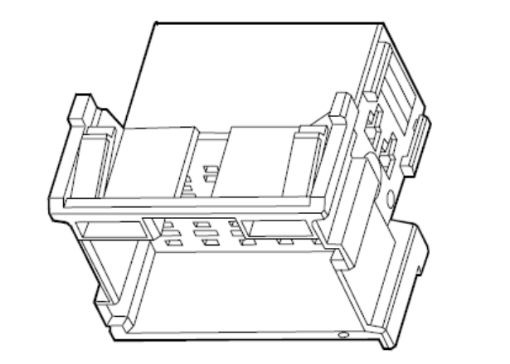
Drawing 1: CiA C413 - cab connector*

Tyco Code | Description
1-967626-1 | CANOpen Cab connector

*illustration only

Connector Pin out

CiA–C413 Cab
Pin | Description | Wire code | Max. Load | Connected to
1 | K 30 | 7796 |  | K30
2 | GND | 0000 |  | GND
3 | Enable | 0975 | 0,5 A | EM X4-28
4 | BB Can | CAN-H |  | EM X4-17
5 | CAN Gnd | 0999 |  | EM X4-09
6 | BB Can | CAN-L |  | EM X4-19
7 | reserved
8 | reserved
9 | reserved
Tab 1: CiA-C413 Pin out

Connector Location
The connectors are located as shown in the drawing.
For a detailed description pls refer to the <<BB connector manual DAILY MY2014>>.

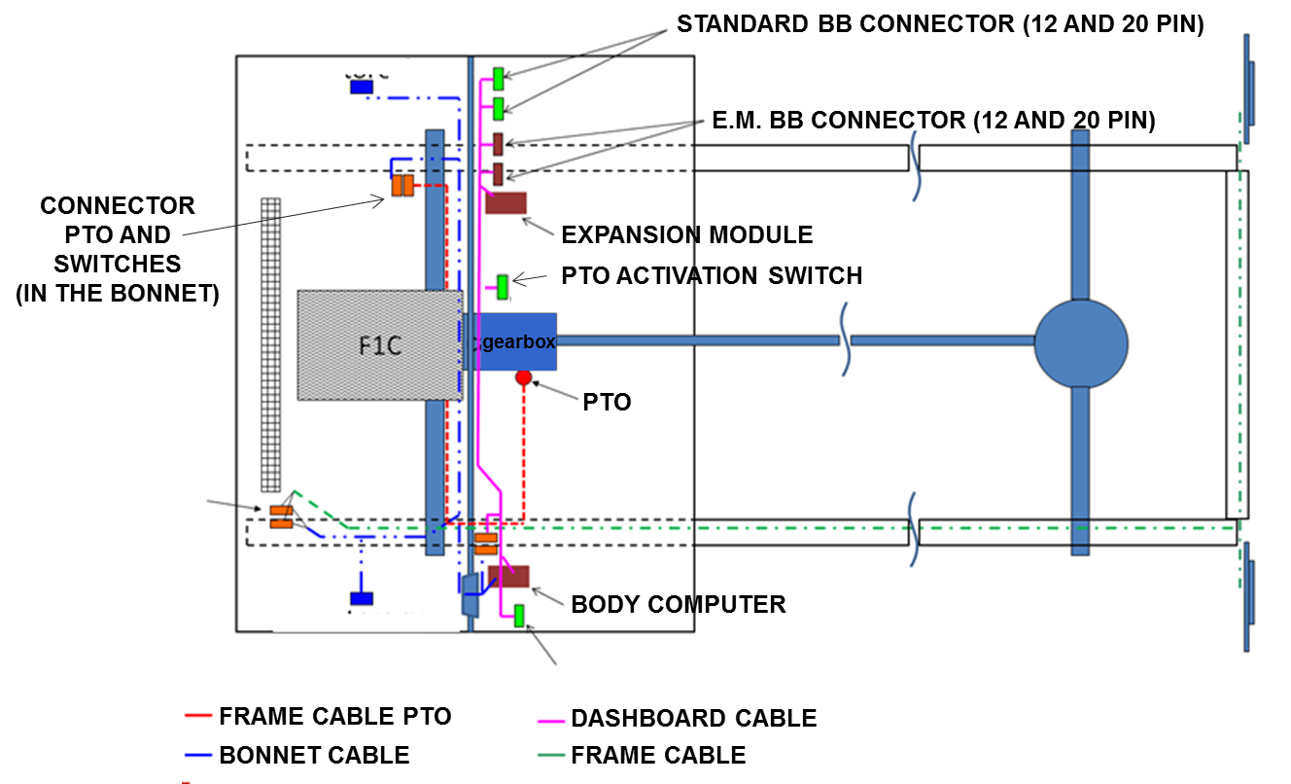

Drawing 2: Wiring Location

CiA–C413 Cab
On DAILY MY2104 Range The connector is located in the co-driver foot compartment on the right side of the ECU panel.

CAN basics – Tutorial
The IVECO BodyBuilder interface is available in various configurations. Pls verify before placing the vehicle order that proper interface configuration is chosen. Installations and Updates in CustumerService are highly time and cost consuming. When you’re intending to use a CAN based interface select the suitable CAN interface approach.

Get familiar with the information available on the IVECO BB homepage and pls contact your BB Market reference. They are trained on this subject and will support and guide you on following tasks:
- Selecting your needed vehicle optional(s)
- Chose the proper CAN interface approach – if intended
- Identify your special customization needs
- Support you on Cost and Project timing
- Support you on Workshop Programming – when needed

If you’re familiar with CANopen pls also make use of the Extended Device Description file, which provide you plenty of detailed information, such as:
- Signal content
- SAE J1939 SPN references
- Minimum and Maximum values
- Signal resolution
- Physical units
These information is highly useful for any CAN based application. There are FreeOfCharge EDS tools available – IVECO is using Freeware “CANeds” from VECTOR Informatik GmbH.

Furthermore the *.XDD file offer you to integrate the Truckgateway inside your VECTOR CANopen simulation environment – allowing you to setup, test and optimize the communication.

CAN Interface Concept
The IVECO CAN interface shall provide a possibility to integrate third party CAN nodes seamlessly in the vehicle E/E architecture.

In order to follow a standardized, well defined and secure approach IVECO decided to implement the CiA 413 Truckgateway device profile in EM WP2.2-LCV. This profile defines a link between SAE J1939 In-Vehicle CAN communication frequently used in commercial vehicle applications and CANopen, a communication protocol widely spread in industrial automation. Since SAE J1939 communication is used in commercial vehicle body applications as well, measures to provide the SAE protocol on Body applications are foreseen in the CiA 413 Truckgateway profile too.

Pls visit the IVECO BB Web Site, where a presentation illustrates the CAN interface features.

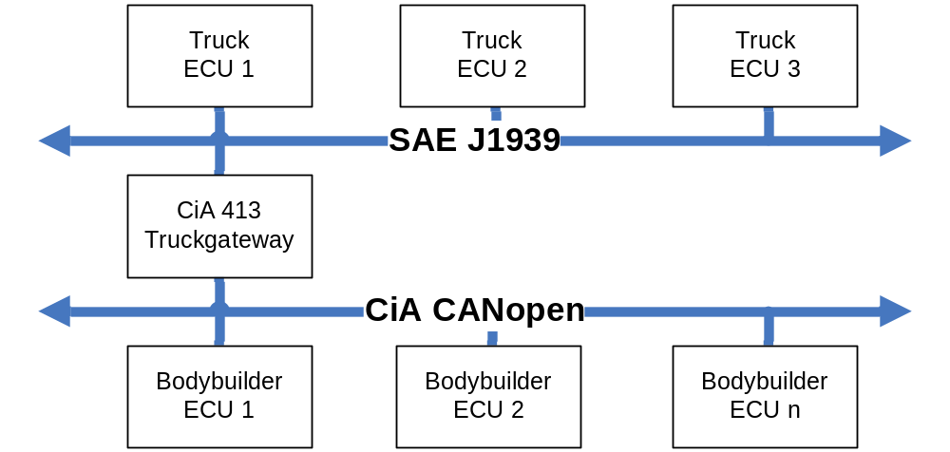
Drawing 3: Truckgateway Concept

Detailed information about the CANopen protocol can be obtained from documents [1, 2, 3, 4, 5, 6]

In order to use all benefits of the CANopen protocol it’s recommended to be aware of above mentioned documents, nevertheless it’s not necessarily mandatory to setup a CAN communication successful.
The following paragraphs will provide detailed instructions how to setup a CAN communication also without deep knowledge of CANopen standards.

For security reasons the access towards the vehicle is under the control of the Truckgateway CAN Firewall. It permits for certain signals CAN access only under predefined conditions. Furthermore a set of functions require to have the BB-enable hardware input being activated.
To cover a wide range of use cases an individual adoption of the conditions is possible via IVECO workshop tool.
The described CAN interface is operational only during K15 on phase. During K15 off phase no Output signals are updated nor the Input signals are monitored.

The IVECO CAN interface offer four different approaches for the Body Builders: Detailed descriptions are available in Chapter 5. Independent on the selected approach the Rules for requests towards the vehicle (Chpt. 9) needs to be respected in any case.:
- 1st Approach: ‘IVECO default CAN communication’
- 2nd Approach: Upload one of the customised Public CANopen communication pre-sets
- 3rd Approach: Contact IVECO to develop an individual & Private CAN communication preset.
- 4th Approach: setup individual CANopen configuration by CANopen configuration tools.
Detailed descriptions of the different approaches are available in Chpt. 5.

Independent on the chosen approach the following rules are to be respected:
- CAN boot-up behaviour (Chpt. 2.3.6)
- CAN timeout behaviour (Chpt. 2.4)
- Requirements for functional Safety (Chpt. 3)
- CAN Firewall (Chpt. 7)
- Rules for requests towards the vehicle (Chpt. 8)

IVECO recommends the BodyBuilder to be aware on the entire DAILY MY2104 BB manual and respect all the related recommendations.

Physical Layer & CAN requirement

General
The Bodybuilder CAN Physical Layer characteristics shall be conform to ISO 11898 [7]. The CANopen Interface can handle 11 bit and 29 bit ID’s according CAN 2.0A and CAN 2.0B

Physical Media
- An unshielded twisted pair of wires (UTP) shall be used.
- The 2 wires shall have a characteristic impedance of 120 +/- 12 Ohms.
- The 2 wires shall be protected by a plastic shield (jacket).
- The 2 wires shall be twisted with a rate being in the range 13-58 twists per meter.
- The wire maximum specific resistance, measured at 20 C, shall be 50 mOhm/m.
- The 2 wires maximum specific line delay shall be 5 ns/m.

Supported Baudrates
Following Baudrates could be supported by the EM.

CANopen Baudrates
50 kbps
100 kbps
125 kbps
250 kbps
Tab 2: Supported Baudrates

The Default Baud Rate is 250 kbps. 125 kbps can be configured at Workshop level.
If you need 100kbps or 50 kbps pls contact your BB Market reference.

Bus Topology
- The wiring topology should be as close as possible to a single line in order to avoid cable reflected waves. In practice short cable tails (stubs) maybe used to connect ECUs.
- To reduce the risk of interference, the bus cable shall be routed away from high current, rapidly switched loads and the wires connected to these devices, including return paths of ECU ground or power. Examples of the devices and associated wiring to avoid include: starter motors, wiper relays, turn signal (flasher) relays, and lamp relays.
- Additionally, the routing of the network and stubs should avoid close proximity to emission sensitive components (e.g. radios, CBs, and other electronic components).
- To minimize bus reflections nodes should not be equally spaced on the bus.
- To minimize bus reflections stubs should not have all the same length.
- The maximum bus length is 40 m (@ baudrate 250kB).
- The maximum number of nodes is 30.
- The minimum distance between nodes is 0.1 m.
- The maximum stub length is 1 m.
- Detailed definitions are described on ISO11898.
Topology example 1, peer-to-peer connection

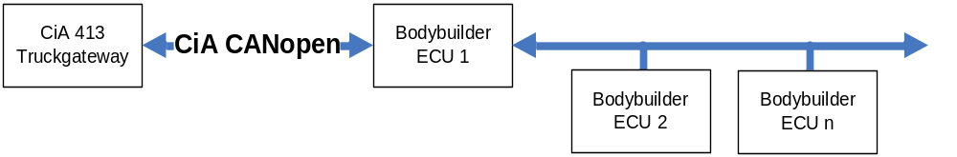
Drawing 4: peer-to-peer communication

Topology example 2, direct network connection

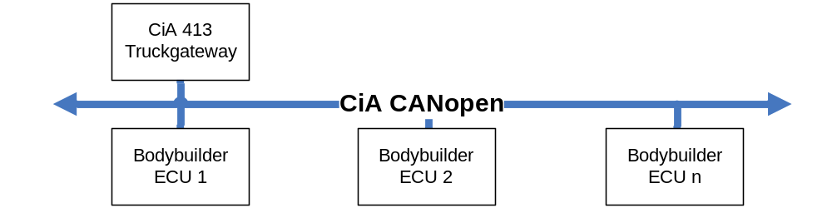
Drawing 5: direct network connection

Bus Termination
Since IVECO does not know the Network topology of Bodybuilder applications, the Bodybuilder has to take care of bus termination. Following rules shall be obeyed:

- Terminating resistors shall be located at both ends of the network.
- Terminating resistors shall have an impedance of 120 +/- 10 Ohms.
- The terminating resistor shall have a minimum power dissipation rating of 220mW.
- Terminating resistors inside ECU’s located at one or both ends of the network are allowed.
- From plant no termination is supplied

CANopen Communication

CANopen is a high-layer protocol based on standard CAN. CANopen foresees that the device’s hardware has a CAN transceiver and controller as defined in ISO-11898.
The Physically Layer of CANopen is standardized in ISO-11898. Bus length is limited by baudrate (communication speed) in the following way :

Baudrate | Maximum Lenght Bus | Supported
1 Mbit/s  500 kbit/s  250 kbit/s  125 kbit/s  100 kbit/s  50 kbit/s | 25 m  100 m  250 m  500 m  1000 m  1000 m | No  No  Yes  Yes  Yes  Yes

The Object Dictionary (OD)
The OD is the presentation of the application and communication specific data items used in a CANopen device. The OD represents the interface between application and communication. Each object is addressed by a 16 bit index and an optional 8 bit sub-index.
The structure of the Object Dictionary is shown below:
INDEX (HEXADECIMAL) | OBJECT
0000 | Not used
0001-001F | Static Data Types
0020-003F | Complex Data Types
0040-005F | Manufacturer Specific Data Types
0060-007F | Device Profile Specific Static Data Types
0080-009F | Device Profile Specific Complex Data Types
00A0-0FFF | Reserved Future Application
1000-1FFF | Communication Profile Area
2000-5FFF | Manufacturer Specific Profile Area
6000-9FFF | Standardised Device Profile Area
A000-FFFF | Reserved Future Application

It is possible to distinguish 4 categories in the following way:
- Data Types : address to 0x0FFF;
- Communication Profile Area: address from 0x1000 to 0x1FFF. It contains communication parameters common for all devices;
- Manufacturer Specific Profile Area: address from 0x2000 to 0x5FFF. It is used by manufacturers for device specific functions.
- Standardized Device Profile Area: address from 0x6000 to 0x9FFF. It contains aspects related to standard devices (CiA 413 1-7 – Truck specific device profile).
Deepening the first category, we can describe individual Data Types:
  - Static Data Types: standard data types (Boolean, integer, floating point, string etc..).They are equal on all the devices.
- Complex Data Types: standard predefined structures consisted of standard data types .They are equal on all the devices.
- Manufacturer Data Types: standard predefined structures consist of standard data types .They are related to a specific device.
Device Profiles can define further data types, specific for their device. In particular, static data types are defined between address 0x0060 and 0x007F, were as complex data types are defined between 0x0080 and 0x009F.
Each element present in Object Dictionary is defined in the following way:
Index | Object | Name | Type | Attribute | M/O
Where:
- Index shows the position in the OD;
- Object shows the symbolic name of the object ( DOMAIN, VAR, ARRAY, RECORD etc..)
- Name shows a textual description;
- Type shows the data type ( BOOLEAN, UNSIGNED8, UNSIGNED16 etc..)
- Attribute shows the access type towards device (Read/Write, ReadOnly, WriteOnly etc..)
- M/O means Mandatory or Optional.
To access to the previous data, two mechanisms are foreseen:
PDO - Process Data Object | SDO - Service Data Object
Used to transfer process data, in real time. | Used to transfer service data. The real time is not a prior requirement.
Synchronous, asynchronous and driven by events messages. | Asynchronous messages.
High priority Identifier. | Low priority Identifier.
Optimized to exchange data in fast and effective way | Optimized to transfer large amount of data, (none time critical).
Direct correspondence with an OD object. | Access to an object indirectly through index and sub-index.
Transfer of one message. | Transfer on more messages.
Supported in NMT-operational only | Supported in all NMT states

Communication Model

CANopen implementation foresees a hierarchical master-slave structure. In this way, the system configuration and network management are simpler. This means that, even if in a CAN bus every node is a master, the interface with Application Layer needs an Application Master for every provided service. The same node could be master for different functions or more nodes could be masters. Moreover it is possible to change master in every cycle system, according to programmed algorithm.
Every master could have till 127 slaves: every node is identified through an only 7bit address (ID, to 1 to 127).

Communication Object COB-ID

CANopen foresees information exchange through Communication Objects (COB). Communication Model CANopen specifies the different COB, communication services and the possible triggering types for data sending. Every COB is identified in an unique way by an ID. CAN2.0A standard supports till 2048 COB, 11bit. Transmission of synchronous and asynchronous messages is supported. Synchronous transmission indicates that it is possible the attainment and actuation of information in coordinated way in the entire network. COB dedicated are Sync Message and Time Stamp Message.
Asynchronous transmission are sent in whatever moment, because they must not respect any predefined synchronization.
Objects related to network management (NMT, SYNC etc..) have high priority. They are followed by PDO and SDO.

Service Data Objects (SDO)

Service Data Object (SDO) allows the access to the OD objects of all nodes. It is not a real time communication, therefore SDO priority is lower than PDO one. It is a peer-to-peer communication. Every device could support one or more than one SDO.
COB-ID used for SDO communication are:
- From Master to Slave: 600h + Node-ID;
- From Slave to Master: 580h + Node-ID

Process Data Objects (PDO)

The exchange of data in real time passes through Process Data Objects (PDO). Every PDO is mapped faithfully to a CAN frame. The data length of a PDO message is limited to 8 Byte.
It is possible classify PDO in 2 categories: T-PDO (Transmitted PDO) and R-PDO (Received PDO).
A device (PRODUCER) sends PDO and another one or more device(s) (CONSUMER) may receive it. Every node can read message(s) and decide acceptance through the Acceptance Filtering procedure.

We can distinguish two different transmission possibilities:
- Synchronized transmission;
- Asynchronized transmission.
The following picture shows the principle of synchronized / asynchronized transmission. Synchronous PDOs are sent immediately after SYNC Object in a determined time interval. Instead asynchronous PDOs have not any relation with this time interval (and SYNC object):
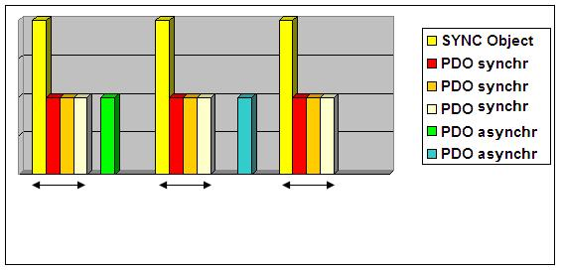

Predefined Communication Objects
Predefined Communication Objects are subdivided in 3 categories:
- SYNC Objects
- Time Stamp Objects
- Emergency Objects
They are explained in the following paragraphs.

SYNC Objects
The SYNC Object is sent periodically to all application devices (SYNC Slave) from synchronization device (SYNC Master). It scans network clock time, while the time between a SYNC object and another one is defined by standard parameter Communication Cycle Period , written by a configuration algorithm in boot-up process node. To guarantee a fast bus access, SYNC object priority is very high: synchronouos nodes use SYNC object to adjust their timing with the SYNC Master device in correct way. Further details depend on single slave and for particular applications (higher precision in synchronization), Time Stamp mechanism could be used.

Time Stamp Objects
The time-stamping mechanism corrects the inevitable clock drift of devices in network. Time Stamp Object is sent by Stamp Producer to all Stamp Consumer: this object contains reference time in ms, (if necessary, the resolution could be even in microseconds).

Emergency Objects
When a device notices an error situation, it sends an Emergency Object to the other devices with a higher priority. For every error event, it can be transmitted only one emergency object, so that the network will not be blocked due to the same error.
The following table defines the different CANopen Communication Profile emergency error codes:
ERROR CODE  (hexadecimal) | Detail
00xx | Error Reset or No Error
10xx | Generic Error
20xx | Current
21xx | Current, input
22xx | Current, inside
23xx | Current, output
30xx | Voltage
31xx | Principle Voltage
32xx | Internal Voltage
33xx | External Voltage
40xx | Temperature
41xx | Environment Temperature
42xx | Device Temperature
50xx | Device Hardware
60xx | Device Software
61xx | Internal Software
62xx | User Software
63xx | Data Set
70xx | Additional Modules
80xx | Monitoring
81xx | Communication
90xx | External Error
F0xx | Additional Functions
FFxx | Device Specification
Table 1 – Emergency Error Code

The error register, and additional information about device error, are present in the following table:

BIT | M/O | Detail
0 | M | Generic Error
1 | O | Current
2 | O | Voltage
3 | O | Temperature
4 | O | Comunication Error
5 | O | Specific of device’s profile
6 | O | Reserved
7 | O | Producer’s Specific
Table 2 – Error Register

As all predefined communication objects, also Emergency Object, are optional.
When EMCY object is available the error codes (00xx and 10xx) must be supported.

Network Management (NMT service)

Network Management acts on nodes and follows a master-slave structure. NMT imposes the use of a single master during start and normal running. NMT services allow to initialize, start, reset, check and stop nodes. Typically one NMT master should be present on a CANopen network.
The following picture (see below) shows a flowchart about a CANopen node:

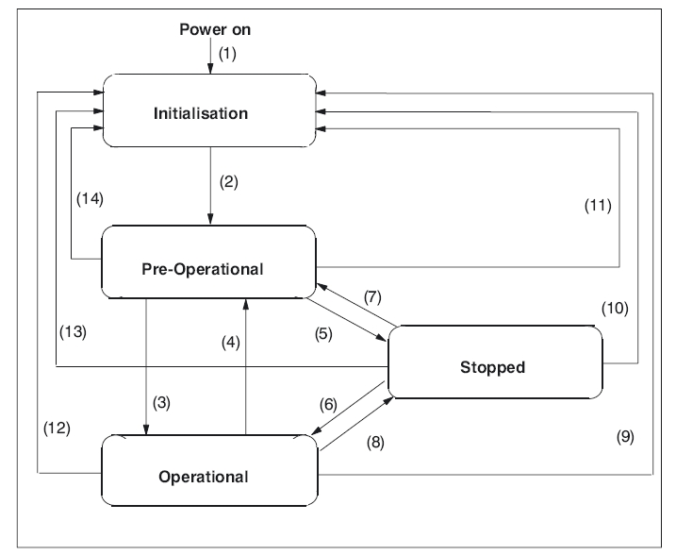
NMT CANopen node flowchart


WARNING: in the NMT Pre-Operational state it is possible SDO communication, whereas cyclic PDO communication is blocked. Only in NMT Operational state the PDO communication works.

In the following table (table 3 below), NMT services are listed:

Transition | Services
(1) | After Power-On, the following and mandatory state is Initialization
(2) | After Initialization, the first mandatory state is Pre-Operational
(3), (6) | Start_Remote_Node (CS = 128) command
(4), (7) | Enter_Pre-Operational_State (CS = 128) command
(5), (8) | Stop_Remote_Node (CS = 2) command
(9), (10), (11) | Reset_Node (CS = 129) command
(12), (13), (14) | Reset_Communication (CS = 130) command
Table 3 - NMT CANopen flowchart

As shown 4 principle status are defined:
- Initialisation or Boot-up;
- Pre-Operational;
- Operational;
- Stopped.
Initialization or Boot-up status are achieved automatically at Power on or after Reset (‘Reset Node’ or ‘Reset communication’).
After Initialisation, node enters in Pre-Operational mode autonomously. In Pre-Operational status, it is possible to assign ID and parameter values. Also SDO communication and EMCY messages are allowed. Device could be commuted in Operational status.
In Operational status, node can converse and all CAN messages are allowed. At any time, NMT master can force device to stop or boot-up.
NMT services have the following functions:
- Start Remote Node: it allows to switch to Operational from Pre-Operational. It is possible to transmit and to receive PDO data only in Operational.
- Stop Remote Node: it allows to switch to Stopped from Pre-Operational or Operational. In Stopped, node can process only NMT command.
- Enter Pre Operational: it allows to switch to Pre-Operational from Operational or Stopped. In Pre-Operational status, node cannot process PDOs. But it can be checked and set by SDO. It is possible to set reference values.
- Reset Node: it allows to switch to Initialization from Operational, Pre-Operational or Stopped. After Reset Node, all objects (1000 hex – 9FFF hex) are set.
- Reset Communication: it allows to switch to Initialization from Operational, Pre-Operational or Stopped. After Reset Node, all communication objects (1000 hex – 1FFF hex) are set to default value.

Heartbeat

To guarantee the CANopen network works correctly, CANopen offer 2 alternatives:
- Node guarding
- Automatic transmission heartbeat message from network node.
In Truckgateway the heartbeat message is implemented. Using heartbeat a node transmits proper communication status automatically at regular intervals. The interval between 2 heartbeat messages is set fix to 3000ms. The EM can monitors up to 7 Nodes. IVECO can develop – upon client request – specific NodeID’s to be supervised via Heartbeat mechanism.

In order to detect a heartbeat missing from a node it’s mandatory to have at least once received a heartbeat message from that node during the K15 cycle.

CAN Boot up behaviour

Per default the EM is configured as NMT Master, on power-on (K15 on) it will send, after a delay of appr. 5s the NMT Start message is sent and set all nodes to operational. Afterwards the cyclic PDO communication will start. The start of the CANopen stack will be reported on BB connectors CiA-F413 / Pin3 and CiA-C413 / Pin 3 too.

For successful communication start it is essential that:

- there is at least one other node active on the CAN.
- the bus is terminated by 2 x 120 Ohm resistors.

Pls consider that EM expects to receive an Acknowledge for all CAN message sent, also the NMT messages. This Acknowledged shall be sent by at least one CAN node on the BB network. Else the EM CAN error counter will increase and EM CAN controller goes to bus-off state according the CAN state machine.

To adopt the start-up behaviour to specific Bodybuilder needs it is possible to configure the device boot-up on workshop level. The possible modifications are.

- NMT Master/Slave
- Communication Start trigger via K15
- HW input (BB enable ST61071B, pin18) – can be developed upon client request
- Variable start delay – can be developed upon client request

NMT Master/Slave

The CANopen device can be configured as Master or Slave. In slave mode no automatic communication start is provided. The Network must start the Truckgateway communication (set EM to operational).

If the EM is configured as Master the NMT boot-up behaviour can be configured in detail. Following actions are foreseen depending on the configuration:

CO_opCfg value | Behaviour
1 | Maintain current state
2 | Go to Pre-Operational
8 | Go to Stop
16 | Reset Node
32 | Go to Operational (default)

Communication Start trigger

It’s possible to configure two different types of communication start up behaviours

- The Communication starts automatically with K15 on (default)
- The Communication starts if BB Enable (ST61071B/Pin18) is connected to GND – can be developed upon client request

The second trigger is useful if bodybuilder CAN communication does not work synchronized to Vehicle K15.

Variable start delay

- If the bodybuilder has problems to synchronize their communication start-up to the vehicle/EM start-up it’s possible to delay the start of the EM CAN interface. Typically it’s ~ 6 sec, via IVECO CS it can be delayed to ~ 8 resp. 10 sec. If a further delay is necessary it can be developed upon client request
.

CANopen Dummy Objects usage
In some cases individual Mapping requires that gaps between signals are to be filled with objects without meaning. In this case dummy objects as defined in Chapter 5.3 can be used to fill the gaps.
Pls respect that signals shall not overlap Byte limitations, therefore 8-bit, 16-bit resp. 32-bit signals shall start at bit 0, 8, 16, 24 and so on.
Pls respect that the Message DLC is automatically adapted. So if e.g. only some signals are mapped a DLC smaller that 0x08 may result.
If the BB CAN controller(s) might not be compatible the DUMMY objects can be used to fill the entire message(s). Pls note that also mapped Dummy object will increase the PLC runtime.

CANopen references
To understand this manual, it is recommended to have a good knowledge of CANopen concepts. This chapter contains the following items:
- A short introduction of principle concepts;
- An overview of CANopen communication objects used by Expansion Module.

The following standards should be known by body-builders:

- CiA DS- 301 V4.02 (Application Layer and Communication Profile)
- CiA DR- 303-3 V1.2 (Indicator Specification)
- CiA DS- 306 V1.3: (Electronic data sheet specification for CANopen)
- CiA DS- 402 V2.0 (Device Profile for Drives and Motion Control)
- CIA DS 413-1 V2.0.10 (Device profile for truck gateways - Part 1 General definitions and default communication objects)
- CIA DS 413-2 V2.0.10 (Device profile for truck gateways - Part 2 Brake and running gear devices)
- CiA DS- 413-3 V2.0.10 (Device profile for truck gateways Part 3: Other than brake and running gear devices)
- CiA DS- 413-5 V1.0.3.2 (Device profile for truck gateways Part 5: Superstructure objects)
- CiA DS- 413-6 V1.0.2.1 (Device profile for truck gateways Part 6: Framework for J1939-based networks)

CAN Timeout behaviour
To control the Bodybuilder Network communication (especially for Messages received by the Truck) IVECO has foreseen two mechanisms.

- Heartbeat control (See CiA 301 [1])
- Timeout Object control (for SAE communication)

Independently which of the mechanisms has been chosen for control, the Truckgateway can be configured to set the vehicle to a defined StoppedState if a timeout is recognized. The Bodybuilder hast the possibility to adjust the StoppedState values up to a certain degree. Pls refer also to Chpt. 2.3.5.

Heartbeat control
For bodybuilders using pure CANopen the EM provides the Heartbeat mechanism as defined in CiA 301 [1]. Since CiA does not recommend Node guarding this is not supported by the EM.

To configure heartbeat control the Bodybuilder has to set the consumer Node ID via IVECO customer service tool. Up to 8 Node ID’s can be handled in the EM. The Consumer Heartbeat time is set fix to 3000ms.
- In the Default Setting following Node ID are set: 0x01, 0x0A, 0x7. Other Nodes – can be developed upon client request

Timeout Object control
Another possibility to control the timeout of a CAN message is the usage of the “Message Timeout Object” 0x2000, 0x02.

If this object is used the Truckgateway expects that the “Message containing the Timeout Object” is periodically received with the value 3. If the Message containing the “Message Timeout Object” is not received periodically a timeout will be generated after approximately 5 sec. Per Default this function is disabled. For enabling the BB need integrate object 0x2000, sub 0x02 inside a cyclic message and in addition Layer2 monitoring needs to be enabled via IVECO Service.

Timeout reaction
As soon as one of the mechanisms creates a timeout the EM reacts by:

- Changing the NMT state of the EM.
- Changing the NMT state of other nodes in the Network. (only if EM is Master)

NMT state Change

EM device NMT:
According to the configuration the EM will change the NMT state if a timeout is recognized:

Value | Behaviour
1 | Maintain current state
2 | Go to Pre-Operational
4 | Reserved
8 | Go to Stop
16 | Reset Node
32 | Go to Operational

Network node NMT:
According to the configuration the EM will send a NMT command to other all devices if a timeout is recognized:

Value | Behaviour
1 | Maintain current state
2 | Go to Pre-Operational
4 | Reserved
8 | Go to Stop (default)
16 | Reset Node
32 | Go to Operational

Requirements for Functional Safety
- When BB application is interfacing the vehicle for Safety related functions then IVECO supports the BB application with a “Vehicle CAN fully operational” output. For Safety related BB applications, which are interfacing the vehicle, IVECO requires from the BodyBuilder to integrate this information in the BB application Technical Safety Concept. The “Vehicle CAN fully Operational” information do not check the content of any transmitted CAN message, but it ensures that CAN communication - and resulting also extracted information provided to the BodyBuilder via the CANopen interface - are still regularly updated within their timing constraints.
- Furthermore at each K15 cycle the delayed state change (between 4 to 6 sec after K15on) needs to be checked. When such check fails the “Vehicle CAN fully operational” output is not to be considered valid.
- The “Vehicle CAN fully operational” output being active provides an information that not any of the monitored Vehicle systems CAN messages remains in CAN timeout for more than 1 sec.
- With the CANopen interface (OPT 0384) the Bodybuilder is able to identify the vehicle degradation level
- When the “Vehicle CAN fully operational” output is not active then the BB application does not have to implement actions (or rather reactions) that relies on the EM nor on the entire IVECO BB CANopen interface functioning properly (as for instance for CANopen gateway)”. The BB is responsible initiating measures that the SafeState of its BB application is entered autonomously.
- When the specific BB application requires also a recovery strategy during “Vehicle CAN fully operational” output being resp. getting passive during BB operation, then contact Iveco for support in completing the technical design of these recovery strategy.
- The responsibility for functional safety of individual BB configurations is always up to the Bodybuilder. When in Customer Service a client specific programming have been required, then after each programming session the affected functionality is to be checked and confirmed by the BodyBuilder. In case of deviations the BB is responsible initiating measures that the SafeState of both vehicle and its BB application are entered autonomously.
- Standard safety procedures and precautions should be followed at all times to eliminate the possibility of vehicle damages, or compromise its integrity, and preserve the risk of accidents.
- The Bodybuilders have to ensure reliable design and wiring for all connections with the IVECO BodyBuilder interface

CANopen CiA 413 objects
The supported objects depend on the vehicle ranges as well as on the installed options.

Predefined Communication Objects 0x1000-0x1018

Type | Object | Sub-Index | Name
ro | 0x1000 | 0x00 | device type
ro | 0x1001 | 0x00 | error register
ro | 0x1003 | 0x01-0x05 | pre-defined error field
rw | 0x1005 | 0x00 | COB-ID sync
rw | 0x1006 | 0x00 | communication cycle period
rw | 0x1007 | 0x00 | synchronous window length
const | 0x1008 | 0x00 | manufacturer device name
const | 0x1009 | 0x00 | manufacturer hardware version
const | 0x100A | 0x00 | manufacturer software version
rw | 0x100C | 0x00 | guard time
rw | 0x100D | 0x00 | life time factor
rw | 0x1010 | 0x02 | store communication parameters
rw | 0x1011 | 0x01 | restore all default parmeters
rw | 0x1014 | 0x00 | COB-ID EMCY
rw | 0x1015 | 0x00 | inhibit Time Emergency
ro | 0x1016 | 0x00-0x0a | consumer Heartbeat Time *
rw | 0x1017 | 0x00 | producer Heartbeat Time
ro | 0x1018 | 0x00-0x04 | identity Objekt
*is only writeable via CS Tool

PDO communication Objects 0x1400-0x1FFF

Type | Object | Name
Record | 0x1400 – 0x1413 | Recieve PDO Communication Parameter
Record | 0x1600 – 0x1613 | Recieve PDO Mapping Parameter
Record | 0x1800 – 0x181d | Transmit PDO Communication Parameter
Record | 0x1a00 – 0x1a1d | Transmit PDO Mapping Parameter

The EM supports up to 30 TPDOs and 20 RPDOs. Inside each PDO up to 16 objects can be assigned.

The objects shall not overlap the Byte borders (except 16/32 bit-signals). Instead eventual gaps between signals need to be filled with Dummy objects as defined in Chapter 2.3.7. Pls consider that also Dummy objects are affecting the PDO object limitation described before.

Dummy Objects
Direction | Object | Name
− | 0x2101 | Dummy Boolean RX
− | 0x2102 | Dummy Boolean 2 RX
− | 0x2103 | Dummy Boolean 3 RX
− | 0x2104 | Dummy Boolean 4 RX
 | 0x2201 | Dummy Boolean TX
 | 0x2202 | Dummy Boolean 2 TX
 | 0x2203 | Dummy Boolean 3 TX
 | 0x2204 | Dummy Boolean 4 TX

Objects CiA 413 Part 2
The resolution, offset and units of the signals are as defined in SAE J1939 and CANopen *.XDD file.

Direction | Object | Name
 | 0x6006 | Wheel based vehicle speed
 | 0x601B | Towing vehicle ABS active/passive
 | 0x6022 | ASR brake control active/passive
 | 0x6023 | ASR engine control active/passive
 | 0x6029 | Brake light switch

Objects CiA 413 Part 3
The resolution, offset and unit of the signals are as defined in SAE J1939 and/or CANopen *.XDD file.

Direction | Object | Name
 | 0x6105 | Anti-teft device request
 | 0x610A | Percent clutch slip
 | 0x610C | Current gear
 | 0x610E | Accelerator pedal low idle switch
 | 0x610F | Engine control allowed
 | 0x6110 | PTO control allowed
 | 0x6111 | Vehicle speed
 | 0x6113 | Engine speed
 | 0x6115 | Driver's demand engine percent torque
 | 0x6117 | Actual engine percent torque
 | 0x6119 | Reference engine torque
 | 0x611B | Percent load at current speed
 | 0x611D | Maximum vehicle speed limit
 | 0x611F | Engine speed upper limit
 | 0x6121 | Engine speed lower limit
 | 0x6123 | Engine coolant temperature warning
 | 0x6124 | Engine oil pressure warning
 | 0x6125 | Engine oil temperature
 | 0x6127 | Engine coolant temperature
 | 0x6129 | Engine oil pressure
 | 0x612E | First clutch dependent PTO feedback
 | 0x612F | Second clutch dependent PTO feedback
 | 0x6130 | Clutch independent PTO feedback
 | 0x6131 | First engine mounted PTO feedback
 | 0x6132 | Second engine mounted PTO feedback
 | 0x6133 | Starter active
 | 0x6134 | Engine running
 | 0x6135 | Engine torque mode
 | 0x614C | Accelerator pedal position
 | 0x614E | Ambient air temperature
 | 0x6150 | Fuel level warning
 | 0x618A | Trailer left-hand stop light(s) command
 | 0x618B | Trailer right-hand stop light(s) command
 | 0x618C | Trailer left-hand direction indicator light(s) command
 | 0x618D | Trailer right-hand direction indicator light(s) command
 | 0x618E | Trailer left-hand rear light(s) command
 | 0x618F | Trailer right-hand rear light(s) command
 | 0x6190 | Trailer left-hand rear fog light(s) command
 | 0x6191 | Trailer right-hand rear fog light(s) command
 | 0x6192 | Trailer left-hand reversing light(s) command
 | 0x6193 | Trailer right-hand reversing light(s) command
 | 0x6194 | Trailer left-hand side marker light(s) command
 | 0x6195 | Trailer right-hand side marker light(s) command
 | 0x6196 | Trailer left-hand rear width indicator light(s) command
 | 0x6197 | Trailer right-hand rear width indicator light(s) command
 | 0x6198 | Trailer left-hand corner marker light(s) command
 | 0x6199 | Trailer right-hand corner marker light(s) command
 | 0x619A | Trailer left-hand rear registration-plate light(s) command
 | 0x619B | Trailer right-hand rear registration-plate light(s) command
 | 0x619F | Trailer work light(s) command
 | 0x61A0 | Transmission output shaft PTO feedback
 | 0x61A1 | Transfer case output shaft PTO feedback
 | 0x61A2 | At least one PTO engaged
 | 0x61A5 | First clutch dependent PTO engagement consent
 | 0x61A6 | Second clutch dependent PTO engagement consent
 | 0x61A7 | Clutch independent PTO engagement consent
 | 0x61A8 | First engine mounted PTO engagement consent
 | 0x61A9 | Second engine mounted PTO engagement consent
 | 0x61AA | Transmission output shaft PTO engagement consent
 | 0x61AB | Transfer case output shaft PTO engagement consent

Direction | Object | Name | Firewall affected
− | 0x6107 | Anti-theft device | No
− | 0x6136 | First clutch dependent PTO switch | No
− | 0x6137 | Second clutch dependent PTO switch | No
− | 0x6138 | Clutch independent PTO switch | No
− | 0x6139 | First engine mounted PTO switch | No
− | 0x613A | Second engine mounted PTO switch | No
− | 0x6140 | Requested engine speed upper limit | Yes
− | 0x6144 | Requested engine torque limit | Yes
− | 0x6146 | Requested vehicle speed limit | Yes
− | 0x614A | Requested engine speed | Yes
− | 0x61A3 | Transmission output shaft PTO switch | No
− | 0x61A4 | Transfer case output shaft PTO switch | No

Objects CiA 413 Part 5
The resolution, offset and units of the signals are as defined in SAE J1939 and/or CANopen *.XDD file.

Direction | Object | Name
 | 0x6304 | Electrical potential
 | 0x6306 | Rated engine power
 | 0x6308 | Rated engine speed
 | 0x630A | Engine oil level
 | 0x6316 | Parking brake device active
 | 0x6317 | Parking light command
 | 0x6318 | Low beam command
 | 0x6319 | High beam command
 | 0x631C | Driver door open active
 | 0x631D | Co-driver door open active
 | 0x631E | Central door lock device active
 | 0x6320 | Fuel filter clocked active
 | 0x6322 | Air filter clocked active
 | 0x6328 | Additional light device active
 | 0x6329 | Working light device active
 | 0x632F | Transmission neutral switch active
 | 0x6330 | Transmission reverse direction switch active
 | 0x6331 | Clutch closed state active
 | 0x6332 | Clutch open state active
 | 0x6337 | Engine speed control upper limit allowed
 | 0x6339 | Engine speed control allowed
 | 0x633A | Engine torque limit control allowed
 | 0x634A | KL15 status

Objects CiA 413 Part 6, SAE & IVECO predefined Messages
The signals included inside the messages as well as their resolution, offset and unit are as defined in SAE J1939. Inside CANopen *.XDD file the signal reference is added too.

Direction | Object | Name | Data Reference
 | 0x6421 | LFE | 0xA440, 0x01
 | 0x6422 | LFC | 0xA440, 0x30
 | 0x6423 | EEC1 | 0xA440, 0x05
 | 0x6424 | EEC2 | 0xA440, 0x06
 | 0x6425 | CCVS | 0xA440, 0x07
 | 0x6426 | ET1 | 0xA440, 0x08
 | 0x6427 | TCO1 | 0xA440, 0x09
 | 0x6428 | VDHR | 0xA440, 0x0A
 | 0x6429 | TD | 0xA440, 0x0D
 | 0x642A | ETC2 | 0xA440, 0x0F
 | 0x642B | EEC3 | 0xA440, 0x15
 | 0x642C | PTODE | 0xA440, 0x16
 | 0x642D | PB_ICS | 0xA440, 0x19
 | 0x642E | EDC2BC | 0xA440, 0x20
 | 0x642F | HOURS | 0xA440, 0x21
 | 0x6430 | Service TCO | 0xA440, 0x22
 | 0x6431 | MUXinfo2 | 0xA440, 0x23
 | 0x6432 | PTOstatus | 0xA440, 0x24
 | 0x6433 | EFLP | 0xA440, 0x25
 | 0x6434 | DD | 0xA440, 0x26
 | 0x6435 | FUELE2 | 0xA440, 0x27
 | 0x6436 | MUXinfoL | 0xA440, 0x2A

Manufacturer Specific objects

Manufacturer Specific Transmit objects
The resolution, offset and unit of the signals are as defined in the CANopen XDD file.

Direction | Object | Name | Rem
 | 2005H,01 | Engine fuel level
 | 2004H,03 | Timeout Object status
 | 2004H,04 | TSC1_ECtrlAlw
 | 2004H,07 | BB_enable
 | 2004H,09 | ISC Controll allowed
 | 2006H,01 | EC_Engine_speed_idle
 | 2006H,02 | EC_Engine_speed_high_idle
 | 2006H,03 | EC_Reference_engine_torque
 | 2006H,04 | PTO 1 Status - Byte2,3 | See Note 1
 | 2006H,05 | EM DI_status IN01….IN 16 | See Note 2
 | 2006H,06 | PTO 2 Status - Byte4,5 | See Note 1
 | 2006H,07 | PTO 3 Status - Byte6,7 | See Note 1
 | 2006H,08 | PLC cycletime
 | 2007H,02 | Bus load and controller state | See Note 3
 | 2007H,03 | RX counter and TX counter | See Note 4
 | 2007H,04 | Utc_Time
 | 2007H,05 | Utc_Time_Local

Note1:
The PTOx_Status-Engagement_Restriction resp. ShutOff_Condition keeps BB informed which PTO Engagement_Restriction resp. ShutOff _Condition is currently violated. The information is available for all the 3 PTO and has the following layout:

PTO_x Status - EngagementRestriction/ShutOff
Bit | Signal allocation | Description
1..2 | PTO op_mode | =00 (Not in degraded mode)  =01 (Degraded mode required but not confirmed)  =10 (Operating in degraded mode - confirmed)  =11 (PTO operation not possible)
3 | Brake (depressed/not depressed) | Brake condition violated
4 | Handbrake (engaged/disengaged) | Handbrake condition violated
5 | EM input (open/short to ground) | EM input violated
6 | Clutch (depressed/not depressed/slipping) | Clutch condition violated
7 | Gear (neutral/reverse/out of limit) | Gear condition violated
8 | Engine RPM | RPM out of range
9 | Vehicle speed | Vehicle speed out of range
10 | Water temperature | Water temperature out of range
11 | PTO control allowed (Eurotronic) | Eurotronic PTO blocked
12 | External ER BB CAN active | ER flag active
13 | Reserved for future use | -
14 | Reserved for future use | -
15 | Reserved for future use | -
16 | Reserved for future use | -

Note 2:

The signal 0x2006, sub 0x5 EM DI_status informs the BB about the status of the physical EM inputs. The information has the following layout:

EM DI_status IN01…IN16
IN | EM HW pin | Description
01 | X3 - 13 | K15 input
02 | X3 - 05 | PTO1 switch request
03 | X3 - 06 | RunLock
04 | X3 - 07 | PTO3 switch request
05 | X3 – 08 | PTO1 feedback switch
06 | X3 – 09 | PTO2 feedback switch
07 | X3 – 10 | PTO3 feedback switch
08 | X3 - 11 | PTO1 pressure switch
09 | X3 - 12 | PTO2 pressure switch
10 | X3 - 16 | PTO3 pressure switch
11 | X3 - 17 | BB enable
12 | X3 - 18 | Scene Lights
13 | X3 - 19 | Additional Lights 1
14 | X3 – 20 | Additional Lights 2
15 | X3 – 21 | BB_EMCY
16 | X4 - 06 | FCC_LI_05 (res for future use)

Note 3:

The signal 0x2007, sub 0x02 RX counter and TX counter informs the BB about the status of the BB CAN bus load and the EM BB CAN controller state. The information has the following layout:

BB-CAN Bus load and controller state
bit | Signal | Description
01…16 | BB CAN bus load | 0% .. 100%, min 0%, max 100%, resolution 1% per bit, offset =0%  0xFFFF not available
17... 32 | BB CAN controller state | Bit 1: not initialised  Bit 2: error active  Bit 3: error passive  Bit 4: Bus Off

Note 4:

The signal 0x2007, sub 0x03 Rx_error_counters and Tx_error_counters informs the BB about the status of the BB CAN transceiver Rx/Tx error counters. The information has the following layout:

BB-CAB Bus load and controller state
bit | Signal | Description
01…16 | BB CAN Rx errors | 0… 0x00FF BB CAN Rx-errors  0xFFFF not available
17... 32 | BB CAN Tx errors | 0… 0x00FF BB CAN Tx-errors  0xFFFF not available

Manufacturer Specific Receive objects
The manufactures specific objects have to be used to send SAE J1939 conform messages to the Vehicle. Inside the selected RPDO configuration both _LSB and _MSB objects are to be mapped.

Direction | Object | Name | Firewall affected
− | 2000H, 0x02 | Message Timeout Object | No
− | 2000H, 0x03 | Run Lock - Daily | No
− | 2000H, 0x04 | ISC Accelerate | Yes
− | 2000H, 0x05 | ISC Decelerate | Yes
− | 2000H, 0x06 | ISC Resume | Yes
− | 2000H, 0x07 | ISC off | Yes
− | 2001H, 0x0A | REQUEST_PGN_BBIU2EDC16_8 - Daily | No
− | 2001H, 0x0B | REQUEST_PGN_BBIU2BC_8 - Daily | No
− | 2001H, 0x0C | Multiple State Switch MSS - Daily | No
− | 2001H, 0x0E | CO_Outputs | No
− | 2002H, 0x02 | REQUEST_PGN_BBIU2EDC16_16 - Daily | No
− | 2002H, 0x03 | REQUEST_PGN_BBIU2BC_16 - Daily | No
− | 2003H, 0x0B | HMI Character | No
− | 2003H, 0x03/04 | TSC1 | Yes
− | 2003H, 0x07/08 | TC1 (future) | Yes
− | 2003H, 0x09/0A | HMI_request | No

Basic CANopen Interface configuration
To configure the EM CANopen interface four different approaches are foreseen. Pls see the presentation available on the BB home page for getting familiar with the different approaches.

- 1st Approach:
Use the ‘IVECO default CAN communication’ being aligned to SAE J1939 communication. The communication matrix is available on IVECO BB homepage.

- 2nd Approach:
Upload one of the customised Public CANopen communication pre-sets

- 3rd Approach:
Contact IVECO to develop an individual and Private CAN communication preset. Pls contact IVECO CS organisation and fill the BB_IF_SpecSheet available on IVECO BB homepage.

- 4th Approach:
Body Builder do an individual CANopen configuration (by Bodybuilder) by means of standard CANopen configuration tools.

In the following paragraphs the configuration approaches are described in detail

CANopen IVECO defaults pre-set
Since DAILY MY2014 all vehicles ordered with CANopen (OPT 75979) will be delivered with the “IVECO default CAN communication”. Such default communication is aligned to to DAILY MY2012 and MY2009 TECSCO XDC. For details on available CAN messages and signals, assigned ID’s and signal ranges pls contact IVECO BB homepage.
The info is available in *.xls as well as *.dbc formats

Public CANopen communication pre-sets upload
To provide individual CAN configurations for Bodybuilders not dealing with CANopen, IVECO defined a dedicated process of CANopen configuration handling. Such public CANopen communication Pre-sets have been developed by IVECO following the requirements of various Branches. The process shall provide following benefits:
- Controlled setup of CAN communication to guarantee technical best solution.
- Bodybuilders must not deal with CANopen configuration details.
- Documentation of vehicle configuration to improve serviceability.
- Facilitate exchange of ECU in case of damage.

Process Steps:
- The Bodybuilder associations defines a desired CAN communication.
- IVECO check and approves the proposal.
- IVECO inserts the approved proposal in the Bodybuilder database.
- The workshop can download the Public preset from the central database and install it on the vehicle.

Private CANopen communication pre-sets upload
To provide individual CAN configurations for Bodybuilders not dealing with CANopen, IVECO defined a dedicated process of CANopen configuration handling.

To provide individual CAN configurations for Bodybuilders not dealing with CANopen, IVECO defined a dedicated process of CANopen configuration handling. Such Private CANopen communication Pre-sets can be developed by IVECO individually upon client request. Pls contact your IVECO BB market responsible and fill the BB_IF_SpecSheet available on IVECO BB homepage.

The process shall provide following benefits:
- Controlled setup of CAN communication to guarantee technical best solution.
- Bodybuilders must not deal with CANopen configuration details.
- Documentation of vehicle configuration to improve serviceability.
- Facilitate exchange of ECU in case of damage.

Process Steps:
- The Bodybuilder defines together with IVECO BB market responsible a desired CAN communication, cost and timing aspects. In best case the Bodybuilder submits the proposal in XDC format.
- IVECO check and approves the proposal.
- IVECO inserts the approved proposal in the Bodybuilder database.
- The workshop can download the preset from the central database and install it on the vehicle.

Bodybuilder privacy handling:

Certain body builders might consider the agreed CAN communication as confidential; therefore the access to Private configurations is handled by a user control system. Each body builder receives a specific and private User Account with login name and password. Depending on the account used during vehicle configuration Bodybuilder specific presets are available for installation.

Individual CANopen configuration
For Bodybuilders that have already CANopen knowledge in house or want to make use of special CANopen features it’s possible and allowed to configure the IVECO CANopen interface individually following the protocol defined in CiA 301 [1]. The CANopen objects listed in Chapter 4 of this document are supported by IVECO. For such advanced configuration IVECO will provide a device specific EDS/XDD file.

The following chapter provide an example how to setup an individual communication. In order to understand the examples basic knowledge of CANopen is required. Also CANopen standard tools are necessary:

Recommended tools necessary for individual CANopen configuration:

- CANopen configuration tool (e.g.: Vector, ProCANopen; IXXAT, CANopen ConfigurationStudio; SYSTEC, CANopen Configuration Suite )
- CAN Hardware interface

Default CANopen settings
From Plant the CiA 413 interface is configured as described in the table:

Property | Value
Node Id | 0x70
Baudrate | 250 kbit/s
NMT | Master
Boot-up behavior | Start with K15 on, auto NMT operational
Tab 3: CiA 413 default configuration

Usage of cyclic Communication, individual messages
Description:

In this example the user will learn how to configure

- 1 individual Received Message (RPDO1), ID = 0x100, cycletime = 100ms
- 1 individual Transmitted Message (TPDO1), ID = 0x200, cycletime = 200ms

Message content:

RPDO1
Signal | Object Index | Start position | length
Requested engine speed value | 0x614A, 1 | 1 | 16
Requested engine speed upper limit | 0x6140, 1 | 16 | 16
Requested engine speed lower limit | 0x6142, 1 | 32 | 16
Requested engine torque limit | 0x6144, 1 | 48 | 8
Requested vehicle speed limit | 0x6146, 1 | 56 | 8

TPDO1
Signal | Object Index | Start position | length
Engine speed value | 0x6113, 1 | 1 | 16
Vehicle speed value | 0x6111, 1 | 16 | 16
Parking brake device active | 0x6316, 0 | 32 | 2

Example: Mapping configuration of cyclic Communication

- Write Object 0x1011:01, Restore default parameters

Object | Value | Name
0x1011, 0x01 | 64h 61h 6Fh 6Ch (daol) | Restore all Default Parameters

- NMT reset ECU

Message ID | Data | Repetition
0x00 | 0x81 0x70 | Once

- Write Object 0x1400 Receive PDO1 communication parameters

Object | Value | Name
0x1400, 0x01 | 0x100 | COB-ID
0x1400, 0x02 | 0xFF | Transmission Type

- Write Object 0x1600 Receive PDO1 mapping parameters

Object | Value | Name
0x1600, 0x00 | 0x05 | Number of entries
0x1600, 0x01 | 0x614A010F | PDO Mapping Entry 1
0x1600, 0x02 | 0x6140010F | PDO Mapping Entry 2
0x1600, 0x03 | 0x6142010F | PDO Mapping Entry 3
0x1600, 0x04 | 0x61440108 | PDO Mapping Entry 4
0x1600, 0x05 | 0x61460108 | PDO Mapping Entry 5

- Write Object 0x1800 Transmit PDO1 communication parameters

Object | Value | Name
0x1800, 0x01 | 0x200 | COB-ID
0x1800, 0x02 | 0xFE | Transmission Type
0x1800, 0x03 | 0x00 | Inhibit Timer
0x1800, 0x05 | 0x64 | Event Timer

- Write Object 0x1a00 Transmit PDO1 mapping parameters

Object | Value | Name
0x1A00, 0x00 | 0x03 | Number of entries
0x1A00, 0x01 | 0x6113010F | PDO Mapping Entry 1
0x1A00, 0x02 | 0x6111010F | PDO Mapping Entry 2
0x1A00, 0x03 | 0x63160002 | PDO Mapping Entry 3

- Write Object 0x1010:02 , Save Communication parameters

Object | Value | Name
0x1010, 0x02 | 65h 76h 61h 73h (evas) | Store Communication Parameters

Usage of predefined SAE resp. CiA413-6 messages
The CANopen Interface incorporates the possibility to gateway complete SAE or IVECO proprietary messages from the vehicle to the Bodybuilder CAN. SAE J1939 transport protocol (BAM/MPM) is not yet supported. The available SAE messages are defined in Chapter 4.7. Further the message send on Bodybuilder CAN, can be configured like any other CANopen TPDO.

In the following example a mapping of the CCVS to CANopen Transmit PDO1 with the ID “0xC101072” and cycletime 100ms is demonstrated.

Example: Mapping configuration of predefined SAE messages

- Write Object 0x1011:01, Restore default parameters

Object | Value | Name
0x1011, 0x01 | 64h 61h 6Fh 6Ch (daol) | Restore all Default Parameters

- NMT reset ECU

Message ID | Data | Repetition
0x00 | 0x81 0x70 | Once

- Write Object 0x1800 Transmit PDO1 communication parameters

Object | Value | Name
0x1800, 0x01 | 0xC101072 | COB-ID
0x1800, 0x02 | 0xFE | Transmission Type
0x1800, 0x03 | 0x00 | Inhibit Timer
0x1800, 0x05 | 0x64 | Event Timer

- Write Object 0x1A00 Transmit PDO1 mapping parameters

Object | Value | Name
0x1A00, 0x00 | 0x03 | Number of entries
0x1A00, 0x01 | 0xA4400740 | PDO Mapping Entry 1

- Write Object 0x1010:02 , Save Communication parameters

Object | Value | Name
0x1010, 0x02 | 65h 76h 61h 73h (evas) | Store Communication Parameters

Extended CANopen Interface configuration

Error Handling
The error handling of the CANopen side of the interface is according to CiA 301[1]. The ECU will generate EMCY objects if a ECU internal or Vehicle network communication error is recognized in the Chassis.
Remark: The EMCY object is only send once on error generation and once on error reset. Meanwhile the error status can be read from the OD error registers.

On the other hand timeout errors in the bodybuilder network will be send to the vehicle instrument cluster.

Vehicle Network Errors
If a communication error occurred in the vehicle network the Truckgateway will send manufacturer specific CANopen EMCY objects.

EMCY Code | Error | Error field
FF00 | ECM in timeout (not present) | 1
FF0B | Brake in timeout (not supported on WP2.2) | 1
FF2F | ECAS in timeout (not supported on WP2.2) | 1
FFEE | TCO in timeout | 1
FF21 | BODY in timeout | 1
FF03 | AUTO_GEARBOX in timeout | 1
FF17 | Instrument Cluster in timeout (not supported on WP2.2) | 1
FFFF | more than one INVN timeout active | 1
8110 | CAN Overrun (PLC cycletime above threshold) | 1
8101 | Vehicle CAN Tx values set to stopped state values due to communication loss | 2

Beside this the EMCY objects defined in CiA 301 [1] are supported.

When any EMCY of error field 1 gets active the ‘Vehicle CAN fully operational’ output will be deactivated. Via the EMCY object the Truckgateway provides more precise information. When not any EMCY timeout is being transmitted but the ‘Vehicle CAN fully operational’ output is deactivated it’s an indication that the Truckgateway communication inside the vehicle might be affected.

Bodybuilder Timeout Errors
Body builder timeout errors are detected when a heartbeat is missing from a CANopen Node. Iit’s mandatory to have at least once received a heartbeat message from that node.
Another possibility to control the timeout of a CAN message is the usage of the “Message Timeout Object” 0x2000, 0x02.

If this object is used the Truckgateway expects that the “Message Timeout Object” 0x2000, sub 0x02 is periodically received with the value 0x03. If the Message containing the “Message Timeout Object” is not received periodically a timeout will be generated.
The period of the “Message Timeout Object” could be adjusted – but requires development upon client request.

CAN Firewall configuration – to be developed on client request
For certain CAN received objects, especially for objects related to engine access, CAN requests are only permitted under defined conditions. The mechanism which handles the access is called CAN Firewall.

Receive CAN objects affected by CAN Firewall

Object | Value | Name | Boolean RR/RS | Engine Speed RR/RS
− | 0x6140 | Requested engine speed upper limit | X | X
− | 0x6144 | Requested engine torque limit | X | X
− | 0x6146 | Requested vehicle speed limit | X | X
− | 0x614A | Requested engine speed | X | X
− | 2000H, 0x04 | ISC Accelerate | X | X
− | 2000H, 0x05 | ISC Decelerate | X | X
− | 2000H, 0x06 | ISC Resume | X | X
− | 2000H, 0x07 | ISC off | X | X
− | 0x2003, 0x05 0x06 | TSC1_E | X | X
− | 0x2003, 0x07 0x08 | TC1 | X | X

Boolean Firewall parameters

The Boolean Firewall parameters consist of two types of parameter sets

- Request restrictions (RR), if one of the RR is violated (the RR is activated and the condition is fulfilled) the request will not be serviced. The RR are monitored before the request gets active
- Request Shutoff (RS), if one of the RS is violated (the RS is activated and the condition is fulfilled) the request will be aborted. The RS are monitored when the request is already active.

The restrictions are:

Boolean Request Restrictions | Boolean Request Shutoffs
Brake depressed | Brake depressed
Brake NOT depressed | Brake NOT depressed
Handbrake engaged | Handbrake engaged
Handbrake NOT engaged | Handbrake NOT engaged
Clutch open | Clutch open
Clutch closed | Clutch closed
Gear NOT in neutral | Gear NOT in neutral
Gear in reverse | Gear in reverse
Powertrain open | Powertrain open
Powertrain closed | Powertrain closed
Vehicle parked | Vehicle parked
Vehicle standstill | Vehicle standstill
Vehicle maneuvering | Vehicle maneuvering
Vehicle driving | Vehicle driving
Restrict if brake NOT depressed AND handbrake NOT engaged | Restrict if brake NOT depressed AND handbrake NOT engaged
BB enable input (72072A/3) | BB enable input (72072A/3)

Engine Speed Restrictions:

For some objects additional conditions are available

These are:

Engine Speed Request Restrictions | Engine Speed Request Shutoff
Minimum Engine Speed | Minimum Engine Speed
Maximum Engine Speed | Maximum Engine Speed

Default CAN Firewall settings:

 | Requested engine speed upper limit | Requested engine torque limit | Requested vehicle speed limit | Requested engine speed | ISC (Acc/Dec/Off/(Res) | TC1 | TSC1_E, see *)
Boolean Request Restrictions
Brake depressed | OFF | OFF | OFF | OFF | OFF | OFF | OFF
Brake NOT depressed | OFF | OFF | OFF | OFF | OFF | OFF | OFF
Handbrake engaged | OFF | OFF | OFF | OFF | OFF | OFF | OFF
Handbrake NOT engaged | OFF | OFF | OFF | OFF | OFF | OFF | OFF
Clutch open | OFF | OFF | OFF | OFF | OFF | OFF | OFF
Clutch closed | OFF | OFF | OFF | OFF | OFF | OFF | OFF
Gear NOT in neutral | OFF | OFF | OFF | OFF | OFF | OFF | OFF
Gear in reverse | OFF | OFF | OFF | OFF | OFF | OFF | OFF
Powertrain open | OFF | OFF | OFF | OFF | OFF | OFF | OFF
Powertrain closed | OFF | OFF | OFF | OFF | OFF | OFF | ON
Vehicle parked | OFF | OFF | OFF | OFF | OFF | OFF | OFF
Vehicle standstill | OFF | OFF | OFF | OFF | OFF | OFF | OFF
Vehicle maneuvering | OFF | OFF | OFF | OFF | OFF | OFF | OFF
Vehicle driving | OFF | ON | OFF | ON | ON | ON | ON
Restrict if brake NOT depressed AND handbrake NOT engaged | OFF | OFF | OFF | OFF | OFF | OFF | OFF
BB_enable (ST72072A/pin3) activated | ON | OFF | ON | ON | ON | ON | ON
Engine Speed Request Restrictions
Minimum Engine Speed | OFF | OFF | OFF | OFF | OFF | OFF | OFF
Maximum Engine Speed | OFF | OFF | OFF | OFF | OFF | OFF | OFF

 | Requested engine speed upper limit | Requested engine torque limit | Requested vehicle speed limit | Requested engine speed | ISC (Acc/Dec/Off/(Res) | TC1 | TSC1_E; see*)
Boolean Request Shutoff
Brake depressed | OFF | OFF | OFF | OFF | OFF | OFF | OFF
Brake NOT depressed | OFF | OFF | OFF | OFF | OFF | OFF | OFF
Handbrake engaged | OFF | OFF | OFF | OFF | OFF | OFF | OFF
Handbrake NOT engaged | OFF | OFF | OFF | OFF | OFF | OFF | OFF
Clutch open | OFF | OFF | OFF | OFF | OFF | OFF | OFF
Clutch closed | OFF | OFF | OFF | OFF | OFF | OFF | OFF
Gear NOT in neutral | OFF | OFF | OFF | OFF | OFF | OFF | OFF
Gear in reverse | OFF | OFF | OFF | OFF | OFF | OFF | OFF
Powertrain open | OFF | OFF | OFF | OFF | OFF | OFF | OFF
Powertrain closed | OFF | OFF | OFF | OFF | OFF | OFF | ON
Vehicle parked | OFF | OFF | OFF | OFF | OFF | OFF | OFF
Vehicle standstill | OFF | OFF | OFF | OFF | OFF | OFF | OFF
Vehicle maneuvering | OFF | OFF | OFF | OFF | OFF | OFF | OFF
Vehicle driving | OFF | ON | OFF | ON | ON | ON | ON
Restrict if brake NOT depressed AND handbrake NOT engaged | OFF | OFF | OFF | OFF | OFF | OFF | OFF
BB_enable (ST72072A/pin3) activated | ON | OFF | ON | ON | ON | ON | ON
Engine Speed Request Shutoff
Minimum Engine Speed | OFF | OFF | OFF | OFF | OFF | OFF | OFF
Maximum Engine Speed | OFF | OFF | OFF | OFF | OFF | OFF | OFF

*) pls respect priorisation hint on <<BB_interface spec Sheet>>, objects affected are:
- 0x6140 Req rpm upper limit (PRIO1)
- 0x614A Req rpm (PRIO2)
- 0x6144 Req Torque limit (PRIO3)
- 0x2003 TSC1 (PRIO4)
The TSC1 have only access when all PRIO 1..3 firewalls are blocked. Such CAN Firewall settings can be developed upon client request - but are not yet available. Therefore advice is to avoid TSC1 usage.

The parameters can not be modified by the IVECO workshop. Anyway special configurations can be developed upon client request.

Transparency

Increasing the transparency IVECO provides “xx_control allowed” signals for major CAN requests. They indicate whether a CAN request from BodyBuilder can be serviced or not. The control allowed signals reflect the status of the CAN Firewall conditions.

Rules for interfacing the vehicle

General rules for CAN interface

Basic rules
- If a request is not active the value shall be 0x03, 0xFF, 0xFFFF (depending on data type)
Such requirement is aligned to SAE J1939 – 71 standard, using the “n.a.” information
- The value of the last request will remain active until K15 OFF or it’s overwritten by another value in case of cyclic communication
- The CANopen network must be in NMT operational
- The ‘Vehicle CAN fully operational’ output must active +12V, further requirements are indicated on ‘requirements for Functional Safety’ acc. Chpt 3
- Pls respect that signals shall not overlap Byte limitations, therefore 3-bit, 4-bit, 8-bit resp. 16-bit signals shall start at bit 0, 8, 16, 24 and so on. The filling of eventual gaps is to be performed by Dummy objects, pls refer to Chapter 5.3.
- Inside a TPDO / RPDO message max. 16 signals can be mapped.
- Also Dummy objects are considered as mapped signals.

StoppedState and Firewall Management for Received Information
GENERAL INFO:

The IVECO CANopen interface follows the CiA413 TruckGateway standard. As all CANopen devices also the IVECO CANopen interface supports the CiA Network management states, which are:
- Pre-operational State
- Operational State
- Stopped State
For details pls refer to Chpt. 2.3.4

According to CiA standard the exchange of Process Data and the Network monitoring are separated.
There is no timeout monitoring of cyclic Process Data foreseen. Instead each node should sent an unique heartbeat message, which allows the other network devices to identify an eventual Node timeout.

The IVECO CANopen interface is prepared to customize the Hearbeat timeout reaction – this can be developed upon client request.

Furthermore the Vehicle perform a CAN Firewall check for the Received signals. This allows to permit the access only when BB application is really in mission.

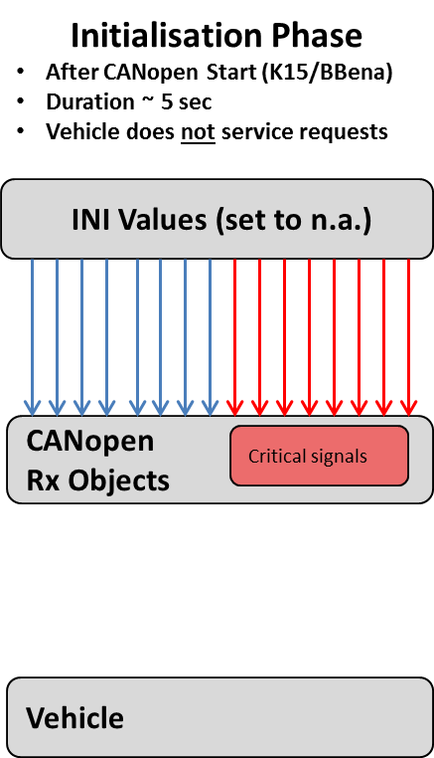
INITIALISATION PHASE:

During Initialisation phase the CANopen Stack is started. When finished the Pre-operational have been entered and the CANopen stack sent a NMT Boot-Up messages. For details see Chpt. 2.3.4.

This Initialisation phase is executed:
- After K15 ON (Default)
- via the BB _enable input St72072A / Pin6 (future).
Note: This would allow also to Stop CANopen Stack.

In Pre-operational phase no CANopen message are transmitted.

In Pre-operational phase all the received CANopen objects are automatically set to ‘don’t care’ values. Anyway these received values are not yet serviced by the vehicle.
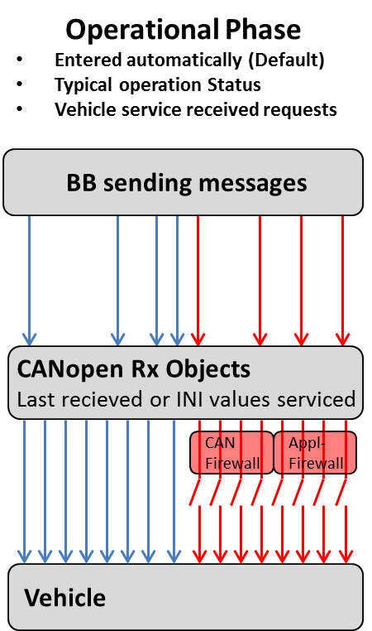
OPERATIONAL PHASE:

When entering Operational phase the CANopen sent a NMT Start-All-Nodes command. For details see Chpt. 2.3.4.

This operational phase is executed:
- After K15 ON (Default)
- via the BB_enable input ST72072A / Pin6 (future)
- BB CANopen Master sending a NMT-Start Node Command

When the device enters the operational state then the Interface transmit it’s cyclic messages. In the operational phase the Vehicle starts to service the Received objects.

Pls respect that depending on the BB CAN communication (XDC mapping) only various objects are received from the BodyBuilder. Typically a BB does not use all the available 28 received objects, instead usually he uses only a sub-set of objects.
These objects are then updated by the BodyBuilder, all the other objects will remain the INI ‘don’t care’ values. Anyway all the entire 28 objects will be forwarded to the Vehicle with the last values.

For some critical signals instead the IVECO interface performs a Firewall check. There the access is allowed only under certain mission conditions, else the BodyBuilder access is ignored. The CAN Firewall settings can be developed upon client request. Also the Application Firewall (mainly PTO engagement/ShutOff conditions monitoring) can be adapted in Customer Service.

Vehicle
CANopen Rx Objects
Critical Signals replaced
BB sending messages
CAN
Firewall
Appl- Firewall
Stopped State
Only for critical situation
Entered after EMCY activation
Allows client specific actions

STOPPED STATE:

The StoppedState is foreseen only for emergency situations. When StoppedState is active the CANopen sent a NMT Stop-All-Nodes command. For details see Chpt. 2.3.4.

This StoppedState phase is entered:
- Heartbeat no longer received cyclically (but @least received once)
- BB sending a NMT-Go2Stop Command

When the device enters the Stopped state then the Interface do not transmit cyclic messages. In the Stopped state the Vehicle ignore received CAN objects, instead the last valid received values are maintained. The values remain active till the CANopen stack is restarted (K15 or BB-enable cycling).
The Firewall function (CAN & Application Firewall) will remain identical as in Operational Phase.

BB CAN Bus errors
CAN offers various mechanism to identify communication errors, such as:
- Bit errors and Bit stuffing errors
- CAN message Format errors
- Cyclic redundancy checks
- CAN Acknowledge
The detected errors are counted by each CAN transceiver, separately for received CAN and transmitted CAN messages. The IVECO CAN interface provide this BB-CAN Transmit & Receive error counter information by means of CANopen object 0x2007 sub0x03, so it’s quite easy to measure BB CAN errors.

Busload and CAN-throughput
The IVECO interface CAN throughput is defined as time between:
- Receiving a CAN message from the BodyBuilder CAN till sending it to the In-Vehicle CAN network
- Receiving a CAN message from the In-Vehicle CAN till sending it to the BodyBuilder CAN network
The IVECO interface CAN throughput depends on:
- Execution time needed for Internal applications tasks, such as:
  - PTO management
  - Receiving messages from and sending messages to the In-Vehicle CAN network
  - CAN Firewall
  - Supervision and Diagnostic tasks
- Execution time needed for external interface tasks, such as:
  - Interrupt load caused by receiving messages from BB-CAN network
  - Copying all the received CANopen signals into object buffers
  - Sending messages to the BB-CAN network
  - Copying all the transmitted CANopen signals into message buffers
  - Supervision and Diagnostic tasks

The typical IVECO CAN interface throughput can be estimated by using the following formula:

Throughput time [ms] = 2* PLC Cycletime [ms] + CAN message cycle time [ms]

For the CiA 413-part 6 message gateway the Throughput time is optimized. The throughput can be estimated by using the following formula:

Throughput time [ms] = 30 ms + CAN message cycle time [ms]

The overall execution time is defined as PLC cycletime, and actual value is provided on CANopen 0x2006, sub8. The experience with plenty client applications over the last years have shown good results, when the PLC cycletime ≤ 350 ms limit have been respected.

As already indicated the PLC cycletime is influenced also by the BB-CAN network. The IVECO CAN interface offers to use either:
- standard 11-bit CAN message Identifiers
typical for CANopen applications and proposed for all time-critical applications
- extended 29-bit CAN message Identifiers (typical for SAE J1939 applications)
When using 29-bit ID the PLC cycletime is directly influenced. Therefore BB-CAN busload using extended 29-bit ID should not exceed 20% resp. PLC cycle time 350ms, especially when PTO’s are mounted on automized gearboxes.

Application guidelines for throughput optimization:
- prefer Peer to Peer topology (see chpt 2.2.4)
- choose 11 bit CAN messages identifiers
- use whenever possible the SAE J1939 message gateway mechanism acc. CiA413 - part6 objects
- optimize communication to your real physical needs
  - reduce number of mapped signals (both for transmit & receive)
  - reduce number of messages
  - reduce message cycle time
  - avoid unnecessary communication

Engine speed request management

The external engine speed management is an integral part of the engine speed management. The speed management is composed by:
- Engine high idle speed management
- Speed request management
- NOTE: For CNG application pls respect requirements of Chpt. 12!

The engine high idle speed is the minimum of:
- Default/Base engine high speed
- External Engine speed request upper limit (CANopen object 0x6140)
- Vehicle internal requests, like:
  - ISC Mode 0,1,2,3 high idle speeds
  - ISC Mode 0,1,2,3 high idle speeds for Driver KickDown
  - ISC Mode 0,1,2,3 high idle speeds for CAN KickDown
  - Etc.
The engine high idle speed is valid for both internal and external request and will be kept. E.g. also ISC commands, Accelerator pedal, etc. cannot force the engine to higher rpm.

Note:
Automatic gearboxes can request a momentary engine overspeed.

The requested engine speed can be temporarily suspended resp. overridden by:
Internal systems directly controlling the engine via TSC1, e.g. automatic gearboxes

The actual engine high idle speed value can be read via object 0x6111. The engine high idle speed can be decreased depending on the engine family.
Engine speed request upper limit can be performed only if:
All firewall conditions are fulfilled.

Requested engine speed upper limit
- The default value after Start-up is 0xFFFF
- The value of the last request will be active until K15 off or it’s overwritten by another value
- If a request is not active the value must be 0xFFFF
Engine speed request upper limit can be performed only if:
- All firewall conditions are fulfilled

Requested engine speed
- The default value after Start-up is 0xFFFF
- The value of the last request will be active until K15 off or it’s overwritten by another value
- If a request is not active the value must be 0xFFFF
Engine speed request can be performed only if
- All firewall conditions are fulfilled

Requested engine torque limit
- The default value after Start-up is 0xFF
- The value of the last request will be active until K15 off or it’s overwritten by another value
- If a request is not active the value must be 0xFF
Engine torque limit request can be performed only if:
- All firewall conditions are fulfilled

Requested vehicle speed limit
The Vehicle speed is the minimum of:
- Default/Base vehicle speed limit
- 2nd Vehicle speed limit active via BB HW connector
- Free Programmable Speed Limit activated by the driver
- Vehicle speed limit request (CANopen object 0x6146)
The default value after Start-up is 0xFF
- The value of the last request will be active until K15 off or it’s overwritten by another value
- If a request is not active the value must be 0xFF
Vehicle speed limit request can be performed only if:
- All firewall conditions are fulfilled

TSC1 Requests
Only TSC1 message signals within Byte 1…4 would supported – but requires development upon client request.
Anyway IVECO prefer the engine management via the following objects:
• Requested engine speed upper limit 0x6140H
• Requested engine torque limit 0x6144H
• Requested engine speed 0x614AH

PTO Control
With the Truckgateway interface it’s possible to control the PTO engagement/disengagement via CAN requests, CAN requests can occur in parallel to Hardware Input requests. Each CAN request is evaluated with same ER/SC conditions as HW Input requests.

Furthermore it’s possible that Bodybuilders block a PTO request with the “PTO consent” signal or disable an active PTO request with the “PTO consent” signal. For each PTO type a consent signal exists. Compare signals of chapter 5.5.

To Enable this feature the Parameters PTO1_extCfg, PTO2_extCfg, PTO3_extCfg are available.

Interface to the HighLine Driver Display

This feature is only supported on HighLine Instrument clusters, present on OPT 76131 / OPT 76132. There the BodyBuilder have the possibility to activate one popup on Driver display by sending a spontaneous message.
The text of the popup is fix <<extBB>>. In addition the warning buzzer can be activated, either continuously or on first occurrence. Also different buzzer tones and levels are selectable. If needed the BB is informed by receiving the feedback from the Driver display.

In detail the following features are available:
- Activate one of 5 ICONs
- Select severity to assign the Popup background
- Activate the buzzer
- Select continuously warning or on first occurrence (future extension)
- Select buzzer tone (future extension)
- Select buzzer level (future extension)

Furthermore the BodyBuilder can verify following feedbacks on the Driver display:
- Actual displayed Popup via ‘Indicator Index’
- Popup activation status (Foreground / Background)
- Popup Acknowledge by the driver
  - no ACK given
  - pos ACK by Driver
  - Neg ACK (when Popup auto-confirmed, after ~30 sec)
- Feedback buzzer Tone (future extension)
- Feedback Buzzer Level (future extension)

Pls consider that the BB can sent only one Popup per time (either background or foreground). Popup’s contemporaneously displayed from any other vehicle systems (Brake, gearbox, engine etc.) may override the BB activated popup. Same applies also to the warning buzzer management which might also be overridden by vehicle events.

Anyway the BB is informed on the actual status reading the HMI_feedback message.

HMI_request Message

The HMI_Request message is sent by Body Builder via CANOpen using the following manufacturer specific objects:

Object Index (hex) | Sub-index name | Variable Name | Sub-index (hex) | Size | Default (hex)
0x2003 | IN_UNSIGNED32_RX_09 | ICRW_EM LSB | 0x09 | 32 | 0xFFFFFFFF
0x2003 | IN_UNSIGNED32_RX_10 | ICRW_EM MSB | 0x0A | 32 | 0xFFFFFFFF

The message layout is defined as follows:

SPN Name | SPN Position | SPN Lenght
Info Activation Mode New | 1.1 | 2
Info Severity | 1.3 | 2
Buzzer Activation Mode New | 1.5 | 2
Buzzer Tone Extended | 2.5 | 4
Buzzer Level Extended | 3.1 | 4
Indicator Index | 5,6.1 | 12
Popup Index | 6.5,7 | 12

Info Activation Mode New
It is “General Activation Signal”. Values should be the following:

- 0x00: Off
- 0x10: On
- 0x11: No action

EM should use only 0x00 and 0x10 values. Default value is 0x00 and with 0x00 a continuous transmission is not needed.

Info Severity
The Info Severity define the background of the popup. Values should be the following:
- 0x00: Lowest severity, No lamp (future extension – actually Red colour displayed)
- 0x01: Medium severity, Yellow colour.
- 0x10: Highest severity, Red colour
- 0x11: No action

Buzzer Activation Mode New
The buzzer activation mode new defines if the driver display warning buzzer should be activated. Values should be the following:

- 0x00: Off
- 0x01: On at first occur or start-up.
- 0x10: On
- 0x11: No action

No action value 0x11 should not be used, to deactivate the buzzer information 0x00 must be used. Buzzer activation is triggered by Info Activation Mode new. EM should use only the following value: 0x00, 0x01 and 0x10.

Pls consider that the buzzer might be overridden by prior vehicle events. Sound priority list as follows:

1. ACC alert sound
2. ACC shutoff sound
3. LDW warning
4. "Handbrake not engaged" sound
5. Lights on Warning (Door open / KL15 off) & Eurotronic warning
6. Inducement warning
7. Warnpopup sound / Hill-Holder Sound both have the same level
8. BodyBuilder Buzzer activation

Buzzer Tone Extended (future extention)
(future extention)Command to select the sound tones. If signal is not available a Default Tone is used. Values should be the following:
Buzzer tone | Buzzer Tone Extended | Note
No tone | 0h
Tone 1 | 1h
Tone 2 | 2h
Tone 3 | 3h
Tone 4 | 4h
Not used | 5h – Eh | Recovery tone: Tone 3
Not available | Fh | Recovery tone: Tone 3

Buzzer Level Extended (future extention)
Command to set the volume of the sound tone. If signal is not available a Default Tone is used. Values should be the following:

Buzzer Level |  | Buzzer Volume %
0x0 | Off | 0%
0x1 | Level 1 | 14%
0x2 | Level 2 | 14%
0x3 | Level 3 | 28%
0x4 | Level 4 | 28%
0x5 | Level 5 | 43%
0x6 | Level 6 | 43%
0x7 | Level 7 | 57%
0x8 | Level 8 | 57%
0x9 | Level 9 | 71%
0xA | Level 10 | 71%
0xB | Level 11 | 86%
0xC | Level 12 | 86%
0xD | Level 13 | 100%
0xE | Level 14 | 100%
0xF | No Available | 100% (Default Level)

EM default level is 0xF

Indicator Index
The Indicator index selects the ICON to be displayed left from the Popup. If signal is not available no ICON is displayed. Values should be the following:

0x0: |  | Default Indicator
0xFFF: |  | No action, No indicator.
EM should use 0xFFF as default value, no indication preferred.

The available ICON’s are:

Indicator Index 0x0C:: Indicator Index 0x0D1:
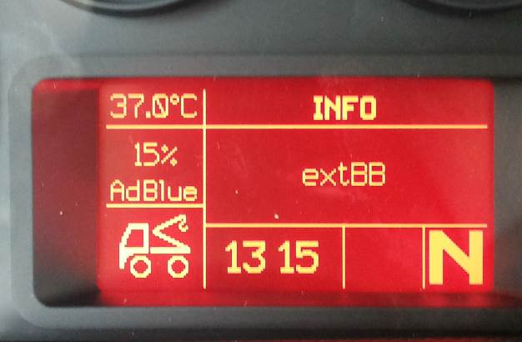
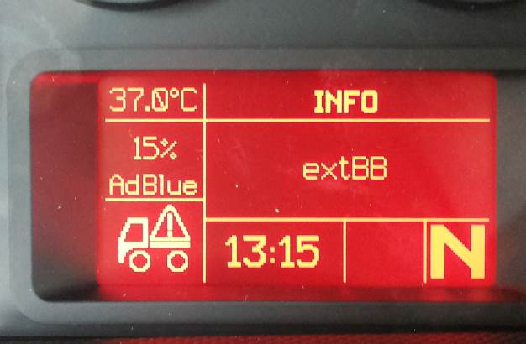

Indicator Index 0x0CF: Indicator Index 0x0D2:
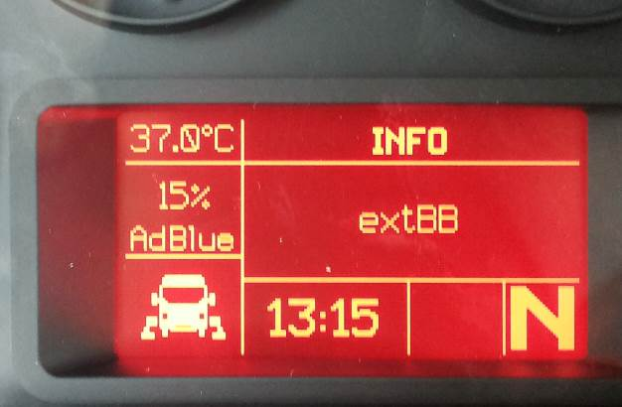
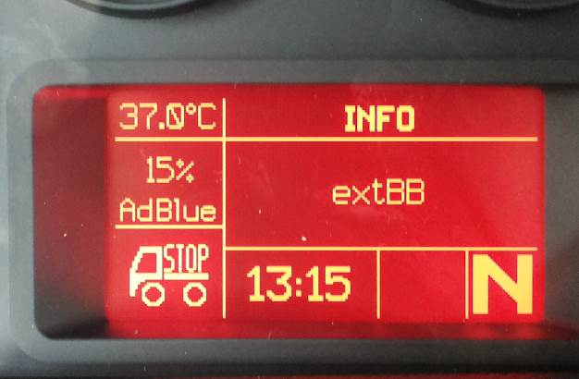

Indicator Index 0x0D0:

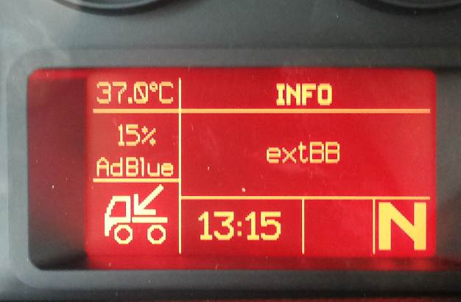

Popup Index
It selects a Popup text. The BB should always sent 0x1, else a unique identification is not possible.

- 0x0: Default Popup text “System info”
- 0x1: Popup Active Popup text “extBB”
- 0xFFF: No action, No popup.

For any value, only one index will be available (0x1). The assigned Text is always “extBB”
For disabling a popup text BB have to send 0xFFF “ “

HMI_feedback Message
The HMI_feedback information is available at CANopen object 0x6439.
HMI_feedback message signals are explained below:

SPN Name | SPN Position | SPN Lenght | Description | Value Table
Indicator Index | 1, 2.1 | 12 | It selects an Indicator Lamp (Tell Tale) or Icon index. | 0x0 Default Indicator  0xFFF No action, No Indicator
Popup Index | 3,4.1 | 12 | It selects a Popup index. | 0x0 Default Popup  0xFFF No action, No Popup
Popup Activation Status | 4.5 | 2 | Driver's activation status of the Popup specified by the signal "Popup Index". | 0x00 Disabled/off  0x01 In foreground  0x10 In background  0x11 Not available or error
Popup Acknowledge Status | 4.7 | 2 | Driver's confirmation status of the Popup specified by the signal "Popup Index". | 0x00 No acknowledge given  0x01 Positive acknowledge received  0x10 Negative acknowledge received  0x11 Not available
Buzzer Tone Extended | 5.1 | 4 | Command to select one of the sound tones available presets or status of the currently active one. | 0x0 Off  0x1 Preset Tone 1  0x2 Preset Tone 2  0x3 Preset Tone 3  0x4 Preset Tone 4  0x5 Preset Tone 5  0x6 Preset Tone 6  0x7 Preset Tone 7  0x8 Preset Tone 8  0x9 Preset Tone 9  0xA Preset Tone 10  0xB Preset Tone 11  0xC Preset Tone 12  0xD Preset Tone 13  0xE Preset Tone 14  0xF No Available, Default Tone
Buzzer Level Extended | 5.5 | 4 | Command to set the volume of the sound tone or status of the currently active level. | 0x0 Level 0  0x1 Level 1  …  0xD Level 13  0xE Level 14  0xF Not Available, Default Level

CNG engines

General Information

The IVECO BB interface is available on CNG applications too. The IVECO Compressed Natural Gas (CNG) engines are Spark Ignition engines working in Otto process. Due to this following limitations are to be respected:
- reaction times slightly delayed compared to a Diesel engine.
- Limitations of Rpm & Torque range for PTO operation
- Limitations of Torque variations during PTO operation
- Rpm control quality in response to varying load.

Physical torque and speed limits

Normally the engine torque in PTO operation must not exceed the torque that the engine can deliver in atmospheric operation (= “without help of the turbocharger“). Like this, it can be guaranteed that the engine can react in a relatively quick way to the need of torque variation. Basically the CNG application governors are optimised for these typical BB operating areas.

Speed controls

The DAILY CNG engine does not support:
- Req. Rpm 0x614A
- Req. Rpm upper limit 0x6140

Note: If enabled the Rpm can also be adjusted using the CC/ISC interface. This is allowed only during standstill conditions. It’s both possible from Driver using CC Set+/Set- buttons as well as using the CANopen CC requests (Canopen objects from 0x2000, sub 0x04 to 2000H, 0x07)

IVECO Customization process
In addition to the flexible CAN interface IVECO could develop - upon client request - also a flexible CAN-Firewall pre-sets. For this features functional groups – aligned to Medium and Heavy Range - will be defined. These functional groups will follow a functional approach, within each group a certain set of Easy2use configurations are available. Therefore pls contact your BB market responsible

