4 Channel Digital Video Recorders
User’s Manual

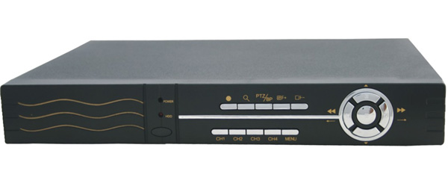

Notice
While recording TV programs or VCD/DVD programs，Pls don’t pirate the third-party’s authority .
The information in this manual was current when published. Then manufacturer reserves the right to revise and improve its products. All specifications are therefore subject to change to change without notice.
Under copyright laws, the contents of this manual may not be copied, photocopied, reproduced, translated or reduced to any electronic medium or machine-readable form, in whole or in part, without prior to written consent of tyam.

Contents

Chapter 1Introduction ……………………………………………………………3
1.Introduction ………………………………………………………………3
2.Feature ……………………………………………………………………3
Chapter 2: Installation……………………………………………………4
1.Manual ……………………………………………………………………4
2.Security warning ……………………………………………………………4
3.Packing list ………………………………………………………………….4
4.Installation environment ……………………………………………………4
5.Rear board connect …………………………………………………………5
6.USB backup ……………………………………...…………………………6
Chapter 3:Display ………………………………...……………………………….6
1.Live display ……………………………...……………………………….6
2.Time display ………………………………...……………………………6
3.Record State ………………………………...…………………………….6
4.Operation State ……………………………...…………………………….7
5.Alarm State …………………………………...……………………………7
6.Playback State ……………………………...……………………………..7
Chapter 4 ：Operation…………………………………………………..7
1.Front Panel..…….……………………………….…………………………7
2. Remote controller…………………………...…………………………….7
3. Button function …………………...…………………………………….8
4.Frequent operation………………………………………………………...13
Chapter 5：Menu setup ………………………………………………………….15
1.Menu operation…………………………………………………………...15
2.Main Menu ……………………………………………………………….15
3.System set ………………………………………………………………...15
4.Camera set ……………………………………………………………….16
5.Motion detection set ……………………………………………………...17
6.Sensor set …………………………………………………………………17
7.SEQ setup ………………………………………………………………...18
8.Net set ……………………………………………………………………18
9. PTZ set…………………………………………………………………...19
10.Record set ……………………………………………………………….19
11. Disk mange. …………………………………………………………20
12.Log mange……………………………………………………… .….….20
Chapter 6：Basic operation. ……………………………………………………21
1. Start…………………………………………………………………….21
2.Close DVR by remote controller ……………………………………21
3. Open DVR by remote controller……………………………………….21
4. Close DVR……………………………………………………………..21
5. Software update………………………………………………………..21
6. HDD change……………………………………………………………22
7.Alarm select…………………………………………………………….22
8 Recording ……………………………………………………………23
9.Manual recording ……………………………………………………….23
10.Alarm recording ……………………………………………………….24
11.Timed recording………………………………………………………..24
12. Search playback and backup…………………………………………..24
13.Audio…………………………………………………………………..25
14.Network………………………………………………………………..25
15.PC view software ……………………………………………………27
16.Picture quality /storage /HDD recording time…………………………27
Appendix 1:Techolongy parameter ………………………………………………28
Appendix 2：F.Q.A………………………………………………………………29

Chapter 1：Introduction of product

1. Introduction
This DVR is designed for Security surveillance system. It uses the embedded processor and embedded operating system, which combines the field of the latest IT technologies, If video / audio compression / decompression, large-capacity hard disk storage, and TCP / IP network remote control technology, It has the high intelligence and high stability.
Support Ethernet, the Internet and other remote network video and audio synchronization, it is simple to operate. Can be applied to banking, telecommunications, schools, hospitals, supermarkets and neighborhood, factories, companies, stores, restaurants, hotels, car parks, museums, water conservancy facilities and places of entertainment in the many areas of security.

2.Features
●Compression
- MPEG4 quality and stream. Standard configuration (40G hard drive) for the video is 45 hours (the standard of quality).
- Quadriplex functions (l) Four channels video and two channel audio simultaneously; (2) Four remote video surveillance networks
(3) Search and playback operation 4) backup

- Linux system
- Support Chinese, English, Russian OSD can optional
- Support IE browse
●Recording and backup
- Recording pixel can change, PAL :352*288（CIF）、704*576（D1），Recording resource CIF-100 F/S（NTSC120F/S），HD1-50 F/S（NTSC60F/S），D1-25 F/S（NTSC 30F/S），3 type can support 4 channel recording simultaneously
- Recording model ：Alarm recording, Timed recording, Manual recording
- Recording picture quality can adjusted from 5 type separately
- USB2.0 ,USB Hard Disk、U disk, Hard Disk
- Support two HDD up to 1000G
- Specially designed video file system; hard disk life can be improved more than 10 times.
- Nobody can change the hard disk recording of video and audio information, they are very credible.
●Search and playback
- The playback search function, according to time, alarm, recording period is powerful
- Each channel and four channel simultaneously, playback and recording simultaneously. And can zoom the video
- Powerful back function according to time of beginning and time of closing
●Control
- Separated form PC, the complete elimination of improper operation of the computer hang , complex with the operation and management of virus infection, with a high stability。It provide operation stability, no hang-up error, more reliability and easy for maintenance. Operation with front panel and remote control and network remote control
- U disk software update
- Speed dome camera control, Network client can control speed dome camera
- Security with password lock. System management require for authority code in order to provide safety system
●Alarm
- Three type alarm ：Sensor, motion detection alarm, loss alarm. Sensor and motion detection support each channel schedule of channel separately

Chapter 2: Installation description

1. Security
This machine is indoor using equipment; in order to avoid dangers of short circuit or electric shock, please do not expose the machine in rain or moist environment. In case any solid or liquids get into the machine’s case, please cut off the power supply immediately, and ask for qualified technicians to check the machine before restart.

2. Packing list
Packing list
Item | Quantity
DVR | 1
Manual | 1
Guarantee card | 1
Remote controller | 1
Remote controller battery | 2
12V power adapter | 1
Power cord | 1
Software CD | 1
USB change IDE | 1（optional ）

3.Installation
Please choose appropriate site to install the machine, to ensure well ventilation around the machine to avoid the machine excessively hot. The machine cannot be installed near radiator and ventilating trunk etc. heat sources, or under straight sunshine, or dusty places or anywhere there is a chance for mechanical librations or impact.
Power supply
This Digital-Video-Recorder applies DC 12/4A voltage indoor power supply. The voltage of the power must be verified before using.
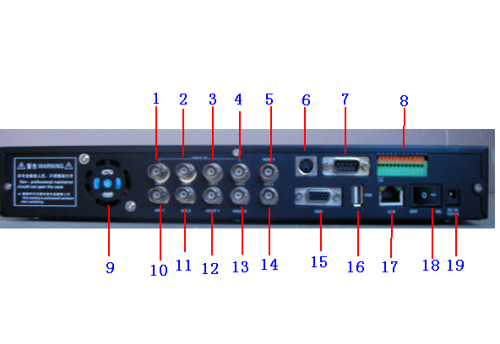
When the machine is not in use for a long time, pull out the plug from the socket and disconnect the power.

4.Rear board connect introduce
1、Illustration as follows:

(1)Camera 1 input ( 2)Camera 2 input ( 3)Camera 3 input ( 4)Camera 4 input (5)Video output (6)S-video port output ( 7)232 port (8)control and alaram (9)．Fan (10).Audio input R (11). Audio input L (12).Audio output R
(13). Audio output L (14). call monitor output ( 15.) VGA output
(16.) USB port ( 17)．Network port (18).Power on/off (19.)Power input

2、Control port
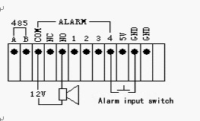
(1) 485 port, can accept exterior host computer control and PTZ control signal
(2)NC/NO/COM is alarm relay output, NC: Normal close, NO :Normal open，COM: Common port
(3) 1-4 alarm input, can connect DV or 5V T level input
(4) Above illustration give a way of alarm input and output connect. Four channel input is low Pp-p trigger; output can connect exterior 12v power, in order to drive the speaker.

5.USB backup
The machine can will not support 5v power USB disk and less than 32M common U disk，If forced into use, there may be a lockup or other anomalies; Addition, This equipment will support the USB devices (requiring only one main branch, Logic does not support District) including ：
(1) More than 32M common U disk
(2) Exterior power USB HDD
(3) Exterior power USB CD-RW and DVD-RW

Chapter 3: Display

1.Live display ：
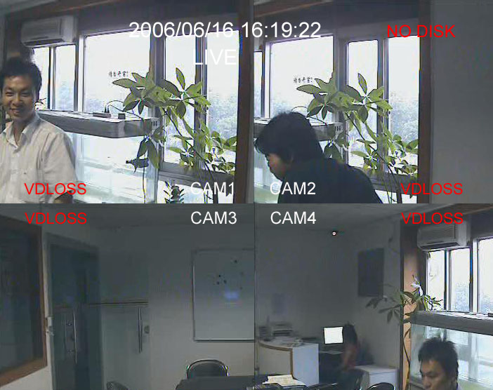

2 .Time display ：live time /date，at top of middle or bottom of middle show, you can amend in “Main menu –system set –time display position ”,time format use in amend time show format; you can change the time“main menu –system set –time set ”，when the time back. Under time backup station, current time not display.
3.Record station ：will display in top right corner，station including ：No HDD / HDD full / No record /manual record / alarm record /Timed record /HDD wrong, When the change named turn red, it shows this channel under record station. Connect power, if it will show “No HDD ”，Pls you check the HDD connect well or not, if appear “ HDD Wrong ”alarm during record process, maybe the HDD appear wrong, Psl check the HDD connect or exchange the HDD
4.Operation station ：including live control /exchange setting /PTZ / Menu / SEQ，Enter this station （expect menu ），this sign will twinkling in middle of up .under in exchange setting，you can choose the channel by ↑,↓ button, the choose channel frame will blink. Under PTZ station, you can choose channel by pressed 1-4button,the channel frame will blink
5.Alarm：Including video loss alarm, motion detection alarm, and sensor alarm.
6.Playback：local image resolution will show over position; playback including :play /pause /Fast forward （fast backward ）X2 /fast forward（fast backward）X4,if the playback came back terminal ,will show play over.

Chapter 4 :Operation

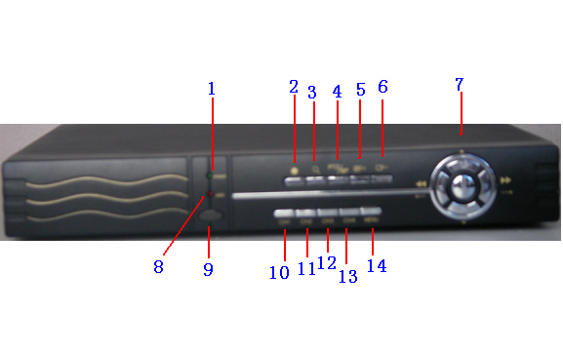
1.Front board introduce
◆front board illustration

(1) Power lamp (2) Recording (3) Search / display (4) PTZ /Playback
(5) Quad /focus plus/plus (6) each /focus minus/minus
(7)Direction key /Enter key，Direction key ;▲ up,▼down ,←left,→ right 、.fast forward 、 fast backward , middle key :Enter
(8)HDD storage lamp (9) IR (10) Channel 1 (11) Channel 2
(12) Channel 3 (13) Channel 4 (14) Menu / Exit

2.Remote controller introduce

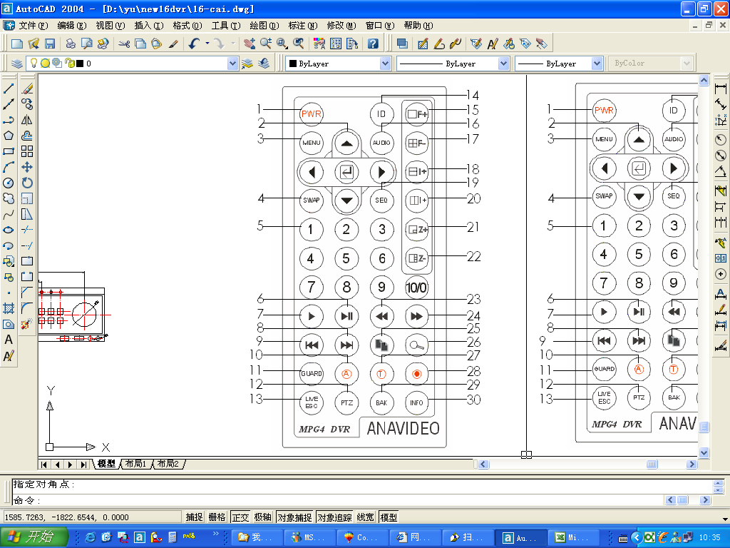NO | English | NO | English
1 | PWR | 16 | AUDIO
2 | /Enter | 17 | Each /focus minus/minus
3 | MENU | 18 | POP/iris plus/
4 | SWAP | 19 | SEQ
5 | Numeric key | 20 | PIP /iris minus/minus
6 | Pause | 21 | Left right /Zoom/plus
7 | Playback | 22 | Up down /shrink/minus
8 | Page down | 23 | Fast backward
9 | Page up | 24 | Fast forward
10 | Alarm record | 25 | Backup
11 | GUARD | 26 | Record search
12 | PTZ | 27 | Time record
13 | /LIVE、ESC | 28 | Manual record
14 | ID | 29 | BAK
15 | Quad/focus plus/plus | 30 | INFO
3.Button function description

(1)．GUARD guard on/off
Press Guard button, the button’s lamp will lights. Then began to detect sensor alarm and motion detection alarm. Any channel as mechanical alarm or motion detection alarm will trigger alarm; Even if not under Guard station, Video happen any time lost, it will trigger off alarm;
Trigger the alarm, the buzzer give off a warning ringing. Relay gives a close and opne sigal. Then keep the information in the HDD.
(2)．MENU menu setup
Every settings are needed to modify in the menu, enter a password-protected menu, only input the correct password, can we modify and set parameters
(3)．SWAP image change
This button under surveillance state will be effective, Press SWAP Key, first channel frames flashing, press 1-4 button, the flash frames will become corresponding channel images, if the other channel images same as this image, will changed automatically as the image of front of blinking frames
(4)．AUDIO audio monitor
(5)．SEQ
Press SEQ button under at locate state. SEQ will twinkling on the top of Monitor, Monitor images SEQ according to 1 -4 CH. Each channel of time of stay due to SEQ set time to confirm.
(6)．  Alarm record
Press Alarm record button, first to start the alert function, equivalent to pressing the alarm button. With the state of alert of all functions, and then started the front alarm record, former alarm record save in memory, after the alarm, This content of record will save in HDD automatically. Alarm stopped, the record will continue automatically to the end of time after the record time stopped. Former alarm and behind alarm can set up RECORD SET menu.
(7)．  Timed record
Record time period can be setup at plan menu. Timing record according to set record time period to start and stop the record.
(8)． Manual record
Press Manual record button, record / audio startup immediately, Especially, Record setup have each channel video and audio record ‘s on off. if the switch is off, the corresponding channel is not for the record . Above three record mode is exclusive, enter into another record mode, we must withdraw from the current record mode; Exit way is : Press corresponding record button again , while the Password window appear , entered the correct password, record exit .
(9)． Key
The record stopped, the locate station; press this button spring backup menu, so you can carry through backup operation.
(10)． Record search
Record search have 3 means, can playback and backup, time search
①TIME SEARCH MENU
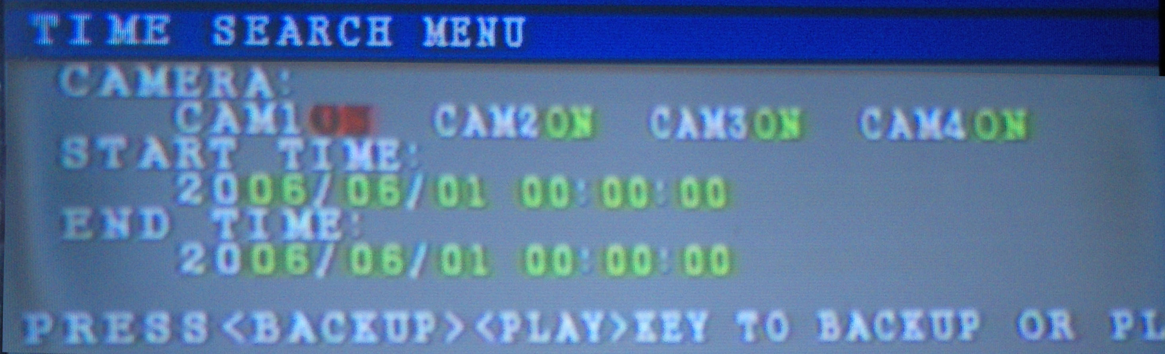
Open searches channel, input the start time, then press ENTER or PLAY button. Playback will start form input the time of beginning. If this time period will not record. Will precede the record location. If you want to backup, it is first necessary to insert USB and selected backup needs channel, input starting and ending time, then press the "Backup" button, then if U disk capacity less than 5 M or backup completed, the backup will automatically stop
②EVENT SEARCH MENU
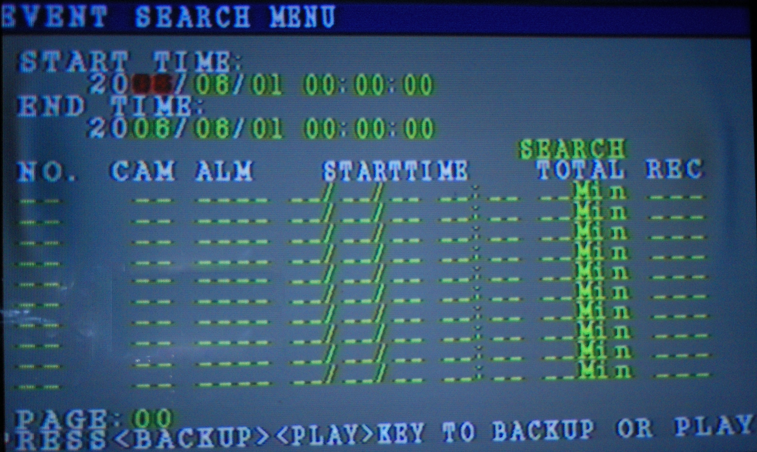

Input the searches beginning and end of time use the up and down cursor move to SEARCH, press the "Enter" button. Then alarm record accord with time condition all will list; cursor moved to a record. If the records in REC line show N, expressed alarm and no record, CIF, HD1, D1 express local resolution, press the "Backup" button can perform backup, press the "Enter" button or the "playback " button to play the selected document. If a page not show fully, the cursor can be moved to PAGE, according to the "plus, minus" button to turn over the page to View, can re-enter input a start and end time, and reduce the scope of search.
Backup operation same as time search
③FILE SEARCH MENU
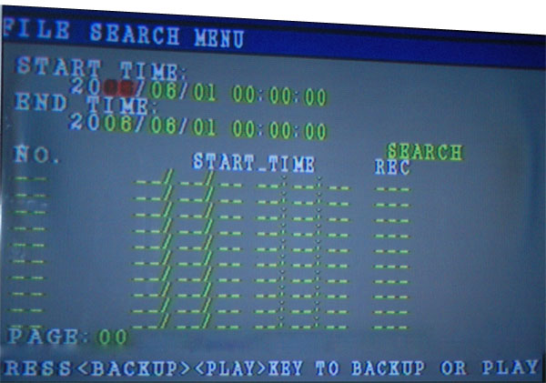
File search menu similar as time search menu, you can follow the operation.
(11)．Numeric button 1-10
(12)． Screen / focus decreases / minus
①In the live state, or playback state, the key will let quad picture switch to a picture , under the big picture state.4 channel image can full screen show according to press 1-4 numeric key to switch
② Under the high-speed dome state, played the role of focus length decreases
③At the state of numerical changes, the role-played minus by numerical
(13)． Screen / Zoom increase / increase
①In the live , or playback state，the key will let a picture switch to quad picture
② under the high-speed dome state，and add the focus effect
③at the state of numerical changes，the role played plus numerical effect
(14)． Picture-in-picture / Iris reduce / minus
①Under the live state，the button can switch quad picture to PIP，Two picture show all can though SWAP button to switch different channel
② In a state of operation of high-speed dome, with increasing role of the iris
③ at the state of numerical changes, the role played by numerical minus
(15)． Picture out of picture / iris increase / increase
①Under the locate state，the button can switch quad picture to picture out of picture . Four pictures show all can though SWAP button to switch different channel
② under the operation of high speed dome , can minus iris
③under the state of numerical changes, can add the numerical
(16)． Up and down screen / reduction / minus
① under the locate state, the key can switch the quad picture to display mode，Two picture show all can though SWAP button to switch different channel
② under the operation of high speed dome，can widen the lens
③ Under the state of numerical changes ,can minus the numerical
(17)． Left and right screen /zoom /add
①under the locate state, the key can switch the quad mode to display picture ,two picture show all can though SWAP button to switch different channel
② under the operation of high speed dome，can pull closer the lens
③under the state of numerical changes ,can increase the numerical
(18)． Direction Keys / Enter key, direction key including the↑,↓,←,→ key , in the middle of the ENTER key.
(19)． Live / exit
This button can be used exit playback, exchange set up, menu, and audio setup, pan and tilt control of the state.
(20)．
Under the locate state, press the button, the screen appeared PTZ, while the first channel dividing lines flashing. Then this channel can be PTZ control by ▲,▼,←,→key , also can operated focus , adjust iris and lens distance and other functions, to change the operating channel, to select through numerical key ,under the state of PTZ. Press PTZ and ESC key, can exit from PTZ state. PTZ parameters can be amend in “PIZ” menu
(21)．
In the record search state, the key is used to backup for the record document, detail operation pls refer to record search
(22)． : SYSTME INFO MENU
In a state of the locate, press the button will display information system menu
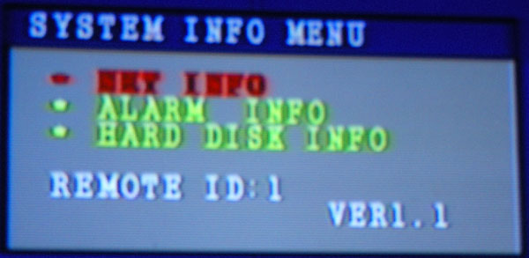
①Network configuration information and network connectivity information
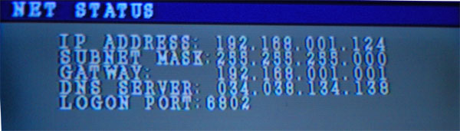
Apart from showing the network configuration information, the client ‘s software of the users IP address can also showed.
②ALARM INFO
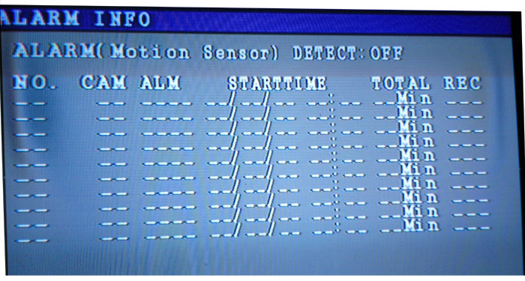
③HARD DISK INFO
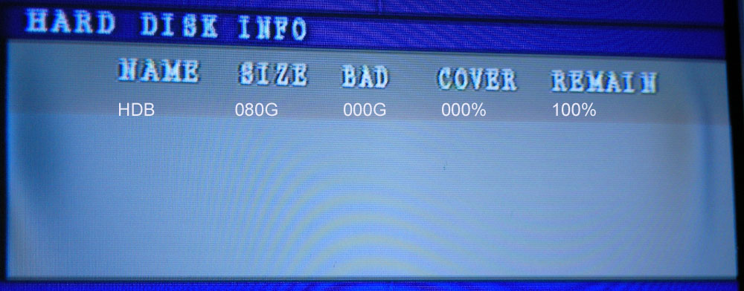
(23)． Playback
Pressing the key, playback will begin form the last period of record.
(24)． Pause
Playback process, press the button, playback will pause, press again, playback continue; under the pause state. Can be single-frame, single key frame exit and so on to operated
(25)． Up frame
When display pause, press this key will show up key frame image
(26)． Next frame
When display pause, press the key will play forward a image.

4. Frequent operation
(1)．General button
① F+/Z+/I+ Besides other functions, there is also "+” function F-/Z-/I- have "- " functions;
② " ▲,▼, ←,→ , Enter" button
③“LIVE/ESC / MENU”button, In addition to not exit from the record , but also other state can use the keys to exit until the locate state.
(2.)Password input
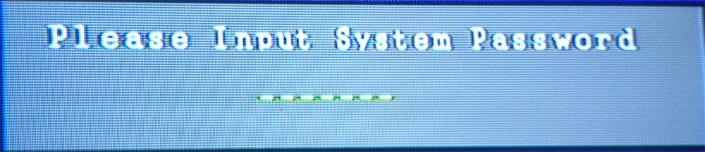
Input numeric Key, the correct password verification, entering sub operation. Default password is "11111111." You can use remote controller numeric key input or use front panel CH1 key input.
(3)．Password change
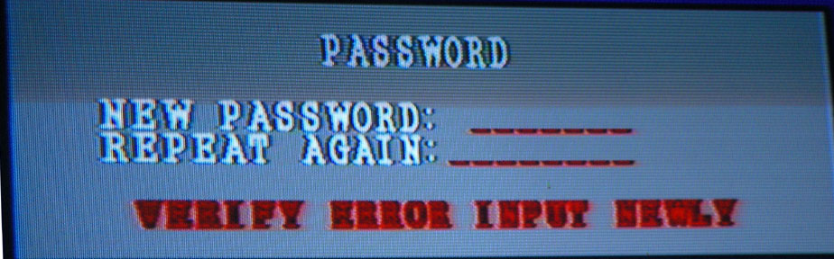

Password menu spring out, entry password, if you input the same password twice, may enter sub operation, otherwise there following his test failure information; after the test failure will be re-input.
(4)．CHAR INPUT
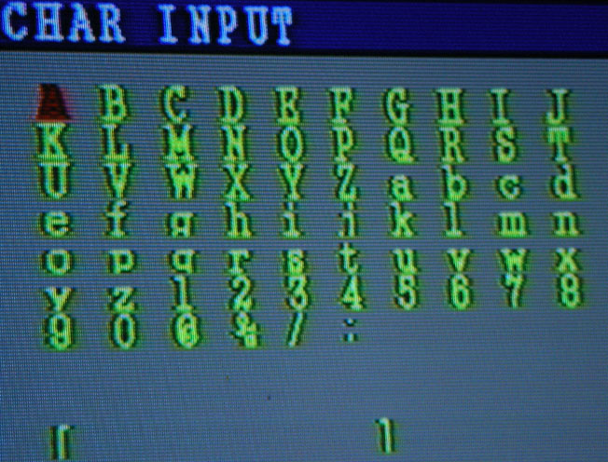
Press "▲,▼, ←,→" button to choose characters, then press "Enter" button to confirm, press "MENU " to refund superior menu.

(5)．MOTION PLAN MENU
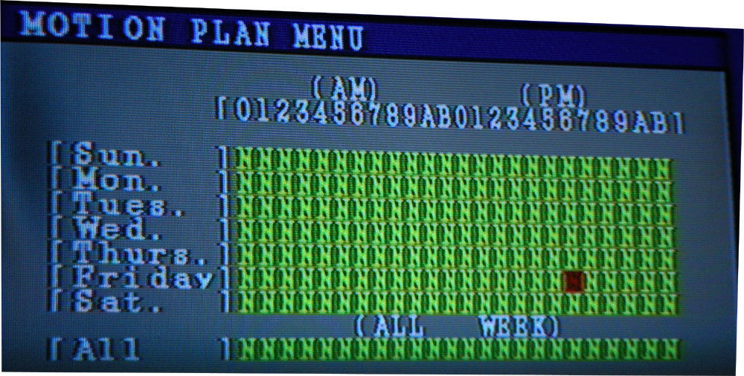
Scheduling a week as a unit, precision is one clock, in order to convenience setup, the bottom line is ALL. Can amend the week at the same time; in this menu, "▲,▼, ←,→,+,- "button effective. Scheduling Setup menu can be used to sensor alarm scheduling, and motion detection alarm scheduling, record scheduling; each channel have independent scheduling.

Chapter 5 Menu setup

- Menu setup
Choice of the remote controller or machinery on the "MENU" button to go direct into the main menu, Select "MENU / LIVE / ESC" to exit the current interface. "▲,▼, ←,→,+,- " button "MENU" "LIVE / ESC" key can be used for menu operation.

- MAIN MENU
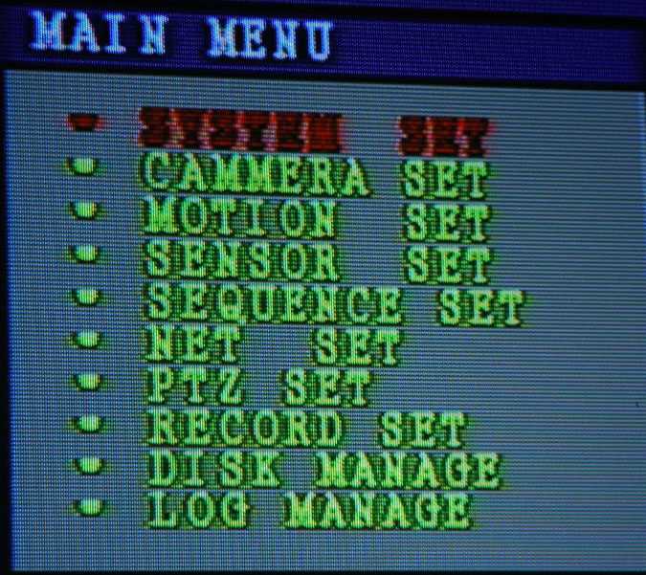

- SYSTEM MENU
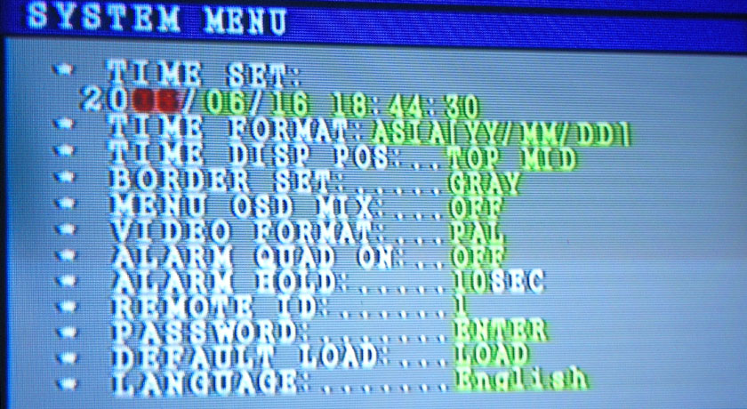
(1) TIME SET: to adjust the period of time systems. Press ▲,▼, ←,→,
to choose the time you want to revise .then press＂+,-＂to revise . at last press enter key to confirm
(2) TIME FORMAT: to set for the date show format, Asia / Europe / USA optional.
(3) TIME DISP POS: Date and Time display location, the choice of top or bottom of the middle of the position. (NO DISPLAY, BOTTOM MID, TOP MID)
(4) BORDER SET: gray / black / white / and off can optional.
(5) MENU OSD MIX: OFF: background color; ON: translucent color
(6) VIDEO FORMAT: PAL/ NTSC system can optional,
(7)ALARM QUAD ON ：After alarm produce, if not spring out quad. (ON, OFF)
(8)ALARM HOLD ：After the alarm, alarm output holds time. (0-9sec)
(9) RMOTE ID: Pls you press ID button and click the numeric keys on remote controller, can be selected corresponding ID equipment, ID on the right, the front plate equipment remote controller receiver lamp will light, then, remote controller control the DVR effectively, the function of a remote control device can control multiple respectively equipment, When ID setup as zero said the infrared remote control function turned off.
(10) PASSWORD: enter or exit to the record menu, it needs to input the password to validate
(11) SOFTWARE UPDATE: before software updates, insert USB of new version software, in the middle of update process, To prevent power shut-off and drew U disk; after Software Update, the system would require the DVR restart.
(12) DEFAULT LOAD: factory parameters install renew; when confirmed, system will enforce the system restart.
(13) LANGUAGES: Selection System language (English or Chinese). Channel and network user name will change according to the language.

4.CAMERA MENU
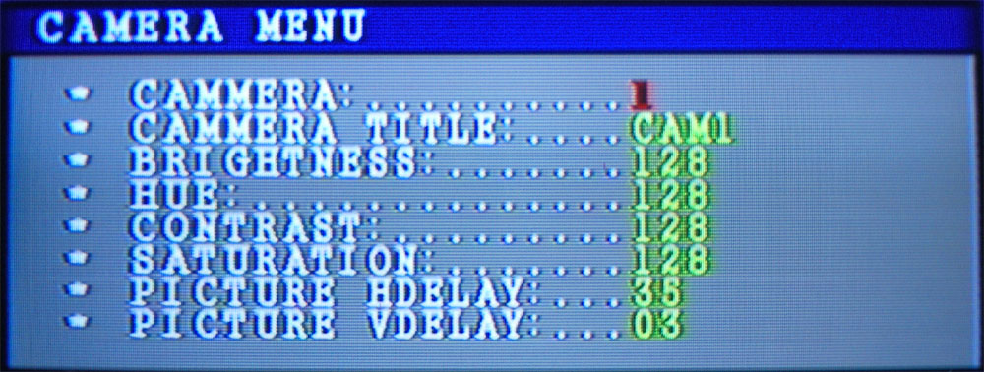
Press '+''-' button to change numerical
(1) CAMERA: to choose that will be set up channel, use +, - to set up.
(2) CAMERA TITLE: press he ENTER button to amend the Channel name,
(3) BRIGHTNESS
(4) HUE
(5) CONTRAST
(6) SATURATION
(7) IMPEDANCE MATCH: Video input impedance matching. Under normal circumstances 75 Ohm, if connect loop Link output, the channel changed to high resistance (Hiz), Press '+''-' button.
(8)PICTURE HDELAY: the channel image central horizontal position adjustment.
(9) PICTURE VDELAY: The channel image central vertical position adjustments
5.MOTION MENU
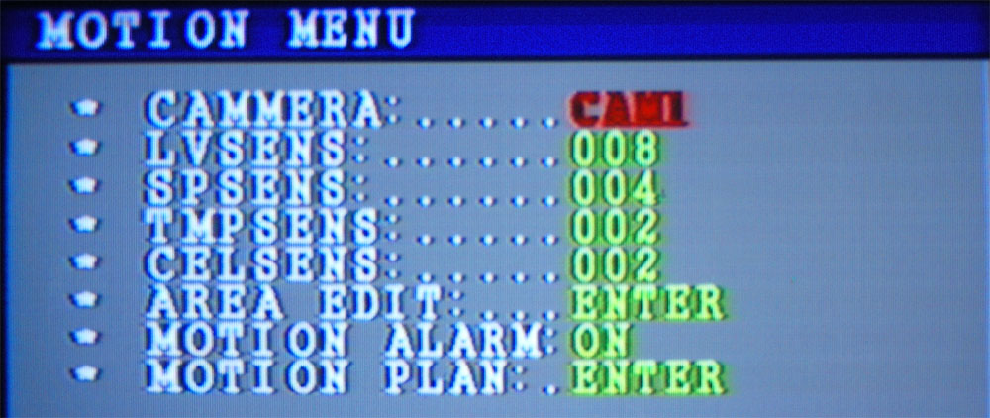
Press '+''-' button to change numerical. In order to watch the setup results you can alter the menu background to transparent color (in the system menu setup), To open the motion detection alarm, please look at the alarm setup
(1) CAMERA: Press '+''-' button to select the channel to be set up.
(2) LEVELS: the level of sensitivity (0-31)
(3) SPSENS: first sensitive parameter space. (0-15)
(4) TMPSENS (0-15)
(5) CHLSENS: the second space sensitivity. (0-3)
(6) AREA EDIT: edit the detect area. press ▲, ▼, ←, → to choose you want to area ,then press ENTER to confirm.
(7) MOTION ALARM: motions alarm whether to activate the alarm. (ON,OFF)
(8) MOTION PLAN: click "ENTER " button to enter the sub menu to setup detection schedule of motion detection alarm.
6.SENSOR MENU
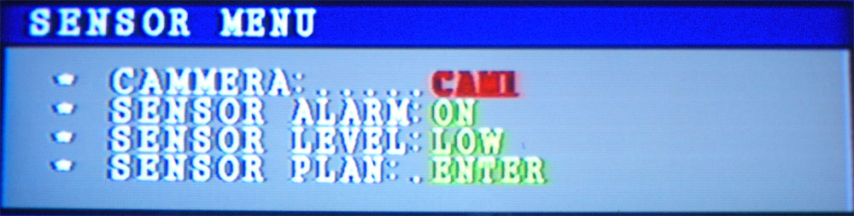

To open the mechanical alarm detection, please look at the alarm setup.
(1) CAMERA: press '+''-' button to select the channel to be set up.
(2) SENSOR ALARM: start motion detection or not
(3) SENSOR LEVEL: sensor trigger level, sensor is TTL level input mode.
(4) SENSOR PLAN: enter sub menu can be setup sensor scheduling. press ▲, ▼, ←, → to choose you want to time ,then press ENTER to confirm.

7.SEQUENCE MENU
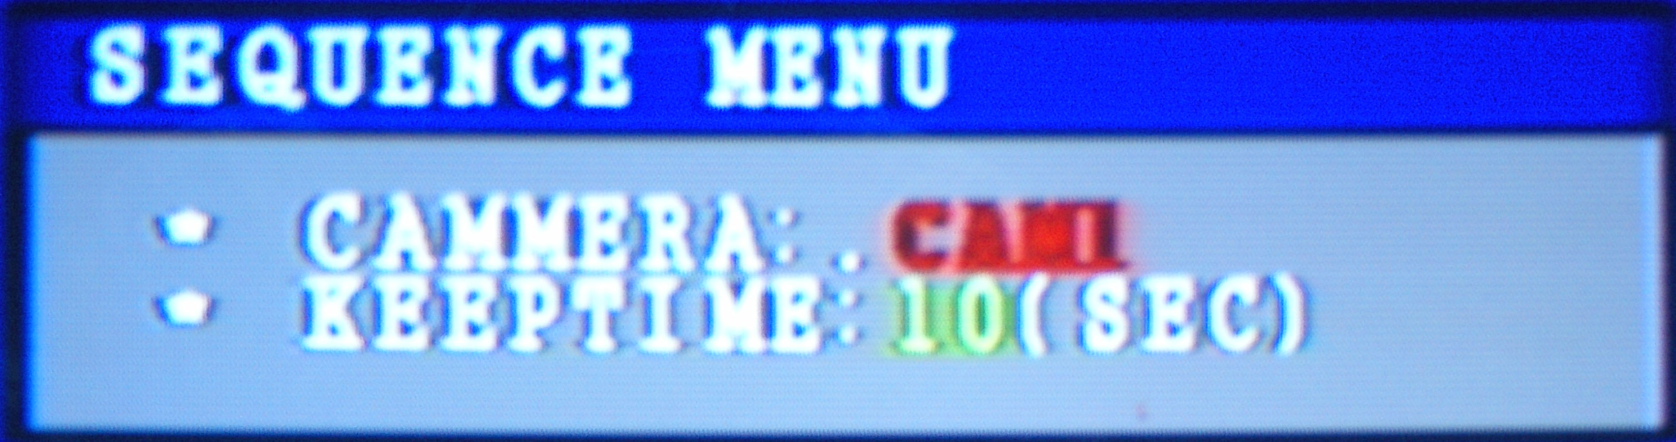
In a state of the live, Press SEQ button, then the main monitor loop output 1-4 images screen. Each channel residence time set by the menu; if keeptime is set to 0, then this channel to stop output.
8.NET MENU
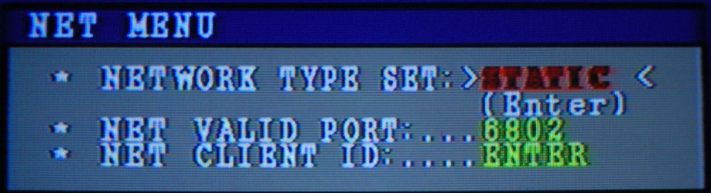
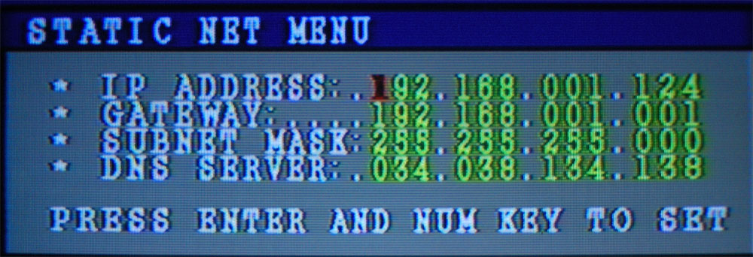

(1) NETWORK TYPE SET: static or dynamic IP, Press '+''-' button to select then press Enter button
(2) IP ADDRESS: using numerical key to amend the relevant addresses, then press "Enter" key to confirmed new set invalid.
(3) NETWORK QUALITY: setup each image of quality, Press '+''-' button to select.
(4) NET VALID PORT: press '+''-' or numerical to revised
(5) NET CLIENT ID: network user management, total of four suits can be set up, include the user name and password, press ENTER button bond.
① CLIENT ID MENU
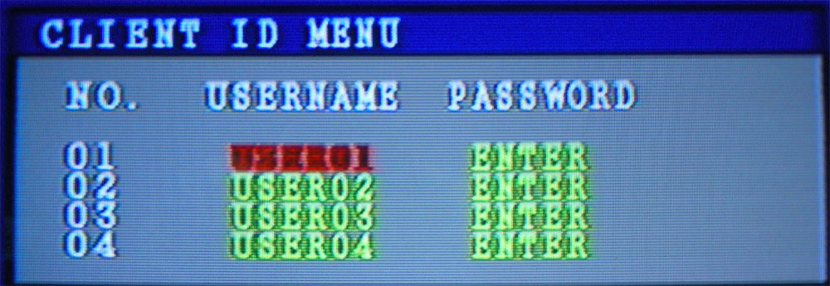

Press Enter button can carry out the associated setup
9．PTZ MENU
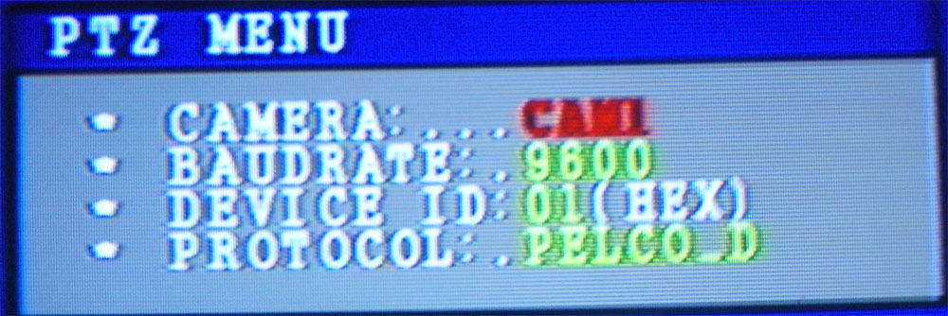

Press '+''-' to select.
(1)CAMRA: To set the channel.
(2)BAUDRATE: 2400,4800,9600,1320 can optional.
(3)DEVICE ID: PTZ address.
(4) PROTOCOL: the PTZ communication protocol. PELCO-P, PELCO-D

10．RECORD SET MENU

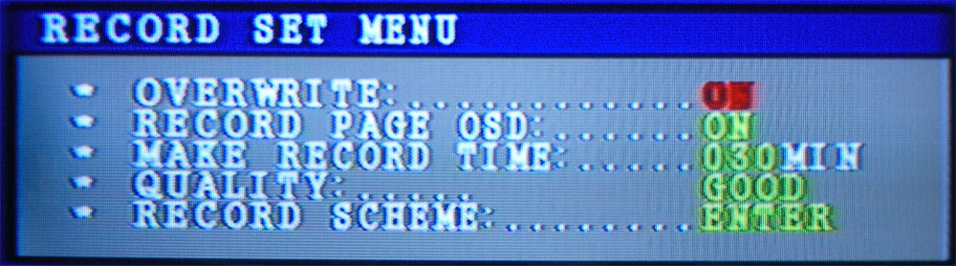
Press '+''-' and Enter button to setup
(1) OVERWRITE: if you choose ON, recording continues and overwrites precious recording when HDD space is full .if you choose OFF, the recording session stops when all HDD is full for recording
(2) RECORD PAGE OSD: to choose whether to write channel name and time characters on record image
(3) MAKE RECORD TIME: file baling time interval. (15,30,60,120MIN can choose)
(4) QUALITH: these are 5 type of channel quality image can optional (good, bad, worse, best, and better)
(5) RECORD SCHEME: After entering the sub-menu can be set up for each channel record scheduling
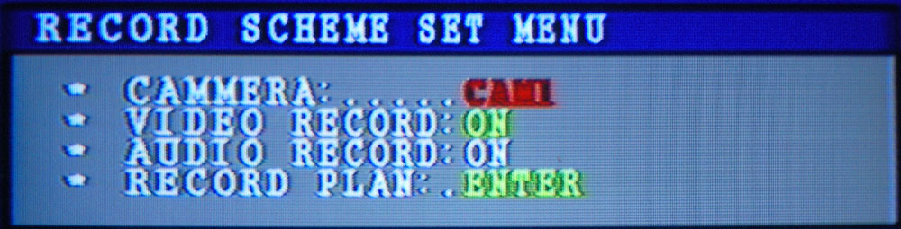
①CAMERA: Select for channel,
②VIDEO RECORD: Video record switch, if it chooses to OFF, This channel in any kind of record mode was not record
③AUDIO RECORD: Recording switch
④RECORD PLAN: Record schedule plan, first enter the record plan ,then use ▲，▼，←，→ to choose time and press ENTER to save.
11.DISK MANAGE
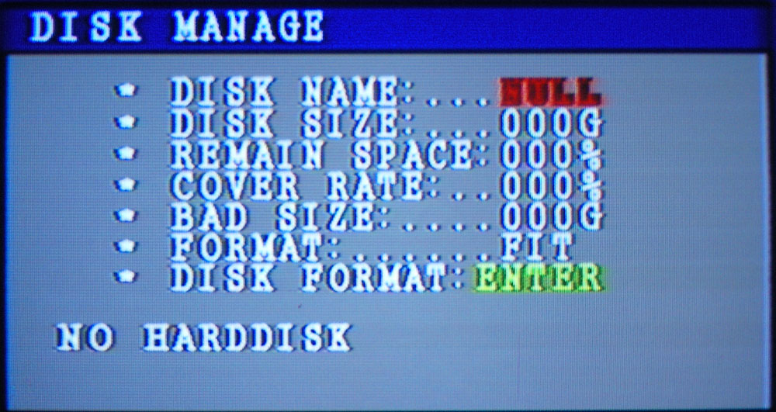
The menu can be used erase or formatting the selected HDD and check HDD information
12.LOG MANGE
Press ▲,▼,←,→to select the start time and end time .then press ENTER to save

Chapter 6: basic operation
1.Start
- Please confirm manual before the beginning of DVR
- Please check system linking correct before started
- Please confirm whether fixed hard disk.
- Please ensure that the DVR input video signal (PAL or NTSC)
- Check inerrability; plug the power cord into the power jack on the wall. Turn on the power switch of the back of the DVR
◆ DVR started, power indicator light showed red, and the DVR will enter power recovery mode at start up

2. Close DVR by remote controller
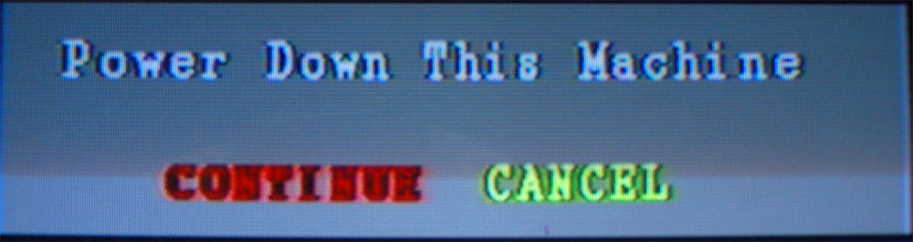
◆Press the power button on the remote controller, pop–up close DVR confirmed menu, select determined then press ENTER key, DVR close related procedures according to program, enter standby mode;
◆Note : Standby mode, the hard disk remain electrify

3. Open DVR by remote controller
- If the finally operation is a soft shutoff, then press and hold Power key on the remote controller three seconds, DVR started up.
DVR start up, and automatically restore the last power recovery mode
4.Close DVR
- First software shutdown, operators see soft shutdown instruction
- Closed DVR back plane power switch.
◆ if longer time not user DVR ,Pls you pull away from the power line from the power jack

5.Software update
◆Copy new version software to U disk
- Then plug the U disk in the DVR’s USB interface
- enter menu “system setup”to choose “firmware update”，when update finished，then DVR will start up renew auto.
- During update process to ensure that the power not off, also cannot pullout USB disk, otherwise update failure.
- The update process will last no more than 10 seconds.
- Upgrade failure will return to the factory software version and not the last upgrade, to re-upgrade to the latest version.
- U disk media mistakes, the upgraded system detects automatically .if found Death will return to the factory version software
◆ Please ensure that the U disk in excellent condition, to avoid to update abnormal

6.Change HDD
- First software shutoff, operators see software shutdown instructions.
- Second hard shutoff. Operators see hard shutdown instructions
- Open DVR case to replacement hard drive, firmly connect the ribbon cable (IDE cable) and power cable to the hard drive interface, then fasten hard disk.
- reopened the power to start the record .

7.Select Alarm
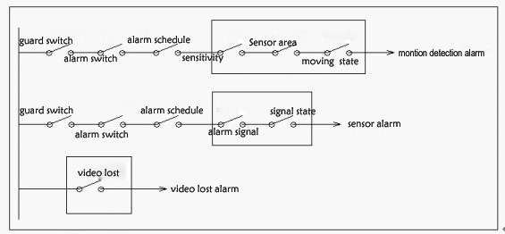

(1) Each channel of each alarm subject to a series of conditions then alarm start
(2) After alarm,
①Alarm systems will record the alarm
②Buzzer sounded
③Relay closure
④If the system menu → alarm quad on is set to open, after alarm, spring out quad
⑤The machinery to maintain the duration of time in the system menu when the alarm end -- "Alarm hold”
(3) No need to setup video lose alarm
(4) Motion detection set
①. Alert switch on the remote controller is the "GUARD" button.
② Camera alarm switch in the menu motion detection → motion menu
③. Alarm scheduling in the menu of motion plan, for the week cycle, the precision of a clock, if choose “ON”, the channel's motion detection opened, if choose “off ”, the channel will not motion detection alarm
④.Sensitivity in the motion detection alarm menu setup, after sensitivity revisions, sensitivity can immediately test results (in the system settings menu where it can be changed to a transparent background), the test channel screen, Mobile objects will appear pane
⑤Detection region in the motion menu to set up→ AREA EDIT setup , transparent region will be detecting regional, purple regional not detect. Up, down, left. Right key can move cursor; the Enter key changes the cursor at the location of the state detection.
⑥Mobile state is a state of the channel in which camera aim at an object moving if or not
(5) Sensor
①.Alert switch is the "GUARD" button.
Camera alarm switch in the Sensor menu → Sensor
②Alarm scheduling the Sensor menu →sensor plan, for the week cycle, the precision of a clock, if choose “ON”, the channel's sensor alarm opened, if choose “off ”,The channel will not sensor alarm .
③Sensor level in the sensor menu → sensor level, if set to low, said when the report was imported low-level, The alarm conditions satisfied.
④ Level mentioned above is a state of alarm imported the actual level.

8.Record ready
- Connect all related equipment before recording, and make sure to Video input and audio input
- On the remote controller "INFO" button View coverage ways and hard disk space left, if the remaining few, Please consider whether or not to replace a hard drive or backup or way to determine coverage.
- When it is discovered that the different between record parameters and the actual demand, please to enter the menu to set up.
- When the actual recording start, the panel lights flashing or light frequently.
- Three record mode switching, first we must stop the current record mode; operation as follows: press record button. Input system password.

9.Manual record
- Manual record first must know the following information through INFO key:
(1) Record resolution can be set up in the record menu →Resolution
(2) The audio-video channel record switch state, The state can change in the menu, and the menu is the location of the video plan; Note: Only Video record set to open state, Audio record can be amended as opening; if choose “off ”, audio record will be off automatically
(3) Each channel image quality will change in the record plan menu
(4) Whether to allow coverage; can amend in record setup; if you choose ON, recording continues and overwrites previous recording when HDD space id full, If you choose OFF, the recording session stops when all HDD is full of recording
(5) It shows the space used on the HDD for recording
- Under the live sate, press the button to start the recording, the key indicator lights, Video record switch is set to ON, the change name will change the red.
◆ Under normal circumstances, Press the key , the HDD in panel will lights flashing lights or Always light
10.Alarm record
- Alarm record will have to known through INFO key
(1) Each audio and video channel switch state, amend ways refer to manual record
(2) Each channel image quality, amend ways refer to manual record
(3) Whether to allow coverage. Refer to manual record to change;
(4) Hard disk space left;
Record time of alarm before and alarm later, before alarm file fist will save in EMS memory. When the alarm happen later, the file will change to save HDD; these two parameters in the record set up menu can be revised.
- Alarm conditions look at the above "ALARM" description.
- Under the live state. press（） button to start alarm record ,
Then the GUARD lamp and alarm button lamp will light
- Alarm occurred, alarm file before save in memory will change to save in HDD, and then to maintain the record, alarm end, the record will last at the alarm time of later alarm, then the record stop
- Record to the hard drive the process, the panel of the HDD flashes or Always light.

11.Time record
- Time record will have to known through INFO key
(1) Each audio and video channel switch state, amend ways refer to manual record
(2) Each channel image quality, amend ways refer to manual record
(3) Whether to allow coverage. Refer to manual record to change;
(4) Hard disk space left;
- If necessary, also need to record plan menu to checks each channel record scheduling.
- Under live sate, press button to start time record, the time recode indicator key will light.
- Time record will record according to setup time. The time has not yet come, the record would not go along, when the time arrival to start record; after time, record will stop automatically.
◆ record time periods arrival , the conditions of all channel changed from red, record to hard drive process, the panel of HDD lamp will flashes or Always light.
12.Search playback and backup
◆three type, during search，can support display record, also support backup，
◆during playback ,can operate fast forward fast backward ,frame up ,frame down ,pause .if press “backup ”button, can carry out backup synchronal
◆after pause，can operate unit frame forward ,key frame backward
13.Audio
◆support two audio input （R、L input ），two audio output （R、L output ）
◆Audio monitor operation ,Please refer to the use of AUDIO keys.
14.Network
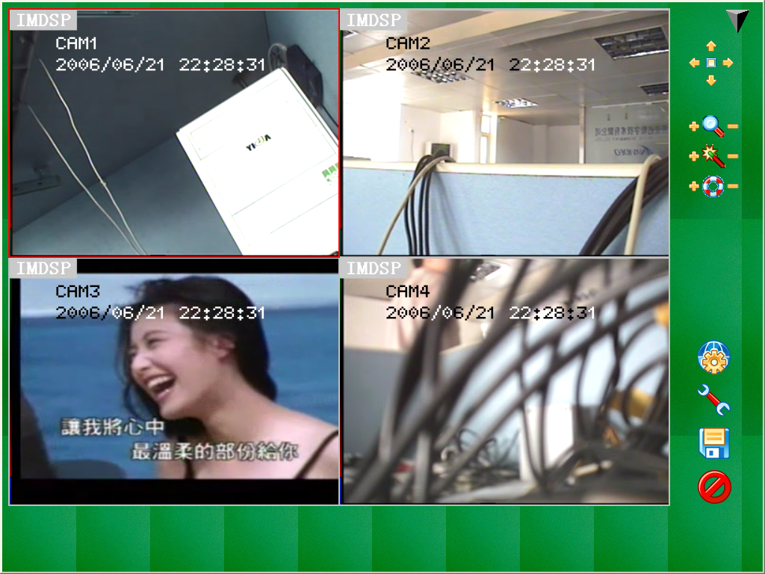
(1) Want to monitor DVR by network, the first to setup the IE correct, setup means is as follows
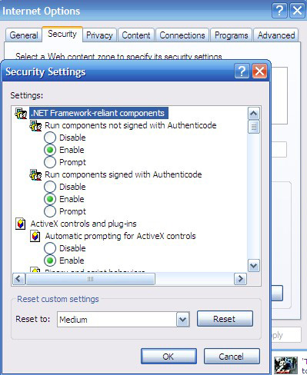

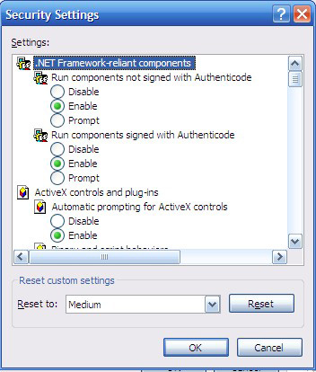
(2) Input IP address on IE, First time use of the users will be required to install a control file (if the security set incorrectly will cause link failure), Press Enter, will be appear DVR network client interface.
(3) Click on the right side of spherical button in client software, enter IP address (or domain name), services port, user name, password, these parameters must corresponding with the DVR menu Net set; input correct parameters, Press Enter button, then the client software will showed four channel images.
(4) Double-click one channel in the client software, this channel will show full screen, double-click again to return to four screen.
(5) Select the channel, the channel frame to turn red .if the channel is the high-speed dome, and PTZ SET menu set correctly, the use of the client software the top of right button. it can be of various function can be operational
(6) Press the tool button, choose audio transmission channel, and also select the local record store location; after choose the audio transmission channel, can use computer audio output port to monitor.
(7) Press record button, image and audio will record at tool buttons setup hard disk location.
Network allows transmission of a channel, Due to audio bandwidth, audio transmission possible intermittent phenomenon

15.PC view software operation

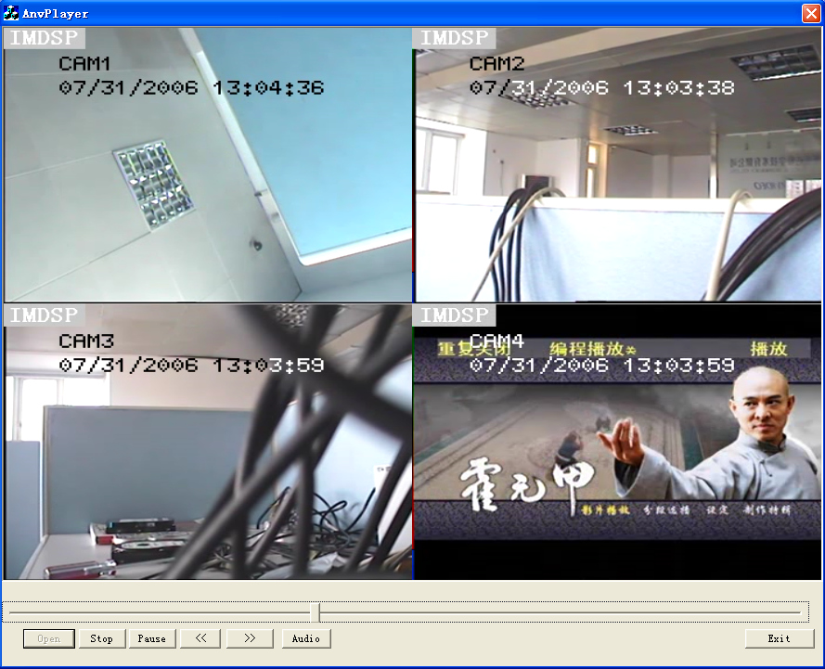
(1) Network Client record locate file, USB backup file, DVR hard disk record files can use this software to play
(2) Click on the "Open " button, and choose *. ANH file to play, other file format does not support.
(3) Support ‘’stop’’, Pause, quick retreat, Fast Forward function, can also one audio channel broadcast.

16.Image quality / storage / Time of HDD record
- Image qualities have five types can choose: very high, high, Normal, Low and lower.
- Higher quality images, storing images will occupy the greater disk space, HDD can be used short of time. Therefore, the user should select the right of quality and the appropriate amount of HDD.
- Video of quality should be established before the video, the video couldn’t change the course of quality.
- Common quality video, occupied disk space is calculated: CIF: 900MByte / hour HD1: 900MByte / hour D1: 675MByte / hour

Appendix A：Technical Specification
Item | Description
Video input | 4 CH Composite ：1.0V p-p/75Ω，BNC×4
Video output | Composite video output：1.0V p-p/75Ω，BNC×1  Composite video loop output：1.0V p-p/75Ω，BNC×4  Composite video 辅助output：1.0V p-p/75Ω，BNC×1  S-Video：1.0V p-p/75Ω，S-Video×1  VGA output
Audio input | 2ch audio input，BNC×2 （R、L input ）
Audio output | 2ch audio output,BNC×2 （：R、L output）
Alarm input | 4 ch input, TTL 5Vp-p
Alarm output | Relay output，(NO)，(NC)，(COM)
Alarm model | Sensor input alarm; video motion detection alarm；Video lose alarm
Backup | USB2.0
Resolution | PAL： 352×288；704×576；704×288  NTSC：352×240；704×480；704×240
HDD | IDE interface;2 PCS IDE，Support 500G HDD
Dimension | 432(L)×60(H)×300mm(W)

Appendix B: F.A.Q
Q. What kind of camera should I buy for this DVR?
A. Any BNC or RCA interface indoor/outdoor/infrared camera will work with the DVR. It doesn’t matter whether it’s a color or black/white camera. However, web cameras that require a USB interface are not compatible with the DVR.
Q. What kind of alarm device should I buy for DVR?
A. Most sound alarms are compatible with our DVR.
Q. I can’t turn on DVR.
A. Make sure that the power cord is plugged in correctly and the red power light on DVR front panel is on.
Q. I see nothing but a blue screen after I turn on DVR.
A. Check the camera input and video output connection on DVR back panel. If you can’t find problem with these connections, check whether the camera power cable is firmly connected. Make sure the system format for NTSC and PAL is right.
Q. Can I prevent other people from stopping the recording while I am gone?
A. If the DVR is in schedule or recording mode, no one can change the set unless he has the right password.
Q. How can I erase all data on the hard disk drive?
A. Select “HDD Format Set” option in the menu.
Q. Can my desktop PC read the video data on hard disk drive in DVR?
A. Yes, you can use our software to read all video data on hard disk and by IE
Q. What happens if I install my PC hard disk drive into the DVR?
A. You can use a PC hard disk drive in the DVR. However, once it runs in DVR, it will delete any PC operation system and files on the hard disk drive.
Q. What kind of hard disk drive should I purchase to make the DVR run?
A. Any PC compatible IDE hard disk drive will work.
Q. Does this DVR kit come with sensors, cameras, or hard disk drive?
A. No. You have to buy each accessory separately.
Q. What is the capacity to record?
A. Up to a year with two 120 GB HDD at the lowest quality setting when set at 1 frame per second.
Q. Does this DVR come with a remote control either hardwire or wireless?
A. Yes, there is a remote control come with the DVR.
Q. Why cannot I access Time/Date Set, HDD Format Set, Record Set menu?
A. Please stop record or play before you access these menu.
Q. Why cannot I access Network Set menu?
A. Please stop the connection of the PC View soft from Internet before you access Network Set menu.
Q. I push record button, but the DVR does not start recording, why?
A. Push display button to see if there is a hard disk detected, also if the DVR is in schedule mode (there is a “S” on the screen in yellow), you cannot start recording by push record button, you have to push schedule button again to cancel schedule mode.
Q. I push record button while recording, but the DVR does not stop recording, why?
A. If the DVR is recording in schedule mode (there is a “S” on screen), you cannot stop recording unless you quit schedule mode first. Push schedule button to cancel schedule mode.
Q. There is a movement, but the DVR does not start recording.
A. Make sure the motion enable of that channel is on, the area set is ok, the A/M rec time is not set to off, and the DVR is in schedule mode. Otherwise set the motion level to HIGH or VERY HIGH.
Q. When the network connection between DVR and client computer is cut off, why the DVR halts and clock stops?
A: In case network is cut off abnormally, DVR machine will halts for 20 seconds without response to any operation of pressing front panel buttons. 20 seconds later, it will restore normal state, but the icon that shows network status won't disappear in 10 minutes and in this period client computer cannot connect to the DVR or enter network menu.
Q. I push the menu button, but it does not display the password menu to enter menu, why?
A. To enter menu, you have to long press the “Menu/search” button, if you just push this button, you will see the search menu.
Q. I long press the “Menu/search” button, but it do not display password menu, and directly enter the menu, why do not I need a password?
A. If the password level setup in Password Setup is “NO USE”, you do not need a password to enter the menu, if you want to need a password when enter menu setup, just change the password level to “SETUP”。

