OWNER:  DG TAXUD | ISSUE DATE:  19/02/2014 | VERSION:  13.00
Taxation and Customs Union DG
CUST-DEV2Project

SUBJECT:
Design Document for Common Operations and Methods
Main Document
Framework Contract TAXUD/2010/CC/100
Specific Contract 16

Document History
Edition | Revision | Date | Description | Action | Pages
DDNTA 8 | 00 | 23/03/2005 | Implementing QA review comments.  Implementing TC’s comments based on TCE-MTM02-L1SA8-v0.20-EN (TCP-ECS Workshop, Athens, March 9th 2005).  Submitted for Acceptance to Taxation and Customs Union DG. | I, R | As Required
DDNTA 8 | 10 | 15/04/2005 | Implementing QA verification comments.  Re-submitted for Acceptance to Taxation and Customs Union DG. | I/R | ECS & NCTS Appendices
0 | 10 | 05/03/2007 | Restructure of DDNTA into DDNA with separate volumes for Common and specific Customs Domains. | I | All
0 | 20 | 23/03/2007 | Implementing internal review comments.  Submitted for review to Taxation and Customs Union DG. | I/R | As Required
1 | 00 | 09/05/2007 | Implementing QA review comments.  Submitted for acceptance to Taxation and Customs Union DG. | I/R | As Required
1 | 10 | 11/05/2007 | Implementing verification comments.  Re-submitted for acceptance to Taxation and Customs Union DG. | I/R | As Required
2 | 00 | 28/09/2007 | Implement ECG Review comments.  Submitted for acceptance to Taxation and Customs Union DG. | I/R | As Required
2 | 10 | 17/02/2008 | DDCOM update for ICS domain  Submitted for review to Taxation and Customs Union DG. | I/R | As Required
3 | 00 | 19/02/2008 | Implementing review comments.  Submitted for acceptance to Taxation and Customs Union DG. | I/R | As Required
3 | 10 | 09/06/2008 | Incorporating RFA 816 functionality.  Submitted for review to Taxation and Customs Union DG. | I/R | Section II:, IV.2, VIII.2.17, VIII.4.12.
4 | 00 | 25/06/2008 | Implementing review comments.  Submitted for acceptance to Taxation and Customs Union DG. | I/R | As Required
4 | 10 | 28/10/2008 | Incorporating RFA 848 functionality for the incorporation of EOS in DDCOM.  Implementing DDNA KEL v0.18.  Implementing calls INC0807.109564 and INC0809.111672.  Submitted for review to Taxation and Customs Union DG. | I/R | Section I.1.1, I.1.2, I.1.8, II.2.1.1, V.2, V.3.1, V.4, VII.4, VII.5.1, VII.5.2, VII.5.6, VII.5.7, VIII.2.6, VIII.2.17, VIII.4.10.
5 | 00 | 18/11/2008 | Implementing review comments.  Submitted for acceptance to Taxation and Customs Union DG. | I/R | As Required
5 | 01 | 26/10/2009 | Implementing DDNA KEL v0.21.  Incorporating information regarding the IE12 message that is exchanged in the scope of the NCTS TIR RU pilot project.  Submitted for internal review. | I/R | Sections: II.2.1.1, II.2.4.2, II.2.4.3, II.4.6.1, II.4.6.3, VI.2.2, VII.6, VIII.2.17, VIII.2.18, VIII.2.19, VIII.2.22, VIII.4.12.
5 | 10 | 27/10/2009 | Implementing internal review comments.  Submitted for review to Taxation and Customs Union DG. | I/R | As required
6 | 00 | 05/11/2009 | Implementing review comments.  Submitted for acceptance to Taxation and Customs Union DG. | I/R | As Required
6 | 01 | 11/01/2010 | Incorporating QTM 970 functionality for Customs Business Statistics.  Implementing the following calls:  - INC0909.135833 for the removal of the programmatic mode from CS/RD and the removal of IE031/IE032 attachments from CS/RD notifications;  - INC0907.132635 for the support of printable ASCII characters only in non-language sensitive fields;  - INC0908.133794 for the non-use of leading and trailing spaces within text fields;  - INC0911.139015 for specifying that text fields shall be case sensitive;  - INC0912.140662 for correcting the inconsistency between TR9181 in DDNA appendix Q2 and DDCOM section VII.5.7.  Submitted for internal QC review. | I/R | Sections: I.1.8, II.2.2.1, II.2.2.4, II.2.3, II.2.4, II.2.5, II.3.2.3, II.4.1, II.4.3, II.4.4, , II.6.1.1, II.6.1.2, II.6.2.3, II.6.2.4, II.7.1, V.2.1.1.2, V.2.1.2.1.2, VII.5.7, VIII.2.19, IX.1.
6 | 10 | 12/01/2010 | Implementing internal QC review comments.  Submitted for review to Taxation and Customs Union DG. | R | As Required
7 | 00 | 01/02/2010 | Implementing review comments.  Submitted for acceptance to Taxation and Customs Union DG. | I,R | As Required
7 | 10 | 15/04/2010 | Implementing ECG review comments.  Submitted for review to Taxation and Customs Union DG. | I,R | As Required
8 | 00 | 20/04/2010 | Implementing verification comments.  Submitted for acceptance to Taxation and Customs Union DG. | I,R | As Required
9 | 00 | 28/02/2011 | Project and contractual data is updated.  Aligned with KEL 0.23 and review comments implemented.  Submitted for review&acceptance to Taxation & Customs Union DG. | I/R | Sections: VII.3, I.1.8, I.3, V.2.1.1.1, VII.6.1
9 | 10 | 01/02/2012 | Project and contractual data updated. Aligned with KEL 0.24.  Submitted for review to Taxation and Customs Union DG. | I/R | Sections:  I.1.8.4, I.3.1.1, I.3.2, V.2.1.2.1.2, V.2.1.2.2
10 | 00 | 22/02/2012 | The review comments are implemented.  Submitted for acceptance to Taxation and Customs Union DG. | I/R | As Required
10 | 01 | 26/03/2012 | Aligned with KEL 0.23a.  Sent to the internal and language review. | I/R | Sections:  I.1.8.5, V.2.1.2.1.1, V.2.1.2.2
10 | 10 | 30/03/2012 | Comments from the internal and language review are implemented.  Submitted for review to Taxation and Customs Union DG. | I/R | As Required
10 | 50 | 27/04/2012 | Submitted for acceptance to Taxation and Customs Union DG. | I | 6
10 | 60 | 24/07/2012 | Project and contractual data updated. Aligned with KEL 0.25.  WARNING: This and the next version do NOT include the changes for KEL v0.24a.  Submitted for review to Taxation and Customs Union DG. | I/R | Sections:  I.1.8.7, I.3.2, VII.1.2
11 | 00 | 20/08/2012 | The review comments are implemented.  Submitted for acceptance to Taxation and Customs Union DG. | I/R | Page 71
10 | 65 | 14/02/2013 | Project and contractual data updated. Aligned with KEL 0.24a.  This and the next version were created in a side branch to address urgent business needs in DDNIA.  Submitted for review to Taxation and Customs Union DG. | I,R | Pages 20, 22, 29 and 32.
10 | 70 | 27/02/2013 | The review comments are implemented.  Submitted for acceptance to Taxation and Customs Union DG. | I,R | Page 22.
11 | 10 | 06/03/2013 | Project and contractual data updated. Aligned with KEL 0.25a.  This and the next version include also the changes introduced within KEL v0.24a.  Submitted for review to Taxation and Customs Union DG. | I/R | Pages 22, 24, 31 and 34
11 | 50 | 08/04/2013 | The review comments are implemented.  Submitted for acceptance to Taxation and Customs Union DG | I/R | Page 23
11 | 51 | 07/08/2013 | Aligned with KEL 0.26.  KEL entries #326 and #332 are implemented.  Sent to the internal review. | I/R | Pages 24, 28, 32-35, 79, 102-106
11 | 60 | 12/08/2013 | The review comments are implemented.  Submitted for review to Taxation and Customs Union DG. | I/R | Pages 32, 103-104
12 | 00 | 06/09/2013 | The review comments are implemented.  Submitted for acceptance to Taxation and Customs Union DG | I/R | Pages 19, 22, 25, 31, 32, 35, 41 and 56
12 | 01 | 08/01/2014 | Project and contractual data updated.  Aligned with KEL 0.27. No major changes implemented.  Sent to the internal review. | I,R | Pages 28, 31, 32 and 35
12 | 10 | 14/01/2014 | The review comments are implemented.  Submitted for review to Taxation and Customs Union DG. | I,R | As required
13 | 00 | 19/02/2014 | The review comments are implemented.  Submitted for acceptance to Taxation and Customs Union DG | I/R | As required

Table of Contents
Section I: General Introduction 15
I.1 Document Overview 15
I.1.1 Purpose of DDNA 15
I.1.2 DDNA Structure 16
I.1.3 Purpose of the DDCOM volume 16
I.1.4 Scope of DDCOM volume 17
I.1.5 Intended audience 17
I.1.6 Structure of DDCOM Volume 17
I.1.7 Document service information 20
I.1.8 Change history 21
I.2 Definitions 24
I.2.1 Definitions 24
I.2.2 Terminology 24
I.2.3 Acronyms and Abbreviations 25
I.3 Applicable and reference documents 29
I.3.1 Applicable documents and standards 29
I.3.2 Reference documents 32
I.4 Symbolism and Conventions Used 34
I.4.1 Time Sequence Diagrams 34
I.4.2 State Transition Diagrams 37
I.4.3 Data Dictionary 38
Section II: Central Services 40
II.1 Messages involved 40
II.1.1 Messages involved in Customs Applications 40
II.2 Exchanges of Reference Data (RD) and Customs Office List (COL) 42
II.2.1 Introduction 42
II.2.2 Functional ways to get data 44
II.2.3 Functional ways to upload data 46
II.2.4 Modes of Access to the CS/RD 47
II.2.5 Set-up and maintenance of National Database 50
II.3 Exchange of statistics and availability data 51
II.3.1 The role of the CS/MIS tool 52
II.3.2 Statistics management 52
II.4 Message exchanges with CS/RD via the Web 56
II.4.1 Approach 56
II.4.2 Message transport 56
II.4.3 Message exchange overview 57
II.4.4 Exchange policy in manual mode with CS/RD 58
II.4.5 The user will also be able to subscribe to the CS/RD system in order to receive an e-mail when CS/RD is updated.CS/RD Web exchanges sequence diagrams 59
II.4.6 Modifiable occurrences in CS/RD 64
II.4.7 The Upload Parsing Response message 69
II.5 Message exchanges with CS/RD via CCN/CSI 71
II.5.1 Introduction 71
II.5.2 Exchange protocols 72
II.6 Message exchanges with CS/MIS across the Web 75
II.6.1 Introduction 75
II.6.2 CS/MIS HTTP exchanges protocols 76
II.6.3 CS/MIS manual mode of operation 79
II.7 Message exchanges with CS/MIS via CCN/CSI 79
II.7.1 Sending IE411 data to CS/MIS 79
II.7.2 Sending the Technical Statistics 79
II.7.3 Sending the CCN audit files 80
II.7.4 Exchanges of requests/responses of MRN Follow up information (NCTS only) 80
Section III: Systems Administration 82
III.1 Introduction 82
Section IV: Technical Message Structure 83
IV.1 Data dictionary 83
IV.1.1 Data Items 83
IV.1.2 Data Groups 83
IV.1.3 Code lists 84
IV.2 Technical message structure 84
IV.3 DDNA consistency 86
Section V: Design principles 87
V.1 Approach 87
V.2 Character Sets and Data Item conventions 87
V.2.1 Common Domain exchanges 88
V.2.2 National and External Domain exchanges 91
V.3 Exception Handling 92
V.3.1 Introduction 92
V.3.2 Scenarios for exception handling 94
V.3.3 Error codes 98
V.4 Functional error message 99
V.5 Constraints 101
V.5.1 Introduction 101
V.5.2 Performance Constraints 101
V.5.3 Timing constraints 102
V.5.4 Availability Constraints 102
V.6 MRN and GRN structure 102
V.6.1 Structure of the Movement Reference Number (MRN) 102
V.6.2 Structure of the Guarantee Reference Number (GRN) 105
Section VI: EDIFACT message formatting 107
VI.1 Introduction 107
VI.2 EDIFACT conventions for Customs 108
VI.2.1 EDIFACT choices 108
VI.2.2 Common Message Header Structure 109
VI.2.3 UNH segment 111
VI.2.4 Segment conventions 111
VI.2.5 Amendments to UNSMs 111
VI.3 Mapping of Information Exchanges 112
VI.3.1 Mapping overview 112
VI.4 Message Hierarchies 112
VI.5 Correlation tables 112
VI.5.1 EDIFACT Mapping 113
VI.6 Functional error message in EDIFACT 115
VI.6.1 Functional error CUSRES Hierarchy 115
VI.6.2 EDIFACT Mapping of functional error message 115
VI.7 EDIFACT CONTRL Message 115
Section VII: XML message formatting 118
VII.1 Introduction 118
VII.1.1 XML 118
VII.1.2 Character set support 118
VII.2 XML mapping of Information Exchanges 118
VII.3 Document Type Definition 118
VII.4 XML error (CONTRL) message 118
VII.5 Message Header 119
VII.5.1 Message Sender and Recipient 120
VII.5.2 Message Type 120
VII.5.3 Date & Time of preparation 121
VII.5.4 Test Indicator 121
VII.5.5 Message Identification 121
VII.5.6 Original Message Identification 121
VII.5.7 Correlation Identifier 121
VII.6 XSD Principles 122
VII.6.1 XSD Conventions 122
VII.6.2 XSDs’ File Structure 123
VII.6.3 XSDs Binding 125
VII.6.4 Internal Structure of XSD Files 125
Section VIII: Transport of messages via CCN/CSI 133
VIII.1 Introduction 133
VIII.1.1 Summary 133
VIII.1.2 Architectural Assumptions 133
VIII.1.3 References to CCN/CSI 135
VIII.2 The CCN communication reminder 135
VIII.2.1 The message descriptor 136
VIII.2.2 The data descriptor 139
VIII.2.3 Allocation of a CSIDD 140
VIII.2.4 Inserting the application data into the CSIDD structure 140
VIII.2.5 Encoding the CSIDD 141
VIII.2.6 The quality of service 142
VIII.2.7 Illustration of the use of the QOS parameters 145
VIII.2.8 Connecting the application to the CCN Gateway 149
VIII.2.9 Creating a security context for an application 149
VIII.2.10 Connecting to the queue manager 150
VIII.2.11 Opening a queue 151
VIII.2.12 CSI verbs allowed for queue accesses 152
VIII.2.13 Putting a message into a queue: HL_mq_put() 152
VIII.2.14 Putting a message into a queue: HL_mq_put1() 153
VIII.2.15 Browsing through a queue: HL_mq_browse() 156
VIII.2.16 Deleting an element from a queue: HL_mq_delete() 156
VIII.2.17 Queue naming and addressing 156
VIII.2.18 National Gateways 159
VIII.2.19 Taxation and Customs Union DG Gateways 161
VIII.2.20 European Anti-fraud Office Gateway 163
VIII.2.21 Queue usage Overview 164
VIII.2.22 Operational Environment 164
VIII.2.23 Common Domain Testing Environment 166
VIII.2.24 National Testing and Training Environments 168
VIII.2.25 Access Control List 169
VIII.3 Recommended use of CCN/CSI 169
VIII.3.1 Main routines 170
VIII.3.2 Program connection 172
VIII.3.3 Sending 173
VIII.3.4 Receiving 174
VIII.3.5 Program disconnect 176
VIII.4 Configuration information 177
VIII.4.1 Introduction 177
VIII.4.2 Configuration information to be provided by the NA 178
VIII.4.3 Collection of External Configuration Data 178
VIII.4.4 Message configuration procedure 179
VIII.4.5 Configuration information to be provided by the Customs systems Central Operation 179
VIII.4.6 Collection of External Configuration Data 179
VIII.4.7 ccnDefaultQOS 180
VIII.4.8 ccnGatewayName 180
VIII.4.9 ccnOrganisationName 180
VIII.4.10 ccnMessageId 180
VIII.4.11 ccnMessageFormalDefinition 181
VIII.4.12 ccnUserProfileId 181
VIII.4.13 Message configuration procedure 183
VIII.5 Description of statistics 184
VIII.5.1 Introduction 184
VIII.5.2 Requirement to be fulfilled by ITSM/CCN-OPS 185
VIII.5.3 Specification of the MSGS file 185
VIII.5.4 Specification of the REPS file 186
Section IX: Transport of messages via the Inter(extra)net 187
IX.1 Introduction 187
IX.2 Security 187

List of Figures
Figure 1: Time Sequence Diagram 36
Figure 2: Example of State Transition Diagram 37
Figure 3: Message exchange policy 58
Figure 4: Subscription to CS/RD 60
Figure 5: Acquisition of COL modifications 61
Figure 6: Acquisition of Common RD modifications 61
Figure 7: Downloading IE931 or IE932 62
Figure 8: Uploading an IE030 63
Figure 9: Download of IE031 via CCN/CSI 72
Figure 10: Request of entire COL 73
Figure 11: Request of entire Common RD 74
Figure 12: Upload via CCN/CSI 74
Figure 13: Notification from CS/MIS 77
Figure 14: Downloading from CS/MIS 78
Figure 15: Uploading an IE070 79
Figure 16: Exchanges of requests/responses of MRN Follow up information 80
Figure 17: Character sets and conventions in use 88
Figure 18: Functional error across the Common Domain (NCTS) 95
Figure 19: EDIFACT error 96
Figure 20: XML Control error 97
Figure 21: XSDs’ Categorisation 124
Figure 22: XSDs’ File Structure 124
Figure 23: Root Element and Message data-groups 127
Figure 24: Abstract type definition for alphanumeric format 128
Figure 25: Specific type definition for DocNumHEA5 129
Figure 26: Definition of Risk Analysis complex type 129
Figure 27: Definition of CD301A.Risk Analysis 130
Figure 28: Technical codelist definition for MessageTypes 132
Figure 29: Normal use of QoS parameters for NCA 146
Figure 30: Exception and expiration reports 148
Figure 31: State Transition Diagram of the sending CSI stack 148
Figure 32: Normal Operations with an NCA 164
Figure 33: Normal Operations with CS/RD 165
Figure 34: Normal Operations with CS/MIS 165
Figure 35: Normal Operations with OLAF (ATIS) 165
Figure 36: Interactions between an NCA and the EC SPEED Platform (SPEED-ECN) in Normal Operations environment 166
Figure 37: International Testing with another NCA 166
Figure 38: International Testing between NCA and OLAF 167
Figure 39: Testing with CS/RD 167
Figure 40: Conformance Testing 167
Figure 41: Interactions between an NCA and the EC SPEED Platform in Conformance testing environment with NCA 168
Figure 42: Interactions between an NCA and the EC SPEED Platform in International testing environment 168
Figure 43: National Testing with STTA or NCTA 169
Figure 44: Training with a Training Application 169
Figure 45: A possible sequence for using CSI verbs 171
Figure 46: Example of IDL definition of CCN Messages for NCTS 184

List of Tables

Table 1: Definitions 25
Table 2: Acronyms 29
Table 3: Applicable Documents 30
Table 4: Applicable Standards 32
Table 5: Reference Standards 32
Table 6: Reference Documents 33
Table 7: UML business modelling elements 35
Table 8: Functionality for the different access modes 47
Table 9: CS/MIS interfaces across the Web 75
Table 10: Additional CS/MIS interfaces across the Web 76
Table 11: Use of status codes 86
Table 12: Error causes 94
Table 13: Segment position of EDIFACT error codes 99
Table 14: Data Items for Functional Error data group in IE906 100
Table 15: Notation of error pointer 100
Table 16: Examples of error pointer 101
Table 17: Structure of MRN 103
Table 18: Check character values 104
Table 19: Remainder of the calculation 104
Table 20: Structure of GRN 105
Table 21: Common message header structure 109
Table 22: Data Items for XML Error data group in IE917 119
Table 23: MQ Message Descriptor 137
Table 24: CSI Data Descriptor 139
Table 25: Example of CSIDD allocation, initialisation with Information Exchange and encoding 142
Table 26: CCN/CSI Quality of Service structure 143
Table 27: MQ Object Descriptor 151
Table 28: CSI verbs for queue access 152
Table 29: CSIMQGMO Object Descriptor 155
Table 30: Queue Names for National Gateways 160
Table 31: Queue Names for Taxation and Customs Union DG Gateways 162
Table 32: Queue Names for European Anti-fraud Office Gateway 164
Table 33: Roles for Customs Systems 177
Table 34: External Configuration Data defined by NA 179
Table 35: External Configuration Data defined by ITSM 179
Table 36: Configuration of default QoS 180
Table 37: Specification of the MSGS file 185
Table 38: Specification of the REPS file 186

General Introduction

Document Overview

Purpose of DDNA
The DDNA, the Design Document for National Applications, supersedes the Design Document for National Transit Applications for NCTS and ECS. It specifies the design requirements to which any Customs Movement Application needs to conform.
The DDNA is applicable to every Transit, Export and Import Control Application and must be considered as a mandatory document for all implementation and verification activities.
The DDNA is aligned with [Error: Reference source not foundR26], [R13] and [R14].
Document [R26Error: Reference source not found] contains the specifications for the entire NCTS (encompassing all Phases and sub-Phases), foreseeing a number of electronic and other (paper) Information Exchanges.
Documents [R13] and [R14] contain the specifications for ECS and ICS respectively, foreseeing a number of electronic exchanges.
The DDNA consists of four volumes. One volume exists for each system (Transit, Export and Import), defining the design requirements of the specific system, and there is one common volume, which defines common operations and methods for all systems. This volume is the Design Document for Common Operations and Methods (DDCOM) volume. For more information about DDCOM’s purpose and structure, please refer to [I.1.3] and [I.1.6], respectively.
Apart from Transit, Export and Import, the DDCOM volume is applicable to EOS for what concerns the interface with CS/RD only, including the exchange of messages IE030, IE031, IE032, IE906, IE913, IE914, IE916, IE917, E931, and IE932. The remaining design specifications of EOS, including design principles, technical message structure definitions, XML mapping of Information Exchanges and specifications for the transport of messages via CCN/CSI, are defined in [R23], which is a self-contained document and is not part of the DDNA.
Information Exchanges are foreseen in the Common Domain (between National Administrations; and between National Administrations and Central Services), in the National Domain (local to a National Administration), and in the External Domain (between National Administration and Traders). Common Domain exchanges will always take place via the CCN/CSI communication platform or the Inter(Extra)net. The different formatting and transport mechanisms will, therefore, be defined, in detail, in the DDNA. Moreover, additional design constraints and additional details on error and exception handling will be stated.
Within the Customs systems, the Central Project Team (CPT) will initially produce a number of Centrally Developed Customs Application (CDCA) tools (e.g. STTA, TTA, CS/RD and CS/MIS) in order to assist the NAs in implementing, verifying and operating their National Customs Application (NCA).All these CDCA tools must conform to this document, although their specification is not part of this document. In order to construct an NCA, the NA should therefore use this document, in order to decide which functionality remains to be implemented.

DDNA Structure
The DDNA consists of the following four volumes:
- Design Document for National Transit Application volume (DDNTA);
- Design Document for National Export Application volume (DDNXA);
- Design Document for National Import Application volume (DDNIA);
- Design Document for Common Operations and Methods volume (DDCOM).

Purpose of the DDCOM volume
This volume, which is the Design Document for Common Operations and Methods, defines the common features applicable to all Customs Applications.
In particular, this volume defines:
- The message exchange protocols between the NCAs and the Common Domain Central Services applications regarding the collection and the dissemination of Common Reference Data (RD) and Customs Office List (COL) data. The specifications of exchanges regarding the Common RD and the COL data defined in DDCOM are applicable to EOS, as well;
- How an NCA can exchange information with Central Services via a manual (web browser) mode. The definition of the modes of access to the CS/RD application are applicable to EOS, as well;
- A number of principles for the NCAs that are common regardless of the transportation mechanism;
- The format of messages (EDIFACT and XML);
- How the messages need to be transported across the CCN/CSI.

Scope of DDCOM volume
This volume is restricted to the electronic Information Exchanges within Customs systems.
This version of DDCOM is applicable to NCTS Phase 4, ECS Phase 2 and ICS Phase 1. It is also applicable to EOS for the definition of the interface with CS/RD only.

Intended audience
The intended audience for this document includes:
- Any person responsible for the functional specifications of a Customs application;
- Any person responsible for the development of software in the context of a Customs application;
- Any person responsible for the definition of tests for a Customs application;
- Anyone within the affected service suppliers in the CCN/CSI projects responsible for the delivery of the required services to a Customs application;
- Any other authorised body affected by a Customs application, including EC/EFTA Joint Committee on Community/Common Transit, Electronic Customs Group, OLAF, and Traders Associations.
Readers are assumed to have a good understanding of the IT concepts and terminology used in this document. It is also assumed that readers are aware of the contents of [R26Error: Reference source not found], [R13], [R14] and [R24].

Structure of DDCOM Volume
This volume is structured in sections (further subdivided in chapters) that are applicable to all movement systems. In addition, some chapters regarding the interface with CS/RD are applicable, apart from movement systems, to EOS. For these chapters, this applicability is explicitly mentioned below.
The different sections and chapter categories are distinguished by their heading naming convention.
This volume comprises the sections, chapters and lists of appendices summarised below:
SECTION I - GENERAL INTRODUCTION includes the following chapters:
- Chapter 1 describes the purpose and the scope of DDNA, the intended audience, the internal structure of the document, plus some document service information;
- Chapter 2 contains definitions used in this document (terminology, acronyms and abbreviations);
- Chapter 3 describes the relationship of this document with other Customs systems baseline documents. It defines dependencies with these documents and states the applicability of these documents. It also explains how this document, together with the other Customs systems documentation, should be used during the development and verification of any Customs application;
- Chapter 4 describes the symbolism and the conventions used in the various models included in this document. It also discusses the technical naming conventions used for the data dictionary.

SECTION II - CENTRAL SERVICES deals with the centralised collection and distribution of data that is of common interest to the various NAs for all Customs systems (such as Customs Office List and Common Reference Data). In addition, this section covers availability reporting and statistics. It is subdivided as follows:
- Chapter 1 defines the Messages involved in Central Services. All Messages exchanged with CS/RD are applicable to EOS, as well;
- Chapter 2 defines how common RD and COL are exchanged. This chapter is applicable to EOS, as well;
- Chapter 3 defines how statistics and availability data are exchanged;
- Chapter 4 defines the message protocols to be used for exchanges with the CS/RD application via the Inter(Extra)net (for COL and Common RD exchanges). In addition to the Information Exchanges, a number of Inter(Extra)net messages are introduced in this chapter. This chapter is applicable to EOS, as well;
- Chapter 5 defines the message protocols to be used for exchanges with the CS/RD application via CCN/CSI (for COL and common RD exchanges). This chapter is applicable to EOS, as well;
- Chapter 6 defines the message protocols to be used for exchanges with the CS/MIS application via the Inter(Extra)net (for exchanges of statistics data and availability data);
- Chapter 7 defines the message protocols to be used for exchanges with the CS/MIS application via CCN/CSI (for exchanges of statistics data only).

SECTION III - SYSTEMS ADMINISTRATION deals with issues such as logging and tracing and any other administration function to be foreseen.
SECTION IV – TECHNICAL MESSAGE STRUCTURE defines the detailed technical structure of the Information Exchanges for movement systems. This section is further subdivided as follows:
- Chapter 1 introduces the data dictionary. It defines a number of items that make up a message, such as Data Items, Data Groups, and Code Lists (sets of discrete values). This chapter is accompanied by the corresponding DDNA Appendices Y, Z and C;
- Chapter 2 presents the detailed Technical Message Structure (TMS) for the different Information Exchanges. The detailed TMS for all messages is included in each domain volume’s Appendix Q. This chapter will only explain how the Appendix Q needs to be interpreted and used;
- Chapter 3 discusses the issue of consistency. It defines with which Customs documents this DDNA needs to be consistent (such as FTSS [R26Error: Reference source not found] and SAM Mapping Specification [R12]) and it explains how this consistency has been achieved during the TMS definition.
SECTION V – DESIGN PRINCIPLES explains how the system, defined in the previous sections, needs to be built. Basically, every Information Exchange needs to be formatted in one of two formats (EDIFACT and/or XML) and needs to be transmitted across one of two communications platforms (CCN/CSI or Inter(Extra)net). This section states a number of principles that are common, regardless of the message format and transportation mechanism:
- Chapter 1 discusses the overall approach;
- Chapter 2 discusses the usage of character sets and Data Item conventions;
- Chapter 3 defines exception handling (how Customs systems should prevent and handle failures, defects, errors or mistakes);
- Chapter 4 describes the use of Functional error data group in IE906;
- Chapter 5 defines constraints (any restrictions that are applicable to a Customs system’s development);
- Chapter 6 defines structure of Movement Reference Number and Guarantee Reference Number.
SECTION VI – EDIFACT MESSAGE FORMATTING defines in detail how messages need to be formatted in EDIFACT. This section is subdivided as follows:
- Chapter 1 introduces EDIFACT conventions in general;
- Chapter 2 defines EDIFACT conventions used in Customs systems;
- Chapter 3 provides an overview of EDIFACT mapping and points to the tables that list which Information Exchanges are mapped to each EDIFACT messages for each Customs domain (NCTS or ECS);
- Chapter 4 describes the Message Hierarchies. Appendix Y accompanies this chapter;
- Chapter 5 explains the detailed low-level mapping of the Customs messages upon the UNSMs. Appendix H and Appendix I accompany this chapter;
- Chapter 6 describes the formatting of Functional Error in EDIFACT;
- Chapter 7 describes the EDIFACT CONTRL message to be used in the EDIFACT exchanges.
SECTION VII – XML MESSAGE FORMATTING defines how messages need to be formatted in an XML format. This section is structured as follows:
- Chapter 1 defines XML conventions for Customs systems;
- Chapter 2 discusses the XML formatting of the Information Exchanges. Appendix R accompanies this chapter;
- Chapter 3 discusses the DTDs of Customs messages. Appendix T accompanies this chapter;
- Chapter 4 describes the XML CONTRL message to be used in the XML exchanges;
- Chapter 5 describes the Message Header for the XML exchanges.
- Chapter 6 describes XSD Conventions as well as the proposed structure of the XSDs to be used for NCTS/ECS/ICS domains.
SECTION VIII – TRANSPORT OF MESSAGES VIA CCN/CSI defines how messages need to be transported across the CCN/CSI communication platform. This section is subdivided as follows:
- Chapter 1 defines architectural assumptions made for the transport of messages via CCN/CSI and details where references to CCN/CSI can be found.
- Chapter 2 presents the mandatory CCN/CSI elements that will ensure end-to-end communication between two CCN gateways.
- Chapter 3 presents the recommended CCN/CSI elements for sending and receiving messages.
- Chapter 4 defines the configuration information necessary for the CCN gateways;
- Chapter 5 defines the CCN/CSI statistics services provided by ITSM/CCN-OPS.
SECTION IX – TRANSPORT OF MESSAGES VIA INTER(EXTRA)NET defines how messages need to be transported across the Inter(Extra)net communication platform.
- Chapter 1 summarises all Information Exchanges and messages for which Inter(Extra)net transport is to be foreseen;
- Chapter 2 defines Inter(Extra)net conventions for Customs;
- Chapter 3 discusses the format and usage of the Information Exchanges and Inter(Extra)net messages for CS/RD. This chapter is applicable to EOS, as well;
- Chapter 4 repeats the same discussion for exchanges with CS/MIS;
- Chapter 5 discusses security aspects of Inter(Extra)net transport.

Document service information
The different parts that make up DDNA will each be submitted individually to configuration and version control. Individual components may be upgraded and delivered separately.
Maintenance will be provided for this document. The Taxation and Customs Union DG will define and schedule the different deliveries.
Comments can be submitted to this document, either via organised reviews or via calls to the Central Service Desk at ITSM (https://itsmtaxud.europa.eu/smt/ess).
Known errors to the DDCOM volume will be maintained in the format of the Known Error List (KEL) published on the Project web site.
Whenever a part of this document is referred to, reference will be given to an entire section or an entire chapter (within a section) or a paragraph (for any other subdivision).
This document will be submitted as a Word file with the following naming convention:
DDCOM-Main Document-vy.zz-SfR/SfA.doc, where y and zz are version and revision numbers.

Change history

Changes in DDCOM versions 5.10 and 6.10
Version 5.10 of DDCOM incorporates the following changes:
- Implementation of DDNA KEL v0.21 (KEL entries #192, #201, #202 and #213);
- Incorporation of message exchange details (i.e., EDIFACT conventions, queue naming and addressing, national and Taxation and Cutsoms Union DG gateways, configuration information) regarding the IE12 message that is exchanged in the scope of the NCTS TIR RU pilot project.
Version 6.10 of DDCOM incorporates the following changes:
- Incorporation of new Customs Business Statistics functionality
    - II.3.2.3: Updated to:
      - Introduce ECS and ICS business statistics;
      - Specify that NAs will be able to send one IE411 message for multiple domains or multiple domain-specific IE411 messages;
      - Indicate that CS/MIS will produce an IE412 message per domain as soon as an IE411 message is received;
      - Define that, each time an IE412 is produced, CS/MIS will combine this IE412 with other IE412 messages created for other periods and generate a domain-specific XLS file, which will also be available for download on CS/MIS Web interface.
    - II.7.1: Updated to define that the IE411 message will have EDIFACT or XML format and will either be sent to the CS/MIS application across CCN/CSI or it will be uploaded on CS/MIS Web interface;
    - II.6.1.2 and II.6.2.4: Updated to include IE411.
- INC0909.135833
    - II and IX: Updated to remove of the programmatic mode from CS/RD and IE031/IE032 attachments from CS/RD notifications.
- INC0907.132635
    - V.2.1.2.1.2: Updated to specify the support of printable ASCII characters only in non-language sensitive fields.
- INC0908.133794
    - V.2.1.1.2: Updated to specify the non-use of leading and trailing spaces within text fields for both normal spaces and non-breaking spaces.
- INC0911.139015
    - V.2.1.1.2: Updated to specify that text fields shall be case sensitive.
- INC0912.140662
    - VII.5.7: Updated to correct the inconsistency between TR9181 in DDNA appendix Q2 and DDCOM section VII.5.7.

Changes from DDNTA version 8.10
DDCOM incorporates the following changes:
- The DDNA has been divided into four volumes – one each for Common, NCTS, ECS and ICS;
- Implementation of “FTSS – AES Addendum 1/2006”;
- Implementation of DDNTA KEL v0.11.

Changes in DDCOM version 9.00
DDCOM incorporates the following changes:
- Implementation of DDNA KEL v0.23
- INC0908.134169 (DDNA KEL#224)
The first and seventh paragraph of DDCOM section V.2.1.1.1 (Numerical fields) amended regarding the definition in the use of numerical value fields.
- INC0910.138415 (DDNA KEL#227)
Section VII.3 (Document Type Definition) updated to exclude ICS.

Changes in DDCOM version 10.00
DDCOM incorporates the following changes:
- Implementation of DDNA KEL v0.24
- IM15049 (DDNA KEL#300)
Section V.2.1.2.1.2 “Non-language sensitive text fields” and second paragraph of section V.2.1.2.2 “Exchanges in XML format” amended regarding the clarification of ASCII characters usage.

Changes in DDCOM version 10.50
DDCOM incorporates the following changes:
- Implementation of DDNA KEL v0.23a
- IM22001 (DDNA KEL#305)
Section V.2.1.2.1.1 “Language-sensitive text fields” and second paragraph of section V.2.1.2.2 “Exchanges in XML format” amended regarding the usage of character set UNOK: Turkish, ISO 8859-9.

Changes in DDCOM version 10.70
No changes were implemented in the DDCOM version 10.70. In the scope of the DDNA Known Error List (KEL) 0.24a only changes in the DDNIA are implemented. This version was created in a side branch to address urgent business needs in DDNIA.

Changes in DDCOM version 11.00
DDCOM incorporates the following changes (WARNING: This version does NOT include the changes for KEL24a):
- Implementation of DDNA KEL v0.25
- IM23666 (DDNA KEL#313)
The chapter ‘VII.1.2 Character set support’ amended - in order to avoid repeating of the supported character sets several times, the cross-reference to "V.2.1.2.1.1 Language-sensitive text fields" paragraph is added.

Changes in DDCOM version 11.50

No changes were implemented in the DDCOM version 11.50. In the scope of the DDNA Known Error List (KEL) 0.25a only changes in the DDNTA, DDNXA and DDNIA are implemented. This version includes also the changes introduced within KEL v0.24a.

Changes in DDCOM version 12.00
DDCOM incorporates the following changes:
- Implementation of DDNA KEL v0.26
- KE11054/IM15061 (DDNA KEL#326 ‘MRN and GRN structure (DDCOM update)’)
New sub-section V.6 ‘MRN and GRN structure’ is added to the section V ‘Design principles’ in order to describe MRN and GRN structure.
- KE10029 (DDNA KEL#322 ‘Clarification of allowed value for ‘MsgType’ in IE411’)
The section ‘II.7.1 Sending IE411 data to CS/MIS’ is updated.

Changes in DDCOM version 13.00
No major changes were implemented in the DDCOM version 13.00. The changes included in the DDNA Known Error List (KEL) 0.27 do not affect DDCOM, but the DDNIA, DDNXA and DDNTA documents.

Definitions

Definitions
Definitions of many of the terms used in this document may be found in the “Glossary of Terms” [Ρ1]. Definitions of the business terms relating to Transit may also be found in [R2].

Terminology
A number of terms are used with a very specific meaning in this document:
Name | Description
Code List | A set of discrete values. Some Data Items can only contain a set of discrete values, in which case they will have an associated Code List.
Customs or  Customs Domain | A Customs regime e.g. Import, Export and Transit.
Customs Office List | A collection of data related to Customs Offices. This set of data is maintained by the CS/RD application and can be exchanged with an NCA in both directions via IE030 and IE031.
Customs System | Any of the Customs IT systems, e.g. NCTS.
Data Group | A Data Group is a part of the Technical Message Structure; it groups Data Items related to the same subject and it is denoted by a Data Group name.
Data Item | A Data Item is an elementary (atomic) piece of information; part of a Data Group.
Functional Message Structure (FMS) | Logical data structure of an Information Exchange, as defined in FTSS [Error: Reference source not foundR26], FSS - AES [R13] and FSS - AIS [R14].
Information Exchange | A logical exchange of information between two locations. An Information Exchange is the conceptual exchange of information between two organisations, independent of its physical means.
Inter(Extra)net | The Internet (World Wide Web) or an Extranet operated on the CCN communications platform.
Inter(Extra)net message | An additional message, introduced to support Information Exchanges via the Internet or an Extranet, according to the HTTP protocol.
Location | A location is the place where the Customs operation is performed.
Message formatting | Representation (of a Technical Message Structure) in or mapping to exchange syntax (e.g. XML or EDIFACT).
Message transport | The sending (and reception) of a formatted message across a communications platform (such as CCN/CSI, the Inter(Extra)net).
Organisation | An organisation is a number of individuals acting in a concerted way towards a common business purpose with allocated roles and responsibilities. An organisation can have one or more roles of a specific type.
Reference Data | A collection of discrete data, maintained by the CS/RD application and that can be sent to an NCA as an IE032. Although this term is sometimes used in order to denote any data maintained by CS/RD, DDNA will use it in the narrow sense defined above.
Technical Message Structure (TMS) | The data structure of the Information Exchange as it needs to be implemented. A TMS is a structure (and hierarchy) of Data Groups.
Time Sequence Diagram | Graphical representation of the message flow between locations over time for a particular Transit operation.
Table 1: Definitions

Acronyms and Abbreviations
The following acronyms are used in this document:
Acronym | Description
AAR | Anticipated Arrival Record
AEO | Authorised Economic Operator
AER | Anticipated Export Record
AES | Automated Export System
AIS | Automated Import System
API | Application Programming Interface
ATR | Anticipated Transit Record
BANSTA | BANking STAtus message
BGM | Beginning of Message. This is the name of a segment of an EDIFACT-message.
CAoDep | Competent Authority of Country of Departure
CASO | Central Application Security Officer
CCN | Common Communication Network
CD | Common Domain
CDCA | Centrally Developed Customs Application
CDIA | ITSM/CCN-OPS Directory Administrator
CoA | Confirm on Arrival
CoD | Confirm on Delivery
COL | Customs Office List
CONTRL | Syntax and service report message (CONTRL) EDIFACT message
CPT | Central Project Team
CS/MIS | Central Services Management Information System
CS/RD | Central Services Reference Data
CSE | Consolidated Specifications Environment
CSI | Common Systems Interface
CSIDD | CCN/CSI Data Descriptor
CSO | ITSM/CCN-OPS Central Security Officer
CSS | Central Services Specification
CUSCAR | CUStoms CArgo Report EDIFACT message (UNSM)
CUSDEC | CUStoms DEClaration EDIFACT message (UNSM)
CUSRES | CUStoms RESponse EDIFACT message (UNSM)
DDNA | Design Document for National Applications
DDNIA | Design Document for National Import Applications
DDNTA | Design Document for National Transit Applications
DDNXA | Design Document for National Export Applications
DMR | Data Maintenance Request (EDIFACT)
DTD | Document Type Definition
DTI | Direct Trader Input
EBP | Elementary Business Process
EC | European Community
ECS | Export Control System
EDI | Electronic Data Interchange
EDIFACT | Electronic Data Interchange for Administration, Commerce and Transport
EFTA | European Free Trade Association
EORI | Economic Operator Registration & Identification
EOS | Economic Operators’ Systems
EXC | Exception Report
EXP | Expiration Report
EXS | Exit Summary Declaration
FMS | Functional Message Structure
FSS | Functional System Specification
FTSS | Functional Transit System Specification
FTX | Free TeXt. This is the name of a segment of an EDIFACT-message.
GENRAL | GENeRAL purpose message
GESMES | GEneric Statistical MESsage EDIFACT (UNSM)
GRN | Guarantee Reference Number
GSS | Generic Security Services
GUI | Graphical User Interface
HS6 | Harmonised System 6
HTML | HyperText Markup Language
HTTP | HyperText Transfer Protocol
HTTPS | HTTP over SSL
ICR | Issue Control Report
ICS | Import Control System
IDL | Interface Definition Language
IE | Information Exchange
IFL | Implementation of Functional Languages
ISO | International Standards Organisation
IT | Information Technology
ITSM | IT Service Management
KEL | Known Error List
LAA | Local Application Administrator
LAD | Local Application Designer
LRN | Local Reference Number
LSO | Local Security Officer
LSYA | Local System Administrator
MIME | Multipurpose Internet Mail Extensions
MRN | Movement Reference Number
NA | National Administration
NCA | National Customs Application
NCF | Notification of Crossing Frontier
NCTA | National Customs Test Application
NCTS | New Computerised Transit System
NDCA | Nationally Developed Customs Application
NECA | National Export Control Application
NTA | National Transit Application
OLAF | Office Europeen de Lutte Anti-fraude / European Anti-fraud Office
OoDep | (Customs) Office of Departure
OoDes | (Customs) Office of Destination
OoExp | (Customs) Office of Export
OoExt | (Customs) Office of Exit
OoGua | (Customs) Office of Guarantee
OoLdg | (Customs) Office of Lodgement
OTS | Old Transit System
PARTIN | Party Information EDIFACT message (UNSM)
PARTTC | Party Transit Computerisation EDIFACT message (PARTIN + DMRs)
QoS | Quality of Service
RD | Reference Data
RFC | Request For Change
SAD | Single Administrative Document
SAM | Single Administrative Message
SGML | Standard Generalised Markup Language
SMTP | Simple Message Transfer Protocol
SPEED | Single Portal for Entry or Exit of Data
SPEED-ECN | Single Portal for Entry or Exit of Data – EDI/CSI Node
SSL | Secure Socket Layer
STTA | Standard Transit Test Application
DG TAXUD | TAXation and Customs Union Directorate General
TC | Technical Centre
TMS | Technical Message Structure
TSD | Time Sequence Diagram
TTA | Transit Test Application
UDP | Upload/Download Parsing
UML | Unified Modelling Language
UN | United Nations
UNB, UNH, UNT, UNZ, UCD, UCI, UCM, UCS | These are not abbreviations but names of (service) segments of an EDIFACT-message.
UNSM | United Nations Standard Message (e.g. CUSDEC)
URI | Universal Resource Identifier
UTF | UCS Transformation Format
WWW | World Wide Web
XML | eXtensible Markup Language
Table 2: Acronyms

Applicable and reference documents

Applicable documents and standards

Documents
The following documents are applicable to this document:
Ref. | Reference | Title |  | Release
A1 | CCN/CSI-PRG-AP/C-01-MARB |  | CCN/CSI Application Programming Guide (C language) | Ed11
A2 | CCN/CSI-PRG-HL/Cob/BS2000-01-MARB |  | HL Programming Guide (COBOL Language for BS2000) | Ed01
A3 | CCN/CSI-PRG-HL/CICS-01-MARB |  | HL Programming Guide (COBOL Language for IBM CICS environment) | Ed03
A4 | CCN/CSI-REF-HL/C-01-MARB |  | CCN/CSI HL Reference Manual | Ed13
A5 | CCN/CSI-REF-GSS/C-01-BING |  | CCN/CSI GSS Reference Manual | Ed05
A6 | CCN/CSI-REF-ComD/C-01-MARB |  | CCN/CSI Common Definitions Reference Manual (C language) | Ed13
A7 | CCN/CSI-REF-ERR-01-MARB |  | CCN/CSI Error Reason Codes Reference Manual | Ed05
A8 | TCE-PQP-MD |  | Project Quality Plan (Main Document) | 6.04-EN
A9 | SD-DDCOM |  | Scope Document Common Volume | 13.00
A10 | CUD2-FC-DLV-0.1-1-FQP |  | Framework Quality Plan | 2.00
A11 | CUSTDEV2-SC16-CQP |  | SC16 Contract Quality Plan | 1.00
A12 | TAXUD/2010/CC/100 |  | Framework Contract | 1.00
A13 | SC 16 |  | Specific Contract 16 under the Framework Contract TAXUD/2010/CC/100 | Dated  24/07/2013
A14 | Ares(2013)3629751 |  | Quoted Time-and-Means Action 160 | N/A
Table 3: Applicable Documents
Note that all documents listed above are applicable to the present volume (and are input to this volume). Any change in any of the documents above is likely to have direct and immediate consequences for this document:
- The series of documents, [A1] to [A7], define the interfaces of the CCN/CSI communications platform and therefore they are used for the description of CCN/CSI information in the DDCOM volume;
- Document [A8] is the TCP Quality Plan and therefore it is applicable to DDCOM;
- Document [A9], defines the common scope of all Customs Movement Systems and therefore the functionality, which is supported in DDCOM.
- Documents from [A10] to [A14] are contractual documents of the specific Quoted Time and Means Action.
The Central Project Team will implement configuration management on all documents and CDCA software versions in order to assure coherence.

Standards
The following standards are applicable to this document:
Ref. | Reference | Title | Release
S11 | ISO 9735 | ISO 9735 - Electronic data interchange for administration, commerce and transport (EDIFACT) - Application level syntax rules
S12 | UNTDID, D96B | United Nations Trade Data Interchange Directory D.96B (United Nations)
S13 | UN/ECE TRADE /WP.4/R.1186/Rev.1 | Syntax and Service Report Message (CONTRL) | 1
S14 | TR/1998/REC-xml-19980210 | XML standard
S15 | Unicode 1999-05-17 (Revision 2) | Unicode standard
S16 | ISO 8859-1  ISO 8859-2  ISO 8859-4  ISO 8859-5  ISO 8859-7  ISO 8859-9 | Character set standards
S17 | RFC-1630 | Universal Resource Identifiers in WWW: A Unifying Syntax for the Expression of Names and Addresses of Objects on the Network as used in the World-Wide Web.
S18 | RFC-1867 | Form-based File Upload in HTML
S19 | RFC-1950 | ZLIB Compressed Data Format Specification version 3.3
S20 | RFC-1951 | DEFLATE Compressed Data Format Specification version 1.3
S21 | RFC-1952 | GZIP file format specification version 4.3
S22 | RFC-2045 | Multipurpose Internet Mail Extensions (MIME) Part One: Format of Inter(Extra)net message Bodies
S23 | RFC-2046 | Multipurpose Internet Mail Extensions (MIME) Part Two: Media Types
S24 | RFC-2047 | MIME (Multipurpose Internet Mail Extensions) Part Three: Message Header Extensions for Non-ASCII Text
S25 | RFC-2048 | Multipurpose Internet Mail Extensions (MIME) Part Four: Registration Procedures
S26 | RFC-2049 | Multipurpose Internet Mail Extensions (MIME) Part Five: Conformance Criteria and Examples
S27 | RFC-2068 | Hypertext Transfer Protocol—HTTP/1.1
Table 4: Applicable Standards

The following standards are referenced in this document but are not applicable:
Ref. | Reference | Title | Release
S28 | RFC-2069 | An Extension to HTTP: Digest Access Authentication
S29 | ISO 6346 | International standard covering the coding, identification and marking of intermodal (shipping) containers
Table 5: Reference Standards
[S11] and [S12] are mandatory EDIFACT standards. For EDIFACT formatting, most Transit Information Exchanges will be mapped upon EDIFACT messages (UNSMs) defined in the EDIFACT directory [S12]. Some Information Exchanges require however, mapping upon an EDIFACT message that is not part of this message directory; this EDIFACT message (CONTRL) is defined in [S13].
Additional standards to be taken into account are the XML ([S14]) standard and a number of character set standards ([S15] and [S16]).
[S17] to [S27] are specific RFC standards, applicable to Central Services only and [S28] is a reference document for Central Services.

Reference documents
The following documents are also of interest to the Customs application designer:
Ref. | Reference | Title |  | Release
R1 | TCI-PQP-GLO | Glossary of Terms |  | 5.05-EN
R2 | TSS-CSA-UNS | User Needs Specification |  | 2.04-EN
R3 | TSS-SEC-POL | Security Policy Document |  | 3.05-EN
R4 | CCN/CSI-OVW-GEN-01-MARB | CCN/CSI System Overview |  | Ed09
R5 | CCN/CSI-AD-GEN-01-MARB | CCN/CSI Architecture Design |  | Ed07
R6 | CCN/CSI-TRA-CSI-01 | CCN/CSI Course Notes (mod1) |  | Ed03
R7 | CCN/CSI-TRA-CSI-01 |  | CCN/CSI Course Notes (mod2) | Ed03
R8 | CCN/CSI-TRA-CSI-01 |  | CCN/CSI Course Notes (mod3) | Ed01
R9 | CCN/CSI-ACG-GEN-01-MARB |  | CCN/CSI Application Configuration Guide | Ed07
R10 | CCN/CSI-SIG-SRA-01 |  | Software Installation Guide – Statistics Receiver Application | Ed00
R11 | DDNA_KEL |  | DDNA Known Error List (KEL) | 0.27
R12 | EDIWG/0100-10 |  | Single Administrative Message - Mapping Specification | 1.00-EN
R13 | FSS – AES |  | FSS AES Addendum | Corrigendum 1/2013
R14 | FSS – AIS |  | FSS AIS Addendum | Corrigendum 1/2013
R15 | SD – ECS |  | Scope of AES-ECS Phase 2 | 9.00
R16 | DDNXA |  | Design Document for National Export Application | 9.00
R17 | DDNTA |  | Design Document for National Transit Application | 18.00
R18 | DDNIA |  | Design Document for National Import Application | 11.00
R20 | SD – NCTS |  | Scope of NCTS Phase 4 | 18.00
R21 | SD – ICS |  | The Business Scope of ICS Phase 1 | 11.00
R22 | TTA-SRD-System Requirements Definition |  | System Requirements Definition for TTA | 6.00
R23 | EOS – DDNA |  | EORI-AEO Design Document for National Applications | 11.00
R24 | EORI – SPM-REQ |  | EORI-AEO System process model and requirements | 11.00
R25 | DGXXI/627/97 Rev. 3 |  | PROPOSAL FOR STRUCTURE OF REFERENCE NUMBERS IN NCTS | N/A
R26 | TSS-FSF-REL4 |  | FTSS 4.00 | Corrigendum 1/2013
Table 6: Reference Documents
- The first document, [R1], contains the glossary applicable to NCTS and/or ECS (terminology, acronyms and abbreviations used in only NCTS and ECS).
- [R2Error: Reference source not found] is accompanied by the User Needs Specification, [R2], defining a number of desirable end-user requirements for NCTS.
- The seven documents, from [R4] to [R10], contain additional documentation on CCN/CSI.
- The SAM Mapping Specification, [R12], is a document describing the Interchange Exchange format.
- The two documents [R13] and [R14] present various business process threads of the Export Core business [R13] and the Import Core business [R14].
- Functional specifications for EOS are contained in [R24].
- Document [R15] is the Scope of AES-ECS Phase.
- The next three documents are the domain specific DDNA volumes [R16], [R17] and [R18].
- The next document, [R20], defines the scope of NCTS.
- Document [R21] is the Scope of AIS-ICS Phase 1.
- The next document, [R23], is the EOS DDNA.
- [R11] is the database which contains all accepted KELs in a particular KEL version.
- [R25] is the document which defines structure of the reference numbers used in NCTS (MRN and GRN).
- FTSS [R26] is the Functional Transit System Specification. It defines the business processes that are supported by DDCOM;

Symbolism and Conventions Used
This chapter presents the symbolism used in this document. An explanation of symbolism used in the appendices can be found at the beginning of the relevant Appendix.

Time Sequence Diagrams
The Information Exchange sequences are presented using Time Sequence Diagrams. Time Sequence Diagrams visualise the Information Exchange sequence between all locations involved in a particular scenario for a Customs movement. Examples of scenarios are, using Transit movements, the core flow for simplified procedure and the core flow including diversion.
As each Time Sequence Diagrams can only be used to show one possible flow of Information Exchanges, a large number of Time Sequence Diagrams is required to specify all allowed Information Exchange sequences.
The business modelling elements used are the following:
Name | Notion | Icon (Example) | UML Stereotype
Business Worker | A business worker is an abstraction of software or even a system that is a composite of these and represents a role performed within business scenarios. A business worker collaborates with other business workers, is notified of business events and performs responsibilities. In the context manipulates business entities of the present document, a business worker is an NCA, which has active participation in the realisation of processes as these are defined in FTSS. Each business worker (NCA) collaborates with other business workers (NCA) through the Common Domain and manipulates business entities such as data, messages in order to perform some activities (its responsibilities) as these are defined in FTSS. |  | <<business worker>>
Business Actor | A business actor represents a role played in relation to the business by someone or something (application) in the business environment. In the context of this document, this is used for the traders, who play a significant role in the business. |  | <<business actor>>
Table 7: UML business modelling elements
The roles that can be taken by organisations are defined in each domain specific DDNA volumes ([R16], [R17] and [R18]).
Customs Offices of a NA and the infrastructure used by a NA are not specified in DDNA.
Each Time Sequence Diagram can only depict one possible sequence of Information Exchanges that is used to record one particular operation. Each different operation might lead to another Time Sequence Diagram. Each different operation might lead to another Time Sequence Diagram.
All the components of a Time Sequence Diagram are shown in the following figure:
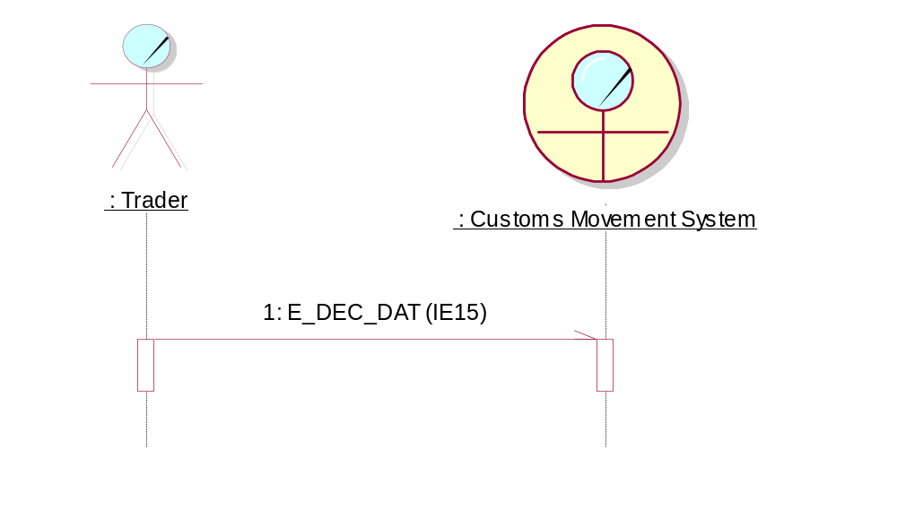
Figure 1: Time Sequence Diagram
In a TSD, each role is represented by an icon (see Table 7) with the name of the role and a vertical line, called the “lifeline”. The name “lifeline” comes from the UML-concept that an object’s life can be ended. This does not apply here.
An arrow between the lifelines represents each Information Exchange (message) between two roles, where the arrow shows the direction of the Information Exchange. Attached to the arrow, a label gives the sequence number of this Information Exchange in the scenario and the coded name and number of Information Exchange.
The above figure (Figure 1) illustrates that the “Trader” submits a message to the Customs Office application. The name of the IE that is sent to Customs Office application is indicated above the Information Exchange.
Moreover, the arrow with half arrowhead indicates that the message is asynchronous.
The narrow rectangles on the lifelines are called ‘focus of control’. It represents the relative time that the control of the flow is focused in that role, thus the time that the role is directing messages. When more than one message starts from (or ends in) the same focus of control, this means that these messages are sent (or received) shortly after each other. The arrows will appear close to each other in that case as well. Please note that in this case the sequence of sending the messages is not important. Therefore, the sequence used to represent them in the TSDs is only indicative. When for two messages exchanged the sequence is important, they are presented to start from a different ‘focus of control’.
The Time Sequence Diagrams conform to the Unified Modelling Language, which is an industry standard for Object Oriented modelling.
The UML business modelling element (Table 7), which will be used for each Role Type in the TSDs is shown in each domain specific DDNA volume ([R16], [R17] and [R18]).
Not all possible combinations are given in this DDNA; only the most relevant have been included.

State Transition Diagrams
State Transition Diagrams consist of states and transitions between those states. Each state represents the condition of a Customs movement for a particular Customs Office Role. Each transition starts at a given state and goes to another state. A transition is allowed to reach its original state. Each transition is triggered by the exchange of a message between two organisations. Only transitions that are triggered by the exchange of a message are shown on these State Transition Diagrams.
Every State Transition Diagram in this document is related to one particular role only. For that role, it will define how state transitions take place according to events (such as the reception of a message from another role).
States will be shown as a box and an arrow will show transitions.
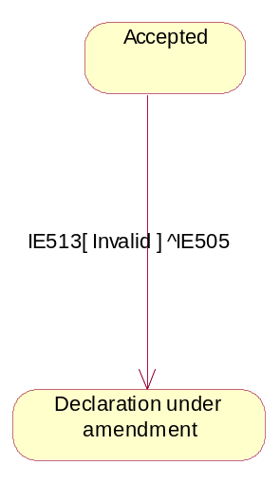
Figure 2: Example of State Transition Diagram
State transitions have the following format A[]^B or [C]^B. The transition is caused by the receipt of message A and if the condition inside the square brackets is satisfied, the state transition is performed and the message B is sent. Please note that only the IE numbers shall be used in the state transitions.
In the example above (which is part of the State Transition Diagram for the Office of Export up to the release of movement), the transition from “Accepted” to “Declaration under amendment” is triggered by the reception of a Declaration Amendment (IE513) message and if the Declaration Amendment is “invalid”. As a result, an Amendment Rejection IE505 message is sent back from Office of Export to the Trader.
When multiple messages are sent as a consequence of an event, a dot sign will separate these multiple messages (“.”). This dot sign needs to be understood as a logical AND.

Data Dictionary
The data dictionary, contained within this DDNA, defines:
- Data Items;
- Data Groups;
- Code lists (sets of discrete values).
A number of naming and spelling conventions and rules have been maintained for these throughout this DDNA.

Data Items
Every name shall start with a capital (uppercase) letter.
Every name can contain letters, digits, and a number of additional characters: the space character, the brackets “(“ and “)”, the ampersand character “&”, the underscore “_”, and the slash character “/”. No other characters are allowed.
Within the name, lowercase letters shall preferably be used (except for the first character and except for abbreviations that will always be in uppercase).

Data Groups
Every name shall start with a letter.
Every name can contain letters, digits, and a number of additional characters: the space character, the brackets “(“ and “)”, the ampersand character “&”, the underscore “_”, and the slash “/”. No other characters are allowed.
Only uppercase letters are allowed.

Code lists
The same rules as for Data Items will apply.

Central Services

Messages involved

Messages involved in Customs Applications
In the business area ‘Central Services’, the Information Exchanges planned are:
- Notification of Customs Offices Modification to Common Domain C_COL_COM (IE030) as identified in the process thread CS1A ‘Manage Customs Offices Data’ (see FTSS [R26Error: Reference source not found], Section IV, Heading 1.2);
- Notification of Customs Offices Modification to National Domain C_COL_NAT (IE031) as identified in the process thread CS1A ‘Manage Customs Offices Data’ (see FTSS [R26Error: Reference source not found], Section IV, Heading 1.2);
- Notification of Common Reference Data Modification to National Domain C_REF_MOD (IE032), as identified in the process thread CS4A ‘Common Domain Manages And Maintains ISO/UN-ECE Codes, Community/Common Transit Codes And Other Reference Data’ (see FTSS [R26Error: Reference source not found], Section IV, Heading 1.9);
- Notification of System Unavailability to Common Domain C_UNA_COM (IE070) and Availability Matrix C_AVL_MTX (IE912);
- Notification of System Unavailability to National Domain C_UNA_NAT (IE071);
- Full Unavailability Schedule C_UNA_DAT (IE971);
- Upload Parsing Response C_UPL_RSP (IE913);
- COL Request C_COL_REQ (IE914);
- Common RD Request C_REF_REQ (IE916);
- COL Data C_COL_DAT (IE931);
- Common RD Data C_REF_DAT (IE932);
- Sending of Statistics Data C_STA_SND (IE411);
- OTS Statistics Sending to Common Domain C_STA_OTS (IE413);
- Statistics Generated Sent to National Domain C_STA_GEN (IE412);
- MRN List Query C_MRN_QUE (IE918);
- MRN List Response C_MRN_ RSP (IE919).
In addition to this, although not strictly an Information Exchange, the technical CCN/CSI statistics and audit files also need to be considered.
The following messages from the Core Business area are also used for the CCN/CSI based exchanges:
- Internal CCN/CSI messages [CCN/CSI Confirm on Delivery Acknowledgement C_COD_ACK (IE908), CCN/CSI Confirm on Arrival Acknowledgement C_COA_ACK (IE909), CCN/CSI Expiration Notification C_EXP_NOT (IE910), and CCN/CSI Exception Notification C_EXC_NOT (IE911)]. These messages are related to the internal usage of CCN/CSI and, when correctly used, are transparent to the user. Details concerning the technical CCN/CSI messages are included in Transport of messages via CCN/CSI;
- Messages for error reporting [Functional NACK C_FUN_NCK (IE906), EDIFACT NACK C_EDI_NCK (IE907), XML NACK C_XML_NCK (IE917)]:
  - EDIFACT NACK C_EDI_NCK (IE907) is used for reporting EDIFACT formatting errors when the message is exchanged in EDIFACT format;
  - XML NACK C_XML_NCK (IE917) is used for reporting XML formatting errors when the message is exchanged in XML format;
  - Functional NACK C_FUN_NCK (IE906) is used for reporting functional errors (e.g. violation of Information Exchange building rules).
The usage of Functional NACK C_FUN_NCK (IE906), XML NACK C_XML_NCK (IE917) and EDIFACT NACK C_EDI_NCK (IE907) is further explained in Design principles, chapter V.3.
In addition, a number of HTTP messages have been defined (for enabling Information Exchange with standard Web technologies). These are (the prefix IM_ denotes an HTTP message):
- IM_REGISTER: for subscription notifications;
- IM_RESULT: for returning the result of another HTTP message (ok/failure or URI where information can be found);
- IM_NOTIFICATION: for notification of new information or presence of upload results;
- IM_INITIATE_DOWNL: for initiation of a download operation;
- IM_GET_FILE: for starting the sending of a file.
These HTTP messages are all in an Internet specific format. Their meaning is explained in Central Services ( and II.6.2), their format in Section IX: Transport of messages via the Inter(extra)net.
Appendix A in each domain specific volume ([R16], [R17] and [R18]) shows all messages relevant to the message protocols for Central Services.
Central Services can be split into five functionally different components:
- The exchange of common reference data (IE032, IE913, IE916 and IE932). Note that IE032 and IE932 are common messages for all Customs movement systems, and, therefore, only the data groups and data elements that are applicable to a specific Customs movement system will be included in the IE032/IE932 that are produced for this system. It is worth noting that a data group, which is applicable to more than one Customs movement system, can have different values for each Customs movement system;
- The exchange of Customs Office List and National Reference Data (IE030, IE031, IE913, IE914 and IE931);
- The exchange of availability data (IE070, IE071, IE912 and IE971);
- The exchange of business statistics data (IE411, IE412, IE413);
- Monitoring of messages and movements (CCN/CSI audit files), queries on these movements (IE918/IE919) and statistics on the messages (CCN/CSI technical statistics).
The first two items (Reference Data and Customs Office List) are covered centrally by the CS/RD CDCA tool; availability data, statistics (business & technical) and monitoring of movements are applicable only for the movement systems and are covered by the CS/MIS CDCA.

Exchanges of Reference Data (RD) and Customs Office List (COL)

Introduction
This section deals with the following messages: IE030, IE031, IE032, IE913, IE914, IE916, IE931 and IE932.
All Common Reference Data and COL will be distributed to the National Customs Applications (NCAs) by means of a separate application, called CS/RD (Central Services/Reference Data). The CS/RD application will be maintained on a central reference site, referred to as ITSM. The CS/RD and CS/MIS systems will also support two logically separated operating environments: 'conformance' and 'operation'.
Note that the COL contains data pertinent to all Customs systems. For this reason, the same instance (replica) of the IE031/IE931 will be distributed to all NCAs.

Management of Common Reference Data
As far as the Common Reference Data messages (IE032/IE932) are concerned, distinct instances of these messages will be distributed to NCAs of different systems, containing the Common Reference Data entities (data groups) and elements (data attributes) that are pertinent to the receiving system. Therefore, the IE032/IE932 instances that are produced for the NCTS system may include different reference data entities and elements from the IE032/IE932 instances that are produced for the ECS, the ICS or EOS. Furthermore, they may also include different items for the same reference data entity. Thus, only the data groups and data elements that are applicable to the NCTS system will be included in the instances of the IE032/IE932 that are produced for the NCTS system. The same is also applicable for the ECS, ICS and EOS systems.
Regarding the definition of the structure of the IE032/IE932, it has to be emphasised that the TMSs and DTDs of these messages that are defined in the DDNA Appendices Q2 and T respectively, specify one common TMS and DTD that incorporates all the common and non- common data entities and data elements. The latter could be considered as a superset of all the Common reference data entities and elements that are maintained in the Common Domain irrespectively of their applicability. A set of technical rules signal the system applicability of the data groups and the data attributes that are not applicable to all systems.
Furthermore, there will be different DTD and/or XSD files per system hosted in CS/RD. Those DTD and XSD files will be system specific, i.e. each DTD or XSD will include only the entities and elements that are applicable to the specific system that the DTD/XSD is meant to support. Each user will be able to download the system specific DTD/XSD from the CS/RD application.
The concurrent existence of different common reference data entities and/or elements for the different phases of a business domain (e.g. ECS phase 1 and ECS phase 2) is also probable. For simplicity reasons and in terms of common reference data management, the different phases in one business domain will be confronted as discrete systems.
In addition, the language specific data that is included in the IE032/IE932 messages sent to the different NCAs will be in different languages depending on the language(s) definition associated with each NCA or the language(s) being requested each time. It should be noted that language specific data for the ‘EN’ language will always be included in the IE032/IE932 messages regardless of the language(s) definition or request.

The Role of Code Lists
Any message from the Core Business area needs to conform to a number of building rules and in principle needs to be validated, upon reception, against those building rules.
Various data fields in an Information Exchange can take only a set of predefined values (also referred to as Code List). Therefore, any NCA must know which values are permitted when composing such an Information Exchange. It must also check if the received values are allowed, upon reception of any Information Exchange. These Common Domain Code Lists are also commonly referred to as being the Common Domain Reference Data. ITSM will maintain a master copy of all Code Lists to be used for Customs systems messages sent across the Common Domain. Furthermore, the code lists can be distinguished to those that are:
- common to all Customs systems;
- and system-specific codelists.

The Role of the Customs Office List (COL)
The Customs Office List (COL) is a list of the Customs Offices in all participating countries and related data such as the Customs Office reference number, country code, region, phone number, language code etc. The data on country regions, national holidays and regional holidays is also considered as being part of the COL and it is sometimes called specifically National Reference Data.
ITSM will maintain a master copy of the COL that will be managed through the CS/RD tool.

Functional ways to get data

Overview
The different functional ways for a user to get the data from the repository are:
- Retrieval gets a set of modifications that have been applied to selected data types during a given time period (specified by begin and end date) and concerns a specific Customs Systems.
- Extraction gets a set of Data Items, from selected data types, that are valid for a given time period (specified by begin and end date) or a part of that period and concerns a specific Customs Systems.
- Acquisition of IE031/IE032 messages produced automatically and broadcasted by the system, every time the COL or Common RD is modified. The IE031/IE032 messages are received over CCN/CSI, or hyperlinks to those messages are received in the notification e-mail.
- Queries get the set of COL or Common Reference data entries that match one or more criteria given by the user.

Retrieval
Retrieval allows the users to retrieve modifications made to the repository during a given time period. These modifications are returned as COL Data C_COL_DAT (IE931) and Common RD Data C_REF_DAT (IE932) messages.
For instance, if a user requests a retrieval of the COL with a time range from the 10th September to the 15th September, he/she will in return receive the list of all the modifications to the COL entered between the 10th September and the 15th September.
It should be stressed that retrieval functionally is very different from extraction because the time range given for the retrieval does not relate to validity dates but to actual dates where the modifications were published in the repository. For instance, it does not make any sense to perform retrieval for dates in the future.
A full retrieval means retrieving all the modifications to the COL or the Common RD since the database was set-up for the first time.

Extraction
Extraction allows the users to extract the Common RD or COL data valid for a given period. This data is returned as COL Data C_COL_DAT (IE931) and Common RD Data C_REF_DAT (IE932) messages.
For instance, if a user requests an extraction of the COL for the period from the 10th September to the 15th September and a Customs Office is modified with a validity date of 13th September, the extraction will provide the following information:
- It will give the value of all the attributes of that Customs Office, such as they are valid on the 10th September;
- It will also provide the modification that takes/took effect on the 13th September.

Acquisition
Acquisition denotes the reception by an NCA of an IE031/IE032 sent automatically by the system (or of a hyperlink to an IE031/IE032 produced by the system).
Whenever a National Data Administrator sends a (valid) IE030 or publishes modifications to the COL using the interactive interface, the system modifies the CS/RD repository as appropriate.
It then creates a new IE031 and makes it available to the public. In the first case, this is a direct replica of the IE030.
Whenever a Common Domain user sends a (valid) IE032 or publishes modifications to the common RD using the interactive interface, the system modifies the CS/RD repository as is appropriate. It then creates a new IE032 and makes it available to the public. In the first case, this is a subset of the original IE032 based on the system applicability of the receiver.
This IE031/IE032 will be sent over the CCN/CSI network in EDIFACT or XML format to the countries that have subscribed to receive CCN/CSI notifications. Moreover, hyperlinks to the IE031/IE032 being produced by the system will be sent in the notification e-mails received by all SMTP registered users. Those users will be able to download the IE031/IE032 messages by visiting the CS/RD website. Please also note that a country may be subscribed to receive both e-mail and CCN/CSI notifications.

Queries
Queries allow the user to specify one or more criteria and receive as a result the set of data entries matching these criteria.
The criteria that can be used are:
- System applicability (for the Common reference data);
- Data type;
- Validity date (i.e. date of applicability for a modification or new entry);
- Validity/Invalidity at a specified period;
- Value of one of the fields pertaining to a selected data type.
For instance, a user could request a list of all the Customs Office entries that have a country code set to “DE” and a validity date between the 1st January 2000 and the 1st April 2002.
This functionality is covered by the interactive mode of access to CS/RD (see chapter II.2.4.1).

Functional ways to upload data
Functionally, there are two different ways to upload COL or reference data to the CS/RD system:
- Online preparation of modifications;
- Upload of pre-prepared IE030 or IE032 messages.
Online preparation of modifications is covered by the interactive mode of access to CS/RD (see chapter II.2.4.1).
Upload of pre-prepared messages is covered by the two other modes of access (see chapter II.2.4.2 and chapter II.2.4.3).

Modes of Access to the CS/RD
The CS/RD application will offer three different modes of access:
- Interactive Mode;
- Manual Mode;
- CCN/CSI Queue based mode.
It should be noted that each mode of access has a different functionality. Table 8 below offers a schematic view of this functionality.
Data Transfer | Network | Access Mode | Functionality | EDIFACT | XML
CSI | CCN | Asynchronous (Queue based) | R, A, U, E | Yes | Yes
HTTP | CCN or Internet | Interactive | Q, U | Yes | Yes
HTTP | CCN or Internet | Manual | R, E, U | Yes | Yes
SMTP | Internet | E-mail notification | A | No | Yes
Table 8: Functionality for the different access modes
In Table 8, the following abbreviations are used:
- A for acquisition;
- E for extraction;
- R for retrieval;
- Q for queries;
- U for upload and modifications.

Interactive Mode
The Interactive mode of access is integrated into the ITSM Portal (https://itsmtaxud.europa.eu/cms/usefullinks). It will allow the Customs system users to prepare COL (IE030) or Common Reference Data (IE032) modifications via a GUI and upload these modifications.
It also allows the users to make queries on the database.
It relies on the HTTP protocol.
Detailed protocol followed by the interactive mode is not described because this mode of access is meant to be user driven. It is noted that as far as the modifications and the queries for the Common Reference Data are concerned, the application will support the system specific consultation and manipulation of each Common Domain RD entity.

Manual Mode
The manual mode is integrated into the ITSM Portal (https://itsmtaxud.europa.eu/cms/usefullinks) and relies on the HTTP protocol. It allows the users to upload pre-prepared IE030 or IE032 messages in just a few clicks on the Project web site.
It also allows the users to perform extractions (chapter II.2.2.3) and retrievals (chapter II.2.2.2) on the CS/RD database.
Users can also use the manual mode to subscribe or unsubscribe themselves to the notification mailing list.
Uploads and downloads in manual mode can be made in XML or in EDIFACT format. Beside the uncompressed format, zip or gzip compression is also allowed.
It is noted that the system specific uploads and downloads in manual mode for the Common Reference Data messages shall be supported by the application.
Moreover, the selection of language(s) applicable to the language specific data of the Common Reference Data messages must be supported for downloads in manual mode.

CCN/CSI Queue Based Mode
The following messages can be exchanged through CCN/CSI in queue-based mode: IE030, IE031, IE032, IE913, IE906, IE907, IE917, IE914, IE916, IE931 and IE932. The protocol for queue-based exchanges of these Information Exchanges on CCN/CSI foresees the basic exchanges of these messages plus error reporting on them. In this access mode, the following operations are needed in case of an update of the COL of the CS/RD system:
- IE030 sending. An NCA can send a file containing an IE030 message. Either the IE030 is accepted as a whole or it is rejected completely;
- IE031/IE032 download. CS/RD shall automatically send to the NCAs that are connected to CCN/CSI the outgoing IE031/IE032 messages through the CCN network;
- IE913/907/IE917 Response to IE030. The NCA shall receive an appropriate response message for each IE030 that it has sent.
It is noted that the dissemination of the appropriate system specific instance of the IE032/IE932 will be based on the user profile of the NCA recipients of such messages. A configuration matrix will be maintained in CS/RD to store the system applicability of each NCA.
Furthermore, CS/RD will maintain configuration information regarding the language definition of language specific data of Common Reference Data for each NCA. Therefore, the dissemination of the appropriate language specific data in IE032/IE932 will be based on the country property of the NCA recipient of these messages.
The following operations are also available:
- IE914, IE916 sending. An NCA can send IE914 and IE916 messages;
- IE931/906/907/IE917 Response to IE914. The NCA shall receive an appropriate response message for each IE914 it has sent;
- IE932/906/907/IE917 Response to IE916. The client shall receive an appropriate response message for each IE916 it has sent.
Users can use the asynchronous queue based mode to receive a full or partial retrieval or extraction of the COL relevant to a specific system. In order to do this, the NCA must send a valid IE914 to the DG TAXUD gateway. CS/RD will then send back the IE931 also including the National RD. Please note that, in case of retrieval, the IE931 will contain all modifications to the COL, whether the entities are valid or not, even for the deleted items. This means that a NA, that receives an IE931 in response to a full retrieval request it has sent, can safely replace the COL content of its database with the content of this IE931.
In addition, the users can use the asynchronous queue based mode to receive a partial retrieval or extraction of the COL. In order to do this, the NCA must send a valid IE914 to the DG TAXUD gateway specifying a date period in order to receive the list of all the modifications to the COL entered in the specified period. Furthermore, the users may also optionally declare in the IE914 if they want to receive an extraction instead of retrieval.
The same applies to the sending of an IE916 requesting an extraction or a retrieval of the Common RD and to the reception of the IE932 that will be sent as a response to that request. Note that different message queues in the National gateways will be used for the exchange of messages that are destined to specific systems. Furthermore, additional queues will be created in the Taxation and Customs Union DG gateway (see section VIII, paragraph VIII.2.19).

Set-up and maintenance of National Database
The Common RD is built as follows:
- The various NAs send their relevant national data to a central reference site, managed by ITSM;
- ITSM updates the reference data into a central database;
- ITSM then forwards each NA’s data to all the other applicable NAs.
Modifications to the Common RD are uploaded (by common domain users) to the CS/RD via an IE032 message (C_REF_MOD). Modifications are also sent back to the NA via an IE032 message.
There may be occasions on which it is necessary to have the capability to reload the entire Common RD into an NCA (e.g. to resynchronise with CS/RD). In that case, it is foreseen to proceed by performing a full relevant national retrieval.
Additionally, the NAs can use the CS/RD interactive interface to request, within a single IE932 message, selected parts of the Common RD or selected modifications made to the common RD. For instance, a NA can request all the modifications made to the Common RD in the last seven days.
The COL is built as follows:
- The various NAs send their relevant national data to a central reference site, managed by the ITSM;
- Alternatively, NA’s can directly upload the reference data into the central database;
- The ITSM updates the reference data into a central database;
- The CS/RD then forwards each NA’s data without consolidation to all the other NAs.
Modifications to the COL are sent to the CS/RD in the format of an IE030 message (C_COL_COM). Modifications are sent back to the NA in the format of an IE031 message (C_COL_NAT).
IE032s/IE031s will be sent to the NAs across the CCN/CSI in EDIFACT or XML for the NAs with CCN/CSI access or hyperlinks to IE032s/IE031s will be sent to the users registered in the notification mailing lists. NAs are not allowed to upload IE032 messages to CS/RD.
Exchanges via the Inter(extra)net or CCN/CSI can take place either in XML or in EDIFACT format.
There may be occasions on which it is necessary to have the capability to reload the entire COL into an NCA (e.g. to resynchronise with CS/RD). In that case, it is foreseen to proceed by doing a full retrieval or an extraction.
Additionally, the NAs can use CS/RD web site to request, within a single IE931 message, selected parts of the Common RD or selected modifications made to the common RD. For instance, a NA can request all the modifications made to the Common RD in the last seven days.

Exchange of statistics and availability data
Statistics and availability management for the movement systems are supported by a centrally developed Customs application (CDCA) called CS/MIS (Central Services/Management Information System). This system collects the statistics and availability data from the various NAs via two physical media (the Web and CCN/CSI) and distributes the information to the NAs after centralised consolidation.
This section deals with the following Information Exchanges:

Common IEs:
- Statistics: Technical CCN/CSI statistics;
- MRN nursing: CCN/CSI Audit files;
- Availability data: IE070, IE071, IE912 and IE971;
- Business Statistics: IE411, IE412, IE413.
Additional IEs involved in NCTS:
- MRN List Query C_MRN_QUE (IE918) and MRN List Response C_MRN_RSP (IE919).

The role of the CS/MIS tool
CS/MIS is a system in the Common Domain, located at the ITSM site. Its role is threefold:
- Keep track of system unavailability;
- Manage and distribute statistics on system, business and resources regarding the Customs systems;
- Monitor of Customs movements (MRN nursing).
CS/MIS web site will be integrated into Project web site.

Statistics management

CCN/CSI technical statistics

CCN/CSI technical statistics for Customs Systems
Separate CCN/CSI technical statistics will be generated for the CCN/CSI network resources and the use of the Common Domain for each Customs system. Technical CCN/CSI statistics provide information collected on the CCN gateways used by Customs Applications. The reports generated here inform the user about utilisation of the CCN/CSI network resources (e.g. number of messages).
Technical statistics report on the use of the Common Domain (CD) by a Customs application. CCN message transport information is collected daily on each NA CCN gateway. It is forwarded daily to the ITSM/CCN-OPS and from there further on to the CCN gateway accessed by ITSM. There, the statistics data is captured by CS/MIS and stored on disk.
Note that the generation of technical statistics data and the collection and forwarding of this data will be performed by the ITSM/CCN-OPS. Therefore, this process is transparent to the NA and no specific implementation from the NA side is required. However, NAs will be able to view and download the statistics from CS/MIS web site.
Technical statistics will be sent across the CCN/CSI platform as a flat file. A separate queue will be created in the Taxation and Customs Union DG gateway for the collection of the Technical statistics for each Customs system (see section VIII paragraph VIII.2.19).

Movement Monitoring

Movement Monitoring for Customs Systems
CCN/CSI audit files from all the Customs Systems’ gateways will be collected by ITSM/CCN-OPS and sent to Taxation and Customs Union DG gateway at ITSM. Separate queues will be created in the Taxation and Customs Union DG gateway for the collection of the CCN/CSI audit files from all the CCN gateways for each Customs system (see section VIII paragraph VIII.2.19).
CS/MIS will then consolidate these audit files daily.
A user will be able to perform “MRN Tracking” in one of two ways to get all the data available about a particular MRN:
- The user can directly enter the MRN into a web form;
- The user can make a query (using a web form) to get a list of the MRNs matching the query and then select a particular MRN from that screen.
In the above cases the result will be a screen displaying all the messages and reports related to that MRN or query. The user shall also be able to request downloading a file in HTML, Excel or XML format that incorporates the results of the submitted query.
In addition to the “MRN Tracking” functionality, the system also presents the “Message Tracking” functionality. Message Tracking gives the user the ability to retrieve a list of messages matching the criteria selected in the Messages query web form and then select a particular message from that screen.
The Messages query results are displayed in a list of entries displaying the type of the message(s), the related CORREL ID(s) and reports.
The CS/MIS application will incorporate the “Movement Query” functionality, which will enable the user to retrieve information about the number of movements (number of distinct MRN) exchanged per country pair, according to the selection criteria of the Movement query web form.
The user will be able to view the data-using HTML or download them in an Excel format.
CCN/CSI audit files from all the Customs Systems’ gateways will be collected by ITSM/CCN-OPS and sent to Taxation and Customs Union DG gateway at ITSM.
CS/MIS will then consolidate these audit files daily.

Additional Movement Monitoring
An NCA may submit a request to the CS/MIS application via CCN/CSI with the help of the IE918 EDIFACT message via which the NA/MS will be able to request the list of MRNs from CS/MIS. CS/MIS will import this IE918 message from the CCN/CSI queue, process it and produce a message (IE919) that would be the reply containing the results as a list of messages with their relevant information, for the requested MRN(s). Alternatively, the CS/MIS shall provide registered users with the ability to manually upload an IE918 as an XML file.

Business statistics
Business statistics serve to provide information to the user on Customs operations from the business perspective. Business statistics can be divided in two kinds:
- NCTS, ECS and ICS business statistics are collected on a monthly basis in the National Domain under automatic procedures by the NCA. Business statistics are sent to the CS/MIS application across CCN/CSI or uploaded on CS/MIS Web interface by means of the Sending of Statistics Data C_STA_SND (IE411). NAs may send IE411 statistical messages that include data for multiple domains (NCTS and/or ECS and/or ICS) and/or IE411 messages that include data for one customs domain. If an NA sends more than one IE411 message concerning a given month and customs domain, the latest information will overwrite any previously communicated data (i.e. if in the first message IE411 for a statistic type a value has been transmitted and the second message IE411 does not contain this certain statistic type, the first value remains valid; if a statistic type value is transmitted in both messages, the second value is used to update the message IE412);
- Business statistics from OTS Customs Offices in NCTS countries can be added at any time to the statistics information by manual interaction or an additional upload. OTS statistics are sent to CS/MIS in the format of an OTS Statistics Sending to Common Domain C_STA_OTS (IE413) across the Web. If a NA communicates more than one IE413 during a given month, each value transmitted will be added.
OTS and NCTS business statistics are added together by CS/MIS.
Each time an IE411 message is received by CS/MIS, a Statistics Generated Sent to National Domain C_STA_GEN (IE412) message is automatically produced per Customs Domain impacted. The produced IE412 messages are available for download via the CS/MIS Web interface in any of the following formats: XML, XLS, HTML or TXT.
In addition, each time an IE412 message is produced, CS/MIS combines this IE412 message with other IE412 messages created for other periods and generates a domain-specific XLS file, which is also available for download on CS/MIS Web interface.

Availability monitoring
Monitoring of Customs Systems informs the NAs about the unavailability of any NA, so that they can take measures to prevent the transmission of messages to the disabled NA.
Three different types of unavailability may be communicated:
- The NA may plan a scheduled unavailability in advance. This information is entered into CS/MIS, using a Notification of System Unavailability to Common Domain C_UNA_COM (IE070) with System Unavailability Type “S” or an Availability Matrix C_AVL_MTX (IE912), kept in a central database and distributed as Notification of System Unavailability to National Domain C_UNA_NAT (IE071) to the other countries (in case the information was entered into CS/MIS via IE070).
- Unscheduled unavailability may be communicated by any non-system means to the Central Help Desk. It is then entered into CS/MIS and monitored by the Central Help Desk. It can also be communicated through a web form on CS/MIS web site or by uploading a Notification of System Unavailability to Common Domain C_UNA_COM (IE070) with System Unavailability Type “U”. All NAs receive an e-mail notification.
- Apart from this, the NA should inform the CS/MIS application about the non-implementation of a particular business service, in order to advise the other NAs not to send messages related to this business service to the specific NA. In order to achieve this, the NA will upload a Notification of System Unavailability to Common Domain C_UNA_COM (IE070) with System Unavailability Type “N” for the particular business service. This information will be distributed to the other countries via the Notification of System Unavailability to National Domain C_UNA_NAT (IE071).
Every NA prepares its own unavailability schedule that is distributed to all other NAs in order to prepare the other NAs for the disruption of service. FTSS [R26Error: Reference source not found], FSS-AES [R13] and FSS-AIS [R14] foresees a mechanism for this purpose: the NA sends its unavailability schedule to the CS/MIS, which stores the information and distributes the unavailability to all other countries.
Four messages will be used for this:
- An IE070 message contains an update from a NA to its currently known schedule;
- An IE071/IE971 message is sent by CS/MIS as an e-mail attachment to all countries to update their local unavailability information about the other NAs;
- By sending an IE912 message, the NA is able to send its unavailability schedule for a chosen time frame to CS/MIS. When a NA does so all its previously stored unavailability with a start date within the chosen time frame are deleted and replaced by the schedule given in the new IE912;
- An IE971 is sent in XML format containing the complete schedule of unavailability.
CS/MIS web site will provide the functionality to manually upload IE070 and IE912 messages. Separate instances of these messages will be used for each Customs system. The format to be used will be XML and the file can be uncompressed, zip compressed or gzip compressed.
There can be many causes of unscheduled interruptions to the services. Therefore, any means of non-system communication (telephone, fax, e-mail) as well as an IE070 having of Type “U” (Unscheduled) may be used to advise the CS/MIS operator about this kind of event. The modifications to the unavailability are broadcast to all NAs by means of an IE071 in XML format attached to e-mail. Unavailability information is also notified to the Central Help Desk.
Statistics on unscheduled unavailability are reported by CS/MIS.
Users will also be able to request from the CS/MIS web site an IE971 in XML format containing the complete schedule of unavailability. They will also be able to see live on the CS/MIS web site which countries are currently unavailable.

Message exchanges with CS/RD via the Web
This chapter defines the external interfaces of the CS/RD application via the Web and explains how an NCA needs to interact with it.

Approach
The external interface provides a way to feed IE030 & IE032 messages into the CS/RD system and to request IE913, IE931 and IE932 messages. The messages to be exchanged are in EDIFACT or in XML format.
There are two different ways to communicate with CS/RD via the web.
- The manual mode interface described in chapter II.4.4;
- The interactive mode interface.

Message transport
Communication with the CS/RD system will be HTTP based. The use of an HTTP-based approach has several advantages.
- It is the main Internet protocol supported by web-browsers.
- There is browser support for sending files in Netscape and Internet Explorer.
- It has standard support for identification and authentication.
- It is a simple protocol that is usually not affected by firewalls.
- The HTTP server handles requests so no polling is required for incoming messages.
- HTTP offers an easy solution for secure communication because it can operate over a secure transport layer.

Message exchange overview
The exchange policy is based on client-server communication. This is the natural way of communicating using HTTP. ‘Clients’ stand here for NCAs in the different NAs. The server is the centralised CS/RD application at the ITSM.
Having the clients request information from the server has some significant advantages. Clients can retrieve information when they want and as many times as they want. Moreover, client knowledge is kept to a minimum at the server side. Finally the same security provisions are available both for incoming and outgoing messages in a uniform way.
Figure 3 shows the overall external message exchange of the CS/RD system. The following operations are foreseen:
- Subscription. A client can subscribe in order to receive e-mail notification when the CS/RD has IE031/IE032 messages available. A hyperlink to the newly produced IE031/IE032 message will be included in the notification mail. This exchange can also be used to stop the subscription.
- IE030/IE032 upload. A client can upload a file containing IE030/IE032 data. The message file is either accepted as a whole or it is rejected completely. The immediate reply is not the result of the processing of these message data but merely an indication that the request was received and communicates the URI where the processing result will be available.
- Client notification. Client notification is optional and is performed through e-mail in order to avoid polling. Client notification can happen because the client has a subscription or because the client agent has supplied an e-mail address when it posted a request. In this case, the client is notified that some processing result has become available. The e-mail notification contains the URI where the response message can be retrieved.
- Get upload result. This request lets the client retrieve the result of the processing of an earlier posted IE030/IE032 file, in the format of an IE913 file.
- Initiate download. This request is used to send the parameters for requests of IE932 and IE931 messages. The client can be notified when the resulting file can be retrieved when it supplies an e-mail address. The immediate reply informs the client at what URI (RFC-1630) the outgoing messages will be available.
- IE931/IE932 download. The client can get the messages requested in step 5.
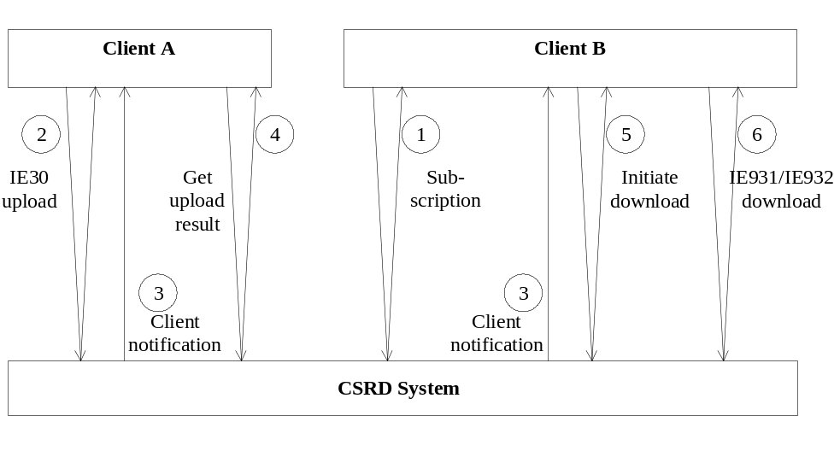
Figure 3: Message exchange policy
To support client authentication, the CS/RD system will get the identification of the user from Project web site. Therefore, the CS/RD user will have to use Project web site logon facility to update his/her password.
Clients can also check to see if there is information available by using the system monitoring functionality.

Exchange policy in manual mode with CS/RD
All the message-based functionality is also available in a manual browser-based mode. The only software needed at the client side is a web-browser that supports RFC-1867.
The sequence diagrams of exchanges applicable to manual mode are described in chapter . By manually uploading and downloading files, using a web-browser, users of the CS/RD system can avoid exchange protocol implementation effort.
The CS/RD user points the web-browser to <CS/RD HOME URI>. On this web page, the user will find all the necessary information on how to:
- Upload a message file;
- View/check the result;
- Perform monitoring tasks;
- Subscribe to the CS/RD system.
The user will first go through a login procedure. Once the HTTP server has identified and authenticated the user, he/she will be able to upload and download messages.
In order to upload messages the user requires a message file in XML or EDIFACT prepared in advance. The server provides a web form that the user completes to start the upload, including as parameters the name of the message file and the format of the file (EDIFACT or XML). When the user clicks on the upload button on the upload page the browser opens the message file and sends its contents, together with other parameters to the server where it is processed. As a result, the server provides the user with a URI that can be used later to verify the processing result. A dedicated form enables the user to download the file containing the processing results in the format of a C_UPL_RSP message (see chapter II.4.7).
Downloading messages also happens in two phases:
- The user posts a query by completing a form that the server provides and receives a URI.
- The user uses the resultant URI to retrieve the outgoing messages.
These messages can be in XML or EDIFACT as specified by the user when posting the query. The user can configure his browser to save the downloaded file or to transfer it immediately to a local application.
The system will provide pages that show the state of the system and of requests that the user has posted.
The user will also be able to subscribe to the CS/RD system in order to receive an e-mail when CS/RD is updated.

CS/RD Web exchanges sequence diagrams

Subscription
NA
CS/RD
1: IM_REGISTER
2: IM_RESULT
Figure 4: Subscription to CS/RD
In order to receive notifications, a user first needs to register with the CS/RD application (IM_REGISTER). This message will contain the e-mail address to which notifications need to be sent.
The CS/RD application will reply by means of an IM_RESULT message that will denote the outcome of the registration (successful or not).
A user can also unsubscribe from CS/RD via the IM_REGISTER message and from there on will no longer receive notifications.

Acquisition
1: IM_NOTIFICATION
(Including hyperlink to IE031)
ND User
CS/RD
Figure 5: Acquisition of COL modifications
1: IM_NOTIFICATION
(Including hyperlink to IE032)
ND User
CS/RD
Figure 6: Acquisition of Common RD modifications
Notifications are sent to the registered user by means of e-mail (IM_NOTIFICATION) to the e-mail address defined in the IM_REGISTER message. This notification informs the user when new IE031/IE032 message is available. A hyperlink to the new IE031/IE032 is included in the body of the notification e-mail.
The user is also informed via IM_NOTIFICATION when upload-processing results have become available (see later on).

Downloading an IE931 or IE932
ND User

GUI
CS/RD
1: IM_INITIATE_DOWNL
2: IM_RESULT
3: IM_NOTIFICATION
4: IM_GET_FILE
5: HTTP_404
6: C_COL_DAT(IE931)
Figure 7: Downloading IE931 or IE932
In order to download an IE931 or IE932, a user first needs to request the download by means of an IM_INITIATE_DOWNL message. This message contains details of the actual information requested (as shown in the IM_NOTIFICATION) and on the required format (EDIFACT or XML).
The CS/RD application replies by means of an IM_RESULT message containing the URI where the requested information can be downloaded.
When the download information has been requested, CS/RD requires some time in order to prepare the outgoing file. It notifies the requester when the file is ready by means of IM_NOTIFICATION (e-mail).
The download is then triggered by means of an IM_GET_FILE message to the URI defined in the IM_RESULT. This will trigger the “get” of a file from the URI specified.
The CS/RD application then sends the requested information. In the example above, an IE931 is sent back.

Uploading an IE030
1: C_COL_COM(IE030)
2: IM_RESULT
3: IM_NOTIFICATION
4: IM_GET_FILE
5: C_UPL_RSP(IE913)
GUI
CS/RD
ND User
Figure 8: Uploading an IE030
In order to perform an upload, a user sends the data to the CS/RD application encapsulated in a file (IE030). During the transmission of the file, a number of parameters on the actual format (EDIFACT or XML) are passed as well.
The CS/RD application then returns (IM_RESULT) the URI where the result of the parsing and validation of the IE030 contents can be found. This parsing is done off-line and is not immediately available after the upload.
If the user is subscribed to CS/RD, he/she is notified when upload processing results become available by means of an IM _NOTIFICATION (e-mail).
The user can later request (IM_GET_FILE) the parsing information at the given URI. The result is sent back (C_UPL_RSP), reporting on the further processing by the CS/RD application of the information uploaded.

Modifiable occurrences in CS/RD
This applies only to IE030, IE031, IE032, IE931, and IE932.

Message identification and Interchange control reference
For every transmission of IE031/IE931 and IE032/IE932 messages performed by CS/RD, an Interchange control reference must be provided. The content of this Interchange control reference is free to be defined but must be a unique identifier for the transmission within the scope of the producer.

Furthermore, for every transmission of IE031/IE931 and IE032/IE932 messages, the Message identification attribute must be provided. Similar to Interchange control reference, the Message identification attribute must be a unique identifier for the transmission within the scope of the producer. In addition, Message identification values must be assigned by CS/RD in ascending order. In this way, the content of the Message identification attribute will indicate the order in which the pertinent message has been sent by the CS/RD system. Because of the above, the recipient of the message will be able to determine the order in which the received message shall be processed. Finally, in case of IE031/IE931 and IE032/IE932 messages sent to CS/RD subscribers, the values assigned by CS/RD to the Message identification attribute must be consecutive, allowing the receiver to detect possible message loss.

Changing the reference data
The CS/RD system maintains a history of the reference data and the COL. This means that all modifications to the data occurrences are available to the users of the system. To be able to conform to this requirement the semantics of these modifications are defined and the mechanisms to implement them are provided.
In this section, the semantics for modifying occurrences are defined. The Data Group ACTION is introduced to enable the different actions (create, update, delete) on the data. For the different actions, the content and the meaning of the different attributes in the ACTION Data Group are described, and the consequence of scalar attributes is explained.

Actions
To enable actions on a certain reference data occurrence the Data Group action is introduced in the messages. The content of this Data Group is used to drive the modifications. The content is as follows (defined in [R16], [R17] and [R18]):

ACTION
 | Operation | R | a1 |  | 24
 | Validity Date | D | n8
 | Modification Subtype | D | n1
 | Legal References | O | an..70
 | Responsible Data Manager | O | an..35
 | Action Identification | R | an..20

The Operation attribute indicates what operation is applied to the occurrence in the message. Operation can have three values: (C)reate, (U)pdate and (D)elete.
The Validity Date attribute is a date in the format yyyymmdd. It denotes the date from which the notified change will become valid. For a given COL or Common RD occurrence, a new change does not affect the validity date associated with changes previously specified.
The Modification Subtype is an indicator that can have the value ‘0’ or ‘1’. When the Operation attribute is equal to “Update” different update operations are possible.
The Legal References is a free text attribute to specify the legal base for the create/update/delete of the occurrence. This optional attribute is only present in the action Data Group for the IE032/IE932 message.
The Responsible Data Manager attribute is a free text attribute to specify the person responsible for the create/update/delete operation. This optional attribute is only present in the action Data Group for the IE032/IE932 message.

Action identification is identification for the occurrence within the Information Exchange Message. The Action identification can be chosen by the producer, respecting Rules and Consitions, and must be unique in the scope of the transaction.This is a technical attribute added to identify the occurrence in the enclosing transaction (message) and intended to enable unique definition of error cases. It should be noted here that the CS/RD system must fill the Action identification attribute of IE031/IE931 and IE032/IE932 messages in ascending order. Therefore, the recipient of such a message can determine the order in which the occurrences enclosed in the message shall be processed.

Create Operation
The ‘create operation’ is used to generate a new occurrence for a certain entity which means create a new Customs Office or new Reference Data occurrence in case it does not exist. Create operation fails and an error is reported (as part of the C_UPL_RSP message) if CS/RD occurrence is already created.
Action attributes:
Operation: | C
Validity date: | Defines the date at which the occurrence becomes valid. It has to be defined in the future, at least one (1) day after system date.
Modification subtype: | The value of this attribute is required to be ‘1’. No other value is used.
Action identification: | Identifies the action within the context of the enclosing transaction. The Action identification can be chosen by the producer, respecting Rules and Consitions, and must be unique in the scope of the transaction.
Actions
The occurrence is created with the specified validity. If there is an error for one or more attributes of the occurrence, the creation is aborted. For all attributes specified in the message, the value is assigned to the corresponding attribute of the occurrence.

Update Operation
The ‘update’ operation is used to modify existing occurrences. A unique key identifies the occurrence. For this Update operation to succeed the occurrence must exist and the validity date of the update operation must be equal or posterior to the validity date of the create operation, otherwise an error is reported as part of the C_UPL_RSP message.
This operation is used when the user needs to:
- Make invalid a CS/RD occurrence;
- Change the attributes of a CS/RD occurrence (i.e. its address, its telephone number etc.);
- Make a CS/RD occurrence valid again in the future.
Action attributes
Operation: | U
Validity Date: | This action attribute has to be defined in the future, at least one (1) day after system date and must be equal or posterior to the validity date of the create operation. Depending on the value of the Modification Subtype attribute the meaning of the validity date is:  Modification Subtype = 0: The occurrence is invalid from the date specified in the action attribute. No occurrence attribute is affected. However, the required attributes of the occurrence must be provided in order for the syntax of the message to be correct. The optional attributes may or may not be provided.  Modification Subtype = 1: The occurrence is valid from the date specified in the action attribute and all the attributes of the occurrence are affected and updated with the new values contained in the message. Therefore, all attributes pertinent to the specific occurrence (required or optional) must be provided.
Modification subtype | The value of this attribute can have the value ‘0’ or ‘1’.
Action identification: | Identifies the action within the context of the enclosing transaction. The Action identification can be chosen freely by the producer but must be unique in the scope of the transaction.
Actions
Attributes and validity of the existing occurrence are updated as specified above for each possible value of "Modification Subtype”.

Delete Operation
The ‘delete’ operation is an exceptional operation. It is only used to undo the erroneous creation of an occurrence. The occurrence must exist otherwise an error will be reported as part of C_UPL_RSP.

Action attributes
Operation: | D
Validity date: | Not used.
Modification subtype: | Not used.
Action identification: | Identifies the action within the context of the enclosing transaction. The Action identification can be chosen by the producer, respecting Rules and Consitions, and must be unique in the scope of the transaction.

Note that the validity date and modification subtype (both optional in this case) are not used because the delete operation has an immediate effect on the occurrence regardless of its validity (Valid/Invalid) and validity date.
Actions
The occurrence is deleted.

Attribute updates
Whenever an update is required for a single attribute of a modifiable occurrence, all attributes of the occurrence are updated. This means that for every update operation of an occurrence the values for all attributes of the occurrence must be retransmitted. The sub Data Groups contained in an occurrence are treated as scalar attributes of the occurrence. The consequence is that all sub Data Groups present in an occurrence are completely replaced by the new value transmitted in the message. As an example some Data Groups of message IE030 are given:
CUSTOMS OFFICE 9999 X O
ACTION 1 X R
CUSTOMS OFFICE SPECIFIC NOTES 99 X O
CUSTOMS OFFICE LSD 9 X R
CUSTOMS OFFICE TIMETABLE 9 X O
CUSTOMS OFFICE TIMETABLE LINE 9 X R
CUSTOMS OFFICE ROLE/TRAFFIC COMPETENCE 9 X R
(DEDICATED) TRADER 99 X O

CUSTOMS OFFICE TIMETABLE
SEASON CODE R N1
SEASON NAME O AN..35
SEASON_NAME_LNG O A2
SEASON START DATE O N8
SEASON END DATE O N8
In this message, Customs Office timetable is a Data Group within the modifiable occurrence CUSTOMS OFFICE. The content of the Data Group is treated as a scalar value. Whenever there is a modification for an occurrence, where a timetable is present in the message, the complete old timetable is replaced by the new timetable.
The advantage of treating all Data Group parts of a modifiable occurrence as scalar attributes is that it makes the message exchange between the different systems simpler and more robust because less semantics are required. The major disadvantage is that more data is transmitted than strictly required.
In addition, the order in which the changes are submitted to the CS/RD application is irrelevant unless two modifications of the same entry are made with the same validity date. In this case, the changes are applied in the order of reception.
To clarify that statement, take the following situation that might occur:
- A user uploads a (valid) modification to a Customs Office with a validity date of 2nd January 2001.
- Later on a user (the same or another one) uploads another (valid) modification to the same Customs Office with a validity date of 15th December 2000.
The changes entered in step 2 will only be valid starting from the 15th December 2000 up to the 1st January 2001.
Therefore, if a user updates RD with a validity date earlier than the validity date of a previously entered modification(s) the application will warn the user. The warning will mention the fact that his/her modification will be overwritten on the validity date of the previous modification(s).

The Upload Parsing Response message
The Common Domain message C_UPL_RSP (IE913) has been introduced in order to report on problems after uploading COL information in the format of an IE030 or Common RD information in the format of an IE032 to CS/RD. This message is also used during the (operational) CCN/CSI exchanges.
For Customs systems, it is essential that a high degree of synchronicity be maintained between data present at the central reference site and data present in the various NCAs. In order to maintain such synchronicity it is essential that problems during data updates are reported as quickly as possible and with a sufficient degree of detail so that problems can be diagnosed accurately and can be repaired quickly.
For the Web based exchanges with CS/RD the C_UPL_RSP is used to report on problems after upload of an IE030 or IE032 to CS/RD (reporting is performed by the CS/RD application).
Some time may elapse between the reception of an IE030/IE032 file, the actual validation (or parsing) of it and the actual data updates. Therefore, the parsing and validation results are returned as a file. After an upload, the URI is returned where the C_UPL_RSP file can be found and a notification sent when it is available.
The C_UPL_RSP message contains the status of a transmission. This status can be:
- OK: The transmission is accepted without any errors. All transactions in the transmission are executed correctly;
- REJECTED: The complete transmission is rejected. This is the case when there is a syntax error in the transmission. No effort is made to recover from syntax errors. In this case, a short descriptive message is given to help identify the cause of this error;
- ERRORS: There are errors for specified transactions in the transmission. The exhaustive list of errors is given in the response message;
- NOAUTH: The producer of the transmission does not have the authority to perform the actions defined in the transmission file. This status for the complete transmission in general will mean that the producer has no rights at all. In practice, it can be that the producer does not have the right to create/update/delete a specific occurrence. In which case the ‘no authorisation’ is reported as an error.
The policy for the response message is that it is a very verbose message. Not only is an error code included but optionally also a description. This way codes can be used to identify the type of error and the description can be used to give a detailed description for the specific error.

Format of the Upload Parsing Response message
The format of the response message is defined below:
UPL RESPONSE | 1 x |  | R
UPL error | 9999x |  | O
UPL RESPONSE
Original message identification | R | an..14
Status | R | a..8
Description | O | an..210
UPL ERROR
Action identification | R | an..20
Attribute Path | O | an..140
Code | R | an..8
Description | O | an..210
The UPL response group contains the status of the transmission. The transmission is identified using the Original message identification attribute. The Original message identification refers to the exchange performed.
The Status attribute defines the status of the transmission. Possible values for Status are: OK, REJECTED, ERROR and NOAUTH.
The Description attribute that is optional is used to provide a general description for the Status attribute (in case of rejection).
Every error is identified by the Action identification and an optional attribute path. The error class is identified by the Code attribute and an optional description of the error instance is given in the Description attribute.
The combination of:
- Original message identification
and
- Action identification
uniquely identifies an occurrence in a message. This unique identifier will be used to report errors to the producer of the transmission.
The Attribute path is a hierarchical path from the root of the modifiable occurrence down to the attribute in the message using indexed Data Group names and attribute names. The syntax is explained using the following example.
Suppose there is an IE030 message that contains a Customs Office with two Customs Office lsd occurrences containing the address information in French and English. Suppose there is an error for the Language Code attribute in this Data Group occurrence for the English version. In this case the content of the
UDP error.Attribute Path attribute is:
Customs Office/Customs Office lsd[1].Language Code
This is a hierarchical path starting from Customs Office, iterating over the Data Groups until the leaf attribute is reached. The Data Groups are separated using the ‘/’ character. If at a level in the hierarchy multiple occurrences of the Data Group exist, the exact occurrence is indexed using the index subscript ‘[‘ number ‘]’. ‘Number’ is a positive integer number starting at zero (for the top level). If there is only one occurrence of a hierarchical Data Group, the index subscript is optional.
The C_UPL_RSP is transmitted in either EDIFACT or XML format for Web based exchanges. The returned IE913 will be in the same (EDIFACT or XML) format as the original IE030/IE032.
The Original message identification is part of the message header as well. When C_UPL_RSP is sent back, the Original message identification in the UPL RESPONSE group points to the message originally transmitted.
For CCN/CSI exchanges, it is always transmitted in EDIFACT or XML format.
In case of EDI errors (incorrect EDIFACT or XML representation) or in case of building rule violation in the IE030/IE032, CS/RD response will be as follows when the IE030/IE032 was sent across the Internet/Extranet:
- The IE913 is sent back with status “REJECTED”. The CS/RD manager then contacts the NA via e-mail in order to further report on the nature of the problems encountered.
See chapter II.5.2.4 for CS/RD response upon upload of an IE030 in CCN/CSI queue based mode.

Building rules
The building rules for the UPL response message are included in Appendix Q.

Message exchanges with CS/RD via CCN/CSI

Introduction
The protocol for exchanges of IE030, IE031, IE032, IE913, IE914, IE916, IE931 and IE932 on CCN/CSI foresees the basic exchanges of these messages, plus error reporting on them. However, it does not foresee subscription, notification.

Exchange protocols

Downloading of IE031, IE032
The central reference site always initiates the transmission of an IE031/IE032 to an NCA. In the example below, an IE031 is transmitted.
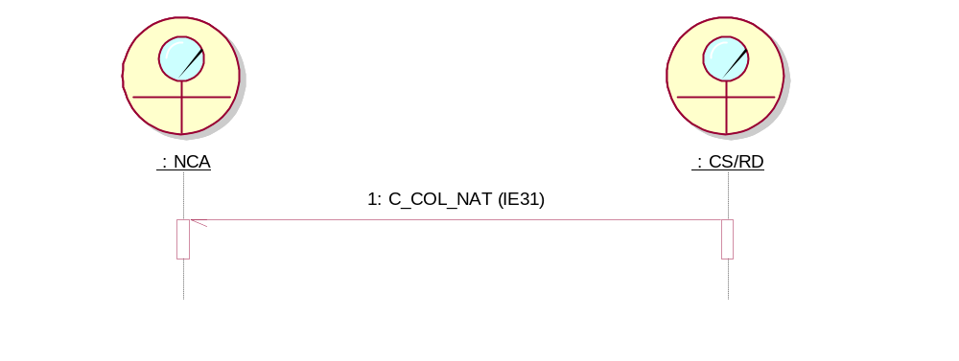
Figure 9: Download of IE031 via CCN/CSI
Problems can be detected upon reception of the IE031 by the NCA:
- Incorrect EDIFACT formatting (if the message is sent to EDIFACT format): In this case, an IE907 (EDIFACT NACK) is sent back to CS/RD;
- Incorrect XML formatting (if the message is sent to XML format): In this case, an IE917 (XML NACK) is sent back to CS/RD;
- Incorrect technical message structure (incorrect implementation of building rules): In this case, an IE906 (FUNCTIONAL NACK) is sent back to CS/RD (shown below);
- Other problems are resolved via non-EDI means.

Download of entire COL
The full retrieval of the COL is requested by means of C_COL_REQ (IE914). CS/RD responds by means of C_COL_DAT (IE931).
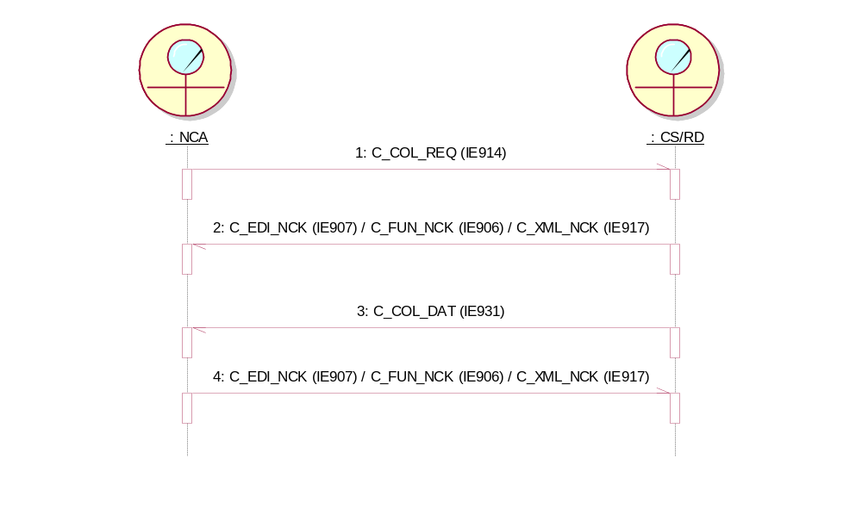
Figure 10: Request of entire COL
The error messages represented (IE906/IE907/IE917) in this figure are only sent when necessary.
Error handling is as expressed in the previous paragraph.

Download of entire Common RD
The full retrieval of the Common RD is requested by means of C_REF_REQ (IE916). CS/RD responds by means of C_REF_DAT (IE932).
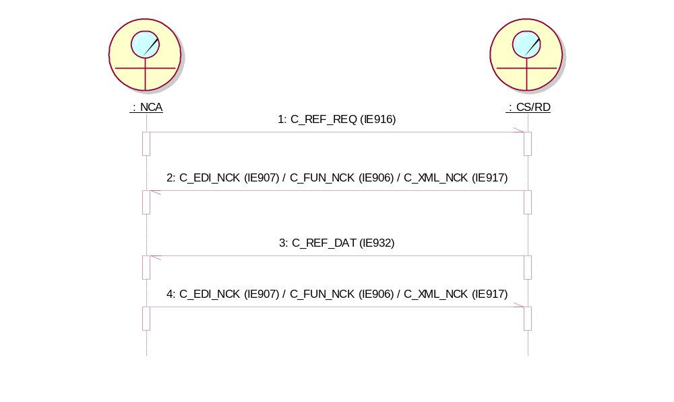
Figure 11: Request of entire Common RD
The error messages represented (IE906/IE907/IE917) in this figure are only sent when necessary.
Error handling is as expressed in chapter II.5.2.1.

Uploading an IE030
The protocol starts with the sending of the IE030. When the upload processing (by CS/RD) has terminated the response message C_UPL_RSP is created and sent back to the NCA.
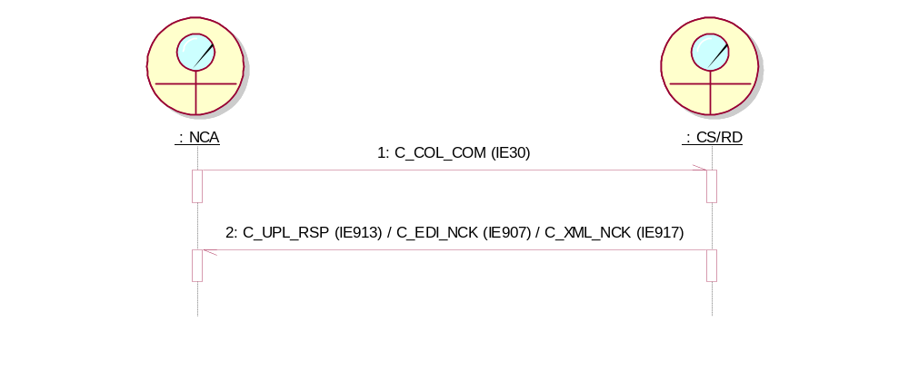
Figure 12: Upload via CCN/CSI
The same logic is followed by CS/RD when reacting to the IE030 received:
- In case of no errors send back IE913 (C_UPL_RSP) with status =”OK”;
- In case functional errors are found send back IE913 (C_UPL_RSP) with status = ”ERRORS” and with details on individual errors;
- In case authorisation problems are found send back IE913 (C_UPL_RSP) with status = “NOAUTH”;
- In case of incorrect formatting of the IE030 send back IE907 (EDIFACT NACK) or IE917 (XML NACK) depending on the IE030 format (EDIFACT or XML respectively).
Should errors (formatting errors or building rules violations) be found in the C_UPL_RSP received by the NCA, it reacts with IE906, IE907, or IE917.

Message exchanges with CS/MIS across the Web

Introduction
This chapter describes the mechanism for exchanging the following messages with CS/MIS:

IEs for Availability
- Availability: IE070, IE071, IE912, and IE971.
CSMIS offers separate data capture screens for some of the above messages. Dedicated instances of these messages will be exchanged for each separate Customs system. The user can supply the information to CS/MIS via a form provided in one of these screens. This is the case for IE070 (notification of unavailability) and IE912 (availability matrix). The following table shows the possibilities and in which direction each message is sent (Upload = from NCA to CS/MIS, Download = from CS/MIS to NCA).
IE | Upload/ Download | Data capture on screen of CS/MIS | Manual operation via browser
IE070 | Up | X | X
IE071 | Down |  | X
IE912 | Up | X | X
IE971 | Down |  | X
Table 9: CS/MIS interfaces across the Web
No error reporting is foreseen via dedicated error message exchanges but only basic transfer.
The HTTP message protocols are similar to the ones for CS/RD. The messages sent to the CS/MIS application will be generated by the HTML GUI (integrated into Project web site) according to the data entered by the user.

IEs for statistics and MRN follow up query
- Statistics: IE411, IE412, IE413;
- MRN Follow up query responses: IE919.
CS/MIS allows the manual upload of IE411 messages on the Web Interface. Either dedicated instances of these messages will be uploaded for each separate Customs system or one instance including data for all Customs systems. Moreover, CS/MIS offers data capture screen for IE413 (OTS statistics for NCTS). The user can simply supply the information to CS/MIS via a form provided in a screen. In addition, when the user submits an MRN Follow up query and selects to download the results in XML format (IE918 in NCTS only), the CS/MIS application offers a link in order for the user to be able to download the IE919 (in XML format) that incorporates the results of the submitted query.
The following table shows the possibilities and in which direction each message is sent (Upload = from NCA to CS/MIS, Download = from CS/MIS to NCA).
IE | Upload/ Download | Data capture on screen of CS/MIS | Manual operation via browser
IE411 | Up |  | X
IE412 | Down |  | X
IE413 | Up | X | X
IE919 | Down |  | X
Table 10: Additional CS/MIS interfaces across the Web
No error reporting is foreseen via dedicated error message exchanges but only basic transfer.

CS/MIS HTTP exchanges protocols

Subscription
In order to subscribe a user for e-mail or CCN/CSI notifications, a web-based administration module accessed via a dedicated URI only is used.

Notification
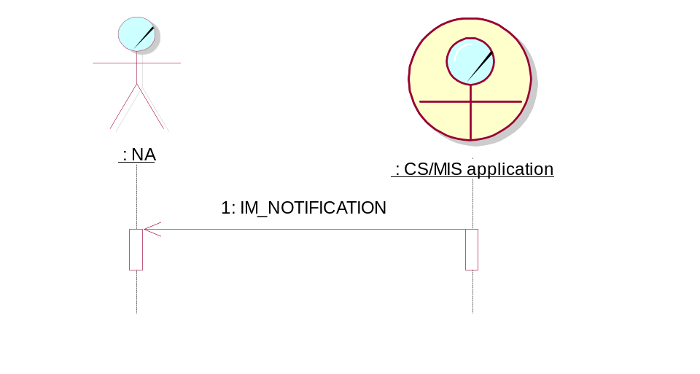
Figure 13: Notification from CS/MIS
Notifications are sent to the registered user by means of e-mail (IM_NOTIFICATION) to the e-mail address defined at registration, informing the user when new information is available. Distinct notifications will be sent to the each Customs system subscriber.

Downloading from CS/MIS
In order to download an Information Exchange from CS/MIS a user first needs to request the download through the GUI, which will generate an IM_INITIATE_DOWNL message. This message contains details of the actual information requested.
The CS/MIS application replies by means of an IM_RESULT message. This message contains the URI where the requested information can be downloaded. The download then needs to be initiated by means of an IM_GET_FILE message. This triggers a “get” from the URI defined beforehand.
The CS/MIS application then sends the requested information. In the example below an IE971 is sent back. Different URIs will be available at CS/MIS for initiating download of IE071, IE412 and IE919. In addition different URIs will be also available for downloads related to each Customs system.
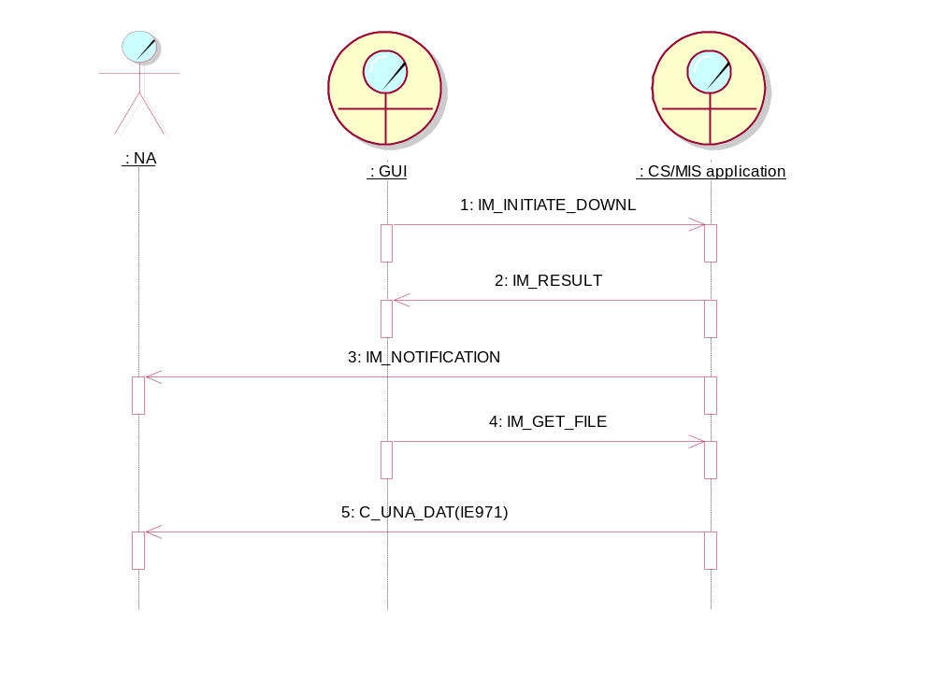
Figure 14: Downloading from CS/MIS

Uploading to CS/MIS
In order to perform an upload the user sends the data to the CS/MIS application (IE070 in the example below). The (NA local) file to be uploaded is chosen through the GUI.
Different URIs will be available at CS/MIS for upload of IE070, IE411, IE413 and IE912.
In addition different URIs will be also available for uploads related to each Customs system.
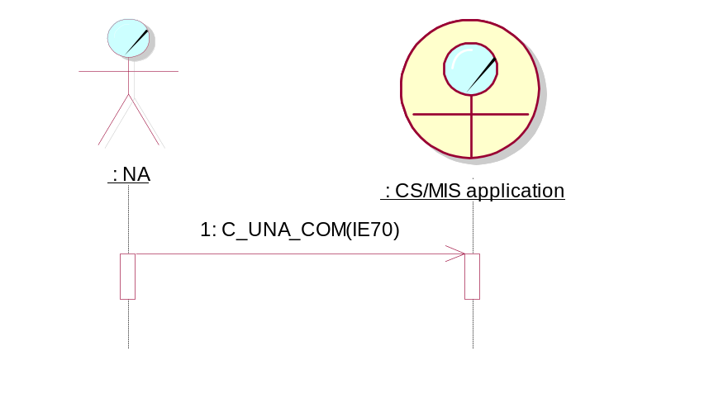
Figure 15: Uploading an IE070

CS/MIS manual mode of operation
A browser interface enables the download of an IE071 and an IE412 in a manner similar to the CS/RD application. Distinct download links will be available for each Customs system.

Message exchanges with CS/MIS via CCN/CSI
This section deals with the IE411, the CCN/CSI technical statistics, the CCN/CSI audit files and the exchange of MRN Follow up queries and responses.

Sending IE411 data to CS/MIS
The IE411 message has EDIFACT or XML as its format and is either sent to the CS/MIS application across CCN/CSI or it is manually uploaded on CS/MIS Web interface.
CS/MIS at ITSM has a dedicated address on the CCN/CSI network and a dedicated queue for capturing the business statistics.
If the IE411 message is sent to the CS/MIS application across CCN/CSI, in the message descriptor the value ‘CSIMQMT_DATAGRAM’ must be used for the data element ‘MsgType’.
If CS/MIS has problems with parsing IE411, an IE906, IE907 or IE917 message is returned to the originator.

Sending the Technical Statistics
Generation of technical statistics is performed under the supervision of the ITSM/CCN-OPS. The ITSM/CCN-OPS therefore installs and configures the necessary software on the CCN gateways. The only thing that is required from the NA is support during the configuration of the CCN gateway. Technical statistics are sent to CS/MIS at ITSM in a dedicated statistics queue created for each Customs system. They will be sent as a flat text file.

Sending the CCN audit files
Generation of CCN audit files is performed under the supervision of the ITSM/CCN-OPS. The ITSM/CCN-OPS therefore installs and configures the necessary software on the CCN gateways. The only thing that is required from the NA is support during the configuration of the CCN gateway. Audit files are sent to CS/MIS in the dedicated audit files queue created for each Customs system. They will be sent as a flat text file.

Exchanges of requests/responses of MRN Follow up information (NCTS only)
This section deals with the IE918/IE919 that enables the NTAs to send MRN Query requests via CCN/CSI and receive back the Query Result Set. The query is encoded as an IE918 message and the Query Result Set is produced as an IE919 message (see next figure).
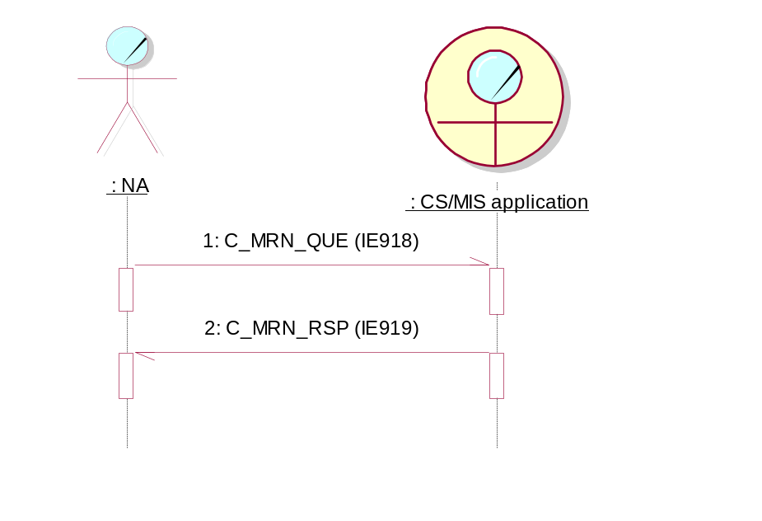
Figure 16: Exchanges of requests/responses of MRN Follow up information

Sending IE918 request to CS/MIS
The IE918 message is formatted in EDIFACT format and is sent to the CS/MIS across the CCN/CSI. CS/MIS has a dedicated address on the CCN/CSI network and a dedicated queue for capturing the IE918 messages.
If EDIFACT errors are detected by CS/MIS, an IE907 message is returned to the originator.

Replying with an IE919 to NTA
The produced results (related to a submitted IE918 request) are encoded in an EDIFACT IE919 message that is forwarded, across the CCN/CSI, to the originator of the MRN Query request.

Systems Administration

Introduction
For all Customs systems the procedures and tools (i.e. archiving procedures, configuration management, version control, data management, fallback procedures, problem tracking, and audit trail) used for system administration are a national matter and consequently do not concern other National Administrations. All NCAs need to keep a log of exchanged information, for relating an error to the information that has been exchanged and to solve any disputes regarding exchanged information. This log needs to contain:
- The content of the messages that have been exchanged (either sent or received), thus including all steering information specified by the Data Group MESSAGE (see Design principles), e.g. interchange reference, interchange addresses, message reference, MRN, and functional message type;
- A timestamp showing at which date and time the Information Exchange (IE) has been prepared for sending or has been received;
- The result of conversion of received EDIFACT interchanges (if the exchange is in EDIFACT format) and a related timestamp including all detected errors;
- The result of application processing of the message, including all detected errors and any state change triggered by the message. If any error has been detected, the message will be viewed as not being processed by a National Application (NCA);
- A timestamp showing the date and time at which the Information Exchange (IE) has been exchanged through CCN. At reception, the timestamp is the date and time of receiving the Information Exchange (IE). At sending, it is the date and time of delivering the message to the CCN Gateway of the sending National Application;
- The CSI header for the particular message. The structure of the CSI header is given in the CCN/CSI Common Definitions Reference Manual (C language or jCSI), see Section VIII:
- The status of the exchange of the message across CCN (e.g. reception of a Confirm on Delivery and its related timestamp);
- The name of the queue to which the message has been submitted.
As there is a one to one correspondence between a CSI message, a EDIFACT interchange, and a EDIFACT message, this log does not need any further detail and can consist of one table. Note that the data needs not to be logged in application format since those formats will be different per Application.

Technical Message Structure

Data dictionary
Whenever there is a reference to an Appendix of this DDNA, please note that there is a separate set of Appendices for each domain, which accompanies each domain specific DDNA volume ([R16], [R17] and [R18]).

Data Items
The different Data Items that are part of each movement system are listed in Appendix Z of the corresponding set of Appendices.
Every Data Item is identified by a unique name. The naming conventions are listed in Section I: of this document. Note that every name will contain, in principle, some lowercase characters, except for the following:
- TIN
- NAD LNG
Every Data Item has an associated type (which can be numeric, alphanumeric or decimal) and, in some cases, a Data Item can have only discrete values. In this case, the Data Item is said to have an associated Code List.
In some cases, there may be some deviations between names at the corresponding functional system specifications [R26Error: Reference source not found], [R13], [R14] and at the DDNA level. The reasons for this are discussed later in this document.
Note that there are two categories of free text fields:
- Fields with an associated language code (LNG field). This LNG field may contain the code of the language in which the text was originally written;
- Fields without such language code.

Data Groups
The different Data Groups being part of each movement system are listed in Appendix Y of the corresponding Appendices.
Every Data Group consists of a number of Data Items in a particular order. Every message is composed of a certain number of Data Groups in a particular hierarchy. Every Data Group is identified by a name. Note that group names are not unique. It may thus very well happen that the same group name is found in different messages. Moreover, groups with the same name do not always include the same data elements. Defining Data Groups that contain all data elements that could potentially be part of it has solved this problem.
Later on, with the message definition, the Data Items which are to be included for a particular group, or not, will be specified.
Every Data Item within a group also has a unique identifier. The unique identifiers have been chosen more or less arbitrarily.
Note that some Data Groups may not always have the same Data Item sequence in different messages.
Later on, with the message definition, the exact sequence of data elements in a particular group will be specified.

Code lists
A Code List is a set of discrete values with an associated meaning. Code lists are included in Appendix C of the corresponding DDNA volume.
A name and a number identify code lists. Generally, Code Lists are maintained by the central reference application (CS/RD). The Central Project Team, supported by the Legal and Procedural team, will maintain the business Code Lists on the central reference site. The NAs can then download the new Code Lists from this reference site.
There are a number of technical Code Lists for which the values are predefined and fixed. These values will never be updated and/or downloaded on/from the reference site. Technical Code Lists are also marked in Appendix C.

Technical message structure
The structure and format of the different Information Exchanges for movement systems is included in the corresponding Appendix Q. These appendices contain a message format description for every Information Exchange that is part of the specific system.
The technical message description is supplied in two parts.
The first part is the message description. This description contains the overall layout of the messages. It defines the different Data Groups that are part of the message, the sequence of the groups, the level of hierarchy of the Data Groups, the optionality of the Data Group, the possible repeat count, and associated rules and conditions. Concerning the optionality, it should be noted that the following rules apply:
- If a Data Group is always required, it is marked as “R” for movement systems;
- If there are some rules and conditions related to the presence of the Data Group, it is marked as ‘D’;
- If there are no rules and conditions related to the presence of a particular Data Group it is marked as ‘O’. However if information is available it should be included in the message despite the fact that this Data Group is characterised as optional. It should be noted that when data in one message is derived from another message the rules and conditions are carried forward.
In order to go down one level in the hierarchy the Data Group at the higher level in the hierarchy needs to be present.
The second part of the TMS contains the description of the different Data Items. This description includes the sequence of the data elements in the group, the optionality, and the associated rules and conditions.
Concerning the optionality of the Data Items, the following rules apply:
- If a Data Item is always required, it is marked as “R”;
- If there are some rules and conditions related to the presence of the Data Item it is marked as ‘D’;
- If there are no rules and conditions related to the presence of a particular Data Item, it is marked as ‘O’. However if information is available it should be included in the message despite the fact that this Data Item is characterised as optional. Moreover, when data is derived from another message the rules and conditions are implicitly carried forward.
Concerning the rules and conditions, the rules and conditions from [R26Error: Reference source not found], [R13] and [R14] have been copied. These are marked as Rule xxx and Cond yyy as specified in the appropriate FSS version. Additional technical rules have also been added. These have been marked as TR xxxx.
Note that not all rules and conditions of [R26Error: Reference source not found], [R13] and [R14] have been copied. The reasons for this are discussed in chapter IV.3.
Additional explanation on the message format for the movement systems is included in Appendix Q.
The message description part of this document consists of message hierarchies, correlation tables to map the Information Exchanges to these hierarchies, and mappings to the different used EDI-formats (EDIFACT, XML).
The status codes used for Data Groups and Data Items for FMS in the FSS ([R26Error: Reference source not found], [R13], [R14]) is related to the status codes used in DDNA volumes as follows:
Status description | FSS status code | DDNA status code | EDIFACT status code
Required/mandatory | R | R | M
Optional | O | O | C
Dependent/Conditional | C | D | C
Table 11: Use of status codes
The abbreviations stand for Required, Mandatory, Optional, Conditional and Dependent.
The DDNA status codes are used in the Correlation tables in the corresponding Appendix J and the TMS in Appendix Q.
The EDIFACT status codes appear in the corresponding Appendix H in the left-hand columns of the mapping tables.

DDNA consistency
The Information Exchanges for the movement systems are aligned with the Single Administrative Message (SAM) Mapping Guide. As the SAM Mapping Guide covers import and export, and needs to cover each Customs system, changes have been made to Information Exchanges in some cases where more detail needed to be added.
The details of all changes between the DDNA TMS and the SAM and/or [R26Error: Reference source not found], [R13] and [R14] are included in the corresponding Appendix Q.
Since these appendices define the detailed list of the Technical Message Structures, they start by first explaining the deviations from the FSS ([R26Error: Reference source not found], [R13] and [R14]) and the SAM Mapping Guide.
As a general overview the major changes between DDNA TMS and FSS FMS and SAM are:
- Changes in the naming conventions – some names have been changed between DDNA and FSS ([R26Error: Reference source not found], [R13] and [R14]);
- Expansion of Information Exchanges inside other Information Exchanges - FSS ([R26Error: Reference source not found], [R13] and [R14]) presents some messages inside messages. In DDNA, the content of the sub-messages has been put in the master-message;
- Message group - this data-group is added in every message;
- Implementation of FMS conditions and rules;
- Technical Rules and Conditions.

Design principles

Approach
Every Information Exchange needs to be in a structure that conforms to this document (TMS). The TMS needs to be formatted in either EDIFACT or XML format, as specified within this document in EDIFACT message formatting and XML message formatting.
The formatted message needs to be transported across CCN/CSI or across the Inter(Extra)net according to the rules laid out in Transport of messages via CCN/CSI and Transport of messages via the Inter(extra)net.
This applies only to mandatory exchanges. For the (strongly) recommended exchanges, it is highly advised to use similar conventions and rules.
Because Information Exchanges are used to update data of Customs operations held by different applications the data needs to be uniquely identifiable. Not all data is uniquely identifiable. Therefore, the following rules are applied to updates of operation data:
- Key fields:
  - The MRN is a key to the Customs operation. It is unique and refers to a specific Customs system movement. Each goods item is uniquely identified by its goods item number within an MRN:
    - If information regarding an MRN needs to be changed, the MRN identifies the operation;
    - If information regarding a particular goods item needs to be changed, the goods item number of that particular goods item is exchanged, together with the changed information;
  - The GRN is a key to uniquely identify the Guarantee Information in Transit;
- Non-key fields: That information that is not uniquely identifiable (e.g. with an MRN or goods item number) is completely exchanged and replaces the information that has already been exchanged. For instance, if a new goods item needs to replace an existing goods item, the existing goods item number with the new information replaces the previously exchanged information of that goods item.

Character Sets and Data Item conventions
Every NA may maintain locally different character set(s) and Data Item conventions. These have usually been selected in order to best fit the NA’s business needs. Customs systems do not impose any standards concerning national usage of character sets or Data Item conventions. However, they impose some standards for the Data Items and the character sets when information is exchanged in the Common Domain.
Every NA should therefore foresee character set conversion and Data Item conversion when information is exchanged across the Common Domain.
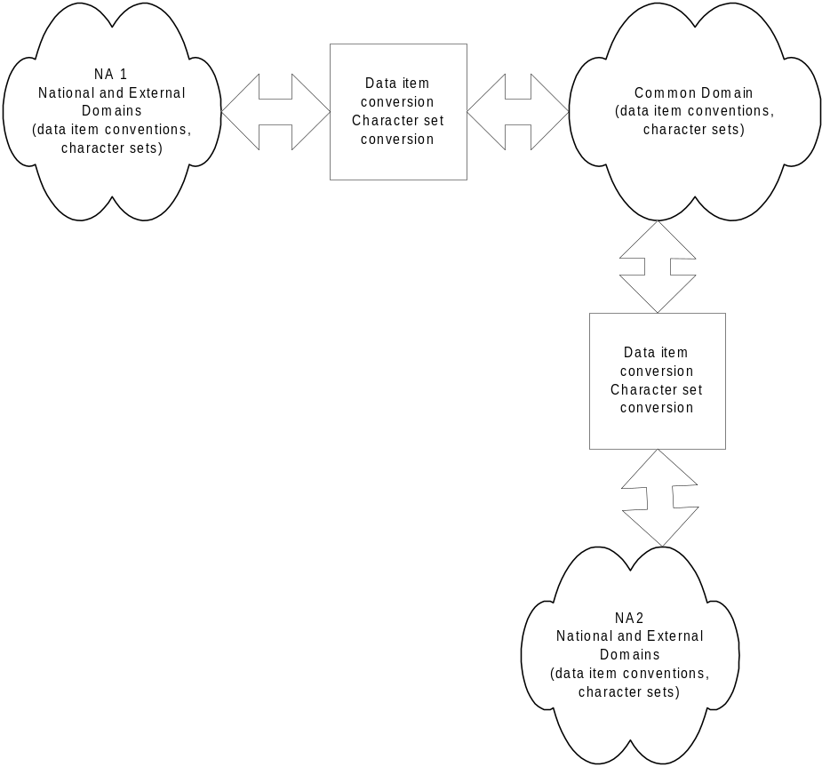
Figure 17: Character sets and conventions in use
The Common domain standards are given below. Recommendations for National and External Domain exchanges are given next.

Common Domain exchanges

Data Item conventions
Every Data Item within a TMS will be either a numerical field or a text field. A number of rules and conventions have been defined for the possible data formats when present in the Common Domain. These rules are the same for data exchanged in EDIFACT format and in XML format.

Numerical fields
Concerning numerical fields, it should be noted that these are either a cardinal value (positive integer value) or a decimal value, unless otherwise specified by a codelist or rule applied to the numerical field.
The decimal separator is the decimal point “.”. No other symbols are permitted as decimal separator.
Triad separators, such as a comma, shall not be used.
Signs, whether positive or negative, shall not be used (all values are intrinsically positive).
For decimal values, the decimal notation (with the decimal point) should only be used when there is a reason to indicate precision.
E.g., for a mass value:
- 89 kg, with a precision of 1 kg;
- 89.2 kg, with a precision of 0.1 kg;
- 89.20 kg, with a precision of 0.01 kg.
For numerical values, leading zeroes shall not be used. Trailing zeroes should only be used to indicate precision.
If the decimal point is present, at least one digit shall be present before the decimal point.
If the decimal point is present, at least one digit shall be present after the decimal point.
Examples for a n..11,3 type.
- 12345678.123 | Valid
- 123456789.123 | Invalid - too many digits before decimal point and too many digits in total
- 12345678.1234 | Invalid - too many digits after decimal point and too many digits in total
- 0123 | Invalid - leading zero not permitted
- +123 | Invalid - plus sign not allowed
- -123 | Invalid - minus sign not allowed
- 1,234 | Invalid - triad separator not allowed
- .3 | Invalid - no digit before decimal point
- 12345. | Invalid - no digit after decimal point
- 0.3 | Valid
- 1.3E1 | Invalid - only digits and decimal point allowed
- 12345678901 | Valid - n..11,3 can have maximally 11 digits of which maximally 3 after decimal point
To be noted is that the rules above also apply to numerical values within Code Lists. Values in such a list should always be stored without leading zeroes (in order to avoid problems of comparing e.g. a value of 60 against a value of 060). If the leading zeroes are indeed omitted a comparison should always work, regardless of whether the comparison was done on a numerical or character basis.
Note that there are no Code Lists with decimal values.

Text fields
Leading and trailing spaces (both normal spaces and non-breaking spaces) shall not be used within text fields.
The EDIFACT separator characters (see EDIFACT message formatting) can be used within such a field. The EDIFACT release character (?) can be used to include the separator characters in fields.
Moreover, text fields shall be case sensitive (i.e. text fields with letter(s) as uppercase and text fields with same letter(s) as lowercase shall be considered as different).

Character set usage
A distinction should be made for the character sets when messages are transported. Indeed EDIFACT only supports byte based character sets, while XML supports Unicode.

Exchanges in EDIFACT format
Text fields can be either language-sensitive (with an associated LNG field) or not. There are some specific rules for both described below.

Language-sensitive text fields
These fields can be in any of the following character sets taken from EDIFACT syntax version 3 for EDIFACT message exchanges in the Common Domain:
- UNOC: Latin-1, ISO 8859-1;
- UNOD: Latin-2, ISO 8859-2 (Central Europe);
- UNOH: Latin-4, ISO 8859-4;
- UNOE: Latin-5, ISO 8859-5;
- UNOF: Greek, ISO 8859-7;
- UNOK: Turkish, ISO 8859-9.

Non-language sensitive text fields
Only ASCII printable characters (characters #32 to #126 decimal) can be used for these fields, unless otherwise specified by a codelist or rule applied to the text field.

Exchanges in XML format
Messages exchanged in XML format shall use the UTF-8 encoding of UNICODE both for language sensitive fields and for non-language sensitive fields.
However, it should be possible to map all the characters of any one language-sensitive field to a single character set to be chosen between UNOC, UNOD, UNOH, UNOE, UNOF and UNOK unless otherwise specified by a codelist or rule applied to the text field. Failure to comply with this statement would make it impossible to properly translate the message to EDIFACT.

Transliteration for language–sensitive text fields
The associated LNG indicator, if present, denotes the language in which the original text was written. From this, the character set used can be derived.
If the LNG field is not present, the character set can be derived from the first characters of the original text. Transliteration can then be done, if necessary, from one character set to the other.
If more than one character set is used in a same free text field, the first identified character set will be used for the transliteration ignoring the other character sets.
It is therefore recommended to use only one character set per free text field.
Every NA should therefore have the capabilities to receive data in any of the character sets above and transliterate them into the character set(s) that is (are) in local use at the NA. Every NA should be capable of transliterating the character set(s) that is (are) in local usage at the NA into one of the character sets specified above.
The NA is expected to establish additional rules on language and character set usage in a later stage. These should clarify which languages and character sets are in local use at the NA and how the character sets can be derived from the language codes.

National and External Domain exchanges
It is highly recommended to use the standards, defined above, to the maximum possible extent in the National and External Domains.

Exception Handling

Introduction
“Exception” is the generic term used to refer to any behaviour of one or more system components of a movement system that is not in accordance with the specification given in DDNA.
On detecting an exception, an NCA must notify another National Application of that error. There are three possible error notification mechanisms:
- Functional errors: a functional message is not filled according to its FMS and rules (e.g. missing functional Data Item or wrong value):
  - A Functional NACK (IE906: C_FUN_NCK) that is sent by the National Application detecting the error to the National Application that has sent the erroneous functional message across the Common Domain;
  - Specific error messages are sent in the External Domain and are identified in each specific DDNA volume ([R16], [R17] and [R18]);
- Format errors:
  - EDIFACT errors: a EDIFACT interchange and its EDIFACT message(s) is not filled according to its specification given in Design principles:
    - An EDIFACT NACK (IE907: CONTRL) is sent by the National Application detecting the error to the National Application that has sent the erroneous interchange;
  - XML errors: an XML message is not filled according to its specification given in Design principles:
    - An XML NACK (IE917) is sent by the National Application detecting the error to the National Application that has sent the erroneous message;
- Communication errors: some error occurs during the exchange of a CCN/CSI message across the Common Domain:
  - The interface software with CSI needs to handle various errors and the Confirm On Arrival and Confirm On Delivery options of the Quality of Service are set to ensure delivery by CCN to a receiving National Application (see also Transport of messages via CCN/CSI).
Section IX of FTSS [R26Error: Reference source not found] specifies exception handling in detail. This section specifies the possible error types and codes and the way they are exchanged in the Functional NACK, the Declaration Rejected and the EDIFACT NACK.
This section only covers exceptions regarding the exchange of EDIFACT or XML messages and their functional message structure. Central Services of this document specifies exceptions with respect to CS/RD.

Architectural assumptions
The mechanisms specified in this section are based on the following assumptions:
- Fallback and recovery procedures are outside the scope of DDNA. In principle, every action related to Information Exchanges needs to be logged to allow recovery and identification of a failed component.
- There is a layered approach to error detection upon reception of information. It consists of the following three layers:
- CCN/CSI layer: communication errors are handled by CCN/CSI software (see also Transport of messages via CCN/CSI);
- Message formatting (EDIFACT or XML) layer: syntax errors are detected in addition to the ones detected by CCN/CSI;
- Functional layer: functional errors are detected on top of those detected by the message formatting (EDIFACT or XML) and CCN/CSI layers.
Security functions in the Common Domain are offered by CCN/CSI. Security functions in the External Domain have to be specified by each NA.
- EDIFACT is used as specified in EDIFACT message formatting, paragraph VI.2.1, e.g. one CSI message contains one EDIFACT interchange with one EDIFACT message.
- XML is used as specified in XML message formatting e.g. one CSI message contains one XML message.
- The FMS is the basis for identifying functional errors. Although the FMS as such may not be implemented in National Applications, it is assumed that Data Group sequencing of sender and recipient is identical. Sequencing provides an easy mechanism for an error pointer.

Examples of error causes
Errors can be caused for the following reasons:

Error cause | Description
Failure of components | A distinction is made between three types of failures:  - Failure of an application;  - Failure of the network;  - Failure of the link between an application and the network.  Failures will cause errors in message sequencing; e.g. one of the applications involved did not receive a message and has not been able to produce the proper answer. This may cause applications to be out of sync.
Software bug | A function of a receiving or sending application does not reach its proper state because a required function is missing, incomplete or incorrect. Errors may be detected in another function; e.g. the recipient of a message may detect errors. For example, a software bug can cause the production of a message of an incorrect type (message sequencing) and/or the incorrect content of a message. The sending application is then likely to be out of sync with the receiving application.
Human mistake | A mistake is a wrong action due to incorrect human intervention; e.g. another MRN is selected than was intended.  A human mistake can cause incorrect contents of a message and incorrect sequencing of a message.
Incorrect Code List | Improper Code Lists are used by a sending or receiving application, e.g. a sender uses an outdated Code List when preparing a message or a recipient does the same when verifying the data of a received message. An incorrect Code List will produce incorrect contents of a message.
Table 12: Error causes

Scenarios for exception handling

General procedure
In general, all errors must be logged upon their detection. Depending on their circumstances, one of the following scenarios has to be initiated:
- Exchange of functional errors;
- Exchange of EDIFACT errors or exchange of XML errors.
Errors regarding the use of CCN are discussed in Section VIII: Transport of messages via CCN/CS.

Functional errors
Every Information Exchange exchanged across the Common Domain can contain functional errors, e.g. a required Data Item is missing or has a value that is not allowed or a Data Item is not allowed to have a value due to a rule specified by FSS ([R26Error: Reference source not found], [R13] and [R14]). The possible values of these errors are specified in Codelist 49 of the corresponding Appendix C.
Figure 18 shows an example of a functional error. It is in NCTS and relates to the reception of an AAR by the Office of Destination.
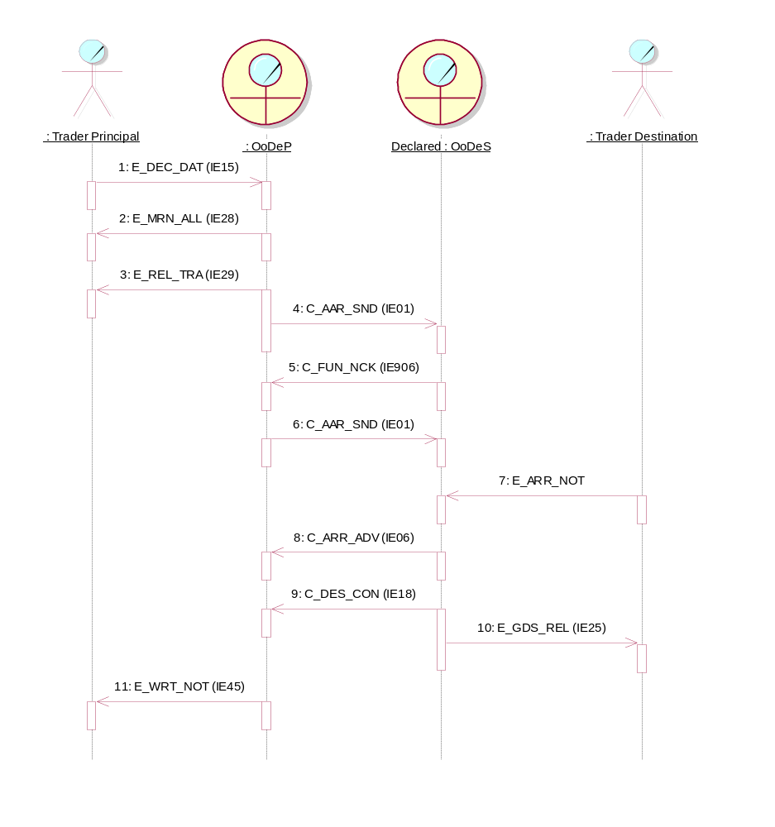
Figure 18: Functional error across the Common Domain (NCTS)
This figure shows the detection of an AAR with a functional error. It causes a rejection of that AAR by the Office of Destination with a C_FUN_NCK. The correct AAR is sent afterwards.
With respect to EDIFACT, if messages are resent after correction of an error, the interchange in which they are resent requires a new interchange reference in the UNB segment (otherwise, a duplicate will be detected by an EDIFACT translator and a CONTRL with error code ‘26’ is exchanged). A message is only unique in the context of an MRN and messages with the same reference in the UNH segment can be received (see EDIFACT message formatting). As the message has not yet been processed by the receiving application, the latter will not detect a duplicate.
It is not permitted to re-send a message other than after correction of the error(s) that caused the previous rejection.

EDIFACT errors
Every interchange exchanged across the Common Domain can contain EDIFACT errors, e.g. a missing segment or use of a syntax version that is not allowed. Figure 19 shows the exchange of a EDIFACT CONTRL message after detection of an error in an interchange. The original interchange and message within the interchange are referred to in the CONTRL. The possible values of these errors are specified in Codelist 23 of Appendix C of the corresponding Customs Systems.
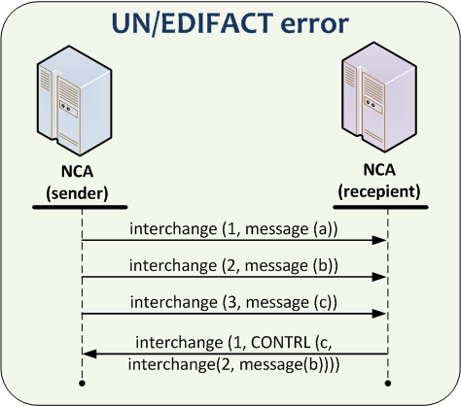
Figure 19: EDIFACT error
Figure 19 shows the exchange of an error detected in the interchange with reference ‘2’ and message with reference ‘b’. As this figure shows, the recipient returns an interchange with reference ‘1’ containing a CONTRL message that refers to the original interchange in which the error has been detected.
This use of reference numbers of interchanges and messages is arbitrary, as long as an interchange reference is unique between a sender/recipient pair and a message reference is unique within a Movement identified with its unique MRN ( Design principles).
A CONTRL message carries its own interchange and message reference, in the figure ‘1’ and ‘c’ respectively. The reference to the interchange and message in which an error has been detected is exchanged in the UCI and UCM segments respectively (EDIFACT message formatting).
Figure 19 only shows a sending and receiving role of an organisation whereas an organisation can have both roles at the same time. Therefore, this figure is a simplification of the actual communication between two organisations.

XML error(s)
The XML error message (IE917: C_XML_NCK) shall be used to report XML format and structure errors.
Every interchange exchanged across the Common/External Domain can contain XML validation errors, e.g. a missing mandatory data item or use of a message version of XML that is not allowed. Figure 20 shows the exchange of a XML CONTRL error message after detection of an error in an XML interchange. The original interchange and message within the interchange are referred to in the XML CONTRL. The reporting of XML errors using the XML NACK is specified in XML error (CONTRL) message.
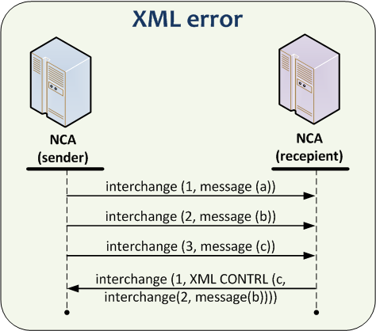
Figure 20: XML Control error
Figure 20 shows the exchange of an error detected in the interchange with reference ‘2’ and message with reference ‘b’. As this figure shows, the recipient returns an interchange with reference ‘1’ containing a XML CONTRL message that refers to the original interchange in which the error has been detected.
This use of reference numbers of interchanges and messages is arbitrary, as long as an interchange reference (Message Identification) is unique between a sender/recipient pair and a message reference is unique within a movement identified with its unique MRN.
A CONTRL message carries its own interchange and message reference, in the figure ‘1’ and ‘c’ respectively. The reference to the interchange and message, in which an error has been detected, is exchanged in the Header of the Message respectively.
Moreover, Figure 20 shows only a sending and receiving role of an organisation, whereas an organisation can have both roles at the same time. Therefore, this figure is a simplification of the actual communication between two organisations.
Finally, if messages are resent after correction of an error, the interchange in which they are resent requires a new interchange reference (Message Identification) in the Message Level. A message is only unique in the context of an MRN and interchange. As the message has not yet been processed by the receiving application, that latter application will not detect a duplicate. It is recommended to re-send a message only after the correction of the error(s) that caused its rejection.

Error codes
This section explains the error codes that can be used by the functional error messages, the EDIFACT NACK. The XML NACK is described in section VII.4 XML error (CONTRL) message. The values are a subset of the generic table provided by EDIFACT and are based on the use of EDIFACT for Customs systems.
Since the errors can be identified either at formatting or at functional level, different error codes are used:
- The errors codes for functional error message (IE906) are specified in Codelist 49 of Appendix C of the corresponding Customs Systems;
- The errors codes for EDIFACT NACK (IE907) are specified in Codelist 23 of Appendix C of the corresponding Customs Systems (if the exchanges in this Customs System are performed in EDIFACT format).
Regarding the rejections due to XML errors (if the exchanges in this Customs System are performed in XML format), please refer to VII.4.
In particular, for the EDIFACT, the following table shows the EDIFACT segment that has to be used for a particular EDIFACT error code.

EDIFACT error segment | EDIFACT error code
UCI | 2, 7, 12, 13, 14, 16, 18, 19, 21, 22, 23, 26, 28, 29, 32, 33.
UCM | 3, 12, 13, 14, 19, 21, 22, 28, 29.
UCS | 6, 13, 15, 35, 36.
UCD | 12, 13, 14, 15, 16, 19, 21, 22, 37, 38, 39, 40.
Table 13: Segment position of EDIFACT error codes
It is assumed that errors are detected by reception of a message. This implies that functional errors are specified in more detail than message formatting errors (EDIFACT or XML). FMS specify more detail on the functional level with respect to:
- Status of a Data Item: a EDIFACT data element can be optional, whereas the related Data Item of an FMS is required;
- Code values: code values are specified at functional level, with the exception of those codes that are specific to EDIFACT (e.g. qualifier values);
- Dependency rules: values of Data Items can be dependent on each other as specified by additional conditions (see FSS [Error: Reference source not foundR26], [R13] and [R14]).

Functional error message
This section describes the use of Functional error data group in IE906.
The Data Group ‘FUNCTIONAL ERROR’ has been introduced to enable the exchange of functional errors. This Data Group is the technical implementation of Rule 123 in the FMS specified in FSS ([Error: Reference source not foundR26] Appendix B, [R13] Appendix B1 and [R14] Appendix B1).
The Data Group consists of the following Data Items:
Data Item | Content | Status | Format
Error type | Values taken from Appendix C. | Required | n2
Error pointer | This Data Item points to the Data Item or Data Group that caused the error by listing the hierarchy of that Data Item and its occurrence in the hierarchy.  In case of error type 90, 91 or 93, the error pointer points to the MRN.  In case of error type 92, the error pointer points to the Message Type.  The syntax for the value of the error pointer is as follows:  (Data Group code ['(' (occurrence) ')' ]'.' )+ [(Data Item name)] | Required | an..210
Error reason | This Data Item contains the identification of the condition, codelist or rule in case error type ‘15’ is detected due to an error related to a condition or a rule or a codelist or a technical rule (for example ‘C099’ to denote a violation of condition 99, ‘TR0001’ to denote a violation of technical rule 1 and ‘CL31’ denote a violation of codelist 31).  In case a specific C_DES_CON or C_EXT_RES building rule is violated the particular error reason code ‘TRxxxx’ is used. | Dependent | an..6
Original attribute value | This Data Item is used to exchange the original value in case sequencing of Data Groups is changed at reception of a message. | Optional | an..140
Table 14: Data Items for Functional Error data group in IE906
Notes to the functional error Data Group:
- The Data Group codes used for the error pointer are listed in the corresponding Appendix Y. The notation used for specifying the pointer is as follows:
Pattern | Semantics | Example
A B | A followed by B | (Data Group code) (Data Item name)
[A] | A or nothing | [occurrence]
A⁺ | One or more occurrences of A | (Data Group code)⁺
(expression) | Expression is treated as unit and may be combined as described in this list | (Data Group code)
‘string’ | A literal string | ‘(’ or ‘.’
Table 15: Notation of error pointer
- Occurrence is a sequence number for a Data Group. An occurrence is only given for repeatable or erroneously repeated Data Groups and is, therefore, optional. An occurrence relates to the sequence in which a message is received. This sequence is not necessarily equal to the sending sequence because the FMS structure may not be implemented as such by a National Customs Application;
- The Data Item names of the FMS are listed in the corresponding Appendix Q of this DDNA. Examples of the error pointer are as follows:
Error pointer value | Semantics
HEA.Containerised indicator | Pointer to ‘Containerised indicator’ of the Header Data Group.
GUA(3).REF(5).Access code | Pointer to ‘Access code’ of the fifth Guarantee reference Data Group within the third Guarantee Data Group.
GDS(3).GS2(4).Kind of packages | Pointer to ‘Kind of packages’ of the fourth Package Data Group within the third goods item.
CE1 | Pointer to ‘(CONSIGNEE) TRADER’ Data Group.
Table 16: Examples of error pointer

Constraints

Introduction
This section describes constraints that National Applications must fulfil in order to participate in one of the Customs systems. The following types of constraints are considered:
- Performance constraints;
- Timing constraints;
- Availability constraints.

Performance Constraints

External domain
Performance constraints related to Information Exchanges crossing the External Domain (communication between a NA and its Traders) or within the National Domain (communications between different locations of the same NA) are a national matter and should be fixed individually by each NA.

Common domain
The time constraints applied to Information Exchanges crossing the Common Domain (communication between two NAs or between a NA and Central Reference Site) must permit meeting the performance constraints defined in FSS ([Error: Reference source not foundR26], [R13] and [R14]). A number of relevant performance constraints are specified by the timer values in the specific Customs system volumes.

Timing constraints
All timing constraints are described in the specific domain volume.

Availability Constraints
The requirements for systems availability for NCAs only consider the international requirements, i.e. the NCAs availability required to support interoperability with other participating NAs through the Common Domain. This also means that this constraint does not apply to the External Domains.
During Initial Implementation, all participating NAs have to guarantee that in the event of a failure of their National Application, or when their National Application is deliberately taken off-line because of business or technical requirements, all Information Exchanges received from CCN will be held until the National Application comes back on-line. They can then be processed as normal, subject to the National Applications fallback rules. This minimum level of availability is met by the CCN functionality.
Sending NCAs should not re-send IEs for which there has been no reply as a result of unavailability of the receiving NCA. The re-send should occur only upon request of the NCA, or receipt of an exception report.

Suspension of sending messages
Each domain specific DDNA volume ([R16], [R17] and [R18]) contains a table that specifies which messages should not be sent to an NA when a specific Business Service is unavailable at that NA.

MRN and GRN structure

Structure of the Movement Reference Number (MRN)
The Movement Reference Number is a unique identifier for a movement and is allocated by the NCA which (after validation) accepts/registers the received declaration data from the Person lodging it.
The MRN contains 18 digits and is composed of following elements:

Field | Content | Field type | Examples
1 | Last two digits of year of formal acceptance of a movement (YY) | Numeric 2 | 12
2 | Identifier of the country from which the MRN originates. | Alphabetic 2 (ISO alpha 2 country code) | LV
3 | Unique identifier for a movement per year and country | Alphanumeric 13 | 9876AB8890123
4 | Check digit | Alphanumeric 1 | 5
Table 17: Structure of MRN
Field 1 and 2 as explained above.
- Field 3 has to be filled in with an identifier for a transaction. The way that field is used is under the responsibility of national administrations but each transaction handled during one year within the given country must have a unique number. National administrations that want to have the office reference number of the competent authorities included in the MRN, could use up to the first 6 characters to insert the national number of the office.
- Field 4 has to be filled with a value that is a check digit for the whole MRN. This field allows for detection of an error when capturing the whole MRN.

Check character algorithm for the MRN

The algorithm for calculating the check digit character for the MRN is based on the ISO 6346 algorithm. Each character of the reference numbers is given a numeric value as determined by Table 18.

Each individual number is then multiplied by a different factor. The factors are in the range 2⁰ to 2¹⁶ producing 17 sub-totals for the MRN.
These individual sub-totals are totalled and that result is then divided by 11. The remainder of the calculation is then used to determine the check digit by using Table 19.

ASCII Character | Check Character Value
0 | 0
1 | 1
2 | 2
3 | 3
4 | 4
5 | 5
6 | 6
7 | 7
8 | 8
9 | 9
A | 10
B | 12
C | 13
D | 14
E | 15
F | 16
G | 17
H | 18
I | 19
J | 20
K | 21
L | 23
M | 24
N | 25
O | 26
P | 27
Q | 28
R | 29
S | 30
T | 31
U | 32
V | 34
W | 35
X | 36
Y | 37
Z | 38
Table 18: Check character values

Remainder | Check character
10 | 0
9 | 9
8 | 8
7 | 7
6 | 6
5 | 5
4 | 4
3 | 3
2 | 2
1 | 1
0 | 0
Table 19: Remainder of the calculation

MRN Check Character Calculation Example
MRN (without check character)
9 | 9 | I | T | 9 | 8 | 7 | 6 | A | B | 8 | 8 | 9 | 0 | 1 | 2 | 0
Check character value (Table 18)
9 | 9 | 19 | 31 | 9 | 8 | 7 | 6 | 10 | 12 | 8 | 8 | 9 | 0 | 1 | 2 | 0
Multiplier
1 | 2 | 4 | 8 | 16 | 32 | 64 | 128 | 256 | 512 | 1024 | 2048 | 4096 | 8192 | 16384 | 32768 | 65536
Values
9 | 18 | 76 | 248 | 144 | 256 | 448 | 768 | 2560 | 6144 | 8192 | 16384 | 36864 | 0 | 16384 | 65536 | 0
Total 154031
154031/11 = 14002 + 9/11; thus, the remainder is ‘9’ and is used as the check digit (Table 19).
Resulting MRN (with check digit) = 99IT9876AB88901209

Structure of the Guarantee Reference Number (GRN)
Each NCTS guarantee is referenced by a unique Guarantee Reference Number (GRN) which is used for validation in the guarantee management sub system.
The "Guarantee Reference Number" (GRN) is allocated by the office of guarantee to identify each single guarantee and it is structured as follows:
Below, extract from Annex D1, Title II, paragraph B of the Convention and Annex 37a, Title II, paragraph B, IP
Field | Content | Field type | Examples
1 | Last two digits of the year at which the guarantee was accepted (YY) | Numeric 2 | 12
2 | Identifier of the country where the guarantee is lodged (ISO alpha 2 country code) | Alphabetic 2 | IT
3 | Unique identifier for the acceptance given by the Office of Guarantee per year and country | Alphanumeric 12 | 1234AB788966
4 | Check digit | Alphanumeric 1 | 8
5 | Identifier of the individual guarantee by means of voucher (1 letter + 6 digits) or NULL for other guarantee types | Alphanumeric 7 | A001017
Table 20: Structure of GRN
Field 1 and 2 as explained above.
Field 3 has to be filled with a unique identifier per year and country for the acceptance of the guarantee given by the office of guarantee. National Administrations which want to have the Customs Office Reference Number of the office of guarantee included in the GRN, could use up to the first six characters to insert the national number of the office of guarantee.
Field 4 has to be filled with a value that is a check digit for the fields 1 to 3 of the GRN.
This field allows the detection of an error when capturing the first four fields of the GRN.
Field 5 is only used when the GRN is related to an individual guarantee by means of vouchers registered in the computerised transit system. In that case, this field has to be filled with the identifier of the voucher.

GRN Check Character Calculation Example
The check character algorithm for the GRN is almost the same as the check character algorithm for the MRN (see section V.6.1.1). The difference is that the factors are in the range 2⁰ to 2¹⁵ producing 16 sub-totals for the GRN.
In this example the check character (yet to be calculated) is represented as *
GRN = 05DE3300BE000106*A001017
0 | 5 | D | E | 3 | 3 | 0 | 0 | B | E | 0 | 0 | 0 | 1 | 0 | 6
Check character value (Table 18)
0 | 5 | 14 | 15 | 3 | 3 | 0 | 0 | 12 | 15 | 0 | 0 | 0 | 1 | 0 | 6
Multiplier
1 | 2 | 4 | 8 | 16 | 32 | 64 | 128 | 256 | 512 | 1024 | 2048 | 4096 | 8192 | 16384 | 32768
Values
0 | 10 | 56 | 120 | 48 | 96 | 0 | 0 | 3072 | 7680 | 0 | 0 | 0 | 8192 | 0 | 196608
Total 215882
215882/11= 19625 + 7/11; thus, the remainder is ‘7’ and is used as the check digit (Table 19)
Resulting GRN (with check digit) = 05DE3300BE0001067A001017

EDIFACT message formatting

Introduction
EDIFACT [S11] is a standard for representation of data during transmission between parties. Version 3 of this standard is used for the Customs systems.
EDIFACT anticipates a number of standard messages for various business purposes. Within Customs systems, it is foreseen to use the standard directory [S12]. Within this directory, the usage of the following standard EDIFACT messages is foreseen: CUSDEC, CUSRES, CUSCAR, PARTIN (renamed to PARTTC in this document), GESMES, GENRAL, and BANSTA. In addition, it is foreseen to use the CONTRL message [S13].
Every EDIFACT message is built according to a number of conventions:
- At the bottom, there are a number of data elements. These data elements have a predefined name and a type. For some data elements, the standard is foreseeing the usage of predefined Code Lists. The collection of data elements is common to a directory definition (all EDIFACT messages are built upon a common collection of data elements);
- Composite data elements are built as a sequence of individual data elements and EDIFACT segments are built as a sequence of composite data elements and single data elements. The collection of segments is common to all messages that are part of a directory (all EDIFACT messages are built with the same segments). A segment has a name, optionality (Mandatory or Conditional) and a maximum repeat count. Within a segment, the sequence of composite data elements and data elements is fixed. A composite data element is either Mandatory or Conditional; an individual data element is also Mandatory or Conditional. Within a composite data element, it is common to use qualifier values in order to denote the meaning of a particular data element (one data element then contains the qualifier while another data element contains the actual value). The standard also foresees a number of predefined qualifier values;
- EDIFACT messages are built as structures of segment groups or individual segments. A segment group is a sequence of segments. Within the structure of an EDIFACT message, there can be hierarchic levels. Within a hierarchy, every segment will have a predefined position, with an associated optionality and repeat count.
When a system is using the EDIFACT standard, it is common to define an Interchange Agreement. This agreement specifies how the different standards are to be applied and which common conventions need to be maintained. This section, together with the corresponding section in each Customs system specific volume, is acting as the EDIFACT interchange agreement for the Customs systems.
To be noted is that changes can be applied to the various items that are part of the EDIFACT standard:
- Overall EDIFACT message structure;
- Optionality and repeat count of the segments;
- Structure of the segments (data elements and composite data elements), optionality of these elements;
- Data types;
- Usage of Code Lists;
- Usage of qualifier values.
This section, therefore, first, specifies a number of common conventions (such as common message header structure), applying to all Information Exchanges that are exchanged using EDIFACT). Next, it defines which Information Exchanges are mapped upon which EDIFACT messages. It, then, defines, in detail, which changes have been applied to the EDIFACT standard. Finally, it defines the mapping rules (correlation between Information Exchanges and EDIFACT messages).
Messages that are exchanged by other means only (XML-format, paper, fax…) are not discussed in this chapter.

EDIFACT conventions for Customs
The following section contains a number of rules for exchanges in the Common Domain. It is highly advisable to use the same (or similar) rules for exchanges in other Domains.

EDIFACT choices
This section lists a number of choices made with respect to EDIFACT syntax options. These choices are identical to the ones made in the Single Administrative Message (SAM) Mapping Guide. They are:
- A EDIFACT interchange starts with an interchange header segment (UNB). The UNA segment is not used.
- One EDIFACT interchange contains only one message. One Information Exchange will correspond to one EDIFACT interchange, which will correspond to one EDIFACT message. Conceptually, EDIFACT enables the transmission of several messages in one interchange. Within the Common Domain, this will be restricted to one message per interchange only.
- The following separator set is used:
- ‘ Segment separator;
- + Data element separator;
- : Composite data element separator;
- ? Release character.
- The decimal notation is a ‘.’ (point).
- Functional grouping is not used (UNG/UNE segments).
- Nesting indicators are not used.
- This document specifies the technical aspects of the Customs systems Interchange Agreement. Separate reference to this agreement is not required because other mechanisms like technical message structures and queue naming conventions are provided.

Common Message Header Structure
Information Exchanges are mapped to EDIFACT UNSMs as specified in this section. Instances of these UNSMs are exchanged in interchanges. The common specification for the use of the interchange service segment UNB (present in every EDIFACT message for Customs systems) is according to the SAM Mapping Guide:
UNB[0], INTERCHANGE HEADER, M, 1 x | MESSAGE
S001 SYNTAX IDENTIFIER M |
0001 Syntax identifier M a4 | Syntax identifier (a4)
0002 Syntax version number M n1 | Syntax version number (n1)
|
S002 INTERCHANGE SENDER M |
0004 Sender identification M an..35 | Message sender (an..35)
0007 Identification code qualifier C an..4 | Sender identification code qualifier (an..4)
0008 Address for reverse routing C an..14 | -
|
S003 INTERCHANGE RECIPIENT M |
0010 Recipient identification M an..35 | Message recipient (an..35)
0007 Identification code qualifier C an..4 | Recipient identification code qualifier (an..4)
0014 Routing address C an..14 | -
|
S004 DATE/TIME OF PREPARATION M |
0017 Date M n6 | Date of preparation (n6)
0019 Time M n4 | Time of preparation (n4)
|
0020 INTERCHANGE CONTROL REFERENCE M an..14 | Interchange control reference (an..14)
|
S005 RECIPIENTS REFERENCE, PASSWORD C |
0022 Recipient’s reference/password M an..14 | Recipient’s reference/password (an..14)
0025 Recipient’s reference/password qualifier C an2 | Recipient’s reference/password qualifier (an2)
|
0026 APPLICATION REFERENCE C an..14 | Application reference (an..14)
|
0029 PROCESSING PRIORITY CODE C a1 | Priority (a1)
|
0031 ACKNOWLEDGEMENT REQUEST C n1 | Acknowledgement request (n1)
|
0032 COMMUNICATIONS AGREEMENT ID. C an..35 | Communications agreement id. (an..35)
|
0035 TEST INDICATOR C n1 | Test indicator (n1)
Table 21: Common message header structure
The left part of this table shows the EDIFACT definition of the segment. The right part shows the corresponding Data Items. All these Data Items belong to the Data Group MESSAGE, as specified for every Information Exchange.
The different items of the UNB segment are now discussed in detail. Mandatory EDIFACT data elements are the following:
Syntax Identifier: this data element is specifying the character set used in the message. This should be equal to ‘UNOC”. Within an EDIFACT message, the UNOC character set will be used, except for some free text fields (these may be encoded in a different character set).
Syntax version number is the current version of the EDIFACT standard. This is always equal to ‘3’.
In the Common Domain MESSAGE Data Group, the Data Items “Message sender” and “Message recipient” should contain the EDIFACT address within Transit or Export as defined below:
<Application Name>.<Country ISO Code>
Where <Application Name> and <Country ISO Code> can have the following values:
- <Application Name> is a valid application used in Customs, e.g. NTA, TTA, CSMIS and NECA;
- <Country ISO Code> is a valid ISO Country Code with the addition of ‘EC’ for addressing of the EC (see Transport of messages via CCN/CSI).
Examples of valid addresses are NTA.DE, TTA.EC, CSMIS.EC, NECA.DE, ATIS.EC and EUECN.EC.
This approach does not impose restrictions on an application with respect to the use of CCN/CSI. A mapping between EDIFACT addresses and CCN/CSI addresses is provided by the interface specification.
Date and Time are also required, being the date and time when the Information Exchange was put in an EDIFACT representation. As syntax version 3 is used, the date format in data element 0017 is limited to n6.
The Test Indicator requires a value ‘1’ for communication between an NCA on the one hand and an STTA or TTA on the other hand. Otherwise, its value is ‘0’. When it is not present, this should also be considered as an operational message.
Interchange Control Reference (ICR) needs to be unique for every EDIFACT interchange created by a specific Customs application. Every EDIFACT message created by the same Customs application (even if it was the same Information Exchange sent twice) should contain a unique ICR. No rules are specified for External and National Domain exchanges, although it is highly recommended to use similar conventions.
All other elements of the UNB segment currently do not have a specific meaning for Common Domain exchanges and are optional.

UNH segment
Every EDIFACT exchange will contain a UNH segment. Within this segment, the only mandatory data element is the message type string. The message type is a short string denoting the Information Exchange type and the Domain in which it is interchanged. Message type strings are defined in the next chapter.

Segment conventions
Some clarifications on EDIFACT standards:
- Within every message, the last but one segment will be a UNT segment, denoting the count of the number of segments in the message. This count should include every segment in the EDIFACT message, including UNH and UNT itself but not UNB and UNZ (last segment) from the EDIFACT interchange;
- Some EDIFACT messages need to point to other segments in an EDIFACT message. In this case, segment number one is the UNH segment;
- Some segments require the presence of a segment at a higher level. This higher-level segment must always be present (even if it does not contain any data at all);
- Some segments are defined as optional. If the relevant data is not present, these segments are not to be included in the EDIFACT message.

Amendments to UNSMs
The detailed structure of the UNSMs to be used for Customs systems is documented as follows:
The overall message structure is defined in the corresponding Appendix G. This Appendix defines the structure and the hierarchy of the UNSMs and the exact location of the various segments in the UNSMs.
The detailed specification of the segments is included in the corresponding Appendix H. (left-hand side).
The following paragraphs define how UNSMs have been modified in order to meet the needs of Customs systems.
It is assumed that the Customs systems’ Information Exchanges need to be supported by an EDIFACT UNSM. Directory D96B is used for mapping the templates to UNSMs. If no UNSM supports the FMS requirements, an existing UNSM is adjusted to support the FMS.
In various cases, the repeat factor of segments UNSMs is insufficient. The repeat factor has been raised to meet the requirements whenever necessary. Requirements of repeat factors higher than offered by the UNSMs, is due to two reasons:
- Proper mapping, repeat count too low
The first reason is the correct mapping of repeating Data Groups or Data Items to a segment with a repeat count that is too low.
- Stuffing
The second reason is a semantically incorrect mapping of Data Items to segments or misusing data elements to qualify a segment, because, otherwise, the required FMS hierarchy and repeating of Data Groups would be violated.
These types of errors cannot be solved by simply reducing the repeat count of Data Groups in the FMS. It may imply deleting Data Items if repeat counts of UNSMs need to be adhered to. Therefore, the repeat factors of UNSMs have been adjusted.
The detailed list of all changes being made to the UNSM is included in Appendix H for consistency reasons. This Appendix defines the mapping of the TMS to the UNSM. This Appendix therefore starts by providing the reader with the full list of changes to the UNSM standard.

Mapping of Information Exchanges
For each domain specific NCTS and ECS DDNA volume ([R16] and [R17]), a corresponding chapter contains the structure of all messages and various tables that list which Information Exchanges are mapped to each EDIFACT message, e.g. CUSDEC, CUSRES, PARTTC, etc. The messages are all part of the D96B-directory.

Mapping overview
In general, an Information Exchange is mapped to CUSDEC D96B when it is used to exchange declaration data or when it is the first message initiated between two communicating organisations. If an Information Exchange is a response to a received Information Exchange and is not used to exchange declaration data, it is mapped to CUSRES D96B. The other UNSMs serve specific purposes. The tables in each volume also define the message type string (to be included in segment UNH) for the various Information Exchanges.

Message Hierarchies
The correct order of the Data Groups can be found in Appendix Y.

Correlation tables
The correlation tables list the correlation between the Message Hierarchies (which are each mapped to one particular UNSM) and the Information Exchanges and can be found in the Appendix I of the NCTS and ECS domain specific DDNA volumes ([R16] and [R17]).
Thus, only Information Exchanges that need to be sent in EDIFACT-format will be found in these correlation tables.
The right-hand side of Appendix H defines the direct correlation between the UNSM segments and the Data Items.
Code lists are included in the corresponding Appendix C of each domain specific DDNA volume ([R16] and [R17]).

EDIFACT Mapping
- Appendix I of NCTS and ECS domain specific DDNA volume ([R16] and [R17]) specifies the correlation between the Technical Message Structure (and all its composites) and the data elements of the EDIFACT messages. For each mapping of a message to an EDIFACT message, a Correlation Table is given. Many Information Exchanges can be mapped to the same EDIFACT messages.
These correlation tables contain the following columns:
- SAD Box
It specifies the box used in the SAD (Single Administrative Document). It is only given for those Data Items for which a SAD box has been identified in the SAM project. This column is only applicable to the mapping of the Core Information Exchanges.
- Name
It specifies the name of the box used in the SAD (Single Administrative Document). It is only given for those Data Items for which a SAD box has been identified in the SAM project. This column is only applicable to the mapping of the Core Information Exchanges.
- Elements
Hierarchy level, specifying the origin of the information to map into the EDIFACT element. The higher level Data Groups are separated from the (lower level) Data Groups by a ‘-‘. An example is ‘GOODS ITEM – PACKAGES’ where ‘GOODS ITEM’ is the higher level Data Group and ‘PACKAGES’ is the concerned Data Group. The information in this column refers to the Message Hierarchy.
Data Item (after the full stop) specifies the actual name of the application Data Item to map into the EDIFACT data element.
- Data type
It describes the type and the length of the Data Item. When a data-type includes a decimal, the maximum number of decimals after the decimal sign is included in the length of the data-type. For instance, the format n..11,3 can have 3 decimals included in its maximum total length of 11 numeric digits. Neither the decimal point nor the sign are included in the length of a data-type, so allowance has to be made for this where necessary.
- Status (numbered columns)
It specifies if the Data Item is required [R], dependent [D] or optional [O] per Functional Message Structure. The status given in a column needs to be read in conjunction with the status of the Data Group specified by the message hierarchy. For instance, the status in a column may read R (required), whereas the status of the related Data Group in the message hierarchy reads O (optional, see Appendix Q). In those cases, the entry in the column is required only when the related Data Group is used.
- Pos
It identifies the EDIFACT segment according to its position in the standard message. The position refers to the branching diagram. The UNB segment is shown as position 0 as it is the interchange header and not part of the message. (Although not part of the formal DDNA review package, branching diagrams are provided in Appendix G for information).
- EDIFACT mapping
It gives the mapping information referring to one particular data element in a segment of a particular EDIFACT message, possibly with reference to all applicable qualifier values. Furthermore, the position number of the segment is given. An example is given by FTX[11](4451=ABL).C108.4440, which is the mapping to data element 4440 of composite C108 with qualifier value ‘ABL’ for element 4451 of the FTX segment at position 11 of the EDIFACT message. In some occasions, a data element is not uniquely identified within a composite or a segment. In those cases, the mapping information is followed by ‘#’ and the sequence number of that particular data element. For instance, FTX[11](4451=ABL).C108.4440#2, is a mapping to the second free text data element of the composite identified by C108 in the segment FTX.
In case no qualifier value is required, e.g. a mapping is constructed to a qualified segment only for one Data Item, this is indicated by a ‘-‘ as the value for a qualifier (the qualifier data element is conditional in those occasions). In case all qualifier values are allowed for a particular mapping, this is indicated by a ‘*’ as the value for a qualifier.
It may appear occasionally that, although this is not mentioned, the number of occurrences of an EDIFACT segment is higher than the maximum allowed by the CUSDEC. However, the number of occurrences always needs to be read in conjunction with the status given by one of the columns.
In some instances, the Correlation Table does not have an entry for data elements of the service segments. This is applicable to those data elements that have a fixed value; e.g. data element 0002 always has the value ‘3’ identifying the syntax version. Those EDIFACT service elements that cannot be found in the Correlation Table are available in the segment description.
Mappings can be constructed to repeating composite data elements within one segment. EDIFACT prescribes that the first composites of a segment need to be filled, which implies that the filling of a composite is independent of its position in a segment. However, if the composite does not contain a composite qualifier and the mapping of a Data Item is fixed by a composite’s position in a segment, it implies that data for such a Data Item is always mapped to the same position in a segment independent of empty composites before that position.
- Code List
If a Code List can and should be applied to the Data Item, the reference number of this Code List is listed in this column. The full set of Code Lists can be found in the corresponding Appendix C.

Functional error message in EDIFACT

Functional error CUSRES Hierarchy
The Data Group ‘FUNCTIONAL ERROR’ of IE906 points to a certain Data Item in an FMS.
The IE906 refers to the message in which the error has been detected with the reference number of that message (MESSAGE.Original message identification). A message reference number is uniquely assigned by a sender of a message (Technical Message Structure).
Functional errors are exchanged by D96B CUSRES. The Data Group ‘FUNCTIONAL ERROR’ is mapped to an FTX segment.
The hierarchy is given as follows:

MESSAGE 1 x, R
HEADER 1 x, D
FUNCTIONAL ERROR 999 x, R

EDIFACT Mapping of functional error message
The Data Item HEADER.Declaration type is required to be able to map to the mandatory EDIFACT BGM segment and to be in line with all other FMS mapped to CUSRES.
The correlation tables can be found in the corresponding Appendix I of this DDNA.

EDIFACT CONTRL Message

General
The EDIFACT CONTRL message structure is used to exchange errors detected in a received interchange. The minimal requirement is to report the first error detected. All other detected errors should be reported if possible.
The structure of CONTRL is based on four segments: UCI (Interchange Level), UCM (Message Level), UCS (Segment Level) and UCD (Data Element Level), each containing a reference to a part of the subject interchange. The parts of the subject interchange are:
- The UNB and UNZ segments, referenced in the UCI segment. UCI refers to the original EDIFACT interchange in which errors have been detected, by copying the sender identification, recipient identification, and interchange reference of that erroneous interchange;
- The UNH and UNT segments, referenced in the UCM segment. UCM refers to the original EDIFACT message in which errors have been detected, by copying the message reference and the message type/version/release number/controlling agency/association assigned code of that erroneous message. The action taken by the recipient of the erroneous message as well as the specific error information (error code – message segment – position in this segment) is transmitted;
- A segment in a message, referenced in the UCS segment. UCS refers to a position of a segment for which an error has been detected in the original EDIFACT message, by means of a segment position. The segment position is a sequence number of the erroneous segment in the EDIFACT message. It starts with and includes the UNH segment as segment number ‘1’. To report a missing segment, this is the numerical count of the last segment that was processed before the position where the missing segment was expected to be. Identifying the first segment in the group as missing denotes a missing segment group;
- A simple, composite or component data element referenced in the UCD segment. UCD refers to a position of a data element in a segment for which an error has been detected in the original EDIFACT message. EITHER the data element position is a counter of all fields starting at ‘1’ for the segment tag OR, if the information can be supplied by the EDI-converter, the data element position is a counter of simple and composite fields starting at ‘1’ for the segment tag and the data component position is the position of the component within the composite field.
On receipt of a CONTRL message, it must be possible to display and/or print the position of an error, regardless of whether a component position is present or not
The UCI segment can only report one error. If more than one error is detected at interchange level, the receiver of the interchange is free to choose which error to report.
It is not allowed to exchange more than one CONTRL message to report several errors in the same interchange.
The list of allowed error codes is given in the corresponding codelist of Appendix C.
The structure of the CONTRL is based on the assumption of one message per EDIFACT interchange.
The message type as exchanged in the association assigned code of the EDIFACT message header (UNH.S009.0057) of the EDIFACT CONTRL is CD907A, where CD indicates the exchange across the Common Domain. The use of the CONTRL in the External Domain is up to each NA.
Should an error be detected in a CD907A, no further message is exchanged but as much data as possible provided for manual intervention.

CONTRL correlation table
The correlation table can be found in the corresponding Appendix I of this DDNA.

CONTRL building rules
At every one of the levels UCI, UCM, UCS or UCD an error, detected at the corresponding level (UNB, UNH, segment, and data element) in the subject interchange, can be specified. Logically, only the error at the right level (and only up to that level) needs to be specified.
Note that the Data Item specifying the error at UCI level is called ‘Syntax Error’ because at this level, it will always concern an error against EDIFACT syntax rules.
This leads to two Technical Rules for IE907, which are documented in Appendix Q.

XML message formatting

Introduction

XML
The Extensible Markup Language (XML) is a subset of SGML. Its goal is to enable generic SGML to be served, received, and processed on the Web in the way that is now possible with HTML. XML has been designed for ease of implementation and for interoperability with both SGML and HTML.

Character set support
XML documents always use one encoding, which is specified in the prologue of the document. Currently this encoding will be UTF-8. The CS/RD system supports the character sets defined in [V.2.1.2.1] and UTF-8 character set encoding when specified in the document prologue. Unicode is obligatory from the moment that the document contains characters from more than one ISO-8859 character set.

XML mapping of Information Exchanges
XML mapping of all Information Exchanges for movement systems can be found in the corresponding Appendix R. This Appendix includes the XML definition of all Information Exchanges for movement systems.

Document Type Definition
The DTDs for all messages used in NCTS and ECS are described in the corresponding Appendix T.

XML error (CONTRL) message
The XML CONTRL message structure (IE917) is used to exchange errors detected in a received XML message. The minimal requirement is to report the first error detected. All other detected errors should be reported if possible.
It is not allowed to exchange more than one XML CONTRL message to report several errors in the same interchange. The structure of the XML CONTRL is based on the assumption of one message per XML interchange. The message type of this XML CONTRL is the CD917A or CD917B, where CD indicates the exchange across the Common Domain.

Data Item | Content | Status | Format
Error Line Number | The line and column of the error are two required numeric data items used to specify the location of the error. The XML parser can be used to provide values for the two data items. | Required | n..9
Error Column Number |  | Required | n..9
Error Code | This data item is required and it is used to codify the error on a message. The values for this data item are specified in the relevant codelist of Appendix C of each domain specific DDNA volume ([R16], [R17] and [R18]). | Required | n2
Error reason | The Error Reason is a required alphanumeric data item that contains the text of the error returned by the XML parser. | Required | an..350
Error Location | The Error Location is an optional alphanumeric data item that may contain the XPath location of the error. Since XPath locations require a valid XML file, this data item is optional in case of an XML parsing error. Even for XML schema error, this data item is optional since not all XML parsers report the location of the error as XPath. If the XPath string is to be truncated (i.e. if the length of the string is greater than 350 characters long), then the data item should not be used. | Optional | an..350
Original attribute value | The Original Attribute Value is an optional alphanumeric data item that should be used when the error is an XML schema error concerning invalid values. The reasons for considering an attribute value invalid might be the format and/or a value for a technical code list. For such cases, the data item should contain the value of the invalid value in order to indicate which value was perceived invalid. | Optional | an..350
Table 22: Data Items for XML Error data group in IE917
The use of the XML error message in the External Domain is up to each NA.

Message Header
This section provides information about the data items of the MESSAGE data group of XML messages.

Message Sender and Recipient
In the MESSAGE Data Group, the Data Items “Message sender” and “Message recipient” contain the address within the specific Customs domain (e.g. NCTS, ECS or ICS), defined as follows:
- Message Sender field is required for detecting the proper sender at reception. The following structure shall be used for this field: <Application Name>.<Country ISO Code>
- Message Recipient field is required for sending a message to its proper destination. The following structure shall be used for this field: <Application Name>.<Country ISO Code>
Where:
- <Application Name> is a valid application used in Customs, e.g. NICA in ICS domain, TTA, CSMIS, etc;
- <Country ISO Code> is a valid ISO Country Code with the addition of ‘EC’ for addressing of the EC (see Transport of messages via CCN/CSI).
Examples of valid addresses are NICA.DE, TTA.EC, and CSMIS.EC.
The above approach does not impose restrictions on an application with respect to the use of CCN/CSI. A mapping between XML addresses and CCN/CSI addresses is provided by the interface specification.

Message Type
Message Type field is required since it contains a string identifying the number of the IE, the domain in which it is used, and the version.
The Message Type shall have the following structure:
- External/National Domain Exchanges = CC<IE Number>A or B or <ISO Country Code><IE Number>A or B
- Common Domain Exchanges = CD<IE Number>A or B or C
Please note that the aforementioned message type for External/National Domain exchanges should be considered only as recommendation. Only the structure for Common Domain Exchanges is required.
The message types for the Common Domain Exchanges in NCTS, ECS and ICS are defined from Codelist 60 in Appendix C of each domain specific DDNA volume ([R16], [R17] and [R18]).
Examples of valid message types for NCTS, ECS and ICS are: "CD301A" and "CD319A".

Date & Time of preparation
Date and Time are also required, being the date and time when the Information Exchange was put in an XML representation.

Test Indicator
The Test Indicator requires a value ‘1’ for communication between an NCA on the one hand and an STTA or the TTA on the other hand. Otherwise, its value is ‘0’. When it is not present, this should also be considered as an operational message.

Message Identification
Message Identification (MsgID) needs to be unique for every XML interchange created by a specific Customs application. Every XML message created by the same Customs application (even if it was the same Information Exchange sent twice) must contain a unique Message Identification. No rules are specified for External and National Domain exchanges, although it is highly recommended to use similar conventions.

Original Message Identification
In case of Functional errors or XML errors in NCTS/ECS, the message identification of the rejected messages must be filled in the “Original message identification” data item of the XML header.

Correlation Identifier
In case of Functional errors or XML errors in ICS, the message identification of the rejected messages should be filled in the “Correlation identifier” data item of the MESSAGE data group. This data item should also be used in case of response messages to indicate the message identification of the pertinent request message. Otherwise, this data item shall not be used.

XSD Principles
The herein section defines the XSD Conventions as well as the proposed structure of the XSDs to be used for NCTS/ECS/ICS domains. These conventions primarily ensure the compliance with the current DTD structure. The assembled XSDs should respect that no structural modification is imposed to DTDs after the introduction of XSDs for validation of NCTS/ECS/ICS XML messages. CSE application that currently holds the message structure information for the aforementioned domains and exports the DTDs for all the messages shall be enhanced with an XSD generation mechanism, in order to export XSD files that are compliant to the XSD conventions mentioned in this section.

XSD Conventions
The following conventions shall be respected by the generated XSDs:

- Inter-domain XSDs: XSDs export mechanism shall identify simple types that are shared between the domains and define them in inter-domain XSDs. In order for a simple type to be regarded as common it shall share the same code, name, format and values amongst the domains for which the export takes place. The resulting inter-domain XSDs shall be consequently imported by all message-specific XSDs;

- Domain Specific XSDs: XSD files shall be categorised, in the context of a single domain, as shared or message specific. Shared XSDs shall contain definitions of simple or complex types that have been identified to be shared between more than one messages of the domain. Message Specific XSDs shall contain the structural definition of a specific XML message and thus message-specific XSDs shall have one to one cardinality with the XMLs of each domain. All shared XSDs of a domain shall be referenced by the message specific ones in order to make use of the simple or complex types defined in the former;

- Common Simple types: shall be defined in a single, common XSD for all data items that are based on a specific pattern (e.g. MRN) or have a common format (e.g. date);

- Common Complex types: shall be defined in a common XSD per domain. Complex types shall be identified as common as long as they share the same structure;

- Technical codelists: shall be defined as simple types in a separate, domain-specific or inter-domain XSD. Whenever a data item of a message is linked to a technical codelist according to Appendix Q2 of the relevant DDNA specific volume ([R16], [R17] and [R18]), this item shall have the corresponding type defined in the technical codelists’ domain-specific XSD (see section VII.6.4.4);

- Message-specific XSDs: shall define the structure of each message and reference the shared domain or inter-domain XSDs when required. A data element that is associated to a codelist will be defined by either a type of domain-specific or inter-domain XSD where common codelists are defined;

- Datagroups repetitions: shall be defined in the XSDs using the attribute “maxOccurs”;

- Optionality: optional data items or data groups shall be defined in the XSDs by setting the “minOccurs” attribute of the corresponding element equal to zero. If this attribute is not used, the data item or data group is required;

- Root Element: each message shall have its Message Type as root element and the children of the Root Element will be a list of data items (simple types) and data groups (complex types);

- XSD documentation: definition of each simple or complex type shall be documented by specific elements. Those elements shall contain information related to description, and applicable rules or conditions. Those documentation elements shall in turn be defined in a shared XSD;

- Comments: each generated XSD shall begin with a comment indicating the DDNA and/or KEL version to which is aligned to at the moment of extraction;

- Namespaces: each XSD has to “import” the required namespaces and then reuse the necessary components by using its origin (i.e. the namespace) as a prefix. Each XSD file is now associated with a distinct namespace;

- Hiding of namespaces: in order to eliminate impact on existing applications and to hide the namespaces within schemas, the ‘elementFormDefault’ and ‘attributeFormDefault’ attributes for all schemas have defined value ‘unqualified’. When the namespaces must be exposed, the attributes value must be set to ‘qualified’ for all involved schemas.

XSDs’ File Structure
The current sub-section describes how the XSD conventions defined in VII.6.1 are realised in terms of XSDs file structure. The XSDs to be generated can be at high level distinguished as “domain specific” and “inter-domain”. Inter-domain XSDs as already mentioned shall be applicable to message-specific XSDs of all domains. Domain Specific XSDs shall be applicable per domain containing definition of Simple and Complex types. Domain Specific XSDs can be further categorised as Message specific and Domain shared XSDs. The following figure provides a high level visualisation of the XSDs categorisation.

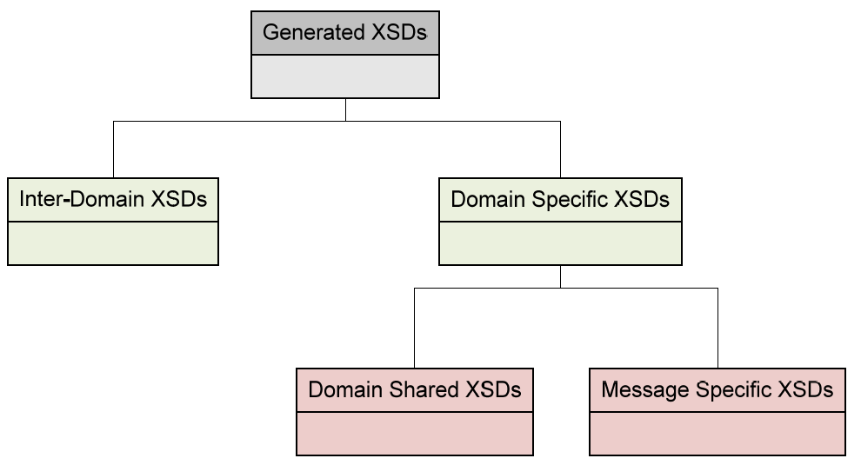
Figure 21: XSDs’ Categorisation
Domain Shared XSDs shall contain definition of Simple and Complex types that are shared between messages of the specific domain. Simple types defined in Inter-Domain XSDs shall not be redefined in the Domain Specific ones. Message Specific XSDs shall contain the definition of the structure for each domain message and shall exist for each message of the domain.
The following figure provides an illustration of the XSD files as they will be extracted from the CSE for a single domain.
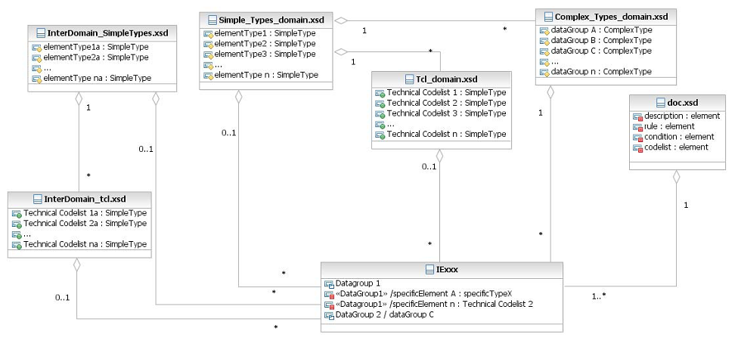
Figure 22: XSDs’ File Structure
A short description of the Domain Shared XSDs is provided below:
- Documentation (doc.xsd): shall contain the template definition of documentation elements (rules, conditions, codelists and descriptions) that are being further declared in the message-specific or common XSDs. The specific file shall be used for documentation purposes only and no validation of codelists, rules or conditions shall be performed by the elements of that file;
- Simple Types XSD (Simple_types_domain.xsd): shall contain the definition of data items that are used in the message-specific as well as in other common XSDs. Definition of those types shall contain the type (alphanumeric, numeric etc) and format, pattern definition. Simple Types that are identified to be repeatedly defined in messages of the same domain shall be grouped under a common definition;
- Technical Codelists XSD (tcl_domain.xsd): shall contain the definition of technical codelists for a specific domain as simple types. It shall provide the definition of their type (e.g. string,integer, etc.) and an enumeration of the applicable values;
- Common Complex Types XSD (Complex_types_domain.xsd): shall contain the definition of data groups used in message-specific XSDs. Complex Types that are identified to be repeatedly defined in messages of the same domain shall be grouped under a common definition;
- Message Specific XSD (IExxx): shall define only the structure of each message. Definition of simple or complex types shall be achieved by referencing the domain or inter-domain XSDs that contain the required definition.
As with the case of common files in a single domain, inter-domain common files shall be also referenced by message specific XSDs of all domains as shown above. A short description of the inter-domain XSDs follows:
- Common Simple Types XSD (Simple_types.xsd): shall contain the definition of data items that are commonly used in all message-specific XSDs of all domains;
- Technical Codelists XSD (tcl.xsd): shall contain the definition of shared technical codelists for all domains.

XSDs Binding
As shown in Figure 22 there is a certain degree of interdependency between the XSD files, whether those are message-specific or common. In order to realise that interdependency and assemble the XSDs, XML Schemas <include> element will be used.

Internal Structure of XSD Files
The current section provides an overview of the internal structure per XSD type as well an example of their application to define simple and complex types.

Message-specific XSDs
Each Message-specific XSD shall define the structure of the pertinent IE. In order for data items and groups to be defined each message specific XSD shall contain reference to the Common XSDs of its domain as well as to the inter-domain ones. The XSD structure is compliant to the characteristics presented below:

- Root Element: is the type of message. As shown in Figure 23, CD301A is the root element of the XSD;

Message Structure / Datagroups: Datagroups ordered under Root Element define the message structure as shown in Figure 23. Data-groups in dashed line shall be defined as required while those with solid line are defined as optional. Documentation elements provide additional information per datagroup, such as description and applicable rules/conditions. Each datagroup consists of data items. Datagroups identified during generation to have a common list of elements are defined in shared XSD (Common complex type XSD for domain) and referenced in the message specific XSD;

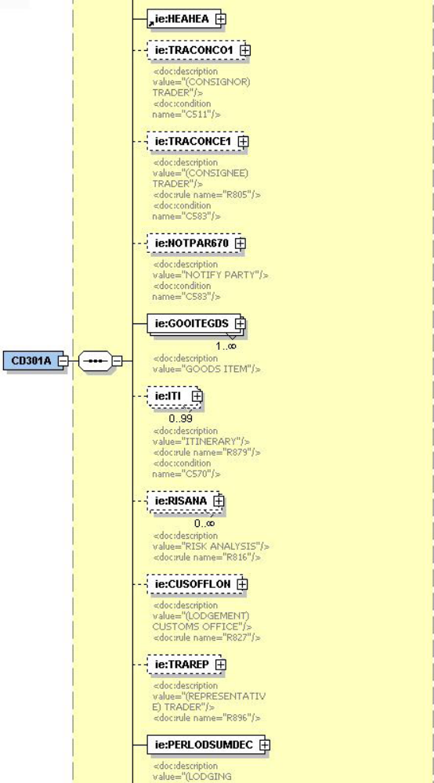
Figure 23: Root Element and Message data-groups
- Message Structure / Data Items: data items and data groups ordered under XSD root element define message structure, thus the format of information related to the message. Data-items that share common definitions in terms of format are defined in domain or inter-domain shared XSDs and referenced in message specific XSDs.

The XSD conventions should follow the principles that are currently in place. As a result, the
Root Element of the XSD shall define the Message Type. The Root Element shall contain the structure of the message according to its TMS presented in Appendix Q2 and T of the relevant DDNA specific volume ([R16], [R17] and [R18]). A list of simple type data items and a list of complex type data groups shall be ordered as in the pertinent DTD. It should be also mentioned that the same XML tags shall be preserved.

In addition, a message-specific XSD per CS/RD message shall be present for each domain, maintaining the current structure of the CS/RD messages as defined by the existing DTDs.

Simple Types XSD (Simple_Types_domain.xsd / Simple_Types.xsd)
Simple types shall be defined in domain (Simple_Types_domain.xsd) or inter-domain (Simple_Types.xsd) XSDs depending on their scope.

Simple types whose scope is limited to a single domain shall be defined in XSDs specific to a domain (e.g. Simple_Types_NCTS.xsd, Simple_Types_ECS.xsd, Simple_Types_ICS.xsd). Simple types that have been identified as shared between more than one domain shall be defined in a shared XSD (simple_types.xsd). Internal structure of both domain specific and inter-domain XSDs shall be similar. Each XSD shall initially define Base Types. Base types shall merely define the type and or size of simple types. Base types shall be further restricted by patterns and or size limitations and thus Specific types shall be defined. An example is presented in Figure 25, where a specific type DocNumHEA5Type is defined for the DocNumHEA5 data item by applying an additional pattern restriction to the Alphanumeric which in that case is the base type.

If a data item is not associated to a technical codelist in Appendix Q2 of the relevant DDNA specific volume ([R16], [R17] and [R18]), this data item shall be defined in the message specific XSD with the corresponding specific type that represents the format of the data item in the types’ domain-specific XSD.

As already mentioned in case of multi-domain XSDs generation, CSE shall identify all commonly defined simple types and define them in an inter-domain XSD for Simple Types.

<xs:simpleType name="Alphanumeric">
<xs:restriction base="xs:token">
<xs:pattern value="."/>
</xs:restriction>
Figure 24: Abstract type definition for alphanumeric format

<xs:simpleType name="DocNumHEA5Type">
<xs:restriction base="Alphanumeric">
<xs:length value="21"/>
<xs:pattern value="[0-9]{2}[A-Z]{2}[A-Z0-9]{13}[0-9] "/>
</xs:restriction>
</xs:simpleType>
Figure 25: Specific type definition for DocNumHEA5

Complex Types XSD (Complex_Types_Domain.xsd)
Complex Types that shall be identified to be shared between more than one messages of the same domain shall be defined in common XSD per domain (e.g. Complex_Types_NCTS.xsd, Complex_Types_ECS.xsd, Complex_Types_ICS.xsd). That way definition of commonly used Complex types per domain shall be shared for the message specific XSDs. Structurally wise, Complex_Types_Domain.xsd shall be fairly simple as it will comprise of a list of complex types definitions.

Complex types XSD shall define the structure of complex types that have been identified as common in message specific XSDs of the same domain. Complex types shall be referenced in the message specific XSDs where the structure of a message shall be defined. The following example in Figure 26 illustrates the definition of Risk Analysis complex type in complex_types_ics.xsd. The specific complex type has been identified to be shared between multiple message specific XSDs of ICS.

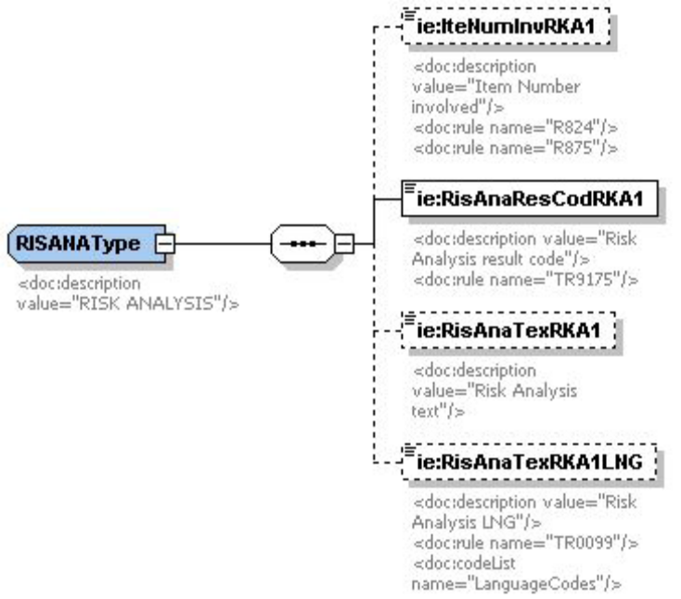
Figure 26: Definition of Risk Analysis complex type

The following figure illustrates how RISANAType is referenced in message specific XSD in order to define data-group CD301A.RISANA.

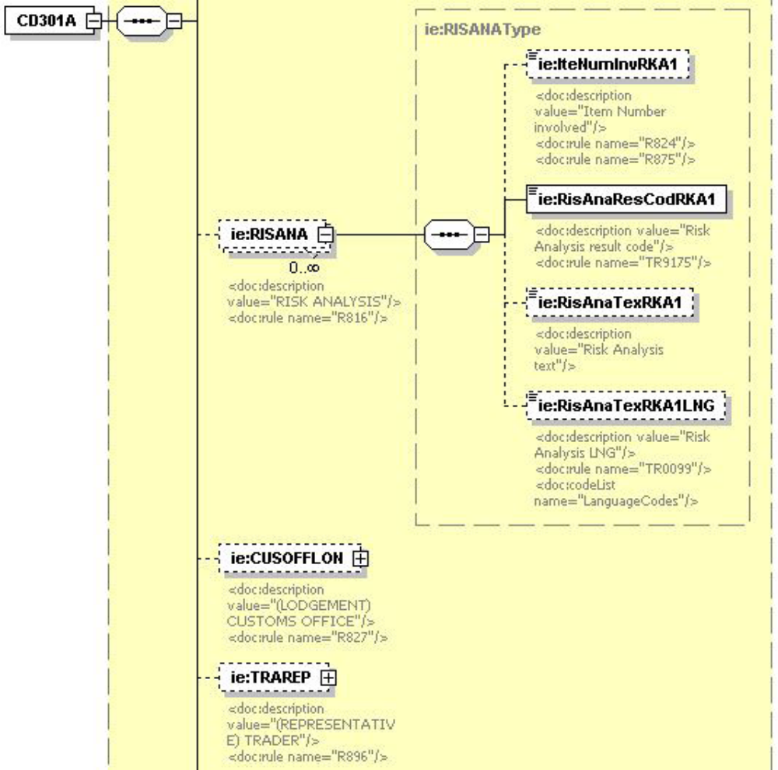
Figure 27: Definition of CD301A.Risk Analysis

Technical Codelists XSD (Tcl_domain.xsd / Tcl.xsd)
Technical codelists shall be defined in domain (Tcl_domain.xsd) or inter-domain (Tcl.xsd) XSDs depending on their scope. Structure of abovementioned XSDs shall be similar, since both shall consist by a list of simple types as the one shown in Figure 28.

Technical codelists whose scope is limited to a single domain shall be defined in XSDs that apply to the specific domain (Tcl_NCTS.xsd, Tcl_ECS.xsd, Tcl_ICS.xsd). Technical codelists that have been identified as shared between more than one domain shall be defined in a shared XSD (tcl.xsd). The latter shall be referenced by message specific XSDs of all domains. If a data item is associated with a technical codelist, according to Appendix Q2 of the relevant DDNA specific volume ([R16], [R17] and [R18]), this data item shall be defined in the message-specific XSD by reference to the pertinent codelist definition in the technical codelists’ common XSD (tcl_domain.xsd or tcl.xsd).
If a data item is associated with a technical codelist, according to Appendix Q2 of the relevant DDNA specific volume ([R16], [R17] and [R18]), this data item shall be defined in the message-specific XSD by reference to the pertinent codelist definition in the technical codelists’ common XSD (tcl_domain.xsd or tcl.xsd).

An example is presented in Figure 28, where the Message Type (MesTypMES20) data item is defined as of type MessageTypes, which represents the relevant technical codelist in the technical codelists’ XSD.

The definition of each domain specific technical codelists’ XSD will be based on Appendix C of the DDNA specific volumes ([R16], [R17] and [R18]).
<!--=========================================-->
<!--===== Message Types =====-->
<!--=========================================-->
<xs:simpleType name="MessageTypes">
<xs:annotation>
<xs:documentation>Message Types</xs:documentation>
</xs:annotation>
<xs:restriction base="xs:token">
<xs:enumeration value="CC004A">
<xs:annotation>
<xs:documentation>Amendment acceptance </xs:documentation>
</xs:annotation>
</xs:enumeration>
<xs:enumeration value="CC005A">
<xs:annotation>
<xs:documentation>Amendment Rejection </xs:documentation>
</xs:annotation>
</xs:enumeration>
<xs:enumeration value="CC007A">
<xs:annotation>
<xs:documentation>Arrival notification </xs:documentation>
</xs:annotation>
</xs:enumeration>
<xs:enumeration value="CC008A">
<xs:annotation>
<xs:documentation>Arrival notification rejection</xs:documentation>
</xs:annotation>
</xs:enumeration>
<xs:enumeration value="CC009A">
<xs:annotation>
<xs:documentation>Cancellation decision </xs:documentation>
</xs:annotation>
</xs:enumeration>
<xs:enumeration value="CC014A">
<xs:annotation>
<xs:documentation>Declaration cancellation request</xs:documentation>
</xs:annotation>
</xs:enumeration>
<xs:enumeration value="CC015B">
<xs:annotation>
<xs:documentation>Declaration data </xs:documentation>
</xs:annotation>
</xs:enumeration>
<xs:enumeration value="XXXX">
....
</xs:enumeration>
</xs:restriction>
</xs:simpleType>
Figure 28: Technical codelist definition for MessageTypes

Transport of messages via CCN/CSI

Introduction

Summary
This section specifies the exchange of messages through the Common Domain.
The specification consists of a set of specified items that are grouped in two parts:
- The mandatory items: these consist of all choices that need agreement in the Common Domain to ensure end-to-end communication between National Applications.
- The recommended items: these consist of all recommendations that are of benefit for the best possible performance of the communication means, beyond what is mandatory and taking into account the fact that varied architectural constraints may exist on different NCA platforms.

Architectural Assumptions
- The exchanges in the Common Domain use the communication services provided by the CCN/CSI infrastructure. The CCN/CSI infrastructure has the main objective of exchanging CCN messages across the Common Domain: a CCN message is an object that is created, sent and received through the CSI API. A CCN message has a structure composed of service elements and Application data.
- The CCN infrastructure consists of a set of interconnected Gateways; each NCA is able to use the CCN services by connecting an NCA front end to a nationally located Gateway and accessing this Gateway through the CSI API.
- Only the subset of CCN asynchronous communication services is used in Customs systems.
- The CCN asynchronous services operate on persistent storage objects named “queues”. In this mode, CCN messages are exchanged between queues by the CCN services. There exists a consistent naming convention for all queues defined for Customs systems.
- In Customs systems, the Application data within a CCN message consist of one Information Exchange. The EDIFACT or XML interchange that carries one Information Exchange consists of one EDIFACT or XML message respectively.
- The responsibility for routing a CCN message coming from the Common Domain, once it is present in the receiving queue, entirely lies upon the NCA. This includes the steps of (a) reading from the receiving queue; (b) dispatching the message contents to processes and destinations within the National Domain; (c) extracting where appropriate the EDIFACT message from the CCN message; (d) reacting appropriately to the EDIFACT message contents in accordance with the Customs systems business process threads, rules and conditions.
- The Information Exchanges do not require an immediate answer. However, the duration between a request and an answer is at maximum 15 minutes.
- A National Application is interacting with CCN/CSI via CCN/CSI API calls. It is mandatory to check the result of any API call (by checking the API return and reason codes) to assure the proper execution of the API call and to take corrective actions in case of problems.
- Whenever an Information Exchange is sent, CCN/CSI enables to request report messages indicating the state of the message transfer. The usage of these report messages is mandatory. The sender must check the reception of the report messages and corrective action needs to be taken in case of problems.
- CCN/CSI enables automated MRN nursing, whereby an automated application can track all CCN/CSI exchanges related to a single MRN, including the exchange of the various CCN/CSI reports. In order to support MRN nursing, it is highly recommended to follow the conventions defined for the usage of MsgId and CorrelId in the CCN/CSI exchanges.
- In Customs systems when two Information Exchanges are sent to the same queue on the same Gateway and the sequence of these is significant (e.g. IE006/IE018 in NCTS), then it is the responsibility of the sending NCA to ensure that this sequence is maintained under all conditions. This may be achieved by delaying the sending of the second until receipt of the first has been acknowledged.
- In order to prevent a message from being deleted from a queue before it has actually been processed, the queue should first be browsed to get the message and then delete the message from it (after the message has been processed). The usage of the verb to get and delete is not allowed since it does not guarantee a correct handling of the message.
- Sending NCAs should not re-send IEs for which there has been no reply as a result of unavailability of the receiving NCA. The re-send should occur only upon request of the NCA, or receipt of an exception report. Specifically for NTAs, the sending NTA should "enable" the sequence check mechanism in order to respect the correct sequence of messages, when this is explicitly defined, as is the case for IE006 and IE018.

References to CCN/CSI
This document does not describe CCN/CSI. That information is available in the relevant CCN/CSI manuals. The document provides a short reminder of the CCN communication with the aim of helping the reader to find his/her way into the CCN/CSI documentation and it also defines the programming choices applicable to Customs systems.
General Introduction lists specific references related to CCN/CSI and the C language ([A1] to [A3] and [R4] to [R10]).
The definitions of data structures, of data types and of constants are found in “include” files (for the C language) or “COPY” files (for the COBOL language). “Library” files providing the compiled code that must be linked with the application-compiled code are also provided. The indications of the files to use are given in:
- For the C language: see [A1] chapter 12 “Building an application on UNIX systems”;
- For the COBOL language on BS2000: see [A2] heading 6.6;
- For the COBOL language on CICS: see [A3] heading 6.6.

The CCN communication reminder
This chapter presents those elements of CCN/CSI that are agreed to ensure end-to-end communication between two CCN Gateways.
In this chapter, the word “message” is to be understood as “CCN message”.
CCN carries messages between Gateways. The messages are prepared and sent by a sending Application, using CSI API; the messages are received and interpreted by a receiving Application. The communication uses the asynchronous mode.
An application is said to communicate in asynchronous mode when this application is able to send a message without having established a connection with its peer application. Messages are exchanged by placing them in and extracting them from the queues.
Figures available from an application currently operational on CCN/CSI demonstrate that the total request/reply round trip delay is in the range of 5 to 10 seconds with all accesses performed in asynchronous mode. This is the time between the moment that the sender puts a Request on its sending queue and the moment when the reply is available for the sender to retrieve from its receiving queue.

The structure of the message consists of:
- A description of the message or “message descriptor” (see [A6] chapter 4.3.2.2);
- A description of the data or “data descriptor” (see [A6] chapter 4.3.3.2); the data descriptor is said to ‘contain’ the data, even when actually it contains only a description consisting of length (in bytes) and address in memory or location in the file system;
- A description of specific parameters, called “quality of services”. These parameters describe particular handling that has to be applied (when sending) or was applied (when receiving), on the data contained in the data descriptor during execution of a CSI verb.
These three structure components are further detailed in the three paragraphs (VIII.2.1, VIII.2.2, and VIII.2.6) that follow.
The sending and receiving of CCN messages may occur after the application has connected itself to the CCN Gateway, has created a security context and has connected to the queue manager: these steps are further detailed in the paragraphs (VIII.2.8, VIII.2.9, VIII.2.10 and VIII.2.11) that follow.
An NCA will always interact with CCN/CSI via CCN/CSI API calls. It is essential that the correct execution be checked after each API call (by checking the API return code) and that appropriate action is taken when the API call has failed. Possible API return codes are documented in [A7].

The message descriptor
The message descriptor consists of a CSIMQMD structure.
This structure is to be prepared, prior to sending a message with the CSI_mq_put verb.
This structure is to be interpreted and some of its elements have to be copied back in an equivalent structure when an Information Exchange is replied with another Information Exchange, in line with the Time Sequence Diagram demonstrated in paragraph VIII.2.7.
Table 23 details the CSIMQMD structure members.
Typedef struct tag |  | Value on SEND | Value for CCN Report | Notes
CSIMQMD {
CSICHAR4 | StrucId; | CSIMQMD_STRUC_ID | CSIMQMD_STRUC_ID
CSILONG | Version; | CSIMQMD_VERSION_1 | CSIMQMD_VERSION_1
CSILONG | Report; | 0L | 0L
CSILONG | MsgType; | CSIMQMT_REQUEST or  CSIMQMT_DATAGRAM | CSIMQMT_REPORT
CSILONG | Expiry; | 3 456 000L | (DNC)
CSILONG | Feedback; | CSIMQFB_NONE
CSILONG | Encoding; | 0L | (DNC)
CSILONG | CodedCharSetId; | 0L | (DNC)
CSICHAR8 | Format; | Empty string | (DNC)
CSILONG | Priority; | 0L | (DNC)
CSILONG | Persistence; | CSIMQPER_PERSISTENT | (DNC) | Message persistence
CSIBYTE24 | MsgId; | CSIMQCI_NONE | =MsgId of reported Msg | Message identifier
CSIBYTE24 | CorrelId; | =MRN | = CorrelId of reported Msg
CSILONG | BackoutCount; | 0L | (DNC) | Backout counter
CSICHAR48 | ReplyToQ; | Empty string | (DNC) | Not used
CSICHAR48 | ReplyToQMgr; | Empty string | (DNC) | Not used
CSICHAR12 | UserIdentifier; | Empty string | (DNC) | Not used
CSICHAR32 | AccountingToken; | Empty string | (DNC) | Not used
CSICHAR32 | ApplIdentityData; | Empty string | (DNC) | Not used
CSILONG | PutApplType; | 0L | (DNC) | Not used
CSICHAR28 | PutApplName; | Empty string | (DNC) | Not used
CSICHAR8 | PutDate; | Empty string | (DNC) | Not used
CSICHAR8 | PutTime; | Empty string | (DNC) | Not used
CSICHAR4 | ApplOriginData; | Empty string | (DNC) | Not used
} CSIMQMD;
Table 23: MQ Message Descriptor
Notes:
- Column “Value on SEND” exhibits the value that an application has to set in each structure member.
- Column “Value for CCN report” defines the value set in the CCN reports.
- The indication “(DNC)” means: “Do not consider”.
- Values in uppercase are CCN/CSI constants defined in the header files.
- The value CSIMQMT_REQUEST has the effect of requesting a reply. The name of the queue to which the reply is to be sent is contained in ReplyToQ field of CSIQOS structure. See paragraph VIII.2.5.
- The CCN Gateway buffers incoming messages in case the application is temporarily unable to process them. The requirement is to be able to buffer the messages for 96 hours (in tenths of second, this duration amounts to: 96 x 3600 x 10 = 3 456 000).
- Value in ‘Feedback’ is set by the queue manager to indicate, within a report message, how the original message was handled on the Destination queue.
The reports are sent back to the sender as specified by the parameters set in the configuration (see chapter VIII.4).
Possible values are:
- A value comprised in the range from CSIMQFB_SYSTEM_FIRST and CSIMQFB_SYSTEM_LAST (those limits included) | Exception report
- CSIMQFB_EXPIRATION | Expiration report
- CSIMQFB_COA | Confirm on Arrival report
- CSIMQFB_COD | Confirm on Delivery report
- The MsgId value is an identifier used by the application to correlate a Report Message with the Information Exchange it reports about. As an Expiration report may only be generated after 96 hours (see Note 2 for ‘Expiry’ field above), it is recommended that the MsgId generating rule uses a counter that does not “rewind” in less than 96 hours.
As the field MsgId presents 24 bytes, the NCA designer is able to choose a MsgId definition that covers this condition and well beyond.
The MsgId is a binary value that can be defined automatically by CCN/CSI or that can be defined by the sending application itself. When automatically created by CCN/CSI, the MsgId is based upon system date and time and is satisfying the criterion defined above.
In order to support MRN nursing, the following conventions should be followed:
- When sending a message, the MsgId is generated automatically by CCN/CSI. The CorrelId is equal to the MRN (in an ASCII format). However, for the IE906, IE907 and IE917 the message ID (MSGID) of the corresponding erroneous message can be filled in and this will enable the correlation of an error message to the erroneous message;
- When a report is sent back, the MsgId is equal to the MsgId of the original message. The CorrelId is equal to the CorrelId of the original message (and is thus equal to the MRN).
Therefore, the MsgId needs to be set to CSIMQMI_NONE. The queue manager will then generate a unique message identifier upon sending.
The MsgId of the original message is copied into the MsgId of the report message by setting the appropriate flag CSIMRQRO_PASS_MSG_ID in the ReportRequest field of the QOS (see section VIII.2.6).
- In order to support MRN nursing, the value of ‘CorrelId’ needs to be equal to the MRN. The CorrelId of the original message is copied into the CorrelId of the report message by setting the appropriate flag CSIMRQRO_PASS_CORREL_ID in the ReportRequest field of the QOS (see section VIII.2.6).
A report message is sent back to the sender:
- Confirm on Delivery (CoD) report when the message has been read by the receiving application and deleted from the queue;
- Confirm on Arrival (CoA) report when the message has arrived on the remote Gateway;
- Expiration (EXP) report when a value of time lapse set in the CSIMQMD.Expiry variable (see Note 2) has expired and an application tries to retrieve this message after the elapsed expiration time: the message, once arrived on Destination queue (CoA), was not fetched from this queue by an application program during the time allotted;
- Exception (EXC) report when other technical errors that are related to the queuing system, have occurred.
The usage of the four report messages (CoA, CoD, EXP and EXC) is mandatory. An NCA will have to request all four types of reports whenever an Information Exchange is sent and will have to wait for the reception of the reports for any Information Exchange sent. In case of problems, corrective action needs to be taken. This usage is further discussed in paragraph VIII.2.7.
The report messages are to be read from the queue whose name is given by the element “ReplyToQ” of the Quality of Service structure. See Table 26. The report messages do not contain the original message.
In case the report message could not be delivered to the queue indicated by this element, it will be stored on the so-called dead-letter queue (CSIMQRO_DEAD_LETTER_Q) on the gateway that sent the report. Each CCN Gateway needs to have this type of queue.

The data descriptor
The data descriptor is implemented by a CSIDD structure shown in Table 24.
Typedef struct tag |  | Value on SEND | Data descriptor
CSIDD {
CSICHAR4 | StrucId; | CSIDD_STRUC_ID | Structure identifier
CSILONG | Version; | CSIDD_VERSION_1 | Structure version
CSILONG | Flags; | O_MEMORY or O_FILE
CSICHAR256 | FileName; | See VIII.2.4
CSIULONG | DataLength; | See VIII.2.4
CSIBYTE | *Data; | See VIII.2.4
} CSIDD;
Table 24: CSI Data Descriptor
Notes:
- Column “Value on SEND” exhibits the value that an application has to set in each structure member.
- The CSIDD structure allows the representation of data:
- Either located in core memory: the structure element ‘Flags’ must have the value O_MEMORY;
- Or located in a file: the structure element ‘Flags’ must have the value O_FILE.
The choice of which method to use for passing the application data is strongly dependent on the design choices taken for the application: it is recommended that the “O_MEMORY” method be used whenever possible.

Allocation of a CSIDD
The CSIDD has to be allocated dynamically and initialised with the function HL_alloc(), documented in [A6]:
CSILONG HL_alloc (
CSIULONG SizeRq,
CSIDD **DataOut,
CSILONG *ReturnCode,
CSILONG *ReasonCode
);
If the data are represented in core memory, the value of argument SizeRq must be at least equal to or greater than, the length of the application data (expressed in octets).
Upon successful call to HL_alloc(), some elements of the allocated CSIDD structure are initialised:
- StrucId = CSIDD_STRUC_ID;
- Version = CSIDD_VERSION_1;
- Flags = O_MEMORY;
- DataLength = 0L.
When a CSIDD structure is not used anymore, it has to be given back to system resources by performing the HL_free() verb, documented in [A6]:
CSILONG HL_free(
CSIDD **DataOut,
CSILONG *ReturnCode,
CSILONG *ReasonCode
);
The example for allocation of a CSIDD structure is part of the listing in Table 25.

Inserting the application data into the CSIDD structure
The application data consist of an Information Exchange in EDIFACT or XML format. In the example provided in Table 25, they are represented as a core memory value named ‘Request’.
- If the application data are represented in core memory:
They have to be copied from their current location into the buffer allocated and pointed to by CSIDD.Data and the element “DataLength” must be entered as the exact length (expressed in octets) of the application data. It cannot be assumed that the Information Exchange is represented in memory as a NULL-terminated string according to the ANSI C convention. The example for this case is provided (as statement “memcpy”) in Table 25;
- If the application data are represented in a file:
The elements of the CSIDD structure must be set to:
  - Flags = O_FILE.
  - DataLength = length of useful contents in the File.
  - FileName = full path name of the file. ‘FileName’ is set to the path name of a file containing application data.

Encoding the CSIDD
When the CSIDD is prepared, with elements either FileName or Data (as well as DataLength) correctly initialised by the application, it has to be presented, on the sending side to the HL_encode() verb. Conversely, after being received, a CSIDD structure must be presented to the HL_decode().
The prototype of the HL_encode verb is:
CSILONG HL_encode(
IN CSIDD *DataIn,
IN CSICHAR32 MsgTypeId,
IN CSILONG CodePage,
IN CSICHAR128 HostFormat,
OUT CSIDD *DataOut,
OUT CSILONG *ReturnCode,
OUT CSILONG *ReasonCode
);
The parameter MsgTypeId must have a value within a pre-determined set of values that are listed in each domain specific DDNA volume ([R16], [R17] and [R18]).
See chapter for an explanation of arguments ‘CodePage’ and ‘HostFormat’ as obtained from configuration information.
The listing in Table 25 illustrates the usage of HL_alloc and HL_encode verbs, as well as the initialisation of the CSIDD structure with the EDIFACT Information Exchange.
REQUEST Request;
CSIDD pCSIrequest;
CSILONG ReturnCode;
CSILONG ReasonCode;

The variable Request has been prepared in REQUEST structure. Assume Request is the EDIFACT_interchange for a CD001A message

Steps are:
- (See VIII.2.3) Allocate Data Descriptors for request HL_alloc (sizeof (REQUEST), &pCSIRequest, &ReturnCode, &ReasonCode);
- Copy REQUEST structure into “Data” field of request CSIDD structure
memcpy (pCSIrequest->Data (CSICHAR *) &Request, sizeof (REQUEST));

pCSIrequest->DataLen = sizeof (REQUEST);

- Encode request
HL_encode (pCSIrequest, “CD001A-MSG.NCTS”, CODEPAGE, HFMT, \

pCSIrequest, &ReturnCode, &ReasonCode);

After these steps: the CSIDD will be sent with HL_mq_put() verb. Logging of this CSI movement will take a record of “CD0001A”

Table 25: Example of CSIDD allocation, initialisation with Information Exchange and encoding
This code is not intended to be used directly as actual working code. All API return codes (and possibly reason codes) will have to be checked after every API call.

The quality of service
CCN specifies a Quality of Service (QoS) with a number of parameters (see [A6] Section 4.3.3.3). These parameters are used in the CSI verbs that handle data; the values of these parameters apply to the data exchanged in the same verb.
When a specific parameter is not mentioned in the QoS (vector QoSToApply in [A6] Section 4.3.3.3), its default value as defined at configuration time (see paragraph VIII.4.7 of Transport of messages via CCN/CSI) applies.
The Quality of Service is represented by the CSIQOS structure shown in Table 26. The fields applicable in this structure are ticked with a “√” in the right-hand column of this Table.
typedef struct tag |  | value on SEND | Notes
CSIQOS{
CSICHAR4 | StrucId; | CSIQOS_STRUC_ID | Structure id. | √
CSILONG | Version; | CSIQOS_VERSION_1 | Structure version | √
CSILONG | QoSToApply; |  | Specified QoS | √
CSILONG | AppliedQoS; | (DNC) | Applied QoS | √
CSILONG | Priority; |  | Priority value | √
CSILONG | ReportRequest; |  | Report/Request flag | √
CSICHAR48 | ReplyToQ; |  | Name of reply queue | √
CSICHAR48 | ReplyToQMgr; | (DNC) | Name of reply queue mgr | √
CSIBYTE24 | CorrelId; | Empty string | Correlation id. | √
CSILONG | Integrity; |  | Integrity flag | √
CSILONG | Confidentiality; |  | Confidentiality flag | √
CSILONG | Compression; |  | Compression flag | √
CSICHAR8 | CompressionId; |  | Comp. Algorithm id. | √
CSICHAR16 | CoT; | DEFAULTCOT | Class of Traffic | √
CSICHAR48 | VASScript; | Empty string | VAS script name | √
CSILONG | DegradedMode; | (DNC) | Degraded mode flag
} CSIQOS;
Table 26: CCN/CSI Quality of Service structure
Notes:
- Column “Value on SEND” exhibits the value that an application has to set in each structure member.
- ‘QoSToApply’ is a vector of bits obtained by adding once or by performing a bitwise OR operation between, the set of values that follow:
QoSToApply =
CSI_QOS_PRIORITY +
CSI_QOS_REPLYTO_Q +
(0 or CSI_QOS_INTEGRITY: see Note 6.1) +
(0 or CSI_QOS_CONFIDENTIALITY: see Note 6.2) +
(0 or CSI_QOS_COMPRESSION: see Note 6.3) +
(0 or CSI_QOS_COMPRESSION_ID: see Note 6.3)
- Two priority values are distinguished (these values are written with the C language convention for long integers):
- High priority: QoS priority parameter has value 7L. This priority is applied to the Information Exchanges listed in the respective tables in the domain specific DDNA volumes ([R16], [R17] and [R18]).
- Normal priority: QoS priority parameter has value 5L. Normal priority is applicable to the other Information Exchanges exchanged across the Common Domain.
When a message is retrieved from a Destination queue, it is accompanied with the QoS that was set at the time of sending. Therefore, the priority set when sending has to be used to fetch the received message in accordance with the rule:

Rule for fetching messages from a receiving queue:
High priority messages will always be processed first and, within the same priority level,“first in, first out” behaviour will be used.
- ‘ReportRequest’ specification is fully defined by configuration (see chapter VIII.4) and hence is not to be set for each individual message. One thus has the choice either to use the default value set by configuration or to use an individual value for every individual message sent. In any case it is required to request all four types of reports (CoA, CoD, EXC, EXP) whenever an Information Exchange is sent. In addition, the following flags need to be set for copying MsgId and CorrelId from the original message to the report message:
    - CSIMQRO_PASS_MSG_ID
    - CSIMQRO_PASS_CORREL_ID
- ‘ReplyToQ’ is to be set to the name of a queue that exists on the CCN Gateway used by the sending application. This name is of no use for the receiving application (because the report message is constructed and sent by the CCN software and not by the receiving application).
- The attributes “Integrity”, “Confidentiality” and “Compression” apply to the link between the NA platform and the CCN gateway. Therefore, the choice of modifying the values preset at Configuration time (see paragraph VIII.4.3) depends of the strength of this link as perceived by the NA Local Security Officer.
The notes 6.1, 6.2 and 6.3 apply to the situation where the decision is taken to change the default values.
  - See chapter VIII.4 for the explanation of the configuration options set for the Integrity (data are accompanied with a signature). If the NCA chooses to set the Integrity for a specific message differently from the configured value, then
- Value CSI_QOS_INTEGRITY must be added to QoSToApply;
- Element ‘Integrity’ in CSIQOS takes the value CSI_INTEGRITY_REQUIRED.
Else:
- Value CSI_QOS_INTEGRITY must not be added to QoSToApply;
- Element ‘Integrity’ in CSIQOS takes the value CSI_INTEGRITY_NOT_REQUIRED.
  - See chapter VIII.4 for the explanation of the configuration options set for the Confidentiality (data are encrypted). If the NCA chooses to set the Confidentiality for a specific message differently from the configured value, then:
- Value CSI_QOS_CONFIDENTIALITY must be added to QoSToApply;
- Element ‘Confidentiality’ in CSIQOS takes the value CSI_ CONFIDENTIALITY _REQUIRED.
Else:
- Value CSI_QOS_CONFIDENTIALITY must not be added to QoSToApply;
- Element ‘Confidentiality in CSIQOS takes the value CSI_ CONFIDENTIALITY _NOT_REQUIRED.
  - See chapter VIII.4 for the explanation of the configuration options set for the Compression and CompressionId. If the NCA chooses to set these parameters for a specific message differently from the configured value, then:
- Value CSI_QOS_COMPRESSION and CSI_QOS_COMPRESSION_ID must be added to QoSToApply;
- Element ‘Compression’ in CSIQOS takes the value CSI_ COMPRESSION _REQUIRED;
- Element ‘CompressionId’ in CSIQOS takes the value CSI_ COMPRESSIONID_LZW.
Else
      - Value CSI_QOS_CONFIDENTIALITY must not be added to QoSToApply;
      - Element ‘Confidentiality in CSIQOS takes the value CSI_ COMPRESSION_NOT_REQUIRED;
      - Element ‘CompressionId’ in CSIQOS takes the value CSI_ COMPRESSIONID_NONE.
  - High priority messages are defined in each domain specific DDNA volume ([R16], [R17] and [R18]) for the specific domain.

Illustration of the use of the QOS parameters
This section illustrates by means of Time Sequence Diagrams (Time Sequence Diagrams) the use of the QoS parameters and of the CCN report messages. It shows the communication between a sending CSI stack, a sending CCN Gateway, a receiving CCN Gateway and a receiving CSI stack. It shows several cases starting with the normal case in which a Confirm on Arrival and Confirm on Delivery are received. Based on this normal case, several exceptions are shown in Figure 29.
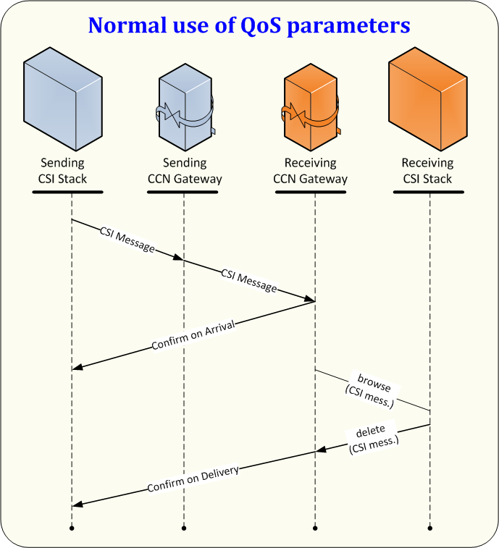
Figure 29: Normal use of QoS parameters for NCA
The figure shows that a queue is to be first browsed for a message, before the message is deleted (after having processed the message). This use of CSI verbs is mandatory in order to prevent a message from being deleted from a queue before it has actually been processed. The usage of the verb HL_mq_get is not allowed.
It should be noted that, for every Information Exchange sent, the user will have to wait for the reception of the CoA and CoD before concluding that the message has been transferred successfully. The CoA is denoting that the Information Exchange has reached the destination queue, while the CoD is denoting that the Information Exchange has been successfully processed at (and deleted from) the destination queue. Please also note that CCN/CSI does not assure the delivery of CoA and CoD in sequence (in rare occasions, the CoD may be returned first).
If a message cannot be sent to a Destination CCN Gateway, the result is indicated in the CSI verb (HL_mq_put). This type of error needs to be handled by the sending CSI stack. In such a case, the CSI message will never arrive at its Destination CCN Gateway and no CCN report message will be generated.
An exception report can be generated for various reasons and can be generated by both sending and receiving Gateways. Whenever a sending application is submitting a message to CCN/CSI via the HL_mq_put verb, the message will first be stored in the internal technical queues of the CCN/CSI stack on the sending Gateway. CCN/CSI will then attempt to forward the message from the internal technical queues on the sending Gateway to the internal technical queues on the receiving Gateway and from these to the destination queue on the destination Gateway. An exception report is generated whenever an anomaly is detected in the internal CCN/CSI behaviour (at either sending or receiving Gateway). This can e.g. be:
- Incorrect addressing at CCN/CSI level, either at sending or receiving side (e.g. invalid Gateway or invalid queue name);
- Unavailability of the receiving Gateway when attempting to transfer the message.
The ITSM/CCN-OPS is maintaining a number of availability flags for the different Gateways. Whenever a Gateway is marked as down, an EXC report will immediately be generated upon sending to this Gateway. When the Gateway is not marked as down, CCN/CSI will attempt to transfer the message; if this does not succeed, an EXC report can still be generated by the sending Gateway.
The Expiration report can be created when the message has arrived at the destination Gateway (Confirm On Arrival has been created) and when the original message has not been read from the Destination queue before the timer set by the ‘Expiry’ field of the message descriptor expires. The Destination CCN Gateway handles the expiration timer. The destination timer is only checked whenever the destination queue is accessed (no expiration reports will be sent when the queue is not accessed at all). Therefore, EXP reports will not always be generated when the expiry took place (they may actually be generated afterwards).
For all these reasons it is therefore mandatory to wait for the processing reports after sending an Information Exchange and to maintain a timer for every Information Exchange sent. When this timer expires, one should check the availability of the destination Gateway (and possibly re-send the message).
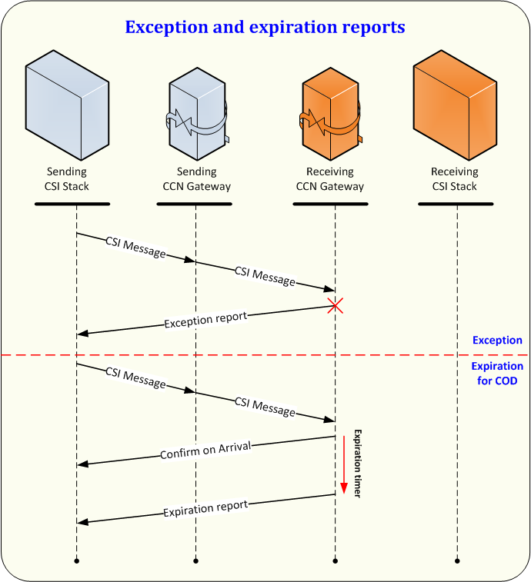
Figure 30: Exception and expiration reports
All possible options for the use of the QoS parameters and their exceptions are shown in the State Transition Diagram in Figure 31. This State Transition Diagram specifies the states of one CSI message present in the sending CSI stack, with respect to the use of CCN. It assumes that the binding of the CSI stack to the CCN Gateway has successfully taken place.
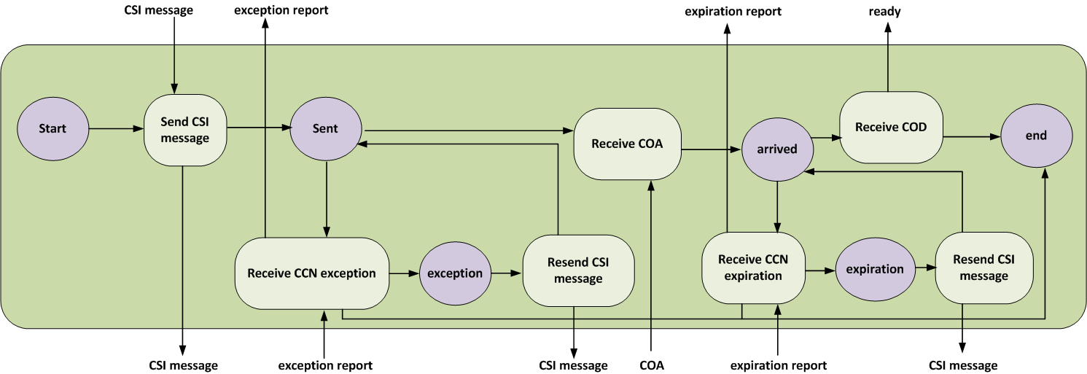
Figure 31: State Transition Diagram of the sending CSI stack
Each of the transitions shown in the previous figure consists of CSI verbs.

Connecting the application to the CCN Gateway
Any instance of any application establishes a CSI session by using the HL_bind() verb:
CSILONG HL_bind(
CSICHAR48 AppliName,
CSICHAR48 ProxyName,
CSIQOS *DefaultQoS,
CSILONG *ReturnCode,
CSILONG *ReasonCode
);
“AppliName” is a value previously registered to the CCN Gateway (see paragraph VIII.4.3 of Transport of messages via CCN/CSI). A remote proxy name must have been set together with the ApplicationName at configuration time. This default value may not be overridden: therefore the “ProxyName” argument in the HL_bind() call must be an empty string.
Closing a CSI session occurs with the verb HL_unbind().
Note that the session, when established, has no identifier on its own.

Creating a security context for an application
Within the session, a security context has to be created by using the verb HL_init_sec_context and is destroyed with the verb HL_delete_sec_context. The parameter of the HL_init_sec_context verb is a CSISECINFO containing (in the current version of CSI software) a GSSNAME structure:
typedef struct tagGSSNAME {
char user_id[GSS_NAME_LENGTH];
char application_id[GSS_NAME_LENGTH];
char user_password[GSS_PASSWD_LENGTH];
char application_key[GSS_PASSWD_LENGTH];
} GSSNAME;
The components of the GSSNAME structure are:
- A user identification;
- An application name;
- A user password;
- An application key.
These four values must have been configured previously by the NA Local Security Officer (see Table 34).

The structure GSSNAME is referenced (i.e. pointed) by a structure CSISECINFO :
typedef struct tagCSISECINFO {
CSILONG securityType;
CSIVOID securityInfoP; / here: GSSNAME */
} CSISECINFO;
‘securityType’ is set to the value BI_SEC_TYPE ([A4]).
Finally the verb HL_init_sec_context() is used with the structure CSISECINFO that was initialised:
CSILONG HL_init_sec_context(
CSISECINFO *credentialInfo,
CSILONG *ReturnCode,
CSILONG *ReasonCode
);
Note that the security context, when established, has no identifier on its own.
The verb HL_delete_sec_context() is used for deleting the security context.

Connecting to the queue manager
The application has to connect itself to the queue manager in order to be able to issue commands related to queue access. The verb HL_mq_conn() is used for this purpose:
CSILONG HL_mq_conn(
CSICHAR48 Name,
CSIMQHCONN *Conn,
CSILONG *ReturnCode,
CSILONG *ReasonCode
);
“Name” value must be set to an empty string for current version of CSI.
“Conn” is initialised by this function and has to be used subsequently for opening any queue.
The verb HL_mq_disc() is used to disconnect from the queue manager:
CSILONG HL_mq_disc(
CSIMQHCONN *Conn,
CSILONG *ReturnCode,
CSILONG *ReasonCode
);
Argument “Conn” in this call must be identical to the one obtained from previously using HL_mq_conn().

Opening a queue
The application has to open a queue before performing any access to it. See in Table 28 the list of verbs that may be used once a queue has been successfully opened.
The verb HL_mq_open() is used to open a queue:
CSILONG HL_mq_open(
CSIMQHCONN Conn,
CSIMQOD *ObjDesc,
CSILONG Options,
CSIMQHOBJ *Obj,
CSILONG *ReturnCode,
CSILONG *ReasonCode
);
Value of argument “Conn” is identical to the one obtained from HL_mq_conn().
Value of argument “Options” is obtained by adding values that control the HL_mq_open() behaviour. There is no mandatory value of this argument in DDNA because the policy for reading and writing into Gateway queues by the application is a local matter. However, the recommended use of the verb HL_mq_browse() for retrieving messages from a queue (see VIII.2.15), as well as the use of default configured values, mandates the use of at least the options CSIMQOO_BROWSE and CSIMQOO_INPUT_AS_Q_DEF. Hence:
Options = CSIMQOO_BROWSE + CSIMQOO_INPUT_AS_Q_DEF.
Successful call of the verb HL_mq_open() for a certain queue provides a value “Obj”, called a “handle”, that will be subsequently used in all verbs (listed in Table 28) that deal with this queue.
Argument “ObjDesc” is a CSIMQOD structure that must be initialised as follows:
Typedef | struct tag | Initial value | Notes
CSIMQOD {
CSICHAR4 | StrucId; | CSIMQOD_STRUC_ID | Structure id.
CSILONG | Version; | CSIMQOD_VERSION_1 | Structure version
CSILONG | ObjectType; | CSIMQOT_Q
CSICHAR48 | ObjectName; |  | Name of queue
CSICHAR48 | ObjectQMgrName; | (DNC) | This field must not be used
CSICHAR48 | DynamicQName; | (DNC) | This field must not be used
CSIBYTE12 | AlternateUserId | (DNC) | This field must not be used
} CSIMQOD;
Table 27: MQ Object Descriptor
Notes:
The Queue Name is inserted here. This allows a maximum length of 47 characters for the Queue Name.
The rules for queue naming are explained in paragraph VIII.2.18.1.
When not used anymore, a queue must be closed by using the verb CSI_mq_close:
CSILONG HL_mq_close(
CSIMQHCONN Conn,
CSIMQHOBJ *Obj,
CSILONG Options,
CSILONG *ReturnCode,
CSILONG *ReasonCode
);
Value of argument “Conn” is identical to the one obtained from HL_mq_conn().
Value of argument “Obj” is identical to the one obtained from HL_mq_open().
Value of argument “Options” must be set to CSIMQCO_NONE.

CSI verbs allowed for queue accesses
When a queue was successfully opened, it is identified by a handle Obj, of type CSIMQHOBJ.
The following verbs may be used to deal with the “Obj” queue contents:
Class of verbs | Verb | Usage
close queue | HL_mq_close() | Mandatory.
write in queue | HL_mq_put() | Mandatory (see also VIII.2.14 however).
read from queue | HL_mq_browse | Mandatory
delete from queue | HL_mq_delete | Mandatory. A message must have been successfully read and processed before deleting.
Table 28: CSI verbs for queue access
It is the responsibility of the application to organise the reading from a receiving queue in order to avoid loss of messages.

Putting a message into a queue: HL_mq_put()
CSILONG HL_mq_put(
CSIMQHCONN Conn,
CSIMQHOBJ ObjDesc,
CSIMQMD *MsgDesc,
CSIMQPMO *PutMsgOpts,
CSIDD *DataIn,
CSIQOS *QoS,
CSILONG *ReturnCode,
CSILONG *ReasonCode
);
Value of argument “Conn” is identical to the one obtained from HL_mq_conn().
Value of argument “Obj” is identical to the one obtained from HL_mq_open().
Argument “MsgDesc” points to a CSIMQMD structure that was prepared as explained in paragraph VIII.2.1. The values present in this structure after a successful call of the HL_mq_put() are not to be considered.
Argument “DataIn” points to a CSIDD structure that was prepared as explained in paragraph VIII.2.2.
Argument “QoS” points to a CSIQOS structure that was prepared as explained in section VIII.2.6.
Argument “PutMsgOpts” is to be initialised with the statements:
- Define a static variable s_DefMQPMO of type CSIMQPMO initialised with constant values:
CSIMQPMO s_DefMQPMO = {CSIMQPMO_DEFAULT};
- Each time the HL_mq_put() verb will be used, define and initialise dynamically a variable s_MQPMO of type CSIMQPMO by using the static variable s_DefMQPMO :
CSIMQPMO s_MQPMO;
memcpy(&s_MQPMO, s_DefMQPMO, sizeof(CSIMQPMO));

Putting a message into a queue: HL_mq_put1()
The verb HL_mq_put1() is identical to the verb HL_mq_put(), with the exception that it uses an additional argument to specify the queue that has to be written to, instead of a queue handle. This verb performs in one call the function of the three operations: HL_mq_open(), HL_mq_put(), HL_mq_close().
Reading a message from a queue: HL_mq_get()
CSILONG HL_mq_get(
CSIMQHCONN Conn,
CSIMQHOBJ ObjDesc,
CSIMQMD *MsgDesc,
CSIMQGMO *GetMsgOpts,
CSIDD *DataOut,
CSILONG *MsgLen,
CSIQOS *QoS,
CSILONG *ReturnCode,
CSILONG *ReasonCode
);
Beware: As soon a message has been retrieved from a queue using the HL_mq_get() verb, this message is deleted from the queue.
Value of argument “Conn” is identical to the one obtained from HL_mq_conn().
Value of argument “Obj” is identical to the one obtained from HL_mq_open().
The “MsgDesc” argument contains, as input parameter, a set of attributes the message to retrieve must have and as output parameter the set of attributes the retrieved message actually has.
Method 1
When the application is in such a state that it is waiting for a report message, it has to set two attributes in the “MsgDesc” as follows:
MsgDesc.MsgId = CSIMQMI_NONE ;
MsgDesc.CorrelId = {value of the MsgId in the original message, for which a report is now awaited};
This initialisation is to be performed before each HL_mq_get() invocation.
Method 2
When the application is in such a state that it is waiting for any kind of message, it has to set two attributes in the “MsgDesc” as follows:
MsgDesc.MsgId = CSIMQMI_NONE ;
MsgDesc.CorrelId = CSIMQCI_NONE ;

This initialisation is to be performed before each HL_mq_get() invocation.
While the policy for reading messages from a queue with HL_mq_get() depends on the design of the application architecture, it is recommended though to use the Method 2 in combination with a priority value explained in attribute “Priority” of the “QoS”.
This means in practical terms that, within a set of messages read with a uniform “Priority” (see argument “QoS”), the messages will be read in their order of appearance.
They have then to be handled separately in line with the value of the “MsgDesc.MsgType” (either CSIMQMT_REQUEST, CSIMQMT_DATAGRAM or CSIMQMT_REPORT, as stated in Table 23). Any message with its MsgType equal to CSIMQMT_REPORT must be matched to its own originator by the rule:
[report_message.CorrelId] is equal to [original_message.MsgId]
To be able to correlate a report with the related Information Exchange, it is recommended that the software controlling the sending CSI stack maintains a dynamic table that cross-references the state of a CSI message and its message identification. Message identification consists of:
- Value of field CSIMQMD.MsgId in the message sent by the sending NTA;
- Value of field CSIMQMD.CorrelId in a report message given by the sending NTA (exception, COA, expiration, COD).
The “GetMsgOpts” argument is a structure that controls the behaviour of the HL_mq_get() verb. The structure is shown in Table 29:
typedef struct tag |  | Initial value
CSIMQGMO{
CSICHAR4 | StrucId; | CSIMQGMO_STRUC_ID
CSILONG | Version; | CSIMQGMO_VERSION_1
CSILONG | Options;
CSILONG | WaitInterval;
CSILONG | Signal1 ; | (DNC)
CSILONG | Signal2 ; | (DNC)
CSICHAR48 | DynamicQName; | (DNC)
} CSIMGMO;
Table 29: CSIMQGMO Object Descriptor
Notes:
- It is a design issue related to the NCA architecture, to choose between an applicative polling of a queue or a triggering mechanism initiated by CCN/CSI software, to be awakened upon a new message forthcoming in the queue. Regarding polling of a queue two processing mechanisms can be used:
  - Constant CSIMQGMO_NO_WAIT is related to first choice;
  - While CSIMQGMO_ WAIT and value of WaitInterval set relate to second choice.
Whichever the choice taken, two precautions must be taken:
  - “WaitInterval” cannot be set to CSIMQWI_UNLIMITED when “Options” has value CSIMQGMO_WAIT;
  - When applicative polling is used (“Options” has value CSIMQGMO_NO_WAIT), then there must be a grace period foreseen in the application between two successive readings in the queue.
Value of argument “DataOut” represents the location of the data, when the value of the “MsgDesc.MsgType” is CSIMQMT_REQUEST or CSIMQMT_DATAGRAM. Otherwise (in the case of a CSIMQMT_REPORT) the CSIDD “DataOut” is left undefined (check this with the value of argument “MsgLen”, that must be 0L).
When a value for “DataOut” is defined, the attribute “Flags” of this CSIDD structure defines the way the information in CSIDD is to be represented.
Value of argument “MsgLen” represents the actual length in bytes of the application data in the retrieved message. It must be compared to the attribute “DataOut.DataLen” (see [A4]).
The argument “QoS” represents a CSIQOS structure that describes the particular handling that was applied on “DataOut”. Within this structure, only the “Priority” attribute is to be considered in order to satisfy the Rule for fetching messages from a receiving queue highlighted in section VIII.2.6.

Browsing through a queue: HL_mq_browse()
CSILONG HL_mq_browse(
CSIMQHCONN Conn,
CSIMQHOBJ ObjDesc,
CSIMQMD *MsgDesc,
CSIMQGMO *GetMsgOpts,
CSIDD *DataOut,
CSILONG *MsgLen,
CSIQOS *QoS,
CSILONG *ReturnCode,
CSILONG *ReasonCode
);
All arguments used in this verb are explained as for the HL_mq_get() verb.
The HL_mq_browse() verb does not delete the message read from the queue. An explicit use of the verb HL_mq_delete() is required for deleting it.
Within the “QoS” structure, only the “Priority” attribute is to be considered in order to satisfy the Rule for fetching messages from a receiving queue highlighted in section VIII.2.6.

Deleting an element from a queue: HL_mq_delete()
CSILONG HL_mq_delete(
CSIMQHCONN Conn,
CSIMQHOBJ ObjDesc,
CSIMQMD *MsgDesc,
CSIMQGMO *GetMsgOpts,
CSIDD *DataOut,
CSILONG *MsgLen,
CSIQOS *QoS,
CSILONG *ReturnCode,
CSILONG *ReasonCode
);
All arguments used in this verb are explained as for the HL_mq_browse() verb.
Important advice: a message may not be left indefinitely in a queue; it must be deleted at some time by using HL_mq_delete(). Otherwise, if the policy of the application is to neglect this message repeatedly, this message will always be in first position to be read after, hence will block the queue for reading any other message.

Queue naming and addressing
Messages on CCN are always exchanged between Gateways. In Customs systems, two kinds of Gateways have to be considered:
- National Gateways used by all the NAs to perform Customs systems business;
- Commission Gateways used by Taxation and Customs Union DG, European Anti-fraud Office (OLAF) or its contractors to operate the Customs systems, including SPEED Platform, or to develop the CDCA.
It has to be noted that countries and Commission always have multimode Gateways, i.e. both operational and back-up.
On every Gateway, Environments will be defined. An environment can be seen as a ‘layer’ in which messages are exchanged.
Within Customs systems, four environments are defined:
- The Operational Environment is used to exchange messages in operations;
- The National Testing Environment is used to exchange messages for national testing purposes. In practice, this environment has to be used for National Testing of an NCA using STTA or a National Test Application;
- The Common Domain Testing Environment is used to exchange messages for testing purposes on the Common Domain. In practice, this environment has to be used for Conformance Testing with ITSM and International Testing between two or more countries or between two or more countries and Russian FCS via the EC SPEED Platform;
- The Training Environment is used to exchange messages for training purposes.
The Operational Gateway contains the Operational Environment. The Back-up Gateway contains the Common Domain Testing Environment, the National Testing Environment and the Training Environment.
In every environment, queues have to be defined on the different Gateways. It has to be noted that messages should only be exchanged between queues belonging to the same Environment.
Every queue always has the following syntax:
<QUEUE NAME.XXXX@GATEWAY NAME>
Where “XXXX” represents the specific Customs system name e.g. NCTS, ECS and ICS.
Within Customs systems, the queues can be divided in several groups based upon their function:
- ‘Core flow’ is used for the messages marked as such in Tables residing in the Customs systems’ DDNA volumes;
- ‘Administration’ is used for IE904, IE905, IE906, IE907, IE913 and IE917;
- ‘Reports’ is used for the CCN/CSI Reports (IE908, IE909, IE910 and IE911). The CCN/CSI reports are returned for every message type. It is received by a sending application in the queue that was indicated by the QoS "ReplyToQ" argument when sending the Information Exchange. It is highly recommended to request these reports in the associated REPORT queue. In this manner, pending reports can be recognised quickly and problems can be identified in a straightforward manner. It is recommended to use the REPORT queue solely for storing those CCN/CSI reports;
- ‘Reference Data’ is used for IE030, IE031, IE032, IE914, IE916, IE931 and IE932. The CSRD-QUE queue will be used for CS/RD operational messages. The CSRD-RCT-QUE queue will be used for CS/RD messages related to CS/RD test environment;
- ‘Technical Statistics’ is used for CCN/CSI technical statistics from ITSM/CCN-OPS ;
- ‘Audit’ is used for CCN/CSI audit files from ITSM/CCN-OPS .
Additional queue groups used within NCTS are:
- ‘Exchange of MRN information’ is used for the IE918;
- ‘ATIS’ is used for sending the IE011 to OLAF.
Additional queue groups used within NCTS, ECS and ICS are:
- ‘Business Statistics’ is used for IE411;

In the following chapters, the queues per environment are defined as well as the actual names to be used for the queues and the Gateways.

National Gateways

Queue Name
Every National Gateway has to be configured to contain the following queues as shown in Table 30:
Environment | Queue Function | Queue Name
Normal operation | Core flow | CORE-QUE
Normal operation | Administration | ADMIN-QUE
Normal operation | Reports | REPORT-QUE
Normal operation | Reference Data | CSRD-QUE
Normal operation | Business Statistics | -
Normal operation | Technical Statistics | -
Normal operation | Audit | -
Common Domain Testing | Core flow | CORE-RCT-QUE  CORE-RIT-QUE
Common Domain Testing | Administration | ADMIN-RCT-QUE  ADMIN-RIT-QUE
Common Domain Testing | Reports | REPORT-RCT-QUE  REPORT-RIT-QUE
Common Domain Testing | Reference Data | CSRD-RCT-QUE
Common Domain Testing | Business Statistics | -
Common Domain Testing | Technical Statistics | -
Common Domain Testing | Audit | -
National testing | Core flow | CORE-LCT-QUE
National testing | Core flow | CORE-xx-LCT-QUE
National testing | Administration | ADMIN-LCT-QUE
National testing | Administration | ADMIN-xx-LCT-QUE
National testing | Reports | REPORT-LCT-QUE
National testing | Reports | REPORT-xx-LCT-QUE
National testing | Reference Data | CSRD-LCT-QUE
National testing | Reference Data | CSRD-PEER-LCT-QUE
National testing | Business Statistics | -
National testing | Technical Statistics | -
National testing | Audit | -
National testing | ATIS | ATIS-LCT-QUE
Training | Core flow | CORE-LST-QUE
Training | Core flow | CORE-xx-LST-QUE
Training | Administration | ADMIN-LST-QUE
Training | Administration | ADMIN-xx-LST-QUE
Training | Reports | REPORT-LST-QUE
Training | Reports | REPORT-xx-LST-QUE
Training | Reference Data | CSRD-LST-QUE
Training | Reference Data | CSRD-PEER-LST-QUE
Training | Business Statistics | -
Training | Technical Statistics | -
Training | Audit | -
Training | ATIS | ATIS-LST-QUE
Table 30: Queue Names for National Gateways
Notes:
- In the above table “xx” can take the value 01 – 10 (or value NCTA in case of Reports) to indicate different queues for use (i) by STTA or NCTA in National Testing environment or (ii) by any application in Training environment.

Gateway Site Names
The name of the Gateway Site for each Country is maintained by and available from Project web site.

Taxation and Customs Union DG Gateways

Queue Name
The names of the Queues are defined as shown in Table 31:
Environment | Queue Function | Queue Name
Normal operation | Core flow | EU2RU-CORE-QUE
Normal operation | Administration | ADMIN-QUE
Normal operation | Reports | REPORT-QUE  RU2EU-REPORT-QUE
Normal operation | Reference Data | CSRD-QUE
Normal operation | Business Statistics | CSMIS-QUE
Normal operation | Technical Statistics | STAT-QUE
Normal operation | Audit | AUDIT-QUE
Normal operation | Exchange of MRN information | CSMIS-MRN-QUE
Common Domain Testing | Core flow | CORE-axx-RCT-QUE  EU2RU-CORE-xx-RCT-QUE  EU2RU-CORE-RIT-QUE
Common Domain Testing | Administration | ADMIN-axx-RCT-QUE
Common Domain Testing | Reports | REPORT-axx-RCT-QUE  RU2EU-REPORT-xx-RCT-QUE  RU2EU-REPORT-RIT-QUE
Common Domain Testing | Reference Data | CSRD-RCT-QUE
Common Domain Testing | Business Statistics | CSMIS-RCT-QUE
Common Domain Testing | Technical Statistics | STAT-RCT-QUE
Common Domain Testing | Audit | AUDIT-RCT-QUE
Common Domain Testing | ATIS | ATIS-axx-RCT-QUE
National testing | -
Training | -
Table 31: Queue Names for Taxation and Customs Union DG Gateways
Notes:
- In the above table, “a” is the TTA Role and “xx” is a value 01 – YY creating a string, which indicates the different queues for use by TTA in Common Domain Testing environment (e.g. “CORE-OoDep01-RCT-QUE”). The TTA roles are defined in the TTA SRD [R22];
- In the above table, “xx” is a value 01 – YY creating a string, which indicates the different queues for use by SSTA in Common Domain Testing or National Testing environment (e.g. “EU2RU-CORE-01-RCT-QUE”). Currently, the SSTA will play the role of EC SPEED Platform for the Common Domain Testing with the Member States of EU and the role of Member State of EU for the National testing environment.

Gateway Names
The Gateway name of the Taxation and Customs Union DG Gateways is always ‘DGXXI.EC’, except from SPEED exchanges where the Gateway name is ‘EUECN.EC’.

European Anti-fraud Office Gateway

Queue Name
The names of the Queues are defined as shown in Table 33:
Environment | Queue Function | Queue Name
Normal operation | ATIS | ATIS-QUE
Common Domain Testing | ATIS | ATIS-RIT-QUE
National testing | -
Training | -
Table 32: Queue Names for European Anti-fraud Office Gateway

Gateway Names
The name of the Gateway Site for OLAF must be available to all MSs.

Queue usage Overview
The following chapters provide an overview of the usage of the queues in the different environments by the NCA.
In every figure, the left side is the NCA and the right side shows the application with which it is communicating. To be noted:
If the CCN/CSI network is coloured grey, it indicates the Back-up Gateway has to be used. Otherwise, the Operational Gateway has to be used.
The queues that are coloured grey, are those defined at the Commission Gateways. The others are defined at the NA Gateways.

Operational Environment
The following diagrams graphically depict the normal operations of an NCA that interacts with another NCA or with the Central Services Applications.
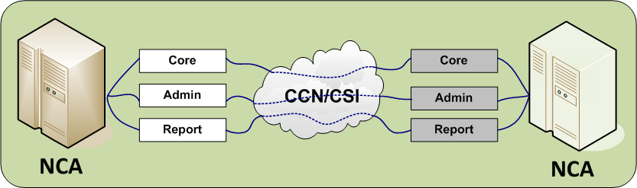
Figure 32: Normal Operations with an NCA
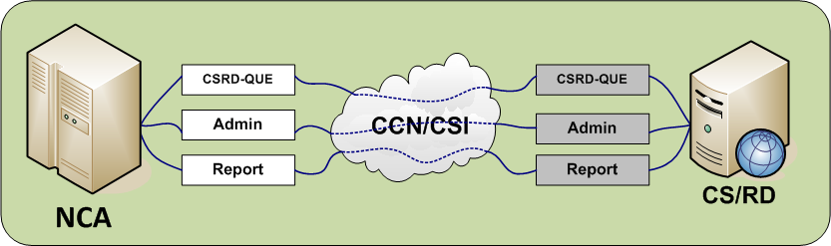
Figure 33: Normal Operations with CS/RD
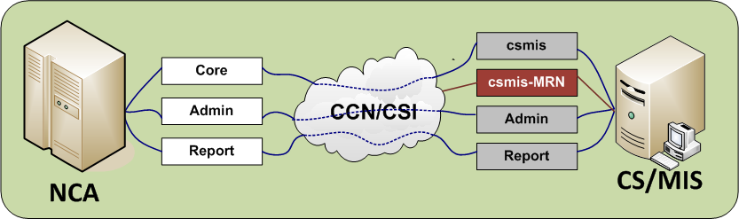
Figure 34: Normal Operations with CS/MIS
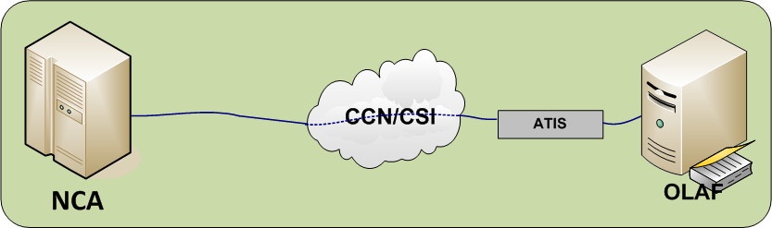
Figure 35: Normal Operations with OLAF (ATIS)
The following diagram graphically depicts the normal operations of an NCA that interacts with the EC SPEED Platform.
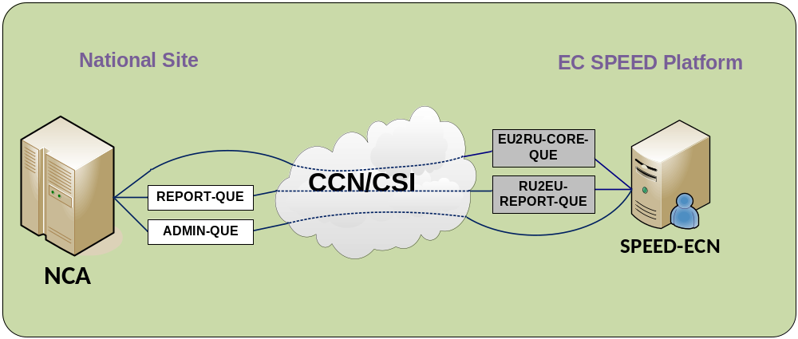
Figure 36: Interactions between an NCA and the EC SPEED Platform (SPEED-ECN) in Normal Operations environment

Common Domain Testing Environment
The following diagrams graphically depict the operations for Conformance Testing of an NCA.
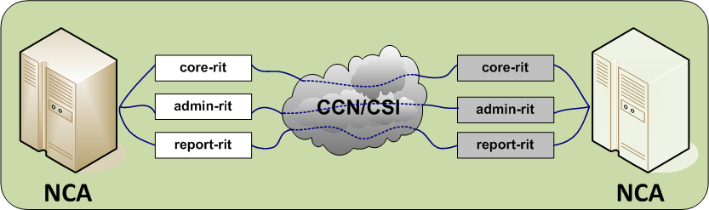
Figure 37: International Testing with another NCA
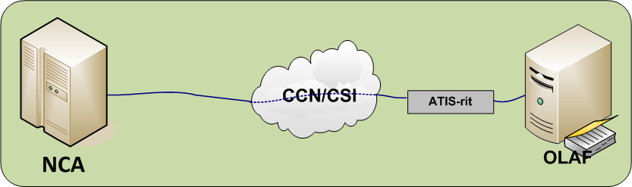
Figure 38: International Testing between NCA and OLAF
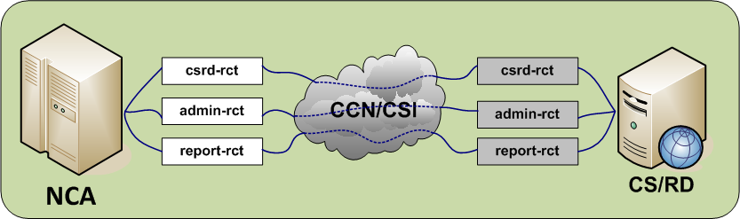
Figure 39: Testing with CS/RD
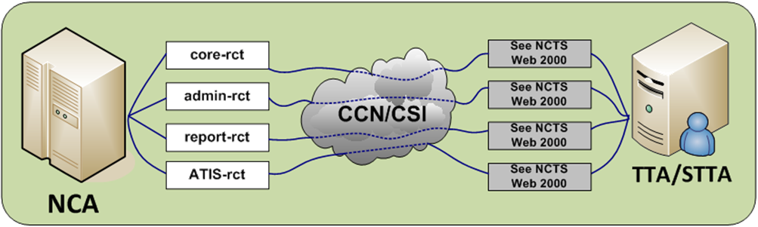
Figure 40: Conformance Testing
The following diagrams graphically depict the operations for Conformance and International Testing of an NCA that interacts with the EC SPEED Platform.
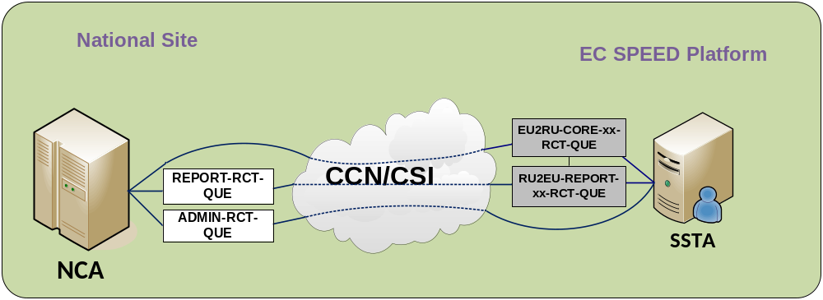
Figure 41: Interactions between an NCA and the EC SPEED Platform in Conformance testing environment with NCA
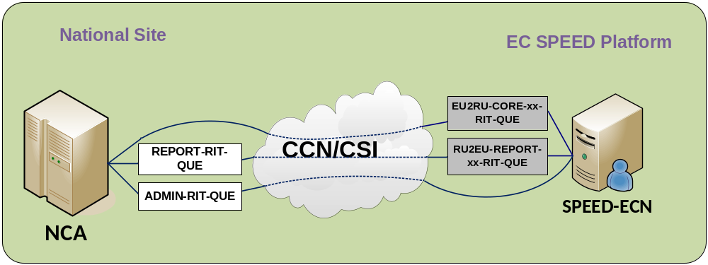
Figure 42: Interactions between an NCA and the EC SPEED Platform in International testing environment

National Testing and Training Environments
The following diagrams graphically depict the operations for National Testing of an NCA.
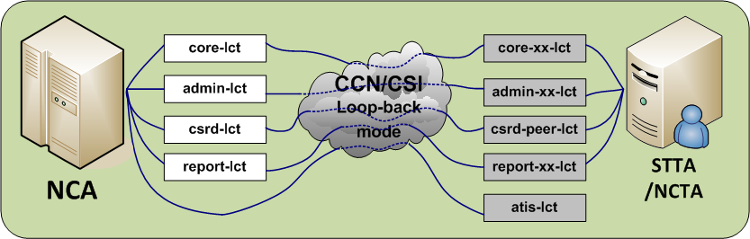
Figure 43: National Testing with STTA or NCTA
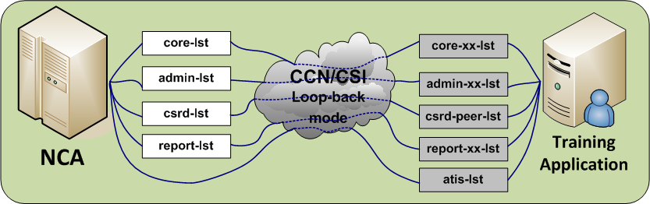
Figure 44: Training with a Training Application

Access Control List
User Profiles are defined by the ITSM at Configuration time (see paragraph VIII.4.6).
User Profiles are defined, corresponding to the different types of queues defined in each specific domain. The NA Local Security Officer associates User Identifiers with each of the User Profiles, as he/she deems useful.
These data are subsequently used when opening a security context (see paragraph VIII.2.9).

Recommended use of CCN/CSI
This section illustrates the use of CCN/CSI in a send and receive routine. This example is only a guide for implementation. It is up to each NA to implement its routines for sending and receiving. The specifications of both routines show the general sequence of synchronous interaction between the application and the corresponding CSI component on the Gateway (“Remote API Proxy”). They illustrate how and where the naming and addressing rules must be applied (examples of C-programs can be found in [A1]).
The routines are specified in a C-like pseudo-code. The setting of a number of parameters of CSI verbs is not shown when these are not relevant for this explanatory purpose.

Main routines
Typical execution phases are as follows:
- Program Connection phase:
  - Program binding to the CSI stack (HL_bind);
  - Establishment of a security context (HL_init_sec_context);
  - Connection to the local Queue Manager (HL_mq_conn).
- Sending phase:
  - Opening of a message queue with the appropriate options (HL_mq_open);
  - Encode the data descriptor passed by the application into another data descriptor, which will be handled by the Sending function, by using a Presentation profile, which corresponds to the Information Exchange type (HL_encode);
  - Send a message to a remote queue that has been opened for output (HL_mq_put). If a queue has not yet been opened, the verb HL_mq_put1 can be used. This latter verb also implies closing the queue after inserting the message into it;
  - Closing the opened message queue (HL_mq_close).
- Receiving phase:
  - Opening of a message queue with the appropriate options (HL_mq_open);
  - Destructive extraction of a message from a local queue (HL_mq_browse, HL_decode, and HL_mq_delete). This sequence of verbs is recommended, rather than the verb HL_mq_get, to overcome deletion of a message if it does not fit in a memory buffer;
  - Decode the received data descriptor into another data descriptor, for application usage. No application profile is to be communicated to this verb. This verb checks the correctness of the CodePage and HostFormat used;
  - Closing the opened message queue (HL_mq_close).
- Program Disconnection phase:
  - Disconnection from the Queue Manager (HL_mq_disc);
  - Destruction of the security context (HL_delete_sec_context);
  - Disconnection from the CSI stack (HL_unbind).
These four execution phases can be executed in a sequence as is for instance shown by Figure 45. Other sequences are also possible, e.g. parallel sending and reception of messages or parallel sending of messages to different queues. Another option is to combine the Sending and Receiving phases into one routine. This routine may first send and secondly read messages out of queues.
It is recommended to distinguish between priorities in sending and receiving, e.g. first browsing a queue for high priority messages before the messages with normal priority are received from the same queue.
For reception, all available queues for reading identified via the Access Control List need to be browsed. A sequence of browsing and reading is up to each application developer.
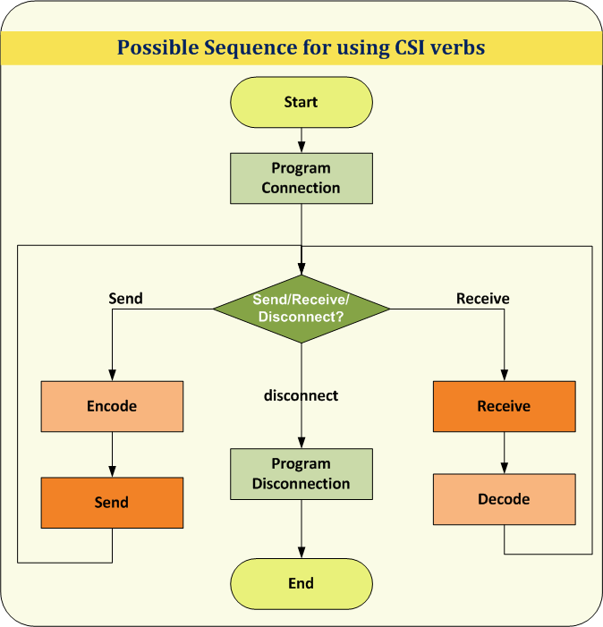
Figure 45: A possible sequence for using CSI verbs
Message queue opening and closing and queue access verbs, as shown in the Sending and Receiving phases, can be inter-mixed in any sequence with the restriction that queues must be properly opened before messages can be written to or read from it.
All program interactions are with the local Queue Manager running in the local CCN gateway. As a consequence, the transmission and processing delays do not slow sending or receiving programs and the response times are significantly improved.
Errors related to the use of CCN/CSI are specified in the appropriate CCN/CSI documentation. They have to be handled by an application program connecting to the CSI stack.
The next examples use the arguments (CSILONG) pReturnCode, pReasonCode as output parameters of a CSI verb. The first indicates success or failure and, in case of failure, the second gives the reason for failure. Working code should check these values after every CCN/CSI call.

Program connection
The following pseudo-code is given for connection of an application named “NCA” to the CCN Gateway.
Connect (out MQHCONN, Returncode)
- The result of the connection is an identifier that needs to be used for sending, receiving, and disconnecting a session with the CCN Gateway (MQHCONN). The result of the execution of this routine is given in Returncode. Errors for executing verbs can possibly be hidden in the connect routine by retrying to connect to the Gateway more than once. Some errors, e.g. there is no validated user password, which require a systems administrator to take action, need to be passed to the application.
HL_bind (in “NCA”, “”, out CSIQOS, pReturnCode, pReasonCode)
- “NCA” is now bound to the CSI stack. Default ProxyName was used (the empty string “”).
- Default QoS for “NCA” is returned by the Gateway in parameter CSIQOS.
- The first CSILONG indicates the success or failure of the verb execution, whereas the second specifies an error reason. If CSILONG indicates a failure, a retry of Connect may be tried, depending on the error reason.
- The application is in charge of obtaining security credentials: UserName equals “NCA” and, “UserPassword” and “ApplicationKey” have to be valid parameter values checked by the CCN Gateway. The variable SecurityInfo, with type CSISECINFO, has been filled as explained above in paragraph VIII.2.9.
HL_init_sec_context (in SecurityInfo, out pReturnCode, pReasonCode)
- Security context between Application Platform and CCN gateway is established. If the security context could not be established, the CSILONG parameters contain the success or failure with the associated reason. The application key and username is checked by the X.500 directory of the Gateway. Both parameters need to be known to the application.
HL_mq_conn (in Mqman, out MQHCONN, pReturnCode, pReasonCode)
- Application is connected to the message queue management system identified by Mqman. The Gateway returns the status of the execution of the verb and an identifier to be used during exchange of information between the “NCA” and the Gateway (MQHCONN).

Sending
For sending a EDIFACT interchange to a given queue in the context of a connection previously set up, the pseudo-code is as follows:
queuename: name of a queue as defined in previous paragraphs, for example:
CORE-LCT-QUE.NCTS@CUSTTAX.NL
send(in EDIFACT_interchange, queuename, MQHCONN, Correlation Identifier out ReturnCode, Correlation Identifier)
- The send routine is specified as a high level routine that returns an error if something failed that could not be solved internally by this routine. The send routine can be extended by its internal error handling, thus hiding some specific results returned by a CCN Gateway. These results can be hidden by, for instance, retrying certain verbs several times. The Correlation Identifier parameter is a list to store the reference that is used by a CCN report message.
prepare_objdesc(in queuename, out ObjDesc)
- A structure ObjDesc is used to pass the name of the queue to be opened.
HL_mq_open (in MQHCONN, ObjDesc, CSIMQOO_OUTPUT, out Handle, pReturnCode, pReasonCode)
- The target queue is open for output. The MQHCONN refers to the connection between the NCA and the Queue Manager. The name of the queue to open is retrieved in ObjDesc. The option CSIMQOO_OUTPUT makes the queue available for writing messages. The CSILONG parameters contain the result of the execution of the verb. The Handle is to be used for further access to the queue, once it has been opened.
HL_alloc (in sizeof(EDIFACT_interchange), out * pDataDesc, pReturnCode, pReasonCode
memcpy(pDataDesc->Data, EDIFACT_interchange, sizeof(EDIFACT_interchange))
- A CSI Data Descriptor structure is allocated for the message to be queued. The CSILONG parameters contain the result of the execution of the verb;
- The actual buffer to be sent is copied into the CSI Data Descriptor structure.
HL_encode (in pDataDesc, MSG_TYPE_ID, CodePage, HostFormat, out pDataDesc, pReturnCode, pReasonCode)
- The HL_encode adds the coding information into the Header field of the data descriptor. The code page and host format can be found in the included files generated by the presentation tools on the Gateway;
- The data descriptor used is that returned by the HL_alloc. It is used for input of the EDIFACT interchange and the same data descriptor is given for output. This use is recommended to avoid any unnecessary duplication of data;
- MSG_TYPE_ID is a value stored in the X500 directory of the CCN Gateway; while not actually modifying the data, it tags the message for technical statistics purpose.
HL_mq_put (in MQHCONN, Handle, inout pMsgAttributes, pPutOptions, pDataDesc, in CSIQOS, out pReturnCode, pReasonCode)
- The message is queued in the local CCN gateway and will be forwarded to the remote queue identified by the Handle. The pDataDesc contains the information to send;
- The result of the execution of the verb, its applied QoS and a reason in case of failure is returned by the Gateway. Additional code is needed to act upon the result;
- The QoS parameters are either the default ones or the changed ones. They contain the reference for correlating the result. The result itself can be received in the administration queue of the NCA. Separate receive routines need to be developed to correlate a Confirm On Delivery with a message.
HL_mq_close (in MQHCONN, Handle, CSIMQCO_NONE, out pReturnCode, pReasonCode)
- The queue is now closed.
HL_free (in pDataDesc, out pReturnCode, pReasonCode)
- The data descriptor structure is cleaned up.

Receiving
queuename: name of a queue as defined in previous paragraphs, for example:
CORE-LCT-QUE.ECS@CUSTTAX.NL
which is the incoming queue for national testing of the core flow messages by the Dutch installation of the NECA.
receive(in queuename, Correlation Identifier, MQHCONN, out Returncode)
- Receive can be made such that either one interchange is received or several. The example does not show that a result is returned but the result is copied to a file on disk that can be used for conversion to the internal data structure of the NCA. The way in which errors will be handled can be similar to the approach taken for sending;
- The Correlation Identifier is used for receiving a CCN report message. It might be stored in memory or on file and used whenever a CCN report message is received.
prepare_objdesc(in queuename, out ObjDesc)
- A structure ObjDesc is used to pass the name of the queue to be opened.
HL_mq_open (in MQHCONN, ObjDesc, CSIMQOO_BROWSE, out Handle, pReturnCode, pReasonCode)
- The queuename is now open for browsing.
HL_alloc (in sizeof(EDIFACT_interchange), out pDataDesc, pReturnCode, pReasonCode)
- A CSI Data Descriptor structure is allocated for the incoming EDIFACT interchange(s) with enough space for incoming message. If the browsing of the queue (step below) detects that still more room is needed, then HL_free and again HL_alloc have to be applied in this order;
HL_mq_browse (in MQHCONN, Handle, inout pMSGDesc, pBrowseOptions, out pDataDesc, MSGLEN, CSIQOS, pReturnCode, pReasonCode))
- The message has been taken non-destructively from the local queue.
HL_decode (in pDataDesc, CodePage, HostFormat, out pDataDesc, pReturnCode, pReasonCode)
- The message needs to be decoded according to the CodePage and HostFormat;
- This verb operates without using a Presentation profile because of its very purpose, which is to free the application from this burden;
- It is recommended to put the message on a disk before deleting it from a queue. This is to prevent loss of messages in case of systems failure between deleting and storing a message.
If
(pMSGDesc.MsgType = ‘CSI_MQMT_REPORT’ and pMSGDesc.Feedback in_set(‘CSIMQFB_COD’,‘CSIMQFB_COA’, ‘CSIMQFB_EXPIRATION’, ‘CSIMQRC_*’))
then
checkCCN_REP (in Correlation Identification, pDataDesc.pMSGDesc, out returncode)
- If the correlation of a received CCN report with an identifier contained in the Correlation Identification structure is not successful, an error is returned and the CCN report is deleted. The error needs to be logged. If it is successful, the Correlation Identification is updated to log the reception of the CCN report. These actions are not shown here.
HL_mq_delete (in MQHCONN, Handle, inout pMSGDesc, pDeleteOptions, out pReturnCode, pReasonCode))
- The message has been deleted from the local queue.
HL_mq_close (in MQHCONN, & Handle, CloseOptions, out pReturnCode, pReasonCode)
- The queue is now closed. The Handle is no longer valid.
HL_free (in pDataDesc, out pReturnCode, pReasonCode)
- The data descriptor structure is cleaned up.

Program disconnect
disconnect (in MQHCONN, out Returncode)
- The purpose is to release the session with the CCN Gateway. It can be successful or fail.
HL_mq_disc (inout MQHCONN, out ReturnCode, ReasonCode)
- The application is disconnected from the message queuing system or not. See ‘ReasonCode’ values for this verb in [A7].
HL_delete_sec_context (out ReturnCode, ReasonCode)
- The security context is deleted, either successful or not. See ‘ReasonCode’ values for this verb in [A6].
HL_unbind (out ReturnCode, ReasonCode)
- The session is terminated either successful or not. There is no entry for this verb [A6].

Configuration information

Introduction
This chapter presents the steps that need to be performed to set up the parameters on the CCN Gateways.
This chapter is divided into:
- The information to be prepared by a NA for all objects that are specific to each NA;
- The information to be prepared by ITSM and that are required to ensure end-to-end interoperability.
Chapter 5 of document [R9] presents a Responsibility Model that distributes the choices to be taken between several roles. It is applicable for all Customs systems. The roles applicable for Customs movement systems are:
Roles for Customs Systems
CDIA | the ITSM/CCN-OPS Directory Administrator, responsible for the central management of the CCN directory.
CASO | the Central Application Security Officer, responsible for security issues that concern a given application of the Taxation and Customs Union DG, running over the CCN/CSI system. This is actually the ITSM.
CSO | ITSM/CCN-OPS Central Security Officer.
LAD | a Local Application Designer, responsible for the design of an NDCA program. In the case of a CDCA, the contractor designer has to further subdivide the design issues between what the CDCA was able to decide and what is left to the NA development to decide.
LSO | the Local Security Officer, responsible for security issues for an NDCA.
LSYA | the Local System Administrator for the NDCA infrastructure, responsible for the system management.
LAA | the Local Application Administrator for the NDCA infrastructure, responsible for the management of the CCN directory data related to the local users of NDCA: this amounts to maintaining the list of UserIds with respect to UserProfiles.
Table 33: Roles for Customs Systems

Configuration information to be provided by the NA
Security aspects for Customs systems are defined in [R3].
Concerning CCN/CSI exchanges, a number of standard security features of the CCN/CSI network will be used. The NA only needs to set up the proper security configuration on their gateways, in co-ordination with the ITSM/CCN-OPS. For CCN/CSI exchanges, document [A5] is containing additional information on security aspects.

Collection of External Configuration Data
The words ‘Entity’ and ‘Attributes’ used in Table 34 refer to the ERD defined in [R9].
The associated values depend on the technical infrastructure that exists within an NA.
These values have to respect the “Formatting Rules” defined in heading 5.3 of [R9].
The values have to be entered onto forms in Annex C of [R9].
It is necessary to cooperate with ITSM for the practical handling of these forms as shown in Table 34.
Entity | Attribute | Provided by | Managed by
Application | ccnApplicationName | LAD | CDIA
Application | ccnApplicationType | LAD | CDIA
Application | ccnAddress | LAD | CDIA
Application | ccnAddressType | LAD | CDIA
Application | ccnAuthorizedSecurityMechanisms | LAD | CDIA
Application | ccnDefaultSecurityMechanisms | LAD | CDIA
Application | ccnDataRepresentationRules | LAD | CDIA
Application | ccnDefaultCodePage | LAD | CDIA
Application | ccnApplicationActivationMode | LAD | CDIA
Application | ccnApplicationExchangeMode | LAD | CDIA
Application | ccnConversationalModeEnabled | LAD | CDIA
Application | ccnApplicationSecurityKey | LSO | LSA or LAA
Application | ccnDefaultQOS | LAD | CDIA
Application | ccnOperationalStatus | LSYA | CDIA
Application | ccnPlatformName | LAD | CDIA
Application | ccnRAPName | LAD | CDIA
Platform | ccnPlatformName | LAD | CDIA
Platform | ccnAddress | LAD | CDIA
Platform | ccnAddressType | LAD | CDIA
Platform | ccnAuthorizedSecurityMechanisms | LAD | CDIA
Platform | ccnDefaultSecurityMechanisms | LAD | CDIA
Platform | ccnDataRepresentationRules | LAD | CDIA
Platform | ccnDefaultCodePage | LAD | CDIA
Platform | ccnOperationalStatus | LSYA | CDIA
Queue | ccnQueueName | LAD | CDIA
Queue | ccnTriggerEnabled | LAD | CDIA
Queue | ccnTriggerType | LAD | CDIA
Queue | ccnMaxQueueDepth | LAD | CDIA
Queue | list of ccnApplicationName | LAD | CDIA
Remote API Proxy | ccnRAPName | LAD | CDIA
Remote API Proxy | ccnMinNbOfRAPInstances | LAD | CDIA
Remote API Proxy | ccnMaxNbOfRAPInstances | LAD | CDIA
User | ccnUserName | LSO | LSA or LAA
User | ccnUserPassword | LSO | LSA or LAA
User | ccnUserDisabled | LSO | LSA or LAA
User | ccnOrganisationName | LSO | LSA or LAA
User | list of ccnUserProfileId | LSO | LSA or LAA
Table 34: External Configuration Data defined by NA

Message configuration procedure
The general message configuration procedure is performed by ITSM.
Note that the information ‘ccnDataRepresentationRules’ and ‘ccnDefaultCodePage’ presented in paragraph VIII.4.3 will be used by the CCN Technical Centre to generate files specific to the NCA development.

Configuration information to be provided by the Customs systems Central Operation

Collection of External Configuration Data
Entity | Attribute | Provided by | Managed by
Application | ccnDefaultQOS | LAD-CAD | CDIA
CCN/CSI organisation | ccnOrganisationName | CDIA | CDIA
CCN gateway | ccnGatewayName | CDIA | CDIA
Message | ccnMessageId | CAD | CDIA
Message | ccnMessageFormalDefinition | CAD | CDIA
Queue | list of ccnUserProfileId | CASO | CSA
Queue | list of ccnUserProfileId | CASO | CSA
Queue | ccnGatewayName | CAD | CDIA
Remote API Proxy | ccnGatewayName | CAD | CDIA
User profile | ccnUserProfileId | CASO | CSA
Table 35: External Configuration Data defined by ITSM
The values to be configured by ITSM are detailed below.

ccnDefaultQOS
As explained in the value configured on all Gateways for all applications may be overridden upon each call (HL_mq_put() or HL_mq_put1()) performed by an application. The values from Table 36 will be entered into CCN/CSI application configuration form -part 4:
- Priority: | 5
- ReportRequest: | - Exception  - Expiration  - Confirm on Arrival  - Confirm on Delivery  - PassMessageId  - PassCorrelId
- ReplyToQ: | left empty
- Integrity: | Forbidden
- Confidentiality: | Forbidden
- Compression: | Forbidden
- CompressionId: | LZW
- DegradedMode: | NotAllowed -- N/A anyway
- CoT: | DEFAULTCOT
Table 36: Configuration of default QoS

ccnGatewayName
See Table 35.

ccnOrganisationName
See Table 34 and Table 35.

ccnMessageId
[Msg Type]-MSG.[DOMAIN]
Where
- [Msg Type] is the message type of the IE, defined in the domain specific DDNA volumes ([R16], [R17] and [R18]);
- [DOMAIN] is the domain (e.g. NCTS, ECS or ICS).
An indicative example for a ccnMessageId for NCTS is the following:
CD001A-MSG.NCTS

ccnMessageFormalDefinition
See paragraph VIII.4.13.

ccnUserProfileId
Syntax for defining the ccnUserProfileId is:
[UserProfileId][ApplicationModeSuffix]-PRF.DOMAIN
Where “DOMAIN” represents the specific Customs system name e.g. NCTS, ECS, ICS. The UserProfileIds correspond to the following queues:
- CORE-QUE
- EU2RU-CORE-QUE
- ADMIN-QUE
- REPORT-QUE
- RU2EU-REPORT-QUE
- CSRD-QUE
- CSMIS-QUE
- STAT-QUE
- AUDIT-QUE
- CORE-RCT-QUE
- ADMIN-RCT-QUE
- REPORT-RCT-QUE
- CSRD-RCT-QUE
- CSMIS-RCT-QUE
- STAT- RCT-QUE
- AUDIT- RCT-QUE
- CORE-LCT-QUE
- CORE-xx-LCT-QUE
- ADMIN-LCT-QUE
- ADMIN-xx-LCT-QUE
- EU2RU-CORE-xx-RCT-QUE
- EU2RU-CORE-RIT-QUE
- REPORT-LCT-QUE
- REPORT-xx-LCT-QUE
- CSRD-LCT-QUE
- CSRD-PEER-LCT-QUE
- ATIS-LCT-QUE
- CORE-LST-QUE
- CORE-xx-LST-QUE
- ADMIN-LST-QUE
- ADMIN-xx-LST-QUE
- REPORT-LST-QUE
- REPORT-xx-LST-QUE
- RU2EU-REPORT-xx-RCT-QUE
- RU2EU-REPORT-RIT-QUE
- CSRD-LST-QUE
- CSRD-PEER-LST-QUE
- ATIS-LST-QUE
- CSMIS-MRN-QUE
- CSMIS-MRN-RCT-QUE
- CORE-axx-RCT-QUE
- ADMIN-axx-RCT-QUE
- REPORT-axx-RCT-QUE
- CORE-RIT-QUE
- ADMIN- RIT-QUE
- REPORT-RIT-QUE
- ATIS-axx-RCT-QUE
- ATIS-QUE
- ATIS-RIT-QUE
Notes:
In the above list,
- “a” is the TTA Role, which are defined in the TTA SRD [R22];
- “xx” is a value 01 – YY creating a string, which indicates the different queues for use by TTA/STTA;
- The following queues “ATIS-LCT-QUE”, “ATIS-LST-QUE”, “ATIS-axx-RCT-QUE”, “ATIS-QUE”, “ATIS-RIT-QUE”, EU2RU-CORE-QUE, RU2EU-REPORT-QUE, EU2RU-CORE-xx-RCT-QUE, EU2RU-CORE-RIT-QUE, RU2EU-REPORT-xx-RCT-QUE and RU2EU-REPORT-RIT-QUE are applicable only to NCTS domain.

Message configuration procedure
In Figure 46, an example of IDL definition is depicted (part of the IDL definition) for the NCTS messages, which are exchanged over the Common Domain. A full definition of all messages of each domain will be contained in the corresponding domain specific DDNA volumes ([R16], [R17] and [R18]). There, the MsgTypeId of each message is defined. The report messages are not defined with an IDL description.
The ITSM must have this IFL definition compiled by the ITSM/CCN-OPS service and must forward to each NA the files obtained from this compilation. Section 6 of document [R9] has to be followed for this process.
The IDL definition of CCN Messages for each domain is based on the following syntax:
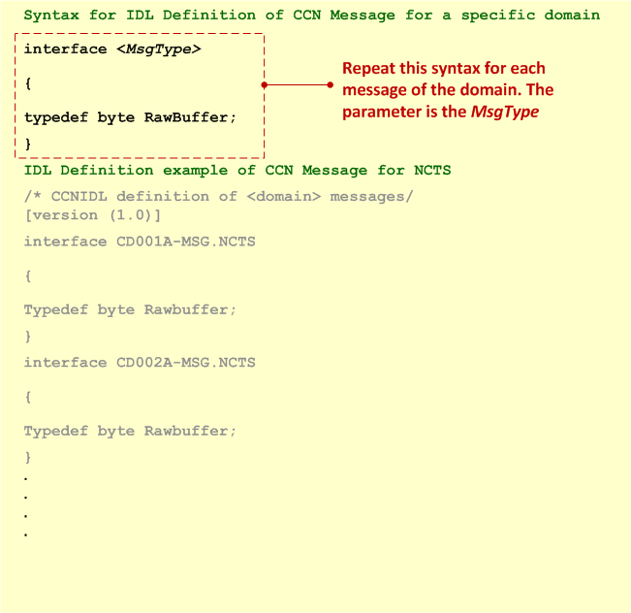
Figure 46: Example of IDL definition of CCN Messages for NCTS

Description of statistics

Introduction
The explanations in this chapter are extracted and summarised from documents produced by ITSM/CCN-OPS.
The CCN/CSI system includes a statistics service, which allows collection of various statistics information about the traffic generated by any application domain relying on the CCN/CSI infrastructure.
Files holding statistics information are first created locally on each CCN gateway, are later transferred and archived on a ITSM/CCN-OPS gateway and are finally dispatched to the ITSM. See [A1] for details about the CCN/CSI statistics generation, centralisation and dispatch processes and [A2] for the specification of the CSI application to be used by ITSM to receive the statistics files dispatched by the ITSM/CCN-OPS .

Requirement to be fulfilled by ITSM/CCN-OPS
Two pairs of daily statistics files must be generated on each CCN gateway participating in the Customs systems: one pair for each system and each pair will consist of two files.
The first file (MSGS) provides information about the Customs system application messages. It contains a detailed view of the type, number and size of the Customs system application messages exchanged between the NA participating in the Customs system during that day.
The second file (REPS) provides information about the report messages associated to these Customs system application messages. It contains a detailed view of the type and number of report messages associated to these Customs system application messages during that day.

Specification of the MSGS file
The MSGS file is a plain ASCII file, composed of a sequence of lines formatted as follows: NA;DIR;TYPE;NBMSG;AVSZ;MINSZ;MAXSZ (Table 37).
Specification of the MSGS file
NA | Is the ISO identifier of the remote NA for which statistics are provided (AT, BE, …).
DIR | Indicates whether the statistics provided concern outgoing or incoming Customs system application messages (“O” for application messages sent to the Common Domain, “I” for application messages received from the Common Domain).
TYPE | Is the CCN/CSI message type identifier for which statistics are provided; it is identical to the MessageTypeId listed in the domain specific volumes.
NBMSG | Gives the number of Customs system application messages of type TYPE sent (DIR = “O”) or received (DIR = “I”) to or from administration NA.
AVSZ | Gives the average size of these NBMSG messages.
MINSZ | Gives the minimum message size among these NBMSG messages.
MAXSZ | Gives the maximum message size among these NBMSG messages.
Table 37: Specification of the MSGS file

Specification of the REPS file
The REPS file is a plain ASCII file, composed of a sequence of lines formatted as follows: NA;DIR;TYPE;NBARR;NBDEL;NBEXC;NBEXP (Table 38).
Specification of the REPS file
NA | Is the ISO identifier of the remote NA for which statistics are provided (AT, BE, …).
DIR | Indicates whether the statistics provided concern outgoing or incoming Customs system application messages (“O” for application messages sent to the Common Domain, “I” for application messages received from the Common Domain).
TYPE | Is the CCN/CSI message type identifier for which statistics are provided.
NBARR | Gives the number of “confirmation on arrival” report messages, generated on Customs system application messages of type TYPE and sent (DIR = O) or received (DIR = I) to or from administration NA.
NBDEL | Gives the number of “confirmation on delivery” report messages, generated on Customs system application messages of type TYPE and sent (DIR = O) or received (DIR = I) to or from administration NA.
NBEXC | Gives the number of “exception” report messages, generated on Customs system application messages of type TYPE and sent (DIR = O) or received (DIR = I) to or from administration NA.
NBEXP | Gives the number of “expiration” report messages, generated on Customs system application messages of type TYPE and sent (DIR = O) or received (DIR = I) to or from administration NA.
Table 38: Specification of the REPS file

Transport of messages via the Inter(extra)net

Introduction
Within this section, some common Internet principles are stated.
All exchanges are based upon exchanges via the HTTP 1.1 protocol (RFC-2068).
Some general principles hold for the HTTP communication.
- The client sends requests using the HTTP/1.0 Basic Access Authentication over SSL. This assumes that the server side knows the password of the user that is managed by use of the Project web site logon facility. As a consequence of this use of the HTTP authentication, the user’s identity is sent with each HTTP request. More information on the security aspect can be found in chapter IX.2;
- Client requests in which parameters are passed to the CS/RD or CS/MIS system conform to the MIME specifications (RFC-2045, RFC-2046, RFC-2047, RFC-2048 and RFC-2049). They are encoded using the media type “multipart/formdata” as described in RFC-1867. MIME defines a wrapper for the useful data. The use of MIME and RFC-1867 allows the client to send files to the HTTP-server using a web-browser;
- A client request parameter may have only one value unless specified otherwise;
- Some requests can take some time to process. The client gets an immediate reply when such a request has been received but the result of the processing is only available for download after some time. It is made available immediately after the processing.

Security
For the CS/RD and CS/MIS applications, the most important security aspects that must be covered are identification and authentication. These are needed for functional and data access control and for logging purposes. Since the communication is HTTP based, the communication system described here inherits the security properties and possibilities of HTTP. The current recommended version is HTTP/1.1, which offers two authentication schemes.
The first scheme is called the “Basic” authentication scheme. The second scheme is the so-called “Digest” authentication scheme.
The latter digest-based scheme, as described in RFC-2069, is safer. As iPlanet server and Netscape Navigator do not support Digest Authentication, Basic Authentication will be used by the CS/MIS and CS/RD applications over SSL.
In order to have extra security, the HTTP protocol can operate over a secure connection. For example, HTTP over SSL (HTTPS) can be used without major changes to the exchange procedure used, giving the client reason to trust the server. Optionally, SSL could be used by the HTTP-server for authentication of the client.
The use of HTTPS is mostly part of the system installation and only visible to the application through the use of different URIs (https://…). The use of HTTP over a secure layer improves the system with higher integrity guarantees.

This history shows for historical reasons the last two releases of the DDNTA before it was restructured into the DDNA. This version is the first version of the DDCOM submitted for review.
Action: I = Insert; R = Replace
This history shows for historical reasons the last release of the DDNTA before it was restructured into the DDNA.
URI stands for Uniform Resource Identifier, and is equal to the name of the Web page where some information can be retrieved. It should be considered as the address where information is available.
National RD is composed of country and regional holiday data.
This also implies that an IE031 cannot contain data on more than one country (since IE030 messages cannot either).
Only Common Domain users are allowed to modify Common Reference Data.
Only Common Domain users are allowed to modify Common Reference Data.
Please note that CS/RD produces an IE906 only in the case that a message with invalid message type has been submitted via CCN/CSI. In all other cases, CS/RD responds with an IE913 if the submitted message contains a functional error.
The EO statistics are out of the CS/MIS scope and are provided by the EOS CDCO.
The IE71 is also sent to the country from which the IE070 or IE912 originated.
Only Common Domain users are allowed to upload IE032 messages.
As already stated, only common domain users are allowed to upload IE032 messages.
URI that is the entry point for the CS/RD system in manual mode.
These other parameters are specified in section that explains the exchange protocols.
A message contains an action Data Group for every modifiable occurrence.
Only Common Domain users are allowed to upload IE032 messages.
A syntax error is defined as an incorrect formatting (in XML or EDIFACT) of the message or an incorrect technical message structure (violation of the building rules as defined in the corresponding DDNA Appendix Q). In such case, the message is always rejected as a whole and is not further parsed.
Currently IE919 is only included in the scope of NCTS.
The numeric value zero (0) is not considered as positive integer or as positive decimal value. The only exception is time numerical fields where the numeric value zero (0) may be used
The only exception is time numerical fields where leading zeros may be used.
The syntax of the Error pointer value defined in Table 14 specifies what string literals are applicable and how those can be used as part of the notation.
For exchanges with OLAF in the context of NCTS P4 and ATIS, the Application Name shall be “ATIS”. For exchanges with the EC SPEED Platform in the context of the pilot project NCTS TIR RU, the Application Name shall be "EUECN".
The complete specification of XML 1.0 can be found at http://www.w3.org/TR/1998/REC-xml-19980210?.
Optionally CC may be replaced with the ISO Country Code of the NA that exchanges an Information Exchange within the National domain.
Represents the version of the FMS structure.
Represents the version of the FMS structure.
This pattern restriction is based on the definition that appears in the “Proposal for Structure of Reference Numbers in NCTS-DGXXI/0627/97-Rev.3” and in the “Check Character Algorithm for the MRN and GRN-DGXXI/0879/99- Rev.3”.
If in future versions this assumption changes, this section will need to be reviewed in that respect. Only EDIFACT messages of the same priority are combined in one interchange
This environment will be configured to work in loopback mode, not to exchange messages with other Gateways.
This environment will be configured to work in loopback mode, not to exchange messages with other Gateways.
Please note that no queues are defined for NAs for this function.
Please note that no queues are defined for NAs for this function.
No queues are defined for NAs for this function. The IE919 (reply to IE918) will be enqueued to the ADMIN queue.
Please note that no queues are defined for NAs for this function.
Please note that these chapters focus on the queues to be used by the National Applications. The queues on the Taxation and Customs Union DG gateway and the European Anti-fraud Office gateway that are not part of country-specific configuration are added, as well. Otherwise, they are made available to all NAs.
The CORE-RIT-QUE, ADMIN-RIT-QUE, REPORT-RIT-QUE are to be used for International Testing (Mode-3) between NAs. The ADMIN-RIT-QUE and the REPORT-RIT-QUE queues shall also be used for International testing with EC SPEED Platform. The ADMIN-RCT-QUE and the REPORT-RCT-QUE queues shall be used for the SPEED Conformance Testing.
The CORE-LCT-QUE, ADMIN-LCT-QUE, REPORT-LCT-QUE, CSRD-LCT-QUE are queues meant to be attached to the National Customs Application (NCA), while the others are meant to be attached to the local Testing Application (STTA or NCTA).
The CORE-LST-QUE, ADMIN-LST-QUE, REPORT-LST-QUE, CSRD-LST-QUE are queues meant to be attached to the National Customs Application (NCA), while the others are meant to be attached to an application for Training purposes.
This queue will be used by the EC SPEED Platform to receive IE012 message from NTAs in the scope of the pilot project NCTS TIR RU.
This queue will be used by the EC SPEED Platform to receive CCN/CSI Reports for IE907 message. The IE907 message is sent in the scope of the pilot project NCTS TIR RU in response to an invalid IE012 message.
The National Customs Applications will use this queue for sending of IE411 operational messages to ITSM.
This queue will be used by the CS/MIS application at ITSM to collect ITSM/CCN-OPS technical statistics files.
This queue will be used to collect CCN/CSI audit files from ITSM/CCN-OPS.
Only the NTAs will use this queue for sending of IE918 messages to CS/MIS.
The Common Domain Testing environment at the Taxation and Customs Union DG Gateway is used for several purposes: - NCTS Conformance Testing using the TTA or STTA and ECS Conformance Testing using the TTA or STTA (CORE-axx-RCT-QUE, ADMIN-axx-RCT-QUE, and REPORT-axx-RCT-QUE) The exact configuration of the queues and their name used for Conformance Testing will be communicated to the NAs; - SPEED Conformance Testing using the SSTA (EU2RU-CORE-xx-RCT-QUE, RU2EU-REPORT-xx-RCT-QUE). The exact configuration of the queues and their name used for Conformance Testing will be communicated to the NAs on the Project web site; - International Testing will be performed using the EU2RU-CORE-RIT-QUE, RU2EU-REPORT-RIT-QUE queues, which shall be used for the communication with the EU MS; - CS/RD Conformace environment is used by CS/RD to perform all exchanges with the CS/RD Conformance Environment. These queues are shown in Table 31; - CSMIS-RCT-QUEUE, AUDIT-RCT-QUE and STAT-RCT-QUE have been defined but are not yet foreseen to be used; - ATIS-axx-RCT-QUE has been defined in order to be used in the NCTS Conformance Testing using the TTA.
The National Testing queues defined on the Taxation and Customs Union DG gateway are not use for any interaction with NAs and are, therefore, not defined in DDNA. Taxation and Customs Union DG uses these queues for internal testing purposes.
The Training queues defined on the Taxation and Customs Union DG gateway are not use for any interaction with NAs and are therefore not defined in DDNA. Taxation and Customs Union DG uses these queues for training purposes.
The Common Domain Testing queues defined on the European Anti-fraud Office Gateway are used for International Testing (Mode-3) between NA and OLAF.
The National Testing queues defined on the European Anti-fraud Office Gateway are not used for any interaction with NAs and are therefore not defined in DDNA. European Anti-fraud Office (OLAF) uses these queues for internal testing purposes.
The Training queues defined on the European Anti-fraud Office Gateway are not used for any interaction with NAs and are therefore not defined in DDNA. European Anti-fraud Office (OLAF) uses these queues for training purposes.
Please note that the information exchange continues after SPEED-ECN with the SPEED-BRIDGE and Russian FCS, however, this communication is not shown in this figure since it is out of scope of this document.
Please note that the information exchange continues after SPEED-ECN with the SPEED-BRIDGE and Russian FCS, however, this communication is not shown in this figure since it is out of scope of this document.

