Jawaharlal Nehru Engineering College

Laboratory Manual

DIGITAL ELECTRONICS

For

Second Year Students CSE
Dept: Computer Science & Engineering (NBA Accredited)

1

FOREWORD

It is my great pleasure to present this laboratory manual for Second year engineering students for the subject of Digital Electronics keeping in view the vast coverage required for visualization of concepts of Digital Electronics with simple language.

As a student, many of you may be wondering with some of the questions in your mind regarding the subject and exactly what has been tried is to answer through this manual.

As you may be aware that MGM has already been awarded with ISO
9000 certification and it is our endure to technically equip our students taking the advantage of the procedural aspects of ISO 9000 Certification.

Faculty members are also advised that covering these aspects in initial stage itself, will greatly relived them in future as much of the load will be taken care by the enthusiasm energies of the students once they are conceptually clear.

Dr S.D.Deshmukh
Principal

2
LABORATORY MANUAL CONTENTS

This manual is intended for the Second year students of CSE branches in the subject of Digital Electronics . This manual typically contains practical/Lab Sessions related Digital Electronics covering various aspects related the subject to enhanced understanding.

Students are advised to thoroughly go though this manual rather than only topics mentioned in the syllabus as practical aspects are the key to understanding and conceptual visualization of theoretical aspects covered in the books.

Good Luck for your Enjoyable Laboratory Sessions

Dr. V. B. Musande Ms. Kajal C. Agrawal
HOD, CSE Asst. Prof, CSE Dept.

3
MGM’s

Jawaharlal Nehru Engineering College, Aurangabad
Department of Computer Science and Engineering

Vision of CSE Department

To develop computer engineers with necessary analytical ability and human values who can creatively design, implement a wide spectrum of computer systems for welfare of the society.

Mission of the CSE Department:
Preparing graduates to work on multidisciplinary platforms associated with their professional position both independently and in a team environment.
Preparing graduates for higher education and research in computer science and engineering enabling them to develop systems for society development.

Programme Educational Objectives

Graduates will be able to

- To analyze, design and provide optimal solution for Computer Science & Engineering and multidisciplinary problems.
- To pursue higher studies and research by applying knowledge of mathematics and fundamentals of computer science.
- To exhibit professionalism, communication skills and adapt to current trends by engaging in lifelong learning.

Programme Outcomes (POs):
Engineering Graduates will be able to:

- Engineering knowledge: Apply the knowledge of mathematics, science, engineering fundamentals, and an engineering specialization to the solution of complex engineering problems.

- Problem analysis: Identify, formulate, review research literature, and analyze complex engineering problems reaching substantiated conclusions using first principles of mathematics, natural sciences, and engineering sciences.

- Design/development of solutions: Design solutions for complex engineering problems anddesign system components or processes that meet the specified needs with appropriate consideration for the public health and safety, and the cultural, societal, and environmental considerations.

- Conduct investigations of complex problems: Use research-based knowledge and research methods including design of experiments, analysis and interpretation of data, and synthesis of the information to provide valid conclusions.

- Modern tool usage: Create, select, and apply appropriate techniques, resources, and modern engineering and IT tools including prediction and modeling to complex engineering activities with an understanding of the limitations.

- The engineer and society: Apply reasoning informed by the contextual knowledge to assess societal, health, safety, legal and cultural issues and the consequent responsibilities relevant to the professional engineering practice.

- Environment and sustainability: Understand the impact of the professional engineering solutions in societal and environmental contexts, and demonstrate the knowledge of, and need for sustainable development.

- Ethics: Apply ethical principles and commit to professional ethics and responsibilities and norms ofthe engineering practice.

- Individual and team work: Function effectively as an individual, and as a member or leader in diverse teams, and in multidisciplinary settings.

- Communication: Communicate effectively on complex engineering activities with the engineering community and with society at large, such as, being able to comprehend and write effective reports and design documentation, make effective presentations, and give and receive clear instructions.
- Project management and finance: Demonstrate knowledge and understanding of the engineering and management principles and apply these to one’s own work, as a member and leader in a team, to manage projects and in multidisciplinary environments.

- Life-long learning: Recognize the need for, and have the preparation and ability to engage independent and life-long learning in the broadest context of technological change.
DOs and DON’Ts in Laboratory:

1. Make entry in the Log Book as soon as you enter the Laboratory.

2. All the students should sit according to their roll numbers starting from their left to right.

3. All the students are supposed to enter the terminal number in the log book.

4. Do not change the terminal on which you are working.

5. All the students are expected to get at least the algorithm of the program/concept to be implemented.

6. Strictly observe the instructions given by the teacher/Lab Instructor.

Instruction for Laboratory Teachers::

1. Submission related to whatever lab work has been completed should be done during the next lab session. The immediate arrangements for printouts related to submission on the day of practical assignments.

2. Students should be taught for taking the printouts under the observation of lab teacher.

3. The promptness of submission should be encouraged by way of marking and evaluation patterns that will benefit the sincere students.

SUBJECT INDEX

1. Study of digital ICs & verification of Logic Gates

2. Study & verification of operation of Half Adder & Full Adder.

3. Given a 4-variable logic expression, simplify it using Entered Variable Map and realize the simplified logic expression using 8:1 multiplexer IC.

4. Design and develop the Verilog /VHDL code for an 8:1 multiplexer. Simulate and verify its working.

5. Realize a J-K Master / Slave Flip-Flop using NAND gates and verify its truth table.

6. Design and develop the Verilog / VHDL code for D Flip-Flop with positive-edge triggering. Simulate and verify its working.

7. Design and implement a mod-n (n<8) synchronous up counter using
JK Flip-Flop ICs and demonstrate its working.

8. Design and develop the Verilog / VHDL code for mod-8 up counter. Simulate and verify its working.

9. Design and implement a ring counter using 4-bit shift register and demonstrate its working.

10. Design and develop the Verilog / VHDL code for switched tail counter. Simulate and verify its working.

11. Design and implement an asynchronous counter using decade counter
IC to count up from 0 to n (n<=9) and demonstrate its working.

Experiment No.1
Aim: To Study and verification of logic gates such as AND, OR, NOT, NAND, NOR, XOR
Apparatus: Bread board, wires, IC-7400,7402,7404 ,7408, 7432,7486
Theory:
1. AND:
Logical AND operation is defined as “the output is 1 iff all the inputs are 1”
Circuit of logical AND is shown below. It has N inputs (N>=2) and one output.
Digital signals are applied at the input terminal marked A,B,C….,N, the other terminal
being grounded(not shown in diagram)The output is obtained at the terminal marked Y,
and it is also a digital signal.

Fig1. LOGIC DIAGRAM OF AND GATE
Mathematically, AND operation is written as
Y=A AND B AND C
Y=A .B. C
Y=ABC…..N
Pin diagram and Truth Table for AND operation
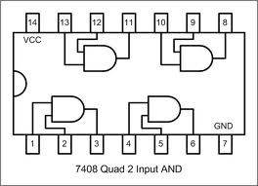
A | B | Y | Y1 | Y2 | Y3 | Y4
0 | 0 | 0
0 | 1 | 0
1 | 0 | 0
1 | 1 | 1
2. OR:
Logical OR operation is defined as “the output is 1 if at least one of the inputs is 1”.
Circuit of logical OR is shown below. It has N inputs (N>=2) and one output. Digital
signals are applied at the input terminal marked A, B, C….,N, the other terminal being
grounded(not shown in diagram).The output is obtained at the terminal marked Y, and it
is also a digital signal.

Fig 2.LOGIC DIAGRAM OF OR GATE
Mathematically,
OR operation is written as
Y=A OR B OR C
Y=A +B+C+……+N
Pin diagram and Truth Table for OR operation
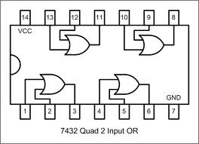
A | B | Y | Y1 | Y2 | Y3 | Y4
0 | 0 | 0
0 | 1 | 1
1 | 0 | 1
1 | 1 | 1

3.NOT:
Logical NOT operation is also called as Inverter. It has one input (A) and one output
(Y).Its logic Equation is written as
Y = NOT A
And is read as “Y equals not A” or “Y equals complement of A”.
Fig 3.LOGIC DIAGRAM OF NOT GATE

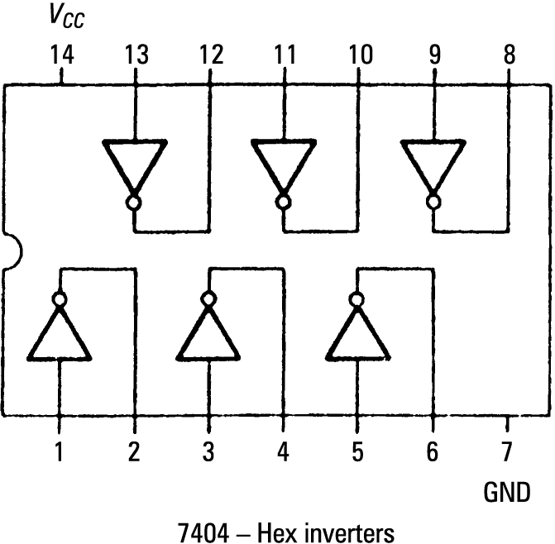

A | Y | Y1 | Y2 | Y3 | Y4 | Y5 | Y6
0 | 1
1 | 0
4. NAND Gate:
The output is 1 when either of inputs A or B is 1, or if neither is 1. In other
words, it is normally 1, going 0 only if both A and B are 1.
Fig 4.LOGIC DIAGRAM OF NAND GATE

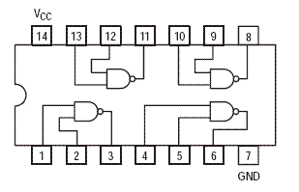 7400 quad 2 i/p NAND gate

A | B | Y | Y1 | Y2 | Y3 | Y4
0 | 0 | 1
0 | 1 | 1
1 | 0 | 1
1 | 1 | 0

4. NOR Gate:
A HIGH output (1) results if both the inputs to the gate are LOW (0). If one or
both input is HIGH (1) or LOW output (0) results. NOR is the result of the negation of
the OR operator. NOR is a functionally complete operation -- combinations of NOR gates
can be combined to generate any other logical function. By contrast, the OR operator is
monotonic as it can only change LOW to HIGH but not vice versa.
Fig 5.LOGIC DIAGRAM OF NOR GATE

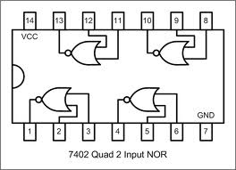

A | B | Y | Y1 | Y2 | Y3 | Y4
0 | 0 | 1
0 | 1 | 0
1 | 0 | 0
1 | 1 | 0
5. XOR Gate:
A HIGH output (1) results if one, and only one, of the inputs to the gate is HIGH
(1). If both inputs are LOW (0) or both are HIGH (1), a LOW output (0) results.
XOR gate is short for exclusive OR. This means that precisely one input must be
1 (true) for the output to be 1 (true). A way to remember XOR is "one or the other but not
both."
Fig 6.LOGIC DIAGRAM OF XOR GATE

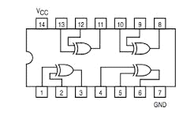 7486 quad 2 i/p XOR gate

A | B | Y | Y1 | Y2 | Y3 | Y4
0 | 0 | 0
0 | 1 | 1
1 | 0 | 1
1 | 1 | 0

Procedure: -
1) pin number 14 Of all IC, Vcc is applied & pin number 7 is connected to grounded.
2) Assemble the circuit on breadboard according to the pin configuration.
3) Give the logical inputs and check for the proper output.
Conclusion: Hence

Experiment No.2
Aim: To study & verification of operation of half and full adder.
Apparatus: Bread board, wires, IC-7402(AND), 7432(OR), 7486 (XOR)
Theory:
Half Adder:
Half Adder is a combinational circuit that performs addition of two bits. It has
two inputs and two outputs. The two I/Ps are the two 1-bit numbers A and B designated
as augend and addend bits. The two O/Ps are the sum ‘S’ of A and B and the carry bit,
denoted by ‘C’.
Truth Table of a half adder can be derived by performing binary addition of augend and
addend bits as follows:

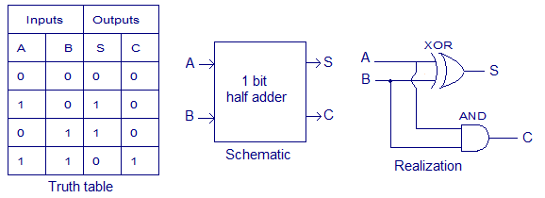
From the truth table, Boolean Expression can be derived as:
S = A’B + AB’ = A ⊕ B
C = AB

Full Adder:-

Full Adder is a combinational circuit that performs addition of three bits. It consists of three inputs and two ouputs. Two of the inputs denoted by A and B are augend and addend bits that are to be added, & third input denoted by Ci represents the carry bit from the previous lower significant position. The two O/Ps are the sum ‘S’ of A and B and the carry bit, denoted by Co.

Truth Table of a full adder can be derived as follows:

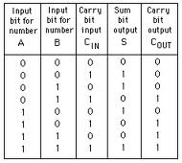

From the truth table, Boolean Expression can be derived as:
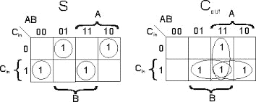
S = Ci ⊕ A ⊕ B
Co = AB + (A ⊕ B) Ci
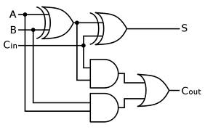
Procedure: -
1) Connect pin number 14 of all IC’s to Vcc & pin number 7 is grounded.
2) Assemble the circuit on breadboard according to the pin configuration.
- Give the logical inputs and check for the proper output.

Conclusion: Hence verified the truth table for half adder and full adder.

Experiment No.3

Aim: Given a 4-variable logic expression, simplify it using Entered Variable Map and realize the simplified logic expression using 8:1 multiplexer IC.

Apparatus: Bread board, wires, IC 74LS151.

Objective : Student should be able to solve the EVM problems.
Theory:
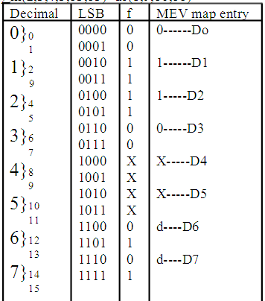
Simplify the function using MEV technique f(a,b,c,d)=∑m(2,3,4,5,13,15)+dc(8,9,10,11)

Pin Diagram of ICs Used:
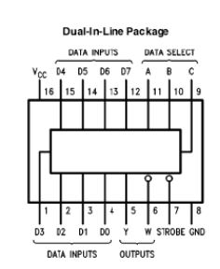

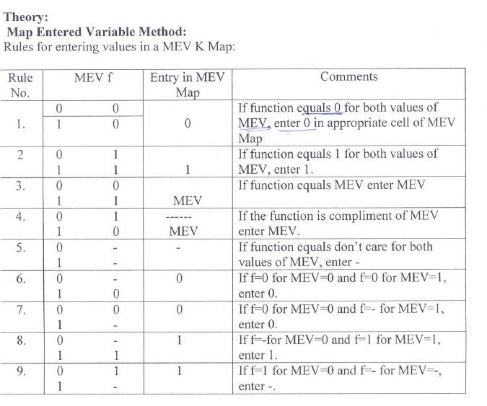

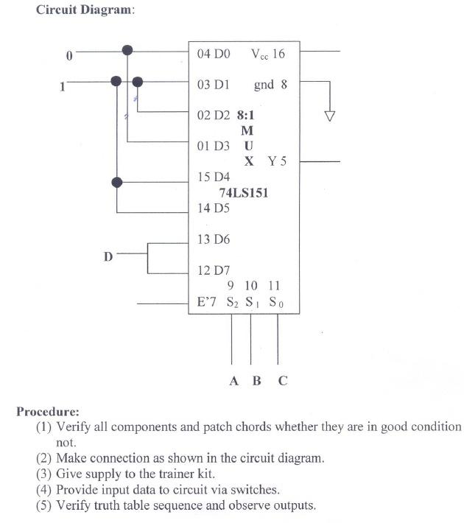

Conclusion: Thus we have studied the pin diagram of IC 74151 Multiplexer by solving
simple example

Experiment No.4

Aim: Design and develop VHDL code for 8:1 MUX. Simulate and verify its working

Objective : Student should understand the VHDL code & concept of multiplexer .

Theory:

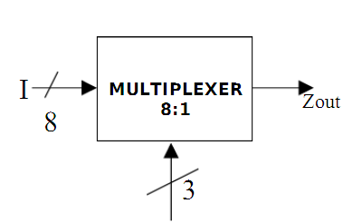

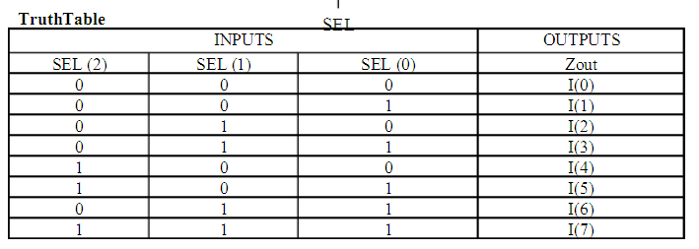

A multiplexer is a combinational digital logic switching device that has multiple inputs and one output. In addition to the input and output lines, the multiplexer has data select lines through which the data passed from an input line to the output line is determined [1] as shown below:
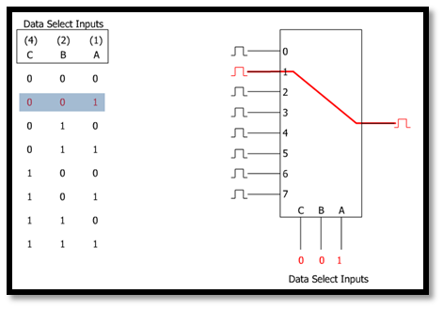[1]
Based on the number of input data lines, we can determine the number of the select data lines since it is always a power of 2. For example if we have 4 input lines we will need 2 data select lines to control it since
2² = 4 . Similarly, if we have 16 input lines we will need 4 data select lines since 2⁴ = 16 , and so on

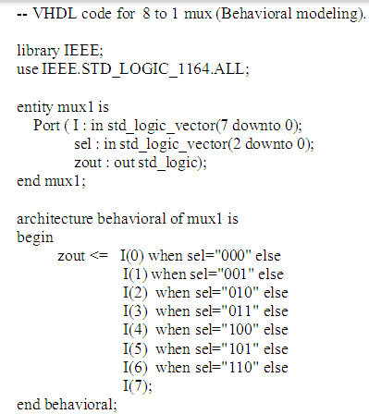

Mux Simulation Results

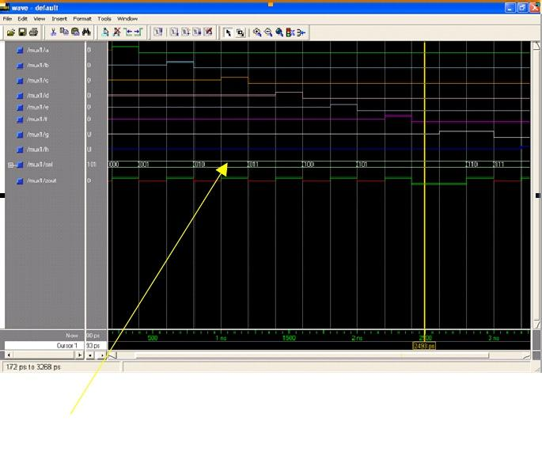

Conclusion: - Hence we have studied 8:1 multiplexer.

16
Experiment No.5

Aim: R ealiz e a J -K M aste r/S l av e F F usin g NAN D g at es and ve ri f y its trut h table.
Apparatus: Bread board, wires, IC 74LS00, IC 74LS10, IC 74LS20.
Objective : Student should be able to design MS-JK-FF & understand the concept
Theory: Pin Details of the ICs: 7400

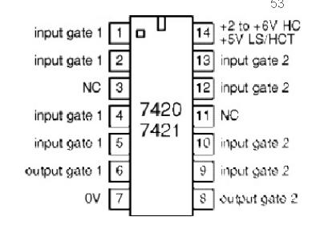

Master-Slave Flip Flop:- The circuit of Master-Slave Flip Flop is basically two latches connected serially. The first latch is called the Master and the second is termed Slave. In a Master-Slave Flip Flop inputs are fed at the +ve edge and output is available at the -ve edge.
Let Qn and Qn+1 represent the present state and next state of the flip flop, here is the truth table and circuit diagram of a Master-Slave Flip Flop:

CLK | J | K | Qn+1 | Qn+1’
1 | 0 | 0 | Qn | Qn’
1 | 0 | 1 | 0 | 1
1 | 1 | 0 | 1 | 0
1 | 1 | 1 | Qn’ | Qn

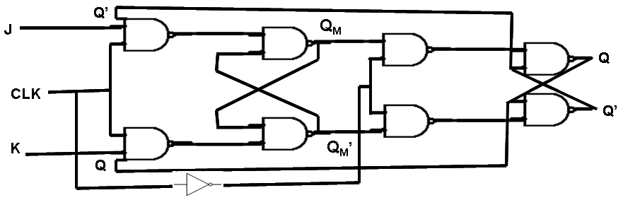

Clock is connected directly to Master and inverted to Slave. When clock is high – Master is functional and when clock is low – Slave is functional. Q and Q’ will be same as QM and QM’. Thus, what a master latch does when the clock goes high, the slave latch copies when the clock goes low.

For example, when J=1, K=1, let Qn=0 and Qn’=1. When clock is high then Qn+1=QM=1, QM’=0. When clock is low then Q=QM=1, Q’=QM’=0. Thus, even when J=1, K=1, the outputs are complement to each other.

Master-slave flip flop is designed using two separate flip flops. Out of these, one acts as the master and the other as a slave. The figure of a master-slave J-K flip flop is shown below.
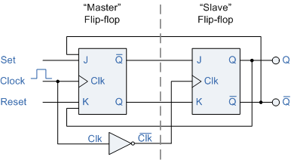
Master Slave Flip Flop
From the above figure you can see that both the J-K flip flops are presented in a series connection. The output of the master J-K flip flop is fed to the input of the slave J-K flip flop. The output of the slave J-K flip flop is given as a feedback to the input of the master J-K flip flop. The clock pulse [Clk] is given to the master J-K flip flop and it is sent through a NOT Gate and thus inverted before passing it to the slave J-K flip flop.
Working :
When Clk=1, the master J-K flip flop gets disabled. The Clk input of the master input will be the opposite of the slave input. So the master flip flop output will be recognized by the slave flip flop only when the Clk value becomes 0. Thus, when the clock pulse males a transition from 1 to 0, the locked outputs of the master flip flop are fed through to the inputs of the slave flip-flop making this flip flop edge or pulse-triggered. To understand better take a look at the timing diagram illustrated below.

Master Slave J-K Flip Flop Timing D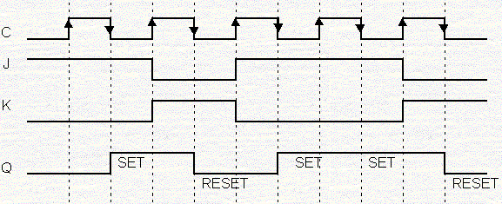iagram
Thus, the circuit accepts the value in the input when the clock is HIGH, and passes the data to the output on the falling-edge of the clock signal. This makes the Master-Slave J-K flip flop a Synchronous device as it only passes data with the timing of the clock signal.

Procedure :
- Verify the components .
- Make the connection as shown in the diagram .
- Provide the i/ps & verify the truth table .

Conclusion: - Hence we have studied the working of master slave J K flip flop

Aim: Design and develop the VHDL code for D Flip-Flop with positive-edge triggering.

Objective : Understanding the VHDL coding and its illustration using of D-FF design

Theory:
D Flip Flop - Delay Flip Flop:- D Flip Flop or a Delay Flip Flop has only data input D and two outputs which are complementary to each other and are denoted by Q and Q’. The Q output is identical to the D input except with one pulse time delay, hence the name D Flip Flop. D flip flop is used to avoid the forbidden state of S-R Latch. Since the inputs to the cross coupled NAND gates (gate 3 & 4) are always in opposite states, the invalid state (forbidden state) never occurs.
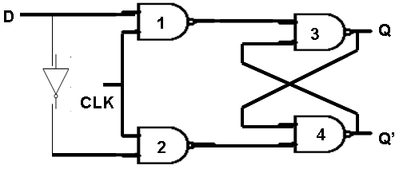
Let Qn and Qn+1 denote the present state and next state of the flip flop, here is the truth table and circuit diagram of a D Flip Flop

D | Qn+1
0 | 0
1 | 1

Application:
It is used in applications where delay is required.

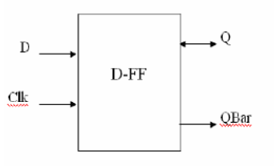
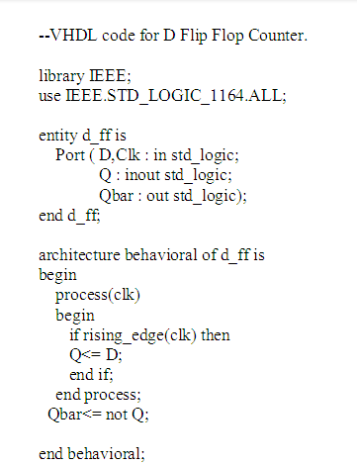

D-flipflop simulation result-

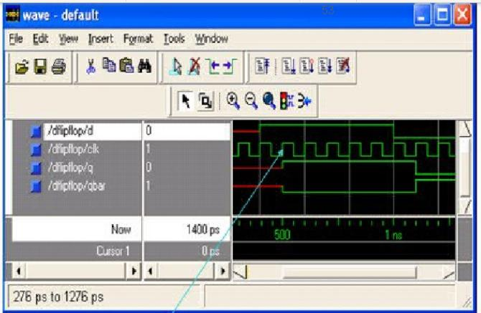
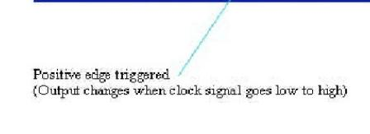
Conclusion:- Thus we have studied working of D Flip Flip with its VHDL code.
=====================

Aim: Design and implement a mod-n (n<8) synchronous up counter using JK Flip-Flop ICs and demonstrate its working.

Apparatus: - Bread board, wires, IC 7476, IC 7408.

Objective : Student should be able to design the synchronous counter using JK – FF .
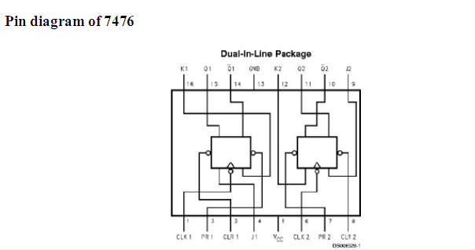

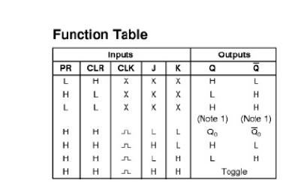

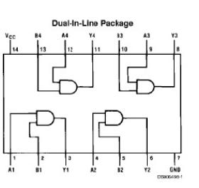

IC 7408

22
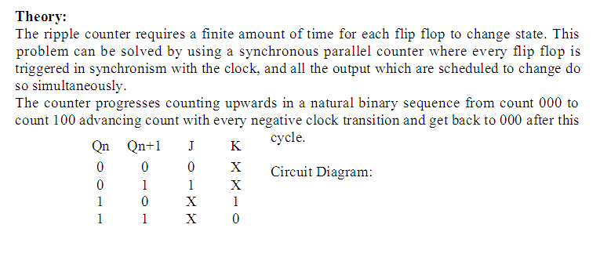

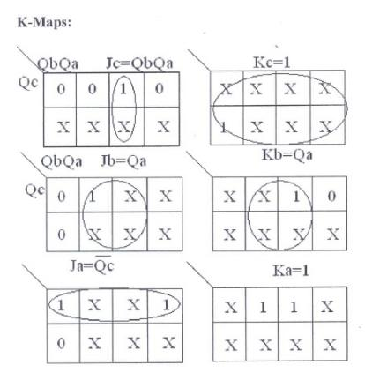

23
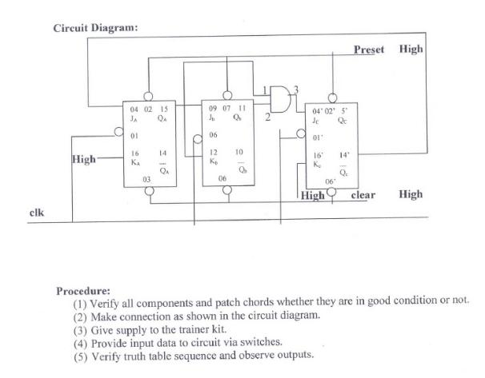

Conclusion:- Thus we have studied the implementation of mod-n (n<8) synchronous up counter using JK Flip-Flop.

24
Experiment No.8

Aim: Design and develop the VHDL code for mod-8 up counter. Simulate and verify its working.

Objective : Student should be able to understand the concept of mod-N up counter.

Theory:-
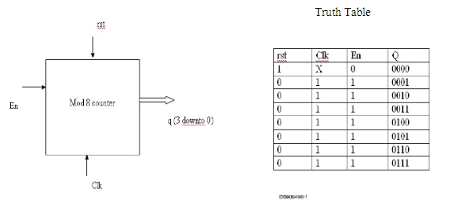

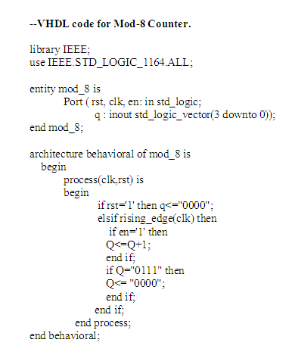

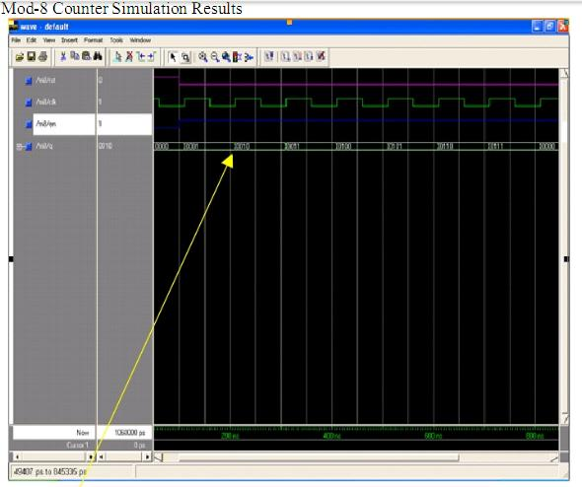

Conclusion:- Thus we have studied VHDL code for mod-8 up counter.

26
Experiment No.9

Aim: Design and implement a ring counter using 4-bit shift register and demonstrate its working.

Apparatus: - Bread board, wires, IC 7495.

Objective : Student should implement and understand the concept of ring counter .

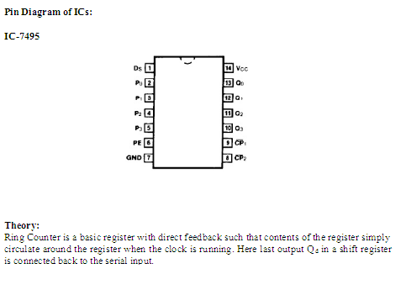

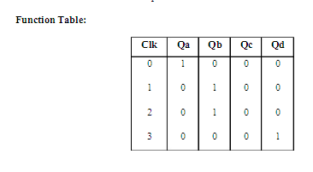

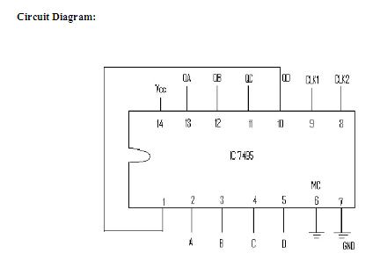

There are couples of ways to define a Register used in Digital Electronics.
“Registers are data storage devices that are more sophisticated than latches.”
“A register is a group of binary cells suitable for holding binary information.”
“A group of cascaded flip flops used to store related bits of information is known as a register.”

Application of Registers
These are used in computers for
• Temporary storage
• Data transferring
• Data manipulation
• As counters

Shift Register : A register that is used to assemble and store information arriving from a serial source is called a shift register. Each flip flop output of a shift register is a connected to the input of the following flip flop and a common clock pulse is applied to all flip flops, clocking them synchronously. Hence the shift register is a synchronous sequential circuit. An n-bit shift register consists of n Flip Flops and the gates control the shift operation There are four types of Shift Registers:

1. Serial-In, Serial-Out (SISO)

2. Parallel-In, Serial-Out (PISO)

3. Serial-In, Parallel-Out (SIPO)

4. Parallel-In, Parallel-Out (PIPO)

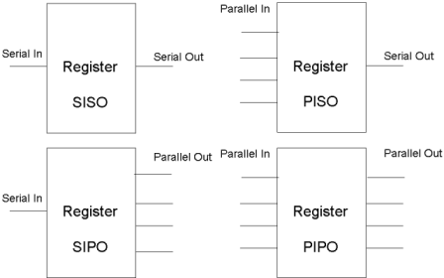

Types of Register

Procedure :

1 ) Verify all the components

2) make the connections as shown in the diagram.

3) Provide the i/p data , verify the truth table .

Conclusion: - Hence we have studied implementation of ring counter using 4-bit shift register.

29
Experiment No.10

Aim: Design and develop the VHDL code for switched tail counter. Simulate and verify its working.

Objective : Student should understand the concept of switched tail counter .

Theory:-
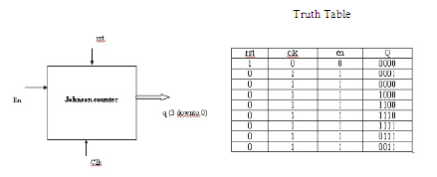

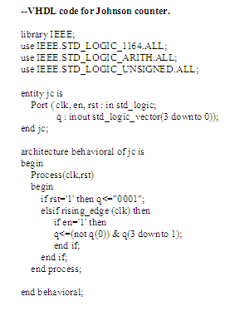
Johnson Counter:- Johnson counter or Switch Tail or Twisted Ring Counter is a synchronous counter. An n-bit ring counter circulates a single bit among the flip flops to provide n distinct states. The number of states can be doubled if the shift register is connected as a switch tail ring counter.
A switch tail ring counter is a circular shift register with the complement output of the last flip flop connected to the input of the fist flip flop. The circular connection is made from the complement output of the rightmost flip flop to the input of the leftmost flip flop. The register shifts its contents once to the right with every clock pulse and at the same time, the complement value of flip flop 4 are transferred to flip flop 1.

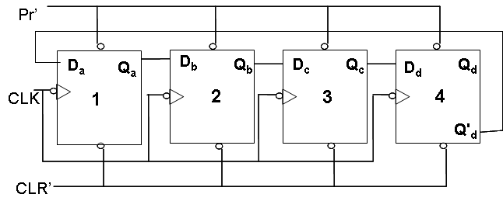

Starting from cleared states, the 4-bit switch tail ring counter goes through a sequence of 8 states. In general, a k-bit switch tail ring counter will go through a sequence of 2k states. Starting from all 0’s, each shift operation inserts 1’s from the left until the register is filled with all 1’s. In the following sequence 0’s are inserted from the left until the register is again filled with all 0’s.

CLK | Qa | Qb | Qc | Qd | Qd’
0 | 0 | 0 | 0 | 0 | 1
1 | 1 | 0 | 0 | 0 | 1
2 | 1 | 1 | 0 | 0 | 1
3 | 1 | 1 | 1 | 0 | 1
4 | 1 | 1 | 1 | 1 | 0
5 | 0 | 1 | 1 | 1 | 0
6 | 0 | 0 | 1 | 1 | 0
7 | 0 | 0 | 0 | 1 | 0
8 | 0 | 0 | 0 | 0 | 1

Mod of Johnson Counter is 2n, therefore it is known as Divide by 2N Counter. frequency of Output = frequency of Clock Pulse / mod fjohnson = f / 2n
Disadvantage of Johnson Counter

Disadvantage of Johnson Counter is that it doesn’t count in a binary sequence.
Johnson counters can be constructed for any number of timing sequences. The number of flip flops needed is one half the numbers of timing signals.

Output :

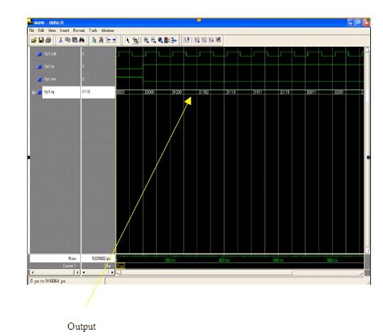

Conclusion: - Thus we studied VHDL code for switched tail counter.
Experiment No.11

Aim: Design and implement an asynchronous counter using decade counter IC to count up from 0 to n (n<=9) and demonstrate its working.

Apparatus: - Bread board, wires, IC 7490.

Objective : Student should be able to design asynchronous counter .

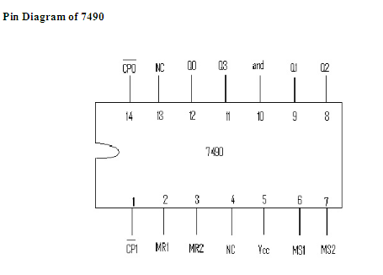

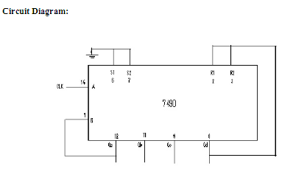
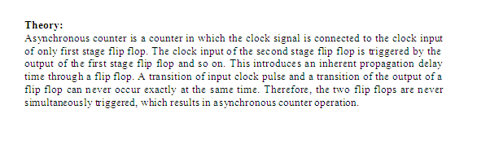
The binary counters previously introduced have two to the power n states. But
counters with states less than this number are also possible. They are designed to have the number of states in their sequences, which are called truncated sequences. These
sequences are achieved by forcing the counter to recycle before going through all of its normal states.
Mod N Counter : N means modulus of counter. It represent the number of state through which the counter progress during its operations
A common modulus for counters with truncated sequences is ten. A counter with ten states in its sequence is called a decade counter. The circuit below is an implementation of a decade counter.

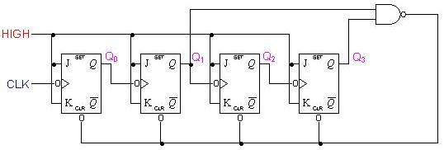

Once the counter counts to ten (1010), all the flip-flops are being cleared. Notice that only Q1 and Q3 are used to decode the count of ten. This is called partial decoding, as none of the other states (zero to nine) have both Q1 and Q3 HIGH at the same time. The sequence of the decade counter is shown in the table below:

Output :

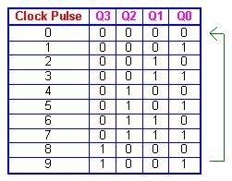

Conclusion : Thus we studied & implemented the asynchronous counter .

