
The Long Island Road Runners
PO Box 232
East Meadow, New York 11554

Edition 18 – MOTIVATION

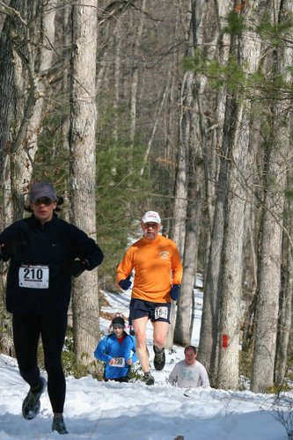

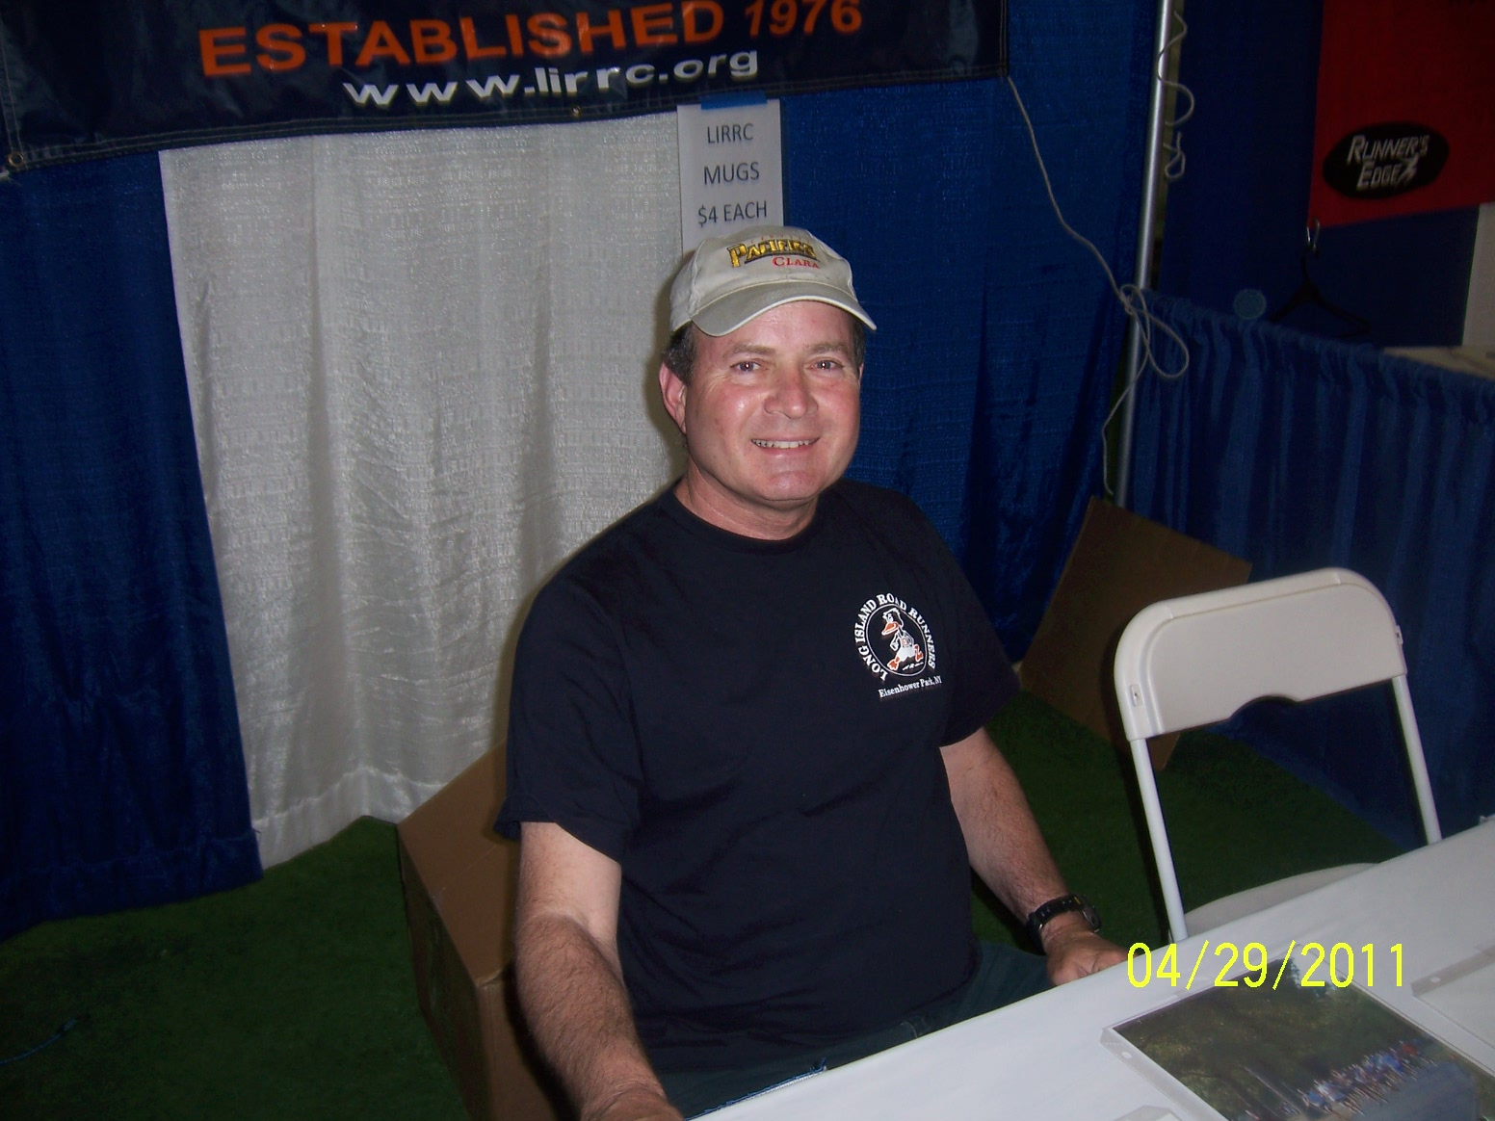

FRED HASLETT
PRESIDENT
LONG ISLAND ROAD RUNNERS
PRESIDENT’S STATEMENT
DECEMBER 2013

As December races are in full swing, and at the same time the year winding down, we all have much on our minds. What gift to get for whom? What do I want? For many of us, like myself, I’m also looking back on the year, wondering why I didn’t put the time in to run more, or do more races.

Well, the reason why I didn’t was because of a lack of motivation and making the time to run. Sure I’m busy with other things, but that’s no excuse. Anyone who has been running a long time, for me it’s going into 35 years since “returning to running” after taking a break after my high school track days, knows you sometimes go through periods of non-running. Usually it’s an injury, life getting in the way, or sometimes just a lack of motivation. One of my favorite sayings is, “There’s always tomorrow.”
But now tomorrow is here! Again! So how do we get motivated? For me, it’s just a matter of connecting with friends and making a date to run. It’s easier for me to run if I’m committed to running with someone else. I don’t want to let them down. But I’m really letting myself down if I blow off a run.
Being around awhile, I fully know the benefits of running, not just because it’s physically healthy but also because it’s emotionally good for one’s head, and let’s not forget the social benefits! I have met so many wonderful people because of running that I would have never met otherwise. Many are good friends, all have given me something. Overall, my life has been enriched by it.

So what is my motivation? When I run I feel good. I can be with people I like, and it’s good for me physically and emotionally. I just have to keep telling myself that.
See you in the park!

CONGRATULATIONS TO OUR MEN’S AND WOMEN’S TEAMS!
A big YAHOO! to our teams competing in the 2013 USATF-LI Grand Prix Series. Our women’s team, led by co-captains Adriana Staiano and Kathy Agricola, placed 3rd in the masters category. Our men’s team, led by captain Juan Oliveras, placed 4th.
Both teams faced stiff competition from other clubs and overcame injuries to team members. We are very proud our both teams and look forward to the 2014 Grand Prix, where we’ll be rested and ready to go! Congratulations again to each and every team member!

SANTA 5K December 22nd!
Join us on Sunday December 22nd for the last race of 2013 at our annual Santa 5K. We are offering pre-registration for this race, and if you get your application is received by Thursday 12/19, you will be in a raffle for a $75 American Express Gift Card! The same low fee applies to run this race, only $6 for members, $5 members over 60, and $11 for non members. There’ll be plenty of refreshments and raffles.
The application can be obtained on our website!

NEW YEARS DAY HANGOVER FUN RUN
Come on down to Eisenhower for our Annual Hangover Fun Run on January 1st, 9:30 AM. Not only is this run fun, with plenty of refreshments, but it’s FREE! All runners, members or non-members are invited to join us for the first run of 2014. We’ll have bagels, coffee, hot chocolate, egg-nog, and more!
Run all 5 miles, or do just a one mile loop, but come down and join some old friends, and new ones, for what is always a good time.

LIRRC GENERAL MEETING AND HOLIDAY PARTY
It’s that time again! Our annual Holiday Party is set for Saturday January 18th, from 6-10PM at Christ the King Church in East Meadow. Tickets must be bought in advance and sales are limited to the first 75!
This venue is wonderful for a party, and we actually had our parties there over 20 year’s ago!
2013 Members only can buy 2 tickets up to December 18th, and then sales will be open to everyone while tickets last.
Absolutely no tickets will be sold at the door; you MUST buy them in advance. The price is $20 a ticket and this goes up to $25 after January 1st, if any are left.
There’ll be plenty of food, wine, beer, dancing, and more! And our annual club awards will be given out at the party. All this and more for ONLY $20!!!
See our website for the party application, or see us at the park at our Sunday races on December 15th and 22nd for tickets.
We hope to see you there!

LIRRC BOOK OF THE MONTH

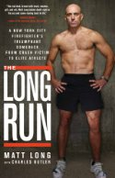

On the morning of December 22, 2005, New York City firefighter Matt Long was cycling to work when he was struck by and sucked under a 20 ton bus making an illegal turn. The injuries he sustained pushed him within inches of death.

In the 18 months before the accident, Matt had competed in more than 20 premier athletic events and in an Ironman triathlon, and had qualified for running’s most prestigious race, the Boston Marathon. After the accident, one doctor told him he would be lucky if he could even walk without a cane.

The Long Run chronicles Matt’s road to recovery as he teaches himself to walk again and, a mere 3 years later, to run in the New York City Marathon. This is the emotional and incredibly honest story of Matt’s determination to fight through fear, despair, loneliness, and intense physical and psychological pain to regain the life he once had.



Running Notes……….
In the NYC Marathon, Priscah Jeptoo won it for the ladies in 02:25:07, while fellow Kenyian Geoffrey Mutai took the lead for the men at 02:08:24…..
In Eisenhower Park, on the same day, LIRRC held the “I’m Not Doing NYC” 4-Miler. Jimmy Peck finished with a blazing 25:29 for the men, and Barbara Cronin-Stagnari led the ladies with a 31:25…..
Other races since our last edition – Celeste Traub finished in 21:23 for the women, while Sean Wosleger led the men at the Veterans Day 5K XC Run on 11/10 with a 20:09…
Adriana Staiano blazed a 47:56 for the ladies, while Jimmy Peck scored first for the men with a 38:28 in the Mel Stamberg 10K on 10/27. …….
On 10/26 Matthew Wontz finished first in the Marianne Volpe Pumpkin 5K with an 18:05. Sue Montefusco finished in 20:23 in her impressive run on the women’s side.
At the Fall 4-miler on 10/20 Mary Ellen Amatulli scored first for the ladies with a 34:27 while Hector Jaramillo won it for the men with an impressive 27:44. Finally, Nicholas Haile blew by the field in 18:13 to take top honors at the 5K XC on November 17th, while Ellen Perchinelli scored a 26:16 for the women. This is some great running by all our top finishers. Congratulations! Remember that the best way to view the Race Results for all our runners is to go right to the webpage and click the Race Results!
From Drew DeMasters…..."Was a Great Marathon...I want to Thank you all again for Helping to support research for EB, and helping Robbie’s Plight. I plan on running the Half and Full Marathon again in 2014 and hope you will all support my effort to help this cause again. God Bless!"….

And From Colin Harris…
Good Morning Jim. Eunice's ALS Fund drive at the Runner's Edge on December 21st 2013. There will be lots of things in the raffle including running shoes. Raffle tickets are now on sale at the park. Tickets are $2.00 each, 3 for $5 & 10 for $10. The event has always been held on a Sunday but this year it will be held on a Saturday.
A Labor Day storm destroyed the famous “Boilermaker Countdown Clock” on Genesee Street in Utica.

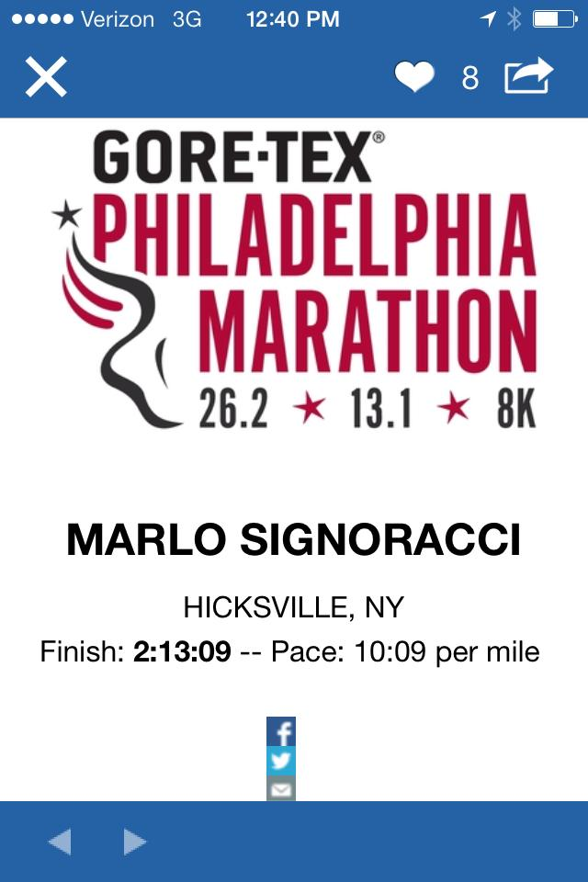

Congratulations, Marlo!



CELL PHONES FOR SOLDIERS
Throughout our country’s history, there have been selfless people who have stepped up to answer America’s call. Let us not forget our men and women in uniform, and let us always let them know that they are appreciated for the sacrifices they and their families make for us. What can we do to show our support our men and women in uniform? There are many ways. We have decided to partner with State Senator Dean Skelos in the “Cell Phones for Soldiers” program. Each week at our races, a collection box will be available to collect old cell phones. Our soldier’s calls home are not free, even from Iraq and Afghanistan, and especially from their coming and going stays in Kuwait. They can pay as much as $5 per minute to call loved ones. Our collection helps them stay in touch with loved ones. Let’s do our part. God Bless our troops! For more information, visit the Cell Phones for Soldiers website at http://www.cellphonesforsoldiers.com/
The story of these two youths who started this program is inspiring.

MEMBER SERVICES
REAL ESTATE NEEDS
Garden City Properties Inc. Club member Mike Ogazon, GRI, CBR. Residential and Comm’l brokerage, appraisals and building management. Call Mike at 516 746-1563
TUTORING
NYS Certified Elementary teacher will tutor your child or give homework help in your home. K-6th grade. Reasonable rates. Call Fred at 516 569-4196 or email fredhas@verizon.net
MATTEO’S in BELLMORE
Visit Matteo’s at 416 Bedford Ave in Bellmore for fine Family Style Italian food. Catering available too! Club member Giovanni Annunziata proprietor. Call 516 409-1779 for info.

FOOT PROBLEMS?
Dr. D.T. Peterson (triathlete), DPM, MS, 8029 Jericho Tpke, Woodbury. Call 516 496-0900.
AUTOGRAPH COLLECTIBLES
Shafran Collectibles, Inc. specializes in buying & selling autographs in variety of fields-Presidential, Sports, Historical&Entertainment. Please visit us at www.shafrancollectibles.com or call Brad at (516)) 978-0094 - special pricing available for LIRRC members!

FEMALE PERSONAL TRAINER
Need a personal trainer? Call Hofstra Certified Trainer Margaret Peralta at 516 319-4993, or email her at Peraltafit2run@yahoo.com.
Margaret also teaches ZUMBA in East Meadow. Classes are only $10.
Meet every Tuesday @ 7PM and Saturday @ 11AM. E-mail Margaret and go see what all the fuss is about!

REAL ESTATE NEEDS
Call member Kathleen Agricola, Licensed Real Estate Associate at Prudential in East Meadow, NY at 516 796-4000 or email her at Kathleen.Agricola@prudentialelliman.com

COMPUTER PROBLEMS?
PCAid to the rescue! Over 25 years in the computer industry, I’ll revitalize your slow PC back to its original speedy self. Upgrades, rebuilds, networking, etc. Call Wing at 516 620-4136.

JDI MORTGAGE CORPORATION
Registered Mortgage Broker –NYS Banking Dep’t. Ben Murolo, CPA, MBA Tel# 516 316-2733.

PERSONAL TRAINING
If anyone is interested in improving their running (who isn’t?), running clinics at schools, individual training sessions and seminars on nutrition and physical fitness.
Running class: Running classes are group workouts designed to help you run farther and faster. I coach different ability levels, from beginner to competitive running, ensuring that you’ll find the right fit. You’ll do a variety of coached workouts depending on your level, classes include steady-paced runs, speed training, intervals, hills, fartlek, and tempo runs.
Call: Jane Vongvorachoti-516-263-5369
Certifications :
NCSF National Certified Personal Trainer, Equinox Tier 2 Trainer, CPR/AED Certified, Pre and Post Natal Certified, USSF D License Soccer Certification

VISIT THE RUNNER’S STOP
in Lynbrook at 20 Atlantic Avenue Lynbrook NY 11563. See Ellen and the gang. Visit their website www.runnersstop.com – or call them at 516.568.7333

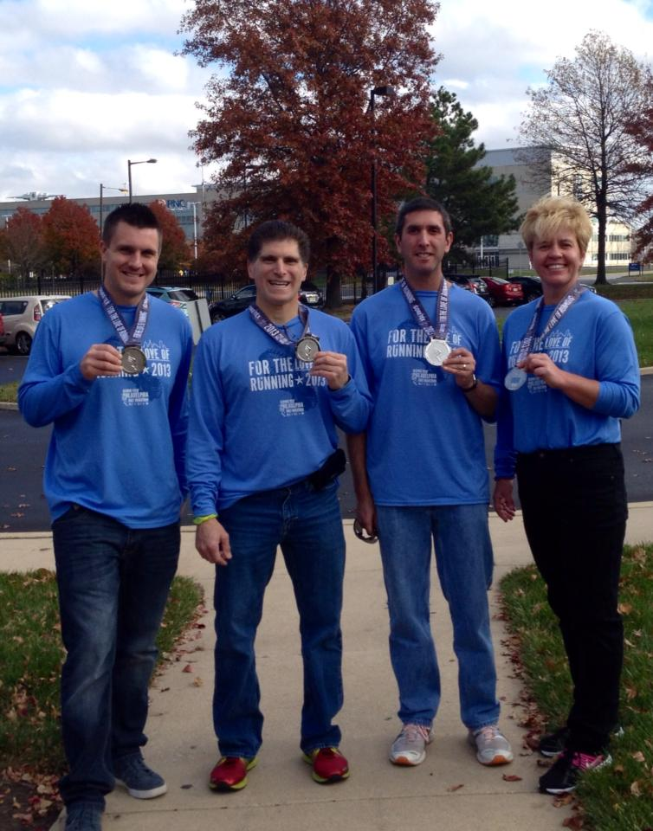
Tim Hill, Robert Monaco, Ira Kaplan & Marlo Signoracci
At the Philadelphia Marathon on 11/17/2013

Hello Ladies,
It's hard to believe we have finished another Grand Prix racing season. Once again, we are so proud of our "Team" and thank you Ladies for being part of the LIRRC Women's Race Team!!
The Fly With the Owls 4 Miler was the last race of the Grand Prix series and we had a nice turnout by our members both guys & gals. Thank you to Yuri Karasz, Susan Schmuck, Maureen Frisone, Marie Brewer and Judy Latta for you participation at Fly With the Owls. Congratulations to Maureen for taking 1st place in the age group. And, separately CONGRATULATIONS to Maureen for qualifying for the Boston Marathon!! Way to go !!

Having completed the 2013 Grand Prix Series the LIRRC Women's Master Race Team finished the year in solid 3rd place with 692 points! Congratulations to all the members of the team for making this happen. We are a small team but we continue to compete and place every year! You all should be very proud of our accomplishment!
WOW!! That is awesome Ladies!! Thank you again for your support and dedication to the LIRRC ! We look forward to 2014 and another great running season with you all our dear friends.

Enjoy your holidays and Happy New Year!

With best regards,

Adriana & Kathy

Gentlemen,

The 2013 LITF Grand Prix results are in the books and my heartfelt appreciation goes out to each and every one of you for being part of our team. Although it was a year plagued with injuries for many of us we still managed to take fourth place in the standings. That is something to be proud of and in my view and huge success.

When you consider our competition - GLIRC, Northport and Bellmore, we in reality competed against a stacked deck. To do so and still contend so well exemplifies our teams’ strength and fortitude.
Once again I thank you for your support in 2013 and also your commitment for without that we would not be as successful as we've been.

I look forward to the 2014 edition of the Grand Prix and my wish is that each and every one of you would join me once again for another great running season filled with fun and camaraderie.

Stay Well,
Juan Oliveras

PS: Hope you can all make the Club Holiday Party on Saturday January 18th, being held at Christ The King Church on 5th Street in East Meadow.



New Members!

Welcome to the best club on Long Island! To add to your experience, you may want to get involved from the start by volunteering at a race, writing an article in the newsletter, or letting us know of your personal or running accomplishments! E-mail Jim Ferguson at proffesor4@aol.com and get involved!

Alanna Bender
Nicholas Fahlbusch
Jaime Freilich
Stephen Guzik
John Koehler
Kerry McElroy
Nicholas Robertson



CONGRATULATIONS YUWANNA!

Yuwanna Landau, member of the LIRRC Women’s Race Team, completed the NYC Marathon on November 3rd!

LIRRC SPOTLIGHTS 

Yuwanna Landau

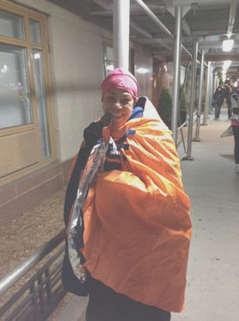
Why I Run

I was diagnosed at age 45, and again at age 55.
Yes the dreadful “C” word that happens to others, not me. “You have Breast Cancer”, said the doctor”. I believe it’s a mistake; this cannot be; who will care for my girls and my special son. The little voice in my head knew it all along. After performing another self breast examination; yep, the dreadful lump, you think it’s a pimple or maybe it will go away, if you massage it hard enough.
After the doctor visit, I found myself along the water banks at Jones Beach pleading with God to spare me. My lots have been more than I can handle. My focus was on my family and taking care of my David.
I felt lost and alone and mostly powerless, which is a “no-no” for an ICU/ER nurse.
As the tears began to flow I started running and screaming. Suddenly I stopped; then realized my “Aha” moment. “I can run God! I am not short of breath”, then the love for running begins from one block to 2 New York City marathons (2008, 2013).
I do not run for a PR or for ego. I run for me, to feel the wind against my skin, to breathe the air and just enjoy God‘s creation.
Thru the help of my new running family, the LIRRC, I am now a runner.
Fast forward 9 years 11 months and 29 days to my tenth anniversary. The ugly beast was back in April 2011.
This time I ask God “Why not me?” I am not special, but give me the strength to fight. Waiting to see my new granddaughter was the motivation to poison my body with the treatments and the deformity of my chest.
My next mission was seeing me running to the finish line in 2012. Sandy came, Osteoarthritis of the knees.
In November 2013, I stood up to Cancer finishing with 3 missing nails, a rock imbedded in the ball of my foot, and a big swollen right knee.
Never underestimate the power of the human spirit, and that is Why I Run.

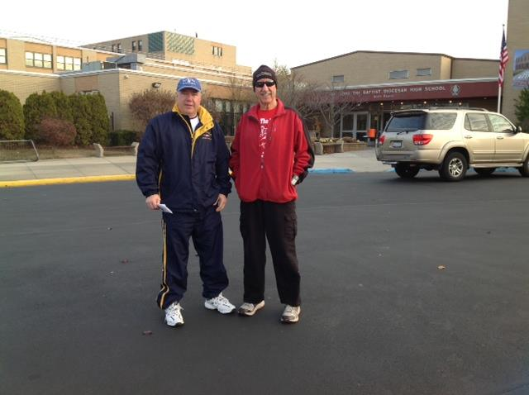

Hi Jim:
Hope all is well...If you need some filler space for the next Newsletter...you can post a pic of me (Michael Ogazon Sr) and my son (Michael Ogazon Jr) doing the St John The Baptist 4K in West Islip 11/29/13...the actual race is called "Run Your Turkey Off 4K"...thanks...you missed a nice 4 miler this morning...cya in the park...
Mike Ogazon

Holiday Survival

By

Dr. Barbara Rosinsky & Dr. Suzanne Plotnik

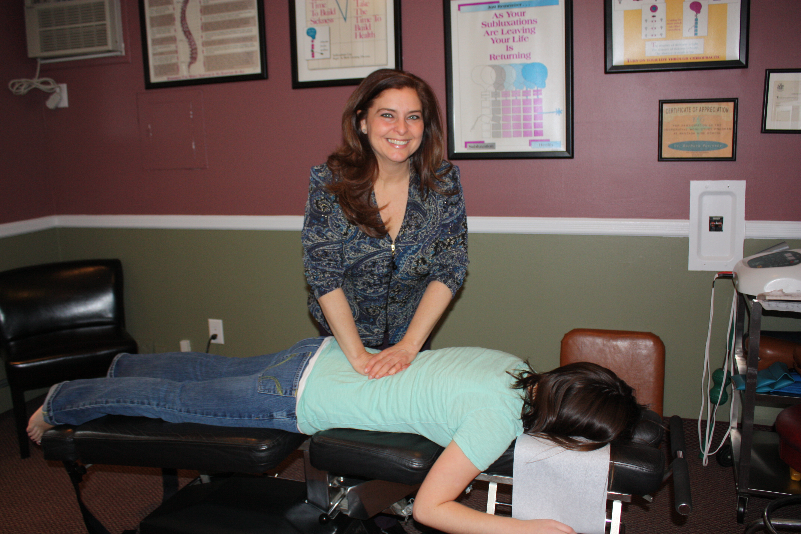

The holidays seem to come earlier and earlier every year -- and along with them, the stresses and strains of frenzied holiday shopping. Take a stroll through your local mall, and you'll already see symbols of the approaching holiday season -- from Thanksgiving and Christmas decorations to notices of blowout sales. As your muscles tense with each passing day, the question becomes, "Are you ready for the holiday shopping challenge?"

Our bodies have the capacity to do a little more than we normally do, but our bodies do not adapt very well to doing a lot more than we normally do. Since the added demands of this season can stress the capacity of our bodies, we need to do everything we can to help ourselves.
Eat right, drink plenty of water, stretch, exercise and take a few minutes to slow down and reflect on what the season is all about.
So relax and enjoy the holidays! Consider the following tips to help keep you and your loved ones healthy, happy and safe this season.
Treat Holiday Shopping As an Athletic Event

- Stay hydrated! Drink eight to ten 8-ounce glasses of water a day. (Coffee, tea, soft drinks and alcohol are dehydrators. Don't substitute them for water.) On shopping days, you may need to drink even more water. Be sure to stretch before and after a long day of shopping. When you are stressed-out, your muscles are less flexible than usual.
- Wear shoes with plenty of cushioning in the soles to absorb the impact of walking on those hard shopping mall floors.
- Make sure your clothing is as comfortable as possible. It's a good idea to wear layers, because you may be going from a cold environment (outdoors) to a warm environment (indoors).
- Leave your purse at home. Wear a light fanny pack, or if necessary, a light backpack instead. Pack only those items that are absolutely essential (driver's license, credit card, etc.).

Wantagh Woods Chiropractic & Wellness
Dr. Barbara R. Rosinsky
Chiropractor
1705 Wantagh Avenue
Wantagh, NY 11793
516-783-0088
Dr.Rosinsky@WantaghWoodsChiropractic.com
Wantagh Woods Chiropractic is located at
1705 Wantagh Avenue in Wantagh, NY.
The Long Island Road Runners Club would like to thank Dr. Barbara Rosinsky & Dr. Suzanne Plotnik for their submission, The doctors are available to pre and post stretch runners at local races and they give health related lectures to various organizations.

The Long Island Road Runners
Remember…..

Joy Johnson

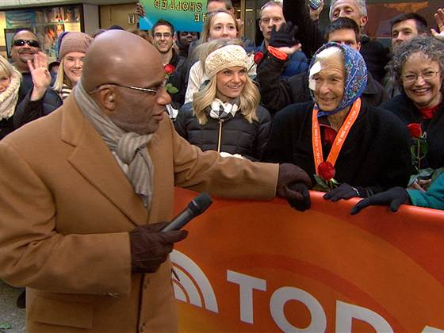
She was a winner, a relentless competitor, and as befits her name, a pleasure to be around. Joy Johnson, 86, who ran her 25th New York City Marathon on Sunday, died one day later at Bellevue Hospital in Manhattan.
Johnson had fallen and hit her head around the marathon’s 20th mile, refused a trip to the hospital, and as was characteristic for her, continued the race with her face and head bandaged to stop the bleeding.
A widow and former gym teacher from San Jose, Calif., Johnson didn’t start running until age 59. She averaged three marathons a year, ran anywhere from 25 to 50 miles a week, and made quilts from her race shirts.
This year she finished the New York marathon in less than eight hours and with a horde cheering her on, thanks to a 2008 Wall Street Journal profile that rendered her a celebrity among running fans. As Johnson did every year of the marathon, she visited TODAY on Monday morning to reconnect with her friend Al Roker, who over the years had sought her out in the crowd for a quick hello and a hug or a peck on the cheek. She was back this week, having her chat with Roker.
“She considered everyone her friend,” her daughter, Diana Boydston, told TODAY.com. “I think she would be happy with this chain of events: to run her beloved New York marathon, talk to her buddy Al, be there with her sister Faith. She told everyone she loved them before the race, and she was at peace.”



From Paul Fetscher:

Prior to the NY Marathon, I was approached by a Columbia University Grad student doing a short on the Marathon. I like what he came up with. Hope you do too!
http://vimeo.com/78129004
Top of Form



Finish Lines

I have to admit it……my original article was a bit of a bummer. It went on about my running injury and how I try to make it down to call splits now, but I still miss running, and it went on and on. Honesty, it was even brutal for me to read.

Then I heard about Joy Johnson, who ran the NYC Marathon at 86, and passed away a few days later. I heard from Yuwanna Landau who refused to let cancer beat her down. I see Richard Cahn almost every week pressing to finish every race. – Paul Fetscher is still out there running - admittedly not as fast but still enjoying every step. These stories speak of the human spirit, of setting a goal and struggling to be the best you can be – not as it is defined by others, or by an illness, or by age, or aches, or doctors - but how YOU define it.

On November 24th George Brown was kind enough to run with me, slowing down his pace because he was convinced that I could finish 4 miles nice and slow – the first time I have run since June. What a great day. I’ve run once since, and have every intention of running the Santa 5K on December 22 at Eisenhower.

The positive energy we get from other runners can force us to stop feeling sorry for ourselves, make us better runners, and make us reinvent ourselves. Runner’s World as well as other running and Track & Field publications are loaded with stories of how runners overcome tremendous obstacles to end up as victors in their own battles. We should remember, though, that we need look no further than the runners in our own club to see such triumphs. The people who run next to us every week are the best and closest examples.

I would like to thank all of my running buddies for all your support and inspiration. May you all have a very Happy and Healthy Holiday Season and a Great New Year!





The Long Island Road Runners Club



This newsletter is a publication of the Long Island Road Runners Club, posted to our website bi-monthly from February through December. Our online publication is dedicated to the memories of Jack Dowling, Co-Founder and Past President, and Eunice Harris, Secretary/Treasurer.
We thank our members, runners, and volunteers who contribute their talents and time to make our club the success that it is. We invite your comments, articles, photos, and race reports, and encourage you to share stories of your successes and accomplishments both on and off the track. Keep in touch through our website, our hotline, or through e-mails or Facebook. Check the schedule on our site for our Fall races, and when the Spring of 2014 comes around, join us for our famous Wednesday Night Series. More importantly, GET OUT THERE AND RUN! It’s good for your health, your body, your mind and your spirit. Remember: Turtles just do it, and wear the Duck proudly!

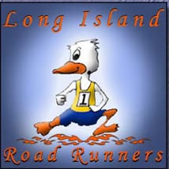
The Long Island Road Runners
PO Box 232
East Meadow, New York 11554
www.lirrc.org
Club Hotline: 516-569-4959

OFFICERS

President—Fred Haslett
Vice President/Technology—Bob Patterson
Vice President/Assistant Race Director—Peter Cirona
Secretary-Treasurer—Colin Harris
Club Counsel—Jim Thornton
Public Relations—Mike Ogazon
USATF-Long Island Rep.—Kathy Agricola

BOARD OF DIRECTORS MEN’S RACE TEAM CAPTAINS
Juan Oliveras Masters Men—Juan Oliveras
Kathy Agricola Senior Masters Men—Jim Thornton
David Philippi Sgt. at Arms – Richie Delorantis

WOMEN’S RACE TEAM CAPTAINS
Adriana Staiano (Co-Captain)
Kathy Agricola (Co-Captain)

RACE OFFICIALS
Fred Haslett Bob Patterson Colin Harris
David Philippi Peter Cirona Juan Oliveras
Joyce Patterson Sally Robson Kathy Agricola

BOARD EMERITI ADVISORY BOARD
Jim Murphy Jim Thornton Michael Ogazon
Herb Waldren Kathy Agricola Juan Oliveras

NEWSLETTER EDITOR
Jim Ferguson (proffesor4@aol.com)

