Domain Testing: Divide and Conquer

by

Sowmya Padmanabhan

Bachelor of Engineering
in Computer Engineering
SAKEC, University of Mumbai, India
2001

A thesis submitted to
Florida Institute of Technology
in partial fulfillment of the requirements for the degree of

Master of Science
in
Computer Sciences

Melbourne, Florida
May 2004

© Copyright by Sowmya Padmanabhan 2004
All Rights Reserved

This research has been partially funded by the National Science Foundation grant EIA-0113539 ITR/SY+PE: "Improving the Education of Software Testers.” Any opinions, findings or conclusions expressed in this thesis are those of the author and do not necessarily reflect the views of the National Science Foundation.

The author grants permission to make single copies

_________________________________
We the undersigned committee
hereby approve the attached thesis

Domain Testing: Divide and Conquer

by
Sowmya Padmanabhan

Bachelor of Engineering
in Computer Engineering
SAKEC, University of Mumbai, India
2001

Cem Kaner, J.D., Ph.D. William D. Shoaff, Ph.D.
Professor Assistant Professor and Head
Computer Sciences Computer Sciences
Principal Advisor Committee Member

Robert Fronk, Ph.D.
Professor and Head
Science Education
Committee Member

Abstract

Domain Testing: Divide and Conquer
by
Sowmya Padmanabhan
Principle Advisor: Dr. Cem Kaner

Domain testing is a well-known software testing technique. The central idea of my thesis work is to develop and validate instructional materials that train people well in domain testing. The domain testing approach presented in my thesis is a procedural black-box testing approach. I present thorough literature reviews of domain testing and instructional design and evaluation strategies. This is followed by the designs of domain testing training material and the experiments conducted on 23 learners. Finally, I present the results of the experiments and draw inferences. I found that the instructional material, with its share of pluses and minuses, was effective in increasing learners’ competence levels in domain testing to a degree that they were able to successfully complete the tasks corresponding to the instructional goals. However, in the opinion of the evaluators of the final performance tests, the learners performed poorly on the performance tests and their performance is not comparable to the standard of a tester during a job interview who has one year’s experience and who considers herself reasonably good at domain testing.
Table of Contents

Chapter 1: Introduction 1
1.01 Problem Description 1
1.02 Background 1
1.02.01 Definitions 1
1.02.02 White-Box Testing Approach 3
1.02.03 Black-Box Testing Approach 3
1.02.04 Complete Testing/Exhaustive Testing 4
1.02.05 Domain Testing 4
1.02.06 Similarities among Different Interpretations of Domain
Testing……………………………………………………………..6
1.02.07 Differences between Different Interpretations of Domain Testing 6
1.03 Domain Testing Approach Presented in Training Material 9
1.03.01 Organization of the Thesis 9
Chapter 2: Domain Testing: A Literature Review 11
2.01 Partitioning of Input Domain 11
2.01.01 White or Black 12
2.01.01.01 White-Box Testing Approach 13
2.01.01.01.01 Path Analysis Approach 13
2.01.01.01.02 Mutation Testing Approach 15
2.01.01.02 Black-Box Testing Approach/ Specification-Based Approach ….16
2.01.01.02.01 Functional Testing Approach 18
2.01.01.03 Combination of Black-Box and White-Box Testing Approaches 19
2.01.02 Driving Factor 20
2.01.02.01 Confidence-Based Approach 20
2.01.02.02 Risk-Based Approach 21
2.01.03 Linear or Non-Linear 23
2.01.04 Overlapping or Disjoint Subdomains 23
2.01.05 Size of Subdomains – Equally Sized or Unequally Sized?........ 24
2.02 Selecting Representatives from Subdomains 24
2.02.01 Random Selection 25
2.02.02 Proportional Partition Testing 25
2.02.03 Risk-Based Selection 28
2.02.03.01 Boundary Value Analysis 28
2.02.03.02 Special Value Testing 31
2.02.03.03 Robustness Testing 31
2.02.03.04 Worst Case Testing 31
2.02.04 Which Test Case Selection Method Should We Use? 32
2.03 Testing Multiple Variables in Combination 33
2.03.01 Cause-Effect Graphs 33
2.03.02 Pairwise / Orthogonal Arrays Testing 34
2.03.03 Combinatorial Testing Using Input-Output Analysis 35
2.03.04 All Pairs Combination 36
2.03.05 Weak Robust Equivalence-Class Testing 36
2.03.06 When to Use What Combination Technique? 37
Chapter 3: Instructional Design and Evaluation: A Literature Review 39
3.01 Definitions 39
3.02 Learning Outcomes 40
3.02.01 Intellectual Skills 41
3.02.02 Cognitive Strategies 43
3.02.03 Verbal Information 43
3.02.04 Motor Skills 44
3.02.05 Attitudes 44
3.02.06 Taxonomy of Learning Levels 45
3.03 Instructional Design 47
3.03.01 Identify Instructional Goals 47
3.03.02 Conduct Instructional Analysis/Task Analysis 47
3.03.03 Identify Entry Behaviors and Learner Characteristics 48
3.03.04 Identify Performance Objectives 49
3.03.05 Develop Criterion-Referenced Test Items 49
3.03.06 Design Instructional Strategy 50
3.03.06.01 Gain Attention 50
3.03.06.02 Informing the Learner of the Objective 50
3.03.06.03 Stimulating Recall of Prerequisite Learned Capabilities 51
3.03.06.04 Presenting the Stimulus Material 51
3.03.06.05 Providing Learning Guidance 51
3.03.06.06 Eliciting the Performance 51
3.03.06.07 Providing Feedback 51
3.03.06.08 Assessing Performance 52
3.03.06.09 Enhancing Retention and Transfer 52
3.03.07 Develop Instructional Materials 52
3.03.08 Conduct Formative Evaluation 53
3.03.09 Revision of Instructional Materials 54
3.03.10 Conduct Summative Evaluation 55
3.04 Evaluation of Instruction 55
3.04.01 Different Evaluation Approaches 56
3.04.02 Collecting Quantitative Information for Evaluation 57
3.04.02.01 Knowledge and Skills Assessment 57
3.04.02.02 Attitude/Behavior Assessment 60
Chapter 4: Instructional Design and Evaluation Strategy for Domain Testing Training 62
4.01 Purpose of Developing the Instructional Material 62
4.02 Domain Testing Approach Used in the Training 62
4.03 Overview of the Instructional Materials 62
4.04 Instructional Strategy 63
4.05 Evaluation Strategy 67
4.05.01 Evaluation Materials 67
4.05.02 Mapping Assessment Items to Instructional Objectives 68
Chapter 5: Experiment Design 69
5.01 Overview of the Experiment 69
5.02 Instructional Review Board 70
5.03 Finding Test Subjects 70
5.04 Facilities Used for the Experiment 71
5.05 Before the Experiment 72
5.06 Structure of Each Training Period 72
5.07 Experimental Error 74
Chapter 6: Results and Their Analyses 76
6.01 Experiment Pretest and Posttest Results 76
6.01.01 Paper-Based Pretest and Posttest: Results and Their Interpretation 76
6.02 Performance Test Results 99
6.03 Questionnaire – Confidence, Attitude and Opinion of Learners 100
Chapter 7: Conclusion 113
7.01 Domain Testing Training – Where Does it Stand? 113
7.01.01 Pluses 113
7.01.02 Minuses 115
7.01.03 Final Remarks 116
Bibliography 118
Appendices 132

List of Charts
Chart 6.01 Paper-Based Pretest and Posttest Final Percentage Score Comparison…………………………………………….......................97
Chart 6.02 Final Scores Percentage Increase…………………………98
Chart 6.03 Averages…………………………………………………..98
Chart 6.04 Averages Final Day (5) Questionnaire Responses………110
List of Tables

Table 6.01 Question 1 – Paper-Based Pretest and Posttest Score Comparison…………………………………………………………...78
Table 6.02 Question 2 – Paper-Based Pretest and Posttest Score Comparison…………………………………………………………...80
Table 6.03 Question 3 – Paper-Based Pretest and Posttest Score Comparison…………………………………………………………...82
Table 6.04 Question 4 – Paper-Based Pretest and Posttest Score Comparison…………………………………………………………...84
Table 6.05 Question 5 – Paper-Based Pretest and Posttest Score Comparison…………………………………………………………...86
Table 6.06 Question 6 – Paper-Based Pretest and Posttest Score Comparison…………………………………………………………...88
Table 6.07 Question 7 – Paper-Based Pretest and Posttest Score Comparison…………………………………………………………...90
Table 6.08 Question 8 – Paper-Based Pretest and Posttest Score Comparison…………………………………………………………...92
Table 6.09 Question 9 – Paper-Based Pretest and Posttest Score Comparison…………………………………………………………...94
Table 6.10 Final Scores - Pretest and Posttest Score Comparison ………………………………………………………………………..95
Table 6.11 Day One Questionnaire Responses……………………...100
Table 6.12 Day Two Questionnaire Responses……………………..102
Table 6.13 Day Three Questionnaire Responses……………………104
Table 6.14 Day Four Questionnaire Responses……………………..106
Table 6.15 Day Five Questionnaire Responses……………………..108

Acknowledgements

- Dr. Cem Kaner, my principle advisor, who helped me with every aspect of my thesis work.
- Sabrina Fay for helping me with the instructional design of the training material for domain testing.
- Dr. Cem Kaner, James Bach and Pat McGee for spending their valuable time in evaluating the performance tests.
- Pat McGee for helping me out with some questions I had about all-pairs combination and the test cases developed by equivalence class analysis using multidimensional analysis.
- Amit Paspunattu for helping me with the literature search.
- Dr. Robert Fronk and Dr. William D. Shoaff, my committee members, for their valuable suggestions on improving my experiment design.
- All my learners for undergoing the training of domain testing and helping me evaluate the effectiveness of the instructional material and instruction on domain testing.
- National Science Foundation and Rational/IBM for funding my thesis work.
- All those who directly or indirectly have helped me with my thesis.

Dedication

This thesis is dedicated to Almighty God for giving me the strength to successfully complete it, for uplifting me during the rough times and for cheering me during the good times. I am thankful to my loving and supportive family and to Sumit Malhotra, my best friend, without whose moral support the completion of this thesis would have been impossible.

Chapter 1: Introduction

  - Problem Description
The central idea of my thesis work is to develop and validate instructional materials that train people well in domain testing. The lack of systematic and effective materials for training novice testers in domain testing, a well-established software testing technique, was the driving force behind the conception of the idea of my thesis work. The National Science Foundation (NSF) has primarily funded this thesis research.

  - Background
This section gives a brief introduction to some basics in software testing and domain testing in an attempt to increase understanding of the detailed literature review of domain testing presented in the next chapter.

1.02.01 Definitions
Computer Program: “A combination of computer instructions and data definitions that enable computer hardware to perform computational or control functions” (IEEE Std. 610.12, 1990, p. 19).

Software: IEEE Std. 610.12 (1990) defined software as “Computer programs, procedures, and possibly associated documentation and data pertaining to the operation of a computer system” (p.66).

Software Testing: “Testing is the process of executing a program with the intent of finding errors” (Myers, 1979, p. 5).

“The purpose of testing is to determine whether a program contains any errors” (Goodenough & Gerhart, 1975, p. 156).

“Testing--A verification method that applies a controlled set of conditions and stimuli for the purpose of finding errors” (IEEE Computer Society, 2004, ¶1).

“Software testing in all its guises is a study of the software input space, the domain over which a program under test is supposed to operate. The whole question of ‘how should testing be done?’ is a matter of input selection” (Hamlet, 2000, p. 71).

Test Case: IEEE Std. 610.12 (1990) defined a test case as:
(1) A set of test inputs, execution conditions, and expected results developed for a
particular objective, such as to exercise a particular program path or to verify compliance with a specific requirement.
(2) (IEEE Std. 829-1983) Documentation specifying inputs, predicted results, and a set of execution conditions for a test item. (p. 74)

Bug/Error/Fault: We test to find bugs, also called errors. IEEE Std. 610.12 (1990) defined a bug, error or fault as:
(1) The difference between a computed, observed, or measured value or condition and the true, specified, or theoretically correct value or condition. For example, a difference of 30 meters between a computed result and the correct result.
(2) An incorrect step, process, or data definition. For example, an incorrect instruction in a computer program.
(3) An incorrect result. For example, a computed result of 12 when the correct result is 10.
(4) A human action that produces an incorrect result. For example, an incorrect action on the part of a programmer or operator. (p. 31)

There are two general approaches to doing testing-
‘white-box’ testing and ‘
black-box’ testing.

1.02.02 White-Box Testing Approach
In this testing approach, the program under test is treated as a white box or a glass box, something you can see through (Kaner, Falk & Nguyen, 1999; Myers, 1979). According to Myers (1979), this approach can also be called a logic-driven testing approach in which the tester does testing based on the internal structure of the program, usually ignoring the specifications. This approach is also known as structural testing or glass-box testing. IEEE Std. 610.12 (1990) defined structural, glass-box or white-box testing as “Testing that takes into account the internal mechanism of a system or component” (p. 71).

1.02.03 Black-Box Testing Approach
In this testing approach, the program under test is treated as a black box, something you cannot see through (Kaner et al., 1999; Myers, 1979). A black-box tester is unconcerned with the internals of the program (Howden, 1980a; Myers, 1979; Podgurski & Yang, 1993) and tests the program using the specifications of the program (Myers, 1979). Black-box testing has been defined by IEEE Std. 610.12 (1990) as “(1) Testing that ignores the internal mechanism of a system or component and focuses solely on the outputs generated in response to selected inputs and execution conditions” (p. 35). Specification can be defined as “A document that specifies, in a complete, precise, verifiable manner, the characteristics of a system or component, and, often, the procedures for determining whether these provisions have been satisfied” (IEEE Std. 610.12, 1990, p. 69).
According to Myers (1979), the black-box testing approach can also be called a data-driven or input/output-driven testing approach since black-box testers feed the program a set of input values and observe the output to see if it is in accordance with what is expected in the specification document.

1.02.04 Complete Testing/Exhaustive Testing
One of the problems with software testing is that it is practically impossible to achieve complete or exhaustive testing (Burnstein, 2003; Collard, personal communication, July 22, 2003; Goodenough & Gerhart, 1975; Huang, 1975; Myers, 1979; Kaner, 2002a; Kaner et al., 1999). According to Kaner (2002a), exhaustive or complete testing is not possible because:
- The domain of possible inputs is too large.
- There are too many combinations of data to test.
- There are too many possible paths through the program to test.
- There are user interface errors, configuration and compatibility failures, and dozens of other dimensions of analysis. (p. 2)

Huang (1975) gave a simple yet very powerful example of why complete testing is just impossible. He described a program that has just two input variables, x and y, and one output variable z. If we were to assume that the variables are integers and the maximum value for x or y is 2³², then it means that each has 2³² possibilities of input values. This in turn means that the total possible combinations of input values for x and y is 2³² x 2³².
Huang (1975) said, “Now suppose this program is relatively small, and on the average it takes one millisecond to execute the program once. Then it will take more than 50 billion years for us to complete the test!” (p. 289). This is called combinatorial explosion.

1.02.05 Domain Testing
Domain testing, one of the widely used software testing methodologies, was designed to alleviate the impossibility of complete testing and thereby enable effective testing with reduced effort. Kaner and Bach (2003) described the fundamental goal or question in domain testing, saying, “This confronts the problem that there are too many test cases for anyone to run. This is a stratified sampling strategy that provides a rationale for selecting a few test cases from a huge population” (part 2, slide 3).
Kaner, Bach and Pettichord (2002) define domain of a variable as “a (mathematical) set that includes all possible values of a variable of a function” (p. 36). According to Hamlet and Taylor (1990), “Input partitioning is the natural solution to the two fundamental testing problems of systematic method and test volume” (p. 1402).
Generally speaking, tasks in domain testing consist of partitioning the input domain, the set of all possible input values, into a finite number of subsets or equivalence classes and then choosing a few representatives from each class as the candidates for testing (Goodenough & Gerhart, 1975; Jorgensen, 2002; Kaner et al., 1999; Myers, 1979). All members of an equivalence class are equivalent to each other in the sense that they are all sensitive to the same type of error (Goodenough & Gerhart, 1975; Howden, 1976; Jeng & Weyuker, 1989; Kaner & Bach, 2003; Kaner et al., 2002; Kaner et al., 1999; Myers, 1979; Richardson & Clarke, 1981; Weyuker & Ostrand, 1980).
However, one member of a class might be more likely to expose such an error or may also be able to expose a different error. In either of these cases, we would treat that member as a better (more powerful) member of the equivalence class. When one is available, we select the best representative (most powerful member) of the equivalence class (Kaner & Bach, 2003, part 2). Although most of the literature describes partitioning of input domain, similar analysis can be applied to the output domain as well (Kaner et al., 2002; Kaner et al., 1999; Myers, 1979; Whittaker & Jorgensen, 2002). For programs having multiple variables, the next task would be to combine the test cases in order to perform combination testing.

In sum, domain testing is a divide-and-conquer method of testing in which researchers systematically reduce an enormously large test data set to a few subsets and further select a few representatives from each.

1.02.06 Similarities among Different Interpretations of Domain

Testing
There are differing interpretations of the domain testing methodology, but a few things are common to all of them. They all agree that input domain of any average program is enormously large and it is impossible to test for all data points. They advocate partitioning the input domain into a finite number of subsets based on some criterion. They also agree that all the members of any such subset are equivalent to each other with respect to the criterion that was used to classify them in their respective subset. All interpretations concur that one or more representatives must be chosen from each such subset.

1.02.07 Differences between Different Interpretations of Domain Testing
One of the differences lies in the criterion that is used for partitioning the input domain. Some researchers have used path analysis as the criterion for partitioning (Boyer, Elspas & Levitt, 1975; Clarke, Hassell & Richardson, 1982; DeMillo, Lipton & Sayward, 1978; Duran & Ntafos, 1981; Ferguson & Korel, 1996; Goodenough & Gerhart, 1975; Hajnal & Forgács, 1998; Hamlet, 2000; Howden, 1976; Howden, 1986; Huang, 1975; Jeng & Weyuker, 1989; Jeng & Weyuker, 1994; Koh & Liu, 1994; Podgurski & Yang, 1993; Weyuker & Jeng, 1991; White & Cohen, 1980; Zeil, Afifi & White, 1992a; Zeil, Afifi & White, 1992b; Zeil & White, 1981; White & Sahay, 1985). Some others have described mutation testing as a form of domain testing. Path analysis and mutation testing approaches are basically white-box approaches and are defined and described under sections 2.01.01.01.01 and 2.01.01.01.02, respectively.
Other researchers have used the features/functions and input/output properties described in the specification as the criterion for partitioning (Beizer, 1995; Chen, Poon & Tse, 2003; Hamlet, 1996; Howden, 1980; Hutcheson, 2003; Jorgensen, 2002; Kaner, 2002a; Kaner et al., 1999; Kaner et al., 2002; Kaner & Bach, 2003; Mayrhauser, Mraz & Walls, 1994; Myers, 1979; Ostrand & Balcer, 1988; Schroeder & Korel, 2000; Podgurski & Yang, 1993; Reid, 1997; Richardson, O’Malley & Tittle, 1989; Weiss & Weyuker, 1988). This is a black-box testing approach.
Some have described a specific form of black-box domain testing approach called functional testing (Hamlet, Manson & Woit, 2001; Howden, 1981; Howden, 1986; Howden, 1989; Podgurski & Yang, 1993; Vagoun, 1996; Zeil et al., 1992b). This has been defined under section 2.01.01.02.01. In the literature, Howden’s works on functional testing have been described to have laid the foundation of black-box testing. There are some others who have suggested incorporating black-box and white-box domain testing approaches into a combined approach that takes advantage of both the specification and the internal structure of a program (Binder, 1999; Chen, Poon, Tang & Yu, 2000; Goodenough & Gerhart, 1975; Hamlet & Taylor, 1990; Howden, 1980a; Howden, 1980b; Howden, 1982; Richardson & Clarke, 1981; Weyuker & Ostrand, 1980; White, 1984).
Another difference is that some researchers have proposed that partitioning of input domain should result in non-overlapping or disjoint subdomains or partitions (Howden, 1976; Jorgensen, 2002; Myers, 1979; White & Cohen, 1980). However, others allowed overlapping subdomains in their analyses as they noted that in practice it may be impossible to get perfectly disjoint subdomains (Jeng & Weyuker, 1989; Kaner et al., 1999; Weyuker & Jeng, 1991).
Yet another difference comes from the way best representatives are selected from an equivalence class. Some have asserted that since all members of an equivalence class are equivalent to each other, any arbitrary member can be chosen at random to represent its respective equivalence class (Howden, 1976; Ntafos, 1998; Podgurski & Yang, 1993; Weyuker & Jeng, 1991; Weyuker & Ostrand, 1980). But others have described strategies such as boundary value analysis for selecting best representatives from each equivalence class (Binder, 1999; Hamlet, 2000; Howden, 1980b; Hutcheson, 2003; Jorgensen, 2002; Kaner & Bach, 2003; Kaner et al., 2002; Kaner et al., 1999; Myers, 1979; White & Cohen, 1980).
In boundary value analysis strategy, test data at the boundaries and just beyond the boundaries is selected. In addition, some researchers have described methods such as special value and worst case testing to supplement boundary value analysis (Jorgensen, 2002). Some have also described proportional partition testing, a partition testing strategy in which the test data selection is random but the number of test cases selected from a subdomain depends on the probability of failure of inputs in the subdomain (Chan, Mak, Chen & Shen, 1997; Chan, Mak, Chen & Shen, 1998; Chen, Wong & Yu, 1999; Chen & Yu, 1994; Chen & Yu, 1996b; Chen & Yu, 1996c; Leung & Chen, 2000; Ntafos, 1998; Ntafos, 2001). In other words, if we were to assume that each input in a subdomain is equally likely to occur, then the number of test cases selected would depend on the size of the subdomain.
There is also a difference in how linear and non-linear domains and continuous and discrete domain spaces are analyzed. Some researchers have described domain testing only for linear continuous space domains (Beizer, 1995; Clarke, Hassell & Richardson, 1982; White & Cohen, 1980). Others have extended their description of domain testing methodology to non-linear and discrete domain spaces as well (Jeng & Weyuker, 1994; Kaner et al., 1999; Zeil et al., 1992b).
While most people in the literature have not described forming equally sized subdomains, there are some who have suggested partitioning input domain into equally sized subdomains (Chan et al., 1998; Weyuker & Jeng, 1991).
Finally, there is the difference in the driving force behind testing. Some researchers have described domain testing strategy as a method of gaining confidence in the program or for proving the correctness of the program (Goodenough & Gerhart, 1975; Howden, 1976; Howden, 1979; Howden, 1981; Howden, 1986; White & Cohen, 1980). Others have described it as a risk-based or failure-based testing approach (Beizer, 1995; Collard, personal communication, July 22, 2003; Frankl, Hamlet, Littlewood & Strigini, 1998; Gerrard & Thompson, 2002; Hamlet & Taylor, 1990; Hamlet, 2000; Kaner, 2002b; Kaner & Bach, 2003; Podgurski & Yang, 1993; Whittaker & Jorgensen, 2000). In the latter approach, partitions or subdomains are formed anticipating failures, whereas in the former approach the goal is to prove that the program is working well. This means that if the program works properly for a representative of a partition, then it is assumed to give confidence of correctness for all the remaining members in the partition.
Testing approaches that concentrate on achieving code coverage, such as the path analysis approach mentioned earlier, fall under this category.

1.03 Domain Testing Approach Presented in Training Material
As mentioned before, the training material was developed with the aim of training novice testers well in domain testing. In the training material I developed, I have adopted a procedural black-box approach to teaching and doing domain testing. Kaner defined the proceduralist approach to teaching, saying, “A proceduralist approach tries to create a procedure for everything, and then teach people to do tasks, or to solve problems, by following the ‘right’ procedure” (e-mail communication, January 31, 2004).
Attempts have been made to add a slight flavor of risk-based testing to this procedural approach. The combination technique discussed in the training material is the all pairs combination technique. I have attempted to incorporate Gagne’s nine conditions of learning in the instructional design and Bloom’s taxonomy in the design of evaluation material, which includes exercises and tests.

1.03.01 Organization of the Thesis
Chapter 2: Domain Testing: A Literature Review: This describes different interpretations of domain testing in the literature.

Chapter 3: Instructional Design and Evaluation: A Literature Review: This describes instructional design and evaluation methodologies.

Chapter 4: Instructional Design and Evaluation Strategy for Domain Testing Training: This contains brief descriptions of the instructional materials and their structure and contents and points to the location of the instructional material in the thesis.

Chapter 5: Experiment Design: This chapter describes how the experiments were set up and explains the two experiments that were conducted as part of my thesis work.

Chapter 6: Results and Their Analyses: This chapter presents the results of paper-based and computer-based pretests and posttests conducted in the two experiments. It also presents analyses and interpretation of the results.

Chapter 7: Conclusion: This chapter draws conclusions from the results obtained and their interpretation.

Bibliography: This contains the list of all sources that I have used directly or indirectly for the completion of my thesis.

Appendices: There are 26 appendices, Appendix A through Appendix Z. These contain the various materials that were directly or indirectly used for the purpose of domain testing training. The last three appendices contain evaluation reports of the performance tests by Dr. Cem Kaner, James Bach and Pat McGee, respectively.

Chapter 2: Domain Testing: A Literature Review

As discussed in the introductory chapter, since exhaustive testing is impossible we have to be able to do selective testing, but in a way that the entire population is represented. Partitioning the input domain and selecting best representatives from each partition is one way to achieve this goal. In this testing strategy, called domain testing, the three main tasks are:
- Dividing or partitioning the set of all possible test cases into partitions based on some criterion.
- Selecting candidates that best represent each partition.
- Combining variables in case of programs having multiple variables.

2.01 Partitioning of Input Domain
This is the process of dividing the input domain or the set of all possible test cases into partitions such that all test cases in one partition are equivalent to each other with respect to some criterion. Although most of the literature describes partitioning of input domain, similar analysis can be applied to the output domain as well (Kaner et al., 2002; Kaner et al., 1999; Myers, 1979).
According to Kaner et al. (2002), test cases can be grouped into an equivalence class if they satisfy the following conditions:
“(a) they all test the same thing; (b)
if one of them catches a bug, the others probably will too; and
(c) if one of them doesn’t catch a bug, the others probably won’t either” (p. 36).
Partitioning of input domain differs in the literature along the following dimensions:
- White or Black:
- White-Box Testing Approach
  - Path Analysis Approach
  - Mutation Testing Approach
- Black-Box Testing Approach/Specification-Based Approach
- Functional Testing Approach
- Combination of White-Box and Black-Box Testing Approaches

- Driving Factor:
- Confidence-based approach
- Risk-based approach

- Type of Domain:
- Linear
- Non-linear

- Overlapping or Disjoint Subdomains:
- Partitioning into overlapping subdomains
- Partitioning into disjoint subdomains

- Size of Subdomains:
- Equally sized subdomains
- No particular sized subdomains

A detailed description of the elements in the above classification of partitioning of the input domain follows.

2.01.01 White or Black
There are some testers that rely solely on the implementation of a program, which demonstrates the actual behavior of a program. We call them the 'white-box testers'. There are others that rely on specification, which describes or is at least supposed to describe the intended behavior of a program. We call this group the 'black-box testers'.
Black-box testers may or may not rely on a specification, and white-box testers often rely on specifications. White-box testers have knowledge of the code, while black-box testers do not.
Some others have realized that both implementation and specification are important sources of information for testing. In this context, different approaches to partitioning the input domain have been described in the literature. The following is a classification of the approaches.

2.01.01.01 White-Box Testing Approach
As mentioned before, there are two visible variations of partition testing under this category:
- Path Analysis Approach
- Mutation Testing Approach

2.01.01.01.01 Path Analysis Approach
Some of those who have described the path analysis approach to doing partition testing are Boyer et al. (1975), Clarke and Richardson (1982), DeMillo et al. (1978), Duran and Ntafos (1981), Ferguson and Korel (1996), Goodenough and Gerhart (1975), Hajnal and Forgács (1998), Hamlet (2000), Howden (1976), Howden (1986), Huang (1975), Jeng and Weyuker (1989), Jeng and Weyuker (1994), Koh and Liu (1994), Podgurski and Yang (1993), Weyuker and Jeng (1991), White and Cohen (1980), White and Sahay (1985), Zeil et al. (1992a), and Zeil and White (1981).
These are definitions of some basic terms concerned with path-analysis:

Path: IEEE Std. 610.12 (1990) defined a path by stating, “(1) In software engineering, a sequence of instructions that may be performed in the execution of a computer program” (pp. 54-55).

Howden (1976) defined a path this way: “A path through a program corresponds to some possible flow of control” (p. 209).

Kaner et al. (1999) defined a path as “…a sequence of operations that runs from the start of the program to an exit point. This is also called an end-to-end path. A subpath is a sequence of statements from one place in the program to another. Subpaths are also called paths” (p. 43).

Path Condition: IEEE Std. 610.12 (1990) defined the path condition as “A set of conditions that must be met in order for a particular program path to be executed” (p. 55).

Path Analysis: This has been defined by IEEE Std. 610.12 (1990) as “Analysis of a computer program to identify all possible paths through the program, to detect incomplete paths, or to discover portions of the program that are not on any path” (p.55).

In the path analysis approach to doing domain testing, partitioning of the input domain is done based on paths. To understand what is meant by path in this context, consider an example of a very simple program:
If x < 10 then
Event A occurs
Else
Event B occurs.
Depending on what the value of the variable x is, the program would either go down the path that leads to the execution of event A or would go down the path that leads to the execution of event B.
In the path analysis approach to doing partition testing, the input domain corresponding to a program would be the set of all paths that the program can take. For instance, in the above example, there are two possible paths. One path is that event A occurs and the other path corresponds to the possibility that event B occurs. Of course, there is another possible path for all the cases when the value of x is non-numeric. In the above example it is difficult to tell, but normally if there were an error-handling capability incorporated in the program, the path taken in the event of such an error would be whatever is mentioned in the corresponding error-handling construct of the program.
In domain testing, the first main task is to partition the input domain into partitions or equivalence classes based on some criterion. As mentioned before, the criterion in the path analysis approach is the path. All members of one partition or subset of the input domain are expected to result in the execution of the same path of the program (Howden, 1976; Weyuker & Jeng, 1991; White & Cohen, 1980). In the example above, the set of all values of variable x less than 10 forms one partition and the set of all values of x greater than or equal to 10 forms another.

2.01.01.01.02 Mutation Testing Approach
If a program passed all the tests from a subdomain, then can one really be sure that the program is actually correct? Either the program really is correct over that subdomain or the tester is using a set of ineffective test cases to test the program (DeMillo et al., 1978). This is where mutation testing comes into play. Mutation testing involves creating a set of wrong versions of a program, called mutants, for every subdomain over whose members the original program seems to operate correctly. That is, it is known to have passed all the tests in that subdomain (DeMillo et al., 1978). A mutant of a program is usually formed by modifying a single statement of the original program (Weyuker & Jeng, 1991). The statement that is modified will depend on which portion of the program the associated subdomain corresponds to.
Adrion, Branstad and Cherniavsky (1982), DeMillo et al. (1978), Howden (1981), Jeng and Weyuker (1989), Podgurski and Yang (1993), and Weyuker and Jeng (1991) are among the researchers that have described how mutation testing can be incorporated in the process of achieving partitioning of input domain.

So, how are the mutants really used? If testing the mutant gives different results compared to the original program, then it is confirmed that the original program was indeed correct. But if the mutant yields results identical to that of the original program, then there is definitely something amiss (DeMillo et al., 1978). Hence, mutation testing is taking domain testing or partition testing a step further. It ensures that when a program passes a set of tests, it really means that the program is correct.
However, Howden (1981) has pointed out one outstanding disadvantage of the mutation testing approach--the large number of mutants that one might end up generating for a program. Howden said, “It is estimated that there are on the order of n² mutants for an n-line program. This implies that if a proposed test set T contains t elements it is necessary to carry out on the order of n² to n²t program executions to determine its completeness” (1981, p. 67).

2.01.01.02 Black-Box Testing Approach/ Specification-Based Approach
Those who have described the process of domain testing using specifications include Beizer (1995), Chen et al. (2003), Hamlet (1996), Howden (1980), Hutcheson (2003), Jorgensen (2002), Kaner (2002a), Kaner and Bach (2003), Kaner et al. (2002), Kaner et al. (1999), Mayrhauser et al. (1994), Myers (1979), Ostrand and Balcer (1988), Patrick and Bogdan (2000), Podgurski and Yang (1993), Richardson et al. (1989), Reid (1997), and Weiss and Weyuker (1988).
Kaner et al. (2002) have suggested doing domain testing by first identifying both input and output variables for every function either by looking at the specification for the program at hand or by looking at the program or prototype from the outside by considering the program or function as a black box. Next, they suggested finding the domain for each variable and partitioning this domain into equivalence classes. After that, they suggested choosing a few candidates from each class that best represent that class.
Myers (1979) suggested associating an equivalence class with every input or output condition mentioned in the specification of the product under test. Myers cited two kinds of equivalence classes associated with every input or output condition:
- A valid equivalence class consists of all values that serve as valid input to the product or program under test, such that the corresponding input or output condition is satisfied.
- An invalid equivalence class consists of all erroneous values or invalid inputs.
Ostrand and Balcer (1988) described the classic category partition method of doing functional testing using specifications. The first three tasks in their method are:

1. Analyze the specification. The tester identifies individual functional units that can be tested separately. For each unit, the tester identifies:
- parameters of the functional unit
- characteristics of each parameter
- objects in the environment whose state could affect the functional unit’s operation
- characteristics of each environment object
The tester then classifies these items into categories that have an effect on the behavior of the functional unit.

2. Partition the categories into choices. The tester determines the different significant cases that can occur within each parameter and environment category.

3. Determine constraints among the choices. The tester decides how the choices interact, how the occurrence of one choice can affect the existence of another, and what special restrictions might affect any choice. (p. 679)

Kaner et al. (1999) described an example of a program whose specification includes 64K to 256K RAM memory requirements. In this case, one could identify three equivalence classes. The first one contains all cases that require operating the program over RAM capacities below 64K. The second class consists of all cases that require operating the program over RAM capacities between 64K and 256K. Finally, the third equivalence class consists of all cases that require operating the program over RAM capacities greater than 256K.
Functional testing has been described in the literature as a specific form of specification-based or black-box domain testing, which is described next.

2.01.01.02.01 Functional Testing Approach
In the context of this thesis, a function is defined as: “In programming, a named section of a program that performs a specific task” (Webopedia, 2003, ¶1).
IEEE Std. 610.12 defined a function as:
(1) A defined objective or characteristic action of a system or component. For example, a system may have inventory control as its primary function.
(2) A software module that performs a specific action, is invoked by the appearance of its name in an expression, may receive input values, and returns a single value. (p. 35)
Hamlet et al. (2001), Howden (1981), Howden (1986), Howden (1989), Podgurski and Yang (1993), Vagoun (1996) and Zeil et al. (1992b) are among the researchers that have described the functional testing approach to doing domain testing.
Howden's work on functional testing is often cited in the literature as having laid the foundation of black-box testing because the approach he described focuses only on the inputs and outputs of a program’s functions and not on how the program executes the functions. According to Podgurski and Yang (1993), “Perhaps the most widely used form of partition testing is functional testing. This approach requires selecting test data to exercise each aspect of functionality identified in a program’s requirement specification. The inputs that invoke a particular feature comprise a subdomain” (p. 170).
In the functional approach to doing domain testing, partitioning of the input domain is done based on functions. Functional structures described in the specification are studied and test data is developed around these structures (Howden, 1986). The program at hand is analyzed to identify the functions involved, the input variables involved and their constraints. According to Howden (1981), identifying functions and selecting reliable test cases are two important tasks in functional testing. Depending on what kind of function it is, the approach to deriving a reliable test data set for the corresponding function will be different, since each will have different kinds of errors associated with it (Howden, 1981).
One of the five types of functions identified by Howden (1981) based on functional structure is the arithmetic relation function. “Arithmetic relation functions are computed by expressions of the form E₁ r E₂, where E₁ and E₂ are arithmetic expressions and r is one of the relational operators <, >, ≤, ≥, = or ≠” (p. 70).
According to Howden (1981), of the many errors that can be associated with this type of function, a simple one is use of illegal or incorrect relation, which in turn means use of an incorrect relational operator. To test for such an error, a tester would consider two partitions. One corresponds to the set of test cases that have the expressions related by the correct relational operator, and the other partition consists of all test cases that have the expressions related by one of the remaining sets of relational operators.

      - Combination of Black-Box and White-Box Testing Approaches
As previously mentioned, there are also a few researchers who have talked about leveraging the advantages of both white-box and black-box testing strategies and described a combined approach to doing domain testing. Among the proponents of such a combined approach have been Binder (1999), Chen et al. (2000), Goodenough and Gerhart (1975), Hamlet and Taylor (1990), Howden (1980a), Howden (1980b), Howden (1982), Richardson and Clarke (1981), Weyuker and Ostrand (1980) and White (1984).
In Weyuker and Ostrand’s (1980) approach to doing domain testing, both program-dependent sources (such as the underlying code) and program-independent sources (such as the program specifications) are used. Program-dependent sources lead to path domains and program-independent sources lead to problem domains. These two domains are intersected to get the final subdomains. Since a program’s specification describes the intended behavior of the program and the implementation represents the actual behavior, Weyuker and Ostrand (1980) suggested that the differences between the path and problem domains are good places to look for errors because that is where the inconsistency between the specification and the implementation lies.

2.01.02 Driving Factor
Are we trying to gain confidence that the program works well, or are we trying to find failures? To achieve confidence in a program, the kind of test cases selected will be different from the ones chosen to break the program. This in turn will affect how a tester forms partitions of the input domain. In this context, there are two general approaches to doing domain testing, which are explained in the following sections.

2.01.02.01 Confidence-Based Approach
Some researchers have described partition testing as a method of gaining confidence in the correctness of the program, rather than testing the program to specifically make it fail in as many ways as possible (Goodenough & Gerhart, 1975; Howden, 1976; Howden, 1979; Howden, 1981; Howden, 1986; White & Cohen, 1980).
Most testing strategies that strive for code coverage fall under this category since the main goal there is to obtain coverage and in turn gain confidence in the correctness of the program. Code coverage-based testing methods like the path analysis approach seem to give confidence in the program since they test all or most portions of the code. This approach will probably miss all or some of the bugs and issues that would have been revealed if the criterion for testing was to expose all risky areas of the program and make the program fail in many interesting and challenging ways.

      - Risk-Based Approach
There are other researchers who have talked about strategizing domain testing effort based on risks. In other words, they described a fault-based or suspicion-based approach to forming partitions (Beizer, 1995; Collard, personal communication, July 22, 2003; Frankl et al., 1998; Gerrard & Thompson, 2002; Hamlet, 2000; Hamlet & Taylor, 1990; Kaner, 2002b; Kaner & Bach, 2003; Myers, 1979; Podgurski & Yang, 1993; Whittaker & Jorgensen, 2002).
Gerrard and Thompson (2002) defined risk as: “A risk threatens one or more of a project’s cardinal objectives and has an uncertain probability” (p. 14).
Kaner (2002b) characterized risk as: “Possibility of suffering loss or harm (probability of an accident caused by a given hazard)” (slide 8). In other words, a statement describing a risk is an assertion about how a program or system could fail.
Collard said, “I often say in classes that a list of assumptions is a list of risk factors with plans for how we are going to manage them. I also emphasize the criticality of assumptions (how much does each one matter?), which is another way of saying we need to prioritize based on risk” (personal communication, July 22, 2003).
Most of those who describe risk-based approaches to doing domain testing do not specifically describe forming equivalence classes or partitions based on risks, but their approach describes how risks should be identified and how test data should be selected based on identified risks. Some researchers have described how data points that represent the most risky areas in an equivalence class should be selected (Beizer, 1995; Collard, personal communication, July 22, 2003; Hamlet & Taylor, 1990; Kaner, 2002b; Kaner & Bach, 2004; Myers, 1979). An example is selection of test data lying on the boundaries of equivalence classes.
However, Hamlet and Taylor (1990) and Kaner and Bach (2004) have not specifically described forming partitions or equivalence classes based on risks or anticipated failures. Kaner and Bach (2004) identified specific tasks involved in the risk-based domain testing approach:

The risk-based approach looks like this:
– Start by identifying a risk (a problem the program might have).
– Progress by discovering a class (an equivalence class) of tests that could expose the problem.
– Question every test candidate
• What kind of problem do you have in mind?
• How will this test find that problem? (Is this in the right class?)
• What power does this test have against that kind of problem?
• Is there a more powerful test? A more powerful suite of tests? (Is this the best representative?)
– Use the best representatives of the test classes to expose bugs. (part 5, slide 3)

Hamlet and Taylor (1990) suggested development of fault-revealing subdomains. They described the partition testing method to doing domain testing as a failure-based approach. They also asserted that a good partition testing method will help create subdomains, each of which is associated with a particular failure, and that testing samples from a subdomain should enable detection of the associated failure.
According to Kaner (2002b), risk-based domain testing leads to development of powerful tests and optimal prioritization, assuming that correct risks are first identified and then prioritized. The hazard with using the risk-based approach is that testers might miss certain risks because they might not think they are likely or just not be aware of them (Kaner, 2002b).
Whittaker and Jorgensen (2002) described an attack-based approach to doing domain testing. They argued that testing any software along four (input, output, storage and computational) dimensions with the right set of attacks will, to a large extent, ensure finding the major bugs in software.

    - Linear or Non-Linear
Not all domains of programs are linear in nature. Kaner and Bach (2003) described linearizable and non-linearizable domains. Linearizable variables are ones whose values can be mapped onto a number line, such as a variable representing a range of numbers. On the other hand, non-linearizable variables are those whose values cannot be mapped onto a number line, such as printers (Kaner et al., 1999; Kaner & Bach, 2003).
Kaner and Bach (2003) also characterized linearizable variables as variables whose values represent ordered sets and non-linearizable variables as ones whose values represent non-ordered sets. Most of the literature on domain testing refrains from wandering into the territory of non-linear domains, but there are some who do discuss it.
Jeng and Weyuker (1994) described a simplified domain testing strategy that is applicable to non-linear domains as much as it is to linear domains. Zeil et al. (1992b) depicted detection of linear errors in non-linear domains. According to both Jeng and Weyuker (1994) and Zeil et al. (1992b), it does not matter whether the domain is continuous or discrete.

2.01.04 Overlapping or Disjoint Subdomains
Some researchers have suggested that partitioning of input domain should result in non-overlapping or disjoint partitions since their analysis is based on a pure mathematical model of doing partitioning (Howden, 1976; Jorgensen, 2002; Myers, 1979; White & Cohen, 1980). Some people talk about having disjoint or non-overlapping partitions because according to them, if two partitions (for example, A and B) overlap and someone were to select test data from the area that forms the intersection of the two partitions, how would one decide whether to consider the test data as belonging to partition A or to partition B, or both?
Ntafos (1998) proposed that one way to resolve the problem of overlapping subdomains is to further partition the overlapping portion until one gets disjoint subdomains. Other researchers have relaxed their requirements and considered the possibility of overlapping subdomains in their analyses, observing that in practice, overlapping subdomains are very probable (Jeng & Weyuker, 1989; Kaner et al., 1999; Weyuker & Jeng, 1991).

2.01.05 Size of Subdomains – Equally Sized or Unequally Sized?
Most partition testing discussions in the literature do not necessitate forming equally sized domains because the size of the subdomains is an irrelevant criterion for them. However, Chan et al. (1998) and Weyuker and Jeng (1991) have asserted that forming equally sized partitions actually helps improve the effectiveness of detecting failures by partition testing over random testing. There is a detailed discussion about this under section 2.02.02.

2.02 Selecting Representatives from Subdomains
Partitioning the input domain is only half the battle. The next task is to select candidates from each partition to represent their respective partitions. The literature outlines some visible distinctions in how the selection of representatives can be done:
- Random Selection
- Proportional Partition Testing
- Risk-Based Selection
- Boundary Value Analysis
- Special Value Testing
- Robustness Testing
- Worst Case Testing
The following section contains detailed descriptions of each of the items listed above.

2.02.01 Random Selection
Some researchers have taken the word “equivalence” in the equivalence class quite literally. They have considered all the elements of an equivalence class to be equivalent in all respects, so much so that they would not know how to prefer a member over any other member of an equivalence class. Hence, they have suggested random selection of one or more members from each equivalence class. Their theory is that the program under test will either pass (behave as expected) over all members of an equivalence class or fail (behave differently from what is expected) over all. According to them, it really does not matter which one is chosen from a partition (Howden, 1976; Ntafos, 1998; Podgurski & Yang, 1993; Weyuker & Jeng, 1991; Weyuker & Ostrand, 1980).
In the literature, those who describe such a random process of choosing best representatives are usually the ones that do not specifically describe a risk-based approach to doing domain testing.

2.02.02 Proportional Partition Testing
This method is a slight variation of the above-defined random selection method. Some researchers have portrayed proportional partition testing, a partition testing strategy in which the test data selection is random but the number of test cases selected from a subdomain depends on the probability of failure of inputs in the subdomain. In other words, if we were to assume that each input in a subdomain is equally likely to occur, then the number of test cases selected would depend on the size of the subdomain (Chan et al., 1997; Chan et al., 1998; Chen et al., 1999; Chen & Yu, 1994; Chen & Yu, 1996; Leung & Chen, 2000; Ntafos, 1998; Ntafos, 2001).
There have been several discussions in the literature about the relative merits of partition testing and pure random testing. Pure random testing is not random selection of test cases from subdomains, but is just random selection of test cases from the entire input domain without forming any partitions. Random and partition testing have been found to be better than each other under certain conditions, and the two are almost equivalent under certain other conditions. Proportional partition testing has mostly been discussed as a method that evolved in order to improve partition testing and to make its effectiveness at finding failures greater than that of random testing. Weyuker and Jeng (1991) noted that when the original partition testing method is refined so that we form all subdomains of equal size and then select an equal number of test cases from each subdomain, pure random testing can never beat partition testing in terms of effectively finding failures. This is assuming that either the number of subdomains formed is very large or the number of test cases chosen from each subdomain is very large compared to the size of the subdomain itself.
Chan et al. (1998) cited a modified version of the proportional partition testing method that somewhat blends the refined version of partition testing described by Weyuker and Jeng (1991) with the traditional proportional partition testing method.
Chan et al. (1998) called their method the Optimally Refined Proportional Sampling (ORPS) strategy. This method involves partitioning the input domain into equally sized partitions as described by Weyuker and Jeng (1991), and then selecting one test case at random from each equally sized subdomain.
Chan et al. (1998) noted that the results of trying out their ORPS strategy on several programs seemed positive enough to recommend this method as a subdomain testing strategy.
Ntafos (1998) has illustrated an experiment in which he compared random testing with proportional partition testing. When doing proportional partition testing, he considered 50 subdomains. He applied the two strategies to 50 test cases to start with, and then increased to 2,000 total test cases in increments of 50 cases. He referred to the number of test cases as n, the probability of detecting at least one failure in subdomain i as P_{i} and the number of subdomains as k. Ntafos (1998) found the following:
The experiment was repeated 1,000 times using random values for the probabilities and the failure rates (but keeping the overall failure rate about the same). Test case allocation for proportional partition testing was done by starting with an initial allocation of n_{i} = max(l, floor(n P_{i} )) and allocating each of the remaining test cases so as to minimize the percentage difference between the current and the true proportional allocation. With 50 test cases we have that proportional partition testing was outperformed by random testing in 154 out of 1,000 cases but the probability of detecting at least one error is 22.5% higher for proportional partition testing than random testing (averaged over the 1,000 cases). (pp. 43-44)

With 2,000 test cases, proportional partition testing is outperformed in only 35 cases but the two strategies perform equally well in 581 cases. The probability of detecting at least one error is now only 0.06% higher for proportional partition testing. The variation of the various values with n is mostly the expected one; note that the number of cases in which random testing outperforms proportional partition testing tends to decrease but the decrease is not monotonic. It is also somewhat surprising that even with 2,000 test cases random testing still outperforms proportional partition testing in a significant number of cases. (p. 44)
Ntafos (1998) repeated his experiment with 100 subdomains. This time, he started with 100 test cases and increased to a total of 4,000 test cases in increments of 100 cases. “The results are similar; even with 4,000 test cases, there is still one case when random outperforms proportional partition testing while the difference in performance is only 0.009%” (p. 44).
Ntafos (1998) concluded that if it requires at least one test case selected from each subdomain and thousands of test cases overall to prove that proportional partition testing beats random testing by an insignificant amount, then the effectiveness of proportional partition testing when compared with random testing is questionable not only in terms of cost (overhead of generation of thousands of test cases) but also in terms of how effective it is in detecting failures.
Ntafos (1998) also pointed out that partition testing strategies that rely on random selection of representatives from subdomains that are considered homogenous are ineffective in finding certain errors when compared with testing strategies that involve knowledge-based selection of test cases. These would include boundary values in domain testing, selection of test cases based on anticipated failures or risk-prone areas in case of risk-based approach and selection of test cases based on important features or functions of a software. He further argued that forming perfectly homogeneous subdomains has been practically impossible, so random selection of test cases from so-called homogeneous subdomains might not be a great idea after all.

2.02.03 Risk-Based Selection

Here we select test cases based on risk. Section 2.01.02.02 discussed how risk-based testing strategies determine risks and select test cases based on these risks. One of the most familiar risk-based test case selection strategies is called boundary values analysis. Jorgensen (2002) also identified certain other risk-based test selection strategies, such as special value testing and worst case testing.

2.02.03.01 Boundary Value Analysis
“Experience shows that test cases that explore boundary conditions have a higher payoff than test cases that do not. Boundary conditions are those situations directly on, above, and beneath the edges of input equivalence classes and output equivalence classes” (Myers, 1979, p. 50).
“A boundary describes a change-point for a program. The program is supposed to work one way for anything on one side of the boundary. It does something different for anything on the other side” (Kaner et al., 1999, p. 399).
Hutcheson (2003) described boundary value analysis as one of the most important testing techniques. “Boundary value analysis is a test data selection technique in which values are chosen to lie along data extremes. Boundary values include maximum, minimum, just inside and outside boundaries, typical values, and error values” (p. 316).
Those who practice boundary value analysis believe that areas on the boundary and around it are risky areas. This, in fact, is a risk-based strategy. According to Kaner et al. (2002), in boundary testing the values of an equivalence class are mapped onto a number line and the boundary values, which are the extreme endpoints of the mapping and the values just beyond the boundaries, are chosen as the best representatives of that equivalence class. “A best representative of an equivalence class is a value that is at least as likely as any other value in the class to expose an error in the software” (p. 37).
Kaner et al. (1999) depicted different kinds of boundaries, some of which are described below.

- Numeric boundaries: lower and upper boundaries defined by a range of values or a single boundary defined by equality.
- Boundaries on numerosity: boundaries defined by the length (or ranges of length) of the elements or the number of constituent characters in the elements.
- Boundaries in loops: minimum and maximum number of times a loop can execute will determine the lower and upper boundaries, respectively, for the loop iterations.
- Boundaries within data structures: boundaries defined by the lower and upper bounds of structures that store data.
- Boundaries in space: boundaries defined by the bounds of objects in two-dimensional or three-dimensional space.
- Boundaries in time: boundaries defined by time-determined tasks.
- Hardware-related boundaries: boundaries defined by the upper and lower bounds of hardware needs and requirements.

According to Hutcheson (2003), boundary value analysis is based on the belief that if a system works correctly for the boundary values, it will also work correctly for all the values within the range. This makes boundary values the most important test cases.
Hutcheson (2003) explained that applying boundary value analysis to a month variable will yield the following six test cases: {0, 1, 2, 11, 12, 13}. The test cases or data points 1 and 12 are minimum and maximum values, respectively, that a month variable can take. Test cases 0 and 2 are just outside and just inside the boundary defined by test case 1, respectively. Similarly, test cases 11 and 13 are just inside and just outside the boundary defined by test case 12, respectively. Hutcheson (2003) further noted that test cases 2 and 11 seem redundant, as both of these serve as data points from the region within the two endpoints. The researcher therefore suggested replacing the two test cases 2 and 11 with mid-point data value 6, which makes {0, 1, 6, 12, 13} the final set of test cases due to boundary value analysis.
Some other researchers have not recommended using any values other than those on the boundaries and ones that are just beyond the boundaries, since the others would simply be redundant. According to them, in the aforementioned example the test case 6 would also be redundant (Kaner et al., 2002; Kaner et al., 1999; Kaner & Bach, 2003; Myers, 1979).

Jorgensen (2002) pointed out one outstanding disadvantage of boundary value analysis. This analysis works well only when there are independent variables that belong to domains with well-defined boundaries.

Jorgensen (2002) gave an example of a function that evaluates the next date of the current date. Just applying boundary value analysis to the date variable of this function will miss errors corresponding to that of a leap year. Also, boundary value analysis cannot be applied to non-linearizable discrete variables.

2.02.03.02 Special Value Testing

Jorgensen (2002) described this strategy as a widely practiced form of functional testing. According to him, in this strategy a tester tests the program or software based on their knowledge of the problem domain. Testers who have tested similar software before or are familiar with its domain of functionality have their own lists of encountered issues and risky areas for such software and the corresponding problem domain. Such testers know where the most risk-prone areas in the software are. Based on their knowledge and experience, they would then select such “special” test cases that address those risks and reveal the vulnerability of the corresponding risk-prone areas.

Jorgensen (2002) noted that for the date example described in the previous section, special value testing would generate test cases that test for leap year risks that would be missed by the normal boundary value analysis technique.

2.02.03.03 Robustness Testing

Jorgensen (2002) described robustness testing as a simple extension of boundary value analysis. He explained that the main focus here is on outputs. This kind of testing is done to determine how well the program handles situations in which the value of the expected output exceeds the maximum tolerated or perhaps falls below the minimum required. Hence, this testing would involve test case generation that yields those values for input variables that push the expected values of the output variables to the extreme and beyond.

2.02.03.04 Worst Case Testing

Jorgensen (2002) illustrated this as an extreme version of boundary value analysis. In this case, one would test using various combinations of test cases that were generated for individual variables using boundary value analysis. The intention here is to see what happens to the software when variables with such extreme values interact together.

Jorgensen (2002) also asserted that this kind of testing is useful when variables are known to heavily interact with each other. However, this has similar shortcomings as with boundary value analysis when there are dependent variables involved.

Beizer (1995) contended that extreme points combination testing might not be an effective test case generation technique. This is because the number of combinations increases exponentially with the number of input variables and when there are dependent variables involved, a large number of the tests that are generated might be meaningless. For example, certain combinations might be impossible due to certain dependency relationships among the input variables.

2.02.04 Which Test Case Selection Method Should We Use?

This thesis research has concluded that risk-based strategy is the best strategy, especially where cost and effective failure detection are concerned. Random testing might be used as a supplement and might be valuable in high-volume automated test case execution. High-volume automated random testing would be inexpensive since it is automated, and having hundreds or thousands of random test cases might help in finding any bugs that were not revealed by the risk-based strategy.

In conclusion, risk-based selection of test cases is something that definitely needs to be done, but high-volume random test selection might be done in addition if time and resources permit, especially for regression testing. Kaner et al. (2002) have described regression testing as follows:

Regression testing involves reuse of the same tests, so you can retest (with these) after change. There are three kinds of regression testing. You do bug fix regression after reporting a bug and hearing later on that it’s fixed. The goal is to prove that the fix is no good. The goal of old bugs regression is to prove that a change to the software has caused an old bug fix to become unfixed. Side-effect regression, also called stability regression, involves retesting of substantial parts of the product. The goal is to prove that the change has caused something that used to work to now be broken. ( pp. 40-41)

2.03 Testing Multiple Variables in Combination

While testing multiple variables together, a test case represents a combination of input values of these multiple variables. As noted in the introductory chapter, one would ideally test for all possible combinations of inputs. But this is practically impossible because even with a normal commercial program with few variables, all possible combinations can lead to combinatorial explosion. The following are some of the techniques described in the literature that involve combination testing of multiple variables with a reduced test case set:

- Cause-effect graphs
- Combinatorial testing using input-output analysis
- Pairwise or orthogonal arrays testing
- All pairs combination testing
- Weak robust equivalence class testing

The following sections include brief discussions of each of the above-listed items.

2.03.01 Cause-Effect Graphs
Bender (2001), Elmendorf (1973), Elmendorf (1974), Elmendorf (1975), Myers (1979), and Nursimulu and Probert (1995) described cause-effect graphing as a combination testing technique. To start with, using the specification of the program under test, one identifies causes, effects and constraints due to the external environment. Next, Boolean graphs are formed with causes and effects as the nodes and the links joining causes and the respective effects that represent the relationship between the causes and effects. The graph is then traced to build a decision table, which is used to produce test cases.
According to Ostrand and Balcer (1988), the cause-effect graphing technique can get very complicated and very difficult to implement, especially when the number of causes is too large.

2.03.02 Pairwise / Orthogonal Arrays Testing
One of the solutions to combinatorial explosion is pairwise testing. “Pairwise testing (or 2-way testing) is a specification based testing criterion, which requires that for each pair of input parameters of a system, every combination of valid values of these two parameters be covered by at least one test case” (Lei & Tai, 1988, p. 1).
Bolton (2004) defined an orthogonal array (OA) as: “An orthogonal array has specific properties. First, an OA is a rectangular array or table of values, presented in rows and columns, like a database or spreadsheet. In this spreadsheet, each column represents a variable or parameter” (About Orthogonal Arrays section, ¶2).
The value of each variable is chosen from a set known as an alphabet. This alphabet doesn't have to be composed of letters—it's more abstract than that; consider the alphabet to be "available choices" or "possible values". A specific value, represented by a symbol within an alphabet is formally called a level. That said, we often use letters to represent those levels; we can use numbers, words, or any other symbol. As an example, think of levels in terms of a variable that has Low, Medium, and High settings. Represent those settings in our table using the letters A, B, and C. This gives us a three-letter, or three-level alphabet.
At an intersection of each row and column, we have a cell. Each cell contains a variable set to a certain level. Thus in our table, each row represents a possible combination of variables and values… (About Orthogonal Arrays section, ¶3-4)

Hence, a row in an orthogonal array would represent one possible combination of values of the existing variables and all the rows together would comprise the set of all possible combinations of values for the variables. The combinations generated due to orthogonal array strategy can quickly become overwhelming and difficult to manage, especially with today’s normal commercial programs that have hundreds of variables.
Pairwise testing tends to alleviate this problem somewhat. It involves testing variables in pairs and without combining them with other variables. The pairwise strategy is helpful if the tester is trying to test for risks associated with relationships that exist among the pairs, but not otherwise (Kaner, 2002c). As pairwise testing has been described in the literature, it seems that the test cases used are actually a subset of the set of all test cases that are generated by orthogonal array testing.

2.03.03 Combinatorial Testing Using Input-Output Analysis
Schroeder and Korel (2000) described the input-output analysis approach to doing combinatorial testing, asserting that the credibility of pairwise testing or orthogonal arrays testing in terms of fault-detecting capability is quite doubtful since it has not been proven that the reduced data set resulting from these methods actually has a good failure-detection rate. They suggested reducing the set of all possible combinations without losing the ability to detect failures in the given program.
Schroeder and Korel (2000) observed that since not every input to a program affects every possible output of the program, if one can identify the influencing subset of input values for every possible output of a program, the number of combinations of input-output for a particular output will be significantly lower compared to the set of all possible input-output combinations for that output. They drew input-output relationship diagrams that have inputs at the top and outputs at the bottom and arrows going down from inputs to the corresponding outputs they affect. After doing this, for every output they listed its influencing inputs as columns of a table. Next, they filled in the rows with values of the inputs that lead to the corresponding output. After they had done this for each output, they used their brute-force algorithm to form a minimal set of combinations of inputs that best represent each of the outputs. The two researchers considered their method better than pairwise or orthogonal testing.

2.03.04 All Pairs Combination
Yet another solution to combinatorial explosion is all pairs combination. This is an extension of pairwise testing, but it yields more combinations. According to Kaner et al. (2002), “Every value of every variable is paired with every value of every other variable in at least one test case” (p. 54). If there are n number of variables in a program, then combinations generated due to the all pairs combination technique will contain n*(n-1)/2 pairs in each combination (Kaner et al., 1999).
Cohen, Dalal, Parelius and Patton (1996) considered the all pairs approach to be far better than the orthogonal arrays approach. They noted that in the pairwise version of orthogonal testing, every pair of values must occur an equal number of times, which makes this combinatorial approach very difficult to implement in practice. They gave an example to prove their point. “For example, for 100 parameters with two values each, the orthogonal array requires at least 101 tests, while 10 test cases are sufficient to cover all pairs” (p. 87). However, this technique is only applicable to independent variables (Kaner & Bach, 2004, part 19).

2.03.05 Weak Robust Equivalence-Class Testing
Jorgensen (2002) cited four forms of equivalence class testing involving multiple variables:

- Weak Normal Equivalence Class Testing: It is called normal because only those test cases that contain valid values for each variable in the input combination will be considered. It is called weak because not all possible combinations of valid equivalence classes of variables involved will be considered.

- Strong Normal Equivalence Class Testing: This is called normal for the reasons stated above and it is called strong because there will be at least one test case for each combination of valid equivalence classes of input variables involved.

- Weak Robust Equivalence Class Testing: This is called robust because there is at least one variable in an input combination whose value is a representative of an invalid equivalence class of that variable. This method is weak because in a given combination of input variables, only one variable has its value coming from an invalid equivalence class.

- Strong Robust Equivalence Class Testing: As mentioned before, the robust part comes from consideration of invalid values. The strong part refers to the fact that a single test case has multiple variables with values coming from their invalid equivalence classes.

2.03.06 When to Use What Combination Technique?
According to Kaner and Bach (2004), when independent variables are involved, all pairs is perhaps the most effective combination technique to use because it generates a minimal number of combinations when compared with other combination techniques, such as orthogonal and pairwise. It also considers several pairs of multiple variables simultaneously. When dependent variables are present in a program, then the cause-effect graphing technique can be used, although this is quite a complex combination technique (part 19).
Kaner and Bach (2004) also presented a method of combining dependent variables by constructing relationship tables for variables in a program and analyzing the dependency relationships existing between them to generate only meaningful combinations (part 19).
Hence, if there are both independent and dependent variables in a program, one might choose to apply the all pairs method to the independent variables and then separately test the dependent variables. This is what I have done in my domain testing training. The variables are first categorized as independent or dependent. The independent variables are combined using the all pairs combination technique and then the dependent variables, if there are any, are tested separately using dependency relationship tables.

Chapter 3: Instructional Design and Evaluation: A Literature Review

3.01 Definitions
Instruction: “Instruction is the intentional facilitation of learning toward identified learning goals” (Smith & Ragan, 1999, p. 2).

“By instruction I mean any deliberate arrangement of events to facilitate a learner’s acquisition of some goal” (Driscoll, 2000, p. 25).

“Instruction is seen as organizing and providing sets of information and activities that guide, support and augment students’ internal mental processes” (Dick, L. Carey & J.O. Carey, 2001, p. 5).

Learning: “Learning has occurred when students have incorporated new information into their memories that enables them to master new knowledge and skills” (Dick et al., 2001, p. 5).

Driscoll (2000) contended that there are certain basic assumptions made in the literature about learning. “First, they refer to learning as a persisting change in human performance or performance potential … Second, to be considered learning, a change in performance or performance potential must come about as a result of the learner’s experience and interaction with the world” (p. 11).

Instructional Design: “The term instructional design refers to the systematic and reflective process of translating principles of learning and instruction into plans for instructional materials, activities, information resources and evaluation” (Smith & Ragan, 1999, p. 2).

Reiser and Dempsey’s (2002) definition of instructional design is, “Instructional design is a system of procedures for developing education and training programs in a consistent and reliable fashion. Instructional design is a complex process that is creative, active, and iterative” (p. 17).

Learning Theory: “A learning theory, therefore, comprises a set of constructs linking observed changes in performance with what is thought to bring about those changes” (Dick et al., 2001, p. 11).

Driscoll (2000) commented about what the focus of any learning theory should be, saying, “Learning requires experience, but just what experiences are essential and how these experiences are presumed to bring about learning constitute the focus of every learning theory” (p. 11).

3.02 Learning Outcomes
Why do we learn? We learn to achieve some desired outcome, perhaps to attain some new skills. There are different kinds of outcomes or skills that one can achieve or aim to achieve via the process of learning. The performance of a learner indicates the kind of outcomes that have been achieved due to learning.
Krathwohn, Benjamin and Masia (1956) stated almost five decades ago that all instructional objectives, and hence learning outcomes, fall under three domains:
- Cognitive – tasks that require intellect, recollection of learned information, combining old ideas to synthesize new ones, etc.
- Affective – deals with emotions, attitudes, etc.
- Psychomotor – tasks requiring muscular movement, etc.
Later in the literature, these three domains were expanded upon and spread out across five different skills or learning outcomes. The following five learning outcomes are described in the literature (Bloom, Hastings & Madaus, 1971; Dick & Carey, 1985; Dick et al., 2001; Driscoll, 2000; Gagne, Briggs & Wager, 1988; Morrison, Ross & Kemp, 2004; Reiser & Dempsey, 2002).
- Intellectual skills
- Cognitive strategies
- Verbal information
- Motor skills
- Attitudes
Intellectual skills, cognitive strategies and verbal information, which are discussed in sections 3.02.01 through 3.02.05, fall under the cognitive domain. Attitudes fall under the affective domain and motor skills are classified in the psychomotor domain.

3.02.01 Intellectual Skills
“Intellectual skills enable individuals to interact with their environment in terms of symbols or conceptualizations. Learning an intellectual skill means learning how to do something of an intellectual sort.” “Identifying the diagonal of a rectangle” is one example of a performance that indicates achievement of an intellectual skill as a learning outcome (Gagne et al., 1988, pp. 43-44).
Also in the literature, the following subcategories of intellectual skill are described (Gagne, 1985; Driscoll, 2000).

- Concept: This skill is the ability to combine previously possessed pieces of knowledge to learn new rules and thereby new concepts. Driscoll (2000) further depicted two different types of concepts, defined and concrete. This means that the learner can state the newly learned rule or concept and can demonstrate the essence of the concept as well.

- Discriminations: This subcategory of intellectual skill is the ability to discriminate between different objects involved in the new concept or rule that needs to be learned. The learner should be able to discriminate between the objects in terms of certain properties, such as color, shape, size and texture. Without learning to make such discriminations, a learner cannot learn new concepts or rules.

- Higher-Order Rules: This is the ability to combine two or more simple rules or concepts and form complex rules or concepts. This skill comes in handy, especially when a learner is involved in some kind of problem-solving activity.

- Procedures: When rules or concepts become too long and complex, they need what is called a procedure. A learner then needs to develop the ability to state a sequence of events or actions of a procedure that describes the simple divisions of a complex rule or concept. The learner, through the learned procedure, should then be able to apply the corresponding complex concept or rule to an applicable problem or situation and should know exactly how and where to start, as well as how to arrive at the end result of the solution.

Here lies the foundational idea of the procedural approach to teaching. I have used the procedural approach in the training material for domain testing. First, I present my learners with the concept of domain testing technique. Next, I describe the tasks involved in performing testing using this technique. Then I lay out the procedures for performing the individual tasks, starting from the first and going to the last in a sequential and procedural manner.
This approach has its advantages and disadvantages. The disadvantages are apparent when higher-order learning is concerned, which I came to realize when my learners’ performance tests were evaluated. The advantage is that you train the learners to a common baseline and there is a lot of uniformity in what they learned and how they apply the knowledge. The problems encountered with the procedural style of teaching domain testing are discussed in Chapter 7.

3.02.02 Cognitive Strategies
Gagne et al. (1988) defined cognitive strategies, saying, “They are capabilities that govern the individual’s own learning, remembering, and thinking behavior” (p. 45). Every individual has their own internal methods of learning things. Cognitive strategies control an individual’s internal mechanisms of learning and in turn, how they learn (Gagne et al., 1988).
“Using an image link to learn a foreign equivalent to an English word” is one of the examples Gagne et al. (1988) gave of a performance that demonstrates use of cognitive strategies as one of the learning outcomes (p. 44). In the context of software testing, an example of a cognitive strategy would be applying knowledge of characteristics of different types of variables to identify variables of a given program and mapping them to different variable types.
According to Gagne (1985), as learners begin to achieve intellectual skills they are trying to develop internal strategies, finding ways to improve the way they learn, think and grasp knowledge and skills.

3.02.03 Verbal Information
“Verbal information is the kind of knowledge we are able to state. It is knowing that or declarative knowledge.” During our lifetime, we all constantly learn verbal information or knowledge (Gagne et al., 1988, p. 46).
“Listing the seven major symptoms of cancer” is one of the examples Driscoll (2000) gave of a performance that demonstrates learned capability of verbal information (p. 350). In the context of software testing, an example of verbal knowledge would be being able to list the different tasks involved with doing domain testing.

3.02.04 Motor Skills
“A motor skill is one of the most obvious kinds of human capabilities. Children learn a motor skill for each printed letter they make with pencil on paper. The function of the skill, as a capability, is simply to make possible the motor performance” (Gagne et al., 1988, pp. 47-48).
“Examples of motor skills include serving a tennis ball, executing a triple axle jump in ice skating, dribbling a baseball, and lifting a barbell with weights” (Driscoll, 2000, p. 356).
Gagne (1985) asserted that learners are said to have learned a motor skill not just when they are able to perform a set of actions, but when they are also able to perform those actions proficiently with a sense of accuracy and smoothness. In the context of domain testing, an example of a motor skill would be use of the wrist, hand and fingers to operate the mouse and position the cursor on the computer screen to type characters, construct equivalence class and all pairs tables, etc.

3.02.05 Attitudes
What we do, how we do what we do, and why we do what we do are determined and influenced by our attitude. “All of us possess attitudes of many sorts toward various things, persons, and situations. The effect of an attitude is to amplify an individual’s positive or negative reaction toward some person, thing, or situation” (Gagne et al., 1988, p. 48).
Determining learners’ attitudes is important when trying to evaluate an instructional design and the corresponding instructional material, since attitudes are influential to the way learners learn and how they perform. Gagne et al. (1988) said that since it is obvious that observing attitudes of each and every learner in a classroom is extremely time consuming, an alternative to observation is having the learners fill out anonymous questionnaires or surveys.
Keeping the questionnaires anonymous helps the learners freely express themselves. This might also help to determine if a learner’s poor performance was due to their own attitude and effort or something lacking in the instruction. However, it would be very difficult to analyze the responses since anonymity does not guarantee that the responses will be accurate. Also, if one learner’s response was very negative and one learner failed the class, there is really no way to prove that these two learners are one and the same. It is quite possible that a student who aced the test might not have really enjoyed the class, or one who enjoyed the class actually did fail.
In general, questionnaires help to measure learners’ overall attitudes towards the instruction and find out on an average what the learners’ opinions about the instruction are. It is also helpful to see if the overall responses are synchronized with the overall performance, or if there is just something outstandingly different about the attitudes when compared with the performance. However, questionnaires might not always be useful for deducing specific correlations between attitude and performance of individual learners.

3.02.06 Taxonomy of Learning Levels
The taxonomy of learning levels proposed by Benjamin Bloom, Gagne’s contemporary, falls within the cognitive domain of learning outcome--one of the three learning levels described by Gagne (Bloom et al., 1971; Driscoll, 2000).
The following is a brief description of the taxonomy of learning levels, popularly known as Bloom’s Taxonomy (Anderson et al., 2001; Bloom et al., 1971; Driscoll, 2000; Learning Skills Program, 2003; Krathwohn et al., 1956; Reiser & Dempsey, 2002).

- Knowledge: This is the ability to recall knowledge and information presented during an instruction. Being able to define domain testing-related terms such as equivalence class analysis, boundary value analysis and all pairs combination is an example of this ability. This is not an intellectual ability. The next five learning levels require intellectual skills.

- Comprehension: This is the ability to understand and grasp the instructional material. The ability to understand what is meant by boundary values of a variable is an example of this learning level.

- Application: This is the ability to use the knowledge and skills learned during the instruction by putting it to practice in real scenarios or situations. Being able to identify variables of a real program and apply equivalence class analysis to the variables to come up with equivalence classes for the variable is an example of this sort of learning level.

- Analysis: This is the ability to see patterns, correlate different information and identify components of a problem. Being able to realize when just applying boundary value analysis is a good idea and when finding additional test cases based on special value testing is a better idea is an example of this kind of ability.

- Synthesis: This is the ability to use different pieces of information and put them together to draw inferences and possibly create new knowledge and concepts. Being able to put all different concepts in domain testing together and correctly apply them to any given program or software is an example of this ability.

- Evaluation: This is the ability to make judgments about the knowledge acquired and concepts learned through an instruction. This is also the ability to compare the learned concepts with other similar concepts and make informed decisions about their value, perhaps even being able to determine to what extent the instructional material addresses the higher-level objectives of the instruction. Being able to evaluate the effectiveness of the domain testing method relative to other testing techniques or being able to judge when one method is more applicable than others to a situation is an example of the highest level in Bloom’s taxonomy.

3.03 Instructional Design
According to Gagne et al. (1988), “The purpose of instruction, however it may be done, is to provide support to the processes of learning” (p. 178). There are 10 stages of instructional design discussed in the literature, and they are outlined in the subsequent sections (Dick & Carey, 1985; Dick et al., 2001; Gagne et al., 1988; Morrison et al., 2004; Smith & Ragan, 1999).

    - Identify Instructional Goals
What exactly do you want the learners to achieve? The instructor has to determine what the need for designing the instruction really is and what performance is expected out of the learners after undertaking the instruction. These desired expectations can be identified as instructional goals. “A goal may be defined as a desirable state of affairs” (Gagne et al., 1988, p. 21).
According to Gagne et al. (1988), this can be done by studying the goals, comparing them with the current scenario and determining what is missing in the current scenario. This will give direction to the design of instruction. In my case, I realized that the existing training materials on domain testing were not thorough enough and there weren’t enough assessment items in the form of exercise questions to train learners for every task involved with doing domain testing. This missing piece was my motivation in developing the training material the way I did.

    - Conduct Instructional Analysis/Task Analysis
What tasks need to be performed to achieve the instructional goals and what skills are required to perform these tasks? The purpose of this stage is to do skill analysis in order to find out what skills are required to achieve each of the goals defined in the first stage. But first and foremost, task analysis needs to be conducted in order to find out the steps or tasks required to achieve each of the goals. Then the associated skills corresponding to each task or step are determined (Dick et al., 2001; Gagne et al., 1988; Jonassen, Tessmer & Hannum, 1999). “Task analysis for instructional design is a process of analyzing and articulating the kind of learning that you expect the learners to know how to perform” (Jonassen et al., 1999, p. 3).
According to Gagne et al. (1988), learning task analysis is carried out if the skills involved are of intellectual nature. “The purpose of a learning task analysis is to reveal the objectives that are enabling and for which teaching sequence decisions need to be made” (p. 24).
In my case, I did a detailed task analysis of the domain testing technique, starting with the higher-level tasks such as identifying variables and conducting equivalence class analysis, further breaking down each individual task into subtasks. Once the tasks were identified, the corresponding skills were analyzed.

3.03.03 Identify Entry Behaviors and Learner Characteristics
What are the prerequisite skills? Gagne et al. (1988) stated that the purpose of this stage is to determine what skills and characteristics the learners should have. This step is important since the instructional designer needs to identify for whom the instruction would be appropriate and for whom it would be inappropriate.
Dick et al. (2001) described the entry behavior test which needs to be administered to determine whether or not the learners possess the required prerequisites. This is discussed further in section 3.04.02.01. In my case, after I completed the task and skill analyses for domain testing, I realized that my prospective learners needed to have at least some basic knowledge in discrete mathematics to sufficiently understand the concept of set theory. They also needed some experience in programming, and having taken at least two programming classes was deemed sufficient. I determined that learners should not have taken any software testing courses before, since that would influence their performance in my training.

    - Identify Performance Objectives
What kind of performance of learners determines their success? The needs and goals should be translated into performance objectives that are specific and detailed enough to show progress towards the instructional goals developed in the first stage.
According to Gagne et al. (1988), there are several reasons why writing performance objectives could be very useful. One of the goals of developing performance objectives is to cater to communication with people at all levels. Having these objectives also helps in the development of instructional material. Yet another reason for having detailed performance objectives is that they enable measurement of student performance against the objectives. Appendix P contains the basic and higher-order instructional objectives that were identified for my training.

    - Develop Criterion-Referenced Test Items
How do we know if the learners have actually learned? Tests are a means to assess the effectiveness of the instructional design. Various kinds of tests are described in the literature, such as entry behavior tests, pretests, posttests and practice tests.
Pretests and posttests enable the instructor to measure the extent to which learners have learned and practice tests or exercises help the instructor to keep track of each learner’s progress and provide corrective feedback from time to time. I had one pretest and two posttests, as well as exercise questions to test each instructional objective. More of this is discussed in section 3.04.02.01.

    - Design Instructional Strategy
What is the instructor’s plan of action to enable the learners to meet the objectives? Gagne et al. (1988) defined instructional strategy, saying, “By instructional strategy we mean a plan for assisting the learners with their study efforts for each performance objective” (p. 27). In order to support the process of learning, an external support structure which consists of events of instruction needs to be designed.
According to Gagne et al. (1988), “The events of instruction are designed to make it possible for learners to proceed from ‘where they are’ to the achievement of the capability identified as the target objective” (p. 181).
Gagne et al. (1988) also stated that the purpose of any teaching should be to provide nine events of instruction, which are described next. Section 4.04 describes how I have attempted to achieve these nine events of instruction in my training of domain testing.

3.03.06.01 Gain Attention
Learners learn the most when instructors have their attention. In order to achieve this, instructors should constantly involve stimulus changes in their lessons. Nonverbal communication is also often used to gain attention.
Kaner (2004) suggested a technique to gain students’ attention and motivate them. He presented the students with a problem even before presenting any related lecture material. He gave them some time to think about it before presenting the lecture and perhaps the solution. He hoped that this would trigger students’ thinking and help them come up with their solution as they follow the lecture.

3.03.06.02 Informing the Learner of the Objective
Informing the learner about instructional objectives is very important, as the learner needs to be made aware of what kind of performance is indicative of having accomplished learning. This also helps give the learner a direction towards achieving the end goals.

3.03.06.03 Stimulating Recall of Prerequisite Learned Capabilities
It is very important that the instructor help the learners recall prior learning by asking probing, relevant questions. This enables the learner to connect new knowledge to previous knowledge and makes learning fun and interesting. “Much of new learning (some might say all) is, after all, the combining of ideas” (Gagne et al., 1988, p. 184).

3.03.06.04 Presenting the Stimulus Material
Every piece of information that is required by the learner to meet the performance objectives must be communicated either verbally or in writing. The written form of communication is called instructional material.

3.03.06.05 Providing Learning Guidance
Guiding the learner facilitates the process of learning. Guiding a learner is not telling the answer but it is giving direction, which in turn is expected to enable the learner to combine previous concepts to learn new concepts.

3.03.06.06 Eliciting the Performance
Once the learners have been provided instruction and guidance, they are tested to see if they can actually perform and exhibit characteristics that indicate that they have indeed learned. In other words, these tests determine if they have met the instructional objectives. Learners can be tested through exercises and tests.

3.03.06.07 Providing Feedback
The learners should be given feedback and should be made aware of the degree of correctness in their performance. There may be written or verbal feedback provided. It is very important for learners to know what they are doing correctly and incorrectly.

3.03.06.08 Assessing Performance
According to Gagne et al. (1988), there are two decisions that need to be made by the instructor when assessing the learners’ performance. “The first is, does the performance in fact accurately reflect the objective? … The second judgment, which is no easier to make, is whether the performance has occurred under conditions that make the observation free of distortion” (pp. 189-190).

3.03.06.09 Enhancing Retention and Transfer
Gagne et al. (1988) have asserted, “Provisions made for the recall of intellectual skills often include arrangements for ‘practicing’ their retrieval” (p. 190). Transfer of learning can be effectively achieved by giving the learners a set of new tasks that are very different from the tasks (for example, practice exercises) that they were exposed to during the actual instruction. The goal of doing this is to see whether or not a learner can apply the concepts and skills learned through the instruction to a situation that is very different, but still in the applicable domain (Gagne et al., 1988).

    - Develop Instructional Materials
What training material will be provided to the learners? “The word materials here refers to printed or other media intended to convey events of instruction” (Gagne et al., 1988, p. 29). Depending on how original the instructional goals are, instructional materials might or might not already be available in the market. If applicable instructional material does not exist, instructors may develop their own instructional material, although it is an expensive affair. Even if the exact required materials are not available in the market, teachers could use the ones that are available and integrate them with their ideas to produce something that is tailored to the requirements of their instructional goals (Gagne et al., 1988).

    - Conduct Formative Evaluation

Does the instructional design really cater to the instructional objectives and will the instruction actually work? “The purpose of formative evaluation is to revise the instruction so as to make it as effective as possible for the largest number of students” (Gagne et al., 1988, p. 30).

Dick and Carey (1985) defined the purpose of formative evaluation strategy, saying, “The major function of formative evaluation is to collect data and information to improve an instructional product or activity” (p. 257).

There are two main things that need to be done in formative evaluation. The first is to have a subject matter expert evaluate the instructional design. The second task is to have the instructional material tried out on some test subjects from the target population. The data hence collected can then be used to revise the instruction (Dick & Carey, 1985).
According to Worthen, Sanders and

Fitzpatrick

(1997), formative evaluation is a technique to determine holes in an instruction, which in turn gives direction to the instructor about what improvements need to be made. Formative evaluation is an early risk-analysis strategy used to determine whether or not the instructional design is going to work.
The following are three levels or stages of formative evaluation that have been discussed in the literature (Dick & Carey, 1985; Dick et al., 2001; Gagne et al., 1988; Smith & Ragan, 1999).

- One-to-One Evaluation/Testing: This involves evaluating the performance of a few individual test subjects chosen from the target population. The goal of one-to-one testing is to find out if the instructional material has some obvious blunders, such as unclear questions on the test or unreasonable learning expectations. If there are such blunders, then corrective measures need to be taken and the instruction needs to be revised.

- Small Group Evaluation/Testing: This involves trying out the instructional materials on a small group of learners. While Gagne et al. (1988) have suggested a group of six to eight test subjects, Dick and Cary (1985) argued that data collected from a group of fewer than eight subjects would not be credible enough to be declared as a correct representation of the target population. Dick and Carey (1985) also said that there are two main objectives in conducting small group evaluation. The first is to check if the blunders found in the previous stage have been effectively implemented, and the second is to find any other errors in the instructional design.

- Field Trial: Now an entire classroom of learners that very closely simulates the actual classroom environment gets to try the instructional materials, which have been revised by one-to-one and small group evaluation techniques. Dick and Carey (1985) have asserted that there are two things that need attention in this final stage of formative evaluation. The first is to verify that the problems found in the small group evaluation stage have been effectively resolved. The second is to determine if the instruction is truly ready for the real audience.

I conducted a single one-to-one evaluation and one small group evaluation for the formative evaluation of my training material. I will collectively refer to these as pilot studies.

    - Revision of Instructional Materials
Have you made the necessary changes and corrections to the instruction based on the data collected during formative evaluation? According to Dick and Carey (1985), there are two basic types of revisions that will need to be made in this stage of instructional design “The first is changes that need to be made in the content or substance of the materials to make them more accurate or more effective as a learning tool. The second type of change is related to the procedures employed in using your materials” (p. 223).
Based on the feedback I received from the pilot studies, I revised my instructional material before conducting the actual training.

3.03.10 Conduct Summative Evaluation

How worthy is the instruction? According to Gagne et al. (1988), once the instructional materials have been revised enough through formative evaluation, their effectiveness as a whole is tested by conducting summative evaluation.

Dick and Carey (1985) defined the purpose of summative evaluation, saying, “Summative evaluation may be defined as the design, collection, and interpretation of data and information for a given set of instruction for the purpose of determining the value or worth of that instruction” (p. 258).

Unlike formative evaluation, the data collected during summative evaluation is not used to improve the existing version of the course or instruction, but it is intended to be used to improve potential future revisions of the course. Summative evaluation may be conducted as early as immediately after formative evaluation or as late as after several years.

According to Worthen et al.

(1997), summative evaluation is carried out to make decisions about the future of the instructional program and to determine whether or not it can be adopted. Chapter 7 presents the evaluation reports of the performance tests taken by my learners. These reports may be treated as a summative evaluation.

3.04 Evaluation of Instruction

Bloom et al. (1971) outlined their view of evaluation in education this way:
- Evaluation as a method of acquiring and processing the evidence needed to improve the student’s learning and the teaching.
- Evaluation as including a great variety of evidence beyond the usual paper and pencil examination.
- Evaluation as an aid in clarifying the significant goals and objectives of education and as a process for determining the extent to which students are developing in these desired ways.
- Evaluation as a system of quality control in which it may be determined at each step in the teaching-learning process whether the process is effective or not, and if not, what changes must be made to ensure its effectiveness before it is too late.
- Finally, evaluation as a tool in education practice for ascertaining whether alternative procedures are equally effective or not in achieving a set of educational ends. (pp. 7-8)

Efforts in teaching software testing, especially these days, seem to have all or most of the above-mentioned objectives as their focus of evaluation. My training primarily attempted to cater to the first three objectives mentioned above.

3.04.01 Different Evaluation Approaches
According to Worthen et al.

(1997), the following are several different evaluation approaches:

Objectives-oriented approaches, where the focus is on specifying goals and objectives and determining the extent to which they have been attained.
- Management-oriented approaches, where the central concern is on identifying and meeting the informational needs of managerial decisionmakers.
- Consumer-oriented approaches, where the central issue is developing evaluative information on ‘products,’ broadly defined, for use by consumers in choosing among competing products, services and the like.
- Expertise-oriented approaches, which depend primarily on the direct application of professional expertise to judge the quality of whatever endeavor is evaluated.
- Adversary-oriented approaches, where planned opposition in points of view of different evaluators (pro and con) is the central focus of the evaluation.
- Participant-oriented approaches, where involvement of participants (stakeholders in that which is evaluated) is central in determining the values, criteria, needs, and data for the evaluation. (p. 78)
I have used the objectives-oriented evaluation approach in this thesis. I found this approach to be most applicable to the kind of evaluation I wanted to do for my training, which was being able to direct the assessment items towards the predefined objectives. This evaluation method provides the perfect technique of mapping assessment items to the instructional objectives, which makes it possible to measure learners’ performance against specific instructional objectives. This is discussed more in Chapter 4, section 4.05.

3.04.02 Collecting Quantitative Information for Evaluation
In the literature, tests and questionnaires have been described as two of the most common methods employed to collect quantitative information that can be used to evaluate the effectiveness of an instructional program.

3.04.02.01 Knowledge and Skills Assessment
The following are four testing approaches described in the literature:

- Norm-Referenced Testing: Worthen et al.

- (1997) stated that the principal aim of administering norm-referenced tests is to compare the performance of one group of learners with the performance of a different group of learners taking the same test. They contended that

- the weakness of this approach could be that the test content might have little or no validity for the curriculum being evaluated. This weakness does not exist in the criterion-based testing approach, which is discussed next.

- Criterion-Referenced Testing: “In contrast with norm-referenced tests, criterion-referenced tests are developed specifically to measure performance against some absolute criterion” (Worthen et al.

- , 1997, p. 352). Such testing has an edge over norm-referenced testing strategy because the content of the tests is tailored according to a specific curriculum and consequently is relevant to that curriculum (Worthen et al.

, 1997). Every item on the test is also tied to some criterion, which makes this testing strategy very effective. Dick et al. (2001) declared that the terms “objectives-referenced” and “criterion-referenced” are one and the same, except that “objectives-referenced” is used to be more specific when tying the assessment or test items to the performance objectives.

Dick et al. (2001) described four kinds of criterion-referenced tests:
  - Entry Behavior Test: These tests are administered to the learners to find out their level of expertise in the prerequisite skills. If some learners perform poorly on this test, it might mean that they would have great difficulty in succeeding in the upcoming instruction or may not succeed at all.
  - Pretest: The pretest is usually administered so that the score can be compared with the score on the posttest to determine how much the learners have really gotten out of the instruction. This also means that both the pretest and posttest should be equivalent in terms of difficulty level and what performance objectives they address. Dick et al. (2001) also specifically said, “A pretest is valuable only when it is likely that some of the learners will have partial knowledge of the content. If time for testing is a problem, it is possible to design an abbreviated pretest that assesses the terminal objective and several key subordinate objectives” (p. 147). The entry behavior test and pretest can be combined into one test if time is especially short (Dick et al., 2001).
  - Practice Tests: These are administered during the instruction at regular intervals, not only because it helps the learners to remain involved with the instruction, but also because they are like milestones that indicate how much the student has learned so far. This helps the instructor provide feedback to the learners from time to time and lets students understand where they are doing well and where they need to improve.
  - Posttest: This is administered to determine how much the learners have learned and whether or not the performance objectives have been met. According to Dick et al. (2001), “Posttests are administered following instruction, and they are parallel to pretests, except they do not include items on entry behaviors” (p. 148). In addition, Worthen et al. (1997) contended that some instructional designs are posttest-only designs because a pretest in those circumstances might not provide useful information for assessment and evaluation.

- Objectives-Referenced Testing: According to Worthen et al.

  - (1997), unlike norm-referenced and criterion-referenced testing strategies that provide a standard for judging learners’ performance, objectives-referenced and domain-referenced testing strategies do not provide any such standards. In objectives-referenced tests, the test items are designed to cater to specific instructional objectives. Dick et al. (2001) have reiterated that the terms “objectives-referenced” and “criterion-referenced” are one and the same, except that “objectives-referenced” is more specific in tying the assessment items back to the stated performance objectives. O

  - bjectives-referenced and criterion-referenced testing are useful mostly for formative evaluation (Worthen et al., 1997).

- Domain-Referenced Testing: In domain-referenced tests, the test items are designed to test the learners’ knowledge and mastery of a domain of content.

I have used objectives-referenced testing strategy in my training, which is categorized under the objectives-oriented evaluation approach. I have used this approach for the reasons previously mentioned.

3.04.02.02 Attitude/Behavior Assessment
Attitudes, particularly behavioral outcomes of instruction, need to be studied because they not only show how effective the instruction has been, but they also enable the instructor to receive corrective feedback from learners in the form of criticism or suggestions that might help improve future instruction (Morrison et al., 2004). Questionnaires, surveys and interviews are some of the techniques described in the literature to assess learners’ attitudes. Attitudes as a learning outcome have been discussed previously in section 3.02.05.

Questionnaires: According to Worthen et al.

(1997), “Questionnaires (sometimes referred to as ‘surveys’) may be developed to measure attitudes, opinions, behavior, life circumstances (income, family size, housing conditions, etc.) or other issues” (p. 353). Jonassen et al. (1999) have stated that questionnaires, called survey questionnaires, might be used during the instructional analysis phase of instructional design itself. According to them, survey questionnaires might be given to a group of subjects from the target audience to determine the kind of tasks they perform, which in turn helps in performing task analysis.

Morrison et al. (2004) have outlined two kinds of questions that might be included in a questionnaire:
- Open-Ended – these require that learners write down answers to the questions in their own words. For example, “What did you like best about the instruction?” is an example of an open-ended question.
- Closed-Ended – these require that learners choose from a given set of answers. Such questions usually have their answers mapping to a rating scale, such as “1-Excellent, 2-Very Good, 3-Good, 4-Fair and 5-Poor.”

I have used questionnaires in my training sessions to measure learners’ attitudes, opinions and behaviors. I have used both open-ended and closed-ended questions in these questionnaires.

Interviews: Morrison et al. (2004) have stated, “An interview allows learners to discuss their reactions toward instruction in more detail than can be done on a survey or questionnaire” (p. 301). They have further contended that it is up to the instructional designer to decide, keeping in mind the comfort level of the interviewees, if group interviews or individual interviews are to be conducted.

Chapter 4: Instructional Design and Evaluation Strategy for Domain Testing Training

  - Purpose of Developing the Instructional Material
As mentioned before, the central idea of my thesis work is to develop and validate instructional materials that train people well in domain testing.

  - Domain Testing Approach Used in the Training
As discussed in Chapter 1, I have presented a procedural black-box approach to doing domain testing in the training material I developed. Attempts have been made to add a slight flavor of risk-based testing to this procedural approach. The combination technique discussed in the training material is the all pairs combination technique. I have attempted to incorporate Gagne’s nine conditions of learning in the instructional design and Bloom’s taxonomy in the design of evaluation material, which includes exercises and tests.

  - Overview of the Instructional Materials
The instructional material collectively contains:

- Reference Materials:
  - Appendix A: Reference Material #1 for Domain Testing Training
  - Appendix B: Reference Material #2 for Domain Testing Training
  - Appendix C: Reference Material #3 for Domain Testing Training
  - Appendix D: Heuristics for Equivalence Class Analysis
  - Appendix E: Guidelines for All Pairs Combination

- Lecture Slides:
  - Appendix F: Day 1 Lecture
  - Appendix G: Day 2 Lecture
  - Appendix H: Day 3 Lecture
  - Appendix I: Day 4 Lecture

- Exercises:
  - Appendix J: Day 2 Exercises
  - Appendix K: Day 3 Exercises
  - Appendix L: Day 4 Exercises

- Tests:
  - Appendix M: Paper-Based Tests (Tests A and B)
  - Appendix N: Performance Test

- Questionnaires:
  - Appendix O: Questionnaires

  - Instructional Strategy
The instruction was designed based on Gagne’s conditions of learning. Specifically, the instruction was designed to meet Gagne’s nine events of instruction.

- Gain Attention
- I have tried to achieve this through motivational introduction on the first day of the training with the help of a simple example showing how even a simple program can make testing seem so impossible. I then introduce domain testing as a software testing technique which helps alleviate the impossibility of complete testing.
- I also utilize nonverbal communication such as voice modulation, in which I vary the tone and pitch of my voice. This not only wakes up sleeping minds and makes them alert, but it also helps emphasize a sentence or concept.
- Before introducing any new topic during the remaining training, I present a scenario that highlights the importance of the topic.

- Identify Objectives
- During the introductory lecture on the first training day, I give the learners a brief overview of the overall instructional and performance objectives so they are aware of what performance is expected of them.
- Before the start of every new topic, I give a brief introduction on what is coming next, including objectives.

- Recall Prior Learning
  - The examples and exercises have been presented in the order of their complexity.
  - Every new example and exercise requires the knowledge and skills acquired in the previous examples and exercises.
  - Before starting with a new example, I help the students recall what they have learned so far and how it extends to what they are going to learn next.

- Present Stimulus
This is achieved through:
  - Lecture slides
  - Reference materials

- Guide Learning
This is achieved through:
  - Reference materials
  - Linking examples to real world problems
  - Examples presented in the order of complexity
  - Examples teaching how to extract information from problem description and translate that to symbolic information
  - Examples organized so that learners get to see patterns from previous examples and generalize them to apply to new situations, examples and exercises. Whether or not the learners actually see patterns and generalize them to apply to new situations has been assessed with the help of corresponding exercises.
  - After every set of examples, the learners get to solve similar exercises that help reinforce the concept that is being taught.

- Elicit Performance
This is achieved through:
  - Exercises
  - Tests

Learners get to take three tests: a paper-based pretest, a paper-based posttest and a computer-based posttest. The paper-based tests are achievement tests, whereas the final posttest is the performance test. An extra posttest was administered for the sake of extra validation of the instructional materials. Learners get to solve both paper-based and computer-based exercises during the training sessions. Computer-based tests and exercises involve actual applications or programs on the computer.

- Provide Feedback
  - Feedback is given after every exercise session.
  - During each exercise session, I go around the class from learner to learner to see their progress and point out what they are doing correctly and where they can improve. If time permits, the learners are required to take corrective action immediately by redoing the exercise question that they previously did incorrectly or incompletely.
  - An answer key to the exercise questions is also shown and is provided for future reference.

- Assess Performance
This is done with the help of:
  - Exercises
  - Tests (pre and post)
  - Answer key
  - Grading standards

- Enhance Retention/Transfer
  - For every new piece of information presented in the examples, learners get to solve exercises that are on various levels of difficulties according to Bloom’s taxonomy. Those levels are:
    - Knowledge
    - Comprehension
    - Application
    - Analysis
    - Synthesis
    - Evaluation
      - Learners get to test real computer applications.

Every exercise question and every question on each of the tests has been assigned a difficulty level according to Bloom’s taxonomy. (See Appendix Q and Appendix R.)

  - Evaluation Strategy
I have used objectives-oriented evaluation strategy. According to Worthen et al.

(1997), the purpose of evaluation in objectives-oriented evaluation strategy is determining the extent to which the instructional objectives have been met.

    - Evaluation Materials
The following materials have been used for evaluation purposes:
- Exercises
- Tests
- Pretest – paper-based test (A or B)
- Posttests
  - Paper-Based Test – equivalent to the pretest
  - Performance Test – testing “real world” application

There are basically two paper-based tests, Test A and Test B. Both of them have an identical number of questions that are equivalent in terms of what instructional goals they test for. However, the scenario described in the corresponding questions is slightly different. In addition, there is a performance test. The learners were divided into two groups at random, and those groups were equally sized whenever possible. Again at random, one of the groups was assigned Test A and the other Test B on the pretest. If learners got Test A on the pretest, then they would get Test B on the posttest and vice versa.

- Questionnaires – Learners got to fill out a questionnaire at the end of each of the five training days. (See Appendix O to find the five questionnaires.)

4.05.02 Mapping Assessment Items to Instructional Objectives
Every exercise question and every question on each of the tests has been mapped to one or more instructional objectives. This is in keeping with the spirit of objectives-oriented evaluation strategy. The matrices illustrating these mappings are located in Appendix R. These matrices, as previously mentioned, also have a difficulty level corresponding to Bloom’s taxonomy assigned to each exercise and test question. (See Appendix Q.)

Chapter 5: Experiment Design

  - Overview of the Experiment
After designing and developing training material for domain testing, I conducted two rounds of pilot studies. These were basically formative evaluations that lead to immense revision and refinement of the training material content, my instruction and the way I was organizing the training material. Once I felt the training material was polished enough to be used in the real experiment, I conducted actual training sessions using the revised training material with 23 learners.
I started with 18 learners in my actual experiment. Each training period lasted for five days, starting on a Monday and ending on a Friday. The entire training period totaled 18 hours. The learners took a paper-based pretest on the first day following a brief introductory lecture on domain testing. The pretest was open book and the learners were given reference materials to consult during the test.
On the second, third and fourth training days, the learners were subject to lectures that involved demonstration of examples that addressed one or more instructional objectives. They were then required to solve exercises based on what they learned in the lecture. The strategy was to alternate between examples and exercises.
The learners could refer to the reference materials and lecture slides to solve exercises. However, they were not allowed to take the reference materials home. This helped control the amount of time subjects actually spent on the material during the week. We didn't want the variability of some students working for several hours per night on the material while others worked only in class. We also wanted to reduce the chances of learners scheduled to attend future training sessions being exposed to the training material, which could influence those future learners’ performance.
On the fifth and final training day, the learners were required to take two posttests. One was a paper-based test which was equivalent to the pretest, and the other was a performance test that required them to apply what they had learned to an actual computer program. As before, both the posttests were open book. The learners had access to the reference materials, lecture slides, exercises and the exercise answer key, along with their own solutions to the exercises. Learners were required to fill out questionnaires after the end of each training day.
Every training day except the first day was split into two sessions. There was a morning session followed by a lunch break and the afternoon session. Lunch breaks lasted for approximately an hour. Caffeinated and carbonated drinks were also served after lunch breaks each training day and during pretests and posttests.
After the completion of this experiment, it was realized that the experiment unfortunately had a blunder associated with one of the instructional objectives. This is discussed further in section 5.06. It was then decided to correct this error and conduct another round of training sessions using five more learners. The first round of experiments is classified as Experiment 1 and the latter round as Experiment 2.

  - Instructional Review Board
Any research at Florida Tech involving human subjects requires approval from Florida Tech’s instructional review board (IRB). If the research meets certain criteria, which mine did, it may be exempted by the IRB. Before conducting the experiments, I submitted an application to the IRB requesting exemption from IRB review. The application was approved. (See Appendix T.)

  - Finding Test Subjects
Flyers and e-mail invitations to open e-mail forums were used to obtain test subjects. Appendix V contains the flyer that was first used to advertise the training sessions. The content of the e-mail invitations was identical to the display flyer. The prerequisites for undergoing this training were successful completion of a discrete math course and at least two programming languages courses. It was also required that the learners had never taken a software testing course before.
This first version of the advertisement helped me get subjects for pilot studies (formative evaluation). The pilot studies were conducted for 15 hours. After the pilot studies, it was realized that 15 hours were not enough to successfully complete the training and that we were falling short by at least three hours. Thus, the training time was extended to 18 hours.
The “Call for Participation” contents were revised and a new version was circulated inviting test subjects for the final experiment. The revised version is included in Appendix W. Again, both flyers and e-mails to open forums were used as media for communication.
To begin with, I had planned out schedules of the training sessions in four successive weeks. When prospective candidates responded to the advertisement, I interviewed them to determine if they had the required prerequisites. If they did satisfy the prerequisites, I explained briefly what the training sessions were and what they were required to do. I then assigned the candidates to one of the four training sessions depending on their availability.
I sent out e-mail confirmations about the dates and times each candidate was scheduled for. I also sent out e-mail reminders to candidates five days before the Monday of their scheduled training week, specifically telling them to confirm their attendance so that in case they were unable to attend, I would have sufficient time to look for some other suitable candidates to fill their spot.

  - Facilities Used for the Experiment
Computer-aided classrooms were used for the training sessions. Classrooms had to be booked in advance. Having computers in the classroom was very useful, especially when the students had to solve exercises and test questions on the computer. The instructor terminal was also connected to a projector that projected the computer screen image on a large screen that faced the students.

  - Before the Experiment
Before starting the training on the first day, the learners were informed about the rules and regulations of the experiment, what their role in the experiment was, how many hours of their time would be invested in the training and how they would be compensated. They were also given a consent form, which explained the same and more. This consent form is included in Appendix U. The learners were allowed to participate in the training sessions only after they had completely read the consent form and signed it.
Learners’ academic transcripts were collected on the first day before the training began. Transcripts were required as proof that they indeed met the prerequisites for attending the training. The learners were also required to fill out a tax form to be compensated for investing their time in the training.
Finally, the learners were assigned secret codes in order to protect their identities. The learners used the codes on tests and exercise sheets. No data collected during the training required the learners’ real names, real student identification numbers or any other personal information.

  - Structure of Each Training Period
The following is a description of sessions on each day. This section and Appendix S describe the distribution of time with respect to the examples and exercises, as well as the order in which the examples and exercise sessions were conducted.

Day 1
  - Introduction to domain testing (30 minutes) – see Appendix F
  - Paper-based pretest (150 minutes), reference materials were provided – see Appendix M and Appendices A through C for reference materials
Day 2 -- See Appendix G and Appendix J
  - Morning session (90 minutes):
          - Testing range type variables along single dimension:
- Numeric variables
  - Integer
  - Floating point
  - Afternoon session (90 minutes):
          - Testing numeric variables defined over multiple ranges
          - Introduction to ASCII and testing in terms of ASCII
          - Testing string type variables along a single dimension
Day 3 -- See Appendix H and Appendix K
  - Morning session (120 minutes):
          - Testing range type variables along multiple dimensions:
- Numeric variables
- Integer
- Floating point
- String variables
          - Testing enumerated variables
          - Identifying variables and their data type of actual computer application functions
  - Afternoon session (120 minutes):
          - Testing actual computer application functions using the concepts and techniques learned in the earlier sessions
Day 4 -- See Appendix I and Appendix L
  - Morning session (90 minutes):
          - Introduction to combination testing
          - Performing all pairs combination on simple problems
          - Identifying independent and dependent variables
          - Demonstration of all pairs combination of test cases pertaining to independent variables belonging to actual computer application functions
          - Testing the dependent variables separately by first finding their dependency relationships
  - Afternoon session (90 minutes):
          - Performing all pairs combination of test cases of actual computer application functions
          - Identifying independent and dependent variables of the functions
          - Combining independent variables using all pairs combination technique and testing dependent variables separately based on dependency relationships
Day 5 -- See Appendix M and Appendix N
  - Morning session (150 minutes):
          - Paper-based posttest
  - Afternoon session (150 minutes):
          - Performance-based posttest

  - Experimental Error
After trying the training material on 18 learners, I realized that I had made an error in the instructional objective that required the learners to be able to do all pairs combination. I misinterpreted and misunderstood the method of doing all pairs combination, so obviously what was taught to the learners was incorrect. Dr. Kaner pointed out this blunder when he and other evaluators were reviewing the performance tests of the 18 learners.
Having corrected my understanding of the all pairs combination technique, I made appropriate changes to the instructional material, reference material and lecture slides involving the topic. The questions on the exercises and the tests remained the same, except that the expected answers were now according to the corrected instruction. All other things remained unchanged. Since the portion of the instructional materials altered was minor, Dr. Kaner recommended that five learners should be sufficient to test the corrected material. Thus, Experiment 2 was performed with five new learners having the same prerequisites as before.

Chapter 6: Results and Their Analyses

6.01 Experiment Pretest and Posttest Results
This section presents the results of evaluation of the pretest and posttests (both paper-based and computer-based performance test). The results have been analyzed and interpreted.
- The scores for individual questions, the final scores of all the 23 learners and the interpretation of the scores are presented in Table 6.01 to Table 6.10.
- The graphic representation of the comparison of the 23 learners’ final scores is presented in Chart 6.01 to Chart 6.03.
- The average of pretest score, posttest score and percentage increase for the 23 learners is presented in Chart 7.12.

6.01.01 Paper-Based Pretest and Posttest: Results and Their Interpretation
All the learners’ scores are presented in Table 6.01 to Table 6.10. Question 6, which tested all pairs combination, had an experimental error corresponding to Experiment 1. This has been discussed in section 5.06. This question, which was worth 10 points, has not been evaluated for Experiment 1. Consequently, the paper-based pretest and posttest for Experiment 1 are evaluated out of a total score of 90 points and those for Experiment 2 are evaluated out of 100 points.
Before we proceed to the results, let us look at the definitions of the terms “average” and “standard deviation.”

Average: “An average is a numerical value used to describe the overall clustering of data in a set. Average is usually used to indicate an arithmetic mean. However, an average can also be a median or a mode” (Intermath Dictionary, 2004a, ¶1).

Standard Deviation: “A measure describing how close members of a data set are in relation to each other. The standard deviation is the square root of the variance, also known as the mean of the mean. The standard deviation can be found by taking the square root of the variance” (Intermath Dictionary, 2004b, ¶1).

Question 1 (10 points):
- Test A: An integer field/variable i can take values in the range –999 and 999, the endpoints being inclusive. Develop a series of tests by performing equivalence class analysis and boundary value analysis on this variable. Analyze only the dimension that is explicitly specified here.
- Test B: An integer field/variable i can take values in the range –1000 and 1000, the endpoints being exclusive. Develop a series of tests by performing equivalence class analysis and boundary value analysis on this variable. Analyze only the dimension that is explicitly specified here.

Table 6.01 analyzes and interprets learners’ scores on Question 1.
Table 6.01: Question 1 – Paper-Based Pretest and Posttest Score Comparison
Student# | Student Code. | Q1 (Pretest score, worth 10 points) | Q1 (Posttest, worth 10 points)
Experiment 1
 | JL711S1 | 9 | 10
 | JL711S2 | 10 | 10
 | JL711S3 | 8 | 10
 | JL711S4 | 10 | 10
 | JL1418S1 | 10 | 10
 | JL1418S2 | 10 | 10
 | JL1418S3 | 10 | 10
 | JL1418S4 | 10 | 10
 | JL1418S5 | 10 | 10
 | JL2125S1 | 9.5 | 10
 | JL2125S2 | 2 | 10
 | JL2125S3 | 5 | 9.75
 | JL2125S4 | 5 | 9.5
 | JL28A1S2 | 4 | 10
 | JL28A1S3 | 8 | 10
 | JL28A1S4 | 8 | 10
 | JL28A1S5 | 10 | 10
 | JL28A1S6 | 9.75 | 10
Experiment 2
 | A2529S1 | 5 | 10
 | A2529S2 | 2 | 10
 | A2529S3 | 4 | 10
 | A2529S4 | 7 | 10
 | A2529S5 | 4 | 10
Average |  | 7.40 | 9.97
Standard deviation |  | 2.85 | 0.11

Interpretation (Question 1): The average score of the students for this question was 7.4 in the pretest and 9.97 in the posttest. This means that most of the students did well on this question in the pretest itself. Almost all of the students scored above 90% in the posttest and their scores improved from pretest to posttest. The standard deviation of the scores was 2.85 and 0.11 in the pretest and posttest, respectively. This means that the deviation in the scores from the average was higher in the pretest than in the posttest. In fact, the deviation in the scores on the posttest was extremely minimal.

Question 2 (10 points):
- Test A: A floating point field/variable f can take values only between –70.000 and 70.000, the left end being inclusive and the right end being exclusive. The precision is 3 places after the decimal point. Develop a series of tests by performing equivalence class analysis and boundary value analysis on this variable. Analyze only the dimension that is explicitly specified here.

- Test B: A floating point field/variable f can take values only between –50.00 and 49.99, both endpoints being inclusive. The precision is 2 places after the decimal point. Develop a series of tests by performing equivalence class analysis and boundary value analysis on this variable. Analyze only the dimension that is explicitly specified here.

Table 6.02 analyzes and interprets learners’ scores on Question 2.
Table 6.02: Question 2 – Paper-Based Pretest and Posttest Score Comparison

Student# | Student Code. | Q2 (Pretest score, worth 10 points) | Q2 (Posttest, worth 10 points)
Experiment 1
 | JL711S1 | 9 | 10
 | JL711S2 | 9 | 10
 | JL711S3 | 6.5 | 9
 | JL711S4 | 8 | 10
 | JL1418S1 | 9.5 | 10
 | JL1418S2 | 10 | 10
 | JL1418S3 | 10 | 10
 | JL1418S4 | 10 | 10
 | JL1418S5 | 8 | 10
 | JL2125S1 | 3 | 10
 | JL2125S2 | 1.5 | 10
 | JL2125S3 | 0 | 10
 | JL2125S4 | 5 | 9.5
 | JL28A1S2 | 3 | 10
 | JL28A1S3 | 10 | 10
 | JL28A1S4 | 8 | 10
 | JL28A1S5 | 8 | 10
 | JL28A1S6 | 7.25 | 10
Experiment 2
 | A2529S1 | 3 | 10
 | A2529S2 | 2 | 10
 | A2529S3 | 4 | 10
 | A2529S4 | 7 | 10
 | A2529S5 | 4.5 | 10
Average |  | 6.36 | 9.93
Standard deviation |  | 3.14 | 0.23

Interpretation (Question 2): Students’ average score for this question was 6.36 in the pretest and 9.93 in the posttest. This means that on an average, the students scored well (63.6%) on this question in the pretest itself. Almost all of the students scored above 90% in the posttest and their scores improved from pretest to posttest. The standard deviation of the scores was 3.14 and 0.23 in the pretest and posttest, respectively. This means that the deviation in the scores from the average was higher in the pretest than in the posttest. In fact, the deviation in the scores on the posttest was minimal.

Question 3 (10 points):
- Test A: A string field/variable s can take only uppercase and lowercase letters from the English alphabet. Develop a series of tests by performing equivalence class analysis and boundary value analysis on this variable. Analyze only the dimension that is explicitly specified here.
- Test B: A string field/variable s can take digits and uppercase and lowercase letters from the English alphabet. Develop a series of tests by performing equivalence class analysis and boundary value analysis on this variable. Analyze only the dimension that is explicitly specified here.

Table 6.03 analyzes and interprets learners’ scores on Question 3.
Table 6.03: Question 3 – Paper-Based Pretest and Posttest Score Comparison

Student# | Student Code. | Q3 (Pretest score, worth 10 points) | Q3 (Posttest, worth 10 points)
Experiment 1
 | JL711S1 | 4 | 10
 | JL711S2 | 5 | 10
 | JL711S3 | 4 | 5
 | JL711S4 | 1 | 10
 | JL1418S1 | 6 | 10
 | JL1418S2 | 4 | 10
 | JL1418S3 | 4 | 9
 | JL1418S4 | 0 | 10
 | JL1418S5 | 2 | 10
 | JL2125S1 | 3 | 10
 | JL2125S2 | 2 | 8
 | JL2125S3 | 0 | 8
 | JL2125S4 | 3 | 8
 | JL28A1S2 | 2 | 7
 | JL28A1S3 | 3 | 7
 | JL28A1S4 | 3 | 10
 | JL28A1S5 | 5 | 10
 | JL28A1S6 | 1 | 9
Experiment 2
 | A2529S1 | 4 | 10
 | A2529S2 | 3 | 9
 | A2529S3 | 4 | 9
 | A2529S4 | 3 | 9
 | A2529S5 | 4.5 | 8
Average |  | 3.07 | 8.96
Standard deviation |  | 1.57 | 1.33

Interpretation (Question 3): Students’ average score for this question was 3.07 in the pretest and 8.96 in the posttest. This means that on an average, the students scored very poorly (30.7%) on this question in the pretest. But the average score improved significantly to 89.6% in the posttest. The standard deviation of the scores was 1.57 and 1.33 in the pretest and posttest, respectively. This means that the deviation in the scores from the average was minimal in the pretest and the posttest, although the scores became somewhat more uniform in the posttest.

Question 4 (10 points):
- Test A: In an online airlines reservation system, there is a year combo-box field that has the following options available:
  - 2003
  - 2004
  - 2005
Develop a series of tests by performing equivalence class analysis and boundary value analysis, if applicable, on this field.

- Test B: DVD Collections, Inc. has a shopping Web site where a user can purchase DVDs. For checking out, a user needs to enter his or her credit card number and the type of the credit card, which is a combo-box field having the following options available:
  - American Express
  - VISA
  - MasterCard
  - Discover
Develop a series of tests by performing equivalence class analysis and boundary value analysis, if applicable, on the “type of credit card” variable/field.

Table 6.04 analyzes and interprets learners’ scores on Question 4.

Student# | Student Code. | Q4 (Pretest score, worth 10 points) | Q4 (Posttest, worth 10 points)
Experiment 1
 | JL711S1 | 9 | 10
 | JL711S2 | 7 | 0
 | JL711S3 | 7 | 10
 | JL711S4 | 9.25 | 9.25
 | JL1418S1 | 9.25 | 10
 | JL1418S2 | 4.25 | 4.25
 | JL1418S3 | 4 | 10
 | JL1418S4 | 0 | 10
 | JL1418S5 | 0.5 | 10
 | JL2125S1 | 1 | 9
 | JL2125S2 | 0.5 | 9
 | JL2125S3 | 1 | 9.5
 | JL2125S4 | 4 | 9.75
 | JL28A1S2 | 0.5 | 10
 | JL28A1S3 | 9.5 | 9.75
 | JL28A1S4 | 6 | 10
 | JL28A1S5 | 2 | 10
 | JL28A1S6 | 0 | 9.25
Experiment 2
 | A2529S1 | 1 | 7
 | A2529S2 | 3 | 8
 | A2529S3 | 3 | 6
 | A2529S4 | 2 | 10
 | A2529S5 | 5 | 10
Average |  | 3.86 | 8.73
Standard deviation |  | 3.29 | 2.42
Table 6.04: Question 4 – Paper-Based Pretest and Posttest Score Comparison

Interpretation (Question 4): Students’ average score for this question was 3.86 in the pretest and 8.73 in the posttest. This means that on an average, the students scored very poorly (38.6%) on this question in the pretest. But the average score improved significantly to 87.3% in the posttest. The standard deviation of the scores was 3.29 and 2.42 in the pretest and posttest, respectively. This means that the deviation in the scores from the average was higher in the pretest than in the posttest.

Question 5 (5 points):
- Test A: The screenshot of the login function of the Yahoo Messenger application program is shown below. For this login function, identify its variables. For each variable, determine the data type and state whether the variables are input or output. 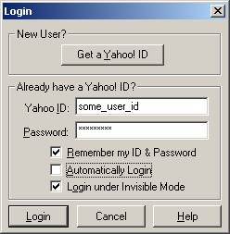

- Test B: The screenshot of an online length or distance unit converter program is provided below. The program takes an input value for length and the corresponding unit of measurement and outputs the corresponding equivalent value for the output unit of measurement chosen by the user. Identify the variables of the unit converter program, the data type of each of the variables and state whether the variables are input or output.
Length or distance
Input
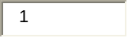

Output
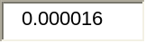

Table 6.05 analyzes and interprets learners’ scores on Question 5.
Student# | Student Code. | Q5 (Pretest score, worth 5 points) | Q5 (Posttest, worth 5 points)
Experiment 1
 | JL711S1 | 5 | 5
 | JL711S2 | 5 | 4.5
 | JL711S3 | 1 | 5
 | JL711S4 | 4 | 5
 | JL1418S1 | 5 | 4.75
 | JL1418S2 | 5 | 5
 | JL1418S3 | 2.5 | 5
 | JL1418S4 | 4.5 | 5
 | JL1418S5 | 3 | 5
 | JL2125S1 | 5 | 5
 | JL2125S2 | 5 | 5
 | JL2125S3 | 3.75 | 5
 | JL2125S4 | 5 | 5
 | JL28A1S2 | 2 | 5
 | JL28A1S3 | 2 | 5
 | JL28A1S4 | 5 | 5
 | JL28A1S5 | 2 | 5
 | JL28A1S6 | 2 | 2
Experiment 2
 | A2529S1 | 4 | 5
 | A2529S2 | 1 | 5
 | A2529S3 | 3 | 5
 | A2529S4 | 5 | 5
 | A2529S5 | 2.5 | 5
Average |  | 3.58 | 4.84
Standard deviation |  | 1.44 | 0.63
Table 6.05: Question 5 – Paper-Based Pretest and Posttest Score Comparison

Interpretation (Question 5): Students’ average score for this question was 3.58 in the pretest and 4.84 in the posttest. This means that on an average, not only did the students score well (71.6%) on this question in the pretest itself, but the average score in the posttest also improved by 25.2%. The standard deviation of the scores was 1.44 and 0.63 in the pretest and posttest, respectively. This means that the deviation in the scores from the average was slightly conspicuous in the pretest but it became quite negligible in the posttest.

Question 6 (10 points):
- Test A: There are five variables l, m, n, o and p in some function. The variables l, m, n and o have five test cases each and p has two test cases. How many total combinations of test cases are possible for these five variables? How many minimal combinations does all pairs combination technique yield? How many pairs will each combination have if all pairs combination technique is used? Develop a series of combination tests on these five variables by performing all pairs combination on them. Show all iterations. Give relevant comments when you backtrack and redo any ordering. Please have a separate table for each reordering.

- Test B: There are four variables a, b, c and d in some function. All four variables have five test cases each. How many total combinations of test cases are possible for these four variables? How many minimal combinations does all pairs combination technique yield? How many pairs will each combination have if all pairs combination technique is used? Develop a series of combination tests on these four variables by performing all pairs combination on them. Show all iterations. Give relevant comments when you backtrack and redo any ordering. Please have a separate table for each reordering.

Table 6.06 analyzes and interprets learners’ scores on Question 6.

Student# | Student Code. | Q6 (Pretest score, worth 10 points) | Q6 (Posttest, worth 10 points)
Experiment 1
 | JL711S1 | This question has not been evaluated for Experiment 1 due to an experimental error (refer to section 5.06) corresponding to the instructional goal that is being tested in this question.
 | JL711S2
 | JL711S3
 | JL711S4
 | JL1418S1
 | JL1418S2
 | JL1418S3
 | JL1418S4
 | JL1418S5
 | JL2125S1
 | JL2125S2
 | JL2125S3
 | JL2125S4
 | JL28A1S2
 | JL28A1S3
 | JL28A1S4
 | JL28A1S5
 | JL28A1S6
Experiment 2
 | A2529S1 | 3 | 10
 | A2529S2 | 2 | 10
 | A2529S3 | 4 | 10
 | A2529S4 | 1 | 9
 | A2529S5 | 4.5 | 10
Average |  | 2.90 | 9.80
Standard deviation |  | 1.43 | 0.45
Table 6.06: Question 6 – Paper-Based Pretest and Posttest Score Comparison

Interpretation (Question 6): Students’ average score for this question was 2.90 in the pretest and 9.80 in the posttest. This means that on an average, the students scored poorly (29%) on this question in the pretest itself. But the average score in the posttest improved significantly to 98%. The standard deviation of the scores was 1.43 and 0.45 in the pretest and posttest, respectively. This means that the deviation in the scores from the average was low in the pretest and it became almost negligible in the posttest.

Question 7 (15 points):
- Test A: The I-20 VISA program for international students lets a student know the status of his or her application for a new I-20 by entering his or her corresponding VISA number. The VISA number is a 16-digit numeric value with no dashes, commas or spaces in between. The minimum allowed VISA number that a student could have ever been assigned is 1000009999000000 and the maximum is 9999955590999800.

What variables could be involved in analysis of this group of facts? What variable do we know enough about to perform equivalence class analysis and then a boundary value analysis? Develop a series of tests by performing equivalence class and boundary value analysis on this variable.

- Test B: Creative Technologies offers its employees the opportunity to attend conferences and training that helps in the enhancement of their skill set and in turn the company’s profits. The company requires that an employee use the company’s reimbursement system to report expenses. The system has an expense report function that has various fields like employee ID, meal expenses, travel expenses, training/conference registration expenses, miscellaneous expenses and total expenditure. The company reimburses the employees up to $5,000. All expense-related fields require entering of only whole numbers, which means that the user should round each expense to the nearest whole number and then enter this number in the corresponding field. What variables could be involved in analysis of this group of facts? What variable do we know enough about to perform equivalence class analysis and then a boundary value analysis? Develop a series of tests by performing equivalence class and boundary value analysis on this variable.

Table 6.07 analyzes and interprets learners’ scores on Question 7.

Student# | Student Code. | Q7 (Pretest score, worth 15 points) | Q7 (Posttest, worth 15 points)
Experiment 1
 | JL711S1 | 4 | 5.5
 | JL711S2 | 3 | 14
 | JL711S3 | 3 | 15
 | JL711S4 | 0 | 15
 | JL1418S1 | 0.5 | 14
 | JL1418S2 | 4 | 15
 | JL1418S3 | 1 | 15
 | JL1418S4 | 1 | 14.75
 | JL1418S5 | 2 | 14
 | JL2125S1 | 1 | 14.5
 | JL2125S2 | 1 | 13
 | JL2125S3 | 3 | 14.75
 | JL2125S4 | 5 | 13
 | JL28A1S2 | 1 | 15
 | JL28A1S3 | 1.5 | 15
 | JL28A1S4 | 3 | 14.75
 | JL28A1S5 | 0 | 14.5
 | JL28A1S6 | 0 | 13
Experiment 2
 | A2529S1 | 5 | 14.75
 | A2529S2 | 0 | 14.75
 | A2529S3 | 1.5 | 14
 | A2529S4 | 4 | 13
 | A2529S5 | 6.5 | 13
Average |  | 2.22 | 13.88
Standard deviation |  | 1.87 | 1.98
Table 6.07: Question 7 – Paper-Based Pretest and Posttest Score Comparison

Interpretation (Question 7): Students’ average score for this question was 2.22 in the pretest and 13.88 in the posttest. This means that on an average, the students scored very poorly (14.8%) on this question in the pretest. But the average score improved significantly to 92.53% in the posttest. The standard deviation of the scores was 1.87 and 1.98 in the pretest and posttest, respectively. This means that the deviation in the scores from the average was almost equivalent in the pretest and the posttest. The students did equally poorly in the pretest and equally well in the posttest.

Question 8 (15 points):
- Test A: Bank X has started a new savings account program that allows customers to earn interest based on their savings account balance. The interest is calculated using the following table:
Balance range | Interest that can be earned
$5000.00 <= balance <= $15000.00 | 1.09%
$15000.00 < balance <= $30000.00 | 1.50%
$30000.00 < balance <= $55000.00 | 1.73%
$55000.00 < balance <= $80000.00 | 2.09%
balance > $80000.00 | 2.50%

What variables could be involved in analysis of this group of facts? What variable do we know enough about to perform equivalence class analysis and then a boundary value analysis? Develop a series of tests by performing equivalence class analysis and boundary value analysis on this variable.

- Test B: XYZ credit cards offer a “cash back” award program. After a customer spends a particular amount of money, he or she receives a cash back award according to the following table:

Amount spent range | Cash back that can be earned
$1000.00<= amount spent <= $1500.00 | $50
$1500.00 < amount spent <= $2000.00 | $75
$2000.00 < amount spent <= $2500.00 | $95
$2500.00 < amount spent <= $3500.00 | $110
amount spent > $3500.00 | $150

What variables could be involved in analysis of this group of facts? What variable do we know enough about to perform equivalence class analysis and then a boundary value analysis? Develop a series of tests by performing equivalence class analysis and boundary value analysis on this variable.

Table 6.08 analyzes and interprets learners’ scores on Question 8.

Student# | Student Code. | Q8 (Pretest score, worth 15 points) | Q8 (Posttest, worth 15 points)
Experiment 1
 | JL711S1 | 2.5 | 14
 | JL711S2 | 0 | 0
 | JL711S3 | 3 | 15
 | JL711S4 | 2 | 14.75
 | JL1418S1 | 3.5 | 14
 | JL1418S2 | 4 | 14.5
 | JL1418S3 | 5 | 10
 | JL1418S4 | 0.5 | 10
 | JL1418S5 | 0 | 14.75
 | JL2125S1 | 0 | 14.5
 | JL2125S2 | 0.5 | 14
 | JL2125S3 | 1 | 14.5
 | JL2125S4 | 5 | 13
 | JL28A1S2 | 1 | 13
 | JL28A1S3 | 2 | 12
 | JL28A1S4 | 4 | 14.75
 | JL28A1S5 | 5 | 11
 | JL28A1S6 | 0 | 11
Experiment 2
 | A2529S1 | 7 | 14
 | A2529S2 | 0 | 12
 | A2529S3 | 5 | 12
 | A2529S4 | 5 | 14
 | A2529S5 | 9 | 11
Average |  | 2.83 | 12.51
Standard deviation |  | 2.53 | 3.17
Table 6.08: Question 8 – Paper-Based Pretest and Posttest Score Comparison

Interpretation (Question 8): Students’ average score for this question was 2.83 in the pretest and 12.51 in the posttest. This means that on an average, the students scored very poorly (18.86%) on this question in the pretest. But the average score improved significantly to 83.4% in the posttest. The standard deviation of the scores was 2.53 and 3.17 in the pretest and posttest, respectively. This means that the deviation in the scores from the average actually increased from the pretest to the posttest. This is because student JL711S2 scored zero on this question in both the pretest and posttest, whereas the others improved significantly in the posttest.

Question 9 (15 points):
- Test A: ZLTech has a Web-based student records system. A student has to enter his or her Social Security number in the text field provided for it and then click on the sign in button to log in and access his or her records, which include courses taken by the student so far and the corresponding grades.

The Social Security number can have only 11 characters. The first three characters have to be digits, then a hyphen and then two more digits, a hyphen and finally four digits. No other characters whatsoever are allowed to be entered for the Social Security number field.

What variables could be involved in analysis of this group of facts? What variable do we know enough about to perform equivalence class analysis and then a boundary value analysis? Develop a series of tests by performing equivalence class analysis and boundary value analysis on this variable.

- Test B: The U.S. Immigration and Naturalization Service has an online application that lets international students check the status of their work authorization application in the United States. Upon applying for work authorization, every student is given a ticket number, which is an 11-character value. Every ticket number consists of digits and uppercase letters, with a letter in the fourth and eighth positions. The other characters have to be strictly digits.

What variables could be involved in analysis of this group of facts? What variable do we know enough about to perform equivalence class analysis and then a boundary value analysis? Develop a series of tests by performing equivalence class and boundary value analysis on this variable.

Table 6.09 analyzes and interprets learners’ scores on Question 9.
Student# | Student Code. | Q9 (Pretest score, worth 15 points) | Q9 (Posttest, worth 15 points)
Experiment 1
 | JL711S1 | 1 | 15
 | JL711S2 | 0 | 14
 | JL711S3 | 2.35 | 14.5
 | JL711S4 | 5 | 15
 | JL1418S1 | 2 | 14.5
 | JL1418S2 | 2 | 12
 | JL1418S3 | 3.5 | 14.5
 | JL1418S4 | 0 | 12
 | JL1418S5 | 2 | 15
 | JL2125S1 | 1 | 14.75
 | JL2125S2 | 2 | 7.5
 | JL2125S3 | 2 | 14
 | JL2125S4 | 4 | 12
 | JL28A1S2 | 2 | 12
 | JL28A1S3 | 1 | 12
 | JL28A1S4 | 3 | 14
 | JL28A1S5 | 0 | 14.5
 | JL28A1S6 | 0 | 14
Experiment 2
 | A2529S1 | 1 | 13.5
 | A2529S2 | 2 | 14
 | A2529S3 | 2 | 13
 | A2529S4 | 2 | 12
 | A2529S5 | 4 | 13
Average |  | 1.91 | 13.34
Standard deviation |  | 1.35 | 1.69
Table 6.09: Question 9 – Paper-Based Pretest and Posttest Score Comparison

Interpretation (Question 9): Students’ average score for this question was 1.91 in the pretest and 13.34 in the posttest. This means that on an average, the students scored very poorly (12.73%) on this question in the pretest. But the average score improved significantly to 88.93% in the posttest. The standard deviation of the scores was 1.35 and 1.69 in the pretest and posttest, respectively.

Student# | Student Code. | Pretest Final Score (out of 90 for 1:18, out of 100 for 19:23) | Posttest Final Score (out of 90 for 1:18, out of 100 for 19:23) | Pretest  % Score | Posttest % Score | Percentage  Increase
Experiment 1
 | JL711S1 | 43.5 | 79.5 | 48.33 | 88.33 | 40.00
 | JL711S2 | 39 | 62.5 | 43.33 | 69.44 | 26.11
 | JL711S3 | 34.85 | 83.5 | 38.72 | 92.78 | 54.06
 | JL711S4 | 39.25 | 89 | 43.61 | 98.89 | 55.28
 | JL1418S1 | 45.75 | 87.25 | 50.83 | 96.94 | 46.11
 | JL1418S2 | 43.25 | 80.75 | 48.06 | 89.72 | 41.67
 | JL1418S3 | 40 | 83.5 | 44.44 | 92.78 | 48.33
 | JL1418S4 | 26 | 81.75 | 28.89 | 90.83 | 61.94
 | JL1418S5 | 27.5 | 88.75 | 30.56 | 98.61 | 68.06
 | JL2125S1 | 23.5 | 87.75 | 26.11 | 97.50 | 71.39
 | JL2125S2 | 14.5 | 76.5 | 16.11 | 85.00 | 68.89
 | JL2125S3 | 15.75 | 85.5 | 17.50 | 95.00 | 77.50
 | JL2125S4 | 36 | 79.75 | 40.00 | 88.61 | 48.61
 | JL28A1S2 | 15.5 | 82 | 17.22 | 91.11 | 73.89
 | JL28A1S3 | 37 | 80.75 | 41.11 | 89.72 | 48.61
 | JL28A1S4 | 40 | 88.5 | 44.44 | 98.33 | 53.89
 | JL28A1S5 | 32 | 85 | 35.56 | 94.44 | 58.89
 | JL28A1S6 | 20 | 78.25 | 22.22 | 86.94 | 64.72
Experiment 2
 | A2529S1 | 33 | 94.25 | 33 | 94.25 | 61.25
 | A2529S2 | 15 | 92.75 | 15 | 92.75 | 77.75
 | A2529S3 | 30.5 | 89 | 30.5 | 89.00 | 58.50
 | A2529S4 | 36 | 92 | 36 | 92.00 | 56.00
 | A2529S5 | 44.5 | 90 | 44.5 | 90.00 | 45.50
Average |  | 31.84 | 84.28 | 34.61 | 91.43 | 56.82
Standard deviation |  | 10.24 | 6.81 | 11.26 | 6.16
Table 6.10: Final Scores - Pretest and Posttest Score Comparison

Interpretation (Final Scores): Since Question 6 has not been evaluated for Experiment 1 (refer to section 5.06), the final pretest and posttest scores for Experiment 1 were computed out of 90 points and the scores for Experiment 2 were computed out of 100 points. All the scores have also been computed on a scale of 100 (% scores) for the sake of uniformity and easier data analysis. On an average, the percentage increase in the scores from pretest to posttest was 56.82%, a good improvement. The standard deviation of the final pretest score was 11.26. It decreased to 6.16 for the posttest, which means that the students’ performance was more uniform compared to that in the pretest.

Chart 6.01, Chart 6.02 and Chart 6.03 graphically represent the comparison of final paper-based pretest and posttest percentage scores, the percentage increases and the averages of the final pretest and posttest percentage scores, and the average percentage increase in the scores from pretest to posttest, respectively.

Chart 6.01: Paper-Based Pretest and Posttest Final Percentage Score Comparison

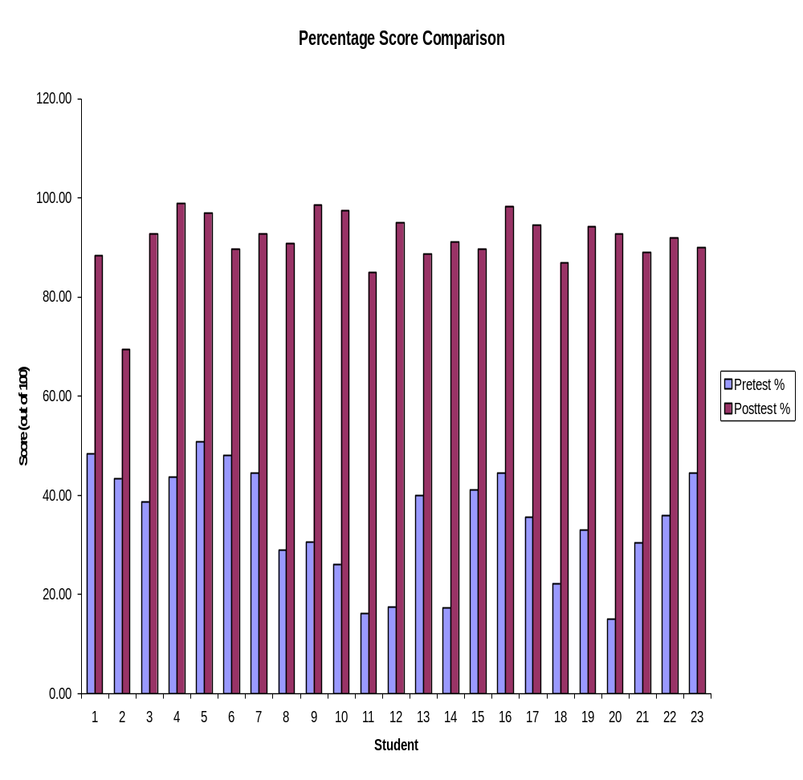

Chart 6.02: Final Scores Percentage Increase

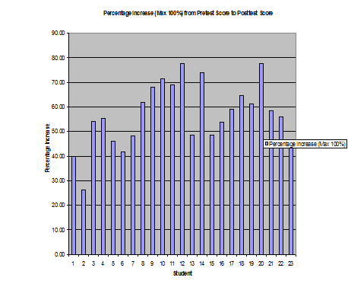

Chart 6.03: Averages

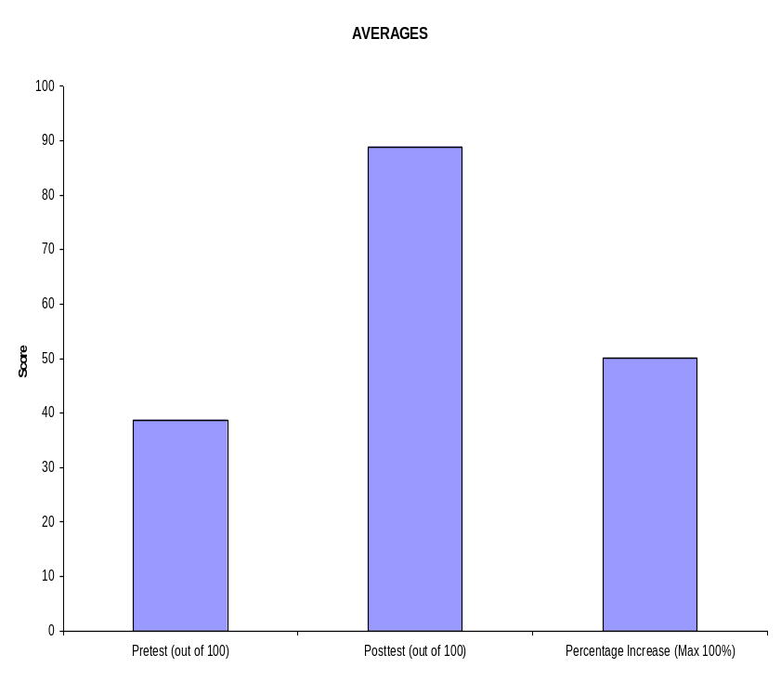

6.02 Performance Test Results
Appendices X, Y and Z contain the performance test evaluation reports by Dr. Cem Kaner, James Bach and Pat McGee, respectively.

6.03 Questionnaire – Confidence, Attitude and Opinion of Learners
As mentioned before, the learners were required to complete questionnaires at the end of each of the five training days. The questionnaires consisted of both closed-ended and open-ended questions. Tables 6.11 through 6.15 describe questions on each questionnaire and their answers.

Table 6.11: Day 1 Questionnaire Responses

Questionnaire – Day 1

 | How would you rate the overall clarity of today's lecture?
 | Excellent | Good | Fair | Poor
 | 10 | 13 | 0 | 0
 | How would you rate the overall clarity of the pretest?
 | Excellent | Good | Fair | Poor
 | 2 | 15 | 5 | 1
 | How would you rate your overall satisfaction with today's lecture?
 | Excellent | Good | Fair | Poor
 | 6 | 15 | 2 | 0
 | How would you rate your overall satisfaction with the pretest?
 | Excellent | Good | Fair | Poor
 | 3 | 13 | 5 | 2
 | How would you rate today's session in terms of how interesting it was?
 | Excellent | Good | Fair | Poor
 | 10 | 10 | 3 | 0
 | Rate your confidence when answering the questions on the pretest.
 | Excellent | Good | Fair | Poor
 | 1 | 7 | 11 | 4
 | Was enough time given to solve the pretest?
 | More than enough | Enough | Little short of enough | Very less time provided
 | 7 | 11 | 5 | 0
 | Were too many or too less questions included in the pretest?
 | Too many questions | Enough | Little short of enough | Very less questions
 | 11 | 12 | 0 | 0
 | How would you rate your competence in doing domain testing?
 | Excellent | Good | Fair | Poor
 | 1 | 7 | 11 | 4
 | What was the most useful part of today’s session?
 | General comments were that the reference materials were very helpful in solving the test. The learners also liked the fact that there was an introductory lecture before the pretest.
 | What did you like best about today’s session?
 | While some commented that the pretest was the best part of the training session, there were some others that commented that the introductory lecture was the best part.
 | What was the least useful part of today’s session?
 | Some commented that the least useful part of the day was taking the pretest. Others complained that the pretest was just too lengthy. There were a couple of learners that felt that everything was useful. One learner commented that he was just too confused to know what was useful and what was useless.
 | What other information would you like to see added to today’s lecture and test?
 | Some commented that they would like to see more examples added to the reference materials, while others said that a longer introductory lecture would have been nice.
 | Would you like to suggest specific improvements to today’s lecture?
 | Some commented that it would be nice to have demonstrations of some more examples during the lecture, which might help during the pretest.
 | Would you like to suggest specific improvements to the pretest?
 | Generally, the comments were that the number of questions on the test should be reduced.

Table 6.12: Day 2 Questionnaire Responses

Questionnaire – Day 2

 | How would you rate the overall clarity of today's lecture?
 | Excellent | Good | Fair | Poor
 | 14 | 9 | 0 | 0
 | How would you rate the overall clarity of today's exercises?
 | Excellent | Good | Fair | Poor
 | 8 | 15 | 0 | 0
 | How would you rate your overall satisfaction with today's lecture?
 | Excellent | Good | Fair | Poor
 | 11 | 12 | 0 | 0
 | How would you rate your overall satisfaction with today's exercises?
 | Excellent | Good | Fair | Poor
 | 7 | 15 | 1 | 0
 | How would you rate today's session in terms of how interesting it was?
 | Excellent | Good | Fair | Poor
 | 9 | 12 | 2 | 0
 | Rate your confidence when solving the exercises.
 | Excellent | Good | Fair | Poor
 | 5 | 18 | 0 | 0
 | Was enough feedback provided for the exercises?
 | More than enough | Enough | Little short of enough | Very less
 | 6 | 16 | 1 | 0
 | Was enough time given to solve the exercises?
 | More than enough | Enough | Little short of enough | Very less time provided
 | 3 | 16 | 4 | 0
 | What was the most useful part of today’s session?
 | While some commented that they best liked the exercises and examples, others specifically mentioned that they found doing equivalence class analysis the best part of the training session. Some also mentioned that they enjoyed learning to do domain testing on non-numbers. A few commented that they found the lecture very informative.
 | What did you like best about today’s session?
 | While some commented that the exercises and examples were the best part, some others commented that they liked the fact that examples and exercises were alternated. Some also commented that they loved the step-by-step approach to doing equivalence class analysis.
 | What was the least useful part of today’s session?
 | While most of them did not answer this question, some commented that everything was useful. There were two that thought that the equivalence class analysis of non-numbers was least useful to them. There was a learner who thought that the lecture slides were least useful.
 | What other information would you like to see added to today’s lecture?
 | While most of them did not answer this question, some commented that they would not like to see anything added. One learner commented that she would like more lecture time.
 | What other information would you like to see added to today’s exercises?
 | Some commented that it would nice to have more explanation of how to build the equivalence class table
 | Would you like to suggest specific improvements to today’s lecture?
 | While most of them did not answer this question or just said “none,” some commented that the lecture was too long.
 | Would you like to suggest specific improvements to today’s exercises?
 | While most of them did not answer this question or just said “none,” a few of the learners requested more time to solve the exercises.

Table 6.13: Day 3 Questionnaire Responses

Questionnaire – Day 3

 | How would you rate the overall clarity of today's lecture?
 | Excellent | Good | Fair | Poor
 | 10 | 12 | 1 | 0
 | How would you rate the overall clarity of today's exercises?
 | Excellent | Good | Fair | Poor
 | 9 | 14 | 0 | 0
 | How would you rate your overall satisfaction with today's lecture?
 | Excellent | Good | Fair | Poor
 | 8 | 14 | 1 | 0
 | How would you rate your overall satisfaction with today's exercises?
 | Excellent | Good | Fair | Poor
 | 8 | 13 | 2 | 0
 | How would you rate today's session in terms of how interesting it was?
 | Excellent | Good | Fair | Poor
 | 9 | 14 | 0 | 0
 | Rate your confidence when solving the exercises.
 | Excellent | Good | Fair | Poor
 | 5 | 15 | 3 | 0
 | Was enough feedback provided for the exercises?
 | More than enough | Enough | Little short of enough | Very less
 | 3 | 20 | 0 | 0
 | Was enough time given to solve the exercises?
 | More than enough | Enough | Little short of enough | Very less time provided
 | 2 | 14 | 3 | 4
 | What was the most useful part of today’s session?
 | While most of the learners commented that they best liked the hands-on experience as they got to test real computer applications, some others commented that they liked the multidimensional analysis of variables.
 | What did you like best about today’s session?
 | Most of the learners commented that they liked the exercises and liked the fact that the exercises involved functions of real computer applications.
 | What was the least useful part of today’s session?
 | While most of them did not answer this question, some commented that everything was useful. There was one who thought slides were least useful.
 | What other information would you like to see added to today’s lecture?
 | While most of them did not answer this question, two of the learners suggested adding more time and examples to the lecture.
 | What other information would you like to see added to today’s exercises?
 | While most of them did not answer this question, some commented that everything was fine. However, there were at least two learners that suggested giving more time to solve exercises.
 | Would you like to suggest specific improvements to today’s lecture?
 | While most of them did not answer this question, some commented that everything was fine. However, one learner suggested that examples required more explanations to solve the corresponding exercises successfully.
 | Would you like to suggest specific improvements to today’s exercises?
 | While most of them did not answer this question or just said “none,” a few of the learners suggested that the number of exercises be reduced.

Table 6.14: Day 4 Questionnaire Responses

Questionnaire – Day 4

 | How would you rate the overall clarity of today's lecture?
 | Excellent | Good | Fair | Poor
 | 11 | 12 | 0 | 0
 | How would you rate the overall clarity of today's exercises?
 | Excellent | Good | Fair | Poor
 | 9 | 13 | 1 | 0
 | How would you rate your overall satisfaction with today's lecture?
 | Excellent | Good | Fair | Poor
 | 11 | 12 | 0 | 0
 | How would you rate your overall satisfaction with today's exercises?
 | Excellent | Good | Fair | Poor
 | 10 | 12 | 1 | 0
 | How would you rate today's session in terms of how interesting it was?
 | Excellent | Good | Fair | Poor
 | 9 | 14 | 0 | 0
 | Rate your confidence when solving the exercises.
 | Excellent | Good | Fair | Poor
 | 4 | 19 | 0 | 0
 | Was enough feedback provided for the exercises?
 | More than enough | Enough | Little short of enough | Very less
 | 5 | 18 | 0 | 0
 | Was enough time given to solve the exercises?
 | More than enough | Enough | Little short of enough | Very less time provided
 | 2 | 15 | 5 | 1
 | What was the most useful part of today’s session?
 | While most of the learners commented that they best liked the exercises, a few others commented that they best liked learning to do all pairs combination and building the all pairs table.
 | What did you like best about today’s session?
 | Most of the learners commented that they liked building the all pairs table and appreciated the fact that a lot of time was spent teaching how to build the all pairs table and enough feedback was provided. Some also commented that they best liked learning how to identify dependent variables and analyzing the dependency relationships. A learner also commented that she liked the fact that there was a lot of student interaction.
 | What was the least useful part of today’s session?
 | While most of them refrained from answering this question, some commented that everything was useful. There was one who thought slides were least useful and another one who thought that it took forever to build the all pairs table.
 | What other information would you like to see added to today’s lecture?
 | While most of them did not answer this question, others just commented “none.”
 | What other information would you like to see added to today’s exercises?
 | While most of them did not answer this question, others just commented “none.”
 | Would you like to suggest specific improvements to today’s lecture?
 | While most of them did not answer this question, some commented that everything was fine.
 | Would you like to suggest specific improvements to today’s exercises?
 | While most of them did not answer this question or just said “none,” a few of the learners commented that more time needs to be provided to solve the exercises.

Table 6.15: Day 5 Questionnaire Responses

Questionnaire – Day 5

 | How would you rate the overall training in terms of how interesting it was?
 | Excellent | Good | Fair | Poor
 | 15 | 7 | 1 | 0
 | How would you rate your overall satisfaction with the training?
 | Excellent | Good | Fair | Poor
 | 14 | 9 | 0 | 0
 | How would you rate the overall clarity of the posttest?
 | Excellent | Good | Fair | Poor
 | 14 | 9 | 0 | 0
 | How would you rate your overall satisfaction with the posttest?
 | Excellent | Good | Fair | Poor
 | 11 | 11 | 1 | 0
 | Rate your confidence when answering the questions on the posttest.
 | Excellent | Good | Fair | Poor
 | 8 | 15 | 0 | 0
 | Was enough time given to solve the posttests?
 | More than enough | Enough | Little short of enough | Very less time provided
 | 3 | 15 | 5 | 0
 | Were too many or too less questions included in the posttests?
 | Too many questions | Enough | Little short of enough | Very less questions
 | 4 | 18 | 1 | 0
 | How would you rate your competence in doing domain testing?
 | Excellent | Good | Fair | Poor
 | 6 | 16 | 1 | 0
 | How likely is it that you'll recommend this training to somebody else?
 | Very likely | Likely | Less likely | Not likely
 | 13 | 10 | 0 | 0
 | What was the most useful part of this training?
 | Some learners commented that they found the training very informative and interactive. Some others commented that they best liked the exercises and examples.
 | What did you like best about the training?
 | Most of them commented that they best liked the exercises and examples. Several others said that they learned so much about a testing strategy that was new to them in just five days. One learner commented that the best part of the training was that he got paid for it. A few commented that hands-on experience during the training was the best part.
 | What was the least useful part of the training?
 | While most of them refrained from answering this question, some commented that everything was useful. There was one who thought slides were least useful and another one who thought that it took forever to build the all pairs table.
 | What other information would you like to see added to or deleted from today’s tests?
 | While most of them did not answer this question or just commented “none,” one learner said that either more time should be provided to solve the tests or some questions should be deleted.
 | Would you like to suggest specific improvements to the posttests?
 | While some of them did not answer this question, some commented that everything was fine. Several learners commented that fewer questions on the paper-based posttest and more on the computer-based performance test would be desirable. A learner commented that the training should actually be spread over more days and the learners should be allowed to take the training materials home. A few commented that the paper-based test was too time consuming. Just one learner said that the difficulty level of the test questions should be increased.
 | Would you like to suggest specific improvements to the training?
 | While most of them did not answer this question or just said “none,” a few of the learners commented that more time needs to be provided to solve the exercises and tests. One learner specifically mentioned that an overview of all software testing paradigms should be provided and it should be explained where domain testing methodology stands amongst all of them.

The following page contains Chart 6.04 that graphically describes the answers to the closed-ended questions on the questionnaire for Day 5 with the help of several pie charts.

Chart 6.04: Final Day (5) Questionnaire Responses
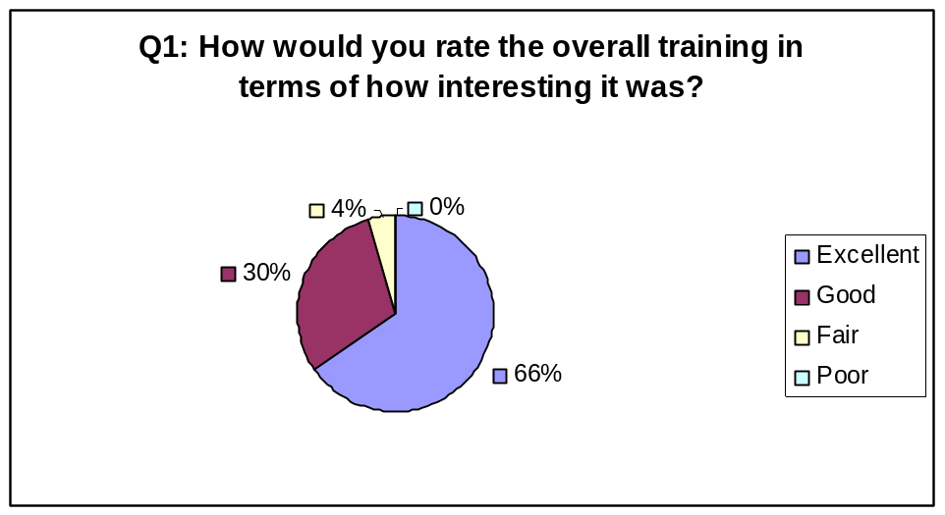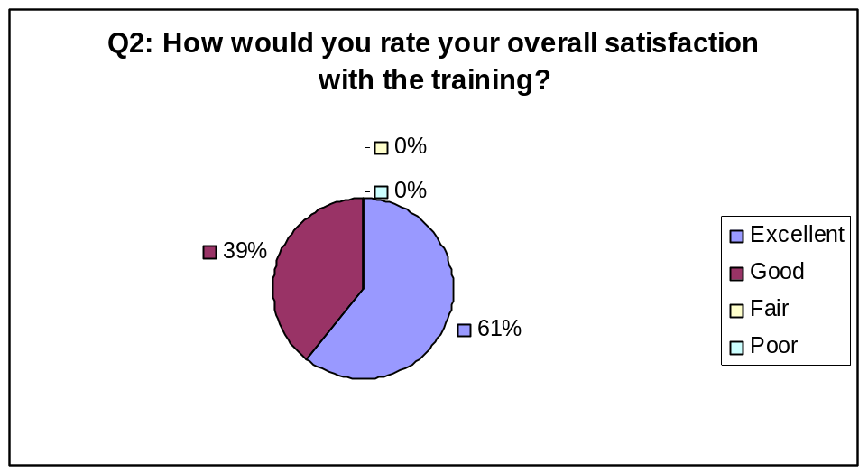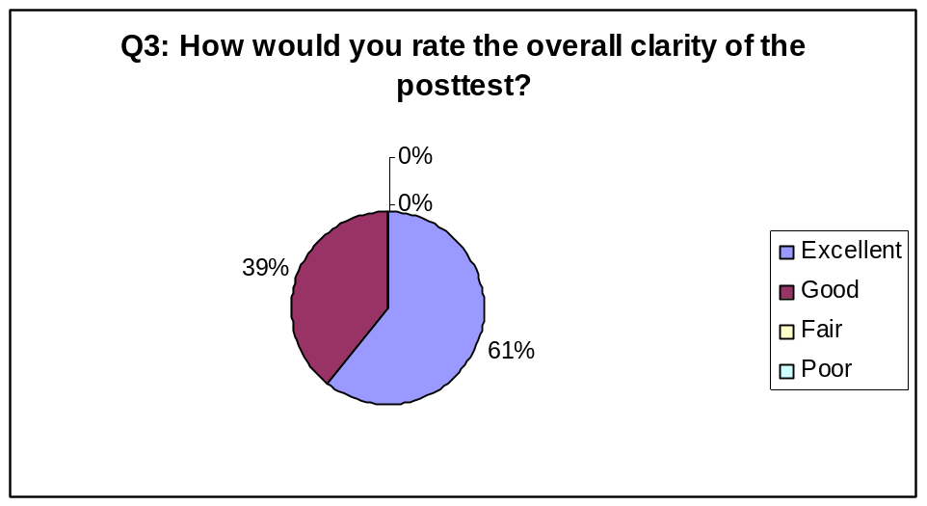
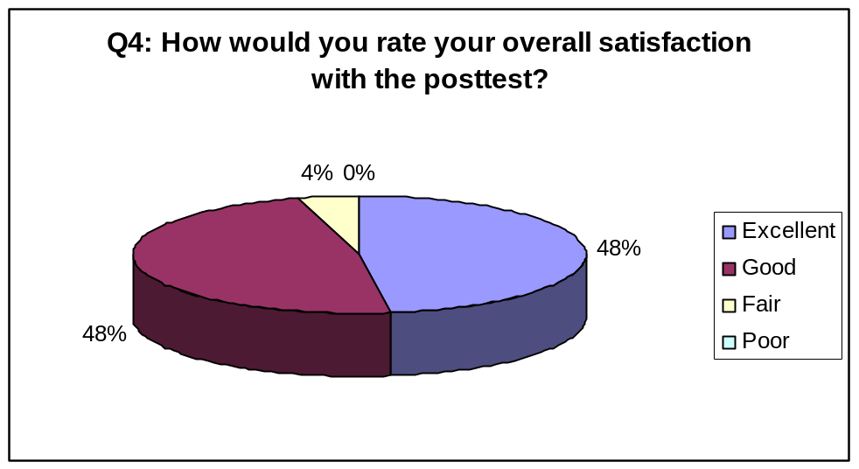
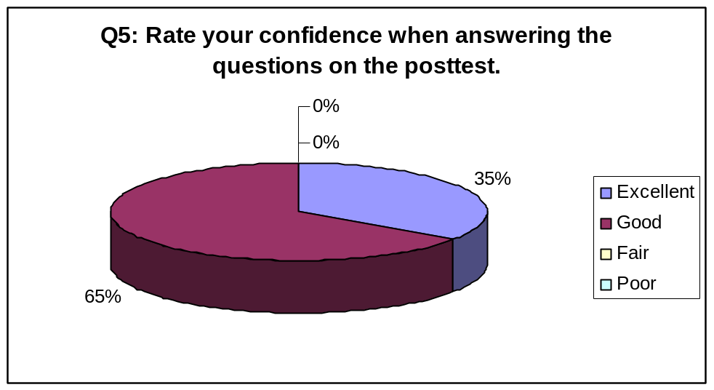
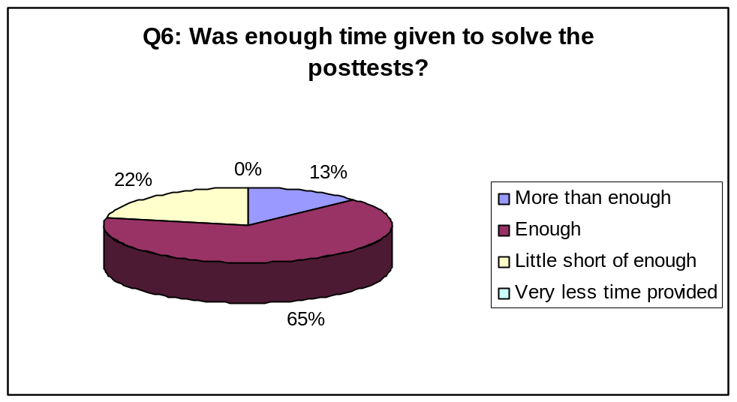

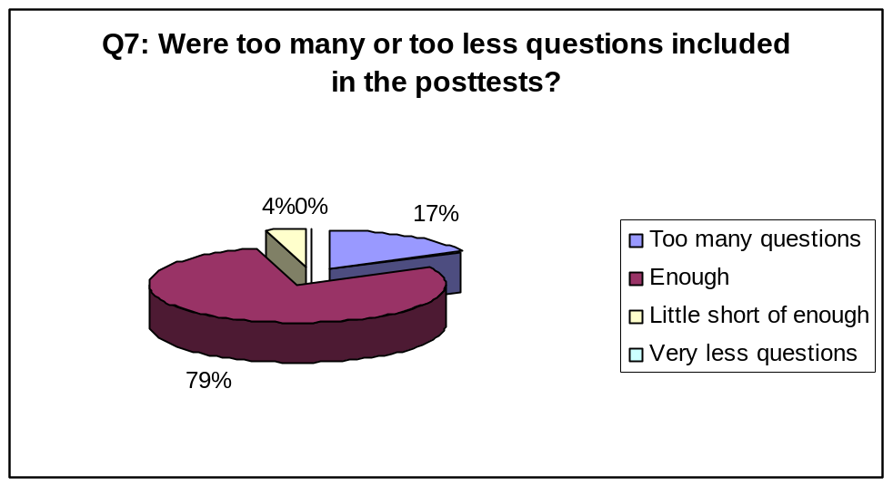
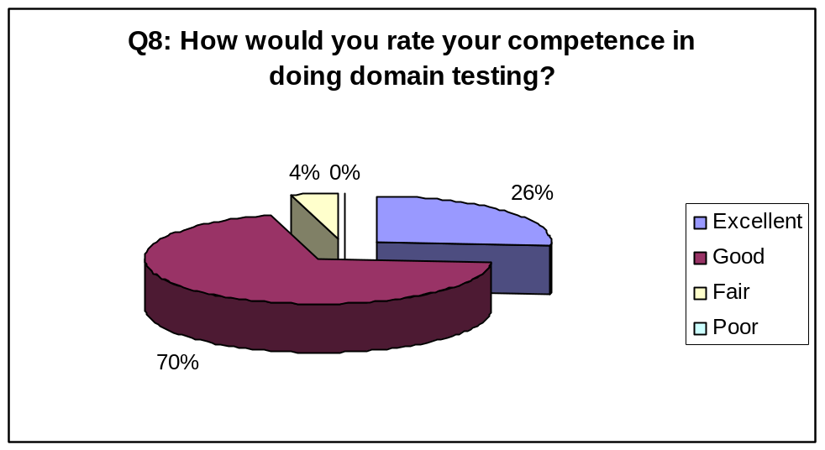
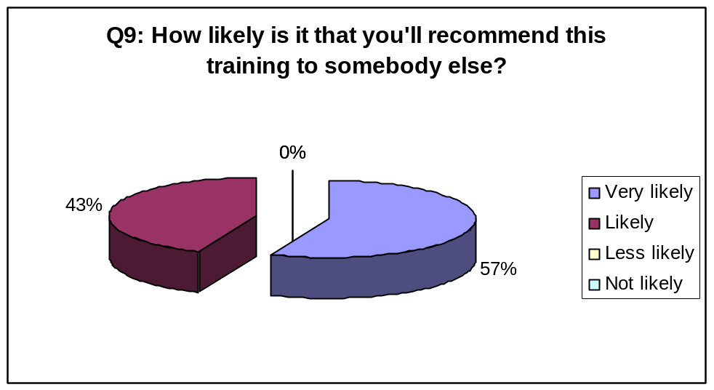

Chapter 7: Conclusion

  - Domain Testing Training – Where Does it Stand?
After evaluation of the tests, it has been observed that there were some plus points and some minus points about the learners’ performance. I evaluated the paper-based tests. As you can see from the results presented in the previous chapter, the learners’ performance improved a lot from the pretest to the posttest. But when it came to testing a real computer-based application, while the learners did do some things very well, they failed in some ways.
The performance tests were evaluated by Dr. Cem Kaner, James Bach and Pat McGee. They have noted some pluses and minuses with the learners’ performance and thus the training material. According to these three evaluators, the learners’ performance is not comparable to the standard of a tester during a job interview who has one year’s experience and who considers herself reasonably good at domain testing. The detailed evaluation reports of the performance tests are available in appendices X, Y and Z, respectively.

7.01.01 Pluses
Kaner (2003) cited some plus points of the learners’ performance in the performance test for the page setup feature of Microsoft’s PowerPoint application, which are mentioned below:
These students’ tables—especially the specific identification of dimensions along which data entered into the variable can vary—look unusually sophisticated for students who have no prior test experience or education and only 15 hours of instruction. The 23 students’ analyses were remarkably consistent. Their tables were structured the same way and almost all identified the same dimensions. For example, for the Page Width variable (a floating point field that can range from 1 to 56 inches), students consistently identified three dimensions: page width (in inches), number of characters that can be entered into the field (from 0 to 32) and the allowed characters (digits and decimal point). (p. 4)

Kaner (2004) mentioned the following plus points about my instructional materials:
In my opinion, the instructional materials developed by Padmanabhan are consistent with the field's most common presentation style for domain testing. She took their approach, did a more thorough job of presenting it to students, and obtained reasonable results when she asked questions that involved straightforward application of what she had taught. The specific results could certainly be improved on, but I don't think that those problems are at the heart of the learning problems faced by the subjects when they tried to transfer their knowledge to the performance test. (p. 10)

McGee cited the following positive point:
They did well on the outside boundaries of each dimension, since these could be tested independently. They did well on the enumerated variables, correctly identifying each value as something they needed to test. (Appendix Z: Performance Tests’ Evaluation Report by Pat McGee, p. 2)

Given the analysis that they did, all of the subjects generated all-pairs tables that were completely or mostly correct. One subject got the first three iterations correct, then completely messed up the fourth iteration. Another generated a table that was completely wrong, but the error was probably a bad copy-and-paste for the first variable. (For that variable, all values listed were the same.) Making a very reasonable correction to this answer would lead to it being completely correct. (Appendix Z: Performance Tests’ Evaluation Report by Pat McGee, p. 3)

7.01.02 Minuses
Kaner (2003) also commented on the things the students failed at in the performance test.
The students were also remarkably consistent in what they missed. Examples: (a) If you enter a sufficiently large paper size, PowerPoint warns that ‘the current page size exceeds the printable area of the paper in the printer.’ No one identified a boundary related to this message. (b) When you change page dimensions, the display of slides on the screen and their font sizes (defaults and existing text on existing slides) change. No one appeared to notice this. And (c) change the page size to a large page and try a print preview. You only see part of the page. (p. 4)

Bach mentions the following problem with some of the risks identified by the students:
Some of the risks identified by the students indicate a lack of insight about the nature of the technology under test. For instance, student #1 suggested using characters that are on either side of the ASCII code range for numeric digits. That kind of test made sense in 1985, but it seems unlikely that the programmers of PowerPoint are still writing their own input filter routines based on ASCII code signposts in an IF statement. Modern languages provide more sophisticated libraries and constructs to perform filtering on input. I think a much better test would be to paste in every possible character code. This is fairly easy to do and would trigger many more kinds of faults in the filtering code. (Appendix Y: Performance Tests’ Evaluation Report by James Bach, p. 4)

McGee commented that the students failed to achieve higher-order learning:
I believe that the problem presented was somewhat different from the simple cases presented in the training. The problem presented had four inter-related controls which basically represented a 2-D space with special points. The material presented in training was mostly about 1-D spaces. So, in many respects, this problem was a good test in that it required performance at level 6 of Bloom's taxonomy. Unfortunately, none of the subjects made this conceptual leap. They tried to treat the problem as if it were two independent 1-D spaces. This led them to propose tests that I thought were not very powerful. (Appendix Z: Performance Tests’ Evaluation Report by Pat McGee, pp. 1-2)

7.01.03 Final Remarks
Kaner (2003) made some final comments about my experiment:
Padmanabhan provided her students with detailed procedural documentation and checklists. From the consistency of the students’ results, I infer that students followed the procedural documentation rather than relying on their own analyses. It’s interesting to note that, assuming they are following the procedures most applicable to the task at hand, the students not only include what the procedures appear to tell them to include, but they also miss the issues not addressed by the procedures. In other words, the students aren’t doing a risk analysis or a dimensional analysis; they are following a detailed set of instructions for how to produce something that looks like a risk analysis or dimensional analysis.
I think we’ll find Padmanabhan’s materials (especially the practice exercises) useful for bringing students to a common procedural baseline. However, we have more work to do to bring students’ understanding of domain testing up to Bloom’s Level 6 (Evaluation) or Gagne’s (1996) development of cognitive strategies. (p. 4-5)

Bach made the following final comments:
I expect more insight, product knowledge, and imagination from a serious tester who had more than a few months of experience working for a company that cared about doing good testing. So, I would not say that this work is strong evidence that the students have been brought to an equivalent of a tester with 1 or 2 years experience. (Appendix Y: Performance Tests’ Evaluation Report by James Bach, p. 4)

McGee made the following final comments:
Overall, I did not get the impression that any of these subjects understood the material well enough to apply it to a new situation. I believe that they mostly could apply these techniques to situations that were very similar to the examples they had been trained on. In terms of Bloom's Taxonomy, I believe they learned the material mostly at level 3 (Application). (Appendix Z: Performance Tests’ Evaluation Report by Pat McGee, p. 4)

Kaner made the following concluding comments in his evaluation report:
Padmanabhan's course takes the approach that I was using (and that is common in the literature and in other instructor's courses) to a higher level. Her teaching is more thorough, has more examples, and more formative assessment.
The lesson that I take from her results is not that she didn't do a good enough job, but that failure despite the acceptable job that she did indicates that we need to rethink the teaching strategy in common use. I think that the modern literature on mathematics education, focusing on how to build higher-order understanding rather than procedural knowledge, can provide a good foundation for the next generation of course (and course-related experimentation), but I think that's the subject for another thesis. (Appendix X: Performance Tests’ Evaluation Report by Dr. Cem Kaner, p. 12)

Bibliography

Adrion, R. W., Branstad, M. A., & Cherniavsky, J. C. (1982, June). Validation, verification, and testing of computer software. ACM Computing Surveys, 14(2), 159-192.
Ammann, P., & Offutt, J. (1994, June). Using formal methods to derive test frames in category-partition testing. IEEE Computer Society, 69-80.
Anderson, L. W., Krathwohl, D. R., Airasian, P. W., Cruikshank, K. A., Mayer, R. E., Pintrich, P. R., et al. (Eds.). (2001). A taxonomy for learning, teaching and assessing: A revision of Bloom’s taxonomy of educational objectives. New York: Addison Wesley Longman.
Bailey, M. A., Moyers, T. E., & Ntafos, S. (1995). An application of random software testing. IEEE Computer Society, 1098-1102. Retrieved October 10, 2003, from http://ieeexplore.ieee.org
Beizer, B. (1995). Black-box testing: Techniques for functional testing of software and systems. United States: John Wiley & Sons.
Bender, R. (2001). How do you know when you are done testing? Retrieved February 20, 2004, from, http://jisqa.org/Presentations/2002%20Presentations/BENDER-D.pdf
Binder, R. V. (1994, September). Design for testability in object-oriented systems. Communications of the ACM, 37(9), 87-101.
Binder, R. V. (1999). Testing object oriented systems: Models, patterns and tools. Boston, MA: Addison-Wesley Longman.
Bloom, B. S. (1956). Taxonomy of educational objectives: Handbook 1 - cognitive domain. New York: Longman.
Bloom, B. S., Hastings, T. J., & Madaus, G. F. (1971). Handbook on formative and summative evaluation of student learning. United States: McGraw-Hill.
Boland, P. J., Singh, H., & Cukic, B. (2003, January). Comparing partition and random testing via majorization and Schur functions. IEEE Transactions on Software Engineering, 29(1), 88-94.
Bolton, M. (2004). Pairwise testing. Retrieved February 29, 2004, from
http://www.developsense.com/testing/PairwiseTesting.html
Boyer, R. S., Elspas, B., & Levitt, K. (1975, June). SELECT – A formal system for testing and debugging programs by symbolic execution. ACM SIGPLAN Notices, 10(6), 234-245.
Burnstein, I. (2003). Practical software testing. New York: Springer-Verlag.
Chan, F. T., Mak, I. K., Chen, T. Y., & Shen, S. M. (1997). On some properties of the optimally refined proportional sampling strategy. Computer Journal, 40(4), 194-199. Retrieved October 25, 2003, from http://www3.oup.co.uk/computer_journal/subs/Volume_40/Issue_04/Chan.pdf
Chan, F. T., Mak, I. K., Chen, T. Y., & Shen, S. M. (1998). On the effectiveness of the optimally refined proportional sampling testing strategy. IEEE Computer Society, 1-10. Retrieved October 10, 2003, from http://ieeexplore.ieee.org
Chen, T. Y., Leung, H., & Yu, Y. T. (1995). On the analysis of subdomain testing strategies. IEEE Computer Society, 218-224. Retrieved October 10, 2003, from http://ieeexplore.ieee.org
Chen, T. Y., Poon, P. L., Tang, S. F., & Yu, Y. T. (2000). White on black: A white-box-oriented approach for selecting black-box generated test cases. IEEE Computer Society, 275-284. Retrieved October 10, 2003, from http://ieeexplore.ieee.org
Chen, T. Y., Poon, P. L., & Tse, T. H. (2003, July). Choice relation framework for supporting category-partition test case generation. IEEE Transactions on Software Engineering, 29(7), 577-593.
Chen, T. Y., Tse, T. H., & Zhou, Z. (2001). Fault-based testing in the absence of an oracle. IEEE Computer Society, 172-178. Retrieved September 23, 2003, from http://ieeexplore.ieee.org
Chen, T. Y., Wong, P. K., & Yu, Y. T. (1999). Integrating approximation methods with the generalized proportional sampling strategy. IEEE Computer Society, 598-605. Retrieved November 6, 2003, from http://ieeexplore.ieee.org.
Chen, T. Y., & Yu, Y. T. (1994, December). On the relationship between partition and random testing. IEEE Transactions on Software Engineering, 20(12), 977-980.
Chen, T. Y., & Yu, Y. T. (1996a). Constraints for safe partition testing strategies. Computer Journal, 39(7), 619-625.
Retrieved September 30, 2003, from http://ieeexplore.ieee.org
Chen, T. Y., & Yu, Y. T. (1996b). More on the e-measure of subdomain testing strategies. IEEE Computer Society, 167-174. Retrieved September 30, 2003, from http://ieeexplore.ieee.org
Chen, T. Y., & Yu, Y. T. (1996c). On the expected number of failures detected by subdomain testing and random testing. IEEE Transactions on Software Engineering, 22(2), 109-119. Retrieved September 30, 2003, from http://ieeexplore.ieee.org
Chen, T. Y., & Yu, Y. T. (1997). Optimal improvement of the lower bound performance of partition testing strategies. IEE Proc.-Softw. Eng., 144(5-6), 271-278.
Chen, T. Y., & Yu, Y. T. (1998). On the test allocations for the best lower bound performance of partition testing. Retrieved September 30, 2003, from http://ieeexplore.ieee.org
Clarke, L. A. (1976, September). A system to generate test data and symbolically execute programs. IEEE Transaction on Software Engineering, SE-2(3), 215-222.
Clarke, L. A., Hassell, J., & Richardson, D. (1982, July). A close look at domain testing. IEEE Transactions on Software Engineering, SE-8(4), 380-390.
Cohen, D. M., Dalal, S. R., Parelius, J., & Patton, G. C. (1996). The combinatorial design approach to automatic test generation. Retrieved December 7, 2003, from http://ieeexplore.ieee.org.
Cohen, M. B., Colbourn, C. J., Gibbons, P. B., & Mugridge, W. B. (2003). Constructing test suites for interaction testing. IEEE Computer Society, 38-48. Retrieved December 23, 2003, from http://ieeexplore.ieee.org
DeMillo, R. A., Lipton, R. J., & Sayward, F. G. (1978, April). Hints on test data selection: Help for the practicing programmer. Computer, 11(4), 34-41.
Dick, W., & Carey, L. (1985). The systematic design of instruction (2nd ed.). United States: Scott, Foresman and Company.
Dick, W., Carey, L., & Carey, J. O. (2001). The systematic design of instruction (5th ed.). New York: Addison-Wesley.
Driscoll, M. P. (2000). Psychology of learning for instruction (2nd ed.). Needham Heights, MA: Allyn and Bacon.
Duran, J. W., & Ntafos, S. (1981). A report on random testing. IEEE Computer Society, 179-183. Retrieved December 13, 2003, from http://ieeexplore.ieee.org
Elmendorf, W. R. (1973, November). Cause-effect graphs in functional testing. TR_00.2487. Poughkeepsie, NY: IBM.
Elmendorf, W. R. (1974). Functional analysis using cause-effect graphs. Poughkeepsie, NY: IBM.
Elmendorf, W. R. (1975). Functional testing of software using cause-effect graphs. Poughkeepsie, NY: IBM.
Fenrich, P. (1997). Practical guidelines for creating instructional multimedia applications. Fort Worth, TX: Harcourt Brace.
Ferguson, R., & Korel, B. (1996). The chaining approach for software test data generation. ACM Transactions on Software Engineering and Methodology, 5(1), 63-86.
Fosdick, L. D., & Osterweil, L. J. (1976). Data flow analysis in software reliability. Computing Surveys, 8(3), 305-330.
Frankl, P., Hamlet, D., Littlewood, B., & Strigini, L. (1997). Choosing a testing method to deliver reliability. Paper presented at ICSE 97, Boston, MA, pp. 68-78.
Frankl, P., Hamlet, D., Littlewood, B., & Strigini, L. (1998). Evaluating testing methods by delivered reliability. Retrieved November 21, 2003, from http://citeseer.nj.nec.com/frankl98evaluating.html.
Frankl, P. G., & Weiss, S. N. (1993). An experimental comparison of the effectiveness of branch testing and data flow testing. Retrieved November 23, 2003, from http://citeseer.nj.nec.com/frankl93experimental.html.
Gagne, R. M. (1985). The conditions of learning and theory of instruction (4th ed.). New York: Holt, Rinehart and Winston.
Gagne, R. M., & Medsker, K. L. (1996). The conditions of learning: Training applications. Fort Worth, TX: Harcourt Brace.
Gagne, R. M, Briggs, L. J., & Wager, W. W. (1988). Principles of instructional design (3rd ed.). New York: Holt, Rinehart and Winston.
Gelperin, D., & Hetzel, B. (1988, June). The growth of software testing. Communications of the ACM, 31(6), 687-694.
Gerrard, P., & Thompson, N. (2002). Risk-based e-business testing. Norwood, MA: Artech House.
Goodenough, J. B., & Gerhart, S. L. (1975, June). Toward a theory of test data selection. IEEE Transactions on Software Engineering, 156-173.
Gotlieb, A., Botella, B., & Rueher, M. (1998). Automatic test data generation using constraint solving techniques. Paper presented at ISSTA 98, Clearwater Beach, FL.
Gronlund, N. E. (2000). How to write and use instructional objectives (6th ed.). Upper Saddle River, NJ: Prentice-Hall.
Gutjahr, W. J. (1999). Partition testing vs. random testing: The influence of uncertainty. IEEE Transactions on Software Engineering, 25(5), 661-674.
Hajnal, À., & Forgács, I. (1998). An applicable test data generation algorithm for domain errors. Paper presented at ISSTA 98, Clearwater Beach, FL.
Hall, P. A. V., & May, J. H. R. (1997, December). Software unit test coverage and adequacy. ACM Computing Surveys, 29(4), 366-427.
Hamlet, D. (1996, September 5). Software component dependability – a subdomain-based theory. Retrieved November 22, 2003, from http://citeseer.nj.nec.com/hamlet96software.html
Hamlet, D. (2000). On subdomains: Testing, profiles, and components. ACM, 71-76.
Hamlet, D., Manson, D., & Woit, D. (2001). Theory of software reliability based on components. Retrieved November 22, 2003, from http://citeseer.nj.nec.com/hamlet01theory.html.
Hamlet, D., & Taylor, R. (1990). Partition testing does not inspire confidence. IEEE Transactions on Software Engineering, 16(12), 1402-1411.
Hantler, S. L., & King, J. C. (1976, September). An introduction to proving the correctness of programs. ACM Computing Survey, 331-353.
Harrell, J. M. (2001). Orthogonal array testing strategy (OATS). Retrieved December 7, 2003, from
http://www.cvc.uab.es/shared/teach/a21291/apunts/provaOO/OATS.pdf.
Hierons, R. M. (2002, October). Comparing test sets and criteria in the presence of test hypotheses and fault domains. ACM Transactions on Software Engineering and Methodology, 11(4), 427–448.
Howden, W. E. (1976, September). Reliability of the path analysis testing strategy. IEEE Transactions on Software Engineering, 2(3), 208-215.
Howden, W. E. (1977, July). Symbolic testing and the DISSECT symbolic evaluation system. IEEE Transactions on Software Engineering, 4(4), 266-278.
Howden, W. E. (1980a). Functional program testing. IEEE Transactions on Software Engineering, SE-6(2), 162-169.
Howden, W. E. (1980b). Functional testing and design abstractions. The Journal of Systems and Software, 1, 307-313.
Howden, W. E. (1981). Completeness criteria for testing elementary program functions. Paper presented at the 5th International Conference on Software Engineering, pp. 235-243.
Howden, W. E. (1982, June). Validation of scientific programs. ACM Computing Surveys, 14(2), 193-227.
Howden, W. E. (1986, October). A functional approach to program testing and analysis. IEEE Transactions on Software Engineering, SE-12(10), 997-1004.
Howden, W. E. (1989). Validating programs without specifications. ACM, 2-9. Retrieved September, 30, 2003, from http://portal.acm.org/
Huang, J. C. (1975, September). An approach to program testing. ACM Computing Surveys, 7(3), 113-128.
Hutcheson, M. L. (2003). Software testing fundamentals: Methods and metrics. Indianapolis, IN: Wiley Publishing.
IEEE Computer Society (2004). Definition of ‘testing’. Retrieved January 30, 2004, from http://www.computer.org/certification/guide/TestingDefinition.htm
IEEE Std. 610.12. (1990). IEEE standard glossary of software engineering terminology. Retrieved December 21, 2003, from
http://standards.ieee.org/
Intermath Dictionary. (2004a). Definition of ‘average’. Retrieved January 12, 2004, from http://www.intermath-uga.gatech.edu/dictnary/descript.asp?termID=46
Intermath Dictionary. (2004b). Definition of ‘standard deviation’. Retrieved January 12, 2004, from http://www.intermath-uga.gatech.edu/dictnary/descript.asp?termid=450
Jeng, B., & Weyuker, E. J. (1989). Some observations on partition testing. ACM SIGSOFT Software Engineering Notes, 14(8), 38-47.
Jeng, B., & Weyuker, E. J. (1994, July). A simplified domain testing strategy. ACM Transactions on Software Engineering and Methodology, 3(3), 254-270.
Jonassen, D. H., Tessmer, M., & Hannum, W. H. (1999). Task analysis methods for instructional design. New Jersey: Lawrence Erlbaum Associates.
Jorgensen, P. C. (2002). Software testing: A craftsman’s approach (2nd ed.). Boca Raton, FL: CRC Press.
Kaner, C. (2002a). Black box software testing: Professional seminar, section 4: The impossibility of complete testing. Retrieved May 23, 2003, from http://www.testingeducation.org/coursenotes/kaner_cem/cm_200204_blackboxtesting/
Kaner, C. (2002b). Risk-based testing and risk-based test management. Professional Seminar on Black Box Software Testing. Retrieved May 23, 2003, from www.testingeducation.org
Kaner, C. (2002c). Combination testing. Professional Seminar on Black Box Software Testing. Retrieved February 23, 2004, from www.testingeducation.org
Kaner, C. (2003). Teaching domain testing: A status report. Retrieved December 2, 2003, from http://www.testingeducation.org/articles/
Kaner, C. (2004). Carts before horses: Using preparatory exercises to motivate lecture material. Retrieved March 4, 2004, from
http://testingeducation.org/conference/wtst_page_2004.php
Kaner, C., & Bach, J. (2003). Black box software testing: 2003 commercial edition. Retrieved October 11, 2003, from http://www.testingeducation.org/coursenotes/
Kaner, C., & Bach, J. (2004). Black box software testing: 2004 academic edition. Retrieved February 14, 2004, from
http://www.testingeducation.org/k04/index.htm#coursenotes
Kaner, C., Bach, J., & Pettichord, B. (2002). Lessons learned in software testing: A context driven approach. New York: Willey Computer.
Kaner, C., Falk, J., & Nguyen, H. Q. (1999). Testing computer software (2nd ed.). New York: John Wiley & Sons.
Koh, L. S., & Liu, M. T. (1994). Test path selection based on effective domains. IEEE Computer Society, 64-71. Retrieved December 23, 2003, from http://ieeexplore.ieee.org
Krathwohn, D. R., Benjamin, B. S., & Masia, B. B. (1956). Taxonomy of educational objectives. The classification of educational goals. Handbook II: Affective domain. New York: David McKay.
Learning Skills Program. (2003). Bloom’s taxonomy. Retrieved May 2, 2003, from
http://www.coun.uvic.ca/learn/program/hndouts/bloom.html
Lee, H. K. (1997). Optimization based domain decomposition methods for linear and nonlinear problems. Retrieved December 7, 2003, from
http://scholar.lib.vt.edu/theses/available/etd-7497-163154/unrestricted/kwon.pdf
Lei, Y., & Tai, K. C. (1988). In-parameter-order: A test generation strategy for pairwise testing. Retrieved December 21, 2003, from http://portal.acm.org/
Leung, H., & Chen, T. Y. (2000). A revisit of the proportional sampling strategy. IEEE Computer Society, 247-254. Retrieved December 13, 2003, from http://ieeexplore.ieee.org
Mayrhauser, A. V., Mraz, R. T., & Walls, J. (1994). Domain based regression testing. IEEE Computer Society, 26-35. Retrieved December 23, 2003, from http://ieeexplore.ieee.org
Mayrhauser, A. V., Mraz, R. T., Walls, J., & Ocken, P. (1994). Domain based testing: Increasing test case reuse. IEEE Computer Society, 1-16. Retrieved December 13, 2003, from http://ieeexplore.ieee.org
Mayrhauser, A. V., Ocken, P., & Mraz, R. (1996). On domain models for system testing. IEEE Computer Society, 114-123. Retrieved November 15, 2003, from http://ieeexplore.ieee.org
Mayrhauser, A. V., Walls, J., & Mraz, R. T. (1994). Sleuth: A domain based testing tool. IEEE Computer Society, 840-849. Retrieved November 23, 2003, from http://ieeexplore.ieee.org
Miller, E. F., & Melton, R. A. (1975). Automated generation of testcase datasets. Paper presented at the 1975 International Conference on Reliability Software, pp. 51-58.
Morrison, G. R., Ross, S. M., & Kemp, J. E. (2004). Designing effective instruction (4th ed.). New York: John Wiley and Sons.
Myers, G. J. (1979). The art of software testing. United States: John Wiley and Sons.
Ntafos, S. (1998). On random and partition testing. Paper presented at ISSTA 98, Clearwater Beach, FL.
Ntafos, S. C. (2001). On comparisons of random, partition, and proportional partition testing. IEEE Transactions on Software Engineering, 27(10), 949-960.
Nursimulu, K., & Probert, R. L. (1995). Cause-effect graphing analysis and validation of requirements. Retrieved December 2, 2003, from http://portal.acm.org/
Offutt, A. J., Jin, Z., & Pan, J. (1997). The dynamic domain reduction procedure for test data generation. Retrieved November 25, 2003, from http://citeseer.nj.nec.com/282317.html
Ostrand, T. J., & Balcer, M. J. (1988, June). The category-partition method for specifying and generating functional tests. Communications of the ACM, 31(6), 676-686.
Podgurski, A., Masri, W., Yolanda, M., & Wolff, F. G. (1999, July). Estimation of software reliability by stratified sampling. ACM Transactions on Software Engineering and Methodology, 8(3), 263–283.
Podgurski, A., & Yang, C. (1993). Partition testing, stratified sampling, and cluster analysis. ACM, 169-181. Retrieved December 2, 2003, from http://portal.acm.org/
Powell, A. (1998). Experiences with category-partition testing. Retrieved September 2003, from http://www.castellan.com/~amp/bups/bups.html
Pozewaunig, H., & Rauner, R. D. (1999). Support of semantics recovery during code scavenging using repository classification. ACM, 65-72. Retrieved December 2, 2003, from http://portal.acm.org/
Ramamoorthy, C. V., & Ho, S. F. (1975). Testing large software with automated software evaluation systems. ACM SIGPLAN Notices, 10(6), 382-394.
Rapps, S., & Weyuker, E. J. (1982). Data flow analysis techniques for test data selection. ACM, 272-278. Retrieved December 15, 2003, from http://portal.acm.org/
Reid, S. C. (1997). An empirical analysis of equivalence partitioning,
boundary-value analysis and random testing. IEEE Computer Society, 64-73. Retrieved November 23, 2003, from http://ieeexplore.ieee.org
Reiser, R. A., & Dempsey, J. V. (2002). Trends and issues in instructional design and technology. Saddle River, NJ: Merrill Prentice Hall.
Richardson, D. J., & Clarke, L. A. (1981). A Partition analysis method to increase program reliability. ACM, 244-253. Retrieved November 23, 2003, from http://portal.acm.org/
Richardson, D. J., O’Malley, O., & Tittle, C. (1989). Approaches to
specification-based testing. Retrieved November 23, 2003, from http://portal.acm.org/
Rothwell, W. J., & Kazanas, H. C. (1998). Mastering the instructional design process: A systematic approach (2nd ed.). San Francisco: Jossey-Bass/Pfeiffer.
Sayre, K., & Poore, J. H. (2000). Partition testing with usage models. IEEE Computer Society, 42(12), 845-850.
Schroeder, P. J. (2004). Involving testing students in software projects, part II. Retrieved March 4, 2004, from
http://testingeducation.org/conference/wtst_page_2004.php
Schroeder, P. J., & Korel, B. (2000). Black-box test reduction using input-output analysis. Retrieved November 23, 2003, from http://portal.acm.org/
Smith, P. L., & Ragan, T. J. (1999). Instructional design (2nd ed.). Upper Saddle River, NJ: Prentice-Hall.
Srinivasan, R., Gupta, S. K., & Breuer, M. A. (1993). An efficient partitioning strategy for pseudo-exhaustive testing. ACM, 242-248. Retrieved November 23, 2003, from http://portal.acm.org/
Tsoukalas, M. Z., Duran, J. W., & Ntafos, S. C. (1993). On some reliability estimation problems in random and partition testing. IEEE Transactions on Software Engineering, 19(7), 687-697.
Vagoun, T. (1996). Input domain partitioning in software testing. IEEE Computer Society, 261-268. Retrieved November 23, 2003, from http://ieeexplore.ieee.org
Webopedia. (2003). Definition of ‘function’. Retrieved December 6, 2003, from http://www.webopedia.com/TERM/f/function.html
Weiss, S. N., & Weyuker, E. J. (1988). An extended domain-based model of software reliability. IEEE Transactions on Software Engineering, 14(10), 1512-1524.
Weyuker, E. J., & Jeng, B. (1991). Analyzing partition testing strategies. IEEE Transactions on Software Engineering, 17(7), 703-711.
Weyuker, E. J., & Ostrand, T. J. (1980, May). Theories of program testing and the application of revealing subdomains. IEEE Transactions on Software Engineering, 6(3), 236-246.
Weyuker, E. J., Weiss, S. N., & Hamlet, D. (1991). Comparison of program testing strategies. ACM, 1-10. Retrieved November 23, 2003, from http://portal.acm.org/
White, L. J. (1984). The evolution of an integrated testing environment by the domain testing strategy. ACM, 69-74. Retrieved November 23, 2003, from http://portal.acm.org/
White, L. J., & Cohen, E. I. (1980, May). A domain strategy for computer program testing. IEEE Transactions on Software Engineering, 6(3), 247-257.
White, L. J., & Sahay, P. N. (1985). Experiments determining best-paths for testing computer program predicates. ACM, 238-243. Retrieved November 23, 2003, from http://portal.acm.org/
Whittaker, J. A., & Jorgensen, P. C. (2002). How to break software: A practical guide to testing. Boston: Addison Wesley.
Worthen, B. R., Sanders, J. R.,

& Fitzpatrick
, J. L.
(1997). Program evaluation: Alternative approaches and practical guidelines
(2nd ed.). New York: Longman
.
Wu, Y. (2001). Category partition testing. Retrieved October 14, 2003, from http://www.isse.gmu.edu/~wuye/classes/637/lecture/CategoryPartitionTesting.pdf
Zeil, S. J. (1984). Perturbation testing for computation errors. Paper presented at the 7th International Conference on Software Engineering, Orlando, FL, pp. 257-265.
Zeil, S. J., Afifi, F. H., & White, L. J. (1992a, October). Detection of linear errors via domain testing. ACM Transactions on Software Engineering and Methodology, 1(4), 422-451.
Zeil, S. J., Afifi, F. H., & White, L. J. (1992b, October). Testing for linear errors in nonlinear programs. ACM, 81-91. Retrieved November 23, 2003, from http://portal.acm.org/
Zeil, S. J., & White, L. J. (1981). Sufficient test sets for path analysis testing strategies. Retrieved November 22, 2003, from
http://portal.acm.org/citation.cfm?id=802531&jmp=abstract&dl=GUIDE&dl=ACM
Zhao, R., Lyu, M. R., & Min, Y. (2003). Domain testing based on character string predicate. Retrieved September 12, 2003, from http://www.cse.cuhk.edu.hk/~lyu/paper_pdf/ats03.pdf
Zhu, H., Hall, P. A. V., & May, J. H. R. (1997, December). Software unit test coverage and adequacy. ACM Computing Surveys, 29(4), 366-427.

