Thoughts on Economics
Vol. 20, No. 04

Global Economic Outlook and Policy Response
to a likely Double-dip Recession with
Special Reference to Bangladesh

Dr. S. M. Ali Akkas

(Abstract: Whether the world economy has already plunged into a double-dip recession or heading towards it or it will take a different course of recovery, no consensus agreement has come out as yet. The concern of another round of recession, whatever might be the shape, looming up from mid-September 2010 is hanging with the almost stalled trends or weaker performance of the major economic actors. US’s further move for a $600 billion QE2 after trillions of dollars fiscal stimulus, a number of EU countries having been trapped in sovereign debt crisis and others bolstering austerity measures have markedly loosened the momentum of cherished world economic recovery. The situation has great implication for countries like Bangladesh pursuing export-led growth strategy wherein the recession-affected developed countries are the principal destinations of their export items. This article examines the likelihood of a double-dip recession and attempts to identify warning spots for Bangladesh in case of a double-dip recession or an L-shape recovery and suggests the type of policy response it needs in battling with the situation.)

Introduction
Since mid-September 2010 the world seems to be increasingly worried about another round of recession, technically known as ‘double-dip recession’, looking at the almost stalled trends or weaker performance of the major economic actors – the United Sates (US), European Union (EU), other developed and emerging countries. The concern is mounting with the ongoing currency wars and lingering resolution of the problem within the G-20. The current article seeks to examine the possibility of a double-dip recession by looking at the current state of affairs of the world economy and the ongoing policy environment of major economic actors. While sections 2 to 4 provide a conceptual exposition, section 5 looks at why, whether and how far a double-dip recession is inevitable. Sections 6 and 7 give an idea of the possible shape of the double-dip recession if that happens at all and the global economic outlook in the immediate future. Section-8 identifies warning spots for Bangladesh in case of a double-dip recession or an L-shape recovery taking longer time for full recovery of the world economy. Concluding remarks are given in Section 9.

What is a Double-dip Recession?
A double-dip recession is a kind of economic scenerio when gross domestic product (GDP) growth slides back to negative after a quarter or two of positive growth. It refers to a recession followed by a short-lived recovery, followed by yet another recession.
According to Investopedia, the causes for a double-dip recession vary but often include a slowdown in the demand for goods and services because of layoffs and spending cutbacks from the previous downturn.
A double-dip (or even triple-dip) is a worst-case scenario. The fear that the economy will move back into a deeper and longer recession makes recovery even more difficult.
Robert Hall, chairman of the National Bureau of Economic Research, views a double dip akin to a continuous recession that is punctuated by a period of growth, followed by a further decline in the economy. Hall explains: "The idea – hypothetical because it has yet to happen – is that activity might rise for a period, but not far enough to complete a cycle, then fall again, and finally rise above its original level, only then completing the cycle."
Hall says, the closest the United States has come to a double dip was in 1980 and 1981. Sung Won Sohn, professor at California State University, says the back-to-back recessions of the early '80s fit his definition of a double dip: A recession followed by a short period of growth followed by a recession.
Brian Bethune, economist at IHS Global Insight, has a view similar to Hall's: A period in which the economy shrinks, starts growing again and then shrinks again – for at least six months.
The NBER has declared the economy fell into a recession in December 2007. It has not yet pinpointed an end to the recession. It said in April that it would be "premature" to do so.
Many other economists say the recession ended in June or July of last year. The economy returned to growth again in the third quarter of 2009, after four straight quarters of decline. More recently, the economy has added jobs in each of the first five months of this year.
Still, the threats to the recovery overseas and at home are growing. So are the risks that the recovery will fade out. Economists say the odds of that remain low but have crept up since a couple of months ago. Analysts are downgrading their growth forecasts for the second half of this year.

World Recession Map
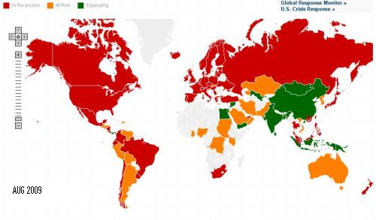
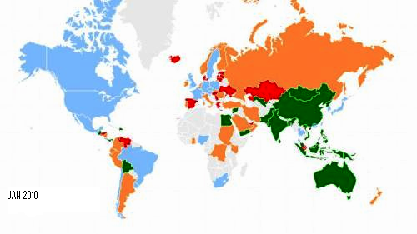
It is interesting to look into Moody’s Economy.com’s ‘World Recession Maps’ and make a comparison of August 2010 with those of January 2010 and August 2009. The map captioned August 2009 shows that the recession swept countries all over North America and Europe, and more than half of the continent of South America (particularly Brazil) and few countries in Asia such as Japan, South Korea, Taiwan, Thailand and Philippines (red area). Only countries in Asia like China, Mongolia, Uzbekistan, Egypt were unaffected and these countries were expanding (green area) during the recession.
By January 2010 the whole of North America and Brazil in South America, and UK, Sweden, Ireland, France, Germany and Netherlands were recovering (light green). Russia, Norway, Finland, Itali in Europe and Saudi Arabia of Asia were struggling for getting out of recession.
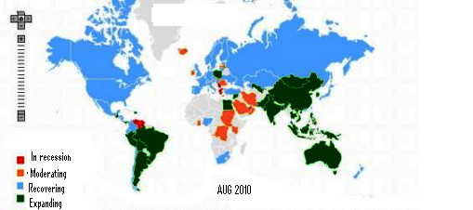
Till August 2010 Guyana of South America was the only country in the world which was under recession (red marked). Except few Asian countries like Saudi Arabia and Iran and African countries like Sudan Chad, and which were moderating for recovery (yellow area), other countries of the world could recover by this time.

Recession Shapes
Recession shapes are used by economists to describe different types of recessions. There is no specific academic theory or classification system for recession shapes; rather the terminology is used as an informal shorthand to characterize recessions and their recoveries.
The most commonly used terms are V-shaped, U-shaped, W-shaped, and L-shaped recessions. The shapes take their names from the approximate shape economic data make in graphs during recessions. The letters can also be applied referring to the recoveries (i.e., "V-shaped recovery").

4.1 V-Shaped Recession
In a V-shaped recession, the economy suffers a sharp but brief period of economic decline with a clearly defined trough, followed by a strong recovery.
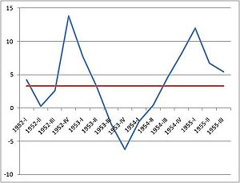
A clear example of a V-shaped recession is the Recession of 1953 in the United States. In the early 1950s the economy in the United States was booming, but because the Federal Reserve expected inflation it raised interest rates, tipping the economy into recession. In 1953, growth began to slow. In the third quarter, the economy shrank by 2.4 percent. In the fourth quarter the economy shrank by 6.2 percent, and in the first quarter of 1954 it shrank by 2 percent before returning to growth. By the fourth quarter of 1954, the economy was growing at an 8 percent pace, well above the trend. Thus GDP growth for this recession forms a classic v-shape.

4.2 U-shaped Recession
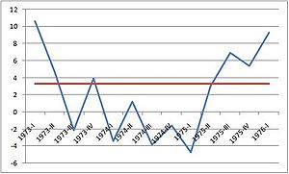
The Recession of 1973–75 in the United States could be considered a U-shaped recession.
A U-shaped recession is longer than a V-shaped recession, and has a less-clearly defined trough. GDP may shrink for several quarters, and only slowly return to trend growth. Simon Johnson, former chief economist for the International Monetary Fund, says a U-shaped recession is like a bathtub: "You go in. You stay in. The sides are slippery. You know, may be there's some bumpy stuff in the bottom, but you don't come out of the bathtub for a long time."

4.3 W-Shaped Recession
A W-shaped recession or "double dip" recession occurs when the economy has a recession, emerges from the recession with a short period of growth, but quickly falls back into recession.
The early 1980s recession in the United States is cited as an example of a W-shaped recession. The economy fell into recession from January 1980 to July 1980, shrinking at an 8 percent annual rate from April to June of 1980.
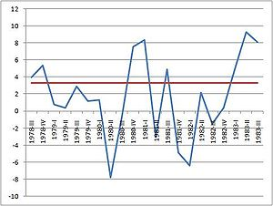
The economy then entered a quick period of growth, and in the first three months of 1981 grew at an 8.4 percent annual rate. As the Federal Reserve under Paul Volcker raised interest rates to fight inflation, the economy dipped back into recession (hence, the "double dip") from July 1981 to November 1982. The economy then entered a period of mostly robust growth for the rest of the decade.

4.4 L-Shaped Recession
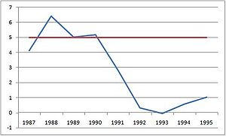
An L-shaped recession occurs when an economy has a severe recession and does not return to trend line growth for many years, if ever. The steep drop, followed by a flat line makes the shape of an L. This is the most severe of the different shapes of recession.
A classic example of an L-shaped recession occurred in Japan following the bursting of the Japanese asset price bubble in 1990. From the end of World War II throughout the 1980s, Japan's economy was growing robustly. In the late 1980s a massive asset-price bubble developed in Japan. After the bubble burst the economy suffered from deflation and experienced years of sluggish growth, never returning to the higher growth Japan experienced in 1950-1990.

Measuring Double-dip Recession

5.1 ECRI Index: Double-Dip Recession Inevitable
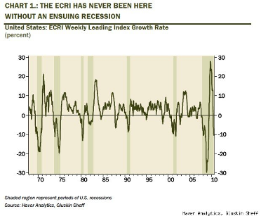
The Economic Cycle Research Institute, an independent organization of economists, best known for publishing the economy's "leading indicators", said its ECRI Weekly Leading Index "growth rate" broke below -10%.
This is shown in the Haver Analytics and Gluskin Sheff chart (chart-1) where the shaded area belonging 2010 is a period when the U.S. economy passes a longest recession after Great Depression.

5.2 Double Dip Recession fears as Service Sector Growth Stalls in Britain
The threat of a double-dip recession intensified after it emerged that Britain's powerhouse services sector saw its growth stall in September, jeopardising hopes of a sustained recovery. Many of the companies surveyed said cancelled public-sector contracts were beginning to hurt their businesses, forcing them to cut jobs and dealing a blow to chancellor George Osborne's hopes of reviving the private sector by reducing public spending.
The gloom was compounded by warnings from leading retailers that consumer spending is cooling off after a strong start to the year amid uncertainty about the economic outlook.
Fed’s willingness to provide more support for the struggling U.S. economy, citing worries about very low inflation, with goods and services remaining cheap despite the increased money being pumped into the economy raised concern that the low inflation will slip into deflation.
Economists said further weakness on the jobs front – which has been struggling with unemployment at more than 9% for a year – or more evidence that low inflation might be shifting into deflation would probably be enough to persuade the Fed to act with more monetary stimulus.
The Fed has announced that the second phase of quantitative easing will involve the purchase of US$600 billion in longer-term Treasuries by the end of Q2 2011, at a pace of about US$75 billion each month.

5.3 The Chances of a Double Dip

5.3.1 Investment Scenarios
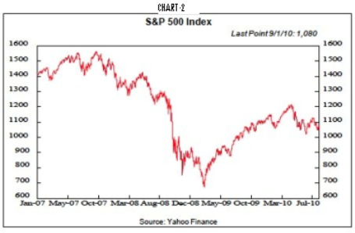
Investor attitudes have reversed abruptly in recent months. They began to realize that the eurozone financial crisis, which had been heralded at the beginning of the year by the decline in the euro, was a serious threat to global growth. Stocks retreated (Chart-2), commodities fell and Treasury bonds rallied and the dollar rose. It is, after all, just one big trade among these four markets, so their correlated actions on the down as well as the up side are not surprising.
Furthermore, investors began to worry about the health of the U.S. economy and the prospects for a second dip in the Great Recession that started in December 2007. The gigantic 2009 fiscal stimuli of close to $1 trillion was running out, threatening a relapse in an economy that was running on government life support. The tax rebate for new home buyers was expiring and might be followed by a drop in house sales. The outlook for exports had turned negative with the robust buck, sagging European economies and the current "stop" phase of China's "stop-go" monetary and fiscal policies. With unemployment remaining high last spring, investors began to fret that consumer spending would falter as fiscal stimuli were exhausted.

5.3.2 Deleveraging
The deleveragings of the global financial sector and U.S. consumer arena are substantial and ongoing. Household debt is down. The credit card and other revolving components as well as the non-revolving piece that includes auto and student loans are both declining. Total business debt is down, as witnessed by falling commercial and industrial loans.
Meanwhile, U.S. federal debt has exploded from $5.8 trillion on Sept. 30, 2008 to $8.8 trillion in late August. Many worry about the inflationary implications of this surge, but the reality is that public debt has simply replaced private debt. The federal deficit has leaped as consumers and business retrenched, which curtailed federal tax revenues, while fiscal stimulus, aimed at replacing private sector weakness, has mushroomed.

5.3.3 Four Cylinders
In the typical post-World War II economic recovery, four cylinders fire to push the economy out of the recession to the highway of economic growth. At present, only one - the ending of inventory liquidation - is generating significant power. The other three - employment gains, consumer spending growth and a revival in residential construction - are sputtering at best.

5.3.4 The Inventory Cycle
The reduction in inventory liquidation has been key to economic growth starting in the second half of 2009. In the third quarter of that year, it accounted for 66% of the 1.6% annual rate real GDP gain and 58% of the fourth quarter's 5.0% advance. The inventory-building in the first quarter of this year was responsible for 67% of the 3.7% annual rate rise in real GDP and 36% of the rise of 1.6% in the second quarter. In total, in the last four quarters, the inventory swing provided 58% of the 3.0% rise in real GDP.
Whether inventories will continue to hype the economy remains to be seen. As of June, the inventory-sales ratio for retailers had returned to its downtrend, but was still above trend for wholesalers and, especially, manufacturers. Furthermore, it's one thing to complete the liquidation of unwanted inventories but another to rebuild them significantly.

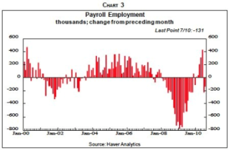
5.3.5 Job Loss
U.S. encountered huge employment losses (Chart-3) since the end of 2007. Many of those jobs are unlikely to return. Of the 7.7 million net non-farm jobs eliminated between December 2007 and July 2010, 86% were in construction, manufacturing, wholesale and retail trade, finance and leisure and hospitality. These six sectors accounted for 44.5% of non-farm payrolls in July, only about half as much as their losses. Furthermore, job losses in those industries spawned employment losses in service and other sectors that depend on them. Home building, for example, spurs employment in the production of appliances, furniture, home furnishings and homeowner insurance and provides revenues that support state and local employment.
Financial activities jobs stabilized with the March 2009-March 2010 revival of Wall Street, but the likely continuance of more recent weakness in many securities markets will lead to more layoffs and bonus cuts.

5.3.6 Cost-Cutting
American business has been diligently cutting costs since the recession started in December 2007, especially labor costs. A recent survey shows that over half of adults have been affected by some combination of layoffs, wage and benefits cuts, involuntary furloughs and involuntary shifts to temporary jobs. Many may never be restored to their earlier statuses. Those layoffs lucky enough to find new jobs often are paid less than earlier.
About 20% of major employers with over 1,000 workers cut or eliminated their 401(k) plan contributions during the downturn but half have failed to restore them so far. Of those with 500 or fewer employees that cut contributions, only 36% have reinstated them or plan to in the next 12 months, according to a Fidelity Investments survey. Furthermore, 10% of all employers plan to reduce or eliminate matching 401(k) contributions in the next year.

5.3.7 Consumer Spending
Calculations show that consumers saved 80% of the tax rebates they received in the summer of 2008. And they initially saved 100% of 2009's tax cuts and special payments of $250 for each Social Security beneficiary. Those actions resulted in the spikes in the saving rate (Chart-4). This is remarkable since the tax cuts did not go to high-income people, normally the only big savers. Also, those folks are relatively few in number so they received few of the extra Social Security checks. Consequently, middle- and lower-income households stepped out of character to save heavily.
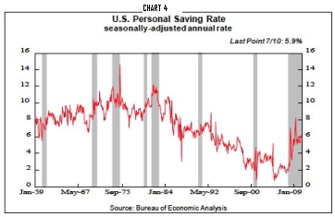
Evidence of recent consumer retrenchment is rampant. Consumer confidence has flattened as people worry about employment and income prospects as well as losses on their stocks and houses. Credit card loans outstanding fell 10% last year and promise to fall further as consumers repay debt, lending standards tighten and the new federal law cuts the profitability of credit card lending. Meanwhile, banks report that demand for consumer loans continues to drop, although at declining rates (Chart-5).
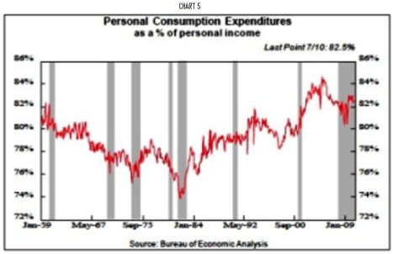
Increased saving is not only being used to repay debt but also to rebuild 401(k)s. Fidelity Investments found that in the second quarter, 5.3% of participants raised their contribution while 2.9% reduced them. That excess of increases over decrease has persisted for five quarters and follows three quarters of the reverse. Still, the numbers that tapped their accounts for loans or hardship withdrawals also rose.

5.3.8 Housing Remains Depressed
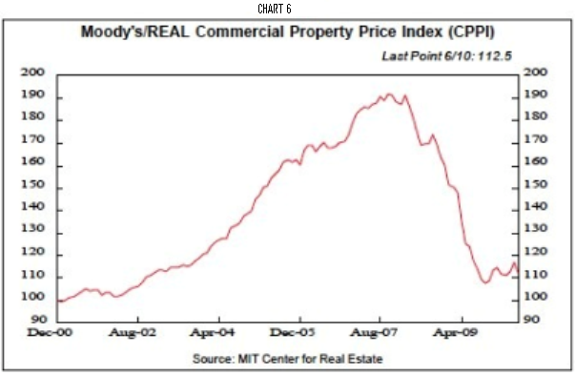
The U.S. housing sector is an important generator of the normal economic recovery even though residential construction only accounts for 4.7% of GDP on average in the post-World War II years. It is the volatility that matters. Residential construction was 6.3% of GDP at its recent peak in the fourth quarter of 2005, but fell to 2.4% at its low in the first quarter of 2010. This 3.9 percentage point decline is very significant, considering that a 3% top to bottom decline in real GDP constitutes a major recession. Moody’s Commercial Price Index depicts a soaring high price in September 2008 with 190 point sliding continuously since then to a level of 110 in September 2010 (Chart-6).

5.3.9 Tax Raise
In reaction to their financial woes, many state and local governments have attempted to raise taxes and fees. The usual suspects include higher sin taxes on tobacco and alcoholic beverages as well as taxes on companies based out of state but doing some business in the state.
Attempts to raise taxes and cut spending have proved wholly inadequate to solving state and local government funding problems. And those woes appear chronic, especially if the forecast of slow economic growth and even deflation is valid. Rises in taxable personal and corporate incomes will be muted. Retail sales and taxes on them will be sluggish as consumers persist for the next decade in their saving spree, replacing the borrowing and spending spree of the last decade.

5.3.10 Foreign Trade
Another economic sector that normally is not a significant engine of economic recovery but is important at present is exports since the U.S. Administration hopes they will double in the next five years and provide meaningful economic growth. The President's zeal to achieve that goal rises as he realizes that massive fiscal stimuli have not revived the economy, and already-huge federal deficits impede further rounds of big spending.
But two significant problems are likely to retard export growth in future years - rising protectionism that clearly impedes foreign trade, and finding foreign countries that will buy this doubling of American exports.

5.4 No Defense Left against Double-dip Recession
The United States, Japan and large parts of Europe have exhausted their policy arsenal, leaving them defenceless against a double-dip recession as recovery slows to ‘stall speed’.
Nouriel Roubini, Professor at New York University said, “The US has run out of bullets” and “More quantitative easing (bond purchases) by the Federal Reserve is not going to make any difference. Treasury yields are already down to 2.5pc, yet credit spreads are widening again. Monetary policy can boost liquidity but it can’t deal with solvency problems.”
Dr Roubini said the US growth rate was likely to fall below 1pc in the second half of the year, despite the biggest stimulus in history: a cut in interest rates from 5pc to zero, a budget deficit of 10pc of GDP, and $3 trillion to shore up the financial system.

5.5 US has Exhausted Fiscal Stimulus
Harvard Professor Niall Ferguson said the US has exhausted fiscal stimulus given warnings from the Congressional Budget Office that interest payments as a share of tax revenues will reach 20pc by 2020 and 36pc by 2030 without drastic retrenchment.
“The fiscal crisis seems to be out of control. The 'big crossover’ is approaching when the US spends more on debt service costs than on security, and historically that is the tipping point for any global power,” he said.
Ferguson said the “Chimerica” marriage of recent years is on the rocks. China is no longer willing to fund the US Treasury bond market, cutting its share of holdings from 13pc to 10pc of the total debt stock.

What the Double-Dip Recession Will Look Like

6.1 Housing
The cost of homes in the areas where prices have already dropped by 50% or more will continue to fall. These regions typically have the highest unemployment rates, the local governments are hard pressed to offer basic services, and potential buyers are aware that home prices could drop further. Real estate values in these areas could drop another 20%. In the rest of the country, protracted unemployment and the unwillingness of banks to lend would make otherwise attractive all-time low mortgage rates unappealing.

6.2 Unemployment
Unemployment could quickly move above 10%. In the 1982 recession, the jobless rate was over 10% for 20 consecutive months and reached 10.8% for two months. During that period, the manufacturing base had not been destroyed. The economy is now arguably worse than it was in 1982. Many Americans who worked in manufacturing before the recession cannot be retrained, and the factories where they worked will not be reopened. Many companies have recently adopted the policy that they will keep as much of their work-force temporary for as long as possible. This keeps the cost of benefits low and allows firms to fire people quickly and without severance. A hiring strike by American businesses could contribute to putting 200,000 to 300,000 people out of work per month. At the peak of the recession that just ended, there were nearly six job seekers for every open job, according to the Labor Department. The job market could return to that point.

6.3 Consumer Spending
One of the primary reasons that consumer buying activity did not grind to a halt at the beginning of the last recession was that people still had access to a huge reservoir of home equity loans, most of which were taken out at the peak of the real estate market in 2005 and 2006. The New York Times recently reported that "lenders wrote off as uncollectible $11.1 billion in home equity loans and $19.9 billion in home equity lines of credit in 2009, more than they wrote off on primary mortgages. So far this year, the trend is the same." Retail activity was helped somewhat by the capital available on these lines of credit, so store closings were probably deferred to the latter part of 2008. With more than 11 million mortgages underwater, 24% of the national total, and several million more within a few percentage points of being negative, the consumer will have no cushion as the economy deteriorates over the coming months.

6.4 Consumer Confidence
Consumer confidence, the critical gauge of the activity that represents two-thirds of U.S. GDP, could plummet again. The Conference Board's Consumer Confidence Index would certainly move back toward the all-time low it hit in February 2009 when it reached 25. Currently, the measure in most months is closer to 60.

6.5 Auto Industry
Auto sales, one of the primary barometers of consumer economic activity and manufacturing output, would probably drop back to recession levels. People concerned about employment may defer car purchases. Annual car sales in the U.S. were over 16 million in 2005 but dropped to just above 10 million in 2009. The car companies hope that domestic sales will rise to 11.5 million this year. In a double-dip recession, at least 1 million of those annual sales would be lost.

6.6 Trade
The nominal balance of trade would almost certainly drop, but probably to a relatively lower deficit of $25 billion a month, as the U.S. takes in fewer imports due to low demand for consumer goods and business inventory. Exports would also drop because an economic crisis in the U.S. would spread quickly worldwide. This is because of the tremendous size of the U.S. GDP in relation to that of any other country. The drop in imports would be a signal that business activity had slowed in China, the rest of Asia and Europe. Demand for consumer and business goods would drop in most regions, forcing a nearly universal cut in jobs outside the U.S.

6.7 Budget
The budget deficit would grow beyond the $1.5 trillion it should reach this year. Treasury receipts fell to $2.1 trillion in the federal fiscal year 2009 and are down to $1.7 trillion so far in the 2010 period. If history is any guide, receipts in a second recession could drop by as much as $200 trillion a year as tax receipts from both business and individuals falter. The demand on the federal government to render aid to the unemployed could add $50 billion to annual government outlays. Unemployment insurance will cost Washington $44 billion this year. As states run out of money to cover benefits, more of the burden could fall on the federal government.

6.8 National Debt
The rise in the deficit and a rapid increase in the American national debt would cause concern among the capital markets investors who purchase U.S. Treasuries. The inability of the Treasury to rein in spending will cause borrowing to increase. This in turn could bring the government's debt rating down, in turn causing U.S. borrowing costs to rise. Increasing costs will then raise the annual expenditure to run the government by increasing debt service. In the EURO zone, national debt problem has turned to ‘sovereign debt crisis’ in countries like Greece, Ireland, Portugal and Italy.

6.9 Stock Market
If the performance of the equity markets in 2008 and early 2009 is any indication, the S&P 500 would drop from its current level of about 1,100 to a low of 676, which it hit in March 2009. This would take trillions of dollars off business balance sheets and from consumer retirement and brokerage accounts. Businesses would become less likely to invest in new plants, equipment and services. For individuals, many would see a large part of their retirement disappear. That would cause a huge drop in consumer spending as people attempt to preserve cash, perpetuating further drops in the stock market.

6.10 Banking
The effect on most of the financial services industry would be catastrophic, particularly at the regional and community bank level where a number of home and commercial real estate loans are held. The FDIC would be forced to borrow money from the Treasury to cover bank closings. The number of failed banks could reach the level of the savings and loan crisis during which over 700 banks and mortgage lenders were shuttered.

6.11 Interest Rates
As the great majority of economists have pointed out, the Fed has already dropped interest rates to near zero. This means the central bank is out of ammunition.

Global Economic Outlook

7.1 Global Overview
The global recovery is much weaker than consensus expected. While 2010 has followed a “Year of Two Halves,” signs of deterioration in the U.S. and global outlooks have prompted Roubini Global Economics (RGE) to upgrade the probability of a double dip to 40%.
RGE maintains a central scenario that entails a sluggish, U-shaped recovery in much of the advanced world, with risks of L-shaped recoveries looming over Japan and the Euro zone.
The recovery continues to be stronger in emerging markets, though these economies will still feel the slowdown.

7.2 United States
Signals of economic slowdown have grown more and more prevalent as the U.S. economy approaches stall speed. The most recent U.S. GDP report reaffirms all the concerns that about extremely anaemic growth close to stall speed.
US personal income registered an unexpected fall in September 2010, while consumer spending was also weak, data from the Commerce Department shows. Households saw their earnings fall at an annualized rate of 0.1% compared with August, the largest fall in personal income in 14 months. In August 2010, incomes rose by a revised 0.4%.
However, analysts say the data does reveal a sharper slowdown than expected in consumer spending that could be a drag on growth during the remainder of the year.
Risks of a negative feedback loop and a dreaded double dip are rising, now at 40%.
With policy bullets limited, the focus should be on job creation with a temporary reduction in payroll taxes for both employers and employees. Since the beginning of 2010, RGE maintained that temporary factors would propel U.S. economic growth early in the year and that their effect would wane in H2.

7.3 Vulnerabilities to the EU
Subdued consumption in core EU countries and the battered euro will weaken Asia’s exports and GDP growth in H2 2010, but risks to 2010 annual growth are low since PIIGS account for a minuscule share of Asian exports and capital needs. However, a credit event, excessive market volatility, capital outflows or demand contraction in the EU will hit exports and private demand in the Asian Tigers, Thailand and Malaysia, whose exports to China are mostly re-exported.
The Euro zone composite PMI slowed to 53.4 in October 2010 from 53.8 in September. The country breakdowns show a growing gap between the core and periphery nations. Activity is still expanding in both manufacturing and services sectors, although at a slower pace. Employment PMI data was weak for the Euro zone as a whole with the composite sub-index declining to 51.0 in October from 51.4 in September.
The German government has doubled its 2010 GDP growth forecast to 3.4%, up from 1.4% earlier this year, following a 5% contraction in 2009. The sharp rise in growth prospects was largely driven by a faster-than-expected rebound in global demand, as a result of which GDP grew by an annualized 9% in Q2 2010. The German government expects economic activity to cool next year, with GDP growth slowing to 1.8%.

7.4 Hong Kong
Hong Kong will underperform its Asian peers in 2010, though it will have a more modest slowdown in 2011. Net exports will be a minor drag on growth in 2010 as demand from China and the G3 (Brazil, India and South Africa) weakens. Ample liquidity will boost investment and property prices, though a reversal of capital inflows remains a risk.
RGE continues to expect Hong Kong’s growth to moderate in H2 2010, but a better-than-expected performance in H1 leads to revise upward the forecast for 2010. RGE now expects a 5.5% growth this year.

7.5 India
As stimulus measures disappear, capital inflows are driving India’s growth by reviving investment, hiring and wages, but consumption remains subpar. Overheating risks could escalate if monetary policy stays behind the curve and the global economy escapes a double dip.
Despite accelerating domestic and foreign investment, the sluggish pace of reforms and human capital development for the rising labor force will keep trend growth below its average 9.2% of 2005-07.

7.6 Indonesia
Indonesia will weather the global growth slowdown in late 2010 and early 2011, thanks to its large consumer base, bevy of domestically oriented industries, and strong commodity export revenues.
Besides external threats such as global risk aversion, the most pressing issues the country faces are rising inflation, weak credit growth and unwieldy government bureaucracy.
Indonesia's Investment Coordinating Board reported a surge in FDI in Q3, raising the likelihood that total gross fixed capital formation in 2010 will be higher than initial government projections.

7.7 China

While still signaling that it maintains a large exposure to the USD, China stepped up JPY (Japanese yen)and KRW (South Korean won) purchases in mid 2010. This portfolio shift into currencies of key Asian and other non-western trading partners may help mitigate China’s dollar dilemma in various ways:
First, this move may help transfer some USD concentration risk to third countries, if they step up their own dollar purchases to prevent excessive appreciation of their currencies (as Japan has begun to).
Second, China is deepening trading relationships by providing (vendor) financing to a wider range of trading partners.

7.8 Malaysia
Malaysia’s economy will slow in Q4 2010 and likely contract q/q in Q1 2011 as global demand for the country’s exports softens and investment spending weakens.
Private consumption will be the bulwark of aggregate demand in Q4 2010 but will likely taper off in the first two quarters of 2011 as waning global economic activity weakens the domestic labour market and consumer confidence.
The central bank has space to cut interest rates should the global slowdown be more severe than anticipated.
Malaysian export growth slowed to 6.9% y/y in September 2010, the sixth straight month of y/y deceleration, suggesting that a cyclical decline in demand for Malaysian manufactured products is well underway.

7.9 Singapore
Singapore enters Q4 carrying momentum from H1 2010, with domestic demand expected to hold up even as the global slowdown weakens export-dependent sectors such as electronics manufacturing and financial services.
A sharper-than-expected contraction in exports would significantly alter the growth outlook, especially if it leads to deterioration in labour and asset markets and thereby hurts consumption and investment.
The central bank will stay on hold over the next several months, despite relatively high inflation in Q3.

7.10 South Korea
An export boom has revived investment and manufacturing activity, and consumption has surprised on the upside, but none of these will remain unscathed amid slowing global growth.
Overleveraged households, businesses and banks could be hit by higher lending rates, housing correction, capital outflows and foreign exchange volatility, necessitating prudent policy intervention for the real estate market and capital account.
Cross-border tensions might deteriorate, taking a toll on South Korea's asset markets and popular support for the government.

7.11 Thailand
The front-loading of an infrastructure-heavy fiscal stimulus package into 2010, resilient exports and rising farm incomes strengthen prospects for a V-shaped recovery. Direct investments have poured into Thailand as young Thai professionals boost demand for condos while foreign companies set up production facilities.
Thailand is headed for a decisive recovery despite political turmoil.
Brazil’s PMI for October dropped below 50 again, potentially darkening the outlook for the industrial sector in Q4 2010, while fiscal revenues came in high in Argentina and inflation surprised on the downside in Peru.

Warning Spots of Bangladesh in case of a Double-dip Recession

8.1 Sectors affected during the Last Recession
Over the past few decades, Bangladesh has increasingly been integrated into the global economy. The degree of openness of the economy enhanced from 16.8% to 42.5% and the extent of globalisation rose from 24.9% to 56.3% between 1990/91 and 2008/09. None can deny that increasing global integration has created an opportunity for Bangladesh to take advantage of the global economy. At the same time, it has exposed the country to vulnerabilities emanating from global shocks.
Analysis shows impacts on Bangladesh economy were rather limited in the first phase of the crisis, but due to lag effects adverse consequences became more evident in recent times since April 2009.
8.1.1 Trade Sector
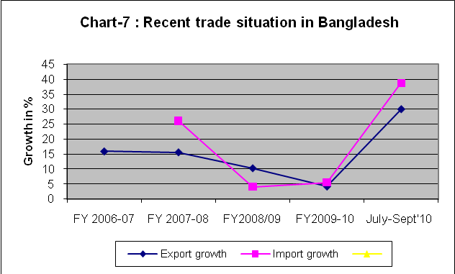
With the deepening of the global financial crisis and the consequent fall in developed country demand for exports from developing countries, a significant sluggish global exports was expected. Bangladesh has witnessed a continuously slowed down export growth during the last two fiscal years. The export growth slowed down to 4.2% in FY2009-10 compared to declining higher growth of 10.3% in FY2008/09, 15.6% in FY 2007-08 and 15.9% in FY 2006-07. That means Bangladesh has been hit consistently by global recession since 2007 with lagged effect.
However, total export receipts during July-September, 2010 increased by US$1159.95 million or 29.98 percent to US$5029.05 million as compared to US$3869.10 million during July-September, 2009 due to slower global economic recovery.
Imports by Bangladesh experienced robust growth during FY2007/08 (26.1%) mainly due to the then high global commodity prices. The Bangladesh Bank data shows the import payment subsequently declined 4.06% and 5.47% during FY2008-09 and 2009-10, respectively. However, Import payments during July-August, 2010 have increased by US$1280.80 or 38.68 percent to US$ 4591.90 million compared to US$ 3311.10 million during July-August, 2009 due enhanced internal demand led by prospective global recovery.
8.1.2 Remittance
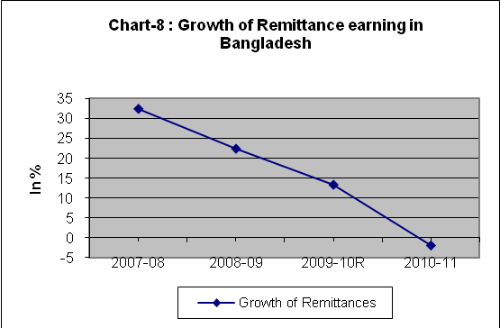
While remittance in dollar terms has increased from 7.91 billion from 2007-08 to 10.99 billion in 2009-10 its growth has decelerated over time. Against a robust growth of 32.39% in 2007-08, remittances in 2008-09, 2009-10 and Q1 (July-September) of 2010-11 registered declining growth rates of 22.42%, 13.4% and -1.8%, respectively. These clearly show dreadful lagged effect of the global recession in spite of slow recovery observed in developed countries.
8.1.3 Foreign Aid
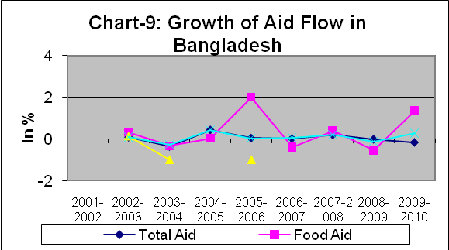
The role of ODA has been on the decline over the past decade. However, ODA still finances about one-third of the total fiscal deficit of Bangladesh (the projected share of net foreign financing in the budget for 2009/10 is 29.7%). Foreign aid inflow in dollar terms increased during 2004-05 to 2007-08. Since then aid flow has declined in absolute term which is observed by declining growth of 0.00% in 2008/09 and a negative growth of 15.0% in 2009-10.
8.1.4 Revenue Collection
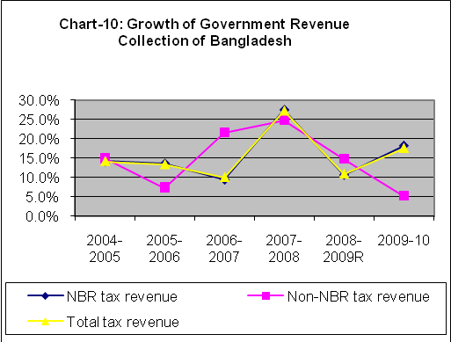
The global financial crisis has had concomitant implications for domestic resource mobilisation in Bangladesh, in a number of ways. First, Bangladesh’s revenue is highly dependent on import duties. With the onslaught of the financial crisis and the consequent decline in global demand, global commodity prices have experienced a significant fall. Combined with the depressed investment situation and lower domestic import demand (both in value terms and, in many instances, in volume terms), revenue from import-related duties has decelerated (a 10.9% fall in 2008-09 preceded by a record 27.3% enhancement in 2007-08). Second, deceleration in economic activities, particularly in export-oriented industries, has meant lower scope for direct tax collection at that level. Third, apprehension regarding a slowdown in foreign resource flows has highlighted the need to generate additional resources at domestic levels to finance the developmental budget.
Finally, the need for higher public expenditure to service the stimulus package and public investment in social safety nets has underlined the need for higher revenue collection to maintain the fiscal balance. The need for countercyclical measures was a reality, but GoB attempted also to go for greater resource generation at domestic levels to reduce the expected higher deficit. This has led to 17.6% increase in revenue collection in 2009-10.
8.1.5 Labour Market
The prolonged recession and the consequent economic downturn have resulted in considerable adverse implications for the employment and labour markets of most economies. In view of the global financial crisis, Rahman et al. (2009b) estimate the employment situation of Bangladesh and its implications on the domestic job market. The resilience of Bangladesh’s economy during 2008/09 contributed towards containing the adverse impacts on Bangladesh’s employment situation. Relatively high growth of the agriculture sector had a positive impact from the labour absorption perspective. Growth of employment opportunities in the industrial sector is expected to slow down; only 0.4 million job opportunities were expected to be created in 2008/09. Moreover, weakening manpower exports would mean an increase in the domestic labour supply by an additional 0.8 million over the 2008/10 period. Considering these factors, the unemployment rate was estimated to be about 3.6% in 2008/09.
8.1.6 Money Market
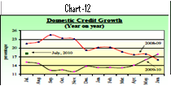
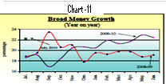
Following global economic recession that started in the latter half of 2007 and intensified with the financial crisis of October 2008, Bangladesh maintained a restrictive monetary and credit policy from Q2 of 2008-09 till Q1 of 2009-10. With the recovery of developed economies it has been maintaining an easy money policy from Q3 of 2009-10.

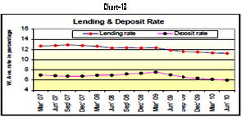
It lowered its lending rate from Q3 of 2007-08 and intensified pushing it down further from Quarter 1 of 2009 in a bid to boost investment and promote economic activities. Since Q1 of 2009 the deposit rate has also been pushed downward continuously in Quarter 2 of FY10, making the spread wider.
The policy could not prevent falling growth rates of export and import and slowed economic activities because of the almost 6-months lagged adverse effects of global recession.
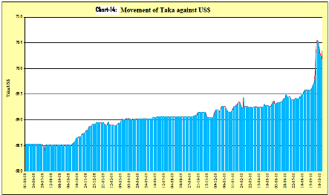
Bangladesh was benefitting from its continuosly depreciated Taka creating a favourable terms for export promotion till mid-September 2010 but it was offset by lower value of its export items and higher import costs caused by its devalued Taka. Bangladesh is also affected by the ongoing currency war, as a result of which its currency markedly appreciated when US Fed by its Q1 ease policy lowered the value of dollar compared to foreign currencies in mid-September 2010.
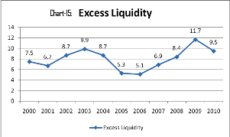
As the global economy is yet to fully recover and struggling to attain the pre- recession growth level, investment climate in Bangladesh continues to stagger as reflected in the continuously high level of excess liquidity that piled up in the banking system from end-June 2007 to end-June 2009. Excess liquidity showed a decline since end-June 2010. It has further declined in end-Sept’10, showing that Bangladesh economy is responding to the recovery taking place in developed countries.
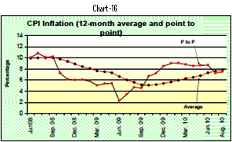
8.1.7 Inflation
As we know, global recession started from end-2007 induced by sluggish demand of developed countries for developing country exports. Since then Bangladesh’s GDP growth deccelerated due to restrictive monetary and credit policy from Q3 of 2008-09 to Q1 of 2009-10 resulting in a decline in CPI inflation during this period. As a result of expansionary monetary and credit policy since Q2 of 2009-10, CPI inflation is on the rise again.
8.1.8 Capital Market
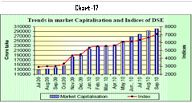
Lax monetary policies have put upward pressure on the real estate and stock market prices leading to a stock and property market boom in Bangladesh. The stock market has recorded a growth of 120% between August 2009 and August 2010compared to a 375% growth in long seven years during 2002-2008 with a 17% drop in 2009. The stock market surge in 2010 is partly due to banks investing their excess liquidity in the capital market instead of lending to the real economy. A recent study by the Bangladesh Bank shows that 18 financial institutions had invested more than 25% of their total liabilities in the stock market with 8 of those investing more than 50%. Bangladesh Bank has now introduced a ceiling limiting banks’ investment within 10% of their total liabilities and established a separate legal entity to avoid potential speculation jeopardizing savings deposits.

8.2 The Global Financial Crisis and Review of Bangladesh’s Policy Stance
As a quick response to the global crisis, in September 2008 the Bangladesh Bank (BB) set up a Forex Investment Committee to monitor forex reserves held abroad. The BB withdrew about 90% of its total investment from international banks that were perceived to be at risk. It also advised the country’s commercial banks to be watchful about such investments. At the initial stage, this quick move helped avert the adverse impacts of the global financial crisis on the country’s foreign exchange reserves. As the global crisis spread, GoB came up with various direct and indirect policy support measures aimed at safeguarding domestic industries, sustaining exports and protecting the poor and the marginalised segments of society. These policy measures consisted of 1) direct policy support and 2) macroeconomic policy stances for economy-wide positive effects.

8.2.1 Direct Support Measures
The first stimulus package: In order to address the adverse effects of the global financial crisis, GoB announced a stimulus package of Tk. 3420 crore ($488.6 million) in April 2009. The fund, earmarked to be used over the last quarter of 2008-09, allocated an additional Tk 450 crore ($6.4 million) in cash subsidies (a total of Tk. 1500 crore or $21.4 million) for export industries badly affected by the crisis. Of the rest, Tk. 1500 crore ($21.4 million) was allocated for agriculture, Tk. 600 crore ($8.6 million) for the power sector, Tk. 500 crore ($7.1 million) for recapitalisation of agriculture loans, and Tk. 374 crore ($5.3 million) for social safety net programmes. The first stimulus package also placed more money into the SME Fund, and its capital was enhanced from Tk. 500 crore ($71.4 million) to Tk. 600 crore ($85.7 million).
Information so far published shows that, as of September 2009, Tk. 995 crore ($14.2 million) in cash incentives was disbursed, in two instalments. The increased cash subsidies could not deter the decline in exports in the sectors in question, but were perhaps helpful in reducing their difficulties at a time of falling demand and falling prices of their export items.
GoB’s response to global financial crisis was criticised by the RMG exporters saying that they were left out from the benefits of the stimulus package. Complaints mounted in September 2009, when exports of apparels experienced a 27% drop compared with the corresponding month of the previous year.
The second stimulus package: Provision of Tk. 5000 crore ($714.3 million) was made in the budget for 2009/10 as part of a second stimulus package. The package contains an allocation of Tk. 3046 crore ($435.1 million) as cash subsidies to affected exporters, out of which Tk. 1311 crore ($187.3 million) has already been released.
The third stimulus package: The government has recently announced a third stimulus package, focusing mostly on the apparels sector: rescheduling of overdue loans; reduction of rate of interest from 13% to 10%; cash incentives (based on actual export value) at the rate of 5% for exporters to new markets (markets other than the US, Canada and the EU); special incentives for SMEs in the apparels sector; Tk 300 crore ($42.9 million) as seed money to create a Contributory Fund with the objective of tackling the adverse effects of the global financial crisis on the exports of textile and apparels.

8.2.2 Indirect Measures: Macroeconomic Policy Measures
Exchange rate management: In the recent past, Bangladesh pursued a policy of maintaining stable exchange rate particularly with the US dollar, even during the crisis period. The BB has periodically been purchasing (and selling) US dollars from (to) the open market to keep the Tk-US$ exchange rate stable. However, the weakening of US dollar against major currencies such as the euro, the Japanese yen and the Indian rupee throughout 2009, with the taka remaining stable against the dollar, has implied some depreciation of the taka against those currencies. Between 1 January and 11 November 2009, the taka depreciated by 6.3% against the euro, 5.4% against rupee and 0.2% against the yen, and appreciated only marginally against the US dollar, by 0.3%.
Interest rate management: BB put in place a ceiling of 13% on commercial lending rates on 19 April 2009 for agricultural credit and credit for large and medium industries (term loan and working capital), along with loans for the housing sector. As it appears, the move by the BB to put a ceiling on interest rates has not had any significant effect in terms of stimulating investments.
Budgetary support for SMEs and cottage industries: GoB has created three funds with seed money of Tk 1000 crore ($144.8 million) to provide refinancing facilities to SMEs against loans disbursed by commercial banks and financial institutions.
Domestic demand and investment stimulation: The government eventually came up with an ADP much bigger than those of the past years. The total size of the ADP for 2009/10 has been fixed at Tk 30,500 crore ($4.4 billion), over 55% higher than the implemented ADP of 2008/09 (IMED, 2009). However, while a larger ADP indicates the intensions of the government, its implementation is a major concern, considering the existing implementation capacity of government institutions. In the past, ADP implementation hovered around 80-85% of the target.
Lower corporate tax rate: Bangladesh has maintained a high corporate tax rate of 45% for companies not listed on the stock exchange. For listed companies, the tax rate is 37.5%. It has been acknowledged that global developments may impact the income and profitability of these companies, particularly financial institutions, and in the budget for 2009/10 the corporate tax rate for financial institutions was brought down to 42.5%. It is estimated that, in doing so, the government will incur a revenue loss of about Tk 550 crore ($78.6 million) in the current fiscal year.
Lower duty on imports of industrial raw materials: The national budget for 2009/10 has brought down the existing level of import duty on raw materials from 7% to 5%. However, this measure has been accompanied by increased duties on imports of luxury goods to make up for the revenue loss incurred from it.
Measures for returnee workers: Steps taken by government to benefit returnee workers include: 1) training programmes for skills development of returnee expatriate workers; 2) a diplomatic initiative to prevent retrenchment of workers; 3) exploration of new labour markets abroad; and 4) strengthening the National Skill Development Council to build a skilled workforce compliant with international labour markets. The government has allocated $10.1 million for these purposes (Rahman et al., 2009b).

8.2.3 Battling Global Financial Crisis: GOB Policy Response–Proactive or Reactive?

While Bangladesh Bank was proactive in deciding withdrawal of its reserve money from international banks perceived to be risky and advising commercial banks to be vigilant on their investments with international banks, government’s role in overcoming adverse effects of the crisis was of something like wait-and-see type, which was not definitely proactive.
The global recovery is much weaker than expected. While 2010 has followed a “Year of Two Halves,” signs of deterioration in the U.S. and global outlook suggest the probability of a double dip to 40%. RGE maintains a central scenario that entails a sluggish, U-shaped recovery in much of the advanced world, with risks of L-shaped recovery looming over Japan and the Euro zone. The recovery continues to be stronger in emerging markets, though these economies will still feel the slowdown.
The world economy still faces several vulnerabilities. U.S. housing starts collapsed 11.7% m/m in October 2010 to a seasonally adjusted annual rate of 519,000 due to a steep drop in the multifamily segment and a 1.1% m/m drop in the single-family segment. U.S. core CPI remained flat m/m for the third consecutive month while the y/y gain eased to 0.6%, the lowest annual rate recorded in the series' history and the seventh consecutive y/y gain below 1%. Very recent sovereign debt crisis in EU member countries like Greece, Italy and Portugal and recently in Ireland, with bailout efforts from EU and IMF gives signal of volatility in the world economy.
In the backdrop of the global economic outlook mentioned above, the same transmission mechanism as worked during the past recession may work for Bangladesh as well if the probable double-dip recession hits the developed countries. As the second thaw of a double-dip recession usually becomes more aggressive and devastating and takes longer time to recover, it is likely that all the infusion channels to Bangladesh, i.e., trade, remittance and foreign aid, will be affected at a wider scale. A more well-thought-out and prudent policy intervention will be needed to tame more wild factors that may emerge from the double-dip recession if it sweeps over the already volatile world economy.

Concluding Remarks
Shocks, crisis, instability created anywhere in the world or policy changes taking place in countries having a major influence on the world economy, cannot but have their impact on Bangladesh economy because of the country’s growing openness to the world economy. The country must be adequately equipped to keep track of these changes taking place in the outer world and respond proactively to any adversity it faces with effective policy to secure and expand its competitiveness and guard economic interests abroad.
However, the government’s response to the recent global financial crisis and recession in terms of preparedness and policy interventions has been largely passive so far, as is apparent in the wait-and-see role of the Ministry of Finance. The Ministry was waiting to see and identify who would be most affected and thus be considered for bailout as if nothing else were to be done. It overlooked the deteriorating competitiveness of the country as a result of policies adopted by other trade competing countries. The government must look into its policy intervention capability in an increasingly globalised world economy with special importance given to the crisis management capability of its policy framing and implementing organs.

REFERENCES

Adviser, Media Mohol – a London-based news network and marketing solution providing company.
http://www.investopedia.com/terms/d/doublediprecession.asp
http://www.huffingtonpost.com/2010/07/01/a-doubledip-recession-def_n_633004.html
Wikipedia, the free encyclopedia, http://en.wikipedia.org/wiki/Recession_shapes
http://www.dailyfinance.com/story/investing/double-dip-recession-one-reliable-measure-says-its-inevitable/19568906/?icid=sphere_copyright
http://www.guardian.co.uk/business/2010/aug/04/double-dip-recession-fears-economy
https://mail.google.com/mail/?hl=en&shva=1#inbox/12c15ca2be527cbf
In the United States, a 401(k) or 401k retirement savings plan allows a worker to save for retirement, and have the savings invested while deferring current income taxes on the saved money and earnings until withdrawal. This type of plan is also known as a "traditional" 401(k).
http://finance.yahoo.com/career-work/article/110344/what-the-double-dip-recession-will-look-like
http://www.roubini.com/analysis/131252.php. Nouriel Roubini, Christian Menegatti and the RGE Macroeconomic Team 9/10/2010 | Last Updated
http://www.roubini.com/analysis/131245.php
http://www.manchesterwired.co.uk/news.php/104159-US-personal-income-falls-unexpectedly-in-September
https://mail.google.com/mail/?hl=en&shva=1#inbox/12c062ef4375e771
An acronym used to refer to the five Eurozone nations, which were considered weaker economically following the financial crisis: Portugal, Italy, Ireland, Greece and Spain.
http://www.roubini.com/analysis/121770.php
The Euro-zone Manufacturing Purchasing Managers Index (PMI) assesses business conditions in the manufacturing sector.
https://mail.google.com/mail/?hl=en&shva=1#inbox/12bd2ac7d1d6fc41
https://mail.google.com/mail/?hl=en&shva=1#inbox/12bd2ac7d1d6fc41
http://www.roubini.com/analysis/131287.php
http://www.roubini.com/analysis/131244.php
http://www.roubini.com/analysis/131254.php
http://www.roubini.com/analysis/132495.php
http://www.roubini.com/analysis/131253.php
https://mail.google.com/mail/?hl=en&shva=1#inbox/12c15ca2be527cbf
http://www.roubini.com/analysis/131257.php
http://www.roubini.com/analysis/131284.php
http://www.roubini.com/analysis/131258.php
A condominium, or condo, is the form of housing tenure and other real property where a specified part of a piece of real estate (usually of an apartment house) is individually owned ... http://www.condocompany.com/
https://mail.google.com/mail/?hl=en&shva=1#inbox/12c15ca2be527cbf
Mustafizur Rahman, et al. Global Financial Crisis Discussion Series Paper 12: Bangladesh Phase 2, January 2010 ,Centre for Policy Dialogue (CPD) ,Dhaka-1209, Bangladesh. www.cpd.
Op cit.
Jenny Nordgren. SEB Merchant Banking – Country Risk Analysis October 25, 2010 http://taz.vv.sebank.se/cgi-bin/pts3/mc1/mb/mblib.nsf/a-w/2329EEC297F209FEC12577D200490B13/$FILE/Bangladesh_October_2010.pdf
Roubini Global Economics Daily 5: published on 18.11.2010

