

Microsoft Exchange Server 2003 Transport and Routing Guide

Microsoft Corporation
Published: December 12, 2006
Author: Exchange Server Documentation Team

Abstract
This guide explains how transport and routing works in Microsoft® Exchange Server 2003, and how you can configure Exchange to enable internal and external mail flow.
Comments? Send feedback to exchdocs@microsoft.com.

Contents
Exchange Server Transport and Routing Guide 15
Part One 15
Understanding Routing Components 16
Types of Routing Components 16
Understanding Routing Groups 17
Understanding Connectors 18
Understanding Link State Information 18
Understanding SMTP and Exchange Server 2003 21
How Exchange Server Extends SMTP Functionality 22
Receiving Internet Mail 23
Sending Internet Mail 24
Understanding the SMTP Virtual Server 25
Misconceptions about Multiple SMTP Virtual Servers 25
Inbound Mail Settings on the SMTP Virtual Server 26
Outbound Mail Settings on the SMTP Virtual Server 26
Setting Relay Restrictions 27
Configuring Default Relay Restrictions 28
Understanding SMTP Connectors 29
Functions of an SMTP Connector 31
Uses for an SMTP Connector 32
Transport Dependencies for Exchange Server 2003 34
Internet Information Services 35
Active Directory 36
Domain Name System (DNS) 37
Recipient Policies 40
Recipient Update Service 41
Directory Service to Metabase Service 41
Part Two 42
Verifying DNS Design and Configuration 43
Configuring DNS for Inbound Mail 43
Configuring DNS for Outbound Mail 44
For More Information 44
How to Verify that MX Records Do Not Point to the FQDN of an Exchange Server 45
Before You Begin 45
Procedure 45
How to Verify that MX Records Do Not Point to an Internal Domain 46
Before You Begin 46
Procedure 46
How to Verify that Exchange Servers Can Resolve Internal DNS Names 47
Before You Begin 47
Procedure 47
How to Use Nslookup to Verify MX record configuration 48
Before You Begin 49
Procedure 49
Example 49
How to Use Telnet to Ensure Internet Accessibility 50
Before You Begin 50
Procedure 50
How to Configure DNS Settings on the Exchange Server 51
Before You Begin 51
Procedure 51
How to Configure Settings on the DNS Server 52
Before You Begin 52
Procedure 52
How to Configure External DNS Servers on an Outbound SMTP Virtual Server 53
Before You Begin 53
Procedure 53
How to Use the DNS Resolver to Verify DNS Configuration 55
Before You Begin 55
Procedure 56
Example 56
How to Use Nslookup to Verify DNS Configuration 57
Before You Begin 57
Procedure 57
Example 58
Configuring a Routing Topology 59
General Planning Considerations 59
Common Routing Topologies 60
Centralized Messaging Topology 61
Distributed Messaging Topology 61
Defining Routing Groups 63
Defining Routing Group Connectors and Bridgehead Servers 65
Connecting Routing Groups 67
How to Configure the Options for a Routing Group Connector 69
Before You Begin 69
Procedure 69
How to Specify a Remote Bridgehead Server for a Routing Group Connector 70
Before You Begin 70
Procedure 70
Understanding Connector Scope and Restrictions 72
Using Connector Scope to Restrict Usage 73
Using Delivery Restrictions to Restrict Usage 73
How to Enable the Registry Keys for Delivery Restrictions 75
Before You Begin 75
Procedure 76
Designating a Routing Group Master 76
How to Change Which Server Is the Routing Group Master 78
Before You Begin 78
Procedure 78
Advanced Routing Configuration 78
Using Connectors for Load Balancing and Failover 78
Suppressing Link State Traffic for Connectors 80
How to Create a Routing Group 81
Before You Begin 82
Procedure 82
Deployment Scenarios for Internet Connectivity 83
Common Deployment Scenarios 84
Using a Single Exchange Server in Its Default Configuration 86
Basic Configuration 86
Inbound Internet Mail 87
Outbound Internet Mail 87
Using a Dual-Homed Exchange Server as an Internet Gateway 88
Basic Configuration 88
Inbound Internet Mail 89
Outbound Internet Mail 89
Using Internet Mail Wizard to Configure a Dual-Homed Exchange Server 90
Security Considerations 91
Using a Bridgehead Server Behind a Firewall 92
Basic Configuration 92
Inbound Internet Mail 94
Outbound Internet Mail 94
Using a Windows SMTP Relay Server in a Perimeter Network 94
Basic Configuration 95
Inbound Internet Mail 97
Outbound Internet Mail 97
Custom Deployment Scenarios 97
Using a Network Service Provider to Send and Receive Mail 98
Supporting Two SMTP Mail Domains and Sharing an SMTP Mail Domain with Another System 99
Supporting Two SMTP Mail Domains 99
Sharing an SMTP Mail Domain with Another System 103
Supporting Additional Mail Systems 108
How to Enable Address Rewrite by Using the Exarcfg Tool 109
Before You Begin 109
Procedure 109
How to Create a Contact in Active Directory 110
Before You Begin 110
Procedure 110
How to View the Setting that Determines Whether Exchange Server is Authoritative 111
Before You Begin 112
Procedure 112
How to Modify the Default Recipient Policy 113
Before You Begin 114
Procedure 114
How to Create a Higher Priority Recipient with the Shared Mail Domain 115
Before You Begin 115
Procedure 115
How to Modify an Existing Recipient Policy for the SMTP Domain that You Want to Share 116
Before You Begin 116
Procedure 116
How to Create a New Recipient Policy for an SMTP Mail Domain that Does Not Exist on a Recipient Policy 117
Before You Begin 117
Procedure 117
How to Create an SMTP Connector to Route Mail to a Specific Host 118
Before You Begin 118
Procedure 118
How to Share All Address Spaces in Your Exchange Organization 119
Before You Begin 119
Procedure 119
Configuring Cross-Forest SMTP Mail Collaboration 120
Enabling Cross-Forest Authentication 122
Enabling Cross-Forest Collaboration by Resolving Anonymous Mail 123
How to Create the Account Used for Cross-Forest Authentication 125
Before You Begin 125
Procedure 126
How to Configure a Connector and Require Authentication for Cross-Forest Authentication 127
Before You Begin 128
Procedure 128
How to Restrict Access by IP Address on the Receiving Bridgehead Server 132
Before You Begin 132
Procedure 132
How to Configure an SMTP Virtual Server to Resolve Anonymous E-mail Addresses 133
Before You Begin 133
Procedure 133
How to Enable an Exchange Server to Accept Message Extended Properties that Are Sent Anonymously 134
Before You Begin 134
Procedure 135
How to Enable an SMTP Virtual Server to Accept Message Extended Properties that Are Sent Anonymously 135
Before You Begin 136
Procedure 136
How to Configure a Windows Server 2003 Server as a Relay Server or Smart Host 136
Before You Begin 137
Procedure 137
For More Information 138
Connecting Exchange to the Internet 138
Using Internet Mail Wizard to Configure Internet Mail Delivery 139
Configuring a Dual-Homed Server Using the Wizard 139
How to Use Internet Mail Wizard 140
Before You Begin 140
Procedure 142
How to Load Exchange SMTP Properly 145
Before You Begin 146
Procedure 146
Example 147
How to Start Internet Mail Wizard 148
Before You Begin 149
Procedure 149
Manually Configuring Your Exchange Server for Internet Mail Delivery 150
Setting Up Your Exchange Server to Receive Internet Mail 150
How to Configure the Inbound Port and IP Addresses on the SMTP Virtual Server 152
Before You Begin 153
Procedure 153
How to Verify that Your SMTP Virtual Server Allows Anonymous Access 154
Before You Begin 154
Procedure 154
How to Verify that Recipient Policies Do Not Contain Addresses that Match the FQDN 155
Before You Begin 156
Procedure 156
How to Verify that Users Can Receive E-mail Messages from Other SMTP Domains 157
Before You Begin 158
Procedure 158
How to Configure the Necessary SMTP E-mail Addresses for Your Users 159
Before You Begin 160
Procedure 160
For More Information 160
How to Verify Relay Restrictions on an SMTP Virtual Server 161
Before You Begin 161
Procedure 161
Configuring Inbound Settings on SMTP Virtual Servers 164
Setting Up Your Exchange Server to Send Internet Mail 164
How to Verify that Your Outbound Port Is Set to Use Port 25 166
Before You Begin 166
Procedure 166
How to Allow Anonymous Access on Your Outbound SMTP Virtual Server 168
Before You Begin 168
Procedure 168
How to Create an SMTP Connector 169
Before You Begin 169
Procedure 170
Configuring a Smart Host on a SMTP Virtual Server 171
Configuring Advanced Settings 172
How to Specify an Address Space for the Connector 174
Before You Begin 174
Procedure 174
How to Configure Access Controls and Authentication Methods 177
Before You Begin 177
Procedure 178
How to Specify Message Limits 180
Before You Begin 180
Procedure 180
How to Ensure your Exchange Server Does Not Use RTF Exclusively 182
Before You Begin 182
Procedure 182
How to Set Outbound Message Limits on Your SMTP Virtual Server 183
Before You Begin 184
Procedure 184
How to Enable Registry Keys for Delivery Restrictions 186
Before You Begin 187
Procedure 187
How to Set Delivery Restrictions on the SMTP Connector 188
Before You Begin 188
Procedure 188
How to Set a Connector Schedule 190
Before You Begin 190
Procedure 190
How to Set Content Restrictions on an SMTP Connector 192
Before You Begin 192
Procedure 192
How to Specify How Undeliverable Mail is Managed 194
Before You Begin 194
Procedure 194
Part Three 196
Securing Your Infrastructure 197
Securing IIS 197
Using Firewalls 198
Using Virtual Private Networks 199
Securing Your Exchange Server 199
Disabling Open Relaying on All SMTP Virtual Servers 200
How to Set Restrictions on a User 202
Before You Begin 202
Procedure 203
How to Set Restrictions on a Distribution Group 204
Before You Begin 204
Procedure 204
How to Restrict Submissions to an SMTP Server Based on a Security Group 205
Before You Begin 206
Procedure 206
How to Restrict Relaying Based on a Security Group 207
Before You Begin 207
Procedure 207
Configuring Filtering and Controlling Spam 208
Connection Filtering 209
Recipient Filtering 213
Enabling Recipient Filtering 213
How to Create a Global Accept List 217
Before You Begin 218
Procedure 218
How to Create a Global Deny List 219
Before You Begin 220
Procedure 220
How to Create a Connection Filter 221
Before You Begin 222
Procedure 222
How to Verify That Exchange 2003 is Configured to Not Resolve Anonymous Mail 226
Before You Begin 226
Procedure 227
How to Configure Exchange 2000 to Not Resolve External Email Addresses 227
Before You Begin 228
Procedure 228
How to Create a Recipient Filter 229
Before You Begin 229
Procedure 229
How to Apply a Recipient Filter to an SMTP Virtual Server 231
Before You Begin 231
Procedure 231
How to Specify an Exception to a Connection Rule 232
Before You Begin 232
Procedure 233
How to Apply a Connection Filter to An SMTP Virtual Server 234
Before You Begin 234
Procedure 234
Part Four 235
Troubleshooting Routing 236
Using WinRoute 236
Common Link State Problems 236
Broken Link State Propagation 244
How to Run Remonitor.exe as Local System Account in Inject Mode 246
Before You Begin 247
Procedure 247
How to Suppress Link State Information on a Server 247
Before You Begin 248
Procedure 248
For More Information 249
Troubleshooting Mail Flow and SMTP 249
Using the SMTP and X.400 Queues 250
How to Use Telnet to Test SMTP Communication 257
Before You Begin 257
Procedure 258
For More Information 258
How to View the Properties of a Queue 260
Before You Begin 260
Procedure 260
How to View Messages in a Queue 260
Before You Begin 261
Procedure 261
How to Check the SMTP Performance Counters 262
Before You Begin 262
Procedure 263
For More Information 263
How to Enable Message Tracking Center on a Server 267
Before You Begin 267
Procedure 267
For More Information 268
How to View the Application Log in Event Viewer 268
Before You Begin 268
Procedure 268
How to View the System Log in Event Viewer 270
Before You Begin 270
Procedure 270
How to Modify Logging Settings for MSExchangeTransport 271
Before You Begin 271
Procedure 271
How to Set Logging at the Debug Level for the SMTP Protocol 272
Before You Begin 273
Procedure 273
How to Enable Logging at the Debug Level for the Message Categorizer 273
Before You Begin 274
Procedure 274
Troubleshooting Non-Delivery Report Messages 274
Tools for Troubleshooting NDRs 275
Troubleshooting Strategies and Tips 276
Determining Possible Causes of an NDR 276
Using Event Logs 290
Using Regtrace 291
How to Enable regtrace 291
Before You Begin 292
Procedure 292
Verifying the Required Active Directory Attributes 294
How the Recipient Update Service Updates Attributes 298
Common Non-Delivery Report Scenarios 300
Issues with Active Directory 300
Delayed Message Delivery Due to Global Catalog Server Issues 302
Non-Delivery Reports When Sending to Personal Address Book and Contact List 304
Sending Messages to a Public Folder 304
How to Determine the Expansion Server for a Distribution Group 306
Before You Begin 307
Procedure 307
How to Correct Missing Attribute Issues 308
Before You Begin 309
Procedure 309
How to Specify a Global Catalog Server 309
Before You Begin 310
Procedure 310
Additional NDR Reference 312
Part Five 314
Understanding Internal Transport Components 315
Receiving Internet Mail 316
Sending Internet Mail 317
Advanced Link State Concepts 318
Link State Components 319
Understanding the OrgInfo Packet 319
Understanding OrgInfo Packet Details 320
Server Services and Routing Nodes 323
Routing Updates 324
Major Updates 325
Minor Updates 325
User Updates 326
Routing Topology Update Communications 326
Directory Updates to Routing Group Masters 327
Routing Group Master Updates to Routing Group Members 332
How Updates Are Communicated in an SMTP Conversation 336
SMTP Commands and Definitions 342
SMTP Commands 342
Event Sinks 344
Common Ports Used by Exchange 345
Copyright 347

Exchange Server Transport and Routing Guide
Microsoft® Exchange servers use Simple Mail Transfer Protocol (SMTP) to communicate with each other and to send messages. SMTP is part of the Microsoft Windows Server™ 2003 or Windows® 2000 Server operating system.
The Exchange Server Transport and Routing Guide discusses basic components of transport and routing, explains how SMTP works in Exchange Server 2003, provides information on configuring a routing topology, discusses deployment scenarios, suggests ways to help secure your infrastructure, and offers troubleshooting tips.
Note:
Download Microsoft Exchange Server 2003 Transport and Routing Guide to print or read offline.

Part One
Together, message routing and transport are responsible for message delivery internally and externally. Message routing is the way that messages flow between servers within the organization and to other servers outside of the organization. Your routing topology, based on the routing groups and connectors that you define, dictates the path that these messages take to reach their final destination. Transport determines the way that messages are processed and delivered.
Simple Mail Transfer Protocol (SMTP) is the transport protocol that Microsoft® Exchange servers use to communicate with each other and to send messages using the routing topology. SMTP is part of the Microsoft Windows Server™ 2003 or Microsoft Windows® 2000 Server operating system. When you install Exchange on a server running Windows Server 2003 or Windows 2000 Server, Exchange extends SMTP to support additional SMTP commands for additional functionality. This functionality includes the ability to communicate the link state status (information about and costs of available messaging routes) and other Exchange functionality.
Part 1 contains the following topics:
• Understanding Routing Components
Explains how routing groups, connectors, and link state information function to enable efficient message delivery.
• Understanding SMTP and Exchange Server 2003
Provides a detailed overview of SMTP, including how SMTP works in Exchange Server 2003, and explains the process of sending and receiving Internet mail.
• Transport Dependencies for Exchange Server 2003
Describes the components on which SMTP depends and discusses each component's interaction with SMTP.

Understanding Routing Components
Routing determines how messages flow between servers within your Microsoft® Exchange organization and to users outside of your organization. For internal and external message delivery, Exchange uses routing to determine first the most efficient path and then the least expensive and available path for message delivery. Internal routing components make this determination based on the routing groups and connectors that you configure and the address spaces and costs that are associated with each path.
Routing is responsible for the following functions:
• Determining the next hop (the next destination for a message en route to its final destination) based on the most efficient path.
• Exchanging link state information (the status and availability of servers and connections between servers) within routing groups and between routing groups.
This topic explains how routing groups, connectors, and link state information enable efficient message delivery.

Types of Routing Components
Routing components make up the topology and the routes that are used to deliver mail internally and externally. Routing relies on the following components that you define within your routing topology:
• Routing groups Logical collections of servers that are used to control mail flow and public folder referrals. Routing groups share one or more physical connections. Within a routing group, all servers communicate and transfer messages directly to one another.
• Connectors Designated paths between routing groups, to the Internet, or to another mail system. Each connector specifies a one-way path to another destination.
• Link state information Information about routing groups, connectors, and their configurations that is used by routing to determine the most efficient delivery path for a message.
• Internal routing components Internal routing components, in particular, the routing engine, that provide and update the routing topology for Exchange servers within your organization. For more information about internal routing components, see Understanding Internal Transport Components.

Understanding Routing Groups
In its default state, Exchange Server 2003, like Exchange 2000 Server, functions as though all servers in an organization are part of a single, large routing group. Therefore, any Exchange server can send mail directly to any other Exchange server within the organization. However, in environments with special administrative requirements, varying network connectivity and geographical distribution, you can increase message flow efficiency by creating routing groups and routing group connectors in accordance with your network infrastructure and administrative requirements. By creating routing groups and routing group connectors, servers within a routing group still send messages directly to each other, but they use the routing group connector on those servers with the best network connectivity to communicate with servers in another group.
For more information about the creation of routing groups and the considerations involved, see Deployment Scenarios for Internet Connectivity.

Using Routing Groups in Native Mode or Mixed Mode
In Exchange Server 2003 and Exchange 2000 Server, the administrative and routing functions are divided into different units:
• Administrative groups define the logical administrative boundary for Exchange servers.
• Routing groups define the physical routes that messages travel over the network.
If your Exchange organization is in native mode, where all servers are running Exchange 2000 Server or later, this division between administrative groups and routing groups enables you to create routing groups that span administrative groups and move servers between routing groups that exist in different administrative groups. This functionality also allows you to separate routing and administrative functions. For example, you can administer servers in two central administrative groups, placing servers from each administrative group in different routing groups, based on your network topology and usage requirements.
However, the functionality of routing groups in a mixed-mode environment, where some servers are running Exchange Server 2003 or Exchange 2000 Server while others are running Exchange Server 5.5, is different than in native mode. In mixed mode, you:
• Cannot have a routing group that spans multiple administrative groups.
• Cannot move servers between routing groups that exist in different administrative groups.
This situation exists because the routing topology in Exchange Server 5.5 is defined by sites—logical combinations of servers connected by a high-bandwidth reliable network. Sites provide the functionality of both the administrative group and routing group in Exchange Server 2003 and Exchange 2000 Server. This difference in routing topology limits the functionality of routing groups in a mixed-mode environment.

Understanding Connectors
Connectors provide a one-way path for message flow to a specific destination. The primary connectors in Exchange Server 2003 are:
• Routing group connectors Routing group connectors provide a one-way path through which messages are routed from servers in one routing group to servers in a different routing group. Routing group connectors use a Simple Mail Transfer Protocol (SMTP) connection to enable communication to servers in the connected routing group. Routing group connectors are the preferred method of connecting routing groups.
• SMTP connectors SMTP connectors are used to define isolated paths for mail that is destined for the Internet or an external address or non-Exchange mail system. Using the SMTP connector to connect routing groups is neither recommended nor preferred. SMTP connectors are designed for external mail delivery.
• X.400 connectors X.400 connectors are designed primarily to connect Exchange servers with other X.400 systems or servers running Exchange Server version 5.5 outside of the Exchange organization. An Exchange Server 2003 server can then send messages using the X.400 protocol over this connector.
Important:
X.400 connectors are only available in Exchange Server 2003 Enterprise Edition.
Each connector has an associated cost and address space or a connected routing group that is designated as the destination point for the connector. When determining the most efficient route for a message, Exchange's routing logic first examines the address space or connected routing group defined on each connector to find the destination that most closely matches the message's destination, and then routing evaluates the cost that is associated with each connector. Routing only uses costs when the defined address space or connected routing groups are the same on two connectors. The following section explains how Exchange uses this information.

Understanding Link State Information
Exchange Server 5.5 relied on the Gateway Address Routing Table (GWART) to determine route selection within an Exchange organization. This method uses a distance vector routing algorithm, which can be susceptible to routing loops in certain situations. Exchange Server 2003, like Exchange 2000 Server, uses a link state routing algorithm and a routing protocol to propagate link state information in the form of a link state table that is stored in memory on all Exchange 2000 Server and Exchange Server 2003 servers in the organization.
A link state algorithm provides the following advantages:
• Each Exchange server can select the optimum message route at the source instead of sending messages along a route where a link (or path) is unavailable.
• Messages no longer bounce back and forth between servers because each Exchange server has current information about whether alternate or redundant routes are available.
• Message looping no longer occurs.
The link state table contains information about the routing topology of the entire Exchange organization and whether each connector within the topology is available (up) or unavailable (down). Additionally, the link state table contains costs and address spaces associated with each available connector. Exchange uses this information to determine the route with the lowest cost for the destination address. If a connector along the lowest cost route is unavailable, Exchange determines the best alternate route, based on cost and connector availability. Between routing groups, link state information is communicated dynamically by using the extended SMTP verb, X-LINK2STATE.

Using Link State Information for Internal Mail Delivery
To understand how link state information and connector costs work, consider a routing topology, in which four routing groups exist: Seattle, Brussels, London, and Tokyo. The connectors exist between each routing group and are assigned costs based on the network speed and available bandwidth.
Routing topology and costs
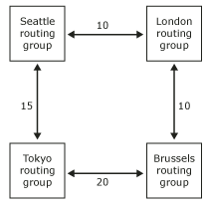

If all connections between the routing groups are available, a server in the Seattle routing group always sends a message to the Brussels routing group by sending the message first through the London routing group. This route has a cost of 20, the lowest cost route available. But, if the bridgehead server in London is unavailable, messages originating in Seattle and destined for Brussels travel through the Tokyo routing group, which has a higher cost of 35.
An important concept to understand is that for a connector to be marked as unavailable, all bridgehead servers for this connector must be down. If you have configured your routing group connector to use the default option of Any local server can send mail over this connector, the routing group connector is always considered in service. For more information about configuring routing group connectors, see "Connecting Routing Groups" in Defining Routing Groups.

Using Link State Information for External Mail Delivery
For external mail delivery, routing uses the information in the link state table to first evaluate the connector with the address space that most closely matches the destination, and then routing evaluates the cost. The following diagram illustrates a company with the following topology:
• One SMTP connector with an address space of *.net and a cost of 20.
• One SMTP connector with an address space of *, encompassing all external addresses and a cost of 10.
How Exchange uses address space to route mail
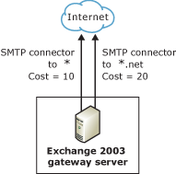

In this topology, when mail is sent to an external user with an e-mail address of ted@treyresearch.net, routing first looks for a connector with an address space that most closely matches the destination of treyresearch.net. The SMTP connector with the address space of *.net most closely matches the destination, so routing uses this connector regardless of cost.
However, if mail is sent to an external user with an address of adam@contoso.com, routing uses the SMTP connector with the address space of * because it is the closest match. Routing does not evaluate cost. If two SMTP connectors exist and both have an address space of * but each have different costs, routing uses the information in the link state table and selects the SMTP connector with the lowest cost. Routing only uses the connector with the higher cost if the lower cost connector is unavailable.
Note:
For more information about link information and how it is propagated, see Advanced Link State Concepts.
Routing does not fail over from a connector with a specific address space to a connector with a less specific address space. In the scenario above, if all users can use both connectors and a user attempts to send mail to a user at treyresearch.net, routing views the connector with the .net address space as its destination. If this connector is not in service or is unavailable, routing does not attempt to find a connector with a different, less restrictive address space such as * because it considers this a different destination.
However, in this same topology, assume that restrictions exist on the connector with the *.net address space, and the restriction permits only users of the sales department to send through this connector. In this situation, if this connector is not in service, routing will not reroute mail that is sent by a user in the sales department and destined to a .net address through the connector with the * address. Mail queues until the connector with the *.net address becomes available. However, users outside of the sales department are never affected when this connector becomes unavailable because their mail is always routed through the SMTP connector with the * address space.

Understanding SMTP and Exchange Server 2003
Before configuring your Exchange Server organization to send and receive mail, you should have a good understanding of how Simple Mail Transfer Protocol (SMTP) enables message flow in Microsoft® ExchangeServer 2003. ExchangeServer 2003 uses SMTP to deliver internal mail between Exchange servers and routing groups. Similarly, Exchange Server 2003 uses SMTP to deliver Internet mail outside the Exchange organization.
SMTP is the Internet standard for transporting and delivering electronic messages. Based on specifications in Request For Comments (RFC) 2821 and RFC 2822, the Microsoft SMTP service is included in Microsoft Windows® 2000Server and WindowsServer™ 2003.
The Windows SMTP service is a component of Internet Information Services (IIS) and runs as part of Inetinfo.exe. Exchange Server 2003 relies on the Windows SMTP service as its native transport protocol; therefore, Exchange uses SMTP to route all internal and external messages.

How Exchange Server Extends SMTP Functionality
When Exchange Server is installed, it extends the underlying SMTP functionality by:
• Moving management of the SMTP service (by means of SMTP virtual servers) from the IIS administrative console to Exchange System Manager.
• Implementing support for link state information. Exchange uses link state information to determine the best method for sending messages between servers, based on the current status of messaging connectivity and cost, and the associated expense of the route that you define based on your topology.
• Extending SMTP to support the command verbs that are used to support link state routing and other Exchange functionality. The following commands are added when Exchange is installed:
• X-EXPS GSSAPI
• X-EXPS=LOGIN
• X-EXCH50
• X-LINK2STATE
Note:
For a list of all the SMTP commands and their definitions, see SMTP Commands and Definitions.
• Setting up an Exchange Installable File System (IFS) store driver to allow message retrieval from and delivery to the Exchange store.
• Setting the disk location where messages are queued to \exchsrv\mailroot\vs 1\queue. This is the location of the first SMTP virtual server on the Exchange server. If you add a second SMTP virtual server, Exchange creates an additional location (\exchsrv\mailroot\vs 2\queue).
• Implementing support for advanced queuing. Exchange enhances the queuing capabilities of Windows 2000 and Windows Server 2003. The advanced queuing engine handles underlying transport functions in Exchange.
• Enhancing message categorization. Message categorization is a process performed by the message categorizer, a component of the advanced queuing engine. The categorizer sends Lightweight Directory Access Protocol (LDAP) queries to the global catalog server to retrieve user and configuration information stored in Microsoft Active Directory® directory service. The message categorizer retrieves recipient policy information and Exchange virtual server information to enable message delivery. It uses this information to validate the recipient address, to verify that message limits are not exceeded, and ultimately to determine how the message is delivered using Exchange routing and SMTP.
An important concept to understand about SMTP and Exchange 2000 Server and later versions is the interaction among Exchange, Active Directory, and the IIS metabase. With Exchange System Manager, any configuration changes you make (such as to your recipient policies and SMTP virtual servers) are written to Active Directory, allowing for easy and remote administration. However, because the SMTP service reads its settings from the IIS metabase, the DS2MB service, which is a component of Exchange System Attendant, replicates this information from Active Directory into the local server's IIS metabase.

Receiving Internet Mail
If the following conditions exist, Exchange Server 2003 is able to receive Internet mail in its default configuration:
• There is a constant connection to the Internet.
Note:
Dial-up connections to the Internet require special configuration. For more information about dial-up connections, see How to Set a Connector Schedule.
• The external Domain Name System (DNS) servers for your domain must have mail exchanger (MX) resource records pointing to your mail servers, or, if you are using an Internet service provider (ISP) or an external system, this external system must have an MX record for your domain and a mechanism to forward mail to your Exchange servers.
• Your mail server must be accessible to other servers on the Internet. If you are using an ISP or external system to receive your mail, this external system must be able to contact your Exchange servers to deliver your mail.
• Your recipient policies must be configured correctly. To receive Internet mail, you must configure a recipient policy that contains an address space matching the SMTP domain. Also, your Exchange organization must be responsible for delivering mail to this address (this is the default setting). For example, to accept Internet mail for ted@example.com, you must have a recipient policy that contains @example.com. However, there are some exceptions to this rule.
Inbound Internet mail flows through an Exchange server in the following manner:
1. The sending SMTP server queries DNS to locate the IP address of the recipient's SMTP mail server.
2. The sending SMTP server then initiates a conversation on the recipient's SMTP server (on port 25). On an Exchange gateway, the recipient's SMTP server is the SMTP virtual server that is configured to accept inbound Internet mail.
3. Ideally, the inbound SMTP server only accepts the incoming message if it is destined for a recipient of its SMTP mail domain. These recipients are defined in the recipient policies (unless the server is open to relay, which is strongly discouraged).
Note:
If you leave your system open for relay, unauthorized users can use your servers to send mail to external addresses. As a result, your system may be block listed—a process that blocks mail from servers that are suspected of sending unsolicited commercial e-mail (spam).
4. When the message is accepted, the SMTP virtual server uses the transport mechanisms within Exchange to determine the method for delivering the message. Exchange locates the recipient in Active Directory and determines which server in the Exchange organization will deliver the message.
5. Finally, the SMTP virtual server uses its internal transport mechanisms to deliver the message to the appropriate Exchange server.

Sending Internet Mail
Assuming there is a constant Internet connection, Exchange sends Internet mail by the following methods:
• It uses DNS directly to contact the remote mail server.
• It routes mail through a smart host that assumes responsibility for DNS name resolution and mail delivery.
Before each of these methods is described in detail, you should have a general understanding of how outbound mail flows in an Exchange organization.
Outbound Internet mail flows through an Exchange Server 2003 server in the following manner:
1. An internal user sends a message to a recipient in a remote domain.
2. To determine if the recipient is local or remote, the SMTP virtual server on the sender's Exchange server uses internal transport functions to query the global catalog server for the recipient address. If the recipient address on the message is not in a recipient policy, it is not stored in Active Directory; therefore, Exchange determines that the message is destined for a remote domain.
3. If necessary, the Exchange server delivers the message to the appropriate SMTP virtual server.
4. The SMTP virtual server uses its IIS metabase information to determine the method for delivering a message to a remote domain.
5. The SMTP virtual server on the Exchange server then performs one of two actions:
• Uses DNS to look up the IP address for the target domain, and then attempts to deliver the message.
• Forwards the message to a smart host that assumes responsibility for the DNS resolution and delivery of the message.

Understanding the SMTP Virtual Server
SMTP virtual servers provide the Exchange mechanisms for managing SMTP. Each SMTP virtual server represents an instance of the SMTP service running on the Exchange server. You use Exchange System Manager to configure SMTP virtual servers that control the behavior of SMTP.
Essentially, an SMTP virtual server is an SMTP protocol stack (a process or server that both receives e-mail messages and acts as a client for sending e-mail messages). Each SMTP virtual server represents an instance of the SMTP service on a server. An SMTP virtual server is defined by a unique combination of an IP address and port number. The default SMTP virtual server uses all available IP addresses on the server and uses port 25 for inbound connections. A single physical server can host many virtual servers.
You use Exchange System Manager to control most of the SMTP settings. The property settings of the SMTP virtual server control inbound mail and, to a lesser degree, outbound mail settings.
Important:
Because an SMTP virtual server plays a critical role in mail delivery, use caution when you modify its property settings. For example, the default SMTP virtual server sends messages within a routing group. Additionally, if the server is a domain controller, Active Directory uses this virtual server for SMTP directory replication. Therefore, instead of modifying the default SMTP virtual server, it is recommended that you either create an additional SMTP virtual server or create an SMTP connector to override the default virtual server settings.

Misconceptions about Multiple SMTP Virtual Servers
A common misunderstanding is that creating multiple SMTP virtual servers on a single Exchange server increases throughput. It is important to understand that each SMTP virtual server is multithreaded. Creating additional SMTP virtual servers on a single Exchange server does not increase performance and introduces complexity in your Exchange organization. An example of a case in which multiple SMTP virtual servers are required is a dual-homed server configuration. For most other scenarios, using the default SMTP virtual server with its default settings is generally sufficient.

Inbound Mail Settings on the SMTP Virtual Server
You can use the virtual server's property settings to configure the following inbound settings:
• Inbound ports and IP addresses The SMTP virtual server listens on its assigned IP address for incoming communications and accepts inbound connections on its assigned port. To configure these settings, use the Generaltab of the SMTP virtual server's properties.
Important:
The SMTP service defines port 25 as its standard port. Do not change this setting.
Note:
Upon installation in its initial configuration, the default virtual server connects to the remote SMTP server on port 25 to send outbound mail. This is a separate setting from the inbound port setting. To configure this setting, use the Outbound Connections button on the Delivery tab.
• Relay restrictions To prevent unauthorized users from using your server to send messages to external addresses, use the Relay button on the Access tab. By default, the default SMTP virtual server relays messages only for authenticated users.
• Restrict submission and relay permissions to specific users and groups In Exchange Server 2003, you can limit who can submit mail to an SMTP virtual server by using Relay and Authentication buttons on the Access tab.
• Security You can require Transport Layer Security (TLS), an implementation of Secure Sockets Layer (SSL), on incoming connections.
You can also configure other settings such as inbound connection restrictions, performance tuning, and handling of delivery reports notifications.

Outbound Mail Settings on the SMTP Virtual Server
If you want your SMTP virtual server to send mail directly to the Internet, you can configure outbound mail settings. Specifically, you can configure your virtual server to use an external DNS server to resolve external addresses and send mail directly to mail servers outside of your organization.
Important:
Because an SMTP virtual server plays a critical role in mail delivery, use caution when modifying its property settings. For example, the default SMTP virtual server sends messages within a routing group. Additionally, if the server is a domain controller, Active Directory uses this virtual server for SMTP directory replication. Therefore, instead of modifying the default SMTP virtual server, it is recommended that you either create an additional SMTP virtual server or create an SMTP connector to override the default virtual server settings.
In many instances, it is preferable (but not required) to set up an SMTP connector to handle outbound mail. For more information about SMTP connectors, see Understanding SMTP Connectors.
Note:
If you use an SMTP connector, it overrides some of the outbound mail settings and controls for outbound mail delivery.
To control outbound delivery on your virtual server, you can configure the following settings:
• Outbound port
• Outbound restrictions
• Outbound delivery options
• Outbound security
• Performance tuning
• Notification of delivery reports
For more information about how to configure these settings, see "Configuring Outbound Settings on SMTP Virtual Servers" in Connecting Exchange to the Internet.

Setting Relay Restrictions
Relaying is the ability to forward mail to domains other than your own. More specifically, relaying occurs when an inbound connection to your SMTP server is used to send e-mail messages to external domains. By default, your Exchange server accepts mail submitted by internal or authenticated users and sends it to an external domain. If your server is open for relaying, or if relaying is unsecured on your server, unauthorized users can use your server to send unsolicited commercial e-mail (spam). Therefore, to secure your SMTP virtual server, it is crucial that you set relay restrictions.
It is important to understand the difference between authenticated relaying and anonymous or open relaying:
• Authenticated relaying Authenticated relaying allows your internal users to send mail to domains outside of your Exchange organization, but requires authentication before the mail is sent. By default, Exchange allows only authenticated relaying.
• Anonymous relaying Anonymous relaying allows any user to connect to your Exchange server and use it to send mail outside your Exchange organization.
The following examples demonstrate how Exchange Server 2003 accepts and relays mail by using authenticated relaying:
• An anonymous user connects to the SMTP virtual server and attempts to deliver mail to an internal user in the Exchange organization.
In this situation, the SMTP virtual server accepts the message because it is destined for an internal domain and because the user exists in Active Directory.
• An anonymous user connects to the SMTP virtual server and attempts to deliver mail to an external user in an external domain.
In this situation, the SMTP virtual server rejects the mail because it is destined for an external domain for which the Exchange server is not responsible. Because the user is not authenticated, the SMTP virtual server does not relay this mail outside of the Exchange organization.
• A user connects to the SMTP virtual server using a Post Office Protocol (POP) or Internet Message Access Protocol (IMAP) client (for example, Microsoft Outlook® Express), authenticates, and then attempts to send a message to a user in an external domain.
In this situation, the e-mail client connects directly to the SMTP virtual server and authenticates the user. Although the message is destined for a remote domain, the SMTP virtual server accepts and relays this mail because the user is authenticated.
By using the relay control features of Exchange Server 2003, you can prevent third parties from relaying mail through your server. Relay control allows you to specify a list of incoming remote IP address and subnet mask pairs that have permission to relay mail through your server. Exchange checks an incoming SMTP client's IP address against the list of IP networks that are allowed to relay mail. If the client is not allowed to relay mail, only mail that is addressed to local recipients is allowed. You can also implement relay control by domain. However, this approach requires the implementation of reverse DNS resolution, which is controlled at the SMTP virtual server level.

Configuring Default Relay Restrictions
By default, the SMTP virtual server allows relaying only from authenticated users. This configuration is designed to prevent unauthorized users from using your Exchange server to relay mail. The virtual server's default configuration allows only authenticated computers to relay mail.
Default relay restrictions
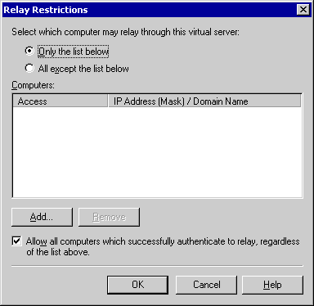

Unsolicited commercial e-mail generally comes from a spoofed or forged address and is often relayed by using a server that is not secured for relay. For this reason, by default Exchange Server 2003 allows only authenticated users to relay. Be cautious when changing this setting—many Internet providers block servers that allow open relaying.

Understanding SMTP Connectors
SMTP connectors are used primarily to connect to other mail systems or to define additional options for an SMTP Internet gateway. SMTP connectors can also be used to connect a routing group to another routing group internally, but an SMTP connector is generally not recommended for doing so. Essentially, SMTP connectors allow you to designate an isolated route for messages to flow either to a specific domain or over the Internet.
One advantage to using an SMTP connector is that you can specify additional configuration settings to affect mail delivery. These settings include:
• Outbound mail delivery
When you configure a connector, you can route mail in one of two ways:
• Use DNS to route all outgoing mail through the connector. If you use DNS to route outgoing mail, the SMTP connector uses DNS to resolve the IP address of the remote SMTP server, and then it delivers the mail.
• Specify a smart host (another server to which the connector routes all mail). The smart host takes responsibility for DNS resolution and delivers the mail.
• Local bridgehead servers
An SMTP virtual server hosts a connector. When you create a connector, you designate at least one Exchange server and SMTP virtual server as bridgehead servers. The connector inherits size restrictions and other settings from the SMTP virtual server; however, you can override these settings on the connector. You can also designate multiple bridgehead servers for load balancing, performance, and redundancy.
• Address space
The address space defines the mail addresses or domains for the e-mail messages that you want to route through a connector. For example, an address space of * (asterisk) encompasses all external domains—this connector is used to route all external e-mail. If you created a second connector with an address space of *.net, Exchange would route all mail sent to a domain with a .net extension through the second connector. This action occurs because Exchange selects the connector that has the most similar address space. This setting is configured on the Address tab of the SMTP connector's properties.
• Scope
You can select either an entire organization or a routing group for the connector's scope. The scope is also defined on the Address tab of the SMTP connector's properties.
• Delivery restrictions
You can restrict who can send mail through a connector. By default, mail is accepted from everyone. These settings are configured on the Delivery tab of the SMTP connector's properties.
Note:
By default, you cannot restrict mail unless you change the registry key settings. If you chose to enable delivery restriction, be aware that restricting delivery is extremely processor-intensive and can negatively affect server performance. For more information about how to enable delivery restrictions, see How to Set Delivery Restrictions on the SMTP Connector.
• Content restrictions
You can specify what types of messages are delivered through a connector. These settings are configured on the Content Restrictions tab of the SMTP connector's properties.
• Delivery options
If you connect to a network service provider to retrieve your mail, you can configure a connector to run on a specified schedule and implement advanced queuing and dequeuing features. These settings are configured on the Delivery Options tab of the SMTP connector's properties.
• SMTP communication
You can control how the connector uses SMTP to communicate with other SMTP servers. Specifically, you can specify whether the connector uses SMTP or Extended Simple Mail Transfer Protocol (ESMTP) commands to initiate a conversation with another server and control the use of the ERTN and TURN commands (these commands are used to request that another SMTP server send any e-mail messages that it has). These settings are configured on the Advanced tab of the SMTP connector's properties.
• Outbound security
You can also ensure that any mail that flows through the connector is authenticated. This is useful if you want to establish a secure route for communicating with a partner company. With this setting, you can establish an authentication method and require TLS encryption.
All of these settings are configured by using the Outbound Security button on the Advanced tab of the SMTP connector's properties.

Functions of an SMTP Connector
SMTP relies on DNS to determine the IP address of its next destination server. To send mail directly to an external mail server, an SMTP connector must use DNS to resolve external domain names. Alternatively, the connector can simply forward mail to a smart host that assumes responsibility for DNS name resolution and delivery.
After you set up an SMTP connector, as long as the destination address matches the address space that is configured on the SMTP connector, the servers no longer route the mail directly; instead, the servers route the mail through the SMTP connector. (These servers are called either gateway or bridgehead servers.)
To illustrate this point, assume that you want all external mail routed through a connector to a bridgehead server, which is the only server that communicates with the Internet. To configure this, create a connector on the bridgehead server with an address space of * (asterisk), which specifies all external domains. When e-mail is sent to an external domain, Exchange automatically routes it to this connector, rather than an SMTP virtual server sending the external mail directly. If you have more than one connector, Exchange first attempts to route mail through the connector that has the most similar address space (which is the most restrictive address space).
Note:
In a mixed-mode environment, if you have an Exchange Server version 5.5 Internet Mail Connector, Exchange Server 2003 treats this connector as a valid route. If you experience problems sending or receiving Internet e-mail messages, check the MTA queues on the Exchange Server 5.5 server and the X.400 queues on the Exchange Server 2003 server. Exchange Server 2003 uses the MTA to communicate with earlier versions of Exchange.

Uses for an SMTP Connector
Because of Exchange Server 2003 virtual server functionality, it is not necessary to create an SMTP connector to allow for mail flow, to connect it to other servers in an Exchange organization, or to connect it to the Internet. Furthermore, you do not need a connector if all of your Exchange Server 2003 servers connect to the Internet and successfully perform Domain Name System (DNS) lookups for Internet addresses.
However, although it is not essential for Internet mail delivery, the benefits of using an SMTP connector are that it:
• Provides simplified administration.
• Provides limited exposure to the Internet.
• Establishes an isolated route for communicating with another domain or another mail system.
• Routes mail to another mail system or relays mail to another domain.
• Allows multiple bridgehead servers for load balancing.
• Allows you to control how SMTP is used to communicate with other servers.
• Permits scheduled connection times with customized settings.
The following sections provide detailed information about each of these benefits. For more information about SMTP connectors, see Microsoft Knowledge Base article 294736, "When to Create SMTP Connectors in Exchange 2000 and Later."
• Simplify Administration of Mail Flow
An SMTP connector provides more administrative control over how Internet mail flows out of your organization. You can use an SMTP connector, or a set of connectors, to limit the available routes for outgoing Internet mail. Also, because you need only check the SMTP queues and other configurations on a single server, using a single server as a bridgehead server simplifies troubleshooting.
• Limit Internet Exposure
One of the primary benefits of creating an SMTP connector is that you can route all inbound or outbound external SMTP mail through a particular server or set of bridgehead servers. By designating an isolated route for Internet mail that uses a connector, you limit your Exchange organization's exposure to the Internet.
To use an SMTP connector to route Internet mail, specify one server or a set of servers as your gateway to the Internet, create an SMTP connector, and then designate those servers as the source bridgehead servers of the connector.
• Isolate a Route for Communicating with Other Domains
You can also use an SMTP connector to establish an isolated route for communicating with other domains. This approach can be useful when you want to use secure communications with a particular company.
In previous versions of Exchange, you can configure settings per e-mail domain. Although these options are not available in Exchange Server 2003, you can create multiple SMTP connectors, set address spaces for these connectors, and then specify the settings that you want for those domains.
For example, suppose you want to use SSL to secure all e-mail messages that are sent to the military, but you do not want to use SSL for other e-mail communications. To achieve this outcome, you need two SMTP connectors:
• One with an address space of SMTP:*.mil
• One with an address space of SMTP:*
Because Exchange routes all mail through the connector that most closely matches the address space, all mail that is destined for the.mil domain initially tries to pass through the*.mil connector. You can specify that the *.mil connector send mail to only one server (a smart host), and that it use SSL and require authentication. Because routing considers *.mil and * as two separate destinations, if the *.mil connector is unavailable, mail queues until the connector becomes available. Mail does not reroute through the SMTP connector that uses the * address space.
• Load Balance with Multiple Bridgehead Servers
When you have a single connector that is hosted by multiple bridgehead servers, the servers using the connector randomly select the bridgehead server that they use, thereby load balancing requests across the bridgehead servers. The situation is different if you have multiple connectors with the same address space, each with a single bridgehead server. The servers that use these connectors use a method based on the server GUID to determine which of the available connectors they will use. The algorithm may not evenly distribute the server selections across the available connectors. So, to achieve load balancing, it is recommended that you use a single connector sourced to multiple bridgehead servers.
• Use Specific SMTP or ESMTP Commands
You can use a connector to control how your Exchange servers use SMTP to communicate with other servers. To initiate SMTP sessions, you can choose whether your server uses the ESMTP commands or SMTP commands, and you can control what type of commands your server issues.
When you configure an SMTP connection, the following communication options are available:
• Send or do not send server-side or client-side ETRN/TURN commands.
TURN is an SMTP command that allows the client and server to switch roles and send mail in the reverse direction without having to establish a new connection. ETRN is an ESMTP command that is sent by an SMTP server to request that another server send any e-mail messages it has. You can use these commands if you depend on a network service provider to hold your mail for you and deliver it upon request.
• Request ETRN/TURN from specific servers.
• Send HELO (an SMTP command) instead of EHLO (an ESMTP command).
HELO is an SMTP command that is sent by a client to identify itself, usually with a domain name; EHLO is an ESMTP command with which a server identifies its support for ESMTP commands.
• Schedule and Customize Outbound Connections
You can use a connector to open an outbound connection at specified times. This functionality is helpful if you use a network service provider to deliver your outbound mail, or if you have limited bandwidth and want to control when external mail is sent.
You can also configure a connector to:
• Allow high, normal, or low message priorities for a domain.
• Allow system or non-system messages.
• Use different delivery times for oversized messages.
• Queue mail for remote triggered delivery.
• Set specific delivery restrictions.

Transport Dependencies for Exchange Server 2003
To function properly, Simple Message Transfer Protocol (SMTP) depends on the following components:
• Internet Information Services (IIS), a feature in Microsoft® Windows Server™ 2003
• Microsoft Active Directory® directory service
• Domain Name System (DNS)
• Recipient policies
• Recipient update service
• Directory service to metabase service (DS2MB)
This topic provides detailed information about each of these components and how they interact with SMTP.

Internet Information Services
Internet Information Services (IIS) provides a framework process for Internet services such as the World Wide Web Publishing Service (W3SVC), SMTP service (SMTPSVC), and Network News Transfer Protocol service (NntpSvc). Do not confuse IIS with Web services because several other services, such as SMTP, depend on IIS to function.
The installation of IIS provides:
• The framework process known as the IIS Admin Service (IISADMIN), which allows for the administration of services through the IIS snap-in.
• Administrative consoles or snap-ins for the Microsoft Management Console (MMC).
• The IIS metabase, which is the configuration repository for IIS.
• Common files, which are shared libraries that provide socket connection pooling, registration, and management of these Internet services.
Microsoft Exchange 2000 Server and Exchange Server 2003 setup requires that the World Wide Web Publishing Service, SMTP service, and NNTP service be installed. This prerequisite ensures that all the necessary components are installed prior to the installation of Exchange. Exchange leverages the core SMTP service through an event infrastructure. (For more information about event infrastructures, see the MSDN® Web site.) After Exchange is installed, the SMTP service is dependent only on the IIS Admin Service. You can disable the World Wide Web Publishing Service without affecting the SMTP service; however, you cannot use the Add/Remove Windows Component option in Add or Remove Programs to disable the IIS Admin Service or to remove the IIS component entirely.
Installing IIS creates several virtual directories under the World Wide Web Publishing Service that are not required for any Exchange component, including Microsoft Outlook® Web Access. To help secure IIS, Microsoft provides the following tools:
• URLScan version 2.5 for Windows Server 2003
URLScan version 2.5 is a security tool that restricts the types of HTTP requests that IIS will process. To increase security on your server that is running Windows Server 2003, run URLScan. You can download URLScan from the Microsoft Download Center. For more information about URLScan, see Microsoft Knowledge Base article 823175, "Fine-Tuning and Known Issues When You Use the Urlscan Utility in an Exchange 2003 Environment."
• IIS Lockdown Wizard for Windows® 2000 Server
IIS Lockdown Wizard is a security tool that removes unnecessary virtual directories, enhances file security, and processes real-time URL requests against user-defined configurations. To increase protection in the unlikely event that the World Wide Web Publishing Service is started in error, if you are running Exchange on Windows 2000 servers, you should deploy the IIS Lockdown Wizard on every Exchange server and domain controller. You can download the IIS Lockdown Wizard from the Microsoft Download Center. For more information about using the IIS Lockdown Wizard, see "Using IIS Lockdown Wizard on Windows 2000 Server" in Securing Your Infrastructure.

Active Directory
Exchange Server 2003 is tightly integrated with Windows 2000 and Windows Server 2003 and with Active Directory. Exchange Server 2003 stores all of its configuration information in Active Directory, including information about recipient policies, routing and connector configuration, SMTP virtual server configuration, user mailboxes, and much more. However, SMTP reads its settings from the IIS metabase. Therefore, to supply IIS with the information that it needs for SMTP functionality, Microsoft Exchange System Attendant (a service in the Exchange Default Services) replicates the configuration information from Active Directory to the IIS metabase.
Additionally, routing depends on Active Directory for information about the current routing topology. On startup, each Exchange server reads information from Active Directory about the routing topology, such as the existing connector configuration, routing groups, and local and remote bridgehead servers. If an object such as a routing group or connector is corrupt, it is not read from Active Directory. When this occurs, servers then have an incomplete topology view. Monitor for event 929 in the Event Viewer to detect this situation. For more information about Event Viewer, see How to View the Application Log in Event Viewer and How to View the System Log in Event Viewer.
After startup, the routing group master (the server that is responsible for maintaining and communicating information about the routing topology in its routing group) in each routing group registers with Active Directory and is notified by the configuration domain controller of major routing version changes. When a routing group master receives an update to the routing topology, it sends the updated information to all member servers in its routing group and notifies all bridgehead servers in remote routing groups. These bridgehead servers then notify their respective routing group masters. Additionally, the categorizer, an internal transport component, accesses a cached version of information in Active Directory using DSAccess or by querying Active Directory directly using the LDAP queries. For more information about the categorizer, see Understanding Internal Transport Components.

Domain Name System (DNS)
Although a complete analysis and discussion of DNS is beyond the scope of this guide, this section provides information about the relationship between DNS and SMTP in Exchange. Because Exchange Server 2003 relies on DNS for name resolution, DNS plays a crucial role in Internet mail flow.
SMTP depends on DNS to determine the Internet Protocol (IP) address of its next internal or external destination server. Generally, internal DNS names are not published on the Internet. Therefore, SMTP must be able to contact a DNS server that can resolve external DNS names to send Internet mail, as well as a DNS server that can resolve internal DNS names for delivery within the organization. For information about how to configure DNS for sending and receiving mail, see Verifying DNS Design and Configuration.
The following sections provide a general overview of DNS queries and an explanation of the role that DNS plays in sending and receiving mail.

How External DNS Queries Work
When a DNS client needs to resolve the name of a server, it queries the DNS servers. Each query that the client sends essentially asks the DNS server to provide the information. The client specifies the query type, which can either indicate a resource record by type or a specialized type of query operation. For example, to find SMTP mail servers from the Internet, specify the query type MX (mail exchanger resource record).
For example, the name that is specified could be an external domain, such as example.microsoft.com., and the query type that is specified to look for could be an MX record by that name. Think of a DNS query as a client asking a server a two-part question: First, "Do you have any MX resource records for a domain named 'example.microsoft.com.'?" followed by "If so, can you resolve this MX record to an A (host) record and resolve its IP address?" When the client receives an answer from the server, it reads and interprets the MX record and gets the A record, thereby resolving the computer's IP address.

Querying a DNS Server
When the DNS server receives a query, the server first checks to see if it can answer the query authoritatively, based on MX record information that is contained in a locally configured zone on the server. If the queried name matches a corresponding MX record in the local zone, the server answers authoritatively and uses this information to resolve the queried name.
If no zone information exists for the queried name, the server then checks to see if it can resolve the name by using locally cached information from previous queries. If a match is found, the server answers with this information. Again, if the preferred server can provide the requesting client with a positive matched response from its cache, the query is completed.
If no zone or cached information exists for the queried name, the query process uses recursion to fully resolve the name. Recursion is the process in which a DNS server queries other DNS servers on behalf of the requesting client to fully resolve the name, and then sends an answer back to the client. By default, the DNS Client service requires that the server use recursion to fully resolve names on behalf of the client before returning an answer. In most cases, the DNS server is configured (by default) to support the recursion process.
How DNS resolves a query for an MX record and finds the IP address
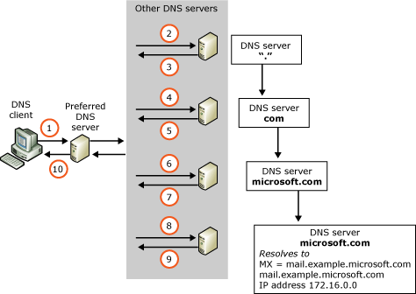

For more information about DNS, see the Windows 2000 or Windows Server 2003 Help.

Role of DNS in Sending and Receiving Internal Mail
Windows 2000 and Windows Server 2003 both register the fully qualified domain name (FQDN) of each server with dynamic DNS. Your Exchange server and your SMTP virtual servers also use the FQDN. If you change the FQDN that your SMTP virtual server uses, be sure to add a record for this FQDN into DNS manually.
Role of DNS in Receiving Internet Mail To receive Internet mail, your external DNS servers must have an MX record pointing to an A record that contains the IP address of your mail servers, or a server that can forward mail to your mail servers. To ensure that your MX records are configured correctly, you can use the Nslookup tool. To verify that your server is accessible on port 25 to other servers on the Internet, you can use telnet.

Using DNS to Send Internet Mail
When you use DNS, the most important thing to remember is that all servers in the DNS search order must be able to resolve external domains (also referred to as Internet domains). Because it is likely you will use internal servers for internal name resolution, you have three possible setup options:
• Set up your internal DNS servers as caching servers that use root hints for Internet domains. Root hints point to DNS servers that are authoritative for the zone containing the domain root and top-level domains. Root hints help DNS servers locate the correct server to resolve a domain name.
• Set up the internal DNS servers with forwarders to external DNS servers. A forwarder is a DNS server that is designated by an internal server to be used for resolving external DNS names. (To set up a forwarder, in the DNS console, select the DNS server. On the Action menu, click Properties, click the Forwarders tab, and then select the Enable forwarders check box. Add IP addresses for other DNS servers that act as forwarders for this server.)
• Configure the SMTP service to use external DNS servers. To configure an external DNS server, right-click your SMTP virtual server, click Properties, and then click the Delivery tab. Click Advanced, and then click Configure to set up an external DNS server.
For example, consider that an internal client in the domain example.com sends a message to a recipient in the remote domain contoso.com. To route the message, Exchange uses DNS to resolve the IP address of the SMTP server in the Contoso domain and deliver the message to the recipient at contoso.com.
How Exchange uses DNS to resolve external IP addresses
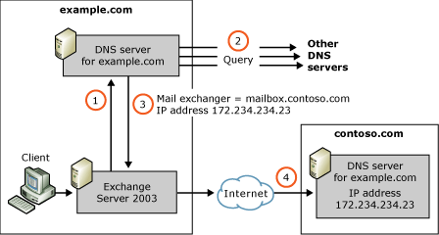

The following sequence also explains how Exchange uses DNS to resolve an external IP address:
1. After the SMTP server in the domain example.com receives the message that is destined for the recipient at contoso.com, the SMTP virtual server contacts the appropriate DNS server and sends an MX query for the external domain of contoso.com.
2. The DNS server locates an A record that is associated with the MX record for contoso.com, and then uses that A record to determine the IP address. For more information about how the DNS server locates the A record, see "Querying a DNS Server" earlier in this chapter.
3. The DNS server returns the IP address of 172.234.234.23 for the mail server in contoso.com to the SMTP virtual server.
4. The SMTP virtual server opens a connection on port 25 of the remote SMTP server at the IP address of 172.234.234.23 and delivers the mail.

Forwarding Internet Mail to a Smart Host
A smart host is a server or mail process that handles the delivery of Internet mail. A smart host does not have to be an Exchange server—it can be any SMTP process or server that takes the responsibility of delivering mail, either by sending it to another SMTP server or by using DNS to deliver the mail directly. In scenarios where there is a persistent connection to the Internet, a smart host is not required. However, often the smart host is an antivirus scanner or a Windows 2000 or Windows Server 2003 SMTP service that is in a perimeter network.
Using a smart host for DNS resolution is similar to using a DNS server, except that the smart host assumes the responsibility of resolving the IP address and sending the mail.
For more information about how to configure the Windows 2000 SMTP service in a perimeter network, see Microsoft Knowledge Base article 293800, "XCON: How to Set Up Windows 2000 as a SMTP Relay Server or Smart Host."
For more information about how to set up Exchange behind Microsoft Internet Security and Acceleration (ISA) Server, see the technical article Microsoft ISA Server 2000 – Configuring and Securing Exchange 2000 Server and Clients.

Recipient Policies
A recipient policy establishes the default e-mail addresses that use a specific protocol (such as SMTP) for a set of users. E-mail addresses are used to define the valid formats for addressing inbound e-mail messages to the Exchange system. The default recipient policy sets the mail domain for which the virtual server accepts incoming e-mail messages. It specifies the default SMTP and X.400 addresses for all Exchange Server 2003-based, mailbox-enabled objects.
Any SMTP domains that are specified in the recipient policies are replicated into the IIS metabase and set as authoritative local domains. As a result, SMTP accepts inbound mail for these domains. The only time that an SMTP address is not considered local is when you clear the This Exchange Organization is responsible for all mail delivery to this address check box in SMTP Address Properties while adding the address to the recipient policy.
A recipient policy can contain more than one e-mail address for a specified protocol (such as SMTP or X.400). For example, if all users in your Exchange organization have an external e-mail address of @example.com, but you want all your Seattle users to have two external mail addresses—one with @example.com, and another with an e-mail address of @seattle.example.com—you can set up a recipient policy for all users in your Seattle office and add an additional address of @seattle.example.com. To achieve this result, perform the following procedure.
For more information about Recipient Policies, see Connecting Exchange to the Internet and "Managing Recipients and Recipient Policies in Exchange Server 2003" in the Exchange Server 2003 Administration Guide.

Recipient Update Service
The Recipient Update Service is part of the Microsoft Exchange System Attendant service (MSExchangeSA) that monitors Active Directory for new recipients and writes the appropriate e-mail address and other Exchange properties for the user in Active Directory. The Recipient Update service uses the information that is defined in recipient policies to update Active Directory with the correct user information for the recipients that are included in each recipient policy.
You must have a Recipient Update Service for each domain in your organization. In large organizations, multiple recipient update services are recommended. Consider having a recipient update service for each Active Directory site. Otherwise, replication of new recipients and their updated information can take up to thirty minutes in a simple replication topology. Until this replication is complete, these recipients are unable to send or receive mail.

Directory Service to Metabase Service
DS2MB service (directory service to metabase service), a component of the Exchange System Attendant service, is responsible for propagating information from Active Directory into the IIS metabase. DS2MB is critical to the operation of SMTP, Internet Message Access Protocol 4 (IMAP4), Post Office Protocol 3 (POP3), and the World Wide Web Publishing Service (W3SVC), which is the service for Microsoft Outlook® Web Access.
DS2MB replicates the following information from Active Directory into the IIS metabase:
• SMTP virtual servers and most of their configurable properties.
• SMTP connector address spaces so that the metabase for the advanced queuing engine routes messages properly.
• Authoritative domains from the recipient policies (replicated to the SMTPSVC/x/Domain subkey and used by the advanced queuing engine).
At startup, DS2MB checks all objects that it has replicated in the past, as well as for any changes since the last replication. If DS2MB detects that no replication has previously occurred, it initializes and replicates all objects.
After startup, DS2MB registers with the configuration domain controller so that the domain controller notifies DS2MB if any changes are made to the Exchange configuration and deleted objects container. As a result, almost as soon as a change is replicated to the configuration domain controller, DS2MB replicates that object to the metabase.
If DS2MB experiences problems, it logs an event with an ID of 1040. If this occurs, increase diagnostic logging to level 5 for MSExchangeMU, the metabase update service. You can turn on diagnostic logging in Exchange System Manager by right-clicking your Exchange server, clicking Properties, clicking the Diagnostic Logging tab, and selecting MSExchangeMU under Services. For more information about this procedure, see How to Modify Logging Settings for MSExchangeTransport.

Part Two
Part 2 explains the factors that you should consider and the procedures that are involved in configuring mail flow within your organization. It contains the following sections:
• Verifying DNS Design and Configuration
This section explains how to verify that DNS is correctly configured for internal and external name resolution. Additionally, this section explains how to verify that other servers on the Internet can find your mail server and deliver mail to your organization.
• Configuring a Routing Topology
This section presents common routing topologies. Also, this section explains how to define and configure routing groups and routing group connectors and how to designate a routing group master.
• Deployment Scenarios for Internet Connectivity
This section presents common and custom scenarios that are used by organizations to connect to the Internet.
• Connecting Exchange to the Internet
This section guides you through the process of connecting to the Internet and configuring your organization to send and receive Internet mail.

Verifying DNS Design and Configuration
Before you can verify your DNS configuration, ensure that your DNS design conforms to the following conditions:
• Each domain controller runs DNS.
• Existing recursive name resolution is used as configured for the organization. If no method is in place, use root hints on all servers.
The following table shows the preferred method of configuring DNS. Several other valid configurations exist. However, the configuration in the table is the preferred method. The table also shows how to configure the zone for each Exchange domain.
Preferred DNS configuration
Design element | Design
Zone type | Active Directory-integrated
Dynamic updates | Secure dynamic updates only
Scavenging | Enabled

When SMTP queries DNS, it always queries for MX records first. If an internal MX record exists and/or it is incorrectly configured, your internal mail delivery may not work.
For detailed steps about how to verify that MX Records do not point to the FQDN of an Exchange Server, see How to Verify that MX Records Do Not Point to the FQDN of an Exchange Server.
For detailed steps about how to verify that MX Records do not point to an internal domain, see How to Verify that MX Records Do Not Point to an Internal Domain.

Configuring DNS for Inbound Mail
DNS plays a vital role in Internet mail delivery. To receive Internet mail, the following settings are necessary:
• A mail exchanger (MX) record for your mail server must exist on your external DNS server. You can use the Nslookup tool to determine if your MX records are configured correctly. Ensure that the mail servers you use as bridgehead servers or Internet mail servers have an MX record on your external DNS servers.
• For external DNS servers to resolve your mail server's MX record and contact your mail server, your mail server must be accessible from the Internet. You can use the telnet program to determine if other servers can access your mail server.
• Your Exchange Server must be configured to contact a DNS server or to resolve DNS names.
• Your DNS server must be configured correctly.
Note:
It is recommended, although not required, that you use the DNS Server service in Microsoft Windows® 2000 or Windows Server 2003. The guidelines in the topics listed in the For More Information section apply to the DNS Server service in Windows 2000 and Windows Server 2003.
For detailed steps about how to use Nslookup to verify MX record configuration, see How to Use Nslookup to Verify MX record configuration.
For detailed steps about how to use Telnet to ensure Internet accessibility, see How to Use Telnet to Ensure Internet Accessibility.

Configuring DNS for Outbound Mail
You can use one of two methods to configure DNS for outbound mail:
• You can configure Exchange Server to rely on your internal DNS servers. These servers resolve external names on their own, or use a forwarder to an external DNS server. Exchange Server relies on your DNS servers to resolve domain names. Generally, you configure your Exchange Servers as DNS clients of your internal DNS server. On your internal DNS server, configure an external forwarder to point to trusted external DNS servers.
• You can configure Exchange Server to use a dedicated external DNS server.
For detailed steps about how to configure DNS settings on the Exchange Server, see How to Configure DNS Settings on the Exchange Server.
For detailed steps about how to configure settings on the DNS server, see How to Configure Settings on the DNS Server.
For detailed steps about how to configure external DNS servers on an outbound SMTP virtual server, see How to Configure External DNS Servers on an Outbound SMTP Virtual Server.
For detailed steps about how to use the DNS Resolver to verify DNS configuration, see How to Use the DNS Resolver to Verify DNS Configuration.
For detailed steps about how to use Nslookup to verify DNS configuration, see How to Use Nslookup to Verify DNS Configuration.

For More Information
The following topics explain how to verify each of these settings.
• How to Verify that MX Records Do Not Point to the FQDN of an Exchange Server
• How to Verify that MX Records Do Not Point to an Internal Domain
• How to Verify that Exchange Servers Can Resolve Internal DNS Names
• How to Use Nslookup to Verify MX record configuration
• How to Use Telnet to Ensure Internet Accessibility
• How to Configure DNS Settings on the Exchange Server
• How to Configure Settings on the DNS Server
• How to Configure External DNS Servers on an Outbound SMTP Virtual Server
• How to Use the DNS Resolver to Verify DNS Configuration
• How to Use Nslookup to Verify DNS Configuration

How to Verify that MX Records Do Not Point to the FQDN of an Exchange Server
When SMTP queries DNS, it always queries for MX records first. If an internal MX record exists and/or it is incorrectly configured, your internal mail delivery may not work.

Before You Begin
Before you perform the procedure in this topic, read Verifying DNS Design and Configuration

Procedure
To verify that MX records do not point to the FQDN of an Exchange Server
1. At a command prompt, type nslookup, and then press ENTER.
2. Type server <IP address>,where IP addressis the IP address of your internal DNS server.
3. Type set q=mx, and then press ENTER.
4. Type <fqdn>, where fqdnis the fully qualified name of your SMTP virtual server (and your Exchange server), and then press ENTER.
5. Verify that no MX records exist for your internal server. Your results should look similar to the following:
> set q=mx
> server1.example.local
example.local
primary name server = server01.example.local
responsible mail addr = hostmaster.example.local
serial = 6225703
refresh = 900 (15 mins)
retry = 600 (10 mins)
expire = 86400 (1 day)
default TTL = 3600 (1 hour)

How to Verify that MX Records Do Not Point to an Internal Domain
When SMTP queries DNS, it always queries for MX records first. If an internal MX record exists and/or it is incorrectly configured, your internal mail delivery may not work.

Before You Begin
Before you perform the procedure in this topic, read Verifying DNS Design and Configuration.

Procedure
To verify that MX records do not point to an internal domain
1. At a command prompt, type nslookup, and then press ENTER.
2. Type server <IP address>, where IP addressis the IP address of your internal DNS server.
3. Type set q=a, and then press ENTER.
4. Type <fqdn>, where fqdnis the fully qualified name of your SMTP virtual server (and your Exchange server), and then press ENTER.
5. Verify that the results that are returned match the IP address of the machine. On a multihomed computer, the IP address should match the IP address of the SMTP virtual server (except in the case of a single virtual server with an IP address of "All unassigned"). Your results should look similar to the following:
set q=a
> server1.example.local
Name: server1.example.local
Address: 192.168.1.10

If the only result returned is the correct A record, internal name resolution should succeed. If there are no records, or if an MX record is returned and points to the wrong FQDN or IP address, other servers may be unable to send mail to this Exchange server.

How to Verify that Exchange Servers Can Resolve Internal DNS Names
When SMTP queries DNS, it always queries for MX records first. If an internal MX record exists and/or it is incorrectly configured, your internal mail delivery may not work.

Before You Begin
Before you perform the procedure in this topic, read Verifying DNS Design and Configuration.
The SMTP DNS Diagnostic Tool is available for use on Exchange Servers running Microsoft® Windows® Server™ 2003. The SMTP DNS Diagnostic Tool simulates the internal code path of the SMTP service and generates diagnostic messages that indicate how DNS resolution is proceeding.
Run the SMTP DNS Diagnostic Tool on the computer for which you want to verify DNS configuration. Your path should include %WINDIR%\System32\Inetsrv so that the tool works.
The SMTP DNS Diagnostic Tool is included with the Windows Server 2003 Resource Kit Tools and you can downloaded it from the Windows Server 2003 Resource Kit Tools Web page.

Procedure
How to verify that Exchange Servers can resolve internal DNS names
1. On your Exchange Server, open a command prompt, navigate to the following directory and type the following:
<drive letter>:\WINDOWS\system32\inetsrv

2. Type the following:
dnsdiag internal host name–v 1

Where internal host name is the fully qualified domain name of another Exchange Server in your organization.
3. Verify that the correct IP address of the Exchange Server is returned. Your output should look similar to the following:
QNAME = example.microsoft.com
Type = MX (0xf)
Flags = UDP default, TCP on truncation (0x0)
Protocol = UDP
DNS Servers: (DNS cache will not be used)
172.16.1.101
Connected to DNS 172.16.1.101 over UDP/IP.
Received DNS Response:
----------------------
Error: 9501
Description: No records could be located for this name
These records were received:
microsoft.com SOA

Querying via DNSAPI:
--------------------
QNAME = example.microsoft.com
Type = A (0x1)
Flags = DNS_QUERY_TREAT_AS_FQDN, (0x1000)
Protocol = Default UDP, TCP on truncation
Servers: (DNS cache will be used)
Default DNS servers on box.
Received DNS Response:
----------------------
Error: 0
Description: Success
These records were received:
example.microsoft.com A 172.16.1.106
1 A record(s) found for example.microsoft.com
Target hostnames and IP addresses
---------------------------------
HostName: "example.microsoft.com"
172.16.1.106.

How to Use Nslookup to Verify MX record configuration
If you are running Exchange Server on a Windows 2000 Server, you can use the Nslookup tool on the mail server that accepts Internet mail to verify that your MX records are configured correctly.

Before You Begin
Before you perform the procedure in this topic, read Verifying DNS Design and Configuration.

Procedure
How to use Nslookup to verify MX record configuration
1. At a command prompt, type nslookup, and then press ENTER.
2. Type server <IP address>,where IP address is the IP address of your external DNS server.
3. Type set q=MX, and then press ENTER.
4. Type <domain name>, where domain name is the name of your domain, and then press ENTER. The MX record for the domain you entered should be displayed. If the MX record is not displayed, DNS is not configured properly.

Example
The example below shows how MX records appear for the fictitious domain, example.com.
C:\> nslookup
Default Server: pdc.corp.example.com
Address: 192.168.6.13
> server 172.31.01.01
Default Server: dns1.example.com
Address: 172.31.01.01
> set q=mx
> example.com.
Server: dns1.example.com
Address: 10.107.1.7
example.com MX preference = 10, mail exchanger = mail1.example.com
example.com MX preference = 10, mail exchanger = mail2.example.com
example.com MX preference = 10, mail exchanger = mail3.example.com
example.com MX preference = 10, mail exchanger = mail4.example.com
example.com MX preference = 10, mail exchanger = mail5.example.com
mail1.example.com internet address = 172.31.31.01
mail2.example.com internet address = 172.31.31.02
mail3.example.com internet address = 172.31.31.03
mail4.example.com internet address = 172.31.31.04
mail5.example.com internet address = 172.31.31.05
In this example, the preconfigured DNS server is behind a proxy server. Therefore, an external or Internet DNS server with a known IP address of 172.31.01.01 was used to perform the query. Next, the query type was set to MX to locate the mail exchangers for example.com. In this example, five SMTP servers are equally balanced, each with its own IP address. However, your domain might only have a single entry, as seen in the following example:
contoso.com MX preference = 10, mail exchanger = mailbox.contoso.com
mailbox.contoso.com internet address = 10.57.22.3

How to Use Telnet to Ensure Internet Accessibility
If servers on the Internet cannot reach your mail server, you cannot receive Internet mail. You can use telnet to verify that your mail server is accessible by other servers on the Internet.
After you verify that your MX records are set up correctly, you can then verify that other servers on the Internet can access your Exchange Server.
To verify that other servers on the Internet can access your Exchange Server, from a location outside of your intranet, use telnet to connect to your mail server on port 25. To validate connectivity when you connect, you must use a computer that has direct access to the Internet. If the server has multiple network interface cards (NICs) or IP addresses, you must use telnet to connect to the Internet-facing IP address.

Before You Begin
Before you perform the procedure in this topic, read Verifying DNS Design and Configuration.

Procedure
To verify that your server is accessible on the Internet
1. At a command prompt, type telnet <your mail server> 25, and then press ENTER.
2. Verify that you receive a response similar to the following, which shows the results of a telnet session to the mail server for Contoso, mailbox.contoso.com.
C:\> telnet mailbox.contoso.com 25
220 corp.contoso.com Microsoft ESMTP MAIL Service, Version: 5.0.
2195.1600 ready at Tue, 5 Sep 2002 11:52:36 -0400

How to Configure DNS Settings on the Exchange Server
The Exchange Server should point to the primary (local) DNS server for your domain. If you have multiple local DNS servers, you can configure Exchange Server to point to any of them. However, it is recommended that Exchange Server point to the primary DNS server for that domain.
To specify which DNS server the Exchange servers point to, you must access the Internet Protocol (TCP/IP) Properties dialog box.

Before You Begin
Before you perform the procedure in this topic, read Verifying DNS Design and Configuration.

Procedure
How to configure DNS settings on the Exchange Server
1. Click Start, point to Settings, and then click Network and Dial-up Connections.
2. Double-click Local Area Connection, and then, in Local Area Connection Status, click Properties.
3. In Local Area Connection Properties, under Components checked are used by this connection, double-click Internet Protocol (TCP/IP).
4. In Internet Protocol (TCP/IP) Properties, verify that DNS is configured correctly.

How to Configure Settings on the DNS Server
This topic provides guidelines for configuring your DNS server.
To access the DNS console, log on as the administrator, click Start, point to Control Panel, point to Administrative Tools, and then click DNS.
Note:
The configuration settings in this topic assume that you are running DNS on your domain controllers.

Before You Begin
Before you perform the procedure in this topic, read Verifying DNS Design and Configuration.

Procedure
To configure settings on the DNS server
1. Ensure that the DNS server points to its IP address. To confirm this setting, access the Internet Protocol (TCP/IP) Properties dialog box for the DNS server. For more information about how to access this dialog box, see How to Configure DNS Settings on the Exchange Server.
Note:
It is strongly recommended that, when operating the computer as a DNS server, you manually configure TCP/IP and use a static IP address.
2. The DNS server should contain forward lookup zones for each of the domains being hosted. To configure forward lookup zones, in the DNS console, expand the DNS server, expand Forward Lookup Zones, right-click the forward lookup zone that you want, click Properties, and then use the settings on theGeneral tab. For each forward lookup zone:
• Set Allow dynamic updates to Yes.
• Set Type to Active Directory Integrated.
3. The DNS server should contain reverse lookup zones for each IP subnet range being hosted. To configure reverse lookup zones, in the DNS console, expand the DNS server, expand Reverse Lookup Zones, right-click the reverse lookup zone you want, click Properties, and then use the settings on the General tab. For each reverse lookup zone:
• Set Allow dynamic updates to Yes.
• Set Type to Active Directory Integrated.
Note:
If reverse lookup zones are not enabled on your internal DNS servers, DNS will still function correctly.
4. Configure your DNS server to include forwarders to external (Internet) DNS servers. This setting allows your DNS server to receive a query for external names, forward the query to the remote server, and deliver the response to the requestor. To configure this setting, open the DNS console, right-click your DNS server, click Properties, click the Forwarders tab, and then configure forwarders to external DNS servers.
Note:
If the Enable Forwarders check box on the Forwarders tab is unavailable, the DNS server was configured as a root DNS server. If this is the case, to configure forwarders you must remove the "." (period) zone, restart the DNS console, and then configure the forwarders.

How to Configure External DNS Servers on an Outbound SMTP Virtual Server
When you configure external DNS servers, you specify a different DNS server than the server that is configured in the TCP/IP properties of the computer running Exchange Server. This DNS server is used by SMTP to resolve external DNS names and deliver mail.

Before You Begin
Before you perform the procedure in this topic, read Verifying DNS Design and Configuration.

Procedure
How to configure external DNS servers on an outbound SMTP virtual server
1. Click Start, point to All Programs, point to Microsoft Exchange, and then click System Manager.
2. In the console tree, expand Servers, expand <Server Name>, expand Protocols, and then expand SMTP.
3. Right-click <Your Outgoing SMTP Virtual Server>, and then click Properties.
4. Click the Delivery tab, and then click Advanced. The Advanced Delivery dialog box appears.
The Advanced Delivery dialog box
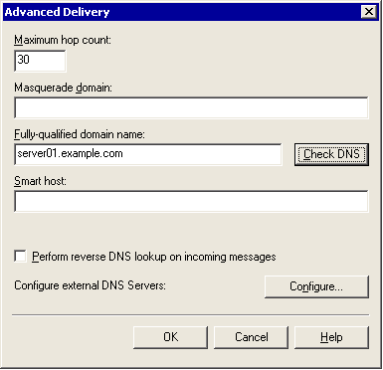

5. In Advanced Delivery, click Configure. TheConfiguredialog box appears.
The Configure dialog box
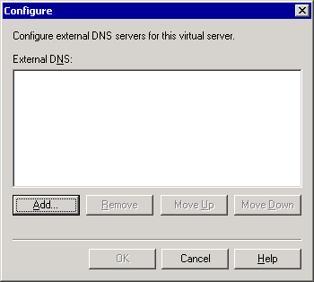

6. In Configure, click Add, type the IP address of the external DNS server that you want to use, and then click OK.
7. In Configure, under External DNS, verify that the IP address is correct, and then click OK twice to apply the settings.

How to Use the DNS Resolver to Verify DNS Configuration
For Exchange Server to send Internet mail, the DNS servers that Exchange Server uses for your domain must be able to resolve external domain names. To verify that your DNS servers can resolve external domain names, use the DNS Resolver tool (Dnsdiag.exe) if you are running Exchange Server 2003 on Windows Server 2003.

Before You Begin
Before you perform the procedure in this topic, read Verifying DNS Design and Configuration.
Note:
The DNS Resolver tool is included with the Microsoft Windows Server 2003 Resource Kit Tools. For more information about how to install and use the DNS Resolver tool, see Microsoft Windows Server 2003 Resource Kit Tools.

Procedure
To use the DNS Resolver tool to verify configuration
1. On your Exchange Server, copy dnsdiag.exe to the path C:\WINNT\system32\inetsrv directory, where C is the drive to which Windows Server is installed.
2. Open a command prompt and navigate to the inetsrv directory.
3. At the command prompt, type the following:
dnsdiag contoso.com -v 1

where contoso.com is an external domain and 1 is the instance number of the SMTP virtual server that you want to use.
The mail exchanger (MX) resource record for the domain that you entered should be displayed. If the MX record is not displayed, DNS is not configured to resolve external domain names.

Example
The following example shows how the DNS server for example.com resolves the IP address of the external domain contoso.com:
Created Async Query:
--------------------
QNAME = contoso.com
Type = MX (0xf)
Flags = UDP default, TCP on truncation (0x0)
Protocol = UDP
DNS Servers: (DNS cache will not be used)
172.16.1.1
Connected to DNS 172.16.1.1 over UDP/IP.
Received DNS Response:
----------------------
Error: 0
Description: Success
These records were received:
contoso.com MX 10 mail.contoso.com
mail.contoso.com A 172.16.1.2

Processing MX/A records in reply.
Sorting MX records by priority.

Target hostnames and IP addresses
---------------------------------
HostName: "mail.contoso.com"
172.16.1.2

How to Use Nslookup to Verify DNS Configuration
For Exchange Server to send Internet mail, the DNS servers that Exchange Server uses for your domain must be able to resolve external domain names. To verify that your DNS servers can resolve external domain names, use the Nslookup tool (Nslookup.exe) if you are running Exchange 2003 on Windows 2000 servers.

Before You Begin
Before you perform the procedure in this topic, read Verifying DNS Design and Configuration.

Procedure
How to use Nslookup to verify DNS configuration
1. At a command prompt, type Nslookup, and then press ENTER.
2. Type server <IP address>, where IP addressis the IP address of your external DNS server.
3. Type set q=MX, and then press ENTER.
4. Type <domain name>, where domain name is the name of an external mail domain, and then press ENTER. The mail exchanger (MX) resource record for the domain that you entered should be displayed. If the MX record is not displayed, DNS is not configured to resolve external domain names.

Example
The following example shows how the DNS server for example.com resolves the IP address of the external domain contoso.com:
C:\> nslookup
Default Server: pdc.corp.example.com
Address: 192.168.6.13
> server 10.255.255.255
Default Server: dns1.example.com
Address: 10.255.255.255
> set q=mx
> contoso.com.
Server: dns1.example.com
Address: 192.168.10.10
contoso.com MX preference = 10, mail exchanger = mail1.contoso.com
contoso.com MX preference = 10, mail exchanger = mail2.contoso.com
contoso.com MX preference = 10, mail exchanger = mail3.contoso.com
mail1.contoso.com internet address = 192.168.255.011
mail2.contoso.com internet address = 192.168.255.012
mail3.contoso.com internet address = 192.168.255.013
In this example, the preconfigured DNS server is behind a proxy server. Therefore, an external or Internet DNS server with a known IP address of 10.255.255.255 was used to perform the query. Next, the query type was set to MX to locate the mail exchangers for contoso.com. In this example, three SMTP servers are equally balanced, each with its own IP address.

Configuring a Routing Topology
This section explains the planning, concepts, and procedures that are involved in configuring your routing topology. It contains the following topics:
Note:
If you are operating Microsoft® Exchange Server on a single server, most of the topics about routing groups do not apply to your organization. However, you may find these topics useful if you are planning to expand your messaging system to support multiple servers.
• General Planning Considerations
This topic explains the information that you need to gather before configuring your routing topology, and the variables that influence your routing topology.
• Common Routing Topologies
This topic presents the two common routing topologies, a centralized routing topology and a distributed routing topology, and explains when these topologies are typically used.
• Defining Routing Groups
This topic explains how to create routing groups, routing group connectors, and how to connect routing groups.
• Understanding Connector Scope and Restrictions
This topic explains the decisions that are involved in using connector scope and restrictions.
• Designating a Routing Group Master
This topic explains what the routing group master is, how it works, and the criteria for designating a routing group master.
• Advanced Routing Configuration
This topic presents advanced routing configuration topics. It discusses how to use connectors for load balancing and failover, and how to suppress link state traffic.

General Planning Considerations
A well-designed routing topology is essential for efficient and reliable message flow. Before you design your routing topology, be aware of the following limitations for a single Exchange organization. A single Exchange organization cannot exceed:
• More than 1,000 administrative groups.
• More than 1,000 servers.
Before you configure your routing topology, you must perform a detailed assessment of your current environment, taking into account the following variables:
• Network topology and users in each location
The connectivity between locations and the available bandwidth, with consideration to the applications currently using the network and future projects requiring the existing bandwidth.
• User number, location, and usage patterns
The number of users sending messages across the network is an important consideration. Additionally, how users are distributed and whether they communicate primarily with other users in their location, or with other users in different locations. Also, you should consider the size of messages that are sent by users in specific locations. For example, a design department may send messages with attachments of large graphic files to various business partners. This traffic will have a greater effect on the network than traffic from a department that sends very few attachments across the network.
• Type of applications used by your company
The types of applications that are used by the network and the peak usage times for the network.
• Data center locations
The location of your data centers and the available connectivity to regional offices and other data centers.
• Free/busy requirements
The use of current free/busy information in different geographical locations. Public folder replication includes the replication of free/busy information. Do users in different geographical locations require current free/busy information for users outside of their geographical locations, or do users generally need current information only for users within their location?
• Current Microsoft Active Directory® directory service design
The placement of global catalog servers and domain controllers, the way in which your Microsoft Windows® sites are designed, and how they correspond to your routing groups.

Common Routing Topologies
This topic discusses two commonly deployed messaging topologies:
• A centralized messaging topology in which all servers have full-mesh connectivity and communicate point-to-point.
• A distributed messaging topology in which a single hub or data center connects to numerous branch office sites.

Centralized Messaging Topology
In a centralized messaging topology, you have a single data center or hub site in which all servers are connected by high-speed, reliable bandwidth. Even if this site spans a large geographical area, as long as all your servers are connected by the same reliable bandwidth, you can use a single routing group.
The advantages of a centralized messaging topology include ease of administration and more efficient mail flow because all servers communicate in a point-to-point manner.
However, if you have some servers in a central location that are connected by a slower network, it is best to group these servers in a separate routing group. One server with unreliable network connectivity in a single routing group can generate link state traffic. Because all other servers need to be notified if this server or a routing group connector on this server becomes unavailable, the routing group master (the server that is responsible for communicating information about the routing topology to servers within a routing group) must propagate changes in this server's status to all the servers in the routing group. For more information about the routing group master, see Designating a Routing Group Master.

Distributed Messaging Topology
In a branch office or distributed messaging topology, typically one or more data centers are connected to several smaller branch office locations using a hub-and-spoke network design. In this scenario, your servers in the central hub are grouped together in a single routing group where all servers have reliable network connectivity. Each branch office location constitutes its own routing group.
Generally, in the central hub site, you have dedicated bridgehead servers that connect to the branch office routing groups. These routing groups are often leaf-noderouting groups, that is, routing groups that have only a single inbound routing group connector and a single outbound routing group connector in exact opposite connections. No other connectors can exist in a leaf-node routing group.
There are three possible configurations for a leaf-node routing group:
• A routing group with an inbound connector to a single routing group and no outbound connectors.
• A routing group with an outbound connector to a single routing group and no inbound connectors.
• A routing group with an outbound connector to a single routing group. See the figure for examples of leaf-node routing groups.
In Exchange Server 2003, if no alternate path exists for a connector connecting to or from a leaf-node routing group, the connector state is always marked as "up" (in service). Exchange Server 2003 no longer changes the connector state to "down" (unavailable) if no alternate path exists. Instead, Exchange queues mail for delivery and sends it when the route becomes available. This change enhances performance because it reduces the propagation of link state information, which is particularly relevant in a distributed messaging environment where a hub-and-spoke topology is used. Consider that you have a single routing group connector connecting the remote site, a leaf-node routing group to the hub, and another routing group connector connecting the hub to the remote site. If the routing group connector becomes unavailable at either the hub or the remote site, messages queue until the connector becomes available. No link state traffic is generated, and the network is not affected.
The following figure illustrates a distributed messaging topology in a typical hub-and-spoke configuration. In this topology, each physical site maps to a routing group. In the central site, all servers are in one routing group and communicate point to point. Because each of the remote office sites has only one available route to the central site, if a connector is unavailable in a remote site, mail queues until it becomes available and no link state changes are propagated.
Distributed messaging topology in a typical hub-and-spoke configuration
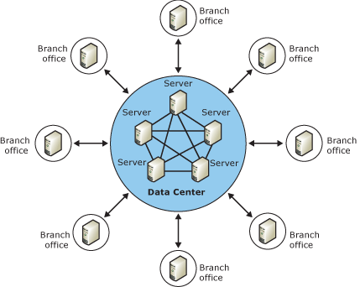

Defining Routing Groups
As a general guideline, you should define one routing group and add others only when necessary. The fewer routing groups in your environment, the less complex and more manageable it is. However, geographical and administrative requirements, as well as network availability, may mandate the creation of additional routing groups.
Routing groups are generally created for one of two reasons:
• To accommodate varying network connectivity across servers.
• To restrict the usage of a connector to users in a particular area. For more information about using routing groups to restrict connector use, see Understanding Connector Scope and Restrictions.
Before you define your routing groups, consider the advantages and disadvantages of multiple routing groups as shown in the following table.
Advantages and disadvantages of multiple routing groups
Advantages of multiple routing groups | Disadvantages of multiple routing groups
• Allows scheduling and control of mail flow. You can restrict connector use to a particular routing group or schedule the use of a connector.  • Allows you to control usage based on message size or content by using connector restrictions. | • Introduces more hops en route to the final destination, thereby decreasing delivery efficiency.  • Adds complexity to your messaging environment.  • Can reduce the reliability of messaging because the more hops you have en route, the more points of failure are possible.  • Simple Mail Transfer Protocol (SMTP) handles latency in a well-connected TCP/IP environment, and this often eliminates the need for multiple routing groups.  • Two routes generally use the same network, and the network has the same inherent reliability or stability.

The chart that is shown in the following figure can help you determine how to define routing group boundaries.
Determining routing group boundaries
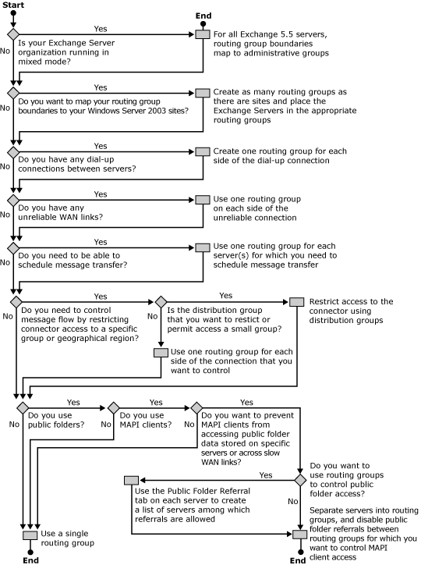

Defining Routing Group Connectors and Bridgehead Servers
Although all servers communicate with each other directly within a routing group, this is not the case when a server in one routing group needs to communicate with a server in another routing group. To allow servers to communicate with servers in other routing groups, you need to create a routing group connector. Although you can use an X.400 connector or an SMTP connector to connect routing groups, the routing group connector is specifically designed for this purpose and is the preferred method of connecting routing groups in most cases.
By default, all servers within a routing group can send mail over the routing group connector. Servers that are capable of sending mail over a routing group connector are bridgehead servers. A bridgehead server is a combination of an SMTP virtual server and an Exchange server that is responsible for delivering all messages through a connector.
When you create a routing group connector, you have the option of either keeping all the servers as bridgehead servers for that connector, or specifying that only a selected set of servers act as bridgehead servers for that connector. The following table compares the advantages of each approach.
Selecting the number of bridgehead servers in a routing group
Number of bridgehead servers | Advantages
All servers in a routing group | • Provides more efficient message flow because all of the servers in the routing group can directly deliver messages to other routing groups.  • Capitalizes on configurations where all of the servers in a routing group have the same network connectivity to the servers in other routing groups.  • Can add complexity in large organizations where all servers communicate in a point-to-point fashion. It can be more difficult to troubleshoot mail flow issues.  • Direct point-to-point connectivity can provide load balancing.
Only a select few servers in a routing group | • Makes troubleshooting message flow easier because there are limited points of contact between routing groups.  • Distributes messaging if you anticipate heavy message flow between routing groups.  • Allows you to specify server roles of bridgehead servers and mailbox servers in large environments where you do not want mailbox servers handling the traffic sent through a bridgehead server.  • Makes mail flow more reliable and efficient in those configurations where some servers have better network connectivity than others.

The following figure illustrates the basic components of routing discussed thus far. Figure 5.4 shows message flow between servers within a routing group and between routing groups. It also illustrates a topology that uses only a single bridgehead server in each routing group.
Communication within and between routing groups
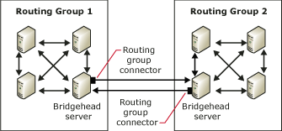

When a topology is as simple as that shown in Figure 5.4, you do not have to consider how to best route messages between routing groups. As topologies become more complex, with large numbers of routing groups spread over varying geographical distances, message routing among groups becomes critical.
You configure routing among routing groups by assigning costs (an associated expense for the route based on network availability, network traffic, and administrative requirements) to the routing group connectors that are used by these groups. When a user on a server in one routing group sends mail to a user on a server in another routing group, Exchange uses these costs (part of the link state information that is maintained by Exchange) to determine the most efficient route. Exchange always uses the route with the lowest cost unless a connector or server in that route is unavailable. So that every routing group knows what the various costs are for each connector and the status of those connectors, each routing group has a routing group master that updates and coordinates this information with all of the other servers in a routing group. For more information about routing group masters, see "Designating a Routing Group Master" later in this chapter.

Connecting Routing Groups
When you create a routing group, you designate a group of servers that can communicate directly with one another. For servers in different routing groups to communicate with each other, you need to connect the routing groups.
It is possible to connect routing groups by using either an SMTP connector or an X.400 connector. However, using these types of connectors is generally not recommended. The preferred connection method is a routing group connector because this connector is designed and intended specifically for connecting routing groups.
Note:
If you must use an SMTP or X.400 connector between routing groups, do not add an address space on the connector. You should only designate a connected routing group; otherwise, routing will not function correctly.
Routing group connectors are one-way routes for outgoing messages, which means that messages travel outbound to the connected routing group. For two routing groups to communicate, a routing group connector must exist in each routing group to send messages outbound to the other routing group. When you create a connector to a routing group, Exchange displays a message asking if you want to create a routing group connector in the remote routing group so that you can send messages from the remote routing group to the routing group where you are creating the first connector.
Before you create and configure a routing group connector, you should think about the following questions:
• To which routing group does this connector deliver messages? This information is critical. Identifying the routing group to which the connector delivers messages establishes the relationship between the sending and receiving routing groups and the rest of your topology. You need to know how the sending and receiving routing groups fit into your topology so that you can determine a cost for the associated connector.
• What cost should this connector have? Cost is the variable that Exchange uses to determine the most efficient messaging route. Exchange considers the lowest cost route the most efficient. Exchange uses a more expensive route only if a server or connector is unavailable on the route with the lowest cost. You should assign the lowest costs to the routes with the highest available network bandwidth.
• Which servers in the routing group can act as bridgehead servers? Only designated bridgehead servers can send messages across the connector to the connected routing group. The default and preferred setting is to have the servers in the local routing group send mail using this connector. Use this default option when all servers in the routing group can connect directly over the network to the remote bridgehead server and share the same messaging load. Connecting directly to the remote bridgehead server provides more efficient message flow.
However, you may have better direct network connectivity between specific servers in the local routing group and the designated remote bridgehead server. For example, Server A has a direct connection of 56 kilobits per second (Kbps) to a remote bridgehead server, and Server B and Server C each have a direct connection of 10 megabits per second (Mbps) to the same remote bridgehead server. In this case, you should specify the servers that have the better direct network connectivity (that is, Server B and Server C) as the bridgehead servers, and add those specific servers to a list of allowable bridgehead servers.
You can configure all servers in the routing group to act as bridgehead servers in one of two ways:
• Select the default option of Any local server can send over this connector. When you select this option, the connector is always marked as in service or available even if all bridgehead servers become unavailable. This option offers the advantage of generating less link state information because this connector is never marked as unavailable.
• Select These servers can send mail over this connector and manually add each server in the routing group as a bridgehead server. When you configure your bridgehead servers in this way, if all the bridgehead servers become unavailable, the routing group connector is marked as unavailable. However, using this option can increase the size of your link state table because the fully qualified domain name (FQDN) of each bridgehead virtual server is then written to the link state table. For more information about link state, see Advanced Link State Concepts.
For more information about evaluating the advantages of using multiple bridgehead servers versus using designated bridgehead servers, see Table 5.3 earlier in this chapter.
• Should users access public folders that are not available locally using this connector? By default, public folder referrals are enabled across connectors connecting routing groups. However, network traffic increases when users access a public folder in a remote routing group. If your routing groups are connected by slow network links, or if your network may not be able to handle the additional traffic, disable public folder referrals.
• What are the remote bridgehead servers to which this connector can send messages? The remote bridgehead servers are the servers in the connected routing group that receive all messages destined for this routing group. The remote bridgehead servers also receive link state information from the bridgehead servers for the connector.
After considering these questions, you can set your configurations options on the General tab in the Routing Group Connector Properties dialog box. You can address the last question in the above list by specifying remote bridgehead servers on the Remote Bridgehead tab.
For detailed instructions, see How to Configure the Options for a Routing Group Connector and How to Specify a Remote Bridgehead Server for a Routing Group Connector.

How to Configure the Options for a Routing Group Connector
When you create a routing group, you designate a group of servers that can communicate directly with one another. For servers in different routing groups to communicate with each other, you need to connect the routing groups.

Before You Begin
The following permissions are required to perform this procedure:
• Member of the local administrators group and a member of a group that has had the Exchange Administrators role applied at the administrative group level.

Procedure
To configure the options for a routing group connector
1. In Exchange System Manager, expand the routing group, right-click Connectors, point to New, and then click Routing Group Connector.
2. On the General tab, select from the following options:
• For the name of the routing group connector, it is a common practice to use the two routing groups that it connects. For example, you could use the name ParisToSeattle to define a connector connecting your Paris routing group to your Seattle routing group.
• In Connects this routing group with, select the routing groups to which you want to connect.
• In Cost, assign a cost for the connector.
• To have all servers within the local routing group function as bridgehead servers, select Any local server can send mail over this connector.
Important:
Remember, when you select this option, the connector is always considered available, even if all bridgehead servers become unavailable. If you want your connector to be marked unavailable if all bridgehead servers become unavailable, add each server in the routing group as the bridgehead server manually, using the These servers can send mail over this connector option described next.
• To specify which servers in the local routing group can function as bridgehead servers for this connector, select These servers can send mail over this connector, and then click Add to add the appropriate servers to the list.
• To prohibit users from accessing public folders that are not available locally using this connector, select the Do not allow public folder referrals check box.

How to Specify a Remote Bridgehead Server for a Routing Group Connector
A remote bridgehead server is a server in a connected routing group that receives all messages destined for that routing group. A remote bridgehead server also receives link state information from the bridgehead servers for the connector.

Before You Begin
The following permissions are required to perform this procedure:
• Member of the local administrators group and a member of a group that has had the Exchange Administrators role applied at the administrative group level.

Procedure
To specify a remote bridgehead server for a routing group connector
1. In the Routing Group Connector Properties dialog box, on the Remote Bridgehead tab, click Add, and then select the remote bridgehead server from the list of servers in the routing group to which you are connecting.
Note:
You must specify a remote bridgehead server. For redundancy, you should specify more than one remote bridgehead server, if possible.
Remote Bridgehead tab in the Routing Group Connector Properties dialog box
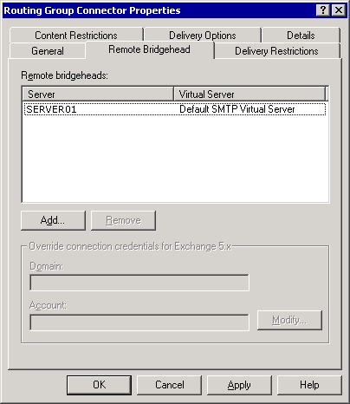

2. If you are creating a routing group connector between routing groups that includes Exchange 5.5 servers, in Override connection credentials for Exchange 5.x, click Modify, and then enter the Exchange 5.5 service account credentials for the Exchange 5.5 server to which you are connecting.
3. Click Apply to create the connector.
4. When a message appears that asks if you want to create a routing group connector in the remote routing group, click Yes.
After you click Yes, Exchange creates a routing group connector in the remote routing group. This new routing group connector allows the remote routing group to send messages to the local routing group. When creating this new routing group connector, Exchange does the following:
5. Exchange designates the bridgehead servers for the remote routing group connector as those servers that are listed on the Remote Bridgehead tab of the local routing group connector.
Note:
When Exchange designates servers in this way, only those servers that are listed on the Remote Bridgehead tab become bridgehead servers for the new connector. If you would rather have all of the servers in the remote routing group (and not just those that are listed) function as bridgehead servers for the new connector, you must manually select the Any local server can send mail over this connector option on the General tab of the new connector, or add each server individually as a bridgehead server.
6. Exchange Server designates the remote bridgehead servers for the remote routing group connector as those servers that are listed as bridgehead servers on the General tab of the local routing group.

Understanding Connector Scope and Restrictions
If you need to control access to specific connectors, either by group or by a specific geographic area, you have two choices:
• Use connector scope to restrict connector use. By definition, only users in a specific routing group can use that routing group's connector. However, you can also designate a routing group scope for another type of connector, like an SMTP connector, so that only users in a particular routing group can use the SMTP connector. Use an SMTP connector with a routing group scope if you want to ensure that users in a specific location always use this SMTP connector.
• Create a restriction on the connector. You can restrict access to any type of connector by using the Delivery Restrictions tab of the connector properties. You can designate a distribution group that explicitly has rights to use this connector, or you can designate a distribution group that is explicitly denied access to the connector.

Using Connector Scope to Restrict Usage
To understand how your routing topology and connector scope affects message flow, consider a company named Contoso, Ltd. (contoso.com), which is located exclusively in the United States with two major offices, one in Colorado and one in Maine. All servers are connected by a high-speed network, but a fax connector and an SMTP connector exist in each site. If the fax connectors have an organizational scope, users in Colorado can use the fax connector in Maine and may incur long distance costs. Additionally, the Contoso administrator wants all users in Maine to use the SMTP connector to the Internet that is located in the Maine site, and all users in Colorado to use the local SMTP and fax connectors. In this case, despite the high network connectivity between all servers, it makes sense to use routing groups and restrict the connector scopes to the appropriate routing group.
Topology of Contoso.com
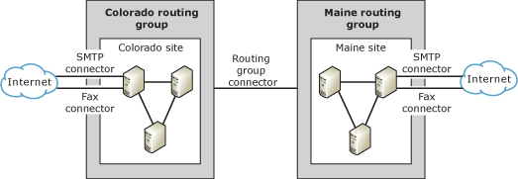

In this topology, each site has the following connectors:
• An SMTP connector to the Internet with a routing group scope.
• A fax connector with a routing group scope.
• A routing group connector that allows any server in the routing group to send messages over this connector and designates all three servers in the remote site as remote bridgehead servers. Because all servers in each site share the same network connectivity, it makes sense to designate all of them as bridgehead servers, so that servers can communicate in a point-to-point fashion.

Using Delivery Restrictions to Restrict Usage
You can restrict the use of your connector to a particular group of users. The advantage of using delivery restrictions to restrict usage is that this option eliminates the need to create a routing group. The disadvantage to using a restriction is that for each message that is sent through this connector, the distribution group must be expanded to its individual recipients to enforce the restriction. This expansion is costly in terms of performance. Therefore, it is recommended that you use the Delivery Restrictions tab on a connector in cases where the distribution group is small or where you are certain that the performance impact is acceptable to your users.
Important:
Be aware that restricting delivery is extremely process-intensive and can affect server performance.
A registry key on the Exchange 2003-based bridgehead server (which is the source for the connector that is being checked) controls the restriction checking functionality. If you need to configure a connector to restrict who can send data to the designated link, you must manually add the restriction checking registry value.
Note:
Incorrectly editing the registry can cause serious problems that may require you to reinstall your operating system. Problems resulting from editing the registry incorrectly may not be able to be resolved. Before editing the registry, back up any valuable data.
For detailed instructions, see How to Enable the Registry Keys for Delivery Restrictions.
After enabling the registry key and restarting the services above, you can set delivery restrictions on the connector properties by using the Delivery Restrictions tab.
Note:
You can also designate specific users or query-based distribution groups on the Delivery Restrictions tab. This approach is not recommended because each user is added as an entry in the link state table, which causes the link state table to grow very large. A large link state table can affect the network and performance because it needs to be replicated to all other servers in the organization.
Delivery Restrictions tab in SMTP Connector Properties dialog box
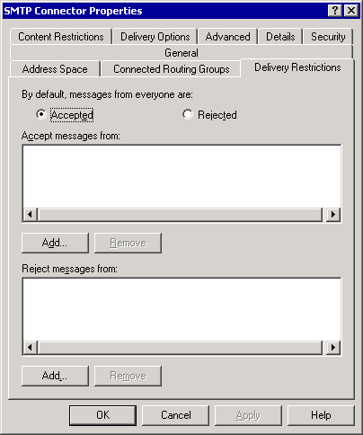

How to Enable the Registry Keys for Delivery Restrictions
A registry key on the Exchange Server 2003-based bridgehead server (which is the source for the connector that is being checked) controls the restriction checking functionality. If you need to configure a connector to restrict who can send data to the designated link, you must manually add the restriction checking registry value.

Before You Begin
The following permissions are required to perform this procedure:
• Member of the local administrators group

Procedure
To enable the registry keys for delivery restrictions
1. Start Registry Editor: From a command prompt, type Regedt32.exe.
2. Navigate to and select the following key in the registry:
HKEY_LOCAL_MACHINE/System/CurrentControlSet/Services/RESvc/Parameters/
3. On the Edit menu, click Add Value, and then add the following registry value:
Value Name: CheckConnectorRestrictions
Data Type: REG_DWORD
Date: 1
Radix: Decimal

4. Exit Registry Editor: On the Registry menu, click Exit.
5. After enabling the registry key setting, restart the following services on your Exchange server:
• Microsoft Exchange MTA Stacks (MSExchangeMTA)
• Microsoft Exchange Routing Engine (RESvc)
• Simple Mail Transport Protocol (SMTPSVC)

Designating a Routing Group Master
When you create a routing group, the first server in that routing group is assigned the role of routing group master. The routing group master maintains current link state information for its routing group and propagates it to the other servers within the routing group. The routing group master monitors the routing configuration that is written in Active Directory for its routing group only. Member servers can communicate any connector state or server availability information to the routing group master. For example, if a member server tries to contact another server in a different routing group over a connector, and this link is unavailable, the member server immediately notifies the routing group master. Likewise, when a non-master server receives new link state information, it immediately transfers the connector state information to the routing group master, so that other servers can receive the information about the routing change.
When you designate a routing group master, ensure that the server you choose has good access to a domain controller because this is where it reads the configuration information that is stored in Active Directory. Additionally, when a change occurs in the configuration of its routing group, Exchange System Manager writes this information directly to Active Directory and then the domain controller notifies the routing group master of this change. The routing group master then propagates this information to all the member servers.
Within a routing group, the routing group master and the other Exchange servers communicate link state information over TCP/IP port 691. However, communication of link state information between routing groups is different. If the routing group master is not a bridgehead server for the routing group, the routing group master sends the link state information to the group's bridgehead server over TCP/IP port 691. The bridgehead server then forwards this information (over TCP/IP port 25 using SMTP and the X-LINK2STATE verb) to the bridgehead servers of other routing groups.
Note:
For more information about link information and how it is updated, see Advanced Link State Concepts.
If you do not want the first server that is installed in the routing group to be the routing group master (the default setting), you can change the routing group master to another server by using the following procedure.
Note:
Do not change the routing group master frequently. When you designate a new routing group master, all member servers need to reconnect and this change requires that the link state table replicate across the organization, which increases network traffic.
For detailed instructions about how to change the routing group master, see How to Change Which Server Is the Routing Group Master.
Important:
There is no automatic failover for routing group masters. If a routing group master fails, you must manually configure a new routing group master in Exchange System Manager. If a routing group master fails, the other servers in the routing group use the last known link state information until a routing group master becomes available or another routing group master is designated. For more information about failure of a routing group master, see Microsoft Knowledge Base article 261827, "http://go.microsoft.com/fwlink/?linkid=3052&kbid=261827."

How to Change Which Server Is the Routing Group Master
When you create a routing group, the first server in that routing group is assigned the role of routing group master. The routing group master maintains current link state information for its routing group and propagates it to the other servers within the routing group.

Before You Begin
The following permissions are required to perform this procedure:
• Member of the local administrators group and a member of a group that has had the Exchange Administrators role applied at the administrative group level

Procedure
To change which server is the routing group master
• In Exchange System Manager, expand the routing group, click Members, right-click an Exchange server that you want to designate as master, and then select Set as Master.

Advanced Routing Configuration
This topic presents some advanced routing configuration topics. It explains the following:
• Using connectors for load balancing and failover Configurations that you can use to enable load balancing or failover between connectors.
• Advanced link state configuration Specific scenarios for disabling or suppressing link state information.

Using Connectors for Load Balancing and Failover
Routing uses the costs that are associated with routing group connectors to determine the best way to deliver messages internally. Routing also uses the costs that are associated with SMTP and X.400 connectors to determine the best method for delivering external mail. It is important to understand that routing always chooses the connector with the closest matching address space and then the lowest cost. You can also use connectors to load balance messages or configure connectors for failover.
The disadvantage to using connectors for load balancing or failover is that both configurations increase the size of the link state table that is replicated across the Exchange organization. Remember, the larger the link state table, the more demands on system performance.

Configuring Connectors for Load Balancing
If you want to configure a connector to load balance requests between two or more bridgehead servers, create a single connector with the desired address space, for example, * for an SMTP connector, and then assign two different Exchange servers and SMTP virtual servers as bridgehead servers. Routing chooses the bridgehead server at random and effectively load balances the requests that are sent through this connector. However, if a message reaches one of these bridgehead servers, and this server becomes unavailable, routing does not automatically choose the alternate route. Mail simply queues until this server becomes available. There is no rerouting among bridgehead servers once a message reaches the intended bridgehead server.
Link state only contains a connector's state, and a connector is always considered available if one bridgehead server is available. If one bridgehead server becomes unavailable, routing still considers this connector a valid path and chooses randomly among the available bridgehead servers.

Configuring Connectors for Failover
If you want to configure connectors to failover automatically, you can create two separate connectors on different bridgehead servers, each with a different cost. Link state for a connector is determined by its local bridgehead server. If the bridgehead server on the preferred connector with the lowest cost is unavailable, that connector is considered unavailable and routing automatically chooses the second connector. When the bridgehead server hosting the connector with the lower cost becomes available, Exchange servers then begin using it again.
If you use two connectors with the same cost, Exchange servers will randomly pick which bridgehead server and connector they use, and if this bridgehead server becomes unavailable, they will fail over to the second connector. However, once the first bridgehead server becomes available, the servers will not failback to this server because the route has the same cost as the server they are already using.

Suppressing Link State Traffic for Connectors
Exchange 2003 suppresses link state traffic when connections are oscillating, or when no alternate route exists to a leaf-node routing group. These improvements reduce the amount of traffic that is generated by link state. Additionally, if you use the default option of Any local server can send over this connector for a routing group connector, this connector state is always marked as up. Using this option effectively suppresses any link state traffic that is generated by changes in this connector's state. However, this option is not possible for SMTP connectors or X.400 connectors.
In environments with extremely low bandwidth and high latency, some companies choose to suppress link state traffic between routing groups. You can suppress link state traffic on individual servers for all connectors by changing a registry key value. When you suppress link state traffic on a server, the server ignores any link state changes on any connectors for which it is a bridgehead server. Link state information for connectors on other servers is still updated, and organizational link state information is still propagated across all servers in the organization; however, the server with link state traffic suppressed does not send any information about its connectors. The following table lists the advantages and disadvantages of suppressing link state traffic.
Suppress link state traffic on a server if the following conditions exist:
• You have a connector whose status is not important to other servers in the rest of the Exchange organization (for instance, a connector that is used exclusively by a routing group or a small number of servers to send mail to the Internet).
• If you have network problems that cause a connector to oscillate between an available and an unavailable state. Remember, in Exchange 2003, an oscillating connection is a connector that changes state twice (up and down) within one link state interval, which is 10 minutes by default. If a connector is marked as unavailable after the link state interval, and then it becomes available after another window, link state traffic is generated. Also, if your Exchange organization contains Exchange 2000 servers, these servers do not have the link state improvements that are provided by Exchange 2003, and they will generate traffic for oscillating links.
Advantages and disadvantages of suppressing link state traffic
Advantages | Disadvantages
Suppression of link state traffic is relatively simple to configure and can be applied to individual servers for isolated conditions. | You cannot create redundant paths or alternate connectors on a server where link state traffic is suppressed. Link state changes on the primary connector are never detected; therefore, messages are not rerouted to an alternate connector because routing assumes that the primary connector is available.
Suppressing link state traffic on a server can decrease network traffic that is caused by frequent changes. A reduction in network traffic is particularly advantageous in situations where network bandwidth is very limited. The actual gain from reduced traffic depends on the size of the Exchange organization and the frequency of link state changes that are replicated. | Suppressing link state traffic on a single server does not completely eliminate link state traffic between routing groups.

Note:
Incorrectly editing the registry can cause serious problems that may require you to reinstall your operating system. Problems resulting from editing the registry incorrectly may not be able to be resolved. Before editing the registry, back up any valuable data.
It is important to understand that changing this registry key does not stop the propagation of the link state table across servers. It suppresses only the link state traffic that is caused by a connector state change.
For detailed instructions, see How to Suppress Link State Information on a Server.

How to Create a Routing Group
By default, Microsoft® Exchange Server functions as though all servers are in a single routing group. Based on your administrative requirements, your network topology, and the reasons that are discussed in Configuring a Routing Topology, you can group servers into routing groups to enable Exchange Server to maximize message flow efficiency.
By default, all servers in a native-mode Exchange Server organization are placed in a single routing group, called First Routing Group, and these servers communicate directly with one another. In a mixed-mode environment (where some servers are running Exchange Server version 5.5 or earlier), each Exchange Server 5.5 site becomes a routing group.
Note:
For more information about the difference between routing groups in mixed and native mode, see "Using Routing Groups in Native and Mixed Modes" in Understanding Routing Components.
After installation, you can create additional routing groups in your Exchange organization. When you install additional Exchange servers into an existing organization, you can then designate the appropriate routing groups for these servers. After installation, you can also move servers between routing groups.
When you create a routing group, two containers appear beneath the routing group:
• Connectors Displays any connectors that are installed on the servers within the routing group. This list includes any connectors to third-party mail systems, such as the Lotus Notes or Novell GroupWise connector, as well as any routing group connectors, X.400 connectors, and SMTP connectors that you configure.
• Members Displays the servers within this routing group. By default, the routing group master is the first server that is added to a routing group.
Note:
Before you can create routing groups, you must configure your Exchange organization to display routing groups. In Exchange System Manager, right-click your Exchange organization, click Properties, and then select the Display routing groups check box.

Before You Begin
The following permissions are required to perform this procedure:
• Member of the local administrators group and a member of a group that has had the Exchange Administrators role applied at the administrative group level.

Procedure
To create a routing group
1. In Exchange System Manager, right-click Routing Groups, point to New, and then select Routing Group.
2. On the General tab, in the Name box, enter a name for the routing group, and then click OK.
General tab for routing group
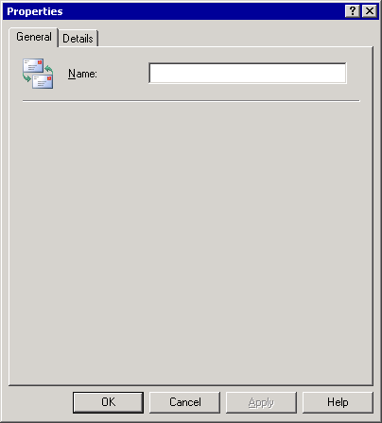

Deployment Scenarios for Internet Connectivity
Now that you have configured internal mail flow, you are probably interested in learning how you can connect to the Internet so that your users can send and receive Internet mail. This section presents both some common and custom deployment scenarios for Internet connectivity.
Common deployment scenarios describe typical configurations that are used by companies to connect to the Internet, including using Microsoft® Exchange in its default configuration, using a dual-homed server, using an Exchange bridgehead server behind a firewall, and using a Microsoft Windows® relay server.
Custom deployment scenarios include topologies that meet special requirements, such as using a network service provider, configuring cross-forest mail collaboration, and sharing Simple Mail Transfer Protocol (SMTP) mail domains or supporting two SMTP mail domains. Exchange Server 2003 introduces a new tool, Address Rewrite, that can be used to rewrite outgoing e-mail addresses from a subsidiary company. As a result, during a merger or acquisition, all users display the same e-mail address.
Regardless of what scenario applies most to your organization, consider the following tips as you contemplate your own implementation:
• If your organization contains multiple servers, you should include gateway bridgehead servers when planning your deployment.
• Firewalls offer the most security for Internet connectivity.
• SMTP connectors offer a convenient and manageable way to route outgoing Internet mail.
• The default SMTP virtual server in its default configuration is sufficient for most scenarios.
• If you use multiple SMTP virtual servers on a single Exchange server, be careful when you configure them. By default, multiple virtual servers cannot communicate with one another. For proper mail flow, you need to configure them appropriately so that mail can be routed between them. Additionally, each SMTP virtual server must be configured with a unique Internet Protocol (IP) address and port combination. Generally, all SMTP virtual servers require port 25 so you must assign unique IP addresses to them.
Note:
Some companies configure multiple virtual servers on a bridgehead server, with one network interface card (NIC) accepting inbound Internet mail and another NIC routing outbound Internet mail. For more information about this configuration, see Using a Dual-Homed Exchange Server as an Internet Gateway.

Common Deployment Scenarios
This section presents some common deployment scenarios for Internet connectivity. The scenarios are presented in order of complexity, starting with the simplest configuration (a single Exchange server in its default configuration). The following table summarizes each of these common scenarios.
Summaries of common deployment scenarios for Internet connectivity
Topology | Best for | Advantages | Considerations
Single Exchange server in its default configuration | Small business with a small user base | Using the default configuration requires no additional configuration after you install Exchange. | This topology does not offer the more robust protection of a firewall. Your Exchange server is exposed on the Internet.
Dual-homed Exchange server | Small business with a small user base | Offers a secure configuration when behind a firewall. | This topology should be used in conjunction with a firewall. Otherwise, your Exchange server is still exposed on the Internet.  Consider using Internet Protocol security (IPSec) policies to filter ports on the Internet NIC.
Using an Exchange bridgehead server behind a firewall | Any size company | Using a dedicated bridgehead server for Internet mail isolates Internet traffic. A firewall protects your intranet. | Normally, a bridgehead server is deployed in larger companies. Because the server does not host mailboxes, it may be underutilized in smaller companies.
Using an Exchange bridgehead server to send mail to a relay server on a perimeter network | Medium to large companies with multiserver environments | Offers the same advantages as an Exchange bridgehead server behind a firewall, but adds an extra layer of security by isolating your SMTP server from the Internet. An SMTP relay server, rather than an Exchange server handling Internet mail, is in an isolated network. Your user information is secured on your Exchange server behind a firewall. | This topology involves more configuration and set up than the scenarios listed above.

Note:
For small companies that want a full-featured network solution that provides a unified setup for e-mail, group scheduling, fax, and database, as well as a shared Internet connectivity for an environment of up to fifty computers, Microsoft Windows Small Business Server2003 may be an appropriate solution. For more information about Small Business Server, see the Small Business Server Web site.

Using a Single Exchange Server in Its Default Configuration
This scenario describes how Exchange delivers Internet mail in its default configuration.

Basic Configuration
In this scenario, you need the following:
• A persistent connection to the Internet.
• A Domain Name System (DNS) server that can resolve external domain names, and a DNS server on the Internet with a mail exchanger (MX) record that points to your Exchange server.
• A recipient policy that is configured with the SMTP mail domain for which you want the Exchange server to receive mail.

Inbound Internet Mail
When using a single Exchange server in its default configuration, incoming Internet mail flows into the Exchange server in the following manner:
1. The remote SMTP server queries DNS to resolve the MX record for your mail domain and to obtain the IP address of your Exchange server.
2. The remote SMTP server then connects to your Exchange server on port 25, which your default SMTP virtual server accepts.
3. Your default SMTP server verifies that the domain on the incoming message matches an SMTP domain in its recipient policies.
4. Your default SMTP server then accepts the message and delivers it to the recipient.

Outbound Internet Mail
When using a single Exchange server in its default configuration, outgoing Internet mail flows out of the Exchange server in the following manner:
1. An internal user sends a message with an external user as a recipient.
2. From its recipient policy information, the default SMTP virtual server determines that the message is destined for a remote domain.
3. Because the internal user is authenticated, the default SMTP virtual server accepts the message for outbound delivery. Remember, the default SMTP virtual server allows relaying for authenticated users only.
4. The default SMTP virtual server queries DNS to resolve the MX record of the remote mail server to the IP address of this server.
5. The default SMTP virtual server connects to the remote SMTP server on port 25 and initiates delivery.

Using a Dual-Homed Exchange Server as an Internet Gateway
This scenario describes a supported configuration of a dual-homed Exchange server that acts as a gateway server for the Exchange organization. This server can handle mail individually, or it can act as a bridgehead server for other servers in the organization. For security purposes, you should use this configuration behind a firewall.

Basic Configuration
The basic configuration consists of a mail gateway that is configured with two network interfaces; this gateway acts as the single connection point between your intranet and the Internet.
The following lists provide general configuration requirements for the two virtual servers and the SMTP connector:
Note:
If you configure two virtual servers on a single Exchange server, be sure to use a unique combination of IP addresses and ports. Do not configure either virtual server to use the default value of all available IP addresses.
• Virtual server 1
• Configure virtual server 1 as the bridgehead server for the SMTP connector.
• Configure virtual server 1 to use external DNS servers, through the external DNS server list.
• Bind virtual server 1 to an intranet IP address on port 25.
• Enter the local company domain (for example, contoso.com).
• Virtual server 2
• Configure virtual server 2 so that it does not relay mail (this is the default configuration). For more information about default relay restrictions, see How to Verify Relay Restrictions on an SMTP Virtual Server.
• Configure virtual server 2 to allow anonymous access (this is the default configuration). For more information about allowing anonymous access, see How to Allow Anonymous Access on Your Outbound SMTP Virtual Server.
• Bind virtual server 2 to an Internet IP address on port 25.
• Select the local company domain (for example, contoso.com).
• SMTP connector
• Configure the SMTP connector to use DNS to route to each address space on the connector.
• Home the SMTP connector to virtual server 1 by specifying it as the bridgehead server.
• Create an address space of * (asterisk) or an equivalent.
• Use two network interface cards (NICs)—an internal NIC and an external NIC.
• Verify that there is no IP routing configuration between the two networks on your server. (This is the default configuration.)
For more information about how to configure an SMTP connector, see How to Create an SMTP Connector.

Inbound Internet Mail
Messages flow into an Exchange organization in the following manner:
1. Messages that originate from the Internet use the Internet IP address to send mail to recipients in the local domain.
2. Virtual server 2 monitors this Internet IP address for mail and receives all incoming Internet messages. Because virtual server 2 is not configured to relay mail, it rejects mail that is not directed to the company's domain (for example, contoso.com).
3. When virtual server 2 receives a message from the Internet that is intended for a host inside the local domain, it contacts the Microsoft Active Directory® directory service through the internal NIC to determine where to send the message. Therefore, messages that are received by virtual server 2 are sent directly to the internal host or to another bridgehead server for delivery to another routing group.
Note:
Although virtual server 2 monitors an external IP address for incoming mail, it uses whatever IP address is appropriate for routing messages, based on the entries in the routing table. Virtual server 2 uses only internal DNS services for name resolution. Virtual server 2 is not configured with an external list of DNS servers, so it does not resolve external addresses. It rejects all messages with addresses to a domain other than the company's domain (in this case, contoso.com).

Outbound Internet Mail
Mail flows out of an Exchange organization in the following manner:
1. A user sends a message to an external recipient.
2. Because this message is outbound, it uses the SMTP connector that is homed on virtual server 1.
3. When virtual server 1 receives a message for a remote domain, it uses the list of external DNS servers to find the IP address of the message recipient, and then uses the external NIC to deliver the external mail. (Generally, external Internet IP addresses are not available on an internal DNS server.)
Important:
Although virtual server 1 is configured to monitor the intranet IP address, it uses the Internet NIC for external mail.
The following figure illustrates the flow of mail through a dual-homed server.
Internet mail flow through a dual-homed Exchange gateway server
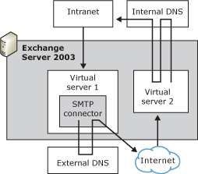

Using Internet Mail Wizard to Configure a Dual-Homed Exchange Server
You can use Internet Mail Wizard to configure a dual-homed Exchange server. The wizard guides you through the necessary configuration and automatically creates a connector on your outbound SMTP virtual server.
Use the How to Start Internet Mail Wizard procedure to configure a dual-homed Exchange server with two SMTP virtual servers to send and receive Internet mail. After you run Internet Mail Wizard, the Exchange server will send and receive all Internet mail according to the configuration you specify in the wizard.
Note:
You cannot use Internet Mail Wizard if you have already configured an SMTP connector or created an additional SMTP virtual server on your Exchange server. You must revert to the default configuration before you can run Internet Mail Wizard.
The wizard creates an additional SMTP virtual server on your Exchange server. It configures Internet mail delivery in the following ways:
• To configure a server to send Internet mail, the wizard guides you through the process of assigning the intranet IP address to the default SMTP virtual server on which it creates the SMTP connector to send outbound mail. You assign the intranet IP address to this virtual server so that only internal users on your intranet can send outbound mail.
• To configure a server to receive Internet mail, the wizard guides you through the process of assigning the Internet IP address to the Internet SMTP virtual server. You assign an Internet IP address to this virtual server because external servers need to be able to connect to this SMTP virtual server to send Internet mail to your company. Additionally, you must have an MX record on your Internet DNS server that references this server.
Internet Mail Wizard also performs the necessary checks on your Internet SMTP virtual server to ensure it is configured correctly. It verifies the following:
• Your Internet SMTP virtual server accepts anonymous connections.
• Your Internet SMTP does not permit relaying.
For more information about Internet Mail Wizard, see Using Internet Mail Wizard to Configure Internet Mail Delivery.

Security Considerations
To increase the security of a dual-homed gateway server configuration, consider the following recommendations:
• Use Internet Protocol security (IPSec) policies to filter ports on the Internet NIC. For more information about IPSec policies, see the Microsoft Windows 2000 or Windows Server 2003 online documentation.
• Strictly limit the users that you allow to log on to the server. One simple way to do this is to leave the server running without a keyboard, mouse, or monitor and to use Terminal Services to manage the server. Then, you allow only administrators to have Terminal server access.
Using a dual-homed Exchange server as a gateway server in this configuration allows a company to limit its exposure by minimizing the entry points from the Internet to its intranet. By preventing the virtual server on the Internet from relaying messages to other Internet hosts, you ensure that the virtual server routes only mail that is addressed to valid internal recipients. Because virtual server 1 uses an external list of DNS servers to route only outbound Internet mail (not for internal mail), external DNS server issues won't affect internal mail traffic. By separating your incoming Internet mail, internal mail, and outgoing Internet mail processes, the points of failure for any of the three processes remain distinct and more manageable.

Using a Bridgehead Server Behind a Firewall
Generally, if your organization contains multiple Exchange servers, you should use a bridgehead server to provide Internet connectivity to a routing group or an Exchange organization.
The following figure illustrates this topology.
Providing Internet connectivity to a routing group
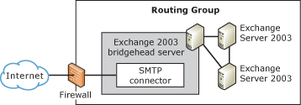

If you use a bridgehead server, it is not necessary for every Exchange server to have Internet connectivity. This configuration enhances security because only the bridgehead server is exposed to the Internet.
Important:
Because gateway servers usually have different security requirements than internal computers, you must examine your gateway servers carefully for security risks.

Basic Configuration
The basic configuration consists of an Exchange bridgehead server that is connected to the Internet and has the appropriate DNS configuration. An SMTP connector is installed on the bridgehead server and provides outgoing message delivery over the Internet. Furthermore, to protect the internal network, a firewall filters incoming Internet traffic and routes mail from the internal and external IP addresses.
The following lists provide general configuration requirements for the DNS servers, the Exchange bridgehead server, the Exchange member servers, and the firewall:
• DNS servers
Exchange relies on the existing DNS servers in its organization. Specifically, Exchange uses internal DNS to route internal messages and relies on the internal DNS server to forward and resolve external addresses through an external DNS server. To configure DNS in this way, ensure that the following conditions are met:
• For the bridgehead server to be identified as the domain's mail server, the organization's external DNS server must contain an MX record for that bridgehead server. This DNS configuration allows inbound mail to be directed to the bridgehead server.
• The organization's internal DNS server must have a forwarder to its external DNS server.
• The Exchange server should point to the internal DNS server.
For more information about how to configure DNS in this way, see Verifying DNS Design and Configuration.
• Exchange bridgehead server
• The Exchange bridgehead server has an Internet connection through the firewall on port 25.
• The default SMTP virtual server is configured to send and receive Internet mail with the following default settings:
- An IP address of port 25, the standard SMTP port.
- Configured to allow anonymous access. You must allow anonymous access to your SMTP virtual server on your Exchange bridgehead server because Internet SMTP servers that send mail to this domain will not expect to authenticate.
- Configured to not relay mail.
• The SMTP connector that is hosted by the SMTP virtual server is configured with an address space of * (asterisk) to force all outgoing mail to use the bridgehead server.
• Exchange member servers
• These servers do not have a direct connection to the Internet.
• These servers use the default settings on the SMTP virtual server.
• Firewall
The firewall is configured in accordance with your organizational guidelines and vendor specifications.
Note:
A complete discussion about firewall configuration is outside the scope of this guide. There are many ways you can configure a firewall to work with an SMTP relay server. You can allow either the firewall or the SMTP relay server to perform network address translation between internal and external addresses. For the purposes of this guide, mail flow through the firewall is treated as if it is transparent.

Inbound Internet Mail
Mail flows into an Exchange organization in the following manner:
1. The remote SMTP server queries DNS to resolve the MX record for your mail domain and to obtain the IP address of your Exchange server.
2. The remote SMTP server connects through the firewall to the SMTP virtual server on port 25.
3. The SMTP virtual server accepts the incoming message and then routes the mail to either the Exchange server that hosts the user's mailbox or to a bridgehead server to deliver the message to another routing group.

Outbound Internet Mail
Mail flows out of an Exchange organization in the following manner:
1. An internal user sends a message to a recipient in an external domain.
2. The internal user's Exchange server sends mail to the SMTP connector on the bridgehead.
Because the connector is configured with an address space of * (which denotes all external domains), each Exchange server in the routing group sends external e-mail messages through the SMTP connector on the bridgehead server.
3. The SMTP connector uses DNS to resolve the IP address of the recipient's e-mail server and to route the mail directly to the recipient's SMTP server.

Using a Windows SMTP Relay Server in a Perimeter Network
Many organizations use a stand-alone Windows 2000 or Windows Server 2003 SMTP server in a perimeter network as a mail relay server for incoming and outgoing Internet mail. In this configuration, your Exchange organization is in an internal domain behind the firewall and the SMTP server is in a separate domain in a perimeter network. Internal Exchange bridgehead servers route outgoing mail through a connector to the SMTP relay server, which assumes responsibility for DNS resolution and mail delivery. Similarly, you can configure the SMTP relay server to accept incoming Internet mail and route it internally.
The following figure illustrates this topology.
Windows Server 2003 relay server in a perimeter network
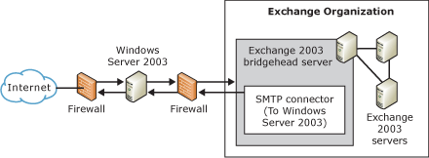

Advantages to using an SMTP relay server in a perimeter network include:
• Limited Internet exposure The internal network protects your Exchange servers that contain your user information and other configuration data.
• Additional security You can install virus-scanning software to scan incoming mail before it reaches your internal network.

Basic Configuration
The basic configuration consists of the following:
• Windows Server 2003 SMTP relay server
The SMTP relay server is configured with a default public domain. It is also configured to relay messages for only SMTP mail domains within the Exchange organization—it does not relay messages to other domains. For detailed steps that describe how to configure the SMTP relay server, see "To configure a Windows Server 2003 server as a relay server or smart host" later in this section.
• DNS Server
• Your external DNS server is configured with an MX record that points to the IP address of your SMTP relay server's domain.
• All Exchange servers point to your internal DNS server.
• Exchange bridgehead server
The Exchange bridgehead server is connected to the Internet through the firewall on port 25.
• SMTP virtual server
The SMTP virtual server is configured to send and receive Internet mail with the following default settings:
• IP address of port 25 (the standard SMTP port).
• Allow anonymous access. You must allow anonymous access to your SMTP virtual server on your Exchange bridgehead because Internet SMTP servers that send mail to this domain will not expect to authenticate.
• Does not relay mail.
• SMTP connector
• The SMTP virtual server hosts the connector.
• The connector is configured with an address space of * (asterisk) to force all outgoing mail to use the Exchange bridgehead server.
• The connector is configured to use the SMTP relay server as a smart host to relay mail.
• All other settings remain at their default values.
• Other Exchange member servers
• Member servers do not have a direct connection to the Internet.
• All member servers use the default SMTP virtual server with its default settings.
• Firewall
• The firewall is configured according to your organizational guidelines and vendor specifications.
Note:
A complete discussion about firewall configuration is outside the scope of this guide. There are many ways that you can configure a firewall to work with an SMTP relay server. You can allow either the firewall or the SMTP relay server to perform network address translation (between internal and external addresses). For the purposes of this guide, mail flow through the firewall is treated as if it were transparent.
For detailed instructions, see How to Configure a Windows Server 2003 Server as a Relay Server or Smart Host.
For more information about how to configure a Windows server as a relay server or smart host, see Microsoft Knowledge Base article 293800, "XCON: How to Set Up Windows 2000 as a SMTP Relay Server or Smart Host."

Inbound Internet Mail
When using a relay server in a perimeter network, inbound Internet mail flows into the Exchange organization in the following manner:
1. Incoming Internet mail flows through port 25 on the firewall.
2. Mail is then sent to port 25 of the SMTP relay server in the perimeter network.
3. The SMTP relay server routes the mail back through the firewall to the Exchange bridgehead server.
4. The Exchange bridgehead server uses SMTP and internal routing to deliver mail to the Exchange server that hosts the user's mailbox.

Outbound Internet Mail
When using a relay server in a perimeter network, outbound Internet mail flows out of the Exchange organization in the following manner:
1. An internal user submits a message to a remote user.
2. The Exchange server on which the user's mailbox resides forwards mail to the SMTP connector on the Exchange bridgehead server.
3. The SMTP connector relays the mail through the firewall to the SMTP relay server in the perimeter network.
4. The SMTP relay server uses DNS to find the MX record and IP address of the remote user's SMTP server.
5. The SMTP relay server sends mail back through the firewall to port 25 of the remote user's SMTP server.

Custom Deployment Scenarios
This section presents two custom deployment scenarios, including overviews of the general configuration requirements for each one.
• Using a network service provider to send and receive mail. This scenario explains how to configure your Exchange server to use a dial-up connection for Internet mail delivery.
• Supporting two SMTP domains and sharing an SMTP domain. This scenario addresses issues that are common in a merger or acquisition. In the early stages of an acquisition, you may need to support two existing SMTP mail domains; in the later stages, it is common to share a single SMTP mail domain between two mail systems. This section explains how to configure Exchange in both situations. Additionally, it explains how to use a new tool, called Address Rewrite, to rewrite outgoing e-mail addresses for users on a subsidiary company's mail system.

Using a Network Service Provider to Send and Receive Mail
If your Exchange server uses a dial-up connection to send and retrieve Internet mail, you must have a dial-up account to your network service provider. Furthermore, you must configure the Windows 2000 or Windows Server 2003 Routing and Remote Access Service (RRAS) to dial and authenticate with the network service provider on demand. For more information about configuring RRAS, see the Microsoft Windows 2000 or Windows Server 2003 Help.
If you want to use a network service provider's SMTP server as a smart host (also known as a relay server) to deliver outbound e-mail messages, you can verify addresses on outgoing mail when you send it. Mail can be sent on demand, or you can set up a specific delivery schedule. To configure these settings, use the Delivery options tab in the SMTP connector's properties.
To retrieve e-mail messages from the smart host, on the Advanced tab of the SMTP connector's properties, click Request ETRN/TURN when sending messages. As mentioned earlier, ETRN is an ESMTP command that is sent by an SMTP server to request that another server send any e-mail messages it has. TURN is an SMTP command that allows the client and server to switch roles and send mail in the reverse direction without having to establish a new connection. This ability to switch during an SMTP session is useful because you can send mail and then issue the TURN command to receive mail without having to re-establish a new connection. Additional times can be specified for retrieval purposes only.
If you want to send e-mail messages directly to remote domains without using the network service provider's e-mail server as a smart host, you can configure the SMTP connector to use DNS to send mail. However, you can still retrieve mail from your network service provider. To retrieve mail from your network service provider, select Request ETRN/TURN from different server on the Advanced tab of the SMTP connector's properties. If you configure the SMTP connector in this way, you are required to set up a schedule for retrieval.

Supporting Two SMTP Mail Domains and Sharing an SMTP Mail Domain with Another System
Special situations (mergers and acquisitions, in particular) necessitate the support of two namespaces and the sharing of a namespace with another system. To help explain such a situation, consider the merger of two fictitious companies: Contoso, Ltd. and Fourth Coffee. Contoso (contoso.com) acquires Fourth Coffee (fourthcoffee.com). The process of consolidating domain namespaces is as follows:
1. Contoso configures its Exchange organization to accept mail for the non-local domain of fourthcoffee.com. For more information about accepting mail for multiple domains, see "Supporting Two SMTP Mail Domains" later in this topic.
2. Both systems eventually share the SMTP mail domain contoso.com.
3. Finally, the users are migrated to a single Exchange organization, and the old organization or system is removed.

Supporting Two SMTP Mail Domains
Supporting two SMTP mail domains is common during the initial phase of a merger or acquisition. As an example of how one Exchange organization can support two SMTP mail domains, consider the same merger scenario involving Contoso and Fourth Coffee. In the initial phases of the acquisition, Contoso continues to use its local SMTP mail domain of contoso.com. However, to allow Fourth Coffee employees to receive e-mail messages with their original address, Contoso must also accept mail for the non-local mail domain of fourthcoffee.com. The following figure illustrates how both the domains of fourthcoffee.com and contoso.com are supported.
Supporting two SMTP mail domains
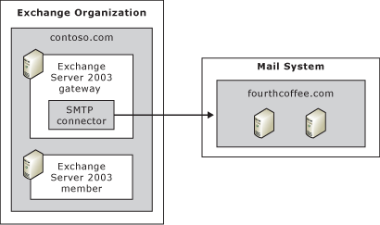

To accept mail for the non-local domain of the newly acquired company, Fourth Coffee, an administrator at Contoso creates an SMTP connector to fourthcoffee.com. This connector is configured with an address space of the SMTP domain that is used by Fourth Coffee (fourthcoffee.com) and configured to relay messages to this domain. To do this, the administrator opens the SMTP connector's properties, clicks the Address space tab, and then selects the Allow messages to be relayed to this domain check box.
Important:
You must configure this connector on each bridgehead server that accepts incoming Internet e-mail for the fourthcoffee.com domain.
Additionally, for the mail domain (fourthcoffee.com) that the administrator wants to accept mail, he ensures that an MX record exists on the Internet DNS server. This MX record should point to the IP address of the gateway server that accepts inbound mail. For more information about DNS, see "DNS" in Transport Dependencies for Exchange Server 2003.

Using Address Rewrite as an Interim Solution
With Exchange 2003, you can use a new tool called Address Rewrite as an interim step in a merger or acquisition scenario. This tool rewrites e-mail addresses on outgoing messages that are sent to Exchange and destined to external or Internet addresses. (Address Rewrite is similar to the Exchange 5.5 feature, ReRouteViaStore.) In a merger or acquisition, you can rewrite all outgoing Internet mail with a single SMTP mail domain of the parent and continue to support both the SMTP domains of the parent company and the acquired company until you are ready to migrate all users to your Exchange system.
Using the example of the acquisition of Fourth Coffee by Contoso, assume that as an interim solution in this acquisition, you want all users of Fourth Coffee to begin using the SMTP mail domain of contoso.com. Because these users have not yet been migrated to your Exchange system, you can use Address Rewrite to rewrite all outgoing e-mail messages that are sent from users on the Fourth Coffee system with the e-mail address of contoso.com. However, you also want to continue to accept e-mail messages that are sent to the users with the old e-mail address of fourthcoffee.com.
To rewrite outgoing addresses and continue to support both SMTP domains, perform the following steps:
1. Use Address Rewrite to rewrite all outgoing e-mail addresses that are sent from Fourth Coffee users.
2. Create contacts in Active Directory for all users on the Fourth Coffee mail system with a target address of fourthcoffee.com and a primary SMTP address of contoso.com.
3. Create an SMTP connector with an address space of fourthcoffee.com.

Step 1: Use Address Rewrite to Rewrite E-mail Addresses
After you configure the mail system that is used by Fourth Coffee Company to route outgoing Internet mail using SMTP through your Exchange server, you then need to enable Address Rewrite on the SMTP virtual servers in your Exchange organization that are responsible for accepting mail from the subsidiary company's mail system. In this example, you enable address rewrite on all SMTP virtual servers that accept mail from the subsidiary company, Fourth Coffee.
The following conditions must exist for Address Rewrite to work properly:
• The message is externally submitted SMTP mail that is sent to the Exchange bridgehead server.
• E-mail messages are destined to the Internet.
Internal mail or mail sent from other Exchange servers in your organization to the bridgehead server where address rewrite is enabled bypass address rewrite. There is one exception; mail submitted using Outlook Express or any other SMTP client undergoes an address rewrite on this bridgehead server.
Remember that the intent of this tool is to rewrite addresses only for mail coming from the subsidiary company (externally SMTP submitted) into your company's e-mail servers and then destined to the Internet.
You can download the Address Rewrite tool (exarcfg) from the Microsoft website at http://go.microsoft.com/fwlink/?LinkId=25097. After you download the tool, use the following procedure to enable address rewrite on the appropriate SMTP virtual servers.
Important:
Address rewrite must be enabled on the bridgehead SMTP virtual servers that receive mail from the subsidiary company's mail system. Address rewrite will not occur if the message is first submitted to an SMTP virtual server without address rewrite enabled.
For detailed instructions, see How to Enable Address Rewrite by Using the Exarcfg Tool.

Step 2: Create Contacts in Active Directory for Fourth Coffee Users
In Active Directory Users and Computers, you must create a contact for each user on the Fourth Coffee company mail system. Each contact must have a target address of fourthcoffee.com and a primary SMTP address of contoso.com.
The target address appears on the Exchange General tab of a contact's properties. You set the primary SMTP address on the E-mail Address tab of a contact's properties. You can use an automated process to add these contacts to Active Directory, or you can perform the steps manually.
The How to Create a Contact in Active Directory procedure shows how to create a contact in Active Directory manually by using the target address of the non-Microsoft mail system, which is Fourth Coffee in this example, and a primary SMTP address that is used by your Exchange organization, which is Contoso in this example.

Step 3: Create an SMTP Connector with an Address Space of fourthcoffee.com
To accept mail for Fourth Coffee Company users, an administrator at Contoso creates an SMTP connector to fourthcoffee.com and specifies each SMTP virtual server that accepts incoming Internet mail as a local bridgehead server for the connector. This connector is configured with an address space of the SMTP domain that is used by Fourth Coffee (fourthcoffee.com) and is configured to relay messages to this domain. To do this, the administrator opens the SMTP connector's properties, clicks the Address space tab, and then selects the Allow messages to be relayed to this domain check box.
Note:
For performance reasons, it is recommended that you do not use the same SMTP virtual server to both receive mail from the subsidiary company and accept incoming Internet mail. You should designate separate SMTP virtual servers on separate Exchange servers for each function.
The following figure illustrates the topology that is used by Contoso and Fourth Coffee. Note that one Exchange server accepts outgoing mail from Fourth Coffee, and a separate server routes incoming mail to Fourth Coffee users. The SMTP virtual server that accepts mail from Fourth Coffee can also function as an outbound gateway server, but this is not a requirement. This SMTP virtual server can either route Internet mail that is received from Fourth Coffee users directly to the Internet, or it can route this mail to the appropriate gateway server
Topology with address rewrite enabled
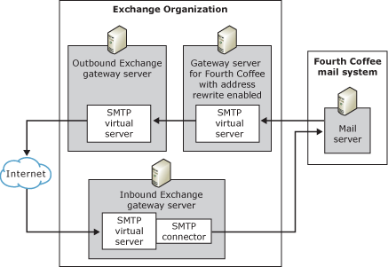

Sharing an SMTP Mail Domain with Another System
Sharing an SMTP mail domain between an Exchange 2003 organization and another e-mail system or another Exchange 2003 organization is common during the final stages of a merger or acquisition. To continue with the previous scenario, assume that Contoso is in the final stages of consolidating its systems with those of the newly acquired company, Fourth Coffee. Mailboxes in both the Exchange 2003 organization (which contains all of the employees of Contoso) and the other system (which contains all of the employees of Fourth Coffee) now use the same SMTP domain of contoso.com in their addresses. Ideally, the best way to share an SMTP mail domain is to allow Exchange to accept incoming mail from the Internet, locate a matching recipient in the Exchange organization, and then forward the mail to the users on the other mail system. The following figure illustrates a shared domain with another system.
Sharing an SMTP domain
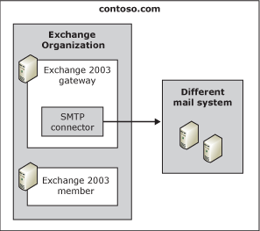

If Exchange functions as the first mail server, there are two methods you can use to configure Exchange to share an SMTP address space.
• Method 1: Sharing Selected Namespaces
In Method 1, the mail systems share only selected SMTP address spaces—Exchange remains authoritative over the others. This is the preferred method because it is the most flexible. Also, you must use this method or use the Address Rewrite tool described previously if any of the following conditions exist in your environment:
• You create contacts in Active Directory for sending mail to external recipients.
• The target SMTP addresses of those external recipients matches any of the SMTP domains that are configured in Exchange 2003 recipient policies. For example, if the address @contoso.com is configured on one of your recipient policies, and you want to create contacts with a target address of @contoso.com, you must use this method to share the @contoso.com SMTP mail domain.
• Method 2: Share All Address Spaces
Although Method 2 is less flexible, it is easier to configure in small environments. However, you cannot use this method if contacts exist in Active Directory for the external recipients on the other mail system. For more information about using contacts in a shared SMTP domain, see Microsoft Knowledge Base article 319759, "XADM: How to Configure Exchange 2000 Server to Forward Messages to a Foreign Messaging System That Shares the Same SMTP Domain Name Space."

Method 1: Sharing Selected Namespaces
Method 1 offers excellent flexibility because you can create contacts in Active Directory and more easily migrate users to a single system. This method uses two basic principles:
• An SMTP connector is created with an address space of the remote domain, fourthcoffee.com. The connector allows messages to be relayed to this domain. Allowing relay to the remote domain permits Exchange to accept inbound messages for this domain.
Important:
You must configure this connector on each bridgehead server that accepts incoming Internet e-mail for the fourthcoffee.com domain.
• Exchange is nonauthoritative over the domain. If Exchange is authoritative over a domain, it assumes that all the addresses in the domain exist in its organization. Therefore, if messages cannot be resolved locally, Exchange never attempts to send the messages through an external connector. By configuring Exchange to be nonauthoritative for the domain, if the user cannot be found locally, Exchange routes the message through the connector to the remote system.
Note:
In this case, because this SMTP mail domain is nonauthoritative, it is irrelevant that Exchange accepts messages that are inbound for domains that it is authoritative over. The connector configuration ensures that the Exchange organization accepts mail for this domain—this is because the connector is configured with an SMTP address space of the remote domain and allows relaying to this domain. Exchange accepts only inbound e-mail for the shared SMTP domain because the connector to the remote e-mail system allows messages to be relayed to this address space. Because Exchange is nonauthoritative for the shared mail domain, if you remove the connector, Exchange stops accepting inbound mail for this SMTP domain. Therefore, if you remove the connector, remember to change the recipient policy and make Exchange authoritative for this SMTP mail domain.
There are three main steps to using Method 1 (each step is detailed further in the sections following):
1. Determine if Exchange is authoritative over the SMTP mail domain you want to share.
2. Configure the recipient policy for the SMTP mail domain that you want to share. How you do this depends on whether the SMTP mail domain exists on the default recipient policy, on another recipient policy, or if it does not yet exist on a recipient policy.
3. Create an SMTP connector to route mail to the other mail system or host.

Step 1: Determine if Exchange is Authoritative Over the SMTP Mail Domain You Want to Share
Before you configure your recipient policy for the SMTP mail domain that you want to share, you must determine if Exchange is authoritative over the domain.
Remember, depending on whether Exchange 2003 is authoritative or nonauthoritative, Exchange handles e-mail messages differently for particular SMTP addresses. Because Exchange does not forward messages that it cannot resolve locally for an authoritative domain, you must ensure that Exchange is not authoritative over the SMTP mail domain you want to share.
For detailed instructions, see How to View the Setting that Determines Whether Exchange Server is Authoritative.

Step 2: Configure the Recipient Policy for the SMTP Mail Domain You Want to Share
When configuring the recipient policy for the SMTP mail domain that you want to share, there are three possible scenarios you may encounter:
• Scenario 1 The SMTP mail domain that you want to share exists on the default recipient policy.
• Scenario 2 The SMTP mail domain that you want to share exists on another recipient policy.
• Scenario 3 The SMTP mail domain that you want to share does not exist on a recipient policy.
Scenario 1: Configuring a Shared SMTP Domain that Exists on the Default Recipient Policy
You cannot set Exchange to be nonauthoritative over the default recipient policy's primary SMTP address space. To prevent Exchange from being authoritative over this domain, you need to change the default recipient policy by adding a new primary address space that is strictly for internal use. This address could be similar to @localhost, signifying that it is used solely for internal mail flow within your Exchange organization. After you add the new address space, you must make the shared address space nonauthoritative.
To configure Exchange to share a mail domain that exists as the primary address space on the default recipient policy, you must perform the following tasks:
1. On the default recipient policy, add a new primary address space over which Exchange is authoritative, and then make the shared address space nonauthoritative.
2. Create a second recipient policy that has the same search filter as the default recipient policy. Then, assign the second recipient policy a higher priority than the default recipient policy so the reply-to or return address is displayed as the shared address space.
This step is necessary because Exchange uses the primary address space as the reply-to address that is displayed in outgoing mail. Because you want outgoing messages to display the shared namespace on the reply-to line, you must create another recipient policy that is also nonauthoritative but has a higher priority; therefore, Exchange uses this address space on the return address of outgoing mail. Because the new recipient policy is not the default recipient policy, you can make this address space nonauthoritative.
Perform the How to Modify the Default Recipient Policy procedure to create a new primary address space on the default recipient policy and make the shared address space nonauthoritative.
Changing the default recipient policy in this way causes Exchange to use the new primary address as the return or reply-to address in outgoing e-mail messages. In the example above, all users in this policy now have a return e-mail address that matches the new primary address space of @localhost. Because you want all your users to have the return address of the shared mail domain (in this case, contoso.com), you must create a new recipient policy with a higher priority recipient policy that contains the contoso.com address space. Exchange uses the higher priority recipient policy on the return address. Furthermore, because this recipient policy is not the default recipient policy, you can make it nonauthoritative. (Remember, this address space must be nonauthoritative for Exchange to route it through the connector to the external system.)
Perform the How to Create a Higher Priority Recipient with the Shared Mail Domain procedure to create a higher priority recipient policy so that outgoing e-mail messages display the correct return (reply-to) address.
Scenario 2: The SMTP Domain You Want to Share Exists on Another Recipient Policy
If the SMTP domain that you want to share is not on the default recipient policy, you can make the address space nonauthoritative.
For detailed instructions, see How to Modify an Existing Recipient Policy for the SMTP Domain that You Want to Share.
Scenario 3: The SMTP Domain You Want to Share Does Not Exist on a Recipient Policy
If the SMTP domain that you want to share does not exist on a recipient policy, you can create a new recipient policy with the address space and make it nonauthoritative.
For detailed instructions, see How to Create a New Recipient Policy for an SMTP Mail Domain that Does Not Exist on a Recipient Policy.

Step 3: Create an SMTP Connector to Route Mail to the Other Mail System
Now that Exchange 2003 is nonauthoritative for the shared SMTP domain, when Exchange 2003 cannot find a matching address in Active Directory, it attempts to locate an external path to this domain. To find this path, Exchange first searches for a connector and then checks Domain Name System (DNS). Unless the mail exchanger (MX) record for that domain already points to the server on which the other mail system resides (in many cases the MX record points to the Exchange 2003 server itself), you must create an SMTP connector to route the mail to a specific host.
Important:
You must configure this connector on each bridgehead server that accepts incoming Internet e-mail for the fourthcoffee.com domain.
For detailed instructions, see How to Create an SMTP Connector to Route Mail to a Specific Host.
After you configure these settings, when Exchange 2003 cannot locate a local address match in that SMTP domain, Exchange forwards the mail to the host that has the matching address space, as specified on the SMTP connector.

Method 2: Sharing All Address Spaces
This method involves sharing all address spaces or SMTP mail domains. Although this configuration is easier to implement, it is much less flexible than Method 1. In this configuration, Exchange 2003 is authoritative for all address spaces. You cannot have any contacts in your directory that have a target address matching a domain over which Exchange 2003 is authoritative.
For detailed instructions, see How to Share All Address Spaces in Your Exchange Organization.
Remember, this setting affects only authoritative domains. Therefore, in an authoritative domain, any message sent to an unresolved address is forwarded to the server that is specified on the SMTP virtual server. Any nonauthoritative domain in Exchange 2003 is not affected by this setting. Any message that is sent to an unresolved address in a nonauthoritative domain is routed to a matching SMTP connector, if present. If no matching SMTP connector is located, the message is sent to the server that is specified in the MX record found in DNS.

Supporting Additional Mail Systems
As described in the preceding scenarios, the other mail system that receives mail forwarded by Exchange may perform the same tasks as Exchange and forward mail to a third e-mail system. To avoid mail looping, it is essential that the last e-mail system (to which mail is forwarded) is authoritative for the domain. In other words, the final receiving mail system must search for a matching recipient; if the system does not find a matching recipient, it generates a non-delivery report (NDR) for the message. Mail looping occurs when the receiving system searches for a match in its recipients and then forwards the mail back to the original system when a match is not found.
If Exchange is the last system in this configuration, by default, it will return an NDR for any unresolved messages. However, it is preferable to create custom recipients in Active Directory for all recipients that reside on a different mail system. These recipients should have target addresses similar to @subdomain.contoso.com, where subdomain provides additional address information to distinguish the address space from the typical @example.com namespace; for example, @sales.contoso.com.

How to Enable Address Rewrite by Using the Exarcfg Tool
Address rewrite must be enabled on the bridgehead SMTP virtual servers that receive mail from the subsidiary company's mail system. Address rewrite will not occur if the message is first submitted to an SMTP virtual server without address rewrite enabled.

Before You Begin
You can download the Address Rewrite tool (exarcfg) from the Downloads for Exchange Server 2003 Web site. After you download the tool, use the following procedure to enable address rewrite on the appropriate SMTP virtual servers.
Before you perform the procedure in this topic, read Deployment Scenarios for Internet Connectivity.
The following permissions are required to perform this procedure:
• Member of the local administrators group

Procedure
To enable address rewrite by using the exarcfg tool
1. Download exarcfg to the directory of your choice.
2. Open a command prompt.
3. Navigate to the directory in which you installed exarcfg.
4. Type the following command:
exarcfg –e -s server –v: SMTP virtual server instance number

Where
server is the fully qualified domain name (FQDN) of the Exchange server on which you want to enable address rewrite.
SMTP virtual server instance number is the number representing the SMTP virtual server instance. If you do not specify the –v option, the command defaults to the first virtual server instance, typically the default SMTP virtual server.

How to Create a Contact in Active Directory
Each user in your Exchange mail system must be a contact in Microsoft® Active Directory® directory service.

Before You Begin
Before you perform the procedure in this topic, read Deployment Scenarios for Internet Connectivity.
The following permissions are required to perform this procedure:
• Member of the local administrators group

Procedure
To create a contact in Active Directory
1. Open Active Directory.
2. Navigate to the folder where you want to create your contacts, right-click the folder, point to New, and then click Contact.
3. On the New Object page, complete the name information, and click Next.
4. On the next page, verify that the Create an Exchange e-mail address check box is selected.
5. In E-mail address, click Modify.
6. In New E-mail Address, select the e-mail address type for the target address. In this example, select SMTP Address, and then click OK.
7. In Internet Address Properties, type the e-mail address that is used by the newly acquired company. In this example, type <user>@fourthcoffee.com, and then click OK.
8. Complete the wizard to create a contact with the proper target address.
9. Right-click the contact, and click Properties.
10. Click the E-mail Addresses tab, and select the SMTP address of the parent company, in this case, user1@northwindtraders.com. Click Set As Primary.
E-mail Addresses tab in User Properties dialog box
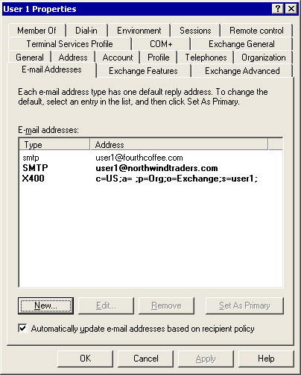

How to View the Setting that Determines Whether Exchange Server is Authoritative
Before you configure your recipient policy for the SMTP mail domain that you want to share, you must determine if Exchange Server is authoritative over the domain.

Before You Begin
Before you perform the procedure in this topic, read Deployment Scenarios for Internet Connectivity.
The following permissions are required to perform this procedure:
• Member of the local administrators group and a member of a group that has had the Exchange Administrators role applied at the organizational level

Procedure
To view the setting that determines whether Exchange is authoritative
1. Click Start, point to Programs, point to Microsoft Exchange, and then click System Manager.
2. In the console tree, expand Recipients, and then click Recipient Policies.
3. In the details pane, right-click a recipient policy, and then click Properties.
4. Click the E-Mail Addresses (Policy) tab, select an SMTP address, and then click Edit. The SMTP Address Properties dialog box appears.
The SMTP Address Properties dialog box for an authoritative domain
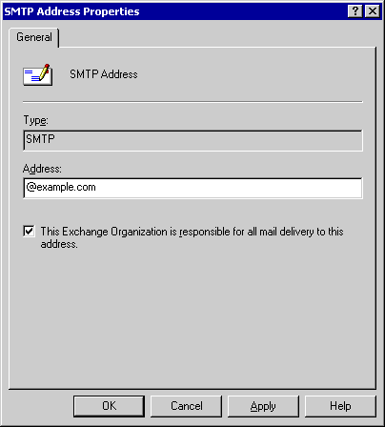

5. If the This Exchange Organization is responsible for all mail delivery to this address check box is selected, Exchange is authoritative for the address. If the check box is cleared, Exchange is not authoritative for the address.
6. For more information about authoritative and nonauthoritative SMTP domains in Exchange, see Microsoft Knowledge Base article 315591, "XCON: Authoritative and Non-Authoritative Domains in Exchange 2000."

How to Modify the Default Recipient Policy
You cannot set Microsoft® Exchange Server to be nonauthoritative over the default recipient policy's primary SMTP address space. To prevent Exchange Server from being authoritative over this domain, you must change the default recipient policy by adding a new primary address space that is strictly for internal use. This address could be similar to @localhost, signifying that it is used solely for internal mail flow within your Exchange Server organization.

Before You Begin
Before you perform the procedure in this topic, read Deployment Scenarios for Internet Connectivity.
The following permissions are required to perform this procedure:
• Member of the local administrators group and a member of a group that has had the Exchange Administrators role applied at the organizational level

Procedure
To modify the default recipient policy
1. Click Start, point to Programs, point to Microsoft Exchange, and then click System Manager.
2. In the console tree, expand Recipients, and then click Recipient Policies.
3. In the details pane, right-click your default recipient policy, and then click Properties.
4. Click the E-Mail Addresses (Policy) tab, and then click New.
5. In New E-mail Address, click SMTP Address, and then click OK.
6. In SMTP Address Properties, in the Address box, type @localhost or some other address space for which the Exchange organization can be authoritative. You can use @localhost or your Active Directory domain if it is different from your Internet domain. This address space is strictly for internal use.
7. Verify that the This Exchange Organization is responsible for all mail delivery to this address check box is selected, and then click OK.
8. On the E-mail Addresses (Policy) tab, click the new SMTP address you just created, and then click Set as Primary.
9. Click the SMTP address space that you want to share (for example, contoso.com), and then click Edit.
10. To make Exchange nonauthoritative for this SMTP address, clear the This Exchange Organization is responsible for all mail delivery to this address check box, and then click Apply.
11. A message appears asking if you want to update all corresponding recipient e-mail addresses. Click Yes.
12. On the E-mail Addresses (Policy) tab, click OK.

How to Create a Higher Priority Recipient with the Shared Mail Domain
Because all of your users should have the return address of the shared mail domain (for example, contoso.com), you must create a new recipient policy with a higher priority recipient policy that contains the contoso.com address space. Exchange Server uses the higher priority recipient policy on the return address.

Before You Begin
Before you perform the procedure in this topic, read Deployment Scenarios for Internet Connectivity.
The following permissions are required to perform this procedure:
• Member of the local administrators group and a member of a group that has had the Exchange Administrators role applied at the organizational level

Procedure
To create a higher priority recipient policy with the shared mail domain
1. Click Start, point to Programs, point to Microsoft Exchange, and then click System Manager.
2. In the console tree, expand Recipients, right-click Recipient Policies, point to New, and then click Recipient Policy.
3. In New Policy, select the E-Mail Addresses check box, and then click OK.
4. On the General tab, in the Name box, type an appropriate name, such as "User Addresses."
5. Under Filter rules, click Modify.
6. In Find Exchange Recipients, select or clear the appropriate check boxes to specify all applicable users. If you want to apply the policy to all users, click OK.
7. On the E-mail Addresses (Policy) tab, click the SMTP mail domain that you want to share, and then click Set as Primary (leaving the @local domain as a secondary proxy), and then click Apply.
8. A message appears asking if you want to update all corresponding recipient e-mail addresses. Click Yes.
9. On the E-mail Addresses (Policy) tab, click OK..

How to Modify an Existing Recipient Policy for the SMTP Domain that You Want to Share
If the SMTP domain that you want to share is not on the default recipient policy, you can make the address space nonauthoritative.

Before You Begin
Before you perform the procedure in this topic, read Deployment Scenarios for Internet Connectivity.
The following permissions are required to perform this procedure:
• Member of the local administrators group and a member of a group that has had the Exchange Administrators role applied at the organizational level

Procedure
To modify an existing recipient policy for the SMTP domain that you want to share
1. Click Start, point to Programs, point to Microsoft Exchange, and then click System Manager.
2. In the console tree, expand Recipients, and then click Recipient Policies.
3. In the details pane, right-click the recipient policy that has the SMTP address space you want to share, and then click Properties.
4. On the E-mail Addresses (Policy) tab, click the SMTP address space, and then click Set as Primary.
5. Click the SMTP address space that you want to share, and then click Edit.
6. To make Exchange nonauthoritative for this SMTP address, clear the This Exchange Organization is responsible for all mail delivery to this address check box, and then click Apply.
7. A message appears asking if you want to update all corresponding recipient e-mail addresses. Click Yes.
8. On the E-mail Addresses (Policy) tab, click OK.

How to Create a New Recipient Policy for an SMTP Mail Domain that Does Not Exist on a Recipient Policy
If an SMTP domain that you want to share does not exist on a recipient policy, you can create a new recipient policy with the address space and make it non-authoritative.

Before You Begin
Before you perform the procedure in this topic, read Deployment Scenarios for Internet Connectivity.
The following permissions are required to perform this procedure:
• Member of the local administrators group and a member of a group that has had the Exchange Administrators role applied at the organizational level

Procedure
To create a new recipient policy for an SMTP mail domain that does not exist on a recipient policy
1. Click Start, point to Programs, point to Microsoft Exchange, and then click System Manager.
2. In the console tree, expand Recipients, right-click Recipient Policies, point to New, and then click Recipient Policy.
3. In New Policy, select the E-Mail Addresses check box, and then click OK.
4. On the General tab, in the Name box, type a name for your new policy.
5. On the E-Mail Addresses (Policy) tab, click the SMTP address space, and then click New.
6. In New E-mail Address, click SMTP Address, and then click OK.
7. In SMTP Address Properties, in the Address box, type the SMTP address space that you want to share.
8. To make Exchange nonauthoritative for this SMTP address, clear the This Exchange Organization is responsible for all mail delivery to this address check box.
9. In SMTP Address Properties, click OK.
10. On the E-mail Addresses (Policy) tab, click OK.

How to Create an SMTP Connector to Route Mail to a Specific Host
When Microsoft® Exchange Server cannot find a matching address in Active Directory® directory service, it attempts to locate an external path to this domain. To find this path, Exchange Server first searches for a connector and then checks the Domain Name System (DNS). Unless the mail exchanger (MX) record for that domain already points to the server on which the other mail system resides, you must create an SMTP connector to route the mail to a specific host.

Before You Begin
Before you perform the procedure in this topic, read Deployment Scenarios for Internet Connectivity.
The following permissions are required to perform this procedure:
• Member of the local administrators group and a member of a group that has had the Exchange Administrators role applied at the administrative group level

Procedure
To create an SMTP connector to route mail to a specific host
1. Click Start, point to Programs, point to Microsoft Exchange, and then click System Manager.
2. In the console tree, right-click Connectors, point to New, and then click SMTP Connector.
3. On the General tab, type an appropriate name, and then click Forward all mail through this connector to the following smart hosts. In square brackets ([ ]), type the fully qualified domain name (FQDN) or the IP address of the server to which e-mail messages for the shared SMTP address space are to be routed.
4. Click Add to configure your bridgehead servers, and then select your Exchange gateway servers that accept Internet mail for this domain.
5. Click the Address Space tab, click Add, click SMTP, and then click OK.
6. In E-mail domain, type the SMTP address space without the "at" symbol (@), for example, fourthcoffee.com, and then click OK.
Note:
It is important to enter the specific SMTP mail domain. Do not type * (asterisk) on the SMTP connector. Setting * causes Exchange Server to accept mail for all external domains and then relay it externally. This configuration allows open relaying for anyone on the Internet and is extremely insecure.
7. Because Exchange Server 2003 must also receive messages for this domain, on the Address Space tab, click Allow messages to be relayed to these domains , and then click OK. This setting makes it possible for all SMTP virtual servers that are listed under Local Bridgeheads to accept messages for this domain.

How to Share All Address Spaces in Your Exchange Organization
Use this procedure to share all address spaces in your Exchange organization.

Before You Begin
Before you perform the procedure in this topic, read Deployment Scenarios for Internet Connectivity.
The following permissions are required to perform this procedure:
• Member of the local administrators group and a member of a group that has had the Exchange Administrators role applied at the organizational level

Procedure
To share all address spaces in your Exchange organization
1. Click Start, point to Programs, point to Microsoft Exchange, and then click System Manager.
2. In the console tree, expand Servers, expand <Server Name>, expand Protocols, and then expand SMTP.
3. Right-click your SMTP virtual server, and then click Properties.
4. In the SMTP virtual server's Properties, click the Messages tab.
5. In the Forward all messages with unresolved recipients to host box, type the IP address, in square brackets ([ ]), or the FQDN of the server that will receive unresolved mail, and then click OK.
6. Repeat this procedure for the default SMTP virtual server on all Exchange 2003 servers, except for any virtual server that is acting as an inbound gateway for the other system. It is recommended that no mailboxes reside on this server.

Configuring Cross-Forest SMTP Mail Collaboration
To prevent spoofing (that is, forging identities), Exchange 2003 requires authentication before a sender's name is resolved to its display name in the global address list (GAL). Therefore, in an organization that spans two forests, a user who sends mail from one forest to another forest is not authenticated. Furthermore, the user's name is not resolved to a display name in the GAL, even if the user exists as a contact in the destination forest.
To enable cross-forest mail collaboration in Exchange 2003, additional configuration steps are required to resolve contacts outside your organization to their display names in Active Directory. You have two options to enable the resolution of these contacts:
• Option 1 (recommended) Use authentication so that users who send mail from one forest to another are authenticated users, and their names are resolved to their display names in the GAL.
• Option 2 Restrict access to the SMTP virtual server that is used for cross-forest collaboration, and then configure Exchange to resolve anonymous e-mail. This configuration is supported, but it is not recommended. By default, in this configuration, the Exch50 message properties, which are the extended properties of a message, are not persisted when mail is sent from one forest to another.
To understand the benefits of configuring cross-forest mail collaboration, consider the following scenarios of anonymous mail submission and cross-forest authenticated mail submission.
Scenario: Anonymous Mail Submission
E-mail addresses are not resolved if the submission is anonymous. Therefore, when an anonymous user who attempts to spoof (forge) an internal user's identity sends mail, the return address does not resolve to its display name in the global address list (GAL).
For example, Kim Akers is a legitimate internal user at Contoso, Ltd. Her display name in the GAL is Kim Akers, and her e-mail address is kim@contoso.com.
To send mail, Kim must be authenticated. Because she is authenticated, the intended recipients of Kim's mail see that the sender is Kim Akers. In addition, the properties of Kim Akers are displayed as her GAL entry. However, if Ted Bremer attempts to forge Kim's address by using kim@contoso.com in the From line and then sending the mail to the Exchange 2003 server at Contoso, the e-mail address is not resolved to Kim's display name because Ted did not authenticate. Therefore, when this e-mail message is displayed in Microsoft Office Outlook®, the sender address appears as kim@contoso.com; it does not resolve to Kim Akers, as authenticated mail from Kim does.
Scenario: Cross-Forest Mail Delivery
Consider a company that spans two forests: the Adatum forest and the Fabrikam forest. Both these forests are single domain forests using the domains of adatum.com and fabrikam.com, respectively. To allow cross-forest mail collaboration, all users in the Adatum forest are represented as contacts in the Fabrikam forest's Active Directory. Likewise, all users in the Fabrikam forest are represented as contacts in Adatum forest's Active Directory.
If a user in the Adatum forest sends mail to the Fabrikam forest, and the mail is submitted over an anonymous connection, the sender's address is not resolved, despite the fact that the sender exists as a contact in the Active Directory and in the Outlook GAL. This is because a user in the Adatum forest is not an authenticated user in the Fabrikam forest.
For example, Ted Bremer is a mail user in the Adatum forest—his e-mail address is ted@adatum.com, and his Outlook GAL display name is Ted Bremer. Adam Barr is a user in the Fabrikam forest—his e-mail address is adam@fabrikam.com, and his Outlook GAL display name is Adam Barr. Because Adam is represented as an Active Directory contact in the Adatum forest, Ted can view Adam's e-mail address and resolve it to the display name of Adam Barr in the Outlook GAL. When Adam receives mail from Ted, Ted's address is not resolved; instead of seeing Ted's display name as it appears in the GAL, Adam sees his unresolved e-mail address of ted@adatum.com. Because Ted sent mail as an anonymous user, his e-mail address did not resolve. Although Ted is authenticated when sending mail, the connection between the two forests is not authenticated.
To ensure that senders in one forest can send mail to recipients in other forests and to ensure that their e-mail addresses resolve to their display names in the GAL, you should enable cross-forest mail collaboration. The following sections explain the two options that are available for configuring mail collaboration between two forests.

Enabling Cross-Forest Authentication
To enable cross-forest SMTP authentication, you must create connectors in each forest that uses an authenticated account from the other forest. By doing this, any mail that is sent between the two forests by an authenticated user resolves to the appropriate display name in the GAL. This section explains how to enable cross-forest authentication.
Using the example of the Adatum forest and the Fabrikam forest (see "Scenario: Cross-Forest Mail Delivery" earlier in this topic), perform the following steps to set up cross-forest authentication:
1. Create an account in the Fabrikam forest that has Send As permissions. (For all users in the Adatum forest, a contact exists in the Fabrikam forest as well; therefore, this account allows Adatum users to send authenticated mail.) Configure these permissions on all Exchange servers that will accept incoming mail from Adatum.
2. On an Exchange server in the Adatum forest, create a connector that requires authentication using this account to send outbound mail.
Similarly, to set up cross-forest authentication from the Fabrikam forest to the Adatum forest, repeat these steps, creating the account in Adatum and the connector in Fabrikam.

Step 1: Creating a User Account in the Destination Forest with Send As Permissions
Before you set up your connector in the connecting forest, you must create an account in the destination forest (the forest to which you are connecting) that has Send As permissions. Configure these permissions on all servers in the destination forest that will accept inbound connections from the connecting forest. The How to Create the Account Used for Cross-Forest Authentication procedure shows you how to set up an account in the Fabrikam forest, and the How to Configure a Connector and Require Authentication for Cross-Forest Authentication procedure shows you how to configure a connector in the Adatum forest, thereby allowing users in the Adatum forest to send mail to the Fabrikam forest with resolved e-mail addresses.

Step 2: Creating a Connector in the Connecting Forest
After creating the account with the proper permissions in the destination forest, create a connector in the connecting forest and require authentication using the account you just created. In the How to Configure a Connector and Require Authentication for Cross-Forest Authentication procedure, assume that you are creating a connector on an Exchange server in the Adatum forest that connects to the Fabrikam forest.

Enabling Cross-Forest Collaboration by Resolving Anonymous Mail
Another way you can configure Exchange to resolve contacts outside your organization to their display names in Active Directory is to configure Exchange to resolve anonymous e-mail. Assume that your company spans two forests, from the Adatum forest to the Fabrikam forest.
Important:
Configuring Exchange servers to resolve anonymous mail submissions allows unscrupulous users to submit messages with a falsified return address. Recipients are unable to differentiate between authentic mail and spoofed mail. To minimize this possibility, ensure that you restrict access to the SMTP virtual server to the IP addresses of your Exchange servers.
Perform the steps below to resolve contacts for Adatum users to their display names in the Fabrikam forest. Each of these steps is explained in detail in the following sections:
1. Create a connector in the Adatum forest that connects to the Fabrikam forest.
2. On the receiving bridgehead server in the Fabrikam forest, restrict access to the SMTP virtual server by IP address. By doing this, you can ensure that only servers from the Adatum forest can send mail to this server.
3. On the SMTP virtual server that hosts the connector, enable the Resolve anonymous e-mail setting.
4. Change a registry key to ensure that the extended message properties (Exch50 properties) are persisted across the forests. Otherwise, you can lose important message information.
After you complete these steps, all users who send mail from the Adatum forest to the Fabrikam forest will resolve to their display names in the Fabrikam global address list (GAL). In a production environment, you would then repeat this process to configure the resolution of Fabrikam contacts in the Adatum forest.

Step 1: Creating a Connector in the Connecting Forest
First you must create a connector in the connecting forest. For detailed instructions, see "How to Create a Connector in a Connecting Forest" in What's New in Exchange Server 2003.
After you create the connector, Exchange Server will route all mail destined to fabrikam.com (the Fabrikam forest) through this connector.

Step 2: Restricting IP Addresses on the Receiving Bridgehead Server
After you create the connector in the Adatum forest (the connecting forest) you must restrict access to the receiving bridgehead server. You do this by allowing only the IP address of the connecting servers in the Adatum forest to send mail to the receiving bridgehead server in the Fabrikam forest.
For detailed instructions, see How to Restrict Access by IP Address on the Receiving Bridgehead Server.

Step 3: Resolving Anonymous Mail on the SMTP Virtual Server
After you have restricted access to the receiving bridgehead server, you must configure the SMTP virtual server on this bridgehead to resolve anonymous e-mail addresses.
For detailed instructions, see How to Configure an SMTP Virtual Server to Resolve Anonymous E-mail Addresses.

Step 4: Enabling Registry Key to Persist Message Properties Across Forests
As explained earlier, when messages are sent anonymously across forests, the extended message properties on a message are not transmitted. For single companies that implement a cross-forest scenario, these message properties must be transmitted because information about the message can be lost. For example, the SCL property, an extended Exchange property, contains a spam rating that is generated by third-party solutions. This property is not transmitted when mail is sent anonymously. So, if an anti-spam solution is deployed in the Adatum forest, and a message that is received in this forest is destined to a recipient in the Fabrikam forest, the anti-spam solution stamps the SCL property on the message. However, when the message is delivered to the Fabrikam forest, the extended property that contains the spam rating is not persisted.
To configure Exchange to accept the extended message properties, you can enable a registry key on the receiving bridgehead server or on the SMTP virtual server that resides on the bridgehead. Enabling the registry key on the Exchange server configures all SMTP virtual servers on the Exchange server to accept extended properties.

Configuring the Exchange Server to Accept Extended Message Properties on Anonymous Connections
Perform the How to Enable an Exchange Server to Accept Message Extended Properties that Are Sent Anonymously procedure to configure the Exchange server to accept extended properties on anonymous connections. If your Exchange server functions solely as the bridgehead server for cross-forest communication, you may want to configure this setting at the server level. If you have other SMTP virtual servers on this Exchange server, consider setting this registry key on the SMTP virtual server only.
Note:
If you enable this registry key on an Exchange server, the setting applies to all SMTP virtual servers on the Exchange server. If you want to configure a single SMTP virtual server with this setting, enable the registry key on the SMTP virtual server.
Note:
Incorrectly editing the registry can cause serious problems that may require you to reinstall your operating system. Problems resulting from editing the registry incorrectly may not be able to be resolved. Before editing the registry, back up any valuable data.

Configuring an SMTP Virtual Server to Accept Extended Message Properties Sent Anonymously
Perform the How to Enable an SMTP Virtual Server to Accept Message Extended Properties that Are Sent Anonymously procedure to configure the SMTP virtual server on the Exchange server to accept extended properties.

How to Create the Account Used for Cross-Forest Authentication
Before you set up a connector in a connecting forest, you must create an account in the destination forest (the forest to which you are connecting) that has Send As permissions. Configure these permissions on all servers in the destination forest that will accept inbound connections from the connecting forest.

Before You Begin
Before you perform the procedure in this topic, read Deployment Scenarios for Internet Connectivity.
The following permissions are required to perform this procedure:
• Member of the local administrators group and a member of a group that has had the Exchange Administrators role applied at the organizational level

Procedure
To create the account used for cross-forest authentication
1. In the destination forest (in this case, the Fabrikam forest), create a user account in Active Directory Users and Computers. This account must be an active account, but it does not require the following permissions: log on locally and log on through terminal server.
2. On each Exchange server that will accept incoming connections from the connecting forest, configure Send As permissions for this account:
Note:
Be careful when creating the password policy. If you set the password to expire, ensure that you have a policy in place that changes the password before its expiration date. If the password for this account expires, cross-forest authentication fails.
3. Start Exchange System Manager: Click Start, point to All Programs, point to Microsoft Exchange, and then click System Manager.
4. In the console tree, expand Servers, right-click an Exchange server that accepts incoming connections from the connecting forest, and then click Properties.
5. In <Server Name> Properties, on the Security tab, click Add.
6. In Select Users, Computers, or Groups, add the account that you just created, and then click OK.
7. On the Security tab, under Group or user names, select the account.
8. Under Permissions for connector, next to Send As, select the Allow check box.
Allowing the Send As permission for a connector
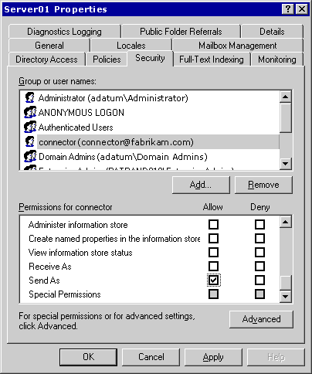

How to Configure a Connector and Require Authentication for Cross-Forest Authentication
When you configure Microsoft® Exchange Server to resolve mail anonymously in a cross-forest scenario, a connector must be created that connects directly to the forest from which you want to receive mail.

Before You Begin
Before you perform the procedure in this topic, read Deployment Scenarios for Internet Connectivity.
The following permissions are required to perform this procedure:
• Member of the local administrators group and a member of a group that has had the Exchange Administrators role applied at the administrative group level

Procedure
To configure a connector and require authentication for cross-forest authentication
1. Start Exchange System Manager: Click Start, point to All Programs, point to Microsoft Exchange, and then click System Manager.
2. In the console tree, right-click Connectors, point to New, and then click SMTP Connector.
3. On the General tab, in the Name box, type a name for the connector.
4. Click Forward all mail through this connector to the following smart hosts, and then type the FQDN or IP address of the receiving bridgehead server.
5. Click Add to select a local bridgehead server and SMTP virtual server to host the connector.
The General tab in an SMTP virtual server Properties dialog box
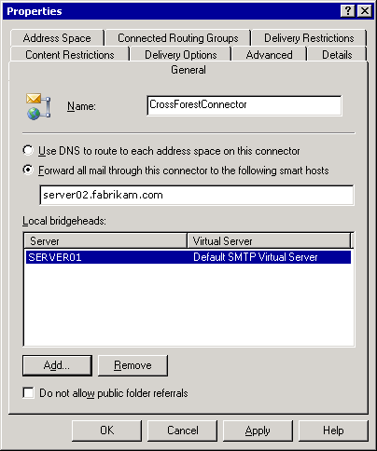

6. On the Address Space tab, click Add, select SMTP, and then click OK.
7. In Internet Address Space Properties, type the domain of the forest to which you want to connect, and then click OK. In this example, because the connector is sending from the Adatum forest to the Fabrikam forest, the address space matches the domain for the forest, fabrikam.com.
The Internet Address Space Properties dialog box
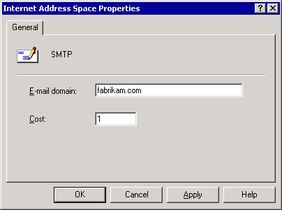

Exchange will now route all mail destined to fabrikam.com (the Fabrikam forest) through this connector.
8. On the Advanced tab, click Outbound Security.
9. Click Integrated Windows Authentication.
The Integrated Windows Authentication button in the Outbound Security dialog box
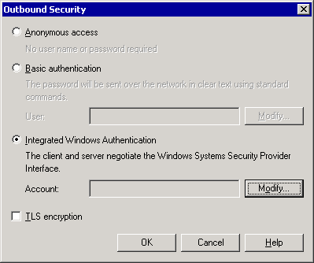

10. Click Modify.
11. In Outbound Connection Credentials, in the Account, Password, and Confirm password boxes, specify an account and password in the destination forest (in this case, Fabrikam) that has Send As permissions and is an authenticated Fabrikam account. Use the following format for the account name: domain\username, where:
• domain is a domain in the destination forest.
• username represents an account in the destination forest with Send As permissions on all Exchange servers in the destination forest that will accept mail from this connector.
The Outbound Connection Credentials dialog box
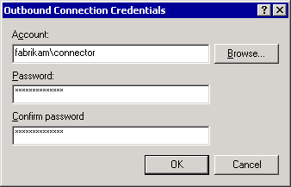

12. Click OK.

How to Restrict Access by IP Address on the Receiving Bridgehead Server
By restricting access to the SMTP virtual server by IP address, you can help make sure that only servers from a specific IP address can send mail to an Exchange bridgehead server.

Before You Begin
Before you perform the procedure in this topic, read Deployment Scenarios for Internet Connectivity.
The following permissions are required to perform this procedure:
• Member of the local administrators group and a member of a group that has had the Exchange Administrators role applied at the administrative group level

Procedure
To restrict access by IP address on the receiving bridgehead server
1. Start Exchange System Manager: Click Start, point to All Programs, point to Microsoft Exchange, and then click System Manager.
2. In the console tree, expand Servers, expand < Bridgehead Server Name >, expand Protocols, and then expand SMTP.
3. Right-click the SMTP virtual server you want, and then click Properties.
4. On the Access tab, click Connection.
5. In Connection, click Only the list below to restrict access to a specified list of IP addresses.
6. Click Add, and then perform one of the following steps:
• Click Single Computer, and in the IP address box, type the IP address of the connecting Exchange server in the Adatum forest (the connecting forest). Repeat this step for each computer in the Adatum forest.
7. Click Group of computers, and in the Subnet address and Subnet mask boxes, type the subnet address and subnet masks for the group of computers that host connectors to the Fabrikam forest.

How to Configure an SMTP Virtual Server to Resolve Anonymous E-mail Addresses
One way to configure Exchange Server to resolve contacts from outside your organization to their display names in Active Directory is to configure the SMTP virtual server on to resolve anonymous e-mail addresses.

Before You Begin
Before you perform the procedure in this topic, read Deployment Scenarios for Internet Connectivity.
The following permissions are required to perform this procedure:
• Member of the local administrators group and a member of a group that has had the Exchange Administrators role applied at the administrative group level

Procedure
To configure an SMTP virtual server to resolve anonymous e-mail addresses
1. Start Exchange System Manager: Click Start, point to All Programs, point to Microsoft Exchange, and then click System Manager.
2. In the console tree, expand Servers, expand < Bridgehead Server Name >, expand Protocols, and then expand SMTP.
3. Right-click the SMTP virtual server you want, and then click Properties.
4. On the Access tab, click Authentication.
5. In Authentication, ensure that the Anonymous access check box is selected, and then select the Resolve anonymous e-mail check box.

How to Enable an Exchange Server to Accept Message Extended Properties that Are Sent Anonymously
When messages are sent anonymously across forests, the extended message properties on a message are not transmitted. However, many small organizations that implement a cross-forest scenario must transmit message properties because that information could otherwise be lost.
For example, the spam confidence level (SCL) property, an extended Exchange Server property, contains a spam rating that is generated by third-party solutions. This property is not transmitted when mail is sent anonymously. If an anti-spam solution is deployed in one forest, and a message is received in this forest is destined to a recipient in another forest, the anti-spam solution will stamp the SCL property on the message. However, when the message is delivered the extended property will not be persisted.
To configure Exchange Server to accept extended message properties, you must enable a registry key on the receiving bridgehead server that resides on the bridgehead. This will allow the Exchange server to accept extended properties anonymously.

Before You Begin
Before you perform the procedure in this topic, read Deployment Scenarios for Internet Connectivity.
The following permissions are required to perform this procedure:
• Member of the local administrators group

Procedure
To enable an Exchange server to accept message extended properties that are sent anonymously
1. Start Registry Editor: Click Start, click Run, and then type regedit.
2. In the console tree, navigate to the following registry key:
HKEY_LOCAL_MACHINE\SYSTEM\CurrentControlSet\Services\SMTPSVC\ XEXCH50
3. Right-click XEXCH50,point to New, and then click DWORD Value.
4. In the details pane, type Exch50AuthCheckEnabled for the value name. By default, the value data is 0, which indicates that the XEXCH50 properties are transmitted when mail is sent anonymously.

How to Enable an SMTP Virtual Server to Accept Message Extended Properties that Are Sent Anonymously
When messages are sent anonymously across forests, the extended message properties on a message are not transmitted. However, many small organizations that implement a cross-forest scenario must transmit message properties because that information could otherwise be lost.
For example, the spam confidence level (SCL) property, an extended Exchange Server property, contains a spam rating that is generated by third-party solutions. This property is not transmitted when mail is sent anonymously. If an anti-spam solution is deployed in one forest, and a message is received in this forest is destined to a recipient in another forest, the anti-spam solution will stamp the SCL property on the message. However, when the message is delivered the extended property will not be persisted.
To configure Exchange Server to accept extended message properties, you must enable a registry key on the receiving bridgehead server or on the SMTP virtual server that resides on the bridgehead. This will allow all SMTP virtual servers to accept extended properties anonymously.

Before You Begin
Before you perform the procedure in this topic, read Deployment Scenarios for Internet Connectivity.
The following permissions are required to perform this procedure:
• Member of the local administrators group and a member of a group that has had the Exchange Administrators role applied at the administrative group level

Procedure
To enable an SMTP virtual server to accept message extended properties that are sent anonymously
1. Start Registry Editor: Click Start, click Run, and then type regedit.
2. In the console tree, navigate to the following registry key:
HKEY_LOCAL_MACHINE\SYSTEM\CurrentControlSet\Services\SMTPSVC\ XEXCH50
3. Right-click XEXCH50, point to New, and then click Key.
4. Type the number of the SMTP virtual server instance as the key value. For example, the default SMTP virtual server instance is 1, whereas the second SMTP virtual server created on a server is 2.
5. Right-click the key that you just created, point to New, and click DWORD Value.
6. In the details pane, type Exch50AuthCheckEnabled for the value name. By default, the value data is 0, which indicates that the XEXCH50 properties are transmitted when mail is sent anonymously.

How to Configure a Windows Server 2003 Server as a Relay Server or Smart Host
When Microsoft® Windows Server™ 2003 is used as an SMTP relay server, it is configured with a default public domain. It is also configured to relay messages for only SMTP mail domains in the Exchange Server organization and does not relay messages to other domains.

Before You Begin
Before you perform the procedure in this topic, read Deployment Scenarios for Internet Connectivity.
The following permissions are required to perform this procedure:
• Member of the local administrators group

Procedure
To configure a Windows Server 2003 server as a relay server or smart host
1. Verify that SMTP is installed on the Microsoft Windows Server 2003 server. To verify that SMTP is installed:
a. In Control Panel, double-click Add/Remove Programs, and then click Add/Remove Windows Components.
b. Under Components, select Internet Information Services (IIS), and then click Details.
c. Under Subcomponents of Internet Information Services (IIS), verify that the SMTP Service check box is selected. If the check box is not selected, select it, click OK, and then complete the installation instructions.
2. In Internet Services Manager, add the SMTP mail domain for which you want the Windows server to relay. To add the SMTP domain:
a. Click Start, point to Programs, point to Administrative Tools, and then click Internet Services Manager.
b. Expand the server that you want, and then expand the default SMTP virtual server. By default, the default SMTP virtual server has a local domain with the fully qualified domain name (FQDN) for the server.
c. To create the inbound SMTP mail domain, right-click Domains, point to New, and then click Domain.
d. In New SMTP Domain Wizard, click Remote as the domain type, and then click Next.
e. In Name, type the domain name of your SMTP mail domain for your Exchange organization.
f. Click Finish.
3. Configure the SMTP mail domain that you just created for relay:
a. In Internet Services Manager, right-click the SMTP mail domain, and then click Properties.
b. Click Allow the Incoming mail to be Relayed to this Domain.
c. Click Forward all e-mail to smart host, and then type the IP address in square brackets ([ ]) or the FQDN of the Exchange server that is responsible for receiving e-mail for the domain. For example, to enter an IP address, type [123.123.123.123].
d. Click OK.
4. Specify the hosts that you want to openly relay to all domains:
a. In Internet Services Manager, right-click Default Virtual Server and click Properties.
b. On the Access tab, click Relay.
c. Click Only the list below, click Add, and then add the hosts that you want to use the SMTP server to send mail.
d. Under Single computer, specify the IP address of the Exchange bridgehead server that you want to relay using this SMTP server. Click DNS Lookup to find the IP address of the specific server.

For More Information
For more information about how to configure a Windows server as a relay server or smart host, see Microsoft Knowledge Base article 293800, "XCON: How to Set Up Windows 2000 as a SMTP Relay Server or Smart Host."

Connecting Exchange to the Internet
Now that you have configured internal mail and have learned about various Internet connectivity scenarios, you are ready to connect your Exchange organization to the Internet. This section contains procedural information about how to configure your Microsoft® Exchange Server 2003 organization to send and receive Internet mail. Specifically, you will learn how to:
• Verify that SMTP has been properly installed Verify that Simple Mail Transfer Protocol (SMTP) is functioning properly on your Exchange server before you connect to the Internet.
• Use a wizard to configure Internet mail delivery Internet Mail Wizard is intended primarily for small and medium companies with less complex environments than large or enterprise companies.
• Manually configure Internet mail delivery In large or enterprise environments, you may need to manually configure Internet mail delivery, in accordance with your organization's policies. When manually configuring Internet mail, you must complete a separate set of tasks that are associated with configuring Exchange to send Internet mail and to receive Internet mail.

Using Internet Mail Wizard to Configure Internet Mail Delivery
Exchange Server 2003 implements a new version of Internet Mail Wizard that helps you configure Internet mail connectivity in Exchange Server 2003 or Exchange 2000 Server. By using Internet Mail Wizard, you can configure an Exchange server to send Internet mail, receive Internet mail, or send and receive Internet mail. Furthermore, using Internet Mail Wizard means that you do not have to manually configure the SMTP connector and SMTP virtual server. Internet Mail Wizard automatically creates the necessary SMTP connector for outgoing Internet mail and configures your SMTP virtual server to accept incoming mail.
You can use Internet Mail Wizard to configure Exchange Server to send, receive or send, and receive Internet mail. Remember, if your messaging environment is large or complex, you cannot use Internet Mail Wizard. Instead, you must manually configure Exchange for Internet mail delivery.
For detailed instructions, see How to Use Internet Mail Wizard.

Configuring a Dual-Homed Server Using the Wizard
When you use Internet Mail Wizard to configure Internet mail delivery on a dual-homed server (a server that is configured with two or more network addresses, usually with two network interface cards), the wizard performs the configuration steps that are described in How to Use Internet Mail Wizard.
The wizard also creates an additional SMTP virtual server on the Exchange server. It enables Internet mail delivery on the SMTP virtual server in the following ways:
• To configure a server to send Internet mail, the wizard guides you through the process of assigning the intranet IP address to the default SMTP virtual server on which it creates the SMTP connector to send outbound mail. You assign the intranet IP address to this virtual server so that only internal users on your intranet can send outbound mail.
• To configure a server to receive Internet mail, the wizard guides you through the process of assigning the Internet IP address to the Internet SMTP virtual server. You assign an Internet IP address to this virtual server because external servers need to be able to connect to this SMTP virtual server to send Internet mail. Additionally, you must have an MX record on an Internet DNS server that references your server and the IP address of the Internet SMTP virtual server.
Important:
To increase the security on a dual-homed server, use Internet Protocol security (IPSec) policies to filter ports on the Internet network interface card (NIC) and strictly limit the users that you allow to log on to this server. For more information about IPSec, see the Windows documentation.

How to Use Internet Mail Wizard
You can use Internet Mail Wizard to configure Exchange Server to send, receive or send, and receive Internet mail. Remember, if your messaging environment is large or complex, you cannot use Internet Mail Wizard. Instead, you must manually configure Exchange for Internet mail delivery.
Exchange Server 2003 implements a new version of Internet Mail Wizard that helps you configure Internet mail connectivity in Exchange Server 2003 or Exchange 2000 Server. Using Internet Mail Wizard, you can configure an Exchange server to send Internet mail, receive Internet mail, or send and receive Internet mail. Furthermore, using Internet Mail Wizard means that you do not have to manually configure the SMTP connector and SMTP virtual server. Internet Mail Wizard automatically creates the necessary SMTP connector for outgoing Internet mail and configures your SMTP virtual server to accept incoming mail.
Note:
If you have already set up SMTP connectors, modified the IP address or port number of your default SMTP server, or created additional SMTP virtual servers on your Exchange server, you cannot run Internet Mail Wizard unless you reset your server configuration to its default state.
Important:
Internet Mail Wizard is intended primarily for small and medium size companies with less complex environments than large enterprise companies. If you have a complex or enterprise messaging environment, you should manually configure Exchange for Internet mail delivery. For more information about manual configuration, see "Manually Configuring Your Exchange Server for Internet Mail Delivery" later in this chapter.

Before You Begin
Before you perform the procedure in this topic, read Connecting Exchange to the Internet.
The following permissions are required to perform this procedure:
• Member of the local administrators group and a member of a group that has had the Exchange Administrators role applied at the administrative group level.
Although Internet Mail Wizard automatically configures your SMTP virtual server and SMTP connector for Internet mail delivery, you must complete the tasks that are shown in this table before you run the wizard.
Prerequisites to running the Internet Mail Wizard
Step | Task | Notes
1 | Verify that SMTP is installed correctly on your Exchange server. | For more information about verifying that SMTP is installed properly, see How to Load Exchange SMTP Properly.
2 | Verify that DNS is correctly configured. | To send Internet mail, the DNS server that is used by your Exchange server must have the ability to resolve external addresses.  To receive Internet mail, you must have a mail exchanger (MX) resource record pointing to the IP address of the SMTP virtual server receiving inbound Internet mail. Additionally, your mail server must be accessible from the Internet so that other DNS servers can resolve the MX record.  For more information about verifying that DNS is correctly configured, see "Configuring DNS for Outbound Mail" in Verifying DNS Design and Configuration.

Procedure
To use Internet Mail Wizard
1. In Exchange System Manager, right-click your Exchange organization, and then click Internet Mail Wizard.
Note:
To run Internet Mail Wizard, you must use the version of Exchange System Manager that comes with Exchange Server 2003.
2. Follow the instructions in the wizard to perform the configuration tasks that are necessary to configure Internet mail delivery. The configuration tasks are documented in the following tables:
• Using Internet Mail Wizard to configure the sending of mail
• Using Internet Mail Wizard to configure the receiving of mail
Using Internet Mail Wizard to configure the sending of mail
Task | Notes
Select an Exchange server within your organization that will send Internet mail. | You cannot run the wizard on a server on which you have already set up SMTP connectors or created additional SMTP virtual servers. You can only use the wizard to designate Exchange 2000 or later servers.
Designate a bridgehead server. | This is the Exchange server and the SMTP virtual server on this server. The wizard creates an SMTP connector on the selected SMTP virtual server and Exchange server. The outbound bridgehead server handles all mail that is sent through this connector.
Configure an SMTP connector to send Internet mail. | Internet Mail Wizard guides you through the process of configuring your SMTP connector. The options that are available to you include the following:  • You can allow Internet mail delivery to all external domains, or you can restrict Internet mail delivery to specific domains.  • You can specify whether the SMTP connector sends outbound mail using DNS to resolve external domain names, or whether it uses a smart host that assumes responsibility for resolving external names and delivering mail.
Verify that your SMTP virtual server is not open for relaying. | With open relaying, external users can use your server to send unsolicited commercial e-mail, also known as spam, which may result in other legitimate servers blocking mail from your Exchange server. If you prevent your server from relaying, only authenticated users can send mail to the Internet using your server.

Using Internet Mail Wizard to configure the receiving of mail
Task | Notes
Select an Exchange server within your organization that will receive Internet mail. | You cannot run the wizard on a server on which you have already set up SMTP connectors or created additional SMTP virtual servers. You can only use the wizard to designate Exchange 2000 or later servers.
Configure your SMTP server to receive Internet mail. | To receive incoming Internet e-mail messages, the server must have only one SMTP virtual server, and that virtual server must have a default IP address of All Unassigned and an assigned TCP port of 25. If more than one SMTP virtual server exists on the Exchange server, or if the IP address or the port assignment is different than the default settings, the wizard will not continue. You can then either restore the Exchange server to its default configuration and rerun the wizard, or you can use Exchange System Manager to configure Exchange manually.
Verify that your SMTP virtual server allows anonymous access. | Other servers on the Internet expect to connect anonymously to your SMTP virtual server. Therefore, anonymous access must be permitted on your SMTP virtual server. If anonymous access is not configured, the wizard guides you through enabling anonymous access.
Configure your recipient policies with the SMTP domains for which you want to receive inbound mail. | The SMTP domains for which you want to receive Internet mail are configured in Exchange System Manager in Recipient Policies. You must have a recipient policy configured for every SMTP domain for which you want to accept Internet mail, and Exchange must be authoritative for this domain, or have a connector for this domain to which relaying is permitted. If your default recipient policy contains the correct mail domain for your organization, use this policy.  If you have created multiple recipient policies in Exchange System Manager, you cannot use the wizard to create additional recipient policies. In this case, if you need to add or modify your recipient policies, you must use Exchange System Manager. For more information about how to configure recipient policies manually, see "Configuring Recipient Policies" in Manually Configuring Your Exchange Server for Internet Mail Delivery.  Remember that your DNS servers must be able to resolve all domain names either locally or by using configured forwarders in DNS. If your DNS server is unable to resolve any domain names, Exchange cannot process mail.

How to Load Exchange SMTP Properly
For mail to flow properly, SMTP must be installed correctly on the Exchange server with all of the necessary commands. If you experience mail problems, you should first verify the basic functionality of your SMTP installation.
When an Exchange server uses SMTP to communicate, it must have access to port 25. When SMTP is configured correctly, Exchange provides extended SMTP verbs to allow for proper communication. These verbs are controlled in the Internet Information Services (IIS) metabase and in Exchange event sinks.

Before You Begin
Before you perform the procedure in this topic, read Connecting Exchange to the Internet.
The following permissions are required to perform this procedure:
• Member of the local administrators group
To determine whether or not the proper extended Exchange verbs are loaded, you can perform a telnet test. To perform this test, telnet to port 25 of your Exchange server's IP address. For example, type the following text at a command prompt:
telnet <server IP address> 25
where server IP address is the IP address of your Exchange server, and 25 indicates a connection to TCP port 25. The following example shows a telnet command to connect to port 25 on a server with an IP address of 172.16.0.1:
telnet 172.16.0.1 25

Next, type ehlo <server name>,where server nameis the fully qualified domain name (FQDN) of your Exchange server. Your Exchange server then responds by listing the SMTP and ESMTP verbs that it supports.

Procedure
To load Exchange SMTP properly
1. Uninstall IIS.
2. Delete the metabase.bin file.
3. Restart the server.
4. Reinstall IIS.
5. If you are running Exchange Server on a Windows 2000 server, reapply the latest Windows 2000 service pack.
6. Reinstall Exchange Server. Reinstalling Exchange Server replaces any missing files and does not affect the settings on the Exchange server.
7. Reapply any Exchange Server service packs and any other Exchange-related program updates (for example, any Exchange updates that are available from the Microsoft Web site).
Note:
Subscribe to the Microsoft Security Notification Service to receive notifications automatically about any security-related Exchange updates. You can register for the service at http://go.microsoft.com/fwlink/?LinkId=12322.

Example
Example 1 lists the verbs that you will receive if SMTP is loaded properly. If SMTP is not configured properly, you will see only the verbs that are listed in Example 2.
Example 1: SMTP extended verbs (if Exchange event sinks are loaded properly)

250-mail1.example.com Hello [172.16.0.1]
250-TURN
250-ATRN
250-SIZE 5242880
250-ETRN
250-PIPELINING
250-DSN
250-ENHANCEDSTATUSCODES
250-8bitmime
250-BINARYMIME
250-CHUNKING
250-VRFY
250-X-EXPS GSSAPI NTLM *
250-AUTH GSSAPI NTLM
240-X-EXPS=LOGIN *
250-X-LINK2STATE *
250-XEXCH50 *
250 OK

* These extended verbs should be displayed.
When Exchange SMTP is not loaded properly, or the IIS metabase is corrupt, the extended Exchange verbs do not appear in the server's response. Example 2 lists the verbs that you will receive if Exchange SMTP is not loaded properly.
Note:
The verbs that are listed in Example2 are the same as the verbs you would see if you had never installed Exchange.
Example 2: SMTP extended verbs (if Exchange 2003 event sinks are not loaded)

250-mail1.example.com Hello [172.16.0.1]
250-TURN
250-ATRN
250-SIZE 5242880
250-ETRN
250-PIPELINING
250-DSN
250-ENHANCEDSTATUSCODES
250-8bitmime
250-BINARYMIME
250-CHUNKING
250-VRFY
250-AUTH GSSAPI NTLM
250 OK

If you receive only the SMTP verbs that are listed in Example 2, the SMTP service for Microsoft Windows® 2000 Server or Windows Server 2003™ is installed, but SMTP in Exchange is not loaded properly. Note that all verbs starting with "X" ("X" = eXtended) are missing.
Other incomplete lists can also indicate that Exchange Server is not properly loaded, or that there is a possible corruption of the IIS metabase. Corruption of the IIS metabase can occur for any of the following reasons:
• Reinstalling Exchange Server 2003
• Reinstalling Windows 2000 Server or Windows Server 2003
• Removing or disabling IIS
• Antivirus software scanning the %systemroot%\system32\inetsrv\metabase.bin file
• IIsadmin.exe process stopped unexpectedly (ungraceful shutdowns)
• Unsupported editing of the metabase
• Disk corruption or other hardware failures
If there is corruption to the IIS metabase, you must load Exchange SMTP properly.
Note:
If you perform this procedure, any customizations to the IIS services will be lost. This potential loss includes customization that is performed on Microsoft Office Outlook® Web Access or any other IIS services.

How to Start Internet Mail Wizard
You can use Internet Mail Wizard to configure a dual-homed Exchange server. The wizard guides you through the necessary configuration and automatically creates a connector on your outbound SMTP virtual server.
Use the following procedure to configure a dual-homed Exchange server with two SMTP virtual servers to send and receive Internet mail. After you run Internet Mail Wizard, the Exchange server will send and receive all Internet mail according to the configuration you specify in the wizard.
Note:
You cannot use Internet Mail Wizard if you have already configured an SMTP connector or created an additional SMTP virtual server on your Exchange server. You must revert to the default configuration before you can run Internet Mail Wizard.

Before You Begin
Before you perform the procedure in this topic, read Deployment Scenarios for Internet Connectivity.
The following permissions are required to perform this procedure:
• Member of the local administrators group and a member of a group that has had the Exchange Administrators role applied at the organizational level

Procedure
To start Internet Mail Wizard
1. In Exchange System Manager, right-click your Exchange organization, and then click Internet Mail Wizard.
Note:
To run Internet Mail Wizard, you must use the version of Exchange System Manager that comes with Exchange Server 2003.
2. Follow the instructions in the wizard to perform the configuration tasks that are necessary to configure Internet mail delivery.
The wizard creates an additional SMTP virtual server on your Exchange server. It configures Internet mail delivery in the following ways:
• To configure a server to send Internet mail, the wizard guides you through the process of assigning the intranet IP address to the default SMTP virtual server on which it creates the SMTP connector to send outbound mail. You assign the intranet IP address to this virtual server so that only internal users on your intranet can send outbound mail.
• To configure a server to receive Internet mail, the wizard guides you through the process of assigning the Internet IP address to the Internet SMTP virtual server. You assign an Internet IP address to this virtual server because external servers need to be able to connect to this SMTP virtual server to send Internet mail to your company. Additionally, you must have an MX record on your Internet DNS server that references this server.
Internet Mail Wizard also performs the necessary checks on your Internet SMTP virtual server to ensure it is configured correctly. It verifies the following:
• Your Internet SMTP virtual server accepts anonymous connections.
• Your Internet SMTP does not permit relaying.

Manually Configuring Your Exchange Server for Internet Mail Delivery
If your messaging environment is large or complex, you cannot use Internet Mail Wizard to configure Exchange to send and receive Internet mail. Instead, you must manually configure Exchange for Internet mail delivery. The following sections explain:
• Setting up your Exchange Server to receive Internet mail
• Setting up your Exchange server to send Internet mail
• Configuring advanced settings

Setting Up Your Exchange Server to Receive Internet Mail
This section explains how to set up your Exchange server to receive Internet mail. Specifically, you will learn how to:
• Configure recipient policies.
• Configure inbound SMTP virtual server settings.
Use the checklist in the following table to ensure that you complete all the configuration steps.
Configuration steps to set up an Exchange server to receive Internet mail
Step | Task | Notes
1 | Verify SMTP is loaded properly on your Exchange server. | See "Verifying SMTP Is Installed Properly."
2 | Verify that an MX record exists on an Internet DNS server that references your server and the IP address of the SMTP virtual server accepting inbound Internet mail. | See "Configuring DNS for Outbound Mail" in Verifying DNS Design and Configuration.
3 | Verify that your mail server is accessible from the Internet. | For external DNS servers to resolve your mail server's MX record and contact your mail server, your mail server must be accessible from the Internet. See "Configuring DNS for Outbound Mail" in Verifying DNS Design and Configuration.
4 | Verify that no recipient policies match the fully qualified domain name of an Exchange server. | See "Configuring Recipient Policies."
5 | Verify that each domain for which you want to receive inbound Internet mail is listed on a recipient policy and Exchange is authoritative for that domain, or, if nonauthoritative, Exchange has a connector configured for the domain and allows relaying to it. | See "Configuring Recipient Policies."
6 | Verify that your inbound SMTP virtual server uses port 25 and is assigned to the proper IP addresses. | Other SMTP servers expect to connect to your SMTP virtual server on port 25. See How to Configure the Inbound Port and IP Addresses on the SMTP Virtual Server.
7 | Verify that your inbound SMTP virtual server allows anonymous access. | Other SMTP servers expect to connect anonymously to your SMTP virtual server. See How to Verify that Your SMTP Virtual Server Allows Anonymous Access.
8 | Verify that the default relay restrictions are configured on your inbound SMTP virtual server. | The default restrictions on an SMTP virtual server prevent open relaying. With open relaying, external users can use your server to send spam, which may result in other legitimate servers blocking mail from your Exchange server.

For detailed instructions, see the following topics:
• How to Verify that Recipient Policies Do Not Contain Addresses that Match the FQDN
• How to Verify that Users Can Receive E-mail Messages from Other SMTP Domains
• How to Configure the Necessary SMTP E-mail Addresses for Your Users
• How to Configure the Inbound Port and IP Addresses on the SMTP Virtual Server
• How to Verify that Your SMTP Virtual Server Allows Anonymous Access
• How to Verify Relay Restrictions on an SMTP Virtual Server

How to Configure the Inbound Port and IP Addresses on the SMTP Virtual Server
The inbound port is the port where the SMTP virtual server listens for incoming communications; the IP address is the address to which incoming requests are sent. By default, the default SMTP virtual server uses port 25 and all available IP addresses to listen for incoming requests.
Before You Begin

Before You Begin
Before you perform the procedure in this topic, read Connecting Exchange to the Internet.
The following permissions are required to perform this procedure:
• Member of the local administrators group and a member of a group that has had the Exchange Administrators role applied at the administrative group level

Procedure
To configure the inbound port and IP addresses on the SMTP virtual server
1. Right-click Default SMTP Virtual Server, and then click Properties.
2. In Default SMTP Virtual Server Properties, click the General tab.
The General tab in the Default SMTP Virtual Server Properties dialog box
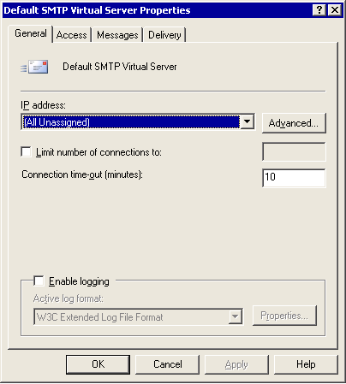

3. Under Default SMTP Virtual Server, verify the following settings:
• IP address The default setting is (All Unassigned). You should not change this setting unless you want to configure multiple SMTP virtual servers. (This is the IP address that is used for incoming connections.)
• If you have either multiple network interface cards (NICs) or multiple IP addresses that are assigned to a single NIC for this SMTP virtual server to listen on, and you want to select individual IP addresses, click Advanced, and then specify ports other than the default.
Note:
Use the Advanced option carefully. Other servers (on the Internet, for example) expect to communicate with your server on the default TCP port 25.

How to Verify that Your SMTP Virtual Server Allows Anonymous Access
As you know, other SMTP servers on the Internet expect your SMTP virtual server to connect to them anonymously. Remember that if you do not permit anonymous access on your gateway servers that accept Internet mail, other SMTP servers on the Internet are unable to send mail to your organization.

Before You Begin
Before you perform the procedure in this topic, read Connecting Exchange to the Internet.
The following permissions are required to perform this procedure:
• Member of the local administrators group and a member of a group that has had the Exchange View-Only Administrators role to view configuration, or the Exchange Administrators role to change configuration, applied at the administrative group level

Procedure
To verify that your SMTP virtual server allows anonymous access
1. Right-click your SMTP virtual server, and then click Properties.
2. Click the Access tab, and then click Authentication.
3. In Authentication, verify that the Anonymous accesscheck box is selected.
Authentication dialog box
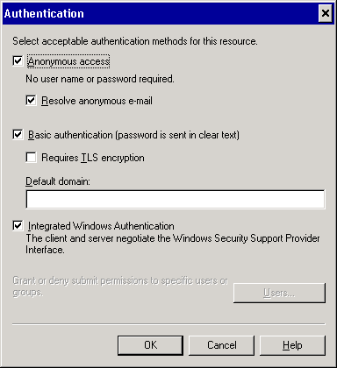

How to Verify that Recipient Policies Do Not Contain Addresses that Match the FQDN
Exchange Server uses recipient policies to determine which messages should be accepted and internally routed to mailboxes in your organization. Recipient policies that are configured improperly can disrupt message flow for some or all recipients in your messaging system. To ensure that your recipient policies are configured properly, verify the following:
• Verify that recipient policies do not contain an SMTP address that matches the FQDN of any Exchange servers in your organization. For example, if you have @exchangeserver.example.com listed as an SMTP address and as a domain name on any recipient policy, it prevents mail from routing to other servers in the routing group.
• Verify that the domain for which you want to receive SMTP mail is listed on a recipient policy—either on the default policy or another recipient policy. By verifying this, you ensure that your users can receive mail from other SMTP domains.
• Verify that you configured the necessary SMTP e-mail addresses to receive e-mail messages for additional domains. If you are not receiving e-mail messages for all of your SMTP domains, you may need to configure additional SMTP addresses for your recipients. For example, some of your users may currently receive e-mail messages addressed to contoso.com, but you also want them to receive e-mail addressed to fourthcoffee.com.
Perform the following procedure to verify that your recipient policies are configured correctly and match your mail domain (for example, @example.com) rather than the FQDN of your Exchange server (for example, @exchange.example.com).
For more information about why recipient policies cannot match the FQDN of Exchange servers, see Microsoft Knowledge Base article 288175, "XCON: Recipient Policy Cannot Match the FQDN of Any Server in the Organization, 5.4.8 NDRs." Although this article is written for Exchange 2000, the same principles apply to Exchange 2003.

Before You Begin
Before you perform the procedure in this topic, read Connecting Exchange to the Internet.
The following permissions are required to perform this procedure:
• Member of the local administrators group and a member of a group that has had the Exchange Administrators role applied at the administrative group level

Procedure
To verify that your recipient policies do not contain addresses that match the FQDN
1. In the console tree, expand Recipients, and then click Recipient Policies.
2. In the details pane, right-click a recipient policy that is configured on the server, and then click Properties.
3. On the E-Mail Addresses (Policy) tab of that policy, view the SMTP addresses that are configured by that policy and ensure that none of the SMTP addresses match the FQDN of any Exchange servers in your organization.
SMTP addresses on a recipient policy
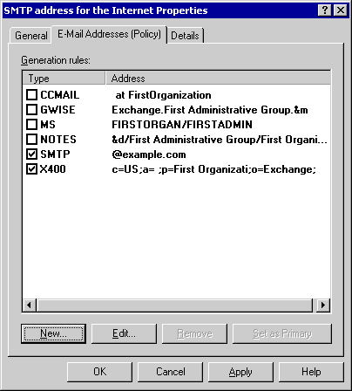

4. Repeat steps 2 and 3 of this procedure for each recipient policy that is configured on this server.

How to Verify that Users Can Receive E-mail Messages from Other SMTP Domains
To receive e-mail messages from other SMTP domains, your recipient policy must correctly specify the domain for which you want to receive mail.
Important:
By default, the SMTP domain name on the default recipient policy is the name of the domain in which Microsoft Active Directory® directory service resides. This default SMTP domain name is not always the same name you want to use for SMTP mail.
For example, if your organization is a large distributed corporation, you can use a unique SMTP address to create distinct e-mail addresses for the recipients in each division. For example, users in different divisions at the company Wingtip Toys could have addresses such as someone@administration.wingtiptoys.com and someone@marketing.wingtiptoys.com.
Perform the following procedure to confirm that recipients in your organization are able to receive mail from other SMTP domains.

Before You Begin
Before you perform the procedure in this topic, read Connecting Exchange to the Internet.
The following permissions are required to perform this procedure:
• Member of the local administrators group

Procedure
To verify that your users can receive e-mail messages from other SMTP domains
1. In Exchange System Manager, in the console tree, expand Recipients, and then click Recipient Policies.
2. In the details pane, right-click a recipient policy that is configured on this server, and then click Properties.
3. On the E-Mail Addresses (Policy) tab of that policy, view the SMTP addresses that are configured by that policy, and then ensure that the domain for which you want to receive SMTP mail is listed as an address. Verify that the check box next to the address is selected.
4. Double-click the SMTP address you want, and then, in SMTP Address Properties, verify that the This Exchange Organization is responsible for all mail delivery to this address check box is selected.
The SMTP Address Properties dialog box

Note:
If you have more than one recipient policy configured on a server, the SMTP e-mail address that you are attempting to verify may be located on another recipient policy.
5. If you have more than one recipient policy configured on a server, repeat steps 3 through 5 of this procedure for each recipient policy.

How to Configure the Necessary SMTP E-mail Addresses for Your Users
Use the following procedure to ensure that each user's e-mail address is correctly configured on a recipient policy. Remember that Microsoft® Exchange Server only accepts mail for addresses that are configured correctly in a recipient policy. These addresses are stored in Microsoft Active Directory® directory service and the IIS metabase where the message categorizer checks for address and configuration information.

Before You Begin
Before you perform the procedure in this topic, read Connecting Exchange to the Internet.
The following permissions are required to perform this procedure:
• Member of the local administrators group and a member of a group that has had the Exchange Administrators role applied at the organizational group level

Procedure
To configure the necessary SMTP e-mail addresses for your users
1. In Exchange System Manager, in the console tree, expand Recipients, and then click Recipient Policies.
2. In the details pane, right-click the recipient policy that you want to modify, and then click Properties.
3. On the E-Mail Addresses (Policy) tab, click New.
4. In New E-mail Address, click SMTP Address, and then click OK.
In SMTP Address Properties, in the Address box, type the information required by the address type you selected. For example, to route mail to Example Corporation, type @example.com as shown in the following figure.

For More Information
For more information about how to configure recipient policies, see Microsoft Knowledge Base article 260973, "XCON: Setting Up SMTP Domains for Inbound and Relay E-Mail in Exchange 2000 Server and Exchange Server 2003." Although this article is written for Exchange 2000, the same principles apply to Exchange 2003.
For more information about how to correct problems with SMTP proxy addresses, see Microsoft Knowledge Base article 140933, "XFOR: SMTP Proxy Address Generated Incorrectly." Although this article is written for Exchange 2000, the same principles apply to Exchange 2003.

How to Verify Relay Restrictions on an SMTP Virtual Server
By default, the default SMTP virtual server allows only authenticated users to relay e-mail. The default setting is preferred because it prevents unauthorized users from using your Exchange server to send e-mail messages to external domains. The most secure relay configuration requires authentication for anyone connecting from the Internet and attempting to relay.
Bridgehead servers that are connected to the Internet and accept Internet mail must generally accept anonymous connections. However, by default, these bridgehead servers do not allow anonymous relaying. Enabling anonymous relaying is strongly discouraged. If you allow anonymous relaying, other users can use your server to send spam. Subsequently, this activity could cause other Internet servers to block list your server.

Before You Begin
Before you perform the procedure in this topic, read Connecting Exchange to the Internet.
The following permissions are required to perform this procedure:
• Member of the local administrators group and a member of a group that has had the Exchange View-Only Administrators role to view configuration, or the Exchange Administrators role to change configuration, applied at the administrative group level

Procedure
To verify relay restrictions on an SMTP virtual server
1. Click Start, point to Programs, point to Microsoft Exchange, and then click System Manager.
2. Expand Servers, expand <Server Name>, expand Protocols, and then expand SMTP.
3. Right-click Default SMTP Virtual Server, and then click Properties.
4. In Default SMTP Virtual Server Properties, click the Access tab.
The Access tab in the Default SMTP Virtual Server Properties dialog box
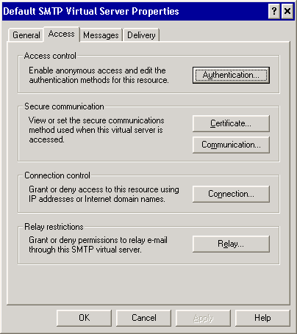

5. Under Relay restrictions, click Relay to verify relay restrictions. The Relay Restrictions dialog box appears.
Default relay restrictions in the Relay Restrictions dialog box

6. In Relay Restrictions, verify the following settings:
• Verify that Only the list below is selected. To list only those hosts that you want to allow to relay mail, click Add, and then follow the instructions. If you click All except the list below, your server may appear to be a server that is a source of unsolicited commercial e-mail on the Internet.
• Verify that the Allow all computers which successfully authenticate to relay, regardless of the list above check box is selected. This setting allows you to deny access to all users who do not authenticate. Any remote Post Office Protocol (POP) and Internet Message Access Protocol (IMAP) users accessing this server will authenticate to send mail. If you do not have users who access this server through POP or IMAP, you can clear this check box to prevent relaying entirely, thereby increasing security.

Configuring Inbound Settings on SMTP Virtual Servers
To configure your SMTP virtual server to receive Internet mail, you must perform the following tasks:
• Configure the inbound port as 25 and specify the IP address.
• Verify that your inbound SMTP virtual server allows anonymous access.
• For security reasons, verify the relay restrictions on your inbound virtual server. By default, relay settings allow only authorized users to relay mail.
Important:
You should verify that your SMTP virtual server settings are correct. You should also be familiar with the consequences of specific configuration choices when troubleshooting SMTP-related message flow issues.

Setting Up Your Exchange Server to Send Internet Mail
This section explains how to configure your Exchange server to send Internet mail. Specifically, you will learn how to:
• Configure outbound settings on SMTP virtual servers.
• Configure a smart host on an SMTP virtual server.
• Configure an SMTP connector.
Use the checklist in the following table to ensure that you complete all the necessary configuration steps to set up your Exchange server to send Internet mail. Each step is explained in detail in the following sections or earlier in this document.
Configuration steps to set up an Exchange server to send Internet mail
Step | Task | Notes
1 | Verify SMTP is properly loaded on your Exchange server. | See How to Load Exchange SMTP Properly.
2 | Verify that your DNS server can resolve external (Internet) names. | See "Configuring DNS for Outbound Mail" in Verifying DNS Design and Configuration.
3 | Verify that your SMTP virtual server's outbound port is set to 25. | Other SMTP servers on the Internet expect your SMTP virtual server to connect to them on port 25. See How to Verify that Your Outbound Port Is Set to Use Port 25.
4 | Verify that your outbound SMTP virtual server permits anonymous access. | Other SMTP servers on the Internet do not expect your SMTP server to authenticate. See How to Allow Anonymous Access on Your Outbound SMTP Virtual Server.
5 | If you must configure a smart host on your SMTP virtual server, verify that it is configured correctly. | It is recommended that you configure smart hosts on an SMTP connector, rather than on the virtual server itself. If you must configure a smart host on the SMTP virtual server, ensure that it meets the criteria specified in Configuring a Smart Host on a SMTP Virtual Server.
6 | Create an SMTP connector on your outbound SMTP virtual server with an address space of * (asterisk) to route Internet mail. | When you create an SMTP connector with an address space of *, Exchange routes all Internet mail through this connector. See How to Create an SMTP Connector.

Configuring Outbound Settings on SMTP Virtual Servers
The outbound settings on an SMTP virtual server control the ports and IP addresses through which outbound mail is sent. Connectors that are configured on bridgehead servers that route mail to the Internet use these settings. Most of these settings are configured on the Delivery tab in the SMTP virtual server properties.
To configure your SMTP virtual server to deliver outbound mail, you must:
• Ensure that the outbound port is set to port 25 (this is the default setting).
• Allow anonymous access for your outbound connection (this is the default setting).
• Set external DNS servers for SMTP to use, if desired. You can configure the SMTP virtual server to use an external DNS server; however, it is easier and more common to rely on internal DNS servers to forward DNS queries to the configured external DNS servers.
For detailed instructions, see the following topics:
• How to Verify that Your Outbound Port Is Set to Use Port 25
• How to Allow Anonymous Access on Your Outbound SMTP Virtual Server

How to Verify that Your Outbound Port Is Set to Use Port 25
To configure the outbound port that your server uses to deliver Internet mail, use the Delivery tab in the SMTP virtual server properties. If you use the same gateway servers to send and receive Internet mail, the inbound and outbound ports should be set to port 25.

Before You Begin
Before you perform the procedure in this topic, read Connecting Exchange to the Internet.
The following permissions are required to perform this procedure:
• Member of the local administrators group and a member of a group that has had the Exchange View-Only Administrators role to view configuration, or the Exchange Administrators role to change configuration, applied at the administrative group level

Procedure
To verify that your outbound port is set to use port 25
1. Right-click Default SMTP Virtual Server, and then click Properties.
2. In Default SMTP Virtual Server Properties, click the Delivery tab. On the Delivery tab, you can specify outbound settings such as retry timers, outbound security and connection limits, and other advanced settings.
The Delivery tab in Default SMTP Virtual Server Properties
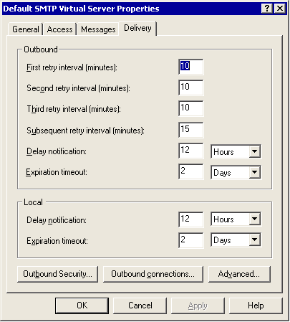

3. On the Delivery tab, click Outbound connections to set the TCP port that the server will use to connect to remote servers. The Outbound Connections dialog box appears.
The Outbound Connections dialog box
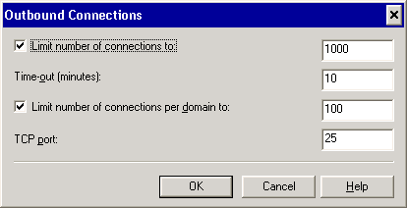

4. In Outbound Connections, verify that the TCP port is set to 25. Remote servers on the Internet expect your server to use TCP port 25. Changing TCP port to a value other than 25 is not recommended.

How to Allow Anonymous Access on Your Outbound SMTP Virtual Server
For your outbound SMTP virtual server, you should enable anonymous access unless you connect directly to a smart host. Remote servers on the Internet do not expect your server to authenticate.
Note:
Generally, configuring a smart host works better on a connector. Configuring a smart host on an SMTP virtual server is not the preferred method.

Before You Begin
Before you perform the procedure in this topic, read Connecting Exchange to the Internet.
The following permissions are required to perform this procedure:
• Member of the local administrators group and a member of a group that has had the Exchange Administrators role applied at the administrative group level

Procedure
To allow anonymous access on your outbound SMTP virtual server
1. Right-click <Your Outbound SMTP Virtual Server>, and then click Properties.
2. Click the Delivery tab.
3. Click Outbound Security to select the type of authentication the server will use with remote servers.
4. In Outbound Security, click Anonymous access.
The Outbound Security dialog box
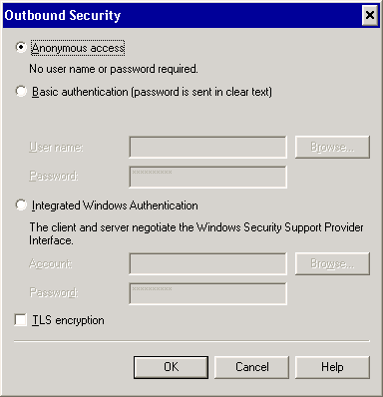

Note:
If you connect to a smart host (configured by clicking Advanced on the Delivery tab), the smart host may require you to authenticate. To discover if authentication is required, contact the owner of the smart host or your Internet service provider (ISP).

How to Create an SMTP Connector
SMTP connectors are an efficient way to route Internet mail. Use the following procedure to create an SMTP connector.

Before You Begin
Before you perform the procedure in this topic, read Connecting Exchange to the Internet.
The following permissions are required to perform this procedure:
• Member of the local administrators group and a member of a group that has had the Exchange View-Only Administrators role to view configuration, or the Exchange Administrators role to change configuration, applied at the administrative group level

Procedure
To create an SMTP connector
1. In Exchange System Manager, right-click Connectors, point to New, and then click SMTP Connector.
2. In Properties, on the General tab, in the Name box, type a name for the connector.
SMTP connector properties
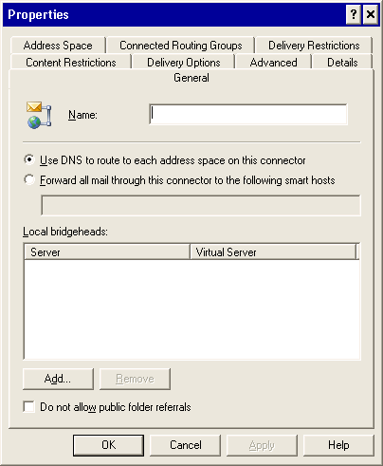

3. Select one of the following check boxes:
• If you want this connector to use DNS names to route mail directly to the remote server, select Use DNS to route to each address space on this connector. By selecting this option, the connector uses the DNS server that is configured to route e-mail messages. If you select this check box, verify the following information:
• Verify that you can use Nslookup to successfully resolve names on the Internet. For more information about routing topology, see Configuring a Routing Topology.
• If you want to route mail to a smart host that assumes responsibility for DNS name resolution and mail delivery, select the Forward all mail through this connector to the following smart hosts check box. This option is often used if you route mail to a Windows SMTP server or another server in your perimeter network. If you select this check box, verify the following information:
• If you list an IP address for the smart host, enclose the IP address in square brackets, for example, [10.0.0.1].
• If you specify an IP address for the smart host, it should not match the IP address of this server.
• If you specify a name for the smart host, the name should be a FQDN. For example, "Server Name" is not an FQDN; however, servername.contoso.com is a FQDN.
• If a name is specified, it should not be the FQDN of this server.
• If you do not have a smart host within your network, contact your ISP to find out what IP address or FQDN you should enter here.
4. Under Local bridgeheads, click Add to define at least one bridgehead server and SMTP virtual server. To send outbound mail, the connector uses the outbound port that is configured on the SMTP virtual server.

Configuring a Smart Host on a SMTP Virtual Server
Problems may occur if you set the smart host at the virtual server level, rather than at the SMTP connector level. When you configure the smart host at the virtual server level, consider the following restrictions:
Note:
The following smart host settings are located in the Advanced Delivery dialog box. To access this dialog box, in <Your Outbound SMTP Virtual Server> Properties, on the Delivery tab, click Advanced.
• If your Exchange organization contains more than one computer running Exchange, you should not type any data in the Smart host box. Mail flow between servers may not work.
• If an IP address is listed in the Smart host box, it should be enclosed in square brackets, for example, [10.0.0.1].
• If an IP address is listed in the Smart host box, verify that it does not match the IP address of this Exchange server.
• If a name is listed in the Smart host box, it should be a FQDN. For example, "Server Name" is not a FQDN; however, servername.contoso.com is a FQDN.
• If a name is listed in the Smart host box, it should not be the FQDN of this server.
• If you do not have a smart host within your network, contact your ISP to find out what IP address or FQDN you should enter here.
• If you do enter a smart host, select the Attempt direct delivery before sending to smart host check box. Selecting this check box may help reduce queuing on this server.
• Using multiple smart hosts and load balancing requests across them requires a specific configuration.
For detailed instructions, see the following topics:
• How to Create an SMTP Connector
• How to Specify an Address Space for the Connector

Configuring Advanced Settings
This section explains how to configure some of the advanced settings that control Internet mail delivery. Although these settings are not essential for mail flow, they can assist you in performance tuning, controlling access to your SMTP virtual servers, and many other areas.
Specifically, you will learn how to:
• Configure advanced inbound settings.
• Configure advanced outbound settings.
• Configure advanced settings on the SMTP connector.
• Configure the notification of delivery reports.
For detailed instructions about configuring access controls and security settings, see the following topics:
• How to Configure Access Controls and Authentication Methods
• How to Specify Message Limits

Configuring Advanced Inbound Settings
This section shows you how to configure advanced settings for inbound mail. Specifically, you will learn how to:
• Configure access controls and other security settings.
• Configure message filters.
• Set limits for incoming messages.
For detailed instructions, see the following topics:
• How to Ensure your Exchange Server Does Not Use RTF Exclusively
• How to Set Outbound Message Limits on Your SMTP Virtual Server

Configuring Advanced Outbound Settings
This section shows you how to configure advanced settings to control outgoing mail. Specifically, you will learn how to configure Internet mail message formats, outbound message limits, and advanced connector settings.

Configuring Advanced Settings on the SMTP Connector
The SMTP connector offers several configuration options, which you can use to tailor your specifications for e-mail messages that are routed through this server. With the exception of message size limits, the settings on the SMTP connector override the settings on the SMTP virtual server. In this case, the lowest size limit is enforced.
In this section you will learn how to perform the following tasks:
• Specify delivery restrictions.
• Set a connector schedule for connecting to a network service provider.
• Set content restrictions on an SMTP connector.
• Configure how non-delivery reports are handled.
For detailed instructions, see the following topics:
• How to Enable Registry Keys for Delivery Restrictions
• How to Set Delivery Restrictions on the SMTP CONNECTOR
• How to Set a Connector Schedule
• How to Set Content Restrictions on an SMTP Connector
• How to Specify How Undeliverable Mail is Managed

How to Specify an Address Space for the Connector
A connector's address space defines the domain or range of domains to which a connector sends mail. You can specify which address groups that a specific connector will handle. If you use multiple SMTP connectors to route Internet mail, at least one connector should have an address space of * (asterisk). The asterisk represents all external domains.

Before You Begin
Before you perform the procedure in this topic, read Connecting Exchange to the Internet.
The following permissions are required to perform this procedure:
• Member of the local administrators group and a member of a group that has had the Exchange Administrators role applied at the administrative group level

Procedure
To specify an address space for the connector
1. In the SMTP connector Properties, click the Address Space tab.
2. Click Add. The Add Address Space dialog box appears.
The Add Address Space dialog box
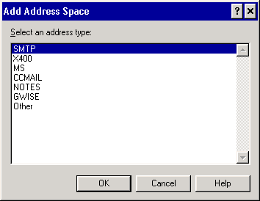

3. Under Select an address type, click SMTP, and then click OK. The Internet Address Space Properties dialog box appears.
The Internet Address Space Properties dialog box
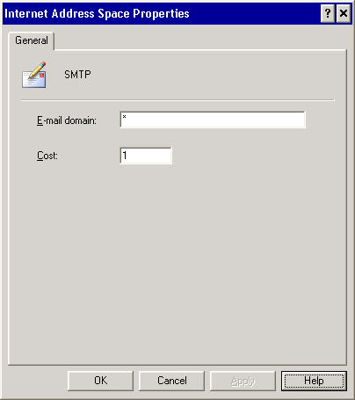

Important:
In Internet Address Space Properties, in the E-mail domain box, there is a default value of *. The * represents all addresses. At least one connector in your organization should have this address space to ensure that all external domains are routed to the Internet.
4. In Internet Address Space Properties, in the E-mail domain box, type an e-mail domain for the connector. In the Cost box, assign an appropriate cost for this connector. For example, if you want all users to always use this connector and only use a backup connector if this connector is unavailable, assign this connector a cost of 1 and assign the secondary connector a higher cost. Remember that Exchange always chooses the route with the lowest cost, if that route is available.
Important:
Do not list your inbound domains on an SMTP address space for a connector. Your inbound domains are listed in your recipient policies. If some or all of your inbound domains are listed, you may receive NDRs that indicate a mail loop (these NDRs may have the diagnostic code 5.3.5). By specifying domains on the Address Space tab, you can configure these domains as routable domains.
5. Click OK to return to the Address Space tab.
6. Under Connector scope, select one of the following based on your routing topology:
• Select Entire organization if you want users in any routing group to be able to send Internet mail through this connector. With this option selected, all Exchange servers in the organization can route mail through this connector to the Internet.
• Select Routing Group if you want only users in this bridgehead server's routing group to send mail through this connector.
Note:
For more information about assigning costs and scoping, see Understanding Connector Scope and Restrictions.
7. If you want mail to be relayed through your system to the domains that you specified, select the Allow messages to be relayed to these domains check box.
Note:
Do not select this check box if you are creating a connector with an address space of *.
8. Click OK.

How to Configure Access Controls and Authentication Methods
For SMTP virtual servers, you can specify what types of connections are accepted or denied, and you can require user authentication before mail delivery. If you support IMAP or POP clients that connect from the Internet, authentication methods are useful. However, on an SMTP virtual server that acts as an Internet gateway, you cannot require authentication if you want to receive mail from users on the Internet.

Before You Begin
Before you perform the procedure in this topic, read Connecting Exchange to the Internet.
The following permissions are required to perform this procedure:
• Member of the local administrators group and a member of a group that has had the Exchange Administrators role applied at the administrative group level

Procedure
To configure access controls and authentication methods
1. Right-click Default SMTP Virtual Server, and then click Properties.
2. Click the Access tab, and then, under Access control, click Authentication to specify the ways in which users must be authenticated prior to sending mail to this server. The Authentication dialog box appears.
The Authentication dialog box
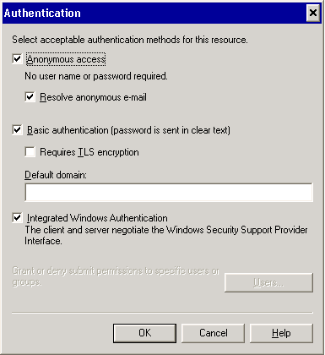

3. In Authentication, the following check boxes are available:
• Anonymous access Typically, you select this check box for servers that are directly connected to the Internet. If you select this check box, other servers on the Internet will not authenticate to this server prior to sending mail. For increased security, disable anonymous access on your internal SMTP virtual servers that do not accept incoming Internet mail. For similar security purposes, you can also disable anonymous access on dedicated SMTP virtual servers that are used for remote IMAP and POP users.
Note:
If the Anonymous access check box is not selected on your Internet gateway servers, you may not receive incoming mail from the Internet. However, for internal SMTP virtual servers or SMTP virtual servers that are used exclusively by IMAP and POP users, you can clear this check box because they must authenticate.
• Basic authentication Use this check box for mail clients (such as Microsoft Outlook) that use Post Office Protocol version 3 (POP3) or Internet Message Access Protocol version 4rev1 (IMAP4) to connect to the server. To send e-mail messages, these clients authenticate to the server.
Important:
If you select the Basic authentication (password is sent in clear text) check box, user names and passwords are sent across the network in clear text. This information can be easily intercepted on the Internet. If you use basic authentication, consider implementing Transport Layer Security (TLS) for more security.
• Requires TLS encryption Use this check box if you have a digital certificate, which is common in a high-security environment. If you select this check box, in the corresponding Default domain box, you must type the Windows 2000 or Windows Server 2003 domain name that the user should authenticate against if he or she does not specify a domain. For more information about TLS encryption, see the Exchange online documentation.
• Integrated Windows Authentication This check box is used only by Windows user accounts. Using the NTLM protocol, user names and passwords are encrypted and are then passed to the SMTP virtual server for authentication purposes.
Note:
By default, the Anonymous access, Basic authentication, and Integrated Windows Authentication check boxes are selected. If you are using a single default virtual server, it is recommended that you use the default settings; this allows users to authenticate by using the most common methods.
4. In <SMTP Virtual Server> Properties, on the Access tab, under Secure communication, click Certificate to configure a certificate (used for TLS encryption) that encrypts messages as they move from server to server. For more information about TLS encryption, see the Exchange online documentation.
5. On the Access tab, under Connection control, click Connection to allow or deny access to the server based on IP address. If you are using multiple SMTP virtual servers, and you want to deny access to specific hosts, you must perform the following procedure for each virtual server:
a. In Connection, click All except the list below for servers directly connected to the Internet.
b. To list only those hosts from which you do not want to receive mail, click Add and then follow the instructions in the Computer dialog box. You can include any servers that you consider to be the source of spam.
c. Click OK twice to apply the settings.

How to Specify Message Limits
On the Messages tab of the virtual server's properties, you can configure the default number of recipients per message. Reducing this number can mitigate the effects of spam by preventing the delivery of a single message to a large number of users. You can also decrease the maximum message size and the length of each session.
Note:
If your organization uses large distribution lists that arrive through SMTP from Internet users, reducing the number of recipients per message can affect your users. However, MAPI recipients, such as Outlook users, are not affected by the reduction.

Before You Begin
Before you perform the procedure in this topic, read Connecting Exchange to the Internet.
The following permissions are required to perform this procedure:
• Member of the local administrators group and a member of a group that has had the Exchange Administrators role applied at the administrative group level

Procedure
To specify message limits
1. Right-click the SMTP virtual server that you want to configure, and then click Properties.
2. Click the Messages tab to specify message limits for this server.
The Messages tab in the Default SMTP Virtual Server Properties dialog box
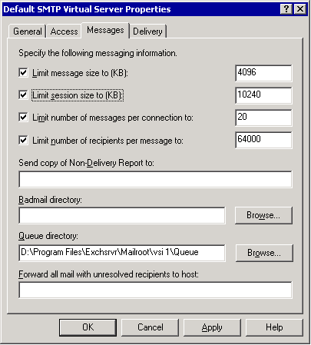

3. Under Specify the following message information, select the Limit message size to (KB) check box to limit the maximum message size. To prevent users from sending large documents, type a small value in the corresponding box. If you do not set a limit to the maximum message size, it can affect performance. It is recommended that you set a limit equal to the maximum message size that is appropriate for your organization.
Note:
Documents expand in size approximately 33 percent when sent outside the routing group or organization. For example, if you want to send documents up to 3MB in size, set the maximum message size to 4,096KB.
4. Select the Limit session size to (KB) check box, and type a value that is larger than the maximum message size.
5. Select the Limit number of messages per connection to check box to configure the system to drop the connection after it reaches the specified number of messages. This default setting optimizes message flow in most messaging topologies. However, selecting this check box can lead to slight performance degradation if your system receives many messages from a single source.
6. Select the Limit number of recipients per message to check box to have Exchange Server return a non-delivery report (NDR) to senders whose messages exceed the maximum number of recipients. Selecting this check box allows you to keep users from sending an e-mail message to an excessive number of recipients.

How to Ensure your Exchange Server Does Not Use RTF Exclusively
For each domain that is listed in Internet Message Formats, you can configure how you send Internet mail messages. As a general rule, do not send mail exclusively in rich text format (RTF) because many non-Microsoft mail servers cannot read rich-text messages. Instead, users receive an empty e-mail message with a winmail.dat file attachment. To avoid this problem, ensure that your global message setting does not use the Exchange RTF exclusively.

Before You Begin
Before you perform the procedure in this topic, read Connecting Exchange to the Internet.
The following permissions are required to perform this procedure:
• Member of the local administrators group and a member of a group that has had the Exchange Administrators role applied at the administrative group level

Procedure
To ensure that your Exchange server does not use RTF exclusively
1. In Exchange System Manager, expand Global Settings, and then click Internet Message Formats.
2. In the details pane, right-click the name you want, and then click Properties.
3. Click the Advanced tab.
4. Under Exchange rich-text format, ensure that either Never use or Determined by individual user settings is selected.
The Advanced tab for Internet Message Formats
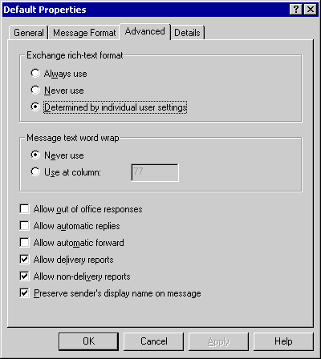

Note:
Selecting Always Use can prevent users on non-Microsoft servers from reading your e-mail messages. They may receive an e-mail message with a winmail.dat file attachment.

How to Set Outbound Message Limits on Your SMTP Virtual Server
On your SMTP virtual server that handles outbound mail delivery, you can configure connection limits and time-out settings that the server uses with remote servers. Configure these limits to ensure that your server does not get overloaded.

Before You Begin
Before you perform the procedure in this topic, read Connecting Exchange to the Internet.
The following permissions are required to perform this procedure:
• Member of the local administrators group and a member of a group that has had the Exchange Administrators role applied at the administrative group level

Procedure
To set outbound message limits on your SMTP virtual server
1. Click Start, point to Programs, point to Microsoft Exchange, and then click System Manager.
2. In the console tree, expand Servers, expand <Server Name>, expand Protocols, and then expand SMTP.
3. Right-click <Your Outgoing SMTP Virtual Server>, and then click Properties.
4. Click the Delivery tab.
5. Under Outbound,you can modify the time in minutes for first, second, third, and subsequent retry attempts by entering the appropriate values for your organization. These outbound settings control message delivery for mail that is sent outside of the organization.
Outbound settings on the Delivery tab

Note:
Setting a retry interval to too low of a value may degrade performance, particularly when your Internet connection or the specified smart host is unavailable.
6. Under Local, set Delay notification and Expiration timeout for local message delivery by typing the values in the corresponding boxes, and then selecting the time in Minutes, Hours, or Days. It is recommended that you use the default settings. These local settings apply to mail that is sent to the local mailbox store or in Microsoft Exchange MTA.
Note:
Systems on the Internet may have different values for delay notification and expiration timeout. The values entered here refer to messages that are queued on this server.
7. Click Outbound connections to configure connection limits and timeout values that the server uses with remote servers. The Outbound Connections dialog box appears.
The Outbound Connections dialog box

8. Depending on your hardware, you can select the Limit number of connections to check box to limit connections to other servers and to reduce traffic. You can also select the Limit number of connections per domain to check box. After you select the check boxes, enter the appropriate values for your organization.
9. Depending on your bandwidth and connection quality, you can change the Time-out (minutes) value.
Note:
Reducing the number of outbound connections and increasing the time-out period may cause all your outbound connections to wait for responses from remote servers. With such settings, e-mail messages remain in the queue for longer periods of time (potentially causing a delay in message delivery), but network traffic is kept to a minimum.

How to Enable Registry Keys for Delivery Restrictions
The default setting allows everyone in your organization to use the SMTP connector. In most situations, the default setting is sufficient because you generally want your users to be able to send Internet mail. If you want to set more rigid restrictions, use the following procedure and How to Set Delivery Restrictions on the SMTP Connector to set delivery restrictions.
You can use the Delivery tab to restrict the use of your connector. However, to enable these restrictions, you must also change certain registry key settings.
Important:
Be aware that restricting delivery is extremely process-intensive and can affect server performance.
A registry key on the Exchange Server 2003-based bridgehead server, which is the source for the connector that is being checked, controls the restriction-checking functionality. If you need to configure a connector to restrict who can send data to the designated link, you must manually add the restriction-checking registry value.
Note:
Incorrectly editing the registry can cause serious problems that may require you to reinstall your operating system. Problems resulting from editing the registry incorrectly may not be able to be resolved. Before editing the registry, back up any valuable data.

Before You Begin
Before you perform the procedure in this topic, read Connecting Exchange to the Internet and How to Set Delivery Restrictions on the SMTP Connector.
The following permissions are required to perform this procedure:
• Member of the local administrators group

Procedure
To enable the registry keys for delivery restrictions
1. Start Registry Editor: From a command prompt, type Regedit.exe.
2. Navigate to and select the following key in the registry:
HKEY_LOCAL_MACHINE/System/CurrentControlSet/Services/RESvc/Parameters/
3. On the Edit menu, click Add Value, and then add the following registry value:
Value Name: CheckConnectorRestrictions
Data Type: REG_DWORD
Date: 1
Radix: Decimal

4. Exit Registry Editor: On the Registry menu, click Exit.
5. After enabling the registry key setting, you need to restart the following services on your Exchange server:
• Microsoft Exchange MTA Stacks (MSExchangeMTA)
• Microsoft Exchange Routing Engine (RESvc)
• Simple Mail Transfer Protocol (SMTPSVC)

How to Set Delivery Restrictions on the SMTP Connector
The default setting allows everyone in your organization to use the SMTP connector. In most situations, the default setting is sufficient because you generally want your users to be able to send Internet mail. If you want to set more rigid restrictions, use the How to Enable Registry Keys for Delivery Restrictions procedure and the following procedure to set delivery restrictions. After enabling the registry key and restarting the services, you can set delivery restrictions on the SMTP connector.

Before You Begin
Before you perform the procedure in this topic, read Connecting Exchange to the Internet and How to Enable Registry Keys for Delivery Restrictions.
The following permissions are required to perform this procedure:
• Member of the local administrators group and a member of a group that has had the Exchange Administrators role applied at the administrative group level

Procedure
To set delivery restrictions on the SMTP connector
1. In Exchange System Manager, expand Connectors by performing one of the following steps:
• If you do not have routing groups or administrative groups displayed, expand your Exchange organization, and then expand Connectors.
• If you have only routing groups displayed, expand Routing Groups, expand <Routing Group Name>, and then expand Connectors.
• If you have only administrative groups displayed, expand Administrative Groups, expand <Administrative Group Name>, and then expand Connectors.
• If you have administrative groups and routing groups displayed, expand Administrative Groups, expand <Administrative Group Name>, expand Routing Groups, expand <Routing Group Name>, and then expand Connectors.
2. Right-click <your SMTP connector>, and then click Properties.
3. Click the Delivery Restrictions tab.
The Delivery Restrictions tab of the SMTP Connector Properties dialog box

4. To accept messages from everyone, but to reject specified users:
a. Under By default messages from everyone are, verify that Accepted is selected.
b. Under Reject messages from, click Add, and then, in Select Recipient, type each user or group's name that you want to prevent from using the connector.
5. To reject messages from everyone but specified users:
a. Under By default messages from everyone are, click Rejected.
b. Under Accept messages from, click Add, and then, in Select Recipient, type each user's name that you want to allow to use the connector.

How to Set a Connector Schedule
If you are using an SMTP connector to connect to a network service provider and download your Internet e-mail messages, you may want to schedule specific times for the connector to contact the network service provider's server. Alternatively, you can specify that a connector hold e-mail messages until a remote server triggers delivery.

Before You Begin
Before you perform the procedure in this topic, read Connecting Exchange to the Internet.
The following permissions are required to perform this procedure:
• Member of the local administrators group and a member of a group that has had the Exchange Administrators role applied at the administrative group level

Procedure
To set a connector schedule
1. In Exchange System Manager, expand Connectors by performing one of the following steps:
• If you do not have routing groups or administrative groups displayed, expand your Exchange Server organization, and then expand Connectors.
• If you have only routing groups displayed, expand Routing Groups, expand <Routing Group Name>, and then expand Connectors.
• If you have only administrative groups displayed, expand Administrative Groups, expand <Administrative Group Name>, and then expand Connectors.
• If you have administrative groups and routing groups displayed, expand Administrative Groups, expand <Administrative Group Name>, expand Routing Groups, expand <Routing Group Name>, and then expand Connectors.
2. Right-click <your SMTP connector>, and then click Properties.
3. Click the Delivery Options tab.
The Delivery Options tab of the SMTP Connector Properties dialog box
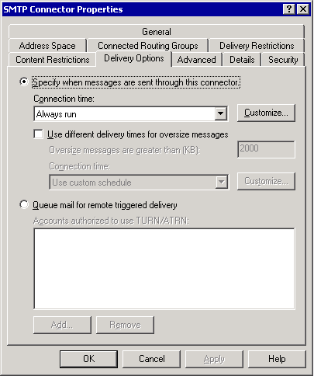

4. To specify a time when the connector runs, click Specify when messages are sent through this connector.
5. In the Connection time list, select a time or click Customize to create a custom schedule.
6. To schedule a different time for the connector to deliver oversize messages, select the Use different delivery times for oversize messages check box. If you select this check box, the following options appear:
• Oversize messages are greater than (KB) In this box, type a threshold number that defines oversize messages.
• Connection time In this list, select a time or click Customize to create a custom schedule.
7. To hold e-mail messages until a remote server triggers delivery, click Queue mail for remote triggered delivery, and then click Add to add authorized accounts that can trigger remote delivery.

How to Set Content Restrictions on an SMTP Connector
You can restrict the type of messages that are delivered through a connector. For example, if you have special business or administrative requirements, you can restrict the message type to only high-priority mail through a particular connector.

Before You Begin
Before you perform the procedure in this topic, read Connecting Exchange to the Internet.
The following permissions are required to perform this procedure:
• Member of the local administrators group and a member of a group that has had the Exchange Administrators role applied at the administrative group level

Procedure
To set content restrictions on an SMTP connector
1. Click Start, point to Programs, point to Microsoft Exchange, and then click System Manager.
2. In the console tree, go to Connectors by performing one of the following steps:
• Under the Exchange organization, expand Connectors.
• If you do not have routing groups defined, expand Administrative Groups, expand <Administrative Group Name>, and then expand Connectors.
• If you have routing groups defined, expand Administrative Groups, expand <Administrative Group Name>, expand Routing Groups, expand <Routing Group Name>, and then expand Connectors.
3. Right-click <your SMTP connector>, and then click Properties.
4. Click the Content Restrictions tab.
The Content Restrictions tab of the SMTP Connector Properties dialog box
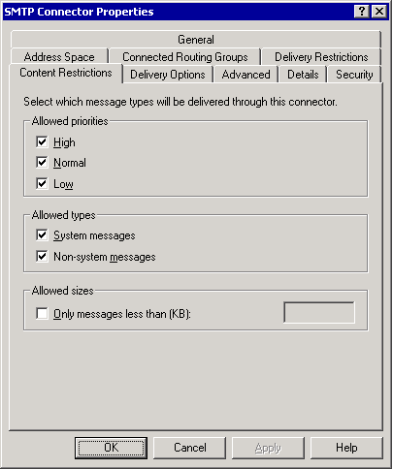

5. Under Allowed priorities, select each type of priority messages that you want to send through the connector.
6. Under Allowed types, select each type of message (system or non-system) that you want to send through the connector.
7. Under Allowed sizes, if you want to set a size restriction, select the Only messages less than (KB) check box, and then type a size limit.

How to Specify How Undeliverable Mail is Managed
Use the following procedure to control how undeliverable mail is handled on a specific virtual server. You can always use the postmaster account to handle all non-delivery reports (NDR) for an organization. If you are sharing a namespace with another mail system, and you want to accept mail for these users and forward this mail to the other system by designating it as a smart host, specifying undeliverable mail handling on a virtual server can be useful.

Before You Begin
Before you perform the procedure in this topic, read Connecting Exchange to the Internet.
The following permissions are required to perform this procedure:
• Member of the local administrators group and a member of a group that has had the Exchange Administrators role applied at the administrative group level

Procedure
To specify how undeliverable mail is managed
1. Click Start, point to Programs, point to Microsoft Exchange, and then click System Manager.
2. In the console tree, expand Servers, expand <Server Name>, expand Protocols, and then expand SMTP.
3. Right-click the SMTP virtual server that you want, and then click Properties.
4. Click the Messages tab.
The Messages tab in the Default SMTP Virtual Server Properties dialog box

5. In the Send copy of Non-Delivery Report to box, type the SMTP address of the Exchange administrator who you want to receive copies of NDRs. You can use the NDRs to help you diagnose user problems. For more information about examining NDRs, see Troubleshooting Non-Delivery Report Messages.
Note:
NDRs often occur because users type the wrong e-mail address. You may want to disable this feature until you experience problems and need to investigate NDRs.
6. In the Badmail directory box, you can modify the location of the messages that are misrouted and cannot be delivered. It is recommended that you keep the default location. The default location is \Exchsrvr\Mailroot\vsi #virtual server instance\badmail.
Caution:
Moving the Badmail directory to a disk that is separate from the queuing directory may degrade performance and make it difficult to track bad messages.
7. In the Forward all mail with unresolved recipients to host box, you can specify an alternate host to which undeliverable messages are forwarded. This is useful if you are sharing a namespace with another mail system—specifically if there are mail recipients with your domain name who do not belong to the Exchange organization. For example, exchange.user@contoso.com resides in the Exchange organization, and unix.user@contoso.com resides outside the Exchange organization. In this example, users at exchange.user@contoso.com can send mail to users at unix.user@contoso.com, and Exchange forwards the message to the specified alternate host.

Part Three
Network attacks are more common than ever, and that trend is likely to continue. Therefore, after configuring mail flow in your Exchange organization, it is crucial that you take measures to help secure this mail flow. Messages that are routed to and from Microsoft® Exchange servers and other external systems also travel across your local network and over the Internet. To prevent malicious Internet users from intercepting your organization's mail and attacking your servers, it is important that you secure your Internet connections. The three types of Internet connectivity are:
• Using connectors over the Internet to have e-mail connectivity between your organization and other external systems.
• Using connectors to connect Exchange routing groups within your organization over the Internet.
• Allowing Exchange clients to use Internet mail protocols or Microsoft Office Outlook® Web Access to access Exchange mailboxes in your organization.
Generally, each of these types of connectivity require a different level of security. The sections in Part 3 address various ways to secure your Exchange organization:
• Securing Your Infrastructure
This section focuses on methods that you can use to help protect your infrastructure by disabling unnecessary services in Internet Information Services (IIS) and by using firewalls and virtual private networks.
• Securing Your Exchange Server
This section discusses general security practices that you can use to protect your Exchange servers.
• Configuring Filtering and Controlling Spam
This section explains how to control unsolicited commercial e-mail, also known as spam, by using Exchange recipient, sender, and connection filtering.
Note:
For more information about securing Exchange, see the Exchange Server 2003 Security Hardening Guide.

Securing Your Infrastructure
This topic focuses on important infrastructure components that you can implement for greater security. It discusses the following:
• Securing your Internet Information Services (IIS) framework to protect Internet services.
• The importance of firewalls in protecting servers from direct Internet access.
• Using virtual private networks as a secure means of accessing private network resources.

Securing IIS
As discussed in "Internet Information Services" in Transport Dependencies for Exchange Server 2003, IIS provides a framework for Internet services such as HTTP, Simple Mail Transfer Protocol (SMTP), Internet Message Access Protocol (IMAP), and Network News Transfer Protocol (NNTP). Therefore, it is essential that you ensure IIS is secure. The way in which you can secure IIS differs depending on which version of Microsoft® Windows® you are running on your Exchange server. Windows 2000 Server provides the IIS Lockdown Wizard; Windows Server 2003™ provides URLScan. Use the appropriate tool for your version of Windows to secure IIS.

Using IIS Lockdown Wizard on Windows 2000 Server
On Windows 2000 Server, the IIS Lockdown Wizard provided for IIS 5.0 disables unnecessary IIS services, thereby reducing your exposure to attack through these services. To defend against attackers, IIS Lockdown Wizard integrates URLScan with customized templates for Exchange servers. IIS Lockdown Wizard is designed primarily to secure Microsoft Office Outlook® Web Access servers and front-end servers; however, it is also useful for checking the security configuration on any Exchange server.
For optimal security, run IIS Lockdown Wizard on each Exchange server and domain controller in your organization. You can download IIS Lockdown Wizard from the Microsoft Download Center.
For more information about IIS Lockdown Wizard, see Microsoft Knowledge Base article 309508, "XCCC: IIS Lockdown and URLscan Configurations in an Exchange Environment."
Some issues exist when running IIS Lockdown Wizard twice. For more information, about running IIS Lockdown Wizard twice, see Microsoft Knowledge Base article 317052, "HOW TO: Undo Changes Made by the IIS Lockdown Wizard."

Running URLScan on Windows Server 2003
IIS Lockdown Wizard is not available for Windows Server 2003; however, you can run URLScan to secure IIS on Windows Server 2003. URLScan version 2.5 is a security tool that restricts the types of HTTP requests that IIS will process. By blocking specific HTTP requests, the URLScan security tool helps prevent potentially harmful requests from reaching your Exchange server.
For more information about the URLScan tool, see Microsoft Knowledge Base article 823175, "Fine-Tuning and Known Issues When You Use the Urlscan Utility in an Exchange 2003 Environment."

Using Firewalls
A firewall prevents unauthorized access to data on servers that reside behind the firewall. Whether your organization has an existing network or is setting up a new one, firewall planning is extremely important.
With software such as Microsoft Internet Security and Acceleration (ISA) Server, you can route all Internet traffic through a single location. Although this requires more setup and planning than a simple direct Internet connection, it provides increased security for the servers in your organization.
You can use a firewall to allow only essential Internet traffic through ports that you specify. For example, you can configure your network to allow only SMTP (port 25) traffic to pass through your firewall, thereby preventing connections on all other ports.
For Exchange to operate properly in a firewall environment, specifically in regard to remote clients, certain requirements are necessary to maintain Internet connectivity. For instance, firewalls can filter certain TCP ports or block them entirely. Therefore, for remote clients and servers to communicate through a firewall, you cannot change or block the port assignments for the various protocols that Exchange supports. For more information about the ports that Exchange requires, see "Common Ports Used by Exchange" in SMTP Commands and Definitions and Microsoft Knowledge Base article 278339, "XGEN: TCP/UDP Ports Used By Exchange 2000 Server." Although this article was written for Exchange 2000 Server, the same information applies to Exchange 2003.
If you need a simple SMTP server in the perimeter network of a firewall, often a Windows 2000 Server or Windows Server 2003 SMTP service computer is all that is necessary. Exchange 2003 Enterprise Server, Windows 2000 Server or Windows Server 2003 Network Address Translation (NAT), Microsoft ISA Server, or any solution that buffers the Internet from the internal LAN can add additional security.
If you do not implement a firewall connection to the Internet, you must consider how security will be affected. All Exchange servers within a network that have a direct connection to the Internet are exposed to the Internet.

Using Virtual Private Networks
The Windows 2000 Server and Windows Server 2003 Routing and Remote Access Service (RRAS) is an open, extensible platform for routing and internetworking. RRAS offers remote access over the Internet and to organizations in LAN and WAN environments by using secure virtual private network (VPN) connections. VPNs are secure, authenticated links across public or private networks, such as the Internet.
The Windows 2000 Server and Windows Server 2003 Remote Access Service (RAS) and RRAS tools offer options that remote users can use for dial-up Internet access. To function properly, these access services require the following:
• A remote connection method called Point-to-Point Tunneling Protocol (PPTP).
• An Internet connection to create a VPN.
PPTP is designed to support VPNs. Because of Digital Subscriber Line (DSL) and cable modem Internet connections, VPNs are less expensive to establish and support than traditional WANs. A VPN eliminates long-distance telephone charges and offers secure connections, mutual authentication, and packet filtering.
After a PPTP server authenticates a remote client, the VPN connection opens. The PPTP session acts as a tunnel through which network packets flow. The packets are first encrypted when sent. The packets then travel through the tunnel and are decrypted upon receipt. For example, an organization can allow remote clients to connect to a corporate network across the Internet using a VPN. Although a broadband connection is not required for a VPN, a broadband VPN connection can benefit remote VPN users. By using a broadband VPN connection, users can connect to a corporate network over the Internet and then use the corporate network as if they were directly logged on to it.

Securing Your Exchange Server
This topic focuses on ways that you can secure your Microsoft® Exchange server. You can help protect your servers by performing the tasks below, which are each explained in detail in the following sections:
• Disable open relaying on all SMTP virtual servers. The default relay restrictions prevent unauthorized users from using your Exchange server to send mail to external locations. If your server is open for relaying, unauthorized users can use your server to send spam. As a result, your server may become known to other organizations as a source for open relay and, as a consequence, blocked from sending legitimate mail.
• Prevent anonymous access on internal SMTP virtual servers and dedicated SMTP virtual servers for IMAP and POP clients. Because all Exchange servers within your organization authenticate with each other to send mail, you do not need to enable anonymous access on your internal Simple Mail Transfer Protocol (SMTP) virtual servers. Additionally, all Post Office Protocol (POP) and Internet Message Access Protocol (IMAP) clients authenticate with your SMTP virtual server, so anonymous access is not required on a server that is used exclusively by POP and IMAP clients. If you disable anonymous access on these servers, you can prevent unauthorized users from accessing them.
• Restrict submissions and relaying access on internal SMTP virtual servers. In Microsoft Exchange Server 2003, you can further restrict access to SMTP virtual servers by using security principles through the standard Microsoft Windows® 2000 Server or Windows Server™ 2003 Discretionary Access Control List (DACL). This ability enables you to grant explicit permissions to users and groups that you want to allow to use an SMTP virtual server.

Disabling Open Relaying on All SMTP Virtual Servers
As explained in Setting Relay Restrictions, it is essential that you do not allow anonymous or open relaying on your SMTP virtual servers. Relaying is when a user uses your Exchange server to send mail to an external domain.
In its default configuration, Exchange allows only authenticated users to relay mail—in other words, only authenticated users can use Exchange to send mail to an external domain. If you modify the default relay settings to allow unauthenticated users to relay, or if you allow open relaying to a domain through a connector, unauthorized users can use your Exchange server to send spam. As a result, your server may be block listed and thereby be prevented from sending mail to legitimate remote servers. To prevent unauthorized users from using your Exchange server to relay mail, you should always use the default relay restrictions.
Note:
Relaying is often confused with spam. Relay control does not block spam. For more information about controlling spam, see Configuring Filtering and Controlling Spam.
For more information about how to control relaying, see Microsoft Knowledge Base article 304897, "XIMS: Microsoft SMTP Servers May Seem to Accept and Relay E-Mail Messages in Third-Party Tests."

Preventing Anonymous Access on Internal SMTP Virtual Servers and Dedicated SMTP Virtual Servers for IMAP and POP Clients
For increased security, you can prevent anonymous access on your internal SMTP virtual servers and on any SMTP virtual servers that are dedicated to accepting incoming mail from remote IMAP and POP users. When sending internal mail, Exchange servers automatically authenticate; therefore, by preventing anonymous access on your internal servers, mail flow is not disrupted, and an extra layer of security is provided on your internal SMTP virtual server.
Similarly, IMAP and POP clients authenticate before sending mail to SMTP virtual servers. So, if you use dedicated SMTP virtual servers for your IMAP and POP clients, you can configure these servers to allow only authenticated access. To prevent anonymous access, on the Access tab in the SMTP virtual server properties, click Authentication, and then clear the Anonymous access check box. For step-by-step instructions about how to prevent anonymous access, see How to Configure Access Controls and Authentication Methods.
Important:
Do not disable anonymous access on your Internet bridgehead SMTP virtual servers. SMTP virtual servers that accept mail from the Internet must allow anonymous access.

Restricting Submissions to Distribution Lists and Users
In Exchange 2003, you can restrict who can send e-mail messages to an individual user or a distribution list. Restricting submissions on a distribution list prevents non-trusted senders, such as unauthorized Internet users, from sending mail to an internal-only distribution list. For example, an All Employees distribution list should not be available to anyone outside the company (by spoofing or otherwise).
Note:
Restricted distribution lists and submission restrictions for users only function on the bridgehead servers or SMTP gateway servers running Exchange Server2003.
Consider setting restrictions on your internal distribution lists that pertain to full-time employees and other internal groups. By taking this action, you protect these distribution lists from receiving spam and restrict any anonymous users from sending to these distribution lists.
For detailed instructions about how to set submission restrictions on users and distribution lists, respectively, see How to Set Restrictions on a User and How to Set Restrictions on a Distribution Group.

Restricting Submissions and Relaying Permissions on an Internal SMTP Virtual Server
In Exchange Server 2003, you can restrict submissions and relaying permissions to an SMTP virtual server to a limited number of users or groups though the standard Windows 2000 Server or Windows Server 2003 Discretionary Access Control List (DACL). This allows you to specify groups of users who can submit or relay mail on a virtual server.

Restricting Submissions to an SMTP Virtual Server
Restricting submissions to an SMTP virtual server is useful if you have specific users that you want to allow to send Internet mail on particular virtual servers. You can grant only these users or groups access to submit mail to these SMTP virtual servers.
Note:
Do not restrict submissions on SMTP virtual servers that accept Internet mail.
For detailed instructions, see How to Restrict Submissions to an SMTP Server Based on a Security Group.

Restrict Relaying on an SMTP Virtual Server
Restricting relaying on virtual servers is useful if you want to allow a group of users to relay mail to the Internet, but you want to deny relay privileges for a different group.
For detailed instructions, see How to Restrict Relaying Based on a Security Group.

How to Set Restrictions on a User
In Exchange Server 2003, you can restrict who can send e-mail messages to an individual user.
Note:
Submission restrictions for users only function on the bridgehead servers or SMTP gateway servers that run Exchange Server 2003.

Before You Begin
Before you perform the procedure in this topic, read Securing Your Exchange Server.
The following permissions are required to perform this procedure:
• Member of the local administrators group and a member of a group that has had the Exchange Administrators role applied at the organizational level

Procedure
To set restrictions on a user
1. Click Start, point to All Programs, point to Microsoft Exchange, and then click Active Directory Users and Computers.
2. Expand your organizational unit container, and then click Users or the container in which the user resides.
3. In the details pane, right-click the user for which you want to restrict submissions, and then click Properties.
4. Click the Exchange General tab, and then click Delivery Restrictions.
5. Under Message Restrictions, under Accept messages, select one of the following options:
• Click From authenticated users onlyto allow only authenticated users to send messages to the selected user. When you select From authenticated users only, this option affects how the other options are implemented.
• Click From everyone to allow anyone who is an authenticated user to send mail to the selected user.
• Click Only from to specify a set of authenticated users or groups that can send messages to the selected user. Click Add to specify the users or groups that you want to allow to send messages to this user.
• Click From everyone except to allow all authenticated users but a select set to send messages to the selected user. Click Add to specify the list of users or groups that you do not want to send messages to this user.
6. Leave From authenticated users only cleared. If you leave this check box cleared, the following options are implemented as such:
• Click From everyone to allow anyone to send messages to the selected user. This includes anonymous users from the Internet.
• Click Only from to specify a select set of users or groups that can send messages to the selected user. Click Add to specify the users or groups you want to allow to send messages to this user.
7. Click From everyone except to allow everyone but a select set of users or groups to send messages to the selected user. Click Add to specify the list of users or groups that you do not want to send messages to this user. These users or groups can be authenticated users or anonymous users.

How to Set Restrictions on a Distribution Group
In Exchange Server 2003, you can restrict who can send e-mail messages to a distribution list. Restricting submissions on a distribution list prevents non-trusted senders, such as unauthorized Internet users, from sending mail to an internal-only distribution list. For example, an All Employees distribution list should not be available to anyone outside the company (by spoofing or otherwise).
Note:
Restricted distribution lists and submission restrictions for users only function on the bridgehead servers or SMTP gateway servers running Exchange Server 2003.
Consider setting restrictions on your internal distribution lists that pertain to full-time employees and other internal groups. By taking this action, you protect these distribution lists from receiving spam and restrict any anonymous users from sending to these distribution lists.

Before You Begin
Before you perform the procedure in this topic, read Securing Your Exchange Server.
The following permissions are required to perform this procedure:
• Member of the local administrators group and a member of a group that has had the Exchange Administrators role applied at the organizational level

Procedure
To set restrictions on a distribution list
1. Click Start, point to All Programs, point to Microsoft Exchange, and then click Active Directory Users and Computers.
2. Expand your organizational unit container, and then click Users or the container in which the distribution list resides.
3. In the details pane, right-click the distribution list for which you want to restrict submissions, and then click Properties.
4. In <Distribution List> Properties, click the Exchange General tab.
5. Under Message Restrictions, under Accept messages, select one of the following options:
• Select the From authenticated users only check box to allow only authenticated users to send mail to the selected distribution list. If you select this check box, the following options are implemented as such:
• Click From everyone to allow authenticated users to send mail to the selected distribution list.
• Click Only from to specify a select set of authenticated users or groups that can send messages to the selected distribution list. Click Add to specify the users or groups you want to allow to send messages to this distribution list.
• Click From everyone except to allow all authenticated users but a select set to send to the selected distribution list. Click Add to specify the list of users or groups that you do not want to allow to send messages to this distribution list.
6. Leave From authenticated users only cleared. If you leave this check box cleared, the following options are implemented as such:
• Click From everyone to allow anyone to send messages to the selected distribution list. This includes anonymous users from the Internet.
• Click Only from to specify a select set of users or groups that can send messages to the selected distribution list. Click Add to specify the users or groups you want to allow to send messages to this distribution list.
• Click From everyone except to allow everyone but a select set of users or groups to send to the selected distribution list. Click Add to specify the list of users or groups you do not want to allow to send messages to this distribution list. These users or groups can be authenticated users or anonymous users.

How to Restrict Submissions to an SMTP Server Based on a Security Group
In Exchange Server 2003, you can restrict submissions and relaying permissions to an SMTP virtual server to a limited number of users or groups though the standard Windows 2000 Server or Windows Server 2003 Discretionary Access Control List (DACL). This allows you to specify groups of users who can submit or relay mail on a virtual server.
Restricting submissions to an SMTP virtual server is useful if you have specific users that you want to allow to send Internet mail on particular virtual servers. You can grant only these users or groups access to submit mail to these SMTP virtual servers.
Note:
Do not restrict submissions on SMTP virtual servers that accept Internet mail.

Before You Begin
Before you perform the procedure in this topic, read Securing Your Exchange Server.
The following permissions are required to perform this procedure:
• Member of the local administrators group and a member of a group that has had the Exchange Administrators role applied at the administrative group level

Procedure
To restrict submissions to an SMTP server based on a security group
1. Start Exchange System Manager: Click Start, point to All Programs, point to Microsoft Exchange, and then click System Manager.
2. In the console tree, expand Servers, expand the server that you want, expand Protocols, and then expand SMTP.
3. Right-click the SMTP virtual server on which you want to restrict submissions, and then click Properties.
4. In <SMTP Virtual Server> Properties, click the Access tab, and then click Authentication.
5. In Authentication, clear the Anonymous access check box, and then click Users to specify a subset of users for which you want to grant submit permissions on this SMTP virtual server.
6. In Permissions for Submit and Relay, to remove a group or user, select the group or user, and then click Remove.
7. To add a group or user, click Add, and then select the group or user for which you want to specify permissions. Select from one of the following options:
• On Windows Server 2003, in Select Users, Computers, or Groups, under Enter the object name to select, type the name of the user or the group. If you want to search for the user or group, click Advanced, search for the user or group name, and then click Check Names to validate your entry.
Tip:
Click the examples link to view the acceptable formats for your entries.
• On Windows 2000 Server, in Select Users, Computers, or Groups, select the group or user that you want to grant submit permissions, and then click Add.
8. Click OK to return to the Permissions for Submit and Relay dialog box.
9. Under Group or user names, select the group that you just added.
10. Under Permissions for <Selected Group>, next to Submit Permission, if necessary, click Allow to allow the selected user or group to submit mail through this SMTP virtual server.
11. Click OK.

How to Restrict Relaying Based on a Security Group
It is useful to restrict relaying on virtual servers if you want to allow a group of users to relay mail to the Internet and deny relay privileges for a different group.

Before You Begin
Before you perform the procedure in this topic, read Securing Your Exchange Server.
The following permissions are required to perform this procedure:
• Member of the local administrators group and a member of a group that has had the Exchange Administrators role applied at the administrative group level

Procedure
To restrict relaying based on a security group
1. Start Exchange System Manager: Click Start, point to All Programs, point to Microsoft Exchange, and then click System Manager.
2. In the console tree, expand Servers, expand the server that you want, expand Protocols, and then expand SMTP.
3. Right-click the SMTP virtual server on which you want to apply relay restrictions, and then click Properties.
4. In <SMTP Virtual Server> Properties, click the Access tab, and then click Relay.
5. In Relay Restrictions, clear the Allow all computers which successfully authenticate to relay, regardless of the list below check box, and then click Users to specify a subset of users that you want to grant relay permissions on this SMTP virtual server.
6. In Permissions for Submit and Relay, to remove a user or group, select the group or user, and then click Remove.
7. To add a group or user, click Add, and then select the users or group for which you want to specify permissions. Select from one of the following options:
• On Windows Server 2003, in Select Users, Computers or Groups, under Enter the object name to select, type the name of the user or the group. If you want to search for the user or group, click Advanced, search for the user or group name, and then click Check Names to validate your entry. Click the examples link to view the acceptable formats for your entries.
• On Windows 2000 Server, in Select Users, Computers or Groups, select the group or user that you want to grant submit permissions, and then click Add.
8. Click OK to return to the Permissions for Submit and Relay dialog box.
9. Under Group or user names list, select the group you just added.
10. Under Permissions for <selected group>, next to Submit Permission, if necessary, select the check box under Allow to allow the selected user or group to submit mail through this SMTP virtual server.
11. Next to Relay Permissions, select the check box under Allow to permit the selected object to relay through this SMTP virtual server, or select the check box under Deny to prevent the selected object from relaying through this virtual server.
Note:
You must allow Submit Permissions if you want to allow Relay Permissions.
12. Click OK.

Configuring Filtering and Controlling Spam
Controlling spam is a challenge, but there are some methods that you can use to reduce spam:
• Use Exchange 2003 filtering features. Microsoft® Exchange Server 2003 offers connection filtering, recipient filtering, and sender filtering to reduce the amount of spam that is sent to users in your organization.
• Educate your users not to respond to or forward spam. Instruct your users not to click any "remove" links included in the mail because the links are often used to verify addresses.
In Exchange Server 2003, you can configure and enable filtering on your SMTP virtual servers to restrict access to the virtual server. Filtering is configured in Exchange System Manager under Global Settings in Message Delivery Properties. Although you configure filtering at the global level, you must enable it on each individual virtual server.
Use filtering to block incoming e-mail messages that are sent to your SMTP virtual server in the following ways:
• Connection filtering allows you to block messages that are sent to your organization based on the Internet Protocol (IP) address of the connecting SMTP server. You can configure global accept lists for IP addresses from which you always want to accept messages and global deny lists for IP addresses from which you always want to reject messages. You can also subscribe to a third-party block list provider, and verify that the connecting IP address is not on their list of blocked IP addresses.
Note:
If you want to block a particular IP address from sending to your SMTP virtual servers, you can add these IP addresses by using the Connection button on the Access tab of your SMTP virtual server properties. You should configure these restrictions on your gateway SMTP virtual servers.
• Recipient filtering allows you to block messages that are sent to a specific recipient address within your organization.
• Sender filtering allows you to block messages that are sent by a specific sender. If your organization repeatedly receives spam from the same sending addresses, you can choose to block these senders from sending mail to your organization.

Connection Filtering
Exchange Server 2003 supports connection filtering based on block lists. Connection filtering takes advantage of external services that list known sources of spam, dial-up user accounts, and servers that are open for relay (based on IP addresses). Connection filtering complements third-party content filter products. This feature allows you to check an incoming IP address against a block list provider's list for the categories that you want to filter. Furthermore, you can use several connection filters and prioritize the order in which each filter is applied.
With connection filtering, you can also do the following:
• Configure global accept and deny lists. A global accept list is a list of IP addresses from which you will always accept mail. A global deny list is a list of IP addresses from which you will always deny mail. You can use global accept and deny lists with or without using a block list service provider.
• Configure a recipient address as an exception to all connection filtering rules. When mail is sent to this address, it is automatically accepted, even if the sender appears on a block list.

How Connection-Filtering Rules Work
When you create a connection-filtering rule, SMTP uses the rule to perform a DNS lookup to a list that is provided by a third-party block list service. The connection filter matches each incoming IP address against the IP addresses on the third-party block list. The block list provider issues one of two responses:
• host not found Indicates that the IP address is not present on its block list.
• 127.0.0.x A response status code indicating that a match for the IP address was found in the list of offenders. The x value can vary, depending on your block list provider.
If the incoming IP address is found on the block list, SMTP returns a 5.x.x error in response to the RCPT TO command (The RCPT TO command is the SMTP command that the connecting server issues to identify the intended message recipient.)
You can customize the response that is returned to the sender. Additionally, because block list providers usually contain different offender categories, you can specify the matches that you want to reject. Most block list providers screen for three types of offenders:
• Sources of spam These lists are generated by scanning unsolicited commercial e-mail messages and adding the source address to the list.
• Known open relay servers These lists are created by identifying open relay SMTP servers on the Internet. The most common reason for an open relay server is a configuration mistake by the system administrator.
• Dial-up user lists These lists are created from either existing Internet service provider (ISP) lists that contain IP addresses with dial-up access, or from the inspection of addresses that indicate a probable dial-up connection.

How Block List Providers Match Offending IP Addresses
After you set up your connection filter, when an e-mail message is sent to your organization, Exchange contacts the block list provider. The provider checks for the existence of an A (host) record in its DNS. Exchange queries for this information in a specific format. For example, if the connecting address is 192.168.5.1, and the block list provider's organization is contoso.org, Exchange queries for the existence of the following record:

<reverse IP address of the connecting server>.<dns name for the block list organization> IN A 127. 0.0.x
which, in this case, is:
1.5.168.192..contoso.org

If this IP address is found on the provider's list, the provider returns a 127.0.0.x status code that indicates an offending IP address and the type of offense. All block list providers return a response code of 127.0.0.x, where x indicates the type of offense. The x value varies, depending on the block list provider.

Understanding Block List Provider Response Codes
As mentioned earlier, if a block list provider finds a match, the provider always returns a status code of 127.0.0.x. The status code is either an explicit return code or a bit mask, which is a multifunctional return code. If your block list provider returns a value, you can specify which values you want to filter against. However, if your block list provider returns a bit mask, you must understand how a bit mask works to specify the matches that you want to filter.
A bit mask is a method that is used for verifying that a particular bit is set for an entry. A bit mask differs from a traditional mask in that it checks for a specific bit value, as opposed to a subnet mask, which checks for a range of values. Consider the following example.
For each match in its block list, assume a block list provider returns the status codes that are listed in the following table.
Examples of block list status codes
Category | Returned status code
Known source of spam | 127.0.0.3
Dial-up user account | 127.0.0.2
Known relay server | 127.0.0.4

However, if an IP address is a member of two lists, the block list provider adds the values of the last octet. Therefore, if an IP address is on the list of known relay servers and known sources of spam, the block list provider returns a status code of 127.0.0.7, where 7 is the combined values of the last octet that is returned for the known sources of unsolicited commercial e-mail status code and the known relay servers status code.
If you want to filter against only known sources of unsolicited commercial e-mail, enter a bit mask value of 0.0.0.3; the block list then filters against any of the possible values, in this case, 127.0.0.3, 127.0.0.5, 127.0.0.7, and 127.0.0.9.
The following table lists the bit mask values that are associated with each of the example status codes.
Examples of block list status codes and corresponding bit mask values
Category | Returned status code | Bit mask value
Known source of spam | 127.0.0.3 | 0.0.0.3
Dial-up user account | 127.0.0.2 | 0.0.0.2
Known relay server | 127.0.0.4 | 0.0.0.4
Known relay server and dial-up user account | 127.0.0.6 | 0.0.0.6

In the last category in this table ("Known relay server and dial-up user account"), the bit mask 0.0.0.6 returns a match for an IP address only if it appears on both the known relay server and dial-up user account lists. It does not return a match if the IP address appears on only one of the two lists. You cannot use a bit mask to check for a single match in multiple lists.
Note:
A bit mask checks only against a single value. If you set a bit mask value that is returned when an IP address appears on two lists, the mask matches only IP addresses that appear on both lists. If you want to check for an IP address on either of two lists, enter the status codes for these settings.

Specifying Exceptions to the Connection Filter Rule
You can allow message delivery to specific recipients, regardless of whether they appear on a block list. This exception is useful if you want to allow legitimate organizations to communicate with your administrators by contacting the postmaster account. For example, if a legitimate company has a server inadvertently configured to allow open relaying, e-mail messages from this company to your users would be blocked. However, if you configure connection filtering to allow message delivery to the postmaster account in your organization, the administrator in the blocked company could send mail to your postmaster account to communicate their situation or inquire as to why their mail was rejected.

Enabling Connection Filtering
To enable connection filtering, perform the following steps:
1. Create the connection filter by using the Connection Filtering tab on the Message Delivery Properties dialog box. For detailed instructions, see How to Create a Recipient Filter.
2. Apply the filter at the SMTP virtual server level. For detailed instructions, see How to Apply a Recipient Filter to an SMTP Virtual Server.
Each of these steps is detailed in the following sections.

Configuring Connection Filtering
To configure connection filtering, perform the following tasks:
• Create global accept and deny lists.
• Create connection filtering rules.
• Create exceptions to the connection filtering rules.
For detailed instructions about creating global accept lists and global deny lists, see the following topics:
• How to Create a Global Accept List
• How to Create a Global Deny List
For detailed instructions on creating exceptions to the connection filtering rules, see the following topic:
• How to Create a Connection Filter
• How to Specify an Exception to a Connection Rule

Applying the Connection Filter to the Appropriate SMTP Virtual Servers
After creating the connection filter and any exceptions for the filter, you must apply it to the appropriate SMTP virtual servers. Usually, you apply the connection filter to the SMTP virtual servers that exist on your gateway servers that accept inbound Internet e-mail messages. Use the following procedure to apply a connection filter to an SMTP virtual server.
For detailed instructions, see How to Apply a Connection Filter to An SMTP Virtual Server.

Recipient Filtering
With recipient filtering, you can filter messages that are sent to nonexistent recipients in your organization, or add specific recipient addresses that are often targeted by senders of spam.

Enabling Recipient Filtering
To enable recipient filtering, perform the following steps:
1. Create the recipient filter by using the Recipient Filtering tab in the Message Delivery Properties dialog box.
2. Apply the filter at the SMTP virtual server level.
Each of these steps is detailed in the following sections.

Sender Filtering
Sender filtering functions in the same way in Exchange Server 2003 as it did in Exchange 2000 Server; it allows you to filter messages that are sent by a specific sender. You can block messages that are sent by any users in a domain or by a specific sender.

Enabling Sender Filtering
To enable sender filtering, perform the following steps:
1. Create the sender filter by using the Sender Filtering tab in the Message Delivery Properties dialog box in Global Settings.
2. Apply the filter at the SMTP virtual server level.

Understanding How Enabled Filters and IP Restrictions Are Applied
Exchange 2003 supports the following filters and IP restrictions:
• Connection filtering
• Recipient filtering
• Sender filtering
• IP restrictions on a virtual server basis
Although connection filtering, recipient filtering, and sender filtering are all configured in Message Delivery Properties, they must be enabled on individual SMTP virtual servers. In contrast, IP restrictions are configured directly on each SMTP virtual server.
This section shows the order in which IP restrictions and filters, when configured and enabled, are checked during an SMTP session.
1. An SMTP client attempts to connect to the SMTP virtual server.
2. The IP address of the connecting client is checked against the SMTP virtual server's IP restrictions (configured on the Connection button on the Access tab of the SMTP virtual server Properties):
• If the connecting IP address is on the list of restricted IPs, the connection is immediately dropped.
• If the connecting IP address is not on the list of restricted IPs, the connection is accepted.
3. The SMTP client issues an EHLO or HELO command.
4. The SMTP client issues a MAIL FROM: command, similar to the following:
MAIL FROM: ted@contoso.com
5. The IP address of the SMTP client is then checked against the global accept list (configured in Exchange System Manager on the Connection Filtering tab in the Message Delivery Properties dialog box).
• If the connecting IP address is on the global accept list, the global deny list is not checked. The process skips Step 6 and proceeds to Step 7.
• If the connecting IP address is not on the global accept list, Steps 6 and 7 are performed.
6. The IP address of the SMTP client is checked against the global deny list (configured in Exchange System Manager on the Connection Filtering tab in the Message Delivery Properties dialog box).
• If the IP address of the SMTP client is on the global deny list, the connection is dropped.
• If the IP address of the SMTP client is not on the global deny list, the session continues.
7. Sender filtering checks the sender that is specified in the MAIL FROM command against its list of blocked senders (configured in Exchange System Manager on the Sender Filtering tab in the Message Delivery Properties dialog box).
• If the sender appears on the blocked senders list, one of two actions occur, depending on how sender filtering is configured:
- If sender filtering is configured to drop the connection, the connection is dropped.
- If sender filtering is configured to accept messages without notifying the sender, the session continues; however, mail is sent to the Badmail directory and not delivered to the intended recipient.
• If the sender does not appear on the sender filtering list, the SMTP virtual server issues a response similar to the following:
250 2.1.0 ted@contoso.com...Sender OK
8. The connecting SMTP server issues a RCPT TO command similar to the following:
RCPT TO: kim@example.com
9. The connection filtering rules check the connecting IP address against any block lists that are provided by their block list service providers.
• If the IP address of the SMTP client is in the accept list, the connection filter rules are bypassed. The process proceeds to Step 10.
• Connection filtering checks each service provider's block list in the order that is configured in connection filtering. If connection filtering finds a match on a provider's block list, the SMTP virtual server returns an error code and then sends the customized error message that is configured for the connection filtering rule. After a match is found, no other service provider lists are checked.
• If the IP address of the SMTP client is not on a block list service provider's block list, the session continues.
10. Connection filtering checks if the intended recipient is on the connection filtering exception list.
• If the recipient is on this list, the communication is accepted, and no other checks are applied at the RCPT TO command. The process skips Steps 11 and 12 and proceeds to Step 13.
• If the recipient does not appear on the exception list, the recipient is checked against other filters.
11. If the recipient does not appear on the exception list that is configured in connection filtering, the recipient is then checked against any blocked recipients that are configured in recipient filtering.
• If the recipient is a blocked recipient, the SMTP virtual server returns an invalid recipient error.
• If the recipient is not a blocked recipient, the session continues.
12. If the recipient is not a blocked recipient, Active Directory is checked to ensure that the intended recipient exists in Active Directory.
• If the intended recipient is not a valid recipient that exists in Active Directory, the SMTP virtual server returns an invalid recipient error.
• If the recipient is a valid recipient that exists in Active Directory, the session continues.
13. For each additional recipient that is specified in a RCPT TO command, Steps 10 through 12 are applied.
14. The connecting server then issues a DATA command that is similar to the following:
DATA
To: Kim Akers
From: ted@contoso.com<Ted Bremer>
Subject: Mail Message
15. Sender filtering then checks that the From address does not match a blocked sender.
• If the sender that is specified in the DATA command is a blocked sender, one of two actions occur:
- If sender filtering is configured to drop the connection, the SMTP virtual server returns a 5.1.0 Sender Denied error and drops the connection.
- If sender filtering is configured to accept messages without notifying the sender, the session continues; however, mail is sent to the Badmail directory and not delivered to the intended recipient.
• If the sender that is specified in the DATA command is not a blocked sender, the message is accepted and queued for delivery.

Identifying Spoofed Mail
You can educate your users on how to identify spoofed mail. Unlike Exchange 2000, Exchange 2003 does not resolve anonymous e-mail messages to their display names in its default configuration. Therefore, when mail is sent from a forged address, Exchange 2003 does not resolve the sender's e-mail address to its display name in the global address list.
To understand how Exchange 2003 prevents spoofing, suppose that you have an internal user named Ted Bremer, and he sends mail internally from your domain example.com. The e-mail message shows his sending address as Ted Bremer, which is the display name that is configured in Active Directory for ted@example.com. (This is because when Ted Bremer sends mail, he is an authenticated user.) Exchange then verifies that Ted Bremer has "send as" permissions under his credentials and then resolves his e-mail address to his display name in Active Directory. Spoofing occurs when an unauthorized user pretends to be Ted by forging this address and then sends mail to another user in your domain.
Exchange 2003 does not resolve e-mail addresses that originate externally. Therefore, when an anonymous user attempts to send mail spoofing Ted's identity, Exchange will not resolve the sending address in the From line to its display name. Instead, ted@example.com will appear in the From line of the e-mail. If your users understand this difference, they can at least identify spoofed mail.
However, Exchange 2000 servers do resolve anonymous e-mail by default. If your organization contains Exchange 2000 servers, and they resolve an anonymous e-mail message and send it to an Exchange 2003 server, the address resolves to its display name in the GAL. To prevent this, configure your Exchange 2000 servers so that they do not resolve anonymous mail.
For detailed instructions, see How to Verify That Exchange 2003 is Configured to Not Resolve Anonymous Mail and How to Configure Exchange 2000 to Not Resolve External Email Addresses.

How to Create a Global Accept List
Connection filtering allows you to create global accept lists. You can use these lists to always accept mail that is sent from specific IP addresses, regardless of whether you use a block list service provider. Any IP address that appears on the global accept list is automatically accepted, and any connection filtering rules are bypassed.
Entries in the global accept list take precedence over the entries in the global deny list. Exchange Server checks the global accept list before it checks the global deny list. Therefore, to reject connections from a specific subnet and mask, but accept connections from a single IP address within this range, you must enter the IP address from which you want to accept connections on the global accept list.
When the connecting IP address that you added to the global accept list attempts to connect to your Exchange server, Exchange Server checks the global accept list first. Because Exchange Server finds a match for this IP address, the connection is accepted, and Exchange Server performs no additional connection filtering checks.

Before You Begin
Before you perform the procedure in this topic, read Configuring Filtering and Controlling Spam.
The following permissions are required to perform this procedure:
• Member of the local administrators group and a member of a group that has had the Exchange Administrators role applied at the organizational level

Procedure
To create a global accept list
1. Start Exchange System Manager: Click Start, point to All Programs, point to Microsoft Exchange, and then click System Manager.
2. In the console tree, expand Global Settings, right-click Message Delivery, and then click Properties.
3. Click the Connection Filtering tab.
4. Click Accept. The Accept List dialog box appears.
The Accept List dialog box
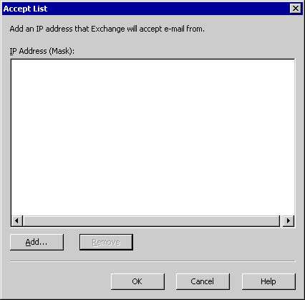

5. Click Add.
6. In IP Address (Mask), select one of the following options:
• Click Single IP Address to add a single IP address to the global accept list for this connection filter rule.
• Click Group of IP Addresses to add a subnet address and mask to the global accept list.
7. Click OK.

How to Create a Global Deny List
Connection filtering allows you to create global deny lists. You can use these lists to always reject mail that is sent from specific IP addresses, regardless of whether you use a block list service provider. Any IP address that appears on the global deny list is automatically rejected.
Entries in the global accept list take precedence over the entries in the global deny list. Exchange Server checks the global accept list before it checks the global deny list. Therefore, to reject connections from a specific subnet and mask, but accept connections from a single IP address within this range, you must enter the subnet and mask for the range of IP addresses from which you want to reject connections on the global deny list.

Before You Begin
Before you perform the procedure in this topic, read Configuring Filtering and Controlling Spam and How to Create a Global Accept List.
The following permissions are required to perform this procedure:
• Member of the local administrators group and a member of a group that has had the Exchange Administrators role applied at the organizational level

Procedure
To create a global deny list
1. Start Exchange System Manager: Click Start, point to All Programs, point to Microsoft Exchange, and then click System Manager.
2. In the console tree, expand Global Settings, right-click Message Delivery, and then click Properties.
3. Click the Connection Filtering tab.
4. Click Deny. The Deny List dialog box appears.
The Deny List dialog box
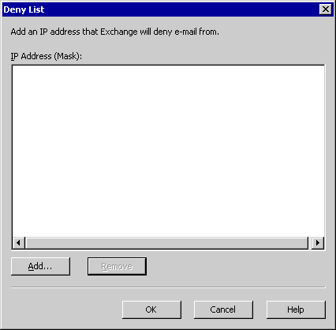

5. Click Add.
6. In IP Address (Mask), select one of the following options:
• Click Single IP Address to add a single IP address to the global deny list for this connection filter rule.
• Click Group of IP Addresses to add a subnet address and mask to the global deny list.
7. Click OK.

How to Create a Connection Filter
Use the following procedure to create a connection filter rule and any exceptions that you want to configure for this rule.

Before You Begin
Before you perform the procedure in this topic, read Configuring Filtering and Controlling Spam.
The following permissions are required to perform this procedure:
• Member of the local administrators group and a member of a group that has had the Exchange Administrators role applied at the organizational level

Procedure
To create a connection filter
1. Start Exchange System Manager: Click Start, point to All Programs, point to Microsoft Exchange, and then click System Manager.
2. In the console tree, expand Global Settings, right-click Message Delivery, and then click Properties.
3. Click the Connection Filtering tab.
The Connection Filtering tab in the Message Delivery Properties dialog box
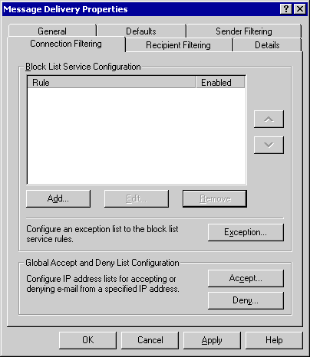

4. To create a connection filter rule, click Add. The Connection Filtering Rule dialog box appears.
The Connection Filtering Rule dialog box
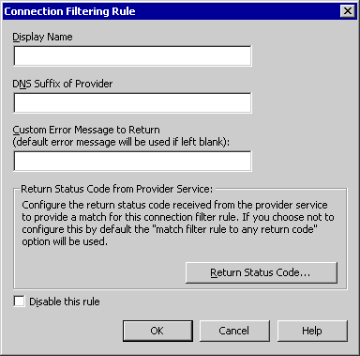

5. In the Display Name box, type a name for the connection filter.
6. In the DNS Suffix of Provider box, type the DNS suffix that the provider appends to the IP address.
7. In the Custom Error Message to Return (default error message will be used if left blank) box, if desired, type the custom error message to return to the sender. Leave this box blank to use the following default error message:
<IP address> has been blocked by <Connection Filter Rule Name>
You can use the following variables to generate a custom message:
• %0 – connecting IP address
• %1 – connection filter rule name
• %2 – the block list provider name
For example, if you want your custom message to read:
The IP address <IP address> has been blocked by the following block list provider <block list provider name>.
type the following in the customer error message:
The IP address %0 was rejected by block list provider %2.
Exchange replaces %0 with the connecting IP address and %2 with the block list provider.
Note:
If you want to include a percent sign (%) in your error message, you must type the percent sign twice (%%).
8. To configure which return status codes received from the block list provider that you want to match in the connection filter, click Return Status Code. The Return Status Code dialog box appears.
The Return Status Code dialog box
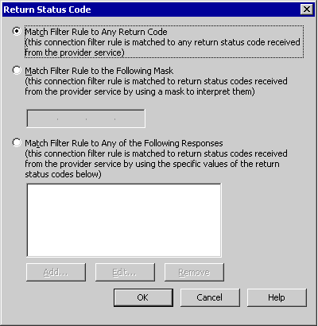

9. Select one of the following options:
• Click Match Filter Rule to Any Return Code (this connection filter rule is matched to any return status code received from the provider service) to set the default value that matches the connection filter to any return status.
• Click Match Filter Rule to the Following Mask (this connection filter rule is matched to return status codes received from the provider by using a mask to interpret them), and then type the mask you want to filter against the masks that are used by your providers.
Note:
A bit mask checks only against a single value. If you set a bit mask value that is returned when an IP address appears on two lists, the mask will match only IP addresses that appear on both lists. If you want to check for an IP address on either of two lists, enter the status codes for these settings.
• Click Match Filter Rule to Any of the Following Responses (this connection filter rule is matched to returned status codes received from the provider service by using the specific values of the return status codes below). Click Add, and in Return Status Code, type the status code that you want to match. For each additional status code, click Add, type the code, and then click OK.
10. Click OK.

How to Verify That Exchange 2003 is Configured to Not Resolve Anonymous Mail
Exchange 2000 servers resolve anonymous e-mail by default. If your organization contains Exchange 2000 servers, and they resolve an anonymous e-mail message and send it to an Exchange 2003 server, the address resolves to its display name in the global address book (GAL). To prevent this, configure your Exchange 2000 servers so that they do not resolve anonymous mail.
Note:
Incorrectly editing the registry can cause serious problems that may require you to reinstall your operating system. Problems resulting from editing the registry incorrectly may not be able to be resolved. Before editing the registry, back up any valuable data.

Before You Begin
Before you perform the procedure in this topic, read Configuring Filtering and Controlling Spam.
The following permissions are required to perform this procedure:
• Member of the local administrators group and a member of a group that has had the Exchange Administrators role applied at administrative group level

Procedure
To verify that your Exchange 2003 server is configured to not resolve anonymous mail
1. Start Exchange System Manager: Click Start, point to All Programs, point to Microsoft Exchange, and then click System Manager.
2. In the console tree, expand Servers, expand < Bridgehead Server Name >, expand Protocols, and then expand SMTP.
3. Right-click the SMTP virtual server that you want, and then click Properties.
4. On the Access tab, click Authentication.
5. In Authentication, under the Anonymous access check box, verify that the Resolve anonymous e-mail check box is cleared.
Note:
Remember that if this server is an internal SMTP virtual server, you can also clear the Anonymous access check box. For more information about anonymous access on an internal SMTP virtual server, see "Preventing Anonymous Access on Internal SMTP Virtual Servers and Dedicated SMTP Virtual Servers for IMAP and POP Clients" in Securing Your Exchange Server.

How to Configure Exchange 2000 to Not Resolve External Email Addresses
Exchange Server 2003 does not resolve e-mail addresses that originate externally. Therefore, when an anonymous user attempts to send mail spoofing a user's identity, Exchange Server will not resolve the sending address in the From line to its display name. Instead, for a user named Ted, ted@example.com will appear in the From line of the e-mail. If your users understand this difference, they can at least identify spoofed mail.

Before You Begin
Be cautious when you select the servers on which you want to enable this setting. If you change the behavior on the default SMTP virtual server, and there are multiple servers in your organization, all internal mail that originates on other Exchange 2000 servers is also affected. Therefore, because Exchange 2000 Server uses SMTP to route internal mail between servers, you may want to create a new SMTP virtual server, or perhaps to apply this setting only on an incoming SMTP bridgehead server.
Before you perform the procedure in this topic, read Configuring Filtering and Controlling Spam and How to Verify That Exchange 2003 is Configured to Not Resolve Anonymous Mail.
The following permissions are required to perform this procedure:
• Member of the local administrators group and a member of a group that has had the Exchange Administrators role applied at the administrative group level

Procedure
To configure Exchange 2000 Server to not resolve e-mail addresses that originate externally
1. Start Registry Editor: Click Start, click Run, type regedt32, and then click OK.
2. Locate or create the following key in the registry (where 1 is the SMTP virtual server number):
HKEY_LOCAL_MACHINE/SYSTEM/CurrentControlSet/Services/ MsExchangeTransport/Parameters/1
Note:
You may need to create both the Parameters key and the 1 key.
3. On the Edit menu, click Add Value, and then add the following registry value:
Value name: ResolveP2
Data type: REG_DWORD

4. Use the following flags to determine which value to use:
Field Value
----------- -----
FROM: 2
TO: and CC: 16
REPLY TO: 32

To determine the value that you want to use, add the values for all of the elements that you want to be resolved. For example, to resolve all of the fields except the sender, type 48 (16+32=48). To resolve only the recipients, type only 16. By default, Exchange 2000 Server resolves everything. You can specify this behavior either by removing the key or by setting the value with this formula: 2+16+32=50.
5. Quit Registry Editor.
6. Restart the SMTP virtual server.

How to Create a Recipient Filter
Use the following procedure to create a recipient filter.

Before You Begin
Before you perform the procedure in this topic, read Configuring Filtering and Controlling Spam.
The following permissions are required to perform this procedure:
• Member of the local administrators group and a member of a group that has had the Exchange Administrators role applied at the organizational level

Procedure
To create a recipient filter
1. Start Exchange System Manager: Click Start, point to All Programs, point to Microsoft Exchange, and then click System Manager.
2. In the console tree, expand Global Settings, right-click Message Delivery, and then click Properties.
3. In Message Delivery Properties, click the Recipient Filtering tab.
The Recipient Filtering tab in the Message Delivery Properties dialog box
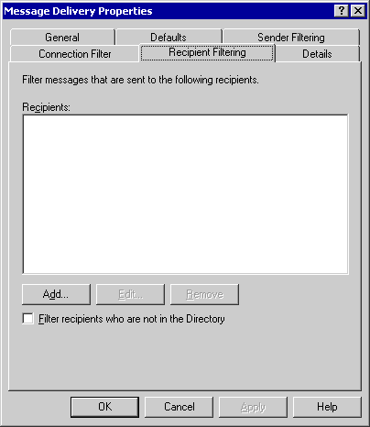

4. To add the address of a specific recipient, click Add, and then, in Add Recipient, type the recipient address, and then click OK. The recipient address must meet the following criteria:
• The recipient address must contain an at sign (@).
• Display names must be enclosed in quotation marks with the @ sign immediately following. Ensure that there are no spaces between the quotation marks and the @ symbol For example, if you want to filter mail for a recipient with the display name of Ted Bremer in the contoso.com domain, you type:
"Ted Bremer"@contoso.com
• Use an asterisk (*) to denote all members of a domain or simply enter @domain. For example, to filter mail that is sent to all users with the domain suffix of contoso.com, type either:
*@contoso.com
@contoso.com
5. To filter mail that is sent to users who do not exist in Microsoft® Active Directory® directory service, select the Filter recipients who are not in the Directory check box.
Note:
Selecting the Filter recipients who are not in the Directory check box can potentially allow malicious senders to discover valid e-mail addresses in your Exchange Server organization.

How to Apply a Recipient Filter to an SMTP Virtual Server
After creating the recipient filter, you must apply it to the appropriate SMTP virtual servers. Usually, you apply the recipient filter on the SMTP virtual servers that exist on your gateway servers that accept inbound Internet e-mail. Use the following procedure to apply a recipient filter to an SMTP virtual server.

Before You Begin
Before you perform the procedure in this topic, read Configuring Filtering and Controlling Spam and How to Create a Recipient Filter.
The following permissions are required to perform this procedure:
• Member of the local administrators group and a member of a group that has had the Exchange Administrators role applied at the organizational level

Procedure
To apply a recipient filter to an SMTP virtual server
1. Start Exchange System Manager: Click Start, point to All Programs, point to Microsoft Exchange, and then click System Manager.
2. In the console tree, expand Servers, expand the server that you want, expand Protocols, and then expand SMTP.
3. Right-click the SMTP virtual server on which you want to apply the filter, and then click Properties.
4. In <SMTP Virtual Server> Properties, on the General tab, click Advanced.
5. In Advanced, select the IP address for which you want to apply the filter, and then click Edit.
6. In Identification, select the Apply Recipient Filter check box to apply the filter that you previously set.
The Identification dialog box
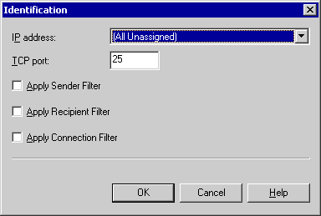

7. If you have multiple virtual servers, repeat Steps 3 through 6 for each virtual server on which you want to apply the filter.

How to Specify an Exception to a Connection Rule
You can create exceptions to the connection filter rule. Specifically, you can allow message delivery to specific recipients (for example, to the postmaster), regardless of whether the connecting IP address is on a block list.

Before You Begin
Before you perform the procedure in this topic, read Configuring Filtering and Controlling Spam.
The following permissions are required to perform this procedure:
• Member of the local administrators group and a member of a group that has had the Exchange Administrators role applied at the organizational level

Procedure
To specify an exception to a connection rule
1. In Message Delivery Properties, on the Connection filtering tab, click Exception. The Block List Service Configuration Settings dialog box appears.
The Block List Service Configuration Settings dialog box
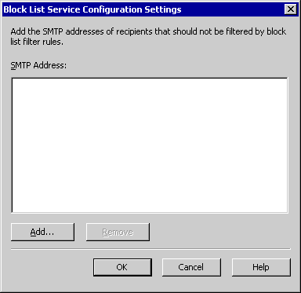

2. Click Add.
3. In Add Recipient, type the SMTP address of the recipient for whom you want to accept all messages, regardless of whether the connecting IP address appears on a block list.
4. Click OK twice.

How to Apply a Connection Filter to An SMTP Virtual Server
After creating the connection filter and any exceptions for the filter, you must apply it to the appropriate SMTP virtual servers. Usually, you apply the connection filter to the SMTP virtual servers that exist on your gateway servers that accept inbound Internet e-mail messages. Use the following procedure to apply a connection filter to an SMTP virtual server.

Before You Begin
Before you perform the procedure in this topic, read Configuring Filtering and Controlling Spam.
The following permissions are required to perform this procedure:
• Member of the local administrators group and a member of a group that has had the Exchange Administrators role applied at administrative group level

Procedure
To apply a connection filter to an SMTP virtual server
1. Start Exchange System Manager: Click Start, point to All Programs, point to Microsoft Exchange, and then click System Manager.
2. In the console tree, expand Servers, expand the server that you want, expand Protocols, and then expand SMTP.
3. Right-click the SMTP virtual server on which you want to apply the filter, and then click Properties.
4. In <SMTP Virtual Server> Properties, on the General tab, click Advanced.
5. In Advanced, select the IP address for which you want to apply the filter, and then click Edit.
6. In Identification, select the Apply Connection Filter check box to apply the filter that you previously set.
The Identification dialog box

7. If you have multiple virtual servers, repeat Steps 3 through 6 for each virtual server on which you want to apply the filter.

Part Four
Part 4 concentrates on troubleshooting techniques that you can use to identify and resolve transport problems. It also presents some common scenarios that can cause message flow problems and illustrates ways to remedy these situations.
• Troubleshooting Routing
This section provides information about using the WinRoute tool to troubleshoot routing problems in a Microsoft® Exchange 2000 Server and Exchange Server 2003 messaging environment.
• Troubleshooting Mail Flow and SMTP
This section explains many common problems in mail flow. In addition, this section provides you with information about how to use several tools and how to configure diagnostic logging.
• Troubleshooting Non-Delivery Report Messages
This section provides strategies to take and tools to use when you are attempting to resolve issues that are related to non-delivery reports. NDRs are a type of delivery status notification.

Troubleshooting Routing
This topic discusses some common situations that can disrupt routing in your Microsoft® Exchange organization. Topics addressed include:
• Using WinRoute
This section explains the value of the WinRoute tool in troubleshooting routing issues.
• Common Link State Problems
This section explains the problems that are created by disconnections between routing groups, routing group master conflicts, deleted routing groups, connectors that are not marked as available, and oscillating connections, and explains how to resolve these situations.
• Broken Link State Propagation
This section explains the problems that occur when you change a routing group bridgehead server from an Exchange Server version 5.5 server to an Exchange 2000 Server or Exchange Server 2003 bridgehead server, and then change the bridgehead server back to an Exchange 5.5 server.

Using WinRoute
WinRoute is an Exchange 2003 tool that is used to determine the routing topology and link state routing information that is known to the routing master. This tool should be the first step in troubleshooting routing issues in an Exchange 2000 and Exchange 2003 messaging environment. The tool connects to the link state port, TCP port 691, on an Exchange 2000 server or Exchange 2003 server, and extracts the link state information for an organization. The information is a series of GUIDs that WinRoute matches to objects in Microsoft Active Directory® directory service, connectors and bridgehead servers, and then presents in a readable format.
Note:
The WinRoute tool and user documentation are available at the Downloads for Exchange Server 2003 Web site. It is recommended that you download and use this tool on all Exchange 2000 and Exchange 2003 servers in your organization. Use this tool rather than the WinRoute tool that shipped with Exchange 2000.

Common Link State Problems
Within a routing group, Exchange uses TCP port 691 to communicate link state and routing information updates between the routing group master and its routing group members. Between two routing groups, two routing group bridgehead servers use the X-LINK2STATE verb to exchange link state information by comparing the digest, an encrypted digital signature in the Orginfo packet, that contains link state information of the two routing group bridgeheads. A discrepancy between these digests causes an exchange of link state information between the two servers using SMTP port 25.
The routing group master coordinates changes to link state that are learned by servers within its routing group and retrieves updates from Active Directory. If the routing group master becomes unavailable, all servers in the routing group continue to operate on the same information that they had at the time that they lost contact with the routing group master.
When the routing group master becomes available again, it reconstructs its link state information, beginning with all servers and connectors marked as unavailable. Then, discovering any unavailable servers, the routing group master updates members within the routing group.
This section discusses the following link state problems and explains the recommended resolution:
• Disconnection between routing group member and master
• Conflicts between routing group masters
• Problems that are caused by deleted routing groups
• Connectors that are not marked as "down"
• Oscillating connections

Disconnection Between Routing Group Member and Master
When a routing group member is unable to connect to the routing group master, WinRoute indicates the situation with a red X next to the routing group member.
Disconnection between routing group members and master
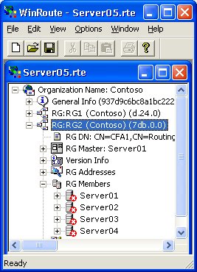

Take the following steps to resolve this issue:
• Ensure that the Microsoft Exchange Routing Engine service (RESvc) is started and in a controlled state on all affected servers in the routing group. If the routing engine service is in an unstable state, routing group members may not be able to connect to the routing group master. Investigate the root cause of any unstable services first.
• Verify that port 691 is not restricted by a firewall by initiating a telnet session to port 691 of the affected servers and the master node. You should see a Microsoft Routing Engine banner to indicate an active state.
• From a command line, type the following:
netstat –a –n

The output should reveal all routing group members and the master itself connecting to port 691 on the master node, similar to the following:
TCP 127.0.0.1:691 127.0.0.1:691 ESTABLISHED

• Check Event Viewer application logs for any events that indicate a failure to authenticate using the machine account (domain\server name). Monitor for the following transport events:
• Event ID 961 is logged when a member server fails to authenticate with its routing group master.
• Event ID 962 is logged after a client node fails to authenticate with the routing service (RESvc).
• Event ID 996 is logged when a client routing node successfully authenticates with the routing engine service.
• Event ID 995 is logged when a routing group member successfully authenticates with its routing group master.
• Verify that the affected servers can generate a ServicePrincipalName (SPN) that is used in the authentication process by checking the ncacn_ip_tcp value in the network address attribute of the affected servers. This is done by using a directory access tool, such as LDP (ldp.exe) or ADSI Edit (adsiEdit.msc).
Members in a routing group have to mutually authenticate with the routing group master to connect. To do this, they use the ncacn_ip_tcp value in the network address attribute of the Exchange server to generate the SPN for the master node by calling DsClientMakeSpnForTargetServer. The routing group members can then authenticate using Kerberos. Make sure this value is a fully qualified domain name (FQDN), and not a NetBIOS name or an Internet Protocol address. Restart the Exchange Routing Engine service.
• Verify that the domain machine account password has not expired.
• If the membership of the routing group spans multiple domains, ensure that the cause of the problem is not a child domain or root domain problem from a DNS misconfiguration.
• Check for any non-Microsoft applications or group policy objects that restrict permissions or security.
• Configure another server in the routing group as the routing group master. This approach offers an interim solution. Reassigning the routing group master role can provide relief until the problem is resolved.
• If the routing group master or any routing group members are missing the SendAs permission, WinRoute will show the server as Am I connected to the Master?: NO. Verify that this server or the groups it belongs to are not explicitly denied the SendAs permission on the routing group master.

Conflicts Between Routing Group Masters
The first server that is installed into the routing group is automatically designated as the master node or routing group master. As other servers are installed, you can designate another server as the routing group master.
At any point in time, only one server should be recognized by itself and other servers as the master. This configuration is enforced by an algorithm where (N/2) +1 servers in the routing group must agree and acknowledge the master. N denotes the number of servers in the routing group. The member nodes consequently send link state ATTACH data to the master.
Sometimes, two or more servers mistake the wrong server as the routing group master. For example, if a routing group master was moved or was deleted without choosing another master node, it is possible for msExchRoutingMasterDN, the attribute in Active Directory that designates the routing group master, to point to a deleted server because the attribute is not linked.
Furthermore, this situation can also occur when an old routing group master refuses to detach as master, or a rogue node keeps sending link state ATTACH information to an old routing group master. In Exchange 2003, if msExchRoutingMasterDN points to a deleted object, the master node relinquishes its role as master and initiates a shutdown of the master role.
Take the following steps to resolve this issue:
• Check for healthy link state propagation within the routing group on port 691. Verify that a firewall or SMTP filters are not blocking communication.
• Verify that no Exchange service is stopped.
• Check Active Directory replication latencies by using the Active Directory Replication Monitor tool (Replmon.exe) that is available in the Windows Resource Kit.
• Check for network problem and latencies.
• Check for deleted routing group masters or servers that no longer exist. If this is the case, a transport event 958 is logged in the application log of Event Viewer that states that a routing group master no longer exists. Verify this information by using a directory access tool, such as LDP (ldp.exe) or ADSI Edit (adsiEdit.msc).

Problems Caused by Deleted Routing Groups
When routing groups are deleted after servers are moved out of them or for other reasons, WinRoute may display the text "object_not_found_in_DS" for the objects.
Exchange servers maintain the link state table that still references the objects, but these objects are missing from Active Directory when the routing engine service initializes and checks Active Directory to find the related objects.
Exchange routing cannot automatically remove deleted routing groups and their members (that is, servers and connectors) from the link state table. In fact, routing treats the deleted routing groups no differently than existing, functional routing groups. In rare cases, deleted routing groups can cause a malfunction in routing as well as mail loops. Deleted routing groups can severely affect topologies in which an Exchange 5.5 site joins an Exchange 2003 organization.
Additionally, these deleted routing group objects may significantly contribute to the size of the link state table, and thereby increase the network traffic that is incurred in the exchange of link state information.
Finally, if the Personal Address Book (PAB) or Offline Address Book (OAB) has a legacyExchange domain name that matches a deleted routing group, the deleted routing group objects will cause mail that is sent to non-existent users from the PABs or OABs to be added to the messages with an unreachable destination queue. After the default timeout of two days, the mail will be returned to the sender with a non-delivery report (NDR). Without the deleted routing group object, mail sent to non-existent users will immediately be returned to the sender with an NDR, instead of being added to the queue first.
Deleted routing group in WinRoute
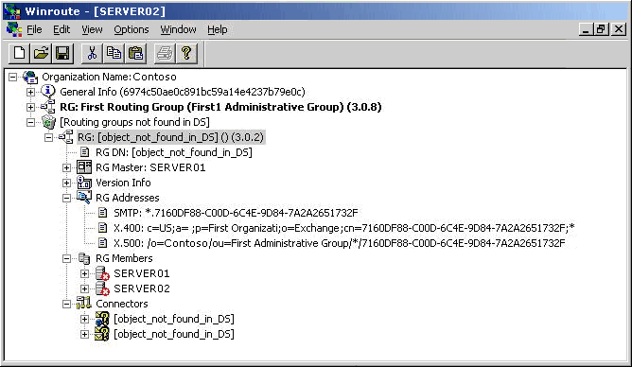

To resolve this issue, first verify that the account that you are using to view routing information on the server has adequate permissions. If possible, log on to WinRoute by using the system account and the AT interactive command. Lack of adequate read permissions can result in erroneous object_not_found_in_DS messages in WinRoute.
You can purge deleted routing groups from the link state information by using one of the following methods:
• Shut down all servers in the organization at the same time to refresh routing cache information, and purge deleted routing groups and connectors.
• Shut down all Exchange and Windows Management Instrumentation (WMI) services on all Exchange servers in the organization simultaneously.
You can also resolve this issue by using Remonitor.exe to reduce the size of the deleted routing group footprint and to mark the routing group as deleted.
Remonitor.exe is a tool that can inject a custom routing packet into an Exchange organization. The custom packet is a modified version of the deleted routing group packet. This modified version does not have server or connector entries, which significantly reduces the size of the routing group object. Also, this version eliminates the possibility of a malfunction or delay in routing that can occur due to a connector entry in which the routing group is deleted. Because the tool injects a modified packet that does not have connector entries, there cannot be a connector entry in which the routing group is deleted. Finally, Remonitor.exe updates the version number of the modified routing group so that no server or connection entries can be added to this deleted routing group.
For detailed instructions, see How to Run Remonitor.exe as Local System Account in Inject Mode.
After running Remonitor.exe, the routing packet no longer contains any server members or connectors. The routing group addresses are now prefaced by the key word deleted. Also, the version number of the routing group object is incremented.
Deleted routing group in WinRoute after running Remonitor.exe
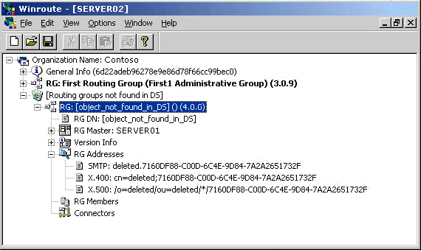

Connectors Are Not Marked as "Down"
There are some instances where a connector's link state may be marked as "up" when it is in fact unavailable or "down." Routing does not mark link state on a connector as down in the following situations:
• Connectors that use DNS to route to a domain in the address space (for example, SMTP connectors using DNS).
• Exchange 5.5 or custom EDK (Exchange Development Kit) connectors because they do not use link state routing.
• Routing group connectors with local bridgehead servers of any local bridgehead. You designate any local bridgehead server as the local bridgehead by clicking Any local server can send mail over this connector when creating a routing group.
• Routing group connectors where one bridgehead server is an Exchange 5.5 server.
Other unusual instances include:
• Situations where, within a routing group, relay mail fails to prevent message transfer agent (MTA) loops within a routing group.
• Connectors configured with a smart host that has changed very recently.
For routing to mark a connector as down, all source bridgehead servers have to be down with a state of VS_CONN_NOT_AVAILABLE or VS_CONN_NOT_STARTED. You can check the status by using WinRoute.

Oscillating Connections
Connectors that are on an unreliable network and are marked as "up" and then "down" repeatedly cause excessive link state updates between servers. These changes cause expensive and frequent recalculation of routes within Exchange. In Event Viewer, event ID 4005 is logged frequently and appears with the text "reset routes." Exchange 2003 mitigates these changes if it detects a frequently changing connector state by leaving the state marked as up within a single polling window, the period during which a server monitors the change. However, if these changes occur in different polling periods, an oscillating connection can still generate link state traffic. The default state delay change interval is 10 minutes for Exchange 2003 servers.
Exchange routing chooses the optimal path and locates the next server for a message to make its next hop to, giving this "next-hop" server name to queuing. The optimal path is chosen considering variables such as cost, message type, and restrictions. Consequently, because of the oscillating state of a connector, Exchange has to recalculate the most optimal path repeatedly, which involves queries to Active Directory and performance costs.
When Exchange queuing notices a link failure to the bridgehead server on a connector, routing relays this information to the routing group master. The routing group master suppresses this information for up to 10 minutes to prevent connector state fluctuations. If routing marks the connector as down, this change is propagated to all Exchange servers in the organization, including the server on which the original failure occurred. This notification is called a reset route, and it is a highly expensive process in terms of CPU usage. Mail no longer queues on the connector, and routing must generate new paths for delivery. The same process occurs for marking a connector as up.
An oscillating connection occurs in the following situations:
• Network problems, which can be seen in a network trace.
• Reactions to link status notification callbacks from underlying protocol services (SMTP and MTA) due to an interference on the X.400 or SMTP protocol levels by non-Microsoft applications. In this scenario, only a network monitor capture can reveal the issues. In addition you can use the remonitor.exe tool that is available from Microsoft Product Support Services.
You can use Network Monitor (Netmon.exe) or the remonitor.exe tool in monitor mode to identify and address the root causes of oscillating connections. Additionally, if the oscillating connections are causing excessive propagation traffic, you can suppress the propagation of link state changes until you solve the root cause.
For detailed instructions, see How to Suppress Link State Information on a Server.
For more information about suppressing link state traffic, see "Suppressing Link State Traffic for Connectors" in Advanced Routing Configuration.

Broken Link State Propagation
Exchange 5.5 servers do not use link state information, but instead they rely on the gateway address routing table (GWART) to route messages. In a mixed-mode organization, Exchange 2000 and later versions recognize this limitation and read the configuration of Exchange 5.5 servers directly from Active Directory. Thus, Exchange 2000 and Exchange 2003 servers do not expect Exchange 5.5 servers to exchange link state information with them.
When an Exchange 5.5 bridgehead server in an Exchange routing group is upgraded to an Exchange 2000 or Exchange 2003 server and designated as a bridgehead server, it begins to participate in the exchange of link state information and it no longer has a major version number of zero. Exchange 2000 and Exchange 2003 servers use version numbers in the link state table to compare link state tables and ensure that servers have the most recent information about link state. A major version number of zero indicates a server that does not participate in link state information or has never exchanged link state information. All pure Exchange 5.5 sites have a version number of zero because they do not exchange link state information. When the server is upgraded to an Exchange 2000 or Exchange 2003 server, it begins to participate in link state information and increments its major version number. So, bridgehead servers in other routing groups expect the newly upgraded server to inform them of link state changes in its routing group.
A problem occurs if you now designate an Exchange 5.5 server as the bridgehead server for this routing group. Other servers still expect the Exchange 5.5 bridgehead server, the former Exchange 2000 or Exchange 2003 bridgehead server, to participate in link state propagation and wait for this server to give them updated link state information. However, because the server has reverted to Exchange 5.5, it no longer has a link state table. Therefore, this routing group now becomes isolated and does not participate in dynamic link state updates in the organization.
This isolated routing group is problematic in a situation as shown in Figure 11.4. Specifically, because the Exchange 5.5 bridgehead server was formerly an Exchange 2000 or Exchange 2003 bridgehead server, other servers expect it to participate in link state propagation. The Exchange 5.5 Internet Mail Connector and Exchange 2003 SMTP connector in the following figure both use a single smart host to route mail to the Internet. The smart host becomes unavailable, so the Exchange 2003 bridgehead server marks the route through its SMTP connector as unavailable. However, because the bridgehead server expects the Exchange 5.5 server to send link state information about its routing groups and connectors, it assumes that the route through the Internet Mail Connector is available and attempts to deliver messages through this route. After one failure, the Exchange 2003 server detects a possible loop and does not attempt delivery through this route.
Exchange 5.5 and Exchange 2003 servers connecting to a smart host
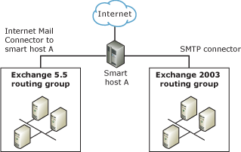

Link state propagation can also be broken if a firewall that is blocking link state propagation is added to the system. For example, ports 25 and 691 are required within a routing group, and port 25 is required between routing groups. Also, the Extended Simple Mail Transfer Protocol (ESMTP) command X-LINK2STATE must not be blocked by a firewall.
To resolve this problem, the following solutions are available:
• Upgrade the Exchange 5.5 bridgehead server to an Exchange 2000 or Exchange 2003 server, or use another Exchange 2000 or Exchange 2003 server to send link state information for this routing group again. Either of these options provides the preferred and simplest resolution.
• To reset non-connected routing groups to link state major version number 0, shut down all Exchange servers in your organization simultaneously, and then restart all Exchange servers.
• Configure the firewall so that link state propagation is not prevented.
For more information about isolated or disjointed routing groups and the major version numbers, see Microsoft Knowledge Base article 842026, "Routing status information is not propagated correctly to all servers in Exchange 2000 Server or in Exchange Server 2003."

How to Run Remonitor.exe as Local System Account in Inject Mode
Remonitor.exe is a tool that can inject a custom routing packet into an Exchange Server organization. The custom packet is a modified version of the deleted routing group packet. This modified version does not have server or connector entries, which significantly reduces the size of the routing group object. Also, this version eliminates the possibility of a malfunction or delay in routing that can occur due to a connector entry in which the routing group is deleted. Because the tool injects a modified packet that does not have connector entries, there cannot be a connector entry in which the routing group is deleted. Finally, Remonitor.exe updates the version number of the modified routing group so that no server or connection entries can be added to this deleted routing group.
To use Remonitor.exe, you must first request the tool from Microsoft® Product Support Services. You must copy Remonitor.exe to the Exchsrvr\bin directory on an Exchange server.
Note:
You cannot inject a routing packet on the same server on which you run the Remonitor tool. You must run the tool on a separate server.
Note:
After you delete a routing group, you must wait for this change to be replicated to all Microsoft Active Directory® directory service servers in the organization before you run Remonitor.exe.
You must run the tool with an account that has SendAs permissions on the Exchange server, such as the local system account.
Note:
You only need to run Remonitor.exe against one server in the Exchange Server organization. The packet injection is propagated to the remaining servers in your organization.
After running Remonitor.exe, the routing packet no longer contains any server members or connectors. The routing group addresses are now prefaced by the key word deleted. Also, the version number of the routing group object is incremented.

Before You Begin
Before you perform the procedure in this topic, read Troubleshooting Routing.

Procedure
To run Remonitor.exe as local system account in inject mode
1. At the command prompt, type the following:
at <time> /interactive "cmd.exe"
where <time> is any time of day.
2. Click Start, point to AllPrograms, point to Accessories, point to System Tools, and then click Scheduled Tasks.
3. In Scheduled Tasks, right-click the At job you just created, and then click Run.
Note:
The At task you created appears as At<ID> where ID is the task ID assigned when you created the task.
4. A new command prompt window opens, running as the local system account.
5. In this window, navigate to the .\Exchsrvr\bin directory in your Exchange installation directory. By default, this directory is <drive letter:>\Program Files\Exchsrvr\bin.
6. Type the following command:
remonitor -i <server to inject>
7. In Scheduled Tasks, right-click the At task, and then click Delete.

How to Suppress Link State Information on a Server
You can use Network Monitor (Netmon.exe) or the remonitor.exe tool in monitor mode to identify and address the root causes of oscillating connections. Additionally, if the oscillating connections are causing excessive propagation traffic, you can suppress the propagation of link state changes until you solve the root cause.
It is important to understand that changing this registry key does not stop the propagation of the link state table across servers. It suppresses only the link state traffic that is caused by a connector state change.
Caution:
Incorrectly editing the registry can cause serious problems that may require you to reinstall your operating system. Problems resulting from editing the registry incorrectly may not be able to be resolved. Before editing the registry, back up any valuable data.

Before You Begin
Before you perform the procedure in this topic, read Troubleshooting Routing.
The following permissions are required to perform this procedure:
• Member of the local administrators group

Procedure
To suppress link state information on a server
1. Start Registry Editor (regedit)
2. Navigate to and right-click the following key:
HKEY_LOCAL_MACHINE\SYSTEM\CurrentControlSet\Services\RESvc\Parameters
3. On the Edit menu, click Add Value, and then add the following registry value:
Value Name: SuppressStateChanges
Data Type: REG_DWORD
Data: 1
Radix: Decimal
4. Close Registry Editor.
5. Restart the following services:
• Microsoft Exchange Routing Engine (RESvc)
• SMTP Service (SMTPSVC)
• Microsoft Exchange MTA Stacks (MSExchangeMTA)

For More Information
For more information about suppressing link state traffic, see "Suppressing Link State Traffic for Connectors" in Advanced Routing Configuration.

Troubleshooting Mail Flow and SMTP
Even after you have successfully configured Simple Mail Transfer Protocol (SMTP) in your Microsoft® Exchange Server organization and taken every measure to secure it, you might experience mail flow problems. This topic discusses many of the common problems that you may encounter and methods to help resolve them.
Specifically, you will learn how to:
• Use Telnet
• Use the SMTP and X.400 queues
• Use Message Tracking Center
• Use Event Viewer
• Configure diagnostic logging for SMTP
However, before considering the troubleshooting recommendations in this topic, first ensure that Exchange Server is configured correctly to send and receive mail. The lists below briefly summarize the requirements for inbound and outbound mail to flow properly.
For incoming Internet mail to flow correctly:
• Your recipient policies must be configured correctly.
• Your SMTP virtual server that accepts Internet mail must be configured on port 25 and allow anonymous connections.
• A mail exchanger (MX) resource record for your domain must exist on an internet DNS server, and the MX record must point to the external or Internet domain of your mail server.
• Your Internet mail server must be accessible to remote servers on the Internet.
For outgoing Internet mail to flow correctly:
• Your SMTP virtual server that sends Internet mail must be configured to use port 25.
• If you are using SMTP connectors, at least one connector must contain an address space of *, which specifies all external domains.
• Your Exchange server must be able to resolve external DNS names. You can resolve external DNS names in the following ways:
• Use an internal DNS server that forwards mail to an external DNS server.
• Configure your SMTP virtual server to use a specific external DNS server.
• Route mail to a smart host that performs DNS resolution.
For more information about how to configure Exchange Server to send and receive e-mail messages, see Verifying DNS Design and Configuration.
For detailed information on how to use Telnet to test SMTP, see the following topic:
• How to Use Telnet to Test SMTP Communication

Using the SMTP and X.400 Queues
SMTP uses the SMTP queues to deliver mail internally and externally. Exchange Server version 5.5 servers, MAPI clients (such as Microsoft Office Outlook®), and other mail connectors (such as Microsoft Exchange Connector for Lotus Notes and Microsoft Exchange Connector for Novell Groupwise) use the X.400 queues to send mail to and receive mail from Exchange Server. The following sections explain how to use both the SMTP and X.400 queues to troubleshoot message flow.

Understanding the SMTP Queues
During message categorization and delivery, the advanced queuing engine sends all mail through the SMTP queues of an SMTP virtual server. If there is a problem delivering the message at any point in the process, the message remains in the queue where the problem occurred.
Use the SMTP queues to isolate the possible causes of mail flow issues. If a queue is in a "Retry" status, you should check the properties of the queue to determine the cause. For example, if the queue properties display a message that is similar to "An SMTP error has occurred," you should review your server's event logs to locate any SMTP errors. If there are no events in the log, you should increase the SMTP Protocol logging level. For more information about how to increase the SMTP Protocol logging level, see How to View the Application Log in Event Viewer and How to Modify Logging Settings for MSExchangeTransport.
The following table lists the SMTP queues, including their descriptions, and troubleshooting information for message accumulation in each queue.
Descriptions of SMTP queues and associated troubleshooting information
SMTP queue | Description | Troubleshooting
[Local domain name] (Local Delivery) | Contains messages that are queued on the Exchange server for local delivery to an Exchange mailbox or public folder store. | Messages can accumulate in this queue if the Exchange server is not accepting messages for local delivery. Slow or sporadic message delivery can indicate a looping message or a performance problem.  This queue is affected by the Exchange store. Increase diagnostic logging for the Exchange store as described in How to Modify Logging Settings for MSExchangeTransport.
Messages awaiting directory lookup | Contains messages to recipients that have not yet been resolved against Microsoft Active Directory® directory service. Messages are also held here while distribution lists are expanded. | Generally, messages accumulate in this queue because the advanced queuing engine is unable to categorize the message. The advanced queuing engine may not be able to access the global catalog servers and access recipient information, or the global catalog servers are unreachable or performing slowly. Additionally the following may cause messages to accumulate:  • Active Directory is unavailable (because the categorizer uses Active Directory to categorize messages).  • Active Directory may be excessively loaded (if many messages are queuing in the pre-categorization queue).  • A failure in conversion. The categorizer also handles content conversion.  • Message categorizer cannot find the mailbox stores.  • If SMTP was reinstalled or removed, that may invalidate the following IIS metabase keys: /smtpsvc/DsUseCat and /smtpsvc/vsi#/DsUseCat. Determine whether SMTP was reinstalled or removed.  The categorizer affects this queue. Increase diagnostic logging for the categorizer as described in How to Modify Logging Settings for MSExchangeTransport.
Messages waiting to be routed | Holds messages until their next-destination server is determined, and then moves them to their respective link queues. | Messages accumulate in this queue if Exchange Server routing problems exist. Message routing may be backed up. Increase diagnostic logging for routing as described in How to Modify Logging Settings for MSExchangeTransport.
Remote delivery  [Connector name|  Server name| Remote domain] | Holds messages that are destined for remote delivery. The name of the queue matches the remote delivery destination, which may be a connector, a server, or a domain. | If messages accumulate in this queue, you must first identify the status of the queue. If the queue is in "Retry," check the queue properties to determine the reason it is in this state. For DNS issues, use Nslookup and telnet to troubleshoot. If the host is unreachable, use telnet to ensure that the remote server is responding.
Final destination currently unreachable | The final destination server for these messages cannot be reached. For example, Exchange cannot determine a network path to the final destination. | Messages can accumulate in this queue if no route exists for delivery. Additionally, any time a connector or a remote delivery queue is unavailable or in "Retry" for a period of time, and no alternate route exists to the connector or remote destination, new messages queue here. This allows an administrator to fix the problem or define an alternate route. To get new messages to flow to their remote destination queue so you can force a connection and get a Network Monitor (Netmon) trace, restart the SMTP virtual server.
Pre-submission | Holds messages that have been acknowledged and accepted by the SMTP service. The processing of these messages has not begun. | Messages that are accumulating constantly may indicate a performance problem. Occasional peaks in performance can cause messages to appear in this queue intermittently.
DSN messages pending submission | Contains delivery status notifications, also known as non-delivery reports that are ready to be delivered by Exchange.  Note The following operations are unavailable for this queue:  • Delete All Messages (no NDR)  • Delete All Messages (NDR) | Messages can accumulate in this queue if the Microsoft Exchange Information Store service is unavailable or not running, or if problems exist with the IMAIL Exchange store component, which is the component that performs message conversion.  Check the event log for possible errors with the Microsoft Exchange Information Store service.
Failed message retry queue | Contains messages that failed some type of queue submission, often before any other processing has taken place. By default, messages in this queue are reprocessed in 60 minutes. | Possible causes for failed messages are:  • Corrupted messages.  • Third-party programs or event sinks may be interfering with message queuing or fidelity.  • Low system resources could cause the system to respond slowly or cause other performance issues. Restarting IIS may temporarily improve resource issues, but you should determine the root cause.
Messages queued for deferred delivery | Contains messages that are queued for delivery at a later time, including messages that were sent by older versions of Outlook. (You can set this option on Outlook client computers.)  Previous versions of Outlook depend on the message transfer agent (MTA) for message delivery. Now, however, SMTP handles message delivery, not the MTA. Therefore, messages that are sent by older versions of Outlook treat deferred delivery differently.  These messages remain in this queue until their scheduled delivery time. | Possible causes for message accumulation are:  • If a message is sent to a user's mailbox while the mailbox is being moved, messages can queue here.  • When the user does not yet have a mailbox and no master account Security ID (SID) exists for the user. For more information, see Microsoft Knowledge Base article 316047, "XADM: Addressing Problems That Are Created When You Enable ADC-Generated Accounts."  • The message may be corrupt or the recipient may not be valid.  • To determine if a message is corrupt, check its properties. If a message is not accessible, it may be a corrupt message. You can also check that the recipient is valid.

For more information about troubleshooting mail flow and SMTP, see the following topics:
• How to View the Properties of a Queue
• How to View Messages in a Queue
• How to Check the SMTP Performance Counters
• How to Enable Message Tracking Center on a Server
• How to View the Application Log in Event Viewer
• How to View the System Log in Event Viewer
• How to Modify Logging Settings for MSExchangeTransport
• How to Set Logging at the Debug Level for the SMTP Protocol
• How to Enable Logging at the Debug Level for the Message Categorizer

How to Use Telnet to Test SMTP Communication
Telnet is an extremely useful tool for troubleshooting issues related to SMTP and mail flow. For example, you can use telnet to:
• Verify that SMTP is installed properly, and that it has all the necessary commands.
• Ensure that your server is accessible over the Internet.
• Attempt mail delivery directly over the TCP port.
• Determine that all servers are accepting connections.
• Determine if a firewall is blocking a connection.
• Ensure that a single user can receive mail.
• Ensure that a specific domain can receive mail.
• Ensure that a specific user or domain can send mail to your domain.
Note:
The following procedure shows you how to test the process of an internal user sending mail to a remote user when basic authentication is required for relaying mail outside your organization.

Before You Begin
Before you perform the procedure in this topic, read Troubleshooting Mail Flow and SMTP.
The following permissions are required to perform this procedure:
• Member of the local administrators group

Procedure
To use telnet to test SMTP communication
1. Open a telnet session: From a command prompt, type telnet, and then press ENTER.
2. Type set local_echo on a computer running Microsoft Windows® 2000 Server or SET LOCALECHO on a computer running Windows Server™ 2003 or Windows XP, and then press ENTER. This command allows you to view the responses to the commands.
Note:
For a list of available telnet commands, type set ?.
3. Type o <your mail server domain> 25,and then press ENTER.
4. Type EHLO <your mail server domain>, and then press ENTER.
5. Type AUTH LOGIN. The server responds with an encrypted prompt for your user name.
6. Enter your user name encrypted in base 64. You can use one of several tools that are available to encode your user name.
7. The server responds with an encrypted base 64 prompt for your password. Enter your password encrypted in base 64.
8. Type MAIL FROM:<sender@domain.com>, and then press ENTER. If the sender is not permitted to send mail, the SMTP server returns an error.
9. Type RCPT TO:<recipient@remotedomain.com>,and then press ENTER.If the recipient is not a valid recipient or the server does not accept mail for this domain, the SMTP server returns an error.
10. Type DATA.
11. If desired, type message text, press ENTER, type a period (.), and then press ENTER again.
12. If mail is working properly, you should see a response similar to the following indicating that mail is queued for delivery:
250 2.6.0 <INET-IMC-01UWr81nn9000fbad8@mail1.contoso.com.

For More Information
The following example shows a telnet test sending mail from contoso.com to a remote domain with a successful result:
250-mail1.fourthcoffee.com Hello [172.16.0.0]
250-TURN
250-ATRN
250-SIZE 5242880
250-ETRN
250-PIPELINING
250-DSN
250-ENHANCEDSTATUSCODES
250-8bitmime
250-BINARYMIME
250-CHUNKING
250-VRFY
250-X-EXPS GSSAPI NTLM
250-AUTH GSSAPI NTLM
250-X-LINK2STATE
250-XEXCH50
250 OK

334 VXNlcm5hbWU6

334 UGFzc3dvcmQ6

235 2.7.0 Authentication successful.

250 2.1.0 kim@fourthcoffee.com....Sender OK

250 2.1.5 ted@contoso.com

354 Start mail input; end with <CRLF>.<CRLF>

.
250 2.6.0 <INET-IMC-01UWr81nn9000fbad8@mail1.fourthcoffee.com> Queued mail for delivery
For more information, see Securing Your Exchange Server.

How to View the Properties of a Queue
When messages accumulate in one of the queues, you can view the queue properties to get more information about the possible causes of this accumulation.

Before You Begin
Before you perform the procedure in this topic, read Troubleshooting Mail Flow and SMTP.
The following permissions are required to perform this procedure:
• Member of the local administrators group and a member of a group that has had the Exchange Administrators role applied at the administrative group level

Procedure
To view the properties of a queue
1. Start Exchange System Manager: Click Start, point to All Programs, point to Microsoft Exchange, and then click System Manager.
2. Expand Administrative Groups, expand <Administrative Group Name>, expand Servers, expand the server you want, and then click Queues.
3. In the details pane, click the queue you want. Any additional information for that queue appears under Additional queue information at the bottom of the details pane.

How to View Messages in a Queue
If you experience mail flow problems, it is important to determine whether you have global problems or problems with individual recipients or domains. Viewing the messages in a queue can help you determine this.

Before You Begin
Before you perform the procedure in this topic, read Troubleshooting Mail Flow and SMTP.
The following permissions are required to perform this procedure:
• Member of the local administrators group and a member of a group that has had the Exchange Administrators role applied at the administrative group level
Right-clicking the individual queues in Queue Viewer provides the following options:
• Find Messages Lets you provide search criteria for the messages that you want to inspect.
• Freeze Stops delivery of all messages that are in the queue. You can use this option to temporarily prevent messages from leaving the queue while you are inspecting the messages. Freezing the queue prevents messages from leaving the queue, but does not prevent messages from entering the queue.
• Unfreeze Enables the delivery of messages that are in the queue to resume. Unfreezing the queue does not unfreeze individual messages that have been frozen by the administrator.
• Force Connection Forces a queue that has a retry state to immediately try to connect.

Procedure
To view messages in a queue
1. Open Exchange System Manager. Expand Administrative Groups, expand <Administrative Group Name>, expand Servers, expand the server on which you want to view queues, and then click Queues.
Note:
If you want to view a specific message, you can use the Message Tracking Center to determine which server last processed that message and then view the queues on that server to inspect the message.
1. The queues that are located on the selected server are displayed in the results pane. In the results pane, right-click the queue you want to inspect, and then click Find Messages. The Find Messages dialog appears.
2. Optional. Specify the Address Restrictions that will be used to filter the search results. To find all messages from a specific sender, type an SMTP address in the Sender field, or click Sender to select a sender from the Active Directory directory service. To find all messages addressed to a specific recipient, type an SMTP address in the Recipient field, or click Recipient to select a recipient from Active Directory.
3. Optional. Specify the Message Restrictions that will be used to limit the search results. To control how many results are returned, select a value from the Number of messages to be listed in the search drop-down list. The default value is 100. To find only messages that have a particular state, select a value from the Show messages whose state is drop-down list. The default value is to show all messages. You can also select to show only messages that have a frozen or retry state.
4. Click Find Now to display the search results. The messages that match the search criteria are displayed in the Search Results.
5. To view the properties of an individual message, in the results pane, right-click the message you want, and then click Properties. The message's Properties dialog box displays the sender's name, the recipient's name, the message size, and other details about the message.
6. To change the status of an individual message, in the results pane, right-click the message, and select from the following options:
• Unfreeze Resumes delivery of a previously frozen message.
• Freeze Suspends delivery of a message.
• Delete (with NDR) Deletes the message from the queue and sends an NDR to the sender of the message.
• Delete (no NDR) Deletes the message from the queue and does not send an NDR to the sender of the message.

How to Check the SMTP Performance Counters
If messages are accumulating in the pre-categorization queue (labeled "messages awaiting directory lookup" in Queue Viewer), check the SMTP performance counters, particularly the categorizer queue length counters. Use the following procedure to enable these performance counters.

Before You Begin
Before you perform the procedure in this topic, read Troubleshooting Mail Flow and SMTP.
The following permissions are required to perform this procedure:
• Member of the local administrators group

Procedure
To check the SMTP performance counters
1. Open System Monitor: Click Start, point to Run, and then type perfmon.
2. In System Monitor, right-click the System Monitor details pane, and then click Add Counters.
3. Select one of the following:
• To monitor any computer on which the monitoring console is run, click Use local computer counters.
• To monitor a specific computer, regardless of where the monitoring console is run, click Select counters from computer, and then specify a computer name (the name of the local computer is selected by default).
4. In Performance object, click SMTP Server.
5. Select one of the following:
• To monitor all counters, click All counters.
• To monitor only selected counters, click Select counters from list, and then select the counters that you want to monitor.
6. Click Add.
7. View the CAT: Categorizer queue length counter..

For More Information
The following table lists additional performance counters that you can use to monitor categorization issues.
Performance counters for monitoring categorization issues
Performance counter | Description
Cat: Address lookup completions | The number of address lookup completions that were processed.
Cat: Address lookup completions/sec | The number of address lookup completions processed per second.
Cat: Address lookups | The number of directory service lookups for individual addresses.
Cat: Address lookups not found | The number of address lookups that did not find any directory service object.
Cat: Address lookups/sec | The number of address lookups that were dispatched to the directory service per second.
Cat: Categorizations completed | The total number of messages submitted to message categorizer that have finished categorization.
Cat: Categorizations completed successfully | The number of categorizations that completed without any errors.
Cat: Categorizations completed/sec | The rate of categorizations that were completed per second.
Cat: Categorizations failed (directory service connection failure) | The number of categorizations that failed because of a directory service connection failure.
Cat: Categorizations failed (directory service logon failure) | The number of categorizations that failed because of a directory service logon failure.
Cat: Categorizations failed (non-retryable error) | The number of categorizations that failed with a hard error (not retryable).
Cat: Categorizations failed (Out Of Memory) | The number of categorizations that failed because of a lack of available memory.
Cat: Categorizations failed (retryable error) | The number of categorizations that failed with a retryable error.
Cat: Categorizations failed (sink retryable error) | The number of categorizations that failed with a generic retryable error.
Cat: Categorizations in progress | The number of categorizations in progress.
Cat: LDAP bind failures | The total number of Lightweight Directory Access Protocol (LDAP) bind failures.
Cat: LDAP binds | The number of successful LDAP binds that were performed.
Cat: LDAP connection failures | The number of connection failures to LDAP servers.
Cat: LDAP connections | The total number of LDAP connections that were opened.
Cat: LDAP connections currently open | The number of LDAP connections that are currently open.
Cat: LDAP general completion failures | The number of LDAP completions with a generic failure.
Cat: LDAP paged search completion failures | The number of LDAP paged searches that completed with a failure.
Cat: LDAP paged search failures | The number of failures to dispatch an asynchronous paged LDAP search.
Cat: LDAP paged searches | The number of LDAP paged searches that were successfully dispatched.
Cat: LDAP paged searches completed | The number of paged LDAP completions that were processed.
Cat: LDAP search completion failures | The number of LDAP searches that completed with a failure.
Cat: LDAP search failures | The number of failures to dispatch an asynchronous LDAP search.
Cat: LDAP searches | The number of LDAP searches that were successfully dispatched.
Cat: LDAP searches abandoned | The number of LDAP searches that were abandoned.
Cat: LDAP searches completed | The number of LDAP search completions that were processed.
Cat: LDAP searches completed/sec | The number of LDAP search completions that were processed per second.
Cat: LDAP searches pending completion | The number of LDAP searches pending asynchronous completion.
Cat: LDAP searches/sec | The number of LDAP searches that were successfully dispatched per second.
Cat: mailmsg duplicate collisions | The number of times that a duplicate recipient address was detected by mailmsg or message categorizer.
Cat: Messages aborted | The number of messages that were marked to be aborted by message categorizer.
Cat: Messages bifurcated | The number of new messages that were created by message categorizer (bifurcation).
Cat: Messages categorized | The number of messages that message categorizer submitted to queuing.
Cat: Messages submitted | The total number of messages that were submitted to message categorizer.
Cat: Messages submitted/sec | The rate at which messages are being submitted to message categorizer.
Cat: Recipients after categorization | The number of MAILMSG recipients that were submitted from message categorizer to queuing.
Cat: Recipients before categorization | The number of MAILMSG recipients that were submitted to message categorizer.
Cat: Recipients in categorization | The number of recipients that message categorizer is currently processing.
Cat: Recipients NDRd (ambiguous address) | The number of recipients with addresses that match multiple directory service objects.
Cat: Recipients NDRd (forwarding loop) | The number of recipients that message categorizer generates an NDR for because of a forwarding loop detection.
Cat: Recipients NDRd (illegal address) | The number of recipients with illegal addresses that were detected by message categorizer.
Cat: Recipients NDRd (sink recip errors) | The number of recipients that message categorizer generates an NDR for because of a generic recipient failure.
Cat: Recipients NDRd (unresolved) | The number of unresolved recipients (local addresses not found).
Cat: Recipients NDRd by Categorizer | The number of recipients for which message categorizer is set to generate an NDR.
Cat: Senders unresolved | The number of senders that were not found in the directory service.
Cat: Senders with ambiguous addresses | The number of senders with addresses that match multiple directory service objects.
Categorizer Queue Length | The number of messages in the message categorizer queue.

How to Enable Message Tracking Center on a Server
To log information about messages that are sent over your messaging system, you can use Message Tracking Center in Exchange Server. Message Tracking Center logs information about the sender, the mail message, and the message recipients. Specifically, you can review statistics such as the time the message was sent or received, the message size and priority, and the list of message recipients. You can also log the subject line of e-mail messages. Message Tracking Center searches for all types of messages, including system messages, public folder messages, and e-mail messages.
You must enable Message Tracking Center on each server for which you want to track messages. When enabled, all messages that are routed through a server are added to the message tracking logs.

Before You Begin
Before you perform the procedure in this topic, read Troubleshooting Mail Flow and SMTP.
The following permissions are required to perform this procedure:
• Member of the local administrators group and a member of a group that has had the Exchange Administrators role applied at the administrative group level

Procedure
To enable Message Tracking Center on a server
1. In Exchange System Manager, expand Servers, right-click the server on which you want to enable message tracking, and then click Properties.
2. On the General tab, select the Enable message tracking check box.
3. To record the subject of any message sent to, from, or through the server, select the Enable subject logging and display check box.
Note:
Enabling subject logging causes some performance degradation.
4. Under Log file maintenance, you can prevent the removal of log files or modify the length of time that the log files are kept. The default period that tracking logs are kept is seven days.
Note:
On servers that process large quantities of mail, the tracking logs grow quickly. Ensure that you have adequate disk space for the log files and for other services or applications that use this disk.
5. Click OK or Apply. You do not need to restart services for this change to take effect.

For More Information
For more information about how to use Message Tracking Center, see Microsoft Knowledge Base article 262162, "XADM: Using the Message Tracking Center to Track a Message."

How to View the Application Log in Event Viewer
In Event Viewer, both the application log and the system log contain errors, warnings, and informational events that are related to the operation of Exchange Server, the SMTP service, and other applications. To identify the cause of message flow issues, carefully review the data that is contained in the application log and system log.
Use the following procedure to view errors, warnings, and informational events in the application log.

Before You Begin
Before you perform the procedure in this topic, read Troubleshooting Mail Flow and SMTP.
The following permissions are required to perform this procedure:
• Member of the local administrators group

Procedure
To view the application log in Event Viewer
1. Click Start, point to Programs, point to Administrative Tools, and then click Event Viewer.
2. In the console tree, click Application Log.
3. To sort the log alphabetically and quickly locate an entry for an Exchange service, in the details pane, click Source.
4. Double-click a log entry to open an event's properties page.
5. To filter the log to list entries for a specific type of Exchange-related event, from the View menu, click Filter.
6. In Application Log Properties, use the Event source list to select an Exchange-related event source. For example:
• MSExchangeTransport Events that are recorded when SMTP is used to route messages.
• IMAP4Svc Events that are related to the service that allows users to access mailboxes and public folders through IMAP4.
• MSExchangeAL Events that are related to the service that addresses e-mail messages through address lists.
• MSExchangeIS Events that are related to the service that allows access to the Exchange Information Store service.
• MSExchangeMTA Events that are related to the service that allows X.400 connectors to use the message transfer agent (MTA).
• MSExchangeMU Events that are related to the metabase update service, a component that reads information from Active Directory and transposes it to the local IIS metabase.
• MSExchangeSA Events that are recorded when Exchange uses Active Directory to store and share directory information.
• MSExchangeSRS Events that are recorded when Site Replication Service (SRS) is used to replicate computers running Exchange 2003 with computers running Exchange 5.5.
• POP3Svc Events that are recorded whenever Post Office Protocol version 3 (POP3) is used to access e-mail.
7. In the Category list, select a specific set of events or, to view all events for that event source, leave the default setting at All.
8. Click OK.

How to View the System Log in Event Viewer
In Event Viewer, both the application log and the system log contain errors, warnings, and informational events that are related to the operation of Exchange Server, the SMTP service, and other applications. To identify the cause of message flow issues, carefully review the data that is contained in the application log and system log.
Use the following procedure to view errors, warnings, and informational events in the system log for the SMTP service.

Before You Begin
Before you perform the procedure in this topic, read Troubleshooting Mail Flow and SMTP.
The following permissions are required to perform this procedure:
• Member of the local administrators group

Procedure
To view the system log in Event Viewer
1. Click Start, point to Programs, point to Administrative Tools, and then click Event Viewer.
2. In the console tree, click System Log.
3. To sort the log alphabetically and quickly locate an entry for an Exchange service, in the details pane, click Source.
4. Double-click a log entry to open an event's properties page.
5. To filter the log to list entries for a specific type of SMTP service events, from the View menu, click Filter.
6. In System Log Properties, in the Event source list, select SMTPSVC.
7. In the Category list, select a specific set of events or, to view all events for the SMTP service, leave the default setting at All.
8. Click OK.

How to Modify Logging Settings for MSExchangeTransport
To help determine the root of a transport issue, view events for MSExchangeTransport. If you experience problems with Exchange Server message flow, immediately increase the logging levels that relate to MSExchangeTransport. Logging levels control the amount of data that is logged in the application log. The more events that are logged, the more transport-related events that you can view in the application log; therefore, you have a better chance of determining the cause of the message flow problem. The SMTP log file is located in the Exchsrvr\ Server_name .log folder.
As discussed in "Understanding the SMTP Queues" in Troubleshooting Mail Flow and SMTP, issues with specific routing and transport components can cause messages to accumulate in a queue. If you are having problems with a specific queue, increase the logging levels for the component affecting the queue.

Before You Begin
Before you perform the procedure in this topic, read Troubleshooting Mail Flow and SMTP.
The following permissions are required to perform this procedure:
• Member of the local administrators group and a member of a group that has had the Exchange Administrators role applied at the administrative group level

Procedure
To modify logging settings for MSExchangeTransport
1. Click Start, point to Programs, point to Microsoft Exchange, and then click System Manager.
2. In the console tree, expand Servers, right-click <Server Name>, and then click Properties.
3. Click the Diagnostics Logging tab.
4. Under Services, click MSExchangeTransport.
5. Under Categories, click the category for which you want to configure the logging level:
• Select Routing Engine/Service to troubleshoot routing issues. Increase the logging level for this component if messages are accumulating in the Messages waiting to be routed SMTP queue.
• Select Categorizer to troubleshoot problems with address resolution in Active Directory, distribution list expansion, and other categorizer issues. Increase the logging level for this component if messages are accumulating in the Messages awaiting directory lookup SMTP queue.
• Select Connection Manager to troubleshoot issues with dial-up and virtual private network connectivity through Connection Manager.
• Select Queuing Engine to troubleshoot problems with the queuing engine. Increase the logging level for this component if you are experiencing mail flow problems, and mail is not accumulating in any of the queues.
• Select Exchange Store Driver to troubleshoot issues with the Exchange store driver. Increase the logging level for this component if messages are accumulating in the local delivery SMTP queue, the X.400 queues, or if you have problems receiving mail from Exchange 5.x servers or other mail systems.
• Select SMTP Protocol to troubleshoot general SMTP issues. Increase the logging level for this component if messages are accumulating in the Remote delivery SMTP queue to determine if SMTP errors are causing the bottleneck.
• Select NTFS store driver to troubleshoot issues with the NTFS store driver. Increase the logging level for this category if messages are accumulating in the Queue folder of your SMTP virtual server and are being processed slowly or not being processed at all.
• Under Logging level, click None, Minimum, Medium, or Maximum. Click Maximum for troubleshooting purposes.
Caution:
If you increase the logging levels for Exchange services, you will experience some performance degradation. It is recommended that you increase the size of the application log to contain all the data that is produced. If you do not increase the size of the application log, you will receive frequent reminders that the application log is full.

How to Set Logging at the Debug Level for the SMTP Protocol
If you are experiencing mail flow issues and want to view all events, you can modify a registry key to set logging to the highest level (field engineering level 7).
Note:
Incorrectly editing the registry can cause serious problems that may require you to reinstall your operating system. Problems resulting from editing the registry incorrectly may not be able to be resolved. Before editing the registry, back up any valuable data.

Before You Begin
Before you perform the procedure in this topic, read Troubleshooting Mail Flow and SMTP.
The following permissions are required to perform this procedure:
• Member of the local administrators group and a member of a group that has had the Exchange Administrators role applied at the administrative group level

Procedure
To set logging at the debugging level for the SMTP protocol
1. Start Registry Editor: From the Start menu, click Run, and then type regedit.
2. In Registry Editor, locate and right-click the following registry key value, and then click Edit:
HKEY_LOCAL_MACHINE\System\CurrentControlSet\Services\ MSExchangeTransport\Diagnostics\SMTP Protocol
3. Set the value to 7.

How to Enable Logging at the Debug Level for the Message Categorizer
If you are experiencing mail flow issues and want to view all events, you can modify a registry key to set logging to the highest level (field engineering level 7).
Note:
Incorrectly editing the registry can cause serious problems that may require you to reinstall your operating system. Problems resulting from editing the registry incorrectly may not be able to be resolved. Before editing the registry, back up any valuable data.

Before You Begin
Before you perform the procedure in this topic, read Troubleshooting Mail Flow and SMTP.
The following permissions are required to perform this procedure:
• Member of the local administrators group and a member of a group that has had the Exchange Administrators role applied at the administrative group level

Procedure
To enable logging at the debugging level for the message categorizer
1. Start Registry Editor: From the Start menu, click Run, and then type regedit.
2. In Registry Editor, locate and right-click the following registry key value, and then click Edit:
HKEY_LOCAL_MACHINE\System\CurrentControlSet\Services\ MSExchangeTransport\Diagnostics\Categorizer
3. Set the value to 7.

Troubleshooting Non-Delivery Report Messages
Non-delivery reports (NDRs) are a type of delivery status notification. NDRs are generated whenever a message cannot be delivered. If a server detects the reason for the delivery failure, it associates the reason to a status code and a corresponding error message is written.
The following are basic questions that you should consider to troubleshoot NDRs in Microsoft® Exchange Server 2003. Gather this information at the beginning of your troubleshooting:
• What types of clients are used (for example, Microsoft Outlook® 2000, or Outlook 2002, or Microsoft Office Outlook 2003)?
• Do one or more users receive NDRs when they send mail to a specific recipient or to every recipient?
• Can other users send mail successfully to the same recipient from the same server?
• Do users on a specific server experience this issue, or do users on multiple servers experience the same issue?
• Is the issue site-specific, or does the issue occur in multiple sites?
• Can you reproduce the issue on demand, or does it occur randomly?
• If the NDRs are random, what is the frequency of the NDRs?
• What type of recipient is experiencing the problem? Where does the recipient physically reside?
• How was the recipient entered in the To field of the message (for example, selected from the global address book, selected from a personal address book, or manually typed)?
Note:
Creating a new test user is always helpful in NDR troubleshooting. Be sure to investigate the time periods when NDRs occur and to obtain any background information that is available about the issue. Be aware of any changing variables that affect the issue. It is important that you narrow the issue as much as possible by asking questions that are similar to those described in the preceding list.

Tools for Troubleshooting NDRs
You can use the following diagnostic tools and files to help with basic NDR troubleshooting:
• A copy of the NDR. Make sure that you save the NDR message.
• The delivery status notification code in the NDR. Make sure that you save the delivery status notification code in the NDR message.
• The application event log. Set the diagnostic logging of the message categorizer to level 7.
• LDP tool outputs. You can use outputs from the LDP tool (ldp.exe) to help troubleshoot NDRs. You can use this tool to perform Lightweight Directory Access Protocol (LDAP) operations against Microsoft Active Directory® directory service. The LDP tool is included with the Microsoft Windows® 2000 Server and Windows Server™ 2003 support tools.
• LDIFDE outputs. You can use outputs from LDIFDE to help troubleshoot NDRs. You can use this command-line tool to create, modify, and delete Active Directory objects. This tool is included with Windows 2000 Server and Windows Server 2003. For additional information about LDIFDE, see the Windows online documentation.
• Message Tracking Center. Message Tracking Center can track messages in Exchange 2003 organizations and in mixed Exchange Server version 5.5 and Exchange 2000 and Exchange Server 2003 deployments. For more information about Message Tracking Center, see the Exchange Server 2003 online documentation.
• Metabase outputs. You can obtain metabase outputs by using Metabase Editor to browse through and modify attributes in the Microsoft Internet Information Services (IIS) metabase. Metabase Editor is included with the Microsoft Windows 2000 Server Resource Kit and Microsoft Windows Server 2003 Resource Kit.
• System Monitor counters. Use the System Monitor counters for Message Categorizer to assist you with NDR troubleshooting. Message categorizer performance counters are discussed later in this section.
• Network Monitor trace. You can use Network Monitor (Netmon.exe) to capture all local network traffic, or you can select a subset of frames to capture. You can also make a capture respond to events on your network. Network Monitor is included with Windows 2000 Server and Windows Server 2003. For additional information about Network Monitor, see the Windows online documentation.
• The regtrace tool. For additional information about the Regtrace tool, see Microsoft Knowledge Base article 238614, "XCON: How to Set Up Regtrace for Exchange 2000." Although this article is written for Exchange 2000, the same information applies to Exchange 2003.

Troubleshooting Strategies and Tips
This section contains strategies and tips for troubleshooting NDRs. Use the following steps to determine the cause of an NDR:
1. Use the diagnostic code of the NDR to determine its possible causes.
2. Increase event logging to capture all events.
3. Use Regtrace to gather information.

Determining Possible Causes of an NDR
The following table lists the most common NDR diagnostic codes, corresponding error conditions, and troubleshooting suggestions.
NDR diagnostic codes and corresponding error conditions
NDR code | Possible cause | Troubleshooting
4.2.2 | In Exchange 2000, this delivery status notification is generated when the recipient's mailbox exceeds its storage limit.  On Windows 2000 and Microsoft Windows Server 2003, this message is generated when the storage size of the drop directory (a directory where messages can be placed for delivery) exceeds the Simple Mail Transfer Protocol (SMTP) virtual server disk quota. The disk quota of the SMTP virtual server is 11 times the maximum message size on the virtual server. If no maximum size is specified, the disk quota defaults to 22 MB. If the disk space is within one maximum message size of the quota or if the disk space reaches 20 MB and no maximum message is defined, Exchange assumes that the incoming message will exceed the disk quota, and then issues the NDR. | Check the mailbox storage and the queue storage quota limit.
4.3.1 | An out-of-memory error occurred. A resource problem, such as a full disk, can cause this problem. | Ensure that your Exchange server has enough disk storage. If possible, move your mail queues to an NTFS disk partition.
4.3.2 | Available in Exchange 2000 Service Pack (SP) 1 and later. This NDR is generated when a queue has been frozen. | Unfreeze the queue.
4.4.1 | A host is not responding. Transient network conditions can cause this error. The Exchange server automatically tries to connect to the server again and deliver the mail. If delivery fails after multiple attempts, an NDR with a permanent failure code is generated. | Monitor the situation. This is a transient problem that may correct itself.
4.4.2 | A connection dropped between the servers. Transient network conditions or unavailable servers can cause this error. The server attempts to deliver the message for a specific time period, and then generates further status reports. | Monitor the situation. This is a transient problem that may correct itself.
4.4.6 | The maximum hop count was exceeded for the message. A looping situation between the sending and receiving servers in different organizations can cause this error. The message bounces between the servers until the hop count is exceeded. | The maximum hop count property is set per virtual server, and you can manually override the default setting of 15. You should also check for situations that might cause looping between servers.
4.4.7 | The message in the queue has expired. The sending server tried to relay or deliver the message, but the action was not completed before the message expiration time occurred. This message can also indicate that a message header limit has been reached on a remote server, or some other protocol time-out occurred while communicating with the remote server. | This message usually indicates an issue on the receiving server. Check the validity of the recipient address and determine if the receiving server is configured correctly to receive messages.  You may have to reduce the number of recipients in the message header for the host about which you are receiving this error. If you resend the message, it is placed in the queue again. If the receiving server is available, the message is delivered.
4.4.9 | This indicates a temporary routing error or bad routing configuration. Possible causes are:  • First scenario: Someone configured an SMTP connector using DNS (rather than a smart host) and added a non-SMTP address space, such as an X.400 address, to this connector.  • Second scenario: Someone created a routing group, and a recipient in this routing group was supposed to receive mail. A routing group connector using DNS was used to bridge the routing group, and then this administrative or routing group was removed. Therefore, any mail sent to this routing group was sent in the MSGWIA.X500 format (the address encapsulation used for non-SMTP addresses); DNS does not recognize this format. | Routing detects these situations, and Exchange returns DSNs.  • To remedy the first scenario, configure the SMTP connector to use a smart host, instead of DNS, to resolve the non-SMTP address space.  • To remedy the second scenario, ensure that you moved all users in the removed administrative group or routing group to a valid group.
5.0.0 | Note Prior to Exchange 2000 SP1, the following codes appeared under the 5.0.0. code:  • 4.3.2  • 5.4.0  • 5.4.4  • 5.5.0  The categorizer failed; possible causes include:  • There is no route for the given address space; for example, an SMTP connector is configured, but this address does not match.  • DNS returned an authoritative host that was not found for the domain.  • The routing group does not have a connector defined; mail from one server in one routing group does not have a route to another routing group.  • An SMTP error occurred. | On one or more SMTP connectors, add an asterisk (*) value as the SMTP address space; verify that DNS is working; ensure that routing groups have connectors connecting them.
5.1.0 | This NDR is caused by a general categorizer-based failure (bad address failure). An e-mail address or another attribute could not be found in Active Directory. Contact entries without the targetAddress attribute set can cause this problem. Another possible cause could be that the categorizer is unable to determine the homeMDB attribute of a user. The homeMDB attribute corresponds to the Exchange server on which the user's mailbox resides.  Another common cause of this NDR is if you used Outlook to save your e-mail message as a file, and then someone opened the message offline and replied to the message. The message property only preserves the legacyExchangeDN attribute when Outlook delivers the message, and therefore the lookup could fail. | Either the recipient address is incorrectly formatted, or the categorizer was not able to resolve the recipient properly. The first step in resolving this error is to check the recipient address and resend the message.
5.1.1 | The e-mail account does not exist in the organization where the message was sent. This can occur when users move to new locations within a site. For instance, if a former Administrative_Group_1 user moves to Administrative_Group_2 and then replies to an old message or does not re-create an Outlook profile, an old Administrative Group style LegacyDN address will be used, and this NDR is issued. Likewise, sending mail to obsolete personal address book entries results in this error.  Also, if you configured your SMTP contact with invalid SMTP characters (as per RFC 821), the categorizer rejects the delivery with this diagnostic code. | Either the recipient address is formatted incorrectly, or the categorizer was not able to resolve the recipient properly. The first step in resolving this error is to check the recipient address, and resend the message.
5.1.3 | This NDR is caused by incorrect address syntax. For example, a contact that was configured in Active Directory with a targetAddress attribute but without an address would result in this error. | Either the recipient address is formatted incorrectly, or the categorizer was not able to resolve the recipient properly. The first step in resolving this error is to check the recipient address and resend the message.
5.1.4 | Two objects have the same (proxy) address, and mail is sent to that address. This issue can also occur if the recipient does not exist on the remote server. | Check the recipient address, and resend the message.
5.1.6 | One possible cause of this NDR is that the user directory attributes such as homeMDB (the user's home mailbox store) or msExchHomeServerName (the server on which the user's mailbox resides) are missing or corrupted. | Check the user directory attribute's integrity, and rerun the Recipient Update Service to ensure the validity of the attributes that are required for transport.
5.1.7 | The sender has a malformed or missing SMTP address, the mail attribute in the directory service. The categorizer cannot deliver the mail item without a valid mail attribute. | Check the sender directory structure, and determine if the mail attribute exists.
5.2.1 | Local mail is refused because the message is too large. A missing Master Account Security ID (SID) number on the recipient can also cause this error. | Check access permissions as well as the message size. Check if the recipient has a SID in Active Directory.
5.2.2 | This NDR is generated when the recipient's mailbox exceeds its storage limit. | Check the mailbox storage or the queue storage quota limit.
5.2.3 | The message is too large, and the local quota is exceeded. For example, a remote Exchange user might have a restriction on the maximum size of an incoming message. | Resend the message without attachments, or set the server or the client-side limit to allow a larger message size limit.
5.3.0 | Exchange 2003 can operate without the message transfer agent (MTA). If mail was mistakenly sent to the MTA, Exchange returns this DSN to the sender. This condition is enforced only if you have disabled the MTA service and used specific registry settings to disable the MTA/StoreDriver. A default configuration strands the misrouted mail on the MTA queues. | Check your routing topology. Use the WinRoute tool to ensure that the routes are properly replicated between servers and routing groups.
5.3.3 | When the Exchange remote server reaches capacity of its disk storage to hold mail, it could respond with this NDR. This error usually occurs when the sending server is sending mail with an ESMTP BDAT command. This error also indicates a possible SMTP error. | Ensure that the remote server has enough storage capacity to hold mail. Check the SMTP log.
5.3.5 | A mail-looping situation is detected. This means that the server is configured to loop mail back to itself. If you have multiple SMTP virtual servers configured on your Exchange server, ensure that they are serving unique incoming ports. Also, to avoid looping between local SMTP virtual servers, ensure that the outgoing SMTP port configuration is valid. | Check the configuration of the server's connectors for loops. If there are multiple virtual servers, ensure that none are set to "All Unassigned."
5.4.0 | Possible causes include:  • Authoritative host not found in DNS.  • Smart host entry is incorrect.  • Fully qualified domain name (FQDN) in HOSTS file (fixed in Windows 2000 SP3).  • DNS failure occurred, or you configured an invalid IP address as your smart host.  • SMTP virtual server does not have a valid FQDN or lookup of your SMTP virtual server.  • A contact's SMTP domain does not resolve to any SMTP address spaces. | Use the DNS Resolver tool (Dnsdiag.exe) or Nslookup to check the DNS configuration. Verify that the IP address is in IPv4 literal format. Verify the valid DNS entry for the server/computer name in question. If you rely on an FQDN in a HOSTS file, update the entry in Exchange System Manager with a valid IP address or correct name.
5.4.4 | Available in Exchange 2000 SP1 and later versions.  This NDR occurs if no route exists for message delivery, or if the categorizer could not determine the next-hop destination.  You set up a routing group topology, but no routing group connector exists between the routing groups. | Add or configure your routing group connector between routing groups.
5.4.6 | A categorizer forward loop is detected. The targetAddress attribute is set on a mailbox-enabled user.  This common hosting configuration problem occurs when someone creates a contact in one organizational unit, and then uses the provisioning tool to create a user in another organizational unit with the same e-mail address. | This happens when contact A has an alternate recipient that points to contact B,which then has an alternate recipient that points back to contact A. Check the contact's alternate recipient. Check and remove the targetAddress attribute from mailbox-enabled users. For hosting, that is, sending mail from one user in one company in an organizational unit to a user in another company in a separate organizational unit, you should configure the following two related objects: User: SMTP proxy: user@contoso.com Contact: targetAddress: user@contoso.com; SMTP proxy: contact@fourthcoffee.com, where fourthcoffee.com is the name of the second company.
5.4.8 | Available in Exchange 2000 SP1 and later versions.  This message warns of a looping condition, which may occur because one of the recipient policies includes a local domain that matches the FQDN of an Exchange server in the organization. When the categorizer is processing mail that is destined for a domain matching an Exchange server's FQDN, it returns this NDR. | Check your recipient policies. If a recipient policy contains an Exchange server's FQDN, you must remove that entry. Your recipient policy should not contain the FQDN of your server; instead, it should contain the mail domain only—for example, instead of server1.contoso.com, you enter contoso.com.
5.5.0 | A generic protocol error or an SMTP error causes this NDR. The remote SMTP server responds to a sending server's identifying EHLO with a 500-level error. The sending system will then terminate the connection and deliver an NDR indicating that the remote SMTP server cannot handle the protocol. For example, if a Microsoft Hotmail® e-mail account is no longer active, a 550 SMTP error will occur. | Run the SMTP Log or a Netmon trace to see why the remote SMTP server rejects the protocol request.
5.5.2 | A generic SMTP error occurs when SMTP commands are sent out of sequence. For example, a server attempts to send an AUTH (authorization) command before identifying itself with an EHLO command.  It is possible that this error can also occur when the system disk is full. | Run the SMTP Log or a Netmon trace, and ensure there is enough disk storage and virtual memory for SMTP to operate.
5.5.3 | Too many recipients on a message can cause this NDR. | The recipient limit is a configurable setting. To resolve this issue, either increase the recipient limit or revise the message into multiple messages to fit the server limit.  Note:  The default recipient limit on an SMTP message is 5,000. To change this limit, start Exchange System Manager, expand Global Settings, right-click Message Delivery , click Properties, and then use the Defaults tab. This can also be a per-user setting in Active Directory.
5.7.1 | Possible causes include:  • General access denied, and sender access denied—the sender of the message does not have the required permissions necessary to complete delivery.  • You are trying to relay your mail through another SMTP server, and the server does not permit you to relay.  • The recipient may have mailbox delivery restrictions enabled. For example, if a recipient's mailbox delivery restriction is set to receive mail from a distribution list only, non-member's mail will be rejected and produce this error.  • New in Exchange 2003: An anonymous user attempted to send mail to recipients or distribution lists that accept mail only from an authenticated SMTP session. | Check system privileges and attributes for the contact, and try sending the message again. Also, to resolve other potential issues, ensure that you are running Exchange 2000 SP1 or later.

Using Event Logs
If you still cannot determine why your mail is generating NDRs, the next step is to increase diagnostic event logging. Then, try to reproduce the NDR, and examine the application event log. It may provide information about why the NDR is being generated. The Windows categorizer has limited event logging, but the Exchange categorizer has extensive event logging.
To identify the causes of NDRs, you should set diagnostic logging on the Message Categorizer to field engineering level 7. When you enable logging at this level, the following informational event message is generated in Event Viewer for messages that produce NDRs:
Messageid=9000
Facility=Interface
Severity=Informational
SymbolicName=PHATCAT_NDR_REASON
The function of <function name> failed for reason <cause of failure> when processing recipient <recipient name> of type <recipient type> A delivery status notification has been generated

Using Regtrace
Regtrace is available on Exchange servers; it is a useful tool for diagnosing and troubleshooting NDRs.
For detailed instructions, see How to Enable regtrace.

The Trace File
The trace file is available at the location that is specified on the Output tab of Regtrace. The default location for the file is C:\Trace.atf.
The trace file is a binary-encoded file than contains debug-level information about the transport and routing components that are being traced. For this reason, Microsoft Product Support Services (PSS) requires that customers send the trace files for internal analysis. You may have to use file compression software to package the files so that you can deliver them to PSS by means of an FTP server, the Microsoft File Exchange (MSFE), or the Premier Service Desk. For details about any of these delivery methods, consult your PSS representative.

How to Enable regtrace
Regtrace is available on Exchange servers. It is a useful tool for diagnosing and troubleshooting NDRs. Use the following procedure to enable regtrace.

Before You Begin
Before you perform the procedure in this topic, read Troubleshooting Non-Delivery Report Messages.
The following permissions are required to perform this procedure:
• Member of the local administrators group

Procedure
To enable regtrace
1. At a command prompt, type regtrace. The Trace Settings window opens.
2. On the Traces tab, select all the check boxes.
Traces tab of Trace Settings properties
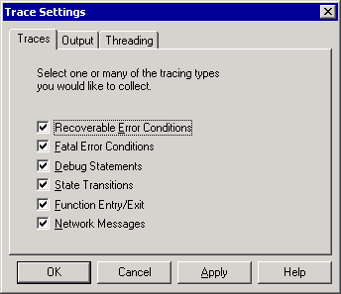

3. On the Output tab, make sure that the File option is selected, and then provide a path to a location that has enough capacity to store a very large file as output.
4. On the Threading tab, make sure that the Write traces on a Background Thread option is not selected, and then click OK.
5. In Registry Editor, locate the following registry key:
HKEY_LOCAL_MACHINE\SOFTWARE\Microsoft\MosTrace\CurrentVersion\
DebugAsyncTrace

6. On the Edit menu, click Add Value, and then add the following registry values:
Value Name: Modules
Data Type: REG_SZ
Value: AQ
CAT
DS2MB
dsevntwrap
EXSINK
IMAP4SVC
REAPI
RESVC
Routing
SMTP
StoreDev
TranMsg
DSACCESS

7. Next, add the MaxTraceFileSize registry key value to set the maximum trace file size to 20 megabytes (MB). On the Edit menu, click Add Value and add the following:
Value Name: MaxTraceFileSize
Data Type: REG_DWORD
Value: 20 (decimal)

8. Quit Registry Editor.
9. Reproduce the issue that you are troubleshooting. For example, if mail is being returned as undeliverable, send some e-mail messages to an address that will cause Exchange to return the message undelivered.
10. When you have reproduced the issue several times, stop tracing. In Regtrace, click the Output tab and select No Tracing.
The trace file is available at the location that is specified on the Output tab of Regtrace. The default location for the file is C:\Trace.atf.
The trace file is a binary-encoded file than contains debug-level information about the transport and routing components that are being traced. For this reason, Microsoft Product Support Services (PSS) requires that customers send the trace files for internal analysis. You may have to use file compression software to package the files so that you can deliver them to PSS by means of an FTP server, the Microsoft File Exchange (MSFE), or the Premier Service Desk. For details about any of these delivery methods, consult your PSS representative.

Verifying the Required Active Directory Attributes
When you are troubleshooting an NDR, verify that all mail-enabled attributes that Message Categorizer requires exist for that recipient in Active Directory. In Exchange 2000, multiple attributes must be correct for messages to be categorized:
• homeMDB
• homeMTA
• legacyExchangeDN
• mail
• mailNickname
• msExchHomeServerName
• msExchMailboxGuid
• msExchMailboxSecurityDescriptor
• proxyAddresses
This list of required attributes is valid only if the recipient is a mailbox-enabled object in Active Directory (for example, an Exchange 2003 recipient). However, if the recipient is an Exchange Server 5.5 recipient, the only attributes that have to be present are:
• legacyExchangeDN
• homeMDB
• homeMTA
For mail-enabled objects (for example, a custom recipient) and alternate addresses, the targetAddress attribute is required. If the targetAddress attribute is not present, the fallback is to the mail attribute.
If an e-mail message is missing any of the required attributes or if they are incorrect, the message may remain in the categorizer, and no events are created in Event Viewer. If you track the message, it appears in Message Categorizer or it generates an NDR, depending on which attribute is missing. If you want to check these attributes for a user in Active Directory, use the LDP tool or ADSI Edit. For more information about the LDP tool or ADSI Edit, see the Windows online documentation.
Note:
If you use the ADSI Edit snap-in, the LDP tool, or any other LDAP version3 client, and you incorrectly modify the attributes of Active Directory objects, you can cause serious problems. These problems may require you to reinstall any of the following: Windows2000 Server or Windows Server2003, or Exchange Server2003. You may not be able to solve problems that occur if you incorrectly modify Active Directory object attributes. Modify these attributes at your own risk.
The following table shows examples of each of the attributes that Active Directory requires.
Mail-Enabled Exchange 2003 Active Directory attributes
Exchange 2003 mail-enabled attribute | Example
homeMDB | CN=Mailbox Store (CONTOSO-MSG-01),CN=First Storage Group,CN=InformationStore,CN=CONTOSO-MSG-01,CN=Servers,CN=First Administrative Group,CN=Administrative Groups,CN=First Organization,CN=Microsoft Exchange,CN=Services,CN=Configuration,DC=contoso,DC=com
homeMTA | CN=Microsoft MTA,CN=CONTOSO-MSG-01,CN=Servers,CN=First Administrative Group,CN=Administrative Groups,CN=First Organization,CN=Microsoft Exchange,CN=Services,CN=Configuration,DC=contoso,DC=com
legacyDN | /o=First Organization/ou=First Administrative Group/cn=Recipients/cn=ted
mail | ted@contoso.com
mailNickname | ted
msExchHomeServerName | /o=First Organization/ou=First Administrative Group/cn=Configuration/cn=Servers/cn=CONTOSO-MSG-01
msExchMailboxGuid | 0x06 0x4f 0x69 0xcc 0x5e 0xfe 0x79 0x4f 0x8c 0x6e 0x7b 0x67 0x57 0x92 0x51 0xd2
msExchMailboxSecurityDescriptor | This attribute is a binary blob that does not display a value in ADSIEdit or LDP.
proxyAddresses | SMTP: scott@contoso.com X400:c=us;a= ;p=First Organizati;o=Exchange;s=Bremer;g=Ted;

The following example shows a dump file from the LDP tool with all the mail-enabled Exchange 2003 Active Directory attributes that the categorizer requires:
Expanding base 'CN=Ted Bremer,CN=Users,DC=contoso,DC=com'...
Result <0>: (null)
Matched DNs:
Getting 1 entries:
>> Dn: CN=Ted Bremer,CN=Users,DC=contoso,DC=com
1> homeMDB: CN=Mailbox Store (CONTOSO-MSG-01),CN=First Storage Group,CN=InformationStore,CN=CONTOSO-MSG-01,CN=Servers,CN=First Administrative Group,CN=Administrative Groups,CN=First Organization,CN=Microsoft Exchange,CN=Services,CN=Configuration,DC=contoso,DC=com;
1> memberOf: CN=Sales Team,CN=Users,DC=contoso,DC=com;
1> accountExpires: 9223372036854775807;
1> badPasswordTime: 0;
1> badPwdCount: 0;
1> codePage: 0;
1> cn: Ted Bremer;
1> countryCode: 0;
1> displayName: Ted Bremer;
1> mail: ted@contoso.com;
1> givenName: Ted;
1> instanceType: 4;
1> lastLogoff: 0;
1> lastLogon: 126416003544864704;
1> legacyExchangeDN: /o=First Organization/ou=First Administrative Group/cn=Recipients/cn=ted;
1> logonCount: 19;
1> distinguishedName: CN=Ted Bremer,CN=Users,DC=contoso,DC=com;
1> objectCategory: CN=Person,CN=Schema,CN=Configuration,DC=contoso,DC=com;
4> objectClass: top; person; organizationalPerson; user;
1> objectGUID: fdd08ce8-be92-4652-96db-f44785ef49e4;
1> objectSid: S-15-C2EF2A3A-4F67EE69-69068D04-64A;
1> primaryGroupID: 513;
2> proxyAddresses: SMTP:ted@contoso.com; X400:c=us;a= ;p=First Organizati;o=Exchange;s=Bremer;g=Ted;;
1> pwdLastSet: 126415962391597356;
1> name: Ted Bremer;
1> sAMAccountName: ted;
1> sAMAccountType: 805306368;
2> showInAddressBook: CN=Default Global Address List,CN=All Global Address Lists,CN=Address Lists Container,CN=First Organization,CN=Microsoft Exchange,CN=Services,CN=Configuration,DC=contoso,DC=com; CN=All Users,CN=All Address Lists,CN=Address Lists Container,CN=First Organization,CN=Microsoft Exchange,CN=Services,CN=Configuration,DC=contoso,DC=com;
1> sn: Bremer;
1> textEncodedORAddress: c=us;a= ;p=First Organizati;o=Exchange;s=Bremer;g=Ted;;
1> userAccountControl: 512;
1> userPrincipalName: ted@contoso.com;
1> uSNChanged: 16820;
1> uSNCreated: 16814;
1> whenChanged: 8/6/2001 11:31:17 Pacific Standard Time Pacific Daylight Time;
1> whenCreated: 8/6/2001 11:30:38 Pacific Standard Time Pacific Daylight Time;
1> homeMTA: CN=Microsoft MTA,CN=CONTOSO-MSG-01,CN=Servers,CN=First Administrative Group,CN=Administrative Groups,CN=First Organization,CN=Microsoft Exchange,CN=Services,CN=Configuration,DC=contoso,DC=com;
1> msExchMailboxGuid: <ldp: Binary blob>;
1> msExchMailboxSecurityDescriptor: <ldp: Binary blob>;
1> msExchALObjectVersion: 56;
1> msExchHomeServerName: /o=First Organization/ou=First Administrative Group/cn=Configuration/cn=Servers/cn=CONTOSO-MSG-01;
1> mailNickname: ted;
1> mDBUseDefaults: TRUE;
1> msExchPoliciesIncluded: {E7B464D2-65EF-4B3E-8AF4-8EB84BA7088E},{26491CFC-9E50-4857-861B-0CB8DF22B5D7};
1> msExchUserAccountControl: 0;

How the Recipient Update Service Updates Attributes
The Recipient Update Service has three system policies for mail-enabled recipients, mailbox-enabled users, and hidden distribution group membership that are installed by default when you install Exchange 2003. All three policies have the same purpose: to update a few attributes for objects in Active Directory under certain circumstances.
When custom tools are used to create users, contacts, or distribution groups, the Recipient Update Service attempts to correct any omissions in cases where a tool does not create all the necessary attributes for an object. If a user, contact, or distribution group lacks required attributes, problems can occur.
For a mail-enabled recipient, a minimum set of attributes is required to make all Exchange components work properly. For example, a mail-enabled entry (a user, contact, group, or public folder) has to have at least these attributes: mailNickname, legacyExchangeDN, and displayName. Without the mailNickname attribute, an object is not considered mail-enabled. After an object has a mailNickname attribute, the other two attributes must be set.

Mail-Enabled Recipient Policy
If the Recipient Update Service identifies a new entry that was added or modified, and that entry has the mailNickname attribute, but does not have the legacyExchangeDN or displayName attributes, the Recipient Update Service tries to create those attributes.
The displayName attribute is copied from the mailNickname attribute as is. The legacyExchangeDN attribute goes through an algorithm that identifies the organization and administration group for the entry, and then creates a value in the following format:
/o=MyCompany/ou=MyAdminGroup/cn=Recipients/cn=MailNickname

Mailbox-Enabled User Policy
For a mailbox-enabled user, two attributes must be present. The first is the mailNickname attribute, and the second is one of the following attributes:
• msExchHomeServerName
• homeMDB
• homeMTA
If any one of these attributes is present, and the user has a mailNickname attribute, the user is considered a mailbox-enabled user.
In this case, the Recipient Update Service attempts to populate some of the following attributes if they are not present:
• msExchHomeServerName
• homeMDB
• homeMTA
• legacyExchangeDN
• displayName
• msExchMailboxGuid
These attributes are populated in the following order:
1. If the msExchHomeServerName attribute is not present, it is created based on the homeMDB or homeMTA attribute, depending on which one is present. If the msExchHomeServerName attribute cannot be created, the process stops.
2. After the msExchHomeServerName attribute is set, the homeMDB and homeMTA attributes are populated if either one is missing. If you have multiple mailbox stores or message transfer agents (MTAs) on your server, the Recipient Update Service picks the first one that it finds when it does an Active Directory search. Therefore, this selection can be considered a random choice.
3. To create the legacyExchangeDN and displayName attributes, the Recipient Update Service follows the same steps that are used for a mail-enabled recipient.
4. Finally, if the msExchMailboxGuid attribute is not present, the Recipient Update Service creates the msExchMailboxGuid attribute by generating a GUID.

Hidden Distribution Group Membership Policy
For the hidden distribution group membership policy, the Recipient Update Service does not run only when a new entry is created (such as a security group or distribution group). The Recipient Update Service also runs when you modify the status of the hideDLMembership attribute.
If this attribute is set to TRUE, the Recipient Update Service adds a noncanonical part to the security descriptor, which prevents anyone from viewing the "member" attribute for that entry. This applies to any type of client that searches the directory by using MAPI or LDAP.
If the attribute is set to FALSE, the Recipient Update Service removes the noncanonical security descriptor, which exposes the member attribute again.
For additional information about hiding group membership, see Microsoft Knowledge Base article 253827, "XADM: How Exchange Hides Group Membership in Active Directory." Although this article is written for Exchange 2000, the same principles apply to Exchange 2003.

Common Non-Delivery Report Scenarios
This topic covers the following common scenarios that can cause NDRs to be generated:
• Issues with Active Directory.
• Delayed message delivery because of global catalog server issues.
• Sending messages to recipients in personal address books or contact lists.
• Sending messages to a public folder.

Issues with Active Directory
Non-delivery reports can occur because of issues with Active Directory. The following categories of NDRs are related to Active Directory issues:
• Recipients were moved to Active Directory by using Active Directory Connector (ADC).
• Recipients were moved to Active Directory by using the Move Mailbox tool.
• Attributes are missing.

Recipients Were Moved to Active Directory by Using Active Directory Connector
If some of your users are experiencing NDRs and you have moved recipients using the Active Directory Connector, determine the following:
• What type of recipient is generating the NDR (for example, a mailbox, a distribution group, or a contact).
• How the recipient was moved to Active Directory. If the recipient was replicated to Active Directory by the ADC, use the ADCDump tool to obtain an ADC dump file, and then compare the attributes that exist in both directories for the recipient that is experiencing the issue. The ADC dump file shows the missing attributes between the Exchange 2003 object and the Exchange Server 5.5 object. To obtain the ADCDump tool, contact Microsoft Product Support Services.
If the users were moved by using the ADC, the users must exist in Active Directory, at least as disabled users. Replicating users to Active Directory as contacts (custom recipients) from the Exchange 5.5 directory results in NDRs. If the Exchange 5.5 and Microsoft Windows NT® Server version 4.0 recipients were replicated to Active Directory as contacts, Exchange 2003 no longer sends e-mail messages to Windows NT Server 4.0 recipients that are represented as contacts in Active Directory. In this scenario, the following NDR is returned:
A configuration error in the e-mail system caused the message to bounce between two servers or to be forwarded between two recipients. Contact your administrator. <servername.contoso.com #5.4.6>
For additional information, see Microsoft Knowledge Base article 272593, "XCON: Message Generates NDR When Sent to a Windows NT Server 4.0 Recipient Represented as Contact in Active Directory." Although this article was written for Exchange 2000, the same principles apply to Exchange 2003.
This behavior does not occur with contacts that are created in Exchange 2003; this behavior occurs only with Windows NT Server 4.0 users that are replicated to Active Directory as contacts through the ADC. Messages can be sent to native Exchange 2003 contacts without issues.
Note:
If disabled users are not displayed in Active Directory, and you are receiving 8277 MSADC error messages, change the replication server for the Connection Agreement to the bridgehead server in the Exchange 2003 site or domain to which you are replicating. Also, for complete interoperability between Exchange 2003 servers and Exchange 5.5 computers, make sure that ADC replication is set to two-way.

Recipients Were Moved to Active Directory by Using the Move Mailbox Tool
Make sure that all mail-enabled attributes exist if a recipient, distribution group, or user exists as a native Exchange 2003 object or was moved from Exchange 5.5 by using the Move Mailbox tool. The following steps are useful:
• Determine the Exchange server that the sender physically resides on. If the recipient is a distribution group, find the distribution group expansion server.
• Determine which global catalog server that the sender's Exchange server or the distribution group expansion server contacts for name resolution. (See the procedure later in this section for detailed steps.)
• Run the Nltest tool, available on Windows 2000 and Windows Server 2003, to determine which global catalog server is being contacted by the sender's server or the distribution group expansion server. Make sure that you run Nltest from the sender's Exchange server or from the distribution group expansion server. If the distribution group expansion is set to any server in the organization, run Nltest from the sending server.
For detailed instructions, see How to Determine the Expansion Server for a Distribution Group.
After you know which global catalog is being used, obtain a dump file of the recipient user distribution group. For additional information about how to obtain a dump file, see the following Microsoft Knowledge Base articles:
• 255253,"XADM: How to Perform a Dump of a Container or Object in Exchange 2000"
• 271201,"XADM: Alternative Methods to Obtain a Dump of an Object"
You can also use the LDP tool to obtain the LDP dump file of the recipient object. If you use the LDP tool, make sure that port 3268 is used when connecting to the global catalog server. This is the port that Message Categorizer uses to query global catalog servers for name resolution.
Note:
If the LDP tool truncates results, you can obtain the base distinguished name information for the object (which is required to use the procedure discussed in Knowledge Base article 271201) from the NDR. Each NDR contains the base distinguished name information of the object that cannot be delivered. If the format of the NDR or the recipient object's base distinguished name information is suspect, you can send a new test message with a delivery receipt requested. Send this test message to the recipient that is experiencing the issue from a user who can successfully send to that recipient.

Missing Attributes
Attributes may be missing from an object for a variety of reasons that range from attributes that were manually deleted to global catalog synchronization issues. However, if any attributes are missing, it is most commonly because Recipient Update Service did not write these attributes correctly or because of ADC replication issues.
For detailed information, see How to Correct Missing Attribute Issues.

Delayed Message Delivery Due to Global Catalog Server Issues
Problems with a global catalog can cause delays in message delivery. In this case, NDRs are generated to notify the sender of the delay. You can use Message Tracking Center to diagnose these problems. The following example shows data gathered from Message Tracking Center:
6/22/2001 3:54 PM Tracked message history on server CONTOSO-MSG-01
6/22/2001 3:54 PM SMTP Store Driver: Message Submitted from Store
6/22/2001 3:54 PM SMTP: Message Submitted to Advanced Queuing
6/22/2001 3:54 PM SMTP: Started Message Submission to Advanced Queue
6/22/2001 3:54 PM SMTP: Message Submitted to Categorizer
6/22/2001 4:24 PM SMTP: Started Outbound Transfer of Message
6/22/2001 4:24 PM Message transferred out to FOURTHCOFFEE.COM through SMTP
6/22/2001 4:24 PM SMTP: Message Submitted to Advanced Queuing
6/22/2001 4:24 PM SMTP: Started Message Submission to Advanced Queue
6/22/2001 4:24 PM SMTP: Message Submitted to Categorizer
6/22/2001 4:24 PM SMTP: Started Outbound Transfer of Message
6/22/2001 4:24 PM Message transferred out to FOURTHCOFFEE.COM through SMTP
6/22/2001 4:24 PM SMTP Store Driver: Message Delivered Locally to Store
In this example, notice that the message was delayed in message categorizer for 30 minutes before outbound transfer started and the message was eventually delivered. In these situations, determine which global catalog server Exchange is using by running the Nltest tool as described in "Recipients Were Moved to Active Directory by Using the Move Mailbox Tool" earlier in this topic. Then, investigate the global catalog servers that are involved. The following are common causes of global catalog issues:
• Overloaded or overworked global catalog servers.
• Performance issues with global catalog servers.
• Low memory.
• Low hard disk space.
• Intermittent network issues between Exchange 2000 and global catalog servers.
• Too many Exchange servers using the same global catalog server (the recommended ratio of Exchange processors to global catalog server processors is four to one).
Important:
Message tracking logs can be misleading. For example, if the global catalog server is working correctly and the message categorized correctly, but a remote SMTP server was unavailable for thirty minutes, the message tracking log looks similar to the sample log shown above. Also, if the message had to be delivered locally and the Exchange store was performing slowly, the message tracking log shows a large gap of time between "Message Submitted to Message Categorizer" and "Message Delivered Locally to Store."
Use a System Monitor log from a global catalog server while you reproduce the issue. It can help you diagnose these issues. Recycling the global catalog servers may resolve these issues. To troubleshoot these issues, you can specify a global catalog server for each Exchange server.
Note:
Manually configuring global catalog servers is only recommended for troubleshooting. When your global catalog servers are manually configured, Exchange cannot detect if a server becomes unavailable.
For detailed information, see How to Specify a Global Catalog Server.
For additional information about DSAccess, see Microsoft Knowledge Base article 250570, "XCON: Directory Service Server Detection and DSAccess Usage."

Non-Delivery Reports When Sending to Personal Address Book and Contact List
If a user is moved from an Exchange Server 5.5 computer by using the Exchange 2003 Move Mailbox tool, and the moved mailbox has a personal address book or contact list in the Exchange 5.5 mailbox, the personal address book and contact list becomes invalid on an Exchange 2003 mailbox. Any addresses that are resolved against the personal address book or contact list generate an NDR that is similar to:
Your message did not reach some or all of the intended recipients.
Subject: Test
Sent: 8/3/2000 5:24 PM
The following recipient(s) could not be reached:
CN=\ Network,OU=United States,OU=Distribution Lists,DC=Contoso,DC=com on 8/3/2000 5:24 PM
The e-mail address could not be found. Perhaps the recipient moved to a different e-mail organization, or there was a mistake in the address. Check the address and try again.
<CONTOSO-MSG-01.Contoso.com #5.1.0>
Because the Move Mailbox tool does not move personal address books and contact lists, all addressing information in personal address books and contact lists becomes invalid.
To resolve this issue, on your Outlook client, ensure that the global address list is selected as the source for the address book. Ideally, your users that have been moved from an Exchange 5.5 server should delete personal address books and contact lists, and then re-create them.

Sending Messages to a Public Folder
Sending an e-mail message to a public folder in Exchange is more complicated than sending an e-mail message to a mailbox. A mailbox can only exist on one server and therefore belongs to a particular mailbox store. Active Directory attributes for a mailbox point to a specific server. Therefore, after the entry is resolved, Exchange can use routing to determine which mailbox store to deliver the message to.
A public folder in Active Directory has no home server. A public folder can exist on multiple servers, and no information is held in Active Directory to indicate which servers hold replicas of the folder. The Exchange store handles this information.
When Exchange delivers a message to a public folder, the first task it performs is to deliver the message to an Exchange store that points to the location of the public folder replicas. The Exchange store looks up the ptagReplicaList entry, which lists the Exchange servers with replicas of the folder, and then resubmits the message readdressed to an Exchange store that holds a replica of the folder.
The categorizer is responsible for correctly resolving the address of a message. In the case of public folders, it is also responsible for:
• Determining which top-level hierarchy the folder belongs to.
• Addressing the message correctly to be submitted to a store in that top-level hierarchy.
• Rewriting the address of the message to a store that holds a replica of that public folder, after the replica list is obtained.
When an e-mail message is sent to a public folder, the categorizer performs the following steps to deliver the message:
1. Initial public folder lookup
2. Top-level hierarchy server lookup

Initial Public Folder Lookup
When an e-mail message is submitted, Exchange resolves the address to an entry in Active Directory. If that entry is a public folder rather than a mailbox, the categorizer attempts to obtain the homeMDB attribute of the public folder:
homeMDB: CN=Public Folders,CN=Folder Hierarchies,CN=First Administrative Group,CN=Administrative Groups,CN=First Organization,CN=MicrosoftExchange,CN=Services,CN=Configuration,DC=contoso-msg-01,DC=contoso,DC=com;
A folder's homeMDB attribute contains the distinguished name of the top-level hierarchy to which the folder belongs.

Top-level Hierarchy Server Lookup
Next, the categorizer looks up the top-level hierarchy that is retrieved from the folder's homeMDB attribute to obtain a list of all the servers in that folder's top-level hierarchy. The categorizer is unable to determine the location of the replica, but it can submit the message to an Exchange store that does have the location information. The top-level hierarchy distinguished name contains a link to all the servers in that top-level hierarchy.
To determine which public folder store or server the categorizer picks from the top-level hierarchy, Exchange uses the following criteria:
• Does one of the public folder stores exist on the local server? If so, Exchange uses that store.
• Does one of the public folder stores exist on an Exchange server in the local routing group? If so, Exchange uses that store.
• Does one of the public folder stores exist on any Exchange server? If so, Exchange uses that store. Otherwise, Exchange uses the first store in the list.
The first server on the list is contained in the msExchOwningPFTreeBL attribute. This attribute is located on the public folder tree under folder hierarchies. The categorizer then chooses a server from the msExchOwningPFTreeBL attribute to which it sends the message.
The following example shows the contents of the msExchOwningPFTreeBL attribute, as obtained from LDP output:
msExchOwningPFTreeBL: CN=Public Information Store (PFREP55),CN=First Storage Group,CN=InformationStore,CN=PFREP55,CN=Servers,CN=FourthCoffee,CN=Administrative Groups,CN=Lake District,CN=Microsoft Exchange,CN=Services,CN=Configuration, DC=cumbria,DC=extest,DC=microsoft, DC=com;
CN=Public Folder Store (PFREP57),CN=First Storage Group,CN=InformationStore, CN=PFREP57,CN=Servers,CN=Coniston,CN=Administrative Groups,CN=Lake District,CN=Microsoft Exchange,CN=Services,CN=Configuration,DC=cumbria,DC=example,DC=microsoft,DC=com;
CN=Public Information Store (PFREP56),CN=First Storage Group,CN=InformationStore,CN=PFREP56,CN=Servers,CN=Coniston,CN=Administrative Groups,CN=Lake District,CN=Microsoft Exchange,CN=Services,CN=Configuration,DC=cumbria,DC=example,DC=microsoft,DC=com;

How to Determine the Expansion Server for a Distribution Group
Expansion servers route messages that are sent to a single distribution list or group for each of the recipient objects in that list or group. When a user sends a message to a group, the Exchange server that is acting as the expansion server expands the group to its individual members. This expansion permits members of the distribution list or group to receive the message. An expansion server also resolves the names of all recipients in the distribution list or group, and then determines the most efficient path for routing the message.

Before You Begin
Before you perform the procedure in this topic, read Troubleshooting Non-Delivery Report Messages.
The following permissions are required to perform this procedure:
• Member of the local administrators group and a member of a group that has had the Exchange Administrators role applied at the administrative group level

Procedure
To determine the expansion server for a distribution group
1. In Active Directory Users and Computers, right-click the distribution group and then click Properties.
2. Click the Exchange Advancedtab, and look in the value under Expansion server.
The Exchange Advanced tab of the Distribution group properties dialog box
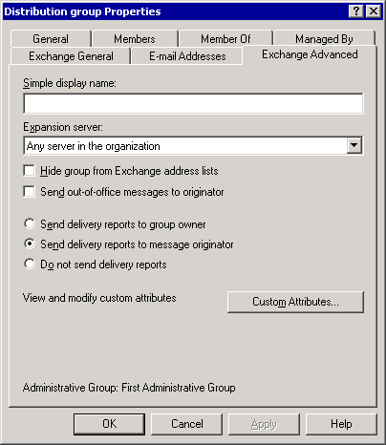

3. From a command prompt, type the following:
NLTEST /DSGETDC:<domain> /GC

where domainis the name of your domain

How to Correct Missing Attribute Issues
Attributes may be missing from an object for a variety of reasons that range from attributes that were manually deleted to global catalog synchronization issues. However, if any attributes are missing, it is most commonly because Recipient Update Service did not write these attributes correctly or because of ADC replication issues.

Before You Begin
Before you perform the procedure in this topic, read Troubleshooting Non-Delivery Report Messages.
The following permissions are required to perform this procedure:
• Member of the local administrators group

Procedure
To correct missing attribute issues
1. In Exchange System Manager, expand Recipients, and then expand Recipient Update Services.
2. Right-click the Recipient Update Service that you want to correct, and then click Update Now to update the missing attributes from the recipient object that is experiencing this issue, or click Rebuild to rebuild all recipient objects.

How to Specify a Global Catalog Server
Problems with a global catalog can cause delays in message delivery. In this case, NDRs are generated to notify the sender of the delay. You can use Message Tracking Center to diagnose these problems.
The following are common causes of global catalog issues:
• Overloaded or overworked global catalog servers.
• Performance issues with global catalog servers.
• Low memory.
• Low hard disk space.
• Intermittent network issues between Exchange 2000 Server and global catalog servers.
• Too many Exchange servers using the same global catalog server (the recommended ratio of Exchange processors to global catalog server processors is four to one).
Important:
Message tracking logs can be misleading. For example, if the global catalog server is working correctly and the message categorized correctly, but a remote SMTP server was unavailable for thirty minutes, the message tracking log looks similar to the sample log shown above. Also, if the message had to be delivered locally and the Exchange store was performing slowly, the message tracking log shows a large gap of time between "Message Submitted to Message Categorizer" and "Message Delivered Locally to Store."
Use a System Monitor log from a global catalog server while you reproduce the issue. It can help you diagnose these issues. Recycling the global catalog servers may resolve these issues. To troubleshoot these issues, you can specify a global catalog server for each Exchange server.
Note:
Manually configuring global catalog servers is only recommended for troubleshooting. When your global catalog servers are manually configured, Exchange cannot detect if a server becomes unavailable.

Before You Begin
Before you perform the procedure in this topic, read Troubleshooting Non-Delivery Report Messages.
The following permissions are required to perform this procedure:
• Member of the local administrators group and a member of a group that has had the Exchange Administrators role applied at the organizational level

Procedure
To specify a global catalog server
1. In Exchange System Manager, expand Servers, right-click your Exchange server and then click Properties.
2. Click the Directory Accesstab.
3. In Show, select Global Catalog Servers.
4. Clear the Automatically discover servers check box.
Directory Access tab
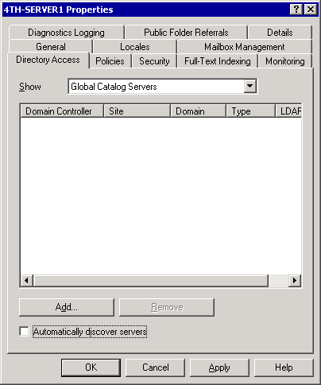

5. Click Add, and select the global catalog server that you want to troubleshoot. The global catalog that you select for the domain must exist in Active Directory, must be accessible by means of LDAP port 3268, must process the Exchange server's request in a timely manner, and must have all mail-enabled attributes for the recipient object.
The following example shows data gathered from Message Tracking Center:
6/22/2001 3:54 PM Tracked message history on server CONTOSO-MSG-01
6/22/2001 3:54 PM SMTP Store Driver: Message Submitted from Store
6/22/2001 3:54 PM SMTP: Message Submitted to Advanced Queuing
6/22/2001 3:54 PM SMTP: Started Message Submission to Advanced Queue
6/22/2001 3:54 PM SMTP: Message Submitted to Categorizer
6/22/2001 4:24 PM SMTP: Started Outbound Transfer of Message
6/22/2001 4:24 PM Message transferred out to FOURTHCOFFEE.COM through SMTP
6/22/2001 4:24 PM SMTP: Message Submitted to Advanced Queuing
6/22/2001 4:24 PM SMTP: Started Message Submission to Advanced Queue
6/22/2001 4:24 PM SMTP: Message Submitted to Categorizer
6/22/2001 4:24 PM SMTP: Started Outbound Transfer of Message
6/22/2001 4:24 PM Message transferred out to FOURTHCOFFEE.COM through SMTP
6/22/2001 4:24 PM SMTP Store Driver: Message Delivered Locally to Store
In this example, notice that the message was delayed in message categorizer for 30 minutes before outbound transfer started and the message was eventually delivered. In these situations, determine which global catalog server Exchange is using by running the Nltest tool as described in the "Recipients Were Moved to Active Directory by Using the Move Mailbox Tool" in Common Non-Delivery Report Scenarios. Then, investigate the global catalog servers that are involved.
For additional information about DSAccess, see Microsoft Knowledge Base article 250570, "XCON: Directory Service Server Detection and DSAccess Usage."

Additional NDR Reference
The following table provides a description of delivery status notification codes. This table can help you interpret the codes that you receive in NDRs.
Delivery status notification codes
Delivery status notification code | Description
X.1.0 | Other address status
X.1.1 | Bad destination mailbox address
X.1.2 | Bad destination system address
X.1.3 | Bad destination mailbox address syntax
X.1.4 | Destination mailbox address ambiguous
X.1.5 | Destination mailbox address valid
X.1.6 | Mailbox has moved
X.1.7 | Bad sender's mailbox address syntax
X.1.8 | Bad sender's system address
X.2.0 | Other or undefined mailbox status
X.2.1 | Mailbox disabled, not accepting messages
X.2.2 | Mailbox full
X.2.3 | Message length exceeds administrative limit
X.2.4 | Mailing list expansion issue
X.3.0 | Other or undefined mail system status
X.3.1 | Mail system full
X.3.2 | System not accepting network messages
X.3.3 | System not capable of selected features
X.3.4 | Message too big for system
X.3.5 | System incorrectly configured
X.4.0 | Other or undefined network or routing status
X.4.1 | No answer from host
X.4.2 | Bad connection
X.4.3 | Routing server failure
X.4.4 | Unable to route
X.4.5 | Network congestion
X.4.6 | Routing loop detected
X.4.7 | Delivery time expired
X.5.0 | Other or undefined protocol status
X.5.1 | Invalid command
X.5.2 | Syntax error
X.5.3 | Too many recipients
X.5.4 | Invalid command arguments
X.5.5 | Wrong protocol version
X.6.0 | Other or undefined media error
X.6.1 | Media not supported
X.6.2 | Conversion required and prohibited
X.6.3 | Conversion required but not supported
X.6.4 | Conversion with loss performed
X.6.5 | Conversion failed
X.7.0 | Other or undefined security status
X.7.1 | Delivery not authorized, message refused
X.7.2 | Mailing list expansion prohibited
X.7.3 | Security conversion required but not possible
X.7.4 | Security features not supported
X.7.5 | Cryptographic failure
X.7.6 | Cryptographic algorithm not supported
X.7.7 | Message integrity failure

Part Five
Part 5 contains advanced concepts about the underlying transport architecture of Microsoft® Exchange Server 2003 and the link state concepts that it uses. You should read Part 1 of this guide and possess a sound knowledge of the concepts that are presented in this guide before reading this section. Part 5 contains the following sections:
• Understanding Internal Transport Components
This section explains how the internal transport components, such as the routing engine, the advanced queuing engine, and the message categorizer, work together in the message delivery process.
• Advanced Link State Concepts
This section examines the details of the link state packet and explains advanced link state concepts.

Understanding Internal Transport Components
This topic provides detailed descriptions of the components that are involved in receiving and sending mail in Simple Mail Transfer Protocol (SMTP). In addition, this topic describes how these components perform in a typical mail flow process. The following are important components that are involved in mail transport:
• Routing engine
The Microsoft® Exchange Routing engine, a service in the Default Exchange Services, is responsible for determining the least expensive available path for message delivery. It supplies this information to the advanced queuing engine as part of the message delivery process.
• Advanced queuing engine
The advanced queuing engine is responsible for several aspects of message delivery. Specifically, the advanced queuing engine retrieves messages from SMTP or the Microsoft Exchange store driver, categorizes them, determines each message's destination, and then provides an interface to the multiple queues to which a message can be assigned while awaiting delivery.
• Message categorizer
The message categorizer is a component of the advanced queuing engine that sends Lightweight Directory Access Protocol (LDAP) queries to the global catalog server to perform directory lookups. These queries retrieve the following information:
• The recipient e-mail addresses
• The mailbox store on which a recipient mailbox resides
• The Exchange server hosting that mailbox store
The following figure illustrates the transport components involved in mail flow. The shaded areas depict transport components.
Message flow through internal transport components
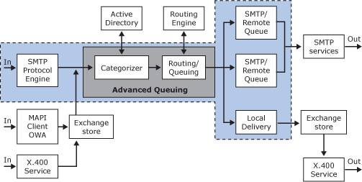

Receiving Internet Mail
Exchange relies on DNS, the SMTP protocol, the message categorizer, the advanced queuing engine, and the Exchange routing engine to receive Internet mail. The components perform the following tasks to deliver Internet mail to a user in an Exchange organization:
1. The sending SMTP server uses DNS to query for the preferred MX (mail exchanger) record of the destination domain or target server. DNS returns a list of A (host) records, which resolve to an Internet Protocol (IP) address or addresses of the server.
2. The sending SMTP server initiates a connection to port 25 of the destination SMTP server. The destination SMTP server is the SMTP virtual server located on the physical gateway server that is configured to accept incoming Internet mail for the domain to which the mail is addressed.
3. Ideally, the inbound SMTP server only accepts the incoming message if it is destined for an SMTP mail domain that is defined in a recipient policy (unless the server is open to relay, which is strongly discouraged).
4. When the message is accepted, the SMTP virtual server creates an envelope for the message—this message structure is called MAILMSG. MAILMSG contains all of the properties of the message, including the sender and recipient names.
5. The message categorizer makes an LDAP query to the global catalog server to find the homeMdb attribute of the recipient. The message categorizer then stamps the fully qualified domain name (FQDN) of this Exchange server on the MAILMSG object. The homeMdb attribute is the user's home mailbox server, which is the location where the user's mailbox store and mailbox reside.
6. One of two events occurs:
• If the user's mailbox store is located on that Exchange server, the message categorizer marks the message for local delivery, and the advanced queuing engine transfers the message to the Exchange store driver. The Exchange store driver then delivers the message to the mailbox store.
• If the user's mailbox store is not located on that Exchange server, the message categorizer transfers the message to the advanced queuing engine. The advanced queuing engine then calls the Exchange routing engine to determine the best way to send the message to the server (based on link state routing), and determines the next destination, or hop, in the route to the user's home server.
7. Finally, complete with destination information from the message categorizer and routing information from the routing engine, the advanced queuing engine sends the message to its final destination in one of the following ways:
• If the destination is a local domain, the message is delivered to the SMTP virtual server located on the Exchange server where the user's mailbox resides. If the user's mailbox is in a remote routing group, the message may have to be sent through other connectors.
• If the destination is outside of the Exchange organization, the message is delivered to the SMTP server for remote domains in a different remote queue. An incoming message will be sent to a remote domain only if one of the following configurations is applied:
- The Exchange server is open for relay.
- The user sending the message is authorized to relay.
- Another connector is configured that allows relaying to these domains.
- If the destination is a connector to another system or to an earlier version of Exchange, the Exchange store driver submits the mail to the message transfer agent (MTA).

Sending Internet Mail
To send Internet mail, Exchange relies on the same components that it relies upon for receiving Internet mail: DNS, the SMTP protocol, the message categorizer, the advanced queuing engine, and the Exchange routing engine. Internet mail is sent through Exchange in the following manner:
1. An internal user sends a message to a remote domain. The message is submitted on the Exchange server on which the user's mailbox resides.
2. The message is submitted to the advanced queuing engine in one of two ways:
• If the message was sent using a Microsoft Office Outlook® Web Access or Outlook (MAPI) client, the Exchange store submits the message to the advanced queuing engine through the store driver.
• If the message was sent using a Post Office Protocol (POP) or an Internet Mail Access Protocol (IMAP) client, SMTP passes the message to the advanced queuing engine.
3. The message categorizer then queries the global catalog server with the recipient address to find the user. If the recipient address is not in a recipient policy, or if a matching recipient with a proxy address does not exist (the recipient address will not be stored in Active Directory), the message categorizer determines that the message is bound for a remote domain.
4. The advanced queuing engine calls into the Exchange routing engine to determine the next destination, or hop, for a route to the address space that more closely matches the remote domain.
5. With this information, the server determines whether to send the message, to route it to the smart host, or to use an SMTP connector with the remote address space.
6. If there are multiple connectors or virtual servers that handle outbound mail, the advanced queuing engine determines the virtual server or connector with the address space that most closely matches the address space of the remote domain and any restrictions for that connector.
7. The message is routed to the outbound connector's SMTP virtual server or to the outbound SMTP virtual server that is responsible for delivery.
8. The SMTP virtual server located on the Exchange server that performs categorization then uses its metabase information for the route action attribute for the remote domain.
9. The SMTP virtual server on the Exchange server then performs one of two tasks:
• Uses DNS to look up the IP address for the target domain and then attempts delivery of the message.
• Forwards the message to a smart host that assumes responsibility for the DNS resolution and delivery.

Advanced Link State Concepts
This section explains advanced concepts that govern how link state information is communicated and propagated throughout a Microsoft® Exchange organization. It contains the following topic:
• Link State Components
• Understanding the OrgInfo Packet
• Understanding OrgInfo Packet Details
• Server Services and Routing Nodes
• Routing Updates
• Routing Topology Update Communications

Link State Components
Several components play a crucial role in the propagation of link state information. These components are the:
• OrgInfo packet that contains the packet of link state information for the Exchange topology.
• Server services and client nodes that use or exchange link state information.
• Routing group master, a type of server service, that is responsible for maintaining accurate link state information for its routing group and distributing that information (the OrgInfo packet) to its routing group members.

Understanding the OrgInfo Packet
The OrgInfo packet is the link state table that contains the details and status of the Exchange organization's routing topology. Routing group masters propagate this information throughout the organization in the form of the OrgInfo packet. The packet includes details such as organization name, routing groups, connectors, and address spaces. The WinRoute tool displays the contents of the OrgInfo packet in a more readable form than the raw packet. To identify in detail the various portions of this packet, however, this topic discusses the packet in its raw data form.
Note:
You can download the WinRoute tool from the Downloads for Exchange Server 2003 Web site.
In general, information fields within the packet are separated by parentheses in the following way:
(Routing group (Routing group members (Connectors in routing group (Connector config))))
Within the packet, GUIDs are referenced for the various components. Certain information is represented in ASCII text, such as:
• Portions of the X.400 and X.500 routing group addresses that are listed in each routing group section.
• The legacy distinguished names, legacyExchangeDNs, of connectors.
• Virtual server FQDNs when listing the source or remote bridgehead servers of connectors.
• For each restriction set on a connector, the distinguished name of the restricted object. For example, if a connector denies usage to three users, the three distinguished names of the users are listed in ASCII text in the packet.
Because the components above are listed in ASCII text, the number of these components in a routing topology affect the overall size of the OrgInfo packet. A practice of denying connector access to users instead of distribution groups or specifying source and destination bridgehead servers when not necessary, for example, will lead to a much larger OrgInfo packet than normal. Because this packet is distributed throughout the Exchange organization, and these restrictions add to the size of the package, the exchange of the link state packet between servers can have profound effects on network utilization depending on the size of the Exchange organization. As a best practice, if you must restrict connector access, use distribution groups rather than users, and only apply specific source and destination bridgehead servers where appropriate if the size of the OrgInfo packet is of a concern.
Another important fact about the size of the OrgInfo packet is that, once a routing group has been created, the routing group remains in memory on each Exchange server in the organization (given that the information has propagated throughout) indefinitely unless all Exchange servers in the organization are shut down simultaneously. This is true even if the routing group has been deleted in Exchange System Manager.

Understanding OrgInfo Packet Details
To explain the contents of an OrgInfo packet, this section analyzes the transmission of an OrgInfo packet from one server to another server within a routing group.
The example that is illustrated in Figure 15.1 is taken from an Exchange organization with one routing group containing two servers, both running Exchange Server 2003, with a single SMTP connector incorporating user restrictions. The OrgInfo packet that was transmitted over the network contained the following information:
{00000457}..a9c421ebe14f06710f6ab596345ac615.(.a2a0f896d197b84999557850ac796258.2d07476703630a4d87a651498e2d73b9.a.0.0.f0dcd868912f54479b26d729863bb825.{26}*.A2A0F896-D197-B849-9955-7850AC796258.{4b}c=US;a=.;p=Example;o=Exchange;cn=A2A0F896-D197-B849-9955-7850AC796258;*.{53}/o=Example/ou=First.Administrative.Group/*/A2A0F896-D197-B849-99557850AC796258.(.2d07476703630a4d87a651498e2d73b9.YES.1.1aae.{10}0701000000000101..979733932e995742bc2d5ecf93198b4d.YES.1.1aae.{10}0701000000000101.).(.f76005bd57ad93428518268f28f4f7e6.(.CONFIG.{4}SMTP.{23}_f76005bd57ad93428518268f28f4f7e6_S.{}.{54}/o=Example/ou=First.Administrative.Group/cn=Configuration/cn=Connections/cn=JUNK.0.0.0.0.ffffffff.ffffffff.0.1.0.().6.(.{24}CN=tester07,CN=Users,DC=domain,DC=com..{24}CN=tester04,CN=Users,DC=domain,DC=com..{24}CN=tester03,CN=Users,DC=domain,DC=com..{24}CN=tester02,CN=Users,DC=domain,DC=com..{24}CN=tester01,CN=Users,DC=domain,DC=com..{29}CN=Administrator,CN=Users,DC=domain,DC=com.).0.().0.()..ARROWS.(.{4}SMTP.{1}*.1.).BH.(.2fdb30b62e4ea949a71f91f319535143.CONN_AVAIL.{13}RGR-65-02.domain.com.).TARGBH.().STATE.UP)))..
Analyzing the packet shown above in order of presentation, the "ORGINFO" signals to the receiving server that the OrgInfo packet is contained within this frame. The contents that follow "ORGINFO" are:
• The MD5 hash, an encrypted signature that represents the version number for the link state table, of the current OrgInfo packet. This signature is important because servers use this information to determine if they have the identical link state information. As illustrated later, if this hash is different between two Exchange servers, it signals that they have different routing information, and they will exchange OrgInfo packets with each other to determine which server has the most up-to-date information.
• The first set of parentheses shows that information within them pertains to a particular routing group. This example shows a single routing group, so all routing information is contained within this set of parentheses:
• The GUID for the routing group: a2a0f896d197b84999557850ac796258
• The GUID for the routing group master: 2d07476703630a4d87a651498e2d73b9
• The major, minor, and user versions of the link state information: a.0.0
• The GUID of this version information: f0dcd868912f54479b26d729863bb825
• SMTP address information for the routing group: {26}. Brackets signal the start of this information. When an organization is fully converged, each routing group will host this information, that is, if there are two routing groups, the information below will be listed within each routing group's section of the OrgInfo packet. (Note that the characters within these and subsequent brackets mentioned are not necessarily identical across implementations.)
• The GUID immediately after the {26}, A2A0F896-D197-B849-9955-7850AC796258, is the GUID for the particular routing group.
• {4b} This signals the start of X.400 addresses for the routing group. As above, this will be shown in each routing group's section of the OrgInfo packet:
• c=US;a=.;p=Example;o=Exchange;cn=A2A0F896-D197-B849-9955-7850AC796258;* indicates the X.400 address space, the "cn" portion being the GUID of the routing group.
• c=US;a=.;p=Example;o=Exchange;cn=A2A0F896-D197-B849-9955-7850AC796258;* indicates the X.400 address space, the "cn" portion being the GUID of the routing group.
• {53} This signals the X.500 address information for the routing group. As above, this will be shown in each routing group's section of the OrgInfo packet:
• /o=Example/ou=First Administrative Group/*/A2A0F896-D197-B849-9955-7850AC796258
• Starting at the next open parenthesis, routing group members are identified:
• The GUID of a member server in the routing group: 2d07476703630a4d87a651498e2d73b9
• Whether or not the member is connected to the routing group master. "YES" indicates that the server is connected.
• Server version numbers are listed last.
Note:
The above three attributes are then identified for the second server in the routing group.
• Starting at the next open parenthesis, connectors are identified:
• The GUID of the single connector: a9c421ebe14f06710f6ab596345ac615
• The next open parenthesis identifies connector configuration information:
• The type of connector (SMTP): {4}
• The address of the local source bridgehead which is in the format: GUID of the connector itself appended by an "_S" (without the quotation marks) to indicate a source bridgehead: {23}_f76005bd57ad93428518268f28f4f7e6_S
This is an SMTP connector. However, if it was a routing group connector with a destination or remote bridgehead server assigned, the OrgInfo packet would show another {23} followed again by the GUID of the connector itself appended with a "_D". If it were an SMTP connector specifying a smart host, the OrgInfo packet would show the FQDN of the given smart host.
• The distinguished name of the connector: {54}/o=Example/ou=First.Administrative.Group/cn=Configuration/cn=Connections/cn=JUNK
• The schedule of the connector is identified by the first "0". (The schedule in this case is "Always".)
• Restrictions of the connector are identified next:
• The scope of the connector is identified by the next "0". (The scope in this case is "Organization".)
• Whether triggered delivery is configured. The third "0" identifies triggered delivery, for example, TURN/ETRN (in this case, triggered delivery is not configured).
• The type of message priority (High, Normal, Low) that is allowed through this connector is identified by the last "0".
• Message size restrictions: ffffffff indicates that there are no message size restrictions through this connector.
• Whether a not a large message threshold was set: ffffffff indicates that no message threshold was set.
• The "0 1 0" following the above identifies that:
- Public folder referrals are allowed.
- By default, messages will be accepted from everyone.
- Allowed originators (which is empty in this case because messages will be accepted from all by default based on the above setting).
• ARROWS indicates the start of address space information for the connector:
• {4}SMTP indicates that the address space type is SMTP.
• {1}* indicates that it is for all SMTP domains.
• 1 indicates that it has a cost of one.
• Starting with "BH", the bridgehead servers for the connector are identified. In this example, there is one bridgehead server that is identified by:
• The GUID of the SMTP virtual server that is designated as a local bridgehead server: 2fdb30b62e4ea949a71f91f319535143
• The availability of the remote bridgehead server: CONN_AVAIL
• The FQDN of the virtual server that acts as a bridgehead server for this connector: {13}RGR-65-02.domain.com
• The FQDN of any target bridgehead servers if they were specified (in this example, none were specified): TARGBH.
• The status of the connector: STATE_UP identifies, in this case, that the status is "UP", which means that the connector is available. ("Down", or unavailable, is the only other option.)

Server Services and Routing Nodes
Now that you understand the contents of the OrgInfo packet, this section explains routing nodes, which are the components that are involved in propagating this information within an Exchange organization. Three types of routing nodes can exist on an Exchange server:
• Master service node
• Subordinate service node
• Client node
Only one type of service node can exist on a server: either the master service node (if the server is the routing group master) or the subordinate service node (if the server is a routing group member). Client nodes consist of various processes, which are consumers of routing information, running on the server. Examples of these processes are SMTP (inetinfo.exe), the Message Transfer Agent (emsmta.exe), the Information Store (store.exe), and the Windows Management Instrumentation (WMI) service (wmiprvse.exe). Two DLLs implement the routing functionality in these components: resvc.dll for the services nodes and reapi.dll for the client nodes.
The following figure illustrates the routing nodes and server services.
Routing services nodes
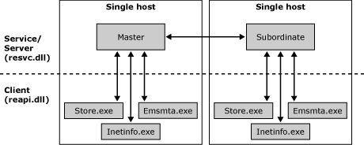

Client nodes communicate directly with their corresponding server services. This communication never occurs outside of any one individual host, for instance, a client node communicates only with other components on the same server. Member and master service nodes within the same routing group communicate with each other over TCP port 691.

Routing Updates
The section discusses the types of updates that the routing group master receives and distributes to its routing group members. Exchange servers and domain controllers may communicate about the following types of information in the context of routing topology and link state updates:
• Major When routing topology updates occur, such as connector configuration, which includes adding or deleting a connector, adding or deleting an address space on a connector, or a when a new server is designated as the routing group master.
• Minor When information about connector or virtual server availability changes, for example, a connector state changes from up or down.
• User When services have been started or stopped on an Exchange server (used in the implementation of the 'Status' node in Exchange System Manager), or when another server has been added to the routing group, or a server loses its connectivity to the routing group master.

Major Updates
A domain controller informs routing group masters of major changes in the routing topology for their particular routing group, according to the standard Lightweight Directory Access Protocol (LDAP) change notification process. When the routing group master starts, it registers with the directory using DSAccess for change notifications that pertain to its routing group.
A routing group master accepts major routing information updates pertaining to its routing group only from the domain controller with which it communicates. When a routing information update is sent to a routing group from another routing group, for example, the receiving routing group master always ignores the information pertaining to its routing group that is within the OrgInfo packet. For minor and user updates that pertain to its routing group, the routing group master accepts changes from its local client nodes or any subordinate services (routing group members) within its routing group.
A domain controller sends notifications to the routing group master in the following situations:
• A new connector has been added to the routing group, or any attribute changes have been made to an existing connector.
• When changes have been made to the routing group object itself, for example, the routing group master changes.
After the change notification process is complete, the routing group master communicates the change in topology to all of the servers in the local routing group and any servers that act as a remote bridgehead for one of the connectors in this routing group.

Minor Updates
Minor updates consist of link state changes in the environment such as a connector changing from a state of "up" to "down." This change in link state may be detected by any client node in the environment. In Exchange 2000 Server, when a client node detects a change, it communicates this change to its server services nodes at 5-minute intervals. In general, whenever a link state update is received by a master or subordinate service node, the server is forced to requeue all messages and inform the routing group master of the link state change. For unreliable connections that cause frequent state changes (oscillating connections), the communications cause excessive and often conflicting communications.
In Exchange Server 2003, if no alternate path exists for a link in a leaf-node routing group, the link state is always marked as available. Exchange does not change the link state to unavailable if no alternate path exists. Exchange queues mail for delivery and sends it when the route becomes available again. This change enhances performance because it reduces the propagation of link state information.
As for oscillating connections, Exchange 2003 views the link state queue and if there are multiple conflicting state changes in a given interval for a connector, the connector is considered an oscillating connection and its link state remains as available. It is better to leave an oscillating connector in an available state than to continually change the link state. This approach reduces the amount of link state traffic that is replicated between servers.

User Updates
User updates consist of minimal changes such as when the routing group master has changed, when services have been started or stopped on an Exchange server, when another server has been added to the routing group, or when a member server loses connectivity to the routing group master.

Routing Topology Update Communications
How Exchange communicates routing information differs depending on whether it is processing an inter-routing group update or an intra-routing group update. This section discusses how specific communication update processes work in several routing topology scenarios, as follows:
• Directory updates to routing group masters Single Exchange server, single domain controller
• Routing group master updates to routing group members Two Exchange servers (same routing group), one domain controller
• Inter-routing group updates Three Exchange servers (two in one routing group, one in another routing group), one domain controller
Note:
Network captures that illustrate the concepts in practice are provided to give a thorough understanding of the communication update process. All of the captures were taken with the Network Monitor tool (Netmon.exe) that is provided with Microsoft Windows Server™2003.

Directory Updates to Routing Group Masters
The routing group masters receive major updates from a domain controller by means of the Microsoft Active Directory® directory service change notification process. Specifically, Exchange relies on its configuration domain controller for directory update information, which is labeled as Config on a server's properties DS Access tab in Exchange System Manager.
The change notification process begins when the client or workstation on which a new connector or another routing change has been made by using Exchange System Manager contacts the domain controller with a request to add this new connector to Active Directory. The domain controller communicates to the workstation that the addition was successful. The domain controller then notifies the Exchange server that is the routing master of this new connector and sends information about this connector through a series of communications. The following network captures illustrate this process.
The following figure shows an excerpt from a network capture involving a Windows 2000 domain controller where a new connector has been added to a routing group (Exchange 2000). Note frame 147, which shows "AddRequest".
A Windows 2000 domain controller where a new connector has been added to a routing group
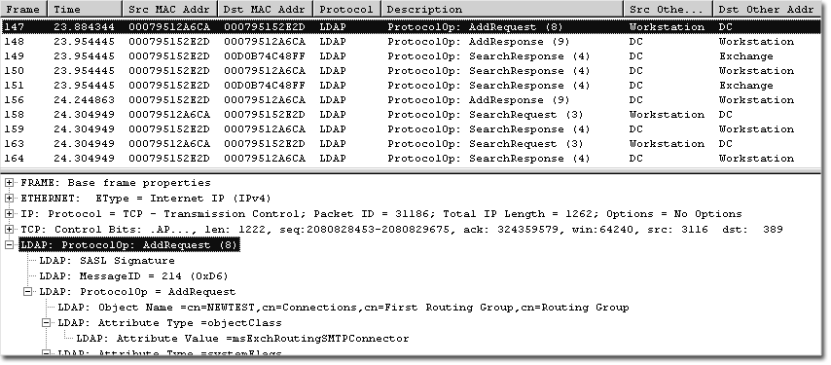

This figure shows the client (Workstation) requesting that the domain controller (DC) add a new SMTP connector to the directory. Frame 148 shows the domain controller signaling the successful completion of this addition. Immediately following in frame 149 (see the following figure), the domain controller sends a "SearchResponse" to the Exchange server that notifies Exchange of the new connector.
The domain controller automatically performs this seemingly unsolicited action because the Exchange server has previously signed up for change notification, as all Exchange 2000 and Exchange 2003 servers do. This illustrates the change notification process at work. Within frame 149, the domain controller is only informing Exchange of the name and distinguished name of the new connector.
The domain controller sends a "SearchResponse" message to the Exchange server that notifies Exchange of the new connector
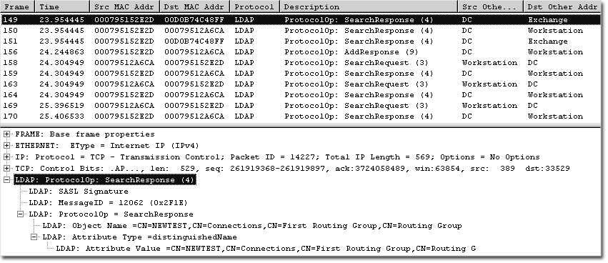

In frames 150 and 151, the domain controller sends more information regarding this addition to both the workstation on which this connector was added and the Exchange server. The following figure illustrates Frame 151 (sent to Exchange). In addition to the name of the object and the distinguishedname, the objectGUID, cn, and objectClass attributes are now included.
The domain controller sends more information regarding this addition to both the workstation on which this connector was added and the Exchange server
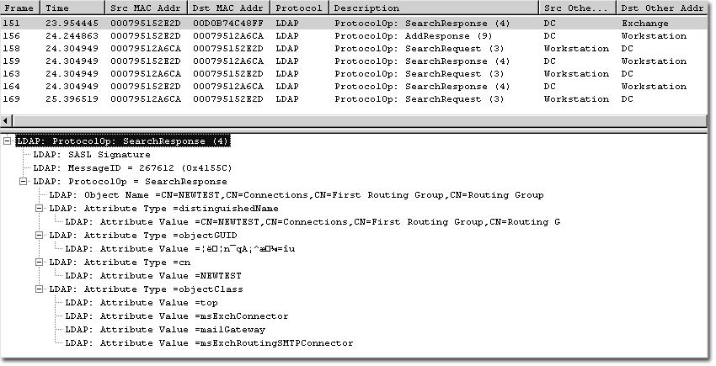

After the domain controller sends this information, the workstation queries the domain controller for the full list of attributes regarding the new connector.
In frame 176 (see the following figure), Exchange initiates queries regarding its routing group. Whenever a change notification has been received by the Exchange server, it initiates these actions. In particular, it begins by querying for the distinguished name of the routing group GUID.
Exchange initiates queries regarding its routing group
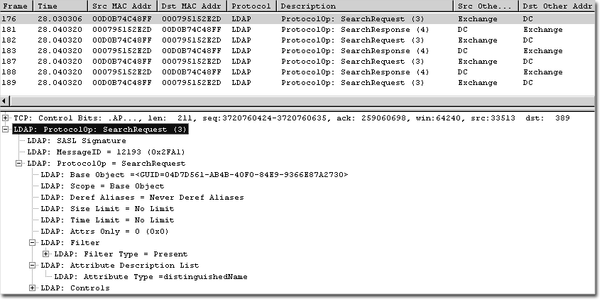

After receiving the distinguished name of the routing group GUID, Exchange queries for all attributes of any child objects that this object may be a parent to and that are of the object type "msExchconnector". Note the "Single Level" scope of the search versus "Base object" search. This designation indicates that the search is for a child object. Frame 182 (see the following figure) shows this search request.
Search request for a child object
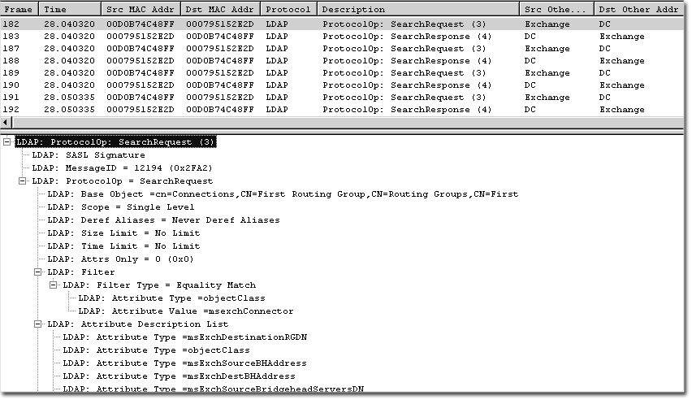

Frame 183 (see the following figure) indicates the partial response from the domain controller.
Partial response from the domain controller
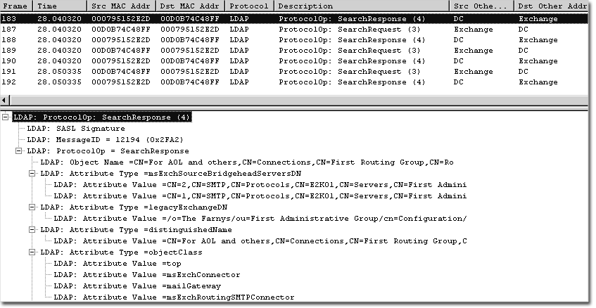

Next, Exchange queries the domain controller and receives the following:
• The FQDN and GUID for any bridgehead server that is associated with the connector in question.
• A query for several attributes of the new connector. This query is based on the GUID of the connector, and it returns the result that is illustrated in the following figure.
Result of a query for attributes of a new connector
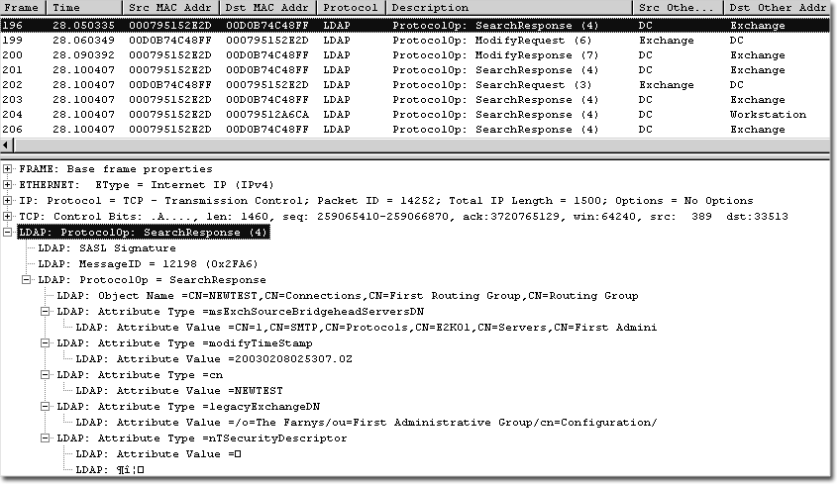

As shown in the following figure, the Exchange server sends a "ModifyRequest" message asking the domain controller to replace three attributes of the "legacy GWART" object within the administrative group : GatewayRoutingTree, GWARTLastModified, and ridServer.
Request from the Exchange server to the domain controller to replace three attributes of the "legacy GWART" object
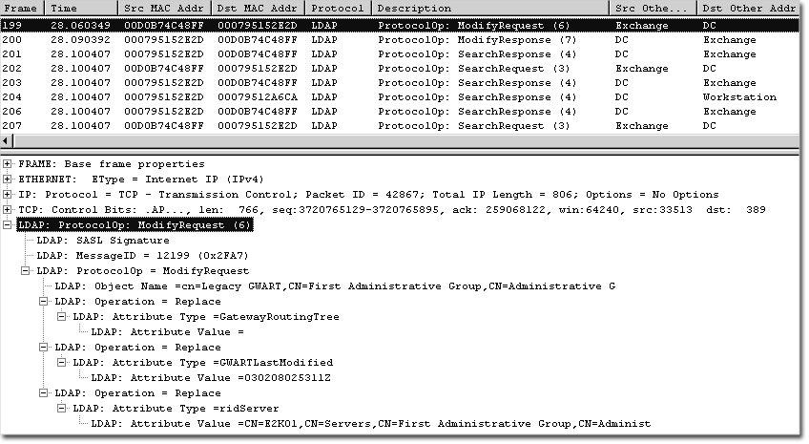

The domain controller responds with a "ModifyResponse" message of success, and the Exchange server continues its query process for various objects within its administrative group.
The entire process that is described in this section shows how domain controllers communicate major topology updates to routing group masters. Following this update, the routing group master must now communicate the information to its member servers. The following section explains how the routing group master communicates this information to its routing group members.

Routing Group Master Updates to Routing Group Members
When the routing group master is informed of an update, it overwrites the link state information that it contains in memory (the OrgInfo packet) with the new information, creating a new MD5 hash based on this information. The routing group master then propagates the new OrgInfo packet to client nodes on the same computer and to subordinate services nodes or routing group members within the routing group. The routing group master communicates with the routing group over TCP port 691.
The following figure illustrates communication occurring on either source or destination port 691. The example illustrates a new connector's addition to a routing group containing two servers.
Routing group master propagates update information to routing group members
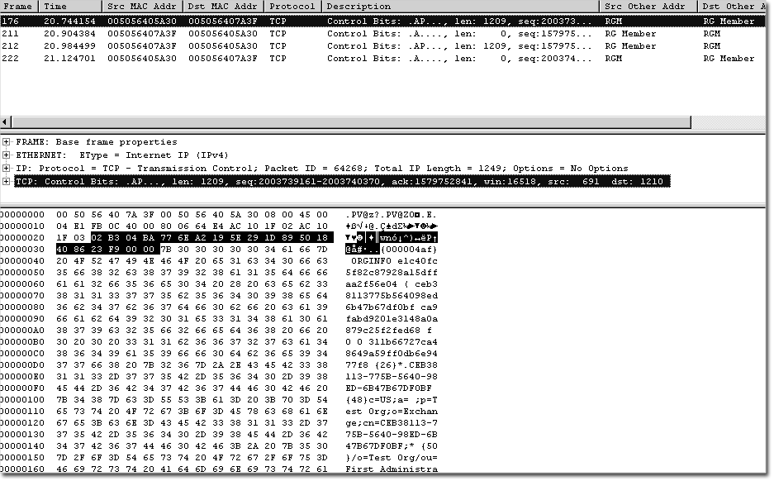

Frame 175 is the "SearchResponse" that a domain controller sends to the routing group master that is registered for change notification. Immediately after receiving this information, the routing group master sends the entire OrgInfo packet to the routing group member, as shown in Frame 176 (Figure 15.11). The characters before the first parenthesis in this packet represent the MD5 hash of the OrgInfo packet, which servers use to determine if they have the most up-to-date information.
Because the MD5 hash that it received is different than the hash in memory, the routing group member also processes the OrgInfo packet. After making the appropriate changes to its link state table in memory, the routing group member sends a short reply to the routing group master, followed in the next frame by its newly revised OrgInfo packet, now also referencing the newer MD5 hash that the routing group master sent earlier. The following figure shows the initial reply.
Initial reply from routing group member to routing group master
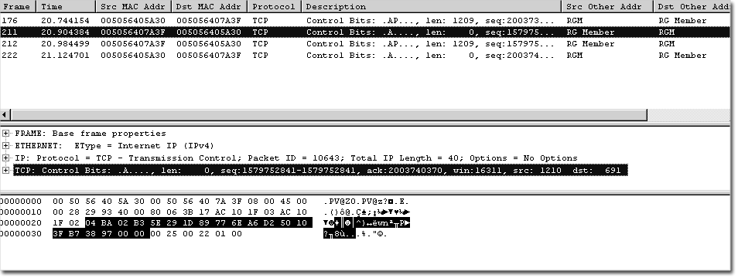

The OrgInfo reply from the routing group member containing the now up-to-date OrgInfo packet is sent next to the routing group master (see the following figure).
OrgInfo reply from the routing group member
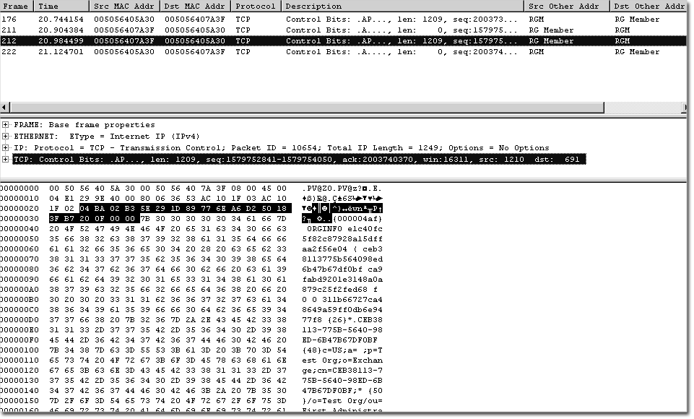

The routing group master processes this information and sends a short acknowledgement to the routing group member.
This process occurs between all routing group members and the routing group master within the particular routing group. Another process, known as polling, ensures that all routing group members have the most up-to-date information from the routing group master.

Polling
Polling is the process of a routing group member querying the routing group master for up-to-date routing information. The following figure illustrates the routing group member polling the routing group master every 5 minutes. Note the time that is associated with each frame (the capture was saved as filtered for communications only over port 691; therefore, the frame numbers that are listed do not reflect the original frame numbers).
Routing group member polling the routing group master
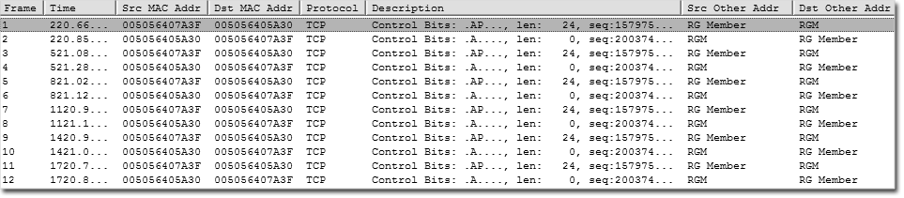

Each two-frame exchange includes the text "Simple_Poll" from the routing group member, and a response from the routing group master. Frame 1 shows the query (see the following figure).
Query from routing group member to routing group master
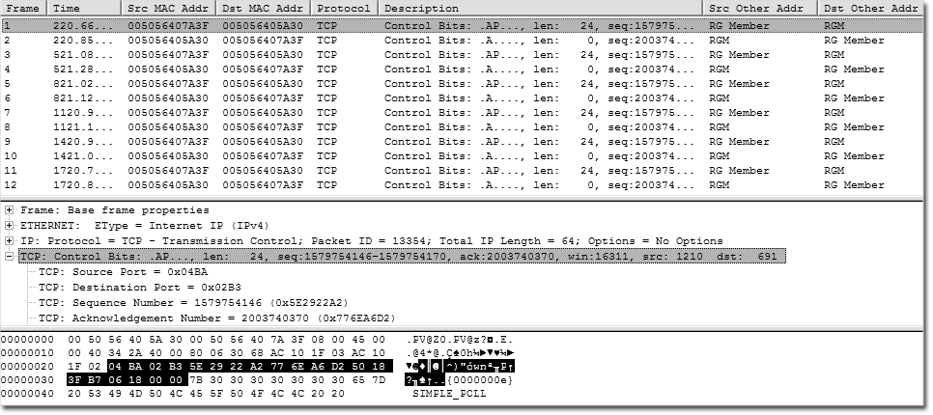

Frame 2 shows the response (see the following figure).
Response from routing group master to routing group member
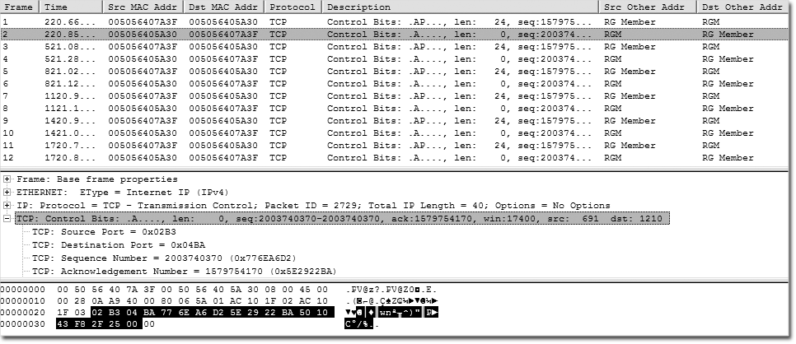

In addition to updating the local routing group, the routing group master must update the remaining members of the Exchange organization. The Exchange SMTP service accomplishes inter-routing group updates.

How Updates Are Communicated in an SMTP Conversation
Routing and link state update communications are part of the Exchange Server 2003 and Exchange 2000 SMTP service. The Exchange SMTP service compares the versions of the OrgInfo packet on each server during every SMTP session between two servers. Whether this is an intra-routing group or an inter-routing group has no effect on this process. The process works in the following way:
1. Server 1 initiates the TCP session and contacts Server 2 using SMTP. Server 2 sends a "220 Ready" response to Server 1.
2. Server 1 sends the EHLO command.
3. Server 2 answers with "250" and a list of its implemented ESMTP commands.
4. Server 1 responds with "X-EXPS GSS API" signaling it wants to authenticate by means of the GSS API.
5. Server 2 responds with "334 GSSAPI supported".
6. The next several frames involve the authentication between the two servers, ending with Server 2 responding "235 2.7.0 Authentication successful".
7. After this response, link state communications begin.
8. Server 1 sends the information shown in the following figure to Server 2:
Information sent from Server 1 to Server 2
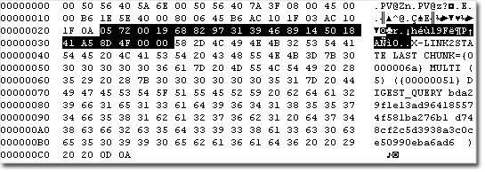

The following information is contained in the information sent from Server 1:
• X-LINK2STATE indicates that this packet contains information pertaining to the organizational routing topology.
• LAST CHUNK indicates that this will be the last frame of link state communications within the current SMTP session. Other options for this command are:
- FIRST CHUNK Indicates that the link state information to follow is spread across several frames, with this frame being the first frame.
- NEXT CHUNK Indicates that the link state information to follow is spread across several frames, with this frame being neither the first nor the last frame.
9. Server 2 now compares its MD5 hash to the MD5 hash that Server 1 sent, and one of two actions occurs:
• If the hashes are identical, Server 2 does not need to receive the complete OrgInfo packet from Server 1. Therefore, Server 2 sends a "DONE_RESPONSE" (see the following figure), and Server 1 sends the "MAIL FROM:" command and completes the process of sending the mail message.
"Done_Response" sent from Server 2 to Server 1
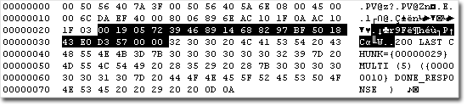

• If Server 2 does not have the same hash as Server 1, Server 2 sends its entire OrgInfo packet to Server 1 in a process that is similar to the one in which Server 1 sent its information to Server 1. The next section describes this process in the context of inter-routing group updates.

Inter-Routing Group Updates
When a major or minor update occurs within a routing group, the local bridgehead servers that are connected to other routing groups propagate the update to their attached routing groups over SMTP on TCP port 25.
Frames 485-487 (see the following figure) contain the complete OrgInfo packet that is being transmitted from the routing group master to the routing group member that is the local bridgehead server. Frame 488 shows the local bridgehead server's acknowledgement.
Transmission of OrgInfo packet from routing group master to routing group member that is the local bridgehead server
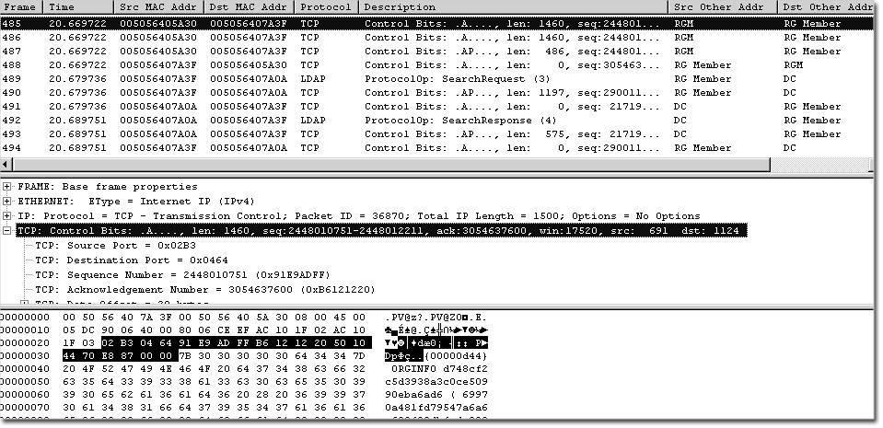

In Frames 489 and 490 (see the following figure), the local bridgehead server queries Active Directory for attributes of the default recipient policy, which is the only recipient policy that existed in the example environment.
Query from local bridgehead server to Active Directory
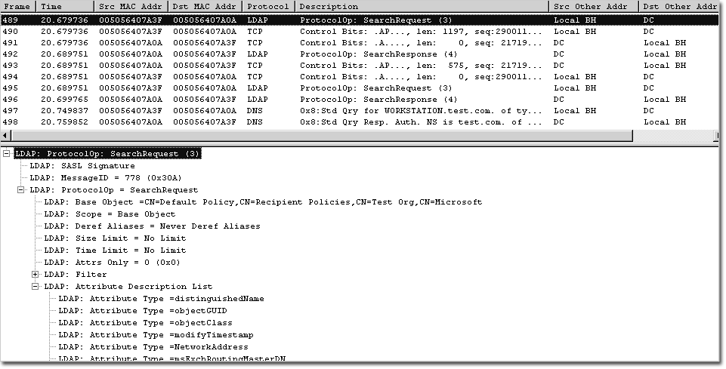

After having received the responses in Frames 491-494, Frame 495 (see the following figure) shows the local bridgehead server now performing a subtree search on the configuration container for any routing group of which it is a bridgehead (note the "LDAP: Filter Type").
Search by local bridgehead server for routing groups of which it is a bridgehead
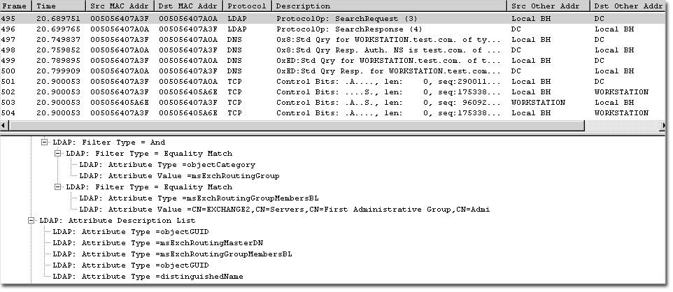

After receiving the response, the local bridgehead server now starts to query DNS for the Exchange server in the remote routing group and sets up a TCP session with this remote bridgehead server.
The local bridgehead server proceeds through the steps that were explained in "How Updates Are Communicated in an SMTP Conversation," earlier in this topic. The process is as follows:
1. When the servers compare MD5 hashes, the remote bridgehead server realizes it does not have the same hash as the local bridgehead server, and sends its entire OrgInfo packet to the local bridgehead server. Because this communication occurs by using SMTP, and the SMTP Request For Comments (RFCs) stipulate that any one SMTP data command may not exceed 1 KB in size, it is likely that the OrgInfo packet will be split into several frames. In this situation, the SMTP service uses the various CHUNK commands illustrated in the following figure.
Use of FIRST_CHUNK command
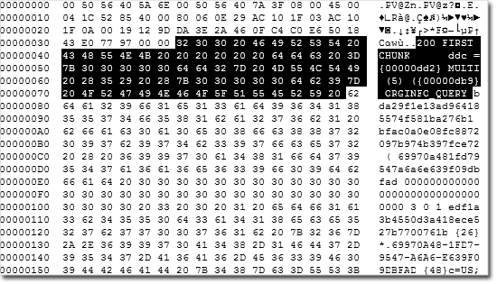

2. The local bridgehead server responds with "X-LINK2STATE MORE" (see the following figure).
Local bridgehead server response to remote bridgehead server
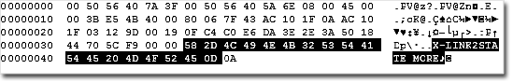

3. The remote bridgehead server sends the next portion of the OrgInfo packet (see the following figure). Note that it just signals "CHUNK":
Remote bridgehead server response to local bridgehead server
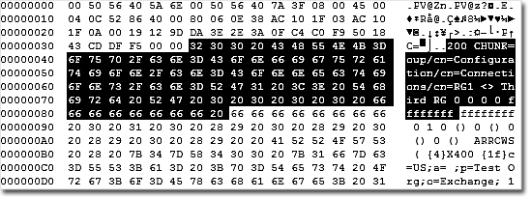

4. The remote bridgehead server again responds with "X-LINK2STATE MORE". This communication continues until the remote bridgehead server sends the last portion of the OrgInfo packet, which it signals by using the LAST_CHUNK command (see the following figure).
Remote bridgehead server signals by using the LAST_CHUNK command that it is sending the last portion of the OrgInfo packet
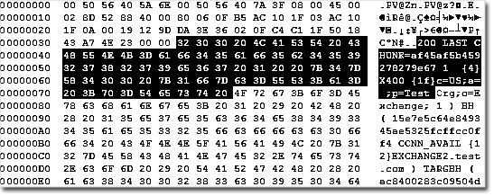

5. After this communication process is complete, the remote and local bridgehead servers reverse roles. After its receipt of the LAST_CHUNK frame from the remote bridgehead server, the local bridgehead server immediately sends a FIRST_CHUNK frame (identifying the start of transmission of its OrgInfo packet) to the remote bridgehead server.
6. After completing the identical process in exchanging the OrgInfo information, the remote bridgehead server responds with a "200 Done" command (see the following figure) after it receives the LAST_CHUNK command.
Remote bridgehead server signals that it has received the OrgInfo packet in its entirety
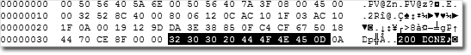

7. The local bridgehead server now issues the "Quit" command, and the remote bridgehead server acknowledges its receipt by closing the SMTP transmission channel.

SMTP Commands and Definitions
This topic contains reference material about the following topics:
• Simple Mail Transfer Protocol (SMTP) commands
• Internal SMTP transport mechanisms
• SMTP event sinks
• Ports that are commonly used by Microsoft® Exchange

SMTP Commands
The following table lists the SMTP commands that are provided by the Microsoft Windows® SMTP service (SMTPSVC).
SMTP commands
SMTP command | Command function
HELO | Sent by a client to identify itself, usually with a domain name.
EHLO | Enables the server to identify its support for Extended Simple Mail Transfer Protocol (ESMTP) commands.
MAIL FROM | Identifies the sender of the message; used in the form MAIL FROM:.
RCPT TO | Identifies the message recipients; used in the form RCPT TO:.
TURN | Allows the client and server to switch roles and send mail in the reverse direction without having to establish a new connection.
ATRN | The ATRN (Authenticated TURN) command optionally takes one or more domains as a parameter. The ATRN command must be rejected if the session has not been authenticated.
SIZE | Provides a mechanism by which the SMTP server can indicate the maximum size message supported. Compliant servers must provide size extensions to indicate the maximum size message that can be accepted. Clients should not send messages that are larger than the size indicated by the server.
ETRN | An extension of SMTP. ETRN is sent by an SMTP server to request that another server send any e-mail messages that it has.
PIPELINING | Provides the ability to send a stream of commands without waiting for a response after each command.
CHUNKING | An ESMTP command that replaces the DATA command. So that the SMTP host does not have to continuously scan for the end of the data, this command sends a BDAT command with an argument that contains the total number of bytes in a message. The receiving server counts the bytes in the message and, when the message size equals the value sent by the BDAT command, the server assumes it has received all of the message data.
DATA | Sent by a client to initiate the transfer of message content.
DSN | An ESMTP command that enables delivery status notifications.
RSET | Nullifies the entire message transaction and resets the buffer.
VRFY | Verifies that a mailbox is available for message delivery; for example, vrfy ted verifies that a mailbox for Ted resides on the local server. This command is off by default in Exchange implementations.
HELP | Returns a list of commands that are supported by the SMTP service.
QUIT | Terminates the session.

The following table lists the extended SMTP commands that Exchange makes available to the SMTP service.
Extended SMTP commands
Extended SMTP command | Command function
X-EXPS GSSAPI | A method that is used by Microsoft Exchange Server 2003 and Exchange 2000 Server servers to authenticate.
X-EXPS=LOGIN | A method that is used by Exchange 2000 and Exchange 2003 servers to authenticate.
X-EXCH50 | Provides the ability to propagate message properties during server-to-server communication.
X-LINK2STATE | Adds support for link state routing in Exchange.

Event Sinks
You can use event sinks to extend and modify the behavior of the Microsoft Windows 2000 Server and Windows Server™ 2003 SMTP service. Exchange 2003 requires the Windows 2000 or Windows Server 2003 SMTP service to function because most of the transport functionality in Exchange 2003 is accomplished with this architecture. Therefore, after you reinstall Internet Information Services (IIS) or the Windows 2000 or Windows Server 2003 SMTP service, you must also reinstall Exchange.
An SMTP service event is the occurrence of some activity within the SMTP service, such as the transmission or arrival of an SMTP command or the submission of a message into the SMTP service transport component. When a particular event occurs, the SMTP service uses an event dispatcher to notify registered event sinks of the event. When notifying event sinks, the SMTP service passes information to the sink in the form of Component Object Model (COM) object references.
The two general categories of SMTP service events are:
• Protocol Events
Protocol events occur when SMTP commands are either received or transmitted over the network. These events occur when:
• A client SMTP service or mail user agent uses SMTP to transmit messages for delivery to the local service.
• The SMTP service relays messages to other SMTP services.
• Transport Events
Transport events occur when the SMTP service receives a message, and that message passes through the SMTP core transport. During the passage through the transport, the message is categorized (examined and placed into categories), and then either delivered to a local storage location or, if it is not local, relayed to another destination.
The default Windows 2000 and Windows Server 2003 protocol and transport events are only accessible by writing Component Object Model (COM) objects in Microsoft Visual C++®. These events are fast, require no extra processing, and offer access to the lowest-level message properties; however, these events are more complex to write. For smaller jobs that do not require high performance, you can use the CDO_OnArrival event, which you can write using Microsoft Visual Basic® Scripting Edition (VBScript).
For more information about writing one of these event sinks, download the Platform SDK, or see the MSDN® developer program article Microsoft Windows 2000 SMTP Service Events.

Common Ports Used by Exchange
The following table lists the ports commonly used by Exchange. For more information about which ports need to be opened internally or externally, see Using Microsoft Exchange 2000 Front-End Servers.
Ports used by Exchange
Protocol | Port | Description
SMTP | TCP: 25 | The SMTP service uses TCP port 25.
DNS | TCP/UDP: 53 | DNS listens on port 53. Domain controllers use this port.
LSA | TCP: 691 | The Microsoft Exchange Routing Engine service (RESvc) listens for routing link state information on this port.
LDAP | TCP/UPD: 389 | Lightweight directory access protocol (LDAP) used by Microsoft Active Directory® directory service, Active Directory Connector, and the Microsoft Exchange Server 5.5 directory use this port.
LDAP/SSL | TCP/UDP: 636 | LDAP over Secure Sockets Layer (SSL) uses this port.
LDAP | TCP/UDP: 379 | The Site Replication Service (SRS) uses this port.
LDAP | TCP/UDP: 390 | This is the recommended alternate port to configure the Exchange Server 5.5 LDAP protocol when Exchange Server 5.5 is running on an Active Directory domain controller.
LDAP | TCP: 3268 | Global catalog. The Windows 2000 and Windows Server 2003 Active Directory global catalog (a domain controller "role") listens on TCP port 3268.
LDAP/SSLPort | TCP: 3269 | Global catalog over SSL. Applications that connect to TCP port 3269 of a global catalog server can transmit and receive SSL encrypted data.
IMAP4 | TCP: 143 | Internet Message Access Protocol (IMAP) uses this port.
IMAP4/SSL | TCP: 993 | IMAP4 over SSL uses this port.
POP3 | TCP: 110 | Post Office Protocol version 3 (POP3) uses this port.
POP3/SSL | TCP: 995 | POP3 over SSL uses this port.
NNTP | TCP: 119 | Network News Transfer Protocol (NNTP) uses this port.
NNTP/SSL | TCP: 563 | NNTP over SSL uses this port.
HTTP | TCP: 80 | HTTP uses this port.
HTTP/SSL | TCP: 443 | HTTP over SSL uses this port.

Copyright
The information contained in this document represents the current view of Microsoft Corporation on the issues discussed as of the date of publication. Because Microsoft must respond to changing market conditions, it should not be interpreted to be a commitment on the part of Microsoft, and Microsoft cannot guarantee the accuracy of any information presented after the date of publication.
This White Paper is for informational purposes only. MICROSOFT MAKES NO WARRANTIES, EXPRESS, IMPLIED OR STATUTORY, AS TO THE INFORMATION IN THIS DOCUMENT.
Complying with all applicable copyright laws is the responsibility of the user. Without limiting the rights under copyright, no part of this document may be reproduced, stored in or introduced into a retrieval system, or transmitted in any form or by any means (electronic, mechanical, photocopying, recording, or otherwise), or for any purpose, without the express written permission of Microsoft Corporation.
Microsoft may have patents, patent applications, trademarks, copyrights, or other intellectual property rights covering subject matter in this document. Except as expressly provided in any written license agreement from Microsoft, the furnishing of this document does not give you any license to these patents, trademarks, copyrights, or other intellectual property.
Unless otherwise noted, the companies, organizations, products, domain names, e-mail addresses, logos, people, places, and events depicted in examples herein are fictitious. No association with any real company, organization, product, domain name, e-mail address, logo, person, place, or event is intended or should be inferred.
© 2006 Microsoft Corporation. All rights reserved.
Microsoft, MS-DOS, Windows, Windows Server, Windows Vista, Active Directory, ActiveSync, ActiveX, Entourage, Excel, FrontPage, Hotmail, JScript, Microsoft Press, MSDN, MSN, Outlook, SharePoint, Visual Basic, Visual C++, Visual Studio, Win32, Windows Mobile, Windows NT, and Windows Server System are either registered trademarks or trademarks of Microsoft Corporation in the United States and/or other countries.
All other trademarks are property of their respective owners.

