

Bender JCC
Early Childhood Center
Family Handbook
2017-2018
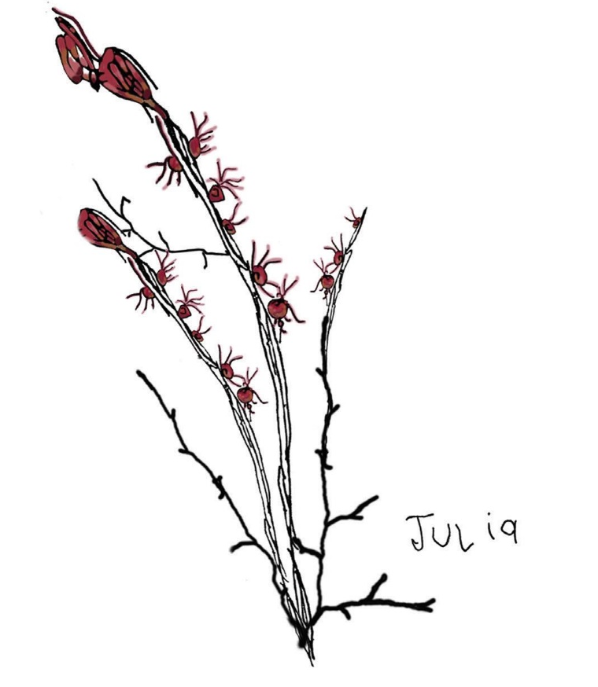

6125 Montrose Road, Rockville, MD 20852
301-348-3839 Benderjcc.org

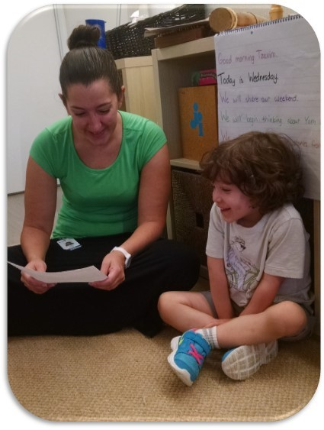
Dear Families,

“Children should come with “owner’s manuals” is a popular comment made by parents of newborns.
Like so many things in life, we really don’t know what we have gotten ourselves into until we are already in the middle of it. We really have no idea how to raise a child until we actually have children of our own. For many of our families, this new preschool year is the first step in many years of formal education for their child. It is also the first step in experiencing the essential partnership between the home and the classroom, the child’s second home. Our goal as a preschool is to join and support you as you take these important first steps. These are essential years in your child’s life, as together we build a foundation for future growth and learning. You are not alone in this adventure; there are teachers, administrators, other parents, and an entire community that is here to support your child and your family. Preschool is not just about your child’s friendships, although how to be a friend and making friends is a essential life skill. You will be surprised how many of your best friends will be made in your child’s preschool. Preschool is not just about your child’s learning and celebrating; we hope it is also about your family learning and celebrating.
Every community has its written and unwritten guidelines. Our Parent Handbook is your guide in understanding who we are a community and what to expect throughout the year. It is essential that every parent read this handbook as a first step being an active partner in our preschool community. Throughout the year, we work to support each individual child in the classroom and also support our larger community. This is the basic philosophy that underlies many of our policies and procedures. Nothing is random; every policy is meant to strengthen our larger community while also be respectful of the needs of individuals and their families. It is a challenging balance but one that is essential for any strong educational community.
We are very excited that you have joined us for this year of learning and celebration. We look forward to getting to know you and your child, and to being an important part of your child’s daily life.

After reading this handbook, if you have any questions, please feel free to contact me. Please remember to sign and turn in the last page of this handbook.

Thank you and have a great year

Ora

L’hitraot,

Ora Cohen Rosenfeld
Director of the Bender Early Childhood Center

General Information 3
Who’s Who? 3
Learning Specialist 4
Contact Us 4
Classroom Names and Ages 5
Hours of Operation 5
Program 6
Our Mission, History and Values 6
We Are A Sheva School 7
In the Classroom 8
Flow of the Day 8
Roles of the Teacher 8
Role of the Family 9
Role of the Environment 9
Good Mornings and Goodbyes 9
Separation 10
Drop-In Care: 11
Napping and The No Nap Room 11
The Classroom and Beyond 11
The Center 11
Our Staff 12
Specialists 12
Families 12
Early Childhood Parent Committee (ECPC) 13
Field Trips 13
Shabbat and Havdalah 13
The Outdoor Classroom 14
Swimming Pool 14
Communication 14
Director 14
Accounting 14
Teachers 15
Issues, Concerns, or Feedback 15
Parent/Guardian Teacher Conferences 15
Absences and Family News 16
Room Parents 16
HoliDaycare and Kid Coverage 16
HoliDaycare 16
Kid Coverage 16
Policies 16
Program Changes 16
Medical and Health Policies 17
Medical Forms 17
Allergies 17
Illness 18
Medication 19
Handwashing 19
Sunscreen 20
Guidance (Discipline) Policy 20
Biting Policy 21
Exclusion from Preschool Policy 21
Reporting Abuse Policy 21
Late Pick Up Policy and Fees 21
Clothing Policy 21
Diapering and Toilet Training Policy 22
Personal Items from Home Policy 22
Babysitting Policy 22
Food Policies and Information 23
Kashrut (Jewish Dietary Laws) 23
Food Allergies 23
Breakfast 23
Lunch 23
Snack 23
Birthdays 23
Emergencies, School Closings, Safety, and Security 24
National Emergencies 24
Inclement Weather Policy 24
Security 24
BENDER JCC Parking Lot 24
Pick Up 25
Helpful Information 25
List of What Families Must Provide 25
Blessings that we say at Preschool 25
Holidays 26
Jewish Holidays 26
Other Holidays 27
Kashrut Certifications 27
Sheva Jewish Lenses 28
Examples of Materials to Collect for the School 29
Acknowledgment of Receipt 30

General Information

Who’s Who?

Ora Cohen Rosenfeld—Director of Early Childhood Education
Contact Ora for:
School policies
Overall school communications
If, after speaking to the appropriate staff member, an ongoing issue needs resolution

Sandy Lanes—Curriculum Director
Contact Sandy for:
Curriculum Questions
Teaching staff issues

Debbie Kivitz—ECC Office Manager
Contact Debbie for:
General Preschool information
Enrollment issues
Changes in children’s hours; adding a drop-in

Maria Chernov - Administrative Assistant
Contact for:
General preschool information
ECPC requests
Carpool changes and dismissal changes
Child pick up arrangements

Learning Specialist
Contact for:
Support for families and staff regarding children who have specific challenges in the classroom or different learning needs

Debbie Unger—Atelierista (Studio Teacher)

Contact Us

Email | preschool@BenderJCC.org
Phone | 301-348-3839
Address | 6125 Montrose Road, Rockville, MD 20852
Snow Line | 301-348-3839
Emergency | In case of an emergency, call the Front Desk at 301-881-0100. Ask the Front Desk to page the preschool with information on how to contact you.

Classroom Names and Ages

Aretz Classrooms (Land Animals)—2 year olds and 2 year olds turning 3 and Toddlers
- Dubim-Bears
- Arayot-Lions
- Peelim-Elephants
- Shualim-Foxes
- Soosim-Horses
- Pandot – Pandas—Toddlers ages 18-24 mo

Mayim Classrooms (Water Animals)—3 year olds turning 4
- Dagim-Fish
- Tzavim-Turtles
- Meduzot-Jellyfish
- Dolfinim-Dolphins

Shamayim Classrooms (Sky Animals)—4 year olds turning 5
- Yanshufim-Owls
- Nesharim-Eagles
- Yonim-Doves
- Zmirim-Nightingales

Hours of Operation
We offer hours to fit families’ different needs.
It is very important that every child arrives on time by 9:15am for the core school hours so that children can orient themselves each day and do not miss key moments in the flow of the day.
Full-Day Preschool | 7:30 a.m. – 6 p.m.
Half-Day Preschool | 9:15 a.m. – 12:30 p.m.
Fours Program | 9:15 a.m. – 2:30 p.m.
Early Day AM | 7:30 – 9:15 a.m.
Extended Day PM until 4 | 12:30 p.m. – 4 p.m.
Extended Day PM until 6 | 12:30 p.m. – 6 p.m.
Fours Extended Day PM until 4 | 2:30 p.m. – 4 p.m.
Fours Extended Day PM until 6  Toddlers | 2:30 p.m. – 6 p.m.  7:30 a.m.-6:00 p.m.

Program

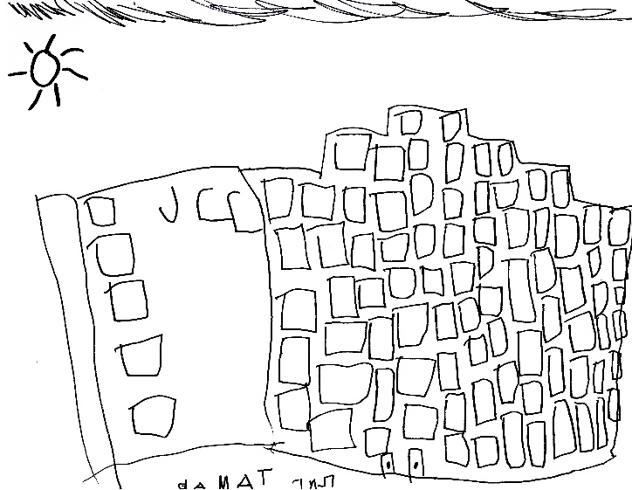
Our Mission, History and Values

THE BENDER JCC PRESCHOOL
Our preschool has been a part of the Bender JCC since its inception and has served young children for over forty years in this building. While we remain true to our mission of bringing Jewish education and experiences to our children and families, our preschool has evolved and developed throughout the years. We work to bring a more progressive and research-based approach to preschool education. As a community of learners, our teachers continue to reflect and study, to remain on the cutting edge of early childhood education.
We are proud to be inspired by the Reggio Emilia approach to teaching. Recognized as a model of excellence in early childhood education, and named as one of the “Ten Best Schools in the World” by Newsweek magazine, schools in Reggio Emilia have at their foundation the belief that children are competent, full of potential, and active in constructing knowledge through their interactions and in relationship with the world and people around them.

HOW WE LEARN
The rich curriculum in our preschool is driven by the long term projects that emerge from the children’s questions and theories. Together, children and teachers are researchers and investigators, as they look for materials and resources to help them answer their questions, build on their ideas, and construct new knowledge. The children represent their thoughts and understandings in a multitude of ways. We can see the reflection of the children’s growing understanding of the world as they test their hypotheses, share perspectives, and exchange knowledge with peers and adults.

SHEVA
Sheva, the Hebrew word for the number seven, is the name of the JCCs of North American Learning Framework and it signifies the seven core elements of exemplary early childhood practice. It is deeply rooted in the latest research in child development as seen through a Jewish lens. We are a Sheva Learning Community because our core values are reflected in the Sheva construct. These values guide all that we do. In 2017, the Bender JCC Preschool was chosen by the JCCA to be a Sheva Lab Community, an example of cutting edge early childhood education for JCC’s around the continent. The Sheva Core Elements follow.

We Are A Sheva School

Children as Constructivist Learners
Children are natural learners. A Jewish expression of values emphasizes that teachers inspire children to question their world and appreciate multiple perspectives. Based on an image of the child as a competent and capable learner full of potential, teachers and children engage in research as a way of co-constructing knowledge. When children are agents of their own learning, they build life-long critical thinking skills and are more deeply invested in the process.

Early Childhood Directors as Visionaries
Visionary leaders galvanize a process for creating and living a shared vision for the school. Inspired by the richness of our Jewish expression of values, we work with families, teachers and lay leadership to create an environment that cultivates a diverse and vibrant community. While all ECE directors serve their communities, JCC ECE directors must be visionary leaders focused on nurturing the minds, souls, and hearts of children and their families.

Early Childhood Teachers as Professionals
At the JCC, educators view themselves as lifelong learners, constantly engaging in the pursuit of learning opportunities, as prized by our Jewish tradition. The combination of education, experience, and passion enriches educators’, children’s and families’ lives. We listen with the understanding that the relationships between school leadership, colleagues, children, families and community members depend on the richness of each conversation.

Families as Engaged Partners
We view family engagement as essential to building a healthy school community. Every early childhood program includes family events, newsletters, and committees. JCC early childhood centers go beyond this to actively listen to and incorporate parents’ perspectives into how we think about teaching and learning. JCCs support and encourage families’ Jewish journeys.

Environments as inspiration of Inquiry
Early childhood programs are rich with materials that inform, instruct and engage children. Our vision for the early childhood learning environment suggests an intentional place for children that provokes wonder, curiosity, intellectual engagement and creativity with endless possibilities. Children and families approach the environment with questions. Attention is given to indoor and outdoor classrooms and common spaces to create community, build connections, and encourage and support opportunities for Jewish living.

Discover CATCH as Shmirat HaGuf (taking care of our bodies)
To help address the nations critical obesity problem, JCC Association, in collaboration with the University of Texas School of Public Health and its CATCH (Coordinated Approach to Child Health) program, has created Discover: CATCH Early Childhood. Based on a foundation of Jewish values, we nurture a love of physical experience in children ages 3 to 5, and encourage them to develop life-long healthy eating habits.

Israel as the story of the Jewish People
For thousands of years without the benefit of modern technology, Jews managed to create powerful images and representations of Israel as a place that most Jews had never seen or experienced. Israel thus permeated the lives of Jews, visited and revisited in the mind throughout the course of a lifetime. When such images of Israel were vivid in the hearts and minds of parents, a connection to Israel could be transmitted at an early stage and in a natural way to young children. Now that such images have become less and less a part of most parents reality, educators are called upon to make up the difference at the crucial developmental stage of early childhood.

In the Classroom
When we are curious about a child’s words and our responses to those words, the child feels respected. The child is respected. ‘What are the ideas that I have that are so interesting… I must be somebody with good ideas.”
-Vivian Paley

Flow of the Day
Our classrooms open at 7:30 AM with children engaging in open ended experiences, guided play, and morning routines for setting up for the rest of the day. At 9:15 AM the core program begins for all classrooms. While each teacher structures the day to best reflect the rhythm of the individual class community, every classroom will typically incorporate the following during the core preschool hours:
- Community Meeting (planning with the children, discussions about ongoing class project work, open-ended sharing, discussions of Jewish topics, stories, songs, games, etc)
- Choice Time (Mini-atelier (in-classroom Arts Studio), Construction, Dramatic Play, Science and Nature Investigation, Books, Literacy/Message Center, Cooking)
- Small Group Work (collaborative project work)
- Visits to the main Atelier (Arts Studio) and to many places around the JCC to build on children’s thinking
- Neighborhood walks
- Snack (may be a separate experience, or incorporated into Choice Time)
- Outdoor Classroom—nature explorations, games, imaginative and gross motor play
- Reflection Meeting (discuss day’s work and future plans)
- Lunch

The core program for our Aretz and Mayim Program ends at 12:30 PM. The children in our full day Aretz and Mayim Program take naps from 1pm-3pm in their own classrooms.

The children in our Shamayim program finish lunch at 1 PM, and continue their learning after a short down time. From 1:30-2:30, the children are engaged in Specials, Story Studio, and small group work in order to delve more deeply into project work.

Children who stay for the late afternoon have a second snack, go outside, and engage in planned activities to extend the learning day.

Roles of the Teacher
- to demonstrate a strong belief in the image of the child as capable through their interactions, expectations, and the environment.
- to partner with the children in their learning experience and research
- to provoke ideas, problem solving, and conflict
- to listen for children’s ideas and theories and build on them for further exploration
- to organize the classroom and materials to be aesthetically pleasing
- to organize materials to help children make thoughtful decisions about the media
- to document children's work to make the process visible to the children, the teachers, and families
- to provide children with opportunities to express their knowledge through representational work
- to create an ongoing dialogue about the projects with parents and other teachers
- to foster the connection between home, school and community

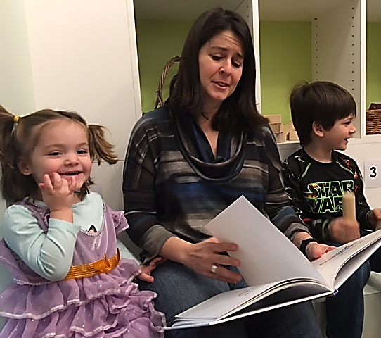
Role of the Family
Families are a vital component in the Reggio philosophy and our school. Parents/guardians are viewed as partners, collaborators and advocates for their children. Teachers respect parents as each child's first teacher and involve them in every aspect of the curriculum. Families are encouraged to participate in different ways in the life of the classroom.
We ask that you:
- see yourself as a partner with the school, and be open to understanding our approach
- attend Back to School night
- read all email communications, the wipe-off board outside the classroom, and the Ongoing Projects sheet outside every classroom so that you have a full vision of the life of the classroom and can contribute your thoughts and ideas
- communicate any concerns with the Lead Teacher and ask questions
- add your perspective to our long term projects
- share any ideas or connections you hear from your child that you find interesting
- share your skills and talents
- participate in the classroom experiences
- reach out to other families and create new relationships
- chaperone field trips and special events
- send in interesting repurposed and natural materials for the class to use
- bring in additional changes of clothing, diapers, etc as necessary

Role of the Environment
In our approach, inspired by Reggio Emilia, the environment is considered “the third teacher” and recognized for its potential to inspire children. We strive to create spaces in which every material is intentionally chosen, and every area is evolving to encourage children to delve deeper into the investigations of their theories. We look for ways that the space can encourage collaboration, communication, exploration, and ways for the children to make their thinking visible. You may notice that the walls, furniture, and carpeting are kept neutral in order to highlight the work of the children. You may also notice that the materials are open-ended in order to encourage creative thinking. Most materials are either made of wood, recycled, are real-life props, or are found in nature. We would love if you could collect interesting materials for us.

Good Mornings and Goodbyes
The preschool is open from 7:30AM to 6PM., Monday through Friday. The core day for the Aretz and Mayim program begins at 9:15AM and ends at 12:30PM, and for the Shamayim Program begins at 9:15AM and ends at 2:30PM. Extended day options are until 4pm and 6pm.

Please arrive to school by 9:15am when the core day begins. Not only are late arrivals disruptive, but it is very difficult for children to enter a group that is already engaged in an experience.

Separation
Children sometimes have difficulty with separation at drop-off. Please know that this normal and we have the experience to help ease you and your child through this time. You should create a goodbye ritual with your child and stick to it—maybe one kiss, and one high-five. You may want to bring a comfort item from home for them to hold. Always make sure to say goodbye and do not sneak out. Do not ask your child for permission to leave. Be confident, but friendly about leaving. It is important that you show them that you believe in their competence and that they will be okay. If your child cries or clings, prolonging the good-bye will only make it harder for yourself and your child.

We are there to help during these transition times to comfort your child once you leave. We offer comforting words such as, “I know it’s hard to say good-bye.” We will hug them and then work to engage them in a fun experience. Once you have gone through your good-bye routines a few times, your child will get to know what to expect and the good-byes will be less difficult. After a short period of time, your child’s anxiety about you leaving ends quickly after you leave. Should this not be the case, we want you to know that we would call you to let you know how he/she is doing.

Your child will pick up on your confidence about having chosen a good place for him/her to be while you are away. Good feelings are contagious.

Pick Up:
At the end of the day, as children are picked up and the number of children decreases, classes of the same age may combine together for their experiences. When you arrive after 4pm, please check with the front desk for the location of your child’s class.

If the child is being picked up by anyone other than the expected driver or there is a change in his/her schedule for the day, please be sure that the preschool office and teacher is informed of the change in writing. Make sure that your child’s emergency card includes all the names of authorized pick-up persons. Children will not be dismissed to any person who does not have permission to pick them up without a note, email, or phone call from the parent/guardian. Please send an email to preschool@BenderJCC.org and cc the teacher if there are different pick up arrangements. All persons authorized to pick up a child must be at least 16 years old.

For those picking up, please note the following:
- When you are ready to leave, please make sure that you tell your child's teacher that you are leaving.
- We want to ensure that the children in our care are well supervised, therefore when you arrive to pick up your children, please plan to leave the program areas such as the classroom or playground soon thereafter.
- Once the person has arrived to pick up the child, we ask for that person to take over the supervision of that child. Do not walk away, and leave them in the classroom or on the playground.
- If a class is involved in a lesson, please attempt to pick up your child as quietly as possible so as not to interrupt or distract the other children.
- Please keep conversations with staff brief when dropping off or picking up so that they may properly supervise the children. If you wish to discuss an issue regarding your child, please email the Lead Teacher to set up a phone or in-person conference.
- If you bring a sibling to the Preschool during drop-off or pick-up, please keep her/him under your direct care and supervision. Children may not linger in the halls or classrooms without the adult who is picking up.
- Please remind all nannies and other caregivers to supervise the children in the hallways.

Lateness:
Adults who are picking up should be on time for dismissal. Imagine how a small child feels when all the other children have been picked up and he or she is still left. If you find you will be unavoidably delayed, email us at preschool@BenderJCC.org or call 301-348-3839. If you are running late, you may do Drop-In Care if it is before 6pm or be charged a late fee (See Late Pick Up Policy and Fees section). If you find you are continually late, please consider changing your child’s program to extend his/her day, so you do not incur a build-up of late stay charges.

Drop-In Care:
If you wish to extend your child’s day beyond the program for which you are registered, email your request to the ECC office, and fill out a Drop-In Care Form. http://www.Bender JCC.org/wp-content/uploads/2013/09/Drop-In-Care-2013.pdf

Napping and The No Nap Room
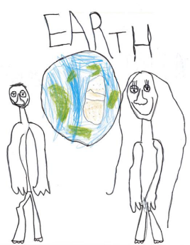
Because we are licensed by the State of Maryland, we must provide the opportunity for children in our Aretz and Mayim programs the opportunity to nap every afternoon. Many children when they turn three reduce or eliminate their napping time, and we have created a space for children who no longer nap. It is the policy of our preschool that we do not wake sleeping children nor prevent children from sleeping who are clearly fatigued. All children must be on their cots for approximately 30 minutes for rest time and if they remain awake, they are invited to play in our No Nap Room for the duration of nap time.

The Classroom and Beyond

The Center
We are so fortunate to have access to the wonderful BENDER JCC facility, which includes a gymnasium, art and dance studios, walking paths, the Indoor Mercaz playspace, gardens, and large grassy areas. The multigenerational and multicultural community at the BENDER JCC enhances our children’s learning experiences.

Our Staff
It is our priority to employ experienced and talented staff members that meet our high standards. We provide ongoing professional development to support our staff in remaining lifelong learners. The ECC program is a professional educational setting and sets clear standards and expectations for all teachers and staff members. Throughout the year, staff members receive formal and informal observations, opportunities for professional growth and constructive feedback. While we are proud of our talented and hardworking staff, there are situations when a staff member’s contract must be terminated or not renewed for the coming school year. The decision to terminate a staff member is never easy and can be based on issues not readily seen by families. Please know that these decisions are always based on the best interest of the school. Details of the termination are governed by the protocol of human resources and are not shared with the public by the school or the BENDER JCC. We will inform families of these changes as is appropriate.

At times it is necessary to have substitute teachers take the place of one of the adults in the classroom if they are absent for any reason. Our substitute teachers are interviewed by the Director and are fingerprinted just like all of our staff members. They are provided with a Staff Handbook and given an orientation to our school’s policies and procedures. When one team member in a classroom is absent, the other staff member assumes the role of leading the class for that day. Our policy is that two teachers from the same shift in a classroom may not take leave at the same time; however, sometimes an emergency situation arises where that may happen, in which case we will assure that an experienced person who is familiar with the children in that class is in the room that day. When a long-term substitute is required, families will be alerted to that change in as timely a manner as possible.

Specialists
We offer a variety of specialized activities for each class. In addition, school-wide special programs are scheduled throughout the year. We also work with the different departments of the BENDER JCC to make use of the wonderful facilities available to us. We currently offer Music for all our classes. Our Shamayim classes engage in other enrichment opportunities such as Sports and Hebrew. Families are welcome to join us for Shabbat Sing on Friday mornings led by our music teacher. Please ask your classroom teacher about your child’s Shabbat Sing time. We also have an Atelier/Arts Studio to where teachers can bring small groups of children to work on projects. To further enrich the classroom, we have a part-time Atelierista, a Studio and materials expert, which is a key component of a Reggio-inspired program. The Atelierista works with staff and children to bring a deeper understanding of materials to the classroom project work.

Families
Our goal is to build an amiable school where children, teachers, and families feel at home. Such a school requires careful thinking and planning concerning procedures, motivations, and interests.
--Loris Malaguzzi,
founder of the
Reggio approach

Together we are better! We take the idea of a partnership with our families very seriously. It is only through the strong partnership of the home and the school that a child can have the richest preschool experience. Families are asked to read the class and school newsletter so they can better discuss with the children the different topics they are studying and share with the teachers their thoughts and observations. Families are invited to school and class celebrations and events so that the home/school connection is strengthened. Communication is essential to a strong home/school relationship. Please email the Lead Teacher to set up a time to meet in person if there is a concern. Please inform teachers about children’s interests and comments related to class projects as well as about family members’ skills and talents that can be shared with the class.

Early Childhood Parent Committee (ECPC)
The ECPC’s function is to advise and support policies and procedures for the ECC programs. The ECPC Executive Board is responsible for fundraising and planning Tzedakah (charitable) projects and special events for the school. The ECPC holds meetings every other month that are open to all families. We ask that you try to attend these meetings as your input is important. Notices will be sent home regularly, inviting you to upcoming ECPC meetings.

Field Trips
Field trips can be a valuable part of the learning experience. Our classes go on regular walks through our neighborhood, and every child is required to have a signed permission slip for these walks on file. Periodically, classes go on field trips beyond our neighborhood to highlight various aspects of their curriculum, for which we will send an additional field trip permission form. Parent/guardian volunteers are needed for supervision of the children and sometimes for transportation. While family participation makes these special experiences possible, it also gives families an opportunity for active involvement in the preschool. When on field trips, please follow the instructions of the teachers. Please do not purchase anything, including food, for yours or any other children while on these trips.

Shabbat and Havdalah
Although Shabbat does not begin until sundown on Friday, we anticipate its arrival by kindling the Shabbat candles with the children during Friday morning snack time. To join us for your child's Shabbat celebration, please see the sign-up sheet on the family bulletin board by each classroom. The teachers will provide more details of ways to participate in this special occasion.

Children are encouraged to bring a couple of coins for Tzedakah (charity) on Fridays. In the past, the money the children collect has helped to feed needy families in the US and Israel, support cancer research, purchase toys for sick children at NIH, and much more.

All are welcome to join us for Shabbat Sing in the lobby atrium. Please check with your teacher for times.
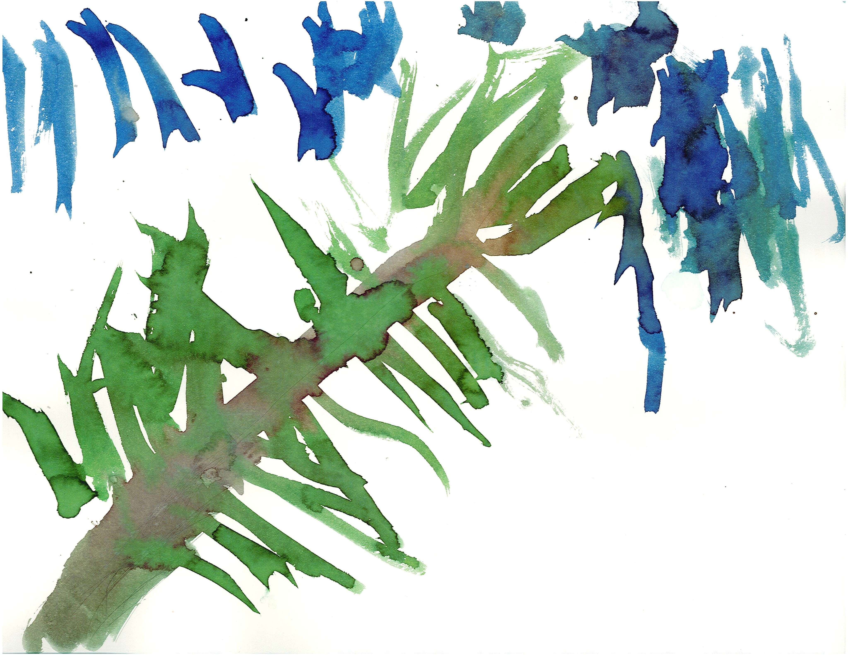
Every Monday morning, the whole school joins together to celebrate Havdalah, a ceremony to welcome the new week. Families are welcome to join us for this celebration in the Social Hall at 9:45am.

The Outdoor Classroom
Teaching children about the natural world should be seen as one of the most important events in their lives.
—Thomas Berry

We have two new lovely playgrounds as well as many areas around the JCC for our children to learn outdoors—fields, gardens, hills, and our back patio. One of our playgrounds is a natural playground, with many opportunities for imaginative play, digging, and construction. This playground has a water pump that is open during the warmer months of the year, and allows children the amazing experience of water play as they create paths in the sand pit and add water to our mud kitchen. When children are engaged in messy sensory play, they learn to wonder, to solve problems, to take risks, and to understand the properties of these materials. Our goal is to involve the children in diverse, and possibly messy, outdoor experiences every day, even when it is cold, hot, raining, or snowy. We will stay out for shorter periods on these types of days, but it is important that children are sent with weather appropriate clothing every day. Every child should have snow boots and warm coats for snowy weather, and raingear for rainy days.
You are asked to keep a pair of rain boots in school at all times.

Swimming Pool
Our preschool is enriched by being in the BENDER JCC setting, where we have access to wonderful resources, such as the indoor and outdoor pools. In the winter, our students are invited to register for individual or group swim lessons as an after school experience. During the summer months students in our Mayim Program (3 year olds turning 4) and in our Shamayim Program (4 year olds turning 5) have instructional swim. Our youngest students in the Aretz Program (2 year olds and 2 year olds turning 3) have free swim in the wading pool each day.

Communication

Director
The Director is available to families daily, including during morning drop-off and
afternoon/evening pick up times. She believes in an open door policy for sharing feedback, both positive and negative. Please do not hesitate to speak to Ora about any issue so that she can attempt to resolve it. She primarily sends information out by email and makes every attempt to do so in a timely manner.

Accounting
Debbie Kivitz, our office manager, handles the financial aspects of the school in concert with the BENDER JCC accounting office. Please contact the school office preschool@BenderJCC.org if you:
- Have a billing questions
- Would like to change your child’s program. If you choose to decrease hours, there is a $100 charge. You must give 30 day notice in writing.
- Need drop in care (the form is on our website)
- Need a receipt for tax purposes or dependent care, although first try logging into your online edge account at BENDER JCC.org and you can print all your receipts.

Teachers
We encourage families and teachers to keep open lines of communication throughout the school year. Each teacher has a BENDER JCC email address and will send out communications to you. Families may contact teachers via email at this address. Teachers are required to check their email at a minimum of once a day. Please be sure that your teacher has your correct email address. Please be aware that our teachers are taking care of your children and may not be able to respond to emails during the day. If you require a quick response, contact the ECC office at preschool@BenderJCC.org or our office staff at 301-348-3839. If it is an emergency and the office staff is unavailable, please call the JCC front desk at 301-881-0100 and ask that they contact the preschool. To insure maximum supervision for our children, please do not call your child’s classroom directly.

Teachers will be writing daily emails to keep you informed about the work going on in the classroom as well as to get your input on ongoing projects. Each daily email will include the thoughts and photos of different children each day, and we ask that you read it even if your child is not highlighted that day. The daily email will give you a sense of the thinking of the children and teachers and a glimpse into some part of the children’s day.

Outside every classroom is a wipe-off board where teachers will share important information such as where the class is located, any special events, who is substituting in the room, and updates about class projects. The Ongoing Projects sheet hangs outside the classroom and alerts you to the ongoing questions asked by the teachers and children throughout a project. Please take the time to stop in and read the class documentation on a regular basis.

Important information concerning your child can be gained through informal conversations between families and staff. Please remember, however, that the teacher cannot talk at length with families either in person or on the phone when the program is in session. Brief messages pertaining to the child’s daily care may be written in a note or email to the teacher.

Issues, Concerns, or Feedback
If you have an issue or concern, you are encouraged to address problems in a direct way with the person or people with whom you are having a challenge. If you have been unsuccessful in reaching resolution in talking with a classroom teacher, you are encouraged to speak to the Preschool Director. If you require further assistance, you may speak to the Chief Operations Officer or the Chief Executive Officer.

We are all part of one community, and we therefore have responsibilities to one another. We ask that you provide feedback in a productive manner and refrain from engaging in conversations or behaviors that undermine the integrity of the school. We also ask that you not approach the child or parent of a child who has had a dispute with your child; this can lead to an escalation of the issue. Please trust the school to intercede on your behalf.

Parent/Guardian Teacher Conferences
Parent/Guardian Teacher Conferences are scheduled twice a year for which the teachers will prepare a written conference form based on developmentally appropriate objectives. See the 2017-2018 school calendar for scheduled time periods. Teachers will post conference sign ups outside the classroom or use Googledocs to schedule conferences. Families or teachers may request additional informal conferences if necessary.

Absences and Family News
We care about your child and family! Please send an email to your child’s teachers as well as the preschool (preschool@BenderJCC.org) to let us know if your child will be absent, or if there is any good or bad news that we should know about. We love to see new baby photos!

Room Parents
We need you! Please consider volunteering to be a Room Parent. It is a great way to get to know other families and to make a difference in the school. Room Parents serve as an important point of contact for the families in your child’s class. You will receive help from the Room Parent Coordinator! Please let your child’s teacher know at the Open House or Back to School Night if you are interested.

HoliDaycare and Kid Coverage

HoliDaycare
For students in both 10-month and 12-month program: HoliDaycare offered on certain Jewish holidays when the preschool is closed, but the BENDER JCC building is open. The hours for HoliDaycare are 9am-5pm and the cost per day is $80. Registration is online. HoliDaycare is only available to children currently enrolled in the BENDER JCC preschool. Space is limited. There are no refunds due to illness or absence. Current school staff will be supervising HoliDaycare, but we cannot guarantee in advance which staff members will be working on a particular day. Please check the school calendar for the dates when this is offered.

Kid Coverage
For students in the 10-month program who wish to attend school during vacation for 10 month program while full year program is still in session. 10 month students will be placed in their current classroom if they are in a classroom that is open full year. 10-month students who are in classrooms that are open only 10-months will be placed where space is available in their age group. The hours for Kid Coverage are 9am-5pm and the cost per day is $80. Registration is online. Space is limited. There are no refunds due to illness or absence. Please see the preschool calendar for the dates when this is offered.

Policies

Program Changes
According to the Terms of Enrollment, 30 days written notice is required for preschool schedule changes. If prior written notice is not given, you will be responsible for the month's tuition. You will need to fill out an Automatic Payment Form.

A $25.00 fee will be assessed for each credit card payment or EFT that is denied. It is the parent's obligation to notify the preschool of any changes in their credit card or EFT account.

There is a $100 service fee to downgrade your child's program to fewer hours.

Medical and Health Policies

Medical Forms
Medical and immunization forms completed by your child’s physician must be on file in the school office prior the first day of school. All children should have the following immunizations:
- 4 DPT
- 3 Polio
- 1 MMR
- 3 Hepatitis B
- 1 Hib and 1 Varicella (Chicken Pox)
If your child, regardless of age, does not have these immunizations, your child’s physician must submit a written explanation. In addition, the following forms must be on file:
2 signed Emergency Forms, Family Information Form, and Child Information Form.

For the health, safety and welfare of both staff and students, the Bender Preschool program follows all the State of Maryland vaccination requirements for students entering our program. Documentation of compliance with these requirements shall be provided to the center for all students upon entry to the ECC. The center will monitor on-going vaccination compliance for children 18 months to 5 years who are enrolled in the ECC. This follows the standards and policies of the American Academy of Pediatrics, the Centers for Disease Control and the American Council on Immunization and Prevention. There are no religious or personal exemptions to this policy. Medical exemptions will be reviewed by the Director of ECC with medical consultation as necessary.

In addition, all families must submit written documentation of a blood-lead screening. All information is confidential and will not be released to outside sources without written approval from parents.

Allergies
After all children have enrolled, but prior the first day of school, all physicians’ medical reports and health history forms will be reviewed. Children who have any allergies are asked to complete the allergy protocol form, even if the allergies are not life threatening.

A master list of those children with allergies, including a photograph, will be created and placed in every classroom. Parents/guardians of these children are required to provide the following:
- Photograph of child (for the master allergy list above)
- Two copies of an allergy treatment protocol from the child’s physician which includes the particular child’s unique history of symptoms and reactions – one will be posted in the child’s classroom and the other will be kept in the master student folder
- A bottle of Benadryl (to be kept in the administrator’s office) with dosing instructions
- Two Epi pens (if prescribed by the physician) – one will be kept in the administrator’s office as a back-up and the second will be kept by the staff person in charge of the child (in other words, wherever the allergic child goes, the Epi pen goes, kept safely by the adult in charge)
- All food the allergic child will eat during any given day including lunches, snacks and celebration treats (ex: a treat to eat for a birthday celebration) will be provided by families for their child if they are not able to eat the food provided by the school.

Children with allergies will not be permitted to start school until all medical forms and a physician’s allergy treatment protocol have been received by the office. An earlier deadline date will be set for these children due to the need for creating the school/classroom plan explained below and for staff and education. A ‘school/classroom plan’ will be developed for the child with allergies based on the information provided by physicians and families. This plan will be tailored and individualized to the specific needs of the child.
- All staff in charge of a child with allergies will be provided with specific information and/or training regarding the child’s allergies and treatment plans (ex: how to administer an Epi pen).
- Staff will maintain current certification in First Aid and CPR.
- The school will maintain properly stocked and readily available First Aid Kits.
- A letter will be sent out to all families in a classroom where a child with allergies has been identified, outlining the responsibilities of the classroom community to assure the health and safety of this child.
Staff will be responsible for assuring that families and classmates follow through on the identified accommodations.

Illness
Illness is difficult for everyone, especially when a child is in a preschool program. Whether to keep a sick child home is not always a straightforward matter. However, the dilemma is certainly lessened if families and other care providers agree upon certain guidelines. The BENDER JCC’s specific policies are based upon the general understanding that ill children should be kept home if they are:

- Contagious and their presence at the preschool represents a significant health risk to other children.
- Disruptive due to illness to the staff's ability to tend to other children. The preschool is not designed to care for ill children and the extra attention required by sick children can compromise the routine care of others.
- Miserable. Illness can make a child feel miserable. If the emotional needs of the child cannot reasonably be met because of illness (despite the staff's best efforts), then the child should be kept at home.

The burden of deciding when a child cannot attend the preschool due to illness falls on families. In situations when a child's degree of contagiousness is not clear, families should seek advice from their pediatrician. Some medical problems, such as allergy and asthma, can be difficult to distinguish from infectious disease. In these situations and others, written documentation may be required from a pediatrician.

Families are expected to honor the following guidelines in good faith, for the health and well-being of their own child and others. Flagrant or repetitive disregard of these guidelines may jeopardize your child's future participation in the school. Although it is unrealistic to completely prevent the spread of infection in a school setting, exclusion of a contagious child can lessen the chance of others being infected. While we are sympathetic to the challenge of having to miss work or leave work because of a sick child, there are times that your child may have to be excluded due to illness. We ask for your partnership in keeping our school healthy.

In deciding whether or not to keep your child home, the following guidelines should be applied:
- Fever
Fever (defined as rectal temperature higher than 100 degrees after one minute, or axillary temperature higher than 99 degrees after one minute) results in exclusion until free of fever for 24 hours. Children who are sent home with a fever one afternoon may not return to school the following day.
- Runny Nose, Conjunctivitis, or Cough
If there is "excessive" nasal discharge, "significant" eye discharge or "frequent" coughing, then the child should be excluded until symptoms have "improved significantly"—that is, less nasal discharge, no significant eye discharge, less frequent cough. If the child has a history of asthma or allergy, respiratory symptoms may not indicate contagiousness; however, these children are at increased risk of infection, and a pediatrician may need to clarify each situation or give general assessment guidelines to the family and this Center for that child. When prescribed, antibiotic treatment by itself does not guarantee prevention of spreading illness. Symptoms must be improving if one is to assume that the infecting bacteria are not resistant to antibiotic treatment. The nature or character of the nasal discharge or cough is an unreliable indication of contagiousness. Minor nasal congestion or cough should not result in exclusion.
- Vomiting or Diarrhea
Vomiting and diarrhea generally indicate an active intestinal infection. Diarrhea is best defined as a significant increase in frequency over normal. The child with an intestinal tract infection may return to the Center if there is no vomiting for a minimum of 24 hours, the frequency of stools is returning to normal and he/she is generally feeling well. Children who vomit during the night for other than allergy or food-related issues should be kept home even if they appear well. When children are sent home with this condition, they cannot return to school the following day as well as meeting the conditions stated above.
- Strep
Strep infection results in exclusion. It may be diagnosed either by a rapid strep test or an overnight culture. If there was concern enough to perform a strep culture, then the child should be withheld from the Center until results are known. The child with strep may return to the Center only after taking an antibiotic for a minimum of 24 hours and he/she is fever free with significant improvement in all symptoms. Some strep infections take longer than 24 hours to respond to antibiotics—if the child is not better after 48 hours, the question of antibiotic resistance should be raised. .
- Head Lice.
The school staff has the right to examine any child suspected of having head lice. If there is a suspected infestation, the school has the right to send the child home immediately. A child will not be readmitted to the program until his/her hair has been thoroughly washed with a prescribed shampoo and all eggs/nits have been combed out. Exclusion will continue until the child is nit-free. Families who find an infestation must notify the classroom teacher or director so appropriate steps can be taken to prevent further spread.
- Hand Foot and Mouth
  - Children diagnosed with HFMD may return to preschool after being fever free for 24 hours and the skin or mouth are free of open blisters. For more information see http://kidshealth.org/en/parents/hfm.html#

Medication
Medication by prescription or purchased over the counter will not be administered without a signed Physicians Medication Form (on school website) on file in the school's office.
http://www.BenderJCC.org/wp-content/uploads/2014/12/1216_MedAuth_073013.pdf. All medications must remain in their original containers.

Handwashing
Handwashing is very important in the prevention of spreading illness. We ask that you help your child wash hands upon arrival at school every morning. We wash hands before eating or handling food and after using the toilet or having a diaper changed. According to our State licensing regulations, we may not use hand sanitizer on the children.

Sunscreen
We feel it is important to take children outside every day and therefore we ask families to apply sunscreen each morning before school. Staff will reapply sunscreen throughout the day only if the form required by Maryland State Licensing has been signed in advance. Staff will provide the form at the start of the school year and it is also available in the school office.

Guidance (Discipline) Policy
Young children are learning how to be with others in the world and at times have mistaken behaviors. Impulse control is a major area of growth and learning for children. Some learn immediately how to direct their anger or frustration in productive manners, and some require more time to learn to control these impulses. We believe that children learn by being involved in the process of resolving conflicts, by learning to express their feelings with words, and by thinking about what it means to be part of a community. We work to create a culture of empathy and understanding. Learning not to hit or bite is part of what children have an opportunity to practice in school.
- We require all staff to provide a positive model of behavior by treating children, families and one another with friendliness, care and courtesy.
- We ask that all families and visitors who enter our school help support the guidance of children by providing a positive model of behavior as well.
- We require all staff to use positive strategies for handling any conflict by helping children find solutions in ways which are appropriate for the children’s ages and stages of development, such as prevention, redirection, providing choices, or conflict resolution
- When children behave in unacceptable ways, we engage in dialogue with them to help them learn more appropriate ways of being with others.
- We do not have children say “I’m sorry” after a harmful action. Young children do not have an adult understanding of what sorry means and may not really feel sorrow over what they did. Being sorry means contemplating the impact of what they have done and feeling regret for having done it. Simply saying “I’m sorry” can become a magic incantation of absolution for some children, as though the words alone are enough to free them from the responsibility for and consequences of their choices.
- We do not use any punitive strategies such as “time out”, and never send children out of the room by themselves.
- We never use physical punishment or touch children in punitive ways.
- We do not shout or raise our voices in a threatening way to respond to children’s behavior.
- We do not use techniques intended to single out, threaten, bribe, or humiliate individual children or groups of children.
- We work with families to address recurring misbehavior, using objective observation records to help us respond appropriately.
- Our Learning Specialist provides support to staff and families regarding behavioral and developmental issues.
- Details of any events in which a child hurts another person, are brought to the attention of the Director and are recorded in an Incident Report. The family of the child who is hurt, will be informed of the situation on the same day. The privacy of all children involved in any such incident will be preserved. Not all incidents require an incident report for the child who hurt the other, unless this behavior is purposefully aggressive or part of pattern of behavior.

Biting Policy
Children sometimes bite other children. Although not all toddlers and two year olds bite, biting is considered a normal stage in child development. Children may bite for a variety of reasons, rarely with the intent to hurt another child. When a child is bitten, that child is immediately comforted and cared for. The biter is told firmly, but without anger, something like “Teeth are not for biting. Biting hurts very much.” The teacher encourages the child who was bitten to express his/her feelings to the other child. “It hurts” or “Don’t bite me” are sentences teacher might model for the child to repeat.

Families are informed about what happened by receiving an Incident Report on the day of the incident for each child involved. If a child has bitten or been bitten before, each family must be called. After three incidents, or if the child is older than the developmentally expected age for biting, then the staff, in cooperation with families, and possibly outside professionals will meet to formulate a plan of action, with set goals to modify the child’s behavior. If the biting continues, a child may be asked to leave the program until this behavior is resolved.

Exclusion from Preschool Policy
There are occasions when the preschool is unable to support the needs of a child or a family. These situations include learning or behavioral challenges that impact the child’s learning and/or impacts the classroom in an ongoing manner. Before a final decision is made on the part of the preschool, many strategies are employed, and there is ongoing communication involving the teachers and parents as well as outside professionals if needed.

Reporting Abuse Policy
In Maryland, the child abuse law mandates that educators who suspect a child is being mistreated must report the matter to Child Protective Services. Any person who in good faith makes a report of abuse or neglect is immune from any civil liability or criminal penalty.

Late Pick Up Policy and Fees
All children have a designated pick-up time. In the event you are late, your child will not be left unattended, however a late fee will be imposed on families who are more than 5 minutes late or if you are late on a regular basis. Please call the school office if you expect that you will be late 301-348-3839. The family will be charged $5 for the first 5 minutes after 6 p.m., or the time your child’s program was scheduled to end or portion thereof; $1 for each additional minute after the first 5 minutes. This policy also applies to early dismissal days. Late fees are to be paid directly to the staff person on duty at the time of pick up. If a family is late in picking up their child more than 3 times, the child’s continuation in the program will be re-evaluated.

Clothing Policy
Children are encouraged to wear play clothes and closed-toe rubber soled shoes that fit well. Daily activities include active and messy play, and they should feel comfortable enough to enjoy themselves without worrying about their clothes or their safety. It is best not to dress your child in jewelry as it can be a safety concern. Please consider your child’s skills at dressing and undressing for the bathroom when dressing for school. Outdoor clothing, including boots should also be easy for children to manage.

We go outside almost every day, so please dress your child appropriately. If your child is too sick to go outside, they are considered too sick to be at school. Each child is asked to keep a pair of rain boots in their cubby for rainy day play.

Please write your child's name on all sweaters, jackets, coats, hats, scarves, caps, snow pants, boots, mittens, extra clothing, etc., with a permanent marker or purchase Bubblelabels through the ECPC http://www.benderjccgw.org/ecpc/

Each child needs to have at least one extra set of clothing at school in case it becomes necessary to change. Please bring a complete change of clothing to keep at the school, labeled with your child's name. Please be sure to supply a new change of clothes every season. If your child comes home wearing these “extra clothes”, please send a new set to school the next day. Children who are toilet training may need to keep multiple sets of spare clothing in school.

Diapering and Toilet Training Policy
Children do not need to be toilet trained in order to attend the preschool. If your child wears diapers, you must provide diapers and wipes and replenish when needed. When a child demonstrates an interest in using the toilet, center staff will work collaboratively with families to assist with the toileting training process. If your child does have a toileting accident, soiled clothing will be put in a plastic bag and placed in your child’s cubby for you to take home. Please send in another extra set of clothing the next day.

Personal Items from Home Policy
We believe in the importance of children sharing what is important to them with their friends and teachers. Teachers will allow children to bring special items from home, but may set some limitations about the sharing of these items during the day. Check with your child’s teacher, about the policy of each individual classroom. The class policies may change if issues arise.
The following general guidelines apply:
- No toy weapons!
- If toys become an object of disruption or conflict, children will be asked to stow them in their cubbies.
- Your child’s teacher may limit the sharing of special items to specific times of day or areas of the classroom.
- The Bender Preschool is not responsible for lost or damaged personal
belongings. Encourage your child not to bring items that are precious, or that your
child cannot bear to share. Be sure to label all personal items!

Babysitting Policy
Staff members are not permitted to babysit for families who have children in the staff person’s class or age group. Families who hire any of our staff members to babysit or drive their children are required to sign a release form. Please see the Director for this form. The BENDER JCC does not authorize or take any responsibility for work done by our staff outside the Center.

Food Policies and Information

Kashrut (Jewish Dietary Laws)
The BENDER JCC and ECC Center observe the laws of kashrut.
NO MEAT OR SHELLFISH MAY BE BROUGHT INTO THE SCHOOL.

Any food product sent to school for class consumption must bear a supervised kashrut seal. A plain K or P (pareve) will not be accepted. No home-baked items may be brought to school, except for individual lunches. Check with the school office if you have any questions. We appreciate your cooperation and adherence to these policies.
Families are asked not to bring food for a class birthday celebration. Classes will be making a special treat in the classroom for each child’s birthday.

When planning classroom celebrations outside of school, please be sensitive to the fact that many of our families observe the laws of kashrut and that some children may have food allergies.

Food Allergies
While our school is not designated as nut free, we do make all attempts to not serve only nut-free items. In addition, some of our classrooms have been designated as Nut Free. The teacher will inform you if your classroom is nut free and there will be a sign posted in the classroom. If the room is nut free, you may not send peanut butter and other nut products for lunch. If a child in the classroom is diagnosed with a nut allergy during the school year, the room will then be converted to a nut free classroom and families will be notified that nut products will no longer be allowed in the classroom. It is the policy of the school, whether it is a nut free room or not, that children are not allowed to share food. Any foods you bring into the classroom for a whole class treat should be nut free.

Breakfast
Children that arrive between 7:30-9am are welcome to bring a healthy breakfast with them to eat in their morning classroom.
Please do not send children to school with candy/lollipops/gum/soda.

Lunch
Children may only bring dairy or vegetarian lunches. Fish (not shellfish) is also an excellent choice. Lunches will be refrigerated in the classroom. Teachers are happy to heat up food as necessary. Milk or water will be offered to your child with their lunches. No candy please.

Snack
Nutritious snacks are provided each day, one around 10am, and one around 3pm. Snacks typically consist of a produce and a carbohydrate, such as cereal, milk, and bananas. A weekly snack menu hangs on the snack shelf near the office.

Birthdays
Birthdays are important celebrations in the lives of the children and their families. Each classroom will create rituals for birthdays. Together, the class will bake or cook a special treat in honor of each child’s birthday. A birthday committee of children will create a special gift to honor the birthday child. Families are encouraged to be a part of the celebration, through reading a story or doing a special experience, or just being present for the celebration. Due to kashrut and allergy issues, families are asked not to bring any snacks to celebrate the birthday. Balloons, goodie bags, and candy are not permitted.
Our children come from varied religious backgrounds. In an effort to make everyone comfortable, please refrain from hosting and inviting children to birthday parties on Shabbat (Saturdays). At home birthday party invitations will be gladly distributed by teachers if the whole class is invited and the party does not take place on Shabbat.

Emergencies, School Closings, Safety, and Security

National Emergencies
In the event of a national emergency, your child will be well supervised at all times by BENDER JCC staff. You may call the school office at 301-348-3839 for instructions. If you are unable to get through, please come to the Center to pick up your child. You can be assured that your child’s safety is our first priority and he/she will be well taken care of.

Inclement Weather Policy
The BENDER JCC makes every effort to remain open during inclement weather. In the event of a weather delay or closing, we will send a mass email. Please see codes below that address specific weather situations. Please watch local news, call 301-881-0100, or visit Bender JCC.org for updates. Information will be updated as weather conditions require.
CODE BLUE School is delayed, Center will open on time.
CODE YELLOW School closed, Center will open on time.
CODE ORANGE School is closed, Center has a delayed opening.
CODE RED School is closed, Center is closed.

Security
When you become a member of the BENDER JCC, you will be issued a picture ID badge. Please have your card with you at all times. You will need to scan this badge upon entering the building as well as the Early Childhood wing. If someone who is not a member will be dropping off or picking up your child on a regular basis, such as a nanny or a grandparent, go with them to the membership office to get them a non-member’s badge.

For security purposes, all families must enter and depart through the front door of the BENDER JCC. While this can be an inconvenience, the safety of the children is our top priority. Please do not open the door for any person you do not know as this compromises the safety of our children. It is every family’s responsibility to carry their own BENDER JCC ID with them while in the Center.

BENDER JCC Parking Lot
There is a great deal of traffic in the BENDER JCC parking lot. For the safety of our children, it is vital that families follow these rules:
- Keep your eye on your child in the parking lot at all times.
- Never park in a spot that blocks another car
- Never park in the fire lane
- Use extreme caution when driving within the parking lot.
- The 20-minute parking spots in front of the playground are for pick-up and drop-off only.
- You may not leave your car parked at the BENDER JCC parking lot when you are not using the Center.

Pick Up
In order to maximize the safety of our JCC, a new pick up procedure has been put in place for the Preschool and KAS. AT 12:30, and again at 5:45-6:00 PM all children will be dismissed from the library. There is no longer any carpool from the front driveway. The adult who is picking up the preschool student must show their Preschool Pick Up card with the child’s name before the child is dismissed to their care. These cards were distributed at the start of the school year. Each child will have a luggage tag with his or her name on it so that the Pick Up Car and the child’s tag match.
.

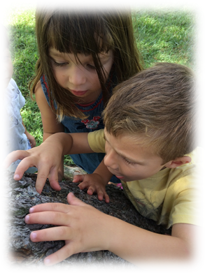
Helpful Information

List of What Families Must Provide
- If in the Aretz or Mayim program, nap items – blanket, pillow, lovie (we provide a cot and a cot sheet)
- Large bag for carrying the bedding home and storing in the closet
- Reusable water bottle/thermos
- A family picture and a picture of the child
- Rain Boots
- For children in diapers--diapers, wipes, cream (with a doctor’s note)
- Sunscreen (be sure to sign sunscreen permission form, which does not need to be signed by a doctor)
- Any medications for allergies etc, with a doctor’s note, i.e. epi pen, Benadryl
- Changes of clothing

Blessings that we say at Preschool
- MEZONOT: Blessing for food that is made from grain but is not bread: Baruch atah A-donay, Elo-heinu Melech Ha’Olam borei minei mezonot. Blessed are you L-rd our G-d, King of the Universe, Who creates various kinds of sustenance.
- HAMOTZI: Blessing for bread: Baruch atah A-donay, Elo-heinu Melech Ha’Olam Hamotzi lechem min haaretz. Blessed are You, L-rd our G-d, King of the Universe, Who brings forth bread from the earth.
- HAGAFEN: Blessing over grape juice or wine:Baruch atah A-donay, Elo-heinu Melech Ha’Olam borei pri hagafen. Blessed are You, L-rd our G-d, King of the universe, Who creates the fruit of the vine.
- PRI HA-AITZ: Blessing over fruit:Baruch atah A-donay, Elo-heinu Melech Ha’Olam borei pri ha-aitz. Blessed are You, L-rd our G-d, King of the universe, who creates the fruit of the tree.
- PRI HA-ADAMA: Blessing over vegetables:Baruch atah A-donay, Elo-heinu Melech Ha’Olam borei pri ha-adamah.Blessed are You, L-rd our G-d, King of the universe who creates the fruit of the earth.
- SHABBAT CANDLES: Baruch atah A-donay, Eloheinu Melech Ha’Olam, asher kidshanu b’mitzvotav v’tsivanu l’hadlik neir shel Shabbat. Blessed are you, Lord, our G-d, King of the Universe, who sanctifies us with his commandments and commands us to light the candles of Shabbat.

Holidays
We are pleased to offer a children’s program which is rich in Jewish culture, tradition, and values. At the BENDER JCC Preschool we celebrate all of the Jewish holidays as well as Thanksgiving, Presidents' Day and Martin Luther King Day. We do not celebrate Halloween, Christmas, Valentine’s Day or Easter. The Jewish holidays are an integral part of our program. We celebrate Jewish holidays through hands-on sensory experiences. To promote our core value of community, families are invited to join the children for Shabbat celebrations and special family events.

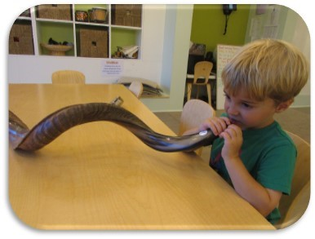
Jewish Holidays
- Shabbat: The Jewish Sabbath starts at sundown every Friday and lasts until sundown on Saturday. It is written in the Torah that G-d created the world in six days and rested on the seventh...giving us Shabbat. In many Jewish homes, candles are lit to welcome the Sabbath. Each classroom has a Shabbat celebration on Friday mornings with challah (twisted bread) and “wine” (juice). Each age level also participates in Shabbat Sing with our music teacher in the lobby atrium. Families are welcome to attend Shabbat Sing.
- Rosh Hashanah: This two-day holiday is the Jewish New Year. It is a time of personal reflection of our past and future behavior. The children enjoy apples and honey, which are symbolic of hope for a sweet year.
- Yom Kippur: This is the most solemn holiday of the year--the Day of Atonement. It is an adult fast day and a day of prayer. We discuss with the children how to be the best we can be.
- Sukkot: Sukkot recalls the journey of the Jews from Egypt to the Promised Land when they lived in sukkot (booths). It is also a harvest holiday symbolized by the Lulav (palm branch) and Etrog (citron). We decorate our Sukkot with fruit, and enjoy a snack in the Center’s Sukkah in the front of the building.
- Simchat Torah: On this joyous holiday, we complete the reading of our Torah for the year and immediately start reading the Torah all over again. This is a happy holiday for children as they march around the BENDER JCC singing songs and carrying flags.
- Chanukah:“The Festival of Lights” celebrates the Maccabean victory, when brave Judah Maccabee and his small band of followers saved the Jewish people from the Syrians. For the eight days of Chanukah, the Chanukiah (an eight-branched candelabra) is lit to recall the rededication of the Temple in Jerusalem and to give thanks for the great miracle of the survival of the Jewish people. At school, we light the Chanukiah and say the blessings, prepare potato latkes (pancakes), as well as other special activities.
- Tu B’Shevat: On Tu B’Shevat we celebrate the New Year of the Trees. Trees are a symbol of life, a symbol of Jewish people. Children do some planting and sample a variety of fruits.
- Purim: Purim is the jolliest of all the holidays, commemorating how Queen Esther and her uncle, Mordechai, saved the Jews of Persia from a plot by the Prime Minister, Haman, to destroy them. We eat hamantaschen (triangle shaped cookies). During the reading of the Megillah, the children make loud noises by shaking groggers (noise-makers) whenever the name Haman is said. The children prepare Mishloach Manot (gifts) to be shared with friends and the less fortunate.
- Passover: Passover (Pesach) commemorates the experiences and ordeals of slavery in Egypt, and the Exodus following them. The Seder is a special family occasion. Prayers and songs from the Haggadah (the story of Passover) are read, and certain foods are eaten. The classes will prepare their own model Seders and invite families.
- Lag B’Omer: This holiday recalls the struggle of the Jews to regain their independence as a Jewish nation. Today, the holiday celebrates Jewish survival. At school, we celebrate with outdoor activities.
- Yom Ha’Atzmaut: Yom Ha’Atzmaut is the Independence Day of modern Israel. We celebrate by making gifts for Israel and presenting them to the JCC’s Israeli emissary.

Other Holidays
Diversity is an important value in our school and we respect the many different cultures, religions and life choices that exist in our community. While we do not celebrate Christmas and other religious holidays that are not part of the Jewish tradition, we do encourage children to share family traditions and rituals, whatever the religion or culture. In our school we do not celebrate Halloween, St Valentine’s Day or St Patrick’s Day, but we also do not discourage children from participating outside the school day. Mother’s and Father’s Day present a challenge in trying to create a setting which acknowledges diversity and the need to be sensitive to all families. There are many different family structures, where there may not be a father or mother present. We have children who have experienced the death of a parent, families where there has been difficult divorce situations, families where the main caregiver is a grandparent, single parent families, and children from same sex couples. In order to be sensitive to our community, we have Thank You for Taking Care of Me Day. In this way, we acknowledge that there are many people in a child’s life with whom the child has a special bond. On this day, children may create a gift or card for those special people.

Kashrut Certifications
The following symbols of kosher supervision can be found on products which may be used in the Center. For more information about kashrut, visit www.kashrut.com.

     :  

Sheva Jewish Lenses
The following seven Jewish Values of the Sheva Framework help us to focus our intentions and serve as Jewish 'lenses' through which we see our curriculum and the life of our school community.

MASA/JOURNEY
מסע
Reflection, Return & Renewal
In order to move forward in a meaningful way, we must reflect upon the past. Our travels are more important than the destination.

TZELEM ELOKIM/DIVINE IMAGE
צלם אלוקים
Dignity & Potential of Each Person
The image of the child as capable and competent is a core Reggio philosophy value. We view children, families and colleagues with dignity. This is a lens of accountability, empathy and self-worth.

BRIT/COVENANT
ברית
Belonging & Commitment – Community
A bound and trusted relationship allows us to unite with others in pursuit of a shared vision. It enables us to grow, take risks, and share with honesty.

DRASH/INTERPRETATION
דרש
The spirit of inquiry within human nature is the drive that aides in reflection and growth. To question, to debate, to interpret, and to communicate are all essential components of the Jewish tradition.

HITORERUT/AWAKENING
התעוררות
When we as adults take the time to slow down, we become more aware of the miracles that exist in every moment, allowing gratitude to flow freely through us. Young children are more apt to wonder, naturally embracing life with exuberance.

TIKKUN OLAM/REPAIR OF THE WORLD
תיקון עולם
Repairing the world is done with a spirit of generosity and a partnership with families and children to continuously make a difference in our community. There is a sense of responsibility to perform social “acts of kindness” every day.

KEDUSHA/HOLINESS
קדושה
We envision holiness in terms of sacred time, spaces and intentions. We find holiness at distinct times in the Jewish calendar, such as Shabbat and holidays. We also unearth holiness in our daily experiences as we observe the interactions of children, listen to their voices, and discover life together.

Examples of Materials to Collect for the School
Judaica  Computer keyboard letters and parts  Beads  Buttons, notions  Hardware (rubber and metal washers, eyehooks, swivels, screws, nuts, bolts…)  Clean rubber or plastic tubing  Seed pods and interesting nature items  Rope, cord, tassels  Transparent, clear and colored, plastic boxes, Petri dishes, plastic slides, containers  Wire (brass, silver, copper, colored), chicken wire, wire mesh, plastic mesh, copper and aluminum screen  Costume jewelry  Old CDs  Puzzle pieces  Plastic caps and lids (clean)  Large Cardboard Tubes (no paper towel or toilet paper tubes)  Wooden massage tools  Seashells (big and small)  Stationary and unused invitations  Leather strips  Tape (colored, cloth, metal)  Wicker baskets | Thimbles  Dowel rods (clear and wooden)  Plexiglas mirror pieces  Springs  Corks  Gears from small clocks, appliances  Colored foils  Ribbon/lace  Interesting wooden pieces  Old game pieces  Rubber stamps  Corrugated cardboard and interesting cardboard shapes  Packaging materials  Old keys  Charms  Silk or dried flowers  Wallpaper and decorative paper  Driftwood  Fabric  Spools (without thread)  Beautiful stones  Metal or wood kitchen items/gently used pots and pans  Other materials identified by you as fabulous! And remember, multiples of anything are interesting!

Acknowledgment of Receipt

I have received a copy of the Bender ECC Program Family Handbook for the school year 2017-2018. I understand that I am responsible for all the information contained in it effective immediately.

Child’s Name_______________________ ________________

__________________________________ ________________
Signature of Parent/Guardian Date

Print Name________________________________

Please sign and return by Back to School Night Wednesday Sept 13 or Thursday Sept.14.

