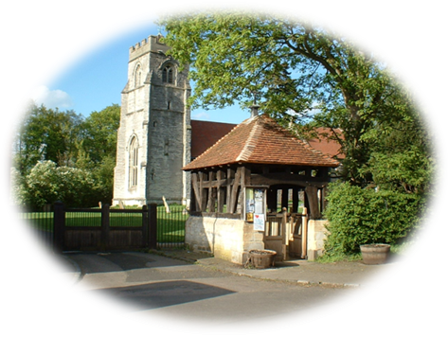






COMMUNITY EMERGENCY PLAN
for
Loxley Parish Council
Update schedule
Plan date: | Update due: | Nominated person:
30/05/2017 | 30/05/18 | Peter Gregory-Hood  Maria-L Garcia

Warwickshire

Title | Loxley Parish Council Emergency Plan
Author | Peter Gregory-Hood and Maria-L Garcia
Publication Date | June 2017
Parish Council Circulation List | Loxley Parish Council, Loxley website, CSW Resilience Officer
Version | June 2017
Action Required | Please destroy previous copies confidentially and print this copy
Contact Details | CSW Resilience Officer  Coventry City Council  LGF The Council House  Earl Street  Coventry CV1 5RR  02476 834332

Contents
Section 1- Introduction & Activation 5
Introduction 5
Aims of the Plan 5
Objectives of the Plan 5
Provide local intelligence to responders 6
Definition of an Emergency/Major Incident 6
Response Structure 6
Parish/Town Council role in an emergency 7
Planning Guidance 7
Activation of community emergency plan 8
Notifying Partners 8
Local risk 9
Local places of safety 9
Details of vulnerable people 9
Communications 10
Section 2 – Contact Details 11
Parish/Town Council Details 13
District/Borough and County Councillor Details 13
Local Volunteer Details 13
Health and medical providers 14
Details of Neighbouring Parish/Town Council 14
Section 3 – Resources 15
Defibrillator 15
Suppliers and contractors 15
Parish/Town flooding information and resources 16
Details of local radio stations and Websites – CSW, WCC, WCC flood 16
Section 4 – Guidance before and during an emergency 17
Preparing for an Emergency- What can you do? 17
Emergency Services Role 18
Advice for councillors in an emergency 19
General information 20
Appendices 21
1. Loxley Parish Council Emergency Group Meeting Agenda 21
2. Emergency Action card 22
3. Log of incident calls 23

Section 1- Introduction & Activation

Introduction
This plan has been developed by CSW Resilience and Warwickshire County Council, to address the need that Parishes or Towns have for an emergency plan. This allows them to be prepared to respond effectively to an emergency in their area. Where applicable this plan should be consider in conjunction with any local arrangements, such as flood action group plans.
Nearly all emergencies affecting the local community will be dealt with routinely by a joint response from the emergency services, Local Authorities and Utility companies. However, in extreme conditions such as snow and flooding, there is a possibility that the emergency services and other agencies may be overwhelmed and not be able to reach the area affected immediately. In such circumstances, the initial response will rely entirely on local people within communities. This plan will assist the community to respond to a major incident/emergency, whilst awaiting the assistance of the Emergency Services and the Local Authority.

Aims of the Plan
The plan has been designed to enable Parish and Town councils within the county to identify the immediate actions they should consider during an emergency. These actions may assist the community in reducing the impact of an emergency until further assistance is available.
The aim of the plan is to:
Provide a framework for Parish/Town councils to deal with the initial impact of an emergency on the local community, particularly when outside assistance from the emergency services and Local Authorities is delayed.

Objectives of the Plan
The key objectives of this plan are to:
- Support community resilience
- Identify resources in the community available to assist during an emergency
- Identify local people and local organisations who may be able to assist during an emergency
- Identify vulnerable people in the community and develop arrangements to assist them
- Provide relevant and timely local information throughout the emergency
- Provide appropriate contact details for the Parish/Town council, key community resources, the emergency services and Local Authorities
- Establish local co-ordination arrangements for dealing with the impact of the emergency at the local level
- To identify and commission places of safety for the public

Provide local intelligence to responders

Definition of an Emergency/Major Incident
An emergency will mean different things to different communities. The Civil Contingencies Act 2004 defines an emergency as:
An event or situation which threatens serious damage to
- Human welfare in a place in the United Kingdom
- The environment of a place in the United Kingdom
- The security of the United Kingdom or of a place in the United Kingdom.

Response Structure
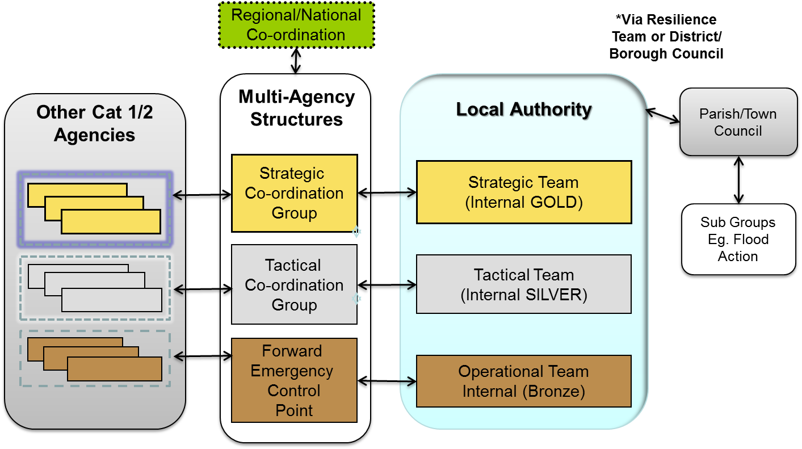
Once an emergency has occurred, the lead agency (e.g. Police, Fire and Local Authority etc.) with partners will deal with the affected local community, for the duration of response

Parish/Town Council role in an emergency
Parish and Town councils should act as a focal point within the local community and act as a direct line into the community for the Local Authority and the CSW Resilience Team. Also the Parish/Town council can provide an initial response to the community and on-going support to responders, by:
- Providing "local knowledge" to responding agencies
- Establishing a co-ordinating link with Parish/Town councillors and local voluntary groups as necessary
- Supporting information exchange and instructions to the local community ( e.g. Liaising with local groups)
- Providing information about vulnerable persons during an emergency i.e. the elderly and the infirm.
- Ensuring that any premises owned by the Parish and Town council which may be required for emergency use are available, e.g. the village hall
- Acting as a conduit for responders to assist and organise local help, when required. This may include places of safety
This plan will help the Parish/Town council to fulfil these roles and sets out useful information for both the Local Authorities and the Parish/Town council for use in an emergency.

Planning Guidance
On a day-to-day basis, the link for the parish on emergency planning issues is to the CSW Resilience Team. The Resilience Team will assist the Parish/Town council in the development of their emergency plan and in ensuring they are regularly updated in the following way:
- Supporting Parish/Town councils with advice on the production of their emergency plans
- Sharing of information within the plans
- Reminders for updating plans
.

Activation of community emergency plan
This plan is to be activated when community’s need immediate help/support in response to an emergency. It may be activated independently or in relation as a result of a sudden impact or notification of a rising tide Incident i.e. flood action group.
Do not assume that somebody has already taken action – it is better that the initial response is duplicated rather than no response is given at all!
1 .Determine the level of the emergency
• Major: the nature and extent of the emergency is such that the number and type of casualties/persons involved requires more than a normal level of response
• Minor: a more localised incident where normal procedures are more likely to be adequate
2. Contact:
• Major: multi-agency response needed, call emergency services: 999 and activate emergency plan
• Minor: emergency: 999 and relevant emergency services and key contacts
3. Follow instructions given by the emergency authorities supported by information included in this plan
4. Take appropriate further action until the emergency services arrive
The Parish/Town council may be asked to support responders during any incident of any scale.
Upon activation the parish emergency group should assemble

Notifying Partners
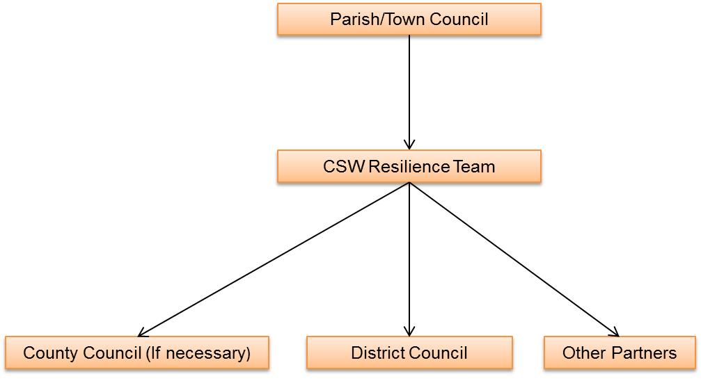

Local risk
Where applicable see supporting documents e.g. flag plan
Risks | Location address | At risk details E.g. No houses affected
Surface water flooding. | Foxlidiate  Old Post Office | These houses are at risk based on recent experience.

Local places of safety
Name | Address | Contact information/ key holder
Loxley Hall | Loxley | Peter Gregory-Hood
Loxley School | Loxley | Matthew Watson
The Fox Pub | Loxley | Richard and Susannah Saul

Details of vulnerable people
The vulnerable person list is a guide to support the community and is not designed to be a definitive list nor are Parish/Town councils or residents required to submit details to this section of the plan. For Data protection purposes, names should only be recorded here if approval has been given by the people concerned. In light of this requirement the Parish Council has decided against publishing details of vulnerable individuals. The Parish Clerk holds this confidential information.

Communications
Loxley Parish Council (through the Emergency Group) will communicate and notify the community via the following methods:

Type | Where Available
Written | Updates will be placed on the following:  - Village / Church notice boards  - Parish Council web site  - The Fox Pub
Verbal | - Community briefings/meetings  - Mobiles, social media, landlines
Note: during emergencies the mobile phones and landline phones may become overwhelmed and therefore should not be relied upon.

Section 2 – Contact Details

Organisation | Details
Warwickshire Country Council | 01926 410410 (request the CSW Resilience Team)
Highways Emergencies  (Flooding of the highway)  NB – to report flooding on Highways, please use these numbers, NOT the Duty Emergency Planning number | Warwickshire  01926 412 515
District/Borough Council:  (Flooding from local watercourses and flooding of council houses) | Stratford  01789 767 573
Health and Community Protection | Duty Social Worker  01926 666 922
Seven Trent (Flooding of drains) | 0800 783 4444
Environment Agency  Environment Incident Flooding | 0800 80 70 60  0345 988 1188
Utilities and other agencies
Western Power/Power Cut | Free phone 105
Gas: National Grid | 0800 111 999
Customer Contact Centre (24hr) | 0800 6783 105
British Telecom: | 0800 100 400
Severn Trent Water | 0800 783 4444
Police | 999 / 101
Warwickshire Fire and Rescue | 01926 423 231
Ambulance Service | 01926 881 331

Parish/Town Council Details
Chair: | Glynn Jones (01789 470 066)
Clerk: | TBC
Emergency Group: | Peter Gregory-Hood / Maria-L Garcia
Parish Councillors: | Maria-L Garcia, Glynn Jones, Peter Gregory-Hood, Dan Bake, Justin Whitehorn, Ken Osborne
Emergency Contact Tree | Maria-L Garcia (07921 927 345)  Glynn Jones (01789 470 066)  Dan Bake (07964 055 382)  Justin Whitehorn (07711 143 068)  Ken Osborne (01789 470 784)  Peter Gregory-Hood (01789 840 212)

District/Borough and County Councillor Details
Local District Councillor: | Penny-Anne O’Donnell
Local County Councillor: | Isobel Seccombe (01295 680 668)

Local Volunteer Details
Organisation | Details
Flood Action Group | Peter Gregory-Hood / Maria-L Garcia
Church Groups: | Loxley Parochial Church Council
Community Groups: | Friends of Loxley School
 | NDP Working Group
 | Environment Working Group
 | Traffic Calming Working Group

Health and medical providers
Organisation | Details
Local Doctors: | Elaine Ross, Scott Sanders, Karen Johnston, Jonathan Phelp
Chemists/Pharmacies: | Wellesbourne (01789 890 489)
First Aiders: | Yvonne Brocklehurst
Health Centre or Clinic: | Hastings House, Wellesbourne
Veterinary Surgeons: | Avonvale Veterinary Centre, Wellesbourne  01926 854 181
NHS 24 | 111
Local Defibrillator Trained Villagers | Maria-L Garcia, Karen Jones, Missy Bake, Dan Bake, Ken Osborne, Lynn Chatwin, Shirl Tyler, Kate Harris.

Details of Neighbouring Parish/Town Council
Parish | Contact details
Charlecote | Vanessa Lewis (01789 842 582)
Ettington | David Hughes (Chairman – 01780 740 736) ettpcdavidh@gmail.com
Wellesbourne and Walton Parish Council | 2 School Road, Wellesbourne, Warwickshire,  CV35 9NH  01789 841 434

Section 3 – Resources
Resource | Location:
Sand bags | Loxley Hall, outbuildings
Defibrillator | The Fox Pub (By side door)

Suppliers and contractors
Specialists | Details
The inclusion of the following names does not imply a recommendation nor is the list exhaustive. An instant response is not guaranteed and names are included purely as a guide to the resources available within the local community

Plumbers | John Shearsby 07768 847 888
Electricians
Builders merchant E.g. Sandbags etc.
Mechanic | Chris Ayres, Rich Wall

Parish/Town flooding information and resources
Parish/Town flood information | Details
Details of Parish/Town flood group (if established) | Peter Gregory-Hood / Maria-L Garcia
Details of sandbags held within the Parish/Town | Loxley Hall outbuildings
Details of other sandbag suppliers | Fairview Trading

Details of local radio stations and Websites – CSW, WCC, WCC flood
BBC Coventry & Warwickshire | 94.8, 103.7 & 104 FM | http://www.bbc.co.uk/news/uk-england-coventry-warwickshire-12582939
Radio WM | 95.6 FM | http://www.bbc.co.uk/news/uk-england-birmingham-12808700
Heart FM | 100.7 FM | http://www.heart.co.uk/westmids/on-air/
Free Radio | 97.0 & 102.9 FM | http://www.freeradio.co.uk/coventry/
Heart FM Oxfordshire | 97.4 & 102.6 FM | http://www.heart.co.uk/oxfordshire/
BRMB | 96.4 FM | http://www.freeradio.co.uk/birmingham/
Touch FM | 102 & 107.3 FM | http://www.102touchfm.co.uk/
Rugby FM | 107.1 | http://www.rugbyfm.co.uk/

Section 4 – Guidance before and during an emergency

Preparing for an Emergency- What can you do?
Visit www.cswprepared.org.uk for further advice.
To prepare for an emergency, it may be useful to know:
• Where and how to turn off water, gas and electricity supplies in your home
• The emergency procedures for your children at school
• The emergency procedures at local workplaces
• How you will stay in contact in the event of an emergency
• If any elderly or vulnerable residents might need your help
• How to tune into a local radio station
• Where fire hydrants are in the village

If you are at home and an emergency happens, try to gather together:

• A list of useful phone numbers, appears earlier in this plan (page 7)
• Home and car keys
• Toiletries, sanitary supplies and any regularly prescribed medication,
• A battery radio, with spare batteries
• A torch with spare batteries, candles and matches
• A first aid kit
• Your mobile phone
• Cash and credit cards
• Spare clothes and blankets
• High visibility jackets
Also, it is always useful to have:
Bottled water, ready-to-eat food (e.g. tinned food) and a bottle/tin opener, in case residents have to remain in their home for several days
In certain very unlikely situations, residents may be asked to leave their home by the emergency services. If this happens, encourage them to leave as quickly and calmly as possible. And, if they have time:
• Turn off electricity, gas and water supplies, unplug appliances and lock all doors and windows
• See the items listed above for what to take with them
• If they leave by car, take bottled water and blankets, and tune in to local radio for emergency advice and instructions
• When they are told that it is safe to return home, encourage them to open windows to provide fresh air before reconnecting gas, electricity and water supplies

Emergency Services Role
The emergency services are trained to cope with a wide range of emergency situations, but there is a lot that you can do to help them and yourself.
Emergency plans exist in all areas of the UK
The police, fire and ambulance services have tried and tested plans for responding to incidents, from fires to explosions, whether they are at your home, your school or affecting transport networks.
Health and Hospitals
Emergency equipment, vaccines and antibiotics are stored around the UK and are quickly available to doctors
Emergency planning exercises
Every year, many exercises are held involving the emergency services and all agencies responsible for recovery. These exercises practise the responses to a range of emergencies, including terrorism, by testing our preparedness.
In most emergencies, the experts from the emergency services will be the best people to deal with any situation. Please ensure that they have been alerted by calling ‘999’. Ask bystanders to keep back and not interfere or become casualties themselves. The ‘walking wounded’ will be dealt with by the emergency services
Contact telephone numbers for emergency services are listed in Section 2. Although 999 will often be more appropriate. Leave the emergency to the trained professionals and help by keeping bystanders back and obeying the instructions of the emergency services

Advice for councillors in an emergency
This section is intended to be a general guide to help Councillors should an emergency occur and is reproduced here to enable easy access. Some of the information is repeated in other sections of this Plan.
The information is based on the government document ‘Preparing for Emergencies’ which was circulated to all households in 2005.
The Emergency Planning Co-ordinator for Loxley Parish Council is:
Peter Gregory-Hood / Maria-L Garcia
If you find yourself in the middle of an emergency, your common sense and instincts will usually tell you what to do. However, it is important to:
- Make sure ‘999’ has been called, including a request for an ambulance if people are injured or if there is a threat to life
- Re-assure bystanders and keep them away from the incident
- Keep bystanders back and out of the way of the Emergency Services
- Avoid putting yourself or others in danger – Rest areas may be available at the Village Hall
- Remain calm and think before acting and try to reassure others
- If you are appropriately trained, you could check for injuries, however, remember to help yourself first before attempting to help others and do not put yourself in any danger
- Always follow the advice of the emergency services
If you are not involved in the incident, but are close by or believe you may be in danger, in most cases the advice is:
Advise people to go inside a safe building (or rest area if available)
Stay inside until advised to do otherwise
Tune in to local radio or TV for more information
Of course, there are always going to be particular occasions when you should not ‘go in’ to a building, for example, if there is a fire. Otherwise advise: GO IN, STAY IN, TUNE IN
REMEMBER
Do not assume that somebody has already taken action – it is better that the initial response is duplicated rather than no response is given at all!
Follow instructions given by the emergency authorities supported by information included in this Plan
Take appropriate further action until the Emergency Services arrive

General information
Further general information can be found on the CSW website which is as follows; www.cswprepared.org.uk

Appendices

Loxley Parish Council Emergency Group Meeting Agenda
At the Emergency Group Meeting the following are items that may need consideration:
- If there is an immediate threat to life call “999”
- Location of the emergency – near a school, vulnerable area, main access route etc.
- Type of emergency – is there a threat to health? E.g. is there a smoke cloud heading towards houses? Flood water rising? No electricity/gas during the winter (hypothermia) etc.
- Are there any vulnerable people involved? E.g. elderly, mothers with young babies with no heating, people cut-off by flood waters etc.
- What actions are required?
- What resources are required?
- What information is available from Stratford District Council or emergency services etc. e.g. Twitter, The web, Local news, local radio etc.
- Organisation of the Parish Council to deal with local issues
- Temporary arrangements if outside assistance is not available
 | Action | Initials | Date & Time | Completed
1 | If an emergency is reported to a member of the Parish/Town Council by the community and it is possible that the emergency services are not aware, call 999 as soon as possible
2 | Contact and inform CSW Resilience Team who will liaise with the District/Borough council  Take note of any safety advice given to you and discuss at the Parish/Town Council’s Emergency Group Meeting
3 | Keep a log and record:  - Any decisions made and actions taken  - Who was spoken to and what was said  - Any information received
4 | Contact the other members of the Parish/Town Council, volunteers and key holders as appropriate
5 | Organise a Parish/Town Council Emergency Group Meeting (via the Chair or Clerk) in a venue which is safe from the emergency with safe access routes
6 | Decide actions to undertake e.g. consider the need for:  - Visiting and checking on vulnerable people  - Distributing sandbags
7 | Decide how to inform the community of the emergency and actions being undertaken  Inform the community of any advice given to you from the County and District Councils or the emergency services  Request the community to tune in to the local radio
8 | Inform the CSW Resilience of any decisions that have been made
9 | Remember to liaise regularly with the County and District Councils to maintain the safety of the community.  If at any time an immediate threat to life occurs or is likely to occur, call 999.  Remember that all reasonable steps must be taken to avoid harm to yourself and the public

Emergency Action card

Log of incident calls
It is of vital importance to both you and the council to keep a log of calls you receive and make in response to an incident. After completing the ‘receipt of initial call’ fill in the details below to help you keep a log of your decisions and actions. Ensure you sign and date the bottom of this document
Page…..of………
Date | Time | Call Received from (name & organisation) | What do they want you to do | Your Action

