BISA Expenses Policy

- Introduction
This document details BISA’s policy for the submission and reimbursement of expenses claims incurred on BISA business or where a funding award has been provided to the limit of the award. We have a duty to our members to show that this policy is fair and equitable and not open to abuse.

This expenses policy has been prepared in accordance with income tax, VAT and HMRC regulations. BISA expenses claims are subject to audit by government agencies and the charity commission, our accountants and our members. Thorough documentation and accounting for expenses is essential.

All claims must be submitted within three months of the event to which the expenditure incurred relates. Consideration must always be given to using the most cost effective method of travel. As the association is a charity, claimants are expected to be prudent in their spending. Claimants must ensure that economy, efficiency and effectiveness are achieved in respect of all expenses incurred.

Travel costs between home and the normal place of work can never be claimed. Where expenses are incurred in foreign currencies, the amounts should be shown with the currency in question clearly marked. Reimbursements will be made in pounds sterling. The rate of exchange will be the rate in force on the date of the claim being processed, as calculated by the BISA office.

Failure to comply with this policy will result in reimbursement being delayed or declined.

- Administration

Expenses will usually be reimbursed through bank transfer direct to the individual’s bank account. Original VAT receipt (i.e. not photocopies or credit card vouchers) must support all claims and, if VAT has been charged, the receipt should contain the VAT registration number and rate of VAT. In the event of hotel accommodation, please ensure that the receipt is either in the name of “British International Studies Association” or your own name. Receipts made out in the name of other organisations, will be returned unpaid.

The BISA office will aim to process all expenses claims within 14 days of receipt at the office. Expenses are claimed using the Association’s expenses claim form, which can be downloaded from the website here or is available in hard copy at the meetings.

- Roles and responsibilities.

The primary responsibility for compliance with this Policy rests with the individuals requesting reimbursement for the business expenses and those who are approving these expenses.

3.1 Claimants
The Claimant is responsible for ensuring the correct documentation for each expense. Typically, this documentation will be a receipt that identifies the individual expenses, VAT, service charge etc. and reflects proof of payment.

When signing the claim form, the Claimant declares that:
- To the best of their knowledge, the expense is compliant with this Policy
- Expenditure has actually been incurred and not claimed from a University or any other organisation.
- Expenditure claimed has been incurred wholly, exclusively and necessarily in the performance of their BISA duties or within the parameters of a funding award.
- No part of the claim relates to personal expenses or private business activities.
- Any costs relating to a spouse, partner or non-BISA travelling companion have been clearly deducted before the claim is submitted.

3.2 Expense Authoriser and Processor

The person authorising and processing the claim must only do so where they are fully satisfied that:

- The expenses claimed represent a valid business expenses or request for funding award reimbursement.
- An adequate description of the expenses is provided (what/when/why /where)
- The claim is properly dated and signed by the claimant.
- Appropriate receipts are provided for all expenditure claimed which identifies the expense and provides proof of payment

It is not acceptable for claimants to require payment due to seniority, when they have failed to comply with this policy and provide the correct documentation.

- Expenses Payment Procedure

4.1 Receipts
In order to comply with HMRC requirements expenses will only be reimbursed on production of suitable receipts showing proof of payment.

Visa, MasterCard, debit or credit card counterfoils and credit card statements are not an acceptable form of proof of purchase, neither are train tickets even if the price is printed on the ticket.

The Claimant is expected to obtain original receipts for all expenses for which they claim reimbursement. An original receipt may take many forms (i.e. cash register receipt or web receipt). A receipt must identify:

- The date of purchase
- The vendor name
- Itemised list and unit price of the purchased items
- The total amount paid
- VAT number (where applicable)

In the event of lost or missing receipts the Claimant should seek duplicate receipts or invoices. Proof of payments may take many forms but must demonstrate that payment was tendered and must identify the means by which payment was tendered by the claimant.

- Travel Expenses

5.1 Rail Travel
Please ensure that you travel at the “best price possible” i.e. no first/business class travel. Claimants should ensure that they secure the best price possible by, for example, booking tickets in advance of the day of travel and/or taking advantage of any Railcards.

We can no longer reimburse claims with only tickets attached, you need to get a payment receipt (or online booking confirmation) and send the original to BISA. Here are examples of accepted/not accepted proof of rail travel purchase.

Not accepted proof of purchase - rail tickets
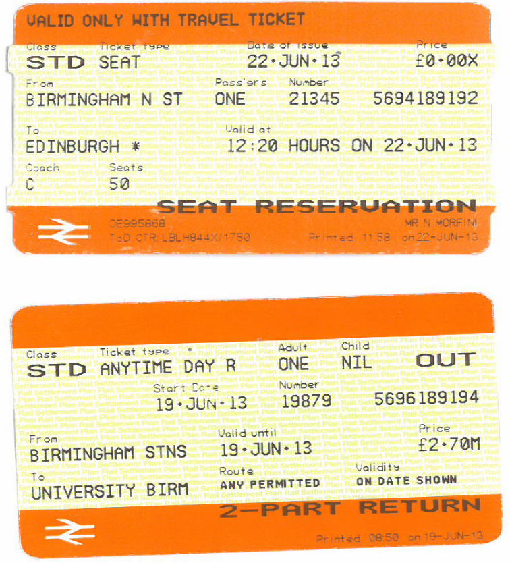
Accepted proof of rail travel – along with till receipt or web booking printout.
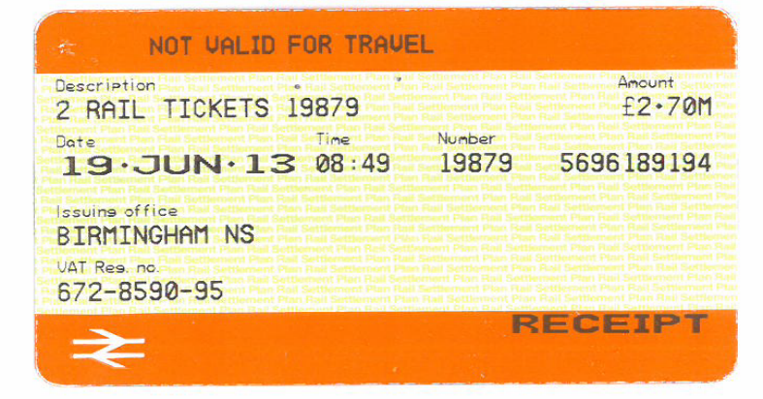
5.2 Travel by Privately owned Car/Motorcycle
The driver, not BISA, is personally liable for any incident, thus drivers should ensure that their own private motor insurance policy is comprehensive and permits the use of their own vehicle for the purpose of travel on BISA business.

A mileage rate will be paid in accordance with the Inland Revenue tax free mileage rates. The allowances are 40p (24p for Motorcycle) per mile for the first 200 miles in any return journey and 20p (12p for Motorcycle) per mile thereafter. Please note that the claim for any journey made must not exceed the standard –class rail fair. A receipt should support claims for parking or other incidental expenses.

BISA asks that you make every effort to travel via public transport as this is usually the cheaper option when standard tickets are purchased in advance claims for mileage may not be honoured in full where excessive claims are made. BISA will not reimburse parking fines, congestion charge fines or fines for other motoring related offences.

5.3 Travel by Taxi
Use of public transport is encouraged and should be used wherever possible. However, it is recognised that the use of a taxi may, in the following circumstances, be the most effective mode of transport.
- Where equipment or heavy baggage is being carried;
- Where no public transport is available; especially in the early morning or late night when public transport is either not running or running irregularly;
- At times when personal safety might be an issue
- Where a claimant is pregnant, or has a disability
Travel by taxis should be kept to a minimum and not be used for long journeys, and claimants should obtain an official receipt from the taxi driver otherwise the claim will not be settled.

Where it is expected that the taxi fare will exceed £15.00, permission to use a taxi should be sought in advance of the expense being incurred.

5.4 Travel by Air
BISA will not normally refund air travel within the UK for the purpose of attending trustees meetings, however it is recognised that air travel may be better value for money on some longer journeys. For travel by this method permission should be sought from the treasurer in advance of the reservation being made. Travel should be via economy class and a receipt should be requested at the time of ticket purchase, advance booking can further reduce the price significantly.

- Accommodation and subsistence

6.1 Accommodation
BISA will reimburse overnight accommodation costs only when necessitated by the timing of an event to which the claim relates. Claimants are reminded of the need to demonstrate value for money and reasonableness of expenditure when selecting accommodation.

In all cases, a receipt for the hotel costs should be obtained that is made out either in the name of BISA or in your own name. Receipts made out in the name of your normal place of work will be returned to you unpaid. You will need to contact the hotel for a replacement receipt to be made out in BISA’s name or your own.

The cost of overnight accommodation and breakfast should not normally exceed BISA’s accommodation rates as detailed below:

- Premier Travel Inn local rates (flexible booking Incl breakfast) http://www.premierinn.com/

6.2 Meals and subsistence
A receipt should support all claims for meals or subsistence. Subsistence may not be claimed for absences from home less than four hours duration. The allowances per person per day are as follows:

- Between 4 and 6 hours, not exceeding £5;
- Between 6 and 10 hours, not exceeding £20;
- For over 10 hours, not exceeding £40;

These subsistence rates include all meals within a 24-hour period.

Please ensure you provide the correct type of receipt with your expenses claim.
Unacceptable receipts examples – Not proof of payment
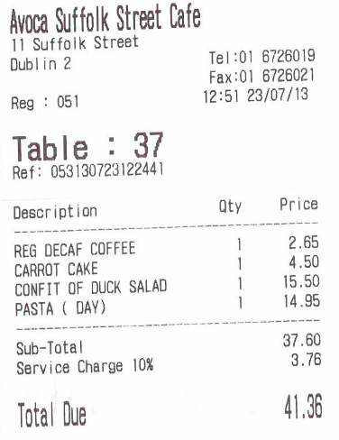
The above receipt is an advisory receipt restaurants bring to a table for payment. You need to ask for a proper VAT receipt as these are not proof of payment as it does not detail the payment has been made, the VAT number or VAT amounts charged.
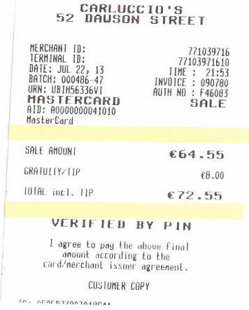
This is a credit card slip; it does not detail what was purchased, the VAT number or VAT amounts.
Acceptable receipt – Proof of payment
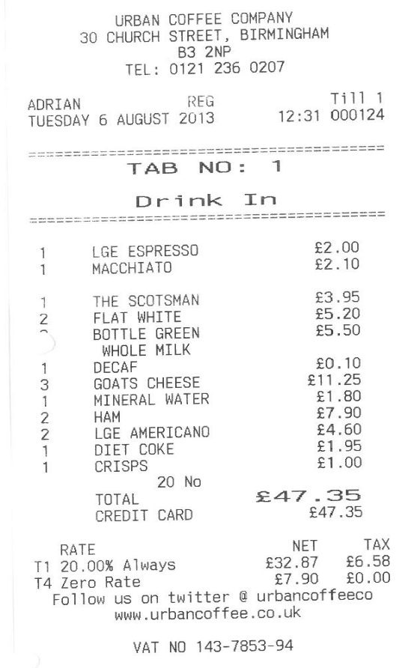
The items purchased are clearly itemised, the VAT number and VAT charged is detailed as well as the company name and address, the receipt also states that the payment was made via credit card. This is an acceptable proof of payment.
6.3 Hospitality expenses
BISA will not normally reimburse entertainment expenses. However, in the rare case where this may be appropriate, permission must be sought in advance from the treasurer or CEO. Hospitality expenses can only be incurred for entertaining persons external to BISA i.e. purchasing food or drinks for a meeting with a publisher or representative of another association, and should still be within the limits set out in this document.

6.4 Alcohol Policy
If travel for BISA involves an overnight stay it is recognised that staff may wish to have alcohol with their evening meal. This is acceptable provided the expenditure is reasonable (up to half a standard bottle of wine per person).

6.5 Conference fees
Conference fees will only be covered where the BISA EC officers/trustees have agreed to the costs being incurred where BISA may gain some benefit in the long term from attendance, i.e. marketing, joint conference, outreach event etc.

Conference attendance for the BISA conference, will be covered by BISA for the 4 Executive officers and CEO on an annual basis due to the requirement for them attend as the BISA senior management to undertake particular duties and responsibilities..

- Expenses and Tax

7.1 Tax statement
BISA’s policy to only reimburse for actual out of pocket expenses incurred, for which there is no tax liability. Claimants would only be liable to pay tax if payments were made that either exceeded actual expenditure, or that are not supported by original receipts. BISA has a dispensation from HMRC and does not have to report normal expense payments.
7.2 Drivers and tax
HMRC sets tax-free mileage rates under the Fixed Profit Car Scheme. Please note these rates apply to your total mileage claimed from any source (your employer, BISA, other associations or voluntary bodies). BISA reimburses for mileage at the tax-free mileage rates; therefore, HMRC assumes the claimant has made no profit.

BISA pays 40p (24p for Motorcycle) per mile for the first 200 miles in any return journey and 20p (12p for Motorcycle) per mile thereafter. These rates apply only in your privately owned car, and are regardless of engine size.

May 2014

