

Letters | 1 – 3
MKS International Bazaar | 4 - 5
MMJ Induction into NWHF | 5 – 7
Essay Corner | 7 - 11
Poetry Corner | 11 - 12
Philosophy Corner | 12 - 13
Responses to Barb DiFrancisco | 13
Prayer Group | 14
Richard Rohr Meditation | 14 - 15
Blogs/Diaries | 15 - 24
Book Review | 24
Contemplative Community | 25 - 26
Favorite Recipes | 27 - 28
Transitions | 28 - 41
Kateri’s Corner | 41 - 42
2014 Mission Institute Program | 43
2014 Reunion Information | 44
Committee Information | 44
Newsletter Subscription Form | Back page

FULL CIRCLE NEWSLETTER

A Newsletter for the Women of Maryknoll | Volume 87 | February 2014

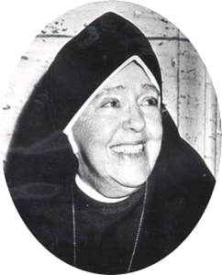

“I would have her distinguished by Christ-like charity and the saving grace of a sense of humor.” – MMJ

LETTERS
PLEASE, CONSIDER EMAILING US WITH ANY CONTRIBUTIONS. THAT WOULD BE SO WELCOME AND ENRICHING! IN ADVANCE, OUR GRATITUDE.

Janet Arndorfer ’68 (Bernard Corde) October 14th Portland, Oregon
I just got my latest Full Circle. Thanks to you and your partners for compiling and editing this newsy, inspiring newsletter. I am interested in all of it, but I am always particularly moved by the remembrances of the sisters who have passed on. Not only do I admire these pioneering and devoted women, but I feel again what it was to be drawn to Maryknoll."

Juanita Campbell ’48 (Frances Alexia) October 3rd Jacksonville, Florida
Thank you for the copy (of the Newsletter). I entered MM in 1948 and left in 1981. I served in Hawaii and California. My religious name was Frances Alexia. I can really relate to many of the articles, especially the one by Terry Herman Sissons. You and the other committee members are doing a superb job.
Just returned from Grand Canyon and San Francisco where I took two priests from India, God bless you and your work. Juanita

Jennie Guastella ’56 (Giovanna Maria) November 7th Baca Raton, Florida
Patricia Oetting, my dear friend and former Maryknoller, has visited Haiti 22 times and has just written a beautiful book about her trips. It is a composite of her reflections after these trips, about what she saw and experienced, very much in the spirit of the Maryknoll Missioner. She pours out her heart and soul and her prayers for her beloved Haitians who continue to live in abject poverty due to the disasters, hurricanes, and the cholera that they've suffered these recent years. The book, "From the Heart: Sealed and Sent" is now available via Amazon. It's a book well worth reading...very moving. Visit her very attractive website: http://frommyheartss.com
Mary Salat Pampalk’60 (Rose Stephen) November 8th Vienna, Austria
I live in Austria and we are involved with a group of reform- minded Christians. We have joined Slovak Christians in protesting the dismissal of their much loved Bishop Robert Bezak of Trinova diocese in June 2012. No reasons were given by the Vatican (Pope Benedict) who ordered him to keep silent and avoid contact with the media. The suspected cause of his dismissal is his uncovering grave financial corruption committed by his predecessor who has powerful support in the Vatican.
Many bishops and clergy deserving of punishment have gotten off very lightly, but others who have tried to live the gospel in a responsible way are being shoved aside or even out of the church.
We have started a campaign to collect signatures for a petition to Pope Francis asking him to rehabilitate Robert Bezak who is now practically living underground without any contact with his former colleagues in the church. Slovakia is a small country and although they have sent two petitions to Rome they have received no response. We want to support them internationally and have prepared a petition in a number of languages hoping to get wide support which may have an influence on our new Pope Francis.
You will find a link to the petition and further information on the homepage of Wir Sind Kirche (We are Church) in various languages. It is the first item with the picture of Bezak subtitled ‘You will always be our bishop’. Thank you.
http://www.wir-sind-kirche.at/content/index.php?option=com_home&Itemid=40
Some of the instructions are in German so I’ll clarify in English. You sign the petition in a 2-step process. After completing the boxes with the requested info and entering the code in your petition click on Senden. You should then receive an email with a link. You need to click on this link in order to confirm your signature. Finally, if done successfully you will receive an email stating that your signature has been recorded.
As we are looking for as many supporters as possible, I’d ask for your help in getting this circulated in the USA and abroad among all those interested in a transparent and responsible Church supporting human rights and justice. The action runs until end March 2014, so we have time to collect lots of signatures.
So thank you all for listening and hopefully supporting this initiative.
In solidarity, Mary

Bernice Kita MM ’59 (Rose Michael) November 26th Chajul, Quiche, Guatemala
How good of you to remember me this Thanksgiving. The quotes you sent (see insert below) came just at the right time. Not only for me, but also for several 17-year old girls from our former Maryknoll high school, Colegio Monte María.
There comes a time in your life, when you walk away from all the drama and people who create it. You surround yourself with people who make you laugh.
Forget the bad and focus on the good. Love the people who treat you right, pray for the ones who don't. Life is too short to be anything but happy.
Falling down is part of life, getting back up is living. Today may there be peace within.
May you trust that you are exactly where you are meant to be.
May you not forget the infinite possibilities that are born of faith in yourself and others.
May you use the gifts that you have received and pass on the love that has been given to you.
May you be content with yourself just the way you are.
Let this knowledge settle into your bones, and allow your soul the freedom to sing, dance, praise and love. It is there for each and every one of us.
This week they are finishing their month of living here with me in my big house - parish convent. They volunteered to teach 1st, 2nd and 6th graders Spanish and math reviews in this house to help the kids do better as they enter their next grades. There have been joys and sorrows, successes and mistakes, efforts to form a working teaching team and efforts to get to know young people in this Ixil Indian parish in the mountains with a language and culture light years away from their own privileged life in the country's capital. They fell in love with the tiny kids; made friends with teenagers; learned to weave; visited in dirt-floored adobe homes with open cooking fires; ate native food; and hiked in the rain with the parish youth group on a pilgrimage with other parishes to celebrate the closing of the Year of Faith. They have definitely been changed. As one girl who left for home yesterday e-mailed me this morning:
I just got up this morning thinking, what I'm suppose (sic) to do with my life now? I miss every single thing about Chajul and it's just the first day I'm not there; I can't stop thinking when I will be back.
Love, Bernice

Barbara Lambert DiFrancisco’55 (Yvonne Marie) October 28th Tularosa, New Mexico
I am submitting this photo IN HONOR/MEMORY of Sisters who were in the Africa region ca. 1969. Thanks to Sr. Katie Erisman, MM and her helpers for supplying the identity of most. How many Sisters can you identify? Compare your list with the names supplied on pg 42.
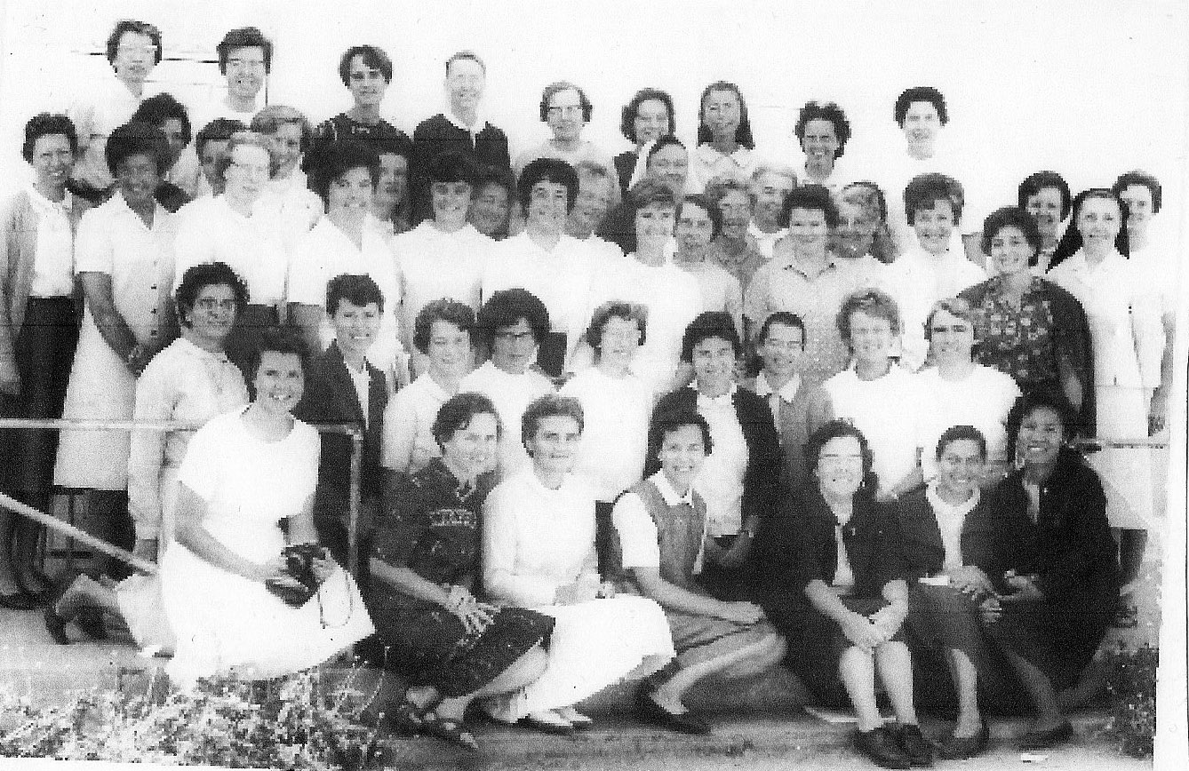

MARYKNOLL SISTERS ANNUaL 2013 BAZAAR


Bazaar 2013, Preliminary Results, by Booth

This year, the Maryknoll Sisters, in an effort to pare down the enormous effort to put on an annual bazaar, moved the venue to the Auditorium from the basement/first floor of the Rogers Building. That meant that instead of a mission, such as Africa, or Latin America, having an entire room, each had one or two tables. Sister Rosalie LaCorte, who headed up the Bazaar along with Srs. Jeanne Houlihan, Anastasia Lott, and Peg Dillon, asked Full Circle members to head up two “booths”: the Christmas booth (Roselani Smith ‘61 and Rose Tocci ‘61) and Golden Fleece (Ginny McEvoy ‘61 and Karen Peterlin ‘58). While the Christmas booth was located in the Auditorium, the Golden Fleece (comprised of donated items) was located in the Elmwood Room – around the corner from both the auditorium and the former novice/postulant dining room. The other booth not in the Auditorium was Sister Marie Pierre’s artwork, located in the Candlelight Dining Room, next to the Elmwood Room. Therefore, the entire Bazaar was confined to the Main Bldg.
Booth | Pre/Sponsors | Bazaar Day | Total
Accounting | $ 2,325 |  | $ 2,325
Africa | 7,485 | $ 2,662 | 10,147
Albania |  | 1,370 | 1,370
Art and Handicrafts | 2,476 | 5,399 | 7,875
Baked Goods | 1,909 | 4,966 | 6,875
Book Sales |  | 868 | 868
Central America | 2,805 | 1,731 | 4,536
Christmas | 2,681 | 1,532 | 4,213
East Asia (combined sponsors) | 4,135 | 3,681 | 10,138
Japan | 100 | 2,222
Filipino Food and Goods | 375 | 4,617 | 4,992
Golden Fleece |  | 1,474 | 1,474
Haiti |  | 1,514 | 1,514
International Buffet/Hot Dogs |  | 2,179 | 2,179
Parking | 2,641 |  | 2,641
Raffle (plus $900 donated back) | 151,134 | 2,362 | 153,496
Sister Marie Pierre (partial) | 1,111 | 653 | 1,746
South America | 1,605 | 3,630 | 5,235
South Asia (combined sponsors…) | 1,502 | 1,771 | 4,373
Pacific Islands |  | 1,100
Trailblazers |  | 867 | 867
US/Wellness Center Donation Jar | 1,261 | 207 | 1,468
Where needed | 2,725 |  | 2,725
Preliminary Totals | $ 186,170 | $ 44,803 | $ 230,973
An international buffet in the dining room was also new this year. The court yard hosted a hot dog stand and Filipino food. This meant that there was ample space to eat, relax and enjoy the venue. All these changes took an enormous effort, planning and the execution were not without difficulty but as you can see from the above results, it was an enormous success. Throughout the day, many full circle members volunteered to sell chances, work booths, help out in the international buffet, parking, sell baked goods, and cleaning up. Great collaboration.

One Good Deed a Day: Choose the longer walk home

Induction of Mother Mary Joseph into the National Women’s Hall of Fame
Pat Brennan ’61 (Maureen Anne) November 6th Point Lookout, New York
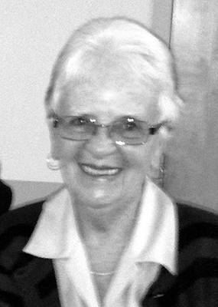
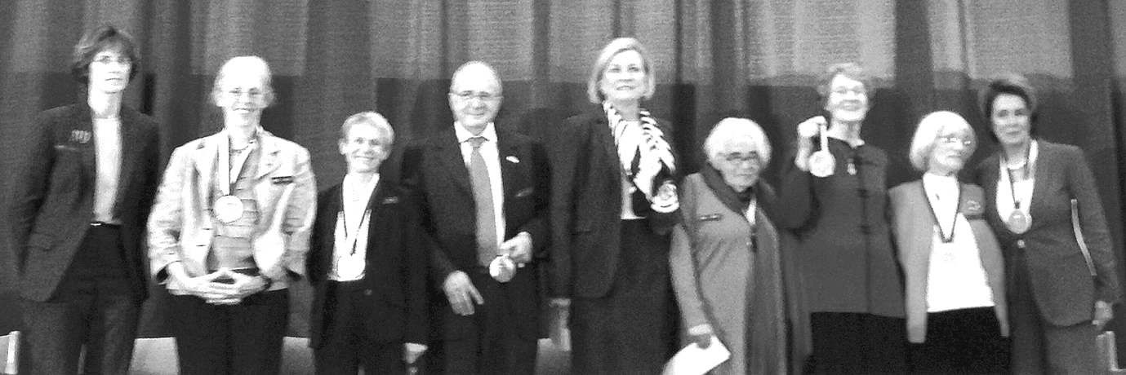
On October 11-12th the induction of Mother Mary Joseph into The National Women’s Hall Of Fame in Seneca Falls, NY, took place along with eight other fantastically accomplished women: Betty Ford , First Lady; Ina May Gaskin, Mother of authentic midwifery; Julie Krone, a jockey; Kate Millet, feminist activist, writer, visual artist, human rights activist; Nancy Pelosi, first woman Speaker of the House of Representatives; Bernice Resnick Sandler, advocate of educational equality for women and girls; Ana Jocobson Schwartz, the most widely acclaimed female economist of the 20th century,& Emma Hart Willard, foundress of Troy Female Seminary in 1821, the first school for young girls.
L to R: Trudy Hall for Emma Hart Willard; Ina Maya Gaskin; Julie Krone; Dr. Michael Bordo for Anna Jacobson Schwartz; Susan Ford Bales for Betty Ford; Kate Millet; Janice McLaughlin, MM for Mother Mary Joseph Rogers, MM; Bernice Resnick Sandler; Nancy Pelosi
The weekend began with a reception on Friday evening. This first event was really special because it was an informal gathering with food and wine where you could meet and talk to the inductees (at least the ones who are still living). The reception was supposed to take place at the Women’s Rights National Historic Park but due to the Government shut-down of all National Parks, it was moved to the Community Center in Seneca Falls.
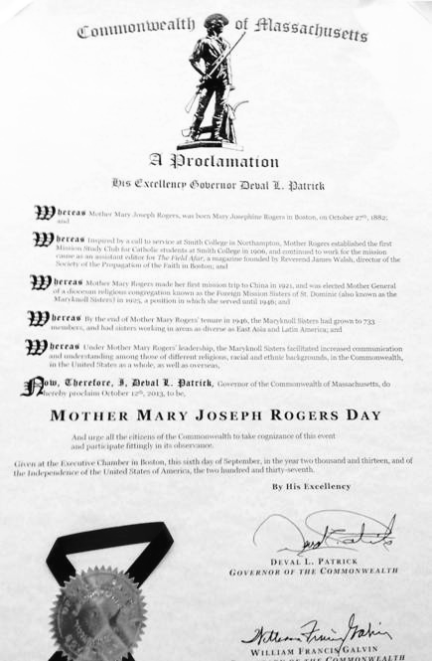
Saturday began with a luncheon-tea which preceded the actual induction ceremony. On view was a copy of Massachusetts’ Governor Deval Patrick’s Proclamation declaring October 12, 2013 Mother Mary Joseph Rogers Day. Members of the Rogers family were in attendance along with Maryknoll Sisters Janice McLaughlin, Rebecca Macugay, Ann Hayden, Bitrina Kirway, Theresa Baldini, Janet Carroll, Peg Dillon, Bernie Duggan, Cathy Encarnacion, Jean Fallon, Jo Kollmer, Sylvia Postles, Jean Pruitt, Veronica Schweyen, and Chris Zvareva. Also present were Maryknoll Fathers Emile Dumas and Jack Sullivan; Full Circle members Rose Tocci, Charlotte Tomaino and me, as well as Sue Palmer, Maryknoll Sisters Communication Office, Ellen Pierce, Maryknoll Archives and her husband Thomas, Elizabeth Carr, former chaplain at Smith College, Mary Ann Bunting, Anna Maria Sagard, and other friends of the Maryknoll Sisters. Janice accepted the induction medal for Mother Mary Joseph and gave a beautiful acceptance speech.
A donation was made to the Maryknoll Sisters, on behalf of the members of Full Circle, enabling nine Maryknoll Sisters to attend the Induction Ceremony.
The following is from a “thank you” note to Full Circle with a print of “Mother’s Garden,” a painting of YooSoo Kim MM ’82.
How utterly fitting is the title of YooSoo’s art. You made it possible for so many of us to enjoy Mother in her evolution as part of the National Woman’s Hall of Fame. My thanks for your generosity and sisterhood. Peg Dillon M.M.
Blessings for each one of you. Thank you for your donation to assist us to come to the ceremony. I appreciate your kindness & all the great things that you do to help us all year long. May God bless you all. Peace, Love and Prayers Sylvia Elaine Postles, MM
Thank you for this special gift. Claris Zvareva, M.M.
Deep gratitude for your great generosity. This is indeed, a graced and special time for all of us who love Mother and try to live out her spirit today.
Peace and prayers. Cathy Encarnacion MM
With many thanks for your precious gift for this special day.
Bernadette Cordis, M.M.
What a wonderful gift to ‘send’ us to Mother Mary Joseph’s Induction into the Woman’s Hall of Fame! I wish you all could have been there with us. Mother joined a group of eight others, who were such great women. It was her Secular canonization ceremony. Thank you. Thank you. Thank you! Jean Fallon M.M.
This is a big “Ahsante.” Thanks so much for your great gift! We all enjoyed the day and the trip! Peace, Roni Schweyen, M.M.
A second note was received:
To Full Circle
Your very generous gift has made it possible for nine sisters to attend this special event honoring MMJ. We are so very grateful and ask God to bless you all in a special way.
We thank you.
Peg Dillon, Bernadette Duggan, Cathy Encarnacion, Jean Fallon, Sylvia Elaine Postles, Jean Pruitt, Elizabeth Salmon, Veronica Schweyen, Claris Zwareva

ESSAY CORNER
Mef Ford ‘64 October 3rd Cambridge, Massachusetts
THE VOCATION
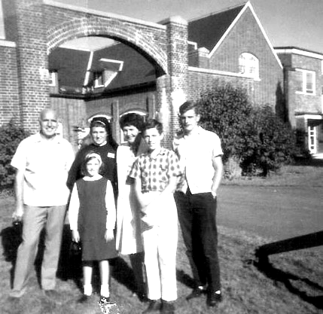
September 2, 1964. An ordinary Wednesday. Late summer leaning into fall. The long, landscaped driveway is lined with cars. Manicured gardens bulge with languid roses, and trees drooping with Rose of Sharon ring the quiet compound.
During the short drive from our home, my father for once could not sing, as he often did on family drives, but had made nervous jokes instead. Mom had told the younger kids to stop their fooling around while my brother Jerry had gazed out the window, escaping into his own peace-loving nature. I was mute.
We park and join the parade of families escorting their daughters up the hill. Behind the graceful brick wall, the inner courtyard empties into an auditorium gradually filling with black trunks. Families are perched gingerly in small circles, waiting.
My own motley crew selects a site. Soon a novice comes, warmly introduces herself, and leads me away. I have visited once before, but this time I am not a guest. As we weave our way across the room and out along the corridors lined with photographs and artifacts from many countries, I walk the path of hundreds of women before me. Their hopes and trepidations linger on the flagstones beneath me. I can hear the swish of their robes and rattles of their beads. Where are they now, I wonder? What will I absorb of their legacy?
On the threshold of my life, we pause briefly in the chapel. Spread across the light gray marble wall behind the altar is a simple gold relief map of the world. The altar floor is flung wide with partial railings at either side leaving an inviting opening in the center. Enclosing the nave, rows of stalls face each other, but we kneel and pray in the benches at the rear as the mid-afternoon sun sweeps amber, magenta, and violet through the windows onto the flagstone floor.
My escort and I come to a door marked "cloister." As I enter for the first time this section known only to the initiated, the sentiment within me is clear: "I have come home." Shown to the cubicle that will be my "room" for the next two years, I pull the curtain around it and remove my lay clothes for the last time. Trembling, I don the black layers of my new life.
Shy with pride, I rejoin my family. Though I--a rebellious public school kid--have known my mysterious vocation since 4th grade, I did not tell my family until two years ago. My tender dream did not need to hear, "What?? The way you act, you want to become a nun??!" No, I had confided only in eccentric old Miss Martin, who called each of us up to her desk one day in 4thgrade to ask what we wanted to become in life. When I cautiously told her, her response reverberated for years. "I hope you always remember that."
We all pretend this isn't happening, though my father's wet eyes betray his honor. Mom is matter-of-fact, the kids anxious to get going. When we did arrive at the Motherhouse, Mom surprised and touched me by bringing a bouquet of flowers to Sister Edmund Damien, our postulant mistress, wishing her better luck in reining me in than she'd had. The flowers were on the altar that evening when we gathered for Vespers.
A walk around the property, photos in various groupings, and then hugs good-bye with promises to write, as if I'm off to summer camp. Not until years later do I learn that my practical, stop-your-crying-or-I'll-give-you-something-to-cry-about mother, wept, to her surprise, all the way home. .
The novice mistress has asked the current novices what food they missed most when they entered, so our first convent meal is hamburgers and french fries. I happen to sit next to Dottie and Sandy, other postulants who will become my closest friends. There is no way to know yet who is so homesick she can barely eat, who is terrified at this huge commitment, who else is full of adventure, or who is the one who had to sneak out the night before to escape a father's opposition.
After vespers, we are treated to a hilarious account of her first mission by one of our superiors. At 9:30, lights out. In the distance are sounds of the Topsfield Fair. My thoughts turn to home. When they go to bed tonight, each will find under the pillow a portion of my remaining money. Alone in my narrow bed, I can see Dad choking up and Mom surprised again with stabs of grief. Jerry will consider it just payment for all my bossing him around. Little sister Jen will later write a 2nd grade thank you note, generously closing with, "Good luk (sic). I hop (sic) they keep you." A month later, I will kneel in chapel and listen to the apples thudding to the ground outside and be deeply grateful to be in the right place at the right time, exactly where I belong.
One of Yevtushenko's poems begins with "You were my beginning in the coloured world, in which I had not yet had my beginning." Imagining I am giving up everything, I cannot yet know that instead I will exchange the black and white for the coloured world. Meet free-thinking women who will challenge my unquestioned beliefs. Work and play alongside free-spirited women whose rich emotional lives will spill into and stretch my carefully contained one. Replace narrow interest with a global vision, and hubris with inspiration. Uncover insurgence, birth longing, free tears, and empty myself into God as I try to bend my will to his. I will also discover depths that on this mild September 2nd evening, I have no idea that I possess.

BEING ALONE
The intentional community I envisioned in childhood and joined at twenty-one was to be home forever. The other missionary sisters, priests, and brothers and those across the globe whom I would serve were my new family. Like an embryo securely attached to its source of nourishment, I thrived. And grew. And grew. A sense of belonging and selfless purpose gave a new identity. Unknown talents emerged. My connection to God deepened. The meaning of life was clear, its direction to be laid out by superiors seeking to fulfill the needs of a world desperate for vigor, kindness, and assistance. As I knelt in chapel that first autumn morning, the sound of apples thudding to the ground outside brought stark awareness of my being in exactly the right place at the right time.
And it was the 60's. Anything was possible. Everything was changing, including the Catholic Church. John XXIII and Vatican II spawned a broader definition of church, mission and service. The thrill of questioning anything emboldened me. All terribly exciting until the anything-that-was-possible came to include the realization that I, embedded in my deeply loved community, had outgrown the structure of religious life. The rules that had once held me securely now bound my expanded spirit. I belonged but didn't fit any more.
What is more intimate than the squeezing of one human being out of another? Yet it was not into warm hands and a welcome assist in breathing that I emerged but a lonely, unfamiliar landscape where for the first time there was no roof, no guardrails, no next step, no plan. While I recall every detail of the day I entered religious life, I have not one memory of leaving. Not of packing, where I went, who picked me up, how or where I spent those first few weeks apart. Twenty-six years old, completely on my own, without purpose and definition, who was I? In what part of the country was I to live? With whom to affiliate? What work to pursue?
I was not forsaken. It was I who had separated. But I, who was found, was now lost.

One Good Deed a Day: Tell a friend he/she is beautiful

Patricia Carroll Oetting ‘64 November 30th Barefoot Bay, Florida
MOTHER OF THE THORN CROWNED
I had returned to Maryknoll for a study of Compassion, a whole week’s worth. During free time I would walk the grounds absorbing the spring beauty of flowers, bushes, and trees. I would often visit some special friends at the cemetery, who were now enjoying a different aspect of eternal life. The bench at Mother Mary Joseph’s gravesite was always the culmination of my chats with friends. I did not know her of course, yet I felt her charism and hoped that she would teach me still.
As I sat in front of the beautiful sculpture done by Sr. Marie Pierre, I realized that I did not know much about it. I had seen it many times, but looking and seeing are two different things altogether. I had not truly grasped its meaning. Ah, but this time it was different. I was filled with awareness of just what it ‘was all about’. My very first response to that was a most sincere apology to our Blessed Mother, she who was the Mother of the Thorn Crowned. How could I have missed it? How could I have ever meditated on the crucifixion and death of Jesus, with that Pieta moment after it, without realizing that the very first action of His mother would have been to RIP that mocking crown of thorns from His head! RIP IT OFF! Never for one second did she consider that the thorns might hurt her. How could a painful touching of sharp thorns be any worse, even compare with, the seeing and the suffering with the pain that Jesus endured for hours? Seeing the one you love suffer is much more of a hurting.
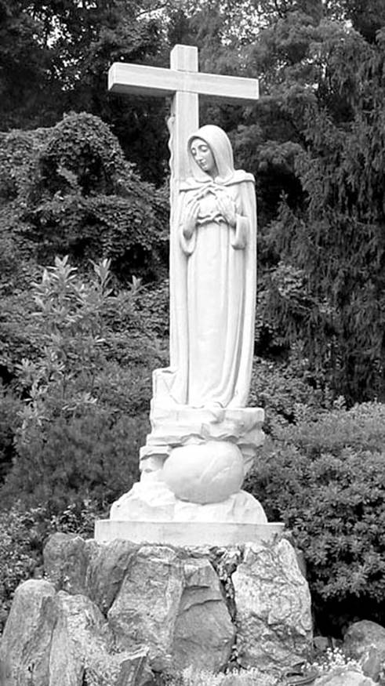
As I looked at that beautiful all white sculpture, I realized that it was a real occasion of grace for me. Often when I look at Michelangelo’s PIETA, I am led to another way of looking at it. I picture a woman, sitting in the dirt at the foot of the cross, cradling her son’s dead body, with His matted hair and His dried blood covering Him. I picture her touching those wounds that opened more as the nails were removed. I see her examine the one in His side.
Mother of the Thorn Crowned
Sr. Marie Pierre, MM
Now with this all white sculpture I also wander a bit in my prayer. I see her sitting holding that crown with some of His matted hair entwined with His dried blood midst the thorns. Her robe is now stained with tiny droplets of her blood. Her face has tears rolling down her cheeks, mixed with dirt. When they come to take the body away, she stood. She STOOD, very tall under that empty cross. She held on to that crown that she had ripped from His head, She, his mother just could not forget how He was mocked and tortured. She stood under that empty cross, as she had stood under it earlier. Standing under to understand it. She is Mother of the Thorn Crowned and the Mother of the Suffering. How could we ever think that she would not understand our hurts, our needs?
And then, there is the deer. Part of the sculpture now, though I doubt part of the scene at Calvary. Many who look at it call to mind David’s Psalm 42.
‘AS THE HART LONGS FOR FLOWING STREAMS
SO LONGS MY SOUL, FOR THEE, O GOD
MY SOUL THIRSTS FOR GOD, THE LIVING GOD’S
Scripture scholars tell us that the Hebrew verb is a feminine one. They translate the longing for, the crying for, as a braying, which actually seems to indicate a mournful sound that she, the hart, would make when she just could not find water. Ah, but this little hart has found water, found her God. She not only found the stream, tasted it and drank from it; she plunged into it, and now rests in Him. She passed from the empty cross of Good Friday right through into the ‘other side of Easter’. She rests in Resurrection. She stays at the feet of Mary, our Mother of the Thorn Crowned. She stays to remind us what this sculpture is all about.
I thank Sr. Marie Pierre for her work. I thank Mother Mary Joseph for helping me understand this occasion of grace. I most sincerely do thank Mary, the Mother of the Thorn Crowned, and our mother also. AMEN, ALLELUIA

POETRY CORNER
Teresa Lilly, MM ’27 (Marius) Monrovia, California
The Gospel from the Other Side
It was a lovely summer day, Jesus and His men were on their way,
“Let’s take this road it will be best, I know a place where we can rest.”
When Martha saw them all arrive, her mind went into Overdrive!
“Food and drink, do I have Plenty?? The guest list is now up to 20!”
This would call for lots of service, which made our Martha very nervous
Then she thought: “When they had no wine, He fixed it up and it was fine.
And then with that crowd for something delicious, He whipped up a meal of Loaves and Fishes.”
This thing was getting pretty scary, she looked around, and where was Mary??
She wasn’t thinking of things to eat, she was sitting at Jesus’ feet!
So Martha said, “Lord, have a heart!”
And Jesus mentioned, “The Better Part.”
Martha felt she was not a winner, but who was going to make the dinner??
Culture and Custom were in intention with a list of worries too long to mention.
We can be sure they all ate well, there’s really nothing more to tell.
But later Martha got her wishes, and Mary had to do the dishes!
Awakenings: A creative Journal of Mission Spirituality, Volume 5, No 1, Summer 2013 p.10

Carolyn Cooke Grassi ’60 (Teresita Marie) Pacifica, California
Such a surprise today! My poem "Oh Tigris, Oh Euphrates" was published in the Jesuits' America Magazine yesterday (Joe's birthday!). Although it was accepted, I did not know when it will appear. Many thanks for encouraging my work. Peace & love, Carolyn
Oh Tigris, Oh Euphrates
Oh Tigris, Oh Euphrates watching Greek armies,
Roman archers, legionnaires armed to the teeth, British
forces, American military, empire-building further, further
east and south across your deserts, hills, ravines, cities,
villages, their shape-shifting alliances, offensives, counter-
Insurgencies, crushing the centuries old silk-trade routes
Oh Tigris descending Armenian highlands,
Oh Euphrates born in Kurdistan, watering Kuna’s
Garden of Eden, marrying as one grand current sweeping
Through Basra emptying into the Persian Sea
Oh Tigris, Oh Euphrates witness of Greeks, Romans,
British, Americans sighting enemies over the next ridge,
Ever expanding military exploits taking a toll on men,
Women, children, plants, animals, here and at home:
The homeless, the unemployed, the sick, the orphans,
The widows, the aged, the rich richer, the poor poorer
Oh Tigris, Oh Euphrates seeing generations of generals
Crossing your sacred shores, their unquenchable thirst
For wealth, power, influence, aiming to outdo others,
Not forgetting Alexander’s legendary exploits in Persia
Oh Tigris, Oh Euphrates birthing Babylonian, Persian,
Shiite, Sunni, Kurdish girls and boys by your endless flow
Of waters, while the Greeks, Romans, British, Americans
sought your artifacts, resources, strategically set
at the crossroads of civilization, Oh Tigris, Oh Euphrates.
C. Grassi’s poetry books are Journey to Chartres (Black Swan Books, Connecticut) and Transparencies (Patmos Press). Her forthcoming collection is Heart and Soul (Patmos Press).

One Good Deed A Day: Send a friend a beloved book from your shelf

PHILOSOPHY CORNER
Conjectures of a Guilty Bystander 1968. Thomas Merton
The terrible thing about our time is precisely the ease with which theories can be put into practice. The more perfect, the more idealistic the theories, the more dreadful are their realization. We are at last beginning to rediscover what perhaps men knew better in very ancient times, in primitive times before utopias were thought of: that liberty is bound up with imperfection, and that limitations, imperfections, errors are not only unavoidable but also salutary. The best is not the ideal. Where what is theoretically best is imposed on everyone as the norm, then there is no longer any room even to be good. The best, imposed as a norm, becomes evil.

Institute for Community Practice November 20th
The Four Immeasurable, Love, Compassion, Joy and Equanimity come from the Buddhist practice and provide a meditative opportunity to reorient our state of being. They are the four aspects of true love within us and within everyone and everything. True love brings joy, a joy that is filled with peace and contentment. Joy is a feeling of upliftedness that we should generate slowly in meditation. By focusing on feeling joy for another person even when we do not feel joy for ourselves, we are lead to rejoice when we see others happy as often as we rejoice in our own wellbeing. Having a joyous disposition does not mean we will not experience pain or discomfort from time to time, but it means we will not be without hope.

When you do things from your soul, you feel a river moving you, a joy. Rumi

RESPONSES TO BARBARA DI FRANCESCO’S ARTICLE
Patti DeRaps Carlomagno ’61 & ’64 (Wilfrid Marie) October 3rd Reno, Nevada
Oh my! What a fabulous edition!!! So much on Barbara DiFrancesco's input and so "right on" real! This edition wraps it all up, I think and many who read it will heave a sigh of relief!
So many of us entered because we caught the Spark that Maryknoll breathed and then were disillusioned by the conflict within. The Lord has continued the journeys we all have embarked on and we all can give thanks that we have been linked together in the Love Song that continues to be the thread that keeps us connected. It is, after all a Full Circle! May we be true to our "First Love" and truly run to Jesus, the Author and Finisher of our faith, ever mindful that without Him we can do nothing. It is He who calls and to Him we will return!
And I give applause for another job very well done. Thank you for all you, and the crew, do to bless us. I pray you are well & send a BIG hug your way from crazy Reno!
We had a homeless, addicted, gal come to our Aglow meeting last month and were able to minister to her and love up on her, even to giving her a room at the Hotel we meet in...and money for food which was closely guarded by another homeless gal who stayed with her that night who is a new Christian. There are many in need here in this gambling City and we're just beginning to see some fruit in these two who attended. We're also ministering to our Spanish speaking sisters and love having them come to bathe in the Lord's presence at our meetings. It's awesome to see Him working in lives and it's so satisfying to worship Him whom we love. God is so good!
Oh...yeah, that "unknown sister" sitting in the car is Michelle Reynolds, I'm quite certain.(cf Full Circle Newsletter Vol.86, October 2013, p.16) .Bet you've heard from others about that, too? David, my husband, thinks the one designated as "Delores Barbeau" is ME! Made me laugh. I think we all looked quite a bit alike in those days!!! My love to all, Pattie

UN BON MOT
Patron to waiter: I am going to order a broiled skinless chicken breast, but I want you to bring me lasagna and garlic bread by mistake.

We all live under the same sky, but we don't see the same light. Chinese proverb

PRAYER GROUP
Approximately 15 years ago, a prayer group began with Full Circle women, when several were diagnosed with various serious illnesses. In the intervening years, the prayer group has increased to include not only Full Circle, but Maryknoll Sisters and friends of Full Circle members. Because we are scattered globe-wide, it is impossible to “meet” at the same time, although 9pm EST has been designated. Requests for prayers get forwarded to Karen Peterlin (kpeterlin@yahoo.com) who forwards the requests via email to the group that is now numbering about 40 members. It is also forwarded to Sister Mary Lou Andrews MM who is our liaison for the Prayer Group but who also coordinates the Adoration Group at the Motherhouse that takes place each Wednesday. The prayer requests also get posted on the bulletin board outside of the Main Chapel.
Recently the Prayer Group was approached by Sister Rose Corde MM, one of the three coordinators of the Adoration Group. We were asked, along with the Maryknoll Fathers/Brothers, Lay Missioners and Affiliates, to join the Sisters with prayer on Wednesdays. Although the Sisters spend one hour each, the joining of intentions is seen as an opportunity to share prayer, on whatever basis an individual can manage. If anyone would like to submit requests for prayers, they are always welcome. Sister Mary Lou has stated that prayer can take many forms and there is no time limitations, so that if 9pm is not convenient for you or if you cannot spend one hour on Wednesdays, do not let that prevent you from joining either of the groups. It is the act itself that is so powerful – to connect us to the Divine, to one another, to the earth, itself. Form/time/place are simply aids to this end. If you would like to join either or both the Adoration Group or the Prayer Group, please just drop Karen a line at the above email or write/call. Information on the last page of Newsletter. Thank you.

The difference between stumbling blocks and a stepping stone
is how the individual perceives them.

RICHARD ROHR’S DAILY MEDITATION
Adapted from Preparing for Christmas with Richard Rohr, pp. 23-24

Seven Themes of an Alternative Orthodoxy

Reality is paradoxical and complementary. Non-dual thinking is the highest level of consciousness. Divine union, not private perfection, is the goal of all religion.
Our Christian wisdom is to name the darkness as darkness, and the Light as light, and to learn how to live and work in the Light so that “the darkness does not overcome it” (John 1:5). But we can never deny that darkness exists, even in ourselves. If we have a pie-in-the-sky, everything-is-beautiful attitude, we are in fact going to be trapped by the darkness because we are not seeing clearly enough to allow both the wheat and the chaff of everything. Conversely, if we can only see the darkness and forget the more foundational Light, we will be destroyed by our own negativity and fanaticism, or we will naïvely think we are apart from and somehow above the darkness.
Instead, we must wait and work with hope inside of the darkness—while never doubting the Light that Jesus says he is (John 8:12)—and that we are too! Many people do not notice that he also says we are the light of the world too (Matthew 5:14). That is the narrow birth canal of God into the world—through the darkness and into an ever-greater Light, but a light that we carry with us and in us.

BLOGS and DIARIES
Sister Elizabeth Salmon, MM ’48 (Elizabeth Cecile) August 2013 Maryknoll, New York
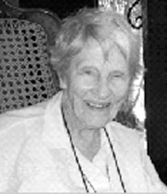
I just returned from a SUPER HOME VISIT! Rosie, my niece, came all the way out from COL to NY to accompany me back. It was the 50th ANNIVERSARY of the Malone Family Reunions! Jerry, husband of my sister (now in heaven 12 yrs!), is the oldest of 7 - they had 12 children. Mary, Jerry’s sister, had 13 – and on down the line. “What’s your name?” I know the 45 cousins of my sister’s children – but it ends there! Over 130 gathered in the beauty and scent of breathtaking Mt. Pines. From Rosie’s kitchen (down in Buena Vista) your eyes feast on the magnificent Collegiate Mountains: Mt. Princeton, Yale, Harvard & in back, Columbia (the latter, still snow-capped)… all are over 14,000 ft. What an experience it was of “how ARE you?” and exchanges in reviewing latest “family news” with the “latest” - 2 little 10 month old girls laughed & played as pictures snapped, amongst Ohs and Ahs. What a terrific joyful gathering to experience all this fun – planned games, songs, ‘acts’ and total enjoyment of seeing and being with “such a Great Family”! I missed the afternoon hikes and “zip–line Valley Ride”, golf & swimming--- (daily nap takes its toll!). Oh well, I “heard” all about it! AND I did hear Mike’s drumming!! And Dan’s auctioning!!!” W0W – does he know how to “real up prices” (a great saving for all the family!). These auctioned “White Elephants” help keep closets clean. Yes! And provide great entertainment. Yeah for Grandma Stella and Grandpa George, our esteemed “Originators of Our Blest Family Reunions!”
Another very important event during my visit was a meeting with Fr. Guilliani (the Bishop’s representative) regarding the Beatification of our Dad, Ben J. Salmon. He listened, took notes, and asked good questions which gave opportunities to explain more. Members of the Peace & Justice Group, “Friends of Franz Jagerstatter”, are an active group from upper NY who attended the Beatification of Franz J. in ’07 and are also pushing the Beatification of our Dad. Their stories are very similar and like Franz in Austria, our Dad is NOT known. Our Mother did NOT share his story as we grew up – simply to protect us from what she went through with her family. No one understood CO’s (Conscientious Objectors) in those days. I was in the habit and I went down to C-Street, NYC and was given a copy of “Jan & Feb 1942 Catholic Worker” where Dorothy Day printed several letters our Dad had written to President Wilson (wonder IF he even read them?). It was the first we knew of the story. Torrin Finney’s book, “Unsung Hero of the Great War”, tells the story of our Dad and the SPIRIT behind his objection to KILLING and WAR. Robert Ellsberg writes of our Dad in his book “All Saints: Prophets and Witnesses for our Times”. YOUR prayers are much needed to move the paperwork along and Inspire Pope Francis I. Won’t you consider praying with us for the Beatification of our Dad?
In addition to this home visit to Colorado, as many of you know, earlier this year in January I made my Return Trip to Nicaragua!! Never in years would I have dreamed it possible, but friends had a Sponsor Party and MADE IT POSSIBLE! It was a dream trip – to see such a “beloved” place AGAIN and the very dear friends I had to leave (because of a half doz. spontaneous spinal fractures – just weak bones from a gluten allergy – but the body heals, with
continued good exercises, thanks to God for our great bodies!).
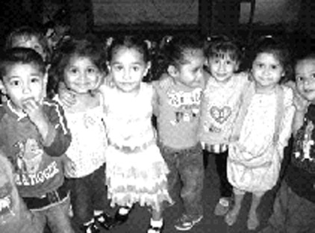
Most cherished of course was to SEE and greet my DEAR Friends again! But my heart aches for their still impoverished conditions! In spite of it all their encouraging spirits & smiles and acceptance of it all (which we would NOT tolerate, a minute in our gifted, blest living) – leaves one truly amazed. It so pulls at the heart strings though, for deep hope and wishes that they would have “it better” in all ways, especially – decent food, water & living conditions! We are SO grateful to Monica with her dedication to remain in Nicaragua. She continues such real, faithful & attentive service with guidance in directing & leading some really good improvements & accomplishments since 1999 when she first came to Nicaragua! Currently we are serving communities in particular in Leon and Esteli while working in partnership with Connecticut Quest for Peace. Our mission presently includes scholarship programs, a feeding program to babies and small children at El Rosario Day Care Center, and outreach to families in need in small rural communities together with a group of Nicaraguan Franciscan Sisters. This is a special lay-community headed by Fr. John Guilliani, a Benedictine priest-artist, who says a blest& inspiring Mass each Sunday. The Music Ministry is led by Sr. Kathleen Diegnan, Sr. of Notre Dame who has made scores of CD’s - her original hymns, sings and plays the guitar.
The OLDEST children at the Day Care Center El Rosario…can anyone say NO to them?!
In ever grateful THANKS for this chance to say “Hello” and share with you. You must know that you and YOURS are in my Daily Prayers for your intentions, health and needs! Your emails are WELCOMED (esalmon@mksisters.org) as well as your phone calls (914 715 3955)!
With Much Love and Prayer (PEACE for our hurting WORLD!) Sr. Elizabeth

If you find that you have dug yourself into a hole, stop digging.
Will Rogers

Terry Herman Sissons ’58 (Bernadette Mary) November 13th Royston Herts, England
http://theotheri.wordpress
The Charles Schultz Philosophy
1. Name the five wealthiest people in the world.
2. Name the last five Heisman trophy winners.
3. Name the last five winners of the Miss America pageant.
4. Name ten people who have won the Nobel or Pulitzer Prize.
5. Name the last half dozen Academy Award winners for best actor and actress.
6. Name the last decade's worth of World Series winners.
Now
1. List a few teachers who aided your journey through school.
2. Name three friends who have helped you through a difficult time.
3. Name five people who have taught you something worthwhile.
4. Think of a few people who have made you feel appreciated and special.
5. Think of five people you enjoy spending time with.
Snopes says it wasn’t written by Schultz, but The Philosophy of Charles Schultz, the creator of the cartoon strip Peanuts feels like it should have been. The fundamental question is who we remember over time, who makes a difference in our lives.
The point is obvious – people who are kind to us, who go out of their way to help us, whom we enjoy, are the people who have made a difference to us. It is not the celebrities or the famous whom we remember. If I’d read this as an adolescent, I would have thought I understood and lived by those values. After all, I was going to be a missionary nun and spend my life serving the poor. I was going to make the world a seriously better place. I didn’t think I was worried about celebrity or wealth or fame.
But with a little rueful self-knowledge that comes with years, I know I didn’t really understand. In fact, I think if I’d been growing up in the world today, I might very well have thought that the number of friends I had on Facebook was an indicator of just how successful and important I was. But I was socialized as a serious Catholic. So my version of celebrity was sainthood. It certainly wasn’t anonymity! I was going to be right up there with St. Theresa of Avila and St. Catherine of Siena, telling popes how to run the world.
In fairness to my parents, I wasn’t named after Therese of Avila but after Therese the Little Flower who was supposed to illustrate that holiness resided in little things. I thought that meant things like picking pieces of paper up off the floor, or drying the dishes so they were really dry all over. I didn’t understand it meant kindness or doing obvious mundane things like cooking for the family every day or doing the laundry, or working hard with one’s students or patients or clients. I thought to be a really great saint one had to be noticed.
In retrospect, I don’t think I was an exceptionally self-centered adolescent focusing only on my own future and fame. I think I was inescapably young. It is part of the human condition.
The great feature about our human species is our incredible capacity to learn. But the other half of this great potential is that we are not born with the variety of instinctive behaviors that include all the essentials we need to survive. We need to learn from experience, from being taught, from watching others. If we don’t have them, it’s a lot harder to learn to love, to work, to think. I’ve had some wonderful people in my life to learn from.
And so if I no longer have the slightest regret about not being a celebrity in any sense of the word, I have a lot of people to thank. Becoming a saint was my adolescent mid-west Catholic version of being famous. No doubt as an adolescent today my version would look rather different. But at the heart of it, it would be the same because I think we have to learn that recognition and adulation isn’t really the mark of ultimate success.
In that context, one of the compliments I once received that I treasure almost above all others was the statement from an old friend who said “You were always so kind.” Fifty years ago I suspect I would have disregarded a description of myself as “kind” as wimpish and pretty common. I was aiming for something much greater than mere kindness. Now my greatest regret is those times when I failed to be kind.

Mary Gil ’56 (James Anthony) Oct 9th San Andreas Huayopam, Mexico
October 9, 2013 Feast of Mother Mary Joseph Rogers
Dear All, sorry it’s been such a long space between Newsletters but we visited the US this summer, been very busy since we got back and I had a cataract operation and couldn’t dote computer too well. In any case you have been in our prayers and thoughts. There are many experiences to share, but I want to talk about the death of Señor Miguel Benjamín the father of our compadre, Juan. If you remember, the last letter I spoke about Juan & Celia who were having such a tough time with an unexpected pregnancy and loss of work. I’m pleased to say Celia feels much better, the baby, Iyari, is thriving and Juan is working a very part time job with a friend. This work enables them to eat. Celia too is doing whatever clothes-making she can. Juan has been looking after his father Benjamin, first paying rent for a room and then bringing him to their house to care for him...after checking with Celia. She was glad to share food with him, whatever they had but it was a trial for them all because he was very difficult to live with. In fact no one in Juan’s whole extended family was willing to give him any welcome. We gave some treatment to him & to Juan, Celia & the girls because with all the stress of the year, there was this. Benja was very thin and malnourished. He suffered from arthritis and had difficulty walking. He was only 64 but appeared at least 20 years older. While we had him on the table, Thom, another member of our healing team, and I both independently had the same thought…”this is Christ in disguise”. Especially interesting because Thom is not Christian! He would have said divine. I felt the compassion and love that God has for this son of his. It was apparent that Benja was not processing thoughts well, and I thought he might be beginning with a dementia.
Within two weeks Benja had been seen by various doctors who could find nothing wrong with him in a serious way; once even after he had fallen. He began to not eat and in a few days just collapsed and died. Mother Juan was very sad…it hadn’t been easy but he had bathed and fed him and accompanied him closely. I will not go into the details of the funeral except to say that all the relatives who hadn’t come to see him or give the help they had promised when they told Juan it was his job to care for his dad showed up in force…with more opinions about the burial than money to help pay for it…another brother (also not well off) who has a job managed to borrow enough money to pay for the funeral. When people came to the humble house of Celia and Juan for a little refreshment, I saw perceptible shock on the faces of those who live in much more comfortable circumstances. Juan and Fausto, Celia’s dad, had built a little room for Benja to sleep in as the family house has only two rooms. How it is that those who have so little materially can give so much from very grand hearts.
My final thoughts…this experience meant a lot to me because it highlights how differently we see things. I felt upset that the family had one more difficulty to face when this man had hidden suffering all his life. Talking with Celia and hearing more of what they knew of his life; the absences, erratic behavior and difficulty in communication, I believe he may have had an undiagnosed mental illness. He loved and took care of his mother until she died and she may have been the only one who really knew and loved him. In any case, he is now home and has had all the tears wiped from his eyes.

Dolores Mitch, MM Monrovia, CA Christmas 2013
My hope and wish is that you may have a blessed Christmas season with your family and friends! The main event in my life this year has been a move from our Center in Ossining, NY to Maryknoll Sisters retirement house in Monrovia, California. You may remember that I lived here once before (1990 – ’93) while serving on the West Coast Mission Awareness Promotion team. It was our base and we traveled out from here to 15 states and 54 dioceses in the western U.S. Even then I realized it was a wonderful community and I might someday come back here to retire.
Monrovia is an old town nestled close to the San Gabriel mountains on the north-eastern edge of the Los Angeles area. We’re about 30 miles from L.A. Our residential area provides lots of places to walk and the mountains remind me of my home, Missoula, Montana! I arrived in late June after having spent 3 weeks visiting family along the way in PA, OH and MO.
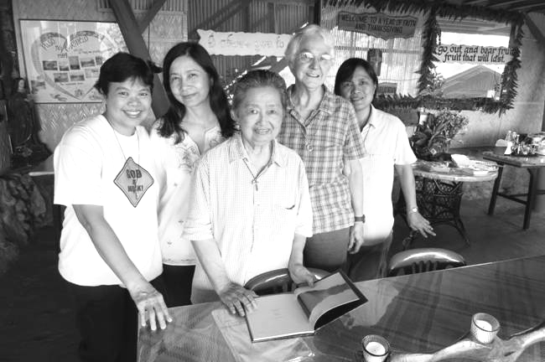
Another unexpected and exciting event was an invitation to visit the Philippines in September. A good friend from my Intensive Journal workshop days, Tetch Canon Garcia, asked me to give a talk on Journaling at a book fair where she was launching a book of verse she wrote as a result of her journaling. I left Sept. 1, staying with Tetch and George Garcia for two weeks. It was a chance to renew friendships with former participants from my workshops as well as the Maryknoll Sisters in Quezon City.
Sr. Janelle, Tetch, Sr. Mary, Dolly, Sr. Elsie

I was also able to visit my friends in Puso Ng Carmelo (Heart of Carmel) , where I made my retreat, in the province of La Union not far from Baguio. From there I visited Baguio, up in the mountains, a mile high, for a few days. This was my last mission in the Philippines at Maryknoll Ecological Sanctuary. It was the rainy season there during my month stay. Although it was damp and hot, I relished being there again, enjoying the tropical fruits and visiting old friends. One thing I didn’t enjoy was the traffic in Metro-Manila, very crowded and time-consuming.
It was after I had returned from the Philippines that the terrible typhoon (hurricane) hit the Visayan Islands in the center of the Philippines. Although I didn’t know anyone in that area, I found out later that Don Mitch’s fiancée was in her father’s house in Ormoc City on Leyte, one of the hardest hit islands. Don is the son of my first cousin Leonard and Claire in PA. Grace’s father’s house lost its roof but was not completely destroyed like many others. Thank God her family was safe. She is currently working on her visa to come to the U.S.
On my return to the US, I drove up to Salinas, CA with my nephew Tom Mitch and his wife Aletha to visit my sister-in-law Alma Mitch for her 100th birthday on Oct. 3. That was a special occasion and many in her family were able to be there. Alma resides in Katherine Health Facility where daughter Judy Smith and granddaughter Julie Faas help her daily eat her lunch and supper.
For most of us here, it is active retirement as we are plenty busy! I spoke at 3 churches this summer for Maryknoll Sisters, 1 in Los Angeles and two in San Diego, besides speaking at a near-by parish in Arcadia for Mission Sunday in October. In early December, 3 of us also participated in a Vocation Fair at Serra H.S. in Gardena, CA. In my spare time I am learning the ropes in taking over the libraries here in our Maryknoll house. I am sure I will be praying to my sister Betty for help when I need it. Betty was a librarian in her early life! Some Sisters also volunteer outside in the Unity Center in Monrovia or at the Catholic Worker Center in downtown L.A. where they help serve meals to the homeless on skid row. A recent activity I added has been to join an Inter-Faith group here in Monrovia which meets monthly along with two other Sisters. This group put on a program the week before Thanksgiving. It includes Christian, (Protestant & Catholic), Muslim, Buddhist, Baha’i, and Sikh. We were the first Catholics in the group.
I try to walk every day to keep up my good health. We also have exercise classes here for seniors if we wish to attend. In my “spare” time, I volunteer to drive the Sisters when they have to go a longer distance requiring using the freeways. My former years driving on promotion work are a big help! It’s a lovely place, we have great weather and there are many things to see in the Los Angeles area. Keep in touch and don’t forget to put me in your address book, e-mail and telephone. Love and prayers, Dolores

Bernice Kita ’59 (Rose Michael) January 1st Chajul, Guatemala
…while they were in Bethlehem, the time came for Mary’s baby to be born. She gave birth to a son and, wrapping him in swaddling clothes, she laid him in a manger, because there was no room for them in the houses. Luke 2:
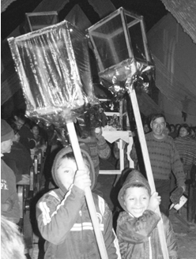
I heard on the news recently that, while Bethlehem is still a small town, it has at least 13 hotels for pilgrims visiting the birthplace of Jesus. Here in Chajul, during the nine evenings leading up to Christmas, there is always room in people’s homes for Mary and Joseph. This is the time of the traditional “Posadas”, a custom originating in Spain. Starting a few days before December 16, children and teenagers from various neighborhoods prepare statues of Mary and Joseph for their journey to Bethlehem, and construct and adorn shelters for their journey. After an afternoon Mass on December 16 when the statues are blessed, boys from each group shoulder the platforms and are led by little boys carrying colored lanterns. They carry the statues down the streets, in the rain or under starry skies.
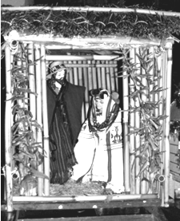
This year there were seven groups, adults and kids, who went singing in procession to host houses. They represent posadas (inns) where the Holy Couple spend the night. An ancient custom has the people outside, representing Mary and Joseph, singing at the closed door asking for a place to stay. Meanwhile, those inside the house sing back, asking who the strangers are. Finally the door is flung open and the statues are brought in for the night. Easily 80 to 100 people, more than half of them children, jam into the one-room houses. After a reading of part of the Christmas story and the singing of Christmas songs, the hosts serve a hot punch or something else traditional to all the guests. The guests go home and the next evening return to that house to walk in procession with the statues to the next house. They do this until Christmas Eve when all the groups bring their statues to church for Christmas Eve Mass. I was honored to be invited by two groups to participate in the Posadas this year. While the children tended to be over-active, the adults sang, listened and prayed with all their hearts.
Once again this year, my house was a posada for a month for six recent high school graduates from Colegio Monte María in Guatemala City. They graduated at the end of October and were brought by their parents at the beginning of November. Their vehicles were laden with teaching materials, food for a month, their favorite pillows and a few sleeping bags. They volunteered in a spirit of adventure and service. I had signed up 30 first graders, 30 second graders and 20 sixth graders for remedial classes in Spanish and math. The volunteers quickly organized themselves into a teaching team for five days a week, for four weeks. A few went with our priest to a distant village where they sloshed through mud, ate unfamiliar food, and witnessed the hard life of the people in the countryside. All of them caught a variety of colds from their students, one sprained a ligament in her knee after too much mountain climbing, one had a few spontaneous and scary nosebleeds, and all took turns cleaning toilets, sweeping and mopping floors and cooking supper. They learned to speak a few words of the local language, Ixil, and set themselves to learn to weave from some of their students. They quickly adapted to their surroundings and loved the children they taught. They had never seen such poverty, much less experienced it first-hand. They became close friends with Cecilia, the young Maya-Ixil woman who translated for them during the day and showed them around Chajul and environs in their free time.
One evening, a week before leaving Chajul, they sat around my kitchen table talking about their experience and a few shed tears. They were deeply touched and changed in those few weeks. Comparing their privileged lives in the capital with the children of Chajul they wondered how they could help them once they returned home. In my kitchen that evening was born a project. With very little free time left these high school graduates became a group of determined young women who arranged with the children, the schools, the parents and the banks so they could contribute during 2014 to the education of six of theirstudents.
I gave these volunteers posada for a month; they will give the gift of schooling for a year. And you have given me here in Chajul your loving support. Thank you, and may your new year bring you peace, health and joy. Lovingly, Bernice

One Good Deed a Day: Be kind to yourself

Rosalie LaCorte MM ‘62 December 4th Maryknoll, New York
Merry Christmas 2013! Our post Centennial year has been busy trying to seed the next century of mission service. Here are few highlights for me.
We had the closing of our Centennial year on January 6th. The Annual Charity Concert on March 3rd was a great success. Then we had a full house for the Benefactors Day on the 14th of April. Sister Mary Reese and I shared our mission experience in Tanzania through a slide presentation.
The day after the Benefactors’ Day I left for the Philippines upon the invitation of Atty. Sol Adapon, my mother’s cousin. It was an eye-opening experience to go to a government office in Makati to give a mission presentation. I was so impressed how they start their day with prayers.
There was a blessing of a 6 foot statue of Our Lady of Maryknoll in the plaza of St. James Church along with another mission awareness program hosted by my cousin, Violy, the donor of this lovely statue.
I made some trips to Syracuse, NY in July where I attended a Greek wedding of Maria Keating & Pano, good friends & supporters of Maryknoll. I also attended the Tanzanian Art Exhibit at Syracuse University. I have never seen such a beautiful display!
October brings us to the Golf Tournament & our International Bazaar. We all look forward to connecting with our many Benefactors & friends during November & December.
Wishing you a Blessed Christmas and a Prosperous New Year! Love – lots, Rosalie

Mary Lou Andrews ’49 (Rose Leon) December 5th Maryknoll, New York
(Letter from Sister Mary Lou for the Sisters in the Adoration Group).
Love from Mary’s Hill. We wish you a holy Advent and blessed Christmas.
Our Wednesday Eucharistic Adoration prayers are offered for our Maryknoll family: Fathers, Brothers, Sisters, Lay Missioners, Affiliates and Full Circle members and your intentions.
Since last year, three more of our Adoration sisters have been called to Heaven by God, namely sisters Charlotta Smith, Norbert McLaughlin and Helen Wild. In the meantime, as Sisters return from the missions, each one is invited, if she wishes, to join our Eucharistic Adoration. Thus, they replace the Sisters who have gone before them.
People ask when and how this Wednesday Adoration started. In the early days of Maryknoll, Mother Mary Joseph started Perpetual Adoration to Jesus in the Tabernacle. The intention was for our missioners. Mother saw this Adoration as union with Jesus so essential for all missioners. After Mother’s death, in the late 50’s and early 60’s, it became difficult to cover all the hours, so Perpetual Adoration was discontinued.
Upon my return from the missions, I felt impelled by Mother Mary Joseph to start a tiny token Adoration to Jesus in the Tabernacle for Mother’s intention that is our missioners here and abroad. We started Ash Wednesday 2001 with 20 Sisters. We now average about 50 Sisters.
Your letters, cards, newsletters and prayer petitions are always welcome. Please send mail by P.O. or hand-carried. Because of nerve damage to my hand, I cannot do email.
Have a Blessed Christmas and a Happy New Year!
Our love and prayers in Jesus, Mary and Joseph. Sr. Mary Lou Andrews

(Personal Letter from Sister Mary Lou)
What have I been up to in this, my 85th year? Jazzy Lee still cruises along like a good Motorized Wheelchair should. Regarding me, I’m a bit more bent and still have my elephantiasis leg with cancerous ulcers. These need double 8x10 ABD pads to catch the drainage, BUT, the rest of me is “pretty good.”
Inside of me, I have the joyous freedom that is ours in our 70’s and 80’s and I live with many Sister friends. I continue to visit our sick Sisters daily. I also write to our missioners, to six prisoners and to you, my dear family and friends. I try to answer every letter I receive. So for me, life is good, life is happy.
Pope Francis spoke of the immense value of older people and included himself in this category. He said that our greatest value is in two virtues, namely, tranquility and prayer. Pope Francis added that our task is to impart wisdom to the young, but not necessarily by our words, rather more by our actions.
A special joy I had this past summer was spending two weeks with my sister-in-law, Laurie, at her home in Niagara Falls. While there I enjoyed visiting family and friends, and I always look forward to a visit to the Falls. The joy of the American Falls is being so close that the spray sprinkles you. As I’ve said before, Laurie is a dearest friend. We talk for an hour plus by phone every Saturday morning. She typed this letter for me and had it printed. For this I am very grateful. Have a happy, holy New Year 2014.

Our listening creates a sanctuary for the homeless parts within another person.
Rachel Naomi Remen
BOOK REVIEW
HIS WINDOW ON THE WORLD, THE PISCATAQUA AND THE DAYS OF HOPLEY YEATON
by Barbara DiFrancesco Reviewed by Carolyn Cook Grassi
Recently I read this amazing book by Barbara DiFrancesco. It is a beautifully written, in-depth detailed history of one of America’s early heroes: Hopley Yeaton along with the fascinating story of New England naval history. And yes, Barbara’s book is a “page turner,” frequently reading like a novel. This 15 chapter book is the next best thing to visiting the sites in Maine and New Hampshire, where Hopley Yeaton and his family lived. Barbara provides the reader with charts, diagrams, photos (many of these taken or drawn by her) along with her lively historically-based narrative. How wonderful to see drawings of the first schooners that Hopley Yeaton commanded, the commission given him by George Washington along with copies of other historical documents.
Barbara’s research is extensive, gleaned during years of visiting, studying, taking notes at such places as the Portsmouth Historical Society and its Public Library, Plymouth State College, Lubec/Eastport Maine’s Records, the National Archives in Washington, DC, the Coast Guard’s museums and several of their historians and/or retired personnel, the resources of New Castle, New Hampshire’s town records, the Unitarian Universalist Church of Portsmouth, NH, the Peabody Essex Museum of Salem, MA and other first-hand sources. Barbara gives insights and excerpts from the correspondence and/or diaries of Hopley Yeaton and his family.
Within these pages are wonderful descriptions of early New England life homesteading, Hopley Yeaton’s childhood, marriage, his gifts as a seaman and his innovations on training young seamen. Barbara’s portrayal is sympathetic and realistic regarding the challenges these New Hampshire and Maine communities faced as they forged a livelihood amid the antagonisms of England toward the colonies, the War of Independence and, among other things, the difficulties of establishing a permanent coastal shipping patrol (that foreshadowed the U.S. Coast Guard). How fitting that Barbara’s book is dedicated to her husband, “David DiFrancesco, Senior Chief E-8, USCG Ret. 22 years of service and to all men and women of the United States Coast Guard, who have followed in the footsteps of an ordinary man who became extraordinary by living his life in an extraordinary way.”
This is an extraordinarily well-written and researched book that brings to life a special time in American history through the story of Hopley Yeaton as told by Barbara DiFrancesco.

One Good Deed a Day: Forgive someone

No act of kindness, no matter how small, is ever wasted.
Aesop

MARYKNOLL CONTEMPLATIVE COMMUNITY AT THE CHALET
For more amazing contributions from the Maryknoll Contemplative Community, please see the Full Circle Website: http://www.fullcirclemks.org
Christmas Blessings from the Contemplative Community
at the Chalet!
We are put on earth for a little space that we may learn to bear the beams of Love!
William Blake
To Our Beloved Companions, Christmas 2013
As the Advent/Christmas season gradually unfolds, so does our awareness of the unfathomable presence of an infinitely inclusive, universal Love. As we honor this awareness, each of you, our sisters and brothers, seem to radiate blessing in the center of our hearts. We are in communion with you and you are with us. This communion is Love’s most precious gift, fully accessible in Jesus the Christ, whose incarnation we celebrate and whose wholehearted embrace we share as one. Thank you from our hearts for your great fidelity to Love’s way for you personally, communally and globally. In the midst of life’s unexpected challenges and pressures, you are attuned to the rhythms of joy and suffering, heartache and hope and are allowing yourselves to be upheld by a profoundly solid yet intangible presence. Yes, it is true! You are known and cherished, guided and strengthened in ways you could not plan or project, so simple are they, so personal and yet radiating unspeakable blessing. This is Love’s incarnation, embracing you and us, here and now, serving our shared humanity, expanding our awareness, deepening our hearts’ capacity for more of ourselves in Love.
What is most personal is most universal. What is most intimate is most communal.
What is most contemplative is most active. Henri Nouwen
We have a very dear friend, a woman who has served in mission for many years, a wife and mother ~ and the recipient of an “unexpected gift,” a chronic illness. Through the ongoing experience of rheumatoid arthritis, Teresa has discovered incarnation in her own way, a truly organic way. Her many surgeries over a period of 20 years have required inner stillness and space, a way of being with herself in which prayer and the kindness of others reveal Love’s actual embrace of her. Teresa inhabits a level of personal vulnerability and dependence which holds the essence of healing and real transformation. “Listen that you might live,” says Isaiah, Love’s prophet. Through our own communal devotion, as contemplative missioners, to serving the mysterious movements of Love, we are joined with Teresa. We honor the places and spaces of incarnation in ourselves and in our universe. We are drawn into the hidden depth of human experience, rejoicing in the healing, transforming presence of incarnate Love which is alive and alert to every nuance of our need.
The all-pervasive presence of God’s Love residing in the heart of every human being is “the cause of the joy that dominates the life of every Maryknoll Sister.
It touches the wells of our hearts. Mother Mary Joseph Rogers
On October 12, 2013, our founder Mother Mary Joseph Rogers, along with eight other illustrious women, was inducted into the National Women’s Hall of Fame at Seneca Falls, NY. At this moment in our history of 101 years, we, her daughters, are ripe to enter a deeper, more expansive surrender to the call which transformed the heart of Mother Mary Joseph into a living flame of Love. In 1920, the group of women which Mollie Rogers had nurtured and guided was recognized as a mission society of women, the Maryknoll Sisters, committed to the humanitarian needs of all people, especially the poor, regardless of race, creed or color. This is an historical fact. It is also an energy field of Love, a Love which is incarnate, all-inclusive, unconditional and universal. This Love cherishes and embraces every level of human reality and is passionately drawn toward the most hidden and unattended places of suffering. Mother Mary Joseph’s heart throbbed with a compassion rooted in the incarnation of Love within us and among us. Hers was a wisdom which saw opportunity in every circumstance. How did she see this? She simply opened herself to her own need for communion with Love, her need to live out of Love’s incarnate presence, which penetrates all of creation. In so doing she made God’s Love visible ~ an incarnation that is alive now. May we all share with great simplicity this presence of Love incarnate, alive in us now, all of us together in Love’s communion.
We are not lacking in the dynamic energies needed to create the future.
We live immersed in a sea of energy beyond all comprehension.
The desert oozes power. But this power is ours, not by domination but by Invocation.
Thomas Berry
Our lives as contemplative sisters in mission continue to unfold. We experience ourselves immersed in the circumstances of this moment in history. We open ourselves to the anguish and the joys which are trustfully shared with us by so many of our sisters and brothers throughout the world. It is our call to align ourselves with Love’s intention to serve all, to transform all, to bring all into wholeness of being. We do this in the silence of our own hearts’ prayer. We do this in our communal sharing and mutual trust. We listen deeply to the cries of others, for personal guidance, for a sense of connection and belonging, for a way to be present to their vulnerabilities, a way to find peace in the midst of conflict and insecurity. All of this belongs to a Love which is incarnate – a presence holding all things together in an infinite embrace.
As we celebrate this mystery of unconditional Love incarnate, we bless each of you from our hearts. We know that you will fulfill your destiny in Love, incarnate within you ~ and that you in turn will bless all with your presence, simple and full, enlivened by Love.
Our prayer for you this Christmas and always:
May you each know your place within the universe as one of LOVE. Amen. Alleluia!
Your sisters and companions on the journey,
Grace Lilla Madeline Marion Consuela Theresa
Maryknoll Contemplative Community ~ Post Office Box 311 ~ Maryknoll, NY 10545-0311

One Good Deed a Day: Eat your next meal in silence and away from a computer

FAVORITE RECIPES
Jerry Hardiman (esposo of Ro Brady Hardiman) Bethany Beach, Delaware
Here are two recipes that arrived since the last newsletter. Rosemary and I prepared and served the sweet potato dish on Thanksgiving and it was a hit with family and friends. It would be a great side dish with many meals, for example, with baked ham. We’re looking forward to making the second recipe, the Chilean empanaditas, as an appetizer for an upcoming neighborhood gathering.

Mashed Sweet Potatoes (Sr. Rose Lauren Earl, MM ’50)
Ingredients
4 medium sweet potatoes (I estimated that number to serve about 6 people.)
½ cup applesauce
2 tablespoons brown sugar
1 tablespoon butter
¼ cup brandy (I added extra)
salt (to taste)
Preparation Steps
- Preheat oven to 350 degrees. Lightly spray casserole dish with vegetable oil spray.
- Peel, cut up and boil potatoes until tender and drain.
- Mash potatoes in large mixing bowl. Add butter, applesauce, brown sugar, brandy and salt. Combine all ingredients. Let stand for 2-3 hours to enhance flavor.
- Spread potato mixture in casserole dish. Bake, covered, for 30-45 minutes until heated throughout and serve.

Chilean Empanaditas (Pat McKinny ’60 (Patrick Mary))
Ingredients
2 cups Bisquick
½ cup hot water
¼ pound lean ground beef
½ cup chunky salsa
1 tablespoon raisins
8 stuffed green olives, sliced
1 hard-boiled egg, sliced
½ teaspoon ground cumin
1/8 teaspoon ground cinnamon
1 egg (uncooked)
1 tablespoon water
Preparation Steps
- Preheat oven to 350 degrees
- Line cookie sheet with parchment paper or tin foil (Reynolds makes a non-stick foil).
- In a medium-size bowl, stir Bisquick and hot water until stiff dough forms. Let stand for 10 minutes.
- Meanwhile, brown ground beef in a skillet over medium heat and drain off fat. Stir in salsa, raisins, sliced olives and hard-boiled eggs, cumin and cinnamon. Set aside.
- Place dough on surface sprinkled with extra Bisquick. Shape into a ball and knead about ten times. Roll dough into a 13-inch round shape. With a 3-inch round cutter, cut dough into rounds. Gather scraps together in a ball; reroll out to about a 1/8-inch thickness; and cut additional rounds. (Makes about 20 rounds total.)
- Spoon 2 to 3 tablespoons of beef mixture onto center of each round. Fold dough in half over filling and press edges firmly with a fork to seal. Place empanaditas about one inch apart on the cookie sheet.
- In a small bowl, whisk the uncooked egg with 1 tablespoon of water. Brush on top of each empanadita.
- Bake about 15 minutes or until golden brown and serve.

Here’s a final thought: As a child my family’s menu consisted of two choices: take it or leave it. Buddy Hackett

One Good Deed a Day: Talk about what you are grateful for.

TRANSITIONS
Diane Lavoie Christian ‘64 Topsfield (1944-2013) by Mef Ford ‘64
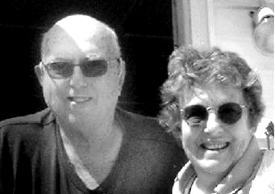
Diane Lavoie Christian was one of the most intense and loving people I have known. Everything she felt, she felt in extremis. Though she was in Maryknoll less than a year, she made life-long friends. Others in her group remember her as having a child-like innocence and simplicity. She was also vivacious and blessed with a “smile that covered her face and an infectiously cheerful tone of voice.” Inner turmoil or suffering was not revealed in her external vivacity.
Maryknoll was her dream and leaving was wrenching. But she went on to have a marriage that was happy for several years and to regularly announce there was another “turkey in the oven,” as she gave birth to four children. Her diagnosis of MS came late in her childbearing years, but she said, “If I’m going to live, I’m going to live,” and out popped another turkey. When her youngest was still crawling around on the floor, her muscles became so weak that she used a scooter to get around and had to stop working and driving.
Offered an experimental trial of Immuran, she dared the odds of developing cancer as a side-effect (her mother had died of cancer), and went on to achieve such a recovery that she was able to return to work as a night nurse, resume driving, and enjoy a full life for many years. After her children were grown, her expansive spirit longed to be of service in a wider venue, and she traveled to Haiti. Finding there a plethora of barely cared-for orphans, she spent several weeks joyfully filling a need she saw--holding babies.
When her marriage ended in the 90s, she moved from Connecticut to Vermont to begin anew. Believing she would never love again, she was more surprised than anyone to find the guy she often shared a bench with in church growing on her. They proved to be an ideal match and she was never happier than those last 10 years or so with her Bud, living what she described as “a simple life.” A single guy, for his part he rejoiced in his instant family, and together they welcomed grandchild after grandchild.
Di always longed to return to Haiti, but failing health prevented it. It was not MS but a systemic muscular disease that made breathing increasingly difficult. A year or two ago, though by then very infirm and living in a nursing home, she was determined to attend the weddings of two of her children. Sheer will lent endurance to her fierce love, and she and Bud were able to make the trips to Connecticut for the ceremonies. Her four children were always a great source of pride and joy. Last Christmas they surprised her by all coming to spend the holiday with her and Bud, and nothing could have been more meaningful.
Diane had a very strong relationship with God and always felt herself under his guidance and care. Our novice mistress, Sr. Edmund Damien (Mary Driscoll), whom Diane loved dearly, died on Oct. 2, 2013 and Diane on the 9th, so perhaps they found themselves in the same orientation class. Diane was not afraid of dying. Apart from the sorrow of having to leave. But, she looked forward to the reunion that she fully expected to embrace. May it be so.

Elizabeth Beck, Ph.D. ’56 (Marian David) d. 4/17/2011
Elizabeth Joan Beck was born in Newark, NJ on 12/8/1926 and died Sunday, 4/17/2011. Betty graduated from Caldwell College, worked briefly as an engineer, and then as a psychiatric technician before being employed by Catholic Charities as a social worker. She became affiliated with the Catholic Worker in New York, an organization whose values of hospitality and ministering to the homeless she held deeply. Betty earned a master’s degree from Fordham University and took courses toward a PHD.
Before she finished her degree, Betty joined the Maryknoll Sisters, hoping that she would be sent to the missions in Africa. Instead she was sent back to Fordham University to finish her doctorate in clinical psychology. In 1965, Betty left Maryknoll after nine years of dedicated service. She became a school psychologist in Methuen, NJ and then joined the graduate faculty of Seton Hall University. There she created and directed the Child Clinical Psychology Program.
Betty lived for nearly 30 years in a 250-year old stone farmhouse in Chester, NJ which she carefully restored. When the house became too much for her to manage, she moved to Ocean County. As a child she had spent long summers “down the shore” and she hoped to spend her last days there. But she became too disabled to live alone, and moved to Madison, NJ to be near friends who could care for her. Betty leaves nieces and nephews and many friends who will miss her wit, her generosity, and her gentle wisdom. Hundreds of school psychologists will remember her as their wise and compassionate teacher. She was a gift to us all. Published in the Daily Record on April 24, 2011.

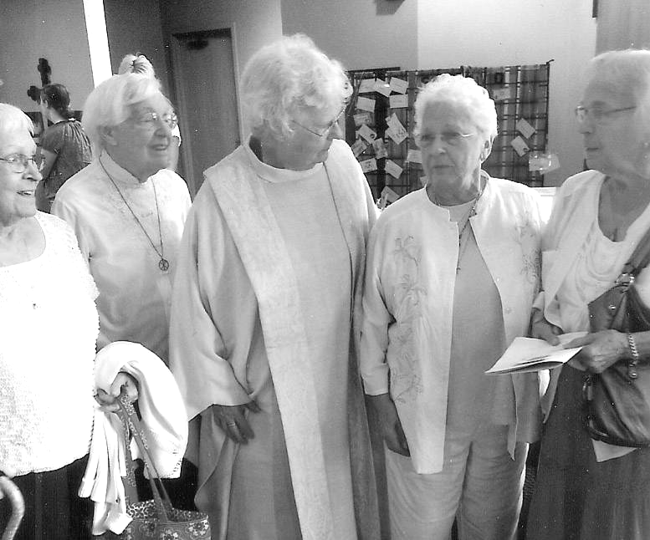
Ordination of Bernadyne Lipetsky Sykora (Sister of Marie Ann Lipetsky MM ’41 Victoria Marie)
L to R Sisters: Lois, Sr Marie Ann, MM, Rev Bernadyne Lipetsky Sykora, Elizabeth & Monica.
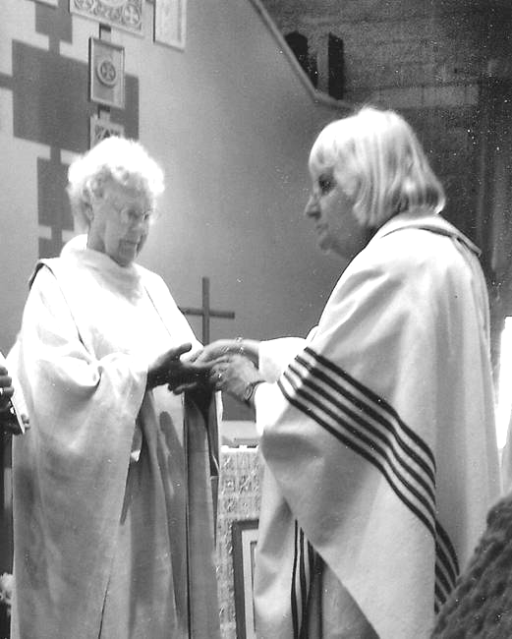

The anointing of the hands of Bernadyne by Bishop Maria Regina Nicolosi
Ordination to the Priesthood (Roman Catholic Womenpriests Order of Worship) on June 23, 2013 in St. Cloud, Minnesota. The following is reprinted from the commemorative pamphlet that was distributed at the ordination ceremony:
Most scholars are agreed that the priesthood as we know it today was a development in the early Church, not something specifically instituted by the historical Jesus. From the Gospels, it is evident that Jesus had a high regard for women and enjoyed spending time in their company. After the resurrection, it was women to whom Jesus appeared first, and it was Mary of Magdala, the Apostle to the Apostles, who told the rest of the disciples about her encounter with the Risen Christ.
Women played important roles in the early Jesus movement. They were in the Upper Room and were present when the Holy Spirit descended on the disciples. Women such as Mary, the mother of John Mark (Acts 12:12) and Euodia and Syntyche (Phil 4:2) were leaders in their communities. Phoebe, who carried Paul’s letter to the church in Rome, was called a coworker, deacon, and benefactor to Paul (Rom 16:1-2). Prisca, along with her husband Aquila, was a prominent teacher, missionary and patron to other believers (Acts 18; Rom 16:3-5a, Cor 16:19). Junia is described by Paul as an apostle or one who had seen the Risen Christ and was engaged in missionary work (Rom 16:7).
Archeological, epigraphical, and literary studies show that women were recognized and functioned as deacons, priests and bishops during the first millennium of Church history. There was a recognized order of women deacons who were ordained with the same rite as male deacons. Several women in the second through the fifth centuries, such as Artemidora of Egypt, Flavia Vitalia of Dalmatia, Giula Runa of Hippo, and Leta of southern Italy, were referred to as presbyters, or priests. At the Roman church of St. Praxedes, dated to early ninth century, a mosaic of four women includes the name of the woman on the far left, Theodora, and identifies her as an episcopa, or bishop. Frescos in catacombs picture women wearing vestments, standing with their arms outstretched in a prayerful position, and having bread and wine in front of them.
Beginning with the ordination of seven women on the Danube in 2002, the members of Roman Catholic Womenpriests have been ordained in valid apostolic succession to witness the call of God, who graciously invites both women and men to minister to the People of God.
Congratulations, Bernadyne!

Unless otherwise noted, the following are adapted from Letters of Appreciation written by Members of the Maryknoll Sisters. Edited by: Rosemary Brady Hardiman ’63

Blanche Thiel, MM ’48 (Matthias Marie) d. 8/29/2013
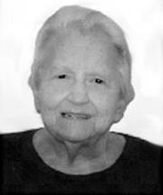
Blanche, the youngest of seven children, was born on 10/10/1925, in Milwaukee, WI. After graduating from high school in 1944, she worked first as a nurse’s aide and later as a toll operator.
Blanche entered Maryknoll at Valley Park, MO in 1948. She received the religious name Matthias Marie, made her First Profession of Vows on 5/8/1951 at Valley Park Mo, and Final Vows on 5/8/1954, at Maryknoll, NY. In 1957 she earned a Bachelor of Science in Home Economics from Marywood College, Scranton, PA, and in 1967 she studied public health nutrition at the University of Minnesota.
In 1960, Sr. Blanche was assigned to Queen of the World Hospital, Kansas City, MO, the first interracial hospital in the nation, where she worked as a staff dietician for two years. In 1962, she was assigned to the Maryknoll Sisters residence in Topsfield, MA, where she worked as kitchen supervisor until 1965.
Sr. Blanche then served for three years as a researcher at the Harvard School of Public Health and joined a team of researchers at Children’s Hospital, Columbus, OH, in 1968. There she worked with the Children’s Hospital Research Foundation and Ohio State University’s Pediatrics Department on a nationwide research program entitled “Evaluation of Nutritional Status of Preschool Children in the United States” and was appointed the program’s supervisor in 1969.
In 1971 Sr. Blanche was assigned to the Central Pacific Region, serving first as dietician at Hale Makua Home and a cook for the Sisters at St. Anthony’s Convent on Wailuku, Maui.
From 1973-1979 she served as a receptionist and pastoral care worker at St. Francis Hospital, Honolulu. In late 1979 Sr. Blanche became the first person commissioned as a Special Minister to serve as Pastoral Care Associate at Queen’s Medical Center, the largest hospital in Honolulu.

While at Queen’s Medical Center, one of her responsibilities was to help families in times of crisis, supporting them during surgery, critical condition or death of a patient. Her kindness built strong connections and for many whom she reached her low-key presence brought peace of mind, especially for those who were burdened with family problems. As a good listener, she remembered details they had shared and at their next contact would ask questions then listen to the update. Some of these contacts led to her being an agent of evangelization. Re-contacting with the Church of their youth was often the key to a person’s return to the Sacraments after years of separation.

“In my work as a hospital pastoral associate,” she reflected in 1981, “every day I see what it means to be a Christian, when I meet a new patient and they cry [because] I came to pray with them.... They are so happy…. Many attribute their becoming better to our visits and prayers.” A Sister from Hawaii recalled that Sr. Blanche had a perfect personality for ministries to the sick as well as for living community life. She had a lovely sense of humor, was outgoing, and easily contributed as much as she received from others. She was quick to notice the needs of others and generous in lending a helping hand.
In 1992 Sr. Blanche was assigned to Monrovia, CA and in 2005, in response to increasing health care needs, Sr. Blanche was assigned to the Maryknoll Center Chi Rho Community and later to the Maryknoll Sisters Home Care 3. During this time, Sr. Blanche’s prayer ministry was Monrovia. We are deeply grateful for Sr. Blanche’s life of generous service to the People of God. Condolences may be sent to her nieces Joyce and Claudia: Joyce and Peter Torcivia, 6365 Chestnut Parkway, Flowery Branch, GA 30542-3872; Claudia Stelter, 7020 Horizon Dr., Greendale WI, 53129-2739. Sr. Pat Ann Arathuzik, MM, Community Member.

Mary Driscoll, MM ‘43 (Edmund Damien) d. 10/2/2013
Mary was born on 7/26/1923, in Portland, Oregon. Her parents, a brother and two sisters predeceased her. She is survived by her sister, Carolyn Neely of Boise, Idaho.
Mary graduated from St. Mary’s Academy in Portland, Oregon, in 1941 and attended Maryhurst College the following year. She entered Maryknoll on 9/7/1943. At Reception, Mary received the religious name of Sr. Mary Edmund Damien. She made her first Profession on 3/7/1946 in Ossining, NY and her Final Vows on 3/7/1949 in Hawaii. In 1955 Sr. Mary received her Bachelor of Education degree from Maryknoll Teachers College, NY. In 1964 she received an M.A. in Theology at Providence College in Rhode Island. From 1969-1979 she attended the University of Pacific Coast in California and became certified to teach EMR students and Learning Disabled children.
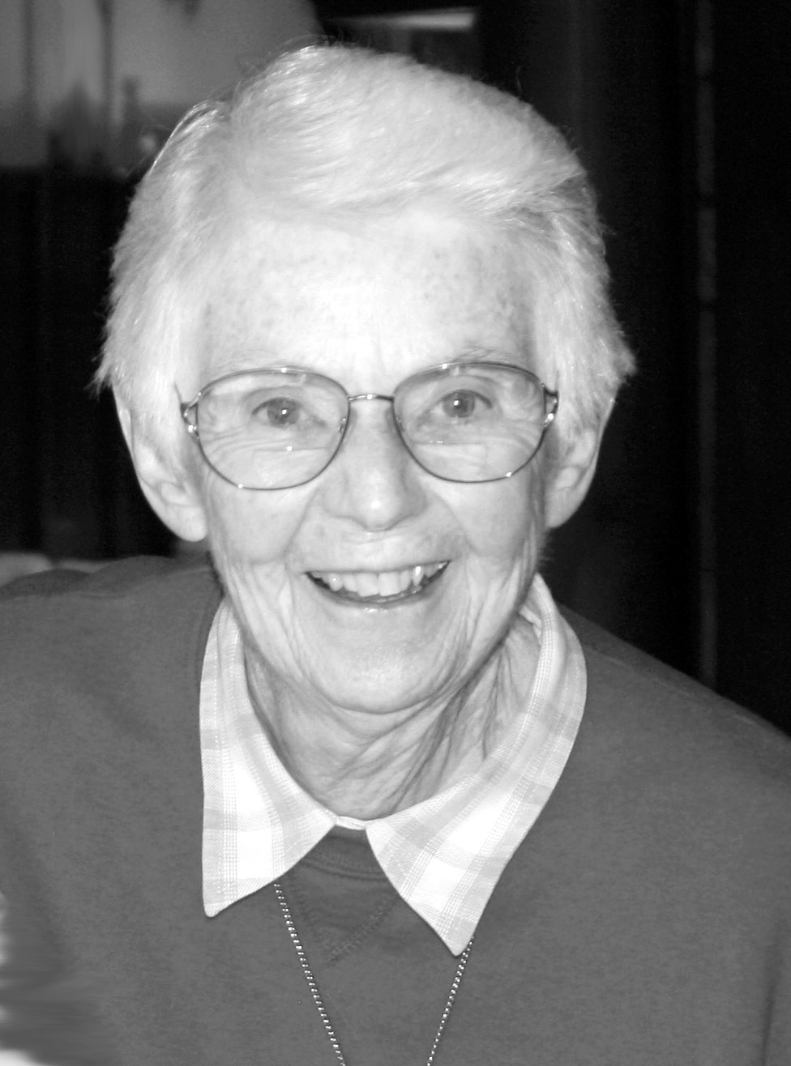
Sr. Mary’s first mission assignment was to Hawaii in 1946 where she began her ministry as teacher, which was to be her major ministry throughout her life. She taught seventh graders at St. Anthony School in Wailuku, Maui, and then taught first and second graders at Maryknoll School in Punahou, Oahu. Sr. Mary is remembered as an enthusiastic teacher who worked well with the parents of her students and encouraged them to take part in student activities, especially field trips. In 1955, Mary went to New York City and taught second grade for three years at Transfiguration School in Manhattan’s Chinatown.
In 1958, Sr. Mary was assigned to the Maryknoll Sisters Novitiate at Maryknoll, NY as Assistant to the Novice Mistress and in 1961 as Postulant Mistress. In 1964 she was named the Novice Mistress at the Novitiate in Topsfield, MA and remained in this position until the Topsfield Novitiate closed in 1968. Sr. Mary is well remembered as a warm and loving person by the many women who entered Maryknoll during her ten years directing the Novitiate. Those years were difficult years because of tremendous change in society, in the Church, in religious life and in Maryknoll. Sr. Mary was open to the changes and this was reflected in her direction of the Novitiate. As one Sister has written, “The early 60’s were unsettling times for many of us but Mary was always such a down to earth, stable presence – a real anchor in the storm. She was a woman of deep prayer and taught me how to pray – especially how to love Scripture.” Mary’s legacy lives on in the many Sisters and women who so generously carry the love of God and the Maryknoll spirit to others as a result of their contact with her.
Assigned to Stockton, CA in the Western U.S. Region in 1968, Sr. Mary lived with Sr. Mary Xavier O’Donnell. They invited Dr. Janet MacLean, who had taught music at the Topsfield Novitiate and had become a good friend of Sr. Mary, to form community with them. With her training in special education, Sr. Mary taught upper elementary EMR students at El Portal School. She received the Outstanding Teacher Award for “exemplary teaching and dedication to school and community.” The Superintendent of Schools added: “Sr. Mary Driscoll has brought to the classroom a compassion and understanding spirit that immediately says to the child, ‘I care about you.’” Sr. Mary, who was an accomplished cellist, played one year with the Stockton Symphony Orchestra.
Although Sr. Mary had frequently expressed the desire to do inner city work, her desire was not realized until 1981 when she and Janet moved to Bardstown, KY. Sr. Mary joined the Eastern U.S. Region in 1982. For eight years she commuted to Louisville, KY and did social work with the Sisters of Charity of Nazareth at the Sister Visitor Center. Her ministry included emergency food, some financial help to the poor, home visiting, and work with the elderly. Sr. Mary also played a prominent role in a local community group protesting energy rates.
In 1989, Sr. Mary left the work in Louisville and concentrated her work in Bardstown teaching at the Creative Education Center (C.E.C.) which Janet had established to serve children who needed specialized education programs, including: very bright students, students with low self-esteem, students who needed programs to assist them in learning. Sr. Mary was given the C.E.C.’s Teacher of the Year Award in 1997. She also volunteered with NELCASA, an agency that finds volunteers to stand up in court as advocates for abused or neglected children. Sr. Mary became a member of the NELCASA Board and later the Board President. For many years, even after she needed to use a wheelchair, she was faithful in participating in the demonstrations to close the SOA (School of the Americas) in Fort Benning, GA. From 2006-2009 Sr. Mary did pastoral work in a Bardstown parish and continued tutoring while caring for Janet during Janet’s terminal illness.
In her 27 years as a member of the Eastern U.S. Region, Sr. Mary is remembered as living the Maryknoll spirit of dedication and service to all. She took an active role in the Region and served several years on the Regional Governing Board. Sr. Mary’s deep spirituality and wisdom were recognized as enriching all.
In 2009 Sr. Mary joined the Chi Rho retirement community at Maryknoll Sisters Center and volunteered as a tutor at the nearby Brookside Elementary School. From 2010 to 2013 she retired to the Sisters’ residence in Monrovia, CA where she continued tutoring, before returning to the Maryknoll Sisters Center at Maryknoll, NY on August 1, 2013. Sr. Mary was ever faithful to her Prayer Ministry which was the Congregational Leadership Team and the Palestinians. Messages of condolence may be sent to Sr. Mary’s sister: Carolyn Neely, 8140 W. Ringbill Lane, Boise, ID 83714. Sr. Mary Grace Krieger, MM, Community Member.

Tributes to Mary Driscoll MM ‘43 (Edmund Damien)
Beth Keim Bastasch‘61 (Juniper) October 2nd Aptos, California
The phone message light is blinking...one from Carol Ryan Salta (Miriam Veronica, '61) voice all quivering...to check my email. A second from Margarita Jamias, MM, my group, (Philipina) now at the Center, telling me of Mary's death at 7:30 in NY. Tears of joy for Mary, who told God every day at Mass that He could take her any time.
I have so many wonderful memories and thoughts. I am going to sit alone and write today to remember and be with her. She was "MISS MARYKNOLL" to me...the model Maryknoll Sister. Talk about unconditional love...and that is what I felt from her and realized its impact and value...really experienced it for the first time in my life. I have the story of my birthday a month after entering. My father had sent me a gigantic box of English toffee, my favorite. I put it on the table outside of her office saying that I had received it for my birthday. Every night after that, I thought it would be put out for us. I never saw it. Then on my birthday, 9 pm, lights out, profound silence. I slip into my bed and there – under by pillow was a plastic bag filled with the toffee together with a note wishing me a happy birthday. Because it was profound silence, I could not effuse as I generally would; instead I just was able to relish her love, the warmth of her until I drifted off to sleep.
I remember the story of her correction for my voice carrying, “not loud, Beth, but resonant” but only telling me this after spending five minutes telling me how much my energy and bubbliness added to the group, how she loved being with me. I left her office walking on air and then thought – oh I think I have been reprimanded – this must be how Maryknoll does it. Mary did what the Maryknoll Sisters say they do: she made God's love visible! During Postulancy, 1960, Cookie (Carolyn Grassi) came into the mail room informing me Sr. Edmund Damien wanted to see me in her office. "Oh, come on in Beth, please sit down." Smiling, Sister went on to tell me how happy she was that I was there, that I had entered Maryknoll. Feeling all aglow I listened as she struggled and stammered to tell me ..."Beth, your voice carries...I'm not saying you are loud ...no...but your voice has a resonance...and when I'm in my office praying I can hear your voice above all the others...and I wonder if you could just moderate it a little bet, Beth...can you do that?" "Oh sure, Sister." "Oh, thank you Beth. You are such a joy and you bring so much laughter and ..." whatever kind words she could find to ease the blow.
As I floated back down the hall to the mail room to resume our free afternoon conversations I remember distinctly thinking, "That was a correction. That is how they correct you in Maryknoll." Mary Driscoll made me want to be better Years later in a Psychology class I learned that was called "The Sandwich Technique"...put the bitter medicine between two sweet slices of affirmation!
During our long visit in Monrovia on Derby Day we had time. Our plan was to take Mary out to lunch and then to the arboretum and she was game. But after Mass Mary doubled over in pain and we all decided to stay put. We found out that Mary was born and raised two blocks from Tom, two blocks and 21 years! Portland, Oregon. She was in the first graduating class of All Saints School, and Tom 21 years later, and the trophy with his name, MVP in eighth grade is there to prove it! And when we asked if she knew Tom's best friend's uncle, Father Tobin, Mary excitedly let us know, "Oh Yes, Father Tobin was part of our family...he was at our house a lot, ate supper with us." Who could have seen the six degrees of separation way back in 1960? What a gift this Mary was to each of us, "each dear one" of us as she would always write on her bulletin board notes...And what a Guardian Angel ...and how she died on their feast day!
I just am so filled with the gift that Mary was...to so many of us. She radiated unconditional love...she spoke her truth too without that edge I find in myself. She prayed for the Palestinians at Mass on Derby Day...that they would have their own homeland which they deserved...and hearing her words so strong and yet without that edge.
I could live to be 1,000 and I fear that edge will not leave me...but Mary was born in Portland, as was my kind and patient husband Tom...and I in Queens...maybe that's it. I still have her last message on my phone which she left while we were on vacation, in which she left her cell phone number...again...and realized we must be away and said she was going back to Maryknoll and then a little laugh..."until God takes me" and another little laugh. Blessing my husband, Tom and me at the end.
Terry Herman Sissons ’58 (Bernadette Mary) October 2nd Royston, Herts, England
I have just received the news that Mary Driscoll died yesterday. She was my postulant mistress when my mother died. I remember her as one of the kindest, most gentle people I have ever met. I have often wondered in recent years how she evaluated the turmoil at Maryknoll during these many years.
I didn't know her - I don't remember ever having so much as a single conversation with her after we moved on to the novitiate. But she didn't impress me as someone who anguished particularly over theological issues or struggled constantly with whether Maryknoll was being true to its mission. I felt there was just something in her almost like a honing pigeon that simply knew that the most important thing was love.
It's an approach whose richness I've only just come to appreciate in my old age and "Sr. Edmund Damien" is one of the few people in my life whom I wish I could go back and visit.
Doris Russell Gonzalez ’60 (Doris Marie) October 3rd North Branch, New York
Ahhh sweet and fond memories of Edmund Damien. Rest in thy lover’s sweet peace O fearless one.
Maureen Doherty McGowan ’58 (William Anne) October 4th Larchmont, New York
I am so very glad that Sister did not linger. I shall always think of her with so much love, as Sr. M. Edmund Damien. She was my Postulant Mistress, along with Sr. Marie Gabriel, and then again Assistant Senior Novice Mistress for my 1958 Motherhouse Group.
I often found myself as a Postulant observing Sister, and thinking about her – wondering what she might be thinking and feeling, behind those beautiful, expressive eyes. I always noted her eyes especially, thinking that they were often filled with sadness, or pensiveness, which seemed to be about us – as though our young struggles, our homesickness, perhaps, or just whatever we were going through was weighing on her own heart. There was so much going on within her, behind that beautiful smile.
I especially remember a day as a Postulant when she took us all ice skating, down at the pond toward the Taconic Entrance (I think that’s where it was.) I don’t remember how we got there, - it must have been by bus) – but I remember how much I enjoyed that glorious day! I’d loved ice skating since very young, and it was deliriously wonderful to be on ice skates again, in the midst of those trees that surrounded the pond. It was a happy day for me – a pleasure I’d never expected to have in my life again.
I felt Mary was so very human, so very “in touch” with all of us, without expressing it in words. I loved her. And again, it seems such a special blessing that she did not linger at the end, which I think she would have hated. She was so physically active, and enjoyed being active so very much. I shall always remember her and love her.
I’ll be there on Monday night for the wake; – sorry I can’t be at the Funeral Mass since I’m working on Monday morning. But I’m glad I can make it on Monday night. She was such a beautiful Maryknoll Sister. Love, Maureen
Kathleen Reiley, MM ’63 October 3rd Kamakura, Japan
Mary was our Postulant and Novice Mistress for 2 years - but she was always just her own warm loving self and never let wearing a hat of Novice Mistress interfere with relating to us as persons. The early 60's were unsettling times for many of us but she was always such a down to earth, stable presence - a real anchor in the storm. And she was a woman of deep prayer and taught me how to pray - especially how to love Scripture.
We met only twice since then and last year's brief visit was so special because we spoke of looking forward to the next phase of what God has in store for us with joy and peace in our hearts. Now I am sure she tastes that peace and joy to the full. I will be with you all in spirit as you see off a wonderful woman of God. Truly the angels will lead her into paradise and she died on their feast day! Kathleen
Helen Delaney ’63 (John Paul) October 3rd St. Louis, Missouri
I have not checked my email in two weeks, since I have been dealing with several friends suffering with various forms of cancer, knee, wrist, and back operations, etc. since the summer. I find it interesting that I chose to check it today, the day of Mary’s funeral. About a month ago I was thinking about her, wondering how she was or even if she was still here and wanting to connect with her. Mary was very special, patient, gentle, loving, and understanding, even when things were somewhat challenging or the hour was late. Well, now I can connect with her in prayer. You and all are in my thoughts and prayers. A friend of mine was looking up the saint of the day in Ellsberg’s All Saints and just called me a few minutes ago as she discovered that Mollie Rogers is mentioned for tomorrow, Oct.9th. She said that she would pray to her for me. I told her about Mary Driscoll, which pleased her to know of another Maryknoll saint to whom she could pray. I would love to have been there with all of you, but it wasn’t meant to be. I am so happy to know that she is at HOME.
Blessings to you and all with love, Helen
Mary Lou Herlihy MM ’61 (Michael Andre) October 3rd Hendersonville, North Carolina
I'm so sorry to hear about Mary. I think of her often when listening to Janet MacLean's CD "Harp Music for Healing and Transformation". My memories of Mary are from the Center where she was called Sr. Edmund Damien. Sr. Blaise and Sr. Grace Marie were our postulant mistresses in 1961. I also remember that she did not agree with rules such as "talking in 2's" (but said while the rule was here we needed to keep it) and that she did her thesis on "Love in the Religious Life". That 2's rule ended in ‘62 if I remember rightly. My other memory is of the play on Damien and the Leper that Cindy Kiley wrote for Mary's feast day.
Let's keep our energy and prayers focused on Mary as she goes to be with MMJ and all our ancestors Love to all, Mary Lou Herlihy
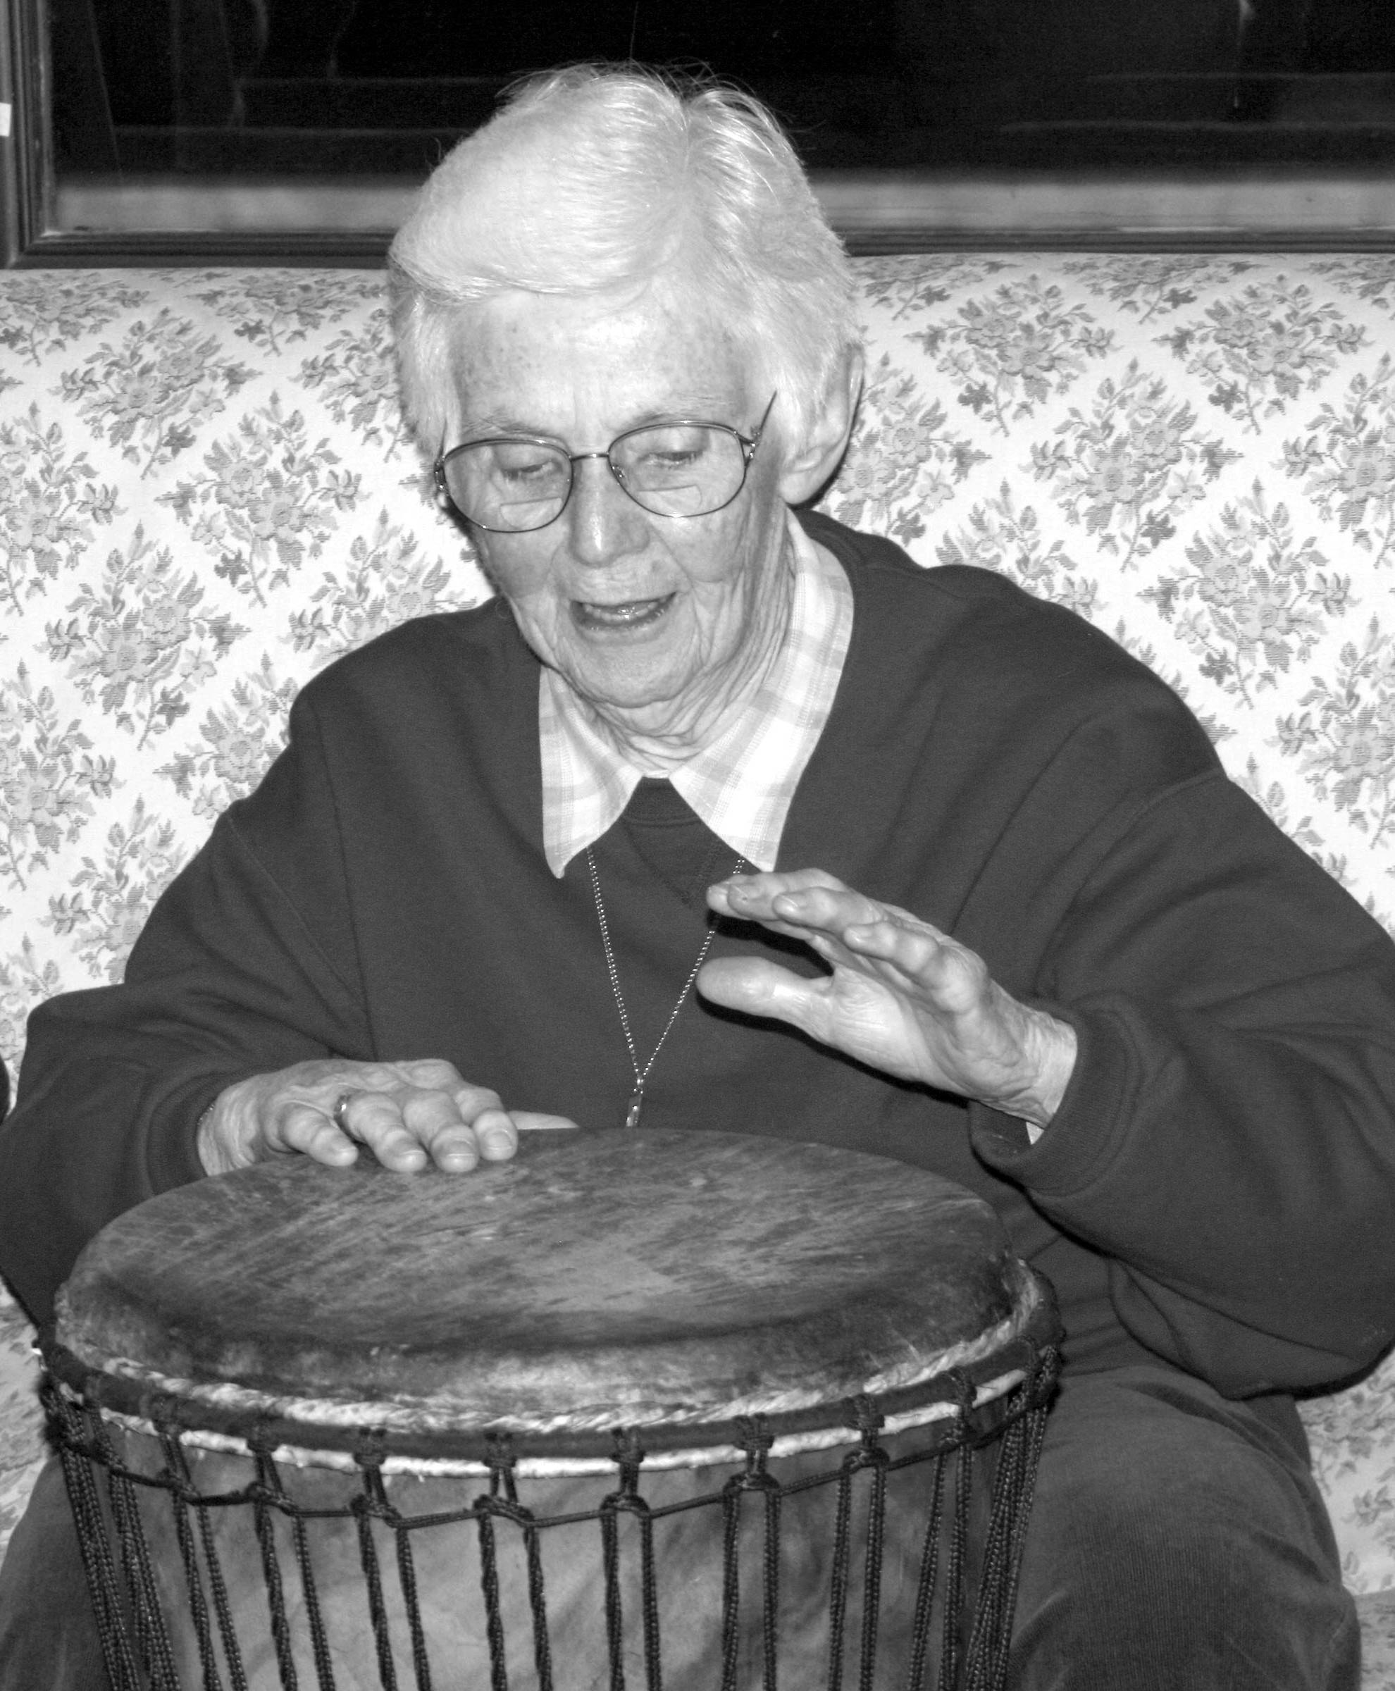
Marie Duffy ‘63 October 3rd Shrewsbury, MA
Mary on Retreat with FC @ Watch Hill
Just some thoughts about a woman who will never be forgotten:
Sister Edmund Damien rocked my world. She promised that she would and she did. She set the bar for courage. She incited revolution without raising her fists or her voice, without demonizing or idolizing. She urged us to abandon mindlessness and return to setting our own course - then showed us how to do it. She lived by the faith that light will prevail - and so it will. I am so grateful to have known her. Marie Duffy
Bobbi Collins Degnan Atz October 4th
It's nearly fifty years since I have seen Mary, and the sparkle in her kind eyes is still with me. What a kind, generous, and understanding heart. Love to you all, Bobbi
Clare Dowling ’64 October 4th East Marion, New York
Mary sometimes tried to stay awake as she so often was up to the wee hours listening to our complaints and questions. I loved her even as she dozed while I longed for clarity as a novice! She is a pure loving spirit who I loved being near. Peace

Eleanor Keeney, MM ’48 d. 11/29/2013
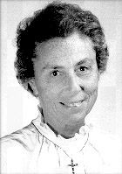
[Ed. Note: The following was written by Sr. Eleanor Keeney and read at her funeral Mass by Sr. Janice McLaughlin, MM., Community President. It has been edited for the FCNL.]
I was born on 3/16/1923, in West Hoboken, NJ. My father died when I was nine months old. My mother remarried when I was about five years old. The family moved to Brooklyn, NY when my sister and I were quite young.
I graduated from Jersey City Medical Center Nursing School in 1945, after which I held various nursing positions for three years. During this time, I was feeling more drawn to religious life and seeking spiritual direction.
During a retreat, I received a prayer partner, an SVD Father who was imprisoned in China, and I began a correspondence with him. In 1947, I went to St. Louis to meet him. It was at this time that he planted the seed for a missionary vocation suggesting the Maryknoll Sisters whom he had met and admired in their ministry in China with Bishop Ford.
On 9/4/1948, I entered Maryknoll at the Venard in Scranton, PA and I came to the Center in late February 1949 to enter the novitiate. I was Professed on 3/7/1951 and assigned to Sri Lanka (Kandy, Ceylon). I made my Final Vows in Ceylon on 3/3/1954.
I held various nursing positions in a 1200 bed general government hospital. In 1958, there was a change of government, which eventually forced the Maryknoll Sisters to leave that beautiful island and the people we had grown to love. We established a small nursing home and clinic for the Bishop, which we turned over to Sinhalese Sisters. We left the Island in 1961 to return to Maryknoll, NY, where I worked as a nurse at the Center for five years.

In 1967, I was assigned to Thailand with Sr. Theresa Grondin, a former China missioner. In the Northeast of Thailand during the Vietnam War, I did mobile medical work with the assistance of the U.S. Air Force. It was a two-year contract with the Bishop during which time Sr. Therese and I visited the Buddhist Monastery where she was asked to teach Christianity to the monks, and I was asked to attend to their health needs. It was a wonderful experience of dialogue. In 1969, I returned to the Center where I was assigned to care for our sick Sisters at Bethany. During this time, my mother died.
In 1971, I began to pursue a Nursing Degree in Education at the University of Connecticut and graduated Summa Cum Laude in 1975. In order to develop my skills in Public Health Nursing while also being able to visit my ailing stepfather, I worked as a Visiting Nurse in Yonkers, NY. There I developed lasting friendships with patients and their families. My stepfather died in 1980 and I then took up a position in Monrovia, CA to care for our retired Sisters.
I received an assignment to Zimbabwe in September 1982 with Theresa Mangieri, who became my good friend and faithful companion. This was soon after the war of Independence when Rhodesia became Zimbabwe. Theresa became a secondary school teacher and I the Director of Nurses in a 75-bed mission hospital.
It was during this time that AIDS became a serious problem and I helped found a Non-profit AIDS Program where I started a Home Care Program to train the local village workers in basic nursing skills. They went into homes to assist the primary care giver to do home nursing. I also did AIDS education in the parishes, schools and with the local parish priests. In 1994, I began training an African to replace me as the program was doing well and in 1995, I left Zimbabwe to return to Maryknoll.
I worked at the mail desk until Theresa Mangieri, Marilyn Ingraham and I took up ministry in North Carolina, Fr. Frederick Price’s home mission territory. We found North Carolina still mission territory in a State that had only three percent Catholic population. We hoped that in some small way we might be able, by our example, to spread the Gospel of love.
After 12 years in North Carolina, we reviewed our ministries. Although it was difficult to leave North Carolina, I knew that at 87 years of age, it was time to return home. We were warmly welcomed and we were happy to spend our twilight days where it had all begun many years ago. I now chose as my prayer ministry, the needs of the United States of America.
With St. Paul I say, “I have fought the good fight, I have finished the course…” and I am grateful to Maryknoll, my family, my friends and my caretakers who have all made it possible for me to realize God’s plan in my life. Condolences may be sent to Sr. Eleanor’s niece: Ms. Maureen Murray, 15 Bailey Road, Millburn, NJ 07041-2009.

Joan Campbell, MM, ’47 (Jeanne d’ Arc) d. 12/12/2013
Joan Anne Campbell was born on 5/7/1927 in Atlantic City, NJ. Her parents and seven siblings have all predeceased her. After graduating from High School in 1944, Joan was employed first as an assistant bacteriologist at Franklin Sugar Company, and later as an assistant pharmacist at Misericordia Hospital, both in Philadelphia.
Joan entered Maryknoll on 10/30/1947 in the first group at the new novitiate in Valley Park, MO. At her Reception she received the religious name Sr. Jeanne d’ Arc, made her First
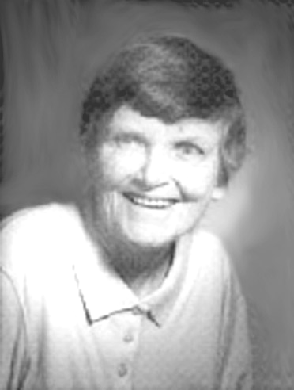
Profession of Vows on 5/8/1950 at Valley Park, and her Final Profession on the same date in 1953 at the Maryknoll, NY. After graduating from Fordham University in 1954 with a BS in Pharmacy, Sr. Joan was assigned to work at Queen of the World Hospital located in Kansas, MO. She studied mathematics at Villanova University in 1967, and theology at Maryknoll Seminary from 1974-1975.
In 1957, Sr. Joan, missioned to Tanganyika, now Tanzania, was assigned to teach Science and Mathematics at Marian College in Morogoro, a newly opened secondary school. The education of girls was a great need at the time. From the moment she first entered a classroom she loved teaching. According to Sr. Rachel Kunkler, her success as a teacher was due in great measure to the fact that Joan enabled others with a seemingly effortless support and belief in them. “Her belief in others made things happen.”
In 1961, Sr. Joan was assigned to open and serve as Headmistress in the Isango Girls Upper Primary in Musoma. In 1964, she turned over the administration to an African Sister. From Isango she returned to Marian College for a short time and then was asked to open a new secondary school for African Sisters in Kurasini, Dar es Salaam. Because the Sisters were older when finishing their religious training, it was difficult for them to continue their education in government schools.
Sr. Joan was gifted with an incredible mind, and a strong loving heart. She was also humble. Her friend Sr. Phyllis Hilbert, SSJ, with whom Sr. Joan lived and worked in Arusha, remarked, “She did not need to be recognized for her achievements or for her incredible mind.” She added: “She walked through life as a delightful observer, entering in [where] invited.”
Following a year of Promotion work in the US, Sr. Joan returned to Tanzania and taught religious education at the Arusha Diocesan Seminary from 1972-76.
She was assigned to Bolivia from 1977-1981. After learning Spanish, she did pastoral work in a parish in Cochabamba. Although very grateful for her time in Bolivia, Sr. Joan realized that her heart was in Africa. She returned to Tanzania in 1982 where, for the first time in Tanzania, she used her pharmaceutical training. She spent two years in a hospital in Makiungu in the Singida Diocese where, with Sr. Katherine Taepke she did medical safaris.
Her next assignment was back to the Arusha Diocese where she began a religious education program for teachers. By 1991 she knew the teachers were ready and she turned the program over to them.
Sr. Joan participated in the Tanzania Regional Government and was a Delegate to the Special Chapter of Affairs in 1968-69. She always responded willingly to any assignment she was given. When she returned to Maryknoll to stay, she left many friends and hundreds of students grateful for all she taught them, in and out the classroom. Back at Maryknoll in 1992, Sister Joan continued to be of service. She volunteered in various Congregational Services offices.
Sr. Joan’s keen mind enabled her to converse on almost any topic. Her friend Sr. Phyllis summed it up this way. “She could see the underlying issues and, when asked, would advise with the wisdom of Solomon. She was a mystery and was so beyond my limited interests and knowledge. She knew every aspect of history, politics, and almost any other topic worth knowing.”
She was an avid reader and when her eyes failed, she used “her ears to continue learning.” In 2012, her declining health necessitated a move to Maryknoll Sisters Home Care III where she remained until her death.
Upon hearing of Joan’s death, Sr. Rachel Kunkler, her close friend of 48 years, wrote: “Joan was a total gift to us in Tanzania, to Africa, to the Congregation. I always wish and pray that our new sisters anywhere in mission will have a Maryknoll Sister who is so imbued with the culture, the politics, the social issues and the love and respect of the local people, like I had in Joan.” Condolences may be sent to: Ms. Patricia Giardinelli, 220 Highland Ave, Media, PA 19063-5733. Sr. Catherine Erisman, M.M., Community Member.

KATERI’S CORNER
This is material received from Bob McEvoy, brother of Ginny McEvoy ‘61
- When you are writing checks to pay on your credit card accounts, do not put the complete account number on the "For" line. Instead, just put the last four numbers. The credit card company knows the rest of the number, and anyone who might be handling your check as it passes through all the check processing channels won't have access to it.
- Put your work phone # on your checks instead of your home phone. If you have a PO Box, use that instead of your home address. If you do not have a PO Box, use your work address.
- Never have your SS# printed on your checks. You can add it, if necessary. But if you have it printed, anyone can get it.
- Place the contents of your wallet on a photocopy machine. Do both sides of each license, credit card, etc. You will know what you had in your wallet and all of the account numbers and phone numbers to call and cancel. Keep the photocopy in a safe place.
- Carry a photocopy of your passport when you travel.
- We've all heard horror stories about fraud that's committed on us in stealing a name, address, Social Security number, credit cards. In one case, within a week of a wallet being stolen, the thieve(s) ordered an expensive monthly cell phone package, applied for a VISA credit card, had a credit line approved to buy a Gateway computer, received a PIN number from the DMV to change the driving record information online, and more. But here's some critical information to limit the damage in case this happens to you or someone you know:
  - Cancel your credit cards immediately. But the key is having the toll free numbers and your card numbers handy so you know whom to call. Keep them where you can find them.
  - File a police report immediately in the jurisdiction where your credit cards, were stolen. This proves to credit providers you were diligent & this is a first step toward an investigation (if there is one). Here's what is perhaps most important:
  - Call the 3 national credit reporting organizations immediately to place a fraud alert on your name & call the Social Security fraud line. The alert means any company that checks your credit knows your information was stolen, and they have to contact you by phone to authorize new credit. Doing this can stop thieves dead in their tracks. Now, here are the numbers you always need to contact when your wallet etc., has been stolen
1.) Equifax: 1-800-525-6285
2.) Experian (formerly TRW): 1-888-397-3742
3.) Trans Union: 1-800-680-7289
4.) Social Security Admin. (Fraud line): 1-800-269-0271
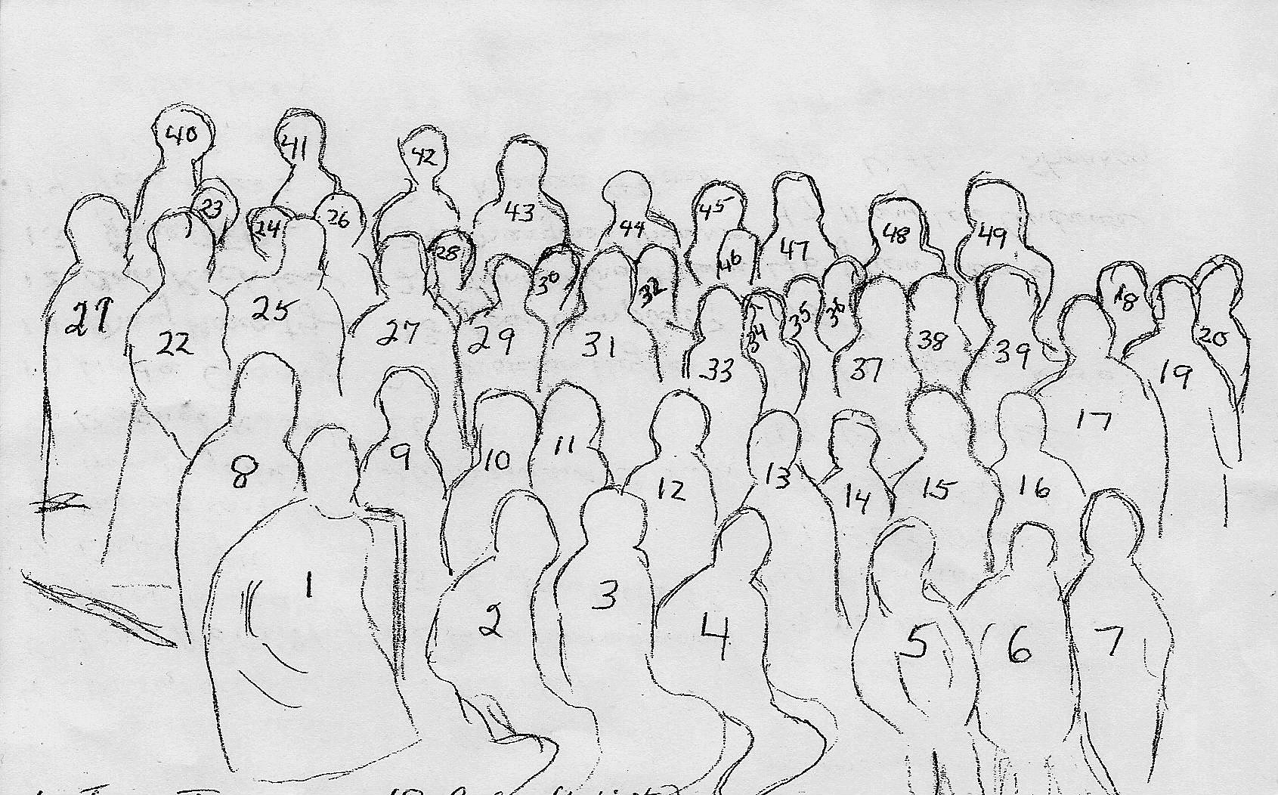
Outline of picture on pg 3 - Mwanza Tanzania Regional Mtg 1969?

1 Jane Tully 2 Katie Erisman 3 Marian Puszca 4 Claudette LaVerdiere 5 Denise McCarthy 6 Ann Klaus 7 Lucy Yu
8 Frances Rossi (from Nigeria) 9 Rachel Kunkler 10 Linda Chavez 11 Mary Moriarty 12 Ann Richter 13 Jane Toth 14 Vera Krass 15 Noel Doescher 16 Jo Lucker 17 Jennie Guastella 18 Julia Kubista 19 ? Mersenger (CGB) 20 Pat Gallogly
21 Pat Hafey 22 James Florence Blanchard 23 Jane Villa (??) 24 ?? 25 Margaret O'Brien 26 ?? 27 Marion Hughes 28 Joan Campbell (??) 29 Connie Krautkramer 30 Margaret Monroe 31 Nunda SrPierre 32 Muriel Vollmer 33 Janet Srebalus 34 Joan Kirsch 35 ? 36 Margaret Good 37 Liz Gormley 38 Miriam Therese Lang 39 Jacquie Dorr
40 Bernadette Meyer 41 Gert Maley 42 Mary Salat 43 Katie Taepke 44 Margaret Rose 45 ?? 46 Juan Maria 47 Mary Lou Andrews 48 Kathryn Shannon 49 Noreen McCarthy
MARYKNOLL MISSION INSTITUTE

Program Plan for 2014

The Mission Institute will offer the following programs during 2014. Write for an application form. (Maryknoll Mission Institute, # 529, Maryknoll, NY 10545-0311, tel. 914-941-7575 @ 5671 or e-mail us at missinst@mksisters.org).

May 11-16 Fear, Faith, Risk and Trust: Larry Lewis, MM
(Sun. - Fri.) The Paschal Mystery in Film

May 18-23 On Being Sacramental People: Barbara Fiand, SNDdeN
(Sun. - Fri.) Embracing the Sacredness of Life

June 1-6 Women Mystics: Drinking from the Well Janet Ruffing, RSM
(Sun. - Fri.) of Women’s Spiritual Tradition

June 8-13 Compassion: Witness to Love Antoinette (Nonie) Gutzler, MM
(Sun. – Fri.)

June 15-20 Responding to the World Around Us: Maria Cimperman, RSCJ
(Sun. - Fri.) Spirituality & Social Analysis for the 21st Century

June 22-27 Reading the Signs of the Times: Joe Holland, Ph.D.
(Sun. - Fri.) Society and Church at the End of the Modern World

July 6-11 Searching for an Evolutionary Spirituality Ursula King, Ph.D.
(Sun. - Fri.) and a New Mysticism: Dialogue with Teilhard de Chardin

July 13-18 ‘Let’s Get Real’: Finding and Following Margaret Silf, MA
(Sun. - Fri.) God in Our Everyday Lives

July 20-25 Resting on the Future: The Search for John F. Haught, Ph.D.
(Sun. - Fri.) God in an Unfinished Universe

Los Altos, CA
Sept. 17-20 The Enduring Power of God’s Call Diarmuid O'Murchu, MSC
(Wed – Sat.)

Monrovia, CA
Sept. 21-26 Women’s Truth in Gospel Wisdom: Diarmuid O'Murchu, MSC
(Sun. - Fri.) Exploring Female Discipleship

Application forms & program descriptions may be found on our Website: http://www.maryknollsisters.org
ONLINE REGISTRATION AVAILABLE

SAVE THE DATE

April 26, 2014

The Mission of God and Postmodern Culture:
The Gift of Uncertainty

John Sivalon, MM

Fr. John Sivalon, MM, author of The Mission of God and Postmodern Culture: The Gift of Uncertainty, will be our presenter this year.
This is the 50th reunion for those who entered in 1964. Please make a special effort to join us! For those who entered in 1989, it is your 25th! A special date for you, too!
We look forward to seeing you there. Additional information and registration information will be available on our website.

We welcome submissions for publication, as well as suggestions for future articles. All submissions are subject to editing for both content and size.

FULL CIRCLE COMMITTEE
Chair Person
Ann Brown Loretan ‘59
11 Belleview Ave, Ossining, NY 10562
aloretan16@gmail.com***
Committee Members
Joan Solly Daly ‘56
Mary Gray D’Arcy ’48
Debbie Kair ‘83
Alice Lachman ‘63
Maryknoll Sisters Liaisons
Sr. Mary Grace Krieger MM ‘’48
Sr. Pat Gallogly, M.M. ’51
Maryknoll Sisters Prayer Liaison
Sr. Mary Lou Andrews, M.M. ’49
Newsletter Columnist
Jerry Hardiman
Rosemary Brady Hardiman ‘63
PO Box 861 Bethany Beach, DE 19930
rbHardiman@aol.com***
Newsletter Editor
Karen Belinger Peterlin ‘58
798 President St, Bklyn, NY 11215
kpeterlin@yahoo.com***
Newsletter Copywriter
Terry Herman Sissons ‘58
Newsletter Lay Out/Photo Editor
Webmaster/Database
Virginia McEvoy ‘61
34A Apollo St, Bklyn, NY 11222
ginny.mcevoy@yahoo.com***
Secretary
Jane Cerruti Dellert ’64
Treasurer
Mef Ford ‘64
195 Harvey St. #5, Cambridge, Ma 02140
drmef@juno.com***

Full Circle Website
http://www.fullcirclemks.org
get password from Ginny McEvoy see address above
***Please indicate “Full Circle” in subject line when emailing, as unidentified email will not be opened due to virus/scam possibilities. Thanks

Full Circle Newsletter Subscription for 2014

That time of the year again! The Newsletter subscription is listed below. It is for the February, June and October Newsletter for the year 2014. The monies raised by the Newsletter subscriptions ($30/yr) pay not only for the Newsletter but for Website and Reunion Expenses as well. Overage provides a donation to both the Sisters and to the Chi-Rho Fund. For this reason, we are requesting these monies, even if you receive the Newsletter electronically. Please be assured that the subscription rate to the Newsletter is a suggested one. If it presents a hardship for you, we are most happy to send it to you, at a reduced rate or free of cost. No problemas. For any Maryknoll Sister or Lay Missioner, the subscription is always free. Please fill out the form below so we will have any changes to your address (foreign addresses are fine).
Thanks. Karen Belinger Peterlin ’58, Editor


I am enclosing $30.00 for my subscription to the Full Circle Newsletter for 2014.

Name: ________________________________________________________

Religious Name: _________________________________________________

Year of Entrance: ___________ Phone:_______________________________

Address: ______________________________________________________
_____________________________________________________________
City __________________________________________________________
State _______________________________ Zip______________________

Email Address: PLEASE FILL THIS OUT - Email addresses are always changing so if you have one please give it to us even if you think we may have it.
Email Address: __________________________________________________

Please make check out to Full Circle and send to:
Mary Elizabeth Ford
195 Harvey St. #5, Cambridge, Ma 02140

MARYKNOLL SISTERS/FULL CIRCLE
PO BOX 311
Nonprofit Org.
U. S. Postage

PAID
Maryknoll, NY
PERMIT No. 2
Nonprofit Org.
U. S. Postage

PAID
Maryknoll, NY
PERMIT No. 2
MARYKNOLL, N. Y. 10545-0311

