FIRE EVACUATION PLAN

FOR

NANYANG AUDITORIUM

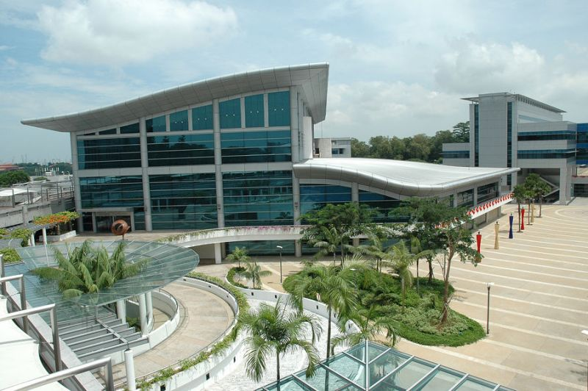

Rev: 0
Date: June 2010

FIRE EVACUATION PLAN

NANYANG AUDITORIUM
NANYANG TECHNOLOGICAL UNIVERSITY

50 NANYANG AVENUE
SINGAPORE 639798

Prepared by:

Fire Safety Manager
Nanyang Technological University
c/o Kim Yew Electrical & Sanitary Pte Ltd
CONTENTS |  | PAGE
A | GUIDELINES FOR EVENT ORGANISER | 4
A1 | ACTIONS TO BE TAKEN IN THE EVENT OF EMERGENCY | 4
A2 | ROLES AND RESPONSIBILITIES | 6
B | FIRE EVACUATION PROCEDURE | 7

APPENDICES
Appendix I | NANYANG AUDITORIUM SITE AND FLOOR PLAN
Appendix II | DEPLOYMENT AND POSITION OF FIRE WARDEN
Appendix III | STANDARD ANNOUNCEMENT FOR EVACUATION
Appendix IV | NANYANG AUDITORIUM EVENT FORM
A. GUIDELINES FOR EVENT ORGANISER

- The evacuation exits of the venue to be projected on the screen before the event’s commencement. (See Appendix I).

- The Event Organiser shall assign a team of Fire Warden to perform the evacuation task. The number of Fire Wardens assigned shall be determined by the Event Organiser depending on the location and number of people involved during the event.
Appendix II shall only be use as a guideline but shall not be limited when assigning the Fire Warden.

- All Fire Wardens shall be equipped with torch lights and safety vest / cap for easy identification. All safety vests / caps and torch lights shall be provided by the Event Organiser.

- Fire Wardens shall be stationed around the Auditorium and positioned near the exit doors.
Refer to Appendix II for the Auditorium’s seating position.

- The University’s FSM (uFSM) will conduct a briefing and site walk to all personnel involved.

A1. ACTIONS TO BE TAKEN IN THE EVENT OF EMERGENCY

- The following highlights the actions that shall be taken in the event of an emergency.

  - To know how to report a fire - sound the alarm without delay.

- Raise the alarm by breaking the nearest fire alarm manual call point.
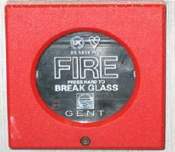

- Call 6790 4777 (NTU FRC).
- To confirm location of fire or when sighting one.

  - To know what to do in the event of a fire - avoid panic and confusion.

- Stay calm and do not panic.
- Be prepared for evacuation.
- Do not use the lifts when evacuating.
- Take instructions from the uFSM.

  - To know the locations of nearby fire extinguishers and hosereels.

- Attempt to extinguish any incipient fire without taking personal risk. If not able to do so, leave the area immediately.

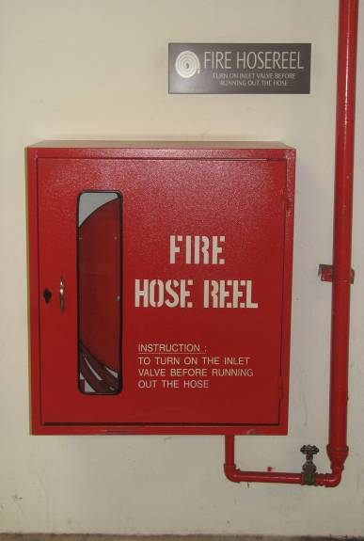
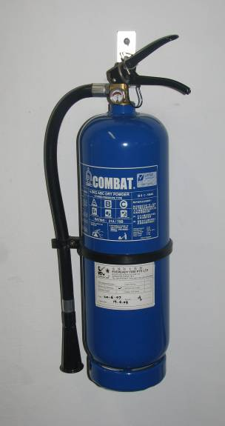

  - To know the means of escape routes from the first exit door till the discharge exit door.

- To facilitate orderly evacuation.
- Use torchlight in dark areas or during evacuation.

A2. ROLES AND RESPONSIBILITIES

  - Assign Fire Wardens for the event.

  - Ensure Fire Evacuation Plan is being briefed by the University’s Fire Safety Manager.

  - Fill in particulars in Nanyang Auditorium Event Form (Appendix II) before each event and submit to uFSM.

  - Know all the locations of Fire Exit Doors and the Fire Escape route.

  - Ensure all exit doors are unlocked and not blocked during the entire event.

  - All fire escape routes to be unblocked at all times.

  - All exit doors’ curtains shall be pulled aside in the event of an emergency or evacuation.

  - Ensure additional fire extinguishers are provided if events are being held outdoor or whenever additional generators are used.

  - Where pyrotechnics are involved, the Event Organiser must submit the approved permit from the relevant Authorities. All necessary risk assessments shall be submitted to OFPM for approval. The Organizer shall take all necessary control measures.

B. FIRE EVACUATION PROCEDURE

- In the event of a real fire, the fire alarm signal will trigger off the alarm bells of the whole building (including the Auditorium).

- Where evacuation is required, the signals to commence evacuation are as follows:

- Announcement for evacuation will be made over by Auditorium AV system in the Control Room, or
- Fire alarm bells will ring continuously.
- Flashing lights above doors will flash.

- Proceed the evacuation of all personnel upon receiving instruction to evacuate.

  - For the Auditorium Area, Fire Wardens are to ensure all curtains are drawn open and all exit doors to be fully opened.

  - All VIPs are to be evacuated first using the Exit Door near to seat number A1 and B45 in the Stall Seats area. (Refer to Appendix I)

  - All occupants are to evacuate in an orderly manner guided by the ushers / fire wardens to the nearest exit. (Refer to Appendix I for escape route)

  - Fire Wardens are to ensure that nobody is left behind before leaving.

  - All Fire Wardens are to report to the Event Organiser of the Evacuation status. Event Organiser will then report to uFSM of the status.

- All occupants / guests should not re-enter the building unless instructed otherwise by SCDF.

Appendix I

NANYANG AUDITORIUM SITE & FLOOR PLAN

DESCRIPTION | Page
(A) Nanyang Auditorium Site Plan | 9
(B) Basement 1 Floor Plan | 10
(C) 1st Storey Floor Plan | 11
(D) 2nd Storey Floor Plan | 12
(E) 3rd Storey Floor Plan | 13

Appendix I- (A) Nanyang Auditorium Site Plan
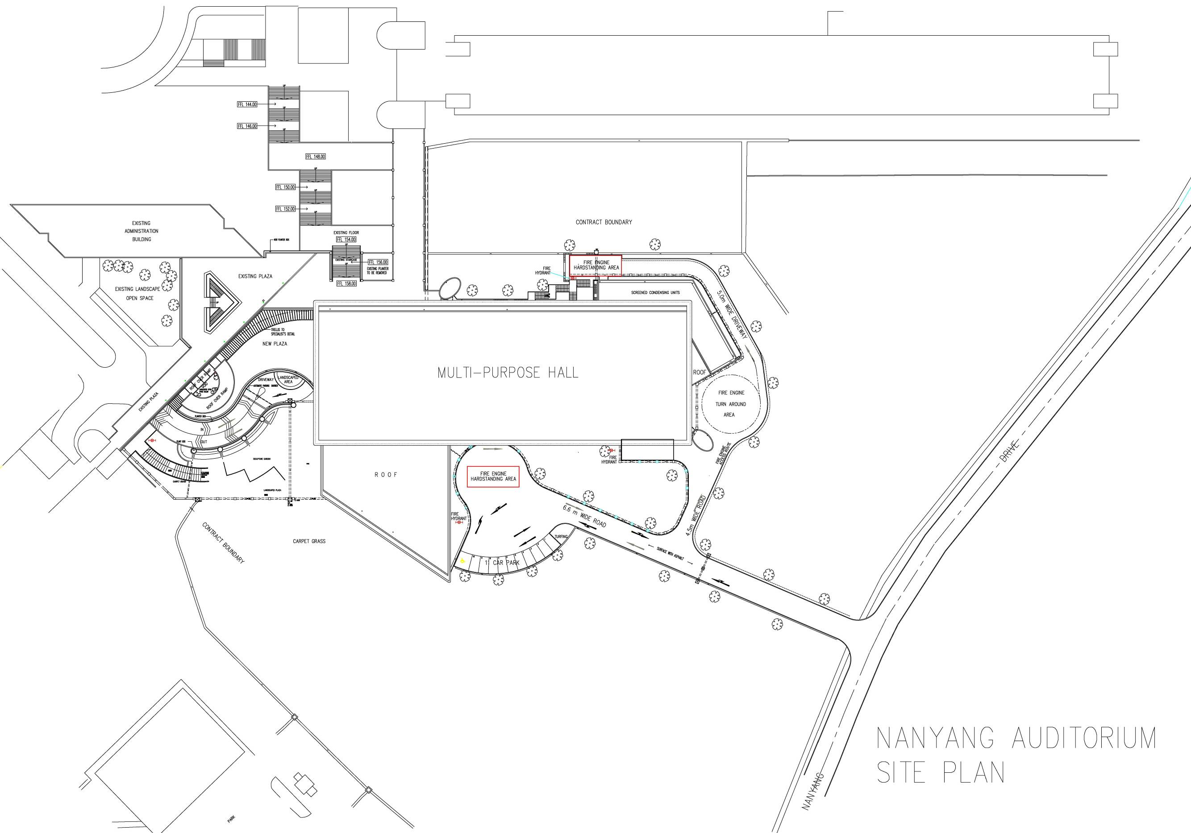

Appendix I- (B) Basement 1 Floor Plan Plan
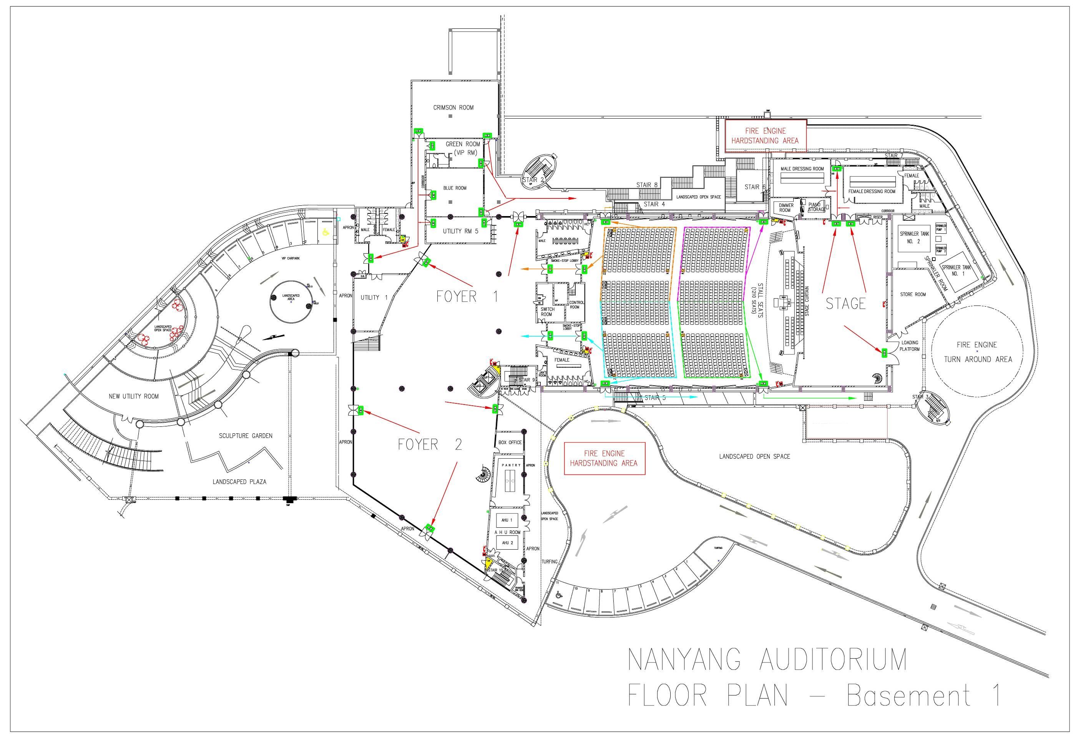

Appendix I- (C) 1st Storey Floor Plan Plan

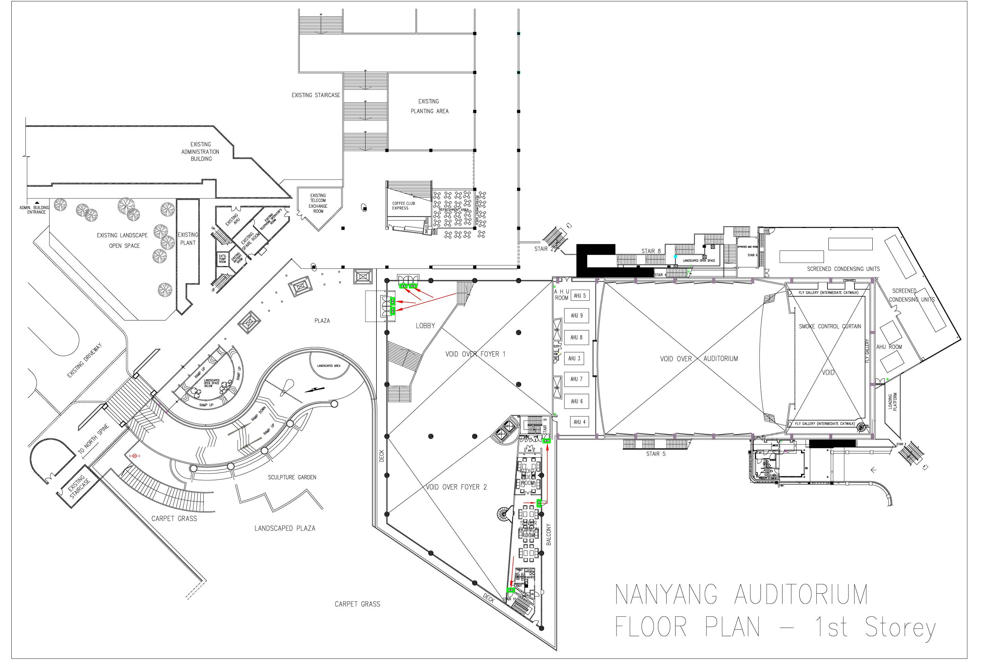

Appendix I- (D) 2nd Storey Floor Plan Plan

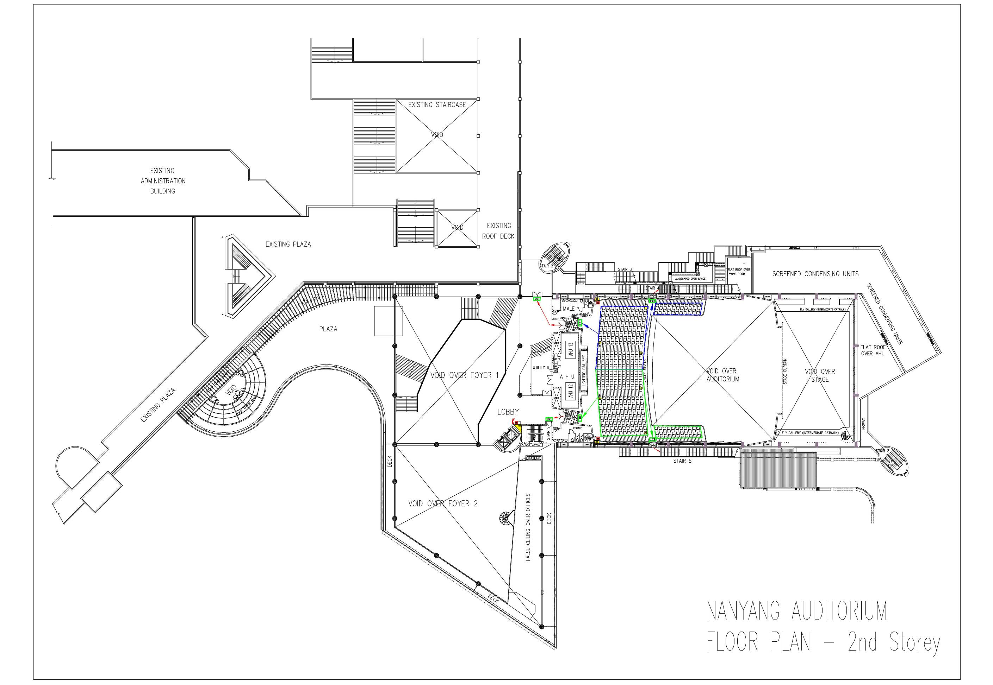

Appendix I- (E) 3rd Storey Floor Plan Plan

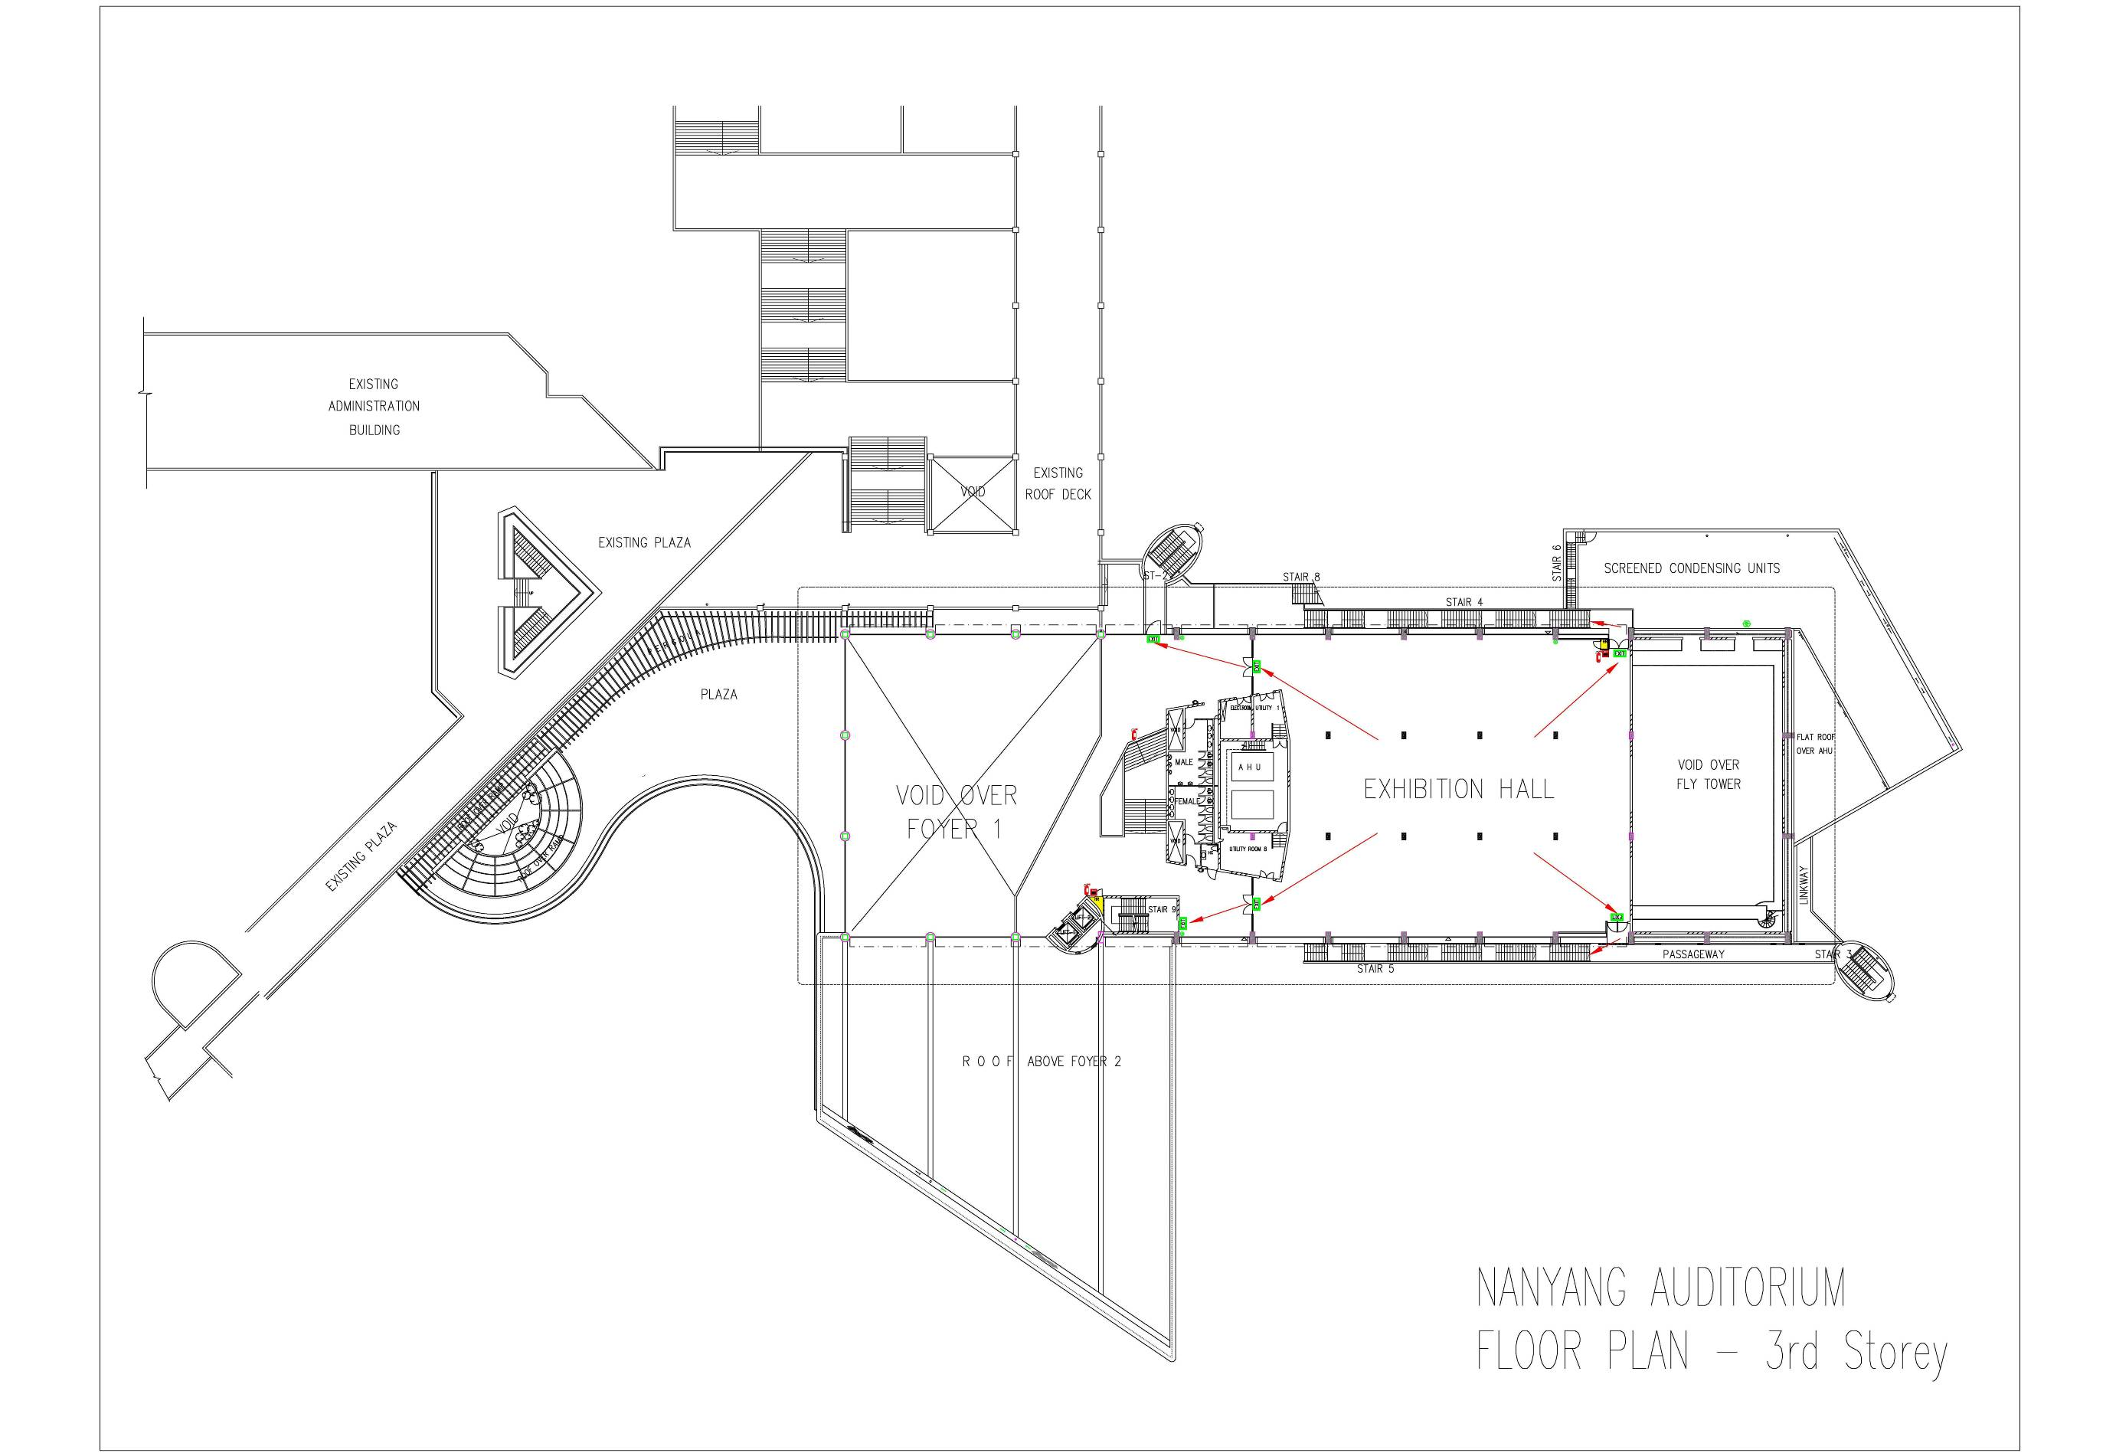

Appendix II

DEPLOYMENT OF FIRE WARDENS

LOCATION | Fire Exit Door | Combing of area | VIP area | Remarks
Nanyang Auditorium Stall Seats area | 6 Fire Wardens | 4 Fire Wardens | 2 Fire Wardens | Priority to be given to VIP to exit first.
Nanyang Auditorium Circle Seats area | 4 Fire Wardens | 2 Fire Wardens
Stage Area (Front and back) | 3 Fire Wardens | 3 Fire Wardens | 1 Fire Warden if VIP is on stage | 1 at front stage,  2 at behind stage.
Foyer Area | 5 Fire Wardens | 4 Fire Wardens
Exhibition Hall | 4 Fire Wardens | 4 Fire Wardens
Male & Female Dressing Room | 1 Fire Warden | 1 Fire Warden
Blue, Green & Crimson Room | 1 Fire Warden | 1 Fire Warden

Note: The above is only for guideline. The Event Organiser shall determine the manpower requirement based on type of event and attendants.

POSITION OF FIRE WARDENS

LOCATION | Fire Exit Door | Seat Position | Combing of area | Seat Position
Nanyang Auditorium Stall Seats area | 6 Fire Wardens | A1, B45, Z1, Z12, ZZ22 & Z45 | 4 Fire Wardens | M15, N15, M31 & N31
Nanyang Auditorium Circle Seats area | 4 Fire Wardens | LL1, LL45, W15 & W31 | 2 Fire Wardens | LL16 & LL30
Stage Area  (Front and back) | 3 Fire Wardens | Behind Stage | 3 Fire Wardens | Behind Stage
Foyer Area | 5 Fire Wardens | To be decided by Event Organiser | 4 Fire Wardens | To be decided by Event Organiser
Exhibition Hall | 4 Fire Wardens | To be decided by Event Organiser | 4 Fire Wardens | To be decided by Event Organiser
Male & Female Dressing Room | 1 Fire Warden | To be decided by Event Organiser | 1 Fire Warden | To be decided by Event Organiser
Blue, Green & Crimson Room | 1 Fire Warden | To be decided by Event Organiser | 1 Fire Warden | To be decided by Event Organiser

Appendix III

STANDARD ANNOUNCEMENT FOR EVACUATION

(To announce via AV System inside the Control Room when an emergency occurs)

"LADIES AND GENTLEMEN, YOUR ATTENTION PLEASE.
THERE EXIST AN EMERGENCY SITUATION IN THIS BUILDING.
WILL ALL OCCUPANTS PLEASE EVACUATE NOW, USING THE NEAREST STAIRCASE AND EXIT DOOR AS SHOWN BY THE FIRE WARDENS.
DO NOT USE LIFTS."

Appendix IV
EVENT FORM

(This form is to be filled in by the Event Organiser and submitted to NTU FSM at least 3 days prior to each event)

Company’s Name:

Name of Event Organiser: |  |  | Contact:
Name of Asst EO: |  |  | Contact:
Type of event:
Date of event:

Time Duration:

Location of event to be held: | Auditorium / Foyer / Exhibition Hall /  Outdoor / Others
Any mobile generator: | YES / NO
Number of Fire Extinguishers supplied:
Any pyrotechnics involved and the approved permit submitted | YES / NO
Any Smoke Generator involved | YES / NO
No. of Fire Wardens: | Auditorium( )Foyer( )  Exhibition Hall ( ) | Outdoor ( )  Others ( )

Checklist prior to event

1 | Briefed by NTU FSM on Fire Evacuation Plan.

________________________________________  Name & Signature of Event Organiser | _____________________  Student Matrix Number

