Carl-von-Linde-Gymnasium Kempten Kollegstufenjahrgang 2005/07

Facharbeit
im Leistungskursfach

Englisch

Electronic Sports – From Gaming in the Basement to Global Competitions

Verfasser: Maximilian Schaaf
Leistungskurs: Englisch
Kursleiterin: Claudia Sauermann
Abgabetermin: 26. Januar 2007
Erzielte Note: _____________ in Worten: ___________________
Erzielte Punkte: _____________ in Worten: ___________________

___________________________
Unterschrift der Kursleiterin

I. Definition and introduction

II. The Evolution of Electronic Sports p. 3
1. History p. 3
a) The breeding ground
b) The roots
c) The boom

2. The prototype of an eSports game: Counter-Strike p. 6

3. Typical organizations and examples p. 8
a) Clans - mousesports
b) Leagues – Electronic Sports League
c) Tournaments – Cyberathlete Professional League

4. The business p. 14
a) eSports as job-generator
b) Professional players
c) eSports as advertising space

5. Negative aspects of electronic sports p. 17
a) Spending time in the virtual world
a) Criticism from the outside: The "killer games" debate

6. The subculture p. 20
a) eSports fandom and premium services
b) Amateur players

III. Conclusion and forecast p. 23

IV. Bibliography, Internet Sources and Table of Figures p. 25

The purpose of this paper is to provide people from outside the video gaming community with a detailed insight into eSports. On the following pages, the reader will receive information about what eSport is, what typical structures it is composed of and what role eSports may play in the future as a subculture for people from all over the world.

I. Definition & Introduction

According to the German eSports-Bund (esb), eSports is an abbreviation for Electronic Sports. Electronic Sports is the term for playing computer games in a professional and competitive environment against other human players or teams. The self-understanding of eSports follows the classic definition of sports: Physical and intellectual skills are necessary to succeed, the most-needed skills in eSports being hand-eye-coordination, reaction rate and tactical understanding of the game. Readers may mistake eSports for simple computer gaming, but the main difference between those two kinds, although both include playing games on a computer, is the absence of the competitive aspect at normal computer gaming. Electronic Sports necessarily requires that two or more players compete for a rank, a title, prize money or just for the sake of winning. In the following, this paper will explain and analyze the structures of electronic sports, including a typical example for each type of organizations. The next step is to have a look at the business that has been created by electronic sports: Jobs and a new advertising market. Some critical aspects of electronic sports and computer gaming will be examined before looking at the role of eSports as a new subculture for fans and players from all over the world.

II. The Evolution of Electronic Sports

1. History

a) The breeding ground

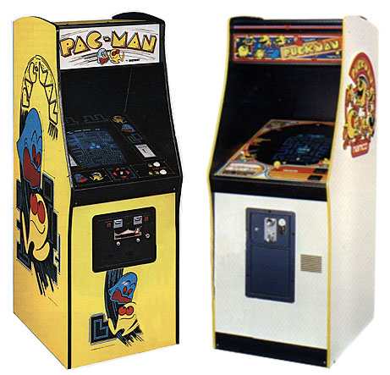
The roots of competing in video games reach back into the eighties of the twentieth century when players in arcade game halls started having tournaments, using the high-score tables provided by the arcade machines. With the breakthrough of personal computers featuring more advanced graphical user interfaces than the ones available in the late eighties, the video gaming market shifted to focussing on computers and consoles (e.g. Nintendo Entertainment System). More and more games were published and lots of them contained some form of ranking system which allowed players to compare their ability in the respective game. With the further development of computer hardware and software, the first games featuring multiplayer modes were brought to the market, enabling players not only to compare their skills, but to compete simultaneously. At the beginning, the players had to be at the same place and to network their computers. All those phases were important for the beginnings of the idea of competing in video games, but the ultimate boost for electronic sports was without a doubt the invention and the spreading of the internet. For the first time, players did not physically have to be in the same place to conduct a match and to compare their skills to other players'.
Figure 1: Arcade-game machines

b) The roots

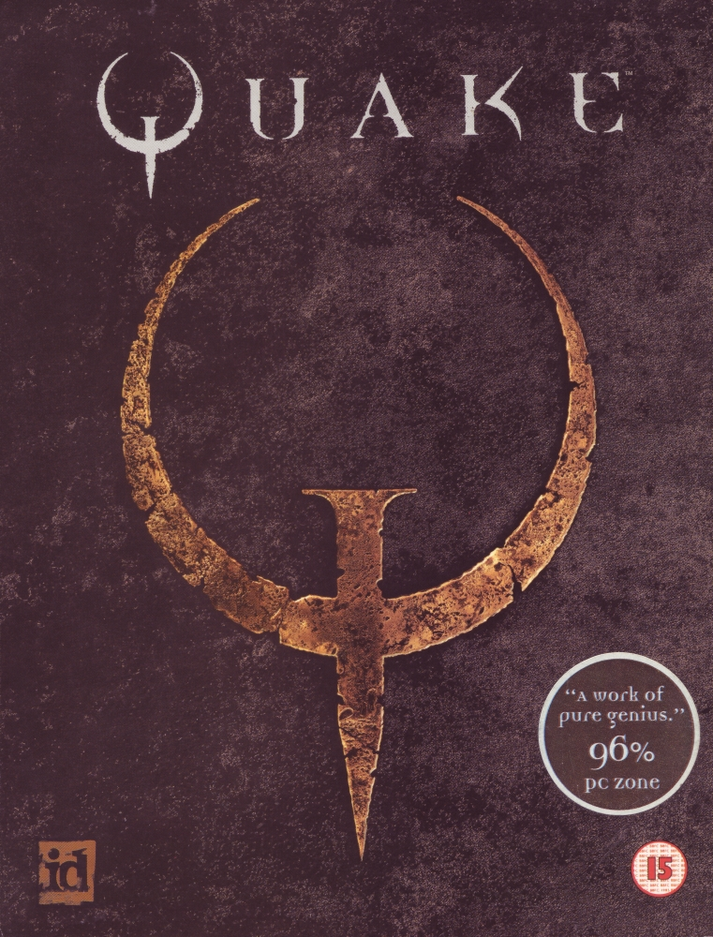
The growing number of games with multiplayer modes and the increasing number of households connected to the internet furthered the idea of competition in video games. The beginning of eSports in today's meaning is marked by 1996 and 1997 when teams competing in a certain game were formed for the first time. The game that sparked this new development was Quake, a first-person shooter with a (for that time) advanced multiplayer mode. The game met such a big interest within the gaming community that the first clans were founded where players competed regularly. Some of the oldest and today most successful clans were founded in this period and still pride themselves on having their roots in this game. Its release is today believed to have been the ignition of a process that has resulted in the evolution from gaming alone in the basement to competing globally at high-profile events.
Figure 2: Quake's original box cover

The next logical step was the creation of a league meeting the demand of the clans who wanted to have a platform to compare their abilities and skills. This demand was satisfied by the foundation of the Deutsche ClanLiga (DeCL), the predecessor of today's most successful eSports league, the Electronic Sports League (see chapter 3b) and other similar structures in countries all over the world. More and more organizations engaged in hosting eSports competitions were founded, not only leagues, but also tournaments. One of the oldest and most notable tournament organizations is the Cyberathlete Professional League (CPL), renowned for their Summer and Winter tournaments which are taking place in Dallas, Texas (see chapter 3c).

c) The boom
The following years saw significant increases in prize money as well as player numbers and turnovers of the teams. A growing number of companies from the IT industry started engaging in electronic sports by sponsoring teams, tournaments and leagues. The clans developed more professional structures and appointed full-time managers. In February 2003, the Swedish clan SK Gaming, one of the most professional and successful gaming organizations today, was the first team to legally bind players to the clan by closing contracts. This was generally seen as a milestone in a scene where virtually everything was based on verbal agreement and trust. This team grew to be the most successful Counter-Strike team ever, having won $157.500 in 2003 alone, setting a world record still not broken. Today, it is very common for clans even on the semi-professional level to have contracts with players. During this period of boom, many then-successful clans did not survive because they failed to establish professional structures and adapt to the demands of a booming environment. The surviving teams are the elite of today, having turned into professionally managed companies. Managers and players started to make enough money in professional gaming to quit their regular jobs and focus entirely on eSports. In this fashion, electronic sports started to be a job creator (see chapter 4a).
In the course of the years, electronic sports grew from a hobby to a professional world with high prize purses, salaries for players and other structures very similar to those of mainstream sports. As gaming and eSports start reaching all genders, classes and nearly all age brackets, companies alien to the IT industry have discovered electronic sports as a viable advertising space (see chapter 4b), but the main part of sponsoring money still comes from companies like Intel or AMD. In 2005, the total amount of prize money distributed at tournaments added up to $5.000.000 which does not include the sponsoring awards given directly to teams and players by companies. The growth rates in eSports are still astonishing and the influx of new people interested in this field is huge. For example, the number of registered members of the Electronic Sports League rose from 510.000 to 620.000 in the past twelve months, constituting a 20% increase. This development is expected to continue in 2007.

2. The prototype of an eSports game: Counter-Strike

Just before the turn of the millennium, the game that should accompany the development of electronic sports for the next decade was released: On June 19th, 1999, Counter-Strike was published. Counter-Strike is a team-based, tactical first-person shooter where your mission is to prevent the terrorist team from planting a bomb (if playing as counter-terrorist) or to plant a bomb and prevent the counter-terrorists from defusing the bomb (if playing as terrorist). In teams of five players each, the players try to fulfil the goal through teamwork and specifically designed tactics. Although Counter-Strike is now almost eight years old, it is still one of the most popular online multiplayer games. This is quite remarkable for the gaming community which is said to be ever-hungry for the latest games and ready to change preferences and favourite games fast.
It was mainly Counter-Strike that furthered the continuing growth of electronic sports. Amateur players founded new teams and took competition in computer gaming to a new level. Counter-Strike was the perfect game for competitive gaming because it requires a balanced combination of individual skills like reaction rate or hand-eye coordination and team skills like tactical overview or communication between the players.
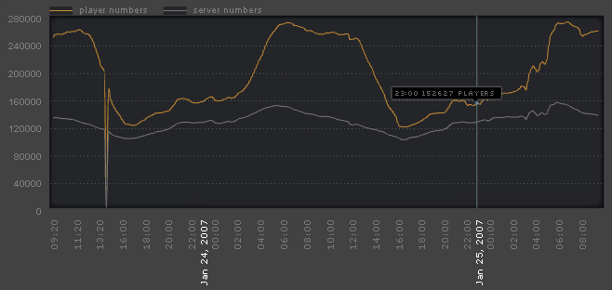
Figure 3: Chart of Counter-Strike player numbers
The figure above displays the current Counter-Strike players all over the world at a certain point of time. The graph shows that it follows a cycle, caused by day and night, but at no point of time are there less than 120.000 single Counter-Strike players online (except for the slump at 13.20 which was caused by technical problems). During peak times, about 260.000 players are online, playing the most successful first-person shooter game of all times.
Counter-Strike still is the game drawing the biggest audiences and featuring the most generous prize purses: At the World Cyber Games 2006, the awards for Counter-Strike totalled to $135.000 in cash and prizes (the winning team receiving $60.000). In 2006, the five major tournaments awarded a combined sum of $745.000 for their Counter-Strike tournaments and $1.535.300 for all tournaments (including Counter-Strike).

3. Typical organisations and examples

It is necessary to have an insight into typical structures and organizations of eSports in order to fully understand the world it has created. You can find a lot of similarities in the structures of other professionally pursued sports, but nonetheless, some special forms remain. For every typical entity, one example is provided.

a) Clans
In eSports, the prevailing structure for teams and players is the so-called "Clan", meaning an association of players and teams under the roof of one management. The term springs from the Gaelic word "clann" which developed into the English word "clan" and describes a "group of people united by kinship and descent". This term has been adopted by online players in the late nineties and is used to describe a group of gamers tied together by some form of structure.

Teams and players choose to play in a clan because all managing and organizing-related issues are taken care of by the management. The management provides support, covers travelling expenses and acquires new sponsors to support the teams. The teams and players can focus on practising. The advantages of this division of labour are at hand: A team or player able to devote his time completely to improving his skills will achieve better results, thereby raising importance and popularity of the clan under which's flag he plays. Increased popularity of a clan enables its managers to acquire new or better sponsors which will most probably result in a higher salary for the teams and players. Typically, a clan hosts teams and players in all important eSports games, but only one player/team per game to avoid clan-internal conflicts. With the basic functions of a clan having been explained, the Berlin-based German clan "mousesports" will serve as a typical example of how a clan works.
mousesports is not a legal body of its own, but a label of the IT company Freaks4U GmbH which has grown to a size of 17 full-time jobs over the past few years. One of the employees of Freaks4U acts as Project Manager for the mousesports label and thereby serves as the head of the clan. The management team consists of the president and vice president of Freaks4U, the project manager for mousesports and the head team manager. mousesports hosts teams for Counter-Strike, FIFA Soccer, Quake 4 and Unreal Tournament and single players for Need for Speed, Warcraft III and Quake 4.

Figure 4: mousesports logo
The management has won companies like BenQ, Levicom and Gigabyte to sponsor the team; all of them come from the hardware industry. They support mousesports with about 30000 EUR per month. While sponsoring is the most important pillar for the financial endowment of a clan, mousesports also receives a certain percentage of the prize money its players and teams earn. The players receive a monthly salary reaching from 150 to 1200 EUR and are obliged to take part in practicing and playing in tournaments and leagues as well as representing the clan to the eSports public by giving interviews and appearing on TV. As one of only a few clans, mousesports has acknowledged that having an active, reliable and skilful editorial department is crucial for success and gaining the attention of eSports enthusiasts. It therefore maintains an 18-heads-strong content management team with editors specialized in certain games and regions. They are supported by several software developers and graphics engineers who take care of the website. Because of the team's latest successes, the international interest in mousesports has grown tremendously, so they provide up-to-date information about the clan and the scene as a whole in both German and English.


Being considered one of the most professional gaming organizations in the world, mousesports has developed into a very successful platform, hosting Germany's most advanced Counter-Strike team and some of the world's finest players in Quake 4 and Warcraft III. The range of action of mousesports is not restricted to Germany: Payroll includes Chinese, American and Australian players as well as Russians, Czechs and Swedes, but the main market is still Germany where especially the Counter-Strike team enjoys tremendous support from a big fanbase, being one of the most successful teams in the world. The team holds the record for the most prize money collected in 2005, having earned a total of $78.000 during the year's tournaments. As of January, the established sports wear manufacturer Kappa, known for sponsoring high-profile athletic teams like the soccer clubs Werder Bremen or Juventus Turin started supporting mousesports, providing their players and fans with sports jerseys and other merchandising clothing.
Figure 5: A mousesports player wearing a Kappa shirt

b) Leagues
The basis for competitions is, just like in real-life sports, leagues and tournaments. In the last decade, a huge variety of leagues and tournaments on national, continental and international level has been created in countries all over the world. Again, the structure itself is hardly different from organizations like Major League Baseball or the Deutsche Fußball Liga, yet their impact on the development from gaming in your basement to global competition has been so important that it is appropriate to have a closer look at the most successful league in Europe: The Electronic Sports League (ESL).

Starting in 1997 as the Deutsche ClanLiga, the ESL and its mother company Turtle Entertainment have grown into a successful business with more than fifty full-time jobs and leadership on the European eSports market. More than 620.000 registered players, most of them from Germany, are the basis of the ESL's success - no other league in Europe features a similarly large number of members. The ESL provides league structures in more than 70 games and satisfies the demands of both amateur and professional players. The backbone of the league is the so-called ladders, leagues everyone can sign-up for with his team or as a single player, depending on the game. For the more advanced players, the ESL features the so-called ESL Amateur Series (EAS) for which a monthly fee of 2 EUR has to be paid. The EAS leagues serve as a kind of second division: At the end of a regular season (which is six months), the best teams and players of an ESL Amateur Series qualify for the ESL Pro Series (EPS) and compete for an overall prize purse of 165.000 EUR per season. Amateur and Pro Series do not exist for all games featured by the ESL, but only for the most popular ones generating the highest public interest. The ESL Pro Series is considered the most prestigious online league in Germany, the winner of the EPS is called German Champion and gains credit for the World Rankings. EPS matches are broadcast via cable TV, internet video streams and in-game TV and yield spectator numbers of up to 10.000 viewers per match. The play-off finals are conducted offline to ensure the equality of the conditions for the players, because the quality of internet connections varies. The Grand Final is followed by up to 3000 eSports enthusiasts who travel to the event location to cheer for their team while another 30.000 people follow the matches via TV and internet.

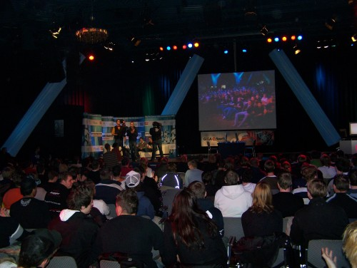
A special series of events organized by the Electronic Sports League is the so-called Intel Friday Night Games (iFNGs). While most of the matches of the ESL Pro Series are played via internet, some selected matches are held at Intel Friday Night Games which are specifically designed to make electronic sports interesting for live audiences. The competing teams and players are invited to the city where the iFNG takes place and play their match locally. Intel Friday Night Games usually attract an audience between 800 and 1000 spectators who can follow the matches on big screens while the players sit in so-called game-rooms to ensure that they are not distracted by the cheers and applause. Side competitions open to all attendants and special exhibitions are provided to make the breaks between the matches more interesting. Members of the eSports press get free admission, a press pass allowing them access to areas restricted to reguar attendants.
Figure 6: Fans at an Intel Friday Night Game

Intel Friday Night Games play a very important role in the overall concept of the ESL. Asked on this topic, the Managing Director of Turtle Entertainment GmbH, the company behind the ESL, Jens Hilgers, said:

"The iFNGs play a big role in our concept because we believe that offline events and the presentation of eSports in an event environment combined with the normal [online] matches of the ESL Pro Series form a sophisticated and well-rounded overall concept. The goal of the Pro Series from the beginning was to have a reasonable balance between online and offline matches. Of course we cannot conduct all Pro Series matches offline, so we decided to hold 11 Intel Friday Night Games per season. Less iFNGs would make the Pro Series less interesting while more iFNGs would not only overstrain the interest of the audience but also our budget. We are working on making the Intel Friday Night Games an incomparable experience for eSports enthusiasts and hope to be able to further increase the interest to conduct more iFNGs per season some day."

So far, Intel Friday Night Games have been held in every major German city. For their European league, the ESL Extreme Masters, the Electronic Sports League has also organized iFNGs in Stockholm, Paris and Moscow.

c) Tournaments – Cyberathlete Professional League
While the system and the structure of a typical league has been explained above, it is also necessary to have a look at the tournaments which are the highlights in the eSports calendar. Big tournaments featuring professional televised coverage and generous prize purses regularly gather the world's best players for a weekend or more. The disciplines are usually the three most popular games in electronic sports (Counter-Strike, Quake 4 and Warcraft III). In order to illustrate the important role of tournaments in the development of eSports, the Cyberathlete Professional League (CPL) will serve as an example.

The Cyberathlete Professional League (CPL) was founded by Angel Munoz, a man who has played a very important role in the history of electronic sports and is widely seen as the "godfather of eSports". He created the term "cyberathlete" and registered it as global trademark. Although the name contains the word "league", the CPL is not a league but rather a series of tournaments. Founded in June 1997, the Cyberathlete Professional League started organizing tournament events several times a year, starting in November 1997 with a Quake tournament which was attended by 300 people, a respectable number for that time. Since then, the CPL was able to expand more and more, giving out more prize money and attracting more participants, spectators and, most important, solvent sponsors. In December 2000, the CPL hosted the first event where the prize money exceeded the $100.000 line: 1000 people took part in the $120.000 tournament in Dallas, Texas. By 2002, the rhythm of the CPL events levelled off to two events per year, the CPL Summer Championship and the CPL Winter Championship. Those tournaments were a fixed date for every ambitious player because these events were regarded to be the most prestigious in the world. For years, the winner of a Cyberathlete Professional League event was considered the world champion.

As one of the first major tournament organizations, the CPL was able to sign sponsorship contracts with companies not linked with the computer industry like the fast-food chain Pizza Hut or the USA's biggest telecommunications service provider Verizon Communications.

In the course of the years, the CPL got serious competition from other prestigious events which attracted the world's best players with generous prize purses and sometimes drew even more media interest like the World Cyber Games or the Electronic Sports World Cup. For this reason, the CPL organized the biggest series of tournaments in electronic sports so far: The $1.000.000 CPL World Tour. From March through November, there were nine tournaments in nine countries, each of them featuring $50.000 prize money and travelling expenses to the final event for the four best players. The tour stops took place in Istanbul, Barcelona, Rio de Janeiro, Jönköping, Dallas, Sheffield, Singapore, Milan and Santiago de Chile. The final event took place at the Nokia Theatre in Times Square, New York City, where the best players from the World Tour Stops competed for a $500.000 prize purse. For the first place, the prize money was $150.000, the largest check ever handed out to a single player in the history of competitive gaming. The whole event was televised by MTV and was watched by reportedly more than 1.000.000 spectators. Although the Grand Final event was won by the American star player and gaming icon Johnathan Wendel, the player who finished second, Sander Kaasjager from the Netherlands, holds the world record for the biggest amount of prize money earned by a single player in one year: In the course of the nine CPL World Tour Stops, he won five times and finished second three times, earning a total of $238.000.

In 2006, the CPL wanted to continue the overwhelming success they had with the 2005 World Tour, so they planned on conducting another World Tour featuring the most popular game in electronic sports, Counter-Strike. These plans were foiled by the loss of the CPL's most important financial backers and main sponsors, semiconductor and microprocessor manufacturer Intel and graphics cards manufacturer NVIDIA who discontinued their support for the CPL after dissensions regarding the amount of sponsoring money the CPL asked for. The CPL was not able to compensate the loss of their two long-term partners and had no choice but to cancel the CPL World Tour.

4. The business

a) eSports as job generator: Professional players and managers
The rise of competitive gaming from a hobby to a professional business that wishes to be considered a sport is also marked by a number of new jobs that have been created in this field. Sponsoring money and higher earnings from prize money enabled clans to have full-time managers and sometimes even a small company behind them. Today's most successful clans like SK Gaming or mousesports need the same infrastructure as a soccer club: Managers, accountants, secretaries, public relations and press officers. In the beginning of electronic sports when budgets were low and spirits high, all those tasks were done based on voluntary work by people who had other, regular jobs or still went to high school or university. In fact, in semi-professional and amateur clans, it is still done this way, although they do of course not even nearly have the same needs. As the earnings of teams increased and some clan's revenues were enough for a living, a lot of clan managers who had done this as a personal hobby quit their jobs and focused on managing their clans full-time.

The same thing has happened among the players. In the beginning, competitions were just for the title and the respective bragging rights, sometimes even t-shirts for the winners or some hardware equipment. As competitions became increasingly lucrative, clans started paying their players salaries to prevent them from joining another clan. While the amount of money players got paid was no more than pocket money in the beginning, it ranges now from roughly 600 to 800 dollars per month for very good players and can reach the four-figure space for the best in the world. These salaries do not include earnings from cash prizes at tournaments which can easily double a player's monthly income. Considering that most of those players do not play video games for a living but have other jobs or go to school or university, gaming has become a quite lucrative side job. Some of the best players in the world have, like the managers mentioned above, quit their regular jobs or suspended their studies to be able to focus on gaming full-time. For players who are convinced of their abilities, quitting another job and taking the time to prepare carefully and thoroughly for the tournaments, can really pay off: Although only very few players receive a salary high enough to live off it, combining the regular monthly pay with expected tournament earnings can be quite lucrative because focussing on gaming full-time will ensure a competitive advantage. Being a professional gamer also enables to travel to all of the tournaments instead of just two or three per year as semi-professional players do. For many pro-gamers, especially from economically disadvantaged countries or personal backgrounds have the opportunity to travel around the world, something they could not afford without electronic sports. Many of the most talented strategy games players come from Eastern Europe or Russia.

A good example for professional players are the members of the Australian clan fnatic's new Counter-Strike team from Sweden which consists of five players who "make their living off competitive gaming and take it as seriously as any sport". This sport is so important for them that they will even live in the same house in Stockholm to be able to practice much more than any other Counter-Strike team.

b) eSports as advertising space
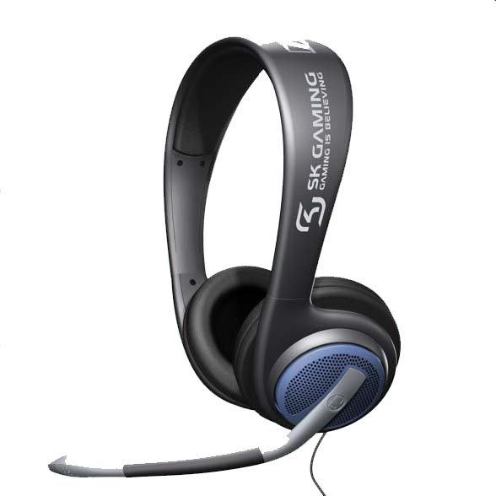
Although eSports has developed from the grassroots of the video gaming community, big companies and money now play a large role. Corporations from the IT and hardware industry have acknowledged eSports as one of the advertising markets of the future. By sponsoring eSports teams, tournaments and leagues, they precisely reach their target audience of young, tech-savvy (and mostly male) people at very low costs compared to traditional advertising. The sponsoring money has fertilized the professionalization of the scene: There is no better incentive than money, so players and teams take a lot of trouble to prepare for important matches and tournaments, thereby increasing the quality of the matches and the excitement for the spectators. The tremendous growth of the number of companies engaged in eSports sponsoring has not only enlarged the prize purses distributed to the players but enabled tournament and league organizers to develop an infrastructure targeted on making eSports a spectator sport like soccer or baseball.
Figure 7: Sennheiser's SK Gaming headset
Sponsors range from global, well-known corporations like Samsung, Intel or Dell to manufacturers of special products specifically designed for professional and amateur players like headsets, special gaming mice or mousepads. Most of those companies have created a brand strategy to make their name known among the gaming community. High-end headsets and microphones maker Sennheiser, renowned for equipping stars like Madonna or Sting, sells special editions of their headsets with the brand name of the world's most famous clan, SK Gaming, on them.
Recently, also companies not rooted in the IT and hardware industries have discovered eSports as a good way of marketing their products. The rising popularity of eSports and the fast-growing number of eSports enthusiasts have convinced companies alien to the scene to invest in gaming. Sports clothing manufacturer adidas has just started a cooperation with a well-known clan and now provides them with team clothing and merchandising products. The American fast-food chain Pizza Hut has recently signed a contract with the Cyberathlete Professional League (CPL), supporting their tournaments with sponsoring money and giving discounts to gamers who order their pizza through the joint-venture Pizza Hut/CPL website.

5. Critical aspects of electronic sports

a) Social life
Because pursuing electronic sports requires spending time in front of the computer, it can, like video gaming in general, have negative impacts on people's social life. As the time spent online and playing games increases, the time shared with partners, friends or family decreases. A lot of eSports enthusiasts seem to spend a large part of their free time in the internet or playing online games. This is time that could otherwise have been spent with friends or at a physical activity. Of course, this danger is present in video gaming in general, but in eSports, this danger is even bigger. In normal video gaming without the competitive aspect, playing against the computer tends to get boring after a while because a computer. In electronic sports, on the other hand, the main fascination is derived from the fact that you are playing against human opponents whose reactions are not predictable. At the same time, you communicate with like-minded people. This increases the temptation to entirely replace the real world with this virtual one, pretending to oneself to keep up a social life, arguing that there actually is interaction with real people. But there is still a huge difference between sitting alone in front of the computer and talking to team mates via headset and actually talking and laughing with people physically present.
Also, the group of people one spends time with on the internet might not be overlapping with one's circle of friends. Getting more and more drawn into the virtual world of computers and internet, one might end up with no time left for real world friends and finally lose them. There are countless examples of people dropping out of school, quitting university studies, losing partners, friends and spouses because they are no longer able to distinguish between reality and virtuality, a phenomenon called "internet addiction" by psychological experts which was first mentioned by the New York psychiatrist Ivan Goldberg.
A good example of internet addiction is the case of a 17-year-old boy who spent more than one and a half years being in the virtual world 16 hours a day, losing any kind of contact to the real world and had to undergo therapy after he finally realized that he was not a player, but an addict when he had lost all his former friends.
In addition, the internet is still quite anonymous. Bad behaviour and lack of social skills are not as big a problem as in reality because nobody is forced to face the people he treated badly or insulted. Since a virtual "me" can always be replaced by a new one, being held responsible for actions on the internet is very unlikely: The alias suffers the consequences so people proceed by creating a new alias.

b) The "killer games" debate
Computer games and movies depicting violence have been under harsh criticism from the public after two amok runs at schools in Germany: The first one took place in Erfurt where 19-year-old student Robert Steinhäuser shot 15 people and finally killed himself. Steinhäuser allegedly played computer games depicting violence which were soon after dubbed "killer games" by the media. Especially Counter-Strike, was accused for "turning young people into murderers" although "Robert Steinhäuser did not play Counter-Strike" according to the investigation committee's final report. The public outrage resulted in tightenings of both the law for the protection of the youth and the firearms law. Calls for a complete ban on "killer games" died down after the public interest in the matter decreased after a few weeks. The whole issue was brought up again when the 18-year-old student Bastian B. injured five people and killed himself during an amok run at his school in Emsdetten. The Interior Ministers of the states of Lower Saxony and Bavaria, Uwe Schünemann and Günther Beckstein, pushed for legislation banning all "killer games", again the game Counter-Strike was in the focus of the media and the general public.

"Is there a connection between "killer games" and growing violence at schools?"

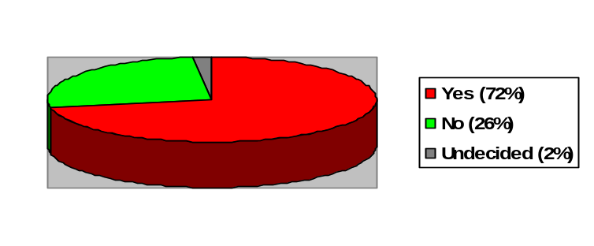
Figure 8: Results of a poll by Forsa, November 29th, 2006

Although the assertion that too much violence in the media, including computer games, can have negative impacts on young people's values and behaviour can not be dismissed, a lot of the public bias against "killer games" is based on wrong information in the media. In one article, for example, the author stated that the sole objective of Counter-Strike is killing innocent civilians and the more brutal the method of killing is the more points are awarded. That is an incorrect statement not reflecting the nature of the game
In a recent poll by Forsa, a majority of 72% think that there is a connection between "killer games" and growing violence at schools while 59% of the respondents supported a ban on "killer games".
Media reports like these have cast a damning light on computer games and electronic sports in particular because the most popular games in eSports are first-person shooters like Counter-Strike and Quake – games of the kind dubbed "killer games" by the media and some politicians. While the electronic sports community does not deny possible links between overly realistic depictions of killings in games and movies and the resulting brutalisation of individuals who do not know how to deal appropriately with this kind of content, the main struggle of eSports enthusiasts and its organizations is to point out that the main characteristic of electronic sports is by no means violence but competition. The objective is not to kill as many opponents as possible but to win the round for your team. The community argues that monocausal explanations like holding games responsible for amok runs misses the point and ignores other triggers for such actions like a difficult family environment and other social problems. Calls for bans on "killer games" have been assessed as some politicians' attempt to "find a scapegoat" as a famous German player put it in an article about Counter-Strike's existence as a "sport for the masses".

6. The subculture

Gaming is huge. The annual turnover of the video games industry has just exceeded the magic 1 billion EUR line and is likely to outperform the music industry's turnover which was 1.746 billion euros in 2005. The Electronic Sports League has more registered members than the basketball association and the golf association in Germany combined. A large percentage of young people in Germany play computer games and competitive gaming attracts a growing number of those people. For its members, eSports has become a subculture just like Punk or Skateboarding or any other kind of youth culture. Two aspects of this subculture are especially worth mentioning.

a) eSports fandom
Just like in "traditional" sports, a team is nothing without its fans. In eSports, the development of clans from hobby clubs to professional organizations is also marked by the growth of their number of fans. Today, the best clans, teams and players enjoy being backed by a big number of supporters who follow their matches, attend offline events where they cheer for their team and even buy merchandising products like caps, hats or t-shirts. With the growing popularity of eSports and clans, some of the clans opened up a new business: Premium services for the fans.

In the beginning, the best players were accessible for everyone. They were in the same online chat rooms, played on the same servers and attended the same offline events. Now that they are stars for many, they do not have the time to do this. Being in the same chat room as their fans would result in their bombardment with questions and fans wanting to play against them – just like Oliver Kahn or David Beckham can not walk on the street without drawing attention, Christian Chmiel or Navid Javadi (famous Counter-Strike players) can not be in a public online chat room. For this reason, the public's access to those top players is now very limited. For the clans, this has opened a new field of making money. For a membership fee ranging between 2 and 7 EUR per month, membership in their premium programs which bear names such as SK Insider, mouz.Backstage can be bought. This guarantees private access to star players. Questions can be asked, discussions can be held and sometimes even schedule a match or a private lesson is scheduled where they teach their best tricks.

This development has drawn a lot of criticism from some fans who criticize the growing commercialization of what once has been a hobby where money played no role. The clans and the supporters of those premium services argue that the money is needed for paying the players good salaries and further the professionalization of eSports which results in higher quality of matches, broadcasting and overall experience of competitive gaming. The big success of those premium services supports the view of the latter: In early January, the 1000th mousesports Backstage user was welcomed.

b) Amateur players
Every mainstream sport lives off the support and interest of amateur players who pursue this particular sport just for recreation without the ambition to earn a living from it or, even simpler, just watch other people pursue this sport: The phenomenon of spectator sports. Millions of Germans are members of soccer clubs, but only a very small percentage of those actually pursue a career as a star player. The same pattern applies to electronic sports. In fact, the very breeding ground of eSports was the amateur scene and casual gamers still constitute the largest part of eSports fans. Those players compete, but they do not compete for prize money but for fun, for the sake of enjoying themselves together with friends. The organizations mentioned above provide sufficient structures for the needs of those amateur players in all games there is a demand for. To illustrate the dimension gaming has now, it is helpful to look at the statistics provided by the Electronic Sports League. In 2006, between 4000 and 5500 matches were played per day, the total number of matches during those 12 months adding up to about 1.5 million matches.

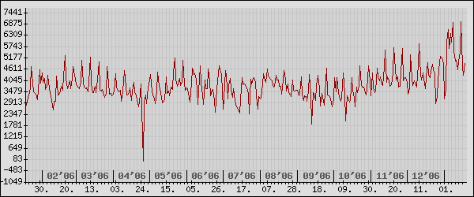
Figure 9: Amateur matches in the Electronic Sports League per day

Amateur players meet online with friends to play computer games competitively. It has become a form of recreation for them. According to a survey conducted by the Electronic Sports League in 2005, 50 percent of those players are between 16 and 18 years old, 10 percent are younger. 98 of 100 players are male and most of them are students. While every level of education is represented, most (46,8 %) attend a gymnasium and another 23 % go to university. The amateur players registered in the ESL spend a considerable part of their leisure time online: Nearly 30% stated that they are online more than 40 hours per week. The given numbers refer to the results of the "ESL-Studie 2005" which was answered by more than 50.000 players and can therefore be seen as representative for amateur eSports players in general. They are also the backbone of the community: The fan basis of the big, successful clans stems from this group as well as the new young talents who will be professional gamers one day.

III. Conclusion and forecast

The most remarkable fact about the development of electronic sports from gaming in your basement to global competition is the astonishingly short amount of time in which this has happened. Ten years ago, nobody would have thought that at some point of time players could earn a living from gaming while travelling all around the world to tournaments that draw the interest of tens of thousands of fans. In the eighties, nobody was talking about computer gaming. In the nineties, when people started talking about video gaming, nobody was talking about online gaming. Now, in the first decade of the 21st century, we are not only talking about gaming, not only about online gaming, we are actually talking about video gaming being on its best way to become a spectator sport. Of course, we can not see the best players and teams facing each other live on free TV yet, but the time when a clash of electronic sports giants will draw audiences big enough to make TV broadcasting profitable might not be too far away. Secondly, although competitive online gaming, especially among young males, is growing very fast, only a few people outside the community are actually aware of it. It is therefore also remarkable how quiet and unnoticed by the public this process took place. The third surprising fact is that although the professionalisation and the growth of electronic sports is mainly supported by big companies from the hardware industry and recently also by big companies from other fields, competitive gaming has developed from the grassroots of the community: At the time when the first major sponsors entered the field, most of the structures that are still prevalent today had already been developed by the community – for the community.

The potential of eSports as advertising platform is being recognized by more and more companies, not only from the hardware industry but from lifestyle brands like adidas, too. The number of full-time managers, the number of professional players, the amount of prize money and the number of full-time electronic sports journalists are sky-rocketing. At some point, the growth rate will slow down, but the peak has not been reached yet. The infrastructure for spectators has constantly been improving as more and more organizations solely dedicated to bringing electronic sports matches to the viewer were founded. Although nobody can possibly know what the future will bring, electronic sports enthusiasts all over the world are convinced that every new year brings new chances, new opportunities and more growth for competitive gaming. It may take another five or ten years, but the electronic sports community hopes that one day you will be able to read the latest Counter-Strike match results in your newspaper's sports section.

IV. Bibliography, Internet Sources and Table of Figures

Bibliography:

- Turtle Entertainment GmbH, ESL-Studie 2005, Cologne 2005
- Sauer, Christian, Untersuchungen zum Vermarktungspotential von eSport in Deutschland, Bielefeld 2004
- Dr. Gasser, Karl-Heinz et al., Bericht der Kommission Gutenberg- Gymnasium, Erfurt 2004
- Schmidt, Harry & Zimmermann, Thomas, Macht das Internet süchtig?, Bern 2000
- Thiel, Thomas, Es war die Hölle, in: Frankfurter Allgemeine Zeitung, January 5th, 2007
- Verbeet, Markus, Die Killerspiel-Profis, in: DER SPIEGEL, December 27th 2006
- Verbandsstatistik der Deutschen Phonoverbände, Berlin 2005

Internet sources:

- http://www.e-sb.de
- http://esb.geetac.de/version2/de/faq/index.html#5
- http://www.thecpl.com/events/
- http://www.sk-gaming.com/news/3723/
- http://www.ggl.com/news.php?NewsId=3818&Page=5
- http://www.g7teams.com/aboutesports.html
- http://www.esl.eu/de/cs/statistics/year/#active_users
- http://en.wikipedia.org/wiki/First-person_shooter
- http://www.worldcybergames.com/5th/2006/GrandFinal/awards.asp
- http://en.wikipedia.org/wiki/Clan
- http://www.ggl.com/news.php?NewsId=3818&Page=4
- http://mouz.clanserver4u.de/en/news/5187
- http://www.esl.eu/de/cs/leagueinfo/esl_structure
- http://www.esl.eu/de/pro-series/info/preisgeld
- http://www.turtle-entertainment.de/basisinfo.php?lang=0&id=12
- http://www.thecpl.com/events/?p=2000events
- http://www.nyse.com/about/listed/lcddata.html?ticker=VZ
- http://readmore.de/index-php?cont=comments&type=news&id=949&page=1
- http://www.readmore.de/index.php?cont=comments&type=articles&id=2162
- http://www.mousesports.com/en/backstage
- http://www.sk-gaming.com/insider
- http://www.esl.eu/de/statistics/year/#matches_per_day

Table of Figures:
- Figure 1: Arcade-game machines, Gerard V. Schip, 2006
- Figure 2: Original box-cover of the video game Quake, id Software, 1996
- Figure 3: Chart displaying the number of Counter-Strike players, Valve Software, 2007
- Figure 4: Logo of the German clan mousesports, Freaks4U GmbH, 2003
- Figure 5: Picture of a Counter-Strike player, Rahn & Hiltscher GbR, 2007
- Figure 6: Picture of eSport enthusiasts at the Intel Friday Night Game in Cologne, Rahn & Hiltscher GbR, 2006
- Figure 7: Sennheiser's PC 160 headset model with the famous clan SK Gaming's logo, Sennheiser GmbH & Co. KG, 2006
- Figure 8: Pie chart by the author, data taken from Forsa's poll, see footnote 41
- Figure 9: Chart displaying the number of matches in the Electronic Sports League per day, Turtle Entertainment GmbH, 2006

Ich erkläre hiermit, dass ich die Facharbeit ohne fremde Hilfe angefertigt und nur die im Literaturverzeichnis angeführten Quellen und Hilfsmittel benützt habe.

Kempten, den 25. Januar 2007-01-26

Maximilian Schaaf

http://www.e-sb.de
http://esb.geetac.de/version2/de/faq/index.html#5
A first-person shooter is a game characterized "by an on-screen view that simulates the in-game character's point of view and a focus on the use of handheld ranged weapons" (http://en.wikipedia.org/wiki/First-person_shooter).
For a definition and description of the term "clan" see chapter 2a)
For example the prize money distributed by the Cyberathlete Professional League rose from $165.000 (2001) to $435.000 (2004), constituting a 260% increase in a 3-year-period (http://www.thecpl.com/events/)
http://www.sk-gaming.com/news/3723/
For a detailed description of Counter-Strike, see chapter 2)
http://www.ggl.com/news.php?NewsId=3818&Page=5
http://www.g7teams.com/aboutesports.html
http://www.esl.eu/de/cs/statistics/year/#active_users
A first-person shooter is a game characterized "by an on-screen view that simulates the in-game character's point of view and a focus on the use of handheld ranged weapons" (http://en.wikipedia.org/wiki/First-person_shooter).
http://www.worldcybergames.com/5th/2006/GrandFinal/awards.asp
World Cyber Games (www.worldcybergames.com); Electronic Sports World Cup (www.esworldcup.com); World Series of Video Games Finals (www.thewsvg.com); Intel Summer Championship (http://www.thewsvg.com/events/intel_summer_2006/tournaments/); Cyberathlete Professional League (www.thecpl.com)
http://en.wikipedia.org/wiki/Clan
Exact numbers can not be given because mousesports considers this kind of information confidential
http://www.ggl.com/news.php?NewsId=3818&Page=4
http://mouz.clanserver4u.de/en/news/5187/
see Figure 5
http://www.esl.eu/de/cs/leagueinfo/esl_structure/
http://www.esl.eu/de/pro-series/info/preisgeld/
i.e. in a Local Area Network (LAN) instead of via internet
http://www.turtle-entertainment.de/basisinfo.php?lang=0&id=12
Excerpt from an interview with Jens Hilgers, Managing Director of Turtle Entertainment GmbH, conducted by the author on October 22th, 2006, at the Intel Friday Night Game in Munich
Munich, Berlin, Hamburg, Cologne, Oberhausen, Nuremberg, Frankfurt, Leipzig
See 1 b)
http://www.thecpl.com/events/?p=2000events
Market Capitalization of 108 billion dollars, http://www.nyse.com/about/listed/lcddata.html?ticker=VZ
The New York Times, December 6th, 2006
http://www.ggl.com/news.php?NewsId=3818&Page=5
http://readmore.de/index.php?cont=comments&type=news&id=949&page=1
A good example would be to compare the structures of FC Bayern Munich to those of SV Wildpoldsried
http://www.readmore.de/index.php?cont=comments&type=articles&id=2162
see 2 c)
see #24
Harry Schmidt & Thomas Zimmermann, Macht das Internet süchtig?, 2000, Bern, p. 3
Thomas Thiel, Es war die Hölle, in: Frankfurter Allgemeine Zeitung, January 5th, 2007.
Bericht der Kommission Gutenberg-Gymnasium, Erfurt, 2004, p.365
The most important changes were that new computer games had to have been approved by the USK (German age-rating agency) before they could be released (§15 JuSchG) and that violences against the JuSchG are now dealt with under the provisions of the Criminal Law (§27 JuSchG).
Rheinische Post, April 4th, 2002.
See Figure 8
Published in the periodical "Der Stern", November 29th, 2006.
Verbeet, Markus, Die Killerspiel-Profis, in: DER SPIEGEL, December 27th 2006, p. 38.
Schmidt, Holger, in: Frankfurter Allgemeine Zeitung, January 22nd 2007, p. 19
Association Statistics of the Bundesverband der Phonographischen Wirtschaft e.V., Berlin, 2006.
see 2b)
203.000 (2005)
457.000 members (2004)
mousesports Backstage (http://www.mousesports.com/en/backstage)
SK Insider (http://www.sk-gaming.com/insider)
http://www.esl.eu/de/statistics/year/#matches_per_day, see Figure 9
from: ESL-Studie 2005, Cologne, p. 5.
ibid., p. 8
ibid., p. 9
ibid., p. 16

