Hotel Fact Sheet
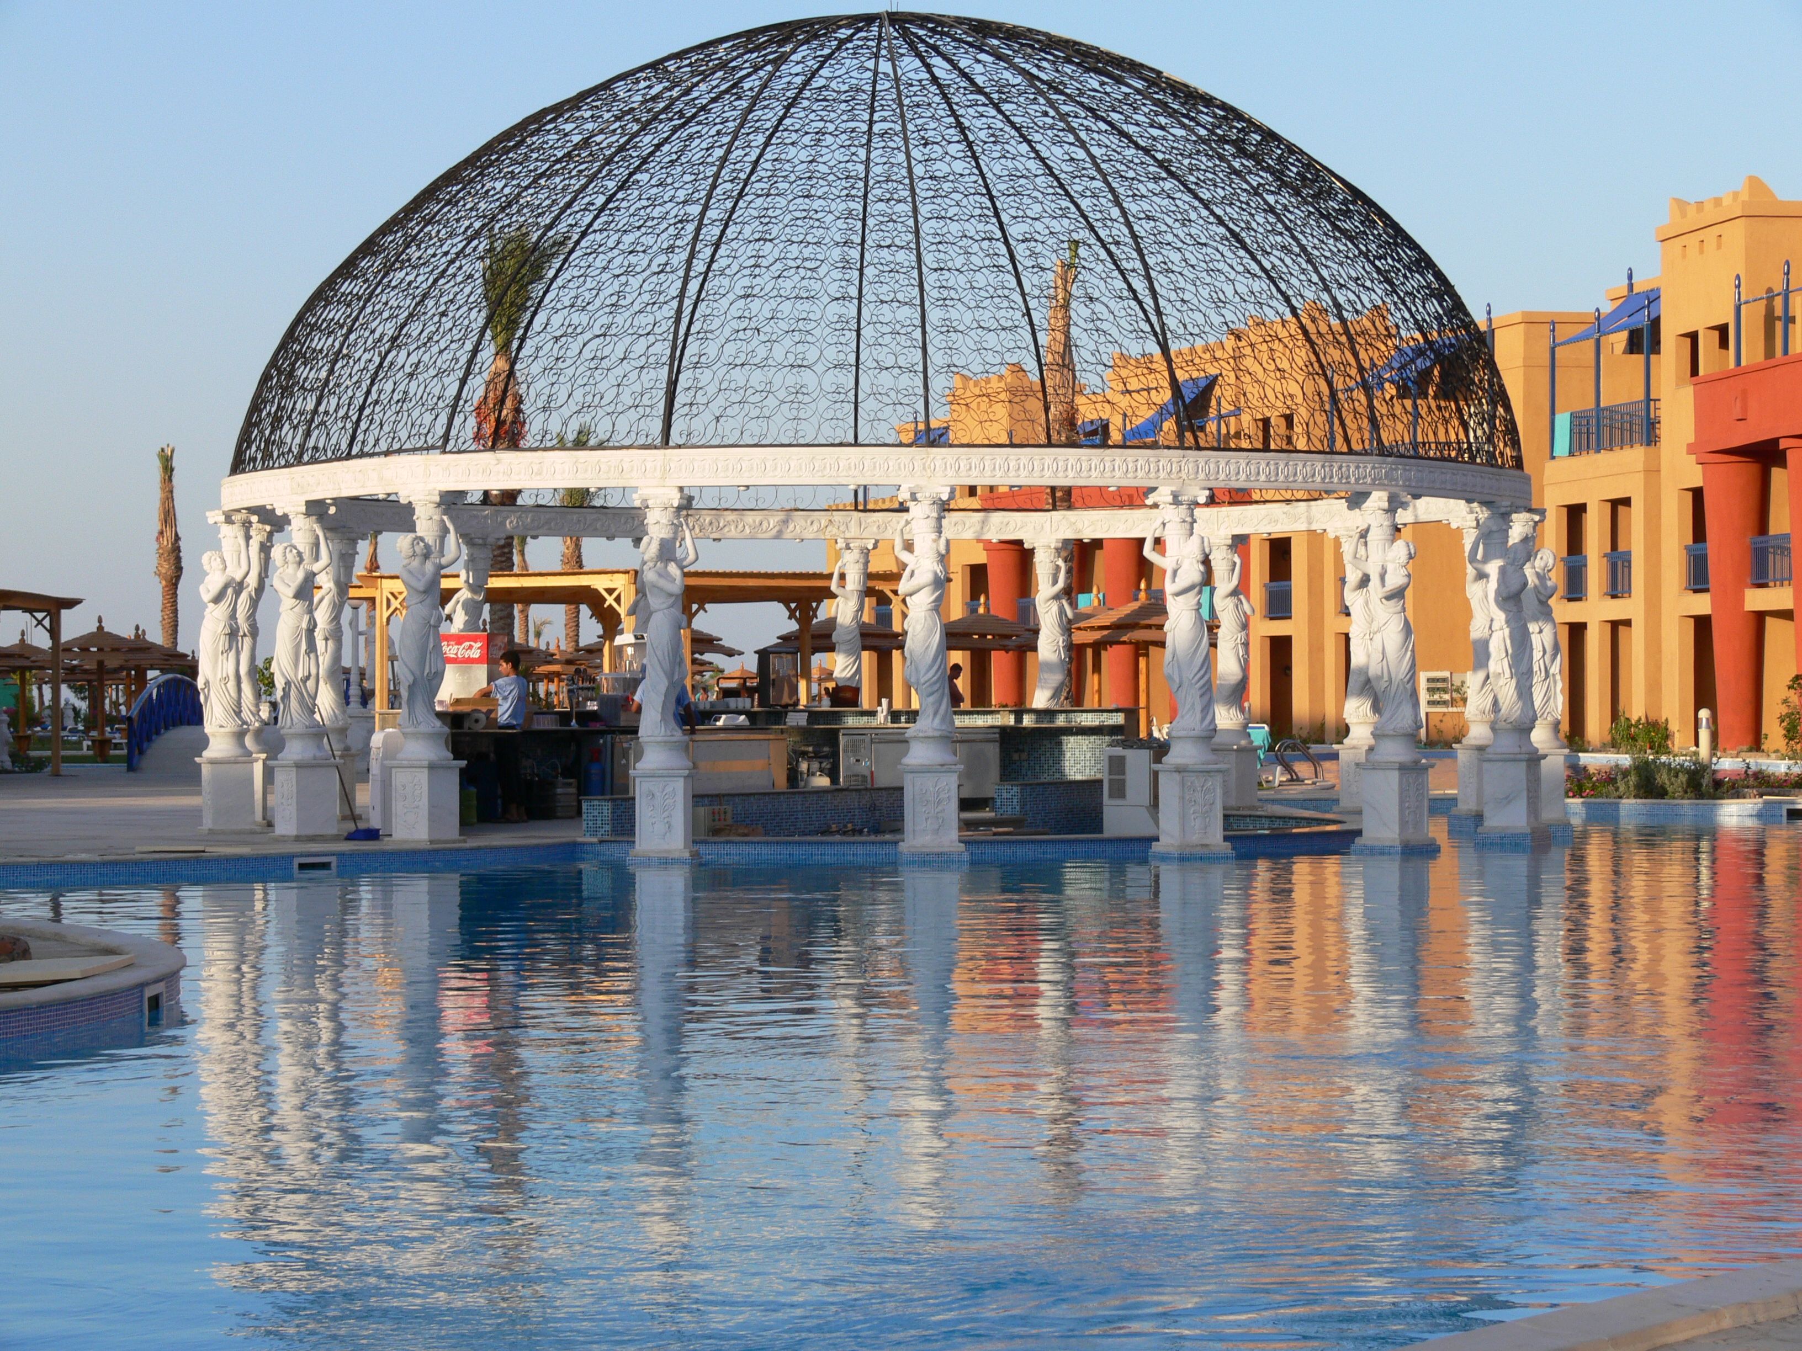

Location and surroundings

17 km from the centre of Hurghada, 10 km From Airport

Cairo 450 km, Luxor 290 km

Category: 5 Stars (NN)

Type of catering: Luxury, Royal all inclusive

Hotel Details

- Total land is 102000 m²
- 3 floors
- 116 Standard rooms, 114 Superior, 90 Family rooms, 47 Bungalows, 48 connected Standard rooms & 174 swim up rooms + 4 handy caped.
- 8000 m Swimming pools
- 1 heated pool
- 2 children pools
- 1 Jacuzzi
- Private beach 365 meter
- Internet cafe & wireless
- Private parking
- Private jetty marine 500 meter

Guest Room Information

All rooms are comfortably furnished and have balcony or terrace, mini bar, LCD TV (satellite channels, music), Shower amenities, hair dryer, Bathroom, shower cabin, Extra Bed, Baby cote, split air-conditioning system (cold/ warm), safe box, daily room cleaning, towels, bed sheet change.

Standard Rooms Surface area of 48m², decorated in soft natural tones. (Bedroom, wardrobe, bathroom with shower cabin, terrace or balcony with garden, pool or sea side view, LCD TV 37 inches).

Swim Up Rooms Direct access to the main pool. Surface area of 48m², decorated in soft natural tones. (Bedroom, wardrobe, bathroom with shower cabin, terrace or balcony with garden, pool or sea side view, LCD TV 37 inches).

Superior Rooms Surface area of 55m², elegantly decorated in soft natural tones. Non-smoking. (Bedroom, Sitting area, wardrobe, bathroom with shower cabin & Jacuzzi, terrace or balcony with garden, pool or sea side view, LCD TV 37 inches).

Family Rooms Surface area of 58m², designed perfectly for families
(2 bedrooms, wardrobe, 1 bathroom with shower cabin, terrace or balcony with garden-, pool or sea side view, LCD TV 37 inches).

Bungalow Rooms Surface area of 48m², located in the middle of swimming pool surrounded by water (King Size bed, wardrobe, bathroom with shower cabin, terrace or balcony with garden-, pool or sea side view, LCD TV 37 inches).

Connected rooms Surface area of 48 m² specially designed for the guests who need rooms next to each others with connected door. (Bedroom, wardrobe, bathroom with shower cabin, terrace or balcony with garden, pool or sea side view, LCD TV 37 inches).

Handicapped Room Surface area of 48 m² specially designed for the disabled guests in terms of tools in the bathroom and wardrobe. All hotel outlets and restaurants can be reached easily and fitted .to wheel chair.

Guest Services

- Internet cafe & wireless (lobby area)
- Cable/satellite TV
- Mini-bar ( Daily refilled for free )
- Hair dryer in the room
- Safe deposit boxes in the room (Free of charge)
- Parking facility
- Laundry, Dry cleaning and valet service
- Clinic and resident doctor
- Thebes hospital
- Reception desk (multilingual 24 hours)
- Limousine service
- Handicap facilities for Guest with special needs

Restaurants, Lounges & Bars

Restaurants

- Cleopatra Restaurant ( Main Dining )

- Antonio Restaurant ( Main Dining )

Japanese & Chinese Restaurant (ala carte with reservation at guest relation desk)

Indian Restaurant (ala carte with reservation at guest relation desk)

Mexican Restaurant (ala carte with reservation at guest relation desk)

Italian Restaurant (ala carte with reservation at guest relation desk)

Titanic Beach Sister Hotel

Chinese Restaurant (ala carte with reservation at guest relation desk)

Titanic Beach Sister Hotel

Lebanese Restaurant (ala carte with reservation at guest relation desk)

Titanic Beach Sister Hotel

Fish Restaurant (ala carte with reservation at guest relation desk)

Titanic Beach Sister Hotel

- Beach Restaurant

Guests are privileged to dine once per week in one of the 7 ala carte restaurants upon prior reservation with the guest relation officer.

Bars

- Cesar bar
- Waves Disco
- VIP Lounge
- Sailors Beach Bar
- Captain Smith Bar
- Pirates Lobby Bar – Sister Hotel
- Oasis Pool Bar – Sister Hotel

Conference facilities

Banquet room with 400 seats capacity well fit for conferences and workstations

SPA & Sport Facilities

- 13 Massage rooms
- 2 Sauna rooms
- 2 Steam Bath rooms
- 1 Turkish Bath room
- 1 Jacuzzi ( Outdoor )
- GYM Free of charges
- 2 Tennis courts
- Mini Golf

Diving Center

Offers different diving courses for beginners and professionals.

Windsurf Center

For Windsurf & Kite surf sport

Aqua Center

For Snorkelling facilities and sea trips

Recreation & Entertainment Facilities

Our guests can spend the day in such calmness that they could even hear the sound of the Red Sea, touch of the sun on their skin, or participate in entertainment and activities. For our dear guests for every age, for every taste, for every culture entertainment and recreation
are provided. Varieties of events and activities, professional shows are endless in our marvellous amphitheatre with capacity of 700 persons and nearby the swimming pools. A world class professional entertainment team is waiting for our privileged guests.

Swimming Pools

The swimming pools 8000 m³ are extended to everywhere in the resort. You reach the pool water from the terrace stairs at your ground floor room. All rooms are surrounded by water, the depth range between 120 cm and 140 cm.
- 2 main swimming pools
- 1 heated pool in front of the lobby
- 7 swim up pools
- 47 private swimming pools
- 1 children pool near the beach

Aqua Park

A huge Aqua Park rankling over 4000 meters swimming pools, for daily recreational activities.
- Open from 10:00 am to 18:00 pm (Summer time)
- Open from 10:00 am to 17:00 pm (Winter time)
- 8 waterslides with 2 heated pools
- Kids boat with 5 slides ( pirates ship ) heated, for kids under 10 years
- 1 rafting river
- 1 wave pool heated

Kids

Kids Club: Kids from 4 till 12 years, under observation from our animation team.
Open 7 days a week from 10:15 am – 12:30 pm & 3:15 pm – 5:30 pm.

Kid’s Playground: Designed as Titanic boat shape with multi games and kids pool.
Kids should be supervised by parents at all times.

Kids Cinema: Daily and evening movie show, special for children.

Entertainment Centre.

We offer our guests, children and adults a huge entertainment centre includes 2 Bowling station, 2 Table Tennis, 8 Billiard tables, 2 Tabletop football, 1 Play stations, 7 Video games & 3 Air hockey.

Animation

Professional multilingual team for daily scheduled activities water polo, pool gymnastic, Darts, Basketball…ETC and evening show, Belly dance , African show , Oriental show , international show, etc. performed at our amphitheatre.

Disco

International cocktails, Local & imported alcoholic are served.

Transfer

Airport pick up upon request, Daily scheduled trips to city Center and back.

Shopping Arcade

Shopping Center includes a selective variety of shops that you can manage your shopping perfectly.

Languages

English, German, Russian, French, Polish

Credit cards

Master cards, Visa cards

Currency

EGP, EURO, GPR, USD

Attractive Extra services

The hotel offers free access at our nearby sister hotel Titanic Beach. You can use the recreational and beverage facilities including the specialty ala Carte Restaurants upon prior reservation with guest relation desk.

