
Phone # (507) 526-3376 Located on the Fairgrounds in Blue Earth.
Faribault County Fitness Center, P.O. Box 38,
Blue Earth, MN 56013
E-mail Address fitness@bevcomm.net or
“Like Us” on Face book
Activities

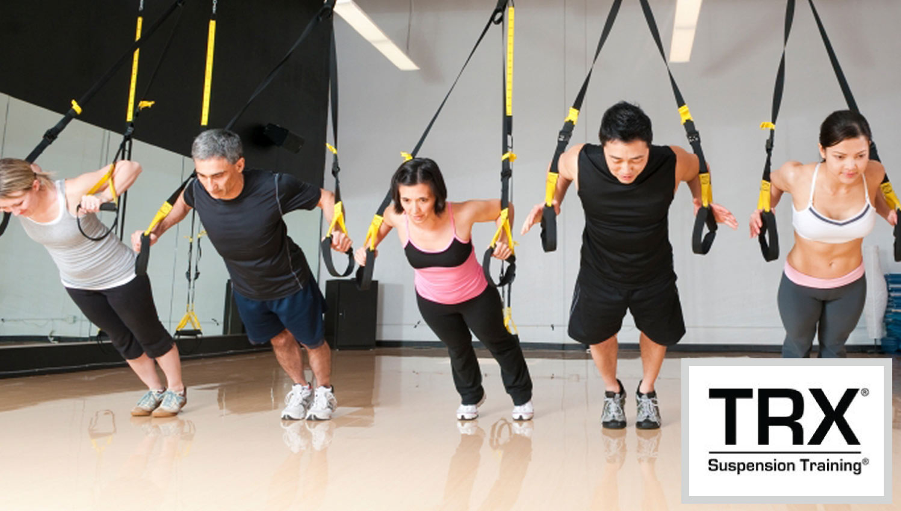
TRX Suspension Training is a revolutionary total-body fitness program that uses gravity against the individual’s own body weight to simultaneously develop strength, balance, flexibility and core stability. The TRX® device is attached to an anchor point. Each participant then grabs the handles with their hands or attaches their feet in the foot cradles. One simply changes the angle of their body from the ground for the different exercises. Having the ability to change the body's angle allows one to work with more or less body weight which can intensify or modify a specific exercise.
When: 12:05-12:40 Mon & Wed (Maximum Class size 7)
Session I Oct 8th-31st
Session II Nov 5th -28th
Cost: $35 Members /$45 Non-Members per session
Instructor: Michelle Hall

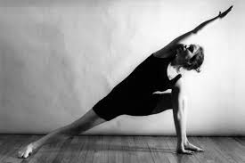"Movements of Grace" Yoga
Yoga focuses on stillness. Each posture is held for several seconds or minutes, allowing the body to fill with positive energy between each movement. Yoga use controlled breathing and meditation to enhance the practice. This Class is held over the lunch hour. All age groups can benefit from Yoga.
When: Tue and Thurs @ 12:05-12:50 PM
Cost: $40
Session I Sept 4th-27th
Session II Oct 2nd -25th
Session III Nov 6th -29th no class on Nov 22nd
Session IV Dec 4th-20th 3 weeks only
Cost: $25.00 Members/$35.00 Non-Members per session
Or: Thurs @ 5:15-6 PM
Cost: $25.00 Members/$35.00 Non-Members per session
Session I Sept 6th -27th
Session II Oct 4th-25th
Session III Nov 1st-29th no class on the 22nd
Session IV Dec 6th-20th 3 Weeks
Instructor: Mary Franta

Gentle 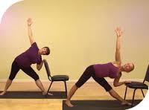 Yoga
There are many psychological benefits to Gentle Yoga. When people take control their attitude helps to create a better sense of wellbeing. Knowing that you can complete a 45-minute yoga routine and recognizing how much better you feel afterwards may encourage you to approach your day differently. Gentle-style yoga classes attempt to serve a variety of distinct needs: people with movement limitations, or profound stiffness due to lack of activity; relief from disabilities and chronic conditions e.g., arthritis, back pain and other issues; recovery from surgery, illness or injury; for seniors, new practitioners, women who are pregnant and those seeking stress-reduction or weight management.
When: Thursdays @ 1:00 PM
Session I Sept 6TH -27TH
Session II Oct 4th -25th
Session III Nov 1st-29th no class on the 22nd
Session IV Dec 26th -20th only 3 weeks
Cost: Free to Silver&Fit Members /$20.00 Members/$30.00 Non-Members per session
Instructor: Mary Franta


Muay Thai Kickboxing
Focus on: Multiple types of strikes: hand, elbow, knee, kick, etc.
Lean tone, Weight loss, Sports performance, Team atmosphere
Testing cardio endurance and push your limits to a higher level
Equipment necessary: Boxing gloves (limited quantity available), water, towel, shin pads, good shoes
When: Mondays and Wednesdays 6p – 7:30p
Session I Oct 1st-Nov 7th No Class Oct 31st
Session II Nov 12th – Dec 19th
Cost: $60 per 6-week session
Instructor: Carl Ekstedt, personal trainer NASM certified, 16+ years fitness experience

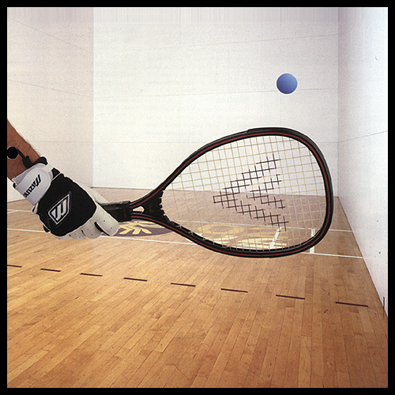 Racquetball Singles Ladder League:
The cool thing about this is that players get to play whatever it
is best within a one week time period. Participants play everyone in
the League at least once during regular season followed by a single
Elimination tournament (Date TBD).
When: Nov1st-February.
Each week a participant will be placed against an opponent and then
will need to set up a match time. This match needs to be completed
within that week and reported to Fitness Director.
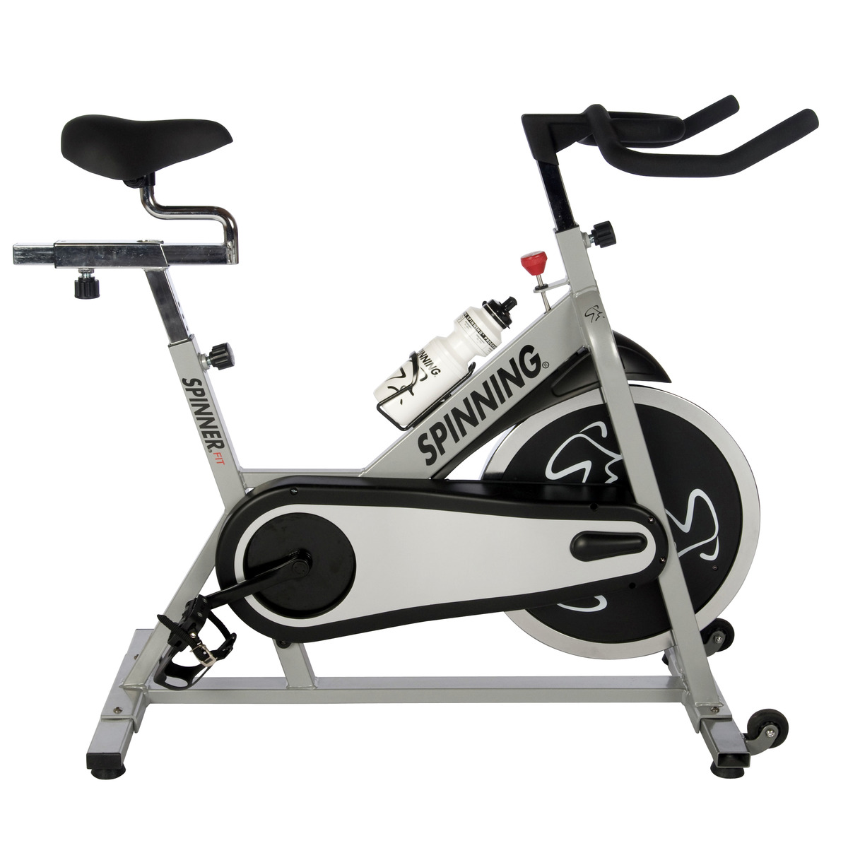  Indoor cycling classes are done in a fitness studio, with various light and music settings to create an energized atmosphere. Do you want to train like an athlete, ride like a racer, and find your inner competitor? Jump on a bike and ride to the driving beats that will improve your cardio endurance and muscular strength. This low impact/high intensity workout will leave you drenched in sweat, yet inspired to come back for more! All you'll need is workout clothes, a towel (to wipe your face) and a water bottle.
When: Mon & Wed 12:05-12:45
Dec 3rd-19th 3 Weeks
Cost: $30
Instructor: Michelle Hall

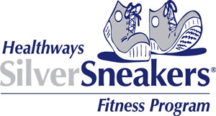
Join one of the nation’s leading exercise programs designed exclusively for older adults, the SilverSneakers® Fitness Program, available to members of participating Medicare health plans. Call or stop by a convenient participating location today to find out if you are eligible for this exciting program.
When: Ongoing Mon and Wednesdays @ 10:00 AM
Cost: Free for Silver Sneakers & Silver&Fit Members/ $35.00 a month for Non-Members
Instructor: Michelle Hall

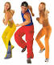 ZUMBA! 
Zumba Fitness
Zumba is a Latin-inspired, dance fitness class incorporating international music and Latin dance movements for a dynamic workout. The class will combine fast and slow rhythms that tone and sculpt the body and achieve a unique blended balance of cardio and muscle benefits. Dancers and non-dancers can master this class and have a great time! Instructor: Amanda Jaskulke. Fee: $60 per session. Walk-ins: $7 per class.
When: Tuesdays & Thursdays @ 5:15 p.m.
Session I: October 2nd-Nov 8th
Session II: Nov 13th-Dec 20th No class Nov 22nd
Cost: $60 a Session Walk-ins $7 Minimum: 8 Students
Instructor: Amanda Jaskulke Certified Zumba Instructor

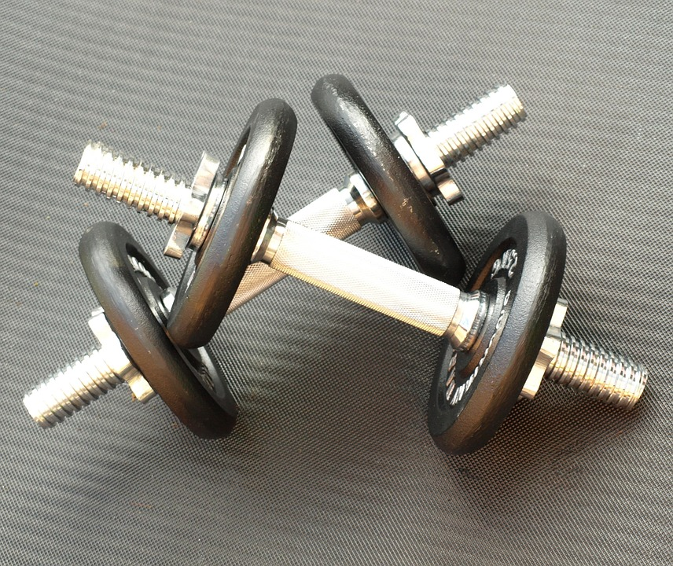 Cardio and Strength Mash Up
Description: Never get bored with your workout! Confuse your muscles, and get results by mixing up your workout each week. Strength and cardio intervals, free weights, exercise bar, each week a new and fun workout!
When: Tue & Thurs @ 4:30-5:15 PM
Session I Sept 4th-27th
Session II Oct 2nd-30th
Session III Nov 6th-29th no class on Nov 22nd
Session IV Dec Mini session Dec 5th -21st $40
Cost: $60 per session Instructor: Elizabeth Stallman

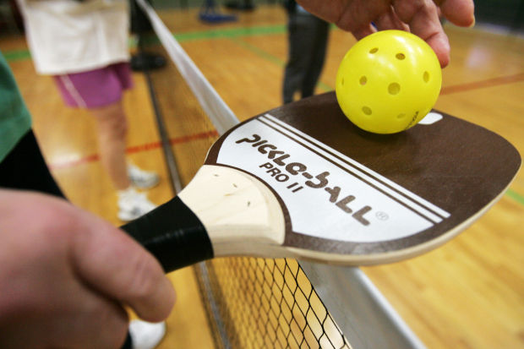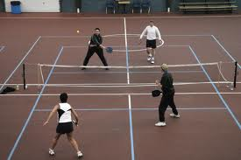
Pickle ball you ask? A Game for Everyone
Many kids and teenagers play it in physical education classes in middle and high schools. Seniors enjoy the social aspects and the ability to stay active in towns and retirement communities. It's OVERSIZED ping pong! Played on a badminton sized court with a tennis sized net. Just use a paddle to keep a plastic ball going back and forth over a net until somebody messes up.
Call 526-3376 to sign-up for lessons and doubles league.
OR
Walk-in play times are Mon- Fri 7:30-10:00 AM
& Thursday 6:30 PM
Free with your membership.

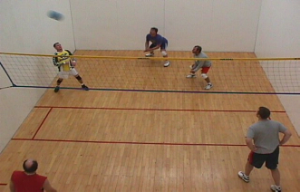
WALLYBALL LEAGUE AT THE FARIBAULT COUNTY FITNESS CENTER
WEDNESDAY NIGHT LEAGUE
When: STARTS Nov. 7th
WITH ROTATION OF PLAY TIMES OF 6, 7, 8 OR 9:00 PM
3 PERSON TEAMS
Cost: $45.00 Non-Member or free with Membership
Kids I Mile Run
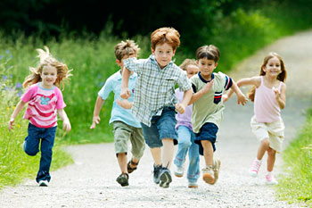
Young runners and walkers participate in a 1 mile run
at the Faribault County Fitness Center Oct 18th
When: 6:15 before our 5th annul Glow Run.
Open to anyone ages 5-12
Cost: FREE but must register by Noon Oct 5th for a free gift.
PAYMENT: Secure online payment with debit/credit card: www.blueearth.k12.mn.us/Quicklinks/WebStore
Or please indicate payment method __Cash, __Check or Money Order payable/form and sent to:
Faribault County Fitness Center, PO Box 38, Blue Earth MN 56013

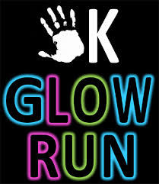

Join us in the 5th annual Glow Run! This event is sponsored by the Faribault County Fitness Center and Blue Earth Area Community Ed.
Thursday, Oct 18th, 2018 7:00 PM @ the Faribault County Fitness
RACE FEE: Early registration $15 by noon on Oct 5th or $20 on day of event. Race Day registration closes at 6:30 PM.
PAYMENT: Secure online payment with debit/credit card: www.blueearth.k12.mn.us/Quicklinks/WebStore
Or please indicate payment method 􀂈 Cash, 􀂈 Check or 􀂈 Money Order payable/form and sent to:
Faribault County Fitness Center, PO Box 38, Blue Earth MN 56013

Open House Thursday, Oct 18th 2018
Open House, Treats, and Door Prizes.
Tour the Fitness Center Try our classes for FREE
8:30 Pickle Ball Demonstration
Noon Yoga Class, Mary Franta
1:00 Gentle Yoga, Mary Franta
4:30 Cardio/Strength Mash-Up, Elizabeth Stallman
5:15 Zumba, Amanda Jaskulke
6:15 Kids 1 mile run Free
Register for the 5K Glow Run/ends at 6:30PM
7:00 5K Glow Run (There is a cost for the Glow Run)


Get your 4 member team together for a 7 week weight challenge.
When: Oct 1st-Nov 19th
Cost: Your weight, = one penny a pound. (The winner team will win the all the entry fees, plus other prizes. So the more teams the more your team will win.) You can have more than one team form a business, etc.
Call the Fitness Center for team forms, Charts, the rules. 526-3376

When you're trying to lose weight, dodging the break room doughnut tray, your office mate's candy bowl or the vending machine makes sticking to your diet that much harder. Encouraging your workplace to join you, though, just might make some of those temptations disappear. People may not bring in the treats -- or at least you'll have new resolve to avoid them. When others in your office are depending on you to lose weight, or you know they'll beat you if you don't, your incentive to stick to your diet intensifies. Set up an office weight-loss challenge to create healthy competition and camaraderie. One person might win, but everyone benefits from getting healthy.

Why Hold a Workplace Weight-Loss Challenge (Four member team, you can have more than one team per work place.)
The idea of a challenge may be influenced by weight-loss reality shows, but a group environment makes weight loss more attainable and desirable to average participants. A study published in a 2012 issue of Obesity found that when people are supported and inspired, such as by co-workers, they have a better chance of losing weight. Of the more than 3,000 people examined in the study, those with group support had a 6 to 20 percent better chance of achieving a 5 percent weight loss.

Set the Parameters Find a point person to be the one who collects data such as starting weights, weekly weigh-ins and final numbers. This person will report progress to the Fitness Center after each

Weight-in. Ideally you have an office wellness coordinator, but if not, choose someone who can be discreet and honest. People will be more willing to participate if they know that they won't be judged.

Start date and end date. Seven weeks Oct 1st-Nov 17th are all long enough for participants to make change without resorting to drastic measures. These periods are also short enough so people won't lose focus and interest. Official weigh-ins is Every Monday and the last weigh-in will be Friday Nov 17th at Noon. Bring in a scale into the office for the official weigh-ins. Scales tend to vary in accuracy, so it's fair if everyone weighs in on the same one. You may also offer a small prize every few weeks to someone who's shown exceptional commitment or progress. This keeps the interest in the program high.

Mail flyers send emails and talk it up at the water cooler. Publicize the challenge in the company newsletter and in the wellness center, if you have one. Team-based programs can create greater incentive to stick to the plan and make the competition more social, as people don't want to let their teammates down.

Create Ground Rules at the Office

Determine the winner by percentage of total weight loss, not total pounds lost. Heavier people can lose weight more quickly and would automatically have an advantage. For example, you'd determine the number of pounds lost and divide it by the beginning weight to figure out the percent weight lost. People may appreciate that their actual weight won't be publicized, too, because you'll post standings according to percentage lost -- not actual weight.

Ban participants from using unhealthy methods to lose weight, such as starvation, diet pills, water pills and laxatives. Encourage people to lose weight by eating whole, unprocessed foods and moving more. Establish a daily lunchtime walk for and share recipes with the participants. Sabotaging fellow competitors by tempting them with treats should be discouraged.

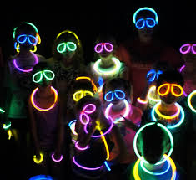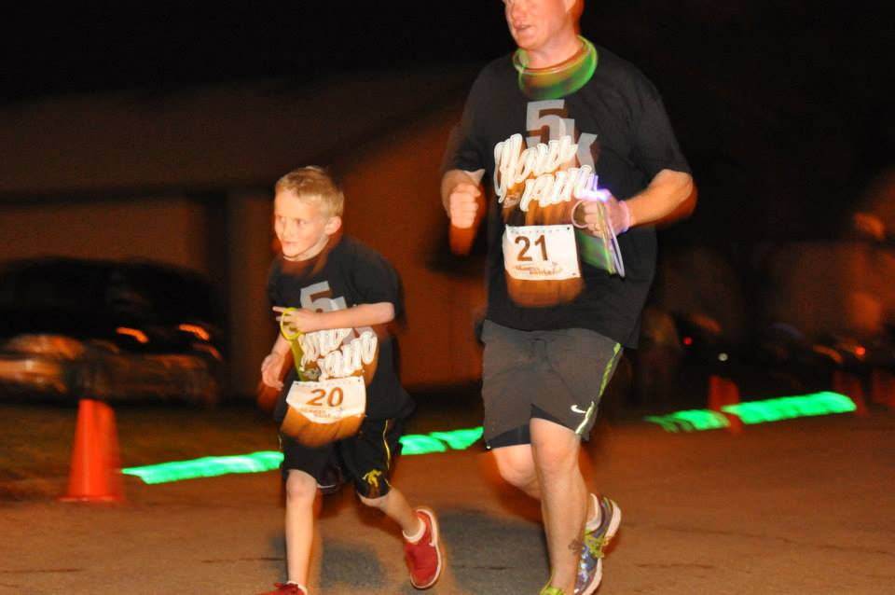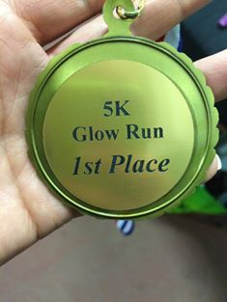
5k Run and Kids 1 Mile Glow Run Thursday Oct 18th
Faribault County Fitness Center
PO Box 38, Blue Earth MN 56013
Phone: 507-526-3376 Fax: 507-526-5108
E-mail fitness@bevcomm.net like us on Face book
Join us in the 4th annual Glow Run! This event is sponsored by the Faribault County Fitness Center and Blue Earth Area Community Ed.
Thursday, Oct 18th, 2018 7:00 PM @ the Faribault County Fitness Center, Blue Earth MN

Full Name: ___________________________________
Gender: Male / Female (circle one)
Age: (on race day) ______ 5K Activity: Running / Walking (circle one) Early registration fee of $15/$20 after 10-5-18
Kids I mile _______ FREE Register by Oct 5th for free gift.
Mailing Address: ____________________________________________________________
City: _____________________________ State/Province: ________ Zip/Postal __________
Phone: (_____) ____________________ Email: ____________________________________

EVENT INFORMATION: Age group Awards for 1st place Male and Female
6 & Under 30-39
7-11 40-49
12-15 50-59
16-19 60-69
20-29 70-Plus
Sorry no pets for safety concerns.
RACE FEE: Early registration $15 by noon on Oct 7th or $20 on day of event. Race Day registration closes at 6:30 PM Sharp.
Kids run is free, but PLEASE register by Oct 3th for free gift.
PAYMENT: Secure online payment with debit/credit card: www.blueearth.k12.mn.us/Quicklinks/WebStore
Or please indicate payment method 􀂈 Cash, 􀂈 Check or 􀂈 Money Order payable/form and sent to:
Faribault County Fitness Center, PO Box 38, Blue Earth MN 56013

EVENT DISCLAIMER: Please review the following waiver and disclaimer. By adding your signature, you accept this waiver and disclaimer. Waiver and Release: By participating in this Event, I do so at my own risk. I assume all risk of injury, illness, damage or loss to me or my property that might result, including without limitation, any loss or theft of personal property. I consent to medical treatment in the event of injury, accident and/or illness during the Event. I agree on behalf of myself (and my personal representatives, heirs, executors, administrators, agents and assigns) to release and discharge the organizers of this event, its principals, its officers & directors, its employees, all sponsors and their representatives and employees from any and all claims or causes of action (known or unknown) arising out of their negligence. I acknowledge that I have carefully read this ‘Waiver and Release’ and fully understand that it is a release of liability. By my signature below, I am waiving any right that I may have to bring legal action to assert a claim against any and all Event sponsors for their negligence. I hereby grant full permission to any and all of the foregoing to use my name and likeness in any broadcast, telecast, video or print media reporting or advertising of the Event without compensation.
􀂈 I AGREE Sign here: _________________________________________________

