February 4, 2015

The Board of County Commissioners met in a regular session on the 4th of February, 2015 and the following members were present: Patrick Haley, Mike Curry and Kerry R. Steed.

President of the Board, Patrick Haley, welcomed everyone to the session and Kerry R. Steed led all in the Pledge of Allegiance to our flag.

RESOLUTION MOVED AND ADOPTED AND OTHER ACTION ON THIS DATE AS FOLLOWS:

With no prior discussion on this date, the following action was taken:

IN THE MATTER
APPROVAL OF MINUTES

RESOLUTION #15-115
BY: Curry and Steed

Mr. Curry moved the adoption of the following Resolution:

BE IT RESOLVED, By this Board of County Commissioners to hereby approve the minutes of February 2, 2015 as read by the Clerk of the Board.

Mr. Steed seconded the Resolution and roll call resulted as follows:

Mr. Haley: YEA Mr. Curry: YEA Mr. Steed: YEA

RESOLUTION #15-115 ADOPTED as of February 4, 2015

February 4, 2015

With no prior discussion on this date, the following action was taken:

IN THE MATTER
EXECUTE DRAWDOWN
FY 13 CHIP-CDBG AND FY 13 CHIP-HOME

RESOLUTION #15-116
BY: Curry and Steed

Mr. Curry moved the adoption of the following Resolution:

BE IT RESOLVED, By this Board of County Commissioners to hereby execute the following Drawdown for FY 13 CHIP-CDBG and FY 13 CHIP-HOME projects in the amount of $91,251.00:

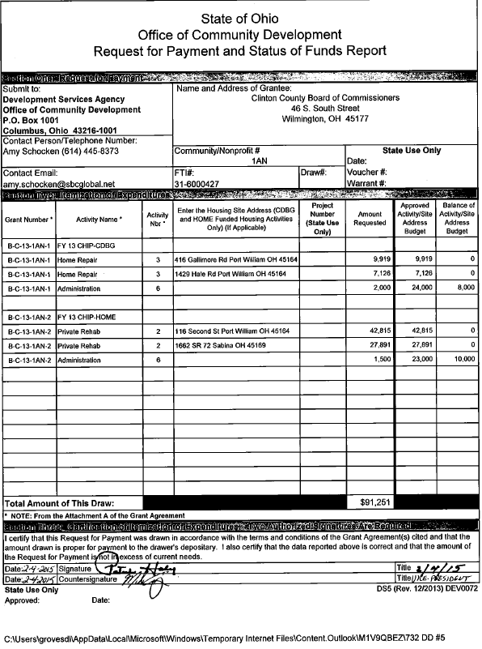

Mr. Steed seconded the Resolution and roll call resulted as follows:

Mr. Haley: YEA Mr. Curry: YEA Mr. Steed: YEA

RESOLUTION #15-116 ADOPTED as of February 4, 2015

February 4, 2015

With no prior discussion on this date, the following action was taken:

IN THE MATTER
AUTHORIZE PRESIDENT TO
EXECUTE TITLE XX PROFILE

RESOLUTION #15-117
BY: Curry and Steed

Mr. Curry moved the adoption of the following Resolution:

BE IT RESOLVED, By this Board of County Commissioners to hereby authorize the President to execute the following Title XX Profile with Job & Family Services for FFY 2016 and FFY 2017:

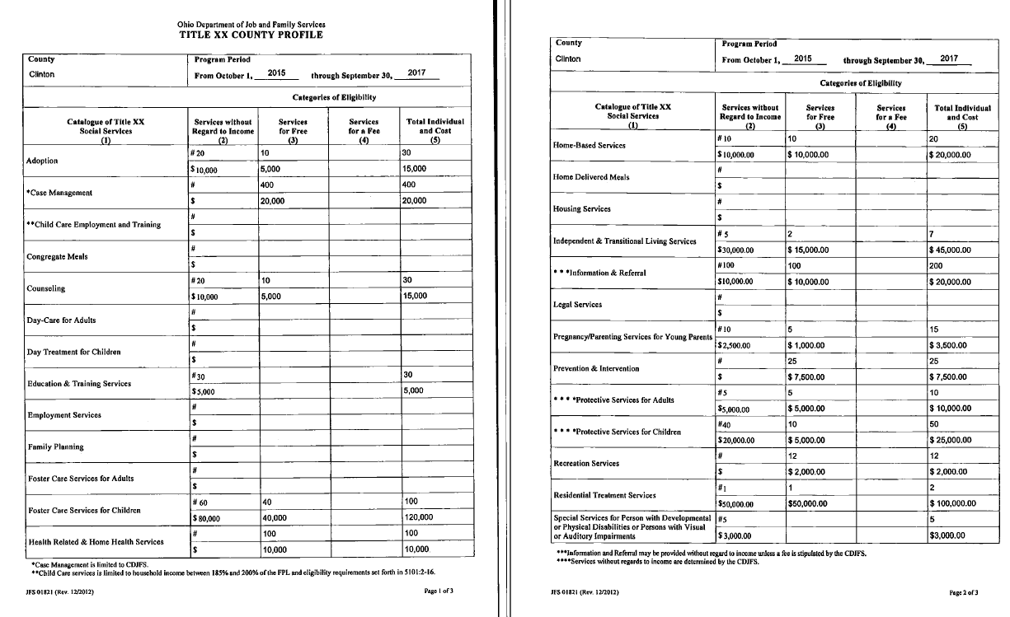

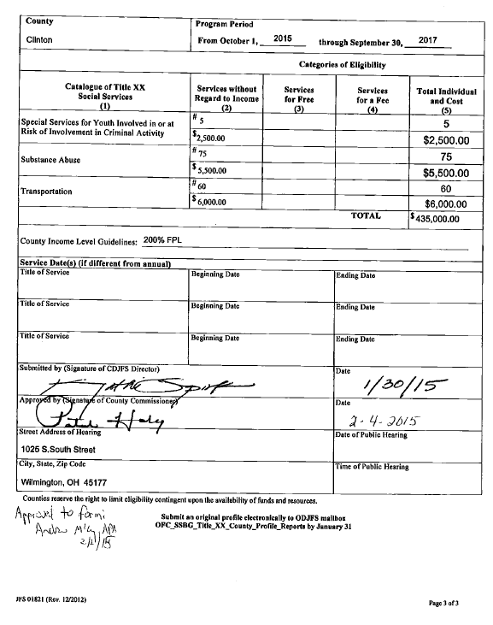

Mr. Steed seconded the Resolution and roll call resulted as follows:

Mr. Haley: YEA Mr. Curry: YEA Mr. Steed: YEA

RESOLUTION #15-117 ADOPTED as of February 4, 2015
February 4, 2015

With no prior discussion on this date, the following action was taken:

IN THE MATTER
AUTHORIZE JUVENILE PROBATION
TO TRAVEL

RESOLUTION #15-118
BY: Curry and Steed

Mr. Curry moved the adoption of the following Resolution:

WHEREAS, A letter has been received requesting approval to travel and reimbursement of expenses;

Juvenile Probation: Authorize Rachel Young, Adam Green, Reaggan Grimes and Regina Partin to Columbus, Ohio for the Annual Intercourt Conference. Estimated expenses $1,044.15 for lodging, registration and meals.

Mr. Steed seconded the Resolution and roll call resulted as follows:

Mr. Haley: YEA Mr. Curry: YEA Mr. Steed: YEA

RESOLUTION #15-118 ADOPTED as of February 4, 2015

With no prior discussion on this date, the following action was taken:

IN THE MATTER
AUTHORIZE CLERK TO ADVERTISE
FOR BIDS FOR STONE

RESOLUTION #15-119
BY: Curry and Steed

Mr. Curry moved the adoption of the following Resolution:

WHEREAS, The Clinton County Engineer has requested this Board to advertise for the bids for the County Highway Department and he has furnished copies of the legal notice and specifications and bid proposal; therefore,

BE IT RESOLVED, By this Board of County Commissioners that the specifications for said furnishing of stone be and are hereby approved with bids to be received in this office until 10:00 a.m., Wednesday, February 25, 2015 for the Clinton County Engineers Department and that the Clerk is hereby directed to advertise.

Mr. Steed seconded the Resolution and roll call resulted as follows:

Mr. Haley: YEA Mr. Curry: YEA Mr. Steed: YEA

RESOLUTION #15-119 ADOPTED as of February 4, 2015

February 4, 2015

With no prior discussion on this date, the following action was taken:

IN THE MATTER
EXECUTE LETTER TO
DUKE ENERGY

RESOLUTION #15-120
BY: Curry and Steed

Mr. Curry moved the adoption of the following Resolution:

BE IT RESOLVED, By this Board of County Commissioners to hereby execute the following letter to Duke Energy regarding electric aggregation with AEP Energy for unincorporated areas in Clinton County:

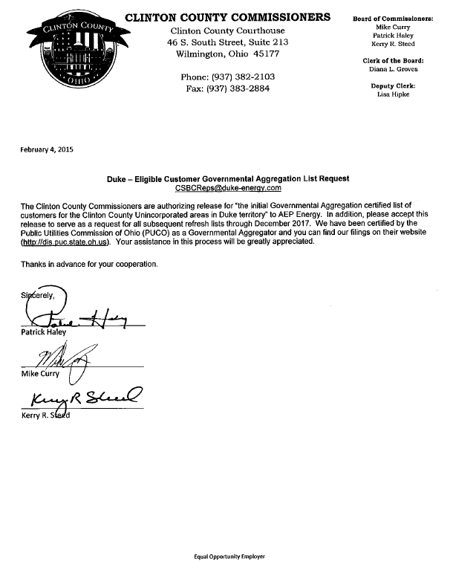

Mr. Steed seconded the Resolution and roll call resulted as follows:

Mr. Haley: YEA Mr. Curry: YEA Mr. Steed: YEA

RESOLUTION #15-120 ADOPTED as of February 4, 2015

February 4, 2015

With no prior discussion on this date, the following action was taken:

IN THE MATTER
EXECUTE LETTER TO
DPL

RESOLUTION #15-121
BY: Curry and Steed

Mr. Curry moved the adoption of the following Resolution:

BE IT RESOLVED, By this Board of County Commissioners to hereby execute the following letter to DPL regarding electric aggregation with AEP Energy for the Village of Midland:

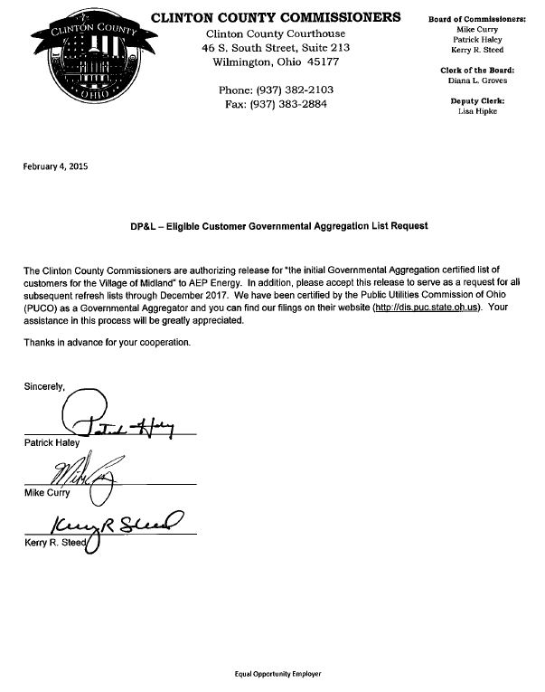

Mr. Steed seconded the Resolution and roll call resulted as follows:

Mr. Haley: YEA Mr. Curry: YEA Mr. Steed: YEA

RESOLUTION #15-121 ADOPTED as of February 4, 2015

February 4, 2015

With no prior discussion on this date, the following action was taken:

IN THE MATTER
AUTHORIZE PRESIDENT TO EXECUTE
AMENDMENT TO PROGRAMMATIC AGREEMENT

RESOLUTION #15-122
BY: Curry and Steed

Mr. Curry moved the adoption of the following Resolution:

BE IT RESOLVED, By this Board of County Commissioners to hereby authorize the President of the Board to execute the following amendment to programmatic agreement for HUD funded programs:

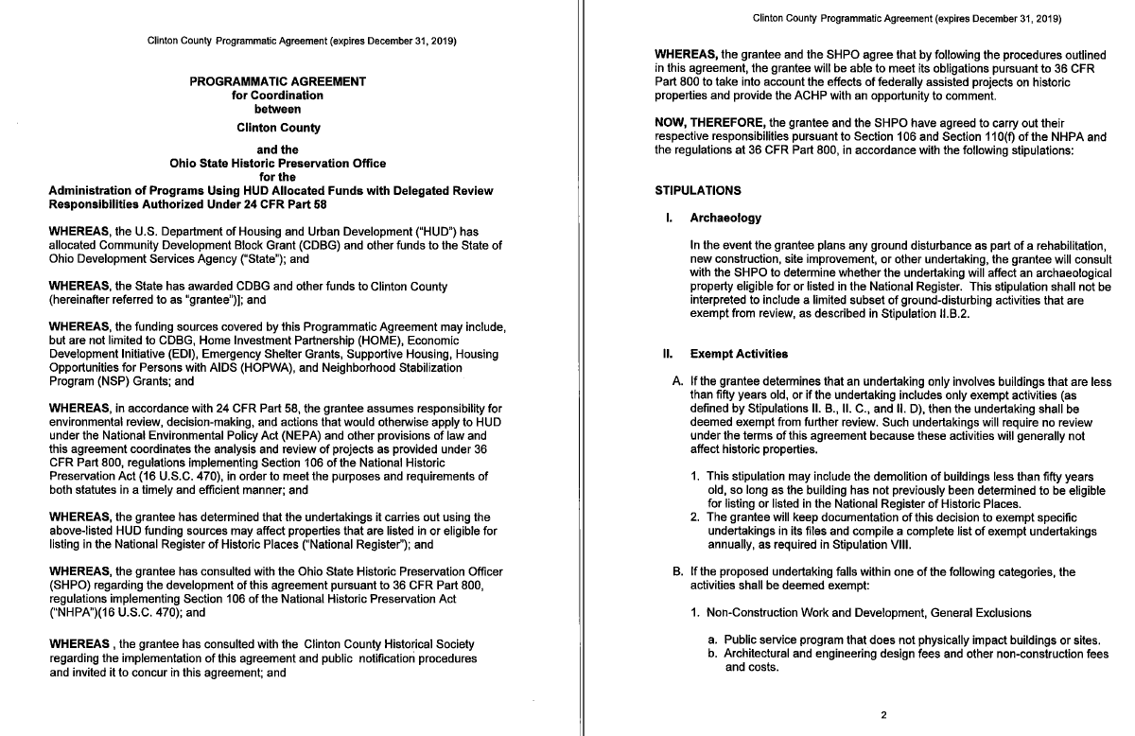
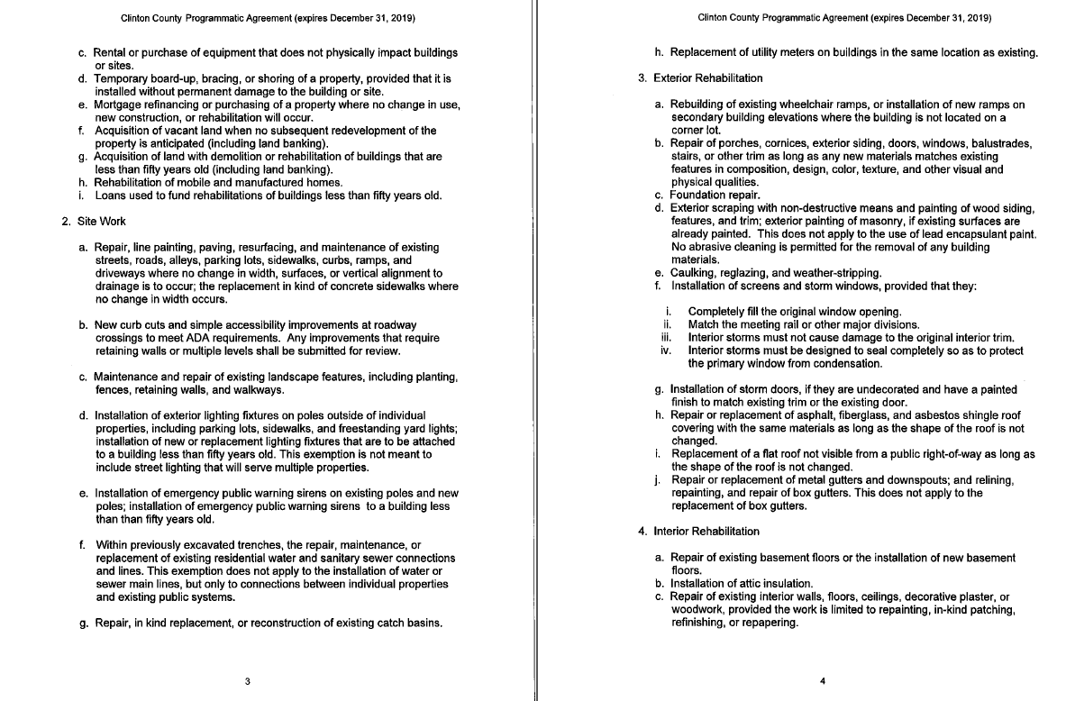

February 4, 2015

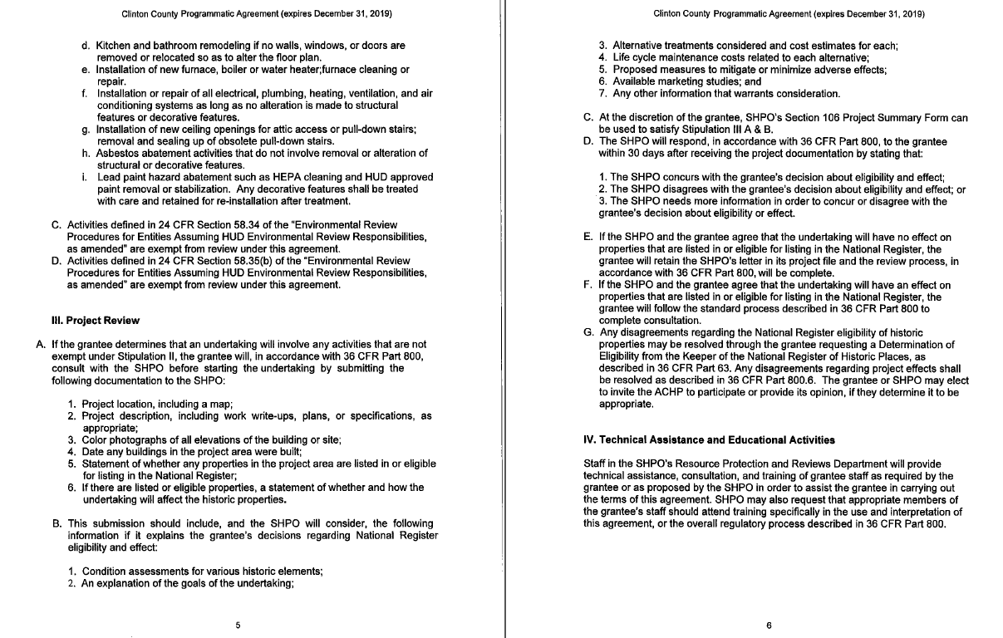
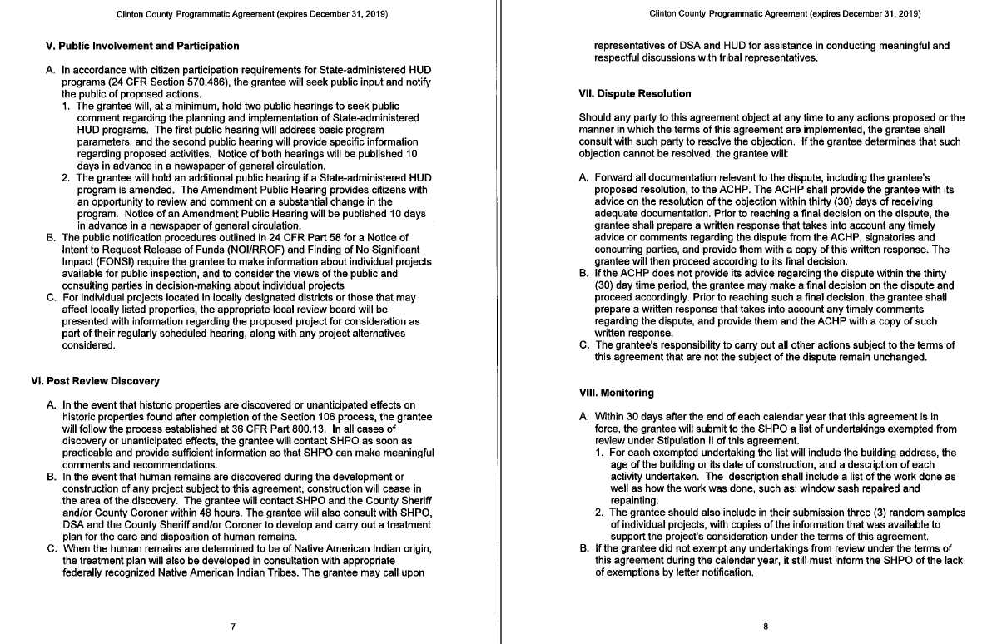

February 4, 2015

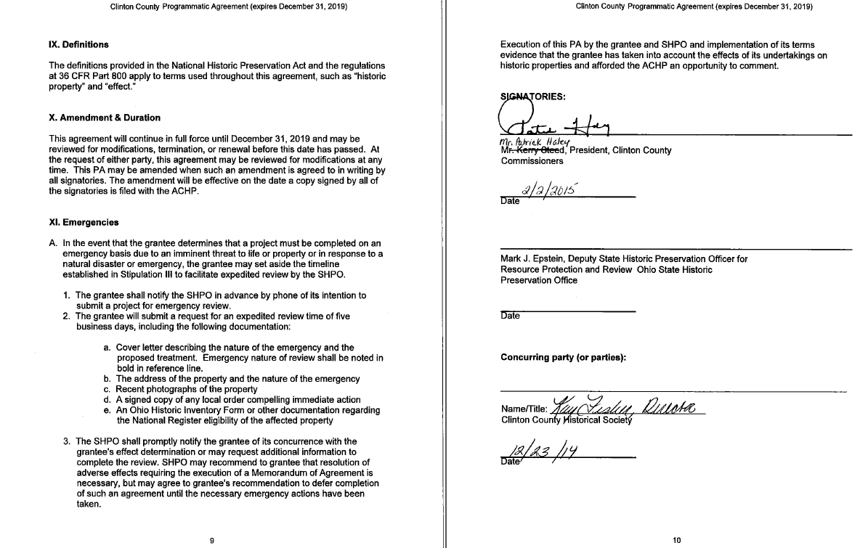
Mr. Steed seconded the Resolution and roll call resulted as follows:

Mr. Haley: YEA Mr. Curry: YEA Mr. Steed: YEA

RESOLUTION #15-122 ADOPTED as of February 4, 2015

February 4, 2015

With no prior discussion on this date, the following action was taken:

IN THE MATTER
APPROVE BILLS AND
AUTHORIZE AUDITOR TO
ISSUE WARRANTS FOR PAYMENT

RESOLUTION #15-123
BY: Curry and Steed

Mr. Curry moved the adoption of the following Resolution:

BE IT RESOLVED, By this Board of County Commissioners to hereby approve the following bills in batch #C15-W05R as presented by the Clinton County Auditor.

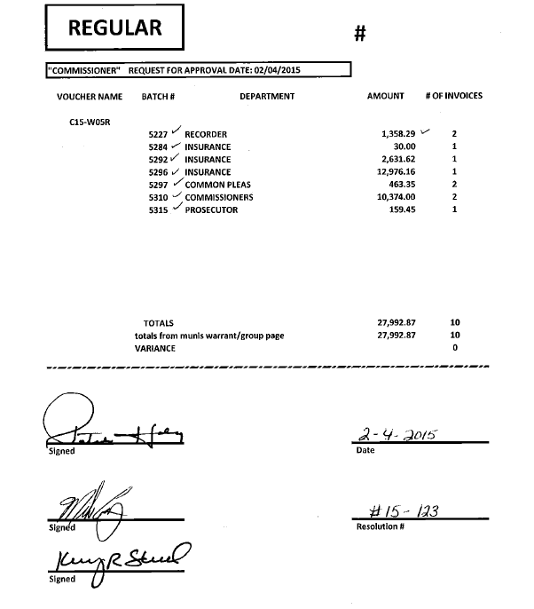

Mr. Steed seconded the Resolution and roll call resulted as follows:

Mr. Haley: YEA Mr. Curry: YEA Mr. Steed: YEA

RESOLUTION #15-123 ADOPTED as of February 4, 2015

February 4, 2015

With no prior discussion on this date, the following action was taken:

IN THE MATTER
PAYMENT OF VOUCHERS
WITHOUT APPROPRIATE
CARRY-OVER PURCHASE ORDERS

RESOLUTION #15-124
BY: Curry and Steed

Mr. Curry moved the adoption of the following Resolution:

WHEREAS, By the Board of County Commissioners, County of Clinton, State of Ohio:

Section 1. Requested the County Auditor pay the following bills with postdated purchase orders:

Batch #C15-W05T

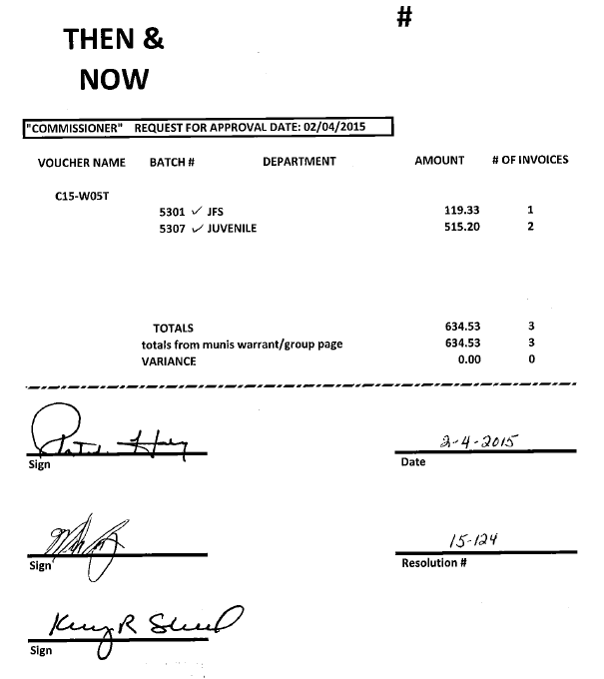

Mr. Steed seconded the Resolution and roll call resulted as follows:

Mr. Haley: YEA Mr. Curry: YEA Mr. Steed: YEA

RESOLUTION #15-124 ADOPTED as of February 4, 2015

Resolution #15-125 was accidently skipped.

February 4, 2015

With no prior discussion on this date, the following action was taken:

IN THE MATTER
PAYMENT OF VOUCHERS
WITHOUT APPROPRIATE
CARRY-OVER PURCHASE ORDERS

RESOLUTION #15-126
BY: Curry and Steed

Mr. Curry moved the adoption of the following Resolution:

WHEREAS, A 2014 carry-over purchase order for an obligation was not requested, and

WHEREAS, A then and now certification is not possible, and

WHEREAS, The Commissioners approve the payment of the obligation outside of the normal budgetary process, and

WHEREAS, The County Auditor should consider this “a substitute for a then and now certificate”,

WHEREAS, The State Auditor has stated that no exception would be taken to the bill provided the Commissioners approve the payment on a separate resolution, and

WHEREAS, A carry-over purchase order was missed because a purchase order was not requested from the Auditor to carry over

NOW THEREFORE, BE IT RESOLVED, By the Board of County Commissioners, County of Clinton, State of Ohio:

Section 1. Requested the County Auditor pay the following bills with postdated purchase orders:

Batch #C15-W05S
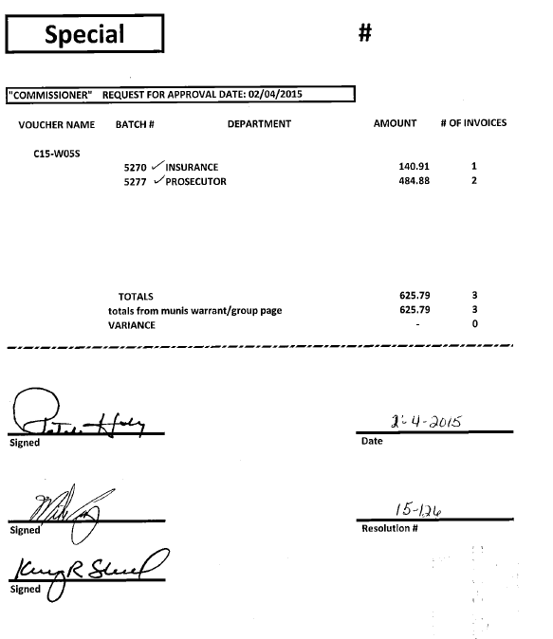
Mr. Steed seconded the Resolution and roll call resulted as follows:

Mr. Haley: YEA Mr. Curry: YEA Mr. Steed: YEA

RESOLUTION #15-126 ADOPTED as of February 4, 2015
February 4, 2015

With no prior discussion on this date, the following action was taken:

IN THE MATTER
ADDITIONAL APPROPRIATION

RESOLUTION #15-127
BY: Curry and Steed

Mr. Curry moved the adoption of the following Resolution:

WHEREAS, It has been brought to the attention of the Board of County Commissioners that there is a need for an additional appropriation in the following department:

#2005 HEALTH INSURANCE #2

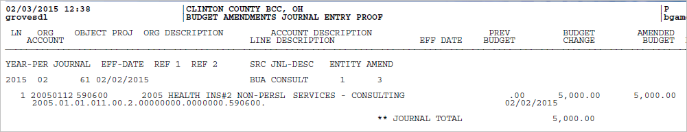

Mr. Steed seconded the Resolution and roll call resulted as follows:

Mr. Haley: YEA Mr. Curry: YEA Mr. Steed: YEA

RESOLUTION #15-127 ADOPTED as of February 4, 2015

With no prior discussion on this date, the following action was taken:

IN THE MATTER
AUTHORIZE CLERK OF COURTS
TO TRAVEL

RESOLUTION #15-128
BY: Curry and Steed

Mr. Curry moved the adoption of the following Resolution:

WHEREAS, A letter has been received requesting approval to travel and reimbursement of expenses;

Clerk of Courts: Authorize Cindy Bailey to Columbus, Ohio for the OCCA legislative reception and OCCA monthly meeting. Estimated expenses $350.00 for lodging, meals and mileage.

Mr. Steed seconded the Resolution and roll call resulted as follows:

Mr. Haley: YEA Mr. Curry: YEA Mr. Steed: YEA

RESOLUTION #15-128 ADOPTED as of February 4, 2015

February 4, 2015

With no prior discussion on this date, the following action was taken:

IN THE MATTER
AUTHORIZE PRESIDENT TO EXECUTE
AIP GRANT OVERSIGHT RISK ASSESSMENT
CERTIFICATION CHECKLIST FOR FAA

RESOLUTION #15-129
BY: Curry and Steed

Mr. Curry moved the adoption of the following Resolution:

BE IT RESOLVED, By this Board of County Commissioners to hereby authorize the President of the Board to execute the following AIP Grant Oversight Risk Assessment Certification Checklist for FAA:

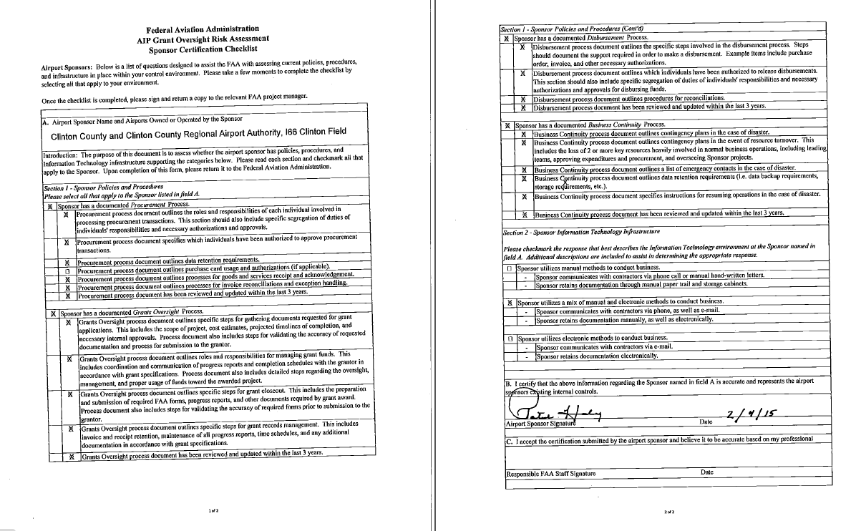

Mr. Steed seconded the Resolution and roll call resulted as follows:

Mr. Haley: YEA Mr. Curry: YEA Mr. Steed: YEA

RESOLUTION #15-129 ADOPTED as of February 4, 2015

With no prior discussion on this date, the following action was taken:

IN THE MATTER
COMMISSIONERS HOLD
EXECUTIVE SESSION

RESOLUTION #15-130
BY: Curry and Steed

Mr. Curry moved the adoption of the following Resolution:

BE IT RESOLVED, That the Board of County Commissioners will hold an Executive Session pursuant to the Ohio Revised Code Section 121.22 (G) (6), at 9:18 a.m. for the purpose of discussing details relative to the security arrangements and emergency response protocols for a public body or public office.

Mr. Steed seconded the Resolution and roll call resulted as follows:

Mr. Haley: YEA Mr. Curry: YEA Mr. Steed: YEA

RESOLUTION #15-130 ADOPTED as of February 4, 2015

February 4, 2015

With no prior discussion on this date, the following action was taken:

IN THE MATTER
COMMISSIONERS RETURN
TO REGULAR SESSION

RESOLUTION #15-131
BY: Curry and Steed

Mr. Curry moved the adoption of the following Resolution:

BE IT RESOLVED, By this Board of County Commissioners to hereby return to Regular Session on this date at 9:40 a.m.

Mr. Steed seconded the Resolution and roll call resulted as follows:

Mr. Haley: YEA Mr. Curry: YEA Mr. Steed: YEA

RESOLUTION #15-131 ADOPTED as of February 4, 2015

With no prior discussion on this date, the following action was taken:

IN THE MATTER
EXECUTE LETTER TO
AUDITOR, TERRY HABERMEHL

RESOLUTION #15-132
BY: Curry and Steed

Mr. Curry moved the adoption of the following Resolution:

BE IT RESOLVED, By this Board of County Commissioners to hereby execute the following letter to Clinton County Auditor, Terry Habermehl:

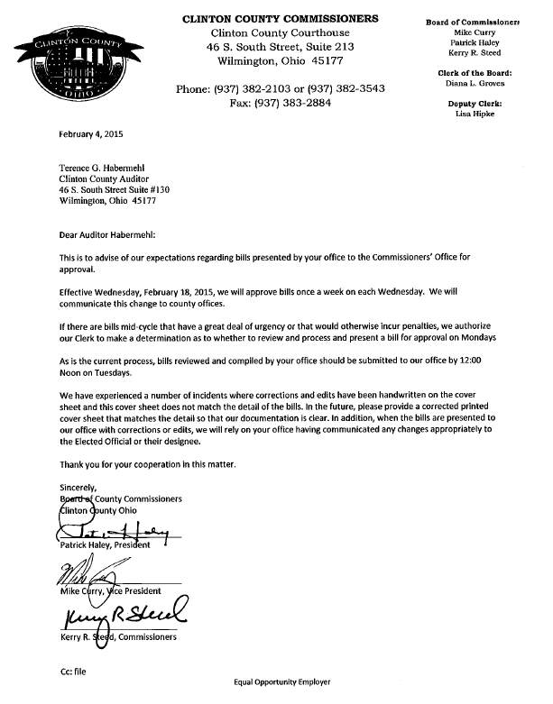

Mr. Steed seconded the Resolution and roll call resulted as follows:

Mr. Haley: YEA Mr. Curry: YEA Mr. Steed: YEA

RESOLUTION #15-132 ADOPTED as of February 4, 2015
February 4, 2015

With no prior discussion on this date, the following action was taken:

IN THE MATTER
AUTHORIZE PRESIDENT TO
EXECUTE AGREEMENT
WITH HORAN

RESOLUTION #15-133
BY: Curry and Steed

Mr. Curry moved the adoption of the following Resolution:

BE IT RESOLVED, By this Board of County Commissioners to hereby authorize the President of the Board to execute the following agreement with Horan to provide Clinton County with consulting services for HealthCare Reform and Impact recommendations for 2016 plan and beyond:

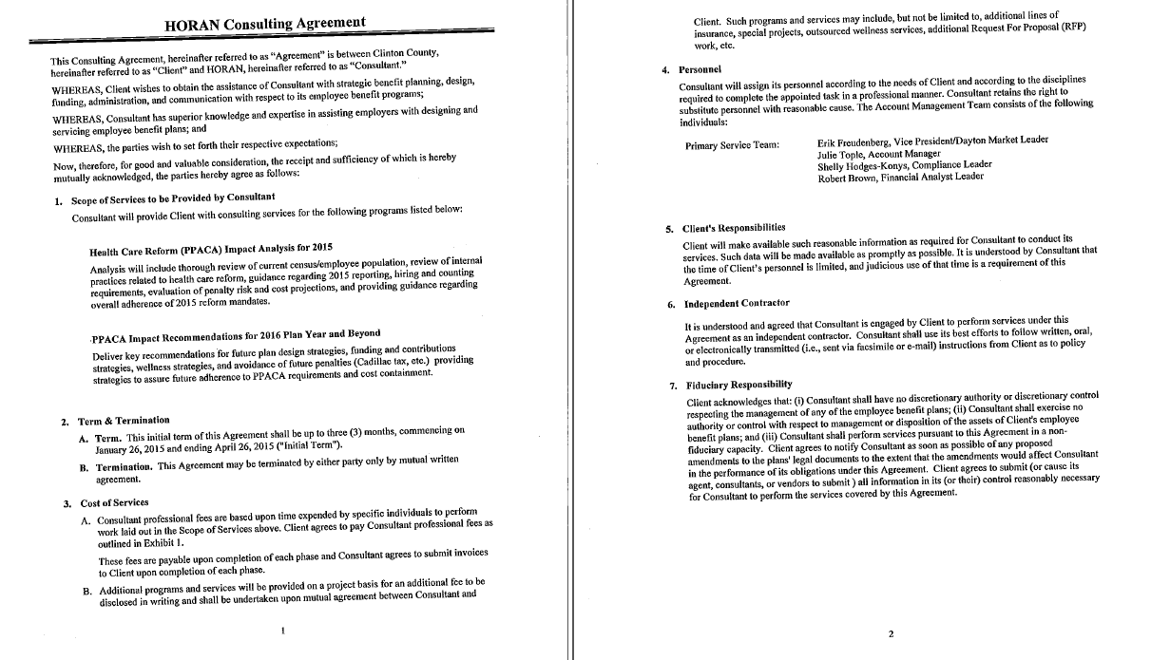
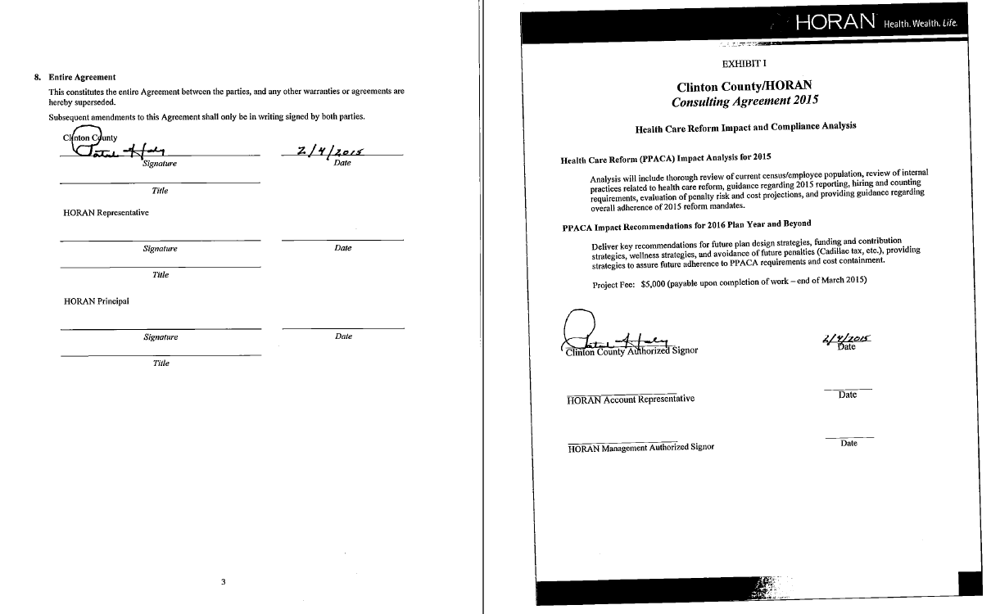

February 4, 2015

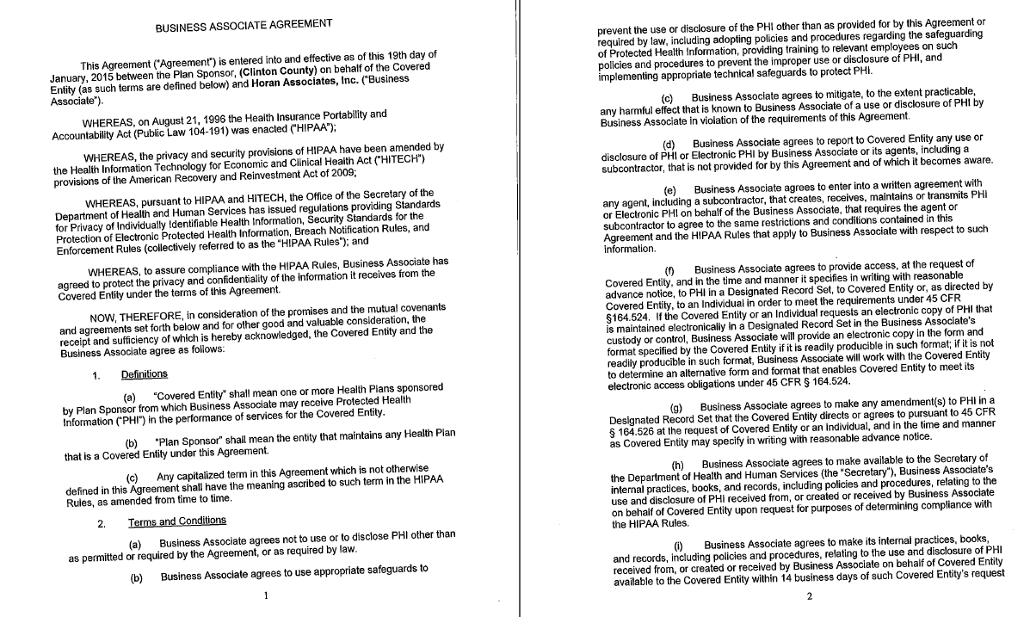

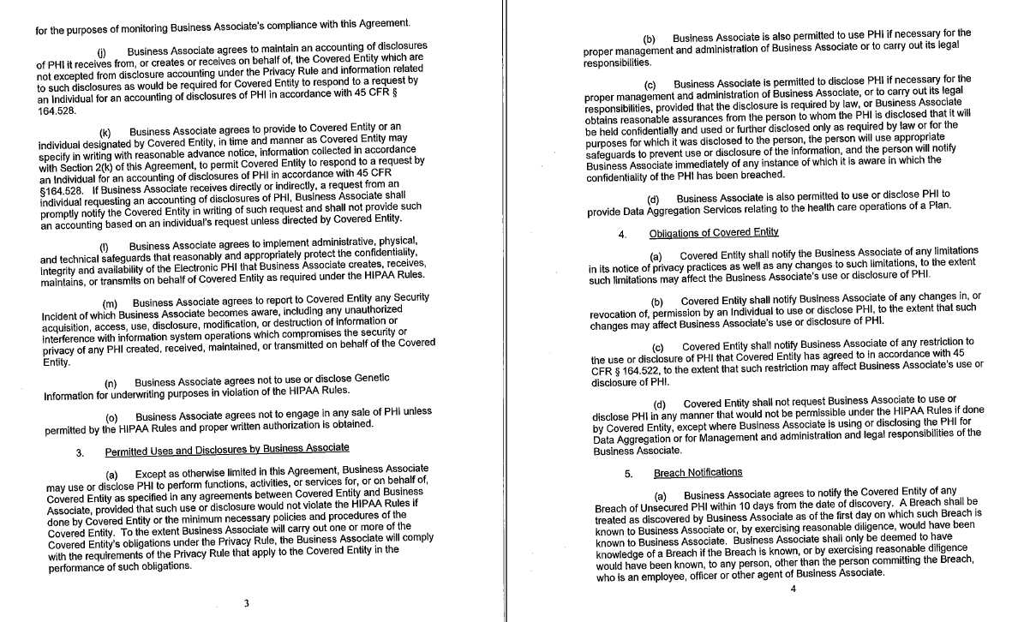

February 4, 2015

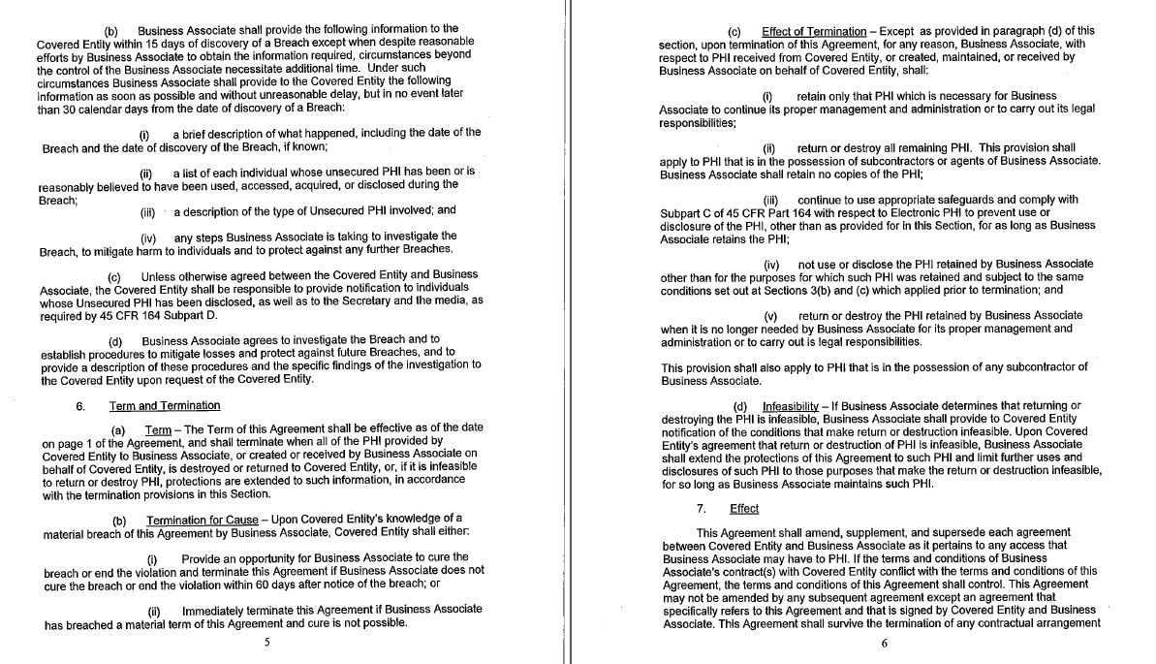
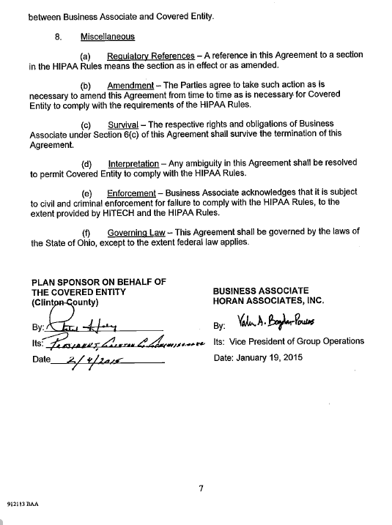

Mr. Steed seconded the Resolution and roll call resulted as follows:

Mr. Haley: YEA Mr. Curry: YEA Mr. Steed: YEA

RESOLUTION #15-133 ADOPTED as of February 4, 2015

February 4, 2015

With no prior discussion on this date, the following action was taken:

IN THE MATTER
EXECUTE LETTER OF
EXCLUSIVITY TO APPOINT
CCAOSC AS EXCLUSIVE AGENT AND
CONSULTANT FOR ELECTRIC AGGREGATION

RESOLUTION #15-134
BY: Curry and Haley

Mr. Curry moved the adoption of the following Resolution:

BE IT RESOLVED, By this Board of County Commissioners to hereby execute the following Letter of Exclusivity to appoint CCAOSC as exclusive agent and consultant for electric aggregation.

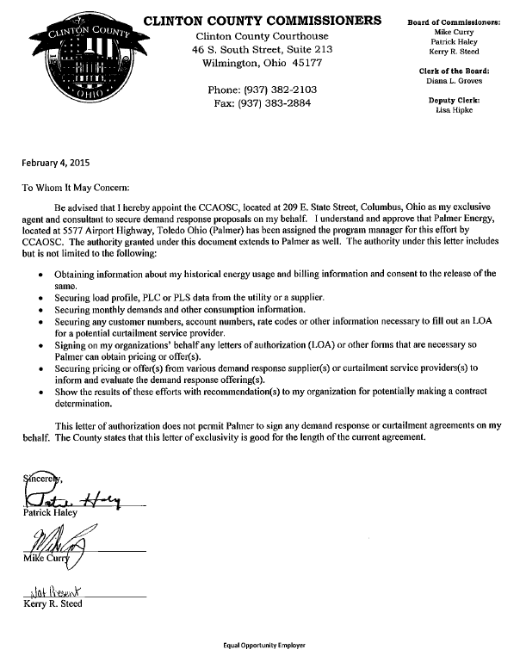

Mr. Haley seconded the Resolution and roll call resulted as follows:

Mr. Haley: YEA Mr. Curry: YEA Mr. Steed: NP

RESOLUTION #15-134 ADOPTED as of February 4, 2015

February 4, 2015

IN OTHER ACTION ON THIS DATE AS FOLLOWS:

- On this date the following credit card use request was approved:
    - Juvenile Probation $644.15

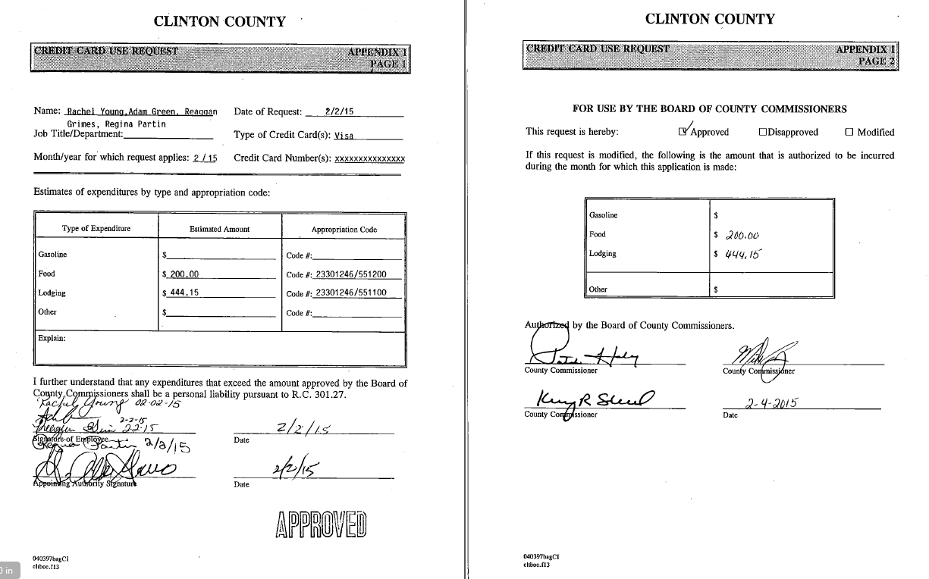

- On this date at 9:00 a.m. the Board met with Mary Ann Foland, Col. Brian Prickett and Lt. Justin Drake to discuss:
    - Courthouse security
    - Fobs & doors – Sheriff March 1, 2015
    - Key in lock box
    - Battery back up on magnetic doors
    - Executive Session Reso# 15-130

- On this date at 9:30 a.m. the Board met with Mary Ann Foland to discuss:
    - Courthouse renovation

Also present: Nathan Kraatz

- On this date at 10:00 a.m. the Board met with Col. Brian Prickett and Mike Jones to discuss:
    - Senior Center update

Also present: Nathan Kraatz, Mary Ann Foland and Col. Brian Prickett

- On this date at 10:45 a.m. the Board met with Dennis Garrison to discuss:
    - Melvin Stone quarry activities
    - All agreements now assigned to Melvin Stone
    - Phase I clean-up
    - Trust
    - Corridor –Clinton County received

Also present: Barry Foxworthy and Nathan Kraatz

- On this date at 11:00 a.m. the Board met with Joe Baldasare and Mike Parks to discuss:
    - Discussion regarding status of Former County Hospital transfer of funds

Also present: Mary Ann Foland and Nathan Kraatz

February 4, 2015

- Topics discussed among the Board on this date as follows:
    - AIP Grant Oversight Risk Assessment Sponsor Certification checklist for FAA
    - Credit card use request
    - Senator Bob Peterson
    - Demolishing of buildings
    - Governor Kasich
    - Letter – bill approval

Also present: Nathan Kraatz

- The President then adjourned the meeting.

---------------------------------------------------
Minutes as of February 4, 2015
APPROVED
---------------------------------------------------

__________________________ _________________________
Patrick Haley Mike Curry Kerry R. Steed

BOARD OF COUNTY COMMISSIONERS
CLINTON COUNTY, OHIO

_______________________________
CLERK OF THE BOARD
Diana L. Groves

