National Portrait Gallery

Finance Assistant – Purchase Ledger, Sales Ledger & Credit Control

The National Portrait Gallery houses a unique collection of all forms of portraiture of the people who have made or are currently contributing to British history and culture; the collection is the most comprehensive of its kind in the world. With around 1.8 million visitors each year and a strong national and international presence through touring exhibitions and special projects, the Gallery is one of the country’s most important and popular galleries.

Purpose

Reporting to the Assistant Financial Controller, the principal duties will be to:
- Administer the Gallery’s purchase ledger alongside the Part-time Purchase Ledger Officer and Assistant Financial Controller,
- Administer the Gallery’s credit control function, and
- Assist in the administration of the Gallery’s sales ledger.

Purchase Ledger Tasks (70%)
Processing supplier invoices promptly and accurately

- Deal with internal and external purchase ledger post.
- Check, scan and accurately input invoices into the Soprano Purchase Order System within two days of receipt.
- Check coding of invoices and ensure VAT is treated correctly.
- Ensure invoices for the subsidiary Trading Company are recognised, separated and posted correctly.
- Ensure that relevant supporting documentation is attached to freelancer invoices before processing.
- Monitor copy invoices.
- Reconcile supplier statements on an ongoing basis and take action to ensure outstanding invoices are received and processed promptly.
- Liaise with purchase order originators, budget managers and suppliers to resolve queries.
- Validate changes to supplier’s bank details.

Organising payments to suppliers within the agreed terms

- Work alongside the Part-time Purchase Ledger Officer to process fortnightly BACS and foreign payments runs for the Gallery and Trading Company to ensure suppliers are paid within thirty days of the invoice date.
- Issue manual cheques when necessary and maintain the cheques register.
- Initiate urgent payments when necessary.
- Work with the Part-time Purchase Ledger Officer to review the Aged Creditors listings, matching unallocated items and eliminating debit balances.

Other purchase ledger tasks
- Accurately processing the Gallery’s credit card statements in line with the monthly timetable and dealing with related issues.
- Maintenance of the purchase ledger filing systems.
- Issuing the monthly Soprano monetary expenditure reports to Budget Holders.
- Providing cover for the Part-time Purchase Ledger Officer and Assistant Financial Controller.

Sales Ledger and Credit Control Tasks (30%)

Chasing overdue debts in a timely manner
- Review outstanding debtors and chase overdue invoices by telephone, email and letter within the agreed guidelines for the Gallery, subsidiary Trading Company and Picture Library department.
- Issue statements and reminders to suppliers each month.
- Maintain an accurate record of debt collection for each customer.
- Deal with customer queries.
- Liaise with the Sales Ledger Officer.
- Check credit references for new customers.
- Formally review aged debtors with the Assistant Financial Controller on a monthly basis and resolve issues arising.

Sales Ledger Assistance

- Collect Retail and Information Desk cash, enter daily sales into spreadsheet for import into the accounting system and maintain banking log.
- Counting donation box and cloakroom income.
- Processing membership cheques and credit card receipts.
- Processing Portrait Award entry fees.
- Raising sales invoices during peak periods.
- Maintenance of sales ledger filing systems.
- Providing ad hoc support and cover for the Sales Ledger Officer.

Other Tasks

- Providing further support to Finance staff and carrying out other ad hoc duties as requested.
- Providing assistance with month end and year end processes.
- Maintenance of desktop instructions.

Performance Targets

- Be well acquainted with the Gallery’s accounting and purchase order systems
- Post supplier invoices within two working days of receipt
- Avoid invoices being processed twice
- Invoices to be paid thirty days of invoice date
- Eliminate payments by cheque as far as possible
- Deal with suppliers queries promptly and efficiently
- Keep filing system up to date at all times
- Minimise bad and overdue debts
- Ensure cash and other receipts are banked and posted within two working days of receipt

Although these are currently the main duties of the post, Gallery management may allocate other tasks, which are of a similar nature or level.
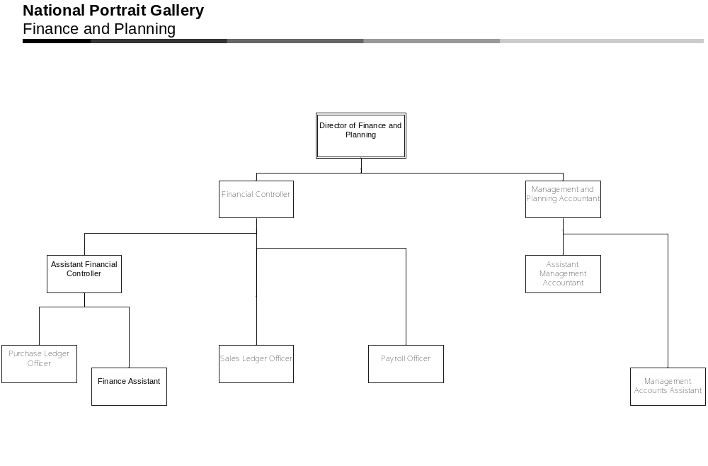
National Portrait Gallery

Finance Assistant – Purchase Ledger, Sales Ledger & Credit Control

Person Specification

Qualifications, knowledge and experience:

- A minimum of 6 months previous experience of working in accounts or finance

- An understanding of the principles of credit control is desirable but not essential

- A good understanding of computerised accounting systems

- Highly organised and able to work effectively with set procedures and timetables, managing time and prioritising tasks as necessary to meet deadlines and objectives

- Numerate with close attention to detail

- A good understanding of double-entry book-keeping and basic principles of VAT is desirable but not essential

- Demonstrates a willingness to make decisions and takes the initiative with appropriate action

Attributes

- Excellent written and spoken communication skills

- The post-holder must have a good telephone manner

- Ability to work well as a part of a team as well as good interpersonal skills

Other

Flexibility of approach in order to cover for other Finance staff at times of absence or need

An interest and commitment to the work and aspirations of the National Portrait Gallery

National Portrait Gallery

Finance Assistant – Purchase Ledger, Sales Ledger & Credit Control
Details of the post are given below and in the job description. You should take care to show in your application how you can fulfil the requirements of the job.

Hours
Your contracted hours of work are 40 gross (5 days) per week including a lunch break of one hour a day.

Pay

The salary for this post will be £20,637 per annum.

Annual Leave
The annual leave allowance for this post is 25 days per annum for the first year, rising to 29 days at the start of the annual leave year following completion of five years’ service and up to 33 days after 10 years service.

Place of Work
Most of the work is based in the Gallery at St Martin’s Place, but all staff are required to work at other locations if necessary.

Equality
The Gallery believes in the employment and advancement of people solely on their ability to do the job required. When recruiting people, we will therefore disregard their gender, marital status, race, age, colour, nationality, ethnic origin, religion and sexual orientation. There will be no unfair discrimination on the basis of disability. If you would like to submit your application in a different format we are happy to allow this. Please contact us (telephone: 020 7306 0055 email: personnel@npg.org.uk) so that we may discuss suitable alternatives.

Pension
Pension benefits are provided under the Principal Civil Service Pension Scheme (PCSPS).

Probation and Trial Period
All appointments are subject to satisfactory employment and character references and security clearance. There is a probationary period of 1 year for all permanent posts. For fixed term appointments the probationary period may be less than 1 year. The probationary period for this post is 1 year.

Data Protection Act
Information provided by you as part of your application will be used in the recruitment process. Any data about you will be held securely with access restricted to those involved in dealing with your application in the recruitment process. Once this process is completed the data relating to unsuccessful applicants will be stored for a maximum of 6 months and then destroyed. If you are the successful candidate, your application form will be retained and form the basis of your personnel record. Information provided by you on the Equal Opportunities Monitoring Form will be used to monitor National Portrait Gallery’s equal opportunities policy and practices. By signing and submitting your completed application form you are giving your consent to your data being stored and processed (if you submit your application by e-mail and the application form is un-signed we will assume that consent by you is given) for the purpose of the recruitment process, equal opportunities monitoring and your personnel record if you are the successful candidate.

Season Tickets
Interest free loans are available for the purchase of a season ticket for travel to work.

Please return your completed application form to:

Personnel at: personnel@npg.org.uk

Or by post

Mrs Caroline Wynter
Head of Personnel
National Portrait Gallery
2 St Martin’s Place
London
WC2H 0HE

by 9.00am on 29 February 2012

We are expecting to hold interviews on 16 March 2012. Please indicate on the form if you will not be available on this date.

If you are delivering your application by hand, please take it to the reception desk at 39-45 Orange Street.

To ensure the best possible use of our limited resources we are unable to respond to every application. If you have not had a response to your application by 15 March 2012 please assume that you have been unsuccessful on this occasion.

We would like to thank you for your time and effort in returning your application.

