October 05, 2017
Fox World Travel Phone and Online Reservations
- Toll-free: 844-319-2892 Direct: 312.361.0144
- E-Mail: ada@foxworldtravel.com
- Online Help: online@gofox.com
- Online: www.concursolutions.com
  - You need your ADA-supplied User Name, First Time Password, Meeting Date/City and Name of Your Meeting for access to 24/7 online travel.
  - ‘changeme’ is the password to use the first time you login. Create your travel profile preferences and a new password. Jot down your new password and keep it for future online travel use. You will not be asked to change your password again.
**changeme** is your password for the first time that you login to Concur. Once logged-in create a travel profile and change your password to something that you will easily remember. You will not be asked to change your password again. For future ADA-funded trips use your new password.

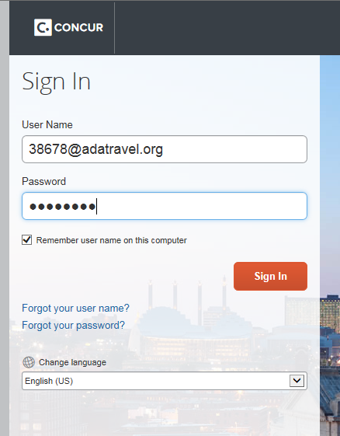

After logging in the first time you will be required to complete your travel profile. When creating your travel profile, please pay particular attention to your name as it appears on the ID that you travel with.
- Change your password
- Build your profile and add your travel preferences
- Confirm your TSA information (name must match your photo ID so PLEASE get your I.D. out when building your travel profile!)
- Remember to click the SAVE buttons
IMPORTANT RESOURCE INFORMATION
Under Company Notes on the home page you will see some important travel policy notes and some very helpful Fox World Travel Resources:
- Concur Training Library – recorded videos and guides that are updated frequently
- Concur Live Training Webinars – done by Fox every couple of weeks
- Concur Tip of the Month
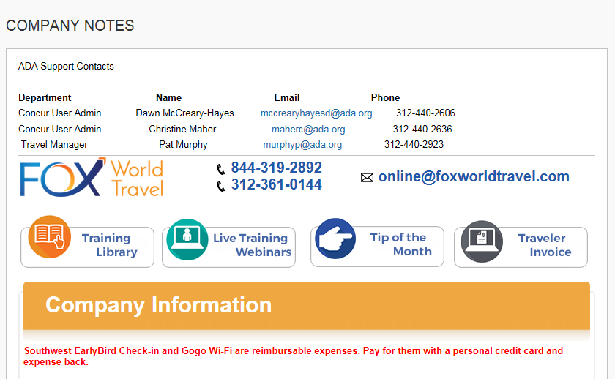

To start the travel process fill in your travel basics: Departure City /Arrival City /Travel Dates /Time of Travel and click on SEARCH. Pay particular attention to the + filter in the departure time box. Concur will check flights 3 hours before and 3 hours after in the example below. If you don’t see a particular flight, you may need to widen your + search. Note you can also search by a specific airline below.
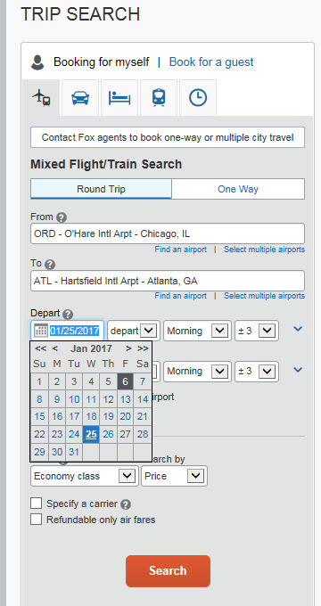

Choose your preferred flights.
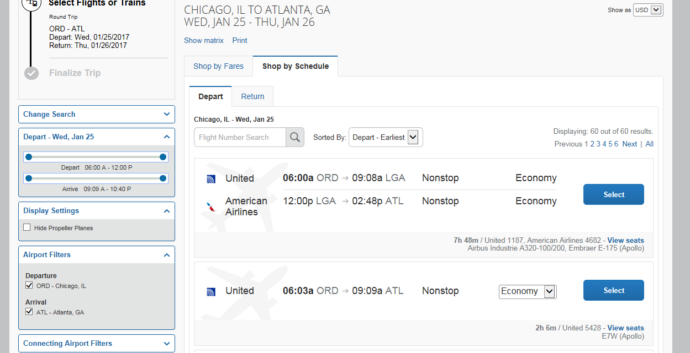
Once you have reviewed your flight options and chosen your flights click on the airfare amount ($150.40 in the example below.)
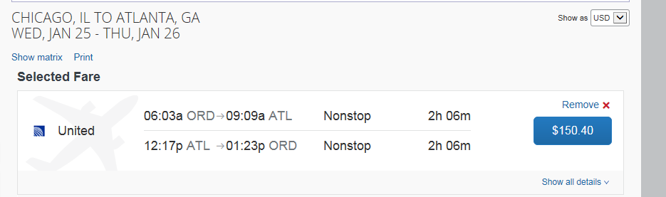
Then click on RESERVE and REVIEW the schedule chosen. If the airfare is outside the ADA travel policy, you will be asked to pick a reason why you chosen your flights /fare. Continue with the reservation process. Your reservation will automatically be sent to the ADA’s travel manager for review once you have completed the reservation. 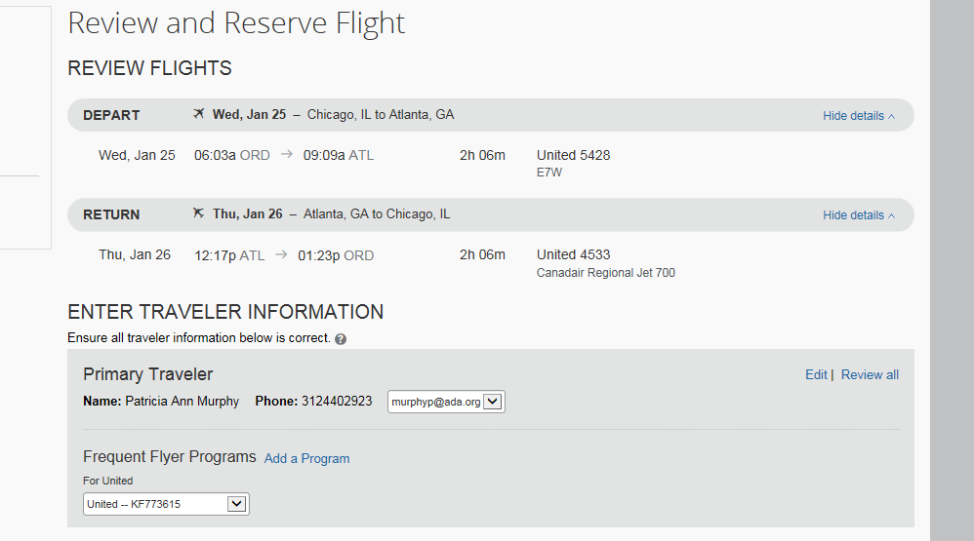

Select your seats or Concur can do it for you based on your seating preference in your travel profile. 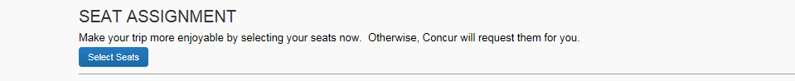
Review your trip details again and click on NEXT.
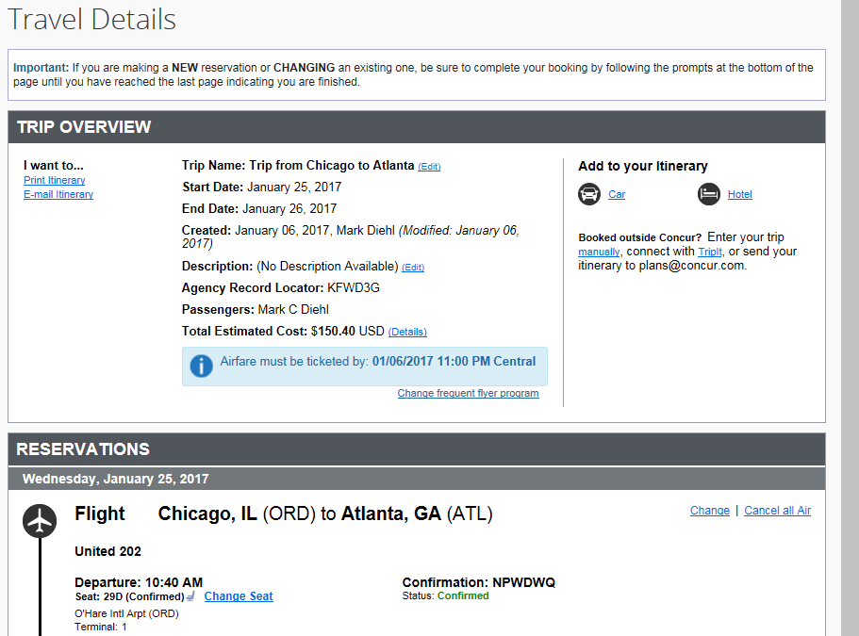
Select the meeting that you are authorized to attend. (REQUIRED) DO NOT CHOOSE A RANDOM MEETING PLEASE. Refer to the travel instructions sent to you by the ADA. 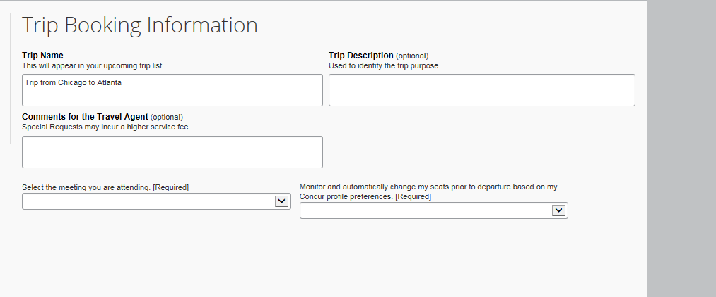

If you do not see your meeting listed, click on MEETING NAME NOT IN LIST and in the box to the right add your meeting name and the ADA or CODA staff contact name so that we can have your travel authorized.

Click on NEXT. Make sure you follow the reservation process all the way to the end by reading each screen and clicking on NEXT (lower right). If you don’t, you will not have completed the reservation process.
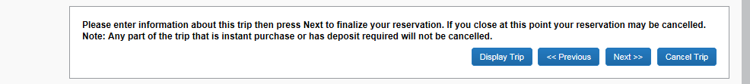
Click PURCHASE TICKET to finalize your reservation and issue your airline or rail ticket. After reviewing your itinerary, click on PURCHASE TICKET to finalize your reservation. 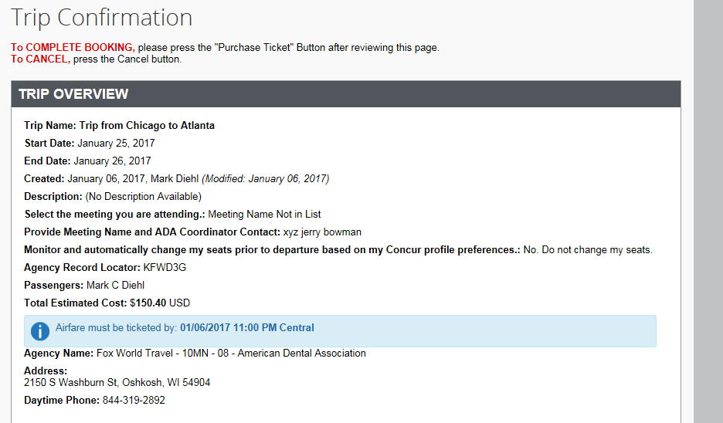
After you click on PURCHASE TICKET you will get your confirmation number:
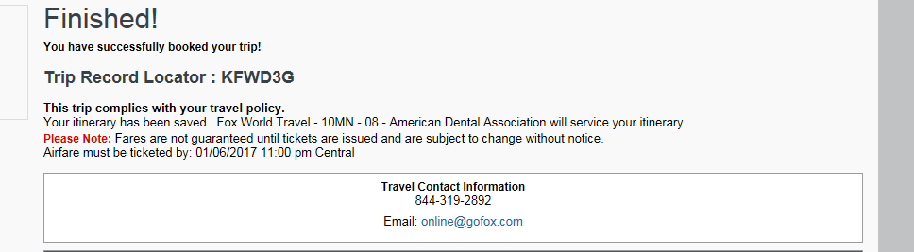
You will receive your travel confirmation via e-mail from Fox World Travel. You should always receive a confirmation from Fox shortly after you make your travel reservation.
The first time you travel with Fox you will also receive a sign up for trip alerts e-mail. You need to either register for this free service or opt out to stop receiving registration e-mails. The ADA strongly suggests that you register to use this service so that you can be advised of flight delays and cancellations. You only need to register once to be covered for all of your ADA-funded trips!
You should also go to www.ada.org/travel and click on the Fox World Travel Program link. This page has many other resources to make your travel and expense reporting for the ADA as easy and successful as possible.
COMPANION TRAVEL
If traveling with a companion, you can also make that reservation in Concur by clicking on the –book for a guest- tab. You have to make each reservation (your guest(s) and your own) individually.
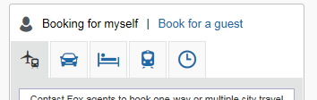
A personal credit card and expiration date is required for each guest. You will have to select the “Use a temporary card” radio button and then enter in the credit card details. There is an $8.00 service fee per ticket issued.

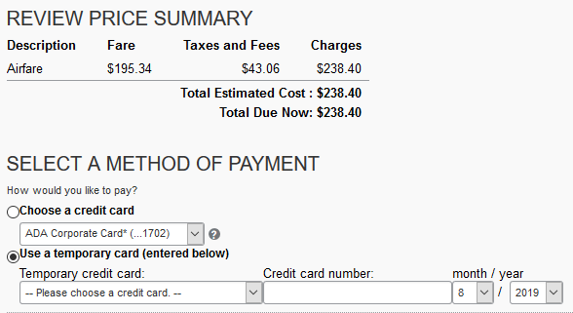
IMPORTANT TRAVEL POLICY NOTES
- Authorized travel will be charged to the ADA credit card automatically. You do not need to attach a copy of your Fox World travel confirmation to your ADA expense report – either in Concur or to a paper expense reimbursement form.
- If you lose your confirmation, you can register to use the Fox instant invoice system. Travelers can register any time for Instant Invoice by vising the following link:
http://reports.foxworldtravel.com/einvoice
- If you are combining personal travel with ADA-funded travel, you must call and speak to an agent. There is a $33.00 service fee for each ticket issued when talking to an agent, this includes two credit card split payment transactions.
- You cannot make two one-way reservations via the online system that exceed the ADA fare ceiling. If you should happen to do this, a Fox World Travel agent will contact you for a personal credit card or to look at lower fare alternatives.
- You can make Amtrak reservations via the online system.
- You can make Southwest Airlines and JetBlue Airways reservations via the online system. If bringing a guest, make that travel reservation yourself via http://www.southwest.com or http://jetblue.com and then make your ADA-funded travel reservation via the online system above.
- The ADA does not book travel on Spirit Airlines.
- Hotel reservations should be made following the instructions of your ADA / CODA staff meeting organizer.

