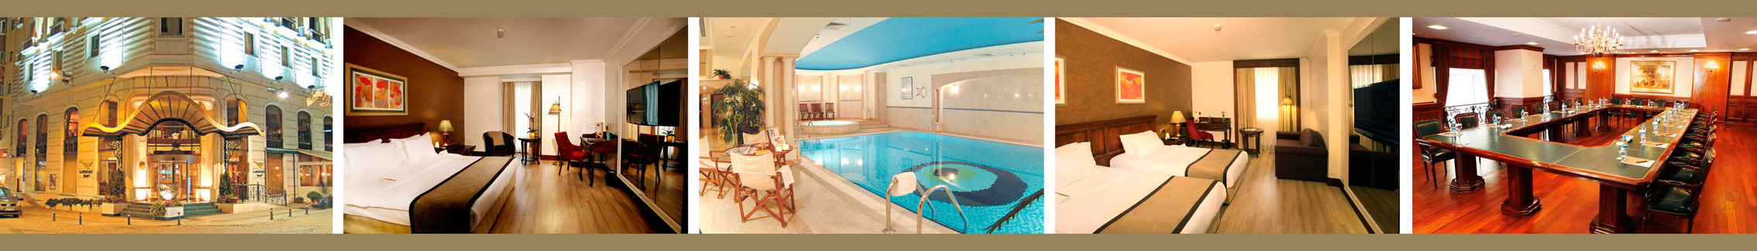


E-mail : reservation@laresparkhotel.com



FUTURE ACADEMY® ICEEPSY & CPSYC & icPSIRS & BE-ci
RESERVATION FORM

NAME :
SURNAME :
E-MAIL :
ADDRESS :
TEL :
FAX :

CHECK -IN DATE :
CHECK -OUT DATE :

SINGLE :

DOUBLE :

PRICE : SINGLE : 150 € (included TAXES &breakfast)
DOUBLE : 170 € (included TAXES &breakfast)

Reservation expire date : 25 September 2015

CREDIT CARD DETAILS :
Credit Card Name :
Credit Card Number :
Expire Date :
Security Number :

Any cancellation between 25 September 2015 and date the before 2 days of declared check-in will be subject to charging 100% of the amount of the first room night.
100% of the acommodation fee will be charged in case of the cancellation of reservation witihin 2 days or less before arrival. No show will be subject to full payment for the whole period.
SIGNATURE : DATE:

