GCSE Maths
Equivalency Tests

Syllabus and Specimen Papers
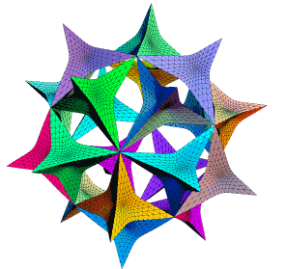

Calculator & Non-Calculator Papers

Other revision materials

Any Intermediate level GCSE Mathematics book on the market will cover all the main points in the syllabus but two cheap and very accessible books are produced by Coordination Group Publications. They are the Intermediate Level Revision Guide ISBN 1-84146-021-4, and the accompanying Workbook ISBN 1-84146-029-X. Details are available at www.cgpbooks.co.uk and they are available at most bookshops.

Edge Hill University

As a leading university, we are dedicated to creating opportunity from knowledge – a philosophy that drives our teaching, our academic research, and our commitment to providing you with a great student experience leading to a rewarding career.

We are continually recognised for our outstanding achievements in student support, graduate employment and innovation, as well as our significant role in transforming lives. Join us, and you will be studying on one of the best campuses in UK higher education, as part of a unique and welcoming academic community.

Standalone Equivalency Exams

Please read the following information carefully, it contains important information about the terms and conditions of Edge Hill University Standalone Equivalency Exams.

This information pack is designed to support your revision in preparation for the exam. It is not designed to emulate the exams in any way. We recommend that you also utilise other GCSE revision resources, such as those provided on the BBC website.

Once you have booked and paid for an exam, you can revise at your own pace. However, we do ask that you take at least 1 attempt of the chosen exam within one year of payment. Refunds can be requested either within 1 year of payment or prior to any attempt at the exam (whichever of these is the earliest). This applies to stand alone exams only.

Please be aware that Edge Hill University Equivalency Exams are designed to meet the GCSE requirements for Edge Hill University only. Other institutions or governing bodies may accept them. However, it is your responsibility as the applicant to ensure that this equivalent exam will be accepted.

On the day of your exam:

Please arrive 30 minutes prior to the start of the exam. This allows time for registration and pre exam briefing. Applicants arriving 0-15 minutes after the start of the exam, may enter the exam, but will not be allocated any additional time. Candidates arriving more than 15 minutes after the start of the exam will be refused entry.

Once you have entered the exam room you are considered to be under exam conditions. All revision material and bags should be stored under your chair or table and out of your / your fellow candidates’ line of vision.

You must not talk to, attempt to communicate with, or disturb other candidates once the exam has started.

Mobile phones and smart watches must be switched off and stored appropriately. They cannot be used as calculators or timing devices. You may be asked to place these in a clear plastic bag (these will be provided).

Any pencil cases to be used during the exam should be clear plastic and kept on top of the desk.

You may leave the exam room once you have finished the exam, as long as you do not disturb other candidates. Please be aware that talking outside of the exam room can be very distracting.
If you require any assistance during the exam please raise your hand and wait for the invigilator to approach you.

Behaviour resulting in the disturbance of other candidates, or contravening any of the above terms and conditions may result in your paper being cancelled. This will count towards one of your attempts at the exam.

You must not remove any materials used during the exam including question books, answer books or drafting paper from the exam room.

If you need to visit the bathroom during the exam, no exam material, bags or other personal effects can be taken out of the room. Additional time is not allowed for such breaks (unless specified under an additional needs report)

If you are found to be using any material or aids that would give you an unfair advantage in the exam, this will be reported as appropriate and may be resulted in your exam being voided.

What to bring with you:

Photo ID. This will be required for registration at the exam. Acceptable ID includes: passport, driving license, recognised age ID card, residential permit, student or NUS Card. This must be in the same name that you have used to register for the exam. If you have recently changed your name you must bring additional evidence such as change of name documents or marriage certificate. If you feel your name has not been registered correctly please contact us prior to the exam.

Exam questions should be answered in black or blue pen (diagrams and graphs can be drawn in pencil).

Candidates for the GCSE Equivalency in Mathematics will require a scientific calculator, protractor, ruler and pencil.

Candidates for GCSE Equivalency in Science, will be provided with a copy of the periodic table. You are permitted to bring and use a scientific calculator.

Calculators are not permitted in level 2 numeracy exam.

Dictionaries/ thesauruses are not permitted in any exam.

Subject Papers:

Please take time before each exam to read the instructions on the front of the exam paper. Please see below for details of exam timings.

English: 2 hours - 1 paper
Maths: 2.5 hours - 2 papers: 75 mins each (one calculator; one non-calculator)
Science: 2 hours - 1 paper
Numeracy: 2 hours - 1 paper (no calculators allowed)
Literacy: 2 hours - 1 paper

Receiving Results

Please allow at least 4 weeks for your paper to be marked. Please do not contact us for results with in the first 28 days.
Unless otherwise requested, candidates will initially be informed of results by telephone. If you are successful in passing the exam, confirmation will also be made in writing and posted to your registered address.

Additional Needs

If you have any additional requirements due to disability or Specific Learning Difficulties, please contact Edgehilltest@edgehill.ac.uk at least 5 days before you exam. We will need to see evidence of your specific requirements such as an educational Psychology Report or Needs Assessment. We will, where appropriate, accommodate additional requirements. However, in certain circumstances, this may mean you need to sit the exam on an alternative date.

CONTENTS PAGE

Syllabus with examples 8 - 13
- Answers to example questions 14

Specimen examination paper 1 15 - 36
- Answers to specimen paper 1 37

Specimen examination paper 2 39 - 60
- Answers to specimen paper 2 61
- Past Paper 1 63
- Answers to Past Paper 1 84
- Past Paper 2 87
- Answers to Past Paper 2 110
- Past Paper 3 111
- Answers to Past Paper 3 133
- Past Paper 4 135
- Answers to Past Paper 4 156
- Past Paper 5 157
- Answers to Past Paper 5 178
- Past Paper 6 179
- Answers to Past Paper 6 199

Syllabus with Examples

Number and Algebra

Topic | Notes | Sample Questions
Understand place value | Read and write whole numbers expressed in figures and words.  Order whole numbers to the nearest 10, 100, 1000 etc.  Round decimals to the nearest whole number or a given number of decimal places.  Round numbers to a given number of significant figures. | 1. Write three hundred thousand , two hundred and six as a number.  2. Write the number 5.6479 correct to  a) one decimal place  b) three significant figures
Understand and use decimals, fractions and percentages | Show equivalence between the three forms.  Use and apply the four rules of numbers to decimals and fractions.  Calculate percentages of a quantity and express a given number as a percentage of another. | 3. Express the fraction as  a) a decimal  b) a percentage  4 A car which had been bought for £5,000 is sold for £3,500 three years later. Calculate the percentage loss on the deal.  5. x
Negative numbers | Using and applying the four rules of number to negative numbers | 6. (–3) + (+8)  7. (-9) – (-2)  8. (-3) x (- 11)  9. (+27) ÷ (- 3)
Ratio |  | 10. Divide £300 in the ratio 7: 8

Index notation, including standard form | Express and use number in standard form with positive and negative powers of 10. | 11. Write these numbers in standard form:  a) 6,340  b) 0.000762  12. Give your answer to the following calculation in standard form:  4.5 x 10⁻⁴ x 4.0 x 10⁻¹  13. Re write this list of numbers in order of size, starting with the smallest.  8.17 x 10³ 5.55 x 10⁻⁵ 2.88 x 10²  7.22 x 10⁻⁵ 5.27 x 10⁵
Understand and use common number properties | Show familiarity with multiples, factors, primes, HCF & LCM, powers and roots. | 14. Express 24 as a product of its prime factors  15. Find the HCF of 12 and 8  16. Which is larger 2³ or 3²?
Manipulate algebraic expressions | Collect like terms; find common factors; multiply two simple brackets; factorise expressions in the form ax² + bx + c | 17. Simplify the following expression:  4x – 8y – 3x + 7y  18. Factorise  a) 9cd + 12de  b) 3ab² – a²b³  c) x² – x - 12  19. Multiply ( 2x + 5 )( x – 3 )
Manipulate algebraic expressions - continued | Apply the rules of indices to simplify algebraic expressions | 20. Simplify  a) 6x⁵ ÷ 3x²  b) 2x² x 3x³  c) ( 3x²)³
 | Change the subject of a formula | 21. Rearrange the following formula to make s the subject  t² – rs = q
Solve equations | Linear equations | 22 Find the value of x when:  a) 2x + 5 = 11  b) 5x + 5 = 7x – 21
 | Simultaneous equations in two unknowns | 23 Find the values of x and y when:  a) 3x + 4y = 23  b) 2x – 3y = 4
 | Quadratic equations using factorisation | 24 Find the value of x when  x² – 2x –15 = 0

 | Use Trial and Improvement to solve equations | 25 Find the value of x to two places of decimals if x³ = 38  i.e. If x = 3, x³ = 27 - too small  if x = 4, x³ = 64 – too big  if x = 3.5, x³ = 42.825 – too big  if x = …………….
Solve inequalities |  | 26 Find the range of values of x if:  a) 3x - 6 ≤ 12  b) x² ≥ 16
Number sequences | Explore number patterns and find a general expression to describe the nth term of a sequence where the rule is linear or quadratic. | 27 Find the next term and the nth term in each of these sequences:  a) 2, 5, 8, 11, 14 ………..  b) 0, 2, 6, 12, 20 ………

Shape and Space

Topic | Notes | Sample Questions
Graphs | Plotting Cartesian Coordinates | 28. The points ABCD form a square. If A is the point ( -1 , 2 ), B is ( 4 ,2 ) and C is ( 4 , -3), find the coordinates of the point D.
 | Conversion graphs, distance time graphs | See specimen papers.
 | Draw and interpret graphs of linear functions and quadratic functions.  y = mx + c | 29. Draw the graph of y = x² – 5 where –4 ≤ x ≤ 4.  From the graph, find the values of x when  y = 0.
 | Use graphs to solve simultaneous equations | 30. Draw the graphs of y = 3x – 5 and y = 3 – x.  Use the graph to solve the simultaneous equations  y = 3x – 5  y = 3 – x
Transformations in a plane | Translation, reflection, rotation and enlargement | 31. Draw x and y axes from –10 to +10. Plot the following points and join them up: A ( -4,4 ),  B ( -3,4 ), C ( -3,3 ), D ( -2,3 ), E ( -2,2 ),  F (-4,2)  (a) Draw an enlargement with a scale factor of 2 for this shape, using (-6,7) as the centre of enlargement.  (b) Draw the reflection of ABCDEF in the line  x = 2 .  (c) Rotate ABCDEF about the point (-6,1 ), through an angle of 90º in a clockwise direction.
Name and understand the properties of simple 2D and 3D shapes | Angle properties of polygons including interior and exterior angles | 32.A hexagon has angles of 155º, 98º and 89º. The other three angles are equal. Find the size of the remaining angles.
 | Angle properties of parallel lines and transversals (corresponding, alternate and interior or allied angles) | 33. Find the size of the missing angles if AB is parallel to CD.  d  A 72º c B  C 59º D  e
Name and understand the properties of simple 2D and 3D shapes – continued. | Area and perimeter of triangles, rectangles.  Area of parallelograms, trapeziums.  Circumference and area of a circle | 34. Calculate the size of the shaded area if the side of the square is 20cm.
 | Volumes of cuboids, cylinders and regular prisms | 35. Find the volume of a tin of beans with a  radius of 3cm and height 7cm.
Pythagoras Theorem | Solve problems in two dimensions | 36. In a triangle ABC, A = 90º, AB = 9cm and  BC = 12cm. Find the length of AC correct to 1 decimal place  B  9cm 12cm  A C
Trigonometry | Solve problems in right angled triangles using sin, cos and tan | 37.If angle BAC = 43º and AB = 10 cm, find the length of AC and BC. Give your answer correct to two places of decimals.  B  A 43º C
Bearings | 3 figure bearings and scale diagrams | 38. A boat leaves a harbour A and sails 5km south – west to a point B, and then 3km south to a point C.  By use of an accurate scale drawing, find on what bearing it must sail to head directly back to harbour and how far it has to sail.
Locus | Points equidistant from  (a) a point  (b) a line

Handling Data

Topic | Notes | Sample Questions
Data collection and representation | Tally charts  Grouped frequency tables  Cumulative frequency tables.  Bar charts,  Pie charts,  Cumulative frequency curves,  Scatter graphs. | 39.The times taken for students to complete two questions were recorded as:  Draw a cumulative frequency table to illustrate this information.
  Time  (t minutes) | No of students
  0 < t ≤ 20 | 3
  21 < t ≤ 25 | 12
  26 < t ≤ 30 | 25
  31 < t ≤ 35 | 49
  36 < t ≤ 40 | 21
  41 < t ≤ 45 | 7
  46 < t ≤ 50 | 3
Interpreting data | Find the range of a set of data.  Find averages using mean, median and mode.  Using cumulative frequency curves to find the median, upper and lower quartiles and interquartile range of a set of data  Box and Whisker diagrams | 40. Draw a cumulative frequency curve for the information in question 39 and use it to find the median and inter quartile range of the data.  41. The annual salaries of employees in a small company are £45,000, £25,000, £15,000, £15,000 and £12,000. Find the mean, mode, median and range of this set of data.

Probability | Outcomes of a combination of 2 experiments.  Using tree diagrams and sample space diagrams | 42. A fair 6 sided die and a 10p coin are tossed simultaneously. Complete the sample space diagram to show all the possible outcomes.  (a) What is the probability of throwing a tail  and an odd number?  (b) What is the probability of throwing a head  or a number greater than 4
   | 1 | 2 | 3 | 4 | 5 | 6
  H | H,1 | H,2
  T | T,1

Answers To Sample Questions

- 300,206
- a) 5.6
b) 5.65
- a) 0.6
b) 60%
- 30 %
- 1/2
- +5
- –7
- +33
- –9
- £140 : £160
- (a) 6.34 x 10³
(b) 7.62 x 10⁻⁴
12. 1.8 x 10⁻⁴
13. 5.55 x 10⁻⁵
7.22 x 10⁻⁵
x 10²
8.17 x 10³
5.27 x 10⁵
14. 2 x 2 x 2 x 3
15. 4
16. 3²
17. x – y

- (a) 3d ( 3c + 4e )
(b) ab² (3 – ab )
(c) ( x – 4 )( x + 3)
- 2x² – x – 15
- (a) 2x³
(b) 6x⁵
(c) 27x⁶
21. s = q – t² or s = t² – q
-r r
22. (a) x = 3
(b) x = 13
- x = 5, y = 2
- x = 5 or x = -3
- x = 3.36
- (a) x ≤ 6
(b) x ≤ -4 or x ≥ 4
- (a) 17, 3n – 1
(b) 30, n² – n
- ( -1,-3 )
- x = +2.2 and x = -2.2
- x = 2, y = 1

- (a) A’ ( -2,1 ), B’ ( 0,1 ), C’ ( 0,-1 ), D’ ( 2,-1 ), E’ ( 2,-3 ), F’ (-2,-3 )
(b) A’‘ ( 8,4 ), B’’ ( 7,4 ), C’’ ( 7,3 ), D’’( 6,3 ),
E’’ ( 6,2 ), F’’ ( 8,2 )
(c) A’’’ ( -3,-1 ), B’’’ ( -3,-2 ), C’’’ ( -4,-2 ),
D’’’ ( -4,-3 ), E’’’ ( -5,-3 ), F’’’ ( -5,-1 )
- 126º
- a = 108º, b= 59º, c = 59º, d = 49º, e = 108º
- Area of square = 400 cm²
Area of circle = 314.16 cm²
Shaded area = 85.84 cm²
- 197.9 cm²
- 7.9 cm
- AC = 10.72 cm, BC = 14.66 cm
- 028º, 7.4 km
39.
Time  (in mins) | Students | Cumulative Frequency
0 < t ≤ 20 | 3 | 3
21 < t ≤ 25 | 12 | 15
26 < t ≤ 30 | 25 | 40
31 < t ≤ 35 | 49 | 89
36 < t ≤ 40 | 21 | 110
41 < t ≤ 45 | 7 | 117
46 < t ≤ 50 | 3 | 120

40. answers are approximate:
median = 32
upper quartile = 35
lower quartile = 28
interquartile range = 7
41. mean = £22,400
median = £15,000
mode = £15,000
range = £33,000
42.
 | 1 | 2 | 3 | 4 | 5 | 6
H | H,1 | H,2 | H,3 | H,4 | H,5 | H,6
T | T,1 | T,2 | T,3 | T,4 | T,5 | T,6

(a)
(b)



Examination in Mathematics

Specimen Paper 1

Two and a half hours

Name ………………………………………………………………………….

ATTEMPT ALL QUESTIONS

Show all your working in the space provided and make sure your answer is clear.

It is assumed that you have a scientific calculator, ruler and protractor.

If your calculator does not have a π button, take the value of π to be 3.142

Diagrams are not necessarily drawn to scale.

The marks for each question are given in brackets by the side of the question.

Marks may be given for method even if your answer is wrong.

The total marks available are 120.

Calculator Questions
1. A cake is made from fat, flour and sugar

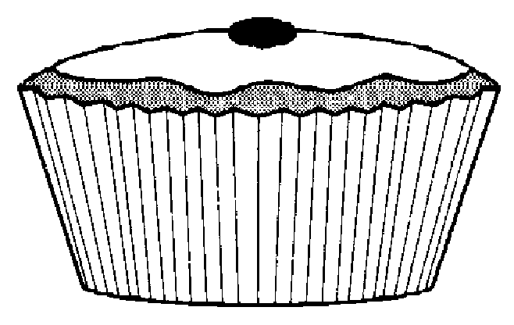
The cake weighs 110g
The weight of the sugar is 42g

(a)(i) What percentage of the weight is sugar?
Give your answer correct to one decimal place.
………………………………………………………………………………………………………………………………..…
………………………………………………………………………………………………………………………………..…
………………………………………………………………………………………………………………………………..… [2]
(ii) The ratio of the weight of flour to the weight of sugar is 3 : 2.
What is the weight of the flour?
………………………………………………………………………………………………………………………………..…
………………………………………………………………………………………………………………………………..…
………………………………………………………………………………………………………………………………..…
………………………………………………………………………………………………………………………………..… [2]

- Two packets of cereal are priced as shown.
Which packet represents the best value? You must show your working clearly.

260g

98p

500g

£1.88

………………………………………………………………………………………………………………………………..…
………………………………………………………………………………………………………………………………..…
………………………………………………………………………………………………………………………………..…
………………………………………………………………………………………………………………………………..… [2]

- One Saturday a newsagent sells the following:

National daily newspapers 510
Echo 360
Magazines and comics 210

Draw a clearly labelled pie chart to represent these sales.

.

………………………………………………………………………………………………………………………………..…
………………………………………………………………………………………………………………………………..…
………………………………………………………………………………………………………………………………..…
………………………………………………………………………………………………………………………………..…
………………………………………………………………………………………………………………………………..… [3]

4. The diagram illustrates a garden.
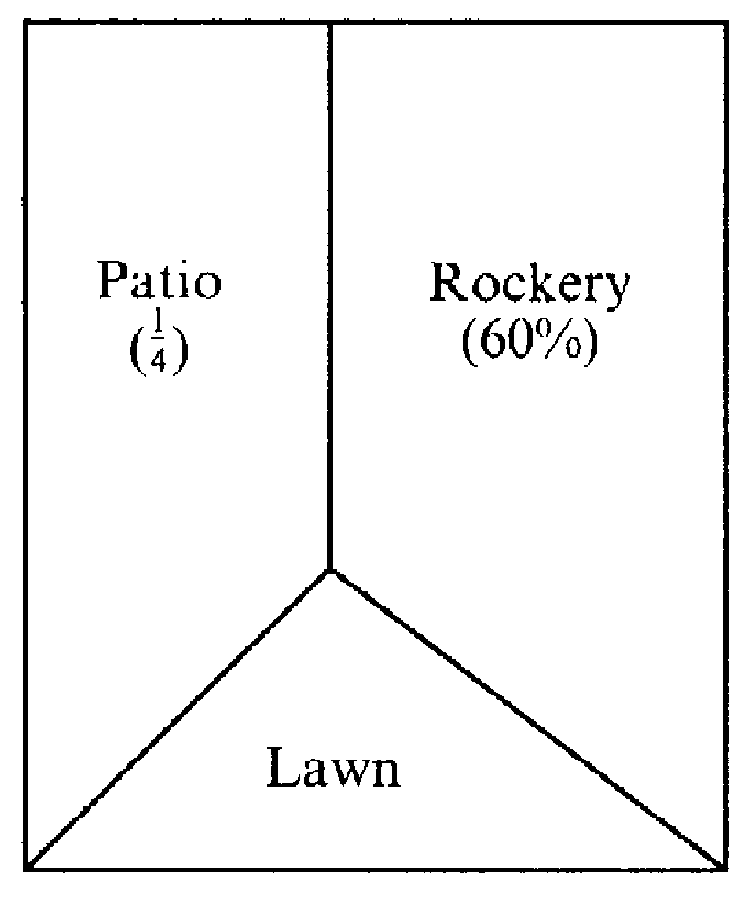
60% of the garden is a rockery.
¼ of the garden is a patio.
What percentage of the garden is lawn?

………………………………………………………………………………………………………………………………..…………………………………………………………………………………………
………………………………………………………………………………………………………………………………..…
………………………………………………………………………………………………………………………………..… [3]

5. (a) Light travels at 186,000 miles per second, to the nearest thousand miles.
Write this number in standard form.
………………………………………………………………………………………………………………………………..… [2]

- The planet Jupiter is 486.6 million miles from the sun.
Calculate how long the light takes to travel from the sun to Jupiter.
Give your answer to the nearest minute.
………………………………………………………………………………………………………………………………..…
………………………………………………………………………………………………………………………………..…
………………………………………………………………………………………………………………………………..…
………………………………………………………………………………………………………………………………..… [3]

6. Mrs Jones earns £21,000 per annum. Her annual pay rise this year
is 3%. What will her new salary be?
………………………………………………………………………………………………………………………………..…
………………………………………………………………………………………………………………………………..…
………………………………………………………………………………………………………………………………..… [2]

7. Darren drives 38km at an average speed of 63km per hour
Calculate how long his journey takes. Give your answer in minutes.
………………………………………………………………………………………………………………………………..…
………………………………………………………………………………………………………………………………..…
………………………………………………………………………………………………………………………………..… [2]
4
3
8. The volume of a sphere is given by the formula V = πr³
(a) Rearrange the formula to give r in terms of V.
………………………………………………………………………………………………………………………………..…
………………………………………………………………………………………………………………………………..…
………………………………………………………………………………………………………………………………..… [2]

(b) Find the value of r when V = 75 cm³
………………………………………………………………………………………………………………………………..…
………………………………………………………………………………………………………………………………..…
………………………………………………………………………………………………………………………………..… [2]

9. A ladder, 2.75m long leans against a wall.
The bottom of the ladder is 1.80m from the wall, on level ground.

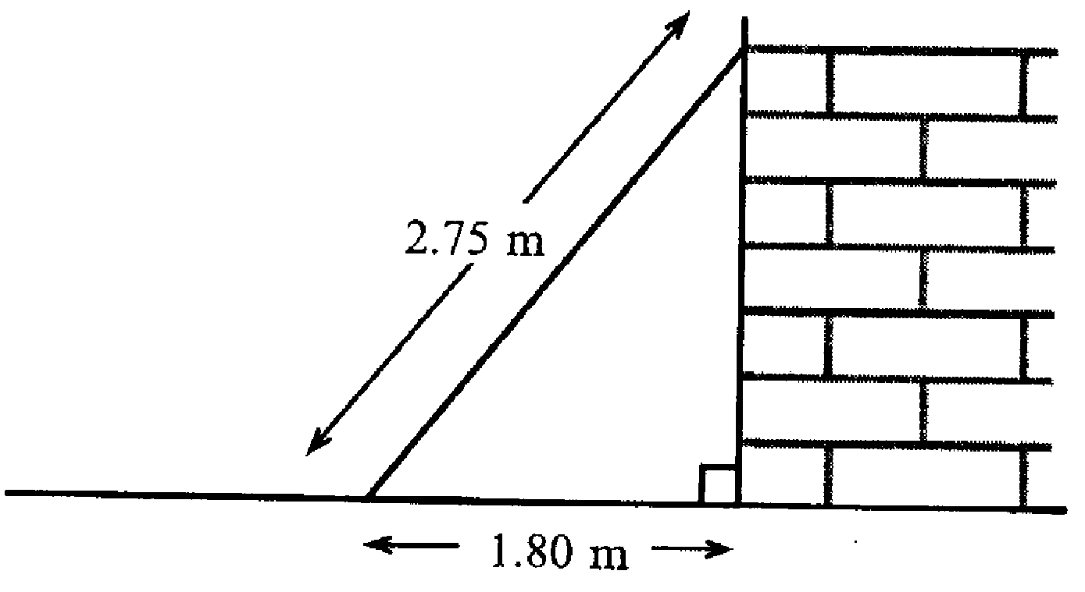

Calculate how far the ladder reaches up the wall.
Give your answer to an appropriate degree of accuracy.
………………………………………………………………………………………………………………………………..…
………………………………………………………………………………………………………………………………..…
………………………………………………………………………………………………………………………………..…
………………………………………………………………………………………………………………………………..…
………………………………………………………………………………………………………………………………..…
………………………………………………………………………………………………………………………………..… [3]
10. The scatter diagram shows the heights of sixteen Year 9 boys and their
fathers.
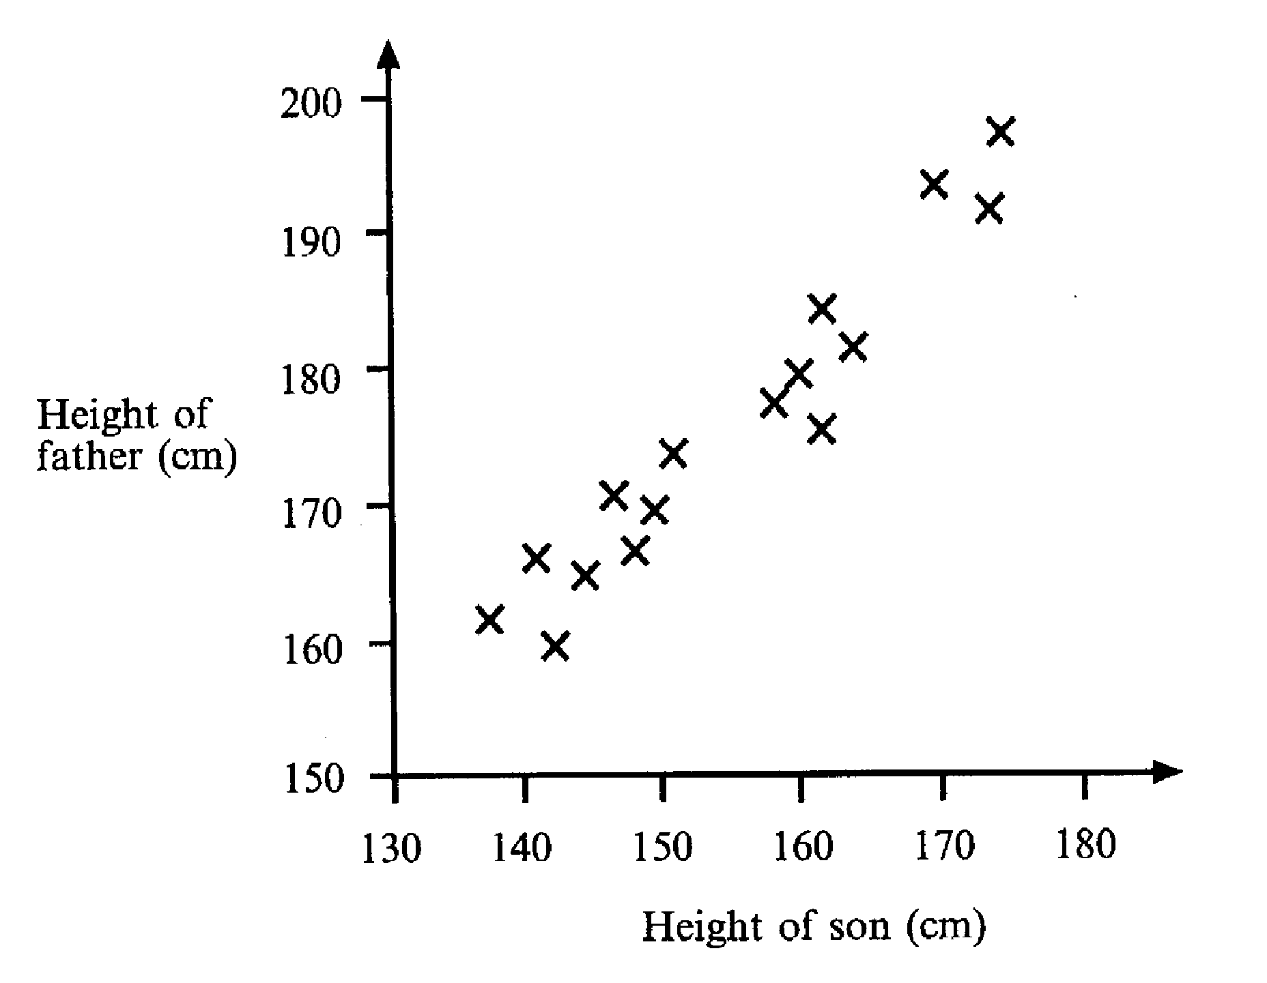
(a) What does the scatter diagram tell you about the relationship between the heights of these boys and their fathers?
………………………………………………………………………………………………………………………………..…
………………………………………………………………………………………………………………………………..…
………………………………………………………………………………………………………………………………..… [1]
(b) Draw a line of best fit on the diagram. [1]

(c) Bill, another Year 9 boy, is 155cm tall.
Use the diagram to estimate the height of Bill’s father.
Show clearly how you obtained your answer.

………………………………………………………………………………………………………………………………..…
………………………………………………………………………………………………………………………………..…
………………………………………………………………………………………………………………………………..… [2]

11. Given that y = x² + 1
(a) Complete the table below,
x | 0 | 1 | 2 | 3 | 4 | 5 | 6
y |  |  |  | 10 |  |  | 37
[2]
- Plot these points on the grid below and hence draw the graph of y = x² + 1
[2]
- Use your graph to find the value of x when y = 30
………………………………………………………………………………………………………………………………..… [1]
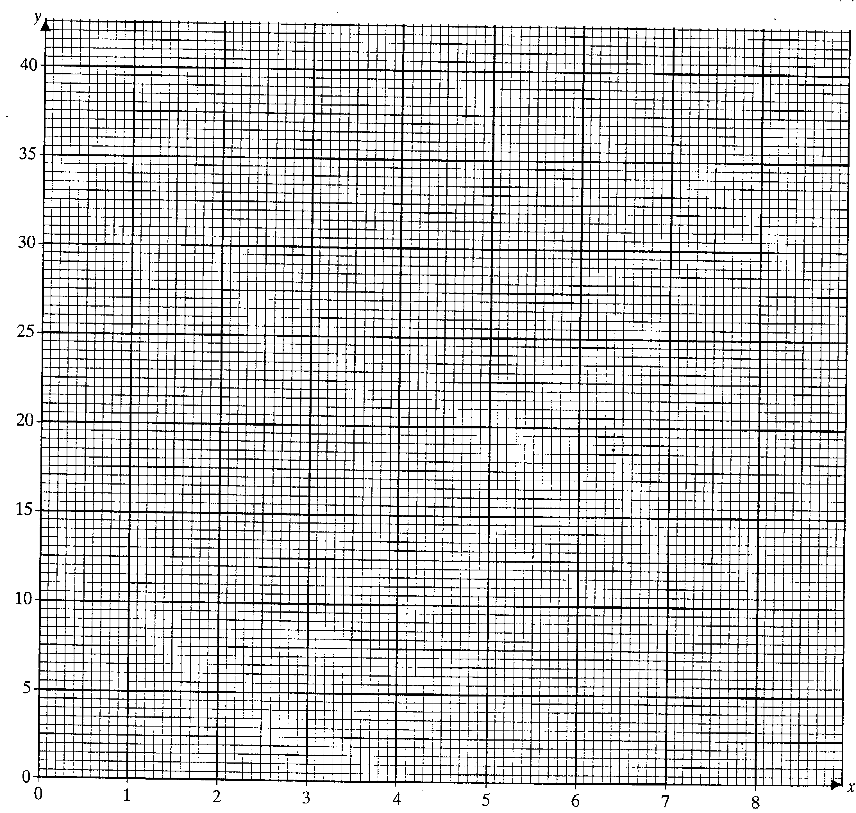
12. (a) Use trial and improvement to solve the equation x³ + x² = 500
One trial has been completed for you.
Show all your trials.
Give your answer correct to 1 decimal place.

x | x³ + x²
7 | 7³ + 7² = 392 | Too small

………………………………………………………………………………………………………………………………..… [4]
- A company makes cartons for fruit juice

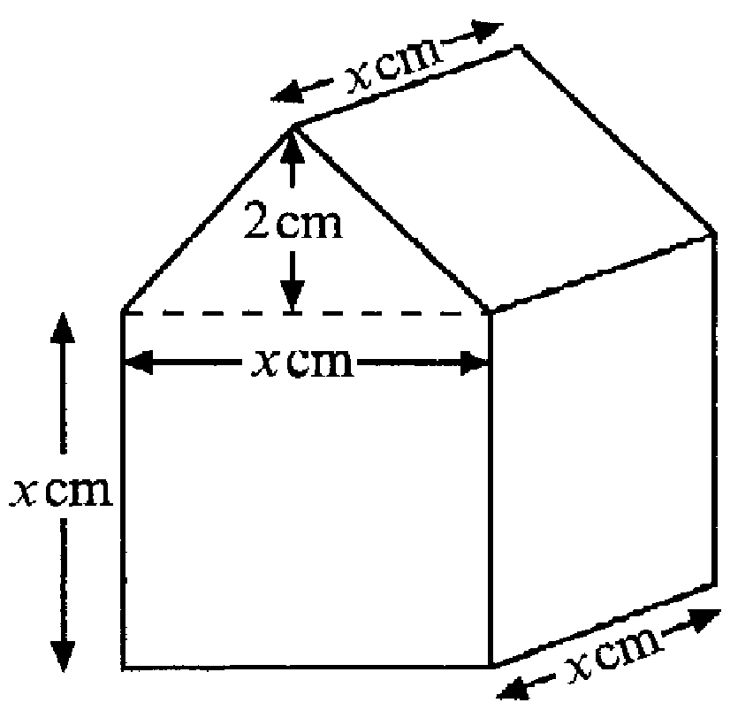

Each carton is a pentagonal prism as shown.
The cross section of the prism is formed from a square and an isosceles triangle.
The perpendicular height of the triangle is 2cm and the base of the triangle is x cm.
The prism is x cm long.

(i) Show that the volume of the carton , V cm³ is given by the formula

V = x³ + x²

………………………………………………………………………………………………………………………………..…
………………………………………………………………………………………………………………………………..…
………………………………………………………………………………………………………………………………..…
………………………………………………………………………………………………………………………………..…
………………………………………………………………………………………………………………………………..… [3]

(ii) The volume of the carton is 500 cm³.
Use your answer to part (a) to find the height of the carton
………………………………………………………………………………………………………………………………..…
………………………………………………………………………………………………………………………………..… [1]
13. The diagram shows a map of a group of islands.
The map has been drawn to a scale of 1cm to 5km.
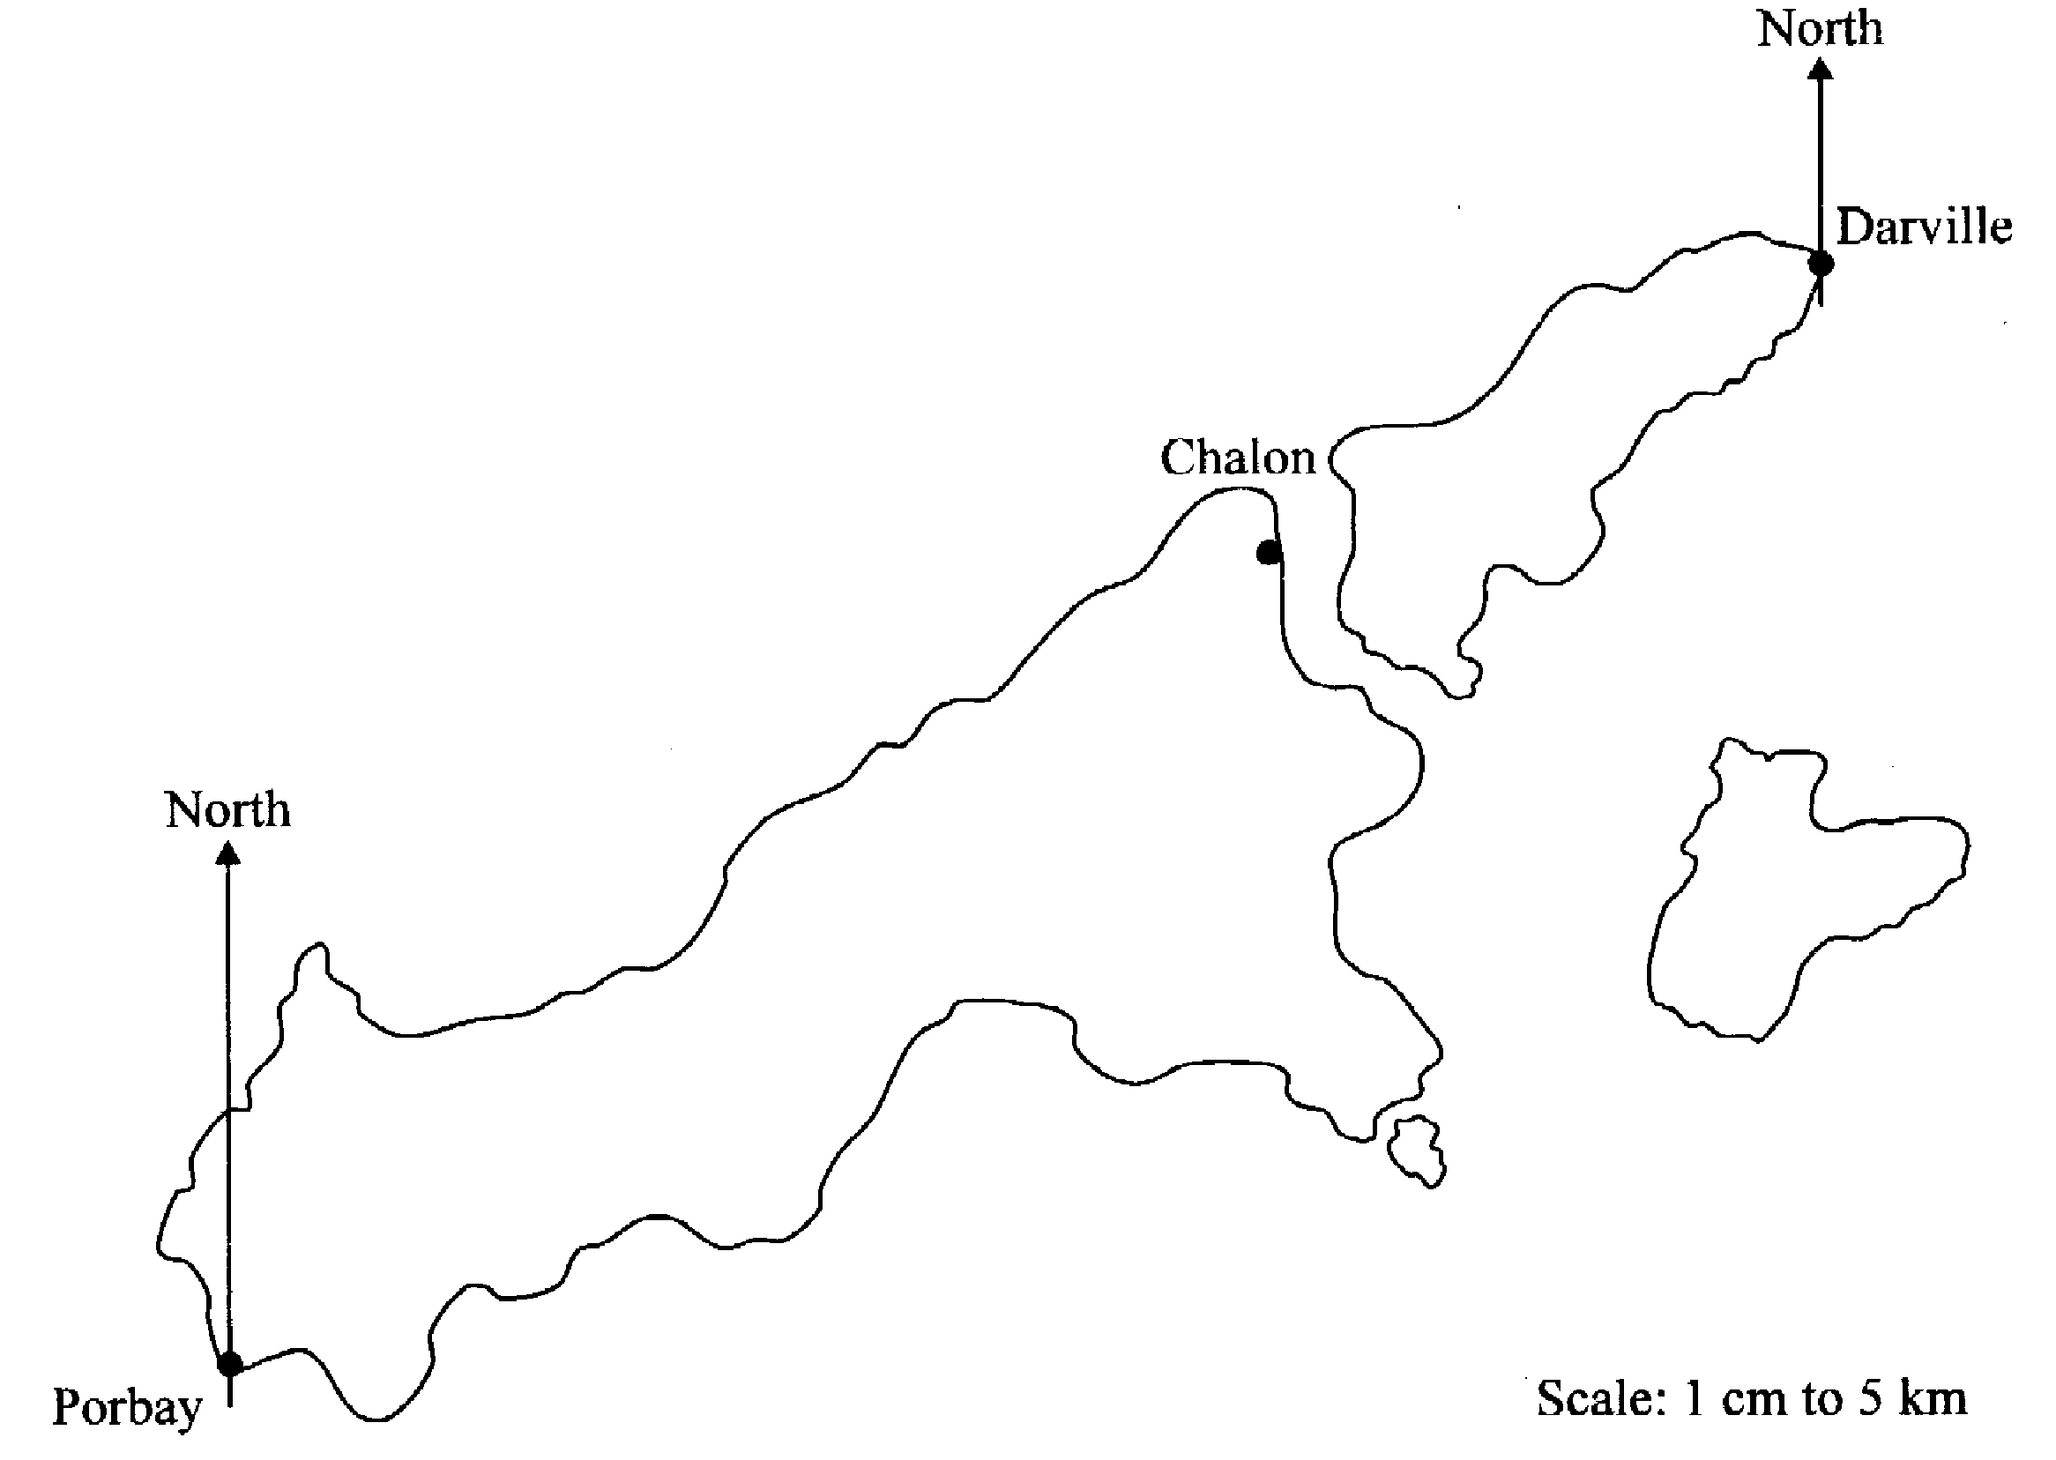

(a) A straight road joins Porbay to Chalon.

- Use the map to find the length of this road in kilometres.
………………………………………………………………………………………………………………………………..…
………………………………………………………………………………………………………………………………..…
………………………………………………………………………………………………………………………………..… [2]
(ii) Brian cycles to Porbay along this road.
He sets off at 0930 and cycles at an average speed of 18km per hour.
At what time does he arrive in Chalon?
………………………………………………………………………………………………………………………………..…
………………………………………………………………………………………………………………………………..…
………………………………………………………………………………………………………………………………..…
………………………………………………………………………………………………………………………………..… [2]

- A lighthouse is on a bearing of 080º from Porbay and 200º from Darville.
Mark, with a cross, the position of the light house on the map.
[3]

14. The diagram shows a ‘No Entry’ sign which has a radius of 35 cm.
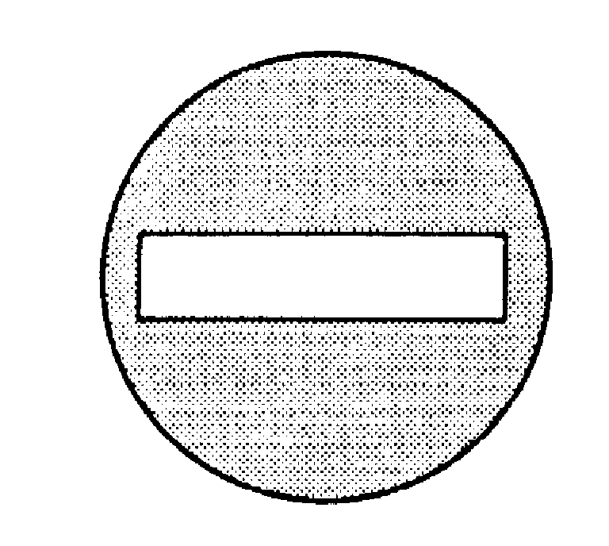

If the white rectangle measures 60 cm by 10 cm, find the area of the sign that is painted red. Give your answer to a reasonable degree of accuracy.
………………………………………………………………………………………………………………………………..…
………………………………………………………………………………………………………………………………..…
………………………………………………………………………………………………………………………………..…
………………………………………………………………………………………………………………………………..…
………………………………………………………………………………………………………………………………..…
………………………………………………………………………………………………………………………………..… [4]

15. A wire 18cm long runs from the top of a pole to the ground as shown in the diagram. The wire makes an angle of 35º with the ground.

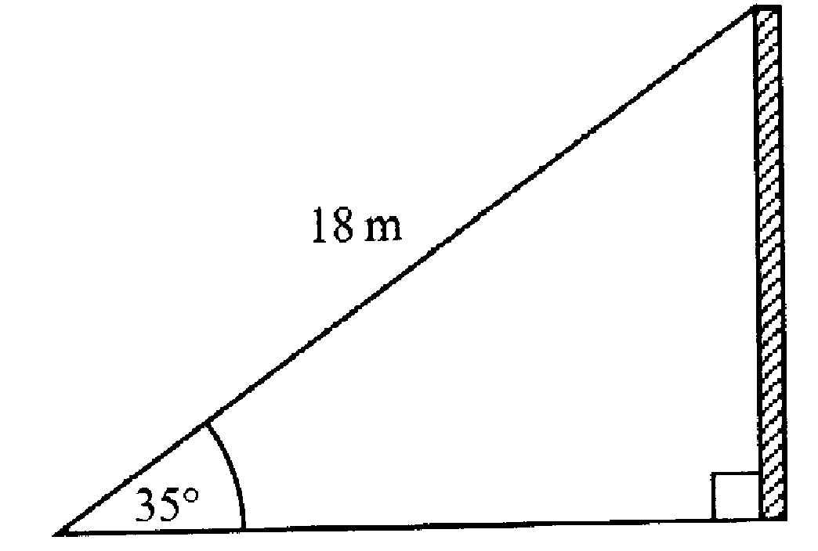

Calculate the height of the pole.
Give your answer to a suitable degree of accuracy.
………………………………………………………………………………………………………………………………..…
………………………………………………………………………………………………………………………………..…
………………………………………………………………………………………………………………………………..…
………………………………………………………………………………………………………………………………..… [4]

Non -calculator Questions

16. (a) Factorise completely 3a² – 6a
………………………………………………………………………………………………………………………………..… [2]
- Multiply out and simplify ( 2x – 1 )( x – 3)
………………………………………………………………………………………………………………………………..…
………………………………………………………………………………………………………………………………..…
………………………………………………………………………………………………………………………………..…
………………………………………………………………………………………………………………………………..… [3]

17. Look at this number pattern.

7² = 49
67² = 4489
667² = 444889
6667² = 44448889

The pattern continues.

(a) Write down the next line of the pattern.
………………………………………………………………………………………………………………………………..… [2]
- Use the pattern to work out 6666667²
………………………………………………………………………………………………………………………………..…
………………………………………………………………………………………………………………………………..… [1]
- What is the square root of 4444444488888889?
………………………………………………………………………………………………………………………………..…
………………………………………………………………………………………………………………………………..… [2]

18. (a) Find the next two terms in the sequence:
3, 8, 13, 18, 23, …, …, …
………………………………………………………………………………………………………………………………..…
………………………………………………………………………………………………………………………………..… [1]
(b) Write down the n^{th} term of the sequence:
………………………………………………………………………………………………………………………………..…
………………………………………………………………………………………………………………………………..…
………………………………………………………………………………………………………………………………..…
………………………………………………………………………………………………………………………………..… [2]
(c) What would be the 100th term in the sequence?
………………………………………………………………………………………………………………………………..…
………………………………………………………………………………………………………………………………..…
………………………………………………………………………………………………………………………………..… [1]
19. In the diagram, AB is parallel to ED. Angle CED = 54º and angle BCD = 100º.

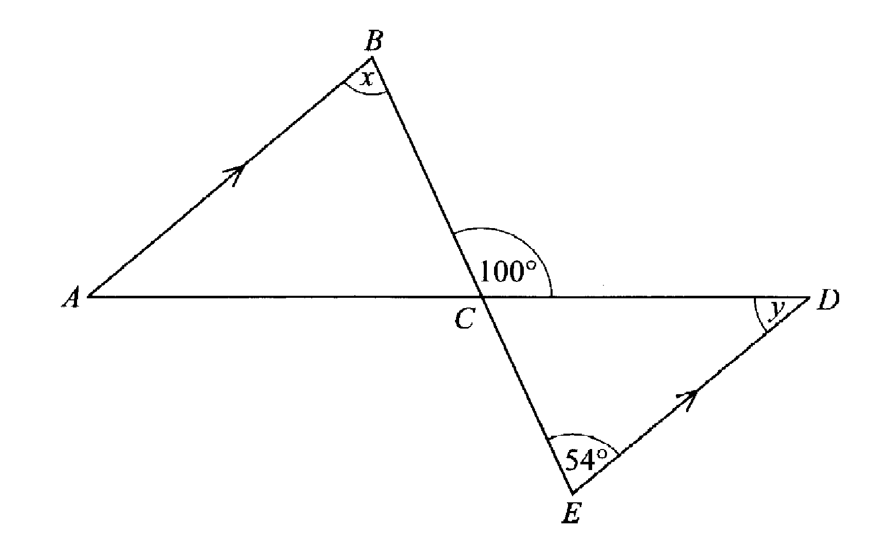not to scale
(a) (i) Write down the size of angle x
………………………………………………………………………………………………………………………………..… [1]
(ii) Find the size of angle y
………………………………………………………………………………………………………………………………..…
………………………………………………………………………………………………………………………………..… [2]
- Triangle ABC is similar to triangle DEC.
AC:CD is 3:2
AB = 5.4 cm

Calculate the length of DE.
………………………………………………………………………………………………………………………………..…
………………………………………………………………………………………………………………………………..…
………………………………………………………………………………………………………………………………..…
………………………………………………………………………………………………………………………………..…
………………………………………………………………………………………………………………………………..… [3]
20. The diagram represents a regular pentagon with two of its lines of symmetry shown.
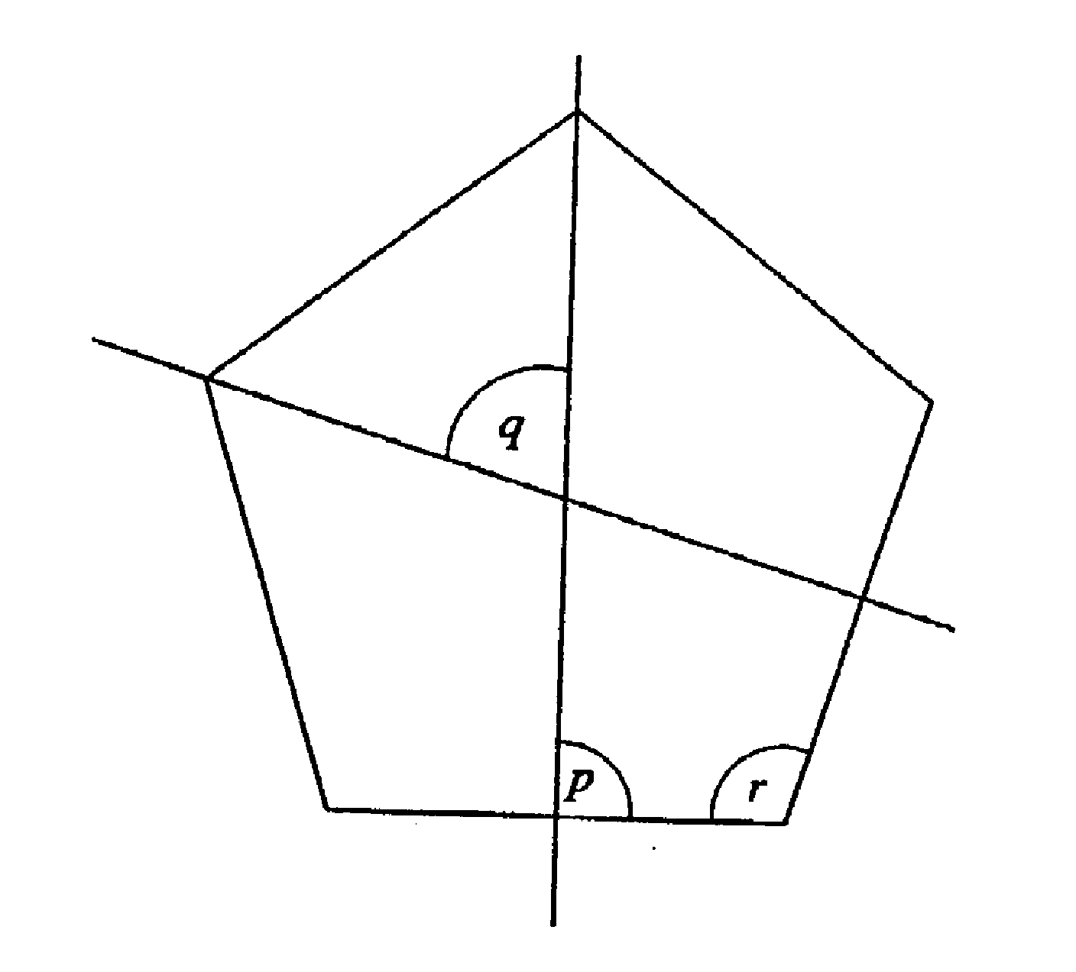
(a) Write down the size of angle p.
………………………………………………………………………………………………………………………………..… [1]
(b) Calculate the size of angle q
………………………………………………………………………………………………………………………………..…
………………………………………………………………………………………………………………………………..…
………………………………………………………………………………………………………………………………..… [2]
- Calculate the size of angle r
………………………………………………………………………………………………………………………………..…
………………………………………………………………………………………………………………………………..…
………………………………………………………………………………………………………………………………..… [2]

21. A graph of the equation y = ax + b is shown.

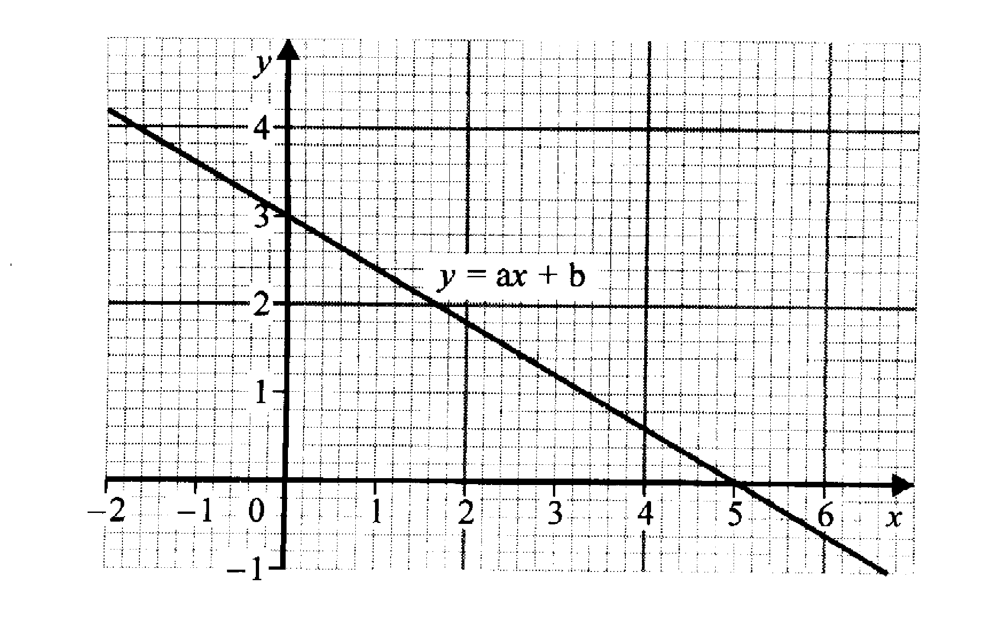
Find the values of a and b.
………………………………………………………………………………………………………………………………..…
………………………………………………………………………………………………………………………………..…
………………………………………………………………………………………………………………………………..… [3]

22. (a) Solve the equation
3x – 2 = x + 7
………………………………………………………………………………………………………………………………..…
………………………………………………………………………………………………………………………………..…
………………………………………………………………………………………………………………………………..… [2]
- Solve the simultaneous equations
x + y = 4
15x + 25y = 76
………………………………………………………………………………………………………………………………..…
………………………………………………………………………………………………………………………………..…
………………………………………………………………………………………………………………………………..…
………………………………………………………………………………………………………………………………..…
………………………………………………………………………………………………………………………………..…
………………………………………………………………………………………………………………………………..… [3]
(c) Solve the inequality
2 ( 3x – 2 ) < 11
………………………………………………………………………………………………………………………………..…
………………………………………………………………………………………………………………………………..…
………………………………………………………………………………………………………………………………..…
………………………………………………………………………………………………………………………………..… [2]

23. Boxes P and Q each contain five numbered balls.
The balls in each box are numbered as shown.

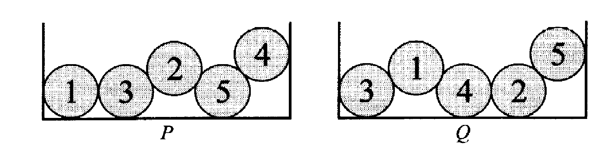

A ball is taken from each box at random.

(a) What is the probability that both balls are numbered 2?
………………………………………………………………………………………………………………………………..…
………………………………………………………………………………………………………………………………..…
………………………………………………………………………………………………………………………………..… [2]
(b) What is the probability that both balls have the same number?
………………………………………………………………………………………………………………………………..…
………………………………………………………………………………………………………………………………..…
………………………………………………………………………………………………………………………………..… [2]
- What is the probability that the number on the ball from box P is greater than the number on the ball from box Q?
………………………………………………………………………………………………………………………………..…
………………………………………………………………………………………………………………………………..…
………………………………………………………………………………………………………………………………..… [2]

24. (a) Write down a decimal that lies between and .
1
3
1
2
………………………………………………………………………………………………………………………………..… [1]
- Which of these two fractions is the bigger?
2
3
3
4
or

Show your working

………………………………………………………………………………………………………………………………..…
………………………………………………………………………………………………………………………………..…
………………………………………………………………………………………………………………………………..… [2]

25. An examiner marked 320 examination papers.
He noted the time it took to mark each one.
The table gives a summary of these times.

Time, t minutes | Frequency | Cumulative frequency
0 < t ≤ 2 | 15
2 < t ≤ 4 | 85
4 < t ≤ 6 | 170
6 < t ≤ 8 | 40
8 < t ≤ 10 | 10

(a) (i) Complete the table by filling in the cumulative frequencies.
[2]
(ii) On the grid opposite, draw a cumulative frequency diagram to show this information
[2]
- Making your method clear, use your diagram to find

- the median time taken to mark each paper
………………………………………………………………………………………………………………………………..…
………………………………………………………………………………………………………………………………..… [2]
(ii) the inter-quartile range of the times taken
………………………………………………………………………………………………………………………………..…
………………………………………………………………………………………………………………………………..… [2]
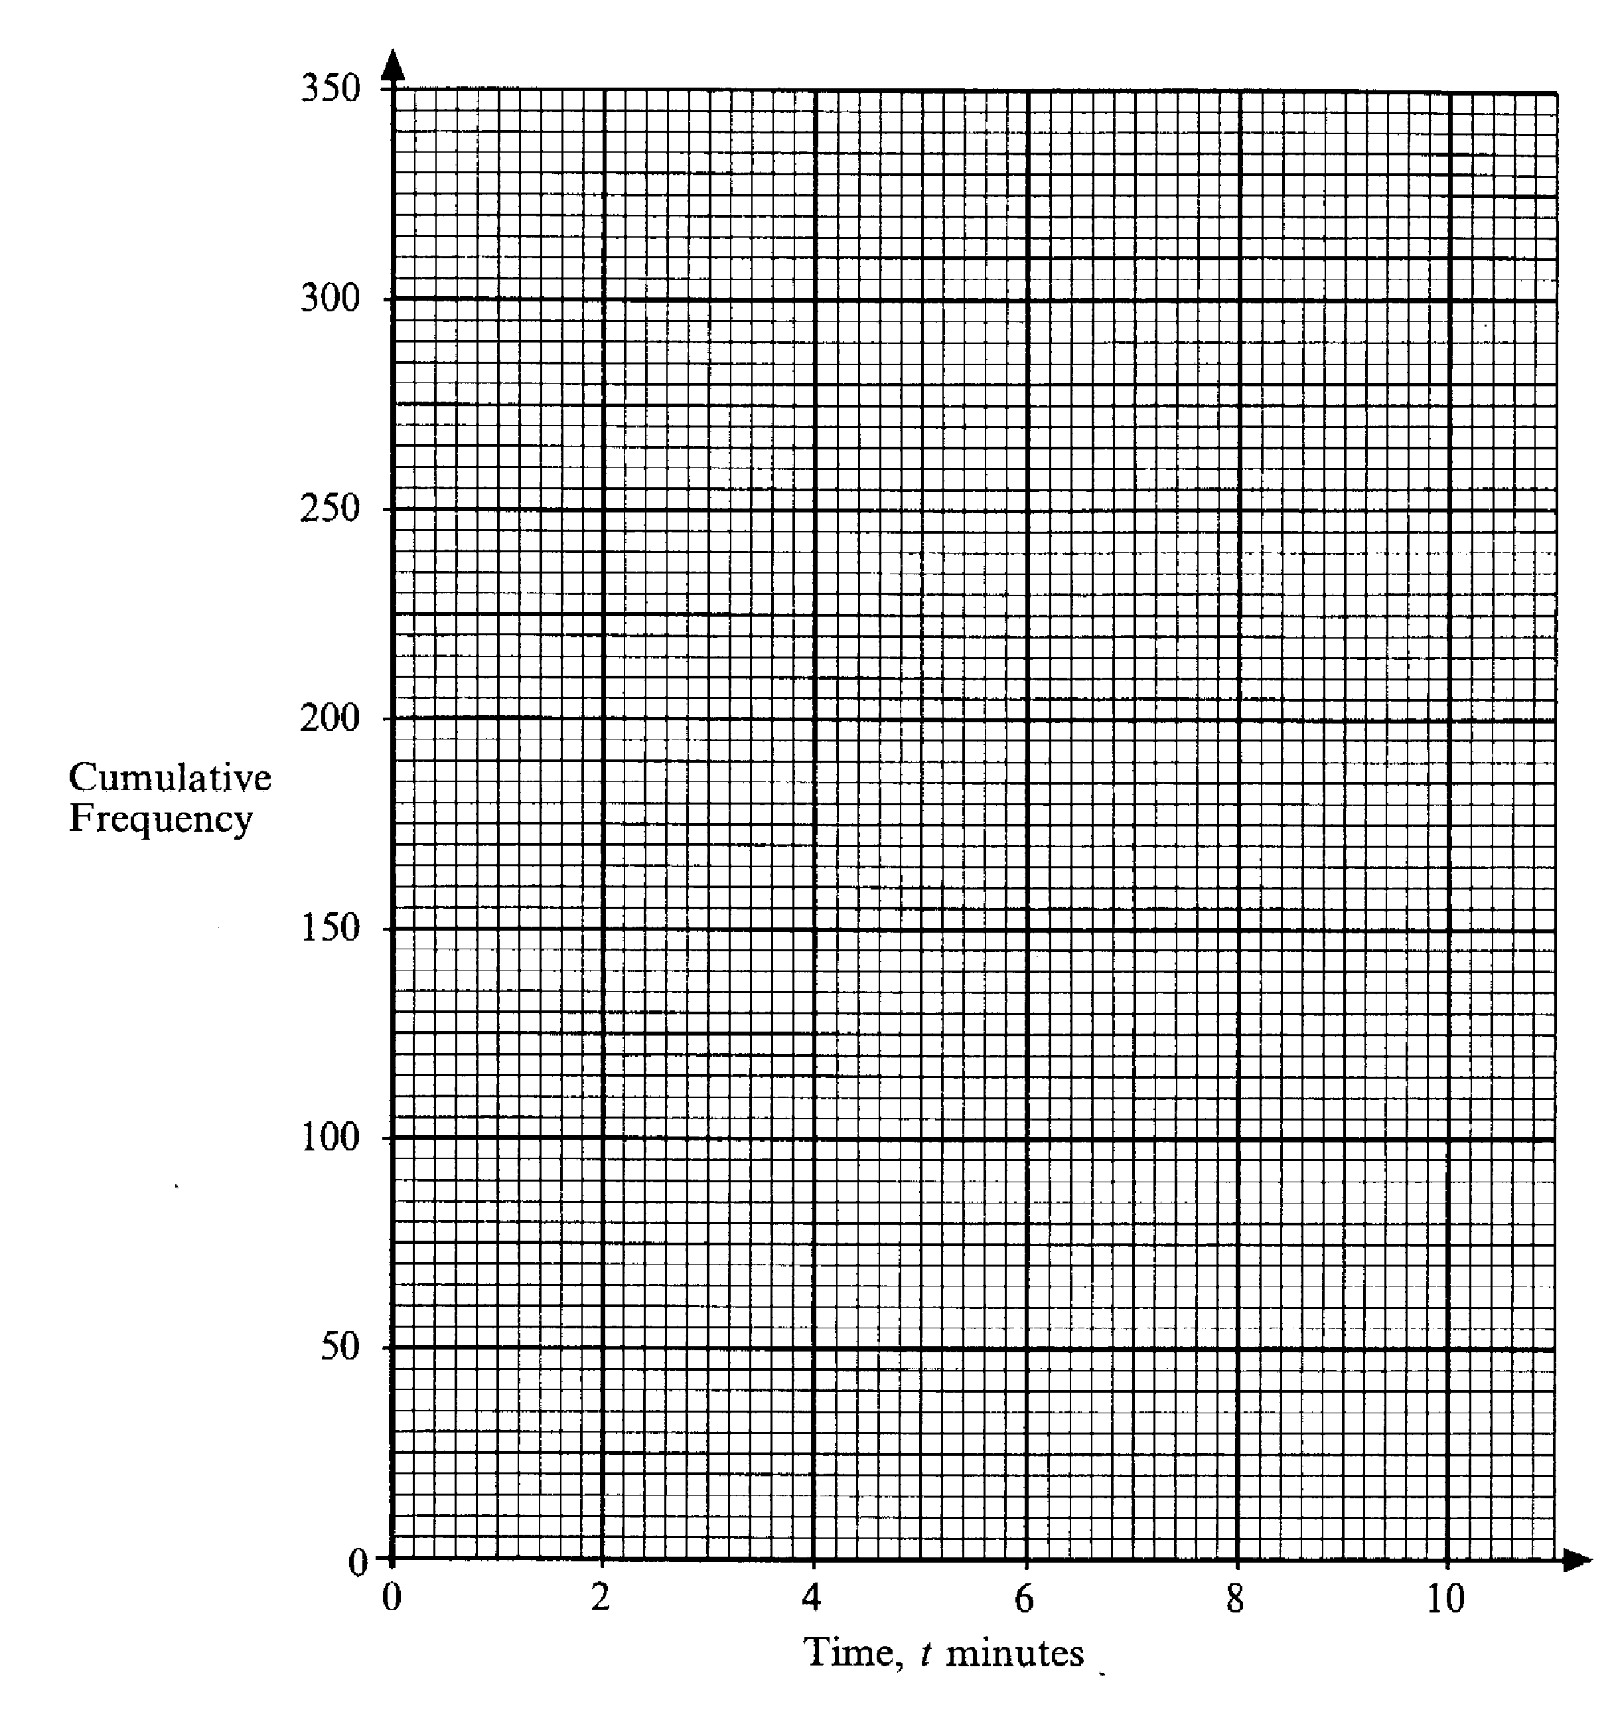

26. The distance between Southampton and London is 120km.

A coach leaves Southampton at 0800 to travel to London.

The coach travels 60 km at an average speed of 80 km per hour and then stops for 30 minutes. It then continues its journey arriving in London at 1100.

At 1115 the coach leaves London and returns to Southampton without stopping. It arrives in Southampton at 1230.

(a) Draw a travel graph for the journey of the coach.

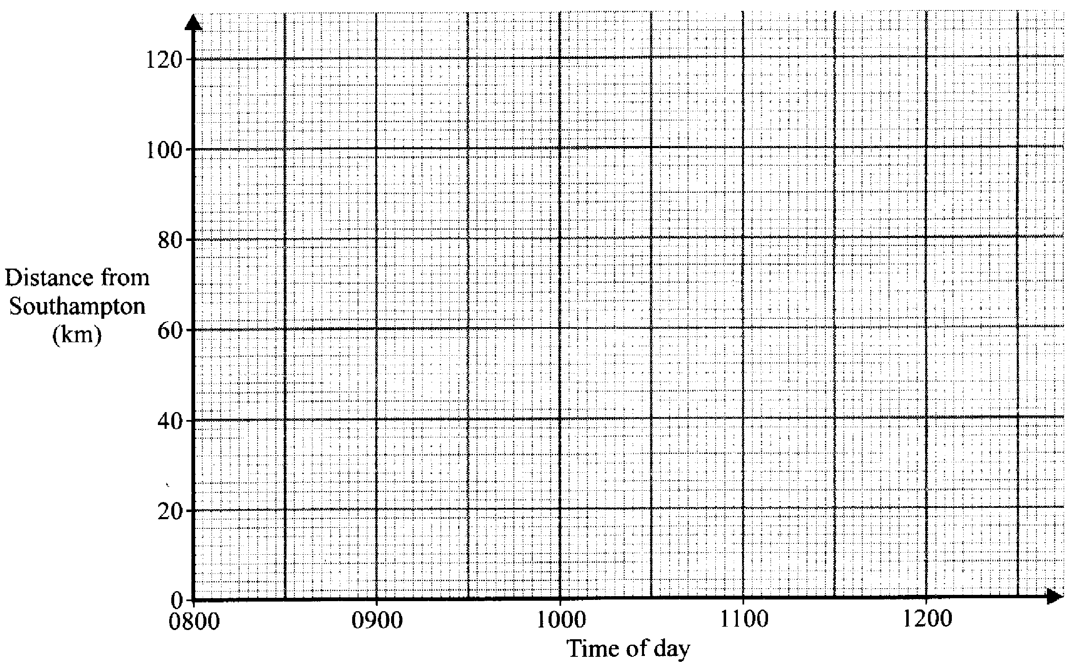

[3]
- What was the average speed of the coach on the return journey?
………………………………………………………………………………………………………………………………..…
………………………………………………………………………………………………………………………………..…
………………………………………………………………………………………………………………………………..…
………………………………………………………………………………………………………………………………..… [2]
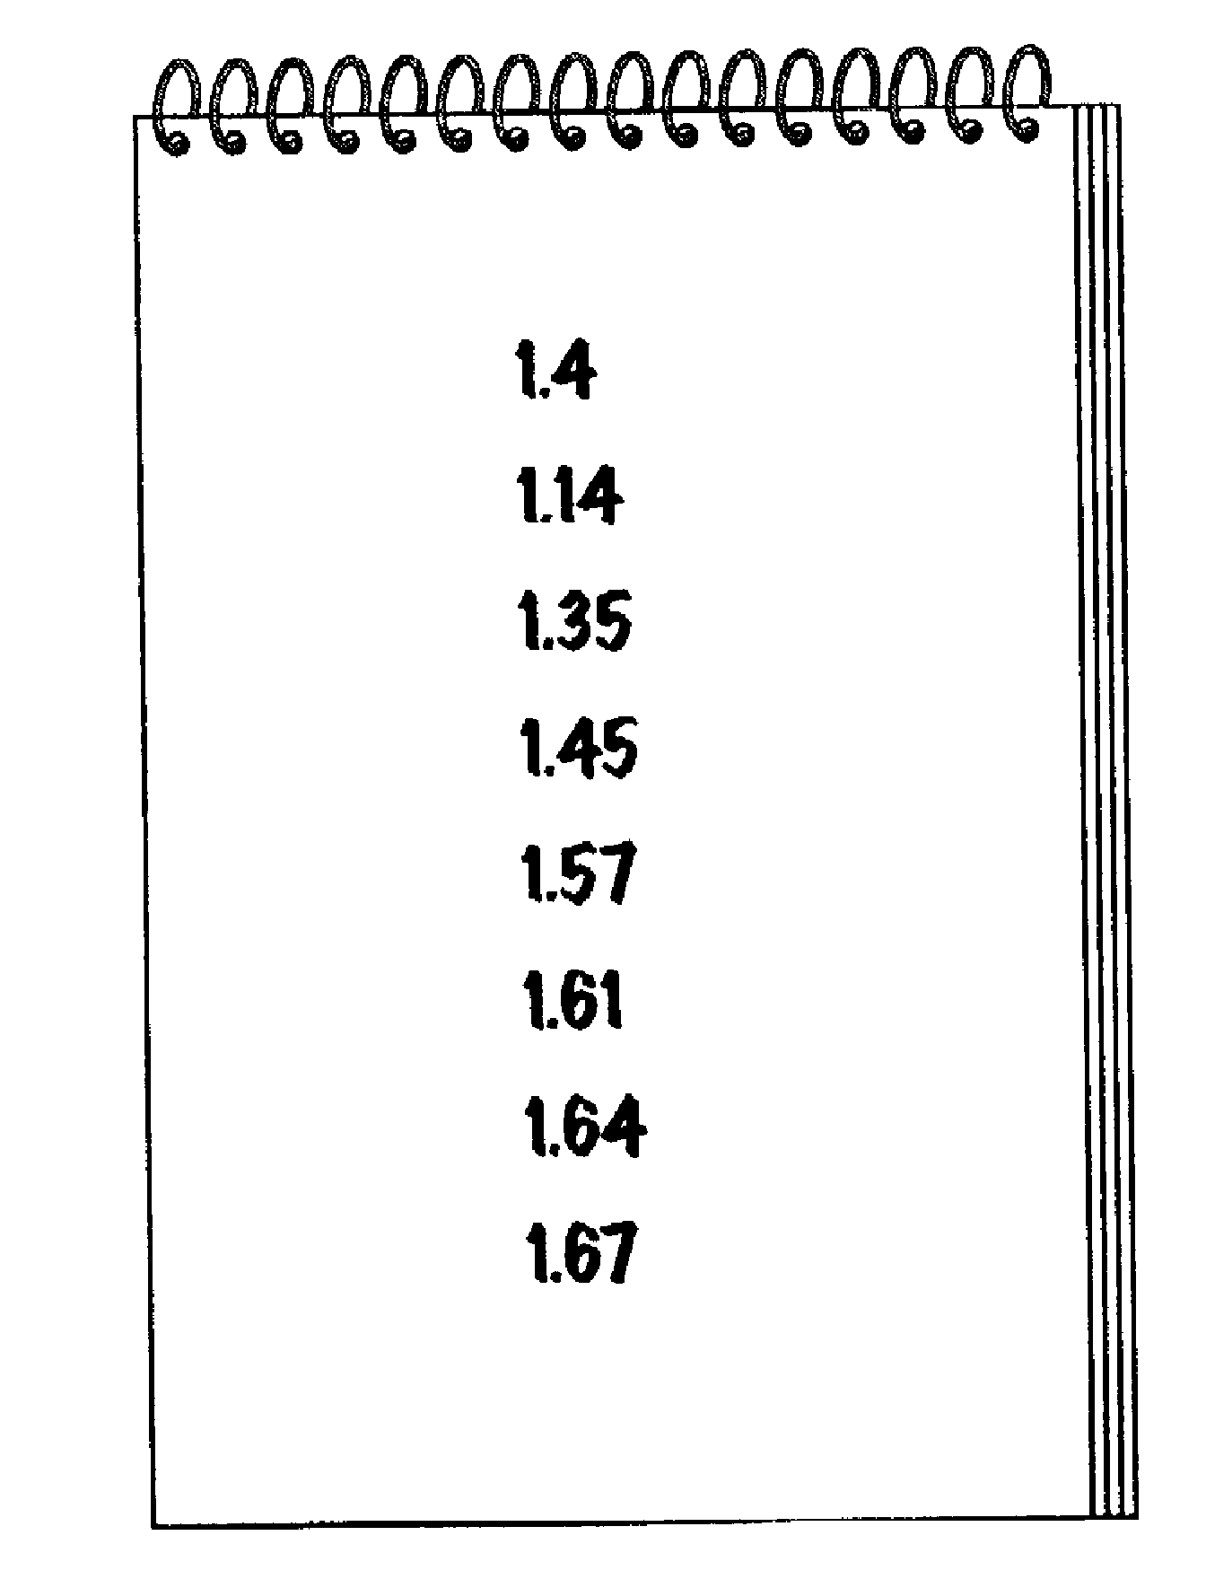
27.

A pupil measures the height in metres of the girls in her class.

She writes these heights in order of size as shown above. One of the heights is in the wrong place.

(a) Put a ring round the height that is in the wrong place.
[1]
- Calculate the mean height of the girls.

………………………………………………………………………………………………………………………………..…
………………………………………………………………………………………………………………………………..…
………………………………………………………………………………………………………………………………..…
………………………………………………………………………………………………………………………………..… [2]

(Total marks 120)

END OF EXAM

Answers To Specimen Paper 1

Answers to questions involving diagrams of graphs may vary slightly

1.(a)(i) 38.2%  (ii) 63g | 21. a=3/5, b=3
2.The 260g box gives 265.30612g per £ so  It is better value | 22. (a) x= 4.5, (b) x=2.4, y=1.6  (c) x<2.5
3.Pie chart with angles 170⁰,120⁰ , 70⁰ | 23. (a) , (b) , (c)
4. 15% | 24. (a) any decimal between 0.33333 and 0.5 (b) ¾ is bigger
5(a) 1.86 x 10⁵  (b) 44 mins | 25. (a) (i) 15, 100,270,310,320 (ii) on diagram  (b) (i) 4.6 minutes (ii) 1.8 minutes
6. £21,630

7. 36 minutes | 26. (a) On graph (b) 96 km per hour
8.a) r=₃√ 3V b)2.62cm  4π | 27. (a) 1.4 (b) 1.48m
9. 2.10m to 2dps
10. There is a good positive correlation – the taller the father the taller the son.
11.(a) 1,2,5,17,26, (b) On graph,
(c) 5.4
12.(a) 7.6 (b)(i) Area of triangle = x, Area of square = x², Area of cross section = x² + x,
Volume of prism = x(x² + x) = x³ + x
(b)(ii) 7.6cm
13.(a)(i)45km, (ii)1200
(b) On map.
14. 3248cm²
15.10.32m
16 (a) 3a(a-2) (b). 2x2 – 7x + 4

17. (a) 66667² = 4444488889
(b) 44444448888889
(c) 66666667
18. (a) 28, 33 (b)5n-2, (c)498

19. (a)(i) 54⁰ (ii) 46⁰
(b)3.6cm
20.(a) 90⁰ (b) 72⁰ (c)108⁰

Specimen Paper 2

Two and a half hours

Name ………………………………………………………………………….

ATTEMPT ALL QUESTIONS

Show all your working in the space provided and make sure your answer is clear.

It is assumed that you have a scientific calculator, ruler and protractor.

If your calculator does not have a π button, take the value of π to be 3.142

Diagrams are not necessarily drawn to scale.

The marks for each question are given in brackets by the side of the question.

Marks may be given for method even if your answer is wrong.

The total marks available are 120.

Calculator Questions
1. An Athletics stadium has 35,000 seats.
4% of the seats are fitted with headphones to help people hear the announcements.
How many headphones are there in the stadium?
………………………………………………………………………………………………………………………………..…
………………………………………………………………………………………………………………………………..…
………………………………………………………………………………………………………………………………..…
………………………………………………………………………………………………………………………………..… [2]

2. Use a calculator to find the value of

(a) 3.86 + 17.59
5 …………………………………………………………………………………………………… [1]

(b) 9.76 + 1.87
18.3 – 15.8 …………………………………………………………………………………………………… [1]

(c) 330
1.2 x 5.5 …………………………………………………………………………………………………… [1]

(d) 1
√(0.16) …………………………………………………………………………………………………… [1]

3. Louise does a sponsored bicycle ride.
Each wheel of her bicycle is of radius 25 cm.

(a) Calculate the circumference of one of the wheels
………………………………………………………………………………………………………………………………..…
………………………………………………………………………………………………………………………………..…
………………………………………………………………………………………………………………………………..… [2]
- She cycles 50km. How many revolutions does a wheel make during the sponsored ride? Give your answer to 3 significant figures.
………………………………………………………………………………………………………………………………..…
………………………………………………………………………………………………………………………………..…
………………………………………………………………………………………………………………………………..…
………………………………………………………………………………………………………………………………..… [3]
4. In a sale a dress costs £28.90.
The original price has been reduced by 15%
What was the original price?
………………………………………………………………………………………………………………………………..…
………………………………………………………………………………………………………………………………..…
………………………………………………………………………………………………………………………………..… [2]

5. Katy is using trial and improvement to find an answer to the equation
x³ – x = 35
The table shows her first two tries.

x | x³ - x | Comment
3 | 24 | Too low
4 | 60 | Too high

Continue the table to find a solution to the equation.

Give your answer correct to 1 decimal place.
………………………………………………………………………………………………………………………………..…
………………………………………………………………………………………………………………………………..… [4]

6. This net will fold into a 3 dimensional shape.
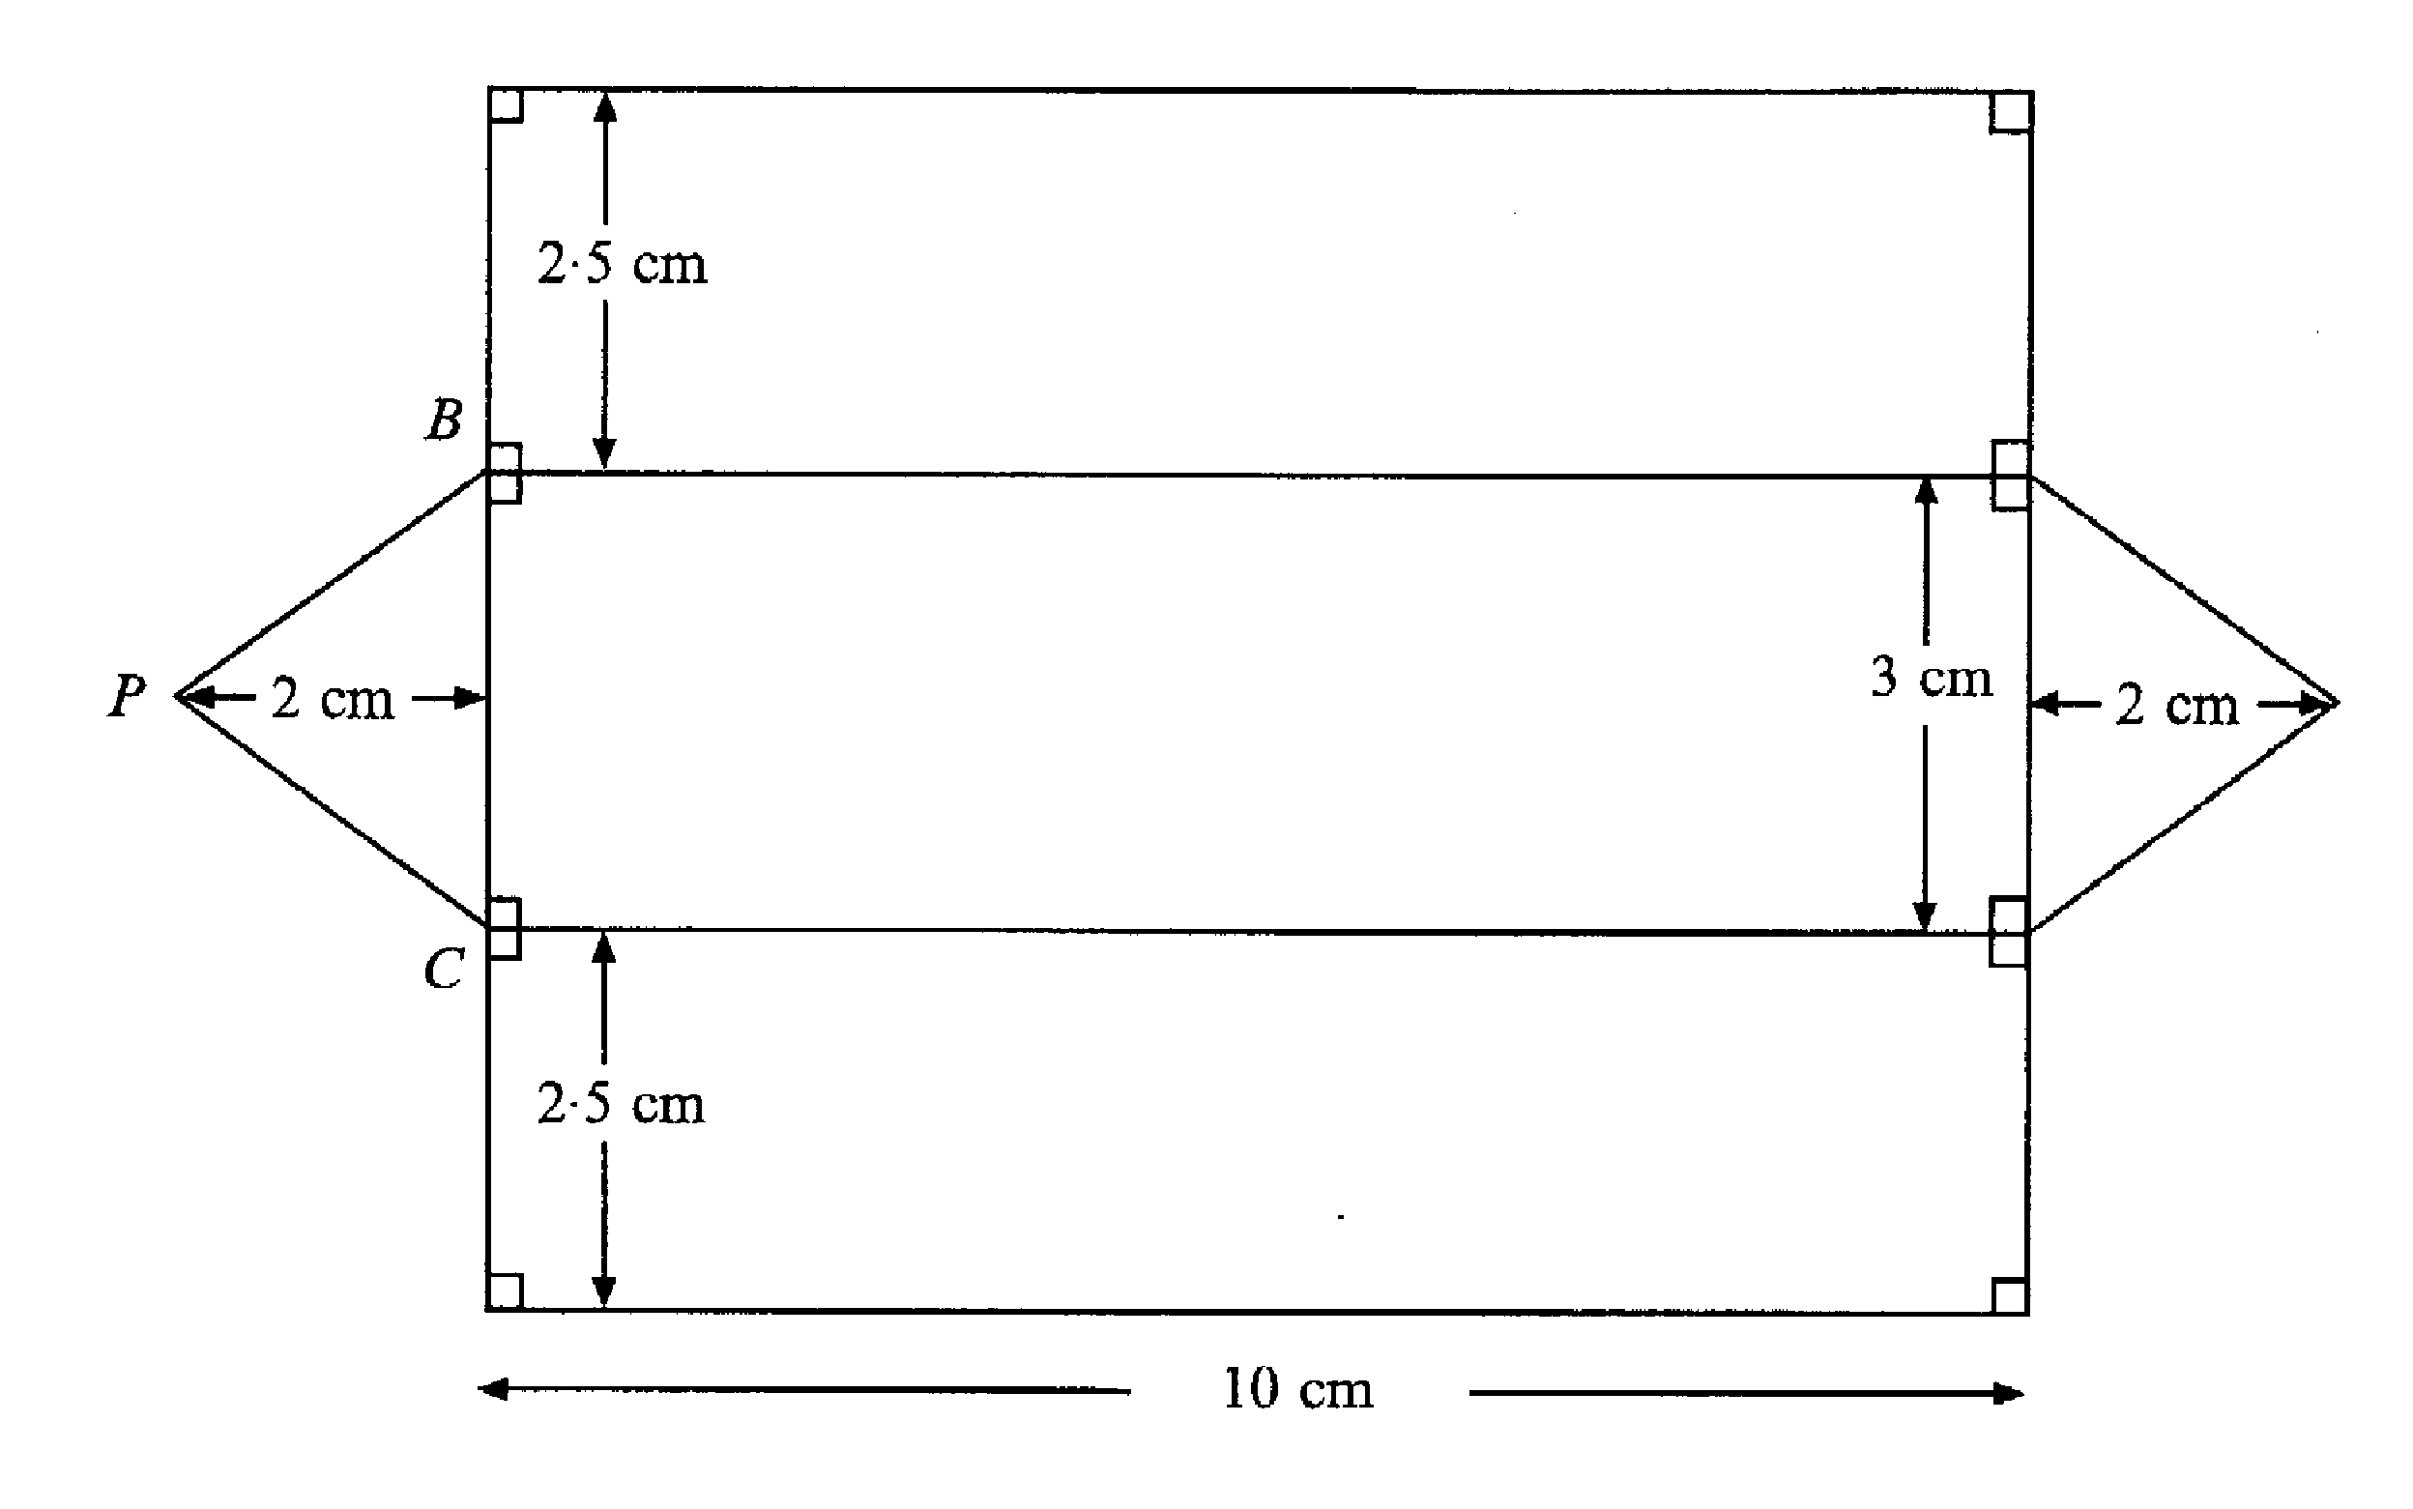

(a) Calculate the area of the net. Remember to state the units in your answer.
………………………………………………………………………………………………………………………………..…
………………………………………………………………………………………………………………………………..…
………………………………………………………………………………………………………………………………..…
………………………………………………………………………………………………………………………………..… [3]

- (i) Draw a sketch of the shape that the net makes when folded.

[2]
(ii) What is the mathematical name for this shape?
………………………………………………………………………………………………………………………………..… [1]

- Calculate the volume of this shape. State the units in your answer.
………………………………………………………………………………………………………………………………..…
………………………………………………………………………………………………………………………………..…
………………………………………………………………………………………………………………………………..…
………………………………………………………………………………………………………………………………..… [3]

7. On a computer keyboard there are 104 keys
(a) 26 of the keys have letters on them
What fraction of the keys have letters on them? Give your answer in its simplest form.
………………………………………………………………………………………………………………………………..… [2]

- 13 of the keys have arrows on them.
What percentage of the keys on the keyboard have arrows on them?
………………………………………………………………………………………………………………………………..…
………………………………………………………………………………………………………………………………..… [2]

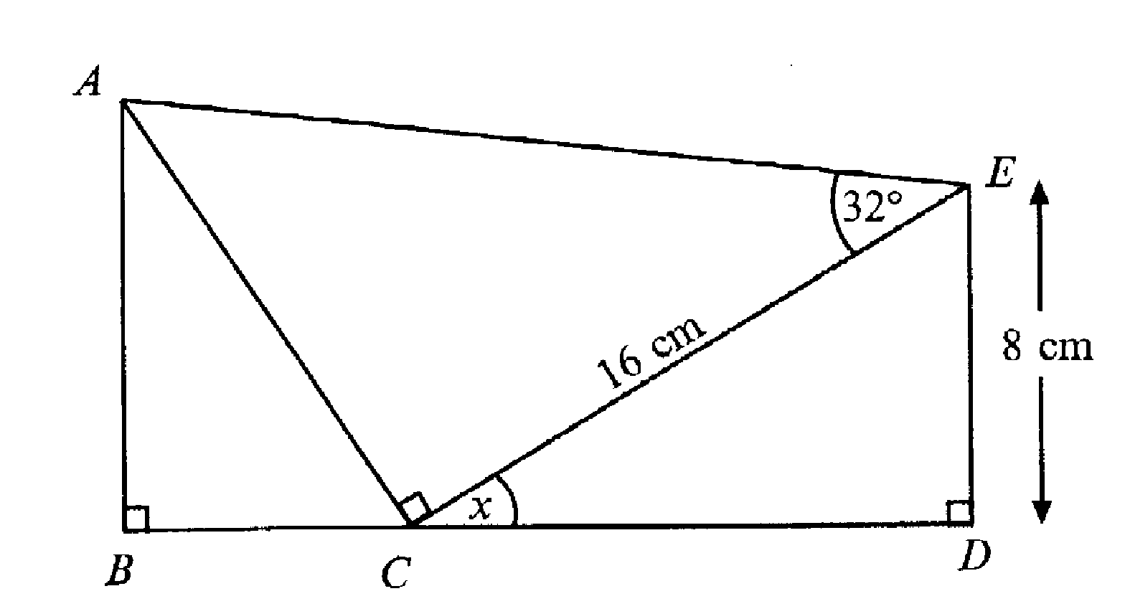
8.

the diagram is not drawn to
scale

BCD is a straight line. CE = 16 cm
(a) Calculate the size of the angle marked x
………………………………………………………………………………………………………………………………..…
………………………………………………………………………………………………………………………………..…
………………………………………………………………………………………………………………………………..…
………………………………………………………………………………………………………………………………..…
………………………………………………………………………………………………………………………………..… [3]
- Calculate the length of AC
………………………………………………………………………………………………………………………………..…
………………………………………………………………………………………………………………………………..…
………………………………………………………………………………………………………………………………..…
………………………………………………………………………………………………………………………………..…
………………………………………………………………………………………………………………………………..… [2]
- Use your answers to parts (a) and (b) to calculate the length of BC
………………………………………………………………………………………………………………………………..…
………………………………………………………………………………………………………………………………..…
………………………………………………………………………………………………………………………………..…
………………………………………………………………………………………………………………………………..…
………………………………………………………………………………………………………………………………..… [3]
9. The contents of books and newspapers can be stored on microfilm.
ABCD is one rectangular frame of this microfilm.
AB = 4.5 x 10⁻³ centimetres and BC = 6.2 x 10⁻⁴ centimetres

(a) Calculate the area of the rectangle.
Give your answer in standard form. State the units in your answer.
………………………………………………………………………………………………………………………………..…
………………………………………………………………………………………………………………………………..…
………………………………………………………………………………………………………………………………..…
………………………………………………………………………………………………………………………………..… [2]
(b) Calculate the perimeter of the rectangle.
Give your answer in standard form. State the units in your answer.
………………………………………………………………………………………………………………………………..…
………………………………………………………………………………………………………………………………..…
………………………………………………………………………………………………………………………………..…
………………………………………………………………………………………………………………………………..… [2]

10. On a motorway there are three lanes, an inside lane, a middle lane and an outside lane.

On day, at midday, the speed of the traffic on these lanes was in the ration 3:4:5.

The speed on the outside lane was 70 miles per hour.
Calculate the speed on the inside lane.

………………………………………………………………………………………………………………………………..…
………………………………………………………………………………………………………………………………..…
………………………………………………………………………………………………………………………………..…
………………………………………………………………………………………………………………………………..… [2]

11. When a model is fired in a kiln, the probability that it shrinks is 0.95.
When taken out to cool, the probability that it cracks is 0.04
(a) What is the probability that when a model is fired it does not shrink?
………………………………………………………………………………………………………………………………..…
………………………………………………………………………………………………………………………………..…
………………………………………………………………………………………………………………………………..…
………………………………………………………………………………………………………………………………..… [2]
- A model is fired in a kiln and then taken out to cool.
Complete the tree diagram
Write all the missing probabilities on the appropriate branches
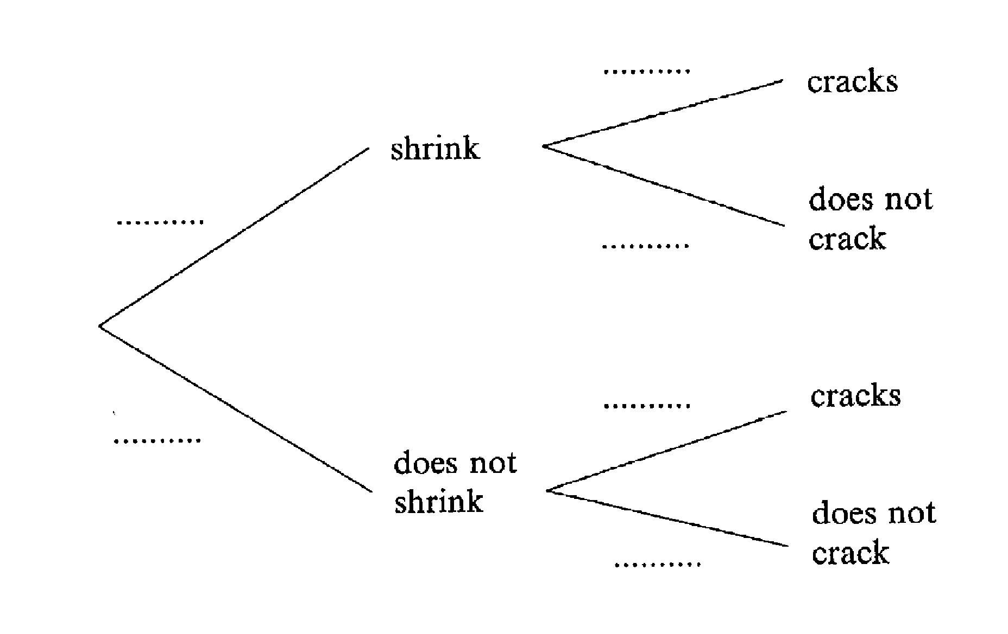

[2]
- Calculate the probability that the model shrinks and also cracks.
………………………………………………………………………………………………………………………………..…
………………………………………………………………………………………………………………………………..…
………………………………………………………………………………………………………………………………..…
………………………………………………………………………………………………………………………………..… [2]
12. Graham and Wendy go ten pin bowling.
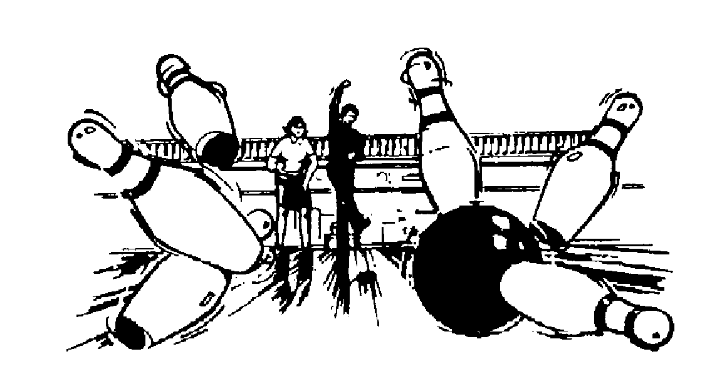

(a) Graham’s first eight scores are:
5, 8, 8, 5, 5, 6, 6, 5
What is his mean score?

………………………………………………………………………………………………………………………………..…
………………………………………………………………………………………………………………………………..…
………………………………………………………………………………………………………………………………..… [2]
- Wendy’s first eight scores are:
5, 8, 2, 2, 9, 3, 2, 9
(i) What is her modal score?
………………………………………………………………………………………………………………………………..…
………………………………………………………………………………………………………………………………..… [1]
(ii) What is the range for Wendy’s scores?
………………………………………………………………………………………………………………………………..…
………………………………………………………………………………………………………………………………..… [1]
- Who is the better bowler?
Give a reason for your answer.
………………………………………………………………………………………………………………………………..…
………………………………………………………………………………………………………………………………..…
………………………………………………………………………………………………………………………………..…
………………………………………………………………………………………………………………………………..… [2]

Non-calculator Questions

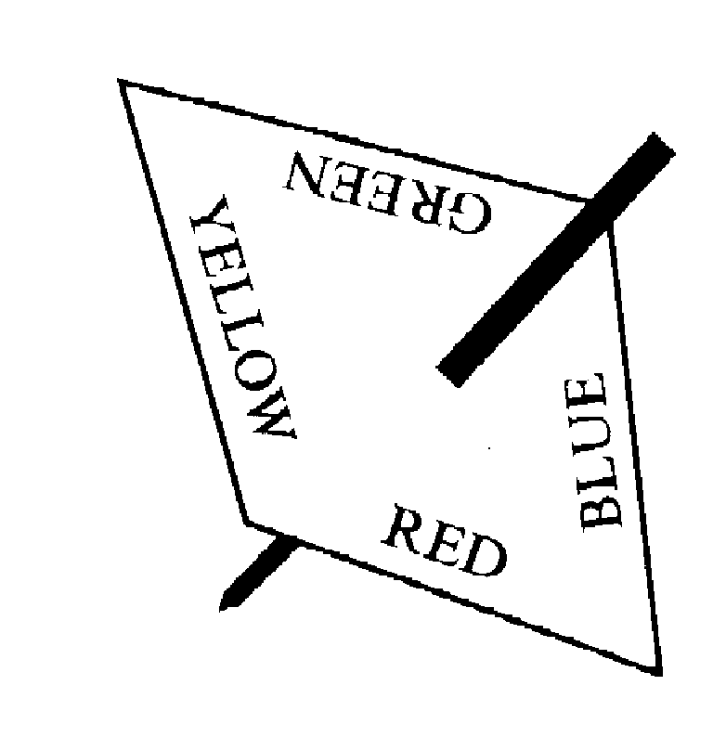
13. The spinner shown is biased.

The probabilities of getting a particular colour are shown in the table below.

Colour | RED | YELLOW | BLUE | GREEN
Probability | 0.4 | 0.1 | 0.3

(a) Complete the table to show the probability of getting GREEN
[1]
(b) The spinner is spun once.
What is the probability of getting either RED or BLUE?
………………………………………………………………………………………………………………………………..…
………………………………………………………………………………………………………………………………..…
………………………………………………………………………………………………………………………………..…
………………………………………………………………………………………………………………………………..… [2]

(c) The spinner is spun 50 times.
Approximately how many times would you expect to get RED?
………………………………………………………………………………………………………………………………..…
………………………………………………………………………………………………………………………………..…
………………………………………………………………………………………………………………………………..… [2]
14. Solve the simultaneous equations
2a + 4c = 13
a + 3c = 8
………………………………………………………………………………………………………………………………..…
………………………………………………………………………………………………………………………………..…
………………………………………………………………………………………………………………………………..…
………………………………………………………………………………………………………………………………..…
………………………………………………………………………………………………………………………………..…
………………………………………………………………………………………………………………………………..…
………………………………………………………………………………………………………………………………..…
………………………………………………………………………………………………………………………………..… [4]
15. Jenny cycles to school each day.
The graph shows her journey from home to school. On the way she stops to talk to her friends.
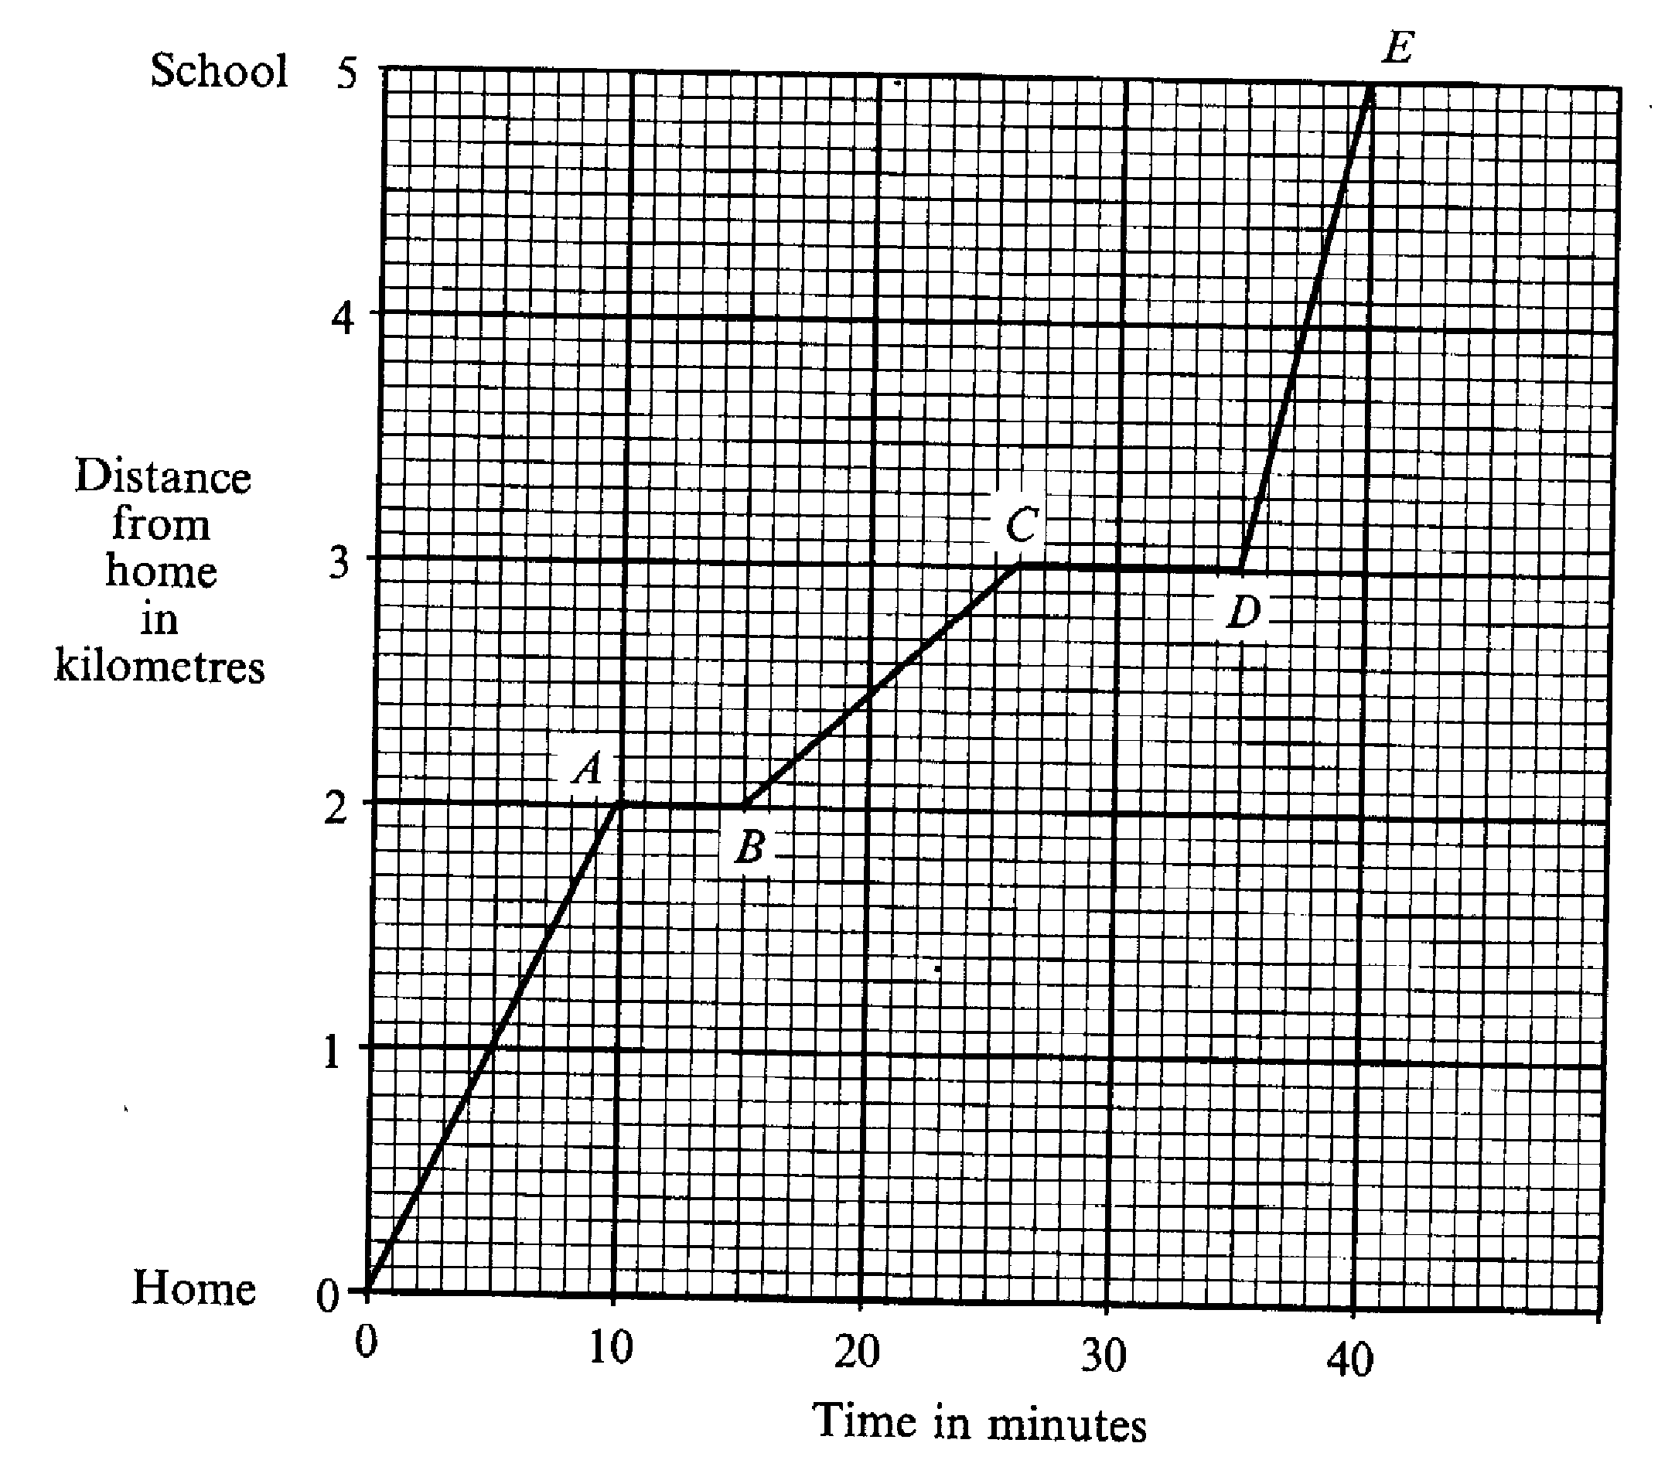

(a) How many times does she stop to talk to her friends?
………………………………………………………………………………………………………………………………..… [1]
(b)(i) How far does she travel in the first stage from home to A?
………………………………………………………………………………………………………………………………..… [1]
(ii) What is her average speed for the first 10 minutes?
Give your answer in kilometres per hour.
………………………………………………………………………………………………………………………………..…
………………………………………………………………………………………………………………………………..…
………………………………………………………………………………………………………………………………..…
………………………………………………………………………………………………………………………………..… [2]
- On which stage of her journey is her average speed fastest?
………………………………………………………………………………………………………………………………..…
………………………………………………………………………………………………………………………………..… [1]
16. Two right angled triangles are put together on a 1cm grid to make a kite.
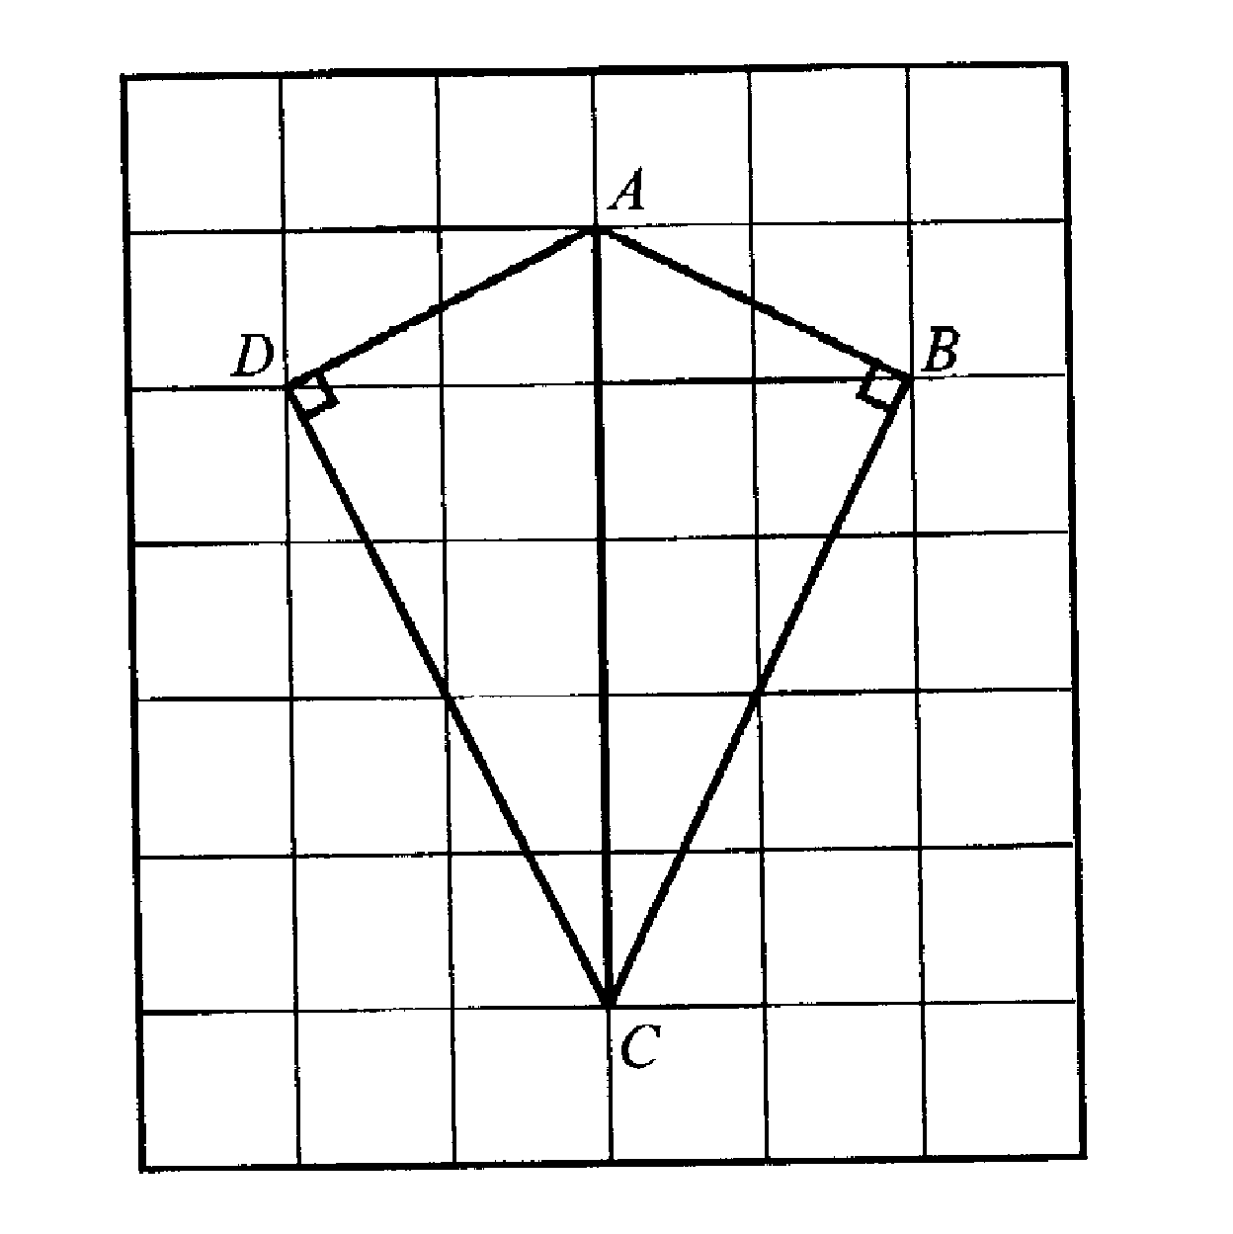

(a) What is the area of the kite? Remember to state the units.
………………………………………………………………………………………………………………………………..…
………………………………………………………………………………………………………………………………..…
………………………………………………………………………………………………………………………………..…
………………………………………………………………………………………………………………………………..… [2]

- Draw a sketch to show how the two triangles can be put together to make an isosceles triangle.

[2]

17. Write down the nth term for each of the following sequences.
(a) 3, 6, 9, 12
………………………………………………………………………………………………………………………………..…
………………………………………………………………………………………………………………………………..… [1]
- 1, 4, 7, 10
………………………………………………………………………………………………………………………………..…
………………………………………………………………………………………………………………………………..… [1]
- 1, 4, 9, 16
………………………………………………………………………………………………………………………………..…
………………………………………………………………………………………………………………………………..… [2]
- 4, 16, 36, 64
………………………………………………………………………………………………………………………………..…
………………………………………………………………………………………………………………………………..… [2]

18. (a) Expand x(3x² – 5)
………………………………………………………………………………………………………………………………..…
………………………………………………………………………………………………………………………………..…
………………………………………………………………………………………………………………………………..… [2]
(b) Expand and simplify (2x + 1)(3x –2)
………………………………………………………………………………………………………………………………..…
………………………………………………………………………………………………………………………………..…
………………………………………………………………………………………………………………………………..…
………………………………………………………………………………………………………………………………..… [3]

19. The map shows part of Shropshire.
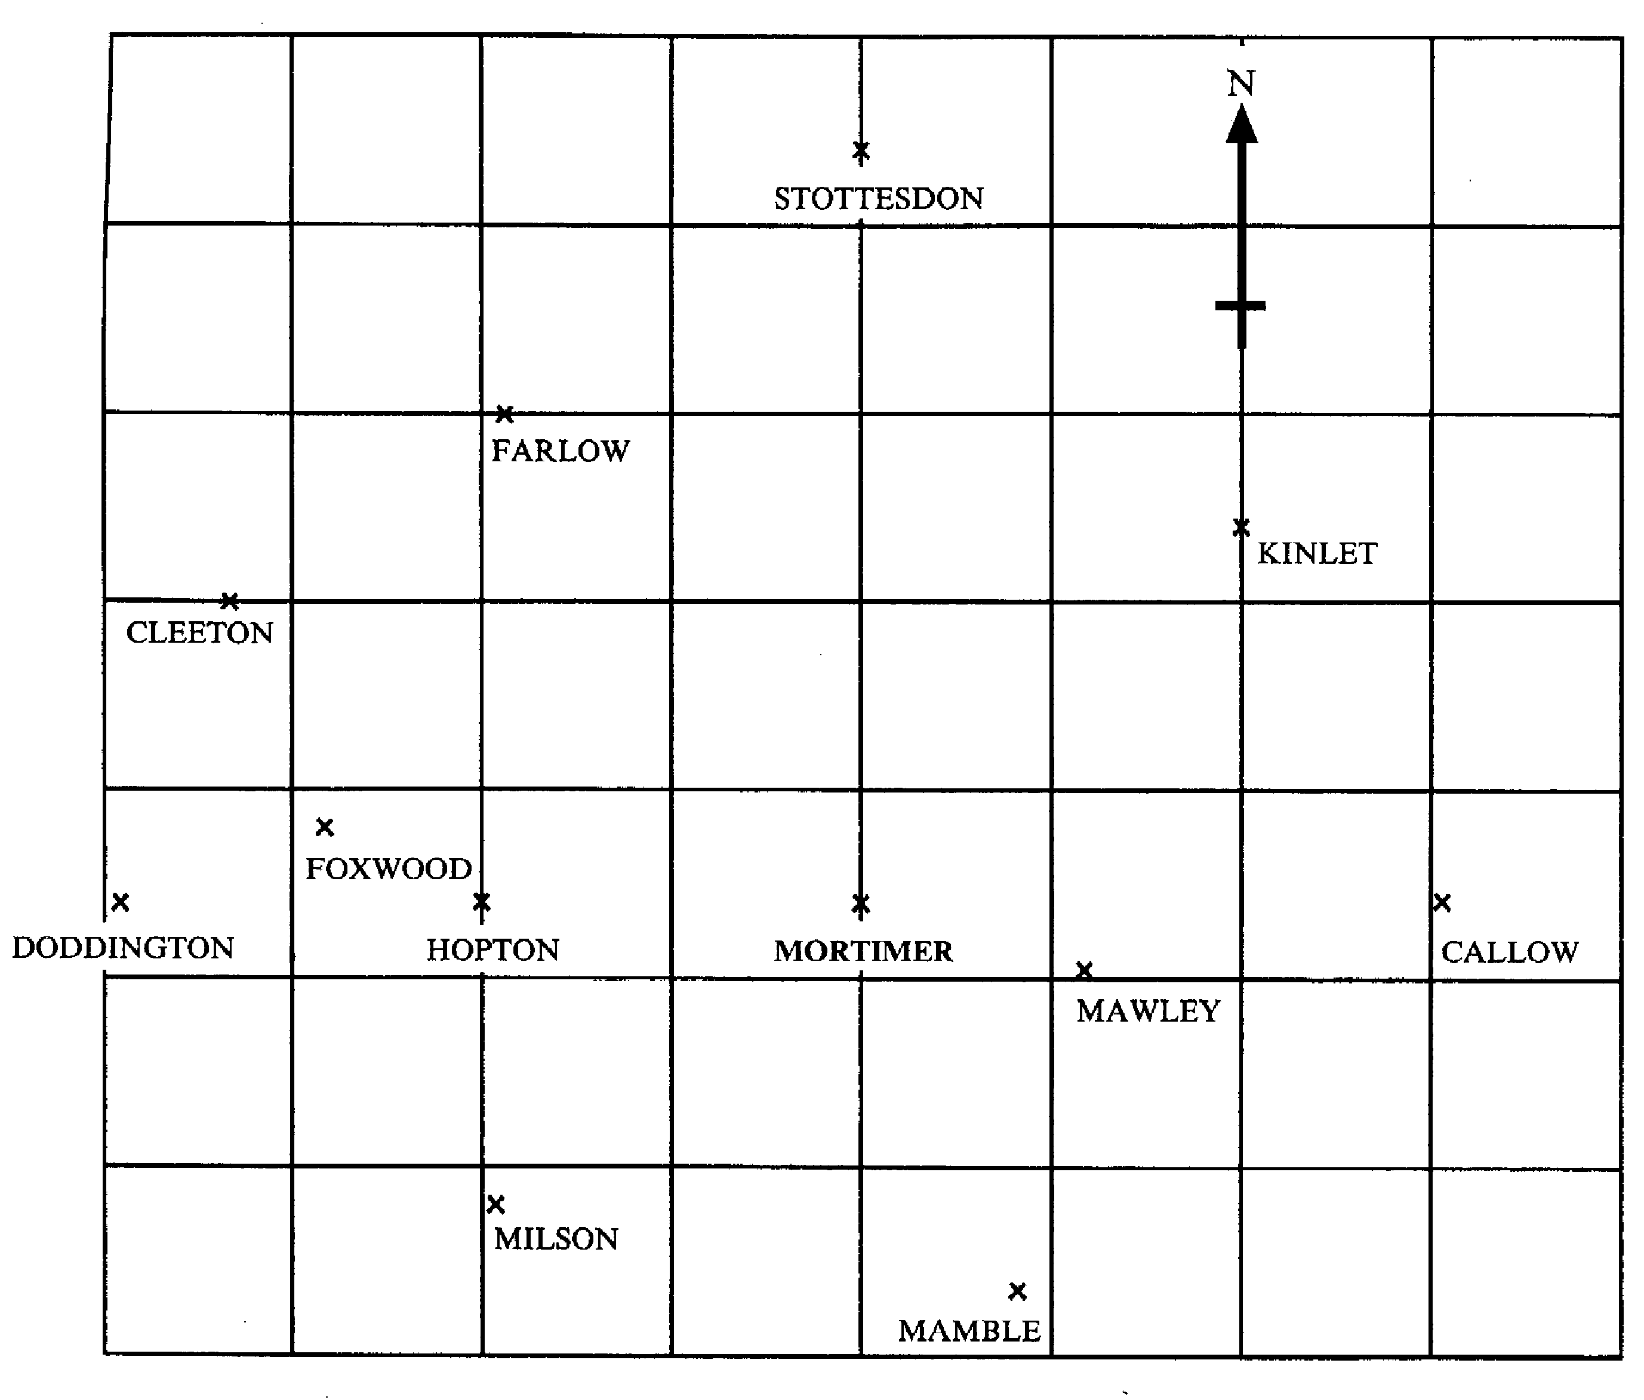
(a) What is the bearing of Cleeton from Mortimer?
………………………………………………………………………………………………………………………………..…
………………………………………………………………………………………………………………………………..… [2]
- Which town is on a bearing of 011º from Mamble?
………………………………………………………………………………………………………………………………..…
………………………………………………………………………………………………………………………………..… [2]

20. The table shows the mathematics test results for 90 students.
The test was marked out of 60.

Mark (x) | Frequency | Cumulative Frequency
0 ≤ x ≤ 10 | 12 | 12
10 < x ≤ 20 | 15
20 < x ≤ 30 | 29
30 < x ≤ 40 | 16
40 < x ≤ 50 | 11
50 < x ≤ 60 | 7

(a) Complete the cumulative frequency column
[1]
- Draw a cumulative frequency diagram on the grid opposite
[3]
- Use your diagram to estimate

  - the median
………………………………………………………………………………………………………………………………..…
………………………………………………………………………………………………………………………………..… [2]

  - the interquartile range
………………………………………………………………………………………………………………………………..…
………………………………………………………………………………………………………………………………..…
………………………………………………………………………………………………………………………………..… [2]

- The pass mark for the test is 25 marks.
Use your graph to estimate how many pupils pass the test.

………………………………………………………………………………………………………………………………..…
………………………………………………………………………………………………………………………………..…
………………………………………………………………………………………………………………………………..… [2]
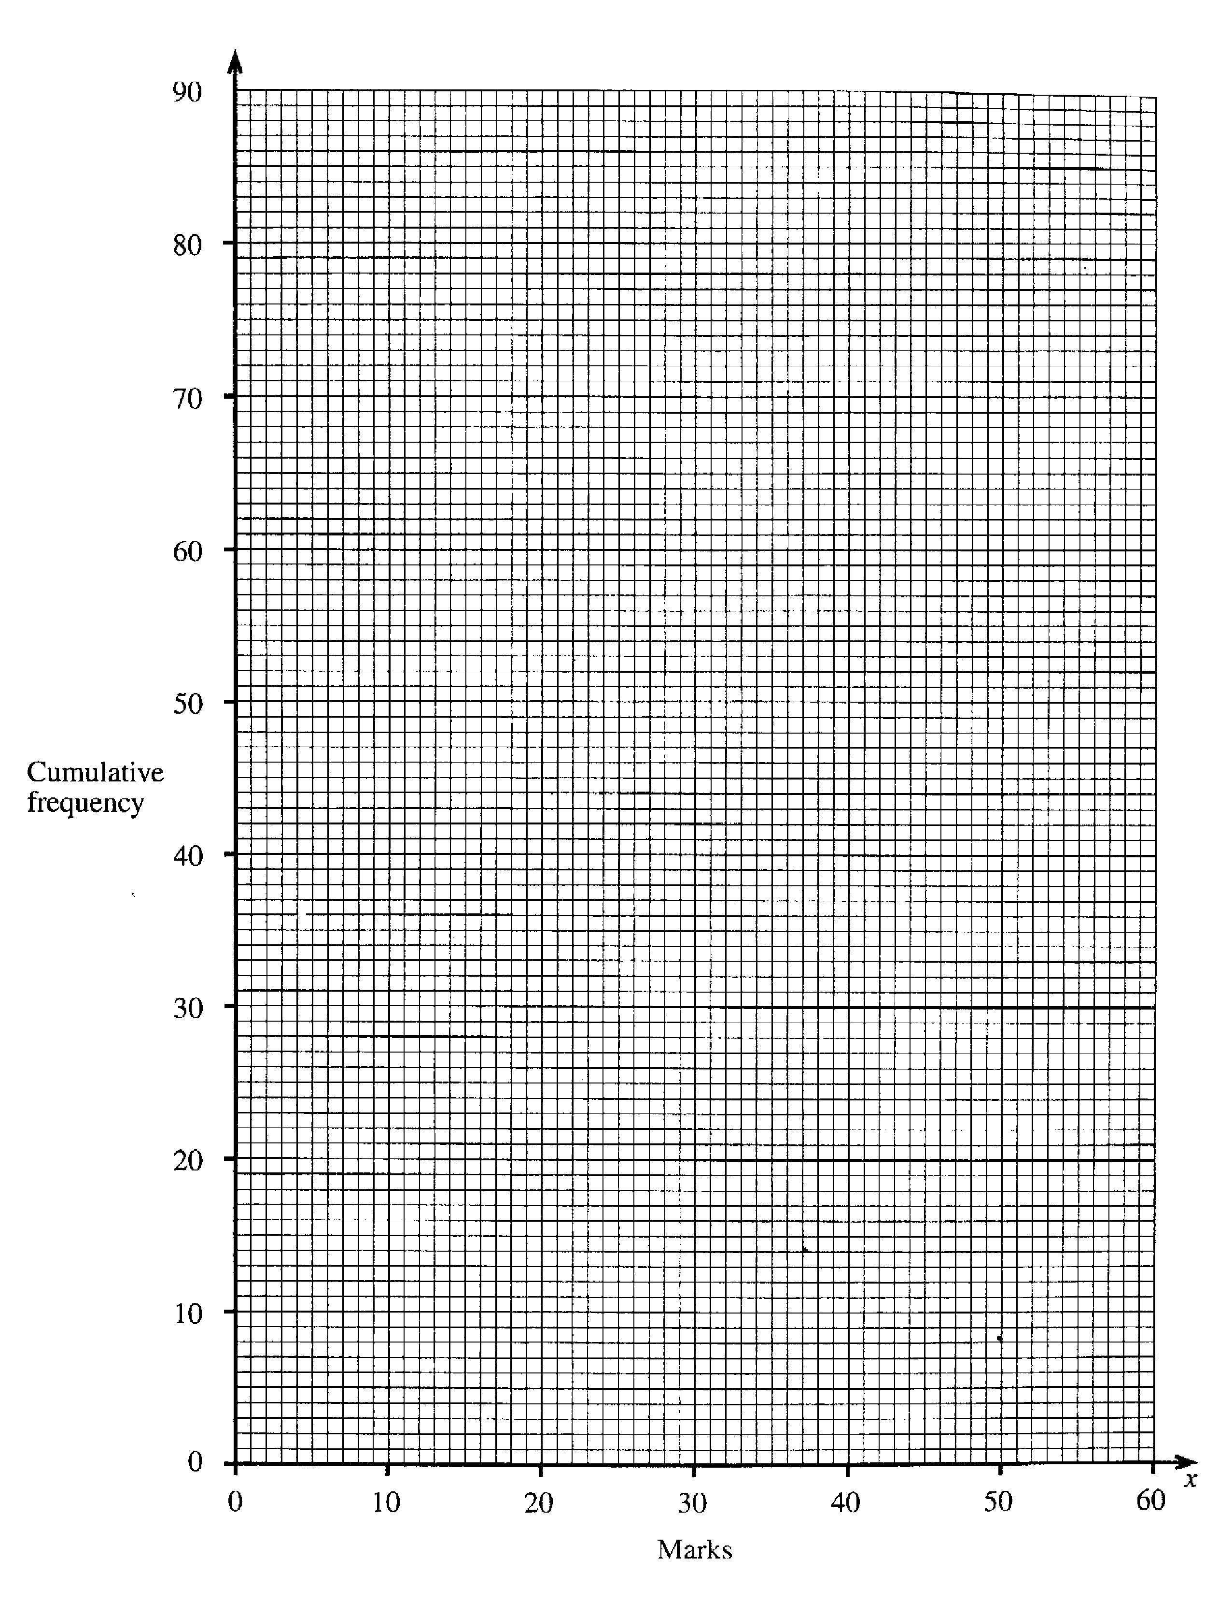

3, 9, 20, 25, 29, 75, 92, 100
21.

Which of the numbers in the box are

(a) square numbers?
………………………………………………………………………………………………………………………………..… [2]
- factors of 100?
………………………………………………………………………………………………………………………………..… [2]
(c) prime numbers?
………………………………………………………………………………………………………………………………..… [2]

22. (a) Factorise completely
3x² – 6x
………………………………………………………………………………………………………………………………..…
………………………………………………………………………………………………………………………………..… [2]
- Make t the subject of the formula.
W = 5t + 3
4
………………………………………………………………………………………………………………………………..…
………………………………………………………………………………………………………………………………..…
………………………………………………………………………………………………………………………………..…
………………………………………………………………………………………………………………………………..… [2]

23.
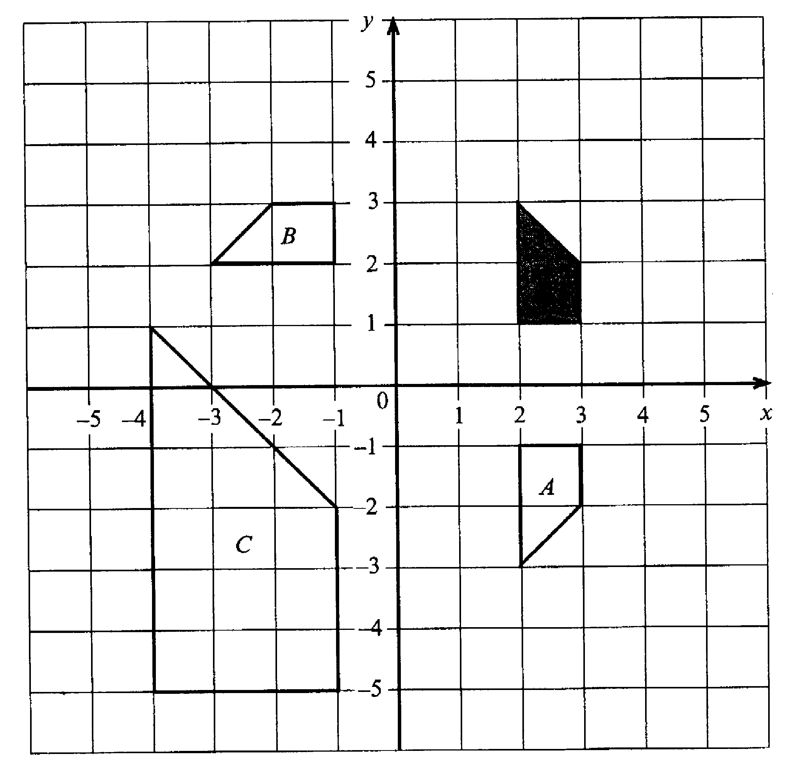

Describe fully a single transformation that would map the shaded shape onto
(a) shape A
………………………………………………………………………………………………………………………………..…
………………………………………………………………………………………………………………………………..…
………………………………………………………………………………………………………………………………..… [2]
- shape B
………………………………………………………………………………………………………………………………..…
………………………………………………………………………………………………………………………………..…
………………………………………………………………………………………………………………………………..… [3]
- shape C
………………………………………………………………………………………………………………………………..…
………………………………………………………………………………………………………………………………..…
………………………………………………………………………………………………………………………………..… [2]

24. Solve the equations
(a) 2x + 10 = 29
………………………………………………………………………………………………………………………………..…
………………………………………………………………………………………………………………………………..…
………………………………………………………………………………………………………………………………..…
………………………………………………………………………………………………………………………………..… [2]
- 5x – 4 = 8 – x
………………………………………………………………………………………………………………………………..…
………………………………………………………………………………………………………………………………..…
………………………………………………………………………………………………………………………………..…
………………………………………………………………………………………………………………………………..… [2]

(Total marks 120)

END OF EXAM

Answers To Specimen Paper 2
Answers to questions involving diagrams or graphs may vary slightly.

1. 1400 | 18. (a) 3x³ – 5x, (b) 6x²-x-2
2. (a) 4.29, (b) 4.652, (c) 50, (d)2.5 | 19. (a) 295⁰, (b)Mawley
3. (a) 157.1cm, (b) 31800 | 20. (a) 27, 56, 72, 83, 90, (b) on diagram, (c)(i)27,  (ii) 20, (d) 53
4. £34 | 21. (a) 9, 25, 100, (b) 20, 25, 100 (c) 3, 29
5. 3.4 | 22. (a) 3x(x-2), (b) t = 4W –3  5
6. (a) 86cm², (b) (i) diagram (ii) triangular prism  (c) 30cm³ | 23. (a) Reflection in the line y = 0 (i.e. x axis)  (b) Rotation through 90⁰ in an anticlockwise direction. The centre of the rotation is (0,0)  (c) Enlargement, scale factor 3, centre of enlargement at (5,4)
7. (a) ¼, (b) 12.5%

8. (a) 30⁰, (b) 9.997cm, (c) 4.95cm

9. (a) 2.79 x 10⁻⁶, (b)1.024 x 10⁻² | 24. (a) x=9.5, (b) x=2
10. 42mph

11.(a) 0.05, (b) 1st column 0.95, 0.05, 2nd column 0.04, 0.96, 0.04, 0.96. (c) 0.038
12. (a) 6, (b)(i)2 (ii)7, (c) different answers, (d) Graham – he has a higher mean score OR, the smaller range means that he is more consistent.

13. (a)0.2, (b)0.7, (c)20

14. a = 3½ , c = 1½

15. (a) twice, (b)(i) 2km, (b)(ii) 12km per hour,
(c) D to E
16.(a) 10cm², (b) Diagram

17. (a) 3n, (b) 3n-2, (c) n², (d)3n²

PAST PAPER 1

Special Examination In Mathematics
For Mature Applicants To Teacher Training

Test Paper 1
2001

Two and a half hours

Name ……………………………………………………………………

ATTEMPT ALL QUESTIONS

Show all your working in the space provided and make sure your answer is clear.

It is assumed that you have a scientific calculator, ruler and protractor.

If your calculator does not have a π button, take the value of π to be 3.142

Diagrams are not necessarily drawn to scale.

The marks for each question are given in brackets by the side of the question.

Marks may be given for method even if your answer is wrong.

The total marks available are 120.

Calculator Questions

1. A circle is drawn inside a triangle as shown.
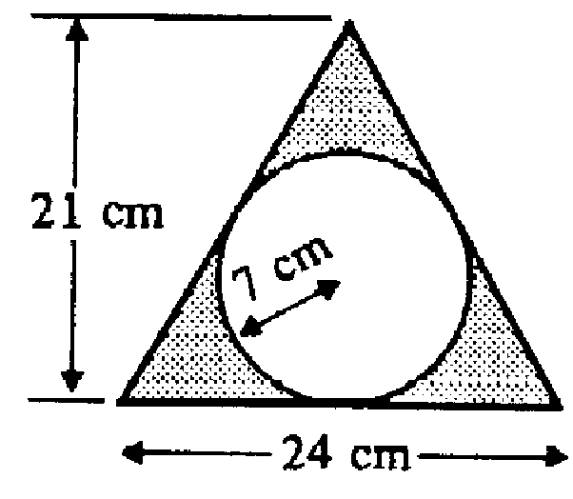

(a) Calculate the area of the triangle
………………………………………………………………………………………………………………………………………..
………………………………………………………………………………………………………………………………………..
………………………………………………………………………………………………………………………………………..
……………………………………………………………………………………………………………………………………….. [2]
(b) Calculate the size of the shaded area
………………………………………………………………………………………………………………………………………..
………………………………………………………………………………………………………………………………………..
………………………………………………………………………………………………………………………………………..
………………………………………………………………………………………………………………………………………..
………………………………………………………………………………………………………………………………………..
……………………………………………………………………………………………………………………………………….. [3]

2. Every hour, on the hour, a train leaves Toronto for Montreal.
At the same times, trains leave Montreal for Toronto.
All trains travel at a speed of 75 mph.
The distance between Toronto and Montreal is 300 miles.

(a) On the grid (on the next page), draw the distance time graphs of the trains.
(One of the distance time graphs has been drawn for you)

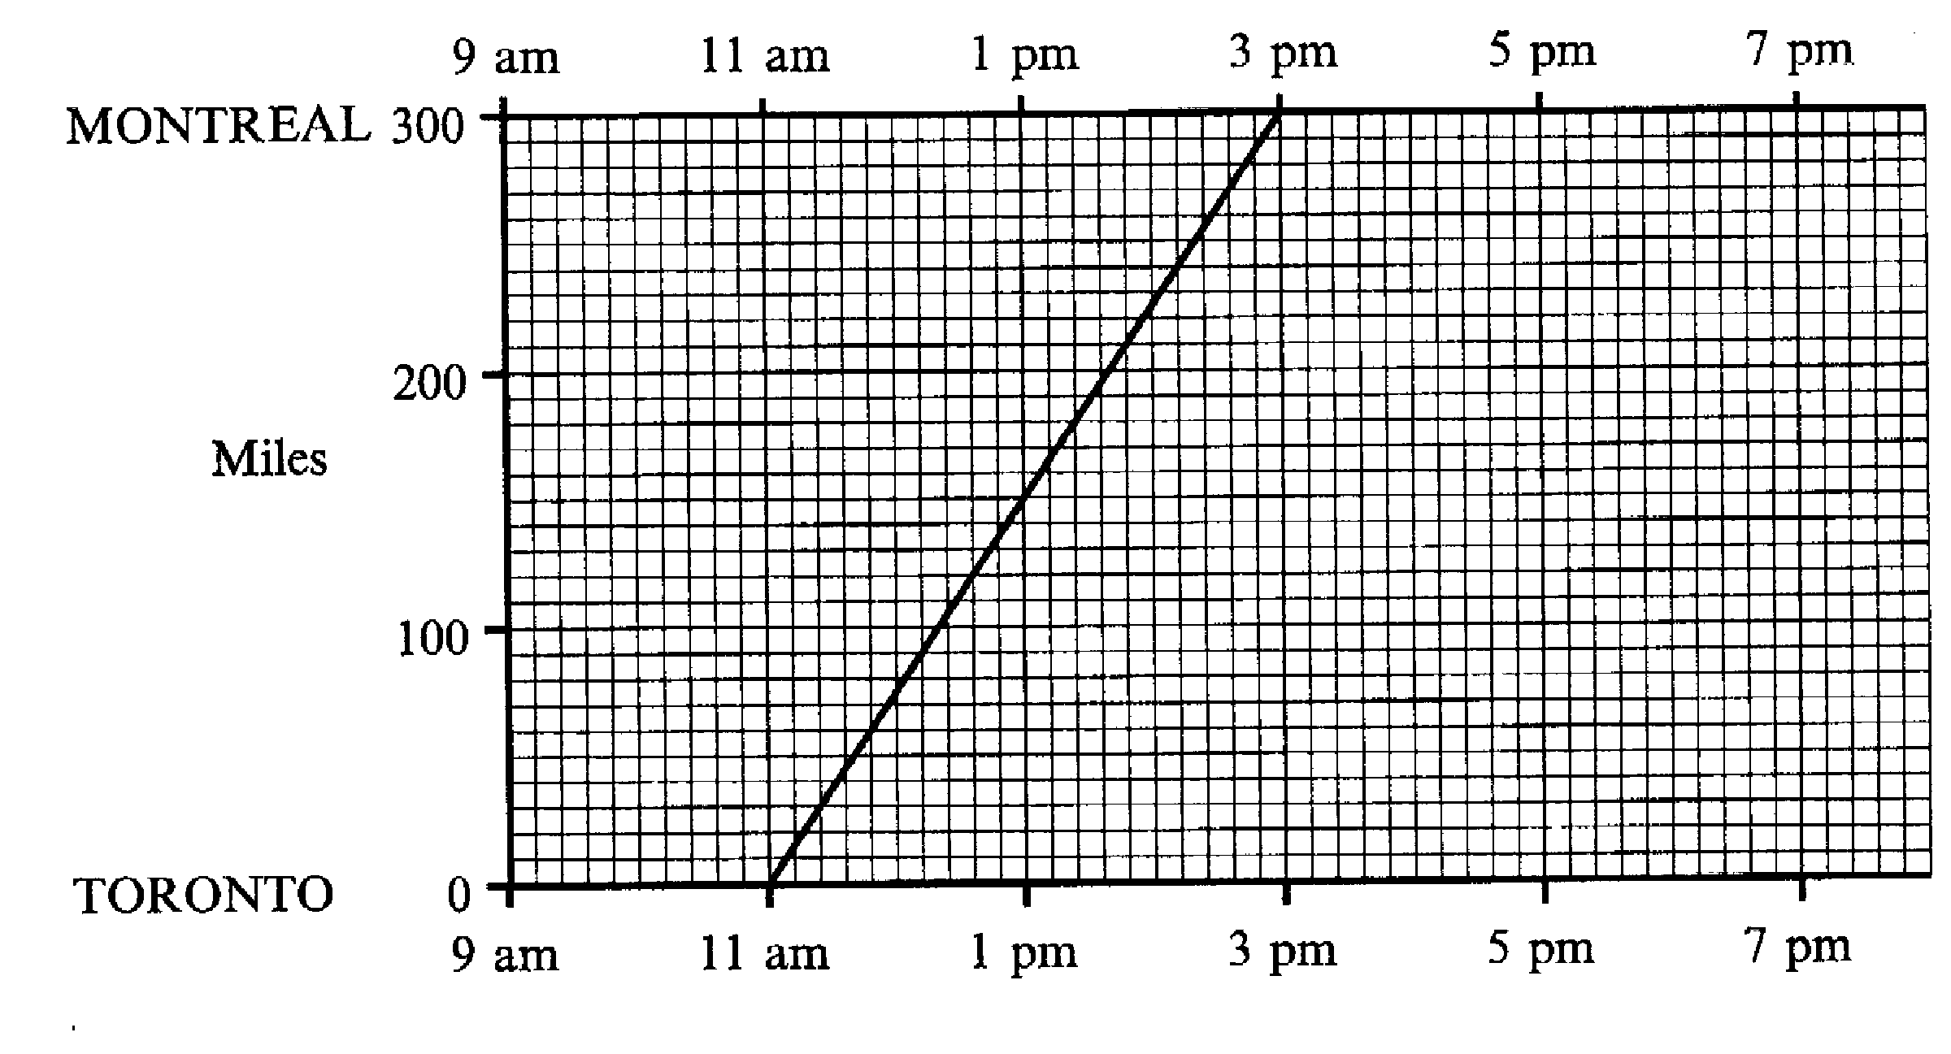

[2]

(b) Use your graphs to find
(i) when the 2 pm train from Toronto passes the 1pm train from Montreal
………………………………………………………………………………………………………………………………………..
……………………………………………………………………………………………………………………………………….. [1]
(ii) how many trains will be passed by the train leaving Toronto at 12 noon on
its run to Montreal.
………………………………………………………………………………………………………………………………………..
……………………………………………………………………………………………………………………………………….. [2]

3. Jane conducted a survey about what her neighbours did on bonfire night. Her results are summarised in the table below.

Stayed at home | 37
Went to the park | 83
Went to a friend’s house | 42
Went to the cinema | 3
Didn’t reply | 15
Total | 180

Jane was asked to draw a pie chart to illustrate these results.
What angle should she use for ‘Went to the park’?
………………………………………………………………………………………………………………………………………..
………………………………………………………………………………………………………………………………………..
………………………………………………………………………………………………………………………………………..
………………………………………………………………………………………………………………………………………..
……………………………………………………………………………………………………………………………………….. [3]

4. In a general election, a candidate loses her/his deposit if s/he does not get at
least 5% of the total votes cast.
Mary Ashworth, John Barnard and Bill Crowther are the only three candidates in the General Election in Bradworth.

5235 people voted for John Barnard
425 people voted for Bill Crowther

Bill Crowther kept his deposit because he got 5% of all the total votes cast.
How many people voted for Mary Ashworth?

………………………………………………………………………………………………………………………………………..
………………………………………………………………………………………………………………………………………..
………………………………………………………………………………………………………………………………………..
………………………………………………………………………………………………………………………………………..
………………………………………………………………………………………………………………………………………..
……………………………………………………………………………………………………………………………………….. [3]

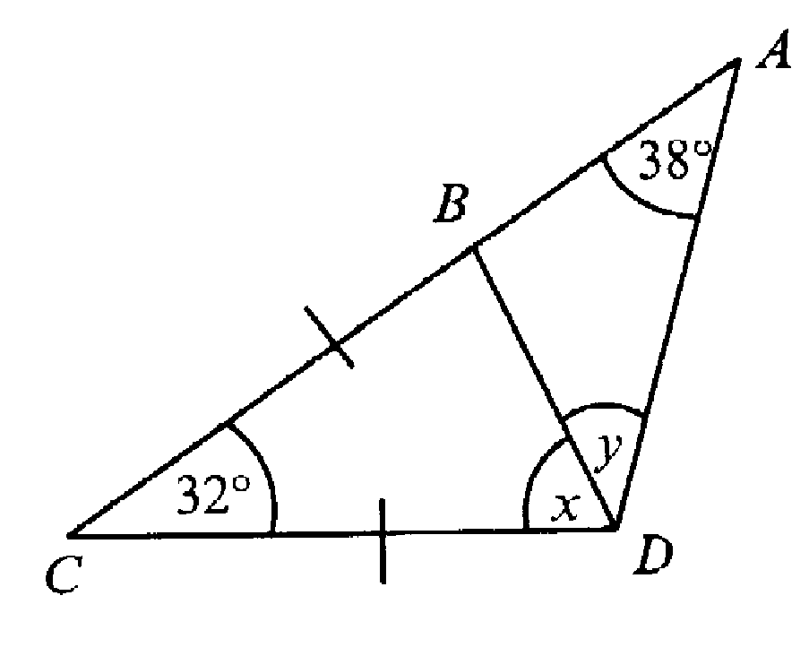
5.

In the diagram CB = CD
- Calculate the size of the angle marked x
………………………………………………………………………………………………………………………………………..
………………………………………………………………………………………………………………………………………..
……………………………………………………………………………………………………………………………………….. [2]
- Calculate the size of the angle marked y
………………………………………………………………………………………………………………………………………..
………………………………………………………………………………………………………………………………………..
……………………………………………………………………………………………………………………………………….. [2]
- Does AB = BD?
Give as reason for your answer
………………………………………………………………………………………………………………………………………..
………………………………………………………………………………………………………………………………………..
……………………………………………………………………………………………………………………………………….. [1]

6. One afternoon a survey was taken of 100 customers at a supermarket.
The time they spent queuing at the checkout was recorded.
The results are shown below.

Time t minutes | Number of customers
0 < t ≤ 5 | 18
5 < t ≤ 10 | 42
10 < t ≤ 15 | 30
15 < t ≤ 20 | 8
20 < t ≤ 25 | 2

Calculate an estimate of the mean time the customers had to queue.
………………………………………………………………………………………………………………………………………..
………………………………………………………………………………………………………………………………………..
………………………………………………………………………………………………………………………………………..
………………………………………………………………………………………………………………………………………..
………………………………………………………………………………………………………………………………………..
……………………………………………………………………………………………………………………………………….. [3]
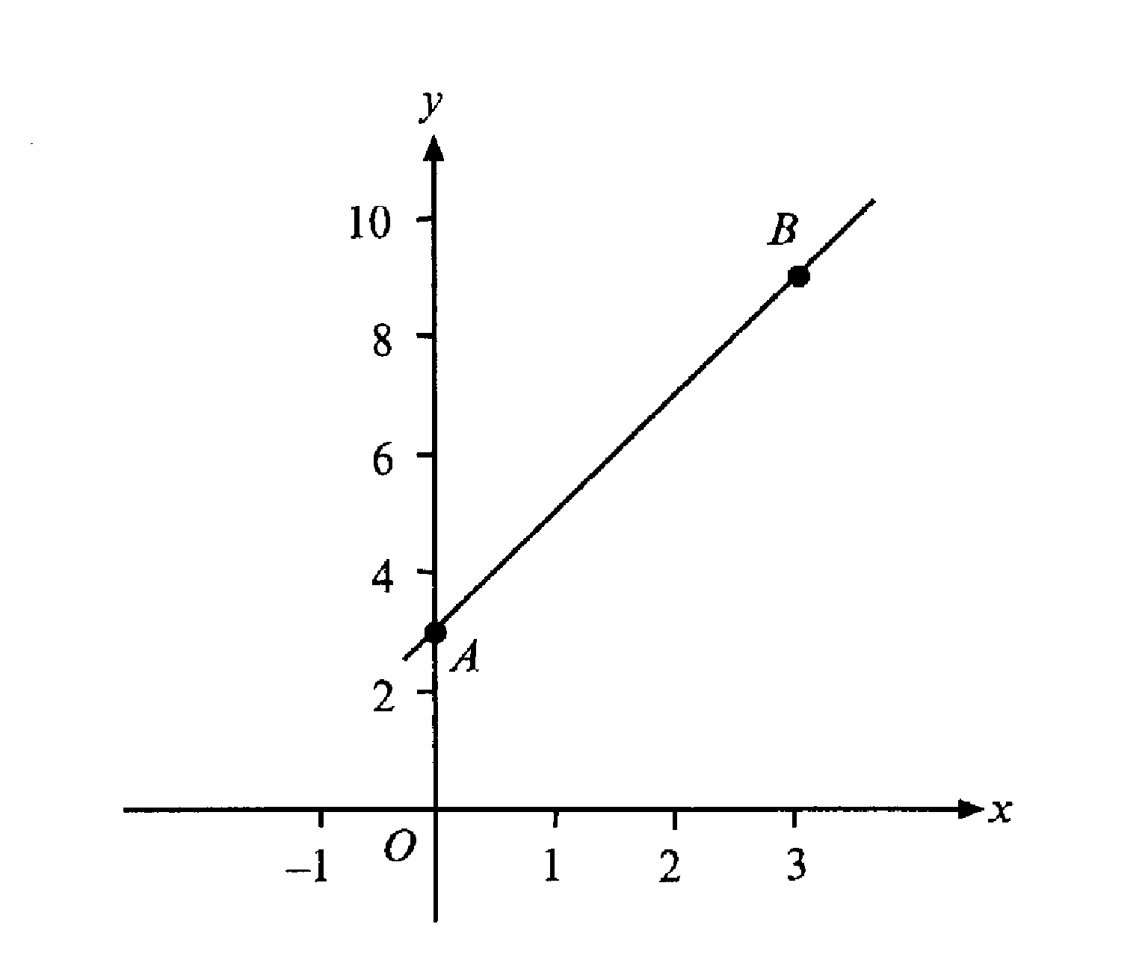
7.

A is the point (0,3) and B is the point (3,9).
(a) Calculate the gradient of the line AB
………………………………………………………………………………………………………………………………………..
………………………………………………………………………………………………………………………………………..
……………………………………………………………………………………………………………………………………….. [2]
(b) Write down the equation of the line AB
………………………………………………………………………………………………………………………………………..
………………………………………………………………………………………………………………………………………..
……………………………………………………………………………………………………………………………………….. [2]

8. The sketch shows triangle ABC.
AB = 40cm, AC = 41cm and CB = 9cm
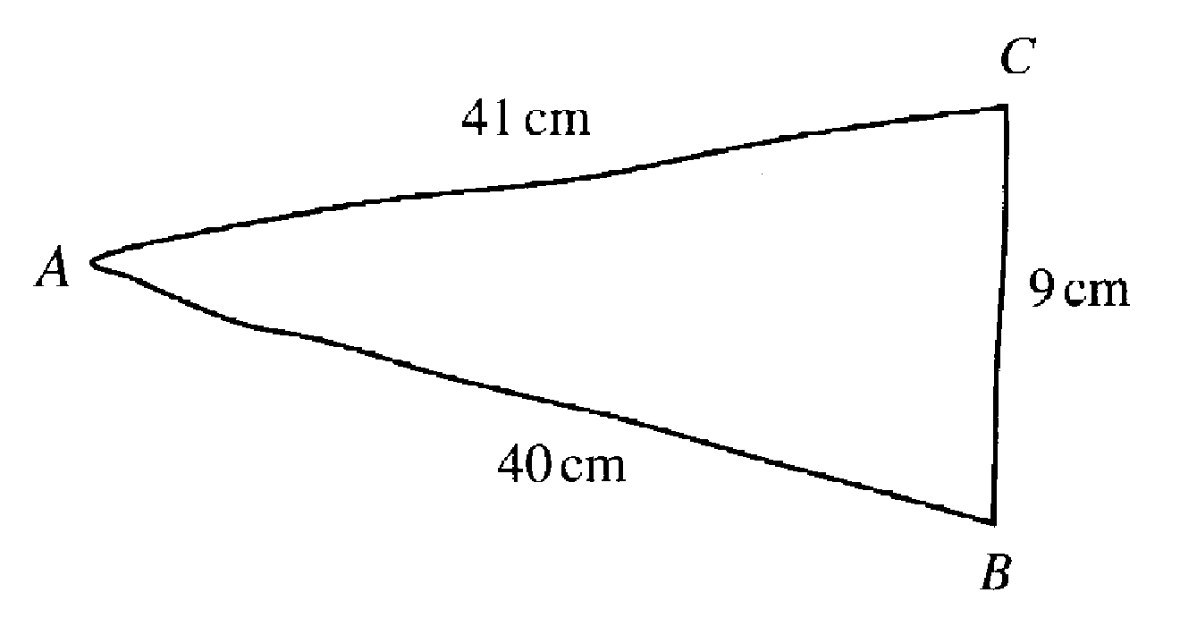
Not drawn accurately

By calculation, show that triangle ABC is a right angled triangle.
………………………………………………………………………………………………………………………………………..
………………………………………………………………………………………………………………………………………..
………………………………………………………………………………………………………………………………………..
………………………………………………………………………………………………………………………………………..
……………………………………………………………………………………………………………………………………….. [2]

9.(a) The distance from the earth to the moon is approximately 384,000 km.
Write this distance in standard form.
………………………………………………………………………………………………………………………………………..
……………………………………………………………………………………………………………………………………….. [2]
(b) Write these numbers in order, starting with the smallest:
8.17 x 10³ 5.55 x 10⁻⁵ 2.88 x 10² 7.22 x 10⁻⁵ 5.27 x 10⁵

………………………………………………………………………………………………………………………………………..
……………………………………………………………………………………………………………………………………….. [2]

10. Use trial and improvement to solve the equation x³ – 2x = 30
Two trials have been completed for you.
Show all your trials.
Give your answer correct to 1 decimal place.

X | x³ – 2x
3 | 3³ – 6 = 21 | Too small
4 | 4³ – 8 = 56 | Too big

[4]
11. A regular polygon has interior angles of 162º. How many sides has the polygon got? Show all your working.

………………………………………………………………………………………………………………………………………..
………………………………………………………………………………………………………………………………………..
………………………………………………………………………………………………………………………………………..
………………………………………………………………………………………………………………………………………..
……………………………………………………………………………………………………………………………………….. [3]

12. A formula is given as v = u + at
(a) Calculate v when a = 3, t = 1.5 and u = 2
………………………………………………………………………………………………………………………………………..
………………………………………………………………………………………………………………………………………..
……………………………………………………………………………………………………………………………………….. [1]

(b) Re-arrange the formula to make a the subject
………………………………………………………………………………………………………………………………………..
………………………………………………………………………………………………………………………………………..
……………………………………………………………………………………………………………………………………….. [2]

- Calculate a when v = 10, u = 3 and t = 5
………………………………………………………………………………………………………………………………………..
………………………………………………………………………………………………………………………………………..
……………………………………………………………………………………………………………………………………….. [2]
13. The diagram shows a kite, ABCD.
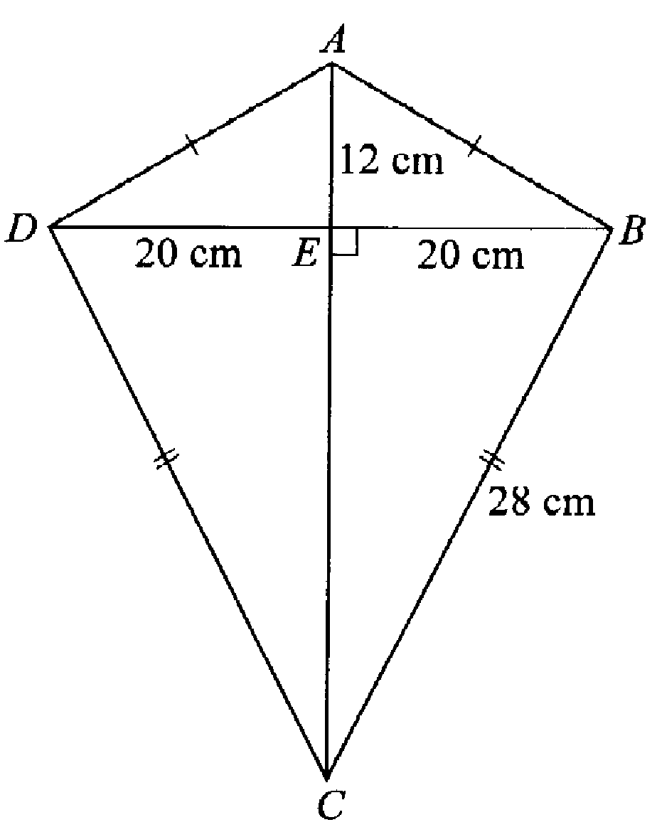

Not to scale

AE = 12 cm, DE = EB =20 cm and BC = 28cm
(a) Calculate the size of angle EBC
………………………………………………………………………………………………………………………………………..
………………………………………………………………………………………………………………………………………..
………………………………………………………………………………………………………………………………………..
………………………………………………………………………………………………………………………………………..
………………………………………………………………………………………………………………………………………..
……………………………………………………………………………………………………………………………………….. [3]

(b) Calculate the length of EC and hence find the area of the kite.
………………………………………………………………………………………………………………………………………..
………………………………………………………………………………………………………………………………………..
………………………………………………………………………………………………………………………………………..
………………………………………………………………………………………………………………………………………..
………………………………………………………………………………………………………………………………………..
………………………………………………………………………………………………………………………………………..
………………………………………………………………………………………………………………………………………..
……………………………………………………………………………………………………………………………………….. [5]

14(a) Write down a decimal that lies between and .
1
5
1
6

………………………………………………………………………………………………………………………………..… [1]
(b) Which of these two fractions is the bigger?
2
7
3
5
or

Show your working

………………………………………………………………………………………………………………………………..…
………………………………………………………………………………………………………………………………..…
………………………………………………………………………………………………………………………………..… [2]

15. A child’s hula hoop has a diameter of 80cm.

(a) What is the circumference of the hula hoop?

………………………………………………………………………………………………………………………………………..
………………………………………………………………………………………………………………………………………..
……………………………………………………………………………………………………………………………………….. [2]

(b) Jenny pushed the hula hoop along a 20 m path. How many complete turns did the hula hoop make?
………………………………………………………………………………………………………………………………………..
………………………………………………………………………………………………………………………………………..
………………………………………………………………………………………………………………………………………..
……………………………………………………………………………………………………………………………………….. [2]

Non-calculator Questions

16.
1, 4, 5, 23, 25, 36, 41, 43, 45

Look at the numbers in the box above.

(a) Which of these numbers are multiples of 3?
……………………………………………………………………………………………………………………………………….. [1]
(b) Which of these numbers are square numbers?
……………………………………………………………………………………………………………………………………….. [1]
(c) Which of these numbers are prime numbers?
……………………………………………………………………………………………………………………………………….. [1]

17. The probability that I am late for work on a Monday is 0.4
The probability that I am late for work on a Tuesday is 0.2

What is the probability that in one particular week
(a) I am late for work on both Monday and Tuesday
………………………………………………………………………………………………………………………………………..
……………………………………………………………………………………………………………………………………….. [2]
(b) I am late for work on Monday but on time on Tuesday
………………………………………………………………………………………………………………………………………..
………………………………………………………………………………………………………………………………………..
……………………………………………………………………………………………………………………………………….. [2]
(c) I am on time both on Monday and on Tuesday
………………………………………………………………………………………………………………………………………..
………………………………………………………………………………………………………………………………………..
……………………………………………………………………………………………………………………………………….. [2]
(d) I am late for work on Monday or Tuesday but not both days
………………………………………………………………………………………………………………………………………..
………………………………………………………………………………………………………………………………………..
……………………………………………………………………………………………………………………………………….. [2]

18. The three angles of a triangle are given as xº, 3xº and 5xº.
Calculate the value of x.
………………………………………………………………………………………………………………………………………..
………………………………………………………………………………………………………………………………………..
………………………………………………………………………………………………………………………………………..
……………………………………………………………………………………………………………………………………….. [3]

19. Factorise fully 5x² – 10x
……………………………………………………………………………………………………………………………………….. ………………………………………………………………………………………………………………………………………..
……………………………………………………………………………………………………………………………………….. [2]

20. List the values of x, where x is a whole number, such that
-2 ≤ x < 3
………………………………………………………………………………………………………………………………………..
………………………………………………………………………………………………………………………………………..
……………………………………………………………………………………………………………………………………….. [2]
21. These are the prices charged for different journeys by taxi.

Length of journey (km) | 1 | 2 | 3 | 5 | 8 | 13 | 14 | 18
Cost (£) | 1.80 | 2.30 | 2.50 | 2.80 | 5.40 | 7.50 | 8.40 | 10.30

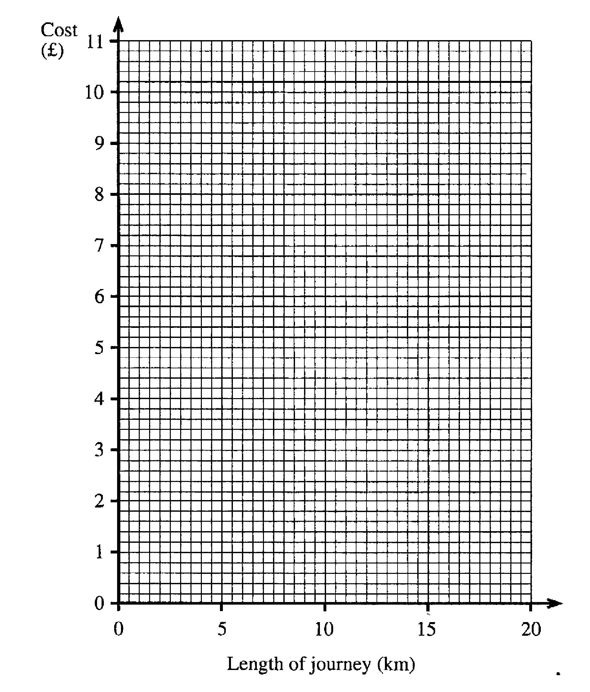
(a) On the grid below, draw a scatter diagram to show this information.

[3]
(b) What does this diagram tell you about the relationship between the length of a journey and its cost?
………………………………………………………………………………………………………………………………………..
……………………………………………………………………………………………………………………………………….. [1]
(c) Draw a line of best fit [1]
(d) Estimate the cost of a taxi journey of 16 km.
………………………………………………………………………………………………………………………………………..
……………………………………………………………………………………………………………………………………….. [1]

(e) I was charged £6.20 for a taxi journey.
Estimate the length of the journey.
………………………………………………………………………………………………………………………………………..
……………………………………………………………………………………………………………………………………….. [1]
22. Paul and Kay take part in a quiz.
The rules are:
For each correct answer +5 points
For each wrong answer -2 points

(a) In the first round, Paul gets three questions correct and one question wrong.
What is his total number of points?
………………………………………………………………………………………………………………………………………..
………………………………………………………………………………………………………………………………………..
……………………………………………………………………………………………………………………………………….. [1]
(b) Kay has +6 points after her first four questions.
Write down one way she may have done this.
………………………………………………………………………………………………………………………………………..
………………………………………………………………………………………………………………………………………..
……………………………………………………………………………………………………………………………………….. [1]

23. Solve the equation
3 (4x – 1) = 27
………………………………………………………………………………………………………………………………………..
………………………………………………………………………………………………………………………………………..
………………………………………………………………………………………………………………………………………..
……………………………………………………………………………………………………………………………………….. [3]

24. Solve the simultaneous equations
6x + 3y = 12
2x – y = -2
………………………………………………………………………………………………………………………………………..
………………………………………………………………………………………………………………………………………..
………………………………………………………………………………………………………………………………………..
………………………………………………………………………………………………………………………………………..
………………………………………………………………………………………………………………………………………..
……………………………………………………………………………………………………………………………………….. ………………………………………………………………………………………………………………………………………..
………………………………………………………………………………………………………………………………………..
………………………………………………………………………………………………………………………………………..
……………………………………………………………………………………………………………………………………….. [4]

25. Solve the equations:
(a) 3x + 9 = 30
………………………………………………………………………………………………………………………………………..
………………………………………………………………………………………………………………………………………..
……………………………………………………………………………………………………………………………………….. [2]
- 5x – 2 = 2x + 7
………………………………………………………………………………………………………………………………………..
………………………………………………………………………………………………………………………………………..
………………………………………………………………………………………………………………………………………..
……………………………………………………………………………………………………………………………………….. [2]

26. Max shares £420 with a friend in the ratio 5:3
How much does each receive?
………………………………………………………………………………………………………………………………………..
………………………………………………………………………………………………………………………………………..
………………………………………………………………………………………………………………………………………..
……………………………………………………………………………………………………………………………………….. [2]

27. Look at the following sequence:
-4, -1, 4, 11, 20
(a) Write down the next two terms in the sequence
………………………………………………………………………………………………………………………………………..
……………………………………………………………………………………………………………………………………….. [1]
(b) Explain how you got your answer to part (a)
………………………………………………………………………………………………………………………………………..
………………………………………………………………………………………………………………………………………..
……………………………………………………………………………………………………………………………………….. [1]
(c) Write down the nth term in the sequence
………………………………………………………………………………………………………………………………………..
………………………………………………………………………………………………………………………………………..
………………………………………………………………………………………………………………………………….. [2]

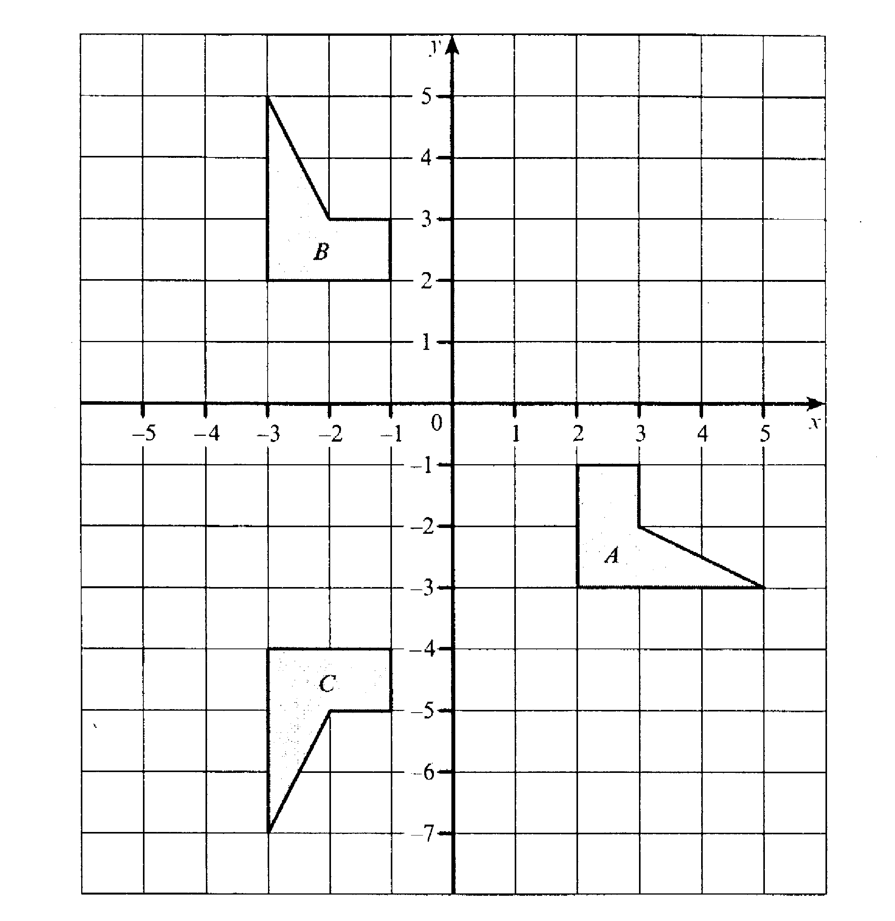
28.

(a) Describe the single transformation that will transform shape C to shape B
………………………………………………………………………………………………………………………………………..
………………………………………………………………………………………………………………………………………..
……………………………………………………………………………………………………………………………………….. [2]

(b) Describe the single transformation that will transform shape A to shape C.

………………………………………………………………………………………………………………………………………..
………………………………………………………………………………………………………………………………………..
………………………………………………………………………………………………………………………………………..
………………………………………………………………………………………………………………………………………..
……………………………………………………………………………………………………………………………………….. [3]

29. A carton is 50cm long, a40 cm wide and 30 com high. How many boxes measuring 10 cm x 8 cm x 3cm would fit into one of these cartons?

………………………………………………………………………………………………………………………………………..
………………………………………………………………………………………………………………………………………..
………………………………………………………………………………………………………………………………………..
………………………………………………………………………………………………………………………………………..
……………………………………………………………………………………………………………………………………….. [2]

30. Given that y = x² + x
(a) Complete the table below,
x | 0 | 1 | 2 | 3 | 4 | 5 | 6
y |  |  |  | 12 |  |  | 42
[2]
(b) Plot these points on the grid below and hence draw the graph of y = x² + x
[2]

(c) Use your graph to find the value of x when y = 25
………………………………………………………………………………………………………………………………..… [1]
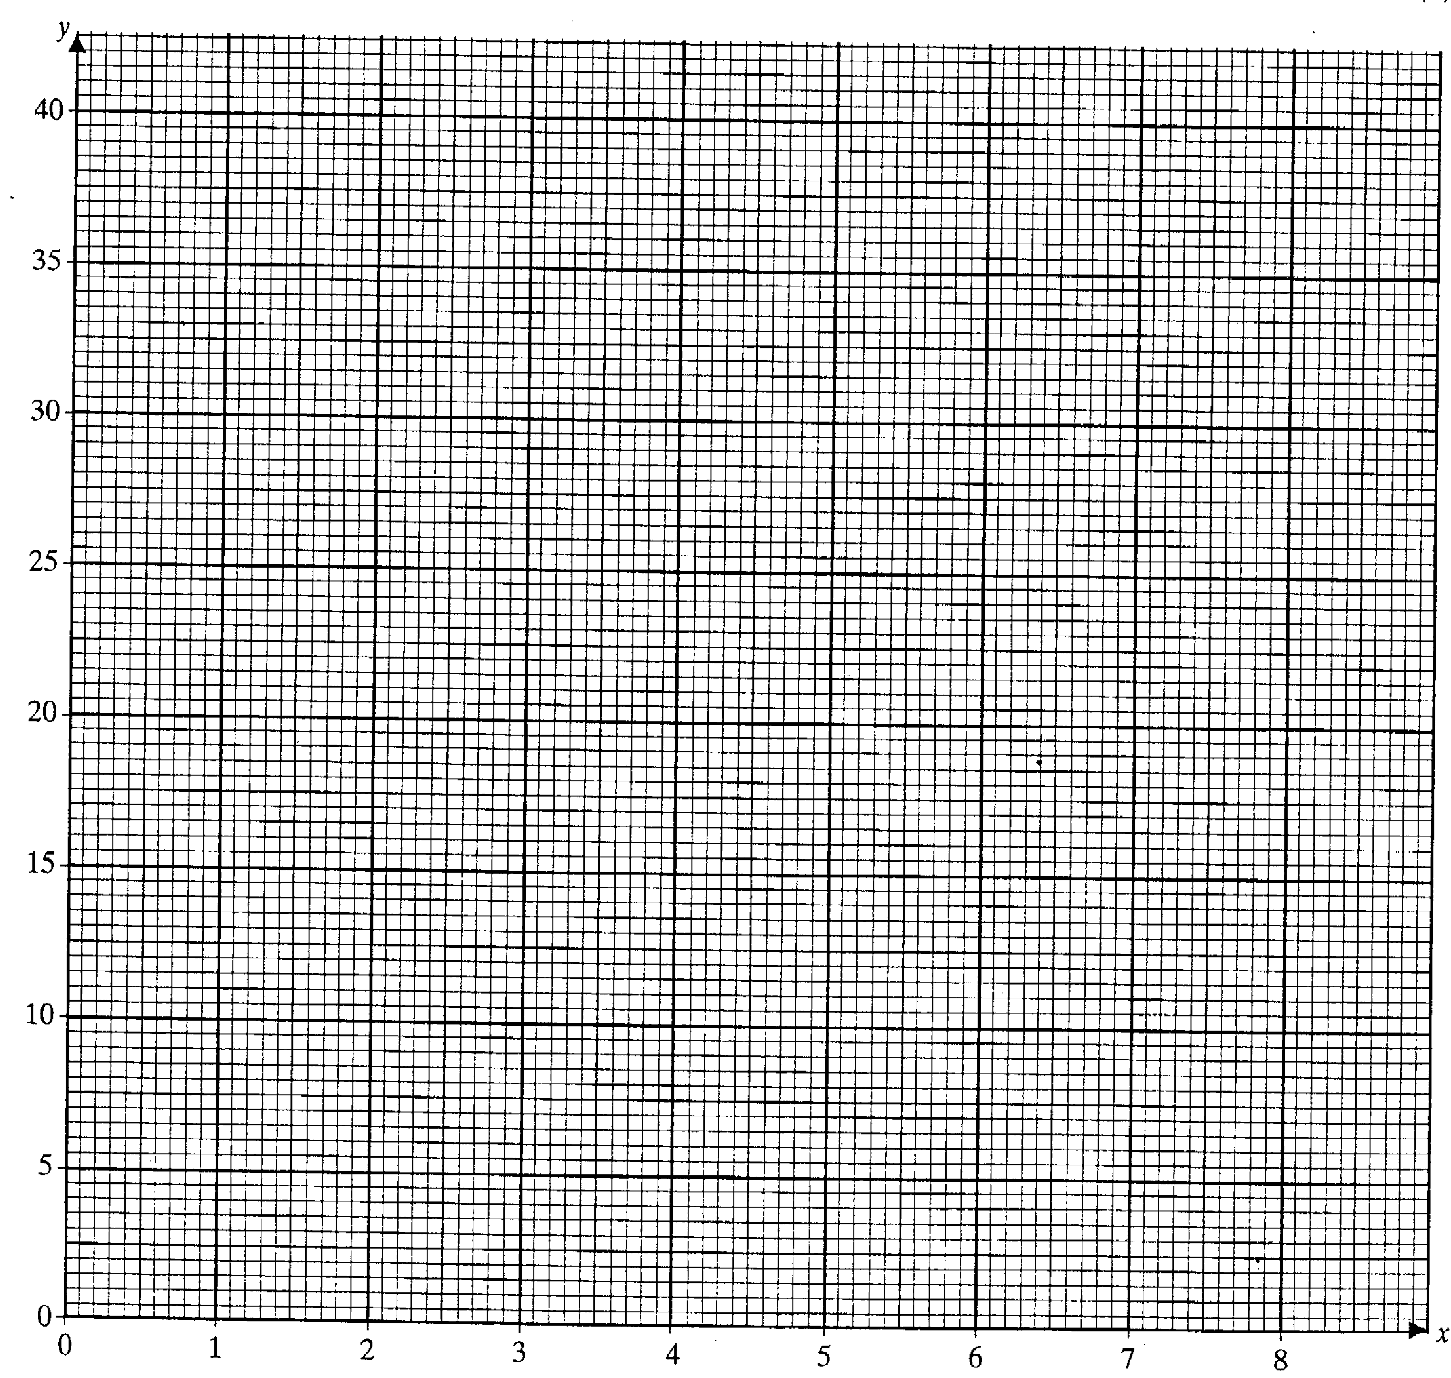

31. The heights of a small group of boys were measured. The results were:
151 cm, 148 cm, 147 cm, 152cm, 154cm, 160 cm, 148 cm, 149 cm

(a) What was their median height?
………………………………………………………………………………………………………………………………………..
………………………………………………………………………………………………………………………………………..
……………………………………………………………………………………………………………………………………….. [1]
(b) What was their modal height?
………………………………………………………………………………………………………………………………………..
……………………………………………………………………………………………………………………………………….. [1]
(c) What was the range of their heights?
………………………………………………………………………………………………………………………………………..
……………………………………………………………………………………………………………………………………….. [1]

End of exam

Answers to test paper 1 – 2001
Answers to questions involving diagrams or graphs may vary slightly.

1.(a) 252 cm² , (b) Area of circle 154cm² , shaded area 98cm² | 15. (a) 251cm² , (b) 7
2.(a) 16 lines in total, 7 in a direction parallel to the line shown. 8 in a direction parallel to the line joining 9am in Montreal with 1pm on Toronto joining 9am and 1pm  (b)(i) 3.30pm or 115 miles from Toronto (ii) 7. | 16.(a) 36,45, (b) 1,2,25,36, (c) 5,23,41,43
 | 17. (a) 0.08, (b) 0.32, (c) 0.48, (d) 0.44
 | 18. 20⁰
3. 166⁰ | 19. 5x (x-2)
4. 2840 | 20. -2,-1,0,1,2
5. (a) 74⁰, (b) 39⁰ , (c)No, the triangle isn’t isosceles as y ≠38⁰ | 21. (b) The longer the journey, the higher the higher the cost. Good positive correlation.  (d) £9.50, (e) 9.5 to 10km
6. 9.2 mins

7.(a) 2, (b) y=2x+3 | 22. (a) 13, (b) 5+5-2-2
8. 9² + 40² = 41² (Pythagoras) | 23. x=2.5
9.(a) 3.84 x 10⁵, (b) 5.55 x 10⁻⁵, 7.22 x 10⁻⁵,  2.88x10², 8.17 x 10³, 5.27 x 10⁵ | 24. x = , y = 3
10. x = 3.3 | 25. (a) x=7, (b) x=3
11. exterior angle – 18⁰, 20 sides | 26. Max £262.50, friend £157.50
12. (a) 6.5, (b) a = , (c)1.4 | 27. (a) 31, 44 (b) The difference between the  Terms increases by 2 each time, (c) n² -5
13. (a) 44.4⁰, (b) 19.6cm, 632cm² | 28. (a) Reflection in the line y = -1, (b) Rotation through an angle of 180⁰ in an anticlockwise direction. Centre of rotation (0.5, -3.5)
14(a) Any number between 0.1666 and 0.2
(b)

29. 250 | 31. (a) 150cm, (b)148cm, (c) 13cm
30. (a) 0,2,6,20,30, (c) 4.6

PAST PAPER 2

Test Paper 3
2001

Two and a half hours

Name………………………………………………………………

ATTEMPT ALL QUESTIONS

Show all your working in the space provided and make sure your answer is clear.

It is assumed that you have a scientific calculator, ruler and protractor.

If your calculator does not have a π button, take the value of π to be 3.142

Diagrams are not necessarily drawn to scale.

The marks for each question are given in brackets by the side of the question.

Marks may be given for method even if your answer is wrong.

The total marks available are 120.

Calculator Questions
- This is an architect’s plan for a new church kitchen.

Scale 1:50
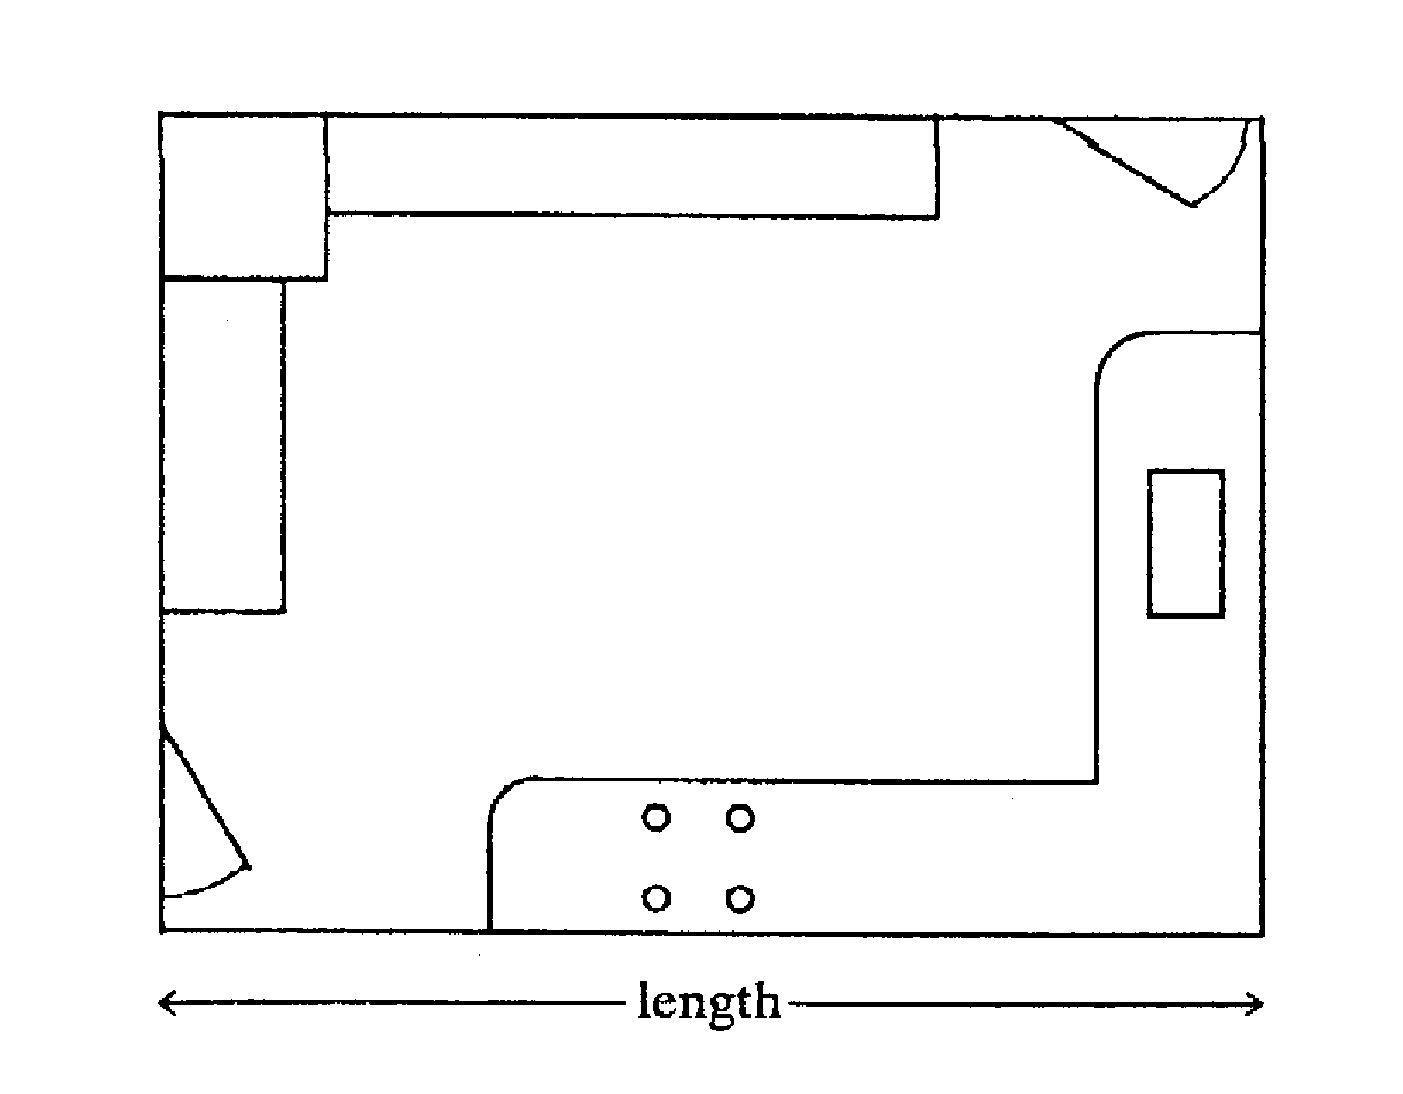

- What is the actual length of the kitchen? Give your answer in metres.
………………………………………………………………………………………………………………………………………..
………………………………………………………………………………………………………………………………………..
……………………………………………………………………………………………………………………………………….. [2]

(b) The doorways are 90cm wide. To improve disabled access, it has been decided that the doorways should be increased by 30%. How wide will they be after the work has been completed?

………………………………………………………………………………………………………………………………………..
………………………………………………………………………………………………………………………………………..
……………………………………………………………………………………………………………………………………….. [2]

2. Solve the equation
3x – 9 = 5x - 5
………………………………………………………………………………………………………………………………………..
………………………………………………………………………………………………………………………………………..
……………………………………………………………………………………………………………………………………….. [2]
3. A kilometre is approximately of a mile. Jean is travelling at an average speed of 36 miles per hour as she drives through a French village with a speed limit of 50 Kilometres per hour. Is she exceeding the speed limit? Show your working clearly.

………………………………………………………………………………………………………………………………………..
………………………………………………………………………………………………………………………………………..
……………………………………………………………………………………………………………………………………….. [2]

4. Snooker is played with 15 red balls, 6 other coloured balls and one white ball. All 22 balls are kept in a box.

- A ball is taken out of the box at random.
What is the probability that it is a red ball?
………………………………………………………………………………………………………………………………………..
……………………………………………………………………………………………………………………………………….. [1]

(b) The ball is put back in the box and another ball is taken out at random.
Calculate the probability that both balls taken out are red.
………………………………………………………………………………………………………………………………………..
………………………………………………………………………………………………………………………………………..
……………………………………………………………………………………………………………………………………….. [2]

5. The mass of one atom of oxygen is given as 2.66 x 10⁻²³ grams.
The mass of one atom of hydrogen is given as 1.67 x 10⁻²⁴ grams.
A molecule of water contains two atoms of hydrogen and one atom of oxygen.
(a) Calculate the mass of the two atoms of hydrogen in a molecule of water.
………………………………………………………………………………………………………………………………………..
………………………………………………………………………………………………………………………………………..
……………………………………………………………………………………………………………………………………….. [2]

(b) Calculate the mass of the molecule of water.
………………………………………………………………………………………………………………………………………..
………………………………………………………………………………………………………………………………………..
……………………………………………………………………………………………………………………………………….. [2]
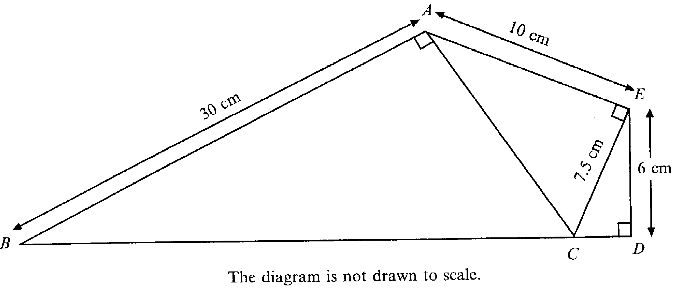
6.

Use Pythagoras’ Theorem to calculate
(a) The length of CD
………………………………………………………………………………………………………………………………………..
………………………………………………………………………………………………………………………………………..
………………………………………………………………………………………………………………………………………..
………………………………………………………………………………………………………………………………………..
……………………………………………………………………………………………………………………………………….. [2]

(b) The length of CB
………………………………………………………………………………………………………………………………………..
………………………………………………………………………………………………………………………………………..
………………………………………………………………………………………………………………………………………..
………………………………………………………………………………………………………………………………………..
………………………………………………………………………………………………………………………………………..
………………………………………………………………………………………………………………………………………..
………………………………………………………………………………………………………………………………………..
………………………………………………………………………………………………………………………………………..
……………………………………………………………………………………………………………………………………….. [3]

7. Find the value of ab² + when a = 5 and b = - 3
………………………………………………………………………………………………………………………………………..
………………………………………………………………………………………………………………………………………..
……………………………………………………………………………………………………………………………………….. [2]

8. The diagram shows a regular 12 sided polygon (called a dodecagon).
Each interior angle is 150º.
The lines BK and DI have been drawn.
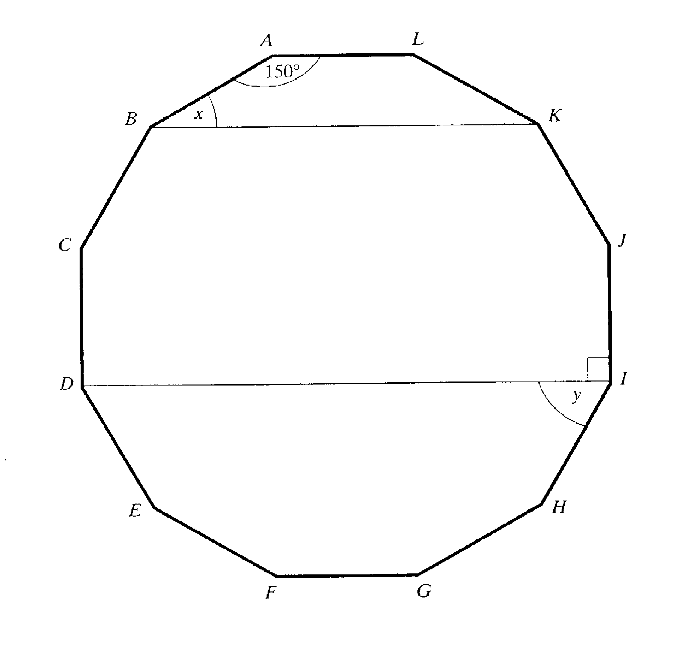

(a) What is the special name for the polygon ALKB?
………………………………………………………………………………………………………………………………………..
……………………………………………………………………………………………………………………………………….. [1]

PTO
(b) Calculate the size of the angle marked x.
………………………………………………………………………………………………………………………………………..
………………………………………………………………………………………………………………………………………..
……………………………………………………………………………………………………………………………………….. [2]
(c) Calculate the size of the angle marked y.
………………………………………………………………………………………………………………………………………..
………………………………………………………………………………………………………………………………………..
……………………………………………………………………………………………………………………………………….. [2]

9. The distance from the planet Earth to Kronos is 35 000 000 000 000 000 miles.
Write this number in standard form.
………………………………………………………………………………………………………………………………………..
……………………………………………………………………………………………………………………………………….. [2]

10. The length of life of 100 batteries of a certain make was recorded.
The table shows the results.

Length of life (hours) | <10 | <15 | <20 | <25 | <30 | <35 | <40
Cumulative frequency | 0 | 2 | 9 | 50 | 86 | 96 | 100
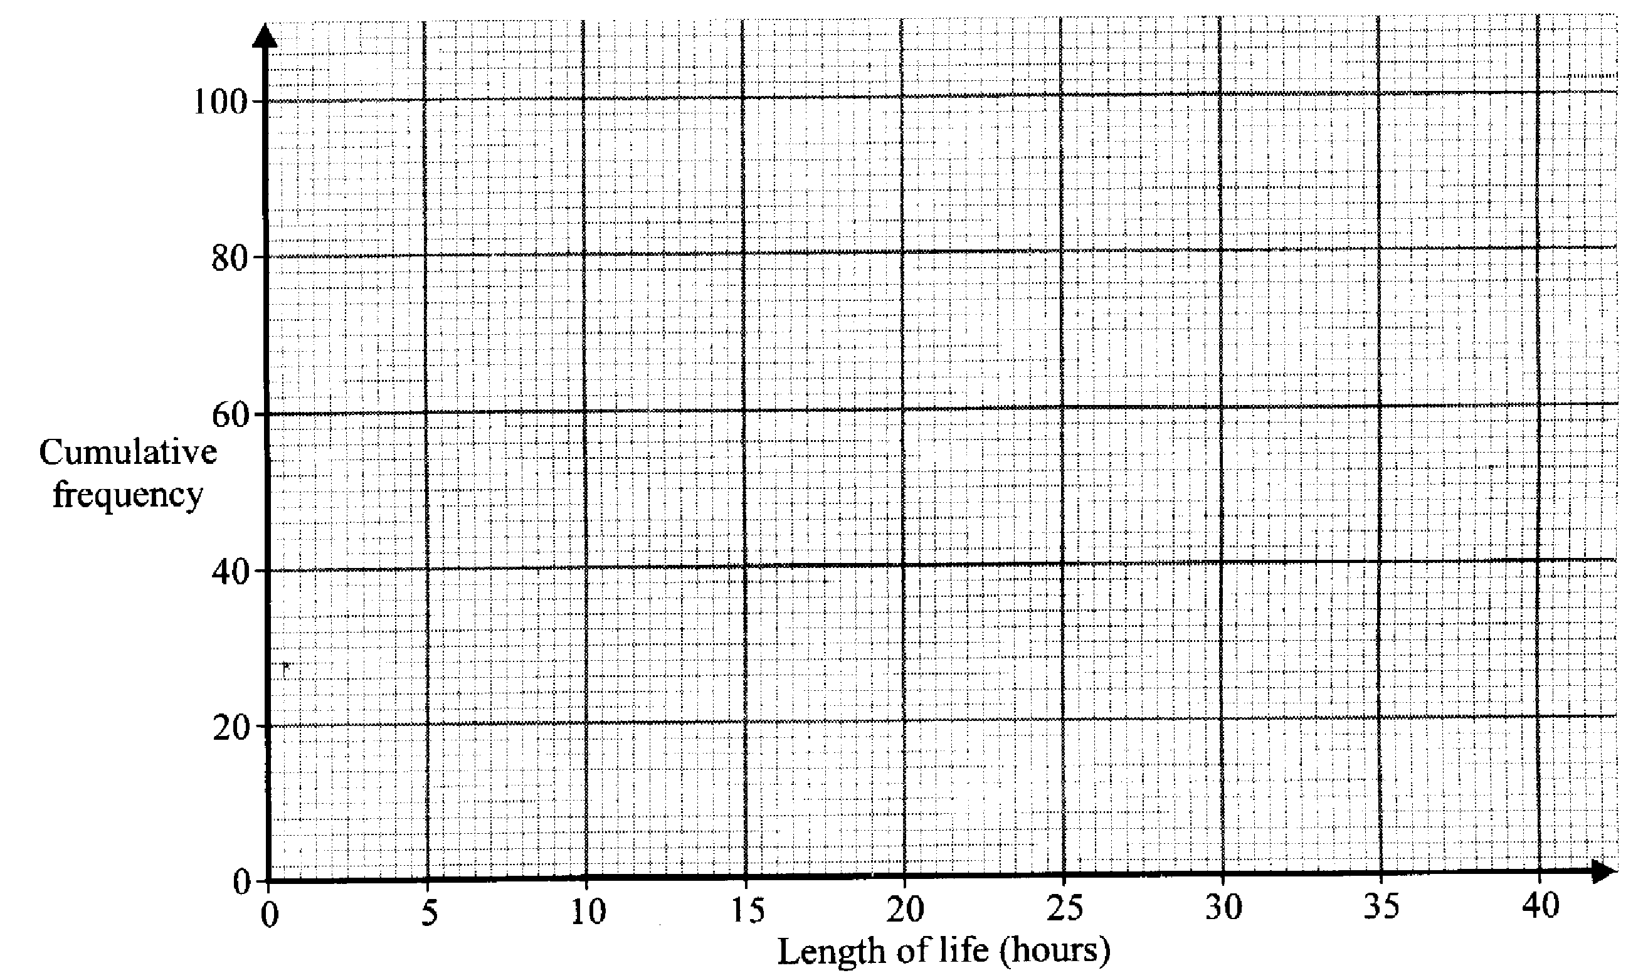

(a) Draw a cumulative frequency graph to illustrate this data. [2]

(b) How many batteries had a life of more than 32 hours?
………………………………………………………………………………………………………………………………………..
……………………………………………………………………………………………………………………………………….. [1]

(c) Use your graph to estimate the median.
………………………………………………………………………………………………………………………………………..
……………………………………………………………………………………………………………………………………….. [2]

(d) Use your graph to estimate the interquartile range.
………………………………………………………………………………………………………………………………………..
………………………………………………………………………………………………………………………………………..
……………………………………………………………………………………………………………………………………….. [3]

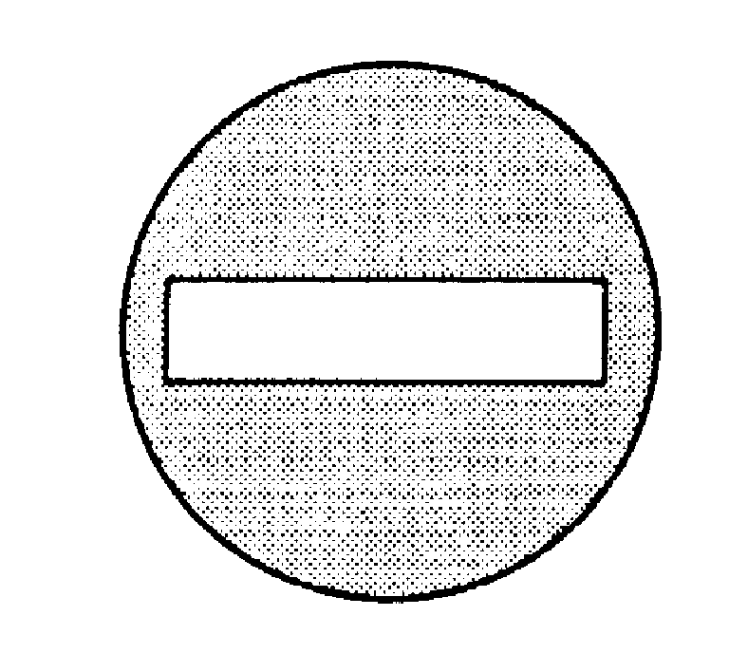
11. A ‘No Entry’ sign consists of a white rectangle on a red circle as shown:

The sign has a radius of 35cm and the white rectangle is 60cm long and 10cm wide.

(a) What is the perimeter of the white rectangle?
…………………………………………………………………………………………………………………..………………
…………………………………………………………………………………………………………………..……………… [1]
(b) Find the area that is painted red.
…………………………………………………………………………………………………………………..………………
…………………………………………………………………………………………………………………..………………
…………………………………………………………………………………………………………………..………………
…………………………………………………………………………………………………………………..……………… …………………………………………………………………………………………………………………..………………
…………………………………………………………………………………………………………………..……………… …………………………………………………………………………………………………………………..………………
…………………………………………………………………………………………………………………..……………… [4]

12. A ‘Travel Saver Card’ entitles the holder to 40% off the normal price of a journey.

(a) A particular journey normally costs £28.50.
How much would it cost with a Travel Saver Card?
…………………………………………………………………………………………………………………..……………… …………………………………………………………………………………………………………………..………………
…………………………………………………………………………………………………………………..………………
…………………………………………………………………………………………………………………..……………… [2]
13. The diagram shows a ladder leaning against a wall.
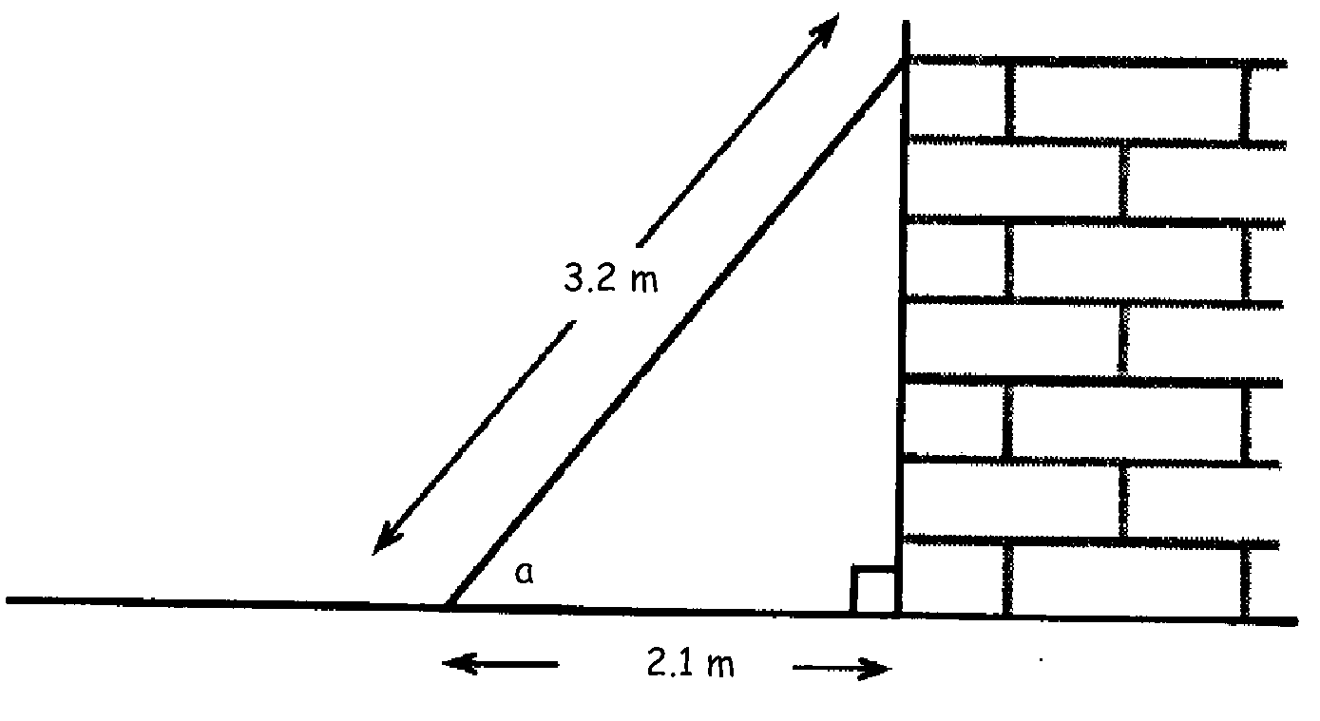

- Calculate the size of angle a.
…………………………………………………………………………………………………………………..……………… …………………………………………………………………………………………………………………..………………
…………………………………………………………………………………………………………………..……………… …………………………………………………………………………………………………………………..……………… [3]

14. Solve the inequality
(a) 3x – 7 < x – 3
…………………………………………………………………………………………………………………..………………
…………………………………………………………………………………………………………………..………………
…………………………………………………………………………………………………………………..………………
…………………………………………………………………………………………………………………..……………… [2]
(b) Solve the inequality
x² < 9
…………………………………………………………………………………………………………………..………………
…………………………………………………………………………………………………………………..………………
…………………………………………………………………………………………………………………..………………
…………………………………………………………………………………………………………………..……………… [2]
(c) List the values of x which satisfy your answer to part (b)
…………………………………………………………………………………………………………………..………………
…………………………………………………………………………………………………………………..………………
…………………………………………………………………………………………………………………..………………
[2]

15. There are two parts to a driving test, a theory test and a practical test.
You must pass the theory test before you are allowed to take the practical test.

Rob is taking his driving test.

The probability that he passes the theory test is 0.7
The probability that he passes the practical test is 0.9

(a) The tree diagram shows the possible outcomes. Fill in the missing probabilities.
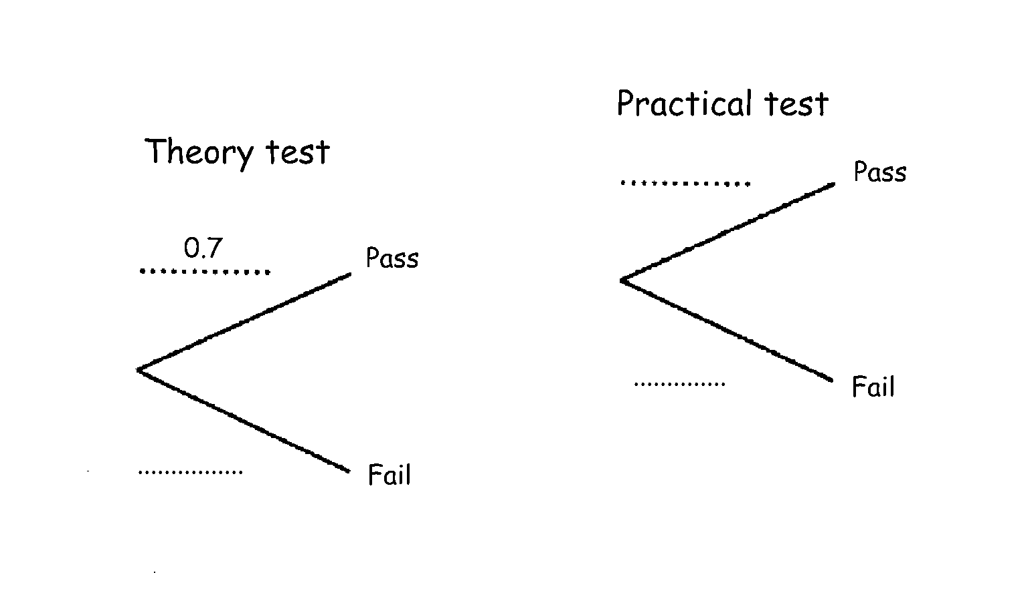

(b) Calculate the probability that Rob passes both parts of his driving test.
…………………………………………………………………………………………………………………..………………
…………………………………………………………………………………………………………………..………………
…………………………………………………………………………………………………………………..……………… [2]
(c) Calculate the probability that he passes the theory test but fails the practical test.
…………………………………………………………………………………………………………………..………………
…………………………………………………………………………………………………………………..………………
…………………………………………………………………………………………………………………..………………
…………………………………………………………………………………………………………………..……………… [2]
(d) Calculate the probability that he fails the driving test.
…………………………………………………………………………………………………………………..………………
…………………………………………………………………………………………………………………..………………
…………………………………………………………………………………………………………………..……………… [2]

16. In computing terms, a kilobyte is 2¹⁰ bytes but the prefix kilo usually refers to a thousand. How many more than 1000 is 2¹⁰?

…………………………………………………………………………………………………………………..………………
…………………………………………………………………………………………………………………..………………
…………………………………………………………………………………………………………………..……………… [2]

Non-Calculator Questions.

17. (a) List the prime numbers that lie between 20 and 30.
………………………………………………………………………………………………………………………………………..
……………………………………………………………………………………………………………………………………….. [2]
(b) List the square numbers that lie between 20 and 50.
………………………………………………………………………………………………………………………………………..
………………………………………………………………………………………………………………………………………..
……………………………………………………………………………………………………………………………………….. [2]

18. 2700 people work in one department of the European Parliament.
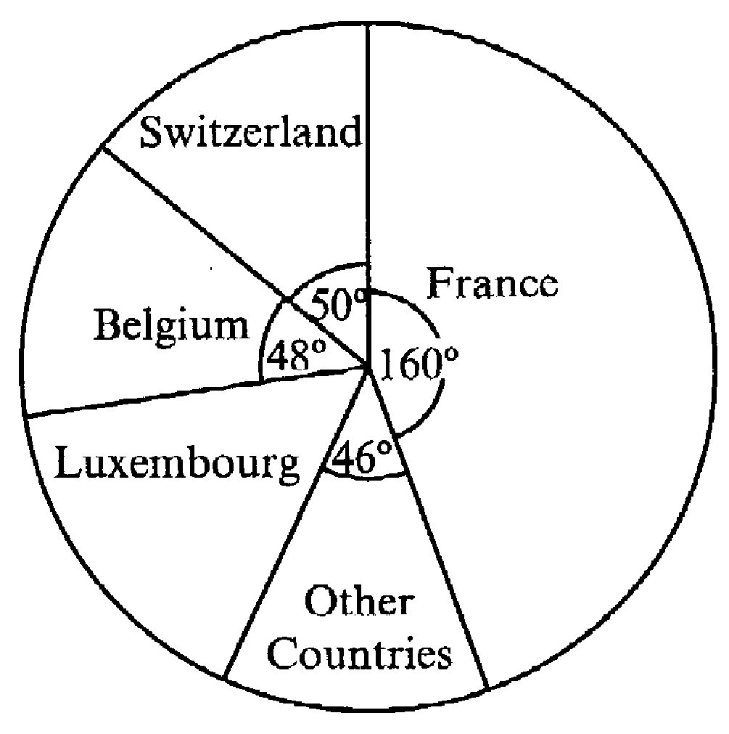
The pie chart shows where the people come from.

(a) Calculate the size of the angle for Luxembourg.
………………………………………………………………………………………………………………………………………..
……………………………………………………………………………………………………………………………………….. [1]

(b) From the information given, calculate how many of the 2700 people came from France.
………………………………………………………………………………………………………………………………………..
………………………………………………………………………………………………………………………………………..
………………………………………………………………………………………………………………………………………..
……………………………………………………………………………………………………………………………………….. [2]

19.(a) Write down the next two terms in the sequence
-1, 2, 7, 14, 23, ….., ….., [2]
(b) Explain how you got your answer.
………………………………………………………………………………………………………………………………………..
………………………………………………………………………………………………………………………………………..
……………………………………………………………………………………………………………………………………….. [1]
(c) What would be the nth term for the sequence?
………………………………………………………………………………………………………………………………………..
……………………………………………………………………………………………………………………………………….. [2]

20. (a) Complete the following number pattern.

1³ = 1 x 1 x 1 = 1
2³ = 2 x 2 x 2 = 8
3³ = ………………. = 27
4³ = ………………. = …….. [1]

(b) Use your answers to part (a) to complete this number pattern.
1³ = 1 = 1²
1³ + 2³ = 9 = 3²
1³ + 2³ + 3³ = 36 = 6²
1³ + 2³ + 3³ + 4³ = ….. = …... [2]

(c) A line of pattern (b) is shown below.
Fill in the missing parts of this line.
………………………………………………… = 441 = ……………… [2]

21. Solve the simultaneous equations
3a + 2b = 29
2a – 3b = 2
………………………………………………………………………………………………………………………………………..
………………………………………………………………………………………………………………………………………..
………………………………………………………………………………………………………………………………………..
………………………………………………………………………………………………………………………………………..
………………………………………………………………………………………………………………………………………..
………………………………………………………………………………………………………………………………………..
………………………………………………………………………………………………………………………………………..
……………………………………………………………………………………………………………………………………….. [4]

22. The map shows the position of three towns.
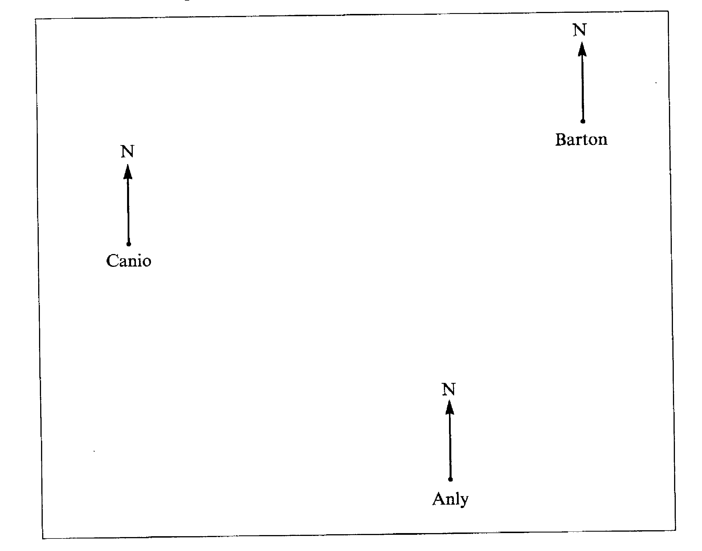
PTO for questions

- What is the bearing of Barton from Anly?
………………………………………………………………………………………………………………………………………..
………………………………………………………………………………………………………………………………………..
……………………………………………………………………………………………………………………………………….. [2]
- What is the bearing of Canio from Barton?
………………………………………………………………………………………………………………………………………..
………………………………………………………………………………………………………………………………………..
……………………………………………………………………………………………………………………………………….. [2]

23. ABCD is a rectangle
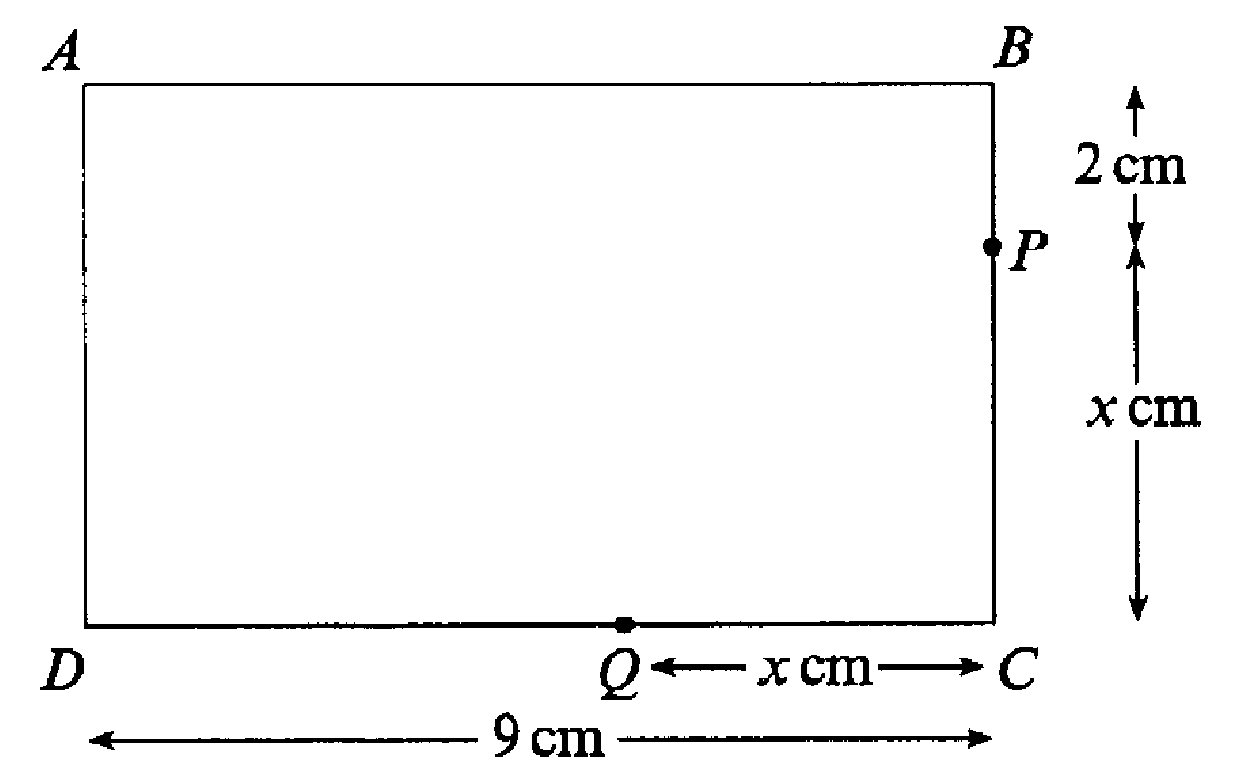

(a) Write down the expression, in terms of x, for
- The length of BC,
………..……………………………………………………………………………………………………………………..
…………..………………………………………………………………………………………………………………….. [1]
- The length of DQ
……………………………..………………………………………………………………………………………………..
……………………………………………………………………………………………………………………………….. [1]
(b) (i) Given that BC =DQ, use your answers to (a) to write down an equation in
terms of x.
………………………………………………………………………………………………………………………………
……………………………………………….……………………………………………………………………………….. [1]
PTO for part (ii)
(ii) Solve your equation to find the value of x
……………………………………………………………………………………………………………………………..
……………………………………………………………………………………………………………………………..
…………………………………………………………………………………………………………………………….. [2]

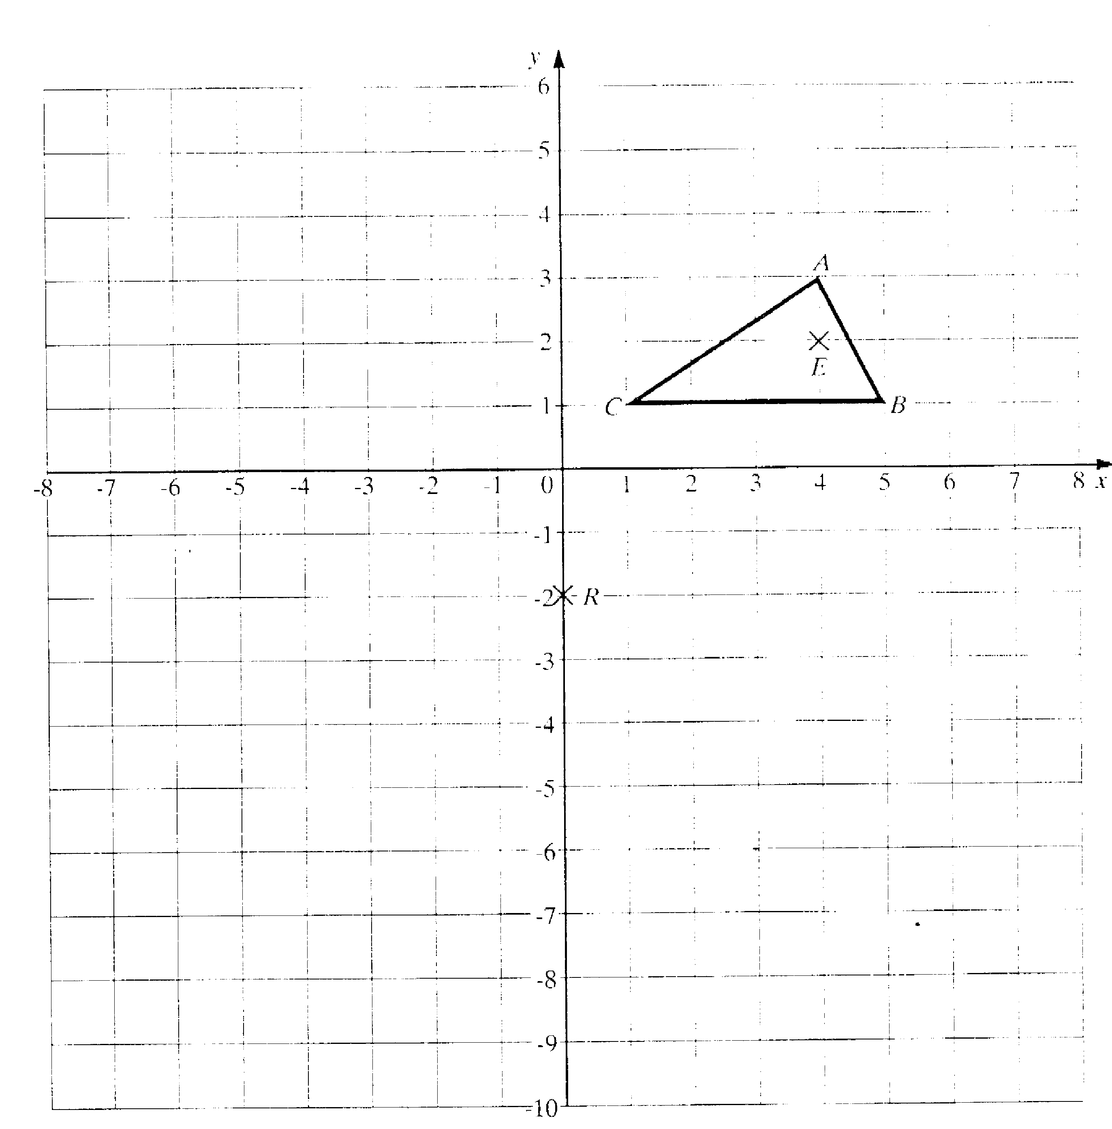
24. A triangle ABC has vertices A(4,3), B(5,1), C(1,1).

(a) Draw an enlargement of triangle ABC by scale factor of 3 from the
centre of enlargement E(4,1). Label the enlarged triangle A’B’C’. [2]

(b) Draw the image of the triangle A’B’C’ after it has been rotated
through 180º about the point R(0,-2). Label the new triangle A’’B’’C’’. [2]
25. Given that y = x² - x
(a) Complete the table below,
x | 1 | 2 | 3 | 4 | 5 | 6 | 7
y |  |  | 6 |  |  | 30
[2]
- Plot these points on the grid below and hence draw the graph of y = x² - x
[2]
- Use your graph to find the value of x when y = 35 ………………………………………………………………………………………………………………………………..… [1]

26.(a) A delivery van driver left Liverpool at 9.30 am, stopped at the motorway services for ½ hour at 11.30 am and finally arrived at her destination in London, 210 miles from home at 1pm. What was her average speed for the whole journey?
…………………………………………………………………………………………………………………..………………
…………………………………………………………………………………………………………………..………………
…………………………………………………………………………………………………………………..………………
…………………………………………………………………………………………………………………..……………… [2]

- After a break of ¾ hour, she returned to Liverpool without stopping. Her average speed for this part of the journey was 55 mph. Complete the distance time graph to show this information.

[3]

27. A magic square is shown below.
Every row, column and diagonal adds up to the same total of 15.

8 | 3 | 4
1 | 5 | 9
6 | 7 | 2

(a) For the magic square below, every row, column and diagonal should add up to 3. Fill in the missing numbers.

2 | -3 | 4
3 | 1
-2 |  | 0

[2]

28. Expand and simplify
( 2x – 3 )²
…………………………………………………………………………………………………………………..………………
…………………………………………………………………………………………………………………..………………
…………………………………………………………………………………………………………………..………………
…………………………………………………………………………………………………………………..……………… [2]

29. The table shows the largest quantity of salt, w grams which can be dissolved in a beaker of water at temperature tº

tº C | 10 | 20 | 25 | 30 | 40 | 50 | 60
w grams | 54 | 58 | 60 | 62 | 66 | 70 | 74

- On the grid below, plot the points and draw a graph to illustrate this information.
[3]
(b) Use your graph to find the lowest temperature that which 63g of salt will dissolve in water.
…………………………………………………………………………………………………………………..………………
…………………………………………………………………………………………………………………..……………… [1]
(c) Use your graph to find the largest amount of salt that will dissolve in the water at 44º C.
…………………………………………………………………………………………………………………..………………
…………………………………………………………………………………………………………………..……………… [1]
(d) The equation of the graph is of the form
w = at + b
Use your graph to estimate the values of the constants a and b.
…………………………………………………………………………………………………………………..………………
…………………………………………………………………………………………………………………..……………… …………………………………………………………………………………………………………………..………………
…………………………………………………………………………………………………………………..……………… [3]

- Use the equation to calculate the largest amount of salt which will dissolve in the water at 95º C.

…………………………………………………………………………………………………………………..……………… …………………………………………………………………………………………………………………..………………
…………………………………………………………………………………………………………………..……………… [2]

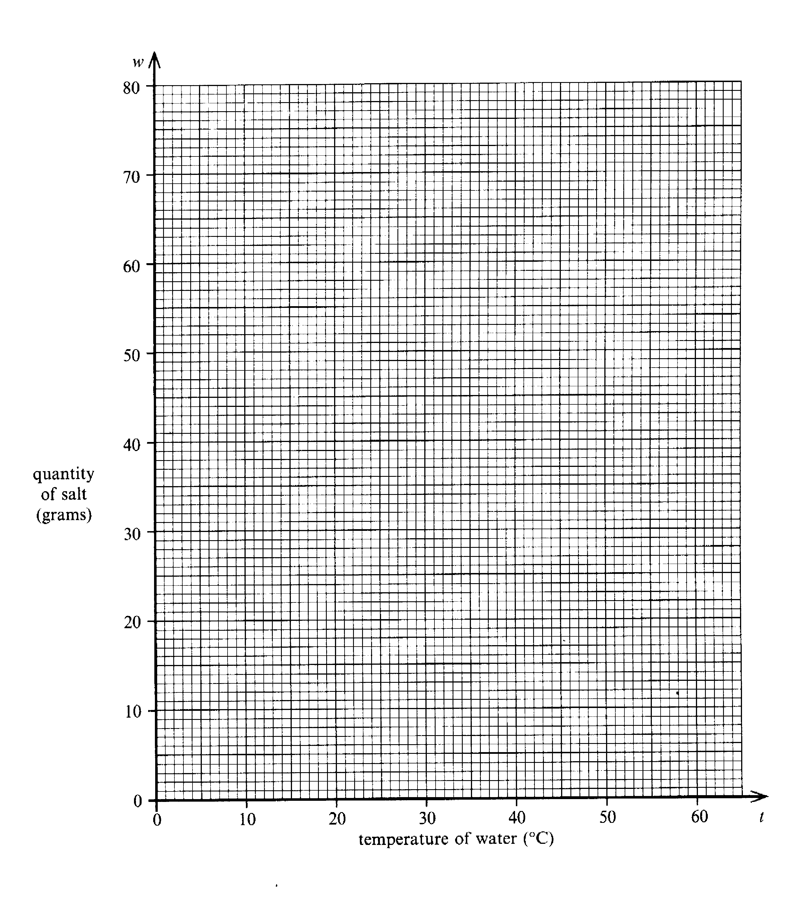

END OF TEST

1. (a) 4m, (b) 117cm | 17. (a) 23, 29 (b) 25, 36, 49
2. x= -2 | 18. (a) 56º, (b) 1200 people
3. Yes she is exceeding the limit. She is travelling at approximately 57.6 km per hour. | 19. (a) 34, 47 (b) The difference between terms increases by two each time. (c) n²-2
4. (a) , (b) | 20. (a) 3 x 3 x 3, 4 x 4 x 4 = 64  (b) 100 = 10²,  (c) 1³ + 2³ + 3³ + 4³ + 5³ + 6³ = 441 = 21²
5. (a) 3.34 x 10⁻²⁴, (b) 3.606 x 10⁻²⁴ | 21. a = 7, b = 4
6. (a) 4.5cm, (b) 32.5cm | 22. (a) 020^{o,} (b) 255º
7. 44.4 | 23. (a) (i) 2 + x, (ii) 9 – x  (b) (i) 2 + x = - x, (ii) 3.5
8. (a) Trapezium, (b) 30º, (c) 60º | 24. (a) A’ (4,5), B’(7,1), C’(-5,-1)  (b) A’’(-4,-9), B’’(-7,-3), C’’(5,-3)
9. 3.5 x 10¹⁶ | 25. (a) 0, 2, 12, 20, 42  (c) 6.4
10. (b) 92, (c) 25, (d) 5 | 26. (a) 60mph  (b) through (1.45,210) and then (3.45,100)
11. (a) 140cm, (b) Area of circle = 3848.45cm²  Area of rectangle = 600cm²  Red area = 3248.45cm² | 27. (a) -1, 5
12. £17.10 | 28. 4x² - 12x + 9
13. (a) 49º | 29. (a) on graph (b) 32ºc, (c) 68g,  (d)a = 0.4, b = 50 (e) 0.37
14. (a) x<2, (b) x<3 or x>-3 i.e -3<x<3
(c) -2, -1, 0, 1, 2

15. (a) 0.3, 0.9, 0.1 (b) 0.63, (c) 0.07
(d) 0.37

16. 2¹⁰ = 1024, 1024 – 1000=24

Solutions to Past Paper 2 – 2001

PAST PAPER 3

Test Paper 1 2003

Two and a half hours

Name ……………………………………………………………………

ATTEMPT ALL QUESTIONS

Show all your working in the space provided and make sure that your answer is clear.

It is assumed that you have a scientific calculator, ruler and protractor.

If your calculator does not have a π button, take the value of π to be 3.142.

The marks for each question are given in brackets by the side of the question.

Marks may be given for method even if your answer is wrong.

The total marks available are 120.

Calculator Questions.

1. The cash price of a mountain bike is £1049
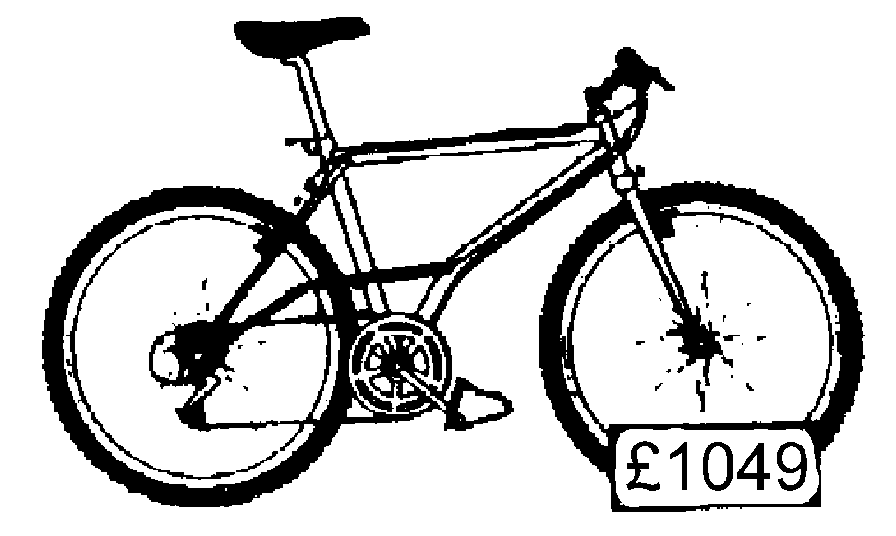

Fred buys the bike by paying a £200 deposit and 12 monthly instalments of £75.
How much more than the cash price does Fred pay?

…………………………………………………………………………………………………………………………………
…………………………………………………………………………………………………………………………………
…………………………………………………………………………………………………………………………………
……………………………………………………………………………………………………………….……………….. [2]

2. Solve the equation
3x + 8 = 23 – 3x
…………………………………………………………………………………………………………………………………
…………………………………………………………………………………………………………………………………
…………………………………………………………………………………………………………………………………
………………………………………………………………………………………………………………………………… [2]

3. Circular tops are stamped out of a sheet of metal like the one shown in the diagram below.
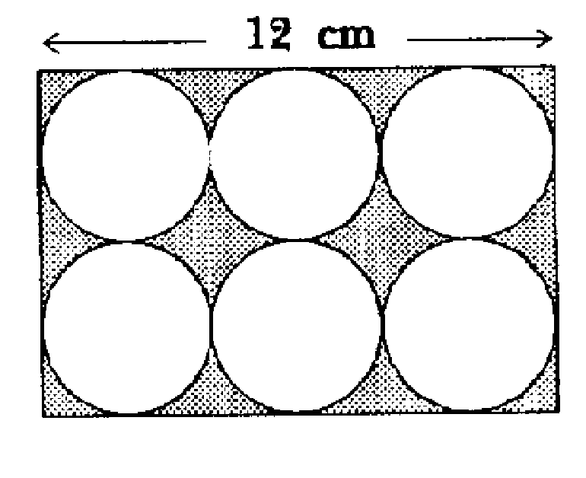

How much of the material is waste?
…………………………………………………………………………………………………………………………………
…………………………………………………………………………………………………………………………………
…………………………………………………………………………………………………………………………………
…………………………………………………………………………………………………………………………………
…………………………………………………………………………………………………………………………………
………………………………………………………………………………………………………….……………………… [5]

4. The table shows the average speed of planets that orbit the sun.

Planet | Average speed of orbit (Km/h)
Jupiter | 4.7 x 10⁴
Mercury | 1.7 x 10⁵
Neptune | 1.2 x 10⁴
Pluto | 1.7 x 10⁴
Saturn | 3.5 x 10⁴
Uranus | 2.5 x 10⁵

(a) Which planet is travelling the slowest?
…………………………………………………………………………………………………………………………………
………………………………………………………………………………………………………………………………… [1]

(b) How far will Uranus travel in 24 hours? Give your answer in standard form.
…………………………………………………………………………………………………………………………………
…………………………………………………………………………………………………………………………………
…………………………………………………………………………………………………………………………………
…………………………………………………………………………………………..…………………………………… [2]

(c) What is the difference between the average speeds of Neptune and Pluto? Give your answer in standard form.
…………………………………………………………………………………………………………………………………
…………………………………………………………………………………………………………………………………
…………………………………………………………………………………………………………………………………
…………………………………………………………………………………………………………..…………………… [2]
5. A girder is 5m long. Its cross section is L shaped as shown below.

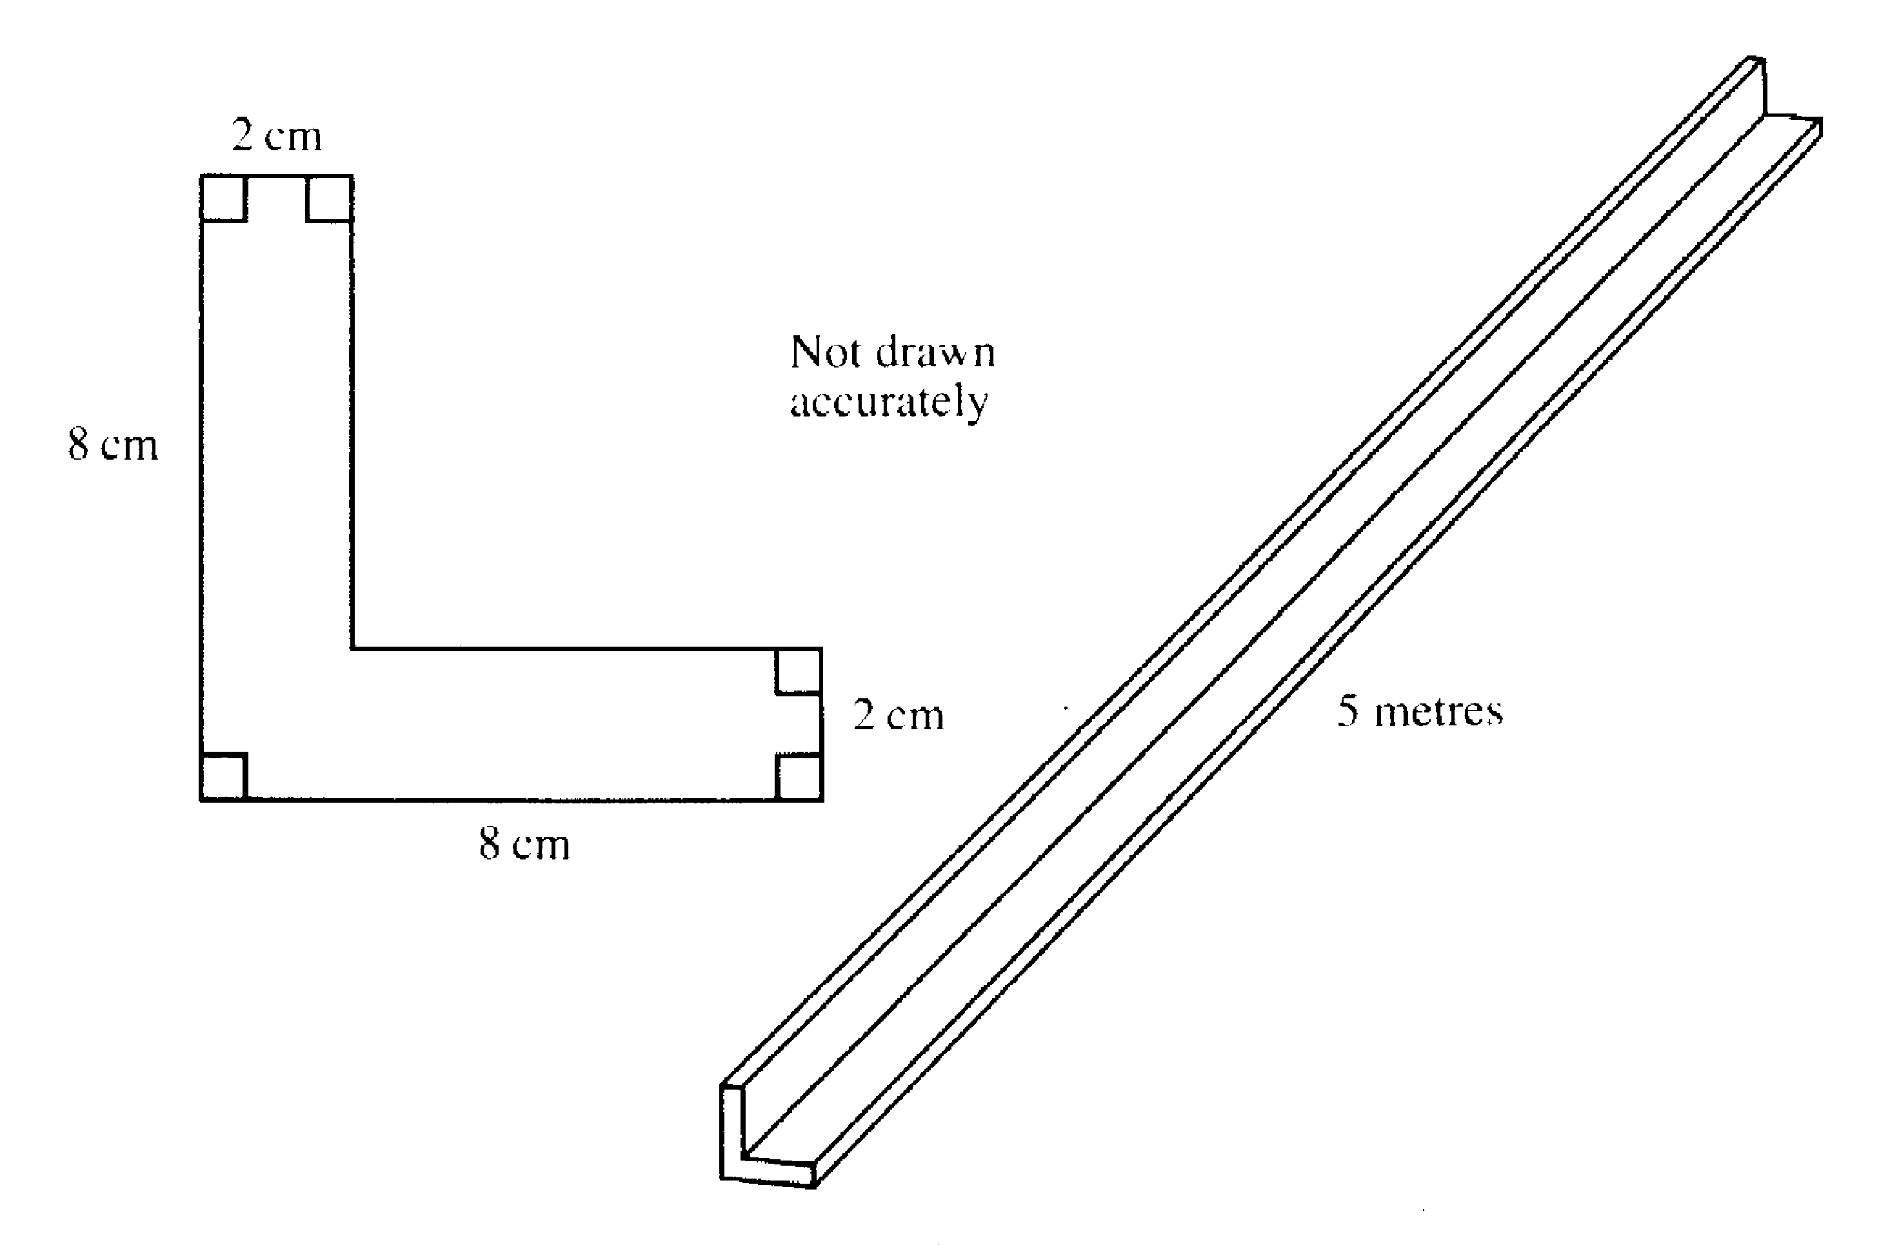

Find the volume of the girder. Remember to state the units in your answer.
…………………………………………………………………………………………………………………………………
…………………………………………………………………………………………………………………………………
…………………………………………………………………………………………………………………………………
…………………………………………………………………………………………………………………………………
…………………………………………………………………………………………………………………………………
…………………………………………………………………………………………………………………………………
………………………………………………………………………………………………………………………………… [5]
6. The distance between Heysham and the Isle of Man is 80m.
A hovercraft travels at 50km per hour.
How long does the journey take? Give your answer in hours and minutes
…………………………………………………………………………………………………………………………………
…………………………………………………………………………………………………………………………………
…………………………………………………………………………………………………………………………………
………………………………………………………………………………………………………………………………… [3]

7. The table below shows the number of candidates at each grade for two music examinations, Strings and Brass

 | Grades
 | Excellent | Very good | Good | Pass | Fail | Total number of candidates
Strings | 200 | 650 | 700 | 400 | 50 | 2000
Brass | 200 | 300 | 250 | 100 | 50 | 900

The pie chart for Strings has been drawn for you.
Complete the pie chart for brass.
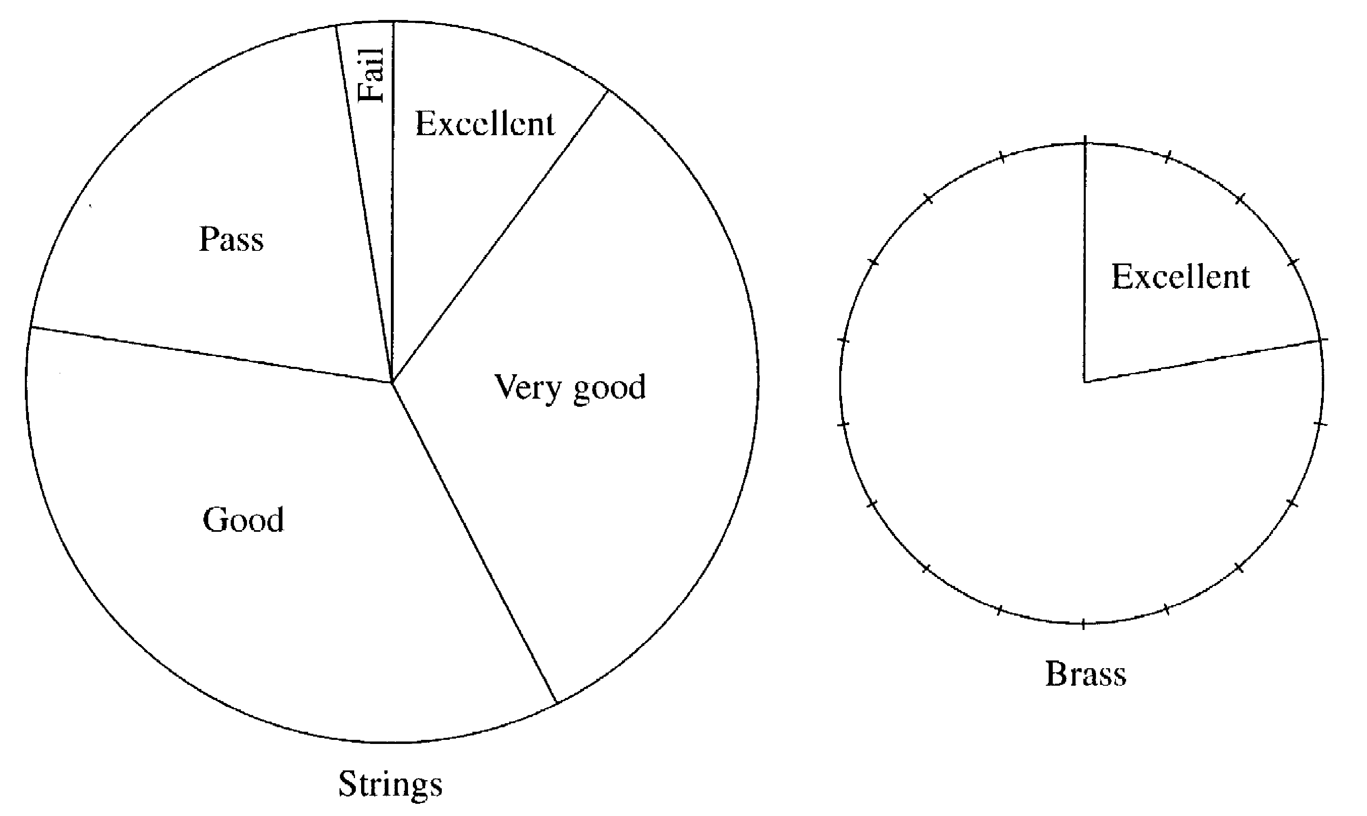

[3]
8. Use your calculator to evaluate the following questions. Give your answers to two places of decimals.

(a)
…………………………………………………………………………………………………………………………………
…………………………………………………………………………………………………………………………………
…………………………………………………………………………………………………………………..…………… [1]
(b) + 3.57
…………………………………………………………………………………………………………………………………
…………………………………………………………………………………………………………………………………
……..………………………………………………………………………………………………………………………… [1]
(c) 5.14 +
…………………………………………………………………………………………………………………………………
…………………………………………………………………………………………………………………………………
………………………………………………………………………………………………………………………………… [1]

9(a) Four of the angles of an octagon are each 125º. The other angles are all equal. Find the size of one of the other angles.
…………………………………………………………………………………………………………………………………
…………………………………………………………………………………………………………………………………
…………………………………………………………………………………………………………………………………
………………………………………………………………………………………………………………………………… [3]

(b)(i) One of the interior angles of a regular polygon is 156º.Find the size of an exterior angle of this polygon.
…………………………………………………………………………………………………………………………………
………………………………………………………………………………………………………………………………… [1]
(ii) How many sides has this polygon got?
………………………………………………………………………………………………………………………………… [1]
10.

Thirty days hath September, April, June and November
All the rest have thirty one
Excepting February alone
Which has but twenty eight days clear
And twenty nine in a leap year

Twelve cards are labeled with the months of the year and put in a box.

January
April
March
February

May
June
July
August

September
November
December
October

Freda takes a card out of the box without looking at it.

(a) What is the probability that the month drawn has 31 days?
…………………………………………………………………………………………………………………………………
………………………………………………………………………………………………………………………………… [1]
(b) What is the probability that the month drawn has more than 27 days?
…………………………………………………………………………………………………………………………………
………………………………………………………………………………………………………………………………… [1]

(c) A card is then drawn out and not replaced. A second card is then drawn. The number of days in the two months drawn are added together. What is the probability that the total number of days in the two months is 61?
…………………………………………………………………………………………………………………………………
…………………………………………………………………………………………………………………………………
…………………………………………………………………………………………………………………………………
………………………………………………………………………………………………………………………………… [3]
11. A rectangle ABCD measures 6cm by 9cm.

A B

6cm Not drawn to scale

C 9cm D

(a) Find the area of the rectangle.
…………………………………………………………………………………………………………………………………
………………………………………………………………………………………………………………………………… [1]
(b) Calculate the perimeter of the rectangle
…………………………………………………………………………………………………………………………………
………………………………………………………………………………………………………………………………… [1]
- Calculate the length of the diagonal AD. Show all your working. Give your answer correct to two places of decimals.
…………………………………………………………………………………………………………………………………
…………………………………………………………………………………………………………………………………
…………………………………………………………………………………………………………………………………
………………………………………………………………………………………………………………………………… [2]
(d) Nelma calculates the angle ADC to be 56.31º. Is she correct? Show all your working.
…………………………………………………………………………………………………………………………………
…………………………………………………………………………………………………………………………………
…………………………………………………………………………………………………………………………………
………………………………………………………………………………………………………………………………… [3]

12(a). Complete the table for the graph of y = x² + 2x – 6
x | -3 | -2 | -1 | 0 | 1 | 2
y | -3 | -6
[2]
(b) Draw the graph on the grid.
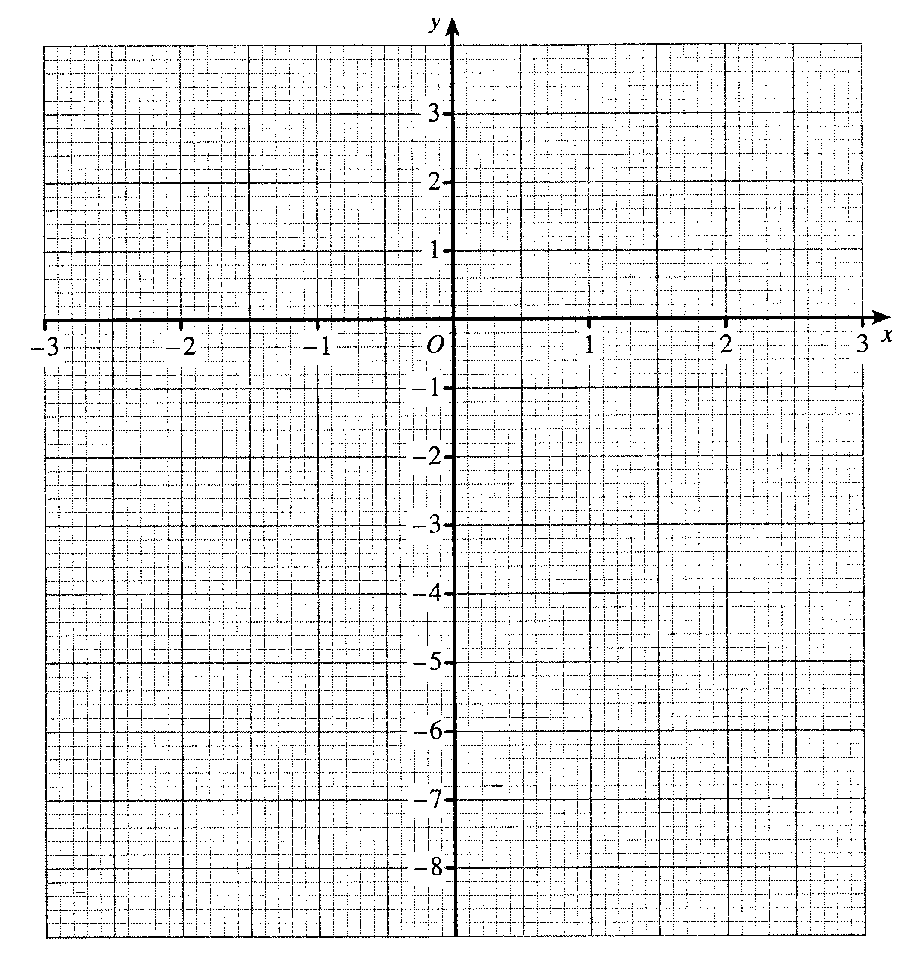
[3]
(c) Use your graph to solve the equation x² + 2x – 6 = -4
…………………………………………………………………………………………………………………………………
………………………………………………………………………………………………………………………………… [2]

Non Calculator Questions.

13(a) Draw the lines of symmetry on this rectangle.
[1]

(b) What is the order of rotational symmetry of this rectangle?

…………………………………………………………………………………………………………………………………
………………………………………………………………………………………………………………………………… [1]

14. The pupils in a class are asked how many goals they each scored in a netball lesson. The results are shown in the table.

Number of goals | Number of pupils
0 | 1
1 | 8
2 | 11
3 | 5
4 | 4
5 | 1

Calculate the mean number of goals per pupil.

…………………………………………………………………………………………………………………………………
…………………………………………………………………………………………………………………………………
…………………………………………………………………………………………………………………………………
…………………………………………………………………………………………………………………………………
…………………………………………………………………………………………………………………………………
…………………………………………………………………………………………………………………………………
………………………………………………………………………………………………………………………………… [3]

15(a) Here are the first three lines of a number pattern.

Line 1 1² + 2 = 3² – 6

Line 2 2² + 4 = 4² – 8

Line 3 3² + 6 = 5² – 10

Write down the fourth line of this pattern

…………………………………………………………………………………………………………………………………
………………………………………………………………………………………………………………………………… [2]
(b) Here is another pattern

Line 1 1² + 2 = 1 x 3

Line 2 2² + 4 = 2 x 4

Line 3 3² + 6 = 3 x 5

(i) Write down the fourth line of this pattern

…………………………………………………………………………………………………………………………………
………………………………………………………………………………………………………………………………… [1]

(ii) Write down the nth line of this pattern.
…………………………………………………………………………………………………………………………………
………………………………………………………………………………………………………………………………… [2]
(c) Expand and simplify

(n + 2)² – 2(n + 2)
…………………………………………………………………………………………………………………………………
…………………………………………………………………………………………………………………………………
…………………………………………………………………………………………………………………………………
…………………………………………………………………………………………………………………………………
………………………………………………………………………………………………………………………………… [4]

16. A quadrilateral with 4 equal sides and 4 right angles is called a square.
What mathematical name is given to :

(a) A quadrilateral with 4 equal sides but no right angles?
…………………………………………………………………………………………………………………………………
………………………………………………………………………………………………………………………………… [1]
(b) A quadrilateral with 2 pairs of opposite sides equal but diagonals of different lengths?
…………………………………………………………………………………………………………………………………
………………………………………………………………………………………………………………………………… [2]

17. AD, BC and EF are parallel. Angle BAC = 79º. Angle ACB = 61º
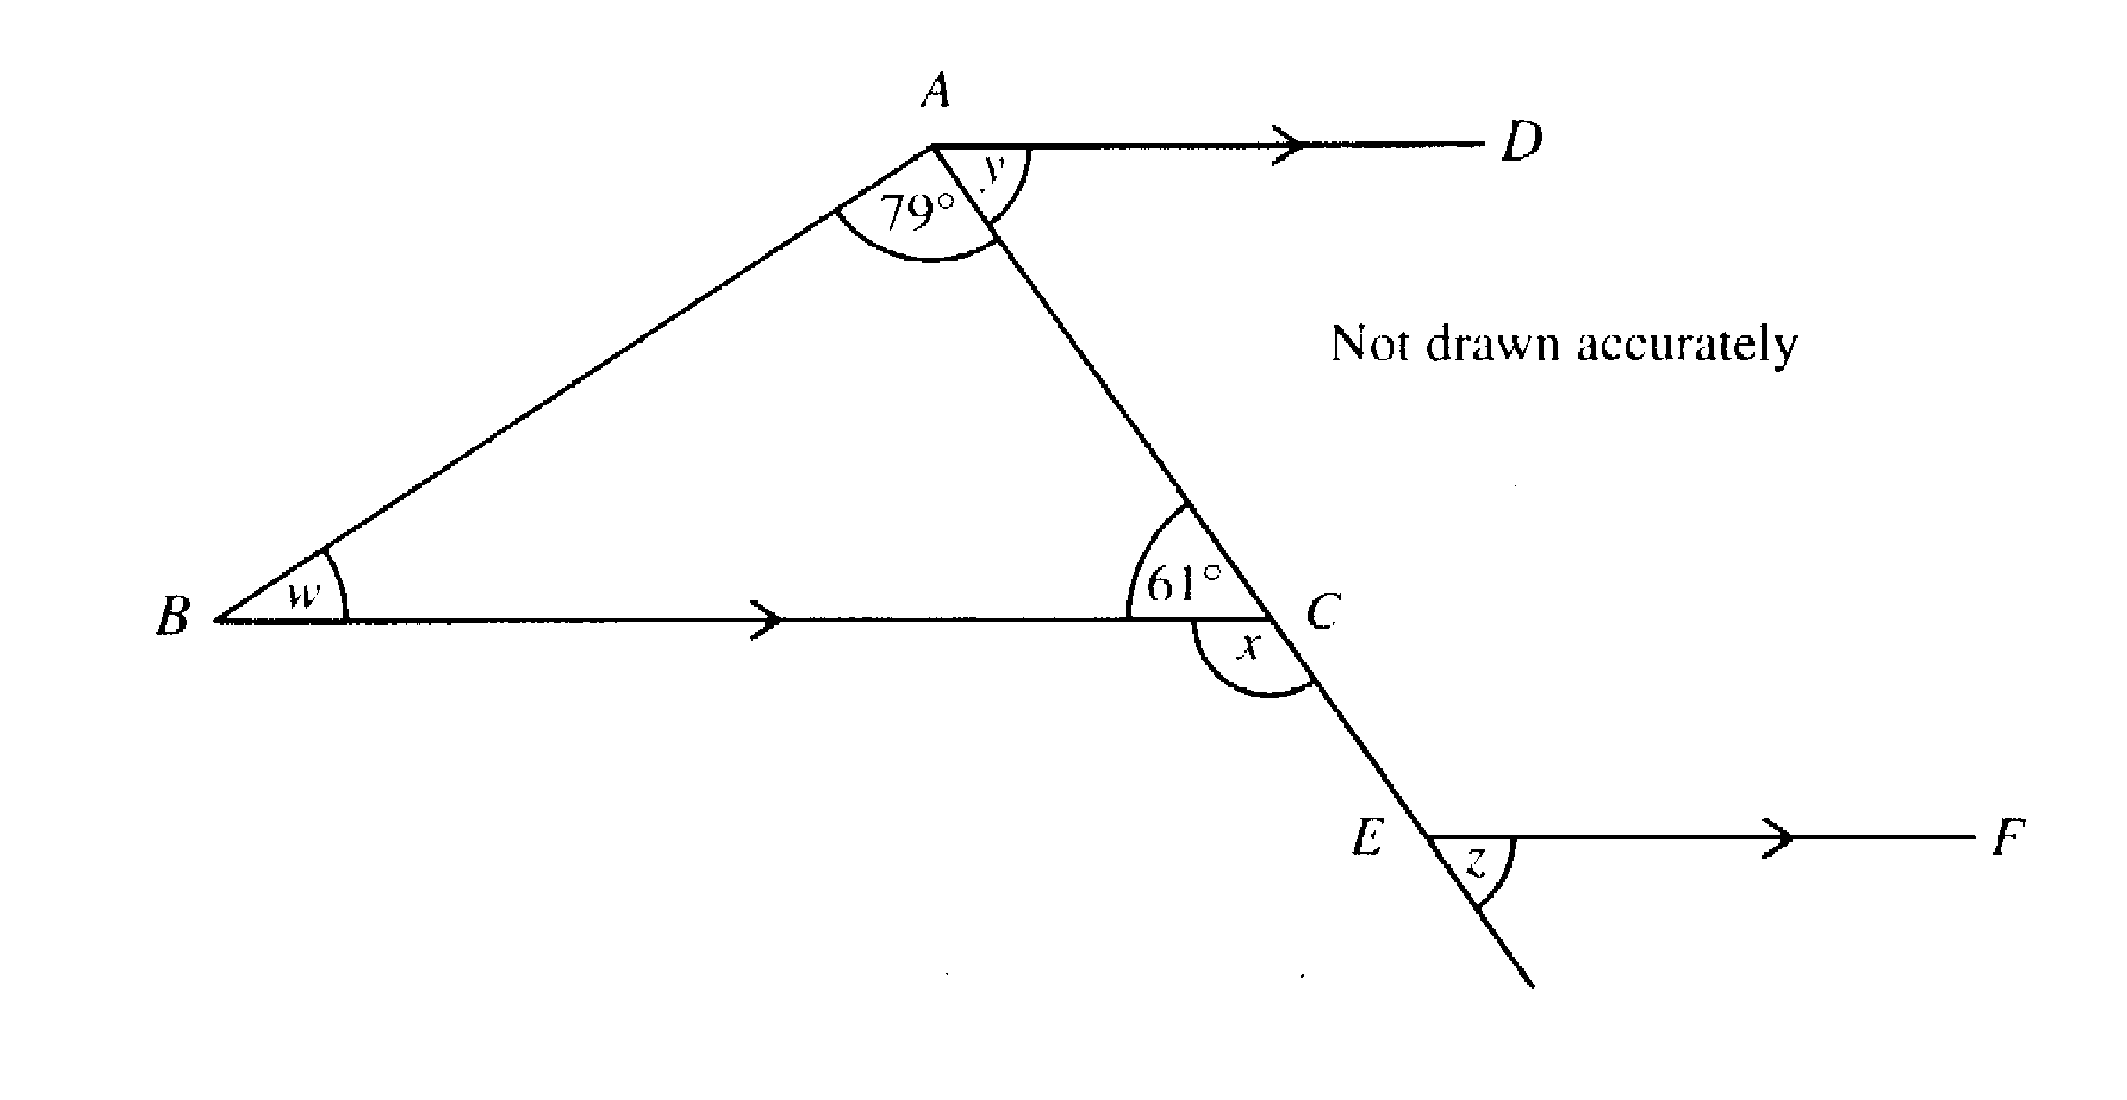

Work out the size of the angles marked w, x, y and z
Angle w
…………………………………………………………………………………………………………………………………
………………………………………………………………………………………………………………………………… [1]
Angle x
…………………………………………………………………………………………………………………………………
………………………………………………………………………………………………………………………………… [1]
Angle y
…………………………………………………………………………………………………………………………………
………………………………………………………………………………………………………………………………… [1]
Angle z
…………………………………………………………………………………………………………………………………
………………………………………………………………………………………………………………………………… [1]
18. Amy is x years old

(a) Her brother Brian is 4 years older than Amy.
Write down an expression, in terms of x, for Brian’s age.
…………………………………………………………………………………………………………………………………
………………………………………………………………………………………………………………………………… [1]
(b) Their mother is three times as old as Amy.
Write down an expression in terms of x, for their mother’s age.
…………………………………………………………………………………………………………………………………
………………………………………………………………………………………………………………………………… [1]
(c) The total of their three ages is 64 years.
Write down an equation in x
…………………………………………………………………………………………………………………………………
…………………………………………………………………………………………………………………………………
………………………………………………………………………………………………………………………………… [2]
(d) Solve your equation for x and find Brian’s age
…………………………………………………………………………………………………………………………………
…………………………………………………………………………………………………………………………………
…………………………………………………………………………………………………………………………………
…………………………………………………………………………………………………………………………………
………………………………………………………………………………………………………………………………… [3]

19. Three radio stations at A, B and C receive a distress call from a boat

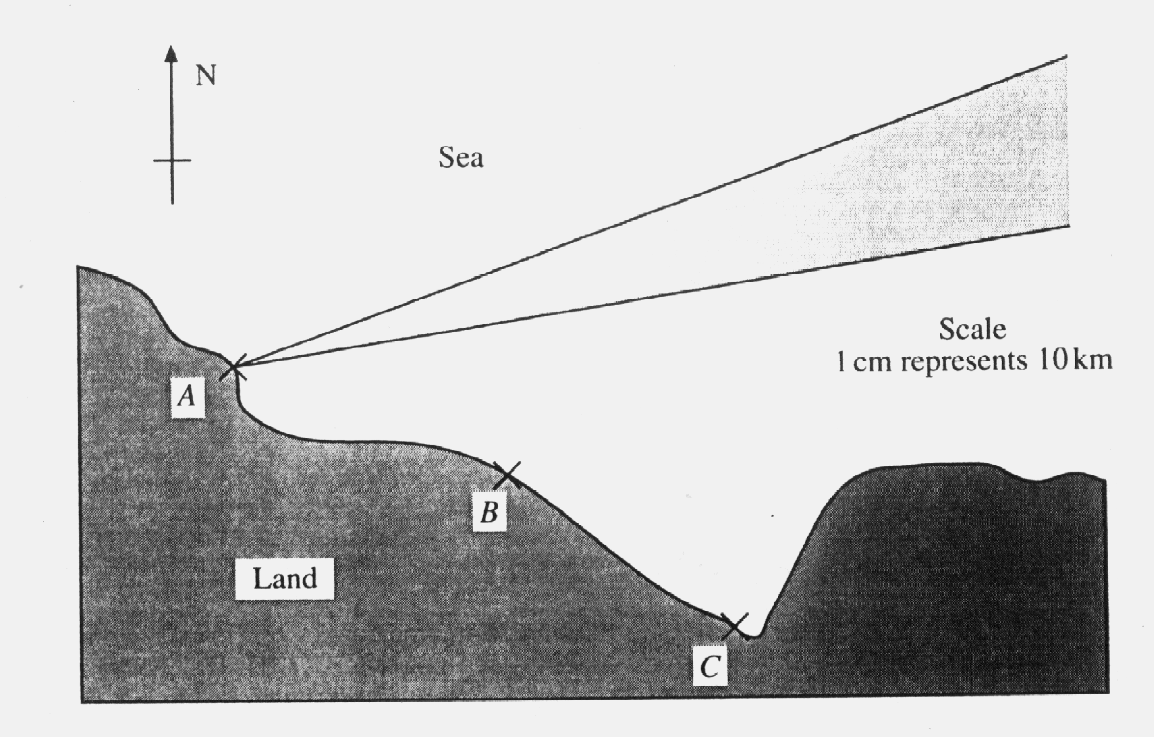
Station A can tell that the boat is on a bearing of between 070º and 080º from A. (This area is shown on the diagram)

Station B can tell that the boat is between 30 km and 40 km from B.

Station C can tell that the boat is between a bearing of 340º and 355º from C.

Show clearly on the diagram where the boat could be. [4]

20.

(a) Describe the transformation that maps the shaded shape ABCD onto A’B’C’D’.
…………………………………………………………………………………………………………………..………………
…………………………………………………………………………………………………………………..………………
…………………………………………………………………………………………………………………..……………… [2]

(b) Using (-2,-2) as the centre of enlargement, enlarge ABCD by a scale factor of 2.
[2]

21. Solve the simultaneous equations

3c + 5d = 23
4c – 3d = -37
…………………………………………………………………………………………………………………………………
…………………………………………………………………………………………………………………………………
…………………………………………………………………………………………………………………………………
…………………………………………………………………………………………………………………………………
…………………………………………………………………………………………………………………………………
…………………………………………………………………………………………………………………………………
…………………………………………………………………………………………………………………………………
…………………………………………………………………………………………………………………………………
…………………………………………………………………………………………………………………………………
………………………………………………………………………………………………………………………………… [4]

22. A box contains counters which are numbered 1, 2, 3, 4 or 5.
A counter is taken from the box at random.

(a) Complete the table to show the probability of each number being chosen.

Number on counter | Probability
1 | 0.20
2 | 0.30
3 | 0.15
4
5 | 0.10
[1]
(b) Is the number on the counter chosen more likely to be odd or even? You must show your working
…………………………………………………………………………………………………………………………………
…………………………………………………………………………………………………………………………………
…………………………………………………………………………………………………………………………………
………………………………………………………………………………………………………………………………… [2]

23. The straight line y = mx + c is parallel to the straight line y = 2x – 5 and passes through the point (-1,1)
(a) Find m
………………………………………………………………………………………………………………………
…………………………………………………………………………………………………………………………………
………………………………………………………………………………………………………………………………… [1]
(b) Find c
………………………………………………………………………………………………………………………
…………………………………………………………………………………………………………………………………
………………………………………………………………………………………………………………………………… [2]
24(a) Expand the brackets
(4x – 3 )( 3x + 4 )
…………………………………………………………………………………………………………………………………
…………………………………………………………………………………………………………………………………
………………………………………………………………………………………………………………………………… [2]
(b) Factorise the expression
12y – 18z
…………………………………………………………………………………………………………………………………
………………………………………………………………………………………………………………………………… [1]
(c)(i) Factorise the expression
x² – 3x – 10
…………………………………………………………………………………………………………………………………
…………………………………………………………………………………………………………………………………
………………………………………………………………………………………………………………………………… [2]
(ii) Using your answer from part (i), solve the equation
x² – 3x – 10 = 0
…………………………………………………………………………………………………………………………………
…………………………………………………………………………………………………………………………………
………………………………………………………………………………………………………………………………… [2]

25. The table shows the mathematics test results for 90 students.
The test was marked out of 60.

Mark (x) | Frequency | Cumulative Frequency
0 ≤ x ≤ 10 | 10 | 10
10 < x ≤ 20 | 17
20 < x ≤ 30 | 27
30 < x ≤ 40 | 18
40 < x ≤ 50 | 10
50 < x ≤ 60 | 8

(a) Complete the cumulative frequency column
[1]
- Draw a cumulative frequency diagram on the grid opposite
[3]
- Use your diagram to estimate

  - the median
…………………………………………………………………………………………………………………………………
………………………………………………………………………………………………………………………………… [2]

  - the interquartile range
…………………………………………………………………………………………………………………………………
…………………………………………………………………………………………………………………………………
………………………………………………………………………………………………………………………………… [1]

- The pass mark for the test is 25 marks.
Use your graph to estimate how many pupils pass the test.

…………………………………………………………………………………………………………………………………
…………………………………………………………………………………………………………………………………
………………………………………………………………………………………………………………………………… [2]
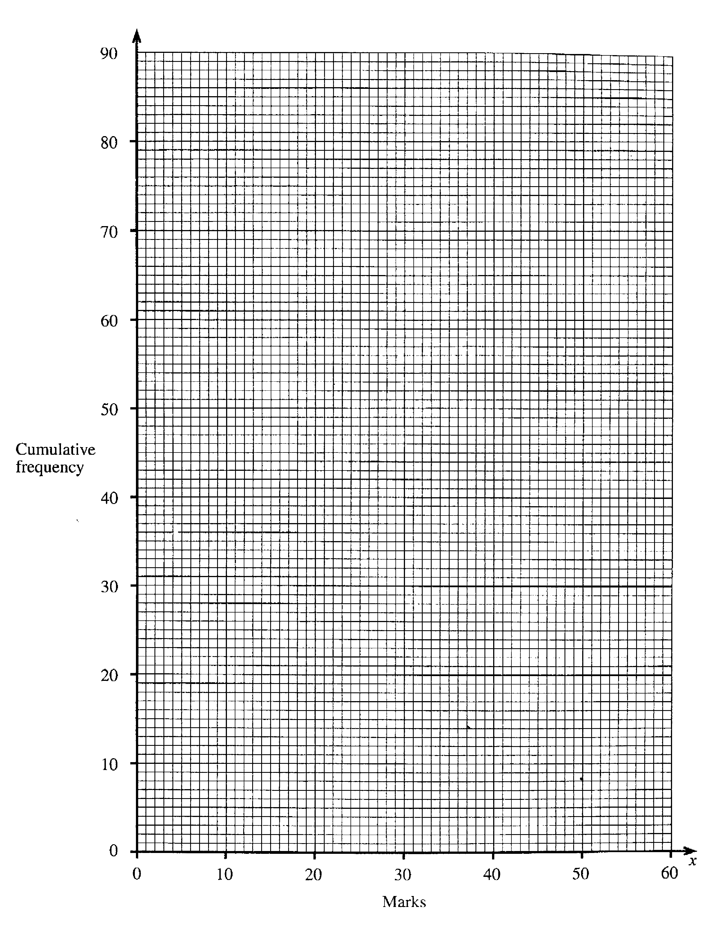

26.
3 | 5 | 7 | 9 | 11
8 | 10 | 12 | 14 | 16
13 | 15 | 17 | 19 | 21
18 | 20 | 22 | 24 | 26

- Which of the numbers in the table are multiples of 7
…………………………………………………………………………………………………………………………………
…………………………………………………………………………………………………………………………………
………………………………………………………………………………………………………………………………… [2]
- Which numbers in the table are prime numbers?
…………………………………………………………………………………………………………………………………
…………………………………………………………………………………………………………………………………
………………………………………………………………………………………………………………………………… [2]
- Which numbers in the table are square numbers?
…………………………………………………………………………………………………………………………………
…………………………………………………………………………………………………………………………………
………………………………………………………………………………………………………………………………… [2]

END OF TEST

1. £51 | 16. (a) Rhombus, Parallelogram
2. 205 | 17. 40º, 119º, 61º, 61º
3. 20.6cm² | 18. (a) x+4, (b)3x, (c)3x+x+x+4=64, (d) x=12, Brian=16
4. (a) Neptune, (b) 6.0x10⁶, (c) 5.0x10³ | 19. Diagram
5. 1.4m³ | 20. (a) rotation, anticlockwise 90º, (4,2), (6,4), (8,2), (6,-2)
6. 1 hour 36 minutes | 21. c = -4, d = 7
7. 6, 5, 2 and 1 sections respectively for VG, G, P and F | 22. (a)0.5, (b) odd total 0.45, even total 0.55. Even more likely
8. (a) 1.62, (b) 9.37, (c) 5.72 | 23.(a) m=2, (b) c=3
9. (a) 145º, (b)i) 24º, ii) 15 | 24. (a) 12x² – 9x +16x -12 = 12x² + 7x – 12 (b) 12y-18z = 6(2y-3z) (c)i) x²-3x-10=0 = (x-5)(x+2)=0, ii) x=5 or x=-2
10. (a) 7/12, (b)1, (c)14/33 | 25. On graph.
11. (a) 54cm², (b) 30cm,  (c)6²+9²=36+81=117 √117 = 10.82  (d) tan ADC = 6/9, tan ADC = 2/3 | 26. (a) 7, 14, 21 (b) 3, 5, 7, 11, 13, 17, 19  (c) 9 and 16
12. (a) x -3, -3, -3, 0, 1, 2 y -3, -6, -7, -6, -3, 2
(b) graph, (c) graph

13. (b) 2

14. 2.2

15. (a) 4²+8=6-12, (b) (i) 4²+8=4x6,
(ii) n²+2n=n(n+2), (c)n² +2n

Answers to Test Paper 3

PAST PAPER 4

Paper 1 2004

Two and a half hours

Name………………………………………………………………………

ATTEMPT ALL QUESTIONS

Show all your working in the space provided and make sure that your answer is clear.

It is assumed that you have a scientific calculator, ruler and protractor.

If your calculator does not have a π button, take the value of π to be 3.142.

The marks for each question are given in brackets by the side of the question.

Marks may be given for method even if your answer is wrong.

The total marks available are 120.

Calculator Questions
1.
1 | 2 | 3 | 4 | 5 | 6 | 7 | 8 | 9 | 10
11 | 12 | 13 | 14 | 15 | 16 | 17 | 18 | 19 | 20
21 | 22 | 23 | 24 | 25 | 26 | 27 | 28 | 29 | 30
31 | 32 | 33 | 34 | 35 | 36 | 37 | 38 | 39 | 40
41 | 42 | 43 | 44 | 45 | 46 | 47 | 48 | 49 | 50
51 | 52 | 53 | 54 | 55 | 56 | 57 | 58 | 59 | 60
61 | 62 | 63 | 64 | 65 | 66 | 67 | 68 | 69 | 70
71 | 72 | 73 | 74 | 75 | 76 | 77 | 78 | 79 | 80
81 | 82 | 83 | 84 | 85 | 86 | 87 | 88 | 89 | 90
91 | 92 | 93 | 94 | 95 | 96 | 97 | 98 | 99 | 100

Bryan and Sue were playing a guessing game. Sue thought of a number between 1 and 100 which Bryan had to guess. Bryan was allowed to ask 5 questions, which are listed with Sue’s responses in the table below.

Bryan’s Questions | Sue’s Responses
Is it prime? | No
Is it odd? | No
Is it less than 50? | Yes
Is it a multiple of 3? | Yes
Is it a multiple of 7? | Yes

What is the number that Sue thought of?

………………………………………………………………………………………………………………………………… [3]

2. The population of Australia is 18 million, of which 3.5 million people live in Sydney and 1 million people live in Perth.

(a) What fraction of the population live in Perth?
…………………………………………………………………………………………………………………………………
…………………………………………………………………………………………………………………………………
………………………………………………………………………………………………………………………………… [2]
(b) What fraction of the population live in Perth or Sydney?
…………………………………………………………………………………………………………………………………
…………………………………………………………………………………………………………………………………
………………………………………………………………………………………………………………………………… [2]

3(a) Thelma borrowed £1000 on her credit card. At the end of the month, she paid off 5% of the money she owed. How much did she then owe?
…………………………………………………………………………………………………………………………………
………………………………………………………………………………………………………………………………… [1]
(b) Interest was then charged on her account at a rate of 2%. How much did she then owe?
…………………………………………………………………………………………………………………………………
………………………………………………………………………………………………………………………………… [1]
(c) If she continues in this way, paying off 5% and then being charged 2% interest, how much will her debt have been reduced by at the end of the fourth month, assuming that she doesn’t spend any more money on her card?
…………………………………………………………………………………………………………………………………
…………………………………………………………………………………………………………………………………
…………………………………………………………………………………………………………………………………
…………………………………………………………………………………………………………………………………
………………………………………………………………………………………………………………………………… [3]
(d) How much money will she have paid the credit card company in total by the end of the fourth month?
…………………………………………………………………………………………………………………………………
…………………………………………………………………………………………………………………………………
………………………………………………………………………………………………………………………………… [2]

4. The figure shows part of a regular 9 sided figure. Its centre is O.
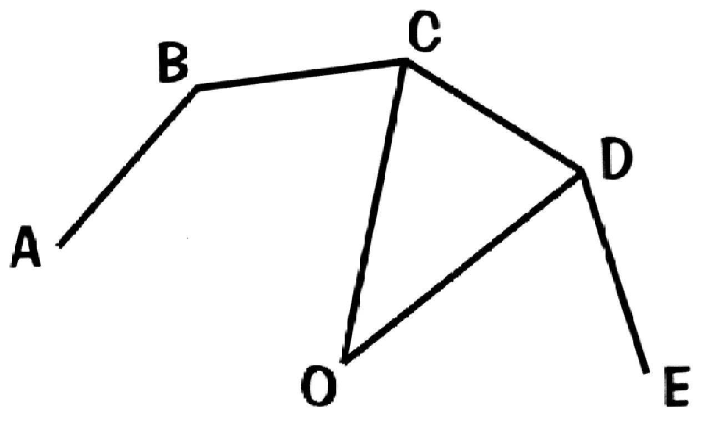

(a) Calculate the size of angle COD:
…………………………………………………………………………………………………………………………………
………………………………………………………………………………………………………………………………… [1]
(b) Calculate the size of angle OCD
…………………………………………………………………………………………………………………………………
………………………………………………………………………………………………………………………………… [2]
(c) Calculate the size of angle ABC
…………………………………………………………………………………………………………………………………
………………………………………………………………………………………………………………………………… [1]

5. 2700 people work in one department of the European Parliament.
The pie chart shows where the people come from.
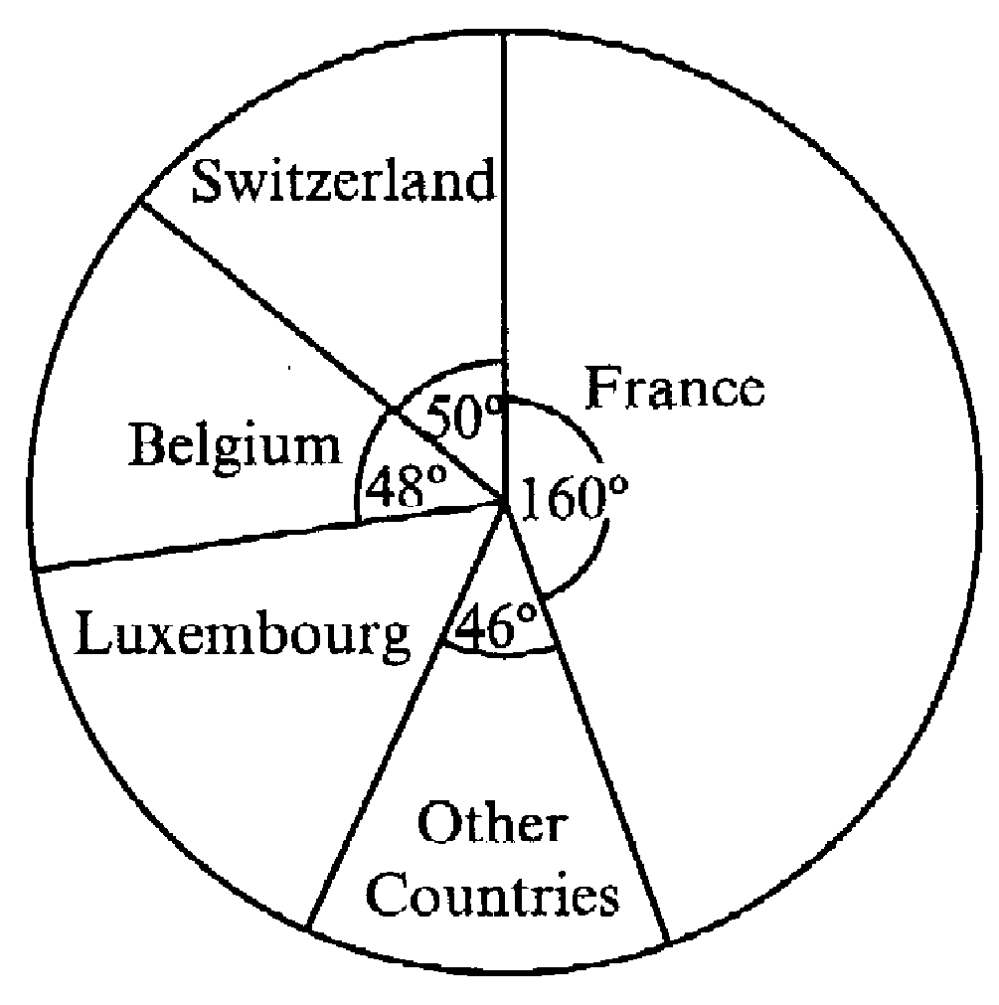

Calculate how many of the 2700 people came from Switzerland.
…………………………………………………………………………………………………………………………………
…………………………………………………………………………………………………………………………………
………………………………………………………………………………………………………………………………… [2]
6. In my garden, I have a circular pond which is surrounded by a ring shaped paved area. The pond is 35cm deep and is filled with water.
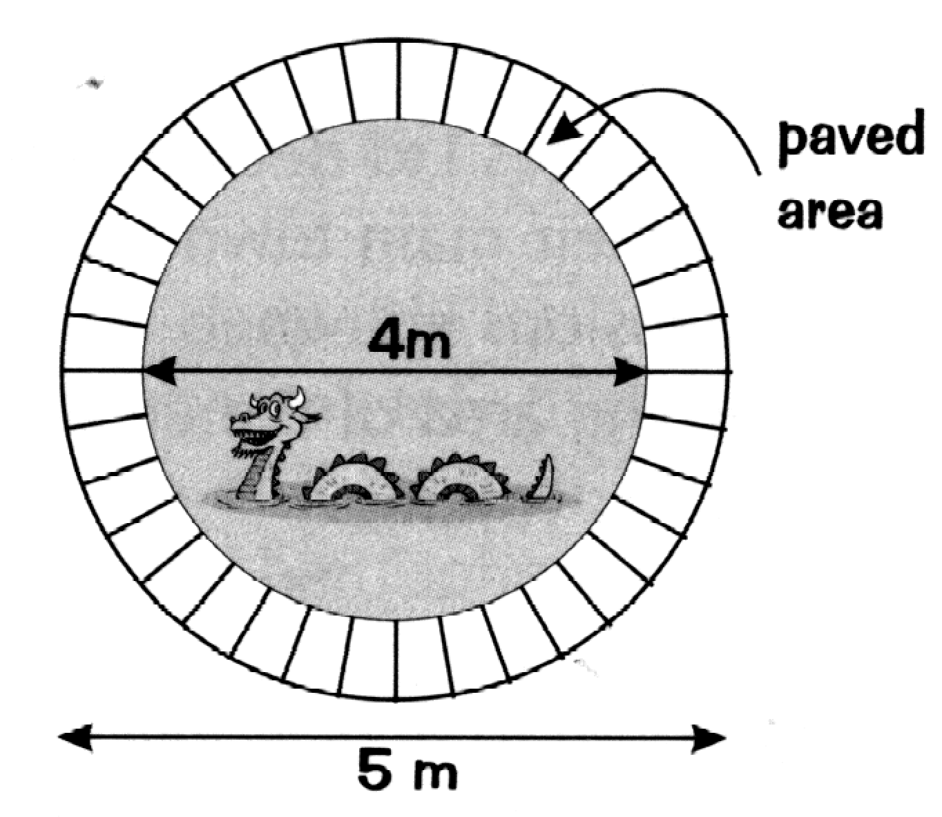

(a) Find the volume of water in the pond when it is full
…………………………………………………………………………………………………………………………………
…………………………………………………………………………………………………………………………………
………………………………………………………………………………………………………………………………… [3]
(b) Find the area of the paving surrounding the pond.
…………………………………………………………………………………………………………………………………
…………………………………………………………………………………………………………………………………
………………………………………………………………………………………………………………………………… [3]

7. ABCD is a trapezium where the AB = BC, angle ABC = 142º,
angle DAC = 90º and the line AB is parallel to the line DC
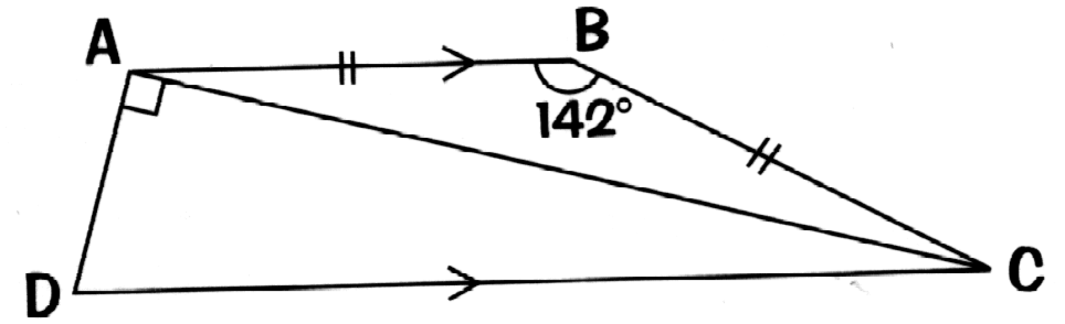

(a) Calculate the size of angle BAC
…………………………………………………………………………………………………………………………………
…………………………………………………………………………………………………………………………………
………………………………………………………………………………………………………………………………… [2]
(b) Calculate the size of angle ADC
…………………………………………………………………………………………………………………………………
…………………………………………………………………………………………………………………………………
………………………………………………………………………………………………………………………………… [2]
8. A plane leaves Amsterdam at 0715 and flies at an average speed of 650km/hr to Paris, arriving at 0800. It takes off again at 0840 and flies at the same average speed to Nice arriving at 1005.

(a) How far is it from Amsterdam to Paris?
…………………………………………………………………………………………………………………………………
………………………………………………………………………………………………………………………………… [2]
(b) How far is it from Paris to Nice?
…………………………………………………………………………………………………………………………………
………………………………………………………………………………………………………………………………… [2]
- What was the average speed for the whole journey?
…………………………………………………………………………………………………………………………………
…………………………………………………………………………………………………………………………………
………………………………………………………………………………………………………………………………… [2]
9. A square tablecloth has a diagonal measurement of 130cm. Calculate the length of one side

…………………………………………………………………………………………………………………………………
…………………………………………………………………………………………………………………………………
…………………………………………………………………………………………………………………………………
…………………………………………………………………………………………………………………………………
………………………………………………………………………………………………………………………………… [4]
10. A lorry driver decided to monitor the time it took him to travel from Liverpool to Birmingham during one week. He recorded his results in a table:

 | Trip one | Trip two | Trip three
Monday | 1 hour 40 mins | 1 hour 55 mins | 2 hours 10 mins
Tuesday | 3 hours 5 mins | 1 hour 50 mins | 2 hours 55mins
Wednesday | 1 hour 20 mins | 1 hour 30 mins | 1 hour 40 mins
Thursday | 1 hour 55 mins | 1 hour 45 mins | 2 hours 5 mins
Friday | 1 hour 35 mins | 1 hour 50 mins | 1 hour 55 mins
Saturday | 1 hour 35 mins

(a) What was his mean journey time on Monday? Give your answer in hours and minutes
…………………………………………………………………………………………………………………………………
…………………………………………………………………………………………………………………………………
………………………………………………………………………………………………………………………………… [2]
(b) What was his median journey time for the whole week?
…………………………………………………………………………………………………………………………………
…………………………………………………………………………………………………………………………………
………………………………………………………………………………………………………………………………… [2]
(c) What was his modal journey time for the whole week?
…………………………………………………………………………………………………………………………………
…………………………………………………………………………………………………………………………………
………………………………………………………………………………………………………………………………… [1]
11. Use trial and improvement to find the value of x in the equation
x³ – x² = 350
Give your answer correct to one place of decimals.
[3]
x | x³ – x² | Comment
6 | 180 | Too low
7 | 294 | Too low

12. The scale drawing shows the position of three towns.
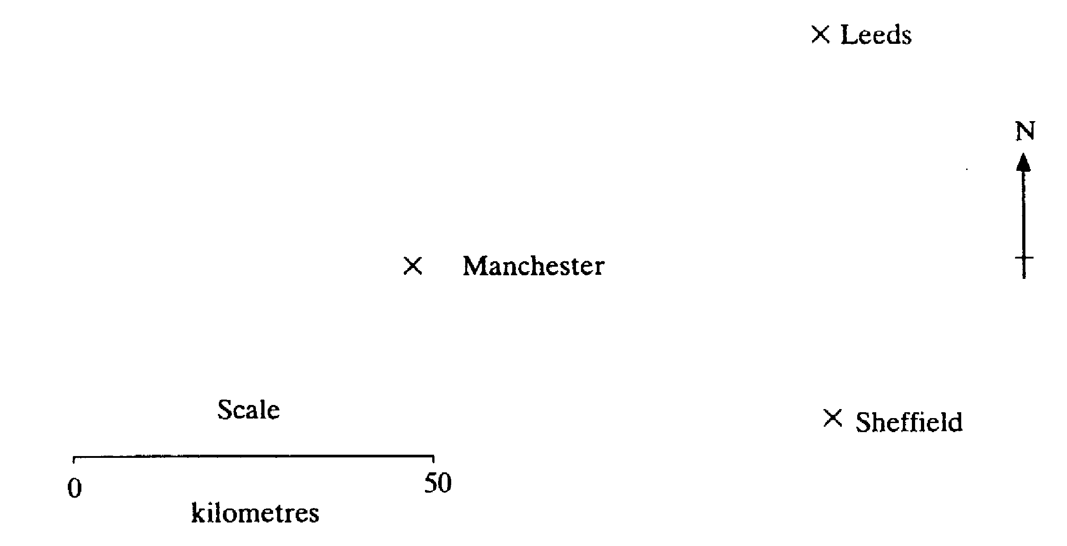

(a) What is the actual distance, in kilometres, between Manchester and Leeds?
…………………………………………………………………………………………………………………………………
………………………………………………………………………………………………………………………………… [2]

(b) What is the bearing of Sheffield from Manchester?
…………………………………………………………………………………………………………………………………
………………………………………………………………………………………………………………………………… [2]
(c) What is the bearing of Manchester from Leeds?
…………………………………………………………………………………………………………………………………
………………………………………………………………………………………………………………………………… [2]

13. Use your calculator to evaluate the following questions. Give your answers correct to two places of decimals.

(a)
…………………………………………………………………………………………………………………………………
…………………………………………………………………………………………………………………………………
………………………………………………………………………………………………………………………………… [1]
(b) + 3.75
…………………………………………………………………………………………………………………………………
…………………………………………………………………………………………………………………………………
………………………………………………………………………………………………………………………………… [1]
(c) 3.24 +
…………………………………………………………………………………………………………………………………
…………………………………………………………………………………………………………………………………
………………………………………………………………………………………………………………………………… [1]

14. Two fell tops are 1.5km apart horizontally. One is 720m high and the other is 340m high.

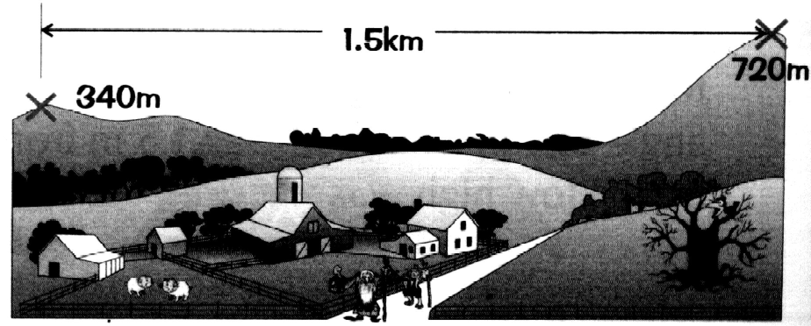

(a) Calculate the difference in height between the two fell tops
…………………………………………………………………………………………………………………………………
………………………………………………………………………………………………………………………………… [1]
(b) Calculate the angle of elevation looking from the lower to the higher fell.
…………………………………………………………………………………………………………………………………
…………………………………………………………………………………………………………………………………
…………………………………………………………………………………………………………………………………
…………………………………………………………………………………………………………………………………
…………………………………………………………………………………………………………………………………
………………………………………………………………………………………………………………………………… [3]

Non-Calculator Questions.

15. Solve the following equations

(a) 3x - 8 = 13
…………………………………………………………………………………………………………………………………
…………………………………………………………………………………………………………………………………
………………………………………………………………………………………………………………………………… [1]
(b) 5(x – 1) + 3(x – 4) = 7
…………………………………………………………………………………………………………………………………
…………………………………………………………………………………………………………………………………
………………………………………………………………………………………………………………………………… [2]

16. Solve the simultaneous equations
3a - 7b = -1
2a + 3b = 30
…………………………………………………………………………………………………………………………………
…………………………………………………………………………………………………………………………………
…………………………………………………………………………………………………………………………………
…………………………………………………………………………………………………………………………………
…………………………………………………………………………………………………………………………………
…………………………………………………………………………………………………………………………………
…………………………………………………………………………………………………………………………………
…………………………………………………………………………………………………………………………………
…………………………………………………………………………………………………………………………………
…………………………………………………………………………………………………………………………………
………………………………………………………………………………………………………………………………… [4]

17. The table gives the diameter and distance from the sun of some planets.

Planet | Distance from Sun in km | Diameter in km
Earth | 1.5 x 10⁸ | 1.3 x 10⁴
Venus | 1.085 x 10⁸ | 1.2 x 10⁴
Mars | 2.28 x 10⁸ | 6.8 x 10³
Mercury | 5.81 x 10⁷ | 4.9 x 10³
Jupiter | 7.8 x 10⁸ | 1.4 x 10⁵
Neptune | 4.52 x 10⁹ | 4.9 x 10⁴
Saturn | 1.43 x 10⁹ | 1.2 x 10⁵

(a) Which planet listed in the table is furthest from the Sun?
…………………………………………………………………………………………………………………………………
…………………………………………………………………………………………………………………………………
………………………………………………………………………………………………………………………………… [2]
(b) Using the information in the table, list the planets in order of size, from smallest to largest.
…………………………………………………………………………………………………………………………………
…………………………………………………………………………………………………………………………………
………………………………………………………………………………………………………………………………… [2]
18. Here is a number pattern:
1 x 4 = 1² + 3
2 x 5 = 2² + 6
3 x 6 = 3² + 9
4 x 7 = 4² + 12

(a) Write down the next row of the pattern
…………………………………………………………………………………………………………………………………
………………………………………………………………………………………………………………………………… [1]
(b) Write down the nth row of the pattern
…………………………………………………………………………………………………………………………………
…………………………………………………………………………………………………………………………………
………………………………………………………………………………………………………………………………… [2]

19. A darts player scored 190 with 6 darts, the individual scores being as follows:

Dart 1 – treble 19
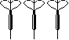
Dart 2 – treble 3
Dart 3 – treble 18
Dart 4 – single 20
Dart 5 – single 18
Dart 6 – double 16

What is the mean score per dart? Give your answer to the nearest whole number.
…………………………………………………………………………………………………………………………………
…………………………………………………………………………………………………………………………………
………………………………………………………………………………………………………………………………… [3]

20. The notepad below shows orders for 4 different sorts of rice at a local takeaway.
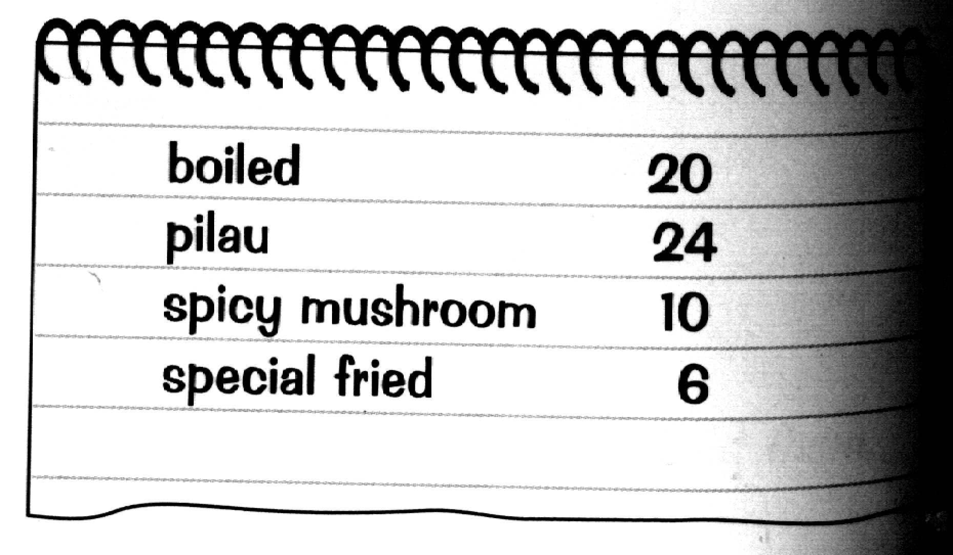

Based on this data, what is the probability that the next order of rice is:
(a) for pilau rice?
…………………………………………………………………………………………………………………………………
…………………………………………………………………………………………………………………………………
………………………………………………………………………………………………………………………………… [2]
(b) for spicy mushroom or special fried rice?
…………………………………………………………………………………………………………………………………
…………………………………………………………………………………………………………………………………
………………………………………………………………………………………………………………………………… [1]
(c) not for boiled rice?
…………………………………………………………………………………………………………………………………
…………………………………………………………………………………………………………………………………
………………………………………………………………………………………………………………………………… [1]

21(a) Solve the inequality
10 – 3w > 1
…………………………………………………………………………………………………………………………………
………………………………………………………………………………………………………………………………… [2]
- List all the integer values of y which satisfy the inequality
y² – 10 < 17
…………………………………………………………………………………………………………………………………
…………………………………………………………………………………………………………………………………
………………………………………………………………………………………………………………………………… [3]

Please turn over for next questions.

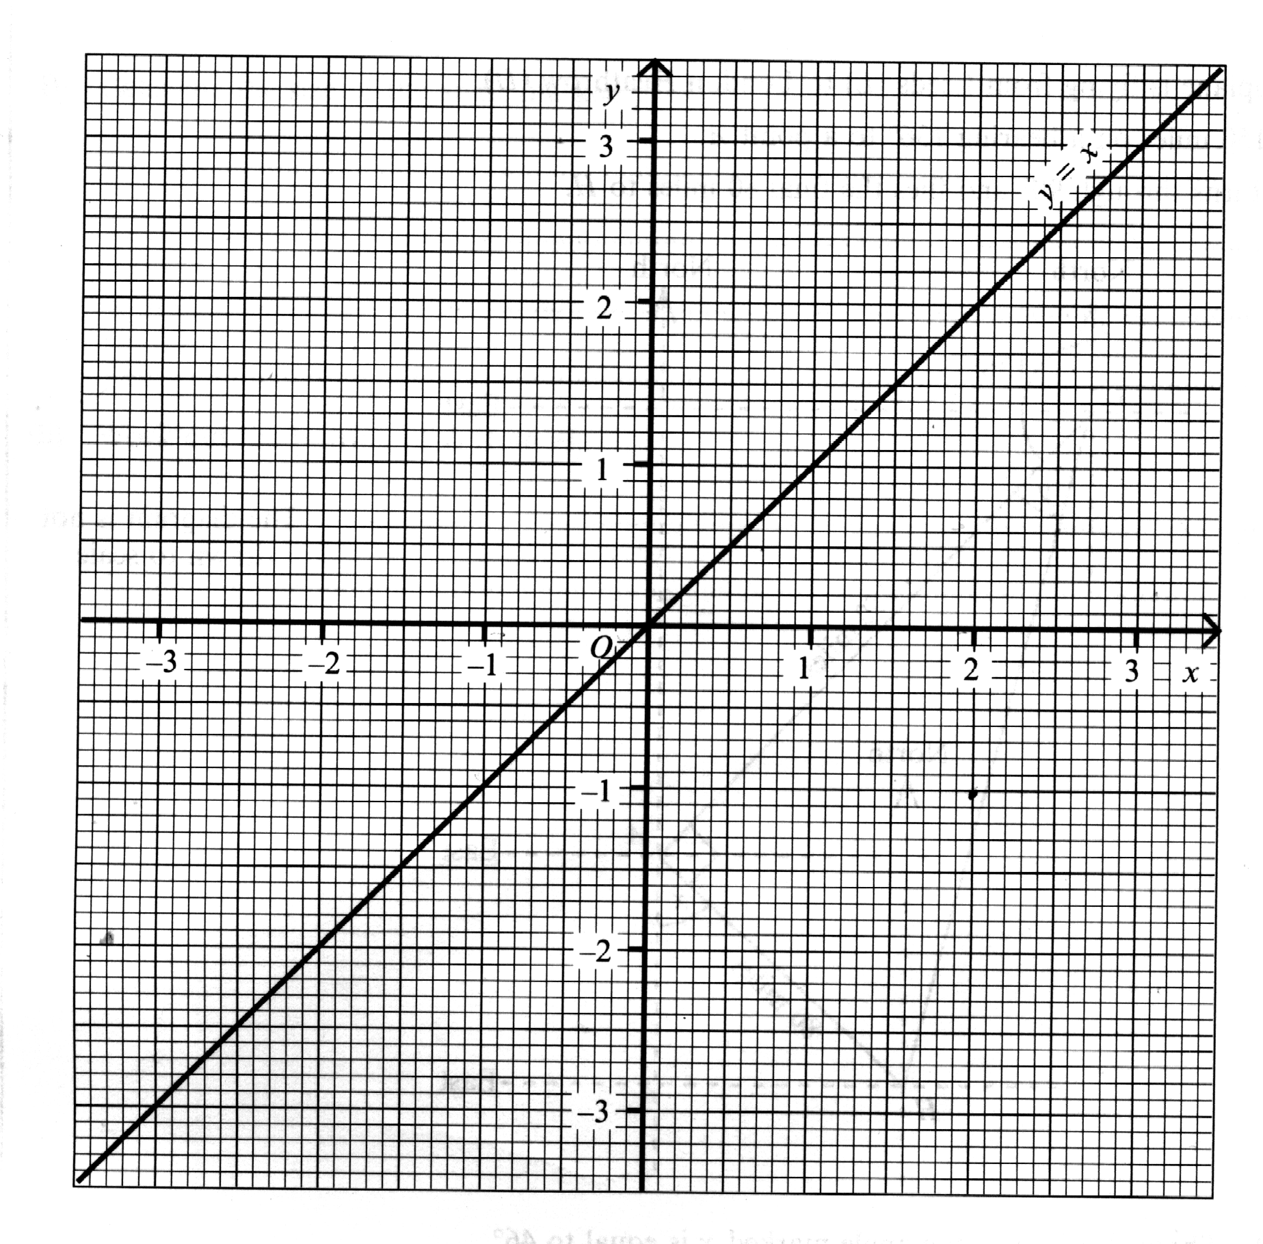
22. The line y =x has been drawn on the grid below.

(a) On this grid, draw the line y = 2x - 1 for values of x from -1 to 2 [2]
(b) Draw the image of y = 2x - 1 when it is reflected in the line y = x.
Label your image line L [2]
(c) Calculate the gradient of the line L
…………………………………………………………………………………………………………………………………
………………………………………………………………………………………………………………………………… [2]
(d) For the line L write down the value of y when x = 0
………………………………………………………………………………………………………………………………… [1]
(e) Write down the equation of the line L
…………………………………………………………………………………………………………………………………
…………………………………………………………………………………………………………………………………
………………………………………………………………………………………………………………………………… [2]

23. Factorise the following expressions completely:
(a) 4a + 2b - 6c
…………………………………………………………………………………………………………………………………
………………………………………………………………………………………………………………………………… [1]
(b) 3g – 12gh
…………………………………………………………………………………………………………………………………
………………………………………………………………………………………………………………………………… [2]
(c) x² – 7x + 12
…………………………………………………………………………………………………………………………………
………………………………………………………………………………………………………………………………… [2]
(d) Use your answer to part (c) to solve the equation
x² – 7x + 12 = 0
…………………………………………………………………………………………………………………………………
…………………………………………………………………………………………………………………………………
………………………………………………………………………………………………………………………………… [2]
24. Given that y = x² + 2x
(a) Complete the table below,
x | 0 | 1 | 2 | 3 | 4 | 5
y |  |  | 8 | 15
[2]
(b) Plot these points on the grid below and hence draw the graph of
y = x² + 2x [2]

(c) Use your graph to find the value of x when y = 30
……………………………………………………………………………………………………………………………….. [1]

Use graph over the page.

25. Expand the brackets and simplify:

(a) 2a(af + 3g)
…………………………………………………………………………………………………………………………………
………………………………………………………………………………………………………………………………… [2]
(b) (3x + 4)(2x – 3)
…………………………………………………………………………………………………………………………………
…………………………………………………………………………………………………………………………………
………………………………………………………………………………………………………………………………… [2]

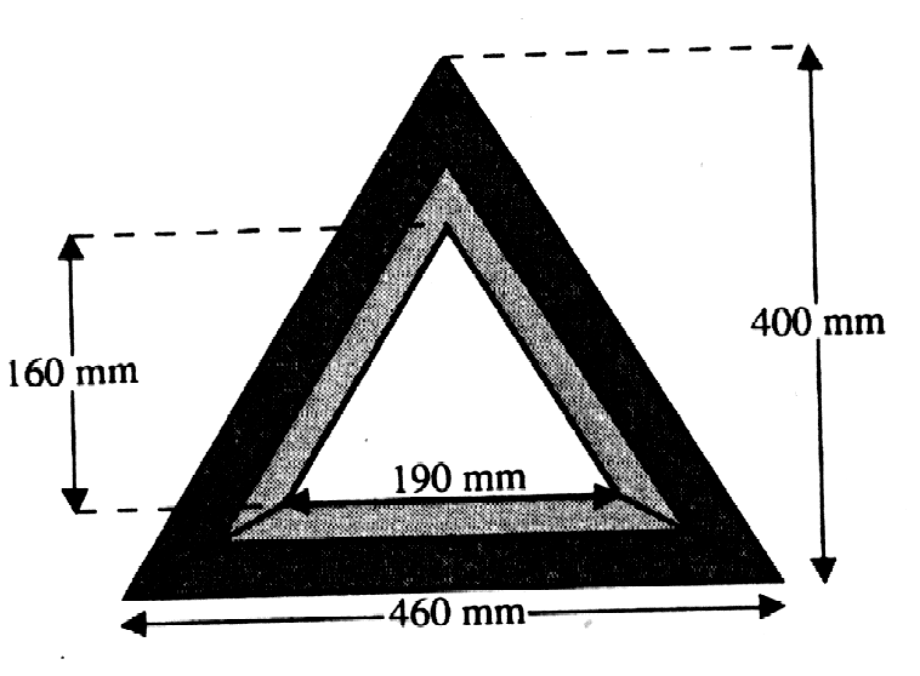
26. Warning triangles are manufactured for a garage to the specifications shown.

If the sign consists of a plastic triangle, coloured in two shades of red, with a triangular hole in the middle, calculate the surface area of the plastic used in the triangle
…………………………………………………………………………………………………………………………………
…………………………………………………………………………………………………………………………………
…………………………………………………………………………………………………………………………………
…………………………………………………………………………………………………………………………………
………………………………………………………………………………………………………………………………… [3]

Please turn over for nest questions.

27. Ten people entered a craft competition.
Their displays of work were marked by two different judges.
The table shows the marks that they gave to each of the competitors.

Competitor | A | B | C | D | E | F | G | H | I | J
First judge | 90 | 35 | 60 | 15 | 95 | 25 | 5 | 100 | 70 | 45
Second judge | 75 | 30 | 55 | 20 | 75 | 30 | 10 | 85 | 65 | 40
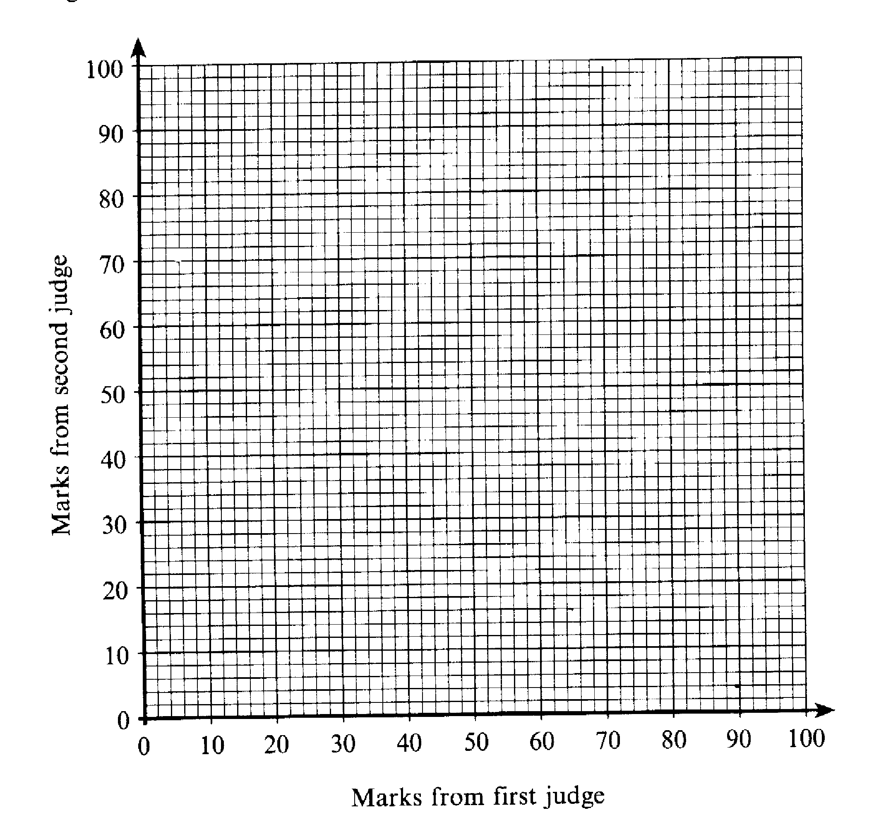
- On the grid below, draw a scatter diagram to show this information. [3]

- Draw a line of best fit [1]

(c) A late entry was given 75 marks by the first judge.
Use your scatter diagram to estimate the mark that might have been given by the second judge. Show how you found your answer.
…………………………………………………………………………………………………………………………………
…………………………………………………………………………………………………………………………………
………………………………………………………………………………………………………………………………… [1]
END OF TEST

Answers for Past Paper 4

1. 42 | 17. (a) Neptune  (b) Mercury, Mars, Venue, Earth, Neptune,  Saturn, Jupiter
2. a) , (b) | 18.(a) 5 x 8 + 5² + 15  (b) n x (n+3)- n² + 3n
3. (a) £950 (b £969 (c) £118.35  (d) £190.89 | 19. 32
4. (a) 40º (b)70º (c) 140º | 20. (a) b) (c)
5. 375 | 21. (a) w ‹3 (b)-5, -4, -3, -2, -1, 0, 1, 2, 3, 4, 5
6.(a) 4.4m³ (b) 7.07m² | 22. (a) Line passes through (2,3) and (-1, -3)  (b) Line passes through (1,1) and (-1,0)  (c) (d) (e)y = x + or 2y = x + 1
7. (a) 19º (b) 71º | 23. (a) 2(2a + b – 3c) (b)3g(1 – 4h)  (c) (x – 3)(x – 4), (d) either x = 3 or x = 4
8. (a) 487.5 km (b) 920.83 km (c) 497 km/hr | 24. (a) 1.71 (b)8.23 (c)4.42
9. 91.92cm | 25. (a)2a²f + 6ag (b)6x² – x - 12
10. (a) 1 hour 55 mins, (b) 1 hour 50 mins  (c) 1 hour 55 mins | 26. 76800mm²
11. 7.4 | 27. (a) graph, (b) Line passes through (0,6) and (100,85) or thereabouts (c)approximately 65
12. (a) 65km, (b) 110º, (c) 240º

13. (a) 1.71, (b) 8.23, (c) 4.42

14. (a) 380m, (b) 14.22º

15. (a) x = 7, (b) x = 3

16. a = 9, b=4

PAST PAPER 5

Paper 2 2004

Two and a half hours

Name ………………………………………………………………………

ATTEMPT ALL QUESTIONS

Show all your working in the space provided and make sure that your answer is clear.

It is assumed that you have a scientific calculator, ruler and protractor.

If your calculator does not have a π button, take the value of π to be 3.142.

The marks for each question are given in brackets by the side of the question.

Marks may be given for method even if your answer is wrong.

The total marks available are 120.

Calculator Questions

1. A teacher has a small group of pupils in a special needs class. Their ages are:

12 years 4 months 11 years 6 months 11 years 11 months
11 years 8 months 12 years 3 months 12 years 1 month
12 years 1 month 11 years 6 months

(a) What is the median age of the children?
…………………………………………………………………………………………………………………………………
………………………………………………………………………………………………………………………………… [1]
(b) What is the mean age of the children?
…………………………………………………………………………………………………………………………………
…………………………………………………………………………………………………………………………………
………………………………………………………………………………………………………………………………… [2]

2. ABCDE is a shape with AB = AE and DE = BC. BE is parallel to CD.
E
B

D

C

A

›

›

/

\
=

=

(a) Show any lines of symmetry for the shape ABCDE on the diagram
[1]
(b) What is the mathematical name given to the shape ABE?
………………………………………………………………………………………………………………………………… [1]
(c) What is the mathematical name give to the shape BCDE?
………………………………………………………………………………………………………………………………… [1]
PTO for next qu’s.
(d) If angle BAE = 40º and angle BCD = 100º, then calculate the size of angle ABC.
…………………………………………………………………………………………………………………………………
…………………………………………………………………………………………………………………………………
………………………………………………………………………………………………………………………………… [3]

3. The council surround a circular flower bed with a concrete edge.
5m

The radius of the flower bed is 5 metres and the concrete extends for a further metre.

(a) Calculate the area of the flower bed.
…………………………………………………………………………………………………………………………………
…………………………………………………………………………………………………………………………………
………………………………………………………………………………………………………………………………… [2]

(b) Calculate the area of the flower bed and the concrete surround together.
…………………………………………………………………………………………………………………………………
………………………………………………………………………………………………………………………………… [1]

(c) Find the area of the concrete surround.
…………………………………………………………………………………………………………………………………
………………………………………………………………………………………………………………………………… [1]
(d) If the concrete surrounding the flower bed is 8cm thick, calculate the volume of concrete used for the job. Remember to state the units in your answer.
…………………………………………………………………………………………………………………………………
…………………………………………………………………………………………………………………………………
………………………………………………………………………………………………………………………………… [3]

4. The number of journeys made using public transport by a group of people in one month are shown in the graph.

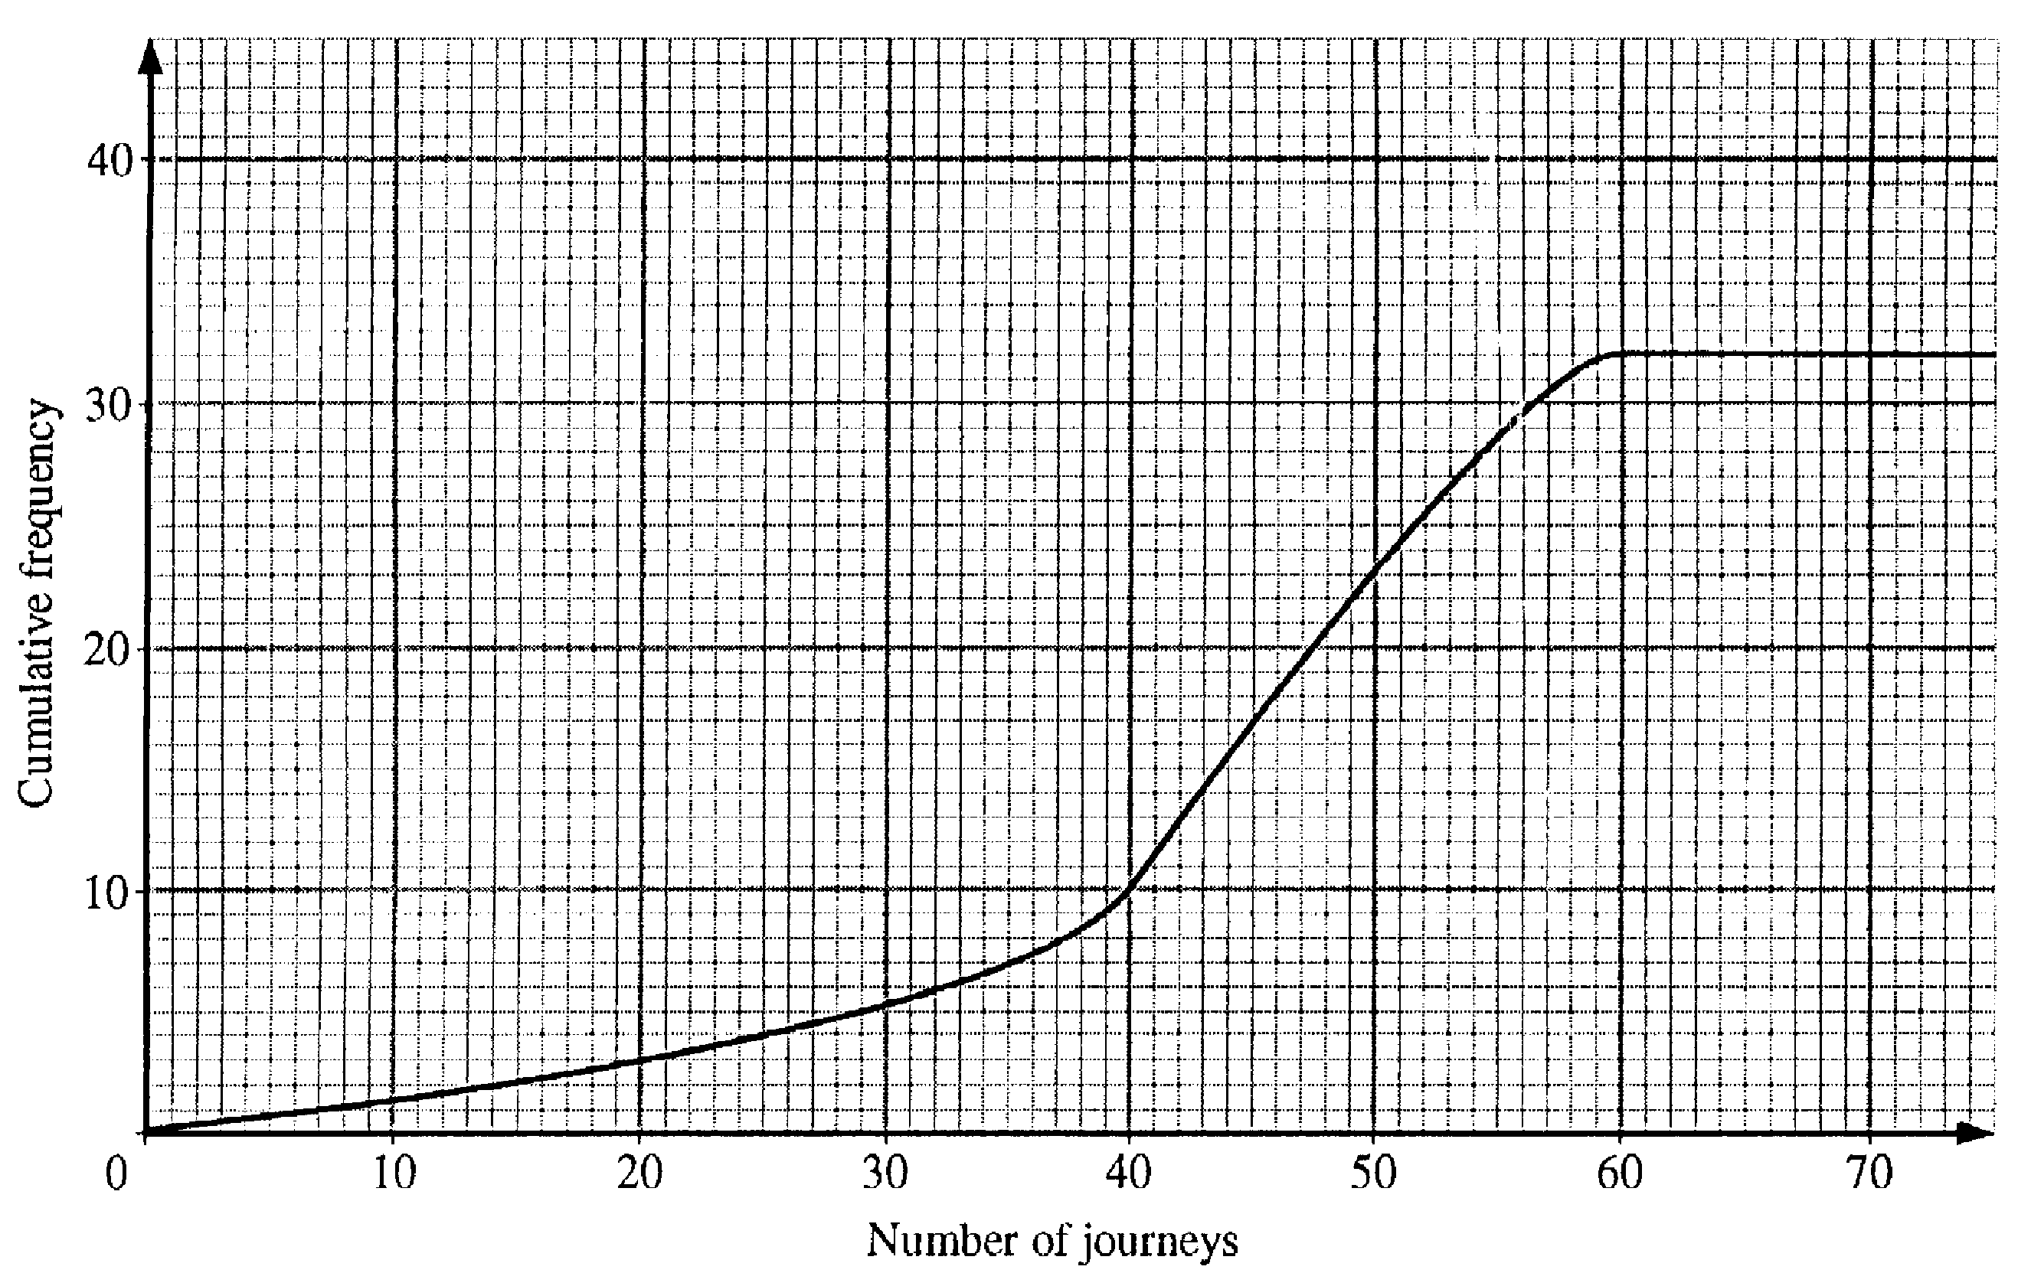
(a) Find the interquartile range
…………………………………………………………………………………………………………………………………
………………………………………………………………………………………………………………………………… [2]
(b) Use the graph to estimate how many people make more than 55 journeys a month on public transport.
…………………………………………………………………………………………………………………………………
………………………………………………………………………………………………………………………………… [2]
5.
A B

C D

ABCD is a rectangle with AB:BD = 8:5.

If the perimeter of the rectangle is 78 cm, find the length of AB.
…………………………………………………………………………………………………………………………………
…………………………………………………………………………………………………………………………………
………………………………………………………………………………………………………………………………… [3]

6. A shopkeeper buys a box of 24 chocolate bars for £6.30. She sells them at a profit of 45%, rounding the price to the nearest penny. How much does she sell each bar for?
…………………………………………………………………………………………………………………………………
…………………………………………………………………………………………………………………………………
…………………………………………………………………………………………………………………………………
………………………………………………………………………………………………………………………………… [3]

PTO to continue

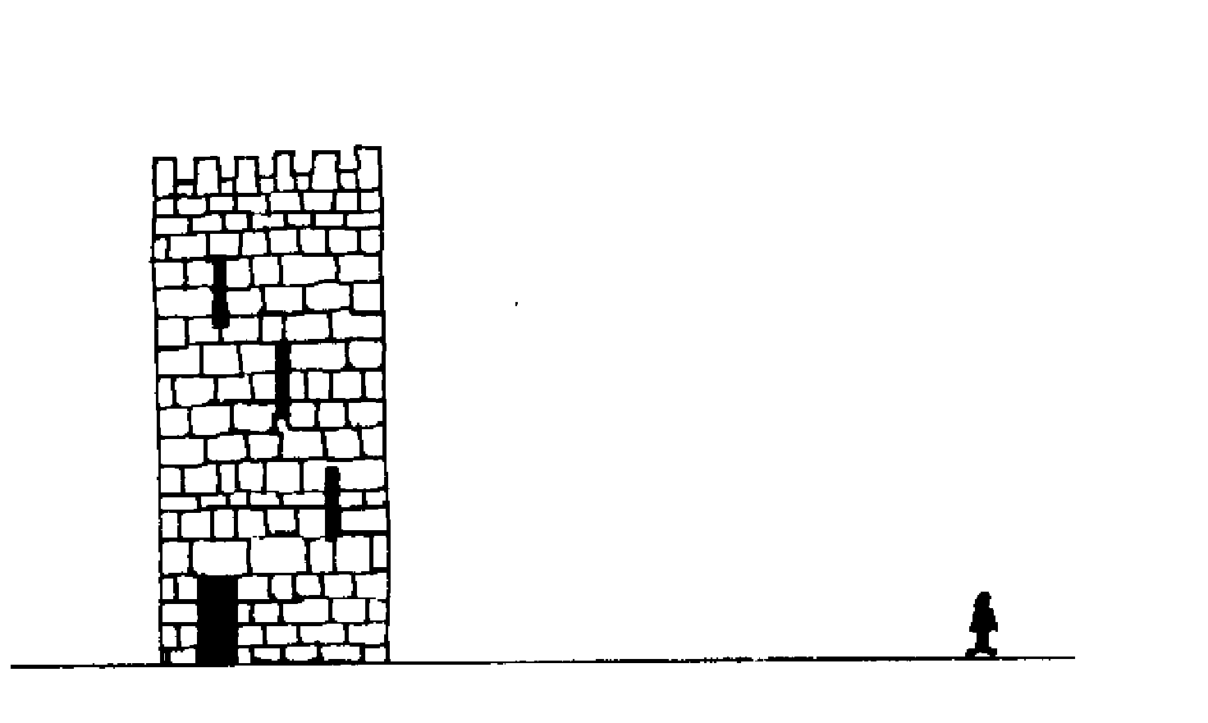
7.

A boy is 90 m due East from the foot of a tall tower and on level ground. He measures the angle of elevation of the top of the tower as 38º from the ground at his feet. Calculate the height of the tower.
…………………………………………………………………………………………………………………………………
…………………………………………………………………………………………………………………………………
………………………………………………………………………………………………………………………………… [3]

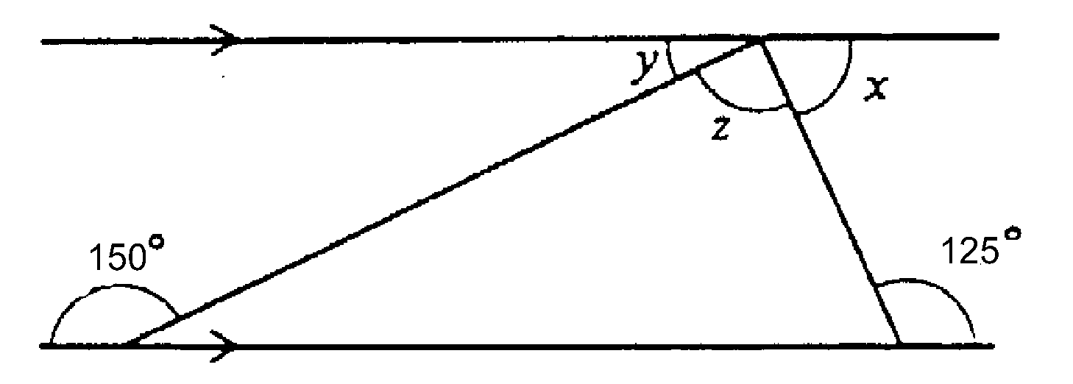
8.

(a) Find the value of x in the diagram.
…………………………………………………………………………………………………………………………………
………………………………………………………………………………………………………………………………… [1]
(b) Find the value of y in the diagram.
…………………………………………………………………………………………………………………………………
………………………………………………………………………………………………………………………………… [1]
(c) Find the value of z in the diagram.
…………………………………………………………………………………………………………………………………
………………………………………………………………………………………………………………………………… [1]

9. The probability that I am late for work on a Monday is 0.8 and the probability that I find a parking space within 5 minutes of arriving at work is 0.7.

(a) What is the probability that I don’t find a parking space within the first 5 minutes of arriving at work?
…………………………………………………………………………………………………………………………………
………………………………………………………………………………………………………………………………… [1]
(b) Complete the tree diagram to show the possible outcomes.
[2]
0.8
Late
Not late
Parking
Parking
No Parking
No Parking
0.7

(c) Use the tree diagram to find the probability that I’m both on time and find a parking space within the first 5 minutes.
…………………………………………………………………………………………………………………………………
…………………………………………………………………………………………………………………………………
………………………………………………………………………………………………………………………………… [2]

10. Use trial and improvement to find the value of x in the equation
x² – 3x = 150
Give your answer correct to one place of decimals.
x | x² – 3x | Comment
12 | 108 | Too low
13 | 130 | Too low
[3]
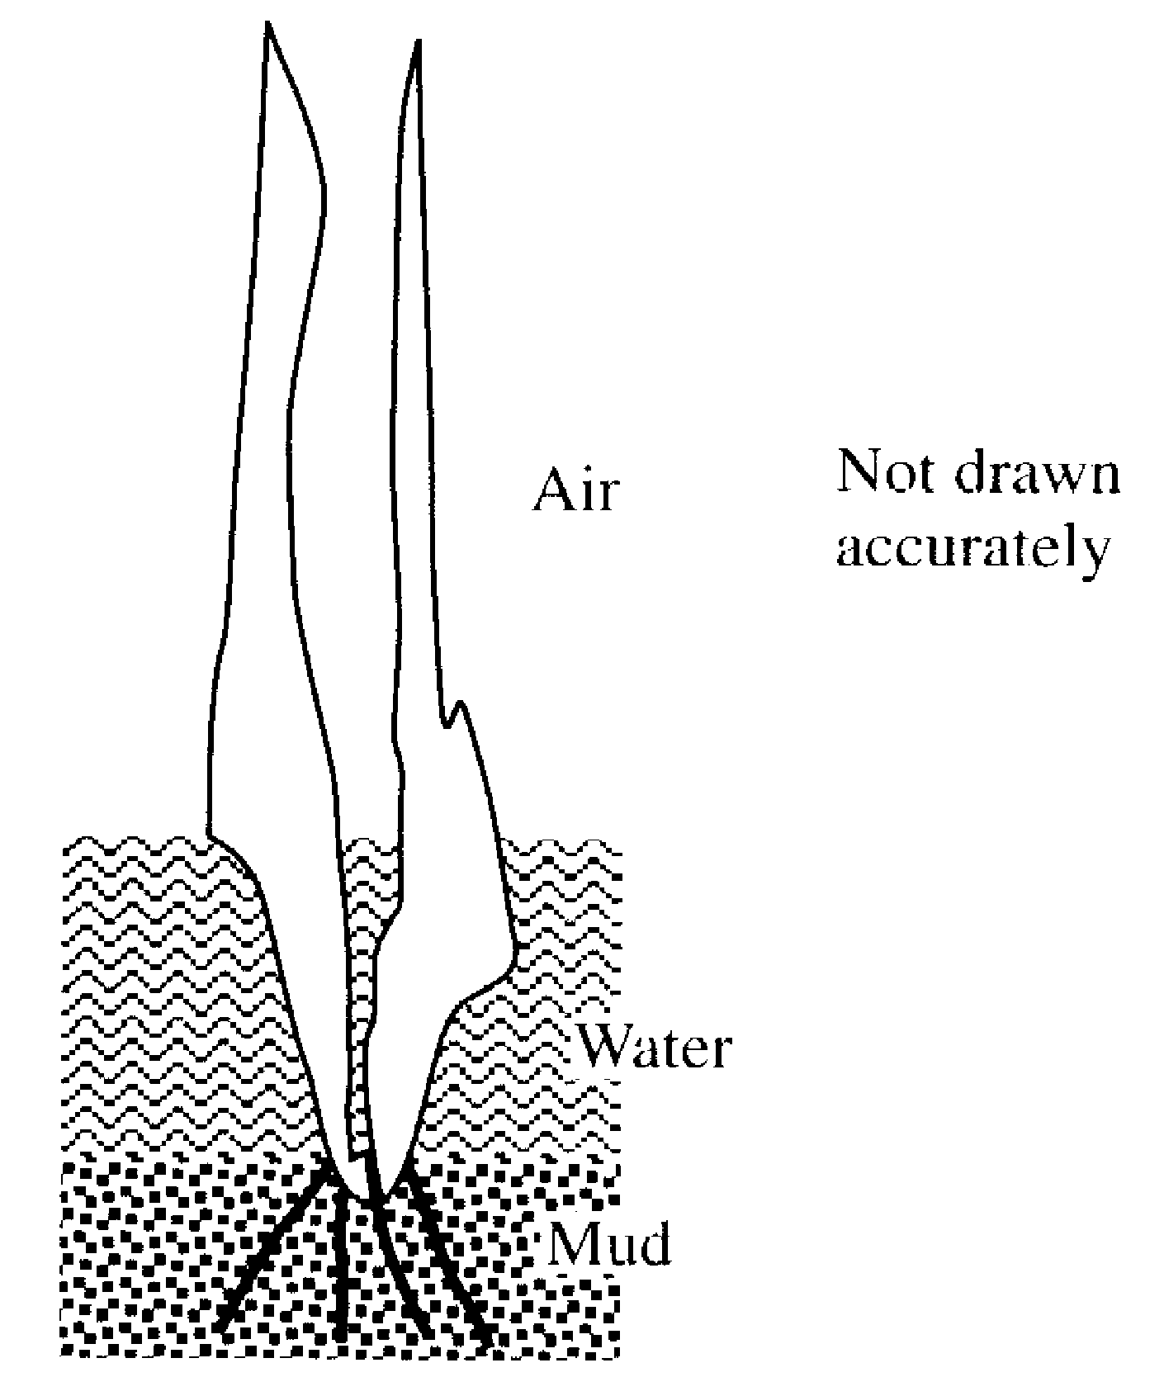
11. A water plant has of its length in the air. Nineteen centimetres of its length are in the water. of its length is in the mud. Calculate the total length of the plant.

…………………………………………………………………………………………………………………………………
…………………………………………………………………………………………………………………………………
…………………………………………………………………………………………………………………………………
………………………………………………………………………………………………………………………..……… [2]
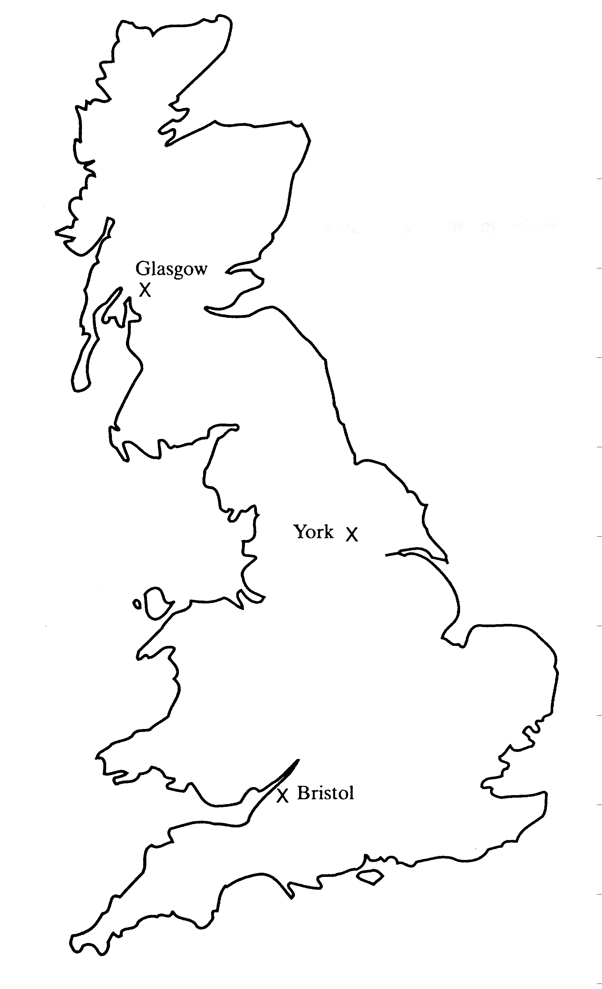
12.
North

(a) A plane flies from Bristol to Glasgow. Use the map to find the flight bearing.
…………………………………………………………………………………………………………………………………
………………………………………………………………………………………………………………………………… [1]
(b) A ship at sea is on a bearing of 110º from York and 070º from Bristol. Show its position on the map.
[2]
13. A group of 50 pupils were asked how long they had spent on their homework on the previous evening. Their answers are recorded in the table below.
Time spent on homework  (t minutes) | Number of pupils
0 < t ≤ 30 | 6
30 < t ≤ 60 | 13
60 < t ≤ 90 | 9
90 < t ≤ 120 | 12
120 < t ≤ 150 | 10
Over 150 | 0

(a) What is the modal class?
…………………………………………………………………………………………………………………………………
………………………………………………………………………………………………………………………………… [1]
(b) Calculate the estimated mean time taken on homework.
…………………………………………………………………………………………………………………………………
…………………………………………………………………………………………………………………………………
…………………………………………………………………………………………………………………………………
…………………………………………………………………………………………………………………………………
………………………………………………………………………………………………………………………………… [3]
14. A square tablecloth has a diagonal measurement of 190cm. Calculate the length of one side

…………………………………………………………………………………………………………………………………
…………………………………………………………………………………………………………………………………
…………………………………………………………………………………………………………………………………
…………………………………………………………………………………………………………………………… [4]
15.
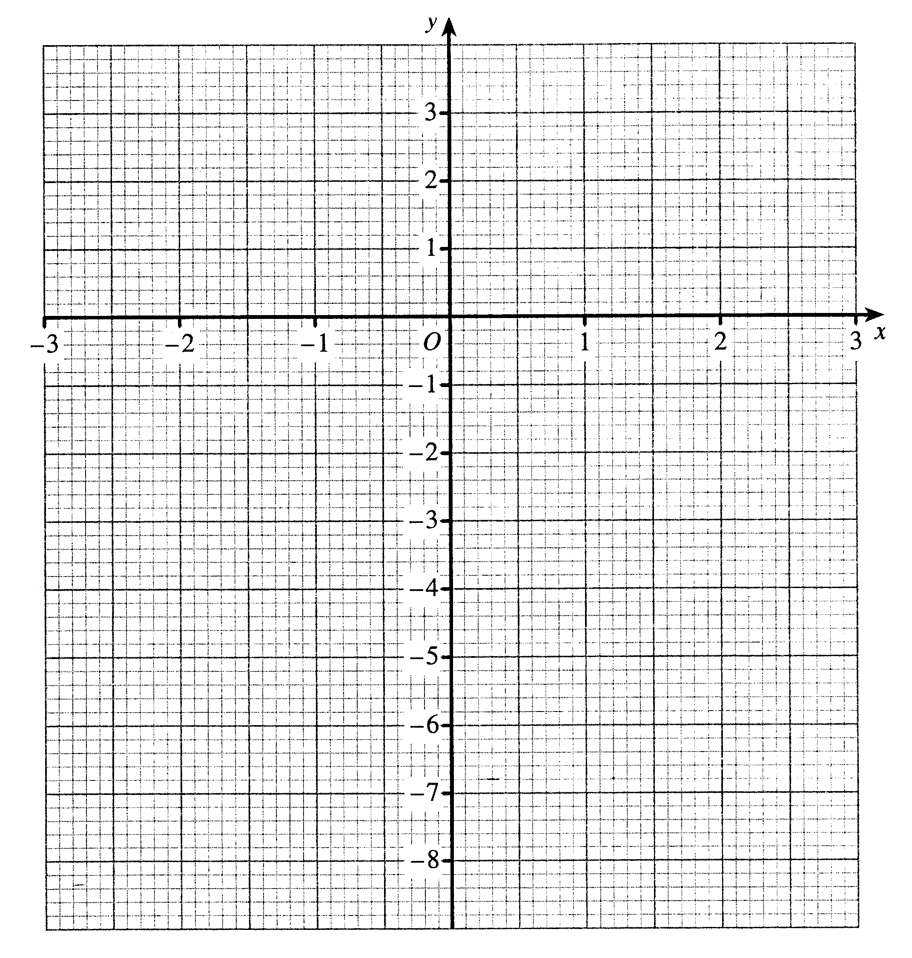

(a) Draw a graph of the line y = -x on the grid above. [2]

(b) Complete the table for the graph of y = x² – 7

x | -3 | -2 | -1 | 0 | 1 | 2 | 3
y | 2 | -3
[2]

(c) Plot the points from your table onto the graph. [2]

(d) Use your graph to find a solution to the simultaneous equations
y= x² – 7
y = -x
…………………………………………………………………………………………………………………………………
………………………………………………………………………………………………………………………………… [2]

Non- Calculator Questions

16. One method used for measuring paper identifies the different sizes of paper by using the letter A and then a number. A6 paper has half the area of A5; A5 paper has half the area of A4 and so on. The diagram shows how a sheet of A0 could be split up.

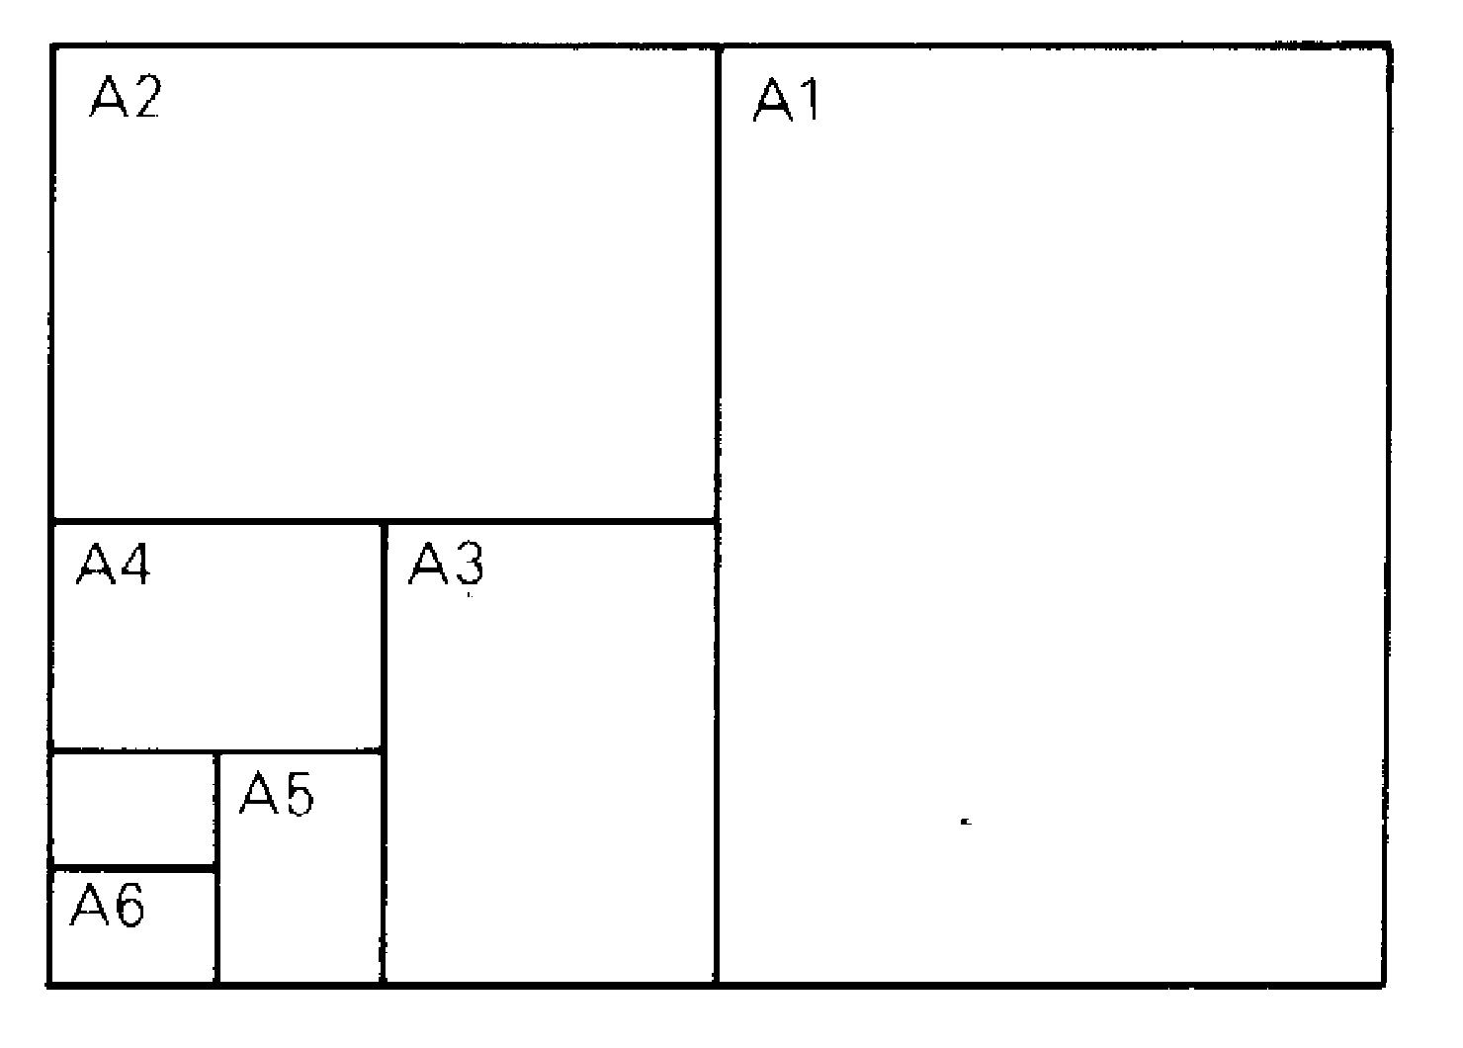

(a) If A0 paper has an area of 1m², what is the area of a piece of A4 paper? Give your answer in cm².
…………………………………………………………………………………………………………………………………
………………………………………………………………………………………………………………………………… [2]
(b) How many sheets of A6 paper can be made from a sheet of A0?
…………………………………………………………………………………………………………………………………
………………………………………………………………………………………………………………………………… [2]
(c) How many sheets of An paper can be made from a sheet of A0, where n is the nth division of the paper?
…………………………………………………………………………………………………………………………………
………………………………………………………………………………………………………………………………… [2]

17. Complete the multiplication table below:

X | -3 | 2 |  | -9
-1 |  | -2 | 4
 | 9 |  | 12 | 27
5 |  | 10 | -20 | -45
7 | -21 | 14

[4]
18. Mr Jones monitored the distance that employees in his company had to drive on business in one week:

Employee A 152 miles
Employee B 608 miles
Employee C 332 miles
Employee D 348 miles

If he represents this information on a pie chart, calculate the size of the angle needed to represent employee B.
…………………………………………………………………………………………………………………………………
…………………………………………………………………………………………………………………………………
………………………………………………………………………………………………………………………………… [2]

19. Line 2 2² – 4 = 2 x 0
Line 3 3² – 6 = 3 x 1
Line 4 4² – 8 = 4 x 2
Line 5 5² – 10 = 5 x 3

(a) Write down line 1 of this pattern
………………………………………………………………………………………………………………………………… [1]
(b) Write down the nth line of this pattern
………………………………………………………………………………………………………………………………… [2]

20. Jake uses this rhyme to convert between pints and litres:
A litre of water’s a pint and three quarters

If the price of petrol increases by 2p per litre and the tank in Jake’s car holds 10 gallons, how much more will it cost for him to buy a full tank of fuel? Give your answer to the nearest penny. Remember that there are 8 pints in a gallon.
…………………………………………………………………………………………………………………………………
…………………………………………………………………………………………………………………………………
………………………………………………………………………………………………………………………………… [3]

21. The line y = mx + c passes through the points (6,0), (3,-1) and (-3,-3)

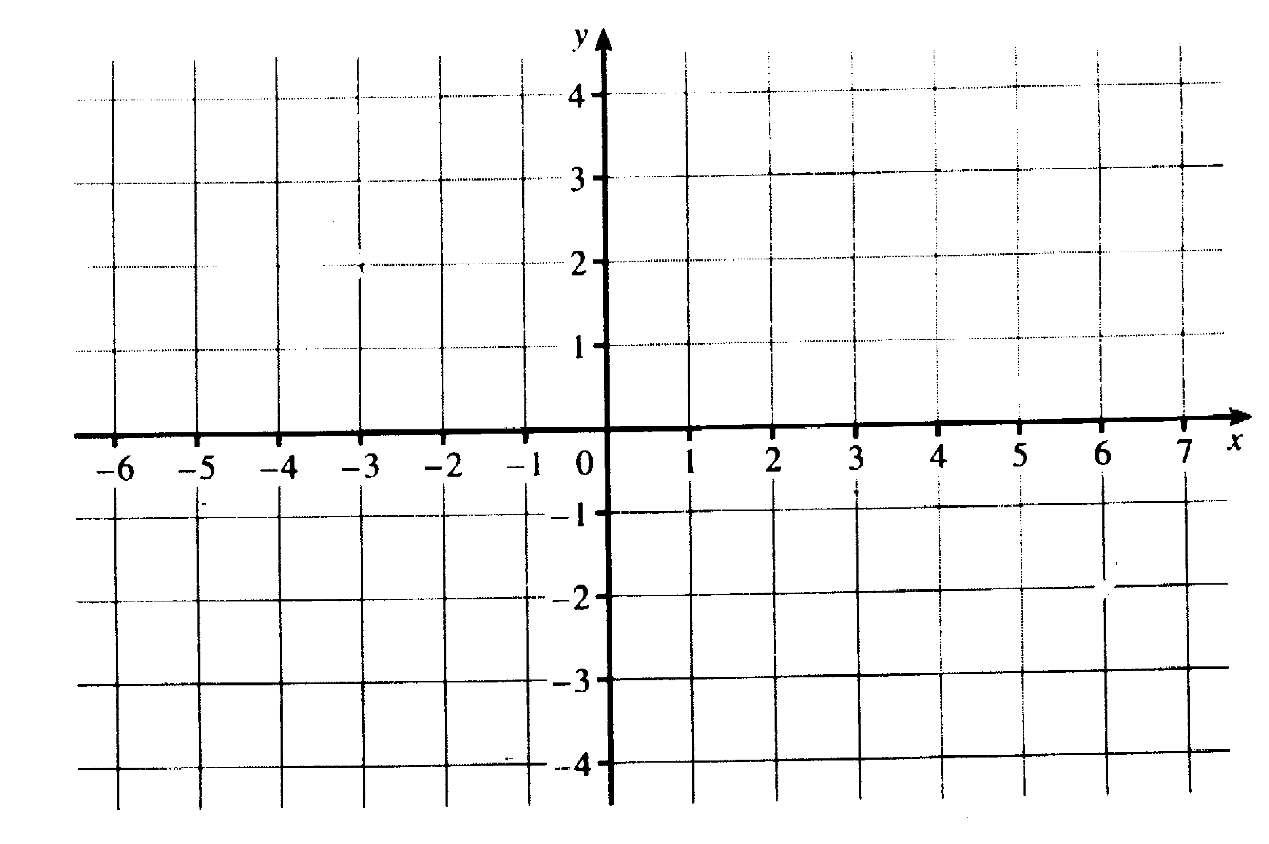

(a) Plot the points on the graph provided and draw in the line y = mx + c.
[2]

(b) Find the value of c
…………………………………………………………………………………………………………………………………
………………………………………………………………………………………………………………………………… [1]
(c) Find the value of m
…………………………………………………………………………………………………………………………………
………………………………………………………………………………………………………………………………… [2]

22. Solve the following equations

(a) 5x - 7 = 33
…………………………………………………………………………………………………………………………………
………………………………………………………………………………………………………………………………… [1]
(b) 5(x – 1) + 2(x – 5) = 13
…………………………………………………………………………………………………………………………………
…………………………………………………………………………………………………………………………………
…………………………………………………………………………………………………………………………………
………………………………………………………………………………………………………………………………… [2]

23(a) Solve the inequality
8 – 2w ‹ 14
…………………………………………………………………………………………………………………………………
…………………………………………………………………………………………………………………………………
………………………………………………………………………………………………………………………………… [2]
(b) List all the whole number solutions of the inequality
x² ≤ 4
…………………………………………………………………………………………………………………………………
………………………………………………………………………………………………………………………………… [3]

24. Write these numbers in order, smallest first. Remember to show all your working.
0.5, , 46%
…………………………………………………………………………………………………………………………………
…………………………………………………………………………………………………………………………………
………………………………………………………………………………………………………………………………… [2]

25. Solve the simultaneous equations

3x + 5y = -1
2x – 4y = 14
…………………………………………………………………………………………………………………………………
…………………………………………………………………………………………………………………………………
…………………………………………………………………………………………………………………………………
…………………………………………………………………………………………………………………………………
…………………………………………………………………………………………………………………………………
…………………………………………………………………………………………………………………………………
…………………………………………………………………………………………………………………………………
…………………………………………………………………………………………………………………………………
………………………………………………………………………………………………………………………………… [4]

26(a) Around the world, there are 1,500,000,000 people who don’t have access to clean drinking water. Write this number in standard form.
…………………………………………………………………………………………………………………………………
………………………………………………………………………………………………………………………………… [2]

(b) 2.5 x 10⁷ people die each year from drinking unclean water. Write this as an ordinary number
…………………………………………………………………………………………………………………………………
………………………………………………………………………………………………………………………………… [1]
(c) What percentage of people who don’t have access to clean water, die each year?
…………………………………………………………………………………………………………………………………
…………………………………………………………………………………………………………………………………
………………………………………………………………………………………………………………………………… [2]

27. Factorise the following expressions:
(a) 3a + 9b -6c
…………………………………………………………………………………………………………………………………
………………………………………………………………………………………………………………………………… [1]
(b) 5g² – 15gh
…………………………………………………………………………………………………………………………………
………………………………………………………………………………………………………………………………… [2]
(c) x² – 2x - 15
…………………………………………………………………………………………………………………………………
………………………………………………………………………………………………………………………………… [2]
(d) Use your answer to part (c) to solve the equation
x² – 2x - 15 = 0
…………………………………………………………………………………………………………………………………
…………………………………………………………………………………………………………………………………
………………………………………………………………………………………………………………………………… [2]

28(a) Here are the first five terms in a series
3 7 11 15 19
Find the nth term in the series
…………………………………………………………………………………………………………………………………
………………………………………………………………………………………………………………………………… [2]
(b) Find the nth term in the series
-3 0 5 12 21
…………………………………………………………………………………………………………………………………
…………………………………………………………………………………………………………………………………
………………………………………………………………………………………………………………………………… [3]

29. 5 8 15 18 23 48 51
From the numbers in the box, write down
(a) Two prime numbers
………………………………………………………………………………………………………………………………… [2]
(b) A cube number
………………………………………………………………………………………………………………………………… [1]

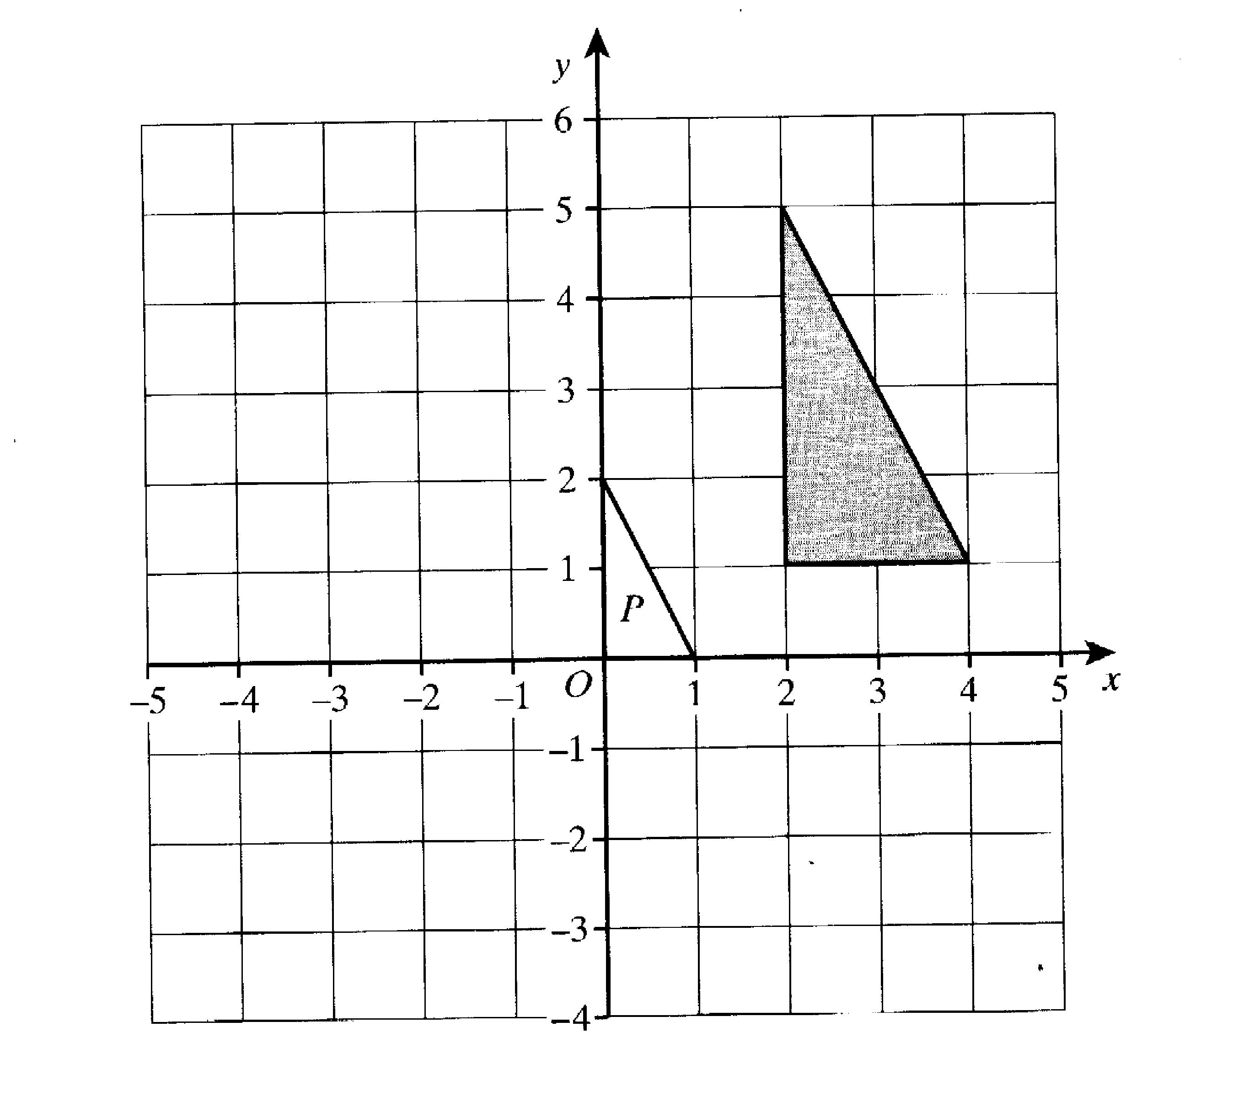
30.

Triangle P is an enlargement of the shaded triangle.
(a) What is the scale factor of the enlargement?
…………………………………………………………………………………………………………………………………
………………………………………………………………………………………………………………………………… [1]
(b) Find the coordinates of the centre of enlargement.
…………………………………………………………………………………………………………………………………
………………………………………………………………………………………………………………………………… [1]
END OF TEST

Answers for Past paper 5

1.(a) 12 years, (b) 11years 11months | 17. -4, 3, 9, -3, -6, -15, -28, -63
2. (a) one vertical line (b) isosceles triangle  (c) trapezium, (d) 150º | 18. 152º
3. (a) 78.54cm² (b) 113.1cm²  (c) 34.56cm² (d) 2.76m³ | 19. (a) 1² – 2 = 1 x -1 (b) n² – 2n = n x (n – 2)
4.(a) 14, (b) 3 | 20. 91p
5. 24cm | 21. (a) on graph (b) -2 (c)
6. 38p | 22. (a) x = 8, (b) x = 4
7. 70m | 23. (a) w › -3 (b) -2, -1, 0, 1, 2
8. (a) 55º (b) 30º (c)95º | 24. 0.444, 0.46, 0.5
9. (a) 0.3 (b) on time 0.2, spaces/ no spaces 0.7, 0.3, 0.7, 0.3 (c) 0.14 | 25. x=3, y=-2
10. x= 13.84 | 26. (a) 1.5 x 10⁹ (b) 25 000 000 (c) 1.7%
11. 78cm | 27. (a) 3(a + 3b -2c) (b) 5g(g – 3h)  (c) (x – 5)(x + 3) (d) x = 5 or x = -3
12. (a) 345º ± 2º | 28. (a) 4n-1  (b) n² - 4
13. (a) The modal class is 30 ˂ t ≤ 60  (b) ∑fₓ  90+583+675+1260+1350 = 3960 = 79.2  50 50  ∑f | 29 (a) 5 and 23  (b) 8
14. x² + x²= 190²  2x² = 36100 so x²= 18050  X= 134.4 (1d.p) | 30.(a) Enlargement scale factor 2  (b) (-2, -1)
15.b) x -3 -2 -1 0 1 2 3
Y 2 -3 -6 -7 -6 -3 2
d) x= 2.2, y=-2.2

16. (a)625cm², (b) 64 (c)2^{n}

PAST PAPER 6

Paper 3 2004

Two and a half hours

Name ………………………………………………………………………

ATTEMPT ALL QUESTIONS

Show all your working in the space provided and make sure that your answer is clear.

It is assumed that you have a scientific calculator, ruler and protractor.

If your calculator does not have a π button, take the value of π to be 3.142.

The marks for each question are given in brackets by the side of the question.

Marks may be given for method even if your answer is wrong.

The total marks available are 120.

Calculator Questions.

1. List these numbers from smallest to largest. Remember to show all your working.
, , ,
…………………………………………………………………………………………………………………………………
…………………………………………………………………………………………………………………………………
…………………………………………………………………………………………………………………………………
………………………………………………………………………………………………………………………………… [3]

2. Nadia is paid a basic rate of £4.90 per hour for a 35 hour week.
Overtime is paid at 1½ times the basic rate.
In one week her total pay was £230.30.
Calculate how many hours of overtime she had worked
…………………………………………………………………………………………………………………………………
…………………………………………………………………………………………………………………………………
…………………………………………………………………………………………………………………………………
………………………………………………………………………………………………………………………………… [2]

3(a) ABCDE is a regular pentagon.
A
B
E

C
D

Calculate the size of angle A.
…………………………………………………………………………………………………………………………………
…………………………………………………………………………………………………………………………………
………………………………………………………………………………………………………………………………… [2]

(b) Jane sketches a pattern of tessellating tiles which are regular pentagons.

Is her assumption that regular pentagons will tessellate correct? Explain how you got your answer.
…………………………………………………………………………………………………………………………………
…………………………………………………………………………………………………………………………………
………………………………………………………………………………………………………………………………… [1]

4. Solve the following equations: Do not use a trial and improvement method.
(a) 4a – 7 = 13
…………………………………………………………………………………………………………………………………
…………………………………………………………………………………………………………………………………
………………………………………………………………………………………………………………………………… [2]
(b) 3f + 15 = 5f + 21
…………………………………………………………………………………………………………………………………
…………………………………………………………………………………………………………………………………
………………………………………………………………………………………………………………………………… [2]
(c) 2h + 4 = h – 5
9
…………………………………………………………………………………………………………………………………
…………………………………………………………………………………………………………………………………
…………………………………………………………………………………………………………………………………
…………………………………………………………………………………………………………………………………
……………………………………………………………………………………………………………………………… [3]
5. (a). A camera is in a sale with 12% off the recommended price. If the recommended price was £135, how much will the camera cost now?
…………………………………………………………………………………………………………………………………
…………………………………………………………………………………………………………………………………
…………………………………………………………………………………………………………………………………
………………………………………………………………………………………………………………………………… [2]
(b) A tripod is in the same sale for £13.20. what was its original price?
…………………………………………………………………………………………………………………………………
…………………………………………………………………………………………………………………………………
…………………………………………………………………………………………………………………………………
………………………………………………………………………………………………………………………………… [3]

6. Two porthole designs are being considered for use in a cabin panel of a ship
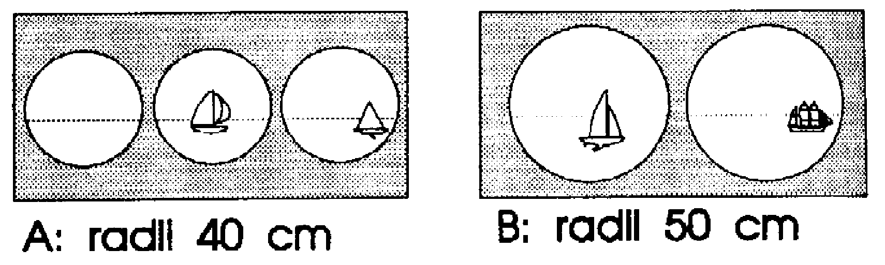

A: radii 35 cm B: radii 45 cm

Design A consists of three portholes, each of radius 35 cm.
Design B consists of two portholes each of radius 45 cm.

(a) Calculate the area of one of the windows in panel A
…………………………………………………………………………………………………………………………………
…………………………………………………………………………………………………………………………………
………………………………………………………………………………………………………………………………… [2]
(b) Calculate the total window area for panel A
…………………………………………………………………………………………………………………………………
………………………………………………………………………………………………………………………………… [1]

PTO for next part of question.

(c) Which of the two porthole designs would let in most light? Show all your working clearly.
…………………………………………………………………………………………………………………………………
…………………………………………………………………………………………………………………………………
…………………………………………………………………………………………………………………………………
………………………………………………………………………………………………………………………………… [3]

7. The mean weight of six parcels is 4.2 kg. When another parcel is added, the mean weight is increased to 5.1 kg. What is the weight of the seventh parcel?
…………………………………………………………………………………………………………………………………
…………………………………………………………………………………………………………………………………
…………………………………………………………………………………………………………………………………
………………………………………………………………………………………………………………………………… [3]
8. ABC is a triangle with A at (-3,2). B at (-1,3) and C at (-1, -2)

(a) Plot the points A,B and C and draw in the triangle ABC.
[2]
(b) Calculate the area of triangle ABC
…………………………………………………………………………………………………………………………………
…………………………………………………………………………………………………………………………………
………………………………………………………………………………………………………………………………… [3]
(c) The triangle ABC is reflected in the line y = -3. Draw the image of the triangle after this transformation. Label it A’B’C’
[3]
(d) The image of ABC after an enlargement is at A’’ ( - ,), B’’ ( ,1) and C’’ ( , 1). Draw this new triangle on the diagram and give the scale factor of the enlargement.
…………………………………………………………………………………………………………………………………
………………………………………………………………………………………………………………………………… [2]
(e) Find the coordinates of the centre of enlargement.
…………………………………………………………………………………………………………………………………
………………………………………………………………………………………………………………………………… [2]

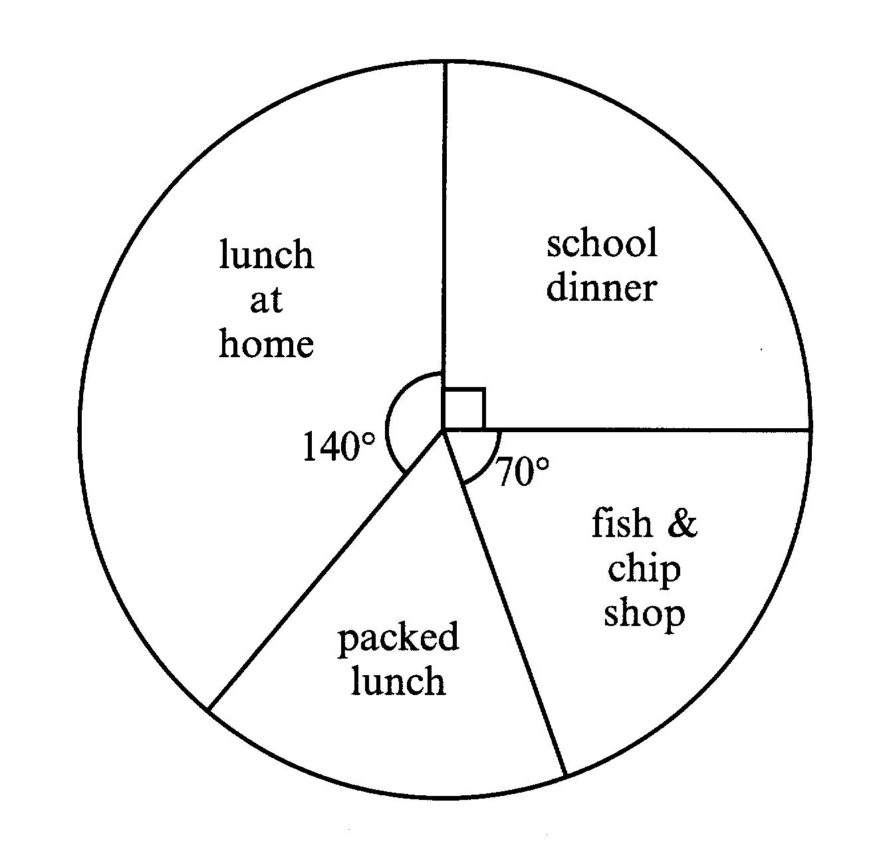
9. The teachers in a secondary school did a survey to find out what pupils in their school did for lunch one day. They asked a total of 900 pupils. The results are shown in the pie chart below.

(a) How many pupils had lunch at the fish and chip shop?
…………………………………………………………………………………………………………………………………
…………………………………………………………………………………………………………………………………
………………………………………………………………………………………………………………………………… [2]
(b) How many had a packed lunch?
…………………………………………………………………………………………………………………………………
…………………………………………………………………………………………………………………………………
………………………………………………………………………………………………………………………………… [2]
10 (a). Complete the table for the graph of y = x² – 2x - 7

x | -2 | -1 | 0 | 1 | 2 | 3
y | 1 | -4
[2]
(b) Draw the graph on the grid.
[3]
(c) Use your graph to solve the equation x² – 2x -7 = -5
…………………………………………………………………………………………………………………………………
………………………………………………………………………………………………………………………………… [2]

11. David sketches a toy boat.
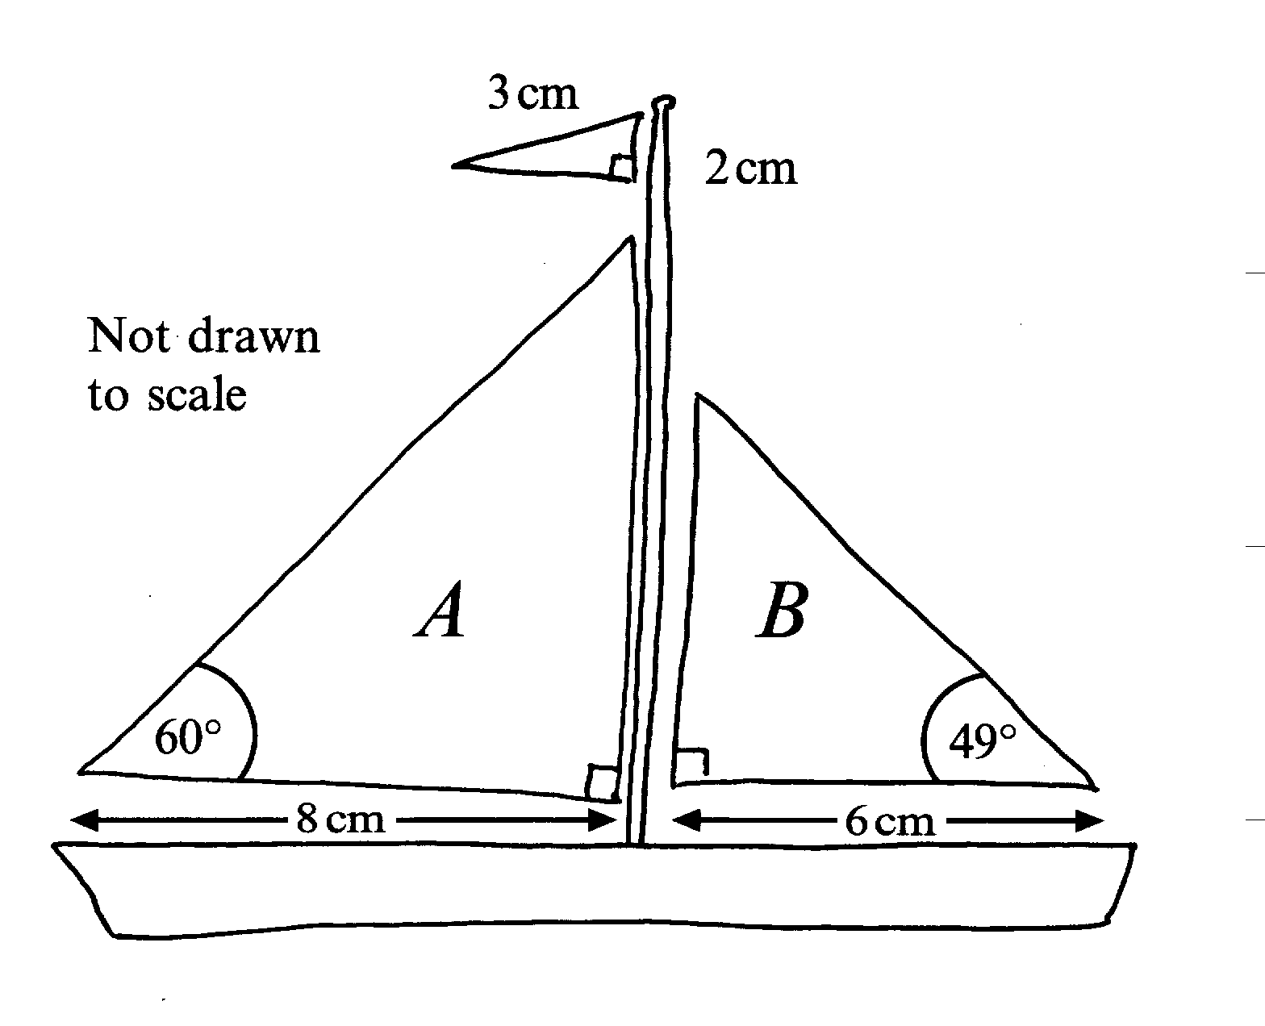

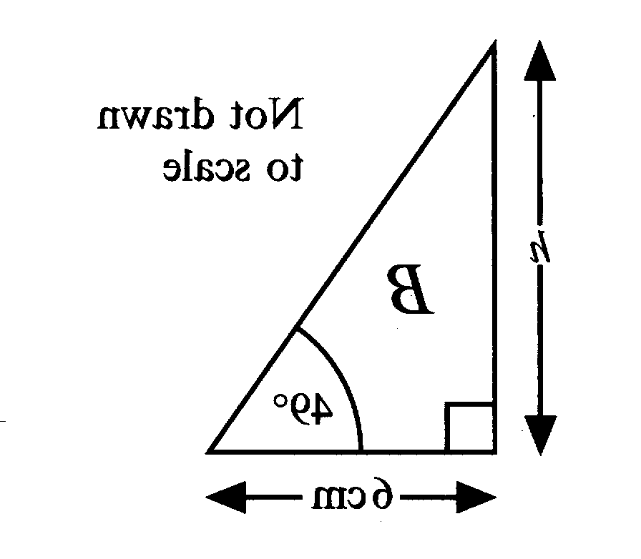

A
h cm

60º
8 cm

(a) Calculate the height h of sail A.

…………………………………………………………………………………………………………………………………
…………………………………………………………………………………………………………………………………
…………………………………………………………………………………………………………………………………
…………………………………………………………………………………………………………………………………
………………………………………………………………………………………………………………………………… [3]
(b) Sail B is 4.5 cm high. Calculate the perimeter of the sail.
…………………………………………………………………………………………………………………………………
…………………………………………………………………………………………………………………………………
…………………………………………………………………………………………………………………………………
…………………………………………………………………………………………………………………………………
………………………………………………………………………………………………………………………………… [4]

Non-Calculator Questions

12.
1 | 2 | 3 | 4 | 5 | 6 | 7 | 8 | 9 | 10
11 | 12 | 13 | 14 | 15 | 16 | 17 | 18 | 19 | 20
21 | 22 | 23 | 24 | 25 | 26 | 27 | 28 | 29 | 30
31 | 32 | 33 | 34 | 35 | 36 | 37 | 38 | 39 | 40
41 | 42 | 43 | 44 | 45 | 46 | 47 | 48 | 49 | 50
51 | 52 | 53 | 54 | 55 | 56 | 57 | 58 | 59 | 60
61 | 62 | 63 | 64 | 65 | 66 | 67 | 68 | 69 | 70
71 | 72 | 73 | 74 | 75 | 76 | 77 | 78 | 79 | 80
81 | 82 | 83 | 84 | 85 | 86 | 87 | 88 | 89 | 90
91 | 92 | 93 | 94 | 95 | 96 | 97 | 98 | 99 | 100

John and Kate were playing a guessing game. Kate thought of a number between 1 and 100 which John had to guess. John was allowed to ask 5 questions, which are listed with Kate’s responses in the table below.

John’s Questions | Kate’s Responses
Is it prime? | No
Is it odd? | Yes
Is it less than 50? | No
Is it a multiple of 3? | Yes
Is it a multiple of 7? | Yes

What is the number that Kate thought of?
…………………………………………………………………………………………………………………………………
………………………………………………………………………………………………………………………………… [3]

13. Join up all the pairs of equivalent expressions.

2a(a + 4b) 2a² + 4b

2(a² + 2b) 12ab + 27a²

12ab + 9a 2a² + 8ab

3a(4b + 9a) 3a(4b + 3)

[3]

14.

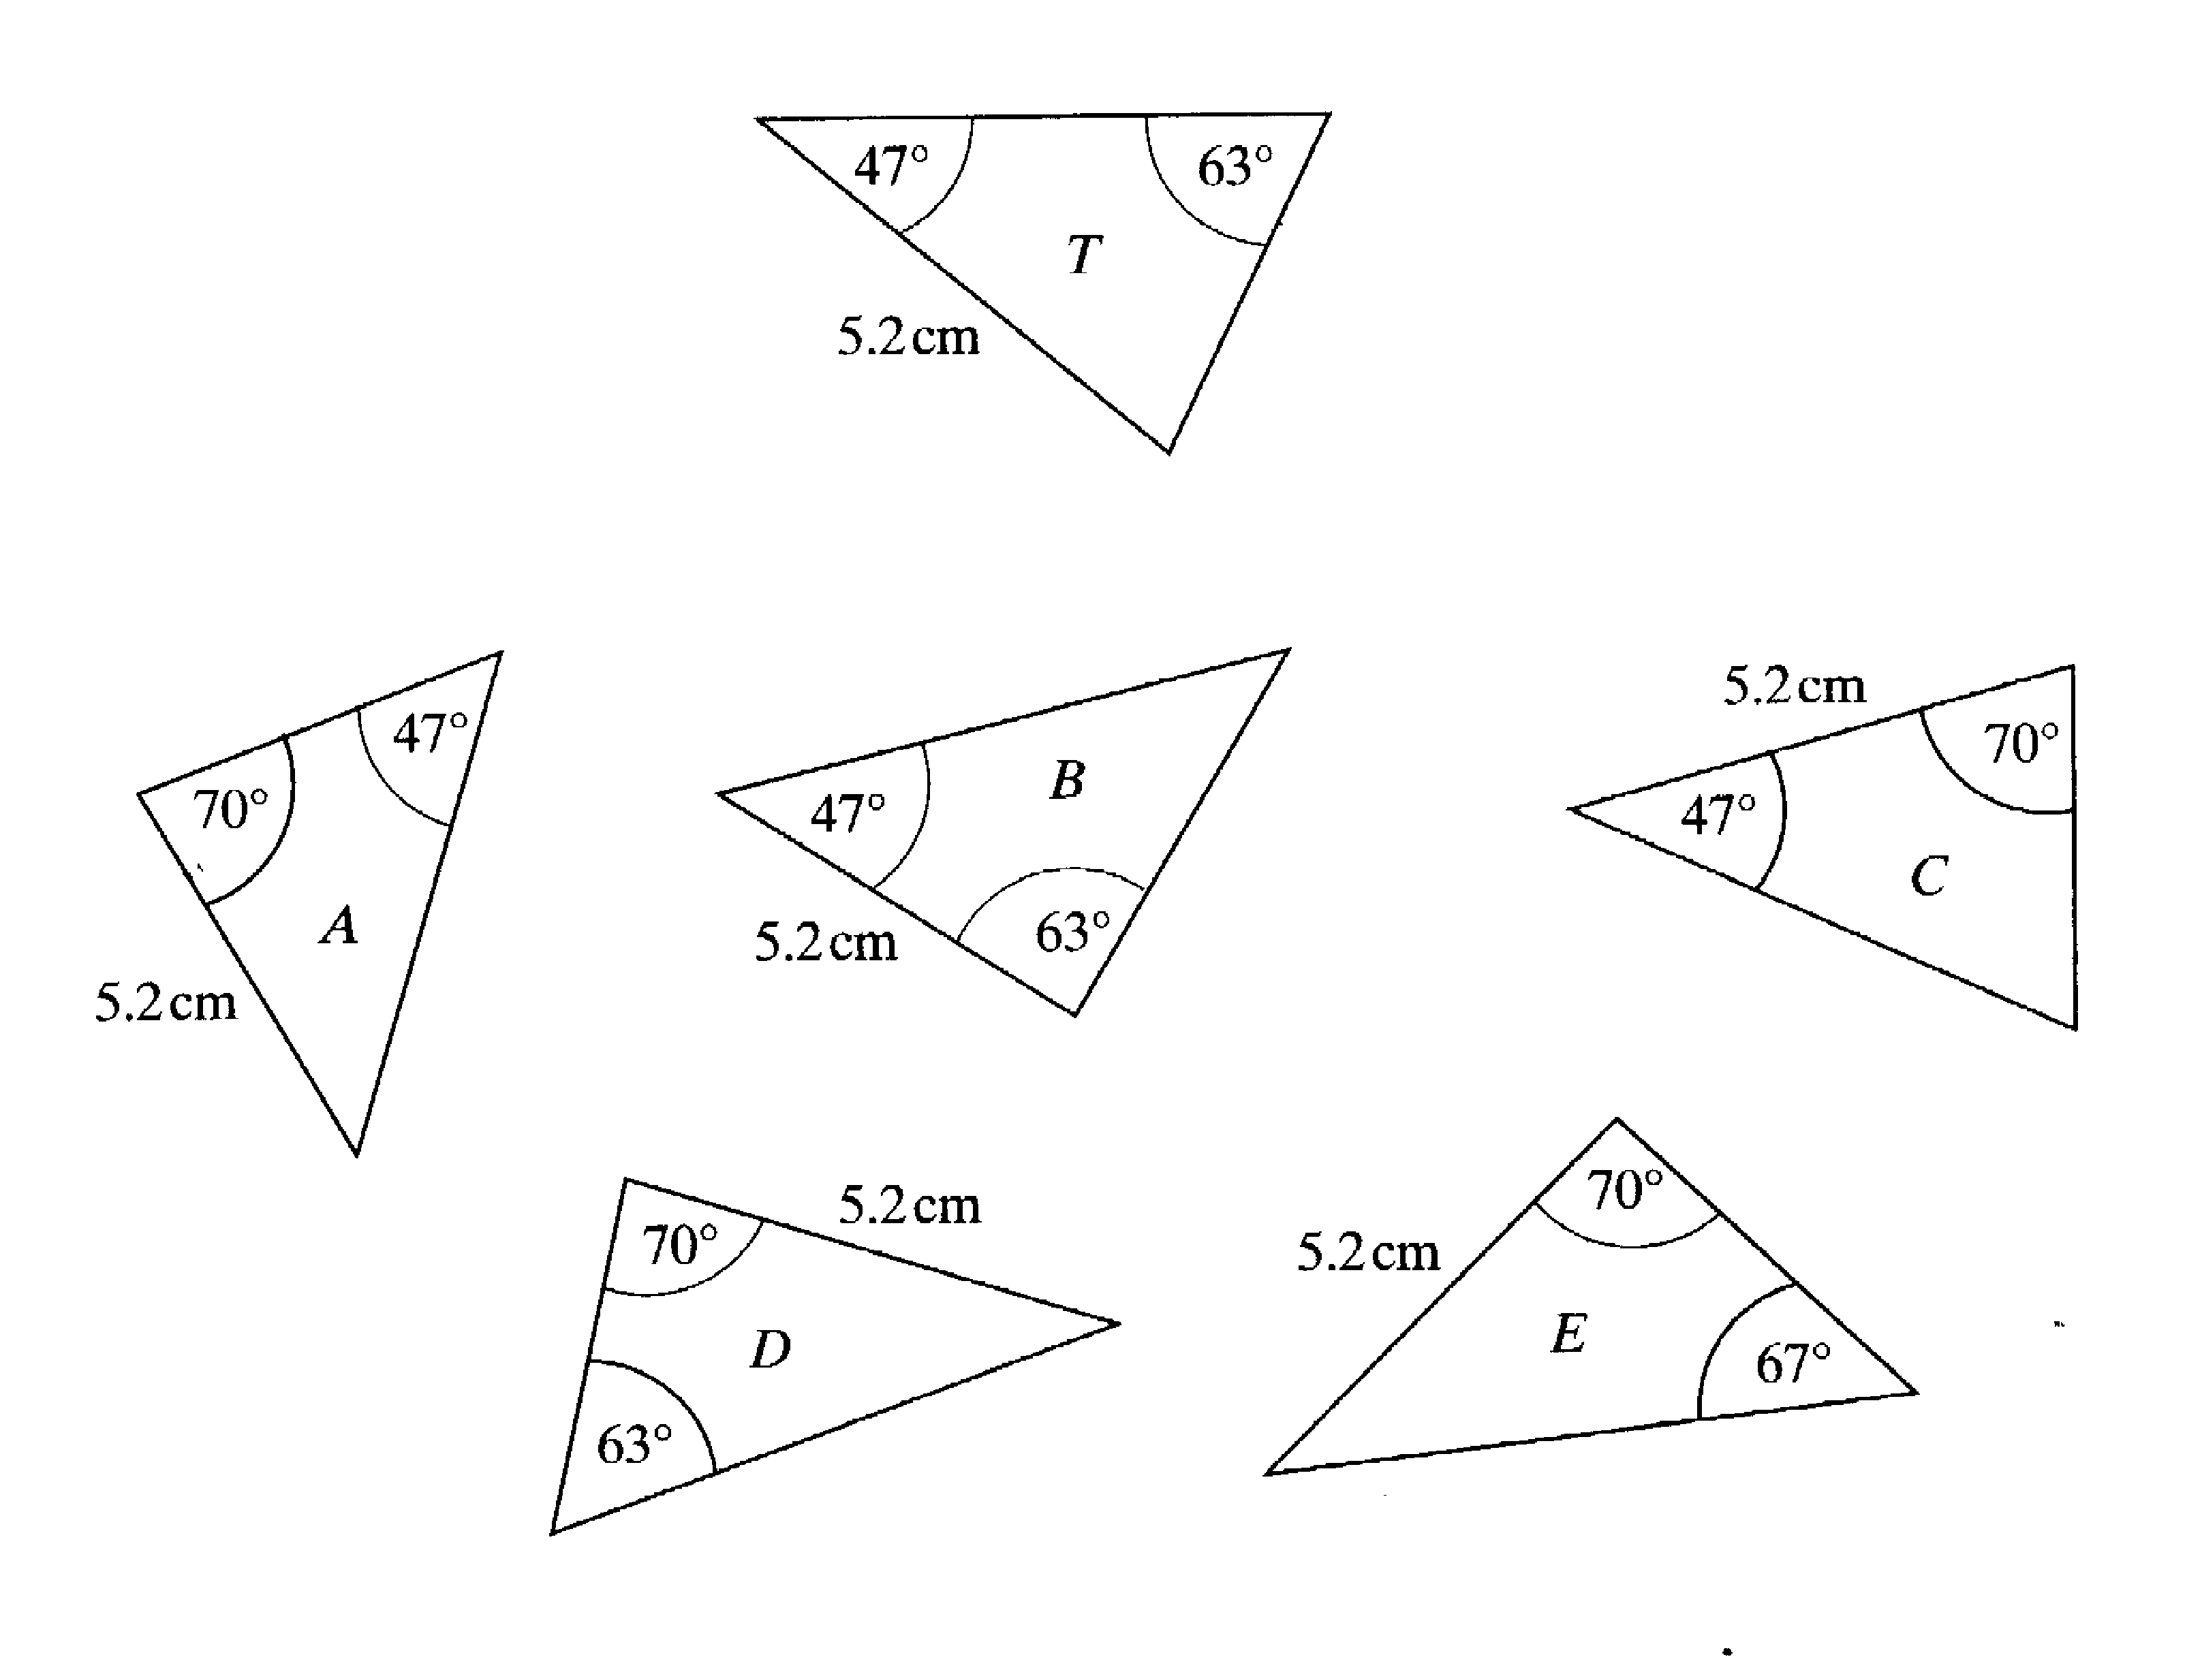

Which of the triangles A, B,C, D and E are congruent to triangle T?
…………………………………………………………………………………………………………………………………
………………………………………………………………………………………………………………………………… [2]

15. Solve the following simultaneous equations. Do not use a trial and improvement method.

4a + 5b = 22
3a + 2b = 6
…………………………………………………………………………………………………………………………………
…………………………………………………………………………………………………………………………………
…………………………………………………………………………………………………………………………………
…………………………………………………………………………………………………………………………………
………………………………………………………………………………………………………………………………… [4]

16. In the box are six numbers written in standard form.
7.5 x 10⁴ 8.1 x 10⁵ 9.3 x 10⁻³
6.25 x 10⁻¹ 8.16 x 10³ 5.37 x 10⁻²

(a) Write down the largest number. ………………………………………………………………………………………………………………………………… [1]
(b) Write down the smallest number.
………………………………………………………………………………………………………………………………… [1]
(c) Write your answer to (b) as an ordinary number.
………………………………………………………………………………………………………………………………… [1]

17. A bag contains a total of 20 beads. There are 6 red beads, 9 blue beads and 5 white beads.
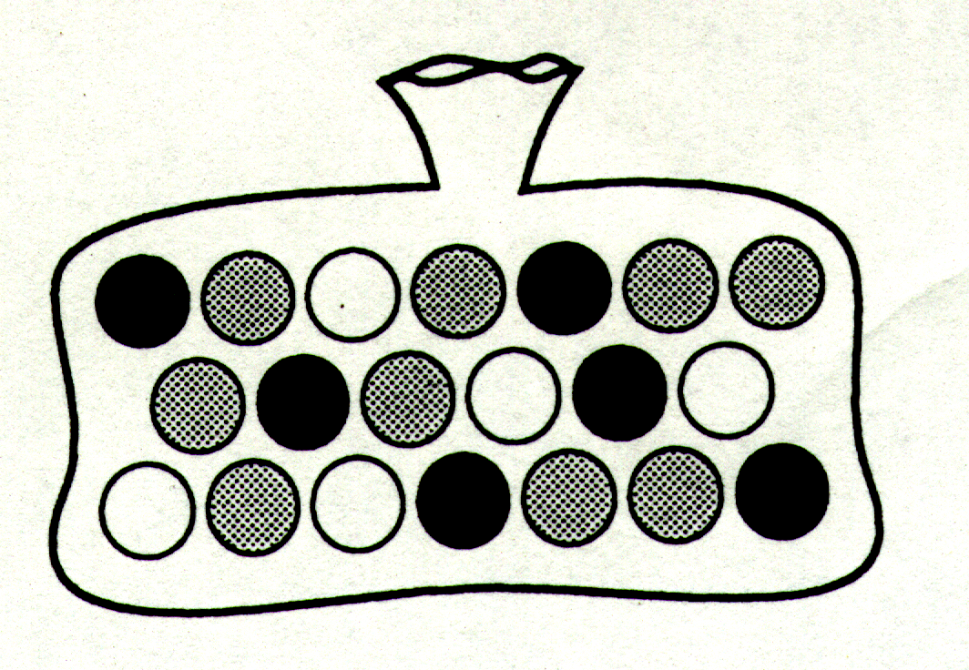

(a) A bead is taken at random from the bag. What is the probability that it is a blue bead?
…………………………………………………………………………………………………………………………………
………………………………………………………………………………………………………………………………… [1]
(b) A bead is taken at random from the bag. What is the probability that it is not a white bead?
…………………………………………………………………………………………………………………………………
………………………………………………………………………………………………………………………………… [1]

(c) A bead is taken at random from the bag and not replaced. A second bead is then taken from the bag. Complete the tree diagram to show the possible outcomes.

First ball Second ball

red

[3]

(d) Use the tree diagram to determine the probability that both of the balls are white.
………………………………………………………………………………………………………………………………
………………………………………………………………………………………………………………………………
………………………………………………………………………………………………………………………………… [2]
(e) Use the tree diagram to determine the probability that at least one of the balls is white.
………………………………………………………………………………………………………………………………
………………………………………………………………………………………………………………………………
………………………………………………………………………………………………………………………………
………………………………………………………………………………………………………………………………… [3]

18. ABCDEFGH is a regular octagon.

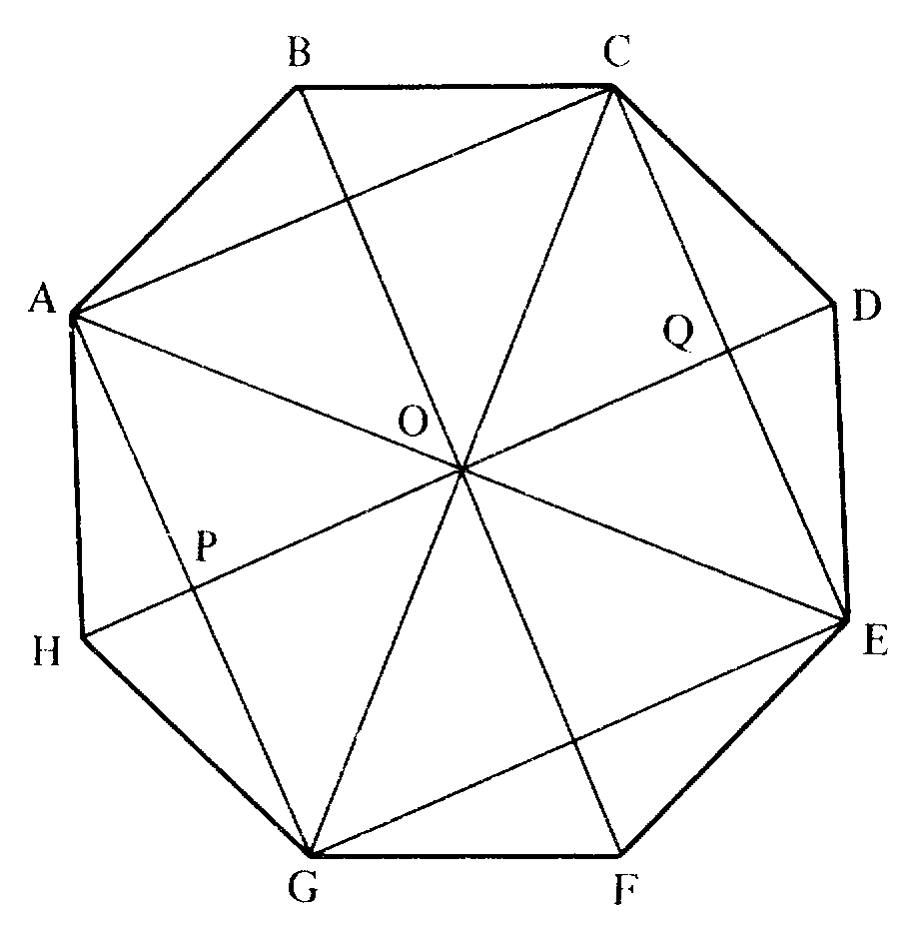

(a) Describe the figure AOGH.
………………………………………………………………………………………………………………………………… [1]
(b) Describe the figure OPGE
………………………………………………………………………………………………………………………………… [1]
(c) Calculate the size of angle COD
………………………………………………………………………………………………………………………………… [1]

19. Make p the subject of the formula
= r
…………………………………………………………………………………………………………………………………
…………………………………………………………………………………………………………………………………
…………………………………………………………………………………………………………………………………
………………………………………………………………………………………………………………………………… [2]

20. Solve the following inequalities:
(a) 2p – 5 > -11
………………………………………………………………………………………………………………………………… ………………………………………………………………………………………………………………………………… [1]
(b) 6 - 3x < -6
…………………………………………………………………………………………………………………………………
…………………………………………………………………………………………………………………………………
………………………………………………………………………………………………………………………………… [2]

21. North
X Lighthouse

X
Ship Not drawn to scale

A captain of a ship at sea spots a lighthouse on a bearing of 085º from the ship. What is the bearing of the ship from the lighthouse?

………………………………………………………………………………………………………………………………………..
………………………………………………………………………………………………………………………………………..
……………………………………………………………………………………………………………………………………….. [2]

22. (a) Factorise the expression
x² + 3x - 10
…………………………………………………………………………………………………………………………………
…………………………………………………………………………………………………………………………………
………………………………………………………………………………………………………………………………… [2]

(b) Using your answer from part (a), solve the equation
x² + 3x - 10= 0
…………………………………………………………………………………………………………………………………
…………………………………………………………………………………………………………………………………
………………………………………………………………………………………………………………………………… [2]

23.. For each of the following number series, find the next two terms and then find the nth term.

(a) 1, 4, 7, 10, …, …,
Next two terms
………………………………………………………………………………………………………………………………… [1]
nth term
………………………………………………………………………………………………………………………………… [2]
(b) 3, 6, 11, 18, …, …,
Next two terms
………………………………………………………………………………………………………………………………… [1]
nth term
………………………………………………………………………………………………………………………………… [2]
(c) 2, 4, 8, 16, …, …,
Next two terms
………………………………………………………………………………………………………………………………… [1]
nth term
………………………………………………………………………………………………………………………………… [2]

24. Jason weighs 9 stone 8 pounds. He converts his weight to kilograms using the following calculation.

(a) What is his weight in Kg?
……………………………………………………………………………………………………………………………………….. [1]
(b) Show how he could simplify the calculation to get a good mental estimate.
………………………………………………………………………………………………………………………………………..
………………………………………………………………………………………………………………………………………..
………………………………………………………………………………………………………………………………………..
……………………………………………………………………………………………………………………………………….. [2]

25. A survey was conducted in a street of 50 houses, asking how many people lived in each house. These are the results:

Size of household | 1 | 2 | 3 | 4 | 5 | 6
Number of households | 11 | 16 | 12 | 7 | 4 | 2

(a) Calculate the modal number of people per household.
………………………………………………………………………………………………………………………………………..
………………………………………………………………………………………………………………………………………..
……………………………………………………………………………………………………………………………………….. [2]
(b) Calculate the median number of people per household.
………………………………………………………………………………………………………………………………………..
………………………………………………………………………………………………………………………………………..
……………………………………………………………………………………………………………………………………….. [2]
(c) Calculate the mean number of people per household.
………………………………………………………………………………………………………………………………………..
………………………………………………………………………………………………………………………………………..
………………………………………………………………………………………………………………………………………..
…………………………………………………………………………………………………………………………………… [3]

26. A wood with 600 trees is planted. The wood is planted with 200 pine trees, 80 oak trees, some birch trees and some ash trees.

(a) Five twelfths of the 600 trees are birch. How many birch trees are there?
…………………………………………………………………………………………………………………..………………
…………………………………………………………………………………………………………………..………………
…………………………………………………………………………………………………………………..……………… [1]
(b) What is the ratio of pine trees to oak trees? Give your answer in its simplest form.
…………………………………………………………………………………………………………………..………………
…………………………………………………………………………………………………………………..………………
…………………………………………………………………………………………………………………..……………… [2]

END OF TEST

Answers to Past Paper 6

1.  , | 17. (a) (b)  (c) 1st ball - Bl , Wh ,  2nd ball – R , Bl , Wh , R , Bl , Wh , R , Bl , Wh  (d) (e)
2. 8 hours

3. (a) 108º, (b) No 360º is not a multiple of 108º

4. (a) a = 5, (b) f = -3, (c) h=7 | 18. (a) kite (b) trapezium (c) 45º
5. (a) £118.80. (b) £15 | 19. 2p = 6r + 10
6. (a) 3848cm², (b) 11545cm², (c) B is the best with an area of 12723cm² | 20. (a) p>-3 (b) x>4
7. 10.5KG | 21. 265º
8. (a) on graph, (b) 10 cm2, (c)A’(-3,-8), B’(-1,-9), C’(-1,-4) , (d) , (e) (2, -1) | 22. (a) (x + 5)(x – 2) (b) x = -5 or x = 2
9. (a) 175, (b) 150 | 23. (a) 3, 16, 3n – 2 (b) 27,38, n² + 2  (c) 32, 64, 2^{n}
10. (a) -7, -8, -7, -4 (b) graph  (c) x = -0.75 or x = 2.75 | 24. (a) 60.91 kg (b) = 75
11.(a) 13.86cm, (b) 18cm | 25.(a) 2 (b) 2 (c) 2.78
12. 63 | 26. (a) 250 (b) 5.2
13. 2a(a+4b) = 2a²+8b
2(a²+2b) = 2a²+4b
12ab+9a = 3a(4b+3)
3a(4b+9a) = 12ab + 27a²
14. C and D

15. a=-2 b=6

16. (a) 8.1 x 10⁵ (b) 9.3 x 10 ⁻³ (c) 0.0093

