GSMA Europe
Park View, 4th floor
Chaussée d’Etterbeek 180
1040 Brussels

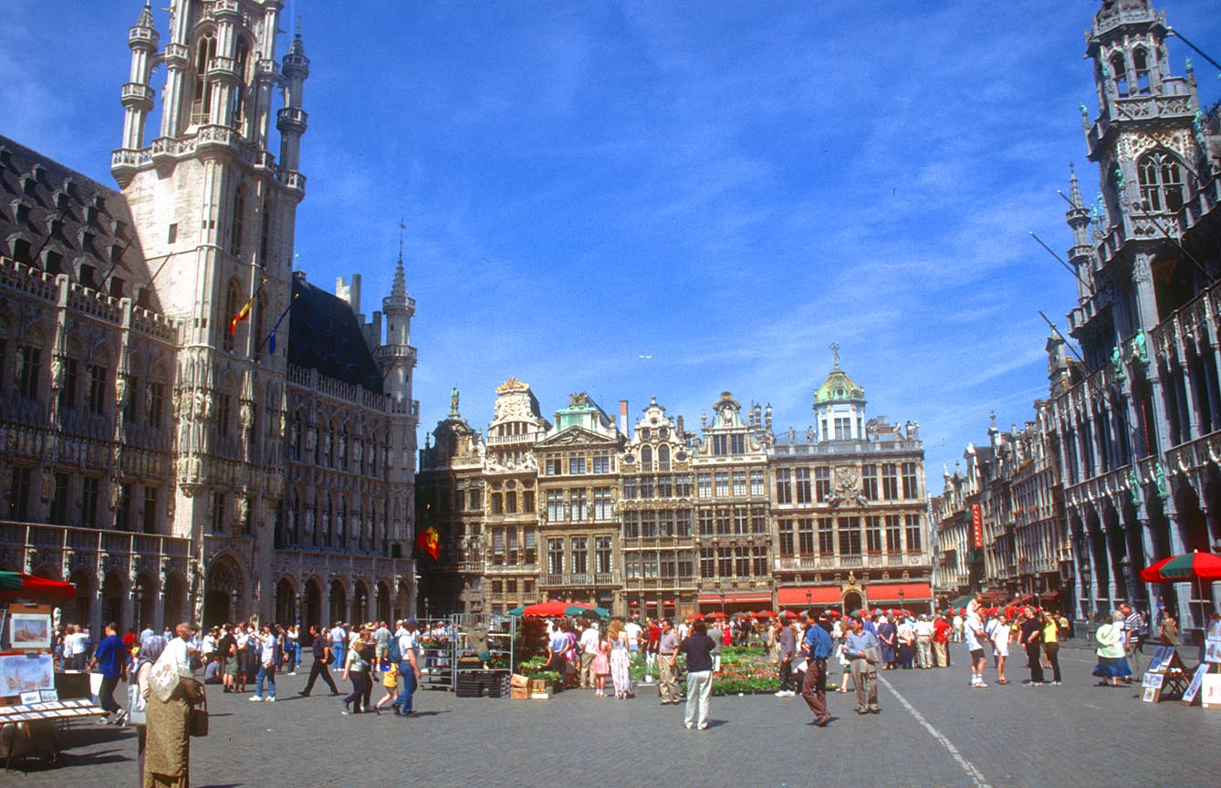

Meeting Venue:

Park View, 4th Floor, Chaussée d’Etterbeek 180, 1040 Brussels, Belgium

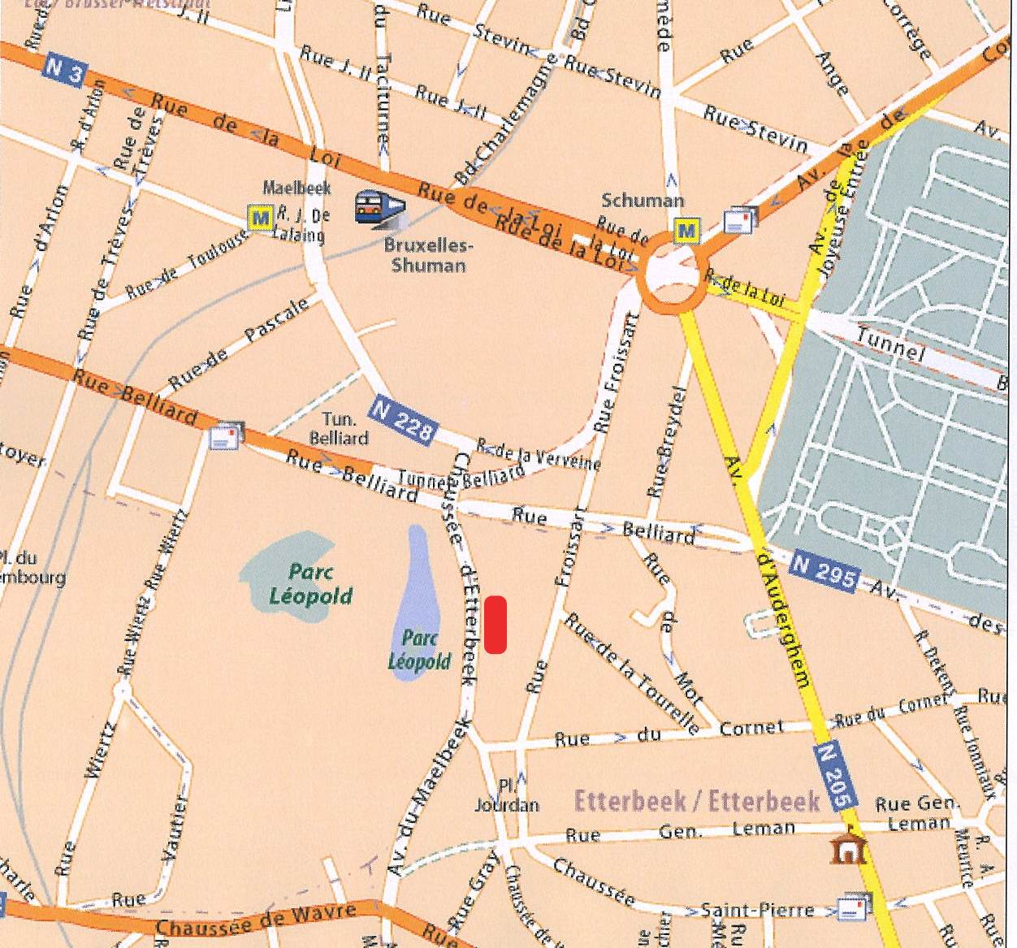

Park View is located in the heart of the European district, surrounded by all the major European Institutions, facing Parc Leopold. The office is conveniently situated close to the railway as well as with easy access to the main metro line and several bus lines.

By metro or train:
From Eurostar you can take directly the metro to Schuman. Take line 2: direction Simonis (Leopold II) or 6 Roi Baudoin and change direction at Arts-Loi / Kunst Wet. Take line 1or 5 direction H. Debroux or Stockel / Stokkel and the 2nd stop is Schuman. From here the GSMA Europe office is at only 5 minutes walking distance.
From the Central station of Brussels (Brussel CENTRAAL), you take directly line 1 or 5direction H. Debroux or Stockel / Stokkel. The 4th stop is Schuman.

From the airport : A taxi from the airport will cost you about 30€ and takes 20 – 30 minutes. You can also take the Airport Express bus. This is bus number 12. The bus leaves from the Airport Zaventem and takes you directly to the Schuman roundabout. (about 20-30 minutes) From there our office is in walking distance.

By car: From France via Mons/E19: Before you get to Brussels take the Waterloo exit; Ring East, and follow the directions for the E40-Liège. Then take the “Bruxelles-Liège-Louvain” exit and go on to “Brussels”.
From Luxembourg via Namur (E411): Follow the directions for the E40 Liège via Ring (R0). Then take the “Bruxelles-Liège-Louvain” exit and go on to “Brussels”.
From Netherlands, via Antwerp (E19) and Oostende(E40): When you get to Brussels, follow the directions for the E40-Liège via Ring (R0). Take the “Bruxelles-Liège-Louvain” exit and go on to “Brussels”.
From Germany via Liège (E40): Stay on the E40 to the end.
In Brussels, follow the signs for “Centre/Communauté Européenne” and go through the tunnel. When you come out, continue along Avenue de Cortenbergh. At the roundabout, Rond Point Schuman, take the third exit to Rue Froissart. Turn right at Rue Belliard and then turn left to Chaussee d’Etterbeek 180. The Park View building is 50 metres away, on the left.

Parking
We have two parking spaces in the Park View garage. The Park View building does not have visitors’ parking but there are several payable parking possibilities in the neighbourhood if one not found on the street.

Parking Forte dei Marmi
61A, avenue du Maelbeek
Situated 200 meters from place Jourdan, 300m from our office
Opening hours :
Sunday-Thursday: 07 :00 – 22 :00
Friday-Saturday: 07:00 – 24:00
Parking Place Jourdan
Outdoor parking situated in the middle of the square.
Sofitel Hotel Parking
Private indoor parking, entrance on the side of Chaussée d’Etterbeek.

Hotel Accommodation in the vicinity of Parkview

Sofitel Brussels Europe hotel *5  http://www.sofitel.com  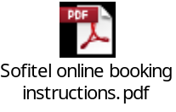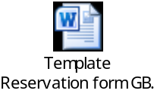  Corporate rate: €174 for Classic room and €204 for Superior room + €6 city tax (breakfast included) | Place Jourdan 1  1040 Brussels  Tel. +32 2 235 5100  Fax. +32 2 2355101  Email : H5282@sofitel.com
Aloft Brussels Schuman *4  http://www.aloftbrussels.com/  Corporate rate : €160/night (breakfast included)  Please quote ref nr 209484 | Place Jean Rey  1040 Brussels  Tel. +32 2 800 08 88  Fax. +32 2 800 08 99  Email. reservations.brussels@starwoodhotels.com
Stanhope hotel *5  http://www.thonhotels.be/stanhope | Rue du Commerce 9  1000 Brussels  Tel : +32 2 506 91 11  Fax : +32 2 512 1708  Email : info@stanhope.be
Radisson Blu EU hotel *5  http ://www.radissonblu.com/euhotel-brussels/contact | Rue d’Idalie 35  1050 Brussels  Tel : +32 2 626 81 11  Fax : +32 2 626 81 12  Email : info.brusselseu@radissonblu.com
Renaissance Brussel hotel *5  http ://www.marriott.com/hotels/travel/brubr-renaissance-brussels-hotel/ | Rue du Parnasse 19,  1050 Brussels  Tel. +32 2 505 29 29  Fax. +32 2 505 25 55
Hotel Silken Berlaymont *4  http://www.hoteles-silken.com/hotel-berlaymont-brussels/en/ | 11-19, Bd Charlemagne  1000 Brussels – Belgium Phone : +32 2 231 09 09  Fax : +32 2 230 33 71
rowne Plaza Brussels Europa *4  http ://www.brusselshotels.crowneplaza.com/ | Rue de la Loi 107  1040 Brussels Belgium  Tel: +32 2 230 1333  Fax: 32 2 230 0326  Email: info@europahotelbrussels.com
Newhotel Charlemagne *4  http ://www.new-hotel.com/charlemagne/en/ | 25/27 Bd Charlemagne  1000 Brussels  Tel : +32 2 230 21 35  Fax : +32 32 2 230 25 10  Email : brusselscharlemagne@new-hotel.com
hon Residence Parnasse *4  http://www.thonhotels.be/Hotels/Countrys/Belgium/Brussels/Thon-Residence-Parnasse/ | Rue d’Idalie 8  1050 Brussels  Tel : +32 2 505 9800  Fax : +32 2 505 9800  Email : parnasse@thonhotels.be
Leopold Brussels hotel *3  http://www.hotel-leopold.be/presentation.swf | 35 Rue De Luxembourg 1050 Brussels,  Tel. +32 2 511 18 28  Fax. +32 2 514 19 39
Libertel City Garden *3  http://www.belgiumvirtual.com/en/lodging/brussels/libertel_city/index.htm  Hotels finder: www.brussels-hotels.com  Bed&Brussels: www.bnb-brussels.be  Bed&Breakfast: www.bedandbreakfast.com | Rue Joseph II 59  1000 Brussels  Tel. +32 2 282 82 82  Fax. +32 2 230 64 37

Entry Visa

If you require a personal invitation letter to for a visa to travel to Brussels, please provide details below to ekane@gsma.com

Passport Details:
Passport number:
Place of birth:
Date of birth:

For visa requirements, please visit: http://diplomatie.belgium.be/en/services/travel_to_belgium/visa_for_belgium/

Currency and Credit Cards
The local currency is the Euro – all credit cards are accepted including Amex, Visa and MasterCard.

Local Attractions
Brussels Grand-Place
Atomium

http://beauty-places.com/brussels/

