Description

The Beckman Coulter Gallios are located in AI0247 and this instrument is equipped with 3 lasers and 10 active detectors to allow maximum flexibility for high end experimental design. The configuration is detailed in the Table 1 below. A list of fluorochromes that can be used with that configuration is also available in this table. The Gallios instrument is also equipped with a fully automated carousel.
Forward scatter signals can be collected at three different angles, which allow that instrument to adapt to particles of various sizes. Thanks to its excellent sensitivity, the Gallios is suited for detection of dim fluorescence signals.

The Kaluza Offline Authoring Software can be downloaded for free to use on personal computers in order to prepare worklists and protocols in advance, all of which can then be uploaded to the Gallios in order to save time on your reservation.

Those are BSL-1 instrument (=Biosecurity Level 1= P1). P2 cells have to be fixed before running on the LSRII or run using a BSL-2 instrument.

Warning: All samples must be filtered just before acquiring.

Table 1: Configuration of the Instrument Gallios

Violet LASER 405 nm | FL10 | 550/40 | Pacific Orange | BV 570 | Aqua | AmCyan | Qdot 565
Violet LASER 405 nm | FL9 | 450/50 | Pacific Blue | BV421 | efluor 450 | CFP | CellTrace Violet
Blue  LASER 488 nm | FL5 | 755 LP | PE-Cy7
Blue  LASER 488 nm | FL4 | 695/30 | PE-Cy5 | PerCP | 7AAD | PE-Cy5.5 | PerCP-Cy5.5
Blue  LASER 488 nm | FL3 | 620/20 | PE-TexasRed | PI
Blue  LASER 488 nm | FL2 | 575/25 | PE | Alexa Fluor 555 | DiI
Blue  LASER 488 nm | FL1 | 525/40 | FITC | GFP | Alexa Fluor 488 | CFSE | MitoTracker Green
Red LASER 640 nm | FL8 | 755 LP | APC-Cy5.5 | APC - Cy7 | APC-efluor 780 | Alexa Fluor 780 | Live-Dead Near IR
Red LASER 640 nm | FL7 | 725/20 | Alexa Fluor 700 | Draq5 / Draq7
Red LASER 640 nm | FL6 | 660/20 | APC | Alexa Fluor 647 | Draq5 / Draq7 | Cy5 | MitoTracker DeepRed

Procedure

During normal workdays the Gallios is started and a quality control is done by the Flow Cytometry Core Facility (PTCF) team in order to verify the performance of the instruments and to monitor the instruments over time. The software will be ready to log in with your personal username and password.

- Start up

Caution: Only required if you are using the Gallios on the Weekend or on public Holidays.

  - Instrument Switch on

Turn on computer and log in. Choose the “Kaluza” icon. Password is “password”.

  - Software Startup

Start “Kaluza” software by double-clicking the shortcut (blue one) on the desktop. The Cytometer connects automatically.
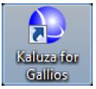

  - Reagent Level

Check the FACSFlow and Waste tank level. To change it, refer to Step 7 below.

  - Warm up

    - Allow 30 minutes for lasers to warm up and stabilize.

    - During the warm up, Select “Open” in the application button (left high icon).

    - Choose -> Data (D:) -> Clean -> Clean Workspace

    - Place in the carousel the 3 tubes: Decontamination, Cleaning and DI water.
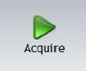
    - Select and it will acquire the three tubes for 1 min each.

- Experiment Setup

Each step for creating an experiment, setup compensation controls, create an acquisition template, and set acquisition criteria will be described below.

  - Kaluza workspace.

“Instrument Control” – Control required for performing and preparing for acquisitions.
“Ribbon” – Allows you to specify “Acquisition Controls” and select “Plots and Gates” to place on the worksheet

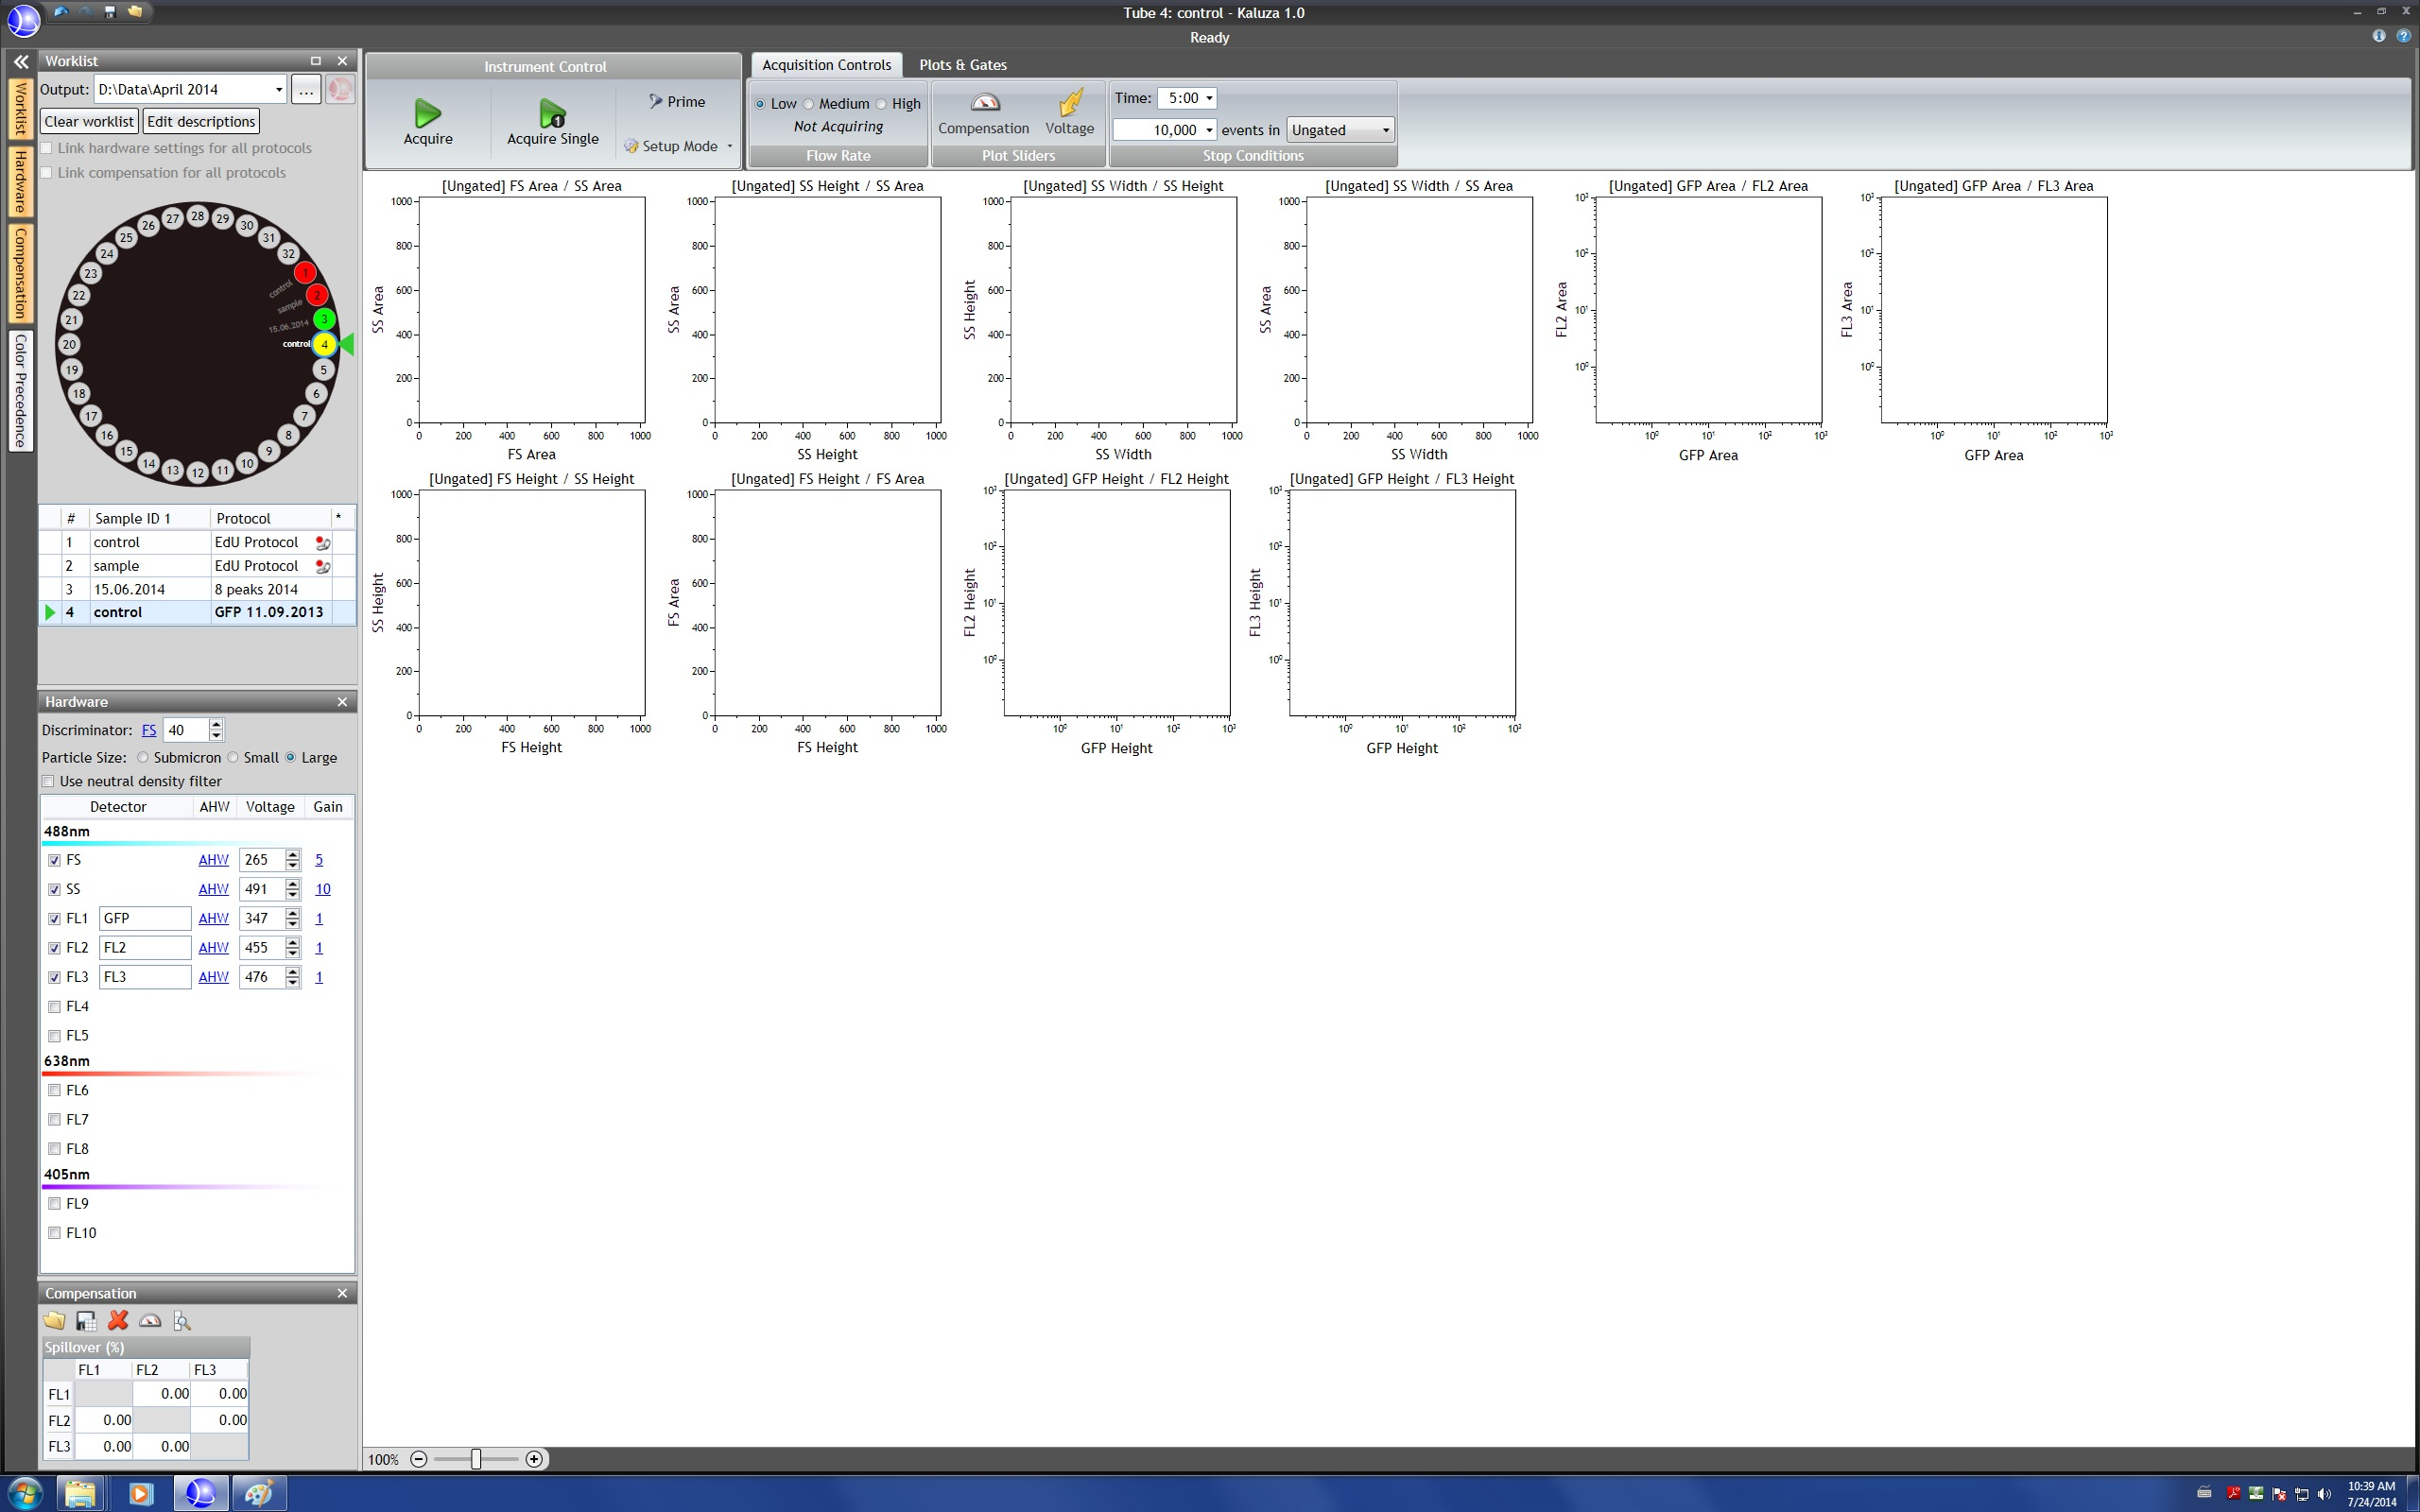

“Plot Sheet” – Plots, gates, statistics, etc. are placed in this location
“Worklist” – Contains the “Worklist”, the “Hardware”, “Compensation”, and/or “Color precedence”

  - Create an experiment
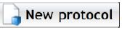
    - From the Kaluza software home screen, select

    - A screen opens, allowing you to rename the protocol and select and define the parameters needed for the experiment. Or select “enable all detectors” if you are using all the detectors.
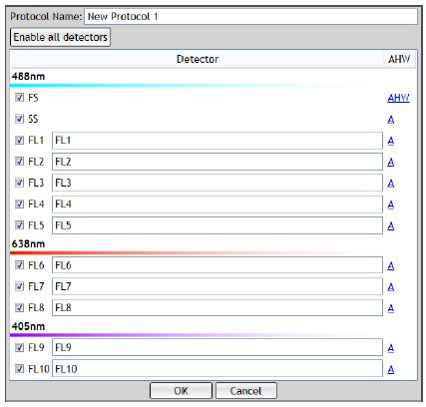

Note: If desired, in the “Description field”, rename each parameter e.g CD3 FITC. The parameter descriptions will display on plots and in the Worklist.

    - By default the software displays Area only (A) on most detectors. Height, H, and Width, W, are also enabled by default on FSC for doublet discrimination.To change the measurement type, or to choose additional types, select A link to the parameter. In the pop-up menu, choose the type(s) you wish to collect by clicking on each needed measurement type.

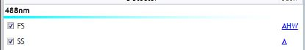
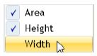

    - Select “OK” to continue setting up your protocol.

    - A workspace will be created.

  - Worklist Setup

Select an output directory
Where sample are being saved

Clear Worklist – Clears all input currently entered into the worklist. This does not remove any saved files associated with the worklist
Load acquired data in Kaluza Analysis Software

Current sample: The green arrow indicates the current select sample
Carousel – Graphical representation of the Gallios carousel. Each number corresponds to the carousel position market on the instrument

Sample ID (or Protocol name)
Vacant Carousel Position: Are indicated by light grey shading

Linked Protocols Symbol: The positions become the same colour in the carousel and this symbol is displayed


    - From the Worklist Panel, select the icon located in the Output field, and select the folder to save the files.

    - Write the name of the sample in the field Sample ID.

Note: You can change the name while the software is saving.

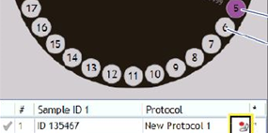

    - Right click in the sample 1 and Duplicate to add more samples to the carousel.

  - Hardware Set-up

The Discriminator eliminates signals caused by debris by excluding signals below the threshold that you define. Any of the signals, including forward scatter, side scatter, or fluorescence, can be set as the discriminator, but only one discriminator can be specified for a sample acquisition.

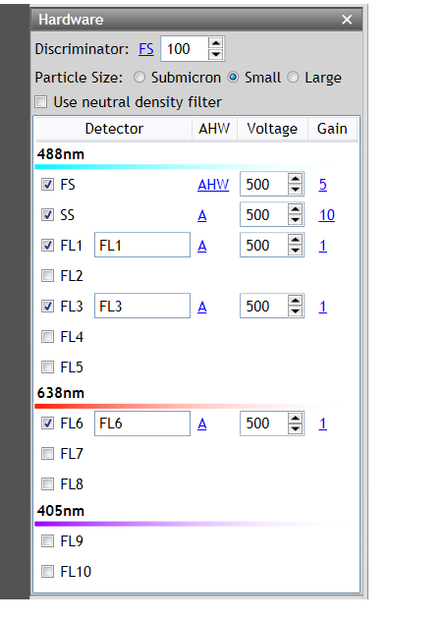
Defining the Particle Size for your acquisition helps to eliminate noise, as this adjusts the detector sensitivity based on the type of particle in your sample
The Side Scatter Neutral Density Filter is an electronic attenuation designed to behave similar to a physical filter (labeled by its power of 10 reduction of light) that will only allow a percentage of any light to pass
Voltage amplification can be changed for individual parameters to increase the visibility of events. Gain changes the amplification factor of voltages

- Acquisition

Instrument will be in “Stand by” Mode. To initialize, Go to application button (left high icon) -> Cytometer -> Initialize.

  - Acquisition Setup

    - Place the controls (unstained + single stained) and samples tubes in a carousel.

    - Open the cover and place the carousel inside.

    - Close the cover.

    - The “Acquisition Controls” tab provides means for making specifications for acquiring samples and viewing data in the plots. This tab is divided into three sections:

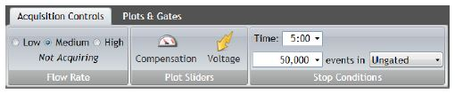

Flow Rate
Plot Sliders
Stop Conditions

    - Flow Rate

Determine the appropriate flow rate for you acquisition. The approximate flow rate for each speed is specified as:
- Low: 10 µL/min
- Medium: 30 µL/min
- High: 60 µL/min

    - Stop Conditions

You can choose to set the acquisition to stop either by set amount of time or when the acquisition has reached a specific number of events in a gate or in total (ungated).

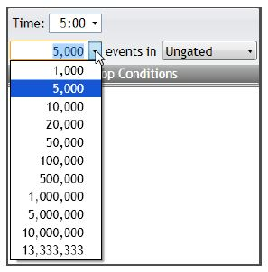

  - Compensation controls acquisiton

    - Run the Negative control. Select the appropriate position in the carousel (green arrow indicates the current select samples) and then click on “Acquire Single” to only acquire the sample selected in the defined worklist.

Declogs or removes bubbles or blockages from the sample line
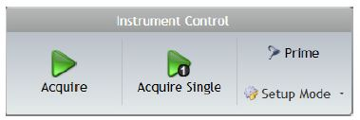
Acquires samples, beginning with the selected sample and continuing to the end of the worklist

Allows you to adjust hardware settings. Data acquired in “Setup Mode” is not saved.

Only acquires the sample currently selected

    - Once the acquisition begins the “Status bar” and “Acquisition Control” tab display details of the acquisition process for the current sample.

Stops the current acquisition and writes the acquired data to a .fcs file

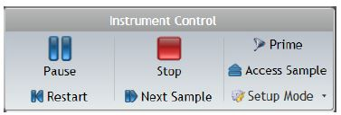
Temporarily stops the acquisition on the sample current being run
Pauses the acquisition and rotates the sample to the tube access door

Restarts the acquisition from the beginning

Stops the current acquisition and begins acquiring the next sample
    - Click on “Setup Mode”, you will see a change in the color (from gray to blue) and the progression bars stopping. Any events will be savings. This mode is only used to define flow rate, voltages for each parameter etc.

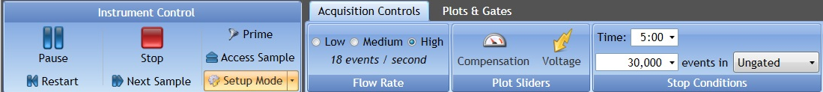

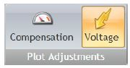
    - Adjust the voltages for all the parameters in the “Hardware” tab by changing manually the numerical value or by clicking on

Note: The negative signal is within the first decade of the histogram.

Note: Plot Sliders

Compensation and Voltage can be changed through sliders on plots. By enabling sliders, you can make adjustments based on the appearance of data on the plot rather than providing a specific numerical value.

To use the compensation and/or voltage sliders:

- Select the icon on the ribbon that corresponds to the type of slider to add to your plots. The icon is highlighted when the slider is enabled.
- Select the slider handle on the plot and drag in the direction you wish to make the change. The numerical value is displayed next to the slider.
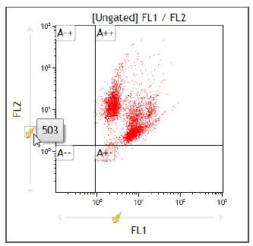

    - Adjust the gain if needed.

    - Before recording data, run all single compensation tubes in order to verify that all positive signals are on scale. To be able to calculate the compensation, voltages should be the same for each tube.

    - When all the voltages are correctly adjusted and you are ready prepared to saved, just select again on “Setup Mode”. You will see a change in the color (from blue to gray) and the progression bars increasing.

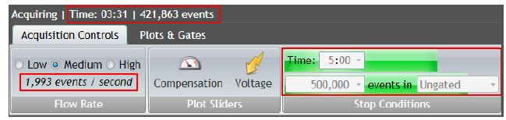

Stop Conditions – When saving two progression bars show the progression of time and number of events captured, based on the limits specified prior to acquisition

    - When it finishes saving, the icon bumps.

    - When clicking it will open the analysis software where you can start with you analysis. The acquisition software (blue) will continue to save the samples.

  - Compensation setup

    - Switch to Kaluza analysis software and select all the compensation controls and then select on “Add selected to new Compensation”.

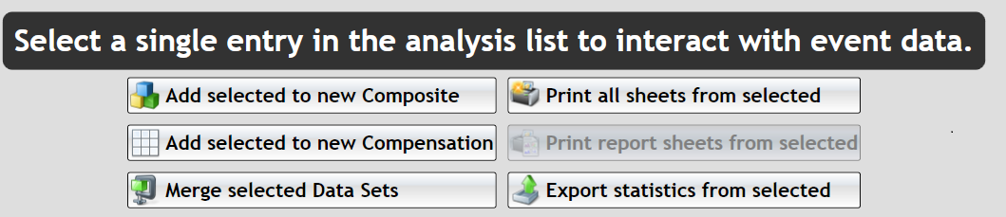

    - Assign each data set to the appropriate compensation roles.

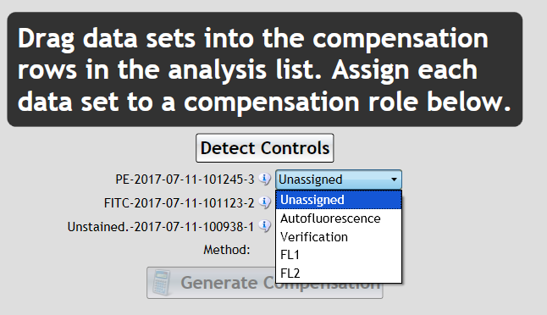

    - Select the appropriate method according your application. We recommend using the method called “Positive-Negative”. In this case, each single control have to include a mix of negative and positive control (mix neg and pos beads).

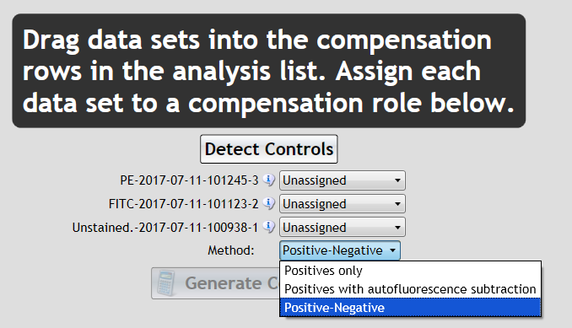

    - Then click on “Generate Compensation” button.

    - Adjust the first gate on your population of interest. Adjust the “Dim” and “Bright” on the second dot plot if needed.

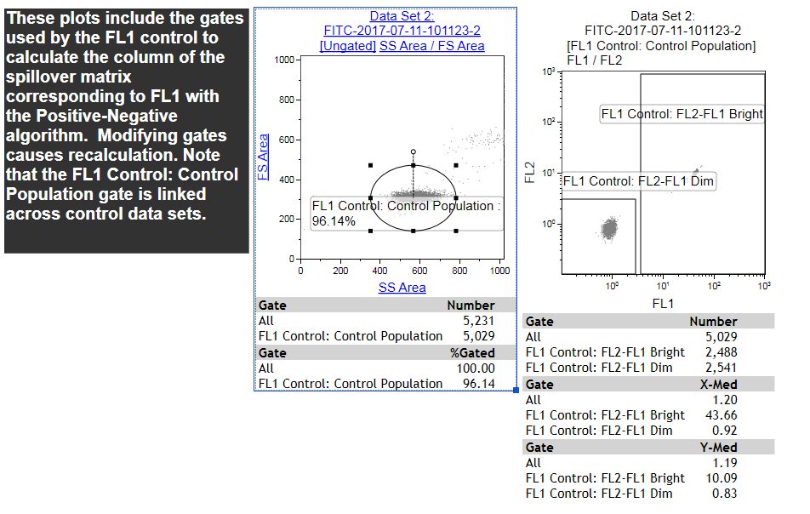

    - The software will automatically calculate the compensation.
Clear and set compensation at 0.00.

Save compensation
Compensation Sliders

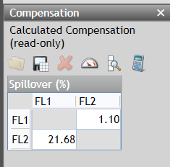
Import compensation data
Autofluorescence Vector

    - Select the icon to save the compensation, rename it and locate in the appropriate folder.

  - Acquisition Samples

    - Define the appropriate “Flow Rate” and “Stop Conditions” for all samples.

    - Select the first sample to run and click on “Acquire” to acquire all the samples created in the carousel or “Acquire Single” to only acquire the sample selected in the defined worklist.
    - When it finishes saving the first sample, the icon bumps.

    - When clicking, it will open the analysis software where you can start with the analysis. The acquisition software (blue) will continue to save the samples.

- Creating Plots and Histograms

Plots and histograms can be created in the “Plot & Gate” tab. The plots will appear in the worksheet that is the main working area where you create plots, define gates, show statistics and population hierarchies and enter custom text.

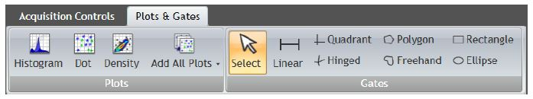

  - Plots

    - Basic Plots and Histograms

When the plot or histograms are created you can change the parameter that it displays. By clicking in the parameter a pop-up appears with a list of the parameters that you have chosen before. “Logicle” option corresponds to biexponantial display.
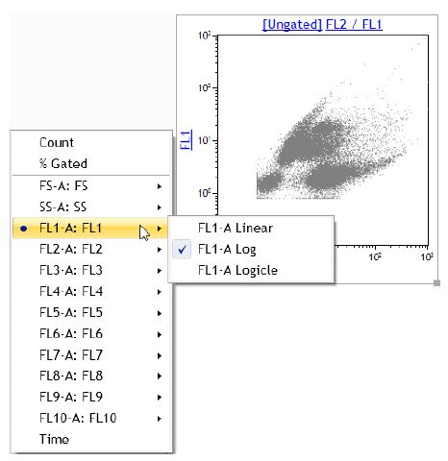

    - Multiple Plots/Gates

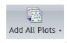

“Add All Plots” is a customizable option that automatically adds multiple plots/gates to the worksheet. The plot types and gate types that are added depend on the configurations you select. To define the options you would like to include when “Add All Plots” is selected, select the drop-down arrow on the icon; this open the “Add All Plots Options” window. Once configurations are made, select the icon to add all of your selected plots to the worksheet.

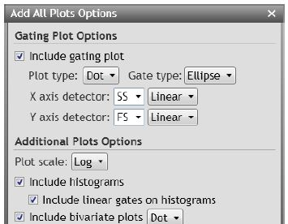

    - Plot Set-up

If you right-click in a plot it will open a radial menu that allows to perform basic editing functions.

Edit

Statistics
Coloring
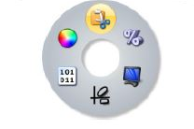

Display
Data

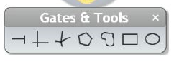

Histograms

Dot Plots

  - Visualization

- Export Experiment and FCS files

All experiments and FCS files will be deleted on a monthly basis during our Cleaning day.
Note: Export and transfer your experiments and FCS files on the “labshare” or on a USB key. You are responsible for your own backup.

- Changing the Sheath and Waste Tank

Warning: Users have to take care of changing both Sheath and Waste tank in the same time.

  - Alarm noise

When the Sheath or Waste tanks need to be changed, an alarm will sound and a message error will appear as: “The 10 L sheath cube is empty” or “The waste container is full”. When the alarm sounds, check that the instrument is in “Standby” mode and if not, put the instrument in “Stand by”. Go to the application button (left high icon) -> Cytometer -> Standby.

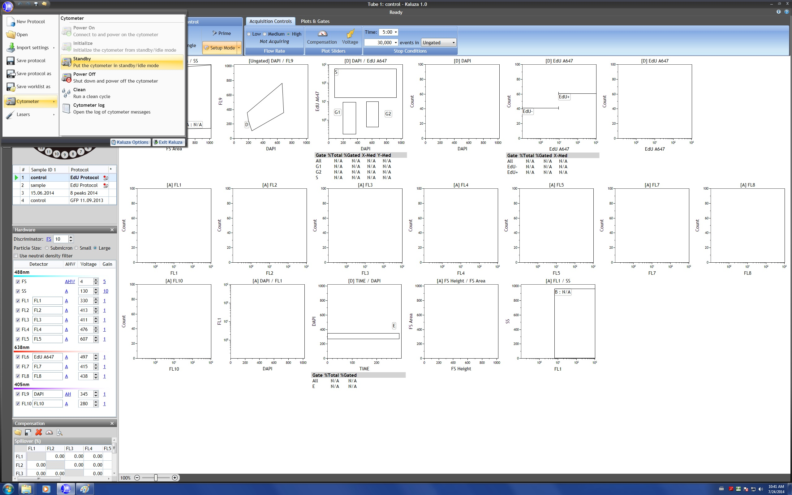

  - Sheath Tank

    - Unscrew the lid and carefully remove sample line.

    - Get a new full BD FACS Sheath box.

    - Put the lid with the sample line back on the new box and put the box back to original position.

  - Waste Tank

    - Remove the holder that holds up the opening of the waste tank.

    - Unscrew the lid of the waste tank.

    - Empty the waste tank in the sink. Add 200mL of bleach from under the sink.

  - Prime fluidics after changing tank

    - Press the “Restart” fluid control panel button.

    - The cytometer is ready to use.

- In Between Users

Check in the reservation web site if you are the last users of the day.

  - Select Open

  - Choose -> Data (D:) -> Clean -> Clean Workspace

  - Place in the carousel the tubes of decontamination, cleaning and DI water.

  - Select and it will acquire the three tubes for 1 min each.

  - Go to the application button (left high icon) -> Cytometer -> Standby

- Shutdown (End of day or Weekend)

Check in the reservation web site if you are the last users of the day.

  - Select Open
  - Choose -> Data (D:) -> Clean -> Clean Workspace
  - Place in the carousel the tubes of decontamination, cleaning and DI water.
  - Select and it will acquire the three tubes for 1 min each.
  - Go to the application button (left high icon) -> Cytometer -> Power off
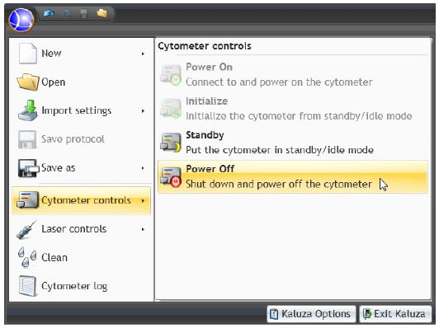

  - Make sure the instrument shutdowns (all the lights turn off)
  - Exit Kaluza
  - Turn off the computer
- If needed: More Options

  - Create statistics

Choose the statistics to display at the bottom of the plot. Available statistics are different, depending on the plot type.



