
www.divecochran.com

Cochran
GEMINI WU
Independent Mode
Owner's Manual

English - Imperial
Ver: GemInd-1.00

Manual Part Number: 4400812

For your records, please fill in the following:

Serial Number: _____________________________________________

Your Name: ________________________________________________

Your Contact: ______________________________________________
__________________________________________________________
__________________________________________________________
Purchase Date: ____________________________________________

Purchase Place: ____________________________________________

Address: __________________________________________________
________________________________________________________________
________________________________________________________________

Product Introduction: The GEMINI Wrist Unit (WU) is quite simple to use and operate, but underneath that simplicity lays a significant level of sophistication. To get the safest and most effective use of this instrument, it is important that the user fully understand the product. Please read and understand this entire manual and know the principles and practices of safe diving before using this device. If you are using the GEMINI WU with the Nitrox and/or the PO2 functions enabled, the diver specifically acknowledges that he has been adequately and thoroughly trained and certified to engage in Nitrox or Constant PO2 diving by a professional, competent, recognized training agency. For the purposes of this manual the Air only GEMINI WU is treated as a special case of the One Blend Nitrox configuration.

This Manual is divided into the following Sections:
Section Page
- Operation as a One Blend Nitrox Dive Computer 1
- Alarm Clock Operation 11
- Touch Programming 14
- Warnings 21
- Oxygen & PO2 factors 22
- Gas Blend Switching 24
- Constant PO2 Operation 28
- Configurable Items 41
- Specifications and Maintenance 45
- Liability, and Warranty 48
- Itemized Index and Subjects 56
SIDE CONTACTS:
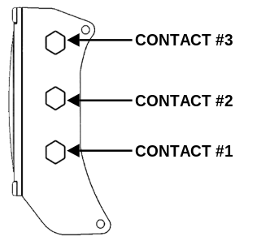

The Contacts are used to let the user command the unit to do a number of functions, or configuring the unit, and determining water conductivity. When Contacts 1 & 2 are shorted, the GEMINI WU can detect the difference between wet fingers, metal objects, fresh water, salt water, and a PC interface probe.

TURNING ON THE GEMINI WU: Although the GEMINI WU automatically turns on when it is submerged in water, it is STRONGLY recommended that wetting two fingers and simultaneously touching Contacts 1 and 2 for two seconds manually power the unit up. This allows the diver to ensure that the unit is operating correctly and has adequate battery capacity prior to entry. Once activated, the unit will remain on for 60 minutes. If a dive is not initiated within these 60 minutes, the GEMINI WU automatically shuts off. Notice that when Contacts 1 & 2 is first bridged, a short beep is issued which indicates that the unit is recognizing the touch. Every time Contacts 1 & 2 is bridged with wet fingers, the unit will stay on for one full hour.

The GEMINI WU will not turn on if the altitude is greater than 15,000 feet or if the battery voltage is less than 2.0 volts, or a fault is detected during the self-test.

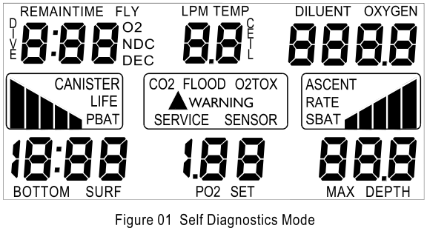

As the GEMINI WU first recognizes a turn-on command, it begins a “Diagnostic” function where many aspects of the system will be exercised and tested. This procedure takes about three seconds and an audible beep is issued each second as certain tests are successfully completed. During this time, all of the segments in the display are turned on so that the user can confirm their operability. Should a test indicate a malfunction or marginal test, the unit will turn back off again. The user should ensure that all of the display segments are on and operating correctly.

TURNING OFF THE GEMINI WU: After the Post Dive Interval following a dive, the GEMINI WU will remain on for one hour before automatically entering its "Sleep Mode". During the Sleep Mode, all calculations continue but the display is off. This is a power saving feature of the GEMINI WU. The unit will continue calculating Surface Interval, compartment off gassing as required, and any changes in altitude as it affects Nitrogen Loading. The current Surface Interval and PreDive Predictions can be viewed by reactivating the unit.

MAIN GEMINI WU OPERATING MODES:

- Surface Interval (No Nitrogen Residual)
- Surface Interval (With Nitrogen Residual)
- Dive Mode (Normal No Deco)
- Decompression Mode
- Post Dive Interval
- Touch Programming

SURFACE INTERVAL - AIR ONLY/SINGLE GAS NITROX:

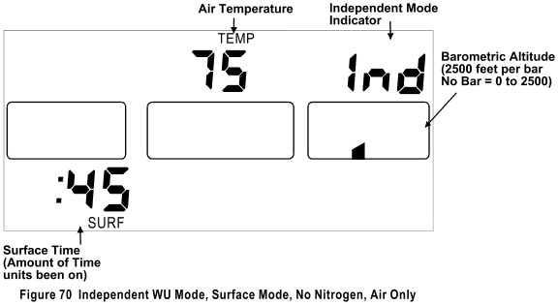
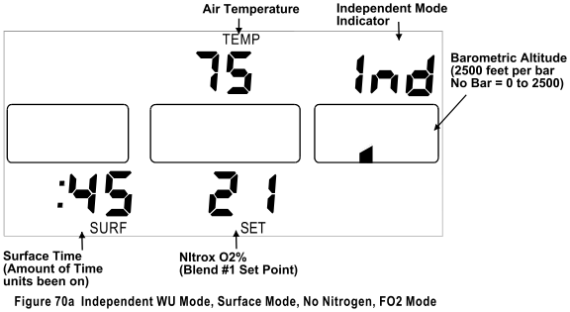
After completion of the Self-Diagnostic mode or after the Post Dive Interval following a dive, the GEMINI WU enters the Surface Interval. This period has either one (no nitrogen) or two (with nitrogen) screens, a Primary and an Alternate. To switch to the Alternate Screen just tap once firmly on the face of the unit. The Primary Screen displays, if applicable; current Surface Time, the previous dive’s Maximum Depth, the Current FO2 (normal Blend) oxygen percentage, Dive of Day number, current Time to Fly, Altitude and Temperature. The Alternate Screen displays the previous dive’s Bottom Time, current calculated CNS and OTU value bar graphs. Figure 70 & 70a shows the display with no residual Nitrogen (a clean Dive). Figure 71 & 71a shows the display with residual Nitrogen (a repetitive dive). Figure 72a shows the alternate screen with residual Nitrogen.

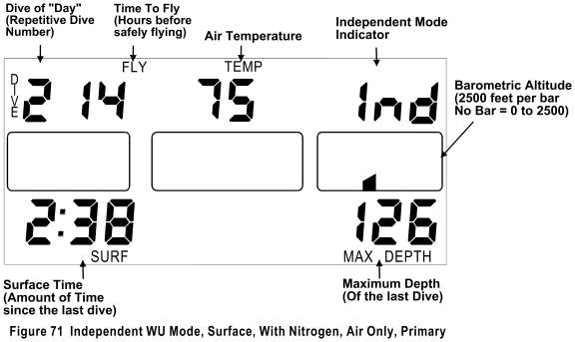

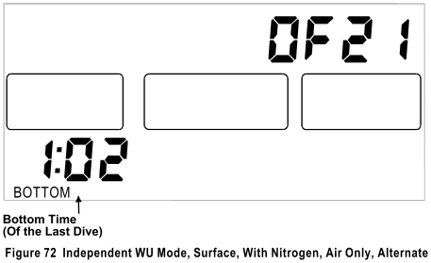

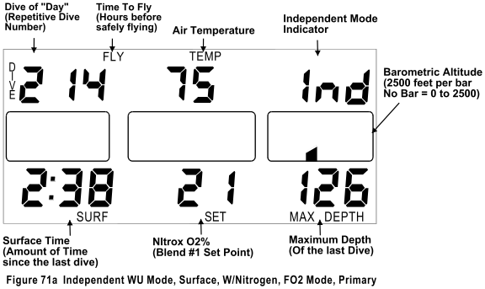

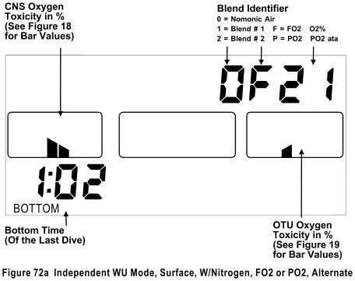

The “Blend Identifier” displays the Oxygen percentage that the computer is using in its no-decompression / decompression calculations. When the unit is on the surface it will display ‘OF21’ to indicate that the computer is calculating out-gassing using air (21%).
“Surface Time” starts at zero after a dive and begins counting minutes. If the computer shuts off and is turned on with Nitrogen residual left, the Surface Time continues to count. If the computer shuts off and is turned on with no Nitrogen residual left, the Surface Time will be zero.
“Dive of Day” starts at zero and increments after each dive regardless of the calendar day. When there is no remaining Nitrogen residual, the Dive of Day is set to zero and the computer is referred to as a ‘clean’ system.
“Time to Fly” is displayed as the number of hours remaining until the nitrogen residual reaches zero plus a twelve-hour safety factor. Flying is not recommended until Time to Fly reaches zero.
“Barometric Altitude” is indicated in six ranges via the Ascent Rate Bar Graph as follows (Altitude compensation is seamless up to 15,000 feet above sea level). The six ranges are for display purposes only: The GEMINI WU actually senses and computes extremely small altitude changes and hence, is called “Seamless”. The term “Barometric Altitude” is used instead of just “Altitude” because the GEMINI WU measures Barometric Pressure to determine Altitude. Barometric Altitude can vary from actual Altitude by over +/- 1000 feet! What is important to the body when diving is Barometric Altitude.

0 Bars sea level to 2,500 feet 1 Bar 2,500 to 5,000 feet
2 Bars 5,000 to 7,500 feet 3 Bars 7,500 to 10,000 feet
4 Bars 10,000 to 12,500 feet 5 Bars 12,500 to 15,000 feet

DIVE MODE – AIR ONLY/SINGLE GAS NITROX:

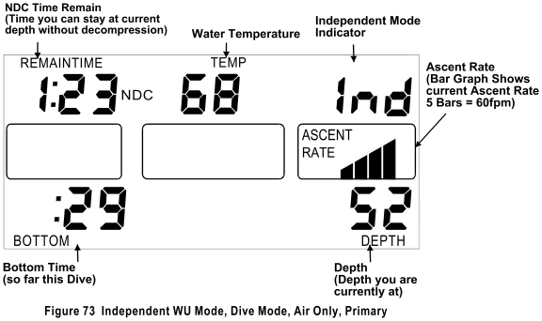

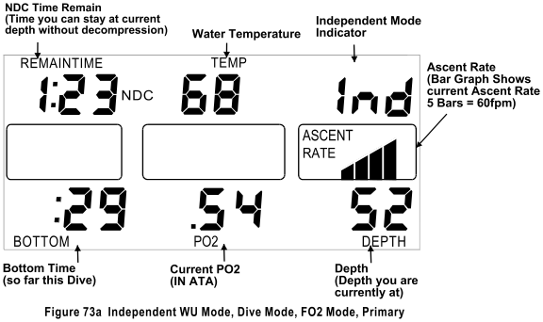

Whether in the Surface Interval, PreDive Prediction Mode, Programming Mode or the Logbook Mode, the GEMINI WU will automatically enter the Dive Mode whenever the unit determines that it is in water deeper than five feet.

On the Primary Screen the Surface time will be replaced with the current bottom time, Blend #1 set point is replaced with the calculated PO₂ value. Maximum Depth will be replaced with current Depth, displayed in one-foot increments. Bottom Time will begin once the GEMINI WU senses that the diver has descended below five feet and continues until the diver has ascended above three feet. The maximum Bottom Time displayed is 9 hours 59 minutes.
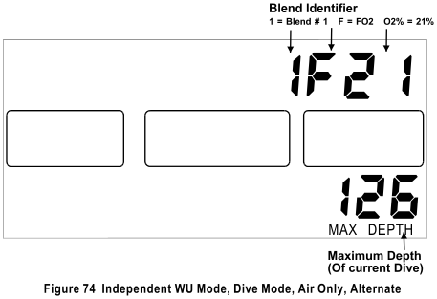

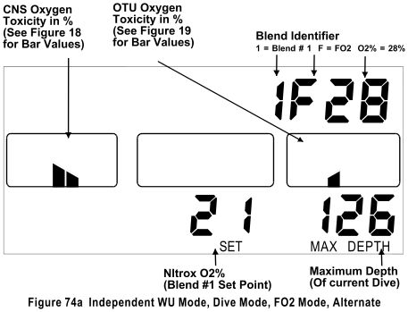

The Alternate Screen will display the current FO₂ value that the unit is using in its NDC calculations, the current CNS and OTU values and the Maximum Depth. (Figure 74 & 74a)
A Depth Alarm, which can be set to warn the diver should a certain depth be exceeded, is set at 130 feet from the factory. The Depth Alarm issues an audible alarm and the “WARNING” legend and Depth Digits will flash on and off for five seconds and be repeated ever two minutes while below the user set depth. The depth alarm is disabled if in the Decompression Mode since flashing depth digits have another meaning in this Mode.
The maximum depth achieved on the current dive is shown as “MAX DEPTH”. This is updated once per second.
“REMAIN TIME” (NDC) is the remaining time (in hours and minutes) that the diver can stay at the current depth without requiring decompression. A “Two Minute Warning” will be issued when this time reaches two minutes or less. An audible alarm will be issued and the “WARNING” legend and “REMAIN TIME” digits will flash. By immediately ascending to a shallower depth, the diver may avoid a required decompression stop.
Temperature is measured for two purposes. One is to compensate the Depth Transducer for Temperature variations. The other is to compensate the Nitrogen algorithm for changes in Temperature that may affect the body. Both of these purposes require that the Temperature be very slow reacting, just like the Depth Transducer and the body. This slow-reacting Temperature is what is displayed. For Temperature effects on the body, the amount of compensation can be set from NORMAL to REDUCED via the Tank Unit (TU) using the Analyst® PC software Interface, if the diver is using a good dry-suit in cold water. Temperature compensation starts at 75 degrees F and gets progressively more conservative as the temperature decreases. There is no compensation above 75 degrees F.
Bottom Time will begin once the GEMINI WU senses that the diver has descended below five feet (see Training Mode) and continues until the diver has ascended above three feet. The maximum Bottom Time displayed is 9 hours 59 minutes.
ASCENT RATE BAR GRAPH:
The Ascent Rate bar graph and alarms are active in both the Dive Mode and Decompression Mode. The five-segment bar graph is used to display the diver's rate of ascent.
Via the Tank Unit using the ® PC Interface, the Ascent Rate Alarms and Bar Graph can be set to the users preferences.
The first option is a VARIABLE-BY-DEPTH Ascent Rate. When on, the Ascent Rate Alarm is determined by depth. As the diver ascends to shallow depths, the Maximum Ascent Rate is lowered. The Maximum Ascent Rates and their associated depth are:
60 feet or deeper 60 feet per minute
60 to 30 feet feet per minute equal to the depth
Less than 30 feet 30 feet per minute
If VARIABLE-BY-DEPTH is off, the Maximum Ascent Rate Alarm and Bar Graph is specified by the user and can be from 20 to 60 fpm, in one-foot increments.
Another selection is the bar graph itself. The two selections are either FIXED or PROPORTIONAL.
With FIXED, each of the five bars indicates an additional 10 feet per minute of Ascent Rate regardless of the Maximum Ascent Rate selected.
With PROPORTIONAL, each of the five bars indicates 20% (one-fifth) of the selected Maximum Ascent Rate.
For FIXED, the maximum ascent rate is 60 feet per minute. With this setting, the ASCENT RATE legend will illuminate but no bars will be illuminated if a diver is ascending at a rate less than 10 feet per minute.
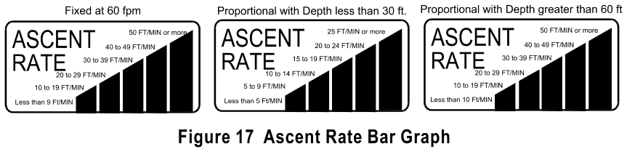
If the diver has an Ascent Rate that exceeds the selected maximum, the tallest Ascent Rate Bar Graph will flash, and the audible alarm will sound once per second, and the WARNING legend will illuminate.
The sensitivity or responsiveness of the Ascent Rate may be selected via the Tank Unit with the Analyst®, eight different levels of sensitivity are available.
NOTE: Customizing the Ascent Rate and Ascent Rate Bar Graph are among many of the additional programmable features available when using the Analyst® PC Interface with the Tank Unit. Available features are described in the section “USER CONFIGURABLE OPTIONS”.
As shipped from the factory, the Ascent Rate is set for VARIABLE-BY-DEPTH AND PROPORTIONAL.

DECOMPRESSION MODE – AIR ONLY/SINGLE GAS NITROX:

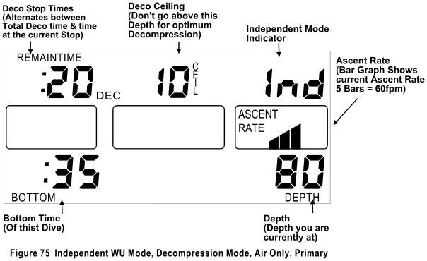

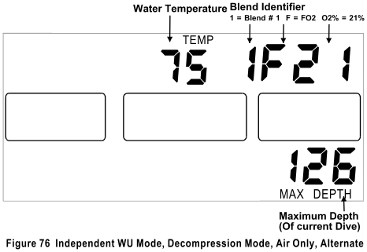

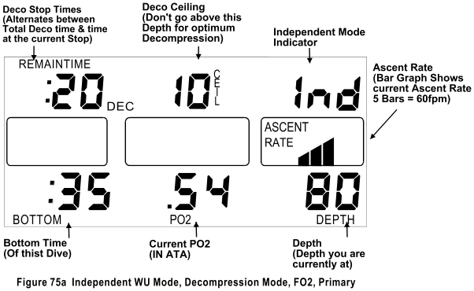

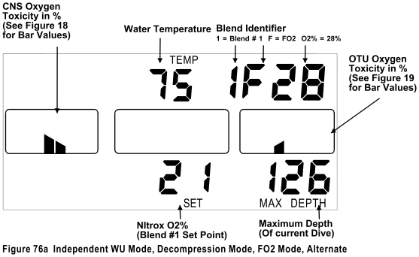

Should a no-decompression limit be overstayed, the GEMINI WU will enter the Decompression Mode. In this mode, the Ceiling digits will display the depth at which the diver must stop and not ascend above during final ascent. The “TEMP” legend and two digits will be replaced with the “CEIL” legend and two digits. The Ceiling will start at 10 feet and increase in ten-foot increments as the diver remains at a relatively deep depth. If a Ceiling of greater than 90 feet is calculated the Ceiling display will flash to indicate that the displayed Ceiling is divided by 10, i.e. 10 flashing = 100 feet, 11 flashing = 110 feet, etc.
The Remaining No-decompression Time and “NDC” legend will be replaced with Decompression Time and “DEC” legend (Figure 75). Both STOP time and TOTAL time are displayed in the upper left hand three digits of the screen in hours and minutes. STOP and TOTAL time will alternate at the rate of once every two seconds. In this way, the diver can view the time to spend at a particular STOP depth, and the TOTAL time it will take to complete all STOPS. Clearly, the larger of the two alternating numbers is the Total Decompression Time of all stops, and the smaller of the two numbers is the time required at the current stop. At the ten-foot stop, the TOTAL and STOP times may be the same and therefore appear to not alternate.
When at a specific stop, the required decompression time at that stop is as shown, and will appear to count down as it is recomputed every second, based on the divers exact current depth. The Decompression times (both Stop and Total) are accurate only if the divers depth is exactly the same as the required Ceiling. However, it is not necessary to be precisely at that specified Ceiling. Appropriate In-gassing or Out-gassing will be computed regardless of the divers current depth.
A small margin shallower than the Ceiling also exists. Should a Ceiling be ‘violated’ (diver is shallower than Ceiling), the “WARNING” legend will illuminate and flash along with the Depth and Ceiling digits. An Audible alarm will sound once every two seconds. This warning will continue until the Depth has been corrected. Out-gassing will continue even though the diver is shallower than the Ceiling. There is no ‘Gauge’ mode or ‘Lockout’ on the GEMINI WU.
The Total Decompression time forecast at depth is based on the User Configured ‘Ascent Rate for Deco Prediction value’; the factory setting is 60 fpm. If the diver ascends faster or slower than this value the actual deco forecast times could vary. Regardless of the effects of the ascent rate, the decompression time forecasted at the deepest stop is accurate.

If the diver surfaces before satisfying his decompression obligation, the GEMINI WU will continue to give out-gassing credit as if it were in a dive, but at a depth of zero feet and will satisfy the decompression time requirements of the required stops using an FO₂ of 21%. The unit will continue to log data and perform as if actually in a dive. When the decompression obligation is finally satisfied, the ten-minute “PostDive Interval” will begin.

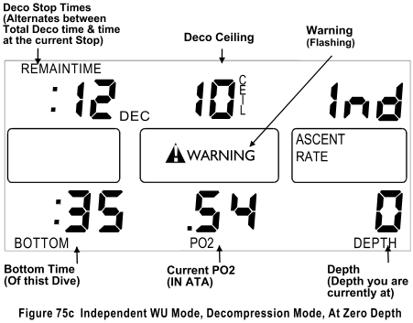

NOTE: COCHRAN does not intend for this instrument to be used for deliberate Decompression diving.

POST DIVE INTERVAL:
During the first ten minutes (or up to thirty if the unit is in the Training Mode) after a dive, the GEMINI WU is in the Post Dive Interval. The flashing "SURF" legend and a Surface Time of less than ten minutes indicate this. Should another dive be commenced before the completion of the Post Dive Interval, that dive will be considered an extension of the previous dive. In this case, Bottom Time will NOT include the time spent on the surface in this Post Dive Interval.

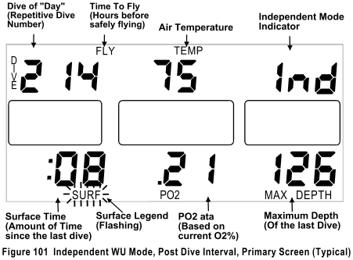

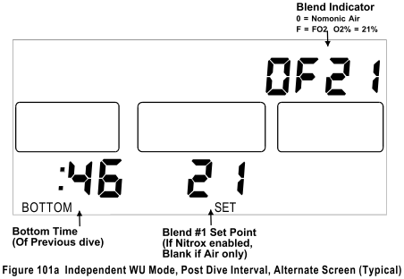

TACLITE™: The GEMINI is equipped with the TACLITE™ tactical low-light fiber-optic backlighted display. The standard TACLITE™ color is night vision safe red, but it is also available in yellow for those individuals who have vision difficulties with the color red. The TACLITE™ can be activated on demand. To turn the TACLITE™ on, tap the face of the GEMINI and the TACLITE™ will turn on for the preprogrammed number of seconds (1 to 98), then turn off. By tapping the face again the TACLITE™ will turn on again. In this fashion the TACLITE™ can be kept on for as long as wanted. If 0 is entered, the TACLITE™ will never turn on. If 99 is entered; the TACLITE™ will stay on continuously and only turn off when the GEMINI does. The number of seconds that the TACLITE™ stays on can be set via the Touch Contact Programming Mode, factory setting is 10 seconds. The TACLITE™ will turn off when the GEMINI turns off. If the batteries get too low, the TACLITE™ will turn off and cannot be turned back on until fresh batteries are installed.

NOTE: The TACLITE™ may not activate when the WU is in the programming mode or if all three touch contacts are wet and the unit is not in a dive.

CLOCK MODE: The Clock operating mode of the GEMINI is enabled when shipped from the factory.

TOUCH PROGRAMMING MODE: The Touch Contact Programming Mode can only be accessed when the unit is in the Surface Interval and will allows the user to view or program into the dive computer:
- Selecting the “Slave” or “Independent” Mode
- Setting Clock and Alarm Time
- Select the PO₂ or FO₂ Operating Mode
- The PreDive Prediction Mode
- Displaying Mode, mode value, CNS, OTU & WU battery voltage
- A Maximum Depth Alarm
- An Added degree of Conservatism from 0 to 50%
- Setting oxygen percentage of blend 1 in the Constant FO₂ Mode
- Setting the Normal PO₂ set point in the Constant PO₂ Mode
- Setting the Deco FO₂ oxygen percentage
- Setting the Deco PO₂ set point in the Constant PO₂ Mode
- Setting the Deco Bottom Time Benchmark
- Setting the Deco Depth Benchmark
- Programming the On Time for the TACLITE™
- Access the Logbook Mode
- Programming TU/WU address code
While all GEMINI WU configurations share certain programming features others are dependent upon the specific configuration of the unit. Refer to the appropriate manual section for the relevant programming menu items.

TOUCH PROGRAMMING - CLOCK: When the GEMINI WU is placed into the Clock mode it will display the time of day in a 24-hour day format. The Clock will continue to run when the GEMINI WU is in the Dive Computer Mode. The GEMINI WU can be placed into the Clock Mode from the Dive Computer Mode when the unit is in the Normal Surface Interval, while the unit is in Clock Mode the Dive Computer will be in the “Sleep” mode.
The Clock Mode can be selected with or without an Alarm. If the Alarm option is selected the unit will display the alarm set time as well as the current time.

When the alarm time is displayed the alarm is activated and at the programmed time the alarm will sound once every 24 hours. When the alarm is activated the unit will issue a medley of all the audible warning tones that the GEMINI WU utilizes and the TACLITE™ will flash for one minute, this audible alarm cannot be turned off, it will sound for the full one-minute period.

NOTE: This Time of Day clock is the same clock that is used to time stamp dives in the WU Logbook.

CLOCK PROGRAMMING PROCEDURE:
Contacts 1, 2, & 3 are for programming sequences.
To begin the programming sequence:
- Turn the unit on;
- Using a coin or other conductive metal object, briefly bridge Contacts 1 and 2 until a short beep is heard and the CLoCk Menu is seen on the display.
- To enter the Clock submenu, bridge Contacts 1 & 2 with wetted fingers. This will cause the unit to display the CLoCk Alarm selection – On or OFF. To Toggle the selection, bridge contacts 1&2 with wetted fingers.
- Using a coin or other conductive metal object, bridge Contacts 1 & 2 to access the CLoCk Time or Alarm setting screen.
- Shorting Contacts 1 & 2 with a coin will cause the first digit of the minutes to flash.
- Shorting Contacts 2 & 3 with a coin will increment the numeric value; continue until the required value is displayed. A confirmation beep will sound with each increment.
- Next using wetted finger, bridge Contacts 1 & 2 to select the next digit, once selected the digit will flash to identify that it is being programmed. Bridge Contacts 2 & 3 till the desired value is displayed.
- To select Hours short Contacts 1 & 2 with a coin, increment as in step 6 and 7.
- Repeat step 5 through 7 until all digits have been programmed.
- To save the changes that have been made bridge Contact 1 & 2 with a coin or other conductive metal object until two beeps are heard. Once the next programming option is displayed the changes have been saved.
To exit the Clock Mode Bridge contacts 1 & 2 with wetted fingers and the computer will return to the Dive Computer Mode’s Surface Display.
NOTE: Ensure that the GEMINI WU is in the Dive Computer Mode before commencing a dive.
Figures 50, 51, 52, 53 and 54 show how the Clock display screens appear.

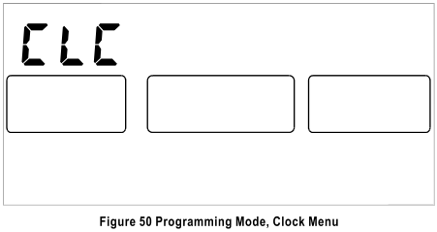

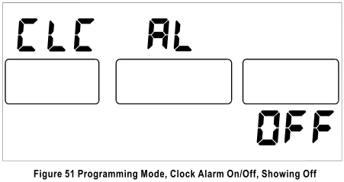

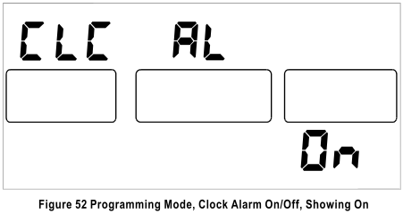

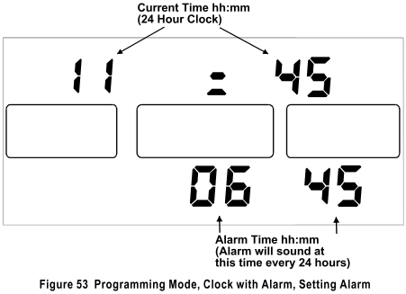

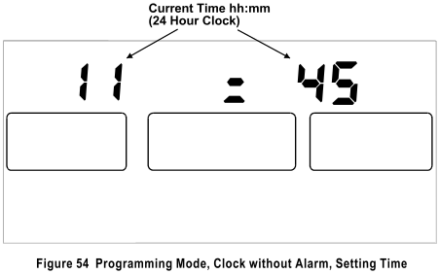

NOTE: Once the GEMINI WU is placed in Clock Mode the unit will remain in that mode until exited by the diver.
NOTE: The Alarm function is only active when the GEMINI WU is in Clock Mode.

TOUCH PROGRAMMING MODE:
NOTE: To enable the Programming Mode, the GEMINI WU must be on the Surface and not in the Post Dive Interval.
NOTE: All audible and visual alarms are suspended while the GEMINI WU is in the Programming Mode. Upon exiting the Programming Mode all alarms are reactivated.
NOTE: Once a value has been changed and the next menu option selected, the new value is stored.
NOTE: It is strongly recommended that the Programming Mode is activated again and a complete review of what was stored is accomplished.
NOTE: If the GEMINI WU is left in the Programming mode for five minutes without the contacts being touched, the unit will automatically exit the Programming Mode and return to the Surface Interval. Once this occurs the GEMINI WU will retain the modified programmed settings that have been stored. Options that have not been modified will retain their previous settings.

TOUCH PROGRAMMING MODE - PROCEDURE:
Contacts 1, 2, & 3 are for programming sequences.
To begin the programming sequence:
- Analyze the gas blend(s) using a calibrated Oxygen Analyzer (for Nitrox enabled units).
- Turn the unit on.
- Using a coin or other conductive metal object, briefly bridge Contacts 1 and 2 until a short beep is heard and the Programming Menu is seen on the display. The Programming Menu options depend on whether the unit is activated for Clock, Nitrox, the number of Gas Blends, and if the unit is in the PO2 or FO2 mode. The Menu options are displayed in sequence, incrementing to the next selection each time that Contacts 1 & 2 are bridged with a coin. The program option is displayed on the upper row of the display. The current setting for this option is displayed in the lower right of the display.
- To reprogram the displayed menu values, bridge Contacts 1 & 2 with wetted fingers. This will cause the current setting to flash or in the case of multi-digit numbers, the least significant digit will flash. The clock will toggle between on and off.
- Using a coin or other conductive metal object, bridge Contacts 2 & 3 to increment the numeric value. A confirmation beep will sound with each increment.
- Next using wetted finger, bridge Contacts 1 & 2 to select the next digit, once selected the digit will flash to identify that it is being programmed. Bridge Contacts 2 & 3 till the desired value is displayed.
- Repeat step 5 until all digits have been programmed.
- To save the changes that have been made bridge Contact 1 & 2 with a coin or other conductive metal object. Once the next programming option is displayed the changes have been saved.
All programming sequences use the same routine of using Contacts 1 and 2 to SELECT the next programming sequence and Contacts 2 and 3 to INCREMENT the specified value.

PROGRAMMING MENU – AIR ONLY
The following table lists the various programming choices with their display identification and figure number.

Identification Description Figure Page
SLA Toggles between Independent & Slave modes 85 38
CLC Clock – if enabled 50 12
PdP PreDive Prediction 88 38
InF Misc. Information 89 39
dEP AL Depth Alarm, Max value is 320 feet. 90 39
Con Added Conservatism, Max allowed value is 50%. 91 39
TAc dL TACLITE™ On Time. Allowed value 00 to 99. 98 40
LOG Logbook 99 41
Add Cd TU/WU Address code. Allowed values 31000 to 63000 100 41

PROGRAMMING MENU - SINGLE GAS NITROX
The following table lists the various programming choices with their display identification and figure number.

Identification Description Figure Page
SLA Toggles between Independent & Slave modes 85 38
CLC Clock – if enabled 50 12
PdP PreDive Prediction 88 38
InF Misc. Information 89 39
dEP AL Depth Alarm, Max value is 320 feet. 90 39
Con Added Conservatism, Max allowed value is 50%. 91 39
EAn 1 Oxygen percentage of Blend, Allowed value 21 to 50 92 39
TAc dL TACLITE™ On Time. Allowed value 00 to 99. 98 40
LOG Logbook 99 41
Add Cd TU/WU Address code. Allowed values 31000 to 63000 100 41

TOUCH PROGRAMMING - PREDIVE PREDICTION:

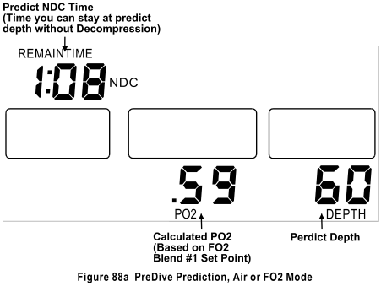
PreDive Prediction is accessed via the Touch Contact Programming Menu. This enables the diver to view the PreDive Prediction information at the touch of the Contacts. The GEMINI WU’s PreDive Prediction starts at 30 feet and increases in 10 feet increments. PreDive Predictions will terminate when the No-Decompression (NDC) time prediction reaches two minutes or a maximum depth of 320 feet is reached. Additional Conservatism, Residual Nitrogen, blend #1 oxygen percentage and Barometric Altitude can affect PreDive Predictions. Once the maximum PreDive Prediction depth has been reached the unit will return to the Surface Interval.
During the PreDive Prediction Mode, the unit will compute and display the maximum safe time and the calculated PO₂ value at that depth.

TOUCH PROGRAMMING - INFORMATION DISPLAY:

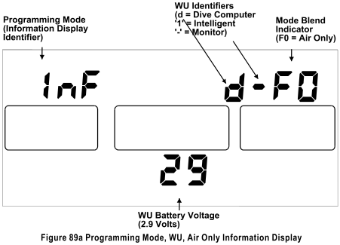

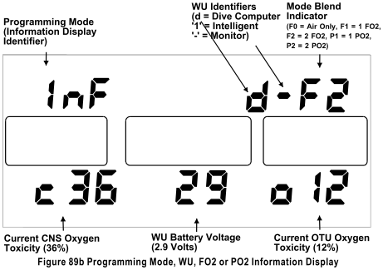

The InFormation display is accessed via the Programming Mode. The information presented will depend on the configuration of the dive computer. The information in the upper right of screen indicates whether unit is in the Constant FO2 or PO2 Mode and the number of gas blends the unit is enabled for. The following table lists the identification and the description.
Identifier Description

F0 Air only
F1 Single Blend Nitrox, 21 to 50%
F2 Two Blend Nitrox, 21 to 50% and 21 to 99.9%
P1 Single Blend PO2, 0.5 to 1.5 ata
P2 Dual Blend PO2, 0.5 to 1.5 ata and 0.5 to 1.5 ata

Battery voltage is displayed in the lower center of the screen as a two-digit number with a decimal point. If the unit is configured for Constant FO2 (Nitrox) or Constant PO2, the screen will display the current CNS, OTU and battery voltage. The current CNS exposure level is displayed on the lower left as a two-digit number proceeded by a lower case “c”. The current OTU value is displayed on the lower right again as a two-digit number but proceeded by a lower case “o”. Both the CNS and OTU values are expressed as percentages. Figure 89a displays an Air Only InFormation screen while Figure 89b displays a typical InFormation screen for a unit that is enabled for two nitrox blends.

TOUCH PROGRAMMING - DEPTH ALARM: The Depth Alarm allows the diver to select a maximum depth below which the diver does not wish to descend before an alarm is issued. This depth can be set from 0 to 320 feet in one-foot increments.

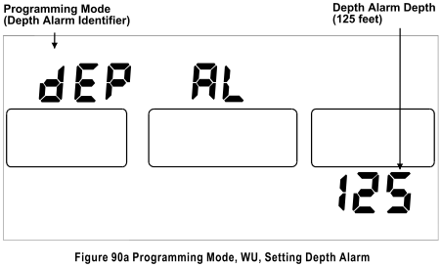

TOUCH PROGRAMMING - CONSERVATISM: This programming function allows the diver to input an added degree of Conservatism into the GEMINI WU’s nitrogen algorithm. Via Touch Programming the Conservatism can be set from 0 to 50%.

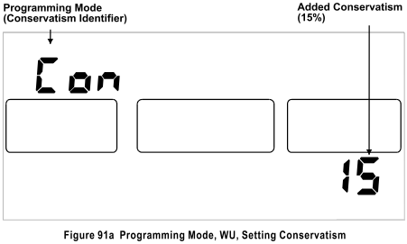

TOUCH PROGRAMMING - BLEND #1:
The oxygen percentage of Blend #1 can be programmed from 21.0% to 50.0%. Once programmed the oxygen percentage will remain at the value programmed until changed by the user.

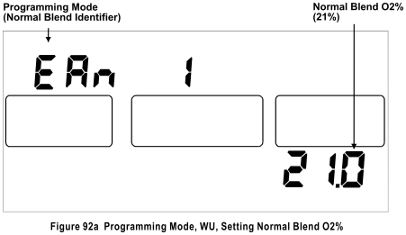

TOUCH PROGRAMMING - TACLITE™: The Taclite™ dwell (on) time can be set so that when the face on the GEMINI WU is tapped the Taclite™ will stay on from 1 to 98 seconds. If the dwell time is programmed to ‘0’ the Taclite™ will never come on, if programmed to 99 the Taclite™ will be on whenever the GEMINI WU is awake.
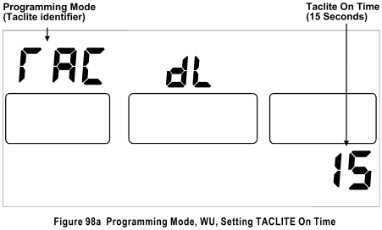

TOUCH PROGRAMMING - LOGBOOK MODE: The Logbook of the GEMINI WU has two screens, a Primary Screen and an Alternate Screen. Tapping firmly on face of the unit will switch it to the Alternate Screen. The Logbook is accessed via the Touch Contact Programming (see page 14). This enables the diver to view dive statistics; the GEMINI WU has the ability to provide diving data for the most recent 12 dives. The most recent dive will be displayed first. To view the next dive, touch the contacts 1 & 2 with wetted finger after pausing for a few seconds. Do not use a metal object such as a coin or knife-blade once in the Logbook since it will cause the unit to exit the Logbook and return to the Surface Interval.
Information contained in the Logbook will include:
Overall Dive Number Date & Time of the Dive
Minimum NDC Time Fastest Rate of Ascent
Minimum Water Temperature Bottom Time
Surface Interval Before Dive Maximum Depth
Ending Battery Voltage Oxygen % of Blend #1
Maximum DEC Time (Deco Dive) Maximum Ceiling (Deco Dive)
Ending CNS Value (Bar Graph) Ending OTU Value (Bar Graph)
It is not necessary to exit the Logbook Mode prior to initiating a dive. Once the diver has descended below five feet, the GEMINI WU will immediately enter the Dive Mode.
NOTE: The overall Dive Number that is displayed on the Logbook Menu screen (Figure 99) permits the diver to identify the total number of dives made with that GEMINI WU. If the logbook example shown is the most recent dive made, it can be readily identified that 9 dives have been made with this specific unit and the 9th dive was made on 18 December 2000 at 11:28 AM.
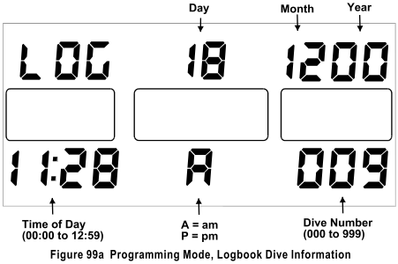

Figures 77 displays a typical Primary Screen of the Logbook of a Normal Dive.

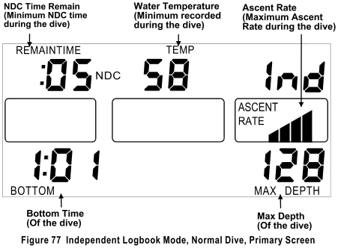

Figures 78 & 78a displays the Alternate Screens for an Air Only and a Nitrox Normal Dive.

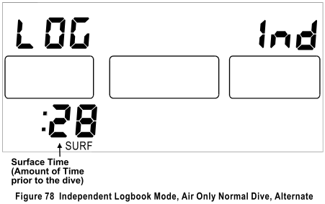

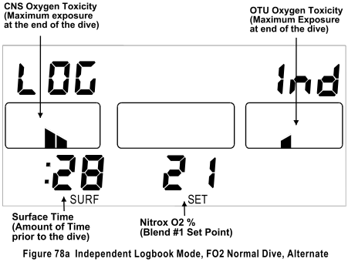

Figures 79 displays a typical Primary Screen of the Logbook of a Decompression Dive.

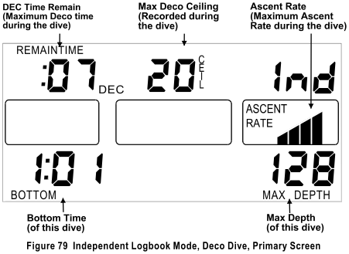

Figures 80 & 80a displays the Alternate Screens for an Air Only and a Nitrox Deco Dive.

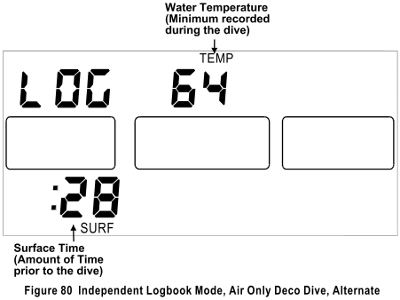

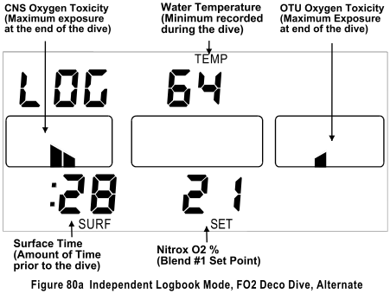

TOUCH PROGRAMMING – SETTING TU ADDRESS CODE: The Address Code that the GEMINI WU uses to identify the TU can be programmed from 31,000 to 63,000. The user must ensure that if the Address Code is changed in the WU it must also be changed in the TU. If the user is going to change the address code, they should change the TU code first and then the WU code.

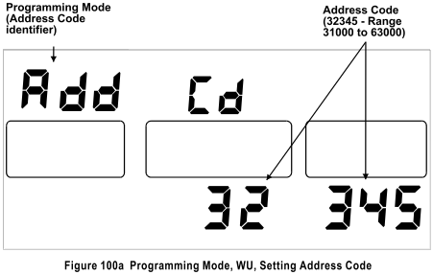

WARNING INDICATIONS: Failure to observe audible and/or visual warnings and take corrective action may result in injury or death.

- If the diver is ascending faster than the selected maximum ascent rate, then the top bar of the ascent bar graph will flash and the “WARNING” legend will illuminate. The unique high to low audible sweep alarm will continue to sound once per second until the situation is corrected.
- If the diver descends below the user set Depth Alarm, the Depth digits will flash. A single beep audible alarm will sound once per second for five seconds and will repeat every two minutes. The Depth alarm is not active in the Decompression Mode to avoid confusion with the “Shallower Than Ceiling” alarm.
- If the battery voltage goes below 2.2 volts, both the “PBAT” & “SBAT” legends will illuminate.
- If the diver has less than two minutes of No-Decompression Time (NDC) remaining, the “WARNING” legend will illuminate and flash along with the Remaining NDC time digits. A single beep audible alarm will sound once per second for five seconds and repeat every two minutes.
- If the diver enters the Decompression Mode, a single audible alarm will sound once per second for five seconds.
- During a Decompression dive, if the Depth is less than the CEILING, the “WARNING” legend will illuminate and flash along with the Depth and Ceiling digits. A unique high to low audible sweep alarm will continue to sound once every two seconds until the situation is corrected.
- If the dive computer determines that either the Depth or Temperature sensor is malfunctioning. The “WARNING” legend will illuminate, the computer will also issue a 5-beep two-tone audible alarm once every two-minute to alert the diver to this condition. On the Appropriate Screen the Maximum Depth will be replaced with or “S=-“ to indicate the low-pressure transducer or “S=t” for the temperature transducer.
- For High PO2, see “OXYGEN TOXICITY FACTORS” on page 22.
- For High CNS, see “OXYGEN TOXICITY FACTORS” on page 23.
- For High OTU, see “OXYGEN TOXICITY FACTORS” on page 23.

If an audible alarm is being issued, the computer will not switch to the Alternate display nor will the TACLITE™ activate.

SENSOR WARNING: The GEMINI WU has the capability of monitoring the integrity of its' sensors, both the low-pressure (depth/altitude) and the temperature. When the computer detects an error in one of the transducers, the diver is alerted to this condition by the illumination of the “WARNING” an “SENSOR” legends. The computer will also issue a 5-beep two-tone audible alarm once every two minutes to alert the diver to this condition. The Maximum Depth will be replaced with “S=-“ to indicate the low-pressure transducer or “S=t” for the temperature transducer (see figure 83a). The “WARNING” legend, along with either the Temperature digits or the Depth digits and the error code will flash once per second. In the highly unlikely situation were both sensors are detected as having errors, the display will alternate between “S=-“ and “S=t”. This warning will be issued whether the computer is in the Surface Interval, Dive Mode, Decompression Mode or Post Dive Interval. The sensor error code will always replace the Max Depth Digits. In the unlikely case that your computer issues one of these warnings the unit should be returned to the factory for evaluation and/or repair.

Figure 83 & 83a show a Sensor Warning, in this case a Depth Sensor, as it would be displayed in the Dive Mode. If the Sensor Warning was for the temperature sensor it would display “S=t“.

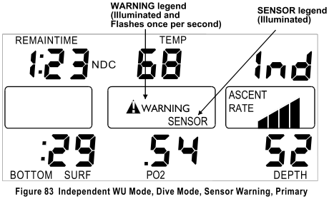

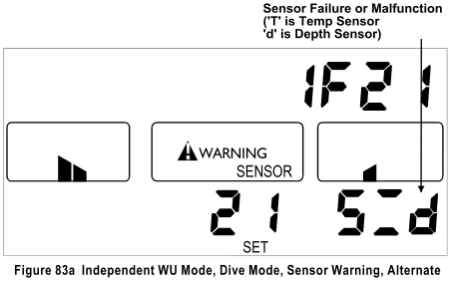

OXYGEN TOXICITY FACTORS: The GEMINI WU has the ability to track Oxygen Toxicity levels for the Central Nervous System (CNS) as well as the Mission Oxygen Tolerance Units Dose (OTU). In addition, a maximum Partial Pressure of Oxygen (PO2) warning alarm can also be set. While most other audible alarms of the dive computer consist of five long beeps, the CNS, OTU, and PO₂ have a distinctive audible alarm that consists of short double-beeps that sound once per second for five seconds.
As long as one or more of these three parameters is outside its limits, the “O2TOX” legend will be illuminated and the “WARNING” legend will continue to flash and the audible alarm will be repeated once every two minutes.
These three functions are not active if the NITROX capability is disabled via the TU with Analyst® PC Interface (Professional Version only).

PARTIAL PRESSURE OF OXYGEN (PO2): High levels of PO₂ can cause severe Oxygen poisoning. Widely different levels of PO2 can affect individual divers. The user via the TU using the Analyst® can set the PO₂ alarm to any level between 0.50 ATA and 1.59 ATA. As shipped from the factory, this is set to 1.40 ATA. Should the PO₂ be above the alarm set point, the “WARNING” legend will illuminate and the audible alarm will sound and the PO₂ value that is displayed will flash.
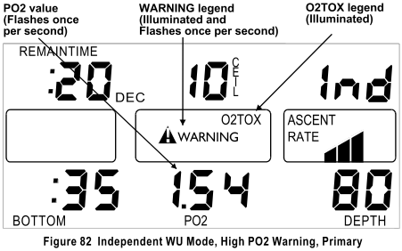

CENTRAL NERVOUS SYSTEM (CNS) TOXICITY: The user via the TU using the Analyst® can set the CNS Toxicity alarm to any level between 40% and 80% of the maximum allowable limit. As shipped from the factory, this is set to 50%. Should the CNS Toxicity reach 50% of the maximum allowable, the “WARNING” legend will illuminate and the audible alarm will sound and on the Alternate Screen the displayed CNS percentage will be flashing along with the “WARNING” legend.
By the accepted definition of CNS toxicity, should a PO₂ value of greater than 1.6 ATA be measured; the CNS Toxicity will be 100%. When the CNS exposure graph is viewed via the Analyst® it will show what the CNS exposure would have been if the diver had not exceeded a PO₂ of 1.60. The ending statistics for the dive will show a 100% CNS exposure. The CNS beginning statistic for the following dive will be based on the recovery time from 100%. The beginning value on the CNS graph and the statistical value will be based on this value. During the Surface Interval, this percentage will decrease as the CNS declines toward zero. Whatever the current CNS Toxicity level, it can also be viewed on the Surface Interval Alternate Screen or on the InFormation screen in the Programming Mode.

OXYGEN TOLERANCE UNITS (OTU): An issue with long term breathing of higher partial pressures of Oxygen above 0.5 ATA is Pulmonary Oxygen Toxicity or sometimes called WHOLE BODY, which must be tracked properly.
The GEMINI WU will track the OTU based on Dr. Bill Hamilton’s ‘REPEX’ method of oxygen exposure management. The OTU Dose is an exponential function of oxygen partial pressure and time.
The time-dependent limit varies with length of time (days) that the diver continues to dive without full recovery to zero OTU. The Mission OTU Clock tracks the OTU, which is a running clock that tracks long-term Oxygen exposure. This clock may run for several weeks if frequent dives are made using high levels of PO₂. The current CNS and OTU values can be viewed on the Alternate Screen while in the Surface Interval or on the InFormation display via Touch Contact Programming, Dive Mode, Decompression Mode or Post Dive Interval. The current CNS and OTU values can also be viewed via the Touch Contact Programming mode by selecting the InFormation option. The recovery portion of the OTU algorithm is a linear reduction of OTU over time. The Mission OTU clock is reset to 0:00 when the OTU Dose reaches zero.
The user via the TU using the Analyst® can set the OTU Toxicity alarm to any level between 40% and 80% of the maximum allowable limit. As shipped from the factory, this is set to 50%. Should the OTU Dose reach 50% of the maximum allowable, the “WARNING” legend will illuminate and the audible alarm will sound and on the Alternate Screen the displayed OTU value will be flashing along with the “WARNING” legend.
Symptoms of Pulmonary Oxygen Toxicity include burning in the throat and chest, coughing, and shortness of breath. Discontinue diving and consult a Physician should any of these, or other, symptoms appear.
Figure 81 & 81a show a CNS & OTU exposure over the alarm set point (50%), in the situation were both the CNS and the OTU exposure was over their set points both values would flash.
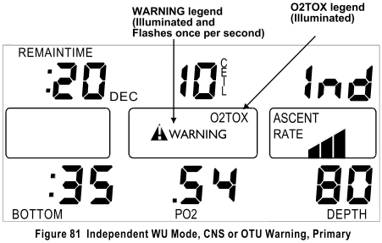

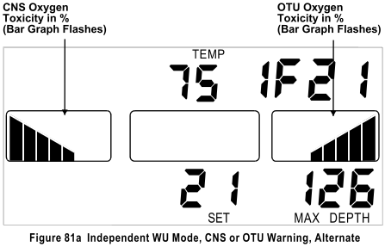

GEMINI WU - TWO GAS NITROX
OVERVIEW: This configuration of the GEMINI WU is capable of being used for two different Nitrox mixtures on the same dive. The first gas or Normal Blend is programmable from 21% to 50% Oxygen in 0.1% increments while the Deco Blend can be programmed from 21% to 99.9% Oxygen again in 0.1% increments. Both Blends are set at the factory to 21% Oxygen and use this in its decompression algorithm. PRIOR to diving an Enriched Air Nitrox gas blend, the unit must be programmed accordingly. This can be done via the Touch Contacts.
GAS BLEND SWITCHING: This configuration of the GEMINI WU is capable of FO₂ to FO₂ gas Blend switching. While most other Nitrox dive computers limit the diver to the use of a single gas blend or percentage of oxygen, the GEMINI WU allows the diver to use two different gas blends during a dive. These two gas blends are commonly referred to as the Normal or Bottom Gas Blend and the Decompression Gas Blend. Commonly, the Bottom Gas Blend is used from initial entry into the water and for most of the time spent during the dive. The Normal Gas Blend is restricted to a maximum of 50% oxygen. The Decompression Gas Blend (Deco Blend) is used only for decompression purposes and can go to 99.9% oxygen content.
Typically, the Deco Blend is in a cylinder that is suspended at some relatively shallow depth beneath the surface.
Since the depth of the Deco Blend switch is known ahead of time, and the expected duration of the dive is also known, these two factors can be used to automatically switch the computer to the Deco Blend or back to the Normal Blend should the diver descend again. This is accomplished prior to starting a dive by specifying both the Normal Gas Blend Oxygen percentage and the Deco Gas Blend Oxygen percentage. The depth of the Deco switch is also specified. Depending on surface swells; a few feet may be added to this depth to ensure that when the diver is shallower than the depth the Deco Blend will actually be in use. If the diver subsequently descends below this depth, the Bottom (Normal) Blend is again assumed to be in use. The other important factor that must be specified is the Bottom Time that must elapse before Blend Switching is enabled. The purpose of this factor is to ensure that the switch to the Deco Blend does not occur prematurely should the diver ascend early and not require use of the Deco Blend, the setting of this factor must be carefully considered. The Deco Blend switch is enabled when the diver descends below the switch depth and satisfies the time requirements and then ascends to the programmed switch depth. If the diver does not exceed the programmed switch depth the unit will not switch to the Deco Blend. All of these factors can be set by either the touch contact programming method or via the TU using the Analyst® PC interface. If switching to the Deco Blend is NOT desired setting both Blends to the same percentage of Oxygen is the same as disabling the Deco Blend.

SURFACE INTERVAL - TWO GAS NITROX:
The Surface Interval for the Two Gas Nitrox configuration is the same as the Single Gas Nitrox, refer to page 2.
DIVE MODE - TWO GAS NITROX:
The Dive Mode for the Two Gas Nitrox configuration is the same as the Single Gas Nitrox, refer to page 5.
In the Dive Mode the Alternate Screen will display the current oxygen percentage that the computer is using in the NDC calculations, therefore after a gas switch the unit will display the Deco Gas Blend oxygen percentage.
DECOMPRESSION MODE - TWO GAS NITROX:
The Decompression Mode for the Two Gas Nitrox configuration is the same as the Single Gas Nitrox, refer to page 8.
If the diver surfaces before satisfying his decompression obligation, the GEMINI WU will continue to give out-gassing credit as if it were in a dive, but at a depth of zero feet. The unit will continue to log data and perform as if actually in a dive. The unit will actually decompress as if it were actually at the various required decompression stops using an FO₂ of 21%. When the decompression obligation is finally satisfied, the ten-minute “Post Dive Interval” will begin and the dive will terminate in ten minutes.
If the Deco Forecast with Deco Blend has been ‘enabled’ via the TU using the Analyst® P.C. Interface, the Total Deco Time will be calculated using the Deco Blend to calculate nitrogen out-gassing for the deco stops shallower than the blend switch depth. If this option is not enabled, the Forecast will be based on the Normal Blend, but if a Gas switch does occur the dive computer will update the decompression times to reflect the change in breathing gas.

Several seemingly ambiguous situations may occur with the Deco Forecast ‘enabled’, they are:
- Satisfying Deco Stops during ascent.
- The Deco Gas Switch may occur early or late.
- Forecast Deco Stop time & depths may switch up/down/up/down as the diver ascends due to the in-gassing and out-gassing of the different ‘controlling’ tissue group.

NOTE: This function should NOT be ‘Enabled’ if the Diver is not performing a Gas switch.

POST DIVE INTERVAL - TWO GAS NITROX:

The Post Dive Interval is the same as in the Single Gas Nitrox, refer to page 10 for detailed information, except that if the unit has performed a gas switch. While in the Post Dive Interval the Alternate Screen will display the Oxygen percentage of the Deco Gas Blend and if the diver re-enters the Dive mode the unit will perform its’ calculations based on the Deco Gas Blend Oxygen percentage until the diver descends below the Gas switch Depth. Below this depth the unit will revert to the Normal Gas Blend for the NDC calculations.

PROGRAMMING MODE - TWO GAS NITROX
The programming procedure is the same as Single Gas Nitrox, refer to page 14.

PROGRAMMING MENU - TWO GAS NITROX
The following table lists the various programming choices with their display identification and figure number.

Identification Description Figure Page
SLA Toggles between Independent & Slave modes 85 38
CLC Clock – if enabled 50 12
PdP PreDive Prediction 88 38
InF Misc. Information 89 39
dEP AL Depth Alarm, Max value is 320 feet. 90 39
Con Added Conservatism, Max allowed value is 50%. 91 39
EAn 1 Oxygen percentage of Blend, Allowed value 21 to 50. 92 39
EAn 2 Deco Oxygen percentage, Allowed value 21 to 99.9. 93 39
dEC b Bottom Time Benchmark for Deco FO2 switching,
Allowed value 10 to 999 minutes. 96 40
dEC d Depth Benchmark for Deco FO2 switching,
Max value is 99 feet. 97 40
TAc dL TACLITE™ On Time Allowed value 00 to 99. 98 40
LOG Logbook 99 41
Add Cd TU/WU Address code. Allowed values 31000 to 63000 100 41

NOTE: If the GEMINI WU is left in the Programming mode for five minutes without the contacts being touched, the unit will automatically exit the Programming Mode and return to the Surface Interval. Once this occurs the GEMINI WU will retain the modified programmed settings that have been stored. Options that have not been modified will retain their previous settings.

TOUCH PROGRAMMING - CLOCK - TWO GAS NITROX: The Clock Programming Procedure for the Two Gas Nitrox is the same as the Single Gas Nitrox, refer to page 11.
TOUCH PROGRAMMING - PREDIVE PREDICTION - TWO GAS NITROX: The PreDive Prediction for the Two Gas Nitrox is the same as the Single Gas Nitrox, refer to page 15.
TOUCH PROGRAMMING - INFORMATION DISPLAY - TWO GAS NITROX: The InFormation display for the Two Gas Nitrox is the same as the Single Gas Nitrox, refer to page 16.
TOUCH PROGRAMMING - DEPTH ALARM - TWO GAS NITROX: The Depth Alarm Programming Procedure is the same as the Single Gas Nitrox, refer to page 17.
TOUCH PROGRAMMING - CONSERVATISM - TWO GAS NITROX: The added Conservatism Programming Procedure is the same as the Single Gas Nitrox, refer to page 17.
TOUCH PROGRAMMING - BLEND #1 - TWO GAS NITROX: The Blend #1 Programming Procedure is the same as the Single Gas Nitrox, refer to page17.
TOUCH PROGRAMMING - BLEND #2 - TWO GAS NITROX: The oxygen percentage of Blend #2 can be programmed from 21.0% to 99.9%. Once programmed the oxygen percentage will remain at the value programmed until changed by the user.
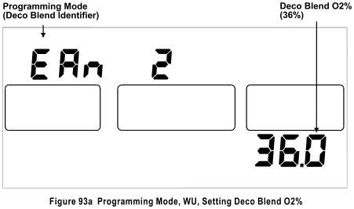

TOUCH PROGRAMMING - BLEND #2 - TIME BENCHMARK - TWO GAS NITROX: The Blend #2 (Deco) Time Benchmark can be programmed from 10 to 999 minutes. Once programmed the setting will remain at the value programmed until changed by the user.

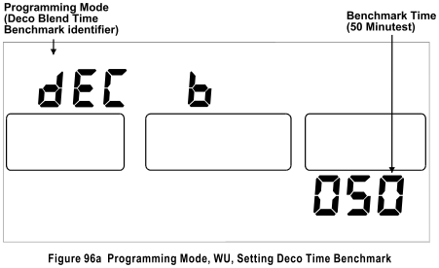

TOUCH PROGRAMMING - BLEND #2 - DEPTH BENCHMARK - TWO GAS NITROX: The Blend #2 (Deco) Depth Benchmark can be programmed from 10 to 999 minutes. Once programmed the setting will remain at the value programmed until changed by the user.

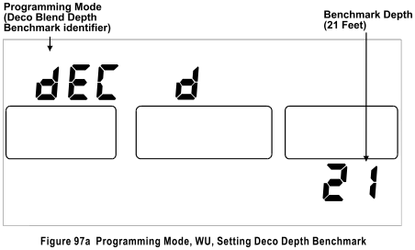
TOUCH PROGRAMMING – TACLITE™ - TWO GAS NITROX: The Taclite™ Programming Procedure is the same as the Single Gas Nitrox, refer to page 17.
TOUCH PROGRAMMING - LOGBOOK MODE - TWO GAS NITROX: The Logbook Mode is the same as the Single Gas Nitrox, refer to page 18 for detailed information.

TOUCH PROGRAMMING - SETTING TU ADDRESS CODE - TWO GAS NITROX: The Address Code Programming Procedure is the same as the Single Gas Nitrox, refer to page 21 for details.
WARNING INDICATIONS - TWO GAS NITROX:
Refer to Warning Indications on page 21.
SENSOR WARNING - TWO GAS NITROX:
Refer to Sensor Warning on page 22.

CONSTANT PO2 OPERATING MODE

CONSTANT PO₂ & FO₂ MODES: Almost all other dive computers only compute using air or enriched air (Nitrox), which is referred to as ”Constant FO₂” and is commonly found in open-circuit systems and in semi-closed circuit rebreathers. The GEMINI WU has this capability, but also computes using a “Constant PO₂” as commonly found in closed-circuit rebreathers. The user can select which of these two modes, or combination of these two modes is desired via the TU using the Analyst® PC Interface. If the user selects CONSTANT PO₂ mode, the Partial Pressure of Oxygen (PO₂) can be selected between 0.5 and 1.5 ata.
Regardless if the GEMINI WU is in CONSTANT PO₂ mode or the CONSTANT FO₂ mode when the unit is on the Surface after a dive, nitrogen out-gassing is based on Air (21% Oxygen).

GEMINI WU - SINGLE GAS PO2

SURFACE INTERVAL - SINGLE GAS PO2: The Surface Interval is the same as in the Single Gas Nitrox configuration, refer to page 2 for a detailed discussion. The exception is that the Alternate Screen displays the Current PO₂ set point value, current calculated CNS and OTU values. Figure 70b shows the display with no residual Nitrogen (a clean Dive).

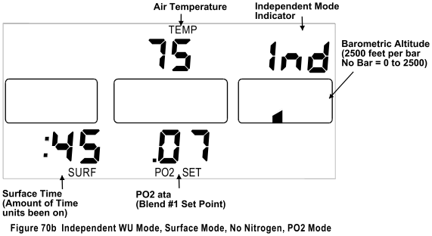

Figure 71b shows the display with residual Nitrogen (a repetitive dive), figure 72b shows the alternate screen with residual nitrogen.

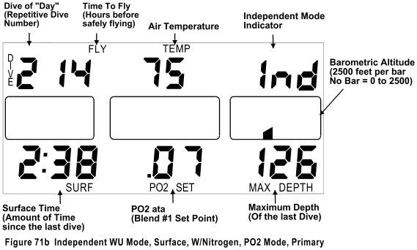

DIVE MODE - SINGLE GAS PO2: The Dive Mode for the PO₂ configuration is the same as the Single Gas Nitrox. The Primary Display Screen will display the current Calculated FO2 of the Breathing Gas, in the lower center of the display, based on the Depth and PO₂ Setting. (Figure 73b)

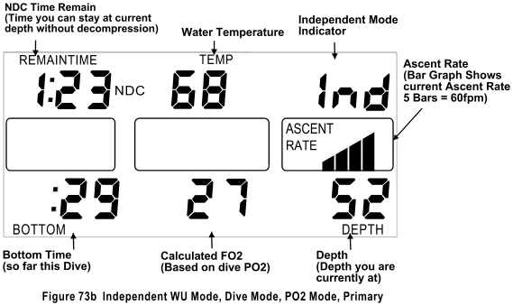

The Alternate Screen in the PO₂ Mode will display the current PO₂ set point that the unit is using in its NDC calculations, the current CNS and OTU values and the Maximum Depth reached so far on this dive. (Fig. 74b)

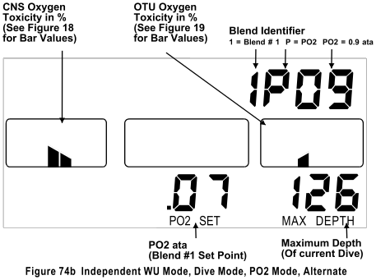

DECOMPRESSION MODE - SINGLE GAS PO2: The Decompression Mode for the PO₂ Mode configuration is the same as the Single Gas Nitrox, refer to page 8.
Figures 75b & 76b shows the GEMINI WU in the PO₂ mode at the Decompression Stop.
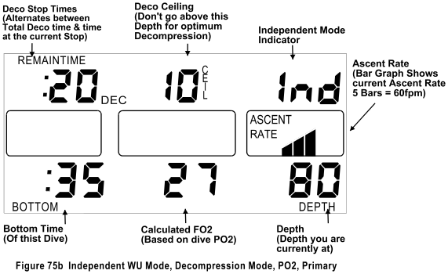
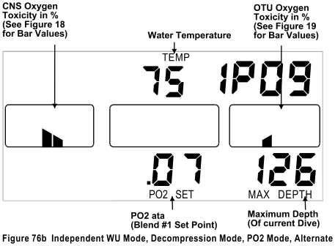

If the diver surfaces before satisfying his decompression obligation, the GEMINI WU will continue to give out-gassing credit as if it was in a dive, but at a depth of zero feet. The unit will continue to log data and perform as if actually in a dive. When the decompression obligation is finally satisfied, the ten-minute “Post Dive Interval” will begin and the dive will terminate in ten minutes.
Figure 75c shows the primary display at a depth of Zero feet.

It should be noted that in the Constant PO₂ mode the shallower the decompression stop the shorter the stop decompression time. This is a result of higher FO2s in the breathing gas as the depth decreases.

POST DIVE INTERVAL MODE - SINGLE GAS PO2: The Post Dive Interval is the same as in the Single Gas Nitrox, refer to page 10 for detailed information.
TOUCH PROGRAMMING - SINGLE GAS PO2
The programming procedure is the same as Single Gas Nitrox, refer to page 15, except that there is an additional programming choice that selects the FO₂ or PO₂ mode. The first table shows the programming sequence with PO₂ selected as the operating mode and the second table shows the menu as it appears with FO₂ selected.
TOUCH PROGRAMMING MENU - FO2/PO2 - PO2 SELECTED
The following table lists the various programming choices with their display identification and figure number. The Programming sequence and choices are determined by the selection of PO₂ or FO₂ Mode. This table assumes programming choice #1 is PO₂.

Identification Description Figure Page
SLA Toggles between Independent & Slave modes 85 38
CLC Clock – if enabled 50 12
PO2 / FO2 Toggles between PO2 Mode and FO2 Mode. 87 32
PdP PreDive Prediction 88 38
InF Misc. Information 89 39
dEP AL Depth Alarm, Max value is 320 feet. 90 39
Con Added Conservatism, Max allowed value is 50%. 91 39
PO2 1 PO2 value. Allowed value 0.5 to 1.50. 94 40
TAc dL TACLITE™ On Time. Allowed value 00 to 99. 98 40
LOG Logbook 99 41
Add Cd TU/WU Address code. Allowed values 31000 to 63000 100 41
TOUCH PROGRAMMING MENU - FO2/PO2 MODE - FO2 SELECTED
The following table lists the various programming choices with their display identification and figure number. The Programming sequence and choices are determined by the selection of PO₂ or FO₂ Mode. This table assumes programming choice #1 is FO₂.

Identification Description Figure Page
SLA Toggles between Independent & Slave modes 85 38
CLC Clock – if enabled 50 12
PO2 / FO2 Toggles between PO2 Mode and FO2 Mode. 86 32
PdP PreDive Prediction 88 38
InF Misc. Information 89 39
dEP AL Depth Alarm, Max allowed value is 320 feet. 90 39
Con Added Conservatism, Max allowed value is 50%. 91 39
EAn 1 Oxygen percentage of Blend, Allowed value 21 to 50. 92 39
TAc dL TACLITE™ On Time Allowed value 00 to 99. 98 40
LOG Logbook 99 41
Add Cd TU/WU Address code. Allowed values 31000 to 63000 100 41

NOTE: If the GEMINI WU is left in the Programming mode for five minutes without the contacts being touched, the unit will automatically exit the Programming Mode and return to the Surface Interval. Once this occurs the GEMINI WU will retain the modified programmed settings that have been stored. Options that have not been modified will retain their previous settings.
TOUCH PROGRAMMING - CLOCK - ONE GAS PO2: The Clock Programming Procedure for the Single Gas PO2 is the same as the Single Gas Nitrox, refer to page 11.
TOUCH PROGRAMMING – PO2/FO2 - ONE GAS PO2: The selection of PO2 or FO2 determines the operating mode of the computer. The selection will toggle between PO2 and FO2. Figure 86 shows the Programming display with FO2 selected and figure 87 with PO2.
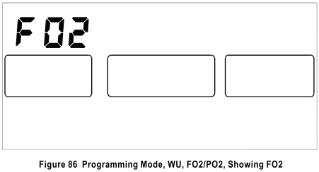

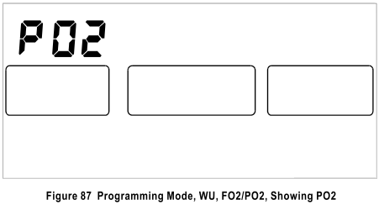

TOUCH PROGRAMMING - PREDIVE PREDICTION - SINGLE GAS PO2: PreDive Prediction is accessed through the Touch Contact Programming Menu (See Programming, page 15). This enables the diver to view the PreDive Prediction information at the touch of the Contacts. The GEMINI WU PreDive Prediction starts at 30 feet and increases in 10 feet increments. PreDive Predictions will terminate when the No-Decompression (NDC) time prediction reaches two minutes or a maximum depth of 320 feet is reached. During PreDive Prediction the current PO2 setting that the unit is programmed for is used to compute the NDC time remaining and will be displayed in the lower center of the display. Additional Conservatism, Residual Nitrogen and apparent Altitude can also affect PreDive Predictions.

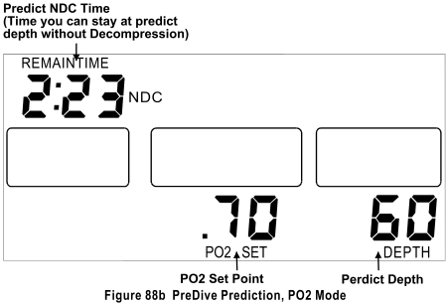

TOUCH PROGRAMMING - INFORMATION DISPLAY - SINGLE GAS PO2: The InFormation display for the Single Gas PO2 is the same as the Single Gas Nitrox, refer to page 16.
TOUCH PROGRAMMING - DEPTH ALARM - SINGLE GAS PO2: The Depth Alarm Programming Procedure is the same as the Single Gas Nitrox, refer to page 17.
TOUCH PROGRAMMING - CONSERVATISM - SINGLE GAS PO2: The added Conservatism Programming Procedure is the same as for the Single Gas Nitrox, refer to page 17.
TOUCH PROGRAMMING - BLEND #1 - SINGLE GAS PO2: The Blend #1 Programming Procedure is the same as the Single Gas Nitrox except the diver is programming a constant PO2 value between 0.5 and 1.5 ata, refer to page 17.

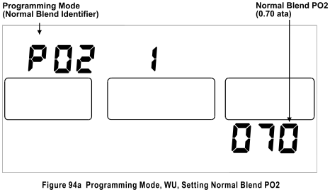

TOUCH PROGRAMMING – TACLITE™ - SINGLE GAS PO2: The Taclite™ Programming Procedure is the same as the Single Gas Nitrox, refer to page 17.

TOUCH PROGRAMMING - LOGBOOK - SINGLE GAS PO2: The Logbook Mode is the same as in the Air Only Mode, but contains additional information on the Alternate Screen (Non Deco dive Figure 78b, Deco Dive Figure 80b), refer to page 18 for detailed information.

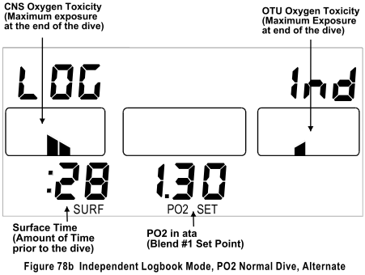

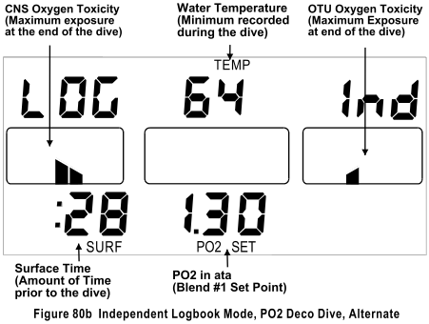

WARNING INDICATIONS - SINGLE GAS PO2:
Refer to Warning Indications on page 21.

SENSOR WARNING - SINGLE GAS PO2:
Refer to Sensor Warning on page 21.
GEMINI WU - TWO GAS FO2 / PO2
CONSTANT PO₂ & FO₂ MODES: Almost all other dive computers only compute using air or enriched air (Nitrox), which is referred to as ”Constant FO₂” and is commonly found in open-circuit systems and in semi-closed circuit rebreathers. The GEMINI WU has this capability, but also computes using a “Constant PO₂” as commonly found in closed-circuit rebreathers. The user can select which of these two modes, or combination of these two modes is desired via the TU using the Analyst® PC Interface.
If the user selects CONSTANT FO₂ mode, the Oxygen content of the Nitrox blends can be selected from 21.0 to 50.0 percent on the normal blend and 21.0 to 99.9 percent on the Deco.
If the user selects CONSTANT PO₂ mode, the Partial Pressure of Oxygen (PO₂) for both the Normal and Deco blends can be selected between 0.5 and 1.5 ata.
Via the TU using the Analyst® PC Interface, the user can specify when, or if the unit should change from CONSTANT PO₂ mode to CONSTANT FO₂ mode at or near the surface.
BLEND SWITCHING: Depending on the configuration of the GEMINI WU ‘BLEND’ refers to Constant FO₂ Nitrox gas blends or Constant PO₂ gas blends. The GEMINI WU is capable of FO₂ to FO₂, PO₂ to FO₂, or PO₂ to PO₂ Blend switching.
For a detailed description of blend switching, refer to page 24.
SURFACE INTERVAL - TWO GAS PO2: The Surface Interval for the Two Gas PO2 configuration is the same as the Single Gas Nitrox, refer to page 2.
DIVE MODE - TWO GAS PO2: The Dive Mode for the Two Gas PO2 configuration is the same as the Single Gas Nitrox, refer to page 5.
DECOMPRESSION MODE - TWO GAS PO2: The Decompression Mode for the Two Gas PO2 configuration is the same as the Two Gas Nitrox, refer to page 8.
If the diver surfaces before satisfying the decompression obligation, the GEMINI WU will continue to give out-gassing credit as if it were in a dive, but at a depth of zero feet. The unit will continue to log data and perform as if actually in a dive. The unit will decompress as if it were actually at the various required decompression stops using an FO₂ of 21%. When the decompression obligation is finally satisfied, the ten-minute “Post Dive Interval” will begin and the dive will terminate in ten minutes.
If the Deco Forecast with Deco Blend has been ‘enabled’ via the TU using the Analyst® P.C. Interface, the Total Deco Time will be calculated using the Deco Blend to calculate nitrogen out-gassing for the deco stops shallower than the blend switch depth. If this option is not enabled the Forecast will be based on the Normal Blend, but if a Gas switch does occur the dive computer will update the decompression times to reflect the change in breathing gas.

It should be noted that in the Constant PO₂ mode the shallower the decompression stop the shorter the stop decompression time. This is a result of higher FO2s in the breathing gas as the depth decreases.

If the Deco Forecast with Deco Blend has been ‘enabled’ via the TU using the Analyst® P.C. Interface, the Total Deco Time will be calculated using the Deco Blend to calculate nitrogen out-gassing for the deco stops shallower than the blend switch depth. If not ‘enabled’ the Deco Forecast will be based on the Normal Gas Blend.

NOTE: This function should not be ‘Enabled’ if the Diver is not performing a Gas switch.
POST DIVE INTERVAL MODE - TWO GAS PO2: The Post Dive Interval is the same as in the Air only Mode, refer to page 10 for detailed information, except that if the unit has performed a gas switch. While in the Post Dive Interval the Alternate Screen will display the Oxygen percentage of the Deco Gas Blend and if the diver re-enters the Dive mode the unit will perform its’ calculations based on the Deco Gas Blend Oxygen percentage until the diver descends below the Gas switch Depth. Below this depth the unit will revert to the Normal Gas Blend for the NDC calculations.

TOUCH PROGRAMMING - TWO GAS PO2/FO2
The programming procedure is the same as for the Single Gas Nitrox, refer to page 15. The first table below shows the programming sequence with FO₂ selected as the operating mode, the second table shows the programming menu as it appears with PO₂ selected.

TOUCH PROGRAMMING MENU - TWO GAS FO2/PO2 - FO2 TO FO2 GAS SWITCH
The following table lists the various programming choices with their display identification and figure number. The Programming sequence and choices are determined by the selection of PO₂ or FO₂ Mode. This table assumes programming choice #1 is FO₂ with an FO₂ to FO₂ gas blend switch.

Identification Description Figure Page
SLA Toggles between Independent & Slave modes 85 38
CLC Clock – if enabled 50 12
PO2 / FO2 Toggles between PO2 Mode and FO2 Mode. 86 38
PdP PreDive Prediction 88 38
InF Misc. Information 89 39
dEP AL Depth Alarm, Max value is 320 feet. 90 39
Con Added Conservatism. Max value is 50%. 91 39
EAn 1 Oxygen percentage of Blend, Allowed value 21 to 50. 92 39
EAn 2 Deco Oxygen percentage, Allowed value 21 to 99.9. 93 39
dEC b Bottom Time Benchmark for Deco FO2 switching,
Allowed value 10 to 999 minutes. 96 40
dEC d Depth Benchmark for Deco switching,
Max value is 99 feet. 97 40
TAc dL TACLITE™ On Time. Allowed value 00 to 99. 98 40
LOG Logbook 99 41
Add Cd TU/WU Address code. Allowed values 31000 to 63000 100 41
TOUCH PROGRAMMING MENU - TWO GAS FO2/PO2 - PO2 TO FO2 GAS SWITCH
The following table lists the various programming choices with their display identification and figure number. The Programming sequence and choices are determined by the selection of PO₂ or FO₂ Mode. This table assumes programming choice #1 is PO₂ with a PO₂ to FO₂ gas blend switch.

Identification Description Figure Page
SLA Toggles between Independent & Slave modes 85 38
CLC Clock – if enabled 50 12
PO2 / FO2 Toggles between PO2 Mode and FO2 Mode. 87 38
PdP PreDive Prediction 88 38
InF Misc. Information 89 39
dEP AL Depth Alarm, Max value is 320 feet. 90 39
Con Added Conservatism, Max value is 50%. 91 39
PO2 1 PO2 value. Allowed value 0.5 to 1.50. 94 40
EAn 2 Deco FO2 Oxygen percentage, Allowed value 21 to 99.9 93 39
dEC b Bottom Time Benchmark for Deco switching.
Allowed Value 10 to 999 minutes. 96 40
dEC d Depth Benchmark for Deco switching.
Max value is 99 feet. 97 40
TAc dL TACLITE™ On Time. Allowed value 00 to 99. 98 40
LOG Logbook 99 41
Add Cd TU/WU Address code. Allowed values 31000 to 63000 100 41

TOUCH PROGRAMMING MENU - TWO GAS PO2/FO2 - PO2 to PO2 GAS SWITCH
The following table lists the various programming choices with their display identification and figure number. The Programming sequence and choices are determined by the selection of PO₂ or FO₂ Mode. This table assumes programming choice #1 is PO₂ with a PO₂ to PO₂ gas switch.

Identification Description Figure Page
SLA Toggles between Independent & Slave modes 85 38
CLC Clock – if enabled 50 12
PO2 / FO2 Toggles between PO2 Mode and FO2 Mode. 87 38
PdP PreDive Prediction 88 38
InF Misc. Information 89 39
dEP AL Depth Alarm, Max value is 320 feet. 90 39
Con Added Conservatism, Max allowed value is 50%. 91 39
PO2 1 PO2 value. Allowed value 0.5 to 1.50. 94 40
PO2 2 Deco PO2 value. Allowed value 0.5 to 1.50. 95 40
dEC b Bottom Time Benchmark for Deco switching,
Allowed value10 to 999 minutes. 96 40
dEC d Depth Benchmark for Deco switching,
Max allowed value is 99 feet. 97 40
TAc dL TACLITE™ On Time. Allowed value 00 to 99. 98 40
LOG Logbook 99 41
Add Cd TU/WU Address code. Allowed values 31000 to 63000 100 41

TOUCH PROGRAMMING - CLOCK - TWO GAS PO2: The Clock Programming Procedure for the Two Gas PO2 is the same as the Single Gas Nitrox, refer to page 11
TOUCH PROGRAMMING - PREDIVE PREDICTION - TWO GAS PO2: The PreDive Prediction for the Two Gas PO2 is the same as the Single Gas Nitrox, refer to page 15.
TOUCH PROGRAMMING - INFORMATION DISPLAY - TWO GAS PO2: The InFormation display for the Two Gas Nitrox is the same as the Single Gas Nitrox, refer to page 16.
TOUCH PROGRAMMING - DEPTH ALARM - TWO GAS PO2: The Depth Alarm Programming Procedure is the same as the Single Gas Nitrox, refer to page 17.
TOUCH PROGRAMMING - CONSERVATISM - TWO GAS PO2: The added Conservatism Programming Procedure is the same as the Single Gas Nitrox, refer to page 17.

TOUCH PROGRAMMING - BLEND #1 - TWO GAS PO2: The Blend #1 Programming Procedure is the same as the Single Gas PO2, refer to page 33.

TOUCH PROGRAMMING - BLEND #2 - TWO GAS PO2: The Blend #2 Programming Procedure is the same as for the Two Gas Nitrox, except the PO₂ value can be programmed from 0.50 to 1.50 ata. Once programmed the oxygen percentage will remain at the value programmed until changed by the user.

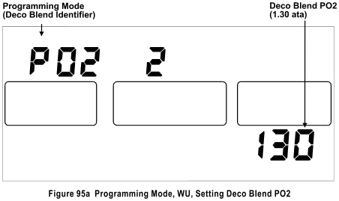

TOUCH PROGRAMMING - BLEND #2 - TIME BENCHMARK: The programming procedure for the Blend #2 Time Benchmark is the same as Two Gas Nitrox, refer to page 27.
TOUCH PROGRAMMING - BLEND #2 – DEPTH BENCHMARK: The programming procedure for the Blend #2 Depth Benchmark is the same as the Two Gas Nitrox, refer to page 27.
TOUCH PROGRAMMING – TACLITE™ - TWO GAS PO2: The Taclite™ Programming Procedure is the same as the Single Gas Nitrox, refer to page 17.
TOUCH PROGRAMMING - LOGBOOK - TWO GAS PO2: The Logbook Mode is the same as in the Single Mix Nitrox, refer to page 18 for detailed information.
WARNING INDICATIONS - TWO GAS PO2: Refer to Warning Indications on page 21.
SENSOR WARNING - TWO GAS PO2: Refer to Sensor Warning on page 21.
TOUCH CONTACT PROGRAMMING SCREENS : The following are all of the screens that the GEMINI WU is capable of presenting in the Touch Programming Mode. Refer to the particular configuration for appropriate screens.

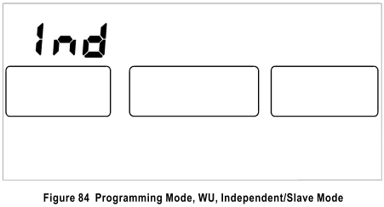

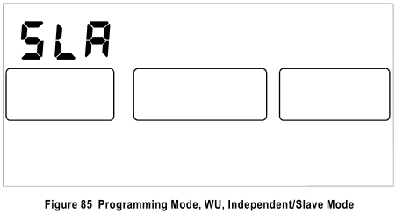

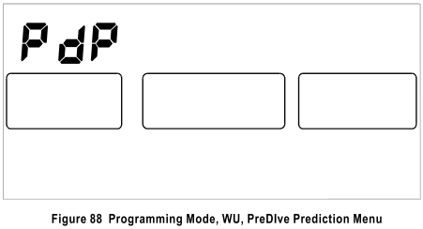

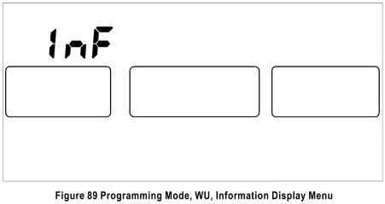

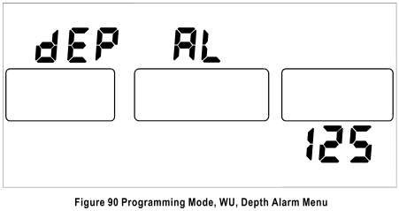

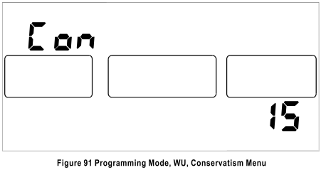

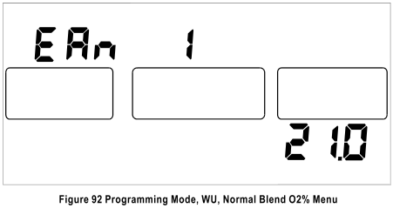

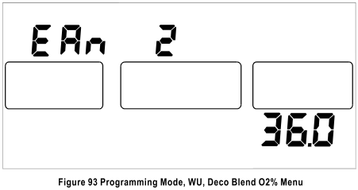

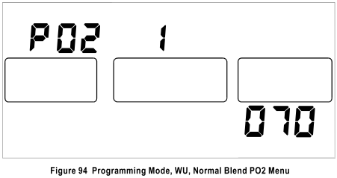

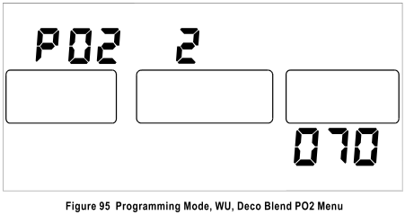

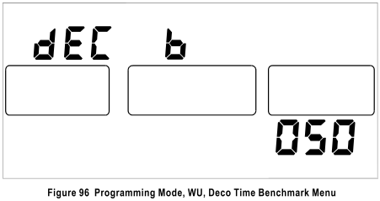

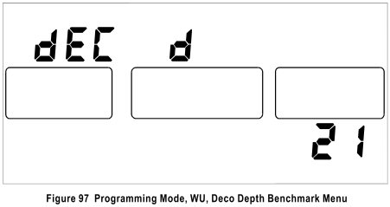

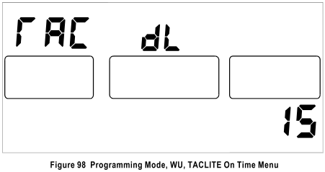

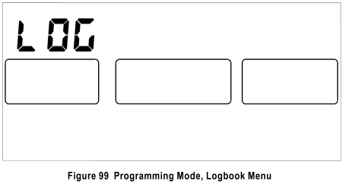

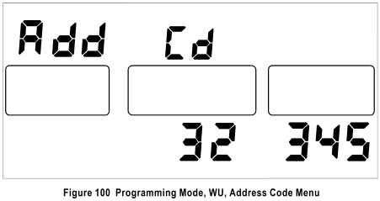

DATA STORAGE TYPES & CAPACITY: The GEMINI WU has the following internal distinct data storage activities:

- Current Variable Information: Local Time, CNS toxicity, OTU dose, OTU Mission Clock, Altitude, Battery voltage, Current unit Temperature, 16 tissues loading.
- Each Dive Beginning Statistics: Local Time Clock, Dive Number, Surface Time, CNS Toxicity, OTU Dose, Altitude, Time to Fly, Battery Voltage. Capacity is the most recent 12 dives.
- Each Dive Ending Statistics: Bottom Time, Max Depth, Max Deco Time, Max Deco Ceiling, CNS Toxicity, OTU Dose, Max Ascent Rate, Min Temperature, Min Battery Voltage, Time to Fly. Capacity is the most recent 12 dives.
- Each Dive Configuration Data: Blend #1 Oxygen %, Blend #2 Oxygen %, Blend #2 Activate Time, Blend #2 Activate Depth, User Conservatism. Capacity is the most recent 12 dives.
USER CONFIGURABLE ITEMS: The number of and which of the configurable options are viewed is determined by the configuration of your GEMINI WU.
Caution: Items that can be changed via Touch Contact Programming may be different from their factory settings.
By using the optional Analyst® Personal Computer Interface with the Wrist Unit in the “Slave” Mode, the user via the Tank Unit has the ability to change the following items:
Dive Time/date Stamp: This is the internal clock setting that is used by the system to time-stamp each individual dive as it occurs. Due to changes in battery voltage and temperature, the internal Time-of-day clock may slowly drift from the ideal. It is recommended that this clock be periodically set to your local time via the Analyst®.
Metric or Imperial: The diver may select whether the data is computed and displayed in Metric or Imperial units. The GEMINI WU may be ordered either way as shipped from the factory.
Selectable Ascent Rate Bar Graph (Fixed or Proportional): This option determines whether the Ascent Rate bar graph indicates the speed of ascent or the percentage of the selected maximum ascent rate. The GEMINI WU is shipped from the factory as ‘Proportional’ (percentage).
Selectable Variable-By-Depth Ascent Rate Alarm (On or Off): This option gives the diver the ability to utilize a fixed ascent rate warning or a warning based on depth. Should the diver prefer the fixed ascent rate warning the diver can select the maximum ascent rate limit of from 20 to 60 feet per minute (See next topic). As shipped from the factory, this is set to ON. If the VARIABLE rate is selected then the warning will illuminate based on the following table:
DEPTH AVERAGE ASCENT RATE
60 feet and deeper 60 feet per minute
60 to 30 feet same as depth
Shallower than 30 feet 30 feet per minute
Selectable Fixed Ascent Rate Alarm Limit: If Variable-By-Depth Ascent Rate Alarm was set to OFF from the above topic; the user may enter the desired Ascent Rate for the alarm to sound.
Ascent Rate for Deco Predictions (20 to 60): This option allows the diver to select the ascent rate to be used in the forecasting of the displayed Total Decompression time. The GEMINI WU is shipped from the factory with this option set to 60.
Ascent Rate Responsiveness (0 to 7): This option determines the responsiveness or sensitivity of the Ascent Rate Bar Graph. Zero is highly responsive and seven is very slow. This feature is set to three as shipped from the factory.
Remaining Time Responsiveness (0 to 7): This determines the responsiveness of the Remaining Time information that is displayed. Zero is highly responsive and seven is very slow. This feature is set to three as shipped from the factory
Max Depth Alarm: This option allows the diver to select a maximum depth below, which the diver does not wish to exceed before an alarm is sounded. This function is disabled when in the Decompression Mode. This option may also be set via the Touch Contact Programming method. As shipped from the factory, the Depth Alarm is set for 130 feet.
Select Decompression Time Display (Total, Stop, Both): There are three options for the manner in which the decompression time is displayed. If you select TOTAL, the decompression time displayed will indicate the total time you will spend in decompression.
Watch the Ceiling depth change in order to identify when to ascend to the next stop depth. If you select STOP, the decompression time displayed will indicate the time you must remain at the current Ceiling. When this time is 0:00, the Ceiling depth will decrease and the new stop time will be displayed. If you select BOTH, the TOTAL time and STOP time will alternate at the rate of once every 2 seconds. From the factory, the unit is set to ‘Both’.
Repetitive Dive Dependent Nitrogen (Off or On): This option allows the dive computer to consider recent dive history’s effects on the nitrogen loading, particularly if the diver engages in inverted profile diving. If “On” the recent dive history is used to compensate the nitrogen loading for the current dive. The GEMINI WU is shipped from the factory with this feature set to ‘Off’.
Temperature Dependent NDC Computations (Normal or Reduced): This feature compensates the decompression algorithm proportional to the ambient water temperature. See User & Environmental Adaptation, Water Temperature on page 50 for a detailed description of this function. The GEMINI WU is shipped from the factory with this feature set to ‘Normal’.
Select Altitude <2000 feet as One Zone (Off or On): This option provides "actual" altitude for any given day at any diving location as explained in the “ALTITUDE ACCLIMATIZATION” on page 51. With changes in barometric pressure due to temperature and weather systems, it is possible, even expected, to have a different apparent altitude at the same dive site from day to day.
While the seamless means of monitoring provides the most accurate decompression schedule, all altitudes less than 2,000 feet above sea level can be treated in the algorithm as sea level if so selected. With this option OFF, the unit is calculating altitude in a seamless fashion. With this option ON altitudes less than 2,000 feet above sea level will be treated as sea level. Regardless of the selection, altitudes greater than 2,000 feet above sea level will be treated in a seamless manner. From the factory, this is set to ‘Off’, seamless altitude from sea level to 15,000 feet.
Select Alternate Screen Viewing Time (3 to 10): This option allows the diver to set the amount of time that the Alternate Screen will be viewed once it has been accessed. From the factory this is set to 4.
Select Display Backlight On Time (0 to 99): This option allows the user to set the amount of time, in seconds, that the TACLITE™ stays on once activated. If this option is set to "0" the TACLITE™ will never activate, if set to "99" the TACLITE™ will stay on all the time and only turn off when the GEMINI WU does. From the factory this is set to 10. This option may also be set via the Touch Contact Programming method.
Select Audible Beeper Alarm (On or Off): This allows the user to enable or disable the Audible Alarms and beeper. As shipped from the factory, this is set to ‘On’.
Select Ceiling Display Divided by 10 (On or Off): This option allows the diver to select when in the Decompression Mode the Ceilings are displayed as 1 = 10, 2 = 20, 3 = 30 etc. (On) or as 10, 20, 30 etc (Off). From the factory this option is set to ‘Off’.
Select Nitrox Computations (Enabled or Disabled): This option enables and disables NITROX computations. If this option is disabled, mixtures other than 21.0% oxygen will be disallowed. Furthermore, if this option is selected as OFF, the GEMINI WU will not compute CNS Toxicity, OTU Dose, or maximum PO2 alarm. The factory setting for this option is ‘On’. This option can only be set via the Professional Edition of the Analyst®. As shipped from the factory, this set to ‘Enabled’.
Select Constant Mode Computations (FO₂ or PO₂): This allows the user to select between the Constant PO₂ and Constant FO₂ modes. This option may also be set via the Touch Contact Programming method. As shipped from the factory, this is set to ‘Constant FO₂’.
Enter Normal Blend Oxygen % in FO₂ Nitrox Mixture (21.0 to 50.0): For Constant FO₂ mode, this option allows the user to enter the desired Oxygen percentage for the FO₂ Blend in 0.1% increments. Values from 21.0% to 99.9% may be entered. This option may also be set via the Touch Contact Programming method. As shipped from the factory, this is set to 21.0%.
Enter Deco Blend Oxygen % in FO₂ Nitrox Mixture (21.0 to 99.9): For Constant FO₂ mode, this option allows the user to enter the desired Oxygen percentage for the FO₂ Deco Blend in 0.1% increments. For Constant PO₂ mode, this option specifies the FO₂ blend percentage if and when the unit switches to FO₂ computations. Values from 21.0% to 99.9% may be entered. This option may also be set via the Touch Contact Programming method. As shipped from the factory, this is set to 21.0%.
Enter Deco Blend Bottom Time Activation Minutes: Here, you will enter the bottom time benchmark for switching to the Deco Blend. The Field Programming Mode previously described may also modify this setting. As shipped from the factory, this is set to 600. This option may also be set via the Touch Contact Programming method.
Enter Deco Blend Ascent Depth Activation: Here, you will enter the depth benchmark, which you will need to be above for switching to the Deco Blend. The Field Programming Mode previously described may also modify this setting. As shipped from the factory, this is set to 10 feet. This option may also be set via the Touch Contact Programming method.
Enter Normal Dive PO₂ for Constant PO₂ Computations (.50 to 1.50): This allows the user to experiment with different PO₂s. This option may also be set via the Touch Contact Programming method. As shipped from the factory, this is set to 0.7.
Enter Deco PO₂ for Constant PO₂ Computations (.50 to 1.50): This allows the user to experiment with different PO₂s. This option may also be set via the Touch Contact Programming method. As shipped from the factory, this is set to 0.7.
Select Deco Blend Nitrox Switching (Enabled or Disabled): This option enables the unit to switch to the Deco blend. If it is disabled the GEMINI WU will not switch to the Decompression gas blend. As shipped from the factory, this set to ‘Enabled’.
Select Automatic PO2/FO2 Switching (Enabled or Disabled): This option enables the unit to switch from the Normal Dive PO2 mode to the Deco Blend FO2 mode. As shipped from the factory, this is set to ‘Disabled’.
Select Touch Contact Programming of PO2/FO2 Switch (Enabled or Disabled): This option allows the diver to switch from the PO2 mode to the FO2 mode and vise versa via the Touch Contacts. As shipped from the factory, this is set to ‘Disabled’.
High PO2 Alarm Point (0.50 to 1.59): This option allows the diver to select a maximum PO2 (Partial Pressure of Oxygen) at which an alarm is sounded. Values from 0.50 to 1.59 are allowed. This is set to a PO2 of 1.40 at the factory before shipping.
Selectable NDC Conservatism (0% to 50%): This feature allows the diver to input an added degree of conservatism to the decompression algorithm from 0 to 50 percent in one-percent increments. This may be desirable if the diver is dehydrated, tired, or has some other factor that warrants added conservatism. This option may also be set via the Touch Contact Programming method. Conservatism is set to ‘0%’ as shipped from the factory.
Enable Mix Switching In Deco Forecast (Enabled or Disabled): This option enables the unit to forecast decompression times utilizing the programmed deco gas for stops that are shallower than the switch depth. As shipped from the factory this option is enabled.
High CNS Alarm Point (40% to 80%): This option allows the diver to select a maximum CNS (Central Nervous System) exposure at which an alarm is sounded. Values from 40% to 80% are allowed. This is set to 50% at the factory before shipping.
High OTU Alarm Point (40% to 80%): This option allows the diver to select a maximum OTU (Oxygen Tolerance Units) exposure at which an alarm is sounded. Values from 40% to 80% are allowed. This is set to 50% at the factory before shipping.
Select Clock Functions (ON or OFF): This option allows the diver to enable or disable the time of day Clock. If ‘ON’ is selected, the clock time can be set via Touch Contact Programming. As shipped from the factory, this is set to OFF.
Enter Clock Time: This allows the diver to set the clock’s time to that of the P.C. time.
Select Alarm Clock Audible Alarm (ON or OFF): This option allows the diver to enable or disable the time of day Clock’s Alarm feature. If set to ON the Alarm Clock time can be set via Touch Contact Programming. As shipped from the factory, this is set to OFF.
Enter Alarm Clock Hour (0 to 23): This allows the diver to program the time of day Alarm Clock’s hour setting. The Alarm Clock’s time utilizes a 24 hour format, i.e. 0 = 12:00 am, 20 = 8:00 pm, etc. This is also settable via Touch Contact Programming.
Enter Alarm Clock Minute (0 to 60): This allows the diver to program the time of day Alarm Clock’s minute setting. This is also settable via Touch Contact Programming.
Restore Original Configuration Settings: This allows the diver to restore the original factory default settings with a single command.
SPECIFICATIONS:

Algorithm 16 Tissue Adaptive Modified Haldanean
Computation Period Once every second
Activation Manual and Water
Depth Range* Over 327 feet
Depth Display 0 to 327 feet, 1-foot increments
Depth Accuracy +/- 1% of full scale (+/- 3.3 feet)
Maximum Altitude 15,000 feet, seamless
Altitude Accuracy +/- 1000 feet
Temperature Display 0 to 99 degrees F, 1 degree increments
Temperature Accuracy +/- 2% of full scale after the unit has stabilized
from a change in temperature)
Surface Time 0 to 19:59 hrs/mins, 1-minute increments
Bottom Time 0 to 19:59 hrs/mins, 1-minute increments
Time To Fly 0 to 36 hours, 1-hour increments
No-Deco Time 0 to 9:59 hrs/mins, 1-minute increments
Decompression Time 0 to 9:59 hrs/mins, 1-minute increments
Decompression Ceiling 0 to 320 feet, 10-foot increments
Dive Summary Storage up to 12 Dives
Typical Battery Life** Over 2000 dive hours under normal diving conditions or 2 years (whichever is first), TACLITE™ off
Over 40 hours, TACLITE™ on continuously
With Clock Mode on, Battery Life is over 1000 dive hours or one year.
* While the Gemini is capable of depths greater than 327 feet it is only rated to 327 feet.
** With fresh new ENERGIZER® brand alkaline batteries
Note: Specifications are additionally +/- one least significant digit due to rounding. Specifications are subject to change without notice.

ENHANCEMENTS: The GEMINI is capable of having its’ capabilities enhanced. It can be upgraded to a two blend Nitrox computer and/or a One or Two blend Nitrox/PO₂ computer. The GEMINI WU must be returned to the factory for all upgrades.

CARE AND MAINTENANCE:

The Wrist Unit contain NO user serviceable components. DO not remove the Lens from the Wrist Unit, doing so WILL VOID the Limited Warranty.

CLEANING THE GEMINI WU: Clean the unit only with fresh water after each use. Towel dry the unit, never use air pressure to dry the unit. This could damage the unit and will void the warranty. Do not use chemicals to clean the case or lens as this may damage the unit, or permanently fog the lens.
CHANGING BATTERIES: The batteries should be changed when the ‘PBAT’ & ‘SBAT’ legends are seen or the battery voltage reaches 2.2 volts as can be seen on the Information Display. The unit will operate until the battery voltage drops below 2.0 volts. Only use fresh, name brand N-Cell size Alkaline batteries for maximum battery life. At this time, Eveready Energizer Alkaline is recommended. Care should be taken not to activate the TACLITE™ during battery replacement. Be sure to confirm that the batteries are REALLY new and have not been sitting on a shelf losing life. Cold temperatures tend to shorten apparent battery life. Change batteries every two years regardless of battery condition.
CAUTION!!! COMPLETE LOSS OF BATTERY POWER MAY CAUSE ALL PREVIOUS DIVE NITROGEN LOADING TO BE LOST. THIS MAY AFFECT NITROGEN CALCULATIONS ON NEAR-FUTURE DIVES. AFTER A BATTERY CHANGE, CONFIRM THAT NO-DECOMPRESSION TIME DATA IS REASONABLE DURING PRE-DIVE PREDICTION MODE. DIVE-OF-DAY NUMBER GOING TO ZERO IMMEDIATELY AFTER CHANGING BATTERIES IS ANOTHER INDICATION OF A LOSS OF NITROGEN LOADING.
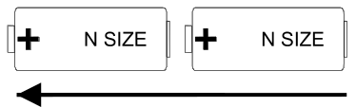
Plus end goes in First
When installing new batteries, ensure that the positive “+” end of the battery is inserted into the battery compartment first. Inspect the battery cap O-rings for nicks and scratches. If either O-ring is damaged carefully remove both O-rings and replace with new silicone O-rings. Lightly lubricate each end of the batteries with silicone grease or petroleum jelly to help minimize corrosion and therefore extend battery life.
When reinstalling the battery cap, lubricate the O-rings lightly and slowly twist the cap into place using a coin (US Quarter supplied). Press the coin into the battery cap slot firmly to prevent slipping and damaging the slot. Ensure there is no dirt or debris on the O-rings or the mating surface and that the O-rings are properly installed.
As the battery cap is screwed in, carefully observe that the double O-rings install correctly. Ask an Authorized Cochran Dealer for a demonstration.
It is best to have the new batteries ready to immediately install since the GEMINI WU was designed to allow for battery changes without resetting and losing any Nitrogen residuals. This period of time is typically 30 seconds, but varies with temperature and the voltage of the batteries being replaced. It can be significantly less if batteries are not replaced promptly when the ‘PBAT’ & ‘SBAT’ legends first come on. Again care should be taken not to activate the TACLITE™ during battery replacement, if the TACLITE™ is activated it will significantly reduce the time that the GEMINI WU allows for battery changes without losing nitrogen residuals.

ASSISTANCE, REPAIR & MAINTENANCE: If you suspect that your GEMINI WU is not operating correctly, please contact our Customer Support Department in the USA for assistance at 972.644.6284 or FAX details to 972.644.6286 or E-mail details to service@divecochran.com. Most problems can be resolved without returning the unit. The unit may also be returned to the place of purchase and request the dealer to contact us. If this is not possible or is inconvenient due to a change in location, contact us for the name of the nearest Team Cochran Authorized Dealer.
- NEVER TEST OR SUBJECT THE PRODUCT TO PRESSURIZED AIR! (Voids Warranty)
- NEVER REMOVE THE LENS FROM THE UNIT! (Voids Warranty)
- ONLY USE FRESH WATER TO CLEAN UNIT! NEVER USE SOLVENTS!
- DO NOT USE A SCREWDRIVER TO REMOVE BATTERY CAP! (Voids Warranty)
- ALWAYS KEEP FRESH ENERGIZER® BRAND BATTERIES INSTALLED!
- LUBRICATE BATTERY ENDS WITH THIN FILM OF SILICONE GREASE!

REPLACEMENT PARTS:
Batteries (2)
Battery Cap O-rings 19930
Battery Cap Assembly 19934
Pins (2) Replacement 19949
Wrist Strap (long Gray) 19950
Wrist Strap (long, black) 19951
Retractor Only 15925
Retractor with Compass 15935
Lens Protector (Pkg. of 3) 15400

ANALYST® Personal Computer Interface
The ANALYST® Personal Computer Interface is a complete hardware/software system that uploads data from the Cochran GEMINI TU to an IBM or compatible Personal Computer with a Windows® 95/98/NT/ME/2000 operating system. The ANALYST® Personal Computer Interface allows the diver to retrieve dive data, customize the dive computer and also to enter and store information for each dive in a logbook database.

FCC LABEL FCC ID: LYP744556-03
This device complies with Part 15 of the FCC Rules. Operation is subject to the following two conditions: (1) this device may not cause harmful interference, and (2) this device must accept any interference received, including interference that may cause undesired operation.

INTERFERENCE STATEMENT
NOTE: This equipment has been tested and found to comply with the limits for a Class B digital device. If not installed and used in accordance with the instructions, it may cause interference to radio communications. The limits are designed to provide reasonable protection against such interference in a residential situation. However, there is no guarantee that interference will not occur in a particular installation. If this equipment does cause interference to radio or television reception, which can be determined by turning the equipment on and off, the user is encouraged to try to correct the interference by one or more of the following measures:
- Reorient or relocate the receiving antenna of the affected radio or television.
- Increase the separation between the equipment and the affected receiver.
- Connect equipment and the affected receiver to power outlets on separate circuits.
- Consult the dealer or an experienced radio/TV technician for help.

MODIFICATIONS
Changes or modifications not expressly approved by Cochran Consulting, Inc. could void the user's authority to operate the equipment.

SHIELDED CABLES
This product is designed to be used only with the Analyst® interface cable (RS-232) to maintain compliance with FCC Regulations.

PATENT INFORMATION
Protected under one or more Foreign or US patents.
5,899,204 5,794,616
5,617,848 5,570,688
Other patents may be pending.

All specifications subject to change without prior notice. GEMINI® and Analyst® are registered trademarks of Cochran Consulting, Inc. Energizer is a registered trademark of the Eveready Battery Co., St. Louis MO. Copyright 2002 Cochran Consulting, Inc.

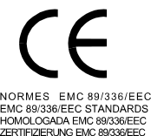
The CE mark is used to mark conformity with the European Union EMC directive 89/336/EEC. Cochran dive instruments fulfill all the required EU directives.

PREN 13319
PREN 13319 “Diving accessories – Depth gauges and combined depth and time measuring devices – Functional and safety requirements test methods” is a European diving depth gauge standard draft. Cochran dive instruments are designed and tested to comply with this standard draft.

LIMITED WARRANTY
To the original purchaser ("OWNER") only, Cochran Undersea Technology, a division of Cochran Consulting, Inc. ("COCHRAN"), represents this Product to be free of defects in materials and workmanship under normal SCUBA use for 24 months from the date of shipment from COCHRAN to the Authorized Dealer or Distributor. For purposes of establishing warranty eligibility, this date of shipment may be noted on the original Product box, or can be determined by contacting COCHRAN.

Any defective Product, unless cause is specifically excluded in the "Warranty Conditions and Limitations" section below, will at the sole discretion of COCHRAN, be repaired or replaced with a new or refurbished unit of comparable or better function and/or condition. COCHRAN is not responsible for any incidental or secondary damages as a result of Product malfunction.

WARRANTY CONDITIONS and LIMITATIONS
Product must have been obtained from a COCHRAN Authorized Dealer. Contact COCHRAN for verification of dealer status. This Limited Warranty is not transferable.

The Warranty Registration card must be sent to COCHRAN within 15 days of purchase in order to validate Limited Warranty.

Failure to provide proper care for this Product will render this Limited Warranty null and void. Damages or malfunction resulting from accidental or deliberate abuse, tampering, battery leakage, exceeding maximum intended operating depth or other parameters, extreme heat or cold, or other conditions which COCHRAN may deem to be outside the intended scope of this Limited Warranty are not covered. This Limited Warranty does NOT cover plastics, O-rings, batteries, battery life, and flooded battery compartments.

This Limited Warranty will be rendered null and void if an attempt is made to establish communications with the computer with any hardware and/or software other than the Cochran approved Analyst® Interface.
OWNER is responsible for shipping this Product to COCHRAN for service, and paying all associated costs, including shipping, insurance, and import duties. OWNER may take Product to an Authorized Dealer to arrange service under terms of this Limited Warranty. COCHRAN will return Product to OWNER or Dealer via a method and carrier of its choosing. Costs for requested expedited return shipping would be the responsibility of OWNER. Product returned for service under terms of this Limited Warranty must be accompanied by a photocopy of the original sales receipt in order for warranty repair or replacement to be performed if the Warranty Registration Card is not on file.

STATEMENT of LIMITED LIABILITY
A mathematical model is used by this Product to calculate physiological effects of SCUBA diving related to use of compressed air or other breathing mixtures while at depth. Such effects specifically relate to nitrogen absorption into and elimination from body tissues, as well as effects of oxygen used in Enriched Air Nitrox breathing mixtures.
However, because of the number of variables and the varying degrees to which they may affect individuals engaged in SCUBA diving, COCHRAN DOES NOT GUARANTEE THAT USE OF THIS PRODUCT WILL PREVENT DECOMPRESSION SICKNESS OR ANY OTHER CONDITION OR INJURY INCURRED WHILE USING THIS PRODUCT.
These influencing variables may include, but are not limited to, dehydration, obesity, age, old injuries, or other physical conditions on the part of the diver, or environmental extremes of heat or cold, or poor training, or diving practices, any of which may promote the onset of decompression sickness or other harmful effects.
This Product is sold and intended to be used only as a guide, providing the TRAINED and CERTIFIED diver the information needed to make safe diving decisions. It is expressly understood that by buying and/or using this Product the Diver assumes ALL RISK as to its operability, reliability, quality, performance, accuracy, and suitability for his diving style.
Furthermore, Diver recognizes that this Product is an electronic instrument being used in a hostile environment and is subject to failure, which may manifest itself in a number of ways. COCHRAN and its distributors and retailers will not be held liable for any personal injuries or other damages resulting from its use, even if COCHRAN has been advised of such occurrences or damages.

These products must be handled with care and properly maintained to assure the optimum performance. Users must possess the proper training for SCUBA diving activities and should be fully educated in the operation of this product. Users are encouraged to possess and utilize a redundant (backup) computer for their dive planning and execution. Divers are always encouraged to dive with a buddy at all times.
COCHRAN strongly supports and agrees with maximum depth limits of 130 feet for recreational SCUBA diving, as established by recognized training and certification agencies, and in no way encourages diving beyond these or any prudent lesser limits as may be necessitated by environmental, diver-specific, or other conditions.

THE WARRANTY AND REMEDIES SET FORTH ABOVE ARE EXCLUSIVE AND IN LIEU OF ALL OTHERS, WHETHER ORAL OR WRITTEN, EXPRESSED OR IMPLIED. COCHRAN UNDERSEA TECHNOLOGY SPECIFICALLY DISCLAIMS ANY AND ALL IMPLIED WARRANTIES, INCLUDING, WITHOUT LIMITATION, WARRANTIES OF MERCHANTABILITY AND FITNESS FOR A PARTICULAR PURPOSE.

No Cochran Undersea Technology dealer, agent, or employee is authorized to make any modification, extension, or addition to this warranty.

USER & ENVIRONMENTAL ADAPTATION: The GEMINI WU is one of the new breed of Dive Computers that adapts its algorithm to the users diving environment and style as originally pioneered by COCHRAN. All of COCHRAN’s newer dive computers incorporate this capability. The factors that are used for this “Adaptation” in the GEMINI WU are:
Water Temperature Salt/Fresh Water Compensation
Microbubble Altitude Acclimatization
User Conservatism Previous Dive Profiles

WATER TEMPERATURE: Diving in cold water can lead to a lower diver core and skin temperature which can affect the gas exchange rate of the body’s tissues. The GEMINI WU features two modes of Temperature Compensation, Normal or Reduced. The GEMINI WU progressively makes its nitrogen algorithms more conservative as the water temperature declines below 75 degrees F. Above this water temperature, there is no temperature compensation. In the Reduced Mode, the algorithms are made more conservative by approximately one-half the amount of the Normal Mode. If the diver is wearing an insulated dry suit and is relatively warm even in cold water, this temperature compensation factor may be set to Reduced Mode at the divers discretion using the Analyst® PC software.

MICROBUBBLE: There are several theories regarding the exact method by which a nitrogen bubble forms from a microbubble, which was formed from micronuclei. Currently the predominant theory states that more rapid ascents accelerate bubble formation. The GEMINI WU comprehends and adjusts for this phenomenon.

USER CONSERVATISM: Current dive computers cannot tell if the diver is dehydrated, tired, smokes, overweight, or has some other physical issue that may require additional conservatism in the nitrogen algorithm. The GEMINI WU allows the diver to input an added degree of conservatism to the nitrogen algorithm from 0 to 50 percent in one-percent increments. This can be done via the Touch Contact Programming Mode or with the Analyst® Personal Computer Interface.

PREVIOUS DIVE PROFILES: Under some circumstances, recent dive activity can have an effect on nitrogen loading, particularly if the diver engages in inverted profile diving. This occurs when a deep dive is followed by an even deeper dive. This recent dive history is used to compensate the nitrogen loading for the current dive. This can be enabled or disabled with the Analyst® Personal Computer Interface.

SALT/FRESH WATER COMPENSATION (High/Low Water Conductivity): There is approximately a three percent difference in depth readings taken in salt water versus fresh water. Some dive computers are calibrated in feet of fresh water and some are calibrated in feet of seawater. Diving in a medium different from what the dive computer is calibrated for will cause apparent depth errors. Only COCHRAN dive computers, including the GEMINI WU, actually determine the type of diving medium and compensate the depth reading accordingly. This is accomplished by measuring the conductivity of the water during a dive. Caution must be taken in interpreting this reading since some apparent fresh water is actually high in minerals or contaminants and is correctly compensated as salt water (High Conductivity). This commonly occurs in some caves, springs, and lakes.
ALTITUDE ACCLIMATIZATION: Driving or flying to a dive site significantly higher in altitude requires special modifications to the "sea level" algorithm. The GEMINI WU regularly samples the ambient barometric pressure to determine these changes in altitude whether the unit is On or Off. Accordingly, the decompression algorithm is changed to reflect these barometric pressure changes. Note: temperature and weather systems also affect barometric pressure and hence, apparent altitude. Using the Time-To-Fly digits, the number of hours required to “adapt” to the new altitude is immediately known to the diver. If a significant altitude change occurs, a minimum of one hour should pass before diving to allow the unit to adapt to this new altitude. Rapid changes in altitude should be avoided. The dive computer may interpret a rapid change from a higher altitude to a lower altitude as a dive. Should this occur, removing the batteries for ten minutes will reset the computer, however, all tissue nitrogen loading will also be lost.
Should it be desired to initiate a dive PRIOR to completing the adaptation time, the GEMINI WU will treat this dive as a repetitive dive in its algorithm, taking into account the "residual" nitrogen present due to travel to altitude. There are two methods of compensating for altitude. Via the Analyst® PC Interface, ZONE or SEAMLESS altitude compensation may be selected.
In ZONE all altitudes less than 2,000 feet above sea level use the sea-level algorithm. At altitudes greater than this, altitude compensation is “seamless”; literally, every small fraction of gained altitude is considered in adjusting the algorithm. ZONE will reduce the occurrences of obtaining slightly different altitude readings and corresponding no-decompression (NDC) limits when diving within a given area. However, ZONE reduces the accuracy of the altitude compensation for the first 2,000 feet above sea level, since all altitudes below 2,000 feet are treated as sea level. The advantage in ZONE is that changes in apparent altitude due to temperature or weather changes at sea level will not affect the NDC computations.
In SEAMLESS, the algorithm is adjusted for extremely small changes in altitude. However, a difference in altitude may be seen from day-to-day at a given dive site due to temperature or weather systems and their effect on barometric pressures. SEAMLESS will provide the most accurate altitude compensation algorithm, but normal variations in atmospheric barometric pressure may affect the no-decompression time which is more predominantly seen in the Pre-dive Prediction forecast.

CAUTION: The GEMINI WU will not perform Altitude Acclimatization if the touch contacts are shorted or bridged. Rinse the unit with clean fresh water and dry it with a towel after each dive. Transporting and storing the unit in its case will help prevent the possibility of the contacts being shorted or bridged.

WARNING: While your GEMINI WU will automatically adjust its no decompression algorithm for altitude, you should NOT attempt to dive at altitudes greater than 1,000 feet above sea level without first completing a sanctioned altitude diving course from a recognized training agency for recreational diving. The GEMINI WU should not be used for this type of diving by anyone without this important training.

METRIC/IMPERIAL MODES: Most dive computers always compute in either Metric or Imperial units and merely convert the display to the other units. The GEMINI WU actually computes and displays in the selected units giving maximum accuracy and user familiarity. If the computer is computing and displaying in Metric, the “METRIC” legend will be illuminated when the computer is on. Metric/Imperial selection is made using the Analyst® software. Changing Modes does not affect any profiles or data stored in the computer.
LOW BATTERY INDICATIONS: Fresh ENERGIZER® brand alkaline batteries should read about 3.2 volts on the InFormation Screen. When the battery voltage drops to 2.5 volts, the ‘PBAT’ & ‘SBAT’ legends will be illuminated. It is recommended to change the batteries at this point, but several dives might still remain possible. One the ‘PBAT’ & ‘SBAT’ legends illuminate it is recommended that the diver monitor the battery voltage as displayed on the InFormation screen. Once the battery voltage declines below 2.0 volts the TACLITE™ is deactivated, to conserve the remaining battery power even though the unit may be on a dive, and cannot be activated until fresh batteries are installed. While there should be sufficient battery power to normally complete a dive, it is not recommended to begin a new dive until fresh ENERGIZER® brand alkaline batteries are installed. After the computer automatically turns itself off (enters Sleep Mode) 70 minutes after a dive, it cannot be turned back on if the battery voltage is less than 2.0 volts. Fresh ENERGIZER® brand alkaline batteries must be installed. See the “BATTERY CHANGES” section of this manual for detailed information on how to change batteries.
CAUTION!!! COMPLETE LOSS OF BATTERY POWER MAY CAUSE ALL PREVIOUS DIVE NITROGEN LOADING TO BE LOST. THIS WILL AFFECT NITROGEN CALCULATIONS ON NEAR-FUTURE DIVES. AFTER A BATTERY CHANGE, CONFIRM THAT NO-DECOMPRESSION TIME DATA IS REASONABLE IN THE PRE-DIVE PREDICTION MODE. DIVE-OF-DAY NUMBER GOING TO ZERO IMMEDIATELY AFTER CHANGING BATTERIES IS ANOTHER INDICATION OF A LOSS OF NITROGEN LOADING.

TABLE OF CONTENTS
Page Number
Product Introduction 1
Side Touch Contacts 1
Turning the Product On & Off 1
Main Operating Modes 2
Surface Interval - Air/Single Gas Nitrox 2
Dive Mode - Air/Single Gas Nitrox 5
Ascent Rate Bar Graph 7
Decompression Mode - Air/Single Gas Nitrox 8
Post Dive Interval Mode - Air/Single Gas Nitrox 10
TACLITE™ 11
Clock Mode 11
Touch Contact Programming 11
Clock Programming 11
Clock Programming Procedure 12
Clock Programming Screens 12
Touch Programming Procedures 14
Programming Menu - Air Only 14
Programming Menu - Single Gas Nitrox 15
Pre Dive Prediction - Air/Single Gas Nitrox 15
Information Display - Air/Single Gas Nitrox 16
Depth Alarm - Air/Single Gas Nitrox 17
Conservatism - Air/Single Gas Nitrox 17
Blend #1 O₂ % - Single Gas Nitrox 17
Taclite™ 17
Logbook Mode - Air/Single Gas Nitrox 18
Logbook Screens 18
Address Code 20
Warning Indications 21
Sensor Warning Mode 21
Sensor Warning Screen 22
Oxygen Toxicity Factors 22
Partial Pressure of Oxygen (PO2) 22
Central Nervous System Toxicity 23
Oxygen Tolerance Units (OTU) 23
GEMINI WU - Two Gas Nitrox 24
Gas Blend Switching - Two Gas Nitrox 24
Surface Interval - Two Gas Nitrox 25
Dive Mode - Two Gas Nitrox 25
Decompression Mode - Two Gas Nitrox 25
Post Dive Interval - Two Gas Nitrox 26
Programming Menu - Two Gas Nitrox 26
Clock Mode - Two Gas Nitrox 26
Pre Dive Prediction - Two Gas Nitrox 26
Information Display - Two Gas Nitrox 26
Depth Alarm - Two Gas Nitrox 26
Conservatism - Two Gas Nitrox 26
Blend #1 O₂ % - Two Gas Nitrox 26
Blend #2 O₂ % - Two Gas Nitrox 27
Blend #2 Depth Benchmark 27
Blend #2 Time Benchmark 27
Taclite™ 27
Logbook Mode - Two Gas Nitrox 27
Address Code 27
Warning Indications - Two Gas Nitrox 27
Constant PO₂ Operating Mode 28
Constant PO₂ & FO₂ Modes 28
GEMINI WU - Single Gas FO₂/PO₂ 28
Surface Interval - Single Gas PO₂ 28
Dive Mode - Single Gas PO₂ 29
Decompression - Single Gas PO₂ 30
Post Dive Interval - Single Gas PO₂ 31
Programming Menu - Single Gas PO₂ - PO₂ 31
Programming Menu - Single Gas PO₂ - FO₂ 31
Clock Mode - Single Gas PO₂ 31
FO₂/PO₂ Mode 32
Pre Dive Prediction - Single Gas PO₂ 32
Information Display - Single Gas PO₂ 33
Depth Alarm - Single Gas PO₂ 33
Conservatism - Single Gas PO₂ 33
Blend #1 PO₂ - Single Gas PO₂ 33
Taclite™ 33
Logbook Mode - Single Gas PO₂ 33
Log Book Screens - Single Gas PO₂ 33
Warning Indications - Single Gas PO₂ 34
Sensor Warning - Single Gas PO₂ 34
GEMINI WU - Two Gas FO₂/ PO₂ 34
Constant PO₂ & FO₂ Modes 34
Gas Blend Switching 34
Surface Interval - Two Gas PO₂ 34
Dive Mode - Two Gas PO₂ 34
Decompression Mode - Two Gas PO₂ 34
Post Dive Interval - Two Gas PO₂ 35
Programming - Two Gas Nitrox/ PO₂ 35
Programming Menu -
Two Gas FO₂/PO₂ - FO₂ to FO₂ 35
Programming Menu -
Two Gas FO₂/PO₂ - PO₂ to FO₂ 36
Programming Menu -
Two Gas FO₂/PO₂ - PO₂ to PO₂ 36
Clock Mode - Two Gas PO₂ 36
Pre Dive Prediction - Two Gas PO₂ 36
Information Display - Two Gas PO₂ 37
Depth Alarm - Two Gas PO₂ 37
Conservatism - Two Gas PO₂ 37
Blend #1 PO₂ - Two Gas PO₂ 37
Blend #2 PO₂ - Two Gas PO₂ 37
Blend #2 Depth Benchmark 37
Blend #2 Time Benchmark 37
Taclite™ 37
Logbook Mode - Two Gas PO₂ 37
Warning Indications - Two Gas PO₂ 37
Sensor Warning - Two Gas PO₂ 37
Touch Programming Screens 37
Data Storage Types & Capacity 41
User Configurable Options 41
Product Specifications 45
Enhancements 45
Cleaning the Unit 45
Changing Batteries 45
Assistance, Repair, & Maintenance 45
Replacement Parts 47
Analyst® Personal Computer Interface 47
Product Certifications 48
Limited Warranty and Liability Statement 49
User & Environmental Adaptation 50
Metric & Imperial Modes 52
Low Battery Indications 52
Table of Contents 53
Figures Index 56

FIGURES INDEX
Fig # Page Number

01 Self-Test Screen 2
17 Ascent Rate Bar Graphs 7
50 Programming Mode - Clock Menu 12
51 Programming Mode - Clock Alarm On/Off - Showing Off 12
52 Programming Mode - Clock Alarm On/Off - Showing On 13
53 Programming Mode - Clock with Alarm 13
54 Programming Mode - Clock without Alarm 13
- Surface - No Nitrogen - Air Only 2
70a Surface - No Nitrogen - FO2 Mode 3
70b Surface - No Nitrogen - PO2 Mode 28
71 Surface Mode - Residual Nitrogen - Air Only - Primary 3
71a Surface Mode - Residual Nitrogen - FO2 - Primary 4
71b Surface Mode - Residual Nitrogen - PO2 - Primary 28
72 Surface Mode - Residual Nitrogen - Air Only - Alternate 3
72a Surface Mode - Residual Nitrogen - FO2 /PO2 - Alternate 4, 29
- Dive Mode - Normal Dive - Air Only -Primary 5
73a Dive Mode - Normal Dive - FO2 - Primary 5
73b Dive Mode - Normal Dive - PO2 - Primary 29
- Dive Mode - Normal Dive - Air Only - Alternate 6
74a Dive Mode - Normal Dive - FO2 - Alternate 6
74b Dive Mode - Normal Dive - PO2 - Alternate 29
- Dive Mode - Decompression - Air Only - Primary 8
75a Dive Mode - Decompression - FO2 - Primary 8
75b Dive Mode - Decompression - PO2 - Primary 30
75c Dive Mode - Decompression @ zero feet 10, 30
- Dive Mode - Decompression - Air Only - Alternate 8
76a Dive Mode - Decompression - FO2 - Alternate 9
76b Dive Mode - Decompression - PO2 - Alternate 30
- Logbook - Normal - Primary 19
- Logbook - Normal - Air Only - Alternate 19
78a Logbook - Normal - FO2 - Alternate 19
78b Logbook - Normal - PO2 - Alternate 33
- Logbook - Deco - Primary 20
- Logbook - Deco - Air Only - Alternate 20
80a Logbook - Deco - FO2 - Alternate 20
80b Logbook - Deco - PO2 - Alternate 34
- Dive Mode - CNS/OTU Warning - Primary 24
81a Dive Mode - CNS/OTU Warning - Alternate 24
82 Dive Mode - PO2 Warning 23
83 Dive Mode - SENSOR Warning – Primary 22
83a Dive Mode - SENSOR Warning – Alternate 22
- Programming Mode - WU - Independent/Slave Mode 38
- Programming Mode - WU - Independent/Slave Mode 38
- Programming Mode - WU - FO₂/PO₂ - Showing FO₂ 32, 38
- Programming Mode - WU - FO₂/PO₂ - Showing PO₂ 32, 38
- Programming Mode - WU - Predive Prediction Menu 38
88a Programming Mode - WU - Predive Prediction - Air/ FO₂ 15
88b Programming Mode - WU - Predive Prediction - PO₂ 32
- Programming Mode - WU - Information Menu 39
89a Programming Mode - WU - Information Display - Air Only 16
89b Programming Mode - WU - Information Display - FO₂ 16
- Programming Mode - WU - Depth Alarm Menu 39

Fig # Page Number

90a Programming Mode - WU - Setting Depth Alarm 17
- Programming Mode - WU - Additional Conservatism Menu 39
91a Programming Mode - WU - Setting Conservatism 17
- Programming Mode - WU - Normal Blend O₂ % Menu 39
92a Programming Mode - WU - Setting Normal Blend O₂ % 17
- Programming Mode - WU - Deco Blend O₂ % Menu 39
93a Programming Mode - WU - Setting Deco Blend O₂ % 27
- Programming Mode - WU - Normal Blend PO₂ Menu 40
94a Programming Mode - WU - Setting Normal Blend PO₂ 33
- Programming Mode - WU - Deco Blend PO₂ Menu 40
95a Programming Mode - WU - Setting Deco Blend PO₂ 37
- Programming Mode - WU - Deco Blend Bottom Time Benchmark Menu 40
96a Programming Mode - WU - Setting Deco Blend Bottom Time Benchmark 27
- Programming Mode - WU - Deco Blend Depth Benchmark Menu 40
97a Programming Mode - WU - Setting Deco Blend Depth Benchmark 27
- Programming Mode - WU - Taclite On Time Menu 40
98a Programming Mode - WU - Setting Taclite On time 18
- Programming Mode - WU - Logbook Menu 41
99a Programming Mode - WU - Logbook, Dive information 18
- Programming Mode - WU - Tank Unit Address Code Menu 41
100a Programming Mode - WU - Setting Address Code 21
101 Post Dive Interval - Primary - Typical 10
101a Post Dive Interval - Alternate - Typical 10

Cochran

GEMINI WU
Independent Mode
Owner's Manual

English - Imperial
Ver: GemInd-1.00

Manual Part Number: 4400812

1758 Firman Drive
Richardson, Texas 75081, USA
Phone 972-644-6284
Fax 972-644-6286
www.divecochran.com

