M.Phil. in Technology Policy
2007/2008

The Road to ZEVs (Zero Emission Vehicles) – Corporate Strategies to cope with Climate Change Legislation

Giles Hodgson

Professor Arnoud De Meyer

I confirm that this piece of work is my own unaided effort and conforms with the Judge Business School’s guidelines on plagiarism

PROJECT AVAILABILITY
please tick ONE box only

Available
(to Cambridge University staff and students only)
Embargoed
(your project will not be made available immediately)
Available after this date:
Consult me  (prospective readers will be directed to e-mail you for permission to read your project: if you do not give us a working e-mail address, we will make your project confidential)  My e-mail address is: gch23@cam.ac.uk or gileshodgson@yahoo.co.uk | X

Supervisor:
Professor Arnoud De Meyer

The Road to ZEVs (Zero Emission Vehicles) – Corporate Strategies to cope with Climate Change Legislation

INDEX
Chapter 1 - Introduction 3
Chapter 2 – Scenario selection methodology 5
Chapter 3 – Drivers of Change - Issues Impacting on the Car Manufacturing Sector. 7
Chapter 4 - Technological Alternatives 13
Chapter 5 - Policy Options 17
Chapter 6 - Interactions between the Drivers, Technology and Policy 23
Chapter 7 – Interviews with Lotus, Land Rover and Bentley. 24
Chapter 9 – Development of a Strategy to Cope with the Scenario Presented 36
Chapter 10 – Summary 41
Appendix 1 – Case Study Questions 42
Cited References 43

Chapter 1 - Introduction

Changes in three enormously powerful global factors are currently coinciding, the result of which will be major changes in policies, business strategies, and society as a whole.

The factors are:
- Climate change
- Energy security and the price of oil
- Economic and population growth in developing countries

A major shift in one factor alone causes concern, the combination of all three is deeply worrying. The subject of this paper, the passenger car manufacturing industry, is at the cross-roads of all three issues. The Climate is affected by cars, the price of oil will impact on customer behaviour, and growth in developing countries offers more potential markets yet increases global pressures on materials, costs and, again, climate change.

To reduce climate change the EU aims to reduce CO₂ levels from 1990 levels by 60% - 80% by 2050. To date the UK has made very little real progress towards its target. This is unlikely to change without considerable intervention from the EU, other supranational bodies, or a tidal-change in public opinion.

Decoupling economic growth and emissions from personal transport is a key challenge for policy makers. Currently mobility both drives growth, and is a consequence of growth. Methods for decoupling have however been suggested including substitution, modal shifts, distance reductions and efficiency increase, all of which will be returned to.

This paper considers the influencing factors that will have an impact on the car manufacturing industry in the future – up to and beyond 2030. These are divided into Drivers of Change, Technical Alternatives and Political Options, Chapters 3-5 respectively. The paper focuses on Europe which is seen as largely homogenous, following UK trends.

Information is drawn from many sources. The 4th IPCC assessment report is used for Climate Change data. Technical papers are reviewed to understand the future fuel and powertrain options. Societal changes are informed by recent research into likely behaviour change, and historical precedents.

To validate the Scenario Planning process, the likely changes in the external environment and current strategies, representatives from three companies were interviewed. Their feedback is detailed in Chapter 7.

The methodology laid out in section 2 is used to select a coherent environmental, technical, economic, political and sociological scenario for 2030, which is presented in Chapter 8. This is not a prediction but a possible future to facilitate better strategic decision making. The risk of missing opportunities is reduced; similarly the risk of being trapped in a technological or strategic cul-de-sac is diminished.

Chapter 9 is the culmination of the paper building on the analysis and scenario presented previously. To do this the strategic development process is explained. The process uses the external environment analysis and generated scenario in sections 3-7 combined with an analysis of the internal strengths of a company (in this instance Fiat) to identify the gaps in the market that the organisation can fill. The output is a strategy to cope with the future climate change influenced world.

This paper has been written in a style that lends itself to being used with relatively minor re-writing as an MBA case study that allows students to consider scenario planning and strategic decision making in the car industry. Marketing and brand value issues could also be explored.

Chapter 2 – Scenario selection methodology
The methodology used in this paper is based on the TAIDA (Tracking, Analysing, Imagining, Deciding and Acting) model of Lindgren & Bandhold. The stages are:
- Preparation – set a goal and explore the extent of the world to consider
- Tracking – Describe the changes in the world that may have an impact
- Analysing – Understand the changes, their interactions and possible implications
- Scenario Creation – Envisage the future world(s)
Having created scenario(s) strategic options can be devised
- Strategic Development – Use strategic management tools to develop competitive strategies

Preparation
Preparation starts with the identification of purpose. In this case the purpose is to; understand the issues facing auto companies, identify opportunities and threats, and develop a strategic vision of the future.

The second preparatory stage is the identification of the system to be analysed. The nature of the car industry results in a huge scope. The causes and effects of climate change, societal issues, individual rights and responsibilities, political power, automotive technology and commercial factors all need to be considered.

Tracking
Tracking in this instance is the monitoring of the factors that may have an impact on the commercial success of car companies and therefore the strategies they should employ. The two stages are identification and quantification. Identification involves listing of the relevant ‘PEST’ (Political, Economic, Social and Technical) issues; quantification the assessment of the possible values. This paper has used media scanning, technical papers, environment scanning, discussions with experts and evidence from other countries for identification and quantification.

Analysing
Analysing involves understand the weight of the factors and the interrelationships between them.

Scenario Creation
One to four scenarios are usually developed. These can be selected from a 2x2 matrix using the two most critical variables as the X and Y axis. The most critical factors for manufacturers are felt to be the rate of technical developments and the public’s willingness to change their behaviour, as shown below.

Fast
Working together
Manufacturer
led clean cars

Note: Actual danger from climate change High and Political awareness of the need to act High

Rate of technical development
Frustrated public

Unhappy
Public

Slow
Low High Public willingness to change their behaviour

The quadrants should be named to aid understanding and a decision made as to how many quadrants to consider. In this case Manufacturer led clean cars & Working Together are unlikely without (currently unanticipated) technical breakthroughs. The other two quadrants however present many challenges. This paper will focus on ‘Unhappy public’ as it is both very possible and challenging.

Once the quadrant(s) of interest have been selected the events contained within should be described to give the reader an understanding of, and empathy for, the newly created world.

Strategic Development
Once the future world scenario is established strategic management tools can be used to identify strategies that will give an organisation a competitive edge.

Chapter 3 – Drivers of Change - Issues Impacting on the Car Manufacturing Sector.

In the future the pressures the motor industry is exposed to will escalate. In the past industry lobbying held at bay much safety and emissions legislation. This could become very difficult if some of the more alarming predicted consequences of climate change are seen. Shaping and adapting to legislation will be more likely than preventing it.

The societal changes resulting from the drivers are very hard to predict; will the public truly embrace green issues, or will they be bored with them. Will concern for those who suffer result in unprecedented altruism, or will a fortress mentality evolve? Will policy makers be given a mandate to make tough choices, or will they have to fight to do so? The sections below detail the most critical issues.

Climate Change -
Climate change is now accepted by all but the most ardent of sceptics to be real and dangerous. The 4th IPCC report explains in detail the causes, possible effects and therefore why climate change is such a powerful driver of change.

Population Growth
Population growth is a primary driver of GHG emissions with the current total of 6.7bn expected to increase to over 9bn by 2050. Historically there has been a correlation between GDP growth and GHG emissions. As long term global annual GDP growth is expected to be around 3.2% GHG emissions will rise unless the two factors can be decoupled. An increase in global GHG emissions of between 25 and 90% between 2000 and 2030 is projected by the IPCC Special Report on Emissions Scenarios.

The result of the above is global warming is set to continue. The range of CO₂ concentrations used in the IPCC 4th assessment report is 350 – 790ppm (current levels are around 380ppm). Assuming CO₂ concentrations are stabilised around 550ppm (which is currently looking difficult to achieve) global average temperatures are expected to increase by 3.2 ºC – 4.0 ºC.

This is important for this paper as the implications of such a temperature rise are enormous, and therefore pressure on Governments to reduce emissions will be similarly enormous.

The Price of Oil and Security of Supply
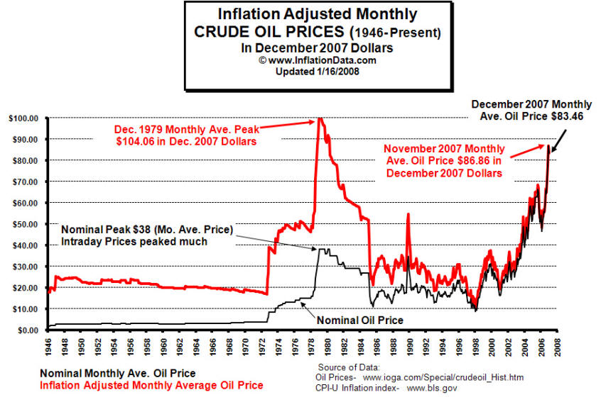
The future price of oil will have a huge impact on the direction of the motor industry. The obvious direct impact is the cost of running a vehicle and therefore the type of fuel / propulsion system chosen. Until 1972 oil prices were stable. Since then they have been anything but, and continue to be highly volatile (see right). Oil has since peaked above $130 a barrel, a 50% increase in six months. Further price increases are possible driven by high demand – particularly in China in preparation for the Olympics, and supply – problems in Nigeria and falling Russian output, leading to the possibility of the $200 barrel.

But a further escalation is not absolutely assured, in the short term at least. New oilfields are still being found, notably off Brazil in November 2007; Nigerian and Russian supplies should recover and, perhaps most importantly, OPEC could cut prices. There is much speculation as to whether ‘peak oil’ has now been reached. As global demand is projected to increase (below) and a decline in supply is expected in the near future the price pressures are clear.

Total Global Primary Energy Supply
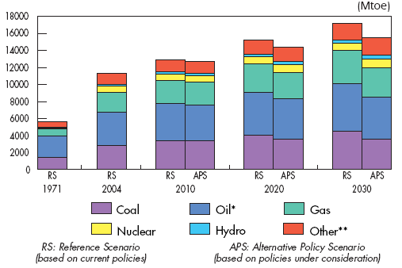
** Other includes combustible renewables & waste, geothermal, solar, wind, tide, etc
Source: IEA. Key World Energy Statistics. 2007

Many factors influence global security of supply (Israel – Palestine, Iraq, Iranian ambitions, Russian politics, US support, etc). Security in the Middle East is critical, particularly within Saudi Arabia, although this is by no means assured .

Visibility of future oil prices would clearly help car manufacturers decide which of the future fuel options to invest in. However, this will remain one of the great unknowns in the decision making process facing all car companies.

Personal Transportation
There have been clear trends in personal transport use in recent years. UK private and light goods vehicle ownership rose consistently between 1980 and 2006, recording an 82% increase resulting in 30m such vehicles on British roads. Not surprisingly the increase in vehicles resulted in a large increase in the total distance travelled. Car and taxi kilometres travelled rose from 215 to 402bn over the same period yet the total length of roads increased by just 10%. Not surprisingly average road speeds have been dropping. The off-peak English average slipped from 26.3 to 24.1 mph (a 9% decline). There is a remarkably high correlation (96%) between total vehicle miles and GDP. This is significant for future traffic projections in view of the expectation of year on year GDP growth of around 2.25% in the UK.

The implications of the above data are in one respect clear – there are very likely to be increases in congestion and subsequent reductions in average speeds.

Societal Factors
Society as a whole is slowly waking up to the importance of environmental issues. New data is published usually reinforcing the previous messages that climate change is real and dangerous, there are frequent discussions on TV and radio, and newspapers carry environmental articles almost daily. Al Gore’s film ‘An Inconvenient Truth’ and subsequent Nobel Prize (jointly with the IPCC report team) has raised awareness globally. Marketing is changing too. BP famously re-branded itself, Marks & Spencer are pushing their ‘Plan A’, even EasyJet is claiming to be green (at least, more so than their rivals).

Concern about the environment is growing. A 2007 survey by Hyder Consulting, cited in the Guardian, found that 86% of the population worry about the environment.

The frequency of ‘freak’ events has and will continue to drive such concern. The 4th IPCC report forecasts that it is very likely that more ‘Heavy precipitation events’ will occur in most areas while simultaneously likely that more areas will be affected by drought. It is also felt likely that ‘intense tropical cyclone activity’ will increase and ‘extreme high sea level’ will be seen.

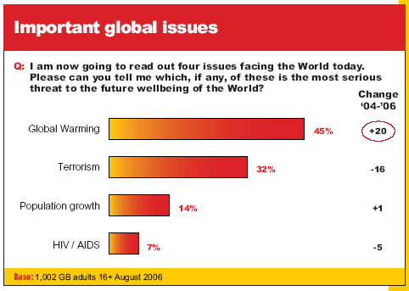
Unusual weather has already been seen. Torrential rain in the summer of 2007 followed the longest period of hot weather experienced in the UK since records began (five months from May to September 2006). The average temperature in Central England, 16.2C, was two degrees above the norm. Further afield, in 2007 the Arctic ice coverage shrank to its smallest ever area.

It is therefore no surprise that Mori found global warming is now seen as the most serious threat to the future.

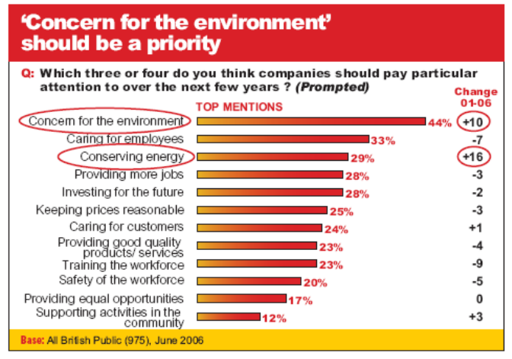
When Mori asked what ‘companies should pay particular attention to over the next few years?’ the answer is clear – Concern for the environment and Conserving energy were both in the top three. However, there is simultaneously evidence that the public have not accepted that their behaviour is going to have to change significantly. Scepticism, a lack of awareness of the true picture, government reluctance to break the bad news, and powerful commercial interests all conspire to give the impression that relatively minor lifestyle changes (drive a Prius, recycle, avoid food that is flown into the UK, walk to the newspaper shop) will be sufficient. A study by Defra of planned behaviour demonstrates this point;

A Mori study ‘Tipping Point or Turning Point came to similar conclusions. 88% of those interviewed believe that climate change is real, 82% are ‘fairly’ or ‘very’ concerned about the consequences, and 70% believe the world will experience a major environmental crisis if there is no change. In theory the public support Government intervention to change behaviour yet only 21% supported raising the cost of flying and fewer still, 14%, increasing tax on petrol.

Moral issues
Questions of moral responsibility also need to be taken into account. What are the moral obligations of vehicle manufacturers to those who do suffer loses? Consumers also have a responsibility for their actions. The information regarding the consequences of their emissions is available. Yet manufacturers convey the idea that their new products are sustainable. Is the consumer persuaded by the advertising that the issues are manageable?

Manufacturers argue that they have to sell what the customer wants to buy. If they are to adopt radical ‘green’ policies that are not commercially successful ‘brown’ competitors gain the advantage.

Does the responsibility therefore lie with the Government or with wider international bodies such as the UN (‘the UN … work(s) to promote respect for human rights, protect the environment, fight disease and reduce poverty.) to impose appropriate regulations? They have the information necessary, the ability to impose restrictions on all manufacturers, and the responsibility to protect their citizens from future risks. The counter argument is that Governments also have a duty to protect wealth in the immediate future and individual freedom. There is also the question of political mandate. If there is not public support for change how can the government act? Following this line of reasoning shifts the responsibility to the voting public who to date have given conflicting signals about these issues.

Awareness of the moral issues will grow in the coming years. Will companies feel the obligation to drive industry wide restrictions, will the public change their purchasing patterns significantly, or will Governments use policy tools to drive through necessary changes against the will of a self-maximising public? (See Grubb for detailed discussion of the moral issues)

Political pressures
Concern about environmental trends is changing the political landscape. All the major parties are trying to persuade the electorate that they currently do or would take action to reduce climate change. The Stern Review is clear in its conclusions. There will be costs associated with climate change; significant but manageable if action is taken now, substantial if there are delays. An ongoing 5% loss in GDP is predicted as a minimum loss if action is not taken, rising to a potential 20% GDP loss if the wider consequences are considered. Yet the cost to mitigate the worst of the changes could be as little as 1% of GDP. The political challenge however is that the 1% has to be paid now, while the benefits or cost avoidance will be felt in the (in political terms) distant future.

Others
The Association of British Insurers currently plays down the industry’s exposure to climate change related loses yet there is a growing awareness of the potentially enormous impact. It is possible that the insurance industry will become a leading emissions reduction lobby voice as the costs to them become clearer? Similarly, if the loses become sufficiently great, is there a risk that the government will have to bail out insurers as they did Northern Rock?

Summary
The conflicting concerns and actions, rights and responsibilities and commercial pressures make for conflict and inaction. However, the world is changing very quickly. Events, attitudes and actions will all happen, change and respond. From a commercial perspective the questions are how far and how soon will the world in which the car manufacturers operate change? What will consumers want? How will the competition act? There are large technological questions to be answered to; will there be one dominant technological solution, will the fuel or the powertrain change, and will there be a major technological breakthrough? The following section reviews the technical progress to date and the future options envisaged.

Chapter 4 - Technological Alternatives
Many factors affect the emissions of vehicles (aerodynamics, weight, friction) however the greatest factor is the choice of powertrain/ fuel combination. This section therefore focuses on this. In theory there are many alternatives. In practice they all have significant obstacles; technical know how, availability of materials, commercial feasibility or cost.

This document outlines the main alternative powertrain and fuel options (internal combustion engines (ICEs), battery power, hybrids, fuel cells) considering their various merits, limitations and the facilitators that would enable implementation. A review of the options for decarbonising electricity is made. For in-depth technical details the reader should consult MacLean, or STOA.

It is useful to consider the measure of emissions. Currently the focus is on ‘tailpipe emissions’. This measures the CO₂ emitted by a vehicle on the road. In the future a more representative ‘Well-to-Wheels’ (WTW) figure is likely to be adopted. This includes the total emissions released, for example including those required to produce electricity to re-charge batteries. While the WTW figure is harder to calculate it will make vehicle comparisons more realistic and incentivise the entire supply chain to reduce carbon.

ICEs.
Many incumbent car manufacturers (eg Saab) are hoping that biofuel powered vehicles with ICEs will conveniently solve the CO₂ problem currently faced. De-carbonising fuel allows manufacturers to continue to build vehicles similar to their current models, with similar performance, comparable costs, that they know their customers want, without enormous investment. The non-fossil fuel options include biodiesel, ethanol and methanol. Fossil fuel alternatives are well known (eg. liquid petroleum gas), however they are not a long term answer as they fail to minimise carbon and move away from security of supply issues, nor do they insulate the West from oil price increases,

Biodiesel
1st generation biodiesel is generally produced from oil crops (eg. oil seed rape). Despite recent enthusiasm from car manufacturers, farmers and the government there are some fundamental blockers to future success. The area required to produce fuel in volumes is enormous (1 acre of European rapeseed produces just 102 gallons of biodiesel p.a.). The replacement of food crops with fuel crops has implications for world food prices as seen recently. The level of CO₂ reduction has also been challenged. Importing bio-fuels is an option. Countries outside the EU have natural conditions that are better suited to growing fuel crops. Concerns about the destruction of rain forest to grow fuel crops and subsequent increases in CO₂ have lead to a call for tighter standards.

Biopetrol
Ethanol and methanol are petrol substitutes. While the fuel crops used differ (Ethanol from sugar cane is widely used in Brazil) the advantages and challenges are similar to those for biodiesel. The WTW CO₂ emission savings vary considerably (between 7 and 48%). A ‘methanol economy’ has been advocated by George A Olah.
The hopes of the motor industry are riding not on the aforementioned 1st generation fuels, but on the 2nd and 3rd generation biofuels. 2nd Generation make use of the residual non-food parts of crops (eg straw and maize stems), and all of fast growing crops such as grasses, or coppiced wood. The output is considerably higher and should cause less conflict with food crops. The challenge is to develop efficient processes capable of releasing the energy from within the plants. Test production plants are now in operation although production volumes are still low. CO₂ emission reductions of around 90% (vs fossil fuels) are claimed.
3rd generation biofuels (often referred to as green algae) offer further hope. Algae is fast growing, has a simple structure making processing easier, can grow in poor conditions, importantly including salt water, and could even be used in power stations as a carbon absorber. The land area required to fuel even the US is believed to be within a reasonable range. However, as the name suggests 3rd generation fuels are less well developed than 1st and 2nd generation. Although the outputs are to some degree speculative and likely production costs are not known even veteran environmentalist Jonathan Porritt has declared himself excited about the possibilities.

Other liquid fuels
Alternatives to the above do exist; Liquefied Natural Gas (LNG), Compressed Natural Gas (CNG) and Liquid Hydrogen can all be used in ICEs. They do however use fossil fuels or require considerable energy to produce and their respective energy densities are considerably lower than that of Petrol (see graph Chapter 7). Biomass to Liquid and Biomass to hydrogen are renewable alternatives but are unlikely to be large scale fuel sources.

A future without successful CO₂ reduction through biofuels is very challenging. The primary alternatives, battery power (including hybrids) and hydrogen present enormous challenges for the motor industry.

Fuel Cells
Liquid hydrogen offers zero tailpipe emissions (other than water) and in marketing terms is attractive. Vehicles could, potentially, have similar performance and usability characteristics to current ICE vehicles but three key challenges exist. The precious metals required for the fuel cells (that convert the hydrogen to electricity) make costs prohibitive, even for luxury cars. An entire supply infrastructure would have to be build to run in parallel with fossil fuel distribution. One cost estimate to supply 40% of light vehicles in the US is $500bn. The low WTW CO₂ emissions are dependent on using a renewable power source. In the absence of abundant renewable or nuclear electricity, fossil fuels will have to be used to produce the liquid hydrogen.

Batteries & Hybrids
Batteries are constrained by their poor energy to mass ratio. Even with improved lithium-ion batteries, the weight, range, performance and cost of batteries are unlikely to approach that of ICEs. Lifespan is another challenge. Emissions reductions are again dependent on spare capacity in the grid or a renewable electricity source. ‘Range extenders’, tiny petrol engines used in an emergency, can be added.

Hybrids, while generating some of their own power using regenerative brakes, still require low carbon fuel (and electricity if ‘plug-in’) to claim low CO₂ status. They also incur both a cost and weight penalty.

‘Project Better Place’ aims to overcome some of these challenges. The Founder Shai Agassi (previously President of SAP) has raised $200m to create a country-wide recharging and battery exchange network, working in conjunction with Renault / Nissan. The project promises to mitigate some of the major challenges of batteries. By facilitating rapid battery exchange the limited range is overcome. By removing the ownership of the batteries from the customer (who are effectively loaned the batteries and charged for the energy stored) the capital costs are reduced. The first cars should be sold in 2011. The project has the potential to create a major disruption in the industry. The UK, particularly the South East, is suited to such a scheme.

Decarbonising Electricity

The success of Hydrogen, Battery and Hybrid vehicles in reducing CO₂ emissions depend on the availability of large quantities of low carbon electricity. Currently underutilised night-time supplies would be used initially however ultimately increased supplies would be required (It is calculated that the US has sufficient spare night time generation capacity to power 73% of the car fleet).

Currently the UK generates around 22% of its electricity from renewables, including 18% nuclear. On the current trajectory the UK will have just one operational nuclear power stationin 2023. It is currently unlikely that nuclear will deliver large quantities of de-carbonised electricity in 2030. While nuclear is now seen more favourably due to the low CO₂ emissions , politically it is however fraught.

Carbon Capture and Storage is seen by some as a potential solution to the carbon problem, others as a false hope. Even if the technology can be developed successfully, it will not be widely used for many years, and will take decades to retrofit.

TREC (Trans-Mediterranean Energy Cooperation) ‘campaigns for the transmission of clean power from deserts throughout Europe, the Middle East and North Africa’ generated via primarily concentrated solar power and wind. The theoretical output is enormous (10,000 GW by 2050) however the organisation does not currently have sufficient backing to make wide-spread implementation imminent.

Scottish Enterprise estimates that tidal currents could generate at least 34% of the UK's electricity demand, although 10% is more likely in 2030.

Wind power is currently in vogue, driven by the Climate Change Levy. However, even with a massive building programme the maximum contribution to needs is not expected to exceed 20% of demand by 2030

Conclusion
In theory there are a range of alternatives to ICEs and petrol / diesel. In practice none offer comparative performance, range, cost and convenience.

Chapter 5 - Policy Options
The table below shows the range of policy options currently used and possible future options available to the regulatory bodies.


Policy Options – Introduction
The table above is divided into two sections. The vertical axis differentiates between current and future policy instruments which is then sub-divided according to the policy objective. Car use and emissions can be reduced using six generic methods; mandate CO₂ reductions, increase costs, increase speed or reduce convenience, reduce the need to travel or make the alternatives more attractive. The ‘x’ axis loosely follows the supply chain and groups the policies by type. It starts at the well, moves through purchase, to ownership and use, finishing with future urban planning. An explanation of each option is given below.

Tax Fuel at the pumps
Sales tax on fuel has been used as a revenue generating tool for decades. It is now seen as both a revenue generating and emissions reduction tool. Rates vary according to the type of fuel. The 2008 budget set the duty on petrol and diesel at 52.35p, and 32.35p on Bioethanol. These could be reduced to zero if other taxes replace fuel duty, alternatively they could continue to rise to reduce demand.

Tax carbon at source.
One of the causes of global warming has been the absence of a cost on the externalities of fossil fuel use. The simplest way to correct this is to tax carbon at source (oil wells, coal mines, etc). This approach requires a global consensus on the collection method and allocation of the resulting revenues.

Personal Carbon Trading / Allowances (PCT/A). Also called Domestic Tradable Quotas (DTQs)
PCT is currently being trialled in the UK. In theory PCT is fair and transparent – everyone gets the same number of credits and then buys to cover shortfalls or sells their surplus. The cost of exceeding the allocated number of credits can be increased (and therefore overall consumption reduced) by allocating fewer credits initially. PCT is favoured by many Green organisations. It is likely to be less well received by the general public. A carbon credit card system will be required if a wide range of activities is to be covered. Setting up such a system would be complex and costly.

Include cars in the European Emissions Trading Scheme (EU ETS)
The EU ETS is the primary instrument of the EU to meet its Kyoto emissions reduction commitments. It is a ‘cap and trade’ tool; the total permitted emissions are set and allocations made to those covered (currently primarily electricity generators and heavy industry). Companies who reduce their emissions can sell spare capacity to those who are struggling to reduce theirs, or for whom purchasing credits is cheaper than reduction. The price of the credits is a product of the number allocated, generated (via the Clean development Mechanism and Joint Implementation), and on-going demand. Car emissions could be included, resulting in a further ‘tax’ on motoring, although the cost would be dictated by the market rather than a fixed rate.

CO₂ limits and Penalties for Exceeding CO₂ Limits
This EU initiated mechanism sets from 2012, a 130g CO₂ /km cap on the average CO₂ emissions from a manufacturer’s vehicles. Failure to reach the target will result in financial penalties of €95 per g over 130g/km in 2014. The cap is likely to be set lower again in the future, and the penalties increased. To date the result of this policy has been strong pressure on manufacturers to reduce emissions and, as the cap relates to a group average CO₂ emissions, conglomerates that include manufacturers of large numbers of small cars have an advantage. This may have influenced Porsche’s decision to increase their stake in VW recently,

Support Low Carbon Technology / Industry
Tax breaks, loans, direct grants, prizes and funding of research and development are all tools public bodies can use to ultimately reduce emissions.

Minimum % ZEV
Mandating that a minimum % of vehicles sold are ZEV is a policy option. The State of California has tried this in the 1990s without success due to pressure from auto companies and poor technology options but is trying again currently. This approach could help de-carbonise urban transport.

Introduce maximum top speeds and acceleration limits
Generally ICE engines spend very little time in the most efficient speed range due to the tuning for performance. Imposing limits would free manufacturers from the current (marketing) need for impressive headline figures and focus their energies on maximising economy. Such policies would not be popular with consumers.

Maximum weight per seat
To cap vehicle weights without disproportionately penalising family cars a maximum weight per seat could be introduced. A weight cap gives economy improvements. In a world were most cars are becoming smaller and lighter a mechanism to reduce maximum vehicle size is likely to be favoured by those feeling vulnerable. It could also be seen (along side maximum speeds) as egalitarian, preventing those with sufficient wealth from simply paying to pollute.

Purchase tax on new vehicles.
Historically this has been a simple % of purchase price. It could be linked to emissions.

Impose a maximum number of vehicles on UK roads
In 1990 Singapore introduced a Vehicle Quota System (VQS). To own a car a 10 year licence is needed for which a bid must be made in the monthly auctions; the price of the licence is set by the market. The total number of cars on the road is controlled (an increase of 3% per annum is allowed). Politically such a policy would be difficult to sell.

Annual road tax
Previously a simple revenue generator, the annual road tax is now a CO₂ reduction tool ranging from £0 to £385 per car per year depending on emissions. Road tax be rolled up into a single fuel based CO₂ tax saving on administration or developed in the current form as it performs secondary roles.

Income tax on Company Cars
Drivers of ‘company cars’ have income tax deducted from their salaries, the amount depending on the emissions of the vehicle.

Congestion Charges
The success of the London Congestion Charge has increased the probability of a similar model being used in other cities. The aim is to reduce total traffic volumes and encourage the use of public transport. It is expected that many more congestion charging schemes will be introduced, possibly leading to road pricing – ‘pay per mile’ (Below).

Toll Roads
On toll roads a charge is made for using certain routes, for example the M6 toll motorway. They are generally accepted if journey times are cut. They are most likely to be introduced (if at all) on new roads and bridges but could be superseded by ‘pay per mile’.

Pay per Mile
A national system has been suggested by the Department of Transport. This would help smooth ‘rush hours’, theoretically reducing congestion, and also raise additional revenue. Linking CO₂ per mile to the costs would require an additional level of complexity. Implementation would involve major privacy, IT and administrative challenges.

Parking Charges, Taxing of Spaces and Reduce No. of Car Parking Spaces
Increasing parking charges or reducing the number would discourage driving but are crude methods of CO₂ reduction that would also be politically unpopular.

Compulsory Carbon Offsetting
Compulsory carbon offsetting could be applied to drivers, car manufacturers or fuel suppliers. To date offsetting has had a poor reputation with allegations of ineffective schemes, misleading information and inappropriateness. The recent introduction of standards by Defra should help change this. The consensus is changing and offsetting may be seen as an alternative to reduction in the future. It is possible that manufactures and fuel companies will become enthusiastic about offsetting if it is seen as an easy and relatively inexpensive alternative to direct reductions. Land Rover has started to ‘offset for the first 45k miles’.

Promote cycling and walking
As the average UK car journey is less than five miles long there is huge potential to encourage cycling and walking. This is also aligned to the need to improve the fitness of the average resident. Urban planning (below) can facilitate such a shift. There is considerable potential to reduce emissions however it will take a shift in societal norms, encouraged by changing cost structures, to realise it.

Minimise Road Building
Road building has lagged behind increases in usage for many years. Maintaining such a strategy will naturally slow traffic and therefore slow the rate of increase by increasing congestion. Many organisations believe road building leads to more traffic although in the short term at least the improved flow can reduce local pollution. Considerable political pressure can be applied by frustrated road users. There is another element to consider; economic benefits can result from making remote areas more accessible.

Reduce Speed Limits and Enforce
To some extent this process has started with the spread of 20mph limits in residential areas. More widespread limits would be very unpopular currently and (arguably) have an economic cost due to wasted time. To effectively enforce lower limits cameras, average speed detection, and even real time tracking are all possible although they would raise strong opposition. Fuel consumption can be 30% greater at 70mph than 50mph. Lower speeds would make the introduction of relatively slow electric vehicles easier. Furthermore the number and severity of incidents would be reduced.

Funding of Public Transport / Bus Lanes
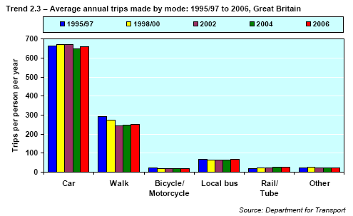
It has been said that everyone wants the person in the car in front of them to get the bus. The provision of public transport alone is rarely enough to persuade drivers to swap, especially once they have invested in a vehicle. Where there have been successes (notably in London following the introduction of the congestion charge) there has been both an incentive to stop driving and improved provision. More priority bus lanes would slow cars and speed up buses thereby performing this task.
While there are opportunities to reduce emissions it must be kept in context. The majority of motorised journeys are made by car, as shown. To decrease this significantly will require a huge increase in public transport.

Urban Planning
Banister and Hickman consider urban planning a key enabler of emissions reduction. They advocate public transport oriented developments, concentrated in urban areas; highly accessible transport hubs with a range of services built around them; less road space for cars giving priority to public transport. The result of building cities around cars is obvious when considering the American model; there is a high dependency and limited alternatives. In the future new developments are almost certainly going to be walking, cycling and public transport friendly. The question is how much effort will be put into modifying current spaces?

ICT
Integrated real-time navigation systems will be able to direct cars via the most effective route, avoiding congestion and accidents where possible. Intelligent cruise control linked to traffic lights and other vehicle sensors could smooth acceleration and braking.

Summary
A wide variety of policy tools are available. Which are used in the future will be a product of history, efficacy and public acceptability.

Chapter 6 - Interactions between the Drivers, Technology and Policy

The three sections above have reviewed societal, technological and policy questions. These do not however stand in isolation, as there are considerable interactions between them. The matrix below takes just two factors, the public perception of climate change and the price of oil, and demonstrates the alternative scenarios generated.

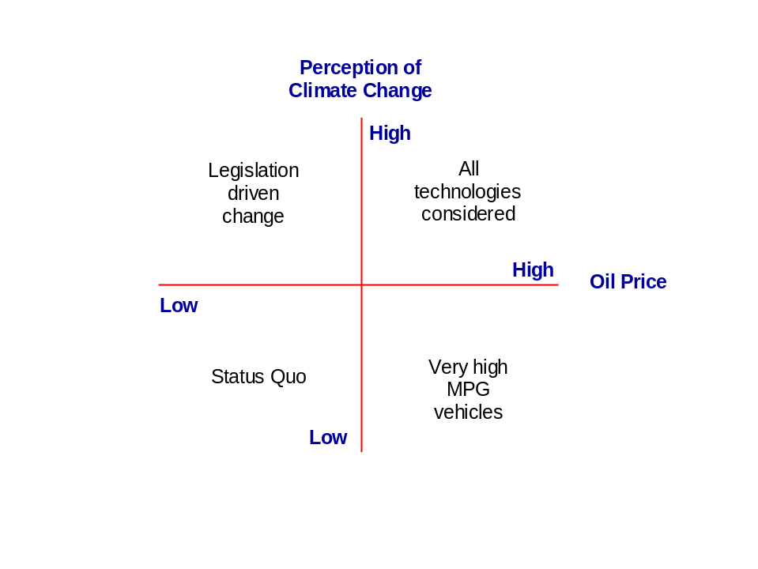

In the ‘Legislation driven change’ world the government is able to impose emission cuts as the reasons are understood. In ‘All technologies considered’ all parties are heading in the same direction – legislators impose emission cuts while simultaneously consumers are very keen to reduce their fuel bills. If the perceived need for change and the price of oil are low there is little impetus for change; if the price of oil increased cost conscious consumers will drive change despite limited regulation being acceptable.

There are a multitude of other possible interactions. Unemployment will reduce a government’s ability to implement policies that may harm the economy; the way the media reports news items influences the public’s opinions; a reversal in the current fashion for demonstrated material wealth may open the path for more modest vehicles.

Scenario planning encourages the interactions to be identified and considered leading to more effective planning and robust organisations.

Chapter 7 – Interviews with Lotus, Land Rover and Bentley.
To obtain an industry perspective on the issues discussed in above interviews were held with representatives from three companies - Lotus Engineering, Bentley and Land Rover. The challenges facing each, and their strategies, are very different giving an insight into some of the real world issues.
Lotus Engineering
Dr Richard Pearson – Technical Specialist, Powertrain Engineering and Clive Card – Project Manager gave their views of the future to 2030, notably the fuel and powertrain options. Their views are summarised below.
Lotus engineering is a leading consultancy to vehicle manufacturers worldwide and the sister company of Lotus Cars. As a consultancy Lotus Engineering must remain at the forefront of technical developments in automotive engineering, including emissions reduction. Lotus is renowned for its product development skills which are based on technical competence and a culture of innovation.
They are currently involved in both internal emission reduction research and external projects including developing the tri-fuel Exige 270E, which runs on any mixture of gasoline, bioethanol and methanol, and an 'EVE’ (Efficient, Viable, Environmental) Hybrid vehicle which showcases their capabilities to engineer hybrid variants of standard cars for other manufacturers.
Despite the enormous investment the worldwide automotive industry is currently making in low emission vehicles there are no easy options - basic laws of physics limit progress.
Most consumers will continue to make purchasing decisions as they currently do. They are aware that there is an issue but unaware of the true scale or implications and reluctant to change their behaviour. ‘Everyone wants their neighbour to buy a super-efficient car so they feel less guilty about theirs’. In the short to medium term change will be brought about only by a huge change in the costs of driving or when the impacts of climate change are impossible to ignore.
Politically the government’s hands are tied. While they understand the need to reduce emissions they can not do so without either increasing the cost of driving enormously, or draconian restrictions are imposed, both of which are currently political suicide.
It is therefore perhaps more likely that action will have to come from the EU. The fleet average CO₂ cap and fine system has caused the industry to focus intently on emissions, unlike the previous ‘voluntary’ target that was ignored by many manufacturers. This is seen as a very powerful driver of change in the industry. The impact of Kyoto has yet to be felt.

While weight reduction, aerodynamic improvements and economy tyres help by far the greatest influencer of a vehicle’s emissions is the engine. However, it will be very difficult to replace internal combustion engines as the default powertrain, and therefore drastically reduce emissions, for many reasons including cost, performance, range and materials. This is likely to be true up to and beyond 2030.

Biofuels, hybrids, battery power (with range extenders), and hydrogen are currently receiving the most investment. All have their challenges.

In principle Biofuels are an ideal new fuel. They absorb CO₂ as they grow, have high energy intensity and are miscible allowing a seamless transition from 100% fossil fuels to a mixture of the two avoiding the need for two parallel infrastructures (as hydrogen would require). Furthermore the cost of enabling cars to use biofuel is very low – around €100 (making it affordable in developing countries too).

The wisdom of first generation biofuels is now being seriously questioned as the switching of crops from food to fuel appears to be exacerbating the current food price peak and shortages in developing countries. There are significant doubts about the total volume of biofuels that Europe could produce (if considering fuel security) and the sustainability of imported fuel.

Second and third generation fuels are likely to be significantly better, however the technology is not yet available and there are again doubts about the total volumes obtainable.

Liquid fuels are seen as the best option for the future (over gaseous fuels). Lotus is working on the development of a synthetic methanol made from hydrogen mixed with CO₂. While the end product is an excellent fuel (even better than petrol) decarbonisation only takes place if the extraction of hydrogen and CO₂ from the chosen sources is powered by renewable electricity.

This comment is also applicable to hydrogen used directly in fuel cells, which also has other challenges. The cost of materials (in the fuel cells and for the high pressure fuel tanks) needs to drop by an order of magnitude for them to be competitive with Internal Combustion Engines (ICEs), there are doubts if there are enough of the metals required be convert more than a few % of cars worldwide and an entire new fuel distribution infrastructure would be required.

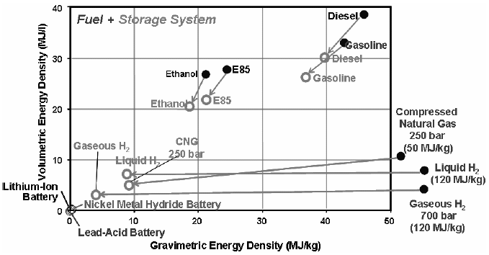
In theory the best way to de-carbonise transport is to go electric. However, hybrids and electric vehicles suffer from the same battery issues; low energy to weight ratio (see graphic), high costs (due to the size required and material) and material security of supply issues as the next generation of lithium-ion batteries use raw materials from middle-eastern countries. Furthermore, it is unlikely that major breakthroughs in battery technology will be achieved before 2030 which will give comparable energy densities to liquid fuels. Hybrids will become more popular in developed economies where the customer can afford the additional cost impacts on the vehicles and will be particularly widespread in the US where they can make a significant impact on large vehicles as an alternative to adopting diesel engines.

Perhaps the most realistic routes for emissions reductions in 2030 could well be small electric vehicles tailored to regular journeys ie. they are equipped with just enough battery for a commute (possible with a very small ICE ‘range extender’ for occasional longer journeys) or bio/ fossil fuel cars such as the VW 1 Litre. The 1 Litre is powered by a 300cc diesel engine producing 8.5 bhp and travels over 280 mpg. Neither is likely to be popular with consumers.

An economic limit may be met when trying to reduce total CO₂ in the atmosphere. At what point is it more cost effective to, for example, de-carbonise electricity generation? Is it going to be realistically possible to reduce vehicle CO₂ emissions significantly? The current expectation is that all options to reduce emissions will have to be taken to meet self imposed CO₂ targets.

The current taxing of fuel per unit volume does not give oil companies any incentive to reduce carbon. Shifting fuel price to be proportional to energy content and the tax burden to the carbon content in fuel would drive oil companies to look for lower carbon alternatives.

Another policy tool could be the introduction of a maximum top speed capability for all vehicles. This would free manufacturers from the current top speed ‘arms race’ and allow the re-tuning for their vehicles for greater economy – possibly 20% more.

A hugely important wider issue (all be it beyond the scope of this paper) is the future emissions from the developing world and their transition into cars.

Land Rover
To understand the scenario planning methodology used by Jaguar/ Land Rover a discussion was held with Dr. Al Saje Manager Business Strategy. His thoughts on the future direction of Land Rover products were also discussed.

Scenario Planning at Land Rover
The scenario planning process has been developed over the last eight years. The process introduced initially was very detailed (a 4x4 matrix was used giving16 possible worlds) but proved unwieldy. This was trimmed to a 2x2 matrix and the process developed internally over the years to the current situation where a ‘walking strategy’ is rolled from one year to the next for review and revitalisation. The process now used was also rolled out into Ford, Land Rover’s parent company.

Land Rover use an annual scenario planning cycle that combines top down and bottom up inputs. The Directors provide the top down input, ‘where do they want to go’, and middle managers the bottom up detail. In advance of the annual planning away days the managers involved are asked to perform a SWOT (Strengths, Weaknesses, Opportunities and Threats) analysis for their function considering the products, their people and business as a whole.

The various SWOTs are brought together and reviewed and presented at the annual scenario planning away days. During the sessions the group splits up and discussing recent developments and the future with special focus on their area of expertise which they then present back to the group as a whole.

Alternative business models and the robustness of current / future product portfolios have been assessed against criteria. For example alternative models could be; splitting of the brands, going very ‘green’, or diversifying into services. The criteria used include; Would the alternative model build the brand, be profitable, and is it aligned with customer trends? The robustness within the context of the scenarios is also considered. A Pugh’s Matrix is used to compare the concepts against the current business.

The interactions between factors are important. The market is affected by the manufacturers and vice-versa, which feeds into public opinion, policy making and the behaviour of competitors.

As discussed elsewhere in this paper, timing is important. Consideration is made of which decisions need to be made now, which should be postponed, and which need more information?

Current Worlds

The four quadrants Land Rover are currently working with are:
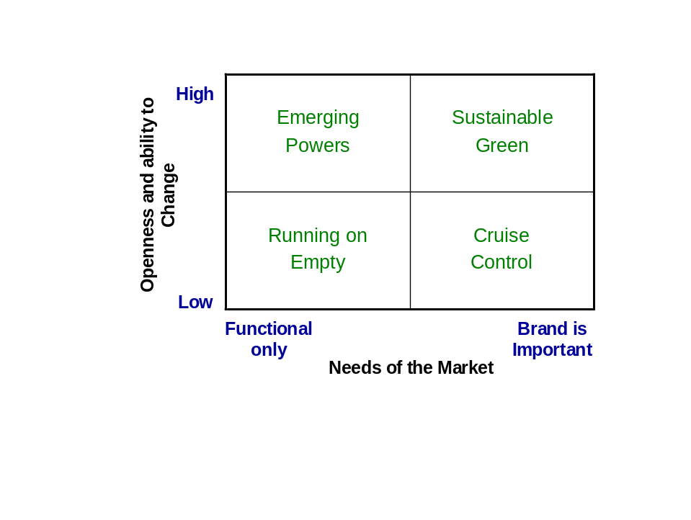
‘Emerging Powers’ sees customers being open to change and looking for function over brand. This is competitively dangerous as low cost, low spec competitors could take market share. ‘Running on Empty’ envisages a reluctant change and a decline in brand values, which is commercially and environmentally undesirable. ‘Cruise Control’ could result in brands becoming complacent and ‘Sustainable Green’ offers both commercial opportunities to sell fresh products to a market looking for changes in the products offered. Two years ago it was recognised that the business was heading dangerously towards ‘Cruise Control’ and is now moving towards ‘Sustainable Green’.

The overriding strategy is to leverage and build the brand, make use of the vehicle design and build core competency and align more closely with customer values.

The business is very aware that as an SUV builder they are vulnerable to policy and societal trends. Possible future directions may include offering present sized vehicles with the current off-road capability but less content (equipment / weight / luxury), building smaller vehicles, becoming more high tech, and offering various powertrain options to suit different markets. Al. Saje does not believe one powertrain type will become dominant and that, particularly globally, many fuel options will be used.

Bentley
Discussions with Mike Hawes (Director, Corporate & Government Affairs) & Tim Hodgson (no relation to author) (Customer Relations Manager) were held to understand the policy outlook and strategic approach of Bentley. A summary of their views is below.

Company position
Security of supply is of more immediate concern to Bentley than climate change. It is felt security issues could already affect the business due to high oil prices, and could impact the business further within the next 5 – 10 years. The company does however recognise the climate change issues and wants to address them while not undermining their credibility or the brand. It is however impossible for their current vehicles to meet the 140g/km Voluntary Agreement or the EU’s proposed 120g/km 2012 target, even with the VAG technological developments envisaged, as these are based on tailpipe emissions and give no or limited CO₂ credit for biofuels.

The obvious priority for the organisation is to stay in business. To do so the organisation believes it must stay true to it brand values. Bentley will never be a brand that produces small cars.

Customers
Bentley is in an unusual position for a car manufacturer. Their customers do not buy their products for ‘rational’ or practical reasons in the conventional sense– their purchase is a celebration of success, part of lifestyle. Craftsmanship, design and performance are imperative. Most customers have a number of cars and properties, frequently around the world.

When asked about climate change customers say that they are concerned and that they do want the company to reduce emissions. However, as with most consumers, there would be a reluctance to pay significant extra costs and, critically, do want the current levels of performance. At the moment, focus groups reveal no appetite for a diesel Bentley although this may change in time as the image of diesels especially in terms of performance and torque begins to change.

Costs are not a disincentive for the average Bentley customer. What owners are more concerned about is how their peers and the public perceive them. They do not want to be seen as making inappropriate decisions by peers, nor jeered at by the public.

Concern about emissions is not felt to have impacted on sales to date although the company follows this issue very closely.

Policy
Bentley believes that the trend towards EU driven policy will continue, notably the group CO₂ average target and penalties. The Company has stated its intention to be at the forefront of emission reduction efforts among the High Luxury Sector Brands. As part of VW, the company benefits from the averaging of CO₂ emissions across the group, although they will have to meet the additional costs the proposed EU legislation will deliver internally. While the UN may have aspirations of influencing legislation, it is not thought likely to be a major influencer in the short term given the EU’s stated intention of leading the world in terms of environmental policy. US policy is felt likely to be more focused on security of supply

It is believed that moving from a tailpipe to a ‘Well-to-Wheel’ emissions measure is critical for optimizing behaviours; for example, currently there is an absence of additional incentive to fit sophisticated ICT, satellite navigation or cruise systems that could reduce real world emissions as credit is not given for the subsequent CO₂ reduction. It also ignores – or gives minimal credit – to the significant CO₂ benefits that can be accrued by switching from fossil fuels to sustainable second generation biofuels. Targets should allow manufacturers the flexibility to reduce emissions using whatever means and technologies are most efficient for them. Standardisation of policy instruments across countries would also help focus efforts (within the EU and worldwide).

In line with the above sentiment personal carbon allowances are felt to be a positive policy, allowing individuals to find their most effective reduction mechanisms.

The company feels that road pricing would be a fairer and effective instrument. For the majority of drivers (of all cars) relatively small differentials can drive desired behaviours (for example the switch to unleaded was accelerated by a differential of a few pence)

Policy Influence
Independently Bentley has some influence over UK policy, particularly that related to employment, balance of trade and skills training. The VW group has a stronger voice in Europe given its footprint.

Strategy
The company is demonstrating to its customers that it acknowledges the issues and is making significant efforts to respond.

Bentley is focused on incremental reductions in emissions through technological developments, and the use of biofuels, now and in the foreseeable future. They do not envisage a fuel cell, battery, hybrid or diesel powered Bentley in the short to medium term as these options do not yet offer the level of performance demanded by customers, nor are they aligned to the brand values.

To be competitive within the auto industry generally heavy investment in R&D will be required. For mass market vehicles plug-in hybrids are felt to be the most likely route to emissions reductions.

Strategy Alternatives
One strategy suggested to Bentley is the use of over-offsetting, assuming the reputation of off-setting does, as expected, improve. Such an approach could help defuse negative public reaction and deflect regulation. The organisation is not sure that offsetting would send out the right messages although they do favour having the flexibility of choice to use whatever tools are effective to reduce WTW emissions.

Comments on Bentley
On one hand Bentley are in a very difficult position. Their customers are clear what they will, and won’t, accept. The combination of vehicle weight, performance expectations and available technology make it impossible for them to reduce emissions significantly from the current very high levels. On the other hand, their customers are amongst the least sensitive to price mechanisms. Most of the policy tools envisaged are unlikely to be a major deterrent. The biggest dangers arise from policies that involve absolute limits (performance, weight, CO₂), and from societal changes that make driving such a vehicle socially difficult.
Chapter 8 –Presentation of the Chosen 2030 Scenario

To develop possible scenarios a 2x2 matrix can be used, as discussed in Chapter 2. The most critical factors for manufacturers are felt to be the rate of technical developments and the public’s willingness to change their behaviour. Rapid technical developments will enable CO₂ reductions that would alleviate environmental pressures. High levels of public willingness to change their own behaviour would ease the introduction of carbon reduction regulations; however, history and human nature suggest this is unlikely to happen.

Fast
Working together
Manufacturer
led clean cars

Note: Actual danger from climate change High and Political awareness of the need to act High

Rate of technical developments
Frustrated public

Unhappy
public

Slow
Low High
Public willingness to change their behaviour

Manufacturer led clean cars and Working together are unlikely without major technical breakthroughs. The other two quadrants present many challenges. The scenario chosen is built around an ‘Unhappy public’ world as it is both possible and challenging.

Presentation of the ‘Unhappy Public’ 2030 Scenario

Climate change has proved to be worse than previously feared, and is accelerating. Local climates have altered dramatically – Australia and Africa now suffer almost permanent droughts, areas with windy seasons (eg. Florida) have been ravaged on three occasions.
There is no doubt that the problems are real, anthropological, and growing.

As anticipated the growth in world population and global wealth have driven up total emissions resulting in the exceeding of the critical 500 ppm atmospheric CO₂ concentration level.

CO₂ reduction efforts have been made around the world, however few countries have taken sufficient action to reduce their emissions to a sustainable level. Much finger pointing and international frustration has resulted.

The UN has continued to coordinate negotiations following on from Kyoto. Progress has however been slow. The EU has had more success, although it has made itself unpopular in the process. The EU ETS has been expanded to include shipping, airlines, service industries and public services. Cars are omitted as other emissions reduction mechanisms are used.

The price of oil has fluctuated between $60 and $290 per barrel. The highs have been driven by instability in Iran and Saudi Arabia, the lows by OPEC increasing production to stall the development of alternatives. The current price of $255 is unlikely to fall significantly.

UK congestion has deteriorated, amid much public outcry, especially as congestion charging is used in most cities. New road building is however rare; a combination of data to show more roads lead to more traffic and successful legal challenges from environmental groups have stifled plans. Those that are built have tolls. Not surprisingly average speeds have fallen.

Plans to introduce ‘Pay per mile’ were prevented by an effective pro-privacy campaign and installation costs concerns.

‘Green’ has become a qualifier rather than an order winner. The public want Green but still find self-imposed restraint difficult.

CO₂ emissions are measured from ‘well-to-wheel’. High vehicle CO₂ emissions penalties have resulted in only the very wealthy being able to afford conventional ICE vehicles, which are viewed with a mixture or ambition and resentment. Sales of larger vehicles have declined. The various taxes and regulations have driven car sizes down and car sharing up.

The introduction of a substantial tax rebate for non car owners helped labour squeeze back into power in 2020. This resulted in a levelling off of the total car pool around 2025.

Biofuels have come a long way. After 1st generation were discredited 2nd generation were developed rapidly and now replace 35% of fossil fuels (for cars) and typically reduce CO₂ by 80% per mile. 3rd generation production facilities are currently being built, although it will be many years before they replace fossil fuels.

Fuel cells have not been widely adopted. Cost, material supply and distribution challenges have proven too great.

Hybrids have proved to be popular, although their emissions are still above sustainable levels. Battery power has proved to be successful for many urban vehicles. Following a successful trial in Israel, ‘Project Better Place’ expanded to a number of other countries including the UK. The biggest automotive beneficiaries, alongside Renault, have been the start-up and spin-off companies that saw the opportunity and did not have an ICE brand to protect.

An unexpected side-effect of the increase in micro vehicles has been a backlash against larger cars as they are seen as a threat to the safety of those in small battery vehicles.

A variety of renewable electricity sources (nuclear, carbon sequestration and storage, tidal, wave, wind and biomass) are used supplying around 35% of needs. Following an accident in France in 2016 new nuclear has been politically impossible. Efforts to reduce overall consumption have brought some benefits.

A personal carbon allowance scheme has been discussed repeatedly. An EU wide system is currently under discussion however the details are proving fraught. A working system is not expected before 2040, if ever.

Maximum permitted performance limits proposed by the Government (a maximum speed of 110mph and 0-60 time of 9 seconds) proved too unpopular for the British public and were fought off. They have however now been passed by the EU and will come into force in 2036. Proposals to impose a maximum weight per seat were defeated by safety arguments.

Safety arguments were however a significant factor in the introduction of lower speed limits (60, 40 and 20mph) which are rigidly enforced. To protect driver’s licences many cars have automatic speed control. The various ICT systems on offer have become a major selling point for manufacturers.

Reduced speeds, lower performance requirements, and very low prices, have allowed Tata and other developing world companies to make in-roads into European markets.

Congestion, high costs and performance limits have resulted in customers looking for compensatory features. ‘Cool’ cars are naturally still highly desirable. The focus has moved from performance to technology, materials, engineering, service levels and lifestyle.

The combination or a lack of major technological breakthroughs, relatively low levels of renewables (fuel and electricity) coupled with high global CO₂ have resulted in the EU preparing a significantly reduced emission cap (45g/km WTW) with severe penalties for exceeding it.

Ironically, old ICE vehicles have become very popular for ‘track days’ where emission limits and road tax are avoided and high fuel costs tolerated.

Chapter 9 – Development of a Strategy to Cope with the Scenario Presented

“Strategy is about winning”, and winning in a commercial world means making profits. So what are the components that make a successful strategy within the auto market?

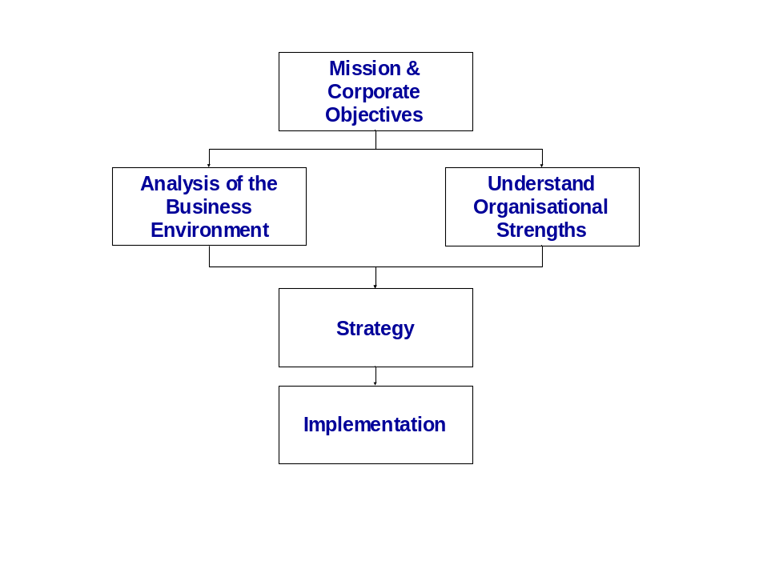
Success requires clear direction from the top of a company in the form of a Mission – a statement of the market sectors in which to operate, products or services to be offered, and company values.

A thorough understanding of the business environment is an essential part of strategy formulation. In this paper Policy, Technology and Societal changes are the focus. Other aspects not covered include the strengths and activities of competitors, potential new entrants, cost and pricing structures, distribution channels, sales and marketing techniques and customer service satisfiers. Awareness of what is a know, a know unknown and what could be an unknown unknown will improve the quality of the information gathered. Such analysis informs an organisation of the layout of the battlefield and strengths of their opponents. However, to win commercial battles an awareness of internal strengths is needed.

Organisational strengths include resources and capabilities. Resources are physical, such as rights to raw materials, factories, delivery trucks and IT systems. Capabilities are less tangible; project management, speed of new product introduction, market analysis, brand management and internal communications, for example. Fiat was chosen for this analysis as it occupies what is considered to be a difficult middle ground; it is neither a niche player nor part of a global super group with the huge resources that are often cited as necessary to succeed.

A successful strategy matches the opportunities in the market place with the organisational strengths. It identifies competitor weakness, unfulfilled customer needs, or future trends that the organisation has the resources and capabilities to tackle successfully.

Analysis of the Business Environment
Chapters 3-5 above give information regarding many of the factors that could influence the future strategic decisions of auto companies. The scenario generated above steers the recommended strategy.

Understanding Organisational Strengths

Fiat Group Autos in 2008.
The Fiat Group Autos, of which Fiat is the key brand, has 51,000 employees, €27bn t/o and made a 2.4% operating profit in 2007. It is seen as a medium sized player in the mass market car industry selling 2.2m cars and vans per year.

In recent years Fiat Cars has been transformed by the leadership of Sergio Marchionne who joined the company in mid-2004. Dramatic changes were needed as the company was losing money, had large debts and a weak product range. The old organisation structure was flattened, staid managers removed and a new generation of empowered leaders given responsibility for improvements. The design group was relocated and an industry leader brought in to ensure that design is a core competency. Stylish and better built new models have since been introduced, including the iconic 500.

The necessity to introduce new models quickly helped develop another key competency – modelling and simulation. Rather than building prototypes (a time consuming task) the company simulated vehicle performance resulting in shorter time to market. The urgency was in part driven by the Consumer Product background of some of the new team. Not only did this increase the pace of introduction but also moved the company’s focus towards the customer needs.

Other strengths include advanced petrol and diesel engine technologies, extensive flex-fuel experience from supplying flex-fuel vehicles in Brazil for many years, and low cost assembly plants around the world,

The number of platforms (vehicle chassis types), a major cost driver, have been reduced substantially to 6. The main products are the 500, Panda, Grande Punto, Bravo, Multipla, and Doblo.

Their current approach to CO₂ reduction combines flex-fuels with down-sizing. The recently developed Multiair engine, a 900cc two cylinder ICE unit, runs on a mixture of compressed natural gas and / or petrol giving very low CO₂ emissions.

Fiat is also experimenting with hydrogen and natural gas blends in their ‘HyperPanda’, using an ICE rather than fuel cells.

Fiat sees emission reduction having two streams; CO₂ and urban pollution; ‘Fiat believe that natural gas propulsion is the most appropriate technology today to solve pollution in built up areas’ Fiat’s fleet CO₂ average is the lowest in Europe thanks in part to the small size of the cars they manufacture.

The brand values include Italian design, innovation, value for money and fun - ‘We don't just want to get you from A to B. We want to get you there with a smile on your face’

Strategic Options

Having analysed the business environment and understood Fiat’s strengths strategic approaches can be considered. A plethora of alternatives are available to the industry as a whole; some will prove suitable for one company and inappropriate for another; others will work in some countries but not in all. Examples include;

- Lobby against regulation

- Develop new vehicles using the current brand
- Develop technology in-house
- Use ‘Green’ as a selling point

- Work with other companies to standardise
- Incremental change
- Lobby for regulation (knowing your competitors will find it difficult to meet them)
- Differentiate and develop a new brand (As Toyota did with Lexus)
- Buy in from suppliers
- Assume ‘Green’ as a qualifier and focus on other ‘unique selling points’
- Work alone to differentiate

- Radical departure

‘20/20 Foresight – Crafting Strategy in an uncertain world’ focuses on, and offers advice on, three key questions:

Shape or Adapt? Should an auto manufacturer try to influence government policy, or simply adapt to the decisions?
Now or Later? Make investments now or in the future?
Focus or Diversify? Invest in on one technology or maintain options in a variety?

Although there are no universal answers to these questions ‘20/20 Foresight’ explains how to identify the best option depending on the circumstances.

Fiat – recommended strategy to 2030.

Fiat’s mission is to become a major vehicle manufacturer. With this, the above strategic options and the 2030 scenario in mind the following strategy is proposed. Suggested dates are shown in brackets.

Fiat should focus on gaining a much larger share of the micro to family car markets. The current models should largely be kept with on-going improvements and redesigns made every few years, aligned to identified customer needs

The brand values should be: Italian design, rewarding to drive, innovation and technology, aligned with customer needs, fun, and value for money.

A new sub-500 size flex-fuel micro car should be designed in Italy and built in Eastern Europe (2015). This will be a Fiat branded, fun, urban vehicle aimed at people without children. This will capitalise on the trend towards smaller more fuel efficient cars while allowing Fiat to develop a reputation for producing cars that are rewarding to drive, when many companies are focused on making very green, safe, but slow and dull, cars.

Fiat should focus their emissions reduction activities on flex-fuels, downsizing engines and reducing the weight of vehicles. The introduction of maximum speeds can be anticipated allowing both development costs to be reduced (it is cheaper to engineer a 110mph car than one capable of 140mph) and weight reduction. Light ICE engines, without the weight penalty of batteries will allow driving dynamics to become a selling point. This is aligned with the fun ethos.

The introduction of 2nd generation bio-fuels and WTW emissions measures, combined with the aforementioned weight/ power reduction strategies will enable Fiat to maintain its CO₂ leadership. Policies, while not encouraged, should not be fought as they will increase costs for brands with strong performance and safety reputations.

The slow-down in demand is expected to hit larger vehicles primarily. Fiat, by targeting the small and family sectors, should be reasonably insulated. Fiat must stay very close to their customers to understand emergent trends, particularly outside of Italy, and utilise their fast speed to market capability to offer fresh products that meet customer needs. Customer input should be gathered through the use of the existing national offices. The offices should work closely with the design centre and the engineers to keep up with customer wishes, and technological progress. As innovation and technology are key brand values it is critical emerging technologies are incorporated as soon lost levels are aligned with Fiat’s market.

There is a close tie-in between the technology and the fun brand values that are also aligned with the needs of drivers on increasingly congested roads; the provision of low cost usability improvements should be a focus; cool boxes, bike racks, flat surfaces to place food on, multimedia tools, spoken internet access and live traffic updates with ‘proximity alerts’ (advising the driver when friends are near by).

A Joint Venture should be established with other biofuel focused car manufacturers to promote research into fuel crop’s cultivation, processing and performance. To avoid food poverty issues efforts must be made to ensure fuel is not being produced at the expense of food as this is likely to lead to a customer and policy backlash.

The reputation for style should be reinforced through the use of designer involvement in product styling. Product placement should also be used. Marketing, while not the focus of this paper, is clearly important.

The current trend towards manufacture in low cost countries should be continued, especially as competition from Tata and other developing companies will increase cost pressures.

Finally, the customer – seller experience should be improved. Customer service will become more important as companies look to differential beyond products alone.

Chapter 10 – Summary

The objective of this paper is to produce a recommended strategy for a car manufacturer, in this instance for Fiat that considers the challenges the industry faces as a result of climate change legislation.

Scenario planning is used to envisage a possible future world, the methodology for which is explained. Chapters 3-6 detail the societal, technological and political factors that will have an impact on all manufacturers, and that feed into the scenario to be created. The interactions between the factors are considered.

Interviews with Lotus Engineering, Bentley and Land Rover are reported in Chapter 7. The interviews reinforce the information provided in the previous chapters and give an insight into the various perspectives companies currently hold.

Chapter 8 presents the 2030 scenario generated. This is one of a number of potential views of the future world, but was chosen as it is felt to be both possible and challenging.

In Chapter 9 the process to develop a strategy is presented. The process uses the information about the current world and the scenario presented to understand the external factors. This is mated with an internal analysis of the resources and capabilities of Fiat cars with a view to taking advantage of future opportunities, the output of which is the presentation of a suggested strategy. The strategy recommends a focus on Italian designed, low emission flex-fuel ICE small and family vehicles that are rewarding to drive, that use technology to enhance journeys and offer value for money. It is believed that such a strategy will allow Fiat to cope successfully with climate change legislation.

Finally, Appendix 1 contains possible questions to pose to students using the above as a case study exercise.

Appendix 1 – Case Study Questions

- Select a current car manufacturer and devise a suitable technology, policy and product strategy for them, taking into account the scenario presented and their current capabilities, brand values and customer base.

  - Which Policy / Technology / Societal variables introduce the most variability and risk?
  - What are likely to be the critical success factors?
  - What marketing approach would you recommend?

- Lotus Engineering highlights the lack of effective alternatives to the Internal Combustion Engine (ICE). Honda is renowned for their ICE engines (www.honda-engines-eu.com). What strategic advice would you give them?

- Do you feel that Bentley have adopted the best strategy to date?
  - What alternatives do you see?
  - What other risks to the organisation can you envisage?
  - The CEO wants to help his management team to think more creatively and has asked you to devise a radical strategy for the business. What would you propose?

- As an SUV builder Land Rover is vulnerable to climate change driven legislation
  - What factors have driven the growth in SUVs? Are these factors, in your opinion, likely to change?
  - Suggest alternative approaches to their current strategy.

Cited References

ZEV = Zero Emission Vehicle ? Car, Motor, Auto, Automobile, Automotive and Vehicle are used interchangeably
CO2 is not the only pollutant from cars but is however the focus of this paper due to the impact on climate change. CO2 and Carbon are used interchangeably
For the purposes of this paper Fiat Cars is seen as an stand alone company and therefore does not have to consider the other brands currently within their portfolio (Alfa Romeo, Lancia, Maserati, Ferrari)
European Parliament resolution on "Winning the Battle Against Global Climate Change" (2005/2049(INI)) www.europarl.europa.eu/sides/getDoc.do;jsessionid=F5BEB6215EA2A44E15DA0C91673FAAA8.node1? language=EN&pubRef=-//EP//TEXT+TA+P6-TA-2005-0433+0+DOC+XML+V0//EN
David Banister, et al. ‘European Transport Policy and Sustainable Mobility’. 2000. Spon Press, London.
IPCC 4th Assessment Report. www.ipcc.ch
Mats Lindgren & Hans Bandhold. ‘Scenario Planning’. 2003. Palgrave Macmillan, Hampshire.
See, for example, Corporate Power, American Democracy, and the Automobile Industry. Stan Luger. New York: Cambridge University Press, 1999
‘we have just ten years to avert a major catastrophe’ An inconvenient Truth. Al Gore. Quoted at; www.climatecrisis.net
IPCC, Op cit.
United Nations. ‘Population Press Release 952’. 13th March 2007. Available at: www.un.org/News/Press/docs//2007/pop952.doc.htm
PWC. John Hawksworth, ‘The World in 2050’ September 2006. Available at: www.pwc.com/extweb/pwcpublications.nsf/docid/DFB54C8AAD6742DB852571F5006DD532/$file/world2050carbon.pdf
IPCC, Op cit, p44
PWC, Op cit. p4
IPCC. Op cit, p67. Table 5.1. Global average sea level rise 0.6 – 2.4 metres.
FT. Javier Blas and Chris Flood. 6th May 2008. ‘Analyst warns of oil at $200 a barrel’ Available at: www.ft.com/cms/s/0/70b4ef0a-1b91-11dd-9e58-0000779fd2ac.html
BusinessWeek. Joshua Schneyer. 19th November 2007. ‘Brazil, the New Oil Superpower’ Available at: http://www.businessweek.com/bwdaily/dnflash/content/nov2007/db20071115_045316.htm?chan=rss_topStories_ssi_5
The point at which the maximum aggregate oil output is reached.
The Guardian. John Vidal. ‘The end of oil is closer than you think’ 21st April 2005. Available at: www.guardian.co.uk/science/2005/apr/21/oilandpetrol.news
Anthony H. Cordesman & Nawaf Obaid. ‘National Security in Saudi Arabia: Threats, Responses, and Challenges’. 2005. Praeger Security International.
Dr. Abbas Bakhtiar. Political Affairs.net. ‘When will the House of Saud feel safe? Saudi Arabia and Military Expenditure’. 7th January 2006. Retrieved 26th May 2008. www.politicalaffairs.net/article/view/3739/
All data in this section is taken from DfT. ‘Transport Trends – 2007 Edition’. www.dft.gov.uk/pgr/statistics/datatablespublications/trends/
Department for Transport. Transport Trends. www.dft.gov.uk/pgr/statistics/datatablespublications /trends/current/ Trend 1.2a
HM Treasury. ‘Trend Growth’. www.hm-treasury.gov.uk/documents/uk_economy/fiscal_policy/ukecon_fisc_trend.cfm
www.easyjet.com/EN/Environment/index.shtml
The Guardian. Alison Benjamin. ‘Survey reveals nation of ‘armchair ecologists’’ 18th July 2007. http://www.guardian.co.uk/environment/2007/jul/18/ethicalliving.carbonemissions
IPCC. ‘Summary for Policymakers’. B. Metz, O.R. Davidson, P.R. Bosch, R. Dave, L.A. Meyer (eds). 2007. Cambridge University Press. www.ipcc.ch
The Guardian. Robin McKie. ‘Official: this summer is the longest, hottest ever’ 15th October 2006. www.guardian.co.uk/science/2006/oct/15/meteorology.uknews1
BBC. ‘Ice withdrawal 'shatters record'’ 21st September 2007. http://news.bbc.co.uk/1/hi/sci/tech/7006640.stm
Mori. Phil Downing and Joe Ballantyne. ‘Tipping Point or Turning Point?’ July 2007. www.ipsos-mori.com/reportsandpublications/socialresearch.ashx
Defra. ‘Public attitudes and behaviours towards the environment’. 14th August 2007. www.defra.gov.uk/news/2007/071102b.htm
Mori. Op Cit.
‘Forging ahead with ecologically sound Flexifuel vehicles’ www.ford.co.uk/ns7/environment. Retrieved 19th May 2008
www.un.org/Overview/uninbrief/ Retrieved 19th May 2008.
For a full discussion on the issues see - Michael Grubb. International Affairs. Vol. 71, No. 3, July 1995, pp. 463-496. ‘Seeking Fair Weather: Ethics and the International Debate on Climate Change’. www.jstor.org/stable/2624836
Sir Nicolas Stern. ‘Stern Review: The Economics of Climate Change’. 30th October 2006. www.hm-treasury.gov.uk/independent_reviews/stern_review_economics_climate_change/sternreview_index.cfm
See www.abi.org.uk/climatechange
For example Lord Levene, Chairman Lloyds. ‘Catastrophe trends and climate change: A global insurer's perspective’ Speak to the US National Press Club. 12th January 2007. www.lloyds.com/News_Centre/Speeches/Catastrophe_trends_and_climate_change_-_A_global_insurers_perspective.htm
Seth Dunn & Christopher Flavin. The Worldwatch Institute. ‘Destructive Storms Drive Insurance Losses Up. Will Taxpayers Have to Bail Out Insurance Industry?’ www.worldwatch.org/node/1648
H.L. MacLean, L.B. Lave. ‘Evaluating automobile fuel/propulsion system technologies’ Progress in Energy and Combustion Science. 29 (2003) 1–69.
STOA, European Parliament. ‘Alternative Technology Options for Road and Air Transport’. 2005. www.europarl.europa.eu/stoa/publications/studies/default_en.htm
Lester R. Brown. ‘Plan B 2.0 Rescuing a Planet Under Stress and a Civilization in Trouble’. 2006. W.W. Norton & Co. NY.
Nils Blythe. BBC. ‘Biofuel demand makes food expensive’ 23rd March 2007. http://news.bbc.co.uk/1/hi/business/6481029.stm
www.shell.com/home/content/aboutshell/our_business/oil_products/fuels/biofuels/biofuels.html
Joseph Fargione et al. ‘Land Clearing and the Biofuel Carbon Debt’ Science 7th February 2008: Vol. 319. no. 5867, pp. 1235 – 1238. www.sciencemag.org/cgi/content/abstract/sci;319/5867/ 1235?maxtoshow=&HITS=10&hits=10&RESULTFORMAT=&fulltext=biofuel&searchid=1&FIRSTINDEX=0&resourcetype=HWCIT
Low Carbon Vehicle Partnership ‘Are Biofuels Sustainable?’ 18th January 2008. www.lowcvp.org.uk/lowcvp-viewpoint/index.asp
George A. Olah, Alain Goeppert, G. K. Surya Prakash, ‘Beyond Oil and Gas: The Methanol Economy’. 2006. Wiley-VCH.
National Non-Food Crop Centre. www.nnfcc.co.uk/metadot/index.pl?id=2191;isa=Category;op=show#2564
EUCAR, CONCAWE and JRC WTW joint evaluation. May 2006. http://ies.jrc.ec.europa.eu/wtw.html
Eviana Hartman. The Washington Post. 6th January 2008. ‘A Promising Oil Alternative: Algae Energy’. http://www.washingtonpost.com/wp-dyn/content/article/2008/01/03/AR2008010303907.html
An average acre of algae grown today for pharmaceutical industries can produce 5,000 gallons (19,000 liters) of biodiesel each year. Alana Herro ‘Better Than Corn? Algae Set to Beat Out Other Biofuel Feedstocks’ 8th October 2007. www.worldwatch.org/node/5391
Jonathan Porritt. Speaking at Climate Space event ‘Businesses and Climate Change: Corporations for climate stability’. 2nd April 2008. www.climatespace.org/?p=655
Mercedes expect to have a commercial fuel cell powered car on sale in 2018 at a €10k premium to ICE. Car. ‘The Future of the Car’ May 2008. www.carmagazine.co.uk
Marianne Mintz et al. Argonne National Laboratory. University of Chicago. ‘Cost of Some Hydrogen Infrastructure Options’. 16th January 2002. www.transportation.anl.gov/pdfs/AF/224.pdf
One suggestion is that in the future hydrogen could be manufactured via direct thermochemical production using high temperature catalytic reaction powered by nuclear fusion. William Nuttall, Bartek Glowacki and Richard Clarke. ‘A Trip to 'Fusion Island'’ Retrieved 25th May 2008. www.msm.cam.ac.uk/ascg/materials/fusionisland.php
For more details regarding battery options see The Economist. ‘In Search of the Perfect Battery’ 8th March 2008. www.economist.com/search/displaystory.cfm?story_id=10789409&CFID= 7031577&CFTOKEN=38224593
www.projectbetterplace.com/
U.S. Department of Energy (DoE) study cited by Dr. Gerhard Schmidt. Ford Motor Company, Dearborn MI, USA. ‘Energy Storage and the Path to Sustainable Transportation’. April 2008. As presented at International Vienna Motor Symposium 2008.
Economic and Social Research Council. ‘Do we need a new generation of nuclear power stations?’ Retrieved 28th May 2008.www.esrcsocietytoday.ac.uk/ESRCInfoCentre/about/CI/CP/Our_ Society_Today/energySociety/new_gen_nuclear.aspx?ComponentId=14118&SourcePageId=14115
Dr Bill Nuttall. ‘Nuclear Renaissance – Technologies and Policies for the Future of Nuclear Power’. 2005. Taylor & Abbingdon, Oxon.
Josh Wolfe. Forbes/Wolfe Emerging Tech Report. ‘Nuclear Renaissance’ 14th Nov 2007. www.forbes.com/2007/11/14/emergingtech-nuclear-renaissance-pf-guru-in_jw_1114advisersoapbox_inl.html
Michael Harrison, and Michael McCarthy. The Independent. ‘Plan for new nuclear programme approaches meltdown after report’. 7th March 2006. www.independent.co.uk/environment/plan-for-new-nuclear-programme-approaches-meltdown-after-report-468928.html
Jeff Logan, John Venezia, Kate Larsen. World resources Institute. ‘Opportunities and Challenges for Carbon Capture and Sequestration’ October 2007. www.wri.org/publication/opportunities-and-challenges-carbon-capture-sequestration
Greenpeace. ‘New Greenpeace report exposes CCS as a dangerous distraction’ 5th May 2008. www.greenpeace.org/usa/news/new-greenpeace-report-exposes
www.trecers.net/
Gerhard Knies. TREC. ’10,000 Solar Gigawatts’ Speaking at Hanover Fair. 23rd April 2008. www.trecers.net/index.html
Quoted by BWEA. ‘Marine Renewable Energy’ Retrieved 28th May 2008. www.bwea.com/marine/resource.html
Based on current plans (eg the Severn barrage) and projected lead times.
Professor David J C MacKay. ‘Sustainable Energy - Without the Hot Air’ Draft 2.1.2. March 25, 2008. Retrieved 28th May 2008. www.withouthotair.com/
H M Treasury ‘Budget 2008’ 12th March 2008. Retrieved 24th May 2008. www.hm-treasury.gov.uk/budget/budget_08/report/bud_bud08_repindex.cfm
See http://carbondaq.rsacarbonlimited.org/main/howcalc
Including the UK Green Party. See www.greenparty.org.uk/news/2637
David Adam. The Guardian. ‘Swipe-card plan to ration consumers' carbon use’ 19th July 2006. www.guardian.co.uk/money/2006/jul/19/environment.ethicalmoney
See the European Commission’s website for details - http://ec.europa.eu/environment/climat/emission.htm
http://ec.europa.eu/environment/air/transport/co2/co2_home.htm
Motor Authority. ‘Porsche may use VW stake to avoid emissions rules’ 25th March 2008. www.motorauthority.com/news/industry/porsche-could-use-vw-stake-to-circumvent-emissions-rules/
Union of Concerned Scientists. www.ucsusa.org/clean_vehicles/california_driving/today-zero-emission-vehicle-program.html
California Environmental Protection Agency – Air Resources board. www.arb.ca.gov/msprog/zevprog/zevprog.htm
For details see http://infopedia.nl.sg/articles/SIP_1005_2006-04-07.html
www.direct.gov.uk/en/motoring/owningavehicle/howtotaxyourvehicle/dg_10012524
www.tfl.gov.uk/roadusers/congestioncharging/6723.aspx
http://news.bbc.co.uk/1/hi/uk/4610755.stm
Kevin Smith. Transnational Institute. ‘The Carbon Neutral Myth - Offset Indulgences for your Climate Sins’ 20th February 2007 www.tni.org/detail_pub.phtml?&know_id=56&menu=11c
Department of Environment, Food and Rural Affairs. ‘Carbon offsetting - Code of Best Practice’ Announced 19th February 2008. www.defra.gov.uk/environment/climatechange/uk/carbonoffset/codeofpractice.htm
Tyndall Centre. ‘Is carbon offsetting a legitimate response to mitigating climate change?’ Tyndall Briefing Note No. 21. September 2007. www.tyndall.ac.uk/generate/pubpages/paper-view.php?id=1059&name=BN21
www.landrover.co.uk/gb/en/Company/Sustainability/ourplanet.htm
www.sustainable-development.gov.uk/sustainable/quality04/maind/pdf/g-comm.pdf
Department for Transport. Transport Trends 2007. www.dft.gov.uk/pgr/statistics/datatablespublications/trends/current/
Friends of the Earth. ‘More road building will be environmental madness’ 15th Janurary 2008. www.foe.co.uk/resource/press_releases/more_roadbuilding_would_be_14012008.html
Directgov. ‘Greener Driving’ www.direct.gov.uk/en/Environmentandgreenerliving/Greenertravel/DG_064428
Robin Hickman & Prof. David Banister. ‘If, At First, The Idea is Not Abserd, Then There is No Hope For It: Towards 15 MtC in the UK Transport Sector’. 45th European Congress of the Regional Science Association. Amersterdam 23-27 August 2005. Paper 791. www.ucl.ac.uk/~ucft696/vibat2.html
Graph showing energy densities for various fuels. Dr. Gerhard Schmidt. Ford Motor Company, Dearborn MI, USA. ‘Energy Storage and the Path to Sustainable Transportation’. April 2008. As presented at International Vienna Motor Symposium 2008.
Giles Hodgson. ‘UK Retail Voluntary Carbon Offset Market’. 22nd April 2008. Paper for MM20 – Environment and Sustainability, JBS, Cambridge University.
PWC. John Hawksworth, ‘The World in 2050’ September 2006. Available at: www.pwc.com/extweb/pwcpublications.nsf/docid/DFB54C8AAD6742DB852571F5006DD532/$file/world2050carbon.pdf
Robert M Grant. ‘Contemporary Strategic Analysis’, 6th Ed. 2008. Blackwell Publishing, Oxford.
Key sources for Chapter 7 – Grant, ibid; Stelios C. Zyglidopoulos. 4E11 Lecture Notes. Lent term 2008. JBS; Hugh Courtney. ’20/20 Foresight – Crafting Strategy in an Uncertain World’. 2001. Harvard Business School Publishing, Boston, MA.
Fiat Group Annual Report 2007. www.fiatgroup.com/en-us/shai/banns/budgets/pages/default.aspx
Datamonitor. Fiat Spa SWOT. 14th January 2008. http://search.ebscohost.com/login.aspx?direct=true&db=bth&AN=31031036&site=bsi-live
The Economist. ‘Rebirth of a carmaker’. 26th April 2008. www.economist.com/displaystory.cfm?story_id=11090197
www.fiat.co.uk/content/?id=2442
www.fiat.co.uk/Content/?id=2358&linkidentifier=id&itemid=2358
Hugh Courtney, ibid.

