

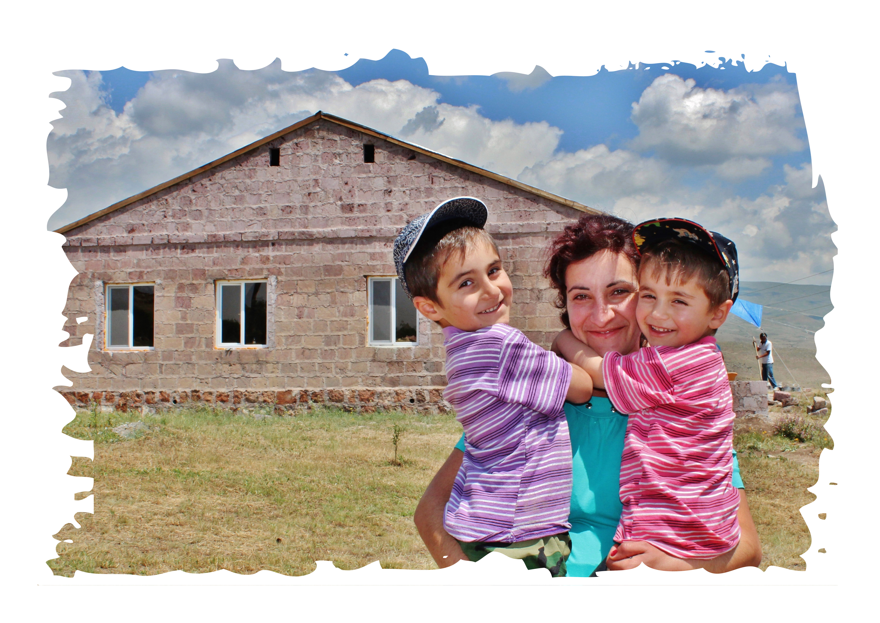

GLOBAL BUILDERS PROGRAM
HANDBOOK-2019
Updated February, 2019

Table of Contents
Welcome from Fuller Center for Housing Armenia 3
INFORMATION ON The Fuller Center Housing (FCH) and Fuller Center for Housing Armenia (FCHA) 3
History 3
Construction techniques 7
Construction work 7
Partner Families 7
Daily and Trip Schedules 7
Logistics 12
Visa 12
FAQ about visa 12
If your application is: 13
Foreign Embassy contacts in Armenia 13
Transportation 14
Metro (Subway) 14
Taxi 14
Minivan – or van (called Marshutka in slang) 15
Buses 15
Security 15
In Yerevan 15
On site 15
Accommodation 15
Meals 16
Armenian traditional foods 16
Breakfast 17
Lunch 17
Dinner 17
Drinking Water 18
Laundry 18
“Conveniences” 18
Safety Information 18
Health Care 19
First-Aid 20
Churches 20
Worship places in Yerevan 20
Post office 21
Money 23
Currency Exchange 23
ATM Machines and Credit Cards 23
Telephone and Internet 23
Fuller Center Armenia Numbers 24
Local Emergency Numbers 24
Phone Facts 24
PACKING LIST 24
Clothing 24
Electricity 25
Essential items: 25
Other items you may wish to bring: 25
Tools to bring/work gear/accessories (by Mike Candan) 26
INFORMATION ON ARMENIA (Extra) 27
Culture 28
Famous Armenians 28
Famous Armenians from overseas 29
Weather 29
How TO SAY IT IN ARMENIAN 30

Welcome from Fuller Center for Housing Armenia

This handbook contains some useful info about Armenia and Fuller Center for Housing Armenia (FCHA). You may want to review all the contents now, and then read the pages/topics that you need to know as the time gets closer to your trip.

Dear Global Builders’ team members,

Many thanks for your interest and willingness to join Fuller Center for Housing Armenia (FCHA) in building simple, decent affordable and healthy homes in Armenia. You will be a great help in this developing country and will surely have many exciting experiences while working with homeowners and visiting different parts of Armenia. Our staff, board and volunteers are here to assist you with any questions you may have. Do not hesitate to contact anyone whenever you have questions.
This handbook is meant to answer questions that you may have before landing in the country. Feel free to read it from the beginning or choose chapters you may want to read first.

We’re looking forward to meeting you here in Armenia and wishing you a great time and experience.

In Christian partnership,
Fuller Center for Housing Armenia (FCHA) staff, board, volunteers and homeowners

INFORMATION ON The Fuller Center Housing (FCH) and Fuller Center for Housing Armenia (FCHA)

History

The Fuller Center for Housing was founded in the spring of 2005 at Koinonia Farm in rural southwest Georgia. After 29 years of tireless service to the poor with Habitat for Humanity, Millard Fuller, the founder and president of Habitat, was motivated to expand his vision of eliminating substandard housing worldwide. The Fuller Center for Housing, faith driven and Christ centered, promotes collaborative and innovative partnerships with individuals and organizations in an unrelenting quest to provide adequate shelter for all people in need worldwide. The FCH has programs in 70 U.S. cities and in 20 countries around the world.

The Fuller Center for Housing Armenia (FCHA) was registered in the spring of 2008. It is a non-governmental charitable organization that supports community development in the Republic of Armenia and Artsakh by assisting in building and renovating simple, decent and affordable homes and advocating the right to a decent shelter as a matter of conscience and action.

FCHA’s goal is to eliminate substandard housing in Armenia. Sub-standard housing is all too common in Armenia. Fuller Center for Housing Armenia plans to build in all regions of Armenia. The choice of communities is based on the scale of housing need, and the willingness of the community to start a partnership. The Fuller Center for Housing Armenia focuses on completing unfinished houses, replacing and renovating roofs, and installing sanitation and heating systems for low-income families in both urban and rural areas. Fuller Center for Housing Armenia provides long-term, interest-free loans to low-income families. Their monthly repayments flow into the Revolving Fund and are used to help more families, thereby providing the financial foundation for a sustainable community development effort.
From April through October each year, the Armenia program hosts teams of local and international volunteers who help build and renovate houses.
Since 2008 FCHA has been changing the lives of Armenian families. So far we have reached out to about 700 families. Helping one family at a time makes a big difference and impacts more than one generation.

Donors and Volunteers

To accomplish its mission, Fuller Center for Housing Armenia (FCHA) is garnering volunteer and financial support from individuals, organizations, corporate partners and churches. International and local volunteers come together to work shoulder to shoulder with the families and help decrease the construction costs.

Programs and Partnerships

ARDI Program (Advanced Rural Development Initiative): ARDI is a 5-year program funded by the US Agency for International Development. Launched in September 2013, the program aims to increase rural employment by tackling constraints to rural economic development of select rural communities in Syunik, Vayots Dzor, Lori and Tavoush marzes (provinces) of Armenia. The program supports interventions in three main rural economic sectors/ value chains involving Dairy Processing, Fruit Processing and Rural Tourism.
During 2018 ARDI program has implemented 12 projects assisting entrepreneurs in dairy, fruit and rural tourism sectors. Interventions have been developed for the establishment of milk collection units, milk processing plants, herbal tea house, farmer service centers, upgrading existing Bed & Breakfasts. Besides the above mentioned infrastructure projects 26 small grant projects have been provided for women and young entrepreneurs in different sub-sectors of agriculture.
Since its inception from 2013 ARDI program has implemented 82 infrastructural projects and provided 125 Seed Grants to start-up businesses led by youth and women.

Partnership with VivaCell-MTS: It’s already the seventh year VivaCell-MTS, Armenia’s leading mobile operator, makes a secure social investment in the protection and development of Armenian communities becoming part of the mission of eliminating poverty housing in Armenia through a striking example of corporate social responsibility. In 7 years 162 families have been assisted through Fuller Center for Housing Armenia & VivaCell-MTS partnership.

Partnership with the International Committee of the Red Cross (ICRC): A continuing partnership aimed to assist the victims of mine/ERW (explosive remnants of war) to rehabilitate their homes during Nagorno Karabakh conflict. In 9 years, 158 families have been assisted through this partnership.

Partnership with ARDA Charitable Foundation and Vanadzor Municipality: In 2008 a memorandum was signed between ARDA Charitable Foundation, Vanadzor Municipality and Fuller Center for Housing Armenia, which planned to build decent homes for families of Vanadzor city, Lori Region living in temporary shelters, called domiks As a result of this partnership already 67 families moved from metal containers into their decent homes.
The Lazarian polystyrene (or Styrofoam) block is the basis for these homes. With these blocks, the housing structures become simple and inexpensive to build. The buildings are energy efficient and the blocks keep out moisture, resist pests, and contain fire retardant materials all within each block.

Other Continuing Strong Partnerships: The year was also prominent with continuous solid partnerships with Hirair and Anna Hovnanian Foundation, Heifer Project International Armenia, KPMG Armenia, Armenia Marriott Hotel Yerevan, U.S. Embassy Armenia Helping Hands, AGBU, UWC Dilijan College, AVC, CYMA, Birthright Armenia, FLEX (Future Leaders Exchange), Armenia Tree Project, Peace Corps in Armenia, also new partnerships with AUA Armenia, Teach for Armenia, Armenian Assembly of America, Microsoft Armenia and many others.

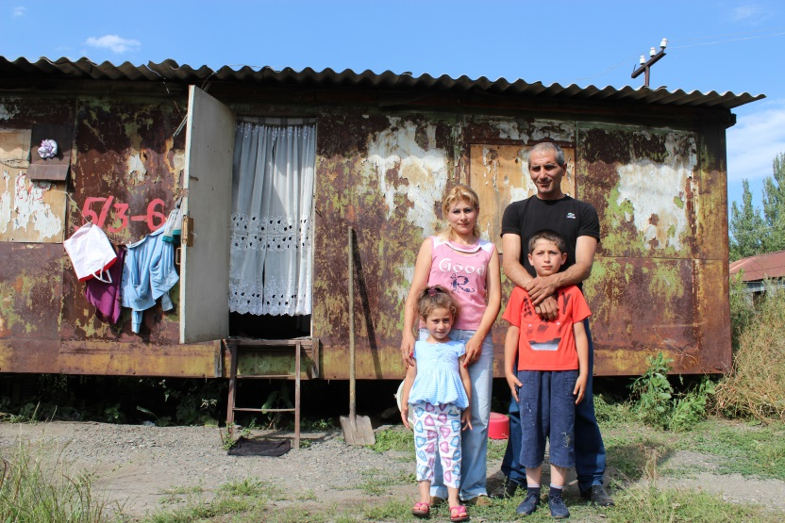
Housing need in Armenia

Need: According to “Social Reforms in Armenia” approximately 64,000 families have housing need in Armenia, of which about 26,000 are without permanent shelter. They live in temporary structures, in most cases metal shipping containers, so-called domiks. Others live in former hotels, schools and kindergartens which were converted to temporary housing. Alongside those without permanent shelter are the tens of thousands of families requiring better housing conditions.
The real estate market in Armenia has experienced dramatic growth in volume, and prices have consistently increased over the last five years. The majority of residential construction targets wealthy customers, and is not accessible even to the middle class. The construction boom has driven a rapid boost in the Price Index for Construction with continuing trends making it extremely hard for low income groups to build or renovate their homes. Homelessness and housing poverty have grave material and psychological consequences for the families and society, which are in complex cause and consequence relations and create a closed cycle of poverty.

Types of need addressed by Fuller Center for Housing Armenia (FCHA)

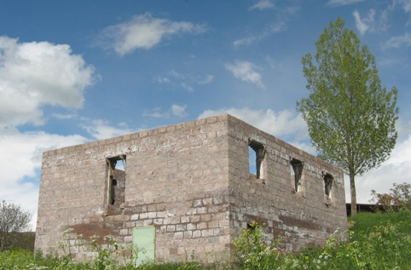
Unfinished houses: Many families had begun to build their own homes after the collapse of Soviet Union. With the ensuing economic crisis, homes were left unfinished - thousands of these foundations and semi-structures can be seen littering the countryside. Many families live either in the dark and damp basements of such houses unable to complete them. Fuller Center Armenia recognizes this as an opportunity to leverage resources already invested in housing solutions. Therefore, the program can help two or three families rather than one, since completing a half-built house is more economical than beginning construction anew.

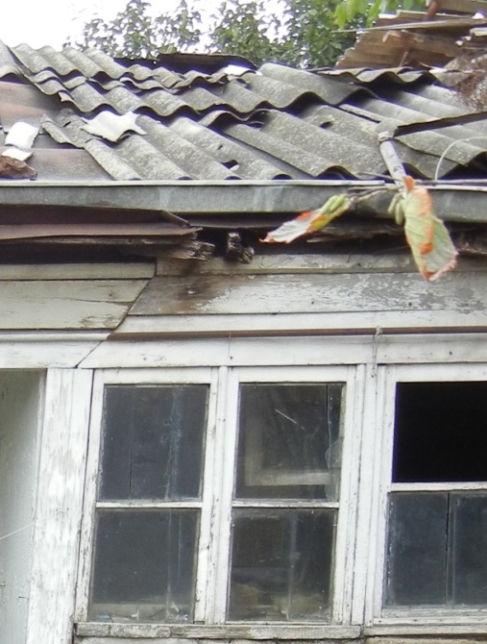
Broken and leaking asbestos roofs: Because of heavy rains and lack of maintenance, the roofs of many Armenian houses are severely deteriorated - slates are often broken, and rainwater leaks in. Besides, most roofs are made of asbestos, which is a hazard for the health of the residents. Fuller Center replaces broken asbestos roofs with corrugated tin roofs on timber frameworks.

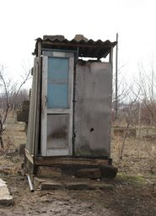
Deteriorated housing stock: The economic difficulties of the past decade have left their mark on the existing housing stock. More than a decade of insufficient investment in maintenance and repair as well as in housing infrastructure has resulted in a deteriorating housing stock and inadequate provision with housing utility services. Recognizing this problem and aiming at the preservation of existing housing stock, Fuller Center Armenia also provides opportunities to the families to renovate their houses.

No sanitation systems: In rural areas, where Fuller Center for Housing Armenia works predominantly, only 14.2% of houses are equipped with basic amenities (kitchen, toilet with draining system, bathroom). Fuller Center Armenia helps families to install a sanitation system in their homes promoting the maintenance of hygiene and healthy living conditions.

No heating system: More than a decade of insufficient investment in maintenance and repair as well as in housing infrastructure has resulted in a deteriorating housing stock and inadequate provision with housing utility services. Recognizing this problem and aiming at the preservation of existing housing stock, Fuller Center Armenia also provides opportunities to the families to renovate their house and to install heating systems.

Overcrowding: Several related families and multiple generations of one family often crowd into small houses and apartments. The living space per person is far below the minimum set by the Armenian government. Not only does this situation threaten people's physical health, but it contributes to a variety of psychological and family problems, including increased divorce rates.

Other: In places where prices are still moderate and affordable, Fuller Center Armenia assists families living in domiks or in overcrowded conditions to purchase a house or an apartment.

Construction techniques
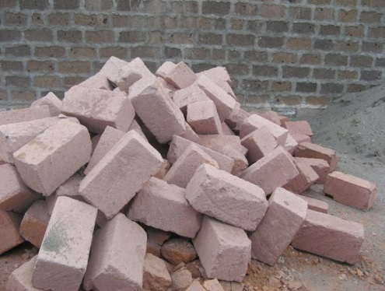
Armenia has a wealth of natural colored stones which makes it possible to build solid, healthy, and aesthetically beautiful homes. The most useful stone, “toof,” is a porous volcanic material. We cut the tuff into 19x28x40cm blocks, and then build double walls in order to keep the homes cool in the summer and warm in the winter. Thanks to the effectiveness of this stone and this method, we do not require any additional insulation. Armenia is located in a seismic zone, so we also build our homes using several kinds of supporting techniques.

Construction work

Global Builders’ construction work involves primarily: concrete work, mixing sand and cement, pouring water, making the mixture and carrying with buckets, hauling toof blocks, plastering and painting walls, sanding the window and door cavities and walls, fixing roofs.

Tasks for 13-16 year-old-volunteers: passing empty buckets, shoveling and cleaning up the equipment and work area.

Partner Families

We are now in the process of selecting future FCHA families with whom your Global Builders’ team will be working. Details about these families will be provided later.

Daily and Trip Schedules

Your team’s specific schedule will be provided in detail later; this is just a typical schedule for work days:
8:30am - breakfast
9:30am - pick up for travel to the construction site
10:15am - start to work (depends on how far the site is)
1:00-2:00 pm – lunch
4:30pm – coffee break
5:00-5:30pm leave the work site
7:30- 8 pm – dinner in restaurant

Please note this schedule is not final and it may be changed slightly depending on worksite distance and team’s preference.
It is suggested that every 2-3 work days be followed with a sightseeing day.

INFORMATION ABOUT ARMENIA

Sightseeing options

Matenadaran – A manuscript museum where old Armenian books are kept dating back to 1700 years ago. The largest and the smallest Armenian books are also on display. Most of the books are handwritten.

Etchmiadzin - city and church complex built in the 4th century. Etchmiadzin cathedral (“the place where the homogeneous come together”) is the most ancient Christian temple of Armenia. It was built in 301—303 by Grigor Lusavorich (St. Gregory the Illuminator), the founder of the Armenian Gregorian church. It is where the Catholicos of all Armenians lives.

Garni – A Pagan temple dating back to the 1st century.

Gehgard – A Christian Church Complex dating back to the 13th century. One of the churches is carved in one rock.

Lake Sevan – A fresh water lake 2000 meters above sea level.

Vernissage – A souvenir market with lots of different hand made items, such as table cloths, napkins, carved souvenirs (wood, stone), pictures, jewelry, etc. It is open on weekends only. You can buy souvenirs starting from $1 up to a few hundred dollars.

Khor Virap - One of the most popular destinations in Armenia for a number of reasons, primarily because it is where Grigor Lusavorich (St. Gregory the Illuminator) was imprisoned for 13 years before curing King Trdat III of a disease. This caused the conversion of Armenia into the first official Christian nation in the world in the year 301. It is also notable as it sits at the foot of the majestic, snow-covered Mt. Ararat.

List of Museums in Yerevan

Most museums are closed on Mondays and the working hours may change. Some of these museums will be included in your sightseeing schedule. If there is any spare time when you would like to visit any of these museums FCHA will assist you. There may be a small fee charged for admission and/or the services of a guide.

NAME | ADDRESS | HOURS | PHONE
Armenian Genocide Museum | Tsitsernakaberd Park | 11:00 AM-4:00 PM  closed Monday | 39-09-81;  39-14-12
Erebuni: Museum of the Establishment of Yerevan | 37 Erebuni St. | 10:00 AM-4:00 PM  closed Monday | 45-82-07; 57-32-02
National Gallery of Armenia | Hanrapetutian Sq. | 10:00 AM-4:00 PM  closed Monday | 58-08-12
Armenian Folk-art museum | 64 Abovyan St. | 11:00 AM- 16:00 PM | 56- 93-80
Matenadaran–Mesrop Mashtots Institute of Ancient Manuscripts | 111 Mashtots St. | 10:00 AM-4:00 PM  closed Sunday, Monday | 56-25-78;  58-32-92
Museum of Children’s Creative Art | 6 Sayat Nova Ave. | 11:00 AM-3:00 PM  closed Monday | 52-78-93;  52-09-02
State Museum of Armenian History | Hanrapetutian Sq. | 10:00 AM-4:00 PM  closed Monday | 58-27-61;  52-14-57

Economy

After several years of double-digit economic growth, Armenia faced a severe economic recession with GDP declining more than 14% in 2009, despite large loans from multilateral institutions. Sharp declines in the construction sector and workers' remittances, particularly from Russia, were the main reasons for the downturn.

The economy began to recover in 2010 with nearly 5% growth. Under the old Soviet central planning system, Armenia developed a modern industrial sector, supplying machine tools, textiles, and other manufactured goods to sister republics, in exchange for raw materials and energy. Armenia has since switched to small-scale agriculture and away from the large agro industrial complexes of the Soviet era. Armenia has managed to reduce poverty, slash inflation, stabilize its currency, and privatize most small- and medium-sized enterprises.

Since the breakup of the Soviet Union in 1991, Armenia had made progress in implementing some economic reforms, including privatization, price reforms, and prudent fiscal policies, but geographic isolation, a narrow export base, and pervasive monopolies in important business sectors have made Armenia particularly vulnerable to the sharp deterioration in the global economy and the economic downturn in Russia.

The conflict with Azerbaijan over the ethnic Armenian-dominated region of Nagorno-Karabakh contributed to a severe economic decline in the early 1990s and Armenia's borders with Turkey remain closed. Armenia is particularly dependent on Russian commercial and governmental support and most key Armenian infrastructure is Russian-owned and/or managed, especially in the energy sector. The electricity distribution system was privatized in 2002 and bought by Russia's RAO-UES in 2005. Construction of a pipeline to deliver natural gas from Iran to Armenia was completed in December 2008, and gas deliveries are slated to expand due to the April 2010 completion of the Yerevan Thermal Power Plant.

Armenia has some mineral deposits (copper, gold, bauxite). Pig iron, unwrought copper, and other nonferrous metals are Armenia's highest valued exports. Armenia's severe trade imbalance has been offset somewhat by international aid, remittances from Armenians working abroad, and foreign direct investment. Armenia joined the WTO in January 2003.

The government made some improvements in tax and customs administration in recent years, but anti-corruption measures have been ineffective and the current economic downturn has led to a sharp drop in tax revenue and forced the government to accept large loan packages from Russia, the IMF, and other international financial institutions. Armenia will need to pursue additional economic reforms in order to regain economic growth and improve economic competitiveness and employment opportunities, especially given its economic isolation from two of its nearest neighbors, Turkey and Azerbaijan.

GDP (purchasing power parity):
$16.86 billion (2010 est.)

Country comparison to the world: 133
$16.43 billion (2009 est.)
$19.14 billion (2008 est.)
Note: data are in 2010 US dollars

Labor force
1.481 million (2007 est.)
Country comparison to the world: 132

Labor force - by occupation:
Agriculture: 46.2%
Industry: 15.6%
Services: 38.2% (2006 est.)

Industries:
Diamond-processing, metal-cutting machine tools, forging-pressing machines, electric motors, tires, knitted wear, hosiery, shoes, silk fabric, chemicals, trucks, instruments, microelectronics, jewelry manufacturing, software development, food processing, brandy

Unemployment rate:
7.1% (2007 est.)
Country comparison to the world: 73

Population below poverty line:
26.5% (2006 est.)
Investment (gross fixed):
33.6% of GDP (2010 est.)
Country comparison to the world: 12
Inflation rate (consumer prices):
8.2% (2010 est.)
Country comparison to the world: 191
3.4% (2009 est.)

Exports - commodities:
Pig iron, unwrought copper, nonferrous metals, diamonds, mineral products, foodstuffs, energy

Exports - partners:
Germany 16.5%, Russia 15.4%, US 9.6%, Bulgaria 8.6%, Georgia 7.6%, Netherlands 7.5%, Belgium 6.7%, Canada 4.9% (2009)
Imports - commodities:
Natural gas, petroleum, tobacco products, foodstuffs, diamonds
Imports - partners:
Russia 24%, China 8.7%, Ukraine 6.1%, Turkey 5.4%, Germany 5.4%, Iran 4.1% (2009)

Updated on October 17, 2011
Source :https://www.cia.gov/library/publications/the-world-factbook/geos/am.html

Education

Education has traditionally played a central role in Armenia, and it has a long history, perhaps beginning in a formal sense as far back as the early Bronze Age, when the stone observatory and 'university' at Karahundj were constructed. The first universities in Asia Minor appeared in Armenia at Ani, Tatev and Gladzor, along with academies attached to monasteries throughout the kingdom.

The beginning of modern education is traced to the Russian takeover of Eastern Armenia beginning in the early 19th century. It should be noted that education for the masses was never a priority in Armenia until the 20th century, and was often reserved for clergy or the upper classes. In the 20th century, for the first time, education became available for the entire population, as thousands of schools were followed by colleges, institutes and universities. Armenia remains the most literate of the republics of the former Soviet Union, and despite woefully inadequate funding and support by the government, among its most educated. In the early 1990s, Armenia made substantial changes to the centralized and regimented Soviet system. Because at least 98 percent of students in higher education were Armenian, curricula began to emphasize Armenian history and culture. Armenian became the dominant language of instruction, and many schools that had taught in Russian closed by the end of 1991. Russian was still widely taught, however, as a second language. The majority of people (56%) are between the ages of 17 and 59 and the level of education is high. Education continues to be one of the main values in Armenian society. Today, there are 18 state universities, 8 foreign managed (American University, French University, European University and 5 Russian universities) and the remainder are private. There are more than 77,000 third-level students.

Today

The law still requires eight to ten years of schooling, from the ages 6-16. State schools are still the norm in Armenia, with classes normally lasting 4-6 hours, but lots of homework rounding out the program. Parents take deep interest in their children's education. After primary schooling, students have the opportunity to attend a 2-year college (vocational school) or university. Armenia has an extensive network of universities and institutes, all of which offer graduate programs. There are twenty-five public institutions of higher education in Armenia (including seven colleges) with 26,000 students recorded in 1995. There are also forty private educational institutions having a total of 14,000 students (1995).

The leading educational institutions, such as Yerevan State University, Yerevan State Engineering University, Yerevan State Medical University, the Armenian Academy of Agriculture, Yerevan State Linguistic University after V. Brusov and Yerevan Komitas State Conservatory, have historically been among the best in their fields.

Officially guaranteed for all citizens free of charge, education has in fact become a private system, deeply threatened by lack of funding and support from the government and outside sources. Kindergartens are considered essential to the education process, and the closing of many of them has created a private system, with families scrambling to raise the money to place their kids.

Educational Indicators:
1 | Education Compulsory Age (years): | 6-17
2 | Illiterate Total (15+) 1995: | 1.6%
3 | Illiterate Males (15+) 1995: | 0.7%
4 | Illiterate Females (15+) 1995: | 2.4%
5 | Gross Enrolment 1994:
6 | Secondary % of relevant age: | M:80; F:90 (1993)
7 | Tertiary % of relevant age: | MF:48.9 (1991)
8 | Public Expenditure on Education:
9 | As % of Current Government Expenditures: | n/a
10 | Expenditure on 2nd Level: | 57.7% (1993)
11 | Expenditure on 3rd Level: | 22.6% (1993)

Updated on October 17, 2011 Source: http://www.tacentral.com/economy.asp
http://www.tacentral.com/education.asp

Logistics

Visa

Effective January 1, 2015, U.S. citizens will be able to travel to Armenia visa-free. (http://armenia.usembassy.gov/visas.html)

Passports are required for all travelers to Armenia and must be valid for an additional six months after the planned departure date from the visited country. Please bring 2-3 copies of the picture page of your passport. To enter Armenia you also need a visa.

From most countries, you can buy your visa when you arrive at the airport in Armenia, but please check your country status with the host coordinator. Buying a tourist visa at Zvartnots International Airport in Yerevan for 21 days will cost 3,000 AMD ($10).

You can also obtain an e-Visa online. The service is available through web sites at www.armeniaforeignministry.am and www.armeniadiaspora.com as well as through the websites of Armenian embassies around the world. Go to the link, follow instructions and pay the fee. If you receive e-visa, make sure to print and keep it with your passport till your departure from Armenia.
Please discuss the visa options (at the airport or e-visa) with your team leader before you make your decision about which way to obtain it.

For those of you traveling through Russia, anyone wishing to leave an airport between flights should check with the embassy of that country because regulations are different and keep changing.

FAQ about visa

1. How long are e-Visas valid? - E-Visas are valid for travel for up to 90 days from date of issue. They are good for a single entry, and a stay of up to up to 21 days.
2. What happens after I apply for my e-Visa? - As soon as your application is received, you receive an immediate confirmation, with the reference number that your application is assigned. Then, your credit card is verified and charging authorization is received from your bank. Finally, your application goes through a verification process. You should use the reference number to check the status of your e-Visa by clicking the "Check Status" option online.
If your application is:
In process
You should check back later. Although most applications are processed within two business days, some applications may take little longer to process.
Approved
You should see a graphic representation of a visa, complete with your visa number and other particulars. You may want to print the page and keep it for your records.
Upon arrival in Yerevan Zvartnots International Airport simply inform the border guards that you have been issued an e-Visa. Border guards will electronically verify validity of your e-Visa.
If data submitted in your application does not exactly correspond with your factual information, you will be considered to have arrived without a visa and will be processed accordingly.
Denied
Your application for an e-Visa could not be approved on line. You may want to contact an Armenian Mission nearest you and apply for a conventional visa. Since e-Visas typically take only 2 days to process and are only good for 90 days, I would have your team members apply about a month in advance. That way, you have time to keep reminding them before you leave and they have time to deal with any problems. And you're sure that the visa is good while you're there.
Foreigners registration at their Embassies
All foreigners residing in or visiting Armenia are strongly encouraged to register with their Consular Section. Registration helps the Embassy provide important services to their citizens abroad. This includes: issuing a replacement passport, locating individuals in cases of family emergency, relaying important travel and safety information about the region, and other administrative services relating to personal documentation. For contacts please see below.

Foreign Embassy contacts in Armenia

Embassy of the United States of America
1 American Avenue
Yerevan 375082, Republic of Armenia
Telephone: (+37410) 464-700
Fax:(+37410) 464-742
E-mail: usinfo@usa.am
Consular E-mail: consular@usa.am

You may register at the Consular Section between 14:00 and 17:00 Monday thru Friday. Please bring your U.S. passport. You may also register by letter, telephone, fax, or online at http://www.usa.am/consular/register.html. If you are registering by letter or fax, please include a photocopy of your passport data page.

Embassy of Great Britain
Address: 34 Baghramyan Avenue, Yerevan 375019, Republic of Armenia
Telephone: (+374) 10 26-43-01
Fax: (+374) 10 26-43-18
http://www.britishembassy.am

Embassy of France
Address: 8 Grigor Lousavorich Str., Yerevan
Phone: (+374) 10 56-11-03, 56-46-67, 10 58-35-11
Fax: (+374) 10 56-98-35
E-mail: admin@ambafran.am
Embassy of Germany
Address: 29 Charents St, Yerevan, Republic of Armenia
Telephone: (+374) 10 58-65-91, 10 52-45-81

Transportation

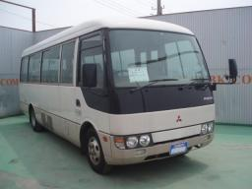
Transportation will be available to/from the work site and for sightseeing. The FCHA has its own bus and minivan for volunteers—there are about 18 & 20 seats plus 5 extra folding seats. Restaurants for dinner will be within walking distance from your hotel so no transportation is needed in the evenings. Taxis are available at reasonable prices if needed then reasonable taxies are available (see below). You will be provided with a map of Yerevan and a brochure listing museums, restaurants, etc., upon your arrival.

Airport

FCHA staff will pick up/drop off your team as a group from/to the airport and drive to your hotel. FCHA requests all team members to arrive and depart to Armenia together. However, in some cases some team members may need to arrive or depart separately from the rest of the team. FCHA will be happy to assist separate pick ups, drop offs and hotel reservations, but the staff can not promise to meet them at the airport.

International airport of Yerevan, Zvartnots, is located about 8 miles southwest of the city center, approximately 20 minutes by car. We will leave for the airport 2 hours prior to your scheduled departure. Please check with your travel agency about luggage allowances prior to your departure.

Metro (Subway)

Using the Yerevan metro is a very easy way to get around the city, and tokens cost only 100 drams (approximately 25 cents). You buy tokens at the booth near the entrance of the metro. There is only one line, which runs through the city northwest to southeast from approximately 7:30 am – 11:00 pm. The metro has ten stops.

Taxi

Taxis are available at almost every intersection and are a convenient way to get around town. Although the taxis don’t usually have meters you can estimate how many kilometers you’ve gone. The standard rate is 100 AMD per kilometer, the minimum cost is 600 AMD (no matter how short your trip distance is) and maximum rides are up to 2,000 AMD within Yerevan.

Minivan – or van (called Marshutka in slang)

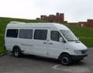
The main public transportation for locals in Yerevan city is the Marshutka. All Marshutkas have numbers on the front windshield with the description of stops. All public Marshutkas and taxis have yellow license plates. (White plates are private cars, and red plates are for diplomatic cars.)

The Marshutkas usually costs 100 drams (about 20 cents) per person. You pay when you get off.

Buses
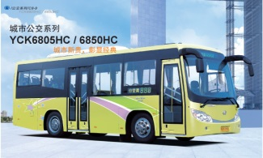
Usually costs 100 drams.
You pay when you get off.

Security

In Yerevan

Volunteers will be housed in a reasonable hotel. While we do our best to provide a safe environment for your personal belongings, we can’t guarantee safe keeping. We strongly recommend that you do NOT bring items with any significant monetary and/or sentimental value.

Yerevan is much safer than comparable cities in Western countries. The residents are friendly and the streets are not considered dangerous. However, volunteers should take all the usual precautions: travel in pairs, do not go to restaurants and bars alone, especially after dark, and be careful when displaying money or other expensive items.

On site

We will be building with a family, if there are more families and different work sites, thus we will let you know each day whether or not to take your tools with you or leave them at site. Volunteers bringing personal tools may want to mark their tools with their name or other information for easy identification. We do not recommend taking valuable items to work site.

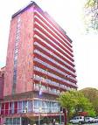
Accommodation
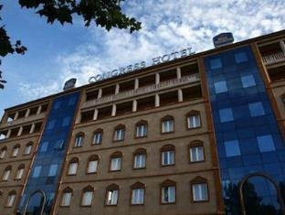
You will be housed in a reasonable hotel near the city center.
We will do our very best to accommodate you as comfortably as possible, but please be aware of the difficulties and inconveniences you may have to put up with.

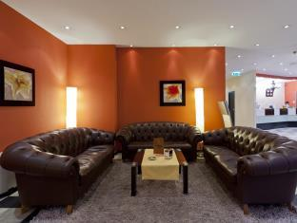
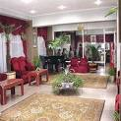

Thank you for your kind understanding and tolerance!
The electrical power supply in Armenia is AC 220 Volts, 50Hz via
sockets for 2-pin plugs.

Meals

Fruits and vegetables are very delicious and organic in Armenia!
However we would like to warn you against eating too much raw food to prevent any “intestinal discomfort” while in Armenia.

Armenian traditional foods
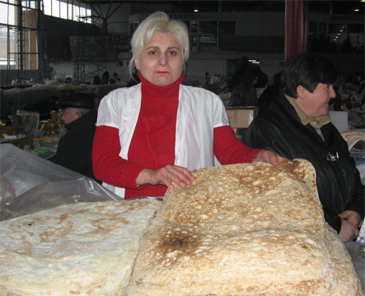
In Armenia you can taste many traditional Armenian foods. From ancient times Armenian cuisine is famous for its fish dishes. Lake Sevan is rich variety of fishes – trout, sig, koghak.
Lavash (on the right) is baked in “toneer” which is a round-shaped clay oven dug into the ground. Lavash has an oval shape. Armenians use lavash to wrap herbs, cheese, khorovats (BBQ), etc. You can buy lavash from any shops or markets.

Lamb, veal or pork are used for cooking khorovats (BBQ). The meat is specially chosen, marinated and then cooked on metal skewers.

Armenia is famous for its fruits--pomegranates, apricots, grapes, peaches, pears and figs. You can find them all around in every market. Armenians are master wine and cognac makers. Today you may try not only a wide range of Armenian grape wines but also very tasty pomegranate wines. Armenian cognac is world renowned.

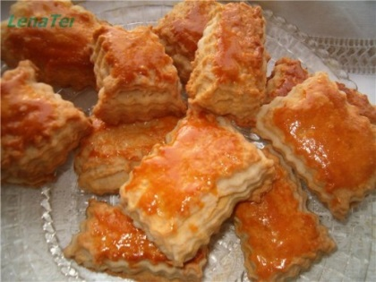
One of the Armenian traditional pastry is gata (on the left). Long ago Armenians made it especially for Christmas. In villages gata is usually made in an oven in the ground, called a toneer, and a coin is put in the dough for luck.

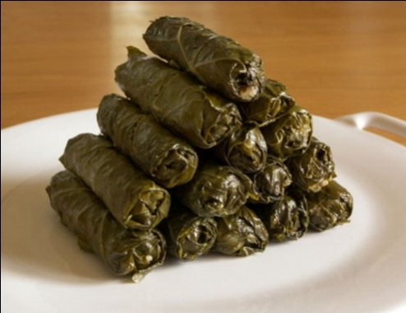
The most famous dish in Armenia is dolma (on the right). Dolma is prepared from ground meat, rice and spices which is wrapped either in grape leaves or cabbage. Summer dolma is the same filling stuffed in eggplant, pepper or tomatoes. Grape leaf dolma is served with madzoun (yogurt) and garlic. Yogurt is indispensable from Armenian table. It is also used for making spas (traditional soup).

Breakfast

Breakfast is included in the room rate. There will be a coffee break during work days at the site.

Lunch

On working days you will have lunch at site: fruit, cheese, bread, there will be both vegetarian and non-vegetarian meals. On some days you may have lunch with homeowners who will bring their own food. If you want, you may share your food with them.
On non-working days we will arrange lunch at a restaurant or other location depending on the sightseeing plans.

Dinner

For dinner we will advise different restaurants in the city. Arrangements will be made beforehand. FCHA staff will make these arrangements with the team leaders. FCHA does not provide transportation for dinners in Yerevan. Most of the recommended restaurants are within walking distance from the hotel. Otherwise taxies are reasonable solution.

Recommended restaurants are:

RESTAURANT NAME | CUISINE | ADDRESS | Phone
Taboule | Lebanese Cuisine | Zakyan St. 8 | 010 544-264
Al Mayass | Lebanese Cuisine | Cascade, Tamanyan St. 1 | 099 04 99 49 011 555-919
Derian (Kebab) | Lebanese-Syrian-Arm. | Teryan St. 89/2 | 096- 453-579
Lebanon Tavern | Lebanese Cuisine | 3 Tamanyan | 010-561-894
Lagonid | Lebanese, Middle Eastern | Nalbandyan 37 | 010 580 804
Anteb | Western Armenian | Yeznik Koghbats st. 30 | 010 530-988
AbuHagop Restaurant | Western Armenian | Yervand Kochar 6 | 095 286585
Yerevan Tavern | Armenian Cuisine | Amiryan and Teryan St. | 010 545 545  099 545 545
Old Erivan | Armenian Cuisine | Northern Ave. 2 | 010-588-855
Dolmama | Armenian Cuisine | Pushkin St. 10 | 010 56-89-31  010 56-13-54
Our Village | Armenian Cuisine | Sayat Nova Ave. 5 | 010 548-700
Tsirani Home | Armenian Cuisine | Northern Ave. 5 | 011 580-950
Caucasus Tavern | Armenian, Georgian | Hanrapetutyan St. 82 | 010 56-11-77  099 56-11-77
Mimino | Armenian-Georgian Cuisine | Alek Manukyan St. 7 | 010 57 88 85
Genatsvale | Georgian Cuisine | Kievyan St. 7  Komitas Ave. 35/2  Paronyan 1  Isahakyan 12 | 010 277 999
Mer Taghe | Armenian Lahmajoon | Tumanyan St. 21/1 | 010 58-01-06
Charentsi 28 | Mix | 28 Charents Street | 010-57-29-45
Artbridge bookstore Café | Mix | Abovyan St. 20 | 010-521-239
Green Bean | Cafeteria Bar | Amiryan 10 , Cascade | 010-52-92-79
Café Central | European Cuisine | Abovyan st. 30 | 010-58-39-90
The Club |  | Tumanyan St. 40 | 010 53-13-61
Aragast (Paplavok) Jazz Cafe |  | Isahakyan St. 41 | 010 542 254
Zatar Pizza | Pizza and fast food | Hanrapetutyan St. 24 | 010 525 106
Darget Craft Brewery | Brewery | Aram St. 72 | 096 870 870
Diamond Pizza | Pizza and traditional food | Abovyan St. 1 | 010-543434/32
Black Angus | American Cuisine | Abovyan 2/5 | 060 508-070
Square One | Sandwich place | Abovyan St. 1 | 094-53-04-14
Marco Polo | Lounge bar, café, restaurant | Abovyan St. 1/3 | 010-545-352
Pizza di Roma | Pizza and salad place | Khorenatsi St. 31/2 | 010-58-71-75
Peppino Pizza | Pizza place | Mashtots St. 23 | 010-538-567 010-531-189
Pizza Toria | Pizza place | Tumanyan 28/20 | 010 480 048

There are many restaurants currently opening in Yerevan, therefore we will distribute to you the updated version of restaurants in Yerevan.

Drinking Water

Please take necessary precautions to adjust to local water. We recommend you drink ONLY bottled water in Armenia, which we will provide.

Laundry

You can arrange to have laundry done at the hotel or by a laundress. There is also a laundry service “Selena” across from Hotel Shirak. FCHA staff will assist you with processing your laundry.

“Conveniences”

While the homes we will be building will eventually be equipped with indoor plumbing, our work site may not be. Outdoor toilets will be available for homeowners and team members. These certainly are no substitute for your bathroom at home. But the volunteer hotel will have flushing toilets and bathing facilities. We appreciate your understanding of this issue!

Safety Information

No job is so important that it can't be done safely!
FCHA requires that you protect your eyes with safety glasses when using power tools. FCHA also advises that safety glasses be used when nailing.

Use ear and eye protection when using power saws for prolonged periods of time.

Wear clothing appropriate for the task. Don't wear loose-fitting clothes around power saws. Wear work boots that protect from falling objects, have a non-slip sole, and that resist nail penetration.

Hard hats are required when working in an area where items could fall or be dropped from above.
Guards on saws must be in place and operating. Tools must be in a safe condition.

Speak up if something looks unsafe. An observer can spot danger quicker than a worker.
Don't lift beyond your strength. Bend your knees and lift with your legs.

Know where the drinking water and first aid kit are located. Tell your Team Leader immediately in the event of an injury.

Select the correct tool for your work. Carry only those you need.

Think and concentrate on your task.

If you are uncertain about how to do a task, or how to operate a power tool, ask your Team Leader.
Remove nails from discarded lumber.

Don't leave loose objects on the roof or on ladders or scaffolding. Keep your tools in your tool belt when they are not in use. When working on a roof, secure all building materials (felt, shingles, plywood, nails, etc.) to prevent items from sliding off. Sweep sawdust and debris off the roof frequently. Let workers below know when you are sweeping or throwing materials off the roof.

Power Saws. Avoid “binding” the blade of any saw. When a blade binds it kicks the saw back toward the operator. Use two hands to hold a circular saw. Firmly secure / hold the material being cut. Ask someone for help when cutting large pieces of material. Make sure you have solid footing. Don't overreach. Keep electric cords out of the way of the saw.

Ladders. Use a ladder that will reach the work. An extension ladder should extend three feet (3') above the step-off point. Move the ladder with your work. Avoid overreaching. The base of an extension ladder should be 1' out from wall for every 4' of height. Place step ladders on solid, level footing. Don't work at a height beyond which you are comfortable.

Scaffolding. Scaffolding should be placed only on solid, level footing. Dig down if necessary. Don't stack loose material (scrap lumber, bricks, concrete blocks, etc.) under scaffolding legs to level. Use leg leveling devices provided with the scaffolding. Make sure that walk boards are fastened securely and are adequate for the number of workers on the scaffolding. Don't work at a height beyond which you are comfortable.

Utility Knives. Keep hands out of the path of the blade. Always retract the blade when not in use.

Trash /Rubbish & Debris. Keep the work area clean. Re-stack unused building materials or serviceable scraps. Put all trash and debris in a trash container or a designated trash area. Sweep out the house regularly.

Health Care

Your health is one of our major concerns. We strongly recommend that you seek professional medical advice to insure that you are healthy enough to handle hard work in a hot and dry climate in a poor country. Please bring all medication needed while you travel. It is also important that you bring prescriptions for all your medications with you. If you have an extra pair of glasses, make sure to have them with you as well.
For your safety on the construction site, it is important that you are up-to-date with your tetanus shot or have one administered prior to your arrival in Armenia, upon the advice of your doctor.

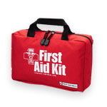
First-Aid

There will be a first aid box on site for any worker who becomes ill or injured at the construction site. In the event of a serious illness or injury, arrangements for transportation to the local hospital will be made.

Nairi Medical Center

Paronyan 21 Yerevan, Tel: 580 099

Churches

The main religion in Armenian is Christian. There are church services every Sunday in all churches, language is Armenian, begins at 11am and usually lasts 2 hours. During sightseeing we will visit different churches built in 4, 6, 7, 11-13th centuries. If you are interested in attending a Sunday service let us know in advance.

Dress: Please dress appropriately when visiting churches. Women: shoulders covered, knees covered by skirt or trousers, (please note women at Armenian Apostolic church cover their heads during Sunday service). Men: long trousers and shirts. Sandals are ok.

Worship places in Yerevan

ST. ASTVATSATSIN CHURCH
Address: 1 Romanos Melikyan St., Yerevan
Tel.: (374 10) 770 075

ST. GEVORG CHURCH
Address: 7 Noragavit St.,Yerevan
Tel.: (374 10) 486 067

ST. GREGORY THE ILLUMINATOR CATHEDRAL
Address: Yervand Kochar St., Yerevan
Tel.: (374 10) 543 332

ST. HAKOB CHURCH
Address: 6 Kanaker St., Yerevan
Tel.: (374 10) 284 820

ST. HOVHANNES CHURCH
Address: 15 Hovhannes Kozerni St., Yerevan
Tel.: (374 10) 580 791

ST. KATOGHIKE CHURCH
Address: 15/1 Abovyan St., Yerevan
Tel.: (374 10) 569 252
E-mail: deravetis@yahoo.com

ST. MARIAM CHURCH
Address: Armenakyan St., Yerevan
Tel.: (374 10) 654 616

ST. SARGIS CHURCH
Address: 21 Israyelyan St., Yerevan
Tel.: (374 10) 585 713

ST. ZORAVOR CHURCH
Address:71 Tumanyan St., Yerevan
Tel.: (374 10) 530 162

ARMENIAN CATHOLIC CHURCH
Address: Tbilisyan crossroad, 1 Alleyway, Bld. #3 (Kanaker, Yerevan)
Tel.: (374 10) 280 577, 388 193

RUSSIAN ORTHODOX CHURCH
Address: 68 Zakarya Kanakertsu St., Yerevan
Tel.: (374 10) 284 212, 281 692

ARMENIAN MISSIONARY ASSOCIATION OF ARMENIA
Address: Nicol Douman 22
Tel: (374) 272 892, 263 656,
Also the new building: Marshal Baghramyan 18

EVANGELIKIAN CHURCH OF YREVAN
Address: 12 Vagharsh Vagharshian, phone:
Tel: (374) 270 832, 273 740

SYNAGOGUE
Address: 23 Nar-Dos St., Yerevan
Tel.: (374 10) 571 968, 571 556

Post office

There are post offices all over Yerevan which are noticeable by their dark blue sign with big white letters saying “POST.” To send a postcard to Europe/United States costs: 240 dram. To send a letter to Europe/United States costs 350 dram. You can either visit the post office on your own, or give postcards/letters along with money for postage to the volunteer coordinator who will post them for you. Sending a post card/letter to The USA and Europe generally takes 14 days but sometimes it takes……a couple of months.

Money

The local currency of Armenia is called the dram (AMD). It was introduced in November 1993 replacing the Russian ruble as the official currency. There are 1,000, 5,000, 10,000, 20,000, 50,000 and 100,000 dram bills, and the coins are in denominations of 10, 20, 50, 100, 200 and 500 drams. As of February, 2018, the exchange rate is 480 drams (AMD) to 1 USD. If a bill is anything less than 10 drams, it will be rounded up or down.

Currency Exchange

Currency exchange offices are available on nearly every street in Yerevan. The rates between different establishments don’t fluctuate much so don’t bother looking for a good deal. Almost all exchange places advertise their rates on signs posted outside. Usually you will get a receipt for the exchanged amount. If you don’t, just ask. Armenians tend to be very honest but count your money before leaving the window as accidents do happen.

ATM Machines and Credit Cards

Credit cards, travelers’ checks and personal checks are not widely accepted and most transactions are made in cash. Some banks accept credit cards and cash traveler's checks.

There is an international bank HSBC in Armenia. (tell:515-000) that has offices located off Republic Square, next to the Armenia Marriott Hotel on 9 Vazgen Sargissian str, on 66 Teryan Str, on 37 Tigran Mets Ave. and in other locations. HSBC offers cash advances on VISA and Master Card but not American Express, and they can cash traveler’s checks or personal checks for significant charges.
ATM machines (Bankomats) that use the PLUS system are located in HSBC Bank’s lobby at Republic Square on 9 Vazgen Sargissian Str, on 18 Mashtots Avenue, on 3 Komitas Ave. up from Barekamutun metro, next to Yeritasardakan metro-on 35 Isahakyan Street, at 37 Tigran Mets Ave., on 27Abovyan Street and at other locations. Each machine has logos placed on the front to tell what type of card they accept. In case you want to use credit card in Armenia please check with your host coordinator prior to departure to the updates on this matter.

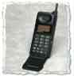
Telephone and Internet

There is free Wi-Fi in most hotels and restaurants in Yerevan. There are phone cards available that you may use to call anywhere in the world. FCHA staff will assist you with these details.

Please note that making international phone calls from hotel-land line is very expensive.

Fuller Center Armenia Numbers

Armen Avetisyan ED of FC Armenia | Office: (374-10) 24 23 48  Mobile: (374- 94) 40 75 59
Rouzanne Sakanyan (Resource Development Manager) | Mobile: (374- 077) 07 37 39
Gohar Vardanyan (Program coordinator) | Mobile: (374- 93) 41-52-54

Local Emergency Numbers

Fire | 101
Police | 102
Ambulance | 103
Information | 109
"Spyur" Yellow Pages, www.spyur.am | 51-99-99

Phone Facts

AT&T Operator | 0-800-111
Sprint Operator | 0-800-155
MCI Operator | 0-800-122
From GB to Yerevan | 00-374 10 + phone number
From Yerevan to GB | 00- 44 + area code + phone number
From US to Yerevan | 011-374-10+local number
From US to Yerevan cellular | 011-374-91(93)-(94)-(98) –(55)-(75)-(77) (45)+ local number
From Yerevan to USA | 00 – 1- area code + phone number
From Yerevan to Marzes (regions in Armenian) | 0+Marz code+number
From Marzes to Yerevan | 0+Yerevan code+number
From Yerevan and Marzes to Cellular | 0+91+cell number  0+93+cell number  0+94+cell number  0+98+cell number  0+77+cell number  0+ 43+cell number  0+45+cell number  0+55+cell number
From Cellular to Yerevan and Marzes | 0+Yerevan or Marz code+number

PACKING LIST

Clothing

Bring clothing which fits comfortably, preferably cotton outfits. Steel toe work boots are preferred, but other boots are okay for construction. No sandals are allowed on the construction site. We highly recommend flip-flops and bathrobe for bathing. It is acceptable for women to wear shorts at the construction site, but not too short. However, women should not wear shorts while visiting churches; admittance may not be allowed.
Generally Armenians 'dress-up' more than the average American. You will be noticed and stared at if walking around in construction clothes. If you don't mind, this is fine. But, please be aware that it may happen.

Electricity

The electricity in Armenia is 220v and plugs have two or three round-prongs. Bring a voltage adapter for any important electric devices from home. Consider, however, that buying an item in Armenia (iron, radio, hair dryer) may be cheaper and longer lasting than buying adapters for each one. Plug attachments that change flat prongs to round prongs are cheap and easy to find.

Essential items:

Money belt
Mosquito repellent (depending on the site this may be needed, check with program coordinator)
Pain relievers
Passport (if you apply for e-visa make sure to keep the printed copy with you till your departure from Armenia)
Prescription & personal medications
Spending money
Sun block lotion
Small light/battery may be used in the evenings as some streets do not have electricity/light
Toiletries
Travel alarm clock
Wide brim hat
Work boots/hiking boots
Work clothes for site
Hand sanitizer

Other items you may wish to bring:

Bath robe
Towel (the hotels provide but this is in case you chose Envoy hostel or prefer to use your own)
Bible
Camera
Ear plugs for light sleepers
European adapter if needed
Journal
Light weight rain jacket
Sandals
Sunglasses
“Breathe Rite” strips or something similar for snorers (since you are going to share room with someone else.)

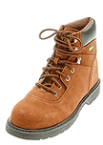

Tools to bring/work gear/accessories (by Mike Candan)

Q: Where can I get boots for the trip?

A: You can purchase decent and relatively inexpensive work boots at Payless Shoe or Kmart. Remember two things: 1) you’ll be wearing your boots for 8-10 hours on work days so you want shoes that are comfortable, and 2) make sure to break in new shoes before the trip. Also, you might want to consider leaving the boots behind at the end of the trip as they’re worth their weight in gold on the job sites in Armenia. Also, they don’t have to be steel-toed work boots, which will protect your toes in case you drop something on them. However, I have a nurse friend who prefers boots without steel toes because in some rare cases they can do more harm than good (and they’re heavier). I personally use regular work boots (without the steel toes) because they’re lighter, but it’s up to you.

Q: Do I really need a back support?
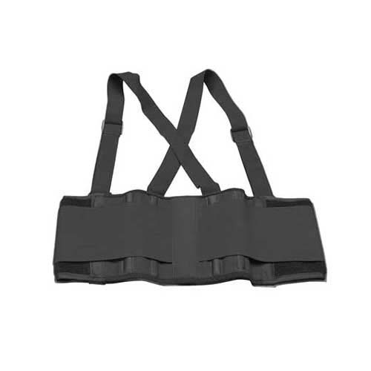
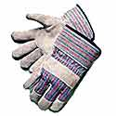
A: Short answer: YES! Longer answer: I believe that they’re essential preventative care for your back. While I always encourage you to be careful when lifting and to stay well within your comfort zone, I have found back supports to be VERY helpful and I use them all the time at worksites. The back support doesn’t allow you to lift something heavier, but it does remind you to keep a proper posture.

Q: What kind of gloves should I get?

A: We would suggest two pairs of work gloves like the ones pictured here (or similar):

Please note that FC Armenia can always use additional gloves and since many of their volunteers have smaller hands, they would prefer gloves that are size Medium (women’s large). For some reason, women’s gloves are much more expensive. We have found a source for medium size gloves in quantity: PK Safety and Supply (in Alameda, CA).Their number is (800) 928-9580 (510-337-8880 locally) and their web site is: www.pksafety.com for online orders.

Q: What’s the deal with dust masks and why should I bring some?
A: We recommend that you bring a box of respirator dust masks (or fewer if you’re conscientious about saving them at the end of the day– they’re cheap and very useful) like this, found in the Safety section of your local hardware store:
We will often work in conditions that can get dusty like rock piles, mixing cement (cement dust can really irritate your lungs), etc.

Q: Knee pads – would I really have a use for knee pads and what kind should I get?
A: Knee pads came in handy on my trip in 2002. We had tasks that involved kneeling on concrete or metal bars and knee pads sure came in handy. You can find really cheap ones made out of foam at Home Depot or Lows (~$4).
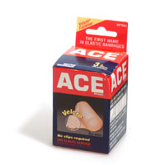

Q: What about bandages for sprains, etc.?
A: While there is a first aid kit with FC Armenia, I recommend 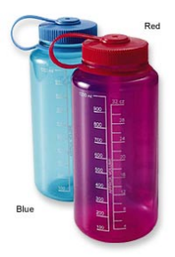that you bring an ‘Ace’ type bandage for personal use just in case.

Q: Any other tools/supplies I ought to bring?
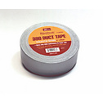
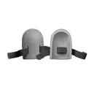
A: Here’s what I would add to FC Armenia’s tool list:

1. Water bottle (make sure to label it with your name.

2. Roll of duct tape. If you don’t use at the site this can be donated to local affiliate. (Be sure to put this in your checked luggage, as I’ve heard of it being confiscated at security with the theory that you could tie someone up with the stuff.)

INFORMATION ON ARMENIA (Extra)

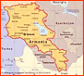
Yerevan, the capital of Armenia, is one of the oldest cities in the world. The history of Yerevan dates back to the 8th century BC, with the founding of the fortress of Erebuni in 782 BC by Menua’s son Argishti. With a population of 1,000,000, there are lots of museums, shops, bars and restaurants. The elevation
in Yerevan is 900- 1200 meters.
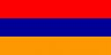
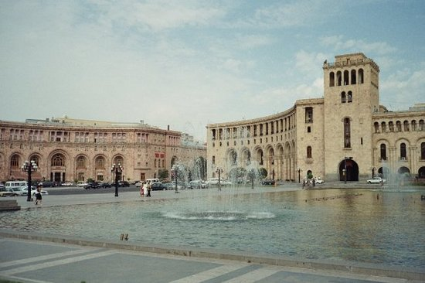
- Armenia is located in the Caucasus, neighboring with Georgia, Azerbaijan, Iran and Turkey.
- Armenia is 29,800 sq km (11,500 sq miles). About the size of state of Maryland, USA.
- The population of Armenia is 3.2 million (3,200,000).
- The official language is Armenian. English and Russian are the most common foreign languages.
- Armenian history goes back to the 8th century BC.
- The Armenian alphabet was created in 405 AD by Mesrop Mashtots.
- The main religion is Christianity. In 301 Armenia proclaimed Christianity as a state religion.
- Government type is republic
- Time difference : UTC+ 4 (9 hour ahead of Washington , DC during Standard Time)
- Administrative divisions: 11 provinces ( marzer, singular- marz) Aragatsotn, Ararat, Armavir, Gegharkunik, Kotayk, Lori, Shirak, Syunik, Tavush, Vayots Dzor, Yerevan
- Flag description: three equal horizontal bands of red (top), blue and orange: the color red recalls the blood shed for liberty, blue the Armenian skies as well as hope and orange the land and the courage of the workers who farm it.
- If you look at a map of Armenia you may notice that it looks like a queen’s head with a crown on it.
- The population of Armenians living outside the country is more then living in Armenia.
- Armenia is rich with churches from different centuries and people sometimes refer to Armenia as an open air museum

Culture

Time is flexible and situational. Armenians are generally on time but don’t be surprised if schedules aren’t rigidly followed.
Rules are also flexible and situational. Individuals may work to “get around” rules by offering a bribe or involving an influential friend.
Traffic flow is fluid and based on immediate circumstances. For this reason, please be extra careful when crossing the street.
Business is “embedded” in family and personal relationships. A friend’s loan may not need to be repaid directly.
Armenians ignore strangers on the street; avoid eye contact and do not smile. When greetings those they know, it’s customary to embrace or kiss on the cheek. Casual, friendly relationships between men/men, men/women and women/women are expressed in relaxed physical contact such as kissing, embracing or holding hands.
Personal space is rare. Current living conditions are crowded and offer very little personal/private space. Armenians usually walk and stand in close proximity. On the sidewalk they may walk abreast in groups and are inattentive to creating space for others to pass by.
A visitor/guest in Armenia is treated as a “king.” Armenians take pride in being hospitable, it means they will likely be sensitive (particularly men) about who picks up the bill for meals, trips, gifts, whatever. There is no comprehension of 'going Dutch.'
Meals include many individual dishes and are served “family style.” A traditional meal may extend over several hours. Guests are served by those seated nearby and refusals for more food/drink are generally ignored. An empty plate means it needs to be filled up, so if you don't want more, leave some on your plate. And if you don't want more and they are 'forcing' it on you, let them (it saves face) and then simply don't eat it. Please don’t feel forced to eat or drink; Armenians are accustomed to refusing food and drink three times before accepting and thus will ask you repeatedly.
Toasting is an important part of drinking in Armenia. Usually one person is in charge of toasting, he is called the “Tamada.” His job is to keep a semblance of order to the toasting and, at long ceremonies, to monitor the pace of drinking. If you would like to give a toast, ask the Tamada for permission. Do not toast with anything other than alcohol unless you are in a familiar setting where they really don’t mind. If you don’t want to drink, use the shot glass to clink with everyone else and then either just put it to your lips or simply set it down. Using other drinks, especially mineral water, shows disrespect. Clinking your glass lower than the other person shows respect.

Famous Armenians

Aram Khachaturyan (1903 – 1978) composer of classical music.
His works include concertos for violin, cello and piano (the latter originally including an early part for the flexatone), concerto-rhapsodies for the same instruments, three symphonies the third containing parts for fifteen trumpets and organ, and the ballets Spartak (Spartacus) and Gayane, the latter featuring in its final act what is probably his most famous movement, the "Sabre Dance." He also composed some film music. In connection with the composer’s 100th anniversary, UNESCO announced 2003 the Year of Khachaturian.

Viktor Hambartsumyan (1908 - 1996) astronomer. Longtime president of the Armenian Academy of Sciences, Founder and director of the Byurakan Observatory. He was one of the pioneers of theoretical astrophysics. He worked on the cosmogony of stars and galaxies, stellar dynamics, and gaseous nebulas. In 1947 he discovered stellar associations. Winner of the Bruce Medal and Gold Medal of the Royal Astronomical Society in 1960 also the Lomonosov Gold Medal in 1971.

Tigran Petrosyan, (1929-84) World Champion of Chess from 1963- 1969.
Djivan Gasparyan, duduk player
Gohar Gasparyan, opera singer
Martiros Saryan, painter

Famous Armenians from overseas

Arshil Gorki, painter USA
Charles Aznavour, singer and actor, France
Wiliam Saroyan, novelist, USA
And many others...

Armenian chess team is Olympic champion

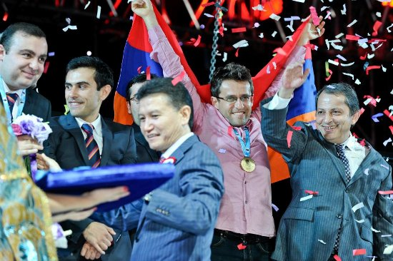
On 24 November, 2008 in Dresden, Armenia beat China to clinch their second consecutive gold medal. A tremendous performance from Aronian, Akopian, Sargissian, Petrosian, and Minasian, brought the gold medal home to Armenia for the second straight Olympiad. In all, they played six of the top ten teams by rating, as well as the strong Serbian and Netherlands teams.
On July 15-26, 2011 in China Armenia takes first place in World Team Chess Championship
Armenia’s team: captain Arshak Petrosian - Levon Aronian, Sergei Movsesian, Vladimir Akopian, Gabriel Sargissian and Armenia 2011 champion Robert Hovhannisyan. On August 27 to Ceptember 10,2012 Armenia win gold medals in the 40th Chess Olympiad in Istambul, Turkey. It was memorable day for all Armenians.

Weather

In summer expect daytime temperatures around 28-35 Celsius (80-95 F). In July and August it is much warmer with daytime temperatures from 30-40 Celsius (90-100 F). In the evening it might be a few degrees cooler.

You need to take precautions and remember the following:
- Place yourself. If the temperature rises, move slowly and take occasional breaks if necessary.
- Drink large quantities of fluids before you get thirsty. We will provide volunteers with bottled water. Armenians do drink tap water but we would not suggest for you to do the same.
- If you feel dizzy, get a headache or stop perspiring, stop work at once. Immediately inform the team leader and then report to first aid.
- Check this web site for weather forecast. www.weather.com type “Yerevan, Armenia”

Web sites on Armenia

Fuller Center for Housing Armenia (FCHA) The Fuller Center for Housing (TFCH)
www.fcharmenia.org www.fullercenter.org

Useful sites to know more about Armenia.

http://www.fructusarmeniacus.com www.cilicia.com
http://www.armeniaweek.com http://www.narek.com
http://www.matenadaran.am
http://www.armeniainfo.am
http://www.armeniaguide.com

Books on Armenia
Rediscover Armenia by Brady Kiesling, which can be downloaded free from:
http://www.arminco.com/embusa/

How TO SAY IT IN ARMENIAN

Usually you will be able to find somebody around who is willing to help you express yourself. However, it is convenient to have some knowledge of the pronunciation of Armenian and to learn a few words.

English | Armenian phonetic | English | Armenian phonetic
A little | Mi kich | I don’t speak Armenian | Es chem khosum Hayeren
Airport | Otanavakayan | I don’t know | Es chgitem
Armenian | Hay | I’m tired | Es hognats em
Bad | Vat | I’m thirsty | Es tsarav em
Car | Avtomekena | I understand | Haskanum em
Do you speak English? | Duk angleren khosum ek? | I want | Yes uzum em
Excuse me or pardon | Neroghutyun | I am fine | Lav em
Good | Lav | Map | Kartez
Good bye | Tsetesutyun or hajogh | Museum | Tangaran
Good evening | Bari yereko | My name is | Im anunn e
Good morning | Bari luys | No | Votch/che
Good night | Bari gisher | No problem | Harts chka
Hi | Voghchuin | Right/left | Ach/dzakh
Hello/good day | Barev dzez | Taxi | Taksi
Help me, please | Khndrum em oknek indz | Thank you | Merci
Here | Aystegh | Theatre | Tatron
Hotel | Hyuranots | Very | Shat
Help my back is hurt | Ogneceq mechks cavum e | Very bad | Shat vat
How are you? | Vonts ek? Inchpes ek? | Very good | Shat lav
Fine | Lav | What is your name? | Dzer anunn inch e??
I am Armenian | Yes hay em | Where is the…??? | Vortegh e….????
I don’t understand | Chem haskanum | With | Het
I don’t want | Yes chem uzum | Watch out | Zguysh eghir
Yes | Ayo | Without | Arants
You are welcome/please | Khntrem | Stop/ wait | Spasir/kangnir
Time indicators
At night | Gishery | Today | Aysor
In the evening | Yerekoyan | Tomorrow | Vaghy
In the morning | Aravotyan | Yesterday | Yerek
Tools
Hammer | Mourch | Cement | Cement
Bucket | Douil | Glue | Sosindz
Ladder | Astichan | Nail | Mekh
Spade | Bah | Pillar | Akcan
Spackling knife | Matskich | Saw | Sghoc
Eating out
Armenian soup prepared from yogurt | Spas | Ground beef and rice rolled in grape leaves or cabbage | Tolma(Dolma)
Armenian style BBQ | Khorovats | I am full | Kusht em
Beaten meat ball, can be stuffed and boiled | Kyufta | It is delicious | Shat hamov e
Bread | Hats | Salad | Salat
Cheese | Panir | Seasoned ground beef formed on a “shish” | Kebab
Give me the menu, please | Tvek menyun khndrum em | The bill, please | Hashivy khndrum em
 |  | Traditional Armenian flat bread | Lavash
Drinks
Beer | Garejur | Mineral water | Jermuk,Bjni,Arzni
Brandy | Cognac | Tea | Tey
Coffee | Surch | Vodka | Oghi
Juice | Hyut | Water | Jur
Milk | Kat | Wine-red/white | Gini-karmir/spitak
Numbers
Zero | Zero | Seven | Yot
One | Mek | Eight | Ut
Two | Yerku | Nine | Iny
Three | Yerek | Ten | Tas
Four | Chors | Hundred | Haryur
Five | Hing | Thousand | Hazar
Six | Vets | How many? | Kani?
Shopping
Big | Mets | How much does it cost? | Inch arzhe?
Cheap | Ezhan | Market | Shuka
Closed | Pak | Money | Dram,pogh
Expensive | Tank | Open | bats
Cost | Arzheq | Small | Pokr
Days of the week
Sunday | Kiraki | Wednesday | chorekshabti
Monday | Yerkushabti | Thursday | Hingshabti
Tuesday | Yerekshabti | Friday | Urbat
 |  | Saturday | Shabat
Tools
Wall | Pat | Plastic gloves | Retine dzernocner
Plaster | Tsepamacik | Goggles | Pashtpanakan aknocner
Shovel | Bah | Paint brush | Nerkelu vrdzin
Wheelbarrow | Dzernasajlak | Window pane | Patuhanapeghk
Sand paper | hghkatoght | Scaffolding | Henacu

THANK YOU!

If you have questions or comments please contact fcarmenia@fcharmenia.org.

