

Gloria’s Design

Notebook



IEOR 170: Experience and Interface Design for Engineers
Spring 2003

Professor Goldberg

TABLE OF CONTENTS

Introduction 1

Design 2
Sony Clié Handheld 3
All-Season Sleeping Bag-Tent 4
Bluetooth Wireless Technology 5
Flatulence Filter Seat Cushion 6
Broadband Phone 7
Dolch Rugged Monitor 8
Octopus Makes Life Easy 9
Disposable Cell Phone 10
New Generation E-book 11
Nescafé Self-heating Coffee 12
Paper Bubble-Wrap 13
Convertible Laptop 14
Heinz Easy Squeeze Ketchup 15
Discover 2Go 16
Laptop Stand 17
Saddle Seat 18
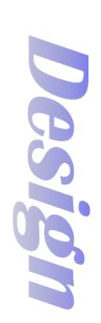
Duracell EasyTab 19

Design Issues 20
Issue #1: Why Are Good User Interfaces 21
So Hard to Make? Three Insights into
Good Design
Issue #2: Making Usable Products: An 23
Informal Process for Good User
Interfaces
Issue #3: The Importance of Simplicity 26
Issue #4: Why Good Design Comes from 30
Bad Design
Issue #5: Why Great Technologies Don't 33
Make Great Designs
Issue #6: The Art of UI Prototyping 37

While everything, technically, is an experience of some sort, there is something important and special to many experiences that make them worth discussing. In particular, the elements that contribute to superior experiences are knowable and reproducible, which make them designable.

−Nathan Shedroff

Introduction
I really like the quote by Nathan Shedroff on the previous page because it summarizes the reason behind this very special class. What makes this class special is that instead of force-feeding us all imaginable details of a subject, we are encouraged to explore – explore all the possibilities in the field of design.

Raymond Loewy, the father of industrial design, was an influential designer in the 20th century. His designs range from household products, to transportation, to corporate identity. He summarized his design philosophy with the acronym, MAYA - Most Advanced Yet Acceptable. This principle reminds designers not to push a design, however excellent, beyond the threshold of acceptability to consumers and manufacturers. There is no point in designing products that will not be accepted by the users. As Nathan Shedroff has stated, everything is an experience of some sort. Therefore, all designs should be designed to maximize the experience of their users.



Raymond Loewy
1

Design

“The urge for good design is the same as the urge to go on living. The assumption is that somewhere, hidden, is a better way of doing things”

−Harry Bertola

Everyday, designers everywhere work to make the world a better place, both aesthetically and functionally, for everyone. The pages to follow contain some of the good designs and articles I discovered this semester.

2

Sony Clié Handheld

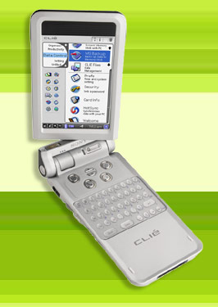

Product Features

- 3.9-inch swivel screen
- Built-in still camera
- Video camera
- Built-in mini-keyboard
- AV Remote Control Feature
- Built-in speakers
- Great mix of software (including ability to sync with Microsoft Outlook)

The hard case protects the screen and makes the product more durable. Graffiti is very difficult to write with for beginners, but the mini-keyboard solves the problem by making data entry a lot easier on the user. By flipping the screen, the handheld instantly transforms from a traditional touch-screen machine to a keyboard-centric system that resembles a small laptop.

Aside from the traditional uses of a handheld, the Clié is an entertainment center in its own. The high-resolution screen and built-in mp3-player and speakers allow users to play music, as well as video clips. The still-camera allows users to capture memories conveniently. And, last but not least, the users can control audio and video products with this versatile handheld.
3

All-Season Sleeping

Bag-Tent

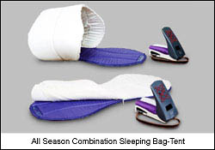

The all-season sleeping bag-tent was designed by Iichiro Hashimoto, a student at the College of Art at Nihon University in Japan. Aside from the basic functionalities of a sleeping bag, its temperature control allows the users to cope with a wide range of temperature in different seasons and topography. The temperature inside of the sleeping bag is adjusted to the users’ body temperature as well as the outside temperature. The way the users can camp out in Nature without being too cold or too hot. And, the best thing is this product is designed for portability, so you can fit all these inside a backpack that is specially made in a stylish form.

4

Bluetooth Wireless Technology

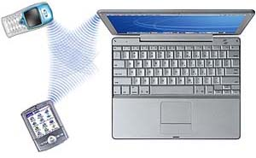

Bluetooth wireless technology is a worldwide specification for a small-form factor, low-cost radio solution that provides links between mobile computers, mobile phones, other portable handheld devices, and connectivity to the Internet. Everything is going wireless these days, and Bluetooth makes managing all these mobile devices easy. Also, users will no longer have to find ways to hide all the ugly wiring between electronic products.

Some of the applications of this technology include:
- Eliminating the need for wired connections between electronic products and accessories.
- Exchanging files, business cards, calendar appointments, etc. with groups of Bluetooth users
- Transfering and synchronizing files between devices
- Connecting to localized content services in public areas
- Functioning as remote controls, keys, tickets and e-cash wallets
5


Flatulence Filter

Seat Cushion



The flatulence filter seat cushion made by GasBGon (www.gasbgon.com) uses carbon filter technology to absorb the sound and odor of flatulence (or fart). By placing this cushion on your office chair, you can save yourself from the embarrassing experience of passing gas in the office while someone is sitting or standing close by.

According to GasBGon’s website, people pass gas on an average of 14 times a day – of course some more often and smellier than other. This seat cushion actually absorbs more than 90% of the odor emitted for most end users. Tests have shown that the odor absorbent property is effective on average of 6 months for women and 3 months for men.
6

Broadband Phone

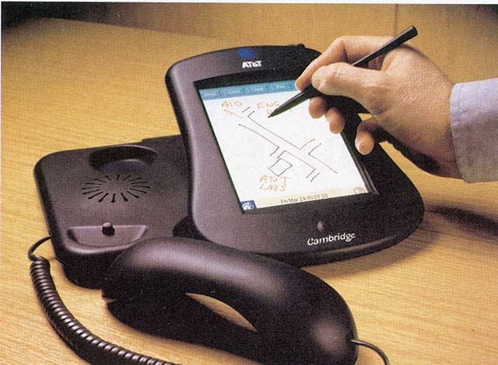

Product Features

- A shared sketchpad
- Messaging: fax, voice-mail, email, chat,etc.
- Directory
- Web browsing
- Video viewing capability
- Photo storage
- Games such as chess, pong, multi-player crossword
- Digital music jukebox

This broadband phone designed by AT&T Laboratories does everything a traditional phone does and MORE. With a touch screen and stylus, it has a friendlier user interface and more functions than traditional phones. While carrying an audio conversation, the user can draw diagrams and maps to better explain themselves. (i.e. It is very difficult to explain the location of a place when you don’t know all the street names or a mathematic proof with many variables by merely speaking.) They can also browse the web or share photos to enhance the user experience.

The phone has no applications or memories stored in it, everything is stored in the service provider. This way the user wouldn’t have to worry about viruses or updating software.

7

Dolch Rugged Monitor

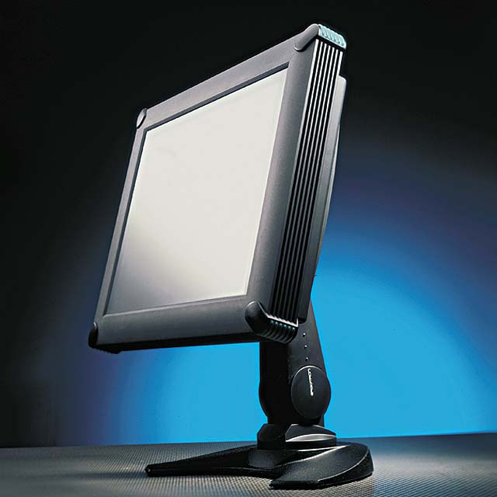

Product Features

- Operating temperature: 0º - 50ºC
- Non-operating temp:
-40º - 70ºC
- Operating shock:
10g, 11ms, ½ sine
- Operating vibration:
.41g, 3-50Hz
- Enclosure rating: NEMA 4/IP 66

The Shark™ flat-panel made by Dolch Rugged Solutions is designed to safeguard the monitor against harsh physical treatment. It is protected against water, dust, and dirt intrusion, and it can withstand high levels of shock and vibration. This product is great for young children or professionals that need to work in harsh environment or transport computer equipments frequently. Despite its bulky appearance, the monitor is relatively light because it has a hollow aluminum frame.

8

Octopus Makes Life Easy

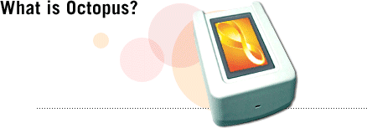


Octopus is an electronic payment system in Hong Kong that using contactless smart card trademaeked as "Octopus Card". Each Octopus card has a built-in microchip, which stores money and other personal information electronically. Users can put money on the card with add-value machines, convenient stores, or any transport service counter, and payment can be made by simply waving their Octopus cards over an Octopus reader. This is pretty much like FastTrak for the toll bridges, except the Octopus card can also be used for public transportation, parking, shopping, and entrance fees for various facilities. In addition to benefits to local residents, the Octopus card makes life much easier for tourists because they no longer have to worry about figuring out which coin or bill is worth how much.

To make life even easier on consumers, consumers can now buy cell phone covers or watches that are integrated with a full-function Octopus card.
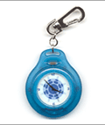
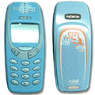
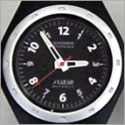

9

Disposable Cell Phone

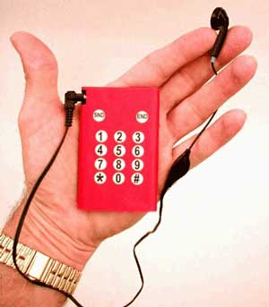
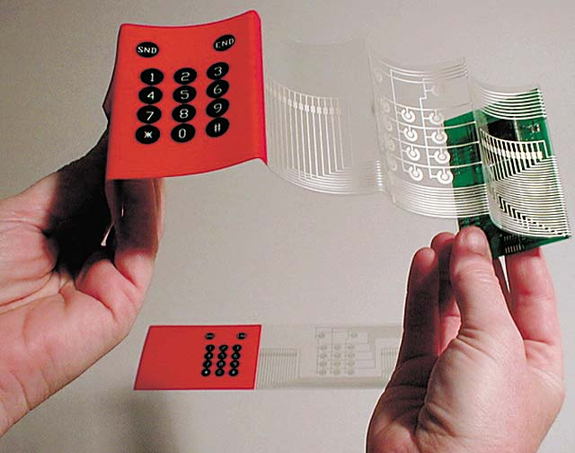

Have you ever forgotten to bring your cell phone with you on a trip and felt like you’ve lost connection to the world? Now you’ll have a solution to that problem – a credit-card-sized disposable cell phone. The 2- by 3-inch phone is made by printing cell-phone circuitry with metallic ink onto a paper substrate. The phone is operated with a headset and can offer approximately one hour of talk time.

10

New Generation E-book

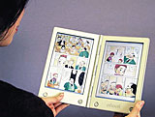

Many people speculated that e-books will replace books on paper in a few years in the beginning of the Internet Age, but companies such as Amazon.com and Barnes & Nobles are still around selling books in their traditional form. One of the major reasons that’s holding me back from switching to e-books is that I find sitting in front of the computer for long periods of time very tiring.

This product made by E-book Initiative Japan, NTT Data, and Toshiba solves the problem. It measures 135 x 10 x 214 mm and weighs only 350g, so it allows users to read the book in the comfort of their beds or favorite couches. Also, with built in speakers, the e-books can also incorporate sounds and motion pictures to make the material more interesting.
11

Nescafé Self-heating Coffee

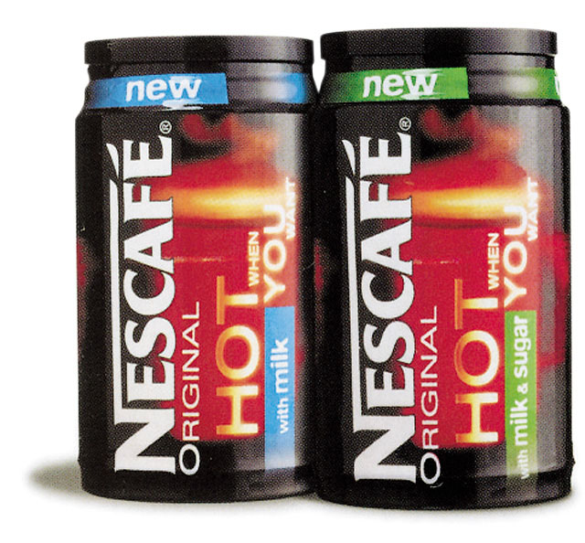

I’ve always been afraid of buying coffee from vending machines because the cups are always very hot and I’m afraid to spill hot coffee all over myself while walking away from the machine, but “Nescafe Hot When You Want” solves this problem. All you have to do is push the center of the bottom of the can to break the foil seal and wait 3 minutes for an exothermic chemical reaction to heat up coffee in the can. Aside from heating the coffee within, the can is also insulated so that the heat would dissipate quickly. The product is only available in England right now, but according to the user reviews online, the can heats the coffee to a warm drinkable level but it is not piping hot.

12

Paper Bubble-Wrap

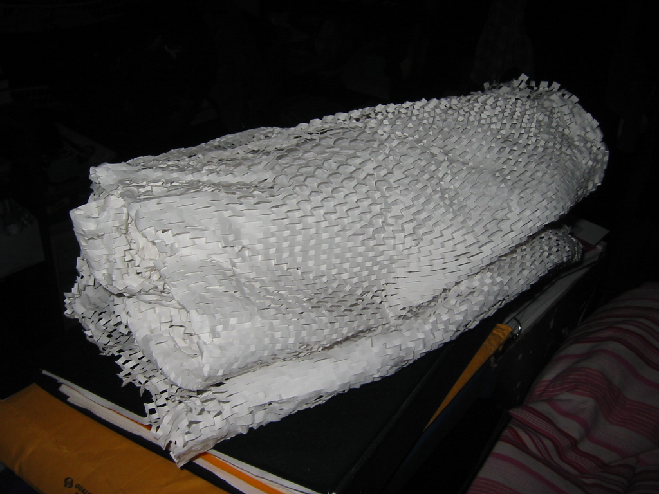

I got this paper bubble wrap from a Disney’s Store in Disney Downtown. This serves the purpose of protecting fragile merchandise by creating air cushioning around it, but this method of protection is a lot more environmentally friendly than the traditional plastic bubble wrap.

13

Convertible Laptop

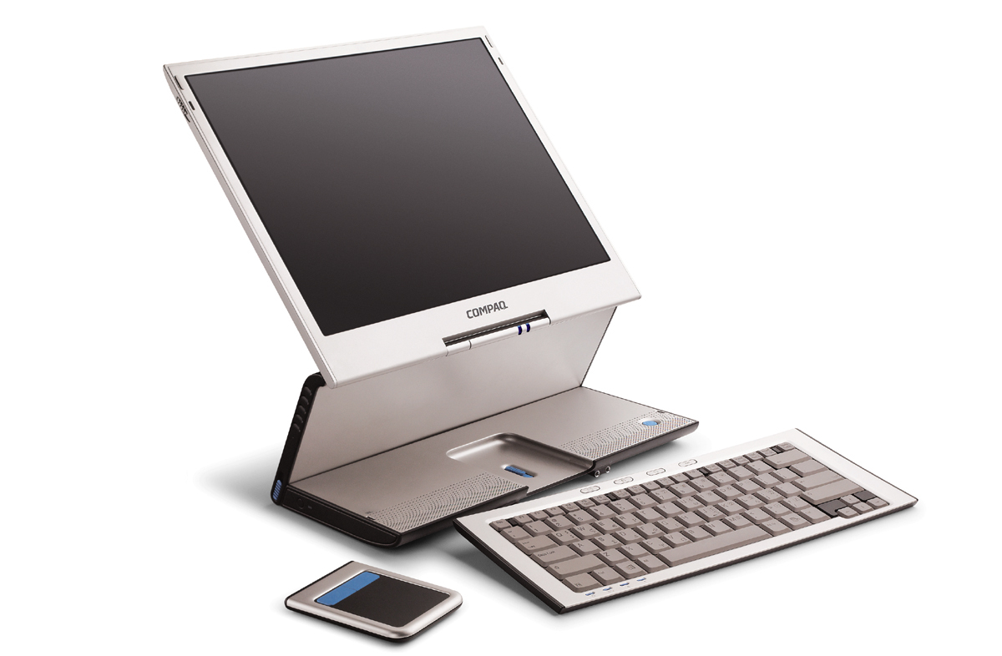

This Compaq laptop has the capability to transform into a desktop with a LCD flat panel screen and a wireless keyboard and mouse. As convenient as a laptop may be, a lot of people still prefer to use a desktop computer at home because the laptop screens are often too low for long periods of use at home. When at home, users can raise the height of the screen by detaching the keyboard from the unit and folding the base. This is truly the desktop replacement.

14

Heinz Easy Squeeze Ketchup

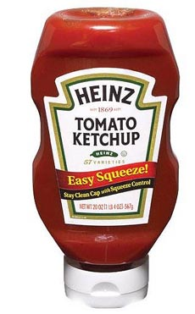

Are you tired of shaking and hitting a bottle of ketchup to get the ketchup out of the bottle? Are you annoyed by the messy gunk of dried ketchup on the cap? Are you sick of having watery stuff on top of the ketchup you worked really work to get out?

With Heinz Easy Squeeze Ketchup, you don’t have to be tired, annoyed, and/or sick anymore. The new bottles are designed to stand on their caps so ketchup can flow easily out of the bottle, and the extra ketchup would be sucked back into the bottle when you turn the bottle upside down to close the cap.
15

Discover 2Go

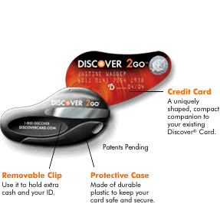

In the plastic age, we can pretty much pay for everything in plastic. We don’t really have to carry any cash with us anymore. In response to the change in payment method, Discover Financial Services designed the Discover 2Go credit card especially for people always on-a-go. This credit card is designed to have a teardrop shape, and it goes right on the users’ key chains. To use the credit card, users should swivel it out of its plastic case. This is a very convenient product because people as forgetful as I am always forget to take their wallets with them.

16

Laptop Stand


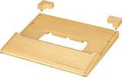
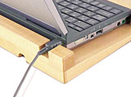

If you don’t have the convertible laptop mentioned earlier, you may want to get this Pasocom Hamal laptop stand in the meantime. The stand measures 290 x 246 x 40mm and can be used for various models made by NEC, Sony, HP, Toshiba, Hitachi, Sharp, Fujitsu, and Casio.

The stand is has a slight incline and an integrated palm rest to lessen fatigue from long periods of use. The bar in the back prevents the user from accidentally pushing the laptop over, and it has an opening for the AC/DC converter plug-in. Also there’s a heat dissipation area at the bottom of the stand to make sure the laptop does not overheat.

17

Saddle Seat

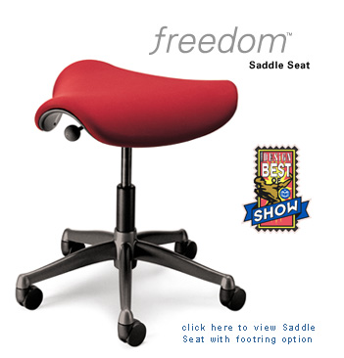

The contoured triangular cushion encourages users to sit in a ”saddle” posture, which lowers the thighs, opens up the hips and puts the spine into a healthy lordotic curve. The ”saddle” posture also reduces pressure points for long-term comfort and allows users to get closer to their work. Aside from bring comfort, this makes leg crossing more difficult. Crossing the legs at the knee or the ankles interrupts the flow of blood to the heart and may promote varicose vein by increasing pressure inside the veins.

18
18

Duracell EasyTab

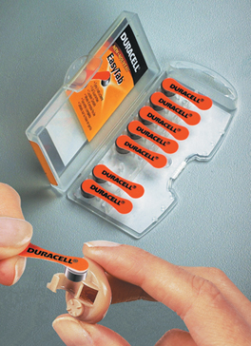

The Duracell EasyTab is a hearing aid battery. Hearing aid batteries are small and hard to grip, especially for the elderly. The EasyTab has a tab that’s used as a tool to remove the battery from newly developed packaging that is rectangular and hinged for easy opening and storage. The tabs are facing toward for easy removal. Also the tabs and packaging are color-coded to enable consumers to easily identify the battery size.

19

Design

Issues

Special Thanks to www.uiweb.com for the following articles.

20

Issue #1: Why Are Good User Interfaces So Hard to Make? Three Insights into Good Design

By Scott Berkun, January, 1999

Last year at Internet World a woman asked me why software and Web sites were so hard to use. Let's call her Pandora. I told Pandora that either we aren't smart enough yet, or the industry has not matured to the point at which well-designed products are required for companies to be profitable. She didn't buy it. She swore that sometimes we just did it on purpose. She laughed when she said it, but I think she meant it. It's my job to make simple-to-use products, and I took what she said to heart. I said that we really are trying, and that we're getting better at it all the time. She walked away unimpressed. I went back to the hotel bar that night and thought about why things are the way they are with the Internet and computers.

On the way up to my room, I had trouble getting the elevator to leave the lobby. After a few long moments I figured out that I needed to slide my room key through a mostly hidden card reader to the side of the control panel. There were no instructions or anything to indicate that this was necessary. As the elevator climbed to my floor, I thought about the many things people encounter that are not well designed. We all know of that one merge onto the highway that is way too short, and angled to abuse a blind spot. Or the door that we try to push open when it requires us to pull. VCRs, microwaves, and downtown streets are all sources of confusing and frustrating interactions. People tolerate bad design every day, even before they turn their computers on. The first insight for me was that bad design is everywhere.

The next day at the conference I spent more time talking to software and Internet users. The friendly-but-pointed conversations crystallized something. People like us who build things for a living are intimate with the technology and have a mental model for how it works. It's our job to know this stuff and we take pride in it. The problem comes when we design how the thing is operated. Because our eyes are biased toward how it was built, the complexity of the inner workings is revealed in the interface. Internal representations become external. Concepts that are familiar to our development team are quietly assumed to be familiar to everyone. Most people who make things spend most of their time with other people who make things and not with the people who will use them. We tend to look at the product from the inside out and unintentionally design it that way. This can happen no matter how smart or hardworking we are. The second thing I realized was that talented, hardworking people make bad interface design decisions all the time.
21

To make something that is useful, we have to invest energy in thinking broadly and maintaining perspective. It takes effort to understand how someone unlike ourselves thinks about the world and, as interface designers, that is exactly what we need to do. We have to research how the product will actually be used and understand which assumptions we can honestly make. It's a challenge to design something that might not suit our own needs and still be confident that it satisfies someone else's. It requires that we think about how we think about designing something. It's not working harder, it's working smarter. The last insight is that we have to make an explicit effort to think about how design decisions are made, and to learn better techniques for making them.

Over the next few months I'll use this space to give some practical advice about designing useful interfaces. There are many techniques to use and pitfalls to avoid in designing useful software: This column will be a place to go to learn new things or ask for help. I've been designing interfaces for awhile and, at worst, I can relate my own mistakes so you can avoid them. Please write in with questions about specific interface design issues or techniques and I'll do my best to help you out. I would like to design this column the right way, so please give me some feedback on what you want to read about or what things I can help with. Maybe someday I can give Pandora a call and tell her we've figured it all out.

22

Issue #2: Making Usable Products: An Informal Process for Good User Interfaces

By Scott Berkun, March/April 1999

During the development of a product I'm the only resource for making user interface design decisions, simply because I'm the developer that's writing the user interface code. Most of the time there is great time pressure to complete the project, and any testers or documentation writers working on the project press hard for decisions to be made fast so they can start doing their jobs. In the frenzy of software development, how can we make sure that our product has a good user interface before it's too late? We want to do the right thing, but we're afraid it will take us a lot more time, which we don't have.
—Steve K. Johnson, TBDSystems, Chicago Illinois

At Microsoft we have full-time employees, called usability engineers, who are trained to help product teams understand what the user's needs are, and analyze how well our product user interfaces match those needs. They do a great deal of work, and understand the discipline of UI design and data collection really well. They are critical to the success of our products. As I've learned from the e-mail I've been getting at hfactor@microsoft.com, most developers don't have the luxury of this kind of support, and are on their own to make good interface design decisions. This issue will introduce a basic development process that helps good UI make it into products. Word of warning: There is no magic recipe for good UI, or for writing good code, and I can't guarantee improved interfaces without some extra effort. This is the first of a two-part series on usability. Next issue, I'll provide some resources for those who want more in-depth information on the steps described in this article.

Step 1: Define the Problems

The most important step toward good interface design is understanding the problems your users need you to solve. Specifications for projects are often created in a vacuum: Managers or executives decide that product X or feature Y is critically important, but not much research is conducted into what the real users of the product need or want. Before you start writing code, you need to understand who your users are, what they do all day, and what problems they have with whatever it is your product is going to replace. If you were a tailor, you wouldn't make a tuxedo without first getting the customer's measurements. Understanding the user is important for all products, including software. Even if your project is the first version, potential users of your product are currently doing their job in some other way, and you want to understand the good and bad about whatever it is you are replacing. There are many ways to collect this kind of information, varying in cost, quality, and time required.
23
The simplest and most informal approach is talking to the intended users of the product. Get information directly from the source as to their work habits, their experience levels, and the problems they struggle with to get their jobs done. Avoid using managers or executives as proxies for what the real consumers' needs are. The users may not understand anything about computer code, but they are experts at whatever it is they do. It's common for small groups of developers and program managers at Microsoft to pay informal visits to users in their workplaces, with the rule that we cannot offer them any help. This gives us a chance to talk with people, discuss how they work, and absorb all the details of the problems they are facing with our products and their jobs. Even if you are short on time, pick a small handful of real users to work with and observe. Working with three or five real users is significantly better than working with none.

Step 2: Digest the Nuggets!

Roll the data and anecdotal comments from users into digestible nuggets. If you know that almost half of the users you asked complained about how hard it was to reset a form field in the data processing dialog box, write down a nugget like "Resetting forms is too hard." Repeat this for all of the data that you have. While you're putting the information into nuggets, avoid thinking about solutions. You want to make sure that you get to the root of the problems and not just patch over the symptoms. If you jump too quickly into problem solving, you'll miss the simple ideas that may solve a lot of problems at the same time.

Once you've collected a list of problem nuggets, you should check back with your users. Prioritize the list of problems and send out a short summary by e-mail to the people you talked to. This is a good time for a checkpoint with management or executives—with the list of nuggets, you can describe exactly what problems the product will solve and emphasize that it's based on real user data. The list of nuggets is a great way to deflect random ideas—when your coworker suggests implementing his spifforama-widget idea, you can tell him with confidence that it really doesn't solve the problems that your users need to have solved. The problem list sets the direction the product needs to take, ensuring that all of your development work will be targeted in the right place. Determining what problems need to be solved is often much more difficult than the act of designing the solution.

Step 3: Brainstorm, Prototype, and Iterate

Designing user interfaces is not a scientific or algorithmic task. There are some rules that I'll cover in future columns, but at best the rules are general and require that you fill in many details. For success in any design problem, it's critical that many ideas are sketched out and considered before the product goes out the door. As many of today's Web sites and software products show, a lot of design ideas turn out to be pretty lame. Bad designs are often the result of too few attempts, not necessarily bad designers. Trying out many ideas is something all good designers do; the trick is to do it without wasting a lot of time or throwing away a lot of code.
24

Working from the list of problems you created, you can use any layout editor (like the ones in Visual Basic or Visual Studio) or paint program to sketch out different ways to create a user interface to solve the problem. Using paper and pencil is fine too—just be careful not to put too much faith in an idea that doesn't have any pixels. Lots of tricky details crop up when you move from pencil to the real thing. You want to try out as many ideas as you can and you don't want to feel bad about sketching out bad ones. The more ideas you try, the greater the likelihood of creating and recognizing a good one. A good idea is one that solves some or all of the user problems you've defined. The throwaway work can be used to show coworkers and clients that the idea you've picked is relatively good compared to the alternatives, so hold on to them. When I'm working on UI, I start with a wild pile of different ideas and then group similar ones together, shooting for three to five groups. Next I write a simple pro/con list for each group to help express how the designs compare and show the list to teammates to generate more thoughts.

As time closes in, start looking for shared work in the approaches you think have value. If every good approach requires the same frizz-o-matic database widget, go build that first. This buys you time to keep thinking and iterating on which UI approach to choose. This is standard operating procedure: Make sure that development is progressing well, but simultaneously give the hard UI problems sufficient time to bake. Flesh out your best one or two ideas in detailed bitmaps or semifunctional prototypes. Prototypes don't need to be exhaustive, just do enough work to effectively simulate the experience of using the real thing. For static items like a dialog box, bitmaps are enough. For multistep features like writing and printing a report, a prototype is the only way to simulate the real flow the user will experience. It's better to learn about your design problems from your prototype than from your final product.

The more real users you work with at this stage, the more valuable the feedback will be. By talking with and observing enough users, you'll have a feel for which issues are general trends and which are random comments. Apply the useful feedback to your ideas, and update them. Try out a new set of changes based on the feedback, and repeat the process as many times as you can. Each iteration will be a distinct improvement over the last, provided you've been generating good feedback and trying out a wide set of ideas.

That's all for now. Next time I'll describe the last few steps, and provide resources for those who want to learn the powerful in-depth techniques for each step in the process.
25

Issue #3: The Importance of Simplicity

By Scott Berkun, July/August 1999

Web sites and software often compete with each other based on the features they provide. The popular assumption is that the more features a product has, the better it will be. The truth is that features improve a product only if they are actually used by the customer. In most cases the proliferation of features in products creates more complexity than value. Each feature gets an icon or a link on a Web site or toolbar, and is yet another item that the user needs to wade through before they can find the one that they need. Web sites are still young, but many Mac and Microsoft® Windows applications show the carnage of years of feature wars with competing products. Over the years I've learned a few things about how to keep interfaces simple, and simultaneously keep the power intact for more sophisticated users.

The Best UI Is No UI

It is hard for user-interface designers to admit, but the best user interface is no user interface. UI implies that the user and the computer have to interact to make something happen. In the ideal case, no interaction is necessary. The computer programmer is smart enough to devise a way to accomplish the right thing without the user helping them out. It often requires more work for developers to figure out ways to avoid annoying the user, and that's part of why it's so rarely done. A good example of a no UI solution is setting the clock on a VCR. For years manufacturers tried all sorts of manual solutions, but the best answer was to automate this task completely. Some VCRs today check for a special time encoding in the broadcast signals and update themselves accordingly. A similar example is network detection in Microsoft Internet Explorer 5.0: Instead of asking the user to tell us which type of connection to use, we figured out a way to check for the active connection ourselves. From the user's perspective, it just works. That's the best kind of user experience you can hope for. If you can add a feature that safely removes a user interaction, you are making the user experience significantly better.

Less UI Is Better UI

In cases where there isn't a way to remove UI completely, the less UI you can provide the better off the user will be. Do not take pride in multilevel tabbed dialogs, or twelve-step wizards. Figure out how to get things down to the essential common cases, and make everything else optional for those savvy enough to need them. Make sure that the five or ten tasks users need to do most often or most critically, are the ones that get the most prominence in your UI, either by highlighting them visually, or giving them more real estate. It's okay to diminish other features to help promote the ones that are most important. Make sure when you add features in a new version that you don't promote them just because they are new: Don't confuse marketing with usability. Once the user has paid for the product, there is no need to advertise your product or parts of your product. Pushing a new feature is only justified if it replaces a popular old feature, or you have evidence that the new feature will be used more often than an older feature. To help users find new features in your product without torturing them, create a What's New? item in the Help menu describing the changes that have occurred since the last version. You can also give advanced users ways to expose additional features if they want quicker access to more commands; just make sure this isn't the default setup.
26

When You Add Something, Replace Something Else

Before you can add the super cool new idea you've come up with, you have to decide what features currently in the product you are willing to remove or improve to get the new one in. We call this the conservation of UI rule: If you add something, replace something else. The right answer for the user is often to take a concept they already understand, and make it better by merging your new ideas into it. If you can't find a way to merge the idea in, or completely replace the old concept with the new concept, it's not in the user's interest to add the feature. The conservation rule forces you to think critically about your new idea by looking at the impact it has on the entire user experience. You have to evaluate its value relative to all of the other things you already have.

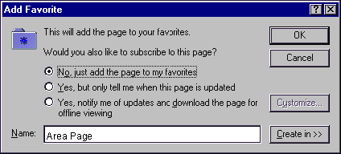

Figure 1. Internet Explorer 4.0 exposed more features than were used by most users.

27
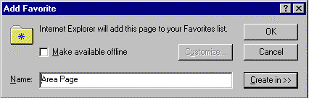
Figure 2. Internet Explorer 5.0 made the most common option easy to find, and gave advanced users a way to get to more advanced options through the Customize button.

A good example of this is Favorites and Channels in Internet Explorer. For version 4 we had a cool new concept called Channels and we added it without deeply examining how it would relate to other concepts already in the product. It caused many problems because it was a new concept and shared many similarities with the existing Favorites feature. In Internet Explorer 5.0 we did what we should have done the first time: We took the valuable parts of the Channels feature and merged it together with the existing concept of Favorites. Users could then keep the benefits of what they had, and if they desired they could use the new functionality without having to learn another concept. Learn from our mistake and do it right the first time. You'll find that many cool ideas just don't fit into the product as a result of this rule because you're not willing to completely reinvent an old feature, or you can't easily merge the cool idea into the old ones. It hurts sometimes, but the product and the user are better off.

The User Is a Limited Resource

There are only so many things the user can comprehend at one time. Their resources for scanning the screen and reading text are limited. The more commands or features you expose at one time, the harder it is for users to find the specific command they're looking for at any one time. Screen real estate is also limited, and should be used conservatively. Because these things are fixed resources, if you treat all features of your product as being equally important, you'll make it very hard for users to find the features and commands they use most frequently. The right approach is to prioritize your UI. Conserve the amount of mental energy users need to apply to get things done. The fewer things you force them to remember, and the fewer concepts they need to understand, the more time they can spend actually getting their work done.

It's Rude to Interrupt

You only interrupt another person if you have something important to say. It follows that computers should only interrupt people if there is no other way to help the user get a task done. When an application throws up a dialog box, or navigates to a Web page that serves the same purpose, it forces the user to stop whatever it was they were trying to do and pay attention to whatever it is that you, the developer, thinks is so important. Use dialog boxes or interruptive Web pages only when it truly is something urgent that prevents the user from doing the thing they want to do. If possible, remove the dialog box completely. Figure out some way to avoid the error case by disabling controls when they have no logical purpose, or be more creative with automating the handling of the choice you presented in the dialog box. Think of computer-activated dialog boxes as the last resort. You should only interrupt the user if you absolutely have to. As Steve Capps once said, the user interface should be like a soundtrack barely noticed by the user. They should be empowered by developers to focus on getting their work done, instead of trying to figure out how to operate the machinery.
28

Simple Can Be Powerful

Simplicity does not mean lack of functionality; it means a fast initial learning curve and consideration for the number of concepts the user needs to understand. Using a hammer is fairly simple to learn: Picking up a hammer and feeling its weight and shape tells even a novice what its basic purpose is. At the same time, the hammer is designed so that master carpenters and craftsmen can use them with expert-level proficiency. It's the same tool, it's just well designed enough that users can grow in skill over time. The goal for your designs should be easy to learn, but have a built-in path to higher proficiency. It's often hard to achieve this kind of scaling for a design, but the closer you get the happier your users will be. One common solution is to allow customization of the workspace so the user can choose to expose more features if they want, but the default experience is optimized for more casual users. This places the user in control of how many things they need access to at once, and how much power they're willing to trade for some additional complexity

29

Issue #4: Why Good Design Comes from Bad Design

By Scott Berkun, March/April 2000

I've received several requests to complete the missing part two of an earlier column, "Making Usable Products: An Informal Process for Good User Interfaces." I read this early column again recently and thought it was awful. So now you're getting part two, which, in my mind, is really a thinly veiled revision of and improvement on part one. Perhaps you won't notice, but of course now that I've told you, you'll probably go back and look at the first one and be really disappointed that I've had a year to write part two and this is the best I could do.

When I was a computer science/philosophy student at CMU, I took a design project course to learn about all of this interface design stuff I'd heard about. The first day of class I arrived at the studio room, and found a young man at a drawing table, sketching out different variations of the Walkman® he was designing. I got close enough to see the large sketchpad and saw 30 or 40 different variations that he had considered and put down on paper. I introduced myself, pleaded ignorance about design, and asked him why he needed to make so many sketches. He thought for a second, and then said, "I don't know what a good idea looks like until I've seen the bad ones." I smiled, but was puzzled. I felt like going back across campus to the computer science labs. If he's a designer, shouldn't he make fewer sketches instead of more? I didn't really understand what he was talking about until many years later.

When I started at Microsoft, I was embarrassed to document bad ideas. I kept a notebook with me at all times to write down ideas when I was in meetings, or traveling on the bus to work, but I never let anyone see it. Many of these ideas were awful, just plain unworkable. But with each idea I came up with, no matter how bad, it revealed some other way of thinking about the problem. Each new idea I sketched out was more informed than the last. Each bad idea illustrated some important aspect of the problem that I hadn't thought about before. Out of every five or six ideas, I'd have one or two that might be feasible. The sketching helped me, but it was something I didn't want others to know I did. I thought folks would think I wasn't a good designer if they saw how many sketches I made.

When it came time to present ideas to developers, managers, or usability engineers, I'd lead with my single best idea. I'd invest time in fleshing out only my best candidate, and hoped I wouldn't be asked about the others. I was always wrong. There are so many variations for designing a Web page, that if you only show one idea, anyone who thinks they can design something (which includes everyone) will point out several alternatives to you, and ask why the idea you're going with isn't the one they just came up with. It can be a frustrating process, especially if the suggestion is one you've already considered, because no one seems to believe you when you tell them that.
30

After many painful review meetings, and hearing advice from seasoned designers, I learned the right way to present ideas—you have to show the other candidates in order to help support the good ones. I began the habit of presenting three to seven different ideas, culling from my total set of ideas the ones that represented the most distinctive or meaningful choices. When in a meeting I now walk through the different designs, calling out what the key trade-offs are between them. When discussing ideas, I call out important negative qualities that are only answered by the idea I'm recommending, which helps set up my recommendation to be well received. Often someone will make a good suggestion for taking something from design A and adding it to design B. That wouldn't be possible if I had only fleshed out a single idea.

Every so often I'll work on a problem that is insanely hard. The only possibilities, because of technology or schedule limitations, are tragically bad. After a few days of intense but fruitless sketching, I'll feel depressed and try to regroup by asking others for their opinions. The magical thing that happens is once you're convinced you've considered all reasonable possibilities, a deductive process can begin; I'll write all possible choices on the whiteboard and sit down with a smile. I know that somewhere on that board is the right answer. When people come by my office and ask me what we're going to do, at least I can point and say it's up there somewhere. There is a psychological advantage to containing the space of choices in this way. To decide, I'll make a pro and con list for each choice, and rely on my designer, developer, or other key people to help make the call. Choosing the best among bad ideas isn't a highlight of design work, but it happens. The right process combined with a dedication to pursuing several ideas makes an impossible situation bearable, and gives you the confidence to make a decision.

When the design student showed me his sketches, he was showing me that he was a designer. All creative, talented people recognize the value of process, and have no concerns about revealing to others that it takes many bad ideas to obtain good ones. You want the bad ideas to come out on sketch paper or in prototypes, not in the product, and you can only do that by expending the energy to explore lots of ideas. If quality design work is important, you have to make sure managers set their schedules to allow it to happen, and pace the range of your thinking to match the schedule.

A common trap for design thinking is searching for perfect designs—the belief that there is a single right answer to a given problem, and a designer should be able to realize it given enough time. In many cases, the best possible design (if there is such a thing) isn't worth more than a good one, especially if it takes twice as much time to find it. General George S. Patton once wrote, "A good plan executed now is better than the perfect plan next week." You have to know the realities of the competitive and financial plan your team is working from, and adjust the goals of your design work to match them. On most Web schedules, it's critical that design energy is prioritized and focused. Make the top three or five user tasks rock solid, and keep the rest simple but adequate until the next release.
31

The more I read about great masters in different fields, the more I see how there is a common thread in their work process. Every great writer, painter, architect, or director attributes the quality of their work to tireless discipline. When asked about their artistry, they don't point to magic or divine inspiration, but describe how many attempts they must make to create things of the quality they desire.

I'll close this column with comments from various well-known figures. I seem to be making a habit of quoting people, but these folks have more credibility than I do:

"The two most important tools an architect has are the eraser in the drawing room and the sledge hammer on the construction site." —Frank Lloyd Wright

Hemingway rewrote the ending to A Farewell to Arms 39 times. When asked about how he achieved his great works, he said, "I write 99 pages of crap for every one page of masterpiece." He has also been quoted as saying "the first draft of anything is shit."
"The physicist's greatest tool is his wastebasket." —Albert Einstein

"Rewrite and revise. Do not be afraid to seize what you have and cut it to ribbons … Good writing means good revising." —Strunk and White, Elements of Style

32

Issue #5: Why Great Technologies Don't Make Great Designs

By Scott Berkun, September. 2000

We all love technology. That's why we're in this industry. We have an unspoken belief that technology will save the world from all of its problems. We excel at creating technologies and packaging them into boxes or Web sites, but we often fail to put them together in ways that our customers can easily use and appreciate. Sometimes we respond with awe at things we know were hard to implement or difficult to build, without regard for the purpose they might serve. Over the years I've noticed that our love for technology doesn't always lead us in the right direction. In this column I'll try to describe the kind of thinking that's missing.

The Fun Employment Clause

Your manager has probably expressed a desire for you to have fun and to work on cool projects. That's not quite the whole story. The hidden truth is what's known as the fun employment clause: You are hired to have fun if, and only if, you're making sure the user has an enjoyable experience with the product. This is because end users pay your salary—they pay all of our salaries. It means that everything you do should ultimately benefit the user and, therefore, your company. You want to focus on growing the intersection between your company's goals and your users' goals.

We Are Not Our Users

We develop inbred thinking in this industry. We spend most of our time with people who scored over 700 on their math SATs, we know people involved in IPOs and stock options, and we work with folks who take computers apart for fun. We forget that the people within our industry are very different from the rest of the world. That's why going into the usability lab or a focus group seems like a trip into the twilight zone. It seems like those users are in the minority, visiting us from some twisted and slower universe. The reality is this: we are the overwhelming minority. Those visitors in the usability lab are the majority, and they are the folks using our products and paying our salaries.

There is no substitute for watching someone use something you've built. It's the only way to see how your intended goals match with the reality. Would you want a surgeon to operate on you without examining you before as well as after the surgery? Would you want a building contractor to remodel your kitchen without discussing your plans and making sure you got what you needed? Good craftspeople want to understand the world in which their product will be used before building it. We have the amazing power to create things, and it's easy to fall into the trap of building things that appeal to us as creators, instead of things that will appeal to our customers. There's no way to know how biased you are without working through usability engineering and other forms of customer feedback. You must spend time with users throughout the product cycle, repeatedly refreshing the team perspective on what you're building and for whom.
33

Which Came First: the User or the Technology?

There is a fundamental difference in how technologists and true designers approach making products. Technical people tend to start with technologies. We take teams of developers, build a technology, and then shoehorn a user interface and a user experience onto the framework dictated by the technology. This guarantees that the user experience will be a poor compromise. The product won't be designed for use, it will be designed as a ship vehicle for a package of technologies. It's a value proposition: We behave as if it's more important for technologies to be shipped than for products to be used. What great products are designed this way? Do master chefs wait until the last minute to figure out how the food will taste to their customers? Do tailors measure their clients after the suit has been sewn together?

A good craftsperson in any trade understands that people will consume their work, and every decision is made with that type of person in mind. Software or Web development is no different. The people who go to restaurants or movies are the same ones who use our products. We need to cultivate an interest in how products in other fields are developed, and how they achieve the results that they do. Makers of automobiles, CD players, and appliances all have the same challenge of balancing engineering, business, and usability, except they've been doing it a lot longer than we have. We can learn a lot from their successes and failures, and by recognizing the differences in approaches they use.

Why Simple Products Are Great Products

The most powerful engineering feats are the ones we don't notice. The real power of engineers and developers is in turning something incredibly complex into something amazingly simple. The automatic transmission in a car represents significantly more engineering work than a manual transmission. The best works of the automobile industry, urban architecture, and consumer electronics express how great engineering is focused on hiding complexity, not reveling in it.

The best approach to adding value to products is to add power without adding complexity. When you want to add a new feature, is there some way to add it without adding a user interface for it? Can it be reliably automated? Or is there some other feature we can modify or remove to include the new feature, replacing something old with something new and improved? Think of automobiles and how they add significant features with minimal user impact. Anti-lock brakes are a supplement to the standard brake pedal UI, just like power steering is an addition to the usual steering wheel. No training or relearning is required on the part of the driver to get the benefits of these new features. This kind of design effort—where complex features appear simple to the user—makes great products.
34

The Real Meaning of Software as a Service

When you walk into any sporting goods store and have a question about the backpack you purchased, you expect to be treated with respect. You want the salespeople to talk to you at your level, deal with your issues, and in a polite and fair way do everything in their power to resolve your problem. Software or Web users are no different. They expect to be treated with respect and to get quality service. The customer, or in this case the user, is always right.

We make a critical mistake when we think of error messages as user errors instead of developer errors. If the user is trying to purchase something from a Web site, and there is a problem with the server database, whose fault is it, really? It's our fault. We weren't smart enough to ensure that the user would never encounter this problem. Either the project manager and designer failed to create the right interface design, or the development and test teams failed to find an important defect in how the system works. Web site error messages are just as bad, if not worse, than the ones found in software. When an error occurs in our products, we are like the service person at the REI counter. Do we provide courteous and helpful support? Do we treat users as though they're always right? Almost never. Usually we respond with an error message like this:

Server error 152432. Scripting service failure.

Every error message is a user in trouble. Imagine your user, sitting there, late for a meeting, frustrated because they can't do the thing they desperately want to do. What would you want your user to see at that moment? What kind of service should they receive? Every error message you put into your product is an opportunity for good service. You have to plan error messages and error handling into your schedule if you want to provide quality service as part of your Web site or product. Project managers should always add error coverage as a feature that is officially entered in the schedules for the dev and test teams. But keep this in mind: There is no such thing as a great error message. A great error is one that has been eliminated through superior error-handling code and product design.

Service goes beyond error messages that provide great support instead of blaming the user. There are countless opportunities throughout a user's experience to provide great service. Watch someone using the key features of your Web site and ask yourself how it compares to the level of service you'd expect at a good store or restaurant. A good waiter knows when to interrupt you, when to leave you alone, and how to do it all in a courteous and respectful way. The closer your Web site or software quality comes to the levels of good service people get in their daily experiences, the closer you'll be to having a great product.
35

Making Time to Create Great Products

Doing anything well is hard. Writing good code takes more time than writing bad code. If your team's management is dedicated to making a great product, then it will do the work to align team goals and schedules into a reality that creates that product. That's their job. If they fail to do this, it's your job to let them know. If the problem is learning about how to integrate the UI, interaction design, or usability into the development process, then ask your design and usability folks if you have them, or send me your questions. Good product design comes from good team process, and many teams still have not figured it out. In many cases, investing in usability engineering saves time and money, because you design things well the first time, instead of trying to patch things up release after release.

A team with good leadership directs everyone to understand how their individual contributions affect the customer. There should be a framework in place before development begins—provided by project management, product planning, and usability—for what problems users have and how the features and technologies the team is building can solve those problems. Without a framework, you're guaranteed to build technologies that don't solve any problems. Once a day, you should ask yourself what problem you're solving, whose problem it is, and whether it makes sense for you to invest your time there.

If your goal is to make something useful, and you know how to make something useful, then you should schedule your project so you can make something useful. Saying, "We don't have time" to develop a critical aspect of the product is always a cop-out. It really means that your team doesn't plan well, or its goals and schedule were not designed to match. If the user's experience of your product is a low-priority item, then maybe it's time to reassess your project's priorities. If you believe something is important, you can schedule and plan for it.

Where Does Greatness Come From?

You can help make great products happen by becoming a user advocate. I'm convinced that it's the team's collective awareness and dedication to their users that makes all the difference. Send this article to people on your team. Go to usability tests or learn how to conduct one if no one else on your team knows how. Talk to product designers about what's going wrong. Ask your usability engineer how they do what they do and how you can help support them. Your official job title doesn't matter; users pay your salary no matter what you do. If you work in a UI discipline, help others on your team broaden their perspective, and invite their participation. When you read a good book or article about design, pass it on to those who need it the most. If you're one of the few on your team who feels passionately about good design, the challenge is yours — but columns like this one are here to help.

36

Issue #6: The Art of UI Prototyping

By Scott Berkun, November 2000

Even the brightest people make mistakes. This is especially true for teams of people. Somehow, as a project moves forward, small assumptions and well-intentioned but poor decisions accumulate, turning hours of work into a lousy user experience. The smart teams eliminate their mistakes before they ship by using a technique called UI prototyping. Combined with usability studies, prototypes keep teams headed in the right direction.

Why Prototype?

Prototyping is a means of exploring ideas before you invest in them. All experienced craftspeople and engineers create prototypes of their work before they build anything: Architects create models out of paper or cardboard, or with virtual reality tools. Aeronautic engineers use wind tunnels. Bridge builders create stress models. Software and Web designers create mock-ups of how users will interact with their designs.

The best reason to prototype is to save time and resources. The value of the prototype is that it is a facade—like a Hollywood set, where only the front of the building is constructed. Relative to the real product, prototypes are easy and inexpensive to create. So, for a minimal investment, you can find usability and design problems and adjust your UI before you invest heavily in the final design and technologies.

On examining the needs of your particular project, you might come up with reasons for creating a prototype other than saving money. Is the goal to explore a new interface model? Make modifications to one part of the existing design? Investigate a new technology? It's important to be clear about why you're building what you're building before you start. If you begin with clear goals, you can be direct and effective in your efforts. The reasons for creating prototypes fall into three basic categories:
Proof of concept. Among some teams there are disagreements about the future direction of a project. You can use a prototype to prove that an idea or new approach has merit or value. A prototype can help illustrate that an idea works, express its qualities in a visual and interactive way, and/or motivate team members to think about the problem from another perspective.
Design exploration. If you design interactive things, the only way to explore how something will be used is to create a mock-up and interact with it. Sometimes the mock-up is tied to a usability study, where parts of the prototype can be evaluated in a structured way. Sometimes it's just a way to clearly express to a developer how something should work or look. In many cases, a designer might simply be experimenting, in an effort to get a sense for what approach might work. Anyone on the team can use prototypes to explore design issues, although designers are generally the most skilled. Design explorations should be directed at trying to solve specific problems that you've recognized in your product.
37
Technical exploration. Developers investigating implementation approaches to a problem often try out different coding techniques to see if they work well. Using HTML, Jscript, SQL, DHTML, Win32, or specific coding approaches within each technology have different tradeoffs. Sometimes a prototype represents an exploration into what technology will work well to support a certain UI or web feature.
Sometimes prototypes are created for a combination of these reasons. If a team plans well enough, they can allot time for a developer and a designer or project manager to work together on a prototype. In such cases, it's extremely important to clearly define the goals and the contributions each team member is expected to make. You want everyone to be clear on what the goals are, what's at stake, and what the potential outcome will be.

Who Is Involved?

Prototyping can be done informally by anyone, regardless of their background or role in the project. It's easy to make a simple but effective prototype by taking a bitmap from Adobe Photoshop, putting it into the Microsoft® FrontPage® Web site creation and management tool, and adding active buttons or links. These lightweight prototypes only go so far, and can become unwieldy for complex interactions.

For more formal prototypes by larger teams, a developer or project manager will often collaborate with a designer and a usability engineer. Together they'll generate ideas, build a prototype that represents the best ideas, and then go into the lab to see how effective it is in solving user problems. Developers might get involved if they can spare the time, or if their technical expertise is needed. Often the designer or project manager will do most of the scripting or coding to build the prototype.

When Do You Build a Prototype?

Depending on the scope of the prototype and the level of detail required, prototypes can be built at any time during the project. Most often they are created early in the project, during the planning and specification phase, before developers write any production code. That's when the need for exploration is greatest, and when the time investment needed is most viable. If developers instead of program managers or designers are prototyping, scheduling time becomes even more important because you need to make sure the work invested in the prototype is accounted for in the development schedule.

Planning for any UI release should include some level of prototyping.
Late in a project, smaller prototypes can help resolve tough design and technical issues. A quick HTML mock-up of how a dialog box or Web page should behave can help answer a developer's question or give other teammates a feel for what the desired experience should be. In some cases, a strong program manager or designer can implement the behavior in Microsoft JScript® development software and approximate much of the programming logic that developers will need to think through.
38
The time it takes to create a prototype can vary tremendously, depending on the scope and precision of what the end result needs to look like. An informal prototype could mean a few hours of work by one person; a more organized effort can involve weeks of effort by an entire team.

How Far Should You Go?

In your prototype, build only as much of the design as you need. It's okay to have buttons that don't work, or text that never updates. As long as you can experience the interactions you want to explore, it's fine to use smoke and mirrors for the rest. Here are a few reasons why you should focus your efforts carefully:
- Cost of building the prototype. You want to minimize the cost involved in building the prototype. The challenge with prototyping is recognizing the minimal investment needed to effectively answer your questions about the design. This is where usability studies are critical, because they clearly identify the parts of your UI that need the most work. Even without usability studies, you should clearly define what user problems you're trying to solve, or what tasks you're trying to improve, with the design in your prototype.
- Limited lifetime. Prototypes should have clearly defined lifetimes. Is the end goal a presentation at a team meeting? An executive review meeting? A spec review? A usability study? Convincing yourself, with your devil's advocate hat on, that the design solves a user problem? Once the needs for these specific objectives are met, the prototype should be set aside. The basic mindset is that the code or bitmaps generated in a prototype will be left behind. There might be exceptions where code or visuals live on in the product, but the expectation should be that this won't be the case.
- Risk of overwhelming the team. Showing prototypes to developers and teammates can be tricky. An overly complex or elaborate prototype, sporting amazing visuals and animation, can overwhelm people. You should always have a sense for how far to go and how much of what you're creating in the prototype you want to be taken seriously.

Determining the Scope of Your Prototype

As you determine where to focus your prototyping efforts, here are some things to consider:
- Customer needs. If you start with an understanding of the key problems or needs of your users (perhaps something your usability engineer has provided for you), then you have an idea about which parts warrant the most exploration.
- Usability study tasks. If you are creating the prototype for a usability study, discuss with the usability engineer what specific tasks will be part of the study, and design around those elements.
- Team input. Talk with key developers on your team as the ideas in your prototype are coming together. Get a basic sense from them on what's reasonable, what's possible, and what is beyond consideration for the next release. In some cases, you might deliberately go beyond what they say is possible for one aspect of the design if it's a key point and you think the team needs to be challenged. However, you don't want to do this with every aspect of your prototype. There is a fine line between pushing the limits and overwhelming your team. If you only want to inspire the team by showing them a vision for several versions out, then go for it. However, if you're looking to define specific changes for the next release, then focus your efforts on those changes. Make sure you call out the specific changes in a modular way to show developers a path for building your designs.
39
- Breadth vs. depth. For larger prototypes, there is the additional consideration of breadth versus depth. Do you make each feature in the design work just a little bit, or do you pick one feature and prototype almost all of its pieces and options? If you're not careful, you'll try to do both at the same time and end up with a large, unwieldy prototype that is hard to modify and difficult to throw away.
- Wireframe vs. Visual design - Depending on your audience, consider what level of visual design quality you need your prototype to have. Sketches or box drawings may suffice for folks you work with often, that you do not need to impress, or who can understand the difference between the prototype, and what it represents. If you are presenting to less experienced clients, certain executives, or more technical audiences, a more robust and aesthetically invested prototype might be appropriate. An additional consideration is what questions you have for the design itself - if you hope to learn about the impact of your aesthetic and layout choices on usability, and you are planning for a usability test, you need to make that additional investment.
- ROI: Return on Investment - Prototypes allow for various forms of evaluation (aesthetic, business, technical, usability). The higher fidelity the prototype is, the greater accuracy your evaluation will have. The most robust prototypes require no explanation - you just point people at it, and let them experience it for themselves. The more you have to explain ("oh, that wouldn't do that in the real version", "the style will be more techno") the less robust it is, and the less accurate the evaluations are likely to be. Of course, you pay a price for the investments you make. Deciding how robust is enough, and how accurate an evaluation you need to make is a judgement call, much like the decision making processes of actual web sites or software products. Your goal is to invest as much as necessary to obtain the information and effects you want, but no more.

Making Prototypes Flexible

One way to focus your prototyping resources is to concentrate on smart design. You can create more effective prototypes by allowing one piece of prototype code to exercise many different ideas. Instead of having five different prototypes, consider making one prototype that has the options to switch the different attributes of the prototype.

Should the toolbar be located on the left or on the top? Should we show 10 items on the home page or 20? A good prototype has some sort of built-in options panel that allows you to change the parameters of how the prototype looks or works. Keep these option panels hidden in your prototype—you don't want a usability participant accidentally finding them during a test.
The challenge is to keep the prototype simple, but still useful enough that you can show it to a teammate, walk through some of the different options you're thinking about, and get feedback on them.

How Do Beta Releases Differ from Prototypes?

Beta releases don't qualify as prototypes, because they are complete engineering efforts. If you find a critical mistake in a feature of a beta release, you are unlikely to throw it away, even if that might be in the best interest of the product. The developers, testers, and designers have already invested their time, and the pressure to live with bad decisions is very high. Betas certainly do help in finding bugs and defects, but they are rarely useful in making controlled studies of the value of specific design directions.
40

Tools and Technologies

There are several different tools and technologies you can use for creating prototypes, each of which has its advantages and disadvantages. Consider the type of design work you're trying to prototype and the goals of your prototyping effort as you decide which tool or technology is right for you.
- Paper - For usability studies or quick reviews, paper is often the fastest way to prototype a design idea. Using Photoshop, mspaint, or any tool you are comfortable with, produce screens that express the design, and print them out on paper. If you make enough screens, you can simulate walkthroughs, allowing test users to make choices and experience the design. However, for prototypes of moderate complexity, generating paper prototypes can be cumbersome. Highly interactive things like games or chat rooms can not be simulated well on paper. Also, the more elaborate the tasks, the more pages you might need to have handy.
- Microsoft Visual Basic—. This is the fastest technology for creating Windows-style UI prototypes. The Web browser object makes it easy to integrate HTML UI with your standard Windows-style components. While it's true that an experienced C/C++ developer might be able to generate UI faster in C/C++, this creates the temptation to reuse code from the UI prototype in your production code. It takes discipline to recognize that the goals of a quick and dirty UI prototype are highly divergent from high-quality engineering. Make sure you know what kind of code you're writing, and that your team or manager understands what will be discarded.
- Macromedia Director or Flash. This is one of the most popular UI prototyping tools among designers. It is most useful for multimedia or non-standard GUI designs, or for prototypes that require significant animation. It's high flexibility makes it cumbersome for Windows-style UI compared to Visual Basic. However, a proficient Director user can generate Windows or Web UI without difficultly.
- HTML. Dreamweaver, FrontPage and other HTML editors allow for fast creation of simple prototypes. To express an idea, you can often create bitmaps that illustrate a sequence of user interaction, and place them into FrontPage. Then you can create link areas to connect the pages, and simulate how you can interact with the design. JScript and DHTML take things to another level, allowing for very sophisticated logic and interaction. If you are using HTML to prototype your Web site, the warning just described for C/C++ applies here as well—don't fall into the trap of confusing quick prototype code with production-quality engineering.
41

