TM
ENTENTE

ENGLISH TO ANY LANGUAGE

Conversational Translator Program for use on IBM compatible personal computers, with both parties present.

Requirements: MS DOS 3.0 or better, disk drive, EGA or VGA display, one megabyte RAM, and at least 480K of first 640K of memory available. OR an HP Palmtop 100LX or 200LX.

Capability: Two way translation between English and any of the following languages: Arabic, Chinese,French, German, Hungarian, Italian, Japanese, Korean, Polish, Portuguese, Russian,
Spanish, and Serbo-Croatian (Yugoslavian).

TM
ENTENTE

ENGLISH TO ANY LANGUAGE

Manual and Program copyright:

Robert Alan Mole

July, 1994

TRANSLATOR COVERAGE

OO
XXXXXXXXXXX OO OO XXXXXXXXXX
XXXXXXXXXX X XXXXXXXXXXXXXXXXX X
XXXXX X OOXXXXXXXXXXXX X
X XXXXXXXX XX OXXXX XXX
XX XXXXXXXXX X OOX
XXXXXX XXXXX X X
XXXXX XXX X XXX
XX XX XXXXXX
X X

X=Covered; Y=Not Covered

(The above is the best ASCII world map I can draw. In the regular manual,
a good map appears here, showing coverage of all the world, except
Scandinavia, the Lowlands, Czechoslovakia, Romania, Bulgaria, Greece, Turkey,
Iran, Iraq, Afghanistan, Thailand and Burma. And Greenland.)

Translator world coverage is shown shaded. All of the Americas,
Australia, and most of Europe and CIS Asia are covered. North
Africa is covered by Arabic, and the rest of Africa by Arabic
or a covered European language--usually the "national language",
required to unite several tribes into one country.

In Asia, Korea is covered, and Japan and China are covered by
phonetic alphabet systems which have been universally taught for
decades in the schools of Japan and Taiwan, and on the mainland
for the past six years.

Countries not yet covered are mostly in the small to medium
population range, such as the Scandinavian countries. In a sense
these areas are covered too, for travelers universally remark
upon what superb linguists those people are. There is a reason
for this: there are four million speakers of Danish, and four
hundred million of English. There are hundreds of times as many
books and papers in English (or German, French or Russian) as in
Danish. Danes wishing to access all this must become superbly
proficient in a major foreign language -- and they do. Likewise,
proficiency in at least one covered language is very widespread
in the other countries not yet included. And in this sense the
translator covers the whole earth.

TABLE OF CONTENTS

SECTION I

Introduction
Disclaimer
Warranty
Discussion of Disclaimer
Installation
Marking Keyboard
Program Mechanics
Program Rules
Practice Sentences
A Session with Entente

SECTION II
Discussion of Rules
Circumlocution
Complexities
Unfortunate Phrases
Importance of Translator
Conclusion
Extra Words & Foreign Fonts

SECTION III
Characteristics and Pronunciation Rules

SECTION IV
Introductions and Rules

SECTION V
Examples of Translations

SECTION I

ALL NECESSARY INSTRUCTIONS

NOTE: This is a thick manual, but do not be dismayed. You only need to read the first eleven pages, and most of that is light reading.

In any event, the program is easy to use, and there are hardly any instructions to learn.

IF YOU'RE IN A HURRY...

You MUST read "Translator Instructions" (one page), and you really should read "Practice Sentences". Then type "SEL" and go. ENTER makes it translate, TAB switches to foreign input, and ESC stops it. If you also read "A Session Using Entente" it will save time in the long run.

INTRODUCTION

Entente is an unusual product: a conversational translator program that solves the problem of mistranslation of ambiguous words. Conventional wisdom has it that such a translator Cannot Be Done. This program shows that it Can Be Done, at a level that allows reasonable and useful communication on any topic.

The program has quirks and one must read and follow the rules, but in return one gets the ability to be universally understood.

Most people like the program and are helped by it. But if you do not, you may have your money back for any reason, for up to a year from purchase.

The translator works without most grammatical rules. It uses no plurals, for we understand the same thing from 3 MAN ROB BANK YESTERDAY as "Three men robbed the bank yesterday." It does not conjugate verbs, or use tenses or moods, for we understand PERHAPS THEY ROB IT YESTERDAY just as well as "It may be that they might have robbed it then." So in using the program, you use only the infinitive (to go, to be, to see, but without the "to".) You write HE GO TOMORROW. I BE IN DENVER.

When you use an ambiguous word, the program asks you to tell it which meaning you want. So when you type I LIKE -- it beeps and prints :
"Please select the number of the meaning you want:

1. I like candy.

2. John is like Susan. "

You type a "1" and continue , and the translation is made correctly. The rest of the rules are given later, but essentially this is all there is to it.

You will use this program on you office desktop computer to converse with someone whose language you do not know. Or you may carry it with you in a notebook computer when you travel abroad. To initiate conversation, you give the foreigner a short set of rules (in his language) to read for a minute. (You may also press F1 to bring up the rules on-screen.) You type in your questions, hit ENTER to translate instantly, and then he can respond. You will find you can say almost anything and be understood, and his response will "sound funny" but be understandable too. For example, if you're traveling on a Eurail Pass and want to find cheap transportation to a mountain you want to climb, ten miles outside of town, you'll say:

I HAVE NO CAR BUT I WANT TO CLIMB SPITZENBERG MOUNTAIN. I WANT
TO RENT A BICYCLE TO GO THERE. BE THERE A BICYCLE SHOP IN TOWN?

In response you'll get: NO, BICYCLE STORE 2 YEAR BEFORE CLOSE. I HAVE BICYCLE. YOU WANT IT RENT? And while this is far from perfect, it gets the job done.

Just like speaking a foreign language, communicating this way is challenging and amusing. But unlike learning French, which takes four years, learning to use this program takes only minutes, and the rules are the same for all languages. The natives will have no trouble with your accent, and you'll be able to talk to Russians, Portuguese, Hungarians, Egyptians, and all sorts of people who cannot understand either English or French.

As with trying to converse in a foreign language, you cannot expect every single thing to make sense, and you must use some effort and intuition to figure out what the foreigner means. When you -- or the program -- do not know a word, you must use your initiative to circumlocute -- to talk around-- the roadblock:

THIS FOOD BE SUPERB (the computer clicks softly to show it doesn't know that last word, so you continue with a substitute) VERY GOOD! The Spanish translation is then: ESTO ALMIENTO SER SUPERB MUY BUENO! The Spaniard disregards the untranslated word, and understands the rest. In the rare case when he does not, he'll just ask for a clarification.

The program works, and it lets you talk to people and say almost anything. It takes some effort, but it beats the alternative of riding for hours in a train compartment with attractive, interesting and friendly foreigners -- to whom you cannot even say "Hello".

I hope you have great adventures with it.

Please write me with questions, suggestions, and words you'd like to have included in the vocabulary. I cannot think of everything, but I can listen to users and make improvements where they want them.)

=============================================================================
DISCLAIMER

You must realize that this translator is imperfect, and will occasionally
give a false, misleading or inappropriate translation. It is dangerous and
foolish to stake a large sum of money, or your life, or anything else of
great value, on anything it says.
=============================================================================

WARRANTY

Entente Corporation warrants that this program, if properly installed and operated on a computer for which it was designed, will perform substantially in accordance with the User's Manual . Furthermore, if the purchaser is dissatisfied with the program for any reason, Entente Corp.will refund his or her purchase payment in full, upon return of the program and manual, for up to one year from the date of purchase.

This warranty is in lieu of all other warranties, express or implied, including but not limited to implied warranties of marketability and fitness for a particular purpose. Entente Corporation's liability shall, in any event, be limited to the purchase price of the program and shall not include any consequential damages, such as misunderstandings or loss or destruction of data, resulting from the use of the program.

ABOUT THE DISCLAIMER

I believe this is a good and useful program, whose output will usually be understood. I think you will ordinarily be far ahead to use it, especially if you don't speak the language at all. But all use of language, even your own, carries a risk of misunderstanding; and translation to a foreign tongue is an art. Even experts often make egregious mistakes.

Around 1930, the first transatlantic telephone service was opened. But in the first days a lot of valuable time was wasted by British and American operators who couldn't understand each other's English! The London operator would ask "Are you through New York?" (meaning "Have you gotten through to your party?") and the American would understand "Are you through talking?" and respond "No, London, we've only just been connected." Then there would be a long pause as everyone tried to figure out the crazy people on the other
side of the ocean...

In 1977, President Jimmy Carter went to Poland and made a speech. But his State Department translator suffered stage fright, and when Carter said "As I left America I thought about how much I loved the Polish people.", the translator spoke Polish meaning "When I left America, never to return, I thought how I wanted-to-go-to-bed-with the Polish people." The Poles giggled, and probably tell American President jokes to this day.

In 1940, the Nazis published a propaganda magazine called Signal, using the best translators they could find. Prussian efficiency notwithstanding, it was full of howlers. The allies called the Stuka a "dive bomber"; the Germans called it a "diving fighter"; but one Signal caption read "A divine fighter wings towards its target..." Though actually it looked more fiendish.

If such diverse symbols of efficiency as Jimmy Carter, The Telephone Company, and the Nazis all suffered from errors in translation, then you must not expect perfection from this little program! Nevertheless, it's surprising how often you will be understood.

INSTALLATION

ENTENTE for HP PALMTOPS
Copyright R.A.Mole 1995
Foreign fonts created using
Gilles Kohl's FCL program.

These special HP instructions supplement the manual. You must still read Section I of the booklet, skipping Installation and Keyboards. The important thing about Entente is the input rules, not the mechanics!

LOADING THE HP

1. Leave the System Manager as explained in Step 5. (& Menu A T (Enter) )
Go to the palmtop drive where you are going to put Entente. (A: or C:)
Make a directory for Entente (say, \ENT).ex.A: (ENTER) MKDIR \ENT (ENTER) CD\ENT (Enter).

2. Use the HP Connectivity Pack or a similar product. Follow its directions to connect the Palmtop to your PC.
Copy all the files from the Entente program disk \ENT directory to the HP \ENT directory.

3. Copy all the files from the Entente Language Disk(s) to the HP \ENT directory. Do not use sub-
directories -- in the end, all files must be in the same directory on the HP.
Terminate the Connectivity application. On the palmtop, leave the System Manager per Step 5, and go to the Entente directory. (CD \ENT).

4. Type ENSTART (Enter). Normally, do this only once. It sets aside memory for foreign fonts. (8k of system RAM). If you do it several times it will set aside so much memory that the computer may freeze, and you will have to restart it with Ctrl Alt Del. Or you might even have to do a hard reset -Ctrl Up-arrow (the shift key) On (See HP User's Guide for details). This loses no files but it is undesirable.
If you have done such a reboot, or lost all power and memory, or if the foreign font does not appear but instead comes out as lower case English letters, only then should you run ENSTART again.

5. Leave the System Manager by pressing & Menu A T (Enter). (Do not leave by pressing "D" or clicking the DOS icon. That leaves the System Manager running and using so much memory that Entente can't run and you'll get the message "Cannot execute". ) While the Manager is "off" your Appointment Manager etc. will be "off" and will not remind you of appointments. Later, to return to System Manager, type: 100 (Enter)

6. Type the abbreviation for the language to which you wish to translate (e.g.. SP for Spanish) and Enter.
If you forget the abbreviation, type SEL (Enter) to see the list. Note that although it takes a long time (three minutes) to load Entente, you can leave it running and turn off the HP. Then, when you turn it on again, Entente is still there, ready to go immediately.

SETTING MEMORY

If you have an A: drive (PCMCIA Card) or a 2- meg internal memory, just set working RAM to 640K (it probably is already set to this). Note: PCMCIA card must not be set to "read-only", or Entente won't run!

If you have a 1 meg memory, you should set working RAM to 540k (RAM Disk will be 448k). Later, check to see that you have more than 130k left on the RAM Disk, as needed to expand the compressed vocabulary files. The messages "File not found" and "Input past end of file" really mean there wasn't room for expansion. You may have to delete memos or other programs to get Entente to run. A one-meg memory is quite small; you can get one, and sometimes two, languages stored at one time.

To set memory: From the opening menu, press & S (setup) Menu O (options) S (Setup), which should display Volume, Contrast and Memory. TAB down to memory, use cursor keys to change setting, press Enter, then Enter again to restart with new setting. (Do type ENSTART (Enter) after this.)

Using Software Carousel

Software Carousel is a program sold by another cmpany that lets you switch quickly betweeen various programs, e.g. between Entente and theSystem Manager in a moment and at a keystroke. Its use with Entente is described at the very end of this manual.

MARKING THE KEYBOARD

For French, Spanish, Portuguese, Japanese (Romaji) and Italian, it is not necessary to modify the keyboard.
For Spanish, the ~ key produces N~.

For other languages you must cut out and put on the correct overlay so the foreigner knows which key produces which of his letters. I regret that this takes a while, but there is no way to do it automatically.

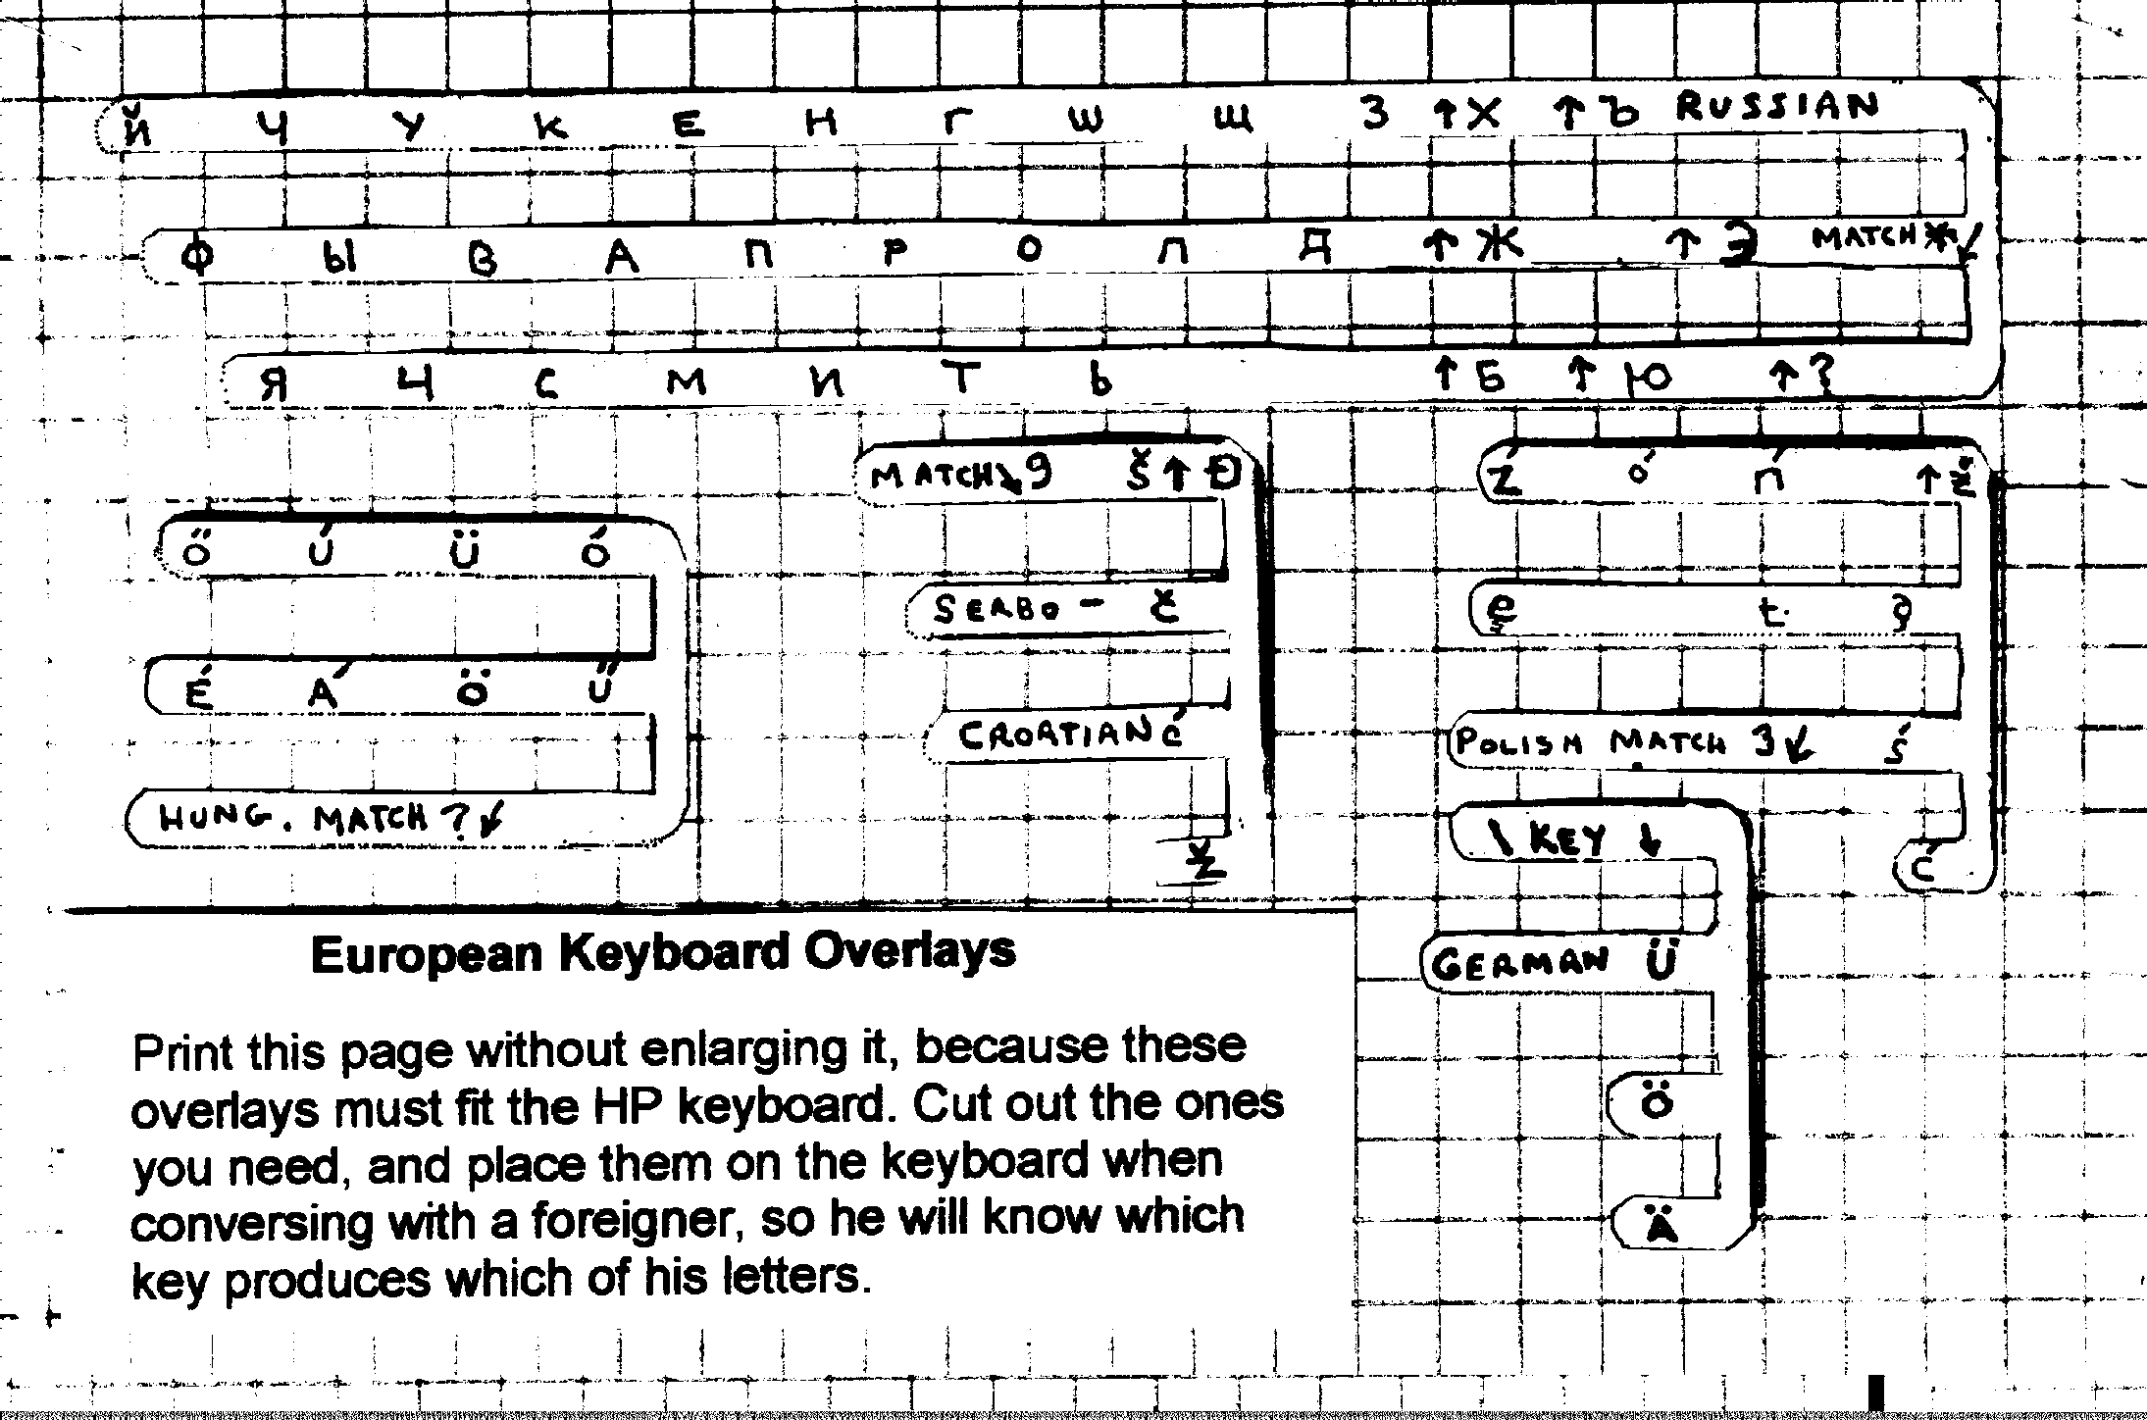
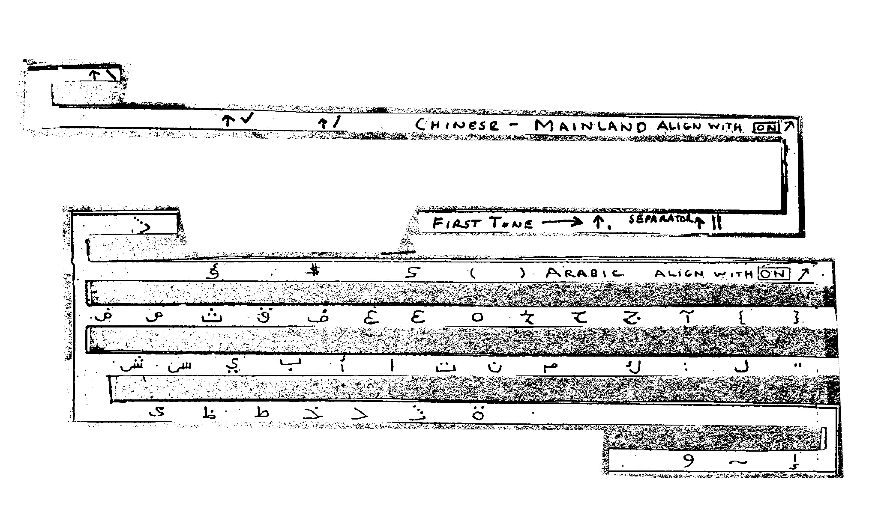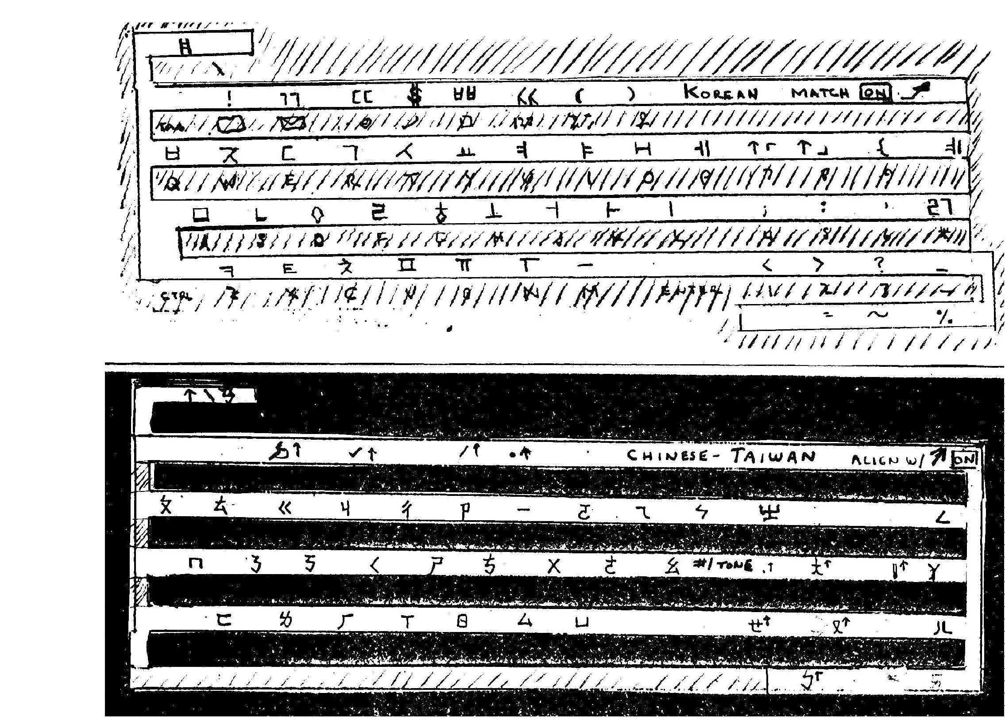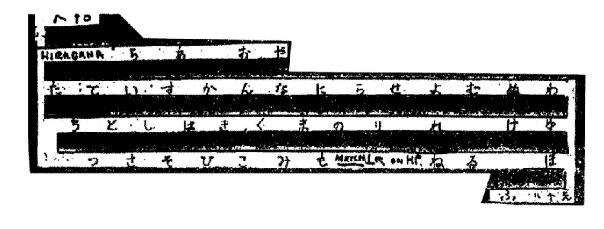
USING THE PROGRAM -- THE MECHANICS

Entente works between English and any other language for which you have purchased a vocabulary. Suppose you've bought Spanish and Hungarian.

Type SEL (Enter). A menu displays; type the number of the language you want (say 16 for Spanish).

The program loads, displays a welcome screen, and asks you to choose a specialty vocabulary. Choose an appropriate one, say, BUSINESS (type 1 and (ENTER)) .

It now asks if you want to print out the conversation (on paper,using a printer). Answer Y (yes) or N (no). For European languages, printout on any printer will work (but no characters will be accented.) For non-Latin fonts (e.g.. Arabic, Russian etc.) your printer must be an Epson 24-pin or compatible. To check for compatibility, it's easiest just to try it. If only lower case English letters come out, your printer isn't compatible. See your manual; some printers can be adjusted.

Next it asks if you want to save the conversation to a file. This is useful if you can send files to foreign friends, via the Internet or modem connection. You would respond Y (for Yes) and make up a short file name at the prompt. Then you would write a message or letter, press Enter to translate, and end the session with ESC (ESCape), and the file would contain your original input and the translation. You could then send it as you would any other file, to your friend. (Because the translations are funny, you would not write a formal letter to the President of Peru in this way!!)

The program takes a few seconds to read the vocabulary. Then it tells you to type in your sentence in English. Do that (for example: HELLO. WHAT BE YOUR NAME?). Press ENTER, and the sentence translates instantly.

Now the other person wants to reply -- for example, in Spanish. Press TAB and the program is ready for Spanish input (you can tell because the screen changes color and the "Type your sentence" message appears in Spanish.) TAB toggles back and forth between English and foreign input.

Suppose you have chosen the automobile specialty vocabulary but you don't know what words are in it, and wonder whether "windshield-wiper is one word, two words, or hyphenated. (many specialty words are hyphenated.) Then press F2, and the words are displayed alphabetically. Look up your word, and return to the main program by pressing any key.

Note that you always type in all caps. Small letters will not translate!

The program sets the CAPS LOCK automatically to the right setting, but if something goes wrong, just press CAPS LOCK to get back to all caps. You can backspace, but only with the back-arrow key above ENTER. The "cursor keys" do not work and cause strange letters to print.

You can also display the rules (e.g. no plurals) at any time by pressing F1. If you're on the English entry screen, the rules are displayed in English; from the foreign screen, they're in the foreign language. To get back to the main program, keep pressing ENTER until all pages have been displayed and itreturns. This display erases anything you've already typed, so it's natural to use this feature at the very start of a session -- usually to allow a foreign stranger to read the rules. Section IV of this manual contains these rules too. It is better to show the foreigner the manual or a copy of the printed page if it is available; the format is prettier and there is a translation of the introduction too.

To stop the program and return to DOS, press Esc (the key in the upper left corner of the keyboard), at either the English or foreign prompt.

Note: This is the one page you MUST read to use Entente.

TRANSLATOR INSTRUCTIONS

1.) Type in your sentences. If you use an ambiguous word the program beeps and asks which sense you mean (1. I like candy 2. Joe looks like John). Type "1" or "2" and continue.

2.) It translates automatically when you hit the "ENTER" key. You can then type another sentence. Or you can press the "TAB" key to switch to foreign input (so the foreigner can reply).

3.) Use only one verb form--the infinitive (as in to walk, to talk, to go, to be)-but forget the "to". Say: John be tall,he go to Peru,I walk over hill, etc.

4.) Use all singular Nouns: 3 man rob bank yesterday, all baby cry in night, most american think that...(you can use they or them or any other pronoun though).

5.) Do not use possessives--not John's car but car of John. As usual you can use the possessive pronouns -- His car, her car, my car, your car, or their car are all OK. (NOTE: for Hungarian and some other languages you should use THE JOHN CAR -- check the section on Language Peculiarities.)

6.) Any sentence with Please in it is a polite command, regardless of word order: US YOU GIVE PASSPORT, PLEASE. (In various languages, word order varies, but this rule takes care of that -- for command always say PLEASE).

7.) Any sentence with a question mark is a question, regardless of word order:"TIME BE 5:00?" "LIKE WINE YOU?"

8.) Do not use complex, multi word verbs. I LEAVE FOR CHILE TOMORROW, not "I will leave"," I should have left", "I am leaving", or "Do I leave?" And, "PERHAPS I GO", not "I may go". You can say: I WANT TO GO, I CAN GO, I MUST GO, I SEE HIM GO -- just stick to the present tense.

9.) Just after you type a word it doesn't know, the computer emits a low, discreet "click". This feature lets you backspace to correct the spelling, remove the "s" from the end of a word you've accidentally pluralized (remember that it doesn't know plurals), or try a similar, perhaps more common word. (Use the back-arrow key above the "ENTER" to backspace. The cursor keys do not work!)Later, look at the translation. Some of the words may be the same as those you typed. This may be OK--the words may be proper names or you may have said I LIVE IN DENVER and it translated YO VIVIR EN DENVER. DENVER and FRED JONES can't be translated, so unknown words are repeated unchanged.

The foreigner can probably read such words with no trouble. (NOTE: For languages such as Arabic that don't use the Latin alphabet you should point to the untranslated word and pronounce it clearly. It may also be helpful to carry a small map, and point to the place.)

But sometimes you'll suspect the word didn't translate because the program didn't know it, and you should try a more common word, or explain it (and when this happens to you, point to the word you don't understand, or ask what it means.)

CAN YOU FLY A GLIDER?
PODER UD VOLER UN GLIDER?
GLIDER MEAN AIRPLANE WITHOUT ENGINE.
GLIDER IMPORTAR AVION SIN MOTOR.
PRACTICE SENTENCES

Above are normal English sentences. Below, the right way to say them with the translator, and explanations. Cover the answers, read the sentence, compose your sentence and then compare it with the answer.

1. Give your passport to me.
PLEASE, YOU GIVE YOUR PASSPORT TO ME. (Other languages form commands with special verb endings and word order, but everyone recognizes that a sentence with "Please" is a polite command. Say "you give" instead of just "give" because you should always state the subject.

2. John sees the car.
JOHN SEE THE CAR. ("to see" is the infinitive. We do not conjugate the verb (I see, you see, he sees), because there are too many forms (veo, veas, vea, vemos veis, vein for the present alone in Spanish), and the computer cannot hold them all. The computer will not translate "sees", but will translate "see".)

3. John has seen the car before.
JOHN SEE THE CAR BEFORE.
(The helping verb "have" is not used in many languages, and makes no inherent sense. Would you understand "John possesses seen the car" ?

4. I see six cows and two deer.
I SEE 6 COW AND 2 DEER. (No plurals; they won't translate.
Use the Arabic numerals -- do not spell out numbers.)

5. By the time they get here, he will have gone.
HE GO BEFORE THEY ARRIVE. (Simplify. Avoid "get" except in the sense of "obtain". And, "will have gone" is a very complex conjugation, and conjugations are not allowed.)

6. She will leave tomorrow.
SHE LEAVE TOMORROW. ("Will" may or may not translate. Some languages have a similar future tense (Spanish says "She go to leave tomorrow.") and some don't. But "SHE LEAVE TOMORROW" is perfectly clear to everyone. As long as you state the time, you don't need tenses.)

7. If I were you, I would drown myself.
IMAGINE THAT I BE YOU. THEN I DROWN MYSELF. ("Were" is the subjunctive tense (or rather "mood"). Subjunctive is used to indicate an imaginary, hypothetical condition -- obviously I cannot really be you. ) But the subjunctive is unnecessary -- if you want someone to imagine something, just tell them to.)

8. It costs $6000.
IT COST $6000. (No conjugations; "cost" not "costs"!)

9. I was in West Berlin in 1968. Wanting to visit East Berlin, I went to Checkpoint Charlie, and gave my passport to the VOPOS...

TIME BE 1968. I BE IN WEST BERLIN. I WANT TO VISIT EAST BERLIN, SO I GO TO CHECKPOINT CHARLIE AND GIVE MY PASSPORT TO THE VOPOS...

( Again, no need for tenses, just tell the time and tell the story. Berlin, Charlie, and Vopos won't translate, of course. They just appear in their original form. You can't translate a word like "Berlin".)

10. Two hours later, the Vopos said they might have given my passport to another American, so I could go in without a passport...

TWO HOUR LATER, VOPO SAY "PERHAPS WE GIVE YOUR PASSPORT TO OTHER AMERICAN, BY ACCIDENT. SO YOU CAN GO IN WITHOUT PASSPORT." YES, I THINK, BUT CAN I EVER LEAVE AGAIN? (You can tell quite a complicated story this way-- and the translator can be a real help if some clumsy border guard loses your passport and you have to check into a West Berlin hotel and explain your lack of documentation. Otherwise, things like this can be dicey!)

11. That touring sedan has fantastic, sensuous lines. THAT CAR BE VERY PRETTY or IT HAVE BEAUTIFUL SHAPE.
(Simplify! You cannot expect a 3500 word vocabulary to have words like "sensuous", and a foreign language may not use "lines" in the sense of "form", and anyway, "lines" is plural! Try to speak as simply and directly as possible.
Incidentally, note that BE should be used instead of IS, AM, or ARE. "TO BE" is the infinitive. But because so many people forget this, IS, AM and ARE will translate-- I've made that accommodation to human nature. But this is the only verb you can conjugate, and only in the present -- WAS and WERE will not translate.)

12. I left my glasses in the store.
I LEAVE MY GLASSES IN THE STORE YESTERDAY. (Some plural words - glasses, pants, etc.-- are included, because there really is no singular. Nobody ever bought one pant!)

A SESSION USING ENTENTE

John turns on the computer, leaves Program Manager, types cd\ent (Enter) and types SP (Enter).
He watches as extraneous messages about "file not found" appear and vanish. (It's OK; they are part of the plan but cannot be surpressed.)

Now he sees the welcoming screen and the request that he choose which specialty vocabulary he wants. "Business" is (1), so he types 1 (enter).

He is told that a three minute delay occurs while the computer is reading the vocabulary. Then:

A screen with a bar at the top telling him everything he can do at this point: Type in English, hit Enter to translate what he has typed, hit Tab to switch to Spanish input (so the Spaniard can reply) or hit ESC to leave the program.

John wants to say "Hello. I like your car".

He types HELLO. I LIKE...

The machine beeps. John ignores it and tries to type more, but with each keystroke there is another annoying beep!

John looks up at the author of the program (conveniently standing by his shoulder) and says "What is wrong? Is it broken? Why does it keep beeping?"

The author responds: It is beeping to get your attention. This means you must look at the screen. John looks, and sees:

HELLO. I LIKE

Please choose a sense, type a number

1. I LIKE CANDY

2. JOHN IS LIKE SUSAN

Oh, says John, a huge white sign has appeared, asking a question. But why, and what must I do?

The author explains: you have used an ambiguous word: LIKE, and the program needs to know which meaning you want. It must know this before it can go on, so now you must read the big white sign and type a 1 or 2 (just the number, not Enter on this one)

John reads the sign and decides he wants meaning 1. He types a "1" and the sign disappears. John finishes his sentence.

Wanting to translate it, he presses "Enter" and the translation appears-

HOLA. YO GUSTAR SU COCHE

Juana, John's Spanish friend, reads the translator and understands it.
(Gustar really means "pleases", so "your car pleases me" is theoretically correct, but GUSTAR can be used in either way (as "like" or "pleases") in closely related Portuguese, and Spaniards really understand it too, despite what American Spanish teachers say. People are more understanding than teachers.)

Juana tries to type a reply: UD PODER... but the computer clicks after every word, to show it does not know these words. Help! Why? Because, says the author, you have not hit TAB to switch to Spanish input. The computer does not know UD or PODER because they are not English words. Hit TAB to go to Spanish.

Juana hits TAB and the screen changes ( not changing languages is an easy mistake to make so the screens have messages at the top in black-on-white or white-on-black to give you the strongest possible indication) And instructions in Spanish appear at the top! She types:

UD PODER COMPRAR LE ... BEEP! Juana wonders what the trouble may be. The author explains that every time it beeps, it means an ambiguous word has been used and you must choose a meaning before continuing ( LE can mean "him" "her" or "it") Juana types 3 for "it" and continues. The translation is:
YOU CAN BUY IT BY $50000.

John notes that "by" is confusing (that's right, prepositions are confusing) but he understands the sentence.

John start to type his reply, but the computer clicks at him after each word. And, he notes, the screen has Spanish instructions at the top! TAB changes it and English instructions appear.

John types his reply THIS PRICE BE EXCESSIVE! but it clicks after "excessive". Uh-oh, the computer did not know that word. Well, it is a bit uncommon. John erases it (using the back-arrow at the upper right of the main keyboard, not the cursor arrows that don't work!) He goes to replace it with TOO MUCH MONEY,
but after TOO the computer beeps! John is confused, but then he remembers: I must have used an ambiguous word! I must look at the screen! And there in a big white box is:

"TOO" IN WHICH SENSE? TYPE A NUMBER:

1. I CAN GO TOO (ALSO)

2. TOO MUCH

John types 2 and continues. (John seems slow to learn about the BEEP, but it really happens this way.)

The translation is ESTO PRECIO SER DEMASIADO MUCHO DINERO.

Which is understood.

Eventually, Juana needs to use her computer for other things again, and wonders "How do I get out of this program? I want to get back to my spreadsheet work." Fortunately the Spanish instructions at the top of "her" green screen tell her "to exit press ESC", so she presses the ESC key (at the upper left of the keyboard) and the program stops, and the DOS prompt (c:> ) reappears.

SECTION II

DETAILS

NOTE: To use the translator it is not necessary to read further. You should turn to Section 3 and read about the special features of the particular language to which you will be translating, but that's all you have to do.

The material following this page discusses why the program works and how well, what odd complexities you may in encounter in foreign lands (they write six-thousand as 6.000 instead of 6,000),and similar issues. All this is important, interesting, and sometimes funny, but it is not required that you read it to use the program.

The translator is easy to use and you have already read everything you need.

DISCUSSION OF THE RULES

Some people may be concerned by the "lack of grammar" in the program. Why do we have grammar in normal language, if we don't need it? Won't there be terrible misunderstandings without plurals and conjugations? I will address these concerns now.

First, we have grammar because it allows us to understand more easily, rearrange our sentences into poetic forms (Thee I love) and catch errors in case we don't hear very well. Suppose we're a'hollerin' between mountaintops, and I say "The man robbed the bank yesterday", but you don't hear the first word very well. "Was that 'the' or 'three'?", you ask. Well, you reason, if it was "three" then the second word would have been "men", but the second word was "man", so the first has to have been "the". Thus you correctly restore the lost data. Of course, we do this unconsciously, but grammar does help.(1)

But with the translator we seldom have a noise problem, and we are not omposing poetry or elegant speeches. We just want to get simple messages across, and we can do without most grammar.

But doesn't the lack of plurals lead to confusion? No. Some English words don't even have plurals, or rather the plural and singular words are the same, and no one even notices. Can you think which words those are? Well, it's a herd of cows but a flock of sheep (not sheeps!) and one elk or six elk; it's six moose (not mooses), five deer, two quail and a school of fish. If "fishes" is used at all it's to imply different kinds of fish.

Generally, this rule seems to apply to the game animals that were hunted in ancient Europe.

But we say I walk, you walk, and he, she or it walks. What if we didn't conjugate the verbs? Well, some we don't. Can anyone think of a verb that's the same for everyone? Sure, everyone can: I can; you can; he, she or it can; we can; everybody can. The only one who "cans" is Susan, who cans peaches. Have you ever noticed this before? Have you lain awake nights, worrying about the problem? No? Very well then, so much for the idea that verbs must have different endings. (I must, you must, she must and they must; but
nothing, not even verbs, "musts", let alone musted or will must.)

1.) Beckmann, Petr, Natural Languages As Error Correcting Codes, Lingua, Vol 28, #3, 1971.
CIRCUMLOCUTION

With only a thousand words, it is possible to say almost anything in a foreign language. The program has all of 3,500 so there is usually a word for what you want. The trouble is, "usually" may be there but not "commonly", "typically", "generally", or "ordinarily". When the program doesn't know a word it gives a little "click" to alert you, as you type the space after the word. When this happens for a word that ought to translate (and remember that words like LONDON and PATRICIA aren't supposed to translate), then you should try a similar word that may be more common. Thus I may type I ORDINARILY (click) USUALLY GO ON HOLIDAYS (click) VACATION IN AUGUST. The translation will be YO ORDINARILY USUALMENTE IR EN HOLIDAYS VACACIONES EN AUGUSTO. The foreigner will ignore the untranslated words and understand those that did translate. (You should likewise ignore untranslated words, though you may glance at them to see if they're cognates that tell you more about exactly what he was trying
to say. Thus if you get HAVE YOU OAKUS PINUS BIG TREE IN YOUR GARDEN? you'll probably realize he was asking about oaks and pines.

Circumlocution means "talking around" a word you don't know. So when you type I HAVE A CELLULAR PHONE, and it clicks on CELLULAR, think for a moment and type CELLULAR PHONE MEAN RADIO PHONE, and continue. Circumlocution is a useful art (especially for speaking a foreign language you know only partially), and with some practice you can become very good.

You may also draw a quick sketch to clarify many things, and it may be a good idea to carry a small map so you can point out your home town of Peoria, and a small dictionary or a credit-card-translator (a small word translating calculator, usually with a vocabulary of 6,000 to 100,000 words) as a supplement to the program. But for most matters, the program will let you say everything you want.

Incidentally, the reason you cannot use credit-card-translators instead of this program is that they only display a word or two at a time, and they offer no help at all with ambiguous words. So when you type I LIKE YOU they're likely to translate it as I AS YOU, which , worse than being incomprehensible, is misleading. (Imagine telling the lovely young Parisiane "I LIKE YOU" and having her receive "JE COMME VOUS"! "Sacre bleu!" she thinks, "This man must mean 'I am like you', but anyone can see this is not so! He is tall and dark and masculine, while I am a cute little blond fille. We say 'Vive la difference!', but zis idiot does not know la difference! Pfuii!" Oh, catastrophe! Oh, heartbreak!)

Credit card translators do sometimes have stock phrases, such as "Thank you very much", and "Bellhop, take the bags to the car" (as though bellhops ever did anything else, or had to be told this!), but these phrases take forever to find and offer no flexibility at all.

To be sure, translator cards are better than nothing, even if used only for nouns. If you type CHEESE and show someone the translation, she's likely to show you a shop that sells the stuff, and HELP RAPE POLICE is likely to get fast action. But with the program, you can fairly easily say "HELP-- MY WIFE FALL AND HURT HEAD WHILE WE WALK ON TRAIL. SHE HAVE BAD INJURY . YOU CALL AMBULANCE PLEASE! SHE BE 3 KM UP THE HILL, ON RIGHT SIDE OF ROAD UNDER A BIG TREE. A CAR CAN GO 1 KM BUT A JEEP CAN GO ALL THE WAY. CAN YOU FIND A JEEP?" Whereas there is no hope of conveying such detailed information using a calculator-translator.
COMPLEXITIES: CASE

In the sentence "I give the book to her," "I" is the subject, "the book" is the object (or direct object, or "accusative") and "her" is the indirect object (or "dative") Many languages put a special ending on every noun to show what it is. English did that with some of its pronouns, adding "m" or "r" to show the word was an object instead of a subject. He-Him, They-Them, She-Her and probably I-Me (the spelling just got a little confused).

This technique allows the word order to be arranged any way at all and the sentence will still be understandable. English still does this in poetry sometimes. "Thee" is the old object form of "You," and "Thee I love" was the title of a song a while back. We knew this meant "I love you". "Her he sees" would be understood as "He sees her," and we know from the case structure that it doesn't mean "She sees him."

The pronouns "you" and "it" are the same for every case, so we tend to dislike sentences like "It hits It," and even poets would avoid use of the phrase "It it hits." We dislike these sentences because "They sound bad,"
and they sound bad because they're ambiguous. They're ambiguous because "it" is defective in English, "defective" in that it lacks a separate word for the objective case.

But other languages are not defective, and speakers of those tongues are free to arrange their sentences any-which-way, and still be clear. Moreover, our defective pronouns have to be translated as some case, and it is always the subject case. As a result, "I see you," sounds as bad in the German translation as "I see he" would sound in English. They still understand, but it's harder for them. The translator instructions warn them of these problems and tell them not to expect case endings on nouns, and not to use object-case endings on the nouns they write (so they don't write "The dogm bite the cat.") The instructions work, and fortunately all the modern romance languages do not decline (put case endings on) the nouns anyway. So Spanish, Italian, French, and Portuguese will work well with this scheme, while German, Polish, Russian and other languages have to strain more.

A worse problem is the indirect-object pronouns. All other languages have different pronouns to indicate the direct or indirect object. English usually uses a preposition (to, for, from, etc.) to indicate the indirect
object: "I give the book to her." We can use word order instead: "I give her the book."

If a father "gives away the bride to the groom," we can say "He gives him her," and be correct. If "HIMQ" meant "him, indirect object" we could say, "He gives himq her," or "He himq her gives," or "Himq her he gives," and still be understood. A German or Russian can say those things. But HIMQ doesn't exist in English. So the Russian phrase "Her himq he gives," will result in, "Her him he gives," in the English translation, and will not be understood by the American. (The instructions request the Russian to use standard word order, which helps, and fortunately the problem doesn't arise often) When the American types "I give him her," "her" translates to Russian as the direct object and the resulting sentence sounds wrong. There's no perfect analogy, but it sounds like "I give her he." (So never use the construction "I give him her" but rather "I give her to him," ) Technically, it can be even worse. "I take her him," might well be interpreted all wrong by the German as, "I take her and him." But no one ever says this. In practice we always use prepositions, so the translations are wrong but understandable.

To deal with this problem, I have included special words in the vocabulary -- pronouns with the final letter doubled: hee, herr, youu, itt, mee, etc.

If you type one of these (YOUU, for example) you are presented with a full choice of meanings (you, subject singular and plural; you, direct object singular and plural, and you, indirect object singular and plural). You choose the meaning and it translates exactly.

Or, if you remember your Shakespearean or biblical English, you can instead use "Thou (you singular subject), "Ye " (you plural subject), and "Thee (you singular object) instead of making the choice every time.

I do not truly recommend either technique, because most of the time they are unnecessary. In actual practice almost every sentence you type will be understandable. When problems do arise it is because of words that aren't in the vocabulary, not because of defective pronouns. But the options are there if you wish to use them.

MORE COMPLEXITIES

NUMBERS: In many places the use of the comma and dot are reversed from American practice. That is, where Americans write "six thousand" as "6,000", they write it as "6.000". And where we write "four and fifty hundredths" as "4.50", they write "4,50." These meanings will usually be clear from context -- a Mercedes with a price of "90.000DM" probably costs 90,000 marks ($60,000) and not 90 marks. In case of confusion, write the number "90000" which is always clear, or write "4 and 50/100" instead of using the decimal point. And "90 thousand" will also translate right.

Hundred, thousand and million are the same in every language, but "billion" is not! An American billion is a thousand million (10^9) and a British billion is a million-million, (10^12), a thousand times more and equal to an American trillion! What a British trillion may be I haven't the courage to ask.

The British Broadcasting Corporation, in its overseas short-wave programs, gets around the problem by avoiding "billion" entirely, referring instead to "thousand-millions". This is clumsy but clear, and I recommend it. Or, you can write it out as 1,000,000,000 or use scientific notation (10^9).

PERHAPS vs. MAY To express uncertainty, use "perhaps" or "maybe" instead of "may". "It may rain tomorrow" may be understood in some languages, but "Maybe it rain then" will be understood in all. And if you receive "IT CAN RAIN TOMORROW", be aware that they probably mean "IT MAY RAIN". (See, it's
confusing, isn't it? Therefore, always use "maybe".)

LONGEST, STRONGEST, BORINGEST The program has some common words like "good", "better" and "best", but in general you should form such comparisons by "good", "more good" and "most good". Although an unabridged English dictionary may list it, even English does not really contain "interestinger",
and most languages contain no such words at all.

WHEN and IF German and English sometimes say "when", when the real meaning is "if" or "whenever". In many languages the sentence "When you see the flash (of an atomic bomb) , duck and cover." implies that this will happen, and when it does you must react this way, whereas the real meaning is "If you see the flash...". Therefore, try to say "if", if that's what you mean, and say "when" only for things that are certain to happen ("When it gets dark, go to bed.")

A and THE These words are notoriously hard to define, and do not exist in every language. "A" means one, any , or any one. (I saw a cat -- I don't know which one.) "The" implies a specific one, often the one just mentioned. A good synonym is "this". (I saw a cat. The cat had two tails!) Slavic languages -- Russian, Polish, Serbo-Croatian etc.-- denote non-specificity by the lack of any modifier, and specificity by "this" (I saw cat. This cat had two tails.)

Many languages have two "the's"-- the-singular and the-plural (the cat = el gato; the cats = los gatos.) In the program, the English "the" always translates as the-singular, which may sometimes cause misunderstandings. It's too bad English doesn't have a plural "the" -- something like "thes" or "these". Hmm--we do have "these", which does look very suspiciously like the remnant of the-plural, though of course it's supposed to be the plural of "this" (which has practically the same meaning as "the" anyway!) So for clarity you may wish to use it that way, and say I SEE 6 MAN YESTERDAY. THESE MAN HAVE COCONUT ON THEIR HEAD.

And what of a plural "a"? A non-specific plural article? There is none, of course, but we and most other peoples say "some" instead: "I see a deer" or " I see some deer." Both imply non-specific animals.

UNFORTUNATE PHRASES

The program contains no curse words. This is an effort at a safety feature, for there are parts of the world where they will execute you for blasphemy, and it's best not to discuss religion at all. For things that must be said "I need to go to the bathroom" and "I want to go to bed with you" are understood everywhere with about the same impact as in English.

Although it's safest to be polite, I have included a few expletives : DARN, OH DEAR, and WOW. Sometimes you have to say something.

All languages have words that are "clean" in most contexts but impolite in some combinations.
In English, "There is a crack in the wall." -- is perfectly polite but "John let a crack in the church
wall go unrepaired." will draw laughter.

The translator knows nothing of this, and may occasionally produce interesting translations. If this happens, you are forbidden to laugh!! You may only smile, and just a little. Seriously, look for the meaning the foreigner intended, and don't get into any fights. So when you type in "PLEASE LET ME DRIVE.", and some German laughs uproariously at the translation, do not be upset, but blame the stupid program, whose feelings cannot be hurt.

These double-entendres are rare in actual use. So far, the only good one came from a Portuguese lady who described a family relationship in words that translated "I AM COUSIN OF THE JOHN,"

(For foreigners unfamiliar with American slang, "The John" is a synonym for "The toilet", and "My cousin is a toilet." makes the listener curious about her uncles and aunts! For English speakers, the Portuguese use an article before a name, as in "I am the son of the Robert." Her cousin wasn't really a Kohler.)

HOW DO THE TRANSLATIONS SOUND IN OTHER LANGUAGES?

The translator was developed by an English speaker, and so undoubtedly sounds better in English than in foreign tongues. For example, English barely modifies a verb at all when it conjugates it, while Spanish uses a different ending for each person:

English Spanish

to walk andar

I walk Yo ando

you walk Tu andas

he/she/it walks Ella anda

we walk Nosotros andamos

you (plural) walk Vosotros andies

they walk Ellos andan

When we use just the infinitive form, it sounds good most of the time (I walk, you walk, he walk, we walk, you all walk, they walk) -- all right except for "he walk", which sounds only a little strange. But to foreigners, using the infinitive always sounds odd.

How does it sound to use the infinitive always? Well, English is descended from German, who's infinitive was what became the "ing" form in our language. GEHEN = GOING in English. Indeed, the "old infinitive form" can be substituted for the new form "To go", in many cases with no appreciable change in meaning : "I like to ride." or "I like riding."; "I am to go tomorrow." or "I am going tomorrow." So if we imagine sentences with "riding" or "going" in place of "ride" or "go", we come close to what the foreigner "hears".

Correct English: "John walks to church." Translator English: "John walk to church." As it sounds to the German: "John walking to church."

English often uses the same word for noun or verb (the cook, or to cook, for example) For common words the program invokes ambiguity, but for uncommon words it sometimes just uses the most common meaning. For instance, CAMP can be noun or verb, and the translator always makes it a verb. How does that sound in German? Is it understandable at all? Yes, in most cases. "I HAVE A NICE CAMPING ON MOUNTAIN." is ugly but understandable.

Spanish words are all either "masculine" or "feminine", and German words can be male, female, or neuter. The articles (a, the) are male or female to match the noun they precede. The translator always uses the same (masculine) form, and so is wrong most of the time. How bad does this sound? Well, probably about as bad as using "AN" instead of "A". "I HAVING AN NICE TIME." Clumsy but clear.

Finally, German often puts the verb at the end of the sentence. Since the translator does not rearrange the words, the worst possible sentence probably sounds like this to the German:
"I AN NICE CAMPING ON THE MOUNTAIN HAVING." Horrible but comprehensible.

But most languages use a near-English word order, and most nouns do not get confused for verbs, so the average statement probably sounds like "I HAS A NICE CAMP ON THE MOUNTAIN." Not too bad, and easy to understand. But please forgive the foreigners if they smile sometimes.

Because the program is naturally biased towards English, translations from other languages to English sound a little better, so if you're a foreigner reading this, don't worry!
THE IMPORTANCE OF A UNIVERSAL TRANSLATOR

When computers were first invented, it was thought that universal, cheap translation would be one of their greatest boons. Translation was tried, but soon failed because of ambiguity. Given documents and no help
from human authors, the programs could not guess the intended sense of words with several meanings, and so produced ludicrous mistakes. In one famous instance, the sentence "The spirit is willing but the flesh is weak" was translated into Russian and the Russian back to English, yielding the following translation :"The wine is good but the meat is rotten".

There were so many such problems that programmers decided language translation was impossible, at least until computers had human-like knowledge of the world, which will take a very long time indeed. And this remains the case -- for documents. (This was written in 1993. Now, in 2000, there are document translation programs and they outsell this one. Document translation seems to be what people want most, however imperfect.)

But for conversation, where the human with his world knowledge can be asked which sense he means, translation is possible. This program proves it.

The program was written by one person--myself--and fourteen languages were compiled with the help of native speakers, over just a two year period. The program now works well, but we can make certain obvious improvements.

We can definitely have a much larger vocabulary with plurals and perhaps a simple past and future tense for each verb. The cost of machine recognition of spoken words is falling, so within a decade we will be able to talk to a palm top computer and have it speak the translation to the foreigner. We can have this for every language on Earth; it is only necessary to compile them. So within ten years, based only on current technology and obvious extensions of this program, we will have tiny boxes that let us talk to anyone in the
world. And this is important.

It is important because it is a wonderful improvement on the present situation. We now spend a full school year (or four years with language as one of four subjects) to learn a single language. Half the students can
barely speak it on graduation day, and hardly anyone is much good after four or five years, far less when they visit Europe after retirement. I seriously think that the program in its present state is as good as the average student in a fourth year class, and much better than he is twenty years later.

And it is that good not for just one language, but now for fourteen and soon for a hundred. This gives the user fantastic power, greater than the greatest linguist who ever lived (and spoke twenty nine languages, though probably less than a thousand words of most.) No one has ever been able to speak a hundred languages pretty well, not even with inborn genius and a lifetime of dedication. More than this, this same program allows all the foreigners to communicate with one another, translating from Hungarian to Portuguese and Arabic to Russian.

The program and its descendants will free the world from the ancient curse of Babel.

Consider just the monetary value. We spend a year of our lives to learn just one language. The average wage in the First World, counting benefits, is $35,000 per year, and there are a billion people here. One billion times $35,000 is thirty five trillion dollars! Ten times the US national debt, and twice the Gross National Product of the entire earth! Translator programs will soon make most of this effort unnecessary, and give us a hundred times our current ability to boot!

That is the importance of Entente. That is why using it is part of a great adventure.

Alan Mole , July, 1993

EVALUATING THE PROGRAM

The program is not perfect, but then nothing is. We occasionally have trouble reading material in our own native language. In learning a foreign language, we never achieve perfection, we only approach it asymptotically. After three years' study of Spanish, I was able to read almost anything, at least with the help of a dictionary. One day I read a newspaper photo caption: JUAN VALDES (SOBRE ESTAS LINEAS) ES EL BANDITO... I thought "John Valdes (along these lines) is the bandit." This made no sense, for "along these lines of thought" is a good phrase, but not in this sentence. I agonized, and finally asked a friend with a Ph.D. in Portuguese, who had studied and taught Spanish at the university for some years, and had lived in Mexico and Spain. "Makes no sense to me either" she said, "Maybe it's a typo..." I thought some more, and one day a week later, through some subconscious process, it hit me: sobre can mean "on", "along", or "above". The phrase doesn't mean "along these lines of thought" but "above these lines of print", or as an American paper would say, simply "John Smith (above), did it". No matter how long we study we never learn everything, and there will always be things we don't understand.

Given that it is not perfect, how good is the program? The only way to find out is to compare it to humans of varying levels of ability, using some kind of standard test. The test and the machine response in Italian are shown in the next section. The program did well on the test, scoring perhaps a 96, though since I created both test and program there may be some bias (I tend to think of the same subjects and words every time, naturally) let's give it about a 92.

Giving the same test to people reveals an interesting break in ability levels. The first example is an engineer required to take Spanish in high school seven years ago. He got a B, but never used the language, nor ever intended to. His remaining abilities are rudimentary; he could barely say anything, and his score is about a 25. This is typical of several people who took required courses some time ago.

The third example is typical of current university Italian students, after one and a half to four years study. Mostly A students, they are majoring (or have received a BA or MA) in the language. They truly expect to use the language to live in or visit Italy sometime. These students are on another plane, and get grades of 89 to 100 on the test. Of course, their grammar is better, they use conjugations and plurals, and they can speak the language -- which is much faster than writing -- but otherwise they do about the same as the program. That is, they get the same information across. It is surprising that the very best student had taken only 1.5 years of Italian, and the BA and MA scored 89 and 92 after three or four years of study. Evidently, the main vocabulary and grammar are imparted early, while further years of study teach things such as obscure tenses and quirks of grammar, and a knowledge of the literature and culture.

In any event, the program did about as well as university A students with 1.5 to 4 years of study, and far, far better than the typical high school student who's had five or fifty years to forget. More to the point, it does well even on complex material, and it seems to be useful. Perhaps the fairest thing is for the reader to compare his own knowledge of a language he has studied to the results for all languages shown in section 4, and make his own evaluation.

Typical Test Pages

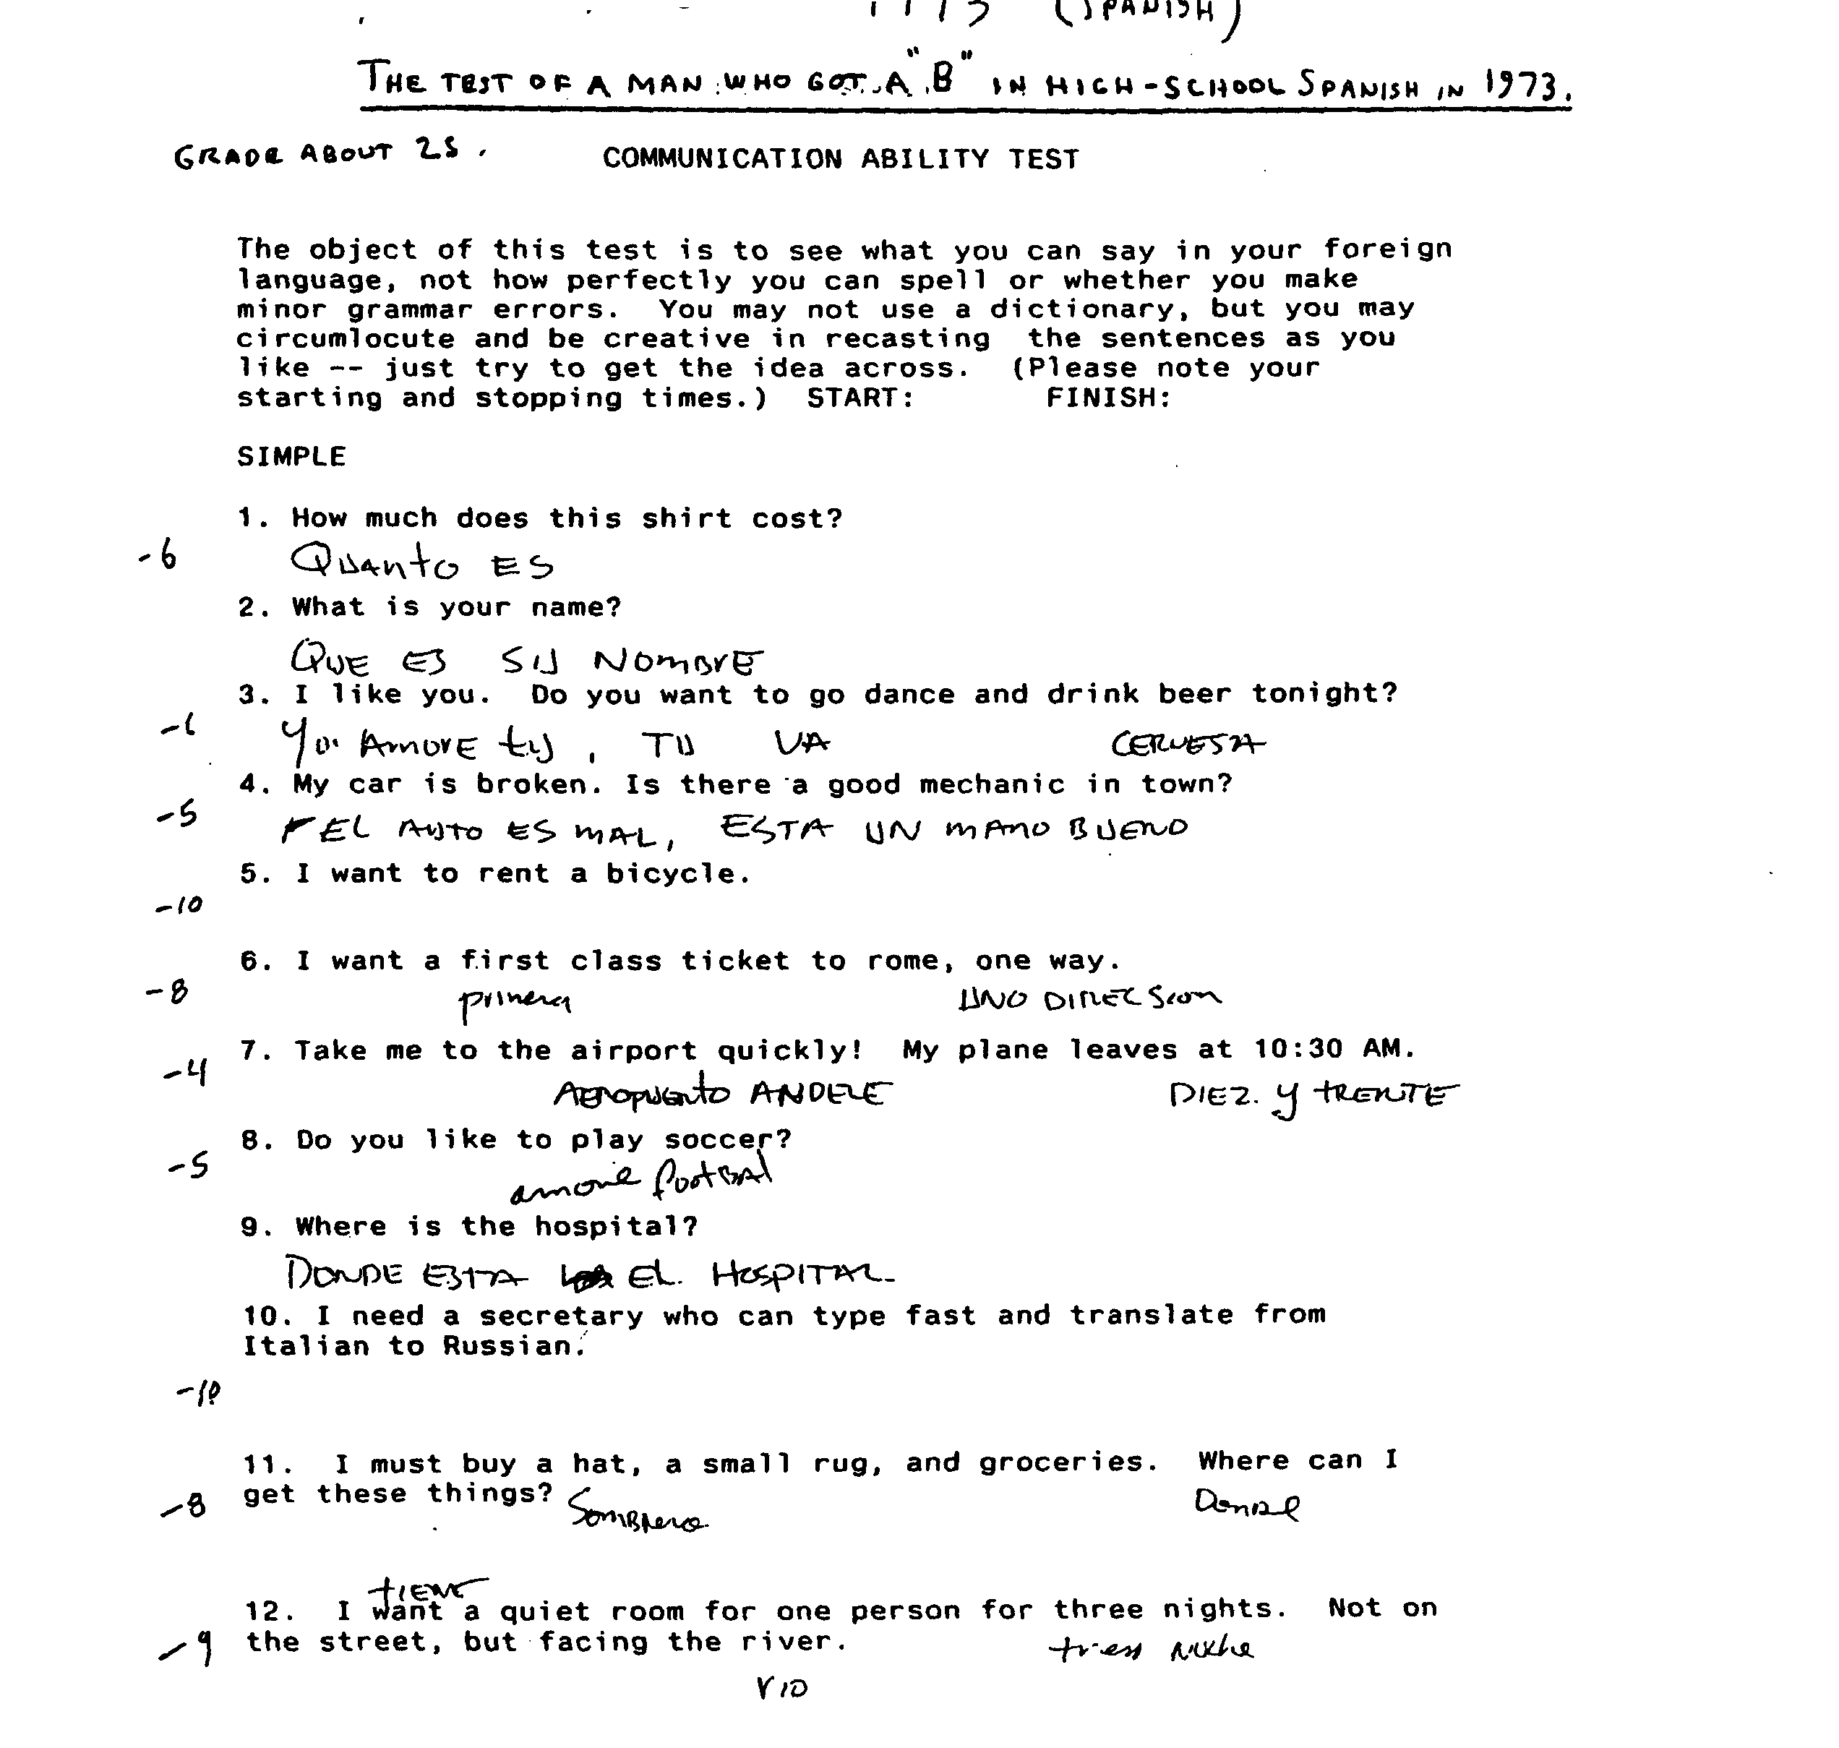
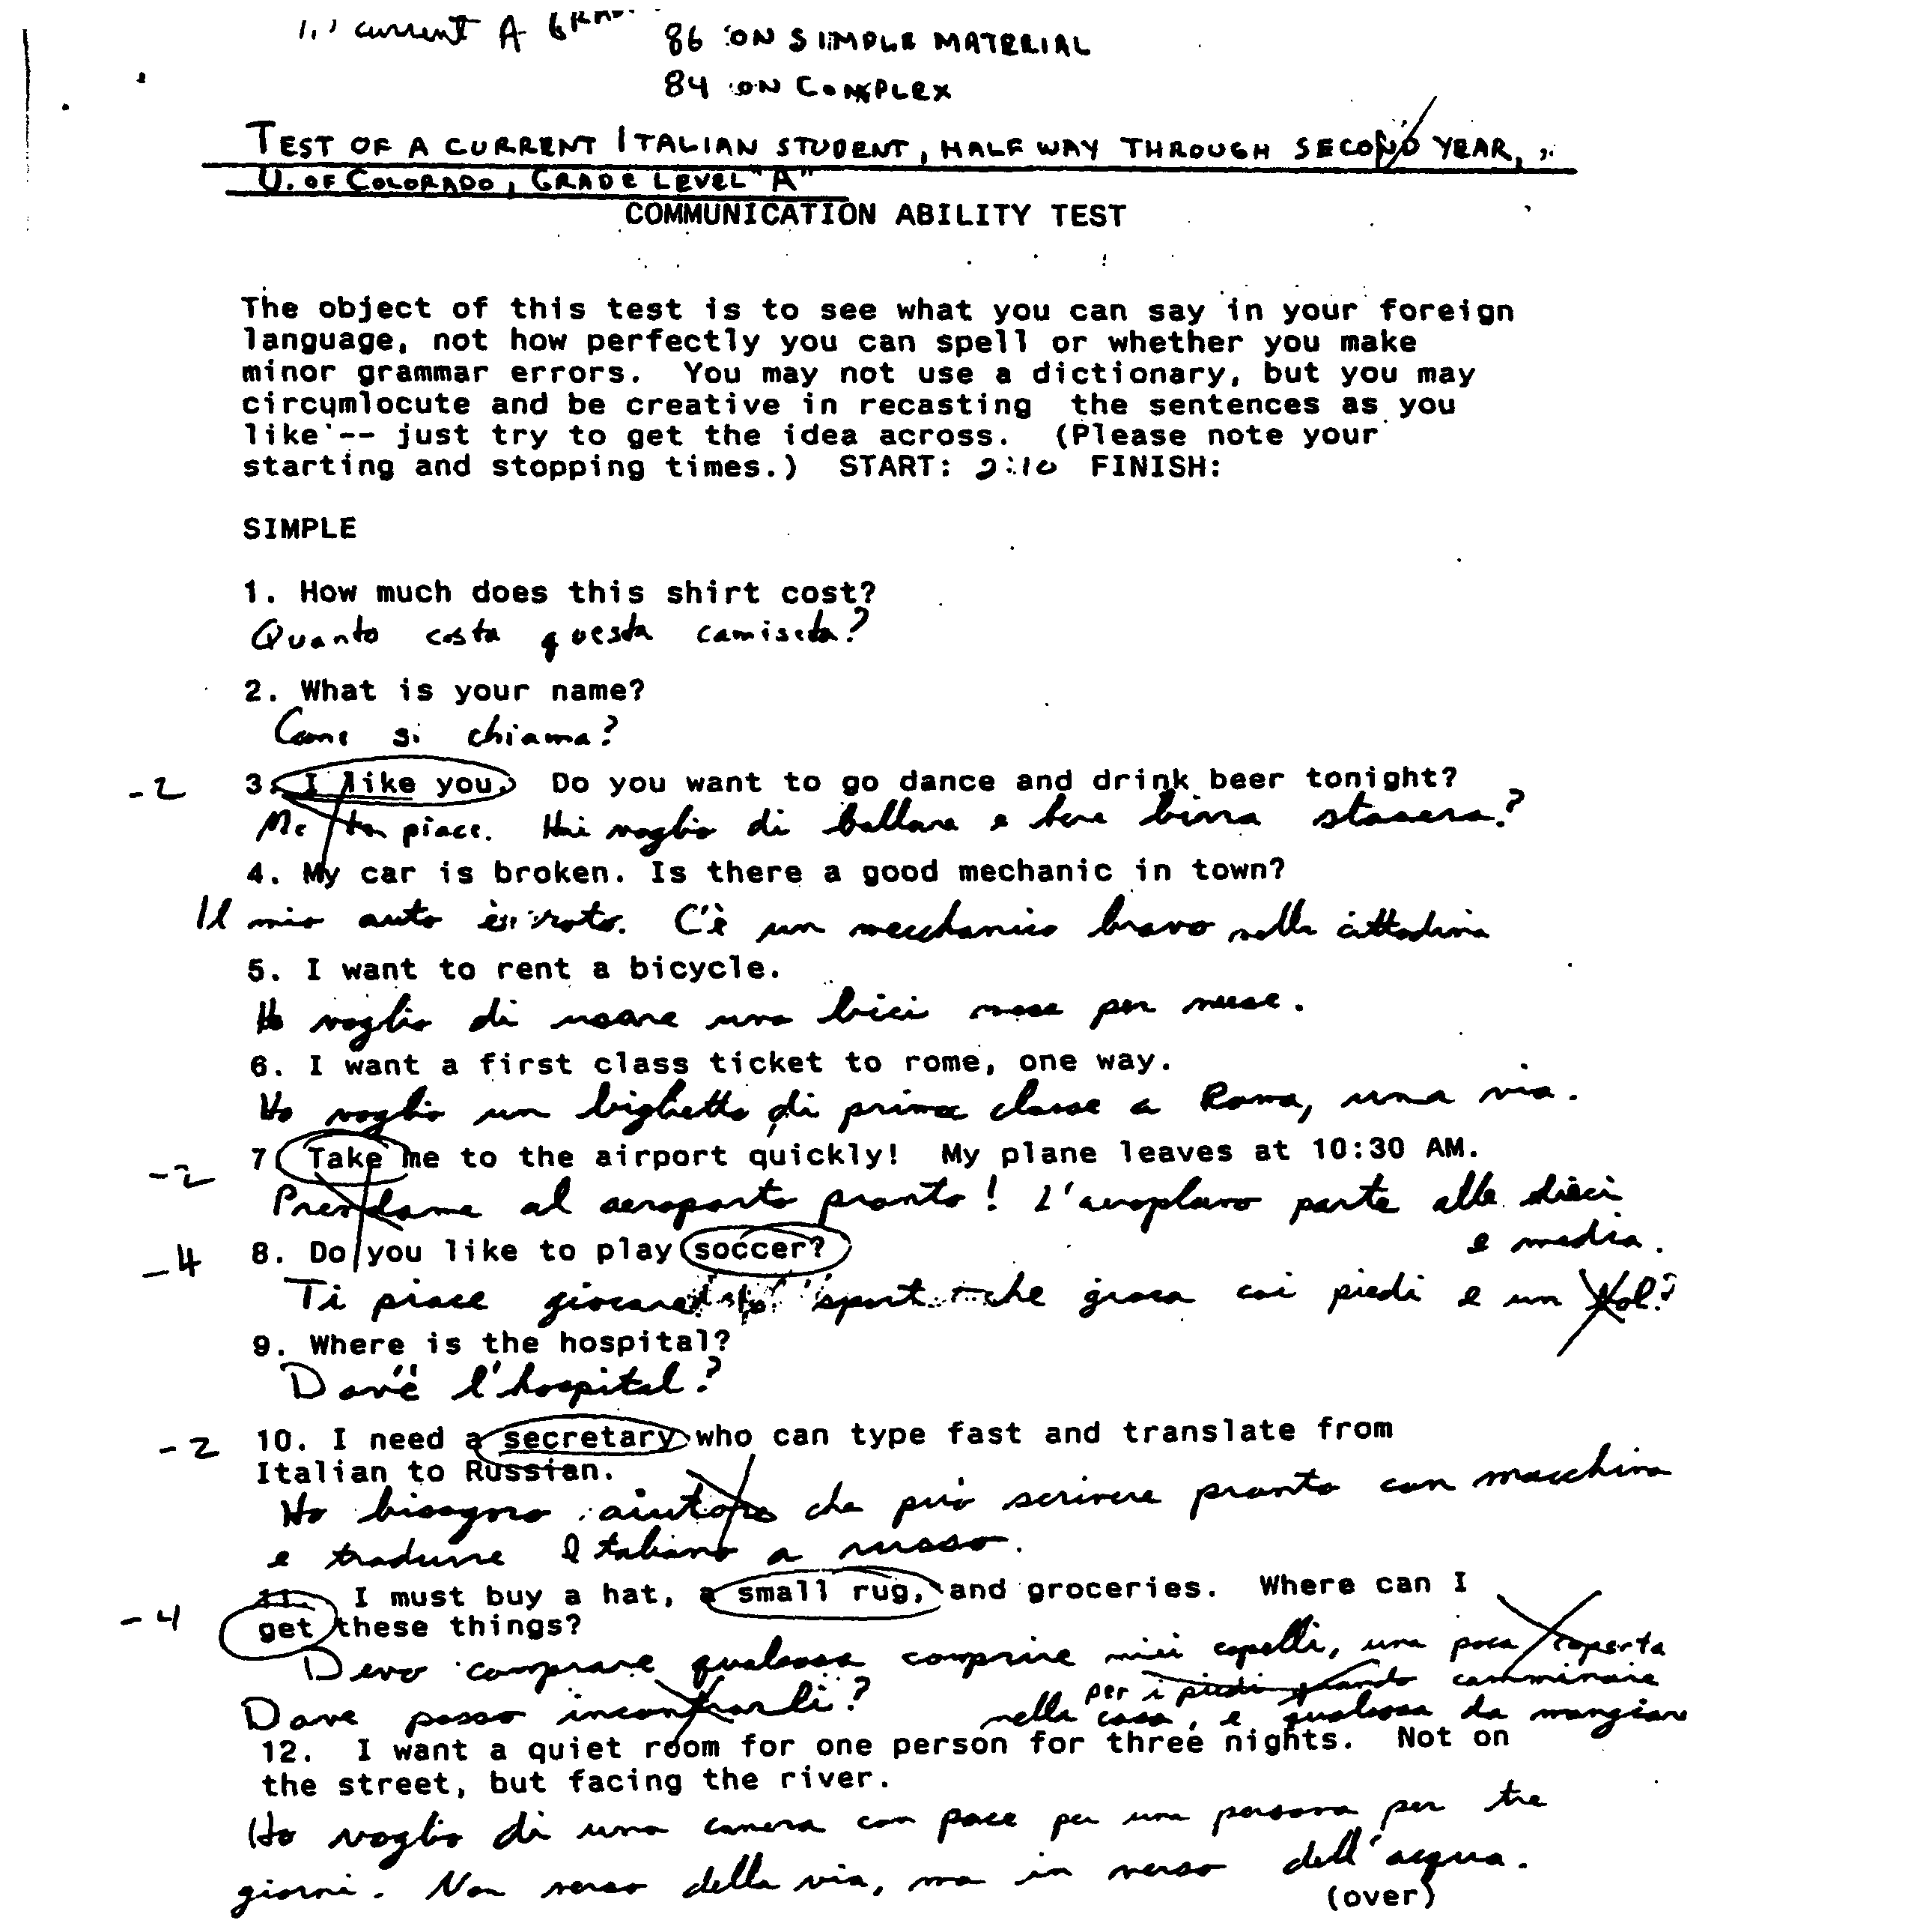

(If you are very concerned with the issue, write, and I'll send copies of everything.)

And it is fair to remember, when the computer beeps at you to show it doesn't know a word, and you swear and ask "How could he have left that out?", that the same thing happens even to excellent language students. Languages are hard, and nothing is perfect.

CONCLUSION

In developing this program I saw a lot of sentences translated to English from fourteen other languages. The experience vindicates the idea of the program -- we can understand grammar-free translation. Some sentences were incomprehensible when words did not translate because they were not in the dictionary; but when all the words did translate the results could be understood every time.

Our language teachers overemphasize the importance of grammar, often to such an extent that students are afraid to speak when they actually meet a foreigner. But grammar is not as crucial as they claim.

We are told that case is critical for understanding. But the Chinese don't use case, not even for pronouns, so I got early translations like "ME WANT RENT BICYCLE." Well, me understand that, and so does everyone else.

We are told that word order is vital. But the Germans the verb at the end of the sentence put. And other nations (Americans and Italians at least) laugh and fuss about this, but they understand. True, Korean word order is so different that complex sentences are confusing, but even then we can understand if both sides use only short, simple sentences. We understand, and can still say complex things about difficult topics.

We understand adjectives in place of adverbs (THIS CAR GO GOOD), and even adjectives where we use verbs: I NECESSARY BUY HAT. (We say "I must buy it.")

We are told that we need conjugations, and everyone will be confused if we use the wrong tense or mood. But a native Italian tells me they're quite used to tourists using the infinitive for everything, and always understand. We may understand even when some words are missing or don't translate: BEFORE 1945, MY FATHER SOLDIER. Do we need conjugations? Shucks, half the time we don't need verbs.

Of course this program is not perfect. It can be improved by enlarging the vocabulary, and I intend to do so. Yet I think that the fundamental idea is proven sound: we can understand without grammar. We can have a universal translator!
EXTRA WORDS
Adding your own special terms

Most people do not want to add extra words and can skip this paragraph. Also, adding words is easier on your desktop computer than the HP. Either way, copy the files in the \enextra directory to the computer on which you plan to work. You can use the Memo function on the HP to edit the _EXTRA file, or the EDIT function on your desktop. (If you edit on the desktop you must transfer the _Extra file to the HP \ent directory when you are finished.)

There is a file of English and Foreign words to which you can add, so that your own special needs can be accommodated. For example, if you deal in wooden art objects and want to add the words for "pine", "oak", and "mahogany" to the Spanish vocabulary, here is how you would do so. Look up the words in the dictionary, and write them down in the form ENGLISH, SPANISH e.g.,

PINE, PINO.

Open the file SEXTRA by typing EDIT SEXTRA (There is one of these files for each language. For French it is FREXTRA; see the list at the end of this subject).

You will see: EXAMPLE, EJEMPLO
STOPP,STOPP

Use the cursor keys to move below this line, and type in your pair of words, one pair per line. After each pair hit "Enter" toget to the next line. Do not erase STOPP, STOPP!

Here is how your file should look when you finish:

EXAMPLE, EJEMPLO
PINE, PINO
OAK, ROBLE
MAHOGANY, CAOBA
STOPP, STOPP

Now hit ALT F, then S, then ALT F then X (to save your work and exit).

Various things can go wrong with this procedure, so it is best to check at this point.

Type CHECKIT. The program will ask for the name of the file to check. Type SEXTRA and ENTER. The program makes the check and tells you to Edit the resulting file CHK. Do so. Type EDIT CHK (ENTER) and see:

Check program for extra words.

English Foreign
EXAMPLE EJEMPLO
PINE PINO
OAK
ROBLE MAHOGANY
CAOBA STOPP

You see that something went wrong after Pine, Pino. Therefore,check your work. Type EDIT SEXTRA and see your file:

EXAMPLE, EJEMPLO
PINE, PINO,
OAK, ROBLE
MAHOGANY, CAOBA

Aha! There is an extra comma after PINO. The computer thinks there is another word on that line, and has read a blank as the next English word, and OAK as the next Spanish word and so on. Remove the offending comma, save again, type CHECKIT again, and see if the new list is OK. Continue to check and correct
until it is. Double commas, missing commas, unpaired quotation marks and so on will cause similar problems.

PINE PINO missing comma
OAK,,ROBLE double comma

If you use a phrase you must separate the words with dashes (no spaces!) and type it that way when using the program. You may put up to 200 word-pairs in this file.

If this file gets too messed up (especially if you somehow delete all the "STOPP,STOPP" 's at the end, then the program will not run. Reinstall the program from the Program Floppy, or at the DOS prompt type COPY EXEXTRA SEXTRA, (or FREXTRA if you are working with French or whatever other language), and enter. This restores the original, nearly empty file.

EXTRA WORDS LISTS

Arabic AREXTRA Japanese(Romaji) JREXTRA

Chinese (Mainland) MLEXTRA Japanese(Hiragana) JHEXTRA

Chinese (Taiwan) TWEXTRA Korean KEXTRA

French FREXTRA Polish PLEXTRA

German GEXTRA Portuguese PREXTRA

Hungarian HEXTRA Portuguese (unaccented) PRUEXTRA

Italian ITEXTRA Russian REXTRA

Serbo-Croatian YEXTRA
(Yugoslavian)
Extra (reserve) EXEXTRA
Spanish SEXTRA

Foreign Fonts

If you are to write foreign words in the Extra file or have saved a session as a file and now want to read it, you must be able to set the keyboard to produce the foreign characters. For Italian, Japanese Romanji, French, Portuguese (unaccented) and Spanish only ordinary "English" letters are needed so you need read no further. (Except, to produce the N~ in Spanish hold down the ALT key while typing 165, and it will appear.)

For other languages you will just type the name below (e.g. from the >ENT prompt, type PLSET (Enter) and the proper font will turn on.) You can still type in English, though the Z and Y keys may be switched. For totally different fonts like Arabic, English will be produced by the upper case keys and the foreign language by the lower case. Just use Shift-Lock to go back and forth. [For Hungarian, in edit mode, O-double-dot is produced by shift = (or +).]

To return to your normal keyboard and font, type mode 80 (Enter), or ENSET (Enter).

Keyboard Preparation Commands

Arabic -- ARSET Korean -- KSET
Chinese -- (Mainland) MLSET Portuguese (accented) -- PRSET
Chinese(Taiwan) -- TWSET Polish -- PSET
German -- GSET Russian -- RSET
Hungarian -- HSET Serbo-Croatian -- SCSET
Japanese (Hiragana) --JHSET

SECTION III

CHARACTERISTICS
OF THE COVERED LANGUAGES

GENERAL FEATURES OF LANGUAGES

Most languages use the same word for "like" and "love"! This is no problem in sentences like "I like candy" or "I love toffee", but we can see there are potential problems if Mr Salim, just to be pleasant, tells Mrs. Jones what he means as "I like you" and it translates "I love you." Worse yet if he says the same thing to Mr. Jones! And the unfortunate Mr. Salim may give Miss Jones the impression he might want to marry her , when he's just trying to be polite. Having "like" and "love" in English lets us make some very important distinctions quite easily, whereas in other languages it is necessary to add qualifying words and phrases.

The word is given as ambiguous in the foreign vocabularies, but just in case the examples are not clear to someone, or he makes the wrong choice, please do not be offended and for heaven's sake (if you're a male U.S. Marine) do not punch Mr. Salim in the nose. Dozens of women think he loves them, and they'll tear you to shreds.

Possession can be expressed in many ways, and we who speak English are fortunate because English uses all of them, at least occasionally, so we can understand them easily. Speakers of other languages have more trouble.

Normally, English says "John's car". So does German. The Romance languages (Italian, Spanish, Portuguese, and French) say "the car of John", which sounds a little odd, though we do say "the man of steel" and "the property of the buyer". Hungarian says "the John car", and of course English never says anything like that -- except perhaps "The Berlin wall, the computer manual, and the company property". Polish, Russian and other Slavic languages say "the car John" , which is unfamiliar except in phrases such as "Radio Free Europe" , "Radio London", and "The clan McGreggor". But it makes sense if you're forewarned. Generally, you should read the section on the features of a language before you use it, and try to use the particular form that they do. It is nothing to worry about -- generally it is self explanatory, and you receive translations like "YESTERDAY THE I CAR EXPLODE -- WHERE BE BUS STOP?" And if there ever is a misunderstanding, remember that every language uses the possessive pronouns the same, so MY CAR, HIS CAR, YOUR CAR , and OUR CAR will work.

(Small glitch: in the Romance languages, they use the same word for "your", "his", "her", "its", and "their", and distinguish the meaning from the context -- as we do with "they", which can mean "he plural", "she plural", or "it plural". So to be absolutely clear in those languages, use the "of him" or "of John" construction. But again, it's seldom a problem.).

Some languages ask "What is your name?", but most ask "What do you call yourself?" or ""How you call self?". Some ask "How old are you?", but most ask "What is your age?", and you should use this form too (otherwise it may sound insulting, like "How ancient are you?") Likewise, "What is your weight?" is better than "How heavy are you?". Some languages ask age by "How many years (or summers) have you?"

We say "John is English, speaks English, and has an English car." We use one word for all three ideas. But most languages use different words, just as we can say "John is an Englishman, speaks the English language, and drives a British car." So to be clear you should say "DAVID BE FRENCH MAN, DRIVE FRENCH CAR AND SPEAK FRENCH LANGUAGE." Otherwise it may sound funny (though understandable), like "I speak British".

A language may convey information either by using a preposition or by adding an ending, e.g..: "I go towards home." or "I go homeward." Some languages, especially the Slavic ones, use eight case endings to convey practically everything. For example, where we say "I write with a pen", they say "I write pen-using." Since the case ending does not translate, we get translations like "I WRITE LETTER PENCIL MY FRIEND." If we're aware we may be loosing some information here, and if we do not demand perfect logic, but adopt an intuitive, "hang loose" attitude, we'll understand such sentences quite well.

The Slavs have trouble with our prepositions too. Prepositions are often illogical -- after all, we do not really write with a pen (not really "accompanied by a pen"), but using a pen. And it's a good thing we're all friends now, because otherwise "I WRITE THE LETTER IN PENCIL" might cause the Russian police to search your pencil to find the secret letter inside.

Prepositions are almost entirely arbitrary. Try to find a general rule for the preposition to use with expressions of time from the following: " In 1994, on June third, at about 6:30, for thirty seconds...." Be aware of this, be flexible, simply ignore nonsensical prepositions you receive in translations, and when someone else doesn't understand your sentence, consider that it may be the preposition and recast the sentence more clearly: " THE PIE HIT HIM IN THE FACE" What??! Inside his face? "IT HIT HIS FACE". Oh, O.K..
CHARACTERISTICS OF ARABIC

"Like" and "love" are the same word, and Arabic speakers have trouble understanding the distinction, and wonder what all the fuss is about. Please do not be offended, or misunderstand a polite remark for an offer of marriage.

The possessive is either "of" (Coat of many colors) or, with a single noun, House John (= John's house, just as Radio Moscow means Radio of Moscow or Moscow's Radio.)

Many speakers of Arabic are very conservative and religious. You should try to learn all you can about this, be very cautious about discussing religion at all, and try hard to say nothing risque or offensive. (If you are a teenager, do not think this is funny and try to do the opposite. There really are places where they execute you for blasphemy! Really.) Please note though, that if you are polite, most Moslems are very polite, considerate and kindly. These societies are different from ours, worse in some respects and markedly better in others.

As many religious westerners did a few generations ago, many Moslems today begin any sentence indicating a plan with "God willing". ( "God willing, we will go today." But not "God willing, my name is Joe", just "My name is Joe.") If you wish, you can do the same by writing "GOD-WILLING". Note the dash ("-"); it won't work without it.

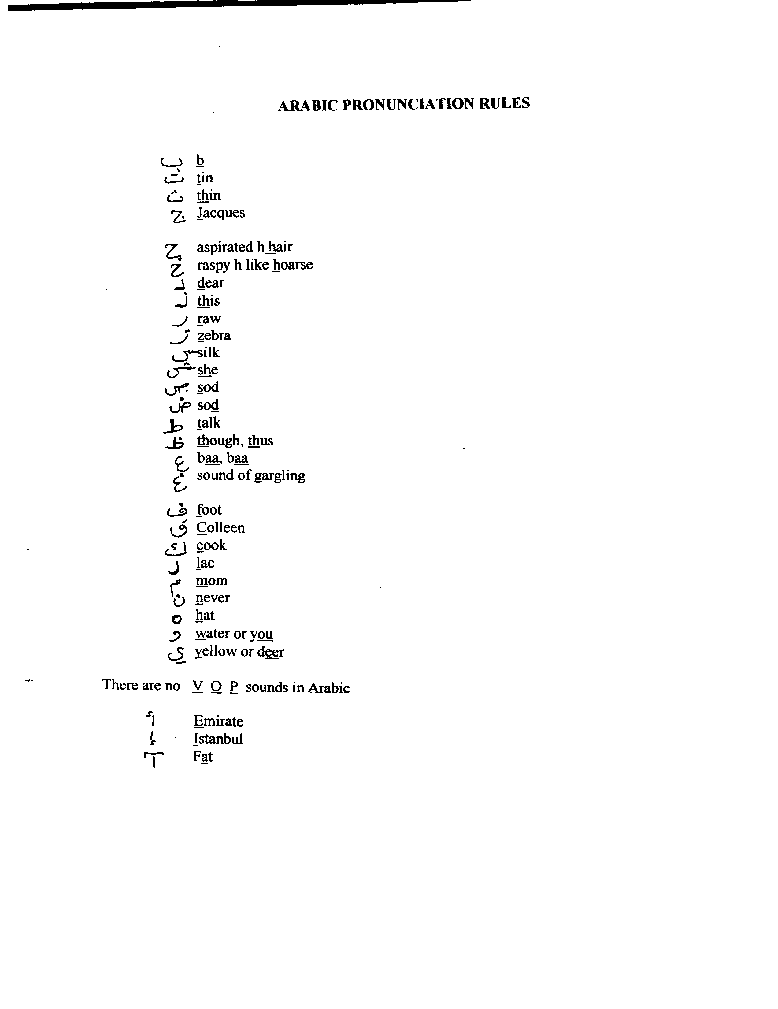

CHINESE

Introduction
There are eight different languages in China, all with words pronounced differently. The most important is Mandarin, the native language of six hundred million people. Mandarin is also learned by the other seven-hundred million Chinese. They treasure it as part of their heritage, study it for six years, and learn it well. This program is in Mandarin and should be useful anywhere in China.

Chinese is written using ideographs --- some eight thousand tiny pictures each representing a word. Thus it is not a phonetic writing system. The Chinese have maintained this system as part of their heritage, and also because it unifies them. For in each of the eight languages the pictures are the same --" " * is Mountain in Mandarin and Cantonese and Fukinese. True, when they read aloud and see " ", one says "TSHUN," another "SWA," and another "SUN", for these are the words for "mountain" in the three languages. But each sees " " and thinks "mountain." So just learning to write by this method gives the student the power to express himself in all eight tongues. Literacy is translation! Naturally, the Chinese don't want to give up this wonderful system.

But pictographs present daunting problems. It 's very hard to build a keyboard with eight thousand keys, and it's impossible to type effectively on such a monstrosity. (It's like a game of "Where's Waldo?" to find each word.) Therefore, the Chinese were forced to adopt phonetic, alphabetical systems to deal with the present state of technology.

There are two alphabets, both called "BOPOMOPHO." In Taiwan they use 37 odd-looking characters to represent sounds and tones. Taiwan has many computers and so practically everyone from 10 to 50 has learned the alphabetic system well.. On the mainland they use the English alphabet, as found on standard typewriters.

The program covers both methods with, the choice of Chinese (Taiwan) or Chinese (Mainland.) For Chinese familiar with the methods it works well. However, the Chinese are not used to phonetic writing, and do not really want to read this way. They squint and stammer a little as they read the translations. Their problems are a bit like ours would be if we had to read phonetic spelling instead of standard: U kan doo it, butt fonetik wurds shuur luc phunny!
Someday this program may produce ideographs for the Chinese to read, and they will like that better. And they may soon have a way around the keyboard problem, because inexpensive computers will have the ability to understand speech within a few years, so the Chinese can say "TSHUN" and the symbol " " will appear with no trouble. Then the Chinese will be able to choose between the two systems freely and without pressure. Perhaps they will find phonetics better and adopt it. Or perhaps we will find we prefer ideographs --- they say you can read them faster. Maybe the trend has started already... : ) **
* Actually this is the old symbol, later stylized as " ."
** For those not familiar with computer networks, " : ) " is a smiley-face ( ) turned sideways, created by a colon and a parenthesis. It is computerese shorthand for "I'm joking." It is an ideograph.

Characteristics of Chinese

Chinese word order and "flavor" are delightfully like those of English. Of course, there are some exceptions...

Chinese constructs the possessive using "of," between the possessor and the possessed -- "John's car" is "JOHN OF CAR." It constructs all adjectives the same way: "the red car" is "THE RED COLOR OF CAR" (equals "the red-color car"), "the tall man" is "THE TALL OF MAN." (Just throw out the confusing "of," and it reads perfectly)

For the passive voice (the window was broken) Chinese says, "THE WINDOW BREAK IN-PAST."

"How do you get permission?" is "YOU HOW GET PERMISSION?" ("How does one get permission" is said only by English...teachers).

Like this program, Chinese neither conjugates verbs nor has tenses. Chinese says "I GO IN-PAST" (equals I went) and "I GO IN-FUTURE" (I will go). Clever! The phrases IN-PAST (spelled with the hyphen) and IN-FUTURE are good ways to construct past and future tenses. They should be used with Chinese and can be used with any language supported by this program. Or you can just say "I GO YESTERDAY" or "I GO TOMORROW."

Afterword

Finally, although it is not necessary to know it, there is another thing about Chinese that is so fascinating that its mention is irresistible. The language is the oldest on Earth, older than the Romans, older than the Greeks, older than the Pyramids. Five thousand years it stretches back, back to the dawn of civilization. And it is readable! A modern student can read writing up to 3500 years old with no trouble at all; with a little effort to 4500, and then with a lot of study clear back to the earliest fragments from 5000 years ago. Imagine reading poems from before Babylon, before Tyre, before Ur! Not in translation but in the original and in much the same language as today's newspaper.

When you work with Chinese you handle a thing of wonder...

MAINLAND CHINESE LETTER PRONUNCIATION

On the mainland, the English alphabet was adopted for phonetic writing, and tone symbols (the same used on Taiwan) were added. Most letters are pronounced as in English, with the exception of a few (most of which have inconsistent pronunciations in English anyway, like "c", which is pronounced K or S in various English words.

C = TS as in starts
E = uh or oo as in book
H = H (like the German H in Halt, a gutteral, throat-clearing H)
I = E as in he
K = K as in king
O = oo (or ooo) as in food
Q = CH as in church
U = U, or OO as in woo-woo (a children's train-whistle sound)
X = SH as in share
Z = TH as in this
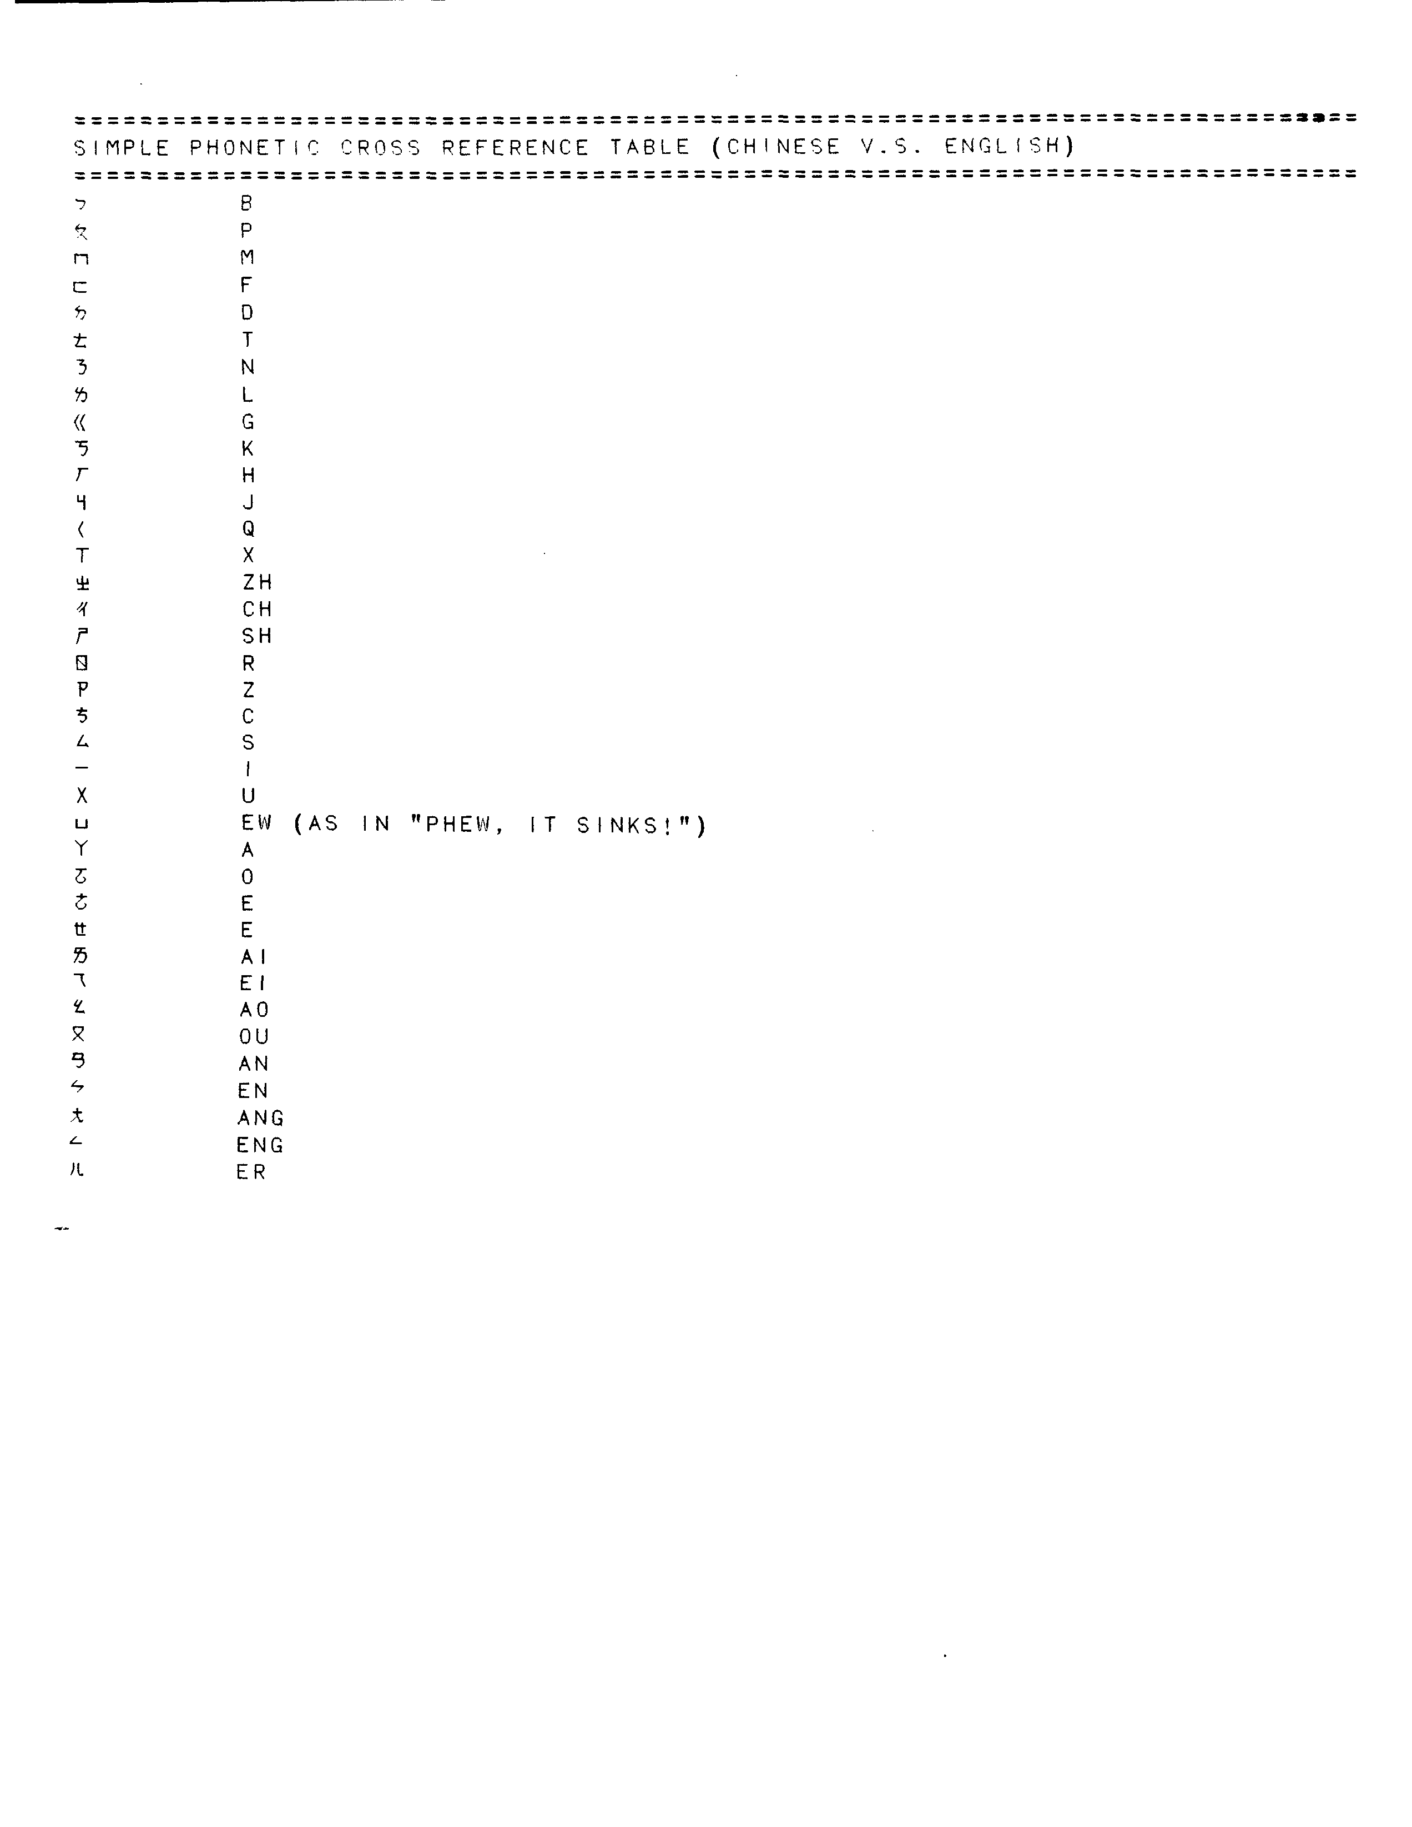

CHINESE TONES ( TAIWAN AND MAINLAND)

Many Chinese words have totally different meanings, depending on whether they are pronounced with a steady tone, a rising tone, falling-rising, or falling tone. The tones are denoted by four character. The first tone, normally a blank, is denoted by a tiny raised dot in this program. All tones are shown at the end of the word "MA"

First tone MA . constant tone, as in English
Second tone MA/ rising tone (not that its like an "up" arrow)
Third tone MAv/ falling then rising
(This cannot be shown perfectly here; should be a "check") fourth tone MA\ falling tone

Since English just isn't spoken this way it's very hard to find examples.

The idea is something like this: imagine a person addressing his mother normally: yes, ma. (MA.) In surprise: Ma! its a motorcycle! (MA/) Upon bumping into something in a dark cellar: Ma?-- is that you? Muaa? (MA /). In great disappointment: oh, ma...(maa!) (MA\) .
ZZZ

CHARACTERISTICS OF ENGLISH

English has few case endings --- only for some pronouns does it even distinguish between subject and object (I-me, he-him,she-her,we-us), and it makes no distinction between direct and indirect object (dative and accusative.) English has only one word for "you", and that can mean you-singular, you-plural, and you -subjective, dative or accusative (subject, object or indirect object)! "YOU" always translates subjective singular. So be aware that "PLEASE, YOU COME VISIT US IN AMERICA" can mean either you singular or "all of you, your entire family". (Explanation for English speakers, this is as odd as if "he" could mean "he, him, they, them, to him, or to them" !)

English has no "familiar you" (like "Du" in German and "Tu " in Spanish) . "You" will always translate "you-formal" with this program. (except possibly in German, where SIE can mean twelve different things, and I may decide to use "Du" to reduce the ambiguity.) Please be aware of this, and realize that English speakers are not cold and formal, they just have no familiar form of "you". If, in Spanish, you receive the translation "YO QUERER UD", then mentally translate it to "Te quiero!", and go on from there.

English forms the possessive by adding "'s" to the end of the word for the owner (John's car), and sometimes by the word "of" (car of John). Program users are instructed to use "of" with languages that use "of", and the form "John car" for languages that form possessive that way, but they may forget occasionally. So if , in a romance language, you receive a translation like "JOHN AUTO SER ROTO" , please realize it means "EL AUTO DE JUAN". And if , in Hungarian or another language that forms possessive differently, you get " THE AUTO (POSSESSIVE) JOHN", realize it means "THE JOHN CAR", and continue.

English barely conjugates verbs at all. It does not have a different ending for each "person", but says "I walk, you walk, he walks, we walk, you-plural walk, and they walk." As a result, English almost always states the subject.. (Whereas Spanish can say "ando", and this means uniquely "I walk", English must say "I walk". ) This program is based on the simple English method, which is why you must always state the subject. The only time English does not state the subject is when the subject is "you". This may be in a command "COME HERE" means "you come here", or informally, in a question "got a light?" means "Have you a match?" Again, English users are instructed to always state the subject, but if they forget, the subject is probably "you".

About ten English verbs are combined with prepositions to form meanings only loosely related to the verb itself. Thus "blow" is combined with "up" to yield "blow up", (to inflate or to explode.) "Get" means to obtain, but may also mean "to obtain a condition of". GET UP means to arise, GET ON means to board, GET OFF means to debark, GET ALONG WITH HIM means to have a good relationship with him. The program tries to catch all such phrases, but if you receive an odd translation anyway, just ask the English speaker what he meant. Verbs used in this troublesome way include GET, PUT, GO, MAKE, TELL, RUN, BLOW, GIVE and DO.

"Do" can mean "perform the work associated with". Thus "DO THE DISHES" means "WASH THE DISHES", "DO THE PAINTING" can mean "APPLY THE PAINT" and so on.

CHARACTERISTICS OF FRENCH

Please see Spanish for the general features of Romance languages.

French lacks the word "ago", and instead says "It is two years since I saw him." But it also drops the "since", and says "It is two years I saw him." I have translated this meaning of "il y a" as "ago", so you will get sentences like AGO 10 YEAR I SEE HIM. Just move "ago" to the right place mentally, and it makes sense.

As English forms questions using "do" -- "Do you see?", so French forms them with "est c' que"; "is it (true) that"... I have translated this as "do", which seems most natural in sentences like "Do you want to drink beer tonight?". But you will also get sentences like "DO IT IS CORRECT?", which really should be "IS IT TRUE THAT THIS IS CORRECT?" Be forewarned.

FRENCH PRONUNCIATION RULES

a-- dad ou--you
b--boot ch--she, chic
ca--cat ai--maid
ce--circus eu--lieutenant
ci--circus
cu--circus --final consonants are usually not
co--circus pronounced unless followed by a
cy--cynic vowel ex: intelligent, intelligente
d--dear --on, en, an, un, in, (nasals, the "n"
e--lieutenant not pronounced)
f--foot --"e" final not pronounced
ga--garage --"th" = t
gu--garage --"s" between 2 vowels, "z"
go--garage --ph always f
gi--Jacques (like zh)
ge--Jacques
h--not pronounced i--feet
j--Jacque (like zh) k--calm
l--lac m--mom
n--never o--no
p--parc q--queen
r--rust s--sand
t--tall u--too
v--valve w--walkman
x--xenophone y--cynic
z--zebra

CHARACTERISTICS OF GERMAN

German is closely related to English in its fundamentals. It forms the possessive by John's car = Johanns auto (no apostrophe), or by "the car of John" (you should use the "car of John" form.) German places the adjective before the noun (the red car) and uses many prepositions (on, to, after...) in the same way as English. Unfortunately it often forms plurals by changing the stem of the word instead of just adding an S. Words we have inherited that work this way are mouse/mice, goose/geese and moose/moose (yes, sometimes the singular and plural are the same!) Verbs end in "en", equivalent to "ing" in English ( Gehen= Going).

Sometimes, when a word does not translate, you will be able to make it out with a knowledge of the rules above. It helps to pronounce it, since the spelling may be different: (BAKERIE = BAKERY)

The main peculiarity of the fully translated sentences you will receive is that the Germans sometimes put the full verb at the end of the sentence. Then, in your mind, you the sentence rearrange must. It not hard is, once you practice.

English has somewhat inherited German's tendency to use "after" with verbs of motion (we say "I ran after her" or "He went to the store after milk") Germans use "after" more widely in place of "to" ("I fly after Denver" instead of "to Denver".) However, NACH (after) is in the German ambiguous list, so it will normally translate "to" in these uses.
German pronounciation
A car
C computer
CH horrible (gutteral)
E hair
G gorgious
H hotel
I bee
J yes
K car
O Poland
Q question
S zero (at the beginning)
S Sam ( at the end or in the middle)
SS kiss
U too
V fall
W word
Y French : "Du Pont"
Z rats
A America
O Sir
U French "Du Pont"

CHARACTERISTICS OF HUNGARIAN

Hungarian is a very strange language. It is not even Indo-European, and is but distantly related to any known tongue. In practical terms, it is unique.

A quote from a native Hungarian: "Understanding the rules for the possessive is impossible. If you're born in Hungary, you may understand it by the time you're eighty. Or you may still be confused." Fortunately, though, the translations are easy to understand. For "John's car" they say "THE JOHN CAR", which is perfectly clear. You should use this form too, because they have trouble with "THE CAR OF JOHN", since there really is no word for "OF" (the closest word means "about".) So, in place of "Jane's hair is pretty" say THE JANE HAIR BE PRETTY, and instead of "The story of Moses" say THE MOSES STORY and so on. As in all languages, THE JANE PICTURE can mean either "the picture Jane owns", or "the picture which shows Jane".

Family relationships are uniquely described. There is no word for "brother" or "sister" generally, but only for "older-brother" or "younger-brother", or eldersister or juniorsister. ("brother" always translates to "older-brother", but the Hungarians are warned of this.) "Cousin " is four different words, specifying " daughter of father's sister", "son of father's brother", etc. If you discuss any genealogy more complex than mother-daughter, it is probably best to draw a family tree!

"VAN" can mean "HAVE" or "BE". If you receive a strange sentence, try the alternative meaning.

"NINCS" means" I have none" or "There are none". In the communist era of shortages, it was the most common word in Hungarian stores. It has a funny connotation, something like "Yes, we have no Bananas."

"NEM" means "not-required" or "not-wanted." It translates "NOT REQUIRED", so you may ask "YOU WANT A SANDWICH?" and get the reply "NOT REQUIRED", which really means "No thanks, I don't want one."

"HUMAN" is used jokingly to describe anyone the speaker thinks is funny. We say "They are odd characters who wear their shoes on their heads." They say "HUNGARIAN HUMAN NOT LOVE COMMUNISM. BUT NOW THAT THERE-ARE-NONE COMMUNIST, EVERYBODY COMPLAIN THAT THE PRICES GO UP.

In spite of the fact that Hungarian is totally alien to English, the sentences that come out of the translator are not frighteningly hard to understand. In fact, they sound pretty familiar. Maybe we're all related after all.

Examples:

I WANT FIRST CLASS RETURN TICKET TO PARIZS. URGENT (PARIZS= Paris)

I WANT A SECRETARY, WHO CAN QUICKLY TYPE..

WHERE BE HOSPITAL CLOSE? MY FRIEND BE WOUNDED, BLEEDING.

QUICKLY NECESSARY AIRPORT GO, MY AIRPLANE DEPART 9. (They say 9, not 9 A.M. or 9 O'clock. Take note!!)

I NECESSARY BUY A CURTAIN, 2 PANTS, AND 3 SUN EYEGLASSES. YOU KNOW
WHERE BUY THESE THINGS? (PANTS and EYEGLASSES are "plural" because
nobody ever bought a single pant. THINGS is plural as an accommodation to the Hungarians, who use the word a lot.)

I NECESSARY GOOD JOB. I LOT LOT MONEY LOOK. YOU KNOW A WELL PAY WORK? (KELL translates as "necessary " but "need" or "must" might be better. Anyway, it has those senses. Note that a computer could not parse or understand "I NECESSARY GOOD JOB" because the sentence has no verb. But people understand anyway. Pretty smart, aren't we? By recognizing and using the abilities of both people and computers, the program lets us accomplish something neither could do alone.

HUNGARIAN PRONUNCIATION

Hungarian is pronounced like most European languages such as Spanish. Letters that are pronounced as in English are: b,d,f,g,h,k,l,m,n,p,q,r,t,v, and z.

A as in car S like the "sh" in shoot
A (+ backslash accent above)like the "i" in nine SZ like the "s" in six
C like the "ts" in cats TY like the "tu" in Tuesday
DZS like the "j" in jacket (as the British say it)
E as in elephant U (+ accent above) like the "oo" in look
E(+ backslash accent above) like the "A" in able U (+ double-dot above) like the "ew" in "Phew! it stinks!"
I as in twins U(+doubleaccent above)likewise,butheldlonger
I like the "ee" in teeth W like the "v" in vacuum
J (and "ly") like the "y" in yellow X as in six
NY as in new Y like the "i" in tint
O like the "a" in almost ZS as in Zha Zha Gabor, or the "J" in
O (+ backslasc accent above) like the "oo" in door Jacques, or the "G" in Gigi
O (+ double dot above) like the "E" in paper
O (_ double vertical line above) likewise, but held longer
CHARACTERISTICS OF ITALIAN

See Spanish for general characteristics of Romance languages.

Italian Pronunciation
A BRIEF INTRODUCTION TO ITALIAN SOUNDS

VOWELS. Unlike English, Italian vowels are never slurred. Instead
they are short and clear:

a is pronounced as in the English word: father.
e is pronounced as in the English word: quest.
i is pronounced as in the English word: marine.
o is pronounced as in the English word: cost.
u is pronounced as in the Egnlish word: rule.
"e" and "0" are often pronounced in a more open fashion depending on the region in Italy. They may sound like the English words: "or" and "bet"

CONSONANTS. With the exception of the following list, the Italian consonants are pronounced as in English, but in Italian the consonants are never aspirated. The Italian alphabet lacks j w x and y.

c preceding a, 0, and u is like the English k in comma.
c preceding e and i is like the English ch in chess and
children.
ch preceding only e and i is like the English k in
chemistry and kick.
g preceding a, o, and u is like the English g in gala, gone and gun.
g preceding e and i is like the English g in gender and gin.
gh preceding only a and i is like the English g in ghetto.

gli unique sound, the closest in English is the "lli" in the word million.
gn the only Italian nasal sound, the closest in English is the "ny" in the word canyon.
h in the initial position is not pronounced at all.
r unlike English it is a very trilled and frontal sound much like in Spanish.
sc preceding a, 0, and u is like the English "sk" in sky, scold and scurry.
sc preceding e and i is like the English sh in finishes and fishy.
sch precedes only a and i and is like the English skin, schedule and schizophrenic.
z could be "dz" or "ts" as in the English words beds and bets, pads and pizza.

DOUBLE CONSONANTS are frequent in Italian and they are to be pronounced forcefully. The best way to achieve the sound is to pause ever so slightly prior to the double consonants:
mamma ma'mma, letto le'tto, dittatore di'ttatore, tutto tu'tto,
carrozza ca'rro'zza, scommettere sco'mme'ttere, abbracciare
a' bbra' cciare.
FINAL NOTE. Italian is a very phonetic language. Once you learn the few letter-combinations (as noted above) the pronunciation is simple given the fact that all consonants and vowels are sounded.

CHARACTERISTICS OF JAPANESE

Japanese is a Ural-Altaic language like Korean and Mongolian, also distantly related to Turkish, Hungarian and Finnish.

Japanese can be written in Kanji (Chinese ideograms), in Hiragana (a Japanese alphabet), or in Romaji (the Roman or English alphabet.) Ideograms are used for old common words, Hiragana for newer Japanese words, and Romaji for western words; and all are mixed together as needed in Japanese text, so Japanese are familiar with all three writing methods. Entente gives you a choice of Romaji, which does not require putting tabs on the keyboard, and gives you a fighting chance to pronounce the Japanese words, or Hiragana, which is easier for the Japanese to read and has more standard spelling.

Of all the languages prepared for the translator, only Japanese and Korean have really confusing word orders. For this reason you should always write very short sentences, and so should the Japanese. "I want rent bike" can be unscrambled from almost any order -- BIKE WANT RENT I, I BIKE RENT WANT -- but longer sentences can be much harder. If you find yourself confused, say "PLEASE WRITE MESSAGE AGAIN. THIS TIME, WRITE VERY SHORT SENTENCE."
Note that short sentences are no barrier to complex thoughts or serious subjects . "North Korea might already have the atomic bomb, and hence cannot be attacked." can be understood quite well when expressed as "PERHAPS NORTH KOREA ALREADY HAVE ATOMIC BOMB. THEREFORE WE CAN NOT ATTACK."

Japanese usually puts the subject first, like English, but puts the verb at the end of the sentence, like German. (I BICYCLE WANT.) Japanese often marks the object of the sentence by "O", and this word is translated as "OBJ", for OBJect. So you will see translations like I BIKE OBJ WANT. This can be helpful in complex sentences, or if they leave out the subject (BIKE OBJ RENT WANT.) They often do leave out the subject, though the rules urge them not to, so you will get "HUNGRY. FOOD OBJ WANT. FOOD OBJ TO ME GIVE PLEASE." (Japanese also marks the subject by putting GA or WA after it, but these words are also used for emphasis after words that aren't the subject. This would be very confusing, so Entente just translates GA and WA as blanks.)

Long sentences can be hard to understand. Japanese doesn't use "who" or "that" to mark subordinate clauses. "I need a secretary who can type fast." becomes "I TYPE FAST SECRETARY OBJ NEED." (It helps to think of the English construction "I want a good-lookin', fast-typin', sweet-talkin' husband.") Note that you can puzzle this out this sentence from the rules given:" I" is the subject because it comes first, "NEED" is the verb that goes with "I", because it comes at the very end of the sentence, and "SECRETARY" is the object because it's marked as such by "OBJ". Of course, it's much easier to understand the sentence if it's broken into two shorter ones: "I need a secretary. She must type fast. "(I SECRETARY OBJ NEED. SHE TYPE FAST MUST.)

Japanese says "the green shirt "(adjective before noun, like English). For possessive it says "John of car" for "John's car".

In spite of this coaching, you will occasionally be confused by sentences that look like the result of an explosion at the word factory. "THAT MAN TO BOOK OBJ GIVE PLEASE. " "RAIN THOUGH WE ANYWAY GO." "JAPAN INDUSTRY VERY BIG THAT FAMOUS BE." Sometimes you can decipher them by logic (Give that book to man please. Though it rain, we go anyway.) Sometimes the meaning is clear by intuition (It must mean "Japan's industry is very big and famous.", or something like that.) And sometimes you'll simply have to ask them to repeat it, just as in ordinary conversation! But most sentences are fairly easy: THIS KNIFE WITH CUT PLEASE... JAPAN AND AMERICA OF TRADE GOOD BE...I TONIGHT MAP OBJ SEE THEN GO PLACE DECIDE. I SOMEWHERE TO TRIP DO WANT... I YESTERDAY BEER OBJ DRINK THEN HOUSE TO RETURN AND GO-TO-BED.

Finally, Japanese relies strongly on the case of pronouns to distinguish subject from object. For most pronouns this is no problem, but "you" in English is the same for both cases (see Complexities - Case in Section 2). Therefore, you should either spell "you" as "YOUU", which triggers an ambiguous word choice, or use "THOU" for the subject case (Thou art beautiful.) and "THEE" for the object (I love thee.) Thou mayst sound funny, but thou wilst be understood.

Japnnese Romanji Pronunciation Guide

Japanese has a five vowel system, which consists of `i, e, a, o, u. From the `ka' series to the `Wa' series, you combine consonant and vowel sounds together. -e.g. y+a=ya

Vowels:
(a)=a as in father (i)=iy as in beat
(u)=u as in boot (e)=e as in bet
(o)=o as in boat

Consonant plus vowel sounds:
(ka)=CO as in couch (sa)=SO as in soccer
(shi)=SH as in ship (ta)=TA as in tatoo
(chi)=CH as in chick (tsu)=TS as in cats
(na)=NA as in Canada (ha)=HO as in howdy!
(ma)=MO as in mount (ya)=YA as in yard

Japanese "r" sounds are similar to the British `r' sound in `very'.

(ra)=RU as in rug (ri)=RI as in river
(wa)=WO as in wonderful (n)=N as in can
(pa)=PA as in Paris (ba)=BU as in bug
(ga)=GU as in gun (za)=ZA as in bizarre
(ji)=JE as in Jesus (da)=DO as in done
(kya)=CA as in can (gya)=Ga as in gap
(sya)=SHA as in shark (tya)=CHU as in Chuck
(nya)=ne-ah (hya)=HYA as in the cattle drive call Hya!
(pya)=PIA as in Pia Zadora (bya)=as in "Don't be a fool"
(mya)=Me-ah (rya)=re-ah

Double Consonants
(tt)= IT as in kit (dd)=ID as in kid
(pp)=IP as in sip (kk)=ICK as in kick
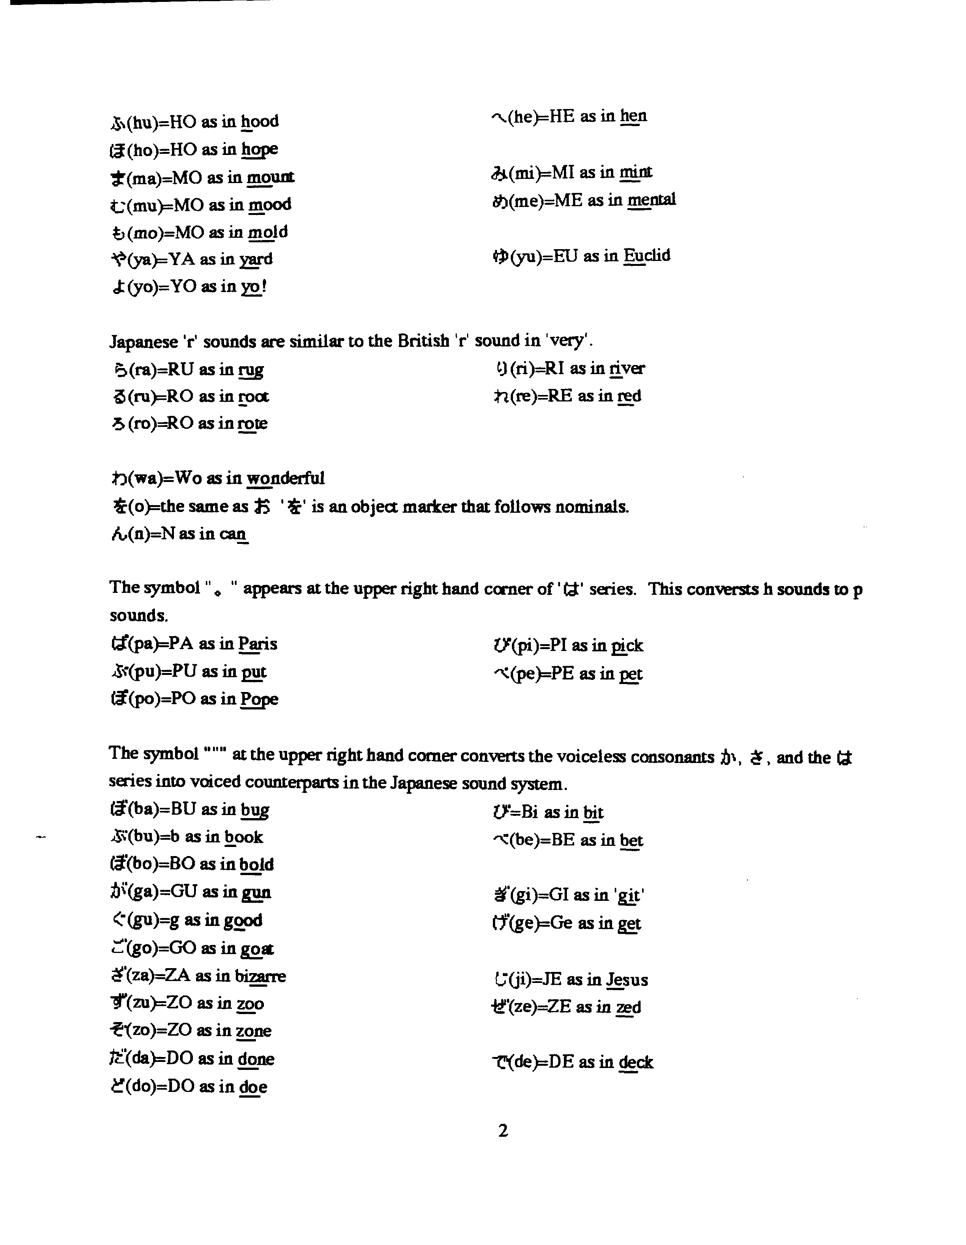
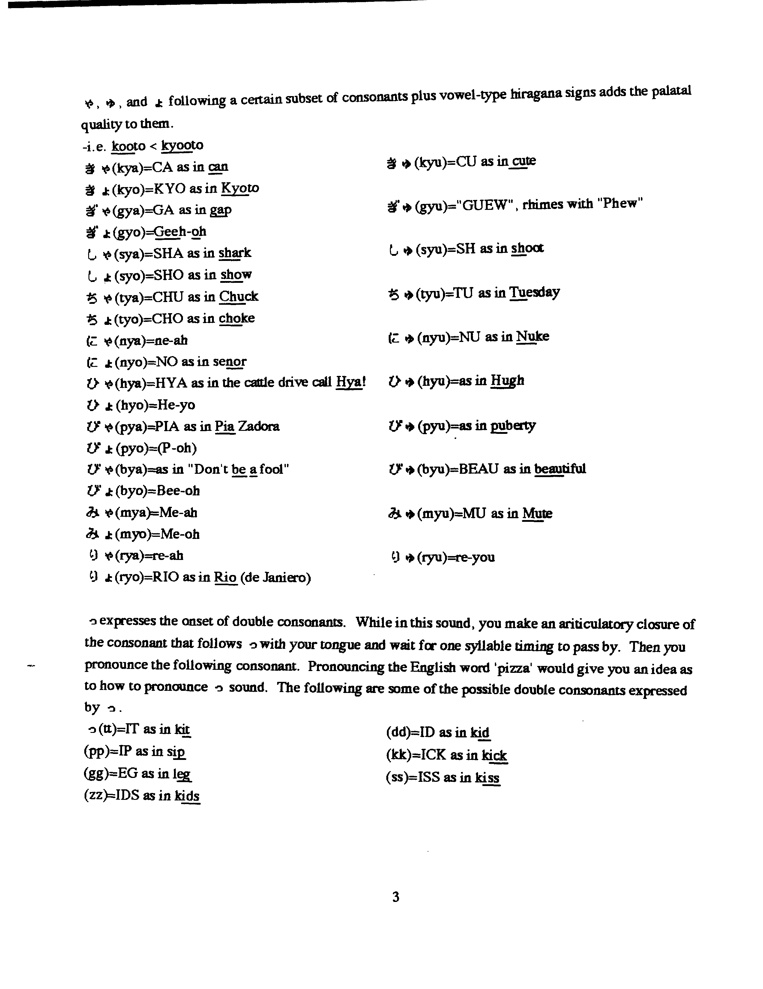

CHARACTERISTICS OF KOREAN

Korean, Japanese and Mongolian are loosely related Ural-Altaic languages. Chinese is not related at all; Turkish, Finnish and Hungarian may by related, very distantly.

Korean word order is practically backwards from English. Like the Germans they sometimes put the verbs at the end of the sentence.

Korean says "John of car" for "John's car". But like English it says "a green shirt" (adjective precedes noun). Korean and Japanese are the only languages whose word order are so jumbled that they are likely to be misunderstood often. This will not happen for simple short sentences, which we can almost always sort out. (How much money this shirt? I bicycle want rent.) But for long complex sentences with several clauses, each with a subject and verb, Korean arranges them so differently that they can cause trouble. "I type fast and translate from Italian to Russian secretary need." This standard sentence (I need a secretary who can type and translate) may be understandable if we're used to it, but one unfamiliar with it would think the Korean meant "I can type and translate, and I need a secretary." By the same token, my Korean consultant begs me not to translate long sentences into Korean -- the word order of English (and most other languages) is incomprehensible to him. How can we escape this trap? It's simple: break each sentence down into very simple sentences with a subject and a verb and no extra clauses: I need a secretary. She must type fast and translate from Korean to Tasmanian.

Koreans have two words for "be"-- one for characteristics, one for location. Because "Be" is so common in so many languages I have not made it ambiguous. Instead, since "is" is in the vocabulary, you should use "is" for location: I is here, John is here, we is here... and Be for characteristics: I BE GOOD, WE BE GOOD. It is easy to remember this if you remember the song "Johnny be Good".

Korean writes some letters underneath others: This happens correctly on the screen, but it's more than I can manage on the printer. Therefore Koreans may be able to make out what the printout means, but they won't like it and it will take some time. Notwithstanding its unusualness, Korean is a very logical language. In 1446 its king invented and gave to his people a beautiful alphabet, perhaps the most logical in the world. Until that time, the people had used Chinese ideographs, which take so long to learn that only a few wealthy scholars could read and write. After the introduction of the Korean alphabet, literacy became universal.

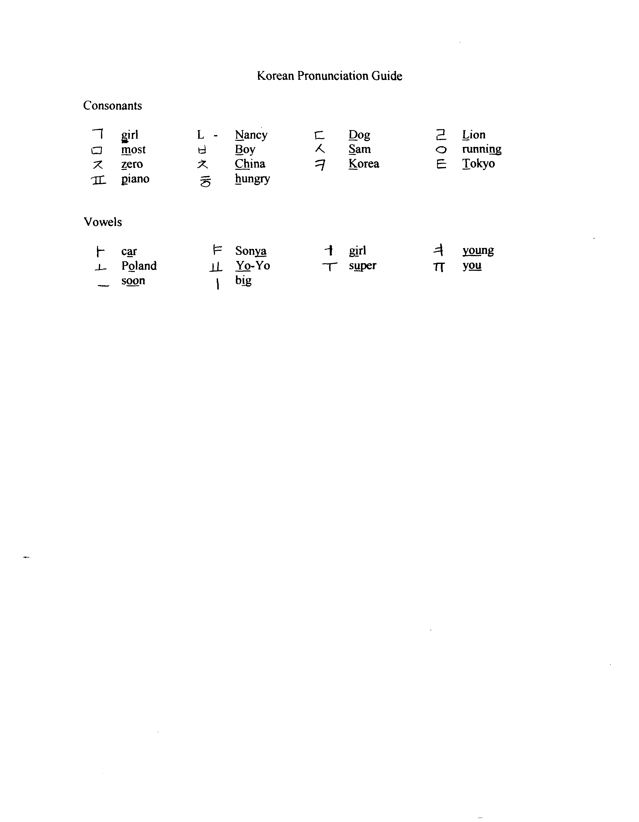
CHARACTERISTICS OF POLISH

Polish is a Slavic language, like Russian and Serbo-Croatian. Polish forms questions with "whether." You will receive translations like "Whether you want drink beer?" which means, "Do you want..." Polish asks "how many year have you?" instead of how old are you. And it sometimes uses "summer" for "year" -- "I have 23 summer" means I have 23 years or am 23 years old.

Like most Slavic languages, prepositions are a problem: in, to , for, at, etc... are often interchanged. We should not be surprised. In English we have no single preposition even for time. Instead, we say: "In 1984 on June 30, at about noon, from 12:03 to 12:04, for one minute the sun was partially eclipsed, and in (or during) that same minute the bank was robbed. (Try extracting a consistent rule from that mess!)

So do not be surprised if you receive "Take me in airport quickly" (instead of "to airport") and "my plane leave in 10:30 in morning."

Slavic languages often leave out "to be." "I cold," or "You hungry?" will often be seen.

Practically every language except English says "I write on the machine," instead of "I type." Normally this phrase will translate "type," but if someone says "She write quickly on machine" it will translate literally. Once you've been warned, the result becomes understandable.

Polish Pronunciation

Polish is pronounced almost exactly like Spanish. Only a few accented characters are unique. If you can read Spanish, and you red the Polish words pretending that they are Spanish, you won't go far wrong. The letters: b,d,f,g,k,l,m,n,p,r,s,t, and z are all pronounced as in English and Spanish.

Consonants

c - rats c - chew cz - church ch - house h - home

s - sam s - shoe sz - rush n - canyon w - very

z - zero z - hoosier z,rz - visual

dz - kids dz - Joe dz, drz - Roger

Vowels

a - car a - awning e - let e - as in French 'un'
i - see o - Poland u,o - too y - big j (semi-vowel) - yes

CHARACTERISTICS OF PORTUGUESE

See Spanish for general characteristics of Romance languages.

PORTUGUESE PRONUNCIATION

Portuguese is pronounced like Spanish, with a few exceptions and additions.
Most consonants are pronounced as in English: b,c,d,f,g,h,k,l,m,,n,p,q,s,t,v,w,x,and z.
Most accented vowels are pronounced almost the same as those without accents.

Vowels

a or AA - ah as in ahh
e e - Edward
e - eh
i i - ea as in hear
o o o - ow as in bowl
u u - oo as in food

Consonants
J like "sz", or the "s" in pleasure
R R is trilled, as in BRR,
A
A
E
N ny canyon

CHARACTERISTICS OF RUSSIAN

Both the Russian language and the culture are very diffferent from our own. So in addition to an unfamiliar grammar we must cope with unusual expressions and ideas too.

Russian uses case where English uses prepositions. Where English says "I write with a pen", Russian says "I write pen-using." Russian has seven case endings: subject, object, and possessive (like English "I-me-my") plus ones for "to-me","using-me", and "about-me".

Since these endings do not translate, we lose some information, and recieve translations like "I write letter pen friend". They receive odd translations with "extra" and confusing prepositions, something like "I write one letter inside pen towards my friend." (From the English "I write a letter in pen to my friend.") We can both understand, but sometimes it takes a little intuition.

Russian sometimes leaves out "is" with characteristics. "John tall" instead of "John is tall", rather like the English sentence "Hot enough for you?"

Russian says "the red car", adjective before the noun, like English. It says "John's car", but the equivalent of "'s" does not translate so we receive "JOHN CAR NOT GO..."

The prepositions (to, by, for, in, on, etc.) are often used differently. "MY PLANE LEAVE IN 10:30 O'CLOCK. " We cannot complain, for there is no logic in the way we use them ( In 1993, on June 30, at 9:30, for ten minutes---), but it can be confusing. So if a preposition is confusing, just ignore it, and seek the meaning in the rest of the sentence.

Occasionally, Russians allude to a story or idea not common in the West. "PEOPLE IN SIBERIA BE STUPID, DRINK TOO MUCH VODKA, AND WAIT FOR BIRTH OF A KIND CZAR..." The speaker means they're helpless and wait for the birth of a kindly leader to tell them what to do, as we might wait for the death of a rich uncle. We find the sentence hard to understand, because we come from a different culture with different legends.

But Russians are good people and you will understand most of what they say through the translator, in spite of these problems.

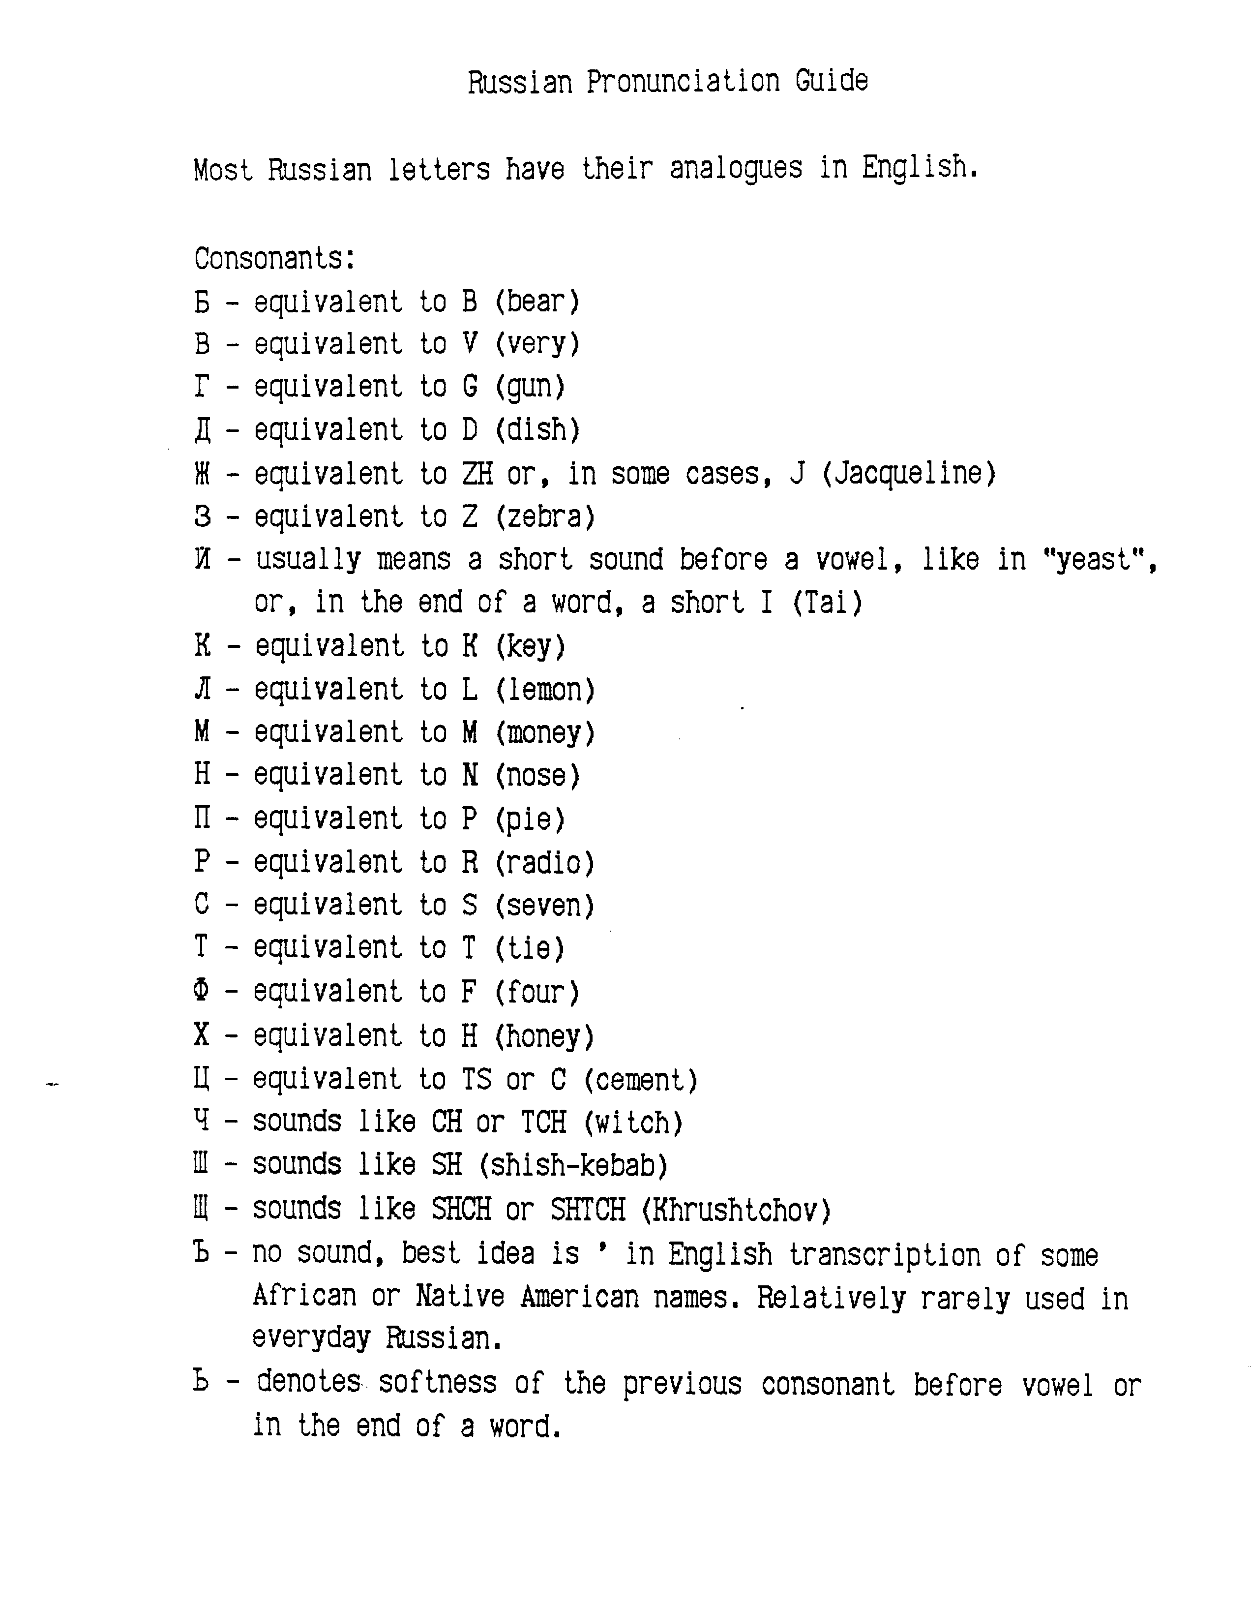
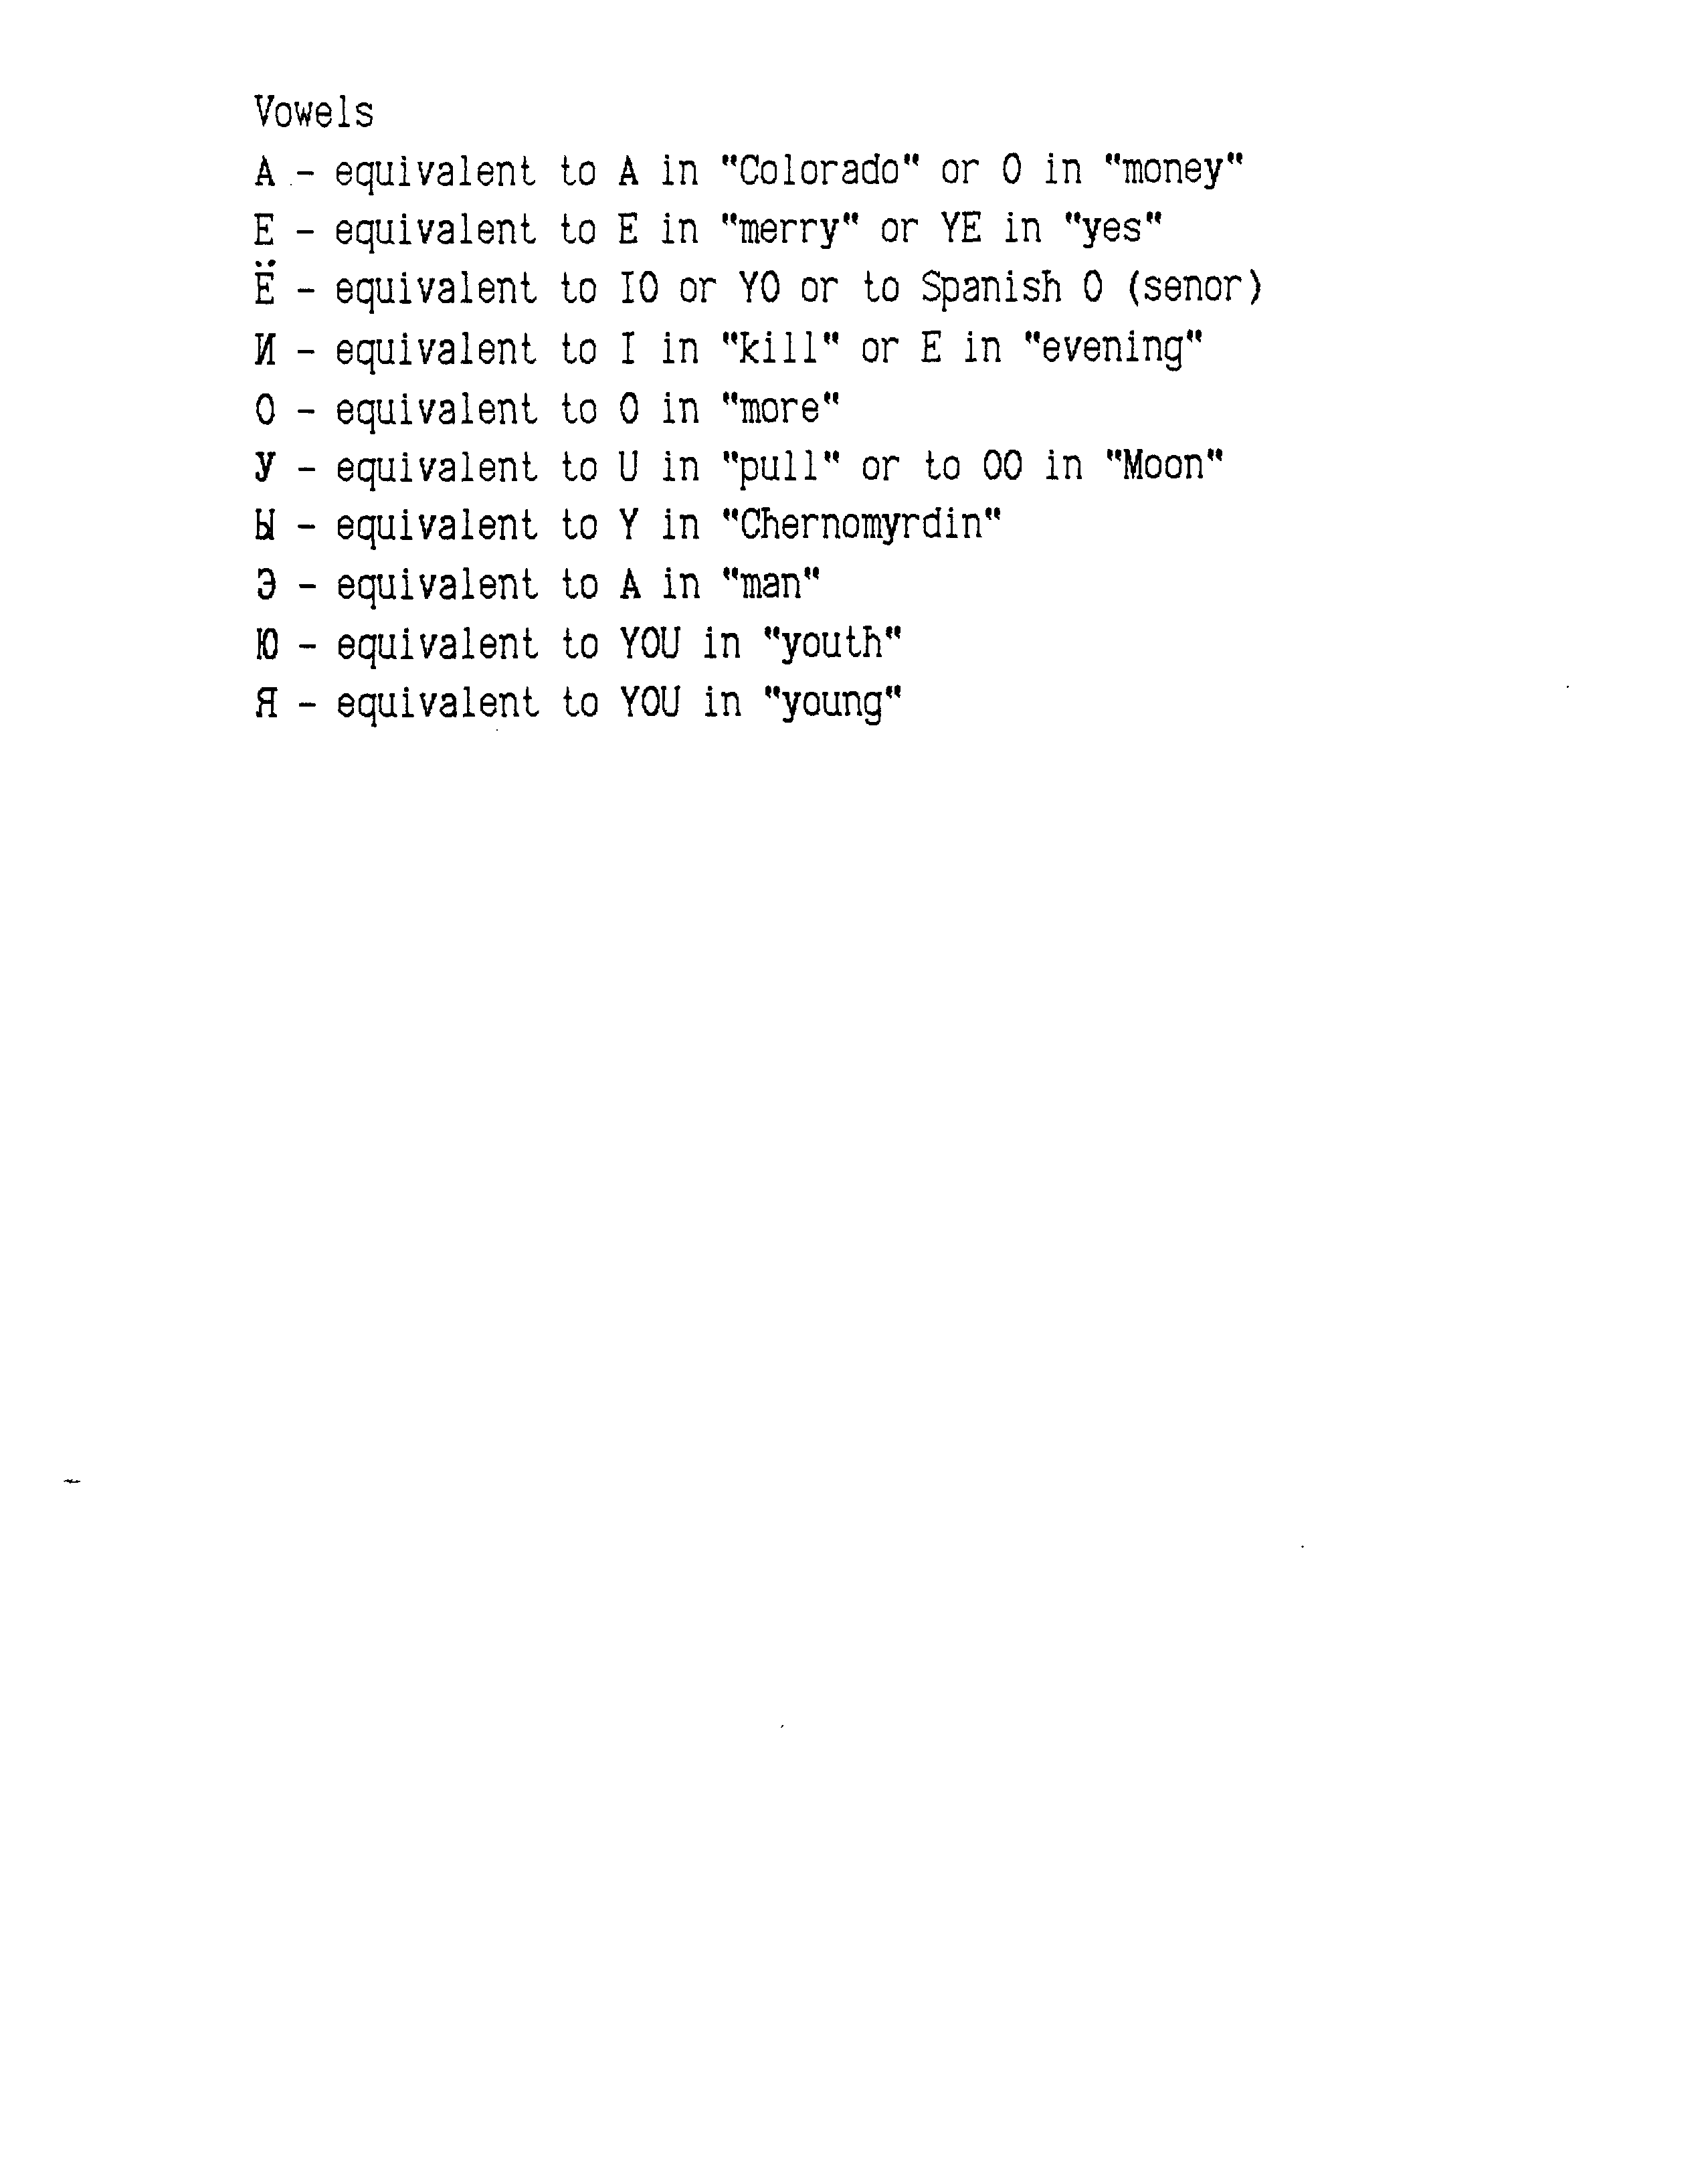

CHARACTERISTICS OF SERBO-CROATIAN

A Slavic language (like Russian and Polish), Serbo-Croatian can be written in either the Cyrillic (Russian style) or Latin (English) alphabet. The program uses the Latin alphabet.

Serbo-Croatian says "The car of John" or "John of car" for the possessive. Use "Car of John" for clarity. It says "the red car" (adjective before noun)

The language forms questions using Dali (do), as in "Do you like wine?". Sometimes it uses "no": "This is beautiful, no?"

For passive voice (the window was broken) they say "the window was broken". For weight and age, they say either "How heavy are you" or " How many kilograms do you have", and "How old are you?", or "How many years do you have?"

Yugoslavian (Serbo Croatian) Pronounciation Guide

Some basic pronunciation rules in Serbo-Croatian. Serbo-Croatian is pronounced almost exactly like Spanish. Except as shown below, all consonants are pronounced as in English. If you can read Spanish, and you read the Serbo-Croatian words pretending that they are Spanish, you won't go far wrong. The letters: b, d, f, g, k, l, m, n, p, r, s, t, and z are all pronounced as in English and Spanish.

c- rats
s- sam
z- zero
c- chew
c- church
d- George
s- shoe
z- Jaques Cousteau
w- very
lj- lyoo
j- yes

Vowels

a- car
i- see
o- Poland
e- let
u- too

CHARACTERISTICS OF SPANISH

Spanish says "It pleases me" rather than "I like it." The actual word arrangement is "Me pleases it." This creates a problem, because "to please" is an uncommon verb in English, and lacking entirely from some other languages. "To like" is much more common. On the advice of a native Spanish speaker, I have solved this problem by translating the Spanish verb in question, "gustar", as "like" instead of "please". So you will receive the ungrammatical translation "Me like candy." My Spanish teacher would hang me for this, but my real Colombian consultant says, surprisingly, that it's all right. "When you say "I pleases candy", we actually hear "I like candy", and understand perfectly. (How odd it is that so many theoretical grammar problems have no practical effect!) Anyway, you should not question the Spaniard's grammar when you see HIM LIKE THE DOG, and you may, if you want to sound better, say "ME PLEASES THE MOVIE."

Spanish says "I call myself Juan" instead of "My name is..". The translation you will receive is I SELF CALL JUAN. This is understandable, and "WHAT BE YOUR NAME?" is understandable in Spanish.

Spanish asks "How many years have you?", instead of "How old are you". You should probably use the same form, or at least "What is your age?" in all languages. Because, when you consider it carefully, the English form is almost insulting (it sounds like "How ancient are you?", and begs the response "Not as old as you are ugly!"). Likewise, "What is your weight?" is better than "How heavy are you?". Instead of "What is the weather?" Spanish asks "What makes the weather?, and in place of "It is raining", says "It makes rain."

Because Spanish conjugates verbs more completely than English, it often leaves the subject unstated ("Hablo" means, uniquely, "(I) speak, so they don't bother to include "I", any more than we say "You come here". We say simply "Come here", and the "you" is understood. The program instructions tell them to always state the subject, but they may occasionally forget. So if you ask about the weather, you may well get the reply "MAKE RAIN." You should mentally fill in the subject, and hear "It makes rain."

In passive voice, we do not name the actor, either because we do not know him or do not want to name him. Instead of "John broke the window." we say "The window was broken." Under the same circumstances, the Spaniard says "The window broke itself". The actual word order and program translation will be SELF BREAK THE WINDOW. Or, HERE SELF SPEAK SPANISH for "Spanish is spoken here." It is a little confusing occasionally, but just remember that SELF BREAK is passive voice, and means something "was broken" by some unnamed party.

Spanish is also more prone to say "I wash myself" (I SELF WASH) than just "I wash" . English is more likely to leave "self" implied. Thus we say "I get Billy up at 6:00 AM" but "I get up earlier." Perhaps we should say "I get myself up." Anyway, Spanish says HE SELF RAISE AT THE 5:30. So simply ignore "self" in the cases it seems superfluous.

Spanish says "I am going to call the roll", as a simple form of future tense. (actually, I GO CALL THE LIST). You may use that form too, though it is usually better to follow the standard rule (Use the present tense and say when for all time frames: I CALL ROLL SOON.) You may also say I WILL CALL -- it will translate the same. Not all languages use the "I WILL" or "I GO" form, and it is best to be consistent and develop good habits. But in Spanish you can get away with it, so use it if you want.

SPANISH PRONUNCIATION

Spanish is pronounced almost exactly like many other European languages such as Hungarian and Polish. If one of these is your native language, and you pronounce Spanish words as you would your own, you will be roughly correct.

Most Spanish letters are pronounced like English -- b, d, f, h, k, l, m, n, p, r, s, t, and z are pronounced the same.

Consonants:
C before "e" or "i", like "s", or the "Hard C" in Circus
Otherwise, like "K" or the "C" in Cat.
G like the normal G in Girl; except before "e" or "i", like the "H" in History.
LL and Y like the "Y" in Yes.
N like the NY in Canyon.
R like R, only trilled slightly. The tongue strikes the front teeth once or twice, as when
we say "Brr, I'm cold."
RR Trilled more, three or four tongue-strikes, as in "Brrrr, I'm really cold!"
V like the "B" in "boy".

Vowells:
A a soft "a" or "ah", as in "Ah, that feels good."
E like the "E" in Extra.
I like the "Long E" in "Me"
O Like the "Long O" in "Cooperate"
U Like the "OO" in "MOO" or the "O" in "Move"

SECTION IV

INTRODUCTIONS AND RULES
IN ALL THE FOREIGN LANGUAGES

INTRODUCTIONS AND RULES IN SOME FOREIGN LANGUAGES, ALPHABETICALLY

You should make an extra copy of the language you will be using, and carry it with you at times when you may meet a new person and want to use the translator. These introductions explain it and tell the foreigner how to use it.



