HRA/FSA/DCA Plan Employee Handout Instructions

Getting Started: You can customize this employee handout template to help your employees understand which Choice Strategies benefit account(s) you are offering them, and how they can be used in conjunction with their health insurance plan.
As many employees may be new to consumer-driven health care, this handout can be a helpful tool to easily provide them with the essential information, links and resources needed to fully take advantage of their specific plan – all in one place.
Before distributing this handout to employees, please find and edit the following, and then delete this page:
- Replace Group Name with your group name
- Replace Carrier with your Health Insurance Carrier name
- Replace January 1, 2015 with your group’s effective date
- Replace 1/1/2015 – 12/31/2015 with your group’s plan year
- Replace $$$$ with your group’s HRA funding for Single, Two-Person and Family
- Review and edit HRA eligible expense and Carrier In-Network summary section
- Replace $2,550 with your group’s allowed FSA maximum
- If you are offering an FSA Carryover, remove the paragraph describing “Use It or Lose It”. If you are not offering an FSA Carryover, remove the paragraph describing the Carryover. You will also need to remove the highlighted instructions.
- If you do not plan to offer your employees an FSA or DCA plan, be sure to remove all instances where the handout references an FSA or DCA and all information that applies to these plans.
- Review the instructions page and remove any sections that do not apply.

Questions?
If you need assistance with your employee handouts please contact: sales@choice-strategies.com

Group Name
Health Reimbursement Arrangement (HRA)
Flexible Spending Account (FSA)
Dependent Care Account (DCA)

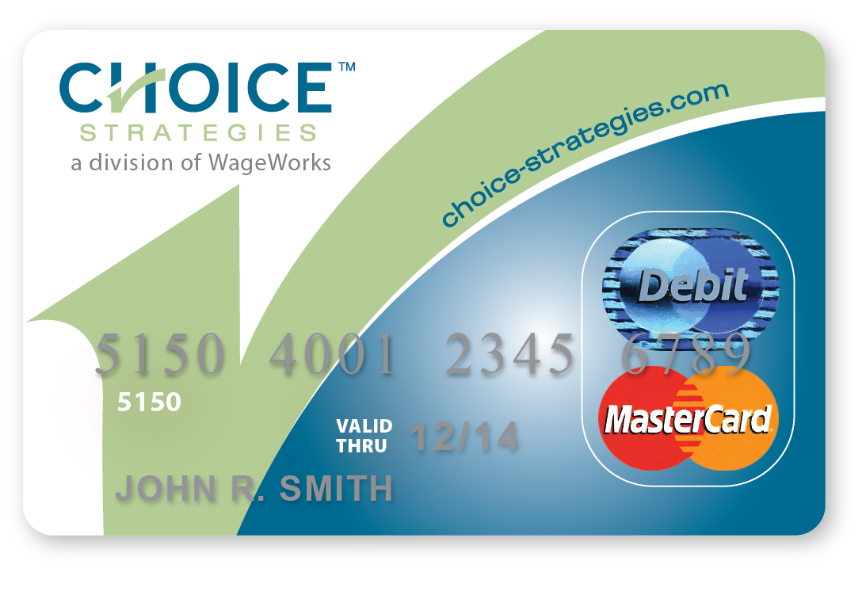
Effective: January 1, 2015
Plan Year: 1/1/2015 – 12/31/2015
Health Benefits will be provided by Carrier, and supplemented by an Employer-funded Health Reimbursement Arrangement (HRA) with Choice Strategies.

Health Reimbursement Account - HRA
- Group Name is supplying you with a Choice Strategies card to pay for eligible medical expenses. Your account will be funded with:

  - $$$$ if you are participating as a single
  - $$$$ if you are participating as a two-person
  - $$$$ if you are participating as a family

- Eligible medical expenses include any expenses that apply to your Carrier deductible including, but not limited to:

    - Office Visits
    - Inpatient
    - Outpatient
    - Prescription

Choice Strategies HRA Instructions:

Medical Deductible Expenses

- When you visit a provider present them with your Carrier Insurance Card. The provider bills Carrier first – do not present your Choice Strategies card at this time.
- Carrier then assigns the negotiated rates and applies charges toward your deductible.
- Carrier sends you an Explanation of Benefits (EOB) statement.
- When billed by the provider, verify that it matches the EOB, and use your Choice Strategies card to pay the amount owed. Payments can usually be made by mail, phone or in person.
Save a copy of your EOB. Choice Strategies may contact you by email or mail asking you to provide documentation to verify the card charge. If requested, you can provide this documentation by uploading the EOB to your online account or by emailing, faxing or mailing it to Choice Strategies.
If you prefer to send less paperwork and verify fewer charges, you can sign up for Choice Strategies’ voluntary Substantiation Service by enrolling online at https://www.choice-strategies.com/substantiation-enrollment. Substantiation will allow Choice Strategies to verify most of your charges without the need for you to submit EOBs or documentation.

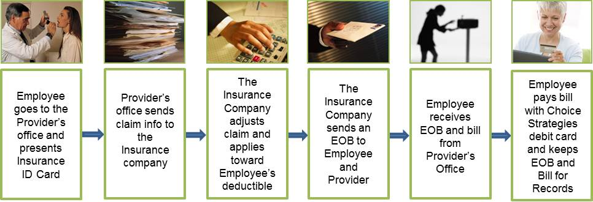

Prescription (RX) Expenses

- Present your Carrier ID card to the pharmacist.
- After your pharmacist processes the claim through Carrier, the pharmacist will ask you for payment at the time of service.
- Pay with your Choice Strategies card and the amount will be processed and applied toward your Carrier Deductible.

- Keep the detailed receipt - you may be contacted by Choice Strategies and asked to validate the purchase by providing documentation.

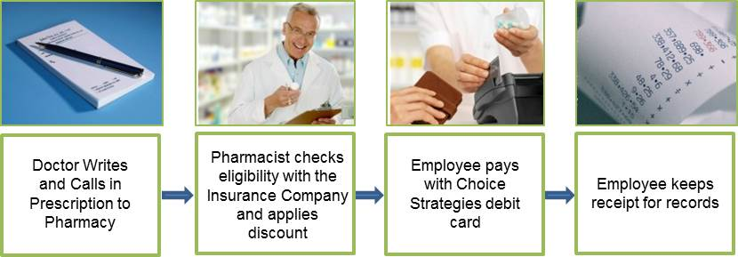

Flexible Spending Account – FSA (Optional)

- Group Name allows you to elect up to $2,550 to be contributed on a pre-tax basis via payroll deductions throughout the plan year into a Flexible Spending Account (FSA).
- FSA funds are best used to pay for predictable out-of-pocket expenses, because any funds contributed that are not used by the end of the plan year are forfeited under the IRS “Use It or Lose It Rule”. REMOVE THIS PARAGRAPH IF CARRYOVER IS OFFERED
- FSA funds are best used to pay for predictable out-of-pocket expenses. If you do not use all of the funds in your FSA by the end of the plan year, up to $500 may be carried over into the next plan year. Any unused funds exceeding $500 will be forfeited due to IRS rules. REMOVE THIS PARAGRAPH IF CARRYOVER IS NOT OFFERED
- These funds can be used for all IRS-eligible expenses including health plan deductible expenses, dental, vision, and much more. An extensive list of eligible expenses is included on the next page, or visit: https://www.wageworks.com/employees/benefits/healthcare-flexible-spending-accounts-fsa/fsa-eligible-expenses.aspx

Dependent Care Account – DCA (Optional)

- Group Name allows you the option to contribute money on a pre-tax basis via payroll deductions throughout the plan year into a Dependent Care Account (DCA).
- The maximum contribution per household is $5,000 if you are single or you are married and filing a joint tax return, or $2,500 if you are married, filing separate tax returns (per IRS guidelines).
- Eligible expenses include custodial care of dependents while employee is at work. For more details, see: https://www.wageworks.com/employees/benefits/dependent-care-flexible-spending-account-fsa.aspx

Example of FSA-Eligible Expenses*

- Acupuncture
- Alcoholism Treatment
- Ambulance
- Artificial Limbs
- Artificial Teeth/Dentures
- Athletic Wrap/ Brace
- Bandages
- Birth Control*
- Capital Expenses for Home Improvements Needed for Medical Care*
- Chiropractors
- Christian Science Practitioner’s Fees
- Contact Lenses and Solution
- Co-payments
- Cost and Care of Guide Dogs
- Crutches, Canes, Walkers
- Deductibles
- Dental fees (Non-Cosmetic)
- Diabetic Testing Supplies
- Diagnostic fees
- Drug and Medical Supplies
- Eyeglasses - Prescription & OTC
- Eye Examination Fees
- Eye Surgery to Correct Vision
- Fertility Monitor and Treatment
- First Aid Kit
- Health Insurance Deductibles
- Hearing Aids & Batteries
- Hospital Services Fees
- Insulin, Testing Materials and Supplies
- Lab Fees
- Lead-Based Paint Removal*
- Operations (for Non-Cosmetic Purposes)
- Medical Services Fees
- Organ Transplants
- Oral Surgery
- Orthodontic Fees
- Orthopedic Devices
- Over the Counter Medicines*
- Oxygen Equipment and Oxygen
- Part of Life-Care Fee Paid to Retirement Home for Medical Care*
- Prescriptions
- Psychologist Fees
- Smoking Cessation Programs
- Special School or Home for Mentally or Physically Disabled Persons*
- Sunscreen (SPF 15 and higher only)
- Surgical Fees
- Transportation for Needed Medical Care
- Treatment at a Drug or Alcohol Center
- Vasectomy
- Wages for Nursing Services
- Weight Loss Programs Associated with a Specific Disease*
- Wheelchair
- X-Rays

*Due to Healthcare Reform, some expenses and OTC medications, like aspirin or cold medication are eligible for FSA reimbursement only when accompanied by a prescription or letter of medical necessity from your provider. These expenses often must be reimbursed by claim submission instead of by using the Choice Strategies card.

For more details, see: https://www.wageworks.com/employees/benefits/healthcare-flexible-spending-accounts-fsa/fsa-eligible-expenses.aspx

Choice Strategies FSA and/or DCA Instructions

- Elect funds to be withheld on a pre-tax basis via payroll deduction for your FSA and/or DCA at Open Enrollment or when you become eligible for the benefit.
- FSA and DCA election amounts can only be changed once a year, during Open Enrollment, or in the case of limited qualifying events. To ensure that your election will be the best fit for your needs for the entire year, you can use the FSA tax calculator tool in the “For Members” section of our website www.choice-strategies.com as a guide when deciding how much to elect.
- Pay for eligible expenses with your Choice Strategies debit card and the amount will be deducted from your Choice Strategies account. For eligible expenses for which you cannot use your debit card, you can submit a claim for reimbursement (see below).
Keep the detailed receipt, as you may be asked to validate the purchase by Choice Strategies. FSA receipt documentation must include date of service or purchase, and itemized description of service or product. Credit card receipts are not considered sufficient documentation.
DCA documentation can be either a DCA claim form with the provider’s signature and Social Security # or Tax ID #, or a bill including the dates of the dependent care service, the dependent’s name and provider name.
- Your FSA is pre-funded by your employer, so although your FSA election will be deducted from your payroll evenly throughout the entire year, the full amount you elect for the entire year will be available for use on the first day of the plan year.
- DCAs are not pre-funded accounts, so funds for those accounts will become available as they are deducted from your paycheck each pay period (the entire annual amount is not available at once).
Because DCA funds accumulate over time, it is possible that you may incur expenses before funding is available to pay your entire claim. In this case, we will reimburse you for the current available balance in your DCA, and will place the remaining claim amount “on-hold”. The remaining on-hold claim amount will be automatically reimbursed to you as payroll contributions are transferred to your DCA.

Things to Remember with your Choice Strategies Account(s)

- Choice Strategies Member Services help is available:
  - 24/7: Members can access account balance, card status and order replacement debit cards 24/7 through our IVR (Interactive Voice Response) system.
  - Phone: 1-888-278-2555 #2 Mon-Fri 8am-8pm EST
    - Assistance is available in more than 200 languages
- Know all your benefits – it is important for you to understand the benefits you have with Carrier. If you have questions about your medical benefits, you may contact Carrier’s Customer Service at the number listed on the back of your Carrier ID card.

- Keep all of your statements and Carrier Explanations of Benefits (EOBs) related to any Choice Strategies reimbursement. You may be asked to provide documentation for some charges made with your Choice Strategies debit card.
- For any expense for which you cannot use your debit card, you can submit claims for reimbursement. For faster reimbursement, submit claims via your online account or mobile app. Paper claim forms are also available on our website, or if you do not have internet access, you can contact Member Services to have a claim form mailed to your home address.
You can submit your claim and documentation:
- Online: www.choice-strategies.com by logging into your online account
- Mobile App: with online account, claims can be submitted via mobile devices or tablets
- Email : claims@choice-strategies.com
- Fax : 1-888-415-6471
- Mail : Choice Strategies
P.O. Box 2205
South Burlington VT 05407

You can be reimbursed for submitted claims via:
- Direct Deposit / Electric Fund Transfer (EFT) – your Direct Deposit information can be provided to Choice Strategies through your online account
- Check – made out and mailed to you
- Check – made out and mailed to your provider

- We encourage you to set up an individual online account, where you can access and manage a variety of information 24 hours a day, 7 days a week.

To set up your account, go to www.choice-strategies.com, and click on the For Members tab.
In the top right hand corner of the page, click on Register, and follow the instructions.
You will need the following information to set up your online account:
- Employee First and Last Name
- Social Security # (referred to as Employee ID)
- Either your 16 digit Choice Strategies debit card number OR your Employer ID (This is your company’s CHO-code, which can be found on any letter you have received from Choice Strategies. You can also call Member Services to obtain.)

Through your online account, you can:

- Check Account Balances
- Submit Claims Online
- View Transaction History
- Upload Documentation
- Change Direct Deposit Information

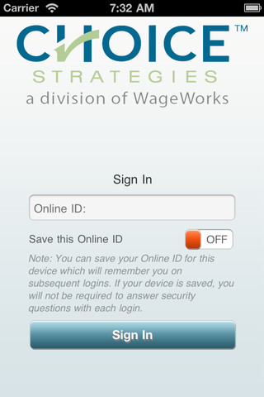
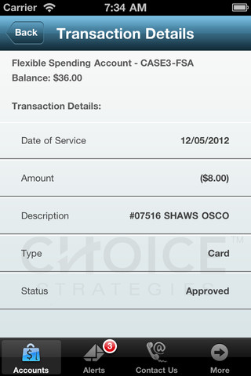
Mobile App
Available for iOS (Apple) and Android-enabled mobile devices and tablets, the Choice Strategies app can be downloaded free of charge. Members can check account balances, view recent transactions, submit claims and upload a receipt or supporting documentation.

