
NATIONAL AGRI-FOOD BIOTECHNOLOGY INSTITUTE
(Department of Biotechnology Ministry of Science and Technology, Govt. of India)
C-127, Industrial Area, Phase 8, SAS Nagar, Mohali, Punjab
Phone:0172-4604888 Fax: 0172-4011916

Section – I
NOTICE INVITING TENDERS
Short Term Tender Notice No:NABI/7(7)/2010-Works
To be opened on 09th September, 2011 at 3:30 PM

National Agri-Food Biotechnology Institute (NABI), Mohali, is desirous of engaging contractor(s) for a project related to the execution of tissue culture &food technology laboratory having floor area of about 12000 sq.ft. on 1st floor in the institutional building of NABI located at C-127, Phase VIII, Industrial Area, SAS Nagar, Mohali, Punjab.

For details regarding Tender document, Broad Scope of Work, etc., kindly visit our website www.nabi.res.in. Last date for submission of application is 9th September, 2011 at 01:30 PM

S.no. | Tender No | Name of Work | Cost Of Tender Document (Rs.) | Estimated Cost of Work (INR) | EMD (INR)
1 | Tender Notice No. NABI/7(7)/2010-Works | SETTING UP, INSTALLATION, COMMISSIONING OF HVAC SYSTEM AND CREATING FACILITY FOR CLEAN ROOM, AT FIRST FLOOR, NABI. | 1,000/- | 1,30,00,000.00 | 2,60,000.00
- Firms who full fill the criteria as given in the Technical Evaluation criteria Sheet are eligible to submit the Tender.
- Tender price shall remain open for acceptance for a period of 90 days from the date of opening of Tender. In case, any tenderer withdraws his tender before the said period or issue of acceptance (whichever is earlier) or makes any modification in the terms and conditions of the tender which are not acceptable to NABI., then the NABI shall without prejudice to any other right or remedy, be at liberty to forfeit 50% of the said earnest money aforesaid.
- Within seven (07) working days from date of the receipt of notification of award , the Supplier/Contractor, shall furnish an amount equal to 5% of the tendered value of the contract as performance Security within the period prescribed for commencement of work award issued to him. In case of termination of contract, this Security Deposit shall be forfeited and amount necessary to make up this amount shall be recovered from money due to the contractor under this contract, or any other contract. A sum @ 5% of the gross amount of the bill shall be deducted from each running bill of the contractor till the sum along with the sum already deposited as earnest money, will amount to security deposit of 5% of the tendered value of work in addition, the contractor shall be required to deposit.

- Submission of the Tender
The Tender should be submitted in two envelopes as detailed below
4.1 Envelope – 1 - marked as – TECHNICAL BID’
This shall contain the following
A. (1) Draft/Pay order towards EMD in a cover super scribed as EMD with tenderers name.
(2)Draft for Rs1000/- towards cost of Tender Form if downloaded from website.
B. The various Details regarding experience, financial standing etc as detailed in the Technical Evaluation Criteria Sheet.

4.2 Envelope – 2 – marked as – ‘ PRICE BID (FINANCIAL BID)’
This shall contain the Price for the supply and Commissioning of the Items.
  - Both envelopes shall be placed in a third envelope and name of work, date of opening etc. shall be written on the cover.

Note: CONTRACTORS WHO HAVE DOWNLOADED THE TENDER DOCUMENTS FROM THE WEBSITE, ARE REQUIRED TO ATTACH DEMAND DRAFT/PAY ORDER FOR Rs.1000/- (ONE THOUSAND ONLY) FAVOURING NATIONAL AGRI-FOOD BIOTECHNOLOGY INSTITUTE, MOHALI, BEING THE COST OF TENDER DOCUMENTS, FAILING WHICH THE TENDER WILL NOT BE CONSIDERED.

Details of Demand Draft/Pay Order

- Demand Draft/Pay Order for Rs.1000/- (Rupees One Thousand Only) drawn on _______________________________________________________________________________ is enclosed with technical bid towards the cost of tender documents

- Demand Draft/Pay Order for Rs.________________(Rupees____________________________
_____________________________________________ drawn on _______________________
___________________is enclosed with technical bid of the tender documents towards Earnest Money Deposit (EMD)

The detailed Tender Documents with complete terms & conditions with technical specifications are available on our website http://www.nabi.res.in.

Change in the technical specifications and terms & conditions if any, for the above item after pre-bid, will be posted on the NABI website. All venders are requested to quote accordingly.

Last date of receipt of complete tenders is : 9th September, 2011 at 1:30 PM
The date of opening of technical bids is : 9th September, 2011 at 3:30 PM
Opening of Price Bids of technically qualified bids : To be intimated subsequently.

Administrative Officer

PROJECT INFORMATION

1 | Owner | NATIONAL AGRI-FOOD BIOTECHNOLOGY INSTITUTE  ( (Department of Biotechnology Ministry of Science and Technology, Govt. of India)
2 | Project Title | SETTING UP, INSTALLATION, COMMISSIONING OF HVAC SYSTEM AND CREATING FACILITY FOR CLEAN ROOM, AT FIRST FLOOR, NABI.
3 | Project Location | MOHALI (PUNJAB)
4 | Project Site | C-127, Industrial Area, Phage 8, SAS Nagar, Mohali, Punjab. Phone:0172-4604888 Fax: 0172-4011916
5 | Consultant | M/s MEDIAIDS, CHANDIGARH.
6 | Nearest Railway Station | CHANDIGARH
7 | Nearest Airport | CHANDIGARH
8 | Time Allotted for completion | 03 (THREE) MONTHS FROM THE DATE OF AWARD OF CONTRACT.

SECTION – II
INSTRUCTIONS TO BIDDERS

A. PREAMBLE

1. Definitions and Abbreviations:

  - The following definitions and abbreviations, which have been used in these documents
shall have the meanings as indicated below :

1.2 Definitions:

( I ) “Owner” means the organization and / or its representatives(consultants) purchasing
goods and services as incorporated in the Tender Enquiry document.
(ii) “Tender” means Bids / Quotation / Tender received from a Firm / Tenderer / Bidder
(iii) “Tenderer” means Bidder/ the Individual or Firm submitting Bids / Quotation / Tender
(iv) “Supplier/Contractor” means the individual or the firm supplying the goods and services as incorporated in the contract.
(v) “Goods” means the articles, material, commodities, livestock, furniture, fixtures, raw material, spares, instruments, machinery, equipment, medical equipment, industrial plant etc. which the Supplier/Contractor is required to supply to the Owner under the contract.
- “Services” means services allied and incidental to the supply of goods, such as transportation, installation, commissioning, provision of technical assistance, training, after sales service, maintenance service and other such obligations of the Supplier/Contractor covered under the contract.
(vii) “Earnest Money Deposit” (EMD) means Bid Security/ monetary or financial guarantee to be furnished by a tenderer along with its tender.
(viii) “Contract” means the written agreement entered into between the Owner and/or consignee and the Supplier/Contractor, together with all the documents mentioned therein and including all attachments, annexure etc. therein
(ix) “Performance Security” means monetary or financial guarantee to be furnished by the successful tender for due performance of the contract placed on it. Performance Security is
also known as Security Deposit.
(x) “Consignee” means the organization/person to whom the goods are required to be
delivered as specified in the Contract. If the goods are required to be delivered to a person as an interim consignee for the purpose of dispatch to another person as provided in the Contract then that “another” person is the consignee, also known as ultimate consignee.
- “Specification” means the document/standard that prescribes the requirement with which goods or service has to conform
(xii) “Inspection” means activities such as measuring, examining, testing, gauging one or more characteristics of the product or service and comparing the same with the specified requirement to determine conformity.
- “Day” means calendar day.

  - Abbreviations:

- “T E Document” means Tender Enquiry Document
- “NABI” means National Agri-Food Biotechnology Institute (The Purchase)
- “NIT” means Notice Inviting Tenders.
- “ITB” means Instructions to Bidders
(iv) “SIB” means Special Instructions to Bidders
(v) “GCC” means General Conditions of Contract
(vi) “SCC” means Special Conditions of Contract
(vii) “DGS&D” means Directorate General of Supplies and Disposals
(viii) “NSI C” means National Small Industries Corporation
- “PSU” means Public Sector Undertaking
(x) “CPSU” means Central Public Sector Undertaking
(xi) “LSI” means Large Scale Industry
(xii) “SSI” means Small Scale Industry
- “LC” means Letter of Credit
(xiv) “DP” means Delivery Period
(xv) “BG” means Bank Guarantee
- “ED” means Excise Duty
- “CD” means Custom Duty
- “VAT” means Value Added Tax .
(xix) “CENVAT” means Central Value Added Tax
(xx) “CST” means Central Sales Tax
- “RR” means Railway Receipt
(xxii) “BL” means Bill of Lading
(xxiii) “FOB” means Free on Board
(xxiv) “FCA” means Free Carrier
- “FOR” means Free On Rail
- “CIF” means Cost, Insurance and Freight
- “CIP (Destinations)” means Carriage and Insurance Paid up to named port of destination. Additionally the Insurance (local transportation and storage) would be extended and borne by the Supplier/Contractor from warehouse to the consignee site for a period including 3 months beyond date of delivery.
(xxviii) “DDP” means Delivery Duty Paid named place of destination (consignee site)
(xxix) “INCOTERMS” means International Commercial Terms as on the date of Tender Opening.
- “MOH&FW” means Ministry of Health & Family Welfare, Government of India.
- “CMC” means Comprehensive maintenance Contract (labour, spare and preventive maintenance)
- “RT” means Re-Tender

- Introduction

The Owner has issued these TE documents for purchase of goods and related services as mentioned in subsequent paragraphs which also indicates, interalia, the required delivery schedule, terms and place of delivery.

2.1 General :
The detailed information of the project given below is as per our present requirement. However, it is not binding on the owner in any way and shall not govern the scope of works.
2.2 Location of Site :
The project site is located at C-127, Phase VIII, Mohali, Punjab.
2.3 Scope of work:-
1.. SETTING UP, INSTALLATION, COMMISSIONING OF HVAC SYSTEM AND CREATING FACILITY FOR CLEAN ROOM, AT FIRST FLOOR, NABI.
- Installation and commissioning of HVAC for the area earmarked in the tender.
- Setting up and installation of clean room area for ISO-7 and ISO-8 classification.
- Testing, validation and certification of clean room facility from authorized company.

Note:
- Materials to be used as per the technical specifications in the tender documents.
- The above scope is a broad indication of the job. Anything not mentioned above, but required for the proper functioning of the system shall be part of the scope.

This section (Section II - “ Instructions to Bidders”) provides the relevant information as well as instructions to assist the prospective tenderers in preparation and submission of tenders. It also includes the mode and procedure to be adopted by the Owner for receipt and opening as well as scrutiny and evaluation of tenders and subsequent placement of contract
The tenderers shall also read the Special Instructions to Bidders (SIB) related to this purchase , as contained in Section III of these documents and follow the same accordingly. Whenever there is a conflict between the ITB and the SIB, the provisions contained in the SIB shall prevail over those in the ITB.
Before formulating the tender and submitting the same to the Owner, the tenderer should read and examine all the terms, conditions, instructions, checklist etc. contained in the TE documents . Failure to provide and/or comply with the required information, instructions etc. incorporated in these TE documents may result in rejection of its tender

- Availability of Funds
As per estimated cost of work.

- Language of Tender

The tender submitted by the tenderer and all subsequent correspondence and documents relating to the tender exchanged between the tenderer and the Owner, shall be written in the English language, unless otherwise specified in the Tender Enquiry. However, the language of any printed literature furnished by the tenderer in connection with its tender may be written in any other language provided the same is accompanied by an English translation and, for purposes of interpretation of the tender, the English translation shall prevail.
The tender submitted by the tenderer and all subsequent correspondence and documents relating to the tender exchanged between the tenderer and the Owner, may also be written in the Hindi language, provided that the same are accompanied by English translation, in which case, for purpose of interpretation of the tender etc, the English translations shall prevail.

- Eligible Tenderers

This invitation for tenders is open to all Supplier/Contractors who fulfill the eligibility criteria specified against clause 17 of ITB Sec. II in this document.

- Eligible Goods and Services

All goods and related services to be supplied under the contract shall have their origin in India or any other country with which India has not banned trade relations. The term “origin” used in this clause means the place where the goods are mined, grown, produced, or manufactured or from where the related services are arranged and supplied.

7. Tendering Expense

  - The tenderer shall bear all costs and expenditure incurred and/or to be incurred by it in connection with its tender including preparation, mailing and submission of its tender and for subsequent processing the same. The Owner will, in no case be responsible or liable for any such cost, expenditure etc regardless of the conduct or outcome of the tendering process.

- Content of Tender Enquiry Documents

  - In addition to Section I – “Notice inviting Tender” (NIT), the TE documents include

- Section II : Instructions to Bidders (ITB)
- Section III : Special Instructions to Bidders (SIB)
- Section IV : General Conditions of Contract (GCC)
- Section V : Special Conditions of Contract (SCC)
- Section VI : Project Site Rules
- Section VII : Contractor’s Obligation Under Statutory Laws
- Section VIII : Qualification Criteria
- Section IX : Tender Form
- Section X : List of Approved Makes
- Section XI : List of Requirements (Applicable Standards and Specifications)
- Section XII :Drawings
- Section XIII : Bank Guarantee Form For EMD (Not Applicable-Deleted)
- Section XIV : Manufacturer’s Authorization Form
- Section XV : Bank Guarantee Form for Performance Security/CMC Security
- Section XVI : Integrity Pact
- Section XVII : Check List for the Tenderers
- Section XVIII : Performance Statement
- Section XIX : Price Schedule (Price Bid)
  - The relevant details of the required goods and services, the terms, conditions and procedure for tendering, tender evaluation, placement of contract, the applicable contract terms and, also, the standard formats to be used for this purpose are incorporated in the above-mentioned documents. The interested tenderers are expected to examine all such details etc to proceed further
- Amendments to TE documents
At any time prior to the deadline for submission of tenders, the Owner may for any reason deemed fit by it, modify the TE documents by issuing suitable amendment(s) to it.Such an amendment will be notified in the website of www.nabi.res.in. Interested parties are advised to regularly visit the website for further updates.
In order to provide reasonable time to the prospective tenderers to take necessary action in preparing their tenders as per the amendment, the Owner may, at its discretion extend the deadline for the submission of tenders and other allied time frames, which are linked with that deadline

- Clarification of TE documents

A tenderer requiring any clarification or elucidation on any issue of the TE documents may communicate the same to the Executive Director, National Agri- Food Biotechnology Institute, Mohali

PREPARATION OF TENDERS

11. Documents Comprising the Tender

  - The Two Bid System, i.e. “Technical Bid” and “Price Bid” prepared by the tenderer shall comprise the following:

A) Technical bid (Un-priced Bid)
i) Earnest money furnished in accordance with ITB clause 19.1 alternatively, documentary evidence as per ITB clause 19.2 for claiming exemption from payment of earnest money.
ii) Tender Form as per Section IX (Un priced).
iii) Documentary evidence, as necessary in terms of clauses 5 and 17 establishing that the tenderer is eligible to submit the tender and, also qualified to perform the contract if its tender is accepted
- Tenderer/Agent who quotes for goods manufactured by other manufacturer shall furnish manufacturer’s Authorisation Form.
- Power of attorney in favour of the signatory of the tender document (if applicable).
- Documents and relevant details to establish in accordance with ITB clause 18 that the goods and
the allied services to be supplied by the tenderer conform to the requirement of the TE documents.
- Performance Statement as per section XVIII along with relevant copies of orders and end users’ satisfaction certificate.
- List of Requirements as per Section XI
- Certificate of country of origin by the bidder from abroad. (Chamber of commerce), wherever applicable.
x) Checklist as per Section XVII.

B) Price Bid:

- Schedule of Prices (Price Bid) as per Section XIX

N.B.

1. All pages of the Tender should be page numbered and indexed.
2. It is the responsibility of tenderer to go through the TE document to ensure furnishing all required documents in addition to above, if any.

11.2 The authorized signatory of the tenderer must sign the tender duly stamped at appropriate places and initial all the remaining pages of the tender

11.3 A tender, which does not fulfill any of the above requirements and/or gives evasive
information/reply against any such requirement, shall be liable to be ignored and rejected

  - Tender sent by fax/telex/cable/electronically shall be ignored

12. Tender Currencies

  - The tenderer supplying indigenous goods or already imported goods shall quote only in
Indian Rupees
  - For imported goods if supplied directly from abroad, prices shall be quoted in any freely convertible currencies say US Dollar, Euro, GBP or Yen. As regards price(s) for allied services, if any required with the goods, the same shall be quoted in Indian Rupees only if such services are to be per formed /undertaken in India. Commission for Indian Agent, if any and if payable shall be indicated in the space provided for in the price schedule and will be payable in Indian Rupees only. Such conversion of currencies will be done based on rate of exchange declared by RBI as on the date of ‘Price Bid’ opening as already incorporated against clause 32 here after
  - Tenders, where prices are quoted in any other way shall be treated as non - responsive and rejected

13 Tender Prices

  - The Tenderer shall indicate on the Price Schedule provided under Section XIX all the specified components of prices shown therein including the unit prices and total tender prices of the goods and services proposed to supply against the requirement. All the columns shown in the price schedule should be filled up as required. If any column does not apply to a tenderer, same should be clarified as “NA” by the tenderer
  - DELETED
  - The quoted prices for goods offered from within India and that for goods offered from abroad are to be indicated separately in the applicable Price Schedules attached under Section XIX
  - While filling up the columns of the Price Schedule, the following aspects should be noted for compliance:

    - For domestic goods or goods of foreign origin located within India, the prices in the corresponding price schedule shall be entered separately in the following manner:
- the price of the goods, quoted ex-factory/ ex-showroom/ ex-warehouse/ off the-shelf, as applicable, including all taxes and duties like sales tax, CST VAT, CENVAT, Custom Duty, Excise Duty etc. already paid or payable on the components and raw material used in the manufacture or assembly of goods quoted ex-factory etc. or on the previously imported goods of foreign origin quoted ex-showroom etc;
- any sales or other taxes and any duties including excise duty, which will be payable on the goods in India if the contract is awarded;
- charges towards Packing & Forwarding, Inland Transportation, Insurance (local transportation and storage) would be borne by the Supplier/Contractor from ware house to the consignee site for a period including 3 months beyond date of delivery, Loading/Unloading and other local costs incidental to delivery of the goods to their final destination as specified in the List of Requirements and Price Schedule.
- the price of Incidental Services, as mentioned in List of Requirements and Price Schedule;
- the prices of Turnkey (if any), as mentioned in List of Requirements, and Price Schedule;
- the price of annual CMC, as mentioned in List of Requirements, and Price Schedule.

    - For goods offered from abroad, the prices in the corresponding price schedule shall be entered separately in the following manner

a) the pr ice of goods quoted DDP Destination, as indicated in the List of Requirements and Price Schedule;
- the price of goods quoted should be on DDP basis at consignee site in India as indicated in the List of Requirements, Price Schedule .
- the charges for Insurance (local transportation and storage) would be extended and borne by the Supplier/Contractor from warehouse to the consignee site for a period including 3 months beyond date of delivery.
- the price of annual CMC, as mentioned in List of Requirements and Price Schedule

  - For transportation of imported goods offered from abroad, relevant instructions as incorporated under GCC Clause 10 shall be followed
  - For insurance of goods to be supplied, relevant instructions as provided under GCC Clause 11 shall be followed
  - Unless otherwise specifically indicated in this TE document, the terms FCA, FOB, FAS, CIF, CIP, DDP etc. for imported goods offered from abroad, shall be governed by the rules & regulations prescribed in the current edition of INCOTERMS, published by the International Chamber of Commerce, Paris.
  - The need for indication of all such price components by the tenderers, as required in this clause (viz., ITB clause 13) is for the purpose of comparison of the tenders by the Owner and will no way restrict the Owner’s right to award the contract on the selected tenderer on any of the terms offered.

- Indian Agent

  - If a foreign tenderer has engaged an agent in India in connection with its tender, the foreign tenderer, in addition to indicating Indian agent’s commission, if any, in a manner described under ITB sub clause 12.2 above, shall also furnish the following information:
a) The complete name and address of the Indian Agent and its permanent income tax account number as allotted by the Indian Income Tax authority.
b) The details of the services to be rendered by the agent for the subject requirement.
c) Details of Service outlets in India, nearest to the consignee(s), to render services during Warranty and CMC period.

15. Firm Price

  - Unless otherwise specified in the SIB, prices quoted by the tenderer shall remain firm and fixed during the currency of the contract and not subject to variation on any account

16. Alternative Tenders

16.1 Alternative Tenders are not permitted.

17 Documents Establishing Tenderer’s Eligibility and Qualifications

  - Pursuant to ITB clause 11, the tenderer shall furnish, as part of its tender, relevant details and documents establishing its eligibility to quote and its qualifications to perform the contract if its tender is accepted
  - The documentary evidence needed to establish the tenderer’s qualifications shall fulfill the following requirements:

- in case the tenderer offers to supply goods, which are manufactured by some other firm, the tenderer has been duly authorized by the goods manufacturer to quote for and supply the goods to the Owner. The tenderer shall submit the manufacturer’s authorization letter to this effect as per the standard form provided under Section XIV in this document
- the tenderer has the required financial, technical and production capability necessary to perform the contract and, further, it meets the qualification criteria incorporated in the Section VIII in these documents.
- in case the tenderer is not doing business in India, it is duly represented by an agent stationed in India fully equipped and able to carry out the required contractual functions and duties of the Supplier/Contractor including after sale service, maintenance & repair etc. of the goods in question, stocking of spare parts and fast moving components and other obligations, if any, specified in the conditions of contract and/or technical specifications.
- in case the tenderer is an Indian agent/authorized representative quoting on behalf of a foreign manufacturer for the restricted item, the Indian agent/authorized representative is already enlisted under the Compulsory Enlistment Scheme of Ministry of Finance, Govt. of India, operated through Directorate General of Supplies & Disposals (DGS&D), New Delhi

18. Documents establishing Good’s Conformity to TE document.

  - The tendered shall provide in its tender the required as well as the relevant documents like technical data, literature, drawings etc. to establish that the goods and services offered in the tender fully conform to the goods and services specified by the Owner in the TE documents. For this purpose the tendered shall also provide a clause-by-clause commentary on the technical specifications and other technical details incorporated by the Owner in the TE documents to establish technical responsiveness of the goods and services offered in its tender
  - In case there is any variation and/or deviation between the goods & services prescribed
by the Owner and that offered by the tendered, the tendered shall list out the same in a chart form without ambiguity and provide the same along with its tender. Tenderers must visit the site and see the means of access to the site, study the drawings and specifications and acquaint him fully about the works to be carried out and all other factors governing the works before quoting his rates. The tenderer shall be liable for; completing the job and/or providing extra material without charging extra for completion of work and/or material. For any additional material/scope (not in the scope at the time of contract) the cost of material and scope shall be decided by the Owner before allotting the job to the contractor.
  - If a tenderer furnishes wrong and/or misguiding data, statement(s) etc. about technical acceptability of the goods and services offered by it, its tender will be liable to be ignored and rejected in addition to other remedies available to the Owner in this regard.
19. Earnest Money Deposit (EMD)

  - Pursuant to ITB clauses 8.1 the tenderer shall furnish along with its tender, earnest money for amount as mentioned in Section-I - NIT. The earnest money is required to protect the Owner against the risk of the tenderer’s unwarranted conduct as amplified under sub-clause 19.7 below
  - The tenderers who are currently registered and, also, will continue to remain registered during the tender validity period with National Small Industries Corporation, New Delhi for the specific goods as per tender enquiry specification shall be eligible for exemption from EMD. Vague stipulations in the Registration Certificate such as “to customers’ specification” etc. will not be acceptable for exemption from furnishing of earnest money. In case the tenderer falls in these categories, it should furnish copy of its valid registration details (with NSI C). The EMD should be furnished in the name of “ Executive Director, National-Agri Food Biotechnology Institute, payable at Mohali”
  - The earnest money shall be denominated in Indian Rupees or equivalent currencies as
Per ITB clause 12.2. The earnest money shall be furnished in one of the following forms:
i) Account Payee Demand Draft
- Banker’s cheque
  - The demand draft or banker’s cheque shall be drawn on any commercial bank in India or country of the tenderer, in favour of the “Executive Director, National-Agri Food Biotechnology Institute, payable atMohali .
  - EMD shall be forfeited fully if the contractor fails to start the work after the award. If any tenderer withdraws his tender within the tender validity period or makes any modifications in terms and conditions of tenders which were not acceptable to departments, then 50% of the EMD shall be forfeited.
  - Unsuccessful tenderer’s ear nest money will be returned to them without any interest, after expiry of the tender validity period, but not later than thirty days after conclusion of the resultant contract. Successful tenderer’s earnest money will be returned without any interest, after receipt of performance security from the tenderer.
  - Earnest Money is required to protect the Owner against the risk of the Tenderer’s conduct, which would warrant the forfeiture of the EMD. Earnest money of a tenderer will be forfeited, if the tenderer withdraws or amends its tender or impairs or derogates from the tender in any respect within the period of validity of its tender or if it comes to notice that the information/documents furnished in its tender is incorrect, false, misleading or forged without prejudice to other rights of the Owner. The successful tenderer’s earnest money will be forfeited without prejudice to other rights of Owner if it fails to furnish the required performance security within the specified period.
19.8 Earnest Money of all tenderers would not be deposited in the bank except the lowest tender.

20. Tender Validity

20.1 If not mentioned otherwise in the SIB, the tenders shall remain valid for acceptance for a period of 90 days (Ninety days) from the date of tender opening prescribed in the TE document. Any tender valid for a shorter period shall be treated as unresponsive and rejected
20.2 In exceptional cases, the tenderers may be requested by the Owner to extend the validity up to a specified period. Such request(s) and responses thereto shall be conveyed by surface mail or by fax/ telex/cable followed by surface mail. The tenderers, who agree to extend the tender validity, are to extend the same without any change or modification of their original tender and they are also to extend the validity period of the EMD accordingly. A tenderer, however, may not agree to extend its tender validity without forfeiting its EMD.
20.3 In case the day up to which the tenders are to remain valid falls on/ subsequently declared a holiday or closed day for the Owner, the tender validity shall automatically be extended up to the next working day.
21. Signing and Sealing of Tender

21.1 The tenderers shall submit their tenders as per the instructions contained in ITB Clause 11.
21.2 The tender shall either be typed or written in indelible ink and the same shall be signed by the tenderer or by a person(s) who has been duly authorized to bind the tenderer to the contract. The letter of authorization shall be by a written power of attorney, which shall also be furnished along with the tender.
  - The tender shall be duly signed at the appropriate places as indicated in the TE documents and all other pages of the tender including printed literature, if any shall be initialed by the same person(s) signing the tender. The tender shall not contain any erasure or overwriting, except as necessary to correct any error made by the tenderer and, if there is any such correction; the same shall be initialed by the person(s) signing the tender
  - The tenderer should seal the tender and write the address of the Owner and the tender reference number on the envelope. The sentence “NOT TO BE OPENED ” before 3.30 P.M on 09-09-2011 (The tenderer is to put the date & time of tender opening) are to be written on these envelopes. The inner envelopes are then to be put in a bigger outer envelope, which will also be duly , sealed marked etc. as above. If the outer envelope is not sealed and marked properly as above, the Owner will not assume any responsibility for its misplacement, premature opening, late opening etc
21.5 The document seeks quotation following two Tender System, in two parts. First part will be known as ‘Technical Bid’, and the second part ‘Price Bid’ as specified in clause 11 of ITB. Tenderer shall seal ‘Technical Bid’ and ‘Price Bid’ separately and covers will be suitably super scribed. Both these sealed covers shall be put in a bigger cover and sealed and procedure prescribed in Paras 21.1 to 21.5 followed.

D. SUBMISSION OF TENDERS

22. Submission of Tenders

  - Unless otherwise specified, the tenders are to be submitted to The Executive Director, National Agri-Food Biotechnology Institute, C-127, Industrial Area, Phase 8, SAS Nagar, Mohali, Punjab,
  - The tenderers must ensure that they submit their tenders not later than the closing time and date specified for submission of tenders. It is the responsibility of the tenderer to ensure that their Tenders whether sent by post or by courier or by person, by the specified clearing date and time. In the event of the specified date for submission of tender falls on / is subsequently declared a holiday or closed day for the Owner, the tenders will be received up to the appointed time on the next working day.

23. Late Tender

23.1 A tender, which is received after the specified date and time for receipt of tenders will be treated as “late” tender and will be ignored and not considered.

24. Alteration and Withdrawal of Tender

24.1 The tenderer, after submitting its tender, is permitted to alter / modify its tender so long as such alterations / modifications are received duly signed, sealed and marked like the original tender , within the deadline for submission of tenders Alterations / modifications to tenders received after the prescribed deadline will not be considered
  - No tender should be withdrawn after the deadline for submission of tender and before expiry of the tender validity period. If a tenderer withdraws the tender during this period, it will result in forfeiture of the earnest money furnished by the tenderer in its tender.
E TENDER OPENING

25. Opening of Tenders

  - The Owner will open the tenders at the specified date and time and at the specified place as indicated in the NIT.
In case the specified date of tender opening falls on / is subsequently declared a holiday or closed day for the Owner, the tenders will be opened at the appointed time and place on the next working day.
  - Authorized representatives of the tenderers, who have submitted tenders on time may attend the tender opening provided they bring with them letters of authority from the corresponding tenderers The tender opening official(s) will prepare a list of the representatives attending the tender opening. The list will contain the representatives’ names & signatures and corresponding tenderers’ names and addresses
25.3 Two - Tender system as mentioned in para 21.6 above will be as follows. The Technical
Bid is to be opened in the first instance, at the prescribed time and date as indicated in NIT. These Tenders shall be scrutinized and evaluated by the competent committee/ authority with reference to parameters prescribed in the TE document. During the Technical Bid opening, the tender opening official(s) will read the salient features of the tenders like brief description of the goods offered, delivery period, Earnest Money Deposit and any other special features of the tenders, as deemed fit by the tender opening official(s). Thereafter, in stage, the Price Bid of only the Technically qualified offers (as decided in the first stage) shall be opened for further scrutiny and evaluation on a date notified after the evaluation of the Technical Bid. The prices, special discount if any of the goods offered etc., as deemed fit by tender opening official(s) will be read out.

F. SCRUTINY AND EVALUATION OF TENDERS

26. Basic Principle

  - Tenders will be evaluated on the basis of the terms & conditions already incorporated in the TE document, based on which tenders have been received and the terms, conditions etc. mentionedby the tenderers in their tenders. No new condition will be brought in while scrutinizing and evaluating the tenders

27. Preliminary Scrutiny of Tenders

  - The Owner will examine the Tenders to determine whether they are complete, whether any computational errors have been made, whether required sureties have been furnished, whether the documents have been properly signed stamped and whether the Tenders are generally in order
27.2 Prior to the detailed evaluation of Price Bid, pursuant to ITB Clause 34, the Owner will determine the substantial responsiveness of each Tender to the TE Document. For purposes of these clauses, a substantially responsive Tender is one, which conforms to all the terms and conditions of the TE Documents without material deviations. Deviations from, or objections or reservations to critical provisions such as those concerning Performance Security (GCC Clause 5), Warranty (GCC Clause 15), EMD (ITB Clause 19), Taxes & Duties (GCC Clause 20), Force Majeure (GCC Clause 26) and Applicable law (GCC Clause 31) will be deemed to be a material deviation. The Owner’s determination of a Tender’s responsiveness is to be based on the contents of the tender itself without recourse to extrinsic evidence.
27.3 If a Tender is not substantially responsive (Non-Responsive), it will be rejected by the Owner and cannot subsequently be made responsive by the Tenderer by correction of the nonconformity.
  - The tenders will be scrutinized to determine whether they are complete and meet the essential and important requirements, conditions etc. as prescribed in the TE document. The tenders, which do not the meet the basic requirements, are liable to be treated as non – responsive and will be summarily ignored. A non responsive tender is one which deviates technically or commercially from any specific provision in the tender enquiry.
  - The following are some of the important aspects, for which a tender shall be declared non – responsive and will be summarily ignored;
(i) Tender form as per Section IX (signed and stamped) not enclosed
(ii) Tender is unsigned
(iii) Tender validity is shorter than the required period.
(iv) Required EMD (Amount, validity etc.) /exemption documents have not been provided
(v) Tenderer has quoted for goods manufactured by other manufacturer(s)
(vi) Tenderer has not agreed to give the required performance security.
(vii) Goods offered are not meeting the tender enquiry specification
(viii) Tenderer has not agreed to other essential condition(s) specially incorporated in the tender enquiry like terms of payment, liquidated damages clause, warranty clause, dispute resolution mechanism applicable law.
(ix) Poor/ unsatisfactory past performance.
(x) Tenderers who stand deregistered/banned/blacklisted by any Govt. Authorities.
(xi) Tenderer is not eligible as per ITB Clauses 5.1 & 17.1
(xii) Tenderer has not quoted for the entire quantity as specified in the List of Requirements in the quoted schedule.
28. Minor Infirmity /Irregularity/Non-Conformity

28.1 If during the preliminary examination, the Owner find any minor informality and/or irregularity and/or non-conformity in a tender, the Owner may waive the same provided it does not constitute any material deviation and financial impact and, also, does not prejudice or affect the ranking order of the tenderers. Wherever necessary, the Owner will convey its observation on such ‘minor’ issues to the tenderer , asking the tenderer to respond by a specified date. If the tenderer does not reply by the specified date or gives evasive reply without clarifying the point at issue in clear terms, that tender will be liable to be ignored.

29 Discrepancies in Prices

  - If, in the price structure quoted by a tenderer, there is discrepancy between the unit price and
the total price (which is obtained by multiplying the unit price by the quantity), the unit price shall prevail and the total price corrected accordingly unless the Owner feels that the tenderer has made a mistake in placing the decimal point in the unit price, in which case the total price as quoted shall prevail over the unit price and the unit price corrected accordingly.
  - If there is an error in a total price, which has been worked out through addition and/or subtraction of subtotals, the subtotals shall prevail and the total corrected and
  - If there is a discrepancy between the amount expressed in words and figures, the amount in words shall prevail, subject to sub clause 29.1 and 29.2 above.
29.4 If, as per the judgement of the Owner, there is any such arithmetical discrepancy in a tender, the same will be suitably conveyed to the tenderer by registered / speed post. If the tenderer does not agree to the observation of the Owner, the tender is liable to be ignored.

30. Discrepancy between original and copies of Tender

  - In case any discrepancy is observed between the text etc. of the original copy and that in the other copies of the same tender set, the text etc. of the original copy shall prevail. Here also, the Owner will convey its observation suitably to the tenderer by register / speed post and, if the tenderer does not accept the Owner’s observation, that tender will be liable to be ignored.

31. Qualification Criteria

31.1 Tenders of the tenderers, who do not meet the required Qualification Criteria prescribed
in Section VIII, will be treated as non - responsive and will not be considered further

32. Conversion of tender currencies to Indian Rupees

  - In case the TE document permits the tenderers to quote their prices in different currencies, all such quoted prices of the responsive tenderers will be converted to a single currency viz., Indian Rupees for the purpose of equitable comparison and evaluation, as per the exchange rates established by the Reserve Bank of India for similar transactions, as on the date of ‘Price bid’ opening

33. Schedule/ Package -wise Evaluation

  - DELETED

- Comparison of Tenders

34.1 Unless mentioned otherwise in Section – III – Special Instructions to Bidders and Section – XI – List of Requirements, the comparison of the responsive tenders shall be carried out on Delivery Duty Paid (DDP) consignee site basis. The quoted turnkey prices and CMC prices will also be added for comparison/ranking purpose for evaluation.

35. Additional Factors and Parameters for Evaluation and Ranking of Responsive Tenders

  - Further to ITB Clause 34 above, the Owner’s evaluation of a tender will include and
take into account the following:
i) Tenderers past experience in similar projects.
ii) Satisfactory completion/performance certificate from the users. Detailsof delayed completion and the reasons thereof.
  - The Owner’s evaluation of tender will also take into account the additional factors, if any, incorporated in SIB in the manner and to the extent indicated therein
35.3 The Owner reserves the right to give the price preference to small-scale sectors etc. and purchase preference to central public sector undertakings as per the instruction in vogue while evaluating, comparing and ranking the responsive

36. Tenderer’s capability to perform the contract
  - The Owner, through the above process of tender scrutiny and tender evaluation will determine to its satisfaction whether the tenderer, whose tender has been determined as the lowest evaluated responsive tender is eligible, qualified and capable in all respects to perform the contract satisfactorily. If there is more than one schedule/ package in the List of Requirements, then, such determination will be made separately for each schedule/ package
  - The above-mentioned determination will, interalia, take into account the tenderer’s financial, technical and production capabilities for satisfying all the requirements of the Owner as incorporated in the TE document. Such determination will be based upon scrutiny and examination of all relevant data and details submitted by the tenderer in its tender as well as such other allied information as deemed appropriate by the Owner.

37. Contacting the Owner

  - From the time of submission of tender to the time of awarding the contract, if a tenderer needs to contact the Owner for any reason relating to this tender enquiry and / or its tender, it should do so only in writing.
37.2 In case a tenderer attempts to influence the Owner in the Owner’s decision on scrutiny, comparison & evaluation of tenders and awarding the contract, the tender of the tenderer shall be liable for rejection in addition to appropriate administrative actions being taken against that tenderer, as deemed fit by the Owner.

G. AWARD OF CONTRACT

38. Owner’s Right to accept any tender and to reject any or all tenders

38.1 The Owner reserves the right to accept in part or in full any tender or reject any or more tender(s) without assigning any reason or to cancel the tendering process and reject all tenders at any time prior to award of contract, without incurring any liability, whatsoever to the affected tenderer.

39. Award Criteria

  - Subject to ITB clause 38 above, the contract will be awarded to the lowest evaluated responsive tenderer decided by the Owner in terms of ITB Clause 36.
Information to be Provided after Award of Contract for Approval

List of Drawings and Documents to be submitted for review, approval and information shall be listed by BIDDER in his offer. The minimum requirements are indicated below.
- All working Drawings for approval from PMC.

NOTE:
Contractor to obtain approval of the calculations of the systems being provided prior to procurement. Contractor shall submit all detailed drawings to CONSULTANT for approval in both soft and hard copies prior to commencement of respective work.

Contractor shall take all the necessary approvals/clearance from various govt. bodies like fire department of fire safety, Pollution control board etc (wherever applicable).

Contractor shall submit all the final drawings to the Owner (NABI) on completion of the job.

40. Deviation of Quantities at the Time of Award/ Currency of Contract

40.1 At the time of awarding the contract, the Owner reserves the right to increase or decrease or eliminate any of the item without any change in the unit price and other terms & conditions quoted by the tenderer.
  - If the quantity has not been increased at the time of the awarding the contract, the Owner reserves the right to increase by up to twenty five (25) per cent the quantity of goods and services mentioned in the contract (rounded off to next whole number) without any change in the unit price and other terms & conditions mentioned in the contract, during the currency of the contract after one year from the Date of Notification of Award.

41. Notification of Award

  - Before expiry of the tender validity period, the Owner will notify the successful tenderer(s) in writing, by registered / speed post/ courier or by fax/ telex/cable (to be confirmed by registered /speed post/courier) that its tender for goods & services, which have been selected by the Owner, has been accepted, also briefly indicating therein the essential details like description, specification and quantity of the goods & services and corresponding prices accepted. The successful tenderer must furnish to the Owner the required performance security within seven working days from the date of receipt of this notification, failing which the EM D will forfeited and the award will be cancelled. Relevant details about the performance security have been provided under GCC Clause 5 under Section IV.
41.2 The Notification of Award shall constitute the conclusion of the Contract.

42. Issue of Contract

  - Promptly after notification of award, the Owner /Consignee will mail the contract form duly completed and signed, in duplicate, to the successful tenderer by registered / speed post/courier
  - Within Seven days from the date of the contract, the successful tenderer shall return the original copy of the contract, duly signed and dated, to the Owner/Consignee by registered / speed post/courier
  - The Owner/Consignee reserves the right to issue the Notification of Award consignee wise.

  - Non-receipt of Performance Security and Contract by the Owner/Consignee

43.1 Failure of the successful tenderer in providing performance security and / or returning contract copy duly signed in terms of ITB clauses 41 and 42 above shall make the tenderer liable for forfeiture of its EMD and, also, for further actions by the Owner/Consignee against it as per the clause 24 of GCC – Termination of default.

44. Return of E M D

  - The earnest money of the successful tenderer and the unsuccessful tenderers will be returned to them without any interest, whatsoever, in terms of ITB Clause 19.6

45. Publication of Tender Result

  - The name and address of the successful tenderer(s) receiving the contract(s) will be mentioned in the notice board/bulletin/web site of the Owner

46. Corrupt or Fraudulent Practices

  - It is required by all concerned namely the Consignee/Tenderers/Supplier/Contractors etc to observe the highest standard of ethics during the procurement and execution of such contracts. In pursuance of this policy, the Owner:
(a) defines, for the purposes of this provision, the terms set forth below as follows:
  - “corrupt practice” means the offering, giving, receiving or soliciting of any thing of value to influence the action of a public official in the procurement process or in contract execution; and
(ii) “fraudulent practice” means a misrepresentation of facts in order to influence a procurement process or the execution of a contract to the detriment of the Owner, and includes collusive practice among Tenderers (prior to or after Tender submission) designed to establish Tender prices at artificial non-competitive levels and to deprive the Owner of the benefits of free and open competition;
(b) will reject a proposal for award if it determines that the Tenderer recommended for award has engaged in corrupt or fraudulent practices in competing for the contract in question;
(c) will declare a firm ineligible, either indefinitely or for a stated period of time, to be awarded a contract by the Owner if it at any time determines that the firm has engaged in corrupt or fraudulent practices in competing for, or in executing the contract

47. Integrity Pact (IP)

The Integrity Pact (IP) will be one of the conditions in this tender enquiry. It will be considered to be a material deviation resulting into ignoring and rejecting the tender if the tenderers do not agree to accept it. The detailed terms of the IP are given in Section XVI.

SECTION – III
SPECIAL INSTRUCTIONS TO BIDDERS

No special instructions are applicable.

SECTION - IV
GENERAL CONDITIONS OF CONTRACT (GCC)
1. Application

  - The General Conditions of Contract incorporated in this section shall be applicable for this purchase/job to the extent the same are not superseded by the Special Conditions of Contract prescribed under Section V and List of requirements under Section XI of this document.

- Use of contract documents and information

2.1 The Supplier/Contractor shall not, without the Owner’s prior written consent, disclose the contract or any provision thereof including any specification, drawing, sample or any information furnished by or on behalf of the Owner in connection therewith, to any person other than the person(s)employed by the Supplier/Contractor in the performance of the contract emanating from this TE document. Further, any such disclosure to any such employed person shall be made in confidence and only so far as necessary for the purposes of such performance for this contract
2.2 Further, the Supplier/Contractor shall not, without the Owner’s prior written consent, make use of any document or information mentioned in GCC sub-clause 2.1 above except for the sole purpose of performing this contract.
Except the contract issued to the Supplier/Contractor , each and every other document mentioned in GCC sub-clause 2.1 above shall remain the property of the Owner and, if advised by the Owner, all copies of all such documents shall be returned to the Owner on completion of the Supplier/Contractor’s performance and obligations under this contract.

- Patent Rights

  - The Supplier/Contractor shall, at all times, indemnify and keep indemnified the Owner, free of cost, against all claims which may arise in respect of goods & services to be provided by the Supplier/Contractor under the contract for infringement of any intellectual property rights or any other right protected by patent, registration of designs or trademarks. I n the event of any such claim in respect of alleged breach of patent registered designs, trademarks etc. being made against the Owner, the Owner shall notify the Supplier/Contractor of the same and the Supplier/Contractor shall, at his own expenses take care of the same for settlement without any liability to the Owner

4. Country of Origin

  - All goods and services to be supplied and provided for the contract shall have the origin in India or in the countries with which the Government of India has trade relations
  - The word “origin” incorporated in this clause means the place from where the goods are mined, cultivated, grown, manufactured, produced or processed or from where the services are arranged
4.3 The country of origin may be specified in the Price Schedule (applicable for instrument/equipments only).

5. Performance Security

5.1 Within seven (07) working days from date of the receipt of notification of award , the Supplier/Contractor, shall furnish an amount equal to 5% of the tendered value of the contract as performance Security within the period prescribed for commencement of work of ward issued to him.
  - The Performance security shall be denominated in Indian Rupees or in the currency of the contract as detailed below:
a) It shall be in any one of the forms namely Account Payee Demand Draft or Fixed Deposit Receipt drawn from any nationalized bank/scheduled bank in India or Bank Guarantee issued by a nationalized bank in India, in the prescribed form as provided in section XV of this document in favor of the Owner. The validity of the Fixed Deposit receipt or Bank Guarantee will be for a period up to sixty (60) days beyond Warranty Period i.e. 12months.
  - In the event of any failure /default of the Supplier/Contractor with or without any quantifiable loss to the government including furnishing of consignee wise Bank Guarantee for CMC security as per Performa in Section XV, the amount of the performance security is liable to be forfeited. The Administration Department may do the needful to cover any failure/default of the Supplier/Contractor with or without any quantifiable loss to the Government.
5.4 In the event of any amendment issued to the contract, the Supplier/Contractor shall, within twenty-one (21) days of issue of the amendment, furnish the corresponding amendment to the Performance Security (as necessary), rendering the same valid in all respects in terms of the contract, as Amended.
5.5 The Supplier/Contractor shall enter into Annual Comprehensive Maintenance Contract with Owner, 3 (three months prior to the completion of Warranty Period. The CMC will commence from the date of expiry of the Warranty Period.
5.6 Subject to GCC sub clause 5.3 above, the Owner/Consignee will release the Performance Security without any interest to the Supplier/Contractor on completion of the Supplier/Contractor’s all contractual obligations including the warranty obligations & after receipt of Owner/Consignee wise bank guarantee for CMC security in favor of the purchase/consignee as per the format in Section XV.

6. Technical Specifications and Standards

6.1 The Goods & Services to be provided by the Supplier/Contractor under this contract shall conform to the technical specifications and quality control parameters mentioned in ‘List of Requirements & Technical Specifications’ under Section XI of this document.

7. Packing and Marking

  - The packing for the goods to be provided by the Supplier/Contractor should be strong and durable enough to withstand, without limitation, the entire journey during transit including transshipment (if any), rough handling, open storage etc. without any damage, deterioration etc. As and if necessary, the size, weights and volumes of the packing cases shall also take into consideration, the remoteness of the final destination of the goods and availability or otherwise of transport and handling facilities at all points during transit up to final destination as per the contract.
7.2 The quality of packing, the manner of marking within & outside the packages and provision of accompanying documentation shall strictly comply with the List of requirements as provided in Sections XI and in SCC under Section V. In case the packing requirements are amended due to issue of any amendment to the contract, the same shall also be taken care of by the Supplier/Contractor accordingly.

7.3 Packing instructions:

Unless otherwise mentioned in the List of Requirements and in SCC under Section V, the Supplier/Contractor shall make separate packages for each consignee (in case there is more than one consignee mentioned in the contract) and mark each package on three sides with the following with indelible paint of proper quality:
a. contract number and date
b. brief description of goods including quantity
c. packing list reference number
d. country of origin of goods
e. consignee’s name and full address and
f. Supplier/Contractor’s name and address

8. Inspection, Testing and Quality Control

8.1 The Owner and/or its nominated representative(s)/ consultant will, without any extra cost to the Owner, inspect and/or test (FAT) the ordered goods and the related services to confirm their conformity to the contract specifications and other quality control details incorporated in the contract. The Owner shall inform the Supplier/Contractor in advance, in writing, the Owner’s program for such inspection ( FAT) and, also the identity of the officials to be deputed for this purpose. The cost towards the transportation, boarding & lodging will be borne by the Owner.
8.2 The Technical Specification and Quality Control Requirements incorporated in the contract shall specify what inspections and tests are to be carried out and also, where and how they are to be conducted. If such inspections and tests are conducted in the premises of the Supplier/Contractor or its subcontractor (s), all reasonable facilities and assistance, including access to relevant drawings, design details and production data, shall be furnished by the Supplier/Contractor to the Owner’s inspector at no charge to the Owner
8.3 If during such inspections (FAT) and tests the contracted goods fail to conform to the required specifications and standards, the Owner’s inspector may reject them and the Supplier/Contractor shall either replace the rejected goods or make all alterations necessary to meet the specifications and standards, as required, free of cost to the Owner and resubmit the same to the Owner’s inspector for conducting the inspections and tests again.
8.4 In case the contract stipulates pre-dispatch inspection of the ordered goods at Supplier/Contractor’s premises, the Supplier/Contractor shall put up the goods for such inspection to the Owner’s inspector well ahead of the contractual delivery period, so that the Owner’s inspector is able to complete the inspection within the contractual delivery period.
8.5 If the Supplier/Contractor tenders the goods to the Owner’s inspector for inspection at the last moment without providing reasonable time to the inspector for completing the inspection within the contractual delivery period, the inspector may carry out the inspection and complete the formality beyond the contractual delivery period at the risk and expense of the Supplier/Contractor. The fact that the goods have been inspected after the contractual delivery period will not have the effect of keeping the contract alive and this will be without any prejudice to the legal rights and remedies available to the Owner under the terms & conditions of the contract.
8.6 The Owner’s/consignee’s contractual right to inspect, test and, if necessary, reject the goods after the goods’ arrival at the final destination shall have no bearing of the fact that the goods have previously been inspected and cleared by Owner’s inspector during pre-dispatch inspection mentioned above.
8.7 Goods accepted by the Owner /consignee and/or its inspector at initial inspection and in final inspection in terms of the contract shall in no way dilute Owner’s/consignee’s right to reject the same later, if found deficient in terms of the warranty clause of the contract, as incorporated under GCC Clause15.

9. Terms of Delivery

  - Goods shall be delivered by the Supplier/Contractor in accordance with the terms of delivery specified in the contract.

- Transportation of Goods

10.1 Instructions for transportation of imported goods offered from abroad:
The Supplier/Contractor shall not make part-shipments and/or transshipment without the express/prior written consent of the Owner. The Supplier/Contractor is required under the contract to deliver the goods under DDP at consignee site.
Transportation of domestic goods including goods already imported by the Supplier/Contractor to be done by the Supplier/Contractor himself and the goods to be delivered at the site of the consignee at his own risk and cost.
11. Insurance:

11.1 Unless otherwise instructed in the SCC, the Supplier/Contractor shall make arrangements for insuring the goods against loss or damage incidental to manufacture or acquisition, transportation, storage and delivery in the following manner:
i) In case of supply of domestic goods on consignee site basis, the Supplier/Contractor shall be responsible till the entire stores contracted for arrival in good condition at destination. The transit risk in this respect shall be covered by the Supplier/Contractor by getting the stores duly insured. The insurance cover shall be obtained by the Supplier/Contractor and should be valid till 3 months after the receipt of goods by the consignee
ii) In case of supply of the imported goods on CIP Named port of Destination Basis, the additional extended Insurance (local transportation and storage) would be borne by the Supplier/Contractor from the port of entry to the consignee site for a period including 3 months beyond date of delivery.
If the equipment is not commissioned and handed over to the consignee within 3 months, the insurance will get extended by the Supplier/Contractor at their cost till the successful installation, testing, commissioning, qualification and handing over of the goods to the consignee. In case the delay in the installation and commissioning is due to handing over of the site to the Supplier/Contractor by the consignee, such extensions of the insurance will still be done by the Supplier/Contractor, but the insurance extension charges at actual will be reimbursed.

12. Spare parts

12.1 If specified in the List of Requirements and in the resultant contract, the Supplier/Contractor shall supply/provide any or all of the following materials, information etc. pertaining to spare parts manufactured and/or supplied by the Supplier/Contractor:
a) The spare parts as selected by the Owner/Consignee to be purchased from the Supplier/Contractor, subject to the condition that such purchase of the spare parts shall not relieve the Supplier/Contractor of any contractual obligation including warranty obligations; and
b) In case the production of the spare parts is discontinued:
i) Sufficient advance notice to the Owner/Consignee before such discontinuation to provide adequate time to the Owner to purchase the required spare parts etc.,
ii) Immediately following such discontinuation, providing the Owner/Consignee, free of cost, the designs, drawings, layouts and specifications of the spare parts, as and if requested by the Owner/Consignee
  - Supplier/Contractor shall carry sufficient inventories to assure ex-stock supply of consumable spares for the goods so that the same are supplied to the Owner/Consignee promptly on receipt of order from the Owner/Consignee
13. Incidental services
13.1 Subject to the stipulation, if any, in the SCC (Section – V) and List of Requirements (Section – XI),the Supplier/Contractor shall be required to perform the following services.
i) Installation & commissioning, Supervision and Demonstration of the goods
ii) Providing required jigs and tools for assembly, minor civil works required for the completion of the installation.
iii) Training of Consignee’s Doctors, Staff, operators etc. for operating and maintaining the goods
iv) Supplying required number of operation & maintenance manual for the goods.

14. EXECUTION OF WORK :
14.1 General:
All the works shall be executed in accordance with the detailed drawings, specifications, and instructions given by the consultant or mentioned in the contract document.
14.2 Drawings:
The drawings given in the tender document are as per the present requirement and are meant for the purpose of giving idea of the type and quantum of work to be executed.
All working drawings / Shop drawings prepared by contractor and approved by Consultant shall be marked “Release For Execution” and duly signed by the Consultant. All the old drawings shall be discarded and marked with “Superseded by Drg. No. ……..”
If during the execution of the work, any discrepancy occurs in the drawings or between the drawings and specification then the same should be clarified from the Consultant prior to the execution of work. The decision given by the Consultant / Owner would be final.
14.3 Inspection Of Works:
a. The Owner/Consultants shall have the full authority to inspect the works at any time, at any stage. The contractor shall provide adequate facilities to carry the inspection work. The contractor should be present himself or his authorized representative during the inspection so that the Consultant can convey the instruction regarding the works.
b. The contractor shall give information to the consultant before covering up the works so that the same can be inspected and measured jointly & correctly to true dimensions.
c. If the contractor fails to get the work inspected before covering it up, then the Owner/consultant has full authority to get the work uncovered at the expenses of the contractor and if any fault is found then the same should be rectified by the contractor without claiming any extra payment.
14.4 Inadequate/substandard works and materials:-
a. If any material brought by the contractor is found unsuitable or of substandard quality after testing, then the contractor shall remove those faulty materials immediately from the site as per the instructions of the consultant.
b. If any work executed by the contractor is found to be of bad workmanship or not as per the drawings, then the same is to be dismantled and re-executed by the contractor without claiming any extra payment or extension in time period.
14.5 Default of contractor in compliance:- If the contractor or his authorized representative fails to follow the instructions given by the consultant/Owner regarding any of the works, then the same shall be got executed by other persons employed by the Owner and the expenses incurred shall be borne by
the contractor.
14.6 Discrepancies between instructions:- If any discrepancy occurs between the various instructions conveyed to contractor or his authorised representative or if any misunderstanding arises between the contractor’s staff and Owner’s staff, the contractor shall report the matter immediately to the consultant/ Owner. The decisions of Owner/consultant shall be final and binding. Moreover, no claims for losses due to discrepancies between instructions, doubts or misunderstandings shall be admissible.
14.7 Change in specifications and valuation of extra items:- If there is any variation in specification for any change in make of item, then it has got to be approved from the Owner/consultant prior to installation or execution and the financial effect, plus or minus, or impact shall be incorporated accordingly by the
Owner/consultant. If any of the items to be executed is not included in the schedule of quantities, then the contractors shall submit the rate analysis of the item specifying the actual landed cost on basis of prevailing rates of material and labour and allowing 15 % to cover overhead & profit. The rates of such items shall be recommended by the consultant and approved by the Owner and shall be binding on the contractor.
14.8 Work not specified in the specification:- If, for any work, no specification has been given in the tender document, then the work will be executed as per the IS specifications, and if the work is not covered by IS specifications also, then it should be executed as per standard engineering practice, subject to approval of
the consultant.
14.9 Testing:-
The contractor shall agree for testing works as mentioned in the specifications of various items of works involved in the project.
a. If the various tests prescribed in the specifications at specified intervals for ascertaining the quality of the work done prove unsatisfactory, the consultant/Owner shall the authority to instruct the contractor to re-execute the work done or make alterations as per the orders of the Owner/consultant.
b. The contractor shall furnish to the Owner/consultant, for approval adequate samples of all materials to be used in the works free of cost. Such samples shall be submitted before the work is commenced, giving ample time to permit the tests.
c. All materials furnished in actual works shall be of the same quality of that of approved samples.
d. The testing of various materials to be used in works shall be tested in standard laboratories as directed by the Owner/consultant and the expenses incurred shall be borne by the contractor.
14.10 Progress Report:- During execution of the contract, the contractor shall furnish fortnightly progress reports to the consultant and in the format as specified by the consultant indicating the progress achieved during the fortnight and the total progress up to the fortnight as against scheduled and anticipated completion dates in respect of key phases of the work. The contractor shall also furnish any other information in order to ascertain progress, if called for by the consultant.
14.11 Liabilities for defects and rectifications:- If it shall appear to the Owner/consultant that any work has been executed with imperfect or unskilled workman or with materials of any inferior description, or of quality inferior to that contracted for, or otherwise not in accordance with the contract, the contractor shall on demand in writing from the Owner/consultant or his representative specifying the work, materials or articles complained of, not withstanding that the same may have been inadvertently passed, certified and paid for, forthwith rectify or remove and reconstruct that work so specified and provide other proper and suitable materials or articles at his own charges and cost, and in the event of failure to do so within a period to be specified by the Owner/ consultant or his demand aforesaid, the Owner/ consultant may on expiry of notice period rectify or remove, re-execute the work at the risk of contractor and the cost shall be recovered from the contractor. The decision of the Owner/ consultant as to any question arising under this clause shall be final and conclusive.
14.12 Period of liability:- The liability period of the work shall be 12months from the date of completion of the work as certified by the Owner and this date will be as indicated in the provisional completion certificate. If any damage or defect occurs in the work during this period then the contractor shall rectify the damage or defect at his own expense to the satisfaction of the consultant/Owner. If the contractor fails to do so, then the Owner shall have the authority to get the work done by other means and the expenditure incurred shall be recovered from the contractor.
14.13 Suspension of work:- The contractor shall suspend the progress of work, on receipt of the written order from the Owner / consultant for any of the following reasons:-
a. On account of any default on the part of the contractor. In this case the contractor shall been entitled for the extension of time, but the contractor shall have no claim for payment of compensation for re-execution of faulty works.
b. For execution of the works for reasons other than the default of the contractor.
c. For safety of the works. In case of suspension of work:- The contractor shall during such suspension,
properly protect and secure the works carried out according to the instructions of the consultant.
If the suspension is ordered for the reasons 14.13 (b) and (c) as stated above, the contractor shall be entitled for extension of time equal to the period of every such suspension but no compensation for damages etc. shall be admissible on account of suspension of work.
14.14 Possession prior to completion:- The Owner shall have authority to take possession of any completed or partially completed works. Such possession shall not be deemed to be acceptance of any work completed in accordance with the contract. If such prior possession delays the progress of works then the adjustment in the time of completion shall be done accordingly. The decision of the consultant / Owner regarding the extent of delay shall be final and binding.

15. Warranty

15.1 The Supplier/Contractor warrants comprehensively that the goods supplied under the contract is new, unused and incorporate all recent improvements in design and materials unless prescribed otherwise by the Owner in the contract. The Supplier/Contractor further warrants that the goods supplied under the contract shall have no defect arising from design, materials (except when the design adopted and / or the material used are as per the Owner’s/Consignee’s specifications) or workmanship or from any act or omission of the Supplier/Contractor, that may develop under normal use of the supplied goods under the conditions prevailing in India.
15.2 This warranty shall remain valid for 1 (One ) years after the goods or any portion thereof or the facility is handed over to Owner as the case may be, have been delivered to the final destination and installed and commissioned at the final destination and accepted by the Owner/Consignee in terms of the contract, unless specified otherwise in the SCC.
a. No conditional warranty like mishandling, manufacturing defects etc. will be acceptable.
b. Warranty as well as Comprehensive Maintenance contract (wherever applicable) will be inclusive of all accessories and Turnkey work and it will also cover all wearable & non wearable components.
c. Replacement and repair will be under taken for the defective goods.
d. Proper marking has to be made for all spares for identification like printing of installation and repair dates.
15.3 In case of any claim arising out of this warranty, the Owner/Consignee shall promptly notify the same in writing to the Supplier/Contractor. The period of the warranty will be as per G.C.C clause number 15.2 above irrespective of any other period mentioned elsewhere in the bidding documents.
15.4 Upon receipt of such notice, the Supplier/Contractor shall, within 24 hours on a 24(hrs) X 365 (days) basis respond to take action and to repair or replace the defective goods or parts thereof, free of cost, at the ultimate destination within 48 hours. The Supplier/Contractor shall take over the replaced parts/goods after providing their replacements and no claim, whatsoever shall lie on the Owner for such replaced parts/goods thereafter. The penalty clause for non-rectification will be applicable as per tender conditions.
15.5 If the Supplier/Contractor, having been notified, fails to respond to take action to repair or replace the defect(s ) within 24 hours on a 24(hrs) X 365 (days) basis, the Owner may proceed to take such remedial action(s) as deemed fit by the Owner, at the risk and expense of the Supplier/Contractor and without prejudice to other contractual rights and remedies, which the Owner may have against the Supplier/Contractor.
15.6 During Warranty period, the Supplier/Contractor is required to visit consignee’s site at least once in 4 months commencing from the date of the installation/commissioning/handing over of facility (as the case may be) for preventive maintenance of the goods.
15.7 The Owner/Consignee reserve the rights to enter into Annual Comprehensive Maintenance Contract between Consignee and the Supplier/Contractor for the period as mentioned in List of Requirements after the completion of warranty period.
15.8 The Supplier/Contractor along with its Indian Agent and the CMC provider shall ensure continued supply of the spare parts for the machines and equipments supplied by them to the Owner for 10 years from the date of installation and handing over.
15.9 The Supplier/Contractor along with its Indian Agent and the CMC Provider shall always accord most favored client status to the Owner vis-à-vis its other Clients/Owners of its equipments/machines/goods etc. and shall always give the most competitive price for its machines/equipments supplied to the Owner/Consignee.
16. Assignment

16.1 The Supplier/Contractor shall not assign, either in whole or in part, its contractual duties, responsibilities and obligations to perform the contract, except with the Owner’s prior written permission.
17. Sub Contracts
17.1 Subletting of Contract: No subletting of contract is permitted

18. Modification of contract

18.1 If necessary, the Owner may, by a written order given to the Supplier/Contractor at any time during the currency of the contract, amend the contract by making alterations and modifications within the general scope of contract in any one or more of the following:
a) Specifications, drawings, designs etc. where goods to be supplied under the contract are to be s specially manufactured for the Owner,
b) Mode of packing,
c) Incidental services to be provided by the Supplier/Contractor
d) Mode of dispatch,
e) Place of deliver y, and
f) Any other area(s) of the contract, as felt necessary by the Owner depending on the merits of the case.

  - In the event of any such modification/alteration causing increase or decrease in the cost of
goods and services to be supplied and provided, or in the time required by the Supplier/Contractor to perform any obligation under the contract, an equitable adjustment shall be made in the contract price and/or contract delivery schedule, as the case may be, and the contract amended accordingly. If the Supplier/Contractor doesn’t agree to the adjustment made by the Owner/Consignee, the Supplier/Contractor shall convey its views to the Owner/Consignee within twenty-one days from the date of the Supplier/Contractor’s receipt of the Owner’s/Consignee’s amendment / modification of the contract.

19. Prices

19.1 Prices to be charged by the Supplier/Contractor for supply of goods and provision of services, in terms of the contract shall not vary from the corresponding prices quoted by the Supplier/Contractor in its tender

20. Taxes and Duties

20.1 Supplier/Contractor shall be entirely responsible for all taxes, duties, fees, levies etc. incurred until delivery of the contracted goods to the Owner.
20.2 Further instruction, if any, shall be as provided in the SCC.
20.3 No exemption certificate will be provided by the consignees for custom duty, central
Excise duty etc. for the goods invoiced from any location in India
20.4 No form ‘D’ to be issued for concessional CST as the same is no longer applicable.
20.5 The entry tax, if applicable, the exemption certificate will be issued.

21. Certificates & Payment Terms

The contractor shall submit running bills along with detailed measurement book as supporting documents to the Owner/consultant. The consultant after verification shall forward the bill for payment to the Owner and the Owner shall release the payment within 20 days from the date of receipt of verified bill from the consultant. On completion of work the contractor shall submit the final bill with revised total measurement sheet, at one time and payment shall be released within one month from the date of receipt of verified final bill from the consultant after checking and necessary corrections and clarifications if any required.

21.1 Schedule of rates:
a. The payments to be made to the contractor for various items of works shall be as per the finalized rates in tender document and the rates of extra items finalized from time to time.
b. The rates finalized in the tender document shall remain firm till the completion of the work including extension of time, if any.
c. After the completion of work, the contractor will have to submit the clearance certificate for all statutory payments like royalties, octroi etc.
d. Rates quoted by the contractor shall include sales tax, duties, octroi, toll tax, realties and all other taxes in respect of this contract and the employer shall not entertain any claim whatsoever in this respect. Tendered rates are inclusive of all taxes levies payable under the respective statutes. However, pursuant to the constitution (Forty Sixth Amendment) Act; 1982 if any further tax or levy is imposed by statutes, after the date of receipt of tenders and the contractor there upon necessarily and properly pays such taxes/levie the contractor shall be re-imbursed the amount as per the rules on producing proof of payment so made provided such payments, if any, is not in the opinion of the Owner/consultant attributable to delay in the execution of work within the control of contractor.

21.2 Measurement:
Joint measurements of the various items of the work shall be taken by the contractor’s authorized representative in presence of the Owner’s and consultants authorized representative from time to time for maintaining the records and preparing the bills. If the contractor fails to send his representative then the measurements taken by the Owner’s and consultants authorized representatives shall be final and no claim shall be entertained in this regard.
21.3 Mode of measurement: All measurement shall be in the metric system and in accordance with Indian standard specifications and in accordance with standard engineering practice. If the contractor has any objection regarding the measurements then he shall inform the Owner/consultant immediately. The decision given by the Owner/consultant shall be final and binding on the contractor. In case of mode of measurement of any items is not specified, and then I.S.I mode of measurement (as applicable during contract period) shall be followed.
21.4 Billing:
a. The running account bills to be submitted by the contractor should be of a minimum reasonable amount (minimum amount of interim bill should be Rs10 lacs) as decided by the Owner/consultant depending upon the quantity of work allotted. The bill should be in the proforma approved by the consultant/ Owner giving abstract and detailed measurements of various items of works executed and material brought by the contractor for execution of work.
b. The billing shall be cumulative billing given details of previous bill amount advance paid & deducted, security deduction and clearly showing the amount due against the submitted bill.
21.5 Lumps sums in tender: For the items in tender where it includes lump sum in respect of parts of works, the contractor shall be entitled to payment in respect of the items at the same rates as are payable under this contract for such items. If in the opinion of the consultant, any part of the work is not susceptible to measurement, the consultant/Owner may at their discretion pay the lumpsum amount for the work and the decision of the consultant/Owner shall be final and binding on the contractor.
21.6Running account payments to be regarded as advances: All running account payments shall be regarded as payments by way of advances against the final payment only and not as payment for work actually done and completed, and shall not prelude the requiring of bad, unsound and imperfect or unskilled work to be removed and taken away and reconstructed or re-erected or be considered as an admission of the performance of the contract or nor shall it conclude, determine or affect in any way the powers of the Owners under these conditions or any of them as to the final settlement of the accounts or otherwise, or in any other way vitiate or affect the contract. The final bill shall be submitted by the contractor within one month from the date of actual completion of the work, otherwise the consultant’s and Owner’s certificate of the measurement and of the total amount payable for the work accordingly shall be final and binding on the contractor. The payment of final bill shall be done within three months after the submission of final bill by the contractor.
a.All interim bills shall be paid within 20 days of their submission.
b.Final bill shall be settled within 30 days of its submission.
21.7 Payment of Contractor’s bills:
a. The payment due to the contractor shall be made only in Indian currency by crossed account payee cheques. In no case, will the Owner be responsible if the cheque is misled or miss-appropriated by the contractor or his representatives. The cheque shall be released only against submission of duly signed and revenue stamped receipt.
b. The Owner reserves the right to carry out post payment audit and technical examination of the bills and work executed including all supporting voucher etc. The Owner further reserves the right to enforce recovery of overpayment when detected. Similarly, if any under payment is discovered, the amount shall be paid to the contractor.
c. Wherever any claim for payment against the contractor arises as per the contract, the same may be deducted from the bill of the contractor or from his security deposit.
21.8 Provisional completion certificate:- When the contractor successfully completes the works as per the contract, he shall be eligible to apply for provisional completion certificate in respect of the works. The Owner shall issue to the contractor the provisional completion certificate after verifying from the completion documents submitted by the consultant and satisfying himself that the work has been completed in accordance with the construction drawings and the contract document. The contractor, after obtaining the provisional completion certificate, is eligible to present the final bill for the work executed by him under the terms of the contract. The work will not be considered as complete and taken over by the Owner until all the temporary works, labour hutments etc. Are removed and the work site cleared to the satisfaction of the consultant. If the contractor fails to comply with the requirements of the above on or before the date for the completion of the works, the Owner may, at the expense of the contractor, remove the tools and plants and surplus materials and dispose off the same and the contractor shall pay the amount of all expense incurred.

B) Payment of Indian Agency Commission:
Indian Agency commission will be paid to the manufacturer’s agent in the local currency for an amount in Indian rupees indicated in the relevant Price Schedule (as per prevailing rate of exchange ruling on the date of Contract) and shall not be subject to further escalation / exchange variation. Payment shall be paid in Indian Rupees to the Indian Agent on successful commissioning of the equipment

C) Payment of Turnkey, if any:

Turnkey payment will be made to the manufacturer ’s agent in Indian rupees indicated in the relevant Price Schedule.

D) Payment for Annual Comprehensive Maintenance Contract Charges (If Applicable):

The consignee will enter into CMC with the Supplier/Contractor at the rates as stipulated in the contract. The payment of CMC will be made on half yearly basis after satisfactory completion of said period, duly certified by the consignee/Owner.
21.9 Mobilization advance to the extent of 10% of the contract value against Performance Bank Guarantee to be
adjusted in interim bills on pro-rata basis. This Mobilization advance shall carry interest @ prevailing
market rates.

22. Delay in the Supplier/Contractor’s performance

22.1 The Supplier/Contractor shall deliver of the goods and perform the services under the contract within the time schedule specified by the Owner/Consignee in the List of Requirements and as incorporated in the contract
22.2 Subject to the provision under GCC clause 26, any unexcused delay by the Supplier/Contractor in maintaining its contractual obligations towards delivery of goods and performance of services shall render the Supplier/Contractor liable to any or all of the following sanctions:
(i) imposition of liquidated damages,
(ii) forfeiture of its performance security and
(iii) termination of the contract for default.
22.3 If at any time during the currency of the contract, the Supplier/Contractor encounters conditions hindering timely delivery of the goods and performance of services, the Supplier/Contractor shall promptly inform the Owner /Consignee in writing about the same and its likely duration and make a request to the Owner/Consignee for extension of the delivery schedule accordingly. On receiving the Supplier/Contractor’s communication, the Owner/Consignee shall examine the situation as soon as possible and, at its discretion, may agree to extend the delivery schedule, with or without liquidated damages for completion of Supplier/Contractor’s contractual obligations by issuing an amendment to the contract.
22.4 When the period of delivery is extended due to unexcused delay by the Supplier/Contractor, the amendment letter extending the delivery period shall, interalia contain the following conditions:
(a) The Owner/Consignee shall recover from the Supplier/Contractor, under the provisions of the clause 23 of the General Conditions of Contract, liquidated damages on the goods and services, which the Supplier/Contractor has failed to deliver within the delivery period stipulated in the contract

(b) That no increase in price on account of any ground, whatsoever, including any stipulation in the contract for increase in price on any other ground and, also including statutory increase in or fresh imposition of customs duty, excise duty, sales tax/ VAT, Service Tax and Works Contract Tax or on account of any other tax or duty which may be levied in respect of the goods and services specified in the contract, which takes place after the date of delivery stipulated in the contract shall be admissible on such of the said goods and services as are delivered and performed after the date of the delivery stipulated in the contract.

(c) But nevertheless, the Owner/Consignee shall be entitled to the benefit of any decrease in price on account of reduction in or remission of customs duty, excise duty, sales tax/ VAT, Service Tax and Works Contract Tax or any other duty or tax or levy or on account of any other grounds, which takes place after the expiry of the date of delivery stipulated in the contract.

22.5 TheSupplier/Contractor shall not dispatch the goods after expiry of the delivery period. The Supplier/Contractor is required to apply to the Owner/Consignee for extension of delivery period and obtain the same before dispatch. In case the Supplier/Contractor dispatches the goods without obtaining an extension, it would be doing so at its own risk and no claim for payment for such supply and / or any other expense related to such supply shall lie against the Owner.

23. Liquidated damages

23.1 Subject to GCC clause 26, if the Supplier/Contractor fails to deliver any or all of the goods or fails to perform the services within the time frame(s) incorporated in the contract, the Owner/Consignee shall, without prejudice to other rights and remedies available to the Owner/Consignee under the contract, deduct from the contract price, as liquidated damages, a sum equivalent to 1% per week of delay or part thereof on delayed supply of goods and/or services until actual delivery or performance subject to a maximum of 5 % of the contract price. Once the maximum is reached Owner/Consignee may consider termination of the contract as per GCC 24 During the above-mentioned delayed period of supply and / or performance, the conditions incorporated under GCC sub-clause 22.4 above shall also apply.

24. Termination for default

  - The Owner/Consignee , without prejudice to any other contractual rights and remedies available to it (the Owner/Consignee ), may, by written notice of default sent to the Supplier/Contractor, terminate the contract in whole or in part, if the Supplier/Contractor fails to deliver any or all of the goods or fails to perform any other contractual obligation(s) within the time period specified in the contract, or within any extension thereof granted by the Owner/Consignee pursuant to GCC sub- clauses 22.3 and 22.4
  - In the event of the Owner/Consignee terminates the contract in whole or in part,
pursuant to GCC sub-clause 24.1 above, the Owner/Consignee may procure goods and/or services similar to those cancelled, with such terms and conditions and in such manner as it deems fit and the Supplier/Contractor shall be liable to the Owner/Consignee for the extra expenditure, if any, incurred by the Owner/Consignee for arranging such procurement
24.3 Unless otherwise instructed by the Owner/Consignee, the Supplier/Contractor shall continue to
perform the contract to the extent not terminated

25. Termination for insolvency

25.1 If the Supplier/Contractor becomes bankrupt or otherwise insolvent, the Owner reserves the right to terminate the contract at any time, by serving written notice to the Supplier/Contractor without any compensation, whatsoever, to the Supplier/Contractor, subject to further condition that such termination will not prejudice or affect the rights and remedies which have accrued and / or will accrue thereafter to the Owner/Consignee.

26. Force Majeure

26.1 Notwithstanding the provisions contained in GCC clauses 22, 23 and 24, the Supplier/Contractor shall not be liable for imposition of any such sanction so long the delay and/or failure of the Supplier/Contractor in fulfilling its obligations under the contract is the result of an event of Force Majeure.

26.2 For purposes of this clause, Force Majeure means an event beyond the control of the Supplier/Contractor and not involving the Supplier/Contractor’s fault or negligence and which is not foreseeable and not brought about at the instance of , the party claiming to be affected by such event and which has caused the non – performance or delay in performance. Such events may include, but are not restricted to, acts of the Owner/Consignee either in its sovereign or contractual capacity, wars or revolutions, hostility, acts of public enemy, civil commotion, sabotage, fires, floods, explosions, epidemics, quarantine restrictions, strikes excluding by its employees , lockouts excluding by its management, and freight embargoes.

26.3 If a Force Majeure situation arises, the Supplier/Contractor shall promptly notify the Owner/Consignee in writing of such conditions and the cause thereof within twenty one days of occur hence of such event. Unless otherwise directed by the Owner/Consignee in writing, the Supplier/Contractor shall continue to perform its obligations under the contract as far as reasonably practical, and shall seek all reasonable alternative means for performance not prevented by the Force Majeure event.
26.4 If the performance in whole or in part or any obligation under this contract is prevented or delayed by any reason of Force Majeure for a period exceeding sixty days, either party may at its option terminate the contract without any financial repercussion on either side.
26.5 In case due to a Force Majeure event the Owner/Consignee is unable to fulfill its contractual commitment and responsibility, the Owner /Consignee will notify the Supplier/Contractor accordingly and subsequent actions taken on similar lines described in above sub-paragraphs.
27. Termination for convenience

27.1 The Owner/Consignee reserves the right to terminate the contract, in whole or in part for its (Owner’s/Consignee ’s) convenience, by serving written notice on the Supplier/Contractor at any time during the currency of the contract. The notice shall specify that the termination is for the convenience of the Owner/Consignee The notice shall also indicate interalia, the extent to which the Supplier/Contractor’s performance under the contract is terminated, and the date with effect from which such termination will become effective.
27.2 The goods and services that are complete and ready in terms of the contract for delivery and performance within thirty days after the Supplier/Contractor’s receipt of the notice of termination shall be accepted by the Owner/Consignee following the contract terms, conditions and prices. For the remaining goods and services, the Owner/Consignee may decide:
a) To get any portion of the balance completed and delivered at the contract terms, conditions and
prices.
b) To cancel the remaining portion of the goods and services and compensate the Supplier/Contractor by paying an agreed amount for the cost incurred by the Supplier/Contractor towards the remaining portion of the goods and services
28. Governing language
28.1 The contract shall be written in English language following the provision as contained in ITB clause 4. All correspondence and other documents pertaining to the contract, which the parties exchange, shall also be written accordingly in that language
29. Notices
29.1 Notice, if any, relating to the contract given by one party to the other, shall be sent in writing or by cable or telex or facsimile and confirmed in writing. The procedure will also provide the sender of the notice, the proof of receipt of the notice by the receiver. The addresses of the parties for exchanging such notices will be the addresses as incorporated in the contract.

29.2 The effective date of a notice shall be either the date when delivered to the recipient or the effective date specifically mentioned in the notice, whichever is later.

30. Resolution of disputes

30.1 If dispute or difference of any kind shall arise between the Owner/Consignee and the Supplier/Contractor in connection with or relating to the contract, the parties shall make every effort to resolve the same amicably by mutual consultations.

30.2 If the parties fail to resolve their dispute or difference by such mutual consultation within twenty-one days of its occurrence, then, unless otherwise provided in the SCC, either the Owner/Consignee or the Supplier/Contractor may give notice to the other party of its intention to commence arbitration, as hereinafter provided the applicable arbitration procedure will be as per the Arbitration and Conciliation Act, 1996 of India. I n the case of a dispute or difference arising between the Owner/Consignee and a domestic Supplier/Contractor relating to any matter arising out of or connected with the contract, such dispute or difference shall be referred to the sole arbitration of an officer in the Ministry of Law and Justice, appointed to be the arbitrator by the Executive Director, NABI. The award of the arbitrator shall be final and binding on the parties to the contract subject to the provision that the Arbitrator shall give reasoned award in case the value of claim in reference exceeds Rupees One lakhs (Rs. 1,00,000/)
  - Venue of Arbitration: The venue of arbitration shall be the place from where the contract has
been issued i.e Mohali.
31. Applicable Law
The contract shall be governed by and interpreted in accordance with the laws of India for the time being in force.
32. General/ Miscellaneous Clauses
32.1 thing contained in this Contract shall be constructed as establishing or creating between the parties, i.e. theSupplier/Contractor/its Indian Agent/CMC Provider on the one side and the Owner on the other side, a relationship of master and servant or principal and agent.
32.2 Any failure on the part of any Party to exercise right or power under this Contract shall not operate as waiver thereof
32.3 The Supplier/Contractor shall notify the Owner/Consignee /the Government of India of any material change would impact on performance of its obligations under this Contract
32.4 Each member/constituent of the Supplier/Contractor/its Indian Agent/CMC Provider, in case of consortium (if permissible by the contract conditions) shall be jointly and severally liable to and responsible for all obligations towards the Owner/Consignee/Government for performance of contract/services including that of its Associates/Sub Contractors (if applicable) under the Contract.
32.5 The Supplier/Contractor/its Indian Agent/CMC Provider shall at all times, indemnify and keep indemnified the Owner/Government of India against all claims/damages etc. for any infringement of any Intellectual Property Rights (IPR) while providing its services under CMC or the Contract.
32.6 The Supplier/Contractor/its Agent/CMC Provider shall, at all times, indemnify and keep indemnified the Owner/Consignee/Government of India against any claims in respect of any damages or compensation payable in consequences of any accident or injury sustained or suffered by its employees or agents or by any other third party resulting from or by any action, omission or operation conducted by or on behalf of the Supplier/Contractor/its associate/affiliate etc
32.7 All claims regarding indemnity shall survive the termination or expiry of the contract
SECTION – V
Special Conditions of Contract:

These special conditions are meant to amplify the general specifications and general conditions of contract.
  - If any discrepancy is noticed between these conditions and specifications, general conditions of contract, drawings etc., the order of precedence would be mentioned in the contract document.

  - Inspection of Site: The contractor must visit site before giving tender and must get acquainted with the working conditions. They should include in their rates all preliminary work such as jungle clearance, construction of temporary roads, cleaning rubbish, pumping out water where necessary to make the area fit for further work etc. (as applicable), to start work and also complete it.
  - Work in Patches and Different shapes, Cement Slurry under flooring etc.:Even if not specifically mentioned in the schedule of quantities, including preamble of Schedule of quantities, the contractor shall be deemed to have allowed necessary materials, labour, tools and plants etc., required for satisfactory completions of the items of work as indicated in the tender document/drawings/specifications. Rates quoted also apply for work in patches, strips, small or large areas and for different shapes. The rates for the flooring shall include the cost of cement slurry at bases where required as per specifications
  - All materials to be used in execution of project shall be first class quality, I.S.I. marked and shall be approved by Owner/consultant before its application.
  - The contractor shall be paying all testing charges required for testing of materials and samples as and when taken by Owner /consultant. The contractor shall arrange necessary labour and transportation to facilitate testing of samples/ materials. Frequency of testing materials/ samples shall be as per related I.S. codes
  - The work should be carried out in truly professional manner, neatly finished with proper line, level and plumb. Cleanliness and finishing of the job is of utmost importance. Hence the job should be done most carefully with best workmanship. For all finishing jobs samples should be approved from the consultant before completely executing the work.
  - The Owner/consultant should be immediately informed for any discrepancy in drawings, specifications and instructions in the execution of job at site before actual execution of particular item having discrepancy
8. Any item found to be having been executed with poor workmanship or materials of inferior quality then the contractor shall have to rectify/reconstruct the work as specified by Owner/consultant. No extra charge will be admissible in such case. If contractors fails to do so, the Owner/consultant reserved the right to rectify reconstruct the through some other agency at the expenses of contractor
9. The schedule of activities as submitted by the contractor shall have to be strictly adhered to. Regular progress reports shall have to be submitted by the contractor giving all details for monitoring of the schedule.
10. The contractor shall take charge of site and if site clearance is involved, he shall attend to it. (If such type of unforeseen and unavoidable situation occurs, in that case actual labour employed for such job shall be paid including overheads and profit).
11. The work shall be carried out in a manner so, as not to damage the existing structure and the working should be such that there is minimum disturbance in the adjoining working area.
12. Special care is to be taken for cleanliness of the site. After the end of day’s work the site should be cleaned immediately.
13 The materials to be used for work are to be stacked at location as shown by the site engineer. For handling of materials, temporary scaffolding may be constructed (if required).
14 The contractor shall have to co-operate with the agencies executing other work in the same area.
While executing the work, the contractor shall ensure safety and security of the property of the Owner so as to avoid theft etc.
Information to be Provided after Award of Contract for Approval

a) List of Drawings and Documents to be submitted for review, approval and information shall be listed by BIDDER in his offer. The minimum requirements are indicated below.
b) Dimensioned general arrangement drawing of AHU showing all equipment with accessories, mounting details, blower details, cooling coil details, filter details, damper details, nozzle locations, etc.
c) Dimensional general arrangement drawings showing filter assembly, mounting details, materials and construction details, etc.
d) Dimensioned duct layout drawing showing all risers modules, diffusers, grilles, dampers, fire dampers, flexible connections, plenums, access doors and all other accessories.
e) Dimensional G.A. Drawing of cooling towers with foundation details & data sheet for approval.
f) Dimensional & foundation detail of all pumps including the performance curves with operational logic write-up for approval.
g) Operation and Maintenance Manual.
h) Design Qualification (DQ)/Inspection Qualification (IQ)/Performance Qualification (PQ)/Operation Qualification (OQ) to the satisfaction of Owner/Consultant.
i) All electrical wiring diagrams for all equipment supplied by Vendor shall be furnished to Owner in order to facilitate the Owner to provide electrical works accordingly.
j) Heat load calculations with TR summary and Room Data Sheet for approval of consultant

SECTION - VI

PROJECT SITE RULES

1. GENERAL DEFINITION
Contractor: The Person or Party who has entered into a contractor for undertaking certain jobs or work as may have been specified in relation to the bounds of the project or in connection therewith & includes their sub-contractors, if any. Engineer: The Construction Manager of the Project or his nominee.
2. GENERAL CONDITIONS
The Contractor shall start work on the site only after obtaining permission / clearance certificate from the Engineer. The Engineer will issue a Clearance Certificate for all jobs, its duration & the specific precautions necessary will be made known to the Contractor. The Contractor shall comply with the Clearance Certificate & will signify his acceptance by signing the same. He shall inform all the employees & sub-contractors, if any, regarding the content of the clearance Certificate, and ensure compliance.
3. LOCATION OF TEMPORARY SHEDS / STRUCTURE
No temporary shed / structure, as workshop or stores otherwise ,shall be put up by the Contractor without obtaining permission from the Engineer regarding the location of the shed & the type of construction of the shed, and the purpose for which it is to be used.
4.EXCAVATION
No excavation shall be started without the written permission of the Engineer. The contractor should check with Client / engineer on any information of running underground utilities if any & shall also explore for the same on his own so as to avoid any damage to the utility and mishap.
5. INSPECTION OF CONSTRUCTION PLANT
The Engineer shall have the right to inspect any construction plant & to forbid its use if, in his opinion, it is unsafe or dangerous to use, no claim arising therefrom shall be made by the Contractor. Any such rejected constructional plant shall be removed forthwith from the site by the Contractor if directed to do so by the Engineer.
Lifting Gear
a. Lifting Machines, chains, ropes & lifting tackles used by the Contractor on site must conform to the following
b. All parts must be of good construction, sound material & adequate strength & free from defects.
c. Must be properly maintained, thoroughly examined & load tested and certified by the Contractor’s competent person regularly. The same shall be submitted to the Engineer.
d. No lifting machine & no chain, rope or lifting tackle should, except for the purpose of test, be loaded beyond safe working load, and this safe working load must be plainly marked on the gear concerned.
6. WORK ON ROOFS
The Contractor shall not have access to existing roofs, if any, without the written permission of the Engineer. Work on roof shall be carried out by observing necessary safety precaution including using safety belts & catwalks.
7. SUSPENSION OF WORK
If the Contractor is found by the Engineer / Owner not complying and / or persisting in non- compliance with safety requirements or with statutory obligations, the Engineer may suspend his work at any time by notice in writing, and the work shall not be resumed unless and until the Engineer shall have cancelled in writing his suspension order. The Engineer / Owner decision in this matter shall be final. No claims arising from such suspension shall be made by the Contractor.
8. FIRE
a. The Contractor shall take every precaution and use all reasonable means to prevent an outbreak of fire and shall tender immediate assistance in case of fire.
b. All inflammable & combustible materials shall be stored at site strictly as directed by the Engineer.
c. No fires shall be lit nor welding done in respect of specified areas without the written permission of the Engineer.
d. The Contractor shall report immediately to the Engineer any outbreak of fire in or near the Contract site after ensuring use of firefighting equipment.
e. Smoking on site is not permitted, but may be allowed in restricted areas as may be authorized by the Engineer.
f. There should be reasonable number & appropriate types of, working / operable fire extinguishers available at the site.
g. The contractors must have adequate number of fire fighting trained staff on site.
9. ACCIDENTAL DROPPING OF MATERIAL
a. The Contractor shall take all reasonable steps to safeguard all persons and plant from the accidental dropping of tools or materials.
b. No material shall be dropped deliberately from a height except with the permission of the Engineer, who will require the contractor to rail off the area and display suitable notices and post a man whose sole duty is to see that no person enters the danger areas.
10. STAGING
a. Properly completed staging with safe means of access shall be provided by the contractor for all work that cannot be done from the ground or with other safe means of support.
b. The Engineer shall have the right to reject any staging or scaffolding considered by him as unsafe and require the Contractor to effect necessary improvement before using such staging or scaffolding.
c. No claim arising from the Engineer’s rejection of any staging or scaffolding shall be made by the Contractor.
11. SAFETY HELMETS, BELTS, SHOES & GOGGLES (Personal Protective Equipment)
The Contractor must provide all his employees / workers working overhead or in other hazardous jobs, with safety belts, Safety helmets, goggles, safety shoes or other footwear as and when directed by the Engineer and ensure their regular use by their employees/ workers to prevent accidents. The safety belts and other equipment as stated above must be subject to inspection and approval by the Engineer.
12. FIRST AID
The Contractor must have arrangement for rendering necessary first-aid in case of accidental injuries. They must provide with first-aid boxes containing items as specified in the Factories Act and Rules framed there-under and keep them in a conspicuous place where it is easily accessible.
13. REPORTING OF ACCIDENTS
The Contractor shall report immediately to the Engineer any accident or dangerous occurrence involving his men or equipment.
14. BARRIERS
All construction areas in or near the existing plant, building access routes or thoroughfare, lift well entrance etc. shall be adequately protected with barriers.
15. IONIC RADIATIONS
The Contractor shall not consign or bring to the Site any radioactive substance, nor use thereon such substance, or any X-Ray apparatus until he has obtained written instructions with regard to such use from the Engineer.

16. ELECTRICAL SAFETY CONDITION
The Contractor shall appoint a competent person holding PWD Electrical License, which shall be valid for Mohali, Punjab, as Electrical Supervisor and this appointment is subject to the satisfaction of the Engineer. This supervisor will be responsible for the control of all maintenance and repairs to any electrical switchboard, distribution board, hand tools etc., and no other unauthorized person must be allowed to touch these. All the electrical equipment must have appropriately rated plug pins, naked wire will not be allowed.
a) Supplies
If the Authorities supply electricity, it will be provided at a point, which would be determined by the Engineer. The supply would be 3 Phase 4 wire 415/230V 50Hz. The provision of all connections and equipment required beyond this point shall be the responsibility of the Contractor and be in accordance with these Safety Conditions and comply strictly with the current Indian Electricity Rules.
b) Electrically operated Hand Tools.
All electrically operated hand tools will be periodically inspected by the Contractor and properly earthing / Grounding prior to their use.
c) Fuses and Equipment belonging to the Project.In no circumstances shall be Contractor tamper with the fuses and electrical equipment belonging to the Project Authority.
d) Connections to project Authority’s Power Sources (Not Applicable since the vendor is providing electricity, However, safety norms shall be followed) Before the Contractor connects any electrical equipment to any power source belonging to the Project Authority he shall:
• Satisfy the Engineer that the equipment is in good condition.
• Inform the Engineer, in writing, of the maximum current required and the voltage and phase of the equipment.
• Obtain the written permission of the Engineer detailing the power sources to which the equipment may be connected.
• Satisfy the Engineer that the cabling to all equipment are of adequate sizes for the power required, have earth conductors in addition to metallic armoring overalls and fitted with suitable connections.
• Satisfy the Engineer that any electrical distribution system which he proposes to install and any electrical instrument he proposes to use, will not endanger persons or property.
e) Care of cable
No electric cable, which is used by the Project Authority, shall be disturbed without prior permission of the Engineer. No weight of any description shall be imposed on any such electric cable nor any staging, ladder or similar equipment shall rest against or be attached to it.
f) Drilling Holes etc
Contractors shall not drill or cut plant, structure or building floor for fixing of cable racks etc., without the permission of the Engineer.
g) Road and Rail Crossing
While taking underground cables under roads and rail tracks already completed, the job shall be made complete the same day without leaving it to be followed up the next day. Exemption from such restriction shall only be allowed by the Engineer, in exceptional cases.
h) Danger Notice
While working or circuits having voltage over 380V suitable warning labels should be posted, such as “Danger-440V – Work in Progress” etc.
i) Care of equipment
No totally enclosed electrical equipment shall be left open or unsecured at the end of the day’s work.
j) Work at Night
Contractor’s employees will not be allowed to work on energized circuits at night unless special permission to the contrary has been obtained from the Engineer.
k) Electricity - “Power & water for erection & commissioning by OWNER as free issue”.

17. RULES FOR CONTRACTORS WORKING AT THIS SITE
Observance of rules
The Contractor shall explain to each of his employees / sub-contractors, the Site Rules in a language understood by the employees. The Contractor shall be responsible for the compliance by his employees and those of his sub-contractors with the Site Rules and must ensure their compliance without fail.
18. ACCESS TO SITE
a) Control at Gates
Access to the Site shall be through specified gates only. All Contractor’s employees shall be checked by watchmen engaged on behalf of the Project Authority and posted at the gates.
b) Identification of Contractors / Sub-Contractors and their employees The Contractor shall arrange to issue a token to be specified by the engineer to each of his workers. The Contractor shall also issue an identification card with photograph affixed to each of his employees/ workers as per approved specimen.
Access to the Site will be allowed only on production of the token and the identification card, as the case may be. The Contractor must ensure that their employees/ workers display the tokens on their person and carry their identity cards at all times at all times while in the Project Site.
c) Withdrawal of identification Cards
When a person ceases to be employed by the Contractor, or his entry into the site becomes forbidden, the Contractor shall withdraw the token and the identification card from such person and confirm to the Engineer his having done so far security reasons, so that the Engineer may in turn inform the Project Authority’s security.

SECTION - VII
CONTRACTORS OBLIGATION UNDER STATUTORY LAWS

1. COVERING EMPLOYMENT OF WORKERS
a) The Contractor shall comply with all applicable statutes, as applicable in respective
countries, like :
• Contractor Labour (Regulation and Abolition) Act, 1970
• Employees’ State Insurance Act, 1948
• Employees’ Provident Funds & Miscellaneous Provision Act, 1952
• Factories Act, 1948
• Payment of Wages Act, 1936
• Minimum Wages Act, 1948
• Workmen’s Compensation Act, 1923
• Such other regulations as may be applicable to their workers.
b) The Contractor shall indemnify and keep the Owner indemnified against all claims, damages, losses and expenses that may arise on account of non-compliance of any of the aforesaid regulations.
c) The Owner reserves the right to withhold payments to Contractor [including subcontractor of Contractor] in the event of the Contractor [including sub-contractor of such Contractor] not complying with the provisions of any of the aforesaid regulations.”
d) Consistent with the requirement of Contract Labour (Regulation and Abolition) Act and Rules framed thereunder or otherwise when required by the Engineer, the Contractor shall deliver to the Engineer or at his office a Return or returns in such form/ forms and at such intervals as may be prescribed showing in detail the names of the individuals and the numbers of the several categories of labour engaged by
the Contractor/ Sub-Contractor on the Project Site from time to time and such information in respect of the construction of the plant as the Engineer may require, besides statutory and other information as may be required from to time. In this connection the Contractor shall maintain such Register and issue such Employment Card and Service Certificate to its works, as also maintain such Muster Roll and Register of wages etc., in such forms as may be prescribed and required of him by law or otherwise by the Engineer.

2. HOURS OF WORK
The Contractor must ensure that their employees conform to such timings (starting, finishing and meal breaks) as prescribed by law for time being in force and observe such norms and rules of discipline on Site as may be specified by the Engineer. While working outside the normal working hours prior written permission of the Engineer is required even though such working may be within the framework of law for the time being in force.
3. STORAGE & CARE OF MATERIALS
The Contractor shall store his plant and materials only in areas allowed to him by the Engineer. The Contractor shall make no claim on PROJECT Authority for any loss or damage thereto caused by whatever source or reason. The Contractor shall be responsible for keeping the site clear and tidy to the satisfaction of the Engineer. Pieces of wood, packing box, timber, shuttering planks, brickbats, excavation spoil, etc. will not be allowed to remain scattered on the site. Such and any other rubbish must be disposed of as they arise in manner as approved by the Engineer. In disposing of the waste, the Contractor shall comply with all applicable regulations at their own cost & all Owner/ Company identifiers shall be removed before the waste is to be transported to the disposal site.
4. REMOVAL OF MATERIALS ETC. FROM SITE
No plant, tools or materials, whether belonging to the Contractor or otherwise, shall be removed from the site unless a pass for it has been issued by the Engineer.
All material leaving the factory shall be subject to examination by security staff deployed on Project Authority’s behalf, even if this necessitates unloading and reloading, at Contractor’s cost.
The Contractor shall not take away from the site any samples, plans or drawings which are the property of Project Authority
5. PARKING OF VEHICLES
The Contractor or his employees shall park their vehicles, including personal cars, only in areas allocated by the Engineer. Parking of vehicles at any other place shall not be permitted.
All the Trucks, trawlers shall have blocks to their wheels when parked.
6. WASTAGE OF WATER
If Project Authority provides water to the contractor, the Contractor shall ensure that no water is wasted in any manner. He shall use press-type taps, if the Engineer so directs, to prevent loss of water arising from his employees leaving the taps open.
7. FEMALE WORKERS
Contractor shall not engage under any circumstances a woman worker except between 6.00 am to 7.00 PM.
8. EATING AT SITE
The Contractors shall ensure that their employees take their food only at specified places to be notified by him. Eating on the job site shall not be permitted.
9. LIVING ON SITE
Contractor’s employees will not be allowed to live on the site. The overall security of the entire site will rest in Watch and Ward deployed on Project Authority’s behalf and no employee of the Contractor shall be allowed to remain on site without the prior permission of the Engineer/Client.
10. INFECTIOUS DISEASE
The Contractor shall report to the Engineer any cases of infectious disease amongst his employees and shall immediately remove such cases from the Site.
11. ACCIDENTS
All accidents to Contractor’s employees or to any other person in the project Site must be reported to the Engineer immediately by the Contractor. The Contractor shall be responsible for complying with all statutory requirements in case of any accident involving his employees.
12. RULES FOR CONTRACTOR’S EMPLOYEES
a. Materials taken from the Site
A Contractor’s employee must not take any material out of the site, except with the written permission of the Engineer.
b. Searching by Security Staff deployed on Project Authority’s behalf Members of the Security Staff at the gate and elsewhere have been authorised to search any person entering or leaving the site or during working hours, and also examine any vehicle, locker, bag, basket, can, parcel, or other container in thepossession of any person on the Site.
c. Photographs
Taking of photographs of anything in the Work Site is strictly prohibited. However photographs showing progress of works may be taken by Contractor unless noted otherwise with official permission in writing from site engineer.
d. Intoxicating liquor or Drugs and disorderly behavior forbidden at the project site. Anybody observed under the influence of intoxicating liquor or drugs shall be refused admittance or may be ordered for eviction from site, and the Contractor shall ensure his removal.
e. Traffic Rules
A Contractor’s employee must, while on site, observe the ordinary rules of the road. These are the same as those in general use outside the site, including the use of lights at night. He must observe speed limits and traffic rules imposed inside the site. He must, when cycling, keep to the roadway. A bicycle shall not carry more than one person at a time.
13. PRIVATE TRADING
A Contractor’s employee must not conduct any form of private trading including money lending on the Site.
14. GENERAL
a. Unless otherwise specified and agreed to in writing by the Engineer, all expenses etc., involved in observing the provisions/ conditions laid down in these Site Rules and/ or covered by statutory requirements, will be to the account of the Contractors and no reimbursement etc., will be made by the Project Authority.
b. The Project Authority will fully stand indemnified against any statutory or other lapses on Contractor’s part, claims arising from his employees, statutorily allowed interval after termination of the contract/ work.
c. The Project Authority reserves the right to amend or delete any of the above clauses or add new clauses, as and when deemed necessary by them and these will be binding on the Contractor.

SECTION - VIII

QUALIFICATION CRITERIA

1. The Bidder/Contractor Firm should possess all the necessary clearance from all the govt. authorities/departments for the related work as well as the regulatory affairs.
2. The Contractor / Firm should have ESI registration with Regional Director ESI Corporation for qualification.
3. The Contractor / Firm should have previous experience in execution of similar works as detailed in the NIT.
4. The Contractor should produce completion certificates from the clients to this effect along with the tender.
5. The Contractor / Firm should have an Average annual turnover of Rs. 1.0Cr in the last three years. The relevant Assessment order / IT certificate should be attached.
6. The bidder/contractor should possess PF registration with Regional Provident Fund Commissioner in force.
7. The Contractor / Firm should have completed as a Prime Contractor at least one similar work of not less than 80% OR 50% for two similar works OR 40% for three similar works during the last five years. The required proof of completion certificate shall be attached. The experience certificate and Statement showing the value of existing commitments and ongoing works as well as stipulated period of completion, remaining for the each of the works listed shall be issued by the firm.
8. The Contractor / Firm should have adequate technical, quality control and quality assurance staff for executing the contract. They should provide an onsite supervisor with relevant experience.

S. No. | Designation | Name of Person | Qualification | Total Years of Experience | Years of Experience in current firm
1. | Site Supervisor

SECTION – IX

TENDER FORM

(To be submitted on letter head by bidder)

To,

The Executive Director,
NATIONAL AGRI-FOOD BIOTECHNOLOGY INSTITUTE
MOHALI.

Dear Sirs,

Having examined the tender document relating to the works comprising of the tender notice conditions of contract specification schedule of quantities etc. and having understood the provision and requirements relating to this project, having conducted a thorough study of the job location of site, soil strata, climatic conditions, transportation and communication facilities, availability and accessibility of materials
and all other factors governing the project, I/we hereby submit our offer for the execution of the proposed work, in accordance with the terms and conditions and within the time period specified, in the tender document at the rates quoted by me/us in the accompanying schedule of quantities.

I/We undertake to do all extra works which may be assigned to us as a part of this contract at rates quoted in tender document.
If after tender document is accepted I/we fail to commence the execution of the works within 15 days, I/we agree that M/s. NABI shall have full authority to forfeit the earnest money.

I /We confirm having deposited earnest money of Rs. ……… (Rs. …….. only) by Demand draft no …….. dated …….. drawn on …….. Bank ……… branch attached hereto.

I/We further confirm that:-
i) I/We have successfully carried out various project of similar nature and I/We have vast experience in handling projects of similar nature.
ii) I/We have sufficient qualified manpower and necessary materials and equipments to execute the project efficiently.
iii) The quoted rates shall be valid up to the completion of the project.
iv) I/We further confirm that all chapters of the tender documents have been read understood and signed and there is no deviation/ discrepancy except that specification mentioned in deviation sheet enclosed with the tender.

…………..
Signature of Tenderer
Name of firm :
Seal of firm :

SECTION – X
LIST OF APPROVED MAKES
The following makes of equipment and materials shall be accepted, but the Contractor
shall specify which material he would be using. In case any make, besides the list given,
is to be used, prior approval of the Client / Consultant is must.
Sl. No. | MATERIAL | MANUFACTURER / SUPPLIER
1 | DX Condensing Unit | Voltas / Emerson / Samsung/ Carrier
2 | Air Handling Units (Double Skin) | CRP / Zeco/ Waves/ Edgetech
3 | Ventilation | CRP / Citizen / Zeco
4 | Cooling Coil | CRP / Zeco/ Waves/ Edgetech
5 | Centrifugal Fan | Nicotra / Kruger / Comefri
6 | Motorised Actuator | Crompton / ABB / Siemens/ Belimo
7 | V-Belt | Fenner / Supreme / Premier / Apollo
8 | Insulation for Duct | Armflex / Trocellen / Beardsell
9 | Controls / Measurement Instrument ( Magnehelic Gauges) | Dwyer / Waaree / H-Guru/ Sensocon
10 | Grills / Diffusers | Carrier / Dynacraft / Cosmos/Dynamic / Anvin CRP
11 | Damper / Fire Damper | Carrier / Airflow/Anvin CRP/ Dynamic
12 | Pre Filter / Fine Filter | Pyramid / CRP / Klenzaids/ Thermadyne
13 | HEPA filters | CRP / Klenzaids / Pyramid/ RST/ UCAPPL
14 | R A Riser | CRP / MK Precision / ETA/ RST/ UCAPPL/ Caire
15 | Strip Heaters | Dass pass / Escorts/ KEPL
16 | G.I. Sheet | Jindal / Tata / Hindalco
17 | Air Shower | CRP / Klengzoids / Fabtech/ RST/ SSE
18 | Garment Storage | CRP / Klengzoids / Fabtech/ RST/ SSE
19 | Static Pass Box | CRP / Klengzoids / Fabtech/ RST/ SSE
20 | Dynamic Pass Box | CRP / Klengzoids / Fabtech/ RST/ SSE
21 | PUF panels (PPGI inner/outer) | Lloyd/Metechno/Vardhman
22 | Clean Room Doors | Synergy/Metaflex/ Metachno

SECTION – XI
LIST OF REQUIREMENTS & TECHNICAL SPECIFICATIONS

A) URS

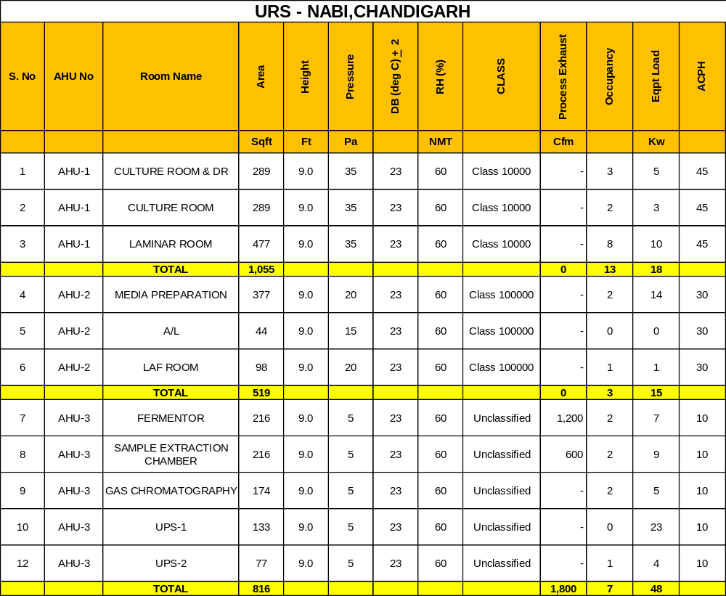

B) BASIS OF DESIGN

Air Conditioning
- General

  - Objective

Objective of air conditioning is to provide air conditioning to all areas of the floor as per URS in cost effective manner. Temperature, Classification, Pressure & Indoor Air Quality shall be maintained in accordance with parameters as specified in Basis of Design.

Refrigerant from condensing units shall be led to air handling units through insulated copper refrigerant piping. It is proposed to install fire dampers in return/supply air line to effect total fire safety for the building & for the occupants. Plant shall be provided with complete distribution system including ductwork, terminal boxes, grilles/diffusers in interior areas.

- The design approach shall be sensitive to environmental issues. The main thrust shall be laid on energy conservation, safety ease of maintenance and current progressive technological developments. Few of the important issues considered in our design are mentioned below:

- Individual condensing units for each AHUs so that unoccupied room can be put to switch off mode.
- Air handling units should have energy efficient motors.
- Adequate fresh air quality shall be provided to air conditioned spaces to maintain good indoor air quality (IAQ).

  - Basis Of Design

Location: Chandigarh

1.2.2 Outdoor Design Condition
Outdoor design data of Chandigarh for heat load calculation purpose as mentioned below:
DBT (Deg C) WBT (Deg C) Rh (%)
Summer 110 75 20
Monsoon 95 80 52
Winter 45 41 70

1.2.3 Indoor Design Condition
Comfort Condition Areas As per URS
Classified Areas As per URS

2.0 Fresh Air
All Classified areas are being designed with minimum 2 ACPH & fresh air is considered as 1 ACPH for all comfort areas.
3.0 Lighting Load:
*1.5 W/Sq Ft
4.0 Equipment Load:
70% of the total room load as provided in equipment detail sheet is considered as an effective load for heat load calculation purpose.
5.0 Occupancy
As per detail mentioned in URS.
- Assumption:

- All Classified areas shall be provided with 80mm thick PUF paneling for partition & ceiling.
- All classified areas shall have 2mm thick epoxy flooring as per Clean Room Standard and balance all other areas shall be provided with normal flooring.
- All exposed/partition walls shall be of 225mm thick brick wall with 10mm thick sand cement plaster on both sides.
- All doors shall be of standard dimension – 900 x 2100mm.
- All doors shall have uniform gap of 3mm all around.
- 3 number of fume hoods of 600 CFM each shall be located in Fermentor & Sample Extraction Area.
- UPS 1 room shall have 150 KVA inverter of which 8% is assumed as heat dissipation in room.
- Glass considered for heat load purpose is normal glass having 5mm thickness.
- Floor above this area is non air conditioned.
- All cabinets inside the Analytical Lab are not closed.
- Fermentor & Sample Extraction Labs shall have double skin wall panel .

  - Design Parameters:
    - Design parameters for selection of Air Handling Units & its components shall be:

Maximum face velocity across filters - 500 FPM

Maximum face velocity across cooling coil - 500 FPM

Maximum outlet velocity at AHU - 2000 FPM

    - Design parameters for duct design shall be:

Maximum flow velocity for air conditioned areas - 1500 FPM

Maximum flow velocity for ventilation areas - 2000 FPM

Maximum velocity at grille/diffuser outlet - 600 FPM

Maximum velocity at Terminal HEPA outlet - 250 FPM
7.0 Total Load
Air conditioning load - 79 TR
- Classified Area - 28 TR
- Unclassified Area - 51 TR
Note: Air conditioning work for comfort area other than Sample Extraction, Fermenter, Gas Chromotography, UPS 1 & 2 and Web & e-mail server room shall not be a part of this contract.
The cooling loads are only approximate & detailed cooling load calculations shall be carried out by HVAC contractor after award of contract.
8.0 Condensing Unit:
The system shall consist of individual condensing unit for each air handling unit located near the AHUs on terrace.

9.0 Common Features of Air Handling Units Catering to Different Areas:
The main features of Air Handling Units catering to areas are as follows:
- Dedicated double skin AHUs with thermal break profile is provided.
- AHUs shall have backward curved supply air fan.
- Cooling coil is provided to offset the outdoor air heat & for necessary dehumidification required.
- Fresh air & return air is filtered through G4 filters installed in mixing box chamber, followed by fine filters located at supply side of AHUs to reduce the load on terminally mounted HEPA filters in classified areas.
- Return air is picked up through return air risers to provide vertical airflow pattern.
- The system will be capable of maintaining differential pressure automatically in addition to temperature & Rh conditions through proposed HVAC system.
10.0 Special Features of Proposed HVAC System:
- We propose to install SS perforated grille in clean areas. This will provide good mixing of air in clean rooms.
- Dampers are proposed in return air duct to have better control over room differential pressure.
- All AHUs are provided with their separate condensing units for power conservation.

C) CLEAN ROOM SUMMARY:

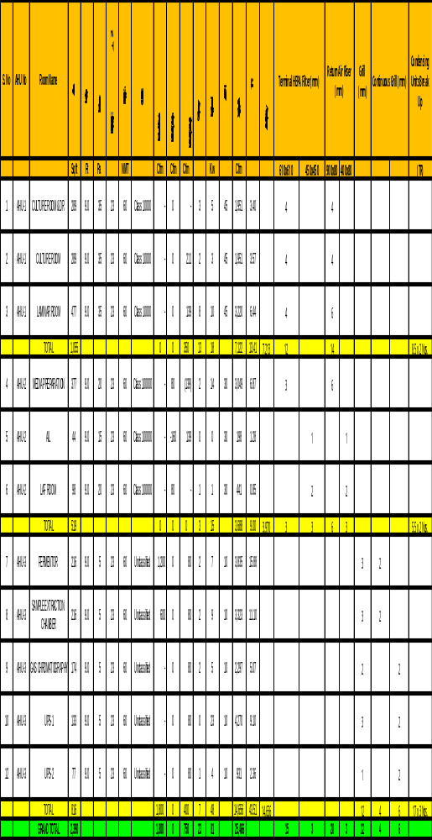

BRIEF SUMMARY OF SCOPE OF TENDER / JOB

Supply of air-cooled condensing units with microprocessor controls and Air handling units. Interconnecting piping, all ducting, Terminal boxes with HEPA filters of 99.97% efficiency, clean room finishes- comprising of metallic sandwich wall panels, ceiling panels, covings, vinyl flooring and wall and ceiling finishes for non clean zones. Accessories such as Garment cubicles, laminar air flow workstation, Cross over bench. Controls, control panel and automation for un- attended running of the total system.

LOADS

Based on the design parameters the peak air-conditioning load works out to 18 TR for Clean Room areas, 47 TR for non clean room areas with AHUs and 24 TR for comfort area with existing VRV system. Considering the above HVAC contractor shall install dedicated condensing unit for each AHU with minimum of 50% capacity as spare separately.

SUPPLIES

- Double skin Air-handling unit is required for the laboratories/Clean rooms (ISO 7 and 8) and for other non clean room areas.

- Air handling units for all the areas will be complete with supply air fans.

- Floor mounted double skin air handling units for Labs. Such air handling unit(s) will have a casing thickness of 25 mm with 24 G G.I pre coated outer sheet & 24 G G.I plain inner sheet. All air handling units are proposed with stainless steel drain tray. Fine filter plenums also form a part of the unit. The detailed specs are as per enclosure. Air handling units are modular and compact in construction and have low noise level. The air handling unit is proposed based on the zoning, cleanliness levels, inside conditions and duration of operation. Supply air will be taken to the various areas by means of GSS ducting duly insulated and distributed by diffusers/HEPA terminal boxes. Exhaust/return air is collected by means of concealed return air raisers, return air diffusers/grills, local exhaust of fume hoods shall be as per specs given separately. All ducts supply/return shall be insulated for conditioned areas.

- Supply and return air ducts for the clean room & non clean room areas are of G.S.S construction. Terminal HEPA filters are provided for the ISO 7 & ISO 8 rooms.

- The air cooled condensing units are proposed for individual AHUs.

- The ducting will run above the false ceiling and distribution is by means of diffusers/grilles/terminal boxes.

- Special mention is made about the flame spread / oxygen level index of various materials and equipments and only the materials and equipments strictly conforming to the same are to be used.

- Electrical work for motor control centre, control panels for various HVAC equipments such as AHUs, Condensing Units, inter connected cabling is included in the scope of the air-conditioning package. The main incomer from transformer to isolator switch in the plant room will be provided by the user.

- Civil works such as construction of plant room, AHU room, cutouts, foundation for mounting AHUs, roof shed over the AHU/condensing unit for protection from rain water will be organized through other agencies by user. The required marking, drawings are to be provided by the air-conditioning contractor well on time.

- Air conditioning ducts are to be insulated with closed cell cross linked polyethylene foam.

HEATING VENTILATION & AIR CONDITIONING WORK

AIR COOLED CONDENSING UNIT

1. General

Unit shall be air cooled Heat Pump type, Variable refrigerant volume/Flow air conditioner consisting of outdoor units and multiple indoor units, each suitable to cool in summer/ winter as per the requirements.

1.2 The refrigerant piping shall be extendable up to 200m with 50m level difference without any oil traps.

- Outdoor Unit

  - The outdoor unit shall be a factory assembled unit housed in a sturdy weather proof
Casing constructed form rust-proofed mild steel panels coated with a baked enamel finish. The ODU must deliver 100% cooling capacity at 41 Deg C ambient Temperature.

    - The outdoor unit shall have multiple scroll compressors and be able to operate even in case of breakdown of one of compressors.

    - The connectable range of indoor units shall be from 0.6 TR with all outdoor units.

    - The noise level shall not be more than 68 dB(A)at normal operation measured horizontally 1m away and 1.5m above ground.

2.2 The outdoor unit shall be modular in design and shall be allowed for side by side installation.

3. Compressor

The compressor shall be of Inverter type capable of modulating capacity by frequency variation / highly efficient hermetic Digital Vapor Injection Scroll capable of capacity modulation by time averaging method & Vapor injection Technology. Each ODU should have minimum 1 no. variable compressor up to 16 HP capacity, 2 nos. variable compressors up to 32 HP capacities, 3 nos. Variable compressor up to 48 HP capacities & 4 nos. variable compressor up to 64 HP capacity.

4. Heat Exchanger

4.1 The heat exchanger shall be constructed with copper tubes mechanically bonded to aluminum fins to form a cross fin coil. The aluminum fins shall be covered by anti-corrosion resin film. The System must have sub-cooling heat exchanger further to Condenser to increase refrigerating effect in Indoor units. The Condenser fins must be coated with Anti-corrosive treatment.

5. Refrigerant Circuit

  - The refrigerant circuit shall include an accumulator, liquid and gas shut off valves and a solenoid valves or pulse width modulation valve.

  - All necessary safety devices shall be provided to ensure the safety operation of the system.

6. Safety Devices

6.1 The following safety devices shall be part of the outdoor unit:

High Pressure Switch, Low Pressure Switch, Fan Motor Safety Thermostat, Over Current Relay, Fusible Plugs, Fuses.

7. Oil Recovery System

7.1 Each unit shall be equipped, with an oil separator to ensure stable operation with long refrigerant piping.

FLOOR MOUNTED AIR HANDLING UNITS

The AHUs will be in conformity to the latest manufacturing guidelines and in conformity to ASHRAE standards.

General Description of Air Handling Unit

The scope of this article comprises of the design, manufacture, testing at manufacturers works, installation, testing and commissioning of Air Handling Units. The schedule of equipment, packaged modular Air Handling Units of Horizontal or Double Decker Type as required, each capable of the duty as specified in the schedule of equipment.

Codes & Standards

The design, manufacture, inspection testing of AHU shall comply with all currently applicable statures, regulation, and safety codes in the locality where the AHUs are to be installed. The equipment shall also conform to the latest applicable Indian/International Standards i.e. ARI/CEN Certified. Nothing in this specification shall be constructed to relieve the Contractor of his responsibility.

Type:

The Air Handling Units shall be in double skin construction with 25mm thick PUF insulation profile comprising of various section described below sequentially in the direction of airflow.

- Mixing Section for return & fresh air with manually operated volume control damper having extended shaft suitable for motorized operation in case of future requirement.
- Fresh air damper should be provided with HDPE insect mesh along with VCD.
- Pre Filter section.
- Multi row deep cooling coil section with insulated SS drain pan.
- Fan section with belt driven centrifugal DIDW Backward / Forward curved fans complete with fan motor base frame, slide rail for motor, belt drive arrangement.
- Fine filter section as per BOQ (if required).
- Wing nut should be used for fixing of filters.

Housing /Casing construction:

The unit casing construction shall have double skin to allow access without damaging the installation. The frame work shall be of extruded aluminum hollow sections of 2.5 mm thick. The frame shall be assembled using nylon type corner profile joints to make a study, strong and self supporting frame work for various sections. The whole unit shall comprise of galvanized sheet double skin casing with 25 mm thick PUF insulation of density 38+/-2 kg / m3.

Double skin panels shall be 25mm thick fabricated out of best quality pre-coated 24 G GI on outer side and 24 G plane Galvanized sheet to inner side with PUF insulation injected in between. Polyurethane foam of density not less than 38+/-2 Kg/M3 shall be sandwich between inner and outer sheet. The panels shall be fixed on thermal break profile in such a manner that fixing screw head does not project on outer face on the panel and sharp end of the screw does not project inside the unit through double walled rib.

Drain tray will be fabricated out of 18 G stainless Steel 304 Sheet with necessary slope to facilitate faster removal of condensate. The tray shall have sufficient depth and proper size drain connection. The tray will be insulated from outside with closed cell / PUF sheet having thickness not less than 10mm. Gasket sleeves at coil header outlet shall be provided to avoid any obstruction at time of coil removal.
Motor and drive
Fan motors shall be 415 +/- 10% voltage, 50 cycles, 3 Phase squirrel cage, totally enclosed fan cooled with IP-55 protection. Motor shall be specially designed for quite operation.
Drive to fan shall be provided through belt-drive arrangement. Belt shall be of the oil-resistant type. AHUs serving flame proof areas will have flame proof motors.
Fan
The fan shall be backward curved, double inlet double width type. The wheel and housing shall be fabricated from heavy gauge galvanized steel. The fan impeller shall be mounted on a solid shaft supporting to its scroll on angle iron flame and pillow block heavy duty ball bearings.

The impeller and fan shaft shall be statically and dynamically balanced. The fan outlet velocity should be kept minimum. Fan housing with motor shall be mounted on a common steel base mounted inside the air handling unit housing on anti vibration springs, mounts or cushy foot mounts.

Blower section will consists of extruded sections of proper size to facilitate the mounting of fan and motor bracket. Direct contact of fan base frame and AHU casing will be eliminated through vibration isolator. Also flexible connection will be provided at the fan outlet. Suitable panel of blower section will be provided with hole for cable entry with required arrangement to cover the sharp edge GI Sheet. If required a proper size box cover will be provided on cable entry location. A provision for earthing will be provided to main frame near the cable entry hole.

Cooling Coils

DX type coils shall have 12.5mm dia tubes minimum 24 G thick with aluminium fins firmly bonded to copper tubes assembled in zinc coated steel frame. Face and surface areas should ensure rated capacity from each unit and be such that air velocity across each should not exceed 2.54 Meters/sec. The coil shall be pitched in the unit casing for proper drainage. Each unit shall be factory tested at 21 kg per sqm air pressure under water. Tube shall be hydraulically/mechanically expanded for minimum thermal contact resistance with Fins. Fin spacing shall be 11 to 13 fins per inch [4 to 5 fins per cm]

Filters

Each unit shall be provided with a Filter Section shall have rigid construction filter frame fabricated out of GI Sheet to house required size filters.

Accessories

Inspection doors at required location will be provided with elegant design hinges made out nylon. Two or more number of hinges per door will be provided depending upon the size of the door to provide required rigidity to the door panel. One or more number of door handles will be provided with cam type tightening arrangement. The handle and can will be made out of files nylon having galvanized iron spindle. The inspection door for blower section will be provided at such a location that the motor and drive package and fan bearing can be assessed for easy maintenance. The inspection doors of the sections accommodating filters will be of sufficient size to take care of filter removal.

The entire AHU assembly will be mounted on a common skid fabricated out of 16 G / 18G GI Channel of 100 mm x 50 mm size. The skid will be secured with AHU Frame structure through threaded fasteners.

All nut bolts, sheet metal screws, fasteners will be Zinc/Nickel plated having resistance against rusting. Each air handling unit shall be installed on neoprene rubber pads or isolation springs.

Safety Features:
Each Air Handling Unit shall have safety features as under:-

- The fan access door shall be equipped with micro switch interlocked with fan motor to enable switching off of the fan motor automatically in the event of door opening.

- Fan and motor base shall be properly earthed from the factory.

- Light inside the AHU interlocked with door switch.

Performance Data:

Air handling units shall be selected for the lowest operating noise level of the equipment. Fan performance rating and power consumption data with operating points clearly indicated shall be submitted and verified at the time of testing and commissioning of the installation.

Testing:

Cooling/heating capacity of the various Air Handling Unit models shall be computed from the measurements of airflow and dry and wet bulb temperatures of air entering and leaving the coil. Flow measurements shall be by Anemometer and temperature measurements by accurately calibrated mercury in glass thermometers. Computed results shall conform to these specified capacities and quoted ratings. Power consumption shall be computed from measurement of incoming voltage and input current. The AHU shall be tested in accordance with DW 142/AMCA 210.

SUPPLY AIR AND HEPA PLENUMS

Air plenums shall be of GSS construction housing fabricated out of 1.2mm thick outer sheet duly powder coated. The plenum/box shall be provided with suitable air tight arrangement for mounting the HEPA filter from the room side. The Volume control will be provided through the housing extending to the room side, for ease of air and pressure balancing. The plenum shall be hung from the ceiling using factory made supports.

DAMPERS

Dampers shall be of opposed blade type for throttling and parallel acting blades for isolation. Multiple units working in tandem shall be provided with outlet dampers. Suitable links, levers and quadrants shall be provided for proper operation, control and setting of the dampers. Every damper shall have indicating device clearly showing the damper positions at all times. The casing the leaves of the dampers shall be of GSS duly powder coated. The dampers for exhaust shall be provided with limit switch for monitoring the open/close position through automation system, if opted for.

The outlet Dampers at the AHU’s will be motorized for shutting off, on receipt of signal from the fire detection system.

FILTERS

FINE FILTERS

The fine filters shall have Non-woven felt of polypropylene medium in the form of a fabric. The separators shall be of tubular aluminium supports. The filter casing shall of CRCA sheet with expanded polyethylene gaskets. The collection efficiency shall be 90-92% down to 5 microns by particle count down method. Fine filters shall be installed on / Aluminium powder coated frame work as mentioned in the drawings/schedules. Test certificates shall be provided for the filters.

HEPA FILTERS

HEPA filters shall be of micro media type having a minimum efficiency of 99.97% particles of size down to 0.3 micron by DOP method. The filter shall be mounted on aluminum frame work. The tenderer shall furnish a test certificate.

ELECTRICAL CONTROL PANEL

The motor and switchgears required for various items shall generally be as as per specifications given below all electric motors shall be suitable for 3 Phase, 50 cycles, 415 volts A.C. supply +/- 10%.

- Starters upto 7.5 kW shall be DOL type & above 7.5 kW shall be Star-Delta type.
- Cabling for electrical supply from floor mounted electrical panel to respective AHUs/Condensing Units/Dehumidifier shall be aluminium armoured.
- Termination of cable at AHU/VU motors and at electrical panel shall be in scope of HVAC contractor. However, termination of incoming cable at electrical panel shall be provided by other agency hired for electrical work.
- Copper lugs should be used for cable termination.
- Bus bar for incoming should be of Aluminium.

DUCTING

Ducts shall be made with galvanized steel sheet. The galvanized steel sheet shall confirm to IS: 277-1965. G.I sheet used for ducting shall be of 120 GSM quality. Further note that 0.63mm G.I duct in comfort areas can be provided G.I flanges. The duct construction shall be as follows:

Rectangular Duct Construction

Max. SIDE (mm) Thickness Type of Joint GSS Sheet Bracing

Upto 750 24 G 25x25x3mm MS Angle None
Flange

751 to 1500 22 G 25x25x3mm MS Angle 25mmx3mm
Flange upto 1000mm & MS Angle
40x40x3mm upto 1500mm

1501 to 2250 20 G 40x40x5mm MS angle 40mmx3mm
Flange MS angle

2251 & above 18 G 50x50x5mm MS 40mmx3mm MS
Angle Flange MS angle

Hangers for Duct

Duct Size Spacing Size of Rod Dia
(mm) (m) (mm)

Upto 750 2.5 8
751 to 1500 2.5 10
1501 to 2250 2.5 10

Note:

- All ducts shall have angle iron flanges.
- Ducting for classified areas shall be provided food grade sealant to avoid air loss from joints.
INSULATION
Technical Specifications of Closed Cell, Chemically Cross-Linked Polyethlene (XLPE) Insulation

- The Insulation Material for Ducts and Pipe Shall Be Closed Cell Cross-Linked Polyethlene Foam.

- The Thermal Conductivity of the Material Shall Not Exceed .036 W/Mk at an average temperature Of 40⁰ c.

- The Product shall have bending trial and dimensional stability as per Din 51949 and Din 53431 for an operating range of – 40⁰c to + 110⁰c.

- The density of the material shall be 30 +/- 3 Kg/M³ or .030gm/Cc.

- The material shall be rated as Class 1, as per Bs 476 Part 7. The rating as per Din 4102 shall be B1.

- The Smoke Density of the material as per As-1530.3 shall not exceed 1.

- The water vapor permeability as per Din 52615 shall not exceed 0.15ng/M.Sec.Pa

- The material shall have a fire approval from CBRI/Fire Advisor (Govt of India)/Chief Fire Officer.

For providing UV protection on exposed ducting the insulation shall be cladded with minimum 30 micron aluminum PE foil. The cladding shall be factory finished to avoid site work. The minimum thickness will be as per specs. The insulation material will be provided with self adhesive covered peel off paper, (as an alternative)

Application

The duct/pipe surfaces will be thoroughly cleaned prior to applying the insulation to avoid application of adhesive in the field the insulation shall be provided with self adhesive, otherwise the adhesive of suitable grade shall be uniformly applied on the insulation and cured, before sticking to the duct. The insulation can be wrapped around the duct as one piece, where size does not permit the same be cut to exact width/height of duct.

The duct /pipe insulation joints will be overlapped with a self adhesive tape of the same material. The tape shall be minimum 2.5mm thick and 50 mm wide.

A self adhesive strip of same material, of suitable thickness (height), to cover the complete height of the flange will be provided around the flanges and the flange joint neatly covered with insulation, so as to reduce heat loss through flanges in addition to covering the flange connection/joint.

For pipe insulation the material should be cut using a die /template to be provided by the manufacturer to ensure proper 45⁰ angle is cut and the joining/overlapping of the insulation does not cause any bulging or stretching.

CLEAN ROOM & CIVIL FINISHESFALSE CEILING

The area / Lab is required to be designed to maintain a clean zone, it is therefore imperative to maintain / build internals which are non shedding and non dusting. This internal fabric or room envelope is critical. The object is to separate the clean room from the less clean space above and side the room. Hence, a false ceiling and partition panel is used for the purpose.

The False Ceiling can be any material that does not produce or collect dust and is easily cleaned, since there’s no danger from impaction by foreign objects.

Brief specifications of the Non walk on false ceiling system will be as under:

Non Walkable False Ceiling GSS pre coated of 0.5 mm thickness on room side, with 100 mm thick EPS insulation of 18 kg density, the panel width will be 1.18m with length to suit the clean room requirement including hanging arrangement as per IS standard of false ceiling, all cutouts for light and filters and ceiling with silicon sealant after fitment. The cut outs will flash with inverted C channels

Suspension Rod: GI of 6/8 mm diameter (as required)

Support on: Wall and Ceiling suspension

Sheet thickness: 0.5mm pre coated architectural polyester paint, on the clean room side, and of similar thickness hot dip galvanized with zinc coating on the ceiling side.

Light Fixtures: Cutout to be Included with proper flashing and sealing

Number of cutouts: As required

Terminal filters: Cutout to be Included with proper sealing

Insulation: EPS

Load Bearing: Not applicable

Sealant: Silicon

Standard width x Length: 1118 x maximum of 6000mm

WALL PANELING SYSTEM

The Wall Paneling shall be from material that does not produce or collect dust and is easily cleaned, since there’s no danger from impaction by foreign objects.

Wall Paneling system should be, in line and sympathy to the ceiling system and shall be GSS pre coated of 0.5mm thickness on both side, with 100 mm thick EPS insulation of 16-18 kg density, the panel width will be 1.18m with length to suit the clean room height. All joints shall be sealed with silicon sealant after fitment. The panels shall have in built return air raisers for extracting room air. The quantity of the raiser to be estimated by the contractor keeping in mind the return air velocities. The paneling system shall provide flush finish on clean room side.

The paneling will be provided with view panels. On the civil side, the view panels to match the windows existing in the civil structure. Suitable provision to be kept for closing /providing sleeve for taking in the utility piping. (Utility piping is not in the scope of clean room contractor)

PUF panel of 100mm thickness will be faced with 0.5 mm thick color coated Galvanized sheet on both sides.

The Galvanized steel sheet facing shall have light cutting grooves. These will improve the general appearance along with imparting considerable strength to the panels. The sheets shall be hot-dip galvanized.

INSULATION MATERIAL:

The insulation material shall be CFC free PUF with CLOSED CELL CONTENT of 90% to 95% minimum. This foam is injected using high-pressure equipment in a precise ratio and proportion and autohessively laminated. The density of foam shall be 40 ± 2 kg/m³, with thermal conductivity [K of 0.023 W/m deg K (AGED)] and dimensional stability over the temperature range of minus 60º C to 100ºC.
. The panel system has been satisfactorily type tested for the under mentioned fire properties:-

- Self extinguishing as per IS:11239
- Conforms to class -I surface spread of flame as per BS: 476 part 7
- Conforms to classified as “Not Easily Ignitable” as per BS 476 part 5.

To facilitate easy and systematic assembly/disassembly, the panels to panel jointing system shall be CAMLOCK. The constructional details shall be as under:

WALL AND CEILING PUF PANELS:

- PUF insulation core thickness : 100mm
- Density : 40 + 2 Kg/M³
- Surface spread of flam : Class I to BS:476 Pt.7
- Ignitability : To BS: 476 Part.5 “not easily ignitable”
- Flammability : To IS:11239 “self extinguishing”
- Environmental acceptance : Environment friendly “CFC Free”
- Outer Skin [Body Sheet] : 0.5 mm GI Colour coated Galvanized sheet
- Inner Skin [Body Sheet] : 0.5 mm GI Colour coated Galvanized sheet
- Jointing [Panel to Panel] : Tongue Groove configuration with CAMLOCK arrangement.

EPOXY FLOORING

Self Leveling Type Epoxy flooring upto 2 mm thick over leveled surface and smoothened with primer before laying of epoxy. Following shall be the properties of the epoxy paint system. Flooring shall be scratch proof and resistant to common lab solvents and chemicals. The flooring shall provide seamless finish.

High Build High Solid Product (Sr 1 & 2 ) | 98% Solid Content
Warranty | Yes
Temperature Resistance | Tolerant up to 70 Deg Cent Intermediate
Chemical Resistance  Sr No -1 | Noah , HNo3, MEK Etc ( Sr No-1)
Abrasion Resistance | 15 mg loss per 1000 cycles
 | (1kg load using CS17 wheels)
 | BS 8204:Part 2 Class AR3
Slip Resistance | TRRL Pendulum Slip Test
 | Dry 70 Wet 40
Surface Hardness | 182 secs. Koenig Hardness Test
Solvent Free | Yes
Less Odour | Yes
Bond Strength | Greater than cohesive strength of
 | 25N/mm2 concrete. >1.5 MPa
Temp during application | 20-45 Deg Cent
Permissible Moisture during application | 10-40% Humidity
Glossy / Matt | Yes
Load Strength | 1.5 Tons

COVING

The wall to ceiling and wall to wall coving must have a radius of 50 mm made of PVC with snap in type arrangement.

The wall to floor coving shall be with epoxy screed and duly painted. This shall also be R50.

DOORS:

44 mm thick doors flush on one side made of:
- MS powder coated door frames totally flushed with the wall panels
- Concealed hardware for fixing the door frames.
- In fill of Expanded Polystyrene is used to give the effective acoustic and thermal insulation.
- Stainless steel double bearing butt hinges as per BS 7352 CLASS 9.
- Mortise sash locks with lever handles.

LIGHTS:

Clean room light fittings of size 2’x2’
- Fitting shall be with opal acrylic cover with powder coated aluminium grid to provide flush finish from clean room side.
- Lights shall be clean room side serviceable type.
- Luminaire shall be 3x36W CFL.

VIEW PANELS:

View panels of size 900x900 mm shall be provided in wall panels
- View panels glass shall be at least 5 mm thick.
- View panels shall be fixed flush to both faces of wall panels.
- No crevices / joints/sloped profiles are used for fixing the glass to avoid particle contamination and dust accumulation.

CLEAN ROOM ACCESSORIES

GARMENT CUBICLE

This shall be used to store clean room garments. Brief specifications shall be as under:

- Size (Outside) :1050 x 775 x 2400mm (Approx)

- Cabinet : MS CRCA construction. Powder Coated/
Stove enamel painted. Color White.

- Motor : 1 No Single Phase, 220 V AC.

- Impellor : Extruded Aluminum, Dynamically & Statically Balanced

- HEPA Filter : 1 No 99.97% Efficiency down to 0.3 Micron, Anodized Aluminum Housing with Aluminum separators & micro fiber glass media.

- Pre Filters : 1 No 90% Efficiency, Washable.

- Protection Grill : M.S. Perforated Sheet Powder Coated White.

- Doors : Sliding, Aluminum frame with Glass in Aluminium
channels.

- Movement : Castor Wheels with leveling bolts

- Lighting : UV Germicidal Light

- Manometer/ Magnehelic : 1 no.

- Power Requirements : Single Phase 220 V AC

PASS BOX / MATERIAL TRANSFER HATCH

Pass Box/ Material Transfer Hatch is installed at the interface of clean and non-clean zone and is used for material movement. The unit is available as floor mounting or wall/ window mounting.

Features:

Static Pass Box

- Wall mounting type
- Door interlocking system.
- Audio visual indication for door operations
- Illumination-diffused fluorescent tubes.
- Doors with view panels –clear acrylic
- Construction: Powder coated CRCA
- Doors: Powder coated CRCA.
- Base / Platform: Powder coated CRCA/ SS 304.
- Interlocking: Electronic type pre- wired unit with interlocking for
doors and alarm circuit

Dynamic Pass box

- Similar to Static Pass box type except that it has clean Air flow ( HEPA Filtered ) as well interlocked with door opening.

AIR SHOWER

Air Shower is a completely enclosed cubicle and has interlocked doors. This is to give a person a total air wash after he has donned clean room garments. Usual location of Air Shower is just prior to entry into the Clean Room(s).

The Air Shower comprises of a set of Pre-filters through which all air is sucked in and then passes through a set of Pre-filters and then HEPA Filters before it is forced onto the personnel standing inside.

The person gets the air through a set of nozzles from two sides and the top. To maintain the effectiveness of the unit the Air Shower has 2 separate blowers on each side.

- Size (Outside) :1600 x 1650 x 2400mm (Approx)

- Cabinet : Made of SS 304

- Motor : 2 No Three Phase AC.

- HEPA Filter : 2 No 99.97% Efficiency down to 0.3 Micron, Anodized Aluminum Housing with Aluminum separators & micro fiber glass media.

- Pre Filters : 2 No 90% Efficiency, Washable.

- Protection Grill : SS 304 Perforated Sheet

- Doors : Hinged type, Aluminum frame with Glass in
aluminium channel
8. Movement : Castor Wheels with leveling bolts.

SECTION - XII
DRAWINGS

AHU ZONING DRAWING

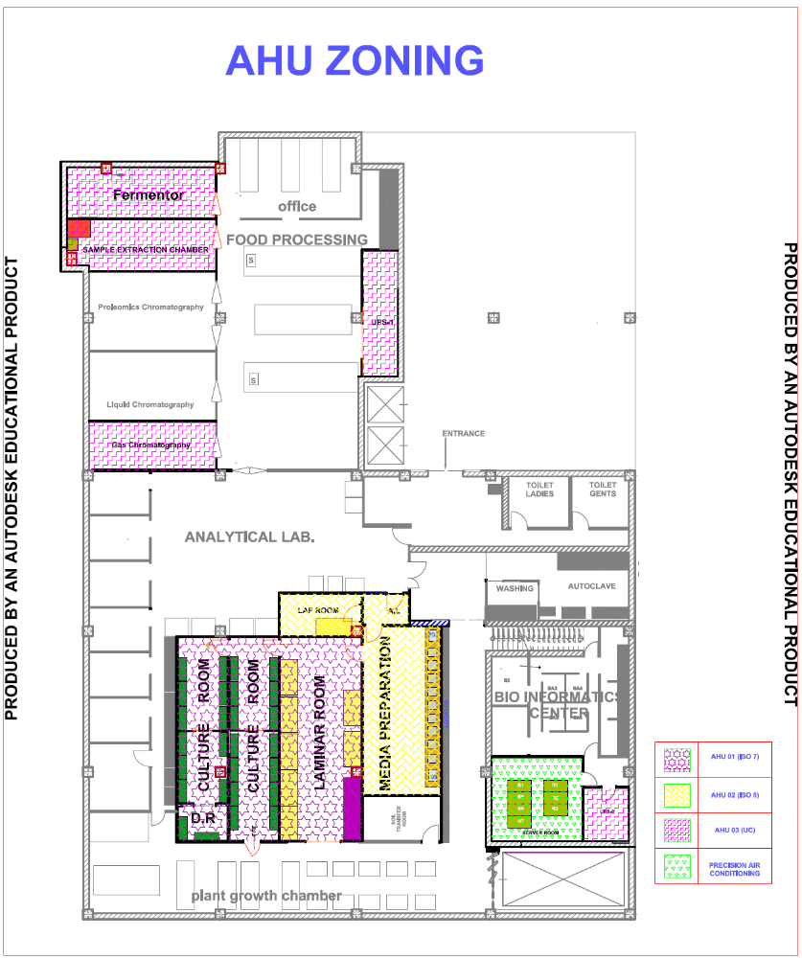

DUCTING LAYOUT
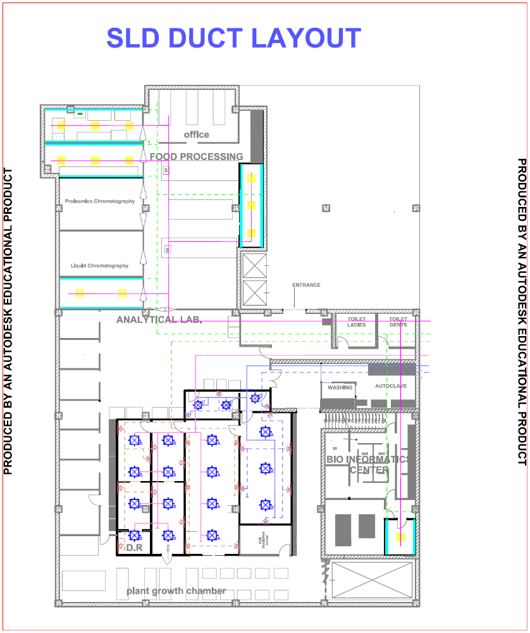

PRESSURE ZONING
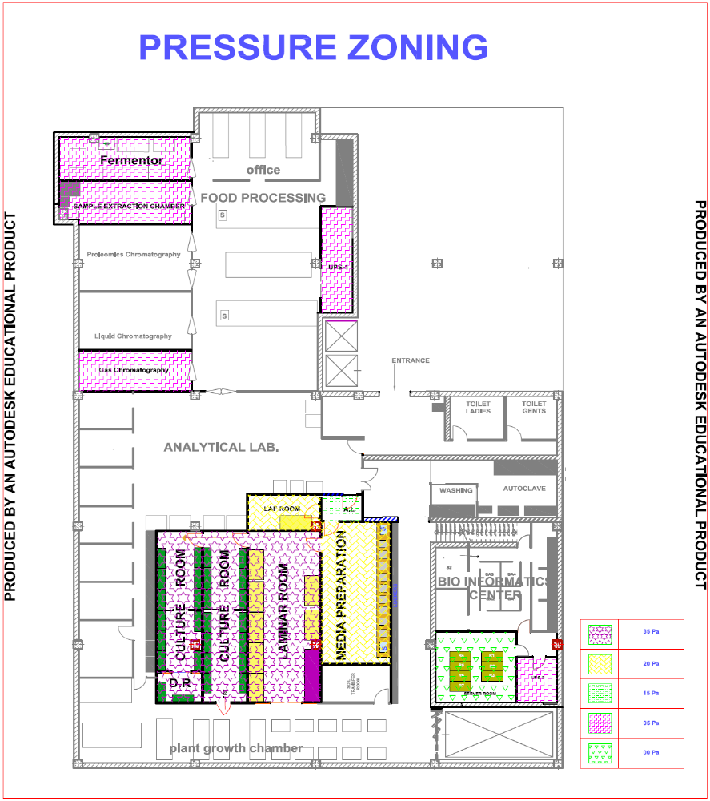

REFLECTED CEILING PLAN
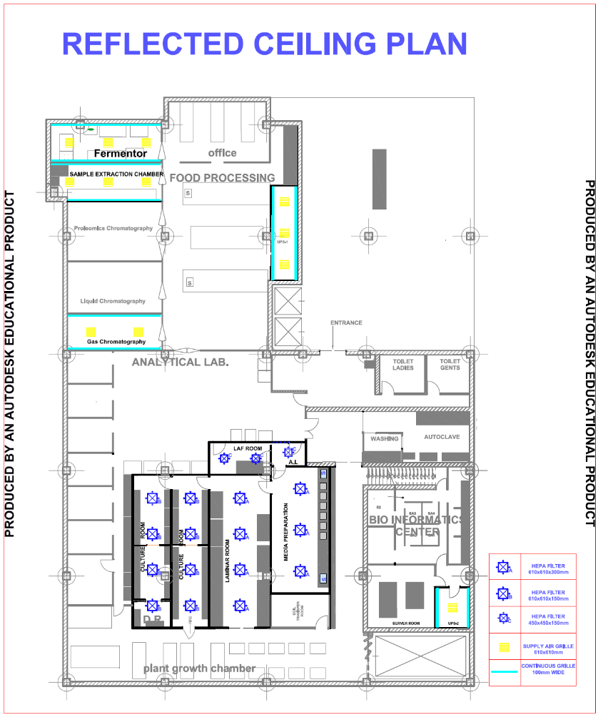

AHU-01
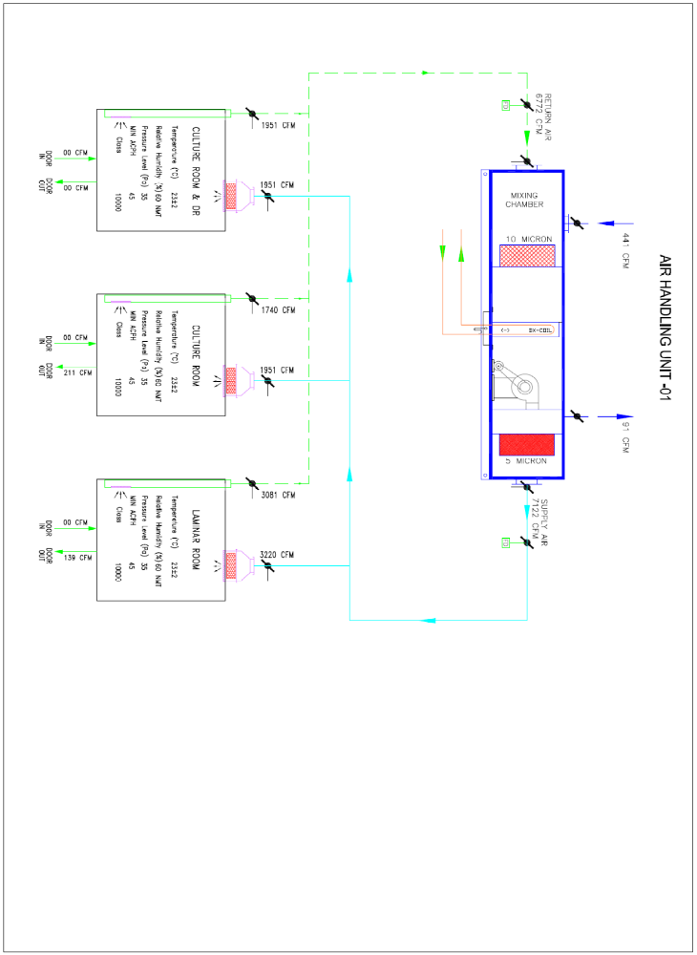
AHU-02
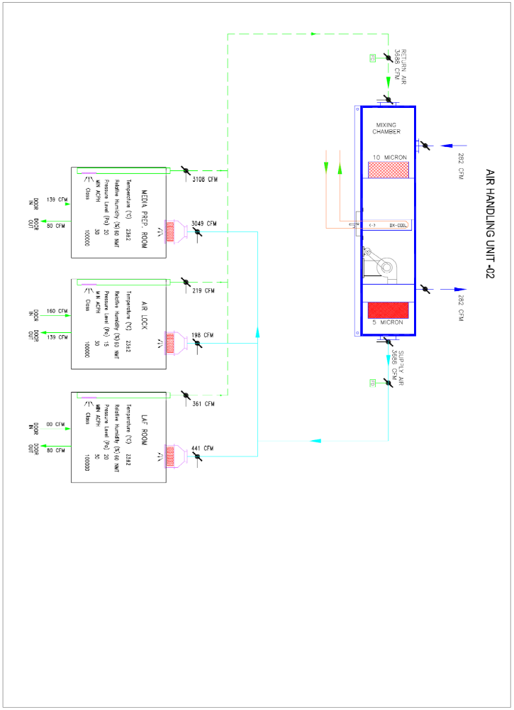
AHU-03
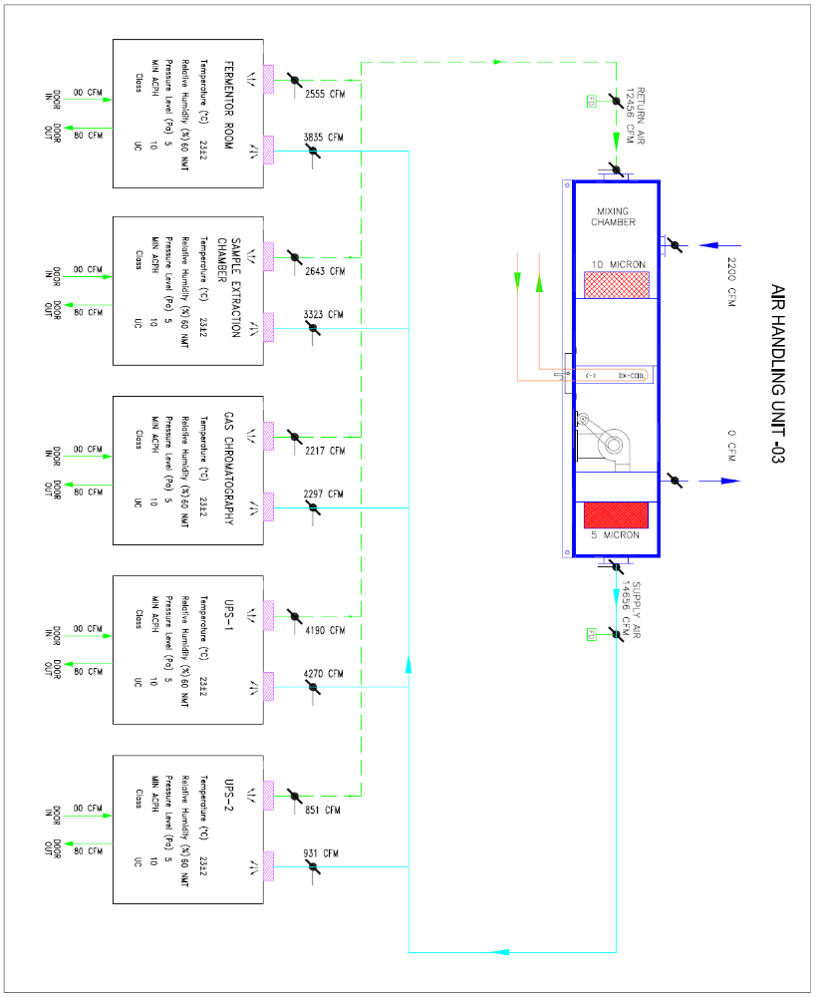

SECTION – XIII (Not Applicable )
BANK GUARANTEE FORMAT FOR EMD

Whereas ……………………………… ………………………………… . . . (Hereinafter called “the tenderer”) has submitted their offer dated …………….. .for the supply of …………………………………………… (Hereinafter called “the tender”) against the Owner’s tender enquiry No. _________________________________
KNOW ALL MEN by these presents that WE …………………………………………… . . .. . . . . . .. (Name of bank) of ……………………….. …………… (Name of country), having our registered office at ………………………………………………………………….. . . . . . . . . . . . . . . . . . . . (Address of bank) (Hereinafter called the “Bank”), are bound unto … …… ……………………………………………… … (Name of Owner) (Hereinafter called “the Owner”) in the sum of ……….. …………….. .. for which payment will and truly to be made to the said Owner, the Bank binds itself, its successors, and assigns by these presents. Sealed with the Common Seal of the said Bank this ……. day of..…….. 20…….

THE CONDITIONS of THESE OBLIGATIONS are:

      - If the tenderer withdraws or amends, impairs or derogates from the tender in any respect within the period of validity of this tender.
      - If the tenderer having been notified of the acceptance of his tender by the Owner during the period of its validity.
      - If the tenderer fails to furnish the Performance Security for the due Performance of the contract.
      - Fails or refuses to accept/execute the contract.

WE undertake to pay the Owner up to the above amount upon receipt of its first written demand, without the Owner having to substantiate its demand, provided that in its demand the Purchase will note that the amount claimed by it is due to it, owing to the occurrence of one or both of the two conditions, specifying the occurred condition or conditions.

The guarantee should remain in force up to and including forty five (45) days after the period of the bid validity, and any demand in respect thereof should reach the Bank not later than the above date.

…….……………………
(Signature of the authorized officer of the Bank)

Name and Designation of the Officer
Seal, Name & Address of the Bank and address of the branch

SECTION – XIV

MANUFACTURER’S AUTHORIZATION
To

Executive Director,
National Agri-Food Biotechnology Institute,
Mohali, Punjab

Dear Sirs,

Ref.: Your TE document No._______________________, dated________________________

We, _________________________________________________who are proven and reputable manufacturers of ____________________________________(Name and description of the goods offered in the tender) having factories at _________________________________________, hereby authorize Messrs_______________________________________________(Name and Address of the agent) to submit a tender, process the same further and enter into contract with you against your requirement as contained in the above referred TE documents for the above goods manufactured by us.

We further confirm that no supplier or firm or individual other than Messrs_____________________________________(Name and address of the above agent) is authorized to submit a tender, process the same further and enter into a contract with you against your requirement as contained in the above referred TE documents for the above goods manufactured by us.

We also hereby extend our full warranty/CMC as applicable as per clause 15 of the GCC, read with modifications, if any, in the speciall conditions of contract (SCC) for the goods and services offered for supply by above firm against this TE document.

Yours faithfully..

(Signature with date, name and designation)
For and On behalf of Messrs________________
(Name and Address of the manufacturer)

NOTE:
1. The letter of authorization should be on the letterhead of the firm and should be signed by competent/authorized person.

SECTION – XV
BANK GUARANTEE FORMAT FOR PERFORMANCE SECURITY/CMC

To

Executive Director,
National Agri-Food Biotechnology Institute,
Mohali, Punjab

In consideration of Executive Director, National Agri-Food Biotechnology Institute called “NABI” having awarded to M/s ___________________________
_____________________________________________________________ a company registered under the Companies Act 1956 (hereinafter) called the Contractor, a contract for (hereinafter) called the said contract under the terms and conditions of an Agreement dated_____________made between NABI and the Contractor hereinafter called the said agreement and NABI agreed to accept the said agreement and the Contractor as herein provided for Rs.______________________(Rupees_______________________________________________________________only) from a Scheduled Bank towards due performance of the contract by the Contractor as per the terms and conditions of the contract on the condition that the Bank on demand from NABI and without demur pay to NABI the aforesaid amount.

2. We, __________________________________Bank Ltd., (hereinafter referred to as the ‘bank’ do hereby undertake to pay to NABI and amount not exceeding Rs. _______________________ against any loss or damage caused to or suffered or would be caused to or suffered by NABI by reasons of any breach or breaches of any of the terms of conditions of the said agreement by the said contractor.
3. We, ___________________________________Bank Ltd., do hereby undertake to pay the amounts due and payable under this Guarantee without any demur, merely on a demand from NABI by stating the amount claimed is due by way of loss or damage caused to or would be caused to or suffered by NABI for reasons of any breach by the said contractor(s) of any of the terms conditions contained in the said Agreement or by reason of the Contractor(s) failure to perform the said Agreement. Any such demand made on the Bank shall be conclusive as regards the amount due and payable by the Bank under this guarantee. However, our liability under this guarantee shall be restricted to an amount not exceeding Rs._____________________
- This guarantee shall come into force immediately and continue in force and remain valid till six months after the completion of all works under the said contract which according to the terms of the said contract, should be six months from the probable dated of completion viz., the__________________________ day of _______
____________________. If, however, the period of the completion of the works under the said contract is for any reason extended and upon such extension if the Contractor fails, before the terms of this guarantee expires, to furnish a fresh or renewed guarantee for the extended period, the Bank shall pay to NABI the said sum of Rs. _____________________
5. This guarantee shall not be affected by any change in the constitution of the Bank or of the Contractor.
- Notwithstanding anything hereinafter contained, the liability of the Bank under this guarantee is restricted to Rs.________________________ (Rupees___________
__________________________________ only) and the guarantee shall remain in force till ____________________________day of 20_______unless claim or demand under this guarantee is presented to the bank within six months from the date all the rights of NABI under this guarantee shall be forfeited and the Bank shall be released and discharged from all obligations hereunder.

SECTION – XVI
INTEGRITY PACT
(To be printed on Non-judicial stamp paper of Rs.50)

Integrity Pact Between

NATIONAL AGRI-FOOD BIOTECHNOLOGY INSTITUTE (NABI)hereinafter called to as “The Principal”
And
………………………………………………………………………..… hereinafter referred to as “The Bidder/Contractor”

Preamble

The Principal intends to award, under laid down organizational procedures, contract/s for ……………………………………. The Principal values full compliance with all relevant laws of the land, rules, regulations, economic use of resources and of fairness/transparency in its relations with its Bidder(s) and /or Contractor(s).

In order to achieve these goals, the Principal will appoint an Independent External Monitor (IEM), who will monitor the tender process and the execution of the contract for compliance with the principles mentioned above.

Section 1 – Commitments of the Principal

- The Principal commits itself to take all measures necessary to prevent corruption and to observe the following principles:

        - No employee of the Principal, personally or through family members, will in connection with the tender for , or the execution of a contract, demand, take a promise for or accept, for self or third person, any material or immaterial benefit which the person is not legally entitles to.
        - The Principal will, during the tender process treat all Bidder(s) with equity and reason. The Principal will in particular, before and during the tender process, provide to all Bidder(s) the same information and will not provide to any Bidder(s) confidential/additional information through which the Bidder(s)confidential/ additional information through which the Bidder(s) could obtain an advantage in relation to the tender process or the contract execution.
        - The Principal will exclude from the process all known prejudiced persons.

- If the Principal obtains information on the conduct of any of its employees which is a criminal offence under the IPC/PC Act, or if there be a substantive suspicion in this regard, the Principal will inform the chief Vigilance Officer and in addition can initiate disciplinary action.

Section 2 – Commitments of the Bidder(s) / Contractor(s)

- The Bidder(s) /Contractor(s) commit himself to take all measures necessary to prevent corruption. He commits himself to observe the following principles during his participation in the tender process and during the contract execution

A. The Bidder(s)/ Contractor(s) will not, directly or through any other person of form, offer, promise or give to any of the Principal’s employees involved in the tender process or the execution of the contract or to any third person any material or other benefit which he/she is not legally entitled to, in order to obtain in exchange any advantage of any kind whatsoever during the tender process or during the execution of the contract.
B. The Bidder(s)/ Contractor(s) will not enter with other Bidders into any undisclosed agreement or understanding, whether formal or informal. This applies in particular to prices, specifications, certifications, subsidiary contracts, submission or non-submission of bids or any other actions to restrict competitiveness or to introduce cartelization in the bidding process.
C. The Bidder(s)/ Contractor(s) will not commit any offence under the relevant IPC/PC Act; further the Bidder(s)/ Contractor(s) will not use improperly, for purposes of competition or personal gain, or pass on to others, any information or document provided by the Principal as part of the business relationship, regarding plans, technical proposals and business details, including information conta8ined or transmitted electronically.
D. The Bidder(s)/ Contractor(s) of foreign origin shall disclose the name and address of the agents/representatives in /India, if any. Similarly the Bidder(s)/ Contractor(s) of Indian Nationality shall furnish the name and address of the foreign principals, if any. Further details as mentioned in the “guidelines on Indian agents of Foreign Suppliers” shall be disclosed by the Bidder(s)/ Contractor(s). Further, as mentioned in the Guidelines all the payments made to the Indian Agent/representative have to be in Indian Rupees only. Copy of the “Guidelines on Indian Agents of Foreign Supplies” is annexed and marked an Annexure.
E. The Bidder(s)/ Contractor(s) will, when presenting his bid, disclose any and all payments he has made, is committed to or intends to make to agents, brokers or any other intermediaries in connection with the award of the contract.

- The Bidder(s)/ Contractor(s) will not instigate third persons to commit offences outlines above or be an accessory to such offences.

Section 3 – Disqualification from tender process and exclusion from future contracts

If the Bidders(s) / Contractor(s), before award or during execution has committed a transgression through a violation of Section2, above or in any other form such as to put his reliability or credibility in question, the Principal is entitled to disqualify the Bidders(s) / Contractor(s), from the tender process or take action as per the owner’s norms.

Section 4- Compensation for Damages

- If the Principal has disqualified the Bidder(s) from the tender process prior to the award according to Section 3, the Principal is entitles to demand and recover the damages equivalent to Earnest money Deposit/Bid Security.

- If the Principal has terminated the contract according to Section 3 or if the Principal is entitles to terminate the contract according to Section 3, the Principal shall be entitles to demand and recover from the Contractor liquidated damage of the contract value or the amount equivalent to Performance Bank Guarantee.\

Section 5 – Previous transgression

- The Bidder declares that no previous transgressions occurred in the last 3 years with any other company in any country conforming to the anti corruption approach or with any other Public Sector enterprises in India that could justify his exclusion from the tender process.

- If the Bidder makes incorrect statement on this subject, he can be disqualified from the tender process or action can be taken as per procedure mentioned in “Guidelines on Banning of business dealings.”

Section 6 – Equal treatment of all Bidders/ Contractors/ Sub Contractors

- The Bidder(s)/ Contractor(s) undertake(s) to demand from all sub contractors a commitment in conformity with this Integrity Pact, and to submit it to the Principal before contract signing.
- The Principal will enter into agreement with identical conditions as this one with all Bidders, Contractors and Sub contractors.
- The Principal will disqualify from the tender process all bidders who do not sign this Pact or violet its provisions.

Section 7 – Criminal charges against violating Bidders/ Contractors/ Sub Contractor

- The Principal appoints competent and credible Independent External monitor for this Pact. The task of the Monitor is to review independently and objectively, whether and to what extent the parties comply with the obligations under this agreement.
- The Monitor is not subject to instructions by the representatives of the parties and performs his functions neutrally and independently. He reports to the Executive Director, NABI.
- The Bidder(s)/ Contractor(s) accepts that the monitor has the right to access without restriction to all Project documentation of the Principal including that provided by the Contractor. The contractor will also grant the Monitor, upon his request and demonstration of a valid interest, unrestricted and unconditional access to his project documentation. The same is applicable to Subcontractors. The Monitor is under contractual obligation to treat the information and documents of the Bidder(s) Contractor(s)/ sub Contractor(s) with confidentiality.
- The Principal will provide to the Monitor sufficient information about all meetings among the parties related to the Project provided such meetings could have an impact on the contractual relations between the Principal and the Contractor. The parties offer to the Monitor the option to participate in such meetings.
- As soon as the Monitor notice, or believes to notice, a violation of this agreement, he will so inform the Management of the Principal and request the Management to discontinue or take corrective action, or to take other relevant action. The monitor
can in this regard submit non-binding recommendations. Beyond this, the Monitor can in this regard to demand from the parties that they act in a specific manner, refrain from action or tolerate action.
- The monitor will submit a written report to the Executive Director, NABI within 8 to 10 weeks from the date of reference or intimate to him by the Principal and should the occasion arise, submit proposals for correcting problematic situations.
- Monitor shall be entitled to compensate on the same terms as being extended to/provide to Independent Directors on the
NABI
- If the Monitor has reported to the Executive Director, NABI as substantiated suspicion of an offence under relevant IPC/PC Act, and the Executive Director, NABI has not, within the reasonable time taken visible action to proceed against such offence or reported it to the Chief Vigilance Officer, the Monitor may also transmit this information directly to the Central Vigilance Commissioner.
- The word ‘Monitor’ would include both singular and plural.

Section 8 – Pact Duration

This pact begins when both parties have legally signed it. It expires for the Contractor 10 months after the last payment under the contract, and for all other Bidders 6 months after the contract has been awarded.
If any claim is made/lodged during this time, the same shall be binding and continue to be valid despite the lapse of this pact as specified above, unless it is discharged/determined by Director, NABI.

Section 9 – Other provisions

- This agreement is subject to Indian Law, Place of performance and jurisdiction is the Registered Office of the Principal, i.e. Mohali.
- Changes and supplements as well as termination notices need to be made in writing. Side agreements have not been made.
- If the Contractor is a partnership or consortium, this agreement must be signed by all partners or consortium members.
- Should one or several provisions of this agreement turn out to be invalid, the remained of this agreement remains valid. In this case, the parties will strive to come to an agreement to their original intentions.

_______________________________ _______________________________
(For & on behalf of the Principal) (For & on behalf of the Bidder/ Contractor)
Office Seal Office Seal

Place…………………………
Date ………………………...

Witness 1:
(Name & Address) : _______________________________
______________________________

Witness 2:
(Name & Address): _______________________________

SECTION – XVII
PERFORMANCE STATEMENT

A) Past Project Experience

Sr. No. | Year Awarded | Project Name | Scope of Work | Contract Value | Client Name and address | Delay in No. of days from the allocated time schedule (if any)
1.1
1.2
1.3
1.4
1.5
1.6
1.7
1.8
1.9
1.10

B) On going Projects

Sr. No. | Year Awarded | Project Name | Scope of Work | Contract Value | Client Name and address | Delay in No. of days from the allocated time schedule (if any)
2.1
2.2
2.3
2.4
2.5
2.6
2.7
2.8
2.9
2.10

SECTION – XVIII
CHECK LIST

FORMAT/QUESTIONNAIR FOR COMPLIANCE OF TERMS AND CONDITIONS

Tender No.: ______________________ Due Date __________________

NOTE:
- Quotation will not be considered without submission of this format.
- If a particular question is not at all applicable please write NA in compliance part in Col. No. 4 below.

SNo | Terms & condition of Tender document |  | Whether acceptable (say ‘Yes’ or ‘No’ (preferably use different colour ink for ‘No’) | Deviation from tender terms, if any, with reasons for noncompliance or alternative condition quoted for
1 | 2 |  | 3 | 4
1 | - Whether EMD has been attached.
1 | - Please specify the form of EMD whether in the form of DD/bank guarantee or TDR/FDR (Please mention No., date & amount of EMD documents.) or Bid Security Format.
1 | - Whether the DD for Rs.1000 has been attached in case of tender documents have been downloaded from website.
2 | a) Whether the Techno-commercial and price bids (for two bid tender system only) have been kept in separate envelopes duly marked with “Techno-commercial Bid” and “Price Bids” respectively.
2 | b) Whether the tender No., Due date & Opening dates have been written outside all the envelopes.
3 | Whether technical literature/leaflets, detailed specifications & commercial terms & conditions etc. as applicable.
 |  | a) Whether prevailing rates of sales tax/service tax has been specified in the quotation. In case the tax component is not mentioned separately, it will be implied that the rates are inclusive of all taxes.
5 |  | Have you mentioned the validity period of the quotation as per our requirements
6 |  | a) Whether the firm is registered with ESI and copy of registration is attached.
 |  | b) Whether copies of last three job orders of the similar kind have been attached with the order copies.
 |  | c) Whether last 3 year IT return copy attached towards proof of average turnover.
 |  | d) Whether the firm is registered with Regional PF office (attach copy).
7 |  | Whether the firm has given the technical staff details as per the tender document.
8 |  | Whether the firm has gone through the Instructions to Bidder and agrees to the same.
9 |  | Do you agree with the terms of Contract?
10 |  | Do you agree for the completion of job within 3 months or as per tender whichever is applicable?
11 |  | Do you agree with the payment terms?
12 |  | Have you mentioned the CMC charges for 2 years after elapse of one year warranty period?
13 |  | Attached tender form duly signed and stamped..
14 |  | Attached Integrity Pact duly signed and stamped.
15 |  | Have signed and stamped on all the bid documents and the tender documents.

Signatures of the authorized signatory_________________
Name of the signatory ______________________________
Designation ______________________________________
Name & Seal of the quoting party___________________
Dated:___________

SECTION – XIX
PRICE SCHEDULE

Name of the Bidder _________________________ Tender No._____________________________

BILL OF QUANTITIES FOR HVAC and CLEAN ROOM WORK AT M/s. NABI, MOHALI
S. No. | Description | Qty. | Unit | Supply (Rs.) |  | Errection (Rs.)
 |  |  |  | Unit Rate | Amount | Unit Rate | Amount
1.0 | AIR HANDLING UNITS
1.1 | Double Skin type 25/43mm thick PUF insulated with thermal break aluminium profile Air handling Unit (AHU) made out of 24G GI plain sheet inside and 24G GI precoated sheet outside, comprising of mixing box, Aluminum aerofoil design FA/RA/SA/EA & By Pass Dampers suitable for motorized operation, Pre filter section with 10 micron filters, Cooling Coil section with 6 rows Deep direct expansion cooling coil made out of copper tubes and aluminium fins with velocity across coil not exceeding more than 2.5m/sec), SS 304 insulated drain tray with pipe connection, DIDW Backward curved centrifugal fan belt driven by suitable Non Flame proof TEFC squirrel cage induction motor and complete with anti vibration mounts, Fine filter section in supply air plenum suitable to load for fine filter, lamp for individual section with limit swithch, service door view glass, limit switch for the fan section acess door with a view port, Exhaust Damper provisen,by pass damper, pressure monitoring ports across each filter section with magnahelic gauge. FA section to be provided with HDE insect mesh to avoid any infiltration.
 | AHU - 1( ISO 7) : 7600 cfm @ 135 mm WC Static Pressure | 1 | No.
1.2 | Condensing Unit of above said AHU of capacity 17 TR along with related accessories like refrigerant piping, valves, filter drier, MS stand, electrical cabling to interconnect AHU with condensing unit to automatically switch on & off the condensing unit with AHU. Condensing unit should have inbuilt MCC to terminate the electrical comnnection directly. | 1 | Set
1.3 | Double Skin type 25/43mm thick PUF insulated with thermal break aluminium profile Air handling Unit (AHU) made out of 24G GI plain sheet inside and 24G GI precoated sheet outside, comprising of mixing box, Aluminum aerofoil design FA/RA/SA/EA & By Pass Dampers suitable for motorized operation, Pre filter section with 10 micron filters, Cooling Coil section with 6 rows Deep direct expansion cooling coil made out of copper tubes and aluminium fins with velocity across coil not exceeding more than 2.5m/sec), SS 304 insulated drain tray with pipe connection, DIDW Backward curved centrifugal fan belt driven by suitable Non Flame proof TEFC squirrel cage induction motor and complete with anti vibration mounts, Fine filter section in supply air plenum suitable to load for fine filter, lamp for individual section with limit swithch, service door view glass, limit switch for the fan section acess door with a view port, Exhaust Damper provisen,by pass damper, pressure monitoring ports across each filter section with magnahelic gauge. FA section to be provided with HDE insect mesh to avoid any infiltration.
 | AHU - 2( ISO 8) : 4100 cfm @ 135 mm WC Static Pressure | 1 | No.
1.4 | Condensing Unit of above said AHU of capacity 11 TR along with related accessories like refrigerant piping, valves, filter drier, MS stand, electrical cabling to interconnect AHU with condensing unit to automatically switch on & off the condensing unit with AHU. Condensing unit should have inbuilt MCC to terminate the electrical comnnection directly. | 1 | Set
1.5 | Double Skin type 25/43mm thick PUF insulated with thermal break aluminium profile Air handling Unit (AHU) made out of 24G GI plain sheet inside and 24G GI precoated sheet outside, comprising of mixing box, Aluminum aerofoil design FA/RA/SA/EA & By Pass Dampers suitable for motorized operation, Pre filter section with 10 micron filters, Cooling Coil section with 6 rows Deep direct expansion cooling coil made out of copper tubes and aluminium fins with velocity across coil not exceeding more than 2.5m/sec), SS 304 insulated drain tray with pipe connection, DIDW Backward curved centrifugal fan belt driven by suitable Non Flame proof TEFC squirrel cage induction motor and complete with anti vibration mounts, Fine filter section in supply air plenum suitable to load for fine filter, lamp for individual section with limit swithch, service door view glass, limit switch for the fan section acess door with a view port, Exhaust Damper provisen,by pass damper, pressure monitoring ports across each filter section with magnahelic gauge. FA section to be provided with HDE insect mesh to avoid any infiltration.
 | AHU - 3(UNC) : 16000 cfm @ 80-100 mm WC Static Pressure | 1 | No.
1.6 | Condensing Unit of above said AHU of capacity 51 TR along with related accessories like refrigerant piping, valves, filter drier, MS stand, electrical cabling to interconnect AHU with condensing unit to automatically switch on & off the condensing unit with AHU. Condensing unit should have inbuilt MCC to terminate the electrical comnnection directly. | 1 | Set
1.7 | Accessories Kit for above mentioned Condensing Units:
 | for AHU 1 | 1 | Set
 | for AHU 2 | 1 | Set
 | for AHU 3 | 1 | Set
1.8 | Copper refrigerant piping dully insulated for abovesaid AHUs | 1 | Lot
1.9 | PAC unit for Server Room to maintain 20+/-1 Deg C & Rh NMT 50% with all related accessories i.e indoor/outdoor unit, interconnected refrigerant piping & cabling, mounting units etc. Capacity 5 TR | 2 | Nos.
 | Note: Above mentioned unit should be capable to maintain atleast 5 micron filtration level within the room & should have inbuilt heaters to maintain the condition. | (1W + 1S)
2.0 | AIR DISTRIBUTION
 | Supply of HEPA Filter module with provision of mounting Volume Control damper, SS perforated grille with dome nut, DOP port, pressure sensing port made out of 18 G G.I. sheet duly epoxy powder coated suitable for Clean Rooms installation.
2.1 | HEPA Filter Module suitable for following Size filters
 | 610 x 610 mm | 15 | Nos
 | 450 x 450 mm | 3 | No.
2.2 | 0.3 micron Box type H-13 grade HEPA filters of 99.97% efficiency
 | 610 x 610 mm | 15 | Nos
 | 450 x 450 mm | 3 | No.
2.3 | Supply/installation/testing & commissioning of double deflection grille/diffuser/4 way grille with VCD | 5.5 | Sqm
2.4 | Supply, installation, testing & commissioning of G.I ducting suitable for MS angle flanges with other related accessories like hangers, duct support, nut-bolts etc. Suitable qualtiy of food grade sealent to be applied for Clean Room area ducting to avoid air leakage.
2.4.1 | 24 G GI ducting | 550 | Sqm
2.4.2 | 22 G GI ducting | 795 | Sqm
2.4.3 | 20 G GI ducting | 585 | Sqm
2.5 | Duct Insulation
 | Aluminum foil faced closed cell cross linked polyethylene insulation. The joints shall be sealed with 2inch wide AL tape.
2.5.1 | 15 mm thick for supply air duct | 1050 | Sqm
2.5.2 | 9 mm thick for return air duct | 1200 | Sqm
2.6 | Dampers
2.6.1 | GI volume control damper for supply air and return air duct. | 13 | Sqm
2.6.2 | GI fusible link type fire damper fro AHUs. | 7 | Sqm
2.7 | 18 G SS perforated grille | 11 | Sqmt
2.8 | Extruded Al continuous grille of 100mm width | 85 | Rmt
3.0 | Pressure Monitoring System
3.1 | Magnhelic gauges of suitable rating to monitor the pressure drop across different Clean Areas | 6 | Nos
3.2 | Magnhelic gauge fixing box complete with CRCA powder coated box with SS304 cover sheet. | 6 | Nos
3.3 | Magnhelic gauges of 0-25mm across fine filters in AHU's | 6 | Nos
4 | Duct Heater dully insulated with mineral wool & finally finished with AL cladding having inbuilt cntrol panel to actuate the heater bank with humidistat & inbuilt sensors with temperature controlling. | 51 | kW
5 | DQ/OQ documents, Maintenance manual,Test certificate for equipment ( IQ format shall be provided by us but filling will be done later).1) Smoke Test2) Air balancing test3) Pressure balancing test4) Temperature & RH test5) Filter integrity test6) Particle Count Test. Certification of 10,000 &1,00,000 shall be provided by the agency. | 1 | LOT
6 | Clean room compatible air tight light fixtures of size 610 mm x 610 mm with reflectors to suit 3 x 36 Watt CFLs bottom openable type complete with all acessories | 28 | No
7 | Personnel Air Shower suitable for accommodating one person made out of SS 304 Construction with Pre-filter section and final HEPA Filter and suitable door interlocking with suitable Timer Circuit and controls etc | 1 | Nos
 | Over all Size : 1600 ( W ) X 1650( D ) X 2400 ( H )
8 | Garment Storage Cabinet | 1 | Nos.
 | Over all Size : 1050x775x2450
9 | STASTIC PASS BOX IN SS 304 Construction. | 3 | Nos.
 | OVERALL SIZE : 775 X 700 X 775
10 | DYNAMIC PASS BOX IN SS 304 Construction | 1 | No.
 | Over all size:890x785x350
11 | CLEAN ROOM SETUP
11.1 | Clean room Wall panel : 100 mm thick puff panel having width 0.5mm TCT PPGI on outer and inner side. Return Air Riser of size 900mmx70mm | 272 | Sqmtr
11.2 | Clean room Ceiling Panel: 100 mm thick puff panel having width 0.5mm TCT PPGI on outer and inner side. | 153 | Sqmtr
11.3 | Clean room view panel size:1000x1000 | 6 | No
11.4 | Flashing for wall panels | 375 | RMT
11.5 | 60mm thick heavy duty hinged single door having door leaf of 40mm thick of size 1200mm x 2100mm with lock and a view port of size 304mm x 304mm | 7 | No
11.6 | 60mm thick heavy duty hinged double door having door leaf of 40mm thick of size 1800mm x 2100mm with lock | 1 | No
11.7 | Aluminium coving and corneres
11.7.1 | TOP Coving - powder coated | 145 | RMT
11.7.2 | Wall to wall coving - powder coated | 95 | RMT
11.7.3 | Alluminium Corners 1/8 th Spheres powder coated | 32 | No
11.8 | Cutouts
11.8.1 | Cut out in false ceiling for modules. | 15 | No
11.8.2 | Cut out in ceiling for fixing of Light Fixtures | 15 | No
11.8.3 | Cutout in wall panel for fixing light switchs / sockets etc. | 11 | No
11.8.4 | Flooring Supply, Installation and Commissioning 3mm thick Anti fungal, chemical resistant, durable - EPOXY Flooring | 153 | Sqmtr
 | Total
 | Taxes (VAT @12.5% and Service Tax @ 10.33%
 | Total Including Taxes
 | Grand Total Supply & Erection: Rs.

CMC Quote for 04 (Four) years from the elapse of one year warranty period:

YEAR | Cost of CMC
1st yr
2nd yr
3rd yr
4th yr

