Brazil Handbook AZP Class XIII
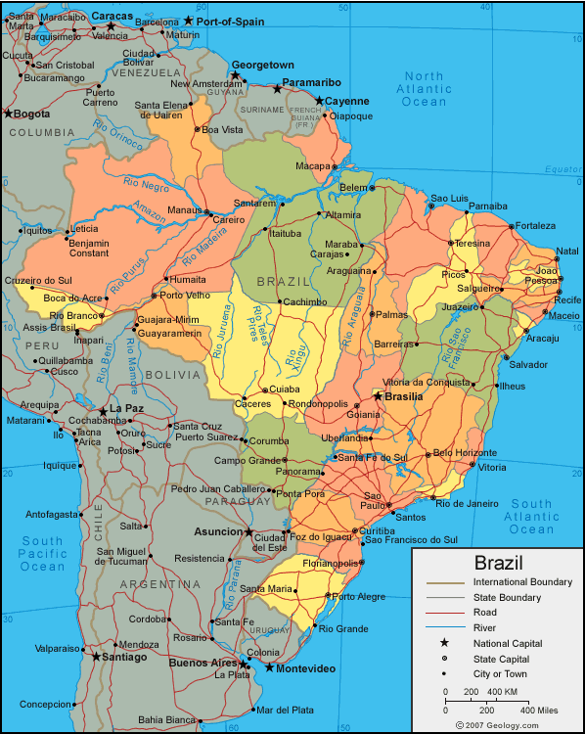
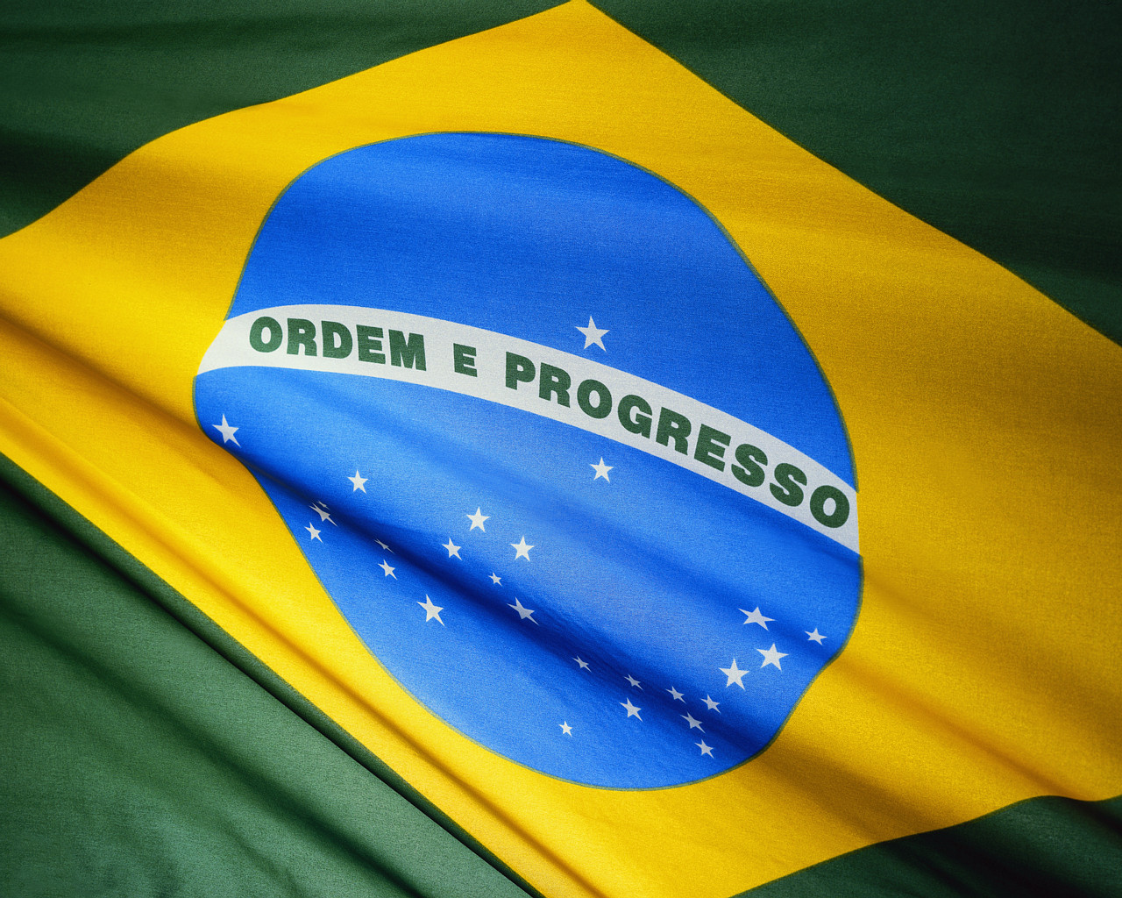

Your mailing address (allow at least 2 weeks)

Your name
C/O Ricardo Shirota
Av Padua Dias, 11
Piracicaba - SP 13418-900
Brazil

Brazilian Coordinator:
Shirota Ricardo
Universidade de São Paulo / ESALQ
Av Padua Dias, 11
Piracicaba - SP 13418-900
Brazil
Work: +55 (19) 3417-8712
Cell: +55 (19) 9726-8729
rshirota@esalq.usp.br

Ohio State Coordinator
Kelly Koren
Office of International Affairs/CFAES
Room 100 Ag Admin
2120 Fyffe Road
Columbus, OH 43210
Work; (614) 688-4144
Koren.10@osu.edu

Where you will be staying:
Piracicaba, State of São Paulo (SP)
Antonio’s Palace Hotel
Av. Independência, 2805
Piracicaba, SP
Brasil
Tel/Fax: +19-3417-6000
Web site: http://www.antonios.com.br/

US Embassy
Rua Henri Dunant, 500,
Chácara Santo Antonio,
São Paulo, SP — 04709-110
Brasil
Phone: (11) 5186-7000
U.S. Citizens Emergency Only: (11) 5181-8730
Fax:(11) 5186-7159
E-mail: acsinfosaopaulo@state.gov

Introduction

This program of study presents the schedule of activities for this six-week study abroad program. It incorporates the contents set forth in the syllabi for the three five-credit courses included in the program: Agricultural Economics 697: Brazil's Agricultural and Natural Resources Economy; International Studies 697: Brazilian History, Culture, Government and Language; and Rural Sociology 697: Brazilian Rural Development and Natural Resource Management.

In this program, each activity is associated with the specific content of a course in the following manner:
- AE3d means that this activity relates to the syllabus for Agricultural Economics 697, Section 3, subsection d, which deals with the agrarian reform and state support for agriculture.
- In a similar manner, the prefixes for the other two courses are IS (International Studies 697) and RS (Rural Sociology 697).

The program is offered at the Universidade de São Paulo’s Escola Superior de Agricultura Luiz de Queiroz (ESALQ), located in Piracicaba, in the state of São Paulo. ESALQ is a partner institution with The Ohio State University’s College of Food, Agricultural, and Environmental Sciences. Classes will be held on the ESALQ campus; however, lodging will be in Antonio’s Palace Hotel. Breakfast will be provided by the hotel. For other meals, students will be provided a meal allowance to eat on their own. The noon meal will be a choice of the ESALQ student cafeteria (R$4.00) or other vendors of your choice. Evening meals will be in restaurants, etc. See the schedule for specific times when group meals are provided.

There will be numerous field trips, some lasting one day, one for three days and one for at least 7 days. On these occasions, lodging and some meals will be provided in route, including weekends; however, other times students will be provided a meal allowance to eat on their own (see schedule for specifics).
Brazil Information
Hotels
  - Breakfast included and consists of meat & cheese, bread, yogurt, fresh fruit, juices, coffee, tea, sweet breads/cakes, jello, rice pudding
  - No dressers for clothes, only 4-5 hangers/room, may want to take some hangers if you need them. Very little space for storage of personal items.
  - Must lock hotel door with the key from the outside when leaving and inside when staying in.
  - Put key in slot on the wall to turn on the electricity in the room
  - It is recommended that you take a drain stopper
Telephones
  - Use pre-paid calling cards like AT&T, etc. (Extra minutes will be subtracted from card when using for international calls). **Reminder –calls cost a lot!
  - Skype- It is recommended that if you have a laptop that you download skype before leaving. If others in the States download it as well, you can talk for free between Skype accounts (voice, IM, and video are all options depending on your hardware.
  - Some hotels charge a fee for just dialing their phone so please ask at each hotel so you don’t get a huge bill when you check out.
  - Use of your cell phone (if international capabilities) is quite expensive – i.e. $2.10/minute!!!
Electricity
  - Use 110 volt like the US; however, depending upon our travel sites, some may use 220 volt so you may need a converter. In the past, the outlets were all OK.
  - The hotel rooms only have one or two outlets and they may have other items plugged into them – refrigerator, lamps, etc. You could bring a surge protector.
Shopping
  - Supermarket (Pão de Açucar) close to hotel has everything.
  - Gas station has snacks & drinks
  - Pizza parlors and other small restaurants with sandwiches, etc.
  - Piracicaba Shopping Center
Drinking water
  - Drink only bottled water
  - Drink a lot of water because you will dehydrate if you don’t
Transportation
  - It is a 25 minute walk from the hotel to the ESALQ campus or you may take a city bus (at your expense)
  - City bus is circular and goes to ESALQ, shopping center, etc.
  - Purchase tickets at street corner near hotel. Cost is R$1/ticket. One ticket for a one-way ride. Purchase these from magazine stand on street, etc.
  - #0002 Panoramica to ESALQ (~5 minutes) and shopping (~15 minutes)
  - #0001 Panoramica back to hotel

Laundry
  - Laundry will be done by a laundry service
  - Group will be divided into Monday, Wednesday and Friday laundry groups
  - Keep count of the number of pieces of clothing each time you turn in your laundry – i.e., 4 shirts, 5 pair socks, etc.
  - Laundry service also is available at most of the hotels during the longer trip mid-program
  - In Piracicaba, laundry cost is a flat rate for loads. Save by combining clothes to make a full load to avoid paying extra.
  - Take a laundry bag with your name on it
Lunch & Dinner
  - Avenida Carlos Botelho (near campus) – many different restaurants available
  - DO NOT eat at any street vender stand at any time
ESALQ Campus
  - Post Office opens from 9 – 11:30 a.m. & 1:30 – 4:30 p.m.
  - Library opens from 8 a.m. – 5 p.m.
  - Bookstore opens from 8 a.m. – 5 p.m.
Banking
  - Suggest $600-$800 for personal spending money.
  - International VISA / MasterCard debit card or Visa / MasterCard travel card (preferred) to withdraw cash from an ATM
  - Not recommended but if you chose travelers checks, American Express travelers checks only
  - Exchange hours (M-F): 10:00 a.m. – 2 p.m.
  - Banespa on ESALQ campus - 10 minute walk from classroom
    - Only exchange a minimum of $300 cash w/passport
  - Expect to spend time exchanging – takes a long time.
E-mail
  - Access in the ESALQ computer lab
  - Computer access in hotel – located in lobby but need to be respectful of other users needing to use the computer as well (don’t be a computer hog!)
  - May not be e-mail access at all locations during the 10-day trip. Probably will have to pay for access at the different hotels. Make sure you ask the front desk each time you change hotels
Large cities
  - Always travel as a group
  - São Paulo is the second largest city in the world so always be aware of your surroundings, the people around you, etc. This would be no different that if you were in a large city in the U.S. such as New York City, San Francisco, etc.
  - Don’t take any belongings to the beaches – only towel & sunscreen.
Reminders
  - Most importantly ---- Relax and go with the culture! Do not judge others or their culture based upon the American culture or way of doing things and/or your personal values. Be open, flexible, adaptable, friendly, willing to share about yourself & the U.S., etc.
  - DO NOT put used toilet paper in commode, put in wastebasket at the side. It will clog their system.
  - DO NOT show or flash your money around as you are paying for things. Always be discreet.
  - Your PASSPORT is an extremely important document so don’t treat it lightly. Always make sure it is secure and you know where it is at all times. You need to lock it in a safety deposit box in the hotel. However, take it with you when you travel to São Paulo city and on the longer trip.
  - Airline ticket & immigration papers – put it in a safety deposit box at Antonio’s Hotel for the duration of your stay. Share a box with your roommate.

Flight information
Tuesday, January 3- Delta 4087 Columbus to New York (JFK) 445p 703p
Delta 121 JFK to Sao Paulo (GRU) 750p 905a (January 4)

Friday, February 9- Delta 256 GRU to Detroit (DTW) 1125p 730a (Feb 10)
Saturday, February 10- Delta 6035 Detroit to CMH 1010a 1108a
Packing List
- Suitcase Size and Weight (international regulations)
  - 2 checked bags that don’t weigh more than 70# each
    - Check here closer to the flight
    - https://www.continental.com/web/en-US/content/travel/baggage/check.aspx
  - 1 carry-on and one personal item
  - Use luggage with wheels
  - A variety of luggage sizes is recommended so that you have options for the fieldtrips.

- Toiletries and personal items
  - Wash cloths
  - Tissues
  - Bar of soap, shampoo, conditioner, deodorant
  - Alarm clock – winding or battery but not electric
  - Sunscreen
  - Laundry bag with your name on it
  - Electric converter for 220 volt
  - Any prescriptions drugs currently taking & Tylenol
  - Sink stoppers – 1” size – sinks typically do not have a stopper
  - Q-tips
  - Fingernail clippers
  - Toothbrush & toothpaste
  - Lotion / aloe
  - Razor & shave cream

- Clothing
  - Swimsuit & beach towel
  - Umbrella and/or raincoat
  - Jeans, shorts, t-shirts, tennis shoes, flipflops, etc.
  - Nice khaki’s, shirt and nice shoes – no tennis shoes (guys) nice dress/skirt & nice shoes (females) for “gone clubbin”
  - Old pair of shoes for field trips
  - Light jacket and/or sweatshirt in case of cool weather (hoodie)
  - Extra duffle bag (empty) to take back souvenirs
  - Extra undershirts
  - Wear jeans and closed toed shoes on all agricultural tours
  - Sunglasses

- Entertainment
  - Camera & extra memory card
  - MP3 player and extra batteries
  - Playing cards
  - Pre-paid phone cards

- Class Supplies
  - Backpack to carry materials to/from class
  - Class materials (paper, pencils, pens, etc.)
  - Journal for journaling
  - English / Brazilian Portuguese dictionary
  - Laptop (optional)

- Gifts for host families
  - Take items that represent your home area/Ohio/US
  - Pancake mix and syrup (for example)
  - Photographs of home, school, family, friends, etc.
  - OSU picture frames with pictures of your family, farm, city, etc.
  - Small gifts from home – t-shirts, etc.

Packing your carry on
Take at least one change of clothing in case your check bags get lost.
Keep prescriptions in your carry on.
Keep your passport on you/in your carry on.
Bring entertainment of some sort (book, PDA, MP3, magazines- movies will be shown on the plane)
Do not bring any drinking liquid but snacks to eat are OK.
Keep in mind that a laptop case is a personal item. Before you buckle up, make sure you have what you need from the bag you put in the overhead bin.

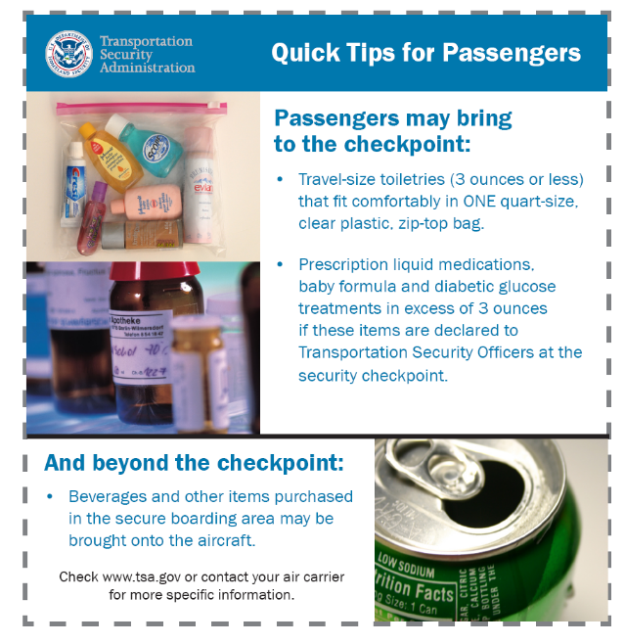

Rules and Expectations
- Be on time regardless of night before, Brazilian time, etc.
- Be professional at all times – at site visits listen, ask questions, and stay engaged. In class, participate and don’t sleep. The visit might not interest you but the next visit might, so be respectful at all times and don’t break off into small groups to talk.
- Don’t be loud, obnoxious Americans in restaurants, hotels, bars, etc. Always be aware of how others around you might be staring at the group of “Americans”. We tend to forget when we are in our group that our voices tend to get louder as we talk at restaurants, during activities, just being together as a group, etc.
- Always travel in pairs any time outside the hotel and in small groups in the larger cities.
- Be an adult – no whining.
- Mix and mingle with everyone in our group. Don’t always pair off with the same small group.
- The bus is everyone’s space so keep it clean, pick up your trash, cups, wrappers, etc.
- No drinking alcohol on the bus at any time. It is fine with meals but not in excess. Over indulgence will not be tolerated at any time!
- Observe people, places, things – everything – there is always something to learn.
- Relate what you see, hear, and learn back to our American culture. Why is it different? Why does the Brazilian way work? What can you learn from the Brazilian ways?
- Be respectful of others in the hotels. We are guests just like everyone else.
- You are representing the United States, the State of Ohio, Ohio State University, and your family at all times.
- The Brazilian graduate student must be with the group any time you go out at night to dance, etc. Never go out to a bar without one of these individuals.
- Don’t show or flash your money around as you are paying for things. Always be discreet.
- Have fun! This is going to be an incredibly memorable experience so take advantage of it as much as you can. Everyone will want to hear about your experience when you return so get ready to recount all the great stories.
Telephone
You will be able to buy calling cards to use the public phones in Brazil. Pre-paid phone cards purchased in the U.S. may NOT work in Brazil. You can also buy calling cards in Brazil for a good price, but may NOT work in the U.S. Check with your cell phone provider about service and what the cost per minute will be. It may be possible to rent a phone.

The Resident Director will have a cellular telephone once you arrive in Brazil. You should give this phone number to your parents, but it is ONLY to be used in case of an emergency!!!

Dialing instructions
To call Brazil from the US, you will first need to dial 011 + 55 + 11 + telephone number.
When dialing within Brazil, you dial 11 + the telephone number with the local area code
To call the US from Brazil, you simply dial the international access code from Brazil, (00), the international country code for the U.S. (1), and then the area code and phone number. So, to call OIE from Brazil, you will dial 00-1-614-292-6101.

HEALTH AND SAFETY

One of the risks travelers take is the possibility of becoming ill or injured in a foreign country. In case of serious health problems contact the OSU Resident Director and/or the Sao Paolo Coordinator immediately. They will take you to the best doctor. Always consult with your Resident Director about any type of problems you are facing.

Stomach aches and diarrhea can occur regularly amongst program participants. These problems are quite common with all types of foreign travel as your body is being introduced to foreign types of bacteria not common in the US.

THE WATER IS NOT DRINKABLE!!!
It is important that you drink plenty of water to avoid dehydration. When off campus, you should only consume bottled water that you have bought. To this effect, it is also highly advisable that you keep an extra bottle on hand to fill up before leaving on field trips. Ice with holes is the only safe ice to use, anywhere.

Food Safety
There are many vendors that sell food along the streets. No matter how delicious the food looks or smells, do not buy any food from them. In the case of fruit and vegetable stands, do not eat produce from them until after you have been able to wash them off with safe water.

In general, American fast food restaurants are safe, as are many of the establishments catering to the tourist industry from abroad. Sao Paolo staff will help you determine how to evaluate the safety of other restaurants throughout your stay. When you first arrive, it is a good idea to consume food moderately until you know how your body is going to react to the cuisine.

Crime
While violent crime is still much rarer in Brazil than in the U.S., visitors would be wise to take a few simple precautions to protect themselves against pickpockets. Be sure to travel in groups, especially at night, preferably of mixed gender.

Don’t carry large amounts of money! The money you do carry should be divided among several places on your person. Be careful with cameras and camcorders. Avoid press-in crowds, such as those on the bus. Be alert when gathered around vendors.

Exercise the usual precautions when walking, and be aware of any poorly lit side streets.

MONEY
The unit of currency is the REAL (R$) : the Brazilian Currency
1.00 USD  United States Dollars | = | 1.68 BRL  Brazilian Real
 |  | When asking class 11 for advice on spending money, keep in mind that their exchange rate was more favorable- 1.77

Cash is used more than any other form of money, so you should always have some on you and avoid relying on ATM’s that may not be as plentiful. It is also a good idea to budget yourself by limiting the amounts of times you exchange money. It is also a very frustrating experience when you only exchange small amounts of money and are constantly needing to locate a bank.

How much you will spend will depend on you, the types of activities you want to do during your free time and how much shopping you will do.

Changing Money
Once you arrive in Brazil, you will need to exchange your US dollars into BRL. You should only exchange money at banks and foreign exchange businesses. Individuals loitering around these places might offer to exchange money for you at a better rate and for less wait, but you should avoid them always as this method of exchange is illegal and puts you at risk for being short changed.

ATM’s
ATMs are the best way to get money in Brazil; however they are less frequently found than in the US. It is important to consult with your bank prior to going to Brazil to see if your ATM will work overseas and what it charges for foreign exchange/withdrawals. Also, know your pin number for your account, as the alphabet is not always available on ATM machines. It is important to not rely on the ATM as your sole source of funds in case you have difficulties withdrawing funds from your account.

Credit Cards
Major cards such as Visa and MasterCard may be used to exchange currency and are also accepted in better hotels, restaurants and shops. If you need to get a cash advance with your credit card, remember your pin number.

Travelers’ Checks
American Express Travelers’ Checks are a very safe way to carry money with you but can be inconvenient to exchange and may have a high right of exchange. If you are extra cautious, take a couple hundred dollars in traveler’s checks in case you lose money and your cards.

Culture
http://www.brazilsf.org/brazil_culture_eng.htm
http://darkwing.uoregon.edu/~sergiok/brculture.html
Handshaking is the common greeting. Abrazos (embrace of good friends) is not as common as in other Latin countries
Titles are important and should be included on business cards. Address a person directly by using his or her title only. A Ph.D or a physician is called Doctor. Teachers prefer the title Profesor, engineers go by Ingeniero, architects are Arquitecto, and lawyers are Abogado. For persons who do not have professional titles it is common to call a gentleman Don (plus his firstname) and a lady Dona (plus her firstname). This is how children and subordinates refer to adults, and it is a sign of courtesy for people doing business with each other to refer to each other in this way unless otherwise requested by the person you are addressing.
Most Hispanics have two surnames: one from their father, which is listed first, followed by one from their mother. Only the father’s surname is used when addressing someone
Politics are freely discussed because of the stability there
Good conversation topics: children, history, art
Bad topics: any personal criticism, religion

Personal Conduct

Demonstrate respect for your group members, resident directors and your host country by being on time. You will be a representative of The Ohio State University and the United States abroad, we expect you to adhere to the highest standards of personal conduct. Inappropriate and/or culturally insensitive behavior will reflect poorly on you as an individual in front of your hosts and other program participants. The OSU Code of Conduct remains in force during your participation in the program. Furthermore (and this goes without saying), you must abide by the laws and regulations of Brazil, as you can expect bigger problems than program dismissal if you break the law and are apprehended.

Group Dynamics
If you have never traveled in a group before, this can sometimes be as much of an adjustment as traveling to a new place. At times, the nature of this program can feel very “24/7.” You will be with your classmates a great deal of time: on the bus, during excursions, during meals, and at your hotels. All of you will be adjusting to Brazil and experiencing different emotions at any given time and will, occasionally, get on one another’s nerves. The important things to remember are to be respectful of your classmates, give someone space when they need it, don’t take your frustrations out on your classmates, speak up when something is bothering you before it eats away at you, and try not to sweat the small stuff. Keep things in perspective: it may be annoying that your roommate takes too much time in the bathroom, but spending too much time and energy on these petty gripes distracts you from fully experiencing the things that matter: learning and living in Brazil and getting everything you can out of this once-in-a-lifetime adventure.

General Brazil Information
Brazil is the largest country in South America. Comprising almost half the South American continent (47.3%), Brazil’s territory spans over 8,547,403 sq. km, or approx. 3,286,000 sq. mi. (source: IBGE). Therefore, it is the fifth largest country in the world, after the Russian Federation, Canada, China and the United States. Except for a small number of islands, Brazil’s territory is a single and continuous land mass on the Eastern seaboard of South America.
The Equator line crosses Brazil at the Northern region; the Tropic of Capricorn crosses the country at the Southeastern region. The East-West and the North-South lengths of the Brazilian territory are similar (respectively, 4,319.4 km and 4,394.7 km, or 2,683.9 mi and 2,730.7346 mi).
Borders
Brazil borders ten countries in South America: French Guyana (an overseas department of France), Suriname, Guyana, Venezuela and Colombia, to the North; Uruguay and Argentina, to the South; and Paraguay, Bolivia and Peru, to the West. Ecuador and Chile are the only countries in the continent which do not border Brazil. The Atlantic Ocean stretches along Brazil’s Eastern side, up to a total of 7,367 km (approx. 4,604 mi) of coastline.
Regions
Brazil divides naturally into five large regions.
1. The North, which consists of the states of Pará, Amazonas, Acre, Rondônia, Amapá, Tocantins and Roraima, is the largest and least inhabited. It is almost entirely covered by the largest equatorial rain forest in the world, known as the Amazon. Some of its areas, called várzeas, are regularly covered by flood water and are among the most fertile in Brazil.
2. The Northeast consists of the states of Maranhão, Piauí, Ceará, Rio Grande do Norte, Paraíba, Pernambuco, Alagoas, Sergipe and Bahia. Its semi-arid area covered with scrubby woodland, known as the caatinga. It is much more densely populated than the North, but income levels are low.
3. The Southeast consists of the states of Minas Gerais, Espírito Santo, São Paulo and Rio de Janeiro. It is the richest and most densely populated region of the country, and the Rio/São Paulo axis includes the most important industrial and financial centers.
4. The South consists of the states of Paraná, Santa Catarina and Rio Grande do Sul. It is a subtropical region, consisting of plateaus which were developed as agricultural land by small colonies of European settlers. The vegetation is made up of forests and grassland.
5. The Center-West consists of the states of Goiás, Mato Grosso, Mato Grosso do Sul and the Federal District where Brasilia, the federal capital, is located. It is a plateau with parts covered by a woodland savanna known as cerrado. The region hosts vast areas as Indian reservations and the ecological wildlife paradise known as the Pantanal. "Pantanal" is a Portuguese word for marshland.
Topography
Brazil has no mountains as high as the Andes, and the Brazilian Highlands do not exceed 1.9 mile high. Plateaus cover five-eighths of the territory, and plains cover the rest. The average altitude is about 0.3 mile. The highest mountain is the Pico da Neblina (3 km or 1.86 mile high) located in the state of Amazonas.
Climate
Brazil’s vast territories, the different geographical areas, altitudes and air masses result in a wide variety of climates. The Equator crosses Brazil in its northern region and the Tropic of Capricorn, in the southeast, putting most of Brazil in the “inter-tropical zone”, where the high and wet climates predominate. The average temperature for the country as a whole is 20º C (68º F), and the thermal amplitude (difference between the highs and lows) is small. Brazil’s main climates are the Equatorial (in the Amazon Region), with all-year rain, high average temperatures between 77º and 80.6º F; and the Tropical (Central Brazil and part of the Northeastern Region), with high average temperatures between 64.4º and 82.4º F and well-defined dry (mid-year) and wet (early in the year) seasons. The south is colder than the rest of Brazil (average temperature of 64.4º F; during winter temperature may fall below freezing point).
Seasons in the Southern Hemisphere are the opposite of those in the Northern: roughly, January-March is summer, April-June is fall, July-September is winter and October-December is spring.
Vegetation
Brazil has some of the most diverse vegetation on the planet, due to the many differences in weather, soil and landscape. Brazilian flora can be divided into 10 groups: the Amazon rainforest, the Atlantic rainforest, caatinga, pantanal, cerrado, campos, mata de araucária, mata de cocais, mangue and restinga.
The Amazon Tropical Rainforest spans approximately 7 million sq. km (approx. 4,375,000 sq. mi) in the north and central parts of South America. It is mostly within Brazilian territory, although parts of it are located in Bolivia, Colombia, Ecuador, Guyana, Peru, Suriname and Venezuela. The Amazon represents 58.5% of the Brazilian territory. The Amazon rainforest holds the largest reserve of biological organisms in the world. The precise number of species in it is not known, but scientists estimate a figure between 800 thousand and 5 million species – 15 to 30% of all known species in the world. The banks of the rivers of the Amazon basin are covered by floodwater - the várzeas - and are among the most fertile soil in Brazil.
The Atlantic Rainforest was common in the Atlantic coast of Brazil. More than 50% of its species are only found there and in no other place. Among the tropical rainforests, scholars believe that this ecosystem has the largest biodiversity per hectare in the world. Nevertheless, it is the most threatened by the increasing urbanization and industrialization in Brazil. Today only 7% of its area remains, mostly in the south and southeast regions of Brazil.
The semi-arid area of the northeast region is covered with scrubby woodland, known as the Caatinga. In some of its areas, semi-deciduous forests can be found.
The Pantanal, the wetlands, is considered the biggest swamp area of the world. It covers an area of 150 thousand sq. km in the states of Mato Grosso, Mato Grosso do Sul and areas of Paraguay. It is considered by the UNESCO a World Heritage Area. About 650 different species of birds, 80 of mammals, 260 of fish, and 50 of reptiles live there. This region is similar to the U.S. Florida's Everglades.
The Cerrado is a savannah region. It covers Central Brazil. It is characterized by a vegetation of bushes and short trees. Today the native vegetation of the cerrado is threatened by increasing agricultural production, specially maize, soybeans, grapes, mangos and other tropical fruits.
Campos is characterized by a vegetation of fields: big grasslands and bushes. It covers areas in the south and southeast of Brazil. Mata de Araucária is an open forest of a species of pines called Araucária (Araucária angustifolia) in Brazil, covering areas in the south of Brazil. Mata de Cocais is situated between the Amazon and the caatinga region. It is seen in the states of Maranhão, Piauí and Tocantins. In the area close to the Amazon, this ecosystem is very wet and palm trees are common. Mangue is an ecosystem composed of bushes and trees and covers areas of lakes and swamps along the coast. Restinga is a vegetation of bushes, herbs and short trees typical in the sandbanks along the coast of Brazil.
Rivers
The huge size of the country and the wet climate produce great river systems. Brazil hosts the largest body of fluvial water in the planet. There are eight river systems in Brazil, the most important being the Amazon in the north, the São Francisco in the center and the Paraguay, the Uruguay and the Paraná systems in the south.
The Amazon river basin is the world's largest, comprising an area of 5,800,000 sq. km (or 2,239,383 sq. miles), of which 3,904,392 sq. km (or 1,507,488 sq. miles) are in Brazilian territory. Its main river has its source in Peru, where it is initially called Vilcanota, then Ucaiali, then Urubamba and Marañon. When it enters Brazil, it is renamed Solimões as far as the confluence with the Negro river, near the city of Manaus; after that, and up until the ocean, it is known as the Amazon river. From source to ocean, it flows for 6,440 km (4,001 miles) and is the world's largest in water flow; some consider the Amazon also the world's longest river, as it extends well into the ocean during the flooding season. On average, the river is 5 km (3.1 miles) wide and at some points can be as wide as 50 km (31 miles). It inputs 20% of the fresh water poured annually into the oceans by all the rivers in the world. The Amazon River basin has the world's largest diversity of fish, between 2,500 and 3,000 species.
Language
The official language in Brazil is Portuguese, a Latin-originated (or "romance") language. Brazil is the only Portuguese-speaking country in Latin America. Portuguese is related to other European languages such as Spanish, French, Italian, Rumanian and others, but its vocabulary is influenced by Arabic (reminiscent of the Muslim conquest of the Iberian Peninsula in the Middle Ages) and, in the case of Brazilian Portuguese, by African and Indian languages.
Main Cities
Most of Brazil's population (81.2%) now lives in cities, which are responsible for generating about 85% of the GDP. Among the most important are:
* São Paulo has a population of 10,406,166 (IBGE, 2000) and it is the largest city in Brazil. It hosts the largest industrial base in the country and the most dynamic cultural activities.
* Rio de Janeiro was the capital of Brazil for almost 200 years (1700's - 1960). Today, Rio is a cultural, financial and tourist metropolis that has not lost its resort character. Its population is 5,850,544 (IBGE, 2000).
* Belo Horizonte, designed and built in the 1890's as the capital of the state of Minas Gerais to replace Ouro Preto, the former colonial capital which was enclosed by mountains. An important transport and industrial center, its population is 2,229,697 (IBGE, 2000).
* Salvador was the capital of Brazil from the 1500's through the 1700's with an impressive colonial architecture. Today, several of its neighborhoods are considered UNESCO landmark. Salvador is a cultural and business center famous for its art, cuisine and a strong African culture influence. Its population is 2,440,886 (IBGE, 2000).
* Brasilia was designed and built as the capital city of Brazil in the geographical center of the country, Brasília was inaugurated in 1960. It is a showpiece of modern architecture. Its urban planning is unique, with a population of 1.6 million.
Political Aspects/Government
Brazil (official name: Federative Republic of Brazil or, in Portuguese, República Federativa do Brasil) is a federation comprising 26 states and a federal district (where the federal capital, Brasília, is located), which are granted self-administration within limits set by the Federal Constitution.
The Federal Constitution was enacted in October 5, 1988 and establishes a democratic political system with periodic elections for public offices. It instituted a presidential republic (that is, a form of government where the public offices are held for a determined period of time and the Public Administration is directed by a President of the Republic, such as in the U.S.). The three branches of Government are the President (aided by ministers), in charge of the Public Administration; the National Congress, consisting of a Senate and a Lower House; and the Judiciary organizations, the topmost being the Federal Supreme Court with 11 justices (currently, 10 men and a woman).
The President is elected for a 4-year term and the incumbent may be re-elected for one additional term; the Vice President is elected in the same ticket. The President is responsible for directing the federal Administration, approving or vetoing legislation, maintaining relations with foreign governments, celebrating treaties, being commander-in-chief of the armed forces, declaring war and peace (in both cases when authorized by Congress) and proposing to Congress the annual federal budget. In the National Congress, the Representatives are elected for 4-year terms; the Senators are elected for 8-year terms (the Senate is renewed at each election at the rate of one-third or two-thirds, alternately). Congress can legislate on all matters pertaining to the federal government. Congress, its houses or any of its committees may summon ministers and other public servants to hearings. The federal judicial system comprises courts and appeals courts; specialized electoral, labor and military court systems; the High Court of Justice, responsible for the uniformity of all judicial decisions; and the Federal Supreme Court, in charge of the constitutionality of judicial, legislative and administrative decisions.
According to the Brazilian Federal Constitution, voting is compulsory for men and women between 18 and 70 years of age, and optional for those 16-18 years old, above 70 or the illiterate. Women conquered the right to vote in 1932; the illiterate, in 1988. In elections for executive posts, in case no candidate gets the absolute majority of valid votes the Constitution requires that a runoff be held between the two most voted candidates. Currently votes for all public posts and in all levels of Government are counted flawlessly by electronic machines, in elections supervised by a special Electoral Court System.
The Federal Constitution provides for a democratic system with a bill of rights (article 5) which grants every person freedom of movement, of thought, of religion, of conscience, of expression, of reunion, and the rights to the due process of law, to ownership, to petition, as well as the guaranties of habeas corpus and others.
The states have their own Constitutions and laws. The branches of Government in each state are similar to the federal level: the Governor, in charge of Administration; the Legislative Assembly; and the judiciary, headed by the state’s Tribunal of Justice.
Economy
The Brazilian economy is one of the eighth largest in the world, with a GNP of US$ 1,148 billion (source: The World Bank, 1999, PPP method) and a per capita income of US$ 6,840. Being dynamic and diversified, the Brazilian economy includes an industrial sector responsible for 38.1% of the economic output, an agricultural sector with 10% and a services sector with 51.9%. Brazil’s economy represents 39% of Latin America’s GDP and is the world's fourth largest recipient of foreign direct investment (US$ 29.8 billion in 2000).
The Brazilian currency is the Real (noted as R$).
The Common Market of the Southern Cone (Mercosul) was established on March 26, 1991, the date on which the Treaty of Asuncion was signed by Brazil, Argentina, Paraguay and Uruguay. As of January 1, 1995, the regional block became a customs union and a free trade area, with the future goal of allowing the free movement of capital, labor and services among the four countries. Since 1991, the trade flows among the member states of Mercosul more than tripled. Brazil’s trade flow with the member states of Mercosul reached US$ 18.7 billion in 1997, up from US$ 3.6 billion in 1990. Chile and Bolivia are associated states to Mercosul.
Agriculture and Cattle
Brazil is the world's largest producer of coffee, sugar cane, oranges, bananas and manioc and the second largest producer of soy bean and cocoa. It is the fourth largest producer of tobacco and beef cattle. Brazil has the world's largest commercial herd of cattle.
Industry
Brazil's main industries are shipbuilding, motor cars, aircraft, metals (including steel), foodstuffs, textiles and chemicals. The state of São Paulo is the most industrialized and the metropolitan area of greater São Paulo is the biggest industrial center in Latin America.
Trade
Brazil's foreign trade is the largest in volume and value of all the Latin American countries combined. The major Brazilian exports fall into three categories:
* Raw materials: coffee beans, iron ore, soy bran, poultry meat, soybeans, tobacco leaves, fresh beef, maize, sisal, jute, etc
*Semi-finished goods: raw sugar, aluminum, cellulose, semi-manufactured of iron and steel, hides and skins, castor oil, cocoa butter, pine-wood, iron alloys, rolling stock, electrical machines, instant coffee, processed beef, crude soybean oil, etc
* Manufactured products: orange juice, shoes, aircraft, cars, auto parts, piston engines, refined sugar, pumps and compressors, rolled products, cargo vehicles, tires, transmission and reception equipment, chassis with motors, machines and equipment for agricultural use, motors, generators and transformers, buses, etc
The Brazilian foreign trade figures attest to the dynamic nature of Brazil. In 2000, Brazil exported a total of US$55.1 billion and imported US$55.7, with total trade flows of US$110.8 billion (source Secex). Our top export markets are the European Community, absorbing slightly over 27% of Brazilian exports, Latin America (over 22%), North America (around 21%), Asia (16%) and the Middle East (2.4%); the remaining exports are distributed over a variety of smaller markets. The United States is Brazil’s largest single country export market, absorbing 19% of Brazilian exports, resulting in a long-term partnership between the two countries. The U.S. is also Brazil's main supplier (imports of US$ 12.8 billion in 2000; source: Secex).
A Few Portuguese Words

Oi! Hi!

Olá! Hello!

Meu nome é João. My name is João.

Tudo bem? How are you?

Prazer em conhecê-lo! Prazer em conhecê-la!
Nice to meet you! (meeting a male / meeting a female)

Bom dia! Good morning!

Boa tarde! Good afternoon!

Boa noite! Good night! / Good evening!

Tchau! Bye!

Até logo! See you soon!

Por favor. Please.

Com licença! Excuse me

Desculpe! I'm sorry!

Obrigado! Thank you!

Muito obrigado! Thank you very much!

De nada! You are welcome!

Como foi seu fim-de-semana? How was your weekend?

Como foi a sua viagem? How was your trip?

