Horry County Schools

High School

Grade Reporting Handbook

July 2007

Developed By

Deborah Maxson

Table of Contents

Sasixp Grade Reporting Setups

Grading Setup Atom (pg 3)
Marks Definition Atom (pg 9)
Credits Definition Atom (pg 9)
GPA Definition Atom (pg 11)
Transcript Definition Atom (pg 12)
Grading Comments Atom (pg 12)

Grade Reporting General Procedures
Includes Grades, GPAs and Posting Course History

Grade Reporting Period One (pg 13)
Grade Reporting Period Two (pg 17)
Grade Reporting Period Three (pg 25)
Grade Reporting Period Four (pg 33)

Graduation Requirements (Pg 39)

Transcript Narrative Comments (Pg 41)

Transcript Printing (Pg 41)

Transcript Repeat Tags (Pg 42)

Duplicate Grade Records (Pg 45)

Checklists (Pg 47)

South Carolina Uniform Grading Policy
Includes Instructions for Calculating GPAs and Printing Transcripts to comply with the Legislative Mandate - Uniform Grading Policy. Uniform Grading Policy documents are:
“Calculating GPAs in Sasi – South Carolina Uniform Grading Policy, 2007-08
“State Board of Education, Synopsis Agenda/Executive Summary”

Horry County Schools URL:
http://www.hcs.k12.sc.us/technology/index.cfm?varAction=file4

Sasixp Grade Reporting Setups

Grade Setup Atom

Setting Grade Reporting Periods – Periods Tab

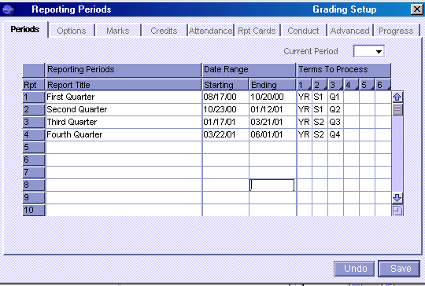

Setting Reporting Options – Options Tab

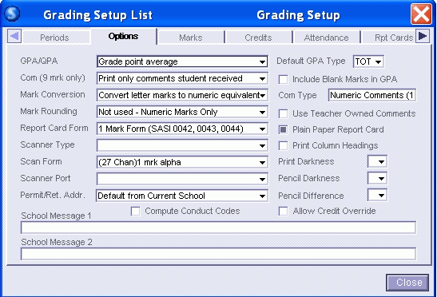
Setting Mark Descriptions – Marks Tab
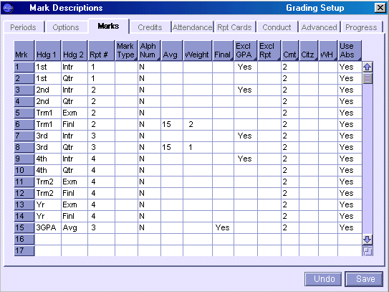

Setting Credit Terms – Credits Tab
Mark Location of Final Grade per Course Type and Defines Term Codes that are processed by the Calculate Semester Average Function.

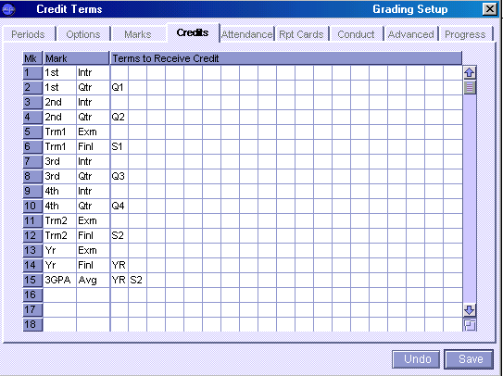

Setting Attendance Options – Attendance Tab
HCS currently does not utilize this Attendance feature for report cards.
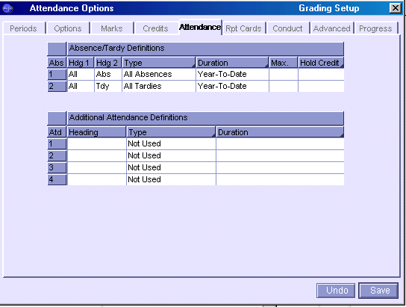

Setting Report Card Text – Rpt Cards Tab
HCS does not utilize the Report Card feature
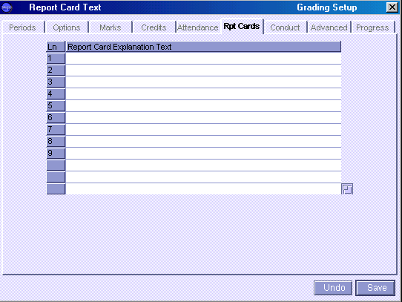
Setting Conduct Conversions – Conduct Tab
HCS does not utilize the Conduct feature
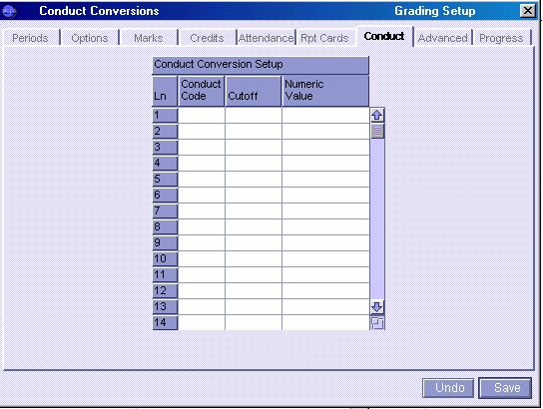

Setting Advanced Options – Advanced Tab

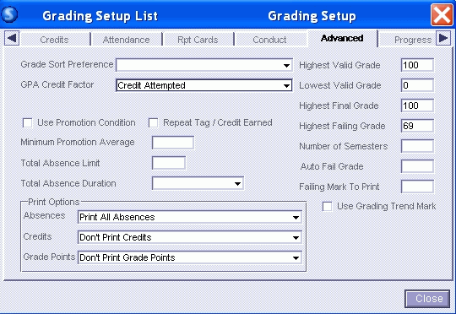

Setting Progress Reporting – Progress Tab
HCS does not utilize the Progress feature
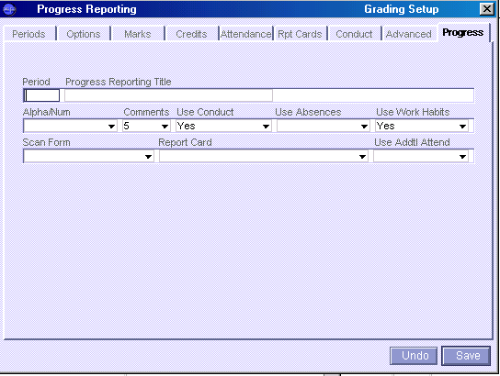

Setting Averaging Reporting – Averaging Tab
HCS does not utilize the Averaging feature.

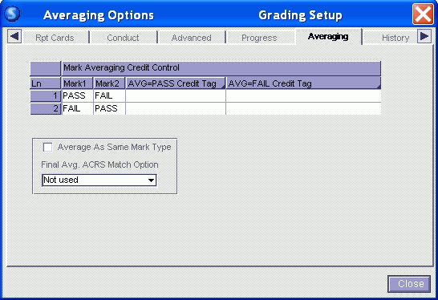

Setting History Reporting – History Tab
This feature allows the Course History to be updated versus using the Update Course History Atom in the Course History Suitcase.

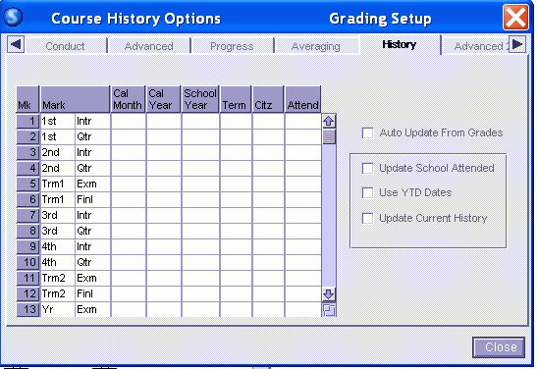

Setting Advanced 2 Reporting – Advanced 2 Tab
This may be set to hide dropped student names from Class Grades Atom seen in Classxp by teachers. HCS teachers use Integrade Pro for grading and generally do not enter grades in Class Grades.

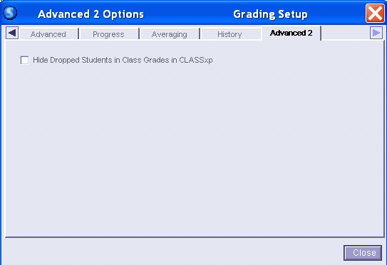

Mark Definitions Atom

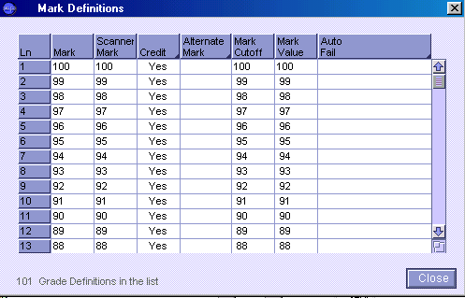

Please note that this table lists all marks from zero to 100. This picture describes the general setup configuration. Under the new state Uniform Grading Scale Policy, marks of WF, FA and WP are defined grades. WF and FA have mark cutoff values of 61. WF, FA and WP have grade point values of 0.0000.

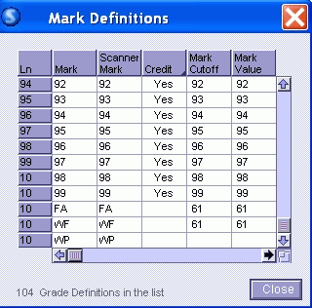

Credits Definition Atom

Setting Credit Weights Screen – Percentage of Credit for Calculating Current Grades in 3rd Quarter GPA

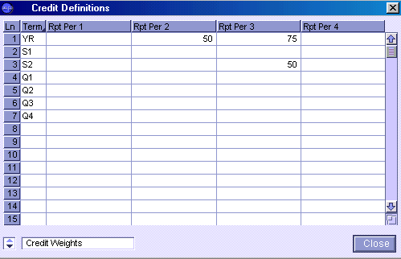

Setting Trans Weights Screen – Percentage of Credit for Posting Credits to Transcript

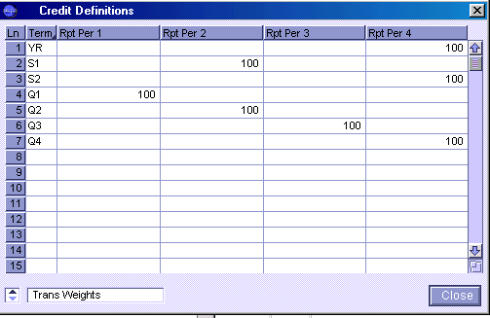

GPA Definition Atom

4.0 GPA Definition – UnWeighted GPA

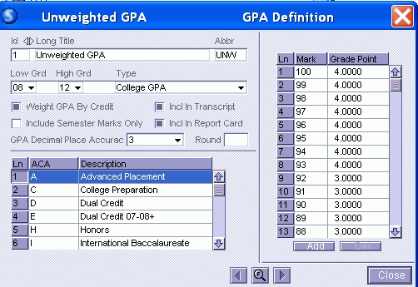

Uniform Grading GPA Definition – Total GPA

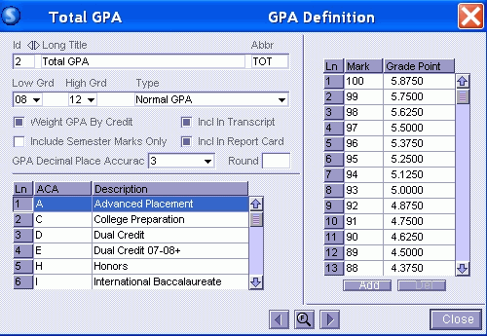

Transcript Definition Atom

See South Carolina Uniform Grading Policy. Includes Instructions for Calculating GPAs and Printing Transcripts to comply with the Legislative Mandate documented in the Uniform Grading Scale Policy
These documents can printed or downloaded from HCS Technology Department’s Pathways Support web page:

“Calculating GPAs in Sasi – South Carolina Uniform Grading Policy, 2007-08
“State Board of Education, Synopsis Agenda/Executive Summary”

Grading Comments Atom

School Designated Comments
Grade Reporting General Procedures

I. Grade Reporting Period 1 (Quarter One)

Interims and Q1 Grades

- Back up Files (especially AGRD, AGRL and AGRA files)

- Change Current Period field to grade period 1 (In Grade Reporting Suitcase, Grading Suitcase, Grading Setup Atom , Periods Tab)

- Update Grading File for grade period 1 (In Grade Reporting Suitcase, Grading Suitcase, Update Grades Atom). Generally complete process for Update Grading File before each Interim and Quarter Grades. Update Grading File checks student schedules to determine whether to create or adjust changes in students’ grade records.

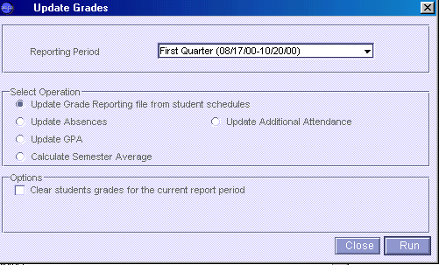

Select Option - Update Grade Reporting file from student schedules. Optional Choices - Update Absences, GPA, Additional Attendance. Since Horry County Schools print Report Cards outside of Sasixp, the Update Absences, GPA or Additional Attendance options are not required.

- Create/Print Grade Reporting Scan Sheets (In Grade Reporting Suitcase, Grading Suitcase, Grade Scanning Atom). Scan Sheet File must be created to print Grade Verification Sheets and for using Classxp. Do not Print Sheets if not scanning. Choose any Scan Sheet Form.

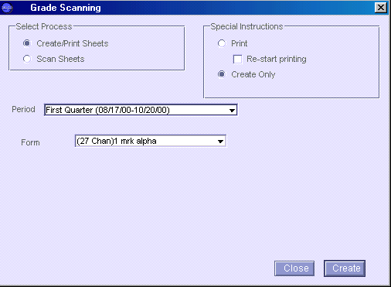

- Enter Grades – IntegradePro, Classxp, Sasixp Grades or Class Grades Atom, Scanning (In Sasixp, Grade Reporting Suitcase, Grading Suitcase, Grades Atom, Class Grades Atom or Scanning Atom) (In Sasixp, IntegradePro functionality is found in Utilities Suitcase, IntegradePro Data Exchange Atom)

Scheduled terms for classes are designated with Q1 (quarter one), Q2 (quarter two), S1 (semester one), Q3 (quarter three), Q4 (quarter four), S2 (semester two), or YR (year long )

During Grade Period 1 Interims, grades will be entered in Mark Heading:
1st Intr - for Q1, S1 and YR scheduled classes
During Grade Period 1 Quarter, grades will be entered in Mark Heading:
1st Qtr - for Q1, S1 and YR scheduled classes

- Verification By Teacher Report (GRD06) Verifies Grades (In Grade Reporting Suitcase, Grading Suitcase, Grades Atom, Menu Option Grade, Verification by Teacher Report (GRD06)).

Teachers may print their own Verification Sheets through Classxp. From the teachers’ Classxp desktop, open Sasi Modules, Grade Reporting Suitcase, Grading Suitcase, Grades Atom, Menu option Grade, Verification by Teacher Report (GRD06). Teachers must use the Sasi Modules to find the Verification Report.

- Make Appropriate Grade Corrections

Make appropriate grade corrections based on teacher verification procedures.

Since Sasi does not validate grade marks during the import of grade data from Integrade Pro, grade marks should be verified in addition to teacher verification procedures. A Sasi query comparing grade marks in the grade file (AGPL) with the mark definition file (AGMK) cannot be written. It is suggested that grade data be exported from Sasi to either Exel or Access for verification. The Sasi export query would look like:
Export
ASTU AGRD AGRL permnum lastname firstname mark if marknum = 1 and Termcode IN [“Q1”,”S1”,”YR”] (Note: Interim Quarter One marknum = 0, Quarter One marknum = 1)

Excel Import: During the import process, ensure that the grade marks are defined as general data type. The permnum, last and first names should be text. Once the data is imported to Excel, sort the data by largest to smallest for grade marks. All letter marks will be visualized at the top of the spreadsheet followed by numeric grades in descending order. Grades marks over 100 would also be clearly visible, if existed.

Access Import: During the import process, ensure that the grade marks are defined as numeric (integer) data type. The permnum, last and first names should be text. During the actual import process, the import process will create an Error table for those marks that are not valid numbers (integer), thus the Error table will show the data lines that do not contain numeric grades. A query will help identify any marks > 100.

- Print Honor Roll Report – if appropriate at this time. (In Grade Reporting Suitcase, Grading Suitcase, Honor/Roll Eligibility)

- Print and Distribute Report Cards

- Back up files – (especially ACHS, AGRD, AGRL, and AGRA)

- Post Grades to Course History – do not complete this step during any Interim reporting.
Complete this step if your school has Q1 scheduled classes.

(In Grade Reporting Suitcase, Grading Suitcase, Update Course History Atom, Transfer Grades Option)

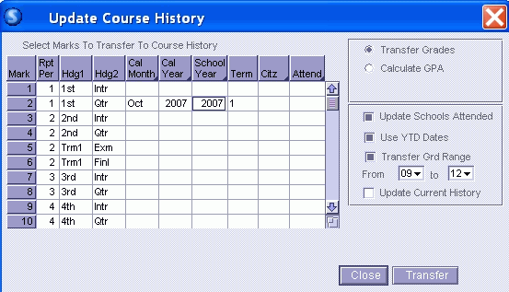
After data entry and before pressing Transfer, be sure to highlight the line that will be transferred.
SPECIAL NOTE:
The user may wish to check the “Update Current History” option box. Checking this box will cause the posting to compare the posting records with other transcript records and only update existing records or add new records. This prevents multiple entries of the same grade records, if the posting was inadvertently completed more than once.

After Grade posting:

Verify that transcript grade marks are valid entries. A Sasi query can be written to compare marks in the course history file (ACHS) with the mark definition file (AGMK). Although a query can not be written to compare the Grade file with the Mark definition file as in Step 7 above, a comparison query can be made between the course history marks and the mark definitions. Use the following query for checking validity.

ASTU ACHS AGMK lastname firstname 2,mark if 2,mark <> 3,mark

Back up Your Files !! Back ups are essential for restoring in the event of any problems.

If this process is performed more than one time, the transcript file will have multiple duplicate records for each student. If it is necessary to perform this process more than one time, you need to select the “Update Current History” option button which enables you to Update Records in the Course History Atom without duplicating existing records.

The Grade records for Q1 scheduled classes are not erased by this process. The Grade File stays intact all year long and is available from year to year.

- GPAs are NOT processed for Grade Reporting Period 1.
II. Grade Reporting Period 2 (Quarter Two)

Interims and Q2 Grades

- Back up Files (especially AGRD, AGRL and AGRA files)

- Change Current Period field to grade period 2 (In Grade Reporting Suitcase, Grading Suitcase, Grading Setup Atom , Periods Tab)

- Update Grading File for grade period 2 (In Grade Reporting Suitcase, Grading Suitcase, Update Grades Atom). Generally complete process for Update Grading File before each Interim and Quarter Grades. Update Grading File checks student schedules to determine whether to create or adjust changes in students’ grade records.

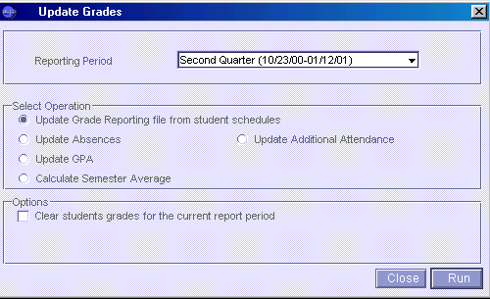

Select Option - Update Grade Reporting file from student schedules. Optional Choices - Update Absences, GPA, Additional Attendance. Since Horry County Schools print Report Cards outside of Sasixp, the Update Absences, GPA or Additional Attendance options are not required.

- Create/Print Grade Reporting Scan Sheets (In Grade Reporting Suitcase, Grading Suitcase, Grade Scanning Atom). Scan Sheet File must be created to print Grade Verification Sheets and for using Classxp. Do not Print Sheets if not scanning. Choose any Scan Sheet Form.

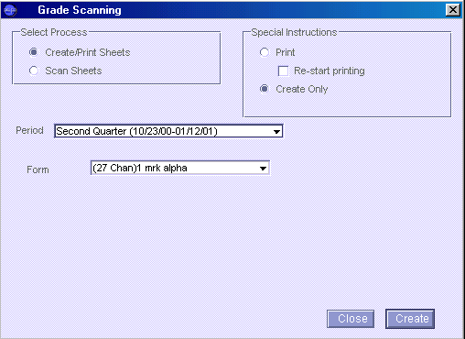

- Enter Grades – IntegradePro, Classxp, Sasixp Grades or Class Grades Atom, Scanning (In Sasixp, Grade Reporting Suitcase, Grading Suitcase, Grades Atom, Class Grades Atom or Scanning Atom) (In Sasixp, IntegradePro functionality is found in Utilities Suitcase, IntegradePro Data Exchange Atom)

Scheduled terms for classes are designated with Q1 (quarter one), Q2 (quarter two), S1 (semester one), Q3 (quarter three), Q4 (quarter four), S2 (semester two), or YR (year long )

Due to GPA requirements and limited Sasixp Grade File configurations, Sasixp will not be used to calculate semester averages. Teachers must compute and enter their own averages.

ALL YR long course teachers must complete the Trm1 Finl mark.

During Grade Period 2 Interims, grades will be entered in Mark Heading:
2nd Intr - for Q2, S1, and YR scheduled classes

During Grade Period 2 Quarter, grades will be entered in Mark Headings:
2nd Qtr - for all Q2, S1 and YR scheduled classes
Trm1 Exm – for all S1 scheduled classes
Trm1 Finl – for all S1 and YR scheduled classes

- Verification By Teacher Report (GRD06) Verifies Grades (In Grade Reporting Suitcase, Grading Suitcase, Grades Atom, Menu Option Grade, Verification by Teacher Report (GRD06)).

Teachers may print their own Verification Sheets through Classxp. From the teachers’ Classxp desktop, open Sasi Modules, Grade Reporting Suitcase, Grading Suitcase, Grades Atom, Menu option Grade, Verification by Teacher Report (GRD06). Teachers must use the Sasi Modules to find the Verification Report.

- Make Appropriate Grade Corrections

Make appropriate grade corrections based on teacher verification procedures.

Since Sasi does not validate grade marks during the import of grade data from Integrade Pro, grade marks should be verified in addition to teacher verification procedures. A Sasi query comparing grade marks in the grade file (AGPL) with the mark definition file (AGMK) cannot be written. It is suggested that grade data be exported from Sasi to either Exel or Access for verification. The Sasi export query would look like:
Export
ASTU AGRD AGRL permnum lastname firstname mark if marknum = 3 and Termcode IN [“Q2”,”S1”,”YR”] (Note: Interim Quarter Two marknum = 2, Quarter Two marknum =3 , Trm1 Exm marknum = 4, Trm1 Finl marknum = 5)

Excel Import: During the import process, ensure that the grade marks are defined as general data type. The permnum, last and first names should be text. Once the data is imported to Excel, sort the data by largest to smallest for grade marks. All letter marks will be visualized at the top of the spreadsheet followed by numeric grades in descending order. Grades marks over 100 would also be clearly visible, if existed.

Access Import: During the import process, ensure that the grade marks are defined as numeric (integer) data type. The permnum, last and first names should be text. During the actual import process, the import process will create an Error table for those marks that are not valid numbers (integer), thus the Error table will show the data lines that do not contain numeric grades. A query will help identify any marks > 100.

- Print Honor Roll Report – if appropriate at this time. (In Grade Reporting Suitcase, Grading Suitcase, Honor/Roll Eligibility)

- Print and Distribute Report Cards

- Back up files – (especially ACHS, AGRD, AGRL, and AGRA)

- Post Grades to Course History – do not complete this step during any Interim reporting. Complete this step if your school has Q2 and/or S1 scheduled classes.

(In Grade Reporting Suitcase, Grading Suitcase, Update Course History Atom, Transfer Grades Option)

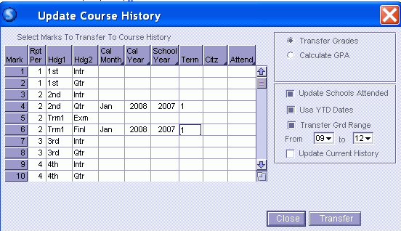
After data entry and before pressing Transfer, be sure to highlight the lines that will be transferred.

SPECIAL NOTE:
The user may wish to check the “Update Current History” option box. Checking this box will cause the posting to compare the posting records with other transcript records and only update existing records or add new records. This prevents multiple entries of the same grade records, if the posting was inadvertently completed more than once.

After Grade posting:

Verify that transcript grade marks are valid entries. A Sasi query can be written to compare marks in the course history file (ACHS) with the mark definition file (AGMK). Although a query can not be written to compare the Grade file with the Mark definition file as in Step 7 above, a comparison query can be made between the course history marks and the mark definitions. Use the following query for checking validity.

ASTU ACHS AGMK lastname firstname 2,mark if 2,mark <> 3,mark

Back up Your Files !! Back ups are essential for restoring in the event of any problems.

If this process is performed more than one time, the transcript file will have multiple duplicate records for each student. If it is necessary to perform this process more than one time, you need to select the “Update Current History” option button which enables you to Update Records in the Course History Atom without duplicating existing records.

The Grade records for Q2 or S1 scheduled classes have not been erased by this process. The Grade File stays intact all year long and is available from year to year.

- Update GPAs for First Semester

This is not required but may be necessary for varying educational purposes. In regards to Class Rank, this is not the appropriate time of the school year for ranking students. This is done after the third quarter grading procedures and directions are found III.12 Third Quarter GPAs below. Transcripts submitted for scholarships for early graduates do not contain classrank (reference State Department of Education, “Calculating GPAs in Sasi – South Carolina Uniform Grading Policy, 2007-08 found HCS Technology Department’s Pathways Support page; also State Board of Education, Synopsis Agenda/Executive Summary”).

(In Grade Reporting Suitcase, Grading Suitcase, Update Course History Atom, Update GPA Option)

GPAs calculated at the end of First Semester may be based on:

- Cumulative transcript records that include the first semester final grade mark (Trm1 Finl) for YR scheduled classes.

All cumulative transcript records are calculated in the First Semester GPA with 100% credit value. YR classes are included in the First Semester GPA with 50% credit value. This 50% credit value for YR classes has been setup in the Credit Definitions Atom on the Credits Weight screen.
Or

- Cumulative transcript records that DO NOT include the first semester final grade mark (Trm 1Finl) for YR scheduled classes.

Teachers for YR scheduled classes must have completed the Trm1 Finl mark in the grade file. Remember that cumulative transcript records now include current year Q1, Q2 and S1 scheduled classes.

See School Administrator for appropriate choice for GPA. These options will produce totally
different GPAs values and must be chosen based on educational purpose.

- Calculating GPAs that INCLUDE first semester Grade Mark (Trm1 Finl)

Select the appropriate Calculate Grd Range option for computing GPAs.

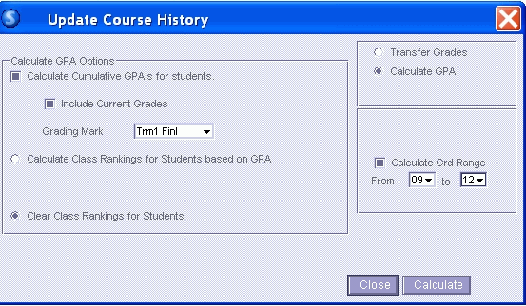

The option “Clear Class Rankings for Students” can be utilized if rankings need to be cleared. Re-running GPAs will replace rankings, if selected.

Note:
If a user manually changes something in a specific student’s transcript record and calculates a new GPA for that student after Rankings have been run, that student’s ranking is zero. If you want to include the student in the ranking, you must calculate GPAs and class rankings again by re-running GPAs.

- Calculating GPAs that DO NOT INCLUDE first semester Grade Mark (Trm1 Finl)

Select the appropriate Calculate Grd Range option for computing GPAs.

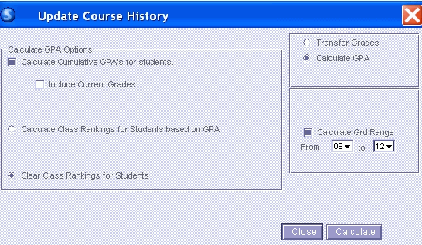

The option “Clear Class Rankings for Students” can be utilized if rankings need to be cleared. Re-running GPAs will replace rankings, if selected.

Note:
If a user manually changes something in a specific student’s transcript record after Rankings have been run, that student’s ranking is zero. If you want to include the student in the ranking, you must calculate class rankings again by re-running GPAs.

- Calculating Classrank (ONLY IF NEEDED)

Run Calculate GPAs again selecting Calculate Class Rankings and selecting appropriate grade levels. It may also be appropriate at this time to implement a filter query for your class ranks depending on the grade level and educational purpose, especially if calculations are to be used for colleges or scholarships. For example: Seniors who will not be receiving a diploma may be filtered out from the senior classrank (use grade range 12 to 12).

SKIP ASTU if DiplomaTyp <> “A”

This query will only be effective in this scenario if all seniors have a value in the Diploma Type field. Diploma Type is displayed on the Course History Academic Summary screen but stored in the student file (ASTU) in DiplomaTyp field name. Change query can be utilized to set the Diploma Type to A for all students, then manual entries made to correct invalid values.

See reference State Department of Education, “Calculating GPAs in Sasi – South Carolina Uniform Grading Policy, 2007-08 found on HCS Pathways Support page, also State Board of Education Synopsis Agenda/Executive Summary)

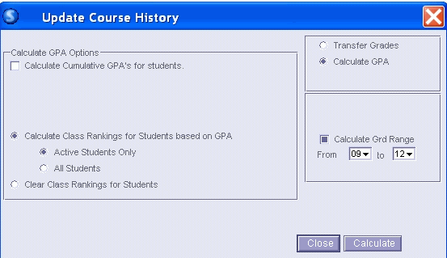

Note:
If a user manually changes something in a specific student’s transcript record after Rankings have been run, that student’s ranking is zero. If you want to include the student in the ranking, you must calculate class rankings again by re-running the calculate GPA process.

Viewing GPA values

GPA values can be found on the Academic Summary screen in the Course History Atom. The GPAs reflect the last “UpDate GPA” process.

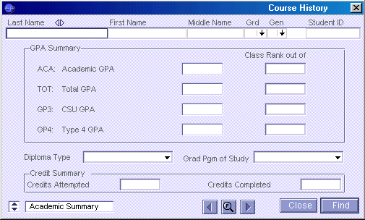

Special Note:

The Academic Summary screen displays the latest GPA calculation. This may or may not match the printed GPA on the transcript (CHS12). During the transcript printing process, the GPA is calculated “on the fly” and reflects the GPA for only courses stored in the course history file and NOT any grades in progress. For example: If a GPA was calculated at the end of 2nd quarter and included grades in progress, then the GPA value stored in the student file (ASTU) and displayed on the Academic Summary screen would NOT match the GPA on the printed transcript.

To query GPAs that are stored in the student file (ASTU), the following could be used:

4.0 Unweighted GPA
Display
ASTU Lastname Firstname CummGPA1 Sort CummGPA1^

Total GPA (Uniform Grading Policy
Display
ASTU Lastname Firstname CummGPA2 Sort CummGPA2^

To query classrank data (if needed), the query should include the Classrank field in the student file
(ASTU).

4.0 Unweighted GPA
Display
ASTU Lastname Firstname CummGPA1 ClassRank 1

Total GPA (Uniform Grading Policy
Display
ASTU Lastname Firstname CummGPA2 Classrank2

III. Grade Reporting Period 3 (Quarter Three)

Interims and Q3 Grades

- Back up Files (especially AGRD, AGRL and AGRA files)

- Change Current Period field to grade period 3 (In Grade Reporting Suitcase, Grading Suitcase, Grading Setup Atom , Periods Tab)

- Update Grading File for grade period 3 (In Grade Reporting Suitcase, Grading Suitcase, Update Grades Atom). Generally complete process for Update Grading File before each Interim and Quarter Grades. Update Grading File checks student schedules to determine whether to create or adjust changes in students’ grade records.

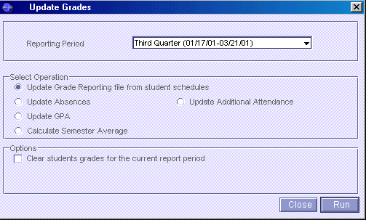

Select Option - Update Grade Reporting file from student schedules. Optional Choices - Update Absences, GPA, Additional Attendance. Since Horry County Schools print Report Cards outside of Sasixp, the Update Absences, GPA or Additional Attendance options are not required.

- Create/Print Grade Reporting Scan Sheets (In Grade Reporting Suitcase, Grading Suitcase, Grade Scanning Atom). Scan Sheet File must be created to print Grade Verification Sheets and for using Classxp. Do not Print Sheets if not scanning. Choose any Scan Sheet Form.

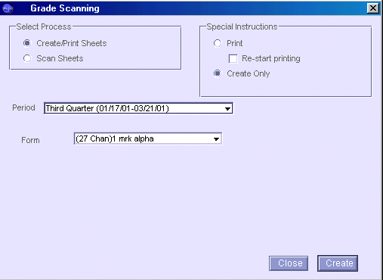

- Enter Grades – IntegradePro, Classxp, Sasixp Grades or Class Grades Atom, Scanning (In Sasixp, Grade Reporting Suitcase, Grading Suitcase, Grades Atom, Class Grades Atom or Scanning Atom) (In Sasixp, IntegradePro functionality is found in Utilities Suitcase, IntegradePro Data Exchange Atom)

Scheduled terms for classes are designated with Q1 (quarter one), Q2 (quarter two), S1 (semester one), Q3 (quarter three), Q4 (quarter four), S2 (semester two), or YR (year long )

During Grade Period 3 Interims, grades will be entered in Mark Heading:
3rd Intr - for Q3, S2, and YR scheduled classes

During Grade Period 3 Quarter, grades will be entered in Mark Headings:
3rd Qtr - for all Q3, S2 and YR scheduled classes

After completion of Period 3 Quarter grade processes, the 135 day GPA and classrank will calculated based on an additional Mark identified as 3GPA Avg in the grade file. See instructions below in step 12. Calculate GPAs.

- Verification By Teacher Report (GRD06) Verifies Grades (In Grade Reporting Suitcase, Grading Suitcase, Grades Atom, Menu Option Grade, Verification by Teacher Report (GRD06)).

Teachers may print their own Verification Sheets through Classxp. From the teachers’ Classxp desktop, open Sasi Modules, Grade Reporting Suitcase, Grading Suitcase, Grades Atom, Menu option Grade, Verification by Teacher Report (GRD06). Teachers must use the Sasi Modules to find the Verification Report.

- Make Appropriate Grade Corrections

Make appropriate grade corrections based on teacher verification procedures.

Since Sasi does not validate grade marks during the import of grade data from Integrade Pro, grade marks should be verified in addition to teacher verification procedures. A Sasi query comparing grade marks in the grade file (AGPL) with the mark definition file (AGMK) cannot be written. It is suggested that grade data be exported from Sasi to either Exel or Access for verification. The Sasi export query would look like:
Export
ASTU AGRD AGRL permnum lastname firstname mark if marknum = 7 and Termcode IN [“Q3”,”S2”,”YR”] (Note: Interim Quarter Three marknum =6, Quarter Three marknum =7)

Excel Import: During the import process, ensure that the grade marks are defined as general data type. The permnum, last and first names should be text. Once the data is imported to Excel, sort the data by largest to smallest for grade marks. All letter marks will be visualized at the top of the spreadsheet followed by numeric grades in descending order. Grades marks over 100 would also be clearly visible, if existed.

Access Import: During the import process, ensure that the grade marks are defined as numeric (integer) data type. The permnum, last and first names should be text. During the actual import process, the import process will create an Error table for those marks that are not valid numbers (integer), thus the Error table will show the data lines that do not contain numeric grades. A query will help identify any marks > 100.

- Print Honor Roll Report – if appropriate at this time. (In Grade Reporting Suitcase, Grading Suitcase, Honor/Roll Eligibility)
- Print and Distribute Report Cards
- Back up files – (especially ACHS, AGRD, AGRL, and AGRA)
- Post Grades to Course History – do not complete this step during any Interim reporting. Complete this step if your school has Q3 scheduled classes.

(In Grade Reporting Suitcase, Grading Suitcase, Update Course History Atom, Transfer Grades Option)

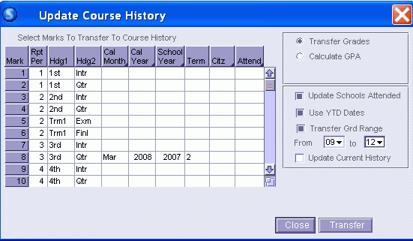
After data entry and before pressing Transfer, be sure to highlight the line that will be transferred.

SPECIAL NOTE:
The user may wish to check the “Update Current History” option box. Checking this box will cause the posting to compare the posting records with other transcript records and only update existing records or add new records. This prevents multiple entries of the same grade records, if the posting was inadvertently completed more than once.

After Grade posting:

Verify that transcript grade marks are valid entries. A Sasi query can be written to compare marks in the course history file (ACHS) with the mark definition file (AGMK). Although a query can not be written to compare the Grade file with the Mark definition file as in Step 7 above, a comparison query can be made between the course history marks and the mark definitions. Use the following query for checking validity.

ASTU ACHS AGMK lastname firstname 2,mark if 2,mark <> 3,mark

Back up Your Files !! Back ups are essential for restoring in the event of any problems.

If this process is performed more than one time, the transcript file will have multiple duplicate records for each student. If it is necessary to perform this process more than one time, you need to select the “Update Current History” option button which enables you to Update Records in the Course History Atom without duplicating existing records.

The Grade records for Q3 scheduled classes have not been erased by this process. The Grade File stays intact all year long and is available from year to year.

- Calculate GPAs and Classrank for Third Quarter – 135 day GPA Calculation

GPAs calculated at the end of the Third Quarter are based on:
cumulative transcript records
3rd Qtr mark for S2 scheduled classes
Trm1 Finl/3rd Qtr Average for YR scheduled classes.

Remember that cumulative transcript records now include current year Q1, Q2, Q3 and S1 scheduled classes.

Create 3GPA Avg mark used for Calculating 135 Day GPA

Sasixp will utilize a third quarter 3GPA Avg grade mark for the 135 Day GPA. Teachers are not to record any marks in the grade mark column headed 3GPA Avg. Sasixp will calculate the 3GPA Avg mark. The 3GPA Avg mark is the only mark for which the computer will generate an average in Sasixp. The 3GPA Avg mark will not print on Report Cards nor transfer to the transcript.

Running the calculate semester average function will copy S2 scheduled classes’ 3rd Qtr mark to the 3GPA Avg mark. It will also calculate an average for the YR scheduled classes based on the formula: Trm1 Finl mark with weight 2 and 3rd Qtr mark with weight 1. This configuration can be seen in the Grade Setup Atom, Marks tab. Sasixp will know where to store the 3GPA Avg by setup configuration found in the Grade Setup Atom, Credits tab.

(In Grade Reporting Suitcase, Grading Suitcase, Updates Grade Atom)

*** Note that the option “Do Not Calculate Semester Average If Blank Marks Exist” is NOT Checked. ***

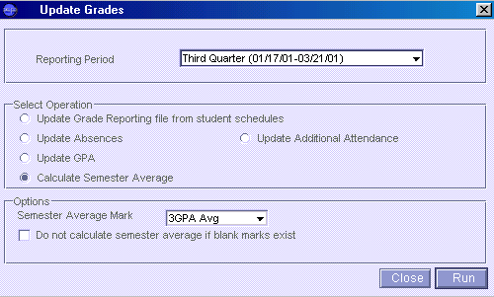

This process has now created a 3GPA Avg mark to be used for calculating a 135 day GPA.

Calculate GPAs and Classrank for 135 day GPA

All transcript records are calculated in the 135 day GPA/Classrank with 100% credit value. YR classes are included in the 135 day GPA/Classrank with 75% credit value. S2 classes are included in the 135 day GPA/Classrank with 50% credit value. These credit values (75%, 50%) for YR and S2 classes have been setup in the Credit Definitions Atom on the Credits Weight screen.

Select the appropriate Calculate Grd Range option for computing GPAs.
Grade Reporting Suitcase, Grading Suitcase, Update Course History Atom, Update GPA Option

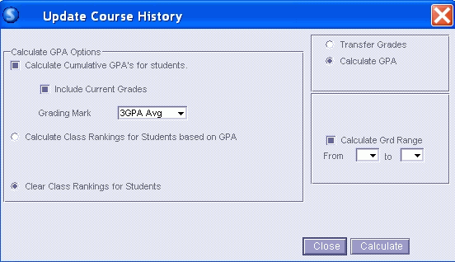

Notice the option “Clear Class Rankings for Students” is marked to clear any existing classranks. Then Re-running GPAs will replace rankings.

Run Calculate GPAs again selecting Calculate Class Rankings. It may also be appropriate at this time to implement a filter query for your class ranks depending on the grade level and educational purpose. For example: Seniors who will not be receiving a diploma may be filtered out from the senior classrank (use grade range 12 to 12).

SKIP ASTU if DiplomaTyp <> “A”

This query will only be effective in this scenario if all seniors have a value in the Diploma Type field. Diploma Type is displayed on the Course History Academic Summary screen but stored in the student file (ASTU) in DiplomaTyp field name. Change query can be utilized to set the Diploma Type to A for all students, then manual entries made to correct invalid values.

See reference State Department of Education, “Calculating GPAs in Sasi – South Carolina Uniform Grading Policy, 2007-08 found on HCS Pathways Support page, also State Board of Education Synopsis Agenda/Executive Summary)

Note:
If a user manually changes something in a specific student’s transcript record and calculates a new GPA for that student after Rankings have been run, that student’s ranking is zero. If you want to include the student in the ranking, you must calculate GPAs and class rankings again by re-running the calculate GPA process.

Viewing GPA values

GPA values can be found on the Academic Summary screen in the Course History Atom. The GPAs reflect the last “UpDate GPA” process.

Special Note:

The Academic Summary screen displays the latest GPA calculation. This may or may not match the printed GPA on the transcript (CHS12). During the transcript printing process, the GPA is calculated “on the fly” and reflects the GPA for courses stored in the course history file and NOT any grades in progress. For example: If a GPA was calculated at the end of 3rd quarter and included grades in progress, then the GPA value stored in the student file (ASTU) and displayed on the Academic Summary screen would NOT match the GPA on the printed transcript.

To query GPAs that are stored in the student file (ASTU), the following could be used:

4.0 Unweighted GPA
Display
ASTU Lastname Firstname CummGPA1 Sort CummGPA1^

Total GPA (Uniform Grading Policy
Display
ASTU Lastname Firstname CummGPA2 Sort CummGPA2^

To query classrank data, the query should include the Classrank field in the student file (ASTU).

4.0 Unweighted GPA
Display
ASTU Lastname Firstname CummGPA1 ClassRank 1

Total GPA (Uniform Grading Policy
Display
ASTU Lastname Firstname CummGPA2 Classrank2
IV. Grade Reporting Period 4 (Quarter Four)

Interims and Q4 Grades

- Back up Files (especially AGRD, AGRL and AGRA files)

- Change Current Period field to grade period 4 (In Grade Reporting Suitcase, Grading Suitcase, Grading Setup Atom , Periods Tab)

- Update Grading File for grade period 4 (In Grade Reporting Suitcase, Grading Suitcase, Update Grades Atom). Generally complete process for Update Grading File before each Interim and Quarter Grades. Update Grading File checks student schedules to determine whether to create or adjust changes in students’ grade records.

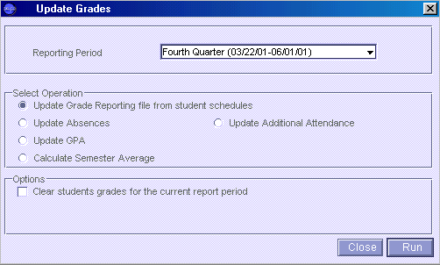

Select Option - Update Grade Reporting file from student schedules. Optional Choices - Update Absences, GPA, Additional Attendance. Since Horry County Schools print Report Cards outside of Sasixp, the Update Absences, GPA or Additional Attendance options are not required.

- Create/Print Grade Reporting Scan Sheets (Grade Reporting Suitcase, Grading Suitcase, Grade Scanning Atom). Scan Sheet File must be created to print Grade Verification Sheets and for using Classxp. Do not Print Sheets if not scanning. Choose any Scan Sheet Form.

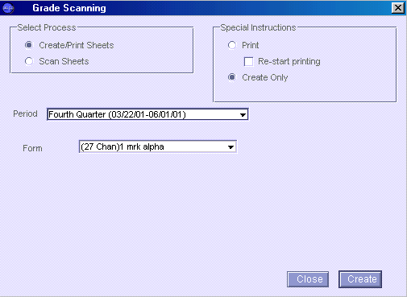

- Enter Grades – IntegradePro, Classxp, Sasixp Grades or Class Grades Atom, Scanning (In Sasixp, Grade Reporting Suitcase, Grading Suitcase, Grades Atom, Class Grades Atom or Scanning Atom) (In Sasixp, IntegradePro functionality is found in Utilities Suitcase, IntegradePro Data Exchange Atom)

Scheduled terms for classes are designated with Q1 (quarter one), Q2 (quarter two), S1 (semester one), Q3 (quarter three), Q4 (quarter four), S2 (semester two), or YR (year long )

Due to GPA requirements and limited Sasixp Grade File configurations, Sasixp will not be used to calculate semester averages. Teachers must compute and enter their own averages.

ALL YR long course teachers must complete the Trm2 Finl mark.

During Grade Period 4 Interims, grades will be entered in Mark Heading:
4th Intr - for Q4, S2, and YR scheduled classes

During Grade Period 4 Quarter, grades will be entered in Mark Headings:
4th Qtr - for all Q4, S2 and YR scheduled classes
Trm2 Exm – for all S2 scheduled classes
Trm2 Finl – for all S2 and YR scheduled classes
Yr Exm – for YR scheduled classes
Yr Finl – for all YR scheduled classes

- Verification By Teacher Report (GRD06) Verifies Grades (Grade Reporting Suitcase, Grading Suitcase, Grades Atom, Menu Option Grade, Verification by Teacher Report (GRD06)).

Teachers may print their own Verification Sheets through Classxp. From the teachers’ Classxp desktop, open Sasi Modules, Grade Reporting Suitcase, Grading Suitcase, Grades Atom, Menu option Grade, Verification by Teacher Report (GRD06). Teachers must use the Sasi Modules to find the Verification Report.

- Make Appropriate Grade Corrections

Make appropriate grade corrections based on teacher verification procedures.

Since Sasi does not validate grade marks during the import of grade data from Integrade Pro, grade marks should be verified in addition to teacher verification procedures. A Sasi query comparing grade marks in the grade file (AGPL) with the mark definition file (AGMK) cannot be written. It is suggested that grade data be exported from Sasi to either Exel or Access for verification. The Sasi export query would look like:

Export
ASTU AGRD AGRL permnum lastname firstname mark if marknum = 9 and Termcode IN [“Q3”,”S2”,”YR”] (Note: Interim Quarter Four marknum =8, Quarter Three marknum =9, Trn2 Exm marknum = 10, Trm2 Finl marknum = 11, Yr Exm marknum = 12, Yr Finl marknum = 13)

Excel Import: During the import process, ensure that the grade marks are defined as general data type. The permnum, last and first names should be text. Once the data is imported to Excel, sort the data by largest to smallest for grade marks. All letter marks will be visualized at the top of the spreadsheet followed by numeric grades in descending order. Grades marks over 100 would also be clearly visible, if existed.

Access Import: During the import process, ensure that the grade marks are defined as numeric (integer) data type. The permnum, last and first names should be text. During the actual import process, the import process will create an Error table for those marks that are not valid numbers (integer), thus the Error table will show the data lines that do not contain numeric grades. A query will help identify any marks > 100.

- Print Honor Roll Report – if appropriate at this time. (In Grade Reporting Suitcase, Grading Suitcase, Honor/Roll Eligibility)

- Print and Distribute Report Cards

- Back up files – (especially ACHS, AGRD, AGRL, and AGRA)

- Post Grades to Course History – do not complete this step during any Interim reporting. Complete this step if your school has Q4 and/or S2 and/or YR scheduled classes.

(In Grade Reporting Suitcase, Grading Suitcase, Update Course History Atom, Transfer Grades Option)

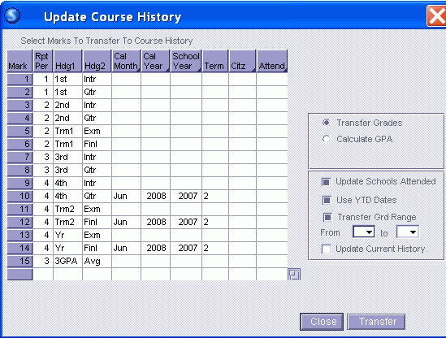
After data entry and before pressing Transfer, be sure to highlight the lines that will be transferred.

SPECIAL NOTE:
The user may wish to check the “Update Current History” option box. Checking this box will cause the posting to compare the posting records with other transcript records and only update existing records or add new records. This prevents multiple entries of the same grade records, if the posting was inadvertently completed more than once.

After Grade posting:

Verify that transcript grade marks are valid entries. A Sasi query can be written to compare marks in the course history file (ACHS) with the mark definition file (AGMK). Although a query can not be written to compare the Grade file with the Mark definition file as in Step 7 above, a comparison query can be made between the course history marks and the mark definitions. Use the following query for checking validity.

ASTU ACHS AGMK lastname firstname 2,mark if 2,mark <> 3,mark

Back up Your Files !! Back ups are essential for restoring in the event of any problems.

If this process is performed more than one time, the transcript file will have multiple duplicate records for each student. If it is necessary to perform this process more than one time, you need to select the “Update Current History” option button which enables you to Update Records in the Course History Atom without duplicating existing records.

The Grade records for Q4, S2 or YR scheduled classes have not been erased by this process. The Grade File stays intact all year long and is available from year to year.

- Update GPAs for End Of Year

(In Grade Reporting Suitcase, Grading Suitcase, Update Course History Atom, Update GPA Option)

GPAs calculated at the end of the year are based on cumulative transcript records. Remember that cumulative transcript records now include current year Q1, Q2, S1, Q3, Q4, S2, and YR scheduled classes.

All cumulative transcript records are calculated with 100% credit value. Select the appropriate Calculate Grd Range option for computing GPAs.

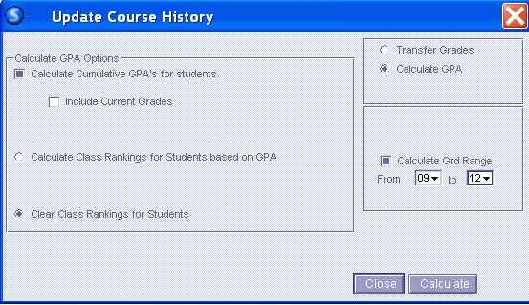

Notice the option “Clear Class Rankings for Students” is marked to clear any existing classranks. Then Re-running GPAs will replace rankings.

Run Calculate GPAs again selecting ONLY Calculate Class Rankings. It may also be appropriate at this time to implement a filter query for your class ranks depending on the grade level and educational purpose, especially if calculations are to be used for colleges or scholarships. For example: Seniors who will not be receiving a diploma may be filtered out from the senior classrank (use grade range 12 to 12).

SKIP ASTU if DiplomaTyp <> “A”

This query will only be effective in this scenario if all seniors have a value in the Diploma Type field. Diploma Type is displayed on the Course History Academic Summary screen but stored in the student file (ASTU) in DiplomaTyp field name. Change query can be utilized to set the Diploma Type to A for all students, then manual entries made to correct invalid values.

See reference State Department of Education, “Calculating GPAs in Sasi – South Carolina Uniform Grading Policy, 2007-08 found on HCS Pathways Support page, also State Board of Education Synopsis Agenda/Executive Summary.

Note:
If a user manually changes something in a specific student’s transcript record and calculates a new GPA for that student after Rankings have been run, that student’s ranking is zero. If you want to include the student in the ranking, you must calculate GPAs and class rankings again by re-running the calculate GPA process.

Viewing GPA values

GPA values can be found on the Academic Summary screen in the Course History Atom. The GPAs reflect the last “UpDate GPA” process.

Special Note:

The Academic Summary screen displays the latest GPA calculation which should have been the final GPA calculation for the school year after ALL grade records have been posted to transcript. This GPA will match the printed GPA on the transcript (CHS12), unless new courses/marks have been manually entered into the course history. New course/marks entries in the transcript would create a different GPA on the printed transcript from the last calculated GPA stored in the student file. Any new entries in the transcript will also nullify validity of classranks for that grade level and would need to be re-calculated.

To query GPAs that are stored in the student file (ASTU), the following could be used:

4.0 Unweighted GPA
Display
ASTU Lastname Firstname CummGPA1 Sort CummGPA1^

Total GPA (Uniform Grading Policy
Display
ASTU Lastname Firstname CummGPA2 Sort CummGPA2^

To query classrank data, the query should include the Classrank field in the student file (ASTU).

4.0 Unweighted GPA
Display
ASTU Lastname Firstname CummGPA1 ClassRank 1

Total GPA (Uniform Grading Policy
Display
ASTU Lastname Firstname CummGPA2 Classrank2

Graduation Requirements

The Sasi program will calculate the total number of units per subject area for graduation for each student. In order for this calculation to occur, the Graduation Requirements Atom and Course Atom must contain the appropriate information.

Subject Area fields must be completed for each Course in the Course Atom. These subject areas define the subject of a particular course.

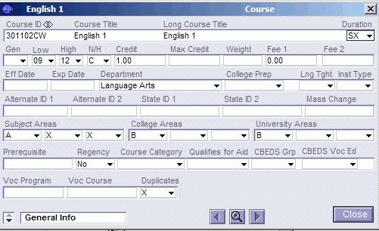

In the Grade Reporting Suitcase, Course History Suitcase, Graduation Requirements Atom, the number of units per subject area is recorded to use for calculations.

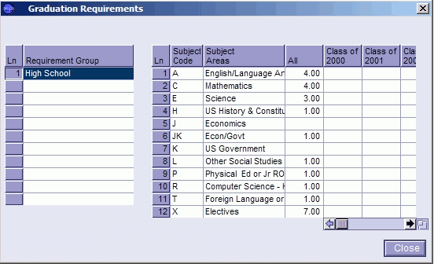

In the Course History atom on the Credit Summary tab, each student’s totals can be seen. These subject area totals can also be printed on the student’s transcript.

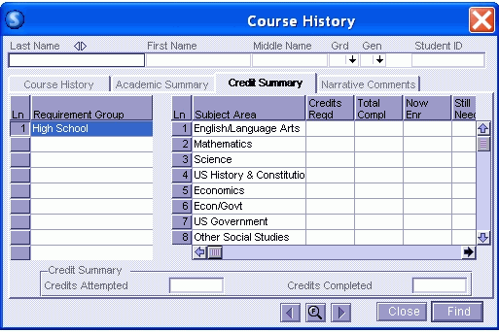

Narrative Comments

Transcript narrative comments can be entered in the Course History Atom, Narrative Comment tab. These comments can also be printed on the transcript.

Transcript Printing

Transcripts are printed by opening the Course History Atom and selecting Transcript (CHS12) from the
Course History menu option.

The printed transcript format is based on configurations established in the Transcript Definition Atom before printing. (Open Grade Reporting Suitcase, Grading Setup Suitcase, Transcript Defintion Atom). Settings are done on the five tab options:

Header/Footer
Course/Grade Options
WIP/College Entrance Options
Style Options
Test History Options

See sample below
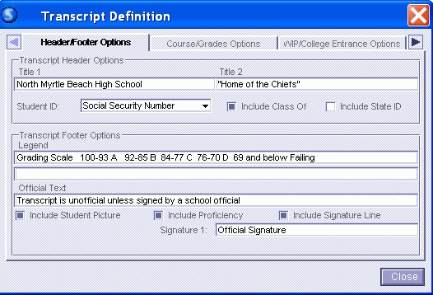

Transcripts that are sent to State Colleges and Universities and also for State Scholarship applications must follow the state transcript format. Details for the appropriate format can be found in accompanying documents provided by the state. These documents can printed or downloaded from HCS Technology Department’s Pathways Support web page:

“Calculating GPAs in Sasi – South Carolina Uniform Grading Policy, 2007-08
“State Board of Education, Synopsis Agenda/Executive Summary”

Transcript Repeat Tags
Students may retake a course in accordance with Uniform Grading Policies. In order for the GPA and credits to be calculated correctly, Repeat Tags must exist in the Repeat Tag Atom as defined below.

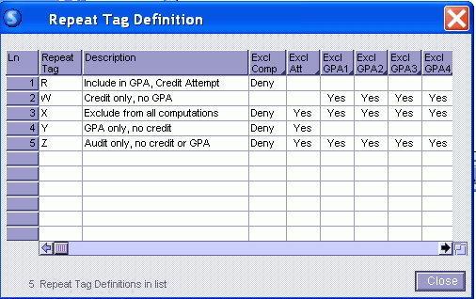

R – indicates a course will be included in GPA calculations, but will not receive completion credits.
X - indicates a course will not be included in any GPA calculations, and will not receive completion credits.

If a course is repeated, as defined in the UGP, assign the Repeat Tag "R" to the course that is not to receive completion credit. This course will be included in the GPA calculation. If a course is taken for no credit, change the Credit Attempted and Credit Completed to 0.0000, and/or use the Repeat Tag “X” that excludes the course from all calculations.

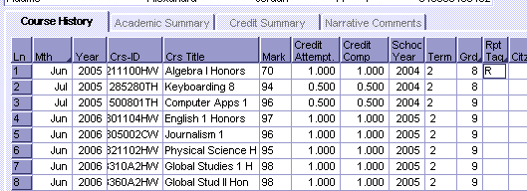

Students who drop out of school or are expelled after the allowed period for withdrawal but before the end of the grading period will be assigned grades in accordance with the following polices:

· The student will receive a WP if he or she was passing the course. The grade of WP will carry no Carnegie units and no quality points to be factored into the student’s GPA.”

· The student will receive a WF if he or she was failing the course. The grade of WF will carry no Carnegie units but will be factored into the student’s GPA as a 61.

IMPORTANT NOTE: When you post student records to the Course History atom with the WP mark, the “credits attemped” will also be posted. If you do not mark the records in course
history to indicate that the WP course should receive “No credit or Attempted Credit” for any academic tag, the GPA will be negatively impacted for those students who were passing the courses.

Therefore, you will need to query your data to determine which students withdrew from a course with a WP. For those students you will need to place an “X” in the Repeat Tag column so that the GPA will calculate properly. The “X” will allow SASI to exclude WP courses from GPA calculations.

Suggested query to DISPLAY such information:

Display
Show Inactive Records
ASTU ACHS Status GR LN FN SchlYear Course CrsTitle Mark RP IF Mark ="WP"

Note Repeat Tag example below:
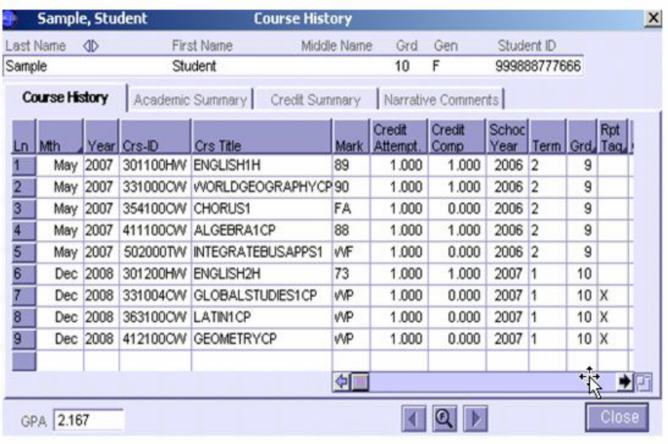

The resulting transcript shows courses from which the student withdrew, but the GPA calculation correctly indicates no effect.

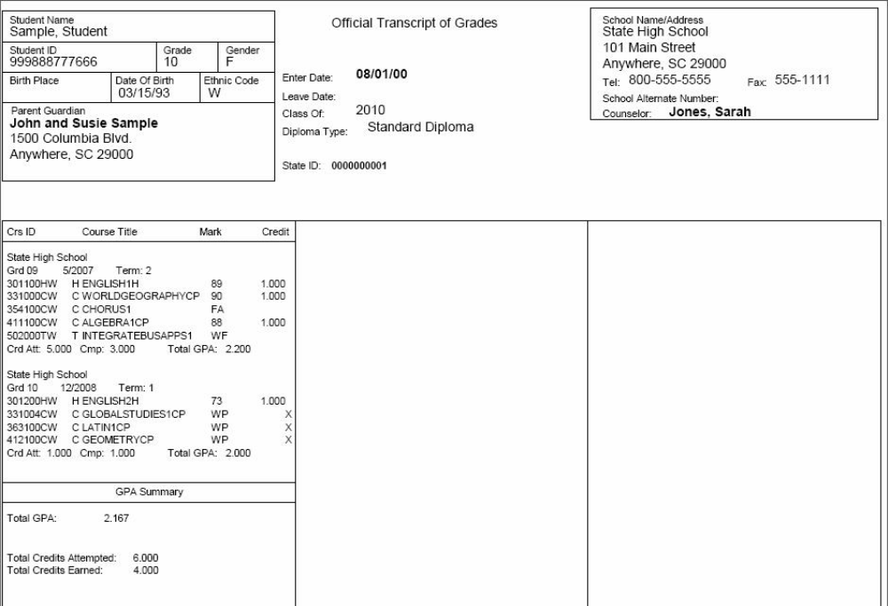

Duplicate Grade Records

It may be necessary for students to have two duplicate course records in the Grade File. Sasixp does not store the SectionID associated with a class, but rather, Sasixp stores the Course number. If a student has to repeat a course in the second semester (even though the student is scheduled in different sections), then Sasixp must understand that a duplicate course can be found in the grade file.

To allow duplicate course numbers in the grade file, the Course must be tagged to allow duplicates. This tag is found on the Course screen in the Course Atom in the field titled Duplicates. Notice the x in the Duplicates field in the example below. Every course should have the Duplicates field tagged x.

First Quarter Checklist

_____ Setup Calendar for Grade Process Completion Dates
_____ Back Up Files
_____ Change Current Period Field to One
_____ Update Grading File
_____ Create/Print Grade Reporting Scan Sheets
_____ Enter Grades – IntegradePro, Classxp, Sasixp Grades or Class Grades Atom, Scanning
_____ Teacher Grade Verification
_____ Additional Grade Corrections/Verifications
_____ Print Honor Roll
_____ Print and Distribute Report Cards
_____ Back up files
_____ Post Q1 grades to Course History
_____ Verify Grade Marks in Course History
_____ Back Up Files

Second Quarter Checklist

_____ Setup Calendar for Grade Process Completion Dates
_____ Back Up Files
_____ Change Current Period Field to Two
_____ Update Grading File
_____ Create/Print Grade Reporting Scan Sheets
_____ Enter Grades – IntegradePro, Classxp, Sasixp Grades or Class Grades Atom, Scanning
_____ Teacher Grade Verification
_____ Additional Grade Corrections/Verifications
_____ Print Honor Roll
_____ Print and Distribute Report Cards
_____ Back up files
_____ Post Q2 and S1 grades to Course History
_____ Verify Grade Marks in Course History
_____ Back Up Files
_____ Update GPAs, IF necessary
_____ Classrank, IF necessary

Third Quarter Checklist

_____ Setup Calendar for Grade Process Completion Dates
_____ Back Up Files
_____ Change Current Period Field to Three
_____ Update Grading File
_____ Create/Print Grade Reporting Scan Sheets
_____ Enter Grades – IntegradePro, Classxp, Sasixp Grades or Class Grades Atom, Scanning
_____ Teacher Grade Verification
_____ Additional Grade Corrections/Verifications
_____ Print Honor Roll
_____ Print and Distribute Report Cards
_____ Back up files
_____ Post Q3 grades to Course History
_____ Verify Grade Marks in Course History
_____ Create 3 GPA Avg Mark for 135 day Third Quarter GPA/Classrank
_____ Calculate actual 135 day Third Quarter GPA and Classrank
_____ Backup files

Fourth Quarter Checklist

_____ Setup Calendar for Grade Process Completion Dates
_____ Back Up Files
_____ Change Current Period Field to Four
_____ Update Grading File
_____ Create/Print Grade Reporting Scan Sheets
_____ Enter Grades – IntegradePro, Classxp, Sasixp Grades or Class Grades Atom, Scanning
_____ Teacher Grade Verification
_____ Additional Grade Corrections/Verifications
_____ Print Honor Roll
_____ Print and Distribute Report Cards
_____ Back up files
_____ Post Q4, S2 and YR grades to Course History
_____ Verify Grade Marks in Course History
_____ Back Up Files
_____ Update GPAs and Classrank

