
FREQUENTLY ASKED QUESTIONS
Ho Chi Minh City, Vietnam
Contents

1. What does the tuition for the program include? 1
2. How do I pay for the course? 1
3. Final payment 1
3. What is an average program day like? 2
4. How many students on average are in the program each month? 2
5. What are the teaching practice students and classes like? 2
6. What is the program accommodation like? Where is it located? 2
7. Can I have things shipped or mailed to me at the school? 2
The job market and teaching in Vietnam; paperwork and documentation 3
1. What is the TEFL job market in Vietnam like? Will I have trouble getting a job? 3
2. When do I need to start looking for work in Vietnam? Where do I start? 3
3. What will TEFL International do to help me secure employment? 3
4. What is the average salary like? 3
5. Do most schools provide accommodations for their teachers? 3
6. How many of the TEFL graduates actually find work in Vietnam? 3
7. Do schools provide health insurance? 3
8. Do schools provide work permits? 3
9. What is a typical teaching position like? 4
10. Can I return to my own country and teach with my certificate? 4
Questions about Ho Chi Minh City; living in Vietnam 4
1. What are the average housing and living expenses in Vietnam? 4
2. What do I do if I get sick in Ho Chi Minh City? Are there western-standard medical facilities? 4
3. What’s the public transportation system like? 4
What to do before departing for Vietnam 5
1. How do I get to Ho Chi Minh City? 5
2. What documents do I need to bring? 5
3. What’s the climate like? What kind of clothing will I need to bring? 5
Contact 6

1. What does the tuition for the program include?
Total fees: US$1,690
Comprised of:
US$ 600 non-refundable deposit
US$ 1090 TEFL course fee without accommodation. This amount includes tuition, course materials, and certification and moderation fees. Airfares and food are not included.

2. How do I pay for the course?
By this stage, you should already have paid the $600 deposit either online by credit card or via bank transfer.
You have the following options for final payment:

3. Final Payment
- Cash on arrival is an acceptable method of final payment in Vietnam. We would accept USD or Vietnamese dong based on the exchange rate of the date quoted on banks.
- Pay by credit card upon arrival. We only accept VISA and Master Cards.
- Pay by bank transfer:
IEL360 BANKING ACCOUNT
Account name | IEL 360
Account number | 187793959
Bank name | ACB (Asia Commercial Bank)
SWIFT Code | ASCBVNVX

On the first morning of the course the trainers will arrive early to handle final payments. All payments MUST be made by the end of lunch on the first day unless special arrangements have been made with the trainers. Late fees of $25 per day may be assessed if payment is not made.
If payments have not been received by the end of class on the first Wednesday, you must gain permission from the Course Director of TEFL International Vietnam to remain in the course.

3. What is an average program day like?
Class time is generally 9:00 am to 4:30 pm, with mid morning and afternoon breaks and a lunch break. For approximately two weeks, you will be preparing to teach—learning all of the things you need to know in order to be successful in the classroom. For the other two weeks, you will actually be teaching and preparing your materials.

4. How many students on average are in the program each month?
The maximum class size in the Ho Chi Minh City course is 18. Normally we've been having somewhere around 8 - 15 trainees. Most of the participants are American, British, Canadian or Australian, although we do accept non-native speakers of English who have a high proficiency in the language.

5. What are the teaching practice students and classes like?
We use local Vietnamese students for the trainees’ teaching practice. Vietnamese students are very keen and enthusiastic, and because we don’t charge them to attend, all students come to classes purely because they want to!

6. What is the program accommodation like? Where is it located?
We have the list of accommodation that we are contacting in Ho Chi Minh City with different locations in District 1 or District 3 that you can choose to stay. If you like to stay near our center, you can stay in one of our guesthouses which take you about 5 minutes on foot. There is a private room with AC, cable TV and other basic facilities.

7. Can I have things shipped or mailed to me at the school?
Yes, this is our address:
IEL360 Building
80B Ly Chinh Thang Street, Ward 8, District 3
Ho Chi Minh City, Vietnam

The job market and teaching in Vietnam; paperwork and documentation

1. What is the TEFL job market in Vietnam like? Will I have trouble getting a job?
The TEFL job market in Vietnam is excellent at the moment. Finding employment immediately is only difficult if you wait until the last day of the course to begin looking. With just a little patience, you will certainly locate work in no time, usually in the area of your choice.

2. When do I need to start looking for work in Vietnam? Where do I start?
We suggest you begin setting up interviews and sending resumes in the second or third week of the course.

3. What will TEFL International do to help me secure employment?
First, we provide you with information related to job search process in Vietnam and guide you how to find a good job. Second, we give you a list of schools in Vietnam and contacts. Finally, we invite some schools to come to our location to recruit you on the last day of the course. We guarantee job placement assistance, but please note that TEFL International doesn’t ‘guarantee’ its graduates employment in Vietnam as such. This job placement assistance is an integral part of the course and is available for as long as you need it afterwards.

4. What is the average salary like?
The average salary in Vietnam is about US$ 1,500 – 2,000 per month (US$ 17-20 per hour), though of course this varies depending on what type of school or company you work for and whether you work full or part-time.

5. Do most schools provide accommodations for their teachers?
No, but we will help you to find good places to stay if you want.

6. How many of the TEFL graduates actually find work in Vietnam?
Most of our course graduates who have wanted to work in Vietnam have been able to secure teaching positions.

7. Do schools provide health insurance?
Generally, no. However, if you are accepted in big schools and have a long term contract with them, you may be given medical coverage at a local specified hospital.

8. Do schools provide work permits?
Most schools here don’t do this but they can help you to get/extend your work visa as well as your work permit.

9. What is a typical teaching position like?
Of course, it varies from school to school, but you may be expected to teach a variety of courses, ranging from children to business professionals at all levels, in groups or in private sessions. Most of the work in Vietnam is at Language Centres and public schools and therefore, most of the hours available are very different. You may need to travel to classes at different schools.

10. Can I return to my own country and teach with my certificate?
Yes, it’s possible though the requirements for working in ESL or TEFL in many Western countries are different and sometimes need graduate education in ESL or TEFL.

Questions about Ho Chi Minh City; living in Vietnam

1. What are the average housing and living expenses in Vietnam?
Most likely you will rent a room in an apartment or house with other teachers (US$250-350 per month), and of course it depends on where you choose to live. A pleasant, small 2 to 3 bedroom house in Ho Chi Minh City is about US$ 400 to 700 per month. Apartments are available for more. It is fair to say that TEFL teachers are very well-paid by local standards in Vietnam, which means they can afford a comfortable standard of living. A local (Vietnamese) teacher in Vietnam earns around US$ 200 - 300 while a TEFL teacher at the same school can expect to earn about US$ 1,500 per month. While this may not sound a lot by international standards, it means you can live very comfortably in Vietnam.

2. What do I do if I get sick in Ho Chi Minh City? Are there western-standard medical facilities?
If you find yourself requiring medical attention, you can go to an international standard clinic which is 5-10 minutes ride from your place (there are quite a few of them in the centre area where the school are located). There are a lot of pharmacies nearby.
While on the course, if there is any serious injury, please inform the Course Director or one of the staff and they will help you to get to the hospital for treatment.

3. What’s the public transportation system like?
The public transportation system is not very good here. Then, you can choose to go by taxi for around 14,000 Dong per kilometre or by “xe om” – motorbike taxi for about 10,000 Dong/couple kilometres. You can use GRAB services with cheaper prices. If you want to travel to tourist places or neighbouring provinces, it is a good choice to use the buses of the travel agencies (Sinh Café Bus seems to be most popular) in Pham Ngu Lao backpacker area. The prices vary from US$ 2 – 5 depending on the place you go.

What to do before departing for Vietnam?

1. How do I get to Ho Chi Minh City?
Ho Chi Minh City is just a 20-minute taxi ride from the airport. A metered taxi charges approximately US$ 10-12 from Tan Son Nhat to the city center whether the guesthouses and the school are located. You can also use Grab services to book a car or a motorbike.

2. What documents do I need to bring?
Please bring your resume/CV because the school will require this in the teaching practice. When you secure work you may be asked to provide originals and copies of your college degrees and transcripts. You might also consider obtaining an international driving permit if driving in Vietnam.
PLEASE BRING ALONG COPIES OF YOUR PASSPORT AND VISA
ON THE FIRST DAY OF THE COURSE FOR REGISTRATION.

3. What’s the climate like? What kind of clothing will I need to bring?
It’s hot and humid. Light, comfortable, easy to launder clothing in natural fabrics such as cotton is most suitable in Vietnam. Good walking shoes and sandals that can be easily removed are recommended especially when entering temples and people's homes.
In Vietnam, teachers are very respectable. So, you will need to have on hand some really smart clothing for the English classes.
Men: Button-down shirts, trousers, a tie, nice shoes that aren't trainers/sneakers... something you'd wear to a job interview.
Women: Shoulders should be covered; very thin straps or tank tops are not allowed. No low-cut necklines, very short skirts or bare midriffs. Open-toed shoes are acceptable.
Please do not hesitate to contact us should you have other questions or concerns.

Contact

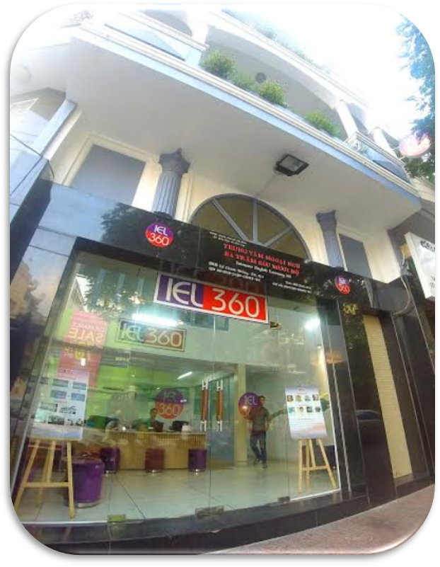
Mr. Andy Lowe: +84.949 100 097,
Email: andy@iel360.edu.vn

Ms. Diem: +84.903 352 062,
Email: diemduongtran@gmail.com
diem@iel360.edu.vn

TEFL International Vietnam
IEL360 Building
80B Ly Chinh Thang Street
Ward 8, District 3
Ho Chi Minh City, Vietnam
Website: www.teflvn.com
Office number:
(+84) 08 38483922
(+84) 08 38483932

Thank you for choosing TEFL International Vietnam to study your course.
☺☺☺

