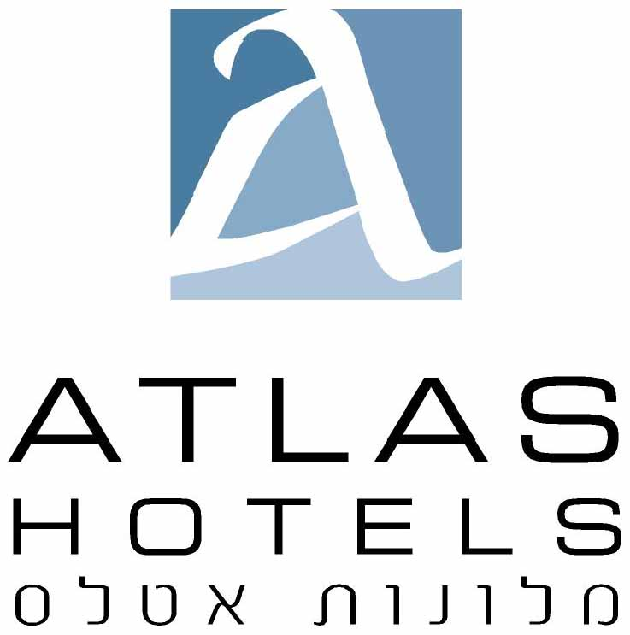

42 hamasger Tel Aviv Israel Tel: 972-3-5425555, Fax: 972-3-7608920 E-mail : ayelet@atlashotels.co.il

DATE: | November 22, 2026 | REF: | 2210
ATTENTION: | Reservations – Noa Adoram
 | noa@atlashotels.co.il

From Quantum Computing to Quantum Chemistry: Theory, Platforms, and Practical Applications
Tel Aviv University
15-18 September 2019.

HOTEL: please advise ----→
Room type:.

Guest name :
Arrival date:
Check-in 14:00:
Departure date
Check-out 12:00
Credit card details for the guarantee: | №:
 | Expiration date: ____ / ____
Card holder’s name
(if different than guest name)
Contact information (tel / email) :

Yam hotel
Single room for 780 Nis per night including breakfast.
Double room for 850 Nis per night including breakfast.

Hotel Tal/Melody hotel
Single room for 880 Nis per night including breakfast.
Double room for 970 Nis per night including breakfast.

Shalom hotel
Single room for 950 Nis per night including breakfast.
Double room for 1030 Nis per night including breakfast

Please note, Israeli passport holders need to add VAT to the rate
Cancellation up to 48 hours prio to arrival without fee.

