


Hotel Reservation Form
( IAMPS 2019 for period from 06.-10.05.2019 )

ACCOMODATION
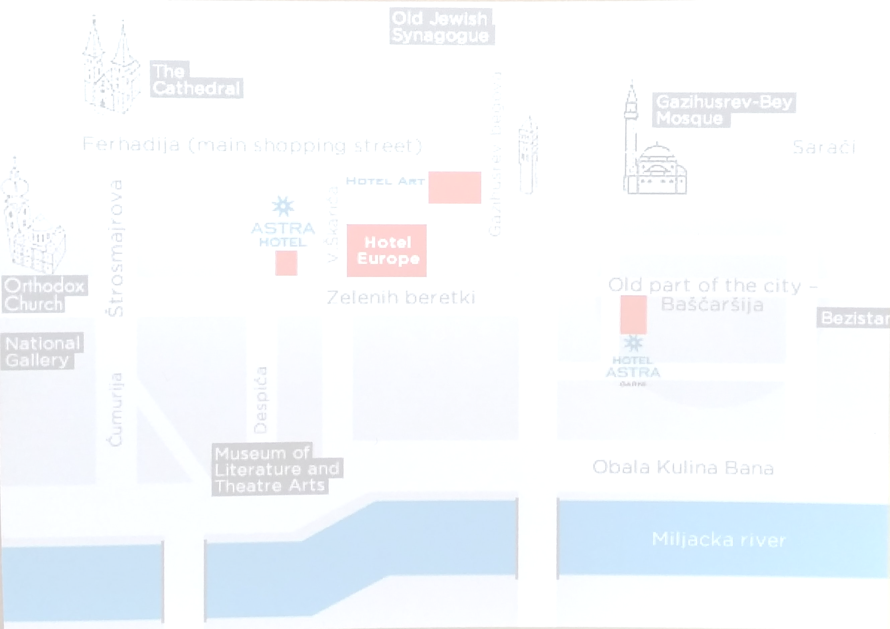
Booking deadline 28th February 2019.
Costs listed below are per room per night and include breakfast. Tax per day and insurance KM 2,50 or € 1,28 is not included in room rate .
**Please note: Number of rooms in each of the listed hotels is limited, so the booking will be subject to availability of room and rate (first come first serve)**

HOTEL EUROPE***** | marketing@hoteleurope.ba  Fax: 00387 33 580 580 | Reservation code: 2018/5710
Single bed room 220,00 KM – 20 % discount =176,00 KM / 90,00 €
Double bed room 260,00 KM – 20 % discount = 208,00 KM / 106,40 €
Please reserve ______room(s) _______ Single _______ Double
* 1,00 € = 1,95583 KM
Check in: May____ , 2019
Check out: May____ , 2019

HOTEL ART**** |  | reception@hotelart.ba  Fax: 00387 33 232 860 |  |  | Reservation code: 2018/902
Single bed room |  |  |  | 160,00 KM – 20 % discount = 128,00 KM / 65,44 €
Double bed room |  |  |  | 180,00 KM – 20 % discount = 144,00 KM / 73,60 €
Please reserve ______room(s) _______ Single _______ Double
* 1,00 € = 1,95583 KM
Check in: May____ , 2019
Check out: May____ , 2019
HOTEL ASTRA garni*** | reception@hotelastragarni.ba  Fax: 00387 33 476 300 |  |  |  | Reservation code: 2018/903
Single bed room |  |  | 140,00 KM – 30 % discount = 98,00 KM / 50,10 €
Double bed room |  |  | 180,00 KM – 30 % discount = 126,00 KM / 64,42€
Please reserve ______room(s) _______ Single _______ Double
* 1,00 € = 1,95583 KM
Check in: May____ , 2019
Check out: May____ , 2019
HOTEL ASTRA *** | reception@hotelastra.ba  Fax: 00387 33 209209 |  |  |  | Reservation code: 2018/700
Single bed room |  |  | 140,00 KM – 30 % discount = 98,00 KM / 50,10 €
Double bed room |  |  | 180,00 KM – 30 % discount = 126,00 KM / 64,42 €
Please reserve ______room(s) _______ Single _______ Double
* 1,00 € = 1,95583 KM
Check in: May____ , 2019
Check out: May ____ , 2019

PERSONAL DETAILS
NOTE: In case of cancellation of the room reservation, please inform us 2 days before guests arrival. Otherwise we charge from your credit card 1st night of the costs for the guests stay.
Name: | Surname:
Phone: | E-mail:
In order to guarantee this booking please provide us:
Numb. of Credit. Card _______________________________ Valid ___/___

