YOUSUNG HOTEL RESERVATION FORM
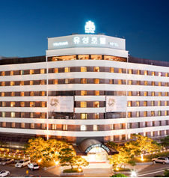 | Address: 9, Oncheon-Ro,Yuseong-gu, Daejon, Korea 34169
Tel: +82-42-820-0100/0617
Fax: +82-42-820-4070/0041
E-mail:jeonghsik@naver.com
Website:http://www.yousunghotel..com

A. Personal Information
□ Mr. □ Ms. □ Prof. □ Dr. □Other | GENDER □ M □ F
First Name: | Last Name:
Arrival(Check-In date): | Departure(Check-Out date):
Address:
City / Country: | E-mail:
Phone: | Passport Number:

B. Hotel Reservation
Room Type | □Standard Double □Standard Twin
Room Rate(Discounted Rate) (KRW) | KRW 115,000 (1 breakfast & spa included)
No. of Room
Special Request of Guest

* Breakfast (buffet) is served at 07:00 ~ 10:00
* All rates are included 10% service charge and 10% VAT.
* Check-in time 14:00 PM, Check-out time is 12:00 noon.
C. Hotel Reservation (Credit Card Information)
□ VISA□ MASTER □ JCB □ OTHER | Card Number:
Expiration Date(MM/YYYY): | Cardholder:
Remark: Your credit card information is for deposit for cancellation or no-show

▶Reservation Cut-off Date: JUNE 17, 2017
▶ Cancellation Policy
- 100% Refund : 2 days before your check-in date
- No Refund : 1 days before your check-in date or No-show

Date : __________________________________Signature :___________________________

