INVITATION OF BIDS FOR RENOVATION WORKS AT SDSC SHAR INCLUDES SUPPLY, FABRICATION AND INSTALLATION OF CIVIL ARCHITECTURAL INTERIORS AND ASSOCIATED ELECTRICAL LIGHTING SYSTEMS AT MOBILE SERVICE TOWER, SDSC SHAR, SRIHARIKOTA

- Proposals are invited from the interested bidders for the enclosed scope of work in two part bid. Part-1 technical and unpriced part of the work and Part-2 Priced commercial part.
- The scope of the work includes Design, Supply, Fabrication and Installation of the civil architectural interior works and associated electrical lighting related works at FLP, SDSC SHAR, Sriharikota, which is located about 100km towards the north of Chennai.
- The address and contact numbers for seeking clarifications regarding this RFP are given below –
 | Bids/queries to be addressed to | Sr.Purchase & Stores Officer, Range Purchase
 | Postal address for sending the Bids | Tender Section  Satish Dhawan Space Centre SHAR,  ISRO, Dept. of Space, Govt. of India,  Sriharikota – 524124,  SPSR Nellore Dist, Andhra Pradesh
 | Name/designation of the contact personnel | Mr.Hasan Md Basha  Sr.Purchase officer
 | Telephone numbers of the contact personnel | 08623-22 5127
 | e-mail ids of contact personnel | hasan@shar.gov.in
 | Fax number | 08623-22 5028
- This RFP is divided into three Parts as follows:
- Part I – Contains General Information and Instructions for the Bidders about the RFP such as the time, place of submission and opening of tenders, Validity period of tenders, etc.
- Part II – Contains essential technical details of the items/services required, such as the detailed scope of work and specifications of various sub systems of renovation works.
- Part III –Contains Evaluation Criteria and Annexures.
- This RFP is being issued with no financial commitment and the Buyer reserves the right to change or vary any part thereof at any stage. Buyer also reserves the right to withdraw the RFP, should it become necessary at any stage.
- DOCUMENTS COMPRISING THE BID
Bids shall be arranged in the following order.
  - PART – I TECHNICAL AND UNPRICED COMMERCIAL PART
Technical and unpriced commercial part shall comprise the attachments, specifying attachment number arranged in the order as follows:
- Submission of bid letter along with one set of proposal document (RFP) duly signed and stamped as token of acceptance
- All the annexure enclosed in proposal duly filled, signed and sealed
- Unpriced copy of schedule of prices with all other commercial terms, taxes, duties, exemption certificates and conditions duly filled (Prices to be kept blank), signed and stamped
- Data sheets for all the equipment & checklists enclosed in proposal duly filled, signed, & stamped.
- Technical details, catalogue, etc as applicable and any other document as mentioned in the proposal.
- Latest income tax certificate.
- Any other relevant document, bidder desires to submit.
  - PART – II PRICED COMMERCIAL BID
Priced commercial bid shall contain schedule of prices duly filled in, signed and stamped. No deviations, terms and conditions, assumptions, conditions, discounts etc. shall be stipulated in price bid. SDSC SHAR will not take cognizance of any such statement and may at their discretion reject such bids.
- BID SUBMISSION

Bids duly filled in by the Bidder should invariably be submitted as stipulated in the Letter inviting bid. Bids shall be submitted in the following manner.
  - PART – I : UN PRICED TECHNO-COMMERCIAL PART OF THE BID FOR THE WORK

Complete Techno–commercial part of the bid shall be filled online in the “Vendor Specified Terms’ form of the e-tender. Any documents related (demand draft for EMD), technical literature, guarantee /warrantee certificates and any other document as per the tender shall be scanned and uploaded to the e-tender under ‘Documents solicited from Vendor’ form only in ISRO e-procurement portal (https://eprocure.isro.gov.in). In case if the space is not adequate to upload, hard copy of the balance documents (without any price figures) shall be submitted before due date.

Envelope of technical bid shall be marked with following:

PART-I TECHNO-COMMERCIAL BID
Name of client | : | Satish Dhawan Space Centre SHAR  Indian Space Research Organisation
Title of the proposal | : | Design, Supply, fabrication and installation of all the civil interior works and associated electrical works at MST, FLP, SDSC SHAR, Sriharikota
Due date and time of the opening | :
From (Name of the bidder with address) | :
To:
Head, Purchase & Stores
Satish Dhawan Space Centre SHAR
ISRO, Dept. of Space,
Govt. of India
Sriharikota – 524 124,
SPSR Nellore Dist,
Andhra Pradesh, India

The deviation statement and checklist shall be filled online, without which the bid will not be considered. The vendor has to submit the architectural concept of the proposed modification works along with quotation. There will not be any payment for submission of architectural concept.
  - PART – II : PRICE PART OF THE BID FOR THE WORK
Price bid shall be filled in the on-line ‘price bid’ form of the e-tender only in ISRO e-procurement website https://eprocure.isro.gov.in. The price schedules for the BOM and other prices shall be uploaded on-line in the respective forms along with the price bid in the e-portal.
- SDSC SHAR may open Part – I of the bid on the due date of opening subject to meeting the minimum evaluation criteria. Price Bids (Part-II) of technically and commercially acceptable offers shall be opened at a later date.
- Unit rate for each of the item shall be indicated separately. The rate quoted shall be on FOR DESTINATION BASIS i.e., FOR SDSC SHAR, Sriharikota basis. Even unloading of the material at our site shall be vendor responsibility at vendor cost. Thus transportation of material from vendor works to SDSC SHAR and unloading at our site shall be the responsibility of vendors.
- If the offers submitted by the tenderers are silent on taxes, it will be presumed that quoted rates are inclusive of taxes & duties and no claim in this regard will be entertained later.
- Supplier has to consider entire bill of material required for renovation as per the schematics provided.
- SDSC SHAR reserves the right to reject any or all the Bids without assigning any reasons thereof.
- Any bids/offers with price details in Techno-Commercial Offer (Part –I) shall be rejected.
PART - I
GENERAL INFORMATION & STANDARD CONDITIONS OF RFP
S.No | Description | Vendor Compliance
 | Prices quoted should be on the basis of F.O.R. SDSC SHAR, Sriharikota, The purchaser will not pay separately for transit insurance. All risks in transit shall be exclusively of the contractor and the purchaser shall pay only for such stores as are actually received in good condition in accordance with the contract.
 | Site Visit: Bidder may visit the site for understanding the works involved before submitting the offer. Claims and objections due to ignorance of existing conditions or inadequacy of information shall not be considered after submission of the Bid and during implementation.
 | OFFER VALIDITY: Bid shall remain valid for acceptance for a period of FOUR months from the due date of submission of the Bid. The Bidder shall not be entitled during the said period to revoke or revise his Bid or to vary the Bid except and to the extent required by SDSC SHAR in writing. Bid shall be revalidated for extended period as required by SDSC SHAR in writing. In such cases, unless otherwise specified, it is understood that validity is sought and provided without varying either the quoted price or any other terms and conditions of Bid finalized till that time.
SPECIFICATIONS AND DRAWINGS
The Supplier shall execute the works in compliance with the provisions of CONTRACT, good engineering practices and codes requirements.
APPROVAL OF TECHNICAL DOCUMENTS / DRAWINGS
Supplier shall prepare and submit to SDSC SHAR for approval following documents and drawings:
- Technical literatures, data sheets and materials supplied by him.
- Erection sequence schedule along with erection drawings.
- No activity shall be executed unless SDSC SHAR’s approval is obtained.
DESIGN & SUPPLY OF SYSTEM
Supplier shall carry out detailed engineering, fabricate / procure and supply the system in accordance with the scope, technical specifications and terms & conditions of contract. Design and Supply shall take place after the award of contract only and after approval of engineering scheme.
DELIVERY AND STORAGE
- Dispatch Instructions given in the Contract shall be strictly followed. Failure to comply with the instructions may result in delay in payment apart from imposing any other charges as may be deemed to fit.
- The Supplier shall be responsible for transporting all the equipment to site, unloading and storage.
- No equipment shall be delivered without obtaining dispatch clearance from SDSC SHAR.
- All the equipment & material shall be properly packed to avoid any damage during transportation / handling / storage.
- The equipment and material received at site shall be stored at a place assigned for this purpose.
- Supplier shall take proper care while storing the equipment and shall provide watch and ward at his own cost.
 | Catalog may be provided by the supplier with the colours and models those can be offered for selection by the Department
For the items quoted, the tenderer shall send the following details along with the tender.
- Detailed specifications of the item in all respects.
- Photograph/catalogue of the item quoted.
- General architectural view after modification shall be provided otherwise offers will be summarily rejected.
 | SDSC SHAR reserves its right to reject any technically not suitable offer.
Clearances from Department: The successful bidder must obtain the clearance from the Department for the following:
- Fabrication drawings indicating the dimensions, materials, etc.
- Color, make & mode, etc.
 | RECORDS : Supplier shall maintain records pertaining to the quality of erection work in a format approved by Department. Whenever erection work is complete, Supplier shall offer erected equipment for inspection to Department's engineer who along with Supplier's engineer will sign such records on acceptance.

INSTALLATION

GENERAL
- Supplier’s staff shall include adequate number of competent erection engineers with proven experience on similar works to supervise the erection works and sufficient skilled, unskilled and semiskilled labour to ensure completion of work in time.
- Supplier's erection staff shall arrive at site on date agreed by SDSC SHAR. Prior to proceeding to work, Supplier shall however, first ensure that required/sufficient part of his supply has arrived at site.
- Erection of equipment may be phased in such a manner so as not to obstruct the work being done by other Suppliers and / or operating staff who may be present at that time.
- During erection, Department's engineer will visit site from time to time with or without Supplier’s engineer to establish conformity of the work with specification. Any deviations, deficiencies or evidence of unsatisfactory workmanship shall be corrected as instructed by Department.
- Supplier shall carry out work in a true professional manner and strictly adhere to the approved drawings. Any damage caused by Supplier during erection to new or existing building shall be made good at no extra cost to Department.
EQUIPMENT ERECTION
- Supplier shall carry out the works in accordance with the specific instructions given on the approved drawings, method statements, manufacturer’s drawings / documents or as directed by Department. Equipment shall be erected in neat workmen like manner so that they are level, plumb, and square and properly aligned and oriented.
- Supplier shall provide all supervision, labour, tools, machines, equipment, scaffolding, rigging material and incidental material such as bolts, wedges, anchors, concrete inserts, grout material etc. required to complete the works. Supplier shall also provide at his own cost all such consumables like oxygen - acetylene gas welding rods, grinding wheels, temporary supports, shims etc. required to complete work.
- Supplier shall take utmost care while handling material, delicate equipment, panels etc. and protect all such equipment on erection.

SAFETY
Supplier shall follow the safety regulations / codes and shall take necessary measures at their own cost.
4.5. ERECTION & CONSTRUCTION POWER
a). Electrical power and available material handling equipment may be extended by SDSC SHAR on chargeable basis, as per the tariff rules of State Electricity Board. Reasonable quality of normal Construction power will be made available at one point (415V, 3 phase, 50 Hz). However onward distribution shall be by the supplier. Installation of necessary energy meters, switchgear & distribution system, etc for Construction power in a safe manner in strict conformity with local rules & regulations will be responsibility of supplier.
b). During non-availability of power, supplier shall make their own arrangement of alternate power source at their cost.
4.6. WORK RULES
No work shall be carried out during night or public holidays unless a written permission is obtained from SDSC SHAR.
4.7. SITE CLEARANCE
Upon completion of work, supplier shall remove all their equipment and material from the site within one month or time mutually agreed. Supplier at all times shall keep site in clean condition and remove all unwanted material at regular intervals. In case supplier fails to remove all their equipment and material within the mutually agreed time it is deemed that SDSC SHAR will arrange to remove the same at Supplier’s cost.
4.8. ACCOMMODATION
a). Very limited accommodation may be provided by SDSC SHAR to senior supervisory staff on chargeable basis subject to availability.
b). Supplier shall make their own arrangement for accommodation & canteen facility for all its staff, technicians, labor & workers including transportation to the staff.

4.9. MEDICAL FACILITIES
No medical facilities will be provided by SDSC SHAR. Supplier shall make their own arrangement at their own expenses for medical facilities for site personnel.
4.10. WORK PROGRAMME
Supplier shall prepare a detailed programme schedule for review / approval by SDSC SHAR. Supplier as per exigencies of work shall revise and update programme periodically.
4.11. SUB-CONTRACTS
a). Whole of the work shall not be subcontracted.
b). Any subcontracting shall be after approval of SDSC SHAR.
c). Supplier shall be responsible for the proper execution of any sub-contract placed by their in connection with this purchase order.
d). Supplier shall furnish to SDSC SHAR the copies of all un-priced sub-orders showing promised delivery dates and places.
5.0 RECORD DRAWINGS AND O&M MANUALS
5.1. Supplier shall submit 3 hard copies & one soft copy of all the approved drawings incorporating any modification / changes made during the execution of CONTRACT. All these drawings shall be marked as 'As Built'.
5.2. Supplier shall submit 3 hard & one soft copy of O&M manual. These manuals should indicate weekly, monthly and yearly maintenance schedule and other instructions necessary for safe maintenance of equipment.
5.3. Submission of the drawings and manuals shall be a precondition for releasing of any final payment due to Supplier.
ERECTION & CONSTRUCTION POWER
- Electrical power and available material handling equipment may be extended by SDSC SHAR. Reasonable quality of normal Construction power will be made available at one point (415V, 3 phase, 50 Hz). However onward distribution shall be by the supplier. Installation of necessary switchgear & distribution system, etc for Construction power in a safe manner in strict conformity with local rules & regulations will be responsibility of supplier.
- During non-availability of power, supplier shall make their own arrangement of alternate power source at their cost.

WORK RULES
No work shall be carried out during holidays/public holidays unless a written permission is obtained from SDSC SHAR.
SITE CLEARANCE AFTER COMPLETION OF WORK
Upon completion of work, supplier shall remove all their equipment and material from the site immediately. Supplier at all times shall keep site in clean condition and remove all unwanted material at regular intervals. In case supplier fails to remove all their equipment and material within the mutually agreed time it is deemed that SDSC SHAR will arrange to remove the same at Supplier’s cost.

ACCOMMODATION AND TRANSPORTATION
- Very limited accommodation may be provided by SDSC SHAR to senior supervisory staff on chargeable basis subject to availability.
- Supplier shall make their own arrangement for accommodation & canteen facility for all its staff, technicians, labor & workers
- Contractor shall make their own arrangements for transportation.

MEDICAL FACILITIES
No medical facilities will be provided by SDSC SHAR. Supplier shall make their own arrangement at their own expenses for medical facilities for site personnel.

WORK PROGRAMME
Supplier shall prepare a detailed program schedule for review / approval by SDSC SHAR. Supplier as per exigencies of work shall revise and update programme periodically
SUB-CONTRACTS
- Whole of the work shall not be subcontracted.
- Any subcontracting shall be after approval of SDSC SHAR.
- Supplier shall be responsible for the proper execution of any sub-contract placed by their in connection with this purchase order.
- Supplier shall furnish to SDSC SHAR the copies of all un-priced sub-orders showing promised delivery dates and places.

RECORD DRAWINGS AND O&M MANUALS
- Supplier shall submit 3 hard & one soft copy of O&M manual. These manuals should indicate weekly, monthly and yearly maintenance schedule and other instructions necessary for safe maintenance of equipment.
- Submission of the drawings and manuals shall be a precondition for releasing of any payment due to Supplier.
CUSTOMS DUTY: SDSC-SHAR is eligible for 100% Customs Duty exemption as per Notification No.12/2012 dated 17.03.2012. This may be taken into account while considering the import of items.
The list of imported components are to be enclosed.
GST as applicable shall be indicated separately in schedule of prices (percentage of GST applicable & amount on which it is applicable).
INCOME TAX: Income tax at the prevailing rate and as applicable from time to time shall be deducted from the supplier's bills as per Income Tax Act. and a certificate will be issued (TDS Certificate).

DELIVERY SCHEDULE: The Design, supply, fabrication and installation of the systems shall be completed as per schedule of delivery enclosed under annexure-2

The time for the date of delivery of the stores stipulated in the purchase order shall be deemed to be the essence of the contract and delivery must be completed no later than the date(s) specified therein. Failure to do so, without adequate justification may involve cancellation of the contract / imposition of LD clause at the discretion of purchaser.

LIQUIDATED DAMAGES: In the event of the Supplier failing to complete the work within the delivery period specified in the annexure-2 or in extension agreed thereto, the Department shall reserve the right to recover from the Supplier as liquidated damages, a sum of 0.5 percentage per week or part thereof of the undelivered portion of the contract subject to a maximum of 10 % (ten percent) of the total Contract.
PERFORMANCE BANK GUARANTEE
  - The supplier shall guarantee for the performance of the contract by providing bank guarantee in favor of the Department for an amount equivalent to 10 % (ten percent) of the total value of this contract valid till the warranty period with a grace period of 2 months.
  - The performance bank guarantee shall be submitted by the supplier with in fifteen days from the date of accepting the material/works as per the CONTRACT. The format for the performance bank guarantee shall be obtained from the Department.
Department reserves right to forfeit the PBG if non-performance of the vendor.
Warranty Services: The bidder should provide one year warranty for the fully commissioned system from the date of acceptance. During warranty, bidder shall maintain adequate spares. During the warranty period supplier should provide and adhere to the following:
- The supplier shall provide comprehensive warranty for all material and accessories against any manufacturing defects. They shall maintain the equipment and repair/replace all the defective components at the installed site at no additional cost.
- In the event of the Supplier’s failure to supply & provide allied services within a reasonable period, the Department on its own will get the defects rectified through another agency at the risk and cost to the Supplier.
MODE OF PAYMENT
Our Bankers are State Bank of India, SDSC SHAR, Sriharikota – 524 124. You may furnish your banker details for transferring the payments through RTGS/NEFT mode
PAYMENT TERMS:
FOR SUPPLY OF EQUIPMENT / MATERIAL:
- 70% supply cost with taxes against factory inspection and receipt of material at SDSC SHAR.
- 30% of supply cost after completion of erection works and against submission of Performance bank guarantee for equal amount valid till warranty period.
FOR FABRICATION AND ISNTALLATION OF MATERIAL AT SITE:
- 90% after completion of installation works on actual quantities certified and accepted as per the schedule of prices.
- 10% after submission of performance bank guarantee or equal amount valid for guarantee/warranty period.
RISK COVERAGE: The Supplier shall arrange comprehensive risk coverage at his own cost covering the value of equipment including transportation to the site from manufacturer’s works, storage at site, fabrication, and installation at site. The period of such coverage shall be up to contractual completion period or any extension granted by Department thereof.
Safety: All equipment shall be complete with approved safety devices. Wherever a potential hazard to personnel exists, provisions shall be made for safe access of personnel to the equipment/sub-assemblies during erection, operation and maintenance.
Bidder shall note that the conditional discounts would not have edge in the evaluation process of tenders.
Non‐acceptance of any conditions wherever called for related to guarantee or warrantee, performance bank guarantee, liquidate damages will be summarily rejected.
Wherever installation and commissioning is involved, the guarantee / warrantee period should recon only from the date of installation and acceptance.
Quality and Workmanship: Materials used in the installation will be new and exclusively developed, produced and supplied to meet site requirements. Workmanship will be suitable for the purpose intended and in accordance with the highest standards and practices.
Test Certificates, wherever necessary, should be forwarded along with supplies.
The tenderer shall at all times indemnify the Purchaser against all claims which may be made in respect of the stores for infringement of any right protected by the patent Registration of design or Trade Mark and shall take all risks of accidents or damage, which may cause a failure of the supply from whatever cause arising and the entire responsibility for the sufficiency of all means used by him for the contract.
ARBITRATION: In the event of any question, dispute or difference arising under these conditions of any condition in the purchase order, (except as to any matters the decision of which is specially provided for by these conditions) the same shall be referred to the sole arbitration approved by Director, SDSC SHAR. The arbitration shall be conducted within India as per the Arbitration and Conciliation Act, 1996 and the applicable language shall be English. The award of the Arbitrator shall be final and binding on the parties of this purchase order.
APPLICABLE LAW AND JURISDICTION
The laws of India shall govern this purchase order for the time being in force. The Courts of Andhra Pradesh, India only shall have jurisdiction to be with and decide any legal matters or disputes what so ever arising out of the purchase order.
FORCE MAJEURE: Should a part or whole work covered under this purchase order be delayed due to reasons of Force Majeure which shall include legal lockouts, strikes, riots, civil commotion, fire accident, quarantines, epidemic, natural calamities and embargoes the completion period for work, equipment referred to in this agreement shall be extended by a period not in excess of the duration of such Force Majeure. The occurrence shall be notified within reasonable time.
PACKING & FORWARDING: The tenderer will be held responsible for the stores being sufficiently and properly packed for transport by rail, road, sea or air, to withstand transit hazards and ensure safe arrival at the destination. The packing and Marking of packages shall be done by and at the expenses of the Contractor.
DISCLOSURE AND USE OF INFORMATION
- If the documents supplied by the SDSC SHAR are marked 'restricted use', supplier shall take all necessary steps to ensure the same.
- Supplier shall guarantee that all information and data received during execution of Purchase Order from SDSC SHAR shall be classified as “confidential” within the meaning of the Official Secrets Act and will not be divulged to any third party without prior written permission of SDSC SHAR. All drawings & documents shall be returned after execution of work.
- No publicity of any kind whatsoever regarding this work shall be given without prior clearance from SDSC SHAR.
ACCEPTANCE AND REJECTION:
On completion of the work or part of the work as specified in the contract, the representative of the Department referred to, shall check as soon as possible, but in any event within the month of notification of readiness for acceptance that the work performed complies with the contract requirements as regards quantity and quality.
In the event of rejection of any of the articles, whereby the Supplier feels himself aggrieved, he may within eight days of the receipt of notification of rejection and before such articles have been removed from the place of inspection, give the Department notice of objection. Such objection shall be considered by a Board of Appeals of the Department. The Department shall, without prejudice to the arbitration clause in the contract, take a decision upon presentation of the Board's findings.
On completion of tests, the members of the Inspection Organisation of the Department or Inspection agency appointed by Department shall prepare a report, which must be countersigned by the Supplier.
SUSPENSION:
- Department may notify the Supplier to suspend performance of any or all of his obligations under the Contract. Such notice will specify the reasons for suspension and the effective date of suspension. Supplier there upon shall suspend the performance of such obligations until ordered in writing to resume performance of Contract by Department.
- If Supplier’s performance or his obligations remain suspended or the rate of progress is reduced, then, the time of completion will be suitably extended and all costs incurred by Supplier as a result of suspension or reduction in rate of progress will be paid to Supplier provided that the suspension or reduction in the rate of progress is not by reasons of Supplier's default or breach of Contract.
CANCELLATION
GENERAL RULE
The Department shall have the right at any time to cancel a contract either wholly or in part by giving written notice by registered mail. From the time of receipt of the written notice the Supplier shall undertake to observe the instructions of the Department as to the winding up of the contract both on his own part and on the part of his sub-suppliers.
WITHOUT FAULT OF SUPPLIER
In the case of cancellation of a contract by the Department without any fault of the Supplier, the Supplier shall on receipt of Department's instructions forthwith take the necessary steps to implement them. The period to be allowed to implement them shall be fixed by the Department after conclusion with the Supplier and, in general, shall not exceed three months.
Subject to the Supplier confirming, Department shall take over from the Supplier at a fair and reasonable price all finished parts not yet delivered to the Department, all unused and undamaged material, bought-out components and articles in course of manufacture in the possession of the supplier and property obtained by or supplied to the Supplier for the performance of the contract, except such material, bought-out components and articles in course of manufacture as the supplier shall, with the agreement of the Department, elect to retain.
WITH FAULT OF SUPPLIER:
The Department reserves the right, after full consideration of all relevant circumstances, including the observations of the supplier, to cancel a contract in any of the following circumstances.
- In the event of the Supplier's failure to meet
  - The Technical requirements of the Supplier.
  - The Progress and/or delivery requirements.
- If the Supplier has not observed the provisions of the contract concerning the disclosure and use of information provided by the Department.
- If the Supplier fails to comply with the provisions of the contract concerning the equipment, supplies and technical documents made available by the Department.
- If the Supplier transfers his contract without the Department's authorization or concludes sub-contracts against the Department's explicit directives.
- In the event that Supplier unjustifiably repudiates the Contract or fails to ship or dispatch all or part of the goods ordered for reasons other than those attributed to the Department’s actions or as provided in the Force Majeure clause, the Department may, by giving an appropriate notice in writing to the Supplier, fix a Date of Essence by which the Supplier must complete the dispatch in full. If the Supplier fails to do so, the Department, in addition to his right to recover Liquidated Damages in terms of the Contract, shall also have the right to cancel this Contract and make substitute purchases from other sources. If the goods are in a partial state of fabrication, Department may have the fabrication completed by other means, in which event Supplier shall be liable to Department for the additional expenses incurred thereby, but shall not have any claim on savings, if any, in such cases.
In the event of such cancellation, the Department shall unless otherwise specified in the contract, only pays.
- In the case of a fixed-cost contract for the supply of equipment or material. The contractual value of items delivered and accepted under the contract before receipt of notification of cancellation, or to be accepted under the special conditions of cancellation.
- In the other cases.
A fair and reasonable price in respect of such work as has been carried out prior to the receipt by the Supplier of notification of cancellation.

The firm will have to carry out the complete work as per site requirement.

Earnest Money Deposit (EMD)

31.1) Vendor has to submit EMD amount for 1 lakh rupees to participate in procurement process. EMD shall be paid in single installment through DD/Banker’s Cheque/Fixed Deposit from scheduled bank with a validity of 45 days beyond the final tender validity date.

31.2) Tender not accompanied with EMD shall be treated as invalid tender and rejected.

PART II
ESSENTIAL DETAILS OF ITEMS/ SERVICES REQUIRED
- INTRODUCTION
The requirement is to renovate the 1m elevation of Mobile Service Tower (MST) as per the configuration and specifications detailed in the subsequent chapters of this RFP. The basic schematic layout of 1m elevation is shown below with the tentative location to be renovated. The renovation works include wall paneling, open cell ceiling, perforated wall paneling, highlighter paneling, SS flooring, Stainless Steel Hand railing for staircase with electrical lighting and its fixtures.

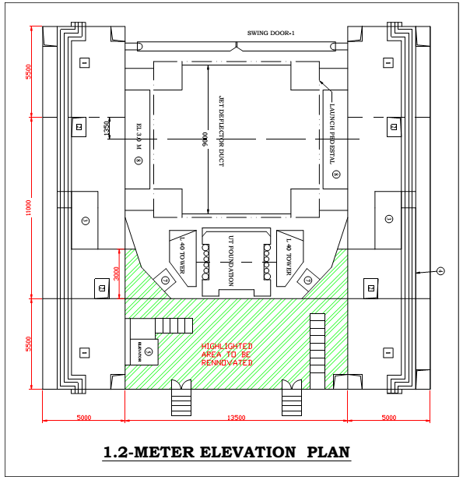

  - SCOPE OF WORK

S.No | Description | Vendor Compliance
2.1.1 | Design and submission of civil architectural interior engineering scheme and associated lighting scheme at 1m elevation floor of Mobile Service Tower (MST) of First Launch Pad, SDSC SHAR, Sriharikota as per the detailed scope of work mentioned below.
2.1.2 | Supply, fabrication and installation of wall paneling system containing customized wall panels, highlighter wall panels, perforated wall panels, back-up support structures with accessories like fasteners, gap panels, border panels etc. at MST 1m elevation of FLP,SDSC SHAR, Sriharikota as per the detailed scope of work mentioned below
2.1.3 | Supply, fabrication and installation of open cell type modular false ceiling panels, support back up structure, painting of back up structure, fasteners and related accessories at MST 1m elevation of FLP, SDSC SHAR, Sriharikota as per the detailed scope of work mentioned below.
2.1.4 | Supply of mounting fasteners, Fabrication and installation of metal flooring sheets with leveling compound and at MST 1m elevation of FLP, SDSC SHAR, Sriharikota as per the detailed scope of work mentioned below.
2.1.5 | Supply, fabrication and installation of customized hand railing system for staircase and associated steps at MST 1m elevation of FLP, SDSC SHAR Sriharikota as per the detailed scope of work mentioned below.
2.1.6 | Supply, fabrication and installation of metal fire rated doors at 1m elevation of MST as per IS3614 Part1&2 / BS476 part2/EN1634 as per the detailed specification enclosed below.
2.1.7 | Supply, Fabrication and Installation of customized flame proof lighting for interior works for 1m elevation of MST at FLP, SDSC SHAR as per the detailed scope of work mentioned below.

2.2 DETAILED SCOPE OF WORK

2.2.1 Detailed specification for Design and submission of detailed architectural scheme and associated engineering drawings for civil architectural interior and lighting scheme at 1m elevation floor of Mobile Service Tower (MST) of First Launch Pad, SDSC SHAR, Sriharikota

- The architectural scheme consists of flat façade, highlighter panels, gap panels, border panels with back up support structure, aluminum open cell ceiling, stainless steel / aluminum metal flooring, flame proof lighting fixtures with lights and its support scheme as per the schematic Drawing-1, 2, 3, 4,5&6
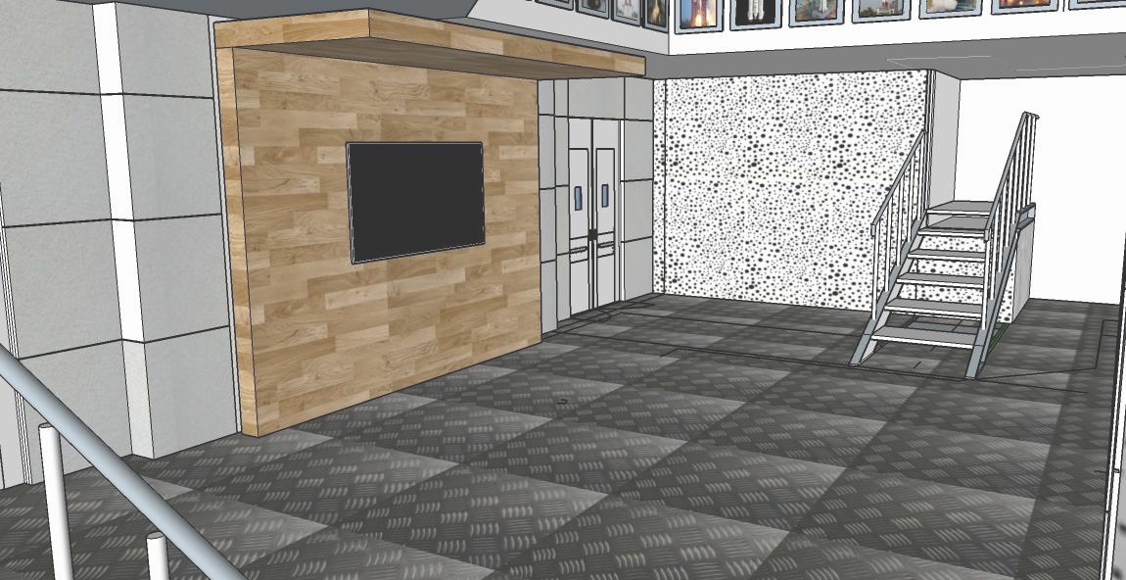

DRAWING-1 (PROPOSED RENNOVATION VIEW FROM INSIDE)
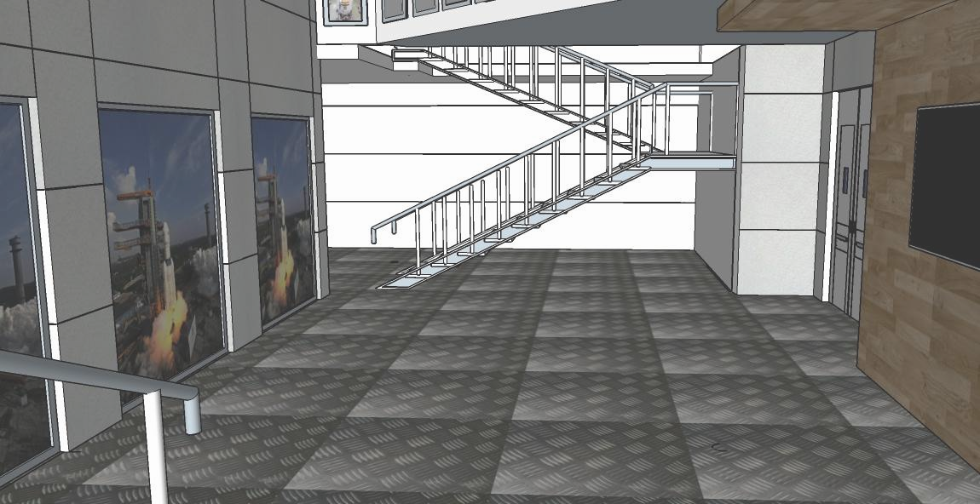

DRAWING-2 (PROPOSED RENNOVATION VIEW FROM ENTRANCE DOOR)

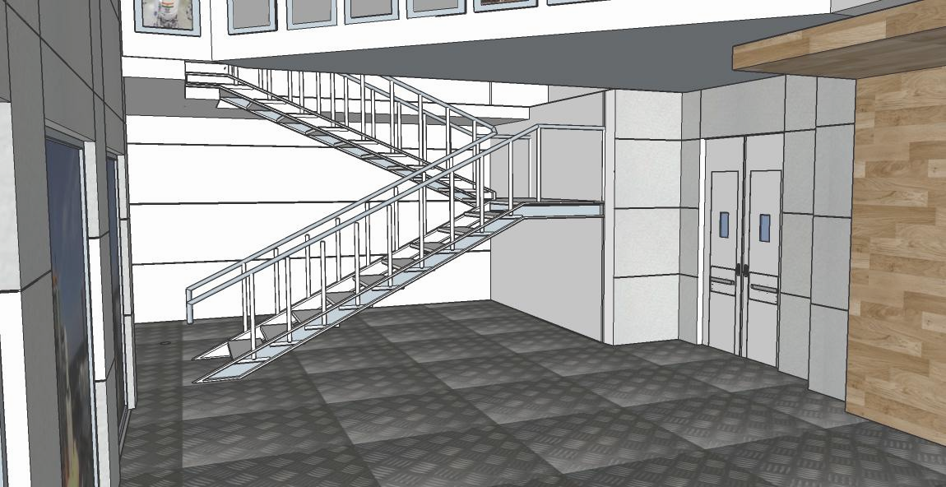

DRAWING-3 (PROPOSED RENNOVATION VIEW FROM ELEVATOR AT 1.2M)

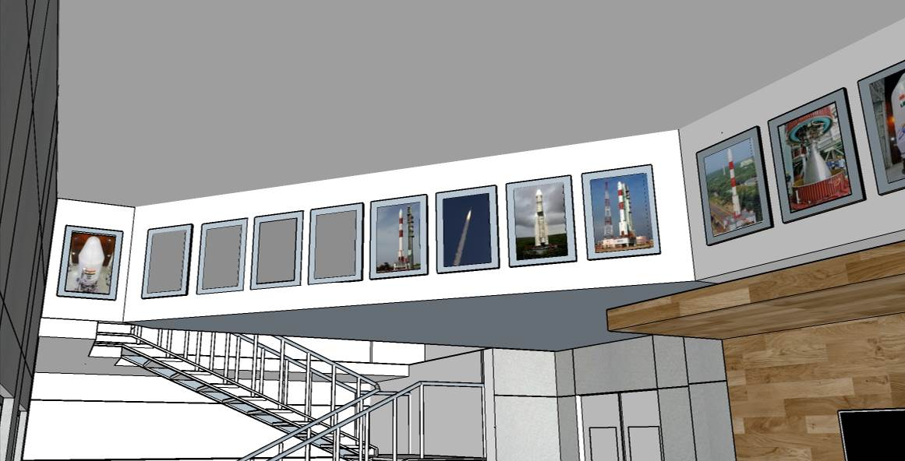

DRAWING-4 (PROPOSED RENNOVATION VIEW SHOWING SPACE FOR PHOTO GALLARY AT TOP CABLE TRAY AREA)

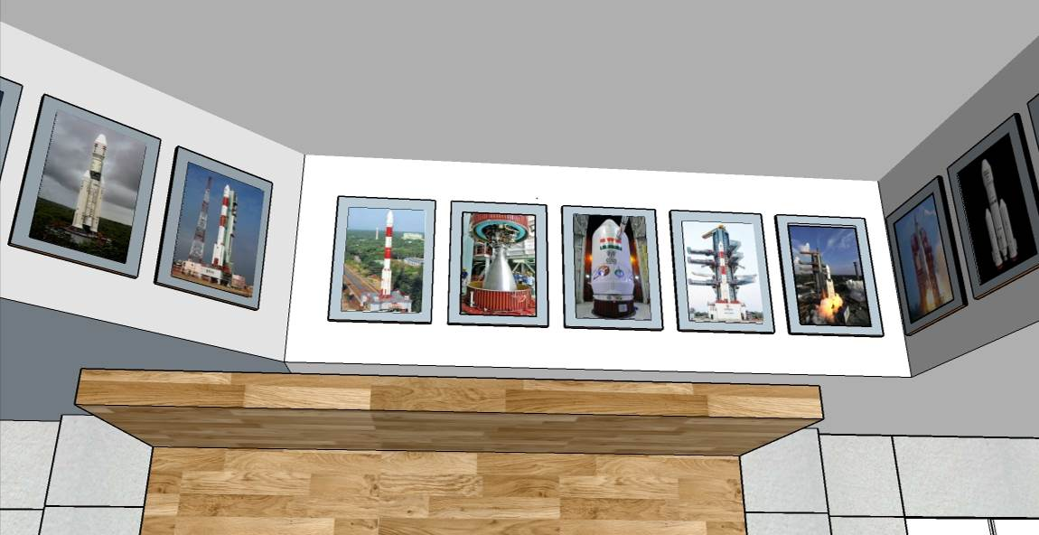

DRAWING-5 (PROPOSED RENNOVATION VIEW SHOWING SPACE FOR PHOTO GALLARY)

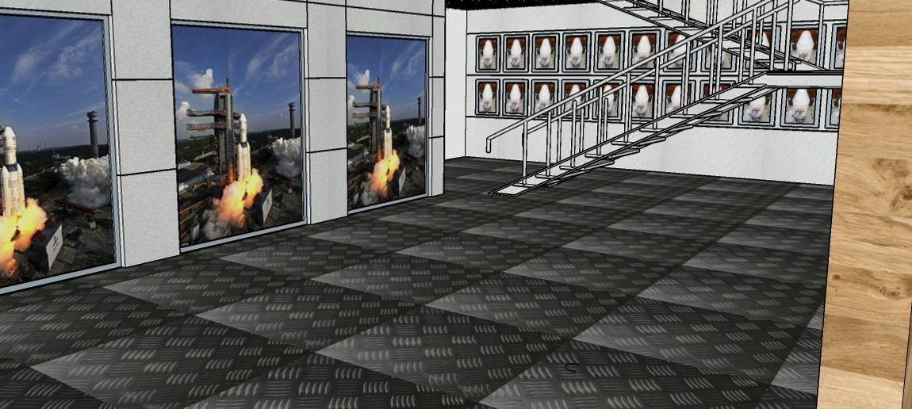

DRAWING-6 (PROPOSED RENNOVATION VIEW SHOWING SPACE FOR PHOTO GALLARY BEHIND 6M STAIRCASE)

- The architectural scheme shall be presented to department after the placing the purchase order. The department shall take a review on scheme and approve for preparation of fabrication drawings. The detailed engineering with fabrication drawings shall be provided to department for interface verification at actual site conditions. Based on verification at site final approval shall be given for vendor to proceed further.

- Two complete sets of hard copies and soft copies (CD/DVD form) shall be provided to department for record immediately after the approval of finalized scheme.

- The complete bill of materials including materials required for site fabrication and installation shall be provided to department.

- The MST 1m elevation existing views (Drawings-A,B,C,D) are shown below for your reference

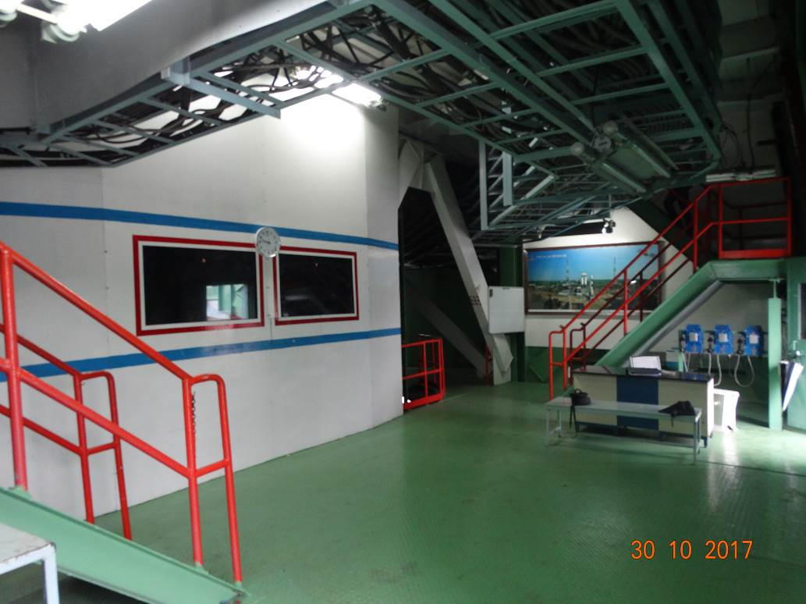

DRAWING-A(EXISTING CONFIGURATION VIEW FROM ENTRANCE DOOR)

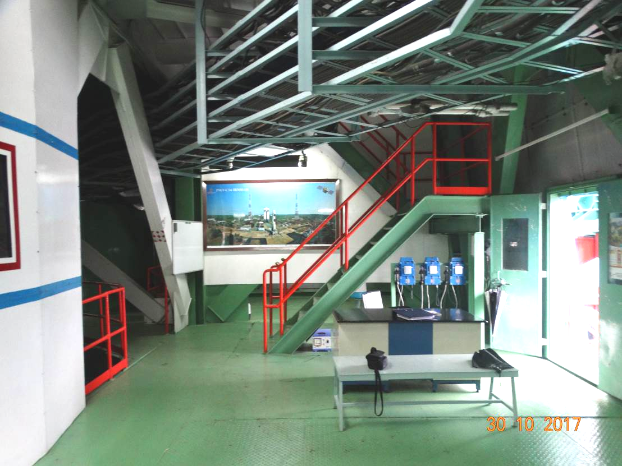

DRAWING-B(EXISTING CONFIGURATION VIEW FROM ELEVATOR AT 1.2M)
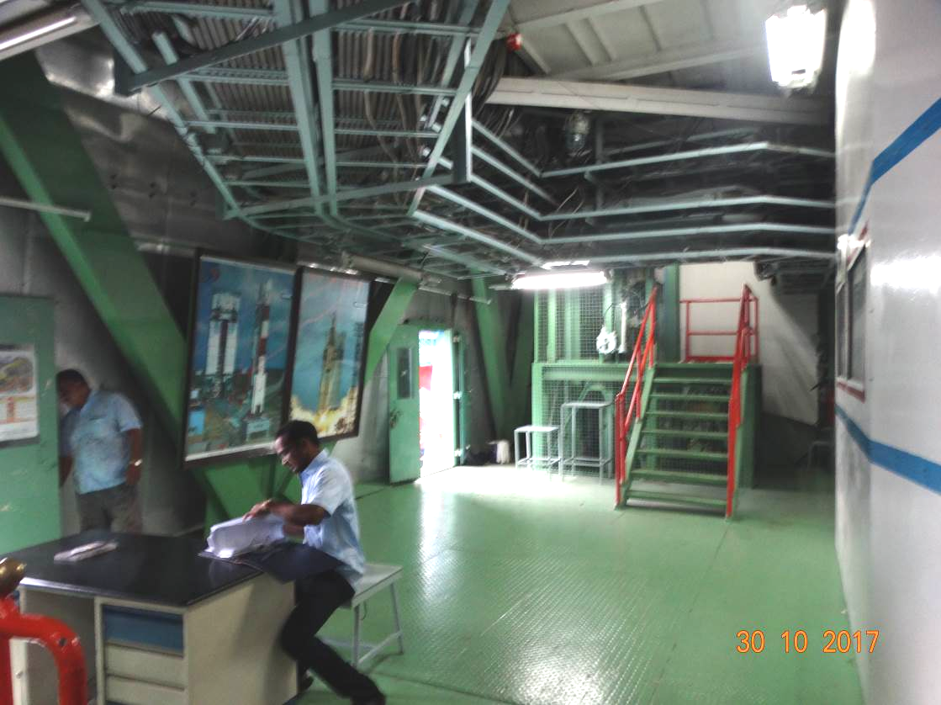

DRAWING-C(EXISTING CONFIGURATION VIEW FROM INSIDE)

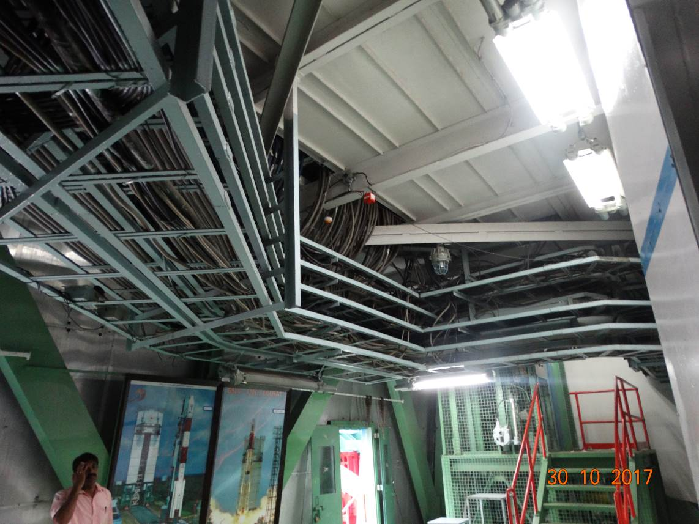

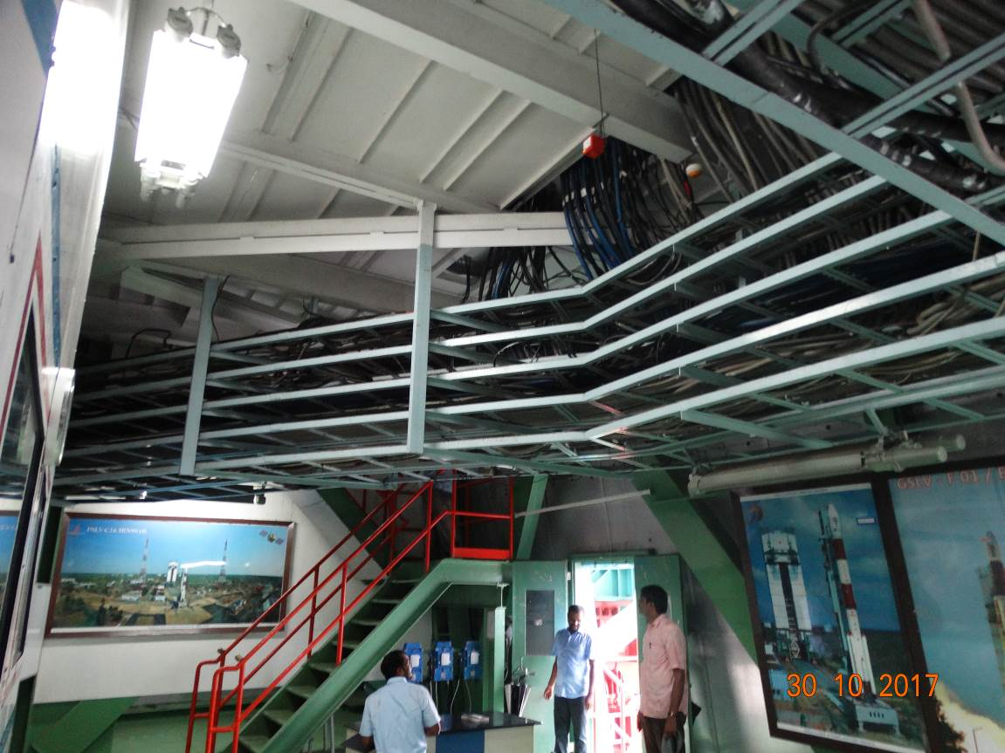

DRAWING-D(EXISTING CONFIGURATION OF CABLE TRAY AT TOP)
2.2.2 Detailed specification for Supply, fabrication and installation of wall paneling system containing customized wall panels, highlighter wall panels, perforated wall panels, back up support structures with accessories like fasteners, gap panels, border panels etc. as per detailed specification enclosed under annexure-1 at MST 1m elevation of FLP,SDSC SHAR, Sriharikota.

- The metal wall panels design shall be with Quadroclad flat facades made with honey comb core structure covered with external aluminum skin attached on both sides of core.
- The panels shall be made with lightweight aluminum material and strong enough for self-standing without intermittent support at panel level. The weight of panel per square meter should be in the range of 6 to 8 kg.
- The panel with its coatings shall compliant to class A fire safety as per EN13501 which means base material shall be non-flammable and associated coatings do not fuel fire and low smoke generation.
- The panels shall be mounted on rugged, pre-fabricated and concealed back up support structure. The very aim of concealed assemblies is to provide seamless corner detailing for viewing.
- The external surface of the panels shall be coated with durable PVDF paint. The external skin shall be coil coated at factory itself to provide colour consistency throughout its surface.
- The quadroclad panels shall withstand for exterior grade wind conditions.
- The quadroclad panels shall be compatible with saline and sea shore environmental conditions. Also it should be easily integrated with other elements like windows and doors interfaces.
- The back up support frame shall be extruded readymade section with end interfaces shall be suitable for mating with mild steel structure at MST.
- The gaps between the panels shall be covered with flush /gap panels/fittings to have seamless experience of wall panel system.
- All the wall panels shall be designed for plug and removable type for any maintenance activities. The joints of panels shall have flexibility to take care of thermal expansion and vibration loads.
- The highlighter panels shall be mounted on selected locations based on approved scheme. The basic mechanical properties/physical properties, mounting scheme shall be comparable with quadroclad panels. The color scheme and texture shall be finalized based on approved samples.
- The panel size shall be optimally considered to suite based on site conditions without loosing its appearance.
- Three no’s of high quality display boards of approximate size 2.0m x 2.5m shall be provided. The necessary interfaces shall be derived for mounting the display boards from wall panel. The photography information to be printed shall be provided by department.
- Total wall paneling area shall be provided with interfaces for mounting display boards based on requirement in the finalized engineering scheme.

2.2.3 Detailed specification for Supply, fabrication and installation of open cell type modular false ceiling panels, support back up structure, painting of back up structure, fasteners and related accessories as per detailed specification enclosed under annexure-2 at MST 1m elevation of FLP, SDSC SHAR, Sriharikota

- The ceiling shall be of modular removable aluminum grid open cell type. The open cell ceiling shall be coated with protective paint coat of sufficient thickness. The coating shall be resistant to weather conditions like high humidity and saline conditions of SHAR.
- The entire ceiling shall be mounted on support structure derived from 6m bottom platform. The backup structure shall be fabricated at site to suite geometry conditions at 1m and 6m elevations. The back structure shall be designed for minimum possible weight either by mild steel or aluminum extruded sections and well painted after completion of site fabrication with compatible paints.
- The open cell ceiling shall be designed to cover entire proposed area including edges of ceiling with special modular ceiling based on requirement.
- The open cell ceiling shall be fixed to back up structure with the help of fasteners/ rigid insertion scheme based on configuration.
- The interfaces of wall and ceiling shall be covered properly to avoid gaps and empty spaces to have seamless finish.
- The open cell ceiling shall be modular and removable type only acceptable to have maintainability for the systems above ceiling like FDA and cable tray.
- The cell panel size, color and finish of the open cell ceiling shall be finalized during the approval of architecture scheme. The cell opening size shall be about 100mm/4inch.
- The entire quantity of material and its accessories required for site installation shall be mobilized at once to complete the work in single stretch.
- Any minor additional material required for overall completion of work shall be provided vendor only.
- The self-weight of the total open cell ceiling shall be provided to get prior approval for modifications at MST.

2.2.4 Detailed specification for Supply, fabrication and installation of metal flooring sheets with leveling compound and sheets mounting fasteners as per detailed specification enclosed under annexure-3 at MST 1m elevation of FLP, SDSC SHAR, Sriharikota

- The existing flooring of MST 1m elevation has been covered with 6mm thick MS chequered plate support with MS back up support structure. The proposal is cover the flooring with SS chequered plate of base thickness 3mm.
- The SS covering plates alone will be supplied by department. The size of the plates is about 1200mm x 2400mm. The covering plates are to be fixed on base MS plate using fasteners. The transition profile between the plate joints /edges/fasteners shall be supplied and installed by vendor.
- Before proceeding to final assembly of covering plates the existing MS chequered plates surfaces has to be levelled using suitable compound to have uniform butting of covering sheets with base plate.
- The leveling compound shall be applied as per OEM instructions. In case if it is proposed to apply on base metal surface directly the existing painted surfaces has to be cleaned with paint remover. The necessary consumable materials and tools required for paint removing shall be in the scope of vendor only.
- Vendor has to note that flooring shall be rugged enough to handle all kinds of general working loads like gas cylinders rolling, ladders movement etc.
- The sufficient quantity of manpower, tools and equipment like welding, cutting, grinding, drilling machines, drills, taps, and fasteners required for covering sheets assembly shall be arranged by vendor only. The flooring sheets shall be cut to required layout with minimum wastage and to have better overall appearance.
- The covering sheet fasteners shall be assembled strategically to avoid making any holes/cuts on main support members of the flooring at MST 1m elevation. As far as possible only chequered base plate only to be used for covering sheets fixing.
- The detailed fabrications drawings/plans are to be prepared and submitted to department before proceeding to site works.

2.2.5 Detailed specification for Supply, fabrication and installation of customized hand railing system for staircase and associated steps as per detailed specification enclosed under annexure-4 at MST 1m elevation of FLP, SDSC SHAR Sriharikota

- The existing steps at 1m elevation for elevators approach paths are provided with MS handrails to the height of 1meter with fully welded configuration.
- It is proposed to change the existing handrails to customized polished stainless steel handrails with elegant appearance also. The handrail members shall be made with pipe of size 50 mm OD and wall thickness 1.6 mm. The handrails are fixed to balustrade with minimum of 50mm diameter and 1.6mm thick with top adaptor (neck) type. The balustrade fixed to top of staircase platform with fasteners. The center to center distance shall be in the order of 900 to 1000mm with handrail height of 1000mm from fixed floor level. The handrails pipes are to be covered with end caps and shall provide articulate rod holder. The material of constriction shall be SS304 grade with satin finish only.
- The steps surface also to be covered with covering sheets and needs to be fixed with fasteners. The steps leveling, trimming and preparation of surface like paint removing for leveling compound application shall be under the scope of contractor only.
- The handrail shall be fabricated in such a way that it shall have smooth edges and without any burrs, scales and ruff weld beads.
- The handrail base and staircase base structure shall be painted with suitable paints in matching colour and finish with surrounding wall paneling and open cell ceiling.
- The handrail design and its associated colour scheme shall be provided in approved scheme and fabrication drawings/scheme.
- The handrails should be very rigid and to be fixed to existing steps with suitable interfacing mechanism.
2.2.6 Detailed specification for supply, fabrication and installation of customized metal fire rated doors for MST 1m elevation at FLP, SDSC SHAR
- The construction of the door shall be pressed galvanized steel.
- The door shall be double leaf only and shall consists of frame, shutter, infill and finish. The exact size shall be in accordance with site conditions and approved codes in practice.
- The thickness of door shall be minimum of 46mm or as per standard, full flush construction and double skin type with vision lite. The door leaf covering skin shall be manufactured from 1.2mm (minimum) thickness galvanized steel sheets.
- The door shall be provided with ball bearing hinges, articulate handle, door closer, vision panel, locking mechanism.
- The interfaces between the surrounding wall paneling and door frame edges shall be matched to have seamless construction.
- The existing door shall be modified or removed based on finalized interfaces after completion of fire doors installation at 1m elevation based on SDSC SHAR decision.
- The total site work from generating interfaces for mounting the fire rated doors shall be under the scope of contractor only.

2.2.7 Detailed specification for supply and installation of flame proof lighting system at
1m elevation of MST FLP, SDSC SHAR
- The supply portion of flame proof lighting system includes the following components as table below.
S.NO | PARTICULARS | UNIT | QTY
 | Supply of Flameproof single phase 5 way junction box complying with specifications furnished below.  - Power Supply: single phase 230 Volts ± 10 % ac, 50Hz  - Hazardous Area classification: Zone-1 as per IS 2148:2004/ IEC 60079-(2001)/Relevant national/international standards  - Enclosure Type: Gas group IIB, ex-d, T6 as per IS 2148:2004/ IEC 60079-(2001)/Relevant national/international standards  - DB Type: Indoor, wall/ceiling mounting type  - Degree of protection: IP-54 as specified in IS-13947  - Finish: Smoke grey shade as per IS:5  - Internal wiring: Minimum 2.5 Sq.mm multi strand COPPER conductor PVC insulated wires.  - Earthing: 1 internal and 2 external earthing.  - Cable entry: 3/4’’ ET -9 nos  - cable glands: Flameproof double compression type  - Accessories as part of the item; 3/4’’ ET Flameproof double compression glands- 12 nos  - Make: Baliga /FCG | Nos | 2
 | Supply of ceiling mountable flameproof 230V,72W LED flood light luminaire complying with the detailed specifications furnished below  - Power Supply: Single phase 230Volts ± 10 % ac, 50Hz  - Lamp type: Integral 72W LED flood light fitting  - Hazardous Area classification: zone-1 as per IS 2148:2004  - Enclosure Type: Gas group IIB, ex-d, T5 as per IS 2148:2004  - Enclosure Material: Die Cast Aluminum Alloy LM-6.  - Mounting type: Wall/ceiling mounting  - Degree of protection: IP-54 or better as specified in IS-13947  - Luminaire efficacy: 80 lm/W or higher  - Color Temperature: Cool white, 5500K or higher  - Ambient temperature: 45 deg C  - Finish: Smoke grey shade as per IS:5  - Internal wiring: Minimum 2.5 Sq.mm multi strand COPPER conductor PVC insulated FRLS wires.  - Earthing: 1 internal and 1external earthing provision  - Cable entry: Incoming cable entry size: 3/4’’ ET -1 no  - Cable glands: Flameproof SS double compression type  - Accessories as part of the item: 3/4’’ ET Flameproof double compression glands- 1 nos  - Make : Baliga/FCG | NOS | 10
 | Supply of flameproof single phase 230V,16A rotary switch complying with the detailed specifications furnished below  - Rating/Type: Single phase 230Volts ac, 50Hz, 16A rotary switch  - Hazardous Area classification: Zone-1 as per IS 2148:2004/ IEC 60079-(2001)/Relevant national/international standards  - Enclosure Type: Gas group IIB, ex-d, T6 as per IS 2148:2004/ IEC 60079-(2001)/Relevant national/international standards  - Type: Indoor, wall mounting, bottom cable entry  - Degree of protection: IP-54 as specified in IS-13947  - Finish: Light grey shade as per IS:5  - Internal wiring: Minimum 2.5 Sq.mm multi strand COPPER conductor PVC/XLPE insulated wires.  - Earthing: 1 internal and 2 external earthing.  - Cable entry: Incoming cable entry size: 3/4’’ ET -1 no  - Outgoing cable entry size: 3/4’’ ET- 1 no  - Cable glands: Flameproof SS double compression type  - Accessories as part of the item: SS 3/4’’ ET double compression gland – 2 nos  - Make: Baliga/FCG | NOS | 2

- Installation of cable wiring, junction boxes, light fittings, rotary switches to be carried out as per below specificationbs
1 | Laying of 1.1KV grade 3CX2.5 SQ.MM class2 copper conductor XLPE insulated & FRLS PVC sheathed armoured heavy duty LT cable in existing cable tray /wall including supply of all necessary materials such as clamps/MS spaers etc and end termination. | Lot | 1
2 | Installation of Flameproof single phase 5way junction box to ceiling including supply of suitable brackets,bolts etc. | Nos | 2
3 | Installation of ceiling mountable flameproof 230V,72W LED flood light luminaire including supply of suitable brackets,bolts etc | Nos | 10
 | Installation of flameproof single phase 230V,16A rotary switch including supply of suitable brackets,bolts etc | Nos | 2
- The tools and equipment required for installation, wiring routing, end terminations, glanding shall be under the scope of contractor only.
- The required length of armored cable shall be arranged by department and shall be given as free issue.
- Department shall extend the power supply to lighting after thorough verification and confirmation of wiring terminations.

3.0) GENERAL INSTRUCTIONS FOR SITE FABRICATION AND INSTALLATION WORKS

- The mild steel backup structure shall be fabricated using conventional fabrication method of cutting, grinding and arc welding only. Wherever possible fastener based assemblies are allowed subjected to site interfaces.
- The equipment and tools like welding machine, grinding machine required for site fabrication works shall be arranged by contractor only.
- The necessary, sufficient and qualified fabrication manpower shall be arranged by contractor. Department will provide only electric power source at free of cost.
- The personnel protective equipment shall be used while doing site fabrication works to prevent accidents. It is the contractors responsibility to take care of equipment and manpower safety during site works.
- The site fabrication works are to be carried out with absolute care and also liable for any damages caused to surrounding systems. The necessary protection mechanism shall be incorporated to surrounding systems at his own cost and risk.
- The site fabrication works shall be supervised by contract supervisor/engineer to ensure smooth functioning of planned works.
- The waste material generated during the site works shall be disposed on daily basis at identified location by contractor. Housekeeping is essential part of the daily work inside MST.

PART III
EVALUATION CRITERIA & ANNEXURES
- Evaluation Criteria. The broad guidelines for evaluation of Bids will be as follows:
S.No | Description | Vendor Compliance
 | In respect of Two-Bid system, the technical Bids forwarded by the Bidders will be evaluated by the Buyer with reference to the technical characteristics of the equipment as mentioned in the RFP. The compliance of Technical Bids would be determined on the basis of the parameters specified in the RFP. The Price Bids of only those Bidders will be opened whose Technical Bids would clear the technical evaluation.
 | During evaluation, SDSC SHAR may request Bidder for any clarification on the bid, additional documents. If required department will visit the installation of bidder where similar system is installed and operational. If bidder do not respond to clarifications within 15 days the offer will be rejected.
 | Bidder must provide the point by point compliance to the technical specifications along with deviations as per Form-J. The tender can be rejected if the deviations are not acceptable to the Department.
 | Performance of Bidder on similar nature of works executed/ under execution shall be taken into consideration before selecting the Bidder for opening his price bid.
 | The time schedule for completion is given in the Proposal document. Bidder is required to confirm the completion period unconditionally.
 | SDSC SHAR reserves the right to reject any bid if technically/commercially not meeting the requirement/terms & conditions. Such decisions by the SDSC SHAR shall bear no liability whatsoever consequent upon such decision.
 | Total price inclusive of all taxes and duties as per schedule of prices under annexure-1 will be considered for arriving L1 and awarding the contract as per the procedures.
 | If there is a discrepancy between the unit price and the total price that is obtained by multiplying the unit price and quantity, the unit price will prevail and the total price will be corrected. If there is a discrepancy between words and figures, the amount in words will prevail for calculation of price.
 | Offers of those bidders taking full scope of the work (supply and erection) only will be considered.
 | The Bidder, whose bid is accepted by SDSC SHAR, shall be issued a Letter of Intent (LOI) /Purchase Order (PO) to proceed with the work. Bidder shall confirm acceptance by returning a signed copy of the LOI/PO. Bidder shall confirm acceptance by returning a signed copy of the LOI/PO along with 10% of total order value as security deposit within 10days from LOI/POS.
 | SDSC SHAR shall not be obliged to furnish any information/clarification to unsuccessful bidder as regard non acceptance of their Bids
 | Splitting of the order/WORK is not possible due to its integrated nature.
Annexure-1
SCHEDULE OF PRICES
FOR THE SCOPE OF WORK UNDER DESIGN, SUPPLY, FABRICATION AND INSTALLATION PORTIONS OF CIVIL INTERIORS AND ELECTRICAL LIGHTING SYSTEM
(Please ensure that this annexure is to be uploaded only along with the price offer)

SNO | ITEM DESCRIPTION | UNIT | QTY | Unit Rate
DESIGN PORTION
1.1 | Design and submission of detailed architectural scheme and its engineering drawings as per basic architectural scheme shown in drawing-1,2,3,4, 5 &6 and approved in technical bid. | LOT | 1
SUPPLY PORTION
1.1 | Supply of approved pre-fabricated wall panels and its back up structure for architectural scheme as shown in the figure-1. Make: Hunter Douglas/Armstrong | SQ.FT. | 1240
1.2 | Supply of approved pre-fabricated highlighter wall panels and its back up structure for architectural scheme as shown in the figure-1 Make: Hunter Douglas/Armstrong | SQ.FT. | 175
1.3 | Supply of perforated wall panels and its back up structure for architectural scheme as shown in the figure-1  Make: Hunter Douglas/Armstrong | SQ.FT. | 375
1.4 | Supply of modular open cell ceiling panels, light dispensers/hoods and its back up structure for architectural scheme as shown in the figure-2  Make: Hunter Douglas/Armstrong | SQ.FT. | 800
1.5 | Supply of pre-fabricated hand railings and its accessories for architectural scheme as shown in the figure-2 | RMT | 35
1.6 | Supply of epoxy floor leveling materials and floor covering sheets mounting fasteners as per architectural scheme shown in the figure-3 | SQ.FT. | 1000
1.7 | Supply of transition profile for flooring sheets gaps, joints and border locations with fixing fasteners. | RMT | 120
1.8 | Supply of metal fire rated double leaf door as per specification enclosed under detailed scope of work. | Nos | 2
1.8 | Supply of Flame proof Group IIB light fittings with LED lights, junction boxed, rotary switches and accessories like glands, bushes, clamps as per the enclosed detailed specification. Make: Baliga/FCG | LOT | 1
INSTALLATION PORTION
2.1 | Dismantling and Disposal of existing MS Railings as per site conditions/ requirement | LOT | 1
2.2 | Fabrication of stainless steel back up structures and its interfaces works as per site conditions | kg | 500
2.3 | Fabrication and installation of back up structure works with mild steel required for wall paneling, ceiling and associated works | kg | 3000
2.4 | Fabrication and installation of back up structure works with aluminum required for wall paneling, ceiling works and associated works | kg | 1000
2.5 | Installation of wall paneling system including highlighter panels | SQ.FT. | 1240
2.6 | Installation of ceiling system with lights and light fixture | SQ.FT. | 800
2.7 | Installation of flooring system with covering sheets and with self-leveling epoxy compound and transition profile for joints and border locations. | Kg | 3000
2.8 | Installation of covering sheets for steps, hand railing system mounting and painting of back up structure | Kg | 1000
2.9 | Application of compatible paints on total modification works wherever required including paint and its accessories | Square meter | 1000
2.10 | Installation of fire rated metal doors as per detailed specification enclosed under scope of work. | NOS | 2
2.11 | Installation of flame proof lighting fittings, junction boxes, rotary switches, cable wiring, terminations for the items specified in the supply portion. | LOT | 1
Other commercial terms and conditions
1 | GST applicable for supply portion
2 | GST applicable for fabrication and installation portions
3 | Any other Duties
4 | Exemptions

Authorized Signature and Stamp

Annexure -2
(TO BE SUBMITTED ALONGWITH TECHNICAL BID)

SCHEDULE OF DELIVERY
Sr.no. | Description of mile stone | Delivery schedule | Vendor Compliance
1 | Release of PO/LOI | T
2 | Acceptance of PO | T+1 week
3 | Submission of detailed architectural scheme for review | T+2 weeks
4 | Submission of final engineering drawings for approval | T+4 weeks
5 | Supply of material | T+12 weeks
6 | Advance intimation for site clearance | Launch-2 weeks
7 | Commence of work at site | Launch +1 day
8 | Completion of site fabrication and installation works | Launch +25 days

Authorized Signature of Bidder with stamp

Annexure -3
(TO BE SUBMITTED ALONGWITH TECHNICAL BID)

SCHEDULE OF EXCEPTIONS AND DEVIATIONS

NAME OF THE WORK : ________________________________________
________________________________________

NAME OF BIDDER : ________________________________________

EXCEPTIONS AND DEVIATIONS

In line with Proposal Document, Bidder may stipulate Exceptions and deviations to the Proposal conditions if considered unavoidable.

SL.NO | Reference in Specification |  | Dept. Specification | Offered Specification | DEVIATION
 | PAGE NO | CLAUSE NO

NOTE :

Only deviations are to be written in this FORM-J.
Any deviations taken by the Bidder to the stipulations of the Proposal document shall be brought out strictly as per this format and enclosed along with the bid.
Any deviations not brought out as per this Proforma (FORM-J) and written elsewhere in the Proposal document shall not be recognized and the same is treated as null and void.
Any willful attempt by the Bidders to camouflage the deviations by giving them in the covering letter or in any other documents that are enclosed may render the Bid itself non-responsive.

(SIGNATURE OF BIDDER)
(TO BE SUBMITTED ALONGWITH TECHNICAL BID)
Annexure -4

ACCEPTANCE OF TERMS AND CONDITIONS BY THE VENDOR

We hereby agree to all the terms and conditions as given in Tender Notice No. ______________________________ dated:_________________ Supply, fabrication and installation of civil interiors and associated electrical lighting system at MST, FLP , SDSC SHAR, Sriharikota.

Company Seal (Authorised Signatory of Company)

Place : ________________

Date : ________________
(TO BE SUBMITTED ALONGWITH TECHNICAL BID)

Annexure -5

CERTIFICATE TO BE FURNISHED BY THE VENDOR

- The equipment once delivered will be subjected to an inspection by the Department at the given consignee location. The specifications of the equipment will be in conformity with the details provided by the user and as per given specifications. The date of completion of commissioning would be deemed to be date on which the warranty will commence.

- We shall provide onsite comprehensive warranty of 12 months for the items being supplied.

- We confirm that we abide by the delivery schedule as laid out in tender enquiry.

- We certify that any cost incurred on additional items/systems/components /accessories required would be borne by us.

Company Seal (Authorised Signatory of Company)

Place :________________

Date : _________________

(
TO BE SUBMITTED ALONGWITH TECHNICAL BID)
Annexure -6
CHECK LIST

S.No | Description | Response by Supplier
 | The detailed scope of work and technical specifications are under stood and price was quoted accordingly. | Yes / No
 | Validity of Offer is 4 months | Yes / No
 | GST to be indicated If not mentioned it shall be assumed that the price quoted are inclusive of GST tax. | Yes / No
 | List of CDEC items if any are provided | Yes / No
 | Delivery Schedule is Acceptable | Yes / No
 | Accepted the Department Payment Terms | Yes / No
 | Warranty for the fully commissioned and accepted system is 12 months | Yes / No
 | Security deposit clause is acceptable | Yes / No
 | 10 % of the Order Value shall be submitted as Performance Bank Guarantee. The PBG submitted against the warranty period. | Yes / No
 | Liquidated Damages clause acceptable | Yes / No
 | Latest income tax certificate is enclosed | Yes / No
 | Registration certificate of the company is enclosed | Yes / No
 | All the technical details of false ceiling material, panelling material, brochures of electrical fittings, etc shall be furnished along with Technical bid. | Yes/No

Signature of Authorized Person with Seal

